## DEVELOPMENT OF A WIRELESS SENSOR NETWORK(WSN) BASED MULTI – NETWORK CATTLE MONITORING SYSTEM.

BY

**IJAH, Aiyedogbon Adoga**

## MEng/SEET/2016/6464

DEPARTMENT OF ELECTRICAL AND ELECTRONICS ENGINEERING, FEDERAL UNIVERSITY OF TECHNOLOGY, MINNA, NIGER STATE

OCTOBER, 2019

## DEVELOPMENT OF A WIRELESS SENSOR NETWORK(WSN) BASED MULTI – NETWORK CATTLE MONITORING SYSTEM.

**BY**

**IJAH, Aiyedogbon Adoga**

## MEng/SEET/2016/6464

**A THESIS SUBMITTED TO THE POSTGRADUATE SCHOOL, FEDERAL UNIVERSITY OF TECHNOLOGY, MINNA, NIGERIA IN PARTIAL FULFILLMENT OF THE REQUIREMENTS FOR THE AWARD OF THE DEGREE OF MASTER OF ENGINEERING (M.ENG.) IN ELECTRICAL AND ELECTRONIC ENGINEERING.**

## OCTOBER, 2019

**DECLARATION**

I hereby declare that this thesis titled: **“Development of a wireless sensor network (WSN) Based Multi-Network Cattle Monitoring System”** is a collection of my original research work and it has not been presented for any other qualification anywhere to the best of my knowledge. Information from other sources (published or unpublished) has been duly acknowledged.

IJAH, Aiyedogbon Adoga ………………………………

M.Eng/SEET/2016/6464 SIGNATURE & DATE FEDERAL UNIVERSITY OF TECHNOLOGY

MINNA, NIGERIA.

## CERTIFICATION

This thesis titled: **“Development of a Wireless Sensor Network (WSN) Based Multi-Network Cattle Monitoring System” by**: IJAH, Aiyedogbon Adoga (M.ENG/SEET/2016/6464) meets the regulations governing the award of the degree of Master of Engineering (M.Eng) of the Federal University of Technology, Minna and it is approved for its contribution to the scientific knowledge and literary presentation.

Engr. Dr. J.G. KOLO -----------------------------------

SUPERVISOR Signature & Date

Engr. Prof. J. TSADO ------------------------------------

CO-SUPERVISOR Signature & Date

Engr. Prof. J. TSADO ………………………………

HEAD OF DEPARTMENT Signature & Date

Engr. Prof. E.N. ONWUKA ………………………........

DEAN OF SCHOOL OF ELECTRICAL ENGINEERING AND Signature & Date TECHNOLOGY

Engr. Prof. S. SADIKU ……………………………

DEAN OF POSTGRADUATE SCHOOL Signature & Date

## DEDICATION

I dedicate this thesis to my Helper (Holy Spirit) and my loving wife and children who have been my strength throughout my programme from beginning to the end.

## ACKNOWLEDGEMENT

My sincere gratitude goes to God Almighty for His dealing and direction over my life before and during my program, and His love in time assured me safety in all things.

It gives me great pleasure to express with deepest respect and most sincere appreciation to my supervisor Engr. Dr. J. G. Kolo, for the guidance and encouragement given to me during this thesis and my co-supervisor, Prof., J. Tsado for His wealth of experiences, invaluably advice contributed greatly to the success of this master research program.

My warmest gratitude goes to the Head of Department of Electrical and Electronic Engineering and my co- supervisor Engr. Prof. J. Tsado for all his contribution and support to see that this thesis was successful, I appreciate you Sir.To all Electrical and Electronic Engineering Department staff for their contribution to the success of this master research program, Thank you all.

I am grateful to my loving wife, Mrs. Stella O. Ijah and children for their love and support which sustained me throughout my programme. My gratitude also go to my mother, Mrs Magret Ife Ijah and my late father, Mr Peter Adekunle Ijah for bringing me into this world.

I also appreciate the contribution of my colleagues to the success of this research work. Finally, I pray that Almighty God bless you all abundantly, Amen.

## ABSTRACT

This study shows how to monitor the movement of cattle using wireless sensor nodes powered by a renewable energy source capable of detecting location, and incorporated in it all the available mobile networks to ensure that information about cattle location gets to the base in real-time. Performance analysis was carried out on the energy consumption pattern of the nodes which indicated that throughout the monitoring period, the average energy consumed by the nodes was thus; master node 6450 joules, node one 1680 joules, node two 1656 joules, node three 1676 joules, node four 1656 joules. The rate of energy consumption was sustained by the renewable energy source. It was equally observed that energy consumption increased depending on how often query was sent and how often the conditions of monitoring was violated. Monitoring of network signal strength was equally carried out which showed - 59dB for MTN, -83 dB for Airtel, - 87 dB for 9mobile and - 93dB for Glo at latitude 96012”04’ and longitude 65066”21’. -87dB for MTN, -51 dB for Airtel, -73dB for 9mobile, -77dB for Glo, at latitude 96021”75’ and longitude 65056”63’. -68dB for MTN, -53 dB for Airtel, -57 dB for 9mobile, -49 dB for Glo at latitude 96032”51’ and longitude 65057”32’. -87dB for MTN, - 78dB for Airtel, -51 dB for 9mobile, - 94dB for Glo, at latitude 96014”09’ and longitude 65072”63’. Also the average signal strength for MTN was -75.25dB, Airtel was -62.25dB, 9mobile was -67dB, and Glo was -72.25dB This is to guarantee that information about cattle location gets to the base without delay due to network failure which has been a major challenge faced with the current existing systems in tackling cattle rustling.

|  |  |  |  |
| --- | --- | --- | --- |
| **CONTENT** | **TABLE OF CONTENTS** | **PAGE** |  |
| Title Page |  |  | i |
| Declaration |  |  | ii |
| Certification |  |  | iii |
| Dedication |  |  | iv |
| Acknowledgement |  |  | v |
| Abstract |  |  | vi |
| Table of Content |  |  | vii |
| List of Tables |  |  | xi |
| List of Figures |  |  | xii |
| List Plates |  |  | xiii |
| Abbreviations |  |  | xiv |

## CHAPTER ONE

* 1. Introduction 1
  2. Background of Study 1
  3. Statement of the Research Problem 3
  4. Aim and Objectives of the Study 4
  5. Scope of the Study 4
  6. Justification of the Study 4
  7. Thesis Outline 5

**CHAPTER TWO**

|  |  |
| --- | --- |
| 2.0 **Literature Review** | 6 |
| 2.1 Overview of Wireless Sensor Network (WSN) | 6 |
| 2.2 History of Global Positioning System | 7 |
| 2.3 History of Animal Global Positioning System (GPS) Tracking | 7 |
| 2.4 Overview of Global System for Mobile Communication (GSM) | 8 |
| 2.5 Review on Topologies With Application | 8 |
| 2.5.1 Point to Point Topology | 9 |
| 2.5.2 Star Topology | 10 |
| 2.5.3 Mesh Topology | 11 |
| 2.5.4 Hybrid Topology | 12 |
| 2.5.5 Tree Topology | 12 |
| 2.6 Reviewed Work | 13 |
| **CHAPTER THREE** | **22** |
| 3.0 **Methodology** | 22 |
| 3.1 Adopted Topology | 22 |
| 3.2 Methodology | 22 |
| 3.2.1 Developed System Architecture | 22 |
| 3.2.1.1 Master or Relay Node | 23 |
| 3.2.1.2 Slave Nodes | 30 |
| 3.2.1.3 User Node | 33 |
| 3.3 Communication Between The Nodes | 34 |
| 3.3.1 Communication Within Field Nodes | 34 |

3.3.2 Communication Between Master and User Node 34

* 1. Network Selection Protocol 38
  2. Software Development 40
     1. Master Node and Slave Node 40
     2. Coordinate Visualization 40
     3. Energy Plot 40

CHAPTER FOUR

* 1. Results And Discussion 41
  2. Introduction 41
  3. Result 41
     1. Developed Master Node Prototype 41
     2. Developed Slave Node Prototype 42
     3. Position Coordinate Extraction 42
     4. Position Visualization 44
     5. Energy Consumption 44
     6. Energy Consumption Plots 46
     7. Measurement of Signal Strength 47
  4. Discussion 48

CHAPTER FIVE

* 1. Conclusion and Recommendations 50
  2. Conclusion 50
  3. Contribution to Knowledge 50
  4. Recommendation 51

Reference 52

Appendix 56

## LIST OF TABLES

**Table Page**

2.6 Meta Analysis Table 19

* 1. Node Position Coordinate 43
  2. Node Energy Consumption 45
  3. Network Strength at different location 47

|  |  |
| --- | --- |
| **LIST OF FIGURES** |  |
| **Figure**  2.1 Point to Point Topology | **Page** |
| 10 |
| 2.2 Star Topology | 10 |
| 2.3 Mesh Topology | 11 |
| 2.4 Hybrid Topology | 12 |
| 2.5 Tree Topology | 13 |
| 3.1 Developed System Architecture | 22 |
| 3.2 System Block Diagram of the Master Node | 23 |
| 3.3 Proteus Implementation of the Power Supply Unit | 24 |
| 3.4 Proteus Implementation of Micro – Controller Unit Configuration | 25 |
| 3.5 GPS Module Interfacing With MCU | 26 |
| 3.6 Interfacing of RF Module With MCU | 27 |
| 3.7 GSM Module Interfacing | 28 |
| 3.8 Master Node Circuit | 29 |
| 3.9 Block Diagram of Slave Node | 31 |
| 3.10 Complete Circuitry of Slave Node | 32 |
| 3.11 Flow Chart Event Based Data Transfer Master Node and User Node. | 35 |
| 3.12 Querry Based Data Transfer Between Master and User | 37 |
| 3.13 Flow Chart of Adaptive Network Selection Scheme | 39 |
| * 1. Visual Map of the Nodes At Time 05;47   2. Voltage And Current Consumption in the WSN | 44  47 |

## LIST OF PLATES

Plate Page

* 1. Snippet of Program Code for Implementing Master Node 30
  2. Snippet of Program Code for Implementing Slave Node 33
  3. Snippet of Program Code for Implementing Event Based Data Transfer 36
  4. Snippet of Program Code for Implementing Query Based Data Transfer 38
  5. Snippet of Program Code for Network Selection Scheme 40
  6. Developed Master Node 41
  7. Developed Slave Node 42

## ABBREVIATIONS, GLOSSARIES AND SYMBOLS

|  |  |
| --- | --- |
| A | Ampere |
| Airtel | Air Telecommunication |
| AT | Attention Commands |
| ATmega | Atmospheric Electricity Measurement |
| AVR | Automatic Voltage Regulator |
| Bps | Unit Of Speed At Which Computer Data Is Transferred |
| C | Capacitor |
| CTMP | Continuous Time Markov Process |
| DC | Direct Current |
| Etisalat | Emirates Telecommunication Corporation |
| GHz | Giga Hertz |
| GLO | Global Communication |
| GPS | Global Positioning System |
| GSM | Global System Of Mobile Communication |
| IEEE | Institute Of Electrical And Electronics Engineers |
| IoT | Internet Of Things |
| LIPO | Lithium Polymer |
| LPWAN | Low Power Access Network |
| mAh | Mili Amp Hour |
| MATLAB | Matrix Laboratory |
| Max | Maximum |
| MCU | Micro-Controller Unit |

|  |  |
| --- | --- |
| MDS | Mobile Data Sink |
| MEMS | Micro-electro- mechanical systems |
| MHz | Mega Hertz |
| MTN | Mobile Telephone Network |
| N | Nunmber Of Networks |
| Ns | Selected Signal |
| PDF | Probability Distribution Function |
| pF | Pico Farad |
| PIC | Programmable Interrupt Controller |
| Pv | Photo-Voltaic Cell |
| RF | Radio Frequency Transceiver Module |
| RFID | Radio Frequency Identifiers |
| Si | Signal Strength |
| SIM | Subscriber Identity Module |
| SIMCON | Simultaneous Communication |
| Sms | Short Message System |
| V | Voltage |
| VHF | Very High Frequency |
| Wi-Fi | Wirerless Fidelity |
| WSN | Wireless Sensor Network |
| WsNs | Wireless Sensor Networks |
| ZigBee | Open Global Standard For Wireless Technology |
| Ω | Omega |

**CHAPTER ONE**

## INTRODUCTION

* 1. **Background of Study**

The origin of the Wireless Sensor Network (WSN) concept is related to military applications and its appearance was motivated by the recent advances in Micro-Electro-Mechanical Systems (MEMS) area that has enabled the production of low cost, low power and multifunction sensor nodes (Akyildiz *et al.*, 2012). In general, WSN concept concerns a large number of inexpensive small sensing self-powered and communicate in a wireless way, with the final goal of delivering their data to a sink node.(i.e base station) which may be connected to other networks(e.g internet) (Puccinelli and Haenggi, 2005).

Wireless Sensor Network (WSN) is a widely used technology in the present world, given its rapid enhancement in data transferring techniques as well as in size and range give freedom for wide range of application. Applications of wireless sensor networks (WSNs) have been growing at a rapid rate over the past couple of decades. Since WSN has received attention, the accompanying technology also rapidly enhanced, leading to the design of small sensors that are capable of sensing, processing and communicating data (Yasaroglu *et al*., 2016). Sensor networks are usually deployed at remote sites. They are charged with the responsibility of sensing and transferring data to the base station for processing and storage. These operations require uninterrupted power source, which constitutes a challenge given the locations of the sensors (Yasaroglu *et al*, 2016).

Cattle stealing is a concern in Nigeria. It is reported that cattle robbers with heavy weapons attack cattle farmers community with the sole aim of killing the farmer and taking away their cattle. The chairman of Miyetti Allah cattle Breeders

Association of Nigeria said their members lost over 7000 cattles to cattle robbers in 2014 (Bashir, 2014). In most cases, the cattle robbers kill and injure the farmers, abuse the women and take away their cattles (Adeniyi, 2015). This happens in Northern Nigeria expecially in Plateau state. Cattle stealing activities are common in Barkin Ladi and some local government Area of the State (Abimaje, 2014), reports also have it that many villages in Kaduna, Zamfara have been constantly under the attack of the cattle robbers who intimidate the helpless cattle farmers. The Nigerian Special Task Force that is responsible in curbing the exceses of the cattle robbers comfirmed that 2501 cows have been stolen and 260 agile persons have lost their lives (Adeniyi, 2015). Interestingly cattle stealing is common in rural communities but its attendant effect goes beyond the communies where the act is perpetrated.

In South Africa and in most African countries stock theft threatens the livelihood of livestock farmers. For example, in the period between 2010 and 2011, goats to the value of R36.3 million, sheep to the value of R85.8 million and cattle worth R256 million Rands were stolen in South Africa (Abimaje, 2014) The impact of stock theft on resource-poor farmers is more severe than on commercial farmers, because they own small numbers of animals and often their livestock is their only source of income and sustenance. Stock theft also increases the cost of production to the agricultural sector and ultimately, food prices rise. There are numerous factors contributing to stock theft such as quick cash yield, unattended grazing as many subsistent farmers allow their animals to wander in search of suitable grazing land, and leaving their livestock in grazing fields for long periods without counting them.

Wireless sensor nodes have been used to optimize pasture utilization, monitor temperature changes and track an animal location (Guo *et al.*, 2007). The utilization of mobile wireless sensor nodes allows data collection which will help prevent livestock theft as well as unnecessary loss

due to environmental stresses. The data collected from this wireless sensor nodes needs to be real-time, correctly analyzed and interpreted in order to extract useful information from the data set, hence the need for a WSN that incorporate in it all the available mobile networks in order to allow for data transmission as soon as they are generated. This research work also focuses on the source of energy that is available to the nodes. Since the generation and transmission of data is energy consuming, a solar panel was incorporated in addition to the rechargeable battery on each node and the local master node is specially equipped with the GSM module of all the networks. The determinant of this arrangement is hinged upon the need to get information to the base in good time to avert the activities of the rustlers.

## Statement of the Research Problem

Cattle rustling pose a serious security threat to the life and property of the people living in Nigeria and South Africa, and the use of Wireless Sensor Network (WSN) in combating the menace is faced with the challenges of battery lifetime and availability of constant mobile connectivity in transferring information about the location of cattle to the base station where analysis could be made and decision taken on where and when to deploy security personnel to recover the missing herd. WSN has the abilities of sensing, processing and communicating over long distances. Its abilities are limited by the capacity of its battery. To use the full functionalities of WSN, either the battery needs to be replaced or recharged in a periodic manner Beng *et al.,* (2016). According to Swain *et al.* (2011), in tracking livestock there is always a give-and-take scene between the lifespan of the battery and how often data collection is taken because the GPS receiver consume more power. This research work makes use of a renewable energy source in powering the nodes and also utilizes all the available mobile networks in transferring of data to the base station in real-time.

## Aim and Objectives

The goal of this work is to develop a WSN based multi-network cattle monitoring system. To attain this goal, the following objectives are set, to

* + 1. Design a multi- network cattle monitoring system using GPS enabled wireless sensor node capable of detecting cattle location
    2. Develop a prototype of the multi-network cattle monitoring system using low energy consumption electronic components.
    3. Evaluate the developed system based on its energy consumption pattern.

## Scope of the Study

The research was basically experimental in nature and focused on the development of a WSN based multi-network cattle monitoring system. It uses a photovoltaic cell (pvc) to complement the rechargeable battery in the WSN. To use full functionalities of WSN, either the battery needs to be replaced or recharged in a periodic manner ( Beng *et al.,* 2016), also according to Swain *et al.,*(2011) in tracking livestock there is always a trade-off between sampling intensity and longevity associated with the battery power demands of the GPS receiver. Analysis was made on the energy consumption pattern of the developed WSN based cattle monitoring system.

## Justification

With the use of wireless sensors networks, that is dual powered and having the ability to transfer position data to base station in real time using the mobile network with the highest signal strength the activities of rustler can be prevented and quality of life in the affected region improved.

## Thesis Outline

The introduction is presented in chapter 1. The rest of the chapters are structured as follows; Detailed review of fundamental concepts and related works about wireless sensor network(WSN), history of Global Positioning System (GPS), Animal tracking using GPS, Overview of Global System for Mobile Communication (GSM), Review of WSN topologies with application are carried out in chapter 2. An in-depth approach in the development of a WSN multi-network cattle monitoring system are presented in chapter 3. The developed prototype of both the master node and the slave node in the WSN based cattle monitoring system, and performance evaluation based on the energy consumption pattern, and discussion of the result are covered in chapter 4. Finally, conclusion, contribution to knowledge and recommendation of further works make up the chapter 5. The list of cited references, C++ codes, matlab code in the appendix are provided at the end of this thesis.

## CHAPTER TWO

* 1. **LITERATURE REVIEW**

Detailed review of fundamental concepts and related works about wireless sensor network (WSN), history of Global Positioning System (GPS), Animal tracking using GPS, Overview of Global System for Mobile Communication (GSM), Review of WSN topologies with application are carried out in this chapter.

## Overview of Wireless Sensor Network (WSN)

A wireless sensor network (WSN) is a wireless network consisting of spatially distributed autonomous devices using sensors to monitor physical or environmental conditions. A WSN system incorporates a gateway that provides wireless connectivity back to the wired world and distributed nodes. The wireless protocol selected depends on application requirements. Some of the available standards include 2.4 GHz radios based on either IEEE 802.15.4 or IEEE 802.11 (Wi-Fi) standards or proprietary radios, which are usually 900 MHz (Puccinelli and Haenggi, 2005).

The importance of using satellite to track a system is because of very low power that is needed of small transmitter that is attached to the animal (Yasuda and Arai, 2005). Nonetheless because the distance accuracy of Global Positioning System (GPS) receivers made it possible for researchers to carry out research in animal behavior to achieve huge success (Rempel *et al*., 1995). The GPS receiver needs a very large power, therefore it is better to study how to carry out research with bigger and larger animals that can withstand the battery weight (Cain *et al.,* 2005; Loarie *et al.,* 2009; Wark *et al.,* 2009; Hebblewhite and Haydon 2010).

## History of Global Positioning System

A Global Positioning System (GPS) is found in computers, cars and even mobile phones in today’s world. It would have been difficult to locate someone or even get direction, if not for the help of a GPS. The application of GPS has gone beyond Military and research use but its application is broad and starts with space exploration.

Sputnik 1 was launched into orbit by the Soviet Union in 1957, hoping that its exact location will not be known. However, Sputnik’s radio transmission was investigated by William Guier and George Weiffenbach in United State. Surprisingly it was realized that Sputniks location was tracked using Doppler effect of radio waves.

This prompted the US navy’s interest and, Guier and Weiffenbach were employed to produce the first satellite system known as TRANSIT which function is to provide location information once every one hour.

The technology of the GPS was for the military alone until 1983, when Rnald Reanan directed that the technology be made available world wide to everyone even the civilian. In 1989 the first GPS was launched into orbit which contains 24 satellites that rotate in every 12 hours. The civilian GPS units started flooding the market one year later (Hulbert and French 2001).

## History of animal Global Positioning System (GPS) tracking

Early animal tracking used VHF radio devices to monitor the movement and habitat use of wild animals (Cochran and Lord1963). In the late 1980s and early 1990s, the availability of satellite- based tracking provided researchers with animal location and movement data that had better spatial accuracy and temporal frequency than radio-tracking systems (Fancy *et al.* 1988; Harrington and Veitch 1992; Foster 1993; Rempel *et al.* 1995). Satellite tracking systems

incorporated data loggers, enabling a larger number of location points to be collected automatically, without the need for researchers to spend long periods of time physically tracking animals (Hulbert and French 2001).

## Overview of Global System for Mobile Communication (GSM)

GSM network is the most worldwide mobile communication network nowadays. Based on the SIEMENS MC35 GSM module, general techniques of communications with GSM network are depicted, including the initialization of terminal equipment, sending and reading messages (sms), sending sms to group users and the management on phonebook of sim card. Furthermore, a flexible solution on real-time reading. Based on the latest investigated report the broadest mobile network in the world is GSM. It provides many forms of business which makes available different choices for the users. All these are not applicable to wired data transfer because of terrains and distance in the field ( Ma Yuchun *et al* (2011).

## Review On Topologies With Application

Topology is a crucial element in wireless sensor netwok which plays a crucial role in minimizing various constraints like computational resource crisis and quality of communication (Stojmennovic 2005). The energy consumption in these networks depends upon the numbers of packet sent and received. The transmission energy consumption depends upon the distance between sender and receiver, nodes on the other hand, the packet size also play a vital role in this. This can be handled through the use of much efficient routing algorithms but the topology of the network set the stage for it. As we know that the sensor networks can be deployed in the remote areas that is why the probability of failure of nodes and data loss is very common; so an efficient topology selection ensures that neighbor nodes are at a minimal distance and reduces the probability of message being lost between

sensors. These are the basic topologies that are used in the wireless sensor networks which can be modified as per requirements of the application for which we want to use the technology. Basically the followings are the topologies that are used in the wireless sensor networks. Wireless networking is used for the communication in the wireless sensor networks. If we talk about the topologies used in this kind of networking then the fact that comes into the picture is that these networks use almost every kind of the topology. The research in topology construction and Connectivity has been approached independently along two paths. In one path, researchers aim to determine critical conditions on network parameters (such as the transmission range (Rodoplu and Meng 1999), the number of neighbors (Li and Hou 2004), the minimum total power required, or the node failure probability to ensure network connectivity with high probability. The topologies used in WSNs are as follows;

1. Point to Point Topology.
2. Star Topology.
3. Mesh Topology.
4. Hybrid Technology.
5. Tree Topology.

## Point to Point Topology

The topology was the most commonly used in wireless sensor network. It consists of a well- distance, sufficient-capacity long-range, wireless connection between two sensor nodes. Interchanged point-to-point topologies are fundamental criteria of conventional networks. This



Figure 2.1 Point to Point Topology.(Li and Hou 2004)

Single data communication channel is the advantage as well as the disadvantage of this topology. The path for communication is secured but the failure of this path will cut down the communication completely between those two nodes (Li and Hou 2004).

## Star Topology

The diagram of this kind of topology is shown in Figure 2.2

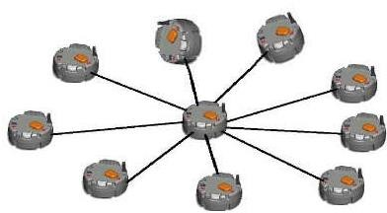

Figure 2.2. Star Topology (Wang *et al* 2008).

The advantages of star topology in wireless sensor network are;

A. Lowest power consumption in this topology which is good from the point of view of Wireless Sensor Networks.

2) The topology is easy to Enlarge; i.e scalable.

The disadvantages of wireless sensor network: -

1. Communication is not reliable in this topology.
2. There is no alternative path in the structure.

## Mesh Topology

Each node in this system can communicate directly. The pictorial presentation of this topology is shown in fig 2.3

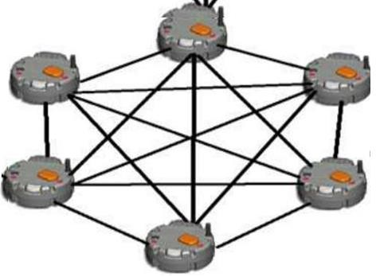

Figure 2.3 Mesh Topology ( Cao *etal* 2009).

The advantage of mesh topology in wireless sensor network: -

1. It is a most reliable communication network structure.
2. It is a more scalable network.
3. Chances of data loss are less.

Demerits of mesh topology in WSN: A .Higher power consumption.

B. Increased latency is the problem of this network.

## Hybrid Technology

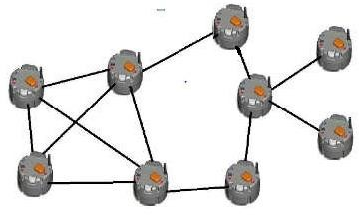This topology is the mixture of the various topologies. So this topology gets all the advantages of other topologies which are included in this but unfortunately some disadvantages also came into it along with others **(**Onodera and Miyazaki 2008).

Figure 2.4 Hybrid Topology (Onodera and Miyazaki 2008).

The advantages of hybrid technology in wireless sensor network are given thus: -

1. No point of failure.
2. Power consumption is low.
3. Nodes have many alternative path.

The disadvantages of hybrid topology in wireless sensor network: -

1. Scalability becomes a problem when too large
2. Interfacing between different types of topology is difficult.

## Tree Topology

The sensors used in the field form a logical tree so we call it Tree Topology. We have two types of nodes here; parent node and leaf node. Data packets are passed from a leaf node to its

parent nodes. A receiver node getting data from the child node sends data to receiver's parent node after cumulating data with its own possessed data.

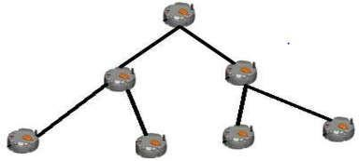

Figure 2.5 Tree Topology **(**http://www.tree topology 04072019).

The advantage of this topology is that it consumes less power than other topologies, as flooding is not necessary for data communication.

The disadvantages of tree topology are:

1. This topology is time consuming and costly as all cost depends upon the formation of the tree.
2. If a parent node fails, then its entire sub-tree is cut off from the base station.
3. The nodes closer to the base station consume a lot of power in forwarding packets from all the nodes in their sub-parts, whereas the leaf nodes in the spanning tree do not have to perform any forwarding at all and consume the least power.
4. There is delay in sending data from leaf to root node.
5. Network depends strongly upon on radio link.

## Reviewed Works

Manju et al., 2018 worked on target coverage heuristic based on learning automata in wireless sensor networks. The study show that for us to prolong the network life time, the activity of the sensor can be scheduled in such a way that only a subset of sensor nodes called cover set, is sufficient enough to cover all the targets. They proposed an energy efficient algorithm based on

learning automata for target coverage problem. However, real-time monitoring was not achieved because not all the sensors are active at a time and the effectiveness in monitoring is also hindered.

Kirti and Sayali (2018) worked on Animal tracking and caring using Radio Frequency Identifiers (RFID) and Internet Of Things (IoT). The study helps to monitor animal movement and connects them globally i.e connects humans, objects and living things with the world. It also addresses the issue of long distance identification of animal using sensors embedded in the RFID tag which can be tracked using GPS. However, the study did not state clearly how the sensor tags was powered because using a GPS is power consuming and if the source of power is not given priority the monitoring will not be achieved.

Bharavi and sukesh Rao (2017) worked on the Design and development of GSM and GPS tracking module.The study was able to integrate GSM and GPS into a single board which was then used for wireless applications. The integrated GSM and GPS was made using the usual SIM808 by SIMCOM which has both GPS and GSM engines. However, the developed device only made provision for only one mobile network for the transmission of data so the efficiency of the system was threatened incase of network instability.

Beng *et al.*, (2016) worked on field testing of IoT devices for livestock monitoring using wireless sensor network, near field communication and wireless power transfer. The study sought a wireless means of charging the battery of the nodes to guarantee the longevity of the network but the usage of wireless technology to transfer power for long range still faces the challenge of transfer efficiency because of the distance between the charging transmitter and receiver.

Dieng *et al.,*(2017) work on IoT solutions to prevent cattle rustling in African context, these zones are generally not covered by the 3G/4G network. The study proposes that ZigBee be used in as much as the cattle are in limited area i.e. not far from the gateway. It also gives details for LoRa technology. LoRA, long Range is a new Low Power Wireless Access Network (LPWAN) technology designed mostly for IoT communication. Its main work is to focus on some critical LPWAN features to improve their use on IoT. These features are battery lifetime, network capacity, range and cost. The limitation of this study is that it assumed a limited distance between the cattle and it does not consider a free- range system.

Aftab *et al.,*(2017) in which work, a wireless sensor network system (WSN) comprising Radio Frequency Identification (RFID), ZigBee module and auxiliary sensors are used to monitor the animals behavior, drinking behavior, lameness, heartbeat and body temperature. This will ensure continuous monitoring of cattle and help in the prevention of health related diseases of the cattles. The work does not consider a free range system and the effect of this is that the animal can still be stolen.

Tsenkov and Tsenev (2017) worked on wireless transmission of biotelemetry data of free roaming animals (particularly cows) using the already existing networks of the mobile operators. The device is mounted on the ear tag of the cow and constantly monitors the temperature changes of the cattle with the environment and a solar system is used in the device to ensure the longevity of the tracker. The work only made provision for one of the mobile operators to be used in the transmission of data to the base station. The effect of this is that the information about the animals will not get to the base station when there is connectivity problem with that particular network. Therefore, getting real-time monitoring of the cattle will not be achieved.

Gokul and Tadepalli (2017) investigated how to make infrastructure of cattle farming smarter and to implement a non-invasive wearable to track physiological and biological activities of cattle using internet of a thing ( IoT). Each cattle is tagged with a wearable device. The wearable device and sink node is designed based on the architecture of device to cloud. In this work, each wearable is designed to cloud which means that each can transmit data at same time, this will easily drain the battery thereby rendering the system inefficient.

Ajayi and Olaifa (2016) proposes the use of virtual fence – an IoT based intrusions detection system that uses active sensors to detect the presence of intruders and logs such intrusions for monitoring purpose. With these logged information, owners of such farmlands can know precisely when and where to deploy or intensify security activities around these large farm lands or plantations. This work only focuses on a ranch system where the animals are restricted in movement, i.e a free range system was not considered.

Kumar and Dash (2017) worked on mobile data sink-based time-constrained data collection from mobile sensors. In this environment, sensor nodes can directly transfer sensed data to the mobile data sink (MDS).Therefore to avoid buffer overflow, the data must be collected by the MDS within a predefined time interval. This is done to prolong the sensor network lifetime for large scale network. The drawback of the study is that data are collected periodically from the mobile sensors. So getting information to the base station is not real-time.

Lopes and Carvalho (2016) the aim of the study was embedding and reducing the size of the electronic tag circuit.The cost of implementation was very low and having a maximal energy advantage shape. Data transmission is not real time. The effect of this work is that effective monitoring was not achieved.

Olaniyan and Yahaya (2016) investigated the causes and consequences’ of, and State responses to cattle rustling in Nigeria. This work only highlighted the causes of cattle rustling but no mention was made on how to curb the menace.

Nkwari *et al.,*(2015) combined Wi-Fi and ZigBee technologies in an application to monitor cattle. This combination has the potential to increase the range of the network when the animal herd is roaming out of range of the sink. The paper actually investigates combined Wi-Fi and ZigBee transceiver on the same sensor node to reliably obtain data of mobile cattle in a field. The solution proposed is a hybrid network conjoining the IEEE 802.15.14 and IEEE 802.11 b/g protocol. The hybrid system goes a long way to solve the issue of when the cattle are far from the sink node but the system consumed more power thereby draining the battery in the shortest time and rendering the system inefficient.

Gutierrez *et al.,* (2013) worked on heterogeneous network mainly based on nodes that uses harvested energy to self energize the network, mostly kinetically powered, was used for the localization of herds in grazing areas under extreme climatic condition. The network consists of secondary and primary node. The secondary node is powered by kinetic generator, take advantage of animal movements to broadcast unique identifiers, while the primary nodes are powered by battery. This work stressed the advantage in harnessing the movement of the cattle to power the secondary node which generate a unique identifier to the base station about their location, so it means we can only know the location of an animal when it is moving, therefore effective monitoring is not achieved.

Kwong *et al.,*(2011) made use of two analysis metrics in data communication requirement for agricultural livestock monitoring application using wireless sensor networks (WSNs). The two analysis metric are ; Connection availability and Connection duration which are used to quantify

the impact of cattle movement on network connectivity. The limitation of this work is the availability of constant connectivity from the mobile operator.

Swain *et al.,* (2011) worked on tracking livestock using Global Positioning System (GPS). The study helps to provide useful information about animal movement in extensive inaccessible environments. However the experimental design is challenged by the number of GPS tracking collears that are available due to cost of each collear and the continual trade-off between sampling intensity and longevity associated with the battery power demands of the GPS receiver. Nkwari *et al.,*(2014) worked on wireless sensor node with a GPS to collect data of a cow’s current position and speed if moving. The data is used to model the animals movement using a probability Distribution Function (PDF) in order to determine the probability of the animal being stolen. The main contribution of this work is to determine the effectiveness of using the continuous time markov process (CTMP) to determine if a cow is being stolen or not. The limitation of the work is that data will only be generated when the animals are moving, and the effect of this is that effective monitoring was not achieved.

From the reviewed works, wireless sensor network (WSN) has a wider application of importance, but the identified gap in its application is battery lifetime and mobile coverage due to harsh and difficult terrains being deployed for use.

The summary of the reviewed work is shown on the meta analysis table in Table 2.6.

Table 2.6 Meta anslysis table.

## Author(s) (Year)

**Title Strength Limitation**

## Gokul and Tadepalli (2017)

Implementation of smart infrastructure and non-invasive wearable for real time tracking and early identification of diseases in cattle farming using IoT.

Made use of wearable device, arduino nano is used as the processor, the communication unit is wi-Fi module, Rechargeable battery is used.

Power and connectivity problems

## Tsenkov and Tsenev (2017)

**Kumar and Dash ( 2017)**

Continuous analysis of free-roaming animals’ behaviour with ear-tag device.

Mobile and Sink- Based Time- constraint data collection from mobile sensors.

Made use of highly efficient solar element, use mobile network and the amount of visible satellite.

In this project a wireless sensor node directly transfer sensed data to the mobile data sink MDS, the data is then collected within a predefine time interval.

Data transfer is not real time, minimize the way hardware works to conserve energy. Getting information to the base station is not real-time so the monitoring is not efficient.

## Lopes and Carvalho (2016)

Livestock low power monitoring system

An module is fixed to the body of animal for identity and a mobile base station.

Data transfer is not real time

## Nkwari et al (2015)

**Nkwari et al (2014)**

Heterogenous wireless network based on Wi-Fi and ZigBee for cattle monitoring.

Cattle monitoring system using wireless sensor in order to prevent cattle rustling

Continuous Time Markov Process (CMTP) was applied to the movement pattern of an individual cow. A value of 2.5 KM/H was used as

Connectivity problem

Network problem. The sensors too large on the animal body.

threshold to detect agitation.

## Gutierrez et al (2013)

**Kwong et al (2011)**

Cattle-powered node experience in a heterogeneous network for localization of herds

Implementation of herd management system with wireless sensor networks.

A heterogeneous network that is mainly based on nodes that uses harvested energy to self-energize. Making use of animal movement to broadcast a unique identifier. Made use of a global positioning system, A wireless system including Antenae diversity with data download optimization scheme utilizing data collector and routers are developed and tested in a working farm environment.

Data transfer is not real time.

Energy constraint and interference on radio channel.

**Swain *et al.,* (2011)** Tracking Livestock

using Global Positioning System (GPS)

Made use numerous numbers of GPS providing location information for monitoring.

The experimental design is challenged the numbers of GPS and longevity associated with the battery power demands of the GPS.

## Olaniyan and Yahaya (2016)

**Ajayi and Olaifa (2016)**

Causes and consequences of , and state response to cattle rustling in Nigeria.

An IoT based intrusions detection system.

Investigate and highlighted the causes of cattle rustling to include joblessness and unwillingness on the part of the Government to take responsibility.

The work uses active sensors to detect the presence of intruders and logs such intrusion for monitoring.

No practical suggestion on how to curb the menace.

The work only focuses on ranch system. Free range system not considerd.

**Aftab *et al.,* (2017)** WSN to monitor

Animal behavior.

This work made use of WSN comprising of Radio Freqeucy Identification, Zigbee module and auxiliary sensors to monitor the lameness, heartbeat and body temperature of animal.

The work does not consider a free range system.

**Lim Teck Beng *et al.,* (2016)**

Field Testing of IoT devices for livestock

The study sort a wireless means of charging the battery of the nodes to

The usage of wireless technology to

monitoring using WSN

**Dieng *et al.,* (2017)** IoT solutions to

prevent cattle rustling in African context.

elongate the monitoring process.

The work uses Zigbee and loRa technology to monitor animal movement in a particular area because the area not covered by 3G/4G network.

transfer power for long range still faces the challenge of transfer efficiency.

Network instability.

## Bharavi and Sukesh Rao (2017)

**Kirti and Sayali (2018)**

## Manju et al., (2018)

Design and development of GSM and GPS tracking module.

Animal tracking and caring using Radio frequency identifiers and IoT.

Target coverage heuristic based on learning automata in wireless sensor networks.

The study integrate GSM and GPS into a single board which was then used for wireless application.

The method used in this work is tracking animal using GPS and connecting them globally

The study shows how to schedule the activities of the sensor in such a way that not all the sensors are active at the same time.

The developed device only made provision for only one mobile network for transmission of data.

The study did not say clearly how the system was powered knowing well that GPS is power consuming.

The effectiveness in monitoring was hindered, not real – time.

**CHAPTER THREE**

# METHODOLOGY

In this chapter, adopted methodology, design procedure, and components of the system were discussed in detail.

## Adopted Topology

The system is made up of a master node or relay node, four slave nodes, farm or ranch and User node. The slave nodes and the master node are mobile around the farm while the user node is at any location. Figure 3.1 shows the Developed System Architecture.

## Methodology

* + 1. **Developed System Architecture**

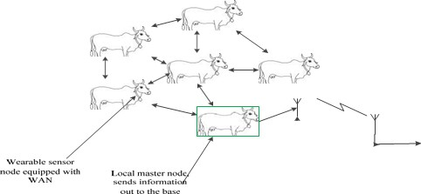The wireless sensor network consists of a relay or master node that transmit the sensors information from the field to the end user, four slave nodes that are distributed around the master node, and the User node which is made up of Global System of Mobile communication (GSM) enabled device. Figure 3.1 shows the wireless sensor architecture for the research.

BASE STATION

Figure 3.1: Developed System Architecture.

## Master or Relay Node

The relay or master node is one of the components of the wireless sensor network that is made up of power supply unit, programmable microcontroller chip, Global Positioning System(GPS) communication module, four GSM modules and Radio Frequency (RF) transceiver module. Figure 3.2 shows the block diagram of the master node.

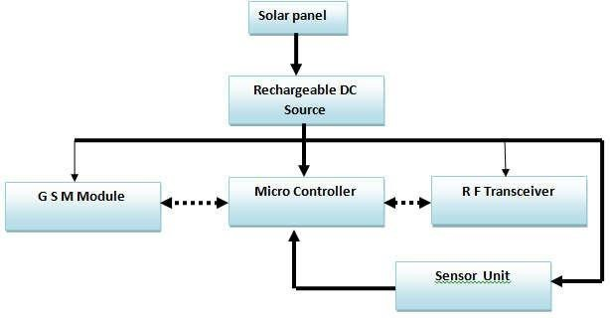

Figure 3.2: System block diagram of the master node

## Power Supply Unit

The power supply is made up of a 10.6V, 500mA solar PV, LIPO battery with capacity of 3.7V, 500mAh, LIPO charging system, voltage regulator system of 5V DC at 2.0A.This power source was used due to it portability and efficiency in providing the needed energy for the system. In the course of implementation of this research work, many energy saving strategies (such as sending information in batches not continuously, idle mode activation for none working GSM module) were considered so as to elongate the useful life of the nodes.

From the ATmel ATmega328p datasheet, it is specified that the operating voltage of the microcontroller is 4.98 V DC.RF module is powered by 3V, 12 mA. The GSM module is operated on 5V, 1.0 A and the GPS module required 5V, 1.0 A. Based on the power requirement of the components, it was observed that the maximum voltage is 5V.

Since all the component requirement is known, a 10.6 V, 500 mA solar PV was used for this work.

Two 3.7 V LIPO batteries were connected in series to obtain 7.4 V DC. For smooth operation of LM7805, it is specified that capacitors C1, C2 and C3 with values 100ρF, 1000µF and 1000µF respectively be used as given in Figure 3.3. This configuration is to ensure that a DC voltage that is free of ripple is obtained at the output of the power supply.

Furthermore, to obtain output voltage of 3.0V, a silicon diode of 0.7V was placed in series at the output of one of the 3.7V LIPO batteries.

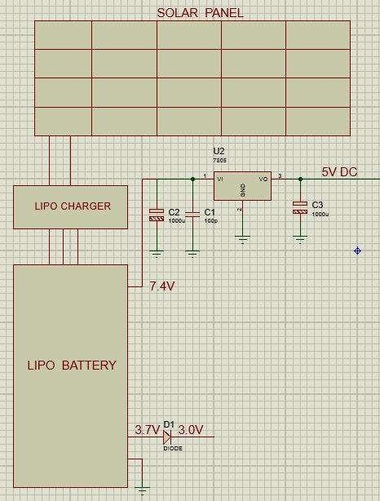

Figure 3.3: Proteus Implementation of the Power Supply Unit

Figure 3.3 showed the Proteus implementation of the power supply unit.

## Microcontroller Unit

The microcontroller used in this research work was ATmega328p programmable controller chip, this is so due to it numerous advantages over other microcontrollers like PIC’s in the sense that the ATmega328p come in small size which fit into our desire for portability, it numerous input/output pins that offered several interfacing of peripheral components. Also, it is programmed in C++ programming language.

The microcontroller was powered by 5V supply from the power supply unit. A resistor R1 and capacitors C4, C5 and C6 were selected based on specifications of the datasheet as 10Kiloohms, 22ρF, 22ρF and 1000µF respectively. The crystal oscillator was chosen as 16MHz, to execute 16 million instructions in one second. The capacitors together with the crystal oscillator set the frequency of the microcontroller to 16MHz. The configuration of the microcontroller unit was implemented in Proteus simulation software as shown in Figure 3.4.

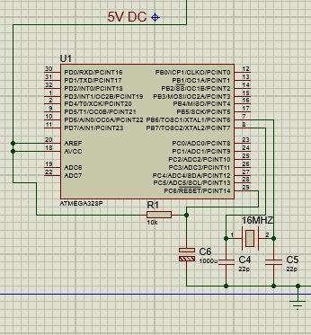

Figure 3.4: Proteus Implementation of MCU Configuration

## GPS Module

The GPS module was interfaced with ATmega328p microcontroller to get the geographical information (position coordinates) of the master node at every instance of time. The GPS modem have the capability of communicating with the satellite system positioned in the sky using line of sight communication principle to extract information after every second of time. The GPS module was powered by 5V supply from the power supply unit. Figure 3.5 shows the Proteus implementation of interfacing GPS module.

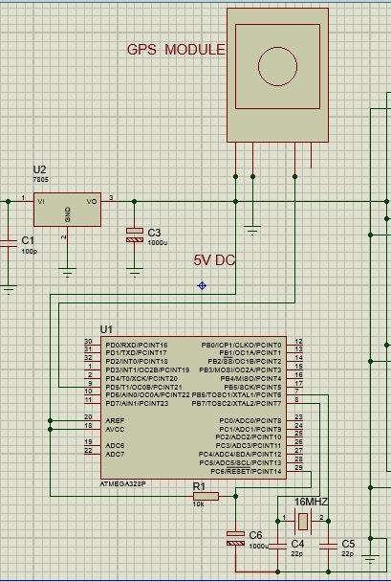

Figure 3.5: GPS Module Interfacing with MCU

## RF Transceiver

The Radio Frequency (RF) transceiver is use to transmit and receive signal in form of radio signal over predefined distance between two devices. The RF module NRF24I01 was chosen due to its portability in size, functionality as the case of high frequency band of up to 2400MHz and low energy consumption of 36 joules (3V 12mA).

RF communication helps in short range data transfer between nodes in the WSN. Figure 3.6 showed the connection of the RF module to the MCU in Proteus implementation. The RF module was powered by 3.0V output from the 3.7V output of the powered supply unit. Its receiver and transmitter terminals were connected to pin 10 and 11 port of the microcontroller.

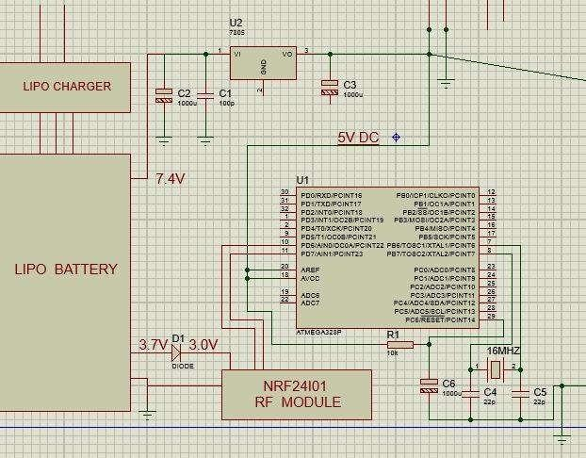

Figure 3.6: Interfacing of RF Module with MCU

## GSM Module

In this research work, GSM module is one of the components of the system that plays a vital role in the communication process. It is capable of receiving and sending data in the form of SMS. Attention commands (AT) were sent to the GSM modem using HyperTerminal serial communication program and the baud rate set to 9600bps. Four GSM modules were used in the course of this work in order to address the problem of network instability using four different service providers. For the purpose of this work A6 mini model of the GSM modem was used due to it portability in size, and faster response time. It can be seen in Figure 3.7 that all the four

GSM modems were interfaced with the microcontroller in Proteus simulation with each powered from 5V DC of the power supply.

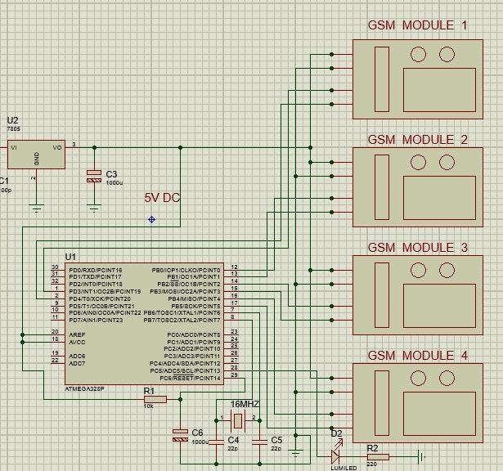

Figure 3.7: GSM Module Interfacing

The complete circuitry connection of the components that made up the master node is given in Proteus implementation shown in Figure 3.8.

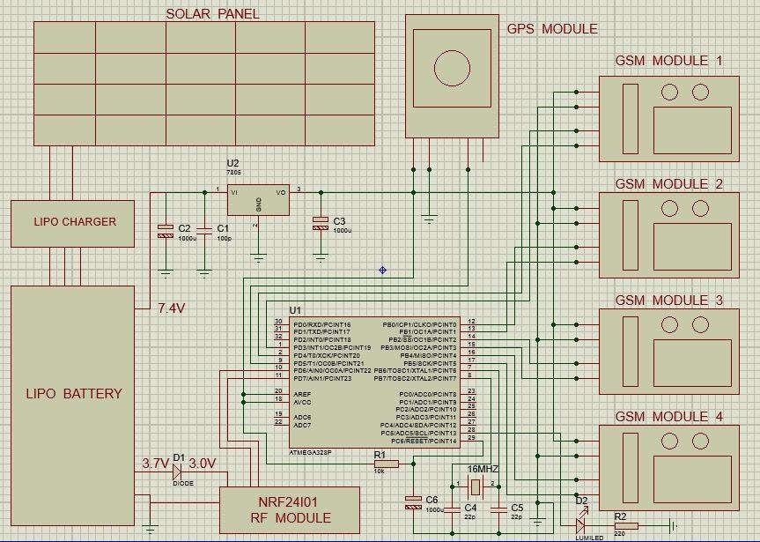

Figure 3.8: Master Node Circuit.

A snippet of the program code for implementing the master node that is presented in section A of the appendix is given in Plate 3.1.

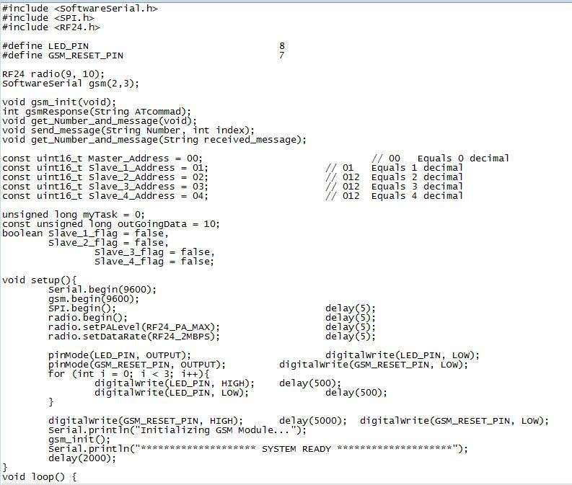

Plate 3.1: Snippet of Program code for implementing master node

## Slave Nodes

The four slave nodes have similar configuration with the master node but with the exception of the GSM modules. Also, the solar panels used in designing the slave nodes in this research work were 6.6 V 400mA because the power required by the slave node is lesser to that of the master.

ATmega328p microcontroller was used as the brain chip for processing and execution of the tasks in the slave node. Receiver and transmitter terminals of the GPS module were connected to interrupt pin 0 and 1 of the microcontroller port while RF module transmitter and receiver terminals were connected to interrupt pins 22 & 23 respectively. The block diagram of the slave node is shown in Figure 3.9.

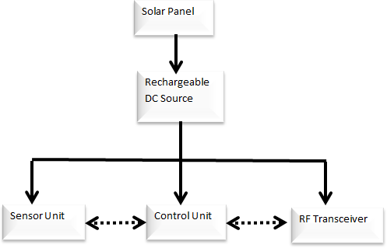

Figure 3.9: Block diagram of slave node

Figure 3.9, shows the components which made up the slave nodes and how they interact with each other. The implementation of the slave node in Proteus software is given in Figure 3.10.

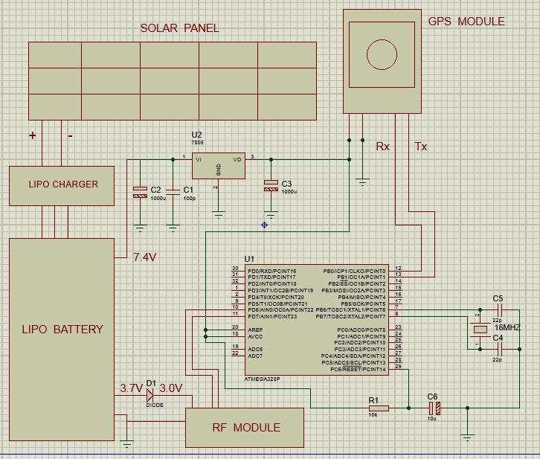

Figure 3.10: Complete Circuitry of the Slave Node.

Plate 3.2 show a snippet of the program code for the designed slave node given in section B of the Appendix.

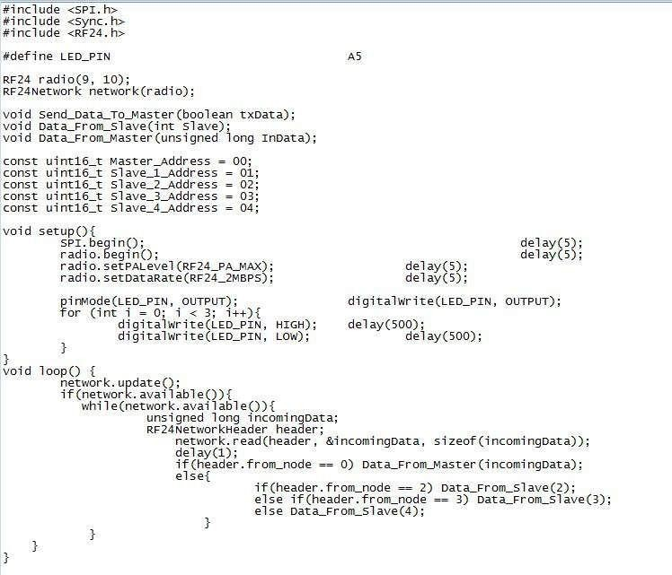

Plate 3.2: Snippet of Program code for implementing slave node

## User Node

The user node is made up of the mobile phone enabled with the capability of receiving SMS message containing data. Mobility of this node makes it more efficient and effective means of acquiring the nodes information at any instance of time and from any location on the globe.

## Communication between The Nodes

The communication aspect of the system is divided into two parts. There is communication within slave nodes themselves, slave nodes and the master, and also the master node to the User node.

## Communication within Field Nodes

In this section, the communication pattern between the field nodes themselves is further divided into two aspects namely;

1. Communication between Slave Nodes

The communication between slave nodes involves monitoring of their separation apart through the RF communication technology. Communication strategy within the slave nodes was to ensure that all nodes are within the expected range of WSN coverage.

1. Communication between Slave and Master Node

In this communication process, the slave nodes report to the master node. The position coordinates of the slave nodes are requested at interval via RF communication protocol.

## Communication between Master Node and User Node

Communication between the master node and the user node is initiated under two conditions. Thus;

1. Event based data transfer

The event-based data transfer occurred when any of the slave nodes is out of the threshold distance range. When such situation occurs, the master node will not receive reply to position request it sent to such node. The master node will yet send a search request to other slave nodes in the network to query the location of the suspected missing node. If any of the slave node receive a reply from the suspected node, it report to the master node else the node is declare missing. Position coordinates of the nodes are equally sent to the user node via GSM communication network.

The flow chart in Figure 3.11 is the developed flow chart for the communication between the master node and the User or mobile node based on event (when one of the nodes is out of range).



Start

Initialization

Any command From master node?

No

Yes

Slave missing Command?

Yes

Query the missing node

No

Did slave respond?

No

Yes

End

Respond with Position coord.

Reply master with slave found

Reply master with slave out of range

Figure 3.11: Flow Chart for Event based Data Transfer between Master nodes and User node

Figure 3.11 show the developed flow chart of communication between the master node and the user node based on event. A snippet of the program code that was used to implement the flow chart as given in section C of Appendix is given in Plate 3.3.

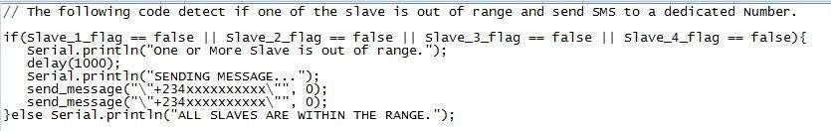

Plate 3.3: Snippet of Program code for implementing Event-based data transfer

1. User Query data transfer

In this mode of data transfer, an SMS syntax containing request command is sent from User node (Mobile Phone) to master node. The SMS is received by the GSM modem at the master node, process and the command executed by the microcontroller. A response SMS is sent to the User node containing the needed information. Figure 3.12 show the flow chart of the query-based data transfer between the master node and the user node.



Start

Initialization

IsUser command found

No

Yes

A

Query all slave nodes

Search for User command



A

No

Isslave Missing?

Yes

Did slave respond?

No

Yes

End

Replyuserwith slaveoutofrange

Reply user with Slave found

Query missing slave

Reply user with slave Nodes co-ordinates

Figure 3.12: Query based Data Transfer between Master node and User node

Figure 3.12 is the developed flow chart for communication between the master and the user node. A snippet of the program code used to implement this flow chart is given in Appendix D.

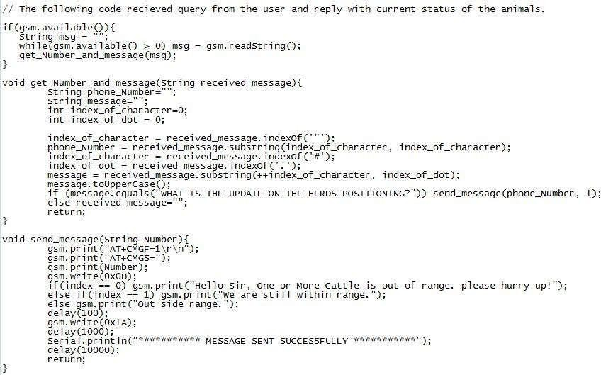

Plate 3.4: Snippet of Program code for implementing Query-based data transfer

## Network Selection Protocol

In order to ensure data transfer between the master nodes and the user node, an adaptive (flexible) network selection scheme was incorporated into this research study. The protocol used is based on received signal strength of the service providers used in the scheme. In this work, the four available service providers (MTN, GLO, 9mobile and Airtel) was used to implement the network selection scheme. In order to formulate the network selection scheme, we assumed *Si* to

be the signal strength of the ith network and *N* is the selected network, the network to be used is

*s*

selected according to equation (3.1).

*Ns*  max (*Si* )

*i*

(3.1)

Where *i*  1, 2,...*n* , and n is the total number of networks available. In the case of this research, four networks were used.

Figure 3.13, shows the developed flow chart for the network selection protocol used in data transfer between the master and user node.

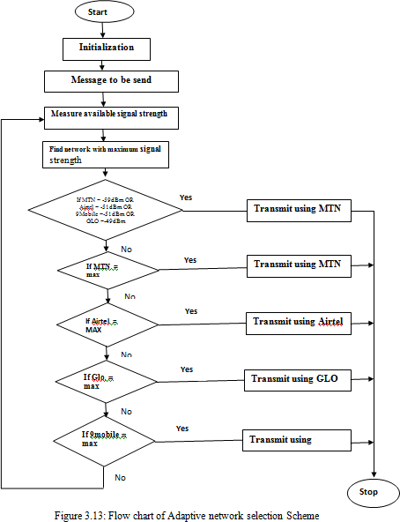

The flow chart in Figure 3.13 shows the adaptive network selection scheme for data transfer during communication between the master node and the user node. In order to implement the adaptive network selection, the program code given in section E of the Appendix was used. Plate

* 1. shows a snippet of the program code for the network selection.

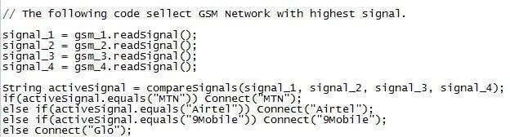

Plate 3.5: Snippet of Program code for network selection scheme.

## Software Development

## Master node and slave node

The software design and implementations of both master and slave nodes in this work were achieved through the following steps.

* + - * Writing of program code in C++ programming Language using ATmel AVR Studio 6.0 compiler.
      * Debugging of the program code for error and generating the .hex file.
      * Building or burning the program .hex file into the microcontroller chip.

## Coordinate Visualization

To visualize the position of the nodes, the coordinates of the nodes were entered in Google Earth application and set as ground view.

## Energy Plot

The energy consumption plots of the nodes was plotted using MATLAB 2018b software that was developed by MATRIX Laboratory.

# CHAPTER FOUR

## RESULTS AND DISCUSSION

## Introduction

In this chapter, the results obtained in the implementation process and discussion of the results are presented as follows.

## Result

## Developed Master Node Prototype

Results of the implementation of the various components of the master node which includes the PVC panel that harness the solar energy that is used to charge the rechargeable battery which powered the system. GPS module that extracts the position coordinates from the satellite and passed it on to the microcontroller for processing.

Interaction between the nodes (between master node and slave nodes or between the slave nodes themselves) is via the RF module. In situation where information needed to be passed (on query or event-triggered) from the nodes (on the field) to the User node, the GSM module with the highest signal strength is selected to transmit the position coordinates. Plate 4.1 shows the designed master node.

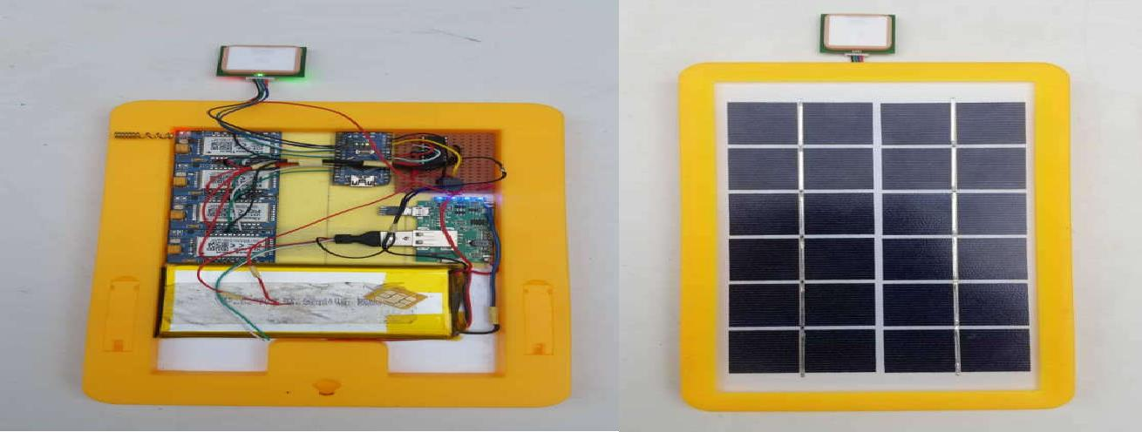

Plate 4.1: Developed Master Node Prototype

## Developed Slave Node Prototype

Figure 4.2 showed the developed slave nodes which is made up of the RF transceiver, GPS module, PVC panel and the battery charging system

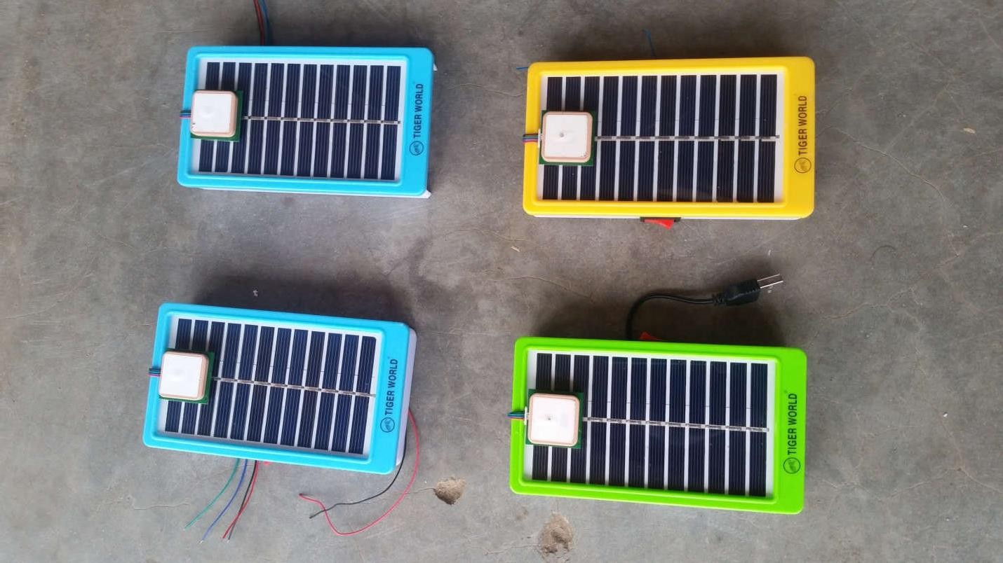

Plate 4.2: Developed Slave Node Prototype

## Position Coordinate Extraction

The position coordinates were extracted at some specific time of the day and presented in columns of latitude and longitude given in Table 4.1

## Table 4.1 Nodes Position Coordinates

|  |  |  |  |  |  |  |  |  |  |  |  |
| --- | --- | --- | --- | --- | --- | --- | --- | --- | --- | --- | --- |
| **Time** | **Query Command** | **Master** |  | **Slave1** |  | **Slave 2** |  | **Slave 3** |  | **Slave 4** |  |
|  |  | Latitude | Longitude | Latitude | Longitude | Latitude | Longitude | Latitude | Longitude | Latitude | Longitude |
| **10:23AM** | What are your locations? | 96012”09’ | 65066”14’ | 96012”09’ | 65066”14’ | 96012”09’ | 65066”14’ | 96012”09’ | 65066”14’ | 96012”09’ | 65066”14’ |
| **12:53PM** | What are your locations? | 96012”04’ | 65066”14’ | 96012”11’ | 65066”15’ | 96012”06’ | 65066”15’ | 96012”09’ | 65066”15’ | 96012”08’ | 65066”12’ |
| **3:09PM** | What are your locations? | 96012”08’ | 65066”12’ | 96012”05’ | 65066”15’ | 96012”17’ | 65066”16’ | 96012”04’ | 65066”18’ | 96012”04’ | 65066”14’ |
| **5:47PM** | What are your  locations? | 96012”09’ | 65066”15’ | 96012”11’ | 65066”14’ | 96012”04’ | 65066”16’ | 96012”07’ | 65066”17’ | 96012”05’ | 65066”15’ |

43

## Position Visualization.

The extracted positions coordinates given in table 4.1 were used to develop a map using Google Earth application installed on a personal computer system.

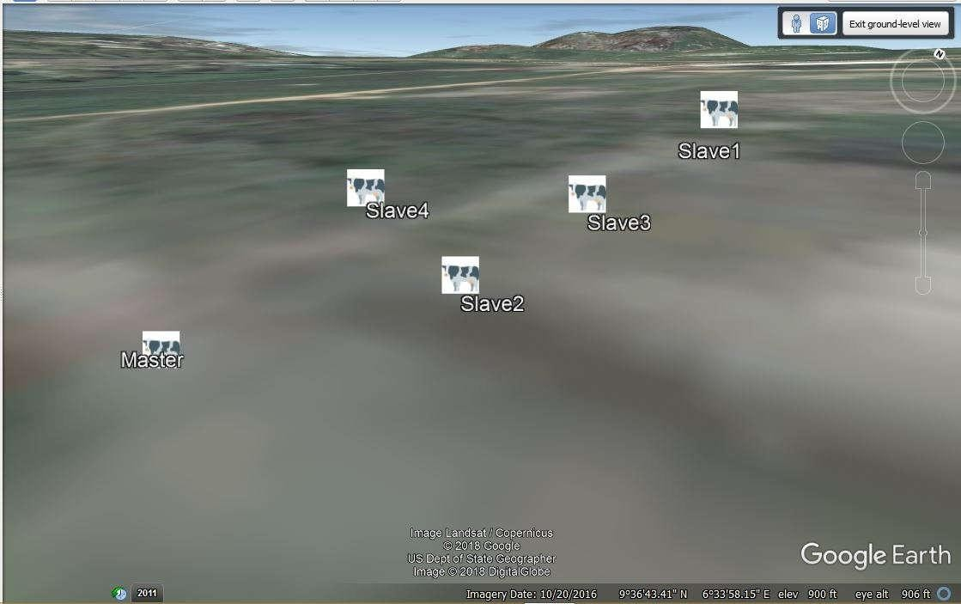

Figure 4.3: Visual Map of the Nodes at time 05:47pm

In Figure 4.3, it can be seen that all the five cows were grazing in close distance between them with the master node being in the middle of the four slave nodes.

## Energy Consumption

The energy consumption pattern during idle mode and transmission mode between the nodes is given in Table 4.2.

44

## Table 4.2 Nodes Energy Consumption

|  |  |  |  |  |  |  |  |  |  |  |
| --- | --- | --- | --- | --- | --- | --- | --- | --- | --- | --- |
| **Time(s)** | **Master Voltage(V)** | **Slave 1 Voltage(V)** | **Slave 2 Voltage(V)** | **Slave 3 Voltage(V)** | **Slave 4 Voltage(V)** | **Master Energy** | **Slave 1 Energy** | **Slave 2 Energy** | **Slave 3 Energy** | **Slave 4 Energy** |
|  |  |  |  |  |  | **(Joules)** | **(Joules)** | **(Joules)** | **(Joules)** | **(Joules)** |
| 1 | 4.94 | 4.99 | 4.98 | 4.99 | 4.97 | 4365 | 1635 | 1620 | 1635 | 1615 |
| 2 | 4.94 | 4.99 | 4.98 | 4.99 | 4.97 | 4365 | 1635 | 1620 | 1635 | 1615 |
| 3 | 4.94 | 4.98 | 4.97 | 4.98 | 4.96 | 4425 | 1695 | 1680 | 1690 | 1670 |
| 4 | 4.94 | 4.98 | 4.97 | 4.98 | 4.96 | 4425 | 1695 | 1680 | 1690 | 1670 |
| 5 | 4.94 | 4.98 | 4.97 | 4.98 | 4.96 | 4425 | 1695 | 1680 | 1690 | 1670 |
| 6 | 4.88 | 4.98 | 4.97 | 4.98 | 4.96 | 9665 | 1695 | 1680 | 1690 | 1670 |
| 7 | 4.88 | 4.98 | 4.97 | 4.98 | 4.96 | 9665 | 1695 | 1680 | 1690 | 1670 |
| 8 | 4.88 | 4.98 | 4.98 | 4.98 | 4.96 | 9665 | 1695 | 1620 | 1690 | 1670 |

45

## Energy Consumption Plots of the Nodes

The plots given in Figure 4.4are the energy (voltages and currents) consumption of the nodes which were plotted using MATLAB code given in Appendix F

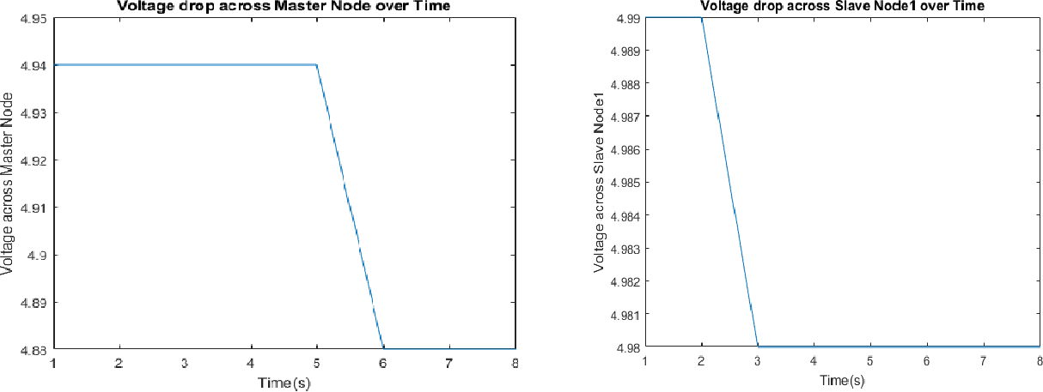

* + - 1. (b)

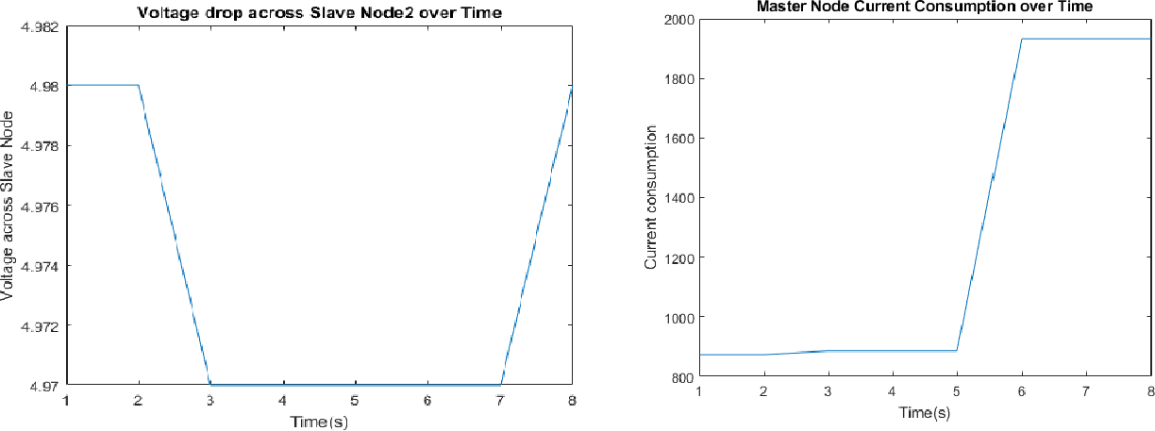

(c) (d)

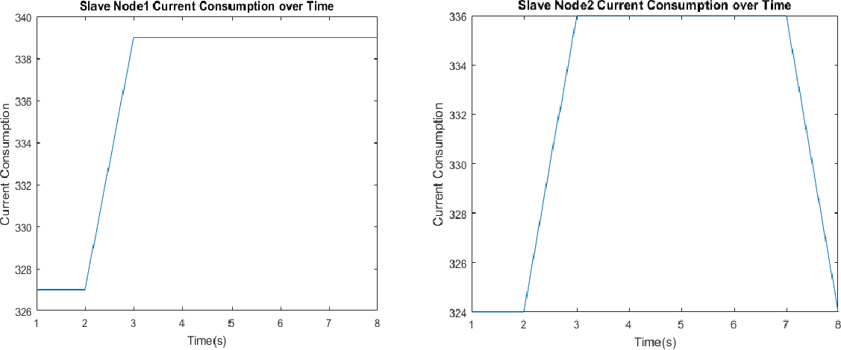

(e) (f)

Figure 4.4: Voltage and Current Consumption in the WSN

## Measurement of Signal Strength

In determining the active network in the monitoring process, the signal strength has to be measured for different locations and is presented in table 3.1

Table 4.3 Network strength at different locations.

|  |  |  |  |  |  |
| --- | --- | --- | --- | --- | --- |
| **LATITUDE** | **LONGITUDE**  **MTN** | **AIRTEL** | **9MOBILE** | **GLO** | **ACTIVE**  **NETWORK** |
| **96012”04’** | 65066”21’ -59dBm | -83dBm | -87dBm | -93dBm | MTN |
| **96021”75’** | 65056”63’ -87dBm | -51dBm | -73dBm | -77dBm | AIRTEL |
| **96032”51’** | 65057”32’ -68dBm | -53dBm | -57dBm | -49dBm | GLO |
| **96014”09’** | 65072”63’ -87dBm | -78dBm | -51dBm | -94dBm | 9MOBILE |

## Discussion

From Figure 4.4(a),(b),(c) and (d) show voltages across the WSN when powered ON, between time interval of 1 to 2 , it can be seen that all the nodes maintained constant voltage magnitude due to idle mode (no communication between the nodes).

Between time 3 to 5, there were changes in voltages and currents during communication between the nodes. During this time, the cattle are within 50meters apart, i.e they are within the selected distance threshold. At this point, the voltage level of the master node, slave node1 and slave node2 are 4.94 V,4.98 V, 4.97 V and those of slave node3 and slave node4 are 4.98 V, 4.96 V respectively as shown in Figure 4.1(a), (b),(c)and in appendix G_1, (d) and (e). The nodes current consumption at this instance are 885 mA, 339 mA, 336 mA, 338 mA and 334 mA respectively.

While at interval 5 to 6, there is a noticeable change in master node voltage and current from4.94 V to 4.88 V and 885 mA to 1933 mA as seen in Figure 4.4(a) and 4.4(d) when compared to the previous energy consumption, this is due to the fact that, the master node was queried from the User node in order to get their location. During this time, the slave nodes voltages and currents remain unchanged because they are only communicating with the master as usual. This shows that, the GSM module consumed greater current while sending or receiving messages when compared to it idle state.

At time interval 6 to 8, as can be seen in Figure 4.4(e) that one of the slave nodes went out of the range. When one of the slave nodes is out of range, the node’s voltage and current return back to normal values because there were no communication with others any more. At this time, the master node send a notification message of a missing node to the User node.

From Table 4.3, it is seen that signal strength varies for different networks in different locations,

this actually play a significant role in the monitoring process because the transfer of location data to base station depends largely on the network signal strength.

Figure 4.3 is a visual display of the location data gotten from the GPS at specific time of the day during the monitoring process, this result was achieved through the help of a google earth application install on a personal computer. Throughout the monitoring process, the adaptive network selection scheme through the use of multiple service provider guarantees that information about cattle location get to the base in real-time.

## CHAPTER FIVE

* 1. **CONCLUSION AND RECOMMENDATION**

## Conclusion

In this research work we have been able to monitor cattle movement by using WSN that is capable of detecting location. A visual map of the cattle’s location was achieved through the use of google earth application installed on a personal computer (PC). The developed system architecture is such that the nodes (cattle) can communicate with each other just like in a mesh topology and the master node keep track the information so as to prompt the user node whenever the conditions of monitoring is violated. The threshold distance between the cattle is set at 50m and the renewable energy source (PVC) ensures the longevity of the battery life which helps in achieving a sustained monitoring. Also, the adaptive network selection scheme in this work made it possible to get information to the base station in real-time without any delay caused by network instability. The software part of the developed system was implemented using c- language to program the control logic of the developed system and also proteus implementation software was used for the entire design. The hardware part which comprises micro-controller, wireless sensor, mini solar panel make up the prototype. The evaluation of the system energy consumption pattern was done using MATLAB which shows how energy was used in the monitoring process.

## Contribution to Knowledge

* An adaptive network selection scheme through the use of multiple service providers was developed to cater for problem of network instability.
* The use of renewable energy source (pvc) to complement the DC battery which guaranteed sustained monitoring.

## Recommendation

* A portable and more efficient source of energy for the WSN should be considered.
* Real time visualization system can be incorporated into the system

## REFERENCES

Abimaje, A. (2014). 260 killed, 2501 cattle rustled in Jos attacks- JTF, in leadership 25 April, Online:<http://leadership.ng/news/3684j/260-killed-2501-cattle> rustled-jos attack-jtf(30 August, 2018)

Adeniyi, (2015). Why incoming FCT Minister must act fast on cattle rustling, in Daily trust 1 July, Online:[http://dailytrust.com.ng/daily/indek.php/city-news/58662-why-incoming-fct](http://dailytrust.com.ng/daily/indek.php/city-news/58662-why-incoming-fct-administration-must-act-fast-on-cattle-rustling)- [administration-must-act-fast-on-cattle-rustling](http://dailytrust.com.ng/daily/indek.php/city-news/58662-why-incoming-fct-administration-must-act-fast-on-cattle-rustling)(15 August, 2018)

Aftab, M. I., Anup, P. M. and Abhishek, P. J., (2017).Continuous health surveillance system for cattle. International conference on Intelligent computing and control system. 1193-1196.

Ajayi, O. O., and Olaifa, O.,(2016). Detecting intrusion In large farm lands and plantations in Nigeria using virtual fences. Conference paper (Researchgate), India

Akyildiz, I., Su, W., Sankarasubramniam, Y., and Cayirci, E. (2012). Wireless Sensor Networks; A survey. In Computer Networks Volume 38 page 392-422 march 2012.

Bashir, M., (2014). Hope for an end to cattle theft, in: Daily Trust, 4 september, online[:<http://dail](http://dailytrust.com.ng/daily/feature/33468-hopes-for-an-end-to-cattle-theft)y[trust.com.ng/dail](http://dailytrust.com.ng/daily/feature/33468-hopes-for-an-end-to-cattle-theft)y[/feature/33468-hopes-for-an-end-to-cattle-theft.](http://dailytrust.com.ng/daily/feature/33468-hopes-for-an-end-to-cattle-theft)

Bharavi, u. and Sukesh Rao, M. (2017). Design and development of GSM and GPS tracking module. 2017 2nd IEEE confeference on Recent trend in electronic information and communication technology (RTEICT),May 19-20, 2017. India.

Cain, J. Krausman, P. Jansen, B. Margart, J.(2005). Influence of topography and GPS fix internal on GPS collar performance. Wildlife Society Bulletin 33, 926-934.

Cocchram, W.W, Lord JRD, (1963). A radio – tracking system for wild animals. The Journal of Wildlife Management 27, 9-24.

Dieng, O., Thiare, O., and DIOP, B., (2017). A study on IOT solution for preventing cattle rustling inAfrican contest. Proceeding of ICC Conference Cambridge city, United Kingdom.

Fancy, S. Park, L. Douglas, D. Curby, C. Gamer, G. Amstrong, S. Regelin, W. (1998). Satelite telemetry; a new tool for wild life research and management. United states Department of interior and wildlife service Resource Publication 172, 1- 61

Gokul, V. and Tadepalli, S., (2017).Implementation of smart infrastructure and non-invasive wearable for real time traking and early identification of diseases in cattle farming using IOT.International conference on I-SMAC, 469-472.

Guo, P. Y., Corke, G., Poulton, T., Wark, G., Bishop, H. and Swain, D., (2007), Animal behavior understanding using wireless sensors networks.IEEE Pervasive Comput. 2007,6,50-57.

Gutierrez, A., Dopico, I.N. and Zazo, S. (2013). Cattle-Powered node experience in a heterogeneous network for localization of herds. IEEE Transaction on industrial electronic, 60, 8-18.

Hemblewhite, M. Haydon, D. (2010). Distinguishing technology from biology; a critical review of the use of GPS telemetry data in ecology. Phylosophical Transaction of the royal society B. Biological Science 365,2303-2312.

Hulbert, I. French, J. (2001). The accuracy of GPS for wildlife telemetry and habitat mapping.

The journal of Applied Ecology 38, 869-878.

Kirti and Sayali (2018).Animal tracking and caring using RFID and IoT. IOSR journal of computer Engineering (iosr-jce) e-ISSN;2278-0661, 2278-8727

Kumar, N. and Dash, D., (2017).Mobile data sink-based time-constrained data collection from mobile sensor.IET journals of engineering and technology, 80, 236-245.

Kwong K.H., Wu, T.T. and Sasloglou, K., (2011).Implementation of herd management systems with wireless sensor netwoks.IET wireless sensor network systems, 2011, Vol. 1, Iss. 2, pp. 55–65

Lim, T.B. Poh, B.K. Lee, M.M. Phoa, N.C (2016). Field testing of IoT Devise for livestock Monitoring Using Wireless sensor network, near field communication and wireless power transfer. IEEE conference on technologies for sustainability.

Loarie, S. Aarde, R. Pimm, S. (2009). Fences and artificial water affect Africa savannah elephant movement patterns. Biological Conservation 142, 3086-3098

Lopes, H.F. and Carvalho, N.B., (2016).Livestock Low Power Monitoring System.IEEE conference proceeding, Universidade de Aveiro. 978-1-5090-1691-4

Li, N.and Hou J.C. (2004). A fault tolerance –topology control Algorithym for wireless networks. In proceedings of the ACM International conference on mobile computing and networking (MobiCom) Philadelphia Pennsylvania, September 2004.

Litting Cao etal, (2009). Automatic Meter Reading System Based on Wireless Mesh Networks and SOPC Technology. Inteligent Networks and Intelligent Systems, 2009.

Manju, Scatish, C. and Bijender K., (2018). Target coverage heuristic based on learning automata in wireless networks. IET journal of Engineering and Technology,2018,(4 )2 85-105.

Maria S. and Tom W., (2018). Energy – efficient medium access control and routing protocol for multi-hop wireless sensors networks.IET journal of Engineering and Technology,2018,(4)4 65-78

Ma Yuchun, H. Yinghang, Z. Kun, L. (2011). General application research on GSM Module.2011 International conference on internet computing and information service.978-0-7695-4539-4/11

Nkwari, P.K., Rimer, S., and Ferreira, H., (2015). Heterogenous wireless network based on Wi- Fi and Zigbee for Cattle monitoring. 1ST- Africa 2015 conference,

Nkwari, P.K., Rimer, S. and Paul. B.S., (2014). Cattle monitoring system using wireless network sensor in order to prevent cattle rustling.1ST- African 2014 conference proceeding,.

Olaniyan, A. and Yahaya, A., (2016).Understanding cattle rustling in Nigeria. GIGA German institute of global and area studies.

Onodera, K. and Miyazaki, T. (2008). Autonomous Algorithym for Construction of Energy- concious Communication Tree in Wireless Sensor Networks. Advanced Information Networking and Applications Workshop.2008.

Pinaki, S.C. and Monideepa R., (2018). Lightweight clone-node detection algorithm for efficiently handling SSDF attack and facilitating secure spectrum allocation in CWSNs. IET journal of Engineering and Technology, 56, 443-463.

Puccinelli, D. and Haenggi, M. (2005). Wireless Sensor Networks; Applications and challenges of ubiquitos sensing. IEEE Circuits and Systems Magazine, 19-31.

Rempel, R. Rodgers, A. Abraham, K. (1995). Performance of a GPS animal location system under boreal forest canopy. The journal of wildlife management 59, 543-551

Rodoplu, V. and Meng T.H. (1999). Minimum energy mobile wireless network, IEEE journal on Selected Areas in Communications,17(8):1333-1344, August 1999.

Swain, D.L. Friend, M.A Bishop-Hurley, G.J Handcock, R.N. and Wark, T. (2011). Tracking livestock using global positioning system. Animal production science journal,2011,51,167-175.

Stojmenovic,I. (2005). *Handbook of Sensor Networks: Algorithms and Architecture*. John Wiley & Sons Inc., Philadelphia.

Tsenkov, Y. and Tsenev, V., (2017).Continuous analysis of free roaming animals’ behaviors with ear-tag device.40th International spring seminal on electronic technology.1-4.

Wark, T. Cork, P. Klingbeil, L. Ying, G. Crooman, C. Valencia, P. Swain DL. Bishop-Hurley, GJ. (2008). Transforming Agriculture through pervasive wireless sensor networks. IEEE pervasive computing/IEEE Computer Society 6, 50-57

Xin- Sheng Wang, (2008). Secure Topology Control Protocol for WSNs Based on Hexagonal Mesh. Wireless Comm, Networking and Mobile Computing 2008.

Yasaroglu, P. Abduljabbar, Z. Alotaibi, H. Akcam, R. Kadavarthi, S. Abuzaghleh, O. (2016). The Shortcoming of Wireless Sensor Networks. IEEE conference publication 2016.

Yasuda, T. Arani, N. (2005). Fine scale tracking of marine turtles using GPS sargos PITs.

Zoological Science. 22, 547-553

**APPENDIX**

**Appendix A**

**Program code for Master node** #include <SoftwareSerial.h> #include <SPI.h>

#include <RF24.h>

#define LED_PIN 8

#define GSM_RESET_PIN 7

RF24 radio(9, 10); SoftwareSerialgsm(2,3); voidgsm_init(void); intgsmResponse(String ATcommad); voidget_Number_and_message(void);

voidsend_message(String Number, int index); voidget_Number_and_message(String received_message);

const uint16_t Master_Address = 00; // 00 Equals 0 decimal const uint16_t Slave_1_Address = 01; // 01 Equals 1 decimal

const uint16_t Slave_2_Address = 02; // 012 Equals 2 decimal

const uint16_t Slave_3_Address = 03; // 012 Equals 3 decimal

const uint16_t Slave_4_Address = 04; // 012 Equals 4 decimal unsigned long myTask = 0;

const unsigned long outGoingData = 10; boolean Slave_1_flag = false,

Slave_2_flag = false,

Slave_3_flag = false, Slave_4_flag = false;

void setup(){

Serial.begin(9600); gsm.begin(9600);

SPI.begin(); delay(5);

radio.begin(); delay(5);

radio.setPALevel(RF24_PA_MAX); delay(5); radio.setDataRate(RF24_2MBPS); delay(5);

pinMode(LED_PIN, OUTPUT); digitalWrite(LED_PIN, LOW); pinMode(GSM_RESET_PIN, OUTPUT); digitalWrite(GSM_RESET_PIN, LOW); for (int i = 0; i < 3; i++){

digitalWrite(LED_PIN, HIGH); delay(500); digitalWrite(LED_PIN, LOW); delay(500);

}

digitalWrite(GSM_RESET_PIN, HIGH); delay(5000); digitalWrite(GSM_RESET_PIN, LOW); Serial.println("Initializing GSM Module...");

gsm_init();

Serial.println("******************** SYSTEM READY ********************"); delay(2000);

}

void loop() {

digitalWrite(LED_PIN, HIGH); RF24NetworkHeader Header_1A(Slave_1_Address);

bool ok1 = network.write(Header_1A, &outGoingData, sizeof(outGoingData)); Serial.println("Data sent to Slave 1. waiting for reply.");

myTask = millis(); do{

network.update(); while ( network.available() ) {

RF24NetworkHeader Header_1B; unsigned long incomingData;

network.read(Header_1B, &incomingData, sizeof(incomingData));

if(incomingData == 10) Slave_1_flag = true;

}

}while ((myTask + 5000) >millis() && Slave_1_flag == false); digitalWrite(LED_PIN, LOW);

delay(5000); digitalWrite(LED_PIN, HIGH);

RF24NetworkHeader Header_2A(Slave_2_Address);

bool ok2 = network.write(Header_2A, &outGoingData, sizeof(outGoingData)); Serial.println("Data sent to Slave 2. waiting for reply.");

myTask = millis(); do{

network.update();

while ( network.available() ) {

RF24NetworkHeader Header_2B; unsigned long incomingData;

network.read(Header_2B, &incomingData, sizeof(incomingData)); if(incomingData == 10) Slave_2_flag = true;

}

}while ((myTask + 5000) >millis() && Slave_2_flag == false); digitalWrite(LED_PIN, LOW);

delay(5000); digitalWrite(LED_PIN, HIGH);

RF24NetworkHeader Header_3A(Slave_3_Address);

bool ok3 = network.write(Header_3A, &outGoingData, sizeof(outGoingData)); Serial.println("Data sent to Slave 3. waiting for reply.");

myTask = millis(); do{

network.update();

while ( network.available() ) {

RF24NetworkHeader Header_3B; unsigned long incomingData;

network.read(Header_3B, &incomingData, sizeof(incomingData)); if(incomingData == 10) Slave_3_flag = true;

}

}while ((myTask + 5000) >millis() && Slave_3_flag == false); digitalWrite(LED_PIN, LOW);

delay(5000); digitalWrite(LED_PIN, HIGH);

RF24NetworkHeader Header_4A(Slave_4_Address);

bool ok4 = network.write(Header_4A, &outGoingData, sizeof(outGoingData)); Serial.println("Data sent to Slave 4. waiting for reply.");

myTask = millis(); do{

network.update();

while ( network.available() ) {

RF24NetworkHeader Header_4B; unsigned long incomingData;

network.read(Header_4B, &incomingData, sizeof(incomingData)); if(incomingData == 10) Slave_4_flag = true;

}

}while ((myTask + 5000) >millis() && Slave_4_flag == false); digitalWrite(LED_PIN, LOW);

delay(3000);

Serial.println("** RESULT OF ALL THE COMMUNICATION **"); if(Slave_1_flag) Serial.println("Slave 1 responded."); elseSerial.println("Slave 1 did NOT respond.");

if(Slave_2_flag) Serial.println("Slave 2 responded."); elseSerial.println("Slave 2 did NOT respond."); if(Slave_3_flag) Serial.println("Slave 3 responded."); elseSerial.println("Slave 3 did NOT respond."); if(Slave_4_flag) Serial.println("Slave 4 responded."); elseSerial.println("Slave 4 did NOT respond."); Serial.println("");

Serial.println("End of Communication with all the Slaves...");

Serial.println("");

Serial.println("");

if(Slave_1_flag == false || Slave_2_flag == false || Slave_3_flag == false || Slave_4_flag == false){ Serial.println("One or More Slave is out of range.");

delay(1000);

Serial.println("SENDING MESSAGE..."); send_message("\"+234XXXXXXXXXX\"", 0);

send_message("\"+234XXXXXXXXXX\"", 0);

}elseSerial.println("POSITION INTACT."); Slave_1_flag = false;

Slave_2_flag = false; Slave_3_flag = false; Slave_4_flag = false; delay(3000);

}

voidgsm_init(void)

{

while(gsmResponse("ATE0\r\n") <= 1);

while(gsmResponse("AT+CMGF=1\r\n") <= 1); delay(1000);

Serial.println("*********** INITIALIZATION PROCESS COMPLETE SUCCESSFULLY

***********");

return;

}

voidget_Number_and_message(String received_message){ String phone_Number="";

String message=""; intindex_of_character=0; intindex_of_dot = 0;

index_of_character = received_message.indexOf('"');

phone_Number = received_message.substring(index_of_character, index_of_character+16);

index_of_character = received_message.indexOf('#'); index_of_dot = received_message.indexOf('.');

message = received_message.substring(++index_of_character, index_of_dot); message.trim();

message.toUpperCase();

if (message.equals("WHAT IS YOUR POSITION?")) send_message(phone_Number, 1); elsereceived_message="";

return;

}

voidsend_message(String Number, int index){ gsm.print("AT+CMGF=1"); delay(5000); gsm.print("AT+CMGS="); gsm.print(Number); gsm.write(0x0D);

delay(5000);

if(index == 0) gsm.print("Hello Sir, One or More Cattle is out of range. please hurry up!"); else if(index == 1) gsm.print("We are still within range.");

elsegsm.print("Out side range."); delay(1000);

Serial.println("*********** MESSAGE SENT SUCCESSFULLY ***********"); delay(10000);

return;

}

|  |  |  |  |
| --- | --- | --- | --- |
|  | **Appendix B** |  | |
| **Program code for Slave node**  #include <SPI.h> |  |
| #include <Sync.h> |  |
| #include <RF24.h> |  |
| #define LED_PIN | A5 |
| RF24 radio(9, 10); |  |
| RF24Network network(radio); |  |
| voidSend_Data_To_Master(booleantxData); |  |
| voidData_From_Slave(int Slave); |  |
| voidData_From_Master(unsigned long InData); |  |
| const uint16_t Master_Address = 00; |  |
| const uint16_t Slave_1_Address = 01; |  |
| const uint16_t Slave_2_Address = 02; |  |
| const uint16_t Slave_3_Address = 03; |  |
| const uint16_t Slave_4_Address = 04; |  |
| void setup(){ |  |
| SPI.begin(); |  |  | delay(5); |
| radio.begin(); |  |  | delay(5); |
| radio.setPALevel(RF24_PA_MAX); |  | delay(5); |  |
| radio.setDataRate(RF24_2MBPS); |  | delay(5); |  |

pinMode(LED_PIN, OUTPUT); digitalWrite(LED_PIN, OUTPUT); for (int i = 0; i < 3; i++){

digitalWrite(LED_PIN, HIGH); delay(500); digitalWrite(LED_PIN, LOW); delay(500);

}

}

void loop() {

network.update(); if(network.available()){ while(network.available()){

unsigned long incomingData; RF24NetworkHeader header;

network.read(header, &incomingData, sizeof(incomingData)); delay(1);

if(header.from_node == 0) Data_From_Master(incomingData); else{

if(header.from_node == 2) Data_From_Slave(2); else if(header.from_node == 3) Data_From_Slave(3); elseData_From_Slave(4);

}

}

}

}

voidData_From_Master(unsigned long InData){ if(InData == 10) Send_Data_To_Master(true); else{

delay(1);

unsigned long OutData = 10; if(InData == 2){

RF24NetworkHeader Slave_2_Header(Slave_2_Address);

bool OK = network.write(Slave_2_Header, &OutData, sizeof(OutData));

}

else if(InData == 3){

RF24NetworkHeader Slave_3_Header(Slave_3_Address);

bool OK = network.write(Slave_3_Header, &OutData, sizeof(OutData)); delay(1);

}

else{

RF24NetworkHeader Slave_4_Header(Slave_4_Address);

bool OK = network.write(Slave_4_Header, &OutData, sizeof(OutData));

delay(1);

}

booleanrxflag = false;

unsigned long myTask = millis(); do{

network.update();

while ( network.available() ) {

RF24NetworkHeader rxHeader; unsigned long incomingData;

network.read(rxHeader, &incomingData, sizeof(incomingData)); if(incomingData == 10) rxflag = true;

}

}while ((myTask + 5000) >millis() &&rxflag == false); Send_Data_To_Master(rxflag);

}

}

voidData_From_Slave(int Slave){ unsigned long OutData = 10; if(Slave == 2){

delay(200);

RF24NetworkHeader Slave_2_Header(Slave_2_Address);

bool OK = network.write(Slave_2_Header, &OutData, sizeof(OutData)); delay(1);

}

else if(Slave == 3){

delay(200);

RF24NetworkHeader Slave_3_Header(Slave_3_Address);

bool OK = network.write(Slave_3_Header, &OutData, sizeof(OutData)); delay(1);

}

else{

}

}

delay(200);

RF24NetworkHeader Slave_4_Header(Slave_4_Address);

bool OK = network.write(Slave_4_Header, &OutData, sizeof(OutData)); delay(1);

voidSend_Data_To_Master(booleantxData){ digitalWrite(LED_PIN, HIGH); unsigned long OutData;

if(txData) OutData = 10; elseOutData = 0;

RF24NetworkHeader Header(Master_Address);

bool OK = network.write(Header, &OutData, sizeof(OutData)); delay(1000);

digitalWrite(LED_PIN, LOW);

}

## Appendix C Program code for Event based data transfer

// The following code detect if one of the slave is out of range and send SMS to a dedicated Number. if(Slave_1_flag == false || Slave_2_flag == false || Slave_3_flag == false || Slave_4_flag == false){ Serial.println("One or More Slave is out of range.");

delay(1000);

Serial.println("SENDING MESSAGE..."); send_message("\"+234xxxxxxxxxx\"", 0);

send_message("\"+234xxxxxxxxxx\"", 0);

}elseSerial.println("ALL SLAVES ARE WITHIN THE RANGE.");

**Appendix D**

**Program code for Query-based data transfer**

// The following code recieved query from the user and reply with current status of the animals. if(gsm.available()){

String msg = "";

while(gsm.available() > 0) msg = gsm.readString(); get_Number_and_message(msg);

}

voidget_Number_and_message(String received_message){ String phone_Number="";

String message=""; intindex_of_character=0; intindex_of_dot = 0;

index_of_character = received_message.indexOf('"');

phone_Number = received_message.substring(index_of_character, index_of_character); index_of_character = received_message.indexOf('#');

index_of_dot = received_message.indexOf('.');

message = received_message.substring(++index_of_character, index_of_dot); message.toUpperCase();

if (message.equals("WHAT IS THE UPDATE ON THE HERDS POSITIONING?"))

send_message(phone_Number, 1); elsereceived_message=""; return;

}

voidsend_message(String Number){ gsm.print("AT+CMGF=1\r\n"); gsm.print("AT+CMGS="); gsm.print(Number); gsm.write(0x0D);

if(index == 0) gsm.print("Hello Sir, One or More Cattle is out of range. please hurry up!"); else if(index == 1) gsm.print("We are still within range.");

elsegsm.print("Out side range."); delay(100);

gsm.write(0x1A); delay(1000);

Serial.println("*********** MESSAGE SENT SUCCESSFULLY ***********"); delay(10000);

return;

}

## Appendix E

**Program code for Network selection**

// The following code sellect GSM Network with highest signal.

signal_1 = gsm_1.readSignal();

signal_2 = gsm_2.readSignal();

signal_3 = gsm_3.readSignal();

signal_4 = gsm_4.readSignal();

String activeSignal = compareSignals(signal_1, signal_2, signal_3, signal_4);

if(activeSignal.equals("MTN")) Connect("MTN");

else if(activeSignal.equals("Airtel")) Connect("Airtel");

else if(activeSignal.equals("9Mobile")) Connect("9Mobile");

else Connect("Glo");

**Appendix F**

## Program codes for the energy plots:

clc close all

y=Data.Master(1:8); x=Data.Time(1:8); plot(x,y) xlabel('Time(s)');

ylabel('Voltage across Master Node(V)'); figure

y=Data.Slave1(1:8); x=Data.Time(1:8); plot(x,y) xlabel('Time(s)');

ylabel('Voltage across Slave Node1(V)'); figure

y=Data.Slave2(1:8); x=Data.Time(1:8); plot(x,y) xlabel('Time(s)');

ylabel('Voltage across Slave Node2(V)'); figure

y=Data.Slave3(1:8); x=Data.Time(1:8); plot(x,y) xlabel('Time(s)');

ylabel('Voltage across Slave Node3(V)'); figure

y=Data.Slave4(1:8); x=Data.Time(1:8); plot(x,y) xlabel('Time(s)');

ylabel('Voltage across Slave Node4(V)'); figure

y=Data.Master2(1:8); x=Data.Time(1:8); plot(x,y) xlabel('Time(s)');

ylabel('Current consumption(mA)'); figure

y=Data.Slave12(1:8); x=Data.Time(1:8); plot(x,y) xlabel('Time(s)');

ylabel('Current Consumption(mA)'); figure

y=Data.Slave22(1:8); x=Data.Time(1:8); plot(x,y) xlabel('Time(s)');

ylabel('Current Consumption(mA)'); figure

y=Data.Slave32(1:8); x=Data.Time(1:8); plot(x,y) xlabel('Time(s)');

ylabel('Current Consumption(mA)'); figure

y=Data.Slave42(1:8); x=Data.Time(1:8); plot(x,y) xlabel('Time(s)');

ylabel('Current Consumption(mA)');

## Appendix G

**Nodes Energy Plots:**

## Section G_1: Voltage Plots

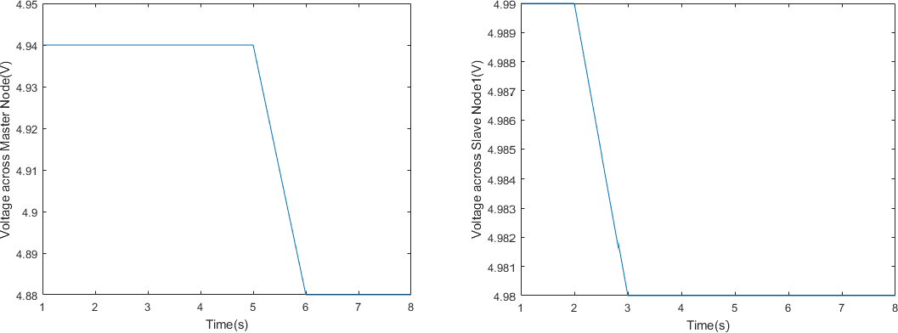

(a) (b)

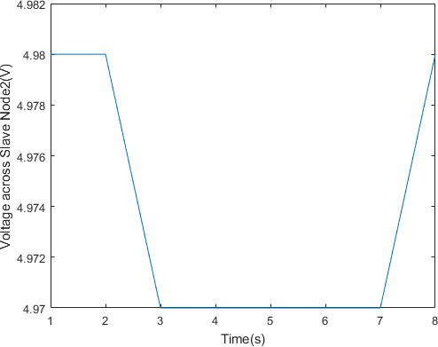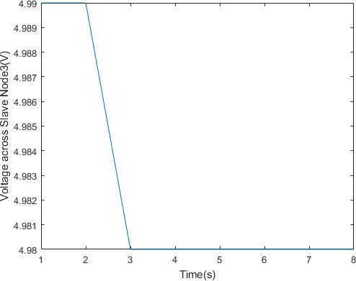

(c) (d)

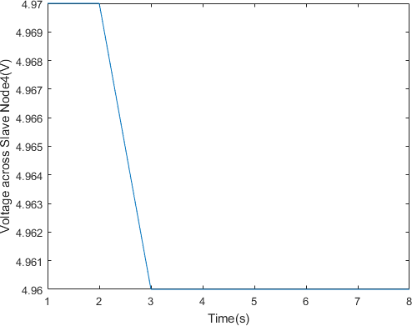

(e)

**Appendix G_2: Current Plots.**

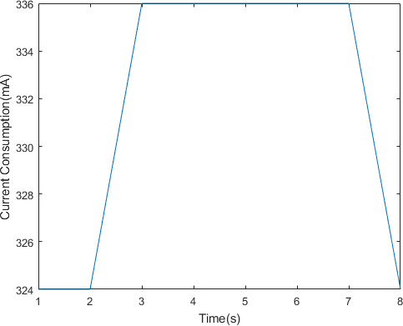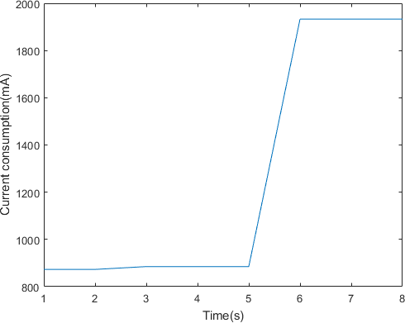

1. (b)

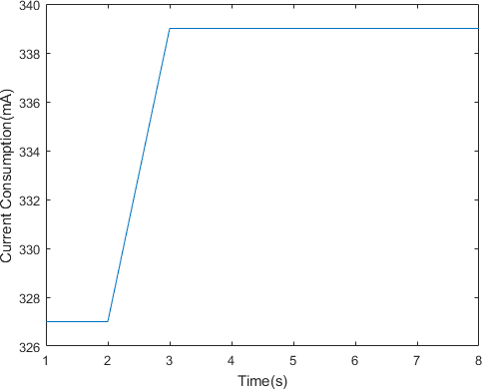 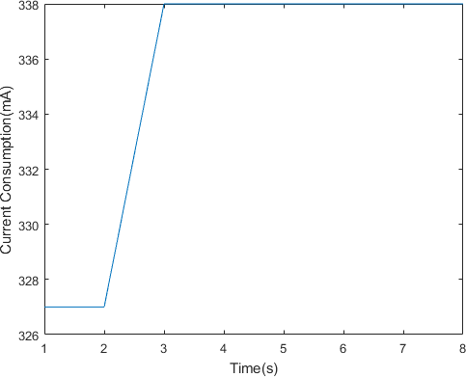

1. (d)

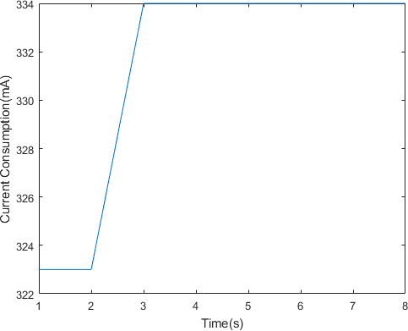

(e)

## Test Cattles

**Appendix H**

