# DEVELOPMENT OF A LOW COST BRIQUETTE MAKING MACHINE

**BY**

# ABDULLAHI, Abdullahi M.ENG/SEET/2017/7178

**DEPARTMENT OF MECHANICAL ENGINEERING FEDERAL UNIVERSITY OF TECHNOLOGY, MINNA.**

# JANUARY, 2022

i

# ABSTRACT

The work focuses on the development of a low cost briquette making machine using Rice husks and Sugarcane baggase as selected materials. The realization that deforestation and wood fuel shortages are likely to become pressing problems in many countries has turned attention to other types of biomass fuel. However, rice husks and sugarcane baggasse residues are often bulky and difficult to burn which lead to this conversion technique developed. In developing this briquetting machine, mild steel was used in preference to other available materials because of its rigidity and strength to support the weight of the component parts put together, widely available, easily machined, improved surface finish and has low carbon content of about 0.15% - 0.25%.The developed briquette machine is based on power screw concept technique which operates in such a way that once the electric motor is plugged into an electricity source and it is switched on, the power being transmitted by the motor drives and rotates the screw shaft of the machine through the V-belt. As the power from the electric motor drives the shaft, it forces the screw shaft to rotate and force the prepared material either sugar cane baggase or Rice husks which has been properly mixed with binder to move into the briquetting die after the compression. The moment the compressed briquette comes out of the briquetting die, it then moved to the collection tray attached to the frame of the machine for proper collection of the briquettes to avoid being scattered. In evaluating the performance of the designed machine, the rice husks and sugarcane baggase were used with starch as a binder. The machine efficiency was found to be 66%. The calorific values of rice husks briquette and sugar cane baggase briquette were found to be 18.978MJ/kg and 15.578MJ/kg respectively.

# TABLE OF CONTENTS

**Contents Page**

Cover page

Title Page i

Declaration ii

Certification iii

Dedication iv

Acknowledgement v

Abstract vi

Table of contents vii

List of Tables xi

List of Figures xii

List of Plates xiii

CHAPTER ONE

* 1. INTRODUCTION 1
  2. Background to the Study 1
  3. Statement of the Research Problem 2
  4. Aim and Objectives of the Study 3
  5. Justification of the Study 3
  6. Scope of the Study 3
  7. Limitations of the Study 4

CHAPTER TWO

* 1. LITERATURE REVIEW 5
  2. Theoretical Fundamentals of Briquetting 5
     1. Biomass Briquettes Composition and Production 6
     2. Advantages of Biomass Briquetting 7
     3. Principle of Operation of Briquette Making Machine 7
     4. The Residual Base 8
     5. Low Moisture Base 8
     6. Ash Content and Composition 8
  3. Review of Past Research Works 10
     1. Review of Previous Research Work on Briquette Making

Raw Materials 10

* + 1. Review of Previous Studies on Binding of Briquettes 13
  1. Research Gap 15

CHAPTER THREE

* 1. MATERIALS AND METHODS 16
  2. Material Selection Criteria 16
  3. Methods for the Analysis 18
     1. Design Analysis of the Frame 18
     2. Design Analysis of the Hopper 19
     3. Design Calculation for the Volume of Hopper 19
     4. Design of the Belt Drive 21
     5. Design Calculation for the Speed of the Shaft 21
     6. Design Analysis of Maximum Tension in the Belt 22
     7. Design Analysis of Mass of the Belt 23
     8. Design Calculation of Belt Velocity 24
     9. Analysis of Centrifugal Tension in the Belt 25
     10. Determination of Tension in the Tight Side of the Belt 26

|  |  |
| --- | --- |
| 3.2.11 Determination of Coefficient if Increase of the Belt Length |  |
| Per Unit Force | 26 |
| 3.2.12 Determination of Angle of Contact | 27 |
| 3.2.13 Determination of Tension in the Slack side of the Belt | 28 |
| 3.2.14 Determination of the Power Transmitted by the Belt | 38 |
| 3.2.15 Design Analysis of the Length of the Belt | 30 |

* + 1. Design Analysis of the Shaft 31
    2. Determination of the Torque 31
    3. Determination of the Power Developed by the Shaft 32
    4. Determination of Machine Efficiency 33
    5. Manufacturing Processes 33
    6. Machine Parts Processes 34
    7. Assembly of the Machine Components 37
    8. Preparation of Selected Materials 39
    9. Principle of the Machine Operation 41
    10. Production Processes 41
    11. Ergonomics Consideration of the Machine 44
    12. Recommended Maintenance Schedule for the Briquette

Making Machine 44

# CHAPTER FOUR

# RESULTS AND DISCUSSION 46

* 1. Results 46
     1. Chemical Compositions of Briquettes Produced 46
     2. Proximate Analysis of the Briquettes Produced 46
     3. Ultimate Analysis of the Briquettes Produced 47
     4. Result of Calorific Value Test of the Briquettes Produced 47
     5. Efficiency 48
  2. Discussion of Results 49
     1. Proximate Analysis 49
     2. Ultimate Analysis 50
     3. Calorific Value 51
     4. Assembly Drawings 51
     5. Bill of Engineering Measurement and Evaluation (BEME) 52

# CHAPTER FIVE

# CONCLUSION AND RECOMMENDATIONS 53

* 1. Conclusion 53
  2. Recommendation 53
  3. Contribution of the Study to Knowledge 54

REFERENCES 55

APPENDICES 57

|  |  |  |
| --- | --- | --- |
|  | **LIST OF TABLES** |  |
| **Table**  2.1 | Ash content of Some Types of Biomass Materials | **Page**  9 |
| 2.2 | Ultimate Analysis of Selected Biomass Materials | 12 |
| 3.1 | Material Selection for Project Components | 17 |
| 3.2 | Construction Processes | 36 |
| 4.1 | Result of Proximate Analysis of the Rice Husks Briquette Produced | 46 |
| 4.2 | Result of Proximate Analysis of the Sugar cane Baggase Briquette |  |
|  | Produced | 46 |
| 4.3 | Result of Ultimate Analysis of the Rice Husks Briquette Produced | 47 |
| 4.4 | Result of Ultimate Analysis of the Sugarcane Baggase Briquette |  |
|  | Produced | 47 |
| 4.5 | Ultimate Analysis of rice Husks Briquette and Sugarcane Baggase | 50 |
| 4.6 | Parts description of the briquette machine | 52 |
| 4.7 | Cost of the Materials Used | 52 |

|  |  |  |
| --- | --- | --- |
|  | **LIST OF FIGURES** |  |
| **Figure**  3.1 | Frame Design | **Page**  18 |
| 3.2 | Hopper Sketching for Analysis | 19 |
| 3.3 | Tension Sketching for Belt Analysis | 22 |
| 3.4 | Sketching for Determination of Angle of Contact | 27 |
| 3.5 | Schematic Sketch of the Process | 42 |
| 4.1 | Assembly Drawing | 51 |

|  |  |  |
| --- | --- | --- |
|  | **LIST OF PLATES** |  |
| **Plate**  I | Fabricated Parts | **Page**  35 |
| II | Assembled Briquette Machine | 38 |
| III | Carbonized Sugarcane Bagasse | 39 |
| IV | Carbonized Bagasse Mixed with Binder | 40 |
| V | Carbonized Rice Husks | 40 |
| VI | Carbonized Rice Husk Mixed with Binder | 40 |
| XII | Production Process | 42 |
| XIII | Packing Process of the Briquette Produced | 43 |
| XI | Drying Process of the Briquette Produced | 43 |
| XI | Calorimeter Set Up | 48 |

# CHAPTER ONE

# INTRODUCTION

# Background to the Study

Briquetting can be regarded as an attempt to link up two large and complex words: that of agriculture and that of fuel supply and use.

The realization that deforestation and wood fuel shortages are likely to become pressing problems in many countries has turned attention to other types of biomass fuel. Agricultural residues are, in principle, one of the most important of these. They arise in large volumes and in the rural areas which are often subject to some of the worst pressures of wood shortage.

However, residues are often bulky and difficult to burn so various conversion techniques have been developed. As the population of the world continues to grow, the demand for energy is becoming critical challenge for the world’s energy leaders (Christoph, 2012). Global energy consumption has about doubled in the last three decades of the past century. In 2004, about 77.8% of the primary energy consumption was from fossil fuels (32.8% oil, 21.1% natural gas, 24.1% coal), 5.4% from nuclear fuels, 16.5% from renewable resources, of which the main one was hydro (5.5%) whereas the remaining 11% consisted of non-commercial biomasses such as wood, hay, and other types of fodder, that in rural-economies still constitute the main resource (BP- Amoco, 2005). With improvements in energy efficiency it is expected that global energy demand doubles by 2050. This is the consequence of global population growth, global economic growth, continued urbanization, as well as the resulting increased demand on mobility and other energy dependent services (Christoph*,* 2013).

The selected materials for making briquettes from this briquette making machine are:

* + 1. Rice husks
    2. Sugar cane bargasse

Briquettes produced from briquetting of biomass are good substitute for coal, lignite, fire wood with numerous advantages. Briquetting is one of the alternative methods to save the consumption and dependency on fire wood, the densities of these fuels can be easily handled, transported and stored.

The process helps to solve residual disposal problems as well as the reduction of fuel wood deforestation; it provides additional income for farmers and creates job. In addition, briquettes have a consistent quality and high running efficiency (Jeng *et al.,* 2012).

Therefore, the cost savings associated with reducing the volume of waste compressed briquette can also be used as a fuel for starting fires or as insulator.

# Statement of the Research Problem

1. Over dependent on fossil fuels conventional energy with their associated increase in Co2 emissions which have detrimental effects on the atmosphere.
2. The high cost of purchasing fossil fuels which affect virtually every sector of the economy.
3. Indiscriminate disposal and burning of Agricultural waste residue, thereby causing environmental pollution.
4. Consumption and dependency on fire wood which causes deforestation.

# Aim and Objectives of the Study

The aim of this research work is to develop a low cost Briquette making Machine. The objectives of this research work are to:

* + 1. Design and construct a low cost briquette making machine which can be used to produce Briquette.
    2. Test the design briquette making machine using selected agricultural residues (Rice husks and Sugar cane bagasse).
    3. Evaluate the efficiency of the design briquette making machine.

# Justification of the Study

The Development of a low cost briquette making machine was chosen for the purpose of this research work mainly for the following reasons;

* + 1. The low cost briquette making machine is easy to construct, operate and maintain.
    2. Persistent energy crisis and the need to shift our focus from fossil fuels to renewable energy source.
    3. Availability of millions tones of Agricultural residues such as rice husks, sugar cane bagasse and other forest residues and the need to solve waste disposal problems.
    4. The low cost briquette making machine gives a very good combustion performance.

# Scope of the Study

This research work is limited to the development of a low cost briquette making machine for the production of briquette using Rice husks and Sugarcane bagasse as selected materials. Using the machine also to solve agricultural wastes management through conversion and recycling of Rice husks and Sugarcane baggase to solid fuel.

# Limitation of the Study

The limitation encountered ranges from the choosing of electric motor which involve precise selection of horse power to suit machine for proper running to that of mixing of the prepared materials with water and binder for proper ejection of the briquette after compression from the machine.

# CHAPTER TWO

# LITERATURE REVIEW

# Theoretical Fundamentals of Briquetting

Briquetting is the densification of loose biomass material. Fuel briquettes emerged as a significant business enterprise in the 20th century. In the 1950s, several economic methods were developed to make briquettes without a binder where multitude of factories throughout the world produced literally tens of millions of tons of usable and economic material that met the household and industrial energy needs (Lardinois & Klundert, 1993). During the two World Wars, households in many European countries made their own briquettes from soaked waste paper and other combustible domestic waste using simple lever-operated presses. Today’s industrial briquetting machines, although much larger and more complex, operate on the same principle (Lardinois & Klundert, 1993). According to (FAO, 1990), briquetting could be categorized into five main types depending on the types of equipment used; piston presses, screw presses, roller press, pelletizing, manual presses and low pressure briquetting.

In Nigeria, the crude method of briquetting began with the use of sawdust following persistent energy crisis of the country then, this crude method involves the use of sawdust burning stove constructed with compartment of compacted sawdust. In this method, a lot of energy is wasted and heat released is uncontrolled (Adegoke & Mohammed, 2002). In spite of availability of these biomass residues that could be briquetted and used as solid fuel for many heating purposes, they are being burnt away. Burning of these Agricultural residues pollutes our environment; also the disposed wastes lead to obstruction of drainages and water ways thereby causing flooding during heavy rainfall. Apart from this, a lot of income is lost to this indiscriminate burning and disposal of these residues which may see as wastes but could be converted to health.

# Biomass Briquettes Composition and Production

Biomass briquettes, mostly made of green wastes and other organic materials, are commonly used for electricity generation, heating and cooking fuel. These compressed compounds contain various organic materials, including rice husk, rice bran, palm kernel, groundnut shells, municipal solid waste, Agricultural waste, or anything that contains high nitrogen content. The composition of the briquettes varies in areas due to the availability of raw materials. The materials are gathered and compressed into briquette in order to burn longer and make transportation of the goods easily. Theses briquettes are very different from charcoal because they do not have large concentration of carbonaceous substances and produced materials. Compared to fossil fuels, the briquettes produce low net total greenhouse gas emissions because the materials used are already a part of the carbon cycle. Compaction is another factor affecting production. Some materials burn more efficiently if compacted at low pressure, while other materials such as wheat and barley-straw require high amounts of pressure to produce heat.

There are different press technologies that can be used. A piston press is used to create solid briquettes of a wide array of purposes. Screw extrusion is used to compact biomass into loose, homogeneous briquettes are substituted for coal in coffering. This technology creates a toroida, or doughnut-like briquette. The hole in the center of the briquette allows for a larger surface area, creating a higher combustion rate (Mani *et al.,* 2010).

# Advantages of Biomass Briquetting

* + - 1. Briquettes have a consistent quality, high burning efficiency, and are ideally sized for complete combustion.
      2. The technology is pollution free and Eco-friendly.
      3. Very easy to ignite.
      4. Continuous burning and long duration.
      5. The process helps to solve Agro-residual disposal problem.
      6. Briquettes are clean, easy to handle and can be packed in bags for ease of handling and storage and it can be easily transported.
      7. Biomass briquette is one of the alternative methods to save the consumption and dependency on wood fuel.
      8. It helps to promote recycling or wastes to energy efficiency. (Kapil & Baxi, 2012).

# Principle of Operation of Briquette Making Machine

Briquetting is one of several compaction technologies in the general categories of densification. In densification, a material is compressed to form a product of higher bulk density, lower moisture content, uniform size, shape, and material properties (Mac Cosgrove, 1985).

Generally, there are two ways by which compaction can be accomplished, one is through the use of a binder and other is without the use of a binder. One must have something to make the material stick either during compression, otherwise when the briquette is removed from the mould, it will crumble to pieces. The fastening agent is known as binder. In some cases, mostly under high temperature and or pressure, a material oilcan acts as its own binder. Wood for example becomes plastic and can be briquetted without a binder under such conditions.

For most cases, the process of briquetting consists of series of steps which include; collection of material for used, preparing material, compacting through the use of briquetting machine, removing, drying, cutting, packaging and storing of the briquettes produced. The binding material can either be combustible binders such as; natural or synthetic resins, tar, animal manure, sewage mud, fish waste, and starch. Non combustible binders include slime, clay, mud and cement (Mac Cosgrove, 1985).

# Residual Base

The potential agro-residues which do not pose any collection and drying problems, normally associated with biomass are rice husk, groundnut shells, coffee husk, palm nut shell, jatropha husk and maize cob. There are many factors to consider before a biomass qualifies for use as feedstock for briquetting. Apart from its availability in large quantities, it should have the following characteristics:

# Low Moisture Content

Moisture content should be as low as possible, generally in the range of 5-15 percent. High moisture content will pose problems in grinding and excessive energy is required for drying. (FAO, 1996).

# Ash Content and Composition

Biomass residues normally have much lower ash content (except for rice husk with 20% ash) but their ashes have a higher percentage of alkaline minerals, especially potash.

The ash content of some types of biomass is given in Table 2.1.

**Table 2.1:** Ash content of some types of biomass materials

|  |  |  |  |
| --- | --- | --- | --- |
| Biomass | Ash content (%) | Biomass | Ash content (%) |

|  |  |  |  |
| --- | --- | --- | --- |
| Corn cob | 1.2 | Coffee husk | 4.3 |
| Jute stick | 1.2 | Cotton shell | 4.6 |
| Sawdust | 1.3 | Tannin waste | 4.8 |
| Pine needle | 1.5 | Almond shell | 4.8 |
| Soya bean stalk | 1.5 | Areca nut shell | 5.1 |
| Bagasse | 1.8 | Castor stick | 5.4 |
| Coffee spent | 1.8 | Groundnut shell | 6.0 |
| Coconut shell | 1.9 | Coir pith | 6.0 |
| Sunflower stalk | 1.9 | Bagasse pith | 8.0 |
| Jawar straw | 3.1 | Bean straw | 10.2 |
| Olive pits | 3.2 | Barley straw | 10.3 |
| Arhar stalk | 3.4 | Paddy straw | 10.5 |
| Lantana | 3.5 | Tobacco dust | 19.1 |
| Subabul leaves | 3.6 | Jute dust | 19.9 |
| Tea waste | 3.8 | Rice husk | 22.4 |
| Tamarind husk | 4.2 | Deoiled | 28.2 |

(Source: Food and Agricultural Organization of the United Nations bangkok, April 1996)

# Review of Past Research Works

The following literatures are studied and the summary is as follows;

# Review of Previous Research Works on Briquette Making Raw Materials

Kishor *et al*. (2019) reported that a large volume of agricultural by products being generated in India and which constitute environmental hazards. Call for effective utilization of that high grade biomass material for solid fuel called briquette. Hence it can be concluded that the waste material like dry leaves, wheat straw, saw dust, etc. are feed stocks for the biomass briquette. Generally dry leaves and wheat straw are burnt to reduce waste, which causes several pollution to environment, but if wisely handled these wastes can then could be a better option for briquetting. Hence for an agricultural country like India that produces huge amount of agricultural waste every year, use of these waste as a briquette can be economically viable, sustainable and environment friendly solution. And also as machine concerned, it can be concluded that by using simple mechanism with widely available machine element the machine cost could be lowered and makes fabrication economical and portable.

Kishan *et al*. (2016) reported that the main objective of this work is to fabricate a low cost portable machine, which can be used in rural areas to produce briquettes with waste materials and use these briquettes in their daily domestic works like cooking and also can be used as a fuel for boilers. So this work helps in waste management and also provides a way to reduce the use of fossil fuels in turn reduces pollution. A valiant effort can be made in future to increase the productivity by increasing the number of cylinders. Here we concentrated only on some waste like coffee husk, sawdust and dry leaves so further work needs to be carried out so that the different wastes can be converted into briquettes, so this machine can be used in different regions. And there is a need to find a

way to replace motor which requires electricity for grinding purpose in this work so that this can be used in remote places.

Omotainse *et al.* (2018) reported also that the developed machine was found to achieve its set objective by the production of compressed byproducts in form of briquettes from agricultural byproduct of rice husk and saw dust mixed with binder fed into it. The design showed that with the right amount of binder, the 5-tonne hydraulic jack, which is a low source of pressure, was able to produce briquettes from two agricultural byproducts mixed with binder. Other materials and binder ratios was not factored in this design. The design has been carried out with due considerations of the major factors as applied to the operational characteristics and cost effectiveness.

Ajieh *et al*. (2016) reported that a shift from fuel wood to grass species promises a robust prospect for communities to produce domestic size briquette for cooking and heating in boilers and stoves. The most promising areas for development of a grass- based energy industry are the Sub-Sahara African countries like Nigeria. From the process considerations, biomass briquette machine was designed. The feedstock is grass species belonging to the POACEAE family and specifically Pennisetum purpureum Shumach and Panicum maximum Jacq., also known as Elephant and Guinea grass respectively. The result of this study shows that a screw press can be used to produce briquette from indigenous grass stalk. More so, grass briquette machine is adaptable for converting wood shavings also known as sawdust to fuel briquette for energy generation. The reason is based on similarities in the forces required for size reduction, compaction and extrusion which are very different when compared to solid wood in form of logs or other hard biomass feedstock.

Maih *et al*. (1999) conducted a study on rice husk briquettes at Sylhet, Khulna and Dinaj Pur districts of Bangladish in order to identify the problems and prospects of using the briquettes as an alternative fuel for cooking. Rice is the staple food for the people of Bangladish. The total annual production of paddy is about 28million tonne (FAO, 1992) and about 20% of this (5.6million tonne) is rice husk. The study also concluded that to prevent environmental hazards caused by rapid deforestation activities, rice husk briquettes may be introduced as an alternative fuel which is smoke free, less hazardous, high calorific value and comparatively cheap.

Shakya *et al.* (2006) stated that the agricultural residues like ground nut shells, straws, tree leaves, grass, rice and maize husks, banana leaves and sawdust can be used for briquette making. Although some materials burn better than others, the selection of raw material is usually most dependent in what is easily available in the surrounding area of where the briquettes are made. The briquettes can consist of a blend between several different raw materials. However to use agricultural residues efficiently for energy production, a detailed knowledge of its physical and chemical properties are required.

Stahl *et al.* (2004) reported that the ultimate analysis of selected biomass summarized in the Table 2.2 below;

**Table 2.2:** Ultimate Analysis of Selected Biomass Materials

|  |
| --- |
| Wheat Straw Rice Husks Sugar cane baggasse Cotton Stalks Wood Mean |
| C 47 49 49 48 48 48+-0,7  H 6 7 6 9 6 6+-0,4  O 45 41 41 44 45 44+-0,2  N 5 1 2 0-8 0-2  S 3 0-7 0-3 0 0 |

The heating value may be reported on two bases. The higher the heating value (HHV, cross heating value) represents the heat of combustion relative to liquid water as the product. The lower heating value (LHV) is based on gaseous water. The difference in the heating value is the latent heat of the product water. For much kind of coals, the gross heating value ranges from 20 to 30MJ/kg. However, nearly all kinds of lignocellulosic biomass feedstock fall in the range 15-19MJ/kg. The values for most woody materials are 17MJ/kg; for most agricultural residues, the heating values are about 15-17MJ/kg. All heat reported here are HHV on a dry basis. The heating value of carbon feed stocks is determined by employing bomb calorimeter that measure the enthalpy change between the reactants and products at 25oC

Olle and Olof (2006) stated that lot of different materials can be used for briquette making, for example agricultural residues like ground nut shells, straw, tree leaves, grass, rice and maize husks and banana leaves. It is also possible to use already processed materials such as paper, saw dust and charcoal fines. Although some materials burn better than others, the selection of raw material is usually most dependent on what is easily available in the surrounding areas of where the briquettes are made. They further stated that, briquette can consist of a blend between many different raw materials. The inflammability is not the only thing that matters when the raw material is being selected. Another important characteristic is its ability to bond together, when compressed. For these reasons; fibre-rich materials are good.

# Review of Previous Studies on Binding of Briquettes

Reineke (1964) carried a research into the binding action of some agricultural residues and came out with the finding that granular materials require no added binder because they are self bonding when briquetted at elevated temperatures. At temperatures above the minimal plastic temperature (325oF for wood), the elastic strains set up in the

material under briquetting pressure are completely relieved and the particle surfaces come together into intimate contact. Cohesion of the interfaces, interlocking of broomed out fibrous parts of the particles, and a possible adhesion of the heat softened lignin (the natural bonding agent between the wood fibers), all contribute to a binding action that imparts satisfactory strength to briquettes after they have cooled under pressure.

Eriksson and Prior (1990) stated that binding agent is necessary to prevent the compressed material from springing back and eventually returning to its original form. This agent can either be added to the process or, when compressing ligneous material, be part of the material itself in the form of lignin. Lignin, or sulphuric lignin, is a constituent in most agricultural residues. It can be defined as a thermo plastic polymer, which begins to soften at temperatures above 100°C and is flowing at higher temperatures. The softening of lignin and its subsequent cooling while the material is still under pressure is the key factor in high pressure briquetting. It is a physico- chemical process related largely to the temperature reached in the briquetting process and the amount of lignin in the original material.

Lardinois and Klundert (1993) suggested that the raw material of a briquette must bind during compression; otherwise, when the briquette is removed from the mould, it will crumble. Improved cohesion can be obtained with a binder but also without, since under high temperature and pressure, some materials such as wood bind naturally. A binder must not cause smoke or gummy deposits, while the creation of excess dust must also be avoided. Two different sorts of binders may be employed. Combustible binders are prepared from natural or synthetic resins, animal manure or treated, dewatered sewage sludge. Non-combustible binders include clay, cement and other adhesive minerals.

Although combustible binders are preferable, non-combustible binders may be suitable if used in sufficiently low concentrations. For example, if organic waste is mixed with too much clay, the briquettes will not easily ignite or burn uniformly. Suitable binders include starch (5 to 10%) or molasses (15 to 25%) although their use can prove expensive.

# Research Gap

The development of the briquettes collection tray attached to the frame of the machine is important as it improves existing ones lacking in various units for proper collection of the briquettes produced. Carbonised rice husks and sugarcane baggasse enhance binding efficiency and surface finish to produced hard briquettes.

# CHAPTER THREE

# MATERIALS AND METHODS

# Material Selection Criteria

When selecting materials for a machine, first consideration is what materials are suitable for the product, the way the product will be made, and method of construction and cost are all vital elements. In fabricating this briquetting making machine, mild steel was used in preference to other available materials because of the following factors;

* + 1. It is widely available.
    2. It can easily be machined.
    3. It has an improved surface finish.
    4. It has a low carbon content of 0.15% - 0.25%.
    5. It has the properties of rigidity and strength to support the weight of all the component parts put together.
    6. It is suitable for fabrication of parts and can be joined together by welding with both oxy-acetylene and electric arc welding method. The Table 3.1 details a summary of the choice of material employed for the construction of the component parts of the briquette making machine.

The materials selection criteria is summarised in the Table 3.1 below:

**Table 3.1:** Material Selection for Project Components

|  |  |  |  |  |
| --- | --- | --- | --- | --- |
| **S/N** | **Machine**  **Components** | **Criteria for Selection for**  **Material** | **Material Selected** | **Remarks** |
| 1 | Frame | Must be of reasonable low cost,  It must be solid, Not too massive,  It must have appropriate  rigidity | Angle Iron (Mild Steel) | It does not twist, Ability to maintain stability, It easily withstand vibration |
| 2 | Shaft | It should be able to withstand stress and the weight of other components attached to it. | Circular rod bar (Mild Steel) | Ability to withstand twisting due to torque moment and compressive for due to weight of other components  attached to it. |
| 3 | Pulley | It should be able to overcome torque from the electric motor or diesel tank  from the machine. | Cast Iron | Proper alignment, Easy adjustment. |
| 4 | Belt | It should be able to overcome torque from the electric motor or diesel tank and from the machine. |  | High allowable stress,  It is easy to install,  Self lubricant, Interchangeability |
| 5 | Electric Motor | It should be able to drive and rotate the shaft which will force the material into die where compression  takes place. | 5 Horsepower | Ability to provide the power needed to rotate the shaft. |
| 6 | Hopper | It should be able to machine into the desired shape that can accommodate the  needed material flow rate. | Mild Steel | Easy machined |
| 7 | Screw Conveyor | It should permit easy flow of bulk materials to the die where compression and formation of briquettes  formed. | Mild Steel | It allows free flow of material. |
| 8 | Briquetting Die | It should be able to contain material being pushed by  the rotating shaft | Mild Steel | It should not react chemically with  the material. |

# Methods for the Analysis

# Design Analysis of the Frame

610 mm

600 mm

270 mm

**Figure 3.1:** Frame Design

Frame is a structure constructed by cutting the angle iron into various sizes and joining them together in which main units of machine tools are coupled shown in Figure 3.1.

The area of the top frame is calculated using equation 3.1

Area of the top of the frame (A) = L x B (3.1) Where

L is the length of the frame B is the breath of the frame

Let the height of the frame = H = 600mm = 0.6 m Length of the frame = L = 610mm = 0.61 m Breadth of the frame = B = 270mm = 0.27 m From the equation 3.1 above,

Area = 0.61 x 0.27

Area of the frame = 0.1647 m2

# Design Analysis of the Hopper

H

𝑎1

𝑎2

h

𝑏2

𝑏1

x

**Figure: 3.2:** Hopper Sketching for Analysis

Let the Length of the Hopper (a1) = 250 mm = 0.25 m Let the breadth of the Hopper (a2) = 200 mm = 0.2 m Let the length of the Hopper (b1) = 100 mm = 0.1 m Let the breadth of the Hopper (b2) = 60 mm = 0.06 m Let the Height of the Hopper (h) = 250 mm = 0.25 m

The height of the small cone below the frustum is the height of the pyramid.

# Design Calculation for the Volume of Hopper

The volume of the Hopper was determined from these following equations

V = V1 – V2 (3.2)

V1 **=** 1 a1 × a2 H (3.3)

3

V2 **=** 1 b1 × b2 x (3.4)

3

Where

V is the volume of Hopper V1 is the volume of pyramid

V2 is the volume of small cone below the frustum Breadth a2 = 200 mm = 0.2 m

Breadth b2 = 60 mm = 0.06 m Height (h) = 250 mm = 0.25 m

By considering the frustum of the pyramid above,

𝑥 0.06

= 𝑥+*ℎ*

𝑎

xa = 0.06x + 0.06h

xa – 0.06x 0.06h

x (0.2 – 0.06) = 0.06 × 0.25

x (0.2 – 0.06) = 0.015

0.14x = 0.015 x = 0.015/0.14 x = 0.107 m

Therefore, the height of pyramid (H) From the above diagram, H = h+ x H = 0.25 + 0.107

H = 0.357 m

Hence, the volume of pyramid V1 **=** 1 a1 × a2 H

3

V1 = 1 (0.25 × 0.2) × 0.357

3

V1 = 0.00595 m3

Similarly, the volume of small cone

V2 **=** 1 b1 × b2 x

3

V2 = 1 (0.1 × 0.06) × 0.107

3

V2 = 0.000214 m3

Therefore, from equation 3.2 V = V1 – V2

V = 0.00595 – 0.000214

V = 0.005736 m3 (Volume of Hopper)

# Design of the Belt Drive

The belt is employed to transmit power from one shaft to another where it is not necessary to maintain an exact speed ratio between two shafts. There are many types of belts which can be used to transmit power but V-belt was used for this design based on the following reasons:

* + - 1. It can be easily installed and removed.
      2. The operation of the belt and pulley is quit.
      3. It can be used where two pulleys are very close to each other.
      4. It can provide excellent grip.
      5. The slip between the belt and pulley is negligible.
      6. It provides compactness due to the small distance between the centres of the pulleys.

# Design Calculation for the Speed of the Shaft

To calculate for the speed of shaft, the below equation was employed

N1 = D2

(3.5)

N2 D1

Where N1 is the speed of the motor (rev/min) N2 is the speed of the shaft (rev/min)

D1 is the Diameter of the motor pulley (mm) D2 is the Diameter of the shaft pulley (mm)

The parameters below were used to determining the speed of shaft of the briquette making machine.

N1 = 1440 rev/min N2 = ? rev/mim

D1 = 80 mm D2 = 300 mm

Therefore, from equation 3.5

N1 = D2

N2

1400

𝑁2

D1

= 300

80

N2 = (1440 × 80)/ 300

N2 = 384 rev/min

# Design Analysis of Maximum Tension in the Belt, T

𝑇1

𝑇2

**Figure 3.3:** Tension sketching for belt analysis

The equation below was used to design the maximum Tension in the belt

T = σA (3.6)

Where T is the maximum Tension in Newton (N)

T1 is The Tension in the Tight side of the belt in Newton (N) T2 is The Tension in the Slack side of the belt in Newton (N) σ is Allowable stress (Nmm-2)

A is the Cross section area of the belt (mm2) To determine the Area of the belt, the equation (3.7)

A = b × t (3.7)

Where b is the belt width (mm)

t is the belt thickness (mm)

The parameters below were used to design the calculation for determining the Maximum Tension of the belt;

σ = 1.7 Nmm-2 for rubber belt (Allen & Afred, 1983) b = 12.5 mm

t = 8 mm

Then, from equation 3.7 A = b × t

A = 12.5 × 8 A = 100 mm2

Therefore, the Maximum Tension can be determine from equation 3.6. T = σA

T = 1.7 × 100 T = 170 N

# Design Analysis of Mass of the Belt, M

The equation below was used to determine the mass of the Belt

M = ρ × A × L (3.8)

Where M is the mass of the belt per meter length in Kilometer per meter (kgm-1) ρ is the Belt density in Kilogram per meter cube (kgm-3)

A is the cross sectional Area of the Belt in square millimeter (mm2) L is the length of the Belt in millimeter (mm)

The parameters below were used to determining the mass of the Belt: A = 100 mm2 = 100 × 10-6 m2

L = 1 m

ρ = 1250 kgm-3 Rubber density (Allen & Alfred, 1983) Then, from the equation 3.8

M = ρ × A × L

M = 1250 × 100 × 10-6 × 1 M = 0.125 kgm-1

# Design Calculation of Belt Velocity, V

The belt velocity for the designed Briquette Making Machine was determined from

these equations;

V1 = 𝜋𝑁1𝐷1

60

V2 = 𝜋𝑁2𝐷2

60

(3.9)

(3.10)

When there is no slip, then the new equation below

V = V1 = V2 (3.11)

Where V is the belt velocity (ms-1)

V1 is the speed of the motor (rev/min) V2 is the speed of the shaft (rev/min)

D1 is the Diameter of the motor pulley (mm) D2 is the Diameter of the shaft pulley (mm)

The parameters below were used for the design calculation in determining the velocity of Belt:

π = 3.142 (Constant value) D2 = 300 mm = 0.3 m

N2 = 384 rev/min (from equation 5) Then, from equation 3.10

V2 = 𝜋𝑁2𝐷2

60

V2 = (3.142 × 384 × 0.3) / 60 V2 = 361.9584/60

V2 = 6.0 ms-1 (Velocity of the Belt)

# Analysis of Centrifugal Tension in the Belt, Tc

The belt continuously runs over the pulleys, some centrifugal force is caused whose effect is to increase the tension in both tight and slack sides. The tension caused by centrifugal force is known as centrifugal tension (Khurmi and Gupta, 2005).

The centrifugal tension was determined from the equation below;

Tc = mV2 (3.12)

Where Tc is the centrifugal tension in Newton (N)

m is the of the belt per meter length in kilogram per meter (kgm-1) V is the velocity of the belt in meter per second (ms-1)

The parameters for the calculating centrifugal tension are as follows; m = 0.125 kgm-1

V = 6.0 ms-1

From the equation 3.12 Tc = mV2

Tc = 0.125 × 6.02

Tc = 4.5 N

# Determination of Tension in the Tight Side of the Belt

The tension T1 in the tight side of the belt was determined from the equation 3.13

T1 = T - Tc (3.13)

Where T1 is the tension in the tight side of the belt in Newton (N) T is the maximum Tension in Newton (N)

Tc is the centrifugal Tension in Newton (N)

The values below were used for the design calculation in determining tension in the tight side of the belt;

T = 170 N Tc = 4.5 N

Then from the equation 3.13 T1 = T - Tc

T1 = 170 – 4.5 T1 = 165.5 N

# Determination of Coefficient if Increase of the Belt Length Per Unit Force, α

The coefficient of increase of the belt length per unit force was determined from the

equation below:

Sinα = 𝑅−𝑟

𝐶

Where α is the coefficient of increase of the belt length per unit force in degree (0) R is the Radius of the shaft pulley in millimeter (mm)

R is the Radius of the motor pulley in millimeter (mm)

C is the distance between the two pulleys in millimeter (mm)

(3.14)

The values used in the calculation of coefficient if increase of the belt length per unit force are stated below:

C = 380 mm

R = 300/2 = 150 mm

r = 80/2 = 40 mm

Therefore, using equation 3.14

Sinα = 𝑅−𝑟

𝐶

Sinα = (150-40) / 380

Sinα = 110/380 Sinα = 0.2895

α = Sin-1 0.2895 α = 16.80

# Determination of Angle of Contact, θ

𝑇2

A

θ

B

𝑇1

**Figure: 3.4**: Sketching for determination of angle of contact

The angle of contact **θ**, is the angle subtended by the arc AB along which the belt touches the pulley at the centre. This angle of contact (**θ**) between the belt and each of the pulleys was determined from the equation below:

θ = (180 - 2α) × 𝜋

180

rad (3.15)

Where θ is the angle of contact on the motor pulley in radian (rad)

α is the coefficient of the belt length per unit force in degree (0) The parameters used in calculating the angle of contact are;

α = 16.80

π = 3.142

Then, from the equation 3.15

θ = (180 - 2α) × 𝜋

180

rad

θ = (180-2×16.8) × 𝜋

180

rad

θ = (180-33.6) × 3.142/180 rad

θ = 2.6 rad = 149°

# Determination of the Tension in the Slack Side of the Belt, T2

The T2 was determined using the equation below;

2.3 log

𝑇1

[ ]

𝑇2

= μ.θ.cosecβ (3.16)

Where T1 is the Tension in the tight side of the belt in Newton (N) T2 is the tension in the slack side of the belt in Newton (N)

μ is the coefficient of friction between the belt and the pulley β is the Grove angle of the pulley in degree (0)

θ is the angle of contact on the motor pulley in radian (rad)

The parameters used in the design for the calculation of Tension T2 in the slack side of the belt are stated below;

T1 = 165.5N

μ = 0.3 for rubber belt (Khurmi & Gupta, 2005) 2β = 30, grove angle of the pulley

β = 150

Hence, from the equation 3.16

2.3 log

2.3 log

𝑇1

[ ]

𝑇2

𝑇1

= μ.θ.cosecβ

0.3 × 2.6 × cosec150

2.3 log

2.3 log

[ ] =

𝑇2

𝑇1

[ ] =

𝑇2

𝑇1

[ ] =

𝑇2

0.3 × 2.6 × 3.8637

3.02

log

log

𝑇1

[ ] =

𝑇2

𝑇1

[ ] =

𝑇2

3.02/2.3

1.31

𝑇1 = 101.31

𝑇2

𝑇1 = 20.417

𝑇2

T2 = T1/20.417

But from equation 3.13 T1 = 165.5

Then, T2 = 165.5/20.417

T2 = 8.106N (Tension in the slack side of the Belt)

# Determination of the Power Transmitted by the Belt, P

According to (Khurmi and Gupta, 2005), the power transmitted by V-belt can be determined from the equation 3.17.

P = (T1 –T2) V (3.17)

Where P is the power transmitted by V-belt in Watts (W)

T1 is Tension in the tight side of the belt in Newton (N)

T2 is The Tension in the Slack side of the belt in Newton (N) V is the Belt velocity in metre per second (ms-1)

The parameters used in calculating the power transmitted by the Belt are stated below; T1 = 165.5 N

T2 = 8.106 N V = 6.0 ms-1

From the equation 3.17, the power transmitted by the belt P = (T1 –T2) V

P = (165.5 – 8.106) × 6.0

P = 157.394 × 6.0 P = 944.364 W

# Design Analysis of the Length of the Belt, L

In designing the length of the belt for the machine, the following equation was used:

L = 𝜋 (R+r) + 2C + (R+r)2

C

Where L is the length of the belt in millimeter (mm) Radius of the shaft pulley in millimeter (mm)

r is the Radius of the motor pulley in millimeter (mm)

C is the centre distance between the two pulleys in millimeter (mm) The parameters used in designing the length of the belt are stated below:

R = 150 mm

r = 40 mm C = 380 mm

From the equation 3.18

L = 𝜋 (R+r) + 2C + (R+r)2

C

(3.18)

L = 3.142 (150+40) + 2 ×380 +

(150+40)2

380

L = 1452 mm

# Design Analysis of the Shaft

A shaft is rotating machine element which used to transmit power from one place to another. The power is delivered to the shaft by some tangential force and resultant torque set up within the shaft permits the power to be transferred to various machine members linked up to the shaft.

Materials used for the shaft have the following properties;

1. High strength.
2. Good heat treatment properties.
3. Low notch sensitivity.
4. Good machinability.

Stress induced in the shaft includes;

* 1. Bending stress (tensile or compressive) due to the forces acting upon machine element like pulley as well as the weight of the shaft itself
  2. Stress due to combined torsion and bending stress
  3. Stress due to axial loading
  4. Shear stress due to the transmission of torque, that is due to torsional load

# Determination of Torque, T

For belt, Torque according to (Khurmi and Gupta, 2005) is given equation 3.19.

T = (T1- T2) R (3.19)

Where T is the twisting moment or torque pulley in Newton millimeter (Nmm) T1 is the tension in the tight side of the belt in Newton (N)

T2 is the tension in the slack side of the belt in Newton (N) R is the radius of the shaft pulley (mm)

By using the following parameters, torque was determined T1 = 165.5 N

T2 = 8.106 N

R = 300/2 = 150 mm

Therefore, from equation 3.19 T = (T1- T2) R

T = (165.5-8.106) × 150

T = 23638.8 Nmm = 23.609 Nm

# Determination of Power Developed by Shaft

In determining the power developed by the rotating shaft, used in equation 3.20. P = 2𝜋𝑁𝑇

60

Therefore, P = 2𝜋𝑁2𝑇 because of the speed of the shaft (rev/min)

60

Where T is the twisting moment or torque pulley in Newton millimetre (Nmm) N2 is the speed of the shaft (rev/min)

P is the power developed by the shaft (W) The parameters used are written below

T = 23.609 Nm

N2 = 384 rev/min

Then, by substituting the parameters, we have

(3.20)

2 × 3.142 ×384 ×23.609

P =

60

P = 949.497 W

# Determination of Machine Efficiency

Machine Efficiency = 𝑃𝑜𝑤𝑒𝑟 𝑡𝑟𝑎𝑛𝑠𝑚𝑖𝑡𝑡𝑒𝑑 𝑏𝑦 𝑡*ℎ*𝑒 𝑚𝑜𝑡𝑜𝑟 × 100 %

𝑃𝑜𝑤𝑒𝑟 𝑑𝑒𝑣𝑒𝑙𝑜𝑝𝑒𝑑 𝑏𝑦 𝑡*ℎ*𝑒 𝑠*ℎ*𝑎𝑓𝑡

(3.21)

The parameters used in calculating the machine efficiency are: Power transmitted by the electric motor = 944.36 W

Power developed by the shaft = 949.497 W

Then from the equation 3.21, we have the efficiency of the machine Machine Efficiency = 𝑃𝑜𝑤𝑒𝑟 𝑡𝑟𝑎𝑛𝑠𝑚𝑖𝑡𝑡𝑒𝑑 𝑏𝑦 𝑡*ℎ*𝑒 𝑚𝑜𝑡𝑜𝑟 × 100 %

𝑃𝑜𝑤𝑒𝑟 𝑑𝑒𝑣𝑒𝑙𝑜𝑝𝑒𝑑 𝑏𝑦 𝑡*ℎ*𝑒 𝑠*ℎ*𝑎𝑓𝑡

Machine Efficiency = 944.36

949.497

× 100

Machine Efficiency = 0.99 × 100 Machine Efficiency = 99%

# Manufacturing Processes

The various processes involved during the construction of this Briquette making machine includes:

1. Measurement
2. Marking out
3. Cutting
4. Welding
5. Drilling
6. Grinding
7. Painting

The various tools and equipments used for the construction of this machine include:

1. Meter rule
2. Scriber
3. Vice
4. Hacksaw and table
5. Cutting machine
6. Welding machine
7. Grinding machine
8. Venier caliber
9. Hammer
10. Spanner
11. Tape

# Machine Parts Processes

The Construction of the briquette making machine was carried out at Hamstring Engineering Company, Minna Niger State. The construction was carried out using the available necessary equipments such as the measuring tape to take measurements, tri- square to check the angles, drilling machine to bore holes, hack saw for cutting, vice for holding the work piece, electric hand grinder for leveling cuts, and welding machine with electrodes to join the parts. The machine fabricated parts was from the frame to the hopper which is shown in Plate I.

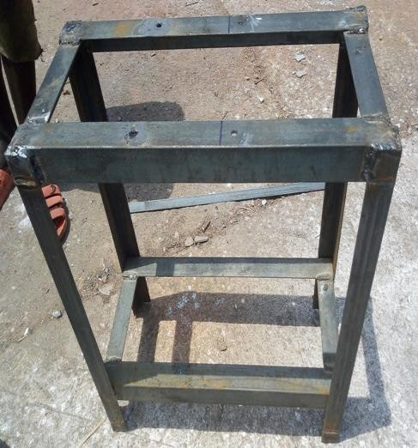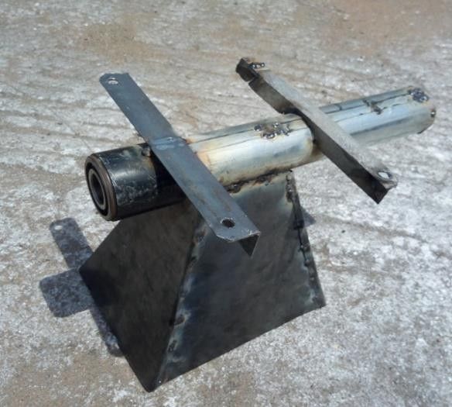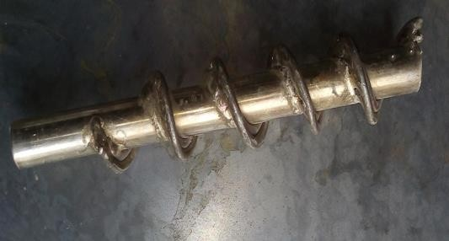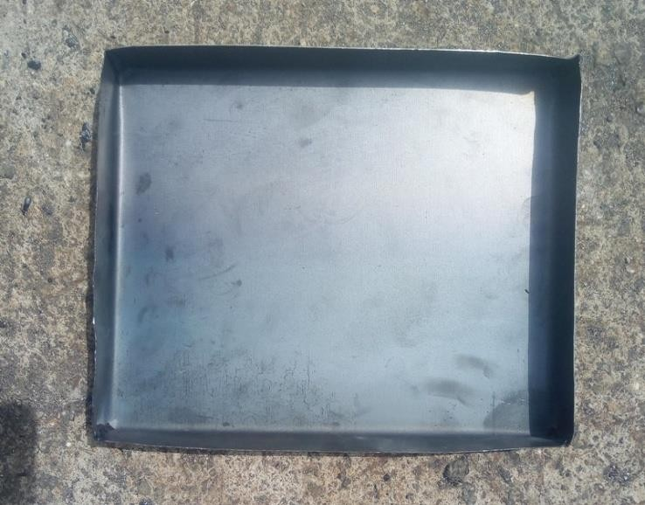

(a)

Frame

(b) Hopper

(C) Screw Conveyor

(d) Collector

**Plate I:** Fabricated Parts

**Table 3.2:** Construction Processes

|  |  |  |  |  |
| --- | --- | --- | --- | --- |
| S/N | Component | Material | Construction process | Equipments used |
| 1 | Frame | Mild steel angle Iron (40mm x 4mm) | The angle iron was cut into a required dimensions 600mm×610mm×270mm and the work-piece were arranged by setting it with try-square to get accurate angle then the work-piece were welded together for required frame. | Measuring tape, vice, hacksaw, welding machine, electrodes, tri- square and drilling machine. |
| 2 | Hopper seat | Mild steel angle Iron | The angle iron mild steel was cut into a required size and used as the hopper seat of the machine and welded on the top of the frame that accommodates machine components such as hopper, screw conveyor, bearing arrangement, barrel and  other machine members. | Measuring tape, vice, hacksaw, welding machine, electrodes, and drilling machine |
| 3 | The Hopper | 18 gauge mild steel plate | Mild steel was cut into required dimensions of 250mm x 200mm x 100mm x 60mm x 250mm and the piece-work are used to form a rectangular pyramid shaped structure which tapers into the screw conveyor casing (barrel) and was welded into the barrel. | Measuring tape, steel ruler, cutting machine, electrodes, and welding machine. |
| 4 | Screw conveyor | Mild steel rod of 10mm and mild steel shaft of 280mm. | A 10mm iron rod in diameter and length 1120mm was turned, grounded, and used to form a thread around 280mm rod using machine electrode which functions as the shaft for the machine and it was made to fixed on the tip end of the shaft. The tip end of the shaft has an iron rod of 30mm and 290mm in length fixed to the shaft inside the two bearing of the machine for rotation simultaneously in the same direction with screw conveyor to  produce briquette. | Measuring tape, vice, hacksaw, cutting machine, welding machine and grinding machine. |
| 5 | Barrel | Mild steel pipe | A mild steel pipe of 330mm long, outer diameter 59mm and inner diameter 56mm with pipe thickness of 1.5mm was used for screw conveyor casing. A section of the  upper face of the pipe was cut in | Measuring tape, vice, cutting machine, welding machine,  grinding |

|  |  |  |  |  |
| --- | --- | --- | --- | --- |
|  |  |  | order to accommodate the outlet end of the rectangular pyramid shaped hopper. | machine and venier caliper. |
| 6 | Briquetting Die | Mild steel pipe | A mild steel pipe of 60mm in length, 56mm in diametre and 1.5mm thickness was used for the die. The die was screwed to the tip end of the barrel (screw conveyor casing). | Measuring tape, vice, hacksaw and drilling machine. |
| 7 | Briquette Collection Tray | Mild steel plate | The briquette collection tray is an adjustable tray attachment made of mild steel plate having a length of 270mm and breadth of 150mm.  Briquette being ejected from the die can be collected and cut on the tray. | Measuring tape, marker, cutting machine, drilling machine and welding machine. |
| 8 | Electric Motor |  | 3 Horsepower electric motor was purchased and fastened with 13 bolts and nuts below the table and it was made to sit on its own fabricated stand within the frame which is 165mm above the ground. The electric motor is required to provide the power needed to drive the screw conveyor. V-belt (A 40) was used to connect the motor pulley to the shaft  pulley. |  |

# Assembly of the Machine Components

The various components of the machine that were welded and bolted together include the following; the frame, hopper, hopper seat, screw conveyor, barrel (screw conveyor casing), briquetting die, shaft pulley, bearing and collection tray.

The electric arc machine was used to weld various components of the machine using electrodes. The assembly of the various components began from welding of angle iron to form the briquette making machine frame. This was followed by the welding the hopper seat upon which other machine members are mounted, welded and bolted together based on the design. These machine members include; the screw conveyor casing (Barrel) which accommodates the screw conveyor, the hopper which was welded

to the hole created in the conveyor casing, the briquetting die which was screwed to the conveyor casing. An adjustable extension table (collection tray) on which briquettes produced on was attached to the main frame through the use of bolts and nuts and it was raised to meet with the end of the briquetting die in such a way that the briquette coming out moved into the collection tray table easily to avoid the briquette being scattered. The two angle iron of length 270mm each were used as reinforcements for the screw conveyor casing and briquetting die and were welded and bolted to the top frame of the machine to ensure rigidity of the machine against vibration during operation. The electric motor was firmly mounted under the frame which is 165mm above the ground using bolts and nuts and it is connected to the shaft pulley through a V-belt. All components of the machine were firmly secured to ensure rigidity and support shown in Plate II. The finishing of the fabricated briquette making machine involves grinding the welded joints using grinding machine and painting with emulsion paint using painting machine.

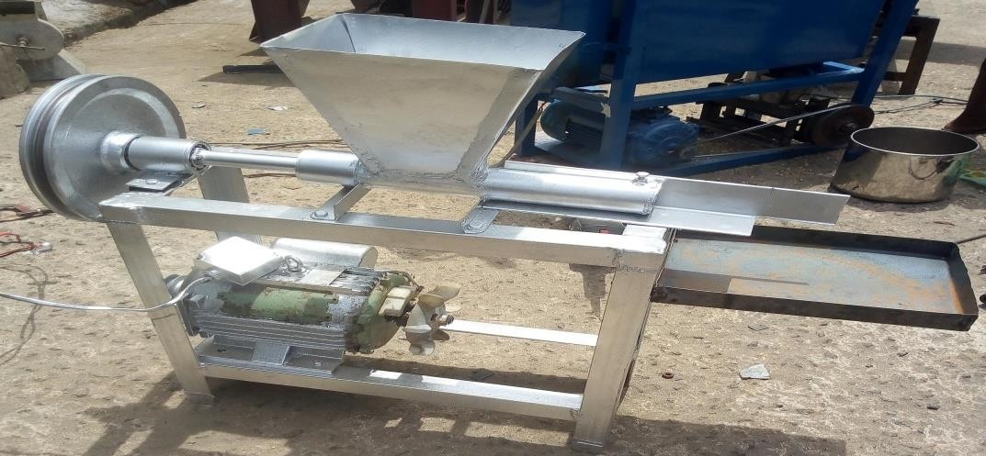

**Plate II:** Assembled Briquette Machine

# Preparation of Selected Materials

A known quantity of Sugar cane baggase and Rice husks were sourced from Sugar cane market, Wuya, along Mokwa road, Gbako Local Government Area, Niger State and Rice Mill at Ciriko Junction, Bida Niger respectively. The materials were carbonized and sieved in order to increase the surface area and to enhance the binding efficiency. 1 kg of each selected materials were mixed thoroughly with cassava starch together with

0.5 litre of water. The cassava starch was used as a binder because of the following reasons; it is easily accessible, it is cheap and burns lightly without smoke when used in required quantity. The sugarcane bagasse was carbonized which is shown in Plate III and then mixed with the binder prepared to put into the machine show in Plate IV. This was also done for the rice husk which is shown in Plate V and VI.

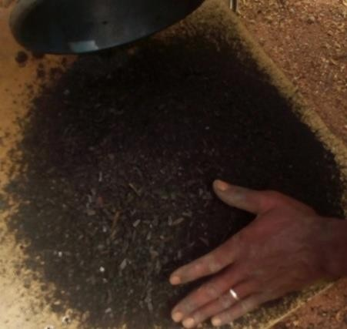

**Plate III:** Carbonized Sugarcane Bagasse

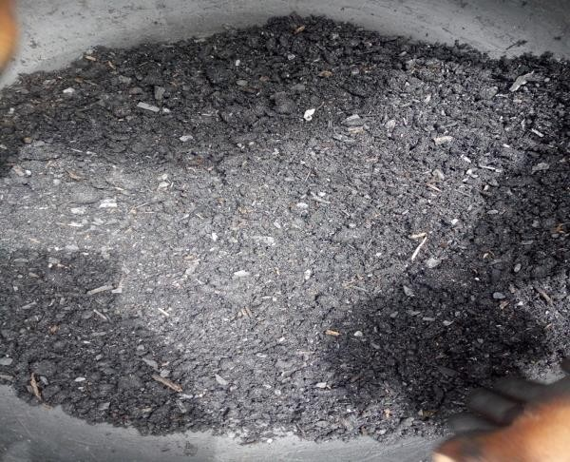

**Plate IV:** Carbonized Sugarcane Bagasse Mixed with Binder

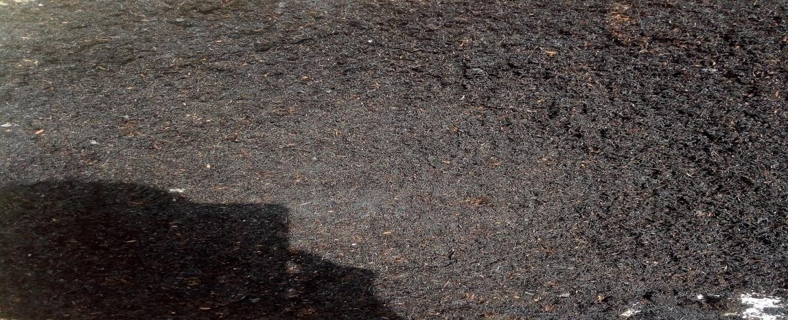

**Plate V:** Carbonized Rice Husks

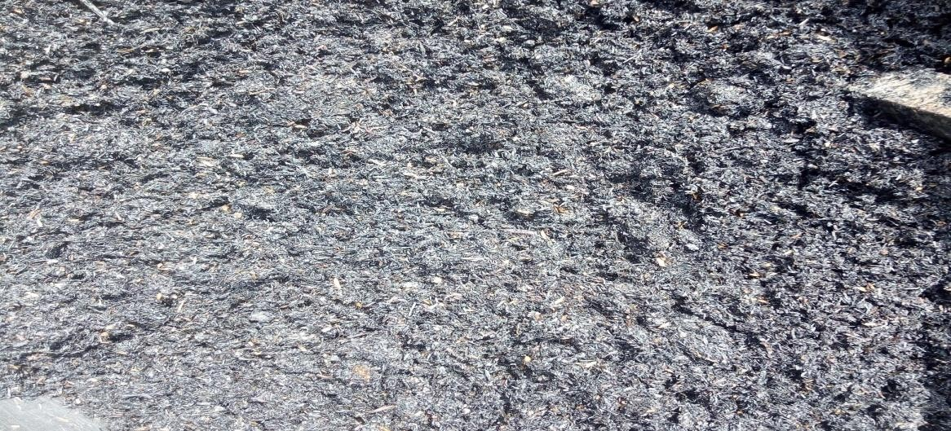

**Plate VI:** Carbonized Rice Husk Mixed with Binder

# Principle of the Machine Operation

The constructed briquette making machine operates in such a way that once the electric motor is plugged into an electricity source and it is switched on, the power being transmitted by the motor drives and rotates the screw shaft of the machine through the V-belt. As the power from the electric motor drives the shaft, it forces the screw shaft to rotate and force the prepared material either sugar cane baggase or Rice husks which has been properly mixed with binder to move into the briquetting die after the compression. The moment the compressed briquette comes out of the briquetting die, it then moved to the collection tray attached to the frame of the machine for proper collection of the briquette to avoid being scattered. Once the materials are prepared and the machine is in continuous operation, the machine is capable of producing 1 briquette per minute and 60 briquettes less than 30 minutes at normal condition.

# Production Process

The electric motor was connected to a power source and it was switched on then the prepared materials were poured into the hopper and as the electric motor drives the rotating screw shaft or conveyor, it forced the material into the briquetting die in which the compression took place. The compressed briquette being ejected from the die was cut with a knife and the process continues for another briquette production. After the production of the briquettes produced, they were sundried for used, in which the process is shown in Figure 3.5.

Drying

Briquette storage

Packaging

**Figure 3.5:** Schematic Sketch of the Process

Mixing with binder

Briquetting

Carbonizing

Raw material preparation

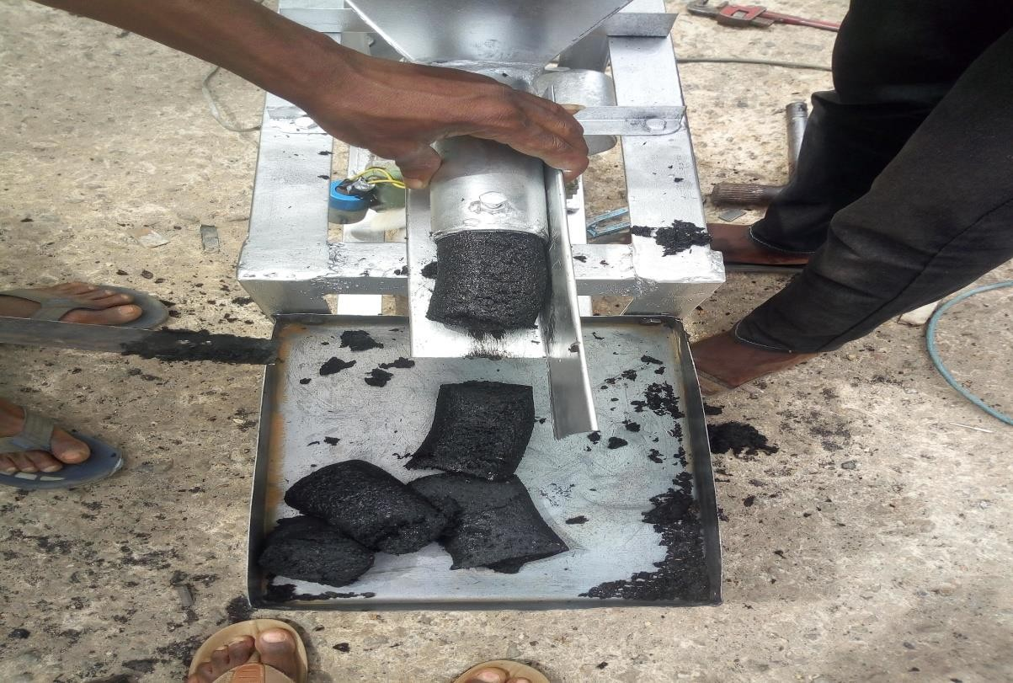

**Plate XII:** Production Process

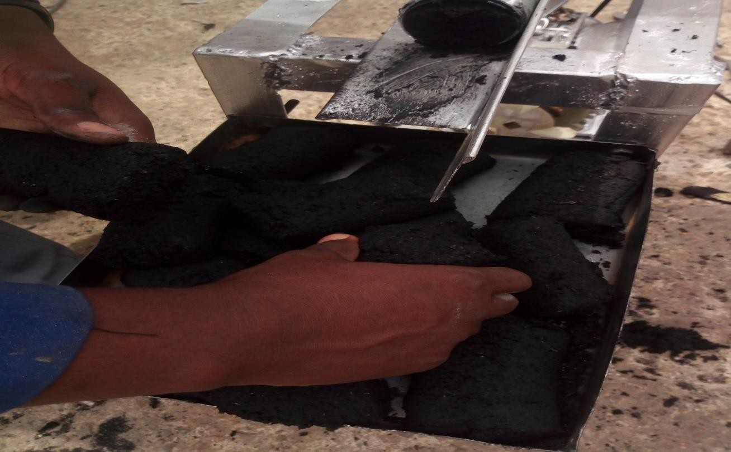

**Plate XIII:** Packing Process of the Briquette Produced

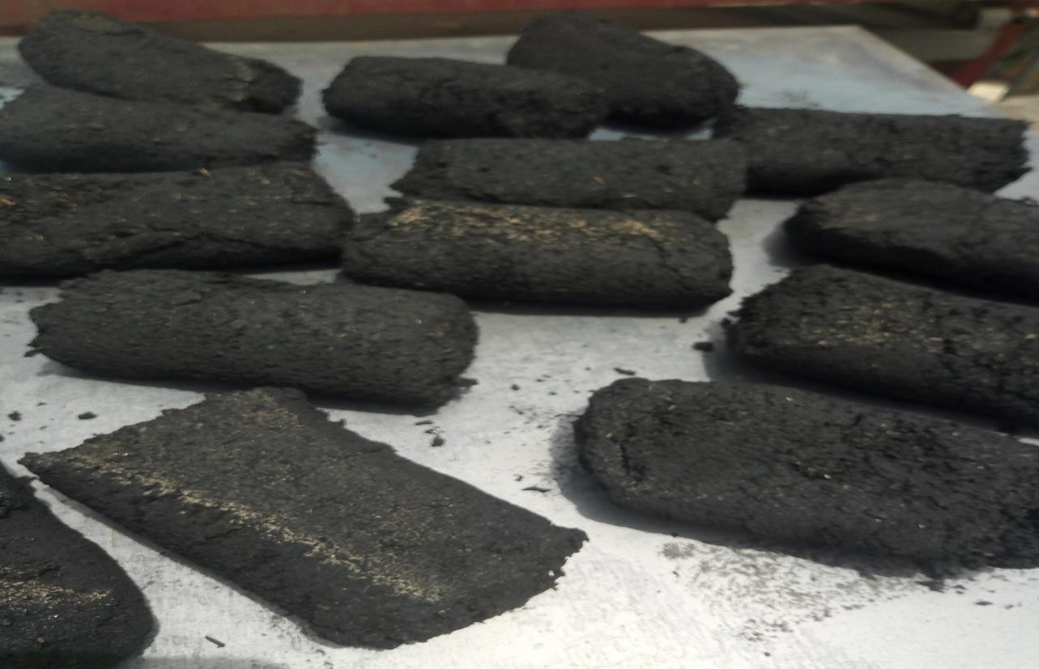

**Plate XI:** Drying Process of the Briquette Produced

# Ergonomic Consideration of the Machine

According to International Ergonomics Association Executive Council (IEAEC, 2000) defined Ergonomics as the scientific discipline concerned with the understanding of interactions among humans and other elements of system, and the profession that applies theory, principles, data and methods to design in order to optimize human well- being and overall system performance.

This briquette making machine was designed in such a way that it can be operated easily and conveniently by a person of an average height of 1.5 metre. Pouring of selected materials into the hopper can be done with ease as well as the ejection of the briquette from briquetting die and collection of the briquette from the adjustable table attached to the frame.

The machine can be operated by a single person easily and conveniently with little or no assistance from any other person. Therefore, the stability of the machine was also put into consideration by making sure that all the assemble components were properly welded and bolted where necessary.

# Recommended Maintenance Schedule for the Briquette Making Machine

* + - 1. Preventive and routine maintenance should be adopted to prevent total breakdown of the machine.
      2. The pulley should be checked regularly to prevent slacking of the belt.
      3. The selected materials should not be poured into the hopper when the electric motor is not switch on.
      4. The machine should not be over fed with the selected materials during operation of the machine to prevent seizure.
      5. The machine components such as; hopper, screw conveyor, briquetting die, screw casing and the adjustable table for the collection of briquettes should be cleansed with clean water after each production to avoid materials sticking to the surfaces.

# CHAPTER FOUR

* 1. **RESULTS AND DISCUSSION**

# Results

The constructed Rice husks and Sugar cane baggase briquette making machine was used to produce briquettes from the two selected materials of rice husks and sugar cane baggase. The briquettes produced are of length 100 mm and 56 mm diameter.

# Chemical Compositions of Briquettes Produced

* + 1. **Proximate Analysis of the Briquettes Produced**

**Table: 4.1:** Result of Proximate Analysis of the Rice husks Briquette Produced

|  |
| --- |
| Component Composition % |
| Component Composition %  Moisture content 6.20  Ash content 1.48  Volatile matter (V/M) 66.22  Fix Carbon 33.76 |

**Table: 4.2:** Result of Proximate Analysis of the Sugar cane Baggase Briquette Produced

|  |
| --- |
| Component Composition % |
| Moisture content 4.20  Ash content 0.84  Volatile matter (V/M) 72.00  Fix Carbon 22.96 |

# Ultimate Analysis of the Briquettes Produced

**Table: 4.3:** Result of Ultimate Analysis of the Rice Husks Briquette Produced

|  |
| --- |
| Component Composition % |
| Carbon 59.34  Hydrogen 4.00  Sulphur 0.20  Nitrogen 1.04  Oxygen 35.42 |

**Table: 4.4:** Result of Ultimate Analysis of the Sugar cane Baggase Briquette Produced

|  |
| --- |
| Component Composition % |
| Carbon 54.92  Hydrogen 6.00  Sulphur 0.30  Nitrogen 0.86  Oxygen 37.92 |

# Result of Calorific Value Test of the Briquettes Produced

The calorific values of Rice husks and Sugar cane baggase briquettes produced were 18.978MJ/kg and 15.578MJ/kg respectively using bomb calorimeter test at Central Service Laboratory, National Cereals Research Institute, Baddegi, Niger State-Nigeria.

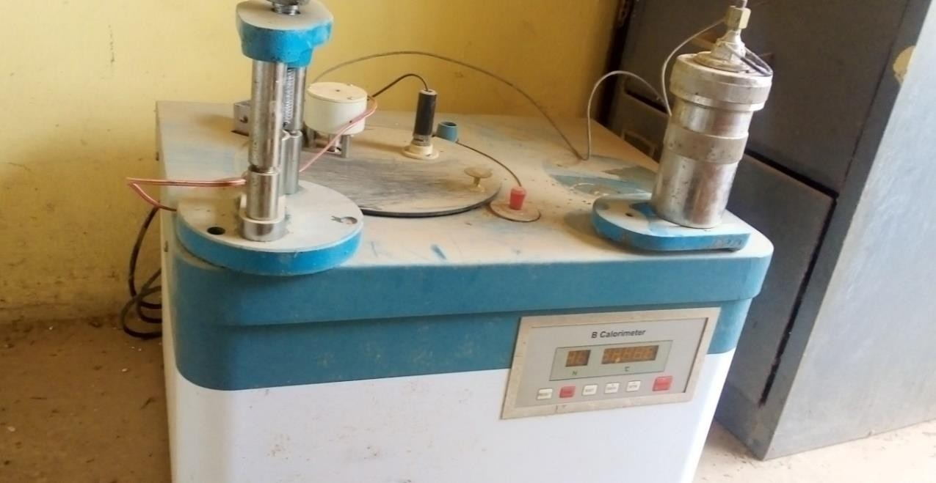

**Plate IX:** Calorimeter Set Up

# Efficiency

Efficiency = 𝑊𝑜𝑟𝑘 𝑜𝑢𝑡𝑝𝑢𝑡 𝑥 100 %

𝑊𝑜𝑟𝑘 𝑖𝑛𝑝𝑢𝑡

Work input = 1.51kg Work output = 1.01kg

Therefore, Efficiency =

1.01𝑘𝑔

1.51𝑘𝑔

x 100 %

Efficiency = 0.66 x 100 %

Efficiency = 66%

# Discussion of Results

The compression of the materials took place when the compacting force of the rotating screw shaft was able to force the mixtures of the materials inside the hopper into the die to produce rice briquette and sugar cane baggase briquette.

The preparation of the materials were easy to prepared but carbonizing the materials took little time before the materials carbonized in order to reduce the carbon mono oxide drastically during the burning .

For the first prepared raw materials of 1 kg each, the each material was thoroughly mixed with 1 litre of water together with starch to form the mixture. When this prepared material was poured into the hopper, it took 2 to minutes before the briquette ejected and it looks watery all over the material due to the too much water on the 1kg of the material. Then, another mixture of the materials were subsequently prepared. In this mixture, 1kg of rice husks and sugar cane baggase were thoroughly mixed with 0.5 litre of water together with binder. When these mixtures were poured into the hopper the ejection of the briquettes produced were done with ease within 30 seconds.

Therefore, when using the briquette making machine of these selected materials to produce briquettes, the quantity of water must not be too much in order to prevent briquette watery and breakage when it is been ejected from the die into the table. Moreover, the water in mixtures must not be too small in order to prevent too much pilling of the materials briquettes produced.

# Proximate Analysis

The proximate Analysis classifies the briquette fuel produced in terms of its moisture content (M), volatile matter (VM), fixed carbon (FC) and ash content.

By comparison between the two results obtained from table 4.1 and 4.2 using proximate analysis, the rice husks briquette produced moisture content of about 6.2% and sugar cane baggase produced moisture content of 4.2%. These values were low and the effect on the calorific value were minimize. Therefore, the rice husks briquette produced high heating value and excessive energy not required for drying since its moisture content falls within the range of 5-15%.

Moisture content should be as low as possible, generally in the range of 5-15 percent. High moisture content will pose problems in grinding and excessive energy is required for drying. (FAO, 1996).

# Ultimate Analysis

The ultimate analysis generally reports the elemental Carbon (C), Hydrogen (H), Sulphur (S), Nitrogen (N), and Oxygen (O) very often by difference in solid fuel. From the table 4.3 and table 4.4 of the ultimate analysis of rice husks briquette produced and sugarcane bagasse briquette produced were close to the values stated for rice husks and sugar cane baggasse in the literature view; Stahl *et al* (2004).

**Table 4.5:** Ultimate Analysis of Rice Husks Briquette and Sugarcane Baggase The values in brackets are from literature review (Table 2.2)

|  |
| --- |
| Rice Husks Sugar cane baggasse Mean |
| C 59.34 (49) 54.92 (49) 48+-0,7  H 4.0 (7) 6.0 (6) 6+-0,4  O 35.42 (41) 37.92 (41) 44+-0,2  N 1.04 (1) 0.86 (2)  S 0.2 (0-7) 0.3 (0-3) |

# Calorific Value

Calorific value is the amount of heat generated by unit mass of the fuel on its complete combustion.

The calorific values of rice husks briquette and sugarcane bagasse briquette produced were obtained to be 18.978MJ/kg and 15.578MJ/kg respectively. From the two results, rice husks have higher calorific value than the sugarcane baggase.

From the literature review; Stahl *et al* (2004) reported that for most agricultural residues, the heating values are about 15-17MJ/kg.

Therefore, 15.578MJ/kg and 18.978MJ/kg were very close to the values stated from the literature review.

# : Assembly Drawings

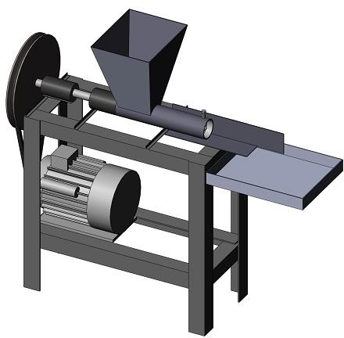

6

**1**

7

**2**

3

8

4

9

10

5

**11**

**Figure 4.1**: Assembly Drawing

**Table 4.6**: Parts description of the briquette machine

|  |  |
| --- | --- |
| S/N | PARTS DESCRIPTION |
| 1 | Hopper |
| 2 | Briquette mould |
| 3 | Tray collector |
| 4 | Frame stand |
| 5 | Braze stand |
| 6 | Pulley |
| 7 | Bearing and holder |
| 8 | Shaft |
| 9 | Belt |
| 10 | Electric motor |
| 11 | Motor seat |

# Bill of Engineering Measurement and Evaluation (BEME)

The cost of the materials used for the constructed machine is shown in Table 4.7.

**Table: 4.7:** Cost of the Materials Used

|  |  |  |  |  |
| --- | --- | --- | --- | --- |
| **S/N** | **Material** | **Quantity** | **Cash (₦)** | **Amount (₦)** |
| 1 | 40mm x 4mm Angle bar | 2 Length | 5000 | 10000 |
| 2 | 60mm Ø Barrel | 1 meter | 2000 | 2000 |
| 3 | 18 guage mild steel plate | 1 sheet  2 | 10000 | 5000 |
| 4 | 35mm solid shaft | 2 feets | 6000 | 6000 |
| 5 | 6mm rod | 1 length | 200 | 200 |
| 6 | Pulley large | 1 | 8000 | 8000 |
| 7 | Electric motor | 1 | 30000 | 30000 |
| 8 | V-belt | 1 | 500 | 500 |
| 9 | Bolts and Nuts | 1 Dozens | 400 | 400 |
| 10 | 25mm shaft | 1 | 1500 | 1500 |
| 11 | Bearings | 2 | 500 | 1000 |
| 12 | Bearing housing | 2 | 500 | 1000 |
| 13 | Paint | 1 litre | 500 | 500 |
| 14 | Thinner | 1 litre | 500 | 500 |
| 15  16 | Labour  Miscellaneous |  |  | 8000  5000 |
|  | **Total cost** |  |  | **79,600** |

# CHAPTER FIVE

* 1. **CONLUSION AND RECOMMENDATIONS**

# Conclusion

The briquette making machine developed is based on power screw concept, and is suitable for the briquetting of the carbonized selected materials of rice husks and sugar cane baggase. The machine developed is a technique which can be easily operated by a single person and machine is capable of producing briquettes from rice husks and sugar cane baggase.

After the chemical composition test carried out, that is; proximate analysis, ultimate analysis and calorific analysis, it was found that the calorific values of rice husks briquette and sugarcane bagasse briquette produced were obtained to be 18.978MJ/kg and 15.578MJ/kg respectively. Its shows that rice husks briquette produced has the higher heating value than the sugar cane baggase briquette produced.

Therefore, with availability of this developed machine technique, it will help in solving problems of waste management, environmental pollution, over dependent on fossil fuels, over dependency on fire wood which lead to deforestation problems through the conversion and recycling of Agricultural wastes to solid fuel. The efficiency of the machine was calculated to be 66%.

# Recommendations

* + 1. The production and use of briquette fuel for cooking and lighting will improve the quality of life for its population and will help in creating wealth.
    2. The use of briquettes as a solid fuel is not widely practiced in Nigeria, therefore Nigeria Government should create awareness for the use of briquettes fuel as well as key strategy in making a clean and healthy environment.
    3. Further study is essential for improvements of the briquette making machine in such a way briquette plant established in this country to serve as a better alternative to other sources of energy.
    4. There is need to change Government of Nigeria Policies so that briquettes as a solid fuel can be made available as a cooking and lighting fuel for household purposes.

# Contribution of the Study to Knowledge

This research developed a low cost briquette making machine with efficiency of 66% using locally sourced materials. The performance test carried using the machine established that the rice husks briquette has a higher calorific value of 18.978MJ/kg compare with that of sugar cane baggase briquette with calorific value of 15.578MJ/kg.

# REFERENCES

Adegoke C. O. and Mohammed T. I. (2002). Investigation of Sawdust Briquettes as High Grade Fuel. *Journal of Engineering,* 25(1), 1-8.

Ajieh M. U., Igboanugo A. C., and Audu T. O. (2016). Design of Grass Briquette Machine. Benin City, Edo State, Nigeria: *Nigeria Journal of Technology,* 35(3), 527-530.

Allen S. H. and Alfred R. H. 1983. (1983). Theory and Problems of Machine Design.

MCGraw-Hill publishing company, New York. 45-105.

BP-Amoco, (2005). Statistical Review of World Energy, 7(2), 43-57.

Christoph .F (2012). Official publication of the World Energy Council to mark the World Energy leaders’ Summit, Istanbul. 24(5), 28-43.

Christoph .F (2013). World Energy issues monitor report, 11(6), 2-5.

Eriksson S. and Prior M. (1990). The Briquetting of Agricultural Wastes for Fuel, FAO, Agriculture and consumer protection Department, Rome, 7(4), 10-25.

FAO (1990). The briquetting of agricultural wastes for fuel. Food and Agriculture Organization of the United Nations, Via delle Treme di Caracalla, 00100 Rome, Italy, 31(7), 2-33.

FAO (1992). Collecting Statistics on Agriculture, Population and Employment. Economic and Social Development. Rome, FAO Statistical Development Service. 10(7),27-34.

FAO (1996). Food and Agricultural Organization of the United Nations Bangkok.

5(2),7-9.

IEAEC (2000). Environment, Health and Safety; ehs.unc.edu/workplace-safety/ergono mics.

Jeng S. L., Zainuddin A. M., Sharifah R.W., and Haslends A. (2012). A review on Utilization of Biomass from Rice Industry as a source of Renewable Energy, 16(3), 3084-3094.

Kapil A. P. and Baxi R.N. (2012). Failure Analysis of Taper Die of Biomass Briquetting Machine, A review; *International Journal of Engineering and Social Science,* 2(10), 47-57.

Khurmi R. S. and Gupta J. K. (2005). A Textbook on Machine Design, Fourteen Edidtion; Eurasia Publishing House (PVT) Ltd. 26-105.

Kishan B. S., Kiran. K., Santhosh T. J., and Amith D. G. (2016). Design and Fabrication of low-cost Briquetting machine and Estimation of Calorific values of Biomas Briquettes. Bengaluru, Karnataka, India: *International Journal of Innovative Research in Science, Enginneeing and Technolgy*, 5(7), doi:10.15680/IJIRSET. 2016.0507055.

Koshor B., Rushikesh K., Omkar K., Rushikesh K., and Gouri B. (2019). Manufacturing of Biomass Briquetting Machine. Maharashtra India: *International Journal of Innovative Research in Science, Enginneeing and Technolgy*, 8(3), doi: 10.15680/IJIRSET.2019. 0803244.

Lardinois I. and Klundert A. (1993). Organic Waste: Options for Small-Scale Resource Recovery Urban Solid Waste Series1. Amsterdam, The Netherlands: TOOL, 50- 61.

Mac Cosgrove. D. (1985). Understanding Briquetting, Published by Volunteers in Technical Assistance (VITA), Virginia USA, 3(8), 11-21.

Maih A., Huda D., and Baqui M. A. (1999). Rice Husk Briquette as Alternative fuel in Bangladesh. Agricultural Mechanisation in Africal and Latin America (AMA). 30(2), 63-68.

Mani S. and Tabi L. G. (2010). Evaluation of Compaction Equation Applied to Four Biomass Species; University of Saskatchewan College of Engineering, 28(6), 26-48.

Olle F. and Olof N. (2006). Biomass Project in Malawi, Degree Project, Department of Management and Engineering, Institute of Technology, Linkoping University, Malawi. 15-31.

Omotainse P. O., Agidi G., Dairo O. U., and Benjamin T. A. (2018). Design and Fabrication of A Briquette Making Machine.. Ogun State, PMB, 2240 Nigeria: *Journal of Engineering, Tertiary Education Trust Fund (tetfund).* 23(5), 52-65.

Reineke L. H. (1964). Briquettes from wood residue. Forest products Laboratory. Forest Service. U.S. Department of Agriculture.[www.fpl.fs.fed.us/documents/fplrn075.pdf](http://www.fpl.fs.fed.us/documents/fplrn075.pdf).

Shakya G. A., Shakya I., and Augustus L. M. (2006). Biomass Briquetting of Agricultural and Forest Residues and Herb Waste in Nepal. Royal Academy of Science and Technology (RONAST). Nepal Energy Field of Study, Asian Institute of Technology (AIT), Thailand, 37(9), 25-61.

Stahl R., Enrich E., Gehrmann H.J., Vodegel S., and Coch M. (2004). Report prepared under the framework of project: *RENEW-Renewable fuels for advanced power trains.* 8(2), 15-19.

# APPENDICES APPENDIX I

**COMPONENTS OF THE BRIQUETTE MACHINE**

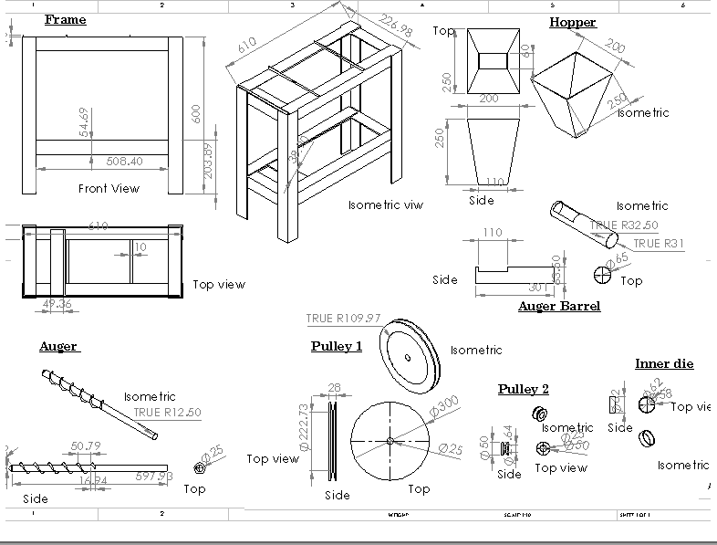

|  |  |
| --- | --- |
| **FEDERAL UNIVERSITY OF TECHNOLOGY MINNA** | |
| **THESIS TITLE** | DEVELOPMENT OF A LOW COST BRIQUETTE  MAKING MACHINE |
| **DRAWING TITLE** | COMPONENT VIEW |
| **NAME** | ABDULLAHI, ABDULLAHI |
| **REG NUM** | M.ENG/SEET/2017/7178 |
| **SUPERVISOR (CHECKED BY)** | PROF. M.S. ABOLARIN |
| **DATE** | NOVEMBER, 2021 |
| **DIMENSION** | MILLIMETERS |
| **SCALE** | 1:10 |

# APPENDIX II

**COMPONENTS OF THE BRIQUETTE MACHINE**

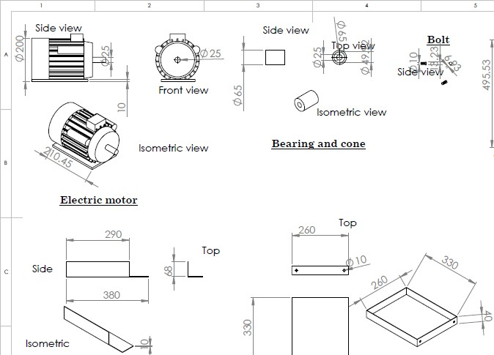

|  |  |
| --- | --- |
| **FEDERAL UNIVERSITY OF TECHNOLOGY MINNA** | |
| **THESIS TITLE** | DEVELOPMENT OF A LOW COST BRIQUETTE  MAKING MACHINE |
| **DRAWING TITLE** | COMPONENT VIEW |
| **NAME** | ABDULLAHI, ABDULLAHI |
| **REG NUM** | M.ENG/SEET/2017/7178 |
| **SUPERVISOR (CHECKED BY)** | PROF. M.S. ABOLARIN |
| **DATE** | NOVEMBER, 2021 |
| **DIMENSION** | MILLIMETERS |
| **SCALE** | 1:10 |

# APPENDIX III

**ISOMETRIC VIEW OF THE BRIQUETTE MACHINE**

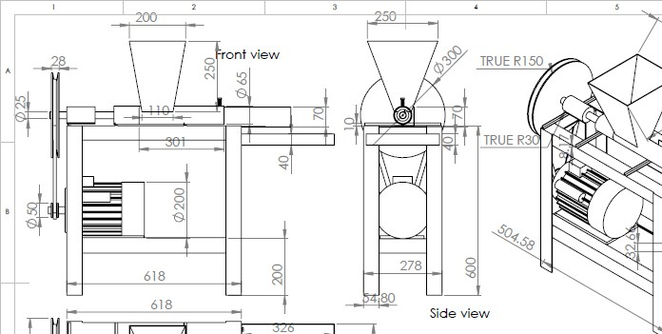

|  |  |
| --- | --- |
| **FEDERAL UNIVERSITY OF TECHNOLOGY MINNA** | |
| **THESIS TITLE** | DEVELOPMENT OF A LOW COST BRIQUETTE  MAKING MACHINE |
| **DRAWING TITLE** | ISOMETRIC VIEW |
| **NAME** | ABDULLAHI, ABDULLAHI |
| **REG NUM** | M.ENG/SEET/2017/7178 |
| **SUPERVISOR (CHECKED BY)** | PROF. M.S. ABOLARIN |
| **DATE** | NOVEMBER, 2021 |
| **DIMENSION** | MILLIMETERS |
| **SCALE** | 1:10 |

# APPENDIX IV

**ORTHOGRAPIC VIEW OF THE BRIQUETTE MACHINE**

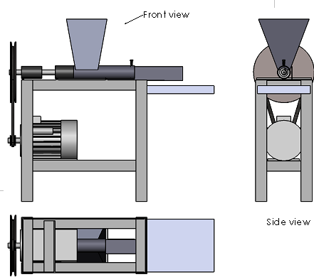

|  |  |
| --- | --- |
| **FEDERAL UNIVERSITY OF TECHNOLOGY MINNA** | |
| **THESIS TITLE** | DEVELOPMENT OF A LOW COST BRIQUETTE  MAKING MACHINE |
| **DRAWING TITLE** | ORTHOGRAPHIC VIEW |
| **NAME** | ABDULLAHI, ABDULLAHI |
| **REG NUM** | M.ENG/SEET/2017/7178 |
| **SUPERVISOR (CHECKED BY)** | PROF. M.S. ABOLARIN |
| **DATE** | NOVEMBER, 2021 |
| **DIMENSION** | MILLIMETERS |
| **SCALE** | 1:10 |

# APPENDIX V

**ASSEMBLING OF THE BRIQUETTE MACHINE**



6

**1**

7

**2**

3

8

4

9

10

5

**11**

|  |  |
| --- | --- |
| **FEDERAL UNIVERSITY OF TECHNOLOGY MINNA** | |
| **THESIS TITLE** | DEVELOPMENT OF A LOW COST BRIQUETTE  MAKING MACHINE |
| **DRAWING TITLE** | ASSEMBLING VIEW |
| **NAME** | ABDULLAHI, ABDULLAHI |
| **REG NUM** | M.ENG/SEET/2017/7178 |
| **SUPERVISOR (CHECKED**  **BY)** | PROF. M.S. ABOLARIN |
| **DATE** | NOVEMBER, 2021 |
| **DIMENSION** | MILLIMETERS |
| **SCALE** | 1:10 |

|  |  |  |
| --- | --- | --- |
| S/N | PARTS  DESCRIPTION | QUANTITY |
| 1 | Hopper | 1 |
| 2 | Briquette mould | 1 |
| 3 | Tray collector | 1 |
| 4 | Frame stand | 1 |
| 5 | Braze stand | 1 |
| 6 | Pulley | 1 |
| 7 | Bearing and holder | 1 |
| 8 | Shaft | 1 |
| 9 | Belt | 1 |
| 10 | Electric motor | 1 |
| 11 | Motor seat | 1 |