DEVELOPMENT AND VALIDATION OF THREE NEW SPECTROPHOTOMETRIC METHODS FOR THE DETERMINATION OF LAMIVUDINE IN PURE AND PHARMACEUTICAL DOSAGE FORMS

BY

NASIR IBRAHIM

DEPARTMENT OF PHARMACEUTICAL AND MEDICINAL CHEMISTRY, FACULTY OF PHARMACEUTICAL SCIENCES,

AHMADU BELLO UNIVERSITY, ZARIA-NIGERIA.

SEPTEMBER, 2014

DEVELOPMENT AND VALIDATION OF THREE NEW SPECTROPHOTOMETRIC METHODS FOR THE DETERMINATION OF LAMIVUDINE IN PURE AND PHARMACEUTICAL DOSAGE FORMS

By

Nasir IBRAHIM B. Pharm (A.B.U) 2010

MSc/Pharm-Sci/4069/2011-2012

A THESIS SUBMITTED TO THE SCHOOL OF POSTGRADUATE STUDIES, AHMADU BELLO UNIVERSITY, ZARIA

IN PARTIAL FULFILMENT OF THE REQUIREMENTS FOR THE AWARD OF A

MASTER DEGREE IN PHARMACEUTICAL CHEMISTRY

DEPARTMENT OF PHARMACEUTICAL AND MEDICINAL CHEMISTRY, FACULTY OF PHARMACEUTICAL SCIENCES,

AHMADU BELLO UNIVERSITY, ZARIA-NIGERIA.

SEPTEMBER, 2014

# Declaration

I declare that the work in this Thesis entitled ‘DEVELOPMENT AND VALIDATION OF THREE NEW SPECTROPHOTOMETRIC METHODS FOR THE DETERMINATION OF LAMIVUDINE IN PURE AND PHARMACEUTICAL DOSAGE FORMS’ has been

carried out by me in the Department of Pharmaceutical and Medicinal Chemistry. The information derived from the literature has been duly acknowledged in the text and a list of references provided. No part of this thesis was previously presented for another degree or diploma at this or any other Institution.

|  |  |  |
| --- | --- | --- |
| Nasir IBRAHIM |  |  |
| Name of Student | Signature | Date |

# Certification

The thesis entitled ‘DEVELOPMENT AND VALIDATION OF THREE NEW SPECTROPHOTOMETRIC METHODS FOR THE DETERMINATION OF LAMIVUDINE IN PURE AND PHARMACEUTICAL DOSAGE FORMS’ by Nasir

IBRAHIM meets the regulations governing the award of the degree of Master of Science in Pharmaceutical and Medicinal Chemistry of the Ahmadu Bello University, and is approved for its contribution to knowledge and literary presentation.

Prof M. Garba

Chairman Supervisory committee Signature Date

Dr A. Musa

Member Supervisory Committee Signature Date

|  |  |  |
| --- | --- | --- |
| Prof U. U. Pateh |  |  |
| Head of Department | Signature | Date |

Prof A. A. Joshua

Dean, School of Postgraduate Studies Signature Date

# Acknowledgement

All praise and thanks are to almighty Allah for seeing me through this work. I also wish to acknowledge my sincere gratitude and prayers to my supervisors Prof M. Garba and Dr. A. Musa for their guidance, patience, tolerance, understanding and commitment for the actualization of this work. I also wish to express my appreciation to all the lecturers and members of staff of the Department of Pharmaceutical and Medicinal Chemistry, A.B.U., Zaria especially those that taught us during the course work year. Also my gratitude goes to Malam Ilyasu Chief Technologist and Malam Umar for assisting me with the UV/VIS spectrophotometric analysis.

I also want to acknowledge my course mates Amina Jega (Class rep), Jephter, Ephraim, Rukayyah, Amina Nata’ala, Maryam, Jamilah, Hajara, Mariah and Doris. I also appreciate all the people we worked together in the Laboratory especially Audu for helping me with Para-toluidine reagent.

I am most grateful to the tremendous contribution of the following individuals; Dr A. M. Musa, Mallam Zayyad, Mallam Sani, Mallam Rafindadi, Malam Muhammad Sulaiman and the members of staff of the Department of Pharmaceutical and Medicinal Chemistry, U.D.U., Sokoto especially Dr A Uba, Dr M. I. Abdullahi, Pharm Alhassan, Malam Abdulrashid and Malam Nuhu.

I must also acknowledge My Parents for their love, prayers and moral support. I also acknowledge my wife (Meemee) for her love, prayers and understanding. I also appreciate my Brothers and Sisters for their prayers and support.

My gratitude goes to Prof I. I. Funtua for accommodating me in area A, throughout the study years.

I also appreciate my brothers and roommates Dr Musa Rabi’u, Eng Kameel and Jamilu. Finally, I am grateful to all those who in one way or the other helped in putting this work together.

# ABSTRACT

In this study three rapid, simple, accurate, economical and reproducible spectrophotometric methods for the quantitative determination of lamivudine in pure form and tablet formulations were developed and validated. The first method is based on dissolution of standard lamivudine powder or extraction of the drug from tablet formulation using methanol as solvent. The resulting extract was filtered and scanned using Helios Zeta Model 164617 UV/Vis spectrophotometer; having a λmax of 273 nm. The second method is based on the formation of a coloured hydrazone by reacting the hydrazine group in 2,4- dinitrophenyl hydrazine with the carbonyl carbon in lamivudine under acidic condition (85

% H2SO4) for 10 minutes. The orange-red coloured hydrazone formed was allowed to stand for 2 hours for complete colour development, then scanned using spectrophotometer and was observed to have a λmax of 438 nm. The third method is based on the diazotization reaction of lamivudine using sodium nitrite and sulfamic acid under acidic condition (2 % H2SO4) for 5 minutes followed by coupling with paratoluidine reagent leading to the formation of yellow chromogen which was allowed to stand for 1 hour for complete colour development, then scanned using spectrophotometer and was observed to have a λmax of 282 nm. The proposed methods were used to prepare a calibration curves for lamivudine and also to assay sample of standard lamivudine powder and three different brands of lamivudine tablets and compared with International Pharmacopoeial method for assay of lamivudine. The three proposed methods obeyed Beer’s law within a concentration range of 2.5 to 15.0, 5.0 to 35.0, and 2.5

to 12.5 µg/ml respectively. Correlation coefficients for the respective methods are 0.9997, 0.9988, and 0.9975. The precision (% coefficient of variation) and accuracy (% relative error) for the respective methods are 1.7, 1.8, 0.5 and 2.1, 4.0, 2.0 %. Percentage recoveries for the three methods obtained were 99.4, 98.9 and 99.6 % respectively. Limits of detection and limits of quantitation for the respective methods were 0.25, 1.3, 1.5 and 0.77, 3.8, 4.5 µg/ml. The percentage content of lamivudine in the standard powder and the three different tablet brands assayed in all the proposed methods were within the BP range of 97.5% to 102.0%. No statistically significant difference was observed between the percentage drug content of the proposed methods and International Pharmacopoeia method at *P < 0.05*. The proposed methods can be interchangeably used with the International Pharmacopoeia method for quantitative estimation of lamivudine in pure and tablet dosage forms.

# TABLE OF CONTENTS

Chapter 1 **INTRODUCTION** Page

* 1. General Introduction 1
  2. Colour and Molecular Structure 1
  3. Lamivudine as Drug of Analysis 2
  4. Statement of Research Problem 3
  5. Justification of the study 5
  6. Aims and Objectives 6
  7. Research Hypothesis 6

Chapter 2 LITERATURE REVIEW

* 1. Lamivudine 7
  2. Properties of Lamivudine 7
     1. IR Spectra of Lamivudine 8
     2. Synthesis of Lamivudine 9
     3. Mechanism of Lamivudine Antiviral action… 11
     4. Adverse effects of Lamivudine 12
     5. Pharmacokinetics of Lamivudine 12
     6. Precautions 13
     7. Uses and Administration of Lamivudine 14
     8. Interactions of Lamivudine 14
  3. Absorption spectroscopy 15
     1. UV/VIS Spectroscopy 17
     2. IR Spectroscopy 19
        1. Number of Vibrational Modes 20
        2. Uses and Applications of IR Spectroscopy 21
  4. Schiff Bases and their Chemistry 22
     1. Biological importance of Schiff Bases 23
     2. Aryl Diazonium Salts 24
  5. Reported UV Methods for Lamivudine Determination 24

Chapter 3 MATERIALS AND METHODS

* 1. Materials 31
     1. Chemicals and Reagents 31
     2. Drug and Drug Reference Standard… 31
     3. Equipment and Glassware 32
     4. Instrumentation 32
  2. Methods 33
     1. Preparation of Solutions and Reagents 33
     2. Identification and Assay of Lamivudine (Official methods) 34
     3. Method 1: Extraction of Lamivudine with Methanol 35
        1. Determination of λmax 35
        2. Preparation of Calibration curve for Method 1… 35
        3. Validation of Method 1… 36
        4. Assay of Lamivudine Tablets using Method 1… 38
     4. Method 2: Condensation of Lamivudine with 2,4-DNPH… 39
        1. Preparation of Calibration Curve for Method 2… 40
        2. Validation of Method 2… 40
        3. Assay of Lamivudine Tablets using Method 2… 41
     5. Method 3: Diazotization of Lamivudine and Coupling with P-toluidine 42
        1. Preparation of Calibration Curve for Method 3… 43
        2. Validation of Method 3… 43
        3. Assay of Lamivudine Tablets using Method 3… 44
        4. Statistical Analysis 45

Chapter 4 RESULTS

* 1. Calibration Curves 46
  2. Validation of Methods 50
  3. Assay Results 51
  4. FTIR Analysis Results 51

Chapter 5 DISCUSSION

* 1. Calibration Curves 58
  2. Validation Parameters 58
  3. Assay Results and Statistical Analysis 59
  4. FTIR Analysis 60
     1. Method 2… 60
     2. Method 3… 60

Chapter 6 CONCLUSIONS AND RECOMMENDATIONS

* 1. Conclusions 62
  2. Recommendations 62

REFERENCES 63

# APPENDICES

**LIST OF TABLES**

Table 2.1: Electric Transitions involving n, σ and 𝜋 molecular orbitals 18

Table 4.1: Calibration Parameters of the Developed Methods 46

Table 4.2: Validation Parameters of the Developed Methods 50

Table 4.3: Assay Results of Lamivudine Tablets for the Developed Method and IP Method… 51

Table 4.4: Comparison on the Reagents used between the Developed Methods and Some of the reported Spectrophotometric Methods 52

# LIST OF FIGURES

Figure 2.1: Two Dimensional Structure of Lamivudine 7

Figure 2.2: Three Dimensional Structure of Lamivudine 7

Figure 2.3: IR Spectra of Lamivudine 9

Figure 2.4: Scheme for Synthesis of Lamivudine 10

Figure 3.1: Formation of hydrazone Between 2,4-DNPH and Lamivudine 39

Figure 3.2: Diazotization of Lamivudine and Coupling with paratoluidine 43

Figure 4.1: Calibration Curve of Lamivudine in Methanol 47

Figure 4.2: Calibration Curve of Lamivudine-2,4-DNPH Complex 48

Figure 4.3: Calibration Curve of Lamivudine-paratoluidine Complex 49

Figure 4.4: FTIR Analysis Result of Lamivudine 53

Figure 4.5: FTIR Analysis Result of the Blank 2,4-DNPH Reagent 54

Figure 4.6: FTIR Analysis Result of Lamivudine-2,4-DNPH Complex 55

Figure 4.7: FTIR Analysis Result of the Blank paratoluidine Reagent 56

Figure 4.8: FTIR Analysis Results of Lamivudine-paratoluidine Reagent 57

**LIST OF APPENDICES**

Appendix 1: Absorption Spectrum of Lamivudine in Methanol Appendix 2: Absorption Spectrum of the Blank 2,4-DNPH Reagent Appendix 3: Absorption Spectrum of Lamivudine-2,4-DNPH Complex Appendix 4: Absorption Spectrum of the Blank paratoluidine Reagent

Appendix 5: Absorption Spectrum of Lamivudine-paratoluidine Complex

# ABBREVIATIONS

|  |  |
| --- | --- |
| UV/vis | Ultraviolet/visible |
| HIV | Human Immunodeficiency Virus |
| HBV | Hepatitis B Virus |
| DNA | Deoxyribose Nucleic acid |
| RNA | Ribonucleic Acid |
| HPLC | High Performance Liquid Chromatography |
| BP | British Pharmacopoeia |
| IP | International Pharmacopoeia |
| USP | United States Pharmacopoeia |
| MBTH | 3-methyl-2-benzothiazolinone hydrazone |
| DDQ | 2,3-dichloro-5,6-dicyano-1,4-benzoquinone |
| ARVs | Antiretrovirals |
| FTIR | Fourier Transform Infrared |
| CSF | Cerebro Spinal Fluid |
| ATR | Attenuated Total Reflectance |
| IBDA | Iodobenzene diacetate |
| API | Active Pharmaceutical Ingredient |
| PDAB | Paradiaminobenzaldehyde |
| PDAC | Paradiaminocinnamaldehyde |
| DL | Detection limit |
| QL | Quantitation limit |
| SEM | Standard error of the mean |

**Chapter 1 INTRODUCTION**

# General Introduction

UV-visible spectrophotometric methods are the instrumental methods of choice which are commonly used in industrial and research laboratories because of their simplicity, accuracy, precision and low cost (Raza *et al*., 2003; 2005a, 2005b). The act of identifying materials based on their color was probably one of the earliest examples of qualitative molecular absorption spectrophotometry. Also, the first recognition that color intensity can be an indicator of concentration was probably the earliest application of employing molecular absorption spectroscopy for quantitative determination. The first measurements were made by using the human eye as the detector and undispersed sunlight or artificial light as the light source (Marczenko, 2000). Later it was found that the accuracy and the precision could be improved by isolating specific frequencies of light using optical filters. Further improvement of the measurement came with the use of prism and grating monochromators for wavelength isolation. Photoelectric detectors were soon developed, but were quickly replaced with phototubes and photomultiplier tubes. The development of solid state microelectronics has now made available a wide range of detector type which if coupled with the computers; provide highly sophisticated readout electronic systems (Marczenko, 2000).

# Colour and molecular structure

Absorption spectrophotometry in the ultra-violet and visible regions is considered as one of the valued techniques for quantitative analysis. Visible light represents a very small part of the electromagnetic spectrum and is generally considered to extend from 380-780 nm. A

solution or object appears coloured when it transmits or absorbs only part of the radiation in the visible spectrum. The optical characteristic of the substance is its absorption spectrum. There is a close relation between the colour of a substance and its electronic structure. A molecule exhibits absorption in the visible or ultraviolet range, when radiation causes an electronic transition, raising the molecule (ion) from the ground state to an exited state. The production or change of a colour is connected with deformation of the normal electronic structure of the molecule. Irradiation causes variations in the electronic energy of the molecules containing one or more chromophoric groups, i.e. atomic groupings with unsaturated linkages. Two or more chromophoric groups in the molecule often enhance one another’s effect, to deepen the colour by displacing the maximum absorption towards longer wavelengths (from the ultraviolet towards the red). This is called bathochromic shift. The displacement of the absorption maximum from the red towards the ultraviolet is known as a hypsochromic shift (Blaedel and Meloche, 2001). The colour of a molecule may be intensified by substituents called auxochromic groups. These groups may also affect bathochromic shifts. The colour determining factor in a number of molecules is the introduction of conjugation of double bonds by means of electron donor and electron acceptor groups. The quantitative applicability of the absorption method is based on the fact that the number of photons absorbed is directly proportional to the number or concentration of atoms, ions or molecules (Blaedel and Meloche, 2001).

# Lamivudine as drug for analysis

Lamivudine is 4-Amino-1-((2*R*,5*S*)-2-(hydroxymethyl)-1,3-oxathiolan-5-yl) pyrimidin- 2(1*H*)-one (BP, 2009) a synthetic nucleoside analogue with activity against the human

immunodeficiency virus (HIV) and hepatitis B virus (HBV) (Sean, 2009). The molecule has two chiral centers and is manufactured as the pure 2R, *cis*(−)-enantiomer. The racemic mixture from which lamivudine originates has antiretroviral activity but is less potent and substantially more toxic than the pure (−)-enantiomer. Compared with the (+)-enantiomer, the phosphorylated (−)-enantiomer is more resistant to cleavage from nascent RNA/DNA duplexes by cellular 3'-5' exonucleases, which may contribute to its greater potency (Skalski *et al.,* 1993). Lamivudine is either formulated alone as a tablet formulation or in combination with zidovudine and it is also available as oral pediatric formulation. The method for assay of lamivudine is HPLC (BP, 2009 and USP, 2007). A few high- performance thin-layer chromatography (HPTLC) and high-performance liquid chromatography (HPLC) techniques have been suggested for analysis of the formulation (Shalini *et al*., 2009). HPLC is the most widely used technique for the estimation of lamivudine in human plasma, saliva, cerebrospinal fluid, and human blood cells, as well as for studying the drug metabolites in the urine (Basavaiah and Somashekar, 2009). The suggested HPTLC and HPLC methods for assay of lamivudine are expensive and need complex and sophisticated instrumentation. Lamivudine can also be determined by Reverse Phase-HPLC method with lesser runtime, but the aforementioned drawback still persists (Babu and Kumar, 2009).

# Statement of Research Problem

The major problem that led to this research is the lack of easy access to the HPLC machine (used for BP and USP assay of lamivudine) in our environment and the technical hands to

operate the equipment. One of the first methods for visible spectrophotometric determination of lamivudine was based on the colored condensation products of aromatic aldehydes, specifically para-dimethyl benzaldehyde (Baig *et al*., 2001). This method suffers the drawback of significant interference from the excipients; since the determination is carried out at much shorter wavelengths. There are also reports on the development of methods using chloramines T (Basavaiah and Somashekar, 2006), para dimethyl cinnameldehyde (Sriker *et al*., 2009), paradimethylaminobenzaldehyde and vanillin (Babu and Kumar, 2009), potassium permanganate (Sarma *et al*., 2002), N-bromosuccinamide (Sarma *et al*., 2002), potassium bromated and bromide mixture (Basavaiah and Somashekar, 2006), bromophenol blue and MBTH (Kumar *et al*., 2011), chloranillic acid and DDQ (Kenneth *et al*., 2011), ethanol, tetrahydrofuran and formic acid (Venkatesh *et al.,* 2012) reagents for the estimation of lamivudine in pharmaceuticals. It is also reported that lamivudine can also be assayed by titrimetric methods based on diazocoupling, redox reaction using Folin-Ciocalteu reagent, and redox-complexation reaction using ferric chloride-orthophenanthroline (Appalaraju *et al*., 2002). However, some of the above mentioned UV spectrophotometric methods are reported to suffer from disadvantages like instability of the reagents, high cost of the chemicals, reduced sensitivity (Sarma *et al*., 2002).

Also a major challenge to treatment scale-up is the low availability of and delays in the delivery of ARVs. Presently, the Nigerian government is the main provider of antiretroviral services in the country (WHO, 2004), and there is a determined effort to further reduce the cost of ARVs to make it affordable to patients. With the local manufacture of generic ARVs,

the need to monitor the quality of these drugs cannot be over emphasized as our contemporary drug market is frequently eroded with fake and substandard drugs. A study carried out by Abuga *et al*., (2003) three samples failed to meet the percentage active ingredient content required out of the thirty three samples selected. In view of this, there is need to provide a simple, accurate and sensitive analytical method by which such problem of monitoring the quality of these drugs can be addressed particularly lamivudine which occupy a strategic position in clinical practice.

# Justification of the study

The cost and unavailability of the HPLC machine in this environment as well as the number of limitations associated with the reported UV spectrophotometric methods for lamivudine assay justifies the need for development of simpler methods that will take care of the limitations.

The presence of free –NH2 and -C=O groups in lamivudine can serve as a suitable site for coupling with a suitable reagent or formation of Schiff base and subsequent generation of coloured compound. The amino group can also be utilized in the formation of coloured diazo compounds. The intensity of the colour can serve as a means for the determination of the drug spectroscopically.

# Aims and Objectives

The aim and specific objectives of the study are:

* + 1. Development of UV spectrophotometric methods for the determination of lamivudine, using diazotization and Schiff’s base formation.
    2. Validation of the methods so developed.
    3. Application of the developed methods in determination of lamivudine in pure form and in tablet dosage form.

# Research Hypothesis

A simple, accurate, precise, quantitative and cost effective spectrophotometric method for the determination of lamivudine can be developed by extracting the drug with methanol, formation of a Schiff’s base via the carbonyl group or diazotization of the free primary amino group in the drug.

# Chapter 2 LITERATURE REVIEW

# Lamivudine

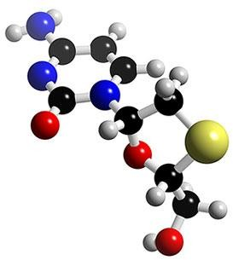Lamivudine is chemically 4-Amino-1-((2*R*,5*S*)-2-(hydroxymethyl)-1,3-oxathiolan-5-yl) pyrimidin-2(1*H*)-one, (BP, 2009)

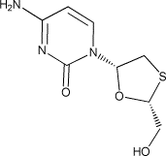

**Fig 2.1: 2D Structure of Lamivudine Fig 2.2: 3D Structure of Lamivudine**

The IUPAC Name is 2',3'-dideoxy-3'-thiacytidine, commonly called 3TC**.**

# Properties of Lamivudine

Consistency = white crystalline solid Melting point = 160 - 162ᴼC

Solubility = Soluble in water, sparingly soluble in methanol, slightly soluble in ethanol (96

%).

Molecular Weight = 229.25624 [g/mol]

Molecular Formula = C8H11N3O3S Empirical Formula = C8H11N3O3S 2H2O Exact Mass = 229.052112

Formal Charge = 0 (Pubchem, 2013)

***By Definition:*** Lamivudine contains not less than 97.0 % and not more than 103.0 % of C8H11N3O3S, calculated with reference to the dried substance (IP, 2005). Lamivudine contains not less than 97.5 % and not more than 102.0 % of C8H11N3O3S, calculated with reference to the dried substance (BP, 2009).

# IR Spectra of Lamivudine

After looking at the structure of lamivudine, it can be concluded that an IR spectra should show the following:

N-H at 3400-3250 cm-1 N=C at 1650-1630 cm-1 C=C at 1680-1640 cm-1

C=O at 1715 cm-1 C-O at 1100 cm-1

O-H at 3600-3200 cm-1

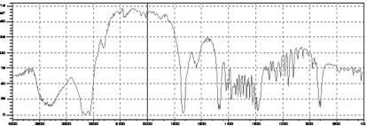

# Figure 2.3: IR Spectra of Lamivudine

Adopted from Pubchem, 2013.

# Synthesis of Lamivudine

The scheme of synthesis of lamivudine is shown in Figure 2.4. Lamivudine molecule has two chiral centers, and exists in the form of two pairs of optical isomers. However the *cis*-(-

)enantiomer (lamivudine) is considerably less toxic than the other three isomers. In order to determine lamivudine and its related substances by HPLC and study the structure-activity relationships of oxathiolanyl nucleosides as potential anti-virus agents, the synthesis of geometrical isomers *cis*-(±) **1** and *trans*-(±) **2** of lamivudine was needed. Among the numerous synthetic strategies documented in literature, the procedure utilizing benzoyloxyacetaldehyde **3** and 1,4- dithiane-2,5-diol **4** as starting materials seems to be the most practical one. In this route the key intermediates **8** and **9** were afforded by reaction of 2-benzoyloxymethyl-5- ethoxy-1,3-oxathiolane with previously N-4-silylated acetylcytosine in the presence of Lewis acids, such as trimethylsilyl triflate (TMSTf)3, iodotrimethylsilane

or anhydrous stannic chloride. However, there are a number of disadvantages associated with the use of such Lewis acids. In particular, they are expensive, highly reactive and unstable and hazardous associated with their use. A convenient and practical method for the synthesis of **1** and **2** is still in demand. Here a novel and facile synthesis of **1** and **2** starting from commercially available **3** and **4** was described. This method avoids the use of Lewis acid catalyst (Deng *et al*., 2006). Synthesis of lamivudine involved the following steps:

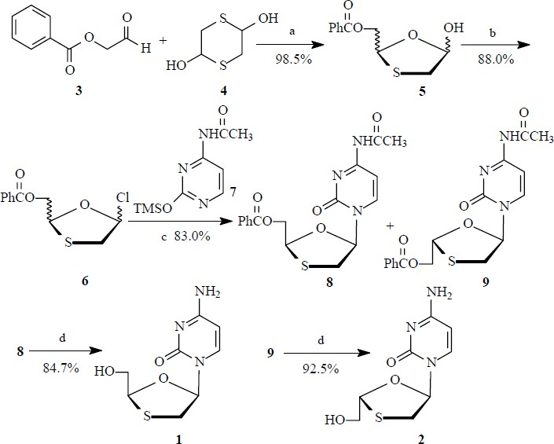

# Figure 2.4: Scheme for Synthesis of Lamivudine

Reaction Conditions: (a) Toluene/TsOH, reflux 5 h, 98.5%; (b) SOCl2/DMF, CH2Cl2, 10- 15ᴼC, 2.5 h, 88%; (c) i. N-4-silylated acetylcytosine, KI, (CH3CH2)3N, CH2Cl2, reflux, 3 h;

ii. Separated by chromatography on silica gel, CH3COOCH2CH3/CH3OH=50:1(v/v), *cis*

58.0%, *trans* 25.0%; (d) NH4OH / C2H5OH, r.t., 8 h, *cis* 84.7%, *trans* 92.5%.

The synthetic route to **1** and **2** is illustrated in figure 2.5 above. In the presence of *p*- TsOH **3** reacted with **4** in toluene at reflux for 5 h afforded oxathiolane lactol **5** in 98.5% yield. Treatment of **5** with SOCl2/DMF at 10-15ᴼC for 2.5 h gave **6**. Without separation, it was coupled with previously silylated N4-acetylcytosine **7** in dry dichloromethane in the presence of (CH3CH2)3N and a catalytic amount of KI at reflux for 3 h provided a mixture of *cis* and *trans* isomers in a 2.5:1 ratio as determined by 1H NMR. The mixture was separated by silica gel column chromatography using CH3COOCH2CH3/CH3OH (50:1) as eluant to achieved **8** in 58% yield as the slow moving component7 and **9** in 25% yield as the fast moving product **8**. Deprotection of **8** and **9** using NH4OH in CH3CH2OH at room temperature produced the desired *cis*-(±) **1** and *trans*-(±) **2** in 84.7% and 92.5% yield, respectively. In summary, the *cis*-(±) **1** and *trans*-(±) **2** isomers of lamivudine have been synthesized simultaneously from benzoyloxyacetaldehyde and 1,4-dithiane-2,5-diol. This synthetic procedure showed many advantages, such as mild conditions, high yields, easily accessible starting materials and easiness of separation, compared to the previously published procedure. The overall yield was 42.6 % and 20.1 %, respectively (Deng *et al*., 2006).

# Mechanism of Lamivudine Antiviral action

Lamivudine is converted intracellularly in stages to the triphosphate. This triphosphate halts the DNA synthesis of retroviruses, including HIV, through competitive inhibition of reverse transcriptase and incorporation into viral DNA. Lamivudine is also active against hepatitis B

virus. Resistance to lamivudine has been reported in isolates of HIV and hepatitis B virus (Sweetman, 2002).

# Adverse effect of Lamivudine

Adverse effects commonly associated with lamivudine include abdominal pain, nausea, vomiting, diarrhoea, headache, fever, rash, alopecia, malaise, insomnia, cough, nasal symptoms, arthralgia, and musculoskeletal pain. Patients taking lamivudine for the treatment of chronic hepatitis B commonly also have increased serum levels of creatinine phosphokinase and alanine aminotransferase. Peripheral neuropathy has been reported in patients taking lamivudine for HIV infection, but not in patients taking lamivudine for hepatitis B virus infection. There have been rare instances of rhabdomyolysis. Pancreatitis has been reported rarely. Neutropenia and anaemia (usually when given with zidovudine), thrombocytopenia, and increases in liver enzymes and rare cases of hepatitis have occurred. Lactic acidosis, usually associated with severe hepatomegaly and steatosis, has been reported during treatment with nucleoside reverse transcriptase inhibitors (Sweetman, 2002).

# Pharmacokinetics of Lamivudine

Lamivudine is rapidly absorbed after oral doses and peak plasma concentrations are achieved in about 1 hour (1 - 1.5 µg/ml). Absorption is delayed, but not reduced, by ingestion with food. Bioavailability is between 80 and 87%. Binding to plasma protein is reported to be up to 36%. Lamivudine crosses the blood-brain barrier with a ratio of CSF to serum concentrations of about 0.12. It crosses the placenta and is distributed into breast

milk. Lamivudine is metabolized intracellularly to the active antiviral triphosphate. Hepatic metabolism is low and it is cleared mainly unchanged by active renal excretion. An elimination half-life of 5 to 7 hours has been reported after a single dose (Sweetman, 2002).

# Precautions

Lamivudine therapy should be stopped in patients who develop abdominal pain, nausea, or vomiting or with abnormal biochemical test results until pancreatitis has been excluded. Treatment with lamivudine may be associated with lactic acidosis and should be discontinued if there is a rapid increase in aminotransferase concentrations, progressive hepatomegaly, or metabolic or lactic acidosis of unknown etiology. Lamivudine should be used with caution in patients with hepatomegaly or other risk factors for hepatic disease. In patients with chronic hepatitis B, there is a risk of rebound hepatitis when lamivudine is discontinued, and liver function should be monitored in such patients. The possibility of HIV infection should be excluded before beginning lamivudine therapy for hepatitis B, since the lower doses used to treat the latter may permit the development of lamivudine-resistant strains of HIV. Dosage reduction may be necessary in patients with impaired renal function (Sweetman, 2002).

# Uses and administration of Lamivudine

Lamivudine is a nucleoside reverse transcriptase inhibitor structurally related to cytosine with activity against retroviruses including HIV. It is used, usually with other antiretrovirals, for combination therapy of HIV infection. It is also used for the treatment of chronic hepatitis B. For HIV infection, the dose of lamivudine for adults is 300 mg by mouth daily as a single dose or in two divided doses. A dose for children aged between 3 months and 12 years is 4 mg/kg twice daily to a maximum daily dose of 300 mg. For chronic hepatitis B, the adult dose is 100 mg once daily by mouth. A dose for children aged over 2 years is 3 mg/kg once daily to a maximum daily dose of 100 mg. In patients with concomitant HIV and hepatitis B infection the dosage regimen appropriate for HIV should be used. Reduction of dosage is recommended for patients with renal impairment (Sweetman, 2002).

# Interactions of Lamivudine

The renal excretion of lamivudine may be inhibited by other drugs mainly eliminated by active renal secretion, for example trimethoprim. Usual prophylactic doses of trimethoprim are unlikely to necessitate reductions in lamivudine dosage unless the patient has renal impairment, but the co-administration of lamivudine with the high doses of trimethoprim (as co-trimoxazole) used in pneumocystis pneumonia and toxoplasmosis should be avoided. Although there is usually no clinically significant interaction with zidovudine, severe anaemia has occasionally been reported in patients given lamivudine with zidovudine. Lamivudine may antagonize the antiviral action of zalcitabine and the two drugs should not

be used together. Once daily triple nucleoside regimens of lamivudine and tenofovir with either abacavir or didanosine are associated with a high level of treatment failure and of emergence of resistance, and should be avoided (Sweetman, 2002)

# Absorption Spectroscopy

The quantitative method used in this study is UV/VIS spectroscopy which is based on absorption spectroscopy. In absorption spectroscopy a beam of radiation passes through a sample. Much of the radiation is transmitted without loss in intensity. At selected frequencies however, the radiation’s intensity is attenuated. This process of attenuation is called absorption. Two general requirements must be met if an analyte is to absorb electromagnetic radiation. The first requirement is that there must be a mechanism by which the radiation’s electric field or magnetic field interacts with the analyte. For ultraviolet and visible radiation, this interaction involves the electronic energy of valence electrons. The second requirement is that the energy of the radiation must exactly equal the difference in energy, ΔE, between two of the analytes quantized energy states (Harvey, 2000).

The attenuation of radiation as it passes through a sample is described quantitatively by two separate, but related terms: transmittance and absorbance. Transmittance is defined as the ratio of the radiation’s power exiting the sample, PT, to that incident on the sample from the source, P0.

T = PT/PO

Attenuation of radiation as it passes through the sample leads to a transmittance of less than

1. Besides absorption by the analyte, several additional phenomena contribute to the net attenuation of radiation, including reflection and absorption by the sample container, absorption by components of the sample matrix other than the analyte and the scattering of radiation. To compensate for this loss of radiation’s power, a method blank is used. The radiation’s power exiting from the method blank is taken to be P0. An alternative method for expressing the attenuation of radiation is absorbance, A, which is defined as;

A = -log T = -log PT/PO = log PO/PT

Absorbance is the more common unit for expressing the attenuation of radiation because it is linear function of the analyte’s concentration. When monochromatic radiation passes through an infinitesimally thin layer of sample, of thickness b, it experiences a decrease in intensity. The fractional decrease in intensity is proportional to the sample’s thickness and analyte’s concentration, C; thus

*A = abC*

Where *a*, is the analyte’s absoptivity with units of cm-1 conc-1. This equation is based on Beer’s law. When concentration is expressed using molarity, the absoptivity is replaced by the molar absoptivity, ε with (units of cm-1 M-1)

*A = εbC*

The absoptivity and molar absoptivity give, in effect, the probability that the analyte will absorb a photon of given energy. As a result, values for both A and ε depend on the wavelength of radiation (Harvey, 2000).

In pharmaceutical products, concentrations and amounts are usually expressed in grams or milligrams rather than in moles and thus for the purposes of analysis of these products, the Beer’s equation is written in the following form:

*A = A (1%, 1 cm) bC*

A is the measured absorbance; A (1%, 1cm) is the absorbance of a 1% w/v (1 g/100ml) solution in a 1 cm cell; b is the path length in cm (usually 1 cm); and *C* is the concentration of the sample in g/100ml. Since measurements are usually made in a 1 cm cell, the equation can be written:

𝐶 = 𝐴/𝐴(1%, 1 𝑐𝑚)

This gives the concentration of the analyte in g/100 ml (Watson, 2005).

# UV/VIS spectroscopy

When a molecule or ion absorbs ultraviolet or visible radiation it undergoes a change in its valence electron configuration. The valence electrons in organic molecules, and inorganic anions, occupy quantized sigma bonding (𝜎), pi bonding (𝜋), and non bonding (𝑛) molecular orbitals. Unoccupied sigma anti-bonding (𝜎 ∗) and pi anti-bonding (𝜋 ∗) molecular orbitals often lie close enough I energy that the transition of an electron from an occupied to an unoccupied orbital is possible. Four types of transitions between quantized energy levels accounts for molecular UV/Vis spectra (Table 2.1). Of these transitions, the most important are the 𝑛 → 𝜋 ∗ 𝑎𝑛𝑑 𝜋 → 𝜋 ∗, because they involve functional groups that are characteristic

of the analyte and the wavelengths that are easily accessible. The bonds and functional groups that give rise to the absorption of ultraviolet and visible radiation called chromophores (Harvey, 2000).

**Table 2.1 Electronic transitions involving** 𝒏, 𝝈 𝒂𝒏𝒅 𝝅 **molecular orbitals**

|  |  |  |
| --- | --- | --- |
| Transition | Wavelength range | Examples |
| 𝝈 → 𝝈 ∗  𝒏 → 𝝈 ∗  𝝅 → 𝝅 ∗  𝒏 → 𝝅 ∗ | <200  160-260  200-500  250-600 | C-C, C-H  H2O, CH3OH, CH3Cl C=C, C=O, C=N  C=O, C=N, N=N, N=O |

*Source: adapted from Harvey, 2000*

The act of identifying materials based on their color was probably one of the earliest examples of qualitative molecular absorption spectrophotometry. Also, the first recognition that color intensity can be the indicator of concentration was probably the earliest application of employing molecular absorption spectroscopy for quantitative determination. The first measurements were made by using the human eye as the detector and undispersed sunlight or artificial light as the light source. Later it was found that the accuracy and the precision could be improved by isolating specific frequencies of light using optical filters. Further improvement of the measurement came with the use of prism and grating monochromators for wavelength isolation. Photoelectric detectors were soon developed, but were quickly replaced with phototubes and photomultiplier tubes. The development of solid state microelectronics has now made available a wide range of detector type which is coupled with the computers; provide highly sophisticated readout electronic systems. Two

or more chromophoric groups in the molecule often enhance one another’s effect, to deepen the color by displacing the absorption maximum (𝜆𝑚𝑎𝑥) towards longer wavelengths (from the ultraviolet towards the red). This is called bathochromic shift. The displacement of the absorption maximum from the red towards the ultraviolet is known as a hypsochromic shift. The color of a molecule may be intensified by substituents called auxochromic groups. These groups may also affect bathochromic shifts. The color determining factor in a number of molecules is the introduction of conjugation of double bonds by means of electron donor and electron acceptor groups. The quantitative applicability of the absorption method is based on the fact that the number of photons absorbed is directly proportional to the number or concentration of atoms, ions or molecules (Blaedel and Meloche, 2001).

# IR spectroscopy

Infrared spectroscopy (IR spectroscopy) is the spectroscopy that deals with the infrared region of the electromagnetic spectrum that is light with a longer wavelength and lower frequency than visible light. It covers a range of techniques, mostly based on absorption spectroscopy. As with all spectroscopic techniques, it can be used to identify and study chemicals. A common laboratory instrument that uses this technique is a Fourier transform infrared (FTIR) spectrometer. The infrared portion of the electromagnetic spectrum is usually divided into three regions; the near-, mid- and far- infrared, named for their relation to the visible spectrum. The higher-energy near-IR, approximately 14000–4000 cm−1 (0.8–

2.5 µm wavelength) can excite overtone or harmonic vibrations. The mid-infrared, approximately 4000–400 cm−1 (2.5–25 µm) may be used to study the fundamental vibrations and associated rotational vibrational structure. The far-infrared, approximately 400–10 cm−1

(25–1000 µm), lying adjacent to the microwave region, has low energy and may be used for rotational spectroscopy. The names and classifications of these sub regions are conventions, and are only loosely based on the relative molecular or electromagnetic properties (Paula *et al.,* 2009).

## Number of Vibrational modes

In order for a vibrational mode in a molecule to be "IR active," it must be associated with changes in the dipole. A permanent dipole is not necessary, as the rule requires only a change in dipole moment. A molecule can vibrate in many ways, and each way is called a *vibrational mode.* For molecules with N atoms in them, linear molecules have 3N – 5 degrees of vibrational modes, whereas nonlinear molecules have 3N – 6 degrees of vibrational modes (also called vibrational degrees of freedom). As an example H2O, a non- linear molecule, will have 3 × 3 – 6 = 3 degrees of vibrational freedom, or modes. Simple diatomic molecules have only one bond and only one vibrational band. If the molecule is symmetrical, e.g. N2, the band is not observed in the IR spectrum, but only in the Raman spectrum. Asymmetrical diatomic molecules, e.g. CO, absorb in the IR spectrum. More complex molecules have many bonds, and their vibrational spectra are correspondingly more complex, i.e. big molecules have many peaks in their IR spectra. The atoms in a CH2X2 group, commonly found in organic compounds and where X can represent any other atom, can vibrate in nine different ways. Six of these involve only the CH2 portion: symmetric and antisymmetric stretching, scissoring, rocking, wagging and twisting (Mukamel, 2000).

## Uses and Applications of IR Spectroscopy

Infrared spectroscopy is a simple and reliable technique widely used in both organic and inorganic chemistry, in research and industry. It is used in quality control, dynamic measurement, and monitoring applications such as the long-term unattended measurement of CO2 concentrations in greenhouses and growth chambers by infrared gas analyzers. It is also used in forensic analysis in both criminal and civil cases, for example in identifying polymer degradation. It can be used in detecting how much alcohol is in the blood of a suspected drunk driver measured as 1/10,000 g/ml = 100 µg/ml. A useful way of analyzing solid samples without the need for cutting samples uses ATR or attenuated total reflectance spectroscopy. Using this approach, samples are pressed against the face of a single crystal. The infrared radiation passes through the crystal and only interacts with the sample at the interface between the two materials. With increasing technology in computer filtering and manipulation of the results, samples in solution can now be measured accurately (water produces a broad absorbance across the range of interest, and thus renders the spectra unreadable without this computer treatment). Some instruments will also automatically tell you what substance is being measured from a store of thousands of reference spectra held in storage. Infrared spectroscopy is also useful in measuring the degree of polymerization in polymer manufacture. Changes in the character or quantity of a particular bond are assessed by measuring at a specific frequency over time. Modern research instruments can take infrared measurements across the range of interest as frequently as 32 times a second. This can be done whilst simultaneous measurements are made using other techniques. This makes the observations of chemical reactions and processes quicker and more accurate. Infrared spectroscopy has also been successfully utilized in the field of semiconductor

microelectronics: for example, infrared spectroscopy can be applied to semiconductors like silicon, gallium arsenide, gallium nitride, zinc selenide, amorphous silicon, silicon nitride (Laurence, 1989).

# Schiff bases and their chemistry

Hugo (Ugo) Schiff a German chemist discovered Schiff bases and other imines, and was responsible for research into aldehydes and had the Schiff test named after him. He also worked in the field of amino acids and Biuret reagent.

Compounds containing an azomethazine group (-CH=N-) are known as Schiff bases. They are usually formed by condensation of a primary amine with a carbonyl compound according to the following scheme:

R-CHO + H2NR → RCH=NR + H2O

Where R may be an aliphatic or an aromatic group. Schiff bases of aliphatic aldehydes are relatively unstable and are readily polymerizable while those of aromatic aldehydes, having an effective conjugation system, are more stable. Condensation of amines with aldehydes and ketones has numerous applications which include preparative use, identification, detection and determination of aldehydes or ketones, purification of carbonyl or amino compounds or protection of these groups during complex action or sensitive reactions.

An amino group found in simple amines and the Schiff bases obtained from aromatic amines are known as anilines. Schiff bases are generally bi- or tri-dentate ligands capable of forming very stable complexes with transition metals. In chemistry, Schiff bases find a versatile use; some of them are basic units in certain dyes. In organic synthesis, Schiff base reactions are useful in making carbon nitrogen bonds (Kumar, 2010).

# Biological importance of Schiff bases

Schiff bases appear to be important intermediates in a number of enzymatic reactions involving interaction of an enzyme with an amino or carbonyl group of the substrate. One of the most prevalent types of catalytic mechanisms in biochemical processes involves condensation of primary amine in an enzyme, usually that of lysine residue, with a carbonyl group of the substrate to form imine or Schiff bases (Kumar, 2010).

Stereochemical investigations carried out with the aid of molecular models showed that Schiff bases formed between methylglyoxal and the amine groups of the lysine side chains of proteins can bend back in such a way towards the nitrogen atoms of the peptide groups that a charge transfer can occur between these groups and the oxygen atoms of the Schiff bases. In this respect, pyridoxal Schiff bases derived from amino acids have been prepared and studied. Schiff bases derived from pyridoxal and amino acids are considered very important ligands from the biological point of view. Transition metal complexes of such ligands are important enzyme models. The rapid development of these ligands resulted in an enhanced research activity in the field of coordination chemistry leading to very interesting conclusions (Kumar, 2010).

Certain polymer Schiff bases have been reported to possess antitumor activity. The Schiff bases have the highest degree of hydrolysis at pH 5 and the solubility in water is also highest at this pH. The antitumor activity of the bases towards ascitic tumors increase considerably with a slight increase in water solubility. Another important role of Schiff base structure is

in transamination. Transaminases appear to have the prosthetic group i.e. pyridoxal phosphate which is none covalently linked to the enzyme protein (Kumar, 2010).

# Aryl diazonium Salts

Aromatic amines when treated with nitrous acid in cold mineral acid solution, yield very important class of compounds known as aryldiazonium salts. Aniline reacts with nitrous acid in hydrochloric acid solution at 0-5ᴼC to form a solution of benzenediazonium chloride.

NH2

HNO2 + HCl

+

2 2H2O

N Cl

+

+

Such aryl diazonium salts were discovered by John Peter Grriesis in 1858 and the reaction producing them is referred to as diazotization. The aryl diazonium salts are valuable in the synthesis of organic compounds and are comparable with Grignard reagent in versatility (Kumar, 2010).

# Reported UV methods for Lamivudine Determination

In literature, some UV visible methods have been reported that are used in the determination and estimation of lamivudine both in pure and in pharmaceutical dosage forms. The reported methods include:

* + - 1. Two methods for assay of lamivudine in bulk drug and in tablet dosage forms using chloramines-T and two dyes, methyl orange and indigo carmine, as reagents were reported. These spectrophotometric methods entail the addition of a known excess of chloramine-T to lamivudine in hydrochloric acid medium followed by determination

of residual oxidant by reacting it with a fixed amount of either methyl orange and measuring the absorbance at 520 nm (First method) or indigo carmine and measuring the absorbance at 610 nm (Second method) against water blank in not more than 15 to 20 min in both cases with a linearity range of 0.1 to 1.0 and 0.25 to 3.5 µg/ml respectively. In all the methods, the amount of chloramine-T reacted corresponds to the amount of lamivudine. These methods make use of the bleaching action of chloramine-T on either dye, the discoloration being caused by oxidative destruction of the dye. The methods are indirect, tedious and no recovery study reported for the methods (Basavaiah and Somashekar, 2005).

* + - 1. Another two spectrophotometric methods for lamivudine assay in bulk drug and in tablets was also reported by (Basavaiah and Somashekar, 2006), using bromate- bromide mixture and two dyes methyl orange and indigo carmine, as reagents in HCl medium. The methods involve the addition of a known excess of bromate-bromide mixture to lamivudine, followed by the determination of residual bromine by reacting with either a fixed amount of methyl orange or indigo carmine and measuring the absorbance at 520 and 610 nm with a linearity range of 0.125 to 1.50 and 1.0 to 8.0 µg/ml respectively. In all the methods, the amount of bromate reacted corresponds to the amount of lamivudine. These reported methods are indirect and tedious but are sensitive and recovery study was reported.
      2. Two simple spectrophotometric methods have been developed and reported for the estimation of Lamivudine in both pure and tablet dosage form. Both methods are

based on the condensation reaction of Lamivudine with carbonyl reagents such as p- dimethylaminobenzaldehyde (PDAB) and vanillin in acidic condition (5 N nitric acid) to form yellow colored Schiff’s bases and heated on boiling water bath for 25 min with maximum absorption at 476 nm and 474 nm respectively. Beer’s law is valid in the concentration range of 2-10 µg/ml. However these methods are less sensitive, utilize expensive chemical and the absorbance is measured at shorter wavelengths (Babu and Kumar, 2009).

* + - 1. Another simple spectrophotometric method has been developed and reported for the estimation of Lamivudine in both pure and tablet dosage form. The method was based on the condensation reaction of Lamivudine with carbonyl reagent p- dimethylaminocinnamaldehyde (PDAC) in acidic condition (5 N nitric acid) to form orange yellow colored Schiff base with maximum absorption at 496 nm and heating on boiling water bath for 25 min. Beer’s law is valid in the concentration range of 2- 10 µg/ml. This method was reported to be less sensitive (Sriker *et al*., 2009).
      2. Two simple, extraction free spectrophotometric methods for the quantitative estimation of lamivudine in bulk drug and tablet formulation have been developed and reported. The first method is based on the interaction of lamivudine with 0.1 % methanolic solution of bromophenol blue to form a stable red coloured ion-pair complex showing the peak at 595 nm. Second method is based on the oxidation followed by coupling of 3-methyl-2-benzothiazolinone hydrazone with lamivudine in the presence of ferric chloride to form green coloured chromogen exhibiting

maximum absorption at 659 nm. Both the methods obeyed Beer’s law in the concentration range 1.0 to 8.0 µg/ml. These methods are sensitive but the chemicals used are relatively expensive (Kumar *et al.*, 2011).

* + - 1. A spectrophotometric method for the assay of lamivudine in pure form and in dosage form was developed in this study. The method was based on charge-transfer complex formation between the drug, which acted as n-donor while chloranilic acid and 2,3-dichloro-5,6-dicyano-1,4-benzoquinone (DDQ) acted as a 𝜋-acceptor in a non-aqueous solvent in each case. Chloranilic acid was found to form a charge- transfer complex in a 1:1 stoichiometry with lamuvudine (lamivudine-chloranilic acid) with a maximium absorption band at 521 nm. Also, DDQ was found to form a charge-transfer complex in a 1:1 stoichiometry with lamivudine (lamivudine-DDQ) with a maximium absorption band at 530 nm. The pH was obeyed at acid range (pH 1-6). The com-plexes obeyed Beer’s law at a concentration range of 0.04 - 0.28 mg/ml. However this method although sensitive but utilize an expensive chemical (Kenneth *et al.,* 2011).
      2. A simple and reproducible UV- spectrophotometric method for the quantitative determination of lamivudine in Tablet formulation was developed and validated in this reported work. The method was based on the extraction of lamivudine in a mixture of solvents (tetrahydrofuran, 60mM formic acid and 95% ethanol). Lamivudine was reported to have the maximum wavelength at 275 nm. Analytical Calibration curves were linear within a concentration range from 4.8 to 7.2μg/ml.

The method is direct, simple and reproducible but the solvents used particularly tetrahydrofuran is expensive and not readily available (Vankatesh *et al*., 2012).

* + - 1. Two simple, rapid and sensitive colorimetric methods have been developed for lamivudine in pharmaceutical tablet formulations. First method is based on the formation of oxidativecoupling reaction involving the use of iron (III)-MBTH (3- methyl-2-benzothiazolinone hydrazone hydrochloride). Second method is based on the formation of Schiff ′s base by using the p-dimethyl aminobenzaldehyde (Ehrlich reagent) under acidic condition (Conc. H2SO4). These colored complexes show maximum absorption at 630nm for first method and 570nm for second method. The developed methods obey Beer’s law in the concentration range of 0.5-20 µg/ml for first method and 5-30 µg/ml for second method respectively. The developed methods have been statistically validated for application in pharmaceutical quality control laboratory. However, the methods are reported to be less selective and the reagents are expensive (Chaithanya *et al.*, 2011).
      2. Two visible spectrophotometric methods have also been developed for the determination of Lamivudine in pure and tablet forms. The first method is based on oxidation of 3-methyl-2-benzothiazolinone hydrazone (MBTH) in the presence of iodoso benzene diacetate (IBDA) to form electrophilic intermediate which is an active coupling species that reacts with the coupler (lamivudine) by electrophilic attack on the most electrophilic site on cyclic ring of the coupler. Second method depends on the diazonium salt formation and consequent reaction with resorcinol

producing coloured product. The absorbances are measured at 590 nm and 540 nm for first and second method respectively. Beer’s law is obeyed in the concentration range of 10.0-60.0 µg/ml. In this methods the colour of the complexes formed during the reaction were not stated and the method is less sensitive as quantitation limits were 5.2 and 11.4 µg/ml for first and second method respectively (Rambabu *et al.,* 2011).

* + - 1. A new simple and sensitive spectrophotometric method in the visible region has been developed and reported for the determination of lamivudine in bulk and tablet formulation. The method is based on the condensation of lamivudine with hydroxylamine under acidic condition (Conc HCl) and heating on boiling water bath at 100ᴼC for 30 min to form an oxime that is a yellow coloured chromogen which shows maximum absorption at 425 nm and obeys Beer’s law in concentration range 5-20 µg/ml. This reported method suffers a disadvantage of being tedious (Karunasree *et al*., 2012).
      2. A rapid, simple, accurate, and economical spectrophotometric method has been developed for the assay of the anti-retroviral agent lamivudine in active pharmaceutical ingredients (API) and in its tablet formulation. The analysis is based on the UV maximum absorption of lamivudine at 270nm, using methanol as solvent. A sample of API was dissolved in methanol to produce a solution of lamivudine. Similarly, a sample of ground tablets were extracted with methanol, centrifuged, and diluted with the same solvent. The absorbance of the sample preparation was

measured at 270 nm against the solvent blank, and the assay was determined by comparing with the absorbance of a similarly prepared standard solution of lamivudine. The calibration graph was linear from 5-15 µg/ml. This reported method is not well validated as some of validation parameters like detection limit and quantitation limit were not reported (Deepali and Elvis, 2010).

# Chapter 3 MATERIALS AND METHODS

# Materials

# Chemicals and Reagents

The methanol used was a JHD laboratory reagent. Distilled deionized water was used in preparing some solutions in this study. The chemical used include the following:

* + - 1. 2,4-dinitrophenyl hydrazine
      2. Thiourea 3. 2 % H2SO4

4. 85 % H2SO4

5. 4.5M H2SO4

6. 0.1M H2SO4

1. 1 % Sodium nitrite
2. 2 % Sulfamic acid
3. 1 % Paratoluidine

# Drug and drug reference standard

Reference standard of lamivudine was purchased from Sigma Aldrich. Three different brands of lamivudine tablets (150 mg) were sampled.

Brand A: Aurobindo Pharma Limited (Batch No: LV1511039-A).

Brand B: Danadams Pharm Industries Limited (LAMDEK® Batch No: 1208250). Brand C: Hetero Labs Limited (Batch No:E120365).

# Equipment and glassware

* + - 1. Mettler AE 240 digital analytical balance, Mettler Instruments Limited, Switzerland.
      2. Mcdonald HH-S digital thermostatic water bath 3. Beakers, 50, 100, 250ml

1. Measuring cylinders, 10, 50, 100ml
2. Pipettes, 1, 5, 10ml
3. Volumetric flasks, 5, 10, 100, 500ml
4. Whatman filter paper no. 41
5. Test tubes and test tube holders
6. Spatula
7. Hand gloves

# Instrumentation

A double scanning UV/VIS spectrophotometer (Helios Zeta, Model 164617) was used to monitor the drug content throughout the analysis.

# Methods

# Preparation of solutions and Reagents

## Preparation of standard stock solution of lamivudine in Methanol

A standard solution of lamivudine was prepared by accurately weighing and dissolving 2mg of pure lamivudine powder in 20ml of methanol to obtain a concentration 100µg/ml.

## Preparation of standard stock solution of lamivudine in deionized water

A standard solution of lamivudine was prepared by accurately weighing and dissolving 2mg of pure lamivudine powder in 20ml of deionized water to obtain a concentration of 100µg/ml.

## Preparation of 4.5 M H2SO4.

4.5 M H2SO4 was prepared using official method (BP, 2002).

## Preparation of 85 % H2SO4.

85 % H2SO4 was prepared by adding 43.8 ml of H2SO4 to 6.2 ml of deionized water.

## Preparation of 2,4-dinitrophenylhydrazine solution

This was prepared by dissolving 2 g of 2,4-dinitrophenylhydrazine and 4 g Thiourea in 100 ml of 4.5 M H2SO4.

## Preparation of 2 % H2SO4

2 % H2SO4 solution was prepared by adding 2 ml of H2SO4 to about 60 ml deionized water and made up to 100 ml with the deionized water.

## Preparation of 1 % sodium nitrite

1. % sodium nitrite solution was prepared by accurately weighing and dissolving 1 g of sodium nitrite salt in 100 ml of deionized water.

## Preparation of 2 % sulfamic acid

1. % Sulfamic acid was prepared by accurately weighing and dissolving 2 g of Sulfamic acid salt in 100 ml of deionized water.

## Preparation of 1 % paratoluidine solution

1 % paratoluidine solution was prepared by accurately weighing and dissolving 1 g of paratoluidine in 100 ml of methanol.

# Identification and Assay of lamivudine (Official methods)

***Identification of lamivudine:*** Lamivudine was identified in both the reference standard and tablet forms using official methods (BP, 2009).

***International Pharmacopoeial Method:*** For this method, a quantity of the powdered tablets of Aurobindo Pharma, Danadams Pharm and Hetero Labs brands containing an equivalent of 30, 40 and 50 mg of lamivudine respectively was accurately weighed and dissolved in

400 ml of water. 5 ml of this solution was diluted to 50 ml with 0.1 M H2SO4. A blank solution was prepared by mixing 5 ml of water with 50 ml of 0.1 M H2SO4. The absorbance of a 1 cm layer of each of the diluted lamivudine solutions was measured against the blank at a maximum of 280 nm. The content of lamivudine in each solution was calculated using the A 1 %, 1 cm value of 607 (IP, 2006). The assay results of the proposed method were statistically compared with that of the International Pharmacopoeial method.

# Method 1: Extraction of Lamivudine with methanol

This method is based on the extraction and dissolution of lamivudine using methanol as a solvent.

# Determination of λ max

From the stock solution, 1 ml was taken and diluted to 10 ml with methanol in a volumetric flask and the solution was scanned on spectrophotometer in the range 200 to 600nm and the maximum absorption was found to be 273nm.

# Preparation of calibration curve for method 1

From the stock solution, different aliquots in the range 0.25, 0.5, 0.75, 1.0 and 1.5 ml were transferred into series of 10 ml volumetric flasks and the volume made up to the mark with methanol to obtain serial dilutions of the concentrations 2.5, 5.0, 7.5, 10.0 and 15.0 µg/ml and their respective absorbances were determined at 273 nm against the reagent blank. A plot of absorbance against the corresponding concentration gave the calibration curve.

# Validation of method 1

The method was checked for its precision, accuracy, recovery, limit of detection and limit of quantitation.

***Precision:*** The precision of this method was checked by replicate analysis of the calibration curve responses determined. This was done by taking five replicates of each concentration of the calibration curve. The percentage coefficient of variation (% CV) for the replicate analysis of each determination was taken as a measure of precision. With good technique and reliable methodology the precision should be < 15 % CV. Calculation of % CV is done as follows:

% CV = S/X × 100 Formula 1

Where S is the standard deviation and X is the mean

***Accuracy:*** The accuracy of this method was checked by standard addition method. 5 µg/ml solutions of lamivudine were prepared in five separate 5 ml volumetric flasks containing 4 ml of 2.5 µg/ml lamivudine, by adding 0.15 ml of stock solution of lamivudine to each of the flasks and making up to the mark with methanol. Five replicate analysis of each of the resulting solutions was done for this determination. Accuracy is usually expressed as percentage relative error (%Er) and is calculated as follows:

% Er = X - µ / µ × 100 Formula 2

Where X is the mean and µ is the expected value

***Recovery:*** The recovery of this method was checked by having five 5 ml volumetric flasks each containing 4ml of 1 µg/ml drug concentration. Flask 1 was left untouched but 0.06, 0.11, 0.16 and 0.21 ml of the standard stock solution were added in flask 2, 3, 4 and 5 respectively and made up to the volume with methanol to obtain concentrations 2, 3, 4 and 5 µg/ml respectively. The absorbance of each solution was measured and the drug content was determined by subtracting the absorbance of the stating 1 µg/ml concentration from that found in each of the respective concentrations and extrapolating the final concentration from the calibration curve, thus the percentage recovery was computed using the formula:

% Recovery = measured concentration / added concentration × 100…. Formula 3

The average of these determinations was taken as the percentage recovery. Simple dilution method was adopted in determining the actual quantities that were taken from the stock solution. The dilution formulas that were used are as follows:

C1V1 = C2V2

C1V1 + C2V2 = C3V3 Formula 4

***Detection limit:*** The detection limit (DL) was determined by studying the calibration curve using samples in the range of DL containing the drug in the concentrations of 2.5, 5.0, 10.0, 12.5, 15.0, 17.5 and 20.0 µg/ml. The standard deviation of y-intercepts of the regression lines was used as standard deviation. DL is expressed as:

DL = 3.3 𝜎 / S Formula 5

Where 𝜎 is the standard deviation of y-intercepts of the regression lines and S is the slope of the calibration curve.

***Quantitation limit:*** The quantitation limit (QL) was determined using the expression:

QL = 10 𝜎 / S Formula 6

Where 𝜎 is the standard deviation of y-intercepts of the regression lines and S is the slope of the calibration curve.

# 4 Assay of Lamivudine Tablets using Method 1

For the assay of lamivudine tablets (150 mg) 20 tablets each of Brand A, B and C were finely powdered in separate mortars. The powder was weighed and average weight per tablet was determined. Accurately weighed amount of powder equivalent to 70 mg lamivudine from each sample except Brand B where a powder equivalent to 75 mg was weighed. These were quantitatively transferred to a 100 ml calibrated volumetric flask containing about half its volume methanol. The volume was made up to the mark with methanol and shaken for 10 minutes. The solutions were filtered through a Whatman filter paper no. 41. From the filtrate 1 ml each was transferred to five 10 ml calibrated volumetric flasks and made up to the marks with methanol to obtain a concentrations 70 µg/ml each Brand A and Brand C samples and 75 µg/ml for Brand B respectively. The solutions were scanned at 273 nm.

# Method 2: Condensation of Lamivudine with 2,4-dinitrophenylhydrazine

This method is based on the formation of a coloured hydrazone by reacting the hydrazine group in 2,4-dinitrophenyl hydrazine with the carbonyl carbon of lamivudine under acidic condition (85 % H2SO4) for 10 minutes.

5 ml quantity samples of stock solution lamivudine in deionized water was treated with 1 ml of 2,4-dintrophenylhydrazine solution to form hydrazone (Figure 3.1). The solutions and a blank (containing 5 ml deionized water and 1 ml of reagent) were heated at 100ᴼC for 10 minutes in a thermostatic bath after that they were treated with 5 ml of chilled 85 % H2SO4. The orange-red coloured hydrazone formed was allowed to stand for 2 hours for complete colour development, then scanned using spectrophotometer in the range 200 to 600 nm and was observed to have a maximum absorption (λmax) of 438 nm. The proposed method was used to prepare a calibration curve for lamivudine and also to assay a sample of standard lamivudine powder and three different brands of lamivudine tablets and compared with International Pharmacopoeial method for assay of lamivudine.

O N NH2

OH

O2N S

NO2

O N

HO H

S

+ H2N

N

H

H

H2N

O

N

N

N

NH

NO2

NO2

+

H2O

# Figure 3.1: Formation of hydrazone between 2,4-DNPH and lamivudine

## Preparation of calibration curve for Method 2

From the stock solution, different aliquots of the 0.5, 1.0, 1.5, 2.5, 3.0 and 3.5 ml were transferred into series of 10 ml volumetric flask and the volume made up to the mark with deionized water to obtain serial dilutions of the concentrations 5.0, 10.0, 15.0, 25.0, 30.0 and

35.0 µg/ml. 5 ml of each concentration was treated as described in the method and their respective absorbances were determined at 438 nm against the reagent blank. A plot of absorbance against the corresponding concentration gave the calibration curve.

## Validation of method 2

The method was checked for its precision, accuracy, recovery, limit of detection and quantitation limit.

***Precision:*** The precision of this method was checked by replicate analysis of the calibration curve responses determined. This was done by taking five replicates of each concentration of the calibration curve. The percentage coefficient of variation (% CV) for the replicate analysis of each determination was taken as a measure of precision. The % CV was calculated using formula 1.

***Accuracy:*** The accuracy of this method was checked by standard addition method. 10 µg/ml solutions of lamivudine were prepared in five separate 5 ml volumetric flasks containing 4 ml of 5 µg/ml of lamivudine, by adding 0.3 ml of the lamivudine stock solution to each of the flasks and making up to the mark with distilled water. Five replicate analysis of each of the resulting solutions was done for this determination. The accuracy was calculated using formula 2.

***Recovery:*** The recovery of this method was checked by having six 5 ml volumetric flasks each containing 4ml of 1 µg/ml initial lamivudine concentration. Flask 1 was left untouched but 0.46, 0.56, 0.66, 0.76 and 0.86 ml of the stock solution of lamivudine in deionized water was added to flask 2, 3, 4, 5 and 6 respectively and made up to the volume with deionized water to obtain concentrations 10, 12, 14, 16 and 18 µg/ml respectively. After treatment as described in the method the absorbance of each solution was measured and the drug content was determined by subtracting the absorbance of flask 1 from that found in each of the respective concentrations and extrapolating the final concentration from the calibration curve, thus the percentage recovery was computed using formula 3.

***Detection limit and Quantitation limit:*** The detection limit (DL) and quantitation limit (QL) were determined in a similar manner as method using formulae 5 and 6 respectively. The solutions used in the range of detection limit are 5.0, 10.0, 15.0, 20.0, 30.0, 35.0 and 40 µg/ml.

## Assay of Lamivudine tablets using Method 2

For the assay lamivudine tablets (150 mg) 20 tablets each of Brand A, B and C were finely powdered in separate mortars. The powder was weighed and average weight per tablet was determined. Accurately weighed amount of powder equivalent to 300 mg lamivudine from each of the three brands was weighed. These were quantitatively transferred to a 100 ml calibrated volumetric flask containing about half its volume deionized water. The volume was made up to the mark with deionized water and shaken for 10 minutes. The solutions were filtered through a Whatman filter paper no. 41. From the filtrate 0.5 ml each was transferred to five 5 ml calibrated volumetric flasks and made up to the marks with

deionized water to obtain a concentrations 300 µg/ml for each of the samples. The solutions were scanned at 438 nm after treatment with 2,4-dintrophenylhydrazine solution and H2SO4 as described in the proposed method.

The assay results of the proposed method were compared with the International Pharmacopoeial method (IP, 2006).

# Method 3: Diazotization of Lamivudine and coupling with Para-toluidine.

This method is based on the diazotization reaction of lamivudine using sodium nitrite and Sulfamic acid under acidic condition (2 % H2SO4) for 5 minutes followed by coupling with paratoluidine reagent.

5 ml of a 10 µg/ml solution of lamivudine in methanol was treated with 1 ml of 2 % H2SO4 followed by 1.5 ml of 1 % sodium nitrite solution, stirred and allowed to stand for 5 minutes. Then 2.5 ml of 2 % sulfamic acid was added, stirred and also allowed to stand for 5 minutes to distribute the residual sodium nitrite, then 1 ml of 1 % p-toluidine solution was added as a coupling reagent. The yellow coloured chromogen formed was allowed to stand for 1 hour for complete colour development, then scanned against the blank (containing 5 ml of methanol, 1 ml of 2 % H2SO4, 1.5 ml of 1 % sodium nitrite, 2.5 ml of 2 % sulfamic acid and 1 ml of 1 % reagent) using spectrophotometer in the range 200 to 600 nm and was observed to have a maximum absorption (λmax) of 282 nm. The proposed method was used to prepare a calibration curve for lamivudine and also to assay a sample of standard lamivudine powder and three different brands of lamivudine tablets and compared with International Pharmacopoeial method for assay of lamivudine.

O N NH2 O N

NaN+ O2

+ NH2

NH2

NN

O N

O

N

H

O N H O N +

HO

N

N

H

H S

HO

H S HO

H

S

H

CH CH

3 3

# Figure 3.2: Diazotization Reaction of Lamivudine and coupling with paratoluidine

## Preparation of calibration curve for Method 3

From the stock solution, different aliquots of 0.125, 0.25, 0.375, 0.5 and 0.625 ml were transferred into series of 5 ml volumetric flask and the volume made up to the mark with methanol to obtain serial dilutions of the concentrations 2.5, 5.0, 7.5, 10.0 and 12.5 µg/ml. 5 ml of each concentration was treated as described in the method and their respective absorbances were determined at 282 nm against the reagent blank. A plot of absorbance against the corresponding concentration gave the calibration curve.

## Validation of method 3

The method was checked for its precision, accuracy, recovery, limit of detection and quantitation limit.

***Precision:*** The precision of this method was checked by replicate analysis of the calibration curve responses determined. This was done by taking five replicates of each concentration of the calibration curve. The percentage coefficient of variation (% CV) for the replicate analysis of each determination was taken as a measure of precision. The % CV was calculated using formula 1.

***Accuracy:*** The accuracy of this method was checked by standard addition method. 10 µg/ml solutions of lamivudine were prepared in five separate 5 ml volumetric flasks containing 4

ml of 5 µg/ml of lamivudine, by adding 0.3 ml of the lamivudine stock solution to each of the flasks and making up to the mark with methanol. Five replicate analysis of each of the resulting solutions was done for this determination. The accuracy was calculated using formula 2.

***Recovery:*** The recovery of this method was checked by having five 5 ml volumetric flasks each containing 4ml of 1 µg/ml concentration. Flask 1 was left untouched but 0.06, 0.11,

0.16 and 0.2 ml of stock solution in methanol was added to flask 2, 3, 4 and 5 respectively and made up to the volume with methanol to obtain concentrations 2, 3, 4 and 5 µg/ml respectively. After treatment as described in the method the absorbance of each solution were measured and the drug content was determined by subtracting the absorbance of flask 1 concentration from that found in each of the respective concentrations and extrapolating the final concentration from the calibration curve, thus the percentage recovery was computed using the formula 3.

***Detection limit and Quantitation limit:*** The detection limit (DL) and quantitation limit (QL) were determined in a similar manner as method using formulae 5 and 6 respectively. The solutions used in the range of detection limit are 1.0, 2.0, 3.0, 5.0, 7.5, 12.5 and 15.0 µg/ml.

## Assay for lamivudine tablets using Method 3

For the assay of lamivudine tablets (150 mg) 20 tablets each of brands A, B and C were finely powdered in separate mortars. The powder was weighed and average weight per tablet was determined. Accurately weighed amount of powder equivalent to 5 mg lamivudine from each of the three Brands was weighed. These were quantitatively transferred to a 100 ml

calibrated volumetric flask containing about half its volume methanol. The volume was made up to the mark with methanol and shaken for 10 minutes. The solutions were filtered through a Whatman filter paper no. 41. From the filtrate 0.5 ml each was transferred to five 5 ml calibrated volumetric flasks and made up to the marks with methanol to obtain a concentrations 5 µg/ml for each of the samples. The solutions were scanned at 282 nm after treatment with H2SO4, sodium nitrite, sulfamic acid and the reagent as described in the method.

The assay results of the proposed method were compared with the International Pharmacopoeial method (IP, 2006).

For the second and Third methods, the drug (lamivudine), 2,4-DNPH blank reagent, lamivudine plus 2,4-DNPH complex, paratoluidine blank reagent and lamivudine plus paratoluidine complex samples were taken for Fourier transform infrared (FTIR) analysis at NARICT Zaria.

## Statistical Analysis

The results obtained were presented as mean % drug content ± SEM. One way ANOVA was used to assess differences between means followed by Tukey’s post hoc. The level of significance was set at 0.05, and the tests were two-tailed. Analyses were performed using GraphPad Prism 4 software.

# Chapter 4 RESULTS

# Calibration curves

The calibration curves for the quantitative determination of lamivudine in all the methods obeyed the Beer-Lambert’s law. The linear relationship between absorbance (A) and concentration (C in µg/ml) gives the regression equation 𝐴 = 𝐶𝑦 ± 𝑥, and the coefficients of correlation (r) are shown in table 4.1 and the calibration curves are presented in figures 4.1, 4.2 and 4.3 respectively.

# Table 4.1 Calibration parameters of the developed methods

|  |
| --- |
| Parameter Method 1 Method 2 Method 3 |
| Beers law range (µg/ml) 2.5 – 15.0 5.0 – 35.0 2.5 – 12.5 Regression equation 𝑨 = 𝑪𝒚 + 𝒙 𝑨 = 𝑪𝒚 − 𝒙 𝑨 = 𝑪𝒚 + 𝒙 Slope (y) 0.0421 0.0072 0.0672  Intercept (x) 0.0038 0.0041 0.0297  Correlation coefficient (r) 0.9997 0.9988 0.9975 |

*A = absorbance, C = concentration*

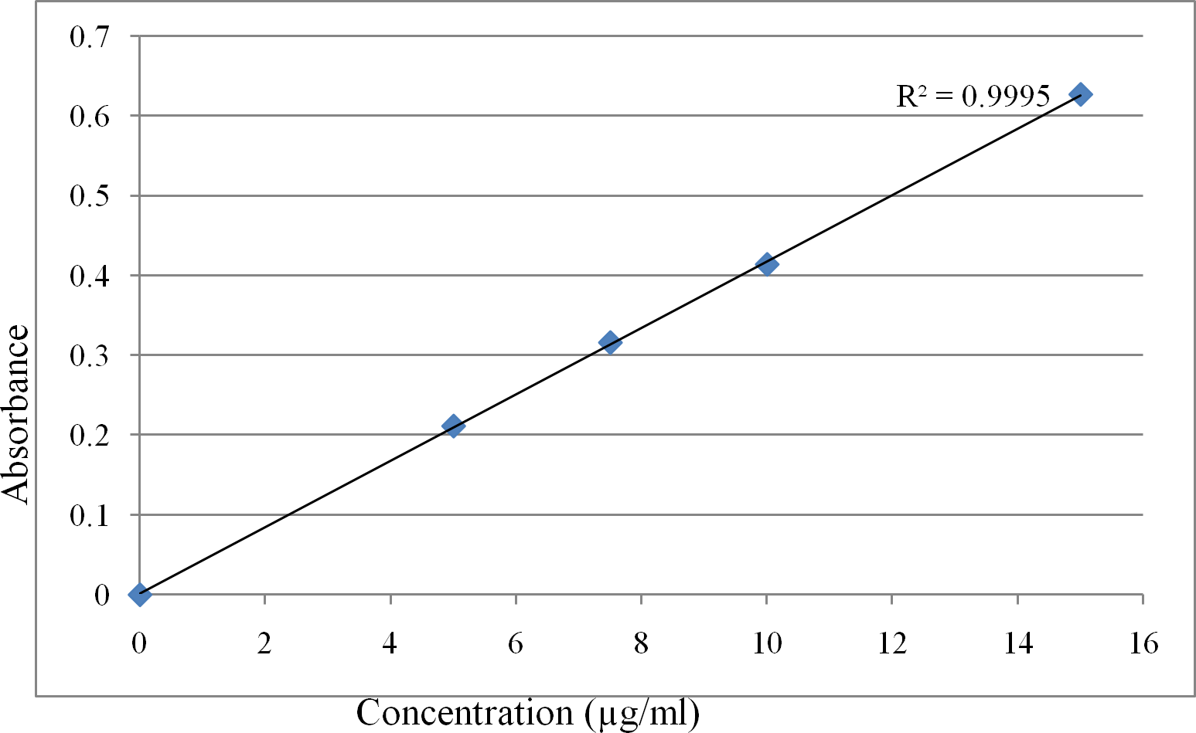

# Figure 4.1: Calibration curve of lamivudine in methanol

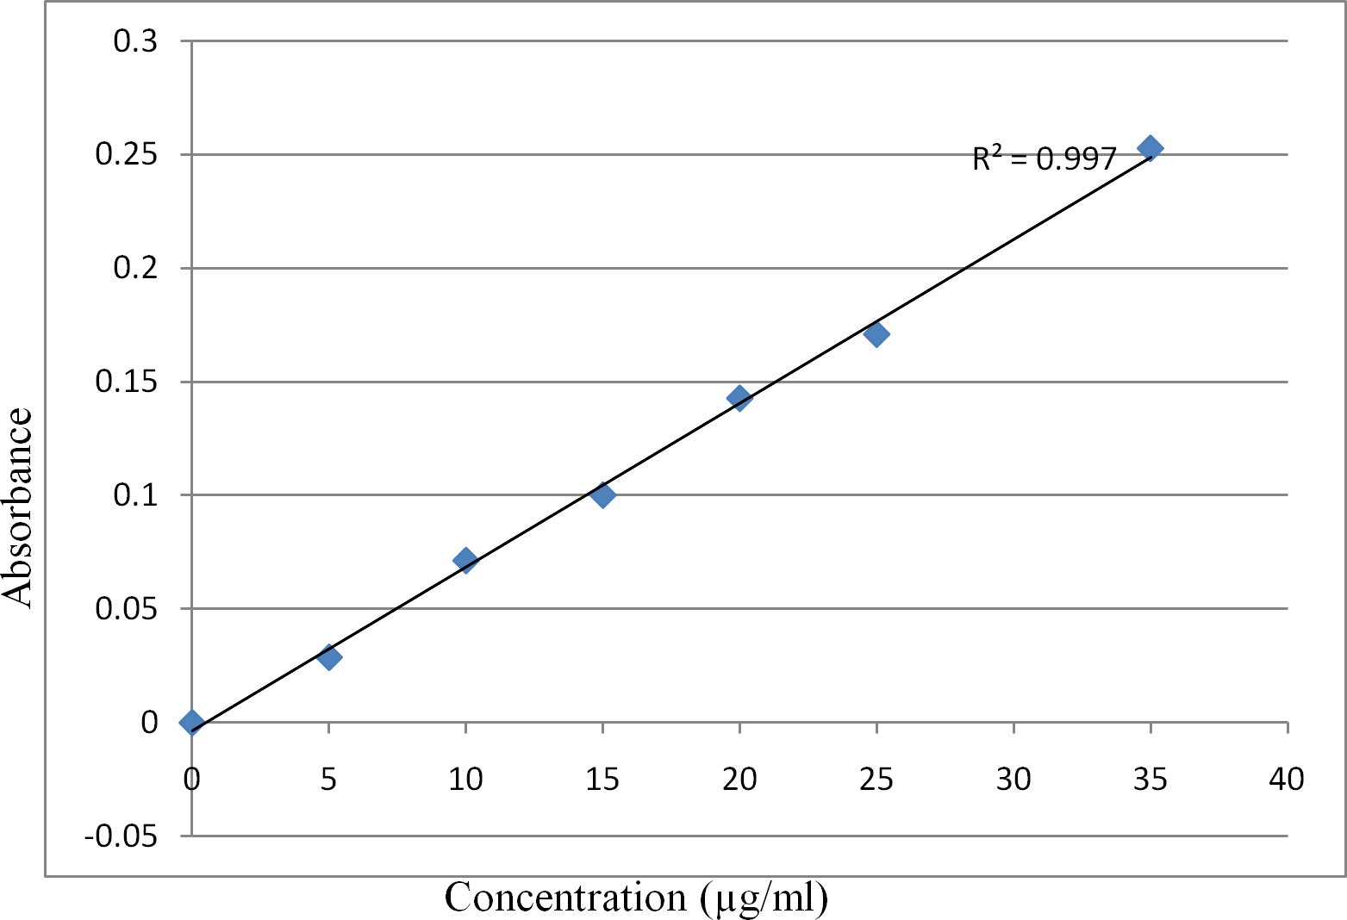

**Figure 4.2: Calibration curve of lamivudine – 2,4-DNPH complex**

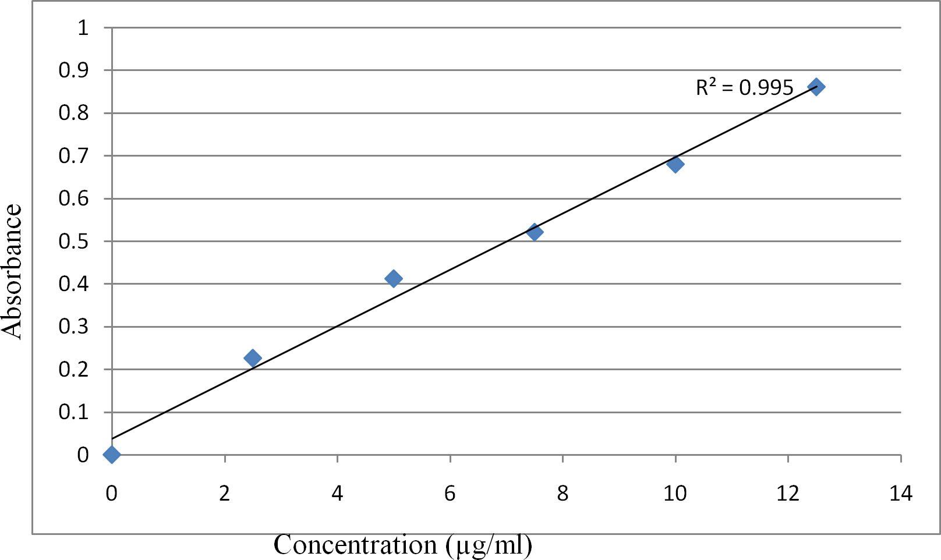

# Figure 4.3: Calibration curve of lamivudine – paratoluidine complex

# Validation of methods

The accuracy, precisions, percentage recoveries, detection limits and quantitation limits for all the three methods are shown in table 4.2. The relatively low percentages of coefficient of variation (% CV) which are within the acceptable limit of < 15 % CV show the precision of the methods. The percentage relative errors (% Er) obtained were within the range (1 – 5 %) for moderately accurate procedure (Harvey, 2000). Satisfactory percentage recoveries, detection and quantitation limits were achieved for lamivudine in all the methods.

# Table 4.2 Validation parameters of the developed methods

|  |
| --- |
| Parameter Method 1 Method 2 Method 3 |
| λmax (nm) 273 438 282  Precision (% CV) 1.7 1.8 0.5  Accuracy (% Er) 2.1 4.0 2.0  Percentage recovery (%) 99.4 98.9 99.6  Detection Limit (µg/ml) 0.25 1.26 1.50  Quantitation Limit (µg/ml) 0.77 3.83 4.50 |

*CV = coefficient of variation*

*Er = relative error*

# Assay Results

The assay results of the three different brands of lamivudine tablets were within the official limits of 97.5 – 102.0 % and 97.0 – 103.0 % of the stated amount in BP, 2009 and IP, 2006 respectively. The assay results of the lamivudine tablets for both the developed methods and the International Pharmacopoeial method are shown in table 4.3.

# Table 4.3 Assay results of lamivudine tablets for the developed methods and IP method

|  |
| --- |
| % Content ± SEM (n = 5)  Lamivudine Tablets IP Method Method 1 Method 2 Method 3 |
| Aurobindo (%) 99.1±0.13 99.3±0.21 99.6±0.57 98.9±0.43  Danadams (% ) 99.2±0.04 100.5±0.09 99.5±0.58 98.0±0.44  Hetero labs (%) 99.4±0.14 101.9±0.21 100.1±0.57 99.8±0.44 |

No statistically significant difference between the means (P < 0.05)

# FTIR analysis results

The Fourier transform infrared (FTIR) analysis results for lamivudine, 2,4-DNPH blank reagent, lamivudine plus 2,4-DNPH complex, paratoluidine blank reagent and lamivudine plus paratoluidine complex samples are presented in Figures 4.4, 4.5, 4.6, 4.7 and 4.8 respectively.

# Table 4.4: Comparison on the reagents used between the developed methods and some of the reported spectrophotometric methods

|  |  |  |
| --- | --- | --- |
| METHODS | REAGENTS USED | COMMENTS |
| Developed Methods 1, 2 and  3 | Methanol, 2,4-dinitrophenyl hydrazine and Paratoluidine  respectively | Stable, sensitive and not expensive |
| Vankatesh *et al*., Method  (2012) | Tetrahydrofuran | Expensive and not readily  available |
| Kenneth *et al*., Method  (2011**)** | DDQ | Expensive |
| Chaithanya *et al*., Method  (2011) | Iron(iii)-MBTH | Expensive |
| Rambabu *et al*., Method  (2011) | MBTH and IBDA | Less sensitive |
| Babu and Kumar Method  (2009) | PDAB and Vanillin (acidic  condition) | Less sensitive and Expensive |
| Sriker *et al*., Method (2009) | PDAC (acidic condition) | Less sensitive Method |

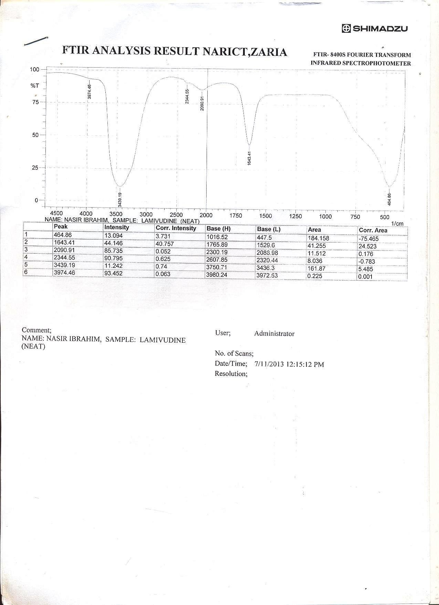

**Figure 4.4: FTIR analysis result of lamivudine**

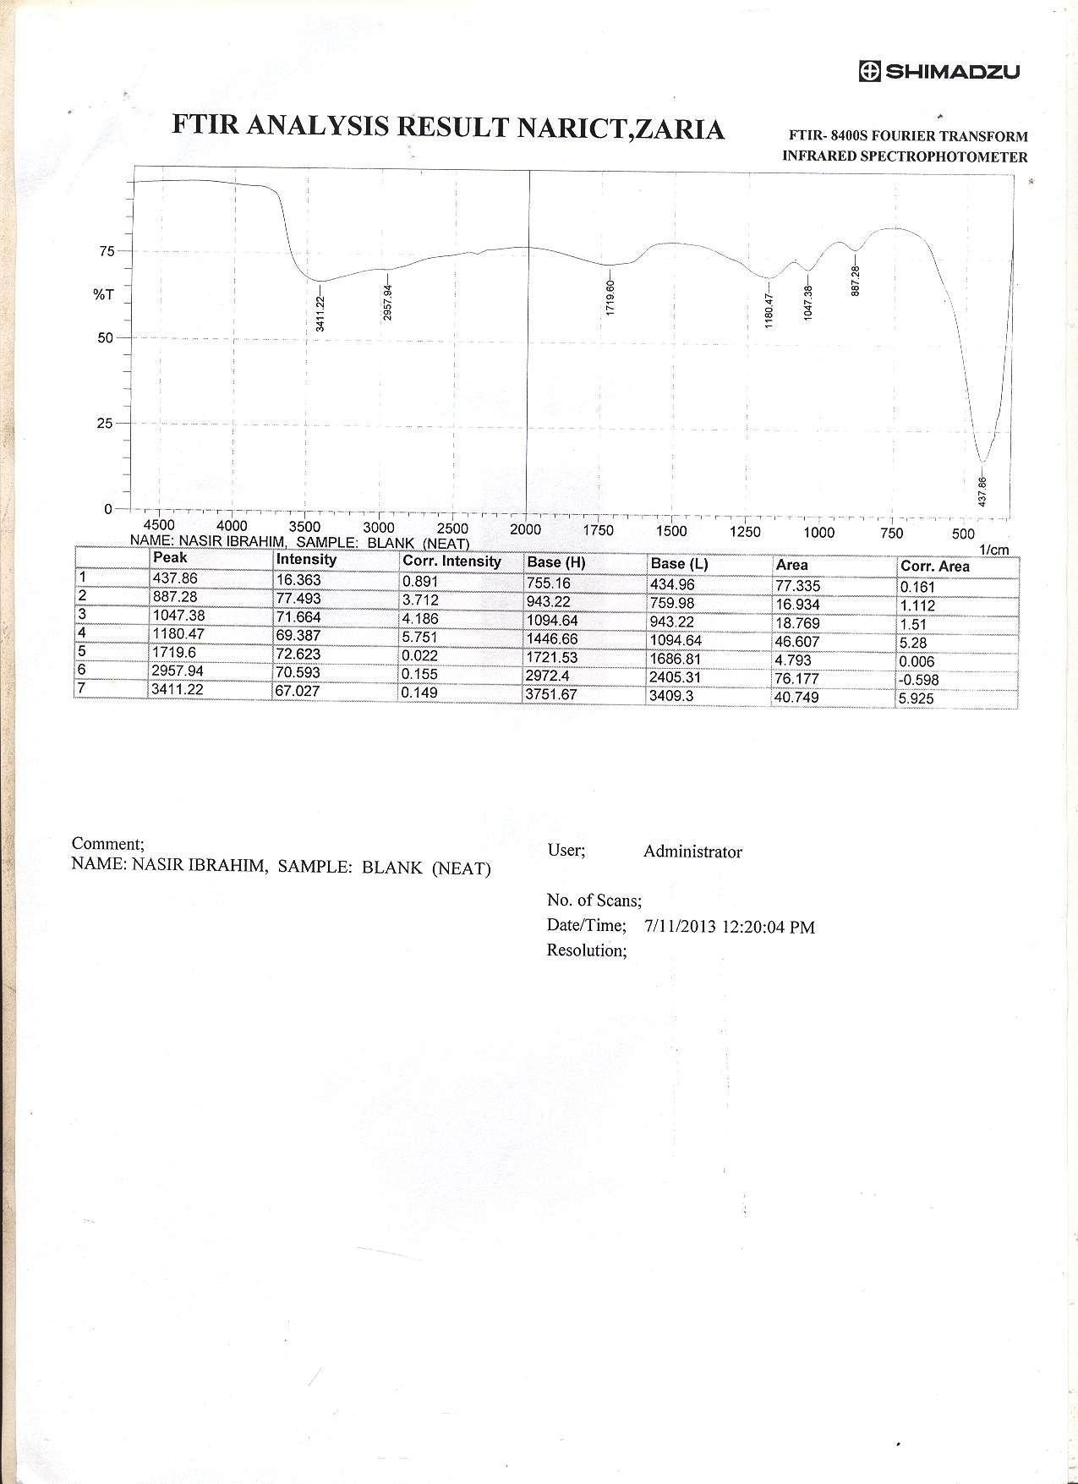

# Figure 4.5: FTIR analysis result of the blank 2,4-DNPH reagent

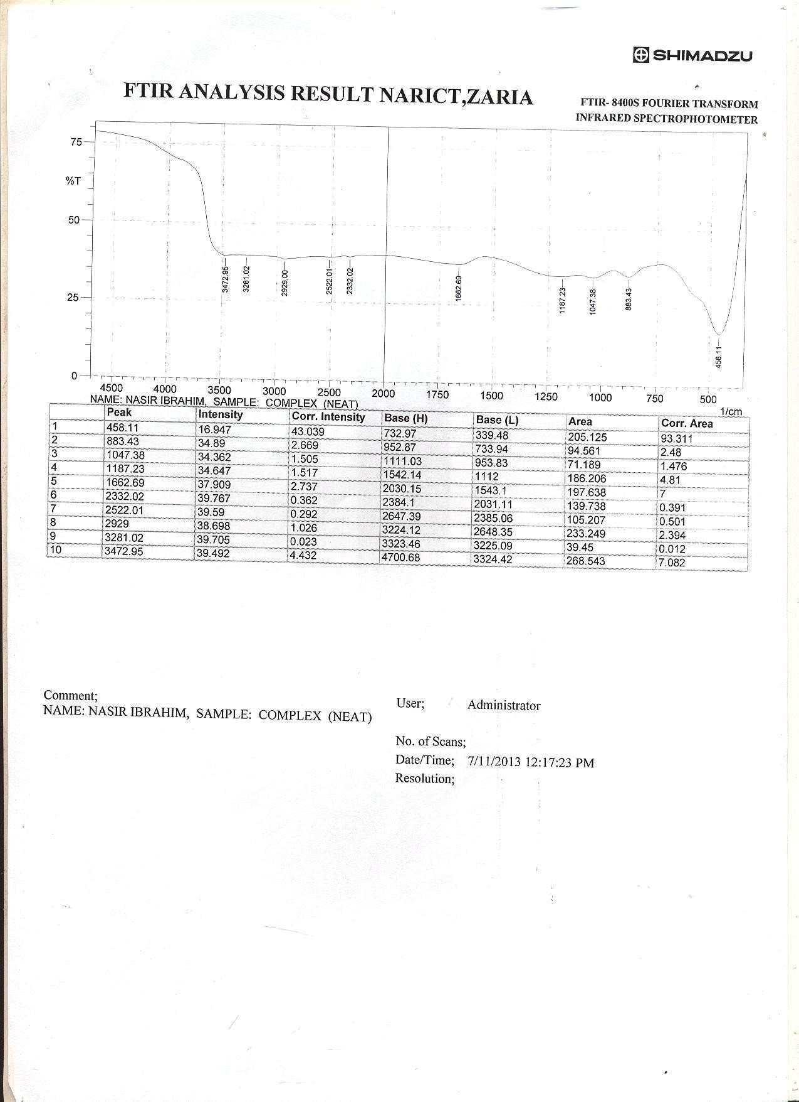

**Figure 4.6: FTIR analysis result of lamivudine – 2,4-DNPH complex**

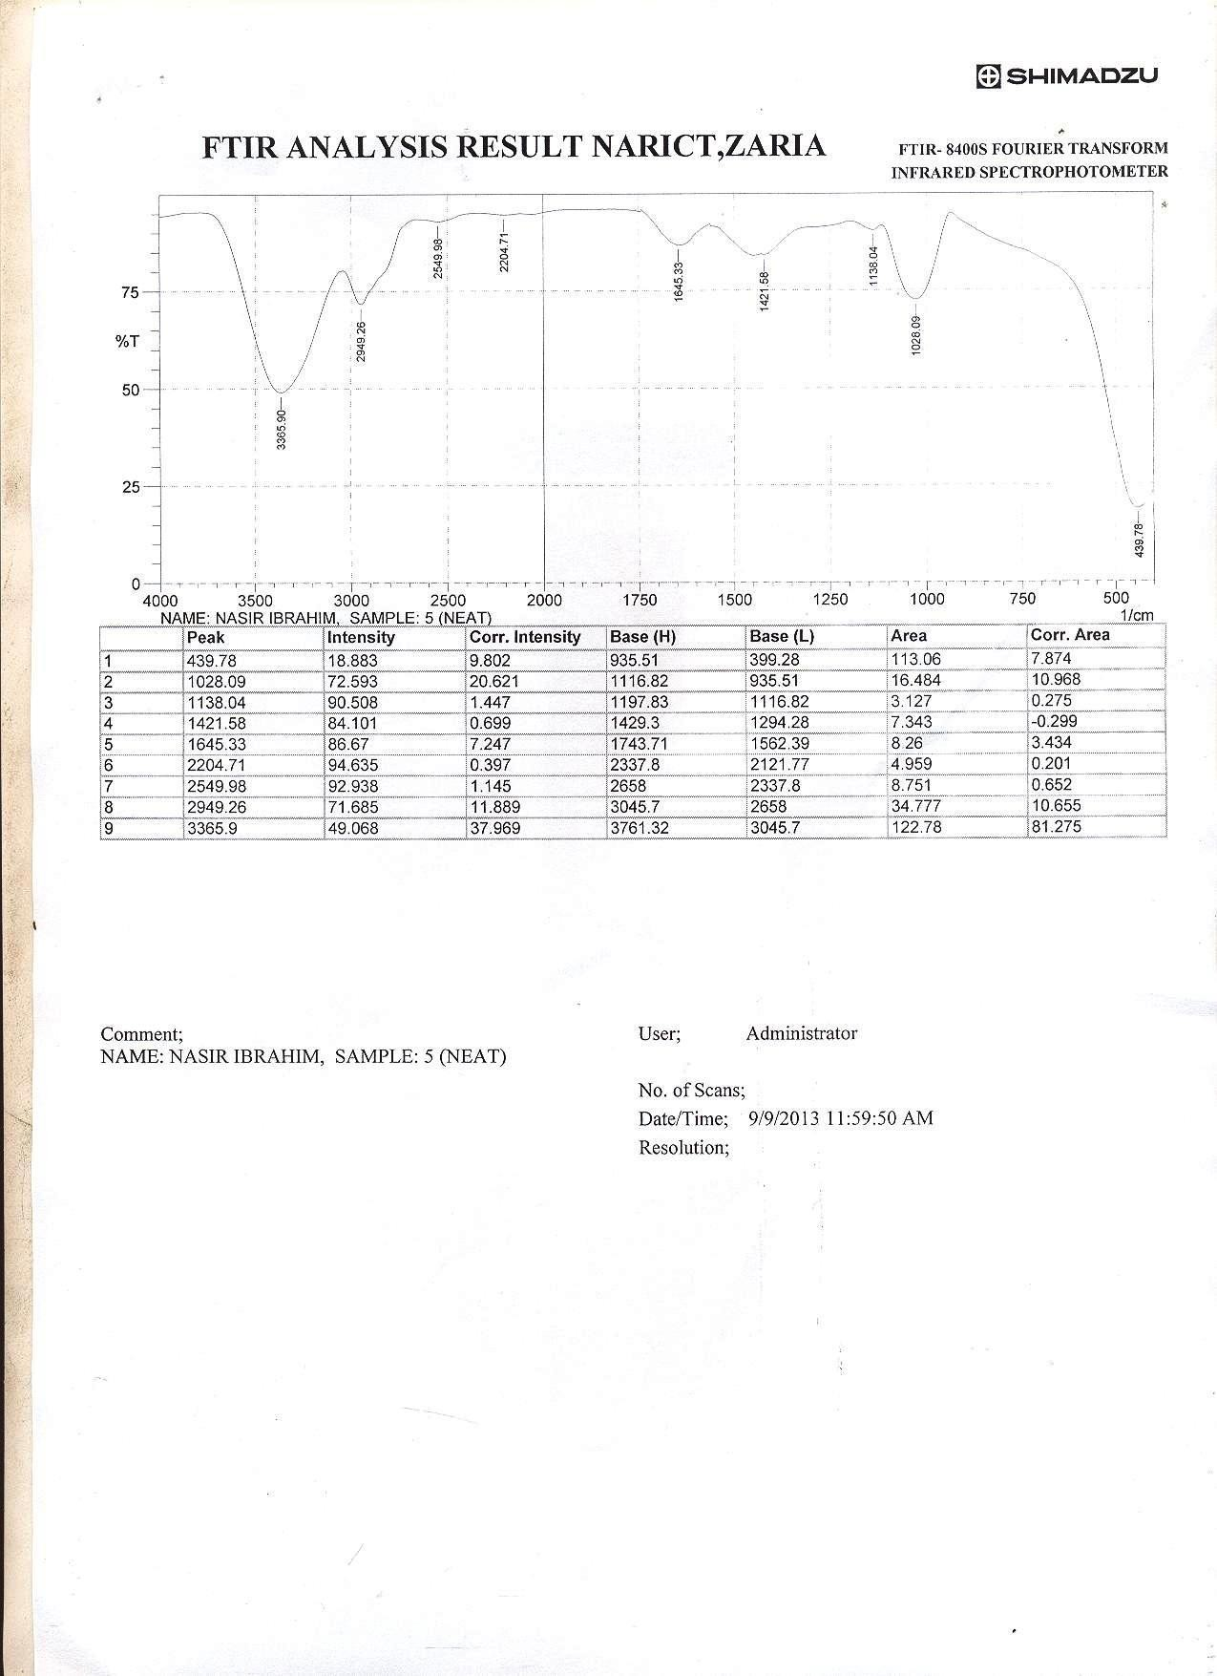

# Figure 4.7: FTIR analysis result of the blank paratoluidine reagent

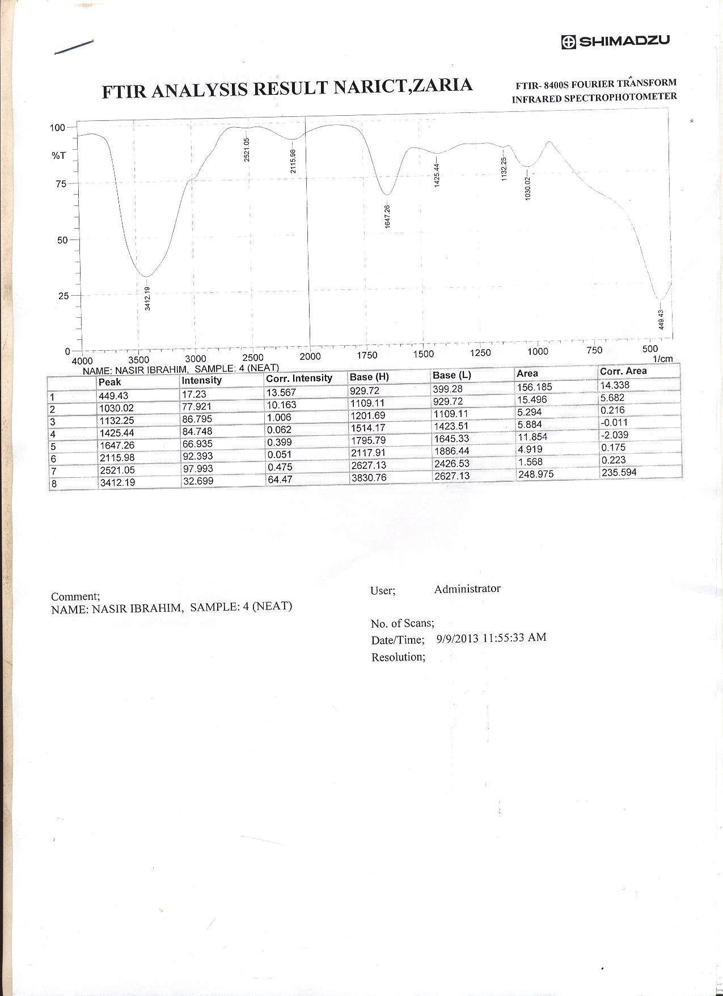

**Figure 4.8: FTIR analysis result of lamivudine – paratoluidine complex**

# Chapter 5 DISCUSSIONS

# Calibration Curves

The calibration curves for quantitative determination of lamivudine in all the three developed methods obeyed Beer-Lamberts law with coefficients of correlation (r) of 0.9997, 0.9988 and 0.9975 for method 1, 2 and 3 respectively. This clearly shows the direct proportional relationship and high correlation between the absorbance (A) and the respective concentrations (C) used for these determinations which gives the regression equations for the three developed methods (Table 4.1).

# Validation Parameters

The accuracy of the three developed methods were presented as the percentages relative error (%Er) and computed to be 2.1, 4.0 and 2.0 % respectively. They were all within the range (1 – 5 %) for moderately accurate procedure (Harvey, 2000). Precision of the methods were expressed as percentages of coefficient of variation (% CV) determined and are 1.7,

1.8 and 0.5 % for method 1, 2 and 3 respectively. The relatively low % CV which were within the acceptable limit of < 15 % CV shows the precision of the methods. Rao and Raji, 2011 reported precisions of 2.11, 2.00 and 1.98 for lamivudine using RP-HPLC method, this shows that the precision of the developed spectrophotometric methods is satisfactory. The percentage recoveries determined for the three developed methods were 99.4, 98.9 and 99.6

% respectively. Percentage recovery of 97.5 % was reported for lamivudine by Vardan *et al*., 2011, although is satisfactory, the percentage recoveries of the developed methods were

better. Detection limit (DL) and quantitation limit (QL) for method 1, 2 and 3 were 0.25, 1.26, 1.50 and 0.77, 3.83, 4.50 µg/ml respectively. Mandloi *et al*., 2009 RP-HPLC method for lamivudine determination reported DL and QL of 1.7 and 5.16 µg/ml respectively. Rambabu *et al*., 2012 spectrophotometric method for lamivudine determination reported DL(s) of 1.6 and 3.4 µg/ml and QL(s) of 5.2 and 11.4 µg/ml respectively. A comparison of these reported DL(s) and QL(s) with those of the developed methods clearly shows that the DL and QL of the three developed methods were better.

# Assay Results and Statistical Analysis

The assay results for the three different Brands (A, B and C) of lamivudine tablets were within the official limits of 97.5 – 102 % and 97.0 – 103 % of the stated amount in BP, 2009 and IP, 2006 respectively. Statistical analysis revealed no statistically significant difference (P > 0.05) between the means of the developed methods and the International Pharmacopoeial method. Tukey’s multiple comparison test among the developed methods shows that method 1 is the most effective method (P < 0.05). This is followed by method 2 and 3 respectively. In terms of effectiveness the order is method 1 > method 2 > method 3 (P

< 0.05).

# FTIR Analysis

## Method 2

The Fourier transform infrared (FTIR) analysis results for method 2 revealed a spectral difference between the spectrum of lamivudine, lamivudine plus 2,4-DNPH complex and that of the 2,4-DNPH blank reagent. The FTIR spectrums of the samples were recorded in KBr Phase in the frequency region 500 – 4500 cm-1. The vibrational frequencies of the groups involved in the reaction were assigned appropriately. The spectrum of Lamivudine displays six peaks and the strong band at 1643.4 cm-1 is assigned to v(C=O) of lamivudine. Spectrum of the reagent (2,4-DNPH) displays seven peaks and is comparable to that reported by Devi *et., al,* 2010 with signals 887.2 cm-1 assigned to v(NO2) and 1180.47 cm-1 assigned to NH2 twisting/ N-H inplane bending. The spectrum of hydrazone complex formed between the carbonyl group of lamivudine and the hydrazine group of 2,4-DNPH showed very strong band at 1662.69 cm-1 and 3281.02 cm-1 which were assigned to v(C=N) and v(NH) respectively (El-Inany *et., a*l, 2006).

## Method 3

For method 3 the coupling reagent (p-toluidine) and the complex formed between the diazotized lamivudine and the reagent were analyzed. The following FTIR bands were identified in the spectrum of the reagent (nine peaks were identified). 3365.9 cm-1 for v(NH2 str), 1645.3 cm-1 assigned to v(C=C), 2949.26 cm-1 for v(C-H str) and 2549.98 cm-1 was assigned for v(CH3) stretching (Ameta *et., al*, 2008). For the complex formed between the reagent and lamivudine eight peaks were identified. The strong band at 1647.26 cm-1 was

assigned to v(C=N) stretching while the very strong band identified at 2115.98 cm-1 was assigned to v(N=N) stretching. The missing peak at 2949.26 cm-1 which was assigned to v(C-H) stretching in the spectrum of the complex may be due to the involvement of the group as coupling point with lamivudine as described in (Figure 3.2).

# Chapter 6 CONCLUSIONS AND RECOMMENDATIONS

# Conclusions

From results obtained, it can be concluded that three new spectrophotometric methods for lamivudine determination in pure form and tablets dosage forms were developed and validated. No statistically significant difference (P < 0.05) between the means of the assayed results of the proposed methods and that of the International Pharmacopoeial method. The Tukey’s multiple comparison post-hoc test results also showed that method 1 is the most effective method followed by method 2 and 3 respectively.

# Recommendations

The present study proposed three new spectrophotometric methods for lamivudine determination in pure and tablets dosage forms, these methods should be utilized for routine quality control of lamivudine.

Due to the low detection limit and quantitation limit of Method 1 (0.25 and 0.77 µg/ml respectively) the method may be used for blood level monitoring of lamivudine since the Cmax is in the order of 1 – 1.5 µg/ml; particularly where sophisticated instrumentation like HPLC is not available.

# REFERENCES

Abuga, K. O., Mwagiru, P. M., Thoithi, G. N., Nguyo, J. M., Ngugi, J. K., Kingondu, O. K., Mugo, H. N. and Kibwage, I. O. (2003). Quality of antiretroviral drugs analyzed in the drug analysis and research unit. *East Central African Journal of Pharmaceutical Sciences,* 6(3): 20–23.

Ameta, C. S., Sharma, R., Mukesh, P., Sadhana, S. and Ameta, R. (2008). Synthesis, characterization and electrical conductivity of charge transfer complex of p-toluidine and chloranil. *Indian Journal of Chamical Technology*, 15(2): 613-616.

Appalaraju, S., Karadi, A. B., Kamalapurkar, G. S. and Sarasambi, P. S. (2002). Spectrophotometric determination of lamivudine. *Asian Journal of Chemistry,* 14(4): 475–8.

Babu, C. J., and Kumar, G. V. (2009a). Validated RP- HPLC method for the quantification of lamivudine in bulk and tablet dosage form. *International Journal of Chemical Technology and Research*, 1(4): 1721–1724.

Babu, C. J., and Kumar, G. V. (2009b). Validated RP- HPLC method for the quantification of lamivudine in bulk and tablet dosage form*. International Journal of Chemical Technology and Research,* 1(4): 1372-1375.

Baig, M. V., Kapse, G. S. and Raju, S. A. (2001). Spectrophotometric determination of lamivudine. *Asian Journal of Chemistry,* 13(3): 185–189.

Basavaiah, K., and Somashekar, B. C. (2005). Titrimetric and spectrophotometric determination of lamivudine in pharmaceuticals. *Indian Journal of Chemical Technology,* 13(2): 7-12.

Basavaiah, K., and Somashekar, B. C. (2006). Sensitive titrimetric and spectrophotometric determination of lamivudine in pharmaceuticals. *Indian Journal of Chemical Technology,* 65(2): 349-354.

Blaedel, W. J., and Meloche, V. M (2001). *Elementary Quantitative Analysis Theory and Practice,* 2nd Edition, Harper and Row, New York, pp. 254.

British Pharmacopoeia (2002). Vol. ll. Printed for Her Majesty’s Stationary office at University Press, Cambridge, Appendix VII.

British Pharmacopoeia (2009). Vol. I and ll. Printed for Her Majesty’s Stationary office at University Press, Cambridge, Appendix VII.

Chaithanya, K., Padma, A., Swapna, A., Swaroopa, R. K., and Ramalingam, P. (2011). An Indirect Spectrophotometric method for estimation of lamivudine in pure and tablet dosage form*. International Journal of Chemical Technology and Research*, 3(2): 733- 736.

Deepali, G., and Elvis, M. (2010). UV Spectrophotometric method for assay of the antiretroviral agent lamivudine in active pharmaceutical ingredient and in its tablet formulation*. Journal of Young Pharmacists,* 2(4): 417-419.

Deng, Y., Shen, Y., Xiang, L. and Zhong, Y. G. (2006). A convenient synthesis of *cis* and *trans*-(±)-4-Amino-1-[2-(hydroxylmethyl)-1,3-oxathiolan-5-yl]-2(1H)-pyrimidinone. West China School of Pharmacy, Sichuan University*, Chengdu Chinese Chemical Letters*, 17(4): 431-433.

Devi, T. U., Laurence, N., Ramesh, R. B., Ramanmurthi, K. and Bhagavannarayana, G. (2010). Structural and optical characterization studies on 2,4-dinitrophenylhydrazine single crystal. *Journal of Minerals Characterization and Engineering.* 9(4): 321-330.

El-Inany, G. A., Saleem, H. S., Eid, M. F., Mousa, M. and Hanafy, F. I. (2006). Complexation of some hydrazones bearing the quinoline ring. potentiometric studies. *Journal of Brazilian Chemical Society,* 17(4): 723-729.

Havey, D. (2000). *Modern analytical Chemistry.* The McGraw-Hill company, Inc. pp. 39-

49. [http://pubchem.ncbi.nlm.nih.gov/summary/summary.gic.sig=7847419.](http://pubchem.ncbi.nlm.nih.gov/summary/summary.gic.sig%3D7847419)

International Conference on Harmonization (1995). Q29(R1): Text on *Validation of Analytical Procedures*, Federal register CPMP/ICH/381/95.

International Conference on Harmonization of Technical Requirements for the registration of Pharmaceuticals for Human use. (1996). *Validation of Analytical procedures*. Methodology. ICH-Q2B, Geneva CPMP/ICH/281/95.

Kapur, A., Chopra, J. A., Haskovic, A., Klepo, L., Tahirovic, I. and Sofic, E. (2012). Spectrophotometric analysis of total ascorbic acid content in various fruits and vegetables. *Bulletin of Chemists and Technologists of Bosnia and Herzgovina*, 38(3): 39-42.

Karunasree, C. P., Rajesh, P. V., Dhaemamoorthy, G., Padmini, K. and Sudeer, C. H. (2012). Develpoment and partial validation of the lamivudine drug in bulk and solid dosage form by calorimetry. *International Journal of Medicinal Chemistry and Analysis,* 2(1): 1-5.

Kenneth, C. M., Ukoha, P. O. and Attama, A. A. (2011). Spectrophotometric determination of lamivudine using chloranilic acid and 2,3-dicchloro-5,6-dicyano-1,4- benzoquinone. *American Journal of Analytical Chemistry*, 2(1): 849-856.

Kumar, A. T, Gurupadayya, B. M. and Rahulreddy, M. B. (2011). Spectrophotometric determination of lamivudine using acidic dye and coupling reagent. *Indian Journal of Chemical Technology,* 18(2): 431-438.

Kumar. S (2010). Synthesis and antimicrobial Studies of some Schiff bases of Sulfonamides, *Dissertation submitted to Rajiv Ghandhi University of Health Sciences, Karnataka for Partial fulfillment of Master of Pharmacy in Pharmaceutical Chemistry,* Department of Pharmaceutical Chemistry Government College of Pharmacy, Bangalore-560 027, Karnataka, India. pp. 3-5.

Laurence, M., Harwood, Christopher, and Moody, J. (1989). *Experimental organic chemistry: Principles and Practice* (Illustrated Ed.). Wiley-Blackwell. pp. 292.

Mandloi, D. K., Tyagi, P. K., Rai, V. K., Dey, S., Ashanda, R. K. and Mohanraj, P. (2009). Method Development and Validation of RP – HPLC in application of Invitro dissolution study of lamivudine in bulk drug and tablet formulation. *Journal of Chemical and Pharmaceutical Research*, 1(1): 286 – 296.

Marczenko, Z. (2000). *Separation and Spectrophotometric Determination of Elements.* John Wiley and Sons, New York. pp. 256-257.

Mukamel, S. (2000). Multidimensional Fentosecond Correlation Spectroscopies of Electronic and Vibrational Excitations. *Annual Review of Physics and Chemistry,* 51(1): 691.

Paula, P. A. and Julio D. (2009). *Elements of physical chemistry* (5th Ed). Oxford: Oxford University press. pp. 459.

Rambabu, C., Babu, B. A., Ramu, G., Muralikrishna, C. H. and Reddy, S. B. (2011). Spectrophotometric determination of lamivudine in pure and tablet forms. *E-journal of Chemistry,* 9(2): 569-575.

Rao, L. A. and Raja, T. (2011). Development and validation of RP – HPLC method for estimation of abacavir, lamivudine and zidovudine in Pharmaceutical dosage form. *International Journal of Pharmaceutical Technology and Research*, 3(2): 852 – 857.

Raza, A., Ansari, T. M. and Rehman, A. (2003). Spectrophotometric determination of tranexamic acid in pharmaceutical bulk and dosage forms. *Journal of Analytical Sciences*, 21(9): 1133.

Raza, A., Ansari, T. M., and Rehman, A. J. (2005a). Spectrophotometric determination of lisnopril in pure and pharmaceutical formulation. *Journal of the Chinese Chemical Society*, 52(5): 1055-1059.

Raza, A., Ansari, T. M. Niazi, S. B. and Bulkari, S. I. H. (2005b). A simple spectrophotometric determination of diclofenac sodium in commercial dosage forms using DDQ. *Pakistan Journal of Analytical Chemistry*, 6(1): 5-9.

Sarma, G. N., Sastry, C. S., and Sastri, C. K. (2002). Simple oxidimetric methods for determination of stavudine and lamivudine*. Asian Journal of Chemistry,* 14(1): 683– 90.

Sean, C. S (2009). *The complete drug reference*. In: Sean C. S. (35th Ed) London Pharmaceutical Press, pp. 238.

Shalini, S., Shanooja, V. P., AbdulJameel, S., Basima,. Harilal, K. K. and Harish, R. (2009). Application of UV-spectrophotometric methods for estimation of lamivudine in tablets. *Journal of Nanomater Biological Structure,* 4(4): 357–60.

Skalski, V., Chang, C. N., Dutschman, G., and Cheng, Y. C. (1993). The biochemical basis for the differential anti human immunodeficiency virus activity of two cis enantiomers of 2', 3'-dideoxy-3'-thiacytidine. *Journal of Biology and Chemistry*, 26(8), 3234-3238.

Srikar, A., Ashok, S., Venu, B. T., Latheeshjlal*,* Madhusudhan, K. and Kumar, B. N. (2009). Validated spectrophotometric estimation of lamivudine in pure and tablet dosage form*. International Journal of Pharmacy and Technology,* 1(1): 26-32.

Sweetman, SC (Eds), *Martindale. The complete drug reference (2002)* 35th edition: The Royal pharmaceutical society of Great Britain, London. Electronic version

United States Pharmacopoeia (2007). Asian Edition 30. *United States Pharmacopoeial Convention.* Inc: pp. 2447.

Vardan, V. P., Vanitha, C., Ramalingam, R., Raja, M. A., Banji, D. and Swathi, A. (2011). Development and validation of UV – Vis spectrophotometric method for the determination of efavirenz, lamivudine and tenofovir disofroxil fumarate in tablet dosage form. *International. Journal of Pharmaceutical Research and Development,* 4(6): 252 – 259.

Venkatesh, M., Bhaskar, M., Veeranjaneyulu, K., Sunitha, K., Bhagyasri, G. and Veliyath,

S. K. (2012). Method development and validation of lamivudine in tablet dosage form

by UV-spectrophotometry. *International Journal of Pharmaceutical and Industrial Research*, 2(1): 33-36.

Watson. D. G. (2005). Pharmaceutical Analysis. In: *A Textbook for Pharmacy Students and Pharmaceutical Chemists,* (2nd Ed) *Elsevier Churchill Livingstone,* pp. 91.

World health organization Mondiale de la santé (2006). *Lamivudine Final text for addition to The International Pharmacopoeia.* QAS/05.124.

World Health Organization, Department of HIV/AIDS (2004). *Summary Country Profile for HIV/AIDS Treatment Scaleup: Nigeria*; Geneva, Switzerland.

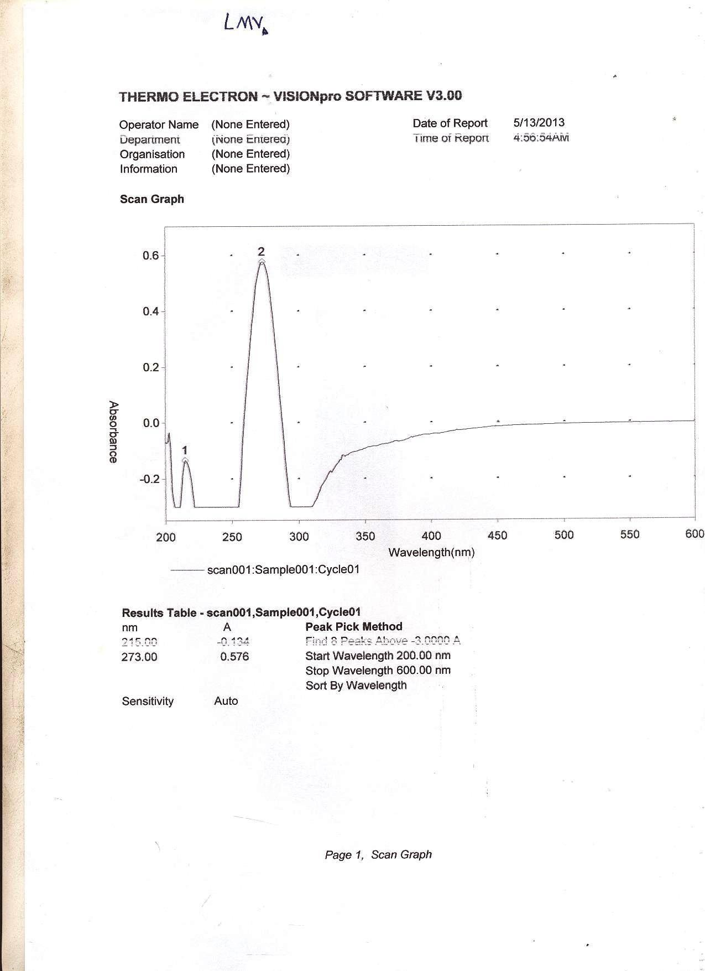

# Appendix 1: Absorption spectrum of lamivudine in methanol

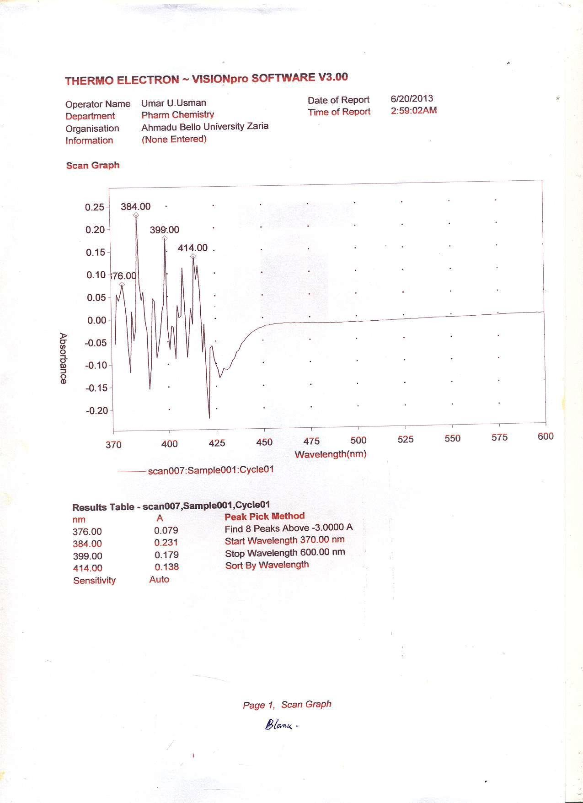

**Appendix 2: Absorption spectrum of the blank 2,4-DNPH reagent**

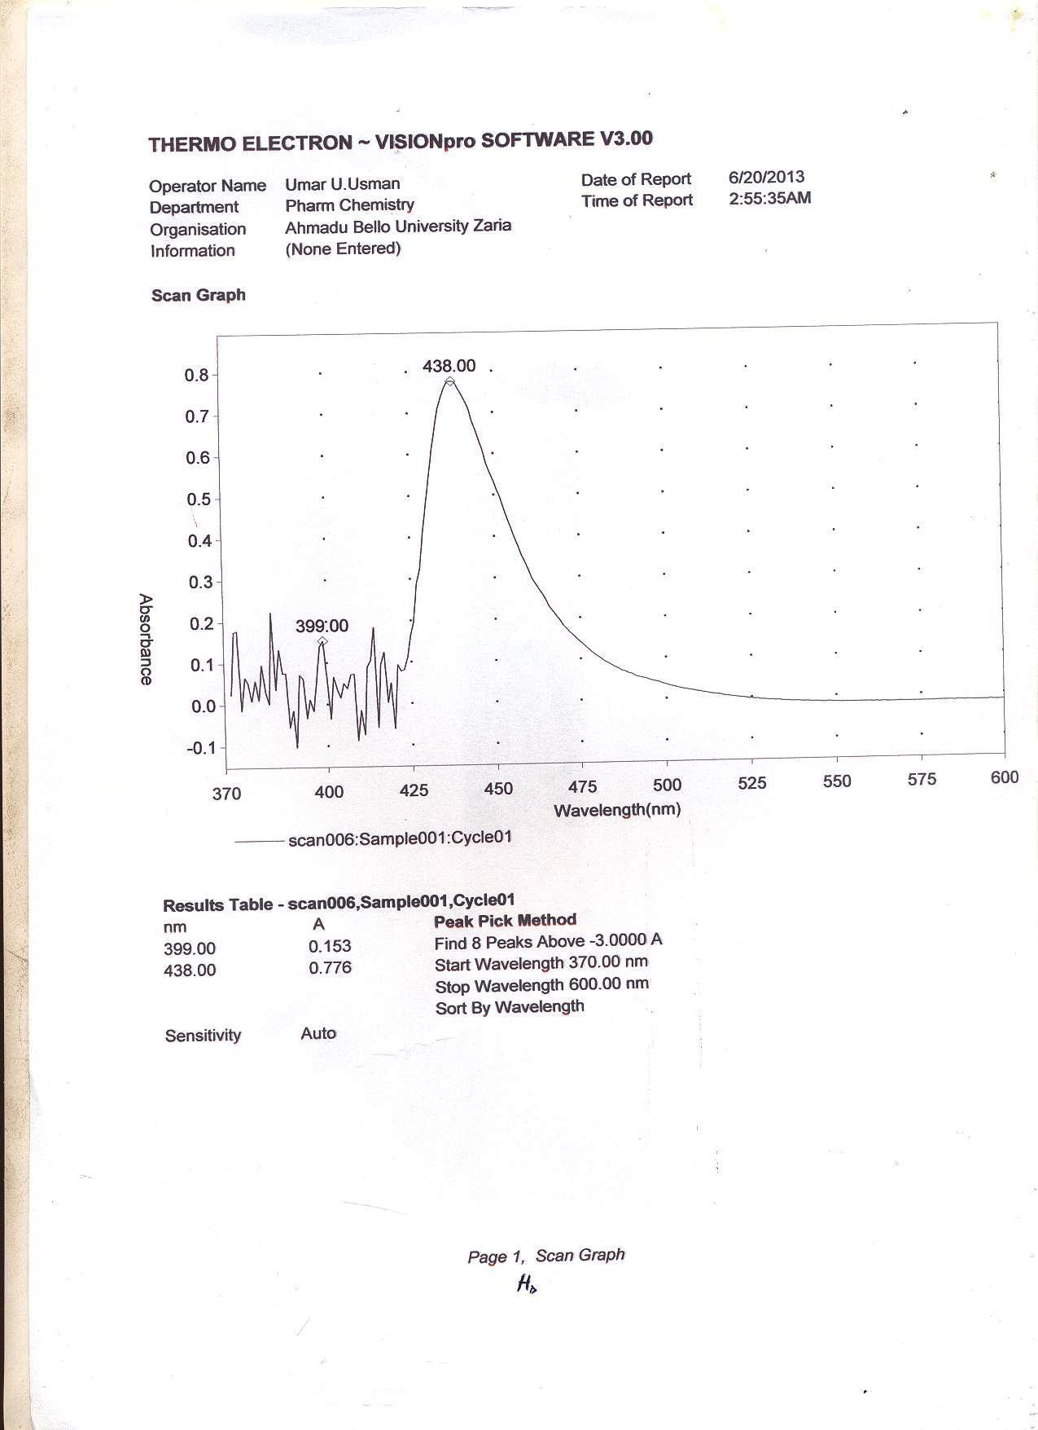

# Appendix 3: Absorption spectrum of lamivudine – 2,4-DNPH complex

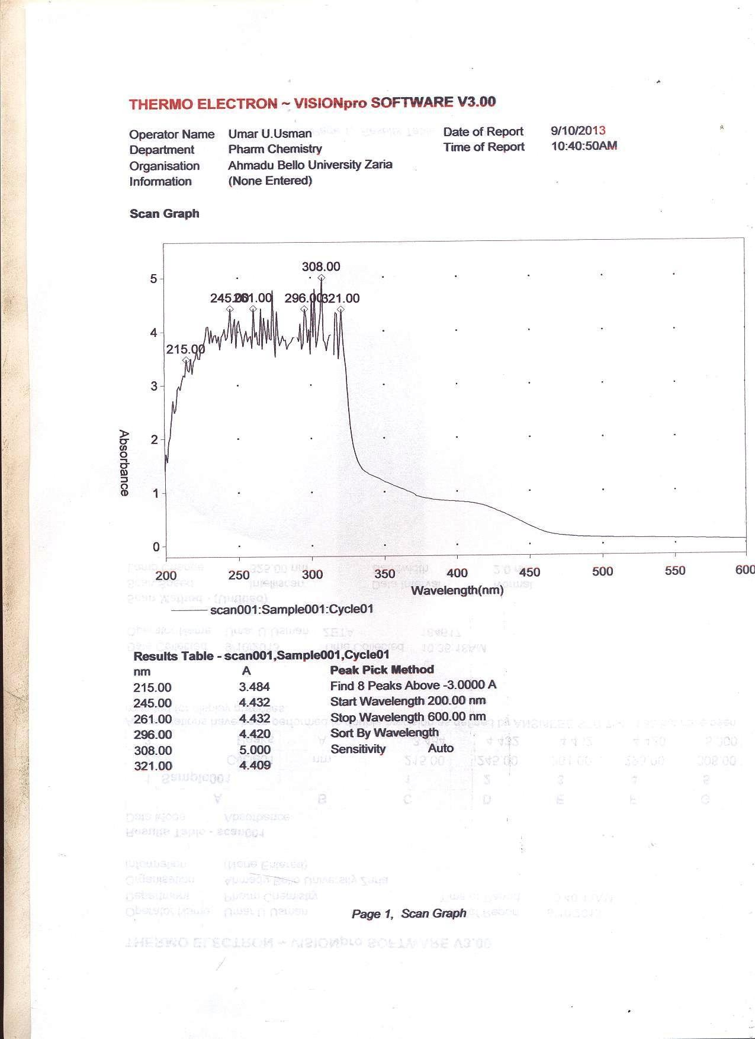

**Appendix 4: Absorption spectrum of the blank paratoluidine reagent**

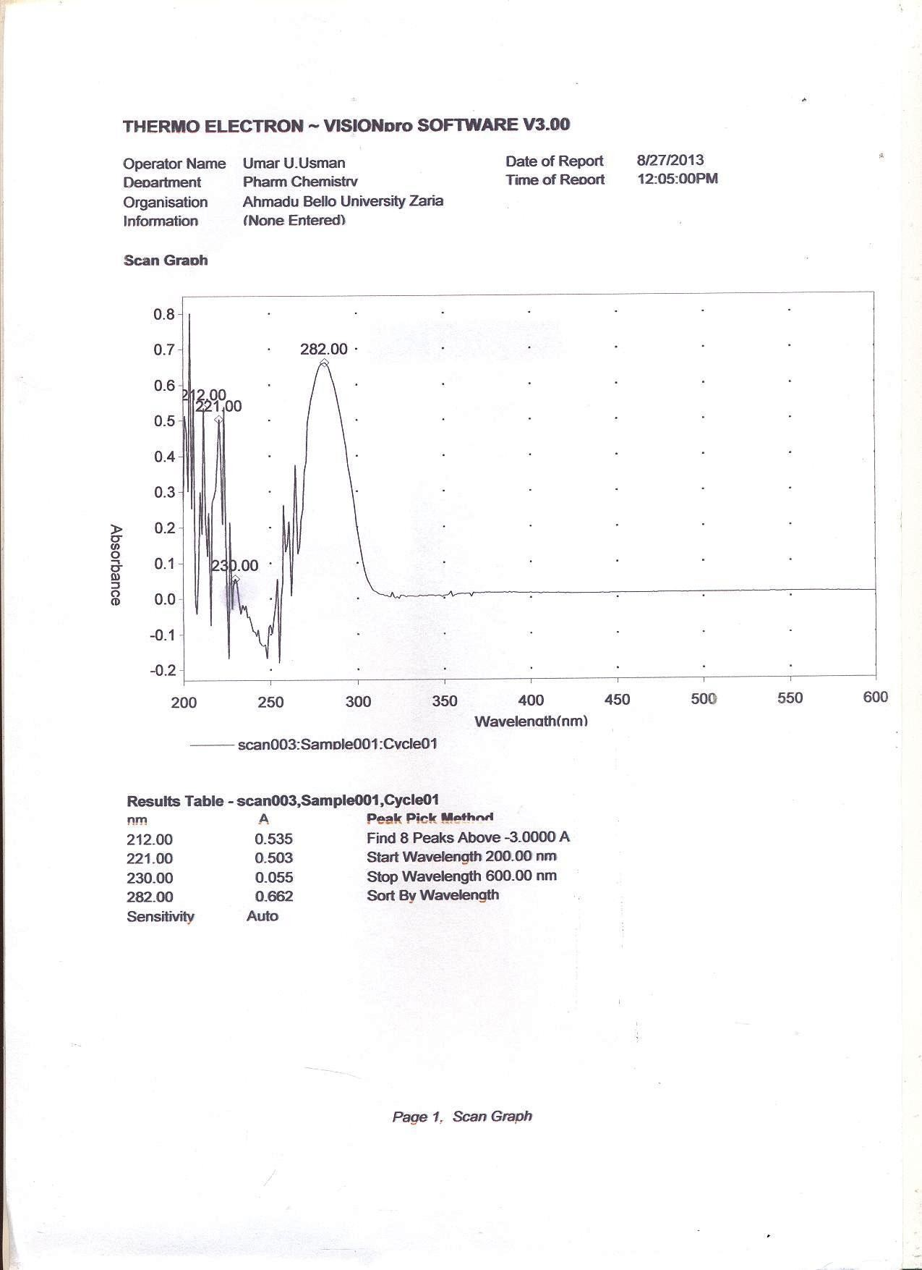

# Appendix 5: Absorption spectrum of lamivudine – paratoluidine complex