# DEVELOPMENT AND VALIDATION OF SPECTROPHOTOMETRIC METHODS FOR THE DETERMINATION OF RISPERIDONE IN PURE AND TABLET DOSAGE FORMS

**By**

**Rukayyat Bukola OLOYEDE, B.PHARM. (JOS) 2006 MSc/Pharm-Sci/3659/11-12**

**A DISSERTATION SUBMITTED TO THE SCHOOL OF POSTGRADUATE STUDIES,**

**AHMADU BELLO UNIVERSITY, ZARIA**

**IN PARTIAL FULFILLMENT OF THE REQUIREMENTS FOR THE AWARD OF A**

**MASTERS DEGREE IN PHARMACEUTICAL AND MEDICINAL CHEMISTRY**

**DEPARTMENT OF PHARMACEUTICAL AND MEDICINAL CHEMISTRY FACULTY OF PHARMACEUTICAL SCIENCES**

**AHMADU BELLO UNIVERSITY, ZARIA NIGERIA**

**AUGUST, 2015.**

# DECLARATION

I declare that the work in this Dissertation entitled **“Development and validation of spectrophotometric methods for the determination of risperidone in pure and tablet dosage forms”** has been carried out by me in the Department of Pharmaceutical and Medicinal Chemistry. The information derived from literature has been duly acknowledged in the text and a list of references provided. No part of this thesis was previously presented for another degree or diploma at this or any other institution.

Name of Student Signature Date

# CERTIFICATION

This dissertation entitled DEVELOPMENT AND VALIDATION OF SPECTROPHOTOMETRIC METHODS FOR THE DETERMINATION OF RISPERIDONE IN PURE AND TABLET DOSAGE FORMS by Rukayyat Bukola

OLOYEDE meets the regulation governing the award of the degree of M.Sc. Pharmaceutical and Medicinal Chemistry of the Ahmadu Bello University and is approved for its contribution to knowledge and literary presentation.

Dr. A.Y. Idris Date

Department of Pharmaceutical and Medicinal Chemistry, Ahmadu Bello University, Zaria. Chairman, Supervisory Committee

Dr. M.A. Usman Date

Department of Pharmaceutical and Medicinal Chemistry, Ahmadu Bello University, Zaria. Member, Supervisory Committee

Dr. A.M. Musa Date

Department of Pharmaceutical and Medicinal Chemistry, Ahmadu Bello University, Zaria. Head of Department

Prof. A.H. Zoaka Date

School of Postgraduate Studies, Ahmadu Bello University, Zaria, Nigeria

Dean

# ACKNOWLEDGEMENT

First and foremost, I would like to acknowledge my major supervisor, Dr. Abdullah Yunusa Idris. My profound gratitude goes to him for his advice, encouragement, resourcefulness and, most importantly the immense amount of patience he showed.

My gratitude also goes to my minor supervisor, Dr. M.A. Usman, who always had words of advice for me.

I also would like to acknowledge the Head of Department, Dr. Aliyu Musa for all the administrative assistance promptly rendered and to all members of staff of the HOD”s office.

I will forever be grateful to all the lecturers of the Department of Pharmaceutical and Medicinal Chemistry especially Dr. Aminu Musa, for the knowledge imparted and support rendered.

I also want to express my appreciation to Mallam Umar of the Department of Pharmaceutical and Medicinal Chemistry for the technical assistance he rendered which facilitated this research work.

Not forgetting my colleagues- Maryam, Jamilah, Amina N., Ephraim, Maria, Jephthah, Nasir, Amina J., Hajara, and Doris.

Finally, my family- Abu Maryam, Maryam, Aasiyah, Khadijah, Abdullah, my parents- Arc. & Mrs. Oloyede and brothers- Taslim and Taofik.

# ABSTRACT

Two simple, sensitive, accurate and extraction-free spectrophotometric methods were developed and described for the determination of risperidone in pure and in tablet dosage forms. The methods are based on the formation of ion-pair complex between risperidone and the dyes bromocresol green in method A and thymol blue in method B at room temperature to form yellow coloured products having absorption maxima at 414 nm and 404 nm respectively. The composition of the ion-pairs was established by Job‟s method and it was found to be 1:1 for both methods. Different variables affecting the reaction conditions such as diluting solvents, concentration of dye, reaction time were studied and optimized. Under the optimal conditions, linear relationship with good correlation coefficients (0.994 and 0.995 for methods A and B respectively) was found between absorbance and the concentrations of risperidone in the range of 2-20 µg/ml and 20-40

µg/ml respectively. The assay limits of detection (LOD) and limits of quantification (LOQ) were 1.27 and 3.84 µg/ml for method A and 7.00 and 21.15 µg/ml for method B. The precision of both methods did not exceed 15% likewise the percentage relative error was within the accepted range of 1-5%. No interference could be observed from the excipients commonly present in tablet or liquid dosage forms. The methods developed have been validated and there is no significant difference (P  0.05) between the methods and the

reference (BP) method. The methods can be successfully applied for the analysis of risperidone in pure and tablet dosage forms.

# TABLE OF CONTENTS

Title Page i

Declaration ii

Certification iii

Acknowledgement iv

Abstract v

Table of Contents vi

List of Figures xi

List of Tables xii

List of Appendices xiii

Abbreviation xiv

* 1. INTRODUCTION 1
  2. Preamble 1
  3. Research Problem 2
  4. Justification of Study 3
  5. Theoretical Framework 3
  6. Aim and Objectives 6
  7. Research Hypothesis 6
  8. LITERATURE REVIEW 7
  9. Psychosis 7
     1. Definition 7
     2. Aetiology of schizophrenia 8
     3. Treatment of schizophrenia and related psychoses 9
  10. Risperidone 10
      1. Overview 10
      2. Physical properties 11
      3. Chemistry of risperidone 11
      4. Benzisoxazole and benzisothiazole derivatives 12
      5. Laboratory synthesis 13
      6. Mechanism of action 14
      7. Side effects of risperidone 14
      8. Drug interactions 14
      9. The place of risperidone in antipsychotic therapy 15
  11. Quantitative Determination of Risperidone 15
      1. Non- UV analytical techniques 15
      2. UV analytical techniques 17
  12. Principles of UV Spectroscopy 18
      1. Introduction 18
      2. Molecular electronic structure 20
      3. Electronic absorption spectra 23
      4. Factors influencing absorption of radiant energy 23
      5. Laws of light absorption 25
      6. Intensities of spectral bands 26
      7. Instrumentation 27
      8. Instrument configuration 27
  13. Dyes 29
      1. Bromocresol green 29
      2. Thymol blue 29
  14. MATERIALS AND METHODS 30
  15. Materials 30
      1. Drugs and reference standards 30
      2. Equipment and glassware 30
      3. Chemicals and reagents 30
  16. Methods 31
      1. Optimization of variables 31
      2. Preparation of solutions and reagents 32
      3. Determination of λ max 32
      4. Determination of stoichiometry of ion-pair complex 32
      5. Identification and assay of risperidone (Official methods) 33
      6. Calibration curves 33
      7. Validation of methods 34
      8. Assay of risperidone tablets using developed methods 37
  17. RESULTS 38
  18. Optimization of Variables 38
  19. Stoichiometry of Ion-pair Complex 39
  20. Calibration Curves 40
  21. Validation of Methods 42
  22. Assay of Risperidone Tablets 43
  23. Statistical Analysis 43

1. DISCUSSION 44
2. CONCLUSION 47

REFERENCES 48

APPENDICES 53

# LIST OF FIGURES

Fig 1.1 Chemical structure of risperidone 1

Fig 1.2 Reaction pathway for risperidone-bromocresol green complex formation.4 Fig 1.3 Reaction pathway for risperidone-thymol blue complex formation 5

Fig 2.1 Chemistry of risperidone 11

Fig 2.2 Analogues of risperidone 12

Fig 2.3 Synthesis of risperidone 13

Fig 2.4 Order of orbital energies 22

Fig 2.5 Schematic diagram for the layout of a single-beam UV-visible spectrophotometer 28

Fig 2.6 Schematic diagram for the layout of a double-beam UV-visible spectrophotometer 28

Fig 2.7 Structure of bromocresol green 29

Fig 2.8 Structure of thymol blue 29

Fig 4.1 Job‟s plot for risperidone- bromocresol green ion-pair complex 39

Fig 4.2 Job‟s plot for risperidone- thymol blue ion- pair complex 40

Fig 4.3 Calibration curve of risperidone-bromocresol green complex 41

Fig 4.4 Calibration curve of risperidone-thymol blue complex 41

# LIST OF TABLES

Table 2.1 Electronic transitions involving 𝑛, 𝜎 𝑎𝑛𝑑 𝜋 molecular orbitals 23

Table 4.1 Choice of solvent for risperidone 38

Table 4.2 Choice of solvent for dyes 38

Table 4.3 Choice of dye concentration 39

Table 4.4 Calibration parameters 42

Table 4.5 Validation parameters 42

Table 4.6 Assay results 43

Table 4.7 Statistical analysis of assay results 43

# LIST OF APPENDICES

Appendix 1 Absorption spectra of risperidone and bromocresol green complex 53

Appendix 2 Absorption spectra of bromocresol green 54

Appendix 3 Absorption spectra of risperidone and thymol blue complex 55

Appendix 4 Absorption spectra of thymol blue 56

**ABBREVIATIONS**

D2- Dopamine type 2 receptors 5HT2- Serotonin type 2 receptors H1- Histamine type 1 receptors BP- British pharmacopoeia

EP- European pharmacopoiea

USP/NF- United states pharmacopoeia/ National formulary HPLC- High performance liquid chromatography

LC- Liquid chromatography UV- Ultraviolet-visible

MS- Mass spectrometry

DSM- Diagnostic and statistical manual of mental disorders EPS- Extrapyrimidal symptoms/ side effects

NMDA- *N*-methyl D-aspartate PCP- Phencyclidine

M- Muscarinic receptors

AMPA- Amino-3-hydroxy-5-methyl-4-isoxazole propionic acid CNS- Central nervous system

DMF- Dimethylformamide CYP- Cytochrome P450 BCG- Bromocresol green TB-Thymol blue

MBTH- 3-methyl-2-benzothiazolinone hydrazone

FDA- Food and Drug Administration

# CHAPTER ONE

# INTRODUCTION

## Preamble

Risperidone is a psychotropic (antipsychotic) agent used in the treatment of schizophrenia. The action is mediated through a combination of dopamine Type 2 (D2) and serotonin Type 2 (5HT2) receptor antagonism. It is a selective monoaminergic antagonist with high affinity for 5HT2, D2 and H1 histaminergic receptors (Potter and Hollister, 2001). It belongs to the chemical class of benzisoxazole derivatives. The chemical name of risperidone is 3-[2-[4- (6-fluoro-1, 2-benzisoxazol-3-yl)-1-piperidinyl]ethyl]-6, 7, 8, 9-tetrahydro-2-methyl-4H- pyrido-[1,2-a]-pyrimidin-4-one) while the molecular formula is C23H27FN4O2 with the molecular weight of 410.49g (The Merck Index, 2001).

N

CH3

N

O N

N O

F

Fig 1.1 Chemical structure of risperidone

According to the British Pharmacopoeia (2009), risperidone contains not less than 99.0 per cent and not more than the equivalent of 101.0 per cent of 3-[2-[4-(6-fluoro-1,2- benzisoxazol-3-yl)piperidin-1-yl]ethyl]-2-methyl-6,7,8,9-tetrahydro-4*H*-pyrido[1,2-*a*] pyrimidin-4-one, calculated with reference to the dried substance (BP, 2009). The absolute oral bioavailability of risperidone is 70% and a half life of 20 hours. It is rapidly distributed

with the volume of distribution being 1-2 L/kg. In plasma, risperidone is bound to albumin. It is extensively metabolized in the liver (USP/NF, 2006).

Risperidone was first developed by Janssen-Cilag from 1988 to 1992 and was approved by the Food and Drug Administration in 1994. However, Janssen-Cilag‟s patent on risperidone expired on December 29, 2003 which paved the way for the introduction of cheaper generics into the world market. Some of these cheaper generics, though affordable often fall short of their required efficacy. Simple „on-spot” assessment of these brands of risperidone has therefore become paramount (www.naminh.org).

## Research Problem

The dearth of equipment employed in the determination of risperidone with methods like high performance liquid chromatography (HPLC) (Woestenborghs *et al.*, 1992; Balant- Gorgia *et al.*, 1999; Schatz and Saria, 2000; Zhou *et al.*, 2004; El-Sherif *et al.*, 2005; Huang *et al.*, 2008; Kirschbaum *et al.*, 2008; Baldaniya *et al.*, 2008; Yunoos *et al.*, 2010; Prakash *et al.*, 2014), liquid chromatography (LC) (Avenoso, *et al.*, 2000; Aravagiri and Mander*,* 2000; McClean *et al.,* 2000; Zhang *et al.*, 2005; Bhatt *et al.*, 2006; Zhang *et al.*, 2007; Locatelli *et al.*, 2009), chemiluminescence assay (Song and Wang, 2004), pulse polarography (Joshi *et al.*, 2006), and the cost of executing these methods constitute an enormous challenge in developing countries like Nigeria. The use of visible spectrophotometric methods reported for the determination of risperidone in its pure form and pharmaceutical preparations have complex procedures and/ or utilization of expensive chemicals and solvents (Hassan, 2008; Narayana and Shetty, 2011; Deepakumari *et al*, 2013; Archana *et al*, 2013; Hassouna *et al*, 2014). This has prompted the call for the

development of sensitive, simple and economical ultraviolet-visible (UV)- spectrophotometric methods for the determination of risperidone which can be used to assay risperidone in pharmaceutical formulations available in the market and achieving precise and accurate results with less difficulty and cost.

## Justification of Study

Risperidone has fewer side effects and has benefitted refractory psychotic patients compared to the typical antipsychotics like haloperidol (Shengquan, 2011). This has contributed to its widespread use. In addition, with the introduction of newer and cheaper generics into the market, it is imperative to develop simple, accurate, precise and cost effective methods for the determination of risperidone to ensure routine quality assessment.

## Theoretical Framework

The basic nature of the risperidone (pka- 8.24) makes it possible to utilize an anionic dye (bromocresol green and thymol blue) to form an ion-pair complex. Due to resonance effect, protonation of the benzisoxazole ring and pyrimidin-4-one is very difficult. Thus, there is only one site which is susceptible to protonation and that is the nitrogen in the piperidine ring (Harikrishna *et al.*, 2008). Among the two tautomers of the dyes (bromocresol green and thymol blue) present in equilibrium, the quinoid ring must predominate because of the strong acidic nature of the sulfonic group. Finally, protonated risperidone form ion-pairs with the dyes Bromocresol green and Thymol blue in 1:1 ratio. The possible reaction pathway is depicted below:

HO Br Br OH

Br Br

HO Br Br O

Br Br

HO Br Br O

Br Br

H3C

CH3

O

S O O

H3C

OH

S O O

H3C

+ H+

O

-

O

S

O

Lactoid ring Quinone ring

1. N



N

N

O

HO

Br Br

O

Br

H3C

O S-

O

O



N N

O

CH3

H

N

+

N

O

1. CH3

HO

Br Br

O

Br

H3C

O S-

O

O

Br

+  Br

F

F

**+**

**-**



N

N

O

H

+

CH3

O

N

N

Br Br

O

O

-

S O

O

HO

Br

H3C

Br

F

1:1 Complex of risperidone-bromocresol green

Fig 1.2 Reaction pathway for risperidone-bromocresol green complex formation

H

H3C

CH3 H3C CH3

O

CH3

O

S O

O

OH H

H3C

O HO

H3C

CH3 H3C CH3

O

CH3

OH

S O O

CH3

CH

H3C

CH3

O

+ H+

O

3

-

O

S

O

Lactoid ring Quinoid ring

1. N

H

N O

CH3

N

F

O

O

O

S-

CH3

O

O

O

N

CH3 H3C CH3

H3C

O

CH3 H3C CH3

O

CH3

O S-

O

+

H3C

H

N

F

N

O

1. CH3

H

+ O

N

**+**

N N

O

CH3

H

N

+

N

O

H3C

CH3

H3C

CH3 **-**

HO O

CH3

O

S- O O

F

1:1 Complex of risperidone–thymol blue

Fig 1.3 Reaction pathway for risperidone-thymol blue complex formation

## Aim and Objectives

* + 1. **Aim**

To develop and validate UV spectrophotometric methods for the determination of risperidone in pure and tablet dosage forms

## Objectives

* Development of UV spectrophotometric methods for the determination of Risperidone.
* Validation of the method developed.
* Application of the developed methods in determination of risperidone in its pure form and in tablet dosage forms.

## Research Hypothesis

An accurate and precise method can be developed for the quantitative determination of risperidone by formation of an ion-pair complex with bromocresol green or thymol blue.

# CHAPTER TWO

# LITERATURE REVIEW

## Psychosis

## Definition

An historical definition of schizophrenia probably began 100 years ago, with the German psychiatrist Emil Kraepelin's description of a type of dementia that was characterized as a severe, chronic mental disorder without known external causation wherein functional deterioration progresses with the symptoms of hallucinations, delusions, thought disorder, incoherence, blunted affect, negativism, stereotyped behavior, and lack of insight. The deterioration progresses to catatonia and hebephrenia (illogical, incoherent, and senseless thought processes and actions, delusions, and hallucinations). Eugen Bleuler, a Swiss psychiatrist later coined the term “schizophrenia” to take into account the perceived “schism” or splitting in mental functioning (Booth, 2008).

A modern definition of schizophrenia comes from the diagnostic and statistical manual of mental disorders (DSM) published by the American Psychiatric Association. The diagnostic criteria for schizophrenia require two or more of the following characteristic symptoms to be present for a significant proportion of time during a 1-month period: delusions, hallucinations, disorganized speech, or grossly disorganized or catatonic behavior. There is, however, flexibility in the diagnostic criteria that leaves room for professional psychiatric judgment. Continuous symptoms must persist for 6 months. Finally, before a diagnosis of schizophrenia is made, mood disorders as well as, drug/alcohol abuse or other medical conditions must be ruled out (Booth, 2008).

Five percent of people aged over 65 and 20% of those over 80 have dementia, a number that continues to increase as the age of the population increases (Ballard *et al*, 2012). Psychoses are psychogenic mental disorders involving a loss of contact with reality. The psychotic disorders include schizophrenia, the manic phase of bipolar (manic–depressive) illness, acute idiopathic psychotic illness, and other conditions marked by severe agitation. The most common is schizophrenia, in which perception, thinking, communication, social functioning, and attention are altered. It characterized mainly by a clear sensorium but a marked thinking disturbance. Symptoms are called *positive* (e.g., delusions, hallucinations) or *negative* (e.g., flat affect, apathy) and cognitive dysfunction may occur (Shengquan, 2011).

## Aetiology of schizophrenia

Epidemiological evidence suggests that individual variation in susceptibility to schizophrenia involves alleles of moderate to small effect in multiple genes. Furthermore, environmental causative factors have been suggested based on prenatal and perinatal risk factors for brain damage (Booth, 2008).

Psychoses can be organic and related to a specific toxic chemical (e.g., delirium produced by central anticholinergic agents), an *N*-methyl D-aspartate (NMDA) receptor antagonist (e.g., phencyclidine [PCP]), a definite disease process (e.g. dementia), or they can be idiopathic (Shengquan, 2011).

Neuroanatomical hypotheses include increased ventricular volume; however, neuropathological changes associated with schizophrenic brains are not obvious as compared to Parkinson's disease. Alterations of brain dopaminergic neurotransmission

revolves around the “dopamine hypothesis” of schizophrenia which came up due to the observations that the first relatively safe and effective antipsychotic drugs, the phenothiazines, such as chlorpromazine, used in the early 1950s affected brain dopamine metabolism. Simply, the dopamine hypothesis of schizophrenia suggests that schizophrenia results from increased dopaminergic neurotransmission and that which approaches to decrease dopaminergic neurotransmission will alleviate psychotic symptoms (Booth, 2008).

A view has been proposed that 5-HT2A receptors are involved in part (the negative symptoms) or wholly in schizophrenia. One result of the development of atypical antipsychotics has been a renewed interest in models of psychosis other than the amphetamine model. Interest in serotoninergic involvement is still high and involves elucidating the roles of 5-HT6 and 5-HT7 receptors (Shengquan, 2011).

There is also interest in understanding the psychosis produced by several central anticholinergics. Muscarinic (M1 and M4) agonists appear to offer the best approach at this time. The role of the M5 receptor awaits synthesis of M5-specific drugs (Shengquan, 2011). PCP (an NMDA antagonist)-induced psychosis has been proposed as a superior model for schizophrenia, because it presents both positive and negative symptoms. It suggests that deficits in glutaminergic function occur in schizophrenia (Shengquan, 2011).

## Treatment of schizophrenia and related psychoses

The most widely used class of drugs in the treatment of psychotic disorders is the so-called neuroleptics which suppress movement as well as behavior. They are characterized by the production of extra-pyramidal symptoms which are reversible on discontinuing or

decreasing the dose of the drug and are associated with blockade of dopamine at D2 striatal receptors. Neuroleptics provide calming, mood-stabilizing, and antihallucinatory effects. Chemical classes of neuroleptics include the phenothiazines, thioxanthenes, and butyrophenones (Booth, 2008; Shengquan, 2011).

Typical antipsychotics began with the serendipitous discovery of the antipsychotic activity of chlorpromazine. A clear association between the ability to block dopamine at mesolimbic D2 receptors was established. The dibenzodiazepines and benzisoxazoles are examples of atypical neuroleptics that have less potential for extrapyramidal side effects and have activity at brain serotonin 5-HT2, adrenergic α1/ α2, abd/ or histamine H1 receptors, in addition to dopamine receptors (Booth, 2008).

## Risperidone

## Overview

Risperidone is a second-generation atypical antipsychotic drug for the acute and long-term treatment of patients with schizophrenia. It is a dopamine antagonist possessing anti- serotonergic, anti-adrenergic and anti-histaminergic properties (Hardman *et al.*, 2001). It was developed by Janssen-cilag from 1988-1992 as an improvement from the typical antipsychotic and first approved by the FDA in 1994. Risperidone became available as a generic drug in October 2008 from Teva Pharmaceuticals and Patriot Pharmaceutics. The Patriot generic is Janssen Pharmaceutical's "authorized generic pharmaceutical" (www.naminh.org).

## Physical properties

Risperidone is a white or almost white powder, freely soluble in methylene chloride, methanol, acetonitrile, dimethylformamide (DMF), dilute 0.1 N HCl; sparingly soluble in alcohol but insoluble in water. It shows polymorphism (USP/NF, 2006; BP, 2009).

## Chemistry of risperidone

Risperidone (Risperdal®, a benzisoxazole) has the structural features of a hybrid molecule between a butyrophenone antipsychotic and a trazodone-like antidepressant (Shengquan, 2011). It forms crystals from DMF + propanol (O‟ Neil, 2013). It is a heterocyclic compound having nitrogen and oxygen in addition to carbon atoms as members of its rings. It consists of a pyrimidine, a piperidine and a benzisoxazole ring (Harikrishna *et al*., 2008).

N

CH3

N

benzisoxazole

9

R

N

O

O

N

butyrophenone-like

F

Risperidone (R = H)

Risperidone active metabolite (R = OH) Fig 2.1 Chemistry of Risperidone

R X

N

+

Y

N

~~Z~~

O

O

N

N

N CH3

O

W

O

CH3

N Cl

H

Tiospirone Risperidone Ziprasidone

(Y = S, X = N, Z = H) (Y = O, X = CH, Z = F, W = H) (Y = S, X = N, Z = H)

Risperidone (active metabolite) (Y = O, X = CH, Z = F, W = OH)

Fig 2.2 Analogues of Risperidone

## Benzisoxazole and benzisothiazole derivatives

Neuroanatomical and neurophysiologic interactions between dopaminergic and serotonergic systems, together with evidence that several benzazepine-type antipsychotic agents (e.g., clozapine and olanzapine) have high affinity for 5-HT2A receptors, led to the proposal that combination D2/D5-HT2A antagonists may produce atypical antipsychotic effects (Busatto and Kerwin, 1997). Combination of the chemical features present in the potent benzamide D2 antagonists (e.g., remoxipride) with those of the benzothiazolyl piperazine 5-HT2A antagonists (e.g., tiospirone) led to the development of the 3-(4- piperidinyl)-1, 2-benzisoxazole nucleus present in the 5-HT2A/D2 antagonist risperidone and ziprasidone, which also have relatively high affinity at histamine H1 and adrenergic α1/α2 receptors (Booth, 2008).

## Laboratory synthesis

Risperidone was first synthesized by the condensation of 6-fluoro-3-(4-piperidinyl)-1,2- benzisoxazole and 3-(2-chloroethyl)-6,7,8,9-tetrahydro-2-methyl-4H-pyridol[1,2- a]pyrimidin-4-one in dimethylformamide (DMF) in basic conditions (sodium or potassium carbonate; Na2CO3/ K2CO3) with catalytic amount of potassium iodide (KI). The crude risperidone product is crystallized from a mixture of DMF and isopropanol with an overall yield of 46% (O‟Neil, 2013).

O

N

F

HN

+

O

N

* + - 1. CH3

Cl

K2CO3,KI, DMF, 12 hrs,

stirring at 85-90oC

6-fluoro-3-(4-piperidinyl)-1, 3-(2-chloroethyl)-6, 7, 8, 9-

2-benzisoxazole tetrahydro-2-methyl-4H-pyridol [1, 2-a]pyrimidin-4-one

N O

N

CH3

N

* + - 1. N

F

Risperidone

Fig 2.3 Synthesis of risperidone

## Mechanism of action

Risperidone has antiserotogenic effects. It is proposed that the 5-HT2A antagonist activity of risperidone uninhibits dopaminergic neurotransmission in the striatun and cortex, reducing the severity of D2 antagonist induced extra-pyramidal side effects and alleviating negative symptoms of schizophrenia while maintaining a blockade of limbic system D2 receptors (Kapur and Remington, 1996).

## Side effects of risperidone

Common side effects include akathisia, anxiety, dysphoria, insomnia, low blood pressure, muscle stiffness, muscle pain, sedation, sexual dysfunction, tremors, increased salivation and stuffy nose. Risperidone has been associated with minimal to moderate weight gain, occasionally breast tenderness and eventually lactation in both genders may occur (Hardman *et al.,* 2001).

## Drug interactions

Polypharmacy is a necessary condition for the optimal treatment of many patients with co- morbid psychiatric and mental illnesses. One concern raised by the wide spread use of multiple concurrent pharmacotherapies is the potential for drug-drug interactions to adversely affect patient outcome. Controlled studies and case reports indicate that risperidone has a low potential for metabolic drug interactions. Drugs that inhibit CYP2D6 or induce or inhibit CYP3A4 may alter risperidone plasma concentrations, but the clinical significance of such interactions seem to be minimal (DeVane and Nemeroff*,* 2001).

## The place of risperidone in antipsychotic therapy

Risperidone has lesser side effects compared with haloperidol at dosage of 6 mg/day or less which has contributed to its very widespread use. It has benefited refractory psychotic patients. Coexisting anxiety and depressive syndromes were also lessened. It is reported to decrease the negative as well as the positive symptoms of schizophrenia. Risperidone is metabolized fairly quickly in the liver by CYP2D6 to an active metabolite, 9- hydroxyrisperidone which is equipotent to risperidone. Therefore, the potential for nausea as observed with antipsychotics subsides usually in two to three hours while the metabolite lingers in the body for much longer (Hardman *et al.*, 2001).

## Quantitative Determination of Risperidone

## Non- UV analytical techniques

Numerous analytical techniques have been reported for the determination of risperidone. The first method reported for the determination of risperidone was an HPLC method (Woestenborghs *et al.*, 1992). They presented an HPLC method for the determination of risperidone and its major metabolite 9-hydroxyrisperidone in plasma, urine and animal tissues. After the first HPLC method reported in 1992, there was a lull in the development of HPLC techniques for the determination risperidone. It however picked up in 1999 with a rapid HPLC method developed by Balant-Gorgia *et al.* (1999). Subsequently, a simultaneous determination of paroxetine, risperidone and 9-hydroxyrisperidone in human plasma by HPLC with coulometric detection was reported by Schatz and Saria (2000). A method for the simultaneous determination of clozapine, olanzapine, risperidone and quetiapine in plasma by HPLC-electrospray ionization mass spectrometry was reported by

Zhou *et al.* (2004). Also reported were, an HPLC and thin layer densitometric methods for the determination of risperidone in the presence of its degradation products in bulk powder and in tablets (El-Sherif *et al.*, 2005), an HPLC-MS/MS method for the determination of risperidone in human plasma by and its application to a pharmacokinetic study in chinese volunteers (Huang *et al.*, 2008) and an automated HPLC with column-switching and ultraviolet detection for the analysis of risperidone and 9-hydroxyrisperidone (Kirschbaum *et al.,* 2008). A gas chromatographic (GC) technique (Schubert, 1996), an electrophoresis technique (Pucci *et al.,* 2000), a chemiluminescence method (Song and Wang, 2004) and a pulse polarography method (Joshi *et al.*, 2006) were also reported.

Meanwhile, several liquid chromatography (LC) techniques were also developed. Three research works were carried out in 2000 describing two LC- electrospray tandem spectrometry methods (Aravagiri and Mander*,* 2000; McClean *et al.*, 2000) and a reversed- LC with ultraviolet detection (Avenoso *et al.*, 2000). Subsequently, an LC-MS method for the determination of risperidone and its active metabolite 9- hydroxyrisperidone in human plasma was developed and validated by Zhang *et al.* (2005) and an LC-tandem mass spectrometry method for simultaneous determination of risperidone and its active metabolite 9- hydroxyrisperidone in human plasma was reported by Bhatt *et al.* (2006). Also, a LC-tandem mass spectrometry method for the simultaneous determination of olanzapine, risperidone, 9-hydroxyrisperidone, clozapine, haloperidol and ziprasidone in rat brain tissue was reported by Zhang *et al.* (2007). Other LC methods presented were; a reverse phase liquid chromatographic method for the estimation of risperidone in tablet dosage forms (Baldaniya *et al.,* 2008); a liquid chromatography method with

electrochemical detection (Locatelli *et al.,* 2009) and a thin layer chromatography (TLC)- densitrometric assay (Maalanka *et al.,* 2009).

## UV analytical techniques

Simple spectrophotometric methods have been reported using 0.1N hydrochloric acid (Kumar *et al.*, 2010; Kulkarni *et al.*, 2012; Roge *et al.*, 2013; Kutty *et al.,* 2013) and 0.1N sodium hydroxide (Kutty *et al.*, 2013). Visible spectrophotometric methods have also been reported. These include the formation of ion pair complexes with methyl orange and orange G (Hassan*,* 2008); ternary complex formation between cobalt thiocyanate and risperidone (Hassan*,* 2008); formation of an ion pair complexes of risperidone and bromophenol blue or phenol red (Deepakumari *et al.*, 2013); oxidative coupling of risperidone with 3-methyl- 2-benzothiazolinone hydrazone (MBTH) in presence of ferric chloride dissolved in HCl and formation of apple green chromogen (Archana *et al.*, 2013); oxidation of risperidone using chloramine-T (CAT) and the excess oxidant is determined by either xylene cyanol FF (XCFF) or malachite green (MG) (Narayana and Shetty, 2011); charge transfer complexation reactions between risperidone as n-electron donor and p-chloranilic acid (p- CA) and 2,3-dichloro-5,6-dicyano-1,4-benzoquinone (DDQ) as 𝜋-acceptors (Deepakumari and Revanasiddappa, 2013); charge–transfer reactions of risperidone as electron donor, with 7,7,8,8,-tetra-cyanoquinodimethane (TCNQ) , 2,3-dichloro-5,6-dicyano-1,4- benzoquinone (DDQ) , tetracyanoethylene (TCNE) and chloranilic acid (CA) as π- acceptors to give colored complexes (Hassouna and Zaki, 2014).

## Principles of UV Spectroscopy

## Introduction

The absorption of electromagnetic radiation of wavelengths between 200 and 800 nm by molecules which have π electrons or atoms possessing unshared electron pairs can be employed for both qualitative and quantitative analysis; as such, it is known as spectrophotometry. As a wide variety of pharmaceutical substances absorb radiation in the near-ultraviolet (200–380 nm) and visible (380–800 nm) regions of the electromagnetic spectrum, the technique is widely employed in pharmaceutical analysis (Miyawa and Schulman, 2002).

The relationship between the concentration of analyte and the intensity of light absorbed is the basis of quantitative applications of spectrophotometry. In addition, features of absorption spectra such as the molar absorptivity, spectral position, and shape and breadth of the absorption band are related to molecular structure and environment and therefore can be used for qualitative analysis (Miyawa and Schulman, 2002).

The absorption of near-ultraviolet or visible light by molecules occurs as a result of the interaction of the electric field associated with a light wave or photon with molecular electrons. The intensity, position in the spectrum, and appearance of the spectral band produced by this interaction depends on the energies of the molecular electrons and their dynamic characteristics with respect to the rest of the molecule (Miyawa and Schulman, 2002).

Two or more chromophoric groups in the molecule often enhance one another‟s effect, to deepen the color by displacing the absorption maximum (max) towards longer wavelengths (from the ultraviolet towards the red). This is called bathochromic or red shift. The

displacement of the absorption maximum from the red towards the ultraviolet is known as a hypsochromic or blue shift. The color of a molecule may be intensified by substituents called auxochromic groups. These groups may also affect bathochromic shifts. The color determining factor in a number of molecules is the introduction of conjugation of double bonds by means of electron donor and electron acceptor groups. The quantitative applicability of the absorption method is based on the fact that the number of photons absorbed is directly proportional to the number or concentration of atoms, ions or molecules (Blaedel and Meloche, 2001).

It has been established that the absorption and emission of energy in the electromagnetic spectrum take place in distinct separate pockets (photons). The relationship existing between the energy of a photon and the frequency matching its propagation is expressed as:

E = *hv*

where, E = Energy (in ergs),

ν = Frequency (in cycles sec– 1)

*h* = Universal constant termed as Planck‟s constant (6.6256 × 10– 27 erg sec).

However, the relationship between wavelength and frequency may be expressed as follows: ν = *c*/λ

where, λ = Wavelength (in cms),

*c* = Velocity of propagation of radiant energy in vacuum (equivalent to 2.9979 × 1010 cm sec– 1).

The radiant power of a beam is designated by its intensity of radiation, which in turn is directly proportional to the number of photons per second that are propagated in the beam (Kar, 2005).

## Molecular electronic structure

Electronic absorption spectra originate with the excitation of the electrons which form the bonds holding the molecule together. A chemical bond originates from the overlap of occupied atomic orbitals. The geometry of the overlap classifies the type of chemical bonding, and the occupancy of the molecular orbital is governed by the Pauli Exclusion Principle (i.e., a maximum of two electrons can occupy one orbital). In  bonds the overlap of two atomic orbitals occurs along the line joining the nuclei of the bonded atoms. Electrons engaged in  bonding are usually bound strongly, and considerable energy is required to promote these electrons to vacant molecular orbitals. This means that absorption spectra involving -electron excitations occur well into the vacuum ultraviolet (200 nm) (Miyawa and Schulman, 2002).

Pi- (π) bonds are formed by the overlap of two atomic orbitals at right angles to the line joining the nuclei of the bonded atoms. π bonding is weaker than - bonding and consequently, π-electrons are higher in energy than -electrons. In a π-bond, the distribution of electronic charge is concentrated above and below the plane containing the

- bond axis. If several atoms are -bonded in series, and each has a *p* orbital with the proper spatial orientation to form a π-bond with the others, a set of π-orbitals is formed which is spread over the entire series of atoms. These π-orbitals are said to be delocalized or conjugated. In some cyclic organic molecules, π-delocalization may extend over the entire molecule. These compounds are said to be aromatic, and they comprise the largest group of substances of interest in absorption spectrophotometry (Miyawa and Schulman, 2002).

Molecules containing delocalized π-electrons usually have π-electron spectra in the near- ultraviolet (e.g., butadiene absorbs at 220 nm), while the super delocalized π-systems, the aromatic molecules, have π-electron spectra which range from the near-ultraviolet for small molecules to the near-infrared for large ones (Miyawa and Schulman, 2002).

In all atoms of the periodic table which have more than four electrons in the valence shell (e.g., nitrogen), there are electrons in the valence shell which are already paired. These electrons are unavailable for conventional covalent bonding and yet have energies comparable to other electrons in the same shell. Consequently, they are called nonbonding or *n*-electrons. Because the *n*-electrons are higher in energy than either the - or π- electrons, they must be considered as potential contributors to the spectral features of molecules possessing them (Miyawa and Schulman, 2002).

In addition to the occupied molecular orbitals which comprise the chemical bonds of molecules, each molecule has associated with it several higher-energy molecular orbitals which are normally unoccupied. These are called anti-bonding orbitals. Anti-bonding orbitals may have their electron density lying along the bonding axis and are then denoted as *-orbitals. Electronic absorption entails the promotion of an electron, by the absorption of energy, from an originally occupied bonding or nonbonding orbital to an originally unoccupied molecular orbital. The lowest possible electronic energy a molecule can have is referred to as its ground electronic state and corresponds to the state having the configuration in which all electrons are in the lowest energy orbitals available. Promotion of an electron from an orbital which is occupied in the ground state to one which is normally unoccupied in the ground state is called an electronic transition and results in the formation of an electronically excited state of the molecule. Because there are several

unoccupied orbitals in each molecule, several electronically excited states are possible (Miyawa and Schulman, 2002).

The electronically excited states of organic molecules which absorb in the near-ultraviolet and visible regions are created by the promotion of π-electrons to π*- orbitals and *n*- electrons to π*- or *-orbitals. The states resulting from these promotions are called π, π*-, *n*, π*-, and *n*, *-states, respectively. The formation of π, *-states is also possible, but because of the relatively low energies of the π- orbitals and the higher energies of the *- orbitals, transitions from the ground state to π, *-states are invariably observable only in the vacuum ultraviolet (at wavelengths less than 200 nm). Generally, the production of *n*,

*-states is observable only in heteroatom-substituted, saturated compounds such as alkyl mercaptans (Miyawa and Schulman, 2002).



|  |  |  |  |  |  |  |
| --- | --- | --- | --- | --- | --- | --- |
|  |  | |  | |  | |
|  |  |  |  |  |  |  |
|  |  |  |  |  | | |
|  |  |  | | | | |



*n*

❐

    *n*- *n* 

Fig. 2.4 Order of orbital energies (and approximate order of electronic transition energies in a hypothetical unsaturated molecule containing a heteroatom with a non- bonded electron pair (*n*))

Table 2.1 Electronic transitions involving 𝑛, 𝜎 𝑎𝑛𝑑 𝜋 molecular orbitals

|  |  |  |
| --- | --- | --- |
| Transition | Wavelength range | Examples |
| 𝝈 → 𝝈 ∗  𝒏 → 𝝈 ∗  𝝅 → 𝝅 ∗  𝒏 → 𝝅 ∗ | <200  160-260  200-500  250-600 | C-C, C-H  H2O, CH3OH, CH3Cl C=C, C=O, C=N  C=O, C=N, N=N, N=O |

## Electronic absorption spectra

The electronic absorption spectrum of a molecule is a graphical representation of the intensity of light absorbed in producing electronic transitions in the molecule as a function of the frequency of the light. In regions where the intensity of light absorbed is high, strong absorption bands are said to occur. Most absorption spectra recorded on commercial scanning spectrophotometers are represented as absorbance versus wavelength. In the ground electronic state, nearly all absorbing molecules occupy the lowest vibrational sublevel. However, if the absorbing sample is scanned over a wide range of UV or visible wavelengths, excitation to some or all of the various vibrational sublevels of the terminal excited electronic state will occur over a fairly broad wavelength region in the spectrum, giving rise to an absorption band rather than a line (Miyawa and Schulman, 2002).

## Factors influencing absorption of radiant energy

1. Absorbing groups (Chromophores)
2. Solvent effects
3. Effect of temperature
4. Inorganic ions

### Absorbing groups (Chromophores)

A „chromophore‟ is a group which when attached to a saturated hydrocarbon produces a molecule that absorbs a maximum of visible of UV-energy at some specific wavelength (Kar, 2005). The energy gap between the highest occupied orbital (lone pair) and the lowest unoccupied orbital of the substituted molecule is thus lower than the corresponding gap of the unsubstituted molecule, and as a result, the absorption spectrum of the substituted molecule lies at longer wavelengths than that of the parent molecule. The introduction of a second substituent into an aromatic ring may have a very small or a very dramatic effect on the positions of the absorption bands. If both substituents are electron donors or electron acceptors, the effect of the second substituent will usually be rather small. If the two substituents are not identical, the electron donor with the highest-energy lone pair will dominate the spectrum (Miyawa and Schulman, 2002).

### Solvent effects

The absorption spectrum of a pharmaceutical substance depends partially upon the solvent that has been employed to solubilize the substance. A drug may absorb a maximum of radiant energy at a particular wavelength in one solvent but shall absorb practically little at the same wavelength in another solvent (Kar, 2005).

### Effect of temperature

Low temperatures offer sharper absorption bands of many pharmaceutical substances than at room temperature. Vibrational resolutions are definitely well-defined at low temperatures because fewer vibrational levels are occupied and the degree of solute-solvent interaction is minimized (Kar, 2005).

### Inorganic ions

The chromophoric entities present in the inorganic compounds either involves several atoms such as permanganate (MnO4–) and dichromate (Cr O –) moieties or single atoms having incomplete outer *d*-electron shells where closely spaced, have abundant unoccupied energy levels. Examples include coordination compounds with rare earths (e.g. Be, Sr, Ra) and transition elements (Cr, Mn, Ni, Pt, Ag, Pd, Cd, Hg and Au). It is worthwhile to note that the absorption spectra of these elements are caused due to a charge transfer process whereby an electron gets transferred from one part of the ion to another. The inclusion of readily polarizable atoms exerts an effect likewise to lengthening a conjugated chain (Kar, 2005).

2 7

## Laws of light absorption

When an organic molecule is exposed to light of intensity Io some of the light is absorbed and some transmitted (I). This brings about a decrease in the intensity of incident light due to absorption. Absorbance (A) can be represented thus:

A= log10 (Io/I)

Transmittance (T) can be represented thus: T= (I/Io)

Lambert‟s law relates the total absorption to the optical path length i.e.

A= log10 (Io/I) = kl

Where Io is the incident light, I the transmitted light, l is the path length and k the proportionality constant for a particular material at a particular wavelength of the light used with the concentration kept constant.

Beer‟s law relates absorption to the absorbing solute, c, in solution Log (Io/I) = kc (path length kept constant)

A combination of the two laws, Beer-Lambert law defines the absorbance of a solution of substance as been related to the path length, l of a solution through which light passes and to its concentration i.e.

A =cl

 =A/cl (Olaniyi, 2000).

## Intensities of spectral bands

The intensity of an absorption band (the absorbance) is determined by the rate of transition between the ground and excited states of the electronic transition giving rise to the band. The rate of transition is determined by the intensity of exciting radiation, the path length of exciting radiation through the sample, the concentration of potential absorbers in the sample, and the probability that an absorptive transition will occur from the ground to an excited state of the absorber. In quantitative analysis, it is the concentration of absorbers that is of interest. However, the concentration of absorbers, the optical depth of the sample, and the intensity of exciting radiation are experimentally controllable variables (Miyawa and Schulman, 2002).

Absorbance is the unit for expressing the attenuation of radiation because it is a linear function of the analyte‟s concentration. When monochromatic radiation passes through an infinitesimally thin layer of sample, of thickness b, it experiences a decrease in intensity. The fractional decrease in intensity is proportional to the sample‟s thickness and analyte‟s concentration, C; thus

A = abC

Where *a*, is the analyte‟s absoptivity with units of cm-1 conc-1. This equation is based on Beer‟s law. When concentration is expressed using molarity, the absoptivity is replaced by the molar absoptivity, ε with (units of cm-1 M-1)

A = εbC

The absoptivity and molar absoptivity give, in effect, the probability that the analyte will absorb a photon of given energy. As a result, values for both A and ε depend on the wavelength of radiation (Harvey, 2000).

## Instrumentation

The basic spectrophotometer generally consists of a light source from which a given wavelength or range of wavelengths is selected by a wavelength selection device (monochromator). The radiation selected is directed through the analytical sample in sample cells and the transmitted light monitored by a detector. The light intensity measured by the detector is subsequently compared to that transmitted by a reference substance, the ratio being displayed usually as an absorbance but less commonly as a percent transmittance on a readout device (Miyawa and Schulman, 2002).

## Instrument configuration

The simplest instrument configuration is the single-beam configuration, in which a single light beam is transmitted from the source through the described modules to the detector. In double-beam instruments the light beam emerging from the source is split into two separate

beams for the sample and the reference paths, respectively. The double-beam instruments have largely superceded the single beam instruments because in the double-beam instruments it is possible to eliminate the instability and drift arising from temporal differences in scanning the reference and sample cells (Miyawa and Schulman, 2002).

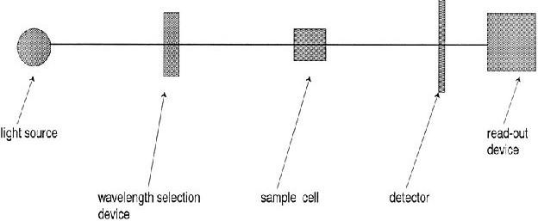

Fig 2.5 Schematic diagram for the layout of a single-beam UV–visible spectrophotometer

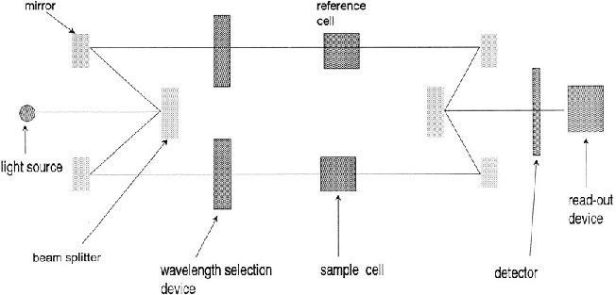

Fig 2.6 Schematic diagram for layout of a double-beam UV–visible spectrophotometer

## Dyes

## Bromocresol green

Bromocresol green (Fig 2.7) belongs to the triphenylmethane family. It is used as a pH indicator in acid-base titrations and in growth mediums of microorganisms. It is beige to brown powder with a molecular mass of 698.01 g/mol and has a wavelength of maximum absorption of 423 nm. It ionizes in aqueous solution to give the monoanionic form (yellow) that further deprotonates at higher pH to give the dianionic form (blue) at a dissociation constant of 4.8 (Diamond *et al*, 2008).

HO Br Br OH

Br

H3C

Br

CH3

O

S O O

Fig 2.7 Structure of bromocresol green

## Thymol blue

Thymol blue (Fig 2.8) also known as thymolsulfonephthalein is a brownish-green crystal powder also used as a pH indicator in acid-base titrations and in growth mediums of microorganisms. It has a melting point of 221-224˚C, insoluble in water but soluble in alcohol and diluted alkali solutions. It has a molar mass of 466.59g/mol and two wavelengths of maximum absorption i.e. at 594nm and 376nm (The Merck Index, 2006).

H OH

H3C

CH3 H3C CH3

O

CH3

O

S O

O

Fig 2.8 Structure of thymol blue

# CHAPTER THREE

* 1. **MATERIALS AND METHOD**

## Materials

## Drugs and reference standards

* Risperidone reference standard (supplied by Janssen- cilag)
* Drug A: Rispzen® tablets 2 mg
* Drug B: Amidrex® tablets 2 mg
* Drug C: Zespidone® tablets 2 mg
* Drug D: Risperdal® tablets 2 mg

## Equipment and glassware

* A double scanning UV/VIS spectrophotometer (Helios Zeta, Model 164617).
* Mettler AE 240 digital analytical balance, Mettler Instruments Limited, Switzerland.
* Beakers, 10, 50, 100 ml
* Glass funnel
* Pipettes, 1, 10 ml
* Volumetric flasks, 100 ml
* Whatman filter paper no. 41
* Spatula
* Hand gloves

## Chemicals and reagents

* Ethylacetate
* Methanol
* Dyes (Bromocresol green, Thymol blue)

## Methods

## Optimization of variables

### Choice of solvent for risperidone stock standard solution

10 mg of risperidone was weighed and dissolved in 100 ml of acetone, methanol, dichloromethane and ethylacetate to give a stock standard solution of 100 µg/ml. 0.5 ml of 0.1% dye was added to 1 ml of the each stock standard solution and the solution was made up to the 5 ml mark. The absorbance was taken for each solution in the range 200-600 nm.

### Choice of solvent for dyes

0.1 g of each of bromocresol green and thymol blue was measured and dissolved in 100 ml of acetone, methanol and ethylacetate.

### Determination of working concentration of dyes

From the 0.1% solution of dye, 0.125, 0.25, 0.5, 1 ml was measured and added to 1 ml of risperidone stock solution. The solution was made up to the 5 ml mark and the absorbance taken for each solution in the range 200-600 nm.

### Determination of reaction time and stability of ion-pair complex

0.5 ml of 0.1% bromocresol green and 0.25 ml of thymol blue was added to 1 ml of risperidone stock standard solution and scanned at 10 minutes, 15 minutes, 1 hour, and 2 hours in the range 200-600 nm.

## Preparation of solutions and reagents

### Preparation of standard stock solution of risperidone

A stock standard solution equivalent to 100 µg/ml risperidone was prepared by dissolving 10 mg of the pure drug in 100 ml of ethylacetate.

### Preparation of 0.1% bromocresol green

0.1 g of bromocresol green was weighed and dissolved in 5 ml of methanol and made up to 100 ml with methanol.

### Preparation of 0.1% thymol blue

* 1. g of thymol blue was weighed and dissolved in 5 ml of methanol and made up to 100 ml with methanol.

## Determination of λ max

2 ml of stock standard solution of risperidone was measured into two separate 10 ml beakers. 0.5 ml 0.1% bromocresol green was added to beaker one and 0.25 ml 0.1% thymol blue was added to beaker two, and each made up to 5 ml with ethylacetate. The solution was scanned on spectrophotometer in the range 200- 600 nm.

## Determination of stoichiometry of ion-pair complex

The Job‟s method of continuous variation of equimolar solutions was employed. Solutions equivalent to 4.10 X 10-3 M risperidone in ethylacetate and 6.98 X 10-3 M bromocresol green and 4.67 X10-3 M thymol blue in methanol were prepared. 1, 0.75, 0.5, 0.25 and 0 ml

of bromocresol green and thymol blue were added separately to 0, 0.25, 0.5, 0.75 and 1 ml of rispeidone respectively in a series of 10 ml beakers and made up to 5 ml with ethylacetate. The absorbance was taken at 414 nm and 404 nm for bromocresol green and thymol blue respectively and a plot of absorbance against mole fraction of the drug was plotted.

## Identification and assay of risperidone (Official methods)

### Identification of risperidone

Risperidone was identified by using official method of infrared absorption spectrophotometry (BP, 2009).

### Assay of risperidone

To determine purity of reference standard, 0.160 g of risperidone was dissolved in 70 ml of a mixture of 1 volume of anhydrous acetic acid and 7 volumes of methyl ethyl ketone and titrated with 0.1 M perchloric acid. The end-point was determined potentiometrically. 1 ml of 0.1 M perchloric acid is equivalent to 20.53 mg of C23H27FN4O2 (BP, 2009).

## Calibration curves

### Preparation of calibration curve for method 1

Aliquots of stock standard solution, 0.2, 0.4, 0.6, 0.8, 1.0 ml of risperidone were transferred into a series of 10 ml calibrated flask. To this, 0.5 ml of 0.1% bromocresol green was added, and the contents were diluted to the 5 ml mark with ethylacetate to give a concentration of 4, 8, 12, 16, 20 µg/ml of risperidone. The absorbance of the ion-pair complex was measured at 414 nm against the reagent blank prepared similarly but without

drug content. The amount of risperidone in the pure sample and tablets was computed from the concurrent regression equation of the calibration curve.

### Preparation of calibration curve for method 2

Aliquots of stock standard solution, 1, 1.25, 1.5, 1.75, 2.0 ml of risperidone were transferred into a series of 10ml calibrated flask. To this, 0.25 ml of 0.1% thymol blue was added, and the contents were diluted to the 5 ml mark with ethylacetate to give a concentration of 20, 25, 30, 35, 40 µg/ml of risperidone. The absorbance of the ion-pair complex was measured at 414 nm against the reagent blank prepared similarly but without drug content. The amount of risperidone in the pure sample and tablets was computed from the concurrent regression equation of the calibration curve.

## Validation of methods

### Precision

The precision of the method was checked by replicate analysis of the calibration curve responses determined. This was done by taking five replicates of 3 concentrations (low, medium, high) off the calibration curve (intra-day precision) and three replicates of 3 concentrations (low, medium, high) off the calibration curve (inter-day precision). The percentage coefficient of variation (% CV) for the replicate analysis is calculated thus:

% CV = S/X × 100

Where S is the standard deviation and X is the mean

The percentage relative error (% Er) was also calculated as follows

% Er = X - µ / µ × 100

Where X is the mean and µ is the expected value

### Accuracy

The accuracy of this method was checked by the recovery method via the standard addition method and by comparison with a reference method as reported in the BP (2009).

*Recovery method (method 1)***:** The recovery method was carried out by having four 5 ml beakers each containing 1 ml of 20 µg/ml drug concentration. Flask 1 was left untouched but 0.2, 0.6 and 1 ml of the standard stock solution were added in flask 2, 3 and 4 respectively and made up to the 5 ml mark with ethylacetate to obtain concentrations 24, 32 and 40 µg/ml respectively. The absorbance of each solution was measured and the drug content was determined by subtracting the absorbance of the starting 20 µg/ml concentration from that found in each of the respective concentrations and extrapolating the final concentration from the calibration curve (Deepakumari and Revanasiddapa, 2013).

*Recovery method (method 2)***:** The recovery method was carried out by having three 5 ml beakers each containing 1ml of 10 µg/ml drug concentration. Flask 1 was left untouched but 1 ml and 1.5 ml of the standard stock solution were added to flask 2 and 3 and made up to 5ml with ethylacetate to obtain concentrations 30 and 40 µg/ml respectively. The absorbance of each solution was measured and the drug content was determined by subtracting the absorbance of the stating 10 µg/ml concentration from that found in each of the respective concentrations and extrapolating the final concentration from the calibration curve (Deepakumari and Revanasiddapa, 2013).

The percentage recovery via the recovery method was computed using the formula:

% Recovery = measured concentration / added concentration × 100

The average of these determinations was taken as the percentage recovery. Simple dilution method was adopted in determining the actual quantities that were taken from the stock solution. The dilution formulas that were used are as follows:

C1V1 = C2V2

C1V1 + (C2V2) = C3V3

*Comparison with reference (BP) method*

Reference method was carried out (as described in section 3.2.4) on each of the four brands of risperidone tablet. The two methods developed were also used to analyze the four brands and the three methods were compared statistically using the *t*-test.

### Specificity

This was determined by interference studies in which 0.001 g of lactose, 0.0001 g of sodium lauryl sulphate and 0.0009 g were added to three beakers each containing 1 ml of stock standard solution. 0.5 ml of 0.1% bromocresol green was added and made up to the 5 ml mark with ethylacetate to give a concentration of 20 µg/ml. The absorbance was taken at 414 nm and 404 nm for methods 1 and 2 respectively.

### Limit of detection

The limit of detection (LOD) was determined by studying the calibration curves using samples in the range of LOD containing the drug in the concentrations of 4, 8, 12 16 and

20.0 µg/ml (bromocresol green) and 20, 25, 30, 35 and 40 µg/ml (thymol blue). The standard deviation of *y*-intercepts of the regression lines was used as standard deviation. LOD is expressed as:

LOD = 3.3 𝜎 / S

Where 𝜎 is the standard deviation of *y*-intercepts of the regression lines and S is the slope of the calibration curve.

### Limit of quantification

The limit of quantification (LOQ) was determined using the expression: LOQ = 10 𝜎 / S

Where 𝜎 is the standard deviation of *y*-intercepts of the regression lines and S is the slope of the calibration curve.

## Assay of risperidone tablets using developed methods

Twenty tablets were grounded into fine powder and the quantity of powder equivalent to 10 mg of risperidone was weighed accurately into a 100 ml calibrated flask and 10 ml of ethylacetate was added. The content was shaken for 30 minutes, made up to the 100 ml mark with ethylacetate, mixed well and filtered using a Whatman No.41 filter paper. The filtrate containing risperidone was subjected to analysis after suitable dilutions by adding

0.5 ml of bromocresol green, making up to 5 ml with ethylacetate and taking the absorbance at 414 nm. In method 2, 0.25 ml of thymol blue was used instead and the absorbance was taken at 404 nm.

# CHAPTER FOUR

# RESULTS

## Optimization of Variables.

Ethylacetate was adopted as solvent for risperidone because of its higher sample absorbance when compared to other solvents (Table 4.1) while methanol was adopted as solvent for the dyes because they are both soluble in it (Table 4.2). 0.5 ml and 0.25 ml of bromcresol green and thymol blue respectively were found to be the concentrations at which the highest sample absorbances were gotten (Table 4.3) and thus adopted as working concentrations. Finally, 10 minutes was found to be sufficient for the formation of ion-pair complexes between risperidone and the dyes and the complex was found to be stable for up to 2 hours.

Table 4.1 Choice of solvent for risperidone

|  |  |
| --- | --- |
| **Solvent (risperidone)** | **Sample absorbance (Å)** |
| **Acetone** | 0.1 |
| **Dichloromethane** | 0.4 |
| **Ethylacetate** | 0.6 |
| **Methanol** | 0.2 |

Table 4.2 Choice of solvent for dyes

|  |  |
| --- | --- |
| **Solvent** | **Solubility** |
| **Ethylacetate** | BCG: Soluble TB: Insoluble |
| **Acetone** | BCG: Soluble TB: Insoluble |
| **Methanol** | BCG: Soluble TB: Soluble |

Table 4.3 Choice of dye concentration

|  |  |  |  |  |
| --- | --- | --- | --- | --- |
| **Volume (ml)** | **0.125** | **0.25** | **0.5** | **1.0** |
| **SAMPLE ABSORBANCE(Å)** | | | | |
| **Bromocresol green** | 0.05 | 0.1 | 0.6 | 0.3 |
| **Thymol blue** | 0 | 0.175 | 0.160 | 0.150 |

## Stoichiometry of Ion-pair Complex

The Job‟s method of continuous variation graphs (Fig 4.1 and 4.2) for the reaction between risperidone and bromocresol green or thymol blue respectively, shows that the reaction occurs on an equimolar basis via the formation of an ion-pair complex in the ratio1:1.



Mole fraction of risperidone

1.2

1

0.8

0.6

0.4

0.2

0

0

0.1

0.2

Series1

0.3

0.4

0.5

0.6

Absorbance

Fig 4.1 Job‟s plot for risperidone: bromocresol green ion-pair complex

Absorbance

Fig 4.2 Job‟s plot for risperidone: thymol blue ion-pair complex



Mole fraction of risperidone

1.2

1

0.8

0.6

0.4

0.2

0

0

0.05

Series1

0.1

0.15

0.2

0.25

## Calibration Curves

The calibration curves (Fig 4.3 and 4.4) for the quantitative determination of risperidone obeyed the Beer-Lambert‟s law. The linear relationship between absorbance *(y*) and concentration (*x* in µg/ml) gives the regression equation *y* = a + b*x*. Calibration parameters were extrapolated from the calibration curve (Table 4.4).

**Absorbance**

Fig 4.3 Calibration curve of risperidone-bromocresol green complex



0.2

**Concentration in mcg/ml**

25

20

15

10

5

0

0

**Bromocresol green**

Series1

Linear (Series1)

0.4

0.6

0.8

y = 0.055x + 0.020

R² = 0.994

1

1.2



**Concentration in mcg/ml**

-0.2

50

40

30

20

10

0

0.2

0

Series1

Linear (Series1)

0.8

0.6

0.4

y = 0.027x - 0.008

R² = 0.995

1.2

1

**Thymol blue**

**Absorbance**

Fig 4.4 Calibration curve of risperidone-thymol blue complex

Table 4.4 Calibration parameters

|  |  |  |
| --- | --- | --- |
| **Parameter** | **Bromocresol green** | **Thymol blue** |
| **Wavelength of maximum absorption**  **(nm)** | 414 | 404 |
| **Linear range (µg/ml)** | 2-20 | 20-40 |
| **Molar absorptivity (L/mol x cm)** | 2.32 x 105 | 1.17 x 105 |
| **Sandell’s sensitivity (µg/cm2)** | 0.3455 | 0.3333 |
| **Correlation coefficient (r)** | 0.994 | 0.995 |
| **Intercept (a)** | 0.020 | -0.008 |
| **Slope (b)** | 0.055 | 0.027 |

## Validation of Methods

The accuracy, precision, specificity percentage recoveries, limit of detection and limit of quantification for the two methods are shown in table 4.5.

Table 4.5 Validation parameters

|  |  |  |
| --- | --- | --- |
| **Parameter** | **Bromocresol green** | **Thymol blue** |
| **Precision (% CoV)** | 4.6 | 7.1 |
| **Accuracy (% RE)** | 1.4 | 1.2 |
| **Accuracy: % Recovery (standard addition method)** | 101.5 | 99.7 |
| **Specificity:% Recovery (interference studies)** | 100.9 | 99.9 |
| **Limit of detection (µg/ml)** | 1.27 | 7.00 |
| **Limit of quantification (µg/ml)** | 3.84 | 21.15 |

## Assay of Risperidone Tablets

The assay results of the risperidone tablets for both the developed methods and the British Pharmacopoeial method are shown in table 4.6.

Table 4.6 Assay results (Percentage recovery of risperidone in tablets)

|  |  |  |  |
| --- | --- | --- | --- |
| **Brands** | **Reference method X (BP 2009)** | **Bromocresol green** | **Thymol blue** |
| **Rispzen® (%)** | 102.7 | 102.3 | 97.0 |
| **Amidrex® (%)** | 102.7 | 99.8 | 97.0 |
| **Zespidone® (%)** | 62 | 67.6 | 62.8 |
| **Risperdal® (%)** | 102.7 | 98.8 | 97.3 |

## 4.6 Statistical Analysis

The outcome of the statistical analysis of the assay of the risperidone tablets is presented below in table 4.7.

Table 4.7 Statistical analysis of assay results (p  0.05)

|  |  |  |  |
| --- | --- | --- | --- |
| **Brands** | **Methods X & A** | **Methods X & B** | **Methods A & B** |
| **Rispzen® (%)** | 0.08 | 1.14 | 1.06 |
| **Amidrex® (%)** | 0.58 | 1.14 | 0.56 |
| **Zespidone® (%)** | 1.12 | 0.16 | 0.96 |
| **Risperdal® (%)** | 0.78 | 1.08 | 0.30 |

# CHAPTER FIVE

# DISCUSSION

The choice of ethylacetate, which has a high sample absorbance, is affordable and readily available conferred on the methods developed- advantages over the method reported by Deepakumari *et al*. (2013) where dichloromethane was used as solvent for risperidone. Akachukwu *et al*. (2013) and Archana *et al*. (2013) used methanol as solvent for risperidone. However, from the result of the optimization of variables, methanol gave a lower sample absorbance of 0.2 Å as against that of ethylacetate which was 0.6 Å. Deepakumari *et al*. (2013) adopted acetone has solvent for the dyes. Thymol blue was not soluble in acetone but was soluble in methanol which informed the choice of methanol in this research work.

The concentration of dyes used in the analysis of risperidone was varied with the aim of obtaining a spectrum that depicts the highest sample absorbance. 0.125, 0.25, 0.5 and 1 ml of the dyes was used. It was discovered that 0.5 ml of bromocresol green and 0.25 ml of thymol blue gave the highest sample absorbance. Hence, these concentrations were employed. The concentrations adopted are similar to those employed in previous methods developed that employed the use of dyes (Hassan, 2008; Deepakumari *et al*., 2013).

The reaction time was found to be within 10 minutes and the ion-pair complex was stable for up to 2 hours. This makes the methods developed easy to conduct and confers on it flexibility as the ion-pair complex can be kept for a while before carrying out the analysis. The reaction times adopted are similar to those employed in previous methods developed that employed the use of dyes (Hassan, 2008; Deepakumari *et al*., 2013). However,

Hassouna and Zaki (2014) reported a reaction time of 20 minutes for the charge-transfer reaction between risperidone and tetracyanoethylene (TCNE).

The calibration curve for the complexes obey the Beer-Lambert‟s law (linearity) within the range of 0-20 µg/ml for bromocresol green and 20-40 µg/ml for thymol blue. However, further analysis showed that the limit of this law is 60 µg/ml and 40 µg/ml for bromocresol green and thymol blue respectively. Hassan (2008) reported a linearity of 0.1-12 µg/ml and 0.5-11 µg/ml for methyl orange and orange G respectively while Deepakumari *et al*. (2013)

reported 0.5-10 µg/ml and 0.5-25 µg/ml for bromophenol blue and phenol red respectively. The two methods were validated using the ICH (2005) guidelines. The precision (% CoV) for the two methods was 4.6 and 7.1 for bromocresol green and thymol blue respectively. The relatively low percentages of coefficient of variation (% CoV) which are within the acceptable limit of < 15 % CoV, show the precision of the methods. The percentage

relative errors (% RE) were 1.4 and 1.2 for bromocresol green and thymol blue respectively. This is within the range of 1-5 % and portrays the accuracy of the methods (Harvey, 2000). Hassan (2008) reported % RE of 1.01 and 1.11 for methyl orange and orange G respectively while Deepakumari *et al*. (2013) reported 1.32 and 0.42 for bromophenol blue and phenol red respectively. The two methods also exhibited good recoveries in the standard addition method (101.5 and 99.7 % respectively) and interference studies (100.9 and 99.9 % respectively). Hassan (2008) reported percentage recoveries of 149 and 152 % for methyl orange and orange G respectively while Deepakumari *et al*. (2013) reported 101.06 and 100.92 % for bromophenol blue and phenol red respectively. This shows that the methods have good accuracy and specificity. The

limits of detection were 1.27 and 7.00 µg/ml while the limit of quantification were 3.84 and

21.15 µg/ml for bromocresol green and thymol blue respectively.

The percentage recovery of risperidone in tablets using the two methods developed fell between the range of official limits of the BP (2009) (97.5- 102%) and IP (2006) (97- 103%) except for Zespidone® which fell below the official limits for both the reference and developed methods. Hassan (2008) reported percentage recoveries of 99.3 % for both methyl orange and orange G while Deepakumari *et al*. (2013) reported 101.06 and 101.54

% for bromophenol blue and phenol red respectively on analysis of different brands of risperidone.

# CHAPTER SIX

# CONCLUSION

In conclusion, the two spectrophotometric methods developed for the determination of risperidone in pure and tablet dosage forms have been validated and there is no significant difference (P < 0.05) between the two methods and the reference BP (2006) method. Therefore, it can be concluded that an accurate and precise method has been developed for the quantitative determination of risperidone by formation of an ion-pair complex with bromocresol green or thymol blue; thus accepting the research hypothesis.

# REFERENCES

Akachukwu, I., Nwodo, N.J. and Mbah, C.J. (2013). Spectrophotometric method for determination of risperidone in pharmaceutical bulk and dosage forms. *International journal of pharmacy*, 3(4): 710-715.

Aravagiri, M. and Mander, S.R. (2000). Simultaneous determination of risperidone and 9- hydroxyrisperidone in plasma by liquid chromatography/ electrospray tandem mass spectrometry. *Journal of Mass Spectrometry,* 35: 718.

Archana, S., Prasanna, Y.N., Pavitra, P., Krupa, D.S. and Sri, M.H. (2013). Development and validation of spectrophotometric method for determination of risperidone by MBTH. *International Journal of Pharmaceutical Sciences and Research,* 4(3): 1116-1119.

Avenoso, A., Facciolà, G., Salemi, M. and Spina, E. (2000). Determination of risperidone and its major metabolite 9-hydroxyrisperidone in human plasma by reversed-phase liquid chromatography with ultraviolet detection. *Journal of Chromatography B*, 746(2): 173–181.

Balant-Gorgia, A.E., Gex-Fabry, M., Genet, C. and Balant, L.P. (1999). Therapeutic drug monitoring of risperidone using a new, rapid HPLC method. *Therapeutic Drug Monitoring*, 21: 105.

Baldaniya, S.L., Bhatt, K.K. Mehta, R.S. and Shah, D.A. (2008). RP-HPLC estimation of risperidone in tablet dosage forms, *Indian Journal of Pharmaceutical Sciences,* 70(4): 494- 497.

Ballard, C.G., Waite, J. and Birks, J. (2012). Atypical antipsychotics for aggression and psychosis in Alzhemier‟s disease. *The Cochrane Collaboration,* 5: 1-135.

Bhatt, J., Subbaiah, G. and Singh, S. (2006). Liquid chromatography/ tandem mass spectrometry method for simultaneous determination of risperidone and its active metabolite 9-hydroxyrisperidone in human plasma. *Rapid Communications in Mass Spectrometry*, 20(14): 2109–2114.

Blaedel, W. J., and Meloche, V. M. (2001). *Elementary Quantitative Analysis: Theory and Practice* (2nd ed.). Harper and Row, NewYork, USA, pp. 254.

Booth, R.G. (2008). Psychotherapeutic Drugs: Antipsychotic and anxiolytic agents. In *Foye’s Principle of Medicinal Chemistry,* (6th ed.). Lippincott, Williams and Wilkins, Philadephia, USA, pp. 601-630.

BP (2009). British Pharmacopoiea, Vol. l. University Press, Cambridge, United Kingdom,

pp. 106-107.

Busatto, G.F. and Kerwin, R.W. (1997). Perspectives on the role of serotonergic mechanism in the pharmacology of schizophrenia. *Journal of psychopharmacology;* 11: 3-12.

Deepakumari, H.N., Mallegowda, S.M., Vinay, K.B. and Revanasiddappa, H.D. (2013). Simple and extraction-free spectrophotometric methods for risperidone in pure form and in dosage forms. *Chemistry Industry and Chemical Engineering Quarterly,* 19(1): 121−128.

Deepakumari, H.N. and Revanasiddappa, H.D. (2013). Use of the charge transfer reactions for the spectrophotometric determination of risperidone in pure and in dosage forms. *Journal of Pharmaceutics*, Article ID 792186, 6 pages.

DeVane, C.L. and Nemeroff C.B., (2001). An evaluation of risperidone drug interactions.

*Journal of Clinical Psychopharmacology*, 21(4): 408-416.

Diamond, D., Law, K.T., Brady, S. and Cleary, J. (2008). Integration of analytical measurements and wireless communication- current issues and future strategies. *Talanta,* 75(3): 600.

El-Sherif, Z.A., El-Zeany, B., and El-Houssini, O.M. (2005). High performance liquid chromatographic and thin layer densitometric methods for the determination of risperidone in the presence of its degradation products in bulk powder and in tablets, *Journal of Pharmaceutical and Biomedical Analysis*, 36(5): 975–981.

Hardman, G., Limbid, L.E. and Gilman, A.G. (2001). *The Pharmacological Basis of Therapeutics* (10th ed.). McGraw-Hill, New York, USA, pp 279.

Harikrishna, K., Nagaralli, B.S. and Seetharamappa, J. (2008). Extractive spectrophotometric determination of sildenafil citrate in pure and pharmaceutical formulations. *Journal of Food and Drug Analysis,* 16: 11-17.

Harvey, D. (2000). *Modern Analytical Chemistry*. McGraw-Hill, New York, USA, pp. 39.

Hassan, W.E. (2008). Extractive colorimetric method for the determination of dothiepin hydrochloride and risperidone in pure and in dosage forms. *Chemical and Pharmaceutical Bulletin*, 56(8): 1092–1096.

Hassouna, M.E.M. and Zaki, G.A. (2014). Spectrophotometric determination of risperidone in pharmaceutical preparations by charge-transfer reactions. *International Journal of Advanced Research*, 2(4): 453-461.

<http://naminh.org/resources-medications-treatments-medications-risperdal-php> Retrieved on January 19, 2015.

Huang, M.Z., Shentu, J.Z., Chen, J.C., Liu, J. and Zhou, H. (2008). Determination of risperidone in human plasma by HPLC-MS and its application to a pharmacokinetic study in chinese volunteers*. Journal of Zhejiang University of Science B*., 9(2): 114- 120.

ICH (2005). International Conference On Harmonization of Technical Requirements for Registration of Pharmaceuticals for Human Use, ICH Harmonised Tripartite Guideline, *Validation of Analytical Procedures: Text and Methodology Q2(R 1)*, Complementary Guideline on Methodology, dated 06 November 1996, incorporated in November 2005, London, United Kingdom.

IP (2006). International Pharmacopoiea, Vol 1. World Health Organization, Geneva, Switzerland.

Joshi, A., Jeyaseelan, C. and Jugade, R. (2006). Differential pulse polarographic studies of risperidone in pharmaceutical formulations. *Croatica Chemica Acta,* 79(4): 541- 544.

Kapur S. and Remington G. (1996). Serotonin- dopamine interaction and its relevance to schizophrenia. *American Journal of Psychiatry*, 153: 466-476.

Kar, A. (2005). *Pharmaceutical drug analysis* (2nd ed.). New age international, New Delhi, India, pp. 293-313.

Kirschbaum, K.M., Finger,S. and Vogel F. (2008). Liquid chromatography with column switching and spectrophotometric detection for determination of risperidone and 9- hydroxyrisperidone in human serum. *Chromatographia,* 67(3-4): 321–324.

Kulkarni, S., Chhabr, G. and Shivani, M. (2012). Development and validation of UV Spectrophotometric method for the determination of risperidone in bulk and tablets formulation. *International Journal of Pharmaceutical Chemistry*, 2(1): 10-14.

Kumar, M.S., Smith, A.A., Vasagam, G.A., Muthu, A.K. and Manavalan, R. (2010). Development of analytical method for risperidone by UV spectrophotometry. *International Journal of Pharmaceutical Sciences and Research,*1(2): 122-126.

Kutty, S.V., Yellinah, H.B., Greeshma, S. and Vidhya, P.M. (2013). Difference spectrophotometric method for the determination of risperidone in bulk and tablet dosage form. *The Pharma Innovation Journal*, 2(2): 44-49.

Locatelli, I., Mrhar, A. and Grabnar, I. (2009). Simultaneous detection of risperidone and 9-hydroxyrisperidone enantiomers in human blood plasma by liquid chromatography with electrochemical detection. *Journal of Pharmaceutical and Biomedical Analysis*, 50**:** 905.

Maalanka, A., Krzek, J. and Patrzaek, A. (2009). Determination of risperidone in tablets in the presence of its degradation products and placebo-derived constituents. *Acta Poloniae Pharmaceutica- Drug Research*, 66(5): 461-470.

McClean, S., O‟Kane, E. J. and Symth, W.F. (2000). Electrospray ionization-mass spectrometric characterization of selected anti-psychotic drugs and their detection and determination in human hair samples by liquid chromatography- tandem mass spectrometry. *Journal of Chromatography B*., 740: 141.

Miyawa, J.H. and Schulman, S.G. (2002). Ultraviolet-visible spectrophotometry. In *Handbook of Pharmaceutical Analysis.* Marcel Decker, New York, USA, pp.202- 294.

Narayana, B. and Shetty, D.N. (2011). Development and validation of spectrophotomtric method for the determination of risperidone. *Der Pharmacia Lettre*; 3 (5):104-109.

Olaniyi, A.A. (Ed) (2000). *Principles of Drug Quality Assurance and Pharmaceutical Analysis.* Mosuro Publishers, Ibadan, Nigeria, pp. 209-272.

O‟Neil, M.J. (Ed) (2013). *The Merck Index- An Encyclopedia of Chemicals, Drugs and Biologicals*. Royal Society of Chemistry, Cambridge, United Kingdom, pp.153.

Potter, W.Z. and Hollister, L.E. (2001). Antipsychotic agents and lithium. In *Basic and Clinical Pharmacology,* (8th ed.). McGraw-Hill, New York, USA, pp 478-497.

Prakash, V.D., Krishna, S., Swapna, B., Rakesh, G., Srikanth, B., Madhu Babu, A., Padmanabha and Rao, A.B. (2014). Method development and validation for estimation of risperidone in novel liquisolid formulation by RP-HPLC. *Der Pharmacia Lettre*, 6 (1): 166-174.

Pucci, V., Raggi, M.A. and Kenndler E. (2000). Quality control of pharmaceutical formulations of neuroleptic drugs by capillary zone electrophoresis. *Journal of Liquid Chromatography. Related Technol*ogies**,** 23(1): 25-34.

Roge, A.B., Shendarkar, G.R., Ghiware, N.B., Gond, N.Y. and Vadvalkar, S.M. (2013). Absorption correction method for estimation of risperidone and trihexyphenidyl hydrochloride in combined tablet dosage form. *International Journal of Chemtech Research*, 5(1): 121-126.

Schatz, D.S. and Saria, A. (2000). Simultaneous determination of paroxetine, risperidone and 9-hydroxyrisperidone in human plasma by high-performance liquid chromatography with coulometric detection. *Pharmacology,* 60: 51-56.

Schuberth, J. (1996). Volatile organic compounds determined in pharmaceutical products by full evaporation technique and capillary gas chromatography/ ion-trap detection. *Analytical Chemistry*, 68(8): 1317–1320.

Shengquan, L. (2011). Central nervous system depressants. In *Wilson and Gisvold’s Textbook of Organic Medicinal and Pharmaceutical Chemistry* (12th ed.). Lippincott, Williams and Wilkins, Philadephia, USA, pp 443-470.

Song, Z. and Wang, C. (2004). Sensitive chemiluminescence assay for risperidone in pharmaceutical preparations. *Journal of Pharmaceutical and Biomedical Analysis,* 36(3):491-494.

Sweetman, S.C. (Ed) (2002). *Martindale- The Complete Drug Reference* (35th ed.). The royal pharmaceutical society of Great Britain, London, England. Pp. 921-922.

The Merck Index (2001). *Merck Research Laboratories. Division of Merck and Company*

(13th ed.)*,* New Jersey, USA, pp. 1627.

The Merck Index (2006). *Merck Research Laboratories. Division of Merck and Company*

(14th ed.), New Jersey, USA.

United State Pharmacopoeia (2006). National Formulary, US Pharmacopieal Convention Inc, MD, pp. 2109.

Woestenborghs, R., Lorreyne, W., Rompaey, F. and Heykants, J. (1992). Determination of risperidone and 9-hydroxyrisperidone in plasma, urine and animal tissues by high- performance liquid chromatography. *Journal of Chromatography B, Biomedical Sciences and Applications,* 583: 223-230.

Yunoos, M., Pragati, B. and Kumar, S. (2010). Development and validated new reverse phase high performance liquid chromatographic method for the determination of risperidone in bulk and tablet dosage forms. *Research Journal of Pharmaceutical, Biological and Chemical Sciences,* 1(2): 165-171.

Zhang, L., Jiao, Z., Yao, Z., Zhong, Y., Zhong, M. and Yu, Y. (2005). *Validation* of an LC-MS method for the determination of risperidone and its active metabolite 9- hydroxyrisperidone in human plasma. *Chromatography,* 61:245.

Zhang, G., Terry, A.V. and Bartlett, M.G. (2007). Sensitive liquid chromatography/tandem mass spectrometry method for the simultaneous determination of olanzapine, risperidone, 9-hydroxyrisperidone, clozapine, haloperidol and ziprasidone in rat brain tissue. *Journal of Chromatography B*, 858: 276–281.

Zhou, Z., Li, X., Li, K., Xie, Z., Cheng, Z. and Peng, W. (2004). Simultaneous determination of clozapine,olanzapine, risperidone and quetiapine in plasma by high-performance liquid chromatography electrospray ionization mass spectrometry*. Journal of Chromatography. B, Biomedical Sciences and Applications*, 802: 257-262.

# APPENDIX

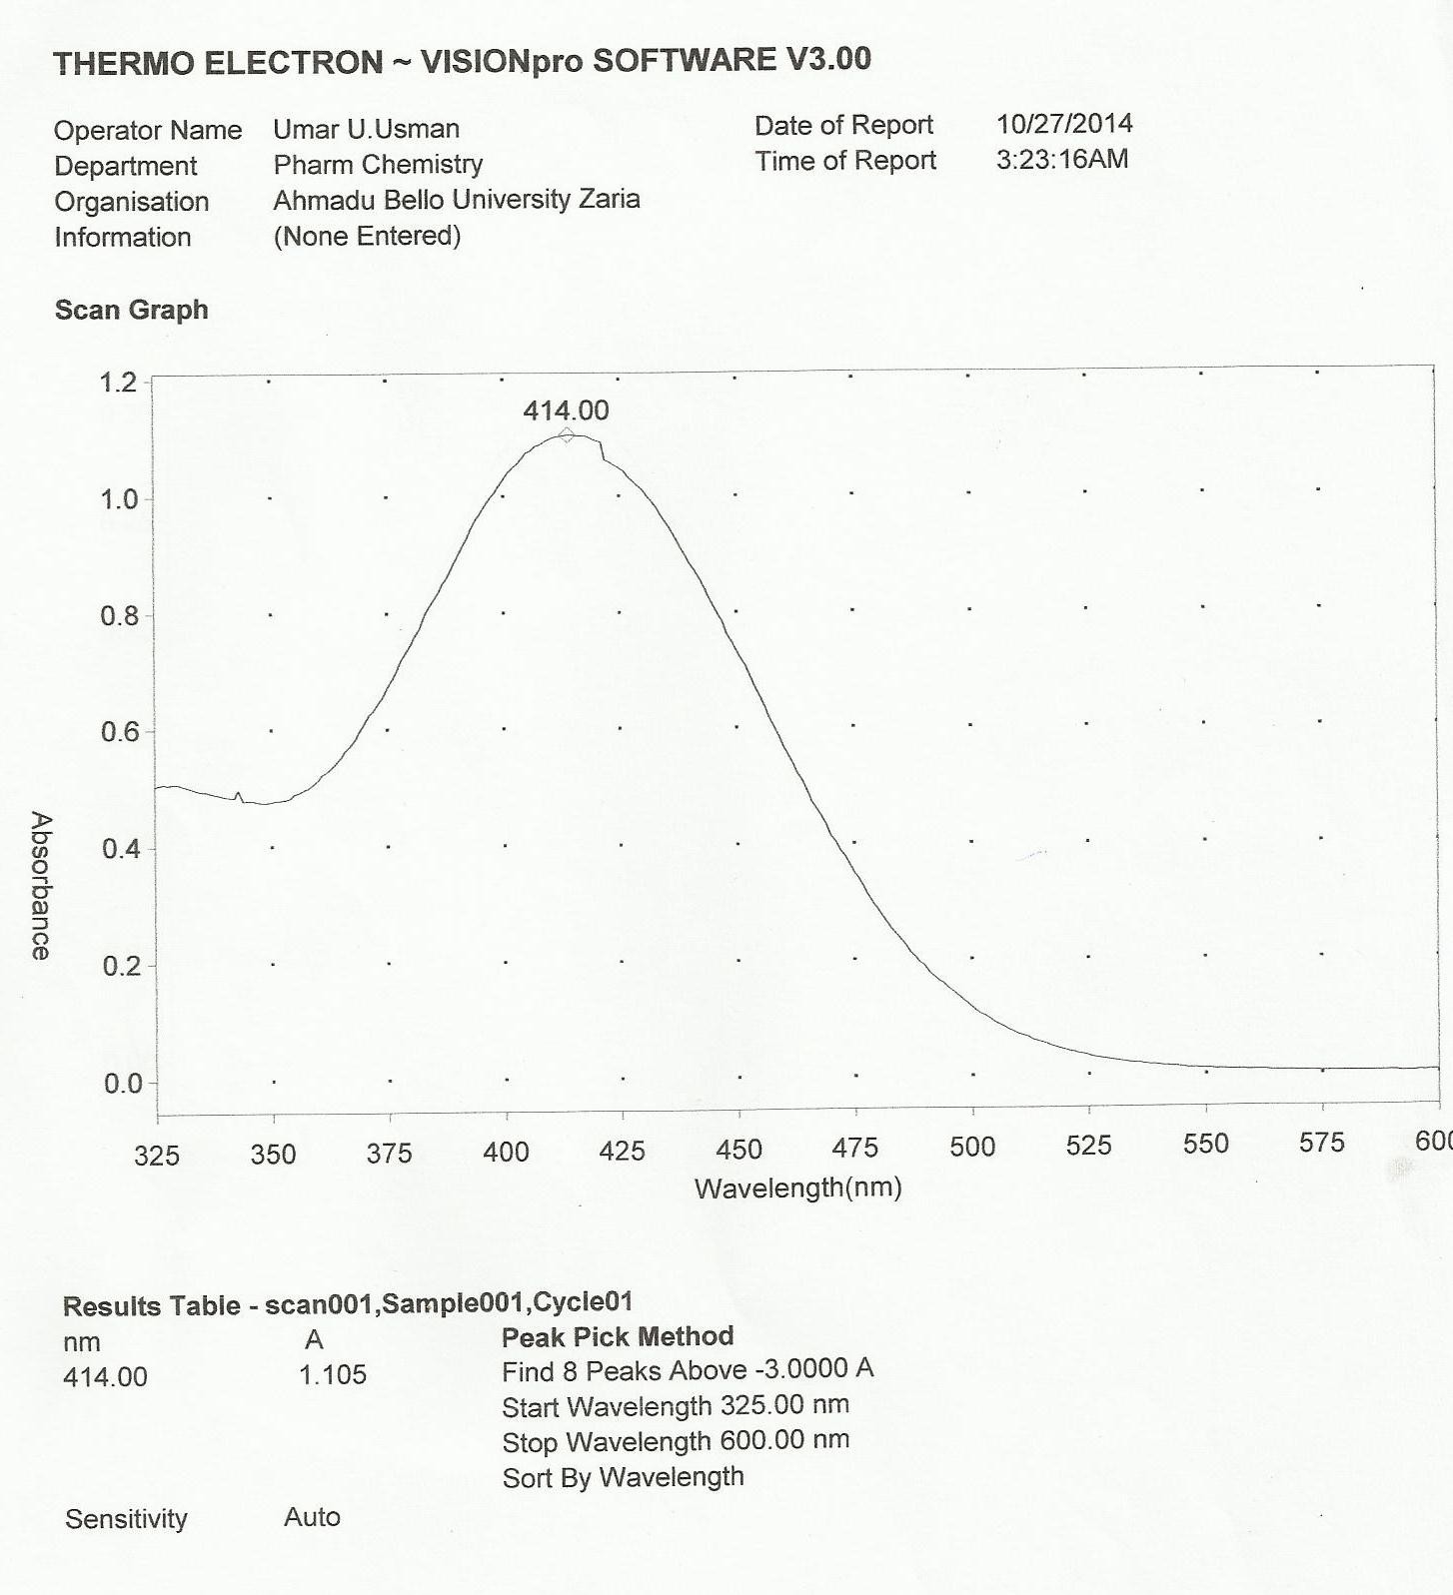

Appendix 1 Absorption spectra of risperidone and bromocresol green complex

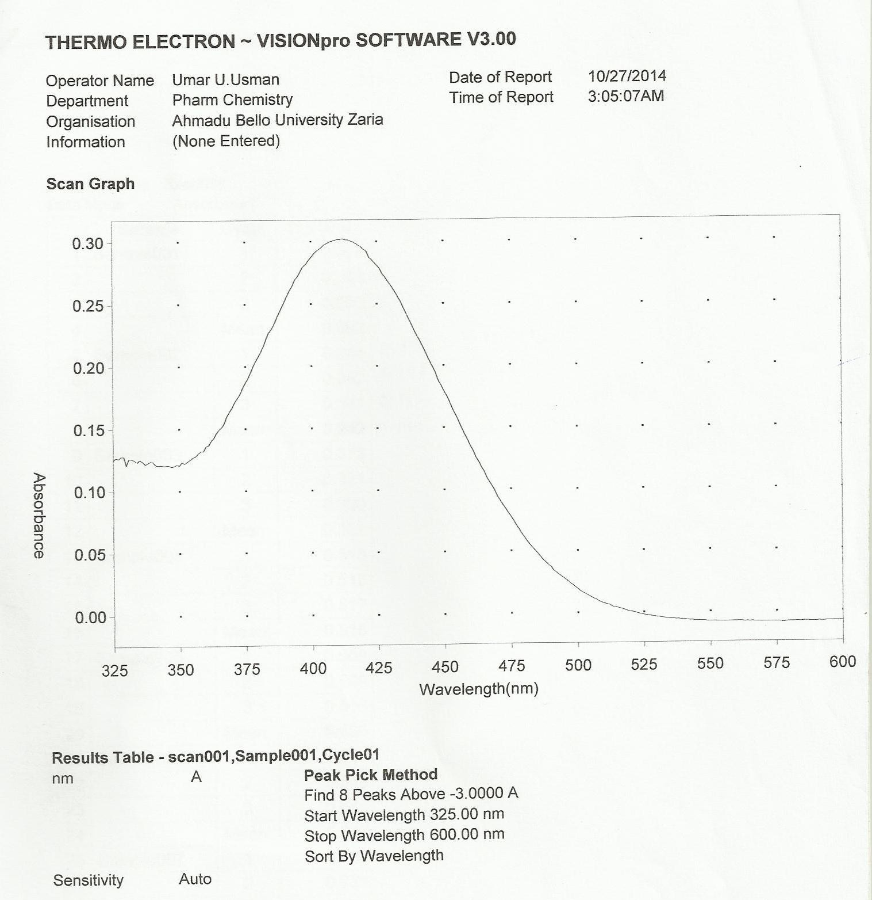

Appendix 2 Absorption spectra of bromocresol green

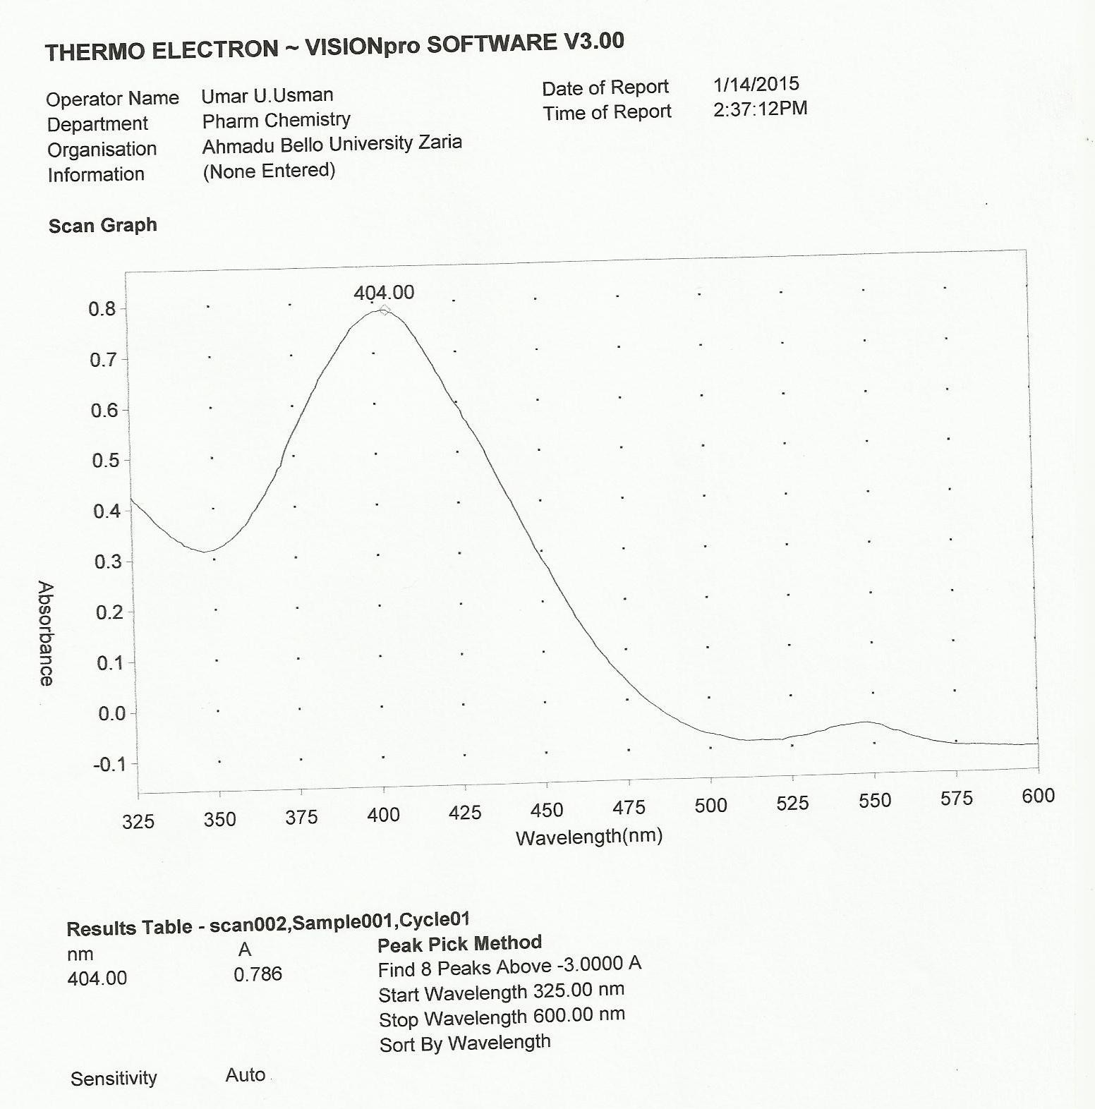

Appendix 3 Absorption spectra of risperidone and thymol blue complex

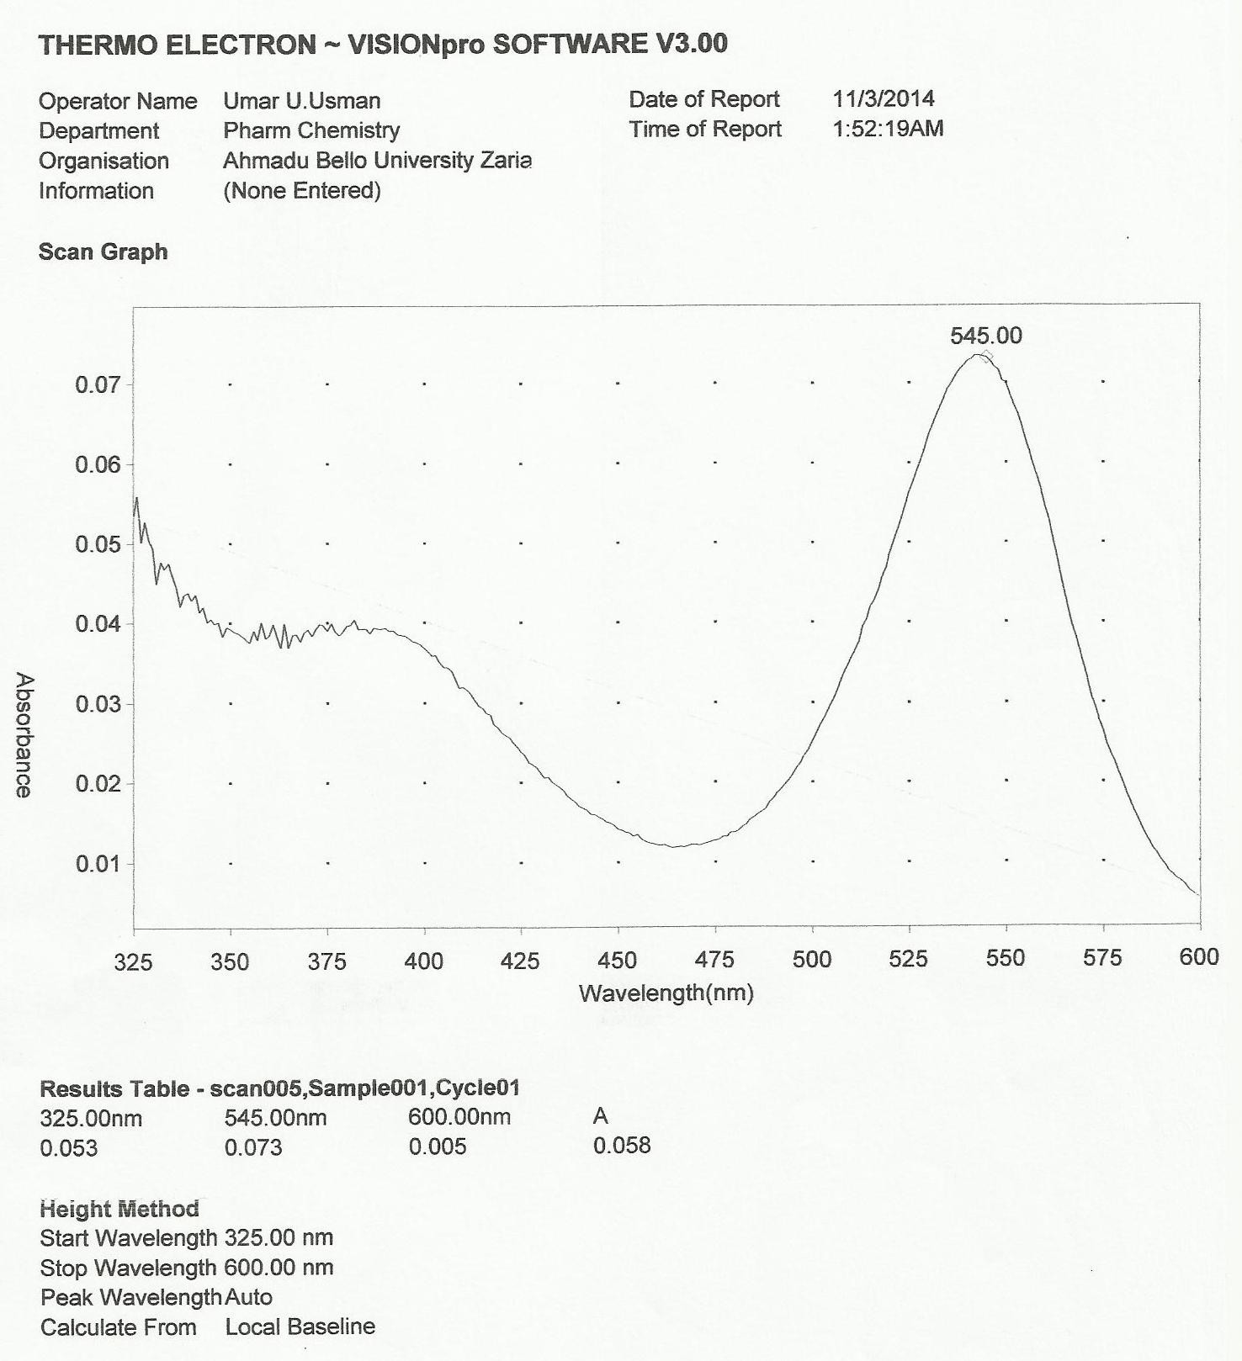

Appendix 4 Absorption spectra of thymol blue