**DEVELOPMENT AND VALIDATION OF FOUR NEW UVSPECTROMETRIC METHODS FOR THE DETERMINATION OF ISONIAZID (INH) IN PURE AND TABLET DOSAGE FORMS**

**BY**

**MAIGARI HAMZA KAKUDI**

**DEPARTMENT OF PHARMACEUTICAL AND MEDICINAL CHEMISTRY, FACULTY OF PHARMACEUTICAL SCIENCES,**

**AHMADU BELLO UNIVERSITY, ZARIA, NIGERIA**

**MARCH, 2019**

**DEVELOPMENT AND VALIDATION OF FOUR NEW UVSPECTROMETRIC METHODS FOR THE DETERMINATION OF ISONIAZID IN PURE AND TABLET DOSAGE FORMS**

**BY**

**Maigari Hamza KAKUDI, B. Pharm (A.B.U) 1993 P15 PHMC 8007**

**A DISSERTATION SUBMITTED TO THE SCHOOL OF POSTGRADUATE STUDIES, AHMADU BELLO UNIVERSITY, ZARIA**

**IN PARTIAL FULFILLMENT OF THE REQUIREMENTS FOR THE AWARD OF MASTER DEGREE IN PHARMACEUTICAL CHEMISTRY**

**DEPARTMENT OF PHARMACEUTICAL AND MEDICINAL CHEMISTRY, FACULTY OF PHARMACEUTICAL SCIENCES,**

**AHMADU BELLO UNIVERSITY, ZARIA, NIGERIA**

**MARCH, 2019**

### Declaration

I declare that the work in this Dissertation entitled ―Development and Validation of Four New UV Spectrophotometric Methods for Determination of Isoniazid in Pure and Tablet DosageForm‖ was carried out by me in the department of pharmaceutical and medicinal chemistry ABU Zaria. The information derived from the literature has been duly acknowledged in the text and a list of references provided. No part of this dissertation was previously presented for another degree or diploma at this or any other Institution.

Maigari Hamza Kakudi …………………. ………….. Name of student Signature Date

### Certification

This Dissertation entitled ―Development and Validation of Four New UV Spectrophotometric Methods for Determination of Isoniazid in Pure and Tablet Dosage Form‖ by Maigari Hamza Kakudi meets the requirements for the award of the degree of Master of Science in pharmaceutical chemistry of the Ahmadu Bello University and was approved by the committee for its contribution to knowledge and literary presentation.

Dr. Aminu Musa …………. …………

Chairman Supervisory Committee Signature Date

Prof.Magaji Garba……………. ………

Member Supervisory Committee Signature Date

Dr.AminuMusa..……… ……….

Head of Department Signature Date

Prof. SadiqZubairu Abubakar ................ ………

Dean, School of Postgraduate Studies Signature Date

### Acknowledgement

All praise and thanks are due to almighty Allah who in his infinite mercy made it possible for me to carry out this work.I wish to express my sincere gratitude and appreciation to my supervisors Dr. Aminu. Musa and Prof. Magaji Garba for their tireless effort, indulgence, accommodation,gu idance, patience, tolerance, understanding and commitment. They played the roles of not only supervisors but academic mentors. My thanks go to Prof U.U.Pateh (former Dean Faculty of Pharmaceutical Sciences, ABU Zaria) and Prof Aliyu Musa.(Head of Department of Pharmaceutical and Medicinal Chemistry ABU Zaria) for their help, support, mentoring and guidance. I also wish to express my appreciation to all the academic and non academic staff of th e department of pharmaceutical and medicinal chemistry, A.B.U. Zaria who contributed directly or indirectly to the success of this work. My appreciation also goes to DrSalisuAwwal, Dr. Nasir, IbrahimMalamIlyasu (chief technologist), MallamBalaRiti, MallamNafiu and Malam Umar for their assistance with UV spectrophotometry work.My sincere gratitude and appreciation to my professional colleagues and roommates Pharm Inuwa Bello, Pharm M.S. Ahmad. Pharm HussainiAbbah Mohammad, who support me by providing the pure Isoniazid standard powder and my entire P15PHMC class. I wish to say thank you.My sincere appreciation and prayers go to my late parent for initiating the process and for their support, encouragement and prayers, may Allah rewards you with JannatulFirdaus. My gratitude also go to my family especially my wives Nafisatu Sulaiman and Aisha Sulaiman, and my children for their patience and support, may Allah bless you abundantly.

I cannot conclude without extending my thanks to Dr. Abba Zakari Umar, Hon. Com. Jigawa state ministry of health, Dr. Kabiru Ibrahim, executive secretary, Jigawa state primary health

care agency and Alhaji Maigari Usman, (SardaunanSarawa) former director,administration and finance, Jigawa state primary health care agency for their support and indulgence.

## ABSTRACT

Tuberculosis (TB) is a serious infectious disease which is on increase since emergence of human immunodeficiency virus (HIV) leading to TB/HIV co infection, causing complications and treatment failure. Isoniazid is a first line drug for the treatment of TB therefore it is important to develop methods that will monitor its quality. In this study, four rapid, simple, relatively accurate, and precise spectrophotometric methods for the quantitative determination of isoniazid in pure and tablet dosage form were developed and validated. Methods 1 and 2 were based on dissolving standard isoniazid powder in distilled water and methanol respectively and scanning using UV-Vis spectrophotometer at a wavelength range of 200 - 400 nm to determine the wavelength of maximum absorption (λmax). Method 3 was based on condensation reaction between isoniazid and 2,4-di-nitrophenyl hydrazine (2,4 DNPH) and heating under acidic condition using 2 mL of 85 % hydrochloric acid (HCl) to form an orange-red hydrazone which was allowed to stand for few minutes for complete color development. Method 4 was based on the diazotization of isonizid with sodium nitrite (NaNO2) and coupling withparaaminotoluidine under acidic condition (2 % HCl) and gently heating to give a colouredchromagen (diazo dye) which was allowed to stand for few minutes for complete color development. The colouredhydrazone and diazo dye formed were scanned at visible range of 400-750 nm to determine their λmaxs. Calibration curves were prepared using these methods. The developed methods were validated using ICH guidelines with respect to linearity, precision, accuracy, percentage recovery, limit of detection (LOD) and limit of quantification (LOQ). Standard isonizid powder and a sample of isoniazid tablet were assayed using each method and compared with BP, 2009 method for the assay of isoniazid. Method 1 and 2 were observed to have a λmax of 264 nm while an orange-red and a yellow chromagencolours were formed for methods 3 and 4

with time for complete development and λmax 15 and 20 minutes, 464 and 420 nm respectively. Methods 1 and 2 obeyed Beer’s law within a concentration range of 1-11 μg/mL while the range for methods 3 and 4 was 1-18 μg/mL. The correlation coefficient for the calibration plot was 0.999 in each case. The precision of the methods were ≤ 1.57 (percentage coefficient of variation, % CV) while the accuracy, percentage relative error (% Er) and percentage recoveries were ≤ 4.130 and ≤ 102.01 respectively. The methods have LOD and LOQ of ≤ 0.145 and ≤

0.559 µg/mL respectively. All the validation parameters were within the normal ranges. The percentage content of isoniazid in the standard powder and brand of the tablet assayed using all the developed methods were within the BP range of 99 - 101 % and 98.0 – 102 % respectively. There was no significant difference (p < 0.05) between the percentages drug content assayed using the developed methods and that of the BP method, thus the developed methods can be interchanged with the BP method for quantitative estimation of isoniazid in pure and tablet dosage form.

## TABLE OF CONTENT

**Content Page Number**

Coverpage i

Title page ii

Declaration… iii

Certification… iv

Acknowledgement v

Abstract vii

Table of contents ix

List of tables… xiii

List of figures… xiv

List of appendices… xv

Abbreviation xvi

CHAPTER

ONE 1INTRODUC

TION 1

* 1. Theoretical Frame Work 2
  2. Statement of the Research 3
  3. Justification of the Research 4
  4. Aim of the Research 4
     1. Specific objectives 4

CHAPTER TWO 5

* 1. LITERATURE REVIEW 5
  2. Chemistry of Isonizid 5
     1. Mechanism of action of isonizid 5
     2. Uses of isoniazid 6
  3. Chemistry of Schiff Base 6
  4. Chemistry of Diazo dye 7
  5. Analytical Methods for the Determination of Isonizid 8
     1. UV spectrophotometric method using distilled water and methanol… 8
     2. Colourometric method using 2,4-dinitrophenyl hydrazine and diazotization… 8
     3. Compedial method of analysis 8
     4. Non compedial methods of analysis 8

CHAPTER THREE 15

* 1. MATERIALS AND METHODS 15
  2. Materials 15
     1. Isoniazid analytical grade standard powder and tablet… 15
     2. Chemicals and reagents 15
     3. Glass wares and accessories… 15
     4. Equipment… 16
  3. Methods……………………..…………………………’ 16
     1. Quality control of isoniazidstandard powder and tablets… 16
     2. Selection of solvents 18
     3. Preparation of solutions and reagents. 18
     4. UV spectrophotometric method using distilled water 18
     5. UV spectrophotometric method using methanol 19
     6. Development of colourometry method using 2,4dinitrophenylhydrazine and optimization 20
     7. Development of colourometric method using paraaminotoluidine (diazotization) and optimization 23
     8. Validation of the analytical methods 25
     9. Statistical analysis 28

CHAPTER FOUR 29

* 1. RESULTS 29
  2. Quality Control of Pure Isoniazid Standard Powder and Tablets 29
  3. Method Development 33
     1. UV spectrophotometric method using water and methanol 33
     2. Colorometeric methods using 2,4dinitrophenylhydrazine and by diazotization 33

CHAPTER FIVE 43

DISCUSSION 43

CHAPTER SIX 46

* 1. CONCLUSION AND RECOMMENDATIONS 46
  2. Conclusion 46
  3. Recommendations 46

REFERENCES 47

APPENDICES 52

## LIST OF TABLES

Table 4.1: Information of isoniazidtablet use for the research 29

Table 4.2: Melting point of isoniazid standard powder and tablet 30

Table 4.3: Solubility of isoniazid in different solvents 33

Table 4.4: Calibration parameters for UV spectrophotometric methods using water and methanol

……………………………………………………………………………………………………34

Table 4.5: Validation parameters for UV spectrophotometric methods using water and methanol… 37

Table 4.6: Calibration parameters of colourometric methods using 2,4-dinitrophenylhydrazine and by diazotization 38

Table 4.7: Validation parameters of colourometric methods using 2,4-dinitrophenylhydrazine and by diazotization 41

Table 4.8: Percentage content of isoniazid tablet 42

## LIST OF FIGURES

Figure 4.1 FTIR spectra of isoniazid standard powder and reference standard… 31

Figure 4.2 FTIR spectrum of isoniazid tablet and reference standard 32

Figure 4.3: Calibration curve of isoniazid in distilled water 35

Figure 4.4: Calibration curve of isoniazid in methanol 36

Figure 4.5: Calibration curve of isoniazid solution in 2,4-dinitrophenylhydrazine 39

Figure 4.6: Calibration curve of isoniazid solution in paraaminotoluidine 40

## LIST OF APPENDICES

Appendix I: FTIR spectrum of isoniazid standard powder 52

Appendix II: Preparation of reagents 53

Appendix III:UV absorption spectrum of isoniazid in distilled water 55

Appendix IV:UV absorption spectrum of isoniazid in methanol 56

Appendix V: UV absorption spectrum of isoniazid and 2,4-dinitrophenylhydrazine 57

Appendix VI: Calibration parameters of isoniazid in distilled water 58

Appendix VII: Effective concentration of 2,4-dinitrophenylhydrazinewith isoniazid for maximum absorption 59

Appendix VIII: Effective time for maximum color development 60

Appendix IX: Calculation of precision 61

Appendix X: Calculation of accuracy, percentage recovery, LOD and LOQ 65

Appendix XI: Slope, intercept and standard deviation 71

**ABBREVIATIONS**

ABU Ahmadu Bello University BCG Bromo cresol green

BPB Bromo phenol blue BP British pharmacopoeia CA Chloranilic acid

DDQ 2, 3-dichloro-5, 6-dicyano- l,4-benzoquinone LOD Limit of detection

LOQ Limit of quantification DNPH Dinitrophenylhydrazine EPI Epichlorohydrine

FTIR Fourier transform infrared H2SO4Sulphuric acid

H1NMR Proton nuclear magnetic resonance HPLC High performance liquid chromatography HClHydrochloric acid

HPC 4-hydroxyphenacylchloride HNQ 2-hydroxy-1,4-napthoquinone

ICH International conference on harmonization of requirements for registration of pharmaceuticals for human use

INH Isoniazid

KIO4 Potassium meta per iodide

MPA 6-methyl-2-pyridine carboxaldehyde NaIO4 Sodium meta per iodide NaNO2 Sodium nitrite

NQS 1, 2-naphthoquinone-4-sulfonate

NAFDAC National agency for food and drug administration and control NBS N-bromosuccinate

P-toluidine paraaminotoluidine

%CV Percentage coefficient of variation

%Er Percentage relative error p-DABparadimethylaminobenzaldehyde

PDT 3-(2-pyridyl)-5,6-diphenyl-1,2,4-triazine R2 Coefficient of determination

r Coefficient of corrilation

SD Standard deviation

TB Tuberculosis

SPSS Statistical package for social sciences TCNE Tetracyanoethelene

ThBThymol blue

UV-Vis Ultraviolet/Visible λmaxWavelength of maximum absorption WHO World health organization

2, 4-DNPH 2,4-dinitrophenylhydrazine

## CHAPTER ONE

* 1. **INTRODUCTION**

Isoniazid (INH) also known as isonicotinyl hydrazide, is a synthetic derivative ofisonicotinic acid hydrazide, chemically knownaspyridine-4-carboxylic acid hydrazide (BP, 2009). It is first line drug in the treatment of pulmonary and extra pulmonary tuberculosis in combination with other anti-tubercular drugs such asrifampicin, ethambutol, pyrazinamide and streptomycinto avoid development ofresistance(WHO, 2010,Niraimathi *et al*., 2013).Isoniazid is a pro-drug and requires activation by the bacterial catalase-peroxidase enzyme (BP, 2009).

HPLC is the most sensitive and selective means of determining isoniazid in its pure and tablet dosage form and methods have been reported (Khuhawr*et al.,* 2005;Milan-segovia*et al.,* 2007; Dhal and Sharma, 2009; Abdallah*et al*., 2016). However, the cost of procurement and the technical hands to operate the HPLC machine is a major challenge in most developing countries. On the other handUV/Vis spectrophotometry is the most readily available instrument in research laboratories for quantitative determination of drugs in their pure and tablet dosage form. This could be due to its low cost, simplicity, relative accuracy and precision (Raza*et al.,*2003, 2005a, 2005b).

Several UV/Vis spectrophotometric methods for the determination of isoniazid in pure and tablet dosage formhave also been reported. A few of these reports includeBabu*et al.,* 2002, Kamel, 2008, Oga, and 2010; Arifa*et al.,* 2013 among others. However, most of these methodssuffers the disadvantage such as; the use of expensive chemicals which are not readily available[Rind*et al.,* 2005;(*HNQ*),Manal*et al.,* 2008;*(BCG, ThB, BPB, DDQ).*Niraimathi*etal.,* 2014;(p-DAB). , heating and cooling for long time(Devani*et al.,* 1985; Issopoulos*et al.,* 1991),indirect and tedious

procedure involving many steps and intermediates (Manal*et al.,*2008; Mohammed *et al.,*2015), low sensitivity (high values of LOD and LOQ) and requiring extraction(Niraimathi*et al.,* 2014)].

The process of identifying drugs and other materials by UV-Visible spectroscopy through their color was probably one of the earliest molecular absorption spectrophotometry for quantitative determination of drugs (Marczenko, 2000). The first measurements were made using eye as the detector and undispersed sunlight or artificial light as the light source, later it was found that the accuracy and the precision could be improved by isolating specific frequencies of light using optical filters. Further improvement of the measurement came with the use of prism and grating monochromators for wavelength isolation. Photoelectric detectors were developed, but quickly replaced with phototubes and photomultiplier tubes. The development of solid state microelectronics has now made available a wide range of detector type which if coupled with the computers; provide highly sophisticated readout electronic systems which subsequently leads to development of UV/Vis spectrophotometry (Marczenko,2000).

The presence of free —NH2 and -C=O groups in isoniazid can serve as suitable sites for coupling with suitable reagents to form Schiff bases or diazo dye. The colour intensity of these compound scan serve as a means for determination of the drug concentration spectrophotometrically.

### Theoretical Frame Work

The mechanism of UV-Vis spectrophotometryis based on absorption of light within UV and visible region and is considered as one of the importanttechnique for quantitative analysis of drugs in their pure and tablet dosage form. Visible light represents a very small part of the electromagnetic spectrum and is generally considered to extend from 400-750 nm. When a solution or object transmits or absorbs only part of the radiation in the visible spectrum, it

appears colored. There is a close relation between the color of a substance and its electronic structure. A molecule exhibits absorption in the visible or ultraviolet range, when radiation causes an electronic transition, raising the molecule (ion) from the ground state to an exited state. The production or change of a color is connected with deformation of the normal electronic structure of the molecule. Irradiation causes variations in the electronic energy of the molecules containing one or more chromophoric groups like atomic groups with unsaturated linkages. Two or more chromophoric groups in a molecule often enhance one another’s effect, to deepen the color by displacing the maximum absorption (λmax) towards longer wavelengths (from the ultraviolet towards the visible). This is called bathochromic shift. The displacement of the absorption maximum from the visible towards the ultraviolet is known as a hypsochromic shift (Blaedel and Meloche, 2001). The color of a molecule may be intensified by substituents called auxochromic groups. These groups may also cause bathochromic shifts. The color determining factor in a number of molecules is the introduction of conjugation of double bonds by means of electron donor and electron acceptor groups. The quantitative applicability of the absorption method is based on the fact that the number of photons absorbed is directly proportional to the number or concentration of atoms, ions or molecules (Harvey, 2000; Marczenko, 2000;Blaedel and Meloche, 2001).

### Statement of Research

Isoniazid is a first line drug in the treatment regimen of tuberculosis, however several reports have indicated the proliferation of fake and substandard isoniazid brands in the market (WHO, 1999a, 2006a;Kelesidis and Falagas, 2015). Thus, there is need to ensure its quality through regular quality control test. However the sensitive HPLC machine for the analysis of isoniazidis not readily available in developing countriesdue to high cost of procurement and installation.

Although many UV/Vis methods have been developed for the analysis of isoniazid in its pure and tablet dosage form(Babu*et al.,* 2002; Kamel, 2008; Oga, 2010; Arifa*et al.,* 2013),theyare tedious and require expensive reagents

### Justification of the Research

As a result of the installation and operating cost of the HPLC machine coupled with the limitations of the reported UV/Vis spectrophotometric methods for the analysis of isoniazid, there is need to develop simple, accurate and sensitive UV/Vismethods that will address the reported drawbacks and can be used for monitoring the quality of isoniazid which is very important in the clinical practice.In addition, the presence of NH2 and C=O groups inisoniazid makes it a good candidate for the formation of colouredSchiffs bases and/or diazo dye that canbe determined spectrometrically.

### Aim of the Research

To develop and validate four new UV/Vis Spectrometric methods for the determination of isoniazid in pure and tablet dosage forms.

### Specific objectives

The specific objectives are to;

1. condenseisoniazid solution with 2, 4-dinitrophenylhydrazine to form colouredhydrazine,
2. coupleisoniazid solution with p-aminotoluidine to form a diazodye,
3. determine the λmax of isoniazid in distilled water and methanol
4. applythe developed methods in the determination of isoniazid in pure and tablet dosage form.

## CHAPTER TWO

## LITERATURE REVIEW

### Chemistry of Isoniazid

Isoniazid (I) isa derivative of isonicotinic acid, chemically called pyridine-4-carboxylic acid hydrazide. It has a molecular formula and molecular weight of C6H7N3O and 137.14 respectively. It is white crystalline powder with melting point range of 170-173 oC. It is freely soluble in polar solvents (eg water, methanol and ethanol) and insoluble in non-polar solvents (egchloroform, ether and benzene). It is a weak base due to presence of a hydrazine group. It is stable in dimethyl sulfoxide and water (BP, 2009) and optically inactive because it has no chiral center (Laurence *et al.,* 1989).

O NH NH2 C

N

(I)

### Mechanism of action of isoniazid

Isoniazid is bactericidal against metabolically active (rapidly-dividing) bacilli and bacteriostatic against resting (slow-growing) bacilli (BP, 2009). It inhibits biosynthesis of mycolic acids which are essential components of the mycobacterial cell wall and also interferes with mycobacterial metabolism of vitamin B6 (Kamel, 2008).

### Uses of isoniazid

Isoniazid is the drug of choice in the treatment of pulmonary and extra pulmonary tuberculosis in combination with other anti-tuberculosis drugs like rifampicin, ethambutol, streptomycin and pyrazinamide to avoid development of resistance. It is also used in combination treatment of leprosy with Dapson (Watson, 2005).

### Chemistry of Schiff,s Bases

Hugo (Ugo) Schiff, a German chemist was the first to discover Schiff bases and other imines. Schiff bases are compounds containing an azomethazine group (-CH=N-) formed by condensation of a primary amine with a carbonyl compound (equation 2.1).

R-CHO + H2NR → RCH=NR + H2O equation 2.1

Where R = an aliphatic or an aromatic group.

Schiff bases of aliphatic aldehydes are relatively unstable and readily polymerize while those of aromatic aldehydes, having an effective conjugation system, are more stable (Kumar, 2010). Condensation of amines with aldehydes and ketones has numerous applications which include preparative use, identification, detection and determination of aldehydes or ketones, purification of carbonyl or amino compounds and protection of these groups during complex action or sensitive reactions (Kumar, 2010). Schiff bases are important intermediates in a number of enzymatic reactions involving interaction of an enzyme with an amino or carbonyl group of the substrate (Kumar, 2010). One of the most prevalent types of catalytic mechanisms in biochemical processes involves condensation of primary amine in an enzyme, usually that of lysine residue, with a carbonyl group of the substrate to form imine or Schiff bases (Kumar, 2010).

Stereochemical investigations carried out with the aid of molecular models showed that Schiff bases formed between methylglyoxal and the amine groups of the lysine side chains of proteins

can bend back in such a way towards the nitrogen atoms of the peptide groups that a charge transfer can occur between these groups and the oxygen atoms of the Schiff bases. (Kumar, 2010).

Certain polymeric Schiff bases have been reported to possess antitumor activity (Mukamel, 2000). These Schiff bases have the highest degree of hydrolysis at pH 5 and the solubility in water is also highest at this pH. Theirantitumor activity considerablyincreases with a slight increase in water solubility (Paula and Julio, 2009). Another important role of Schiff base structure is in transamination, the transaminases appear to have the prosthetic group i.e. pyridoxal phosphate which is none covalently linked to the enzyme protein (Kumar, 2010).

### Chemistry of Diazo dye

Aromatic amines when treated with nitrous acid in cold mineral acid solution yield very important class of compounds known as aryl diazonium salts example, aniline reacts with nitrous acid in hydrochloric acid solution at 0-5°C to form a solution of benzenediazonium chloride (John Peter *et al.,* 1858).

NH2 N2Cl

+ HCl + HNO3

+ H2O

… equation 2.2

Diazonium salts were discovered by John Peter Grriesis in 1858 and the reaction producing them is referred to as diazotization (John Peter*et al.,* 1858). These diazonium salts are valuable in the synthesis of organic compounds and are comparable with Grignard reagent in versatility (Kumar, 2010).

* 1. **Analytical Methods for the Determination of isoniazid**

### UV spectrophotometric method using distilled water and methanol.

### Colourometric method using 2,4-dinitrophenylhydrazine and diazotization.

Several analytical methods have been reported for quantitative determination of isoniazid in its pure and tablet dosage form. Both official (compendial) and unofficial methods have been reported

### Compendial method of analysis

British Pharmacopoeia 2009 (BP, 2009) describes titration of isoniazid with potassium bromate in presence of potassium bromide using methyl red as indicator while United State pharmacopoei a (USP) describes HPLC method using L1 column (4.6 mm× 25 cm) and a mobile phase consisting of methanol: water (40:60) (pH adjusted to 2.5 with H2SO4) with a flow rate of 1.5 mL/ min and UV detection at 254 nm (USP)

### Non compendial methods of analysis

* + - 1. *Titrimetric methods*

Four titrimetric procedures for the assay of isoniazid in dosage form were reported.Three of the methods were redox titrations developed using N-bromosuccinimide, bromamine-B and bromamine-T as titrants(Mohan *et al.,* 1984; Raju*et al.,* 2001; Nagendra*et al.,* 2002).

Anothermethod involves the titrimetric determination of isoniazid using *N*-bromophthalimide as a titrant. It is determined either directly using methyl red or amaranth as indicator, or by a back titration method in which a known excess of N-bromophthalimide solution is added to isoniazid solution and then the residual unreacted reagent is determined (El-Brashy and El-Ashry,1992).

* + - 1. *Spectrophotometric methods*

Several UV (200 -400 nm) and visible spectrophotometric (400 -750 nm) methods have been

reported for the determination of isoniazid in pure form and in its tablet dosage form. Some of these methods include:

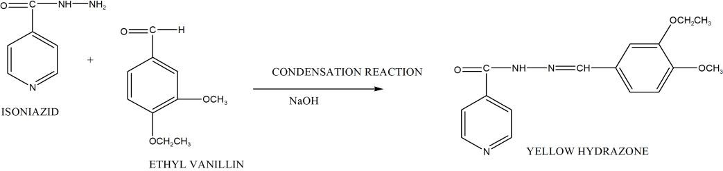A method based on condensation reaction between isoniazid and ethyl vanillin in basic medium ( NaOH) to form a colored hydrazone (equation 2.3) with λmax of 410 nm. Beer’s law was obeys i nthe range 2-16 µg/mL(Ravalkashyap*et al.,* 2012).The method is direct, simple and rapid however, other parameters such as limit of detection and limit of quantification were not reported.

+ H2O

…equation 2.3

A similar method was reported in which the reagent was vanillin in acidic medium (HCl) resultin g in a product with a λmax 405 nm. Beer’s law was obeyed in the range of 1-12 µg/mL.(Oga, 2010). This method has advantage of being rapid, simple, sensitive and low cost however there is poor linearity (r = 0.96) and limit of detection and limit of quantification, were not indicated.

…..equation 2.4 Isoniazid was reported to react with 1, 2-naphthoquinone-4-sulfonate (NQS) atpH 13 to form a pink-colored product which was measured at 495 nm. Beer’s law was obeyed in the range 0.5-30

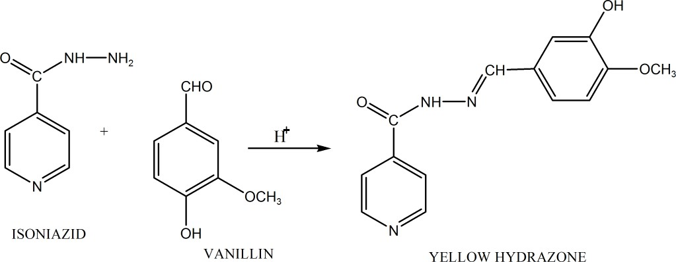

Cond. rxn

+ H2O

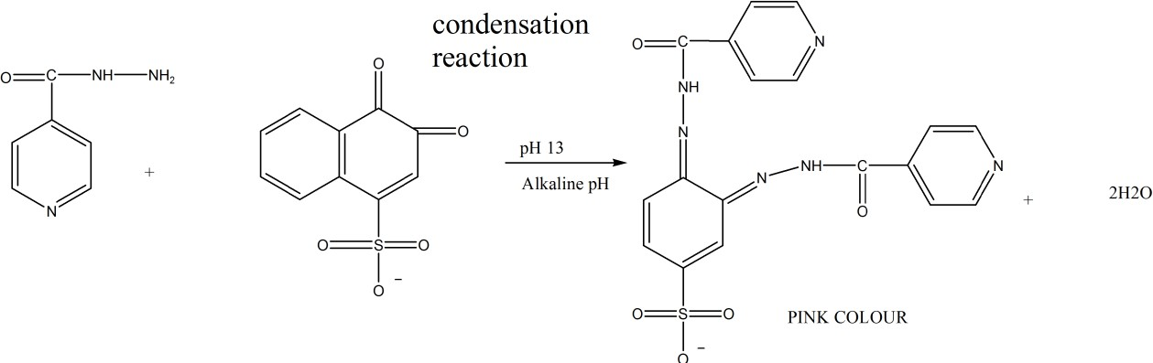µg/mL.(Ravalkashyap*et al.,* 2012). This methodrequires an expensive reagents that are not readily available.

2

……..equation 2.5

Another method with similar problem is the reaction of isoniazid with isatin in acidic (pH 1.4) to formisatin-isonicotinyl hydrazone (yellow colored product) with λmax of 340 nm. Beer’s law wa s obeyed in the range of 0-32 µg/mL (AbdelHamid*et al.*, 1992).

Isoniazid was also reported to reactwith 2-hydroxy-1,4-napthoquinone (HNQ) at pH 3 in aqueous-methanolic solution to give a yellow colored product having absorption maximum at 365 nm (Rind*et al.,* 2005).

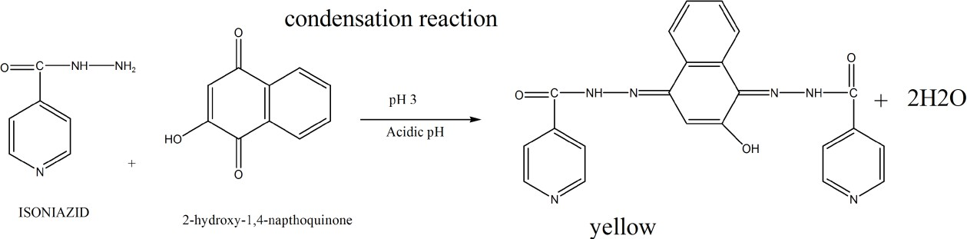This method in addition to having similar problem is the reaction of isoniazid with 6 -methyl-2- pyridinecarboxaldehyde (MPA) resulting in a coloured hydrazine with λmax at 328 nm obeyed B eer’s law but detection limit was very high (Khuhawar*et al.,* 1988).

2

…..equation 2.6

H2O

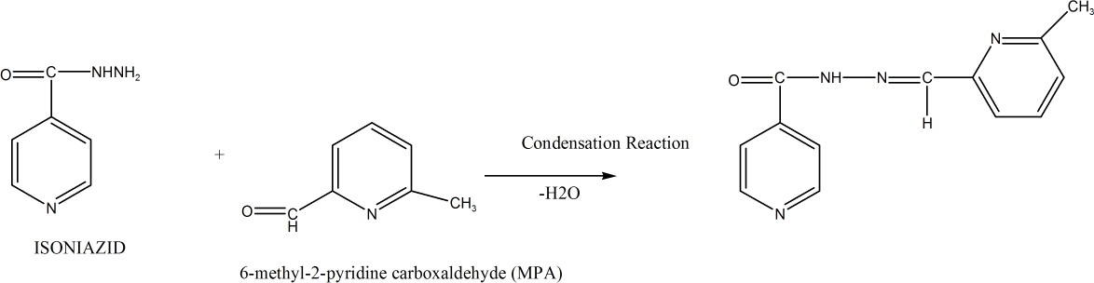

+

……equation 2.7

Oxidation oftiron with KIO4 followed by coupling with isoniazid in alkaline medium to give red colored product with maximum absorbance at 505 nm obeys Beer’s law in the concentration of 1.5-18 µg/mL(Gowda*et al.,* 2003)

O C NH NH2

SO3Na

HO SO3Na

OH

KIO4

O

SO3Na

O

N

SO3Na

NaOH

O

N

N NH C

SO3Na

ONa

O

Red Colour

……….equation 2.8

The same authors developed another method based on same reaction but NaIO4 was used as oxidizing agent and absorbance of the coupled product was measured at 507 nm (Naidu *et al.,* 2005).This method obeys Beer’s law in the concentration of 1.5-18 µg/mL but it was tedious.

O C NH NH2

SO3Na

HO SO3Na

OH

NaIO4

O

SO3Na

O

N

SO3Na

NaOH

O

N

N NH C

SO3Na

ONa

O

Red Colour

…equation 2.9

Method developed fairly sensitivebased on diazotization of 4, 4-methylene-bis-m-nitroaniline followed by the coupling with isoniazid in HCl medium to give purple-colored chromogen having λmax at 495 nm obeyed in the range 0.1-15 µg/mL.This method is indirect and less sensitive

N

NH2

NH

C

O

2

N

H2N

O

O

N

+

CH2

O

O

HCL

N

Diazotization reaction

NH N

H2N

N

N

CH2

NH N

2H2O

N

+

4,4-methylene-bis-m-nitro aniline Purple colour

… equation 2.10

The diazotization of 4, 4 sulphonyldianiline (dapsone) followed by coupling with isoniazid in NaOH medium to formed diazo-dye with λmaxat 460 nm is also complex(Padmarajaiah*et al.,* 2002).

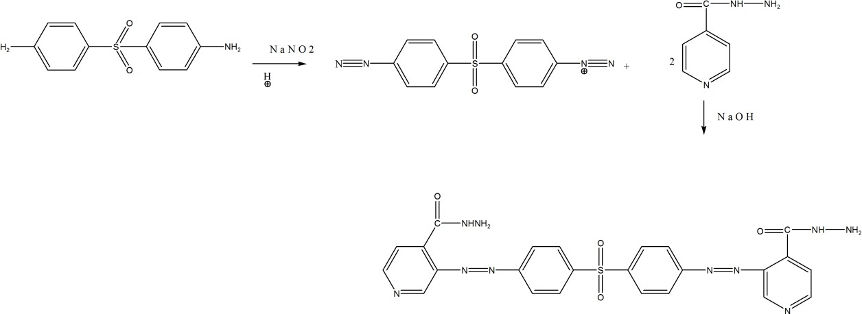

+

2H2O

… equation 2.11

Two other methods were developed based on reaction of isoniazid with epichlorohydrine (EPI) and 4-hydroxyphenacylchloride (HPC) in NaOH medium to form yellow colored chromogen

with λmax at 405 and 402 nm for EPI and HPC respectively (Divya*et al.,* 2011). This method is also complex.

H20

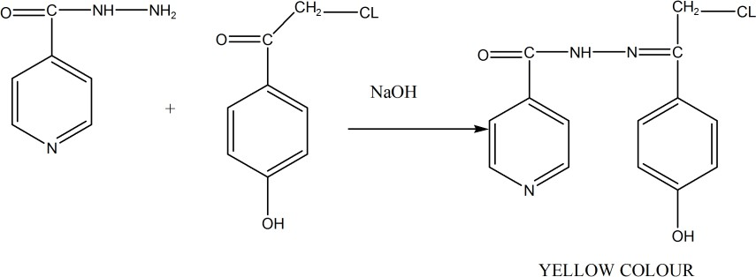

+

………equation 2.12

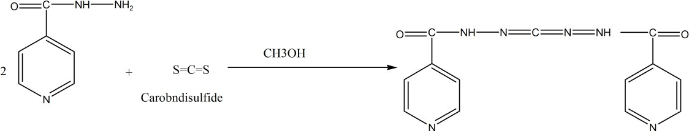The reaction of isoniazid with carbon disulfide in methanol medium followed by addition of uranyl acetate to form yellow colored uranylisonicotinyldisthiocarbazate complex with λmax at 410 nm (Kumar et al., 2011). This method lacks readily available reagents.

+ 2H2S

………equation 2.13

Another method was developed from aliquots of standard stock solution of different concentrations ranging from 100-600 µg/mLtransferred to a series of 50 mL volumetric flasks. To each flask 5 mL of ethanolic p-dimethylaminobenzaldehyde (p-DAB) solution was added. The volume was then made up with distilled water and the absorbance of the yellow colored Chromogen was measured at 395 nm against the reagent blank. The amount of isoniazid was computed from the calibration curve obtained by plotting concentration versus absorbance.

Pure powder and tablet of isoniazid was successfully analyzed by this method (Niraimathi*et al.,* 2014). These methods are indirect, less sensitive and use expensive chemicals, absorbance measured at shorter wavelength and reagents.

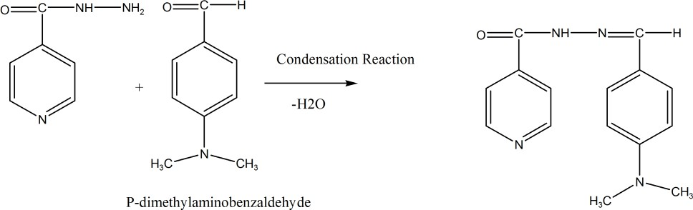+ H2O

Other methods include those of Niramathi*et al.,* 2013, Safavi*et al.,* 2004, Diab*et al.,* 2008, Prab*et al.,* 2008, Prab*et al.,* 2012 among others.

## CHAPTER THREE

## MATERIALS AND METHODS

### Materials

* + 1. **Isoniazid analytical grade powder and tablet**

Standard isoniazid powder was purchased from Sigma Aldrich Germany while the tablet was purchased from registered pharmacy. Information on tablet was recorded.

### Chemicals and reagents

All chemicals are of analytical grade. The methanol, ethanol, distilled water, Concentrated HCl, 2,4-dinitrophenyl hydrazine,Thiourea,Sodium nitrite, Sulfamic acid, Paratoluidine, Potassium bromide were purchased from.BDH chemical, England.

### Glass wares and accessories

10 mL,100 mL measuring cylinders (Pyrex England)

100 mL and 250 mL conical flasks (Pyrex England) 25 mL and 50 mL beakers (Pyrex England)

10 mL test tubes (Pyrex England)

10 mL,50 mL and 100 mL volumetric flasks (Pyrex England) 10 mL Centrifuge tubes (Pyrex England)

1 mL, 10 mL pipette Filter paper Capillary tube

Glass rod

### Equipment

Electronic weighing balance (MetlersPr 63 Switzerland) Centrifuge machine (Gallenkamp, England) UV double beam spectrophotometer model (MNF, Helious Zeta, Model 164617. Thermo Scientific England)

Stop watch (Smith England clock system) Melting point apparatus(Gallenkamp, England)

Infra-red spectrophotometer (Model. Cary 630, Agilent Technology Germany) pH meter (Fisher scientific, Singapore)

Water bath (modelBJE 750 AGallenkamp, England)

Thermometer (Mc Donald Scientific International, England)

### Methods

* + 1. **Quality control of isoniazidstandard powder and tablet**
       1. *Identificationof pure* isoniazid *powder Melting point determination*

A capillary tube was filled with the standard isoniazid powder and carefully tapped to about 3.5 mm, placed into the melting point apparatus and machine set at high temperature for rapid determination of melting point. The melting process was observed with magnifying lens and the melting point recorded was compared with reference standard (BP, 2009)

*FTIR analysis*

A portion of pure isoniazid powder was directly subjected to FTIR analysis and the spectrum obtained was compared with the spectrum of a reference.

* + - 1. *Assay of standard* isoniazid*powder*

The assay was carried out by dissolving the standard isoniazid powder (0.250 g) in 100 mL of distilled water. A portion (20 mL) of the solution was withdrawn and transferredinto a beaker. Water (100 mL), hydrochloric acid (20 mL), potassium bromide (0.2 g) and methyl red solution (0.05 mL) were added. The resultant solution was then titrated with 0.0167 M potassium bromate with continues shaking until the red colour disappeared.

Isoniazid content was determined using relation 1 mL of 0.0167 M potassium bromate is equivalent to 3.429 mg of isoniazid (BP, 2009).

* + - 1. *Identificationof* isoniazid*tablet FTIR analysis*

Ten tablets of isoniazid were weighed and powdered in pestle and motor. A quantity of powder equivalent to 0.1 g of isoniazid was taken and shaken with 10 mL of ethanol (96 %v/v) for 15 minutes then centrifuged and supernatant liquid was decanted. The residue was further extracted with two 10 mL portions of ethanol (96 %v/v) and the combine extract was evaporated to dryness. The infrared spectrum of the dried residue was determined and compared with the reference spectrum of isoniazid (BP, 2009).

* + - 1. *Assay of isoniazid tablets*

Twenty tablets of isoniazidwere accurately weighed and powdered in pestle and motor. A quantity of powder 0.467 g equivalent to 0.4 g of isoniazid was dissolved in distilled water and filtered. The residue was washed with sufficient water to produced 250 mL To 50 mL of resulting solution, water 50 mL, hydrochloric acid 20 mL and potassium bromide 0.2 g were add ed and titrated with 0.0167 M potassium bromate with continues shaking until the red colour disa ppeared. Each one mL of potassium bromate 0. 0167Mis equivalent to 3.429 mg of isoniazid

(BP, 2009).

### Selection of solvents

The solubility of isoniazid in distilled water, methanol, ethanol, chloroform, ether and benzene at room temperature was tested.

### Preparation of solutions and reagents

* + - 1. *Preparation of isoniazidstock solutions in distilled water and methanol.*

Stock solutions(100 µg/mL) of isoniazid were prepared in distilled water and methanol by dissolving 10 mg isonizid standard powder in 100 mL distilled water and methanol respectively.

* + - 1. *Preparation of reagents.*

Preparation of 4.5M HCl, 2%, 85%w/vHCl, 1%w/v sodium nitrite, 2% sulfamic acid,2, 4- dinitrophenylhydrazine and para toluidine solutions were prepared as described in appendix II.

* + 1. **UV spectrophotometric method using distilled water.**

This method was based onusing distilled water as solvent.

* + - 1. *Determination of wavelength of maximum absorption (λmax).*

A working solution (10 µg/mL) was prepared from the stock solution and then scanned through 200-400 nm against reagent blank on the UV spectrophotometer to determine the λmax.

* + - 1. *Determination of pH of maximum absorption.*

Portion (5 mL) of isoniazid solution in distilled water (10 µg/mL) was transferred into 10 different test tubes labeled 1 – 10 and adjusted to pH 1 – 10 respectively. The absorbance of each solution was then measured at the obtained λ max.

* + - 1. *Preparation of calibration curve*

Different solutions of isoniazid of concentrations 1,2,3,4,5,6,7,8,9 and 10 µg/mL were preparedfrom the stock solution and adjust to the pH of maximum absorption. Theabsorbance of

each solution was then measured at the λ max against reagent blank. Theabsorbances obtained were then plotted against their corresponding concentrations.

*3.2.4. 4Assay of isoniazidtablets by UV spectrophotometric method using distilled water*

A quantity of powder containing equivalent to10 mg isoniazid was accurately weighed from the previously crushed 20 isoniazid tablets, transferred into a tovolumetric flask (100 mL) and the volume made up to mark with distilled water. The pH of the mixture was adjusted to the pH of maximum absorption and shaken for 10 minutes. The solution was filtered through a Whatman filter paper no. 41. A portion (1mL)was transferred into a volumetric flask (10 mL) and made up to the 10 mL mark with distilled water to obtain a concentrations 10 μg/mL. The absorbance of the resulting solution was then measured at the λmax against the reagent blank.

* + 1. **UV spectrophotometric method using methanol.**

This method was based on using methanol as solvent.

* + - 1. *Determination λ max.*

A working solution (10 µg/mL) was prepared from the stock solution and then scanned through 200-400 nm against reagent blank on the UV spectrophotometer to determine the λmax.

* + - 1. *Determination of pH of maximum absorption.*

Portion (5 mL) of isoniazid solution in methanol (10 µg/mL) was transferred into 10 different test tubes labeled 1 – 10 and adjusted to pH 1 – 10 respectively. The absorbance of each solution was then measured at the obtained λ max.

* + - 1. *Preparation of calibration curve*

Different solutions of isoniazid of concentrations 1,2,3,4,5,6,7,8,9 and 10 µg/mL were prepared from the stock solution and adjust to the pH of maximum absorption. The absorbance of each

solution was then measured at the λ max against reagent blank. The absorbances obtained were then plotted against their corresponding concentrations.

* + - 1. *Assay of* isoniazid*tablets by UV spectrophotometric method using methanol*

A quantity ofpowder 12 mg equivalent to 10 mg isoniazid was accurately weighed from the previously crushed 20 isoniazid tablets, transferred into avolumetric flask (100 mL) and the volume made up to mark with methanol. The pH of the mixture was adjusted to pH of maximum absorption and shaken for 10 minutes. The solution was filtered through a Whatman filter paper no. 41. A portion (1 mL) was transferred into volumetric flask (10 mL) and made up to the 10 mL mark with methanol to obtain a concentrations 10 μg/mL. The absorbance of the resulting solution was then measured at the λmax against the reagent blank.

* + 1. **Development of colorometric method using 2,4-dinitrophenylhydrazine and optimization.**

This method is based on formation of Schiff,sbase between isoniazid and2,4-dinitrophenyl hydrazine under acidic condition (equation 3.1).

NH2

HN

O

+

NH2 NH

NH2

NO2

Condensation reaction 2 ml of 85 % HCl

HN

N

H NO2

N

+ H2O

N

5 ml of 10 micro grm

INH in Distilled water

NO2

2 ml 2,4-DNPH in 4.5 M HCl

N

Orange - red hydrazone

NO2

… equation 3.1

* + - 1. *Determination of λ max.*

A portion (5 mL) of isoniazid solution (10 μg/mL) in distilled water was treated 2,4- dintrophenyihydrazine in the presence of 4.5 M HCl (2 mL). The resulting solution and also the reagent blank (containing 5 mL distilled water, 2 mL reagent and 2 mL of chilled 85 % HCl) wereheated at 100°C in a thermostatic water bath for 10 minutes. Thereafter, the solution containing isoniazid was treated with 2 mL of chilled 85 %v/v HClto form an orange-red colouredhydrazone (equation 3.1). The hydrazone formed was allowed to stand for 15 minutes for complete color development then scanned through a wavelength range 400 – 750 nm against the reagent blank of 5 mL distilled water,2 mL 2,4-dinitrophenylhydrazine, 2 mL 85% HClon the UV spectrometer to obtain the λ max.

* + - 1. *Optimization of analytical working conditions.*

*Determination of effective concentration of the reagent. 2,4-dinitrophenylhydrazine (1-20*

µg/mL)

Different concentrations (1-20 µg/mL) of 2, 4-DNPH (2 mL each) were added to separate 5 mL solutions of isoniazid (10 µg/mL) in distilled water in twenty different flasks and treated as described earlier to form orange-red colouredhydrazone. Absorbances were recorded at the fixed λ maxto determine the effective concentration of reagent.

*Determination of effective volume of the reagent.*

Different volumes (1,2,3,4 and 5 mL) of 2,4-DNPH at effective concentration were condensed with 5 mL of 10 µg/mL isoniazid in distilled water and absorbance of the hydrazine formed were measured at λmax to determine the effective volume.

*Determination of effective time for complete color development*

A solution of 5 mL of10 µg/mLisoniazid in distilled water was reacted with 2,4-DNPH at the effective concentration and volume, the absorbance of colouredhydrazone formed was measured at λ max attime intervals of 5, 10, 15, 20, 25 and 30 minutes to determine the time at which maximum absorbance is observed. This isthe effective time for complete colourdevelopment.

* + - 1. *Preparation of calibration curve for concentration of the reagent.*

*2,4-dinitrophenylhydrazine (1-20* µg/mL)

Different solutions of isoniazid in distilled water of concentrations 2, 4, 6, 8, and 10 µg/mLwere treated with 2,4-DNPH at the effective concentration and volume. Thecolours of the hydrazone formed were allowed to stand up to the effective time for complete development. The absorbance of each solution was measured at the λmax against reagent blank. The calibration curve was constructed by plotting the absorbance against their corresponding concentrations.

* + - 1. *Assay of* isoniazid *tablets using colorometric method using 2,4-dinitrophenylhydrazine and optimization.*

A quantity of powder tablet 12 mg, equivalent of 10 mg isoniazid was accurately weighed from the previously crushed 20 isoniazid tablets, transferred to volumetric flask (100 mL) and the volume made up to mark with distilled waterand shaken for 10 minutes. The mixture was filtered through a Whatman filter paper no. 41. A portion (1 mL) was transferred to a volumetric flask (10 mL) and the volume made up to mark with distilled water to obtaina 10 μg/mL solution. A portion (5 mL) of this solution wastreated with 2, 4 DNPH at effective concentration and volume, then heated at 100 °C in a thermostatic water bath for 10 minutes. Thereafter, 2 mL of chilled 85 %v/v HCl was added to form orange-red colouredhydrazone which was allowed to

stand up to the effective time for complete colour development. The absorbance was then measured at λ max determined against reagent blank.

* + 1. **Development of colorometric method by using paraaminotoluidine and optimization.** This method is based on the formation of a diazo dye from the reaction of isoniazid with p- toluidine.

N

N HN

NH2

O

HN

+ 2 ml of 2 % HC l

+ 2 ml of 1 % Na N O 2

+ 3 ml of 2% Sulfamic acid

N

O

NH2

+

CH3

N

O N

NH

5 ml of 10 micro grm / ml INH in Methanol

N

Diazomium ion

CH3

2 ml of P-Toluidine

N

Yellow Chromagen

**…….** Equation 3.2

* + - 1. *Determination of λ max*

A portion (5 mL) of isoniazid solution 10 μg/mLin methanolwas treated with 2 mL of 2 % HCl followed by 2 mL of 1 % sodium nitrite solution (NaNO2), stirred with glass rod and allowed to stand for 5 minutes. Thereafter 3 mL of 2 %w/v sulfamic acid was added, stirred and also allowed to stand for 5 minutes to distribute the residual sodium nitrite. Finally2 mL of p- toluidine solution was added and heated for 10 min. Theyellow colouredchromagen formed was allowed to stand for complete colour development then scanned through wavelength range 400– 750 nm against reagent blank (containing 5 mL methanol, 2 mL2 % HCl, 2 mL of 1 % sodium nitrite, 3 mL of 2 % sulfamic acid 2 mL of p-toluidine) on the UV spectrometer and the λ max recorded.

* + - 1. *Optimization of analytical working conditions.*

*Determination of effective concentration of the reagent p-toluidine (1-20 µg/mL)*

Different concentrations (1-20 µg/mL) of p-toluidine (2 mL each) were added to separate 5 mL solutions of isoniazid (10 µg/mL) in methanol in twenty different flasks and treated as described earlier to form yellow-colouredchromagen. Absorbances were recorded at the fixed λ max to determine the effective concentration.

*Determination of effective volume of the reagent.*

Different volumes (1, 2, 3, 4 and 5 mL) of p-toluidine at effective concentration were coupled with 10 µg/mL isoniazid in methanol and absorbance of the yellow chromagenformed weremeasured at λ maxto determine the effective volume.

*Determination of effective time for complete color development*

A solution of 5 mL of 10 µg/mL isoniazid in methanol was reacted with p-toluidine at the effective concentration and volume, the absorbance of coloured chromagen formed was measured at λ max at time intervals of 5, 10, 15, 20, 25 and 30 minutes to determine the time at which maximum absorbance is observed. This is the effective time for completecolour development.

* + - 1. *Preparation of calibration curve for colorometric method by using paraaminotoluidine*

Different solutions of isoniazid in methanol of concentrations 1, 2, 3, 4, 5, 6, 7, 8, 9, 10, 11, 12, 13, 14, 15 and 16 µg/mL were treated with p-toluidine at the effective concentration and volume. The yellow colouredchromagen formed were allowed to stand up to the effective time for

complete development. The absorbance of each solution was measured at the λmax against reagent blank. Then calibration curve was constructed by plotting the absorbance against their corresponding concentrations.

* + - 1. *Assay of isoniazid tablets using colorometric method by using paraaminotoluidine*

A quantity of powder containing equivalent of 10 mg isoniazid was accurately weighed from the previously crushed 20 isoniazid tablets, transferred into a volumetric flask (100 mL) and the volume made up to mark with methanoland shaken for 10 minutes. The mixture was filtered through a Whatman filter paper no. 41. A portion (1 mL) was transferred to a volumetric flask (10 mL) and the volume made up to mark with methanol to obtain a 10 μg/mL solution. A portion (5 mL) of this solution was then treated with 2 mL of 2% HCl, 2 mlof 1% NaNO2and stirred with glass rod for 5 minutes followed by addition of 3 mL 2 % sulfamic acid and stirred for another 5 minutes. The solution of p-toluidine at effective concentration and volume was added to the content of the flaskthen gently heated in a thermostatic water bath for 10 minutes. The yellow colouredchromagen formed was allowed to stand up to the effective time for complete colour development. The absorbance was then measured at λ max determined against reagent blank.

### Validation of the analytical methods

All the four developed analytical methods were validated according to ICH Q2R1 (1996)guide lines for validation of analytical procedures in order to determine the linearity, precision, accuracy and percentage recovery, limit of detection and limit of quantification.

* + - 1. *Linearity*

The linearity of each developed methodwas evaluated by analyzing different concentrations of the standard isoniazid from the stock solution. Linearity was examined by plotting the

absorbance against concentration. Beer,s-Lamberts was obeyed at a particular concentration range to give a straight line graph (concentration is directly proportional to absorbance). Coefficient of correlation ( r) indicate linearity. The closer the r value to 1, the more the linearity of the calibration curve.

* + - 1. *Precision*

The precision was carried out to ascertain the reproducibility of the developed methods.

*Intraday*

A solution of isoniazid(10 µg/mL) solution was prepared from the stock solution and absorbance measured at interval of one hour for six hours within the same day after treatment using each of the methods developed.

*Interday*

A solution of isoniazid (10 µg/mL) was prepared from the stock solution and absorbance measured daily for three consecutive days, after treatment using each of the methods developed. From the result, then mean, standard deviation (SD) and percentage relative standard deviation or percentage coefficient of varience( % CV) were calculated.

% CV = S/X x 100 Formula 1

Where S is the standard deviation and X is the mean

* + - 1. *Accuracy and percentage recoveries*

Accuracy is expressed as percentage relative error (%Er). Accuracy of this method was checked by standard addition method. A solution of 10μg/rnL solutions of isoniazid in distilled water was prepared in four separate 10 mL volumetric flasks and labeled A, B, C and D. Test tube A was left unspikedwhile test tubes B, C and D were spiked with 80% (8 μg/mL), 100% (10 μg/mL)

and 120% (12 μg/mL)from the stock solution (100 μg/mL) and made up to the mark with distilled water and methanol for methods 1, 3 and 2, 4 respectively. Absorbances were measured and substituted in the regessioneqution to determine the concentrations. Percentage relative error (%Er) was calculated as follows:

%Er=X- μ/μ xl00… Formula 2

Where X is the actual value (concentration) and μ is the expected value (concentration).

% recovery = measured concentration / expected concentration x 100. Formula 3

The average of these determinations was taken as the percentage recovery.

* + - 1. *Limit of detection*

The detection limit (LOD) was determining the standard deviation of y-intercept over slope of the calibration curve.

LOD=3.3σ/S Formula 4

Where σ is the standard deviation of y-intercepts and S is the slope of the calibration curve.

* + - 1. *Limit of quantification*

The quantitation limit (LOQ) was determined using the expression:

LOQ = 10σ / S Formula 5

Where σ is the standard deviation of y-intercepts of the regression lines and S is the slope of the calibration curve.

### 3.2.9 Statistical analysis.

Results were expressed as mean ± SD using IBM statistical package for social sciences (SPSS)summer 2013 version 2.0 software at p < 0.05. Difference between the mean of the developed methods and that of official standard was insignificant.

## CHAPTER FOUR

## RESULTS

### Quality Control of isoniazid Standard Powder and Tablet

The labeled information of the isoniazid tablet sample used for this study is presented in table

* + 1. **The melting point of both isoniazid standard powder and tablet sample are shown intable**
    2. **while their respective IR spectrums are presented in figure 4.1 and 4.2 respectively.**

**Table 4.1: Information of isoniazid tablet used in the research**

|  |  |  |  |  |  |  |
| --- | --- | --- | --- | --- | --- | --- |
| **Drug** | **Source** | **INH content**  (mg) | **Batch No**. | **Man date** | **Exp. date** | **NAFDAC No.** |
| INH | India | 300 | TQ27 | 06/2015 | 05/2020 | A4-0763 |

**Table 4.2: Melting point determination of isoniazidstandard powder and tablet**

|  |  |
| --- | --- |
| **Sample** | **Melting point** |
| Standard INH Powder | 170 – 172 oC |
| Tablet | 172 – 174 oC |

Official reference standard is170 – 174 oC

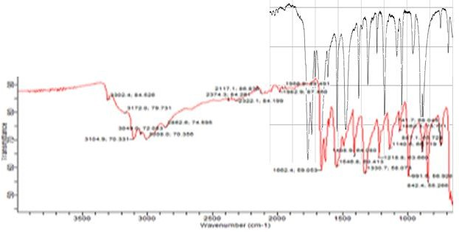

**Figure 4.1: FTIR Spectra of isoniazid standard powder and reference, superimpose at fingerprint region (600-1500 cm-1)**

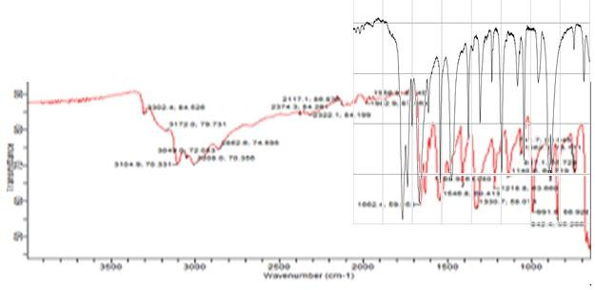

**Figure 4.2: FTIR spectra of isoniazid tablet and referencesuperimposed**

* 1. **Methods Development**
     1. **UV spectrophotometric methods using water and methanol**

The solubility of isoniazid in various solvents is presented in table 4.3. The method and calibration parameters of method 1 and 2 are presented in table 4.4, figure 4.3 and figure 4.4 respectively. The validation parameters are shown in table 4.5.

### Colorimetric methods using 2,4-dinitrophenylhydrazine and by diazotization.

The method and calibration parameters of method 3 and 4 are presented in table 4.6, figure 4.5 and figure 4.6 respectively. The validation parameters are shown in table 4.7

### Table 4.3: Solubility of isoniazid in different solvents

|  |  |  |  |  |  |  |
| --- | --- | --- | --- | --- | --- | --- |
| **Sample** | **Water** | **Methanol** | **Ethanol** | **Chloroform** | **Ether** | **Benzene** |
| INH Std Powder | Soluble | Soluble | Soluble | Sparingly soluble | Insoluble | Insoluble |

**Table 4.4: Validation parameters for UV spectrophotometric methods using water and methanol.**

|  |  |  |
| --- | --- | --- |
| **Parameter** | **Water** | **Methanol** |
| λ max | 264 nm | 264 nm |
| Beer.s law range | 1 – 11 µg/mL | 1 – 11 µg/mL |
| Regression equation | y = ax - b | y = ax - b |
| Slope (a) | 0.0657 | 0.0658 |
| Intercept (b ) | 0.0288 | 0.0296 |
| Coefficient. of determination R2 | 0.9999 | 0.9998 |
| Coefficient. of correlation ( r ) | 0.9999 | 0.9999 |
| Effective pH for max. absorption | 4 | 4 |

0.6



R² = 0.999

y = 0.065x - 0.028

0.5

0.4

**Absorbance**

0.3

0.2

0.1

0

0 2 4 6 8 10

**Concentration in μg/ml**

### Figure 4.3: Calibration curve of isoniazidin distilled water

0.6



y = 0.065x - 0.029 R² = 0.999

0.5

0.4

**Absorbance**

0.3

0.2

0.1

0

0 2 4 6 8 10

**Concentration in μg/ml**

**Figure 4.4: Calibration curve of isoniazid in methanol**

**Table 4.5: Validation parameters for UV spectrophotometric methods using water and methanol.**

|  |  |  |  |
| --- | --- | --- | --- |
| **Parametr** | **Water** | **Methanol** | **Acceptable**  **limit** |
| Precision (% CV) | 0.630 | 0.168 | < 15 % |
| Accuracy ( % Er ) | 4.130 | 0.251 | < 5 % |
| % recovery | 102.01 | 99.8 | 98-102 % |
| LOD (µg/mL) | 0.113 | 0,145 |  |
| LOQ (µg/mL) | 0.342 | 0.438 |  |

**Table 4.6m Validation parameters for calorimetric methods using 2,4- dinitrophenylhydrazine and by diazotization.**

|  |  |  |
| --- | --- | --- |
| **Parameter** | **Hydrazine** | **paratoluidine** |
| λ max | 464 nm | 420 nm |
| Beer.s law range | 1 – 18 µg/mL | 1 – 18 µg/mL |
| Regression equation | y = ax + b | y = ax + b |
| Slope (a) | 0.0093 | 0.068 |
| Intercept (b ) | 0.0041 | 0.0376 |
| Coefficient. of determination R2 | 0.9992 | 0.9971 |
| Coefficient. of correlation ( r ) | 0.9996 | 0.999 |
| Effective concentration of the reagent | 18 µg/mL | 18 µg/mL |
| Effective volume of the reagent | 3 mL | 4 mL |
| Effective time for complete colour development | 15 min | 20 min |

0.12



R² = 0.999

y = 0.009x + 0.004

0.1

0.08

**Absorbance**

0.06

0.04

0.02

0

0 2 4 6 8 10 12

**Concentration in μg/ml**

### Figure 4.5: Calibration curve of isoniazid solution in 2,4-dinitrophenyl hydrazine.

1.2



y = 0.068x + 0.037 R² = 0.997

1

0.8

**Absorvance**

0.6

0.4

0.2

0

0 5 10 15 20

**Concentration in μg/ml**

**Figure 4.6: Calibration curve of isoniazid solution in paraaminotoluidine.**

**Table 4.7: Validation parameters for calorimetric methods using 2,4-dinitrophenylhydrazine and by diazotization.**

|  |  |  |  |
| --- | --- | --- | --- |
| **Parametr** | **Hydrazine** | **Paratoluidine** | **Acceptable**  **limit** |
| Precision (% CV) | 1.570 | 0.182 | < 15 % |
| Accuracy ( % Er ) | 0.328 | 0.670 | < 5 % |
| % recovery | 99.83 | 100.06 | 98-102 % |
| LOD (µg/mL) | 0.355 | 0.185 |  |
| LOQ (µg/mL) | 1.076 | 0.559 |  |

**Table 4.8: Percentage content of isoniazid assayed.**

|  |  |  |  |  |  |
| --- | --- | --- | --- | --- | --- |
| **Methods** | **1** | **2** | **3** | **4** | **BP, 2009** |
| Standard powder | 99.9 | 99.5 | 99.7 | 99.8 | 99-101 |
| Tablet | 98.3 | 98.0 | 98.1 | 98.2 | 98-102 |

Official range for standard powder and tablet is 99 - 101 % and 98 – 102 % (BP, 2009).

## CHAPTER FIVE

**5.0 DISCUSSIONS**

The melting point purity agreement with what was reported in the literature. 170 – 172 0Cand 172 – 174 0Cas compared to official standard of 170 – 1740C(table 4.2)while their IR spectra was found to be superimposable with the reference standard of isoniazid spectrum therefore the sample is likely to be isoniazid.(figures 4.1 to 4.2).

Solubility studies showed that isoniazid is soluble in polar solvents such as water, methanol and ethanol and insoluble in non-polar solvents such as benzene, ether and chloroform (table 4.3). This is what informed the use of water and methanol as solvent for preparing stocksolutions of isoniazid. This is in agreement with BP 2009.

The four developed methods have maximum absorption (λmax) at 264 nm for 1 and 2 with 464 nm and 420 nm for methods 3 and 4 respectively. The calibration curves for quantitative determination of isoniazid in all the four developed methods obeyed Beers-Lamberts law within concentration range of 1-11 µg/mL for methods 1 and 2 and 1-18 µg/mL for methods 3 and 4 respectively. The coefficient of correlations (r) of the calibration curve is a measure of the linearity of the methods developed. In all four methods, their value was very close to unity, indicating the linearity of the methods. It clearly shows the direct proportional relationship and high correlation between the absorbance (y) and the respective concentration (x) used for this determination in the regression equations for the four developed methods (tables 4.4 and 4.6) wascompared to 0.996, 0.96, 0.9998 reported by Padmarajaiah*et al.,* (2002), Pratap*et al.,* (2012) and Arifa*et al.,* (2013) the r value in our methods were better. Both methods 1 and 2 were found to have effective pH at 4. This is the pH at which the drug absorbs maximally. Methods 3 and 4

were found to have effective concentrations of 18 µg/mL and effective volumes of 3 and 4 mL for methods 3 and 4 respectively. The yellow coloured hydrazine formed takes 15 minutes for the colour to completely develop while it takes 20 minutes for method 4 which indicates the methods are rapid..

Precision which is express as Percentage of Coefficient of Variation (% CV). Both the intraday and interday precisions of the four methods developed were found to be very good. This is indicated by the very low % CV (table 4.5 and 4.7) recorded in all the methods which were within the acceptable limit of < 15 % CV.(Padmarajaiah*et al.,* (2002),Pratap*et al.,* (2012) andArifa*et al.,* (2013) reported the precisions of 0.35, 1.2, 1.37 % respectively. Precision of the developed UV/Vis spectrometric methods are satisfactory. This is in accordance with the

accuracy of the four developed methods which were presented as the percentage relative error (% Er) and computed to be 4.13, 0.251, 0.328 and 0.670 % UV spectrophotometric methods using w ater and methanol.and calorimetric methods using 2,4-dinitrophenylhydrazine and by diazotization respectivelyPadmarajaiah*et al.,* (2002), Pratap*et al.,*(2012) and Enoche,(2010) reported respectively 0.4908, 0.05 and 2.47 %. They were all within the range of (< 5 %) for moderately accurate procedure (Harvey, 2000). Percentage recoveries determined for the four developed methods (102.02, 99.8, 99.83 and 100.06) were in the range of percentage recoveries of 100.63, 99.0 and 100.95 % reported by Enoche, (2010), Pratap*et al.,*(2012) andArifa*et al.,* (2013). LOD is the lowest quantity of drug a method can detect limit of detection in the solution but not necessarily quantify..

LOD for the four methods were 0.113, 0.145, 0.355 and 0.185 µg/mL for UV spectrophotometric methods using water and methanol.and calorimetric methods using 2,4-dinitrophenylhydrazine a

nd by diazotization respectively indicating better sensitivity of the methods as compared to 0.3243, 0.481, 80 and0.585 µg/mL reported by Padmarajaiah*et al.,* (2002), Pratap*et al.,* (2012), Nagaraju*et al.,* (2012) and Arifa*et al.,* (2013) respectively. The limit of quantification (LOQ) is the small quantity of drug a method can detect and quantify in a solution. LOQ for the four methods UV spectrophotometric methods using water and methanol.and calorimetric methods us ing 2,4-dinitrophenylhydrazine and by diazotization respectively which were 0.342, 0.438, 1.076 and 0.559 µg/mL respectively were higher than 1.08, 1,59, 240, 1,772 µg/ml as reported by

Padmarajaiah*et al.,* (2002), Pratap*et al.,* (2012), Nagaraju*et al.,* (2012) and Arifa*et al.,* (2013) respectively.The limit of detection (LOD) and limit of quantification (LOQ) are the function of sensitivity of the methods detect and quantify within acceptable precision and accuracy under the stated condition of tests.

A comparison of themean percentage content of the isoniazid assayed using the developed methods and by using the official method (BP, 2009) showed thatno statistical significant difference (*p*< 0.05) was observed in the mean percentage contents of isoniazid.Therefore, the developed methods can be interchanged with the official method for the routine assay of isoniazid. UVspectrophotometric method using distilled waterhas the highest recovery of isoniazidcompared with the other developed methods(table 4.8).

## CHAPTER SIX

* 1. **CONCLUSIONS AND RECOMMENDATIONS**

### Conclusions

From results obtained, it can be concluded that four new spectrophotometric methods for

isoniazid determination in pure and tablet dosage formwere developed and validated. There is no significant differencebetween the content of isoniazid assayed using the developed methods and that of the BP method, thus the developed methods can be interchanged with BP method.

### Recommendations

Based on the findings of this research,four new developed spectrophotometric methods for isoniazid determination in pure and tablet dosage form can be used for routine quality controltest of isoniazid.There is need for collaborations between the drug regulatory agencies such as NAFDAC that monitor and control drug use. There is also need for further studies to examine and compare the developed methods in biological fluids and compare the methods using advance techniques such as high performance liquid chromatography.

## REFERENCES

Abdallah, A., Mahjoub., Amer H., Khan, Syed., Sulaiman, Razak., and Lajis. (2016). Simultaneo us Determination of Isoniazid and Prazinamide in Plasma by High Performance Liquid Chromatography. *Tropical Journal of Pharmaceutical Research,* 15(11): 2474-2481.

AbdelHamid, A. N., Samia, E., Gizawy, M., Hussein, E.,and Subbagh, I. (1992). Spectrophotom etric Determination of Isoniazid Using Ethyl 8-Quinolinoxy Aceta. *Journal of Analytical letters,* 25(1): 73-80.

Arifa, B. S.K., Basava, R. D., and Rama, R. (2013). Simultaneous estimation of rifampicin and isoniazid in combined dosage form by a simple UV spectrophotometric method. *Der Pharmacia Lettre,* 5 (3):419-426.

Babu, C. J., and Kumar, G. V. (2009a). Validated RP- HPLC method for the quantification of lamivudine in bulk and tablet dosage form. *International Journal of Chemical Technology and Research*, 1(4): 1721—1724.

Babu, C. J., and Kumar, G. V. (2009b). Validated RP- HPLC method for the quantification of lamivudine in bulk and tablet dosage form. *International Journal of Chemical Technology and Research,* 1(4): 1372-1375.

Babu, G. G., Mahaveer, B. M., Jaldappa, S., and Kodagali, C.S. (2002). Spectrophotometric Determination of isoniazid in pure and pharmaceutical Formulations. *Journal of Analytical Sciences,* 18: 839-841.

Blaedel, W. J. and Meloche, V. M. (2001). *Elementary Quantitative Analysis Theory and Practice*. Harper and Row, New York, pp. 254.

British Pharmacopoeia (2009). Volume I, II &III Monographs: Medicinal and Pharmaceutical substance Isoniazid. Her majesty stationary office, London. PP 361-7978.

Das, A., and Boparai, K. S. (1982). Titration ofthioactazone and isoniazid with sodium methoxide in non- aqueous medium. *Talanta,* 29: 57-60.

Devani, M.B. Shishoo, C.J., Doshi, K., and Bhlara, D.D. (1980).*Indian Journal of Pharmaceutical Science,* 42: 179.

Dhal, S.K., and Sharm, R. (2009). Development and Validation of RP-HPLC method for simultaneous of pyridoxine Hydrochloride, Isonizid, Pyrazinamide and Rifampicin in pharmaceutical formulation. *Chem Anal,* (warsaw), 54: 1487.

Diab, M. M. A.,Barsoum, N. B., Kamel, M. S., and Elkhateeb, S. Z. (2008). Spectrophotometric determination of isoniazid and rifampicin. *Bulleting of faculty pharmaceuticals(cairo university),* 46: 103-113.

Divya, K. K.,Tripathi, J.S., Tawari, S. K., (2011). Anovel approach to Drug Delivery System Ayurveda. *International Journal of Pharmacy,* 2(11): 18-20

El-Brashy El-Ashry, S.M. (1992). Colorimetric and titrimetric assay of isoniazid. *Journal of Pharmaceutical and Biomedical Analysis,* 10*(6):421-26.*

Gowda, B. G., Melwanki, M. B., Seetharamappa J., Murthy, K. C. S. (2003). Spectrophotometric determination of isoniazid in pure and pharmaceutical formulations. *Analytical Science* 18: 839-841.

Harvey, D. (2000). *Modern analytical Chemistry.* The McGraw-Hill company Inc, pp. 39- 49.

ICH, (1996). Technical Requirements for the Registration of Pharmaceuticals for Human Use, Validation of analytical procedures, Methodology, ICH-Q2B, *Geneva Switzerland.*

Issopoulos, P.B. (1991). Indian Drugs*,* pp: 171.

Kamel, M.S. (2008). Spectrophotometric determination of isoniazid in pure form and pharmaceutical preparation. *World Journal of Chemistry*, 3(1): 11-16.

Kelesidis, T., and Falagas, M.E. (2015). Substandard/counterfeit antimicrobial drugs. *Journal of AmericanSociety for Microbiology,* 28(2):443-464.

Khuhawar, M. Y., Rind, F. M. A., and Almani, K. F. (1988). Spectrophotometric determination of isoniazid using 6-methyl-2-pyridinecarboxaldehyde as a derivating reagent. *Pakistan Journal of Chemical science,* 20: 260-270.

Khuhawr, M. Y., Rind, F.M.A., and Rajper, A.D. (2005). High Performance Liquid Chromatographic Determination of Isoniazid, Pyrazinamide and Indomethacin in pharmaceutical preparations. *ActaChromatographica, No. 15.*

Kumar, A. T., Gurupadayya, B. M., and Rahulreddy, M. B. (2011). Spectrophotometric determination of lamivudine using acidic dye and coupling reagent. *Indian Journal of Chemical Technology,* 18(2): 43 1-438.

Kumar. S. (2010). Synthesis and antimicrobial Studies of some Schiff bases of Sulfonamides*.*

Karnataka, India, pp. 3-5.

Laurence, M., Harwood, Christopher., and Moody, J. (1989). *Experimental organic chemistry.*

Wiley-Blackwell, pp. 292.

Manal, S. K. (2008). Spectrophotometric Determination of Isoniazid in pure form and Pharmaceutical Preparations. *World journal of chemistry,* 3(1): 11-16.

Marczenko, Z. (2000). Separation and Spectrophotometric Determination of Elements. John Wiley and Sons New York, pp. 256-257. United State of America.

Milan-Sgovia, R. G., Prez-Flores, J.D., Torres-Tirado, X., Hermosilla-Ramirez, M., Vigna- Perez., and Romana-Moreno, S. (2007). Simultaneous HPLC Determination of Isoniazid and acetyl Isoniazid in Plasma. *ActaChromatographica, No. 19.*

Mohamed, A., Mohamed, O. S., Shantier, W. M., Mohamed, A., Elrasheed, A. G., and Esraa,

M.O. (2015). Spectrophotometric Method for the Simultaneous Determination of Isoniazid and Rifampicin in Bulk and Tablet Forms.*International Journal of Pharmaceutical Sciences Review and Research,* 32(2): 154-156.

Mohan, B. M.,Yathirajan, H. S., Rangaswamy, J. (1984). Determination of ascorbic acid and isoniazid with N-bromosuccinimide. *Indian Journal of Pharmaceutical Science,* 46: 156- 158.

Mukamel, S. (2000). Multidimensional Fentosecond Correlation Spectroscopies of Electronic and Vibrational Excitations. *Annual Review of Physics and Chemistry*, 51(1): 691.

Musa, A., Nasir, I., and Garba, M.(2014).A Novel Spectrophotometric Method for Determination of Lamivudine in Pure and Tablet Dosage Form by Formation of a ColouredHydrazone Using 2,4-dinitrophenyl Hydrazine. *African Journal of Pharmaceutical Research Development,* 6 (1): 1-5.

Nagendra, P., Yathirajan, H.S., Mohona, K.N. (2002). *Indian Journal of Chemical Science*, 79(1):75.

Naidu, G. K., Suvardhan, K., Kumar, K. S., Rekha, D., Shastry, B. S., and Charanjeevi, P. (2005). Simple sensitive spectrophotometric determination of isoniazid and ritodrine hydrochloride. *Journal of Analytical Chemistry,* 60: 822-827.

Niraimathi, V., Jerad, A. S., and Ramaprabha, R. (2013). Simple UV Spectrophotometric methods for the estimation of isoniazid in bulk and pharmaceutical dosage form. *Indo American Journal of Pharmaceutical Research,* 3 (9): 7210-7216.

Niraimathi, V., Jerad, S. A., Ramaprabha, R., and Senthil K. I. (2014). Visible Spectrophotometri c Estimation of Isoniazid in Bulk and Pharmaceutical Dosage Form. *International Journal of Pharmaceutical Sciences Review and Research,* 24(2): 50-52.

Oga, E.F. (2010). Spectrophotometric determination of isoniazid in pure and pharmaceutical formulations using vanillin. *International Journal of Pharmacy and Pharmaceutical Science,* 2(1): 55-58.

Padmarajaiah, N., Kallanchira, S., Ramanathapura, V., and Hemmige, Y. (2002). Novel Method for the Spectrophotometric Determination of Isoniazid and Ritodrine Hydrochloride. *Turk Jounal of Chemistry,* 26: 743 – 750.

Pratap, Y. P., Anjali, V. L., Sandhya N. B., Sumedha, and Rathi, R. (2012). Simultaneous UV Spectrophotometric Method for Estimation of Isoniazid and Pyridoxine in Tablet Dosage Form. *Der PharmaChemica,* 4 (2):749-754.

Raju, C. R., Yathirajan, H. S., Rangappa, K. S., Mohana, K. N., Lokanath., Rai, K. M. (2001). Oxidimetric determination of isoniazid and amino acids with bromine-B in buffer medium *Oxidative Commodities,* 24: 393-399.

Raval kashyap, E. V. S., Subrahmanyan, A.R., and Sharbaraya. (2012). Development

and validation of UV spectroscophy method for the estimation of prednisolone in bulk and dosage form. *Journal of chemical and pharmaceutical research,* 4(2): 1090-1096.

Raza, A., Ansari, T. M., and Rebman, A. (2003). Spectrophotometric determination of tranexamic acid in pharmaceutical bulk and dosage forms. *Journal of Analytical Sciences,* 21(9): 1133.

Raza, A., Ansari, T. M., and Rehman, A. J. (2005a). Spectrophotometric determination of lisnopril in pure and pharmaceutical formulation. *Journal of the Chinese Chemical Society,* 52(5): 1055-1059.

Raza, A., Ansari, T. M., Niazi, S. B., and Bulkari, S. I. H. (2005b). A simple spectrophotometric determination of diclofenac sodium in commercial dosage forms using DDQ. *Pakistan Journal of Analytical Chemistry,* 6(1): 5-9.

Rind, F.M.A., Khuhawar, M.Y., Almani, K.F., and Rajpar, A.D. (2005). Spectrophotometric determination of isoniazid in dosage form by derivitization. *Pakistan Journal of Analytical Chemistry,* 6(2): 84-88.

Safavi, A., Karimi, M.A., Hormozi, N. M.R., Kamali, R., and Saghir, N. (2004). Sensitive indirct Spectrophotometric determination of isoniazid. *Spectrochimica Acta Part A: Molecular and Bimolecular Spectroscopy,*60(4): 765-769.

Watson. D. G. (2005). Pharmaceutical Analysis. In: A Textbook Jör Pharmacy Students and Pharmaceutical Chemists, (2nd Ed) Elsevier Churchill Livingstone, pp. 91.

Watson, D. G. (2005). Pharmaceutical Analysis. In: *A Textbook of Pharmacy Students and Pharmaceutical Chemists.* Elsevier Churchill Livingstone, pp. 91.

World Health Organization. **(**1999 a). Summary of WHO counterfeit drug database as of April 1999, unpublished paper of the WHO Division of Drug Management and Policies. *Geneva, Switzerland.*

World Health Organization. **(**1999). Counterfeit and sub-standard drugs in Myanmar and Vietnam. *Geneva, Switzerland*.

World Health Organization. **(**2000). World Health Organization counterfeit drug reports: 1999- October 2000.

World Health Organization (2005) Proposal to waive in vivo bioequivalence requirements for the WHO model list of essential medicines immediate release, solid oral dosage forms. <http://www.who.int/medicines/services/expertcommittees/pharmprep/QAS04_109Rev>.

World Health Organization (2006a). ―Combating counterfeit drugs: A concept paper for effective international cooperation,‖ p.3.

World Health Organization (2006). World Health Organization Expert Committee on specifications for pharmaceutical preparations, 40th report. Available from:

<http://apps.who.int/prequal/> i n f o _ g e n e r a l / d o c u m e n t s / T R S 9 3 7 / WHO_TRS_937_eng.pdf#page=359. (accessed 4th May, 2016).

World Health Organization (2010). Medicines: essential medicines. Available from: <http://www.who.int/mediacentre/factsheets/fs325/en/>. (accessed 28th September, 2016).

## APPENDICES

### Appendix I: IR spectrum of isoniazid standard powder

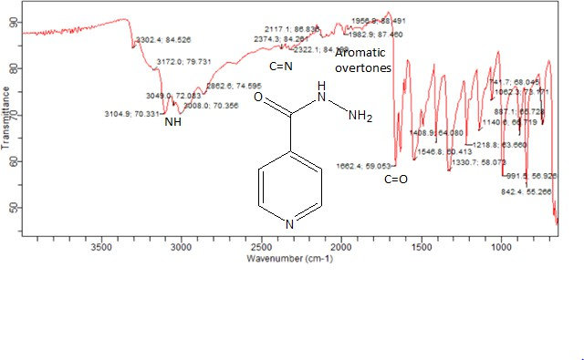

**Appendix II: Preparation of reagents Preparation of 4.5 M HCl**

Molarity required = 4.5 Molar mass = 98 gm

Volume of 4.5 M HCl required = 100 mL

Amount required = Molarity x Mola mass x Volume require / 1000 (constant)

= 4.5 x 98 x 100 mL / 1000 (constant)

= 44.1

Volume of ConcHCl required = Amount x 100 (constant) / Specific gravity x % purity

= 44.1 x 100 / 1.83 x 98

= 24.59 mL

Therefore 24.59 mL of Conc. HCl was diluted with distilled water to make 100 mL which gave

4.5 M HCl.

For Solids: Molar mass of the solid is dissolved in 1000 mL of distilled water will gives I M And 4.5 x Molar Mass dissolved in 1000 mL (1 liter) gives 4.5 M

### Preparation of 85 %v/v HCl

A solution of 85 %v/v HCl was prepared by adding 85 mL of Conc. HCl to 15 mL of distilled water.

### Preparation of 2 %v/v HCl

A solution of 2 %v/v HCl was prepared by adding 2 mL of Conc. HCl to 98 mL of distilled water.

### Preparation of 2, 4-dinitrophenylhydrazine solution

This was prepared by dissolving 1 mg of 2, 4-dinitrophenylhydrazine and 2 mg Thiourea in 100 ml of 4.5 M HCl

### Preparation of 1 %w/v sodium nitrite

A solution of 1 %w/v Sodium nitrite was prepared by accurately weighing and dissolving 1 g of sodium nitrite salt in 100 mL of distilled water.

### Preparation of 2 %w/v Sulfamic acid

A solution of 2 %w/v Sulfamic acid was prepared by accurately weighing and dissolving 2 g of Sulfamic acid salt in 100 mL of distilled water.

### Preparation of Para toluidine solution

Para toluidine solution was prepared by accurately weighing and dissolving 1 mg of Para toluidine in 100 mL of methanol.

**Appendix III: UV Spectrum of isoniazid in distilled water.**

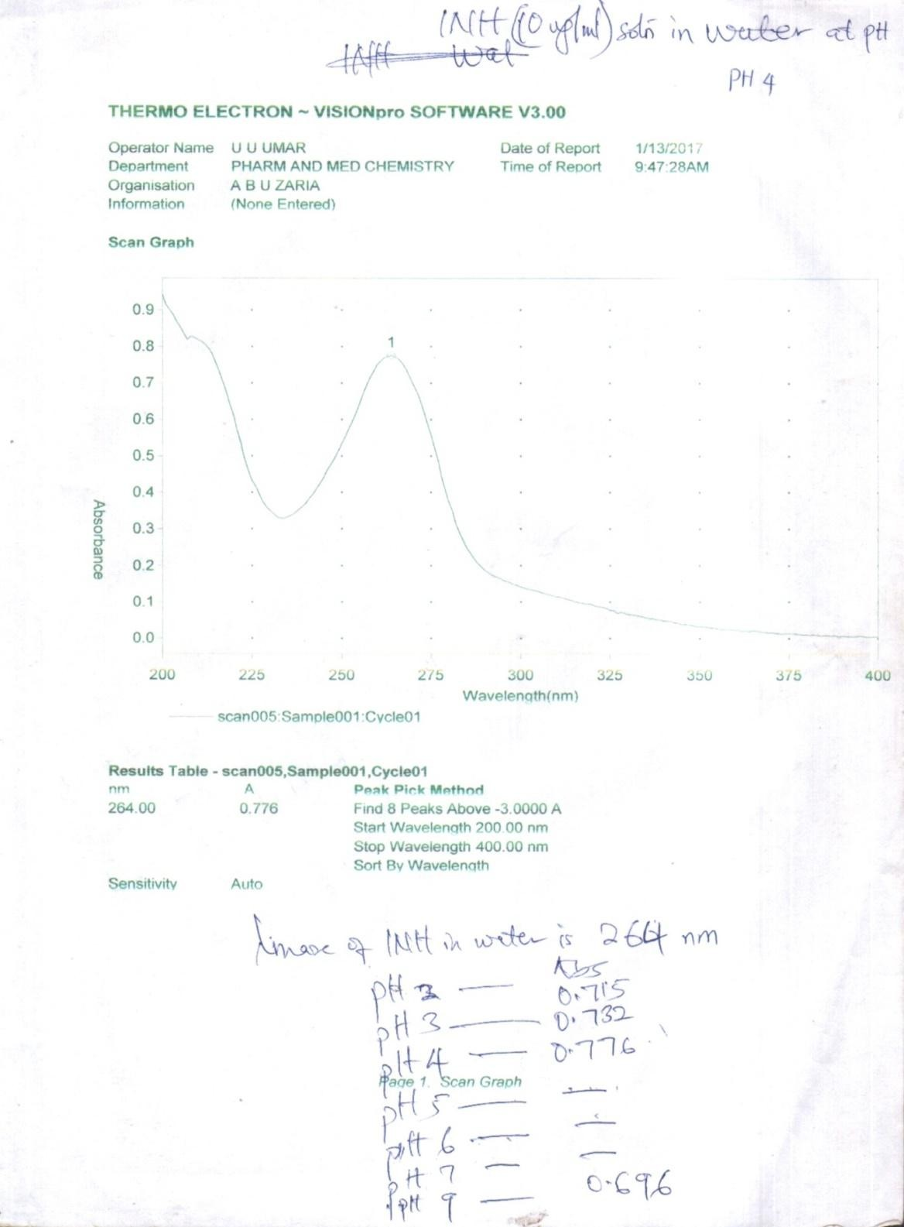

**Appendix IV: UV Spectrum of isoniazid in methanol**

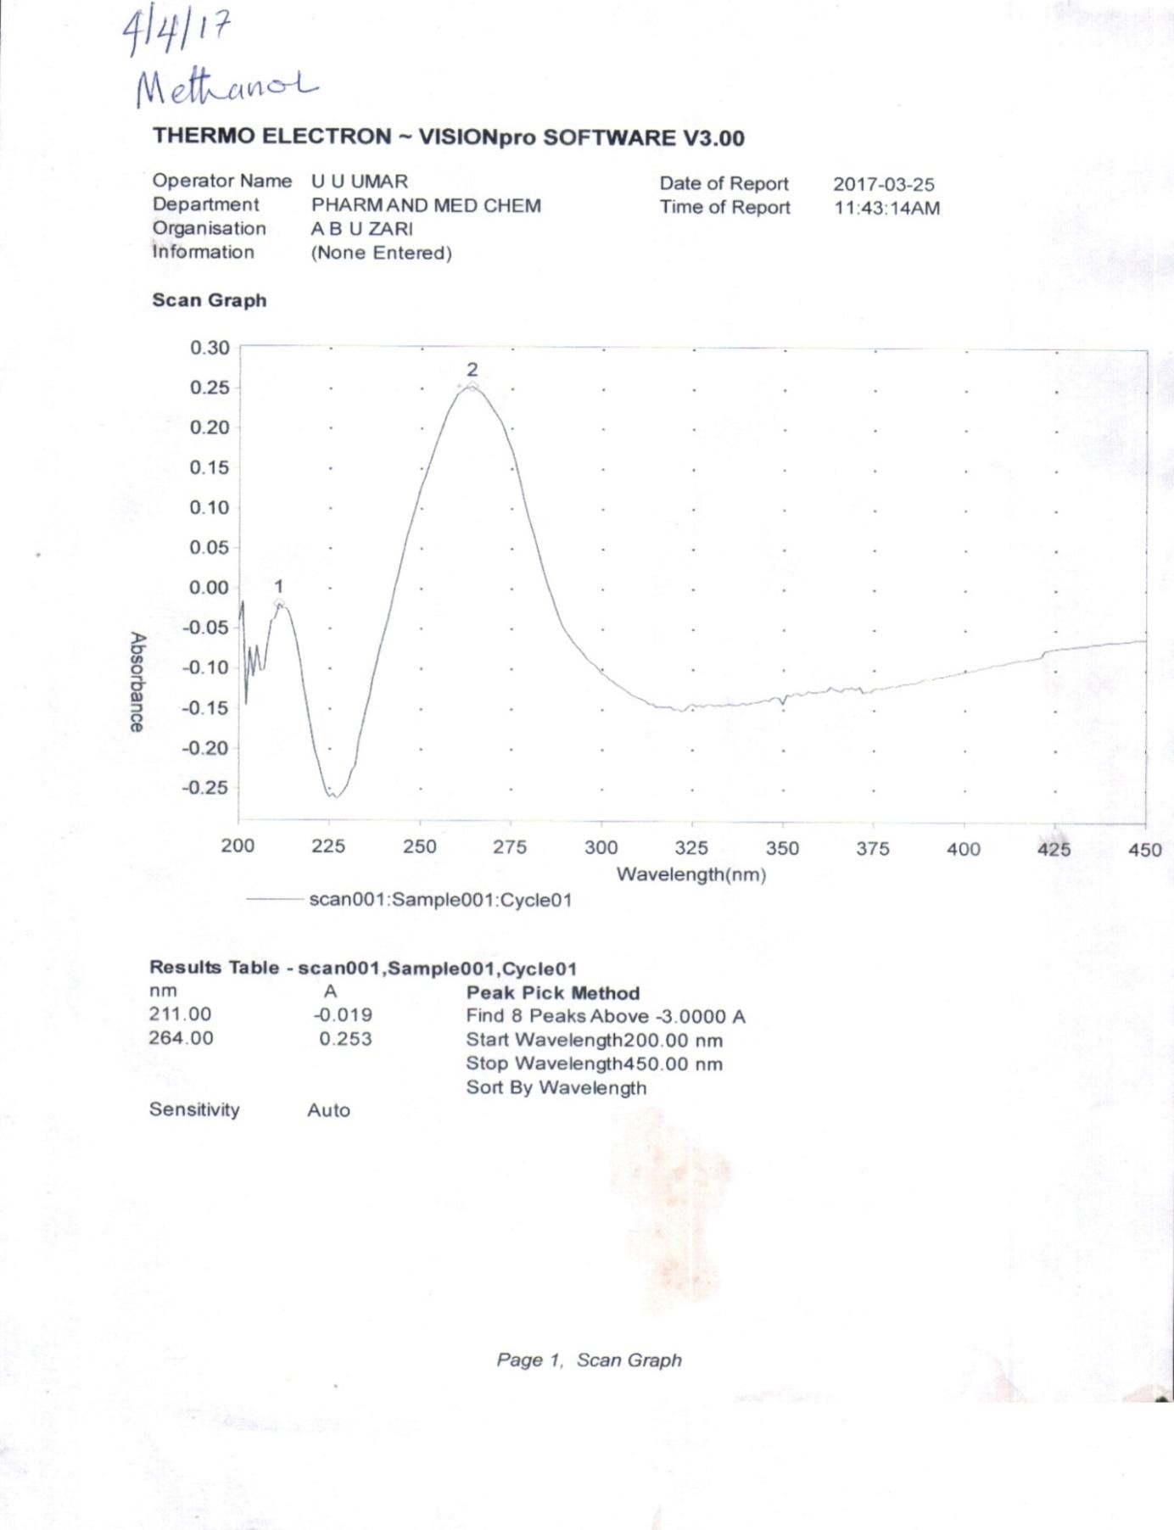

**Appendix V: UV Spectrum of isoniazid Solution with 2,4-dinitrophenylhydrazine**

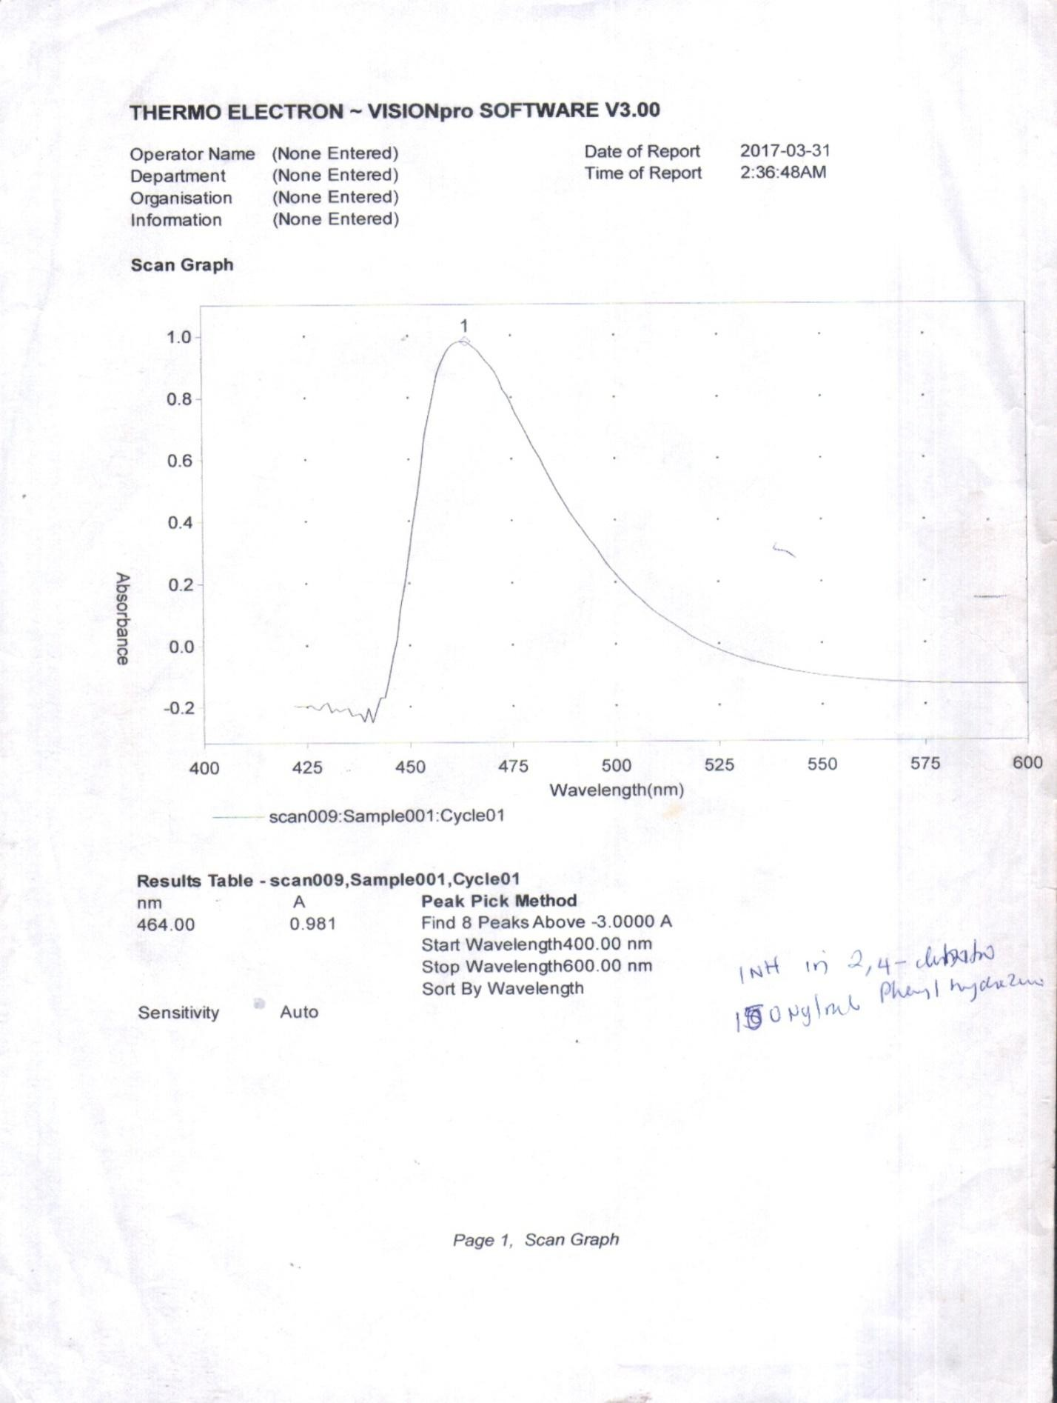

**Appendix VI: Calibration parameter of isoniazid in distilled water**

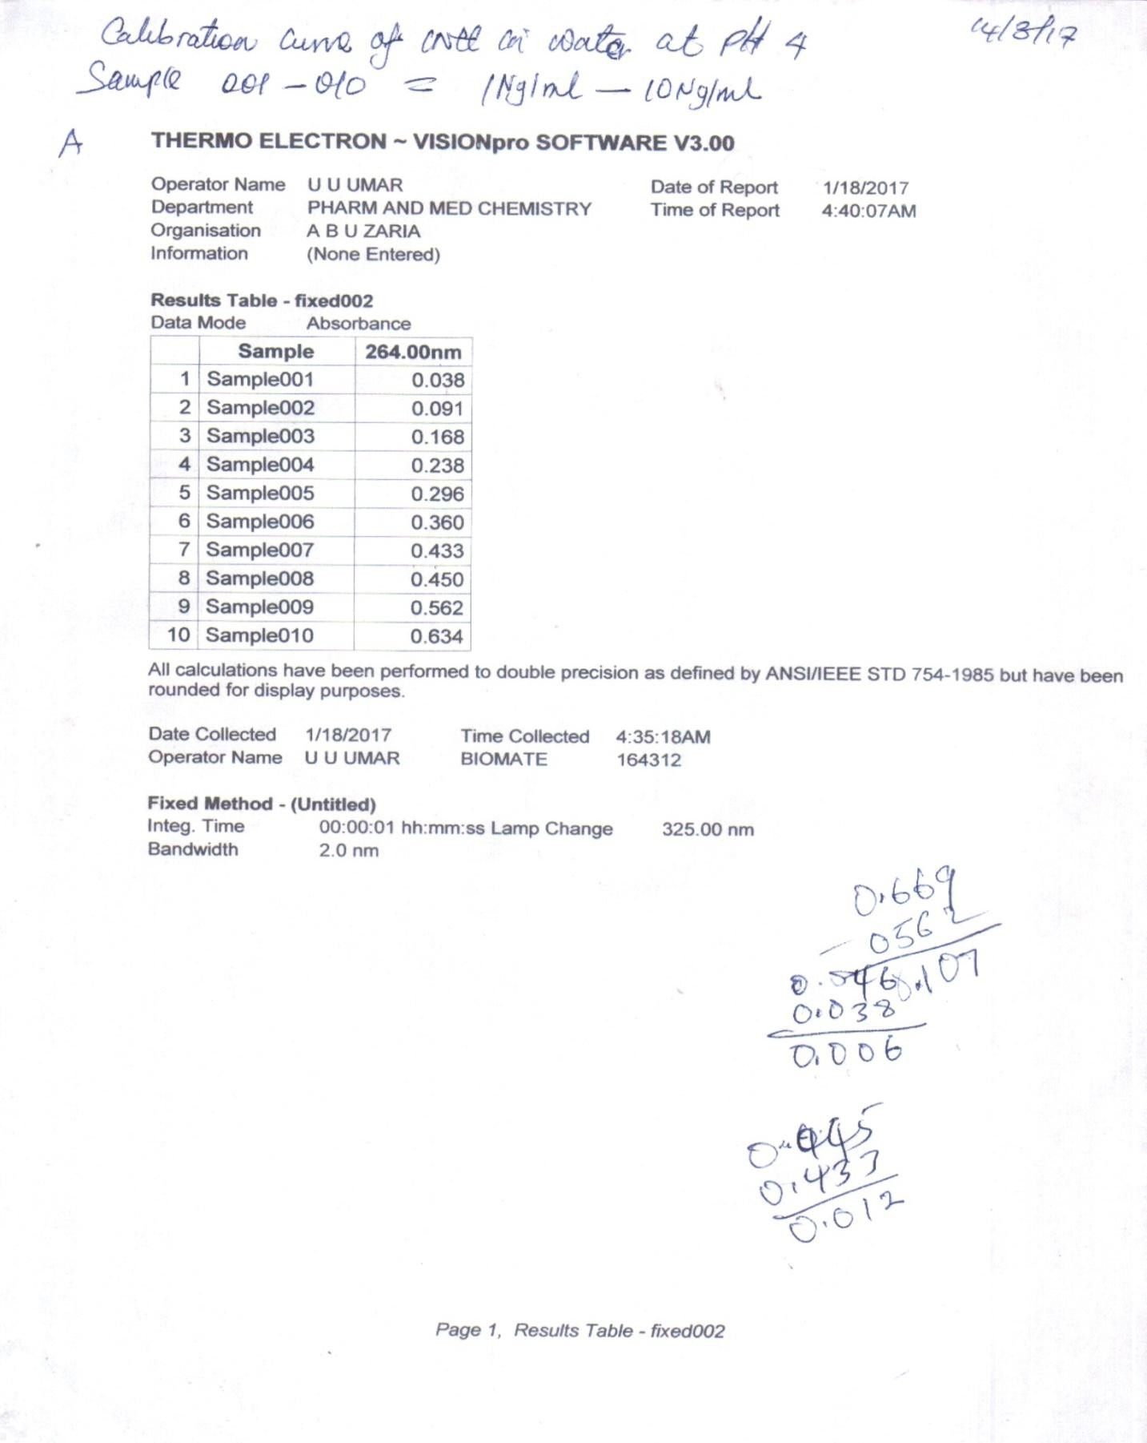

**Appendix VII: Maximum concentration of 2,4-dinitrophenylhydrazine**

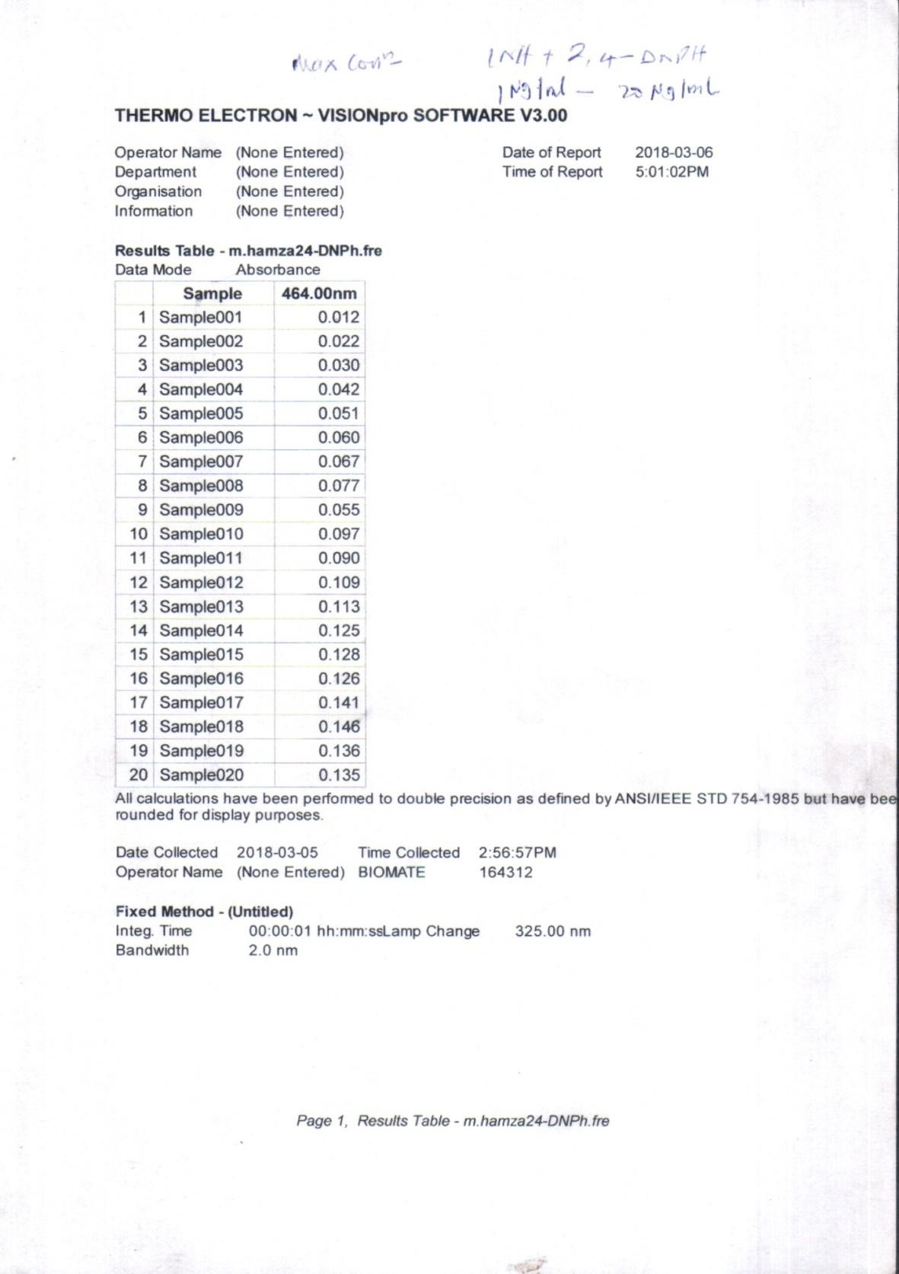

**Appendix VIII: Maximum time for colourdevelopment**

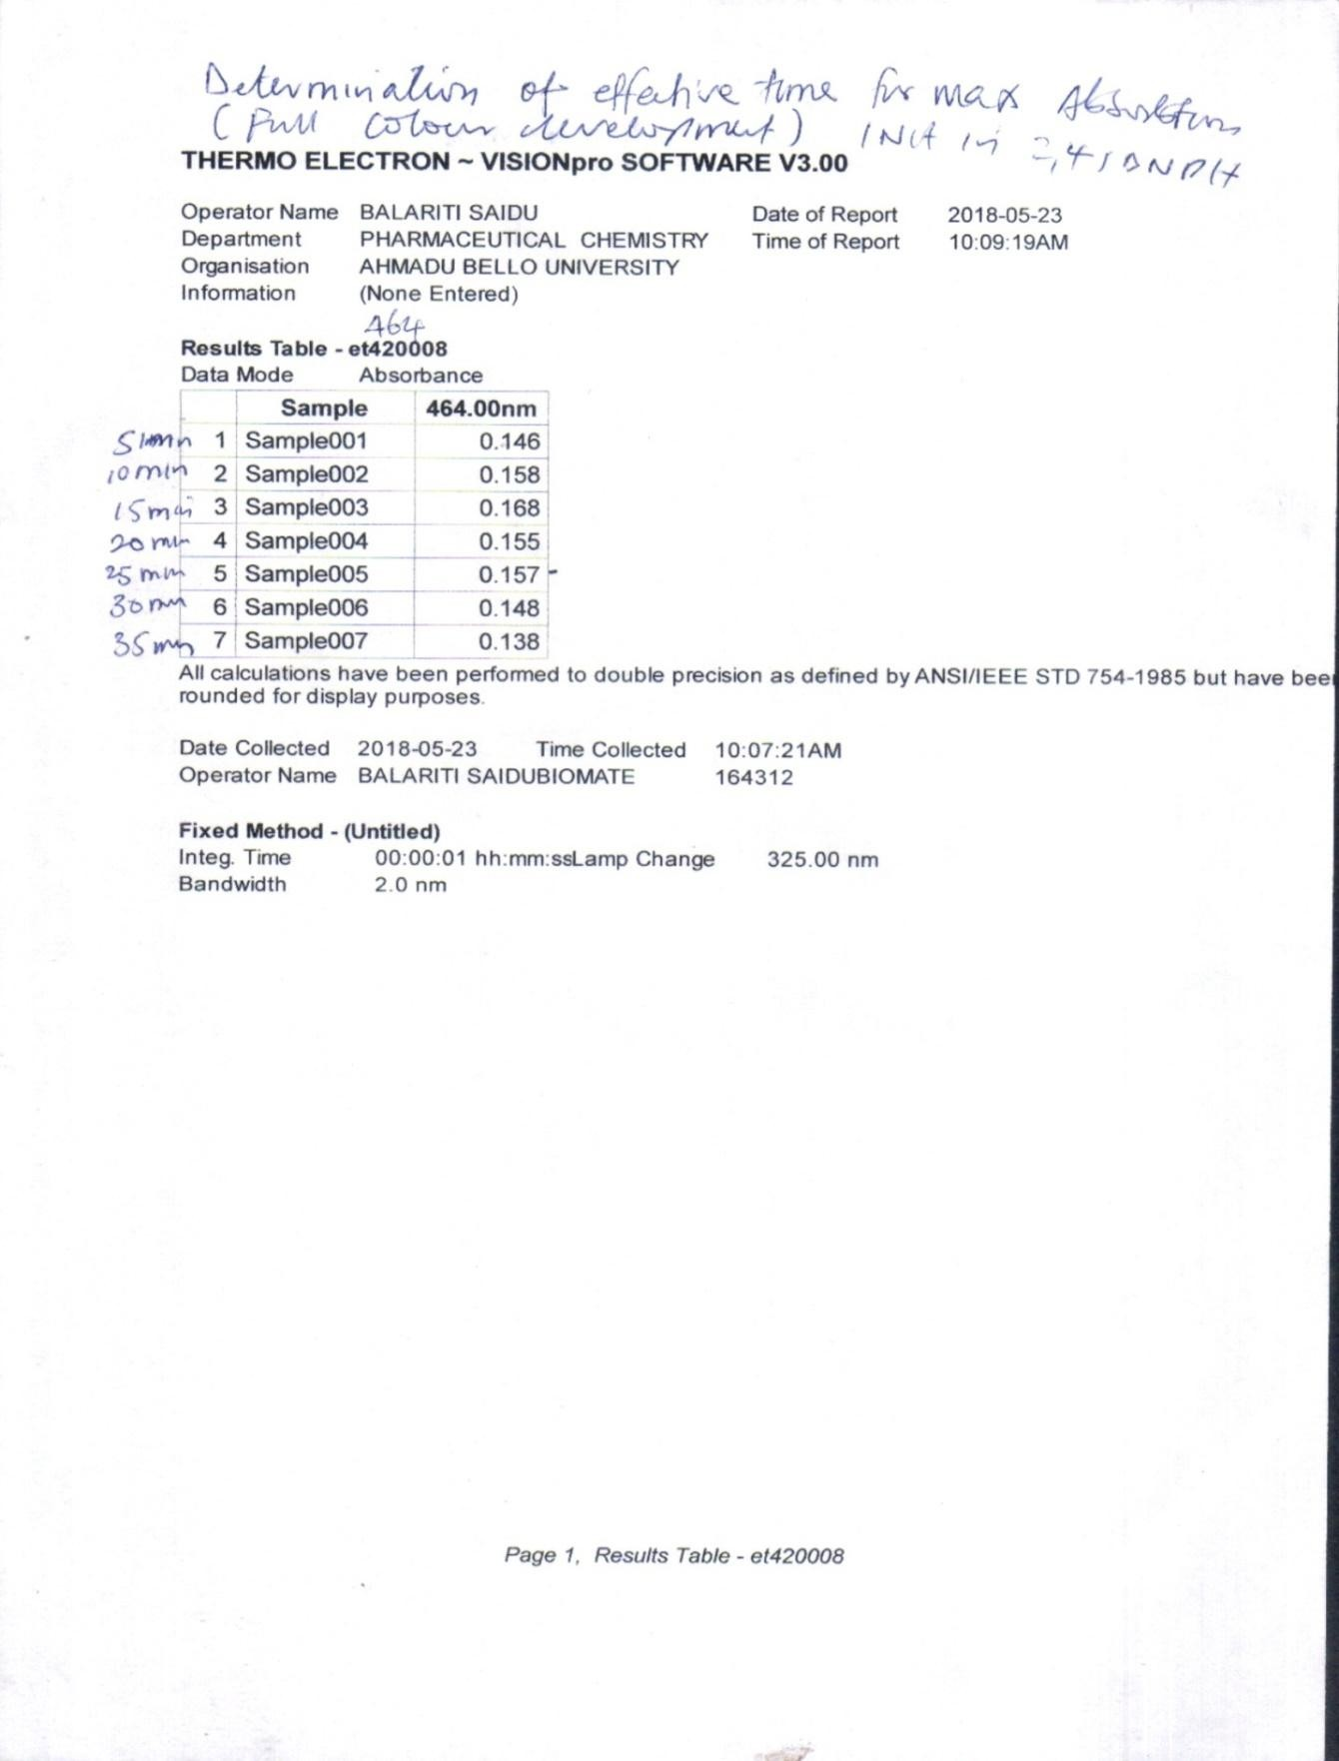

**Appendix IX: Calculation on precision**

METHOD 1

|  |  |  |  |  |  |  |  |  |  |  |  |  |
| --- | --- | --- | --- | --- | --- | --- | --- | --- | --- | --- | --- | --- |
| INTRA DAY FOR METHOD 1 | | | | | | | | | | | | |
| 0 (hrs) | | 1 (hrs) | | 2 (hrs) | | 3 (hrs) | | 4 (hrs) | | 5 (hrs) | | TOTAL  MEAN |
| Cyc. | Abs. | Cyc. | Abs. | Cyc. | Abs. | Cyc. | Abs. | Cyc. | Abs. | Cyc. | Abs. |  |
| 1 | 0.186 | 1 | 0.184 | 1 | 0.184 | 1 | 0.184 | 1 | 0.184 | 1 | 0.186 |  |
| 2 | 0.187 | 2 | 0.182 | 2 | 0.183 | 2 | 0.183 | 2 | 0.182 | 2 | 0.187 |  |
| 3 | 0.187 | 3 | 0.181 | 3 | 0.182 | 3 | 0.181 | 3 | 0.181 | 3 | 0.187 |  |
| 4 | 0.186 | 4 | 0.180 | 4 | 0.186 | 4 | 0.180 | 4 | 0.180 | 4 | 0.186 |  |
| 5 | 0.186 | 5 | 0.182 | 5 | 0.184 | 5 | 0.183 | 5 | 0.182 | 5 | 0.186 |  |
| AVERAGE | 0.186 |  | 0.182 |  | 0.184 |  | 0.182 |  | 0.182 |  | 0.186 | 0.184 |
| SD | 0.0049 |  | 0.001327 |  | 0.001327 |  | 0.00147 |  | 0.001327 |  | 0.0049 | 0.001072 |
| %RSD | 0.262821 |  | 0.72973 |  | 0.72179 |  | 0.806638 |  | 0.72973 |  | 0.262821 | 0.585588 |

|  |  |  |  |  |  |  |  |
| --- | --- | --- | --- | --- | --- | --- | --- |
| **INTER DAY FOR METHOD 1** | | | | | | | |
| **DAY I** |  | DAY 2 |  | DAY 3 |  | TOTAL | TOTAL MEAN |
| **Cyc.** | Abs. | Cyc. | Abs. | Cyc. | Abs. |  |  |
| **1** | 0.186 | 1 | 0.184 | 1 | 0.186 |  |  |
| **2** | 0.187 | 2 | 0.183 | 2 | 0.187 |  |  |
| **3** | 0.187 | 3 | 0.181 | 3 | 0.187 |  |  |
| **4** | 0.186 | 4 | 0.180 | 4 | 0.186 |  |  |
| **5** | 0.186 | 5 | 0.183 | 5 | 0.186 |  |  |
| **AVERAGE** | 0.186 |  | 0.182 |  | 0.186 | 0.555 | 0.185 |
| **SD** | 0.0049 |  | 0.00147 |  | 0.0049 | 0.00245 | 0.000817 |
| **%RSD** | 0.262821 |  | 0.806638 |  | 0.262821 | 1.332279 | 0.444093 |

METHOD 2

|  |  |  |  |  |  |  |  |  |  |  |  |  |
| --- | --- | --- | --- | --- | --- | --- | --- | --- | --- | --- | --- | --- |
| INTRA DAY FOR METHOD 2 | | | | | | | | | | | | |
| 0 (hrs) | | 1 (hrs) | | 2 (hrs) | | 3 (hrs) | | 4 (hrs) | | 5 (hrs) | | TOTAL  MEAN |
| Cyc. | Abs. | Cyc. | Abs. | Cyc. | Abs. | Cyc. | Abs. | Cyc. | Abs. | Cyc. | Abs. |  |
| 1 | 0.610 | 1 | 0.612 | 1 | 0.611 | 1 | 0.611 | 1 | 0.612 | 1 | 0.611 |  |
| 2 | 0.611 | 2 | 0.611 | 2 | 0.610 | 2 | 0.610 | 2 | 0.611 | 2 | 0.608 |  |
| 3 | 0.610 | 3 | 0.608 | 3 | 0.609 | 3 | 0.609 | 3 | 0.608 | 3 | 0.609 |  |
| 4 | 0.610 | 4 | 0.609 | 4 | 0.608 | 4 | 0.608 | 4 | 0.609 | 4 | 0.609 |  |
| 5 | 0.609 | 5 | 0.610 | 5 | 0.610 | 5 | 0.610 | 5 | 0.610 | 5 | 0.610 |  |
| AVERAGE | 0.610 |  | 0.610 |  | 0.610 |  | 0.610 |  | 0.610 |  | 0.609 | 0.610 |
| SD | 0.000632 |  | 0.001414 |  | 0.00102 |  | 0.00102 |  | 0.001414 |  | 0.00102 | 0.001087 |
| %RSD | 0.103681 |  | 0.231838 |  | 0.167291 |  | 0.167291 |  | 0.231838 |  | 0.167346 | 0.178214 |

|  |  |  |  |  |  |  |  |
| --- | --- | --- | --- | --- | --- | --- | --- |
| **INTER DAY FOR METHOD 2** | | | | | | | |
| **DAY I** |  | DAY 2 |  | DAY 3 |  | TOTAL | TOTAL MEAN |
| **Cyc.** | Abs. | Cyc. | Abs. | Cyc. | Abs. |  |  |
| **1** | 0.610 | 1 | 0.611 | 1 | 0.611 |  |  |
| **2** | 0.611 | 2 | 0.610 | 2 | 0.608 |  |  |
| **3** | 0.610 | 3 | 0.609 | 3 | 0.609 |  |  |
| **4** | 0.610 | 4 | 0.608 | 4 | 0.609 |  |  |
| **5** | 0.609 | 5 | 0.610 | 5 | 0.610 |  |  |
| **AVERAGE** | 0.610 |  | 0.610 |  | 0.609 | 1.829 | 0.610 |
| **SD** | 0.000632 |  | 0.00102 |  | 0.00102 | 0.002672 | 0.000891 |
| **%RSD** | 0.103681 |  | 0.167291 |  | 0.167346 | 0.438317 | 0.146106 |

METHOD 3

|  |  |  |  |  |  |  |  |  |  |  |  |  |
| --- | --- | --- | --- | --- | --- | --- | --- | --- | --- | --- | --- | --- |
| INTRA DAY FOR METHOD 3 | | | | | | | | | | | | |
| 0 (hrs) | | 1(hrs) | | 2 (hrs) | | 3 (hrs) | | 4 (hrs) | | 5 (hrs) | | TOTAL  MEAN |
| Cyc. | Abs. | Cyc. | Abs. | Cyc  . | Abs. | Cyc  . | Abs. | Cyc. | Abs. | Cyc  . | Abs. |  |
| 1 | 0.098 | 1 | 0.097 | 1 | 0.099 | 1 | 0.097 | 1 | 0.099 | 1 | 0.099 |  |
| 2 | 0.095 | 2 | 0.097 | 2 | 0.099 | 2 | 0.097 | 2 | 0.098 | 2 | 0.098 |  |
| 3 | 0.094 | 3 | 0.095 | 3 | 0.096 | 3 | 0.095 | 3 | 0.097 | 3 | 0.099 |  |
| 4 | 0.096 | 4 | 0.096 | 4 | 0.094 | 4 | 0.096 | 4 | 0.095 | 4 | 0.099 |  |
| 5 | 0.099 | 5 | 0.096 | 5 | 0.095 | 5 | 0.096 | 5 | 0.096 | 5 | 0.097 |  |
| AVERAGE | 0.096 |  | 0.096 |  | 0.097 |  | 0.096 |  | 0.097 |  | 0.098 | 0.097 |
| SD | 0.001855 |  | 0.000748 |  | 0.002059 |  | 0.000748 |  | 0.001414 |  | 0.0008 | 0.001271 |
| %RSD | 1.923987 |  | 0.777891 |  | 2.1316 |  | 0.777891 |  | 1.457952 |  | 0.813008 | 1.313722 |

|  |  |  |  |  |  |  |  |
| --- | --- | --- | --- | --- | --- | --- | --- |
| **INTER DAY FOR METHOD 3** | | | | | | | |
| **DAY I** |  | DAY 2 |  | DAY 3 |  | TOTAL | TOTAL MEAN |
| **Cyc.** | Abs. | Cyc. | Abs. | Cyc. | Abs. |  |  |
| **1** | 0.098 | 1 | 0.097 | 1 | 0.099 |  |  |
| **2** | 0.095 | 2 | 0.097 | 2 | 0.098 |  |  |
| **3** | 0.094 | 3 | 0.095 | 3 | 0.099 |  |  |
| **4** | 0.096 | 4 | 0.096 | 4 | 0.099 |  |  |
| **5** | 0.099 | 5 | 0.096 | 5 | 0.097 |  |  |
| **AVERAGE** | 0.096 |  | 0.096 |  | 0.098 | 0.291 | 0.097 |
| **SD** | 0.001855 |  | 0.000748 |  | 0.0008 | 0.003403 | 0.001134 |
| **%RSD** | 1.923987 |  | 0.777891 |  | 0.813008 | 3.514887 | 1.171629 |

METHOD 4

|  |  |  |  |  |  |  |  |  |  |  |  |  |
| --- | --- | --- | --- | --- | --- | --- | --- | --- | --- | --- | --- | --- |
| INTRA DAY FOR METHOD 4 | | | | | | | | | | | | |
| 0 (hrs) | | 1(hrs) | | 2 (hrs) | | 3 (hrs) | | 4 (hrs) | | 5 (hrs) | | TOTAL MEAN |
| Cyc. | Abs. | Cyc. | Abs. | Cyc. | Abs. | Cyc. | Abs. | Cyc. | Abs. | Cyc. | Abs. |  |
| 1 | 0.739 | 1 | 0.738 | 1 | 0.741 | 1 | 0.738 | 1 | 0.738 | 1 | 0.742 |  |
| 2 | 0.740 | 2 | 0.737 | 2 | 0.740 | 2 | 0.738 | 2 | 0.737 | 2 | 0.744 |  |
| 3 | 0.739 | 3 | 0.739 | 3 | 0.736 | 3 | 0.737 | 3 | 0.739 | 3 | 0.743 |  |
| 4 | 0.738 | 4 | 0.736 | 4 | 0.735 | 4 | 0.739 | 4 | 0.736 | 4 | 0.739 |  |
| 5 | 0.737 | 5 | 0.737 | 5 | 0.737 | 5 | 0.736 | 5 | 0.737 | 5 | 0.741 |  |
| AVERAGE | 0.739 |  | 0.737 |  | 0.738 |  | 0.738 |  | 0.737 |  | 0.742 | 0.738 |
| SD | 0.00102 |  | 0.00102 |  | 0.002315 |  | 0.00102 |  | 0.00102 |  | 0.00172 | 0.001352 |
| %RSD | 0.138073 |  | 0.138297 |  | 0.313793 |  | 0.13826 |  | 0.138297 |  | 0.231931 | 0.183109 |

|  |  |  |  |  |  |  |  |
| --- | --- | --- | --- | --- | --- | --- | --- |
| **INTER DAY FOR METHOD 4** | | | | | | | |
| **DAY I** |  | DAY 2 |  | DAY 3 |  | TOTAL | TOTAL MEAN |
| **Cyc.** | Abs. | Cyc. | Abs. | Cyc. | Abs. |  |  |
| **1** | 0.739 | 1 | 0.741 | 1 | 0.742 |  |  |
| **2** | 0.740 | 2 | 0.740 | 2 | 0.744 |  |  |
| **3** | 0.739 | 3 | 0.736 | 3 | 0.743 |  |  |
| **4** | 0.738 | 4 | 0.735 | 4 | 0.739 |  |  |
| **5** | 0.737 | 5 | 0.737 | 5 | 0.741 |  |  |
| **AVERAGE** | 0.739 |  | 0.738 |  | 0.742 | 2.2182 | 0.740 |
| **SD** | 0.00102 |  | 0.002315 |  | 0.00172 | 0.005055 | 0.001685 |
| **%RSD** | 0.138073 |  | 0.313793 |  | 0.231931 | 0.683797 | 0.227932 |

# Appendix X:Calculations on accuracy, % recovery, LOD and LOQ

To 10 mL volumetric flask A1 contains 5 mL of 10 μg/mL isoniazidsolution and was kept unspiked. Its absorbance was measured and was recorded as (a = 0.630)

How to prepare 18 μg/L in test tube B1.

Concentration of isoniazid solution in 10 mL volumetric flask B1 = 10 μg/mL (C1) Volume of solution in 10 mL volumetric flask B1 = 5 mL (V1)

Concentration of stock solution = 100 μg/mL (C2)

Volume of stock solution to be added to 10 mL volumetric flask B1 = (V2?) Final concentration of 10 mL volumetric flask B1 = 18 μ/mL (C3)

Final volume of test tube B1 =10 mL (V3)

C1V1+C2V2 =C3V3

10 μg/mL * 5 mL +100 μg/mL * V2 = 18 μg/mL * 10 mL 50 μg + 100 μg/mL * V2 = 180 μg

100 μg/mL * V2 = 180 μg – 50 μg 100 μg/mL * V2 =130 μg

V2 = 130μg * mL/100 μg V2 = 1.3mL

1.3 mL from the stock solution was withdrawn and added to 10 mL volumetric flask B1 and made up to 10 mL volume with distilled water and its absorbance was measured and recorded as (b = 1.156)

How to prepare 20 μg/mL in 10 mL volumetric flask C1.

Concentration of isoniazid solution in 10 mL volumetric flask C1 = 10 μg/mL (C1) Volume of solution in10 mL volumetric flask C1 = 5 ml (V1)

Concentration of stock solution = 100 μg/mL (C2)

Volume of stock solution to be added to 10 mL volumetric flask C1 = (V2?) Final concentration of 10 mL volumetric flask C1 = 20 μg/mL (C3)

Final volume of 10 mL volumetric flask C1 =10 mL (V3)

C1V1+C2V2 =C3V3

10 μg/mL * 5 ml +100 μg/ml * V2 = 20 μg/ml * 10 ml 50 μg + 100 μg/mL * V2 = 200 μg

100 μg/mL * V2 = 200 μg – 50 μg 100 μg/mL * V2 =150 μg

V2 = 150 μg * mL/100 μg V2 = 1.5 mL

1.5 mL from the stock solution was withdrawn and added to 10 mL volumetric flask C1 and made up to 10 mL volume with distilled water and its absorbance was measure as (c

= 1.235)

How to prepare 22 μg/mL in 10 mL volumetric flask D1.

Concentration of isoniazid solution in 10 mL volumetric flask D1 = 10 μg/mL (C1) Volume of solution in 10 mL volumetric flask D1 = 5 mL (V1)

Concentration of stock solution = 100 μg/mL (C2)

Volume of stock solution to be added to 10 mL volumetric flask D1 = (V2?) Final concentration of 10 mL volumetric flask D1 = 22 μ/ml (C3)

Final volume of 10 mL volumetric flask D1 =10 mL (V3)

C1V1+C2V2 =C3V3

10 μg/mL * 5 mL +100 μg/mL * V2 = 22 μg/mL * 10 mL 50 μg + 100 μg/mL * V2 = 220 μg

100 μg/mL * V2 = 220 μg – 50 μg 100 μg/mL * V2 =170 μg

V2 = 170 μg * mL/100 μg V2 = 1.7 mL

1.7 mL from the stock solution was withdrawn and added to 10 mL volumetric flask D1 and made up to 10 mL volume with distilled water and its absorbance was measure as (d

= 1.422)

Then using regression/linear equation, we can calculate as follows: y = 0.0657x-0.0288

For B1 which was 18 μg/mL: (b-a) = 0.0657x – 0.0288 0.0657x= (b-a) + 0.0288

0.0657x = (1.156-0.630) + 0.0288

0.0657x = 0.526 + 0.0288

0.0657x = 0.5548

X = 0.5548/0.0657 = 8.444 μg

% recovery = 8.444/8 x100 = 105.55 Accuracy = 8.444 – 8/8 = 0.0555 For C1 which was 20 μg/mL:

(c-a) = 0.0657x – 0.0288

0.0657x=(c-a) + 0.0288

0.0657x = (1.235-0.630) + 0.0288

0.0657x = 0.605 + 0.0288

0.0657x = 0.6338

X = 0.6338/0.0657 = 9.650

% recovery = 9.650/10 x100 = 96.5 Accuracy = 10 – 9.65/10 = 0.035 For D1 which was 22 μg/mL:

(d-a) = 0.0657x – 0.0288

0.0657x= (d-a) + 0.0288

0.0657x = (1.422-0.630) + 0.0288

0.0657x = 0.7920 + 0.0288

0.0657x = 0.8208

X = 0.8208/0.0657 = 12.49 μg

% recovery = 12.49/12 x100 = 104 Accuracy = 12.49 – 12/12 = 0.04083333

Therefore mean % recovery for the three values = 105.5+96.5+104/3 = 102.01 % Therefore mean Accuracy for the three values = 0.04083333+ 0.035+0.0555/3 = 0.04377

***Detection limit:*** The detection limit (LOD) was the sensitivity of the method to detect the presence of the analytical drug in the solution- LOD is expressed as the formula:

LOD = 3.3σ/S

Where σ is the standard deviation of y-intercepts of the regression lines and S is the slope of the calibration curve.

***Quantitation limit:*** The quantitation limit (LOQ) was determined using the expression: LOQ = 10σ/S

Where σ is the standard deviation of y-intercepts of the regression lines and S is the slope of the calibration curve.

# Appendix XI: slope, intercept and standard deviations

|  |  |  |  |
| --- | --- | --- | --- |
| Slope | 0.06565 | Intercept | -0.02885 |
| Standard deviation  of slope | 0.000391 | Standard deviation  of intercept | 0.002243 |
| R2 | 0.999894 | Degree of freedom | 0.00247 |

LOD = 3.3σ/S = 3.3 X0.002243/0.06565 = 0.1127479 LOQ = 10σ/S = 10 X 0.002243/0.06565 = 0.341660

This was repeated for methods 2, 3 and 4