DEVELOPMENT AND PERFORMANCE OPTIMISATION OF A TWO-ROW ENGINE-PROPELLED SEEDRIDGE PLANTER

BY

Eneji James UPAHI

B.Eng (Ilorin, 1988), M.Eng. (Minna, 2001) P16EGAE9007 (PH.D/ENG/1408/2008-09)

A THESIS SUBMITTED TO

THE SCHOOL OF POSTGRADUATE STUDIES AHMADU BELLO UNIVERSITY

ZARIA

IN PARTIAL FULFILLMENT OF THE REQUIREMENTS FOR THE AWARD OF A DOCTOR OF PHILOSOPHY DEGREE IN AGRICULTURAL ENGINEERING

DEPARTMENT OF AGRICULTURAL ENGINEERING FACULTY OF ENGINEERING

AHMADU BELLO UNIVERSITY ZARIA, NIGERIA

AUGUST, 2017

**DEDICATION**

To the memories of my late parents Late Pa Ali Upahi

and

Late Mrs. Mary Awawu Upahi

To

My lovely wife

Mrs. Veronica Unoiza Upahi and

To my lovely children Otuoze, Omeiza and Ovayoza

**DECLARATION PAGE**

I declare that the work in this Thesis entitled **Development and Performance Optimisation of a Two-Row Engine-Propelled Seed Ridge Planter**has been carried out by me in the Department of Agricultural Engineering. The information derived from the literature has been dully acknowledged in the text and in the references provided. No part of this Thesis was previously presented for another degree or diploma at this or any other institution

# Eneji James,UPAHI

Name of Student Signature Date

**CERTIFICATION PAGE**

This Thesis entitled **Development and Performance Optimisation of a Two-Row Engine-Propelled Seed Ridge Plante**r by Eneji James UPAHI meets the regulations governing the award of the degree of Doctor of Philosophy of the Ahmadu Bello University, and is approved for its contribution to knowledge and literary presentation

|  |  |  |
| --- | --- | --- |
| **Prof.AbdullahiM.I. El-Okene** |  |  |
| Chairman, Supervision Committee | Signature | Date |

|  |  |  |
| --- | --- | --- |
| **Prof.DaudaD. Yusuf** |  |  |
| Member, Supervision Committee | Signature | Date |

|  |  |  |
| --- | --- | --- |
| **Prof.MaiwadaL. Suleiman** |  |  |
| Member, Supervision Committee | Signature | Date |

|  |  |  |
| --- | --- | --- |
| **Prof.MaiwadaL. Suleiman** |  |  |
| Head of Department | Signature | Date |

|  |  |  |
| --- | --- | --- |
| **Prof.Sadiq Z. Abubakar** |  |  |
| Dean, School of Postgraduate Studies | Signature | Date |

**ACKNOWLEDGEMENTS**

This research work was done with the assistance of some people. They are hereby acknowledged for their various contributions.

My Research Supervisors, Prof. A.M.I. El-Okene, Prof D.D. Yusuf and Prof. M.L. Suleiman (who doubles also as the Head of Department)at the Ahmadu Bello University, Zaria are acknowledged for their thorough academic scrutiny and directions which led to the success of this research work.

The contributions of Engr. Prof. U.S. Mohammed, Engr. Prof. Henry Igbadun and Engr. Prof.MoshudiIsiaka in the design process and the field evaluations are highly appreciated. I appreciate other academic and non-academic staff of the Department for their cordiality and moral support.

The Authors whose previous works were used in this research are acknowledged with gratitude.

The technical contributions of Engr. Dr. Joachim O. Daudu (MD of ARMECO Ltd, Kaduna), Engr. Dr. Hassan F. Alade of the Department of Chemical Engineering, Kaduna Polytechnic, Engr. ShehuEtsu Umar and Engr. Jonathan C. Obianukoof the Department of Agricultural and Bio-Environmental Engineering, Kaduna Polytechnic, Mr. Sunday Bature, Mr. Bulus P. Gwajacks and Alh. Salihu Ahmed of the Department of Agricultural Engineering, Ahmadu Bello University, Zaria are acknowledged with utmost gratitude.

The Management of Kaduna Polytechnic, Kaduna (my employer) is highly appreciated for granting me permission to undertake this course of study.

I acknowledge the emotional and moral support from my lovely wife, Mrs. Veronica Unoiza Upahi through the period of this study.

I request God’s blessing upon you all.

Above all I adore God for His Omnipotent and Omniscient disposition to this work. With Him all things have been made possible.

# ABSTRACT

In the bid to find solutions to the problems associated with planting on ridges and for the fact that existing planters for cereals in Nigeria are not built on the concept of ridges but on flat land planting, this research work was embarked upon to develop anengine- propelled two-row ridge planter for cereals. The planter was designed, fabricated and evaluated. The planter has the functional units of two hoppers, two seed metering units, two delivery chutes, two coulters, two soil covering devices and a drive mechanism. The developed planter was evaluated in terms of planting speed, seedling emergence, plant-to-plant spacing, energy expended, seed delivery rate, number of seeds per hill and percent seed damage. The results obtained compared with those of an existing IAR single-row animal drawn planter and with the manual planting method in 2012, 2013 and 2014 planting seasons using Quality Protein Maize (QPM) as the test crop. In terms of planting speed, seedling emergence and plant-to-plant spacing, the engine-propelled planter performed best. It recorded the highest average planting speed of 0.55 m/s,average plant density of 28,803 plants per hectare representing 73.85% of the design plant density, plant spacing of 25.9 cm, which is the closest to the designed plant spacing of 25cm. The engine-propelled planter expended the least energy of

261.82 MJ/ha as against the 2,308.18 MJ/ha and 1,099.09 MJ/ha of energy for the animal drawn planter and manual planting respectively. The seed delivery rate was 19.80kg/ha, Effective Field Capacity of 0.22ha/hr, field efficiency of 70.71%, Speed of Emergence of 4.33 plants per day, Mean Emergence Data of 9.6, Emergence Rate Index of 6.77 and a Relative Emergence of 0.87. The performance indices were subjected to optimisation using the Response Surface Methodology with a Central Composite Design (CCD). The Design Expert, Release 9.0 was used as the optimisation software. Models were developed for optimizing each of the performance indices of seedling emergence, plant spacing, depth of planting, number of seeds per hole, energy expended and number of damaged seeds using speed of planting and soil moisture content as the input variables. Mathematical models were developed for optimising the number of emerged seedlings, depth of planting, plant-to-plant spacing, number of seeds per hole, energy expended and the number of damaged seeds (as the performance indices) using the engine-propelled planter only. The Sequential Sum of Squares, Lack of Fit Test and the Summary of Statistics were used in determining that the quadratic models were best in evaluating the optimal values of the performance indices. Results of optimisation showed that the seedling emergence could be maximised to 24.52 plants within the planting area of 0.0011 hectares which translated to 22,290 plants per hectare of maize. The results also revealed that the maximum depth of planting was 36.74 mm, plant-to-plant spacing was maximised to 44.00 mm and maximum number of seeds per hole was determined to be 3 seeds. The energy expended could be minimised to 1.97MJ over 0.0011 hectares (or 1,790 MJ in one hectare) and the number of damaged seeds could be minimised to zero.At the end of the research, it was concluded that the developed 2-row engine-propelled seed planter could be used for planting maize seeds on ridges in well drained sandy loamy soils and that it compared favourably with the existing IAR single row planter and the manual planting. The engine-propelled planter was produced and assembled at a cost of N176,178.08.

# TABLE OF CONTENTS

Title Page

|  |  |
| --- | --- |
| Title page | i |
| Dedication | ii |
| Declaration page | iii |
| Certification page | iv |
| Acknowledgements | v |
| Abstract | vi |
| List of Figures | x |
| List of Tables | xii |
| List of Plates | xvi |
| List of Appendices | xvii |
| **CHAPTER ONE** | 1 |
| 1.0 **INTRODUCTION** | 1 |
| 1.1 **Preamble** | 1 |
| 1.2 **Statement of Problem** | 3 |
| 1.3 **Justification** | 4 |
| 1.4 **Aim and Objectives of the Study** | 5 |
| 1.5 **Scope and Limitations** | 5 |
| **CHAPTER TWO**  2.0 **LITERATURE REVIEW** | 7 |
| 2.1 **Crop Planting** | 7 |
| 2.2 **Agronomic Requirements for Planting** | 7 |
| 2.2.1 Seed factors | 7 |
| 2.2.2 Environmental factors | 8 |
| 2.2.3 Control of planting depth | 9 |
| 2.2.4 Plant competition | 10 |
| 2.2.5 Plant population and spacing requirements | 10 |
| 2.3 **Methods of Planting** | 10 |
| 2.4 **Agronomic Requirements of Machines for Sowing** | 14 |
| 2.5 **Planter Functional Requirements for Crop Establishment** | 14 |
| 2.6 **Planters and their Classifications** | 15 |
| 2.6.1 Types of planter | 15 |
| 2.6.2 Planter components | 18 |
| 2.7 **Design Features of Seed Planters** | 18 |
| 2.7.1 The hoppers | 18 |
| 2.7.2 The metering mechanisms and types | 19 |
| 2.7.3 Design parameters for metering rollers | 24 |
| 2.8 **Performance of Seed Metering Mechanisms** | 30 |
| 2.9 **Seed Transport Mechanisms** | 31 |
| 2.10 **Furrow Opening and Covering Devices** | 32 |
| 2.11 **Performance of Soil Opening and Covering Devices** | 34 |

* 1. Evaluating Planter Performance 34
  2. Soil-Implement Relationship 36
  3. Animal Draught power 37
  4. Draft Relationships for Planting (Seeding) Equipment 38
  5. Energy Consumption in the Operation of Planters 40
     1. Human (manual) power 40
     2. Animal draught power 43
     3. Mechanical (fuel) energy 44
  6. OptimisationProcess 44
  7. Previous Research Activities 46
  8. Summary of Literature Review 48

CHAPTER THREE

* 1. MATERIALS AND METHODS 49
  2. Materials 49
     1. Materials used in the design 49
     2. Materials used in the fabrication and assembly 49
     3. Materials used in the laboratory evaluation 49
     4. Materials used in the field evaluation 49
  3. Methods 51
     1. The design concept 51
     2. Development of the engine-propelled 2-row seed ridge planter 53
     3. The fabrication and assembly 68
     4. Principle of operation of the engine-propelled 2-row seed ridge planter 71
     5. Laboratory evaluations 71
     6. Field performance evaluation 74
     7. Field measurements 77
     8. Energy expended 81
     9. Total areas planted 82
     10. Analysis of data collated 83
     11. Research costing 93

CHAPTER FOUR

* 1. RESULTS AND DISCUSSIONS 100
  2. Results of laboratory evaluations 100
     1. Results of soil physical evaluation 100
     2. Results of 1000 seed weight 100
     3. Results of percent seed damage 102
     4. Results of seed metering and ground wheel speed 103
     5. Results of soil moisture content determination 104
  3. Results of Field Evaluation 105
     1. Results of machine performance evaluation at field level 105
     2. Effects of evaluated factors on planting speed 105
     3. Effects of evaluated factors on seedling emergence 107
     4. Effects of evaluated factors on plant-plant spacing 109
     5. Effects of evaluated factors on energy expended 111
     6. Results of statistical evaluations 113
  4. Computed Machine Characteristics 135
     1. Seed delivery rate 135
     2. Theoretical working width 135
     3. Effective working width 135
     4. Working depth 135
     5. Seed spacing evenness 136
     6. Field effective capacities and field efficiencies of the three

planting methods 136

* + 1. Seedling emergence ratios 138
  1. Response Surface Optimisation Results 140
     1. Response surface modelling of seedling emergence with

respect to seed planting process parameters 141

* + 1. Selection of adequate model for seedling emergence 141
    2. Seedling emergence model 144
    3. Response surface modelling of depth of planting with

respect to seed planting process parameters 150

* + 1. Response surface modelling of plant spacing with

respect to seed planting process parameters 157

* + 1. Response surface modelling of number of seeds per hole with

respect to seed planting process parameters 166

* + 1. Response surface modelling of total energy expended with

respect to seed planting process parameters 174

* + 1. Response surface modelling of number of damaged seeds with

respect to seed planting process parameters 184

CHAPTER FIVE

* 1. SUMMARY, CONCLUSIONS AND RECOMMENDATIONS 194
  2. Summary 194
     1. The design 194
     2. Performance evaluation 195
     3. Energy expenditure 196
     4. Optimisation 196
  3. Conclusions 197
  4. Recommendations 199
  5. Contributions to Knowledge 199

REFERENCES 201

# APPENDICES

**LIST OF FIGURES**

|  |  |  |
| --- | --- | --- |
|  | Title | Page |
| Figure 2.1 | Planting by broadcasting | 10 |
| Figure 2.2 | Drill planting | 10 |
| Figure 2.3 | Precision planting | 12 |
| Figure2.4 | Hill drop planting | 12 |
| Figure2.5 | Steep triangular shaped grooves | 25 |
| Figure2.6 | Design variables of brush | 28 |
| Figure2.7 | Animal draft measurement | 43 |
| Figure3.1 | Ground wheel on furrows | 52 |
| Figure3.2 | The design concept in form | 52 |
| Figure3.3 | Hopper configuration |  |
| Figure 3.4 | Cross sectional configuration of the selected v-belt | 64 |
| Figure 3.5 | Design Expert 9.0 program for computing the coefficients |  |
|  | of the response surface model, t-test and p-values | 93 |
| Figure4.1 | Result of planting speed from the three methods of |  |
|  | planting | 106 |
| Figure4.2 | Result of seedling emergence from the three methods of |  |
|  | planting | 108 |
| Figure4.3 | Result of plant spacing from the three methods of |  |
|  | planting | 110 |
| Figure4.4 | Result of energy expended from the three methods of |  |
|  | planting | 112 |
| Figure4.5 | Average planting speed under the planting methods |  |
|  | for the years 2012, 2013 and 2014 | 126 |
| Figure4.6 | Average number of emerged seeds under planting the |  |
|  | methods for the years 2012, 2013 and 2014 | 129 |
| Figure4.7 | Average plant spacing under the planting methods |  |
|  | for the years 2012, 2013 and 2014 | 131 |
| Figure4.8 | Average energy expendedunder the planting methods |  |
|  | for the years 2012, 2013 and 2014 | 134 |
| Figure4.9 | Normal plot of residuals for seedling emergence | 147 |
| Figure4.10 | Mean model contour plot showing the effects of |  |
|  | moisture contentand planting speed on seedling emergence |  |
|  | for surface response optimisation | 149 |
| Figure4.11 | Mean model surface response plot showing the effects |  |
|  | of moisture content and planting speed on seedling |  |
|  | emergence for surface response optimisation | 149 |
| Figure4.12 | Normal plot of residuals for depth of planting | 155 |
| Figure4.13 | Mean model contour plot showing the effects of moisture |  |
|  | Contentand planting speed on depth of planting for surface |  |
|  | response optimisation | 156 |

|  |  |  |
| --- | --- | --- |
| Figure4.14 | Mean model surface response plot showing the effects of |  |
|  | moisture content and planting speed on depth of planting |  |
|  | for surface response optimisation | 156 |
| Figure4.15 | Normal plot of residuals for plant spacing | 163 |
| Figure4.16 | Mean model contour plot showing the effects of moisture |  |
|  | Contentand planting speed on plant spacing for surface |  |
|  | response optimisation | 165 |
| Figure4.17 | Mean model surface response plot showing the effects |  |
|  | of moisture content and planting speed on plant spacing |  |
|  | for surface response optimisation | 165 |
| Figure4.18 | Normal plot of residuals for number of seeds per hole | 171 |
| Figure4.19 | Mean model contour plot showing the effects of moisture |  |
|  | Contentand planting speed on number of seeds per hole |  |
|  | for surface response optimisation | 173 |
| Figure4.20 | Mean model surface response plot showing the effects of |  |
|  | moisture content and planting speed on number of seeds |  |
|  | per hole for surface response optimisation | 173 |
| Figure4.21 | Normal plot of residuals for total energy consumed | 181 |
| Figure4.22 | Mean model contour plot showing the effects of moisture |  |
|  | contentand planting speed on total energy consumed for |  |
|  | surface response optimisation | 183 |
| Figure4.23 | Mean model surface response plot showing the effects of |  |
|  | moisture content and planting speed on total energy |  |
|  | expended for surface responseoptimisation | 183 |
| Figure4.24 | Normal plot of residuals for number of damaged seeds | 190 |
| Figure4.25 | Mean model contour plot showing the effects of moisture |  |
|  | Contentand planting speed on number of damaged seeds |  |
|  | for surface response optimisation | 192 |
| Figure4.26 | Mean model surface response plot showing the effects of |  |
|  | moisture content and planting speed on number of damaged |  |
|  | seeds for surface response optimisation | 192 |

# LIST OF TABLES

|  |  |  |
| --- | --- | --- |
|  | Title | Page |
| Table2.1 | Interpretation of groove variables | 26 |
| Table2.2 | Interpretation of design variables for a brush | 29 |
| Table3.1 | Design procedure for the planter components | 54 |
| Table3.2 | Input variable levels based on research study | 87 |
| Table3.3 | Response surface methodology experimental run |  |
|  | design | 88 |
| Table 3.4 | Machine development cost | 94 |
| Table 3.5 | Cost of materials used for the fabrication | 95 |
| Table 3.6 | Fabrication and assembly costs | 96 |
| Table 3.7 | Energy cost | 96 |
| Table 3.8 | Field evaluation material cost | 97 |
| Table 3.9 | Data analysis cost | 98 |
| Table 3.10 | Labour costing for the research | 98 |
| Table 3.11 | Research documentation cost | 98 |
| Table4.1 | Result of 1000 seed weight | 101 |
| Table4.2 | Result of percent seed damage | 102 |
| Table4.3 | Result of seed metering test on the 2-row planter | 103 |
| Table4.4 | Result of ground wheel travel speed | 103 |
| Table4.5 | ANOVA of the effects of planting method, soil |  |
|  | moistureand depth of planting on the planting speed |  |
|  | in 2012testing season | 113 |
| Table4.6 | ANOVA of the effects of planting method, soil |  |
|  | moistureand depth of planting on the planting speed |  |
|  | in 2013testing season | 114 |
| Table4.7 | ANOVA of the effects of planting method, soil |  |
|  | moistureand depth of planting on the planting speed |  |
|  | in 2014testing season | 114 |
| Table4.8 | ANOVA of the effects of planting method, soil |  |
|  | moistureand depth of planting on the seedling emergence |  |
|  | in 2012testing season | 116 |
| Table4.9 | ANOVA of the effects of planting method, soil |  |
|  | moisture and depth of planting on the seedling emergence |  |
|  | in 2013testing season | 116 |
| Table4.10 | ANOVA of the effects of planting method, soil |  |
|  | moisture and depth of planting on the seedling emergence |  |
|  | in 2014testing season | 117 |
| Table4.11 | ANOVA of the effects of planting method, soil |  |
|  | moisture and depth of planting on plant spacing |  |
|  | in 2012testing season | 119 |
| Table4.12 | ANOVA of the effects of planting method, soil |  |
|  | moisture and depth of planting on plant spacing |  |
|  | in 2013testing season | 119 |

|  |  |  |
| --- | --- | --- |
| Table4.13 | ANOVA of the effects of planting method, soil |  |
|  | moisture and depth of planting on plant spacing |
|  | in 2014testing season | 120 |
| Table4.14 | ANOVA of the effects of planting method, soil |  |
|  | moistureand depth of planting on energy expended |  |
|  | in 2012testing season | 122 |
| Table4.15 | ANOVA of the effects of planting method, soil |  |
|  | moisture and depth of planting on energy expended |  |
|  | in 2013testing season | 122 |
| Table4.16 | ANOVA of the effects of planting method, soil |  |
|  | moisture and depth of planting on energy expended |  |
|  | in 2014testing season | 123 |
| Table4.17 | ANOVA of the pooled analysis of the effects of planting |  |
|  | method, soil moisture and depth of planting on planting speed |  |
|  | in 2012, 2013 and 2014 testing seasons | 125 |
| Table4.18 | ANOVA of the pooled analysis of the effects of planting |  |
|  | method, soil moisture and depth of planting on seedling emergence |  |
|  | in 2012, 2013 and 2014 testing seasons | 127 |
| Table4.19 | ANOVA of the pooled analysis of the effects of planting |  |
|  | method, soil moisture and depth of planting on plant spacing |  |
|  | in 2012, 2013 and 2014 testing seasons | 130 |
| Table4.20 ANOVA of the pooled analysis of the effects of planting method, soil moisture and depth of planting on energy expended | | |
|  | in 2012, 2013 and 2014 testing seasons | 132 |
| Table4.21 | Seed rate for the engine-propelled planter | 135 |
| Table4.22 | Seed spacing evenness | 136 |
| Table 4.23 | Efficiencies and effective field capacities of the three methods |  |
|  | of planting for the years 2012, 2013 and 2014 | 137 |
| Table 4.24 | Seedling emergence ratios | 139 |
| Table4.25 | Response surface methodology experimental run results |  |
|  | for seedling emergence, depth of planting, plant spacing and |  |
|  | number ofseeds per hole | 141 |
| Table4.26 | Sequential Model Sum of Squares (SMSS) analysis for |  |
|  | seedling emergence model | 143 |
| Table4.27 | Lack of Fit test for seedling emergence model | 143 |
| Table4.28 | Summary statistics for seedling emergence model | 143 |
| Table4.29 | Coefficient table for seedling emergence response surface |  |
|  | reduced quadratic model | 144 |
| Table4.30 | ANOVA table for seedling emergence response surface |  |
|  | reduced quadratic model | 145 |
| Table4.31 | Model summary statistics for seedling emergence response |  |
|  | surface reduced quadratic model | 146 |
| Table4.32 | Sequential Model Sum of Squares (SMSS) analysis for |  |
|  | depth of planting model | 151 |

|  |  |  |
| --- | --- | --- |
| Table4.33 | Lack of Fit test for depth of planting model | 151 |
| Table4.34 | Summary statistics for depth of planting model | 151 |
| Table4.35 | Coefficient table for depth of planting response surface |  |
|  | reduced quadratic model | 152 |
| Table4.36 | ANOVA table for depth of planting response surface |  |
|  | reduced quadratic model | 153 |
| Table4.37 | Model summary statistics for depth of planting response |  |
|  | surface reduced quadratic model | 154 |
| Table4.38 | Sequential Model Sum of Squares (SMSS) analysis for |  |
|  | plant spacing model | 158 |
| Table4.39 | Lack of Fit test for plant spacing model | 158 |
| Table4.40 | Summary statistics for plant spacingmodel | 158 |
| Table4.41 | Coefficient table for plant spacing response surface |  |
|  | reduced quadratic model | 159 |
| Table4.42 | ANOVA table for plant spacing response surface reduced |  |
|  | quadratic model | 161 |
| Table4.43 | Model summary statistics for plant spacing response |  |
|  | surface reduced quadratic model | 161 |
| Table4.44 | Sequential Model Sum of Squares (SMSS) analysis for |  |
|  | number of seeds per hole model | 167 |
| Table4.45 | Lack of Fit test for number of seeds per hole model | 167 |
| Table4.46 | Summary statistics for number of seeds per hole model | 167 |
| Table4.47 | Coefficient table for number of seeds per hole response |  |
|  | surface reduced quadratic model | 168 |
| Table4.48 | ANOVA table for number of seeds per hole response |  |
|  | surface reduced quadratic model | 170 |
| Table4.49 | Model summary statistics for number of seeds per hole |  |
|  | response surface reduced quadratic model | 171 |
| Table4.50 | Response surface methodology experimental run result of |  |
|  | total energy expended and number of damaged seeds | 174 |
| Table4.51 | Sequential Model Sum of Squares (SMSS) analysis for |  |
|  | total energy expended model | 176 |
| Table4.52 | Lack of Fit test for total energy expended model | 176 |
| Table4.53 | Summary statistics for total energy expended model | 176 |
| Table4.54 | Coefficient table for total energy expended response |  |
|  | surface reduced quadratic model | 177 |
| Table4.55 | ANOVA table for total energy expended response surface |  |
|  | reduced quadratic model | 179 |
| Table4.56 | Model summary statistics for total energy consumed |  |
|  | response surface reduced quadratic model | 180 |
| Table4.57 | Sequential Model Sum of Squares (SMSS) analysis for |  |
|  | number of damaged seeds model | 185 |
| Table4.58 | Lack of Fit test for number of damaged seeds model | 185 |
| Table4.59 | Summary statistics for number of damaged seeds model | 185 |

|  |  |  |
| --- | --- | --- |
| Table4.60 | Coefficient table for number of damaged seeds response |  |
|  | surface reduced quadratic model | 186 |
| Table4.61 | ANOVA table for number of damaged seeds response |  |
|  | surface reduced quadratic model | 188 |
| Table4.62 | Model summary statistics for number of damaged seeds |  |
|  | response surface reduced quadratic model | 188 |
| Table4.63 | Optimal values | 193 |

**LIST OF PLATES**

Title Page

PlateI Manual planting methods 13

PlateII Animal drawn planting 13

PlateIIIMechanical planting method 14

Plate IV A broadcaster 16

Plate V A drill planter 16

Plate VI Precision planter 17

Plate VII Dibble planter 17

Plate VIII Precision metering devices 21

Plate IX Mass flow metering devices 21

Plate X Draught animals in operation 38

Plate XI Developed 2-row engine-propelled seed ridge planter 50

Plate XII IAR single row animal drawn seed planter 50

Plate XIII Manual planting 51

# LIST OF APPENDICES

Title

AppendixA Design considerations

AppendixB Adopted design values

Appendix C Biometric sizes of maize

Appendix D Engineering drawings

Appendix E Experimental layout and ANOVA Table Appendix F Field data sheet

AppendixG Some pictures of laboratory and field evaluation activities Appendix H Soil textural analysis results

AppendixI Results of soil moisture content determination AppendixJ Summary of results of field performance evaluation AppendixK Seed spacing evenness

# CHAPTER ONE

* 1. **INTRODUCTION**

# Preamble

Sowing and planting are interchangeably used to describe the act of introducing seeds to the ground at predetermined depths in a farming process. These two seed distribution methods can be achieved by the use of machineries(seeders and planters). Seeders and planters are used for generative reproduction while transplanters are used for vegetation propagation (Yusuf, 2010). Sowing or planting can be done by any of broadcasting, drill seeding, cross sowing, band planting, square nest sowing, single grain sowing, furrow sowing or hill sowing.

Two major factors are used to classify the type of planting. According to Kepner *et al.* (1982), if the rows or planting beds are far apart enough to permit operating machinery between them for inter-tilling or other cultural operations, the result is known as row crop planting; otherwise, it is considered to be a solid planting. In solid planting, drilled rows are 15 – 36cm apart and in row cropping, spacing between rows is commonly 51cm.Solid planting can be done either by broadcasting or by drilling while row crop planting can be by any method other than by broadcasting.

The method adopted for planting depends upon a number of criteria. These include, the agronomic requirement for the seed to be planted such as depth of root penetration into the soil, required distance between plants (inter and intra row); the moisture content of the soil on which the seed is planted; the type of soil to be planted on; the desired precision of sowing; the effectiveness of the method for maximal crop germination; the type of crop to be planted and the field layout in terms of topography, row length and row-end turning space (Kepner *et al.,* 1982; Bosoi *et al.,* 1988 and Srivastava *et al.,* 1993)

Planting is a post tillage farming activity. The seeds can be planted on cleared but untilled soil (zero tillage), or on soils that have been subjected to primary tillage only (i.e. ploughing and harrowing) or on soils that have been subjected to both primary and secondary tillage. The choice of which state of soil (as above) to plant on, depends on the type and state of soil (moisture content of the soil and whether the soil is tilled or not; the agronomic requirements for the effective growth of the plant (i.e. if the crop will require elevation above the ground, loose or hardened soil and the state of soil draining required; the economic factors i.e. the cost implication of planting on the soil and the likely effect on the final earning on the farm operation (Murray, 2006).

Planting can be done manually (i.e. direct planting by man) or by the use of modern planting equipment. Planting by direct human labour has been found to be cost ineffective and inefficient in ensuring maximal use of planting area (Jekayinfa, 2006). To this effect, developed planting equipment have proved to be more effective. Though these equipment are more effective, the technology for their use has to be reduced to the level of the local farmers (which is a main characteristic of the Nigerian farming populace especially in northern Nigeria).

The Nigerian farming activity is dominated by the cultivation of cereals (rice, maize, sorghum and millet) in the rainy and dry seasons and by vegetables during the dry seasons of the year (Olujimi, 1991).

Most of the existing cereal planters are imported into Nigeria. They are mostly designed for planting on flat lands and also mostly trailed by tractors or bulls. There

are the problems of cost of acquisition, running and maintenance and that of optimal use on Nigerian soils. There is therefore the need for indigenously developed planters whose costs of acquisition, running and maintenance will be reduced and whose performance can be optimised on Nigerian soils

Optimisation is the process of determining the best possible actions that will result in the best outcome. In the case of planting, it is the choosing of the best possible option(s) that will lead to the maximization of desired number of germinated plants on a planted plot. This simply means maximizing the use of available space and minimizing wastages (Hudges and Kearney, 2007). Optimisation is a group of mathematical techniques which are used to obtain the best solution from a range of possibilities. The best solution may be a minimization e.g. a lesser cost solution or a maximization, e.g. largest improvement for a given investment.

The first step in a mathematical optimisation problem is to choose some quantity, typically a function of several variables, to be maximized or minimized, subject to one or more constraints. The next step is to choose a mathematical method to solve the optimisation problem (optimisation techniques).

Optimisation has become a veritable tool in assessing unit operations in science and technology.

# Statement of Problem

According to Kepner *et al.* (1982), the main objective of a planting operation is to establish the optimum plant population and plant-to-plant spacing (intra-row spacing) and depth of sowing.

Also, through subjective evaluations, farmers in Nigeria plant some of the cereals on ridges. The scientific reason behind this is that most cereal crops need to be planted on well drained soils. In areas where the soils are not well drained, ridging on the soil is made to raise the root zone above the expected water-laddened surface. This accounts for why ridges are used in the planting of most cereal crops that are not water tolerant.

The Nigerian agriculture is stillcharacterized by direct labour input by man. The problems that are associated with planting in Nigeria includes:

* + 1. High level of drudgery (Owolarafe and Olujimi, 1999; Emekoma, 2002).
    2. Non-uniformity of plant-to-plant spacing and depth of planting.
    3. Low rate of seed emergence (Bilbiro and Wanjura, 1982).
    4. High energy expenditure while in operation (Igbeka, 2002; Jekayinfa, 2006) and
    5. Losses associated with seed scattering.

Most of the existing planters developed to alleviate the drudgery of farmers are either manually operated or at best are animal drawn. There is still large amount of energy required to operate these locally developed machines as they are not engine- propelled. In addition, these machines can only be used over one row at a time thereby resulting in low field capacity and consequently reducing the net return to the farmer as he will have to involve more manual hands. There is therefore the need to have a planter that will address these three problems of planting on ridges, being engine-propelled and planting on at least two rows so as to increase the capacity.

The optimal levels of performance of a locally developed planter will be more reliable than the foreign equipment which were not tested on Nigerian soils.

# Justification

The desire for increased food production necessitates that the scale of production must be increased. This increase will be brought about by mechanisation. Planting of cereals (as part of mechanisation) calls for the use of precision planters.

Sequel to the problem statement above, there is the need to develop a planter that will suit the local needs of cereal farmers, i.e planting on ridges that will reduce the drudgery experienced by farmers and that will increase the field capacity of the planting operation. This research is intended to produce such a machine.

# Aim andObjectives of the Study

The aim of thisresearch is to design, fabricate and carry out evaluation and performance optimisation of a two-row seed ridge planter which will be engine- propelled.

The specific objectives are:

* + 1. To design a 2-row engine-propelledseedridge planter
    2. To fabricate the designed parts of the 2-row engine-propelled seed planter using locally sourced engineering materials and to assemble the fabricated parts into a single unit
    3. To evaluate the performance parameters of the fabricated planterand compare the performances with an existing IAR single row animal drawn planter and manual method of planting
    4. To compare energy expended while in operation of the developed planter with an existing IAR single row animal drawn planter and the manual method of planting
    5. To optimize the performance of the 2-row engine-propelled seed ridge planter using appropriate optimisationtechnique.

# Scope and Limitations

The scope of the research work covered the design and fabrication of a 2-row engine-propelled seed ridge planter; evaluation of the developed planter in comparison with an existing animal drawn seed planter and the manual planting method; develop optimization models for optimizing the performance parameters of the developed planter subject variations in the planting speed and the soil moisture content.

The limitations in this research work included:

* + 1. The field evaluations were done during the regular rainy seasons of the years.

There was the limitation of having equal amounts of soil moisture content at the testing periods in the subsequent years.

* + 1. The types of soil to be tested on are expected to have same composition and consistency. There was the limitation of non-consistency of the soils
    2. The was the limitation on the non-reliability and un-equal sensitivity of the measuring equipment such as the timers, stethoscope, weighing balances, etc

# CHAPTER TWO

2.0 **LITERATUREREVIEW**

2. 1 **Crop Planting**

Crop planting is the introduction of seeds to the ground or on predetermined rows on ridges at specific depths and spacing. Some seeds are usually planted in drilled rows, 15 to 36cm apart in what is referred to as solid planting (Kepner *et al*., 1982, Bosoi *et al.*, 1988 and Srivastava *et al.,* 1993). Certain cereals (such as rice) can be planted by broadcasting. Other than this, crops are planted in rows on un-prepared soils, soils subjected to primary tillage or soils subjected to primary and secondary tillage (such as ridges). When planting is done in rows on ridges, such is referred to as “bed planting” (Kepner *et al*., 1982).

* 1. **Agronomic Requirements for Crop Establishment and their Implications on Planting** For planting to be agronomically proficient, certain physical requirements apart from in-situ soil conditions must be met. There are agronomic requirements for

germination, for emergence and for crop establishment. The agronomic requirements for germination includes seed factors (seed quality and pre-sowing treatments on the seeds) and environmental factors. These have implications for planter performance.

The implications of the agronomic requirements for germination on aspects of planter performance are:

# Seed factors

Seed quality has major implications for seed metering devices. Substantial increases in planting rate to compensate for low seed viability can impair the performance of seed meters, particularly precision seed metering devices (Norris, 1982; Halderson, 1983 as in Murray, 2006).

Variations in seed size and shape can also influence planter performance. Some precision seed metering systems (e.g. plate type) require uniformity in both size and shape for optimum performance; others (e.g. vacuum disc type meters) will tolerate a range of seed size and shape without a significant reduction in metering performance (Zulin*et al*., 1991). Norris (1982) concluded that:

* + - 1. seed damage increases with meter speed and/or seed size;
      2. seed meter performance is reduced as meter speed and/or seed size increases and
      3. the maximum recommended operating speed of vacuum and finger pick-up units severelylimits operating speed when planting large seeds, such as peanuts, at the recommendedspacing.

Pre-sowing seed treatments can improve or impair seed metering performance.

# Environmental factors

Planter soil-engaging components have a major influence on optimising environmental factors for germination.

To optimise moisture availability to the germinating seed, the planter must open a furrow, place the seedin the furrow, cover the seed and firm the seedbed. Opening a furrow enables the seed to be planted at adepth where moisture conditions are generally more favourable than those at the soil surface. It is ofparticular importance in regions where high evaporation rates after rainfall promote rapid drying of the surface layer (Maiti and Carrillo-Gutierrez, 1989 as in Murray 2006). Covering the seed and firming the soil around ithelps to stabilise temperature and moisture availability conditions, and protects the seed from predatorssuch as birds and ants.

The degree of soil disturbance in the seed zone during the furrow opening process has a major influenceon moisture availability to the germinating seed. The nature and degree of disturbance is largely afunction of furrow opener design (Dickey*et al.*, 1994). When crop establishment is the first priority,the degree of disturbance should be restricted to that necessary to obtain sufficient tilt to help cover the seed and ensure sufficient seed/soil contact.

Opener design should be such that the seed is placed in or on the moist soil at the base of the furrow anddry soil is not placed immediately on the top of the seed during the covering phase.

The implications of the agronomic requirements for emergence on aspects of planter performance are:

# Control of planting depth

Planting depth is a major determinant of seedling emergence and hence one of the most importantoperational requirements of a planting machine (Rainbow *et al.,* 1992). Inadequate depth controlaccuracy is recognized by farmers and researchers as a major deficiency of planting machines. Providing planting machines capable of maintaining uniform depth under field conditions is a major challenge for equipment designers. Optimum planting depth has two essential components: the depth of the furrow relative to the originalsoil surface and the depth of soil covering the seed. The depth from the original soil surface hasimplications for the level and likely duration of moisture availability to the seed. The depth of soil coverover the seed has implications for emergence.

The implications of the agronomic requirements for establishment on aspects of planter performance are (Kepner *et al.,* 1987):

# Plant competition

Competition between plants for water, nutrient and light resources has important implications forestablishment. Time of seedling emergence has the largest effect when the spread is large, the seedlings have a highrelative growth rate, the plant density is high and growth to harvest time is short.

# Plant population and spacing requirements

The primary objective of any planting operation is to establish an optimum plant population and spacing. Factors other than yield are sometimes of considerable

importance in establishing the best population and/or spacing for a particular crop. Plant spacing is usually by specified inter row and intra row for every variety of the crop.

The plant population (i.e. the number of established plants/ha) influences the degree to whichcompetition influences crop establishment. Many factors have to be considered when determining the optimum population and the spacing (i.e. thedistance between rows of plants and the spacing of plants within a row) for a particular crop. Row spacing may affect the ease of inter-row cultivation and harvesting. Populations and row spacingmay affect weed growth and control.

# Methods of Planting

The methods of planting are as outlined below:

**Broadcasting:** This entails random scattering of seeds over the surface of the field followed by raking or harrowing to bury the seeds (Srivastava, *et al.,* 1993; Yusuf, 2010). The method of broadcasting is as in Figure 2.1

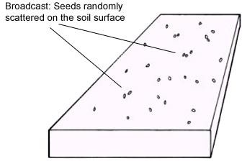

Figure 2.1: Planting by broadcasting (Murray *et al.,2006*)

**Drill seeding:** This is the random dropping and covering of seeds in furrows to give definite rows of plants (Yusuf, 2010). Drill seeding method is as in Figure 2.2.

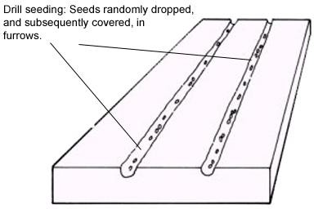

Figure 2.2: Drill Planting (Murray *et al.,2006*)

**Cross sowing:** This is drill seeding done in two cross runs with the row, 15 cm apart (Bosoi *et al*., 1988).

**Band planting:** In this, narrow rows (about 15 cm) alternate with wide rows (about 45 cm) (Bosoi *et al.*, 1988).

**Square nest sowing:** In this, seeds are sown in a nest in one row in each run of the drill. This method allows for mechanized tillage of row spacing in two mutually perpendicular directions (Bosoi *et al.*, 1988).

**Single grain sowing:** In this, seeds are drilled in rows at approximately equal distances from each other. This is referred to as precision planting. Precision planting is as shown in Figure 2.3

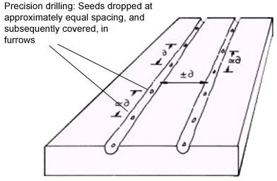

Figure 2.3: Precision drill planting (Murray *et al.,2006*)

**Furrow sowing:** This method involves sowing seeds on the furrows between ridges. This method is used when it is necessary to create good growth conditions in a locality (Bosoi *et al.*, 1988). It is mostly practiced in semi-arid conditions for row crops such as maize, cotton and sorghum (Yusuf, 2010).

**Hill sowing** (sowing on ridges): This method is used where there is excess moisture in the soil and which may not be suitable for growing of crops (Bosoi *et al.*, 1988).

Kepner *et al.* (1982) and Srivastava *et al.* (1993) on the other hand classified seed distribution methods into three distinct methods. These are broadcasting, drilling and precision planting. Hill sowing is as shown in Figure 2.4

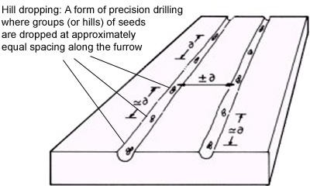

Figure 2.4: Hill drop planting (Murray *et al.,2006*)

Categorically, planting can be achieved by three broad methods namely manual planting, animal drawn planting and mechanical planting (by the use of tractors of other prime movers. The three basic methods are as in Plates I to III (Agricultural Machinery and Equipment, 2010).

 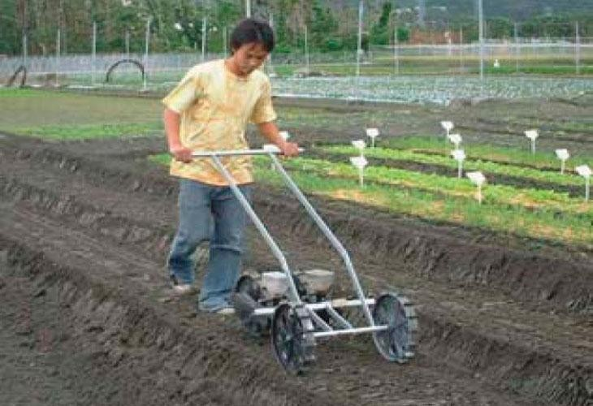

(a) Direct manual planting (b) Manually operated planter

Plate I: Manual planting methods

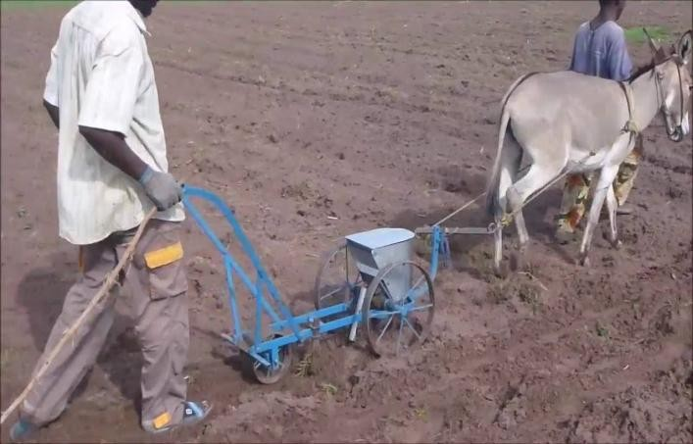

Plate II: Animal drawn planting

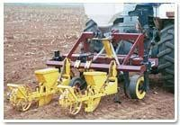

Plate III: Mechanical planting method

# Agronomic specifications of machines for sowing

Agronomic specifications for sowing as submitted by Bosoi *et al*., (1988) include: Distribution of seeds over the sown area must (as much as possible) be uniform subject to uniformity in soil fertility across the sown area; dropping of seeds by the metering mechanism must be uniform; number of seeds in each row must be the same and must check out to not more than 3% deviation for cereals; seeds must not be damaged by the parts of the planter and that furrow openers must create slightly compressed furrows at specified depths.

Permissible deviations from the given depth are ±0.5, ±0.7 and ±1.0cm for depths of 3-4, 4-5 and 6-8cm respectively.

# Planter Functional Requirements for Crop Establishment

To successfully establish crops over the range of conditions likely to exist at planting; a planter should be able to open a furrow, meter the seed, deliver the seed to and place the seed appropriately in the furrow, cover the seed in the furrow, firm the seedbed and perform other functions as required e.g. weed control, apply crop chemicals, etc.

These functions must be performed at an acceptable forward speed and with a high degree of reliability.

Not all planting machines are capable of performing or necessarily need to perform all the functions. Nevertheless, the ability to perform all functions improves planter

flexibility and crop establishment prospects, particularly when sub-optimal crop establishment conditions exist at the time of planting.

The functions performed by the planter’s soil-engaging components and its seed metering and distribution system largely determine its overall performance under particular conditions.

The planter functions undertaken by the soil-engaging components include those associated withopening the furrow, covering theseed and firming the seedbed.

# Planters and their classifications

Planting machinery are broadly classified according to: the number of rows planted in one pass of the machine, the method of attachment to and the power source used to propel the planter and the type of planting machine based on the resultant planting pattern (Murray *et al.,*2006).

The number of rows planted is specified by the number of furrow openers that the planter has, hence we can have single-row, 2-row, ….., 40-row etc.

On the basis of power source, a planter could be classified as manual planter (human operated), animal drawn planter or mechanically powered.

# Types of planter

Types of planter include broadcasters, drills, precision planters, dibble and specialized planters (Murray*et al.,* 2006).

* + - 1. **Broadcasters:** These distribute seeds randomly on the soil surface. Harrowing may be needed to cover the seeds. A hand held broadcaster is as shown in Plate IV.

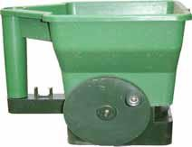

PlateIV: A Broadcaster (Murray *et al.,2006*)

* + - 1. **Drill planters:** These drop seeds randomly in furrows to form definite rows and where there is no need for seeds to be placed at equidistant spacing. The mass flow type of seed meter is used in this type of planter. An example of a drill planter is shown in Plate V.

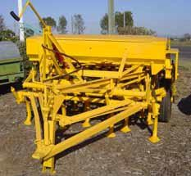

Plate V: A drill Planter (Murray *et al.,2006*)

* + - 1. **Precision planters:** These accurately place single seeds or group of seeds at almost equidistance apart along a row. Where there is the desire for near accurate control on the plant density and spacing, the precision planter is used. Crops that can be planted using this type of planter include sorghum, maize, sunflower, soybeans and cotton. To this is also fixed a precision seed metering device. An example of a precision planter is shown in Plate VI.

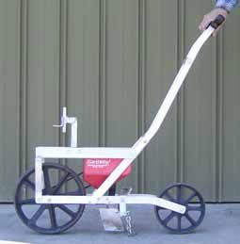

Plate VI: Precision Planter (Murray *et al.,2006*)

* + - 1. **Dibble/Punch planters:** These type of planters place seeds or number of seeds in discrete holes. The holes may be equally spaced and aligned. An example is shown in Plate VII.

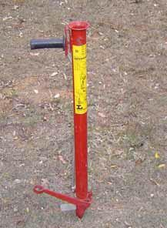

Plate VII: Dibble Planter (Murray *et al.,2006*)

* + - 1. **Specialized planters:** This type of planters do not plant seeds but whole plants (i.e seedling transplant), plant stems (e.g. sugar cane) or tubers

# Planter Components

Going by the basic functions of a planter (particularly a seed drill) according to Kepner *et al.* (1982) it must have the following basic functional parts;

Means of opening the furrow to the required depth (Coulter), means of metering the seed (metering mechanism); means of delivering the seed to the made furrow (delivery tube) and means of covering the seeds with soil.

In addition to the above however, a functional planter must have a hopper to hold the grains to be planted, a frame to hold the components of the planter and a drive system to ensure the mobility of the planter.

Soil moisture plays a vital role on the functionality of planting machines. When planting, wet spots in the field can cause mud build-up and delays planting (Kathirvel *et al.,* 2005).

# Design Features of Seed Planters

* + 1. **The hoppers**

The hoppers serve as container for the seed to be marked and ensure grain flow through the output openings through the chutes. According to Bosoi *et al.* (1988), hoppers usually are in trapezoidal, hexahedral or in combined shapes in cross section. In the combined, the upper part is rectangular while the lower part is trapezoidal. The capacity of the hopper is given as (Bosoi *et al.*, 1988):

*Vc* 

*Lg QH B*

104 *q*

(m3) 2.1

*c H*

where,

Vc = Hopper capacity, m3 Lg = run length, m

|  |  |  |
| --- | --- | --- |
| QH | = | seed rate, kg/ha |
| B | = | sowing width, m |
| ηc | = | Coefficient of features of the hopper= 0.9 |
| qH | = | volume weight, kg/m3 |

The hopper length is given as:

Lc = a (nb+ l) (m2) 2.2

where,

a = row width, m

nb = number of discharge points

The cross sectional area of the hopper is given by

*F*  *Vc*

|  |  |  |
| --- | --- | --- |
|  | *c* | *Lc* |
| where, |  |  |
| Fc | = | cross sectional area of the hopper, m2 |
| Vc | = | Capacity of the hopper, m3 |
| Lc | = | effective height of the hopper, m |

(m) 2.3

Total volume of one hopper in the planter is given by

*Vb*

where,

 *Vc*

*n*

(m3) 2.4

n = number of hoppers in the planter Vb = volume of one hopper, m3

# The metering mechanism and types

Seeds fall from the hopper openings to fill the upper cavity of the metering mechanism. The function of the metering mechanism is to dispense the seedsthrough the delivery tubes in equal proportions (Bosoi *et al.,* 1988; Murray *et al.,* 2006).The re-direction of the seed motion is effected by the distributor feed. In

the past, for the planting of cereal crops, only the Roller Distributor Feeds (RDF) and

the Peg Wheel Feeds (PWF) were used but recently, electronic and pneumatic systems are in use.

Metering mechanism could, according to Rainbow*et al.* (1992) consists of an agitator with adjustable hole, fluted or external force feed, double run or internal force feed, cup feed, vertical plate feed, inclined plate planter and a horizontal seed plate.

A number of seed metering devices exist but most of them can be classified as either ‘precision’ or ‘mass flow’ depending primarily on their mode of operation and the resulting planting pattern (Murray, *et al*., 2006). Precision seed meters select single or two seeds (as may be designed for) from the seed lot and deliver them from the meter at preset intervals. If this interval is maintained as the seeds are delivered, the seeding pattern will be such as where the seeds are delivered at equal distances along the row or ridge. A precision meter plus an accumulation device enables a hill drop pattern while a precision meter with an accumulation and an indexing device will enable check row planting pattern.

Precision seed meters are used for crops that are usually planted at relatively low seeding densities (about 10 – 150 seeds per square meter), for seeds that are planted at relatively wide rows (250 – 900mm), crops that have relative narrow range of plant population from which optimum yields can be expected for a given environment and for crops that have yield responses to evenness of plant spacing along the row. These crops include; maize, sorghum, sunflower, beans and horticultural crops. Examples of precision seed metering devices are shown in Plate

VIII. Plate IX shows samples of mass flow meters.

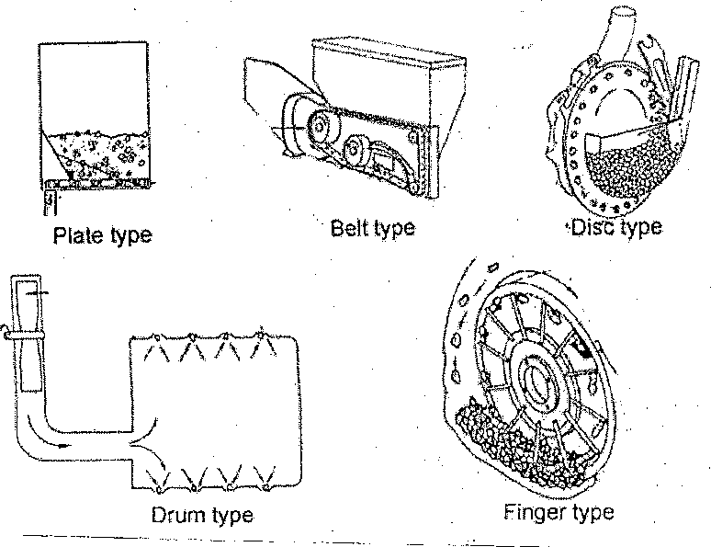

Plate VIII: Precision seed metering devices (after Murray *et al*., 2006)

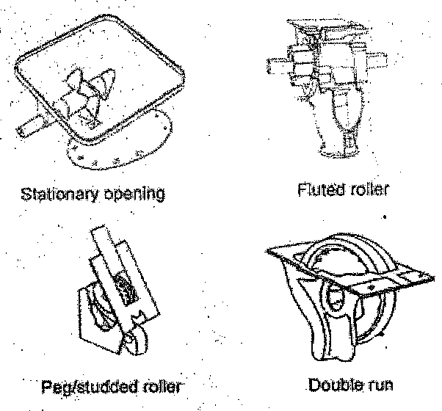

Plate IX: Mass flow metering devices (after Murray *et al*., 2006)

Mass flow meters do not meter single seeds, rather they meter consistent volume of seeds per unit time. Mass flow meters are used for crops that are usually planted at higher seeding densities (150 – 1500 seeds/m2); planted on narrow rows (80 – 350mm) and that can tolerate considerable variation in both seeding rate and uniformity of seed spacing without significant loss in yield. Cereal grains and grass pastures are examples of crops that can be metered using mass flow meters. Mass flow meters are used in broadcasters, drill planters and air seeders.

According to Bosoi *et al.* (1988), “seed metering mechanisms must create a uniform and continuous flow of seeds; secure stable sowing of the determined rate independent of the speed of the drill, the degree of filing, inclinations and vibrations of the grain hopper during motion on field”. In addition, they must not damage the seeds. The main design focus is to make them universal, simple in construction and offer reliable and suitable adjustment.

The working volume of the seed metering mechanism is the volume of seeds sown by the fluted wheel in one revolution (Bosoi *et al*., 1988). This depends on the seed rate, the row width (a) and gear ratio.

Amount of seeds sown per meter of the path of travel is given as (Bosoi *et al.*, 1988):

*qo*

where,

 *QH a*

1000

2.5

qo = quantity of seeds per meter of path, kg/m QH = seed rate, kg/ha

a = row width, m

The quantity of seeds sown by one mechanism per revolution of the driving or power wheels is (Bosoi *et al*., 1988):

*q*  *q* *D*  *QH a**D* , kg 2.6

1 *o* 1000

where D = diameter of the wheels, mm

Mass of seeds sown by one mechanism per one revolution of the seed barrel without considering the sliding of the wheels is (Srivastava *et al*., 1993):

where,

*q*  *qo**D*

*i*

2.7

q = mass of seeds sown, g

i = gear ratio from shaft to wheel,

If the density (g/cm3) of the seed is denoted by  then the working volume

*Vo*  

*q*

or

1.  *QH a* *D*

*o* 100 *i*

* 1. 2.9

where ρ = density of the seed, g/cm3

When metering by volume, rate of metering according to Srivastava *et al.* (1993) is

given as:

*Rs*

 10000*Q**b*

*wv*

* 1. 2.10

where,

Rs = seeding rate (kg/ha)

Q = flow rate of seeds from the metering unit (m3/sec)

b = bulk density (kg/ m3)

w = width of coverage of (m)

v = travel speed of planter (m/s)

For small seeds since it is impracticable to count, seeding rates are given in kg/ha. For layer seeds, seeding rate can be expressed in kg/ha or in number of seeds per hectare. For planters that meter individual seeds, the theoretical seeding rate according to Srivastava *et al.* (1993), is given as:

10000



*Rst wX*

*s*

where, Rst = Theoretical seeding rate (seeds/ha)

*w* = row width (m)

Xs = seed spacing along the row (m)

According to Srivastava *et al.* (1993), the seed spacing along the row is gotten from

where,

*X*  60*v*

*s*  *n*

*c*

* 1. 2.12

c = number of seeds delivered per revolution of the metering device n = rotational speed of metering device (rev/min)

v = travel speed of the planter (m/s)

One major problem with hill top planting (i.e planting on ridges) is the scattering of seeds, whereas precise row dropping of seeds on the ridge is a major determinant

for high yield. To this effect, Ryu and Kim (1998) provided the roller type of metering device.

The roller type (of all the types of metering devices) has been identified as being most widely used. This is because of its advantages over the other types. These advantages include simplicity in structure, light weight, easy adjustment of seed discharge rate, suitability to high speed planting and cost effectiveness.

Among others, using the wrong tube has been identified as being responsible for the scattering of seeds (Ryu and Kim, 1998). In ridge planting, scattering is reduced by placing rotary valves in the lower part end of the seed tube low enough to reduce the impact velocity against soil.

# Design parameters for metering rollers

According to Ryu and Kim (1998), the parameters used in the design of metering rollers include, depth of groove (dg), open angle of groove (θg), left side and right side angles of groove (βls and βrs), radius of curvature of the groove (Rc) and the angle of displacement of the groove (θ). The groove size and number of grooves are the important parameters in the design of rollers. The groove size is determined by the size of the seed(s) to be planted per hill.In the design of the grooves, five design variables and two position variables are used. Figure 2.5shows the orientation while Table 2.1 shows the interpretation of the variables.

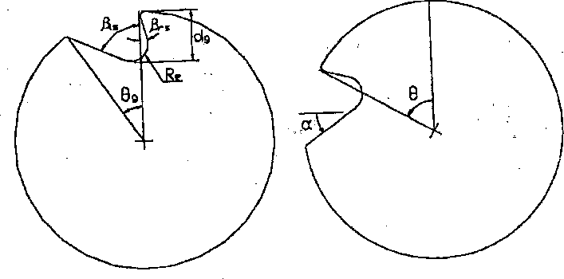

* + - 1. Design Variables (b) Position Variables

Figure 2.5: Steep triangular shaped grooves (Ryu and Kim, 1998)

Table 2.1: Interpretation of groove variables (after Ryu and Kim, 1998) Variable Interpretation

dg This denotes the depth of groove. It should be slightly larger than the length of the seed. If shorter, damage will be caused to the seed and the power required to drive the shaft will increase.

θg This denotes the open angle of the groove. It is the angle between the two lines connecting the starting and final points of the grooves to the centre of the roller. Smaller open angles are better for precision planting but too small an angle leads to lower dropping performance.

βls This denotes the left side angle of the groove.This is the most important design parameter of the roller for precision planting because it affects time delay between seeds consecutively dropped

from the grooves. Time delay decreases as βls increases. A compromise must be struck between locating capacity and delay time.

βrs Denotes the right side angle of the groove. It determines the seed holding capacity of the loading process of the grooves. βrs must be less than βls. Ifβrs>βls feeding and dropping performance will be poor.

Re This is the radius of curvature of the groove bottom. Making the bottom round will prevent the seed and any other substance from clinging on the bottom. Re must be larger than the length of the seed.

θ This is the angular displacement of the roller measured in the counter-clockwise direction. This angle determines the position of the groove with respect to the vertical.

α This is the slope angle of the left side of the groove measured from the horizontal

The procedure for the design of the roller therefore is summarized as (Ryu and Kim, 1998):

Step 1:Determine dgfirst according to the size of the seed. Step 2: Determine βls as large as possible for the given θg Step 3: Determine βrs

Step 4: Determine Re (according to the roundness of the seed)

The computation approaches involve the following (Ryu and Kim, 1998) α = θ + βls – 90 2.13

The position angle (θsp) i.e angle atwhich the seed will start to slide down is given as θsp = фr - βls + 90 2.14

The number of grooves must not be too many so that scattering will not be encouraged. As the number of grooves is reduced the speed must be increased to keep the spacing constant. The following relations were also proposed by Ryu and Kim (1998):

Number of grooves, Ng is given as

*N*  3.6*Dsc*

*g* 

2.15

*g*

where,

*Dsc* = Desired degree of scattering (%) θg = open angle of groove (deg)

The quantity of seeds per hill qh is given as

*qh*

where,

 *Qsr ds*

10

2.16

d = hill distance (m) s = row space (m)

Qsr= seeding rate (kg/ha)

Since the quantity of seeds per hill should be held in one grove, the opening length of the grove (*Wg*) is given by:

1.  100*Qsr ds*

❒

*g*

2.17

*s Ag*

where, ρs = density of the seed (kg/m3)

*Ag* = surface area of the groove (m2)

The roller type of metering device is always incorporated with a brush. The brush regulates the number of seeds retained in the grove and removes seeds that are

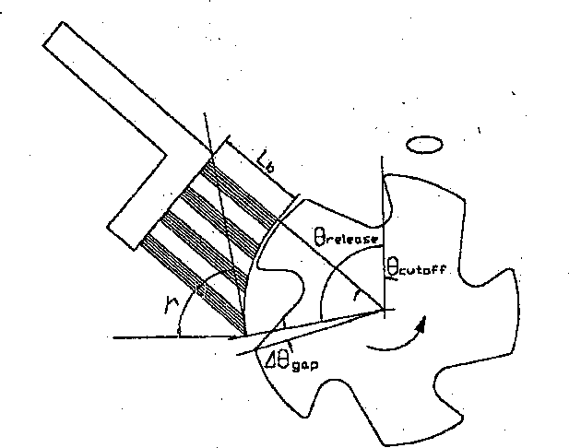over the groove.Figure 2.6 and Table 2.2 show the configuration of the brush arrangement and design variables for a brush (Ryu and Kim, 1998).

Figure 2.6: Design Variables of Brush

Table 2.2: Interpretation of design variable for a brush Variable Interpretation

Cutoff Denotes cutoff angle = angle between the upper surface of the brush and the vertical line representing the upper surface of the brush. It must pass through the center of the groove.If the line is above, the brush will bend and if it is below the brush will not be able to remove the seeds on the surface.

Release Denotes the release angle.It is the angle between the line connecting the lower end of the brush center and the vertical line from the center. This determines the position on the groove from where the seed can be dropped.

gap Denotes gap angle

γ Denotes contact angle of the brush. It is the angle between the tangent to the surface of the roller and the horizontal or the seed release point.

Source: (Ryu and Kim, 1998).

The computational relations are as follows;

1 2*ts* 

Where;

 *gap*  *Sin*

 

 *d R* 

2.18

*ts* = length of the seed (mm)

dR = diameter of the roller (mm)

  180    180       

*release fall g gap*

2.19

where;

*θfall* = angular displacement of groove when seeds start to slide (0) (Ryu and Kim, 1998)

*Release* = ½ * (270 + *g* – βls-gap -b+r) 2.20

where,

b = friction angle between seed and the brush

r = friction angle between seed and the groove.

Two constraints govern the determination of the cutoff angle. Either the brush should cover more than half the groove opening when roller rotates about the sliding position angle or the brush can cover the entire groove opening.

# Performance of Seed Metering Mechanisms

The performance of a metering mechanism depends upon the type and desired scale of operation.Of all the metering mechanisms, the seed broadcaster is the least accurate.This is due to:

* + 1. The variable orifice is not a positive displacement metering device
    2. Due to reason in (i) above, the metering rate is not limited to the travel speed rather this rate depends upon the operating skill of the operator.
    3. The swath width of the seeder cannot be precisely determined as a result of non-

uniform spreading pattern.

Drill metering devices provide room for more precise control. This is because the swath width can be controlled and the metering rate is linked to the travel speed.Since the seeds are delivered to the seed tubes in cells, speed spacing in a row is not uniform.Field slopes affect the flow rate in fluted wheel meters. Flow rates increase to as much as 44% on a down slope of 15% (Srivastava *et al*., 1993).Searle *et al.*(2008) submitted that slopes and travel speeds have significant effects on the seed spacing uniformity for corn seeds. Nafziger (1996), Doerge *et al.*(2002) and Searle *et al.* (2008) also submitted that non-uniform spacing of corn seeds can result to a 5% to 10% reduction in yield. On the other hand, Glenn and Daynard (1974) and Krall *et al.*(1977) as cited in Searle *et al. (*2008), submitted that uniform spacing of

seeds/plants could increase corn yield to about 5.5%. Since the metering device is driven by ground wheels, the states of the wheel (under inflation or dentation) and slippage will affect the seeding rate.

Metering devices that deliver single seeds allow for the most precise control of the seeding rates. This however is dependent on if the seed cell carries the single seed as desired and delivers such at the required time (Srivastava *et al.*, 1993).

Performance of metering devices can be carried out either on standardized planter test stands or on the field. In doing this, three parameters can be used. These according to Searle *et al. (*2008)are the ISO miss index, the ISO multiples index and coefficient of precision (CP3)

# Seed Transport Mechanisms

There are mechanisms by which the metered seed(s) is/are deposited on the surface on the furrow. Most of the transport systems rely on gravity for vertical movement of the seed(s).Friction plays a vital role in the path followed by the seed(s) to the ground.For broadcast seeders, one or more spinning disks are used. The drills carry exit gates through which seeds escape to the ground surface (Srivastava *et al*.,1993). Drills and precision planters carry drop tubes to transport seeds to the ground from the metering device.These tubes according to Bosoi *et al.* (1988) and Srivastava *et al.*(1993) are either vertical or nearly vertical. Hence, the drop velocity of the seed or the entry point in the x-direction is said to be zero. The seed velocity in the drop tube (Z) according to Srivastava *et al.* (1993) is given by:

.  *C*7 sinh(2*C*6 *C*7 *t*)

*Z*

1  *Cosh*2*C C t* 

2.21

6 7

where,

C6 = 0.5 CDρa Ap/m 2.22

 *g* 0.5

C7 =  

 *C*6 

2.23

CD = Drag co-efficient

ρa = Density of air (kg/m3)

Ap= Projected frontal area of particle (m2) m = mass of the seed (kg)

g = acceleration due to gravity (m/s2) t = transit time in the tube (s)

According to Bosoi *et al.* (1988), drill tubes come in different designs. These include corrugated rubber, spiral strip steel, transparent plastic telescopic among others. In placement, the tubes are usually bent slightly so that at the exit point, an x- component (horizontal component) of the drop velocity exists and is quantified as;

. .

*x*  *z* tan*e*

Where ***x***= Horizontal component of exit velocity (m/s)

e = Angle to the vertical to which the tube is bent.

e, according to Bosoi *et al.* (1988) should not exceed 250.

2.24

As earlier stated, seed bounce in furrows disrupts spacing of uniformly metered seeds. This can be eliminated or minimized if ***x***is equal to the forward speed of the planter.

The height of the metering point (or drop pick up point) to the ground should be as lower as possible. Drop tubes are used when designing precision planters.

# Furrow Opening and Covering Devices

For the seed to be planted, the soil must be opened to an agronomic required depth and after the seed is deposited, it must be covered back and slightly pressed- over.Devices used for opening furrows (also called the boots) includes hoes, runners, single and double disks (Kepner *et al.*, 1982; Bosoi *et al.*, 1988and Srivastava *et al*., 1993). The single disk openers are formerly used in opening furrows for drills. The runners are used in plate type planter and in precision planters.In precision planters, the double disk opener is used either alone or in combination with the runner. In this case, the runner can be made to create a v-groove on the soil. This v-shape further helps to reduce the seed bouncing. Studies have shown that the type of furrow opener adopted for use depends on the type and characteristics of the soil (Morison, 2002).

When the seed(s) is/are deposited, a covering disk or scrapper is used to cover the seeds. This can be followed by a follow wheel (press wheel) to fracture the smeared seed furrow walls and slightly press the soil on the seed(s) thereby improving the seed-soil contact (Morison, 2002; Kepner *et al.,* 2008).This slight pressing is to ensure good moisture transfer to the seeds. Alternatively, a soil firming wheel can be used to effect the covering and pressing at a go. In the firming, vertical pressure is undesirable; therefore the seed planted must be adequately covered with soil. This is because for the seed to germinate it must have adequate moisture and moisture is transferred to the seed through the soil.Theoretically, moisture increases with depth of soil and thus it could have been concluded that deeper depths of planting would be desirable, but two factors modify this. These are; soils are usually warmer towards the surface and soil warmth is needed for seed germination and if the

depths are too large, the germinating seeds would not be able to thrust the soil and emerge at the surface.

Based on these, the choice of depth of planting will be done with some degree of compromise. This is why varying depths are prescribed for different crops and infact with respect to the variety of the crop. However, Celic *et al.* (2007) proposed planting depths for corn (40-65mm), cotton (25-50mm) sorghum (19-25mm) soybeans (25-50mm) and wheat (25-50mm).

Furthermore, Bolton and Booster (1981), Karlen *et al.,*(1991) and Morison (2002) submitted that there exists a compatible level between the tillage system, the type of furrow opener and covering device that will ensure optimal plant germination.

# Performance of Soil Opening and Covering Devices

The most reliable means of evaluating these devices is to determine the percentage of emergence.This approach suffer usability on the ground that since seed emergence depends on soil characteristics, location and variation in climatic conditions, it will have to be tested over a number of years for a particular location. Short term tests involve determining the ability of the opener to cut through plant residue in the soil.For this therefore, the disk type of opener is most reliable (Srivastava *et al.*, 1993).

The shape and velocity of operation of the opening devices affect the overall performance of the planter (Yisa *et al.,* 1994).

# Evaluating planter performance

In evaluating planter performance, metering accuracy, spacing accuracy and uniformity of depth of planting are measured (Thomson, 1986).These can be determined both in the laboratory and on the field. In the laboratory, stationary tests are used to determine the metering and spacing accuracy. This is done by placing the drive wheels of the planter on a treadmill and turningat the speed at the derived speed on the field. The grease board technique is applied to an elongated feed collection device to capture the seeds as they exit the drop tubes.With this experiment, the seed spacing can be assessed manually or automatically. In addition, the number of skips (when the cell fails to deliver seed) and multiples (when the cell delivers more than required seeds) are determined by observation. The average spacing is, compared after the skips and multiples have been removed. The values can be subjected to mathematical evaluation using equations 2.25 to 2.27 (Kathirvel *et al.,* 2005).

*i*

*t*

* *qi*

*q* *i*0 2.25

*t*

*Sd* 

*i**t* 

− 2

*i*0  

*t* 1

 *qi*  *q*

2.26

where,

*Cv*  100*sd*

*q*

−

2.27

−

*q* = Average quantity of seeds collected

qi = quantity of seed collected in trial (over the length of the collector)

t = average number of seeds in all trials

Sd = standard deviation of number of seeds in trials Cv= coefficient of variation (%)

For a perfect planting,Cv=0. This implies that there are no skips or multiples. Uniformity of depth of planting is usually assessed by digging out seeds and measuring the depths of plant.Spacing between plants is thus a major determinant of the performance of a planter. While fairly accurate spacing may be achieved while testing the planter in the laboratory, there exists a considerable variation in plant spacing on the field (Church, 1987; Kachman and Smith, 1995).

Furrow openers and covering devices (or boots) are expected to form furrows with a compact bottom without turning the wet lower soil layers to the surface, cover the seed with wet layer of soil of a given thickness and maintain the row width and distribute the seeds in drill rows within the limits determined by agronomic specifications.

Boots are distinguished by the angle of entrance into the soil (i.e. the angle formed by the furrow bottom to the target to the boot nose).

# Soil-Implement Relationship

Implements modify the state of the soil for conducive planting, germination and crop management on farm. In the modification process, there are interactions between the soil and the implement which bring about forces in play. For example, to open up the soil by the soil opener of the planter, the opener exerts forces on the soil (even if it has been tilled). The soil in return creates reactions to those forces for a state of equilibrium. The force to be applied by the opener should be able to open up the soil; therefore it must be higher than the forces at play at state of equilibrium.

On the other hand, the planter will propel on the driving force generated from the wheels. The wheels move in contact with the soil. In this process there are tractive forces in play and these forces must overcome the resisting forces of the soil to enable movement. Those forces in play are what are needed in the design of implements that have interactions with the soil while they are in operation.

Murray *et al.* (2006) while reviewing the mechanics of soil cutting blades submitted that the performance of any soil cutting device can be evaluated by determining the states of the physical properties of the soil and the stress-strain relation while cutting, only a limited volume of soil is in front of the blade out of the semi-infinite mass. What is needed is to determine the extent of the broken-off part of the entire mass and with this done, the forces on the blade can be obtained from the conditions of static equilibrium together with Coulomb’s constant determining the soil strength. Coulomb’s proposition is that if the shape of the failure surface is known, its actual location can be found. Coulomb’s approaches are used in determining the surface of failure when the blade cuts the soil include Ohdes graphical logarithmic spiral method and analytical logarithmic spiral method.

Whilethe first method could be used to determine the frictional component (P’) and cohesive component (P’’) of the passive force, the second method can be used to determine the passive earth force per unit width without adhesion component (P). Both processes are evaluated from predetermined developed software for computers.

Cohesion is the property of the soil to which draught is sensitive. Even though this property varies over a wide range the angle of shearing resistance, angle of soil-

metal friction and adhesion are comparatively constant. Fortunately, these are the three properties of the soil that have effect on the direction of the resultant force on the implement and whose value (the resultant force) is of greater importance in implement design.

# Animal Draught Power

Draught animal power refers to the muscle power of draught animals used for thefollowing tasks (Ramaswamy**,** 1994):

1. pulling agricultural implements
2. hauling carts
3. giving motive power to devices such as water pumps, cane and seed crushers, and electricity generation equipment
4. carrying loads on the back, as pack animals
5. handling, dragging and stacking timber logs in forests
6. hauling sledges in snow-covered regions.

Plate X shows an example of draught animals in operation ([www.wikipaedia.com](http://www.wikipaedia.com/) )

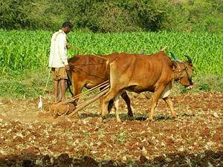

Plate X: Draught animals in operation

The amount of draught power which can be delivered by an animal depends on the species, breed, size, body weight, etc. The amount of power also varies in accordance

with a number of other factors, including; quality and quantity of food and nutrition provided, state of physical health of the animal, ambient condition, terrain or soil condition, training of the animal and management.

Horse power (hp) is the unit for estimating the power of a draught animal.The power of an average draught animal isapproximately 0.66 hp.The majority of draught animals provide 0.4-0.6 hp on a sustained basis (Ramaswamy**,** 1994)

# Draft Relationship for Planting (Seeding) Equipment

Draft, according to ASAE (1994) as cited by Harrigan and Rotz (1995), is the force required to propel an implement in the direction of travel. Draft relationship is important in machinery design and management. The total draft on an implement includes the functional draft (i.e. soil and crop resistance) and the draft required to overcome rolling resistance of the implement (Harrigan and Rotz, 1995). Since seeding equipment operate at shallow depths, the draft requirement is primarily a function of the width of the implement and the speed of travel (Summers *et al*., 1986; Khalilian *et al*., 1988; Grissso *et al*., 1994).

Bowers (1989) however stated that there exists wide variations in draft within and between soil textual groups due to soil moisture, residue cover and other soil and machine physical properties. A simple relation was proposed for use in estimating the draft. This is given as:

*D = Fi * (A + B(s) + C(s) 2* W * Td* 2.28

where,

*D* = Implement draft, kN

*F* = Soil texture adjustment parameter

*i* = 1 for fine, 2 for medium and 3 for coarse texture soils.

*A,B,C* = machine specific parameters

*S* = Field speed, km/h

*W* = Machine width, m

*Td* = Tillage depth, cm for major tillage tools, 1 (dimensionless) for minor tillage tools and seed equipment (Harrigan and Rotz, 1995).

The machine parameters, A, B and C are determined and tabulated for various tillage and seeding equipment. The constant parameter A is a function of the soil strength while, B or C is speed parameter of the machine that is related to soil bulk density. For row crop planters, details of draft are published. ASAE (1994) however reported that residue from the previous cropping influences planter draft more than the tillage practice employed. Planter drafts have been reported to range from 1,200N to 1,800N (Bowers, 1989; Mathews *et al*., 1981;Stephens *et al.,* 1981; Reid *et al.*, 1983). However values of about 500N were reported for some soils. Rolling resistance of transport and press wheels form later parts of planter drafts. Planter drafts for prepared seed beds (such as ridges) were reported to be 500N. This is because draft on prepared beds is not greatly affected by soil texture or planting depth. For mounted and drawn units, the draft increases to 900N (Harrigan and Rotz, 1995).

# Energy Consumption in the Operation of Planters

The energy consumed in the operation of a planter can be derived from any (or a combination) of three sources namely; human (manual) power, animal draft power and mechanical power (running on fuel). The amount of energy expended using any of the above can be estimated as detailed in the following subheadings:

# Human (manual) power

According to Odigboh (1992), at the maximum continuous energy consumption rate of 0.3kW and conversion efficiency of 25%, the physical power output of a normal human labour in tropical climates is approximately 0.075kW sustained for an 8-10 hour workday. Based on this, Norman (1978) and Pimentel (1992) as cited by Abubakar and Umar (2006), used the following relations to estimate manual energy input:

*EMf = 0.68Ta* 2.29

where,

*EMf =* Female manual energy input (MJ)

0.68 = Energy input of an adult female (MJ/h)

Ta = Useful time spent by a female worker per unit operation (hrs) and that,

*EMm = 0.75Ta* 2.30

where,

*EMm =* Male manual energy input (MJ)

0.75 = Energy input of an adult male (MJ/h)

Ta = Useful time spent by a male worker per unit operation (hrs) Bamgboye and Jekayinfa (2006) however used the following relation

*Eh = 0.75*N*Mh* 2.31

where:

*Eh* = Human energy input (kWh)

*N* = Number of persons involved in the operation

*Mh* = Man-hour requirement (hrs)

Konz (1994) on the other hand provided that energy expended by man is directly related to the energy needed for metabolic activities within the period of work. This energy is broken into three (3) categories namely;

* + - 1. Energy needed for basal metabolism (Ebas)
      2. Energy needed for direct activity (Eact) and
      3. Energy needed for specific dynamic action (ESDA)

So that total energy needed in a manual labour (ET) is given by: ET = Ebas + Eact + ESDA 2.32

Ebas = Fbas * WT * SA 2.33

where,

Fbas = basal activity factor

= 1.28 (for male) and

= 1.16 (for female) WT = weight of the operator

SA = Surface area of the operator, m2 By the submissions of Konz (1999):

SA = 0.208 + 0.945[0.007184(HT)0.725(WT)0.425], m2 2.34

and that for males,

Ebas = [64.95 – 0.8875A + 0.0078A2]*SA 2.35

|  |  |  |
| --- | --- | --- |
| and for females, |  | |
| Ebas = [59.43 – 0.9315A + 0.0076A2]*SA  where: |  | 2.36 |
| A = age (5<A<70) |  |  |
| Eact = Fact *WT  where, | 2.37 |  |

Fact = activity metabolism factor (chosen from tables)

= 4.9 W/kg for walking and gardening

and

ESDA = 0.1[Ebas + Eact] 2.38

As a result of the metabolic activities, there can be increase in the heart beat rate of the operator(s).

IHB = K + 0.12IMET 2.39

where,

IHB = increase in heart beat (beats/min) K = constant

= 2.3 for arm work only

= -11.5 for walking or walking with arm work IMET = increase in metabolism (W)

Maximum permissible heart beats when estimating using Astrand and Rodahl method is (Konz, 1999):

HBmax = 220 – A 2.40

where, A = age

and by Arstilla method (which is a more recent submission), HBmax = 200 – 0.66A 2.41

# Animal draught power

Animal power to create a draft can be estimated from Figure 2.7

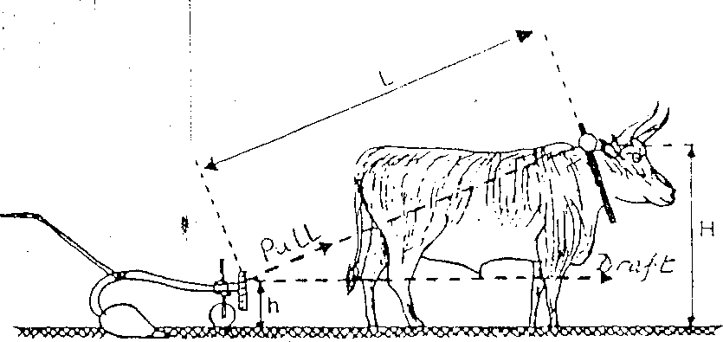

Pull

Draft

Figure 2.7: Animal draft measurement (FAO, 1994) Key:

L = Distance between draft force equipment and the point of yoke attachment (m)

H = Height of point of yoke from the ground (m)

h = Distance from the point of draft force measuring equipment to the ground surface (m)

Pull = Draft force as measured by the equipment (N) The draft force is then estimated from (FAO, 1994):

*Draft*  2.42

*Pull x* *L*2  *H*  *h*2 

*L*

# Mechanical (Fuel) energy

Energy derivable from fuel is estimated by Pimentel (1992) as in Bamgboye and Jekayinfa, 2006 as:

*Ef = Cf W* 2.43

where,

*Ef* = Fuel energy consumed, (J)

*Cf* = Calorific (lower heating) value of the fuel (J/litre)

*W* = Quantity of fuel used, (litres)

Abubakar and Umar (2006) in citing Pimentel (1992) reported that;

*EFLD = 47.8D* 2.44

Where,

*EFLD* = Liquid fuel energy input for diesel (MJ)

*47.8* = Unit energy value of diesel (MJ/litre)

*D* = Amount of diesel consumed per unit operation and that

*EFLP = 42.3P* 2.45

where,

*EFLP* = Liquid fuel energy input for petrol (MJ)

*42.3* = Unit energy value of petrol (MJ/litre)

*P* = Amount of petrol consumed per unit operation (litres)

# Optimisation Process

Optimisation is the process of choosing the permissible actions that will result in the best outcome (Hudges and Kearney, 2007). It is a tool that is used in seeking solutions to the problems of decision in daily life. The basic objective of optimisation

is to maximize or minimize as appropriate with the intent of adding value to the final product or action.

In a general format therefore, the model is such that will maximize or minimize the objective functions subject to the constraints (Taha, 2007). By this concept, solutions are found to the models which are mathematical in nature. This solution is flexible if it satisfies all the constraints. It is optimal if, in addition to being flexible, it yields the best values of the objective function.

A number of agricultural processes have been optimized by previous researchers. Akinoso *et al.* (2006), Skwarcz (2006) optimized some processes in agricultural production and processing.

Planting on a ridge or a flat land is subject to conditions which may either be machine based or soil based or a combination of both. The spacing of planting can be affected by the efficiency of the metering device, of the transporting device (which must function to avoid rebounce), traction characteristics of the soil and state of the soil (i.e. moisture content, type and degree of tillage). The depth of planting is affected by the design and seed placement characteristics of the furrow opener.

These factors vary the degree of the precision of planting. It will therefore be right to determine the best states in which the planter will perform optimally.

The problem of maximizing or minimizing a given function

z = f(x) 2.46

subject to the given constraints,

yi(x) ≤, = or ≥ bi 2.47

is called the general constrained optimisation problem. In (2.47), the number of independent equality constraints must be less than the number of variables; otherwise the problem is over specified.

Constrained non-linear optimisation problem often arise in modeling when it is desired to optimize same performance criteria subject to conditions which describe the operation of a system.

If the constraints are linear and the objective is a positive definite quadratic function, then optimisation equation reduces to a quadratic programming problem.

# Previous Research Activities

In the past, several researchers have been involved in the development of one type of planter or the other for different crops in attempts to ensuring effective planting and maximization of yield from a planted field. Some of such researchers include the following;

Okudo (1974), designed, constructed and tested a seed planter. The planter metered three seeds as against the designed two seeds. Seed spacing compared favourably under laboratory and field conditions with the former showing greater wheel skid. The planter was designed for planting on tilled flat land only; Yamakawa *et al*. (1989) developed a no-till seeder for soybean with the objectives of eliminating ploughing and soil breaking works before sowing, sow seeds in moist and heavy soils and avoid retarded emergence caused by clay crust formation. The planter increased labour efficiency and increased yield over planted area; Varshney *et al*. (1991) developed and evaluated a power tiller drawn seed/fertilizer drill. The planter was passed through field evaluation as against a 3-row animal drawn seed/fertilizer drill using

wheat, soybean, sorghum, bengalgram and pigeon pea crops. Results show increases in field capacity and yield for the various crops. Despite these results, the planter could not be used to plant on ridges; Far *et al*. (1994) developed a hydropneumatic planter for primed vegetable seeds. The planter worked well on a paved surface, the performance was as good as a regular air planter and the primed seeds germinated faster; Molin (2002) developed a punch planter with adjustable seed spacing for no- till soils. The planter planted seeds at spacings between 16 to 21 cm as against the desired 14 cm. To effect change in spacing, a set of two plates with opposite spiral slots and a third one with radial slots were incorporated; Bamgboye and Mofolasayo (2006) developed and evaluated a 2-row manually operated okra planter. The planter had a seed rate of 0.36 kg/hr, a 4.97 % difference between weights of seeds discharged from the two hoppers, a 3.51 % reduction in percentage damage on seeds when spacing varied from 59 cm to 70 cm, average depth of planting of 8 – 9 mm and an overall efficiency of 71.75 %; Matin *et al*. (2008) developed and evaluated a multi-crop power tiller operated Inclined Plate Planter (IPP) for the establishment of maize. The planter was evaluated against traditional practice of planting in Bangladesh. It had an average field work rate capacity of 0.19 ha/hr saving 3.28 % total cost and 79.2 % labour cost. It had 18 % increases in yield; Isiaka (2000) developed and evaluated a 2-row animal drawn planter. The planter was evaluated for flat and ridge planting using maize and it was determined that the planter had field capacity of 0.438 ha/hr delivering two seeds per hill and a seed rate of 13.5 kg/ha. The planter was not without flaws. The hopper of the planter was observed by the researcher to be touching the ridge thus a requirement for flexibility

to adjust height to the prevailing ridge heights. It was also observed that the metering unit will need to be encased to avoid over clogging with seeds.

# Summary on Literature Review

From the reviewed literature, it could be concluded that:

1. Planting is a vital segment in the agricultural production process and thus needs to be focused on.
2. The Nigerian agriculture is still largely subsistent in nature and that only appropriate mechanisation can change it.
3. There are different types of planting techniques and that machinery for planting are developed for the type of planting envisaged.
4. There are agronomic requirements for planters to be proficient.
5. Whatever be the agronomic requirements, every planter should have a seed hopper, soil opening device, seed metering mechanism, seed dropping chute and soil covering device.

# CHAPTER THREE

# MATERIALS AND METHODS

# Materials

All the materials used in the design, fabrication, assembly and field works are detailed under the following headings.

# Materials used in the design

1 set of personal computer, AutoCAD 2007 software and drafting sheets

# Materials used in the fabrication and assembly

1 No. Tools box, 1 No. Hacksaw frame and blade, 1 No. Centre punch, 1 No. Tri- square, 1 No. metal scriber, 1 No. 3.5 kW Gestetner Centre Lathe, 1 No. 2.75kW Gestetner centre drill, 1 No. 1.35kW mounted power saw, 1 No. 360 Watts Bosch hand drilling machine, 1 No. 1.5 kW hand held grinding machine, 1 No. 750 Watts Arc welding machine, 1 No. Plate cutting machine (maximum 1.5 mm thick) and 1 packet of G12 welding electrode.

# Materials used in the laboratory evaluation

1 No. vacuum oven, 1 No. digital weigh balance (200 mg capacity), 300 Watts vertical sample stirrer, 6 Nos. graduated cylinders, 1 set of computerized shear box apparatus, 1 set vertical tyler sieves with shaker.

# Materials used in the field evaluation

The equipment and materials used in the evaluation of the planter include: 1 No of 2-row ridge engine-propelled planter (the fabricated planter), 1 No. single row IAR animal drawn planter, 20kg of Quality Protein Maize (QPM)seeds (pre-tested for viability), 1 No. stop watch, 2 Nos. graduated cylinders, 10 litres of petrol fuel, 1 No measuring rule, 1 No. hp digital camera, 1 No.72hp MF tractor, 1 No. (each) of Emcot disc plough, harrow and mouldboard ridger, 1 No. knapsack sprayer, 0.5 litres each of Atrazine and Gramozone (pre-emergence chemical), 12 Nos. of soil moisture sample dishes, 1 No. digital weigh balance (Range: 0 to 200mg), 1 No. GPS equipment (GARMIN 76 model No. 14110688) and 1 No. Soil core sampler.

The three methods tested are shown in Plates XI - XIII:

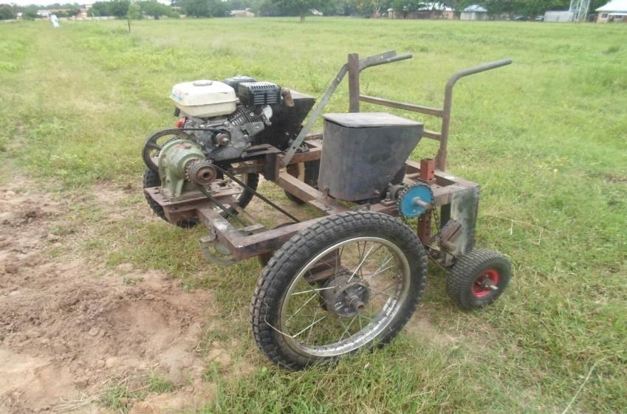

Plate XI: Developed 2-row Engine-Propelled Seed Ridge Planter

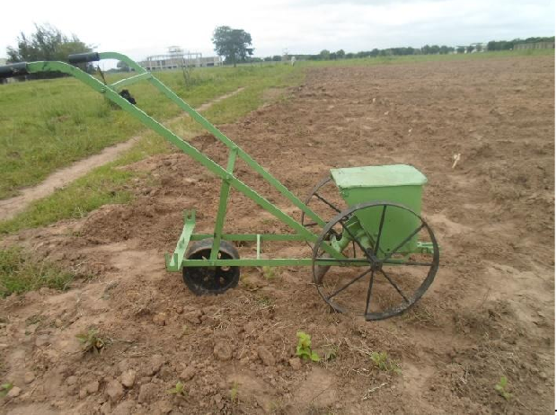

Plate XII: IAR single row animal drawn planter

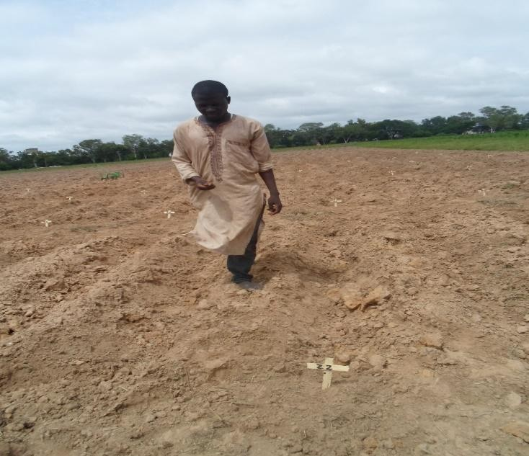

Plate XIII: Manual Planting

# Methods

# The design concept

The 2-row engine-propelled ridge planter was conceived to have two ground wheels that will run on the furrows and over two prepared ridges (see Figure 3.1).

The plate type of metering device was adopted in design and two of such plates were designed. The metering plates are carried by two metering boxes which

aidedthe holding and turning the plate meters to meter seeds from the hopper through the delivery chutes. The planter was provided with two hoppers hovering over the metering boxes to carry the seeds to be planted. A petrol engine was adopted as the primary power source. This petrol engine powers the ground wheel through speed reduction device (the gear box) and a set of pulleys. Two opening and soil covering devices are also provided. The components are mounted on a frame and provided with a trailing handle. The concept of the design is as shown in Figure 3.2



Ridges

Ground

wheel

Figure 3.1: Ground wheel on furrows

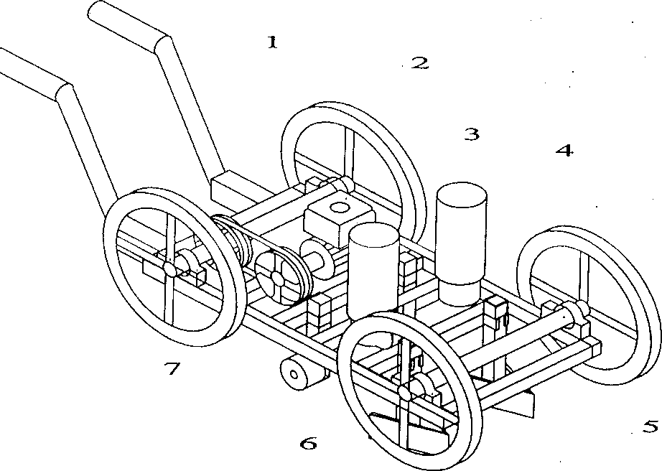

Key

1

2

1 = Drive handle

2 = Ground wheel

3

4

3 = Petrol Engine

4 = Hopper

5 = Coulter

6 = Soil covering

5

device

6

Figure 3.2: The design concept in form

The design and fabrication was done at the Department of Agricultural Engineering, Ahmadu Bello University while the field evaluation will be done at the IAR C1 experimental farm of the Ahmadu Bello University, Zaria

# Development of the engine-propelled 2-row seed ridge planter

* + - 1. **The components of the engine-propelledseed ridge planter**

The engine-propelled 2-row planter is conceived to have the following parts:

2 Nos of hoppers, 2Nos of metering boxes, 1 No. of 10:1 gear box, 1 No. 5.5 hp petrol engine, 3 Nos. of pulleys, 2 Nos. of sprockets and chains, 1 No. of frame, 1 No. of throttle lever, 2 Nos. of drive handle, 2 Nos. of ground wheels, 2 Nos. of idle wheels, 2 Nos. of coulters and 2 Nos. of soil covering devices.

# Design of Planter Components

The procedure for the design of the planter components is as in Table 3.1. The design considerations are as in Appendix A while the adopted design values are as in Appendix B.

Table 3.1: Design procedure for the planter components

|  |  |
| --- | --- |
| **References** | **Design Details** |
|  | **Design of planter components** |
|  | **(1)Design of the Seed Plate**  The metering roller plate as in Figure 2.5 was adopted for this design  *Design Parameters required* |

|  |  |
| --- | --- |
| Mohsenin, 1978 | 1. Groove size (from βrs, βls, dg and θg) and 2. The number of grooves on the roller.   **Design Steps**   1. **Determination of the depth of groove, dg**   This was done with respect to the sizes of the seed.  The length of the seed (a) and the width (b)were done by direct measurements.The biometric sizes for maize seed are in Appendix C  Average overall length (a) = 11.6mm Average overall width (b) = 9.1mm Design dg = 15mm  Design ‘b’ = 12mm   1. **Determination of the number of grooves on the seed plate Design assumptions**   Desired degree of scattering, Ds = 20%  Right and left side angles are chosen to be  βrs = 10o βls = 70o  Depth of groove as computed, dg = 15mm |

Diameter of roller is assumed DR = 160mm

Angle of groove is obtained graphically. From the graph, angle of groove, θg = 25o (measured)

Length of the groove, Lg is the length of the line along the groove curve. Lg = 27mm (measured) = 27x2mm = 54mm (actual length)

Sowing rate for chosen spacing and plant density is Qsr = 34kg/ha

Inter-row spacing, Sr = 75cm

Intra-row placing (Plant spacing), Sp = 25cm

...Number of grooves on roller as in equation 2.15,

*N*  3.6 *Ds*

*g* 

*g*

... *N*

*g*

 3.6 *x*20

25

= 12.88

i.e. Number of grooves = 13

The area of groove was gotten from equation 2.17 as 65.8 mm2.

Thickness of the plate was chosen to be slightly more than 2 times the average thickness of the maize seed (S224.1 in ASAE,2005).

|  |
| --- |
| Average thickness of maize side, c = 4.5mm 2c = 9 mm  ... The chosen thickness of plate, t = 12mm  The plate was provided with a hole of diameter 10mm to accommodate the rotating shaft.  The plate also carries a 5mm key way to provide for locking of the shaft. Aluminum cast was chosen as the material for the metering plate.  (See Appendix D for drawing details) |
| 1. **Hopper Design**    1. The Shape chosen was rustrum with rectangular cross section as this is most widely used for cereals (Srivastava, 1993).   The parameters that were designed for are:   1. Hopper capacity (Vc) 2. Hopper, height (H) 3. Top neck width (B’) 4. Bottom neck width (B’’)   The design variables were extracted from Appendix A |

Using equation 2.1 (Page 18)the total hopper capacity was computed to be 1.3m3.

Since there are two rows, volume of one hopper was computed to be half of the total hopper capacity.

... Volume of one hopper V

 *Vn* m33.1

b *n*

 1.3 m3

2

= 0.65 m3

The standing height of hopper was computed from Ht = w (n + 1) 3.2

w = row width

= 25cm = 0.25 m

... Ha = 0.25 (1 + 1)

= 0.5m

20% freeboard was added to the standing height to give the overall height of the hopper as:

Ho = 1.2 x 0.5 m

= 0.6 m

The configuration in Figure 3.3 was adopted for the hopper.

a

h

b

|  |  |
| --- | --- |
| www.hackmath  .net (2000) | Figure 3.3 Hopper configuration  Total volume of hopper was computed from  *V*  1 0.5*a*  *b**h**d* 3.3  *T* 3  where,  d = width of the hopper (m) and it was determined as 0.25mfrom equation 3.3 using VT as 0.65m3.  (See Appendix D for the drawing details)  Mild steel plate was selected as the material for the hopper owing to its strength and availability. |

|  |  |
| --- | --- |
| Bosoi *et al*. (1988)  ASAE (2005)  Bosoi *et al.*(1988) | 1. **Design of Opening Devices**   See Appendix A for design requirements  Bosoi *et al*. (1988) proposed the runner boot soil opener for corn planting. The runner boot has the following configurations as extracted from ASAE (2005).  Width of cut, w = 53mm  Angle of penetration, α = 51o Clamping length, L = 98mm Height of shin, h = 30mm  This opener is attached to a bar which is clamped to the frame. The clamp allows for the adjustment of the depth of penetration of the runner.  (See Appendix D for the opening device details)  Mild steel was chosen as the material for the soil opening device   1. **Design of the Covering Device**   See Appendix A for design requirements  The open center, concave steel press wheel is recommended for corn. |

|  |  |
| --- | --- |
|  | The wheel consists of two concave discs Outer diameter of discs, doc = 120mm Inner diameter of discs, dic = 90mm  The discs are fixed together by bars 15mm long to form the open center.  The wheel will rotate on a shaft at the center, diameter = 10mm on machine slots on roller bearings.  The slots will be joined to the wheel guide by bar spikes. The wheels will rotate freely.  To further cover the seed, drag chains fixed to extended bar will be provided.  Length of extended bar, = 30mm behind the wheels. (See Appendix D for the drawing details)  Mild steel was chosen as the material for the soil opening device |
| Kepner *et al*. (1982) | **(5) Design of the seed delivery tubes**  Corrugated rubber drill tube is recommended for corn transport. The month piece is made of corrugated metal sheet.  Adopted upper diameter of the tube = 25mm |

|  |  |
| --- | --- |
|  | Adopted neck diameter of the tube = 20mm  Transport tube is fitted directly behind the opening device and fastened to the clamp of the opening device.  (See Appendix D for the drawing details) |
| ASAE (2005) | 1. **Design of the Drive Mechanism**    1. **The wheel**   wheel type:  The press wheel with crown thread is adopted according to S224.1  The details of the thread are provided by S224.1 of the ASAE standards. wheel size:  Size of wheel will depend on the average height of ridges. By direct field measurements,  average height of ridges = 244mm  The radius of the wheel is set to be 50mm above the average ridge height.  ... radius of wheel = 244 + 50mm  = 294mm |

|  |  |
| --- | --- |
| ASAE (2005)  ASAE (1994,  2005)  Hannah and Stephens (1972,  Khurmi (1981) | ... outer diameter of wheel do = 588mm  ... From S224.1 wheel specifications are as follows: Tyre size = 8 x 20 (c)  Maximum width = 215.9 mm do = 589.28mm Loaded radius = 266.7mm Maximum load = 90.7 kg  Translational speed of planter = 1m/s  circumference of wheel = пdo 3.4  = п x 589.28 mm  = 1,851.28 mm  No. of revolutions of wheel at 1 m/s  *rpm*  1000 *x* 60  1851.38  = 32.4 rpm  Speed from the engine is reduced to this wheel speed. wheel shaft  angular speed on wheel shaft |

|  |  |
| --- | --- |
| Spotts (1988), Muvdi and  McNabb (1988) | ⬥  2 *n* , rad/s 3.5  60  where n = rpm    2 (32.4) rad/s  60  = 3.39 rad/s  Since the shaft rotates about two anti-friction bearings, initial torque on the shaft is negligible (Khurmi, 1981).  Maximum permissible load on the wheels as stipulated in ASAE (2005)is  90.7 kg. This turns the shafts about the radius of the wheel (R) For the purpose of design, maximum load is taken to be 90 kg. Load on one shaft = 45kg  ... torque one shaft  ts = Force (F) x radius (R) 3.6  = 45 kg x 0.588m  = 26.46Nm  It was assumed that there were no torsional bending along the shaft. Diameter of the shaft ***ds*** is given by: |

|  |  |
| --- | --- |
| Spotts (1988) | *d* 3  16 *k M* 2  *k M* 2 3.7  *s* *S b b t t*  *s*  where,  Ss = Shear stress associated with the shaft  Kb = Combined fatigue factor applied to bending moment (Nm) Mb = Bending moment (Nm)  Kt = Combined shock and fatigue factor applied to torsional moment Mt = Torsional moment (Nm)  Since bendings on the shaft are negligible;  *d* 3  16 *k M* 2 3.8  *s* *S t t*  *s*  Ss = 5.63 MPa Kt = 1.5 to 3.0  For this design and since a lot of shock loads will be expected. Kt = 2.0  ... *d* 3  16 2 *x* 26.46 2  *s*  *x* 5.63 *x*106  3 – 5  ds = 4.79 x 10  ... ds = 3 4.79 *x*105 m |

|  |  |
| --- | --- |
| Hall *et al*. (1961) | = 0.0363 m  A 40 mm diameter shaft was thus adopted for the shaft Power required to turn the wheel was computed from:  P = Tω 3.9  where,  P = Power required to turn the wheel (Watts) T = Torque on the shaft (N-m)  ω = Angular speed of the shaft (rad)  Since two sets of wheel are involved the total power required is computed from:  PT = 2 Tω  = 2 x 26.46 x 3.39 watts  = 179.4 watts  = 179.4 x 0.001341 hp  = 0.24 hp  **Selection of wheel shaft bearing**  With a diameter over 30mm, ball bearings of trade specification |

|  |  |
| --- | --- |
| ASAE (2005) | P2 – 06 with internal diameter = 40mm will be used  These will be mounted on the frame to carry the wheels on the designed shafts.  **Selection of Belt drives**  The classical v-belt is specified for power transmission in this planter.  Desired variables are   1. Effective width (We) 2. Cross section and depth of groove 3. Effective diameter of v-belt pulley 4. Effective length of belt 5. Speed ratio and belt speed 6. Installation allowance 7. Y-centre distance   The ASAE S211.5 was used for this design.  By this standard, the 16f cross section of the classical v-belt was selected because a heavy duty operation is expected.  Effective width, We = 16mm  Depth of groove, hg = 10mm |

|  |  |
| --- | --- |
| ASAE (2005) | Effective length range = 760 – 7,620 mm Pulley outside diameter (min),  dop = 143.2mm  Pulley groove angle, α = 34o  Pulley groove top width, bg = 16.5mm Groove depth, hg = 14 mm  Force on belt, F = 450 N  The cross sectional configuration of the v-belt as selected is shown in Figure 3.4  16.5mm  14mm  OD = 143.2mm |



|  |  |
| --- | --- |
| Hannah and  Stephens (1972)  Hannah and Stephens (1972) | Figure 3.4: Cross sectional configuration of the selected v-belt  Horizontal distance between engine and wheel pulley is fixed as x = 300mm  Speed transmission between motor and wheel is related by  *Dep*  *r* 3.10  *d pm R*  where,  Dep = Effective diameter of pulley at wheel (mm)  dpm = Effective diameter of pulley at motor end (mm) r = Speed of pulley at engine end (in rpm)  R = Speed at wheel end(in rpm)  A minimum diameter of 40mm is chosen as the diameter of the pulley at the engine end.The effective length of the belt was computed as:  *L*   *Dep*  *d pm*   2  *e*  2*x*  1.57 *Dep*  *d pm*  4*x* 3.11    143  402  *Le*  2(300) 1.57 143  40  4 *x* 300  = 600 + 1.57 (183) + (103)2 mm |

= (600 + 287.31 + 8.84) mm

= 896.15 mm

This is above the minimum required effective length for HB or 16F v-belt.

Therefore the length falls within the recommended range of 760 – 7,620 mm of length.

# Drive for metering device

Diameter of metering plate as earlier selected, dp = 160mm

Number of grooves, Ng = 13

The circumference of plate, L = πdo L = π x 160 mm

= 502.7 mm

Number of revolutions of plate with respect to the translational speed of

1 m/s of the wheel=

1000

502.7

*x* 60 = 119.35 rpm

... Reduction ratio = 119.35

32.4

= 3.7

... Diameter of plate pulley

dp = 3.7 x 50 mm

= 185 mm

Selectionsof the pulleys were done based on these computations

# Determination of the power required to operate the system

Power required to operate the system include:

* 1. Power required to roll the wheels
  2. Power to drive the metering unit
  3. Power to overcome soil reactions

(a) = 0.24 hp (Earlier determined)

1. Since the plate will be rolling at the same speed with the wheel, it will be under the same torque. So power required = 0.24 hp
2. Isiaka (2000) in citing Crossley and Kilgour (1983) submitted that the applied shearing force on the soil (horizontal force).

F = Aϵ+ WtanΦ 3.12

where,

F = Total shearing force (N) A = Contact area (m2)

ϵ = Cohesion

|  |  |
| --- | --- |
| Crossley and Kilgour (1983)  Crossley and Kilgour (1983) | W = Static load on the wheel (N)  Φ = Angle of shearing resistance by the soil (degrees).  ϵ and Φ vary according to the type and state of soil. For traction tyres, A is treated as being rectangular  i.e. A = bL where,  b = 0.87 bo L = 0.31 do  bo = Overall width  do = Over all diameter  For loamy sands (on which maize is planted) F = (0.14 x 25 x 103) + 222.5 tan 24o  = (3500 + 99.1) N  = 3,599.1 N  Effective horizontal force, Fe Fe = F - RR3.13  where RR = rolling resistance  Since studded wheels were used, |

RR = 0

... Fe = F = 3599.1 N

Power required to overcome soil resistance; P = F x speed

= 3599 N x 1 m/s

= 3599 watts

= 3,599 x 0.001341 hp

= 4.9 hp

Total power = (0.24 + 0.24 + 4.9)

= 5.38 hp

An engine of power rating 5.5 hp was thus selected for the planter as the prime mover

See parts drawing with embedded material selections in Appendix D.

# The fabrication and assembly

The parts of the planter were constructed using the facilities at the central workshop of the Departments of Agricultural and Mechanical Engineering, Ahmadu Bello University, Zaria; the central workshop of Industrial Development Centre, Zaria Kaduna Machine Works and Mechanical workshops at Kaduna Polytechnic.

Each of the designed parts were fabricated as detailed in the following sub-headings:

* + - 1. Fabrication of the frame

The 50x25mm rectangular mild steel pipe was cut to sizes that for the segments of the frame using a hacksaw fitted with a hacksaw blade. The cut parts were thereafter welded to shape using the arc welding machine to get the rectangular shape of the frame. The same size of pipe was cut to sizes that form the brackets for the soil opening device and the soil covering device. 10 mm holes were drilled at 100 mm spacing on the brackets. The brackets were thereafter welded to the frame at the determined points. The frame gang was then grinded using a 250 Watts hand grinding machine.

* + - 1. Fabrication of the engine seat

A 2mm mild steel plate was cut to a size of 450 mm x 140 mm using the steel cutting machine. Two slots measuring 300 mm x 20 mm were made at 50 mm away from the edges of the width of the plate and 75 mm from the ends of the length of the plate using the centre milling machine. Four legs measuring 25 mm long each were cut from a 25x25 angle iron and welded to the fabricated plate to form the engine seat.

* + - 1. Fabrication of the clutching arm

The clutching arm was made from a 5 mm thick mild steel bar. Three 10 mm holes were drilled at equal distances of 25 mm from the centre of the first leg of the clutch. A 10 mm centre drill was made at 20 mm away from the base to form the coupling point of the clutching arm with the centre of the rear edge of the engine seat.

* + - 1. Fabrication of the soil opener

The soil opener was fabricated from a 1 mm mild steel sheet. The development drawing of the soil opener was placed on the steel plate sheet, the edges marked out and the edges cut out using a steel plate shear. The plates were then folded to shape using a prepared jig on a work bench.

* + - 1. Fabrication of the soil covering device

The development drawings of the soil covering device were made, marked out on the steel plate, cut out, folded into the cylindrical shape and the edges welded to get the covering devices. Four circular plates of diameter 90 mm were cut out of the mild steel sheet to form the side covers of the cylinders. 10 mm holes were drilled through the centres of the plates to accommodate the device shaft. The shafts were properly positioned and welded to the end plates to form the covering devices.

* + - 1. Fabrication of the hoppers

The development drawing of the main hopper body was done on a wide sheet of paper. The development was transferred to the mild steel sheet plate to mark out the edges and centres for the holes. The edges were cut out, the holes were drilled and the hopper body was folded progressively to get the hopper body. The hopper covers were fabricated in the same way.

* + - 1. Fabrication of the seed plates

The seed plates were made by casting. The pattern of the seed plate was made on a clay mold. Pieces of alluminium steel were melted and poured on the visible side of the mold to produce the seed plates. The edges and the faces were later dressed using a rough file and followed by a smooth file.

* + - 1. Fabrication of the metering box

The metering box was done at Kaduna Machine Works. The gear train and the attachments to the seed plates were done by casting using mild steel and alluminium alloys.

* + - 1. Fabrication of the shafts

The shafts were acquired according to the design sizes and cut to the various lengths using a 1.35 kW mounted power saw.

* + - 1. Fabrication of the guide handle and stand

Galvanized pipe of size 25 mm in diameter was used in the construction of the guide handle. The standing height of 500 mm was marked out followed by the handle length of 375 mm and the pipe cut out. Two of such pipes were cut out using the hacksaw and folded to right angle at the 500 mm point leaving the 375 mm length as the handle length.

# Planter Assembly

The assemblage involves the following:

* + - * 1. The wheels were mounted on the base frame using a 30mm shaft with two PS204 bearings to serve as the rollers fastened to the base plates with 12mm bolts and nuts.
        2. The idle wheels were fixed to the idle wheel bracket by means of a 20mm shaft, two bearings and 10mm bolts and nuts on either side of the planter.
        3. The two hoppers were mounted over the metering boxes and fixed in position on the base frame by means of 10 mm bolts and nuts using the 10mm flat spanner.
        4. The soil openers were fixed in position directly behind the discharge points of the metering boxes by using two 10 mm diameter bolts and nuts. The soil covering devices were fixed on the frame behind the openers by using two 10 mm diameter bolts and nuts.
        5. The engine was fixed on the fabricated seat, the gear box was also fixed to align with the motor, and the transmission belts were fixed to tension point to the shaft connecting the ground wheels.

The assembly drawing in orthographic projections is as in Appendix D2 and the isometric drawing of the planter is as in Appendix D3.

# Principle of operation of the 2-row engine-propelled seed ridge planter

The soil openers are set to the required levels, the delivery chutes are also set to near the point of dropping of seed. The hoppers are filled to the required level (quarter-filled, half-filled or full). The engine fuel tank is filled to the desired level and the planter is set in line with the ridges. Thereafter, the clutching arm is dropped down to jack the engine up and to put it in idle state and the engine of the planter is cranked on and allowed to run idle for two minutes to allow for the stabilization of the engine.

To put the planter in operation, the clutch arm is lowered to engage the drive of the planter which puts it in motion. At the end of a planting row, the clutch is raised to disengage the engine and to allow for turning and the sequence is repeated until the entire plot is planted.

# Laboratory evaluations

The following laboratory evaluations were carried out on the collected soil sample and the developed planter.

# Soil texture evaluation

The samples were allowed to dry at ambient temperature for 72 hours. The samples were thereafter subjected to sieve analysis, Atterberg’s Limits Test and Direct Shear Box Tests (Laboratory Test , 2011)

# 1000 seed weight

1. 1000 seeds of the QPM were manually counted in 8 replications
2. Each replicate was weighed on the digital weighing balance and the weights were recorded.
3. Average weight of the 8 replicates was determined and adopted as the 1000 weight of the seeds

# Percent seed damage

This experiment was done in three sets: with the hoppers full, half-filled and one- quarter filled. For each case, the planter was powered on and allowed to move over five revolutions. At the end, the broken seeds and whole seeds metered were

collected and weighed.

% *seed damage* 

*Weight of brokenseeds*

3.14

*Weight of wholeseeds* *Weight of brokenseeds*

# Ground wheel travel speed and seed metering

1. The two hoppers of the engine-propelled planter were cleaned up and the plates were set to pick seeds at the first roll.
2. The two hoppers of the developed planter were half filled (0.65 kg) with the QPM seeds
3. A distance of 5m was marked out as the distance to be travelled by the planter iv). The engine of the planter was powered on and allowed to run on idle speed for 1 minute
4. The planter was engaged to roll and move forward.
5. At the marked start point, the stop watch was put on, the planter was guided along a straight path and at the terminal point, the stop watch was stopped and the time taken to travel the distance was recorded.
6. The average spacing between the dropped seeds were measured and recorded and the number of seeds dropped at each point and along the path were counted and recorded.
7. Steps iii – vii were repeated for two more trials.
8. The average translational speed was computed using:

*Speed*  *Dis* tan *ce* cov *ered* (*m*)

*Time taken*(*s*)

3.15

# Soil moisture content determination

Soil moisture content was determined by gravimetric method as described by Gardner (1986). The experimental plot was divided into twelve points (4 rows at 5m apart and 3 points on each row. The rows were labelled A,B,C and D and the points were numbered 1,2,3 giving points A1,A2, A3, B1,B2,B3, C1, C2, C3, D1,D2,and D3. Twelve (12) soil samples were taken each of the labelled points on the plot to a 20cm depth (root zone depth). The samples were weighed and oven dried for 24 hours at 105oC. The following equation was used to calculate the soil moisture content (FAO, 1994):

*M*  *W*2  *W*3 *x*100

*c*

3.16

3  *W*1

*W*

where,

Mc = Soil moisture content (dry weight basis), % W1 = Weight of container, g

W2 = Weight of container + wet soil, g

W3 = Weight of container + oven dried soil, g

# Determination ofseed delivery rate

This test was done in three stages for the developed planter. The first was with the hoppers full, the second was with the hoppers half-filled and the third was with the hoppers quarter-filled. At each stage, the planter was allowed to roll over five revolutions. The dropped seeds were then collected and weighed. Each stage was repeated thrice and the average values were obtained.

Seed delivery was obtained as (Srivastava *et al.,*1993):

*Q*  *L* *10,000

*De nw*

where,

Q = delivery rate (kg/ha)

3.17

L = distance in a given number of revolution (n) of forward wheel. De = effective diameter of ground wheel (m).

n = number of revolutions of ground wheel. w = nominal working width (m).

# Field performance evaluations

The field performance evaluations were done by having an experimental design and by carrying out planting using the three methods, obtaining field data and statistically drawing inferences from the analyzed data.

# The experimental design

The treatments considered are three planting methods [engine-propelled planter (a1),animal drawn planter (a2) and manual planting(a3)], three soil moisture levels (b1, b2 and b3) to be measured at three different periods and three planting depths (c1, c2 and c3). The treatments were randomly assigned in a 3x3 factorial experiment arranged in a Randomized Complete Block Design (RCBD) in three replications. The

randomization of the treatments and field layout and the proposed ANOVA table are shown in Appendix E (Gomez and Gomez, 1984).

# The Experimental site

The study was conducted at Samaru (Latitude 12o 1’N and Longitude 073oE) in Kaduna State in the northern guinea savanna vegetation zone of West Africa. The soils are on broad gentle slopes in an undulating topography with a friable porous consistency. Percolation of water occurs freely because the clay fraction that consists of Kaolin and hydrated iron oxide (Pugh and King, 1952). The specific location of the field was determined using a GPS equipment, GARMIN 76 model No. 14110688 to get the longitude, latitude and height above sea level of the four corners of the entire plot.

# Soil sampling

The experimental plot was divided into twelve points (4 rows at 5m apart and 3 points on each row. The rows were labelled A,B,C and D and the points were numbered 1,2,3 giving points A1,A2, A3, A4,A5,A6, A7, A8, A9, A10,A11,and A12. Twelve (12) soil samples were taken from each of the labelled points on the plot at a depth of 75 mm.

# Comparative performance evaluation at field level

The plantings were done during the rainy seasons of 2012, 2013 and 2014. The dates of planting and evaluations are contained in the evaluation data sheet as in Appendix

F. During each of the planting exercise, the followings were done:

1. Two bulls were used for the field work during the planting operation. Their weights were recorded before and after operation at each season of testing. The time taken to complete each plot was also recorded at each season of testing.
2. The hoppers of the engine-propelled and the animal drawn planters were half-filled with the QPM seeds.
3. The fuel tank of the engine-propelled planter was filled to a pre-marked point which was used as the point indicating the level of full tank.
4. The furrow openers of the engine-propelled planter and animal drawn planter were adjusted to the first planting depth (c1).
5. Four soil samples from the region where planting was to be done were taken for moisture content determination.
6. Planting was done using the engine-propelled planter, the animal drawn planter and by manual planting by a hired farmer.
7. Duration taken for planting by each method were recorded for the different test points.
8. The initial heart beats of the operators were measured using a stethoscope before the commencement of work and at the end of planting operation.
9. Thus only one-third of the field was planted first starting from 8.15am
10. The field was left for four hours to have a change in the moisture level and steps iv –vi were repeated starting at 12.15pm and at 4.15pm completing the planting of the entire field.
11. At the end of the planting exercise, the tank of the engine to the engine- propelled planter was refilled with measured petrol fuel using a graduated

cylinder to the pre-marked level at the beginning. This was to know the amount of fuel consumed while in operation.

1. The field was left for 4 days to allow for germination.
2. Germination count (seedling emergence) was done starting on the fifth day for five consecutive days on each plot and recorded.
3. Plant-to-plant spacing (PS), Inter-row spacing (IS), depth of planting (DP) were measured.
4. Number of seeds per hole were counted on every row Subsequent tests were done following the same procedure.

Other machine related measurements were done on the three methods of planting under evaluation as enumerated in the proceeding headings:

Appendix G show the pictures of some of the field evaluation activities.

# Field Measurements

The following measurements were carried out on the field:

# Seedling emergence

The number of seeds that emerged after the fourth day of planting were counted and recorded for each of the planted plots and for each method used.

# Intra-row spacing

The spacing between emerged plants on each row on each plot were measured using a metric tape and recorded

# Depth of planting

The soil beside each emerged seedling on the first one metre on each row was carefully removed to reveal the base of the seedling and the depths were measured using a metre rule and the depths were recorded.

# Inter-row spacing

The spacing between rows were measured and recorded.

# Time of operation

Time taken by each method to plant a given length of plot were recorded.

# Heart beat rates

The heart beat rates of the operators for each of the three methods were measured using a stethoscope.

# Spacing evenness

The spacing evenness was estimated from (FAO, 1994):



*Es*  *SD*



*E*

*s* 

*Es*

3.18

where,

Es = Evenness of spacing (cm). Ḕ = Average seed spacing (cm). SD = Standard deviation.

# Ratio of established plants to seeds sown based on delivery rate

*C*  *E* *10,000 *x*100

3.19

1 *D w*

(Bilbiro and Wanjura, 1982)

where,

C1 = Ratio of established plants to seeds sown based on delivery rate (%) E = Number of established plants in a sample area.

D = Delivery rate at test confirmed in trial prior to test presumed from metering characteristic (kg/ha).

w = Theoretical working width (m).

# Ratio of established plants to seeds sown based on dug seeds

*C*2 

*E*

*N*  *E*

*x*100

3.20

where,

C2 = Ratio of established plants to seeds sown based on dug seeds. N = Number of non-emerged seeds in a sample area.

E = Number of established plants in a sample area.

# Theoretical working width

This is the measured width of the planter 3.2.7.11**Effective working width**

This was estimated from (Kepner, *et al.,* 1987):

*W*  *Wp*

*E N*

3.21

*P*

where,

WE = Effective working width (m) Wp = Plot width (m)

Np = Number of passes 3.2.7.12**Working depth**

This is the depth of the drill

# Working speed

This was computed from (FAO, 1994):

*V*  *Dav*

*tav*

3.22

# Determination of Field efficiency

This was estimated using (Kepner, *et al.,* 1987):

*e*  *Te*

*Tt*

*x*100

3.23

where,

e = Field efficiency (%)

Te = Effective operating time (s). Tt = Total time taken (s)

= Effective operating time + time lost in the process.

# Determination of Effective field capacity

This was estimated using (Kepner, *et al.,* 1987):

*C*  *We x Smf xe*

*e* 10

3.24

where,

Ce = Effective field capacity (ha/hr).

We = Implement effective width or the inter-row spacing (m). Smf = Mean forward speed of the planter (km/hr).

e = Field efficiency (in decimals).

# Determination of Seedling emergence ratios

Seedling emergence is determined from the counts of newly emerged seedlings in each row, three times (morning, afternoon and evening) daily. Speed of Emergence (SOE) (Tressier, 1988), Mean Emergence Data (MED), Emergence Rate Index (ERI) and Relative Emergence (RE) (Bilbro and Wanjura, 1982) were calculated directly

from the emergence counts as follows:

*SOE*  *N*1  *N*2      *Nn* 

*t*1  *t*2        *tn* 

*MED*  *N*1*t*1  *N*2*t*2      *Nntn* 

*t*1  *t*2        *tn* 

3.25

3.26

*ERI*  *N*1  *N*2      *Nn* 

*MED*

*RE*  *N*1  *N*2      *Nn* 

*NS*

3.28

3.27

where: N1, N2, ………Nn are numbers of newly emerged seedlings at times t1, t2,. tn

NS = number of seeds planted in each row = number of germinated seeds + counted un-germinated seeds on the rows (Bilbiro and Wanjura, 1982).

# Energy expended

The energies expended in the planting operations were estimated according to the methods of planting. Since the energy consumed will be compared, their values were determined according to their modes of energy expenditure as in equation 3.29.

1. Energy is expended by burning fuel and by man (who loads and guides the planter).

Thus, the energy expenditure was estimated from (Konz, 1999):

E1 = Ef +Em 3.29

where,

E1 = Energy expended in operating the engine-propelled planter(MJ) Ef = Energy expended through the use of petrol fuel(MJ)

Em = Manual energy expended(MJ)

Ef = 42.3P 3.30

(Bamgboye and Jekayinfa, 2006). where,

P = Quantity of petrol fuel used (litres).

and

*Em*

 *NL* * *t* * *FL*

*A*

3.31

(Konz, 1999)

where,

NL = Number of labourers.

t = Time taken in planting (hr). FL = Labour factor.

1. Energy expended in operating the animal drawn planter

Energy expended in operating the animal drawn planter is estimated by: E2 = Em + Ea 3.32

where,

Em = manual energy input (as in equation 3.30) Ea = animal power input

*W*

= (MJ) 3.33

*a*

(Kummer *et al.,* 1986)

where,

W = power equivalent of a pair of bullocks

= 2(0.746)*t.

t = time spent in planting (hr). a = area covered (ha).

1. Energy expended in manual planting is given by **ET**only and as modified by the increase in metabolism as a result of increase in heart beat rate

# Total areas planted

The area covered by each experimental plot planted by a planting method was computed from the measured and recorded lengths of run and the widths of the plots:

Area = length x breadth 3.34

# Analysis of data collated

The data collated were statistically analysed using the Statistical Analysis System (sas) 2009 version to generate the Analysis of Variance (ANOVA) tables.

# Response Surface Optimisation

The Response Surface Optimisation (RSO) was implemented using Design Expert release 9.0. Two models were developed to correlate the effect of the output response factors (seedling emergence, planting depth, plant spacing, number of seeds per hole,total energy expended and number of damaged seeds). The optimisation model shows how the seed planting process parameters (planting speed and moisture content) can be used to maximize the output responses (seedling emergence, planting depth, plant spacing, number of seeds per hole) and minimize the output responses (total energy expended and number of damaged seeds). Therefore, the objective of the model is to determine the seed planting speed and moisture content settings that will maximize plant population, number of seeds per hole, planting depth, plant spacing and minimize total energy expended and number of damaged seeds.

The Response Surface Matrix (RSM) method used for carrying out the experiment is the Central Composite Design (CCD). The empirical model selection and ANOVA calculation using RSM was carried out in Design Expert 9 software.

# Estimation of decision variables (alternatives)

The variables for evaluating the objective were:

* + - * 1. Planting speed (x1)
        2. Moisture content of the soil (x2)
        3. Seedling emergence (y1)
        4. Seed depth of planting (y2)
        5. Plant-to-plant spacing (y3)
        6. Number of seeds per hill (y4)
        7. Total energy expended(y5)
        8. Number of damaged seeds (y6)

x1 and x2 are the input variables while y1 ….y6 are the response variables.

The objective of the optimisation study was to optimize the performance variables of the engine-propelled two-row planter.A set of polynomial equations defined for each of the response variables were used since it is only a polynomial that can give the needed curvature that will define the maximum and minimum points. The objective criteria for evaluating the alternate is therefore given by the following general polynomial functions:

*y*  *a*  *a x*  *a x*  *a x x*  *a x* 2  *a x* 2

3.35

1 0 1 1 2 2 3 1 2 4 1 5 2

*y*  *b*  *b x*  *b x*  *b x x*  *b x* 2  *b x* 2

3.36

2 0 1 1 2 2 3 1 2 4 1 5 2

*y*  *c*  *c x*  *c x*  *c x x*  *c x* 2  *c x* 2

3.37

3 0 1 1 2 2 3 1 2 4 1 5 2

*y*  *d*  *d x*  *d x*  *d x x*  *d x* 2  *d x* 2

3.38

4 0 1 1 2 2 3 1 2 4 1 5 2

*y*  *e*  *e x*  *e x*  *e x x*  *e x* 2  *e x* 2

3.39

5 0 1 1 2 2 3 1 2 4 1 5 2

*y*  *f*  *f x*  *f x*  *f x x*  *f x* 2  *f x* 2

3.40

6 0 1 1 2 2 3 1 2 4 1 5 2

a0…. a5, b0……b5, ……. e0……e5 are the constants of the polynomials which will be determined and upon which the polynomials will be redefined and validated.

While y1, y2, y3and y4will be maximized, y5 and y6 will be minimized. This is because energy consumed in operation and the number of damaged seeds are desired to be at minimal level in the planting operations

# Constraints

The constraints to the alternatives above are the limits of the input variables. The limits will be categorized into LOW and HIGH limits for the two input variables.

From literature and according to Gardner (1986), Harrigan and Rotz (1995), Heckman *et al*. (2002) and Arzu and Adnan (2006), the low and high levels of soil moisture content for planting correspond to the moisture content at wilting point of the soil (as low) and Field Capacity of the soil as high. These translate into 12.37% (db) for low and 21.1 % (db) for high. Similarly, according to Bilbiro and Wanjura (1982), FAO (1994) and Grisso *et al*. (1994) and as confirmed by previous results obtained in this research, the speed limits are fixed for 0.94m/s as Low and 1.32m/s as high.

Thus the limits are defined and the constraints can thus be represented as:

0.94  *x*1  1.32

3.41

12.37  *x*2  21.1

3.42

# Optimisation method

The problem of optimisation, putting the variables of interest into consideration is of the form (Taha, 2007):

*Maximize*

*y*  *a*  *a x*  *a x*  *a x x*  *a x* 2  *a x* 2  

1 0 1 1 2 2 3 1 2 4 1 5 2

*y*  *b*  *b x*  *b x*  *b x x*  *b x* 2  *b x* 2  

2 0 1 1 2 2 3 1 2 4 1 5 2

*y*  *c*  *c x*  *c x*  *c x x*  *c x* 2  *c x* 2  

3 0 1 1 2 2 3 1 2 4 1 5 2

*y*  *d*  *d x*  *d x*  *d x x*  *d x* 2  *d x* 2  

4 0 1 1 2 2 3 1 2 4 1 5 2

Subject to

0.94  *x*1  1.32

12.37  *x*2  21.1

and Minimize

*y*  *e*  *e x*  *e x*  *e x x*  *e x* 2  *e x* 2  

5 0 1 1 2 2 3 1 2 4 1 5 2

*y*  *e*  *f x*  *f x*  *f x x*  *f x* 2  *f x* 2  

6 0 1 1 2 2 3 1 2 4 1 5 2

Subject to

0.94  *x*1  1.32

12.37  *x*2  21.1

The polynomial constants were determined through an experiment

# Response surface experimental matrix design

The input process variables (planting speed and soil moisture content), and the output responses (seedling emergence, seed planting depth, plant-plant spacing, number of seeds per hill, energy expended and number of damaged seeds) for both modelling and correlation studies were selected as described by previous researches (Akinoso *et al.,* 2006; Skwarcz, 2006). Experimentation was executed based on the experimental matrix defined using Response Surface Matrix (RSM) Central Composite Design (CCD) approach. The relationship between the output responses the input variables were defined using RSM modelling approach. The experimental design was developed using the Response Surface Matrix (RSM) Central Composite Design (CCD), produced by Design Expert version 9.0 software which uses asuitable matrix/experimental layout based on CCD. The three groups of design points for CCD are:

1. nf = 2k, Response Surface design or corner points (k is the number of input variables of the process)
2. na = 2k; axial or star points and
3. nc center points, which are usually repeated several times to obtain a good estimation of experimental pure error.

Then the total number of experiments would be: N = nf + na + nc 3.43

Response Surface points: nf = 2k = 22 = 4 Axial points: na = 2k = 2x2 =4

Center points: nc = 5

Total number of experiments would be: N = nf + na + nc = 4+4+5 = 13 3.44

Table 3.2 shows the limits of the input variables.

Table 3.2: Input variables levels based on research study

|  |  |  |  |
| --- | --- | --- | --- |
| Input Factors | Units | Low Level | High Level |
| planting speed | m/s | 0.94 | 1.32 |
| moisture content | % (db) | 12.37 | 21.1 |

Extracted from Grisso *et al.* (1994); Summers *et al.* (1986)

The developed CCD for the uncoded design is shown in Tables 3.3.

Table 3.3. Response surface methodology experimental run design

|  |  |  |  |  |  |  |  |  |
| --- | --- | --- | --- | --- | --- | --- | --- | --- |
| Exp Run | Planting Speed (m/s) | Moisture Content (%) | Seed emergence (in 0.01ha) | Depth of  Planting (mm) | Plant  Spacing (mm) | Number of  Seeds Per Hill | Total Energy  Consumed (MJ) | Number of  damaged seeds |
| 1 | 1.32 | 16.74 | x | x | x | X | x | x |
| 2 | 1.13 | 16.74 | x | x | x | X | x | x |
| 3 | 0.94 | 12.37 | x | x | x | X | x | x |
| 4 | 1.32 | 12.37 | x | x | x | X | x | x |
| 5 | 1.32 | 21.10 | x | x | x | X | x | x |
| 6 | 1.13 | 16.74 | x | x | x | X | x | x |
| 7 | 1.13 | 21.10 | x | x | x | X | x | x |
| 8 | 1.13 | 16.74 | x | x | x | X | x | x |
| 9 | 0.94 | 16.74 | x | x | x | X | x | x |
| 10 | 1.13 | 16.74 | x | x | x | X | x | x |
| 11 | 1.13 | 16.74 | x | x | x | X | x | x |
| 12 | 1.13 | 12.37 | x | x | x | X | x | x |
| 13 | 0.94 | 21.10 | x | x | x | X | x | x |

x = values to be measured on field

# Development of response surface empirical model

The empirical model correlating seedling emergence, depth of seed planting, plant spacing, number of seeds per hole, energy consumed and number of damaged seeds to the process factors (planting speed ( ) and moisture content ( )) is described as follows:

# Development of response surface empirical model for output responses

The empirical model correlating output responses **(**seedling emergence, depth of seed planting, plant spacing, number of seeds per hole, energy consumed and number of damaged seeds - (y)) to the process factors (planting speed, moisture content) and the interaction between them is best explained by equation 3.45 as generated by Design Expert 9.0 Software.

 3.45



where,

*Y*RSM = Response Surface matrix output

planting speed (m/s)

moisture content (% db)

= interaction between planting speed and moisture content

square of the main effect (planting speed)



square of the main effect (moisture content)



coefficients of the model parameters in Equation 3.50.

ϵ = error value

 = seedling emergence, depth of seed planting, plant spacing, number of seeds

per hill, energy expended and number of damaged seeds for response surface model

In order to determine the constants in Equation 3.45, a matrix model for the process factors was developed from experimental matrix as:





3.46



The response factors (seedling emergence, depth of seed planting, plant spacing, number of seeds per hill, energy expendedand number of damaged seeds) were represented as:

3.47



The error term was represented as

3.48



The coefficients in the model were represented as:



3.49



The general form of Equation 3.49is represented as:

3.50

A vector of the least square estimator that minimized Equation 3.50

 3.51

and Equation 3.51which was minimized is as given in equation 3.52.

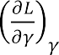3.52

The coefficients ( ) in the model Equation 3.52 was determined by Design Expert 9.0 software as shown in Equation 3.53.

3.53



* + - 1. **Significance testing of the coefficients of the response surface model (Validation)** Following the determination of coefficients in model Equation, the significance of the coefficients was determined by Design Expert 9.0 software as described below. The SSE,

, SSY and SSR were calculated using Equation 3.54, 3.55, 3.56 and 3.57 respectively.

The Minitab program in Figure 3.5 was used to compute the response surface coefficient of the empirical model, t-test value and the p-value.

  3.54

 3.55





where

n = length (y) = length of the output response (y)

p = length ( ) = number of the coefficient to be estimated

The Sum of Square of output responses (SSY) was determined from Equation 3.55 as:

 3.56

The Sum of Square of the Residual Error was determined by Design Expert 9.0 as shown in Equation 3.57.

 3.57

A Minitab program shown in Figure 3.5 was programmed to create a matrix of three columns. The first column has the response surface coefficient. The lists of the t-values is the second column. The t-test was performed for each separate coefficient to confirm whether the coefficient is considered worthwhile. The power of the t-test is the third column. This yields a t-test value connected to the confidence, indicating that the parameter under consideration is important.

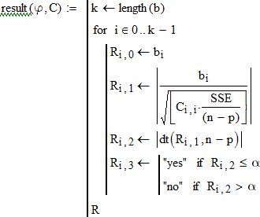

Figure 3.5: Design Expert 9.0 Program for Computing the Coefficient of the Response Surface Model, t-test value and the p-value.

The result obtained by Design Expert 9.0 program as presented in Chapter Four.

# Research Costing

The cost of executing this research is estimated under the following headings:

1. Machine development costs
2. Fabrication material cost
3. Fabrication and assembly costs
4. Field evaluation cost
5. Data analyses costs
6. Labour and logistics costs
7. Research work documentations cost

# Machine Development Cost

This comprised of the cost of design and prototype module production. The costs are as in Table 3.4

Table 3.4Machine development costs

|  |  |  |
| --- | --- | --- |
| S/N | Heading | Cost (N) |
| 1.  2. | Design cost  Prototype module production | 50,000  12,500 |
|  | Total | 62,500 |

# Fabrication Materials Costs

The costs of the materials purchased for the fabrication of the engine-propelled planter are as in Table 3.5.

Table 3.5: Cost of materials for fabrication

|  |  |  |  |  |  |
| --- | --- | --- | --- | --- | --- |
| **S/N** | **Item** | **Specification** | **Quantity** | **Unit Cost (**N**)** | **Total Cost**  **~~N~~** |
| 1 | Rectangular hollow pipe | 2” x 1” | ½ 1gt | 5,200 | 2,600 |
| 2 | Rectangular hollow pipe | 1” x 1” | ½ lgt | 3,500 | 1,750 |
| 3 | Galvanized pipe | ½” | ¼ lgt | 2,800 | 700 |
| 4 | Galvanized steel bar | 25mm | ¼ lgt | 7,200 | 1,800 |
| 5 | Internal combustion engine (pms) | 6.5 Lp | 1 | 16,500 | 16,500 |
| 6 | Gear box | 10:1 | 1 | 7,500 | 7.500 |
| 7 | Transmission belt | v-classical | 2 | 350 | 700 |
| 8 | Sprocket | 32 teeth | 1 | 150 | 150 |
| 9 | Sprocket | 12 teeth | 1 | 150 | 150 |
| 10 | Chain | Studded | 1 | 200 | 200 |
| 11 | Mild steel sheet | 2mm | ¼ sheet | 12,000 | 3,000 |
| 12 | Galvanized steel sheet | 2mm | ½ sheet | 16,000 | 8,000 |
| 13 | Mild steel plate | 5mm | 1/8 sheet | 8,000 | 1,000 |

|  |  |  |  |  |  |
| --- | --- | --- | --- | --- | --- |
| 14 | Mild steel shaft | 1” | ¼ Lgt | 6,200 | 1,300 |
| 15 | Metering box | Cast | 2 | 50,000 | 100,000 |
| 16 | Alluminium seed plates | Cast | 2 | 2,500 | 5,000 |
| 17 | Press wheel | Crown thread 590mm ID |  |  |  |
|  |  |  | 2 | 3,750 | 7,500 |
| 18 | Press wheel | Studded 152mm ID |  |  |  |
|  |  |  | 2 | 1,200 | 2,400 |
| 19 | Bearings | PS 204 | 8 | 500 | 4,000 |
| 20 | Angle bar | 2” x 2” 5mm thick | ¼ Lgt | 8,400 | 4,200 |
|  |  |  | **Total** |  | **167,450** |

# Fabrication and Assembly Costs

The cost of fabrication and assembly is as detailed in Tables 3.6 and 3.7 Table 3.6: Fabrication and assembly costs

|  |  |  |  |  |
| --- | --- | --- | --- | --- |
| **S/N** | **Heading** | **Quantity** | **Unit cost**  **~~N~~** | **Total Cost**  **~~N~~** |
| 1 | Purchase of G12 welding electrode | 2pkts | 1,200 | 2,400 |
| 2 | Cutting discs | 2 | 850 | 1,700 |

|  |  |  |  |  |
| --- | --- | --- | --- | --- |
| 3 | Grinding discs | 2 | 850 | 1,700 |
| 4 | Drilling bits | 3 | 250 | 750 |
| 5 | Tools | Item | - | 1,500 |
| 6 | Riveting pins | 1 pkt | 500 | 500 |
|  |  |  | Total | **8,550** |

Table 3.7: Energy Costing

|  |  |  |  |  |  |  |
| --- | --- | --- | --- | --- | --- | --- |
| **S/N** | **Equip** | **Rating (kW)** | **Hours of run** | **Total power consumed (kWh)** | **Unit cost**  **~~N~~** | **Total Cost ~~N~~** |
| 1 | Welding machine | 0.75 | 2.5 | 1.88 | 26.36 | 49.56 |
| 2 | Hand grinding machine | 0.3 | 1.5 | 0.45 | 26.36 | 11.87 |
| 3 | Center drill | 1.5 | 1.5 | 2.25 | 26.36 | 59.31 |
| 4 | Gestetner lathe machine | 1.5 | 0.75 | 1.125 | 26.36 | 29.66 |
| 5 | Hand held drilling machine | 0.3 | 3.5 | 1.05 | 26.36 | 27.68 |
|  |  |  |  |  |  | 178.08 |

# Field Evaluation Costs

Table 3.8 Presents the details of the cost of materials and equip used in the field evaluation

Table 3.8: Field Evaluation Material Costing

|  |  |  |  |  |
| --- | --- | --- | --- | --- |
| **S/N** | **Item** | **Quantity** | **Unit cost**  **~~N~~** | **Total Cost**  **~~N~~** |
| 1 | **Equipment**  Stop watch Graduated cylinders HP digital camera  72 HP MF Tractor (hiring) Disc plough (hiring) Harrow gang (hiring) Knapsack sprayer (20L) Sample dishes  Digital weigh source GPS equipment  Engine-propelled planter Animal drawn planter Measuring tape (50m)  Dry air oven (hired) | 1  2  1  1 x 3  1 x 3  1 x 3  1  12  1  1  1  1  1  1 x 3 | 600  350  18,000  5,000  1,000  1,000  5,200  100  125,000  165,000  -  - 1,800  1,500 | 600  700  18,000  15,000  3,000  3,000  5,200  1,200  125,000  165,000  -  - 1,800  4,500 |
| 2 | **Materials**  Maize seeds | 20kg | - | 1,200 |

|  |  |  |  |
| --- | --- | --- | --- |
| Petroleum fuel | 10 L x 3 | 145 | 4,350 |
| Artrazine | 1 L x 3 | 1,200 | 3,600 |
| Gramozone | 1 L x 3 | 1,300 | 3,900 |
| Bulls (Hiring) | 2 x 3 | 4,000 | 24,000 |
|  |  | **380,050.00** | |

# Data Analysis Costs

The costs of analyzing the collated data and optimisation are detailed in Table 3.9. Table 3.9: Data Analysis Costing

|  |  |  |  |  |
| --- | --- | --- | --- | --- |
| **S/N** | **Heading** | **Quantity** | **Unit Cost**  **~~N~~** | **Total Cost**  **~~N~~** |
| 1 | ***sas*** software | 1 | 25,000 | 25,000 |
| 2 | Design Expert 9.0 | 1 | 100,000 | 100,000 |
|  |  |  |  | **125,000** |

# Labour and Logistics

The labour engaged in the research work is detailed in Table 3.10 Table 3.10: Labour costing for the research

|  |  |  |  |  |
| --- | --- | --- | --- | --- |
| **S/N** | **Heading** | **Quantity** | **Rate** | **Total Cost** |

|  |  |  |  |  |
| --- | --- | --- | --- | --- |
|  |  |  | **~~N~~** | **~~N~~** |
| 1 | Technicians   1. Welders 2. Machinists 3. Machinery technician |  |  |  |
|  | 2  2  1 | 1,000  1,000  1,000 | 3,000  3,000  15,000 |
| 2 | Land preparation operators | 3 | 3,000 | 9,000 |
| 3 | Bull operators | 2 x 3 | 1,500 | 9,000 |
| 6 | Planter (manual) | 1 x 3 | 1,500 | 4,500 |
| 7 | Evaluation Assistants | 2 x 3 | 1,000 | 6,000 |
| 8 | Driver | 1 x 3 x 10 | 1,000 | 30,000 |
| 9 | Logistics | - | - | 10,000 |
|  |  |  |  | **143,500** |

# Research Documentation Costs

This involved the drafting of reports and documentation. Table 3.11 presents the details. Table 3.11: Research documentation costs

|  |  |  |
| --- | --- | --- |
| **S/N** | **Heading** | **Cost ~~N~~** |
| 1 | Primary data collection | 22,500 |

|  |  |  |
| --- | --- | --- |
| 2 | Research proposal drafting and presentation | 14,700 |
| 3 | Progress report drafting and presentation | 23,800 |
| 4 | Final seminar drafting and documentation | 28,000 |
| 5 | Drafting and external presentation | 16,000 |
| 6 | Post defence documentations | 8,000 |
|  |  | **113,000** |

# Total Research Costing

Total Research Cost = Machine development cost + Fabrication material cost +

Fabrication and assembly costs + Field evaluations costs + Data analyses costs + Labour and logistics costs +

Research work documentation cost

= N[62,500 + 167,450 + 8,550 + 178.08 + 380,050 + 125,000

+ 143,500 + 113,000]

# = N1,000,228.08

Machine production cost = N (167,450 + 8,550 + 178.08)

= N176,178.08

# CHAPTER FOUR

# RESULTS AND DISCUSSIONS

# Results of laboratory evaluations

The results of the laboratory evaluations are as presented in the following sub-sections.

# Result of soil physical evaluation

The results of the soil physical evaluations are as in Appendix H

The soil is classified as sandy loam. By the United State Classification of Soils (USCS), this falls within the highly organic soils ([www.wikipaedia.com](http://www.wikipaedia.com/) , 2010). This soil type is suitable for the growing of maize seeds. Classically, sandy loam soils have minimal resistance to soil penetration but it varies with the moisture content of the soil (Weise and Eichhorn, 1997). The part of the planter that has critical bearing with the soil is the soil opening device and it is a winged shear which forces the soil to open. Its operation has direct bearing on the running cost of the planter. The soil covering device and the traction wheels roll over the soil and are resisted by resisting shear forces. Sandy loam soils are low in shear resistance.

# Results of 1000 seed weight analysis

The result of the 1000 seed weight is as in Table 4.1

Table 4.1: Result of One thousand seed weight

|  |  |
| --- | --- |
| Sample No. | Weight (g) |
| 1 | 312.74 |
| 2 | 268.42 |
| 3 | 256.19 |
| 4 | 271.68 |
| 5 | 265.95 |
| 6 | 270.02 |
| 7 | 271.36 |
| 8 | 271.36 |
| Total | 2,187.72 |
| Average | 273.47 |

# Result of percent seed damage

The result of the seed damage test is as in Table 4.2 Table 4.2: Result of percent seed damage

|  |  |  |  |  |
| --- | --- | --- | --- | --- |
| Sample  No. | Right Hopper | | Left Hopper | |
|  | Weight of  whole seeds (g) | Weight of damaged  seeds (g) | Weight of whole  seeds (g) | Weight of broken  seeds (g) |
| 1 | 5.2 | 0.0 | 5.5 | 0.0 |
| 2 | 5.8 | 0.0 | 6.0 | 0.0 |
| 3 | 5.6 | 0.0 | 5.7 | 0.0 |
| 4 | 5.1 | 0.2 | 5.0 | 0.0 |
| 5 | 5.0 | 0.0 | 6.8 | 0.0 |
| Total | 26.7 | 0.2 | 29.0 | 0.0 |
| Average | 5.34 | 0.04 | 5.80 | 0.0 |
| % |  | 0.75 |  | 0.00 |

Seed damage by the engine-propelled planter is near zero. This implies that the planter is mechanically efficient in the delivery of whole seeds to the soil. Broken seeds reduce the number of seedlings that can emerge on a planted field. The higher the number of damaged seeds, the lower the plant population on a planted area. The engine-propelled planter thus has the capability of maintaining maximum plant emergence after planting.

# Results of seed metering and ground wheel speed

The results of seed metering and ground wheel speed are shown on Tables 4.3 and 4.4 respectively.

|  |  |  |  |  |  |  |
| --- | --- | --- | --- | --- | --- | --- |
| Trial  T  No.  a | Spacing between dropped seeds (cm) | | Average Spacing (cm) | | No. of seeds dropped per point | |
| b  l | Hopper 1 | Hopper 2 | Hopper  1 | Hopper  2 | Hopper 1 | Hopper 2 |
| e1 | 26,23,25.5,25.6 | 25.3,26.1,26,27.1 | 25.03 | 26.13 | 2+2+1+2=7 | 1+1+2+2=6 |
| 2  4 | 26.7,27.9,26.8,26 | 25.2,26.1,25,27.1 | 26.85 | 25.85 | 1+2+1+2=6 | 2+2+2+1=7 |
| 3  . | 28.5,26.1,24,26.6 | 23,24,25.6,22.3 | 26.30 | 23.73 | 2+1+1+3=7 | 3+2+1+2=8 |
| 3 | Total | | 78.18 | 75.71 | 20 | 21 |
| : |  | Average | 26.06 | 25.24 | 1.6 | 1.8 |

Results of seed metering test on the 2-row ridge planter

Table 4.4: Result of ground wheel travel speed

|  |  |  |  |
| --- | --- | --- | --- |
| Trial No. | Distance (m) | Time taken (secs) | Travel speed (m/s) |
| 1 | 10 | 11.50 | 1.15 |
| 2 | 10 | 12.88 | 1.29 |
| 3 | 10 | 13.20 | 1.32 |
|  |  | Average | 1.25 |

From the results of the wheel travel and metering tests, it is found that the engine- propelled planter will meter between 1 and 2 seeds per hole and having an average travel speed of 1.25m/s. These values are likely to be affected while working on the field as the conditions on the field are not the same as with the laboratory.Bamgboye and Mofolasayo (2006) submitted that planters that are not tractor trailed have not been able to reach the 1 m/s operational speed on the field. The number of seeds delivered per point agrees with the design stipulation. This also may be affected on the field since there could be wide variations in soil moisture contents. Soil moisture tends to inhibit the smooth movement of any equipment that depends on the soil for traction

# Results of soil moisture content determination

The results of the soil moisture content for the three years as computed from the values gotten from laboratory determination using Microsoft Excel 2013 release. The results are as in Appendix I.

The slippage in tillage operation is an important factor for analysis of fuel consumption. Fuel consumption and wheel slippage of tillage operation with a given implement is greatly affected by soil moisture, operation speed and the working depth. Wheel slippage and fuel consumption increase with increasing soil depth, planter speed and soil moisture values under study. A very efficient way of saving fuel is to choose the time at which there will be available good soil moisture content (Tayel *et al.,* 2015).

# Results of Field Evaluations

* + 1. **Results of machine performance evaluation at field level**

The collated data from the field for the testing of the 2-row engine-propelled planter alongside the single row IAR planter and the manual method of planting were summarized into statistically usable formats for the three years. The summarized results from collated data are as in AppendixJ for the 2012, 2013 and 2014 testing years respectively. From the summarized results, the effects of the evaluated factors on the field performance evaluations for the three methods are as in Figures 4.1 to 4.4.

# Effects of evaluated factors on planting speed

0.7

0.6

0.58

0.5

0.46

0.4

0.3

Engine-propelled

planter

Animal drawn planter

0.2

0.16

Manual planting

0.1

0

Year 2012

Planting speed (m/s)

The effects of soil moisture content and the depth of planting on the seedling emergence is depicted in Figure 4.1 for the three years.

From Figure 4.1, the hi m/s by the engine pro

Planting speed (m/s)

Figure 4.1: Results of the planting speeds using the three methods of planting

was the highest of the three planting methods. A number of factors could be responsible for this: The soil moisture could increase the slippage and it could also cause the planter tyres to be held in the soil thus retarding the ease of movement. The inability of the engine to freely propel the planter could also increase the time it takes to cover the run and since speed is a function of distance and time, the resulted speed could be affected. As for the animal drawn, the inconsistency in the movement of the animals could cause delays in covering the distance of run. The speed of planting manually actually depends on the experience of the planter. A more

ghest speed recorded was in the second testing and it was of value 0.61

pelled planter. Even though this falls short of the design value of 1 m/s, it

0.7

0.61

0.6

0.5

0.43

0.4

0.3

Engine-propelled

planter

Animal drawn planter

0.2

0.16

Manual planting

0.1

0

Year 2013

0.5

0.45

0.4

0.45

0.35

0.3

0.25

0.2

0.15

0.1

0.05

0

0.21

0.2

Engine-propelled

planter

Animal drawn planter

Manual planting

Year 2014

Planting speed (m/s)

experienced planter could cover a distance in a shorter time than an inexperienced planter thus resulting in difference in planting speed.

# Effects of evaluated factors on seedling emergence

The effects of soil moisture content and the depth of planting on the seedling emergence is depicted in Figure 4.2 for the three years.



**Year 2012**

**292, 34% 307, 35%**

**270, 31%**

Engine-propelled planter

Animaldrawn planter

manual planting



**Year 2013**

**319, 33%**

**339, 35%**

**304, 32%**

**Year 2014**

**332, 34%**

**367, 37%**

**288, 29%**

Engine-propelled planter

Animaldrawn planter

manual planting

Engine-propelled planter

Animaldrawn planter

manual planting

From Figure 4.2, it could be seen that the engine-propelled planter maintained the highest number of established seedlings having a minimum of 307 seedlings and a maximum of 367 seedlings in 0.011 hectares of land cultivated. These translate to 27,909 and 33,363 plants per hectare respectively as against the design projection of 39,000 plants per hectare. The values recorded convert to 71.56 % (minimum) and

85.55 % (maximum) respectively.

The manual planting performed next to the engine-propelled planter by recording a maximum of 77.39 % of the projected plant population. The animal drawn planter recorded the least of 70.86 %.

40

35

30

25

20

15

10

5

0

Engine-propelled

planter

Animaldrawn planter

Manual planting

Year 2012

Average plant spacing (cm)

# Effects of evaluated factors on plant-plant spacing

The effects of soil moisture content and the depth of planting on the plant-plant spacing is depicted in Figure 4.3 for the three years.

35

30

25

20

15

10

Engine-propelled

planter

Animaldrawn planter

Manual planting

5

0

Year 2013

Average plant spacing (cm)

Figure 4.3: Results of the plant spacing using the three methods of planting

35

30

25

20

15

10

5

0

Engine-propelled

planter

Animaldrawn planter

Manual planting

Year 2014

Axis Title

Average plant spacing (cm)

In terms of plant spacing and as can be seen from Figure 4.3, the animal drawn planter recorded the highest plant spacing of 31.77cm in the first year and the remaining two years. The 26.43cm recorded by the engine-propelled planter is the smallest in value but it is the value that is closest to the design projection of 25cm. It can be concluded that the engine-propelled planter is most reliable in terms of plant spacing.

# Effects of evaluated factors on energy expended

The effects of soil moisture content and the depth of planting on the energy expended is shown in Figure 4.4 for the three years.

Year 2012

260.00

1,156.36

2,296.36

Engine-propelled

planter

Animal drawn planter

Manual planting

Year 2013

261.82

Engine-propelled

planter

1,075.46

2,730.00

Animal drawn

planter

Manual planting

Year 2014

263.64

1,066.36

2,438.18

Engine-propelled

planter

Animal drawn planter

Manual planting

Figure 4.4: Results of the energy expended using the three methods of planting

From Figure 4.4, a minimum of 2,296.36 MJ/ha was recorded in operating the animal drawn planter. This is against the 1,156.36 MJ/ha maximum energy for the manual planting recorded in the first year of testing and the maximum of 263.64MJ/ha recorded by the engine-propelled planter. The wide difference in the energy expended could be attributed to the level of power input to each of the planting methods. This implies that with the engine-propelled planter, drudgery is drastically reduced.

# Results of statistical evaluations

The statistical evaluations of the collated data were done using ***sas*** software 2009 version and the results generated are as in Tables 4.5 to 4.16.

# Effects of planting methods, soil moisture and depth of planting on plant variables in 2012, 2013 and 2014 testing seasons

Table 4.5 to 4.7 show the effects of the fixed variables on the planting speed for the year 2012, 2013 and 2014.

Table 4.5: ANOVA of the Effects of planting methods, soil moisture and depth of planting on planting speed (SP) in 2012 testing season

Source of Sum of Tabular F Variation df Squares Mean Square Computed F 5% 1%

|  |  |  |  |  |  |  |
| --- | --- | --- | --- | --- | --- | --- |
| REP | 2 | 0.01146667 | 0.00573333 | 0.54 NS | 3.18 | 5.03 |
| MTD | 2 | 2.45098519 | 1.22549259 | 115.01** | 3.18 | 5.03 |
| SM | 2 | 0.01656296 | 0.00828148 | 0.78 NS | 3.18 | 5.03 |
| DP | 2 | 0.04056296 | 0.02028148 | 1.90 NS | 3.18 | 5.03 |
| MTD*SM | 4 | 0.13449630 | 0.03362407 | 3.16 NS | 2.55 | 3.70 |
| MTD*DP | 4 | 0.03429630 | 0.00857407 | 0.80 NS | 2.55 | 3.70 |
| SM*DP | 4 | 0.11642963 | 0.02910741 | 2.73 NS | 2.55 | 3.70 |
| MTD*SM*DP | 8 | 0.04733333 | 0.00591667 | 0.56 NS | 2.12 | 2.86 |
| ERROR | 52 | 0.55406667 | 0.01065513 |  |  |  |
| TOTAL | 80 | 3.40620000 |  |  |  |  |

NOTE: NS = Not Significant, * = Significant at 5% confidence level, ** = Significant at 1% confidence level

Table 4.6: ANOVA of the Effects of planting methods, soil moisture and depth of planting on planting speed (SP) in 2013 testing season

Source of Sum of Tabular F Variation df Squares Mean Square Computed F 5% 1%

|  |  |  |  |  |  |  |
| --- | --- | --- | --- | --- | --- | --- |
| REP | 2 | 0.01716296 | 0.00858148 | 0.94 NS | 3.18 | 5.03 |
| MTD | 2 | 2.73080741 | 1.36540370 | 150.22** | 3.18 | 5.03 |
| SM | 2 | 0.00005185 | 0.00002593 | 0.00 NS | 3.18 | 5.03 |
| DP | 2 | 0.06854074 | 0.03427037 | 3.77* | 3.18 | 5.03 |
| MTD*SM | 4 | 0.03407407 | 0.00851852 | 0.94 NS | 2.55 | 3.70 |
| MTD*DP | 4 | 0.00767407 | 0.00191852 | 0.21 NS | 2.55 | 3.70 |
| SM*DP | 4 | 0.04118519 | 0.01029630 | 1.13 NS | 2.55 | 3.70 |
| MTD*SM*DP | 8 | 0.03266667 | 0.00408333 | 0.45 NS | 2.12 | 2.86 |
| ERROR | 52 | 0.47263704 | 0.00908917 |  |  |  |

TOTAL 80 3.40480000

NOTE: NS = Not Significant, * = Significant at 5% confidence level, ** = Significant at 1% confidence level

Table 4.7: ANOVA of the Effects of planting methods, soil moisture and depth of planting on planting speed (SP) in 2014 testing season

Source of Sum of Tabular F Variation df Squares Mean Square Computed F 5% 1%

|  |  |  |  |  |  |  |
| --- | --- | --- | --- | --- | --- | --- |
| REP | 2 | 0.01536543 | 0.00768272 | 2.40 NS | 3.18 | 5.03 |
| MTD | 2 | 1.07071358 | 0.53535679 | 167.26** | 3.18 | 5.03 |
| SM | 2 | 0.03462469 | 0.01731235 | 5.41** | 3.18 | 5.03 |
| DP | 2 | 0.02988395 | 0.01494198 | 4.67* | 3.18 | 5.03 |
| MTD*SM | 4 | 0.01508642 | 0.00377160 | 1.18 NS | 2.55 | 3.70 |
| MTD*DP | 4 | 0.01178272 | 0.00294568 | 0.92 NS | 2.55 | 3.70 |
| SM*DP | 4 | 0.00504938 | 0.00126235 | 0.39 NS | 2.55 | 3.70 |
| MTD*SM*DP | 8 | 0.00592840 | 0.00074105 | 0.23 NS | 2.12 | 2.86 |
| ERROR | 52 | 0.16643457 | 0.00320066 |  |  |  |
| TOTAL | 80 | 1.35486914 |  |  |  |  |

NOTE: NS = Not Significant, * = Significant at 5% confidence level, ** = Significant at 1% confidence level

With computed F greater than the Tabular F at 1% confidence level, the planting methods (MTD) have planting speeds that are at significant variance. The engine- propelled planter (though has the highest planting speed of 0.58m/s) still has its speed lower than the expected plating speed of 1 m/s. Mechanical inefficiencies could affect the speed of planting of each of the methods on the field.

Method of planting has significant effects on the evaluation of Speed of Planting (SP) at 1% confidence level. The Depth of Planting (DP) has significant effect at the 5% confidence level only. The same factors that affect planting and delay time also affect the

speed of planting. For the mechanical planters, draft problems tend to reduce the speed at which they move while in operation (Igbeka, 1986; Harrigan and Rotz, 1995)

The ANOVA in Table 4.7 indicates that all the three treatments MTD, SM and DP have significant effects on the speed of planting (SP) while the MTD and SM are significant at 5% and 1% confidence levels respectively, DP is significant at 5% confidence level only. This situation, according to Okudo (1974), Srivastava *et al*. (1993) and Matin *et al*. (2008), are close to the ideal situation where the three treatments are expected to have significant effects on the speed of planting. Since this is occurring last, it may be interpreted that the planting methods were improved upon as the seasons progressed.

Tables 4.8to 4.10 show the effects of the fixed variables on the seedling emergence for the year 2012, 2013 and 2014.

Table 4.8: ANOVA of the Effects of planting methods, soil moisture and depth of planting on seedling emergence (SE) in 2012 testing season

Source of Sum of +Tabular F Variation df Squares Mean Square Computed F 5% 1%

|  |  |  |  |
| --- | --- | --- | --- |
| REP | 2 | 0.17283951 0.08641975 0.04NS3.18 | 5.03 |
| MTD | 2 | 25.65432099 12.827160496.19** 3.18 | 5.03 |
| SM | 2 | 4.172839512.086419751.01 NS3.18 5.03 |  |
| DP | 2 | 1.28395062 0.641975310.31 NS3.18 | 5.03 |
| MTD*SM | 4 | 0.641975310.160493830.08 NS2.55 3.70 |  |

MTD*DP 4 2.419753090.60493827 0.29 NS2.55 3.70

SM*DP 4 1.012345680.25308642 0.12 NS2.55 3.70

|  |  |  |  |
| --- | --- | --- | --- |
| MTD*SM*DP | 8 | 10.83950617 1.35493827 | 0.65 NS2.12 2.86 |
| Error | 52 | 107.8271605 2.07359922 |  |
| Total | 80 | 154.0246914 |  |

+Gomez and Gomez (1984)

NOTE: NS = Not Significant, * = Significant at 5% confidence level, ** = Significant at 1% confidence level

Table 4.9: ANOVA of the Effects of planting methods, soil moisture and depth of planting on seedling emergence (SE) in 2013 testing season

|  |  |  |  |  |
| --- | --- | --- | --- | --- |
| Source of  Variation df | Sum of  Squares Mean Square Computed F 5% | | Tabular F  1% | |
| REP | 2 0.765432100.38271605 0.28 NS 3.18 | | 5.03 | |
| MTD SM | 2  2 | 22.83950617 11.41975309 8.26**  6.09876543 3.049382722.21 NS 3.18 | 3.18  5.03 | 5.03 |
| DP | 2 | 6.39506173 3.19753086 2.31 NS | 3.18 | 5.03 |
| MTD*SM | 4 | 34.71604938 8.67901235 6.28 NS | 2.55 | 3.70 |
| MTD*DP | 4 | 9.08641975 2.271604941.64 NS 2.55 | 3.70 |  |
| SM*DP | 4 | 13.16049383 3.290123462.38 NS 2.55 | 3.70 |  |
| MTD*SM*DP | 8 | 7.80246914 0.975308640.71 NS 2.12 | 2.86 |  |
| ERROR | 52 | 71.9012346 1.3827160 |  |  |
| TOTAL | 80 | 172.7654321 |  |  |

NOTE: NS = Not Significant, * = Significant at 5% confidence level, ** = Significant at 1% confidence level

Table 4.10: ANOVA of the Effects of planting methods, soil moisture and depth of planting on Seedling Emergence (SE) in 2014 testing season

|  |  |  |  |  |  |
| --- | --- | --- | --- | --- | --- |
| Source of  Variation df | Sum of  Squares Mean Square Computed F 5% | | | Tabular F  1% | |
| REP | 2 0.29629630.1481481 0.07 NS 3.18 | | | 5.03 | |
| MTD | 2 116.0740741 58.0370370 27.18** | | | 3.18 5.03 | |
| SM | 2 0.22222220.11111110.05 NS 3.18 5.03 | | |  | |
| DP | 2 | 0.5185185 | 0.2592593 0.12 NS | 3.18 | 5.03 |
| MTD*SM | 4 | 11.9259259 | 2.9814815 1.40 NS 2.55 | 3.70 |  |
| MTD*DP | 4 | 6.7407407 | 1.6851852 0.79 NS 2.55 | 3.70 |  |
| SM*DP | 4 | 4.1481481 | 1.0370370 0.49 NS 2.55 | 3.70 |  |
| MTD*SM*DP | 8 | 17.2592593 | 2.1574074 1.01 NS 2.12 | 2.86 |  |
| ERROR | 52 | 111.0370370 | 2.1353276 |  |  |

TOTAL 80 268.2222222

NOTE: NS = Not Significant, * = Significant at 5% confidence level, ** = Significant at 1% confidence level

For the 2012 and as in Table 4.8, only the Planting methods have significant difference in the measurement of plant population at 1% confidence level. That there is significant difference implies that the number of emerged seedlings vary widely with respect to the planting method used. That the soil moisture and depth of planting did not have significant difference implies that they do not affect the outcome of crop emergence. This however runs counter to the submissions of Yisa *et al.* (1994), Nielson (2001) and Ugese *et al.* (2010) who stated that variations in soil moisture and the depth of planting affect the rate of seedling emergence. The same trend was observed in the 2012, 2013 and 2014 testing seasons. From table 4.8, the engine-propelled planter recorded highest plant population in 2012 testing season having 35% of the total plant population on the testing plot. The plant population of 307 plants in 0.0107hectares of area translates into 28,691plants per hectare which represents 73.57% of the estimated plant density. The engine-propelled planter is closely followed by the manual method of planting with 70.63% of the design estimate. The animal drawn planter is least. This owes to the difficulty in maneuvering the bulls on the farm which leads to longer time in planting and wide variations in the depth of planting.

Similar to 2012 testing season, the methods of planting have significant effects on the plant population at 1% confidence level. The engine-propelled planter maintained a 35% share of the total plant population in 2013 as evident from Figure 4.2. The engine- propelled planter accounted for 339 maize plants in 0.0118 hectares giving rise to

28,728 plants per hectare which represents 73.66% of the design population. This is followed with the manual planting method with 70.50% of the estimated plant population.

The trend of the effect of the planting methods on the plant population is maintained in 2014 as in 2012 and 2013. The engine-propelled planter maintained the highest plant population of 367 plants in 0.0125ha accounting for a plant density of 29,360 plants per hectare representing 75.28% of the design plant density. The values gotten in the 2014 testing season are higher than those gotten in 2012 and 2013 respectively.

Tables 4.11 to 4.13 show the effects of the fixed variables on the plant spacing for the year 2012, 2013 and 2014.

Table 4.11: ANOVA of the Effects of planting methods, soil moisture and depth of planting on plant spacing (PS) in 2012 testing season

Source of Sum of Tabular F variation df Squares Mean Square Computed F 5% 1%

|  |  |  |  |  |  |
| --- | --- | --- | --- | --- | --- |
| REP | 2 | 419.8676543 | 209.9338272 | 3.65 NS 3.18 | 5.03 |
| MTD | 2 | 876.6528395 | 438.3264198 | 7.61** 3.18 | 5.03 |
| SM | 2 | 4.4720988 | 2.2360494 | 0.04 NS 3.18 | 5.03 |
| DP | 2 | 95.0624691 | 47.5312346 | 0.83 NS 3.18 | 5.03 |

|  |  |  |  |  |  |  |
| --- | --- | --- | --- | --- | --- | --- |
| MTD*SM | 4 | 112.5234568 | 28.1308642 | 0.49 NS | 2.55 | 3.70 |
| MTD*DP | 4 | 77.0597531 | 19.2649383 | 0.33 NS | 2.55 | 3.70 |
| SM*DP | 4 | 98.4493827 | 24.6123457 | 0.43 NS | 2.55 | 3.70 |
| MTD*SM*DP | 8 | 174.3972840 | 21.7996605 | 0.38 NS | 2.12 | 2.86 |
| ERROR | 52 | 2993.692346 | 57.571007 |  |  |  |
| TOTAL | 80 | 4852.177284 |  |  |  |  |

NOTE: NS = Not Significant, * = Significant at 5% confidence level, ** = Significant at 1%

confidence level

Table 4.12: ANOVA of the Effects of planting methods, soil moisture and depth of planting on plant spacing (PS) in 2013 testing season

Source of Sum of Tabular F Variation df Squares Mean Square Computed F 5% 1%

|  |  |  |  |  |  |  |
| --- | --- | --- | --- | --- | --- | --- |
| REP | 2 | 11.8451852 | 5.9225926 | 0.33 NS | 3.18 | 5.03 |
| MTD | 2 | 407.2807407 | 203.6403704 | 11.27** | 3.18 | 5.03 |
| SM | 2 | 23.8896296 | 11.9448148 | 0.66 NS | 3.18 | 5.03 |
| DP | 2 | 0.4422222 | 0.2211111 | 0.01NS | 3.18 | 5.03 |
| MTD*SM | 4 | 22.0940741 | 5.5235185 | 0.31 NS | 2.55 | 3.70 |
| MTD*DP | 4 | 74.5925926 | 18.6481481 | 1.03 NS | 2.55 | 3.70 |
| SM*DP | 4 | 49.7948148 | 12.4487037 | 0.69 NS | 2.55 | 3.70 |
| MTD*SM*DP | 8 | 131.6814815 | 16.4601852 | 0.91 NS | 2.12 | 2.86 |
| ERROR | 52 | 939.581481 | 18.068875 |  |  |  |
| TOTAL | 80 | 1661.202222 |  |  |  |  |

NOTE: NS = Not Significant, * = Significant at 5% confidence level, ** = Significant at 1% confidence level

Table 4.13: ANOVA of the Effects of planting methods, soil moisture and depth of planting on plant Spacing (PS) in 2014 testing season

Source of Sum of Tabular F Variation df Squares Mean Square Computed F 5% 1%

|  |  |  |  |  |  |  |
| --- | --- | --- | --- | --- | --- | --- |
| REP | 2 | 4.4051852 | 2.2025926 | 0.12 NS | 3.18 | 5.03 |
| MTD | 2 | 491.3266667 | 245.6633333 | 13.17** | 3.18 | 5.03 |
| SM | 2 | 34.3874074 | 17.1937037 | 0.92 NS | 3.18 | 5.03 |
| DP | 2 | 55.7118519 | 27.8559259 | 1.49 NS | 3.18 | 5.03 |
| MTD*SM | 4 | 15.6770370 | 3.9192593 | 0.21 NS | 2.55 | 3.70 |
| MTD*DP | 4 | 86.2925926 | 21.5731481 | 1.16 NS | 2.55 | 3.70 |

|  |  |  |  |  |  |
| --- | --- | --- | --- | --- | --- |
| SM*DP | 4 | 29.7851852 | 7.4462963 0.40 NS | 2.55 | 3.70 |
| MTD*SM*DP | 8 | 136.6348148 | 17.0793519 0.92 NS | 2.12 | 2.86 |
| ERROR | 52 | 969.774815 | 18.649516 |  |  |
| TOTAL | 80 | 1823.995556 |  |  |  |

NOTE: NS = Not Significant, * = Significant at 5% confidence level, ** = Significant at 1%

confidence level

Similar to Seedling Emergence, it is only the method of planting that has significant effect on the plant spacing with computed F > tabular F at 1% confidence level. With an average intra-row planting spacing of 26.43cm, the engine-propelled planter has plant-to- plant spacing closest to the design plant spacing of 25cm. The animal drawn planter and manual have average values of 34.33cm and 31.77 cm respectively. These in- consistencies in spacing by both the animal drawn and manual method of planting have been attested to by Yisa *et al.* (1994). According to them, the inaccurate judgment of sizes by the human being doing the manual planting and the non-uniform movement of the bulls on the farmland while in operation can lead a variation of plant spacing from the desired spacing.

Similar to that of 2012 testing season, it is only the planting methods that have significant effects on both the Seedling Emergence (SE) and plant spacing (PS) in the 2013 testing

season. The soil moisture and depth of planting do not have significant effects and so are their interactions with planting method. The differences in replications were not significant. That they were not significant implies that there were no remarkable differences in the measurements between the replications and within the replications. Thus the values measure tend to agree with each other even between seasons.

As in the 2012 and 2013 testing seasons, it is only the planting methods that have significant effects on the evaluation of the Seedling Emergence (SE) and Plant Spacing (PS). The planting methods (MTD) have significant effects on SE and PS at 1% confidence level, with computed F greater than the Tabular F in both cases. The soil moisture, depth of planting and their interactions with the planting methods do not have significant effects on the evaluation of plant population and plant spacing.

Tables 4.14 to 4.16 show the effects of the fixed variables on the energy expended for the year 2012, 2013 and 2014.

Table 4.14: ANOVA of the Effects of planting methods, soil moisture and depth of planting on energy expended (EC) in 2012 testing season

|  |  |  |  |  |  |  |  |
| --- | --- | --- | --- | --- | --- | --- | --- |
| Source of  Variation df | Sum of  Squares | | Mean Square Computed F | | 5% | Tabular F  1% | |
| REP | 2 0.018580 0.0092900.23 NS | | | | 3.18 | 5.03 | |
| MTD | 2 | 6808.733343 | | 3404.36667284852.7** | | 3.18 | 5.03 |
| SM | 2 | 0.036328 | | 0.018164 0.45 NS 3.18 | | 5.03 |  |

|  |  |  |  |  |  |
| --- | --- | --- | --- | --- | --- |
| DP | 2 | 0.153202 | 0.076601 1.91 NS | 3.18 | 5.03 |
| MTD*SM | 4 | 0.119086 | 0.029772 0.74 NS | 2.55 | 3.70 |
| MTD*DP | 4 | 0.124612 | 0.0311530.78 NS | 2.55 | 3.70 |
| SM*DP | 4 | 0.046894 | 0.011723 0.29 NS | 2.55 | 3.70 |
| MTD*SM*DP | 8 | 0.132669 | 0.016584 0.41 NS | 2.12 | 2.86 |
| ERROR | 52 | 2.086286 | 0.040121 |  |  |
| TOTAL | 80 | 6811.451002 |  |  |  |

NOTE: NS = Not Significant, * = Significant at 5% confidence level, ** = Significant at 1%

confidence level

Table 4.15: ANOVA of the Effects of planting methods, soil moisture and depth of planting on energy expended (EC) in 2013 testing season

|  |  |  |
| --- | --- | --- |
| Source of  Variation df | Sum of  Squares Mean Square Computed F 5% | Tabular F  1% |
| REP | 2 0.255647 0.127823 1.70 NS 3.18 | 5.03 |
| MTD | 2 7387.007410 3693.503705 49194.3 ** | 3.18 5.03 |

|  |  |  |  |  |
| --- | --- | --- | --- | --- |
| SM | 2 | 0.004077 0.002038 0.03 NS | 3.18 | 5.03 |
| DP | 2 | 0.110402 0.055201 0.74* 3.18 | 5.03 |  |
| MTD*SM | 4 | 0.237420 0.0593550.79 NS 2.55 | 3.70 |  |
| MTD*DP | 4 | 0.292383 0.073096 0.97 NS | 2.55 | 3.70 |
| SM*DP | 4 | 0.402205 0.1005511.34 NS 2.55 | 3.70 |  |
| MTD*SM*DP | 8 | 0.294143 0.0367680.49 NS 2.12 | 2.86 |  |
| ERROR | 52 | 3.904153 0.075080 |  |  |
| TOTAL | 80 | 7392.507840 |  |  |

-

NOTE: NS = Not Significant, * = Significant at 5% confidence level, ** = Significant at 1% confidence level

Table 4.16: ANOVA of the Effects of planting methods, soil moisture and depth of planting on energy consumption (EC) in 2014 testing season

|  |  |  |  |  |  |  |  |  |
| --- | --- | --- | --- | --- | --- | --- | --- | --- |
| Source of  Variation df | Sum of  Squares | | Mean Square Computed F 5% | | | | Tabular F  1% | |
| REP | 2 | 0.036002 | | 0.018001 0.48 NS 3.18 | | | 5.03 |  |
| MTD | 2 | 7905.645291 | | 3952.822646 106332** | | | 3.18 | 5.03 |
| SM | 2 | 0.089965 | | 0.044983 | 1.21 NS | 3.18 | 5.03 | |
| DP | 2 | 0.100477 | | 0.050238 | 1.35 NS | 3.18 | 5.03 | |
| MTD*SM | 4 | 0.075620 | | 0.018905 | 0.51 NS | 2.55 | 3.70 | |
| MTD*DP | 4 | 0.310220 | | 0.077555 | 2.09 NS | 2.55 | 3.70 | |

|  |  |  |  |  |  |
| --- | --- | --- | --- | --- | --- |
| SM*DP | 4 | 0.120923 | 0.030231 0.81 NS | 2.55 | 3.70 |
| MTD*SM*DP | 8 | 0.404047 | 0.050506 1.36 NS | 2.12 | 2.86 |
| ERROR | 52 | 1.933064 | 0.037174 |  |  |
| TOTAL | 80 | 7908.715610 |  |  |  |

NOTE: NS = Not Significant, * = Significant at 5% confidence level, ** = Significant at 1%

confidence level

The methods of planting have significant differences on the energy that was expended in the planting operation with computed F > tabular F at 1% confidence level. The animal drawn planter takes the highest level of energy while in operation. It accounted for 62% of the total energy expended in the farming operation. This can be explained on the fact that the animal drawn planter engages the services of two work bulls and two operators. In the course of guiding the planter and controlling the bulls, the operators experience high level of increased heartbeats. The engine-propelled planter consumed least of the energy taking only 7% of the total energy used in the 2012 testing season. According to Jekayinfa (2006), energy expended in operations differ with respect to the method involved in operation. Soil moisture and depth of planting and their interactions with planting methods do not have significant effects on the energy consumed.

The planting methods and the depth of planting had significant effects on the energy expended in the 2013 testing season. While the animal drawn planter still maintains the highest share of the energy expended in operation with 64%, the engine-propelled planter maintains the least value of 7%. This portrays that the engine-propelled planter is more energy efficient than the other two methods

It is still the planting method that has significant effects on the energy expended. There is a wide variation between the engine-propelled planter and the other two methods of planting.

# Pooled analysis of the effects of planting methods, soil moisture and depth of planting on planting variables in the 2012, 2013 and 2014 testing seasons

Tables 4.17 to 4.20 show the statistical results of the data for the three years (2012, 2013 and 2014) pooled together in one analysis.

Table 4.17: ANOVA of the Pooled analysis of the effects of planting methods, soil moisture and depth of planting on planting speed (SP) in the 2012, 2013and 2014 testing seasons

|  |  |  |  |  |
| --- | --- | --- | --- | --- |
| Source of |  | Sum of |  | Tabular F |
| Variation | df | Squares | Mean Square Computed F 5% | 1% |

|  |  |  |  |  |  |  |  |
| --- | --- | --- | --- | --- | --- | --- | --- |
| REP |  | 2 | 0.01653416 | 0.00826708 | 1.08NS | 3.06 | 4.75 |
| MTD |  | 2 | 5.54630700 | 2.77315350 | 363.51** | 3.06 | 4.75 |
| SM | 2 | 0.03152922 | 0.01576461 | 2.07NS | 3.06 4.75 |  |  |
| DP | 2 | 0.11376872 | 0.05688436 | 7.46** | 3.06 4.75 |  |  |

SM*DP 4 0.09966584 0.02491646 3.27NS 2.43 3.44

|  |  |  |  |  |  |  |  |  |  |
| --- | --- | --- | --- | --- | --- | --- | --- | --- | --- |
| YEAR | 2 | | 0.66155391 | | 0.33077695 | | 43.36** | 3.06 | 4.75 |
| MTD*SM | 4 | 0.12097942 | | 0.03024486 | | 3.96** | 2.43 | 3.44 | |
| MTD*DP | 4 | 0.02262140 | | 0.00565535 | | 0.74NS | 2.43 | 3.44 | |
| MTD*YEAR | 4 | | 0.70619918 | | 0.17654979 | | 23.14** | 2.43 | 3.44 |

|  |  |  |  |  |  |  |
| --- | --- | --- | --- | --- | --- | --- |
| SM*YEAR | 4 | 0.01971029 | 0.00492757 | 0.65NS | 2.43 | 3.44 |
| DP*YEAR | 4 | 0.02521893 | 0.00630473 | 0.83NS | 2.43 | 3.44 |
| MTD*SM*DP | 8 | 0.05321811 | 0.00665226 | 0.87NS | 2.00 | 2.62 |
| MTD*SM*YEAR | 8 | 0.06267737 | 0.00783467 | 1.03NS | 2.00 | 2.62 |
| MTD*DP*YEAR | 8 | 0.03113169 | 0.00389146 | 0.51NS | 2.00 | 2.62 |
| SM*DP*YEAR | 8 | 0.06299835 | 0.00787479 | 1.03NS | 2.00 | 2.62 |
| MTD*SM*DP*YEAR16 | | 0.03271029 | 0.00204439 | 0.27NS | 1.71 | 2.12 |
| ERROR 160 | | 1.22059918 | 0.00762874 |  |  |  |
| TOTAL 242 | | 8.82742305 |  |  |  |  |

NOTE: NS = Not Significant, * = Significant at 5% confidence level, ** = Significant at 1% confidence level

For the planting speed pooled statistical evaluation as in Table 4.17, it could be submitted that the planting method, the depth of planting, the year of planting (Test), the interactions of planting method and year and that of soil moisture and depth of planting all have significant effects on the planting speed. This implies that the method of planting, the soil moisture and the depth of planting significantly affect the planting speed of the method adopted. Wetter soils and deeper depths tend to inhibit the movement of the planter in use and thus slowing the rate of movement.

That non-significance of the replicationsimplies that the values could be accepted. This implies that no single test can be taken but average values will be treated in model predictions. The effects of methods of planting (MTD) and depth of planting (DP) are significant at the 1% confidence level. The interactions of YEAR and MTD and MTD and SM are significant in planting speed at 1% confidence level. The interaction of SM and

DP are also significant at the 1% confidence level.Since there are significant differences between tests, average values will be taken for the variables

Figure 4.5 shows the graphical representation of the speeds of planting by each of the planting methods.

0.6

0.55

0.5

0.4

0.37

0.3

Self-propelled planter

Animal drawn planter Manual planting

0.2  ~~0.17~~

0.1

0

Planting Methods

Average planting speed (m/s)

Figure 4.5: Average planting speed under the planting methods for the years2012, 2013 and 2014

The engine-propelled planter has the highest average planting speed of 0.55 m/s with the manual planting method recording the lowest average planting speed of 0.17 m/s. Even though the planting speed recorded by the engine-propelled planter is highest in these tests, it is still lower than the recommended planting speed on the field of 1m/s (Far *et al.,* 1994; Celic *et al.,* 2007).This implies that none of the methods could measure up to the recommended speed. This calls for further modifications on the mechanical means of planting. Researches by Igbeka (1986) and Bamgboye and Mofolasayo (2006) show that studies on manual planting has never reached the recommended 1m/s

planting speed in Nigeria. Other planting machineries imported from abroad (even though they are for flat planting) are yet to be tested to know their compliance to planting speed on Nigerian soils.Table 4.18 presents the pooled ANOVA for the years 2012, 2013 and 2014 with respect to the seedling emergence results. Three years’ data were pooled and the effects of the three treatments were measured.

Table 4.18: ANOVA of the Pooled analysis of the effects of planting methods, soil moisture and depth of planting on seedling emergence in the 2012, 2013and 2014 testing seasons

|  |  |  |  |  |  |  |  |
| --- | --- | --- | --- | --- | --- | --- | --- |
| Source of  Variation | df | Sum of  Squares | | Mean Square Computed F 5% | | Tabular F  1% | |
| REP | 2 | | 0.2304527 0.1152263 | | 0.06NS 3.06 | 4.75 |  |
| MTD | 2 | | 140.9958848 70.4979424 | | 38.66** | 3.06 | 4.75 |
| SM | 2 | | 4.8477366 2.4238683 | | 1.33 NS 3.06 | 4.75 |  |

DP 2 3.8106996 1.9053498 1.04 NS 3.06 4.75

YEAR 2 95.4650206 47.7325103 26.18** 3.06 4.75

|  |  |  |  |  |  |  |  |  |
| --- | --- | --- | --- | --- | --- | --- | --- | --- |
| MTD*SM | 4 | 3.7448560 | | 0.9362140 0.51 NS 2.43 3.44 | | | | |
| MTD*DP | 4 | 8.5596708 | | 2.1399177 1.17 NS 2.43 3.44 | | | | |
| MTD*YEAR 4 23.5720165 5.8930041 3.23* 2.43 3.44  SM*DP 4 7.6707819 1.9176955 1.05 NS 2.43 3.44 | | | | | | | | |
| SM*YEAR | 4 | | 5.6460905 | | 1.4115226 0.77 NS | | 2.43 | 3.44 |
| DP*Year | 4 | | 4.3868313 | | 1.0967078 0.60 NS | | 2.43 | 3.44 |
| MTD*SM*DP8 15.7366255 1.9670782 1.08 NS 2.00 2.62 | | | | | | | | |
| MTD*SM*YEAR | | 8 | 43.5390947 | | 5.4423868 | 2.98** 2.00 | 2.62 |  |
| MTD*DP*YEAR | | 8 | 9.6872428 | | 1.2109053 | 0.66 NS | 2.00 | 2.62 |
| SML*DP*YEAR | | 8 | 10.6502058 | | 1.3312757 | 0.73 NS | 2.00 | 2.62 |
| MTD*SM*DP*YEAR16 | | | 20.1646091 | | 1.2602881 | 0.69NS | 1.71 | 2.12 |
| ERROR 160 | | | 291.7695473 | | 1.8235597 |  |  |  |
| TOTAL 242 | | | 690.4773663 | |  |  |  |  |
| NOTE: NS = Not Significant, * = Significant at 5% confidence level, ** = Significant at | | | | | | | | |

1%

confidence level

In this pooled analysis, it is seen that there are no significant differences between replications within the testing periods. This implies that the values gotten in the three replications agreed with each other as they are close in magnitude. There was significant

difference between the tests, the interaction between method, soil moisture and the year of testing at 1% confidence level. The planting methods and the interaction between the method of planting and the year of planting have significant effects on the seedling emergenceat the1% and 5% confidence levels respectively. This implies that the methods showed varying capabilities in the number of plants that emerged.Plant emergence according to Yisa *et al.* (1994) and Heckman *et al.* (2002) is related to the depth at which the seed is planted, the state of soil coverage, firming and the soil moisture. Variation in the number of emerging seedlings with respect to the planting methods shows that the methods either deviated in the accuracy of depth of planting or they deviated in their accuracies of seed coverage and firming.

Figure 4.6 shows the graphical representation of the summaries of the number of emerging seedlings for the years 2012, 2013 and 2014.



**Average number of emerged**

**seeds/ha**

**28,545**

**30,636**

**26,091**

Engine-propelled planter Animal drawn planter

Manual planting

Figure 4.6: Averagenumber of emerged seeds under the planting methods for the years 2012, 2013 and 2014

From Figure 4.6,it can be seen that the engine-propelled planter maintained the highest number of seed emergence for the years 2012, 2013 and 2014 with an average emergent seedling of 337 plants within the cultivated area of 0.011 hectares. This therefore translates to a plant density of 30,636 plants per hectare representing 73.85% of the design plant density. The manual planting method is next in terms of seed emergence for the three years of testing. The animal drawn planter has the lowest plant population density. The submissions of Matin *et al.* (2008) and Ikechukwu *et al.* (2014)agree with this trend that a mechanical means of planting save not only energy but also ensures higher plant density resulting from the near accurate seed/plant spacing and uniformity of depth of planting.

Table 4.19: ANOVA of the Pooled analysis of the effects of planting methods, soil moisture and depth of planting on plant spacing (PS) in the 2012, 2013and 2014 testing seasons

|  |  |  |  |  |
| --- | --- | --- | --- | --- |
| Source of |  | Sum of |  | Tabular F |
| Variation | df | Squares | Mean Square Computed F 5% | 1% |

|  |  |  |  |  |  |  |  |
| --- | --- | --- | --- | --- | --- | --- | --- |
| REP |  | 2 | 200.305514 | 100.152757 | 3.12NS | 3.06 | 4.75 |
| MTD |  | 2 | 1713.218848 | 856.609424 | 26.67** | 3.06 | 4.75 |
| SM | 2 | 33.067984 | 16.533992 | 0.51NS 3.06 | 4.75 |  |  |
| DP | 2 | 91.643539 | 45.821770 | 1.43NS 3.06 | 4.75 |  |  |
| YEAR |  | 2 | 243.181317 | 121.590658 | 3.79* 3.06 | 4.75 |  |

|  |  |  |  |  |  |  |  |  |
| --- | --- | --- | --- | --- | --- | --- | --- | --- |
| MTD*SM | 4 | 50.942881 | | 12.735720 0.40NS 2.43 | | | 3.44 | |
| MTD*DP | 4 | 133.090288 | | 33.272572 1.04NS 2.43 | | | 3.44 | |
| MTD*YEAR 4 62.041399 15.510350 0.48NS 2.43 3.44  SM*DP 4 61.931523 15.482881 0.48NS 2.43 3.44 | | | | | | | | |
| SM*YEAR | 4 | | 29.681152 | | 7.420288 0.23NS | | 2.43 | 3.44 |
| DP*YEAR | 4 | | 59.573004 | | 14.893251 0.46NS | | 2.43 | 3.44 |
| MTD*SM*DP8 190.807984 23.850998 0.74NS 2.00 2.62 | | | | | | | | |
| MTD*SM*YEAR | | 8 | 99.351687 | | 12.418961 | 0.39NS | 2.00 | 2.62 |
| MTD*DP*YEAR | | 8 | 104.854650 | | 13.106831 | 0.41NS | 2.00 | 2.62 |
| SM*DP*YEAR | | 8 | 116.097860 | | 14.512233 | 0.45NS | 2.00 | 2.62 |
| MTD*SM*DP*YEAR16 251.905597 15.744100 0.49NS 1.71 2.12 | | | | | | | | |

ERROR 160 5138.861152 32.117882

TOTAL 242 8580.556379

NOTE: NS = Not Significant, * = Significant at 5% confidence level, ** = Significant at 1%

confidence level

From Table 4.19, there are significant differences on the effects of Replications and Year on the plant spacing (PS) at 1% and 5% confidence level respectively.The variations in plant spacing with respect to the methods of planting signifies the level of accuracy of the planting method. Mechanical methods of planting according to Okudo (1974), Yisa *et al.* (1994) and Bamgboye and Mofolasayo (2006) have been found to be more precise in plant spacing than other methods. Plant spacing in the animal drawn planting method can be affected by not only the soil moisture but also in the inconsistent movements of the animals in the field. On the other hand, accuracy of plant spacing in manual planting depends upon the experience of the farmer. There is therefore the tendency for wide variations in plant spacing while planting manually.

The soil moisture and depth of planting did not affect the plant spacing significantly in the three tests. The interactions between the tests and the treatments did not have significant effects on the plant spacing and thus could be considered for exclusion from the predictive model for plant spacing estimations.

Figure 4.7 shows the graphical representation of the behavior of the three methods of planting employed for the years 2012, 2013 and 2014.

Average Plant spacing (cm)

**29.93**

**25.97**

Engine-propelled planter

Animal drawn planter Manual planting

**32.42**

Figure 4.7: Average plant spacing under the planting methods for the years 2012, 2013 and 2014

From Figure 4.7, the animal drawn planter has the widest average plant spacing of 32.42 cm for the three year testing period. The manual planting method is next in plant spacing with 29.93 cm while the engine-propelled planter has average plant spacing of 25.9cm. The recommended plant spacing for maize is 25cm (Sasakawa, 2000). This shows that it is the engine-propelled planter that has the plant spacing closest to the recommended plant spacing of 25 cm. The closer the plants are the less weeds would be on a planted field (Kachman and Smith, 1995). This therefore pre-supposes that the engine-propelled planter could have effect on reducing weed density on the field in addition to planting.

Table 4.20: ANOVA of the Pooled analysis of the effects of planting methods, soil moisture and depth of planting on energy expended (EC) in the 2012, 2013and 2014 testing seasons

|  |  |  |  |  |  |  |  |  |
| --- | --- | --- | --- | --- | --- | --- | --- | --- |
| Source of  Variation | df | Sum of  Squares | | Mean Square Computed F 5% | | | Tabular F  1% | |
| REP | 2 | | 0.06622 | | 0.03311 | 0.65NS 3.06 | 4.75 |  |
| MTD | 2 | | 22054.83586 | | 11027.41793 | 216025** | 3.06 | 4.75 |

|  |  |  |  |  |  |  |  |  |  |  |  |
| --- | --- | --- | --- | --- | --- | --- | --- | --- | --- | --- | --- |
| SM | 2 | 0.05587 0.02794 | | | | 0.55NS | | 3.06 | 4.75 | | |
| DP | 2 | 0.12523 0.06262 | | | | 1.23NS | | 3.06 | 4.75 | | |
| YEAR 2 2.46416 1.23208 24.14** 3.06 4.75 | | | | | | | | | | | |
| MTD*SM | | 4 | 0.13731 | | 0.03433 0.67NS 2.43 | | | | | 3.44 | |
| MTD*DP | | 4 | 0.20685 | | 0.05171 1.01NS 2.43 | | | | | 3.44 | |
| MTD*YEAR 4 46.55018 11.63755 227.98** 2.43 3.44  SM*DP 4 0.16512 0.04128 0.81NS 2.43 3.44 | | | | | | | | | | | |
| SM*YEAR | | 4 | | 0.07450 | | 0.01862 0.36NS | | | | 2.43 | 3.44 |
| DP*YEAR | | 4 | | 0.23885 | | 0.05971 1.17NS | | | | 2.43 | 3.44 |
| MTD*SM*DP8 0.21817 0.02727 0.53NS 2.00 2.62 | | | | | | | | | | | |
| MTD*SM*YEAR | | | 8 | 0.29482 | | 0.03685 0.72NS | | | | 2.00 | 2.62 |
| MTD*DP*YEAR | | | 8 | 0.52037 | | 0.06505 1.27NS | | | | 2.00 | 2.62 |
| SM*DP*YEAR | | | 8 | 0.40491 | | 0.05061 0.99NS | | | | 2.00 | 2.62 |
| MTD*SM*DP*YEAR16 | | | | 0.61269 | | | 0.03829 0.75NS | | | 1.71 | 2.12 |
| ERROR 160 | | | | 8.16751 | | | 0.05105 | | |  |  |
| TOTAL 242 | | | | 22115.13861 | | |  | | |  |  |

NOTE: NS = Not Significant, * = Significant at 5% confidence level, ** = Significant at 1%

confidence level

For the analysis of the energy expended in the tests and as shown in the ANOVA in Table 4.20, the method of planting, the year of testing and their interactions had significant effects on the total energy expended at the 1% confidence level. This implies that the energy expended in planting varied widely between the methods of planting and also between the years of testing. In this evaluation, the engine-propelled planted was operated with the aid of one operator. This operator does the loading, cranking and guiding while the engine-propelled planter does the work of opening the soil, dropping the seeds and covering and firming the seeds with soil and it derives its power from an internal combustion engine which serves as the prime mover. Thus energy expended is in the forms of manual input from the operator and fuel consumption by the internal combustion engine for propelling the planter.

On the other hand, animal drawn planting involves energy expended by two work bulls and two operators. The bulls will require energy to pull their weights and the draft in pulling planter behind them. The operators will require energy to propel their weights and to guide the bulls and the planter.

In the manual planting, the planter involves both the movement of the whole body, legs and hands. He/she will need energy to propel self, dig the soil, drop the seeds and cover the seeds with the toes. In the course of these, energy is expended and this energy is quantified by the amount of energy lost through metabolic activities (Karlen *et al., 1991*). This is related to the increase in the heart beat of the operator.

As a result of the forgoing, there will be variations in the energy expended by the methods. In these tests the soil moisture and depth of planting do not have significant effects on the energy expended. This however runs counter to the submissions of Harrigan and Rotz (1995) and Jekayinfa (2006).

Figure 4.8 shows the graphical representation of the average energy expended in the three-year testing period.

Figure 4.8: Average energy expendedunder the planting methods for the years2012, 2013 and 2014

2,500.00 ~~2,368.18~~

2,000.00

1,500.00

Engine-propelled planter

1,099.09

Animal drawn planter

1,000.00

Manual planting

500.00

261.82

0.00

Planting Methods

Average Energy expended (MJ/ha)

More energy was expended in the animal drawn planter than the other two methods of planting.An average value of 2,368.18 MJ/ha was expended. The manual planting methodwas next with 1,099.09 MJ/ha while the engine-propelled planter took in the least energy of 261.82 MJ/ha of energy. From the economic point of view, it implies that it is most economical to plant with the engine-propelled planter.

Mathews *et al*. (1981) and Jekayinfa (2006) corroborate this that manual energy alone employed in farming costs least but it is not desirable because of its attendant disadvantages of un-timeliness and crop placing inaccuracy .

# ComputedMachine Characteristics

* + 1. **Seed Delivery Rate (Q)**

Table 4.21 shows the summation for the seed rate for the engine-propelled planter.

Table 4.21: Seed rate for engine-propelled planter

|  |  |  |  |  |  |  |  |  |
| --- | --- | --- | --- | --- | --- | --- | --- | --- |
| Year | Mass of seeds in 5 revolutions (g) | Length of run (m) | Working width (m) | Area covered in 1 pass (sq.m) | Mass in kg | Area in ha | Seed delivery rate, Q (kg/ha) | Average Q  (kg/ha) |
| 201  2 | 29.7 | 10 | 1.5 | 15 | 0.029  7 | 0.001  5 | 19.8 | 19.8 |
| 201  3 | 30.4 | 10 | 1.5 | 15 | 0.030  4 | 0.001  5 | 20.3 |  |
| 201  4 | 28.8 | 10 | 1.5 | 15 | 0.028  8 | 0.001  5 | 19.2 |  |

From Table 4.21, it can be seen that the engine-propelled planter has the capacity to deliver 19.80kg of maize seeds in one hectare in planting. This figure falls within the range of seed rate specified for maize at 25cm plant spacing and delivering 2 seeds per hole by Sasakawa (2000). The specification is 25 – 34kg/ha.

# Theoretical Working Width

Theoretical working width (Tww) = Measured width of the planter = 1.345m

# Effective Working Width (Eww)

The effective working width is the same as the theoretical working width. This is because the engine propelled planter covers the theoretical width in one pass.

4..3.4 **Working Depth (Dw)**

Dw=depth of the drill = 25.4mm (average)

# Seed Spacing Evenness

Using equation 3.21 and the summations in Appendix K, Table 4.22 is generated using Microsoft Excel 2013.

Table 4.22:

|  |  |  |  |  |  |
| --- | --- | --- | --- | --- | --- |
| Method of Planting | Year | Sᴧ 2 | S=√Sᴧ 2 | Spacing evenness | Average Evenness |
| Engine- propelled planter | 2012 | 1.4733 | 1.21 | 0.18 |  |
| 2013 | 0.6248 | 0.79 | 0.27 | 0.24 |
|  | 2014 | 0.3763 | 0.61 | 0.63 |  |
| Animal drawn planter | 2012 | 126.9273 | 11.27 | 0.91 |  |
|  | 2013 | 39.7663 | 6.31 | 0.84 | 0.86 |
|  | 2014 | 36.1948 | 6.02 | 0.83 |  |
| Manual planting | 2012 | 18.843 | 4.34 | 0.77 |  |
|  | 2013 | 6.0541 | 2.46 | 0.59 | 0.70 |
|  | 2014 | 12.7907 | 3.58 | 0.72 |  |

Seed

spacing evenness

Seeding specialists and agronomists have long used 2-related statistics, average plant spacing evenness and standard deviation (SD), as the preferred metrics to quantify meter performance and plant spacing uniformity. A SD value of 25mm or the corresponding evenness value of 0.33 are widely cited as the thresholds above which, corn yield loss would be expected (Doerge *et al.,* 2014; Nielsen, 2001). From the values gotten from Table 4.22, it is only the engine-propelled planter that can ensure maximum yield on the planted field.

* + 1. **Effective Field Capacities (Ce) and Field Efficiencies (e) of the three planting methods** Using equations3.22 to 3.24, the Effective Field Capacities and Field Efficiencies for the three methods of planting were computed. The values are as reported in Table 4.23.

|  |  |  |  |  |  |  |  |  |  |
| --- | --- | --- | --- | --- | --- | --- | --- | --- | --- |
| Planting Method | Year | Distance covered (m) | Width (m) | Area covered (ha) | Effective time (s) | Total time (s) | Speed (Km/hr) | Field Efficiency | Effective Field Capacity, Ce (ha/hr) |
| Engine Propelled |  | 81 | 35.7 | 0.011 | 456.63 | 653.36 | 0.64 | 0.6989 | 0.33 |
| Animal drawn | 2012 | 81 | 37.51 | 0.011 | 300.30 | 783.88 | 0.97 | 0.3831 | 0.28 |
| Manual |  | 81 | 35.28 | 0.011 | 696.63 | 998.56 | 0.42 | 0.6976 | 0.22 |
| Engine Propelled |  | 81 | 39.3 | 0.012 | 998.12 | 1,415.23 | 0.29 | 0.7053 | 0.15 |
| Animal drawn | 2013 | 81 | 39.35 | 0.012 | 589.63 | 1,479.68 | 0.49 | 0.3985 | 0.15 |
| Manual |  | 81 | 39.42 | 0.012 | 916.05 | 1,256.36 | 0.32 | 0.7291 | 0.17 |
| Engine Propelled |  | 81 | 41.29 | 0.012 | 878.64 | 1,225.36 | 0.33 | 0.7170 | 0.18 |
| Animal drawn | 2014 | 81 | 41.44 | 0.012 | 666.92 | 2,118.48 | 0.44 | 0.3148 | 0.10 |
| Manual |  | 81 | 41.47 | 0.012 | 825.63 | 1,123.56 | 0.35 | 0.7348 | 0.19 |

Table 4.23: Efficiencies and Effective Field Capacities of the three methods of planting for the years 2012, 2013 and 2014.

From Table 4.23, the average efficiencies and field capacities are 70.71% and 0.22 ha/hr for the engine-propelled planter, 36.45% and 0.18 ha/hr respectively for the animal drawn planter and 72.05% and 0.19 ha/hr for the manual planting method.

The average field efficiency of manual planting is higher than that of the engine- propelled planter because in the manual planting, less time is lost in the operation than in the engine-propelled planter and the animal drawn planter. However the engine- propelled planter has higher effective field capacity of 0.22ha/hr or 4.55 hr/ha. The effect of the use of a planter that is self-propelled and that covers two rows of planting can be seen.

4..3.7 **Seedling emergence ratios**

Using the values on the seeds emergence data and equations 3.25 to 3.28, the seed emergence ratios for the three planting methods were computed for 2012, 2013 and 2014. The computed ratios are as in Table 4.24.

Table 4.24: Seedling emergence ratios

|  |  |  |  |  |  |  |  |  |  |  |  |  |  |  |
| --- | --- | --- | --- | --- | --- | --- | --- | --- | --- | --- | --- | --- | --- | --- |
| Planting Method | Year |  |  |  |  | Total number of seeds emerged, N | | Number of seeds planted in a row | Sum of days, t | Sum of Nt | SOE | MED | ERI | RE |
|  |  | N1 | N2 | N3 | N4 | N5 |  |  |  |  |  |  |  |  |
| Engine-propelled |  | 0 | 2 | 4 | 3 | 2 | 11 | 14 | 15 | 38 | 0.73 | 2.53 | 4.34 | 0.79 |
| Animal drawn | 2012 | 1 | 1 | 2 | 2 | 1 | 7 | 10 | 15 | 22 | 0.47 | 1.47 | 4.77 | 0.70 |
| Manual |  | 4 | 2 | 3 | 2 | 0 | 11 | 12 | 15 | 25 | 0.73 | 1.67 | 6.60 | 0.92 |
| Engine-propelled |  | 2 | 5 | 4 | 3 | 1 | 15 | 18 | 15 | 41 | 1.00 | 2.73 | 5.49 | 0.83 |
| Animal drawn | 2013 | 2 | 2 | 1 | 2 | 0 | 7 | 10 | 15 | 17 | 0.47 | 1.13 | 6.18 | 0.70 |
| Manual |  | 5 | 3 | 4 | 2 | 1 | 15 | 16 | 15 | 36 | 1.00 | 2.40 | 6.25 | 0.94 |
| Engine-propelled |  | 4 | 5 | 3 | 2 | 2 | 16 | 20 | 15 | 41 | 1.07 | 2.73 | 5.85 | 0.80 |
| Animal drawn | 2014 | 0 | 0 | 3 | 3 | 1 | 7 | 12 | 15 | 26 | 0.47 | 1.73 | 4.04 | 0.58 |
| Manual |  | 4 | 4 | 2 | 5 | 2 | 17 | 20 | 15 | 48 | 1.13 | 3.20 | 5.31 | 0.85 |

The values above describe the seed emergence behaviour after planting. Sowing depth has been reported to be a key factor in determining germination (or emergence) percentage and speed (Tripathi and Bajpai, 1985) as in Ugese *et al*. (2010) and Heckman *et al*. (2002).

Manzoor *et al*. (2007) added that the number of days after planting also affects the rate of emergence. In addition, David and Abdelrahman (2014) submitted that the soil cone index has significant effect on the rate of emergence of sown seeds

# Response Surface Optimisation Results

The results and discussion of Response SurfaceOptimisation (RSO), whose methodology was presented in section 3.2.10 to 3.2.12 are presented as follows:

# Response surface modelling of seedling emergence with respect to seed planting process parameters

The results of the model correlating planting speed and seed planting moisture content to seedling emergence are as presented in Table 4.25. Also presented are the results of model selection and model terms significance. The model developed provide the basis for optimisation to determine the settings of seed planting moisture content and planting speed that will maximize plant population.

Table 4.25: Response Surface Methodology Experimental Run and Results of Seedling Emergence, Planting Depth, Plant Spacing, Number of Seeds per hole

|  |  |  |  |  |  |  |
| --- | --- | --- | --- | --- | --- | --- |
| Exp Run | Planting Speed  (m/s) | Moisture  Content (%) | Number of  seeds emerging | Depth of  Planting (mm) | Plant  Spacing (cm) | Number of  Seeds Per Hole |
| 1 | 1.32 | 16.74 | 14 | 21.50 | 25 | 2 |
| 2 | 1.13 | 16.74 | 20 | 30.00 | 36 | 3 |
| 3 | 0.94 | 12.37 | 9 | 13.50 | 16 | 1 |
| 4 | 1.32 | 12.37 | 12 | 18.00 | 22 | 2 |
| 5 | 1.32 | 21.10 | 12 | 18.00 | 22 | 2 |
| 6 | 1.13 | 16.74 | 20 | 30.00 | 36 | 3 |
| 7 | 1.13 | 21.10 | 21 | 31.50 | 38 | 3 |
| 8 | 1.13 | 16.74 | 19 | 28.50 | 34 | 2 |
| 9 | 0.94 | 16.74 | 20 | 30.00 | 36 | 3 |
| 10 | 1.13 | 16.74 | 19 | 28.50 | 34 | 2 |
| 11 | 1.13 | 16.74 | 20 | 30.00 | 36 | 3 |
| 12 | 1.13 | 12.37 | 11 | 16.50 | 20 | 1 |
| 13 | 0.94 | 21.10 | 24 | 36.00 | 43 | 3 |

# Selection of adequate model for seedling emergence

The sequential model sum of squares, Lack of Fit Tests and model summary statistics shown in Tables 4.26, 4.27 and 4.28 respectively were used to determine the appropriate empirical model to correlate the input parameters to seedling emergence.

Tables 4.26 – 4.28 show how adequate models were fitted to various output characteristics based on three different statistical tests. Table 4.26 demonstrates how the model terms contribute to the developed model from the sequential model sum of squares test. Result shows that the most suitable model for all the responses is the quadratic model as it has the lowest p-value. Comparison of the pure error to the residual error from the replicated design points represents the lack of fit. Also, the result in Table 4.27 shows that the quadratic model is adequate as its characteristic p-value is not significant. The results of high “R2” value, low Adequate Precision (PRESS) and low standard deviation obtained in Table 4.28 demonstrate that the quadratic model is the most suitable model.

|  |  |  |  |  |  |  |
| --- | --- | --- | --- | --- | --- | --- |
|  | Sum of |  | Mean | F | p-value |  |
| Source | Squares | df | Square | Value | Prob > F |  |
| Mean vs Total | 3757 | 1 | 3757 |  |  |  |
| Linear vs Mean | 141.6667 | 2 | 70.8333 | 5.6069 | 0.0233 |  |
| 2FI vs Linear | 56.2500 | 1 | 56.2500 | 7.2235 | 0.0249 |  |
| Quadratic vs 2FI | 65.5517 | 2 | 32.7759 | 50.6290 | < 0.0001 | Suggested |
| Cubic vs Quadratic | 2.8333 | 2 | 1.4167 | 4.1709 | 0.0860 | Aliased |
| Residual | 1.6983 | 5 | 0.3397 |  |  |  |
| Total | 4025 | 13 | 309.6154 |  |  |  |

# Table 4.26. Sequential Model Sum of Squares (SMSS) Analysis for Seedling Emergence Model

**Table 4.27. Lack of Fit Test for Seedling EmergenceModel**

|  |  |  |  |  |  |  |
| --- | --- | --- | --- | --- | --- | --- |
|  | Sum of |  | Mean | F | p-value |  |
| Source | Squares | df | Square | Value | Prob > F |  |
| Linear | 125.1333 | 6 | 20.8556 | 69.5185 | 0.0005 |  |
| 2FI | 68.8833 | 5 | 13.7767 | 45.9222 | 0.0013 |  |
| Quadratic | 3.3316 | 3 | 1.1105 | 3.7018 | 0.1192 | Suggested |
| Cubic | 0.4983 | 1 | 0.4983 | 1.6609 | 0.2670 | Aliased |
| Pure Error | 1.2 | 4 | 0.3 |  |  |  |

# Table 4.28. Summary Statistics for Seedling Emergence Model

|  |  |  |  |  |  |  |
| --- | --- | --- | --- | --- | --- | --- |
|  | Standard |  | Adjusted | Predicted |  |  |
| Source | Deviation | R-Squared | R-Squared | R-Squared | PRESS |  |
| Linear | 3.5543 | 0.5286 | 0.4343 | -0.1168 | 299.2967 |  |
| 2FI | 2.7905 | 0.7385 | 0.6513 | -0.1870 | 318.1289 |  |
| Quadratic | 0.8046 | 0.9831 | 0.9710 | 0.8731 | 33.9960 | Suggested |
| Cubic | 0.5828 | 0.9937 | 0.9848 | 0.7774 | 59.6524 | Aliased |

* + 1. **Seedling Emergencemodel**

The experimental data shown in Table 4.25 was used to obtain the second order empirical model coefficients of equations 4.1 and 4.2. The empirical model equations for the seedling emergenceas a function of process variables (planting speed and moisture content) was

developed using experimental data of Table 4.25. The quadratic equation model terms excluding insignificant ones are shown in Table 4.29.

# Table 4.29. Coefficient Table for Seedling EmergenceResponse Surface Reduced Quadratic Model

|  |  |  |  |  |  |  |
| --- | --- | --- | --- | --- | --- | --- |
| **Factor** | **Coefficient Estimate** | **df** | **Standard Error** | **95% CI**  **Low** | **95% CI**  **High** | **VIF** |
|  |  |  |  |  |  |  |
| Intercept | 19.9310 | 1 | 0.8042 | 18.0295 | 21.8326 |  |
| A-Planting Speed | -0.5000 | 1 | 0.7907 | -2.3696 | 1.3696 | 1 |
| B-Moisture Content | 2.8333 | 1 | 0.7907 | 0.9637 | 4.7029 | 1 |
| AB | -2.2500 | 1 | 0.9684 | -4.5398 | 0.0398 | 1 |
| A2 | -3.2586 | 1 | 1.1654 | -6.0143 | -0.5030 | 1.1698 |
| B2 | -5.2586 | 1 | 1.1654 | -8.0143 | -2.5030 | 1.1698 |
| Intercept | 19.9310 | 1 | 0.8042 | 18.0295 | 21.8326 |  |

The coded emergence empirical model generated is shown in Equation 4.1.

4.1



The actual emergence empirical model is shown in Equation 4.2.

 4.2



# Analysis of variance for seedling emergence model

The Ananlysis of Variance (ANOVA) for the seedling emergence model is as in Table 4.30.

The ANOVA result of Table 4.30 shows that seed planting parameters having p-value less than

0.05 are considered significant for seedling emergence response factor. The backward elimination technique was used to screen the insignificant parameters from the model. Seedling emergence ANOVA result indicates that the planting speed (A), the moisture content (B), the interaction terms (AB) and the quadratic terms (A2, B2) are significant and affect seedling emergence.

The statistical inferences of Table 4.30 showthat seedling emergence model developed is significant as it has a Lack of Fit value of 3.70 relative to the pure error. Therefore there is 11.92% probability that Lack of Fit value of 3.70 and Model F-value of 81.40 could occur due to noise. Therefore the non-significant Lack of Fit obtained for the seedling emergence empirical model shows that the model actually represents the experiment.

# Table 4.30. Analysis of Variance (ANOVA) Table for Seedling Emergence Response Surface Reduced Quadratic Model

|  |  |  |  |  |  |  |
| --- | --- | --- | --- | --- | --- | --- |
| Source | df | Mean Square | Sum of Squares | F  Value | p-value Prob > F |  |
| Model | 5 | 52.6937 | 263.4684 | 81.3962 | < 0.0001 | significant |
| A-Planting | 1 | 37.5000 | 37.5000 | 57.9264 | 0.0002 |  |

|  |  |  |  |  |  |  |
| --- | --- | --- | --- | --- | --- | --- |
| Speed |  |  |  |  |  |  |
| B-Moisture  Content | 1 | 104.1667 | 104.1667 | 160.9068 | < 0.0001 |  |
| AB | 1 | 56.2500 | 56.2500 | 86.8897 | 0.0003 |  |
| A2 | 1 | 13.2422 | 13.2422 | 20.4553 | 0.0027 |  |
| B2 | 1 | 28.0993 | 28.0993 | 43.4052 | 0.0004 |  |
| Residual | 7 | 0.6474 | 4.5316 |  |  |  |
| Lack of Fit | 3 | 1.1105 | 3.3316 | 3.7018 | 0.1192 | not significant |
| Pure Error | 4 | 0.3 | 1.2 |  |  |  |
| Cor Total | 12 |  | 268 |  |  |  |

The results in Table 4.30 indicate that planting speed (linear) and soil moisture content (linear) were the most significant factors in determining the optimum seedling emergence with *p* values of 0.0001 and 0.0002 followed by interaction between moisture content and planting speed, moisture content (quadratic) and planting speed (quadratic), with *p* values of 0.0003, 0.0004 and 0.0027 respectively.

Table 4.31 presents the model summary of statistics for seedling emergence in the Response Surface model.

# Table 4.31. Model Summary Statistics for Seedling Emergence Response Surface Reduced Quadratic Model

|  |  |  |  |  |  |  |  |
| --- | --- | --- | --- | --- | --- | --- | --- |
| Standard  Deviation | Mean | C.V. % | PRESS | R2 | Adjusted R2 | Predicted R2 | Adequate  Precision (%) |
| 0.8046 | 17 | 4.7329 | 33.9960 | 0.9831 | 0.9710 | 0.8731 | 28.9662 |

The "Predicted R2” of 0.8731 of Table 4.31 agrees with the "Adjusted R2" of 0.9710. Adequate Precision" measures the signal to noise ratio. The value of adequate precision of 28.9662 greater than minimum of 4 shows that the model can be used to predict the design space. Also,

the model terms (A, B, AB, A2, B2) are significant as their "Prob > F" less than 0.0500 as shown in Table 4.30.

The primary diagnostic tool residual analysis was also investigated. Figure 4.9 shows the normal probability plot of the residuals**.** The data points are normally distributed as they follow a straight line as in Figure 4.9. Figure 4.9 shows that the model assumptions are correct as the actual values follow the predicted values.

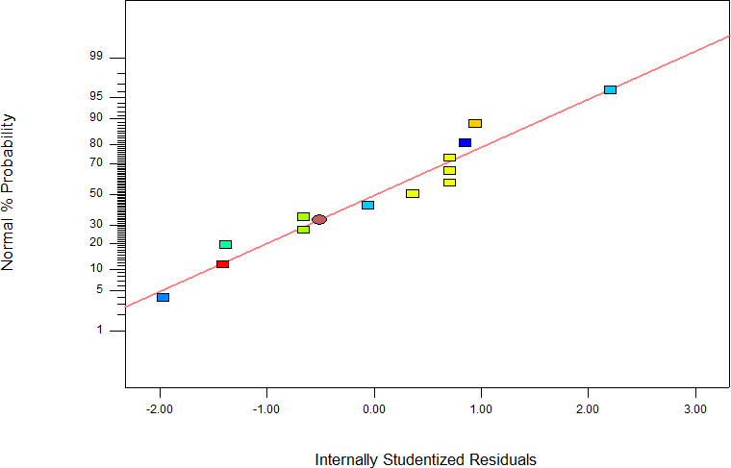

Figure 4.9. Normal Plot of Residuals for Seedling Emergence

# Effect of process variables on seedling emergence using the optimized model

Figures 4.10 and 4.11 show the contour and surface plots of the seedling emergence model respectively. The experimental levels of each factor and the relationship between them was graphically represented using contour and response surface plots. The plot shows the effect of varying two process parameters. The plots show that increased seedling emergence was observed with increasing planting speed and moisture content values.Further increase in seed planting moisture content beyond the optimum point caused a decrease in the seedling emergence.

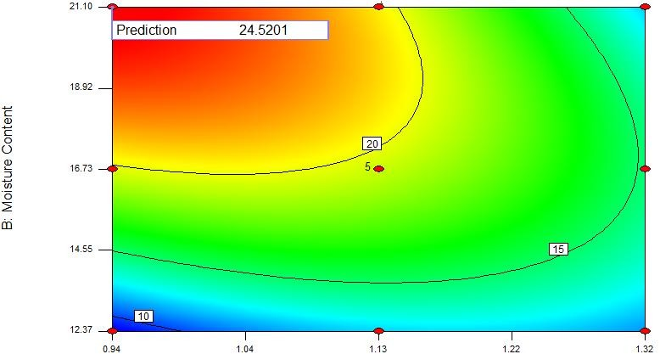

Figure 4.10. Mean model contour plot showing the effect of moisture content and planting speed on seedling emergence for response surface optimisation model.

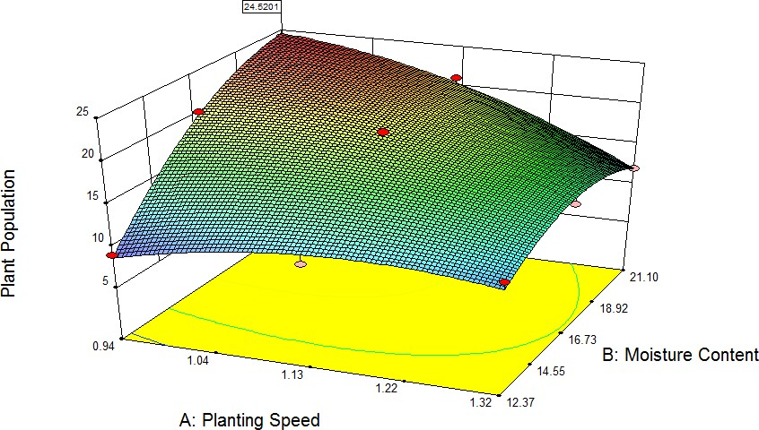

Se ed lin g e m er

ge

Figure 4.11. Mean Model Response Surface Plot Showing the Effect of Seed Planting Moisture Content and Planting Speed on Seedling Emergence for Response Optimisation of Plant Population Model.

# Response surface modelling of depth of planting with respect to seed planting process parameters

The results of the model correlating seed planting moisture content and planting speed to depth of planting are presented in this section. Also presented are the results of model selection and model terms significance. The model developed provide the basis for optimisation to determine the settings of seed planting moisture content and planting speed that will maximize depth of planting.

# Selection of adequate model for depth of planting

The sequential model sum of squares, lack of fit tests and model summary statistics in Tables 4.32, 4.33 and 4.34 respectively were used to determine the appropriate

empirical model to correlate the input parameters to depth of planting. The Tables 4.32

– 4.34show how adequate model were fitted to various output characteristics based on three different statistical tests. Table 4.32 demonstrates how the model terms contribute to the developed model from the sequential model sum of squares test. The result shows that the most suitable model for all the responses is the quadratic model as it has the lowest p-value of <0.0001. The comparison of the pure error to the residual error from the replicated design points represents the lack of fit. Also, the result of Table 4.33 shows that the quadratic model is adequate as its characteristics p-value is not significant. The results of high “R2” value, low Adequate Precision (PRESS) and low standard deviation obtained in Table 4.34 demonstrate that the quadratic model is the most suitable model.

# Table 4.32. Sequential Model Sum of Squares (SMSS) Analysis for Depth of planting Model

|  |  |  |  |  |  |  |
| --- | --- | --- | --- | --- | --- | --- |
|  |  | Mean | Sum of | F | p-value |  |
| Source | df | Square | Squares | Value | Prob > F |  |
| Mean vs Total | 1 | 8478.7692 | 8478.7692 |  |  |  |
| Linear vs Mean | 2 | 157.5208 | 315.0417 | 5.5526 | 0.0239 |  |
| 2FI vs Linear | 1 | 126.5625 | 126.5625 | 7.2493 | 0.0247 |  |
| Quadratic vs 2FI | 2 | 73.9969 | 147.9937 | 56.7156 | < 0.0001 | Suggested |
| Cubic vs Quadratic | 2 | 2.8542 | 5.7083 | 4.1672 | 0.0861 | Aliased |
| Residual | 5 | 0.6849 | 3.4246 |  |  |  |
| Total | 13 | 698.2692 | 9077.5 |  |  |  |

**Table 4.33. Lack of Fit Test for Depth of plantingModel**

|  |  |  |  |  |  |
| --- | --- | --- | --- | --- | --- |
|  | Sum of |  | Mean | F | p-value |
| Source | Squares | df | Square | Value | Prob > F |
| Linear | 280.9891 | 6 | 46.8315 | 69.3800 | 0.0005 |
| 2FI | 154.4266 | 5 | 30.8853 | 45.7560 | 0.0013 |

|  |  |  |  |  |  |  |
| --- | --- | --- | --- | --- | --- | --- |
| Quadratic | 6.4329 | 3 | 2.1443 | 3.1767 | 0.1467 | Suggested |
| Cubic | 0.7246 | 1 | 0.7246 | 1.0734 | 0.3587 | Aliased |
| Pure Error | 2.7 | 4 | 0.675 |  |  |  |

**Table 4.34. Model Summary Statistics for Depth of planting Model**

|  |  |  |  |  |  |  |
| --- | --- | --- | --- | --- | --- | --- |
|  | Standard |  | Adjusted | Predicted |  |  |
| Source | Deviation | R-Squared | R-Squared | R-Squared | PRESS |  |
| Linear | 5.3262 | 0.5262 | 0.4314 | -0.1265 | 674.4814 |  |
| 2FI | 4.1783 | 0.7376 | 0.6501 | -0.2075 | 722.9485 |  |
| Quadratic | 1.1422 | 0.9847 | 0.9739 | 0.8881 | 67.0005 | Suggested |
| Cubic | 0.8276 | 0.9943 | 0.9863 | 0.8528 | 88.1381 | Aliased |

**Key**

2FI = 2 Factor Interaction

# Depth of planting model

The experimental data of Table 4.25 was used to obtain the second order empirical model coefficients of Equations 4.3 and 4.4. The empirical model equations for the depth of planting as a function of process variables (moisture content and seed planting speed) was developed using experimental data of Table 4.25 and are represented as Equations 4.3 and 4.4. The quadratic equation model terms excluding insignificant ones is shown in Table 4.35.

# Table 4.35. Model Coefficient Table for Depth of planting Response Surface Reduced Quadratic Model

|  |  |  |  |  |  |  |
| --- | --- | --- | --- | --- | --- | --- |
| **Factor** | **Coefficient**  **Estimate** | **df** | **Standard**  **Error** | **95% CI**  **Low** | **95% CI**  **High** | **VIF** |
|  |  |  |  |  |  |  |
| Intercept | 29.2586 | 1 | 0.4743 | 28.1371 | 30.3801 |  |
| A-Planting Speed | -3.6667 | 1 | 0.4663 | -4.7693 | -2.5640 | 1 |
| B-Moisture Content | 6.2500 | 1 | 0.4663 | 5.1473 | 7.3527 | 1 |
| AB | -5.6250 | 1 | 0.5711 | -6.9755 | -4.2745 | 1 |
| A2 | -3.1552 | 1 | 0.6873 | -4.7804 | -1.5299 | 1.1698 |
| B2 | -4.9052 | 1 | 0.6873 | -6.5304 | -3.2799 | 1.1698 |

The coded population empirical model is shown in Equation 4.3.

4.3



The actual population empirical model is shown in Equation 4.4.

4.4



**Key:** *Ps* = Planting speed, *Mc* = Moisture content

# Analysis of variance for depth of planting model

The ANOVA result of Table 4.36 shows that seed planting parameters having p-value less than 0.05 are considered significant for depth of planting response factor. The backward elimination technique was used to screen the insignificant parameters from the model. Depth of planting ANOVA result of Table 4.36 indicates that the seed planting speed (A), the moisture content (B), the interaction terms (AB) and the quadratic terms (A2, B2) are significant and affect depth of planting.

# Table 4.36. Analysis of Variance (ANOVA) Table for Depth of planting Response Surface Reduced Quadratic Model

|  |  |  |  |  |  |  |
| --- | --- | --- | --- | --- | --- | --- |
| Source | df | Mean Square | Sum of Squares | F  Value | p-value Prob > F |  |
| Model | 5 | 117.9196 | 589.5979 | 90.3806 | < 0.0001 | significant |
| A-Planting  Speed | 1 | 80.6667 | 80.6667 | 61.8277 | 0.0001 |  |
| B-Moisture  Content | 1 | 234.3750 | 234.3750 | 179.6390 | < 0.0001 |  |
| AB | 1 | 126.5625 | 126.5625 | 97.0050 | < 0.0001 |  |
| A2 | 1 | 27.4951 | 27.4951 | 21.0739 | 0.0025 |  |
| B2 | 1 | 66.4534 | 66.4534 | 50.9338 | 0.0002 |  |
| Residual | 7 | 1.3047 | 9.1329 |  |  |  |
| Lack of Fit | 3 | 2.1443 | 6.4329 | 3.1767 | 0.1467 | not  significant |
| Pure Error | 4 | 0.675 | 2.7000 |  |  |  |
| Cor Total | 12 |  | 598.7308 |  |  |  |

The statistical inferences of Table 4.36 showthat depth of planting model developed is significant as it has a lack of fit value of 3.1767 relative to the pure error. Therefore there is 14.67% probability that lack of fit value of 3.1767 and Model F-value of 90.3806 could occur due to noise. Therefore the non-significant lack of fit obtained for the depth of planting empirical model shows that the model actually represents the experiment.

The results in Table 4.36 indicate that seed planting moisture content (linear) and interaction between moisture content and planting speed were the most significant factors in determining the optimum depth of planting, with *p* value of <0.0001, The results in Table 4.36 also indicate that planting speed (linear) with *p* value of 0.0001 was the most significant parameter for obtaining optimum depth of planting, followed by moisture

content (quadratic) and planting speed (quadratic), with *p* values of 0.0002 and 0.0025 respectively.

The "Predicted R2” of 0.8881in Table 4.37 agrees with the "Adjusted R2" of 0.9739."Adequate Precision" measures the signal to noise ratio. The value adequate precision of 30.6058 greater than minimum of 4 shows that the model can be used to predict the design space. Also, the model terms (A, B, AB, A2, B2) are significant as their "Prob > F" less than 0.0500 as shown in Table 4.35.

# T

|  |  |  |  |  |  |  |  |
| --- | --- | --- | --- | --- | --- | --- | --- |
| **a**Standard  Deviation | Mean | C.V. % | PRESS | R2 | Adjusted R2 | Predicte  d R2 | Adequate  Precision (%) |
| **b** 1.1422 | 25.539 | 4.473 | 67.0005 | 0.9847 | 0.9739 | 0.8881 | 30.6058 |

**le 4.37. Model Summary Statistics for Depth of planting Response Surface**

The primary diagnostic tool residual analysis was also investigated. Figure 4.12 shows the normal probability plot of the residuals**.** The data points are normally distributed as it they follow a straight line. This shows that the model assumptions are correct as the actual values follow the predicted values.

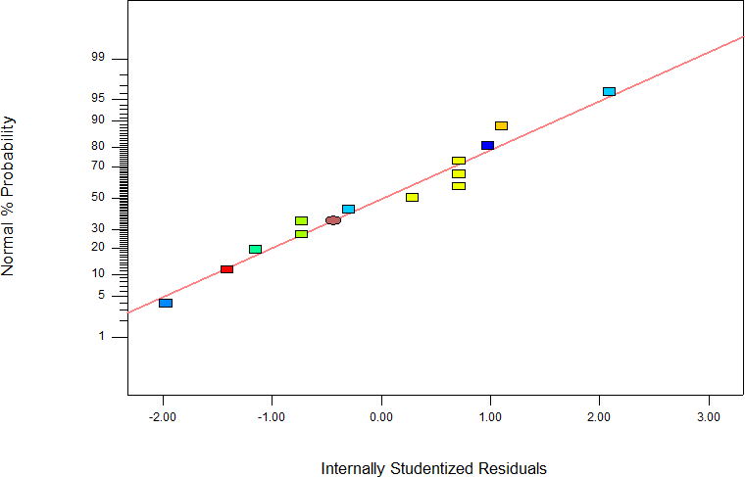

Figure 4.12. Normal Plot of Residuals for Depth of planting

# Effect of process variables on depth of planting using the optimized model

Figures 4.13 and 4.14 show the contour and surface plots of the depth of planting model respectively. The experimental levels of each factor and the relationship between them was graphically represented using contour and response surface plots. The plots show the effect of varying the two input parameters. Figures 4.13 and 4.14 show influence of quadratic function of seed planting moisture content and significant influence of seed planting speed on depth of planting. The plots show that increased depth of planting was observed with increasing seed planting speed and moisture content values.The Figures also show that increased depth of planting was observed with increasing moisture content and decreasing planting speed values. Further increase in seed planting moisture content beyond the optimum point caused a decrease in the depth of planting.

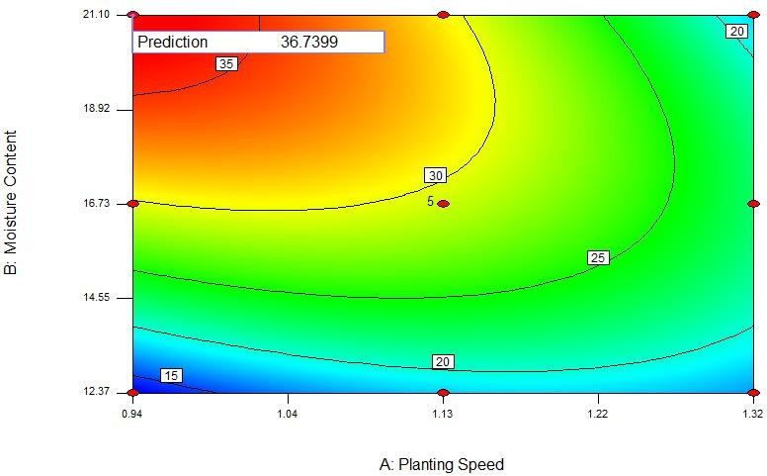

Figure 4.13. Contour plot showing the effect of moisture content and planting speed on depth of planting.

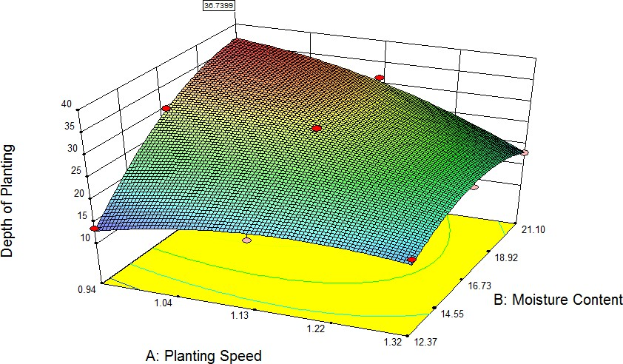

Figure 4.14. Surface plot showing the effect of seed planting moisture content and planting speed on depth of planting.

# Response surface modelling of plant spacing with respect to seed planting process parameters

The results of the model correlating seed planting moisture content and planting speed to plant spacing are presented in this section. Also presented are the results of model selection and model terms significance. The model developed provide the basis for optimisation to determine the settings of seed planting moisture content and planting speed that will maximize plant spacing.

# Selection of adequate model for plant spacing

The sequential model sum of squares, lack of fit tests and model summary statistics shown in Tables 4.38, 4.39 and 4.40 respectively were used to determine the appropriate empirical model to correlate the input parameters to plant spacing. The Tables 4.38 – 4.40 show how adequate model were fitted to various output characteristics based on three different statistical tests. Table 4.38 demonstrates how the model terms contribute to the developed model from the sequential model sum of squares test. The result shows that the most suitable model for all the responses is the quadratic model as it has the lowest p-value. The comparison of the pure error to the residual error from the replicated design points represents the lack of fit. Also, the result of Table 4.39 shows that the quadratic model is adequate as its characteristics p-value is not significant. The results of high “R2” value, low Adequate Precision (PRESS) and low standard deviation obtained in Table 4.40 demonstrate that the quadratic model is the most suitable model.

**Table 4.38. Sequential Model Sum of Squares (SMSS) Analysis for Plant spacing**

|  |  |  |  |  |  |  |
| --- | --- | --- | --- | --- | --- | --- |
|  |  | Mean | Sum of | F | p-value |  |
| Source | df | Square | Squares | Value | Prob > F |  |
| Mean vs Total | 1 | 121.8492 | 121.8492308 |  |  |  |
| Linear vs Mean | 2 | 2.2508 | 4.501666667 | 5.5864 | 0.0235 |  |
| 2FI vs Linear | 1 | 1.8225 | 1.8225 | 7.4334 | 0.0234 |  |
| Quadratic vs 2FI | 2 | 1.0179 | 2.035769231 | 41.7084 | 0.0001 | Suggested |
| Cubic vs Quadratic | 2 | 0.0542 | 0.108333333 | 4.3333 | 0.0810 | Aliased |
| Residual | 5 | 0.0125 | 0.0625 |  |  |  |
| Total | 13 | 10.0292 | 130.38 |  |  |  |

**Table 4.39. Lack of Fit Test for Plant spacing**

|  |  |  |  |  |  |  |
| --- | --- | --- | --- | --- | --- | --- |
|  |  | Mean | Sum of | F | p-value |  |
| Source | df | Square | Squares | Value | Prob > F |  |
| Linear | 6 | 0.6635 | 3.9811 | 55.2931 | 0.0008 |  |
| 2FI | 5 | 0.4317 | 2.1586 | 35.9767 | 0.0020 |  |
| Quadratic | 3 | 0.0409 | 0.1228 | 3.4120 | 0.1333 | Suggested |
| Cubic | 1 | 0.0145 | 0.0145 | 1.2083 | 0.3334 | Aliased |
| Pure Error | 4 | 0.0120 | 0.0480 |  |  |  |

**Table 4.40. Summary Statistics for Plant spacing Model**

|  |  |  |  |  |  |  |
| --- | --- | --- | --- | --- | --- | --- |
|  | Standard |  | Adjusted | Predicted |  |  |
| Source | Deviation | R-Squared | R-Squared | R-Squared | PRESS |  |
| Linear | 0.6348 | 0.5277 | 0.4332 | -0.1223 | 9.5741 |  |
| 2FI | 0.4952 | 0.7413 | 0.6551 | -0.1750 | 10.0238 |  |
| Quadratic | 0.1562 | 0.9800 | 0.9657 | 0.8509 | 1.2719 | Suggested |
| Cubic | 0.1118 | 0.9927 | 0.9824 | 0.7943 | 1.7550 | Aliased |

* + - 1. **Plant spacing model**

The experimental data of Table 4.25 was also used to obtain the second order empirical model coefficients of Equations 4.5 and 4.6for the plant spacing as a function of process variables (planting speed and moisture content) was developed. The quadratic equation model terms excluding insignificant ones is shown in Table 4.41.

# Table 4.41. Model Coefficient Table for Plant spacing Response Surface Reduced Quadratic Model

|  |  |  |  |  |  |  |
| --- | --- | --- | --- | --- | --- | --- |
| **Factor** | **Coefficient Estimate** | **df** | **Standar d**  **Error** | **95% CI**  **Low** | **95% CI**  **High** | **VIF** |
|  |  |  |  |  |  |  |
| Intercept | 3.5000 | 1 | 0.0649 | 3.3466 | 3.6534 |  |
| A-Planting Speed | -0.4333 | 1 | 0.0638 | -0.5841 | -0.2825 | 1 |
| B-Moisture Content | 0.7500 | 1 | 0.0638 | 0.5992 | 0.9008 | 1 |
| AB | -0.6750 | 1 | 0.0781 | -0.8597 | -0.4903 | 1 |
| A2 | -0.4000 | 1 | 0.0940 | -0.6223 | -0.1777 | 1.16976127 |
| B2 | -0.5500 | 1 | 0.0940 | -0.7723 | -0.3277 | 1.16976127 |

The coded population empirical model is shown in Equation 4.5.

 4.5



The actual population empirical model is shown in Equation 4.6.





4.6

# Analysis of variance for plant spacing model

The ANOVA result in Table 4.42 shows that seed planting parameters having p-value less than 0.05 are considered significant for plant spacing response factor. The backward elimination technique was also used to screen the insignificant parameters from the model. From Table 4.42it can be seen that the seed planting speed (A), the moisture content (B), the interaction terms (AB) and the quadratic terms (A2, B2) are significant and affect plant spacing.

The statistical inferences of Table 4.42 showthat plant spacing model developed is significant as it has a lack of fit value of 3.4120 relative to the pure error. Therefore there is 13.33% probability that lack of fit value of 3.4120 and Model F-value of 68.51 could occur due to noise. Therefore the non-significant lack of fit obtained for the plant spacing empirical model shows that the model actually represents the experiment.

The summary of statistics is as in Table 4.43

# Table 4.42. Analysis of Variance (ANOVA) Table for Plant spacing Response Surface Reduced Quadratic Model

|  |  |  |  |  |  |  |
| --- | --- | --- | --- | --- | --- | --- |
| Source | Sum of Squares | df | Mean Square | F  Value | p-value Prob > F |  |
| Model | 8.3599 | 5 | 1.6720 | 68.5107 | < 0.0001 | significant |
| A-Planting  Speed | 1.1267 | 1 | 1.1267 | 46.1659 | 0.0003 |  |
| B-Moisture  Content | 3.3750 | 1 | 3.3750 | 138.2927 | < 0.0001 |  |
| AB | 1.8225 | 1 | 1.8225 | 74.6780 | < 0.0001 |  |
| A2 | 0.4419 | 1 | 0.4419 | 18.1073 | 0.0038 |  |
| B2 | 0.8355 | 1 | 0.8355 | 34.2341 | 0.0006 |  |
| Residual | 0.1708 | 7 | 0.0244 |  |  |  |
| Lack of Fit | 0.1228 | 3 | 0.0409 | 3.4120 | 0.1333 | not  significant |
| Pure Error | 0.0480 | 4 | 0.0120 |  |  |  |
| Cor Total | 8.5308 | 12 |  |  |  |  |

**Table 4.43. Summary Statistics for Plant spacing Response Surface Reduced Quadratic Model**

|  |  |  |  |  |  |  |  |
| --- | --- | --- | --- | --- | --- | --- | --- |
| Standard  Deviation | Mean | C.V. % | PRESS | R2 | Adjusted R2 | Predicted R2 | Adequate  Precision (%) |
| 0.1562 | 3.0615 | 5.102  7 | 1.2719 | 0.9800 | 0.9657 | 0.8509 | 26.8537 |

The results in Table 4.42 indicate that moisture content (linear) and interaction between moisture content and planting speed were the most significant factor in determining the optimum plant spacing, with *p* value of <0.0001.It also indicates that planting speed (linear) with *p* value of 0.0003 was the most significant parameter for obtaining optimum plant spacing, followed by moisture content (quadratic) and planting speed (quadratic), with *p* values of 0.0006 and 0.0038 respectively.

The "Predicted R2” of 0.8509in Table 4.43 agrees with the "Adjusted R2" of 0.9657."Adequate Precision" measures the signal to noise ratio. The value adequate precision of 26.8537 greater than minimum of 4 shows that the model can be used to predict the design space. Also, the model terms (A, B, AB, A2, B2) are significant as their "Prob > F" less than 0.0500 as shown in Table 4.40.

The primary diagnostic tool residual analysis was also investigated. Figure 4.15 shows the normal probability plot of the residuals**.** The data points are normally distributed as they follow a straight line. Figure 4.15 shows that the model assumptions are correct as the actual values follow the predicted values.

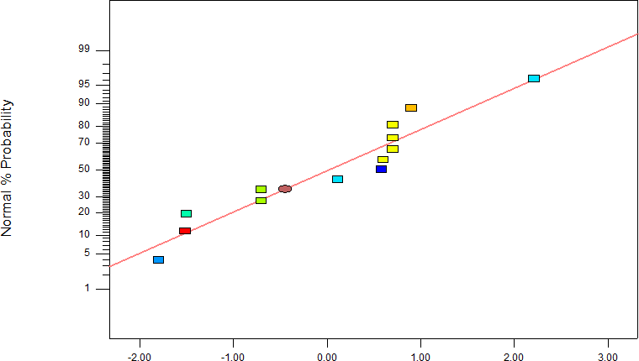

Figure 4.15. Normal Probability Plot of Residuals for Plant spacing

# Effect of process variables on plant spacing using the optimized model

Figures 4.16 and 4.17 show the contour and surface plot of the plant spacing model respectively. The experimental levels of each factor and the relationship between them was graphically represented using contour and response surface plots. The plot shows the effect of varying two process parameters. Figures 4.16 and 4.17 show influence of quadratic function of seed planting moisture content and significant influence of seed planting speed on plant spacing. The plots shows that increased plant spacing was observed with increasing seed planting speed and moisture content values.The Figures show that increased plant spacing was observed with increasing moisture content and decreasing planting speed values. Further increase in seed planting moisture content beyond the optimum point caused a decrease in the plant spacing.

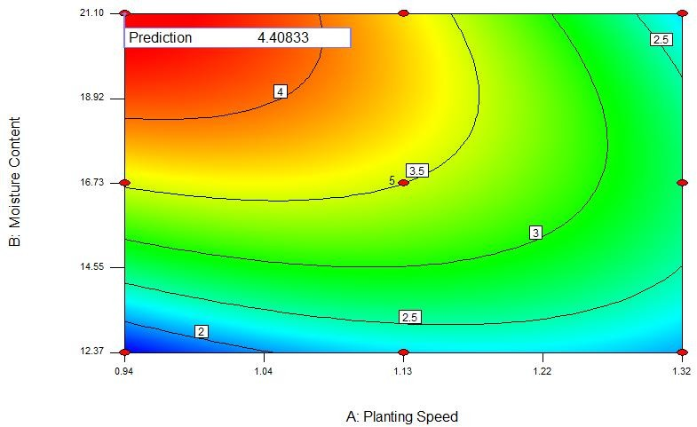

Figure 4.16. Contour plot showing the effect of moisture content and planting speed on plant spacing.

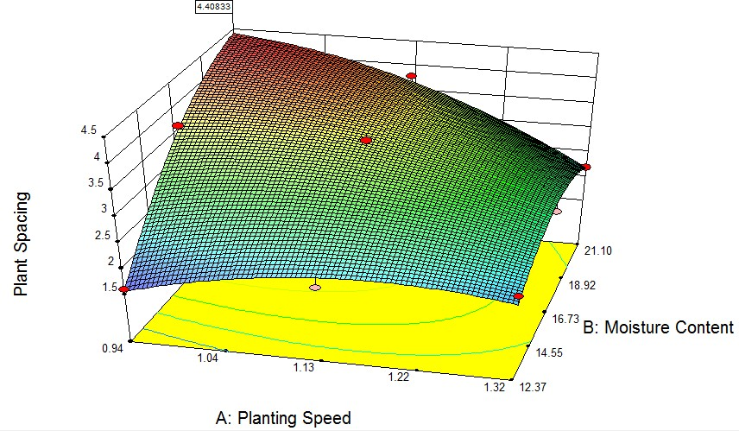

Figure 4.17. Response surface plot showing the effect of seed planting moisture content and planting speed on plant spacing.

# Response surface modelling of number of seeds per hole with respect to seed planting process parameters

The results of the model correlating moisture content and planting speed to number of seeds per hole are presented in this section. Also presented are the results of model selection and model terms significance. The model developed provide the basis for optimisation to determine the settings of seed planting moisture content and planting speed that will maximize number of seeds per hole.

# Selection of adequate model for number of seeds per hole

The sequential model sum of squares, lack of fit tests and model summary statistics shown in Tables 4.44, 4.45 and 4.46 respectively were used to determine the appropriate empirical model to correlate the input parameters to the number of seeds per hole. The Tables 4.44 – 4.46 show how adequate model were fitted to various output characteristics based on three different statistical tests. Table 4.44 demonstrates how the model terms contribute to the developed model from the sequential model sum of squares test. The result shows that the most suitable model for all the responses is the quadratic model as it has the lowest p-value. The comparison of the pure error to the residual error from the replicated design points represents the lack of fit. Also, the result of Table 4.45 shows that the quadratic model is adequate as its characteristics p- value is not significant. The results of high “R2” value, low Adequate Precision (PRESS) and low standard deviation obtained in Table 4.46 demonstrate that the quadratic model is the most suitable model.

# Table 4.44. Sequential Model Sum of Squares (SMSS) Analysis for Number of seeds per hole Model

|  |  |  |  |  |  |  |
| --- | --- | --- | --- | --- | --- | --- |
|  | Sum of |  | Mean | F | p-value |  |
| Source | Squares | df | Square | Value | Prob > F |  |
| Mean vs Total | 59.0223 | 1 | 59.0223 |  |  |  |
| Linear vs Mean | 2.1417 | 2 | 1.0708 | 5.2854 | 0.0271 |  |
| 2FI vs Linear | 0.9025 | 1 | 0.9025 | 7.2295 | 0.0248 |  |
| Quadratic vs 2FI | 1.0782 | 2 | 0.5391 | 83.2758 | < 0.0001 | Suggested |
| Cubic vs Quadratic | 0.0283 | 2 | 0.0142 | 4.1709 | 0.0860 | Aliased |
| Residual | 0.0170 | 5 | 0.0034 |  |  |  |
| Total | 63.1900 | 13 | 4.8608 |  |  |  |

**Table 4.45. Lack of Fit Test for Number of seeds per holeModel**

|  |  |  |  |  |  |  |
| --- | --- | --- | --- | --- | --- | --- |
|  | Sum of |  | Mean | F | p-value |  |
| Source | Squares | df | Square | Value | Prob > F |  |
| Linear | 2.0140 | 6 | 0.3357 | 111.8903 | 0.0002 |  |
| 2FI | 1.1115 | 5 | 0.2223 | 74.1017 | 0.0005 |  |
| Quadratic | 0.0333 | 3 | 0.0111 | 3.7018 | 0.1192 | Suggested |
| Cubic | 0.0050 | 1 | 0.0050 | 1.6609 | 0.2670 | Aliased |
| Pure Error | 0.0120 | 4 | 0.003 |  |  |  |

# Table 4.46. Model Summary Statistics for Number of seeds per hole Model

|  |  |  |  |  |  |  |
| --- | --- | --- | --- | --- | --- | --- |
|  | Standard |  | Adjusted | Predicted |  |  |
| Source | Deviation | R-Squared | R-Squared | R-Squared | PRESS |  |
| Linear | 0.4501 | 0.5139 | 0.4166 | -0.1570 | 4.8220 |  |
| 2FI | 0.3533 | 0.7304 | 0.6406 | -0.2506 | 5.2123 |  |
| Quadratic | 0.0805 | 0.9891 | 0.9814 | 0.9184 | 0.3400 | Suggested |
| Cubic | 0.0583 | 0.9959 | 0.9902 | 0.8569 | 0.5965 | Aliased |

* + - 1. **Number of seeds per hole model**

The experimental data of Table 4.25 was also used to obtain the second order empirical model coefficients of Equations 4.7 and 4.8 for the number of seeds per hole as a function of process variables (moisture content and seed planting speed) was developed. The quadratic equation model terms excluding insignificant ones is shown in Table 4.47.

# Table 4.47. Coefficient Table for Number of seeds per hole Response Surface Reduced Quadratic Model

|  |  |  |  |  |  |  |
| --- | --- | --- | --- | --- | --- | --- |
| **Factor** | **Coefficient**  **Estimate** | **df** | **Standard**  **Error** | **95% CI**  **Low** | **95% CI**  **High** | **VIF** |
|  |  |  |  |  |  |  |
| Intercept | 2.4483 | 1 | 0.0334 | 2.3693 | 2.5273 |  |
| A-Planting Speed | -0.3000 | 1 | 0.0328 | -0.3777 | -0.2223 | 1 |
| B-Moisture Content | 0.5167 | 1 | 0.0328 | 0.4390 | 0.5943 | 1 |
| AB | -0.4750 | 1 | 0.0402 | -0.5701 | -0.3799 | 1 |
| A2 | -0.2690 | 1 | 0.0484 | -0.3834 | -0.1545 | 1.1698 |
| B2 | -0.4190 | 1 | 0.0484 | -0.5334 | -0.3045 | 1.1698 |

The coded population empirical model is shown in Equation 4.7.

4.7



The actual population empirical model is shown in Equation 4.8.

4 4.8



# Analysis of variance for number of seeds per hole model

The ANOVA result of Table 4.48 shows that seed planting parameters having p-value less than 0.05 are considered significant for number of seeds per hole response factor. The backward elimination technique was used to screen the insignificant parameters from the model. Number of seeds per hole ANOVA result of Table 4.48 indicates that the seed planting speed (A), the moisture content (B), the interaction terms (AB) and the quadratic terms (A2, B2) are significant and affect number of seeds per hole.

The statistical inferences of Table 4.48 showthat number of seeds per hole model developed is significant as it has a lack of fit value of 3.7018 relative to the pure error. Therefore there is 11.92% probability that lack of fit value of 3.7018 and Model F-value of 127.3571 could occur due to noise. Therefore the non-significant lack of fit obtained for the number of seeds per hole empirical model shows that the model actually represents the experiment.

# Table 4.48. Analysis of Variance (ANOVA) Table for Number of seeds per hole Response Surface Reduced Quadratic Model

|  |  |  |  |  |  |  |
| --- | --- | --- | --- | --- | --- | --- |
| Source | df | Mean Square | Sum of Squares | F  Value | p-value Prob > F |  |
| Model | 5 | 0.8245 | 4.1224 | 127.3571 | < 0.0001 | significant |
| A-Planting  Speed | 1 | 0.5400 | 0.5400 | 83.4141 | < 0.0001 |  |
| B-Moisture  Content | 1 | 1.6017 | 1.6017 | 247.4103 | < 0.0001 |  |
| AB | 1 | 0.9025 | 0.9025 | 139.4096 | < 0.0001 |  |
| A2 | 1 | 0.1998 | 0.1998 | 30.8637 | 0.0009 |  |
| B2 | 1 | 0.4848 | 0.4848 | 74.8878 | < 0.0001 |  |
| Residual | 7 | 0.0065 | 0.0453 |  |  |  |
| Lack of Fit | 3 | 0.0111 | 0.0333 | 3.7018 | 0.1192 | not  significant |
| Pure Error | 4 | 0.0030 | 0.0120 |  |  |  |
| Cor Total | 12 |  | 4.1677 |  |  |  |

The results in Table 4.48 also indicate that moisture content (linear) and interaction between moisture content and planting speed and moisture content (quadratic)were the most significant factor in determining the optimum number of seeds per hole, with *p* value of <0.0001.It also indicates that planting speed (linear) with *p* value of <0.0001was the most significant parameter for obtaining optimum number of seeds per hole.

The "Predicted R2” of 0.9184 of Table 4.49 agrees with the "Adjusted R2" of 0.9814."Adequate Precision" measures the signal to noise ratio. The value adequate precision of 36.2839 greater than minimum of 4 shows that the model can be used to predict the design space. Also, the

model terms (A, B, AB, A2, B2) are significant as their "Prob > F" less than 0.0500 as shown in Table 4.49.

# Table 4.49. Model Summary Statistics for Number of seeds per hole Response Surface Reduced Quadratic Model

|  |  |  |  |  |  |  |  |
| --- | --- | --- | --- | --- | --- | --- | --- |
| Standard  Deviation | Mean | C.V. % | PRESS | R2 | Adjusted R2 | Predicted R2 | Adequate  Precision (%) |
| 0.0805 | 2.1308 | 3.776 | 0.3400 | 0.9891 | 0.9814 | 0.9184 | 36.2839 |

The primary diagnostic tool residual analysis was also investigated. Figure 4.18 shows the normal probability plot of the residuals**.** The data points is normally distributed as it follows a straight line. Figure 4.18 shows that the model assumptions are correct as the actual values follow the predicted values.

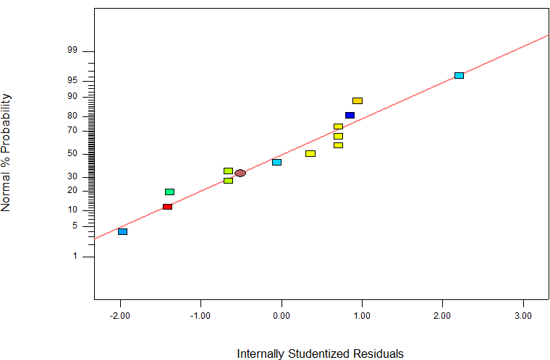

Figure 4.18. Normal Probability Plot of Residuals for Number of seeds per hole

* + - 1. **Effect of process variables on number of seeds per hole using the optimized model** Figures 4.19 and 4.20 show the contour and surface plots of the number of seeds per hole model respectively. The experimental levels of each factor and the relationship between them was graphically represented using contour and response surface plots. The plots show the effects of varying the two process parameters. Figures 4.19 and 4.20 show influence of quadratic function of seed planting moisture content and significant influence of seed planting speed on number of seeds per hole. The plots show that increased number of seeds per hole was observed with increasing seed planting speed and moisture content values. Figures 4.19 and 4.20 show that increased number of seeds per hole was observed with increasing moisture content and decreasing planting speed val-

ues. Further increase in seed planting moisture content beyond the optimum point (3.05) caused a decrease in the number of seeds per hole.

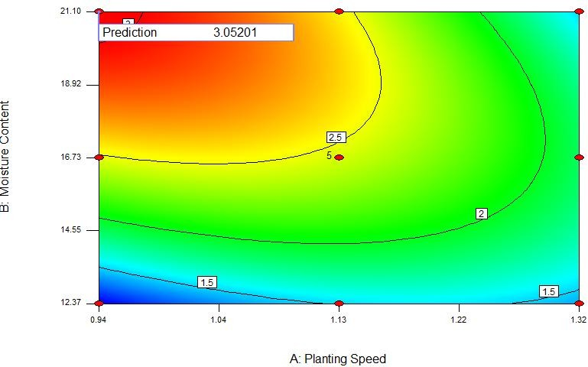

Figure 4.19. Contour plot showing the effect of moisture content and planting speed on number of seeds per hole.

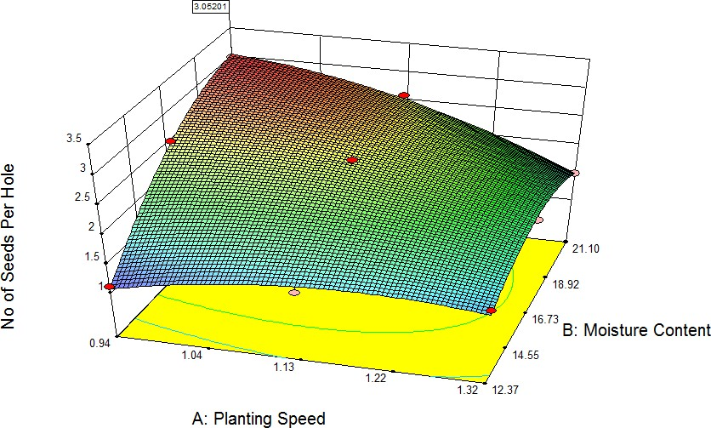

Figure 4.20. Response surface plot showing the effect of moisture content and planting speed on number of seeds per hole.

# Response surface modelling of total energy expended with respect to seed planting process parameters

The results of the model correlating moisture content and planting speed to total energy expended are presented in this section. Also presented are the results of model selection and model terms significance. The model developed provide the basis for optimisation to determine the settings of seed planting moisture content and planting speed that will minimize total energy expended.

Table 4.50 contains the results of the Response Surface experimental runs for the total energy expended.

|  |  |  |  |  |
| --- | --- | --- | --- | --- |
| Exp Run | Plant Speed | M1o9is2ture Content | No of Damaged  Seeds | Total Energy  Consumed |

|  |  |  |  |  |  |
| --- | --- | --- | --- | --- | --- |
| T | | m/s | % |  | MJ |
| 1 | | 1.32 | 21.1 | 2 | 3.68 |
| a | 2 | 1.13 | 16.735 | 0 | 2.00 |
| b | 3 | 1.32 | 12.37 | 2 | 3.68 |
| 4 | | 1.13 | 16.735 | 0 | 2.08 |
| l | 5 | 1.13 | 16.735 | 1 | 2.40 |
| 6 | | 1.40 | 16.735 | 2 | 3.68 |
| e | 7 | 1.13 | 16.735 | 0 | 2.00 |
| 8 | | 1.13 | 10.56 | 1 | 2.88 |
| 9 | | 0.94 | 12.37 | 1 | 2.00 |
| 4 | 10 | 1.13 | 22.91 | 2 | 3.68 |
| 11 | | 1.13 | 16.735 | 0 | 2.60 |
| . | 12 | 0.94 | 21.1 | 1 | 4.00 |
| 13 | | 0.863 | 16.735 | 1 | 2.24 |

5

0. Response surface methodology experimental run and results for number of damaged seeds and total energy expended

# Selection of adequate model for total energy expended

The sequential model sum of squares, lack of fit tests and model summary statistics shown in Tables 4.51, 4.52 and 4.53 respectively were used to determine the appropriate empirical model to correlate the input parameters to total energy expended. The Tables 4.51 – 4.53 show how adequate model were fitted to various output characteristics based on three different statistical tests. Table 4.51 demonstrates how the model terms contribute to the developed model from the sequential model sum of squares test. The results show that the most suitable model for all the responses is the quadratic model as it has the lowest p-value. The comparison of the pure error to the residual error from the replicated design points represents the lack of fit. Also, the result of Table 4.52 shows that the quadratic model is adequate as its characteristics p- value is not significant. The results of high “R2” value, low Adequate Precision (PRESS) and low standard deviation obtained in Table 4.53 demonstrate that the quadratic model is the most suitable model.

# Table 4.51. Sequential Model Sum of Squares (SMSS) Analysis for Total energy

**consumed**

|  |  |  |  |  |  |  |
| --- | --- | --- | --- | --- | --- | --- |
|  |  | Mean | Sum of | F | p-value |  |
| Source | df | Square | Squares | Value | Prob > F |  |
| Mean vs Total | 1 | 104.8528 | 104.8528 |  |  |  |
| Linear vs Mean | 2 | 1.3338 | 2.6677 | 2.7745 | 0.1100 |  |
| 2FI vs Linear | 1 | 1.0000 | 1.0000 | 2.3637 | 0.1586 |  |
| Quadratic vs 2FI | 2 | 1.6330 | 3.2661 | 21.1129 | 0.0011 | Suggested |
| Cubic vs Quadratic | 2 | 0.0758 | 0.1515 | 0.9715 | 0.4401 | Aliased |
| Residual | 5 | 0.0780 | 0.3899 |  |  |  |
| Total | 13 | 8.6406 | 112.3280 |  |  |  |

**Table 4.52. Lack of Fit Test for Total energy consumed**

|  |  |  |  |  |  |  |
| --- | --- | --- | --- | --- | --- | --- |
|  |  | Mean | Sum of | F | p-value |  |
| Source | df | Square | Squares | Value | Prob > F |  |
| Linear | 6 | 0.7524 | 4.5144 | 10.2675 | 0.0205 |  |
| 2FI | 5 | 0.7029 | 3.5144 | 9.5917 | 0.0240 |  |
| Quadratic | 3 | 0.0828 | 0.2483 | 1.1295 | 0.4372 | Suggested |
| Cubic | 1 | 0.0968 | 0.0968 | 1.3210 | 0.3145 | Aliased |
| Pure Error | 4 | 0.0733 | 0.2931 |  |  |  |

**Table 4.53. Model Summary Statistics for Total energy consumed**

|  |  |  |  |  |  |  |
| --- | --- | --- | --- | --- | --- | --- |
|  | Standard |  | Adjusted | Predicted |  |  |
| Source | Deviation | R-Squared | R-Squared | R-Squared | PRESS |  |
| Linear | 0.6934 | 0.3569 | 0.2282 | -0.1098 | 8.2963 |  |
| 2FI | 0.6504 | 0.4906 | 0.3209 | -0.3009 | 9.7244 |  |
| Quadratic | 0.2781 | 0.9276 | 0.8758 | 0.7025 | 2.2238 | Suggested |
| Cubic | 0.2793 | 0.9478 | 0.8748 | 0.1100 | 6.6532 | Aliased |

# Total energy expended model

The experimental data of Table 4.50 was used to obtain the second order empirical model coefficients of Equations 4.9 and 4.10 for the total energy consumed as a function of process variables (planting speed and moisture content) was developed and are represented as Equations 4.9 and 4.10. The quadratic equation model terms excluding insignificant ones are shown in Table 4.54.

# Table 4.54. Model Coefficient Table for Total energy consumed Response Surface Reduced Quadratic Model

|  |  |  |  |  |  |  |
| --- | --- | --- | --- | --- | --- | --- |
| **Factor** | **Coefficient**  **Estimate** | **df** | **Standard**  **Error** | **95% CI**  **Low** | **95% CI**  **High** | **VIF** |
|  |  |  |  |  |  |  |
| Intercept | 2.2160 | 1 | 0.1244 | 1.9219 | 2.5101 |  |
| A-Plant Speed | 0.4246 | 1 | 0.0983 | 0.1920 | 0.6571 | 1 |
| B-Moisture Content | 0.3914 | 1 | 0.0983 | 0.1589 | 0.6239 | 1 |
| AB | -0.5000 | 1 | 0.1391 | -0.8288 | -0.1712 | 1 |
| A2 | 0.4270 | 1 | 0.1054 | 0.1777 | 0.6763 | 1.0173 |
| B2 | 0.5870 | 1 | 0.1054 | 0.3377 | 0.8363 | 1.0173 |

The coded population empirical model is shown in Equation 4.9.

4.9



The actual population empirical model is shown in Equation 4.10.

4.10

4



# Analysis of variance for total energy expended model

The ANOVA result in Table 4.55 shows that seed planting parameters having p-value less than 0.05 are considered significant for total energy consumed response factor. The backward elimination technique was used to screen the insignificant parameters from the model. Total energy expended ANOVA result indicates that the seed planting speed (A), the moisture content (B), the interaction terms (AB) and the quadratic terms (A2, B2) are significant and affect total energy expended.

The statistical inferences of Table 4.55 showthat total energy expended model developed is significant as it has a lack of fit value of 3.7018 relative to the pure error. Therefore there is 0.07% probability that lack of fit value of 3.7018 and Model F-value of 127.3571 could occur due to noise. Therefore the non-significant lack of fit obtained for the total energy expended empirical model shows that the model actually represent the experiment.

# Table 4.55. Analysis of Variance (ANOVA) Table for Total energy consumed Response Surface Reduced Quadratic Model

|  |  |  |  |  |  |  |
| --- | --- | --- | --- | --- | --- | --- |
| Source | df | Mean Square | Sum of Squares | F  Value | p-value Prob > F |  |
| Model | 5 | 0.8245 | 4.1224 | 127.3571 | < 0.0001 | significant |
| A-Planting  Speed | 1 | 0.5400 | 0.5400 | 83.4141 | < 0.0001 |  |
| B-Moisture  Content | 1 | 1.6017 | 1.6017 | 247.4103 | < 0.0001 |  |
| AB | 1 | 0.9025 | 0.9025 | 139.4096 | < 0.0001 |  |
| A2 | 1 | 0.1998 | 0.1998 | 30.8637 | 0.0009 |  |
| B2 | 1 | 0.4848 | 0.4848 | 74.8878 | < 0.0001 |  |
| Residual | 7 | 0.0065 | 0.0453 |  |  |  |
| Lack of Fit | 3 | 0.0111 | 0.0333 | 3.7018 | 0.1192 | not  significant |
| Pure Error | 4 | 0.0030 | 0.0120 |  |  |  |
| Cor Total | 12 |  | 4.1677 |  |  |  |

The results in Table 4.55 also indicate that moisture content (linear) and interaction between moisture content and planting speed and moisture content (quadratic)were the most significant factors in determining the optimum total energy expended, with *p* value of <0.0001, The results in Table 4.55 also indicate that planting speed (linear) with *p* value of 0.0003 was the most significant parameter for obtaining optimum total energy expended, followed by planting speed (quadratic) with *p* values of 0.0009.

Table 4.56 shows the model summary of statistics

# Table 4.56. Model Summary Statistics for Total energy consumed Response Surface Reduced Quadratic Model

|  |  |  |  |  |  |  |  |
| --- | --- | --- | --- | --- | --- | --- | --- |
| Standard  Deviation | Mean | C.V. % | PRESS | R2 | Adjusted R2 | Predicted R2 | Adequate  Precision (%) |
| 0.2781 | 2.8400 | 9.793 | 2.2238 | 0.9276 | 0.8758 | 0.7025 | 10.7416 |

The "Predicted R2” of 0.7025 of Table 4.56 agrees with the "Adjusted R2" of 0.8758."Adequate Precision" measures the signal to noise ratio. The value adequate precision of 10.7416 greater than minimum of 4 shows that the model can be used to predict the design space. Also, the model terms (A, B, AB, A2, B2) are significant as their "Prob > F" less than 0.0500 as shown in Table 4.55.

The primary diagnostic tool residual analysis was also investigated. Figure 4.21 shows the normal probability plot of the residuals**.** The data points are normally distributed as they follow a straight line. Figure 4.21 shows that the model assumptions are correct as the actual values follow the predicted values.



Figure 4.21. Normal Plot of Residuals for Total energy expended

* + - 1. **Effect of process variables on total energy expended using the optimized model** Figures 4.22 and 4.23 show the contour and surface plots of the total energy expended model respectively. The experimental levels of each factor and the relationship between them was graphically represented using contour and response surface plots. The plot shows the effect of varying two process parameters that will minimize total energy expended. Figures 4.22 and 4.23 show influence of quadratic function of planting speed and significant influence of moisture content on total energy expended. The plots show that decreased total energy expended was observed with decreasing moisture content and planting speed values.Further increase in planting speed beyond the optimum point caused an increase in the total energy expended. Also, as planting speed increases beyond 14.55%, the total energy expended began to decrease at all of moisture content, suggesting a minimum total energy consumption of 1.97 MJ was obtained at optimum moisture content of 14.99% and planting speed of 1.05 m/s.

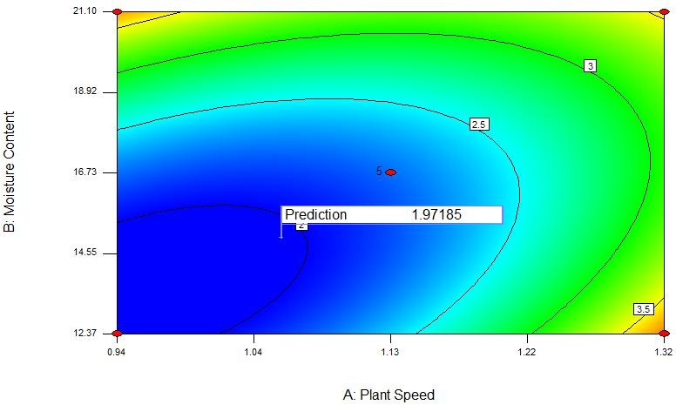

Planting Speed

Figure 4.22. Contour plot showing the effect of moisture content and planting speed on total energy consumed.

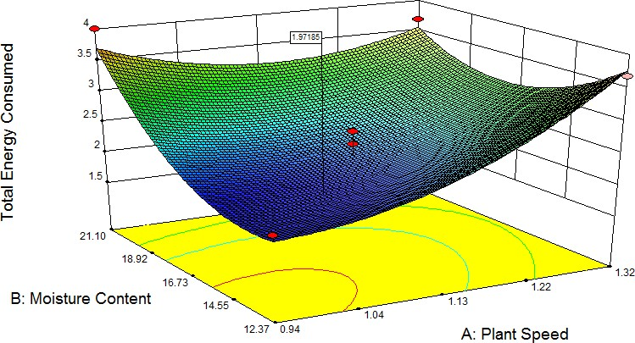

**Planting Speed**

To tal en er gy ex pe nd

Figure 4.23. Response surface plot showing the effect of moisture content and planting speed on total energy consumed.

# Response surface modelling of number of damaged seeds with respect to seed planting process parameters

The results of the model correlating moisture content and planting speed to number of damaged seeds are presented in this section. Also presented are the results of model selection and model terms significance. The model developed provide the basis for optimisation to determine the settings of planting speed and planting moisture content that will minimize number of damaged seeds.

# Selection of adequate model for number of damaged seeds

The sequential model sum of squares, lack of fit tests and model summary statistics shown in Tables 4.57, 4.58 and 4.59 respectively were used to determine the appropriate empirical model to correlate the input parameters to number of damaged seeds. The Tables 4.57 – 4.59 show how adequate the models were fitted to various output characteristics based on three three different statistical tests. Table 4.57 demonstrates how the model terms contribute to the developed model from the sequential model sum of squares test. The result shows that the most suitable model for all the responses is the quadratic model as it has the lowest p-value. The comparison of the pure error to the residual error from the replicated design points represents the lack of fit. Also, the result of Table 4.58 shows that the quadratic model is adequate as its characteristics p-value is not significant. The results of high “R2” value, low Adequate Precision (PRESS) and low standard deviation obtained in Table 4.59 demonstrate that the quadratic model is the most suitable model.

# Table 4.57. Sequential Model Sum of Squares (SMSS) Analysis for Number of damaged seeds Model

|  |  |  |  |  |  |  |
| --- | --- | --- | --- | --- | --- | --- |
|  | Sum of |  | Mean | F | p-value |  |
| Source | Squares | df | Square | Value | Prob > F |  |
| Mean vs Total | 13.0000 | 1 | 13.0000 |  |  |  |
| Linear vs Mean | 1.7071 | 2 | 0.8536 | 1.3564 | 0.3012 |  |
| 2FI vs Linear | 0.0000 | 1 | 0.0000 | 0.0000 | 1.0000 |  |
| Quadratic vs 2FI | 5.2000 | 2 | 2.6000 | 16.6530 | 0.0022 | Suggested |
| Cubic vs Quadratic | 0.2929 | 2 | 0.1464 | 0.9153 | 0.4584 | Aliased |
| Residual | 0.8000 | 5 | 0.1600 |  |  |  |
| Total | 21.0000 | 13 | 1.6154 |  |  |  |

**Table 4.58. Lack of Fit Test for Number of damaged seedsModel**

|  |  |  |  |  |  |  |
| --- | --- | --- | --- | --- | --- | --- |
|  |  | Mean | Sum of | F | p-value |  |
| Source | df | Square | Squares | Value | Prob > F |  |
| Linear | 6 | 0.7524 | 4.5144 | 10.2675 | 0.0205 |  |
| 2FI | 5 | 0.7029 | 3.5144 | 9.5917 | 0.0240 |  |
| Quadratic | 3 | 0.0828 | 0.2483 | 1.1295 | 0.4372 | Suggested |
| Cubic | 1 | 0.0968 | 0.0968 | 1.3210 | 0.3145 | Aliased |
| Pure Error | 4 | 0.0733 | 0.2931 |  |  |  |

# Table 4.59. Model Summary Statistics for Number of damaged seeds Model

|  |  |  |  |  |  |  |
| --- | --- | --- | --- | --- | --- | --- |
|  | Standard |  | Adjusted | Predicted |  |  |
| Source | Deviation | R-Squared | R-Squared | R-Squared | PRESS |  |
| Linear | 0.7933 | 0.2134 | 0.0561 | -0.2195 | 9.7557 |  |
| 2FI | 0.8362 | 0.2134 | -0.0488 | -0.7037 | 13.6300 |  |
| Quadratic | 0.3951 | 0.8634 | 0.7658 | 0.5834 | 3.3328 | Suggested |
| Cubic | 0.4000 | 0.9000 | 0.7600 | 0.8438 | 1.2500 | Aliased |

* + - 1. **Number of damaged seeds model**

The experimental data of Table 4.50 was used to obtain the second order empirical model coefficients of Equations 4.11 and 4.12 for the number of damaged seeds as a function of process variables (planting speed and moisture content) was developed and are represented as Equations 4.11 and 4.12. The quadratic equation model terms excluding insignificant ones is shown in Table 4.60.

# Table 4.60. Model Coefficient Table for Number of damaged seeds Response Surface Reduced Quadratic Model

|  |  |  |  |  |  |  |
| --- | --- | --- | --- | --- | --- | --- |
| **Factor** | **Coefficient**  **Estimate** | **df** | **Standard**  **Error** | **95% CI**  **Low** | **95% CI**  **High** | **VIF** |
|  |  |  |  |  |  |  |
| Intercept | 0.2000 | 1 | 0.1767 | -0.2178 | 0.6178 |  |
| A-Plant Speed | 0.4268 | 1 | 0.1397 | 0.0964 | 0.7571 | 1 |
| B-Moisture Content | 0.1768 | 1 | 0.1397 | -0.1536 | 0.5071 | 1 |
| AB | 0.0000 | 1 | 0.1976 | -0.4672 | 0.4672 | 1 |
| A2 | 0.6500 | 1 | 0.1498 | 0.2958 | 1.0042 | 1.0173 |
| B2 | 0.6500 | 1 | 0.1498 | 0.2958 | 1.0042 | 1.0173 |

The coded population empirical model is shown in Equation 4.11.

 4.11



The actual population empirical model is shown in Equation 4.12.

4.12



# Analysis of variance for number of damaged seeds model

The ANOVA result in Table 4.61 shows that seed planting parameters having p-value less than

0.05 are considered significant for number of damaged seeds response factor. The backward elimination technique was used to screen the insignificant parameters from the model. ANOVA result for the number of damaged seeds as in Table 4.61 indicates that the seed planting speed (A), the moisture content (B), the interaction terms (AB) and the quadratic terms (A2, B2) are significant and affect number of damaged seeds.

The statistical inferences of Table 4.61 showthat number of damaged seeds model developed is significant as it has a lack of fit value of 0.4882 relative to the pure error. Therefore there is 70.89% probability that lack of fit value of 0.4882 and Model F-value of 8.85 could occur due to noise. Therefore the non-significant lack of fit obtained for the number of damaged seeds empirical model shows that the model actually represent the experiment.

Table 4.62 presents the Analysis of Variance (ANOVA) for the number of damaged seeds in the Response Surface model while Table 4.63 presents the summary of statistics for the number of damaged seeds in the Response Surface model.

# Table 4.61. Analysis of Variance (ANOVA) Table for Number of damaged seeds Response Surface Reduced Quadratic Model

|  |  |  |  |  |  |  |
| --- | --- | --- | --- | --- | --- | --- |
| Source | df | Mean Square | Sum of Squares | F  Value | p-value Prob > F |  |
| A-Plant Speed | 1 | 1.4571 | 1.4571 | 9.3328 | 0.0185 |  |
| B-Moisture  Content | 1 | 0.2500 | 0.2500 | 1.6013 | 0.2462 |  |
| AB | 1 | 0.0000 | 0.0000 | 0.0000 | 1.0000 |  |
| A2 | 1 | 2.9391 | 2.9391 | 18.8252 | 0.0034 |  |
| B2 | 1 | 2.9391 | 2.9391 | 18.8252 | 0.0034 |  |
| Residual | 7 | 0.1561 | 1.0929 |  |  |  |
| Lack of Fit | 3 | 0.0976 | 0.2929 | 0.4882 | 0.7089 | not  significant |
| Pure Error | 4 | 0.2000 | 0.8000 |  |  |  |
| Cor Total | 12 |  | 8.0000 |  |  |  |

**Table 4.62. Model Summary Statistics for Number of damaged seeds Response Surface Reduced Quadratic Model**

|  |  |  |  |  |  |  |  |
| --- | --- | --- | --- | --- | --- | --- | --- |
| Standard  Deviation | Mean | C.V. % | PRESS | R2 | Adjusted R2 | Predicted R2 | Adequate  Precision (%) |
| 0.3951 | 1.000  0 | 39.513 | 3.3328 | 0.8634 | 0.7658 | 0.5834 | 7.0912 |

The results in Table 4.61 indicate that moisture content (quadratic) and planting speed (quadratic) were the most significant factor in determining the optimum number of damaged seeds, with *p* value of 0.0034. The results in Table 4.61 also indicate that planting speed (linear) with *p* value of 0.0185 was the next most significant parameter for obtaining optimum number of

damaged seeds. The moisture content (linear) and interaction between planting speed and moisture content with *p* values of 0.2462 and 1.00 respectively were not significant.

The "Predicted R2” of 0.5834 in Table 4.62 agrees with the "Adjusted R2" of 0.7658."Adequate Precision" measures the signal to noise ratio. The adequate precision value of 7.0912 is greater than minimum of 4 shows that the model can be used to predict the design space. Also, the model terms (A, B, AB, A2, B2) are significant as their "Prob > F" less than 0.0500 as shown in Table 4.62.

The primary diagnostic tool residual analysis was also investigated. Figure 4.24 shows the normal probability plot of the residuals**.** The data points are normally distributed as they followa straight line. Thus Figure 4.24 shows that the model assumptions are correct as the actual values follow the predicted values.

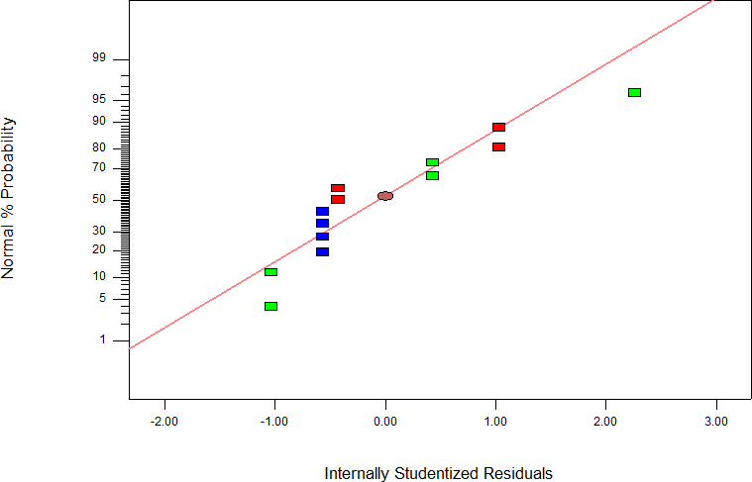

Figure 4.24. Normal Probability Plot of Residuals for Number of damaged seeds

* + - 1. **Effect of process variables on number of damaged seeds using the optimized model** Figures 4.25 and 4.26 show the contour and surface plots of the number of damaged seeds model respectively. The experimental levels of each factor and the relationship between them was graphically represented using contour and response surface plots. The plots show the effect of varying two process parameters that will minimize number of damaged seeds. Figures 4.25 and 4.26 show influence of quadratic function of planting speed and significant influence of moisture content on number of damaged seeds. The plots show that decreased number of damaged seeds was observed with decreasing moisture content and planting speed values.Further increase in planting speed beyond the optimum point caused an increase in the number of damaged seeds. Also, as planting speed increases beyond 14.55%, the number of damaged seeds began to decrease with decrease in moisture content, suggesting a minimum seed damage of 0.13 at optimum moisture content of 14.99% and planting speed of 1.05 m/s.

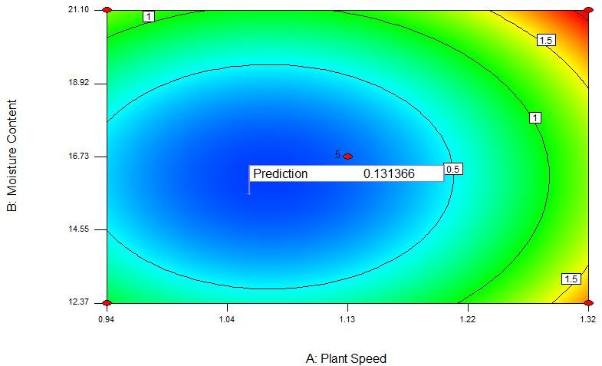

Planting Speed

Figure 4.25. Contour plot showing the effect of planting speed and moisture content on number of damaged seeds.

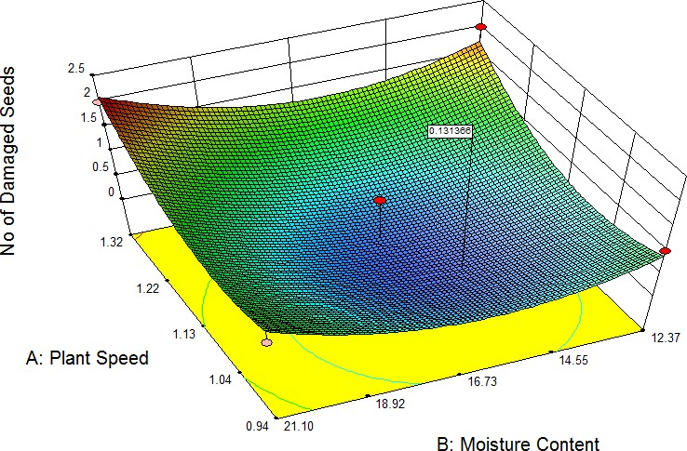

**Planting Speed**

Figure 4.26. Response surface plot showing the effect of planting speed and moisture content on number of damaged seeds.

The optimal values obtained are summarized in Table 4.63

# Table 4.63. Optimal values

|  |  |  |
| --- | --- | --- |
| S/N | Response variable | Optimal value |
| 1.  2.  3.  4.  5.  6. | Seedling emergence (plants in 0.011 ha) Depth of planting (mm)  Plant spacing (cm) Number of seeds per hole  Total energy consumed (MJ)  Number of damaged seeds | 24  36.74  4.40  3  1.97  0.13 |

* 1. **SUMMARY, CONCLUSIONS AND RECOMMENDATIONS**

# Summary

The research was embarked upon to develop a two-row engine-propelledridge planter, determine its performance in comparison with an existing animal drawn planter and manual planting method (as control) and optimize the performance of the engine- propelled planter. The developedengine-propelled planter was designed, fabricated and tested on the field alongside the other two methods, the animal drawn planter and the manual method of planting in 2012, 2013 and 2014 using a 3 x 3 Randomized Complete Block Design for the experiments with three (3) replications. The data collected was used to determine the performance of the engine-propelled planter and compare same with the animal drawn planter and manual planting method for seedling emergence, plant spacing (plant-to-plant spacing), number of seeds dropped at planting points, the energy expended and the number of broken seeds. The data collected for each year was tabulated and analyzed using the statiscal analysis system (*sas*) statistical package. At the end of the third year, a pooled analysis was conducted to study the variations between the years.The performance of the engine-propelled planter was subsequently

subjected to optimisation process using the Response Surface Methodology with a Central Composite Design (CCD) using Design Expert optimisation software release 9.0.

* + 1. **The design:**The engine-propelled planter was designed using available manuals and facts and with the aid of AutoCAD 2007. It has seven parts namely the hoppers, the seed metering unit, the drive, the frame, the coulters, the soil covering devices and the ground wheel. Designed power for the engine is 5.4hp. The components of the designed planter were fabricated and assembled into a functional unit.
    2. **Performance evaluation**: Performance evaluations of the deeveloped engine- propelled 2-row ridge seed planter in comparison with those of animal drawn planter and manual planting were carried out through a 3x3x3 Randomized Complete Block Design. The evaluation was done over eighty one (81) number of experimental plots measuring 10m x 1.5m. The seedling emergence, intra-row plant spacing, the depth of planting, number of seeds per hole, the amount of energy consumed in operation, planting speed were evaluated. In the evaluation, a plot of size 27 x 22 metres was used at the C1 research farm at the Ahmadu Bello University was used. The soil tests were done to confirm the dominant soil type in the area which was discovered to be sandy loam. Planting was done after the land preparation operations using the 2-row engine-propelledplanter, the single row animal drawn planter and manual planting method over three (3) regimes of soil moisture and depth of planting.
       1. The collated data for each of the years 2012, 2013 and 2014 and the pooled data were subjected to yearly statistical analysis and pooled analysis using Statistical Analysis System***(sas)*** 2009 release.
       2. The engine-propelled planter had an average of 36% of the total number of seeds that emerged after planting and thus was the best performing method of planting in terms of seedling emergence.
       3. The engine-propelled planter had an average of 25.64cm of intra-row spacing which was the closest to the designed spacing of 25cm and thus has the ability of ensuring highest plant density when used in planting
       4. The evenness of plant spacing was 0.24 for the engine-propelled planter, 0.86 for the animal drawn planter and 0.70 for the manual planting.
       5. Speed of planting: The manual planting method was the slowest while the engine-propelled planter was the fastest with an average planting speed of 0.55m/s
       6. Seed delivery rate for the engine-propelled planter was 19.8kg/ha
       7. The overall field efficiency of the engine-propelled planter was 70.71 % and an effective capacity of 0.22ha/hr or 4.55 hr/ha
    3. **Energy expenditure:** The energy expenditure levelwas evaluated. It can be concluded that the engine-propelled planter expended the least energy of 2.89MJ over a total area of 0.011 hectares which translated to 262.73 MJ/ha. The energy expended in the animal

drawn planter was highest with value of 26.05 MJ over a total area of 0.011 hectares which translates to 2,368.18 MJ/ha.

* + 1. **Optimisation:** To optimise the performance of the planter a Response Surface Matrix predictive model was used in a Design Expert Version 9 Optimisation Software. The optimisation models were developed, validated and used in optimizing the seedling emergence, the plant-to-plant spacing, depth of planting, plants per hole, energy consumed and number of damaged seeds.

The optimisation objectives as detailed in Chapter Three of this study was used in the estimation of the optimisation model. Two process factors (soil speed of planting (x1) and soil moisture content (x2)) were adopted to evaluate five (5) response factors namely plant population, plant-to-plant spacing, number of seeds per hole, energy expended in planting and number of damaged seeds.

The Response Surface Matrix (RSM) Central Composite Design (CCD) was adopted. Design Expert version 9.0 simulation/optimisation software was used in generating the relating models. The generated models were tested with values gotten from experiments to determine which of the models will best suit. The quadratic models were best models and were thus adopted for the optimisation of the response factors.

Optimisation results showed that the engine-propelled planter had the following:

* + - 1. Optimal plant population of 24 plants over a unit area of 0.0015 hectares of land.
      2. Optimal depth of planting of 36.73mm as against the recommended 30mm
      3. Optimal plant spacing of 4.41cm as against the recommended 3.5 cm
      4. Optimal seeds per hole of 3 as against 2
      5. 1.97 MJ of energy as the minimal energy that can be expended on the operation of the engine-propelled planter and
      6. Near zero of damaged seeds while in operation

These optimal values can be used to improve on the re-design of the engine-propelled planter.

# Conclusions

The two-row engine propelled ridge seed planter was developed and evaluated for performance in comparison with an existing single row animal drawn seed planter and the manual planting method.

The developed planter has the capacity for planting two seeds per hole in one hectare in

4.55 hours. Seedling emergence under the developed planter was 30,636 per hectare as against the 26,091 per hectare for the animal drawn planter and 28,545 per hectare for the manual planting.

The field capacities for the developed planter, the animal drawn planter and the manual planting method were 0.22, 0.18 and 0.19 ha/hr respectively. The average speeds of planting were 0.55 m/s, 0.37 m/s and 0.17 m/s for the developed planter, animal drawn planter and the manual planting methods respectively. The average plant-plant spacings were 25.97 cm for the developed planter, 32.42 cm for the animal drawn planter and

29.93 cm for the manual planting. It was therefore concluded that the developed engine- propelled planter was more efficient in terms of intra-row spacing of plants. The developed planter was also more efficient in terms of energy use in operation. It can take

in 262.73 MJ/ha as against the 2,368.18 MJ/ha and 1,099.09 MJ/ha for the animal drawn planter and the manual planting respectively.

A Response Surface Optimisation method was adopted for optimizing the performance parameters of the developed planter with two input parameters (planting speed, x1 and soil moisture content, x2). The Central Composite Design (CCD) of the Response Surface Matrix (RSM) was adopted. Within this, thirteen (13) experiments were laid out for estimating the coefficients of the models for the optimization process. Quadratic optimization models were developed for the parameters and were used in estimating the effects of the input parameters and their interactions on the performance parameters of the developed two-row engine-propelled seed ridge planter. With these, the optimal values of the performance parameters were determined and indicated on their respective contour and response surface plots for the performance parameters.

The engine-propelled planter is a good replacement for the animal drawn planter and the manual method of planting as it will reduce drudgery and reduce the operational planting costs.

# Recommendations

The engine-propelled 2-row planter is recommended for use in sandy-loam to loamy soils and where the plant density is of interest.

For further improvement on this work, the following are recommended:

1. The drive should be made more flexible and stable. Slippages on the belt driven parts by replacing them with chains and sprockets.
2. An engine with in-built ignition and clutching systems should be adopted to ease the interchange between the active and idle drive states.
3. The engine-propelled planter should be evaluated on other types of soil and using other varieties of maize and other seeds.
4. The number of experimental levels for the treatments should be increased to a minimum of five (5). This will help in determining the actual behavior of the performance parameters.

# Contributions to Knowledge

The followings were recorded as the contributions to knowledge in this research.

1. A multi-row seed planter that was engine-propelled and manually guided was developed and it had the ability to meter seeds on guided rows.
2. The seed planter could deliver two seeds per hole at an average intra-row spacing of

25.9 cm for maize seeds and could effectively deliver 19.8 kg/ha of seeds at average operating speed of 0.55 m/s, field efficiency of 70.71 % and a field capacity of 0.22 ha/hr or 4.55 hr/ha.

1. In comparison with the existing IAR single row animal drawn planter and the manual method of planting, the multi-row planter could plant on ridges with evenness of spacing of 0.24 as compared to the other two methods; the animal drawn single row planter having 0.86 and the manual method of planting having 0.70. Acceptable evenness is ≤ 0.30.
2. Energy expended in operation is minimal with the developed multi-row planter as it requires a maximum energy expenditure of 262.73 MJ/ha as against the 2,368.18 MJ/ha on the animal drawn planter and 1,099.09 MJ/ha for the manual method of planting.
3. A quadratic mathematical model was developed for optimising the performance parameters of the multi-row planter using 0.94 ≤ planting speed ≤ 1.32 m/s and 12.37 ≤ soil moisture content ≤ 21.10 % (dry basis) over a well-drained soil.
4. The developed multi-row planter had optimal seedling emergence of 22,290 plants per hectare, a maximum planting depth of 44.0 mm, optimal seeds per hole of 3 and optimal seed damage of 0.13.

# REFERENCES

Abubakar, M.S. and Umar, B.(2006). Comparison of energy use patterns in Maiduguri and

Yobe flour mills, Nigeria; *Agric Engr’g Int.: CIGR e-journal* (3):11pp; [http://test-](http://test-ir.library.cornell.edu/)

[ir.library.cornell.edu](http://test-ir.library.cornell.edu/) Retrieved August 2009.

Agricultural Machinery and Equipment (2010).[*www.agriculturalproductsindia.com*](http://www.agriculturalproductsindia.com/), 3pp Akinoso, R., Igbeka, J.C. and Olayanju, T.M.A.(2006). Process optimisation of oil expression

from sesame seed; *CIGR e-journal, manuscript* FP 06 011 8:1-7.

American Society of Agricultural Engineers (ASAE) (1994).*Standards Book*, ASAE Publications, USA, pp81 – 91.

American Society of Agricultural Engineers (ASAE) (2005).*Standards Book*, ASAE Publications, USA, pp 70 – 79.

Arzu,Y. and Adnan, D. (2006).Optimisation of the Performance of a Precision Planter

Metering Cotton Seed Using Response Surface Methodology; *ASABE meeting presentation paper No. 061076.*

Bamgboye, A.I. and Jekayinfa, S.O.(2006).Energy consumption pattern in palm kernel oil processing operations ; *Agric Engr’g Int.: CIGR e-journal* (3):10pp; [www.google.com/academicjournals](http://www.google.com/academicjournals)Retrieved August 2009.

Bamgboye, A.I. and Mofolasayo, A.S.(2006). Performance Evaluation of a Two-Row Okra Planter; *CIGR e-journal*, 8:10.

Bilbro, J.D. and Wanjura, D.F.(1982). Soil crust and cotton emergence relationships;

*Transactions of the ASAE*, 25: 1485 – 1488.

Bosoi, E.S., Verniaev, O.V., Smirnov, I.I. and Sultan-Shakh, E.G.(1988).*Theory Construction and Calculations of Agricultural Machines*; Russian Translation Series 1:233-275.

Bowers Jr. C.G. (1989). South Eastern Tillage Energy Data and Recommended Reporting:

*Transactions of the ASAE* 28(3): 731 – 7737.

Celic, A.,Ozturk, I. and Way, T.R.(2007). Effects of various planters on emergence and seed distribution uniformity of sunflower; *J. of Applied Engineering in Agriculture,* ASAE publication 23(1): 57-61.

Crossley, P. and Kilgour, J.(1983).*Small farm mechanisation for developing countries*; John Willey and Sons Ltd, New York; pp116-123.

David, L. and Abdelrahman, A. A.(2014). Variability of Cone Index on Seedling Emergence Rate and Growth Establishment of Cowpea in a Sandy Loam Soil (*Eutric Leptosol*); *International Journal of Sciences: Basic and Applied Research*; [http://gssrr.org/index.php?journal=JournalOfBasicAndApplie](http://gssrr.org/index.php?journal=JournalOfBasicAndApplied)d Retrieved Aug. 2009.

Dickey E.C., Jasa, P.J. and Grisso, R.D.(1994). Long Term Tillage Effects on grain yield and soil properties in a soybean/grain sorghum production. *J. Prod. Agric*. 7(4):465-470.

Doerge, T., Hall, T. and Gardner, D.(2002). New research confirms benefits of improved plant spacing in corn. *Corn Insights* 12(2): 1-5.

Emekoma, C.C.(2002).Reminiscence of Twenty-two Years as an Agricultural Engineer and Some Postulations;*NIAE quarterly*, 13(4): 3.

Foods and Agricultural Organization (FAO) (1994).*Testing and evaluation of agricultural machinery and equipment: Principles and practices*; FAO Agric Services Bulletin 110: 150- 169.

Far, J.J., Upadhyaya, S.K. and Shafii, S.(1994). Development and field evaluation of a hydropneumatic planter for primed vegetable seeds; *Transactions of the ASAE*, 37(4): 1069-1075.

Gardener, H.W (1986). Water Content. In. A. Klute (ed). *Methods of soil analysis*. Part 1.

Am. Soc. of Agron. Inc. Madison, U.S.A. pp 35-36

Glenn, F.B. and Daynard, T.B.(1974). Effects of genotype, planting pattern and plant density

on plant-to-plant variability and grain yield of corn. *Canadian Journal of Plant Science*

54:323-330.

Gomez, K.A and Gomez, A.A. (1984).*Statistical Procedures for Agricultural Research*,(2nd

ed.), John Wiley and Sons, New York; pp13-28.

Grisso, R.D., Yasin, M. and Kocher, M.F.(1994). Tillage implement forces operating in silty clay loam; *ASAE paper 94-1532*, St. Joseph Mich: ASAE, 10pp.

Halderson, J.L. (1983). Planter selection accuracy for edible beans; *Trans. ASAE,* 26(2):367 - 371 Hall, A.S., Holowenko, A.R. and Langlin, H.G.(1961).*Theory and Problems of Machine*

*Design*; Schaum outline series, McGraw Hill Book Company, London pp 56-65.

Hannah, J. and Stephens, R.C.(1972).*Mechanics of Machines*; Edward Arnold Publishers Ltd, pp 371-374).

Harrigan, T.M. and Rotz, C.A.(1995). Draft Relationships for Tillage and Seeding Equipment*, J. of Applied Engineering in Agriculture*, ASAE 11(6): 773- 783.

Heckman, N.L., Garald L. H., and Roch, E.G.(2002).*Planting Depth Effect on Emergence*

*and Morphology of Buffalograss Seedlings*; Agronomy & Horticulture -- Faculty Publications; University of Nebraska – Lincoln; 3pp.

Hudges E. and Kearney, T.(2007).*Optimisation with SAS/OR*. [www.sas.com. Retrieved15](http://www.sas.com.Retrieved15/)

August 2007 3pp.

Igbeka, J.C(1986). Economic Evaluation of Tillage Operation in Some Mechanized Farms in Nigeria, *Journal of AMA* 17 (2): 17-27.

Igbeka, J.C(2002).AgriculturalEngineering and the Society,*NIAE quarterly*, 3 (2): 7.

Ikechukwu, I.B., Gbabo, A. and Ugwuoke, I.C.(2014). Design and fabrication of a single row maize planter for garden use; *Journal of Advancement in Engineering and Technology,* <http://scienceq.org/journals/JAET.php>Retrieved July 2014.

Isiaka M. (2000). Development of two-row animal drawn seed planter; An *MSc. Thesis* submitted to the Dept of Agricultural Engineering, Ahmadu Bello University; Unpublished; 104pp.

Jekayinfa, S.O(2006). Energy Consumption Pattern of Selected Mechanized Farms in Southwestern Nigeria*;CIGR E. Journal Manuscript* Vol.8 [www.google.com](http://www.google.com/) Retrieved 8th

Sept. 2008.

Kachman, S.D. and Smith, J.A.(1995). Alternative measures of accuracy in plant spacing for planters using single seed metering; *Transactions of ASAE*, 38(2): 379 – 387.

Karlen, D.L., Busscher, W.J., Hale, S.A., Dodd, R.B., Strickland, E.E. and Garner, T.H.(1991).

Drought condition energy requirement and subsoiling effectiveness for selected deep tillage implements; *Transactions of the ASAE* 34(5): 1967-1972.

Kathirvel, K., Manian, R., Reddy, A. and Senthilkuamr, T.(2005). Performance evaluation of planters for cotton crop; *AMAA*36(1): 61-65.

Kepner, R.A., Bainer, R. and Barger, E.L.(1978).*Principles of Farm Machinery* (3rd Ed.) AVI Publishing Co. Inc. Westport, connections’ pp 209-233.

Kepener, R.A., Roy B. and Barger, E.L. (1987). Principals of Farm Machinery. 8th ed. CBS Publishers and Distributors, New Delhi, India.

Khalilian, A., Garner,T.H.,Musen,L., Dodd, R.T. and Hale, S.A.(1988). Energy for

conservation tillage in coastal plain soils*.Trans of ASAE* 31(5): 1333 – 1337.

Khurmi, R.S. (1981).*Strength of Materials*; S.Chad and Co. Ltd 11:642.

Konz, S. (1999).*Work Design: Industrial Ergonomics*; Holsom Harthaway Publications 59: 188-221.

Krall, J.M., Esechie, H.A., Raney, R.J., Clark, S., TenEyeck, G., Lundquist, M and Vanderlip,

R.L.(1977). Influence of within row variability in plant spacing on corn grain yield.

*Agronomy Journal*,69(5): 797-799.

Kummer, K., Naaresh, N.K. and Ojha, T.P.(1986).*Design construction and performance of a manually operated seeding attachment for an animal drawn cultivator*”. Agricultural mechanization in Asia, Africa and Latin America 17(2): 35-38.

Laboratory Tests(2010). Direct shear box test theory. [www.arcwear.com/testing/IEC-61482-1-2](http://www.arcwear.com/testing/IEC-61482-1-2)

. Retrieved July 2012.

Maiti, R.K. and Carrillo-Gutierrez, M. De J.(1989).Effect of planting depth on seedling emergence and vigour in sorghum, *Seed Sci. and Technol;* 17:83-90

Mathews, E.J., Shackle-ford, P.S. and Walker, J.T.(1981). Low Energy Cotton Production Systems; *ASAE paper* 81 – 1573.

Matin, M.A., Roy, K.C. and Amin, M.N.(2008). Performance of BARI developed planter for establishment of maize; *CIGR e-journal manuscript* PM 07 023, vol. x, [www.asabe.org](http://www.asabe.org/)Retrieved 12th January 2010.

Manzoor, Z, Ali,S. S., Akhtar,M. S., Awan, T. H. and Safdar, M. E.(2007).Influence of

Seed Density Classification on Emergence and Seedling Traits In Rice (Oryza sativa L.);

*J. Anim. Pl. Sci*. 17(1-2).

Mohsenin, N.N. (1978).*Physical properties of plant and animal materials* (2nd ed.); Gordon and Breach, Science Publishers Inc. New York; p66-78, 495-499.

Molin, J.P. (2002). A punch planter with adjustable seed spacing; *A paper presented at the*

*2002 annual international meeting/CIGR XVth world congress*, paper No. 021174; [www.asabe.org](http://www.asabe.org/) retrieved 12th January 2010.

Morrison Jr, J.E(2002).Compatibility among three tillage systems and types of planter presswheels and furrow openers for vertisol clay soils; *J. of Applied Engr’g in Agriculture*, ASAE publication 18(3): 293-295.

Murray, J.R., Tullberg, J.N. and Basnet, B.B.(2006).*Planters and their components: Types, attributes, functional requirements, classification and description*; Australian Centre for Int. Agricultural Research, Carberra; p26 – 157.

Muvdi B. B. and McNabb, J.W.(1988).*Engineering Mechanics of Materials*, Macmillan pub Co. Inc.

Nafziger, E.D. (1996). Effects of missing and two-plant hills on corn grain yield. *J. of Production Agriculture* 9(2): 238-240.

Nielsen, D.L. (2001).*Stand establishment variability in corn*. Dept. of Agronomy publication AGRY-91-01., Purdue Univ. pp 62, 78-80.

Norman, M.J.T. (1978). Energy inputs and outputs of subsistence cropping systems in the tropics.

*Agro-ecosystems*, 4:355-366.

Norris, C.P. (1982). Performance of some different types of peanut/maize planters in NQ. *Proc. Conf. on Agric Eng.* Armidale I.E. Aust. Nat. Conf. Publ. 82(8):149-154*Conf. on Agric Eng.* Armidale I.E. Aust. Nat. Conf. Publ. 82(8):149-154

Odigboh, E. U. (1992).*Research Development and Manufacture of Agricultural machinery in Nigeria: A National Imperative.* NSE 1992 Distinguished Food and Agriculture Lecture, Co-Sponsored by NCAM, Ilorin, 11, July 1992, 13pp.

Okudo, U.P(1974). The design and construction of a seed planter for the Nigerian farmer;

*Transaction of the ASAE*, 449-451.

Olujimi, J.A.B. (1991).Village Re-going as a Rural Development Strategy. A case study of Ajowa village in Ondo state – Nigeria**.***Journal of Technical Education* 8(1&2): 87-97

Owolarafe O.K and Ogunjimi, A.O. (1999).An Overview of Effective Grassroots Agricultural Mechanisation Structure as an aid to Successful National Agricultural MechanisationPolicy implementation; *Proceedings of the Annual Conference of NIAE,* 21

:320.

Pimentel, D. (1992). Energy inputs in production agriculture; *Energy in farm production;*

Elservier and Amsterdam, pp 13 – 29.

Rainbow, R.W., Slattery, M.G. and Norris, C.P.(1992). Effects of seeder design specification on emergence and early growth of wheat. *Proc. Conf. on Agric. Eng.,* Albury, I.E. Aust. Nat. Conf. Publ. 92(11):13-20

Ramaswamy, N.S. (1994). Draught animals and welfare; *Rev. Sci. Tech. off. Int.* EP12, 13(1):195-216.

Reid, J.T., Carter, I.M. and Clark, R.L.(1983). Draft measurements with a 3-point dynamo- meter, *ASAE paper* 83-1036.

Ryu. I.H. and Kim, K.U.(1998). Design of Roller Type Metering Device for Precision Planting; *Transaction of the ASAE*; 41(4): 923-930.

Searle, C.L., Kocher, M.F., Smith, J.A. and Blankenship, E.E.(2008). Field slope effects on

uniformity of corn seed spacing for three precision planter metering systems; *J. of Applied Engineering in Agriculture, ASAE publication*, 24(5): 581 – 586.

Sasakawa Global (2000).Building Food Security in Africa; [www.nippon-foundation.or.jp](http://www.nippon-foundation.or.jp/)

Skwarcz, J. (2006).Optimisation of the choice of agricultural machines; *e-journal of Polish Agricultural Universities*, 9(3); [www.ejpau.medi.pl](http://www.ejpau.medi.pl/) Retrieved Sept. 2009.

Spotts, M.F. (1988).*Design of Machine Elements*, 6th ed. Prentice-Hall of India Private Ltd; New Delhi, pp149 – 160.

Srivastava, A.K.., Goering, C.E and Robrbach, R.P.(1993).*Crop Planting*; ASAE Textbook, ASAE Michigan 6: 221-263.

Stephens, L.E., Spencer,A.D., Floyd, V.G. and Brixius, W.W.(1981). Energy requirements for tillage and planting; *ASAE paper* 81 – 1512.

Summers, J.D., Khalilian, A. and Batchelder, D.G.(1986). Draft relationships for primary tillage Oklahoma soils. *Transactions of the ASAE* 29(1): 37-39.

Taha, H.A. (2007).*Operations Research: An Introduction (8th ed)*; Prentice-Hall of India Private Ltd; pp 1-48.

Tayel M.Y., Shaaban, S. M. and Mansour, H.A. (2015).Effect of Plowing Conditions on the Tractor Wheel Slippage and Fuel Consumption in Sandy Soil; International Journal of ChemTech Research; 8(12):151-159.

Thomson, M. (1986). Drill performance review; *British Sugar Beet Review* 54(4): 11 – 14.

Tressier, S. (1988). Zero-till furrow opener geometry effect on wheat emergence and zone properties; *PhD dissertation*, Washington State University, Pullman, 65pp.

Tripathi, J.P. and Bajpai, S.P.(1985). Effect of depth of sowing on germinationof kardan (*Anogeissus pendula*) seeds. Indian Forester 111: 167-169.

Yamakawa, H., Itoh, K. and Nakajima, Y.(1989). Development of a new no-till seeder for soybean; *JARQ*, 23(1): 24 – 30.

Yisa, M.G., Walczyk, J. and Terao, H.(1994). Effects of Coulter Shape and operating velocity

on the performance of precision planters. *J. Faculty of Agriculture,* Hokkaido University, Sapporo 66(1): 79-98.

Yusuf, D.D. (2010).*Use and management of seeders, planters and fertilizer applicators*; An invited paper presented at the National workshop on tractor and farm machinery management for sustainable agricultural production; NAERLS, Ahmadu Bello University, Zaria (unpublished); 18pp.

Ugese, F. D., Baiyeri, K. P. and Mbah, B. N.(2010). Effect of sowing depth and mulch

application on emergence and growth of shea butter tree seedlings (*Vitellaria paradoxa*

C. F. Gaertn.); *African Journal of Biotechnology* 9 (10):1443-1449.

Varshney, A.C., Bohra, C.P. and Narang, S.(1991). Design, development and evaluation of

power tiller-drawn seed cum fertilizer drill; *Agricultural Mechanisation in Asia, Africa and Latin America (AMA); AMA*, 22(1): 39-41.

Weise, G. and Eichhorn, H.(1997). The application of Mohr-Coulomb soil mechanics to the design

of winged shares. *J. Agric Engr’g Res.* 67:235-247.[www.wikipaedia.org](http://www.wikipaedia.org/) .2010. Soil classifications. [https://en.m.www.wikipaedia.org](https://en.m.www.wikipaedia.org/). Retrieved July 2012.

Zulin, Z., Upadhayaya, S.K., Shaffi, S. and R.E. Garrett(1991). A hydropneumatic seeder for primed seeds b. *Trans. ASAE* Am. Soc. Agr. Eng. St. Joseph, MI; 34(1):21-26.