DEVELOPMENT AND OPTIMIZATION OF THE THRESHING PERFORMANCE OF A MULTICROP THRESHER

BY

MUNA Nyambi Humphred
B.Eng (ABU, 2004), MSc.Eng (ABU, 2010) (PhD/ENG/6571/2010-2011)

DEPARTMENT OF AGRICULTURAL ENGINEERING FACULTY OF ENGINEERING
AHMADU BELLO UNIVERSITY, ZARIA, NIGERIA

A DISSERTATION SUBMITTED TO THE POSTGRADUATE SCHOOL, AHMADU BELLO UNIVERSITY, ZARIA, IN PARTIAL FULFILLMENT OF THE REQUIREMENTS FOR THE AWARD OF THE DEGREE OF DOCTOR OF PHILOSOPHY IN AGRICULTURAL ENGINEERING

SEPTEMBER, 2017

DECLARATION

I hereby declare that this thesis titled “Development and Optimization of the Threshing Performance of a Multicrop Thresher” is written by me and that it is a record of my own research work. It has not been presented before in any previous application for a higher degree. All sources of information which were cited and did not originate from me were specifically acknowledged by means of references.

------------------------------------ ---------------------
N.H. MUNA Date
(PhD/ENG/6571/2010-2011)

CERTIFICATION

This is to certify, having read through, that this thesis “Development and Optimization of the Threshing Performance of a Multicrop Thresher” by the author Muna, Nyambi Humphred; meets the regulations governing the award of degree of Doctor of Philosophy (Agricultural Engineering) of Ahmadu Bello University, Zaria, and is approved for its contribution to scientific/technical knowledge and literary presentation.

Prof. U.S. Muhammad Date
Chairman, Supervisory Committee

Prof. A.M.I. EL-Okene Date
Member, Supervisory Committee

Prof. M. Isiaka Date
Member, Supervisory Committee

Prof. M. L. Suleiman Date
Head of Department

Prof. S. Z. Abubakar Date
Dean, School of Postgraduate Studies

DEDICATION

I dedicate this work to God Almighty for granting me His Grace, Mercy, Strength and Wisdom to complete this PhD degree programme, and to all my friends and members of my family who supported me morally and financially.

ACKNOWLEDGEMENTS

Special thanks to God Almighty, for His love and protection throughout my PhD degree programme.

My profound gratitude to my supervisors Prof. U.S. Muhammad, Prof. A.M.I. EL-Okene and Prof. M. Isiaka for their excellent suggestions, advice and criticisms at various stages of this research work.

My special appreciation goes to my mummy and Daddy Mr. and Mrs. Muna for their immeasurable contributions and pieces of advice throughout my PhD degree programme.

My heart-felt gratitude goes to my wife (Pharm.) Mrs. Elizabeth Muna and all members of my family for their prayers, financial supports and encouragements.

I express a very deep depth of appreciation to my lecturers; Prof. M.L. Suleiman (Head, Department of Agric. Engineering), Prof. O.J. Mudiare, Prof. A.A. Ramalan, Prof. M.A. Oyebode, Prof. D.D. Yusuf, Prof. S. Z. Abubakar, Prof. H.E. Igbadun, Prof. M.K. Otman, Dr. M.
A. Gwarzo, Engr. A.O. Lawal, and all other academic staffs of Agric. Engineering Department for their great contributions during my seminar presentations.

I am sincerely grateful to Mr. Aminu, Mr. Amsain, Mr. Adamu Janfaru, Engr. Aminu, Mr. Ayeni, Mr. Ayo, Mr. Andrew, Mr. Sunday and all workshop staff of Agric Engineering Department for assisting me during the construction work.

I am grateful to all my colleagues and friends Engr. Abubakar Mohammed, Dr. O. Ezekiel, Dr.

M.L. Attanda, Dr. D.D. Nalado, Dr. H.T. Kimeng for their excellent suggestions and advice throughout the course of this research.

ABSTRACT

The existing IAR multicrop thresher was evaluated and found to have low feed rate and output with millet and soybean crops. The machine was modified and reconstructed to increase its threshing performance. Its components were increased in size and a shredder was added below the feed hopper to cut stems of crops that entangle the threshing cylinder and stop its motion. The beaters were tilted and arranged spirally on the threshing cylinder to facilitate the flow of threshed grains, chaff and unthreshed materials. Performance tuning was done and the machine‟s performance was evaluated. With millet as the test crop the machine gave feed rate, threshing efficiency, cleaning efficiency, scatter loss, grain damage and output capacity of 14 kg/min,
99.98 %, 99.71 %, 12.18 %, 0.62 %, and 520.6 kg/hr as against 3 kg/min, 92 %, 80 %, 2.4 %, 3.5

%, and 81 kg/hr respectively for the existing IAR multicrop thresher. With soybean the machine gave 12 kg/min, 100 %, 97.26 %, 7.25 %, 6 %, and 205 kg/hr as against 1.7 kg/min, 80 %, 70 %, 2 %, 1.94 %, and 23 kg/hr respectively for the existing IAR soybean thresher. Therefore, feed rate was increased from 3 to 14 kg/min and from 1.7 to 12 kg/min; output was increased from 81 to 520 kg/hr and from 23 to 205 kg/hr for millet and soybean respectively. Threshing and cleaning efficiencies for both crops were also increased. The ANOVA indicates that the effect of all the factors evaluated and their interactions were significant at 1 % probability level. Further analysis using Duncan multiple range test shows that there was significant difference between the means at 1 % level of significance. A good linear relationship was achieved between the measured and predicted data with r² equals 0.73. Hence the threshing efficiency model was accurate as the calculated t-value (0.101) was less than the tabular value (1.96) at 1 % level of significance. Optimum feed rate, threshing efficiency, cleaning efficiency, scatter grain loss, grain damage, output capacity of 12 kg/min, 99.7 %, 97.4 %, 11.2 %, 0.02 %, 420 kg/hr and of 10 kg/min, 100 %, 92.5 %, 4.7 %, 0.3 %, 163 kg/hr were attained for millet and soybean at a cylinder speed of 18.7 m/s and crop moisture content of 11.9 % and 12.2 % respectively.

TABLE OF CONTENTS

CONTENTS PAGE

Title Page i
Declaration ii
Certification iii
Dedication iv
Acknowledgment v
Abstract vi
Table of Contents vii
List of Tables xiv
List of Figures xvii
List of Plates xxvi
List of Appendices xxviii
CHAPTER ONE
  - INTRODUCTION 1
  - Background of the Study 1
    - Varieties of soybean 1
    - Nutritional and economic values of soybean 2
    - Varieties of millet 2
    - Nutritional and economic values of millet 3
  - Statement of Problem 4
  - Aim and Objectives of the Study 5
  - Justification of the Study 6
CONTENTS PAGE
CHAPTER TWO
  - LITERATURE REVIEW 7
  - Research and Development Efforts on Threshing 7
    - Research and development efforts on soybean threshing 7
    - Research and development efforts on millet threshing 9
  - Kernel Physical and Mechanical Properties 10
    - Mechanical and physical properties of soybean 10
    - Mechanical, physical and aerodynamic properties of millet 12
  - Threshing Parameters 14
  - Factors Affecting Grain Threshing 14
    - Cylinder tip speed 15
  - Factors Affecting Grain Cleaning 15
    - Terminal velocity 16
    - Orientation of particle 17
  - Types of Shaft Loadings 19
    - Transverse loading 19
    - Torsional loading 19
    - Axial loading 19
  - Important Design Factors (Criteria) 19
    - Factor of safety (FoS) 20
    - Design factor 20
    - Reserve factor 20
  - Performance Tuning 21
  - Threshing and Separation Model Development 22
CONTENTS PAGE
  - Dimensional Analysis 24
    - Methods of dimensional analysis 25
    - Methods of determining pi terms 26
  - Performance Optimization 26
    - MATLAB optimization process 27
  - Description of the Existing IAR Multicrop Thresher 28
CHAPTER THREE
  - MATERIALS AND METHODS 30
  - Design Considerations 30
  - Selection of Construction Materials 31
  - Design Equations (Design Theories) 31
    - Determination of blower casing diameter 31
    - Determination of shaker frequency of oscillation 32
    - Determination of threshing cylinder diameter 32
    - Determination of concave sieve radius 33
    - Determination of sieve hole diameter 33
    - Determination of power required for sieve oscillation 34
    - Determination of weight of the blower blades 34
    - Determination of fan speed required for cleaning 35
    - Determination of air discharge by blower 35
    - Determination of number of blades 36
    - Determination of pulleys diameter 36
    - Determination of belt length 36
    - Determination of belt speed 37
CONTENTS PAGE
    - Determination of belt tension ratio 37
    - Determination of torsional moment 38
    - Determination of angle of lap (contact) of belt 38
    - Determination of power required by the engine 39
    - Determination of power required by the blower 39
    - Determination of weight of a material 40
    - Determination of shaft diameter 40
  - Design Calculations 41
    - Determination of blower casing diameter 41
    - Determination of threshing cylinder diameter 41
    - Determination of sieves hole diameter 42
    - Determination of the concave sieve radius 42
    - Determination of fan speed required for cleaning 43
    - Determination of air discharge by the blower 43
    - Determination of the number of blades required 44
    - Determination of weight of the blower 44
    - Determination of pulley diameters 45
    - Determination of belt lengths 45
    - Determination of belt speeds 46
    - Determination of angles of lap (contact) of belts 47
    - Determination of power required to oscillate sieve 48
    - Determination of power required by the blower 48
    - Determination of power required by the engine 49
    - Determination of belt tensions ratio 50
CONTENTS PAGE
    - Determination of shaker frequency of oscillation 51
    - Determination of torsional moment 51
    - Determination of total load on the threshing cylinder shaft 52
    - Determination of maximum shear force and bending moment 53
    - Determination of the threshing cylinder shaft diameter 55
  - Construction of the Machine 55
  - Description of the Developed Multicrop Thresher 63
  - Operations of the Developed Multicrop Thresher 63
  - Performance Tuning 67
  - Performance Evaluation 68
    - Test materials 68
    - Test apparatus 68
    - Determination of crop moisture content 68
    - Determination of output capacity 69
    - Determination of threshing efficiency 69
    - Determination of cleaning efficiency 69
    - Determination of scattered grain loss 70
    - Determination of grain damage 70
  - Data Collection 72
  - Experimental Treatments 75
  - Experimental Design 75
  - Experimental Layout 75
  - Data Analysis 76
  - Development of Threshing Efficiency Mathematical Model 76
CONTENTS PAGE
    - Determination of component equations 81
    - Component equations combination criteria 85
    - Determination of the constant (C) 85
    - Determination of prediction equations 86
  - Development of Threshing Loss Mathematical Model 87
  - Development of Output Capacity Mathematical Model 89
  - Model Verification 90
    - Verification of dimensions of threshing efficiency model 90
    - Verification of threshing efficiency determination with the model 91
  - Model Validation 92
    - Model validation experimental treatments 92
    - Measures of the model performance 93
  - Optimization of Threshing Performance of the Thresher 96
  - Problem Formulation 97
    - Identification of objective functions and design variables 97
    - Identification of independent and dependent variables 98
    - Specification of the constraints on the independent variables 99
    - Determination of optimum point for each design vector 100
    - MATLAB Goal attainment method 102
    - Minimizing the maximum objective method 106
  - Defining the problem in MATLAB optimization toolbox syntax 108
  - Running the Optimization 112
CONTENTS PAGE
CHAPTER FOUR
  - RESULTS AND DISCUSSION 113
  - Output Capacity for Millet Crop 113
  - Threshing Efficiency for Millet Crop 121
  - Cleaning Efficiency for Millet Crop 129
  - Scattered Grain Loss for Millet Crop 137
  - Grain Damage for Millet Crop 145
  - Output Capacity for Soybean Crop 153
  - Threshing Efficiency for Soybean Crop 161
  - Cleaning Efficiency for Soybean Crop 169
  - Scattered Grain Loss for Soybean Crop 177
  - Grain Damage for Soybean Crop 185
  - Model Validation Results 193
  - Optimization Results 195
CHAPTER FIVE
  - CONCLUSIONS AND RECOMMENDATIONS 197
  - Conclusions 197
  - Recommendations 198
REFERENCES 200
APPENDICES 206

LIST OF TABLES

TABLE PAGE
- Some physical and mechanical properties of two soybean varieties 11

  - 1000 seed mass and axial dimensional properties of soybeans 11

  - Some physical properties of Ex-Borno and SOSAT C88 millet seeds 13

  - Aerodynamic properties of soybean at different moisture content 18

- Cost of materials used for developing the multicrop thresher as at

December, 2016 56

  - The multicrop thresher components and their fabrication methods 57

  - Threshing efficiency function relevant variables and their dimensions 78

  - Pi terms data for threshing efficiency model 83

- ANOVA of output capacity for millet crop 119

  - a D. M. R. T. for variation of speed with output capacity for

millet crop 120

  - b D. M. R. T. for variation of feed rate with output capacity for

millet crop 120

  - c D. M. R. T. for variation of crop moisture content with output

capacity for millet crop 120

  - ANOVA of threshing efficiency for millet crop 127

  - a D. M. R.T. for variation of speed with threshing efficiency

for millet crop 128

4.3b D. M. R.T. for variation of feed rate with threshing efficiency

for millet crop 128

TABLE PAGE
  - c D. M. R.T. for variation of crop moisture content with
threshing efficiency for millet crop 128
  - ANOVA of cleaning efficiency for millet crop 135
  - a D. M. R.T for variation of speed with cleaning efficiency
for millet crop 136
4.5b D. M. R.T. for variation of feed rate with cleaning
efficiency for millet crop 136
  - c D. M. R.T. for variation of crop moisture content with
cleaning efficiency for millet crop 136
  - ANOVA of scattered grain loss for millet crop 143
  - a D. M. R.T. for variation of speed with scattered grain loss
for millet crop 144
4.7b D.M.R.T. for variation of feed rate with scattered grain
loss for millet crop 144
  - c D.M.R.T. for variation of crop moisture content with
scattered grain loss for millet crop 144
  - ANOVA of grain damage for millet crop 151
  - a D. M. R.T. for variation of speed with grain damage for
millet crop 152
4.9b D. M. R.T. for variation of feed rate with grain damage
for millet crop 152
  - c D. M. R.T. for variation of crop moisture content with
grain damage for millet crop 152
  - ANOVA of output capacity for soybean crop 159

TABLE PAGE
  - a D.M.R.T. for variation of speed with output capacity for
soybean crop 160
4.11b D.M.R.T. for variation of feed rate with output capacity
for soybean crop 160
  - c D.M.R.T. for variation of crop moisture content with
output capacity for soybean crop 160
  - ANOVA of threshing efficiency for soybean crop 167
  - a D. M. R.T. for variation of speed with threshing
efficiency for soybean crop 168
4.13b D. M. R.T. for variation of feed rate with threshing
efficiency for soybean crop 168
  - c D. M. R.T. for relationship between crop moisture content
and threshing efficiency for soybean crop 168
  - ANOVA of cleaning efficiency for soybean crop 175
  - a D. M. R. T. for variation of speed with cleaning
efficiency for soybean crop 176
4.15b D. M. R. T. for variation of feed rate with cleaning
efficiency for soybean crop 176
  - c D. M. R.T. for relationship between crop moisture content
and cleaning efficiency for soybean crop 176
  - ANOVA of scattered grain loss for soybean crop 183
  - a D. M. R.T. for variation of speed with scattered grain
loss for soybean crop 184

TABLE PAGE
4.17b D.M.R.T. for variation of feed rate with scattered grain
loss for soybean crop 184
  - c D. M. R.T. for variation of crop moisture content with
scattered grain loss for soybean crop 184
  - ANOVA of grain damage for soybean crop 191
  - a D. M. R.T. for variation of speed with grain damage for
soybean crop 192
  - b D M. R.T. for variation of feed rate with grain damage
for soybean crop 192
  - c D. M. R.T. for variation of crop moisture content with
grain damage for soybean crop 192
  - a Maximum performance of the multicrop thresher for SOSAT C88
millet variety and Samsoy-2 soybean variety 196
  - b Optimum performance of the multicrop thresher for SOSAT C88
millet variety and Samsoy-2 soybean variety 196
  - c Minimum performance of the multicrop thresher for SOSAT C88
millet variety and Samsoy-2 soybean variety 196

LIST OF FIGURES

FIGURE PAGE
3a Free body diagram of the cylinder shaft 54

3b Shear force diagram of the cylinder shaft 54

3c Bending moment diagrams of the cylinder shaft 54

  - Plot of π ₁
against π10
with π₁₁ constant 84

  - Plot of π ₁
  - Plot of π10
against π₁₁ with π10
against π₁₁ with π ₁
constant 84
constant 84

  - Geometric representation of the goal attainment method in two dimensions………104 4a Variation of speed with output at various moisture content and
constant feed rate of 6 kg/min for millet crop 115
4b Variation of speed with output at various moisture content and
constant feed rate of 8 kg/min for millet crop 115
4c Variation of speed with output at various moisture content and
constant feed rate of 10 kg/min for millet crop 115
4d Variation of speed with output at various moisture content and
constant feed rate of 12 kg/min for millet crop 116
4e Variation of speed with output at various moisture content and
constant feed rate of 14 kg/min for millet crop 116
  - a Variation of feed rate with output at various moisture contents
and constant speed of 12.1 m/s for millet crop 117
  - b Variation of feed rate with output at various moisture contents
and constant speed of 14.3 m/s for millet crop 117
  - c Variation of feed rate with output at various moisture contents

and constant speed of 16.5 m/s for millet crop 117

FIGURE PAGE
  - d Variation of feed rate with output at various moisture contents
and constant speed of 18.7 m/s for millet crop 118
  - e Variation of feed rate with output at various moisture contents
and constant speed of 20 m/s for millet crop 118
  - a Variation of speed with threshing efficiency at various moisture
content and constant feed rate of 6 kg/min for millet crop 123
  - b Variation of speed with threshing efficiency at various moisture
content and constant feed rate of 8 kg/min for millet crop 123
  - c Variation of speed with threshing efficiency at various moisture
content and constant feed rate of 10 kg/min for millet crop 123
  - d Variation of speed with threshing efficiency at various moisture
content and constant feed rate of 12 kg/min for millet crop 124
  - e Variation of speed with threshing efficiency at various moisture
content and constant feed rate of 14 kg/min for millet crop 124
  - a Variation of feed rate with threshing efficiency at various moisture
contents and constant speed of 12.1 m/s for millet crop 125
  - b Variation of feed rate with threshing efficiency at various moisture
contents and constant speed of 14.3 m/s for millet crop 125
  - c Variation of feed rate with threshing efficiency at various moisture
contents and constant speed of 16.5 m/s for millet crop 125
  - d Variation of feed rate with threshing efficiency at various moisture
contents and constant speed of 18.7 m/s for millet crop 126
  - e Variation of feed rate with threshing efficiency at various moisture

contents and constant speed of 20 m/s for millet crop 126

FIGURE PAGE
  - a Variation of speed with cleaning efficiency at various moisture
content and constant feed rate of 6 kg/min for millet crop 131
  - b Variation of speed with cleaning efficiency at various moisture
content and constant feed rate of 8 kg/min for millet crop 131
  - c Variation of speed with cleaning efficiency at various moisture
content and constant feed rate of 10 kg/min for millet crop 131
  - d Variation of speed with cleaning efficiency at various moisture
content and constant feed rate of 12 kg/min for millet crop 132
  - e Variation of speed with cleaning efficiency at various moisture
content and constant feed rate of 14 kg/min for millet crop 132
  - a Variation of feed rate with cleaning efficiency at various moisture
contents and constant speed of 12.1 m/s for millet crop 133
  - b Variation of feed rate with cleaning efficiency at various moisture
contents and constant speed of 14.3 m/s for millet crop 133
  - c Variation of feed rate with cleaning efficiency at various moisture
contents and constant speed of 16.5 m/s for millet crop 133
  - d Variation of feed rate with cleaning efficiency at various moisture
contents and constant speed of 18.7 m/s for millet crop 134
  - e Variation of feed rate with cleaning efficiency at various moisture
contents and constant speed of 20 m/s for millet crop 134
  - a Variation of speed with scattered grain loss at various moisture
content and constant feed rate of 6 kg/min for millet crop 139
  - b Variation of speed with scattered grain loss at various moisture

content and constant feed rate of 8 kg/min for millet crop 139

FIGURE PAGE
  - c Variation of speed with scattered grain loss at various moisture
content and constant feed rate of 10 kg/min for millet crop 139
  - d Variation of speed with scattered grain loss at various moisture
content and constant feed rate of 12 kg/min for millet crop 140
  - e Variation of speed with scattered grain loss at various moisture
content and constant feed rate of 14 kg/min for millet crop 140
  - a Variation of feed rate with scattered grain loss at various moisture
contents and constant speed of 12.1 m/s for millet crop 141
  - b Variation of feed rate with scattered grain loss at various moisture
contents and constant speed of 14.3 m/s for millet crop 141
  - c Variation of feed rate with scattered grain loss at various moisture
contents and constant speed of 16.5 m/s for millet crop 141
  - d Variation of feed rate with scattered grain loss at various moisture
contents and constant speed of 18.7 m/s for millet crop 142
  - e Variation of feed rate with scattered grain loss at various moisture
contents and constant speed of 20 m/s for millet crop 142
  - a Variation of speed with grain damage at various moisture content
and constant feed rate of 6 kg/min for millet crop 147
  - b Variation of speed with grain damage at various moisture content
and constant feed rate of 8 kg/min for millet crop 147
  - c Variation of speed with grain damage at various moisture content
and constant feed rate of 10 kg/min for millet crop 147
  - d Variation of speed with grain damage at various moisture

content and constant feed rate of 12 kg/min for millet crop 148

FIGURE PAGE
  - e Variation of speed with grain damage at various moisture
content and constant feed rate of 14 kg/min for millet crop 148
  - a Variation of feed rate with grain damage at various moisture
contents and constant speed of 12.1 m/s for millet crop 149
  - b Variation of feed rate with grain damage at various moisture
contents and constant speed of 14.3 m/s for millet crop 149
  - c Variation of feed rate with grain damage at various moisture
contents and constant speed of 16.5 m/s for millet crop 149
  - d Variation of feed rate with grain damage at various moisture
contents and constant speed of 18.7 m/s for millet crop 150
  - e Variation of feed rate with grain damage at various moisture
contents and constant speed of 20 m/s for millet crop 150
  - a Variation of speed with output at various moisture content
and constant feed rate of 4 kg/min for soybean crop 155
  - b Variation of speed with output at various moisture content
and constant feed rate of 6 kg/min for soybean crop 155
  - c Variation of speed with output at various moisture content
and constant feed rate of 8 kg/min for soybean crop 155
  - d Variation of speed with output at various moisture content
and constant feed rate of 10 kg/min for soybean crop 156
  - e Variation of speed with output at various moisture content
and constant feed rate of 12 kg/min for soybean crop 156
  - a Variation of feed rate with output at various moisture contents

and constant speed of 12.1 m/s for soybean crop 157

FIGURE PAGE
  - b Variation of feed rate with output at various moisture contents
and constant speed of 14.3 m/s for soybean crop 157
  - c Variation of feed rate with output at various moisture contents
and constant speed of 16.5 m/s for soybean crop 157
  - d Variation of feed rate with output at various moisture contents
and constant speed of 18.7 m/s for soybean crop 158
  - e Variation of feed rate with output at various moisture contents
and constant speed of 20 m/s for soybean crop 158
  - a Variation of speed with threshing efficiency at various moisture
content and constant feed rate of 4 kg/min for soybean crop 163
  - b Variation of speed with threshing efficiency at various moisture
content and constant feed rate of 6 kg/min for soybean crop 163
  - c Variation of speed with threshing efficiency at various moisture
content and constant feed rate of 8 kg/min for soybean crop 163
  - d Variation of speed with threshing efficiency at various moisture
content and constant feed rate of 10 kg/min for soybean crop 164
  - e Variation of speed with threshing efficiency at various moisture
content and constant feed rate of 12 kg/min for soybean crop 164
  - a Variation of feed rate with threshing efficiency at various moisture
contents and constant speed of 12.1 m/s for soybean crop 165
  - b Variation of feed rate with threshing efficiency at various moisture
contents and constant speed of 14.3 m/s for soybean crop 165
  - c Variation of feed rate with threshing efficiency at various moisture

contents and constant speed of 16.5 m/s for soybean crop 165

FIGURE PAGE
  - d Variation of feed rate with threshing efficiency at various moisture
contents and constant speed of 18.7 m/s for soybean crop 166
  - e Variation of feed rate with threshing efficiency at various moisture
contents and constant speed of 20 m/s for soybean crop 166
  - a Variation of speed with cleaning efficiency at various moisture
content and constant feed rate of 4 kg/min for soybean crop 171
  - b Variation of speed with cleaning efficiency at various moisture
content and constant feed rate of 6 kg/min for soybean crop 171
  - c Variation of speed with cleaning efficiency at various moisture
content and constant feed rate of 8 kg/min for soybean crop 171
  - d Variation of speed with cleaning efficiency at various moisture
content and constant feed rate of 10 kg/min for soybean crop 172
  - e Variation of speed with cleaning efficiency at various moisture
content and constant feed rate of 12 kg/min for soybean crop 172
  - a Variation of feed rate with cleaning efficiency at various moisture
contents and constant speed of 12.1 m/s for soybean crop 173
  - b Variation of feed rate with cleaning efficiency at various moisture
contents and constant speed of 14.3 m/s for soybean crop 173
  - c Variation of feed rate with cleaning efficiency at various moisture
contents and constant speed of 16.5 m/s for soybean crop 173
  - d Variation of feed rate with cleaning efficiency at various moisture
contents and constant speed of 18.7 m/s for soybean crop 174
  - e Variation of feed rate with cleaning efficiency at various moisture

contents and constant speed of 20 m/s for soybean crop 174

FIGURE PAGE
  - a Variation of speed with scattered grain loss at various moisture
content and constant feed rate of 4 kg/min for soybean crop 179
  - b Variation of speed with scattered grain loss at various moisture
content and constant feed rate of 6 kg/min for soybean crop 179
  - c Variation of speed with scattered grain loss at various moisture
content and constant feed rate of 8 kg/min for soybean crop 179
  - d Variation of speed with scattered grain loss at various moisture
content and constant feed rate of 10 kg/min for soybean crop 180
  - e Variation of speed with scattered grain loss at various moisture
content and constant feed rate of 12 kg/min for soybean crop 180
  - a Variation of feed rate with scattered grain loss at various moisture
contents and constant speed of 12.1 m/s for soybean crop 181
  - b Variation of feed rate with scattered grain loss at various moisture
contents and constant speed of 14.3 m/s for soybean crop 181
  - c Variation of feed rate with scattered grain loss at various moisture
contents and constant speed of 16.5 m/s for soybean crop 181
  - d Variation of feed rate with scattered grain loss at various moisture
contents and constant speed of 18.7 m/s for soybean crop 182
  - e Variation of feed rate with scattered grain loss at various moisture
contents and constant speed of 20 m/s for soybean crop 182
  - a Variation of speed with grain damage at various moisture
content and constant feed rate of 4 kg/min for soybean crop 187
  - b Variation of speed with grain damage at various moisture

content and constant feed rate of 6 kg/min for soybean crop 187

FIGURE PAGE
  - c Variation of speed with grain damage at various moisture
content and constant feed rate of 8 kg/min for soybean crop 187
  - d Variation of speed with grain damage at various moisture
content and constant feed rate of 10 kg/min for soybean crop 188
  - e Variation of speed with grain damage at various moisture
content and constant feed rate of 12 kg/min for soybean crop 188
  - a Variation of feed rate with grain damage at various moisture
contents and constant speed of 12.1 m/s for soybean crop 189
  - b Variation of feed rate with grain damage at various moisture
contents and constant speed of 14.3 m/s for soybean crop 189
  - c Variation of feed rate with grain damage at various moisture
contents and constant speed of 16.5 m/s for soybean crop 189
  - d Variation of feed rate with grain damage at various moisture
contents and constant speed of 18.7 m/s for soybean crop 190
  - e Variation of feed rate with grain damage at various moisture
contents and constant speed of 20 m/s for soybean crop 190
  - Plot of measured versus predicted threshing efficiency of the machine 194

LIST OF PLATES

PLATE PAGE

2a Rear view of the existing IAR Multicrop Thresher used for threshing

millet and sorghum 29

2b Front view of the existing IAR Multicrop Thresher used for threshing

millet and sorghum 29

3a Illustrations of the threshing drum cover of the multicrop thresher with

a feed hopper and a platform 59

3b Illustration of the multicrop thresher step-shaped threshing cylinder having

tilted beaters and chaff throwers welded at fixed points on the drum 59

  - a Illustration of the multicrop thresher top sieve with 5 mm diameter sieve

holes for millet threshing 60

  - b Illustration of the multicrop thresher top sieve with 8.5 mm diameter sieve

holes for soybean threshing 60

  - a Illustration of the multicrop thresher bottom sieve with 4 mm diameter sieve

holes for millet threshing 61

  - b Illustration of the multicrop thresher bottom sieve with 7.5 mm diameter sieve

holes for soybean threshing 61

  - Illustration of the multicrop thresher shaker mechanism 62

  - a Isometric view of the developed multicrop thresher from the front illustrating

the Hopper, Chaff Outlets, Shaker tray and Engine seat 65

  - b Front view of the developed multicrop thresher illustrating the Hopper,

Chaff Outlets, Shaker tray and Engine seat 65

PLATE PAGE
  - a Isometric view of the developed multicrop thresher from the back illustrating
the Stand, Blower, Tow bar, Shaker mechanism and Rear Wheels 66
  - b Rear view of the developed multicrop thresher illustrating the Stand,
Blower, Tow bar, Shaker mechanism and Rear Wheels 66
  - a Illustration of soybean grains collected during performance evaluation 71
  - b Illustration of millet grains collected during performance evaluation 71
  - a Illustration of soybean experimental materials sun dried for few hours to
warm it prior to threshing 74
  - b Illustration of millet experimental materials sun dried for few hours to warm
it prior to threshing 74

LIST OF APPENDICES

APPENDIX PAGE
- Design Calculations 206
- Analysis of variance (ANOVA) for the 5 x 5 x 5 factorial experiment in a
complete randomized design 241
- A complete randomized design showing a layout of 5 x 5 x 5 factorial experiment involving 5 levels of cylinder speeds (S₁, S₂, S₃,S₄, S₅), 5 levels of feed rates (F₁, F₂, F₃, F₄, F₅) and 5 levels of moisture contents (M₁, M₂, M₃,
M₄, M₅) in three replications RI, RII and RIII 242
- Measured values of output capacity for SOSAT C88 millet variety at five
levels of cylinder speed, feed rate and crop moisture content 243
- Measured values of output capacity for Samsoy-2 soybean variety at five
levels of cylinder speed, feed rate and crop moisture content 244
- Measured values of threshing efficiency for SOSAT C88 millet variety at
five levels of cylinder speed, feed rate and crop moisture content 245
- Measured values of threshing efficiency for Samsoy-2 soybean variety at
five levels of cylinder speed, feed rate and crop moisture content 246
- Measured values of cleaning efficiency for SOSAT C88 millet variety at
five levels of cylinder speed, feed rate and crop moisture content 247
- Measured values of cleaning efficiency for Samsoy-2 soybean variety at
five levels of cylinder speed, feed rate and crop moisture content 248
- Measured values of scattered grain loss for SOSAT C88 millet variety at
five levels of cylinder speed, feed rate and crop moisture content 249
- Measured values of scattered grain loss for Samsoy-2 soybean variety at

five levels of cylinder speed, feed rate and crop moisture content 250

APPENDIX PAGE
- Measured values of grain damage for SOSAT C88 millet variety at five levels
of cylinder speed, feed rate and crop moisture content 251
- Measured values of grain damage for Samsoy-2 soybean variety at five levels
of cylinder speed, feed rate and crop moisture content 252
- Measured and predicted threshing efficiencies of the machine 253
O1 Isometric view of the thresher (Front view) 254
O2 Isometric view of the thresher (Rear view) 255
O3 Orthographic projection of the threshing cylinder 256
O4 Isometric view of the threshing cylinder 257
O5 Orthographic projection of the millet top sieve 258
O6 Orthographic projection of the soybean top sieve 259
O7 Isometric view of the millet top sieve 260
O8 Isometric view of the soybean top sieve 261
O9 Orthographic projection of the millet bottom sieve 262
O10 Orthographic projection of the soybean bottom sieve 263
O11 Isometric view of the millet bottom sieve 264
O12 Isometric view of the soybean bottom sieve 265
O13 Front View of the multicrop thresher 266
O14 End View of the multicrop thresher 267
O15 Plan of the multicrop thresher 268
O16 Orthographic projection of the multicrop thresher 269



CHAPTER ONE

INTRODUCTION

Background of the Study
A multicrop thresher is a machine capable of threshing many different types of grain crops such as Soybean and Millet. The threshing process is mechanical and the thresher can be powered by several types of prime movers such as an electric motor, diesel or petrol engines as well as a tractor power take off (PTO) shaft. Mechanical threshing was first invented in 1786 by a Scottish mechanical engineer Andrew Meikle for use in agriculture. It involved the detachment of grain kernels from the heads, cobs or pods depending on the crop type. It takes away the drudgery involved in the slow and laborious process of manual threshing and cleaning. It cuts down cost of production on farm and increase agricultural production worldwide. Since the invention of this machine, several engineers all over the world have progressively introduced improved varieties, all tending to simplify labour, and to augment the quantity and quality of the work performed on farms.

Varieties of soybean
Soybean, Glysine max (L) Merr is a leguminous plant that grows in tropical, subtropical and temperate climates. The stems, leaves and pods are covered with fine tawny or grey pubescence. The pods contain one to four seeds which are round or elliptical in shape. It grows

erect with cultivars ranging from 450-1200 mm and is bushy and leafy with a growth period of 75-150 days. The pods are small, straight or slightly curved. Soybean has many varieties world- wide. The varieties found in the United States of America includes: Amsoy, Corsoy and Harosoy. The varieties found in Nigeria developed by the National Coordinated Research Project on Soybean (NCRPS) include: Samsoy1, Samsoy2, TGX 536-020, TGX 344, TGX 814-270, TGX 855-610. All these are similar in botanical characteristics and are adapTable in most northern states of Nigeria such as Kaduna, Kano, Niger, Plateau, and Taraba (NCRPS, 1986).

Nutritional and economic values of soybean
Soybean is one of the world‟s most important food crops having superior amino acid profile compared to other sources of plant protein. It provides about 64 % of world‟s oil seed meal supply and is a major source of oil, accounting for about 29 % of total world‟s production. (Smith and Huyser, 1987). It is an important source of high quality but inexpensive protein and oil with dominant supply of the world‟s edible vegeTable oil and feed supplements for livestock. It is referred to as “meat of the world” (Tandon and Panwar, 1989). It contains about 40-41 % protein and 20.5-21.5 % oil and is second to groundnut in terms oil content amongst food legumes. Soybean production represents an important source of foreign currency especially in counties like Brazil and Argentina. World-wide soybean production amounts to about 130 million tones per year, utilizing about 60 million hectares of land. The largest producers being the USA, Brazil, China, Argentina, and India (Smith and Huyser, 1987). Other products of soybean include: Soybean Milk, Soy-Source, Soy Flour, Soybean Curd and Soybean Sprouts. Soybean also contain important nutrients including calcium, magnesium and many B-complex vitamins. Investigation has shown that from 100 g of soybean milk you can get 2.8-3.4 g of protein, 1.5 g of lipids, 12-24 mg iron. It is comparable to cow milk for amino acid and vitamin B (Marina, 1991).

Varieties of millet

Millets are a group of small - seeded species of cereal crops or grains belonging to the family Gramineae and widely grown around the world for food and fodder. It has slender stems which are divided into distinct nodes. The leaves of the plant are linear or lance-like, possess small teeth and can grow up to 1 m (3.3 ft) in length. The inflorescence of the plant is a spike- like panicle, made up of many smaller spikelets where the grain is produced. Pearl millet can reach 0.5 to 4 m (1.6 –13.1 ft) in height depending on the cultivar and is an annual plant, harvested after one growing season. Pearl millet may also be referred to as bulrush millet, cat-tail millet or yellow bristle grass and originates from the Sahel zone of Africa. Millet has many varieties world-wide. The various millet species can be divided into two broad categories: Pearl millet (Pennisetum glaucum, P. typhoides, P. tyhpideum, P. americanum) and Small millet (Eleusine coracana, Eragrostistef, Panicum sumatrense, Digitariaexilis). Amongst the cultivated pearl millet in Nigeria, only two varieties are extensively grown; „Gero‟, Penisetum Typoids, and
„Maiwa‟, Penisetum Maiwa. These two varieties are similar in every aspect, except in the grain size. The grains of „Gero‟ (Ex- Borno) are long while those of „Maiwa‟ are more spherical. Gero constitutes the largest production of all the millet grown in Nigeria with a yield potential of 2,000 -3,000 kg/ha while the improved SOSAT variety has a yield potential of 2,500-3,500 kg/ha (LCRI, 1997). Nigeria produced 13 % of the world millet in 1990 (FAO, 1991). In the year 2010, the area under millet cultivation was 3.75 million hectare (FAOSTAT, 2012). The most widely cultivated species in order of worldwide production are pearl millet (Pennisetum glaucum), Foxtail millet (Setaria italica), Proso millet (Panicum miliaceum) and Finger millet (Eleusine coracana). The most important characteristic of millet is their unique ability to tolerate and survive under adverse condition of continuous or intermittent drought as compared to most other cereals like maize and sorghum (LCRI, 1997).

Nutritional and economic values of millet

Millets are principally food sources in arid and semi-arid regions of the world. Ikwelle et al. (1993) ranked pearl millet as the most important cereal in the southern Sudan and the Northern Guinea. Nkama (1998) outlined the uses and traditional food preparations of pearl millet in Nigeria. The grain serve as food for the majority of people of Africa who utilize it in the form of porridge produced from flour called „tuwo‟, refreshing drink „kunu‟, dessert „dan wake‟ and palp „ogi‟, millet beer in Cameroon , millet flour called „ Bajari‟ in western India. The flour is also used for making flat bread or cooked to form couscous. The plant stems can be used for roof thatch and building construction. In countries other than Africa and India it is most widely grown as fodder. Furthermore, the seed is a valuable food resource on account of its protein and lipids contents: 12% protein, 3% crude fiber, 4% fat (Ojediran, 2008). There is a growing interest in the crop because of its utilization in in starch production in industries. Therefore, consequent on the large scale production and commercial exploitation of the crop is the need to study its physical and mechanical attributes, which are important in the design of equipment for handling, cleaning, storing and processing (Sanchez et al., 2008).

Statement of Problem
- Tandon and Panwar (1989) reported percentage losses and grain damage in mechanical threshers to be as high as 40 %. Hyetson (2003) reported that the threshing cylinder of these machines have difficulties in rotating when bulky crops such as soybean and millet are fed. That the crop stems entangled on the threshing cylinder of the machine thereby either reducing its speed or completely stopping the rotation. This results to low threshing capacity, low threshing and cleaning efficiencies. As a result, most Nigerian farmers accomplish soybean and millet threshing manually by putting the crops in a sack and beating them with sticks to thresh. Cleaning is also done manually by winnowing. These traditional threshing and cleaning processes are costly, slow, energy consuming and results to much drudgery.

- The output capacity, threshing and cleaning efficiencies of the existing IAR multicrop thresher when threshing millet were determined to be low. A preliminary performance test conducted, indicated that the existing IAR multicrop thresher had a maximum feed rate of 3 kg/min with millet when operated at a speed of 20 m/s. At this speed, the threshing efficiency, cleaning efficiency, scatter loss, grain damage and output capacity obtained with SOSAT C88 Millet variety were 92 %, 80 %, 2.4 %, 3.5 %, and 81 kg/hr respectively. Also, the shaker was not working effectively as most of the chaff accumulates on the bottom sieve, causing it to clog frequently during threshing.
- The output capacity, threshing and cleaning efficiencies of the existing IAR prototype soybean thresher were low. IAR (2006) evaluated the thresher for performance and reported that the threshing efficiency, cleaning efficiency, scatter loss, grain damage and output capacity obtained with Samsoy-2 soybean variety were 80 %, 70 %, 2 %, 1.94 %, and 23 kg/hr, respectively, while the values obtained with TGX 1485-ID variety were 86
%, 64 %, 1.6 %, 2.2 %, and 21 kg/hr, respectively. It was concluded that the best combination of cylinder speed and feed rate that gave the highest threshing efficiency was 909 rpm cylinder speed and 1.7 kg/min feed rate with both varieties.
- The high cost incurred by farmers purchasing separate threshing machines per crop has made them to buy very few threshers or even abandon mechanical threshing completely. They prefer to thresh their crops manually using different techniques. Hence, it is necessary to produce a machine that can thresh more than one crop and make it available and affordable to farmers.

Aim and Objectives of the Study
The aim of the study was improving the threshing performance of IAR multicrop thresher for higher output capacity, threshing and cleaning efficiencies at lower scatter grain loss and grain damage.

The specific objectives are:

- to conduct design analysis for an improved IAR multi-crop thresher

- to construct the components of the prototype thresher and assembly of the machine
- to evaluate the performance of the thresher using Samsoy-2 soybean and SOSAT C88 millet varieties as the test crops
- to develop a model that predict and optimize the threshing performance of the machine

Justification of the Study
- Modifying the existing IAR multicrop thresher to improve its threshing performance will solve the problem of farmers threshing bulky crops such as soybean and millet manually. The mechanical threshing/cleaning process will also be faster and easier than the traditional methods which are time wasting, energy consuming and result to much drudgery.
- Reconstructing this machine will increase its working efficiency for soybean and millet.

Hence increasing their production as the quantity of materials fed, threshed and cleaned per minute will increase for both crops. It will also cut down the cost incurred by farmers purchasing separate threshing machine per crop.
- Performance evaluation of this machine with soybean and millet as the test crops will help determine its output capacity, threshing efficiency, cleaning efficiency, scattered grain loss, grain damaged and their relationships with cylinder speed, feed rate and crop moisture content.
- The mathematical model developed for predicting threshing efficiency of this machine will help researchers for improving and optimizing the performance of other spike tooth threshers, hence providing useful techniques for understanding the operations of these machines in different crop situations and different threshing conditions.

- Optimizing the threshing performance of this machine will help in obtaining optimum combination of cylinder speed, feed rate and crop moisture content required for determining optimum threshing efficiency, cleaning efficiency, scatter loss, grain damage and output capacity of Samsoy-2 soybean and SOSAT C88 millet varieties.

CHAPTER TWO

  - LITERATURE REVIEW

Research and Development Efforts on Threshing
Several research and development efforts have been made over the years on soybean and millet threshers, some of which are stated below:

Research and development efforts on soybean threshing
Singh (1968) designed a spike tooth, vertical flow soybean thresher and observed that feed rate, concave clearance and type of concave have direct effect on the losses of grains with chaff. At a cylinder speed of 900 rpm, concave clearance of 1.03 cm, moisture content of 9.5 %, feed rate of 1.15 kg/min, a minimum seed damage of 3.6 % was obtained with the thresher.
Hyetson (2003) also worked on an existing IAR spike tooth, axial flow soybean thresher. Some missing components of the thresher were identified and replaced and the performance of the thresher was evaluated using some parameters. After the evaluation, the best performance with TGX 1485-ID variety was obtained at a cylinder speed of 900 rpm and feed rate of 20 kg/hr. This combination has 98 % threshing efficiency, 2.99 % mechanical grain damage, 75 % cleaning efficiency, 2.99 % scatter loss and 22 kg/hr output capacity. Also the result shows that threshing efficiency increases with increase in cylinder speed for both varieties. The mechanical

grain damage also increases with feed rate and cylinder speed for both varieties but samsoy-2 has greater grain damage than the TGX1485-ID variety. The cleaning efficiency decreases with an increase in feed rate in both varieties but with an increase in speed, samsoy-2 appears to have higher cleaning efficiency than the TGX 1485-ID variety. The scatter loss increases with speed and feed rate in both varieties but TGX1485-ID has the highest loss than Samsoy-2. The output capacity also increases with increase in cylinder speed and feed rate for both varieties with samsoy-2 having higher output capacity than the TGX1485-ID.
Oforka (2004) evaluated the IAR spike tooth, axial flow soybean thresher and obtained the best performance combination at a cylinder speed of 850 rpm, feed rate of 30 kg/hr with samsoy-2 variety at 10 % moisture content of the grain. Also from the results the values of the parameters obtained were 96 % threshing efficiency, 2.86 % mechanical grain damage, 97 % cleaning efficiency, 2.86 % scatter loss and 33 kg/hr output capacity.
IAR (2006) evaluated their existing prototype spike tooth, axial flow soybean thresher for performance and reported that the threshing efficiency, cleaning efficiency, scatter loss and output capacity obtained with Samsoy-2 variety were 80 %, 70 %, 2 %, 1.94 %, and 23 kg/hr respectively, while the values obtained with TGX 1485-ID variety were 86 %, 64 %, 1.6 %, 2.2
%, and 21 kg/hr respectively. The study also concluded that the best combination of cylinder speed and feed rate that gave the highest threshing efficiency was 900 rpm cylinder speed and 20 kg/hr feed rate with both varieties.
Anusorn et al. (2006) developed and evaluated a spike tooth, axial flow soybean thresher. Machine/crop parameters affecting the performance of the soybean thresher were evaluated. The threshing mechanism consists of a threshing cylinder with spike tooth rotating inside a two section concave. The diameter and length of the cylinder were 420 mm and 930 mm respectively. The concave was made up of mild steel rod arranged longitudinally with spacing of 25 mm, the clearance between the concave and the threshing cylinder was fixed at 40 mm. The

most common soybean variety KKU-35 grown in Thailand was used for the test. The performance evaluation shows that at grain moisture content of 14.34 % (w.b.), feed rate of 720 kg/hr and a cylinder speed of 700 rpm with an average power of 1.85 kW, the output capacity, threshing efficiency, grain damage and grain loss were found to be 214 kg/hr, 99.49 %, 2.6 % and 0.80 % respectively.

Research and development efforts on millet threshing
Several research and development efforts have been made on millet threshers, some of which are stated below:
Harrington (1970) designed an axial flow multicrop thresher using spike toothed cylinder and a fixed concave clearance of 2.5 cm for threshing Japanese paddy and American wheat. A 3
% grain loss was recorded for both paddy and wheat.

Wagami (1979) designed and fabricated a spike tooth, axial flow millet thresher. The thresher was evaluated by Abolaji (1980) and the author reported a low output capacity of 25 kg/hr.
Joshi (1981) reported that with a spike tooth, axial flow wheat thresher, threshing at 700 rpm and 63.5 mm peg spacing, the threshing efficiency, grain damage, cleaning efficiency and separation losses were 99.63 %, 0.47 %, 96.47 % and 2.4 % respectively.
Singhal and Thierstein (1987) developed a spike tooth, axial flow thresher with a multi- crop potential. Using pearl millet at 12 % moisture content, the author obtained a threshing efficiency of 86 %, scatter loss of 5 % and output capacity of 400 kg/hr.
Ndirika (1994) developed and evaluated the performance of a spike tooth, axial flow millet thresher and obtained the machine best output with threshing efficiency of 96.5 %,

cleaning efficiency of 98.3 %, mechanical grain damage of 3.5 %, scatter loss of 2.3 %, and output capacity of 75 kg/hr.
Kamble et al. (2003) developed and evaluated a spike tooth, axial flow pearl millet thresher and obtained the machine‟s best output with a threshing efficiency of 98.6 %, grain damage of 2.75 %, and total grain loss of 2.1 %. The author also obtained 87 % germination of the threshed seeds.

Kernel Physical and Mechanical Properties
Kebede and Mishra (1990) stated that before fabricating a thresher, it is necessary to obtain certain design parameters based on the engineering properties of grains. These include moisture content, bulk density, size, angle of internal friction and angle of repose. The angle of repose or angle with a horizontal surface formed when a free flowing grain come to rest, can be used to estimate the slope of the oscillating sieve. The angle of repose for soybean is in the range 12-18° (Huji, 2001) and that of millet is in the range 29-40° (Ojediran, 2008). These variations depends on the mechanical properties and other factors such as size and shape of kernels, moisture content, foreign materials content, presence of molds and also the filling and emptying method.

Mechanical and physical properties of soybean
Huji (2001) conducted a research on the physical and mechanical properties of two soybean varieties and the findings are shown in Table 2. Refik et al., 2006 determine some physical properties of soybean at different moisture content. The authors stated that the physical properties of soybean increases with moisture content as shown in Table 2.1

Table 2: Some physical and mechanical properties of two soybean varieties

 | Samsoy-2 |  |  | TGX 1485-ID
Parameters | Nº of  Sample | Mean  Value | Standard  Deviation | Nº of  Sample | Mean  Value | Standard  Deviation
Length (mm) | 60 | 6.39 | 0.47 | 60 | 6.47 | 0.64
Width (mm) | 60 | 5.28 | 0.44 | 60 | 5.43 | 0.57
Thickness (mm) | 60 | 4.69 | 0.51 | 60 | 4.65 | 0.65
Weight (g) | 30 | 0.17 | 0.05 | 30 | 0.17 | 0.04
Surface Area (cm²) | 30 | 3.24 | 0.68 | 30 | 3.73 | 0.35
Volume (mm³) | 30 | 0.21 | 0.03 | 30 | 0.24 | 0.04
Density (kg/m³) | 30 | 0.83 | 0.43 | 30 | 0.21 | 0.05
Sphericity | 30 | 1.44 | 0.33 | 30 | 1.65 | 0.41
Roundness | 30 | 0.63 | 0.07 | 30 | 0.74 | 0.14
Angle of Repose | 20 | 17.50 | 3.97 | 20 | 12.85 | 3.05
Grain to Formice | 20 | 5.10 | 0.86 | 20 | 7.43 | 2.41
Hardness (kg) | 20 | 28.06 | 6.57 | 20 | 19.37 | 4.77
Compressive Strength | 20 | 98.65 | 13.62 | 20 | 101.30 | 17.30

Source: (Huji, 2001).

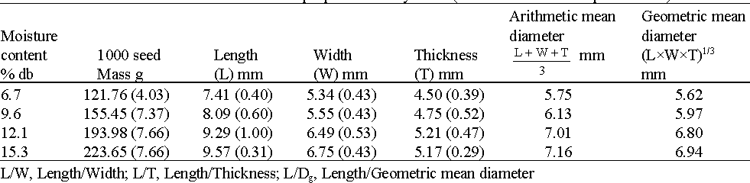
Table 2.1: 1000 seed mass and axial dimensional properties of soybeans (STD in Parentheses)

Source: (Refik et al., 2006).

Mechanical, physical and aerodynamic properties of millet
Ojediran et al. (2006) determine the aerodynamic properties of pearl millet and reported that terminal velocity increased from 3.73 to 5.13 with an increase in moisture content from 10
% to 20 %. Ojediran (2008) conducted a research on the physical and mechanical properties of millet using two varieties and reported his findings as shown in Table 2.1.

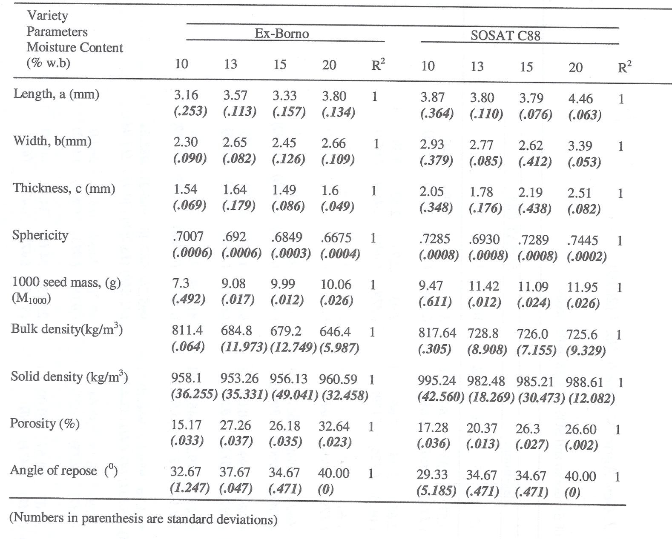

Table 2.2: Some physical properties of Ex-Borno and SOSAT C88 millet seeds

Source: (Ojediran, 2008).

Threshing Parameters
Sharma and Devnani (1978) developed a specially designed variable speed thresher used for determining threshing parameters like feed rate, grain output, threshing efficiency, energy consumption, and grain damage for soybean and cowpea at the sun dried moisture content of 6.1
% and 6.5 % respectively. The authors found that energy consumption in threshing was found to be directly proportional and highly correlated with feed rate and cylinder tip speed, irrespective, of the concave clearance. At the same rate of material flow the cylinder tip speed the energy consumption for cowpea was higher than for soybean. Also the cleaning and separating units for cowpea consumed 0.625 kW hr/g while that of soybean consumed 0.5 kW hr/g.
This higher energy consumption at some speed and feed rate was associated with the more bushy nature of the crop. It was also noted that the peripheral speed of the cylinder and concave clearance were the most important factors that causes grain damage. For the same cylinder speed and concave clearance, the visible grain damage was grater for soybean whereas the internal grain damage was greater for cowpea. It was also noticed that, although at higher speeds the visible grain damage was below 5 %, the internal damage to grain was very high as determined by germination test.

Factors Affecting Grain Threshing

Threshing of soybean, millet and other similar grain crops can be done with a squeezing action, a rubbing action or a combination of the two, and is a function of crop and machine variables. The crop variables are related to the type, variety, maturity, and moisture content. The machine variables include the feed rate, type of cylinder and concave, cylinder tip speed and concave clearance (Sharma and Devnani 1978).

Cylinder tip speed
Semple et al. (1989) stated that damage from rasp bar cylinder increased with peripheral speed, especially at speed above 15.2 m/s. The author also reported that the trend is one of increased crack with increasing or decreasing moisture content. At high kernel moisture content, the soft kernels are easily crushed from impact loading. At low kernel moisture content, the kernel becomes hard and brittle, in this condition it becomes easily fractured under impact loading of the threshing cylinder. Sandra et al. (1981), investigated crack formation in maize kernel due to impact loading. The author found no significant difference in both internal and external damage at cylinder speed of l0 m/s. However, at 18m/s, the author obtained highest internal and external damage. Waeiti and Buchele (1969), reported that mechanical damage to seeds which occur during threshing and other farm operations can seriously affect seed viability, germination ability, growth, vigor, insect and fungal attack and the quality of the final product. Therefore, it is important that threshing be done with care, otherwise this operation can cause damage (crack) of grain or protective husk, thus reducing the products quality and fostering subsequent losses from the action of insects and moulds.

Factors Affecting Grain Cleaning

Grains cleaning occur while particles are changing their orientation rapidly in a random manner within the threshing space. The physical parameters affecting the cleaning process are grouped into:
- Machine factors which include : frequency of sieve oscillation, amplitude of oscillation, sieve slope, length of sieve, width of sieve, sieve hole diameter, threshing pressure, air density, angle of air flow and terminal velocity of the grain.
- Crop factor which include: crop varieties, maturity stage, grain moisture content, straw moisture content, bulk density of grain, bulk density of straw, stalk length, grain diameter and angle of repose.

Terminal velocity
Air separation, also called winnowing has been an age long seed cleaning method used by man, where a mixture of grain and chaff was thrown into the air. The heavy grain fell almost straight back onto the reed tray, while the light chaff was moved laterally by the wind beyond the rim of the tray and fell to the ground. The main disadvantages of natural winnowing are due to unpredicTable direction, velocity and continuity of natural wind (Aguirre and Carry, 1999). Since the wind was not a dependable source of moving air, winnowing was later mechanized, (Vaughn and De Louche, 1968). Wang et al. (1994), stated that when a grain mass enters a processing plant for cleaning, contaminants are removed on the principles of differences of physical characteristics of components in the mixture. These characteristics are; shape, density, surface texture, terminal velocity, color, electric conductivity. The pertinent of these properties is the terminal velocity, which is the speed a seed will attain in free fall before air resistance will keep it from falling faster (Vaughn and De Louche, 1968). The author stated that this phenomenon could be defined in another way as equivalent to that velocity of air required to suspend the seed in a confined rising column of air. Clark (1984) stated that terminal velocity (u_{g}) is given as;

₂ ⎛ ρ_{s} − ρ _{f} ⎞

ug = 3dg⎜ ⎟
⎝
⎠
(2.1)

Where,
⎜ ρ f ⎟

u_{g} = terminal velocity (ms⁻¹)

d = geometric mean of kernel physical dimensions in the three axial directions (m)

ρ_{s} = particle density (kgm⁻³)
ρ_{f} = fluid density (kgm⁻³)

g = gravitational acceleration (ms⁻²)

According to Bolz (1953), the geometric mean of kernel physical dimensions in the three axial directions can be determined as follows;
d = (mean length x mean width x mean thickness)^{1/3} (2.2)

Orientation of particle
Henderson and Newman (1972) stated that when the oscillating frequency of a pan is greater than the natural rocking frequency of a prolate spheroid the particle will orientate itself with its major axis parallel to the plane of oscillation, and when the oscillating frequency of the pan is less than the natural rocking frequency, the particle will orientate itself with its major axis perpendicular to the plane of oscillation. Harrison and Blecha (1983) observed that the natural rocking frequency of grains is considerably larger than the oscillating frequency of commercial grain cleaners, suggesting that the major axis of kernels will be perpendicular to the plane of oscillation. The author stated that an equation relating the rocking frequency, f (Hz), with the major and minor axis is given as:

f = ( )⎢5g⎜
1

−1⎟⎥
⎢b⎜
1

2

+ 6⎟⎥

(2.3)

⎡
12π
⎝
⎣
⎛ a ²
⎜ b2
⎞⎤ 2
⎟
⎠⎦
⎡ ⎛ a ² ⎞⎤
⎣ ⎜ b2 ⎟
⎝
⎠⎦

Where,

f = the rocking frequency (Hz)

a = the length of the major axis (mm)

b = the length of the minor axis (mm)
g = the acceleration due to gravity (mms²)
Refik et al. (2006) determine the aerodynamic properties of soybean at different moisture content. The author stated that the terminal velocity of soybean increases with moisture content as shown in Table 2.3

Table 2.3: Aerodynamic properties of soybean at different moisture content

Moisture content % d.b | Terminal velocity (m/s) | SD
6.7 | 7.13 | 0.31
9.6 | 7.49 | 0.62
12.1 | 8.88 | 0.50
15.3 | 9.24 | 0.56
Source: (Refik et al., 2006).

Types of Shaft Loadings
A load applied to a mechanical member will induce mechanical forces within the member called stresses when those forces are expressed on a unit basis. The stresses acting on the material causes deformation of the material in various manners. The deformation of the material is called strain when those deformations too are placed on a unit basis. The applied load may be axial (tensile or compressive), or shear. The various types of loadings are stated below:

Transverse loading
Transverse loading is where forces are applied perpendicular to the longitudinal axis of a member. Transverse loading causes a member to bend and deflect from the original position, with internal tensile and compressive strains accompanying the change in curvature of the member. Transverse loading also includes shear forces that cause shear deformation of the material and increase the transverse deflection of the member.

Torsional loading
Torsional loading is where twisting action caused by a pair of externally applied equal and oppositely directed force couples acting on parallel planes or by a single external couple applied to a member that has one end fixed against rotation.

Axial loading
Axial loading is where the applied forces are collinear with the longitudinal axis of the member. The forces cause the member to either stretch or shorten. (www.wikipedia.org/wiki/strength of materials/types of shaft loading/)

Important Design Factors (Criteria)
In every design process there are many important design criteria taken into consideration.
Some of these factors are stated as follows.

Factor of safety (FoS)
Factor of safety (FoS) also known as safety factor (SF) is a design criteria that an engineered component or structure must achieve. It is a term describing the structural capacity of a system beyond the expected loads or actual loads. Essentially, it is how much stronger that system is than it usually needs to be for an intended load. Factor of safety is usually defined as the ratio of absolute strength (structural capacity) to actual applied load. This is a measure of reliability of a particular design. Components whose failure could result in substantial financial loss, serious injury, or death may use a safety factor of four or higher. Non critical components generally might have a factor of safety of two.

Design factor
The design factor is defined for an application (generally provided in advance and often set by regulatory code or policy) and is not an actual calculation. The safety factor is a ratio of maximum strength to intended load for the actual item that was designed. Design factors for specific applications are often mandated by law, policy or industry standards.

Reserve factor

A measure of strength frequently used in Europe is the reserve factor (RF). With the applied loads expressed in the same units, the reserve factor is defined as:
RF = Proof Strength / Proof Load
RF = Ultimate Strength / Ultimate Load
Design stresses that have been determined from the ultimate or yield point values of the materials give safe and reliable results only for the case of static loading. Many machine parts fail when subjected to non steady and continuously varying loads even though the developed stresses are below the yield point. Such failures are called fatigue failure. The failure is by a fracture that appears to be brittle with little or no visible evidence of yielding. However when the stress is kept below “fatigue stress” or “endurance limit stress”, the part will endure indefinitely. When a part is subjected to a cyclic stress, also known as stress range (Sr), it has been observed that the failure of the part occurs after a number of stress reversal (N) even if the magnitude of the stress range is below the material‟s yield strength. Generally, the higher the stress range, the fewer the number of reversals needed for failure. For loading that is cyclical, repetitive, or fluctuating, it is important to consider the possibility of metal fatigue when choosing factor of safety. A cyclic load well below a material‟s yield strength can cause failure if it is repeated through enough cycles (www.wikipedia.org/wiki/strength of materials/terms used in design/).

Performance Tuning
Performance tuning is the improvement of a system performance. It is typical with computer systems. Steps of performance tuning involve measuring; evaluating, improving and validating until the goal are reached as listed below.
- assess the problems by evaluating the performance of the machine before modification.

- analyze the result.

- identify the parts of the machine that were critical for improving the performance. These were the bottleneck.

- modify these parts of the machine to remove the bottleneck.

- evaluate the performance of the machine again after the modifications were completed.

- if the modification makes the performance better, adopt it. If the modification makes the performance worse, put it back the way it was. (www.wikipedia.org/wiki/performance_tuning).
Certain rules should be kept in mind when optimizing performance:

- performance tuning must be part of every project.

- do not optimize early in the development cycle.

- performance is only as good as the weakest link.

- always think about capacity vs. volume.

- optimize important things first.
- never optimize without realistic goals. (www.docs.adobe.com/docs/en/cq/5-6-1/deploying/performance.html)

Threshing and Separation Model Development
Threshing and separation process can be divided into the following sections:

- Detachment of the grains from the ears by which the grains becomes free separable grains in the threshing space.
- Segregation of free grains kernels through the straw mat to the concave/grate surface.

- Passing of free grains kernels through the opening of concave or grates. (Huynh et al., 1982, Miu, 1994, 1995)
(Wacker, 1985; Gasparetto et al., 1989; Miu, 2002) has developed the universal mathematical model for grain threshing and separation. The distribution frequency of un- threshed grain percentage into the threshing space is a continuous variable. At the end of the threshing space (e.g x=L for axial unit), the un-threshed grain becomes threshing loss, V_{t} (%).

Vt = Sn
(L) = e^{−λL}
(2.4)

Where,

V_{t} = Threshing loss (%)

S_{n} = Percentage of un-threshed grain
L = Length of the threshing space (m)
λ = Space increments between respective successive event changes (m⁻¹)
Enaburekan (1994) developed mathematical and optimization models for the threshing process in a stationary grain thresher using wheat and sorghum. He developed amongst others the following threshing efficiency model:

Et
Where,
= 1 − e−3KT ρ (1−α )VWDL/ 2QC

(2.5)

E_{t} = threshing efficiency (%)

K_{T} = threshing constant

ρ = crop bulk density (kgm⁻³)

α = crop moisture content (%, dry basis) V = velocity of threshing cylinder (m/s) W = width of thresher (m)
D = effective cylinder diameter (m)

L = concave length (m)

Q =crop mass feed rate (kg/s)

C= concave clearance (m)

Miu, (1995) developed a universal mathematical model of grain threshing and separation and was applied to tangential feeding (Miu et al., 2008). The probability that grains will reach the separation surface is the same over the separation length as the probability of free grain passage through the openings of separation surface (Huynh et al., 1982; Mailander, 1984; Miu,

1994, 1995; Miu et al., 2008; Kutzback and Quick, 1999). The probabilistic laws that respectively describe the above mentioned events were identified as follows:

(a)
Fx ( x)
= e− λx
(2.6)

(b)
F (x) = λ (e ^{−βx} − e ^{−λx} )
f λ − β

(2.7)

(c)
FS (x) =
1
λ − β
[λ(1 − e^{−βx} )− β (1 − e^{−λx} )]

(2.8)

Where,

F_{x} (x) = un-threshed fraction over the threshing length, x.

F_{f}(x) = free grain fraction

F_{s} (x) = cumulative separated grain, fraction

λ and β are probability density function, in decimals, as defined on the threshing space length (x). They represent space increments between respective successive event changes.
λ =specific threshing / segregation rate (m⁻¹).
β = specific separation (m⁻¹)

Ndirika (1997) developed mathematical and optimization models for the threshing process in a stationary grain thresher using millet and sorghum. The author developed amongst other things the following threshing model:

Te = 1− e
−1.5Kt ρ_{d} DVb Lc
(1−β ) Fr

(2.9)

Where,

T_{e} = threshing efficiency parameter (%)

K_{t} = threshing constant

ρ = bulk density (kg/m³)

V_{b} = cylinder velocity (m/s)

L_{c}= concave length (m)

F_{r} = feed rate (kg/s)

D = cylinder diameter (m)
β = moisture content (%, dry basis)

Dimensional Analysis
Dimensional analysis offers a method for reducing complex physical problems to the simplest form prior to obtaining a quantitative answer. To understand its principles, we must return to some of the very fundamental concepts in science (Sonin, 2001).

Methods of dimensional analysis
The following two methods are important to develop the Effect of physical quantities:

- Rayleigh‟s method.

This method of dimensional analysis was originally proposed by Lord Rayleigh in 1899. In this method, functional relationship of variables is expressed in the form of an exponential equation which must be dimensionally homogeneous. It has been observed that Rayleigh‟s method of dimensional analysis becomes bulky when more variable are involved. In order to overcome this, Buckingham‟s method may be used.
- Buckingham‟s pi-theorem

When a complete Effect of dimensional physical quantities is expressed in dimensionless form, the number of independent quantities that appear in it is reduced from the original n to n-k, where k is the maximum number of the original n that are dimensionally independent.

Thus:

If πo = F ( A1 , A2 ,..., An )

(2.10)

Then

π_{o}= f (π₁, π₂,…, π_{r<n}) (2.11)

Where,

π_{o} = dependent variable.

A₁, A₂,…,A_{n}= independent variables.

π₁, π₂,…, π_{r<n}= non dimensional groups of A_{i}‟s.

F, f = functional relationships of A_{n}‟s and π_{r}‟s respectively.

Every correct physical equation; that is every equation that expresses a physically significant Effect of numerical values of physical quantities must be dimensionally homogeneous. Dimensionally homogeneity imposes the following constraints on any mathematical representation of a relationship:
- Both sides of the equation must have the same dimension.

- Where a sum of quantities appears in f, all the terms in the sum must have the same dimension.
- All arguments of any exponential, logarithmic, trigonometric or other special functions that appear in f must be dimensionless.

For example; if a physical equation is represented by
A = Be^{−C} − (D1 + D2 ) + F
E

(2.12)

C must be dimensionless, D₁ and D₂ must have the same dimension, and A, B, D/E and F must have the same dimension. An important consequence of dimensional homogeneity is that the form of a physical equation is independent of the size of the base units.

Methods of determining pi terms
- Inspection method

- Step-by-step Method
- Exponent Method

Performance Optimization
To optimize is to make as effective, perfect, or useful as possible. In mathematics it is to determine the maximum or minimum values of a specified function that is subject to a set of constraints. In engineering design it is to find the best compromise among several often conflicting requirements (www.thefreedictionary.com/optimize).
Process optimization is the discipline of adjusting a process so as to optimize some specified set of parameters without violating some constraint. The most common goals are minimizing cost, maximizing output, and/or efficiency. When optimizing a process, the goal is to maximize one or more of the process specifications, while keeping all others within their constraints (www.wikipedia.org/wiki/process_optimization).

MATLAB optimization process
MATLAB optimization is done with MATLAB software. A MATLAB optimization tool “optimtool” is used to select the solver, the optimization options and to run the problem. The optimization tool provides a convenience interface to all optimization routings including those of Genetic Algorithm and Direct search toolbox functions and the results exported to an M-file or to the MATLAB workspace as a structure. The optimization tool also made it easier to:
- Define and modify the problem quickly

- Use the correct syntax for optimization functions

- Import and export from the MATLAB workspace

- Generate code containing configurations for the solver used and options

- Change parameters of the optimization during the execution of certain genetic Algorithm and direct search Toolbox Functions
The steps involved in the MATLAB optimization process include:

- Problem formulation

- Defining the problem in the MATLAB toolbox syntax

- Running the optimization

- Interpreting the Result (Cleve et al., 2008).

Description of the Existing IAR Multicrop Thresher
The IAR multicrop thresher is a vertical flow thresher consisting of the following components: a feed hopper, threshing unit, suction unit, shaker unit, sieve plate, shaker tray, structural frame and power transmission unit. The feed hopper which is trapezoidal in cross section is constructed from gauge 18 mild steel metal sheet with a dimension of 375 mm x 50 mm x 332 mm. The threshing unit consists of a cylinder, beaters and perforated concave Plate. Clearance between the free end of the beaters and concave was 20 mm for soybean threshing and 10 mm for millet threshing. Beaters made of rasp bars are attached on the cylindrical- shaped threshing cylinder. A concave sieve plate made of square iron rods is located below the threshing cylinder to separate the threshed grains from the chaff. As the threshed materials flows down the funnel by gravity onto the shaker, chaff are further removed by a suction fan located at one end of the shaker. The shaker sieve plate constructed with gauge 16 mild steel metal sheet is positioned inside the shaker to separate the chaff that falls along with the grains. The clean grain is then collected in the bottom tray and conveyed through the grain outlet. The structural frame consists of four vertical angle iron 1000 mm high positioned at the four corners of the machine. Two angle iron 800 mm long are welded along its length to support the bottom cover of the machine while two square pipes 470 mm long are welded along its width to support the bearings of the threshing cylinder. The power transmission unit consists of pulleys, V-belts and a 5 Hp petrol engine mounted on a structural frame. The thresher is stationary with its entire weight resting on the ground. A preliminary performance test conducted, indicated that the existing IAR multicrop thresher had a maximum feed rate of 3 kg/min with millet when operated at a speed of 20 m/s. At this speed, the Threshing efficiency, Cleaning efficiency,

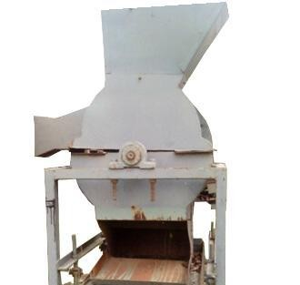
Scatter loss, Grain damage and Output capacity obtained with SOSAT C88 Millet variety were 92 %, 80 %, 2.4 %, 3.5 %, and 81 kg/hr respectively. Plates 2a and 2b are rear and front views of the existing IAR multicrop thresher used for threshing millet and sorghum.

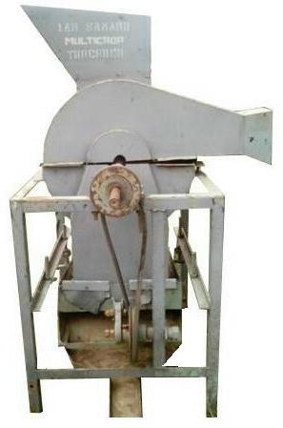
Plate 2a: Rear view of the existing IAR multicrop thresher used for threshing millet and sorghum.

29

Plate 2b: Front view of the existing IAR multicrop thresher used for threshing millet and sorghum.

CHAPTER THREE

MATERIALS AND METHODS

Design Considerations
The following factors were considered in the design of the multicrop thresher:

- The choice of materials used for construction of the machine was based on durability, strength, cost and availability in the local market.
- The size of the feed hopper was increased to accommodate bulky crops.

- The threshing drum diameter was varied along its length to increase volume.

- The peripheral threshing cylinder speeds were in the range 10 to 20 m/s.

- Millet and soybean grain characteristics were considered in determining concave clearance and sieves hole diameter of the concave and shaker sieves.
- The terminal velocities of free falling grains were considered in determining the number of blades on the blower for perfect cleaning.
- The frequency of the shaker was maintained at 2.4 Hz and the shaker tray was maintained at a slope angle of 23 º to the horizontal for easy grain flow.
- All power transmission was made to take place at one end of the shaft

- The moisture content wet bases considered were in the range 10 % to 16 %.

- The strength of soybean and millet stem was considered in selecting the thickness of the shredder, top sieve and beaters.
- The total volume of crop fed per minute was considered in selecting the volume of the hopper and threshing chamber.
- The operator‟s safety was considered by locating the operator‟s stand away from all rotating machine parts and crop particles propelled by the machine.
- Towing of the machine was considered by incorporating a tow bar and rear wheels.

Selection of Construction Materials
The following materials were selected and used: Gauge16 (3 mm) and 18 (2 mm) mild steel sheets, medium carbon steel rods (C1040), angle iron bar (250 mm x 250 mm x 3 mm), square pipe (250 mm x 250 mm x 3 mm), pulleys (of different diameters), V-belts (of different lengths), Flat belt, bolts and nuts, bearings (of different diameters), spraying machine, leaf green paint and two 14 inches tires.

Design Equations (Design Theories)
The following equations were employed in the design of the machine.

Determination of blower casing diameter
Mohammed (2009) and Hem (1981) stated that the airflow (QA) through a blower is

given as;

QA = V × D ×W

(3.1)

Where,

V= velocity of air required for cleaning, (ms⁻¹).

D = depth of air stream (m).

W= width over which air is required (m).

The authors stated that the efficiency of a centrifugal blower is 30 %. Therefore, theoretical air discharge (Q_{T}) is given as:

Q = QA

(3.2)

^{T} 0.3
Also, the outer casing of a blower should follow a spiral of the arithmetic form given by the equation below:

γ = γ o (1 + κθ )
(3.3)

Where,
γ = radius of casing at 6° shift from initial radius of casing (mm). γ_{o} = initial radius of casing (mm).
k = constant (0.0020 to 0.0023).

θ = angular displacement in degrees.

Determination of shaker frequency of oscillation
Harrison and Blecha (1983) stated that an equation relating the rocking frequency f (Hz), with the major and minor axis is given as:

f = ( )⎢5g⎜
1

−1⎟⎥
⎢b⎜
1

2

+ 6⎟⎥

(3.4)

⎡
12π
⎝
⎣
⎛ a ²
⎜ b2
⎞⎤ 2
⎟
⎠⎦
⎡ ⎛ a ² ⎞⎤
⎣ ⎜ b2 ⎟
⎝
⎠⎦

Where,

f = the rocking frequency (Hz)

a = the length of the major axis (mm)
b = the length of the minor axis (mm)
g = the acceleration due to gravity (mms²)

Determination of threshing cylinder diameter

Hem (1981) recommended the peripheral cylinder speed V for maize threshing to fall in the range 750 to 1220 m/min, while Mohammed (2009) recommended the number of revolutions of the threshing cylinder N for maize threshing to fall in the range 450 to 986 rpm. The threshing cylinder diameter was determined by Hem (1981) and Mohammed (2009) as follows:

V = πDN
(3.5)

Where,

D = diameter of circle inscribed by beater tip (m)
N = number of revolution of the threshing cylinder (rev/min)

V = peripheral cylinder speed (m/min)

Hence
D = V
πN

Also, D = d + 2 p Where,
D = diameter of circle inscribed by beater tip (m) d = diameter of threshing cylinder (m)
p = height of peg (m) Therefore, d = D - 2p

and d =
V
πN - 2 p

Determination of concave sieve radius
Nalado (2006) and Mohammed (2009) stated the expression for determining the concave sieve radius as follows:

rc = rd + hp + cc
(3.6)

Where,

r_{c} = radius of concave sieve (mm)

r_{d} = radius of threshing cylinder (mm)

h_{p} = height of peg (mm)

c_{c} = concave clearance (mm)

Determination of sieve hole diameter
(ASAE, 1984) stated the expression for determining the diameter of sieve hole as follows:
(3.7)

Where,

D_{e} = equivalent diameter (sieve hole) (mm)

V_{g} = grain volume (mm³)

Determination of power required for sieve oscillation
Hem (1981) stated that the power required for oscillation is the summation of the power required for movement in the vertical and horizontal directions.
Power required for vertical and horizontal movement were given as:

kW1

kW2
= ws × N × 2 × y

4500

= ws × N × μ × 2 × x

4500

(3.8)

(3.9)

Where,

kW₁= the power required for vertical movement

kW₂ = the power required for horizontal movement

w_{s}= weight of reciprocating unit along with the material on it (kg)

N = eccentric speed (rpm)

y = the vertical displacement of the reciprocating system in meter per stroke x = the horizontal displacement of reciprocating system in meter per stroke μ = the kinetic coefficient of friction at hinge points
Total power required for sieve oscillation was therefore given by:
P = kW₁ +kW₂

Determination of weight of the blower blades
Hannah and Steven (1984) stated the expression used for determining the weight of

blower blades (W_{b}) as follows:
Wb = δgv

(3.10)

Where,

W_{b} = weight of blower blade (N)

δ = density of blower galvanized steel blade (kg/m³)

g = acceleration due to gravity (m/s²)

v = volume of the blower blades (length x width x thickness) (m³)

Determination of fan speed required for cleaning
Joshi (1981) stated the expression for determining air discharge through the blower as

follows:

V = 2πrN
60

(3.11)

Where,

N = fan speed (rpm)

V = air velocity required for cleaning (m/s)

r = distance between the center of the shaft to the apex of the fan blade (m)

Determination of air discharge by blower
Joshi (1981) stated that the air flow rate was given as:

Q = AV (3.12)

Where,

Q = air flow rate (m³/s)
A = area of inlet duct of the blower (m²)
V = terminal velocity of the threshed grain (air velocity required for cleaning) (m/s)

But A = LW

Where,

A = area of inlet duct of the blower (m²) L = length of inlet duct of the blower (m) W = width of inlet duct of the blower (m)

Determination of number of blades
Joshi (1981) stated that the number of blades required by a blower was obtained as:

N = Q
b V
(3.13)

Where,

N_{b} = number of blades required

V= volume of air displaced per blade (m³)

Q= required air flow rate for cleaning (m³/s)

Determination of pulleys diameter
Hannah and Stephen (1984) stated the expression used for determining pulleys diameter

(D) as follows:

N1 D1 = N2 D2

(3.14)

Where,

N₁ = speed of drive (petrol engine) pulley (rpm)

D₁ = diameter of drive Pulley (m)

N₂= speed of driven pulley (rpm)

D₂ = diameter of driven pulley (m)

Determination of belt length
Khurmi and Gupta (2007) stated the expression used for determining length of each belt
of a machine (L) as follows:
π (D − d )2

L = (D + d ) + 2c +
2 4c
(3.15)

Where,

L = effective length of belt (cm)

c = center distance from drive to driven pulley (cm)

d = outside diameter of drive pulley (cm) D = diameter of driven pulley (cm)

Determination of belt speed
Hannah and Stephen (1984) stated the expression used for determining speed of each belt

of a machine (V) as follows:

V = πDN
60

(3.16)

Where,

N = drive speed (rpm)

D = diameter of drive pulley (m)

V = belt speed (m/s)

Determination of belt tension ratio
Hannah and Stephen (1984) stated the expression used for determining the tension on each belt of a machine (T) as follows:

Tt = eμθ cosec(β )
Ts
(3.17)

Where,

T_{t} = tension on the tight side of belts (N) T_{s} = tension on the slack side of belts (N) θ = angle of lap (º)
β = one half angle of the pulley groove (º)

µ = coefficient of friction between the belt (rubber) and the pulley (steel)

Also T_{t} –T
= mt
s r
(3.18)

Where,
m_{t} = torsional moment (Nm)
r = radius of driven pulley (m)

Determination of torsional moment

Hannah and Stephen (1984) established the expression used for determining torsional moment of a machine (m_{t}) as follows:

m_{t} =
P , and
w
w = 2πN
60

Hence m_{t} =
Px60 (3.19)
2πN

Where,

m_{t} = torsional moment (Nm)

P = rated engine power (kW) w = angular velocity (rads/sec) N = rated engine speed (rpm)

Determination of angle of lap (contact) of belt

Mohammed (2009) determines the angle of lap (θ) of a V- belt as follows:

θ = 180 − 2 sin ⁻¹ ⎛ R − r ⎞
(3.20)

1 ⎜ C ⎟
⎝
⎠

θ = 180 + 2 sin ⁻¹⎛ R − r ⎞
(3.21)

2 ⎜ C ⎟
⎝
⎠

Where,
R = radius of larger pulley (mm)

r= radius of smaller pulley (mm)

C = center distance between driven and driving pulleys (mm)

θ₁ =angle of lap for smaller pulley (º)

θ₂ =angle of lap for larger pulley (º)

Determination of power required by the engine
The power required by the engine for threshing and cleaning soybean/millet was determined by the relationship:
P_{E} = P_{T}+P_{C} (3.22)

Where,

P_{E} = engine power (kW)

P_{T} = power required for threshing (kW)

P_{C} = power required for cleaning (kW)

But,

P_{E} = T_{E}W_{E} P_{T} = T_{T}W_{T} P_{C} = T_{C}W_{C}
Where,

T_{E} = engine torque (Nm)

W_{E} = angular velocity of engine (rads/sec)

T_{T} = torque required for threshing (Nm)

W_{T} = angular velocity required for threshing (rads/sec)

T_{C} = torque required for cleaning (Nm)
W_{C} = angular velocity required for cleaning (rads/sec)

Determination of power required by the blower
The power required by the blower was determined according to William et al. (2015)

thus:

P = Pd Q

(3.23)

P = 1 ρV ²
d 2
Where:

P = power required by the blower (W)

P_{d} = dynamic pressure (N/m²) Q = volume flow rate (m³/s)
ρ = density of air (kg/m³) V = velocity of air (m/s)

Determination of weight of a material
Hannah and Stephen (1984) stated the expression used for determining the weight of a material as follows:
W = δgv (3.24)

Where,

W = weight of material (N)

δ = density of galvanized steel (kg/m³)

g = acceleration due to gravity (m/s²)

v = volume of the material (length x width x thickness) (m³)

Determination of shaft diameter
To determine the diameter of a shaft ASME code (1948) stated that the maximum allowable shear stress is obtained as the lower value of 18 % ultimate tensile stress (S_{t}) and 30 % yield stress (S_{y}). And for shaft with keyway the maximum allowable shear stress is reduced by 25 % to take care of the stress concentration.
Hall and Holowenko (1982) stated the expression for determining the diameter of a shaft that is subjected to only bending and torsion as follows:
t
t

d ³ =
16
πSa
(Kb Mb
)2 + (K M )2
(3.25)

Where,
d = shaft diameter (m)
S_{a} = allowable shear stress (N/m²)
M_{b} = bending moment (Nm)

M_{t} = torsional moment (Nm)

K_{b} = combined shock and fatigue factor applied to bending moment (1.5)

K_{t} = combined shock and fatigue factor applied to torsional moment (1.0)

Design Calculations
The following calculations were conducted in the design of the machine. Details of the calculations are shown on Appendix A.

Determination of blower casing diameter
The diameter of blower casing was determined using the expression in equation (3.3).
γ = γ o (1 + κθ )

γ_{o} = radius of blade + clearance = 176 mm + 14 mm = 190 mm

k = 0.0023

θ = 15° (assume a displacement of 15° from initial position)

γ = 190 (1+ 0.0023×15) = 196.555 mm

A radius of 197 mm was determined thus, the diameter of the blower casing was chosen to be 394 mm.

Determination of threshing cylinder diameter
The threshing cylinder diameter was carefully selected. The threshing cylinder was designed to have two different diameters along its length. A section on the cylinder was chosen to have a diameter of 210 mm. This forms the larger diameter section of the threshing cylinder which lay directly below the feed hopper so that crops such as soybean with cultivars ranging from 450 mm to 1200
mm will not entangle easily on the cylinder. Another section on the cylinder was chosen to have a diameter of 160 mm. This forms the smaller diameter section of the threshing cylinder with a larger threshing volume to accommodate much threshing material at a time. Both diameters were carefully selected to solve the problem of bulky crops such as soybean and millet entangling the cylinder causing it to slow down or stop as was observed on the existing IAR multicrop thresher.

Determination of sieves hole diameter
The diameter of sieve hole was determined using the expression in equation (3.7).
D = [6V π 1
e
]
g
3

The grain volume of SOSAT C88 millet seed at 20 % moisture content V_{g} = 37.9496 mm³

For easy discharge of grains the chosen diameter was made 20 % larger than the calculated equivalent diameter of the millet seed.
Thus, the chosen diameter D = 0.2D_{e} +D_{e}

The sieve hole diameter for millet threshing was determined to be 5 mm.

The grain volume of TGX 1485-ID soybean seed at 15 % moisture content V_{g} =163.36 mm³

For easy discharge of grains the chosen diameter was made 25 % larger than the calculated equivalent diameter of the soybean seed.
Thus, the chosen diameter D = 0.25D_{e} +D_{e}
The sieve hole diameter for soybean threshing was determined to be 8.5 mm.

Determination of the concave sieve radius
The radius of the concave sieves was determined using the expression in equation (3.6).

rc = rd + hp + cc

r_{d} = 80, h_{p} = 130, c_{c} = 20 for soybean and c_{c} = 10 for millet Thus, r_{c} = 80 + 130 + 20 = 230 mm
The soybean concave sieve radius was determined to be 230 mm Thus, r_{c} = 80 + 130 + 10 = 220 mm
The millet concave sieve radius was determined to be 220 mm

Determination of fan speed required for cleaning
The fan speed required for cleaning was determined using the expression in equation

(3.11).

V = 2πrN
60
The terminal velocity of millet (V)= 5.13 m/s, r = 0.176 m Hence, 5.13 = 2 × π × 0.176× N
60

5.13× 60
N = 2 × π × 0.176
= 278.1 rpm

The fan speed required for cleaning millet was determined to be 278.1 rpm The terminal velocity of soybean (V) = 9.24 m/s, r = 0.176 m

Hence,
9.24 = 2 × π × 0.176× N
60

9.24× 60

N = 2 × π × 0.176
= 501.1 rpm

The fan speed required for cleaning soybean was determined to be 501.1 rpm

Determination of air discharge by the blower
The air discharge by the blower was determined using the expression in equation (3.12).

Air flow rate (Q) = AV

But the area of inlet duct of the blower (A) = LW L = 0.510 m, W = 0.126m
A = 0.510 x 0.126 = 0.06426 m²
Considering the terminal velocity of the heavier grain V = 9.24 m/s Therefore, Air flow rate Q = 0.06426 x 9.24 = 0.5938 (m³/s)
Since the efficiency of a blower is 30 %, (Hem, 1981) the actual air flow rate was given as:

Q_{a} = 0.3 x 0.5938 = 0.1781 (m³/s)

Therefore, the actual air flow rate of the blower was determined to be 0.1781 (m³/s)

Determination of the number of blades required
The number of blades required was determined using the expression in equation (3.13).

Volume of air displaced = Area of blade x Distance covered by blade per second
V = (l × w)× (π × D)

l = 430 mm = 0.43 m, w = 130 mm = 0.13 m, D = 260 mm = 0.26 m
Therefore, V = (0.43 × 0.13)× (π × 0.26)= 0.04566 (m³/s)

The number of blades (N_{b}) required = Actual air flow rate / Volume of air displaced per blade (V)

N = Qa
b V

N = Qa
b V
= 0.1781
0.04566
= 3.9

N_{b} = 3.9 ≈ 4

The number of blades required by the machine was determined to be four.

Determination of weight of the blower
The weight of the blower was determined using the expression in equation (3.10).
Wb = δgv

δ = 7850 (kg/m³), g = 9.81 (m/s²), v = (0.43 x 0.13 x 0.002) = 1.118 x 10⁻⁴ (m³)

Hence, all four blower blades W₁= 34.4 N The weight of blower shaft (W₂) = 18.9 N The weight of blower pulley (W₃) = 13.1 N
Therefore, W_{b} = W₁ + W₂+ W₃ = 34.4 + 18.9 + 13.1 = 66.4 N

The weight of the blower was determined to be 66.4 N; thus the mass was 6.64 kg

Determination of pulley diameters
The pulley diameters were determined using the expression in equation (3.14).

N1 D1 = N2 D2

The diameter of the driven cylinder pulley (D₂) was determined as shown below:

N₁ = 1300 rpm, D₁ = 100 mm, N₂= 650 rpm

Thus,
D = N1 D1
2
N
2
= 1300x100 = 200 mm
650

The diameter of the driven cylinder pulley D₂ was chosen to be 200 mm.
The diameter of the shaker pulley (D₄) was determined as shown below:
N₃ = 650 rpm, D₃ = 90 mm, N₄ = 189 rpm

Thus,
D = N 3 D3
4
N
4
= 650 × 90
189
= 309.5 ≈ 310 mm

The diameter of the shaker pulley was determined to be 310 mm.

The diameter of the blower pulley (D₅) was determined as shown below:

N₄ = 650 rpm, D₄ = 200 mm, N₅ = 929 rpm

Thus,
D = N 4 D4
5
N
5
= 650× 200 = 140 mm
929

The diameter of the blower pulley was determined to be 140 mm.

Determination of belt lengths

L = π
2
The length of each belt was determined using the expression in equation (3.15).
(D − d )2
+ + +
(D d ) 2c
4c

The cylinder belt length (L₁) was determined as shown below:

c =107 cm, d =10 cm, D =20 cm

π ( ) (20 −10)2
261.4

Thus,
L₁ = 2 (20 +10) + 2 107 +
4(107)
= 261.4 cm OR
2.5
= 104.5 ≈ 105 inches

The cylinder belt length was determined to be A105.

The shaker belt length (L₂) was determined as shown below:

c = 42 cm, d = 9 cm, D = 31 cm

π

(31− 9)2

149.7

Thus,
L2 =
(31+ 9) + 2(42) +
2
4(42)
= 149.7 cm OR
2.5
= 59.9 ≈ 60 inches

The shaker belt length was determined to be A60.

The blower belt length (L₃) was determined as shown below:

c = 64 cm, d = 20 cm, D = 14 cm

π

(14 − 20)2

181.5

Thus, L3 = 2 (14 + 20) + 2(64) +
4(64)
= 181.5 cm OR
2.5
= 72.6 ≈ 73 inches

The blower belt length was determined to be A73

Determination of belt speeds

The speed of each belt was determined using the expression in equation (3.16).

V = πDN
60
When the prime mover was set at 909 rpm, the cylinder belt speed was determined as shown below:
N = 909 (rpm), D = 100 mm = 0.1 (m)

Thus, V1
= π × 0.1× 909 = 4.76 m/s
60

The cylinder belt speed was determined to be 4.76 m/s.
When the prime mover was set at 909 rpm, the shaker belt speed was determined thus: N₁D₁ = N₂D₂
N₁ = 909 rpm, D₁ = 100 mm, D₂ = 200 mm

N₂ was determined to be = 454.5 (rpm)

D₃ = 90 mm = 0.09 (m)

Thus, V₂
= π × 0.09 × 454.5
60
= 2.14 m/s

The shaker belt speed was determined to be 2.14 m/s.

When the prime mover was set at 909 rpm, the blower belt speed was determined as shown below:
N₂ = 454.5 (rpm)

D₂ = 200 mm = 0.2 (m)

Thus, V₃
= π × 0.2 × 454.5 = 4.76 m/s
60

The blower belt speed was determined to be 4.76 m/s

Determination of angles of lap (contact) of belts
The angle of lap (contact) of V-belt on a pulley was determined using the expression in equations (3.20) and (3.21).

θ = 180 − 2 sin ⁻¹ ⎛ R − r ⎞
1 ⎜ C ⎟
⎝
⎠

θ = 180 + 2 sin ⁻¹⎛ R − r ⎞
2 ⎜ C ⎟
⎝
⎠

The belt lap angles between prime mover and cylinder pulleys:
R = 100 mm, r = 50 mm and C = 1160 mm
The lap angle on the prime mover pulley was 175.1 º and that on the cylinder pulley was 184.9 º.

The belt lap angles between cylinder and shaker pulleys:

R = 155 mm, r = 45 mm and C = 420 mm

The belt lap angle on the cylinder pulley was 149.6 º and that on the shaker pulley was 210.4 º.

The belt lap angles between cylinder and blower pulleys:

R = 100 mm, r = 70 mm and C = 640 mm

The belt lap angle on the cylinder pulley was 185.4 º and that on the blower pulley was174.6 º.

Determination of power required to oscillate sieve
The power required to oscillate sieve was determined using the expression in equations (3.8) and (3.9).

kW1

kW2
= ws × N × 2 × y

4500
= ws × N × μ × 2 × x

4500

w_{s} = 15 kg, N = 900 rpm, x = 4 cm, y = 4 cm and μ=0.08

Power required for vertical movement (kW₁) was determined to be = 0.24 kW Power required for horizontal movement (kW₂) was determined to be = 0.02 kW Total power required P = kW₁ + kW₂
P = 0.24 + 0.02 = 0.26 kW

The power required to oscillate sieve was determined to be 0.26 kW

Determination of power required by the blower
The power required by the blower was determined using the expression in equation

(3.23).

P = Pd Q

P = 1 ρV ²
d 2
ρ =1.165 kg/m³ at 30 ºC, V = 9.24 m/s, Q = 0.5938 m³/s
P = 1 ×1.165(9.24)2 = 49.73 N/m²
d 2

P = 49.73× 0.5938= 29.53 W = 0.03 kW
The power required by the blower was determined to be 0.03 kW

Determination of power required by the engine
The power required by the engine for threshing soybean or millet was determined using the expression in equations (3.22)
P_{E} = P_{T}+P_{C}
But, P_{E} = T_{E}W_{E}, P_{T} = T_{T}W_{T}, P_{C} = T_{C}W_{C}
The power required for cleaning (P_{C}) equals the power required by the shaker and the power required by the blower.
The power required by the shaker was determined previously as 0.26 kW and that required by the blower was also dertermined to be 0.03 kW.
Hence, P_{C} = 0.26 + 0.03 = 0.29 kW

The power required to thresh crop equals the total torque on the shaft multiplied by the total angular velocity.
Thus, PT = TTWT
The total torque on the shaft is equal to the effective torque on the beaters required for cutting plus that required for threshing.

Hence, T_{T} = 23.94 +7.56 = 31.5 Nm

The threshing speed of the IAR thresher for soybean and millet was determined during preliminary test to be (20 m/s). From Appendix O3 the diameter of the peripheral cylinder was 420 mm or 0.42m. Hence, the required speed of the threshing cylinder for the developed thresher was determined as follows:
V = πDN
60

20 = π × 420× N
60

60 × 20

N = π × 0.42
= 909rpm

Hence, for the developed thresher 20 m/s equals to 909 rpm. Thus,

W = 2πN =
^{T} 60
2π 909 = 95.19 rads / sec
60

And PT = TTWT
PT = 31.5 × 95.19 = 2998 .49 W = 3 kW

Therefore the power required for threshing soybean or millet was 3 kW.

The engine power required for threshing soybean or millet was determined thus:

P_{E} = P_{T} + P_{C} P_{E} = 3 + 0.29 P_{E} = 3.29 kW
The engine power required for threshing and cleaning soybean or millet was determined to be 3.29 kW.

Determination of belt tensions ratio

The tension on each belt (T) was determined using the expressions in equations (3.17), (3.18) and (3.19).

m_{t} =
P , and
w
w = 2πN
60

Hence, m_{t} =
P × 60

2πN

Also, m_{t} = (T_{t} –T_{s}) r

T_{t} –T
= mt
s r

Tt = eμθ cosec(β )
Ts

θ = 175.1º, β = 20º and µ = 0.5

The belt tension driving the cylinder pulley on the slack side was 7.04x10⁻⁴⁰ N and that driving the cylinder pulley on the tight side was 313.3 N
The initial tension on the cylinder belt (T_{i}) was 156.65 N θ = 149.6º, β = 20º and µ = 0.5
The belt tension driving the shaker pulley on the slack side was 9.2 x10⁻³⁵ N and that driving the shaker pulley on the tight side was 35.23 N
The initial tension on the shaker belt (T_{i}) was 17.62 N θ = 185.4º, β = 20º and µ = 0.5
The belt tension driving the blower pulley on the slack side was 1.25x10⁻⁴⁴ N and that driving the blower pulley on the tight side was 9 N
The initial tension on the blower belt (T_{i}) was 4.5 N

Determination of shaker frequency of oscillation
The frequency of oscillation of the shaker tray was determined using the expression in equation (3.4).

f = ( )⎢5g⎜

1

−1⎟⎥

⎢b⎜
1

2

+ 6⎟⎥

⎡
12π
⎝
⎣
⎛ a ²
⎜ b2
⎞⎤ 2
⎟
⎠⎦
⎡ ⎛ a ² ⎞⎤
⎣ ⎜ b2 ⎟
⎝
⎠⎦

With a = 505 mm, b = 140 mm and g = 10000 mms²

The frequency of oscillation of the shaker tray was determined to be 2.4 Hz. Therefore the shaker makes 2.4 circles per second.

Determination of torsional moment
The maximum torsional moment was determined using the expression in equation (3.19).

m_{t} = P ,
w
w = 2πN Hence, m_{t} =
60
P × 60

2πN

Determination of torsional moment required for threshing (M₁)
From above, the total torque on the shaft required for threshing was calculated to be 31.52 Nm.

Determination of torsional moment required by shaker shaft (M₂)
P = 0.26 kW and N = 454.5 rpm M₂ = 5.46 Nm.

Determination of torsional moment required by the blower shaft (M₃)
P = 0.03 kW and N = 454.5 rpm M₃ = 0.63 Nm.
The maximum torsional moment of the machine was given by:

m_{t} = M₁ + M₂ + M₃

m_{t} = 31.52 + 5.46 + 0.63

m_{t} = 37.61 Nm

The maximum torsional moment used for threshing and cleaning was 37.61 Nm

Determination of total load on the threshing cylinder shaft
The weight of a material was determined using the expression in equation (3.24).

W = δgv

Determination of threshing cylinder weight (W₁)
δ = 7850 (kg/m³), g = 9.81 (m/s²) and v = 2.271 x 10⁻³ (m³)
W₁= 7850 x 9.81 x 2.271 x 10⁻³ = 174.9 N

Determination of beaters weight (W₂)
δ = 7850 (kg/m³), g = 9.81 (m/s²) and v = 9.31 x 10⁻⁴ (m³)
W₂ = 7850 x 9.81 x 9.31 x 10⁻⁴ = 71.7 N

Determination of chaff thrower weight (W₃)
δ = 7850 (kg/m³), g = 9.81 (m/s²) and v = 2.1 x 10⁻⁴ (m³)

W₃ = 7850 x 9.81 x 2.1 x 10⁻⁴= 16.2 N

The total load on the threshing cylinder shaft was given by:

W = W₁ + W₂ + W₃

W = 174.9 + 71.7 + 16.2 = 262.8 N

The total load on the shaft due to the cylinder, beaters and chaff throwers was 262.8 N

Determination of load on the cylinder shaft due to belt tensions
The load on the cylinder shaft due to shaker belt tension was determined to be 35.23 N. The load on the cylinder shaft due to blower belt tension was determined to be 9 N.
The load on the cylinder shaft due to prime mover belt tension was determined to be 313.3 N.

Since the prime mover and the blower share the same pulley on the threshing cylinder shaft their combined load exerted at that point was = 313.3 + 9 = 322.3 N
The loads acting on the shaft are represented on a free body diagram (FBD) in Fig. 3a. R₁ and R₂ are normal reaction forces acting at the bearings.
R₁ was determined to be 106.94 N R₂ was determined to be 504.39 N

Determination of maximum shear force and bending moment

Considering the forces acting downward as positive while those acting upward as negative, the shear forces at each point (A, B, C, D and E) of the shaft were determined.
The maximum shear force was determined to be 348.53 N
Considering the bending moment (BM_{A} and BM_{E}) at the end loads as zero and considering clockwise direction as negative and anti clockwise direction as positive, the bending moments at each point (A, B, C, D and E) of the shaft were determined.
The maximum bending moment was determined to be 75.03 Nm

The free body diagram (FBD), shear force diagram (SFD) and bending moment diagram (BMD) of the cylinder shaft loadings are shown on Fig. 3a, 3b and 3c respectively.

262.8 N 35.23 N 313.3 N

FBD
D
C B A

R₂= 504.39 N
700
65 37 58
E

R₁=106.94 N

178
700

Fig. 3a: Free body diagram of the cylinder shaft (The dimensions are in millimeters).

+ 348.53 N
+ 313.3 N
+106.94 N

0 0 SFD

-155.86 N

Fig. 3b: Shear force diagram of the cylinder shaft.

+75.03 Nm
- 11.59 Nm
- 34.25 Nm

0 0 BMD

Fig. 3c: Bending moment diagrams of the cylinder shaft.

Determination of the threshing cylinder shaft diameter
The threshing cylinder shaft diameter was determined using the expression in equation
(3.25).

d ³ =
16
πSa
(Kb Mb
)2 + (K M )2

The maximum allowable shear stress was obtained as the lower value of 18 % ultimate tensile stress (S_{t}) and 30 % yield stress (S_{y}). Since the shaft has keyway the maximum allowable shear stress was reduced by 25 % to take care of the stress concentration.
t
t
With S_{a} = 90.3 MN/m², K_{b} = 1.5, K_{t} = 1.0, M_{b} = 75.03 Nm and M_{t} = 37.61 Nm

The threshing cylinder shaft diameter was determined to be 18.85 mm

A factor of safety of 1.32 was chosen to take care of deformation due to fatigue caused by cyclic loading. Thus, a 25 mm diameter shaft was chosen for the threshing cylinder.

Construction of the Machine
The following tools were used for construction: Center punch, hammer, vice, hake saw, chisel, square, drilling machine, drill bits, cutting machine, cutting disc, grinding machine,

grinding disc, bending machine, rolling machine, lathe machine, welding machine, electrodes, Vernier caliper (fischer scientific with resolution count of 0.01 cm), measuring tapes and spanners. The components of the machine were constructed at Agricultural Engineering Department workshop, Ahmadu Bello University, Zaria. The specifications determined by design calculations were used in the construction of the components. These components include: the structural frame, feed hopper, threshing cylinder, sieves, blower, shaker mechanism, power transmission unit, tow bar and rear wheels. The costs of materials used for developing the multicrop thresher as at December, 2016 are shown in Table 3. The multicrop thresher components are shown in Plates 3(a, b), 3.1(a, b), 3.2(a, b), 3.3 and Appendix O1 to O16. Their fabrication methods are given in Table 3.1.
Table 3: Cost of materials used for developing the multicrop thresher as at December, 2016

Description | Quantity | Unit Cost (N) | Total Cost (N)
(50 x 50) mm Angle iron Gauge18 mild steel Sheet (3 mm) Gauge16 mild steel Sheet (2 mm) Flat bars (5 mm thick)  15 mm diameter rod 25 mm diameter shaft 20 mm diameter shaft A 73 V-belt  A 60 V-belt  A 105 V-belt  P 250 Thrust bearing P 200 Thrust bearing 20 mm Ball bearings G 12 Electrodes  M 19x3 bolts and nut M 24x4 bolts and nuts M 17x3 bolts and nuts  4 mm Drill bits  5 mm Drill bits  7.5 mm Drill bits  8.5 mm Drill bits 11 mm Drill bits  90 mm diameter pulley 140 mm diameter pulley 200 mm diameter pulley 310 mm diameter pulley 14 inch tyre and wheels | 3  1  3  1  1  1  1  1  1  1  2  4  2  2pkts 14pcs 6pcs 12pcs 6  6  6  6  2  1  1  1  1  2 | 7500  15400  11500  4500  5200  3800  1900  750  750  800  2400  2200  1300  1400  80  50  20  130  130  290  340  550  2100  2800  3900  8500  12000 | 22500  15400  34500  4500  5200  3800  1900  750  750  800  4800  8800  2600  2800  1120  300  240  780  780  1740  2040  1100  2100  2800  3900  8500  24000

Body filler  Gloss paint | 1tin  1tin | 5500  5300 | 5500  5300
Sub -Total  7 Hp Diesel Engine | 1 | 83,000 | 169,300.00  83,000
Grand Total |  |  | N 252,300.00

Table 3.1: The multicrop thresher components and their fabrication methods

S/Nº | Component | Materials | Tools | Method
1. | Frame (Appendix) O13, O14 | Square pipe and Angle iron  50 x 50 x 5 mm, | Power saw, Drilling, Welding and Grinding machines, G 12 Electrodes, Tape,  Square, Scriber, 8.5 | Measure, mark and cut all materials. Drill holes for bolts and nut before welding in position. Grind  all rough and sharp edges.

 |  |  | and 11 mm drill bit.
2. | Hopper (Appendix) O13, O14 | Gauge16 mild steel sheet (2 mm) | Welding, Bending, Cutting and Grinding machines, Vise, Tape, Square, Scriber, G 12  Electrodes. | Measure, mark and cut all materials. Bend to the required angle before welding in position. Grind  all rough and sharp edges.
3. | Threshing cylinder cover (Appendix) O13, O14 | Gauge16 mild steel sheet (2 mm),  M 19x3 bolts and nut | Welding, Bending, Cutting and Grinding machines, Hack saw, Vise, Tape, Square, Scriber, 2.5 mm electrode. | Measure, mark and cut all materials. Bend to the required angle before welding in position. Drill holes for bolts and nut then grind all rough /  sharp edges.
4. | Threshing cylinder (Appendix) O3, O4 | Gauge18 mild steel sheet (3 mm),  15 and 25 mm Medium carbon steel rods, P 250 Thrust bearing, M 24x4 bolts and nuts, 90 and 200 mm diameter pulleys,  A105 V-belt. | Welding, Cutting, Grinding, Drilling and Rolling machines, Hack saw, Vise, Tape, Square, Scriber, G 12 Electrodes. | Measure, mark and cut all materials. Roll to the required circumference before welding in position. Weld all beaters vertically on the cylinder before tilting 45º. Grind all rough / sharp edges.  Install bearings and pulleys.
5. | Top Sieves (Appendix) O5, O6, O7, O8 | Gauge18 mild steel sheet. (3 mm), 5 mm flat bars | Cutting, Drilling, Rolling, Bending and Grinding machines, Center punch, Hammer, Tape, Square, Scriber, 5 mm and 8.5 mm drill bits. | Measure, mark and cut all materials. Mark and punch drilling points.  Drill all sieve holes before rolling to the required semi circle. Bend edges and weld flat bar.  Grind all rough / sharp edges.
6. | Bottom sieves (Appendix) O9, O10, O11, O12 | Gauge16 mild steel sheet. (2 mm) | Cutting, Drilling, Rolling, Bending and Grinding machines, Center punch, Hammer, Tape, Square, Scriber, 4 mm  and 7.5 mm drill bits. | Measure, mark and cut all materials. Mark and punch drilling points.  Drill all sieve holes then bend the edges. Grind all rough / sharp edges.

Table 3.1: Continue

S/Nº | Component | Materials | Tools | Method
7. | Blower (Appendix) O14, O15 | Gauge16 mild steel sheet (2 mm), 20 mm diameter  medium carbon | Welding, Rolling, Bending and Grinding machines, Hack saw,  Vise, Tape, Square, | Measure, mark and cut all materials. Roll casing to the required  circumference and bend

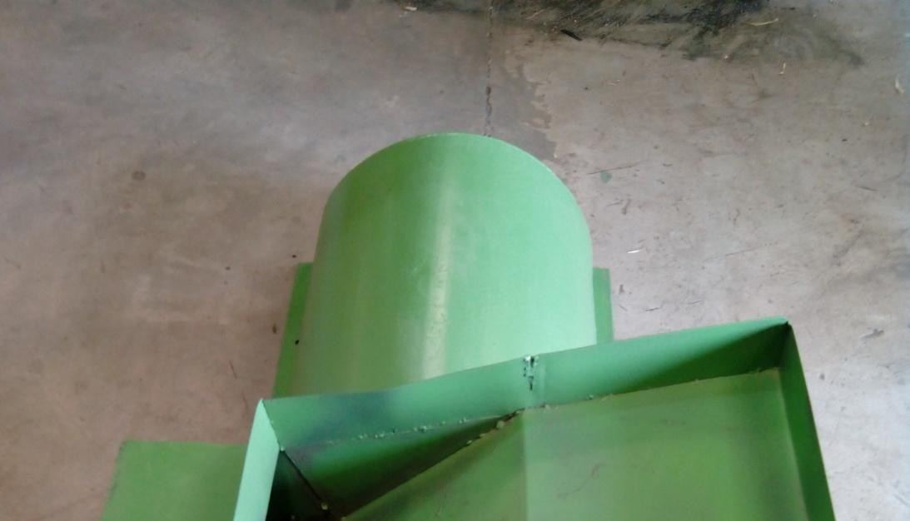
 |  | steel rod, P 200 Thrust bearing, M  17x3 bolts and nuts, A 73 V-belt. | Scriber, G 12 Electrodes | blades to the required angle before welding in position.
8. | Shaker (Appendix) O13, O14, O15 | Gauge16 mild steel sheet (2 mm), 5 mm flat bars, 20 mm medium carbon steel rod, P 200 Thrust bearing, 20 mm diameter ball bearings, 310 mm diameter pulley, A  60 V-belt. | Welding, Bending and Grinding machines, Hack saw, Vise, Tape, Square, Scriber, G 12 Electrodes | Measure, mark and cut all materials. Mount shaker tray first before installing bearings, pulleys and shaker mechanism in position. Grind all rough / sharp edges
9. | Tow bar (Appendix) O13, O14, O15 | Square pipe and Angle iron 50 x 50  x 5 mm, 20 mm diameter medium carbon steel rod, 14 inch tyre and wheel. | Power saw, Grinding, Welding and Drilling machines, G 12 Electrodes, Tape, Square, Scriber | Measure, mark and cut all materials. Weld in position and install tyres and stand. Grind all rough and sharp edges.
10. | Engine Seat (Appendix) O14, O15 | Angle iron  50 x 50 x 5 mm, 7 Hp Diesel Engine. | Power saw, Grinding, Welding, and Drilling machines, G 12 Electrodes, Tape,  Square, Scriber, 8.5 mm drill bit. | Measure, mark and cut all materials. Drill holes for bolt and nuts before welding in position. Grind all rough and sharp edges.
11. | Machine body (Appendix) O13, O14,  O15 | Body filler and Gloss paint | Filler applicator, Spraying machine | Clean all components from dust. Apply body filler to all rough edges and tiny holes before  spraying.

59

Plate 3a: Illustrations of the threshing cylinder cover of the multicrop thresher with a feed hopper and a platform.

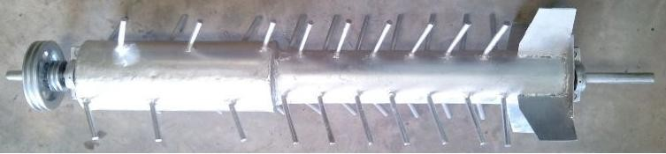

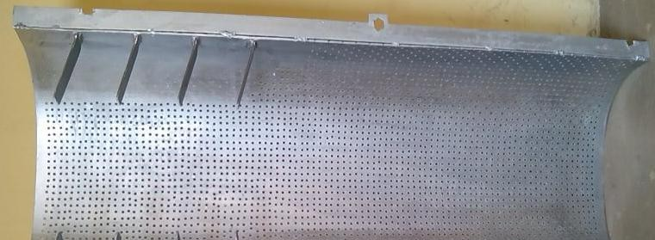
Plate 3b: Illustration of the multicrop thresher step-shaped threshing cylinder having tilted beaters and chaff throwers welded at fixed points on the cylinder

60

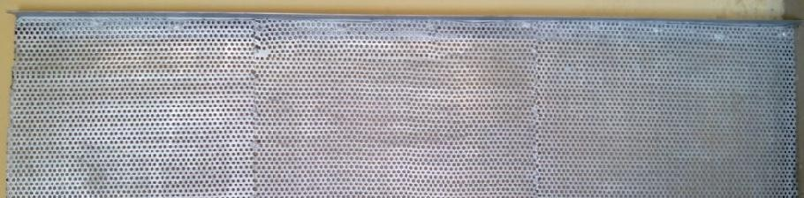

Plate 3.1a: Illustration of the multicrop thresher top sieve with 5 mm diameter sieve holes for millet threshing.

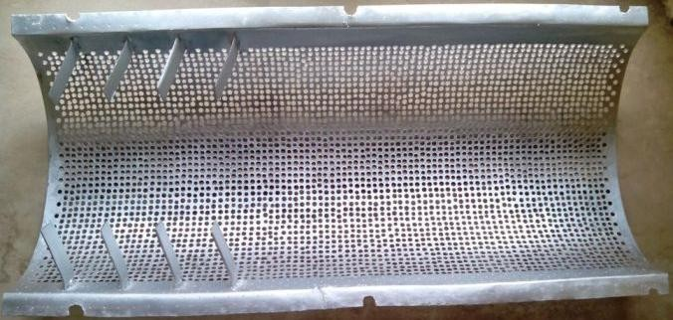

Plate 3.1b: Illustration of the multicrop thresher top sieve with 8.5 mm diameter sieve holes for soybean threshing

61

Plate 3.2a: Illustration of the multicrop thresher bottom sieve with 4 mm diameter sieve holes for millet threshing.

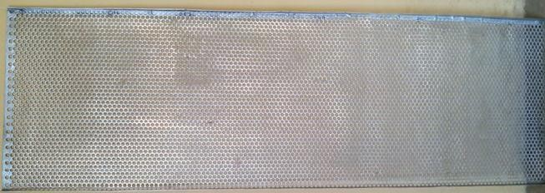

Plate 3.2b: Illustration of the multicrop thresher bottom sieve with 7.5 mm diameter sieve holes for soybean threshing

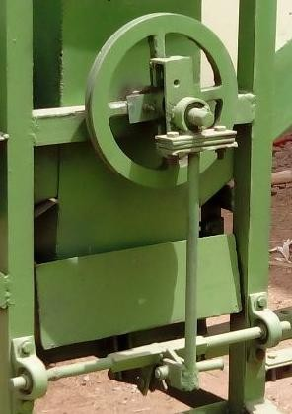

Plate 3.3: Illustration of the multicrop thresher shaker mechanism

Description of the Developed Multicrop Thresher
The developed multicrop thresher consists of the following components: A structural frame, top cover with feed hopper, step-shaped threshing cylinder with beaters and chaff thrower, perforated concave sieve plate with horizontal knife edge flat bars, centrifugal blower,

shaker mechanism, power transmission unit which consist of pulleys and the shaker tray with flat sieve plate. The feeder was constructed from gauge 18 mild steel metal sheets and consists of two sections; a platform and a hopper. The platform extends outward from the hopper with length 640 mm, width 610 mm and height 80 mm. A tow bar and two 14 inch tires were fixed at the base of the frame. The front view, end view and plan of the developed multicrop thresher are illustrated in Appendix O13, O14 and O15 respectively. The autographic projection is illustrated in Appendix O16. The isometric view of the front and rear sides of the machine are illustrated in Appendix O1 and O2 respectively.

Operations of the Developed Multicrop Thresher
The developed multicrop thresher was design such that the direction of flow for grains after threshing was vertical by a combination of impact by the beaters and gravitational force acting on it while the direction of flow for chaff and un-threshed material was lateral by a combination of impact by the beaters and suction generated by the chaff throwers positioned at the end of the threshing cylinder. The threshing unit is directly below the feed hopper and consists of the step-shaped threshing cylinder with beaters and chaff thrower. A perforated concave sieve plate with horizontal cutting knives was placed below the threshing cylinder for primary separation of grains from chaff. Clearance between the free end of the beaters and concave sieve plate was maintained at 20 mm for soybean threshing and 10 mm for millet threshing. The blower unit was located below the concave sieve plate and consists of a four blade centrifugal fan that blow‟s off the lighter chaff and dust from the grain as it flows down a funnel on to a sieve plate on the shaker tray. The shaker sieve plate at the bottom of the machine further separates grains and chaff of similar weight as the shaker oscillates. The clean grain was then collected at the bottom of the tray and conveyed through the grain outlet. All power transmission took place at one end of the machine and the unit consists of pulleys, V-belts and a 7Hp (5.22 kW) diesel engine which was mounted on the engine seat. The tow bar and two 14 inch tires

fixed at the base of the frame help to facilitate towing by a tractor. Plates 3.4 (a, b) and 3.5 (a, b) illustrates the front views and rear views of the machine respectively.

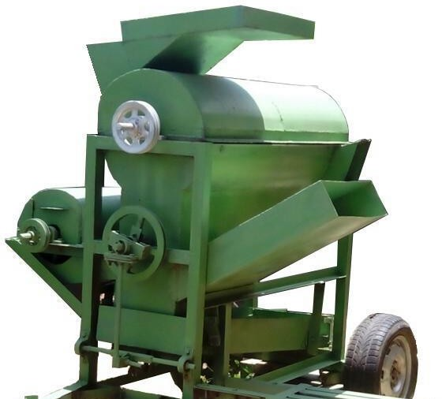
Hopper

Chaff Outlets

Tow Bar
Shaker Tray

Engine Seat
65

Plate 3.4a: Isometric view of the developed multicrop thresher from the front illustrating the Hopper, Chaff Outlets Tow Bar, Shaker tray and Engine seat
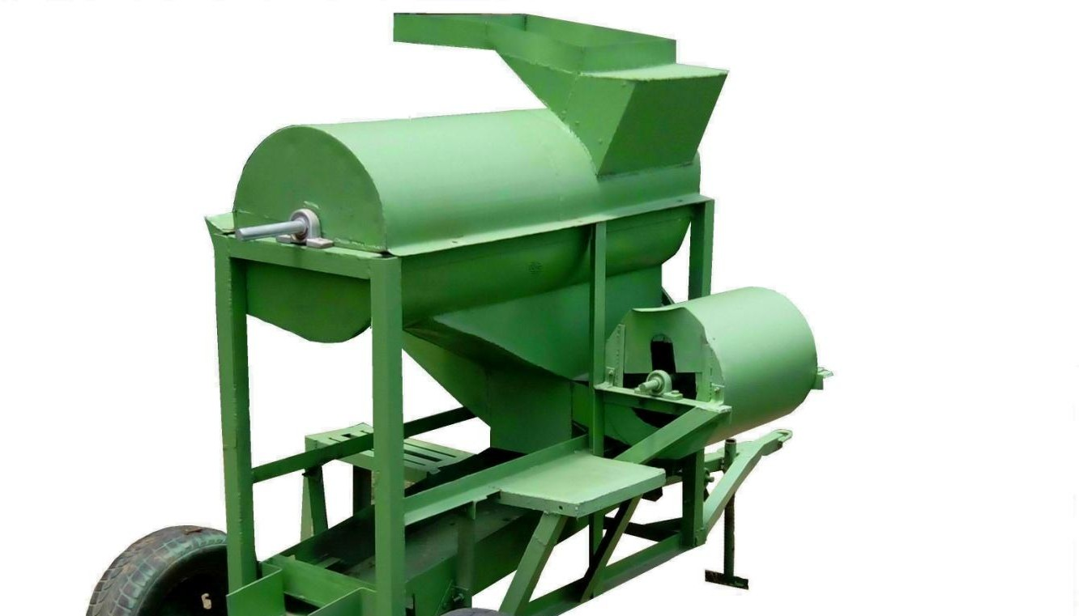
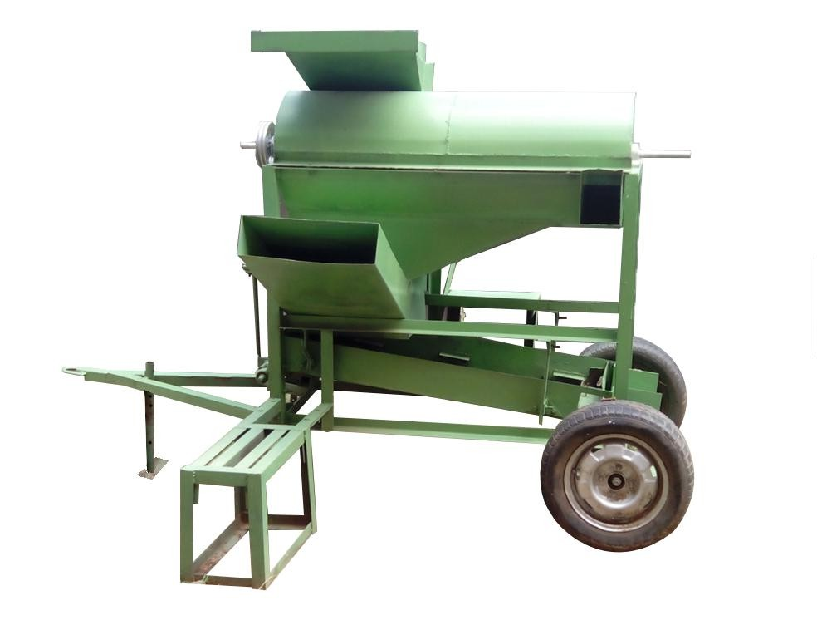
Hopper

Tow Bar
Chaff Outlets

Engine Seat
Shaker Tray

Plate 3.4b: Front view of the developed multicrop thresher illustrating the HoppHero,pCpehraff Outlets Tow Bar, Shaker tray and Engine seat

Blower

Tow Bar
66

Plate 3.5a: Isometric view of the developed multicrop thresher from the back illustrating the Operator‟s Stand, Blower, Tow bar, Shaker mechanism, Hopper and Rear Wheels
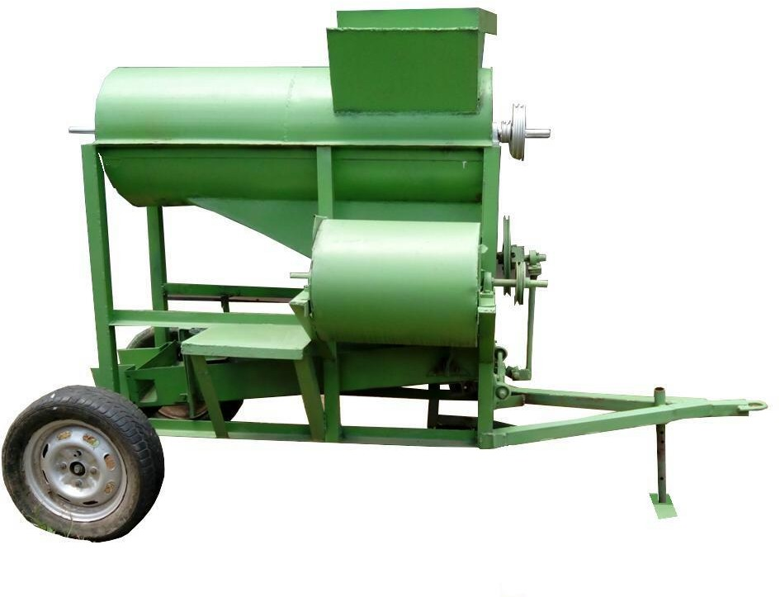
Hopper
Shaker Mechanism
Blower
Rear Wheel
Operator‟s Stand
Tow Bar
Plate 3.5b: Rear view of the developed multicrop thresher illustrating the Operator‟s Stand, Blower, Tow bar, Shaker mechanism, Hopper and Rear Wheels

Performance Tuning
Performance tuning was carried out to improve the initial performance of all components of the multicrop thresher that were critical to its overall performance. The performance tuning

process involved measuring, evaluating, design re-iteration, re-construction and re-evaluation until a set goal was reached.
Goals that were set before modification include:
- Threshing efficiency to be greater than 98 %.
- Cleaning efficiency to be greater than 90 %.
- Grain damage to be less than 1 %.
- Grain loss to be less than 10 % for both crops.

- Output to be greater than 350 kg/hr for millet and greater than 150 kg/hr for soybean.

The steps taken in the performance tuning process were as follows:

- the performance of the multicrop thresher was assessed by initial performance evaluation before modification.
- the data of the performance evaluation was analyzed and the initial result noted.

- the parts of the thresher that were critical for improving the performance were identified as the bottleneck.
- goals were set.

- these parts of the thresher were modified to remove the bottlenecks one at a time, checking to ensure that the modifications had not disrupted the way the machine function.
- the performance of the thresher was re-evaluated after the modifications were completed.

- the modifications that made the performance better were adopted; but those that made the performance worse were rejected and the machine was put back the way it was.
These bottlenecks were removed one at a time by modification and testing with millet and soybean crops as test materials. In the performance tuning process output capacity, threshing and cleaning efficiencies were maximized while grain damage and grain loss were minimized until the set goals were reached. When the performance tuning was completed the overall performance of the multicrop thresher was evaluated.

Performance Evaluation
The machine was evaluated in the Department of Agricultural Engineering, Ahmadu Bello University, Zaria.

Test materials
The test materials were: unthreshed soybean crop (samsoy-2 soybean variety) and unthreshed millet crop (SOSAT C88 Millet variety).

Test apparatus
The test apparatus were: mettler balance (model pn 1210), 7Hp (5.22 kW) 4-stroke water cooler diesel engine, diesel, digital tachometer (tz5000 model), digital stop watch, digital scale (with 0.01g sensitivity) and oven.
The performance evaluation of the machine involved the following parameter:

- moisture content (%)

- output capacity (kg/hr)

- threshing efficiency (%)

- cleaning efficiency (%)

- scattered grain loss (%)

- grain damage (%)

Determination of crop moisture content
The crop moisture content on wet basis (in the range 10 - 16 %) was determined by oven- dry method according to ASAE standard S358.2 thus:

M wb
= (Ww − Wd ) x100
W

(3.26)

w

Where,
W_{w} = mass of wet samples before drying (g)
W_{d} = mass of sample after drying (g)

M_{wb}= moisture content on wet basis (%)

Determination of output capacity
The output capacity of the machine was evaluated according to Mohammed (2009):

C = QT
t
(3.27)

Where,

C = output capacity (kg/hr).

Q_{T} = mass of whole grain collected in unit time (kg).
t = threshing time (hr)

Determination of threshing efficiency
The threshing efficiency of the machine was evaluated according to Mohammed (2009):

⎛ UM ⎞

ET = 100 − ⎜
T
⎟x100
(3.28)

Where,
⎝ M ⎠

E_{T} = threshing efficiency (%)

U_{M} = mass of unthreshed material in unit time (kg)

T_{M} = mass of total material input in unit time (kg)

Determination of cleaning efficiency
The cleaning efficiency of the machine was evaluated according to Mohammed (2009):

η = ⎛ B ⎞x100
⎜ ⎟
C D
(3.29)

⎝ ⎠

Where,

η_{C} = cleaning efficiency (%)

B = mass of whole clean grain in unit time at grain outlet (kg)

D = mass of whole material collected in unit time at the grain outlet (kg)

Determination of scattered grain loss
The scattered grain loss of the machine was evaluated according to Mohammed (2009):

⎛ E ⎞

Sg = ⎜
T
⎟x100
(3.30)

⎝ G ⎠
Where,
S_{g} =scattered grain loss (%)

E = mass of scattered grain collected in unit time (kg)

T_{G} = total grain input per unit time by mass (kg)

Determination of grain damage
The grain damage of the machine was evaluated according to Mohammed (2009):

D = ⎛ G ⎞x100
(3.31)

g ⎜ 100 ⎟
⎝ ⎠
Where,

D_{g} = grain damage (%)

G = mass of visually damaged grain isolated in 100 grams of threshed sample (g)

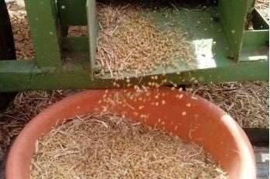
Plates 3.6a and 3.6b are illustrations of soybean and millet grains respectively collected during performance evaluation.

71

Plate 3.6a: Illustration of soybean grains collected during performance evaluation.

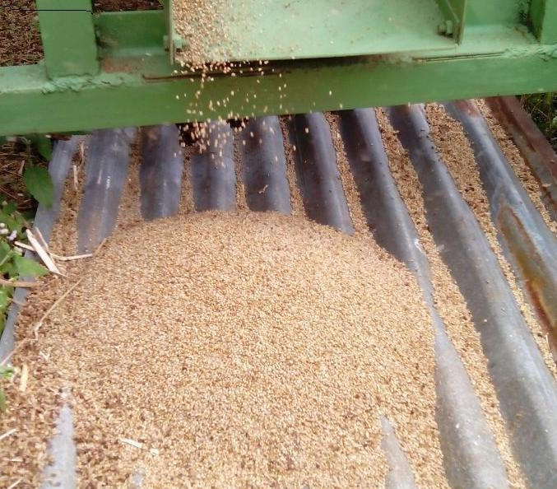

Plate 3.6b: Illustration of millet grains collected during performance evaluation

Data Collection

Several trial operations were conducted to determine the point at which the thresher will be unable to consume the materials fed into it at a swoop. During the trials it was observed that feeding the thresher with millet at 6 kg / min and with soybean at 4 kg / min when running below 550 rpm leads to frequent stalling of the prime-mover. At 550 rpm there was no stalling of the prime-mover. Successive increment of 2 kg and 100 rpm drum speed was made until it was noticed that when the threshing speed was increased beyond 909 rpm, the vibration caused by the shaker was intolerable. Also it was observed that feeding the thresher with millet at 14 kg / min and with soybean at 12 kg / min when running at 909 rpm there was no stalling. But when fed above 14 kg/min with millet and above 12 kg / min with soybean when running at 909 rpm leads to build up of un-threshed material in the threshing chamber and hence frequent stalling of the prime-mover. Therefore five levels of speed were chosen with 550 rpm being the minimum and 909 rpm being the maximum. Also five levels of feed rate were chosen with 4 kg / min and 6 kg / min being the minimum values for soybean and millet respectively, while 12 kg / min and 14 kg
/ min were the maximum values for soybean and millet respectively. The desired threshing speeds were obtained by regulating the prime mover throttle. A digital tachometer was used to monitor the drum speed and a stop watch was used to record the time of feeding.
As the materials were harvested from farm the initial moisture content wet bases was determined to be 18.2 %. This moisture content was considered not good for threshing as most of the materials pass out un-threshed when fed into the machine. So the material was closely monitored daily until its moisture content reaches 15.8 % wet basis where threshing was possible. The moisture content was varied as the crop dried naturally. The materials to be threshed were first weighed according to feed rate and then sun dried for two hours to warm them. Samples were randomly selected from each and taken to the laboratory for moisture content determination. Three replications were made for each threshed sample and a two days interval was given between threshing to allow the crop to dry naturally to different moisture

content. During threshing, sacks were placed at both chaff outlets. One was placed at the top chaff outlet to collect chaff, unthreshed materials and grain losses. Another was placed at the blower outlet to collect chaff and grain losses. Also one was placed at the grain outlet to collect threshed grains, broken grains and chaff. The contents of the sacks were emptied, winnowed manually and weighed to obtain the weights of clean grains, unthreshed materials, chaff, broken grains and grain losses. 3000 kg of soybean crop and 3750 kg of millet were used for the experiments. Plates 3.7a and 3.7b illustrate soybean and millet experimental materials respectively sun dried prior to threshing.

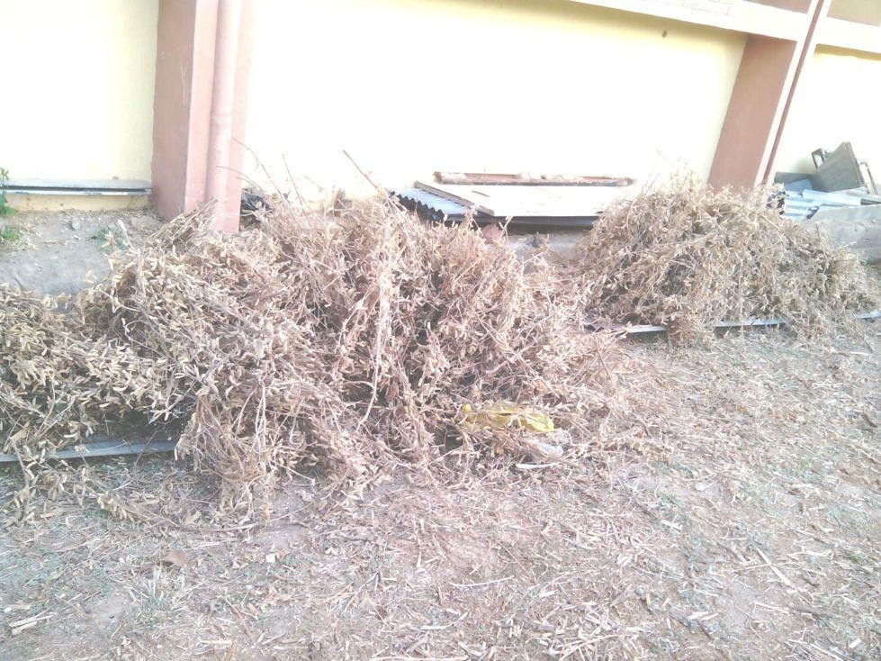
Plate 3.7a: Illustration of soybean experimental materials sun dried for few hours to warm them prior to threshing.

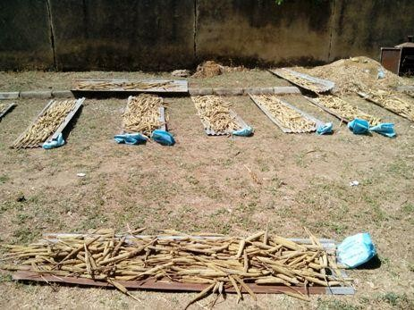

Plate 3.7b: Illustration of millet experimental materials sun dried for few hours to warm them prior to threshing.

Experimental Treatments
For both crops the multicrop thresher was subjected to three experimental treatments Thus the following treatments were considered for millet threshing:
- Moisture content (M) at 5 levels: M₁ = 10.6 %, M₂ = 11.9 %, M₃ = 13.2 %, M₄ = 14.3 % and M₅ = 15.8 %.
- Cylinder speed (S) at 5 levels: S₁ = 550 rpm (12.1 m/s), S₂ = 650 rpm (14.3 m/s), S₃ = 750 rpm (16.5 m/s), S₄ = 850 rpm (18.7 m/s) and S₅ = 909 rpm (20 m/s).
- Feed rate (F) at 5 levels: F₁ = 6 kg/min, F₂ = 8 kg/min, F₃ = 10 kg/min, F₄ = 12 kg/min and F₅ = 14 kg/min
Thus the following treatments were considered for soybean threshing:

- Moisture content (M) at 5 levels: M₁ = 10.8 %, M₂ = 12.2 %, M₃ = 13.5 %, M₄ = 14.6 % and M₅ = 15.4 %.
- Cylinder speed (S) at 5 levels: S₁ = 550 rpm (12.1 m/s), S₂ = 650 rpm (14.3 m/s), S₃ = 750 rpm (16.5 m/s), S₄ = 850 rpm (18.7 m/s) and S₅ = 909 rpm (20 m/s).
- Feed rate (F) at 5 levels: F₁ = 4 kg/min, F₂ = 6 kg/min, F₃ = 8 kg/min, F₄ = 10 kg/min and F₅ = 12 kg/min

Experimental Design

A complete randomized design (CRD) was used. The analysis of variance (ANOVA) is shown in Appendix B.

Experimental Layout

A layout of 5 x 5 x 5 factorial experiment involving 5 levels of cylinder speeds (S₁, S₂, S₃, S₄, S₅), 5 levels of Feed rates (F₁, F₂, F₃, F₄, F₅) and 5 levels of moisture contents (M₁, M₂, M₃, M₄, M₅), in three replications RI, RII, and RIII is shown in Appendix C

Data Analysis
SAS Statistical package was used to analyze the data. The difference between the means and variables was compared using ANOVA and Duncan‟s multiple range tests.

Development of Threshing Efficiency Mathematical Model
Mathematical models for predicting threshing efficiency, threshing loss and output capacity of the multicrop thresher were developed. In this study, dimensional analysis was used; because it offers a method for reducing complex physical problems to the simplest form prior to obtaining a quantitative answer. The Buckingham‟s π-theorem was adopted.

If λ = F ( A₁, A₂ ,..., A_{n} )
(3.32)

Then λ = f (π₁, π₂,…, π_{r<n}) (3.33)

Where:

λ = dependent variable.
A₁, A₂,…,A_{n}= independent variables.

π₁, π₂,…, π_{r<n}= non dimensional groups of A_{i}‟s.

F, f = functional relationships of A_{n}‟s and π_{r}‟s respectively.

Step-by-step method of dimensional analysis according to David (2013) was used to develop the threshing efficiency model.
Step 1: Identify the relevant variables.

Threshing efficiency E_{T} (%) evaluates the percentage of grains detached from the crop by the beaters of the machine. The relevant variables identified to influence the rate of detachment of grains per second were as follows: Mass of beater, M_{b} (kg), Velocity of peripheral cylinder, V_{c} (m/s), Mass of crop fed, M_{f} (kg), Height of the threshing chamber, h (m), Concave clearance, C_{c} (m), Length of threshing cylinder, L_{c} (m), Number of beaters, N_{b} (dimensionless), Dueling time

of crop within the threshing chamber, t (s), and Moisture content of the crop, M_{c} (% wb),
(dimensionless). Thus, E_{T} = f (M_{b} ,V_{c} , M _{f} , h,C_{c} , L_{c} ,t, N_{b} , M_{c} )

Step 2: Write down their dimensions.

The threshing efficiency function relevant variables and their dimensions are shown in Table 3.2.

Table 3.2: Threshing efficiency function relevant variables and their dimensions

Variable | Symbol | S.I Unit | Dimension  [M][L][T]
Threshing Efficiency | E_{T} | - | 1
Mass of beater | M_{b} | kg | M
Velocity of peripheral cylinder | V_{c} | m/s | ML-1
Mass of crop fed | M_{f} | kg | M
Height of the threshing chamber | h | m | L
Concave clearance | C_{c} | m | L
Length of threshing cylinder | L_{c} | m | L
Dueling time of crop in the threshing chamber | t | min | T
Moisture content of crop | M_{c} | - | 1
Number of beaters | N_{b} | - | 1

Step 3: Establish the number of independent dimensions and non dimensional groups. Number of relevant variables n = 10
Number of independent dimensions m = 3 (M, L, T)
Number of nondimensional groups formed = n – m = 10 – 3 = 7
Step 4: Choose m dimensionally independent scaling variables.
Mass of crop fed, M_{f} (M), Concave clearance, C_{c} (L) and Dueling time of crop within the threshing chamber, t (T) were chosen.
Step 5: Create the π_{s} by nondimensionalizing the remaining variables.

π₁ = E_{T} (3.34)

π₂ = N_{b} (3.35)

π₃ = M_{c} (3.36)

π ₄ = (Mb
)(M f
)ª (C
)^{b} (t)^{c}

Considering the dimension of both sides
c

M ⁰ L⁰T ⁰ = (M )(M )ª (L)^{b} (T )^{c}

M : 0 =1+ a ⇒ a = −1
L : 0 = b ⇒ b = 0
T : 0 = c ⇒ c = 0
Substitute a, b and c in π₄ above:

π ₄ = M
Mb
(3.37)

f

π₅ = (Vc )(M f

)ª (C
c

)^{b} (t)^{c}

Considering the dimension of both sides

M ⁰ L⁰T ⁰ = (LT ⁻¹)(M )ª (L)^{b} (T )^{c}

M : 0 = a ⇒ a = 0
L : 0 =1+ b ⇒ b = −1
T : 0 = −1+ c ⇒ c =1
Substitute a, b and c in π₅ above:

π = Vct
5 C

(3.38)

c

π₆ = (h)(M f

)ª (C
c

)^{b} (t)^{c}

Considering the dimension of both sides

M ⁰ L⁰T ⁰ = (L)(M )ª (L)^{b} (T )^{c}

M : 0 = a ⇒ a = 0
L : 0 =1+ b ⇒ b = −1
T : 0 = c ⇒ c = 0
Substitute a, b and c in π₆ above:

π 6 = C
h
(3.39)

c

π₇ = (Lc )(M f

)ª (C
c

)^{b} (t)^{c}

Considering the dimension of both sides

M ⁰ L⁰T ⁰ = (L)(M )ª (L)^{b} (T )^{c}

M : 0 = a ⇒ a = 0
L : 0 =1+ b ⇒ b = −1
T : 0 = c ⇒ c = 0
Substitute a, b and c in π₇ above:

π 7 = C
Lc
(3.40)

c

Step 6: Rearrange for convenience. We are free to replace any of the pi‟s by a power of that pi, or by a product with the other pi‟s provided we retain the same number of independent dimensionless groups.
Thus, rearranging the pi terms we have:

π 2 Nb
π
=
π
=
8

3 Mc

π 7 Lc
π
=
π
=
9

6 Cc

× Cc

h

= Lc h

(3.41)

(3.42)

π = π × π
= MbVct

(3.43)

10 4 5
M
C
f c

π = π ×π
= Nb Lc

(3.44)

11 8 9
M
h
c

Step 7: Set out the non dimensional relationship.
The three pi terms that were used in the model formulation are: π₁, π₁₀ and π₁₁. These pi terms were related as follows:

π1 =

f (π10 ,π11 )

(3.45)

Hence,

⎛ MbVct

Nb Lc ⎞
,

ET = f ⎜
⎜ M
⎝
⎟
f Cc Mc ⎟
h
⎠
(3.46)

Determination of component equations
The component equations were formed from experimental data on the pi- terms. Shafii et al. (1996) stated that in order to verify that equation (3.46) is correct, at least 2m-3 tests need to be conducted, where m is the number of pi terms.

Hence, (2x3) - 3 = 3 tests was conducted to establish three component equations as follows:

(π 1 )11 was held constant at π11 and π10
was varied to give the component equation (π 1 )11 ,

(π1 )10 was held constant at π10 and π11 was varied to give the component equation (π1 )10 ,

(π10 )1

was held constant at

π 1 and

π11
was varied to give the component equation (π10 )1 as

shown on Fig. 3.1, 3.2 and 3.3 respectively. The regression equations of the graphs represent the

component equations. The constant values of the pi terms π 1 , π10
and π11
were determined by

calculating the average of the pi term data. The pi terms data for threshing efficiency model are given in Table 3.3

Table 3.3: Pi terms data for threshing efficiency model
π₁ = ET |  | π = MbVct  10 M C  f c |  | π = Nb Lc  11 M h  c
99.98 | 97.79 | 62.67 | 37.60 | 9.11 | 6.76
99.97 | 97.72 | 58.59 | 31.33 | 9.11 | 6.76
99.96 | 97.66 | 47.00 | 29.30 | 8.12 | 6.76
99.95 | 97.63 | 43.95 | 35.16 | 8.12 | 6.76
99.94 | 97.56 | 43.95 | 43.95 | 7.32 | 6.76
99.93 | 97.52 | 37.60 | 31.02 | 9.11 | 6.76
99.91 | 97.47 | 35.16 | 25.11 | 9.11 | 6.76
99.87 | 97.38 | 62.67 | 58.59 | 7.32 | 6.76
99.86 | 97.35 | 35.16 | 47.00 | 9.11 | 6.76
99.85 | 97.31 | 58.59 | 25.85 | 7.32 | 6.76
99.83 | 97.01 | 29.30 | 22.16 | 9.11 | 6.76
99.82 | 96.71 | 35.16 | 37.60 | 8.12 | 6.12
99.81 | 96.70 | 31.02 | 31.33 | 9.11 | 6.12
99.78 | 96.65 | 31.33 | 62.67 | 7.32 | 6.76
99.72 | 96.52 | 26.86 | 26.86 | 7.32 | 6.12
99.71 | 96.44 | 31.02 | 29.30 | 8.12 | 6.12
99.69 | 96.41 | 25.85 | 25.11 | 9.11 | 6.12
99.65 | 96.39 | 25.11 | 35.16 | 9.11 | 6.12
99.61 | 96.23 | 25.85 | 43.95 | 8.12 | 6.12
99.59 | 95.99 | 29.30 | 47.00 | 7.32 | 6.12
99.56 | 95.95 | 25.11 | 31.02 | 8.12 | 6.12
99.54 | 95.82 | 25.85 | 58.59 | 7.32 | 6.12
99.52 | 95.74 | 22.16 | 25.85 | 9.11 | 6.12
99.48 | 95.68 | 25.11 | 22.16 | 7.32 | 6.12
99.45 | 95.11 | 22.16 | 62.67 | 8.12 | 6.12
99.42 |  | 22.16 |  | 7.32
π₁ = 98.28 |  | π₁₀ = 36.18 |  | π₁₁ = 7.34

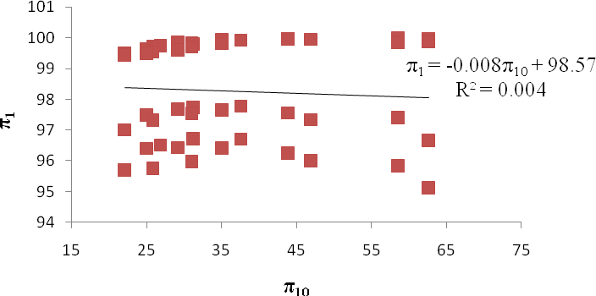

Fig 3.1: Plot of π ₁
against π10
with π₁₁ constant

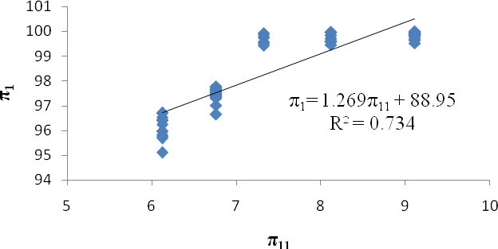

Fig 3.2: Plot of π ₁
against π₁₁ with π10
constant

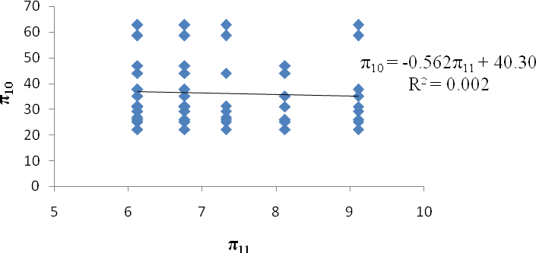

Fig 3.3: Plot of π10
against π₁₁ with π ₁
constant

Component equations combination criteria
Murphy (1950) stated that the component equations may be combined by either summation or multiplication to form the general prediction equation. The selection depends on which criteria a set of component equations satisfies. He stated that when a set of component equations plot to form a plane surface on space (linear space) it will have the form y = a + bx , such equation would be valid for combination as summation.
The general prediction equation with s pi terms will be:

π₁ =
1 2 3 s 2 2 3 s s 2 3 s
f (π ,π ...π )+ f (π ,π ,...π )+ f (π ,π ,...π )− C

(3.47)

Where,

C = constant of summation subtracted from the sum of the component equations.
f₁(π 2 ,π 3 ), f₂ (π 2 ,π 3 ), f_{s−1}(π 2 ,π 3 ,...π s )= component equation functions.

π 2 ,π 3 = constant values of the pi terms.

Whereas those equations that plot to form curved surface in logarithmic space, will have the

form y = ax^{b}
, such would be valid for combination as product.

The general prediction equation with s pi terms will be:
π = C. f (π ,π ...π )× f (π ,π ,...π )× f (π ,π ,...π )
1 1 2 3 s 2 2 3 s s−1 2 3 s

(3.48)

Where,

C = constant of multiplication.
f1 (π 2 ,π 3 ), f2 (π 2 ,π 3 ), fs−1 (π 2 ,π 3 ,...π s )= component equation functions.

π 2 ,π 3 = constant values of the pi terms.

Determination of the constant (C)
The constant for S number of pi terms is given as:
C = (S − 2) f (π 2 ,π 3 ,π 4 ,...π s )

Where,

C = constant of summation or multiplication. S = number of pi terms
π 2 ,π 3 = constant values of the pi terms.

When the number of pi terms is 3, the expression of the constant term becomes:

C = f1 (π 2 ,π 3 ), or C =

f2 (π 2 ,π 3 )

Murphy (1950) stated that constants calculated from either of the component equations are approximately equal. Thus the constant can be determined from either of the equations.

Determination of prediction equation
Since the component equations above were linear, it favoured combination by summation to give the prediction equation. The prediction equation involed 3 pi terms, thus the general equation is given by:

π1 =
f1 (π 2 ,π 3 )+ f2 (π 2 ,π 3 )− C

(3.49)

f1 (π 2 ,π 3 ) = −0.008π10 + 98.57
f2 (π 2 ,π 3 ) = 1.269π11 + 88.95
(3.50)

(3.51)

Substituting equations (3.50) and (3.51) in equation (3.49) we have:
π1 = −0.008π10 +1.269π11 + 98.57 + 88.95 − C

π1 = −0.008π10 +1.269π11 +187 .52 − C

(3.52)

But
π10 = 36.18
and π₁₁ = 7.34

Substituting π10 in equation (3.50) or π₁₁ in equation (3.51), C was determined as follows:

C = −0.008(36.18)+ 98.57 = 98.28 or C = 1.269 (7.34)+ 88.95 = 98.27

Substituting C in equation (3.52) the prediction equation was determined as follows:

π1 = −0.008π10 +1.269π11 +187 .52 − 98.28

π1 = −0.008π10 +1.269π11 + 89.24

(3.53)

Substituting equations (3.34), (3.43) and (3.44) in equation (3.53) the threshing efficiency mathematical model was given by:
⎛ MbVct ⎞ ⎛ Nb Lc ⎞

ET = −0.008⎜
⎜
⎟
M C

⎟ +1.269⎜
M

⎟ + 89.24

h
(3.54)

⎝ f c ⎠ ⎝ c ⎠
Where,

E_{T} = threshing efficiency (%)

M_{b} = mass of beater (0.188 kg)
Vc= velocity of peripheral cylinder (m/s)

t = dueling time of crop in the threshing chamber (1min)

M_{f} = total mass of crop fed (kg)

C_{c} = concave clearance (m)

N_{b} = number of beaters (38).

L_{c} = length of threshing cylinder (1.195 m)

M_{c} = moisture content of the crop (% wb)

h = height of the threshing chamber (0.47 m)

Development of Threshing Loss Mathematical Model
Threshing loss includes the unthreshed grain loss, plus the scattered grain loss. The scattered grain loss (S_{g}) includes: threshed grains sucked out with chaff at the top chaff outlet, plus threshed grains falling out of the hopper, threshed grains blown away with chaff by the blower, threshed grains falling from the shaker. The percentage of scattered grain loss (S_{g}) for both crops were obtained by conducting field experiments on the multicrop thresher with the crops and collecting the grains scattered all around the machine to determine its percentage.

Since the scattered grains were those lost from different parts of the machine as the grains flow down the thresher it was easier to determine it by field experiment than by calculations. The ANOVA for scattered grain loss indicates that the mean percentages for both crops were: (S_{g}= 9.67 % for millet and S_{g} = 3.98 % for soybean). To determine the percentage of unthreshed grains, the variables of importance were identified to be similar to those given in Table 3.2.
The percentage of unthreshed grains (G_{u}) was determined from the following relationship:

Gu = 100 − ET
(3.55)

Substituting equation (3.54) into equation (3.55) we have:

⎡ ⎛ M
V t ⎞
⎛ N L ⎞ ⎤

G = 100 − ⎢− 0.008⎜ b c ⎟ +1.269 ⎜ b c ⎟ + 89.24⎥
⎜ f c ⎟ ⎝ Mc h ⎠ ⎥
M C
u
⎢
⎣ ⎝ ⎠ ⎦
⎛ MbVct ⎞ ⎛ Nb Lc ⎞

Gu = 100 + 0.008⎜
⎜
⎟
M C

⎟ −1.269⎜
M

⎟ − 89.24

h

⎝ f

⎛ MbVct ⎞
c ⎠ ⎝ c ⎠

⎛ Nb Lc ⎞

Gu = 0.008⎜
⎜
⎟
M C

⎟ −1.269⎜
M

⎟ +10.76

h
(3.56)

⎝ f c ⎠ ⎝ c ⎠
The threshing loss function (L_{T}) was determined from the following relationship:

L_{T} =
Sg + Gu
(3.57)

Where:

L_{T} = threshing loss (%)
S_{g} = scattered grains (%)

G_{u} = unthreshed grains (%)

Substituting equation (3.56) into equation (3.57) the threshing loss model was given by:
⎛ MbVct ⎞ ⎛ Nb Lc ⎞

LT = Sg + 0.008⎜
⎜
⎟
M C

⎟ −1.269⎜
M

⎟ +10.76

h
(3.58)

⎝ f c ⎠ ⎝ c ⎠

Where:

L_{T} = threshing loss (%)

S_{g} = scattered grains (%) (S_{g}= 9.67 % for millet, S_{g} = 3.98 % for soybean)
M_{b} = mass of beater (0.188 kg)
Vc= velocity of peripheral cylinder (m/s)
t = dueling time of crop in the threshing chamber (1min)

M_{f} = total mass of crop fed (kg)

C_{c} = concave clearance (m)

N_{b} = number of beaters (38).

L_{c} = length of threshing cylinder (1.195 m)

M_{c} = moisture content of the crop (% wb)

h = height of the threshing chamber (0.47 m)

Development of Output Capacity Mathematical Model
Output capacity evaluates the quantity of clean grain collected at the grain outlet of the multicrop thresher for the total quantity of crop fed per hour. That is, output equals the total grain threshed from the crop fed minus the threshing loss. To determine the total grain threshed from the crop fed through the hopper, the variables of importance were identified to be similar to those given in Table 3.2. To determine the threshing loss, the unthreshed grain loss and the scattered grain loss were added together. The output capacity function (O_{c}) was developed from the Effect of the mass of crop fed, threshing efficiency, threshing loss and grain to crop ratio.
The output capacity function was developed as follows:

When the mass of crop fed per second was = M_{f} (kg/s) The output per second was given by:
O_{c}=M_{f} (E_{T} - L_{T})(G_{r} / C_{r})/100 (3.59)

When the mass of crop fed per hour was = 3600M_{f} (kg/hr)

The output per hour was given by:

O_{c} = 36M_{f} (E_{T} - L_{T})(G_{r} / C_{r}) (3.60)

Hence, the output mathematical model was given by:

O_{c} = 36M_{f} (E_{T} - L_{T})(G_{r} / C_{r})

Where:

O_{c} = output capacity (kg/hr)

M_{f} = mass of crop fed per second (kg/s)

E_{T} = threshing efficiency (%)

L_{T} = threshing loss (%)
G_{r} / C_{r} = grain to crop ratio. (G_{r} / C_{r} = 0.25 for soybean and 0.55 for millet)

Model Verification
The objective of the model verification was to ensure that the model was correct and that it was able to perform its respective task. In the implementation of the model it was tested for errors using input data of field experiments and the errors found were fixed.

Verification of dimensions of threshing efficiency model
The dimensions (length (L), mass (M), and time (T)) on both sides of the equality sign of the threshing efficiency model was verified if they were the same as follows:
⎛ MbVct ⎞ ⎛ Nb Lc ⎞

ET = −0.008⎜
⎜
⎟
M C

⎟ +1.269⎜
M

⎟ + 89.24

h

⎝ f c ⎠ ⎝ c ⎠
Where,

E_{T} = threshing efficiency (%)

M_{b} = mass of beater (0.188 kg)
Vc= velocity of peripheral cylinder (m/s)
t = dueling time of crop in the threshing chamber (1min)

M_{f} = total mass of crop fed (kg)

C_{c} = concave clearance (m)

N_{b} = number of beaters (38).

L_{c} = length of threshing cylinder (1.195 m)
M_{c} = moisture content of the crop (% wb)
h = height of the threshing chamber (0.47 m)
Thus,
[E_{T}] = 1

⎡ M V t ⎤
M .L.T ⁼¹.T
M .L

⎢ b c ⎥ =
⎢⎣ M f Cc ⎥⎦
M .L

. = = 1
M .L

⎡ Nb Lc ⎤ = 1.L = L = 1

⎢ ⎥
M
h
⎣ c ⎦


1.L L

Hence, the dimension on the left hand side of the equality sign equals the dimension on the right hand side of the equality sign.

Verification of threshing efficiency determination with the model
One of the treatments that were given to the multicrop thresher during field experiments was used for testing the model. From Table 4.3a, the combination of cylinder speed, feed rate and moisture content of 14.3 m/s, 12 kg/min and 11.9 % respectively gave measured threshing efficiency of 99.37 %. This treatment was given to the model and the predicted threshing efficiency was compared with the measured.
The model was used to predict the threshing efficiency of the multicrop thresher as follows:

E_{T} = 99.37 %, M_{b} = 0.188 (kg), V_{c}= 14.3 (m/s), t = 1 (min), M_{f} = 12 (kg), C_{c} = 0.01 (m), N_{b} = 38,
L_{c} = 1.195 (m), M_{c} = 11.9 (% wb), h = 0.47 (m).

Thus:

⎛ MbVct ⎞

⎛ Nb Lc ⎞

ET = −0.008⎜
⎜
⎟
M C

⎟ +1.269⎜
M

⎟ + 89.24

h

⎝ f c ⎠ ⎝ c ⎠

99.37% = −0.008⎛ 0.188 ×14.3×1⎞ +1.269 ⎛ 38 ×1.195
⎞ + 89.24

⎜ 12 × 0.01 ⎟ ⎜11.9 × 0.47 ⎟
⎝ ⎠ ⎝ ⎠
99.37% = −0.008(22.4033 )+1.269(8.1191 )+ 89.24
99.37% = −0.1792267+10.3031093+ 89.24
99.37% ≈ 99.36%

The measured threshing efficiency of the machine (E_{T} = 99.37 %) was approximately equals to the predicted threshing efficiency of the model (E_{T} = 99.36 %).

Model Validation
Half of the measured data was used for model development, while the other half of the data was used for model validation. Predictive validation was used for this study. The developed model was used to predict the multicrop thresher performance with the same treatments given during field experiments. Then, the measured and predicted threshing efficiencies were plotted.

Model validation experimental treatments
The threshing efficiency model was subjected to three experimental treatments:

i Moisture content (M) at 5 levels: M₁ = 10.6 %, M₂ = 11.9 %, M₃ = 13.2 %, M₄ = 14.3 % and M₅ =15.8 %.
ii. Cylinder speed (S) at 3 levels: S₁ = 550 rpm (12.1 m/s), S₂ = 650 rpm (14.3 m/s), S₃ = 750 rpm (16.5 m/s)
iii Feed rate (F) at 5 levels: F₁ = 6 kg/min, F₂ = 8 kg/min, F₃ = 10 kg/min, F₄ = 12 kg/min and F₅ = 14 kg/min

Measures of the model performance
Reddy et al. (1995) reported that a common statistical technique to judge the performance of models is to plot measured against predicted values and fit a straight line through the data with a zero intercept. The values of slope and coefficient of determination (r²) are then used as indices of agreement.
Wilmot (1982) suggested that Bias and Root Mean Square Error (RMSE), equations (3.61) and (3.62) were amongst the best overall measures of a model performance.

Bias =

RMSE =
1
N
∑ i
i=1
N
(P − M )
2
i
1 ^{N}
N i=1
∑
(Pi − Mi )
(3.61)

(3.62)

Where,

P_{i} and M_{i} = predicted and measured values of the variable of interest respectively

N = the number of observations.

Thus, Bias =

1 ^{N}
∑
N i=1

(Pi − Mi

) = 42.91 = 0.74%
58

RMSE =
1
N
∑
N
(P − M )
2
i=1
i
i
=
= 0.96

The discrepancy between the measured and predicted values of the model was determined using Mean Square Deviation (MSD), Square Bias (SB) and lack of correlation weighted by the standard deviation (LCS), equations (3.63), (3.64) and (3.65) Kobayashi and Salam (2000).
53.2195
58
2

MSD =
1 n
n i=1
∑
(Pi − Mi )
(3.63)

SB = (P − M )2

(3.64)

LCS = 2 x SD_{p} x SD_{m} x (1- r) (3.65)

Where,

P and M = average predicted and measured values respectively.
SD_{p} and SD_{m} = standard deviations of predicted and measured values respectively. r = the correlation coefficient between predicted and measured values.

Thus,

MSD =

- n
n i=1
∑

(Pi − Mi

)2 = 53.2195
58

= 0.92%

SB = (P − M )2 = (98.351 − 98.234 )2 = 0.014 %
LCS = 2 x SD_{p} x SD_{m} x (1- r) = 2 ×1.169718×1.745122× (1− 0.732) = 1.1%

The model performance was quantified by calculating the Standard Error (SE) and Average Absolute Deviation (AAD), equations (3.66) and (3.67) Yusuf (2001).
Thus:

SE =
∑(y − y )
2
m p
n
(3.66)

AAD =
∑ ym − yp
n
(3.67)

Where,

y_{m} and y_{p} = measured and predicted values respectively. n = number of observed values.
Thus,

SE =
∑(y − y )
2
m p
n
=
58
53.2195

42.91
∑ ym − yp
= 0.13 %

AAD =
=
n 58
= 0.74 %

The Coefficient of Efficiency was determined by equation (3.68) (Logates and Mc Cabe,

1999):

N
∑ Mi − Pi
E = 1 − i=1
N
∑ Mi −
M
i−1

(3.68)

Where,

M_{i} = measured data

P_{i} = predicted data.

Thus,

N
∑ Mi − Pi
E = 1 − i=1
N

= 1 −

42.91

= 1 − 0.475 = 0.53

∑
M
i−1
Mi −
90.32

A paired t-test was conducted at 0.01 level of significance with tabular value equals to

1.96 as follows:
∑ d
N
(∑d )2
N
∑ d ² −
N (N − 1)

t =

(3.69)

Where,

d = deviations.

N = number of variables.

Thus,

t = 0.74
7.295

= 0.101

Optimization of Threshing Performance of the Thresher
Optimization of threshing performance of the multicrop thresher aimed at maximizing or minimizing some performance characteristics of the multicrop thresher so as to achieve a higher threshing efficiency at low grain loss and low grain damage. MATLAB optimization software was used for the optimization process. On the MATLAB software some specified variables of the threshing efficiency model were maximized while others were minimized without violating their constraint, while keeping all others constant and within their constraints. A MATLAB optimization tool “optimtool” was used to run the problem. On the tool, the solver, the constraints and the optimization options were first selected before clicking on the start button to run the optimization. The optimization tool optimtool was chosen because it provides a convenience interface to all optimization routings including those of Genetic Algorithm and Direct search toolbox functions. The optimization tool also made it easier to:
- Define and modify the problem quickly

- Use the correct syntax for optimization functions

- Import and export from the MATLAB workspace

- Generate code containing configurations for the solver used and options

- Change parameters of the optimization during the execution of certain Algorithm and direct search Toolbox Functions
The optimization processes involved in MATLAB were as follows:

- Problem formulation

- Defining the problem in the MATLAB toolbox syntax

- Running the optimization

- Optimization result

Problem Formulation
The optimization problem was formulated by stating a set of performance characteristics that were defined as the performance vector (x). Hence, Velocity of peripheral cylinder (V_{c}), Mass of crop fed (M_{f}) and Moisture content of the crop (M_{c}) were chosen as the performance vectors. The optimization aim at obtaining optimum combination of these performance vectors subject to their constraints. The objective function to be optimized was the function f(x) subject to nonlinear inequality and linear equality constraints g(x). A constrained optimization was done and the method that was used for the optimization was based on the procedure recommended by Glenn (1950), Yusuf (2003) and Rao (2009) in the following sequence for a constrained optimization thus:
- The objective functions were determined and the quantity to be optimized (maximized or minimized) and its functional dependence on the independent variables were stated.
- The constraint on the independent variables for which an optimum was determined was specified.

Identification of objective functions and design variables
The objective function to be optimized was the threshing efficiency function f (x) on equation (3.54) subject to constraint functions g (x).
⎛ MbVct ⎞ ⎛ Nb Lc ⎞

ET = −0.008⎜
⎜
⎟
M C

⎟ +1.269⎜
M

⎟ + 89.24

h

⎝ f c ⎠ ⎝ c ⎠

Thus,

⎛ MbVct ⎞

⎛ Nb Lc ⎞

f (x) = −0.008⎜
⎜
⎟
M C

⎟ +1.269⎜
M

⎟ + 89.24

h
(3.70)

⎝ f c ⎠ ⎝ c ⎠
Where,

f (x) = threshing efficiency (%)

M_{b} = mass of beater (0.188 kg)

Vc= velocity of peripheral cylinder (m/s)
t = dueling time of crop in the threshing chamber (1min)

M_{f} = total mass of crop fed (kg)

C_{c} = concave clearance (m)

N_{b} = number of beaters (38).

L_{c} = length of threshing cylinder (1.195 m)

M_{c} = moisture content of the crop (% wb)

h = height of the threshing chamber (0.47 m)

The design variables were the machine, crop and operational parameters critical for improving or reducing the thresher‟s performance. These variables were: Velocity of peripheral cylinder, V_{c}(m/s), Mass of beater, M_{b} (kg), Mass of crop fed per second, M_{f} (kg), Height of threshing chamber, h (m), Acceleration due to gravity, g (m/s²), Concave clearance, C_{c} (m), Length of threshing cylinder, L_{c} (m), Number of beaters, N_{b}, and Moisture content of the crop, M_{c} (% wb). The design vector which minimizes or maximizes f (x) was stated as:
V_{c} M_{f} M_{c}
x
=

Thus f (x) becomes:

⎛ MbVct ⎞

⎛ Nb Lc ⎞

f (Vc , M f , Mc ) = −0.008⎜
⎜
⎟
M C

⎟ +1.269⎜
M

⎟ + 89.24

h
(3.71)

Where,
⎝ f c ⎠
⎝ c ⎠

f (V_{c}, M_{f}, M_{c}) = the objective function to be optimized (V_{c}, M_{f}, M_{c}) = the design vectors/variables

Identification of independent and dependent variables
For this study the design variables were the independent variables and are listed as follows:

- Velocity of peripheral cylinder, V_{c} (m/s)

- Mass of beater, M_{b} (kg)

- Mass of crop fed per second, M_{f} (kg)
- The height of threshing chamber, h (m)
- Dueling time of crop in the threshing chamber (1min)
- Concave clearance, C_{c} (m)
- Length of threshing cylinder, L_{c} (m)

- Number of beaters, N_{b}

- Moisture content of the crop, M_{c} (% wb)

However the objective functions was the dependent variables and is listed as follows:

- Threshing efficiency, f (V_{c,} M_{f}, M_{c}) (%)

- Cleaning efficiency, f (V_{c,} M_{f}, M_{c}) (%)

- Grain damage, f (V_{c,} M_{f}, M_{c}) (%)

- Threshing loss, f (V_{c,} M_{f}, M_{c}) (%)

- Output capacity, f (V_{c,} M_{f}, M_{c}) (kg/hr)

Specification of the constraints on the independent variables
The constraints g (x) on the variables was divided into nonlinear inequality and equality constraints.
The nonlinear inequality constraints were:

- 12.1 ≤ V_{c} ≤ 20 (m/s)

- 6 ≤ M_{f} ≤ 14 (kg) for millet, 4 ≤ M_{f} ≤ 12 (kg) for soybean

- 10.6 ≤ M_{c} ≤ 15.8 (%) wet basis

The equality constraints were:

- C_{c} = 0.01 m for millet, C_{c} = 0.02m for soybean

- L_{c} = 1.195 m

- h = 0.47 m

- N_{b} = 38

- M_{b} = 0.188 kg
- t = 1 min

Determination of optimum point for each design vector
The optimum point for each design vectors (V_{c,} M_{f}, and M_{c}) subject to given constraint g(V_{c,} M_{f}, and M_{c} ) was determine using equations of D. M. R. Relationship established above: Regression equations for determination of optimum speed (V_{c}) for millet
Threshing Efficiency Vs Speed f₁(V_{c}) = – 0.005V_{c}² + 0.224V_{c} + 96.38 Cleaning Efficiency Vs Speed f₂(V_{c}) = 0.004V_{c}² + 0.031V_{c} + 92.78 Grain loss Vs Speed f₃(V_{c}) = 0.002V_{c}² – 0.017V_{c} + 9.162 Grain Damage Vs Speed f₄(V_{c}) = 0.0001V_{c}² + 0.0001V_{c} + 0.112
Output Capacity Vs Speed f₅(V_{c}) = – 0.529V_{c}³ + 23.47 V_{c}² – 313.4V_{c} + 1489

Regression equations for determination of optimum Mass Fed (M_{f}) for millet

Threshing Efficiency | Vs Mass Fed | f₆(M_{f}) = – 0.005M_{f}² + 0.028M_{f} + 98.78
Cleaning Efficiency | Vs Mass Fed | f₇(M_{f}) = 0.012M_{f}² – 0.514M_{f} + 98.44
Grain loss | Vs Mass Fed | f₈(M_{f}) = 0.119M_{f} + 8.49
Grain Damage | Vs Mass Fed | f₉(M_{f}) = 0.001M_{f}² – 0.018M_{f} + 0.241
Output Capacity | Vs Mass Fed | f₁₀(M_{f}) = 0.114M_{f}² + 0.020M_{f} + 312.5
Regression equations for determination of optimum Moisture Content (M_{c}) for millet Threshing Efficiency Vs Moisture Content f₁₁(M_{c}) = – 0.176M_{c}² + 3.914M_{c} + 78.08 Cleaning Efficiency Vs Moisture Content f₁₂(M_{c}) = – 0.340M_{c}² + 7.089M_{c} + 61.40 Grain loss Vs Moisture Content f₁₃(M_{c}) = – 0.143M_{c}² + 2.854M_{c} – 2.615 Grain Damage Vs Moisture Content f₁₄(M_{c}) = 0.023M_{c}² – 0.52M_{c} + 2.929
Output Capacity Vs Moisture Content f₁₅(M_{c}) = – 0.599M_{c}² + 10.78M_{c} + 288

Regression equations for determination of optimum speed (V_{c}) for soybean

Threshing Efficiency Cleaning Efficiency Grain loss  Grain Damage | Vs Speed Vs Speed Vs Speed  Vs Speed | f₁₆(V_{c}) = 0.04V_{c} + 98.61  f₁₇(V_{c}) = 0.530V_{c} + 78.32  f₁₈(V_{c}) = 0.024V_{c}² – 0.615V_{c} + 7.457  f₁₉(V_{c}) = – 0.055V_{c} + 1.044
Output Capacity | Vs Speed | f₂₀(V_{c}) = – 0.383V_{c}² + 14.71V_{c} – 16.37
Regression equations for determination of optimum Mass Fed (M_{f}) for soybean
Threshing Efficiency | Vs Mass Fed | f₂₁(M_{f}) = – 0.04M_{f} + 99.58
Cleaning Efficiency | Vs Mass Fed | f₂₂(M_{f}) = – 0.78M_{f} + 92.42
Grain loss | Vs Mass Fed | f₂₃(M_{f}) = 0.007M_{f}² – 0.249M_{f} + 5.408
Grain Damage | Vs Mass Fed | f₂₄(M_{f}) = – 0.055M_{f} + 1.044
Output Capacity | Vs Mass Fed | f₂₅(M_{f}) = 15.15M_{f} – 2.786
Regression equations for determination of optimum Moisture Content (M_{c}) for soybean Threshing Efficiency Vs Moisture Content f₂₆(M_{c}) = – 0.206M_{c}² + 4.933M_{c} + 70.74 Cleaning Efficiency Vs Moisture Content f₂₇(M_{c}) = – 1.538M_{c}² + 36.09M_{c} – 117.6
Grain loss Vs Moisture Content f₂₈(M_{c}) = – 0.198M_{c}² + 4.469M_{c} – 19.87 Grain Damage Vs Moisture Content f₂₉(M_{c}) = 0.150M_{c}² – 3.704M_{c} + 22.79 Output Capacity Vs Moisture Content f₃₀(M_{c}) = – 2.595M_{c}² + 61.45M_{c} – 232.9
A multi-objective programming problem such as the one above was solve in MATLAB by finding x which minimizes f₁(x), f₂(x),…, f_{k}(x). Where; f₁(x), f₂(x),…, f_{k}(x) denote the objective function to be minimized simultaneously. The function f (x) was also treated in MATLAB as a constrained optimization problem. Constrained optimization problems in MATLAB used the Karush-Kuhn-Tucker (KKT) equation. The KKT equation is necessary conditions for optimality for a constrained optimization problem. If the problem is a convex programming problem, that is

f(x) and g_{i}(x), i =1,…,m are convex function, then KKT equation are both necessary and sufficient for a global solution point. A KKT general problem description was stated as:
min f(x), (3.72)
Subject to
g_{i}(x) = 0 i = 1,…,m_{e},
g_{i}(x) ≤ 0 i = m_{e} + 1,…,m, Where,
x = the vector of length n design parameter

f (x) = the objective function, which returns a scalar value

g_{i} (x) = returns a vector of length m containing the values of the equality and inequality constraints evaluated at x.
There are several optimization toolbox solvers in MATLAB that address problems with constrained single and multiple objective functions. They include: ga Genetic Algorithm, fgoalattain, fminimax etc. All the solvers have inbuilt algorithms in MATLAB.
The MATLAB fgoalattain solver was used for the optimization. The goal attainment process is described below.

MATLAB Goal attainment method
The MATLAB goal attainment method used was that of Gembicki, 1974. This involves expressing a set of design goals, F* = {F*₁, F*₂,…,F*_{m}}, which is associated with a set of objectives, F(x) = {F₁(x), F₂(x),…,F_{m}(x)}. The problem formulation allows the objectives to be under – or overachieved, enabling the designer to be relatively imprecise about initial design goals. The relative degree of under – or overachievement of the goals was controlled by a vector of weighting coefficients, w = {w₁, w₂,…,w_{m}}, and is expressed as a standard optimization problem using the following formulation.

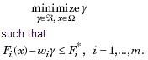
(3.73)

The term w_{i}γ introduces an element of slackness into the problem, which otherwise imposes that the goals be rigidly met. The weighting vector, w, enables the designer to express a measure of the relative tradeoffs between the objectives. For instance, setting the weighting vector w equal to the initial goals indicates that the same percentage under – or overachievement of the goals, F*, was achieved. A constraint was incorporated into the design by setting a particular weighting factor to zero (i.e., w_{i} = 0). Fig.3.5 is a geometric representation of the goal attainment method in two dimensions.

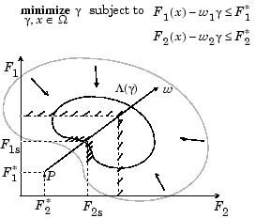

Fig.3.4: Geometric representation of the goal attainment method in two dimensions

Specification of the goals, {F₁*, F₂*}, defines the goal point, P. the weighting vector defines the direction of search from P to the feasible function space, Λ(γ). During the optimization γ was varied, which changes the size of the feasible region. The constraint boundaries converge to the unique solution point F_{1s}, F_{2s}.
In algorithm improvements for the goal attainment method a more appropriate merit function was achieved by posing equation (3.73) as a minimax problem.
Thus:

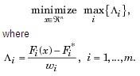
(3.74)

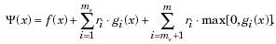
Following the argument of Brayton et al., 1979 for minimax optimization using sequential programming, we have the merit function:
(3.75)

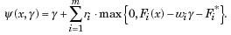
Using the merit function of equation (3.74) for the goal attainment problem of equation (3.73) gives

(3.76)

When the merit function of equation (3.75) was used as the basis of a line search procedure, although ψ(x,γ) might decrease for a step in a given search direction, the function Λ_{i} might paradoxically increase. This was accepting degradation in the worst case objective. Since the worst case objective was responsible for the value of the objective function γ, this was accepting a step that ultimately increases the objective function to be minimized. Conversely, ψ(x,γ) might increase when max Λ_{i} decreases, implying a rejection of a step that improves the worst case

objective. According to Brayton et al., 1979 a solution was therefore to set ψ(x) equal to the worst case objective.
Thus;
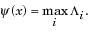
(3.77)
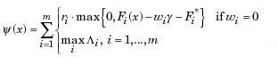
Combining equations (3.75) and (3.76) gives:

(3.78)

Minimizing the maximum objective method
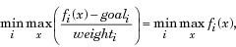
fminimax also uses a goal attainment method. It takes goals of 0, and weights of 1. With this formulation, the goal attainment problem becomes;

(3.79)

which is a minimax problem.

The optimum point of the function f (x) subject to given constraint g (x) can also be computed

analytically as follows:

⎛ MbVct ⎞

⎛ Nb Lc ⎞

f (x) = −0.008⎜
⎜
⎟
M C

⎟ +1.269⎜
M

⎟ + 89.24

h
(3.80)

⎝ f c ⎠ ⎝ c ⎠
g_{i} (x) ≤, = or ≥ b_{i} (3.81)

Let‟s consider maximizing a function Z = f (x) (3.82)

Subject to a given constraints function g_{i} (x) = b_{i} (3.83) Where,
x = the vector of length n design parameter

f (x) = the objective function, which returns a scalar value

g_{i} (x) = returns a vector of length m containing the values of the equality and inequality constraints evaluated at x.
b_{i} = the upper and lower limit of the independent variable

Assumed that f (x) has a constrained local maximum x = x*.
At x = x* we have;

df ≡ ∑
j
∂f dx = 0
∂x ^{j}
j

(3.84)

and

dgi

≡ ∑∂gi dx = 0

(3.85)

_{j} ∂xj
j
Multiplying the constraints in equation (3.85) by a constant λ_{i} and summing all the resulting equations, we have the Lagrange function defined as follows:

F(x,λ) ≡
f (x) + ∑λi (bi − gi (x))

(3.86)

Where,
F = Lagrange function

λ_{i} = Lagrange multiplier as a component of the m-vector λ.

Hence,
dF ≡ ∑ ∂F dx = 0
j

(3.87)

_{j} ∂x j

Since there were m independent constraints listed above, then only n-m of the variables x_{j} were independent.
Let the variables be

xm+1,…, x (3.88)
Optimizing the independent variables under the constraints above, an arbitrary value was chosen for λ_{i} such that:

∂F = 0
∂xi

(3.89)

Equation (3.79) becomes:

∂F
∂xm+1

dxm+1
+ ... + ∂F
∂xn
dxn = 0

(3.90)

Since the variables (x_{m+1},…,x_{n}) were independent and different, we vary each of them in turn after another and obtain the following equation:

∂F = ... =
∂xm+1
∂F = 0
∂xn
(3.91)

Thus from equations (3.83) and (3.84) we have the stationary or optimal point given by:

∂F ≡
∂f − ∑λ ∂gi = 0

(3.92)

∂xj

∂xj i j
∂x
i

Defining the problem in MATLAB optimization toolbox syntax
To use the optimization toolbox „optimtool‟:

- The objective function f(x) was first defined in the MATLAB code as an M-file or anonymous function.
- The constraints function g(x) was also defined in MATLAB code as separate M-files or anonymous functions.
- A problem structure was created on the MATLAB workspace as a separate M-file.

- The problem and options were imported from the MATLAB workspace to the optimization tool.
- The solution was exported from the optimization tool to the MATLAB workspace.

The M-files were created using the MATLAB Editor / Debugger. From the file menu at the top of the MATLAB command windows, New › M-file was selected to open the MATLAB editor. The threshing efficiency objective function was then transformed into MATLAB code by typing on the text editor to create an M-file. The M-file was then imported into the MATLAB

workspace by selecting File › Import into workspace. The name of the M-file was made to match the name of the objective function on the optimtool so that the tool could easily trace and read the function file. The MATLAB M-files are written below.
An M-files thresheff.m for the objective function was written as follows:

Function f = thresheff (V_{c,} M_{f}, M_{c})

f = -0.008(M_{b}V_{c}t/M_{f}C_{c}) + 1.269(N_{b}L_{c}/M_{c}h) + 89.24
f = thresheff (V_{c,} M_{f}, M_{c})

f (V_{c}) = (f₁(V_{c}), f₂(V_{c}), f₃(V_{c}), f₄(V_{c}), f₅(V_{c}));

f (M_{f}) = (f₁(M_{f}), f₂(M_{f}), f₃(M_{f}), f₄(M_{f}), f₅(M_{f}));

f (M_{c}) = (f₁(M_{c}), f₂(M_{c}), f₃(M_{c}), f₄(M_{c}), f₅(M_{c}));
An M-files confun.m for the inequality and equality constraints functions was written as follows:

Function [c, ceq] = confun (V_{c},M_{f},M_{c},N_{b},L_{c},M_{b},C_{c},t,h)

% nonlinear inequality constraints c = - V_{c} + 12.1 <= 0;
c = V_{c} – 20 <= 0; c = - M_{f} + 6 <= 0; c = M_{f} - 14 <= 0;
c = - M_{c} + 10.6 <= 0; c = M_{f} – 15.8 <= 0;
% linear equality constraints

ceq | = | N_{b} | – 38 = 0;
ceq | = | L_{c} | – 1.195 = 0;
ceq | = | M_{b} | – 0.188 = 0;
ceq | = | C_{c} | – 0.01 = 0;
ceq = h – 1 = 0;

ceq = h – 0.47 = 0;

x0 = [-1,1]; % make a starting guess at the solution options = optimset (‘Display’,’iter’,’Largescale’,’on’) x = fgoalattain(thresheff,x0,goal,weight)
x = fgoalattain(thresheff,x0,goal,weight,A,b)

x = fgoalattain(thresheff,x0,goal,weight,A,b,Aeq,beq)
x = fgoalattain(thresheff,x0,goal,weight,A,b,Aeq,beq,lb,ub) x = fgoalattain(thresheff,x0,goal,weight,A,b,Aeq,beq,lb,ub, confun)
x = fgoalattain(thresheff,x0,goal,weight,A,b,Aeq,beq,lb,ub, confun,... options)
x = fgoalattain(problem)

[x,fval] = fgoalattain(@thresheff,x0,[],[],[],[],[],[],@confun, options)
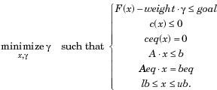
[x,fval,attainfactor] = fgoalattain(...) [x,fval,attainfactor,exitflag] = fgoalattain(...) [x,fval,attainfactor,exitflag,output] = fgoalattain(...) [x,fval,attainfactor,exitflag,output,lambda] = fgoalattain(...) The solver was used to find the minimum of the function F(x) as follows:

(3.93)

x, weight, goal, b, beq, lb, and ub are vectors, A and Aeq are matrices, and c(x), ceq(x), and F(x) are functions that return vectors. F(x), c(x), and ceq(x) can be linear or nonlinear functions.

MATLAB Toolbox Syntax:

x = fgoalattain(thresheff,x0,goal,weight)

x = fgoalattain(thresheff,x0,goal,weight,A,b)
x = fgoalattain(thresheff,x0,goal,weight,A,b,Aeq,beq)
x = fgoalattain(thresheff,x0,goal,weight,A,b,Aeq,beq,lb,ub)
x = fgoalattain(thresheff,x0,goal,weight,A,b,Aeq,beq,lb,ub,confun)
x = fgoalattain(thresheff,x0,goal,weight,A,b,Aeq,beq,lb,ub,confun,... options) x = fgoalattain(problem)
[x,fval] = fgoalattain(...) [x,fval,attainfactor] = fgoalattain(...)
[x,fval,attainfactor,exitflag] = fgoalattain(...) [x,fval,attainfactor,exitflag,output] = fgoalattain(...) [x,fval,attainfactor,exitflag,output,lambda] = fgoalattain(...) Description:
x = fgoalattain(thresheff,x0,goal,weight) tries to make the objective functions supplied by fun attain the goals specified by goal by varying x, starting at x0, with weight specified by weight.
x = fgoalattain(thresheff,x0,goal,weight,A,b) solves the goal attainment problem subject to the linear inequalities A*x = b.
x = fgoalattain(thresheff,x0,goal,weight,A,b,Aeq,beq) solves the goal attainment problem subject to the linear equalities Aeq*x = beq as well. Set A = [] and b = [] if no inequalities exist.
x = fgoalattain(thresheff,x0,goal,weight,A,b,Aeq,beq,lb,ub) defines a set of lower and upper bounds on the design variables in x, so that the solution is always in the range lb = x = ub.
x = fgoalattain(thresheff,x0,goal,weight,A,b,Aeq,beq,lb,ub,confun) subjects the goal attainment problem to the nonlinear inequalities c(x) or linear equality constraints ceq(x) defined in confun.

fgoalattain optimizes such that c(x) = 0 and ceq(x) = 0. Set lb = [] and/or ub = [] if no bounds exist.
x = fgoalattain(fun,x0,goal,weight,A,b,Aeq,beq,lb,ub,confun,... options) minimizes with the optimization options specified in the structure options. Optimset was used to set these options.
x = fgoalattain(problem) finds the minimum for problem, where problem is a structure described in Input Arguments.
The structure problem was created by exporting a problem from Optimization Tool

[x,fval] = fgoalattain(...) returns the values of the objective functions computed in fun at the solution x.
[x,fval,attainfactor] = fgoalattain(...) returns the attainment factor at the solution x. [x,fval,attainfactor,exitflag] = fgoalattain(...) returns a value exitflag that describes the exit condition of fgoalattain.
[x,fval,attainfactor,exitflag,output] = fgoalattain(...) returns a structure output that contains information about the optimization.
[x,fval,attainfactor,exitflag,output,lambda] = fgoalattain(...) returns a structure lambda whose fields contain the Lagrange multipliers at the solution x.

Running the Optimization
To run the optimization, the problem structure was created and modified in optimtool by exporting the problem information to the MATLAB workspace. An option structure was created using the “optimset” function or the export option of optimtool. The optimtool solver starts the optimization tool with the specified solver. For this study, the fgoalattain solver was used to perform the optimization. In the optimtool interface the solver, toolbox function and constraints were selected, the optimization options were specified before clicking on the start button to run the optimization. The goal attainment problem was solved by minimizing the multi-objective functions f(x) simultaneously. The result of the optimization was displayed in an output.

CHAPTER FOUR

RESULTS AND DISCUSSION

Output Capacity for Millet Crop
Output capacity evaluates the quantity of clean millet grains collected at the grain outlet of the multicrop thresher for the total quantity of crop fed per hour. The millet grains collected ranges from 166.6 kg/hr to 520.6 kg/hr when threshing was done at different levels of cylinder speed, feed rate and crop moisture content. The variation of speed with output at various moisture contents and constant feed rates are illustrated in Fig. 4(a, b, c, d and e). It indicates that output capacity increase as speed increase. This may be due to increase kinetic energy transfer from beater to crop causing more grains to be detarched. However at constant speed and feed rate output capacity decreases as moisture content increase. This was as a result of cohesive and adhesive forces that exist in crop with high moisture content that keeps the grains in place resulting to reduction in grain detarchment and output capacity.
The variation of feed rate with output at various moisture contents and constant speed are illustrated in Fig. 4.1(a, b, c, d and e). It indicates that output capacity increases as feed rate increase. The reason was increase in the quantity of crop entering the hopper. However at a constant speed and feed rate output capacity decreases as moisture content increases. These results were similar to those of Sinha et al. (2009) and Osueke (2013). Therefore output capacity is directly proportional to speed and feed rate but inversely proportional to moisture contents. The equations of the regression lines are listed alongside the lines with their coefficient of determination (R²).
The analysis of variance (ANOVA) of output capacity for millet crop is shown in Table

4. The ANOVA indicates that the effect of all the factors evaluated and their interactions were significant at 1 % probability level. Further analysis of the results using Duncan‟s Multiple Range Test (DMRT) are shown in Tables 4.1(a, b and c). The result shows that in the variation

of speed, feed rate and moisture content with output capacity there were significant differences between the means at 1 % level of significance. This implies as speed increase to another level output capacity increase significantly (Table 4.1a); as feed rate increase to another level output capacity increase significantly (Table 4.1b); as moisture content decrease to another level output capacity increase significantly (Table 4.1c). Appendix D represents measured values of output capacity at five levels of cylinder speed, feed rate and crop moisture content for millet crop.

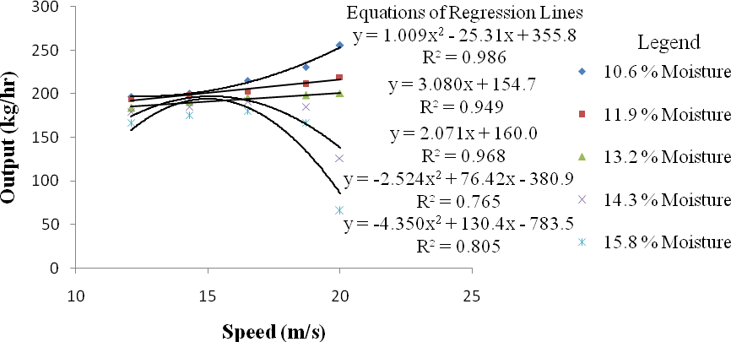
Fig. 4a: Variation of speed with output at various moisture content and constant feed rate of 6 kg/min for millet crop
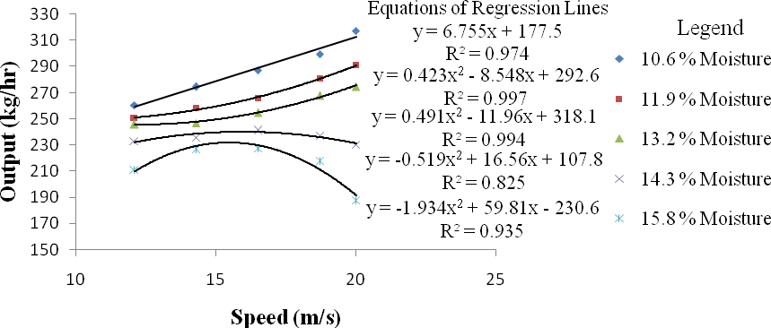
Fig. 4b: Variation of speed with output at various moisture content and constant feed rate of 8 kg/min for millet crop
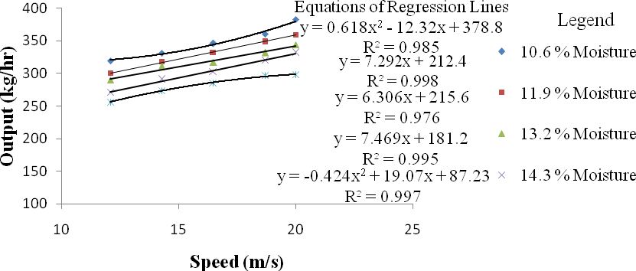
Fig. 4c: Variation of speed with output at various moisture content and constant feed rate of 10 kg/min for millet crop

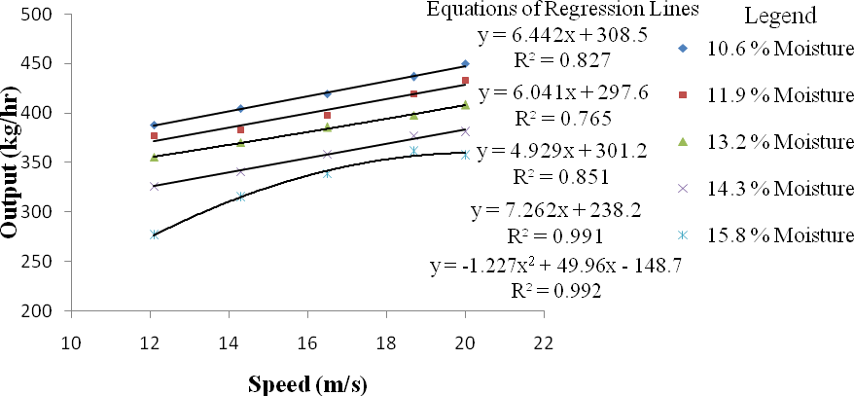

Fig. 4d: Variation of speed with output at various moisture content and constant feed rate of 12 kg/min for millet crop
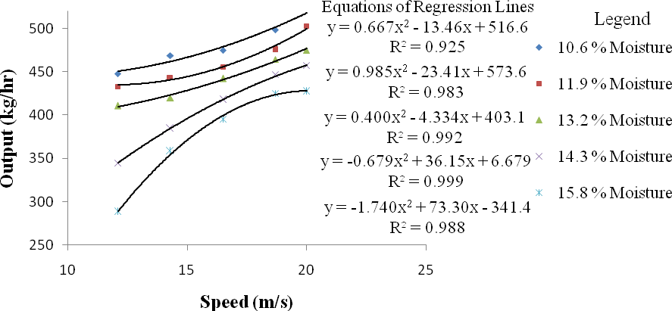
Fig. 4e: Variation of speed with output at various moisture content and constant feed rate of 14 kg/min for millet crop

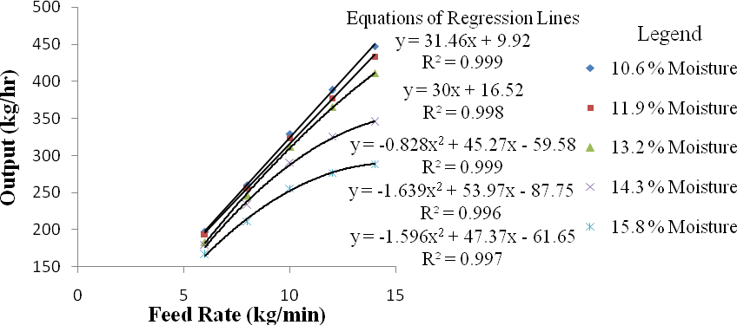

Fig. 4.1a: Variation of feed rate with output at various moisture contents and constant speed of
12.1 m/s for millet crop
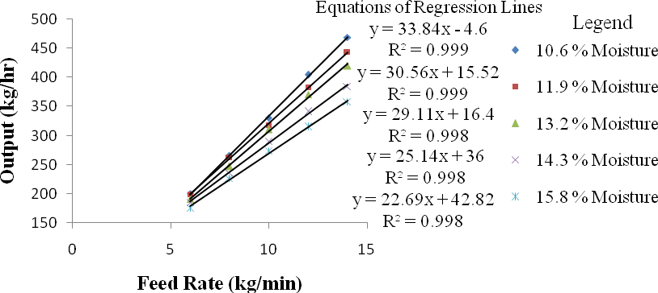
Fig. 4.1b: Variation of feed rate with output at various moisture contents and constant speed of
14.3 m/s for millet crop
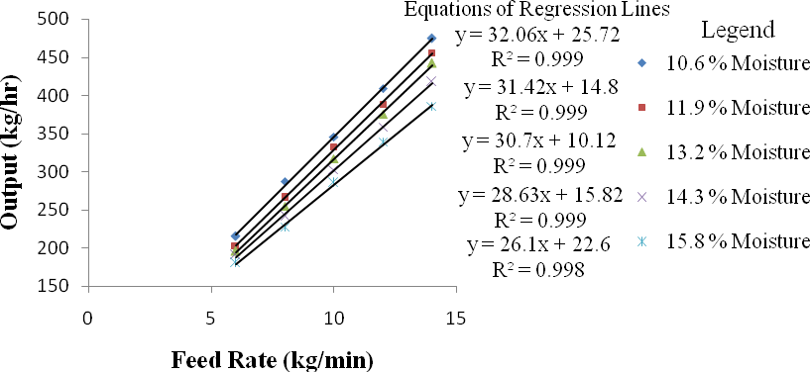

Fig. 4.1c: Variation of feed rate with output at various moisture contents and constant speed of
16.5 m/s for millet crop

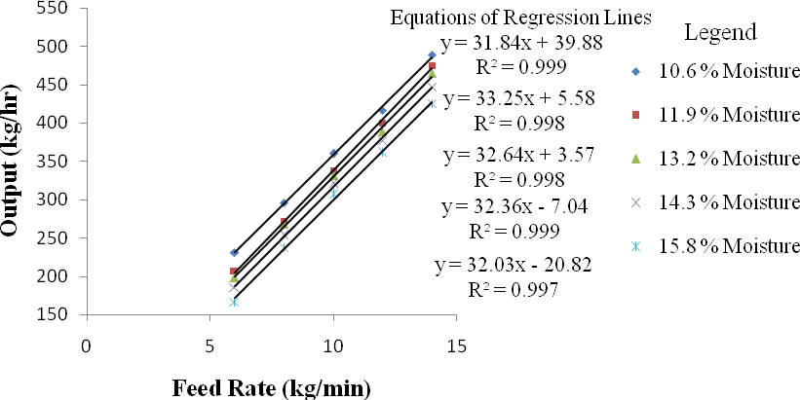
Fig. 4.1d: Variation of feed rate with output at various moisture contents and constant speed of
18.7 m/s for millet crop
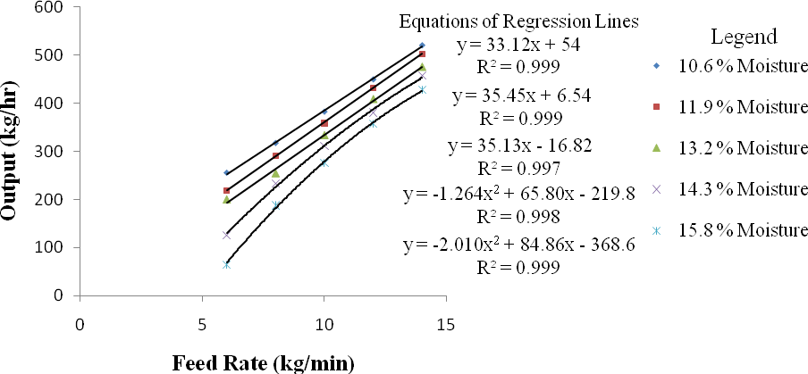
Fig. 4.1e: Variation of feed rate with output at various moisture contents and constant speed of 20 m/s for millet crop

Table 4: ANOVA of output capacity for millet crop

Source | Degree of Freedom | Sum of Squares | Mean Squares | F Value
Replication | 2 | 1.47
Moisture (M) | 4 | 32850.78 | 8212.70 | 10056.3 **
Speed (S) | 4 | 3197133.97 | 799283.49 | 978706 **
Feed rate (F) | 4 | 16764.92 | 4191.23 | 5132.07 **
M × S | 16 | 2274.61 | 142.16 | 174.08 **
M × F | 16 | 1465.07 | 91.57 | 112.12 **
F × S | 16 | 25563.07 | 1597.69 | 1956.34 **
M × S × F | 64 | 3763.91 | 58.81 | 72.01 **
Error | 248 | 202.54 | 0.82
Total | 374 | 3280020.32
** = Significant at 1 % probability level

Table 4.1a: D. M. R. T. for variation of speed with output capacity for millet crop

Duncan  Grouping | Mean  Output (kg/hr) | N | Speed  (m/s)
A | 194.45 | 75 | 12.1
B | 261.53 | 75 | 14.3
C | 324.69 | 75 | 16.5
D | 377.95 | 75 | 18.7
E | 371.95 | 75 | 20.0
Alpha= 0.05, Error Degrees of Freedom = 248, Error Mean Square = 0.817
Number of Means | 2 |  | 3 | 4 | 5
Critical Range | 0.29 | 0.31 |  | 0.32 | 0.33

Table 4.1b: D. M. R. T. for variation of feed rate with output capacity for millet crop

Duncan  Grouping | Mean  Output (kg/hr) | N | Feed Rate  (kg/min)
A | 317.18 | 75 | 6
B | 319.13 | 75 | 8
C | 324.84 | 75 | 10
D | 329.28 | 75 | 12
E | 335.14 | 75 | 14
Alpha= 0.05, Error Degrees of Freedom = 248, Error Mean Square = 0.817
Number of Means | 2 | 3 | 4 | 5
Critical Range | 0.29 | 0.31 | 0.32 | 0.33

Table 4.1c: D. M. R. T. for variation of crop moisture content with output capacity for millet crop

Duncan  Grouping | Mean  Output (kg/hr) | N | Moisture  Content (%)
A | 334.78 | 75 | 10.6
B | 331.25 | 75 | 11.9
C | 327.57 | 75 | 13.2
D | 317.71 | 75 | 14.3
E | 309.26 | 75 | 15.8
Alpha= 0.05, Error Degrees of Freedom = 248, Error Mean Square = 0.817
Number of Means | 2 | 3 | 4 | 5
Critical Range | 0.29 | 0.31 | 0.32 | 0.33

This test controls the Type I comparison wise error rate, not the experiment wise error rate. Any two means with the same letter are not significantly different at 1 % level of significance.

Threshing Efficiency for Millet Crop
Threshing efficiency evaluates the percentage of grains detached from the crop by the beaters of the multicrop thresher. It ranges from 94.02 % to 99.98 % for millet when threshing was done at different levels of cylinder speed, feed rate and crop moisture content. The variation of speed with threshing efficiency at various moisture contents and constant feed rates are illustrated in Fig. 4.2(a, b, c, d and e). It indicates that threshing efficiency increases as speed increase. This may be due to increase kinetic energy transfer from beater to crop causing more grains to be detarched. However at constant speed, threshing efficiency decreases as moisture content increase. The reason was the existence of cohesive / adhesive forces in crop with high moisture content that keeps the grains in place resulting to reduction in threshing efficiency.
The variation of feed rate with threshing efficiency at various crop moisture contents and constant speed are illustrated in Fig. 4.3(a, b, c, d and e). It indicates that threshing efficiency decreases as feed rate increase. This was because of reduction in speed as the load intensity on the beaters increase as more crops are fed. However at a constant feed rate, threshing efficiency decreases as moisture content increase. This may be due to cohesive and adhesive forces that exist in crop with high moisture content that keeps the grains in place resulting to reduction in threshing efficiency. These results were similar to those of Sinha et al. (2009); Osueke (2013) and Saeidirad et al. (2013). Therefore threshing efficiency is directly proportional to speed but inversely proportional to feed rate and moisture contents. The equations of the regression lines are listed alongside the lines with their coefficient of determination (R²).
The analysis of variance (ANOVA) of threshing efficiency for millet crop is shown in Table 4.2. The ANOVA indicates that the effect of all the factors evaluated and their interactions were significant at 1 % probability level. Further analysis of the results using Duncan‟s Multiple Range Test (DMRT) are shown in Tables 4.3(a, b and c). The result shows that in the variation of speed, feed rate and moisture content with threshing efficiency there were significant

differences between the means at 1 % level of significance. This implies as speed increase to another level threshing efficiency increase significantly (Table 4.3a); as feed rate increase to another level threshing efficiency decrease significantly (Table 4.3b); as moisture content decrease to another level threshing efficiency increase significantly (Table 4.3c). Appendix F represents measured values of threshing efficiency at five levels of cylinder speed, feed rate and crop moisture content for millet crop.

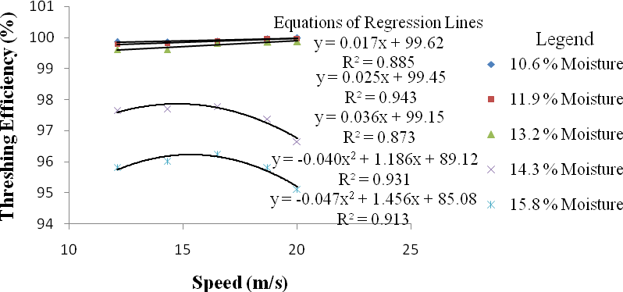
Fig. 4.2a: Variation of speed with threshing efficiency at various moisture content and constant feed rate of 6 kg/min for millet crop
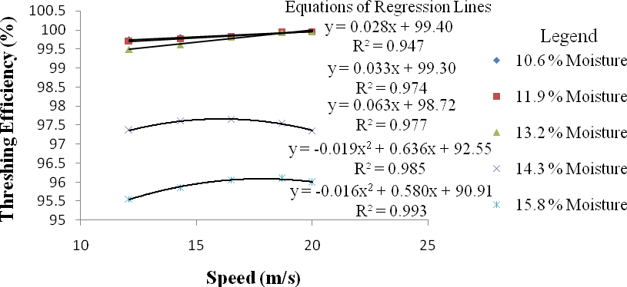
Fig. 4.2b: Variation of speed with threshing efficiency at various moisture content and constant feed rate of 8 kg/min for millet crop
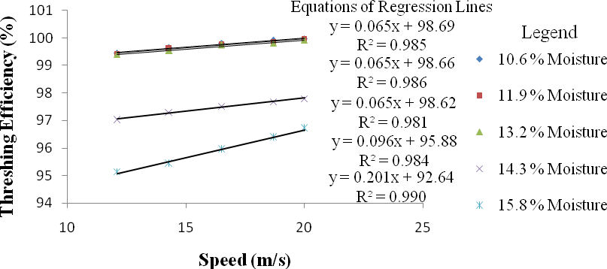
Fig. 4.2c: Variation of speed with threshing efficiency at various moisture content and constant feed rate of 10 kg/min for millet crop

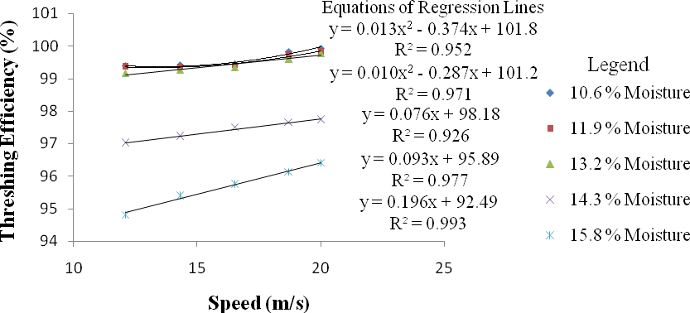
Fig. 4.2d: Variation of speed with threshing efficiency at various moisture content and constant feed rate of 12 kg/min for millet crop
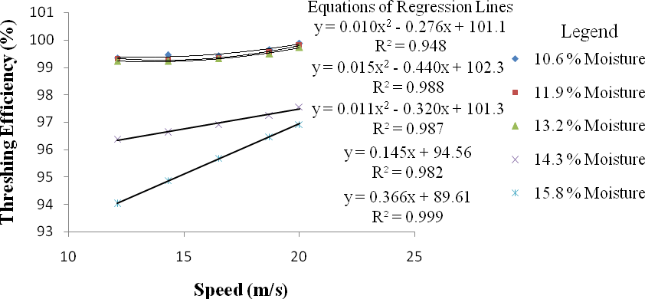
Fig. 4.2e: Variation of speed with threshing efficiency at various moisture content and constant feed rate of 14 kg/min for millet crop

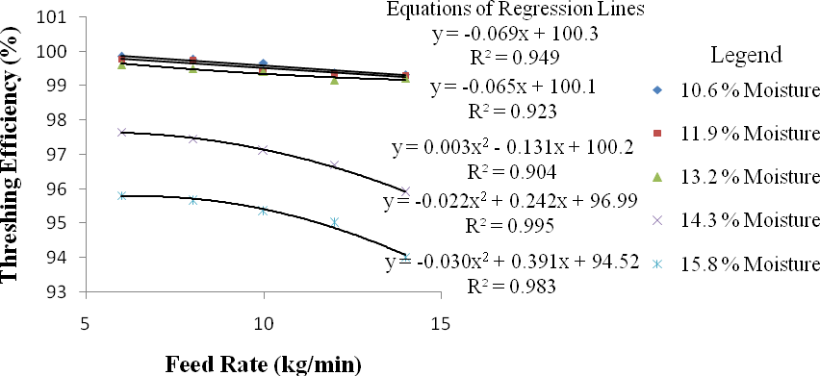
Fig. 4.3a: Variation of feed rate with threshing efficiency at various moisture contents and constant speed of 12.1 m/s for millet crop
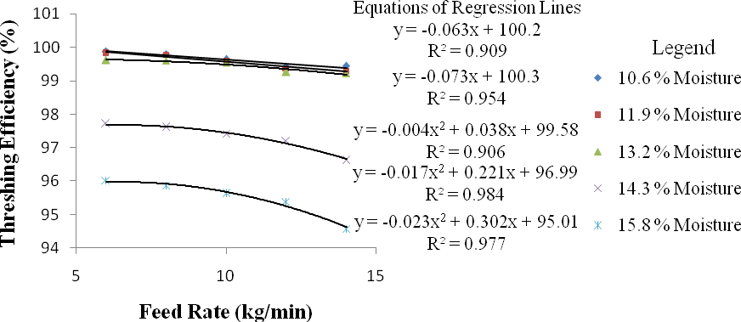
Fig. 4.3b: Variation of feed rate with threshing efficiency at various moisture contents and constant speed of 14.3 m/s for millet crop
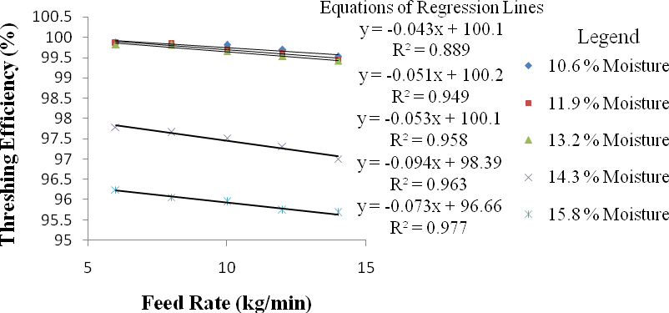
Fig. 4.3c: Variation of feed rate with threshing efficiency at various moisture contents and constant speed of 16.5 m/s for millet crop

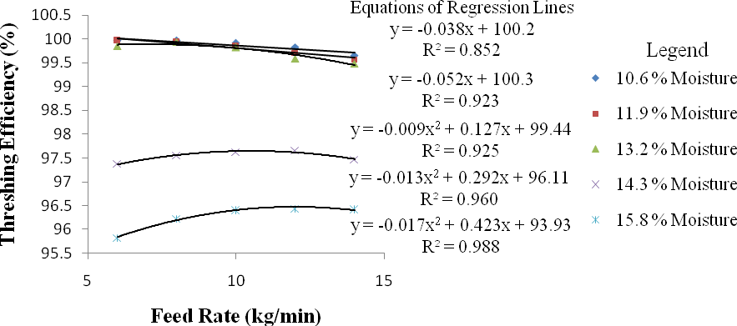

Fig. 4.3d: Variation of feed rate with threshing efficiency at various moisture contents and constant speed of 18.7 m/s for millet crop
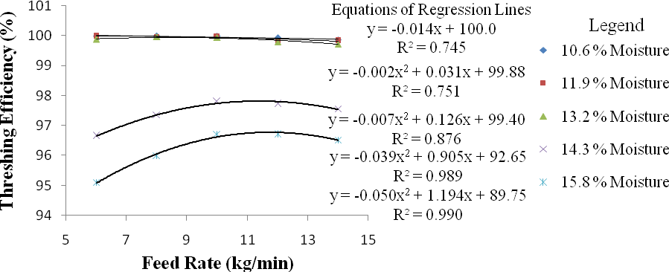

Fig. 4.3e: Variation of feed rate with threshing efficiency at various moisture contents and constant speed of 20 m/s for millet crop

Table 4.2: ANOVA of threshing efficiency for millet crop

Source | Degree of Freedom | Sum of Squares | Mean Squares | F Value
Replication | 2 | 0.003
Moisture (M) | 4 | 812.649 | 203.162 | 46041.8**
Speed (S) | 4 | 7.271 | 1.818 | 411.93**
Feed rate (F) | 4 | 16.259 | 4.065 | 921.19**
M × S | 16 | 2.793 | 0.175 | 39.56**
M × F | 16 | 8.705 | 0.544 | 123.30**
F × S | 16 | 3.761 | 0.235 | 53.27**
M × S × F | 64 | 6.600 | 0.103 | 23.37**
Error | 248 | 1.094 | 0.004
Total | 374 | 859.136
** = Significant at 1 % probability level

Table 4.3 a: D. M. R.T. for variation of speed with threshing efficiency for millet crop

Duncan Grouping | Mean Threshing  Efficiency (%) | N | Speed (m/s)
A | 98.28 | 75 | 12.1
B | 98.48 | 75 | 14.3
C | 98.57 | 75 | 16.5
D | 98.64 | 75 | 18.7
E | 98.67 | 75 | 20.0
Alpha = 0.05, Error Degrees of Freedom = 248, Error Mean Square = 0.004 Number of Means 2 3 4 5
Critical Range 0.021 0.022 0.023 0.024
Table 4.3 b: D. M. R.T. for variation of feed rate with threshing efficiency for millet crop
Duncan Grouping | Mean Threshing  Efficiency (%) | N | Feed Rate (kg/min)
A | 98.77 | 75 | 6
B | 98.70 | 75 | 8
C | 98.58 | 75 | 10
D | 98.38 | 75 | 12
E | 98.21 | 75 | 14
Alpha = 0.05, Error Degrees of Freedom = 248, Error Mean Square = 0.004 Number of Means 2 3 4 5
Critical Range 0.021 0.022 0.023 0.024
Table 4.3 c: D. M. R.T. for variation of crop moisture content with threshing efficiency for millet crop
Duncan Grouping | Mean  Threshing Efficiency (%) | N | Moisture Content (%)
A | 99.73 | 75 | 10.6
B | 99.69 | 75 | 11.9
C | 99.64 | 75 | 13.2
D | 97.41 | 75 | 14.3
E | 96.17 | 75 | 15.8
Alpha = 0.05, Error Dgrees of Freedom = 248, Error Mean Square = 0.004 Number of Means 2 3 4 5
Critical Range 0.021 0.022 0.023 0.024
This test controls the Type I comparison wise error rate, not the experiment wise error rate. Any two means with the same letter are not significantly different at 1 % level of significance.

Cleaning Efficiency for Millet Crop
Cleaning efficiency evaluates the percentage of clean grain collected at the grain outlet. It indicates the effectiveness of the sieves, the blower and the shaker to separate grains from chaff as they flow to the bottom of the thresher. It ranges from 84.27 % to 99.71 % for millet when threshing was done at different levels of cylinder speed, feed rate and crop moisture content. The variation of speed with cleaning efficiency at various moisture contents and constant feed rates are illustrated in Fig. 4.4(a, b, c, d and e). It indicates that cleaning efficiency increases as speed increase. This may be due to increase in air flow rate of the blower as speed increases. However at constant speed, cleaning efficiency decreases as moisture content increase. The reason was the existence of cohesive / adhesive forces and small mass difference between grains and chaff with high moisture content resulting to grains being blown away with chaff hence reduction in cleaning efficiency.
The variation of feed rate with cleaning efficiency at various moisture contents and constant speed are illustrated in Fig. 4.5(a, b, c, d and e). It indicates that cleaning efficiency decreases as feed rate increase. This was because of increasing load intensity on the sieves as multiple particles act as obstruction to grain flow resulting to more grains blown away with chaff. Also at a constant feed rate, cleaning efficiency decreases as moisture content increase. These results were similar to those of Simonyan and Yiljep (2008); Osueke (2013). Therefore cleaning efficiency is directly proportional to speed but inversely proportional to feed rate and crop moisture content. The equations of the regression lines are listed alongside the lines with their coefficient of determination (R²).
The analysis of variance (ANOVA) of cleaning efficiency for millet crop is shown in Table 4.4. The ANOVA indicates that the effect of all the factors evaluated and their interactions were significant at 1 % probability level. Further analysis of the results using Duncan‟s Multiple Range Test (DMRT) are shown in Tables 4.5(a, b and c). The result shows that in the variation

of speed, feed rate and moisture content with cleaning efficiency there were significant differences between the means at 1 % level of significance. This implies as speed increase to another level cleaning efficiency increase significantly (Table 4.5a); as feed rate increase to another level cleaning efficiency decrease significantly (Table 4.5b); as moisture content decrease to another level cleaning efficiency increase significantly (Table 4.5c). Appendix H represents measured values of cleaning efficiency at five levels of cylinder speed, feed rate and crop moisture content for millet crop.

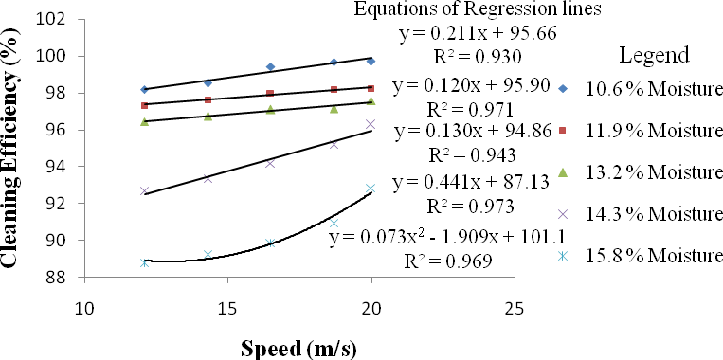

Fig. 4.4a: Variation of speed with cleaning efficiency at various moisture content and constant feed rate of 6 kg/min for millet crop
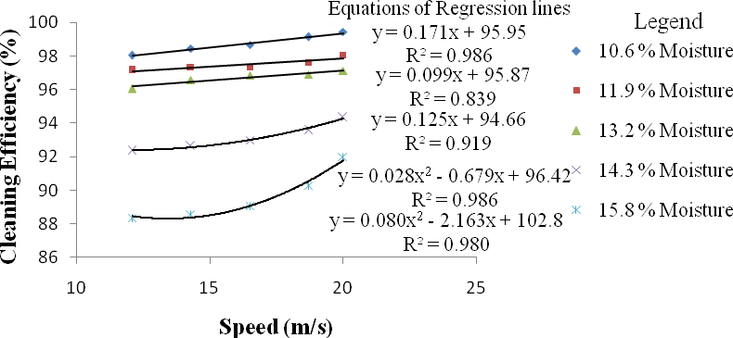
Fig. 4.4b: Variation of speed with cleaning efficiency at various moisture content and constant feed rate of 8 kg/min for millet crop
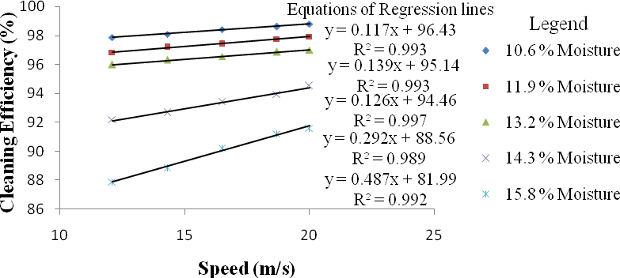
Fig. 4.4c: Variation of speed with cleaning efficiency at various moisture content and constant feed rate of 10 kg/min for millet crop

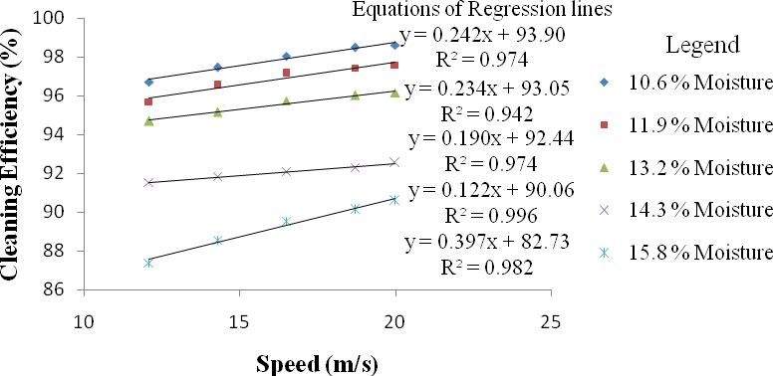
Fig. 4.4d: Variation of speed with cleaning efficiency at various moisture content and constant feed rate of 12 kg/min for millet crop
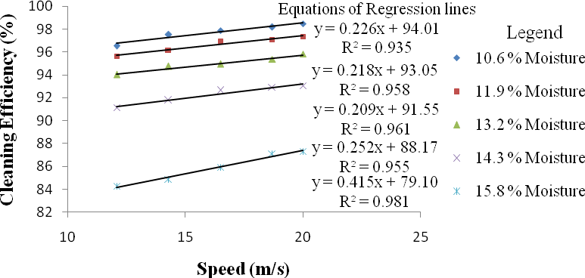
Fig. 4.4e: Variation of speed with cleaning efficiency at various moisture content and constant feed rate of 14 kg/min for millet crop

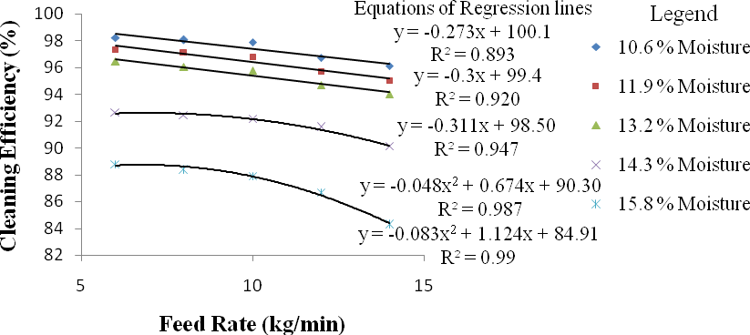
Fig. 4.5a: Variation of feed rate with cleaning efficiency at various moisture contents and constant speed of 12.1 m/s for millet crop
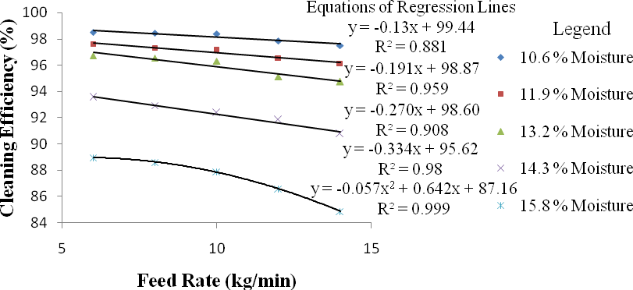

Fig. 4.5b: Variation of feed rate with cleaning efficiency at various moisture contents and constant speed of 14.3 m/s for millet crop
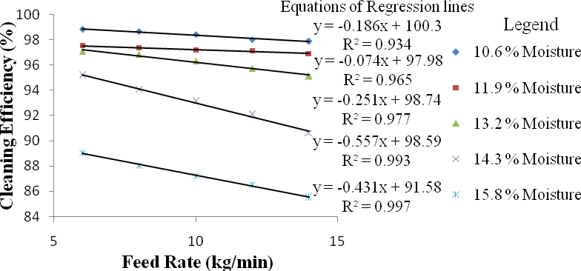

Fig. 4.5c: Variation of feed rate with cleaning efficiency at various moisture contents and constant speed of 16.5 m/s for millet crop

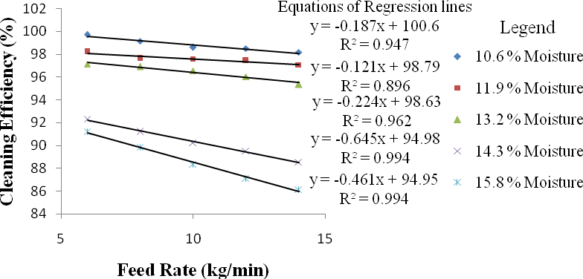

Fig. 4.5d: Variation of feed rate with cleaning efficiency at various moisture contents and constant speed of 18.7 m/s for millet crop
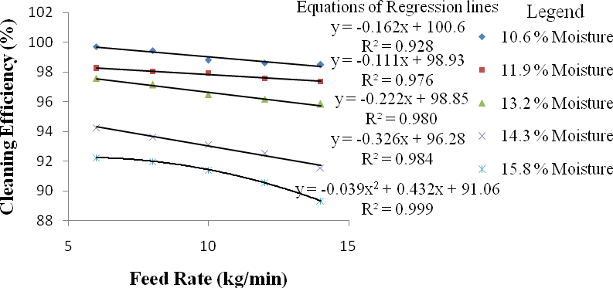
Fig. 4.5e: Variation of feed rate with cleaning efficiency at various moisture contents and constant speed of 20 m/s for millet crop

Table 4.4: ANOVA of cleaning efficiency for millet crop

Source | Degree of Freedom | Sum of Squares | Mean Squares | F Value
Replication | 2 | 0.01
Moisture (M) | 4 | 4850.31 | 1212.58 | 55341.7**
Speed (S) | 4 | 112.61 | 28.15 | 1284.85**
Feed rate (F) | 4 | 192.62 | 48.16 | 2197.83**
M × S | 16 | 97.67 | 6.10 | 278.60 **
M × F | 16 | 74.05 | 4.63 | 211.23 **
F × S | 16 | 44.49 | 2.78 | 126.90 **
M × S × F | 64 | 92.03 | 1.44 | 65.63 **
Error | 248 | 5.43 | 5.43
Total | 374 | 5469.23 | 5469.23
** = Significant at 1 % probability level

Table 4.5 a: D. M. R.T for variation of speed with cleaning efficiency for millet crop

Duncan Grouping | Mean  Cleaning Efficiency (%) | N | Speed (m/s)
A | 93.87 | 75 | 12.1
B | 94.31 | 75 | 14.3
C | 94.62 | 75 | 16.5
D | 94.88 | 75 | 18.7
E | 95.42 | 75 | 20.0
Alpha = 0.05, Error Degrees of Freedom = 248, Error Mean Square = 0.022 Number of Means 2 3 4 5
Critical Range 0.048 0.050 0.052 0.053
Table 4.5 b: D. M. R.T. for variation of feed rate with cleaning efficiency for millet crop

Duncan Grouping | Mean  Cleaning Efficiency (%) | N | Feed Rate (kg/min)
A | 95.83 | 75 | 6
B | 94.81 | 75 | 8
C | 94.58 | 75 | 10
D | 94.12 | 75 | 12
E | 93.72 | 75 | 14
Alpha = 0.05, Error Degrees of Freedom = 248, Error Mean Square = 0.022 Number of Means 2 3 4 5
Critical Range 0.048 0.050 0.052 0.053
Table 4.5 c: D. M. R.T. for variation of crop moisture content with cleaning efficiency for millet crop

Duncan Grouping | Mean Cleaning  Efficiency (%) | N | Moisture Content (%)
A | 98.35 | 75 | 10.6
B | 97.24 | 75 | 11.9
C | 96.29 | 75 | 13.2
D | 92.66 | 75 | 14.3
E | 88.52 | 75 | 15.8
Alpha = 0.05, Error Degrees of Freedom = 248, Error Mean Square = 0.022 Number of Means 2 3 4 5
Critical Range 0.048 0.050 0.052 0.053
This test controls the Type I comparison wise error rate, not the experiment wise error rate. Any two means with the same letter are not significantly different at 1 % level of significance.

Scattered Grain Loss for Millet Crop
Scattered grain (S_{g}) includes: threshed grains sucked out with chaff at the top chaff outlet, plus threshed grains falling out of the hopper, plus threshed grains blown away with chaff by the blower, plus threshed grains falling from the shaker during threshing and cleaning. It ranges from
5.77 % to 12.18 % for millet when threshing was done at different levels of cylinder speed, feed rate and crop moisture content. The variation of speed with scattered grain loss at various moisture contents and constant feed rates are illustrated in Fig. 4.6(a, b, c, d and e). It indicates that scattered grain loss increases as speed increase. This may be due to increase in machine vibration and air flow rate of the blower above optimum. However at constant speed, scattered grain loss decreases as moisture content increase. This may be due to cohesive and adhesive forces that exist in crops with high moisture content that keeps the grains and chaff together resulting to reduction in grain loss.
The variation of feed rate with scattered grain loss at various moisture contents and constant speeds are illustrated in Fig. 4.7(a, b, c, d and e). It indicates that scattered grain loss decreases as feed rate increase. This may be due to increase load intensity on the beaters causing the machine rotation, vibration and air flow rate to be low. Also at a constant feed rate, scattered grain loss decreases as moisture content increase. These results were similar to those of Simonyan and Yiljep (2008). Therefore scattered grain loss is directly proportional to speed but inversely proportional to feed rate and moisture content. The equations of the regression lines are listed alongside the lines with their coefficient of determination (R²).
The analysis of variance (ANOVA) of scattered grain loss for millet crop is shown in Table 4.6. The ANOVA indicates that the effect of all the factors evaluated and their interactions were significant at 1 % probability level. Further analysis of the results using Duncan‟s Multiple Range Test (DMRT) are shown in Tables 4.7(a, b and c). The result shows that in the variation of speed, feed rate and moisture content with scattered grain loss there were significant

differences between the means at 1 % level of significance. This implies as speed increase to another level scattered grain loss increase significantly (Table 4.7a); as feed rate increase to another level scattered grain loss decrease significantly (Table 4.7b); as moisture content decrease to another level scattered grain loss increase significantly (Table 4.7c). Appendix J represents measured values of scattered grain loss at five levels of cylinder speed, feed rate and crop moisture content for millet crop.

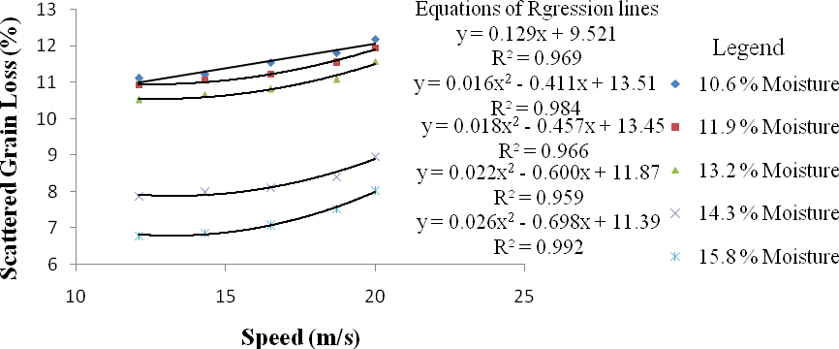

Fig. 4.6a: Variation of speed with scattered grain loss at various moisture content and constant feed rate of 6 kg/min for millet crop
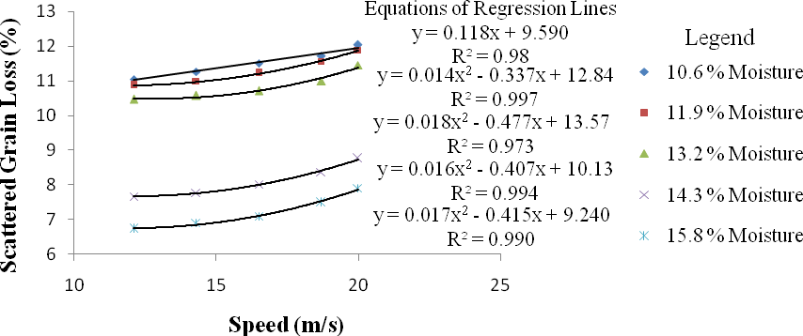
Fig. 4.6b: Variation of speed with scattered grain loss at various moisture content and constant feed rate of 8 kg/min for millet crop
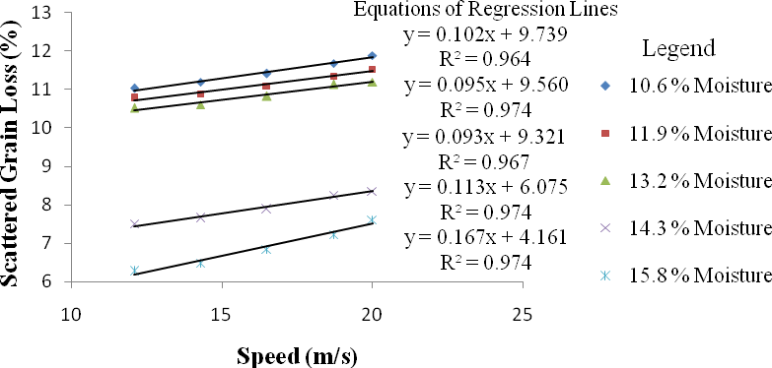
Fig. 4.6c: Variation of speed with scattered grain loss at various moisture content and constant feed rate of 10 kg/min for millet crop

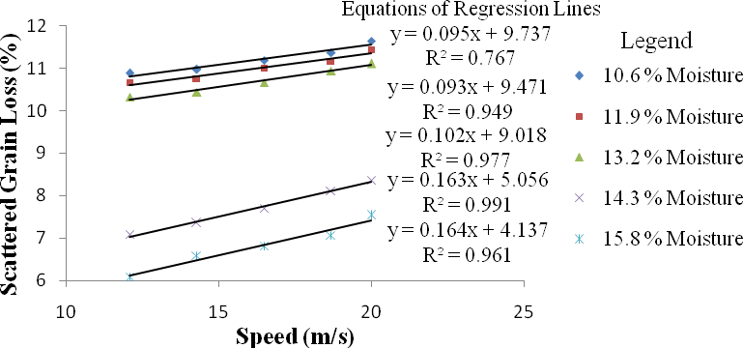

Fig. 4.6d: Variation of speed with scattered grain loss at various moisture content and constant feed rate of 12 kg/min for millet crop
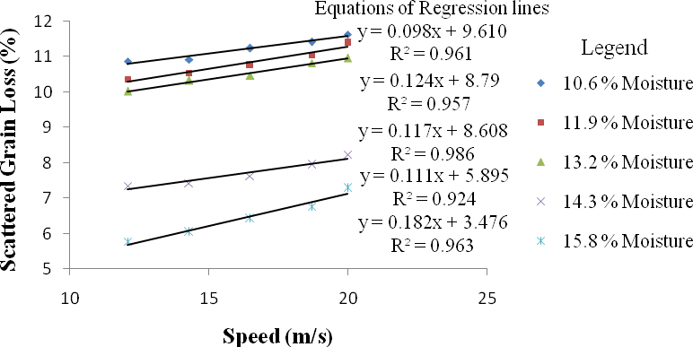

Fig. 4.6e: Variation of speed with scattered grain loss at various moisture content and constant feed rate of 14 kg/min for millet crop

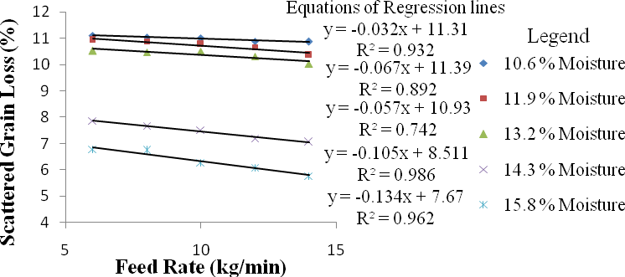

Fig. 4.7a: Variation of feed rate with scattered grain loss at various moisture contents and constant speed of 12.1 m/s for millet crop
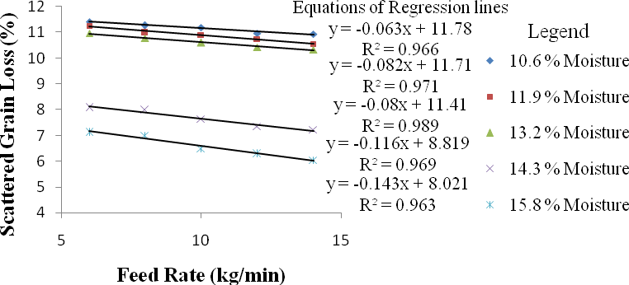
Fig. 4.7b: Variation of feed rate with scattered grain loss at various moisture contents and constant speed of 14.3 m/s for millet crop
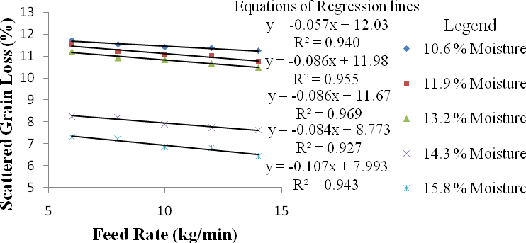

Fig. 4.7c: Variation of feed rate with scattered grain loss at various moisture contents and constant speed of 16.5 m/s for millet crop

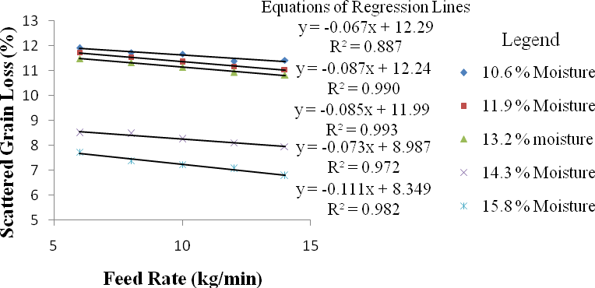

Fig. 4.7d: Variation of feed rate with scattered grain loss at various moisture contents and constant speed of 18.7 m/s for millet crop
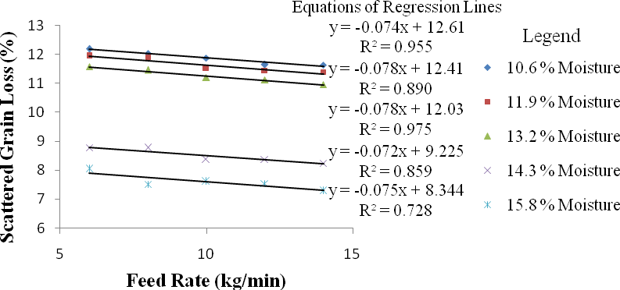

Fig. 4.7e: Variation of feed rate with scattered grain loss at various moisture contents and constant speed of 20 m/s for millet crop

Table 4.6: ANOVA of scattered grain loss for millet crop

Source | Degree of Freedom | Sum of Squares | Mean Squares | F Value
Replication | 2 | 0.00
Moisture (M) | 4 | 1239.92 | 309.98 | 1.453E7**
Speed (S) | 4 | 17.92 | 4.48 | 209943**
Feed rate (F) | 4 | 42.85 | 10.71 | 502106**
M × S | 16 | 0.74 | 0.05 | 2159.33 **
M × F | 16 | 2.23 | 0.14 | 6539.99 **
F × S | 16 | 0.69 | 0.04 | 2010.32 **
M × S × F | 64 | 3.13 | 0.05 | 2288.87 **
Error | 248 | 0.01 | 0.00
Total | 374 | 1307.47
** = Significant at 1 % probability level

Table 4.7 a: D. M. R.T. for variation of speed with scattered grain loss for millet crop

Duncan  Grouping | Mean  Grain Loss (%) | N | Speed  (m/s)
A | 9.37 | 75 | 12.1
B | 9.52 | 75 | 14.3
C | 9.67 | 75 | 16.5
D | 9.82 | 75 | 18.7
E | 9.99 | 75 | 20.0
Alpha = 0.05, Error Degrees of Freedom = 248, Error Mean Square = 0 Number of Means 2 3 4 5
Critical Range 0.015 0.016 0.016 0.017
Table 4.7 b: D.M.R.T. for variation of feed rate with scattered grain loss for millet crop

Duncan  Grouping | Mean  Grain Loss (%) | N | Feed Rate  (kg/min)
A | 9.19 | 75 | 14
B | 9.47 | 75 | 12
C | 9.67 | 75 | 10
D | 9.91 | 75 | 8
E | 10.16 | 75 | 6
Alpha = 0.05, Error Degrees of Freedom = 248, Error Mean Square = 0 Number of Means 2 3 4 5
Critical Range 0.015 0.016 0.016 0.017
Table 4.7 c: D.M.R.T. for variation of crop moisture content with scattered grain loss for millet crop

Duncan  Grouping | Mean  Grain Loss (%) | N | Moisture  Content (%)
A | 11.39 | 75 | 10.6
B | 11.18 | 75 | 11.9
C | 10.83 | 75 | 13.2
D | 7.94 | 75 | 14.3
E | 7.04 | 75 | 15.8
Alpha = 0.05, Error Degrees of Freedom = 248, Error Mean Square = 0 Number of Means 2 3 4 5
Critical Range 0.015 0.016 0.016 0.017
This test controls the type I comparison wise error rate, not the experiment wise error rate. Any two means with the same letter are not significantly different at 1 % level of significance.

Grain Damage for Millet Crop
Grain damage evaluates all the broken grains present within the clean grains collected at the output. It was as a result of direct impact between the beaters of the threshing cylinder and the crop fed. It ranges from 0.001 % to 0.62 % for millet when threshing was done at different levels of cylinder speed, feed rate and crop moisture content. The variation of speed with grain damage at various moisture contents and constant feed rates are illustrated in Fig. 4.8(a. b, c, d and e). It indicates that grain damage increase as speed increases. This may be due to increase in collision rate between grains and beaters. However at constant speed, grain damage decreases as moisture content increase from 10.6 % to 13.2 % for millet; then increase constantly as moisture content increase above 13.5 %. The variation of feed rate with grain damage at various moisture contents and constant speeds are illustrated in Fig. 4.9(a. b, c, d and e). It indicates that grain damage decrease as feed rate increases. This may be due to increase in cushion phenomenon as more crops are fed hence reducing the intensity of collision on the grains. Also at a constant feed rate, grain damage decrease greatly as moisture content decreases from 15.8 % to 13.5 %, and then increase gently as moisture content decreases from 13.2 % to 10.6 % for millet. These results were similar to those of Saeidirad et al. (2013) and Osueke (2013). Therefore grain damage is directly proportional to speed but inversely proportional to feed rate. The reason for this behaviour was because as moisture content decreases from 15.8 % to 13.5 %, softer grains that were breaking easily with increase in speed became elastic and grain damage reduces drastically. However as moisture content decreases from 13.5 % to 10.6 %, grains that were elastic became brittle and grain damage increases a little. The equations of the regression lines are listed alongside the lines with their coefficient of determination (R²).
The analysis of variance (ANOVA) of grain damage for millet crop is shown in Table

4.8. The ANOVA indicates that the effect of all the factors evaluated and their interactions were significant at 1 % probability level. Further analysis of the results using Duncan‟s Multiple

Range Test (DMRT) are shown in Tables 4.9(a, b and c). The result shows that in the variation of speed, feed rate and moisture content with grain damage there were significant differences between the means at 1 % level of significance. This implies as speed increase to another level grain damage increase significantly (Table 4.9a); as feed rate increase to another level grain damage decrease significantly (Table 4.9b); as moisture content decrease from 15.8 % to 13.5 % grain damage decrease significantly (Table 4.9c); as moisture content decrease further from 13.5
% to 10.6 % grain damage increase significantly (Table 4.9c). Appendix L represents measured values of grain damage at five levels of cylinder speed, feed rate and crop moisture content for millet crop.

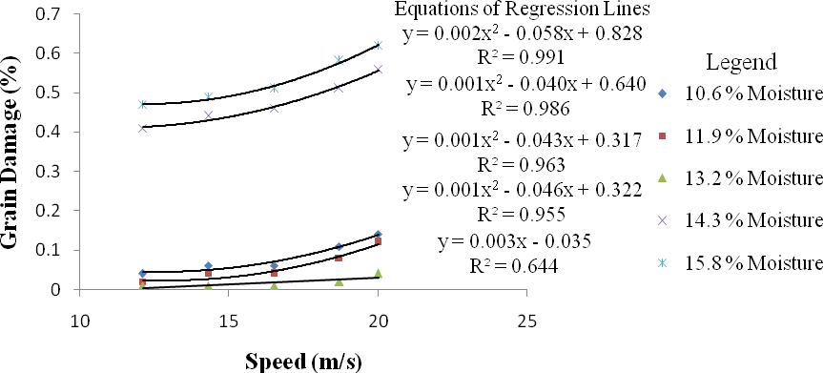
Fig. 4.8a: Variation of speed with grain damage at various moisture content and constant feed rate of 6 kg/min for millet crop
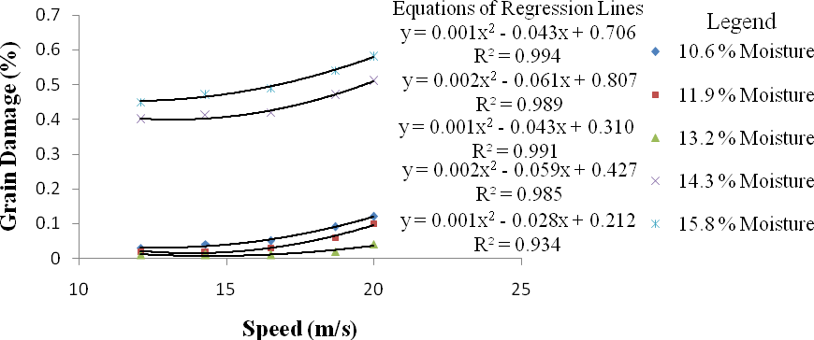
Fig. 4.8b: Variation of speed with grain damage at various moisture content and constant feed rate of 8 kg/min for millet crop
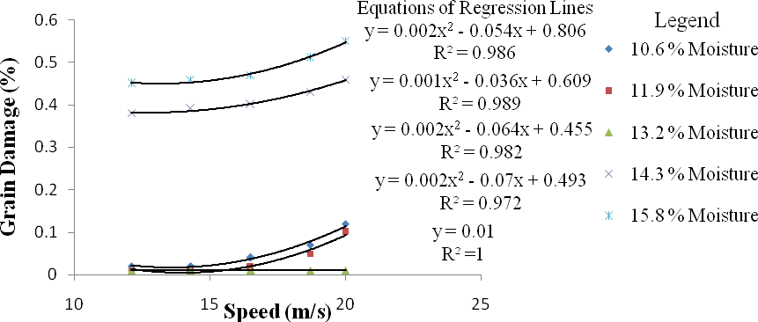

Fig. 4.8c: Variation of speed with grain damage at various moisture content and constant feed rate of 10 kg/min for millet crop

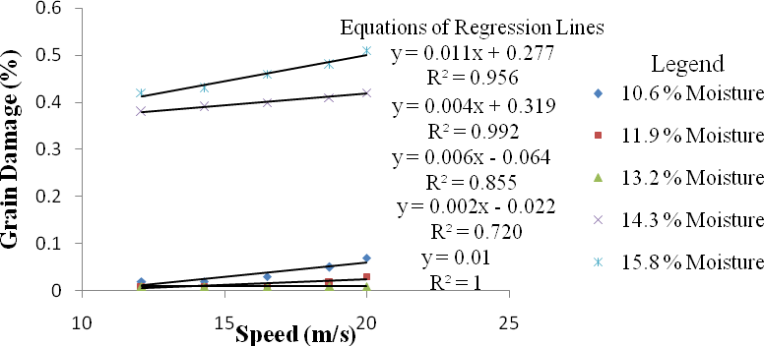

Fig. 4.8d: Variation of speed with grain damage at various moisture content and constant feed rate of 12 kg/min for millet crop
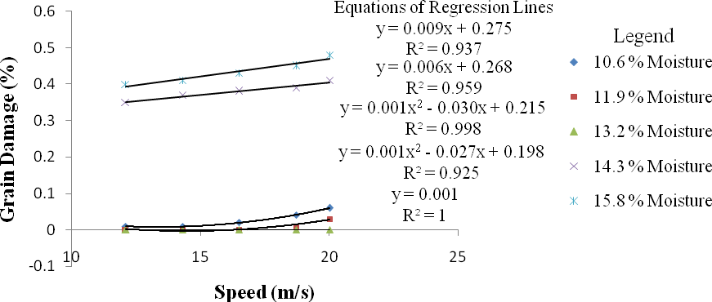

Fig. 4.8e: Variation of speed with grain damage at various moisture content and constant feed rate of 14 kg/min for millet crop

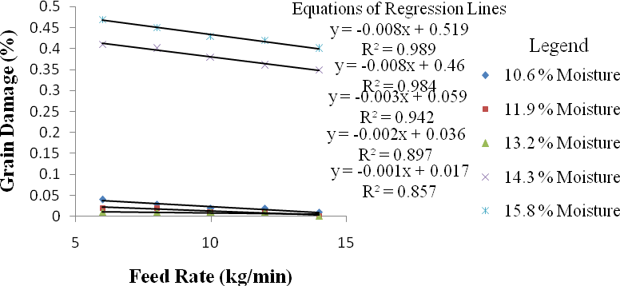
Fig. 4.9a: Variation of feed rate with grain damage at various moisture contents and constant speed of 12.1 m/s for millet crop
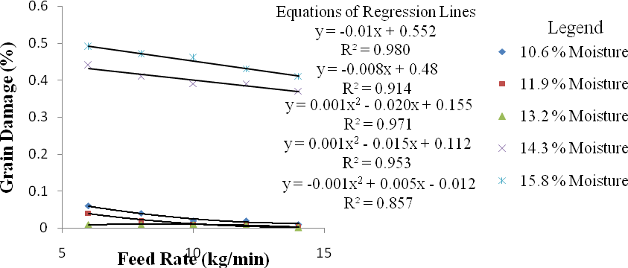

Fig. 4.9b: Variation of feed rate with grain damage at various moisture contents and constant speed of 14.3 m/s for millet crop
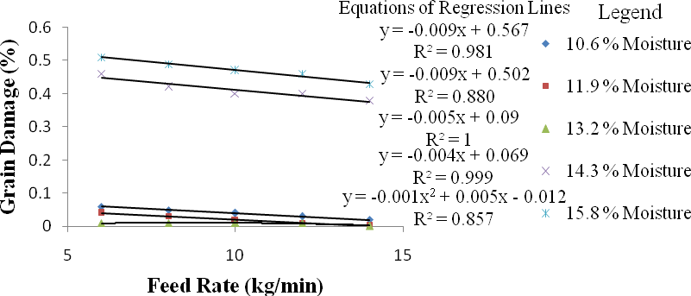

Fig. 4.9c: Variation of feed rate with grain damage at various moisture contents and constant speed of 16.5 m/s for millet crop

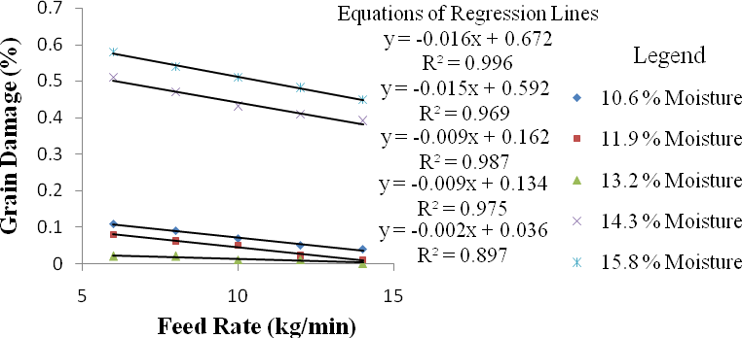

Fig. 4.9d: Variation of feed rate with grain damage at various moisture contents and constant speed of 18.7 m/s for millet crop
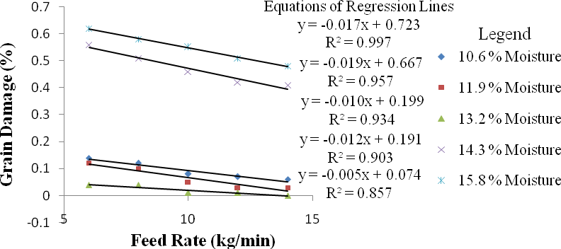

Fig. 4.9e: Variation of feed rate with grain damage at various moisture contents and constant speed of 20 m/s for millet crop

Table 4.8: ANOVA of grain damage for millet crop

Source | Degree of Freedom | Sum of Squares | Mean Squares | F Value
Replication | 2 | 0.00
Moisture (M) | 4 | 15.77 | 3.941 | 3.03E14**
Speed (S) | 4 | 0.22 | 0.054 | 9.47E18**
Feed rate (F) | 4 | 0.26 | 0.064 | 8.61E13**
M × S | 16 | 0.07 | 0.004 | 1.27E17**
M × F | 16 | 0.06 | 0.004 | 4.67E12**
F × S | 16 | 0.03 | 0.002 | 6.91E14**
M × S × F | 64 | 0.02 | 0.001 | 5.39E16**
Error | 248 | 0.00 | 0.00
Total | 374 | 16.42
** = Significant at 1 % probability level

Table 4.9 a: D. M. R.T. for variation of speed with grain damage for millet crop

Duncan Grouping | Mean Grain Damage  (%) | N | Speed (m/s)
A | 0.16 | 75 | 12.1
B | 0.18 | 75 | 14.3
C | 0.20 | 75 | 16.5
D | 0.22 | 75 | 18.7
E | 0.24 | 75 | 20.0
Alpha = 0.05, Error Degrees of Freedom = 248, Error Mean Square = 0
Number of Means | 2 | 3 | 4 | 5
Critical Range | 0 | 0 | 0 | 0

Table 4.9 b: D. M. R.T. for variation of feed rate with grain damage for millet crop

Duncan Grouping | Mean Grain Damage  (%) | N | Feed Rate (kg/min)
A | 0.175 | 75 | 14
B | 0.186 | 75 | 12
C | 0.189 | 75 | 10
D | 0.208 | 75 | 8
E | 0.249 | 75 | 6
Alpha = 0.05, Error Degrees of Freedom = 248, Error Mean Square = 0
Number of Means | 2 | 3 | 4 | 5
Critical Range | 0 | 0 | 0 | 0

Table 4.9 c: D. M. R.T. for variation of crop moisture content with grain damage for millet crop

Duncan Grouping | Mean Grain Damage  (%) | N | Moisture Content (%)
A | 0.058 | 75 | 10.6
B | 0.038 | 75 | 11.9
C | 0.012 | 75 | 13.2
D | 0.250 | 75 | 14.3
E | 0.490 | 75 | 15.8
Alpha = 0.05, Error Degrees of Freedom = 248, Error Mean Square = 0
Number of Means | 2 | 3 | 4 | 5
Critical Range | 0 | 0 | 0 | 0

This test controls the type I comparison wise error rate, not the experiment wise error rate. Any two means with the same letter are not significantly different at 1 % level of significance.

Output Capacity for Soybean Crop
Output capacity evaluates the quantity of clean soybean grains collected at the grain outlet of the multicrop thresher for the total quantity of crop fed per hour. The soybean grains collected ranges from 42 kg/hr to 205 kg/hr when threshing was done at different levels of cylinder speed, feed rate and crop moisture content. The variation of speed with output at various moisture contents and constant feed rates are illustrated in Fig. 4.10(a, b, c, d and e). It indicates that output capacity increase as speed increase. This may be due to increase kinetic energy transfer from beater to crop causing more grains to be detarched. However at constant speed, output capacity decreases as moisture content increase. This was as a result of cohesive and adhesive forces that exist in crop with high moisture content that keeps the grains in place resulting to reduction in grain detarchment and output capacity.
The variation of feed rate with output at various moisture contents and constant speed are illustrated in Fig. 4.11(a, b, c, d and e). It indicates that output capacity increases as feed rate increase. The reason was increase in the quantity of crop entering the hopper. However, at constant speed and feed rate output capacity decreases as moisture content increases. These results were similar to those of Sinha et al. (2009) and Osueke (2013). Therefore output capacity is directly proportional to speed and feed rate but inversely proportional to moisture contents. The equations of the regression lines are listed alongside the lines with their coefficient of determination (R²).
The analysis of variance (ANOVA) of output capacity for soybean crop is shown in Table 4.10. The ANOVA indicates that the effect of all the factors evaluated and their interactions were significant at 1 % probability level. Further analysis of the results using Duncan‟s Multiple Range Test (DMRT) are shown in Tables 4.11(a, b and c). The result shows that in the variation of speed, feed rate and moisture content with output capacity there were significant differences between the means at 1 % level of significance. This implies as speed

increase to another level output capacity increase significantly (Table 4.11a); as feed rate increase to another level output capacity increase significantly (Table 4.11b); as moisture content decrease to another level output capacity increase significantly (Table 4.11c). Appendix E represents measured values of output capacity at five levels of cylinder speed, feed rate and crop moisture content for soybean crop.

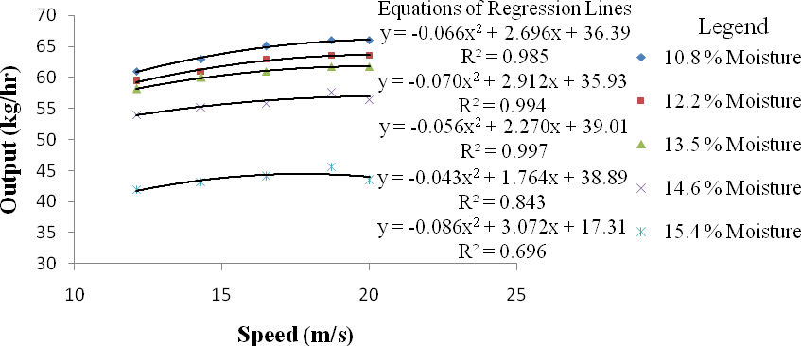
Fig. 4.10a: Variation of speed with output at various moisture content and constant feed rate of 4 kg/min for soybean crop
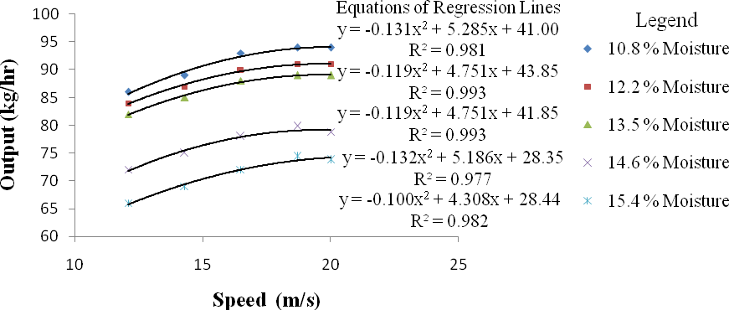
Fig. 4.10b: Variation of speed with output at various moisture content and constant feed rate of 6 kg/min for soybean crop
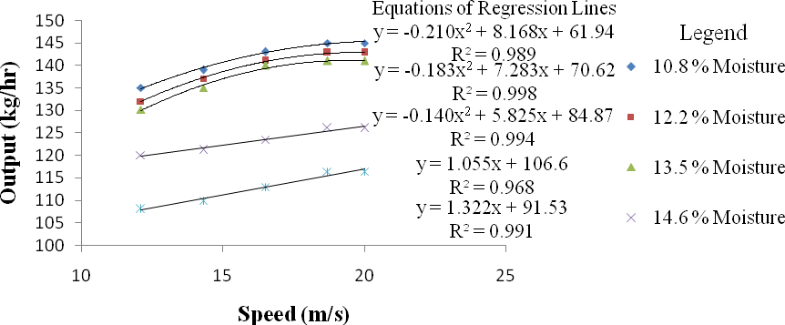
Fig. 4.10c: Variation of speed with output at various moisture content and constant feed rate of 8 kg/min for soybean crop

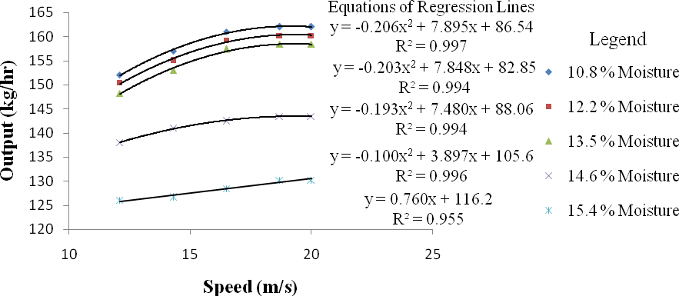
Fig. 4.10d: Variation of speed with output at various moisture content and constant feed rate of 10 kg/min for soybean crop
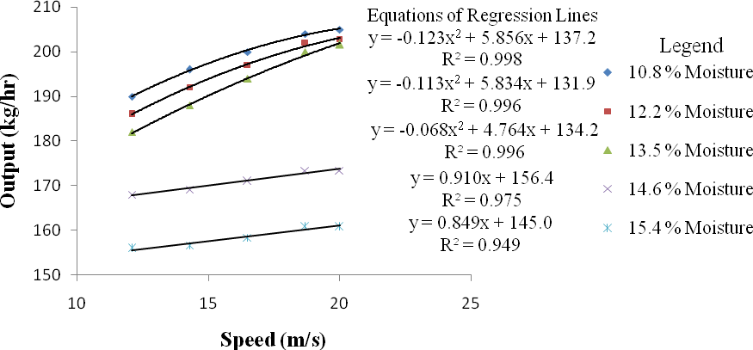
Fig. 4.10e: Variation of speed with output at various moisture content and constant feed rate of 12 kg/min for soybean crop

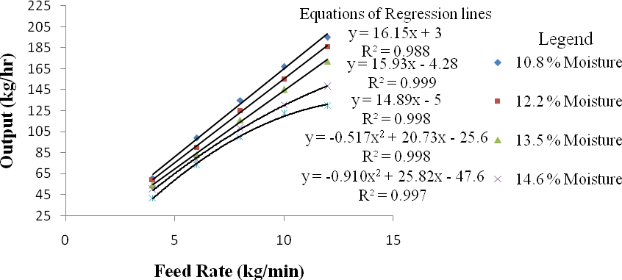
Fig. 4.11a: Variation of feed rate with output at various moisture contents and constant speed of
12.1 m/s for soybean crop
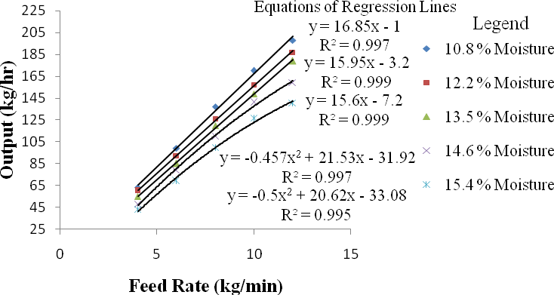
Fig. 4.11b: Variation of feed rate with output at various moisture contents and constant speed of
14.3 m/s for soybean crop
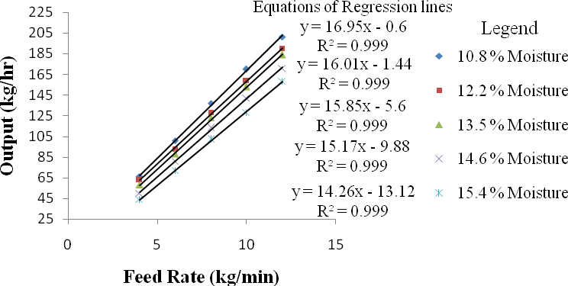
Fig. 4.11c: Variation of feed rate with output at various moisture contents and constant speed of
16.5 m/s for soybean crop

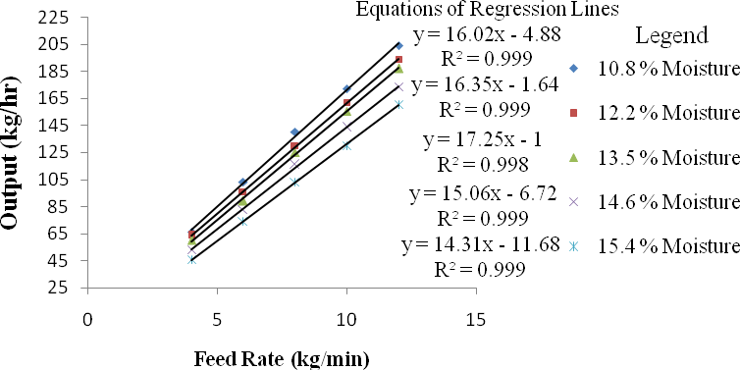

Fig. 4.11d: Variation of feed rate with output at various moisture contents and constant speed of
18.7 m/s for soybean crop
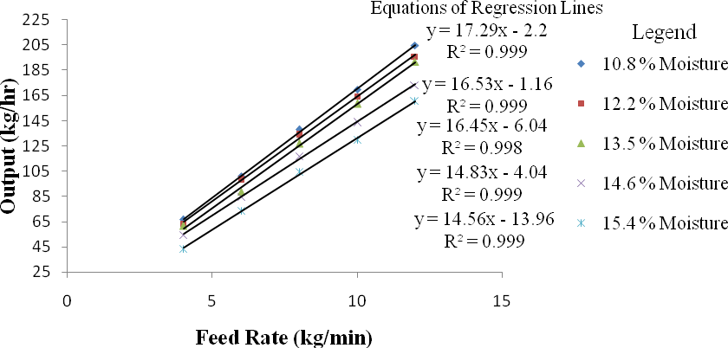

Fig. 4.11e: Variation of feed rate with output at various moisture contents and constant speed of 20 m/s for soybean crop

Table 4.10: ANOVA of output capacity for soybean crop

Source | Degree of Freedom | Sum of Squares | Mean Squares | F Value
Replication | 2 | 0.00
Moisture  (M) | 4 | 56413.90 | 14103.47 | 5.01E15 **
Speed (S) | 4 | 19863.50 | 4965.88 | 1.76E15 **
Feed rate (F) | 4 | 699203.80 | 174800.95 | 6.21E16 **
M × S | 16 | 5490.67 | 343.17 | 1.22E14 **
M × F | 16 | 7819.58 | 488.72 | 1.74E14 **
F × S | 16 | 6960.51 | 435.03 | 1.54E14 **
M × S × F | 64 | 4495.19 | 70.24 | 0.49E13 **
Error | 248 | 0.00 | 0.00
Total | 374 | 800247.13
** = Significant at 1 % probability level

Table 4.11a: D.M.R.T. for variation of speed with output capacity for soybean crop

Duncan  Grouping | Mean  Output (kg/hr) | N | Speed  (m/s)
A | 105.84 | 75 | 12.1
B | 114.58 | 75 | 14.3
C | 122.98 | 75 | 16.5
D | 124.30 | 75 | 18.7
E | 124.46 | 75 | 20.0
Alpha= 0.05, Error Degrees of Freedom = 248, Error Mean Square = 2.82E-12
Number of Means | 2 | 3 | 4 | 5
Critical Range | 0 | 0 | 0 | 0

Table 4.11b: D.M.R.T. for variation of feed rate with output capacity for soybean crop

Duncan  Grouping | Mean  Output (kg/hr) | N | Feed Rate  (kg/min)
A | 57.19 | 75 | 4
B | 83.57 | 75 | 6
C | 128.50 | 75 | 8
D | 144.79 | 75 | 10
E | 178.10 | 75 | 12
Alpha= 0.05, Error Degrees of Freedom = 248, Error Mean Square = 2.82E-12
Number of Means | 2 | 3 | 4 | 5
Critical Range | 0 | 0 | 0 | 0

Table 4.11c: D.M.R.T. for variation of crop moisture content with output capacity for soybean crop

Duncan  Grouping | Mean  Output (kg/hr) | N | Moisture  Content (%)
A | 129.12 | 75 | 10.8
B | 127.85 | 75 | 12.2
C | 126.38 | 75 | 13.5
D | 111.19 | 75 | 14.6
E | 97.61 | 75 | 15.4
Alpha= 0.05, Error Degrees of Freedom = 248, Error Mean Square = 2.82E-12
Number of Means | 2 | 3 | 4 | 5
Critical Range | 0 | 0 | 0 | 0

This test controls the Type I comparison wise error rate, not the experiment wise error rate. Any two means with the same letter are not significantly different at 1 % level of significance.

Threshing Efficiency for Soybean Crop
It ranges from 95.6 % to 100 % for soybean when threshing was done at different levels of cylinder speed, feed rate and crop moisture content. The variation of speed with threshing efficiency at various moisture contents and constant feed rates are illustrated in Fig. 4.12(a, b, c, d and e). It indicates that threshing efficiency increases as speed increase. This may be due to increase kinetic energy transfer from beater to crop causing more grains to be detarched. However at constant speed, threshing efficiency decreases as moisture content increase. The reason was the cohesive and adhesive forces that exist in crop with high moisture content that keeps the grains in place resulting to reduction in threshing efficiency.
The variation of feed rate with threshing efficiency at various crop moisture contents and constant speed are illustrated in Fig. 4.13(a, b, c, d and e). It indicates that threshing efficiency decreases as feed rate increase. This was because of reduction in speed as the load intensity on the beaters increase as more crops are fed. However at a constant feed rate, threshing efficiency decreases as moisture content increase. This was as a result of cohesive and adhesive forces that exist in crop with high moisture content that keeps the grains in place resulting to reduction in threshing efficiency. These results were similar to those of Sinha et al. (2009); Osueke (2013) and Saeidirad et al. (2013). Therefore threshing efficiency is directly proportional to speed but inversely proportional to feed rate and crop moisture contents. The equations of the regression lines are listed alongside the lines with their coefficient of determination (R²).
The analysis of variance (ANOVA) of threshing efficiency for soybean crop is shown in Table 4.12. The ANOVA indicates that the effect of all the factors evaluated and their interactions were significant at 1 % probability level. Further analysis of the results using Duncan‟s Multiple Range Test (DMRT) are shown in Tables 4.13(a, b and c). The result shows that in the variation of speed, feed rate and moisture content with threshing efficiency there were significant differences between the means at 1 % level of significance. This implies as speed

increase to another level threshing efficiency increase significantly (Table 4.13a); as feed rate increase to another level threshing efficiency decrease significantly (Table 4.13b); as moisture content decrease to another level threshing efficiency increase significantly (Table 4.13c). Appendix G represents measured values of threshing efficiency at five levels of cylinder speed, feed rate and crop moisture content for soybean crop.

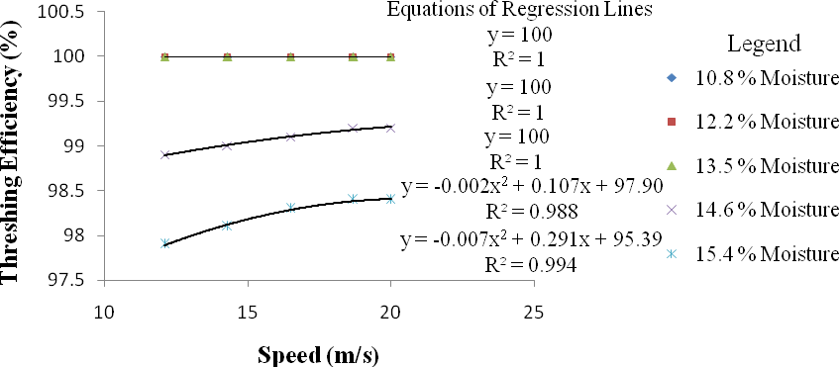
Fig. 4.12a: Variation of speed with threshing efficiency at various moisture content and constant feed rate of 4 kg/min for soybean crop
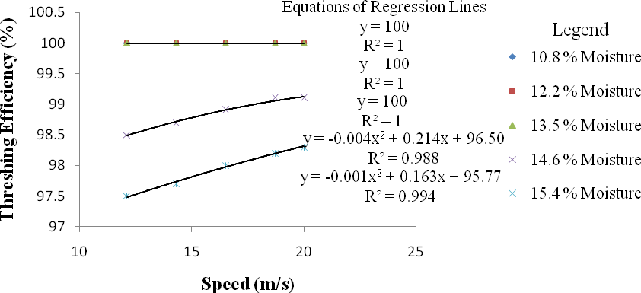
Fig. 4.12b: Variation of speed with threshing efficiency at various moisture content and constant feed rate of 6 kg/min for soybean crop
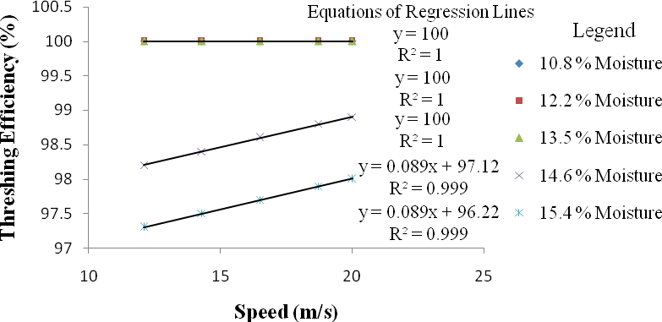
Fig. 4.12c: Variation of speed with threshing efficiency at various moisture content and constant feed rate of 8 kg/min for soybean crop

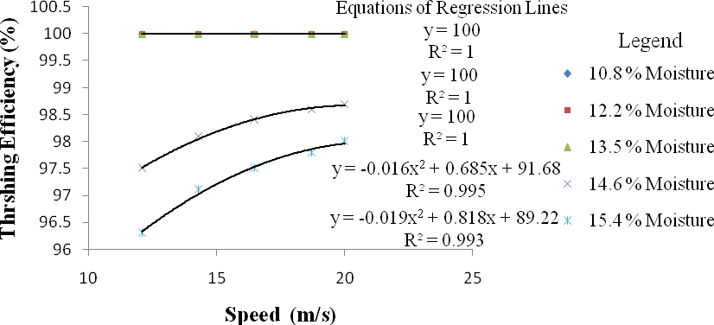
Fig. 4.12d: Variation of speed with threshing efficiency at various moisture content and constant feed rate of 10 kg/min for soybean crop
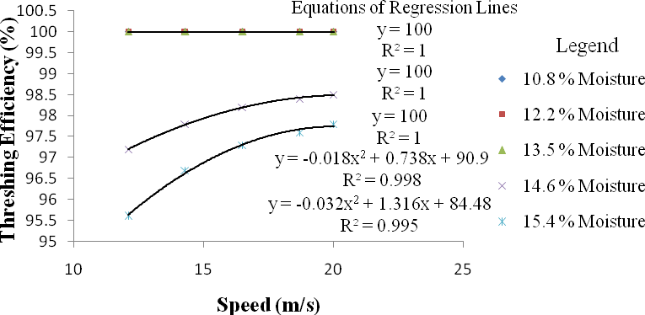
Fig. 4.12e: Variation of speed with threshing efficiency at various moisture content and constant feed rate of 12 kg/min for soybean crop

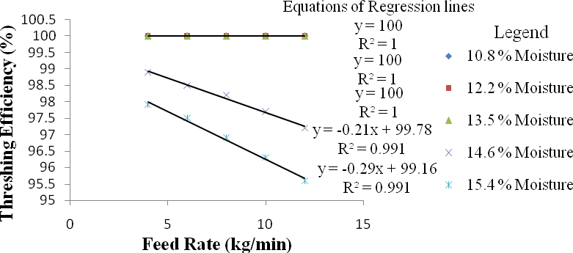

Fig. 4.13a: Variation of feed rate with threshing efficiency at various moisture contents and constant speed of 12.1 m/s for soybean crop
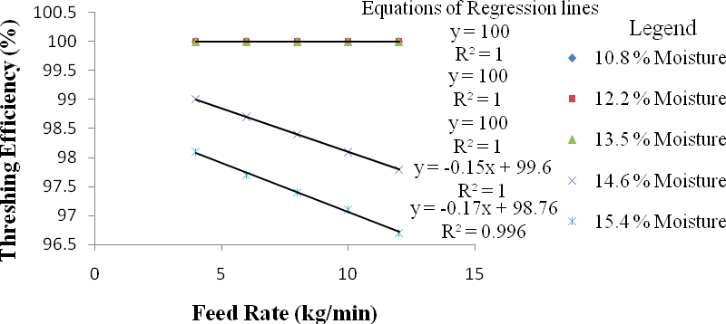

Fig. 4.13b: Variation of feed rate with threshing efficiency at various moisture contents and constant speed of 14.3 m/s for soybean crop
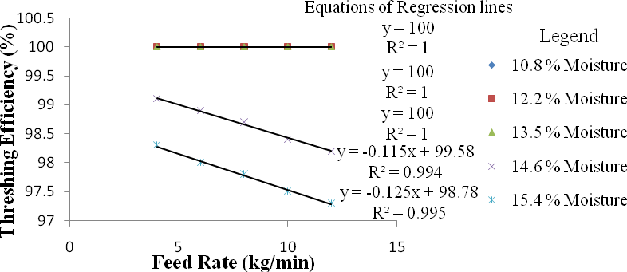

Fig. 4.13c: Variation of feed rate with threshing efficiency at various moisture contents and constant speed of 16.5 m/s for soybean crop

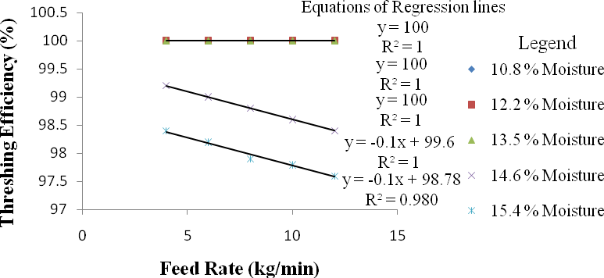
Fig. 4.13d: Variation of feed rate with threshing efficiency at various moisture contents and constant speed of 18.7 m/s for soybean crop
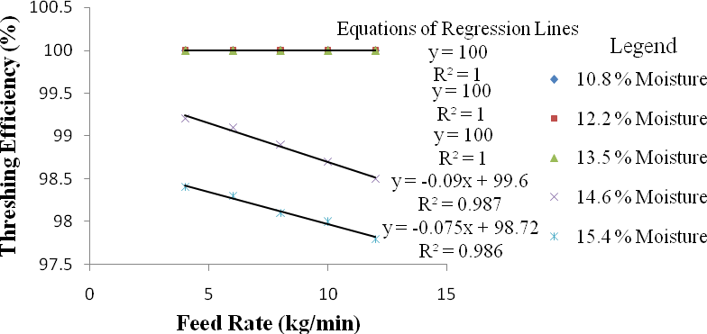

Fig. 4.13e: Variation of feed rate with threshing efficiency at various moisture contents and constant speed of 20 m/s for soybean crop

Table 4.12: ANOVA of threshing efficiency for soybean crop

Source | Degree of Freedom | Sum of Squares | Mean Squares | F Value
Replication | 2 | 0.00
Moisture(M) | 4 | 329.45 | 82.363 | 1671.73**
Speed (S) | 4 | 5.13 | 1.283 | 2191.62**
Feed rate (F) | 4 | 4.68 | 1.171 | 511.83**
M × S | 16 | 7.84 | 0.490 | 473.51**
M × F | 16 | 7.03 | 0.440 | 783.23**
F × S | 16 | 0.03 | 0.002 | 91.74**
M × S × F | 64 | 0.12 | 0.002 | 56.63**
Error | 248 | 0.00 | 0.000
Total | 374 | 354.29
** = Significant at 1 % probability level

Table 4.13 a: D. M. R.T. for variation of speed with threshing efficiency for soybean crop
Duncan Grouping | Mean Threshing  Efficiency (%) | N | Speed (m/s)
A | 99.10 | 75 | 12.1
B | 99.19 | 75 | 14.3
C | 99.26 | 75 | 16.5
D | 99.36 | 75 | 18.7
E | 99.42 | 75 | 20.0
Alpha = 0.05, Error Degrees of Freedom = 248, Error Mean Square = 0
Number of Means | 2 | 3 | 4 | 5
Critical Range | 0 | 0 | 0 | 0

Table 4.13 b: D. M. R.T. for variation of feed rate with threshing efficiency for soybean crop
Duncan Grouping | Mean Threshing  Efficiency (%) | N | Feed Rate (kg/min)
A | 99.43 | 75 | 4
B | 99.34 | 75 | 6
C | 99.27 | 75 | 8
D | 99.18 | 75 | 10
E | 99.11 | 75 | 12
Alpha = 0.05, Error Degrees of Freedom = 248, Error Mean Square = 0
Number of Means | 2 | 3 | 4 | 5
Critical Range | 0 | 0 | 0 | 0

Table 4.13 c: D. M. R.T. for variation of crop moisture content with threshing efficiency for soybean crop
Duncan Grouping | Mean Threshing  Efficiency (%) | N | Moisture Content (%)
A | 100.0 | 75 | 10.8
B | 100.0 | 75 | 12.2
C | 100.0 | 75 | 13.5
D | 98.6 | 75 | 14.6
E | 97.8 | 75 | 15.4
Alpha = 0.05, Error Degrees of Freedom = 248, Error Mean Square = 0
Number of Means | 2 | 3 | 4 | 5
Critical Range | 0 | 0 | 0 | 0

This test controls the Type I comparison wise error rate, not the experiment wise error rate. Any two means with the same letter are not significantly different at 1 % level of significance.

Cleaning Efficiency for Soybean Crop
It ranges from 72.34 % to 97.26 % for soybean when threshing was done at different levels of cylinder speed, feed rate and crop moisture content. The variation of speed with cleaning efficiency at various moisture contents and constant feed rates are illustrated in Fig. 4.14(a, b, c, d and e). It indicates that cleaning efficiency increases as speed increase. This may be due to increase in air flow rate of the blower as speed increases. However at constant speed, cleaning efficiency decreases as moisture content increase. The reason was the existence of cohesive / adhesive forces and small mass difference between grains and chaff with high moisture content resulting to grains being blown away with chaff hence reduction in cleaning efficiency.
The variation of feed rate with cleaning efficiency at various moisture contents and constant speed are illustrated in Fig. 4.15(a, b, c, d and e). It indicates that cleaning efficiency decreases as feed rate increase. This was because of increasing load intensity on the sieves as multiple particles act as obstruction to grain flow resultilg to more grains blown away with chaff. Also at a constant feed rate, cleaning efficiency decreases as moisture content increase. These results were similar to those of Simonyan and Yiljep (2008); Osueke (2013). Therefore cleaning efficiency is directly proportional to speed but inversely proportional to feed rate and crop moisture content. The equations of the regression lines are listed alongside the lines with their coefficient of determination (R²).
The analysis of variance (ANOVA) of cleaning efficiency for soybean crop is shown in Table 4.14. The ANOVA indicates that the effect of all the factors evaluated and their interactions were significant at 1 % probability level. Further analysis of the results using Duncan‟s Multiple Range Test (DMRT) are shown in Tables 4.15(a, b and c). The result shows that in the variation of speed, feed rate and moisture content with cleaning efficiency there were significant differences between the means at 1 % level of significance. This implies as speed

increase to another level cleaning efficiency increase significantly (Table 4.15a); as feed rate increase to another level cleaning efficiency decrease significantly (Table 4.15b); as moisture content decrease to another level cleaning efficiency increase significantly (Table 4.15c). Appendix I represents measured values of cleaning efficiency at five levels of cylinder speed, feed rate and crop moisture content for soybean crop.

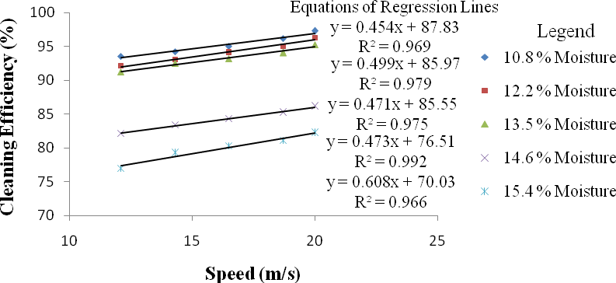
Fig. 4.14a: Variation of speed with cleaning efficiency at various moisture content and constant feed rate of 4 kg/min for soybean crop
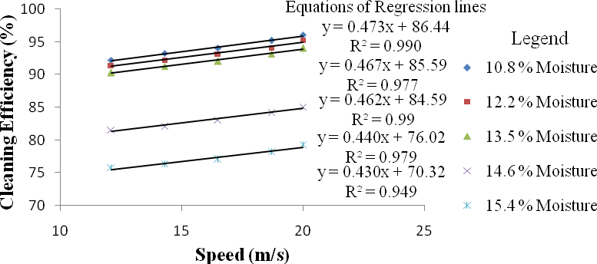

Fig. 4.14b: Variation of speed with cleaning efficiency at various moisture content and constant feed rate of 6 kg/min for soybean crop
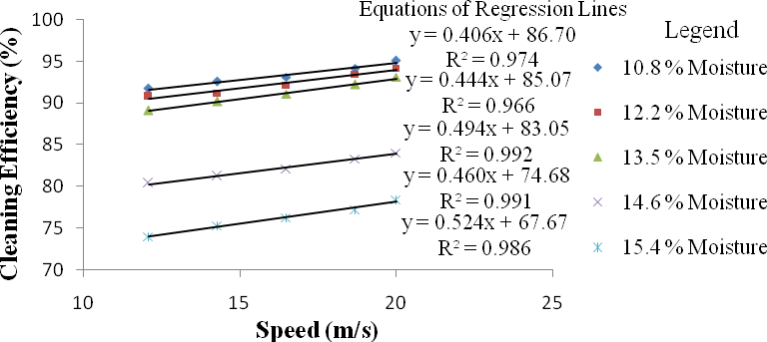
Fig. 4.14c: Variation of speed with cleaning efficiency at various moisture content and constant feed rate of 8 kg/min for soybean crop

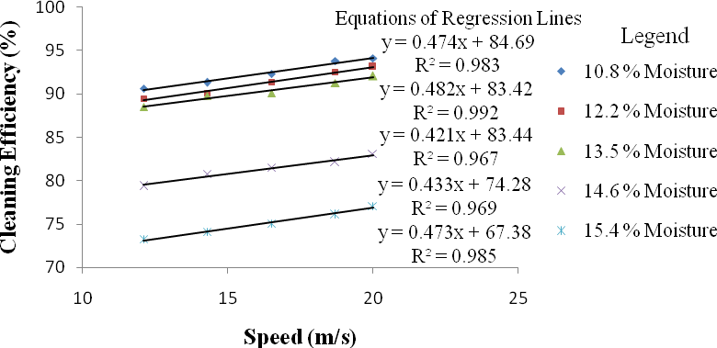
Fig. 4.14d: Variation of speed with cleaning efficiency at various moisture content and constant feed rate of 10 kg/min for soybean crop
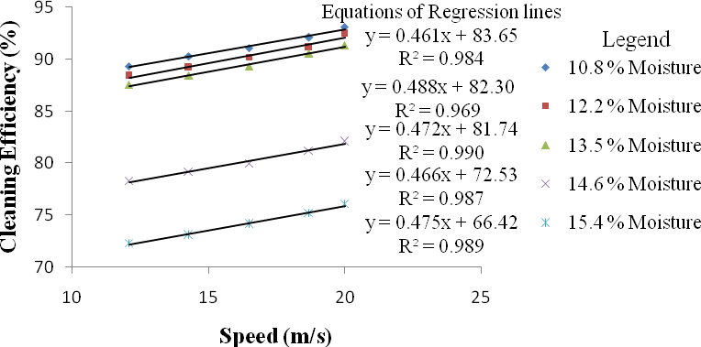
Fig. 4.14e: Variation of speed with cleaning efficiency at various moisture content and constant feed rate of 12 kg/min for soybean crop

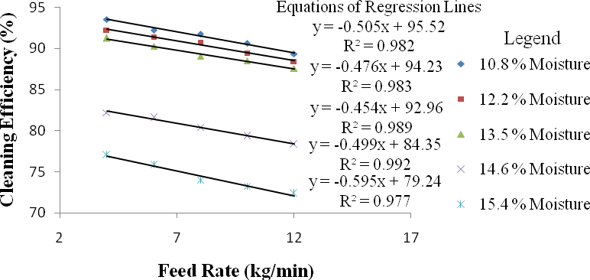
Fig. 4.15a: Variation of feed rate with cleaning efficiency at various moisture contents and constant speed of 12.1 m/s for soybean crop
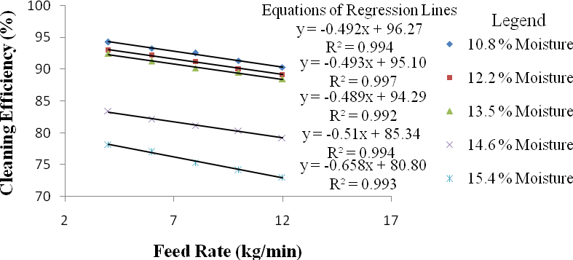
Fig. 4.15b: Variation of feed rate with cleaning efficiency at various moisture contents and constant speed of 14.3 m/s for soybean crop
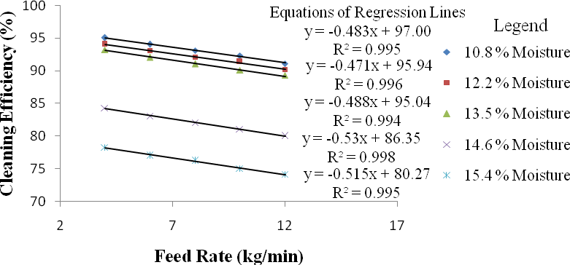
Fig. 4.15c: Variation of feed rate with cleaning efficiency at various moisture contents and constant speed of 16.5 m/s for soybean crop

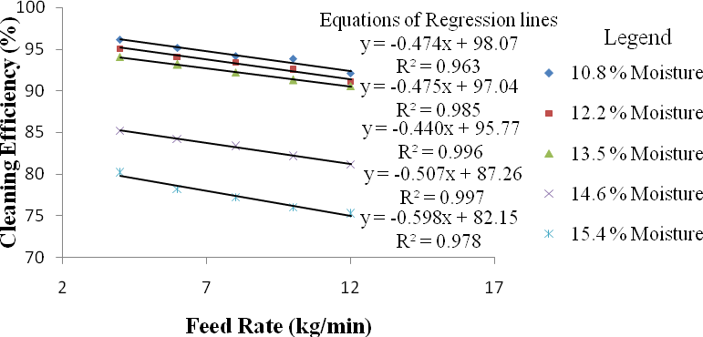
Fig. 4.15d: Variation of feed rate with cleaning efficiency at various moisture contents and constant speed of 18.7 m/s for soybean crop
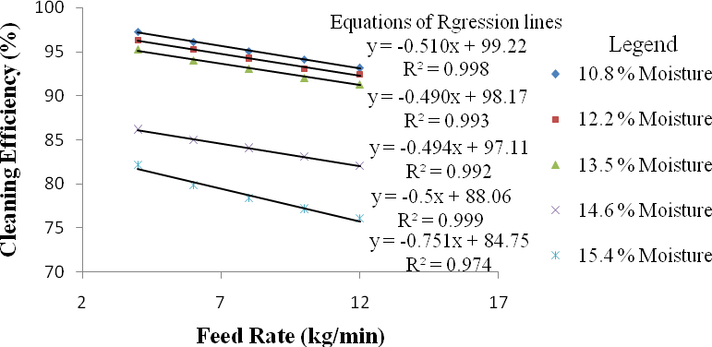

Fig. 4.15e: Variation of feed rate with cleaning efficiency at various moisture contents and constant speed of 20 m/s for soybean crop

Table 4.14: ANOVA of cleaning efficiency for soybean crop

Source | Degree of Freedom | Sum of Squares | Mean Squares | F Value
Replication | 2 | 0.00
Moisture (M) | 4 | 22614.16 | 5653.54 | 872.64**
Speed (S) | 4 | 3273.21 | 818.30 | 5830.20**
Feed rate (F) | 4 | 1847.22 | 461.81 | 280.60**
M × S | 16 | 2235.87 | 139.74 | 981.60**
M × F | 16 | 557.34 | 34.83 | 837.60**
F × S | 16 | 876.44 | 54.78 | 708.60**
M × S × F | 64 | 1497.11 | 23.39 | 97.60**
Error | 248 | 0.00 | 0.00
Total | 374 | 32901.35
** = Significant at 1 % probability level

Table 4.15a: D. M. R. T. for variation of speed with cleaning efficiency for soybean crop

Duncan Grouping | Mean  Cleaning Efficiency (%) | N | Speed (m/s)
A | 80.60 | 75 | 12.1
B | 86.18 | 75 | 14.3
C | 87.04 | 75 | 16.5
D | 88.11 | 75 | 18.7
E | 89.01 | 75 | 20.0
Alpha= 0.05, Error Degrees of Freedom = 248, Error Mean Square= 0
Number of Means | 2 | 3 | 4 | 5
Critical Range | 0 | 0 | 0 | 0

Table 4.15b: D. M. R. T. for variation of feed rate with cleaning efficiency for soybean crop
Duncan Grouping | Mean Cleaning  Efficiency (%) | N | Feed Rate (kg/min)
A | 89.34 | 75 | 4
B | 88.02 | 75 | 6
C | 85.70 | 75 | 8
D | 84.66 | 75 | 10
E | 83.22 | 75 | 12
Alpha = 0.05, Error Degrees of Freedom = 248, Error Mean Square = 0
Number of Means | 2 | 3 | 4 | 5
Critical Range | 0 | 0 | 0 | 0

Table 4.15c: D. M. R.T. for variation of crop moisture content with cleaning efficiency for soybean crop
Duncan Grouping | Mean  Cleaning Efficiency (%) | N | Moisture Content (%)
A | 93.28 | 75 | 10.8
B | 92.21 | 75 | 12.2
C | 91.17 | 75 | 13.5
D | 80.79 | 75 | 14.6
E | 73.49 | 75 | 15.4
Alpha = 0.05, Error Degrees of Freedom = 248, Error Mean Square = 0
Number of Means | 2 | 3 | 4 | 5
Critical Range | 0 | 0 | 0 | 0

This test controls the Type I comparison wise error rate, not the experiment wise error rate. Any two means with the same letter are not significantly different at 1 % level of significance.

Scattered Grain Loss for Soybean Crop
It ranges from 1.54 % to 7.25 % for soybean when threshing was done at different levels of cylinder speed, feed rate and crop moisture content. The variation of speed with scattered grain loss at various moisture contents and constant feed rates are illustrated in Fig. 4.16(a. b, c, d and e). It indicates that scattered grain loss increases as speed increase. This may be due to increase in machine vibration and air flow rate of the blower above optimum. However at constant speed, scattered grain loss decreases as moisture content increase. This may be due to cohesive and adhesive forces that exist in crops with high moisture content that keeps the grains and chaff together resulting to reduction in grain loss.
The variation of feed rate with scattered grain loss at various moisture contents and constant speeds are illustrated in Fig. 4.17(a, b, c, d and e). It indicates that scattered grain loss decreases as feed rate increase. This may be due to increase load intensity on the beaters causing the machine rotation, vibration and air flow rate to be low. Also at a constant feed rate, scattered grain loss decreases as moisture content increase. These results were similar to those of Simonyan and Yiljep (2008). Therefore scattered grain loss is directly proportional to speed but inversely proportional to feed rate and moisture content. The equations of the regression lines are listed alongside the lines with their coefficient of determination (R²).
The analysis of variance (ANOVA) of scattered grain loss for soybean crop is shown in Table 4.16. The ANOVA indicates that the effect of all the factors evaluated and their interactions were significant at 1 % probability level. Further analysis of the results using Duncan‟s Multiple Range Test (DMRT) are shown in Tables 4.17(a, b and c). The result shows that in the variation of speed, feed rate and moisture content with scattered grain loss there were significant differences between the means at 1 % level of significance. This implies as speed increase to another level scattered grain loss increase significantly (Table 4.17a); as feed rate increase to another level scattered grain loss decrease significantly (Table 4.17b); as moisture

content decrease to another level scattered grain loss increase significantly (Table 4.17c). Appendix K represents measured values of scattered grain loss at five levels of cylinder speed, feed rate and crop moisture content for soybean crop.

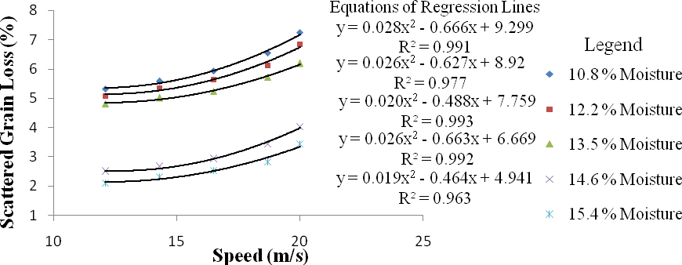
Fig. 4.16a: Variation of speed with scattered grain loss at various moisture content and constant feed rate of 4 kg/min for soybean crop
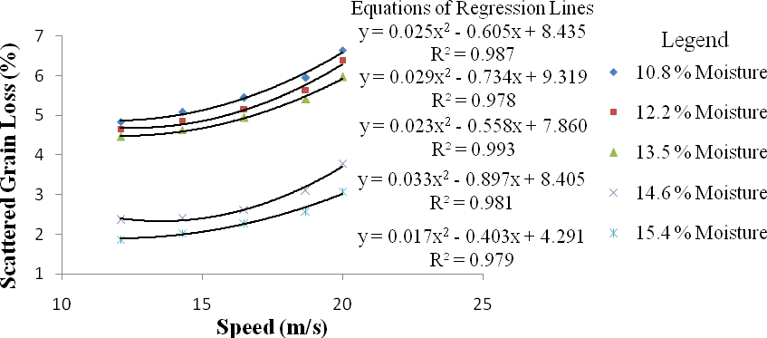
Fig. 4.16b: Variation of speed with scattered grain loss at various moisture content and constant feed rate of 6 kg/min for soybean crop
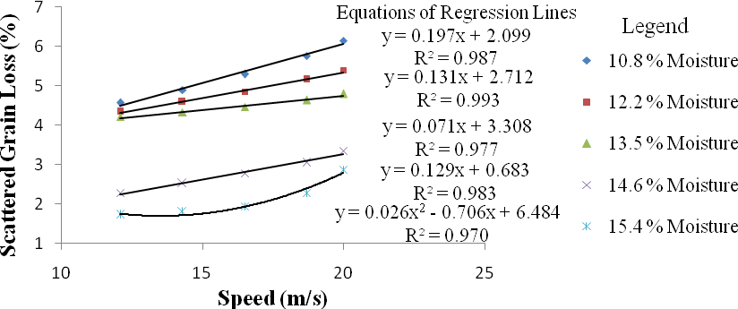

Fig. 4.16c: Variation of speed with scattered grain loss at various moisture content and constant feed rate of 8 kg/min for soybean crop

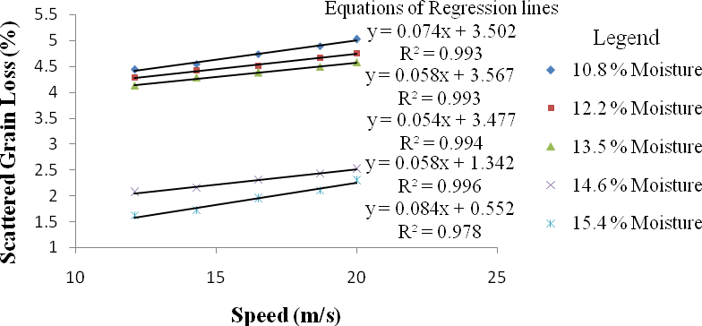
Fig. 4.16d: Variation of speed with scattered grain loss at various moisture content and constant feed rate of 10 kg/min for soybean crop
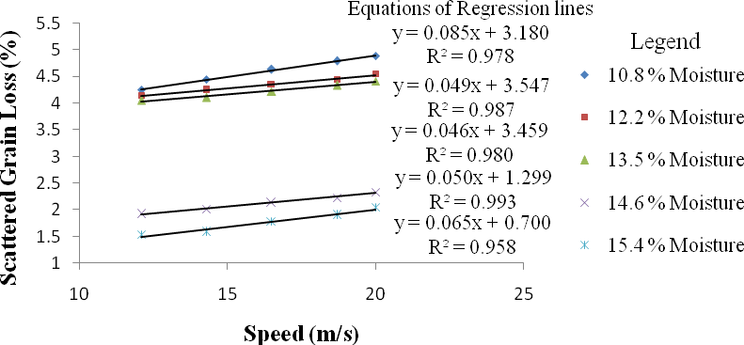
Fig. 4.16e: Variation of speed with scattered grain loss at various moisture content and constant feed rate of 12 kg/min for soybean crop

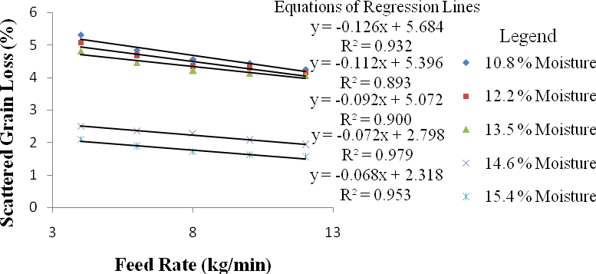
Fig. 4.17a: Variation of feed rate with scattered grain loss at various moisture contents and constant speed of 12.1 m/s for soybean crop
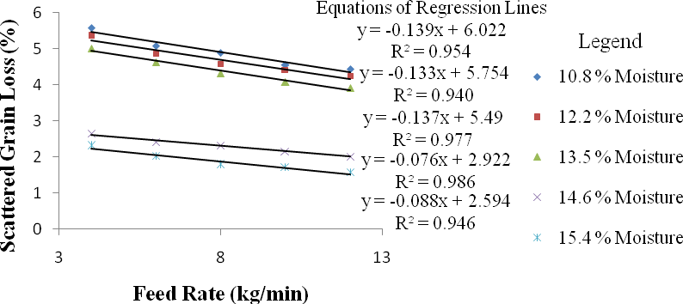
Fig. 4.17b: Variation of feed rate with scattered grain loss at various moisture contents and constant speed of 14.3 m/s for soybean crop
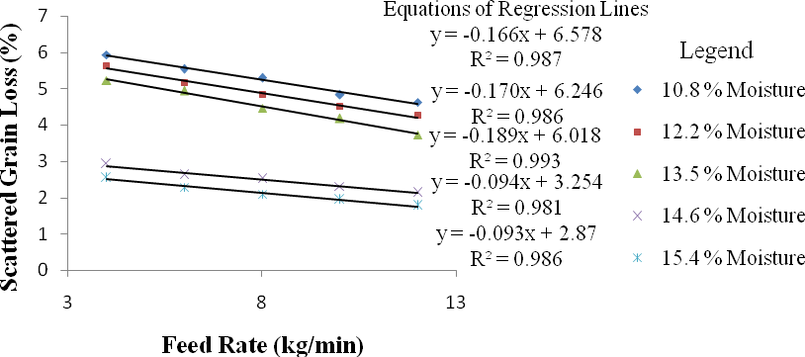
Fig. 4.17c: Variation of feed rate with scattered grain loss at various moisture contents and constant speed of 16.5 m/s for soybean crop

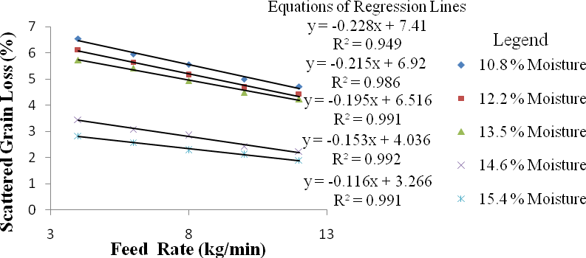

Fig. 4.17d: Variation of feed rate with scattered grain loss at various moisture contents and constant speed of 18.7 m/s for soybean crop
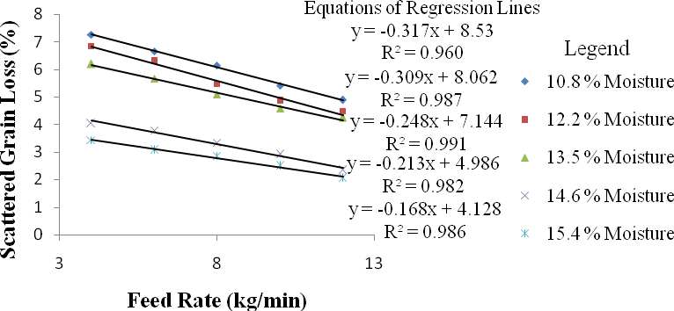
Fig. 4.17e: Variation of feed rate with scattered grain loss at various moisture contents and constant speed of 20 m/s for soybean crop

Table 4.16: ANOVA of scattered grain loss for soybean crop

Source | Degree of Freedom | Sum of Squares | Mean Squares | F Value
Replication | 2 | 0.00
Moisture (M) | 4 | 641.10 | 160.27 | 2068243**
Speed (S) | 4 | 85.82 | 21.45 | 276857**
Feed rate (F) | 4 | 47.12 | 11.78 | 152000**
M × S | 16 | 2.66 | 0.17 | 2141.42 **
M × F | 16 | 2.24 | 0.14 | 1807.92 **
F × S | 16 | 1.39 | 0.09 | 1124.97 **
M × S × F | 64 | 1.25 | 0.02 | 252.39 **
Error | 248 | 0.02 | 0.00
Total | 374 | 781.59
** = Significant at 1 % probability level

Table 4.17a: D. M. R.T. for variation of speed with scattered grain loss for soybean crop

Duncan  Grouping | Mean  Grain Loss (%) | N | Speed  (m/s)
A | 3.50 | 75 | 12.1
B | 3.66 | 75 | 14.3
C | 3.85 | 75 | 16.5
D | 4.28 | 75 | 18.7
E | 4.85 | 75 | 20.0
Alpha = 0.05, Error Degrees of Freedom = 248, Error Mean Square = 0 Number of Means 2 3 4 5
Critical Range 0.0028 0.0030 0.0031 0.0032
Table 4.17b: D.M.R.T. for variation of feed rate with scattered grain loss for soybean crop
Duncan  Grouping | Mean  Grain Loss (%) | N | Feed Rate  (kg/min)
A | 4.54 | 75 | 4
B | 4.18 | 75 | 6
C | 3.92 | 75 | 8
D | 3.70 | 75 | 10
E | 3.54 | 75 | 12
Alpha = 0.05, Error Degrees of Freedom = 248, Error Mean Square = 0 Number of Means 2 3 4 5
Critical Range 0.0028 0.0030 0.0031 0.0032
Table 4.17c: D. M. R.T. for variation of crop moisture content with scattered grain loss for soybean crop
Duncan  Grouping | Mean  Grain Loss (%) | N | Moisture  Content (%)
A | 5.29 | 75 | 10.8
B | 5.02 | 75 | 12.2
C | 4.79 | 75 | 13.5
D | 2.60 | 75 | 14.6
E | 2.19 | 75 | 15.4
Alpha = 0.05, Error Degrees of Freedom = 248, Error Mean Square = 0 Number of Means 2 3 4 5
Critical Range 0.0028 0.0030 0.0031 0.0032
This test controls the type I comparison wise error rate, not the experiment wise error rate. Any two means with the same letter are not significantly different at 1 % level of significance.

Grain Damage for Soybean Crop
It ranges from 0.001 % to 6 % for soybean when threshing was done at different levels of cylinder speed, feed rate and crop moisture content. The variation of speed with grain damage at various moisture contents and constant feed rates are illustrated in Fig. 4.18(a. b, c, d and e). It indicates that grain damage increase as speed increases. This may be due to increase in collision rate between grains and beaters. However at constant speed, grain damage decreases as moisture content increase from 10.8 % to 13.5 % for soybean; then increase constantly as moisture content increase above 13.5 %.
The variation of feed rate with grain damage at various moisture contents and constant speeds are illustrated in Fig. 4.19(a. b, c, d and e). It indicates that grain damage decrease as feed rate increases. This may be due to increase in cushion phenomenon as more crops are fed hence reducing the intensity of collision on the grains. Also at a constant feed rate, grain damage decrease greatly as moisture content decreases from 15.8 % to 13.5 %, and then increase gently as moisture content decreases from 13.5 % to 10.8 % for soybean. These results were similar to those of Saeidirad et al. (2013) and Osueke (2013). Therefore grain damage is directly proportional to speed but inversely proportional to feed rate. The reason for this behaviour was because as moisture content decreases from 15.8 % to 13.5 %, softer grains that were breaking easily with increase in speed became elastic and grain damage reduces drastically. However as moisture content decreases from 13.5 % to 10.6 %, grains that were elastic became brittle and grain damage increases a little. The equations of the regression lines are listed alongside the lines with their coefficient of determination (R²).
The analysis of variance (ANOVA) of grain damage for soybean crop is shown in Table

4.18. The ANOVA indicates that the effect of all the factors evaluated and their interactions were significant at 1 % probability level. Further analysis of the results using Duncan‟s Multiple Range Test (DMRT) are shown in Tables 4.19(a, b and c). The result shows that in the variation

of speed, feed rate and moisture content with grain damage there were significant differences between the means at 1 % level of significance. This implies as speed increase to another level grain damage increase significantly (Table 4.19a); as feed rate increase to another level grain damage decrease significantly (Table 4.19b); as moisture content decrease from 15.8 % to 13.5
% grain damage decrease significantly (Table 4.19c); as moisture content decrease further from
13.5 % to 10.6 % grain damage increase significantly (Table 4.19c). Appendix M represents measured values of grain damage at five levels of cylinder speed, feed rate and crop moisture content for soybean crop.

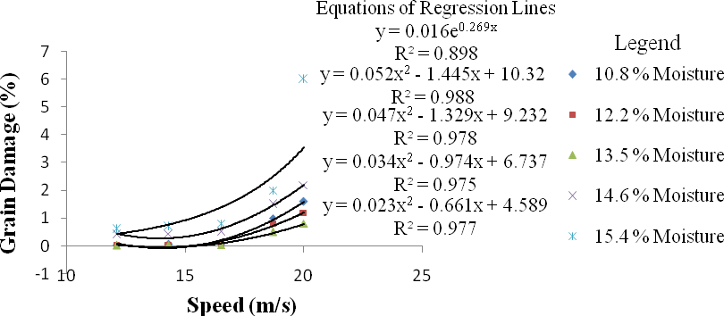
Fig. 4.18a: Variation of speed with grain damage at various moisture content and constant feed rate of 4 kg/min for soybean crop
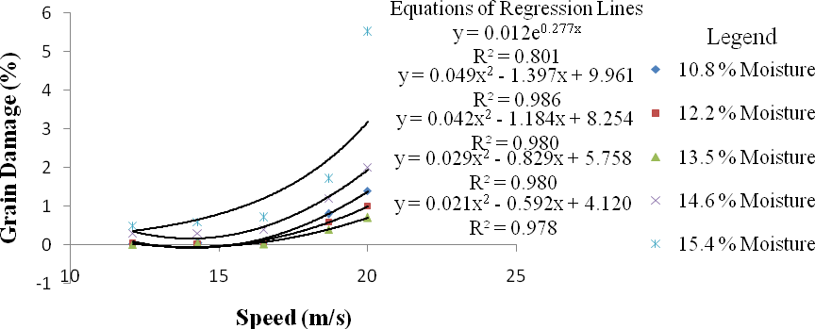
Fig. 4.18b: Variation of speed with grain damage at various moisture content and constant feed rate of 6 kg/min for soybean crop
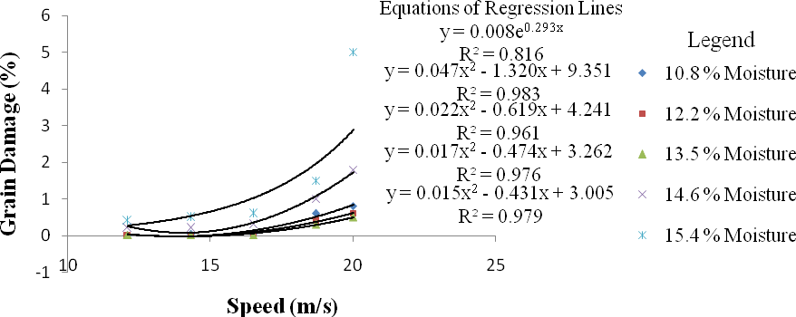
Fig. 4.18c: Variation of speed with grain damage at various moisture content and constant feed rate of 8 kg/min for soybean crop

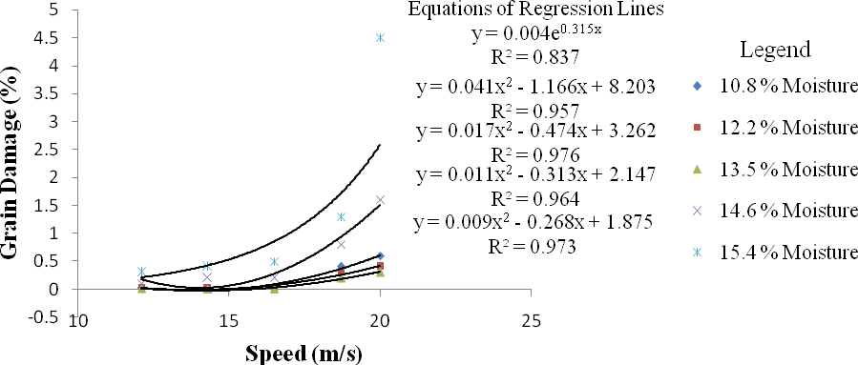

Fig. 4.18d: Variation of speed with grain damage at various moisture content and constant feed rate of 10 kg/min for soybean crop
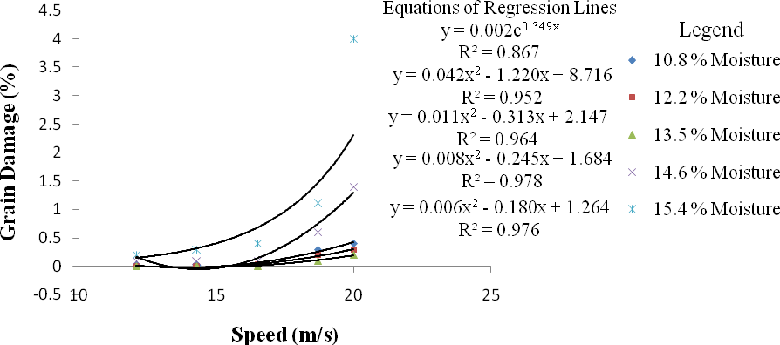

Fig. 4.18d: Variation of speed with grain damage at various moisture content and constant feed rate of 12 kg/min for soybean crop

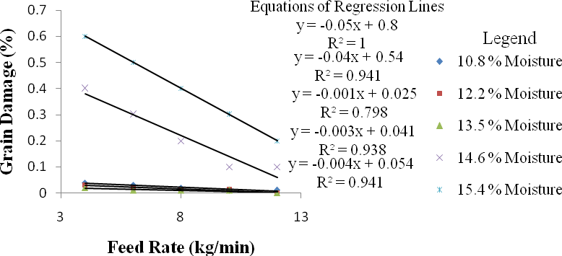
Fig. 4.19a: Variation of feed rate with grain damage at various moisture contents and constant speed of 12.1 m/s for soybean crop
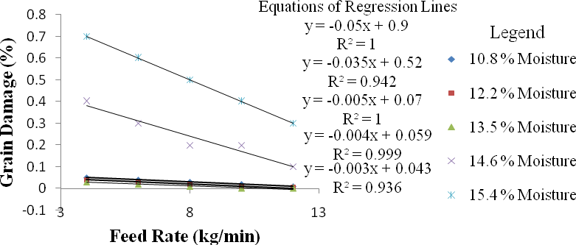

Fig. 4.19b: Variation of feed rate with grain damage at various moisture contents and constant speed of 14.3 m/s for soybean crop
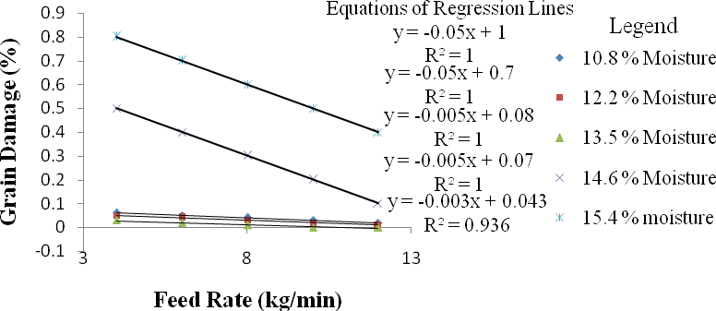
Fig. 4.19c: Variation of feed rate with grain damage at various moisture contents and constant speed of 16.5 m/s for soybean crop

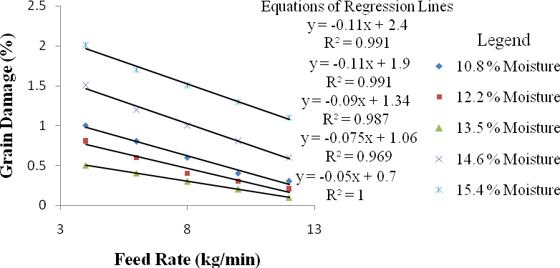
Fig. 4.19d: Variation of feed rate with grain damage at various moisture contents and constant speed of 18.7 m/s for soybean crop
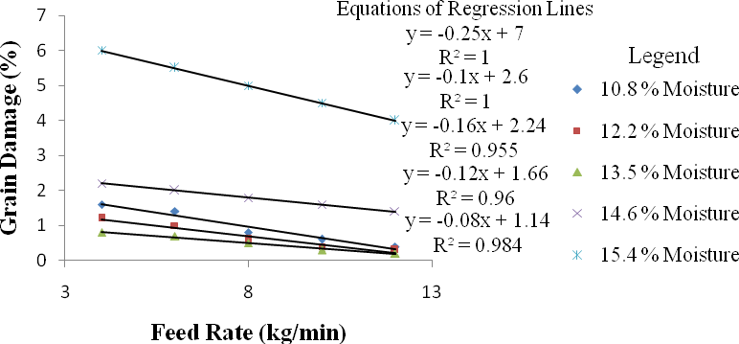
Fig. 4.19e: Variation of feed rate with grain damage at various moisture contents and constant speed of 20 m/s for soybean crop

Table 4.18: ANOVA of grain damage for soybean crop

Source | Degree of Freedom | Sum of Squares | Mean Squares | F Value
Replication | 2 | 0.00
Moisture (M) | 4 | 107.62 | 26.91 | 5.87E16**
Speed (S) | 4 | 143.70 | 35.92 | 7.84E16 **
Feed rate (F) | 4 | 8.98 | 2.25 | 4.90E15 **
M × S | 16 | 129.83 | 8.11 | 1.77E16 **
M × F | 16 | 2.21 | 0.14 | 3.01E14 **
F × S | 16 | 5.61 | 0.35 | 7.65E14 **
M × S × F | 64 | 1.35 | 0.02 | 4.59E13 **
Error | 248 | 0.00 | 0.00
Total | 374 | 399.30
** = Significant at 1 % probability level

Table 4.19 a: D. M. R.T. for variation of speed with grain damage for soybean crop

Duncan Grouping | Mean Grain Damage  (%) | N | Speed (m/s)
A | 0.134 | 75 | 12.1
B | 0.161 | 75 | 14.3
C | 0.197 | 75 | 16.5
D | 0.784 | 75 | 18.7
E | 1.744 | 75 | 20.0
Alpha = 0.05, Error Degrees of Freedom = 248, Error Mean Square = 4.58E-16
Number of Means | 2 | 3 | 4 | 5
Critical Range | 0 | 0 | 0 | 0

Table 4.19 b: D M. R.T. for variation of feed rate with grain damage for soybean crop

Duncan Grouping | Mean Grain Damage  (%) | N | Feed Rate (kg/min)
A | 0.83 | 75 | 4
B | 0.71 | 75 | 6
C | 0.60 | 75 | 8
D | 0.49 | 75 | 10
E | 0.39 | 75 | 12
Alpha = 0.05, Error Degrees of Freedom = 248, Error Mean Square = 4.58E-16
Number of Means | 2 | 3 | 4 | 5
Critical Range | 0 | 0 | 0 | 0

Table 4.19 c: D. M. R.T. for variation of crop moisture content with grain damage for soybean crop

Duncan Grouping | Mean Grain Damage  (%) | N | Moisture Content (%)
A | 0.30 | 75 | 10.8
B | 0.23 | 75 | 12.2
C | 0.17 | 75 | 13.5
D | 0.72 | 75 | 14.6
E | 1.60 | 75 | 15.4
Alpha = 0.05, Error Degrees of Freedom = 248, Error Mean Square = 4.58E-16
Number of Means | 2 | 3 | 4 | 5
Critical Range | 0 | 0 | 0 | 0

This test controls the type I comparison wise error rate, not the experiment wise error rate. Any two means with the same letter are not significantly different at 1 % level of significance.

Model Validation Results
A good linear relationship was achieved between the measured and predicted data with the coefficient of determination (r²), slope and intercept found to be 0.73, 1.3 and -27.3 respectively (Fig. 4.20). A paired t-test was conducted and the result revealed that the calculated t-value (0.101) was less than the tabular value (1.96) at 1 % level of significance. This shows that there was no significant difference between the predicted and measured threshing efficiency values. A Standard Error of 0.13, Mean Squared Deviation (MSD) of 0.92, Bias (mean deviation) of 0.74 and Root Mean Square Error (RMSE) of 0.96 were obtained for the predicted and measured values. These small values for Standard Error, Mean Squared Deviation (MSD), Bias and Root Mean Square Error (< 1 %) for a threshing efficiency range of 0 to100 % indicate that the model is accurate. A high Coefficient of Determination (r² = 0.73) and Coefficient of Efficiency (E = 0.53) is also an indication that the model is accurate. The developed threshing efficiency model is given in equation (3.54). Appendix N represents measured and predicted threshing efficiencies of the machine for SOSAT C88 millet variety at five levels of cylinder speed, feed rate and crop moisture content. Fig. 4.20 represents plot of measured versus predicted threshing efficiency of the machine.

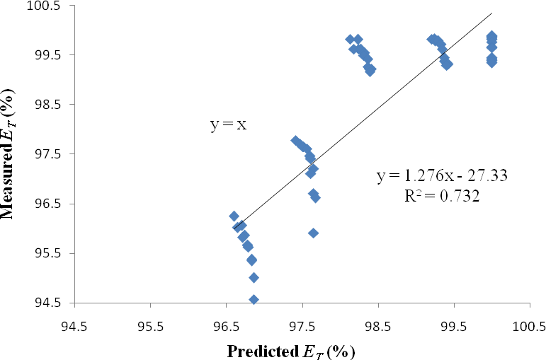

Fig. 4.20: Plot of measured versus predicted threshing efficiency of the machine

Optimization Results
An optimum speed of 18.7 m/s was determined for millet and soybean. An optimum feed rates of 12 kg/min and 10 kg/min were determined for millet and soybean respectively. Optimum moisture contents of 11.9 % and 12.2 % were determined for millet and soybean respectively.
- Optimum threshing efficiency of 99.7 % and 100 % were determined for millet and soybean respectively.
- Optimum cleaning efficiency of 97.4 % and 92.5 % were determined for millet and soybean respectively.
- Optimum Scatter loss of 11.2 % and 4.7 % were determined for millet and soybean respectively.
- Optimum grain damage of 0.02 % and 0.3 % were determined for millet and soybean respectively.
- Optimum output capacity of 420 kg/hr and 163 kg/hr were determined for millet and soybean respectively.
Tables 4.20(a, b and c) are Maximum, Optimum and Minimum performance respectively of the multicrop thresher for SOSAT C88 millet variety and Samsoy-2 soybean variety.

Table 4.20a: Maximum performance of the multicrop thresher for SOSAT C88 millet variety and Samsoy-2 soybean variety

Crop Type | Max Speed (m/s) | Max Feed Rate  (kg/min) | Max Moisture Content  (%) | Output Capacity (kg/hr) | Threshing Efficiency (%) | Cleaning Efficiency (%) | Grain Loss (%) | Grain Damage (%)
Millet | 20 | 14 | 15.8 | 520.6 | 99.98 | 99.71 | 12.18 | 0.62
Soybean | 20 | 12 | 15.4 | 205 | 100 | 97.26 | 7.25 | 6

Table 4.20b: Optimum performance of the multicrop thresher for SOSAT C88 millet variety and Samsoy-2 soybean variety

Crop Type | Opt. Speed (m/s) | Opt. Feed Rate  (kg/min) | Opt.  Moisture Content (%) | Output Capacity (kg/hr) | Threshing Efficiency (%) | Cleaning Efficiency (%) | Grain Loss (%) | Grain Damage (%)
Millet | 18.7 | 12 | 11.9 | 420 | 99.7 | 97.4 | 11.2 | 0.02
Soybean | 18.7 | 10 | 12.2 | 163 | 100 | 92.5 | 4.7 | 0.3

Table 4.20c: Minimum performance of the multicrop thresher for SOSAT C88 millet variety and Samsoy-2 soybean variety

Crop Type | Min Speed (m/s) | Min Feed Rate  (kg/min) | Min Moisture Content  (%) | Output Capacity (kg/hr) | Threshing Efficiency (%) | Cleaning Efficiency (%) | Grain Loss (%) | Grain Damage (%)
Millet | 12.1 | 6 | 10.6 | 166.6 | 94.02 | 84.27 | 5.77 | 0.001
Soybean | 12.1 | 4 | 10.8 | 42 | 95.6 | 72.34 | 1.54 | 0.001

CHAPTER FIVE

CONCLUSIONS AND RECOMMENDATIONS

Conclusions
The IAR multicrop thresher was modified and reconstructed at the Department of Agricultural Engineering, Ahmadu Bello University; to increase its threshing performance for Millet and Soybean crops. The performance of the machine was evaluated, mathematical models for predicting its threshing efficiency, threshing loss and output capacity were developed and the machine was optimized for both crops. Based on the result of this study the following conclusions were made:
- The materials used for construction of the machine components were durable and resilient as the stress imposed by the stems of bulky crops on the threshing cylinder of the existing IAR Soybean/Multicrop threshers causing it to slow down or even stop was not noticed in the modified machine during performance testing.
- The performance test conducted on the modified machine gave a feed rate, threshing efficiency, cleaning efficiency, scatter loss, grain damage and output capacity of 14 kg/min, 99.98 %, 99.71 %, 12.18 %, 0.62 %, and 520.6 kg/hr respectively with SOSAT
C88 millet variety, as against 3 kg/min, 92 %, 80 %, 2.4 %, 3.5 %, and 81 kg/hr respectively for the existing IAR multicrop thresher when both machines were operated at 20 m/s. With Samsoy-2 Soybean variety the modified machine gave 12 kg/min, 100 %,
97.26 %, 7.25 %, 6 %, and 205 kg/hr respectively, as against 1.7 kg/min, 80 %, 70 %, 2

%, 1.94 %, and 23 kg/hr respectively for the existing IAR soybean thresher when both machines were operated at 20 m/s.
- The above result indicates that the modifications made on the hopper, threshing cylinder, top sieve, shaker and blower of the existing IAR multicrop thresher has greatly increase feed rate for millet from 3 kg/min to 14 kg/min and output capacity from 81 kg/hr to 520

kg/hr, feed rate for soybean from 1.7 kg/min to 12 kg/min and output capacity from 23 kg/hr to 205 kg/hr when the machine was operated at a speed of 20 m/s. Also, threshing and cleaning efficiencies of the machine for both crops were increased.
- The model developed was accurate and valid for predicting the threshing efficiency of the machine. This was confirmed by low values for Standard Error, Mean Squared Deviation (MSD), Bias and Root Mean Square Error (< 1 %); and high values for coefficient of determination (r² = 0.73) and coefficient of efficiency (E = 0.53).
- The optimum threshing efficiency, cleaning efficiency, scatter loss, grain damage and output capacity obtained was 99.7 %, 97.4 %, 11.2 %, 0.02 %, and 420 kg/hr respectively with SOSAT C88 millet variety at a cylinder speed, feed rate and moisture content of
18.7 m/s (850 rpm), 12 kg/min and 11.9 % respectively; and 100 %, 92.5 %, 4.7 %, 0.3
%, and 163 kg/hr respectively with Samsoy-2 Soybean variety at a cylinder speed, feed rate and moisture content of 18.7 m/s (850 rpm), 10 kg/min and 12.2 % respectively.
- Developing this multicrop thresher has cut down the cost of purchasing separate machine for each crop. As its cost of production is closer to the cost of producing several single crop threshers. It has also solved the problem of threshing bulky crops such as soybean and millet manually by farmers.

Recommendations
- Even though soybean and millet was the only test crops used for this study, the machine was design to thresh many other cereal crops such as sorghum, rice, wheat and maize. So researchers are encouraged to continue testing this machine with different cereal crops so that its full potential can be exploited.
- Farmers are encouraged to purchase this multicrop thresher as it will greatly cut down cost of purchasing separate machine for each crop.

- To achieve the best threshing result, the sieve hole diameter of the top and bottom sieves should always match the crop to be threshed. Hence users are advised to always change the top and bottom sieves to match the crop size and also adjust the air entering the blower by shifting the side cover up or down for perfect cleaning.
- The design of other spike tooth threshers can be improved by using the mathematical models for predicting threshing efficiency, threshing loss and output capacity of this machine. Hence researcher should test and adopt these models on their machines.
- The models should be used in optimizing the threshing performance of spike tooth threshers in different parts of the world. Hence, providing useful methods for understanding how these machines can be operated in different crop situations and different threshing conditions
- The cleaning efficiency and grain damage models for this machine were yet to be developed, so other researcher are encouraged to develop them.

REFERENCES

Abolaji, A.R. (1980). Improvement on a locally built axial millet thresher. Unpublished B. Eng project Submitted at the Department of Agricultural Engineering A.B.U. Zaria.

Aguirre, R. and Carry, A. E. (1999). Continuous Flowing PorTable Separator for Cleaning and Upgrading Bean Seeds and Grain. Agricultural Mechanization for Asia, Africa and Latin America. 30(1): 59 - 63.
ASAE Standards (1984). VegeTable Oil Fuels. Proceedings of Conference on Plant VegeTable Oils Fuels, Nord Dakota, August ASAE 2950 Niles Road, St-Joseph,
Michigan 49085, U.S.A

ASAE Standards 37th Ed.(1983). S358.2: Moisture Measurement. Grains and Seeds. St. Joseph, Mich. ASAE

ASME Code (1948). The Code of Federal Regulations of the United States of America Standards. Addenda to ASME Boiler Construction Code, Material Specification Approved July 26, 1948.

Anusorn, V. and Salome, V.M. (2006). Machine Crop Parameters Affecting Performance of an Axial Flow soybean Thresher. Ama Vol. 37, No 3, Pp. 32-37

Bolz , H. (1953). Materials Handling Hand Book. Ronal Press Co. New York.
Brayton, R.K., Director, S.W., Hachtel, G.D. and Vidigal, L. (1979). "A New Algorithm for Statistical Circuit Design Based on Quasi-Newton Methods and Function Splitting," IEEE Transactions on Circuits and Systems, Vol. CAS-26, Pp 784-794.

Clark, B. (1984). Cleaning Seeds by Fluidization. Journal of Agricultural Engineering Research.
3(3): 231-242.

Cleve M., Jack, L. and Bangert, S. (2008). MATLAB Software Version 7.6.0 (R2008a). Help / Optimization Toolbox / Standard Algorithm / Optimization Theory Overview, Multiobjective Optimization.

David A. (2013). Hydraulics 2. T3-1. Topic T3: Dimensional Analysis. Pp 6-7

Enaburekhan, J.S.O. (1994). Mathematical and Optimization Modeling of the Threshing Process in a Stationary Grain Thresher. Unpublished PhD Thesis, Department of Agricultural Engineering, Ahmadu Bello University, Zaria.

FAO (1991). Improving Training Quality. A Trainers Guide to Evaluation, Rome, November 1990

FAOSTAT (2012), FAO Statistical Year Book: World Food and Agriculture 2012

Gasparetto, E., Echo, P., Pessina, D. and Rizzato, E. (1989). High Speed Movie Observation of an Axial Flow Combine Harvester Cylinder. Land and Water Use. 1935-1945. Rotterdam Balkema Holland.

Gembicki, F.W. (1974). "Vector Optimization for Control with Performance and Parameter Sensitivity Indices," Ph.D. Thesis, Case Western Reserve Univ., Cleveland, Ohio.

Glenn, M. (1950). Similitude in Engineering. The Royal Press Company, New York, pp. 36-37. Hall, S.A. and Holowenko, R.A. (1982). Machine Design. Schallms Outline Series. Pp. 112.
Hannah, R.D. and Stephen, R.C. (1984). Mechanics of Machine 3rd Edition, Edward Arnol Publisher Ltd, London P. 10-26
Harrington, R.E.(1970). Thresher Principles Confirmed with a Multicrop Thresher. Journal of Agricultural Engineering, 7 (2):49-61

Harrison, H.P. and Blecha, A. (1983). Screen Oscillation and Aperture Size-Sliding Only.
Transaction of the American Society of Agricultural Engineers. 343 - 348.

Henderson, J.M. and Newman, A.M. (1972). Orientation of a Prorate Spheroid Object.
Transaction of the American Society of Agricultural Engineers. 15(15)

Hem, C.J. (1981). Design and Selection of Thresher Parameters and Components. Agricultural Mechanization in Asia, Africa and Latin America. Spring Edition. 12(2): 61-68.
Huji, H. (2001). Physical and Mechanical Properties of Soybean. Unpublished B. Eng. Agric. Engineering Project, Department of Agric. Engineering, Ahmadu Bello University, Zaria.

Huynh, M.V., Powell, T., and Siddal, N.J. (1982). Threshing and Separation Process. A Mathematical Model Trans ASAE 25 (1): 65-73.

Hyetson, R.D. (2003). Performance Evaluation of a Soybean Thresher. Unpublished B. Eng. Agric. Engineering Project. Department of Agric. Engineering, Ahmadu Bello University, Zaria.

I.A.R. (2006). Improvement of An I.A.R. Soybean Thresher. Progress Report of Research Projects Undertaken in 2005-2006 I.A.R. Ahmadu Bello University, Zaria Pp. 152-153.

Ikwelle, M.C.; Lube, D.A. and Nwasike, C.C. (1993). Millet production in Nigeria: Constraints and prospects. In: Proceedings of the regional pearl millet improve. W/shop (O. Youm, and K. A. Kumar, (Eds). ISC, Niger.

Joshi, H.C. (1981). Design and Selection of Threshers Parameter and Components and Components. Agricultural Mechanization in Asia, Africa and Latin America. Vol. Xi, No. 2 Pp. 61-63

Kamble, H.G., Srivastava, A.P and Pnawar, J.S. (2003). Development and Evaluation of a Pearl- Millet Thresher. Journal of Agricultural Engineering 40(1):18-25

Kebede, D. and Mishra, T. N. (1990). Development and Performance Evaluation of a Sorghum Thresher. Agricultural Mechanization in Asia, Africa and Latin America. 21(3):33-37.

Khurmi, R.S. and Gupta, J.K. (2007). A Text Book of Machine Design. 14 Edition. Eurasian Ltd.
Ran Nagar. New Delhi. P. 313- 351

Kobayashi, K. and Salam, M.U. (2000). Comparing Simulated and Measured Values Using Mean Squared Deviation and its Components. Agron. J. 92(2): 345-352
Kutzbach, H.D. and Quick, G.R. (1999). Harvesters and Threshers. CIGR Handbook of Agricultural Engineering. Vol. III, Plant Production Engineering Pp. 311-347.
LCRI, 1997. Lake Chad Research Institute Extension Guide No. 8 on the production of millet. Logates, D.R. and McCabe, G.J. (1999). Evaluating the Use of “goodness of fit” Measures in
Hydrologic and Hydro Climatic Model Validation. Water Resource Research 35 (1): 233- 241

Mailandure, M. (1984). Development of a Dynamic Model of a Combine Harvester in Corn.
ASAE Paper No 841588 ASAE St Joseph, M.I.

Marina, D.B. (1991). Post Harvest Processing Technologies of African Staple Foods. Food and Agricultural Services. Bulletin (89), Rome, Pp 164-170

Miu, P.I. (1994). Concave Separation in a Tangential Threshing Unit. ASAE Paper No 941544.
ASAE, St Joseph, M.I.

Miu, P.I. (1995). Mathematical Modeling of Threshing Process in Cereal Combine Harvesters.
PhD Diss. Bucharest: Politchnica University of Bucharest, Romania.

Miu, P.I. (2002). Kinematic Model of Material Movement through an Axial Threshing Unit.
ASAE Paper No. 023052. ASAE, St Joseph, M.I.

Miu, P.I., Beck, F. and Kutzbach, H.D. (2008). Mathematical Modeling of Threshing and Separating Process of Axial Threshing Units. ASAE Paper No. 971063. ASAE, St Joseph, M.I.

Mohammed, J. (2009). Development of an Axial Flow Maize Dehusker Thresher. Unpublished Masters Degree Thesis Submitted to the Department of Agricultural Engineering, Ahmadu Bello University, Zaria.
Murphy, G. (1950). Similitude in Engineering. The Ronal press company, New York. Pp 36-37. Nalado, D.D. (2006). Modification of IAR Maize Dehusker Sheller for Multicrop Threshing.
Unpublished Masters Degree Thesis Submitted to the Department of Agricultural
Engineering, Ahmadu Bello University, Zaria.

NCRP (1986). National Coordinated Research Project on soybean Bulletin.

Ndirika, V.I.O. (1994). Development and Performance Evaluation of Millet Thresher. Journal of Agricultural Engineering Technology, 2:83-88.

Ndirika, V.I.O. (1997). Modeling the Performance of Selected Stationary Grain Threshers. Unpublished PhD Thesis, Department of Agricultural Engineering Ahmadu Bello University, Zaria.

Nkama, I. (1998). Traditional food preparations of pearl millet in Nigeria. In: Pearl millet in Nigeria Agriculture: Production, utilization and research priorities. Proc. of the pre- season national coordination and planning meeting of NCRP for pearl millet (A. M. Emechebe; M. C. Ikwelle; O. Ajayi; M. A. Kano and A. B. Anaso (Eds) LCRI Maiduguri. Pp. 179 – 208).
Oforka, C.M. (2004). Improvement of I.A.R. Soybean Thresher . Unpublished B. Eng. Agric. Engineering Project, Department of Agric. Engineering, Ahmadu Bello University, Zaria.

Ojediran, J.O. (2008). Sorption phenomena and mechanism of moisture movement during the drying of pearl millet (Pennisetum glaucum) and castor (Ricinuscommunis) seeds. An unpublished Ph.D thesis, Dept. of Agricultural and Environmental Engineering, Univ. of Ibadan, Ibadan, Nigeria.

Ojediran, J.O. and Ajav, E.A. (2006). Some Physical and Aerodynamics Properties of Three Nigerian Cereal Crops as Related to Their Cleaning. American Society of Agricultural and Biological Engineers, St Joseph, Michigan paper number 066006. www.asabe.org

Optimize. (www.thefreedictionary.com/optimize), 2012.
Osueke, C.O. (2013). Study of the Influence of Crop, Machine and Operating Parameters on Performance of Cereal Threshers. International Journal of Engineering Research and Development.Vol.7: 1-9.

Performance Optimization. Overview/Adobe Experience Manager 5.6.1/Deploying/Performance Optimization. (www.docs.adabe.com/docs/en/cq/5-6-1/deploying/performance.html), 2012.

Performance Tuning. (www.wikipedia.org/wiki/performace_tuning), 2012. Process Optimization. (www.wikipedia.org/wiki/process_optimization), 2012.
Rao, S.S. (2009). Engineering Optimization Theory and Practice. Forth Edition . John Willey
and Sons Inc. New Jersey, USA.

Reddy, K.R., Boone, M.L., Reddy, A.R., Hoodges, H.F., Turner, S.B., and Mekinin, J.M. (1995).
Developing and validating a model for plant growth. Agron J., 87(67): 1100-1105.

Refik, P., Umran, A. and Cevdet, S. (2006). Some Physical and Aerodynamic Properties of Soybean. Journal of Agronomy 5(1): 74-78

Robertson, G.H., Lazar, M.E., Galinat, W.C., Farkas, D.F. and Krocha, J.M. (1979). Impact on Unit-Kernel Sweet Corn. Western Region Research Centre. U.S. Department for Agriculture, Berkley, California.

Saeidirad M. H., Esaghzade M., Arabhosseini S. and Zarifneshat S. (2013). Influence of machine-crop parameters on the threshability of sorghum. Agricultural Engineering International: CIGR Journal Vol. 15, No.3 55

Sanchez, J.M., Aurelio, D.L, Salvador, N.G and Lopez-Sandoval, J.A. (2008). Some physical properties of Roselle (Hibiscus sabdariffaL.) seeds as a function of moisture content. Journal of Food Engineering, 87: 391-397
Sandra, M.C.M., Krutz, G.W. and Foster, G.H. (1981). Crack Formation in Corn Kernels Subject to impact. Transaction of the American Society of Agricultural Engineers. 24(4): 889 - 892.

Semple, R.L., Frio, A.S., Hicks, P.A. and Lozare, J.V. (1989). Mycotoxin Prevention and Control in Food Grains. FAO Document Repository. RAP Publication.

Shafii, S., Upadhayaya, S.K. and Garrett R.E. (1996). The Importance of Experimental Design to the Development of Empirical Prediction Equations: A case study. Transaction of of the American Society of Agricultural Engineers 39(2): 377-384.

Sharma, R.D. and Devnani, M. (1978). Threshing Studies on Soybean and Cowpea. Ama Vol. XI No 1. Winter 1980 Pp. 65-68.

Simonyan K. J. and Yiljep Y.D. (2008). Investigating Grain Seperation and Cleaning Efficiency Distribution of a Conventional Stationary Rasp-bar Sorghum Thresher. Agricultural Engineering International: the CIGR Ejournal Manuscript P.M. 07 028 Vol. 10, 2008.

Singh, B. (1968). Testing, Design and Selection of Soybean Machine. Annual Reports. G.B. Part University of Agriculture and Technology U.P. Pp. 71.

Singhal, O.P and Theirstein, G.E. (1987). Development of an Axial Flow Thresher with Multicrop Potential. Agricultural Mechanization in Asia, Africa and the Latin America 8
(3): 57-65.

Sinha J.P., Dhaliwal I. S., Sinha S. N. and Anoop D. (2009). Studies on Machine-Crop Parameters for Chickpea Seed Crop Threshing. Agricultural Engineering International: the CIGR Ejournal Manuscript PM 07 026 Pp. 5.

Smith, K.J. and Huyser, W. (1987). World Distribution and Significance of Soybean. Soybean Improvement Production and Uses. Second Edition. American Society of Agronomy Madison Wisconsin pp. 1-22.

Sonin, A.A. (2001). The Physical Basis of Dimensional Analysis. Second Edition 2001. Strength of Materials. (www.wikipedia.org/wiki/strength of materials), 2012.
Tandon, S.K. and Panwer, S.J. (1989). Status of Mechanization of Harvesting and Threshing of Soybean in India. Agricultural Mechanization in Asia, Africa and Latin America. Vol. 20, No 1 Pp 55-60.

Vaughn, G. and DeLouche, J. (1968). Seed Processing and Handling. Handbook No 1. Seed Technology Laboratory. Missisipi State University, Missisipi-175- 182.

Wacker, P. (1985). Researches on threshing and Separating Process in an Axial Threshing Unit). PhD DDiss. Universitat Hoheinhem, Forschungs bericht Agrarfechnik der MEG Nr. 117, Stuttgart Germany.
Waeiti, H. and Buchele, W.P. (1969). Factors Affecting Corn Kernel Damage in Combine Cylinders. Transaction of American Society of Agricultural Engineers. 12(1).

Wagami, S.Y. (1979). Design and Fabrication of a Prototype Millet Thresher. Unpublished B. Eng. Project Submitted to the Department of Agricultural Engineering A.B.U. Zaria.

Wang, Y.J., Chung, D.S., Spillman, C. K., Eckhoff, S.R., Rhee, C. and Converse, H.H. (1994). Evaluation of Laboratory Grain Cleaning and Separation Equipment-Part 1.Transaction of American Society of Agricultural Engineers. 37(2): 507 - 513.

William, D., Zongxuan, S. and James, V. (2015). Fluid Power System Dynamics. Center for Compact and Efficient Fluid Power. University of Minnesota, Minneapolis, USA.

Wilmot, C.J. (1982). Some Comments on the Evaluation of Model Performance. American Meteorological Society, Bulletin. 63 (11): 1309-1313

Yusuf, D.D. (2001). Mathematical Modeling of Tillage Machine-Soil Interaction effects on maize Grain Yield. PhD Dissertation Submitted to the Department of Agricultural Engineering, Ahmadu Bello University, Zaria.
Yusuf, D.D. (2003). Development and Validation of a Crop Yield Model. AZOJETE Vol. 3:12- 21.

APPENDIX A

Design Calculations
The following calculations were conducted in the design of the machine.

Determination of blower casing diameter
The diameter of blower casing was determined using the expression in equation (3.3) as

follows:
γ

= γ o (1 + κθ )

Where,

γ_{o}= initial radius of casing (mm).

k = constant (0.0020 to 0.0023).

θ = angular displacement in degrees.

γ = radius of casing at θ shift from initial radius of casing (mm). γ_{o} = radius of blade + clearance = 176 mm + 14 mm = 190 mm k = 0.0023
θ = 15° (assume a displacement of 15° from initial position)

γ = 190 (1+ 0.0023×15) = 196.555 mm

Thus, a radius of 197 mm was determined.

Therefore the diameter of the blower casing was chosen to be 394 mm.

Determination of threshing cylinder diameter
The threshing cylinder diameter was carefully selected. The cylinder was design to have two different diameters along its length. A section on the cylinder was chosen to have a diameter of 210 mm. This forms the larger diameter section of the threshing cylinder which lay directly below the feed hopper so that crops such as soybean with cultivars ranging from 450mm to 1200mm will not entangle easily on the cylinder. Another section on the cylinder was chosen to

have a diameter of 160 mm. This forms the smaller diameter section of the threshing cylinder with a larger threshing volume to accommodate much threshing material at a time. Both diameters were carefully selected to solve the problem of bulky crops such as soybean and millet entangling the cylinder causing it to slow down or stop as was observed on the existing IAR multicrop thresher.

Determination of sieves hole diameter
The diameter of sieve hole was determined using the expression in equation (3.7) as

follows:
D = [6V π 1
e
]
g
3

Where,

D_{e}= equivalent diameter (mm)

\V_{g}= grain volume (mm³)

The grain volume of Ex Borno millet seed at 20 % moisture content V_{g}= 16.1728 mm³
1

Hence,
De = [6(16.1728 )π ]3

D_{e}= 3.14 mm
The grain volume of SOSAT C88 millet seed at 20 % moisture content V_{g} = 37.9496 mm³
1

Hence,
De = [6(37.9496 )π ]3

D_{e}= 4.17 mm
For easy discharge of grains the chosen diameter was made 20 % larger than the calculated equivalent diameter of the millet seed.
Thus, the chosen diameter = 0.2D_{e} +D_{e}

= 0.2(4.17) + 4.17

= 5 mm

Therefore the sieve hole diameter for millet threshing was determined to be 5 mm.

The grain volume of Samsoy-2soybean seed at 15 % moisture content V_{g} =158.24 mm³
1

Hence,
De = [6(158 .24)π ]3

D_{e} = 6.71 mm

The grain volume of TGX 1485-IDsoybean seed at 15 % moisture content V_{g} =163.36 mm³
1

Hence,
De = [6(163 .36)π ]3

D_{e}=6.78 mm

For easy discharge of grains the chosen diameter was made 25 % larger than the calculated equivalent diameter of the soybean seed.
Thus, the chosen diameter = 0.25D_{e} +D_{e}
= 0.25(6.78) + 6.78
= 8.5 mm
Therefore the sieve hole diameter for soybean threshing was determined to be 8.5 mm.

Determination of the concave sieve radius
The radius of the concave sieves was determined using the expression in equation (3.6) as

follows:

rc

= rd + hp + cc

Where,
r_{d} = radius of threshing cylinder (mm)

h_{p} = height of peg (mm)

c_{c} = concave clearance (mm)

r_{c} = radius of concave sieve (mm)

With r_{d} = 80, h_{p} = 130, c_{c} = 20 for soybean and c_{c} = 10 for millet Thus, r_{c} = 80 + 130 + 20 = 230 mm
The soybean concave sieve radius was determined to be 230 mm

And r_{c} = 80 + 130 + 10 = 220 mm

The millet concave sieve radius was determined to be 220 mm

Determination of fan speed required for cleaning
The fan speed required for cleaning was determined using the expression in equation (3.11) as follows:
V = 2πrN
60
Where,

V = terminal velocity of crop or air velocity required for cleaning (m/s)

N = fan speed required for cleaning (rpm)

r = distance between the center of the shaft and the apex of the fan blade (m)

The velocity of air required for cleaning a particular type of grain is less than or equal to the terminal velocity of the grain since chaff and threshed heads which constitute a larger portion of the total mass of material has terminal velocities substantially less than that of the grain. Ojediran et al. (2006) determined the terminal velocity of millet at 20 % moisture content as 5.13 m/s. Therefore, for millet threshing, the fan speed to achieve this terminal velocity was obtained as follows:
V = 5.13 m/s, r = 176 mm= 0.176 m

Hence, 5.13 = 2 × π × 0.176× N
60

5.13× 60
N = 2 × π × 0.176
= 278.1 rpm

Therefore the fan speed required for cleaning millet was determined to be 278.1 rpm

Refik et al. (2006) determined the terminal velocity of soybean at 15.3 % moisture content as 9.24 m/s. Therefore, for soybean threshing, the fan speed to achieve this terminal velocity was obtained as follows:

V = 9.24 m/s, r = 176 mm = 0.176 m

Hence,

9.24 = 2 × π × 0.176× N
60

9.24× 60

N = 2 × π × 0.176
= 501.1 rpm

Therefore the fan speed required for cleaning soybean was determined to be 501.1 rpm

Determination of air discharge by the blower
The air discharge by the blower (Q) was determined using the expression in equation (3.12) as follows:
Air flow rate (Q) = AV

Where,

Q = air flow rate (m³/s)
A = area of inlet duct of the blower (m²)

V = terminal velocity of the threshed grain (air velocity required for cleaning) (m/s)

But the area of inlet duct of the blower (A) = LW

Where:

L = length of inlet duct of the blower (m) = 510 mm = 0.510m

W = width of inlet duct of the blower (m) = 126 mm = 0.126m Therefore, A = 0.510 x 0.126 = 0.06426 m²
Considering the terminal velocity of the heavier grain V = 9.24 m/s Therefore, Air flow rate Q = 0.06426 x 9.24 = 0.5938 (m³/s)
Since the efficiency of a blower is 30 %, (Hem, 1981) the actual air flow rate was given as:

Q_{a} = 0.3 x 0.5938 = 0.1781 (m³/s)

Therefore, the actual air flow rate of the blower was determined to be 0.1781 (m³/s)

Determination of the number of blades required
The number of blades required was determined using the expression in equation (3.13) as follows:
The volume of air displaced per blade per second (V) was given as:
Volume of air displaced = Area of blade x Distance covered by blade per second
V = (l × w)× (π × D)

Where,

l = length of blade (m) = 430 mm = 0.43 m

w = width of blade (m) = 130 mm = 0.13 m

D = diameter of circle inscribed by tip of blade (m) = 260 mm = 0.26 m Therefore, V = (0.43 × 0.13)× (π × 0.26)= 0.04566 (m³/s)
Thus,
The number of blades (N_{b}) required = Actual air flow rate / Volume of air displaced per blade (V)

N = Qa
b V

Where,

Q_{a}= air flow rate (m³/s)

V = volume of air displaced per blade per second (m³/s)

N_{b} = number of blades required

N = Qa
b V
= 0.1781
0.04566
= 3.9

N_{b} = 3.9 ≈ 4

Therefore, the number of blades required by the machine was determined to be four.

Determination of weight of the blower
The weight of the blower (W_{b}) was determined using the expression in equation (3.10) as follows:
Wb = δgv

Where,

W_{b} = weight of blower (N)

δ = density of blower galvanized steel blade (kg/m³)

g = acceleration due to gravity (m/s²)

v = volume of the blades (length x width x thickness) (m³) The weight of blower blade (W₁) was determined as follows:
With δ = 7850 (kg/m³)

g = 9.81 (m/s²)

v = (0.43 x 0.13 x 0.002) = 1.118 x 10⁻⁴ (m³)

Hence, W₁= 7850 x 9.81 x 1.118 x 10⁻⁴ = 8.6 N. Thus, all four blower blades weighed 34.4 N The weight of blower shaft (W₂) was determined as follows:
With δ = 7850 (kg/m³)

g = 9.81 (m/s²)

v = (π D₁²/4) L = (π 0.02²/4) 0.78 = 2.45 x 10⁻⁴ (m³)

Where,

D₁ = diameter of shaft (m)
L = length of shaft (m)
Hence, W₂ = 7850 x 9.81 x 2.45 x 10⁻⁴ = 18.9 N. Thus, the blower shaft weighed 18.9 N The weight of blower pulley (W₃) was determined as follows:
With δ = 7850 (kg/m³)
g = 9.81 (m/s²)

v = (π (D₂-D₁)²/4) t = (π (0.14 - 0.02)²/4) 0.015 = 1.7 x 10⁻⁴ (m³)

Where,

D₂ = external diameter of pulley (m)
t = thickness of pulley (m)
Hence, W₃ = 7850 x 9.81 x 1.7 x 10⁻⁴ = 21.8 N. Thus, the blower pulley weighed 13.1 N Therefore, W_{b} = 4W₁ + W₂+ W₃ = 34.4 + 18.9 + 13.1 = 66.4 N
Thus, the weight of the blower (W_{b}) was determined to be 66.4 N; so the mass was 6.64 kg

Determination of pulley diameters
The pulley diameters were determined using the expression in equation (3.14) as follows:

N1 D1 = N2 D2

Where,

N₁ = speed of drive pulley (petrol engine pulley) (rpm)
N₂= speed of driven cylinder pulley (rpm)

D₁ = diameter of drive pulley (petrol engine pulley) (mm)

D₂ = diameter of driven cylinder pulley (mm)

The driven cylinder pulley
The diameter of the driven cylinder pulley (D₂) was determined as shown below:

N₁ = 1300 rpm

D₁ = 100 mm
N₂= 650 rpm

Thus,
D = N1 D1
2
N
2
= 1300x100 = 200 mm
650

Therefore, the diameter of the driven cylinder pulley D₂ was chosen to be 200 mm.

The shaker pulley
The diameter of the shaker pulley (D₄) was determined as shown below:

N₃ = speed of threshing cylinder smaller pulley = 650 rpm D₃ = diameter of threshing cylinder smaller pulley = 90 mm N₄= speed of shaker pulley = 189 rpm

Thus,
D = N 3 D3
4
N
4
= 650 × 90
189
= 309.5 ≈ 310 mm

Therefore, the diameter of the shaker pulley D₄ was chosen to be 310 mm.

The blower pulley
The diameter of the blower pulley (D₅) was determined as shown below:

N₄ = speed of thresher pulley = 650 rpm

D₄ = diameter of threshing cylinder larger pulley = 200 mm

N₅ = speed of blower pulley = 929 rpm

Thus,
D = N 4 D4
5
N
5
= 650× 200 = 140 mm
929

Therefore, the diameter of the blower pulley D₅ was chosen to be 140 mm.

Determination of belt lengths
The length of each belt (L) was determined using the expression in equation (3.15) as

follows:

π

(D − d )2

L = (D + d ) + 2c +
- 4c

Where,
L = effective length of belt (cm)
c = center distance from drive to driven pulley (cm)
d = outside diameter of drive pulley (cm)
D = diameter of driven pulley (cm)

The cylinder belt length
The cylinder belt length (L₁) was determined as shown below:

c =107 cm
d =10 cm

D =20 cm

π

( ) (20 −10)2

261.4

Thus,
L₁ = 2 (20 +10) + 2 107 +
4(107)
= 261.4 cm OR
2.5
= 104.5 ≈ 105 inches

Therefore, the cylinder belt length (L₁) was chosen to be A105.

The shaker belt length
The shaker belt length (L₂) was determined as shown below:

c = 42 cm
d = 9 cm

D = 31 cm

π

(31− 9)2

149.7

Thus,
L2 =
(31+ 9) + 2(42) +
2
4(42)
= 149.7 cm OR
2.5
= 59.9 ≈ 60 inches

Therefore, the shaker belt length (L₂) was chosen to be A60.

The blower belt length
The blower belt length (L₃) was determined as shown below:

c = 64 cm

d = 20 cm

D = 14 cm

π

(14 − 20)2

181.5

Thus,
L3 =
(14 + 20) + 2(64) +
2
4(64)
= 181.5 cm OR
2.5
= 72.6 ≈ 73 inches

Therefore, the blower belt length (L₃) was chosen to be A73

Determination of belt speeds
The speed of each belt (V) was determined using the expression in equation (3.16) as follows:
V = πDN
60
Where,

N = drive speed (rpm)

D = diameter of drive pulley (m)

V = belt speed (m/s)

The cylinder belt speed
When the prime mover was set at 909 rpm, the cylinder belt speed was determined as shown below:
N = 909 (rpm)

D = 100mm = 0.1 (m)

Thus,
V = π × 0.1× 909 = 4.76 m/s
¹ 60
Therefore, when the prime mover‟s revolution was 909 rpm, the cylinder was driven at a belt speed (V₁) of 4.76 m/s.

The shaker belt speed
When the prime mover was set at 909 rpm, the shaker belt speed was determined as shown below:
N₁D₁ = N₂D₂

N₁ = 909 rpm, D₁ = 100 mm, D₂ = 200 mm

∴ N2
= 909×100
200
= 454.5 rpm

N₂ = 454.5 (rpm)

D₃ = 90mm = 0.09 (m)

V = π × 0.09 × 454.5
² 60
= 2.14 m/s

Therefore, when the prime mover‟s pulley revolution was 909 rpm, the cylinder pulley revolution was 454.5 rpm and the shaker was driven at a belt speed (V₂) of 2.14 m/s.

The blower belt speed
When the prime mover was set at 909 rpm, the blower belt speed was determined as shown below:
N₂ = 454.5 (rpm)

D₂ = 200mm = 0.2 (m)

V = π × 0.2 × 454.5 = 4.76 m/s
³ 60
Therefore, when the prime mover‟s pulley revolution was 909 rpm, the cylinder pulley revolution was 454.5 rpm and the blower was driven at a belt speed (V₃) of 4.76 m/s

Determination of angles of lap (contact) of belts
The angle of lap (contact) of V-belt on a pulley was determined using the expression in equations (3.20) and (3.21) as follows:
θ = 180 − 2 sin ⁻¹ ⎛ R − r ⎞
1 ⎜ C ⎟
⎝
⎠

θ = 180 + 2 sin ⁻¹⎛ R − r ⎞
2 ⎜ C ⎟
⎝
⎠

Where,

R = radius of larger pulley (mm)

r = radius of smaller pulley (mm)

C = center distance between driven and driving pulleys (mm)

θ₁ =angle of lap for smaller pulley (º)

θ₂ =angle of lap for larger pulley (º)

Belt lap angles between prime mover and cylinder pulleys
The belt lap angles between prime mover and cylinder pulleys were determined as shown
below:
R = 100 mm
r = 50 mm
C = 1160 mm

θ = 180 − 2 sin ⁻¹⎛ 100 − 50 ⎞= 175.1º
¹ ⎜ 1160 ⎟
⎝
⎠

θ = 180 + 2 sin ⁻¹⎛ 100 − 50 ⎞ = 184.9 º
² ⎜ 1160 ⎟
⎝
⎠

Therefore, the lap angle on the prime mover pulley was 175.1 º and that on the cylinder pulley was 184.9 º.

Belt lap angles between cylinder and shaker pulleys
The belt lap angles between cylinder and shaker pulleys were determined as shown

below:

R = 155 mm

r = 45 mm

C = 420 mm

θ = 180 − 2 sin ⁻¹⎛ 155 − 45 ⎞= 149.6 º
¹ ⎜ 420 ⎟
⎝
⎠

θ = 180 + 2 sin ⁻¹⎛ 155 − 45 ⎞ = 210.4 º
² ⎜ 420 ⎟
⎝
⎠

Therefore, the belt lap angle on the cylinder pulley was 149.6 º and that on the shaker pulley was

210.4 º.

Belt lap angles between cylinder and blower pulleys
The belt lap angles between cylinder and blower pulleys were determined as shown

below:
R = 100 mm
r= 70 mm
C = 640 mm

θ = 180 − 2 sin ⁻¹ ⎛ 100 − 70 ⎞ = 174.6 º
¹ ⎜ 640 ⎟
⎝
⎠

θ = 180 + 2 sin ⁻¹⎛ 100 − 70 ⎞ = 185.4 º
² ⎜ 640 ⎟
⎝
⎠

Therefore, the belt lap angle on the cylinder pulley was 185.4 º and that on the blower pulley was174.6 º.

Determination of power required to oscillate sieve
The power required to oscillate sieve was determined using the expression in equations (3.8) and (3.9) as shown below:

kW1

kW2
= ws × N × 2 × y

4500
= ws × N × μ × 2 × x

4500

Where:

kW₁= the power required for vertical movement (kW)

kW₂ = the power required for horizontal movement (kW)

w_{s}= weight of reciprocating unit along with the material on it (kg)

N = eccentric speed (rpm)

y = the vertical displacement of the reciprocating system in meter per stroke

x = the horizontal displacement of reciprocating system in meter per stroke.

μ = the kinetic coefficient of friction at hinge points. With w_{s} = 15 kg, N = 900 rpm, x = 4 cm, y = 4 cm, μ=0.08 Power required for vertical movement was obtained as:
kW = ws × N × 2 × y = 15× 900× 2 × 0.04 = 0.24 kW

¹ 4500

4500

Power required for horizontal movement was obtained as:

kW = ws × N × μ × 2 × x = 15× 900× 0.08× 2 × 0.04 = 0.02 kW

² 4500

4500

Total power required P = kW₁ +kW₂ P = 0.24 + 0.02 = 0.26 kW
Therefore the power required to oscillate sieve was 0.26 kW

Determination of power required by the blower
The power required by the blower was determined using the expression in equation

(3.23).

P = Pd Q

P = 1 ρV ²
d 2
Where:

P = power required by the blower (W)

P_{d} = dynamic pressure (N/m²) Q = volume flow rate (m³/s)
ρ = density of air (kg/m³) V = velocity of air (m/s)
With ρ =1.165 kg/m³at 30 ºC, V = 9.24 m/s, Q = 0.5938m³/s

P = 1 ×1.165(9.24)2 = 49.73 N/m²
d 2

P = 49.73× 0.5938= 29.53 W = 0.03 kW
Therefore the power required by the blower was 0.03 kW

Determination of power required by the engine
The power required by the engine for threshing soybean or millet was determined using the expression in equations (3.22)
P_{E} = P_{T}+P_{C}

Where,

P_{E} = engine power (kW)

P_{T} = power required for threshing (kW)

P_{C} = power required for cleaning (kW)

But,

P_{E} = T_{E}W_{E} P_{T} = T_{T}W_{T} P_{C} = T_{C}W_{C}
Where,
T_{E} = engine torque (Nm)
W_{E} = Angular velocity of the engine (rads/sec)
T_{T} = torque required for threshing (Nm)

W_{T} = Angular velocity required for threshing (rads/sec)

T_{C} = torque required for cleaning (Nm)

W_{C} = Angular velocity required for cleaning (rads/sec)

The power required for cleaning (P_{C}) equals the power required by the shaker and the power required by the blower.
The power required by the shaker was determined previously as 0.26 kW and that required by the blower was also dertermined to be 0.03 kW.

Hence, P_{C} = 0.26 + 0.03 = 0.29 kW

The power required to thresh crop equals the total torque on the shaft multiplied by the total angular velocity. Thus,
PT = TTWT

Robertson et al. (1977) reported that about 3 N force was required per beater to detach grains of maize. Assuming 3 N force was also required per beater for detaching grains of soybean or millet, this force will exert a torque on the shaft given by:
T = Fr
Where,

T = torque required to thresh crop (Nm)
F = force required to detach grain (N)

r = peripheral cylinder radius (m)

thus,

F= 3 N

r = 210 mm = 0.21 m

T = 3 x 0.21 = 0.63 Nm

Therefore the effective torque (T_{E}) exerted by the 38 beaters was obtained as:

T_{E} = 0.63 x 38 = 23.94 Nm

Also, assuming a 3 N force was required for chopping the soybean and millet stem into pieces before threshing, this force will exert a torque on the shaft given by:
T = Fr
Where,
T = torque required to chop crop stem (Nm)
F = force required to chop crop stem (N)
r = peripheral cylinder radius (m)

thus,

F = 3 N

r = 210 mm = 0.21 m
T = 3 x 0.21 = 0.63 Nm
Therefore the effective torque (T_{E}) exerted by the 12 beaters below the feed area for cutting was obtained as:
T_{E} = 0.63 x 12 = 7.56 Nm

Therefore, the total torque on the shaft equals the effective torque on the beaters required for threshing plus that required for cutting. Hence,
T_{T} = 23.94 +7.56 = 31.5 Nm

The threshing speed of the IAR thresher for soybean and millet was determined during preliminary test to be (20 m/s). From Appendix O3 the diameter of the peripheral cylinder is 420 mm or 0.42m. Hence, the required threshing speed of the cylinder was determined as follows:
V = πDN
60

20 = π × 420× N
60

60 × 20
N = π × 0.42
= 909rpm

Hence, for the developed thresher 20 m/s equals to 909 rpm.
But, W = 2πN
60
Where:
W = angular velocity (rads/sec)

N = speed of threshing cylinder (rpm)

Thus,

W = 2πN =
^{T} 60
2π 909 = 95.19rads / sec
60

And PT = TTWT
PT = 31.5 × 95.19 = 2998 .49 W = 3 kW

Therefore the power required for threshing soybean or millet was 3 kW.
The engine power required for threshing soybean or millet was determined thus:
P_{E} = P_{T} + P_{C}

P_{E} = 3 + 0.29 = 3.29 kW

P_{E} = 3.29 kW

The engine power required for threshing and cleaning soybean or millet was determined to be 3.29 kW.

Determination of belt tensions ratio
The tension on each belt (T) was determined using the expressions in equations (3.17),

(318) and (3.19) as shown below:

Belt tensions driving the cylinder pulley
The belt tensions driving the cylinder pulley were determined with the following relationships:

m_{t} =
P , and
w
w = 2πN
60

Hence, m_{t} =
P × 60

2πN

Where,

m_{t} = torsional moment (Nm)

P = rated engine power required for threshing and cleaning (kW) = 3.2724 kW

w = angular velocity (rads/sec)

N = maximum engine speed for threshing and cleaning (rpm) = 909 rpm

Thus m_{t} =
3.2724x60 = 0.03133kNm = 31.33Nm
2xπx909

But m_{t} = (T_{t} –T_{s}) r

T_{t} –T
= mt
s r

Where,
m_{t} = torsional moment = 31.33Nm
r = radius of driven pulley = 100 mm = 0.1 m

T_{t} = tension on the tight side of belts (N)

T_{s} = tension on the slack side of belts (N)

Thus T_{t} –T_{s} = 31.33 = 313.31N
0.1

Also,

Tt = eμθ cosec(β )
Ts

Where,

T_{t} = tension on the tight side of belts (N)

T_{s} = tension on the slack side of belts (N)

θ = angle of lap of the driving pulley (º) = 175.1º

β = one half angle of the pulley groove (º) = 20º

µ = dynamic coefficient of friction between belt (rubber) and pulley (steel) = 0.5

Hence,

Tt Ts

Tt

= e0.5×175.1cos ec(20)

= T e0.5×175.1/ sin( 20)
s

T = 4.45 ×10 ⁴¹T
s
t

But T_{t} –T_{s} = 313.31N

Thus
4.45 ×10 ⁴¹T − T = 313 .31N

T (4.45 ×10 ⁴¹ −1) = 313 .31N
s
s s

Ts =
313.31N
4.45×1041 = 7.04x10

-40N

T_{t} = 313.3 + 7.04×10⁻⁴⁰ N
T_{t} = 313.3N
Therefore, belt tension on the slack side driving the cylinder pulley was 7.04x10⁻⁴⁰ N and that on the tight side driving the cylinder pulley was 313.3 N
- The initial tension on the belt (T_{i}) was determined as shown below:

Ti = Tt + Ts
2

313 .3 + 7.77 ×10 ⁻⁴⁰
T_{i} = 2

T_{i} = 156.65 N

Therefore the initial tension on the belt (T_{i}) was 156.65 N

Belt tension driving the shaker pulley
The belt tensions driving the shaker pulley were determined with the following relationships:

m_{t} =
P , and
w
w = 2πN
60

Hence, m_{t} =
P × 60

2πN

Where,
m_{t} = torsional moment (Nm)
P = engine power required by the shaker (kW) = 0.26 kW

w = angular velocity (rads/sec)

N = cylinder speed at the time of threshing and cleaning (rpm) = 454.5 rpm

Thus m_{t} =
0.26x60

2xπx454.5
= 0.00546kNm = 5.46Nm

But m_{t} = (T_{t} –T_{s}) r

T_{t} –T
= mt
s r

Where,

m_{t} = torsional moment = 5.46 Nm

r = radius of driven pulley = 155 mm = 0.155 m

T_{t} = tension on the tight side of belts (N)

T_{s} = tension on the slack side of belts (N)

Thus T_{t} –T_{s} =

Also,
5.46

0.155
= 35.23N

Tt = eμθ cosec(β )
Ts

Where,

T_{t} = tension on the tight side of belts (N)

T_{s} = tension on the slack side of belts (N)

θ = angle of lap of the driving pulley (º) = 149.6º

β = one half angle of the pulley groove (º) = 20º
µ = dynamic coefficient of friction between belt (rubber) and pulley (steel) = 0.5

Hence,

Tt Ts

= e0.5×149.6 cosec(20)

T = T e0.5×149.6 / sin( 20)
s
t

T = 3.83 ×10 ³⁵ T
s
t

But T_{t} –T_{s} = 35.23N

Thus
3.83 ×10 ³⁵T − T
= 35.23N

T (3.83 ×10 ³⁵ −1) = 35.23 N
s s
s

Ts =
35.23N

3.83×10³⁵

= 9.2x10

-35N

T_{t} = 35.23 + 9.2 ×10⁻³⁵ N
T_{t} = 35.23N
Therefore, the belt tension on the slack side driving the shaker pulley was 9.2 x10⁻³⁵ N and that on the tight side driving the shaker pulley was 35.23 N
- The initial tension on the belt (T_{i}) was determined as shown below:

Ti = Tt + Ts
2

35.23 + 9.2 ×10 ⁻³⁵
T_{i} = 2

T_{i} = 17.62 N

Therefore the initial tension on the shaker belt (T_{i}) was 17.62 N

Belt tensions driving the blower pulley
The belt tensions driving the blower pulley were determined with the following relationships:

m_{t} =
P , and
w
w = 2πN
60

Hence, m_{t} =
P × 60

2πN

Where,

m_{t} = torsional moment (Nm)

P = engine power required by the blower (kW) = 0.03 kW

w = angular velocity (rads/sec)
N = cylinder speed at the time of threshing and cleaning (rpm) = 454.5 rpm

Thus m_{t} =
0.03x60

2xπx454.5
= 0.00063kNm = 0.63Nm

But m_{t} = (T_{t} –T_{s}) r

T_{t} –T
= mt
s r

Where,

m_{t} = torsional moment = 0.63 Nm

r = radius of driven pulley = 70 mm = 0.07 m

T_{t} = tension on the tight side of belts (N)

T_{s} = tension on the slack side of belts (N)

Thus T_{t} –T_{s} = 0.63 = 9N
0.07
T_{t} –T_{s} = 9 N

Also,

Tt = eμθ cosec(β )
Ts

Where,

T_{t} = tension on the tight side of belts (N)

T_{s} = tension on the slack side of belts (N)

θ = angle of lap of the driving pulley (º) = 185.4º

β = one half angle of the pulley groove (º) = 20º

µ = dynamic coefficient of friction between belt (rubber) and pulley (steel) = 0.5

Hence,

Tt Ts

Tt

= e0.5×185.4 cosec(20)

= T e0.5×185.4 / sin( 20)
s

T = 1.25 ×10 ⁴⁴ T
s
t

But T_{t} –T_{s} = 9N

Thus
1.25 ×10 ⁴⁴ T − T
= 9N

T (1.25 ×10 ⁴⁴ −1) = 9N
s s
s

Ts =
9N
1.25×1044 = 7.18x10

-44N

T_{t} = 9 + 7.18×10⁻⁴⁴ N
T_{t} = 9N
Therefore, the belt tension on the slack side driving the blower pulley was 1.25x10⁻⁴⁴ N and that on the tight side driving the blower pulley was 9 N
- The initial tension on the belt (T_{i}) was determined as shown below:

Ti = Tt + Ts
2

9 + 1.25 ×10 ⁻⁴⁴
T_{i} = 2

T_{i} = 4.5 N

Therefore the initial tension on the belt (T_{i}) was 4.5 N

Determination of frequency of oscillation
The frequency of oscillation of the shaker tray was determined using the expression in equation (3.4) as shown below:

f = ( )⎢5g⎜

1

−1⎟⎥

⎢b⎜
1

2

+ 6⎟⎥

⎡
12π
⎝
⎣
⎛ a ²
⎜ b2
⎞⎤ 2
⎟
⎠⎦
⎡ ⎛ a ² ⎞⎤
⎣ ⎜ b2 ⎟
⎝
⎠⎦

Where,

f = the rocking frequency (Hz)

a = the length of the major axis (mm)

b = the length of the minor axis (mm)

g = the acceleration due to gravity (mms²)

Frequency of the shaker
The oscillation frequency of the shaker was determined as shown below:

a = length of connecting rod = 505 mm

b = length of the slender Plate = 140 mm

g = the acceleration due to gravity = 10000 mms²

f = ( )⎢5 ×10000⎜

1

−1⎟⎥

⎢140⎜
1

2

+ 6⎟⎥

⎡
12π
⎝
⎣

⎛ 505²
⎜ 140²
⎞⎤ 2 ⎡
⎟
⎠⎦ ⎣

⎛ 505² ⎞⎤
⎜ 140² ⎟
⎝
⎠⎦

f = 123.34 = 2.4 Hz

51.6
The frequency of oscillation of the shaker tray was determined to be 2.4 Hz. Therefore the shaker makes 2.4 circles per second.

Determination of torsional moment
The maximum torsional moment was determined using the expression in equation (3.19) as follows:

Torsional moment required for threshing
The torsional moment required for threshing was determined using the expression in equation (3.19) as follows:

m_{t} =

Hence, m_{t} =
P , and
w
P × 60

2πN
w = 2πN
60

Where,

m_{t} = torsional moment (Nm)

P = engine power required for threshing (kW) = 2.9824 ≈ 3 kW

w = angular velocity (rads/sec)

N = maximum engine speed required for threshing and cleaning (rpm) = 909 rpm

Thus m_{t} =
3x60

2xπx909
= 0.03152kNm = 31.52Nm

Therefore, the torsional moment required for threshing (M₁) was 31.52 Nm.

Torsional moment required by shaker
The torsional moment required by shaker was determined using the expression in equation (3.19) as follows:

m_{t} =

Hence, m_{t} =
P , and
w
P × 60

2πN
w = 2πN
60

Where,
m_{t} = torsional moment (Nm)

P = engine power required by the shaker (kW) = 0.26 kW w = angular velocity (rads/sec)
N = cylinder speed at the time of threshing and cleaning (rpm) = 454.5 rpm

Thus m_{t} =
0.26x60

2xπx454.5
= 0.00546kNm = 5.46Nm

Therefore, the torsional moment required by shaker (M₂) was 5.46 Nm.

Torsional moment required by the blower
The torsional moment required by the blower was determined using the expression in equation (3.19) as follows:

m_{t} =

Hence, m_{t} =
P , and
w
P × 60
2πN
w = 2πN
60

Where,

m_{t} = torsional moment (Nm)
P = engine power required by the blower (kW) = 0.03 kW
w = angular velocity (rads/sec)
N = cylinder speed at the time of threshing and cleaning (rpm) = 454.5 rpm

Thus m_{t} =
0.03x60

2xπx454.5
= 0.00063kNm = 0.63Nm

Therefore, the torsional moment required by the blower (M₃) was 0.63 Nm.

The maximum torsional moment of the machine was given by:

m_{t} = M₁ + M₂ + M₃

m_{t} = 31.52 + 5.46 + 0.63

m_{t} = 37.61 Nm

Therefore, the maximum torsional moment used for threshing and cleaning was 37.61 Nm

Available torsional moment on the prime mover
At a threshing speed of 909 rpm the torsional moment on the prime mover which was not used by the machine was determined as follows:

m_{t} =
P × 60

2πN

Where,

m_{t} = engine torsional moment (Nm)

P = rate engine power 7 Hp = 7 x 0.746 = 5.22 kW

N = maximum speed required for threshing and cleaning (rpm) = 909 rpm

Thus, m_{t} =
5.22 × 60

2 × π × 909
= 54.84Nm

The torsional moment available for use = 54.84 – 37.61 = 17.23 Nm

Therefore, at a threshing speed of 909 rpm the torsional moment available for use was 17.23 Nm

Determination of weight of a material
The weight of a material was determined using the expression in equation (3.24).
W = δgv

Where,

W = weight of material (N)

δ = density of galvanized steel (kg/m³)

g = acceleration due to gravity (m/s²)

v = volume of the material (length x width x thickness) (m³)

Cylinder weight
The threshing cylinder weight was determined as shown below:

δ = 7850 (kg/m³)

g = 9.81 (m/s²)

v = (0.66 x 0.545) 0.003 + (0.79 x 0.503) x 0.003 = 2.271 x 10⁻³ (m³)

W₁= 7850 x 9.81 x 2.271 x 10⁻³ = 174.9 N

Beaters weight
The beaters weight was determined as shown below:
δ = 7850 (kg/m³)
g = 9.81 (m/s²)
L = 5270 mm = 5.27 m

D = 15 mm = 0.015 m

v = (π D²/4) L = (π 0.015²/4) 5.27 = 9.31 x 10⁻⁴ (m³)

W₂ = 7850 x 9.81 x 9.31 x 10⁻⁴ = 71.7 N

Chaff throwers weight
The chaff thrower weight was determined as shown below:
δ = 7850 (kg/m³)
g = 9.81 (m/s²)

v = ((0.05 x 0.125) + (0.1 x 0.1) + (0.025/2 x 0.1)) 0.003 x 4 = 2.1 x 10⁻⁴(m³)

W₃ = 7850 x 9.81 x 2.1 x 10⁻⁴= 16.2 N

The total load W = W₁ + W₂ + W₃

W = 174.9 + 71.7 + 16.2 = 262.8 N

Therefore, the total load on the shaft due to the cylinder, beaters and chaff throwers was 262.8 N

Load on shaft due to shaker belt tension
The load on shaft due to shaker was the tension on the tight side of the shaker belt determined previously above as 35.23 N.

Load on shaft due to blower belt tension
The load on shaft due to blower was the tension on the tight side of the blower belt determined previously above as 9 N.

Load on shaft due to prime mover belt tension
The load on shaft due to prime mover was the tension on the tight side of the prime mover belt determined previously above as 313.3 N.
Since the prime mover and the blower share the same pulley on the threshing cylinder shaft their combined load exerted at that point = 313.3 + 9 = 322.3 N
The loads acting on the shaft are shown on the free body diagram (FBD) in Fig. 3a.

R₁ and R₂ are normal reaction forces acting at the bearings. They were determined as shown below:
The sum of vertical forces equals to zero Thus, ∑ F = 0
R₁ + R₂ = 262.8 + 35.23 + 313.3 R₁ + R₂ = 611.33
The sum of moments about a point equals to zero Thus, ∑ M = 0
Taking moments about point E

1400 R₂ = 700 x 262.8 + 1465 x 35.23+ 1502 x 313.3

1400 R₂ = 706148.55
R₂ = 706148.55/ 1400 = 504.39 N R₂ = 504.39 N
R₁ + 504.39 = 611.33

R₁= 611.33 – 504.39 R₁ = 106.94 N

Determination of maximum shear force and bending moment
The shear forces and bending moments were determined as shown below:

Shear force
Considering the forces acting downward as positive while those acting upward as negative, the shear forces at each point (A, B, C, D and E) of the shaft were determined as shown below:
SF_{A} = 313.3 N

SF_{B} = 313.3 + 35.23 = 348.53 N

SF_{C} = 313.3 + 35.23 – 504.39 = -155.86 N

SF_{D} = 313.3 + 35.23 – 504.39 + 262.8 = 106.94 N

SF_{E} = 313.3 + 35.23 – 504.39 + 262.8 – 106.94 = 0 N

The maximum shear force was determined to be 348.53 N

Bending moment
Considering the bending moment (BM_{A} and BM_{E}) at the end loads as zero and considering clockwise direction as negative and anti clockwise direction as positive, the bending moments at each point (A, B, C, D and E) of the shaft were determined as shown below:
BM_{A} = - 313.3 x 0 = 0

BM_{B} = - 313.3 x 0.037 = -11.59 Nm

BM_{C} = (-313.3 x (0.037 + 0.065)) + (-35.23 x 0.065) = -34.25 Nm

BM_{D} = (-313.3 x (0.037 + 0.065 + 0.7)) + (-35.23 x (0.065 + 0.7) + (504.39 x 0.7) = 75.03 Nm

BM_{E} = (-313.3 x (0.037 + 0.065 + 0.7 + 0.7)) + (-35.23 x (0.065 + 0.7 + 0.7) +
(504.39 x 0.7+ 0.7) + (-262.8 x 0.7)

= (-313.3 x 1.502) + (-35.23 x 1.465) + (504.39 x 1.4) + (-262.8 x 0.7) = 0 Nm

Therefore, the maximum bending moment was determined to be 75.03 Nm

The free body diagram (FBD), shear force diagram (SFD) and bending moment diagram (BMD) of the cylinder shaft loading are shown on figures 3a, 3b and 3c respectively.

262.8 N 35.23 N 313.3 N

FBD
D
C B A

R₂= 504.39 N
700
65 37 58
E

R₁=106.94 N

178
700

Fig. 3a: Free body diagram of the cylinder shaft. The dimensions are in millimeters

+ 348.53 N
+ 313.3 N
+106.94 N

0 0 SFD

-155.86 N

Fig. 3b: Shear force diagram of the cylinder shaft.

+75.03 Nm

0 0 BMD

- 11.59 Nm

- 34.25 Nm

Fig. 3c: Bending moment diagrams of the cylinder shaft.

Determination of the threshing cylinder shaft diameter
To determine the diameter of the threshing cylinder shaft, the limits for the maximum allowable shear stress, bending and torsional moment of the shaft were considered. Also the weight of the pulleys, threshing cylinder, beaters and the tension exerted by each belts on the shaft were determined. Then the maximum bending moment was determined from the shaft shear force and bending moment diagram, while the maximum torsional moment was determined from the rated engine power and rated engine speed.
Thus, the shaft diameter was determined using the expression in equation (3.25) as shown

below:

d ³ =
16
πSa
(Kb Mb
)2 + (K M )2

Where,
t
t

d = shaft diameter (m)

S_{a} = allowable shear stress (N/m²)

M_{b} = bending moment (Nm)
M_{t} = torsional moment (Nm)
K_{b} = combined shock and fatigue factor applied to bending moment (1.5)
K_{t}= combined shock and fatigue factor applied to torsional moment (1.0)

Determination of the allowable shear stress
The allowable shear stress (S_{a}) was determined as shown below:

Medium carbon steel rod (C1040) having the following strength properties (Yield Stress (S_{y}) of

568.7 MN/m² and Tensile Stress (S_{t}) of 668.8 MN/m²) as stated by ASME, 1948 was chosen as the threshing cylinder shaft. The lower value of the allowable shear stress (S_{a}) (18 % ultimate tensile stress (S_{t}) or 30 % yield stress (S_{y})) was obtained as follows:
0.18S_{t} = 0.18 x 668.8 = 120.38 MN/m²
0.3S_{y} = 0.3 x 568.7 = 170.61 MN/m²

Therefore, S_{a} = 120.38 MN/m²

Since the shaft has a key way, the allowable shear stress was reduced by 25 % to take care of the stress concentration.
Hence, S_{a}= 120.38 x 0.75 = 90.3MN/m²
Therefore, the allowable shear stress (S_{a}) was 90.3 MN/m²

Cylinder shaft diameter
The cylinder shaft diameter (d) was determined as shown below:

d ³ =
16
πSa
(Kb Mb
)2 + (K M )2

S_{a} = 90.3 MN/m², K_{b} = 1.5, K_{t} = 1.0, M_{b} = 75.03 Nm, M_{t} = 37.61 Nm
t
t

d ³ =
16
π 90.3×10⁶
(1.5 × 75.03)2 + (1× 37.61)2

d ³ = 6.692639 x 10⁻⁶

d = = 0.01885m = 18.85 mm
³ 6.692639×10⁻⁶

To avoid the use of an overweight shaft, a factor of safety of 1.32 was chosen to take care of deformation due to fatigue caused by cyclic loading.
Thus, d = 18.85 x 1.32 = 24.882 ≈ 25 mm

Hence for reliability and safety, a 25 mm diameter shaft was chosen for the threshing cylinder.

APPENDIX B
Analysis of variance (ANOVA) for the 5 x 5 x 5 factorial experiment in a complete randomized design

Source |  | DF | SS | MS | F
Replication, | R = r-1 | 2
Moisture content, | M = m-1 | 4
Speed, | S = s-1 | 4
Feed rate, | F = f-1 | 4
M * S | (m-1)(s-1) | 16
M * F | (m-1)(f-1) | 16
F * S | (f-1)(s-1) | 16
M * S * F | (m-1)(f-1)(s-1) | 64
Error | (mfs-1)(r-1) | 248
Total | (rmfs-1) | 374

APPENDIX C
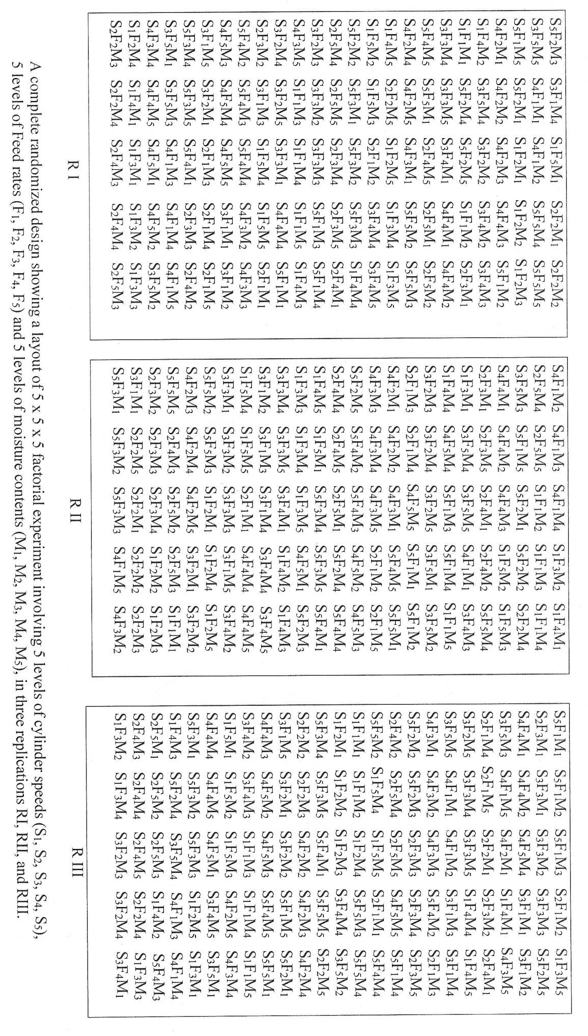

APPENDIX D
Measured values of output capacity for SOSAT C88 millet Variety at five levels of cylinder speed, feed rate and crop moisture content

Cylinder Speed (m/s) | Feed Rate (kg/min) | Output Capacity (kg/hr)
 |  | 10.6 %  Moisture | 11.9 %  Moisture | 13.2 %  Moisture | 14.3 %  Moisture | 15.8 %  Moisture
550 rpm  (12.1 m/s) | 6 | 196.8 | 193.6 | 183.8 | 179.6 | 166.6
 | 8 | 260.6 | 250.8 | 245.8 | 233.2 | 211.2
 | 10 | 319.4 | 300.2 | 290.2 | 270.8 | 255.8
 | 12 | 388.2 | 377.0 | 355.8 | 326.2 | 276.6
 | 14 | 447.6 | 433.0 | 410.8 | 345.0 | 288.4
650 rpm  (14.3 m/s) | 6 | 200.4 | 198.6 | 190.5 | 185.4 | 175.4
 | 8 | 274.6 | 258.2 | 246.6 | 236.0 | 226.6
 | 10 | 330.6 | 317.8 | 310.4 | 290.4 | 273.6
 | 12 | 404.6 | 383.4 | 370.2 | 340.8 | 314.8
 | 14 | 468.8 | 443.6 | 419.8 | 384.4 | 358.2
750 rpm  (16.5 m/s) | 6 | 215.2 | 202.8 | 195.8 | 190.4 | 180.2
 | 8 | 287.0 | 265.8 | 254.6 | 241.0 | 227.8
 | 10 | 345.4 | 332.4 | 317.2 | 302.6 | 285.4
 | 12 | 419.4 | 398.2 | 385.8 | 358.8 | 339.0
 | 14 | 474.6 | 455.8 | 442.2 | 417.8 | 395.6
850 rpm  (18.7 m/s) | 6 | 230.8 | 210.8 | 198.4 | 185.2 | 166.6
 | 8 | 299.4 | 281.2 | 267.6 | 237.2 | 217.8
 | 10 | 360.0 | 347.8 | 331.4 | 320.4 | 296.6
 | 12 | 436.6 | 419.4 | 398.1 | 377.2 | 361.2
 | 14 | 488.6 | 475.2 | 464.6 | 446.8 | 425.2
909 rpm  (20 m/s) | 6 | 255.6 | 219.2 | 200.6 | 125.8 | 65.4
 | 8 | 317.4 | 291.2 | 274.6 | 230.2 | 187.8
 | 10 | 382.6 | 359.0 | 343.8 | 331.4 | 298.4
 | 12 | 449.8 | 433.0 | 408.4 | 380.8 | 357.2
 | 14 | 520.6 | 502.8 | 475.0 | 457.2 | 427.2

APPENDIX E
Measured values of output capacity for Samsoy-2 soybeanvariety at five levels of cylinder speed, feed rate and crop moisture content

Cylinder Speed (m/s) | Feed Rate (kg/min) | Output Capacity (kg/hr)
 |  | 10.8 %  Moisture | 12.2 %  Moisture | 13.5 %  Moisture | 14.6 %  Moisture | 15.4 %  Moisture
550 rpm  (12.1 m/s) | 4 | 61 | 59.4 | 54.2 | 50.0 | 42.0
 | 6 | 99 | 90.0 | 83.0 | 78.0 | 73.0
 | 8 | 135 | 125.0 | 116.2 | 108.0 | 100.0
 | 10 | 167 | 155.4 | 145.2 | 131.0 | 122.0
 | 12 | 195 | 186.0 | 172.0 | 148.0 | 130.0
650 rpm  (14.3 m/s) | 4 | 63 | 60.0 | 55.0 | 48.0 | 43.2
 | 6 | 99 | 92.0 | 85.0 | 79.0 | 69.0
 | 8 | 137 | 126.0 | 120.0 | 110.0 | 100.0
 | 10 | 170 | 157.0 | 149.0 | 141.0 | 126.6
 | 12 | 198 | 187.0 | 179.0 | 159.2 | 140.6
750 rpm  (16.5 m/s) | 4 | 65 | 63.0 | 58.0 | 50.0 | 44.0
 | 6 | 101 | 93.0 | 88.0 | 81.0 | 72.0
 | 8 | 137 | 128.0 | 123.0 | 113.0 | 102.0
 | 10 | 170 | 159.2 | 153.0 | 142.4 | 128.4
 | 12 | 201 | 190.0 | 184.0 | 171.0 | 158.4
850 rpm  (18.7 m/s) | 4 | 66 | 63.6 | 60.0 | 53.0 | 45.6
 | 6 | 103 | 96.0 | 89.0 | 83.0 | 74.4
 | 8 | 140 | 130.0 | 125.0 | 116.0 | 103.0
 | 10 | 172 | 162.2 | 155.4 | 143.4 | 130.2
 | 12 | 204 | 194.0 | 187.0 | 173.4 | 160.8
909 rpm  (20 m/s) | 4 | 66 | 63.6 | 61.8 | 54.4 | 43.4
 | 6 | 101 | 98.0 | 89.0 | 84.8 | 73.8
 | 8 | 138 | 133.8 | 127.0 | 117.0 | 104.4
 | 10 | 170 | 164.2 | 158.4 | 143.4 | 130.2
 | 12 | 205 | 195.8 | 191.6 | 173.4 | 160.8

APPENDIX F
Measured values of threshing efficiency for SOSAT C88 millet variety at five levels of cylinder speed, feed rate and crop moisture content

Cylinder Speed (m/s) | Feed Rate (kg/min) | Threshing Efficiency (%)
 |  | 10.6 %  Moisture | 11.9 %  Moisture | 13.2 %  Moisture | 14.3 %  Moisture | 15.8 %  Moisture
550 rpm  (12.1 m/s) | 6 | 99.85 | 99.78 | 99.62 | 97.65 | 95.82
 | 8 | 99.76 | 99.71 | 99.49 | 97.46 | 95.66
 | 10 | 99.66 | 99.44 | 99.41 | 97.11 | 95.35
 | 12 | 99.39 | 99.35 | 99.16 | 96.71 | 95.01
 | 14 | 99.34 | 99.31 | 99.22 | 95.91 | 94.02
650 rpm  (14.3 m/s) | 6 | 99.87 | 99.82 | 99.62 | 97.71 | 96.02
 | 8 | 99.81 | 99.78 | 99.61 | 97.61 | 95.86
 | 10 | 99.64 | 99.61 | 99.54 | 97.41 | 95.63
 | 12 | 99.41 | 99.37 | 99.26 | 97.21 | 95.38
 | 14 | 99.44 | 99.29 | 99.22 | 96.62 | 94.57
750 rpm  (16.5 m/s) | 6 | 99.88 | 99.85 | 99.82 | 97.78 | 96.25
 | 8 | 99.84 | 99.83 | 99.81 | 97.65 | 96.06
 | 10 | 99.81 | 99.71 | 99.65 | 97.52 | 95.95
 | 12 | 99.69 | 99.61 | 99.54 | 97.31 | 95.74
 | 14 | 99.52 | 99.45 | 99.42 | 97.01 | 95.68
850 rpm  (18.7 m/s) | 6 | 99.97 | 99.96 | 99.85 | 97.38 | 95.82
 | 8 | 99.96 | 99.95 | 99.94 | 97.56 | 96.23
 | 10 | 99.91 | 99.86 | 99.82 | 97.63 | 96.39
 | 12 | 99.83 | 99.71 | 99.59 | 97.66 | 96.44
 | 14 | 99.65 | 99.56 | 99.48 | 97.47 | 96.41
909 rpm  (20 m/s) | 6 | 99.98 | 99.97 | 99.87 | 96.65 | 95.11
 | 8 | 99.97 | 99.96 | 99.96 | 97.35 | 95.99
 | 10 | 99.98 | 99.98 | 99.93 | 97.79 | 96.71
 | 12 | 99.93 | 99.81 | 99.78 | 97.72 | 96.70
 | 14 | 99.86 | 99.82 | 99.72 | 97.56 | 96.52

APPENDIX G
Measured values of threshing efficiency for Samsoy-2 soybean variety at five levels of cylinder speed, feed rate and crop moisture content

Cylinder Speed (m/s) | Feed Rate (kg/min) | Threshing Efficiency (%)
 |  | 10.8 %  Moisture | 12.2 %  Moisture | 13.5 %  Moisture | 14.6 %  Moisture | 15.4 %  Moisture
550 rpm  (12.1 m/s) | 4 | 100 | 100 | 100 | 98.9 | 97.9
 | 6 | 100 | 100 | 100 | 98.5 | 97.5
 | 8 | 100 | 100 | 100 | 98.2 | 96.9
 | 10 | 100 | 100 | 100 | 97.7 | 96.3
 | 12 | 100 | 100 | 100 | 97.2 | 95.6
650 rpm  (14.3 m/s) | 4 | 100 | 100 | 100 | 99.0 | 98.1
 | 6 | 100 | 100 | 100 | 98.7 | 97.7
 | 8 | 100 | 100 | 100 | 98.4 | 97.4
 | 10 | 100 | 100 | 100 | 98.1 | 97.1
 | 12 | 100 | 100 | 100 | 97.8 | 96.7
750 rpm  (16.5 m/s) | 4 | 100 | 100 | 100 | 99.1 | 98.3
 | 6 | 100 | 100 | 100 | 98.9 | 98.0
 | 8 | 100 | 100 | 100 | 98.7 | 97.8
 | 10 | 100 | 100 | 100 | 98.4 | 97.5
 | 12 | 100 | 100 | 100 | 98.2 | 97.3
850 rpm  (18.7 m/s) | 4 | 100 | 100 | 100 | 99.2 | 98.4
 | 6 | 100 | 100 | 100 | 99.0 | 98.2
 | 8 | 100 | 100 | 100 | 98.8 | 97.9
 | 10 | 100 | 100 | 100 | 98.6 | 97.8
 | 12 | 100 | 100 | 100 | 98.4 | 97.6
909 rpm  (20 m/s) | 4 | 100 | 100 | 100 | 99.2 | 98.4
 | 6 | 100 | 100 | 100 | 99.1 | 98.3
 | 8 | 100 | 100 | 100 | 98.9 | 98.1
 | 10 | 100 | 100 | 100 | 98.7 | 98.0
 | 12 | 100 | 100 | 100 | 98.5 | 97.8

APPENDIX H
Measured values of cleaning efficiency for SOSAT C88 millet variety at five levels of cylinder speed, feed rate and crop moisture content

Cylinder Speed (m/s) | Feed Rate (kg/min) | Cleaning Efficiency (%)
 |  | 10.6 %  Moisture | 11.9 %  Moisture | 13.2 %  Moisture | 14.3 %  Moisture | 15.8 %  Moisture
550 rpm  (12.1 m/s) | 6 | 98.2 | 97.31 | 96.44 | 92.67 | 88.79
 | 8 | 98.04 | 97.15 | 96.05 | 92.44 | 88.35
 | 10 | 97.86 | 96.81 | 95.78 | 92.17 | 87.88
 | 12 | 96.71 | 95.69 | 94.69 | 91.53 | 86.66
 | 14 | 96.13 | 95.04 | 94.01 | 90.12 | 84.27
650 rpm  (14.3 m/s) | 6 | 98.53 | 97.64 | 96.73 | 93.55 | 88.95
 | 8 | 98.44 | 97.33 | 96.57 | 92.93 | 88.58
 | 10 | 98.39 | 97.18 | 96.30 | 92.35 | 87.85
 | 12 | 97.86 | 96.53 | 95.14 | 91.83 | 86.55
 | 14 | 97.52 | 96.13 | 94.74 | 90.76 | 84.85
750 rpm  (16.5 m/s) | 6 | 98.82 | 97.57 | 97.09 | 95.19 | 89.05
 | 8 | 98.67 | 97.36 | 96.86 | 94.09 | 88.06
 | 10 | 98.42 | 97.19 | 96.34 | 93.13 | 87.25
 | 12 | 98.04 | 97.15 | 95.75 | 92.08 | 86.52
 | 14 | 97.87 | 96.93 | 95.13 | 90.62 | 85.51
850 rpm  (18.7 m/s) | 6 | 99.70 | 98.20 | 97.14 | 92.31 | 91.20
 | 8 | 99.14 | 97.62 | 96.91 | 91.17 | 89.86
 | 10 | 98.60 | 97.57 | 96.55 | 90.22 | 88.35
 | 12 | 98.48 | 97.43 | 96.01 | 89.51 | 87.12
 | 14 | 98.16 | 97.08 | 95.35 | 88.53 | 86.12
909 rpm  (20 m/s) | 6 | 99.71 | 98.23 | 97.57 | 94.26 | 92.24
 | 8 | 99.43 | 98.05 | 97.14 | 93.64 | 91.98
 | 10 | 98.79 | 97.92 | 96.48 | 93.11 | 91.39
 | 12 | 98.62 | 97.57 | 96.16 | 92.53 | 90.57
 | 14 | 98.49 | 97.36 | 95.84 | 91.55 | 89.31

APPENDIX I
Measured values of cleaning efficiency for Samsoy-2 soybean variety at five levels of cylinder speed, feed rate and crop moisture content

Cylinder Speed (m/s) | Feed Rate (kg/min) | Cleaning Efficiency (%)
 |  | 10.8 %  Moisture | 12.2 %  Moisture | 13.5 %  Moisture | 14.6 %  Moisture | 15.4 %  Moisture
550 rpm  (12.1 m/s) | 4 | 93.55 | 92.18 | 91.25 | 82.19 | 77.01
 | 6 | 92.23 | 91.39 | 90.25 | 81.58 | 75.81
 | 8 | 91.74 | 90.76 | 89.08 | 80.39 | 74.01
 | 10 | 90.61 | 89.41 | 88.49 | 79.34 | 73.25
 | 12 | 89.31 | 88.41 | 87.59 | 78.32 | 72.34
650 rpm  (14.3 m/s) | 4 | 94.25 | 93.05 | 92.47 | 83.41 | 78.21
 | 6 | 93.27 | 92.24 | 91.27 | 82.15 | 76.99
 | 8 | 92.55 | 91.21 | 90.19 | 81.19 | 75.32
 | 10 | 91.31 | 90.09 | 89.49 | 80.39 | 74.11
 | 12 | 90.31 | 89.19 | 88.47 | 79.19 | 73.07
750 rpm  (16.5 m/s) | 4 | 95.07 | 94.06 | 93.21 | 84.32 | 78.31
 | 6 | 94.06 | 93.11 | 92.04 | 83.07 | 77.02
 | 8 | 93.13 | 92.11 | 91.05 | 82.09 | 76.23
 | 10 | 92.34 | 91.38 | 90.07 | 81.09 | 75.06
 | 12 | 91.10 | 90.21 | 89.31 | 80.01 | 74.14
850 rpm  (18.7 m/s) | 4 | 96.15 | 95.07 | 94.06 | 85.19 | 80.11
 | 6 | 95.18 | 94.10 | 93.13 | 84.25 | 78.24
 | 8 | 94.16 | 93.44 | 92.19 | 83.30 | 77.23
 | 10 | 93.82 | 92.48 | 91.26 | 82.09 | 76.06
 | 12 | 92.09 | 91.13 | 90.59 | 81.20 | 75.22
909 rpm  (20 m/s) | 4 | 97.26 | 96.28 | 95.28 | 86.11 | 82.21
 | 6 | 96.09 | 95.24 | 94.03 | 85.02 | 79.91
 | 8 | 95.09 | 94.18 | 93.11 | 84.01 | 78.40
 | 10 | 94.14 | 93.09 | 92.05 | 83.10 | 77.11
 | 12 | 93.13 | 92.45 | 91.33 | 82.07 | 76.10

APPENDIX J
Measured values of scattered grain loss for SOSAT C88 millet variety at five levels of cylinder speed, feed rate and crop moisture content

Cylinder Speed (m/s) | Feed Rate (kg/min) | Scattered Grain Loss (%)
 |  | 10.6 %  Moisture | 11.9 %  Moisture | 13.2 %  Moisture | 14.3 %  Moisture | 15.8 %  Moisture
550 rpm  (12.1 m/s) | 6 | 11.11 | 10.93 | 10.52 | 7.87 | 6.79
 | 8 | 11.05 | 10.87 | 10.46 | 7.66 | 6.73
 | 10 | 11.02 | 10.77 | 10.41 | 7.51 | 6.27
 | 12 | 10.88 | 10.67 | 10.32 | 7.19 | 6.09
 | 14 | 10.87 | 10.36 | 10.02 | 7.05 | 5.77
650 rpm  (14.3 m/s) | 6 | 11.21 | 11.06 | 10.66 | 7.97 | 6.86
 | 8 | 11.27 | 10.98 | 10.57 | 7.78 | 6.81
 | 10 | 11.19 | 10.89 | 10.60 | 7.65 | 6.49
 | 12 | 10.97 | 10.75 | 10.43 | 7.35 | 6.28
 | 14 | 10.93 | 10.55 | 10.33 | 7.22 | 6.04
750 rpm  (16.5 m/s) | 6 | 11.54 | 11.22 | 10.81 | 8.12 | 7.06
 | 8 | 11.51 | 11.22 | 10.71 | 8.01 | 7.09
 | 10 | 11.41 | 11.08 | 10.69 | 7.88 | 6.85
 | 12 | 11.38 | 11.01 | 10.67 | 7.70 | 6.82
 | 14 | 11.24 | 10.76 | 10.47 | 7.63 | 6.42
850 rpm  (18.7 m/s) | 6 | 11.81 | 11.53 | 11.08 | 8.4 | 7.52
 | 8 | 11.73 | 11.45 | 10.99 | 8.36 | 7.49
 | 10 | 11.68 | 11.34 | 11.13 | 8.25 | 7.23
 | 12 | 11.37 | 11.16 | 10.94 | 8.11 | 7.06
 | 14 | 11.42 | 11.05 | 10.82 | 7.94 | 6.77
909 rpm  (20 m/s) | 6 | 12.18 | 11.94 | 11.57 | 8.97 | 8.04
 | 8 | 12.03 | 11.89 | 11.45 | 8.76 | 7.91
 | 10 | 11.88 | 11.52 | 11.19 | 8.36 | 7.61
 | 12 | 11.64 | 11.43 | 11.11 | 8.37 | 7.53
 | 14 | 11.63 | 11.39 | 10.96 | 8.24 | 7.28

APPENDIX K
Measured values of scattered grain loss for Samsoy-2 soybean variety at five levels of cylinder speed, feed rate and crop moisture content

Cylinder Speed (m/s) | Feed Rate (kg/min) | Scattered Grain Loss (%)
 |  | 10.8 %  Moisture | 12.2 %  Moisture | 13.5 %  Moisture | 14.6 %  Moisture | 15.4 %  Moisture
550 rpm  (12.1 m/s) | 4 | 5.31 | 5.08 | 4.81 | 2.49 | 2.1
 | 6 | 4.83 | 4.66 | 4.46 | 2.36 | 1.87
 | 8 | 4.56 | 4.33 | 4.21 | 2.28 | 1.72
 | 10 | 4.43 | 4.28 | 4.13 | 2.06 | 1.62
 | 12 | 4.25 | 4.15 | 4.05 | 1.92 | 1.54
650 rpm  (14.3 m/s) | 4 | 5.57 | 5.35 | 5.01 | 2.65 | 2.31
 | 6 | 5.08 | 4.86 | 4.63 | 2.42 | 2.03
 | 8 | 4.89 | 4.58 | 4.32 | 2.32 | 1.79
 | 10 | 4.55 | 4.42 | 4.08 | 2.16 | 1.72
 | 12 | 4.44 | 4.24 | 3.91 | 2.02 | 1.58
750 rpm  (16.5 m/s) | 4 | 5.94 | 5.64 | 5.23 | 2.92 | 2.54
 | 6 | 5.54 | 5.16 | 4.94 | 2.62 | 2.28
 | 8 | 5.29 | 4.84 | 4.46 | 2.51 | 2.09
 | 10 | 4.83 | 4.51 | 4.18 | 2.31 | 1.94
 | 12 | 4.63 | 4.26 | 3.72 | 2.13 | 1.78
850 rpm  (18.7 m/s) | 4 | 6.54 | 6.11 | 5.72 | 3.44 | 2.83
 | 6 | 5.95 | 5.63 | 5.41 | 3.09 | 2.57
 | 8 | 5.56 | 5.15 | 4.93 | 2.84 | 2.28
 | 10 | 4.99 | 4.67 | 4.49 | 2.44 | 2.11
 | 12 | 4.71 | 4.44 | 4.23 | 2.23 | 1.9
909 rpm  (20 m/s) | 4 | 7.25 | 6.85 | 6.19 | 4.03 | 3.44
 | 6 | 6.65 | 6.29 | 5.67 | 3.78 | 3.07
 | 8 | 6.14 | 5.48 | 5.09 | 3.34 | 2.87
 | 10 | 5.42 | 4.85 | 4.58 | 2.91 | 2.49
 | 12 | 4.89 | 4.48 | 4.25 | 2.33 | 2.05

APPENDIX L
Measured values of grain damage for SOSAT C88 millet variety at five levels of cylinder speed, feed rate and crop moisture content

Cylinder Speed (m/s) | Feed Rate (kg/min) | Grain Damage (%)
 |  | 10.6 %  Moisture | 11.9 %  Moisture | 13.2 %  Moisture | 14.3 %  Moisture | 15.8 %  Moisture
550 rpm  (12.1 m/s) | 6 | 0.04 | 0.020 | 0.010 | 0.41 | 0.47
 | 8 | 0.03 | 0.020 | 0.010 | 0.40 | 0.45
 | 10 | 0.02 | 0.010 | 0.010 | 0.38 | 0.43
 | 12 | 0.02 | 0.010 | 0.010 | 0.36 | 0.42
 | 14 | 0.01 | 0.001 | 0.001 | 0.35 | 0.40
650 rpm  (14.3 m/s) | 6 | 0.06 | 0.040 | 0.010 | 0.44 | 0.49
 | 8 | 0.04 | 0.020 | 0.010 | 0.41 | 0.47
 | 10 | 0.02 | 0.010 | 0.010 | 0.39 | 0.46
 | 12 | 0.02 | 0.010 | 0.010 | 0.39 | 0.43
 | 14 | 0.01 | 0.001 | 0.001 | 0.37 | 0.41
750 rpm  (16.5 m/s) | 6 | 0.06 | 0.040 | 0.010 | 0.46 | 0.51
 | 8 | 0.05 | 0.030 | 0.010 | 0.42 | 0.49
 | 10 | 0.04 | 0.020 | 0.010 | 0.40 | 0.47
 | 12 | 0.03 | 0.010 | 0.010 | 0.40 | 0.46
 | 14 | 0.02 | 0.001 | 0.001 | 0.38 | 0.43
850 rpm  (18.7 m/s) | 6 | 0.11 | 0.080 | 0.020 | 0.51 | 0.58
 | 8 | 0.09 | 0.060 | 0.020 | 0.47 | 0.54
 | 10 | 0.07 | 0.050 | 0.010 | 0.43 | 0.51
 | 12 | 0.05 | 0.020 | 0.010 | 0.41 | 0.48
 | 14 | 0.04 | 0.010 | 0.001 | 0.39 | 0.45
909 rpm  (20 m/s) | 6 | 0.14 | 0.120 | 0.040 | 0.56 | 0.62
 | 8 | 0.12 | 0.100 | 0.040 | 0.51 | 0.58
 | 10 | 0.08 | 0.050 | 0.010 | 0.46 | 0.55
 | 12 | 0.07 | 0.030 | 0.010 | 0.42 | 0.51
 | 14 | 0.06 | 0.030 | 0.001 | 0.41 | 0.48

APPENDIX M
Measured values of grain damage for Samsoy-2 soybean variety at five levels of cylinder speed, feed rate and crop moisture content

Cylinder Speed (m/s) | Feed Rate (kg/min) | Grain Damage (%)
 |  | 10.8 %  Moisture | 12.2 %  Moisture | 13.5 %  Moisture | 14.6 %  Moisture | 15.4 %  Moisture
550 rpm  (12.1 m/s) | 4 | 0.04 | 0.030 | 0.020 | 0.4 | 0.6
 | 6 | 0.03 | 0.020 | 0.010 | 0.3 | 0.5
 | 8 | 0.02 | 0.010 | 0.010 | 0.2 | 0.4
 | 10 | 0.01 | 0.010 | 0.010 | 0.1 | 0.3
 | 12 | 0.01 | 0.001 | 0.001 | 0.1 | 0.2
650 rpm  (14.3 m/s) | 4 | 0.05 | 0.040 | 0.030 | 0.4 | 0.7
 | 6 | 0.04 | 0.030 | 0.020 | 0.3 | 0.6
 | 8 | 0.03 | 0.020 | 0.010 | 0.2 | 0.5
 | 10 | 0.02 | 0.010 | 0.001 | 0.2 | 0.4
 | 12 | 0.01 | 0.001 | 0.001 | 0.1 | 0.3
750 rpm  (16.5 m/s) | 4 | 0.06 | 0.050 | 0.030 | 0.5 | 0.8
 | 6 | 0.05 | 0.040 | 0.020 | 0.4 | 0.7
 | 8 | 0.04 | 0.030 | 0.010 | 0.3 | 0.6
 | 10 | 0.03 | 0.020 | 0.001 | 0.2 | 0.5
 | 12 | 0.02 | 0.010 | 0.001 | 0.1 | 0.4
850 rpm  (18.7 m/s) | 4 | 1.00 | 0.800 | 0.500 | 1.5 | 2.0
 | 6 | 0.80 | 0.600 | 0.400 | 1.2 | 1.7
 | 8 | 0.60 | 0.400 | 0.300 | 1.0 | 1.5
 | 10 | 0.40 | 0.300 | 0.200 | 0.8 | 1.3
 | 12 | 0.30 | 0.200 | 0.100 | 0.6 | 1.1
909 rpm  (20 m/s) | 4 | 1.60 | 1.200 | 0.800 | 2.2 | 6.0
 | 6 | 1.40 | 1.000 | 0.700 | 2.0 | 5.5
 | 8 | 0.80 | 0.600 | 0.500 | 1.8 | 5.0
 | 10 | 0.60 | 0.400 | 0.300 | 1.6 | 4.5
 | 12 | 0.40 | 0.300 | 0.200 | 1.4 | 4.0

APPENDIX N
Measured and predicted threshing efficiencies of the machine

Measured E_{T} | Predicted E_{T} | Deviation | Measured E_{T} | Predicted E_{T} | Deviation
99.88 | 100.00 | 0.12 | 99.29 | 99.40 | 0.11
99.87 | 100.00 | 0.13 | 99.26 | 98.36 | 0.90
99.84 | 100.00 | 0.16 | 99.22 | 98.41 | 0.81
99.83 | 99.24 | 0.59 | 99.22 | 98.38 | 0.84
99.82 | 99.20 | 0.62 | 99.16 | 98.39 | 0.77
99.82 | 98.13 | 1.69 | 97.78 | 97.41 | 0.37
99.81 | 100.00 | 0.19 | 97.71 | 97.47 | 0.24
99.81 | 98.23 | 1.58 | 97.65 | 97.52 | 0.13
99.78 | 99.25 | 0.53 | 97.65 | 97.51 | 0.14
99.78 | 99.29 | 0.49 | 97.61 | 97.56 | 0.05
99.76 | 100.00 | 0.24 | 97.46 | 97.60 | 0.14
99.71 | 99.33 | 0.38 | 97.41 | 97.61 | 0.20
99.66 | 100.00 | 0.34 | 97.21 | 97.65 | 0.44
99.65 | 100.00 | 0.35 | 97.11 | 97.61 | 0.50
99.62 | 98.24 | 1.38 | 96.71 | 97.65 | 0.94
99.62 | 98.18 | 1.44 | 96.62 | 97.67 | 1.05
99.61 | 99.34 | 0.27 | 96.25 | 96.60 | 0.35
99.61 | 98.27 | 1.34 | 96.06 | 96.70 | 0.64
99.54 | 98.32 | 1.22 | 96.02 | 96.65 | 0.63
99.49 | 98.31 | 1.18 | 95.91 | 97.65 | 1.74
99.44 | 100.00 | 0.56 | 95.86 | 96.74 | 0.88
99.44 | 99.37 | 0.07 | 95.82 | 96.71 | 0.89
99.41 | 98.36 | 1.05 | 95.66 | 96.78 | 1.12
99.41 | 100.00 | 0.59 | 95.63 | 96.79 | 1.16
99.39 | 100.00 | 0.61 | 95.38 | 96.83 | 1.45
99.37 | 99.37 | 0.00 | 95.35 | 96.83 | 1.48
99.35 | 99.40 | 0.05 | 95.01 | 96.86 | 1.85
99.34 | 100.00 | 0.66 | 94.57 | 96.86 | 2.29
99.31 | 99.42 | 0.11 | 94.02 | 96.88 | 2.86

