**DEVELOPMENT AND DESIGN SPACE EXPLORATION OF DEEP CONVOLUTION NEURAL NETWORK FOR IMAGE RECOGNITION**

A Thesis Submitted to the Department of Computer Science

African University of Science and Technology

In Partial Fulfilment of the Requirements for the Degree of MASTER of Computer Science

By

Aboki Nasiru Aliu Abuja, Nigeria November, 2017

# CERTIFICATION

This is to certify that the thesis titled “Development and Design Space Exploration of Deep Convolution Neural Network for Image Recognition” submitted to the school of postgraduate studies, African University of Science and Technology (AUST), Abuja, Nigeria for the award of the Master's degree is a record of original research carried out by Aboki Nasiru Aliu in the Department of Computer Science.

**DEVELOPMENT AND DESIGN SPACE EXPLORATION OF DEEP CONVOLUTION NEURAL NETWORK FOR IMAGE RECOGNITION**

By

ABOKI Nasiru Aliu

A THESIS APPROVED BY THE COMPUTER SCIENCE

DEPARTMENT

RECOMMENDED:

Supervisor, Prof. Ben Abdallah

Co-supervisor

Head, Department of Computer Science

APPROVED:

Chief Academic Officer

Date

**COPYRIGHT**

**© 2017**

**Aboki Nasiru Aliu**

ALL RIGHTS RESERVED

# ABSTRACT

Deep Neural Networks are now deployed for many modern artificial Intelligence applications including computer vision, speech recognition, self-driving cars, cancer detection, gaming and robotics.

Inspired by the mammalian visual cortex, Convolutional Neural Networks (CNNs) have been shown to achieve impressive results on a number of computer vision challenges, but often with large amounts of processing power and no timing restrictions. Software simulations of CNNs are an efficient way to evaluate and explore the performance of the system.

In this thesis, I present a software implementation and study of a Deep CNN for image recognition. The parameterization of our design offers the flexibility to adjust the design in order to balance performance and flexibility, particularly for resource-constrained systems. I also present a design space exploration for obtaining the implementation with the highest performance on a given platform.

# ACKNOWLEDGEMENTS

Success is said to be achieved when preparation coincides with opportunity. I want to acknowledge the enormous sacrifice of my dearest treasure and darling wife, Mrs. Fajemi Comfort Aboki, for showing me the biggest support throughout the course of this masters’ program and for adding to my joy by giving me a lovely son, Jaden Zebada Aboki, during the course of the masters’ program. Much gratitude goes to all the Faculty that have contributed a wealth of knowledge that has given me the confidence to carry out this research. I really want to appreciate my supervisor, Prof. Ben Abdallah for generously taking his time to guide me through this project to produce the best in my thesis work and I am thankful for his words of encouragement which reminded me that I can achieve anything I put my mind to accomplish. I also want to thank AUST for providing me with such an opportunity and platform to advance my knowledge in my current academic discipline. I am also grateful to all my class and set mates for their encouragements and contributions that have enabled me to be successful during our stay in AUST. The race has not been easy but God has been faithful. Much gratitude goes to Mr. Isah Charles Saidu, once again you have proved yourself a good friend and helper. I want to acknowledge the efforts and contributions of my Father and Mother In-law and the rest of their Family. You are all a gift to me and God sent and I cherish you all for you have been with my wife and I through thick and thin. To my Elder Brother, Dr. Nuruddeen and Family, we are really grateful for your love, support and encouragement as well. I am also grateful to my fellow residents of Red Roof Mini-Estate for all their help, love and support as well. To the rest of my grand Family, I want to say a big thank you for all the roles you have played in my life that has made me come this far. May God continue to crown all your efforts with success. Amen!!!

# DEDICATION

I dedicate this thesis to God Almighty, for giving me the strength, enablement, vision and purpose to go thus far in my academic pursuits. I also dedicate this thesis to the memory of the loved ones I lost too soon, My darling Mother, Mrs. Betty Aisha A. Lukolm, My dearest Dad, Mr. Aliu Ango Aboki and my sweetest and most enduring sister, Hadiza Ladi Aboki.

**TABLE OF CONTENTS**

CERTIFICATION ii

ABSTRACT v

ACKNOWLEDGEMENTS vi

DEDICATION vii

LIST OF TABLES x

LIST OF FIGURES x

LIST OF ABBREVIATIONS xii

CHAPTER ONE Introduction 1

* 1. Introduction to Neuro-Inspired Systems 1
  2. Statement of the Problem 2
  3. Motivation 3
  4. Research Objective 4
  5. Significance of Study 5
  6. Thesis Outline 5
     1. Chapter 1 – Introduction to Neuro-inspired Systems 5
     2. Chapter 2 – Literature Review (Related work about Image Recognition) 5
     3. Chapter 3 – Study of Image Recognition Algorithm Using Supervised Learning Algorithms 5
     4. Chapter 4 – Evaluation and Discussion 5
     5. Chapter 5 – Conclusion and Future Work 6

CHAPTER TWO Literature Review 7

* 1. Introduction 7
  2. Computer Vision Supervised Machine Learning Classifiers 7
     1. Pairwise Support Vector Machine 7
     2. K-Nearest-Neighbour (K-NN with Euclidean Distance) 9
     3. Deep Convolutional Neural Networks 10
  3. Machine Learning Algorithms 11
     1. Unsupervised Machine Learning Algorithm 11
     2. Reinforcement Machine Learning Algorithm 12
     3. Supervised Machine Learning Algorithm 13
     4. Backpropagation Learning Algorithm 13
  4. Conclusion 23

CHAPTER THREE Methodology 24

* 1. Introduction of Deep Convolutional Neural Networks 24
  2. Topology of Deep Convolutional Neural Networks 25
  3. Layers of Deep Convolutional Neural Networks 25
     1. Convolutional Layer 25
     2. Activation Layer 26
     3. Down-Sampling or Pooling Layer 27
     4. Fully Connected Layer 28
  4. Learning Algorithm of Deep Convolutional Neural Networks 29

CHAPTER FOUR Implementation 32

* 1. Introduction to the Implementation 32
  2. Model Implementation of the Deep Convolutional Neural Networks 32
  3. Test Results of the Convolutional Neural Network Model 34
  4. Test Observation and Discussion 38

CHAPTER FIVE Evaluation and Conclusion 39

* 1. Introduction 39
  2. Evaluation of various Deep Convolutional Neural Network Models 39
     1. Training Time Against Filter Size Evaluation 40
     2. Training Time Against Activation Function Evaluation 41
     3. Accuracy Against Activation Function Evaluation 42
     4. Accuracy Against Filter Size Evaluation 43
  3. Future Work 43
     1. Data Augmentation 44
     2. Transfer Learning 44
     3. Object Localization, Detection and Segmentation 45
  4. Discussion and Conclusion 46
     1. Contribution to Deep Performance CNN Modelling 46
     2. Conclusion 47

REFERENCES 48

# LIST OF TABLES

Table 2.1: Probabilistic Table for Rainfall Occurrence 14

Table 2.2: Normalized Probabilistic Table for Rainfall Occurrence 15

Table 2.3: Normalized Probabilistic Table for Rainfall Occurrence with Output Errors(Ȳ)

.................................................................................................................. 19

Table 2.4: Final Normalized Probabilistic Table for Rainfall Occurrence 22

Table 2.5: Final Probabilistic Table for Rainfall Occurrence 22

Table 5.1: Training & Test Accuracy Table for the Convolutional Neural Network Models 40

# LIST OF FIGURES

Figure 1.1: Object Recognition in Machines and Humans 3

Figure 2.1: Pairwise SVM Image Classification 8

Figure 2.2: K-NN Image Classification 9

Figure 2.3: A Deep Convolutional Neural Network 11

Figure 2.4: A Neural Network for Rainfall Predictions 15

Figure 2.5: Sigmoid Activation Function 16

Figure 2.6: A Rectified Linear Unit Activation Function 17

Figure 2.7: A Tanh Activation Function 18

Figure 2.8: Forward Propagation 18

Figure 2.9: A Neural Network for Rainfall Predictions with Random Weight Values 19

Figure 2.10: Backward Pass 20

Figure 2.11: Weights Updates 20

Figure 2.12: Final Optimal Weights 20

Figure 2.13: A Neural Network for Rainfall Predictions with Optimal Weight Values 21

Figure 3.1: Structure of A Convolutional Neural Network 24

Figure 3.2: Element-Wise Multiplication and Summation Convolution 26

Figure 3.3: A Rectified Feature Map Transformation 27

Figure 3.4: A Max-Pooling Transformation 28

Figure 3.5: A Fully Connected Layer Transformation 28

Figure 3.6: A Gradient Descent Slope 29

Figure 4.1: Class Label and Test Image 35

Figure 4.2: Class Label and Test Image 35

Figure 4.3: Class Label and Test Image 36

Figure 4.4: Class Label and Test Image 36

Figure 4.5: Class Label and Test Image 36

Figure 4.6: Class Label and Test Image 36

Figure 4.7: Class Label and Test Image 37

Figure 4.8: Class Label and Test Image 37

Figure 4.9: Class Label and Test Image 37

Figure 4.10: Class Label and Test Image 37

Figure 5.1: Training Time Against Filter Size 40

Figure 5.2: Training Time Against Activation Function 41

Figure 5.3: Accuracy Against Activation Function 42

Figure 5.4: Accuracy Against Filter Size 43

Figure 5.5: Image Classification, Object Localization and Object Detection 45

Figure 5.6: Image Classification and Object Segmentation 46

# LIST OF ABBREVIATIONS

|  |  |
| --- | --- |
| Adadelta | Adaptive Delta |
| Adagrad | Adaptive Gradient Algorithm |
| Adam | Adaptive Moment Estimation |
| AI | Artificial Intelligence |
| ANN | Artificial Neural Network |
| API | Application Programming Interface |
| Backprop | Backpropagation |
| BDG | Batch Gradient Descent |
| CNN | Deep Convolution Neural Network |
| ConvNet | Convolutional Neural Network |
| CPU | Central Processing Unit |
| CV | Computer Vision |
| DCNN | Deep Convolutional Neural Network |
| DCNN | Deep Convolution Neural Network |
| DL | Deep Learning |
| DNN | Neural Network |
| FC | Fully Connected |
| GD | Gradient Descent |
| GPU | Graphics Processing Unit |
| HOG | Histogram of Gradients |
| ILSVRC | ImageNet Large Scale Visual Recognition Competition |
| ML | Machine Learning |
| MSE | Mean Square Error |
| NAG | Nesterov Accelerated Gradient |
| NN | Neural Network |
| OpenCV | Open Computer Vision |
| RELU | Rectified Linear Unit |

|  |  |
| --- | --- |
| RL | Reinforcement Learning |
| RMSProp | Root Mean Square Propagation |
| RNN | Recurrent Neural Network |
| SML | Supervised Machine Learning Algorithms |
| SGD | Stochastic Gradient Descent |
| SVM | Support Vector Machine |
| USML | Unsupervised Machine Learning Algorithms |

**CHAPTER ONE**

**Introduction**

## Introduction to Neuro-Inspired Systems

Neuro-Inspired systems are computing systems which are modelled after biological neuro- processes in the brain of animals, especially higher animals like humans. Such processes have cognitive abilities which make the animal intelligent, in the sense that they are able to make decisions having processed data they receive from their environment or with changes involved in their body system. Biological beings are not born with the ability to make decisions after perceiving stimuli but they attentively perform an activity when they continually process such novel stimulus; and such neurological cognition is the ability that neuro-inspired systems want to leverage on and mimic, if not surpass.

Artificial intelligence (AI) is a branch of computer science that emphasizes the creation of intelligent agents that work and perceive as humans do (Techopedia, 2017). Machine learning (ML) algorithms are learning algorithms for AI and have to do with the mathematical models used to build software that progressively modifies its algorithms so as to improve future results, that is software with the ability to learn. These algorithms are different from the conventional sequential algorithms mostly used in computing in the fact that they are not deterministic algorithms. Examples of machine learning algorithms are supervised learning, unsupervised learning, reinforcement learning, transduction, learning to learn, semi-supervised learning algorithms.

Artificial neuro-science deals with artificial neural networks (ANNs) which are an ML method with the goal of building cognitive algorithms which are closely modelled after neural networks in the human brain (a connectionist network). Deep learning has to do with perceiving many levels of abstraction and representation that help a person to make sense of datasets such as

images, sound, and text (Ng et al., 2015). It is composed of more complex algorithms because it is an advanced form of an ANN.

Computer vision is the science of endowing computing machines with visual perception, that is, the ability to see (Henrique & Pinheiro, 2017). A convolutional neural network (CNN) is a variant of ANN that possesses a deep learning architecture which is a neural network architecture with a stack of more than two or more non-linear layers (Ian, 2016). The eyes are described as being the light of the body or the window of the soul, the soul being an embodiment of thought or perception. In computer vision, the processing elements emulate the activity of neuronal cells in the visual cortex of the human eye and their deep complex architecture, where some neurons activate when low-level features are seen, while other neurons which have a wider receptive field activate when more abstract or high-level features are being viewed. Computer vision – an image recognition system with the aid of convolutional neural networks – is the focus of this thesis due to this deep neuro-inspired architecture.

## Statement of the Problem

Most computing algorithms are deterministic or sequential in nature. A sequential algorithm is an algorithm that follows a specific set of rules to accomplish a task. But not all computing problems can be solved with deterministic algorithms. Deterministic algorithms do not have cognitive abilities, meaning that they cannot learn from examples provided and use the information gained to identify patterns.

The Von Neumann architecture of computing does not possess true parallelism due to the processing latency it experiences between the memory and the central processing unit, but a neural networking system eliminates the use of such an architecture and it is regarded as possessing true parallelism.

An ANN can be a software or hardware implementation. A software implementation of an ANN suffers the bottlenecks of bandwidth and use of too much memory. Consequently, the

hardware implementation is a massively parallel system which overcomes such bottlenecks. A software or hardware implementation of a neural network can still have cognitive abilities and can solve problems that sequential algorithms cannot.

## Motivation

Deep learning became a sensation in its use for classification of objects using deep CNNs (DCNNs) in the year 2012 when Krizhevsky achieved impressive results in the yearly ImageNet image classification contest (Krizhevsky, Sutskever, & Hinton, 2012). The computational power using parallel processing computational units and graphical processing units have further advanced research using deep learning methods. DCNNs are able to learn feature representations for novel datasets, they behave well when they are trained using many datasets and have adhered to state of the art performance compared to other computer vision approaches. Computer vision can be applied in industry and find various applications in our daily lives, like the production of driverless cars, autonomous aerial vehicles and can be used in medicine to identify pathogens and ailments like cancer with very high success (Davy et al., 2013). Figure 1.1 depicts the vision of a CNN system and that of a human eye.

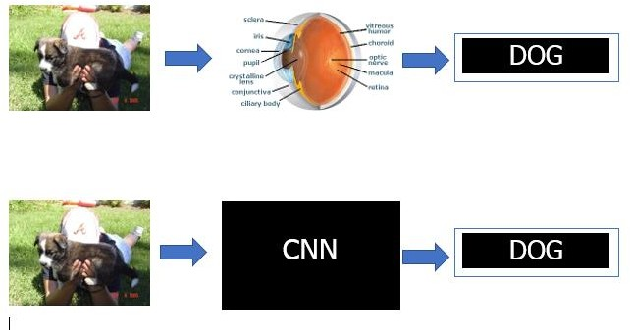

**Figure 1.1: Object Recognition in Machines and Humans**

## Research Objective

ANNs are of various kinds and can be applied in various aspect of life. One of the objectives of this thesis is to gain a deep understanding of neuro-inspired computing systems and their various applications such as in weather predictions, in building recommender systems, in predicting stock exchange markets, and building autonomous systems.

The main objective of this thesis to gain a deep understanding of DCNNs that are used for image recognition and build an efficient algorithm that can be used for object recognition and classification and perform deep space explorations by implementing software emulations to determine the best CNN model that can be used for an image classification based the performance of its image classification accuracy. The deep space exploration is achievable because the design of the algorithm for our CNN model provides us with the flexibility to adjust some of its parameters so as to observe the results of its performance in image classification. The optimized classifier system should be used for software emulations that exhibit neuronal processing in the visual cortex for object recognition of static and real-time images just as it is possible in humans, with little room for errors caused by objects in an image exhibiting variations such as pose, view pose, illumination, appearance and occlusion. Visual recognition is a difficult computational problem and it will be significantly involved in making intelligent systems (Pinheiro & Henrique, 2017). A DCNN (Yann, Haffner, Bottou, & Yoshua, 2012) has an architecture that has surpassed others when it comes to the use of image-based applications for computer vision. It is able to reliably identify objects in an image irrespective if its position and pose within the image dataset.

## Significance of Study

Object recognition using DCNN machine learning models is of importance as a study because of the diversity it can cut across in its application. Before a cognitive agent is able to make decisions in a live environment, its first point of call is an observation of its surroundings, which is possible with computer vision. DCNNs can be applied in building autonomous machines, speech recognition and natural language processing. DCNN models are cheap to implement. The only downside is the time taken to train the network models, but once they are implemented, they can be made available on the internet for use by millions of people that require their features.

## Thesis Outline

### Chapter 1 – Introduction to Neuro-inspired Systems

This chapter introduces the definition of neuro-inspired systems, using neuro-inspired systems for image recognition, its objects and goals.

### Chapter 2 – Literature Review (Related work about Image Recognition)

Related work about Image recognition agents is discussed in this chapter.

### Chapter 3 – Study of Image Recognition Algorithm Using Supervised Learning Algorithms

Supervised machine learning algorithms such as backpropagation will be discussed in this chapter and results from software emulations of the CNN models tested will be documented as well.

### Chapter 4 – Evaluation and Discussion

In this chapter, the software model being developed is evaluated against the objectives set in Chapter one of this project, to see if it meets up with the requirements and goals that were initially set.

### Chapter 5 – Conclusion and Future Work

The purpose of this chapter is to see if the project has added more knowledge and functionality to similar previous works being carried out to evaluate the effects of using other activation functions such as Sigmoid, Tanh in the activation layer in a chosen CNN model and also the effect of using different kernel sizes in the convolution layer of a chosen CNN. Future work regarding the software model is also discussed.

**CHAPTER TWO**

**Literature Review**

## Introduction

This chapter reviews literature associated with this thesis. Section 2.1 discusses different computer learning classifiers used for computer vision with emphasis on their image classification accuracy and how deep learning methods using a CNN have proven to outperform other traditional computer vision learning methods with much better accuracy in image classification. Section 2.2 discusses the various machine learning (ML) algorithms and the ML algorithm used for a CNN.

## Computer Vision Supervised Machine Learning Classifiers

### Pairwise Support Vector Machine

A Support Vector Machine (SVM) is a traditional computer vision classifier and it uses a supervised learning algorithm. Pairwise classification is the task to predict whether a binary pair belongs to the same class or different classes (Brunner, 2012). Image classification problems can be treated in this manner. The order of the binary pair in pairwise classification should not affect the classification result (Brunner, 2012). The learning algorithm that would be required for this classification is done using an SVM. SVM uses a histogram of gradients (HOG) descriptor in its algorithm for classification. SVM uses the best demarcation line to distinguish features extracted from other unwanted features as seen in Figure 2.1.

An HOG is a feature extractor algorithm that converts an image of fixed size to a feature vector of fixed size and is called the HOG feature descriptor of that image (Mallick, 2016).

An HOG is based on the idea that local object appearance can be efficiently described by the distribution (histogram) of edge directions also known as oriented gradients (Mallick, 2016). During training, we provide the SVM with symmetric datasets or examples from separate classes which it uses to distinguish their features using the provided HOG descriptor

vector(Brunner, 2012). SVM is a well-known and widely adopted binary classification algorithm still in use in industry today. The demerits of a HOG are that it is a hand-crafted feature extractor, in the sense that it is already proven that two simple features that can be extracted from images are curves and edges; therefore, a HOG materializes on that information for its feature extraction; thus, its accuracy on classification is not very precise. The learning algorithm therefore, is already fixed in the sense that it cannot check for more complex high- level features than what is already defined (it does not learn to detect features automatically). Applying an SVM learning method with Gaussian kernels in a data training and classification exercise performed, produced poor test error performance results on given test images compared to its counterpart, the CNN image classifier (LeCun, Huang, & Bottou, 2004). The advantage of SVM is that it performs exceptionally well on datasets that have many features, even when the training datasets size is limited. The disadvantage of SVM though is that it has limitations in speed and size during the testing and training phase of its algorithm and also a selection of its kernel function is another hassle (Kim, Kim, Savarese, & Arbor, 2012). Figure

2.1 depicts the working principle of an SVM classifier.

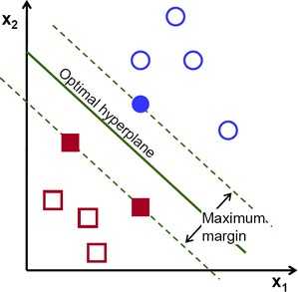

**Figure 2.1: Pairwise SVM Image Classification**

(Image adapted from https://docs.opencv.org)

### K-Nearest-Neighbour (K-NN with Euclidean Distance)

K-NN is another traditional computer vision classifier which uses a supervised learning algorithm for classification problems. The K-NN algorithm is a learning object classification based on closest training examples in a particular feature space (Kim et al., 2012). The K-NN classifier has one of the simplest machine learning algorithms. During training, the algorithm stores only feature vectors and labels of the training images (Kim et al., 2012). During the testing/classification phase of the K-NN model, the test image is assigned to the label of its K- NN based on a majority vote and the value of K-NN must have a value of k=1 (Kim et al., 2012). The K-NN classifier uses the Euclidean distance function to determine its k-neighbours (Muralidharan, 2014). A K-NN algorithm has good accuracy performance with multi-modal classes, but its disadvantage is that it uses all the features equally during testing to determine a class for an object, which can lead to classification errors, especially when there are just a few features extracted for a classification(Kim et al., 2012). Figure 2.2 depicts the working principle of a K-NN classifier.

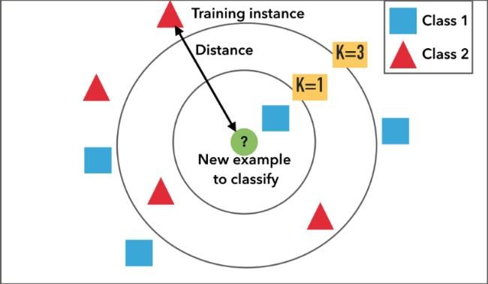

**Figure 2.2: K-NN Image Classification**

(Image adapted from https://static.squarespace.com)

### Deep Convolutional Neural Networks

Neural Networks also use a supervised machine learning algorithm called backpropagation learning networks. A DCNN uses deep learning during its training phase for object recognition (‘Deep’ in the sense that it has many hidden layers with kernels that will need to be trained for optimal feature extraction). A CNNs which is a DNN is a state-of-the-art means of image classification and object recognition. A CNN uses a backpropagation machine learning algorithm during training of the network to enable it to perform image classification (Yoshua, Yann, Bottou, & Haffner, 1998). A CNN was first proposed by Prof. Yann LeCun when he carried out experiments using images of hand written digits and their labels using a Modified [National Institute of Standards and Technology](https://en.wikipedia.org/wiki/National_Institute_of_Standards_and_Technology) database. He trained the datasets using a supervised learning algorithm called a backpropagation learning algorithm which he engineered and from which he got outstanding results (Yoshua et al., 1998).

A CNN has the advantage of training using datasets of labelled images that are very large compared to other computer vision classifiers (Krizhevsky et al., 2012). CNNs actually gained popularity during the ImageNet Large Scale Visual Recognition Competition (ILSVRC) in 2012 when Alex Krizhevsky achieved outstanding performance results and the least error rate observed during the image recognition exercise (Krizhevsky et al., 2012). CNNs have better image classification accuracy that its other object recognition classifier counterparts due to the fact that they are not easily affected by variations and transformations such as pose, lighting, noise, occlusions, clutter and so on during the training of the network(LeCun et al., 2004). A CNN does not also use hand-crafted feature extractions created by experts but the classifier model is able to detect and learn features automatically during training using its backpropagation machine learning algorithm (Yann et al., 2012). A CNN combines three architectural concepts so as to ensure an appropriate degree of shift, scale and distortion invariance such as local receptive fields, shared weights (weight replication across the layers) and spatial or temporal sub-sampling (Yoshua et al., 1998). Figure 2.3 depicts the working principle of a CNN Classifier.

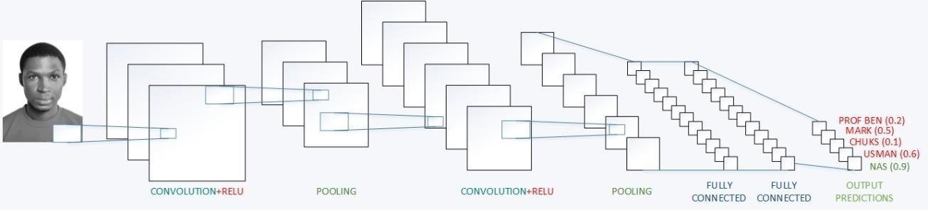

**Figure 2.3: A Deep Convolutional Neural Network**

## Machine Learning Algorithms

### Unsupervised Machine Learning Algorithm

An Unsupervised Machine Learning Algorithm (USML) is a machine learning algorithm that involves training a classifier model, but the datasets used during the training phase of the model are not labelled (Emer, 2017). It is much harder than a supervised learning approach because we tell a computer to complete a task without telling it the means of accomplishing it (Ayodele, 2010). There are two approaches to USML algorithms. The first approach is to teach the agent by handing it explicit categories but using a reward system to indicate failure or success (Ayodele, 2010).

This is a decision/problem approach and not a classification exercise. The goal is to make decisions that would yield maximal trends of success until a goal is attained and a punishment will occur for making wrong decisions (Ayodele, 2010). Reinforcement learning (RL) can be used for USML, where the agents base their next actions based on past rewards or punishment. The advantage of this approach is that the agent knows what to expect before any processing (a reward or punishment) so does not need to take every step for making decisions (Ayodele, 2010). Still, there are many trial and error attempts before success occurs (Ayodele, 2010). An example of the success of this approach was found when a USML program beat the champion of the backgammon game. The other USML approach is called clustering, the assumption being that clusters that are discovered will have an intuitive classification (Ayodele, 2010). The goal here is to find similarity between training datasets.

The USML algorithm produces clusters based on similarity of training data and uses the clusters to create new examples, as in the case where social information filtering algorithms are used to create clusters of groups and users are assigned to such clusters, and recommendations are made to them based on the type of books they usually purchase on the web (Ayodele, 2010). Clustering algorithms are only possible if there is sufficient data during training.

### Reinforcement Machine Learning Algorithm

In reinforcement learning, the algorithm learns of a policy of how to act after observing its environment (Ayodele, 2010). Every action has some predominant impact in the surrounding world and the environment provides feedback (memory of a success or failure) that helps to guide the learning algorithm. Therefore, the subsequent outputs are assessed based on a reward or punishment after an action is taken (Emer, 2017).

Reinforcement learning is learning what to do and how to map situations to actions, thus maximizing the reward (Shaikh, 2017). The agent is not told which action to take but instead must discover which action will yield the maximum reward (Shaikh, 2017).

In a problem statement, an agent is trying to manipulate his environment by taking actions from one state to another (Shaikh, 2017). The agent receives a reward for accomplishing a task or punishment if the task is not accomplished. Reinforcement learning has a mapping between an input and output but unlike supervised learning where an external supervisor helps its agent to complete a task based on its knowledge of the environment (Shaikh, 2017). The reinforcement agent learns by receiving a reward function after a trial and error which acts as a feedback to the agent based on its next actions (Shaikh, 2017). Thus, RL algorithms build a knowledge graph base on maximal rewards.

### Supervised Machine Learning Algorithm

Supervised learning is used for logical regression and classification problems, but it is mostly used for classification (Ayodele, 2010). Its training examples are labelled datasets and it consists of an external supervisor which has prior knowledge of the problem to be solved. Therefore it guides it agent on the actions it should take in an environment so as to receive a reward (Shaikh, 2017). Various supervised learning classifiers exist, such as Support-Vector- Machines, K Nearest Neighbour, neural networks, Bayesian Networks and so on. Our point of interest though has to do with the neural network classifier and its supervised learning algorithm which is the backpropagation learning algorithm that can be applied to DNNs such as a CNN.

### Backpropagation Learning Algorithm

Backpropagation (backprop) is a gradient-based learning technique (Yann et al., 2012). Gradient-Based learning algorithms can be used to synthesize complex decisions that can classify high dimensional patterns with minimal computational processing (Yoshua et al., 1998). A CNN which is specifically designed to deal with two-dimensional datasets has been shown to outperform their counterparts during image classification by applying gradient-based learning.

The synaptic weights that are obtained for producing optimal outputs in a neural network are derived using backpropagation. CNNs use backpropagation during their training phase to update the values of their parameters or weights on each of their filters so as to be able to detect the feature abstractions used for classification. Backpropagation has four phases, namely forward pass, loss function, backward pass and weight update.

These four phases are known as a single epoch. Many epochs need to be performed before optimal parameter values can be obtained during the training of a neural network. Care should be taken not to put the system in a state of over-generalization (overfitting). The loss function

is minimized using gradient descent and is used to update the values of the weights accordingly so as to enable the CNN to predict better classifications or outputs.

Gradient descent (GD) is an optimization technique used to find the values of weights of a function that minimizes the loss function during backpropagation. GD is best used when optimal parameters in a neural network cannot be found analytically and must be obtained using optimization algorithms.

#### An Example of Backpropagation Applied in a Neural Network

We are going to train a set of data using a neural network so as to be able to predict rainfall due to weather changes. Backpropagation was used to determine the average probability of rainfall given hours of sunshine and very high temperatures experienced over a couple of three days during the raining season. The optimal parameters derived from the exercise can then be used to generalize rainfall patterns based on hours of sunshine experienced over the period of the rainy season. Table 2.1 displays the weather pattern experienced, which is the dataset that backpropagation algorithm will be used on.

Backpropagation consists of four phases; Forward Pass, Loss, Function, Backward Pass and Weight Update. The following phases will be displayed in the example being studied.

**Table 2.1: Probabilistic Table for Rainfall Occurrence**

|  |  |  |
| --- | --- | --- |
| X0 | X1 | Output(Ȳ) |
| Atmospheric Temperature (°C) | Hours of Sunlight in a Day (Hrs.) | Expected Chances of Rainfall (%) |
| 40 | 9 | 95 |
| 35 | 10 | 80 |
| 29 | 7 | 74 |

**Table 2.2: Normalized Probabilistic Table for Rainfall Occurrence**

|  |  |  |
| --- | --- | --- |
| X0 | X1 | Output(Ȳ) |
| Atmospheric Temperature(°C) | Hours of Sunlight in a Day(Hrs.) | Expected Chances of Rainfall (%) |
| 1.0 | 0.9 | 0.95 |
| 0.875 | 1.0 | 0.80 |
| 0.725 | 0.7 | 0.74 |

The neural network representation diagram is also needed for visual stimulation and understanding and it is displayed in Figure 2.4.

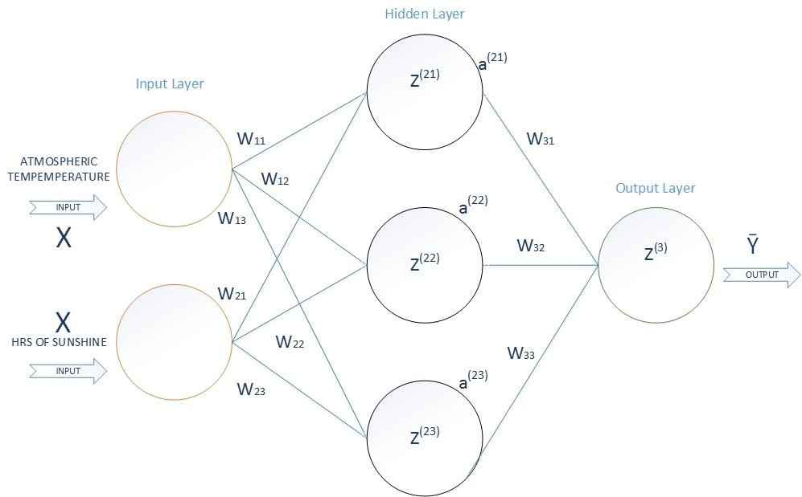

**Figure 2.4: A Neural Network for Rainfall Predictions**

Symbols used in the network are:

X – A tensor or Array of input elements(Datasets) Y- An Array output from Network

W – The Weights on the Synapses

Z – The Sum of the product of Inputs and Weights in the Neurons

a – The activation on ‘Z’ across the Neurons which is a “Sigmoid Function” in this case

1 𝑒−𝑧

𝑆𝑖𝑔𝑚𝑜𝑖𝑑(𝑍) = 𝑓(𝑍) = (1 + 𝑒−𝑧) , 𝑆𝑖𝑔𝑚𝑜𝑖𝑑𝑃𝑟𝑖𝑚𝑒(𝑍) = 𝑓′(𝑍) = (1 + 𝑒−𝑧)

Various activation functions can be applied to the model apart from a sigmoidal activation function Such as a Tanh activation function or a RELU activation function. These activation functions are necessary so as to find non-linear patterns that are necessary for the prediction process. The activation functions can also be applied in a CNN. The activation layer of a CNN uses either a Tanh or RELU Activation function and Sigmoid Activation function can be used as a binary classifier as well in the fully connected layer of a CNN.

#### Sigmoidal Activation Function

1

𝑆𝑖𝑔𝑚𝑜𝑖𝑑(𝑧) = (1 + 𝑒−𝑧)

The range of values of z are -9.0 to 9.0, with a step size of 0.01.

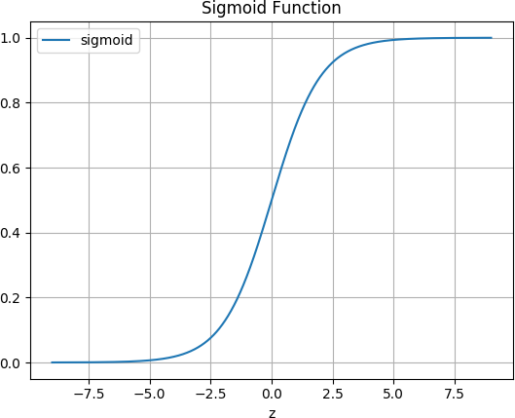

**Figure 2.5: Sigmoid Activation Function**

#### RECTIFIED LINEAR UNIT ACTIVATION FUNCTION

RELU(z) = Max(z,0)

The range of values of z are -2.0 to 2.0, with a step size of 0.1.

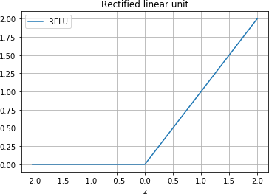

**Figure 2.6: A Rectified Linear Unit Activation Function**

#### Tanh Activation Function

(e𝑧 − e−𝑧) Tanh(z) = (e𝑧 + e−𝑧)

The range of values of z are -6.0 to 6.0, with a step size of 0.01.

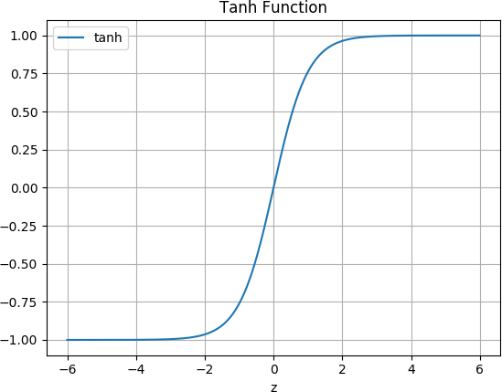

**Figure 2.7: A Tanh Activation Function**

During the Training Phase of the Neural Network, the Forward Pass exhibited a couple of outputs which were captured in Table 2.2 and Fig 2.7. Note that the network is initiated with random weights and the random weights are gradually updated via backpropagation.

The Forward Propagation:

The initial weights are randomly generated

The output, Ȳ = f (f (X * W ) * W

(1)

(2)

The Loss Function, J = ∑ ½ (Y – f (f (X * W ) * W )

(1)

(2) 2

**Figure 2.8: Forward Propagation**

**Table 2.3: Normalized Probabilistic Table for Rainfall Occurrence with Output Errors(Ȳ)**

|  |  |  |  |
| --- | --- | --- | --- |
| X0 | X1 | Output(Ȳ) | Output(Y) |
| Atmospheric Temperature(°C) | Hours of  Sunlight in a Day(Hrs.) | Network Predicted Chances of Rainfall (%) | Expected Chances of Rainfall (%) |
| 1.0 | 0.9 | 0.2199 | 0.95 |
| 0.875 | 1.0 | 0.2161 | 0.80 |
| 0.725 | 0.7 | 0.2351 | 0.74 |

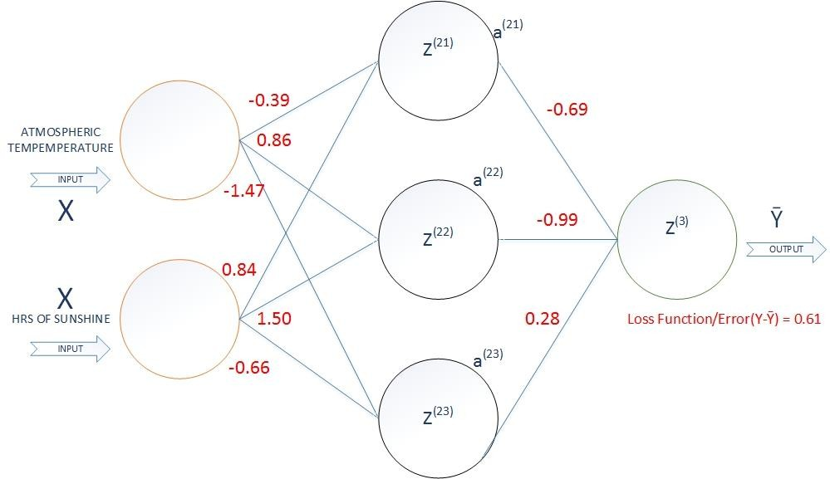

**Figure 2.9: A Neural Network for Rainfall Predictions with Random Weight Values**

The Backward Pass is shown in Figure 2.10.

The Back-Propagation Begins:

(2),

gradient descent for Weights W

𝑑𝐽⁄𝑑𝑊(2) =−(Y−Ȳ) * f′ (Z (3)) * dZ (3)/dW (2)

gradient descent for Weights W

(1)

𝑑𝐽⁄𝑑𝑊(1) =(X) * δ (3) * (W ) * f′ (Z ), Where δ = −(Y−Ȳ) * f′ (Z )

T

(2) T

(2)

(3)

(3)

**Figure 2.10: Backward Pass**

The Weight updates are shown in Figure 2.11 for every synapse in the NN

Weights update for W

(2)

W 𝑑𝐽 𝑑𝑊

(2) ±

⁄

(2)

Weights update for W

(1)

W ±𝑑𝐽 𝑑𝑊

(1)

⁄

(1)

**Figure 2.11: Weights Updates**

The Final optimal weights are obtained after training the network using

Back-Propagation.

The output, Ȳ = f (f (X * W ) * W

(1)

(2)

The output result ‘Y’ is now very good

The Loss Function, J = ∑ ½ (Y – f (f (X * W ) * W ) :

The Loss function(Error) in the network is now minimal

(1)

(2) 2

**Figure 2.12: Final Optimal Weights**

After backprop occurrence, the neural network model can now predict rainfall occurrence even when new data is presented to the model because the optimal values for the weights have been found across each synapse after the network learning process. The final results of the Network can be seen in Table 2.4, Table 2.5 and Figure 2.13.

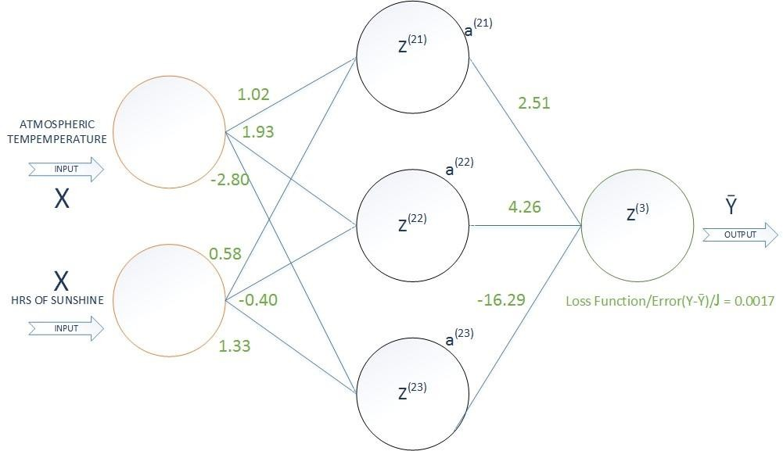

**Figure 2.13: A Neural Network for Rainfall Predictions with Optimal Weight Values**

**Table 2.4: Final Normalized Probabilistic Table for Rainfall Occurrence**

|  |  |  |  |
| --- | --- | --- | --- |
| X0 | X1 | Output(Ȳ) | Output(Y) |
| Atmospheric  Temperature (°C) | Hours of  Sunlight in a Day (Hrs.) | Network  Predicted Chances of Rainfall (%) | Expected  Chances of Rainfall (%) |
| 1.0 | 0.9 | 0.947 | 0.95 |
| 0.875 | 1.0 | 0.799 | 0.80 |
| 0.725 | 0.7 | 0.741 | 0.74 |

**Table 2.5: Final Probabilistic Table for Rainfall Occurrence**

|  |  |  |  |
| --- | --- | --- | --- |
| X0 | X1 | Output(Ȳ) | Output(Y) |
| Atmospheric  Temperature (°C) | Hours of  Sunlight in a Day (Hrs.) | Network  Predicted Chances of Rainfall (%) | Expected  Chances of Rainfall (%) |
| 40 | 9 | 94.7 | 95 |
| 35 | 10 | 79.9 | 80 |
| 29 | 7 | 74.1 | 74 |

## 2.4 Conclusion

CNNs require a supervised learning backpropagation algorithm during training so as to be able to learn feature abstractions that are necessary for accurate image classification. It should be noted though that a CNN possesses various parameterizations that need to be correctly chosen in order learn the feature abstractions such as filter size used for convolutions, activation function in the activation layer of the CNN, the learning rate of the CNN model, momentum, number of strides, padding and so on. Design space exploration is carried out during the course of this thesis where different metrics are altered for some parameterizations so as to determine the CNN implementation model with the highest performance on a given platform. The metrics of that model can then be used to build an optimized hardware CNN implementation. Hardware CNN implementation is better for real-time usage because it offers true parallelism, does not consume much power and is not memory intensive.

**CHAPTER THREE**

**Methodology**

## Introduction of Deep Convolutional Neural Networks

A deep convolutional neural network is an example of a DNN. It is called a deep network due to its possession of multiple hidden layers. It is used in the large-scale classification of objects in an image or images. The DCNN model was built by a New York University professor named Yann LeCun and his associates (Yoshua et al., 1998), but it gained its popularity when Alex Krizhevsky used it to win the ImageNet computer vision classification competition in 2012 (Krizhevsky et al., 2012). The DCNN model is the image recognition system that is used in this thesis because of its depth of accuracy in predicting objects in images. It has a neuro- inspired architecture because it was modelled after the neuronal processing of the human visual cortex. A CNN goes through a network training phase where it learns to identify various patterns that give distinguishable characteristics that are necessary for object classification and a CNN model is built and saved after training. The CNN’s inputs during a training phase are image datasets with their corresponding dataset labels. During the training phase, the CNN can adjust values of its filters through a process called backpropagation. The durability of the CNN model is checked during the testing phase so as to measure how accurate it performs in image classification exercises. Figure 3.1 depicts the schema of a Convolutional Neural Network.

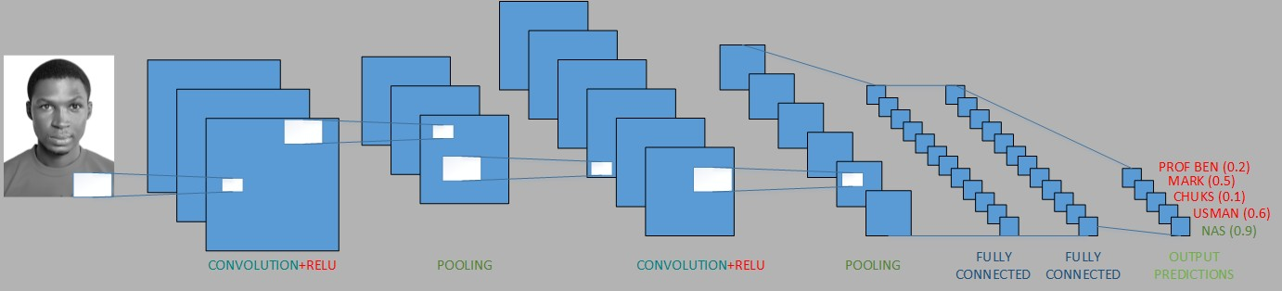

**Figure 3.1: Structure of A Convolutional Neural Network**

## Topology of Deep Convolutional Neural Networks

The topology of a DCNN consists of a hierarchical order of layers which are the Convolution layer, the activation layer, the down-sampling layer and fully connected layer. Each layer is responsible for some sort of feature extraction. The convolution, activation and sub-sampling layers can be replicated multiple times before being connected to the fully connected layer(s). A DCNN is usually a repetition of a number of layers as mentioned, but the abstract features obtained are more complex the deeper they are within the neural network. The network layers will be discussed in detail in the next section. Inputs to the DCNN consist of image datasets which are convolved by the convolutional layer and the outputs from the DCNN are obtained after exiting from the fully connected layers.

## Layers of Deep Convolutional Neural Networks

The DCNN consists of the following hierarchical layers:

### Convolutional Layer

The convolutional layer is the building block of a CNN. The aim of the CNN is to be able to look for specific features that distinguish between objects in an image, and the Convolutional layer is the first step to this computation. It uses filters (an array of numbers or weights or parameters) which slide and move across an input image dataset (an array of pixel values) from the top left corner (the receptive field), to produce feature/activation maps. Filters look for simple colours and geometries such as edges or curves that are required for low-level feature extraction. The convolutional layer is not an entirely connected layer. The filter size, padding and strides used in convolution are a number of hyper-parameters that need to be carefully chosen in order to obtain optimal results in feature extractions. Subsequent convolutional layers in the DCNN have filters that look for a higher level of feature abstractions that will be needed in making decisions for object classifications.

A convolution is an element-wise matrix multiplication and summation between the input image and the filter in the convolution layer which produces activation maps. An example of a substantial filter size is 3 by 3 with an RGB colour channel (3*3*3). The input image can also be normalized to have uniform width and height of 32 by 32 with an RGB colour channel as well (32*32*3).

Figure 3.2 shows an illustration of what happens in the Convolution layer.

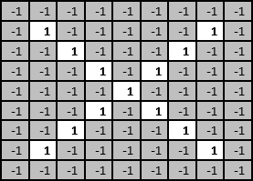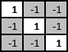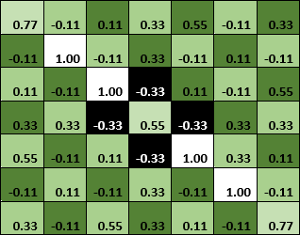

An Input Image

**Figure 3.2: Element-Wise Multiplication and Summation Convolution**

### Activation Layer

The activation layer introduces non-linearity to the system because the computations of the previous convolutional layers have been linear, while still maintaining that the determined desired features in an input exist (during training in the network). Various non-linear functions exist that can be applied in the activation layer such as Tanh, Sigmoid or RELU activation functions, but the most acceptable is the RELU activation function because it allows the network to train faster than the other activation functions, and it helps to alleviate the vanishing gradient problem experienced in gradient descent during the network training (Deshpande, 2016). We are normalizing our model so as to enable it check for complex patterns, in other words increasing the model’s non-linear properties.

The RELU activation function f(x) = max(x,0) is applied on all the input values to the activation layer and it basically changes all the negative values to 0 or maintains the values greater than

0. This in turn, increases the non-linear properties of the input feature map. The example in Figure 3.3 shows an input feature map and a rectified feature map when the RELU function is applied to it.

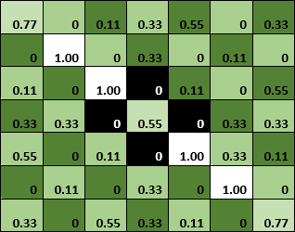**RELU FUNCTION**

**Figure 3.3: A Rectified Feature Map Transformation**

### Down-Sampling or Pooling Layer

Different pooling functions can be applied to this layer but the most popular and efficient based on research is the max-pooling function. Max-pooling is when a filter of size 2 by 2 with a stride of 2 is applied to an input feature map to convolve over it. The maximum number in every convolved region is the resultant output of the Convolution and the remaining values are disregarded. The result obtained is that the spatial dimensions of the input feature map are reduced, that is the width and height are reduced but features obtained in the feature map do not change. Reducing the spatial dimensions help to reduce the number of parameters, thus reducing computational cost and also it controlling overfitting. Overfitting is a term used when the network model is fine-tuned to predicting the training datasets very well but is not able to predict objects on novel datasets during the testing phase. Figure 3.4 depicts an example of max-pooling.

 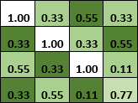

**Figure 3.4: A Max-Pooling Transformation**

### Fully Connected Layer

The convolutional, RELU and pooling layers discover a host of complex patterns but cannot understand them. Thus, the fully connected layers look at the output of the previous layers which are high values in the activation maps that represent high-level features from the input image and predict what the input image is based on probabilities (data sample classification). The output can be a single class or a probability of classes that best describe the image. Outputs are usually expressed using labels. The feature maps are stacked onto a vector in the FC and are connected to one of the predictions to be voted for during the testing phase. This vector stacking occurs during training. Figure 3.5 depicts a transformation from feature maps to a vector (1-dimensional array) which is then tied to a prediction during training.

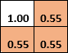

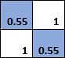Predicted

Final Rectified



**Figure 3.5: A Fully Connected Layer Transformation**

## Learning Algorithm of Deep Convolutional Neural Networks

CNNs make use of a learning algorithm called backpropagation. Backpropagation is a supervised learning algorithm for neural networks. The synapse weights that are obtained for producing optimal outputs in a neural network are derived using backpropagation. CNNs use backpropagation during their training phase to update the values of their parameters or weights on each of their filters so as to be able to detect the feature abstractions used for classification.

Backpropagation has four phases, namely the forward pass, loss function, backward pass and weight update. The loss function is minimized using gradient descent and is used to update the values of the weights accordingly so as to enable the CNN to predict better classifications or outputs. Gradient descent is a ratio of the change in a loss or cost function to change in weight of the synapses on the neurons and it is a partial derivative. It is used to train the network until we can obtain the least cost function. The gradient is best when it is at the minimum as it descends down a slope as seen in Figure 3.6.

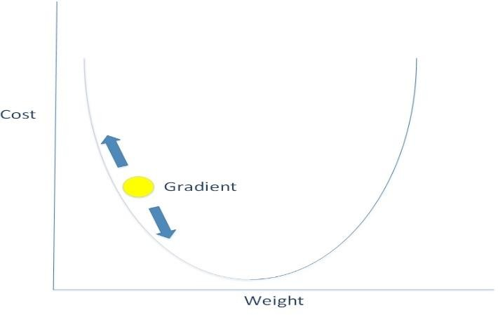

**Figure 3.6: A Gradient Descent Slope**

As mentioned earlier, CNNs make use of a supervised learning algorithm called backpropagation, where training sample datasets are propagated through the network in its training phase and the outputs obtained are compared against an anticipated set of test datasets. The computed difference between them is known as the error or loss function. Our

goal is to keep the error between the computed output from the network and the actual outputs we are expecting to a minimum, and that is possible when the weights on the neurons in the network are iteratively updated during backpropagation, till the optimal weight values are obtained.

There are various mathematical functions for calculating the loss function such as mean square error (MSE) and cross-entropy loss function. The latter is a better means of calculating loss function because it solves the learning slowdown experienced using an MSE quadratic cost function when any learning rate value is chosen (Nielsen, 2017).

An optimization algorithm in neural network learning is used to produce better results by updating weight and bias values in a neural network accordingly. Gradient descent or batch gradient descent (BGD) is an optimization algorithm used to minimize the loss function using its gradient values with respect to the weight parameters on synapses. BGD, also known as an offline gradient descent, calculates the gradient of a batch of data samples but makes just one update at a time, thus converging slowly to a minimum on the slope. Other faster optimizations are stochastic gradient descent (an online gradient descent) which updates the parameters after every training sample iteration. Mini-batch gradient descent is an improvement on the SGD because it performs updates after iterating through a batch of training samples and it overcomes the high variance experience in parameter updates when trying to determine the local minima of a slope.

Other optimizations algorithms which can be used to further improve convergence and find the optimal direction in which parameter updates should occur include momentum, Nesterov accelerated gradient (NAG), adaptive gradient algorithm (Adagrad), adaptive delta (Adadelta), adaptive moment estimation (Adam) and root mean square propagation (RMSProp). These optimization algorithms all help to determine the fastest convergence but the algorithms that

support an adaptive learning algorithm for each parameter update amongst them such as Adagrad, Adadelta and Adam converge very fast.

**CHAPTER FOUR**

**Implementation**

## Introduction to the Implementation

The DCNN is implemented using the Python programming language and its machine learning APIs such as Keras, PyQt, Numpy, OpenCV, TensorFlow, SciPy etc. The CNN model itself is built using the Keras deep learning library. Keras is an open-source high-level neural network API which has a capability of working on top of TensorFlow, MXNet, Deeplearning4j, CNTK or Theano Python APIs (Chollet, 2015). It was built by François Chollet who is an engineer at Google. It has a set of abstractions but its usage is made to be modular, simple and highly extensible regardless of the backend computing library. Keras data structure is a linear stack of layers, the most popular model being the sequential model. The sequential model can be used to build various types of abstractions of neural networks such as a CNN and recurrent neural network. The advantages of its use make it a preference for research and experimentation with DNNs; therefore, it has become the choice that was made for building, training and testing the CNN model used in this research. Keras also has the compatibility of running on a CPU or GPU.

## Model Implementation of the Deep Convolutional Neural Networks

The model of the CNN will have a sequential stack of layers comprising modules that are stacked together to obtain a deep structure of the neural network to be obtained. All the hyper- parameters can easily be configured into the model because the neural layers, activation functions, optimizers and regularization schemes are individual modules that are combined to build the system and give it its ‘deep’ structure.

The model of the CNN is simple and extensible and a sample of its structure is displayed using the following algorithm:

# dimensions of our images. img_width, img_height = 150, 150

input_shape = (img_width, img_height, 3) model = Sequential ()

model.add (Conv2D (32, (3, 3), input_shape=input_shape)) model.add(Activation('relu'))

model.add (MaxPooling2D (pool_size= (2,2))) model.add (Conv2D (32, (3, 3))) model.add(Activation('relu'))

model.add (MaxPooling2D (pool_size= (2,2))) model.add (Conv2D (64, (3, 3))) model.add(Activation('relu'))

model.add (MaxPooling2D (pool_size= (2,2))) model.add (Conv2D (128, (3, 3))) model.add(Activation('relu'))

model.add (MaxPooling2D (pool_size= (2,2))) model.add (Flatten ())

model.add (Dense (128)) model.add(Activation('relu')) model.add (Dropout (0.5))

model.add (Dense (1)) model.add(Activation('sigmoid'))

model. compile (loss='binary_crossentropy', optimizer='rmsprop', metrics=['accuracy'])

model.fit_generator (train_generator, steps_per_epoch=2048,

epochs=30,

validation_data=validation_generator, validation_steps=nb_validation_samples)

model.save_weights('models/simple_CNNLinux.h5') model.save('models/simple_CNNLinuxModel30epochs.h5')

The saved model after training is the structure of the CNN and it can be used to test against a set of novel images for object classification exercises. The model can be called for object prediction testing using the algorithm below.

basedir = "test1/test1/" predict (basedir, test_model)

model = load_model('models/simple_CNNLinuxModel30epochs.h5') def predict (basedir, model):

for i in range (12490,12501): #24 to 29

path = basedir + str(i) + '.jpg' #path = basedir + str(i) + '.jpg' orig = cv2.imread(path)

orig = cv2.cvtColor(orig, cv2.COLOR_BGR2RGB) max_dim = max (orig. shape)

scale = 480/max_dim

orig = cv2.resize(orig, None, fx= scale, fy = scale) orig = cv2.cvtColor(orig, cv2.COLOR_RGB2BGR) print("[INFO] loading and preprocessing image...") names = ['cat', 'dog']

img = load_img (path, False, target_size= (img_width, img_height)) x = img_to_array(img)

x = np.expand_dims (x, axis=0) print("[INFO] classifying image...") preds = model.predict_classes(x)

if (preds== [[0]]):

label = names [0] else:

label = names [1]

# Display the predictions

print ("Label: {}”. format(label))

cv2.putText(orig, "Label: {}”. format(label), (10, 30),

cv2.FONT_HERSHEY_SIMPLEX, 0.9, (255, 0, 255), 2)

cv2.imshow("Classification", orig) cv2.waitKey(0) predict (basedir, test_model)

print ('Prediction Ended')

## Test Results of the Convolutional Neural Network Model

The model is being trained with dog and cat datasets and their respective labels. The dataset of cats and dogs was downloaded from Kaggle.com website. Kaggle is a machine learning organization which provides free datasets that can be used for training diverse neural networks. The training phase had a dataset of 2048 images, 1024 each for both cats and dogs,

and a validation dataset of 832 images, 416 each for both cats and dogs. It is a binary classification model. The training simulation was run over 30 epochs and it took about 10 hours. On testing of the CNN model, the classifier should display a prediction of a 0 or 1 (binary classification), depending on the test input image, to be able to identify if the image contains either a cat or a dog (0 or 1). A CNN model can also be trained to classify more than two objects depending on what the model is built to perform. A binary classifier uses a sigmoid function for its classification, while a categorical classifier uses a SoftMax function.

A test simulation was performed on the obtained model of the CNN which showed considerable ability in distinguishing objects in novel images to obtain predictions for cats and dogs. The test evaluations for 10 images were captured on screen and the results are displayed later in this report. The simulation was performed to test the accuracy and robustness of the classifier. Figures 4.1 to 4.10 depict the results of the test results carried out. Using a visual aid as seen in Figure 4.1–4.10 to demonstrate the classification and its label to check for accuracy is efficient.

|  |  |
| --- | --- |
| **Figure 4.1: Class Label and Test Image** | **Figure 4.2: Class Label and Test Image** |

|  |  |
| --- | --- |
| **Figure 4.3: Class Label and Test Image** | **Figure 4.4: Class Label and Test Image** |

|  |  |
| --- | --- |
| C:\Users\Dr Tech\AppData\Local\Microsoft\Windows\INetCache\Content.Word\dogT2.png  **Figure 4.5: Class Label and Test Image** | C:\Users\Dr Tech\AppData\Local\Microsoft\Windows\INetCache\Content.Word\catT3.png  **Figure 4.6: Class Label and Test Image** |

|  |  |
| --- | --- |
| **Figure 4.7: Class Label and Test Image** | **Figure 4.8: Class Label and Test Image** |

|  |  |
| --- | --- |
| C:\Users\Dr Tech\AppData\Local\Microsoft\Windows\INetCache\Content.Word\catF1.png  **Figure 4.9: Class Label and Test Image** | C:\Users\Dr Tech\AppData\Local\Microsoft\Windows\INetCache\Content.Word\catF.PNG  **Figure 4.10: Class Label and Test Image** |

## Test Observation and Discussion

The predictions from the test simulations demonstrated a high success rate in the image classification exercise. On the other hand, it was observed that not all the objects were predicted correctly. The trained CNN model has an average prediction accuracy of about 70% whenever it is run against a random set of test images. It classified eight out of 10 images correctly in Figure 4.0 – 4.10 captured above. Figure 4.9 and 4.10 were not classified correctly. Visual Recognition is a very difficult computational issue. Here are various reasons why a classifiers’ accuracy may vary;

* + - A CNN needs many training datasets for better feature abstractions in its feature maps.
    - A CNN needs a long training iteration period (epochs) over the datasets provided which could run for hours or days.
    - Each of the objects to be identified in the training and test images have a lot of variations across them such as pose, appearance, viewpoint, background, the position of objects in the image, illumination and occlusion (Pinheiro & Henrique, 2017).
    - A DCNN is a black box with thousands or millions of free parameters that need to be well trained for better feature abstractions and learning the optimal parameters with a few thousand training images may be insufficient (Oquab, Bottou, Laptev, & Sivic, 2014).
    - Overfitting (where the classifier has a 95% chance identifying the objects properly, but during testing, it may have a 50% chance) may occur during training and it may affect the generalization ability of the classifier during testing.
    - The size of the filters that are used for feature extraction during training of the CNN can also affect its ability to classify objects. A large filter size can overlook the basic features needed for extraction and could skip the essential details in the images, whereas a small filter size could provide too much information that can lead to computational complexity. Thus, there is a need to determine the most suitable filter size used for feature extraction.

**CHAPTER FIVE**

**Evaluation and Conclusion**

## Introduction

Benchmarking is performed to set a point of reference for something that can be measured. It is also a set of standards used as a point of reference for evaluating performance metrics or quality (BusinessDictionary, 2017). This benchmarking evaluation was performed to determine which was the best CNN model for solving the classification task required, and the metrics that were varied in each of the models were the activation function used in the activation layer of the CNN Model as well as the filter/kernel size that was used in the convolutional layer of the CNN model as well. The size of the dataset that was used during the training phase of each CNN Model obtained had 2048 Images (1024 images of cats and 1024 images of dogs). Each CNN model was trained using the following computing system specification:

* + - A 64-bit Ubuntu 16.04 LTS Linux Operating System
    - An Intel Core i5-6500 CPU @ 3.20GHz (4 CPU cores)
    - 8 GB of System Memory.

## Evaluation of various Deep Convolutional Neural Network Models

Table 5.1 contains all the metrics and hyper-parameters that were used to build the chart evaluations of the various CNN models that were trained and observations that were noticed have been recorded with possible reasons why they occurred during the testing of each model for accuracy of object classifications. All the models were tested against the same size of the dataset. A dataset can definitely affect the accuracy of object classification. A CNN needs a lot of training datasets, possible millions for better object classification. Figures 5.1–5.4 are charts that depict various evaluations.

**Table 5.1: Training & Test Accuracy Table for the Convolutional Neural Network Models**

|  |  |  |  |  |  |  |  |
| --- | --- | --- | --- | --- | --- | --- | --- |
| S/N | Activation Function | Filter Size | Training Time (hrs.) | Test Accuracy (%) using 10 test sample images | Training Data Set  (images) | Validation Data Set  (images) | No. of Epochs |
| 1 | RELU | 3 | 9.7 | 70 | 2048 | 832 | 30 |
| 2 | Sigmoid | 3 | 15.2 | 10 | 2048 | 832 | 30 |
| 3 | Tanh | 3 | 15.4 | 40 | 2048 | 832 | 30 |
| 4 | RELU | 7 | 19.5 | 10 | 2048 | 832 | 30 |
| 5 | Sigmoid | 7 | 21.7 | 10 | 2048 | 832 | 30 |
| 6 | Tanh | 7 | 21.3 | 50 | 2048 | 832 | 30 |

### Training Time Against Filter Size Evaluation

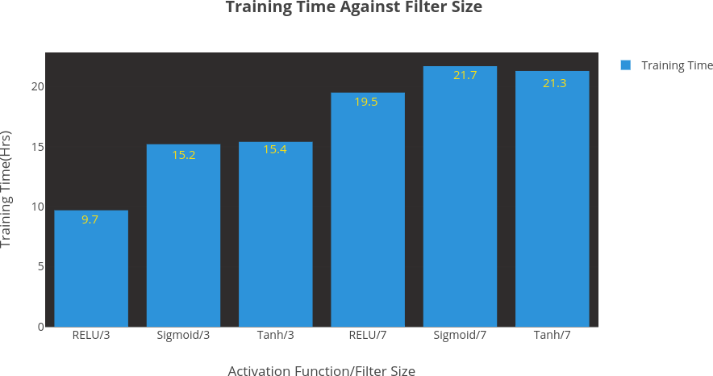

**Figure 5.1: Training Time Against Filter Size**

From observations in Figure 5.1, it can be deduced that there would be fewer computations at a given time for each convolution with smaller filter sizes during the linear element-wise

computations between the filters and their relative reception fields on every input image during each epoch so that the training time will be less.

### Training Time Against Activation Function Evaluation

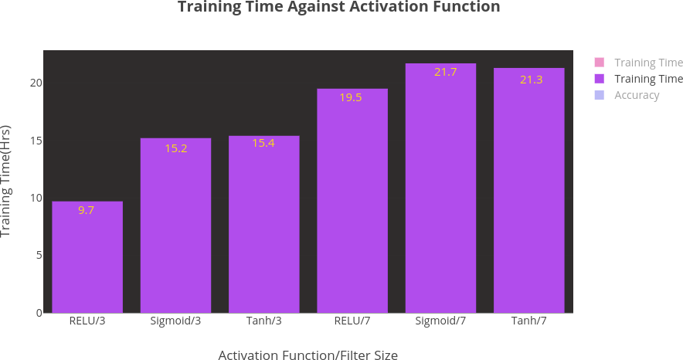

**Figure 5.2: Training Time Against Activation Function**

From observations in Figure 5.1, it can be deduced that the CNN models that were trained using the RELU Activation function had faster training time compared to the rest. This is due to the fact that RELU Activation function converges quicker during training to update the parameters on their neurons to optimal values that would be used during object classification.

### Accuracy Against Activation Function Evaluation

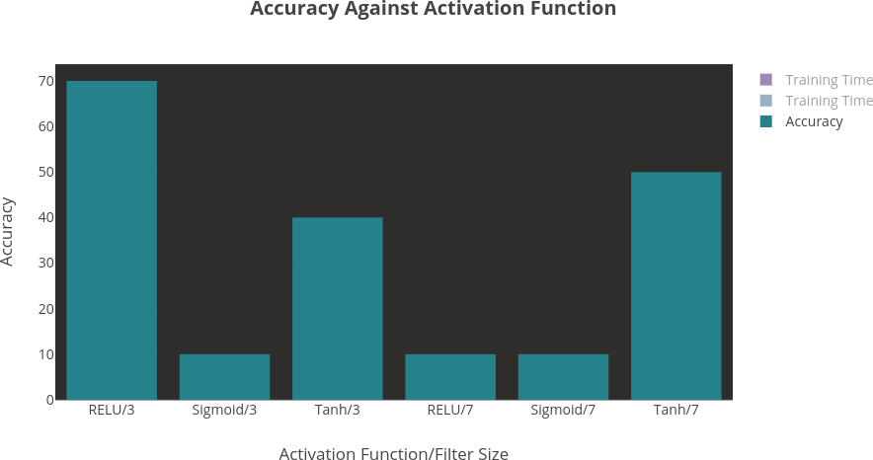

**Figure 5.3: Accuracy Against Activation Function**

From observations in Figure 5.3, it can be deduced that RELU activation does not suffer the vanishing gradient problem during backpropagation like Tanh and sigmoid activation functions. While using a sigmoid activation function during the backward pass in a backpropagation, the weights are not updated, so the loss function remains unchanged and the network does not learn. While using a RELU the network converges faster and the parameters (weights on each synapse) are optimized with the required values necessary for quicker feature extraction. There might not also be a guarantee for the network to learn while using a RELU because an appropriate filter size was not chosen during training; therefore, the low-level features that are necessary to capture interesting properties are unforeseen. It should be noted that the probability on each properly classified object using the RELU with a filter size 3 had 100% probability of prediction, but the Tanh activations had between 40% and 50% probability of a prediction guess, despite having accurate classifications.

### Accuracy Against Filter Size Evaluation

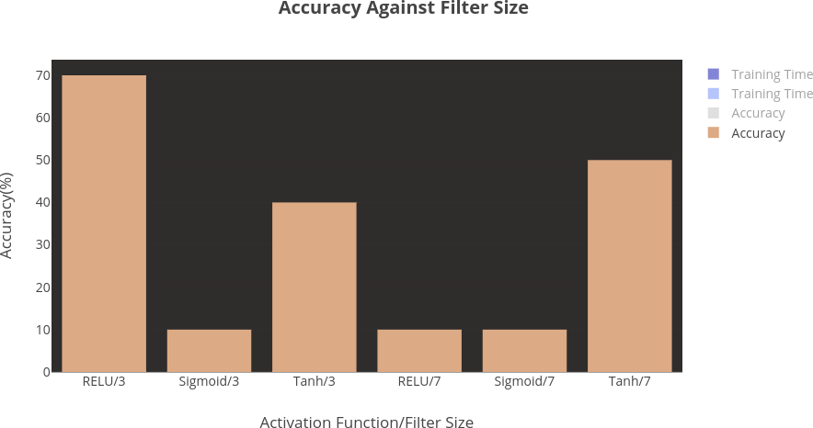

**Figure 5.4: Accuracy Against Filter Size**

From observations in Figure 5.4, it can be deduced that the size of the filters plays an important role in finding the key features used for classification of objects. A larger kernel size can overlook the necessary features during training of the network and could skip the essential low-level details in the training dataset images.

## Future Work

Various means of improving the object classification of the CNN model such as data augmentation and transfer learning (using a pre-built model) will be discussed, as well as better means of representing the classified objects in the data by visual means such as object localization, object detection, object segmentation and such visual means are possible through the use of Python programming languages’ OpenCV library. The models created are able to identify just one object at a time.

A better model can be built to identify the binary objects that need to be classified at the same time and display their labels.

### Data Augmentation

The size of the dataset used during the training phase of a ConvNet can affect its classification accuracy properties. If the size is small, the CNN model will not be able to properly effect best object classification (Krizhevsky et al., 2012). Data augmentation can be used to remedy such a case because it is an artificial means of making your existing dataset larger through a couple of needful transformations (Deshpande, 2014). Data augmentation is also a means of preventing overfitting in generalization (Krizhevsky et al., 2012). The input image dataset is an array of pixel values or numbers and transformations can be made by altering a few of the values but still maintaining the label and classification of the object in the image and therefore new datasets samples can be created by such means. Various dataset augmentation techniques used for applying transformations to sample training datasets include grayscales, vertical flips, colour jitters, translations, rotations, random crops, horizontal flips and much more (Deshpande, 2014). The size of the training examples can be increased significantly through such artificial means.

### Transfer Learning

Transfer learning involves using a pre-built or pre-trained model has been done by someone else, where the weights on the synapses of the model have been highly optimized by training them using a very large dataset that and using it to train your own model (Deshpande, 2014). The pre-built model will act as your feature extractor. Transfer learning (using a pre-built CNN model) helps to train your network faster and you get better object classification results from input images. A pre-built model has already been trained with millions of images, so the parameters on the synapses of the neurons are already optimized. You only need to replace the fully connected layer on the pre-built model so it can classify your images. Using a pre- built model also minimizes the time required to train your network. Rather than training your

CNN model with initial random weights, you use the weights on the layers of the pre-built model during gradient descent and train the higher layers for classification (Deshpande, 2014).

### Object Localization, Detection and Segmentation

Image classification is not enough (predicting that an object exists in an image, e.g. a cat or a dog). It is a better exercise to determine and show visually the precise region in with the classified objects exist in a receptive field. It would be necessary especially when an autonomous vehicle needs to make appropriate decisions upon viewing its receptive field such what to do upon viewing the colour of a traffic light or to avoid coming in contact with other vehicles, pedestrians and so on.

Object localization involves putting a bounding box to describe where an object exists in an image alongside its label (Deshpande, 2014). Image detection is an image localization process which involves putting a bounding box on every object in an image alongside their relative labels as well (Deshpande, 2014). Figure 5.5 shows an image with object localization.

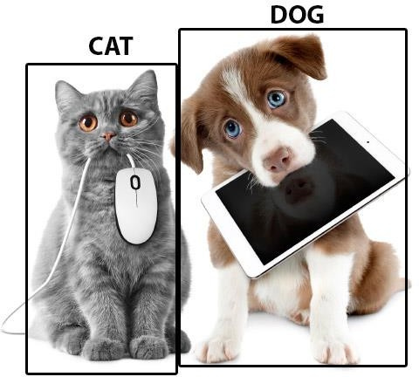

**Figure 5.5: Image Classification, Object Localization and Object Detection**

(Image courtesy http://images.google.com)

Image segmentation involves displaying the exact region where each classified object exists in a test input image by displaying the outlined region over the object and the label for the object as well (Pinheiro & Henrique, 2017); therefore we are assigning an object class to every pixel. Figure 5.6 shows an image with object segmentation.

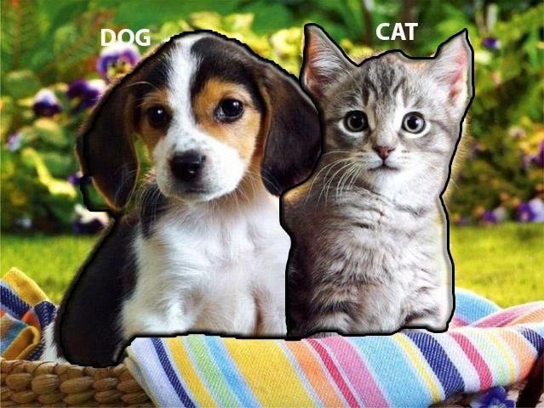

**Figure 5.6: Image Classification and Object Segmentation**

(Image courtesy www.petsworld.in)

## Discussion and Conclusion

### Contribution to Deep Performance CNN Modelling

Based on the evaluation of the performance of the deep learning models built, it was possible to determine the hyper-parameters that are necessary for the best performance of a CNN model that can be used for image classification. I was also able to use OpenCV library for the visualization of the Classification images and display their corresponding labels as well. The classification of objects were binary representations. I was able to collect the data during testing and transform them to string representations as well (cat or dog).

### Conclusion

The computer vision Implementation carried out in this thesis was done via software simulations, and it was necessary to be able to find out the optimal parametrizations that can be used on a CNN model so as to satisfy the design space explorations objective of this thesis. The optimized CNN model obtained also proved to serve as a better image classifier compared to other machine learning implementations mentioned in the related works section of this thesis, because of its high accuracy of performance and low error rate experienced during the object recognition testing phase. The limitations of using software simulations though is that it is memory intensive, it does not offer real parallelization, and it requires long computational hours for training the network even though it is still very fast for usage. Hardware CNN models are a better option for real-time usage and the results obtained using software simulations can be adapted to build the hardware convolutional network system. Hardware CNN offers true parallelism computing, it has low power consumption and it does not suffer the computation and bandwidth bottlenecks suffered due to limitations of memory usage during CNN Software Simulations (Projects, 2017). Computer vision applications using a DCNN by far have proven to mimic the human visual cortex with very slight variations and are outstanding in their usage as well.

# REFERENCES

Ayodele, T. O. (2010). Types of Machine Learning Algorithms. *New Advances in Machine Learning*, 19–49. https://doi.org/10.5772/56672

Brunner, C. (2012). Pairwise Support VectorMachines and their Application to Large Scale Problems. *Journal of Machine Learning Research*, *13*(1), 2279–2292.

BusinessDictionary. (2017). What is a benchmark? definition and meaning - BusinessDictionary.com. Retrieved October 26, 2017, from <http://www.businessdictionary.com/definition/benchmark.html>

Chollet, F. (2015). Keras Documentation. *Keras.io*. Retrieved from https://keras.io/#why-this-name-keras

Davy, A., Havaei, M., Warde-farley, D., Biard, A., Tran, L., Jodoin, M., … Bengio, Y. (2013). Brain Tumor Segmentation With Deep Neural Networks, 2013.

Deshpande, A. (2014). Understanding CNNs The 9 Deep Learning Papers You Need to Know About Part 3. *https://adeshpande3.github.io/adeshpande3.github.io/The- 9-Deep-Learning-Papers-You-Need-To-Know-About.html*, 1–31.

Deshpande, A. (2016). A Beginner's Guide To Understanding Convolutional Neural Networks, 1–17.

Emer, J. (2017). Hardware Architectures for Deep Neural Networks CICS / MTL Tutorial Speakers and Contributors.

Henrique, P., & Pinheiro, O. (2017). Large-Scale Image Segmentation with Convolutional Networks, *7571*, 1–70.

Ian, G. (2016). Deep Learning. https://doi.org/10.1007/s00287-016-1013-2

Kim, J., Kim, B., Savarese, S., & Arbor, A. (2012). Comparing Image Classification Methods : K-Nearest-Neighbor and Support-Vector-Machines, 133–138.

Krizhevsky, A., Sutskever, I., & Hinton, G. E. (2012). ImageNet Classification with Deep Convolutional Neural Networks. *Advances In Neural Information Processing Systems*, 1–9. https://doi.org[/htt](http://dx.doi.org/10.1016/j.protcy.2014.09.007)p[://dx.doi.org/10.1016/j.protcy.2014.09.007](http://dx.doi.org/10.1016/j.protcy.2014.09.007)

LeCun, Y., Huang, F. J., & Bottou, L. (2004). Learning Methods for Generic Object

Recognition with Invariance to Pose and Lighting. *Computer Vision and Pattern Recognition, 2004. CVPR 2004. Proceedings of the 2004 IEEE Computer Society Conference on*, *2*, II-97-104. https://doi.org/10.1109/CVPR.2004.1315150

Mallick, S. (2016). Image Recognition and Object Detection : Part 1 | Learn OpenCV. Retrieved November 14, 2017, from https:/[/www.le](http://www.learnopencv.com/image-)a[rnopencv.com/image-](http://www.learnopencv.com/image-) recognition-and-object-detection-part1/

Muralidharan, R. (2014). Object Recognition Using K-Nearest Neighbor Supported By Eigen Value Generated From the Features of an Image, 5521–5528.

Ng, A., Ngiam, J., Foo, C. Y., Mai, Y., Suen, C., Coates, A., … Sameep Tandon. (2015). Deep Learning Tutorial. *University of Stanford*. Retrieved from <http://ufldl.stanford.edu/tutorial/supervised/ConvolutionalNeuralNetwork/>

Nielsen, M. a. (2017). Improving the way neural networks learn. *Neural Networks and Deep Learning. Determination Press*. Retrieved from <http://neuralnetworksanddeeplearning.com/chap3.html>

Oquab, M., Bottou, L., Laptev, I., & Sivic, J. (2014). Learning and transferring mid- level image representations using convolutional neural networks. *Computer Vision and Pattern Recognition*, 1717–1724.

Pinheiro, O., & Henrique, P. (2017). Large-Scale Image Segmentation with Convolutional Networks, *7571*.

Projects, C. (2017). Research and Projects Learning Theory , Learning Algorithms, 1– 9.

Shaikh, F. (2017). Beginner’s guide to Reinforcement Learning & its implementation in Python. Retrieved November 15, 2017, from https://[www.analyticsvidhya.com/blog/2017/01/introduction-to-reinforcement-](http://www.analyticsvidhya.com/blog/2017/01/introduction-to-reinforcement-) learning-implementation/

Techopedia. (2017). What is Artificial Intelligence (AI)? - Definition from Techopedia. Retrieved September 12, 2017, from https://[www.techopedia.com/definition/190/artificial-intelligence-ai](http://www.techopedia.com/definition/190/artificial-intelligence-ai)

Yann, L., Haffner, P., Bottou, L., & Yoshua, B. (2012). Object Recognition with Gradient-Based Learning. *AT&T Shannon Labs*, *XXXIII*(2), 81–87. https://doi.org/10.1007/s13398-014-0173-7.2

Yoshua, B., Yann, L., Bottou, L., & Haffner, P. (1998). Gradient-Based Learning Applied to Document Recognition. *Proceeding of the IEEE , November 1998*, 46. https://doi.org/10.1109/5.726791

Brunner, C. (2012). Pairwise Support Vector Machines and their Application to Large Scale Problems. *Journal of Machine Learning Research*, *13*(1), 2279–2292.

BusinessDictionary. (2017). What is a benchmark? definition and meaning - BusinessDictionary.com. Retrieved October 26, 2017, from <http://www.businessdictionary.com/definition/benchmark.html>

Chollet, F. (2015). Keras Documentation. *Keras.io*. Retrieved from https://keras.io/#why-this-name-keras

Current Projects. (n.d.). Retrieved November 16, 2017, from [http://adaptive.u-](http://adaptive.u-/) aizu.ac.jp/?page_id=5

Davy, A., Havaei, M., Warde-farley, D., Biard, A., Tran, L., Jodoin, M., … Bengio, Y. (2013). Brain Tumor Segmentation with Deep Neural Networks, 2013.

Deshpande, A. (2014). Understanding CNNs: The 9 Deep Learning Papers You Need to Know About Part 3. *https://adeshpande3.github.io/adeshpande3.github.io/The- 9-Deep-Learning-Papers-You-Need-To-Know-About.html*, 1–31.

Deshpande, A. (2016). A Beginner’s Guide to Understanding Convolutional Neural Networks, 1–17.

Emer, J. (2017). Hardware Architectures for Deep Neural Networks CICS / MTL Tutorial Speakers and Contributors.

Henrique, P., & Pinheiro, O. (2017). Large-Scale Image Segmentation with Convolutional Networks, *7571*, 1–70.

Ian, G. (2016). Deep Learning. https://doi.org/10.1007/s00287-016-1013-2

Kim, J., Kim, B., Savarese, S., & Arbor, A. (2012). Comparing Image Classification Methods: K-Nearest-Neighbor and Support-Vector-Machines, 133–138.

Krizhevsky, A., Sutskever, I., & Hinton, G. E. (2012). ImageNet Classification with Deep Convolutional Neural Networks. *Advances in Neural Information Processing Systems*, 1–9. https://doi.org[/htt](http://dx.doi.org/10.1016/j.protcy.2014.09.007)p[://dx.doi.org/10.1016/j.protcy.2014.09.007](http://dx.doi.org/10.1016/j.protcy.2014.09.007)

LeCun, Y., Fu Jie Huang, & Bottou, L. (2004). Learning methods for generic object recognition with invariance to pose and lighting. *Proceedings of the 2004 IEEE Computer Society Conference on Computer Vision and Pattern Recognition, 2004. CVPR 2004.*, *2*, 97–104. https://doi.org/10.1109/CVPR.2004.1315150

LeCun, Y., Huang, F. J. H. F. J., & Bottou, L. (2004). Learning Methods for Generic Object Recognition with Invariance to Pose and Lighting. *Computer Vision and Pattern Recognition, 2004. CVPR 2004. Proceedings of the 2004 IEEE Computer Society Conference on*, *2*, II-97-104. https://doi.org/10.1109/CVPR.2004.1315150

Mallick, S. (2016). Image Recognition and Object Detection: Part 1 | Learn OpenCV. Retrieved November 14, 2017, from https:/[/www.le](http://www.learnopencv.com/image-)a[rnopencv.com/image-](http://www.learnopencv.com/image-) recognition-and-object-detection-part1/

Muralidharan, R. (2014). Object Recognition Using K-Nearest Neighbor Supported by Eigen Value Generated from the Features of an Image, 5521–5528.

Ng, A., Ngiam, J., Foo, C. Y., Mai, Y., Suen, C., Coates, A., … Sameep Tandon. (2015). Deep Learning Tutorial. *University of Stanford*. Retrieved from <http://ufldl.stanford.edu/tutorial/supervised/ConvolutionalNeuralNetwork/>

Nielsen, M. a. (2017). Improving the way neural networks learn. *Neural Networks and Deep Learning. Determination Press*. Retrieved from <http://neuralnetworksanddeeplearning.com/chap3.html>

Oquab, M., Bottou, L., Laptev, I., & Sivic, J. (2014). Learning and transferring mid- level image representations using convolutional neural networks. *Computer Vision and Pattern Recognition*, 1717–1724.

Pinheiro, O., & Henrique, P. (2017). Large-Scale Image Segmentation with Convolutional Networks, *7571*.

Shaikh, F. (2017). Beginner’s guide to Reinforcement Learning & its implementation in Python. Retrieved November 15, 2017, from https://[www.analyticsvidhya.com/blog/2017/01/introduction-to-reinforcement-](http://www.analyticsvidhya.com/blog/2017/01/introduction-to-reinforcement-) learning-implementation/

Techopedia. (2017). What is Artificial Intelligence (AI)? - Definition from Techopedia. Retrieved September 12, 2017, from

https://[www.techopedia.com/definition/190/artificial-intelligence-ai](http://www.techopedia.com/definition/190/artificial-intelligence-ai)

Yann, L., Haffner, P., Bottou, L., & Yoshua, B. (2012). Object Recognition with Gradient-Based Learning. *AT&T Shannon Labs*, *XXXIII* (2), 81–87. https://doi.org/10.1007/s13398-014-0173-7.2

Yoshua, B., Yann, L., Bottou, L., & Haffner, P. (1998). Gradient-Based Learning Applied to Document Recognition. *Proceeding of the IEEE, November 1998*, 46. https://doi.org/10.1109/5.726791