CHAPTER ONE INTRODUCTION
  - Backgroundof the Study

Fibre-reinforced composites are used in a wide range of applications such as automobiles, aircraft, ships, boats, pipelines, sport equipment, storage tanks, etc. The traditionalpolymeric and metallic materials have been replaced successfully by fibre-reinforced composites (Ihueze & Okafor, 2012). This is as a result of their high strength-to-weight ratio, light weight, goodchemical andcorrosion resistance, fatigue resistance and low maintenance requirements. The unique properties achieved depend on the fibre reinforcing material, and the polymer matrix. The fibre reinforcing material is mainly responsible for the strength and stiffness of composites while the polymer matrix material is responsible for the load distribution applied on the fibres and the protection of the fibres from the effect of environmental harm conditions (Okafor, Ihueze & Nwaigbo, 2014)
Generally, the reinforcing materials are high performance fibres such as glass, carbon, Kevlar etc., whereas the matrix material can be either thermoplastic (polyetheretherketone, nylon 6, polystyrene, acrylic, polyester, polyethylene, etc.) or thermoset polymer (unsaturated polyester, phenolics, epoxy, vinyl ester, polyimide, melamine formaldehyde, etc.). Amongst thermoset resins, the unsaturated polyester (UP) is one of the widely used thermoset resin matrix for fiber-reinforced composite, owing to its excellent mechanical properties, good moisture resistance, good corrosion and chemical

resistances (Kandola, Mouritz, Mathys, Sorathia, Ness, Blum, Horrocks &Price, 2018). Despite these advantages, poor flame resistance, the evolution of smoke and emission of styrene during burning of UP based composites are the major limiting factors for applications where fire safety is important(Mouritz & Mathys, 2013). In order to mitigate the high flammability and thermal decomposition of polymers, there is strong need to reduce their flammability (McGeorge & Hoyning, 2014; Grenier, 2015).
The intrinsic flammability property of UP can be altered either by chemical modification of the resin or by adding flame retardant chemicals into it. In the chemical modification of the resin, flame retardant elements such as halogen or phosphorus (Dai, Song, Jiang,Yu, Yang, Richard, Yuen&Hua, 2013) are introduced in the UP resin backbone. The presence of halogen or phosphorus in UP resin significantly improves the flame retardancy of UP, but when it burns the presence of halogen raises environmental issues (Levchik, Piotrowskia, Weilb, Yaob, Walczak & Horold, 2015)
On the other hand, commonly used mineral fillers such as alumina trihydrate (ATH), magnesium hydroxide and calcium carbonate can be used, however to be effective, they are required in high concentration (typically >30 wt.%), which can deleteriously affect the mechanical properties of the composite (Horrocks & Kandola, 2005; Ihueze et al., 2014).
An alternative method to improve the fire resistance of the composites is to coat the surface with ceramic or intumescent coatings. When exposed to heat, the
surface coatings protect the composite by forming a thermally insulative

ceramic layer or intumescent char (Wang, Han & Ke, 2015). However, this method has its own limitations, mainly of additional weight.
Presently, there have been developments in the area of polymer/ nanocomposites, where nanoparticles such as nanoclays and carbon nanotubes are dispersed into a resin matrix to enhance the fire retardancy and mechanical properties of the composites. Nanoclays are used at low loading levels (2-5 wt.
%). Even 5 wt. % clay loadings can reduce the peak heat release value by 70 % for polymers such as poly butylene terephthalate, co-polyester elastomer (Kiliaris 2010; Katsoulis & Papaspyrides, 2010). However, the use of nanoparticles dispersed in the uncured Unsaturated Polyester(UP) may cause an increase in resin viscosity and so decrease the ease of processing.
Considering these drawbacks, a different approach to improve the fire retardancy of polymers with biobased fire retardant additives that will be human and environmentally friendly as well as not impact negatively on the engineering properties of the composites is clearly required. With this in mind, UP will be blended with cow horn ash particle to give composites that are green and sustainable with fire retardancy and mechanical properties that will compete favourably with other fire retarded polymer composites as well as address environmental and human health concern.
In the prevention of fire-induced loss of lives and properties, bio-sourced fire retardant additives (cow horn ash particle) will provide a valuable preventive and control measure to reduce the risk of fire initiation, and flash

over. This will become an attractive class of fire retardant material as a result of their human and environmental friendliness, low cost and availability.

Statement of Problem

It would be difficult to imagine how modern life across the globe would operate in theabsence of synthetic polymers. Although these materials (mostly in the form of plastics) haverevolutionized our daily lives, there are consequences to their use, one of these being their high levelsof flammability. For this reason, research into the development of flame retardant (FR) additives forthese materials is of tremendous importance. However, many of the FRs prepared are problematicdue to their negative impacts on human health and the environment. Furthermore, their preparationsare neither green nor sustainable since they require typical organic synthetic processes that rely onfossil fuels. Because of this, the need to develop more sustainable and non-toxic options is vital. Manyresearch groups have turned their attention to preparing new bio- based FR additives for syntheticpolymers. This research will therefore assess the suitability of using cow horn ash particle to produce a bio-based flame retardant additive for the production of composites, which will be applied in a wide range of engineering materials and applications.

Aim and Objectives of the Study

The aim of the project is to develop and characterize banana peduncle fibre reinforced polyester composites using cow horn ash particles as flame retardant additive.

The objectives of this work include:

    - Material collection and Preparation of cow horn ash particle (CHAp) and banana peduncle fibre (BPF).
    - Development of the composite using polyester as matrix, BPF as reinforcement material and CHAp as flame retardant additives.
    - Characterization of BPF, CHAp and the developed composite.

    - Evaluation of thermal andflameretardant properties and optimal setting for total heat release rate of the developed composites.

Scope of the Study

A novel bio-based flame retarded composites will be produced. Thermal, morphological, and elemental compositional analysis; of the material and composites will be conducted. Mechanical and physical tests will also be carried out. Flame retardancy test using cone calorimeter for the developed composites will be investigated. These experiments will be conducted under laboratory condition using certified scientific equipment and procedure. The suitability of using CHAp as a locally sourced flame retardant additive that is human and environmentally friendly and cost effective will be determined.

Significance of the Study

The following are the significance ofthis study.

- This work is expected to develop a new class of flame retarded polymer composite for engineering applications.

- A novel flame retardant (FR) additive material using cow horn ash particle which is locally available and sustainable, cost effective, nontoxic, ecologically friendly and of bio-origin will be produced as a possible alternative to the prevalent inorganic and organic flame retardants, to combact their human, environmental and engineering property drawback.
- This research will add economic value to banana peduncle and cow horn agricultural waste by converting them from waste to wealth creation materials. It will also reduce the environmental pollution problem caused by their littering and burning.
- The establishment of composite factories using this research finding will create jobs and reduce unemployment for the teaming unemployed youths of our country.
- This research finding, if developed and utilized will bring foreign exchange earnings to our country through the exportation of the developed flame retardant additive and composites.

CHAPTER TWO

LITERATURE REVIEW

Historical Background of Composites Materials

A composite material is a material system which consists of a mixture or a combination of two or more distinctly differing materials which are insoluble in each other and differ in form or chemical composition (Aigbodion & Hassan, 2010). Thus composites are combination of two materials in which one of the materials called reinforcing phase is in the form of fiber sheets or particles and are embedded in other materials called the matrix phase (Ihueze, Oluleye, Okafor, Obele, Abdulrahman & Obuka, 2017). Composites are made by combining two or more natural or artificial materials to exploit their useful properties and minimize their flaws. Glass-fibers reinforced plastic (GRP), combines glass fibers (which are strong but brittle) with plastic (which is flexible) to make a composite material that is tough but not brittle, is one of the oldest and best-known composites (Aigbodion & Hassan, 2010). Composites are typically used in place of metals because they are equally strong but much lighter (Hine, Bonner, Ward & Riley, 2016). Most composites contain fibers of one material tightly bound into another material called a matrix. The matrix binds the fibers together a bit like an adhesive and makes them more resistant to external damage, whereas the fibers make the matrix stiffer and stronger and help it resist cracks and fractures. Fibers and matrix are usually (but not always) made from different types of materials. The fibers are typically carbon, glass,
silicon carbide, or asbestos, while the matrix is usually metal, plastic, or a

ceramic material (though materials such as concrete may also be used) (Gurunathan, Mohanty& Nayak, 2015).

Components of a composite material

In its most basic form, a composite material is one, which is composed of at least two elements working together to produce material properties that are different to the properties of those elements on their own (Pamela, 2017). Most composites consist of a bulk material (the matrix), and reinforcement added primarily to increase the properties of the matrix (Pamela, 2017).
A composite material is a macroscopic combination which has a recognizable interface between two or more distinct materials (Troitzsch, 2010). In many fields such as automotive, aerospace, marine, etc. composites are accepted as high performance engineering materials. Modern composite materials are usually optimized to achieve a balanced property for particular application.
Composites consist of resins, reinforcements, fillers and additives. Each of these ingredients plays an important role in the processing and final product performance. Fibre reinforced plastic (FRP) composites with fibres / fabrics bonded with organic polymers have many inherent advantages and is being referred to as the materials of 21st century. FRP consists of a polymer matrix embedded with high-strength glass, aramid or carbon fibres with a sufficient aspect ratio to provide a discernible reinforcing function in one or more directions. FRP composites and their properties can be specifically tailored based on the end product requirement which is accomplished by adjusting the

- Resin matrix, fibre reinforcement

- Amount of fibres, fillers or additives used

- Fibre orientation (unidirectional, woven, etc)

- Fabrication techniques

FRP composite differs from traditional construction materials such as steel or aluminum and it provides the best mechanical properties in the direction of the fibre placement. The FRP composites can be defined as glass fibre reinforced polymer (GFRP), carbon fibre reinforced polymer (CFRP) and aramid fibre reinforced polymer (AFRP) based on the type of fibres used.

Advantages of composites

Natural fibre reinforced composites are being used in many applications from house to aerospace products. The use of natural fibre in polymer matrix composites has increased because of the following advantages.
      - Light weight, high strength-to-weight ratio

      - Directional strength, dimensional stability

      - Corrosion and weather resistance

      - Low thermal conductivity and coefficient of thermal expansion, high dielectric strength
      - Radar transparency, non-magnetic, part consolidation

      - High impact strength, low maintenance, long term durability

      - Small to large part geometry, tailored surface finish

      - High specific strength, design freedom, low or nil maintenance

Disadvantages of composites

Natural fibres possess some disadvantages when considered as building material such as variability in properties, less durability due to high moisture and chemical absorption, generation of concrete crakes due to swelling and volume changes, weakening due to alkaline environment of cement and poor interface between natural fibre and polymeric or cementitious matrices.
Inspect of several existing solutions to overcome the shortcomings of natural fibre, the major concern till date is the durability issue of natural fibre base composites and therefore a great deal of research effort is necessary for successful implementation of natural fibre in structural application.

Applications of composites

In Nigeria, little attention has been given to the development of composites. If given the proper place, composites finds application in various areas of interest in industrial and national development. These areas include:-
- Aerospace and defence, land transport

- Marine vessels and structures

- Chemical plant and corrosion resistant structures (acid storage tanks, road transportation tankers, pipelines, scrubbers, etc.)

- Building construction and infrastructure (roofing sheets, doors, water tanks, partitions, domes, furniture)
- Electrical, electronic and communication

- Mechanical engineering and energy appliances

- Biomedical appliances including body support systems

- Sports goods and consumer durable goods

Role of Matrix in a Composite

Many materials when in a fibrous form exhibit very good strength property but to achieve these properties the reinforcement should be bonded by a suitable matrix (Mai, Tu, Bilotti& Peijs, 2015). The matrix isolates the fibres from one another in order to prevent abrasion and formation of new surface flaws and acts as a bridge to hold the reinforcement in place. A good matrix should possess ability to deform easily under applied load, transfer the load onto the reinforcement and evenly distributes stress concentration (Pamela, 2017). Other roles of the matrix are:
- It binds the reinforcement together and acts as the medium by which an externally applied stress is transmitted and distributed to the reinforcement.
- Secondly, to protect the individual reinforcement from surface damage as a result of mechanical abrasion or chemical reactions with the environment.

- Finally, the matrix separates the fibres/particles and, by virtue of its relative softness and plasticity, prevents the propagation of brittle cracks from fibre to fibre which could result in catastrophic failure; hence it serves as a barrier to (crack) propagation.

Role of reinforcement materials in a composite

Reinforcement in their basic form, are embedded in the bulk material (matrix), principally to give and improve the mechanical property of the matrix and the composite material at large (Arnold, Marshall& Wood,2015). The matrix which is continuous surrounds the other phase often called the dispersed phase or in our case fibres. The properties of composites are a function of the properties of the constituent phases, their relative amounts, and the geometry of the reinforcement (dispersed phase) (Gurunathan, Mohanty& Nayak, 2015). Dispersed phase geometry in this context means the shape of the fibres/particles and the particle size, distribution and orientation. One simple scheme for the classification of composite materials is shown in Figure 2.1, which consists of three main divisions – particle reinforced, fibre reinforced, and structural composites; also, at least two subdivisions exist for each. The dispersed phase for particle -reinforced composites is equiaxed (i.e. particle dimensions are approximately the same in all directions); for fibre reinforced composites, the dispersed phase has the geometry of a fibre (i.e., a large length – to – diameter ratio), Structural composites are combinations of composites and homogenous
materials (Callister, 2014).

COMPOSITES

Sandwich panels
Dispersion

Strengthened
Large

particle
Structural
Fiber – reinforced
Particle Reinforced

Figure 2.1: Classification scheme for the various composite types (Callister,2014).
Randomly oriented
Aligned
Continuous

(aligned)
Laminates
Discontinuous

(Short)

Constituent materials of a fibre reinforced composite

The major constituents of a fiber reinforced composite material are reinforcing fiber, matrix, coupling agents, coatings and fillers. Fibers are the principal load carrying members while the matrix which surrounds it, keeps them in proper location and correct orientation (Cyras, Liliana, Manfredi, Ton- That & Vazquez, 2013). Matrix acts as the medium by which the load is transferred through the fibers by means of shear stress. Matrix protects the fiber from environmental damages caused by elevated temperature and humidity. Coupling agents and coatings applied to fibers improve their wettings with the matrix and also facilitate bonding across the fiber-matrix interface. The major

purpose of using fillers in some polymeric matrices is to reduce cost and achieve a better dimensional stability (Anon, 2013).

Fibers

Materials in fiber form are stronger and stiffer than that used in bulk form. There is a likely presence of flaws in bulk material which affects its strength while internal flaws are mostly absent in the case of fibers. Further, fibers have strong molecular or crystallographic alignment and are in the shape of very small crystals. Fibers have also a low density which is advantageous (Anon, 2013).

Fiber is the most important constituent of a fiber reinforced composite material (Satayanarayana, Arizaga&Wypych, 2016). They also occupy the largest volume fraction of the composite. Reinforcing fibers as such can take up only its tensile load capacity. But when they are used in fiber reinforced composites, the surrounding matrix enables the fiber to contribute to the major part of the tensile, compressive, and flexural or shear strength and stiffness of FRP composites (Andrzej, Bledzki & Chate, 2014).

A fiber is defined by its length which is much greater than its cross- sectional dimensions. Fibers are very effective in improving the fracture resistance of the matrix because reinforcement having a long dimension opposes the growth of cracks normal to the reinforcement that might otherwise lead to failure, particularly with brittle matrices (Faruk, Bledzki, Fink & Sain, 2012).

Fibers, because of their small cross- sectional dimensions, are not directly usable in engineering applications. They are, therefore, embedded in matrix materials to form fibrous composites. The matrix serves to bind the fibers together, transfer loads to the fibers and protect them against environmental attack and damage due to handling. Fibrous composite can be subdivided into - continuous fiber (large aspect ratio), discontinuous (short) fiber (low aspect ratio) and hybrid (Andrzej et al., 2014).

Continuous fibres

Continuous fiber composites can be either single layer or multilayered. The single layer continuous fiber composites can be either unidirectional or woven, and multilayered composites are generally referred to as laminates. The material response of a continuous fiber composite is generally orthotropic (Andrzej et al., 2014).

Discontinuous fibers

Material systems composed of discontinuous reinforcements are considered single layer composites. The discontinuities can produce a material response that is anisotropic, but in many instances the random reinforcements produce nearly isotropic composites (Andrzej et al., 2014).

Polymeric Matrix

Polymers are divided into two broad categories: thermoplastic and thermoset. Thermoplastic polymers are those which are heat softened, melted and reshaped as many times as desired. But a thermoset polymer cannot be melted or reshaped by the application of heat or pressure. Depending on the particular thermoplastic material used, thermoplastic matrix components can, however, be used over a wide range of temperature – from 100 to 300ºC (Song& Ehrenstein, 2015). The advantage of thermoplastic matrices is their improved fracture toughness over the thermoset matrix and their potential of much lower cost in the manufacturing of finished composites (Hayaty, Beheshty& Shrinkage, 2014).

Traditionally, thermoset polymers (also called resins) are extensively used as a matrix material for fiber reinforced composites in structural composite components. Thermoset polymers develop thermal stability and chemical resistance. The main disadvantages are their limited storage life at low temperature, the considerable time wastage using this matrix in fabrication in the mould and low value of strains to failure (Hayaty et al., 2014). For the purpose of a simple classification, we may classify the thermosets into five groups: Polyester resin, epoxy resin, vinyl ester resin, phenolic resin and high performance resin.

Polyester resin

The most commonly used resin in glass reinforced plastic construction is the polyester resin and they have exhibited good performance (Goa, Yu& Liu, 2012). An unsaturated polyester resin is formed by the reaction of a saturated difunctional acid, an unsaturated difunctional acid, and a difunctional glycol. The main advantages of polyester resins are their reasonable cost and ease with which they can be used.

Epoxy resins

Epoxy resins are mostly used in aerospace structures for high performance applications (Hine, Olly & Ward, 2018). It is also used in marine configurations, rarely though, as cheaper varieties of resins other than epoxy are accessible. Epoxy is a copolymer; it is formed from two distinct chemicals. These are referred to as the "resin" and the "hardener". The resin consists of monomers or short chain polymers with an epoxide group at either end. Most communal epoxy resins are produced from a reaction between epichlorohydrin and bisphenol-A, though the latter may be substituted by similar 45 chemicals (Qin, Soykeabkaew, Xiuyuan& Peijs, 2013). The hardener consists of polyamine monomers, for example triethylenetetramine (TETA). When these compounds are mixed together, the amine groups react with the epoxide groups to produce a covalent bond. Each NH group can react with an epoxide group, so that the resultant polymer is heavily cross linked, and is thus very hard and
strong.

Vinyl ester resins

Being a combination of the principles of both epoxy and polyester resin chemistry, vinyl ester resins have a close resemblance to polyester resins, but have a chemical similarity to epoxy resins (Izer, Barany& Varga, 2013). Vinyl ester resin is superior to polyester resin because it offers greater resistance to water (Izeret al., 2013). These resins provide superior chemical resistance and superior retention properties of strength and stiffness at elevated temperature. Vinyl ester resins are between polyester resins and epoxies from the cost point of view.

Phenolic resins

The main characteristics of phenolic resins are their excellent fire resistance properties. As such, they are now introduced in high temperature application area (Ratna, Prasad& Mohana, 2017). The recently developed cold- cure varieties of phenolic resins are used for contact molding of structural laminates. Phenolic resins have mediocre mechanical properties compared to both polyester resins and epoxy resins, but have higher maximum operating temperature, much better flame retardant and smoke and toxic gas emission characteristics(Ratna et al.,2017). Phenolic resins are increasingly used in internal bulkheads, decks and furnishings in ships (Louis& Ross, 2017).

Filler and Other Additives Applied in Composites Production

Filler may be added to the polymeric matrix for one or more of following reasons: reduction of cost, increase of modulus, control of viscosity, production of a smoother surface (Bárány, Izer & Menyhard, 2010). The most common filler in polyester and vinyl ester resins is calcium carbonate (Alcock, Cabrera, Barkoula, Loos & Peijs, 2016). It not only reduces the cost but also lessens mould shrinkage. Examples of other fillers are clay, mica, and glass microspheres. Although fillers increase the modulus of an unreinforced matrix, they also tend to reduce its strength and impact resistance (Alcock et al., 2016). The impact strength and crash resistance of brittle thermosetting polymers can be improved by mixing them with small amounts of elastic elastomeric toughness (Louis et al., 2017).

Types of Composites

    - Composites classification on the basis of matrix:

Broadly, composite materials can be categorized into three groups on the basis of matrix material. They are: Metal matrix composites (MMCs), ceramic matrix composites (CMCs) and Polymer matrix composites (PMC).

Metal matrix composites (MMCs)

Metal matrix composites, as the name suggests, have a metal matrix. Examples of matrices in such composites comprise aluminum, magnesium and

titanium. The typical fiber contains carbon and silicon carbide. Metals are generally reinforced to suit the requirements of design (Ray, Sarkar, Rana & Bose, 2012). For example, the strength of metals and elastic stiffness can be increased, while the thermal and electrical conductivities of metals, large co- efficient of thermal expansion can be reduced by the addition of fibers such as silicon carbide (Aigbodion & Hassan, 2010).

Ceramic matrix composites (CMCs)

Ceramic matrix composites have ceramic matrix such as calcium, alumina, alumina silicate reinforced by silicon carbide. The advantages of CMCs include its hardness, high strength, chemical inertness, high service temperature limits for ceramics and low density. They are naturally resistant to high temperature. They have a tendency to become brittle and to fracture (Aigbodion & Hassan, 2010).

Polymer matrix composites (PMCs)

The most common advanced composites are polymer matrix composites. These composites consist of a polymer thermosetting or thermoplastic reinforced by fiber (natural boron or carbon) (Karger-Kocsis, 2013). These materials can be moulded into a variety of sizes and shapes. They provide abundant stiffness and strength along with resistance to corrosion. The purpose of this being most common is their high strength, low cost and simple

manufacturing methods. Due to the lower density of the ingredients/ the polymer composites often show outstanding specific properties.

Classification of Composites according to Reinforcements

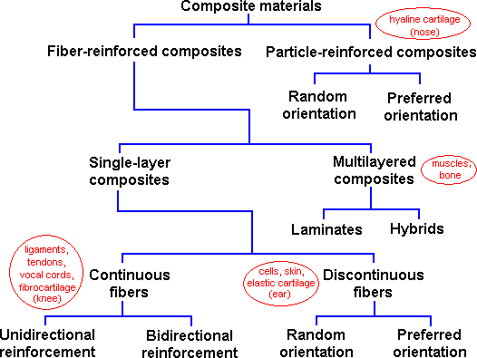

Figure 2.2: Classification of composites according to reinforcements. (Ihueze et al., 2017)

Composites materials are categorized into two groups on the basis of reinforcing materials as follows:

Classification composites on the basis of reinforcement

        - Particulate composites

As the name itself indicates, the reinforcement is of particle nature (platelets are also included in this). It may be cubic, spherical, a platelet, tetragonal, or of other regular or irregular shape, but it is roughly or

approximately equated or equal in shape. Thus, particulate-reinforced composites include those reinforced by flakes, rods, spheres and many other shapes of roughly equal axis. In general, particles are not very operative in improving fracture resistance but they improve the stiffness of the composite to a limited extent. Particle fillers are broadly used to improve the properties of matrix materials such as to modify the electrical and thermal conductivities, reduce friction, improve performance at elevated temperatures, increase abrasion and wear resistance, improve machinability, increase surface hardness and reduce shrinkage (Bledzki & Gassan, 2014).

        - Fibrous composite

A fiber is characterized by its length being much larger compared to its cross-sectional dimensions. The dimensions of the reinforcement define its competence at contributing its properties to the composite (Karger-Kocsis, 2015). Fibers are very effective in refining the fracture resistance of the matrix. A reinforcement having a long dimension depresses the growth of emerging cracks normal to the reinforcement that might otherwise lead to failure, mainly with brittle matrices. Man-made fibers or filaments of non-polymeric materials exhibit much greater strength along their length since large defects, which may be present in the bulk material, are decreased because of the small cross- sectional dimensions of the fiber. Orientation of the molecular structure is responsible for high strength and stiffness, in case of polymeric materials (Bledzki & Gassan, 2014).

Natural fibers reinforced composites

The interest in natural fiber-reinforced polymer composite materials is rapidly growing both in terms of their fundamental research and industrial applications (Yao, Li& Nagarajan, 2016). They are cheap, renewable, partially or completely recyclable and biodegradable. Plants, such as jute, cotton, flax, hemp, kenaf, sisal, ramie, pineapple, bamboo, banana, etc., as well as wood, used from ancient as a source of lignocellulosic fibers, are more and more frequently applied as the reinforcement of composites (Karger-Kocsis, 2015). Their low density, renewability, availability and price as well as satisfactory mechanical properties make them a pretty ecological alternative to carbon, glass and man-made fibers used for the manufacturing of composites (Gamze, Yesil& Aytac, 2014).

Natural fibre composites mostly consists fibres of jute, cotton, hemp and non conventional fibres such as coir and many empty fruit bunches (Fakirovet al., 2010). Natural fibre thermoplastic composites are attractive as they are cheaper, stiffer, paintable, and rot-resistant and also can be given the look of wood in addition to all this they have more life- cycle. Natural fibre composites are attractive to industry because of their low density and ecological advantages over conventional composites Natural fibres are lingocellulosic in nature. These composites are gaining importance due to their non-carcinogenic and bio- degradable nature (Gamzeet al., 2014). Natural fibre composites are very cost effective material especially in building and construction purposes packaging,

automobile and railway coach interiors and storage devices (Peijs, 2016). These can be potential candidates for replacement of high cost glass fibre for low load bearing applications.

Physical properties of natural fibers

Depending on their origin, natural fibers can be grouped into seed, bast, leaf and fruit qualities (Fakirovet al., 2010). The bast and leaf (the hard fibers) types are the most commonly used in composite applications. Examples of bast fibers include hemp, jute, flax, ramie and kenaf. Leaf fibers include sisal and banana. Flax fiber is an important bast fiber from the dicotyledonous Linum usitatissimum plant native to the Middle East. Its color is pale cream to brown. It has been used for centuries in the manufacture of fine linens (Williams & Wool, 2013). Flax is a plant with a single stem, nearly one meter in height. The diameter at the base varies between 1 to 2 mm. The length of a fibril is around 15-20 mm. Vegetable fibers have density of about half that of glass fibers. These fibers can withstand processing temperatures up to 250ºC (Sreekala, Jayamol, Kumaran & Sabu, 2012). The strength characteristics of natural fibers depend on the properties of the individual constituents, the fibrillar structure and the lamellae matrix (Joseph, Mattoso, Toledo, Thomas, Carvalho, Pothen, Kala & James, 2015). For an understanding of the mechanical properties and durability of fibers, the structural components of the fibers (cellulose, hemicellulose and lignin) will be examined. Additional characteristics include fiber strength, fiber fitness, the polymerization of the cellulose, cleanness or

purity and homogeneity of the sample, but these are not essentially genotype dependent. Natural fibers exhibit considerable variation in diameter along with the length of individual filaments. Quality and other properties of fibers depend on factors such as size, maturity and processing methods adopted for the extraction of fiber (Karger-Kocsis, 2015). Properties such as density, electrical resistivity, ultimate tensile strength and initial modulus are related to the internal structure and chemical composition of fibers (Mohanty, Misra&Drzal, 2018). Desirable properties for fibers include excellent tensile strength and modulus, high durability, low bulk density, good moldability and recyclability. Natural fibers have an advantage over glass fibers in that they are less expensive, abundantly available from renewable resources and have a high specific strength. Table 2.1 shows a comparison of properties of natural fibers and conventional man-made fibers.

Table2.1. Comparative properties of natural man-made fibers (Ihueze et al., 2017).
Fibre | Density(g/cm3) |  | Tensile strength(MPa) | Specific tensile  strength(MPa) | Elastic modulus(GPa) | Specific elastic modulus(GPa)
E-glass | 2.5-2.55 |  | 2000-3500 | 800-1373 | 70-73 | 28-28.62
Flax | 1.40 |  | 800-1500 | 571.43-  1071.42 | 60-80 | 42.86
Hemp | 1.48 |  | 500-900 | 337.83-608.11 | 70.00 | 47.30
Jute | 1.46 |  | 400-800 | 273.97-547.96 | 10-30 | 6.85-20.55
Ramie | 1.50 |  | 500.00 | 333.33 | 44.00 | 29.33
Coir | 1.25 |  | 220.00 | 176.00 | 6.00 | 4.80
Sisal | 1.33 |  | 600-700 | 451.13-526.32 | 38.00 | 28.57
Abaca | 1.50 |  | 980.00 | 653.33 | 12.00 | 8.00
Cotton | 1.4-1.51 |  | 400.00 | 285.71-264.90 | 12.00 | 8.51-7.95
Kenaf | 1.45 |  | 930.00 | 641.38 | 53.00 | 36.55
Unmodified Plantain stem | 1.358 | 41-201 |  | 30.19-148.01
Modified  Plantain stem | 0.132 | 1383-5099 |  | 10477.27-38638 | 27816.79 | 210.73

Source: Author‟s compilation 2018

Chemical composition of natural fibers

Natural fibers are complex in structure. They are generally lignocellulosic, consisting of helically wound cellulose micro fibrils in an amorphous matrix of lignin and hemi- cellulose (Qin, Soykeabkae, Xiuyuan& Peijs, 2013). Table 2.2 shows natural fibers and their chemical and structural composition.

Table 2.2. Chemical composition and structural parameters of natural fibers (Mohanty et al., 2000).
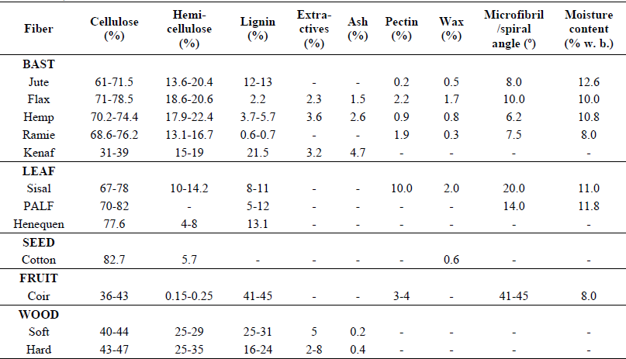
Source: Researcher‟s compilation 2018

Mechanical properties are determined by the cellulose content and microfibril angle. A high cellulose content and low microfibril angle are desirable properties of a fiber to be used as reinforcement in polymer composites (Williams & Wool, 2013). The cells of flax fiber consist mostly of pure cellulose, being cemented as fascicle bundles by means of non-cellulosic

incrusting such as lignin, hemicellulose, pectin, protein or mineral substances, resins, tannins, dyers and a small amount of waxes and fat. A mature flax cell wall consists of about 70% to 75% cellulose, 15% hemicellulose and pectic materials. Cellulose is a natural polymer with high strength and stiffness per weight, and it is the building material of long fibrous cells. Both the hemicellulosic and pectic materials play important roles in fiber bundle integration, fiber bundle strength and individual fiber strength as well as water absorbency, swelling, elasticity and wet strength. The production of individual fibers without the generation of kink bands will generate fibers with much higher intrinsic fiber strength which is very useful for composite application.

Moisture absorption characteristics of natural fiberscomposites

Natural fibers are hygroscopic in nature and they absorb or release moisture depending on environmental conditions. A major limitation of using natural fibers, in durable composite applications, is their high moisture absorption and poor dimensional stability (swelling) (Panigrahi, Tabil, Crera, Sokansanj, Ward, Powell, Kovacs & Braun, 2015). Swelling of fibers can lead to micro-cracking of the composite and degradation of mechanical properties. This problem can be overcome by treating these fibers with suitable chemicals to decrease the hydroxyl group in the fibers. Strong intermolecular fiber-matrix bonding decreases the rate of moisture absorption in biocomposites. To increase the interfacial adhesion between the fiber and matrix, the fiber surface must be

cleaned and chemically modified and the surface roughness must be increased (Yuan, Jayaraman& Bhattacharyya, 2012).

Chemical treatment of natural fibres

Natural fibres are amenable to modification as they bear hydroxyl groups from cellulose and lignin. The hydroxyl groups may be involved in the hydrogen bonding within the cellulose molecules thereby reducing the activity towards the matrix. Chemical modifications may activate these groups or can introduce new moieties that can effectively interlock with the matrix.

In principle, natural fiber-reinforced composites could offer specific properties comparable to those of conventional fiber composites; however, low interfacial properties between fiber and polymer matrix often reduce the potential of natural fibers as reinforcing agents (Mohanty et al.,2018). Interfaces play an important role in the physical and mechanical properties of composites (Joseph et al.,2017). In order to improve natural fiber-matrix adhesion, the matrix should be commonly modified to better match fiber surface properties. Conversely, simple chemical treatments can be applied to the fibers with the aim of changing surface tension and polarity through modification of fiber surface. Several classes of compounds are known to promote adhesion, by chemically coupling the adhesive to the material (Nodo, Leong& Hamada, 2012). Silane coupling agents are one of many ingredients in commercial sizing that are applied to fibers. The chemical composition of coupling agents allows
them to react with the fiber surface and forms a bridge of chemical bonds

between the fiber and matrix (Al-Moussawi, Drown & Dral, 2013). Generally, coupling agents are molecules possessing two functions. The first function is to react with OH groups of cellulose and the second is to react with functional groups of the matrix. The selection of a coupling agent that can combine both strength and toughness to a considerable degree is important for a composite material to facilitate the optimum stress transfer at the interface between fiber and matrix. Several processes have been developed to modify polymers and fiber surfaces including chemical treatments, photochemical treatments, plasma treatments and surface grafting (Jiaet al., 2014).

Surface chemical modifications of natural fibres

Several studies have shown the influence of various type of chemical modification on the performance of natural fiber and fiber-reinforced composites (Bocz, Vig, Szolnoki Szabo, Erdelyi, Zimonyi& Marosi, 2010). The different surface chemical modifications of natural fibers such as mercerization, isocyanate treatment, acrylation, latex coating, permanganate treatment, acetylation, silane treatment and peroxide treatment including various coupling agents and others, have achieved various levels of success in improving fiber strength, fiber fitness and fiber-matrix adhesion in natural fiber composites (Bocz et al., 2010). Brief descriptions of some important fiber chemical modifications are summarized in the following sub-sections.

2.5.8.1. Mercerization (alkali treatment) of natural fibres

Alkali treatment of cellulosic fibres, also called mercerization, is the usual method to produce high quality fibres. Alkali treatment improves the fibre-matrix adhesion due to the removal of natural and artificial impurities (Mishra, Nayak & Satapathy, 2010). Moreover, alkali treatment leads to fibrillation which causes the breaking down of thecomposite fiber bundle into smaller fibers. In other words, alkali treatment reduces fiber diameter and thereby increases the aspect ratio. Therefore, the development of a rough surface topography and enhancement in aspect ratio offer better fiber-matrix interface adhesion and an increase in mechanical properties (Joseph et al., 2017). Alkali treatment increases surface roughness resulting in better mechanical interlocking and the amount of cellulose exposed on the fiber surface. This increases the number of possible reaction sites and allows better fibre wetting.

The following reaction takes place as a result of alkali treatment:

Fibre-OH + NaOH Fiber-O-Na+ + H₂O (2.1)

Jähn, Schroder, Futing, Schenzel & Diepenbrock (2016), found that the cellulosic fine structure of the flax fibres was directly influenced by mercerization treatment. Moreover, alkali treatment influenced the chemical composition of the flax fibres, degree of polymerization and molecular orientation of the cellulose crystallites due to cementing substances like lignin

and hemicellulose which were removed during the mercerization process. Consequently, mercerization or more general alkali treatment has a lasting effect on the mechanical behavior of flax fibers, especially on fiber strength and stiffness (Bledzki & Gassan, 2014). Several other studies were conducted on alkali treatment (Mishra et al., 2014; Joseph et al., 2015; Sreekala et al., 2012). They reported that mercerization led to the increase in the amount of amorphous cellulose at the expense of crystalline cellulose and the removal of hydrogen bonding in the network structure.

Silane treatment of natural fibres

Coupling agents usually improve the degree of cross-linking in the interface region and offer a perfect bonding result. Silane coupling agents were found to be effective in modifying the natural fiber-matrix interface. Various silanes treaments were effective in improving the interface properties of wood- polypropylene composites (Bocz, Barany, Toldy, Bodzay, Csontos, Madi&Marosi, 2013);(Ihueze etal., 2013). Alkoxy silanes are able to form bonds with hydroxyl groups. Coupling agents such as toluene dissocyanate and triethoxyvinyl silane were tested in fiber treatment in order to improve the interface properties. Silanes undergo hydrolysis, condensation and bond formation stage. Silanols can form polysiloxane structures by reaction with hydroxyl group of the fibers. The reaction schemes are given in Figure 2.2 and
  - In the presence of moisture, hydrolyzable alkoxy group leads to the formation of silanols.

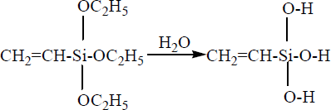
(2.2)

Figure 2.3 Hydrolysis of silane (Sreekala et al., 2000).

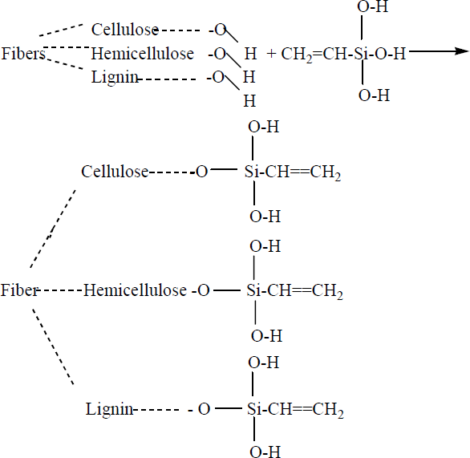
(2.3)

Figure 2.4: Hypothetical reactions of fiber and silane (Sreekala et al., 2012).

Silane treatment of cellulosic fibers can increase the interfacial strength and therefore the mechanical properties of the composite (George, Screekala and Thomas, 2012)

Benzoylation treatment of natural fibres

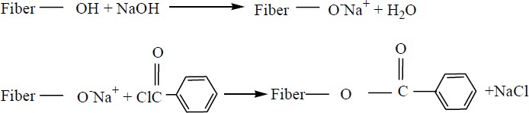
Joseph et al.,(2017) studied the benzoylation treatment on the surface of fibers. A fixed amount of washed fiber (35g) was soaked in 18% NaOH solution for 0.5 h, filtered and washed with water. The treated fiber was suspended in 10% NaOH solution and agitated with 50 ml benzoyl chloride. The reaction between the cellulosic –OH group of sisal fiber and benzoyl chloride is shown in Figure 2.4 as follows:

(2.4)

Figure 2.5: A possible reaction between cellulosic-OH groups and benzoyl chloride (Joseph et al., 2017).

Peroxide treatment of natural fibres

The decomposition of the peroxide and the subsequent reaction at the interface is expected at the time of curing of composites. Figure 2.5 shows the decomposition of the peroxides.
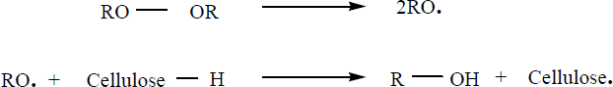
(2.5)

Figure 2.6: Peroxide treatment reaction (Sreekala et al., 2012).

Peroxide-induced adhesion in cellulose fiber-reinforced thermoplastic composites has attracted the attention of various researchers due to easy processing and improvement in mechanical properties. (Sapieha, Allard &Zang, 2016) indicated that the addition of a small amount of benzoyl peroxide or dicumyl peroxide to cellulose-polymer (LLDPE) systems during processing improved the composite mechanical properties. The improvement of mechanical properties is attributed to the peroxide-induced grafting of polyethylene onto cellulose surfaces.

Joseph et al.,(2017) investigated benzoyl peroxide treatment on short sisal fiber-reinforced polyethylene composites. They reported that peroxide- treated composites showed an enhancement in tensile properties due to the peroxide-induced grafting. Sreekala et al.,(2012) also studied benzoyl peroxide treatment on oil palm fiber-reinforced phenol formaldehyde composites. Fibers were coated with benzoyl peroxide from acetone solution after alkali pre- treatments. High temperature was favored for decomposition of the peroxide. They reported that peroxide-treated fiber composites could withstand the tensile stress to higher strain level.

The chemical treatment methods of natural fibres

Several interface modification methods were reported in literature. Acetylation of natural fibers is a well-known esterification method to introduce plasticization to cellulosic fibers (Zimniewska,Wladyka-Przybylak &Mankowski, 2011).Acetylation has been extensively applied to wood

cellulose to stabilize the cell wall, improving dimensional stability and environmental degradation. One of the modification techniques employed by the Okura Company in Japan was to produceesterified woods (Mohanty et al., 2018), which would be molded into plastic sheets by hot pressing. Another effective method of surface chemical modification of natural fibers is graft copolymerization. Optimized vinyl grafted natural fibers, consisting of the orderly arrangement of grafted moieties, act as compatible reinforcing fibers with several resin systems to obtaining better fiber-matrix adhesion of the resulting biocomposites (Mohanty et al.,2018).

Isocyanate has a functional group -N=C=O which is very susceptible to reaction with the hydroxyl group of cellulose and lignin in the fibers and forms strong covalent bonds, thereby creating better compatibility with the binder resin in the composites (Kokta, Maldas, Daneault & Beland, 2013); (Raj, Kokta, Maldas & Deneault, 2018) pointed to the performance of isocyanate as a coupling agent. Isocyanates provided better interaction with thermoplastics resulting in superior properties. Isocyanates could act as a promoter or as an inhibitor of interaction.

The radical enhances the chemical interlocking at the interface. Permanganate treatment was carried out to improve the bonding at the fiber- polymer interface. (Joseph &Thomas, 2017) and (Sreekala, Kumaran, Joseph, Jacob & Thomas, 2012) investigated the fibers which were pre-treated with alkali and then dipped in permanganate solution in acetone. Tensile strength

values of the composite showed a marginal increase with permanganate treatment. Acrylation treatment, maleated polypropylene/maleic anhydride treatment and titanate treatment of cellulosic fibers have also been reported (Mohanty et al.,2018; Monte & Sugerman, 2014; Sreekala et al.,2012). Acrylation treatment resulted in high strain values of the composites. The composites ability to withstand the applied flexural stress is manifested by higher strain values, which indicate the elastic nature of the material. Maleated polypropylene or maleic anhydride grafted polypropylene (MAPP) has been widely used as a coupling agent or a compatibilizer in natural fiber reinforced polypropylene composites. The treatment of natural fibers with MAPP copolymer provides covalent bonds across the interface. Through such treatment, the surface energy of the fibers is increased, thereby providing better wettability and high interfacial adhesion (Bocz, Barany, Toldy, Bodzay, Csontos, Madi& Marosi, 2013). Many other compounds such as chromium complexes and titanates can be used as coupling agents. The processing of composites with titanate coupling agents found that the deposition of a monolayer of organ functional titanate eliminated the water of hydration. This enhanced the dispersion and compatibility at the interface.

Development of Natural FibreComposites

Studies on composites, particularly natural fibre-reinforced plastics have gained increasing attention of researchers and manufacturers (Joseph et al., 2017). The increased interest in natural fiber-reinforced composites is due to the

high performance in mechanical properties, significant processing advantages, excellent chemical resistance, low cost and low density. They have long served many useful purposes but the application of material technology for the utilization of natural fibers as reinforcement in polymer matrix has taken place in recent years (Joseph et al.,2017). Biocomposite consists of a polymer as the matrix material and a natural fiber as the reinforcing element. The use of fibers derived from annually renewable resources, such as reinforcing fibers; provide positive environmental benefits with respect to ultimate disposability and raw material utilization. Recent studies indicate that plant-based natural fibers can be used as reinforcement in polymer composites, replacing the expensive and non-renewable synthetic fibers such as glass, because of their potential for recyclability (Mohanty et al., 2017). Vegetable fibers can serve as excellent reinforcing agent for plastics because of their moderately high specific strength and stiffness which is used as reinforcing materials in polymeric resin matrices to make useful structural composite materials (Joseph et al., 2017). Cellulose- based natural fibers are a potential resource for making low cost composite materials. Cellulosic fillers of a fibrous nature have been of greater interest, because they would give composites with improved mechanical properties compared to those containing non-fibrous fillers. Lignocellulosic fibers like jute, sisal, coir, and pineapple have been reportedly used as reinforcements in polymer matrix (Joseph et al., 2017).

Effects offibresurface modifications on fibres

The chemical modification directly influences the cellulosic fine structure of natural fiber. The mechanical performance of fibers is dependent upon its chemical composition, chemical structure and cellular arrangement. Sreekala et al.,(2012) performed tensile stress-strain test for untreated and modified oil palm fiber. Each individual fiber was composed of fibrils held together by non- cellulosic substances, such as lignin and pectin. Failure of the fiber was gradual upon the application of tensile stress. It showed intermediate behavior between brittle and amorphous. As stress gradually increased, some of the fibrils may have slipped out. The total of the stress was then sheared by fewer cells. Further increase of stress led to the rupture of cell walls and decohesion of cells. This resulted in a catastrophic failure of the fiber. Modifications led to major changes on the fibrillar structure of the fiber. It removed the amorphous components. This changed the deformation behavior of the fibers. The brittleness of the fiber was substantially reduced upon treatments. Sreekala et al.,(2012) measured the tensile properties of untreated and modified fibers, such as tensile strength, Young‟s modulus and elongation at break. Many of the modifications decreased the strength properties due to the breakage of the bond structure, and also due to the disintegration of the non-cellulosic materials. Some of the treatments, like silane and acrylation, led to strong covalent bond formation and thereby the strength was enhanced marginally. Optimum mechanical performance was observed for silane-treated and acrylated fiber. The reinforcing ability of the

fibers did not just depend upon the mechanical strength of the fibers but on many other features, such aspolarity of the fiber, surface characteristics and presence of reactive centers (Bocz et al.,2012). These factors control interfacial interaction. The Young‟s modulus of the fibers improved upon acrylation, alkali and silane treatment. The improved stiffness of the fibers was attributed to the crystalline region (cellulosic) of the fiber. The fiber also showed very good elongation properties, with values increasing upon modifications. Lower elongation of the untreated fiber may be due to the three dimensionally cross- linked networks of cellulose and lignin. Treatment broke this network structure giving the fiber higher elongation and lower strength properties. (Mishra, Tripathy, Nayak & Mohanty, 2014) investigated the tensile properties of untreated, chemically modified and AN-grafted sisal fibers. Chemically modified fibers showed an appreciable decrease in the tensile properties. This decrease was attributed to the substantial delignification and degradation of cellulosic chains during chemical treatment. The extension at break of these fibers did not change much. In all the cases of grafting, it has been found that the tensile strengths were higher than that of untreated fiber (Bocz et al., 2012).

Effects of fiber surface modifications on composite properties

Chemical treatments will be necessary to strengthen the interface between fiber and matrix. Several studies have been conducted on the influence of various types of chemical modifications on the properties of natural fiber- reinforced thermoplastic composites. This section reviews the effects of fiber

modification on the mechanical properties, thermal properties and macro- mechanical properties of composites.

Mechanical properties of fibre reinforced composites

The mechanical properties of a natural fiber-reinforced composite depend on many parameters, such as fiber strength, modulus, fiber length and orientation, in addition to the fiber-matrix interfacial bond strength (Bocz et al., 2012). A strong fiber-matrix interface bond is critical for high mechanical properties of composites. A good interfacial bond is required for effective stress transfer from the matrix to the fiber whereby maximum utilization of the fiber strength in the composite is achieved. Modification to the fiber also improves resistance to moisture-induced degradation of the interface and the composite properties (Joseph etal.,2017). In addition, factors like processing conditions/techniques have significant influence on the mechanical properties of fiber-reinforced composites (George,Sreekala & Thomas, 2016; Sapieha et al.,2016) have found that by the addition of a small amount of dicumyl peroxide or benzoyl peroxide into the cellulosic fiber-polymer (LDPE) systems during processing significantly improved the mechanical properties of the composite. Kokta et al.,(2013) have extensively studied the effect of different chemical modifications, such as silane treatment and grafting, on the mechanical properties and dimensional stability of cellulosic fiber-thermoplastic composites. They found that the chemically modified cellulosic fiber-reinforced thermoplastic composites offered superior physical and mechanical properties

under extreme conditions even after recycling. Ray et al.,(2012) have employed the technique on jute and found that the improvements occurred on the fiber properties. Münker & Holtmann (2012) studied different natural fibers (flax, ramie, curaua) and matrices (polyester, polypropylene).Their findings showed that mechanical properties of natural fiber-reinforced composites could be improved by the use of different coupling agents.

Tensile Properties of fibre reinforced composites

Natural fiber-reinforced composites often show enhancement in tensile properties upon different modifications owing to the increased fiber-matrix adhesion. Tensile properties can be explained on the basis of the changes in chemical interactions at the fiber-matrix interface. The tensile strength of flax fiber-reinforced composites is determined both by the tensile strength of the fibers and the presence of weak lateral fiber bonds. Sreekala et al., (2012) performed one of the pioneering studies on the mechanical performance of treated oil palm fiber-reinforced composites. They studied the tensile stress- strain behavior of composites having 40% by weight fiber loading. Isocyanante- silane- acrylated, latex coated and peroxide-treated composite, withstood tensile stress to higher strain level. Isocyanate treated, silane treated, acrylated, acetylated and latex coated composites showed yielding and high extensibility. Tensile modulus of the composites at 2% elongation showed slight enhancement upon mercerization and permanganate treatment. The elongation at break of the composites with chemically modified fiber was attributed to the

changes in the chemical structure and bondability of the fiber. Alkali treated (5%) sisal-polyester biocomposite showed about 22% increase in tensile strength. (Mishra, Misra, Tripathy, Nayak& Mohanty2014); (Ichazo, Albano, Gonzalez, Perera& Candal 2016) found that adding silane-treated wood flour to PP produced a sustained increase in the tensile modulus and tensile strength of the composite. Joseph &Thomas (2017) studied the effect of chemicaltreatment on the tensile and dynamic mechanical properties of short sisal fiber-reinforced low density polyethylene composites. It was observed that the CTDIC (cardanol derivative of toluene diisocyanate) treatment reduced the hydrophilic nature of the sisal fiber and enhanced the tensile properties of the sisal-LDPE composites. They found that peroxide and permanganate treated fiber-reinforced composites showed an enhancement in tensile properties. They concluded that with a suitable fiber surface treatment, the mechanical properties and dimensional stability of sisal-LDPE composites could be improved. Mohanty et al.,(2018) studied the influence of different surface modifications of jute on the performance of the biocomposites. More than a 40% improvement in the tensile strength occurred as a result of reinforcement with alkali treated jute. Jute fiber content also affected the biocomposite performance and about 30% by weight of jute showed optimum properties of the biocomposites.

Impact properties of fibre reinforced composites

Fibres have a significant effect on the impact resistance through the principle of stress transfer. When an impact load is applied perpendicular to the

reinforcing fibres, good fibre-matrix adhesion is required for even moderate impact strength (Bocz et al., 2012). The impact properties of the polymeric materials are directly related to the overall toughness of the material (Shah, 2018). Toughness is defined as the ability of the polymer to absorb applied energy. Impact resistance is the ability of a material to resist breaking under a shock loading or the ability to resist fracture under stress applied at high speed(Bocz et al., 2012).

Detailed studies have already been done on the impact resistance of short fibre reinforced composites (Jang, Chen, Hwang, Hawkes& Zee, 2018). The impact resistance of fiber-reinforced composite depends on fibre rigidity, interfacial stress resistance and fibre aspect ratio. The strength of the matrix, the weakest part of the material, should be related to the failure process. The involvement of fibres in the failure process is related to their interaction with the crack formation in the matrix and their stress transferring capability. The total energy dissipated in the composite before final failure occurs is a measure of its impact resistance. The total energy absorbed by the composite is the sum of the energy consumed during plastic deformation and the energy needed for creating new surfaces (Boczet al., 2013).

Composition and Properties of Banana Fibre

Banana fibre is a lingo-cellulosic fibre, which obtained from the pseudo- stem of banana plant. Banana fibre is a bast fibre with relatively good mechanical properties. Banana fibre has good specific strength properties

comparable to those of conventional material, like glass fibre. This material has a lower density than glass fibres. The pseudo-stem is a cylindrical, clustered aggregation of leaf stalk bases. Banana fibres are waste products of banana cultivation and are either not properly utilized or partially done so. Useful applications of such fibres would regularize the demand, which would reflect in enhanced economic value. Banana fibres have high strength, light weight, smaller elongation. Banana fibre is used making products like filter paper, paper bags, greeting cards, lamp stands, pen stands, decorative papers, rope, mats and composite materials etc. Banana fibre is used in making currency notes in Germany. Polypropylene reinforced with banana fibre is used by automobile companies for making under floor protection panels in luxurious cars like Mercedes. Banana fibre ismostly used in making handicrafts and home decoratives. Composite materials of banana fiber are used in buildings, and fire resistance boards.

Table 2.3: Production Details of fibres, origin of banana fibres

Botanical name | Musa Ulugurensiswarb
plant origin | Leaf, bast
Production per metric ton | 200
Source: Researcher‟s compilation

Banana fibres exhibit excellent highest aspect ratio which conferes on it high tensile properties, and surface area which are advantageous for reinforcement purposes.

Table 2.4: Physical properties of the banana fibres

Dia (um) | 80-250
Length (mm) | 1000-5000
Aspect Ratio (1/d) | 150.00
Moisture content (%) | 60.00
Source: Researcher‟s compilation

Table 2.5 shows the chemical composition of banana plant fibres, and their physical properties. It is noted that cellulose is the main constituent of plant fibres followed by hemiscellulosses and lignin interchangeably and pectin respectively. Cellulose is also the reinforcement for lignin, hemi cellulose and pectin.

Table 2.5: Chemical composition of banana fibres

Cellulose (%) | 60-65%
Hemi cellulose (%) | 6-19
Lignin (%) | 5-10
Pectin (%) | 3-5
Ash (%) | 1-3
Extractives (%) | 3-6
Source: Researcher‟s compilation

Table 2.6 shows mechanical properties of banana fibres, by which we use fibres as reinformement, for good mechanical properties of composite materials.

Table 2.6: Mechanical properties of banana fibres

Tensile strength (Mpa) | 529-914
Specific Tensile strength (Mpa) | 392-677
Young‟s Modulus (Gpa) | 27-32
Specific Young Modulus (Gpa) | 20-24
Failure strain (%) | 1-3
Density (Kg/m3) | 950-750
Source: Researcher‟s compilation 2018.

Thermal decomposition of natural fibre reinforced polymercomposites
Previous research in thermal decomposition of natural fibre reinforced polymer composites was primarily motivated by applications such as renewable biomass energy and natural fuels (Malek, Mitsuhashi& Criado, 2017). Due to the complexity of thermal decomposition reactions of natural fibre reinforced polymer composites, extensive research has been done in determining individual behaviours of the main components (or pseudo-components) of natural fillers like pure cellulose, lignin, and hemicelluloses (Boczet al.,2013). For practical engineering applications, however, it may be sufficient to consider only the basic characteristics of the thermal decomposition process with some simplified mechanisms (Gronli, Varhegyi& Blasi, 2015).
For natural fiber reinforced polymer composite processing, it is of more

practical relevance to understand and predict the thermal decomposition of the

reinforcing fillers based on the simplified kinetic scheme and parameters under specific process temperature of polymer/natural filler composite. However, there have been few fundamental studies in this field. Moreover, the reported values of kinetic parameters for natural fibre reinforced polymer composites were in a large range, e.g. activation energy for pure cellulose from 100 to 250kJ/mol(Malek, 2017).
This variability was primarily caused by different kinetic schemes used and pre-assumption of the reaction function and reaction order in kinetic modeling process. The suitable kinetic models for natural fillers remain to be developed (Malek, 2014). A method proposed by Málek, (2017); Málek et al.,(2013) allows fairly reliable kinetic analysis and interpretation of non- isothermal TG-DTG data (Malek et al., 2017).

Theoretical approach of thermal decomposition

The fundamental rate equation used in all kinetic studies is generally described as (Malek et al., 2001).

(2.2)

Where the rate constant k, and f (α) in the reaction model is a function depending on the actual reaction mechanism. Equation(2.2) expresses the rate of conversion, dα/dt, at a constant temperature as a function of the reactant concentration loss and rate constant. In this study, the reaction rate α is defined as (Liu & Fan, 2012).
(2.3)

WhereW₀, W_{f}, and Wt, are initial weight, final weight, and time of the sample respectively. The rate constant k is generally given by the Arrhenius equation (Liu & Fan, 2012):

(2.4)

Where E is the apparent activation energy (KJ/mol), R is the gas constant (8.314J/Kmol), A is the pre-exponential factor (s⁻¹), and T is the absolute temperature (K). Combination of equations(2.2) and (2.4) gives the following relationship (Liu & Fan, 2012):

(2.5)

For a dynamic TGA process, introducing the heating rate, β= Dt/dt into Eq. (2.4), Eq. (2.2) is obtained
(2.6)

Equations (2.1) and (2.2) are the fundamental expressions of analytical methods to calculate kinetic parameters on the basis of TGA data.
The most common “model-free” methods used in this study are summarized in Table 2.3. The Friedman method is the isoconversional method, which directly leads to -Ea/R for a giving value of α by plotting the term ln (dα/dt) against 1/T. In the Kissinger method, is In(β/T²_{p}) plotted against 1/T_{p} for a series of experiments at different heating rates with the peak temperature, T_{p}, obtained from the DTG curve.

The conversional Flynn-Wall-Ozawa (F-W-O) method is the integral method, which leads to -Ea/R from the slope of the line determined by plotting log (β) against 1/T at any certain conversion rate. The modified Coats-Redfern method is a multi-heating rate application of the Coats-Redfern equation. Plotting the left hand side for each heating rate versus 1/T at that heating rate gives a family of straight lines of slope -Ea/R. The full solution is to be done relatively by first assuming a value of Ea and then recalculating the left hand side until convergence occurs. Here, a quick solution, however, is also available by moving into the intercept and assuming that it is a constant.

Table 2.7 Kinetic methods used in evaluating activation energy in this study.
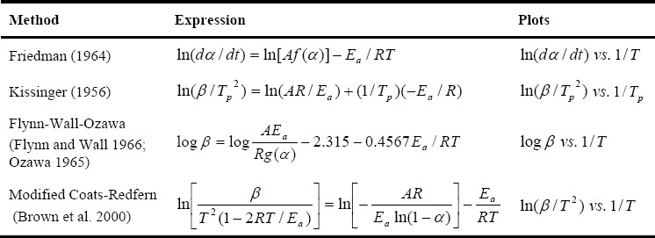
Source: Researchers compilation 2018

Flame Retardant Composites

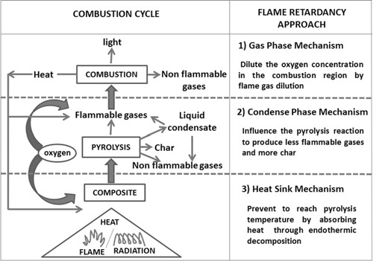

Figure 2.7 Schematic diagrams of combustion cycle and possible flame retardancy approach.

Flame retardancy behavior or fire performance of a composite material can be improved in two ways. Firstly, byimproving the fire performance of composite making constituentsi.e. matrix and reinforcing agent, and secondly by providingprotective FR-coating around the core composites. Different methods of improving fire performance of composite materials through component modification as well as throughproviding protective coating have been discussed below.

2.7.1.Flame Retardant Treatment for Reinforcing FibrousMaterials

Depending on the end uses, different synthetic and naturalfibres are being extensively incorporated inside polymericmatrix system, mainly for enhancing the mechanical performance.Presently with increasing environment

consciousness,attempts are being made to use the bio-degradable naturalfibres where ever it is possible (Wambua, Ivens& Verprost, 2015; Netravali & Chabba, 2013). Synthetic fibres likeglass, carbon, ceramic fibres are inherently FR in nature butthe natural fibres are highly flammable and unlike syntheticpolymers they also burn rapidly with the release of heat,light and smoke. Natural fibres (Jute, sisal, ramie, flax etc.) which are being used as reinforceing agent in the polymericcomposite are mostly ligno-cellulosic in nature. Theflammability of these lingo-cellulosic natural fibres can beimproved by treating with suitable FR-chemicals.FR-treatment of natural fibres was carried out either by (i)Pad-Dry-baking method or by (ii) Spraying-baking method or by(iii) Steeping-drying method (Zhang& Sun, 2015). FR-agents can be classified in different ways based on their chemical nature,flame retardancy principle, durability of finish etc. Table 3shows fibres, based on durability, FR- chemicals for ligno-cellulosic materials are classified into two main classes.

Table 2.8. Different types of flame retardant chemicals and their working principle (Mahadev, Alagirusamy & Apurba, 2014).

Flame retardant chemical  nature | Example of flame  retardants | Working mechanism
Metal oxides and hydroxides | Magnesium hydroxide, Aluminium hydroxide, alumina trihydrate, calcium carbonate,  THPC | Heat sink
Boron based | boric acid, borax borate,  boron phosphate | By forming insulating layer
Halogen based | TCPA, TBPA,  Polybrominated diphenyl ethers, polybrominated diphenyl | Gas phase
Phosphorus based | THPC | Condense phase
Synergistic | P/N, Halogen/Antimony tri-oxide, P/halogen | Flame retardancy of the primary compound enhanced  by the presence of another
Intumescent | Acid odour (ex- phosphoric acid, ammonium polyphosphate), carbonizing agent (ex- pentaerythritol), bowling agent (ex-melamine,  urea) | Both in gas and condense phase
Source: Author‟s compilation 2018

2.7.2 Flame Retardant Treatment for Polymeric Matrix

Matrices of polymeric composite are broadly classified into two main categories such as thermoplastic matrix andthermoset matrix. Both the thermoplastic and thermosetmatrices burn rapidly in fire and the flame retardancy ofthese polymeric materials can be improved in three differentways. These are (i) by adding flame retarding material to thepolymer matrix (ii) by
incorporating a flame retardantcompound into the polymeric backbone (iii) by

intumescentsystem. Nano particles are being extensively added to polymer systems to improve its mechanical properties but insome studies it was reported that nano particles can improvethe fire performance of the polymeric system. Thus additionof nano particle is another approach of improving fireperformance of polymer matrixes.The concept of intumescent FR-mechanism relies uponthe formation of an expanded carbonized layer on polymersurface during thermal degradation. This layer act as abarrier for heat transfer from heat source to polymer and italso limits the fuel transfer from polymer towards the flameas well as the diffusion of oxygen into the material. Anintumescent system mainly consists of three main components (i) an acid source, (ii) a carbonizing agent and (iii) a blowing agent. When an intumescent system is exposed to fire,depending on the source, some organic acid is releasedbetween 150 ºC to 250 ºC which esterifies the carbon-richcomponents just above the acid release temperature. During or prior to esterification the acid mixed material melts andthen through dehydration the ester decomposes and forms acarbon-inorganic residue and at the same time it also releasessome gases which trigger the expansion of carbonized layer.Near completion of this reaction, the melt becomes gel andthen solidified in the form of multicellular foam (Horacek& Grabner, 2016).

Table 2.9 Flammability of Some composites making polymer matrix (Mahadev, 2014)
Polymer | Ignition Temp. (^{O}C) | LOI (%) | Thermal degradation temp. (^{O}C) | Total heat of combustion at 50 flux  (kJ/g) | Peak rate of heat release at 50 flux (kW/m²) | Smoke rerelease at 50 flux  (m²/kg)
Polyethylene | 370 | 18 | 399 | 37 | 1130 | 362
Polypropylene | 330 | 18 | 354 | 44 | 1300 | 621
Nylon – 6 | 430 | 25 | 424 | 30 | 1272 | 160
Polycarboante | 500 | 25 | 476 | 31 | - | -
Poly (styrene) | 319 | 18 | 356 | 28 | 407 | 546
Poly  (acrylonitrile) | 480 | 27 | 320 | 28 | 343 | 140
Epoxy resin | 427 | 19 | 427 | 25 | 755 | 866
Unsaturated  polyester | 330 | 20 | 380 | 23 | 985 | 801
Source: Author‟s compilation 2018

Effect of Flame Retardant Treatment on Other Composite Properties

Polymeric composite materials are widely used in differentareas where flame retardancy is one of the most importantrequirements. It is observed that flame retardant treatmentnot only affect the fire performance of composite materials italso affects the other composite properties which are discussedbelow.
Matrix Viscosity and Fibre-Matrix InteractionMelt viscosity (for thermoplastic polymer) or resinviscosity (for thermoset polymer) plays an important role ondifferent composites properties like void content, matrixreinforcement,interaction, mechanical properties etc. It was observed that addition of flame retardant compound topolymeric matrix system influences its rheological propertiesquite significantly. The shear viscosity of thermoplasticpolymer melt increases with increasing micro sized flameretardant

content and this rate of increase, decreases withincreasing load or temperature. In case of PP matrix systemwhen particle size of Al(OH)₃ or Mg(OH)₂ is smaller than 5μm, melt viscosity increases with increasing particle sizeafter that it decreases with increasing particle size (Yang, Liang& Tang, 2019). Fibrematrix interaction of fibre reinforced polymer compositesystem is mainly expressed in terms of its tensile property.
Generally it was observed that a composite having goodfibre matrix adhesion shows good tensile property and vice versa. In case of fibre reinforced polymer composite whenpolymer matrix was modified by incorporating micro sizedFR-filler, its tensile strength decreases and when thereinforced fibre or both the matrix and reinforced fibre weremodified then its tensile strength increases (Shumao, Jie, Hua, Taoa & Weizhong, 2010). FR-treatmentof reinforce fibres makes the fibre surface rough which leadsto better fibre matrix adhesion and better tensile strength ofcomposites.

Mechanical Properties

The mechanical behaviour of a composite material is mainly expressed in terms of their tensile behaviour, flexuralproperty and impact property. It is observed that the mechanicalproperty of a composite material is greatly affected by differentFR-treatment. Metal hydroxides are being extensively usedfor improving fire performance of composite material whichis already discussed above but the addition of these materialshas a negative impact on mechanical behaviour of compositematerials (Supperkarn & Jarukmjorn, 2016) found that
in 30 % sisal-PPcomposite if 15 % sisal is replaced by Magnesium

hydroxide(Mg(OH)₂) or a mixture of Mg(OH)₂and zinc borate its tensile strength decreases due to poor compatibility betweenPP and flame retardants.
It was found in case of flexural property that the flameretardant added composite shows higher impact strength than 30% sisal-PP composite. The impact strength of a compositematerial is greatly affected by high loading of fillers becausethey disturb matrix continuity and each filler is a site ofstress concentration and initiates micro-cracks. The particlesize of flame retardants is smaller than sisal fibre thus flameretardant has a lower effect on impact strength (Sain, Park, Suhara & Law, 2014) tried to improve the compatibility between matrix andflame retardant by adding coupling agent E-43. It was observed that despite the presence of coupling agent, addition ofMagnesium hydroxide to rice husk and saw dust filled PPcomposite shows a reduction of 15 % and 17 % in flexuraland tensile properties respectively while the impact behavior was not affected too much by magnesium hydroxide addition. Laoutid, Bonnaud, Alezandre, Lopez-Cuesta & Dubois( 2013) have found that with increasing nano fillerloading percentage the tensile strength of nano-Mg(OH)₂ toPP composite system increases continuously and it shows86 % improvement in tensile strength at 4 % loading while43.3% improvement was observed in case of Young‟s modulus.Impact property of nano-Mg(OH)₂-PP composite decreaseswith increasing nano filler concentration upto 4 % and afterthat it becomes stable. It was observed that to achieve a samedegree of flame retardancy less amount of halide based flameretardant is required when
compared to metal hydroxidebased flame retardant. In case of composites made

of samematrix having same degree of flame retardancy, metal hydroxide added composite showed lower tensile and impact propertythan halide based flame retardant added composite due tolow add-on percentage of halide based flame retardant. Butwith same add-on percentage, metal hydroxide addedcomposites show better tensile property than halide basedflame retardant added composites (Tia, Robert& Li, 2011).Addition of antimony oxide to PP-IFR system shows thatits tensile strength increases upto addition of 1% antimonyoxide and after that it decreases with increasing antimonyoxide concentration while same kind of result was observedin case of bending strength and impact strength (Li, Xia, Mao, Wang, Guan & Zheng, 2017).Kandola, Horrocks, Mylera & Blair (2018) found that the addition of phosphate based intumescent and the mixture of intumescent and inherentflame retardant fibre to glass-epoxy composite dose notreduce the flexural modulus and in some cases it increasesslightly while its tensile modulus decreases with additives. It was concluded that the addition of additives does not affectcomposite‟s tensile property; the lower tensile strength ofadditive added composites is due to lower glass fibre content.
Mechanical property of core composite material is not affectedby protective flame retardant coating but post heat mechanicalproperty gives the idea about coating property. It wasgenerally observed that composite‟s mechanical propertydeteriorates with increasing applied heat flux and exposuretime.

Thermal Property

Thermal analysis of polymer composite plays an importantrole in the study of flame retardant composite. This providesimportant information for the evaluation and development offlame retardant composites through thermal decompositionprofile (Fernandes, Araujo, Fonseca, Fernandes & Silver, 2012). Thermal behaviour of composite materials ismainly analysed by Thermo- gravimetric analysis (TGA). Itwas observed that among all the natural fibres which arebeing extensively incorporated inside the polymer matrix,flax shows highest thermal stability due to its lowest lignin content (Manfredi, Rodriguez, Przybylak & Vazquez, 2016). It was observed that addition of flame retardants topolymeric matrix system greatly affects its thermal property. Suppakaran et al., (2016) observed that virgin PP startsthermaldegradation at 390ºC in nitrogen atmosphere and at 270 ºCin oxygen atmosphere. The addition of Mg(OH)₂ to PP matrixincreases its starting degradation temperature to 394ºC and272 ºC in nitrogen and oxygen atmosphere respectively.While the addition of natural fibre to PP matrix system decreasesits starting degradation temperature as the hemicelluloses and lignin part of natural fibre start degradation at lowertemperature. Mishra, Sonawane, Singh, Bendale& Patil (2015) found that with the addition of nano Mg(OH)₂ to PP matrix initially decreases its meltingtemperature to about 0.2 ºC at 4 % loading and after that itincreased to 0.8 ºC at 12 % loading. The difference in meltingtemperature is mainly due to even distribution of nano particlein PP matrix. Chen, & Chuanmei (2010) have found that APP basedIFR added PP composite degraded
at a higher temperaturewhen compared to APP added PP composite. But the

additionof APP based IFR to PP matrix decreases its startingdegradation temperature as APP starts to degrade at lower temperature (Ma, Gao& Bai, 2014).

Mode of action of flame retardants

Depending on the nature of combustion process, the flame retardants can interfere with combustion at any of the following stage: during heating, decomposition, ignition or flame spread by either acting chemically or physically in the solid, liquid or gas phase (Horacek et al., 2016).

Physical action of flame retardation

The combustion process can be retarded by the following physical ways (Mazrouh, 2014):

- Cooling: Some FRs actually cools the substrate to a temperature below that is required for sustaining the combustion process.
- Formation of a protective layer (coating): The combustible material is prevented from ignition by forming a solid or gaseous protective layer over the substrate and thus allows the condensed phase to cool. This evolves smaller quantities of pyrolysis gases and excludes the oxygen necessary for the combustion process and hence heat transfer is impeded. Phosphorous and boron compounds are the examples.
- Dilution: Addition of inert substances such as fillers and additives release

water and / or carbon dioxide on decomposition which dilutes the fuel in

the solid and gaseous phases, so that the lower ignition limit of the gas mixture is not exceeded. Example for this type is ATH.

Chemical action of flame retardation

The most important chemical reactions that take place in the solid and gas phases by interfering with the combustion process are (Mazrouh, 2001):

- Reaction in the gas phase: In the gas phase, the flame retardant interrupts the free radical mechanism of the combustion process. Thus stops the exothermic processes and cools down the system by reducing the supplies of flammable gases. Examples are halogenated flame retardants.
- Solid phase reaction: Two types of reaction can take place. In the first type, the flame retardants break down the polymer molecules and allow the polymers to flow away from the flame. In the second type, the solid phase flame retardants (eg. phosphorus compounds) cause a layer of carbonaceous char over the polymeric surface. The flame retardant generates double bonds in the polymer through the dehydrating action. Due to this action the carbonaceous layer is formed which is much harder to burn and prevents further burning. Intumescent types of flame retardant materials swell up behind the protective char layer by the addition of chemicals which provides much better insulation behind the protective barrier.
- Condensed phase mechanisms: The phosphorus compounds are known to be effective FR for the formation of char in both cellulose and

thermoplastics. The more effective phosphorus compounds must form the polyphosphoric acid initially, then the phosphorylated cellulose breaks down to water, phosphoric acid and an unsaturated cellulose analogue. By repetition of these steps the char formation takes place which also act as a physical barrier to heat and gases.
- Gas phase mechanisms: The flame retardant bromine compounds in any gas-phase mechanism, releases the volatile bromine-containing species, which then inhibit the flame reactions. Generally it is assumed that liberated hydrogen bromide reacts with the free radicals that are responsible for the propagation of combustion, by replacing them with relatively unreactive bromine atom.

RBr + HE HBr + RE. (2.7)

HE. + Hbr H₂ + BrE. (2.8)

OHE. + Hbr H₂O + BrE. (2.9)
When the polymer with Br compound is heated to sufficiently higher temperatures some of these compounds are thermally stable and volatilizes whereas the others decompose to give either lower molecular weight organic bromine compounds or hydrogen bromide. Generally the bromine compounds breakdown at quite low temperatures (typically 200-300°C) due to their low C- Br bond energy (Kim et al.,2012). This temperature range overlaps well with the decomposition of many common polymers which makes the effectiveness of
Br compounds superior compared with that of chlorine compounds.

- Co-additives for use with flame retardants: Addition of co-additives increases the effectiveness of brominated FRs so that they are more often used in conjunction with other compound notably phosphorus, antimony and certain other metals. Studies of the effects of phosphate esters and bromine compound in polyesters showed that more char is formed on the combustion of polyesters; it means that the bromine remains in the char, which suggests that the condensed-phase process was affected by the bromine-phosphorus compound. Antimony is always used in conjunction with a halogen compound and is a much more effective co-additive than phosphorus (Mazrouh, 2014). The use of it greatly reduced the higher loading levels of bromine compounds normally needed for effective flame retardance in the gas phase. While burning of organic polymer with these compounds, the major part of the antimony is volatilized, probably as SbBr₃ or SbOBr which then provides hydrogen bromide and also produces a fine particle of solid SbO, which can catalyze the free radicals that are responsible for flame propagation, via the formation of SbOH. The metal-bromine compounds such as zincoxide with bromine shows more specific modes of action in inhibiting polymer combustion.
  - Smoke suppressants: Numbers of parameters are available for the
determination of smoke production. There is no comprehensive theory that exists for describing the formation and constitution of smoke. Ferrocene, for example, effectively suppress the smoke by oxidizing soot in the gas phase as well as by charring in the condensed phase.

Intumescent systems form the protective char which suppress the smoke (Boulos, Laurence, Wassef, Claude & Bruno, 2013).

  - Typesand Characteristics of Flame Retardants
Flame retardants are currently classified as halogenatedcompounds, phosphorus compounds, inorganiccompounds, nitrogen-containing organic compounds,silicone compounds, etc.Halogenated flame retardants include the decabrominatedPBDE retardant excluded from WEEEand RoHS control in 2005(Boulos et al., 2013), although the compoundis still used, consumption is falling. Predominant inthis group are TBBA, TBBA-epoxy oligomer, TBBApolycarbonateoligomer, brominated polystyrene, were investigated for WEEE and RoHSfor a time and although the risk assessment continues,they have now almost certainly been exempted fromcontrol and demand is increasing. Brominated aromatictriazine compounds have also appeared. Of the phosphorus flame retardants, the aromaticphosphate esters used as general- purpose flameretardants and plasticisers continue to play a centralrole in general consumer goods though demand forphosphates of condensed type has recently beenincreasing on account of the heat-resistance andextraction-resistance required (Meifang, Yuan & Qi, 2017).

Intumescent agents of high flame retardant efficiencyhave recently been in the spotlight. While problems withwater resistance and electrical properties remain, thegroup is characterised by high flame retardant efficacydue to expanded char formation and application topolyolefins has been anticipated. Aiming at even

higherflame retardancy, systems characterised by microceramicexpanded char formation in combined use with nanofibres and silicone compounds are being developed(Meifang et al., 2017). Phosphazine compounds, recently heralded as a futureflame retardant of outstanding heat resistance and flame retardancy have yet to reach practical applicationbecause of cost and supply problems, though numbersof patents are still being filed. Red phosphorus andred phosphorus plus intumescent graphite are highly flame retardant but discolouration and stability duringprocessing are a worry and must be kept under control;they are used in the general industrial product field.

Whitened agents coated with titanium white are recentlybeen developed and marketed. Application as asbestossubstitutes has also been investigated(Green, 2015).

Antimony trioxide, an auxiliary retardant usedwith halogenated flame retardants, has the strongestsynergistic action on flame retardance of any inorganic flame retardant when combined with halogenatedagents and has supported a stable demand. However,its toxic potential has raised concern and zinc borate,zinc stannate and zinc sulphide is being marketedas alternatives. The characteristics of the alternativesare ill-defined and the amounts used are still small.Interest has recently grown in the microparticulate typeand manufacturers‟ fine powder grade products arebeing used. Antimony pentoxide has low toxicity andlittle effect on automated solder plating catalyst; it istherefore used for making circuit boards in electricaland electronic equipment

flame-retardant, but as itonly has a modest effect, demand is small. Hydratedmetal compounds promise much as inorganic flameretardants of environmentally friendly type: magnesiumhydroxide and aluminium hydroxide are mostly used(Chin-Lung, Ri-Cheng & Yie-Chan, 2018).

They find practical application in combination withauxiliary retardants particularly as the main retardantfor electrical leads and cables. More recently, retardantsderived by the comminution and surface treatment ofminerals that occur in China have been launched aslow cost additives by different coomanies. They are alittle inferior to synthetic agents in respect of colour, heatresistance, and flame retardancy, but improved typesare under development.
Because of their low flame retardant efficacy, hydratedmetal compounds must be added in large amounts (around160 parts) for UL-94/V-0 compliance; and 120-130 parts still needs to be added in combination with an auxiliaryretardant. This is presumably because the hydroxideonly has an endothermic reaction of short duration in thecombustion system, thermogravimetric analysis indicating rapid elimination of water at around 350°C for magnesiumhydroxide or 210°C for aluminium hydroxide.Various new types of hydrated compound havebeen developed. Typical examples are: (1) aluminiumhydroxide treated with a nitrogen compound (Pyrolyzer-HG), (2) magnesium hydroxide and aluminium hydroxidetreated with zinc stannate (USP 5183410), (3) aluminiumhydroxide treated hydrothermally at high temperature(Japan Patent Kokai No. 11-323011),
(4) magnesiumhydroxide treated with a nickel compound (USP

5401442, etc), (5) magnesium hydroxide treated withsilicone polymer (Magnifi nn), (6) magnesium hydroxidetreated with cationic polymer (Junmag), and (7) nanosizemagnesium hydroxide. Nanosize magnesium hydroxideis currently at the development stage and has yet to bemarketed as a bulk product(Chin-Lung et al., 2018).
Zinc sulphide is used as a substitute for antimonytrioxide and it has been confirmed that the flame retardantmechanism is due to charring in the condensed phase.The nanocomposite flame retardant materialsattracting most recent interest are of three kinds:montmorillonite (MMT), nanosilica, and carbonnanotube. A flame retardance sufficient to satisfy the flame retardancy standards has not been obtained with nanocomposites alone: usual practice is to reduce the overall amount of flame retardant added by combination with a conventional flame retardant (Chin-Lung et al.,2018). Research on nanocomposites still has to answer many questions such as the nanocomposite criteria, efficacy of the organiccompounds used in nano fibre treatment, and effect of dispersed morphology; although no conclusions can yet be drawn, it seems that a material highly flame retardant in its own right will be difficult to develop. The hope is that, by combination with conventional flame retardants, nanofibre will provide a high flame-retardancy in the condensed phase due to the formation of combustionresidue of high stability utilising the active surface and microparticulate dispersion effects. Nitrogen-containing flame retardants include guanidine compounds, melamine compounds and triazine compounds.
The melamine compound 2,4,6- triamino-1,3,5-triazine will serve as an

example: it sublimes above 200°C and the flame-retardance mechanism has been attributed to dilution of oxygen at the combustible surface together with the endothermiceffect due to a heat of sublimation of 29 kcal/mol and heat of decomposition of 470 cal/mol. Compared with halogenated retardants, flame retardancy is low, while the effect in combination with phosphorus flame retardants is high. Compounds like melamine phosphate that contain both phosphorus and nitrogen in the molecule are used for glass reinforced PET, PA and polyolefin resins. Typical applications for nitrogen compounds are polyurethane foam and refractory coatings, paper, wood, etc. Some auxiliaries not usually classed as flame retardants but which are nevertheless of key significance in flame retardant technology merit consideration. Antimony trioxide, antimony pentoxide, zinc borate, zinc stannate and zinc sulphide function as auxiliary retardants with synergistic action when used with halogenated flame retardants and are hence classed as flame retardants; the emphasis here will therefore be mainly on the hydrated metal compounds, phosphorus flame retardants andintumescent flame retardant auxiliaries. As already noted, hydrated metal compounds have low flame retardant efficiency and must be incorporated in large amounts, impairing matrix properties and processability; technology for enhancing flame retardant efficiency and reducing total formula weight with auxiliaries is therefore of some importance. The same may be said of the most recent phosphorus flame retardants and intumescent flame retardants.

Since flame retardancy can be improvedby using various auxiliary retardants in combination, auxiliaries are themselves better viewed as falling within a morebroadly defined category of flame retardant. The mechanism by which they operate invariably entails promoting the formation of a combustion residue (barrier layer) in the condensed phase, thereby stabilising the residue and exerting oxygen exclusion and insulating effects.
Intumescent flame retardants, while themselves offering the potential of high flame retardance due to expanded char, are also effective as auxiliaries that contribute to the reinforcement of cell structure and stability in the expanded char, pointing the way to a novel mechanism.

Silicone polymers and silicone oils are effective flame retardants, and silicon manufacturers are marketing a series of flame retardants, notably DC47045, DC47051, DC47081, EXP02 and XC99-B5664, whose compatibility with polymers is regulated by the introduction of polar groupproperties. The mechanism of flame retardance is formation of a composite layer of silicon oxide plus char in the condensed phase, though since the effect is small on its own, hydrated metal compounds, phosphorus compounds, etc, are commonly used as auxiliary retardants. They hindered amine flame retardant developed in Europe, exploits the free-radical trapping effect in initial combustion, though it has a weak action compared with halogen compounds.

Recent new developments include novel composite types of flame retardant. Leading examples are the STEM series, Exolit OP series and Polysafe

series, which have been attracting interest as novel composite retardants utilising a potent synergistic effect. KSS-FR is the potassium salt of a diphenyl sulphonesulphonate and diphenyl sulphone disulphonate complex and highly effective as a flame retardant for polycarbonate. An addition of merely 0.2% gives a UL-94/V-0 compliant effect. The following flame retardant types made up chieflyof metal compounds are known to meet the recently highlighted need for low smoke emission and low toxic gas emission; a number of these have found practical application.
- Compounds with low smoke emission Hydrated metal compounds, iron oxide, iron hydroxide, ferrocene, zinc borate, molybdenum compounds, copper oxalate, copper thiocyanate, zinc stannate, silica, hydroquinoline metal salts, and ferrocenium salts.
- Compounds with toxic gas adsorption and absorption effects Halogen gases: hydrated metal compounds, microparticulate calcium carbonate, lithium carbonate, magnesium carbonate, barium oxide, copper oxide, titanium oxide. HCN gas: CuO and Cu₂O Nitrogen oxides: active ferroxide, Ni/Al-Cu-oxide/ zeolite.
Bear in mind that metal compounds of this type need to have a fine particle size for good dispersibility and should not lower resistance to thermal degradation.

Fabrication techniques
For the manufacture of flame retardant polymers composites products, various techniques are available which may be considered under two main

headings such as open and closed mould techniques. A brief description of FRP processes is given below:
- Hand lay up: Material are laid by hand and brushed into the mould, consolidated with the roller. No heating or pressure is applied.
- Spray up: Chopped strands of fiber is sprayed along with the resin onto the mould and consolidated with the roller. Heating or pressure is not required.
- Vacuum bag moulding: The vacuum is applied after lay up of materials using a bag to remove air voids and to compact the lay up.
- Pressure bag moulding: After lay up of materials, the pressure is applied on the lay up using a flexible pressure bag.
- Autoclave moulding: After lay up of materials in an autoclave, vacuum, pressure and temperature are applied.
- Compression moulding: The fibre and resin are laid up in mould cavity after closing, the mould pressure is applied.
- Injection moulding: Chopped strand with resin and fillers are made into dough moulding compound and then it is injection moulded.
- Resin transfer moulding: Fibre is arranged in the closed mould and then the resin is injected under pressure and allowed to cure.
- Filament winding: Rovings wetted with resin/tapes/prepregs before they are wound on a rotating cylindrical / spherical mandrel.
- Pultrusion: It is a highly automated continuous process in this the fibre wetted with resin is pulled through a die and simultaneously cured.
  - Review of Related Works

Bharatkumar (2018) reported on the use of non-traditional fillers as flame retardants in polyester resin composites. The study evaluated the fire-retardant properties of non-traditional fillers viz. hydroxyapatite, zinc borate and fly ash in combination with traditional fire retardant filler antimony trioxide, in polymer polyester resin composite system. Flammability properties studied using limiting oxygen index suggested that incorporation of non-traditional fillers increases fire retardancy with considerable improvement in mechanical properties. The results revealed that good improvement in fire resistance with considerable increase in mechanical properties and thermal stability was obtained with 30% zinc borate as filler.
Venkata & Venkata (2018) reported on the mechanical properties of short uniaxially-oriented intimately-mixed kapok/glass fabric-reinforced polyester hybrid composites, by keeping the volume ratios of kapok to glass at 1:0, 3:1, 1:1, 1:3, and 0:1. The 9 vol% of fabric for kapok/glass was optimized. Hybrid composite materials were made by hand layup technique. The mechanical properties like tensile and hardness properties of the composites were studied. Best results were obtained for composites having increased glass fabric content in kapok/glass. The effect of alkali treatment of fabrics on the mechanical properties of these kapok/glass hybrid composites has also been studied. A significant improvement was observed in tensile and hardness properties of these composites by alkali treatment. Tensile properties were found to be better in composites having volume ratios of kapok to glass at 1:3 ratios. The hybrid

composites exhibited good properties coMPared to the single kind of fabric/polyester composites.
Baljinder, John & Kawser (2015) reported on the possibility of reducing the flammability of unsaturated polyester (UP) resin, commonly used in marine composites, by co-blending with less combustible and char-forming resins such as phenol-formaldehyde, melamine-formaldehyde and furans. The coMPatibility and curing properties of UP, other resins and their blends in 50:50 wt-% ratios has been studied by differential scanning calorimetry (DSC) and dynamic mechanical thermal analysis (DMTA) techniques. Based on the successful establishment of curing conditions, plaques of resins have been cast and cured. Thermal stability was studied by thermogravimetry (TGA), whereas the fire performance evaluation was carried out by limiting oxygen index (LOI) and cone calorimtery at 50kW/m² heat flux. According to a fire risk assessment based on cone calorimetric data, the resole phenolic resins and their blends with UP achieved the highest fire safety rating (Chappleet al., 2010).
The synthesis of fire retardant UPR based composite has been conducted by varying the concentration of Al(OH)₃/Mg(OH)₂ additive fire retardancy was observed by using UL-94V standard. The thermal degradation behaviour of composite was studied by thermal gravimetric (TG) and differential scanning calorimetry (DSC) analysis while the mechanical properties were observed from tensile strength and hardness testing. The best fire retardancy was obtained from the composite with concentration of 40 % Al(OH)₃ and 10 %Mg(OH)₂(Sarkos
2010). Combination of 40 %/Al(OH)₃ and 10 % Mg(OH)₂ could improve the

thermal stability of composite by reducing the mass loss rate (MLR) to 4.9

%/min and total mass loss to 77 %, while the tensile strength decreased to 64 % and the hardness improved to 64.5 % (Dorez et al.,2015). The morphology and mapping of composite showed that Al (OH)₃ additive was well-dispersed, while Mg(OH)₂ had the tendency to agglomerate.
Zhao, Hu & Chen (2011) studied the thermal stability and the burning behavior of glass fiber (GF)–reinforced polyamide 6 composites containing aluminium hypophosphite. The addition of the aluminium hypophosphite enhanced the thermal decomposition behavior by decreasing the onset decomposition temperature, the maximum mass loss rate, and the maximum rate of degradation and by increasing the char formation. These benefits were also confirmed for the fire resistance properties, finding a reduction of the main cone calorimeter parameters, such as PHRR and total heat released (THR) due to the formation of a compact residual char.
Perret, Schartel, Stob, Ciesielski, Diederichs, Doring, Kramer & Altstadt (2019) investigated the effectsof the pyrolysis and fire behavior of a novel phosphorus compound (DOPI) incorporated in two different epoxy resins (DGEBA/DMC and RTM6). The action of the flame retardant was different for the two resins, finding just a flame inhibition in the gas phase for the DGEBA/DMC composite, while flame inhibition and a condensed-phase interaction increasing charring for the RTM6 composites.
The thermal degradation and the fire behavior of a polyester resin

containing phosphate-based fire-retardant additives and its corresponding glass

fiber composites were investigated by Maria et al., (2012). An unsaturated commercial polyester resin was modified by the addition of three phosphate- based fire retardants: ammonium polyphosphate, silane-coated ammonium polyphosphate, and melamine pyrophosphate, at 35% w/w. The effects of the fire retardants on resin thermal decomposition and small-scale fire behavior were studied using dynamic thermogravimetric tests at different heating rates and microcalorimetric measurements according to ASTM D7309-07. Different modes of degradation with different activation energy levels for the neat resin and the phosphate-loaded resins were identified by analyzing the thermogravimetric data through the Kissinger method (Sarkar& Adhikari, 2011). Since the ammonium polyphosphate-containing resin showed greater thermal and fire performance than the other systems, it was used to manufacture unidirectional glass fiber composites by a vacuum infusion process. The oxidative pyrolysis and fire behavior of the composites produced were studied using thermogravimetric and cone calorimeter tests that demonstrated improvement of their thermal stability and fire performance.
Bourbigot & Duquesne (2017)investigated the synergistic effect of expandable graphite (EG) and phosphorus-based flame retardants such as APP and triphenyl phosphate (TPP) on the thermal properties and the flammability of an unsaturated polyester resin. Their results indicated that APP both alone and in combination with EG is more efficient than TPP to prevent the thermal degradation and reduce the combustion of the investigated polyester resin due to
greater char yield and the similar values of the decomposition temperatures to

the resin. In fact, to be effective, a flame retardant should decompose in a range of temperatures where the polymer decomposes simultaneously.
Nazare, Kandola& Horrocks (2016) investigated the flammability properties of unsaturated polyester resins modified by the addition of nanoclay and different condensed-phase flame retardants, such as APP and MPP. They observed that APP formulations showed the best results coMPared to the other flame retardants (MPP and ATH) since the peak heat release rate (PHRR) of the APP formulation was reduced by around 70% with respect to the pure resin. In addition, in well-ventilated fire conditions, APP itself proved to be a good smoke suppressor.
Kandare, Chukwudolue, Kandola & Baljinder (2018) investigated the use of integral, hybrid intumescent thermal barriers (mats) to provide surface protection to the core fibre-reinforced polyester composite structural integrity when exposed to a fire or heat source. Glass fibre-reinforced composites protected by intumescent mats/fabrics containing silicate fibres, expandable graphite and in some cases borosilicate glass bound together by an organic matrix have been evaluated for fire performance under a constant heat flux of 50 kw/m². The effect of insulative fabric thickness as well as chemical composition on the flammability of the resultant hybrid composites is evaluated. Glass-fibre- reinforced polyester composites without any surface protection have a relatively higher time-to-ignition and peak heat release rate values when compared to core composites protected by insulative fabrics. Thermograms representing the
variation of temperature on the reverse side of the hybrid composites with time

when exposed to a constant heat flux , show that the inclusion of intumescent surface barriers results in retarded temperature increments within the core glass fibre reinforced polyester.
The thermal and reaction to fire characteristics of flame retardant unsaturated polyester (UP) ternary system were investigated by (Hapuarachch &Peiji,2018). Thermal gravimetric analysis showed an improved thermal stability between 200–600°C with the addition of ammonium polyphosphate (APP) and aluminium trihydroxide (ATH) formulation. Cone calorimetry tests indicated that ATH is more efficient than calcium carbonate at delaying the ignition time, lowering the carbon monoxide yield and lowering the peak heat release (PHRR). However the addition of APP and ATH to the formulation failed to demonstrate any significant synergistic effect at reducing the PHRR.
Suppakarn & Jarukumjorn (2010) studied the effect of magnesium hydroxide and zinc borate addition to the sisal-polypropylene (Si-PP) composites as a FR-agent. The flammability of these composite materials was checked by horizontal burning test method. It was observed those Si-PP composite burns at a higher rate than neat polypropylene (PP) and when magnesium hydroxide was added to PP matrix, its burning rate decreases with increasing magnesium hydroxide concentration. Zinc borate does not affect the burning rate of PP but the char formation rate increases with increasing zinc borate concentration. However, synergistic effect of zinc borate and magnesium hydroxide was not found when these two were added together to PP matrix. A
similar result was observed with magnesium hydroxide.

Nayra & Javier (2016) reported on the possibility of reducing the flammability of flax bio-polyester composites with potential use in the transportation and construction sectors through the combination of several novel fire retardant additives, which are halogen-free and considered environmentally friendly. Cone calorimeter tests indicated that proper combinations of fire retardant additives such as alumina trihydrate, ammonium polyphosphate and Exolite 740 reduced heat release rate and flammability up to a 60%; delaying the ignition time with respect to the unfilled material. These results were achieved at concentrations much lower than those with traditional solutions. However, the addition of dimethyl propyl phosphonate to the resin formulation with alumina trihydrate and ammonium polyphosphate failed to demonstrate any significant synergistic effect at reducing the heat release rate.
Zhang, Reynolds & Peijs (2013) observed that the fire performance of polypropylene grafted with acryl-amide (AAM) is much better than that grafted with methacrylic acid (MAA) and acrylic acid (AA) and it was also noticed that saponification of grafted sample enhance flame retardancy by promoting the char formation
Manfredi, Rodriguez, Wladyka-Przybylak & Vazquez (2016) have prepared a series of composites using mod-acrylic and unsaturated polyester as matrices and jute, flax, sisal and glass as reinforcing material and compared the flame retardancy behaviour of these composite materials. It was noticed that flax fibre reinforced composite releases the highest amount of heat while glass
fibre reinforced composite shows the lowest release. At the same time flax

composite shows large flashover zone which indicates that it will offer longest time to escape or to extinguish the fire and jute composite releases least quantity of smoke volatiles than other composites and burns quicker than other natural fibre composites. Among unsaturated polyester and mod-acrylic resins, the latter shows a longer flashover zone and releases more heat than the first. During burning, mod-acrylic forms a char layer which is not found in case of unsaturated polyester resin. The fire risks of all composites were compared by plotting the total heat evolved against the peak heat release rate divided by time of ignition. It was observed that glass reinforced unsaturated polyester composite shows the least fire risk compared to other composites but none of these were flame retardant in nature.
Abdullah, Ahmed & Sains (2011)have prepared coconut fibre reinforced polyester composite (CFRPC) by incorporating sodium hydroxide and silane treated coconut fibre inside unsaturated polyester resin prepared from waste PET. Dicron, a phosphate based flame retardant was added to CFRPC system to enhance its retardant. It was observed that silane treatment of coconut fibre increases the hydrophobicity of coconut fibre thus untreated coconut fibre reinforced polyester composite shows better flame retardancy when compared to silane treated coconut fibre reinforced polyester composite. However, when Dicron was added to polyester matrix, saline treated coconut fibre composite shows better flame retardancy over the untreated fibre composite. The burning time and LOI index of silane treated composite increases with increasing Dicron

add-on upto 5 wt% but after that it decreases while in case of untreated composite it increases continuously with increasing Dicron add-on.
Chiang (2005); Lua (2017);Teodorescu-Draghicescu & Damiralp (2019) showed that mechanical property improvement failed to hold in all polymer based composites. The latter can be regarded to few influencing factors that were individually identified, monitored and debated. In materials testing, flexural strength is most commonly determined through 3-point bending test. It was reported that the flexural strength and the inter-laminar shear strength (ILSS) are strongly influenced by the hybrid design and depend on the reinforcing fiber position.
Manders & Bader (2014) reported on flexural properties of glass and carbon fibers hybrid composites. According to their findings, the failure strain of carbon phase increased as the relative proportion of carbon fiber was decreased, and as the carbon fiber was more finely dispersed. They called this behavior a hybrid effect and reported an enhancement in failure strain of up to 50%.
Selmy (2012) reported on „hybridization‟ based on the same type of material used as reinforcement but a different shape/distribution/volume fraction such as unidirectional and random glass fibers. Their findings indicated that the in-plane shear properties (i.e. shear strength and modulus) of unidirectional fiber composite can be considerably improved by incorporation of random glass fiber to proffer structural composite architecture.

Gungor, Demet & Nuri (2015) reported on conventional propylene glycol-based unsaturated polyester synthesized and modified with diphenylmethane-4,40-diisocyanate (MDI), which leads to the formation of a hybrid polymer network (HPN). The effect of this modification on the mechanical properties was studied experimentally. The optimum molar ratio of MDI to unsaturated polyester which had the highest toughness was found to be NCO/OH 0.25/ 0.45 using compression testing. In the second stage of the research, e-glass-reinforced unidirectional composites were produced with pure unsaturated polyester (UP) and an optimum amount of HPN. Tensile and bending tests were applied to the neat unsaturated polyester, the HPN resins, and to the composites prepared from these resin matrices. For pure polyester, the tensile strength at rupture was 27 MPa with a Young‟s modulus of 920 MPa, whereas the tensile strength and the modulus of HPN were 42 and 860 MPa, respectively. In unsaturated polyester composites, a tensile strength of 500 MPa and a Young‟s modulus of 27,800 MPa are obtained while in HPN composites, the tensile strength and the modulus are 685 and 26,300 MPa, respectively. Hence, an increase in toughness was achieved for both resin matrices and composites by the use of MDI. The bending strength and the modulus of elasticity were 60.7 and 2464 MPa for UP resin, and 65.7 and 2871 MPa for the HPN resin. The corresponding values for UP composites were 858 MPa and
29.8 GPa, and are 1141 MPa and 37.5 GPa, respectively for the HPN composite.Hybrid polymer based composite architectures were tailored out of
glass (Ahma, Yel, Mai & Su, 2014). Kevlar and carbon woven fibers embedded

within two different matrices: epoxy and polyester resins. Their result shows linear increase in tensile strength with an increase in volume fraction fabric for both polyester and epoxy based composites. In addition, the hybrid composites have shown up to more than 100% increase in modulus of polyester composites while glass fabric reinforced polyester composites showed high tensile properties.

Valenca(2015) reported on the mechanical behavior of hybrid epoxy based composites using Kevlar and glass fibers as constitutive. The structural composites developed performed excellent in tensile, bending and impact tests coMParatively with their counterparts. Earlier, Dutra et al.,(2014) reported on impact performance of a mixture of polypropylene and carbon fibers as reinforcing elements into an epoxy matrix. They argued on the improved properties of hybrids in comparison with CF based composites. Researchers studied the environmental influences (e.g. moisture absorption) and atmospheric, accelerated or thermal aging effects upon the mechanical properties of hybrid composites during their studies aiming a comprehensive perspective on tailored materials. (Barjasteh, 2019), Boualem & Sereir (2011), Burks & Kumosa (2012); Tsai et al.,(2016).The conclusion underpinning their research resides in the unchanging or small discrepancies in the monitored effective properties due to the above mentioned external influences.

Rahmanian (2014)reported on the mechanical properties of multiscale hybrid polymer composites out of carbon fibers (CF) while Gamze et al,.

(2014)employed short glass fibers. Unsurprisingly, all works report on improvements on the monitored mechanical property along with arguments in favor of synergetic effects.

Divya, Kakhandaki & Suresha (2014) studied the three-body abrasive wear behavior of different weight percentage (wt%) filled organo-modified montmorillonite (OMMT) with constant wt% of treated and untreated coir sheath (CS) in unsaturated polyester (USP) resin. Three-body abrasive wear of the hybrid composites were studied under different filler loading, treatment of the coir sheath, and abrading distance. The results of the abrasive wear test revealed that the wear volume increases with increase in abrading distance and specific wear rate is high for the untreated composites (UTCs) compared to alkali treated composites (ATCs) and silane treated composites (STCs). STCs with 1 wt% oMMT-filled USP hybrid composite exhibited better abrasive wear resistance compared to UTCs and ATCs. Different wear mechanisms were observed on the worn surfaces of the composites, including pitting, micro- and/or macro- cracks, as well as crack propagation of the matrix in the transverse direction.

Bharatkumar (2018)reported on the use of non-traditional fillers as flame retardants in polyester resin composites. Studies have been carried out to evaluate the fire-retardant properties of non-traditional fillers viz. hydroxyapatite, zinc borate and fly ash in combination with traditional fire retardant filler antimony trioxide, in prepolymer polyester resin composite

system. Polyester resin was synthesized using phthalic anhydride (PA), maleic anhydride (MAN) and propylene glycol (PG). Flammability properties studied using limiting oxygen index suggests that incorporation of non-traditional fillers increases fire retardancy with considerable improvement in mechanical properties. However, the effectiveness of fillers as flame retardants depends on several factors including the type of fillers and incorporation level of the fillers. The use of antimony trioxide and fly ash increases the fire resistance behavior but there is decrease in mechanical properties and thermal stability. The results reveal that good improvement in fire resistance with considerable increase in mechanical properties and thermal stability was obtained with 30% zinc borate as filler.

Harshvardhan, Arun & Alok (2012) depicted on the processing and mechanical characterization of a new class of multi-phase composites consisting of polyester resin reinforced with glass fiber and filled with alumina particulates. Four different composite samples were prepared with 0, 5, 10 and 15wt % of Al₂O₃(alumina). The mechanical properties of these composites were evaluated. It was found that Al₂O₃ modifies the tensile, flexural and the inter- laminar shear strength of the glass-polyester composites. The hardness and density of the composites were also greatly influenced by the content of these fillers.

Mishra et al., (2013) investigated the mechanical performance of bio- ﬁber/glass reinforced polyester hybrid composites. The degree of mechanical

reinforcement that could be obtained by the introduction of glass ﬁbers in natural ﬁber (pineapple leaf ﬁber/sisal ﬁber) reinforced polyester composites was assessed experimentally. Addition of relatively small amount of glass ﬁber to the pineapple leaf ﬁber and sisal ﬁber-reinforced polyester matrix enhanced the mechanical properties of the resulting hybrid composites. Different chemically modiﬁed sisal ﬁbers were used in addition to glass ﬁbers as reinforcements in polyester matrix to enhance the mechanical properties of the resulting hybrid composites. The surface modiﬁcation of sisal ﬁbers such as alkali treatment produced optimum tensile and impact strengths, while cyanoethylation resulted in the maximum increase in ﬂexural strength of the hybrid composites. Scanning electron microscopic studies have been carried out to study the ﬁbre-matrix adhesion.

Sanjay, Arpitha, Laxmana & Gopalakrishna (2016) evaluated and compared the mechanical properties of laminates prepared of different composition of banana and e-glass fabrics. The mechanical properties evaluated are tensile strength, flexural strength, impact strength and hardness. The density of each of the laminates and water absorption properties were also evaluated. The six laminates of banana and e-glass fabrics of dimension 240*240*3 mm³ were fabricated by hand layup and vacuum bagging method. The impregnation of laminates was done by using polyester resin as matrix material. Finally, curing is done in the autoclave for 4 hours at 70ºC. From the results of the testing process, it was found that the maximum tensile strength, maximum

flexural strength, maximum impact strength and maximum hardness was observed in pure glass fabric laminate and minimum in pure banana fabric laminate. The pure E-glass fabric laminate absorbs more amount of water and pure banana fabric laminate absorbs minimum amount of water. From all these tests, it was found that as the glass layer in the laminate increases its mechanical properties enhances.

Sreekala, Jayamol, Kumaran& Sabu (2012) investigated the mechanical performance of hybrid phenol-formaldehyde-based composites reinforced with glass and oil palm ﬁbers. Oil palm ﬁber was hybridised with glass ﬁber in order to achieve superior mechanical performance. Tensile strength, tensile modulus and ﬂexural strength increase with an increase in ﬁber loading. Hardness of the composites was decreased by glass ﬁber reinforcement. The overall performance of the composites was improved by the glass ﬁber addition. Impact strength shows great enhancement by the introduction of a slight amount of glass fiber.

Wambua, Iven& Verpoest (2013) worked on the replacement of glass fibers with natural fibers .The mechanical properties of the different natural ﬁbre composites were tested and compared. Kenaf, hemp and sisal composites showed comparable tensile strength and modulus results. The tensile modulus, impact strength and the ultimate tensile stress of kenaf reinforced polypropylene composites were found to increase with increasing ﬁber weight fraction. Coir ﬁber composites displayed the lowest mechanical properties, but their impact

strength was higher than that of jute and kenaf fibre reinforced polymer composites.

Maria, Vincenza, Michele & Mauro (2012) reported on the thermal degradation and the fire behavior of a polyester resin containing phosphate- based fire-retardant additives and its corresponding glass fiber composites. An unsaturated commercial polyester resin was modified by the addition of three phosphate-based fire retardants: ammonium polyphosphate, silane-coated ammonium polyphosphate, and melamine pyrophosphate, at 35% w/w. The effects of the fire retardants on resin thermal decomposition and small-scale fire behavior were studied using dynamic thermogravimetric tests at different heating rates and microcalorimetric measurements according to ASTM D7309-
07. Different modes of degradation with different activation energy levels for the neat resin and the phosphate-loaded resins were identified by analyzing the thermogravimetric data through the Kissinger method. Since the ammonium polyphosphate-containing resin showed greater thermal and fire performance than the other systems, it was used to manufacture unidirectional glass fiber composites by a vacuum infusion process. The oxidative pyrolysis and fire behavior of the composites produced were studied using thermogravimetric and cone calorimeter tests that demonstrated improvement of their thermal stability and fire performance.

Singh, Gope, Chauhan, Bisht& Mater (2012) developed a banana fiber and silica powder reinforced composite material. Scanning electron microscopy

shows that banana fibers are well dispersed in the resin matrix. Addition of fiber increases the modulus of elasticity and decreases the ultimate tensile strength of the epoxy. And further addition of silica also increases the modulus of elasticity reduces the ultimate tensile strength. Addition of banana stem fiber highly reduces yield strength and addition of silica gives better results than banana reinforced composites but still having yield strength highly reduced. Banana reinforced improve the impact strength of epoxy materials. Addition of fibers increases the capacity of water absorption. This test is necessary where the composites are used in moisture affected areas.

Zhang et al.,(2013) investigated the tensile and interfacial properties of unidirectional ﬂax/glass ﬁber reinforced hybrid composites. The tensile properties of the hybrid composites were improved with the increase in glass ﬁber content. A modiﬁed model for calculating the tensile strength was given based on the hybrid effect of tensile failure strain. The fracture toughness and inter laminar shear strength of the hybrid composites were even higher than those of glass ﬁber reinforced composites.

Akash, Gupta&Rao (2017) studied fire retardant behavior and moisture absorption behavior of different weight percentage (10, 20, 30, 40 and 50 wt.
%) of sisal/coir fiber reinforced epoxy resin hybrid composites. Traditional cold pressing method was used to fabricate hybrid composites. Flammability behavior of the hybrid composite was studied by using vertical and horizontal burning rates as per standard UL-94. Addition of the cellulosic fiber increases

the flammability since natural fiber supports fire. It proved as a bad flame retardant due to the generation of a surface layer during pyrolysis of the cellulosic fiber which exhibits poor fire retardant nature. This layer acts as fire support, which spreads the heat from being transferred to the un-pyrolised material. The speed of flame was much faster in vertical burning position compared to horizontal burning position due to preheating of the specimen. Moisture absorption of sisal/coir fiber reinforced epoxy resin hybrid composites were studied according to ISO 62:1999 standard procedure. Absorption of moisture increases with increasing in the reinforcement weight percentage of cellulosic fiber in fabricated hybrid composite.

Baljinder et al.,(2015) prepared a novel blends of two furan resins with an unsaturated polyester cured by parallel free radical (for the unsaturated polyester) and acid-catalysed crosslinking (for the furan resin) to give co-cured composite materials. Although these materials have inferior physical properties, such as low Tg and low storage modulus compared with those of unsaturated polyester and furan resins alone, they show markedly improved flame retardance compared with that of the normally highly flammable unsaturated polyester. This increased flame retardance arises from a condensed phase mechanism in which the furanic component forms a semi-protective char, reducing rates of thermal degradation and total heat release and heat of combustion. The blends also burn with reduced smoke output compared with that from unsaturated polyester alone.

Bruce (2013) incorporated the combination of 60% ammonium polyphosphate (APP) and ATH into the non-halogenated GP polyester resin. He did not find improvements in fire and smoke properties of the resin with the increase of APP.

Cristiane, Aline, Fernando & Sandro (2011) synthesized organo modified

- Layered double hydroxides (LDH) MgAl intercalated with glycinate to formulate epoxy composites with distinct LDH content and evaluated their mechanical, thermal and flame-retardant properties. They found that the chloroform and dimethylformamide increased interlayer spacing with better diffusion of epoxy molecules between the LDH layers with much lower burning rate coMPared to pristine epoxy. It was concluded LDH is a good halogen-free and environmentally friendly flame-retardant for epoxy formulations.

Chen & Jiao (2012) used aluminium salt of hypophosphorous acid (AP) as flame retardant for glass-fibre-reinforced poly (butylene terephthalate) via melt compounding and tested their flame retardance and combustion behavior using LOI, vertical burning UL-94 test and cone calorimetric test. They investigated the thermal behaviors and thermal decomposition kinetics using TGA under N₂ atmosphere which showed the decreased onset decomposition temperature and found AP as an effective FR for the above composite, which showed V0 classification, increased LOI of 32.5% and the char indication from XPS and FT-IR analysis.

Horold (2019) explained that the non-halogen, phosphorus compounds do not affect the curing reactions of the resins and can be used in both cold and hot cured systems. He found in most of the thermoset resins, the combination of red phosphorus with ATH as excellent flame retardant with relatively low amounts of fillers (e.g. 50±70 phr compared to 150±250 phr using ATH alone).Thus he concluded that the low filler levels reduces the viscosity of the formulations and the density of the laminates.

Rota, Huskie, Makarrovic, Mlakara & Ignob (2019) examined the tensile strengths of polyester laminates with respect to the interfacial properties of e- glass fibre – unsaturated polyester resin (UPR). They observed that the UPR compositions with higher amount of linear ether glycol and lower degrees of unsaturation increased the flexibility of UPRs, thus improved the adhesion with e-glass fibre and consequently increased the tensile strength of the polyester laminates.

Chow, Chang& Jaafar (2014) reported that epoxy/glass fiber/organo- montmorillonite hybrid composites with triaryl phosphates and decabromodiphenyl oxide flame retardants were prepared by vacuum-assisted resin infusion technique. The effects of triaryl phosphates and decabromodiphenyl oxide on the flammability properties of epoxy/glass fiber/organo-montmorillonite composites were evaluated through UL-94 vertical flammability test and limiting oxygen index. Epoxy/glass fiber/organo- montmor-illonite hybrid composite showed no rating in UL-94 test up to 40 phr

of triaryl phosphates. Field emission scanning electron microscopy showed the amount of char formed increased, denser char structure and better coverage of glass fibers as triaryl phosphates loading increased. Interestingly, the hybridization of 30 phr decabromodiphenyl oxide with respect to 10 phr triaryl phosphates flame retardants showed V-0 rating with limiting oxygen index of 33%.

Nazare et al.,(2016) reported on the use of polymer-layered silicate nano clays as potential ﬂame retardants in unsaturated polyester resins. Preparation, characterization and ﬂammability properties of polyester-clay hybrids have been studied. X-ray diffraction studies have provided evidence that dispersion of functionalized clays in the polymer matrix depends on the type of functional group of the organic modiﬁer used. Flammability properties studied using cone calorimetry suggests that incorporation of nano clays (5%w/w) reduces peak heat release rate (PHRR) by 23–27% and total heat release (THR)values by 4– 11% (V et al. 2001). The ﬁre growth rate index (FIGRA) was also reduced by 23–30% following nano clay inclusion.While incorporation of condensed-phase ﬂame retardants such as ammonium polypho-sphate, melamine phosphate and aluminatrihydrate reduce the PHRR and THR values of polyester resin, the inclusion of small amounts of nano clay (5%w/w) in combination with the sechar-promoting ﬂame retardants causes total reductions of the PHRR of polyester resin in the range 60–70%. Ammonium polyphosphate, in particular

and in combination with polyester-nano clay hybrids show the best results compared to other ﬂame retardants.

Abdullah et al.,(2011) reported the effect of four types of inorganic phosphorus salts on flammability and mechanical properties (flexural and tensile) strength, of partially cross linked modified unsaturated polyester reinforced with glass fibers. In addition, the influence of two types form of glass fibers (chopped strand mat and woven roving), on flammability and mechanical properties of the composite, were studied. Sheets of composites with different weight percentage of additives and reinforced with two layers of each type of glass fibers, were prepared. Four standard test methods used to measure the flame retardation and mechanical properties are: ASTM: D – 2863, ASTM: D – 635, ASTM: D – 790 and ASTM: D – 638.Results obtained from these tests indicated that, additive (IV) (poly ammonium phosphate) has high efficiency as a flame retardant, self – extinguishing (S.E.) occured at the percentage of 1.5 % and non – burning ( N.B. ) occured at the percentage of 2.5 % for resin reinforced with glass fiber type woven roving and showed high effect to reduce the values of the mechanical behaviors, but mono ammonium phosphate have low effect on retard composition and showed low effect on the values of mechanical properties.
Odera, Onukwuli & Atuanya(2015) studied the thermo-microstructural analysis of Raffia palm fibres proposed for roofing sheet production. The work studied fibre particles using XRD, SEM/EDS and AFM. The various results

obtained showed that the density of RPF and RPFAp was 0.3g/cm³ and 0.21g/cm³ respetively. The thermal degeneration behaviour was fully investigated using TGA/DTA and DSC curves. The various results obtained are equivalent to that of other agro-waste materials used in the production of mortar roofing sheets. The work showed that raffia palm fibres are good materials for mortar roofing sheets composites production.
Akindapo, Binni, Umar& Sanusi (2015) reported on the development of roofing sheet material using groundnut shell particles and epoxy resin as composite material. Three different samples of roofing sheets “A”, “B” and “C” were prepared and produced from three different weight particle length sizes of 0.5mm, 1mm and 1.5mm at a weight ratio of 70:30 between epoxy and groundnut shell. The sample roofing sheets were cast manually and the rate of water absorption, tensile strength, impact and flexural strength due to bending and deflection were all experimentally evaluated. The sample specimen A with a particle length of 0.5mm has the lowest rate of water absorptivity value of 8.3%, with the highest impact value of 29.65KJ/m². Likewise sample B with a particle length of 1mm have the highest ductility and tensile strength of 2.356mm and 8.25N/mm2 respectively. The results revealed that groundnut shell particles can be used as reinforcement for polymer matrix.

2.12 Research Gap

Like thermoplastic composites, thermoset composites arealso still at the nascent stage as far as the improvement infire retardant properties are concerned

and like thermoplasticcomposites, flame retardancy of thermoset composite materialscan be modified in different ways. Boron containing compound like mixture of borax and boric acid have some efficiency inretarding flame spread. In addition to usual char formingcatalytic effect, they also have a low melting point and forma glassy film around the burning component when exposed tofire. Baysal, Yalinkilic, Altinok, Sonmez, Peker & Colak (2017)have treated sapwood with 1 % boraxand boric acid (1:1) mixture and then prepared vinylmonomer-wood composites. Styrene, methylmethacrylateand the mixture of Styrene and methylmethacrylate (50:50)was used for vinyl monomer-wood composite preparation.The fire performance of the composite materials wasevaluated in terms of weight loss after fire test and the testresultsshowed that the weight loss percentage decreasessignificantly when sapwood was treated with 1 % borax andboric acid (1:1) mixture. Fernandes, Araujo, Fonsece, & Silva,(2012)have addeddecabromine diphenyl oxide associated with antimonytrioxide as additives to unsaturated polyester matrix toenhance the fire performance of sisal-polyester composite,where the additives were added to the polymer system byhigh shear mixing prior to the addition of the curing catalyst.The fire performance of sisal-polyester and flame retardantadded sisal- polyester composite were checked by UL94Vtest and it was found that sisal- polyester composite burnscompletely while the flame retardant added sisal- polyestercomposite achieved a self- extinguishment in 0.72s whichresulted in a V-0 classification, a very high security standardfor polymer system.In another
study, Kandola , Horrocks, Myler& Blai (2018) have added inherentlyflame

retardant cellulosic fibre visil and Phenol-formaldehyde (keynol) fibre and antiblaze NH, a phosphate based intumescentand combination of flame retardant fibre and intumescent tothe glass-epoxy composite and evaluated the flame retardancybehaviour of all composites by LOI test and by conecalorimetric test method. Glass-Epoxy composite shows a LOI of 27.5 and it reaches to 35.2 when 5 % intumescentwas added to it, 36.2 while 5 % visil fibre wasadded along with 5 % intumescent, but 5 % kynol and 5 %intumescent combination shows a LOI index of 30.2 whichwas not so effective.
The cone calorimetry test at an incidentheat flux of 50 kW/m2, shows that the time of ignition of allthe composites were between 24 to 31s and the peak heatrelease rate was upto 54 % less and the combustion period isprolonged when compared to control specimen. FR-composites evolve more char than the control sample, this is due tochemical reaction of intumescent and visil fibre with theepoxy resin during thermal decomposition. Perret, Schartel, Stob, Ciesieski, Derderichs, Doring & Kramer (2019) added 9,10-dihydro-9 oxy-10- phosphaphenanthrene (DOPO) based flame retardants to carbon fibre reinforced epoxy composite (CFREp) systemand investigated their fire performance in terms of LOI andUL94 test method. It was observed that DOPO basedcompounds act in gas phase through flame inhibition as wellas in condensed phase through char formation. Addition ofDOPO based FR-agent to epoxy matrix achieved a V-0 rating from NR in UL94 test while the LOI index reached to38 from 25. The incorporation of carbon fibre to DOPOadded epoxy
resin enhanced its LOI from 38 to 43 but itsuppressed charring thus in case of

CFREp composite DOPO based flame retardants acted only via flame inhibitionmechanism.
Abdullah& Ahmad (2013) have prepared coconut fibre reinforcedpolyester composite (CFRPC) by incorporating sodiumhydroxide and silane treated coconut fibre inside unsaturatedpolyester resin prepared from waste PET. Dicron, a phosphatebased flame retardant was added to CFRPC system toenhance its fire performance. It was observed that silanetreatment of coconut fibre increased the hydrophobicity ofcoconut fibre thus untreated coconut fibre reinforcedpolyester composite showd better flame retardancy when compared to silane treated coconut fibre reinforced polyestercomposite. However when Dicron was added to polyestermatrix, saline treated coconut fibre composites showd betterflame retardancy over the untreated fibre composites.
Theburning time and LOI index of silane treated composite increased with increasing Dicron add-on upto 5 wt% but after that it decreased while in case of untreated composite itincreased continuously with increasing Dicron add- on.Another important approach of enhancing flame retardancyof thermoset composite is by incorporating flame retardantcompound into the polymer backbone. Series of flameretardant epoxy resin were being developed by incorporating phosphorus based compound into the epoxy polymer backbonewhere phosphorous based compounds were introducedeither as a part of the curing agent or as a part of an epoxymonomer. These newly developed
epoxy polymers showed excellent flame retardancy even at low phosphorous

concentration (Hergenrother, Thompson, Smith, Connell, Hinkley, Lyon & Moulton, 2005; Thomson et al., 2004).
Lu & Hamerton (2015) have summarized the chemistry of halogenfree FR- polymers where P, N, Si containing compounds andother miscellaneous compounds are being incorporated intothe backbone of different polymer or reactive monomer likeepoxy, polyvinyl, polyester, polyamide, polyurethane resinsetc. These modified flame retardant polymers can be used ontheir own or added to bulk commercial polymers to enhancefire performance of composite system.
Derouet, Morvan, & Brosse (2011) have prepared epoxy-amine resinhaving good flame retardant property by reacting bisphenol-A with dialkyl phosphate which was followed bycuring in the presence of 4,4'-diaminodiphenylsulfone (DDS).Organ phosphorus groups were introduced into the thermosettingepoxy resin structure by formation of stable covalent bondbetween P-OH groups of dialkyl phosphate and Oglycidyle Oglycidylering of epoxy resin.The flammabilityof modified epoxy resin was studied with LOI test methodand it was observed that modified epoxy resins flammabilitydepends on the nature of the phosphate compound and theirconcentration in the epoxy resin.Toldy, Szolnoki, & Marosi (2015) have developed phosphorus containing reactive amine TEDAP. It was used as acrosslinking agent as well as a flame retardant for aliphaticand aromatic epoxy resins system. Using this newly developedepoxy resin, carbon fibre reinforced epoxy composites were prepared.

It was observed that aromatic epoxy has higherLOI value than the aliphatic epoxy resin. But the addition of reactive flame retardant curing agent makes aliphatic epoxy more flame retardant than aromatic and similar kind of resultwas observed in case of carbon fibre reinforced epoxycomposites. In cone calorimetric test it was observed that theincorporation of carbon fibre significantly reduces the PHRRand THR but the incorporation of carbon fabrics layershinders the intumescent effect of phosphorus thus instead offorming a well charred layer a thin char layer was observedin between carbon fibre plies.The mechanical properties of fibre reinforced polymericcomposite materials are affected significantly by the addition ofconventional micro-sized flame retardant fillers which is not desirable for different uses of composite materials. Nanomaterials have higher surface energy due to their nano scaledimensions and when these nano particles are dispersedproperly into the polymeric matrixes are known to improvethermal, mechanical and fire performance properties of the composite materials. Sometimes it was observed that nanosized flame retardants can reduce the loading percentage forachieving the same degree of flame retardancy. Mainly fourtypes of nano materials are added to the polymer matrices toimprove its fire enactments. They are (i) Layered nano materialssuch as nano clays, ii) Fibrous nano materials such as carbonnano tubes, iii) Nano sized polyhedral oligosilsesquioxaneand iv) Nano sized metallic oxides and hydroxides.
Laoutid, Bonnaud, Alexandre, Lopez-Cuesta& Dubois (2013) have recently

reviewed the new prospects of flameretardancy of polymer composite materials

achieved byadding nano particles to polymer matrixes and also explainedthe flame retardancy mechanism of different nano particles.It was concluded that nano clay particles improves flameretardancy of nano clay/polymer composites by forming abarrier against heat and volatiles through the migration of nano particle towards the polymer surface which leads tochar formation. The fibrous nano materials i.e: carbon nanotubes, multi wall nano tubes and silsesquioxane materialsimprove the fire performance of the composite materialthrough enhancing char formation only.
Nano clays, carbonnano tubes and silsesquioxanes all the three types of nanomaterials improves the fire performance of composite materialsbut not so significantly while the nano metal oxides andhydroxides are quite impressive.Laachachi, Cochez, Ferriol, Lopez-Cuesta& Leroy, (2015)have added titanium oxide and ferricoxide nano particles to poly methyl methacrylate (PMMA)polymer and studied the flammability by cone calorimetrytest method. It was observed that presence of 20 % titanium oxide nano particle reduces 50% peak heat release ratewhile same amount of ferrous oxide nano particle reduces only 35%. The time of ignition increases significantly whiletitanium oxide nano particle are added to PMMA butAddition of ferrous oxide nano particle does not affect the time of ignition of nano-PMMA composite and at the same time it evolves more smoke than virgin PMMA composite. Mishra, Sonawane, Singh, Bendale, & Patil (2014) found that addition of nano magnesiumhydroxide to polypropylene composites improves its fire performance quite significantly
where the fire performanceof nano magnesium hydroxide-PP composite was

checkedby assessing burning rate per second. It was observed that ascompared to neat polypropylene; a 35 % improvement in theflame retardancy was found when 12 wt% nano magnesiumhydroxide was dispersed in polypropylene. Murariu, Bonnaud, Yoann, Fontaine, Bourbigot & Dubois (2010) have prepared poly (lactic acid) (PLA) based nanocomposite by adding nano calcium sulphate to PLA matrix.
Two organo modified layer silicates (OMLS) i.e. Bentone104 and closite 30B were further added to nano calciumsulphate/poly (lactic acid) composites for further improvement in flame retardancy. Flammability of OMLS- nano calciumsulphate/poly (lactic acid) composites were evidenced bycone calorimetry and UL94V test methods. Addition ofOMLS and nano calcium sulphate to poly (lactic acid) matriximproves the flammability of nano calcium sulphate/polylactic acid composites leading to high time of ignition and to a lower peak heat release rate.
The future direction of flame retardantdevelopment, centers on the following criteria andmay be listed under specific headings as follows.
- High flame retardancy

Systems that are stable under moulding/processing conditions but decompose effectively at combustion initiation temperature to exhibit flame retardancy.
- Highly effective in initial combustion (flame retardant in the vapour phase).

- Environmental safety (low toxic emission, low smoke emission)
- Superior recyclability Properties tolerant of repeated use (material recycling) andreadily combustible with little toxic gas emission (chemical recycling).

- Minimal effect on matrix properties or processability

A critical study of the works of scholars as reviewedabove showed one or more shortcomings with the listed criteria above for the future development of flame retardant additives. In this research, an attempt willbe made to develop a biobased flame retardant additives from agricultural wastes (cow horn), that will be enviromentally friendly as well as not impact negatively on the engineering properties of composites. The developed flame retadant additive will be green, sustainable and exhibit flame retardant and engineering properties that will compete favourably with the existing inorganic, nano particle and high breed flame retardant additives as discussed above, as well as address the enviromental and human health concern issues associated with existing flame retardants.

CHAPTER THREE MATERIALS AND METHOD

  - Materials Collection and preparation

Polyester resin(Matrix)

Unsaturated polyesters are extremely versatile in properties and applications and have been a popular thermoset used as polymer matrix in composites. The matrix used in this study was unsaturated polyester. It is a viscous liquid, transparent, thermosetting polymer type. The liquid converts to

solid by adding hardener additives methyl-ethyl-ketone-peroxide (MEKP), which is transparent liquid with 2% for each 100g of UPE at room temperature. Table 3.1 Physical Properties of polyester Resin (Pradeep, Sugunakar & Chetty,2015)
S/No | Properties | Value | Unit
1 | Appearance | Colorless to pale yellow liquid
2 | Specific gravity | 1.12±0.01 | g/cm3
3 | Viscosity | 450±50 | Cp
Source: Author‟s compilation 2018.

Reinforcement Material

The reinforcement material is banana peduncle fibre. This was collected from banana sellers at Ogbete Main market in Enugu state Nigeria. (Plate 3.1)Banana fibers are generally lignocelluloses material, consisting of helically wound cellulose micro-fibrils in amorphous matrix of lignin and hemicelluloses. The cellulose content serves as a deciding factor for mechanical properties along with micro fibril-angle. A high cellulose content and low micro-fibril angle impart desirable mechanical properties for banana fibers. Lignins are associated with the hemicelluloses and play an important role in the natural decay resistance of the lignocellulosesmaterial (Oreko,Atanocha,Emagbere&Ihueze,2018).

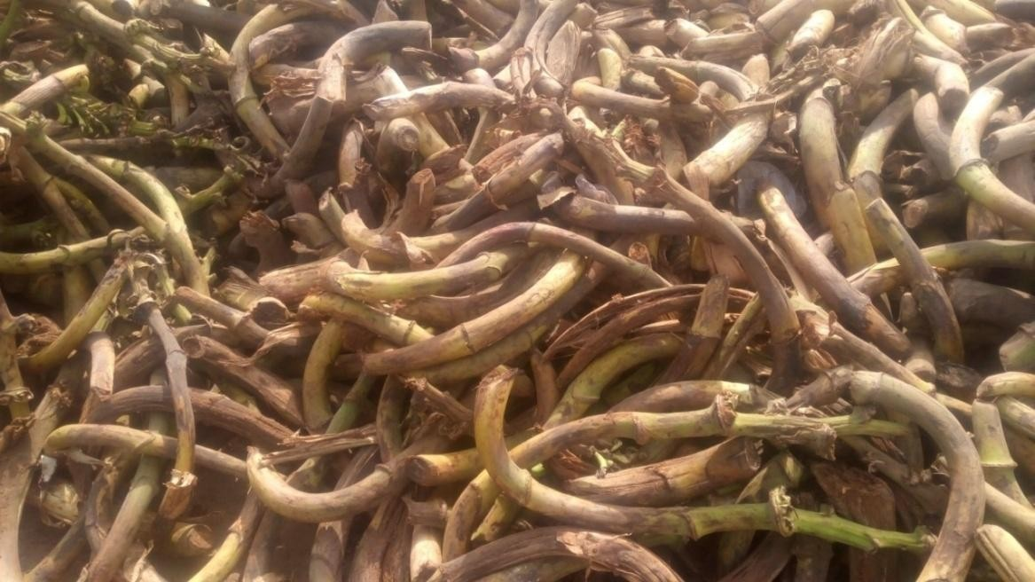

Plate 3.1 Banana peduncles.

Banana peduncle fibre extraction

The banana peduncle was subjected to water retting process for 25 days to extract the fibres from the peduncle. The peduncle was chopped at the inter- node and beaten gently with a mallet in other to loosen and to separate the fibre. Water retting enhanced the production of more identical and high quality fibres. The fibres were removed from the water-retting tank, hand robbed and rinsed in sufficient water. The resulting fibre bundle was scrapped with knife and combed. The process of combing and scrapping was repeated until individual fibres were separated. The separated fibres were washed carefully using running tap water to remove any impurities. Finally, the banana peduncle fibre was sun- dried for one week in atmospheric air to remove the maximum moisture from the fibre for further chemical treatment and analysis.

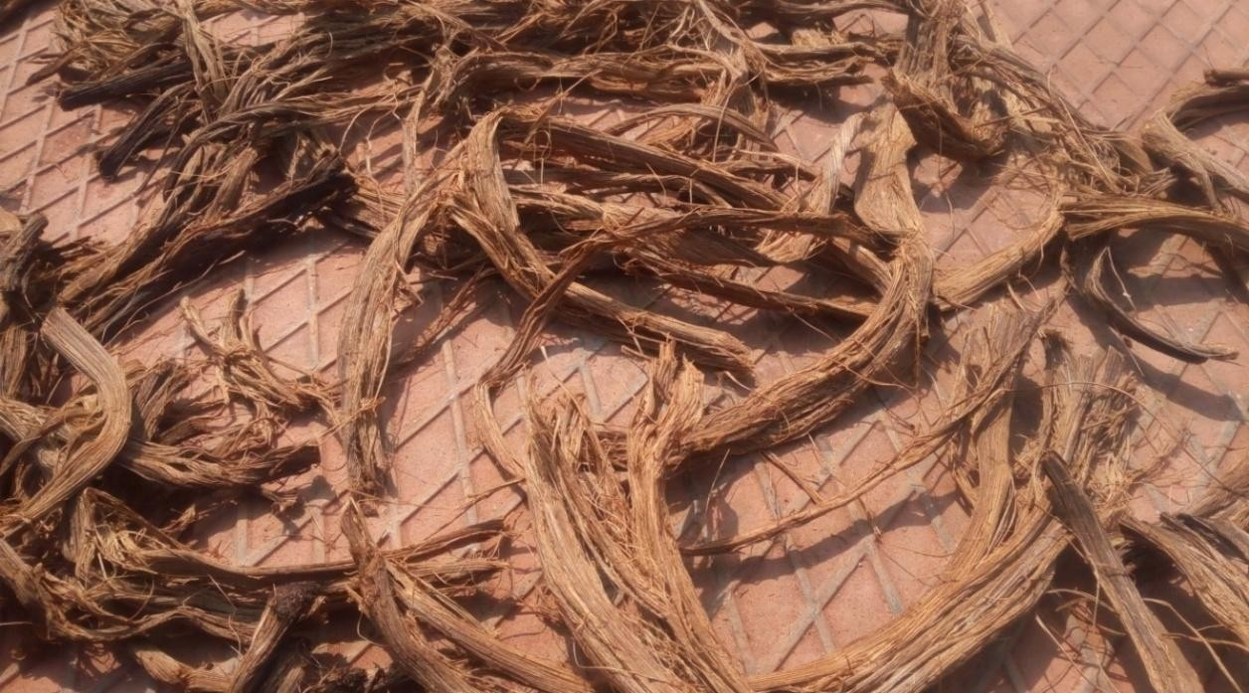

Plates 3.2: Photograph of extracted BPF after water retting



Plate 3.3: Banana peduncle fibreafter extraction

Proposed fire retardant additive material

The proposed fire retardant additive material is cow horn ash particle. The cow horn used for this research was obtained from Artisan Market Abattoir in Enugu, Enugu State Nigeria. The cow horn was washed with water and sun- dried for four weeks. The horn was mechanically crushed with a hammer and

the bony core was isolated from the keratin sheath. About 5kg was washed with water and degreased by soaking it in 5 litres of acetone for two hours. This was to remove any trace of marrow, blood and other substances that will inhibit proper bonding between the matrix and the additive. The degreased bony core was then sun dried for 2 weeks (Plate 3.3).
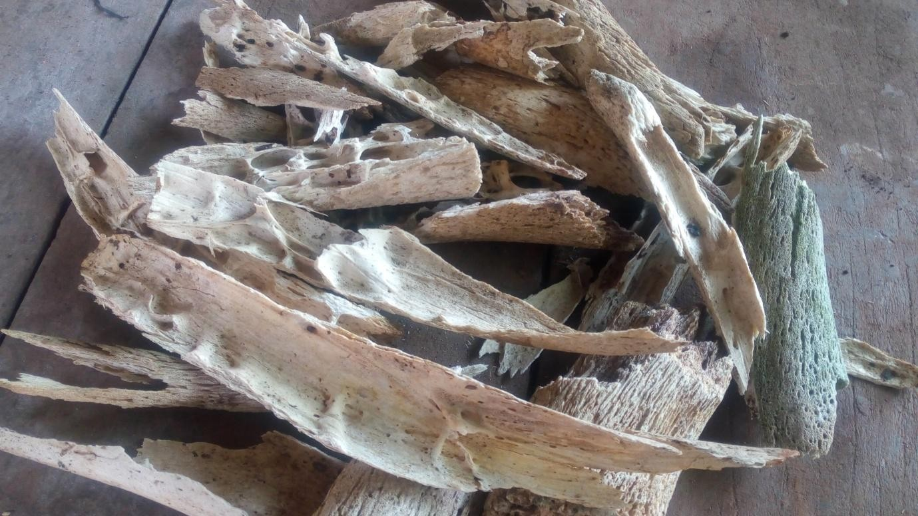

Plates 3.4: Photograph of cow horn bony core.

The bonny core was finally carbonized in a muffle furnace at a temperature of 1200⁰C in the absence of oxygen (Plate 3.4)

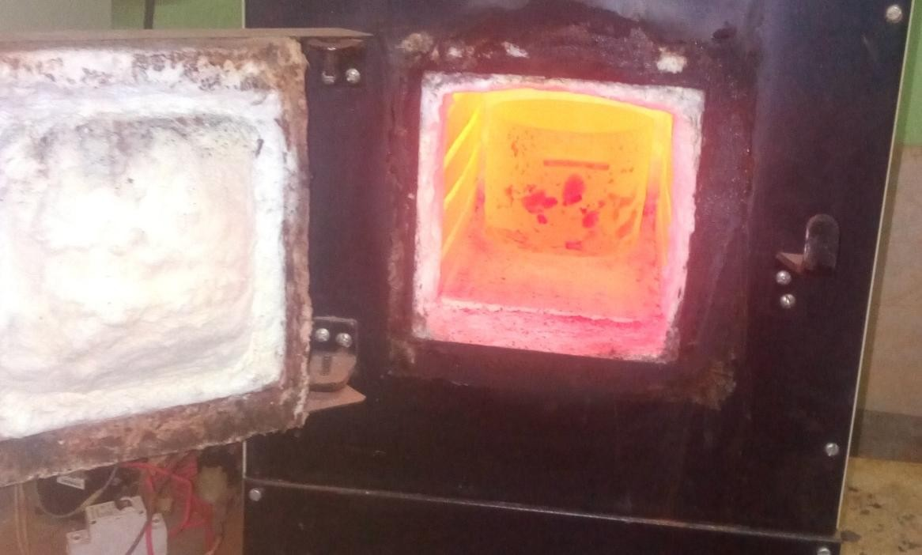

Plate3.5:Photograph of carbonized cow horn bonny core in a muffle furnace.

The carbonized bonny core was size reduced using hammer mill and sieved to a particle size of 125micrometer. The choice of this particle size was informed from literature which gave a range of (90-355micrometer) for particles as having the best tendency to enhance surface activity and blending with polymer-coupling agent(Koranteng, 2015). Generally increasing particle size improves the mechanical properties of particulate rienforced polymer composites. Tensile and flexural properties also are found to gradually increase with increasing particle size (Tasdemis, Biltekin& Caneba, 2009).

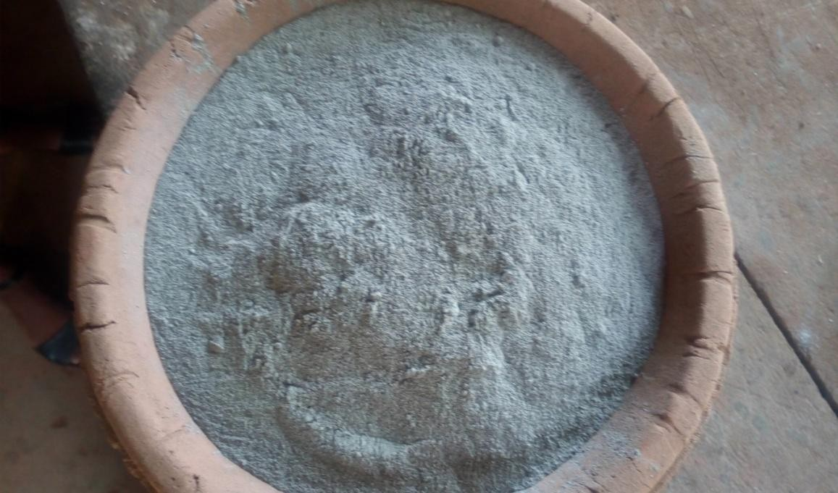

Plates 3.6: Photograph of the sieved cow horn (bone).

Equipment/ Tools

The equipment/tools used includes; Paintbrush, Pair of scissors, Hand gloves, rollers, grinding and filing machine,digital weighing balance,muffle furnace,scriber,universal tensonometer,x-ray diffractometer, transmission electron microscope, cone calorimeter, scanning electron microscope, fourier transform infrared instrument, differencial scanning calorimeter, thermo- gravimetric instrument.

Methods

    - Fibre treatments of banana peduncle fibre

The fibre treatment methods used in this study was adopted from (Ihueze

et al., 2017) with suitable experimental method modifications.

Alkali (Mercerization) treatment

The banana peduncle fibres were cut into 190mm length and thickness of 0.6mm. Small quanties of fibres (20g) were weighed using digital balance. The fibres were placed in a container with pre-mixed NaOH at room temperature. Fibre liquour ratio of 1:15 by weight and NaOH concentration of 2% was used. Treatment times of 1, 2, 3 and 4 hours were investigated.
After each treatment, the fibres were thoroughy washed with running water after neutralization with 1%acetic acid untill a pH of 7 was achieved. The fibres were finally dried to a constant weight in an oven.

Coupling/Silane treatment

Silane coupling agent treatment of fibre has proven to be effective in reducing the number of cellulose hydroxyle groups in fibre – matrix interface. This results in better bonding between fibre and matrix leading to better stress transfer between matrix and fibre.
3-amino-proply trimethoxy silane with concentration of 1% in a solution of acetone and water (50/50 by volume) was used to modify the Banana peduncle fibres at 1, 2, 3 and 4 hours of treatment respectively with fibre lengths of 190mm and thickness of 0.6mm. This was followed by 30 minutes air drying for hydrolyzing the coupling agent. This treatment usually leads to composites with higher tensile strength and improved thermal stability.

Potassium permanganate treatment

The alkali treated fibres were soaked with 4% KMnO₄ (Adjusted to pH of 4 with 4NH₂SO₄ at a liquor ratio of 1:40) solution in 0.055% acetone for 1, 2, 3 and 4 hours of treatment respectively. After each treatment, the fibres were thoroughly washed several times with distilled water until pH 7. Thenthe fibres were decanted to dry in air for 48 hours. The fibre lengths and thickess used were 190mm and 0.6mm respectively.

Acetylation treatment

Acetylation treatment of fibre was reported to improve the fibre-nature adhession. The procedure included an alkali treatment initially followed by acetylation. 20g of Banana peduncle fibres were immensed in 5% NaOH for 1 hr at 30⁰C. The alkaline-treated fibres were soaked in 5% glacial acetic acid for 1hr at optimum temperature 100⁰C using water bath. It was decanted and soaked in an acetic anhydride containing one drop of concentrated H₂SO₄ for 5mins. The treatment with 5% glacial acetic acid was done for 2, 3 and 4 hours respectively at subsequent treatments of test sample. The treated fibres were then filtererd and washed in clean water until pH 7 and dried in an oven at 45⁰C for 1hour. Fibres lengths of 190mm and diameter 0.6mm were used for this modification process.
The choice of acetylation temperature of 100ºC for the research was taken from (Callur & Meke, 2008). Acetylation reaction temperature of 120ºC and above had resulted in the reduction in tensile properties by reducing the
fibre structures (stress, modulus and elongation at break). However at

100ºC,acetylated fibre samples exhibited improved mechanical properties (Tensile strength and modulus) but elongation at break is slightly reduced at high fibre loading of composites. Similar observations were made by (Kuncoro, Andy, Robbi, & Yohor, 2007; Wang, Kabir, & Lau, 2015; & Anike, Onuegbu, Ugochukwu, & Ezuh, 2015).

Composites preparation

      - Formulation of the proposed composites

A basis of 302.40g total mass was used in the proposed coposite composition. This was derived from the density of polyester and dimensions of the fabrication mould.
Density (ϼ) ^{𝑀𝑎𝑠𝑠} ^{(𝑚)}
𝑣𝑜𝑙𝑢𝑚𝑒 (𝑣)

m= ϼv

m = 1.12g/cm³ x (30 x 30 x 0.3)cm³ Total Mass of Composites (m) = 302.40g

Table 3.2: Composition of the proposed composites
Samples | A(%w/w)  BPF:P | B (%w/w)  CHAp:P | C (%w/w)  CHAp:BPF: P | D(% w/w)  BPF: AH: P
1 | 0:100 | 0:100 | 0:0:100 | 0:0:100
2 | 5:95 | 5:95 | 2.5:2.5:95 | 2.5:2.5:95
3 | 10:90 | 10:90 | 5:5:90 | 5:5:90
4 | 15:85 | 15:85 | 7.5:7.5:85 | 7.5:7.5:85
5 | 20:80 | 20:80 | 10:10:80 | 10:10:80

BPF: Banana peduncle fibe, CHAP: Cow horn ash particle,AH: Aluminium hydroxide. P = Polyester resin matrix

Table 3.3: Mass equivalent of composites materials weight percent

Wt% | Mass equivalent (g)
2.5 | 7.56
5 | 15.12
7.5 | 22.68
10 | 30.24
15 | 45.36
20 | 60.48
80 | 241.92
85 | 257.04
90 | 272.16
95 | 287.28
100 | 302.40
Source: Author‟s compilation 2018

      - Composite Fabrication

There are several methods of fabricating composites; the method employed here was the hand lay-up method. A mould having dimensions of 300 x 300 x 3mm was used. Polyvinyl alcohol and wax were used to polish the surface of the mould; they both served as releasing agents that made it easy during demolding of the composite. The resin, polyester and the hardener (MEK) were measured into a beaker in a ratio of 2:1 that is two parts of polyester against one part of the hardener. The mixture was stirred with a glass

rod. Part of the resin was poured into the mould and a brush was used to distribute it across the surface of the mould. The fibres were manually distributed randomly across the mould. The resin was added in the mould while the brush was used to impregnate the fibres until they were saturated.
The cast was cured using a light weight of 8.72KN. The mould was closed for curing at a temperature of 25°C for 24 hours at constant pressure. The cast was cured again in the air for 24hours after removal from the mould. Samples were prepared according to ASTM standard for each mechanical parameter and then taken to the laboratory for test.
Utmost care was taken to maintain uniformity and homogeneity of the composite since reproductivity is somewhat difficult in hand layup method that was used.
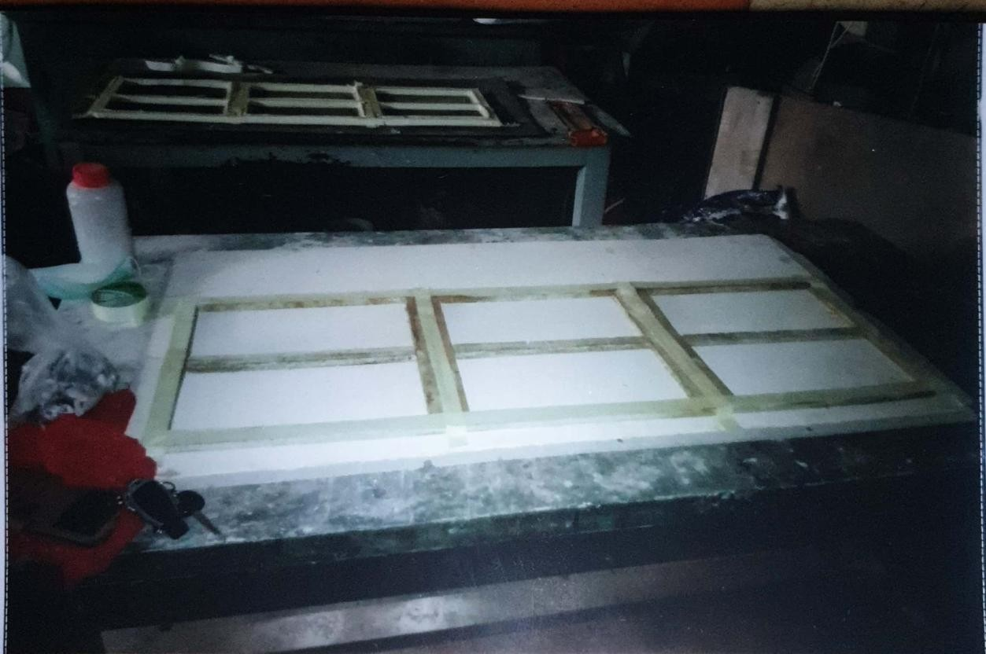
Plate 3.7: Photograph of composites fabrication mould

Plate 3.8: Photograph of the developed composites using cow horn particles.

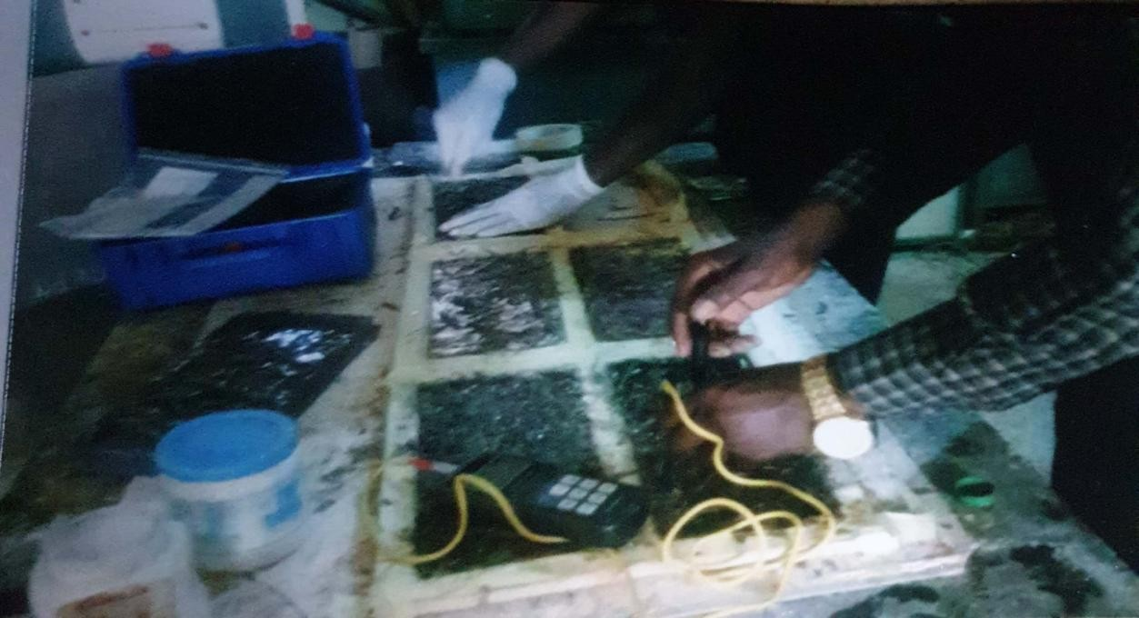
Thermal analytical methods

      - Thermogravimetric analysis (TGA)

Thermal decomposition (TGA) was observed in terms of global mass loss using a TGA Instrument: TGA Q50 thermogravimetric analyzer. The tests were carried out in the laboratories of School of Mining, Metallurgy and Chemical Engineering,University of Johannesburg; South Africa.The apparatus detects the mass loss with a resolution of 0.1 as a function of temperature. The samples were evenly and loosely distributed in an open sample pan of 6.4 mm diameter and 3.2 mm deep with an initial sample weight of 8-10 mg. The temperature change was controlled from room temperature (25±3°C) to 1000°C with a heating rate of 10°C/min. High purity argon was continuously passed into the furnace at a flow rate of 60 mL/min at room temperature and atmospheric pressure. Before starting each run, the argon was used to purge the furnace for

30 min to establish an inert environment in order to prevent any unwanted oxidative decomposition. The TGA and DTA curves were obtained from TGA runs using universal analysis 2000 software from TGA Instruments.
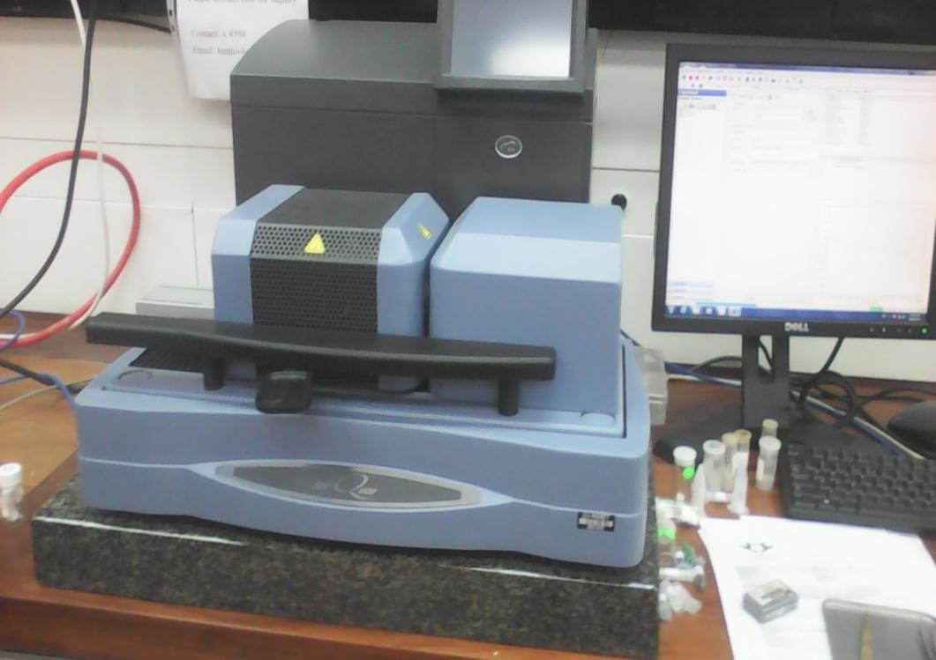
Plate 3.9: Photograph of DTA-TGA equipment.(TA Instruments). 3.3.3.2Differential scanning calorimeter (DSC)
SDT2960 simultaneous DTA-TGA instrument was used for differential scanning calorimetric (DSC) test. All DSC experiments were performed under nitrogen gas flow rate of 20cm³/min with a heating rate of 5°C/min covering the suitable temperature range (Peltolaet al. 2011). 10mg of each test sample was used for each test.
      - Scanning electron microscopic study

Themorphology of BPF,CHAp, and the test composites samples were analysed using a scanning electron microscope (SEM). Scanning electron microscopy (SEM) measurements were carried out using an FEI Quanta 200

(FEI Co., Eindhoven, the Netherlands) electron microscope and operated at an accelerating voltage of 20/10 kV. Test samples were prepared by freezing them in liquid nitrogen before fracturing to expose the cross-sectional area for a visibility of test samples distribution and morphology. (Plate 3.10)
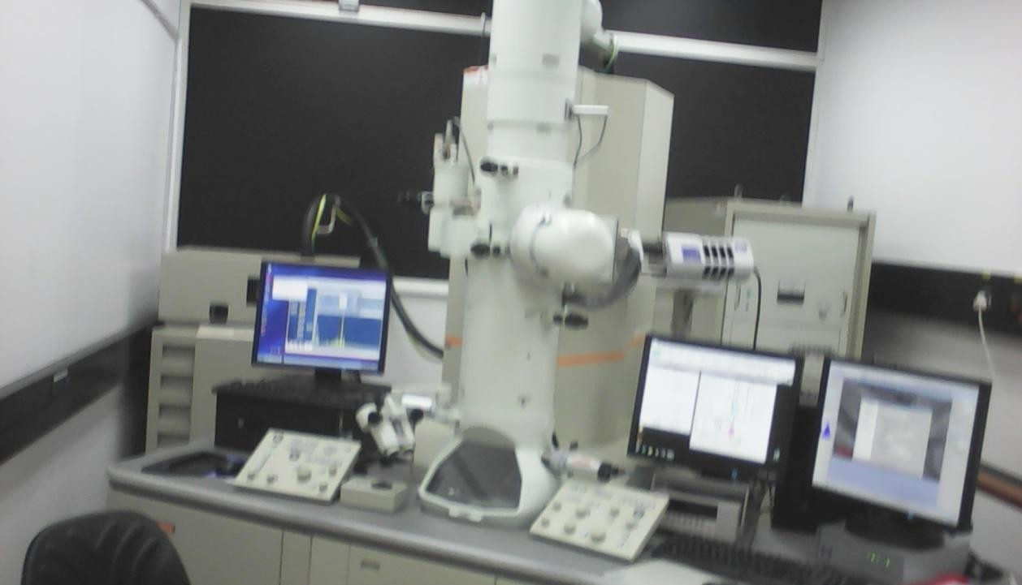

Plate 3.10: Photograph of SEM/EDS instrument

Mechanical Tests of the composites

        - Tensile Tests

Tensile tests were carried out in accordance with ASTM 3039-76 standards using computerized testonometer testing machine for polymer matrix composite materials. Using rectangular sheets of 177mm x 20mm x 5mm and a guage length of 100mm were marked usint the scriber. Tests were done at ambient temperatures at a cross head speed of 10mm/min. Each sample was then tested and the maximum stress (ultimate tensile strength) and maximum strain were recorded. Three (3) specimens from each sample were tested.

        - Flexural Test

The test sample was dimensioned to standard according to ASTM testing code ASTM D2344-84, (4mm thickness x 13mm width x with a length of 190mm), with a cross – head speed of 10mm/min. The sample was placed on a three-point fixture while the machine applied forces of varying degrees on the samples; this went on until the sample deflected. The flexural strength, maximum flexural stress, maximum strain and stress at a strain of the sample were generated by the computerized testonometric instrument. Three specimens each from each sample were tested.
        - ImpactEnergy Test

The basic purpose of impact testing was to determine the energy absorbed at breaking the composite materials. The charpy impact test was used to determine the impact energy of the composities materials. Test samples of the composites were supported and loaded in flexural by the pendulum striker of at a test velocity of 5m/s. V-notch depth of 2.5mm and notch angle of 45⁰ was cut on each specimen prior to testing.
The striker was fixed at the end of the pendulum. The test specimen was changed vertically in the charpy support anvils, fitted on the base of the machine and placed with the notch facing the striker. The sticker swings downwards, hitting the test specimen above the notch at the bottom of its swing. The test was carried out according to ASTMD 256 standards using advanced digital pendulum impact tester instron – IT 9050. Type testing machine (Arbelaiz et al., 2015)

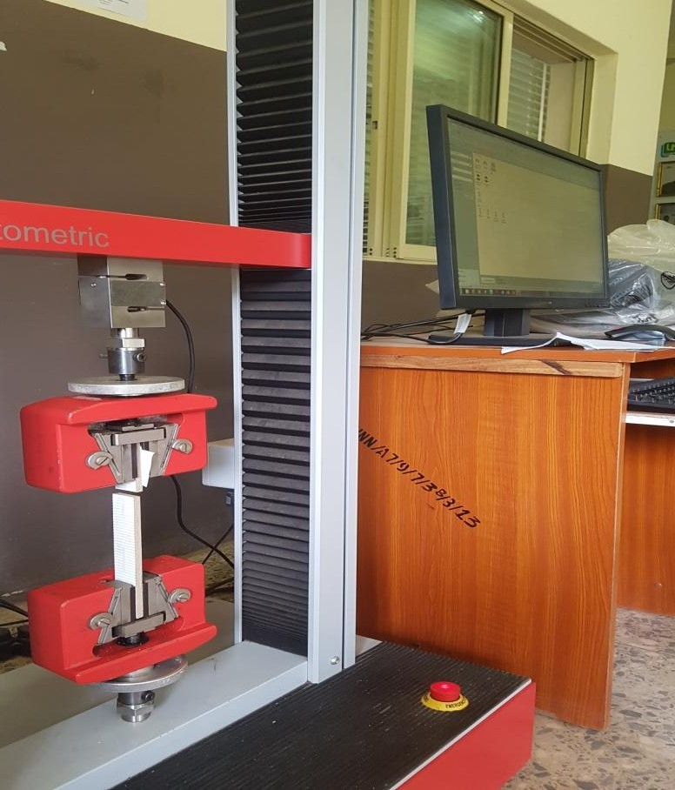

Plate 3.11 Photography of computerized tensonometeric machine

Physical characterization of composites

      - Water absorption tests

The water absorption tests of the developed composites were conducted in accordance with ASTM D570 standard. The water absorption test was carried out in distilled water. Treated banana peduncle fibres were also subjected to this test in this water media. The measurement of water absorbed by the fibres and composites were carried out using an electronic analytical balance. The electronic analytical weighing balance used for measuring masses in this experiment is a JA-series model JA203H, made in China with 0.001g measuring accuracy. The initial masses of the treated fibre materials and composites were measured. The quantity of water absorbed is evaluated using equation

𝑊𝐴=𝑚𝑎−𝑚𝑑/𝑚𝑎 (3.10)

Where𝑚𝑎−𝑚𝑑 is the change in mass after exposure in water (m_{c}), m_{a} is the mass after exposing in water; m_{d} is the mass of dried sample.
      - Density test

A clean sample of 100g of the composites components were weighed accurately in air using a laboratory digital balance and then suspended in water. The weights of the samples when suspended in water were determined, the volumes of the samples were determined from the effect of displacement by water (Archimedean principle). The theoretical density (ρ_{ct}) of the composites in terms of weight fractions were obtained using the relation given by Ahmed et al. (2014).

1

ρ = wf wm
(3.11)

ρ_{f} + ρ_{m}

Where, W and ρ designates the weight fraction and density, respectively. The suffix f, m and ct represent the fibre, matrix and the composite materials, respectively. The actual density (ρ_{ac}) of the composites was determined by simple water immersion technique(Wang, Ding & Sun, 2015).

Elemental Composition Analysis of the Developed Composites

      - FTIR/XRD analysis

In the present study, the infrared spectra of test samples were measured with a FTIR (SHIMADU, series 8300). 2mg of fine powdered test samples pelletized with pottasuim bromide was used for recording the spectra.

Transmittance was measured over a range from 4000 to 500cm⁻¹. In order to assess the influence of the treatment on the fiber crystallinity, XRD analysis was applied using a X‟Pert High Score PW 3209 diffractometer. The equatorial diffraction patterns (2ϴ) was recorded from 10 to 40⁰ using Cu-Kα radiation at 40KV and 20mA. The crystallinity indices (CI) were calculated according to the Segal empirical method:
CI(%) = 100 [(/₀₀₂ - /_{am})/1₀₀₂]

Where 1₀₀₂is the maximum intensity of the 002 lattice reflecttion of the cellulose crystallographic form at 2ϴ = 1_{m} is the intensity of diffraction of the amorphous 2ϴ = 18⁰ (Plate 3.12).
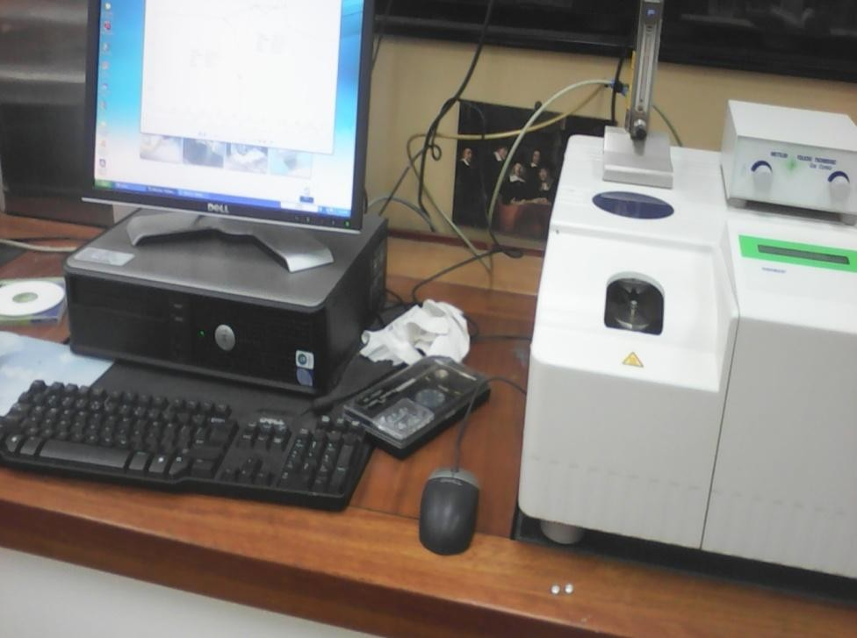

Plate3.12 Photograph of FTIR instrument.

      - Transmission electron microscopy (TEM)

FEI Tecnai 20 transmission electron microscope with a 200-kV acceleration voltage wasused to obtain the TEM micrographs of the test sample. Particle size and morphology of produced CHAp were examined by TEM (Joel,
2010) using a 200 KeV electron beam on the sample mounted on a carbon

coated copper grid. 5ml of CHAp suspension was taken using a dropper and spread on the carbon coated copper grid and allowed to dry in room temperature. The copper grid was introduced into the instrument and the sample chamber was evacuated. The sample was scanned along the path of the electron beam and photograph of the sample was taken.
      - X-ray fluorescence

The elemental composition of the CHAp and BPF were determined using X-ray fluorescence (XRF) analysis. The particles were formed into pellets in a pelletizer with hydraulic press (Carver Inc). 10 g of the pellets were then sealed into the chamber of the XRF (Amptek Inc) and allowed to run for 1000s at a voltage of 20KV, and a current of 40µA. the resulting spectrum measured the elemental composition of the material.

Flammability Test of the Developed Composites

      - Cone calorimetric analysis

Cone Calorimeter instrument was used for this analysis. Test samples were cut on a table saw to the dimensions of 100 x 100mm. All materials are conditioned at 23±3⁰C and the relative humidity of 50±5% for 24hours prior to testing. The samples were rapped with alluminum foil around the back and edges before placing the samples unto the holder and then into the cone calorimeter. This was carried out to prevent any moulting material dripping from the sample unto the load cell. The samples were then backed with a non- combustible insulating refractory material (brick). All tests were carried out in
accordance with ASTM E1354. All the tests were conducted on the cone

calorimeter assembled by fire testing technology limited. The samples were orientated horizontally and exposed to irradiances of 25 and 50kW/m² at a temperature approximate to 600⁰C. The samples were pilot ignited and ran in triplicate; the average score of the three runs were taken. The following parameters were measured, peak heat release rate, total heat release rate, mid heat release rate, total smoke released, time to ignition, total smoke produced and end of test time.
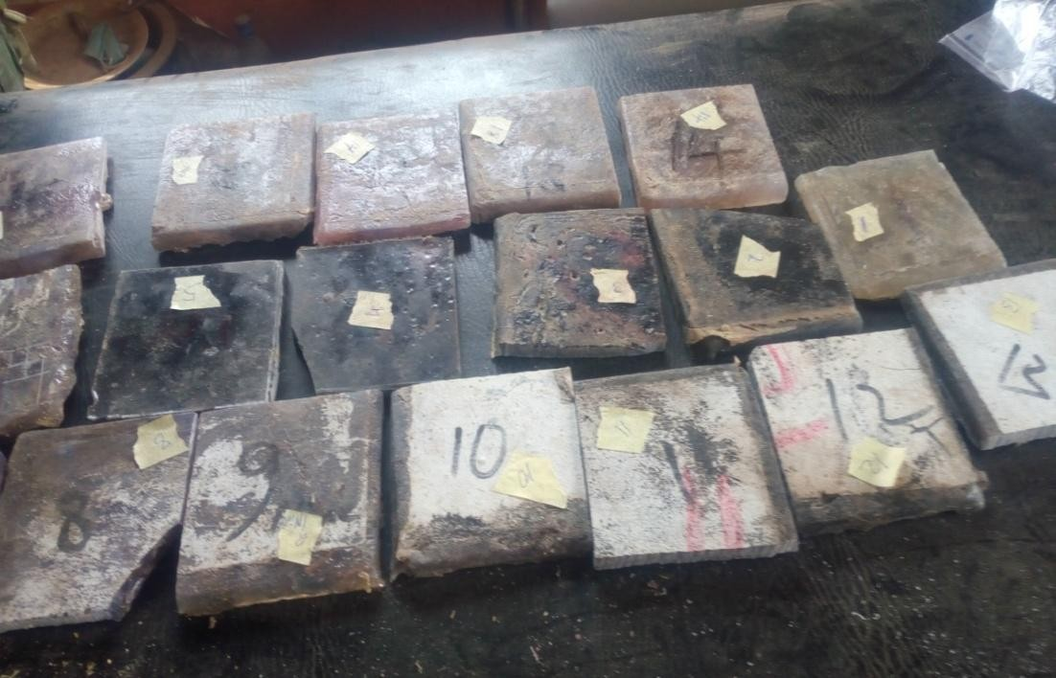

Plate 3.13: Photograph of cone calorimeter test sample.

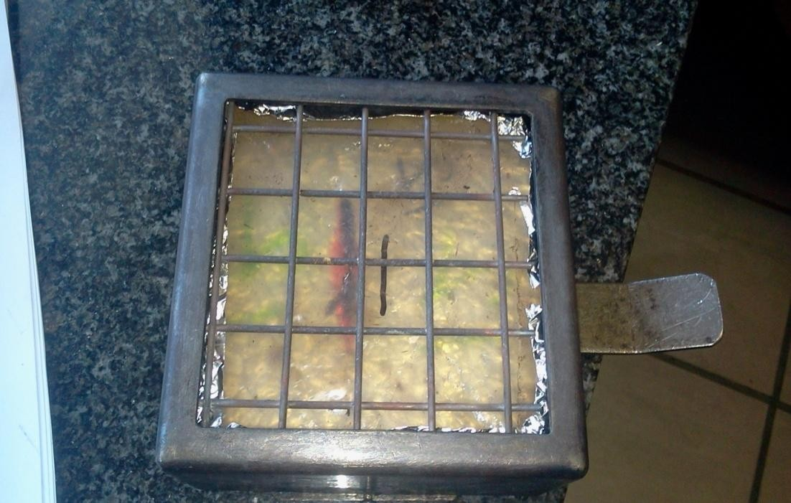

Plate 3.14: Photograph of sample placed in sample holder before the test.
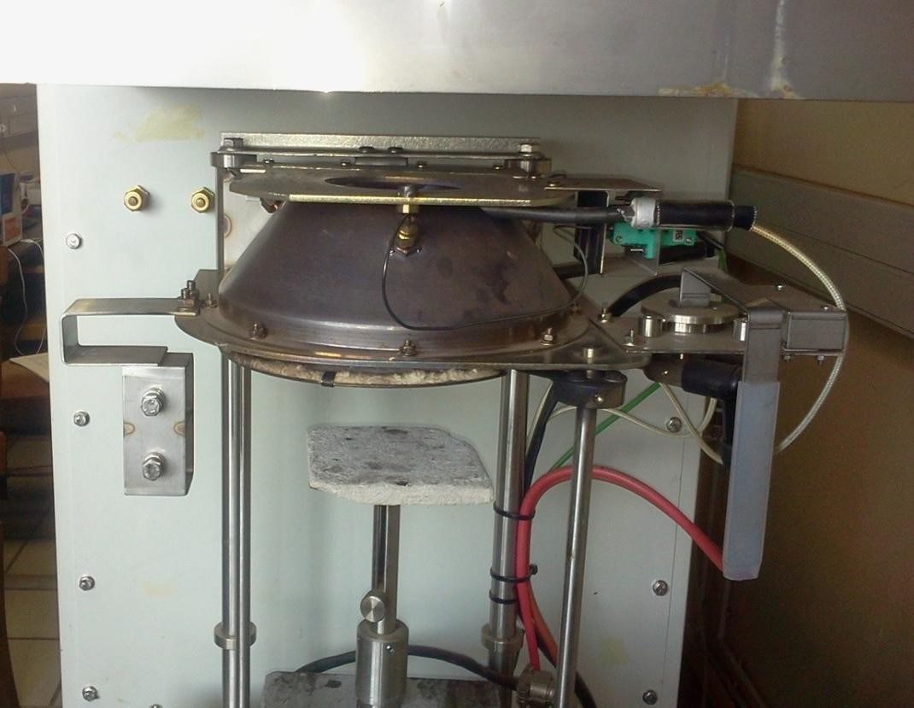
Plate 3.15: Photograph of dual cone calorimeter machine.

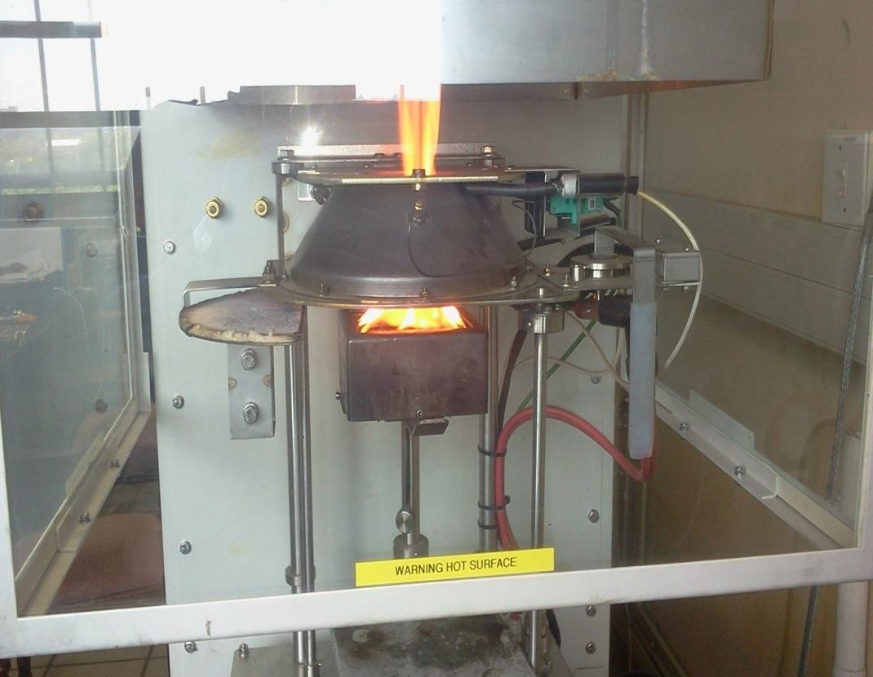

Plate 3.16: Photograph of sample flaming inside the cone.
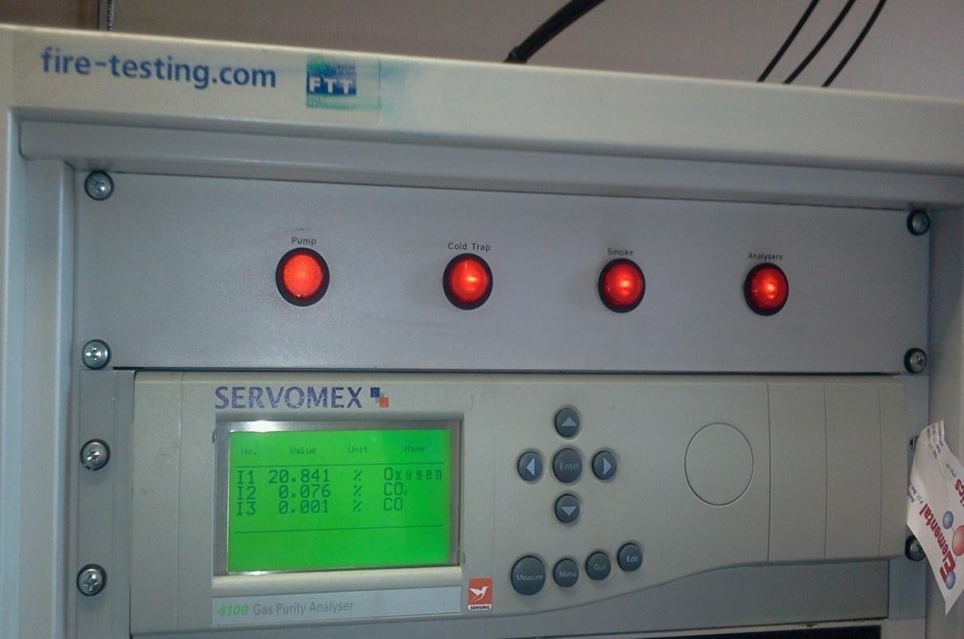
Plate 3.17: Photograph of dual cone calorimeter machine display

CHAPTER FOUR

RESULTS AND DISCUSSION

This chapter presents an analysis of the results of the investigations undertaken in this research and the discussions to enhance adequate interpretations and inferences.

4.1 Results of XRF Analysis of CHAp

Table 4.1 XRF analysis of cow horn ash particle (CHAp)
Element | CaO | SiO2 | K2O | MgO | Na2O | Fe₂O₃ | MnO | Ti₂O
Cow Horn Ash | 86.09 | 8.79 | 0.32 | 1.54 | 0.50 | 0.01 | 0.05 | 0.002

Source: Researchers compilation 2018
The chemical composition of the CHAp was determined by XRF. The results obtained are shown in Table 4.1. From this table, CaO had the highest percentage (86.09%) of the constituents of CHAp. This high percentage of CaO was expected since CHAp was the bony portion of the cow horn. CHAp also had reasonable amounts of SiO₂ (8.79%) and MgO (1.54%). The presence of other compounds such as K₂O, Na₂O, Ti₂O, and MnO occurred at percentages less than one.
This result showed that CHAp could be used as a composite material, since its chemical compositions are similar to that ofXRF analysis of snail shell, eggshell and periwinkle shell used as fillers in composites production (Hassan, Aigbodion and Patrick, 2012; Asuke and Aigbodion, 2016).

4.1 XRD Analysis of Cow Horn Ash Particles (CHAp)

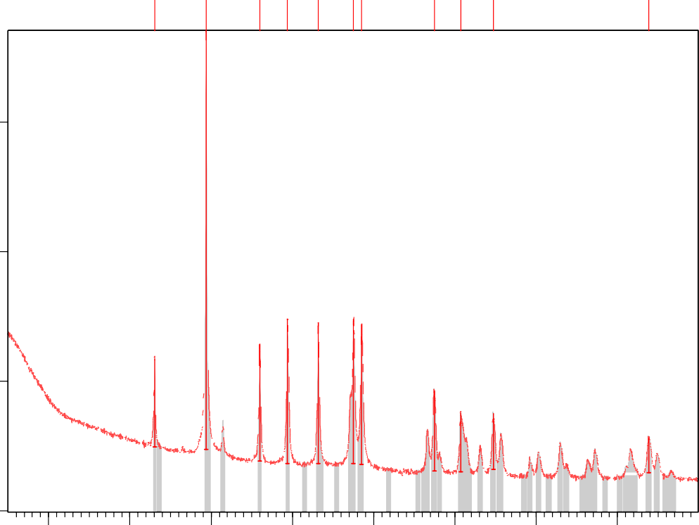Counts
COW HORN XRD.CAF
Ca ( C O3 )

22500

10000
Ca ( C O3 )
Ca ( C O3 )
Ca ( C O3 )
Ca ( C O3 )
Ca ( C O3 )
Ca ( C O3 ); Si O2

2500
Ca ( C O3 )
Ca ( C O3 )
Ca ( C O3 )
Ca ( C O3 )

0
10 20

30 40

50 60
Position [°2Theta]

70 80

Figure 4.1: XRD pattern of CHAp

Table 4.2 Identified pattern list of XRD analysis of CHAp
Visible | Ref. Code | Score | Compoun d name | Displace ment [°2Th.] | Scale factor | Chemical formula
* | 86-2334 | 81 | Calcite | 0.000 | 0.904 | Ca C O₃
* | 81-0069 | 23 | Silicon Oxide | 0.000 | 0.026 | Si O₂
Source: Researchers compilation 2018

Table 4.3: Peak List of XRD pattern of CHAp
Pos. [°2Th.] | Height [cts] | FWHM [°2Th.] | d- spacing [Å] | Rel. Int. [%] | Tip width [°2Th.] | Matched by
23.0340 | 2834.41 | 0.2676 | 3.86128 | 8.40 | 0.2720 | 86-2334
29.3907 | 33727.82 | 0.1673 | 3.03902 | 100.00 | 0.1700 | 86-2334
35.9657 | 3786.14 | 0.2007 | 2.49711 | 11.23 | 0.2040 | 86-2334
39.3997 | 5181.80 | 0.1506 | 2.28702 | 15.36 | 0.1530 | 86-2334
43.1614 | 4946.80 | 0.2007 | 2.09601 | 14.67 | 0.2040 | 86-2334
47.5109 | 5146.45 | 0.2342 | 1.91379 | 15.26 | 0.2380 | 86-2334
48.5053 | 4853.74 | 0.2342 | 1.87685 | 14.39 | 0.2380 | 86-2334;  81-0069
57.4448 | 1910.32 | 0.3346 | 1.60423 | 5.66 | 0.3400 | 86-2334
60.6983 | 1212.91 | 0.3346 | 1.52580 | 3.60 | 0.3400 | 86-2334
64.7088 | 1164.65 | 0.3346 | 1.44059 | 3.45 | 0.3400 | 86-2334
83.8315 | 589.31 | 0.5712 | 1.15308 | 1.75 | 0.4760 | 86-2334
Source: Researchers compilation 2018
Figure 4.1, table 4.2and table 4.3, showed the XRD spectrum andidentified peak list of CHAp. It was observed from the XRD results that calcite (CaCO₃) was the predominant compound in the spectrum. All the peaks are calcite (CaCO₃) phases expected at 48.5053ºand had both Calcite (CaCO₃) and SiO₂ phases. It was observed that as angle 2θ increased from 23.0340⁰ to 83.8315º the interspacing distance deceased from 3.86128⁰ to 1.15308Aº (Table 4.3). The results of the XRD were in agreement with that of XRF shown in section (4.1).

Transmission electron microscopic analysis of CHAp (TEM)

The morphology of CHAp usingTEM is shown in Figure 4.2. CHAp was observed to be round andsolid in nature, but exhibited an irregular size.Spherically shaped particles were also identified. The average particles size of CHAp was determined as 98.13nm (Figure 4.2)

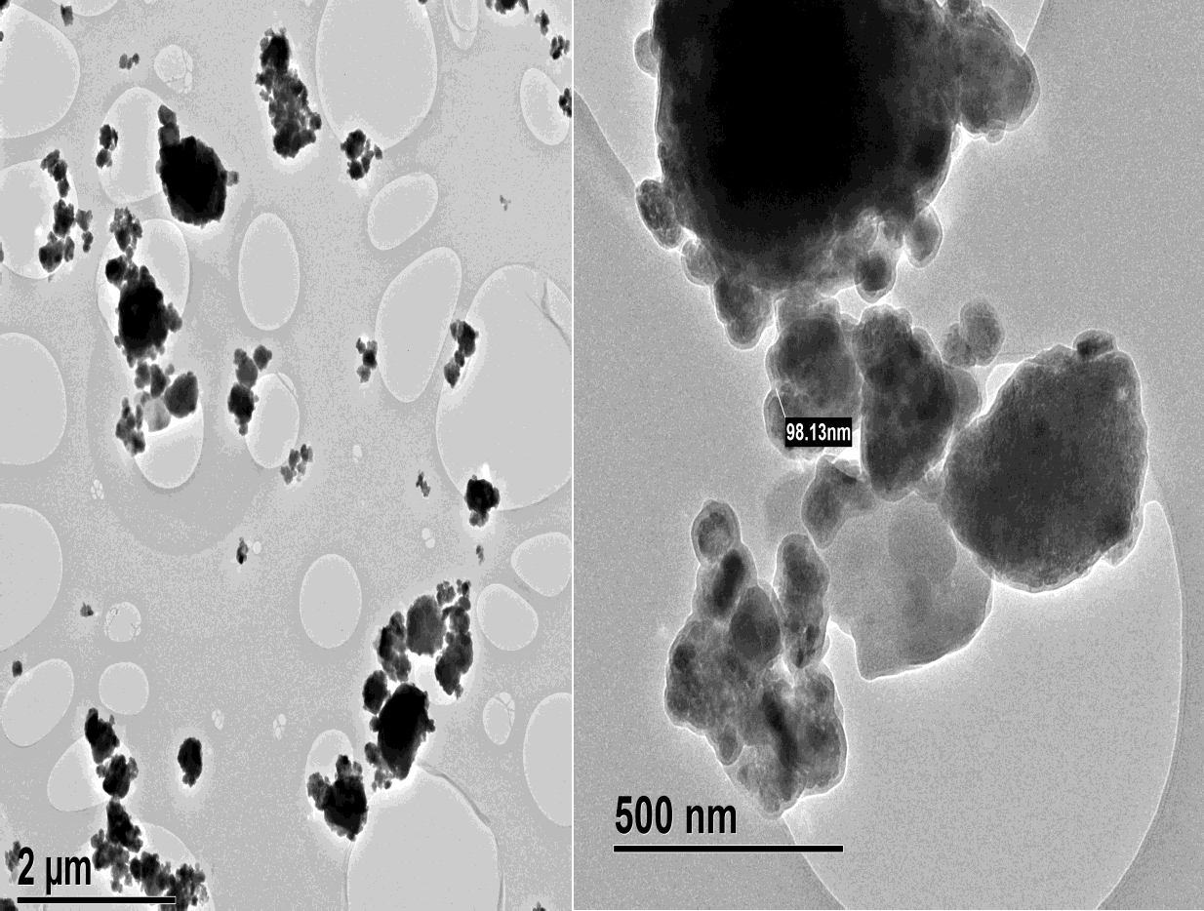

Figure 4.2: TEM morphology of CHAp

SEM analysis of cow horn ash particles

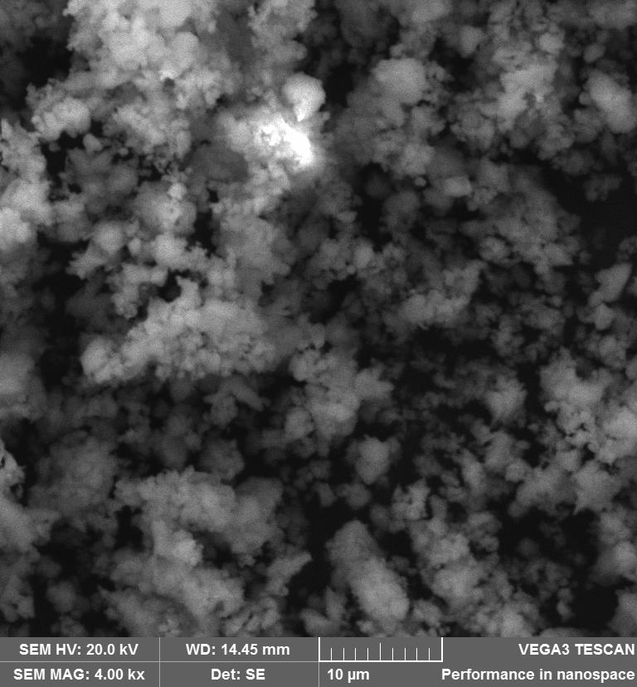

Figure 4.3: SEM analysis of cow horn ash particles

SEM was further used to study the microstructure of CHAp. The resultof the SEM of CHAp is shown in Figure 4.3. It was seen from the figure that the SEM microstructuresof CHAp were round, spherically shaped and solid in nature.The shapes were also tiny and fine.

EnergyDispersion Spectrometric analysis of cow horn ash particles

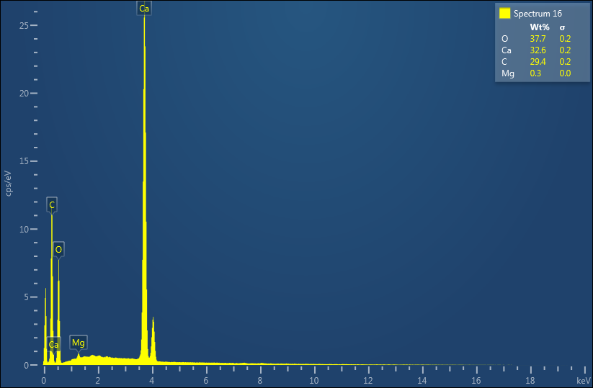

Figure: 4.4EDS analysis of cow horn ash particles

The energy dispersionspectrometric analysis (EDS) of the SEM of CHAp in Fig 4.4 showed a high peak of Ca. This high peak of Ca as revealed by EDS analysis was in agreement with the XRD and XRF analysis that CaO was the dominant compound in CHAp. The presence of C in the EDS analysis was as a result of carbon coating before the SEM analysis. The EDS analysis also showed a high persentage composition of oxygen with smaller concentrations of magnesium. These elements aid the formation of char residue during combustion and reconstructuring approaches.

DTA/TGA of CHAp and BPF

The temperature of destruction (Tdes) of CHAp and BPF were determined from the DTA curves. DTA data were recorded on “Derivatograph

OD 102”, (Q50 thermogravimetric analyzer) at heating rate of 10ºC/min in argon. The results of the DTA/TGA scan of CHAp and BPF are shown in Figures 4.5-4.6. TGA curve of CHAp indicated that it exhibited less decomposition potential. At temperature above 700ºC, the residual weight of CHAp stabilized as a result of the silica and CaO content.This was in agreement with the values earlier reported in literature (Avérous andBoquillon, 2004); (Odera et al., 2016). As the sample was heated up to 700ºC, it started to decompose and decomposition by-products including silica and calcium oxide were formed. The silica and calcium oxide delayed the degradation process and made CHAp more thermally stable when compared to BPF. From the thermal analysis results, CHAp retained 80% of its weight at temperature of 1000ºC (Figure 4.5).
From Figure 4.5 the thermal decomposition of BPF showed an onset decomposition temperature (Tdes) at 200◦C, and the thermal decomposition process hadonly one stage with Tmax at 350◦C (Figure 4.6). BPF left almost no char (residue) at a temperature of 495◦C. The higher temperature of thermal stability of CHAp than BPF indicated that CHAp can serve as a flame retardant additive which could be used to increase the thermal stability of composites.

100
BPF CHAp

80

60
Weight loss (%)

40

20

0

-100 0 100 200 300 400 500 600 700 800 900 1000 1100
Temperature (oC)

Figure 4.5: TGA curves of the CHAp and BPF.

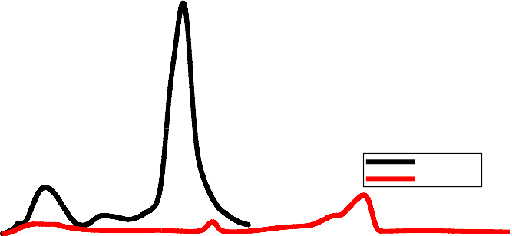1.2
BPF CHAp

1.0

0.8
Deriv.weight

0.6

0.4

0.2

0.0

-100 0 100 200 300 400 500 600 700 800 900 1000 1100
Temperature (oC)

Figure 4.6: DTA curves of the CHAp and BPF

Densities of CHAp and BPF

From the density tests on CHAp and BPF, it was observed that CHAp had a density of 0.962g/cm³ and BPF had a density of 0.438 g/cm³. These lower densities showed that CHAp and BPF are lighter materials than Polyester which had a density of 1.12g/cm³. This signifies that lower weight composites can be produced using CHAp and BPF as filler and reinforcement respectively in polyester composites production.

Chemical treatment of BPF

Standard methods were used for this analysis (Metller Toledo xsz05 and Sartorius, model MA45)

Table 4.4: Compositions of BPF at different chemical treatments
Compound | Untreated BPF | Alkali Treated  BPF | Silane Treated  BPF | KMnO₄  Treated BPF | Acetylation Treated BPF
α-Cellulose | 63.40 | 75.81 | 82.23 | 77.78 | 79.67
Hemicellulose | 10.56 | 6.45 | 3.78 | 5.81 | 4.56
Lignin | 8.50 | 7.31 | 2.34 | 4.09 | 3.68
Pectin | 3.56 | 1.34 | 1.02 | 1.30 | 1.24

Source: Researchers compilation from chemical composition analysis 2018.

Mechanical analysis of banana peduncle fibre at different treatment methods and time
Results of tensile testing (Appendices B (1-16)) revealed that strain rates played a significant role in the strength of the Fiber Stress-Strain Curves.The representative stress-strain curves for banana peduncle fiberat different chemical treatments and time are shown in Appendices B (1-16). There was some initial compliance of the system. The curves showed the tendency of a dominantly brittle fracture for the fibers, except at the lowest strain rate of 0.1 min−¹. Some of the fibers showed verification for strain-hardening. This fact can be taken as a progressive reorientation of micro-fibrils, which occured for some of the fibers. Apparently from the stress–strain curves, higher strain rates

resulted in higher apparent modulus values. Banana peduncle fibers have shown high variability along the length and between fibers, which is a characteristic of natural fibers. The Stress of banana peduncle fibers was a function of the testing speed. At lower strain rate, an increase in strain facilitates the amorphous to crystalline sharing of load. At higher speeds, however, the faults dominate with catastrophic failure at the highest strain rates. Therefore, there is an inversely proportional relationship between the strain rate and the strain. Some of the stress- strain curves showed signs of strain hardening.
The tensile strength is the ratio of the force at yield, to the cross sectional area, tensile modulus is the ratio of stress to strain. The flexural strength is the force at rupture divided by the cross sectional area, while impact strength is the ratio of energy value taken from pendulum to the sample thickness. In the present study these mechanical values were automatically generated at test points by a computerized testonometric instrument, as shownin the stress – strain curves for each chemical treatment method and varying time(Appendices B:1-16).
The tensile strengths of chemically modified BPF were determined. The results are shown in Appendices B (1-16) and Figures 4.8-4.10. It was observed that treatment time and different chemical treatments played a major role in determining the tensile properties of the BPF. It had been established that chemical treatment of natural fibres helped to remove lignin, oil and wax that covered the fiber wall, exposed the short length crystallites and depolymerised
the cellulose (Ratna and Mohana, 2017). It was also observed that the results of

the elastic modulus are quite different from that of the tensile strength and % elongation. The higher the elastic modulus the, lower the % elongation of the fibres (Rahmanian 2014).
6000
5000
4000
3000
Alkali
Silane
2000
KMnO4
Acetylation
1000
0
1
2
3
4
Treatment time(hours)
Elastic Modulus(N/mm₂)

Figure 4.7: Variations of elastic modulus with treatment time.
160
140
120
100
80
60
40
20
0
Alkali
Silane KMnO4
Acetylation
1 2 3 4
Treatment time(hours)
Tensile Strength(N/mm₂)

Figure 4.8: Variations of tensile strength with treatment time.

%Elongation

Figure 4.9: Variations of %elongation with treatment time.
12

10

8

6

4

2
Alkali
Silane KMnO4
Acetylation
0
1
2
3
4
Treatment time(hours)

The tensile strength effect for alkali treatment is shown in Figure 4.10. From Figure 4.8, it was observed that the alkali treatment of the BPF increased its tensile strengths from 1.62 to 55.28, 98.33, 89.61 and 54.29N/mm² at treatment time of 1, 2, 3, 4hours respectively. The alkali treatment of the BPF before other chemical treatments ionized the hydroxyl to alkoxide and removed lignin, andhemicelluloses. The fibrils were arranged along the tensile loading direction whichexerted higher stress on the fibres. Maximum tensile strength was observed for alkali treatment at 2hours (Figure 4.10).After 2hours of treatment with alkali, the delignification of the BPF occurred and decreased the strength of the fires.

Mean

Figure 4.10: Variationn of the tensile strength with treatment time for the alkali treatment.
Main Effects Plot for Alkali
Data Means
100
90
80
70
60
50
1
2
3
4
Time(hours)

The tensile strength effect of silane treatment is shown in Figure 4.11. From Figures 4.8 and 4.11 it was noticed that there was significant improvement on the mechanical properties of the silane treated fibre. This treatment increased the strength of the fiber to 143.61N/mm², at 3hours well above that of the alkali treatment (98.33N/mm²), and the untreated fiber (51.62N/mm²). The silane treatment had a high %elongation of 9.931% while that of the untreated fibre was 2.39%(Figure 4.9). The higher percentage elongation values recorded for the silane treatment of the BPF was attributed to the fact that it reduced the number of hydroxyl groups in the fibre. The hydrolysable alkoxy group formed silanols, which reacted with the BPF to form a well stable covalent bond.

Mean

Figure 4.11: Variation of the tensile strength with treatment time for the silane treatments.
Main Effects Plot for Silane
Data Means
140
130
120
110
100
90
80
70
60
50
1
2
3
4
Time(hours)

Figure 4.12 showed the tensile strength effect of acetylation treatment of the BPF. From Figures 4.9 and 4.12 it was observed that acetic anhydride treatment of the BPF had a maximum tensile strength of 108.61N/mm² at 2hours(Figure 4.12), which is more than that of the alkali 98.33N/mm² and that of the untreated fiber which is 51.62N/mm². These results obtained for the acetylation treatment were attributed to the plasticization of the cellulosic fibres which decreased the hygroscopic nature of the fibres.

Mean

Figure 4.12: Variation of the tensile strength with treatment time for the acetylation treatments.
Main Effects Plot for Acetylation
Data Means
110
100
90
80
70
60
1
2
3
4
Time(hours)
Figure 4.13 showed the tensile strength of the permanganate treatment of BPF. Maximum strength of 118.89N/mm² was recorded at 2hours (Figure 4.8 and Figure 4.13). As the treatment time increased, the effect of KMnO₄ on the fiber became more severe, setting in chemical degradation of the fiber and reduced its strength.

Mean

Figure 4.13: Variations of the tensile strength with treatment time for the KMnO₄treatment
Main Effects Plot for KMnO4
Data Means
120

110

100
90

80
70

60
1
2
3
4
Time(hours)

It has been generally observed that potassium permanganate treatment of natural fibre, improves all tensile properties of ultimate composite system except tensile strain.

Chemical composition of BPF

The chemical constituents of BPF are shownin Table 4.4. It was observed that cellulose was the major constituent of the fibre, followed by hemicelluloses and then lignin. The presence of hemicelluloses and lignin, contributed to the weak interfacial bonding of the fibre in polymer matrix. After chemical treatment, the percentages of hemicelluloses and lignin reduced drastically. This was because chemical treatment helped to remove impurities
and exposed the fibres micro pores. The presence of micro pores in the BPF

showed that it could accommodate more resins than the untreated fibres, depicting increased interfacial bonding. From the Table 4.4, it was observed that the Silane treated fibres had reduced amount of non-celluloses fibre materials such as: hemicelluloses, lignin and pectin.

The celluloses contents of BPF were enhanced to 63.40, 75.81, 82.23,

77.78 and 79.67% for the untreated BPF, with alkali, silane, KMnO₄ and acetylation treatments, respectively. This improvement in the celluloses content could be attributed to the fact that the reduction in the percentage of non- celluloses contents enhanced the quantity of the cellulose content of the fibres. Similar findings were observed in the work of Joseph et al.(2015).

Treatments with alkali only, decreased the lignin content from 8.5 to 7.31% comparedto silane treatment which decreased the values to 2.34%. This connoted that with alkali treatment, the effective removal of lignin cannot be achieved due to the strong carbon-carbon bonds of the lignin. The higher percentage of the cellulose content in the silane treatment is the major reason for the higher tensile strength recorded in this work. The silane treatment for 3hours was the treatment choice for fibre treatments and was used in the production of the composite, since the maximum tensile strength was obtained at this condition.

Microstructure of the untreated and coupling/Silane treated BPF

The microstructure of the untreated and silane treated BPF were obtained with the aid of SEM. Figures 4.14-4.15 displayed the microstructure of theBPF. From thesefigures, it was observed that the SEM image of the untreated fibres was smoother in surface than that of the treated fibres Figure 4.14and Figure
4.15. In Figure 4.14 it was observed that wax, oil and impurities had formed a protective layer on the surface of the fibres which caused weak interfacial bonding between polymers and the fibres. In Figure 4.15, it was observed that the surface of the fibres were rough due to the removal of wax, oil and impurities by chemical treatment with silane. The increased surface roughness enhanced the interfacial bonding between the BPF and the polymer matrix and the possibility of load transfer between the BPF and polymer increased. Similar observation was made by (Kokta et al.,2012).

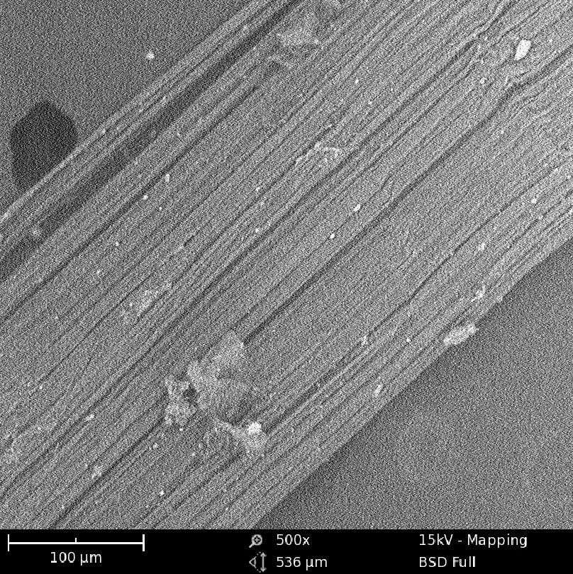

Figure4.14: SEM microstructure of untreated BPF.

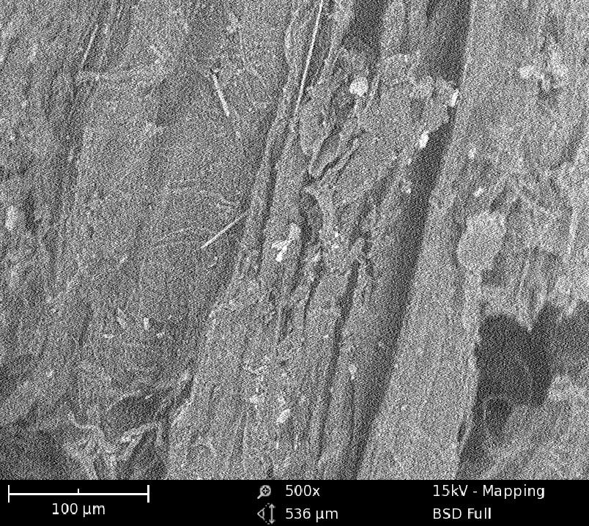

Figure 4.15: SEM microstructure of Silane treated BPF.

The energy dispersion spectrometeric analysis (EDS), of the treatedBPF is shown in Figure 4.16. It exhibited a high peak of Carbon. This high peak of Carbon identified in the EDS analysis signified that BPF is from the organic family of cellulose. Other major elemental compositions of BPF are oxygen 52.4%, potasium5.2%, aluminium 2.1%, silicon 2%, and calcium 1.1%.
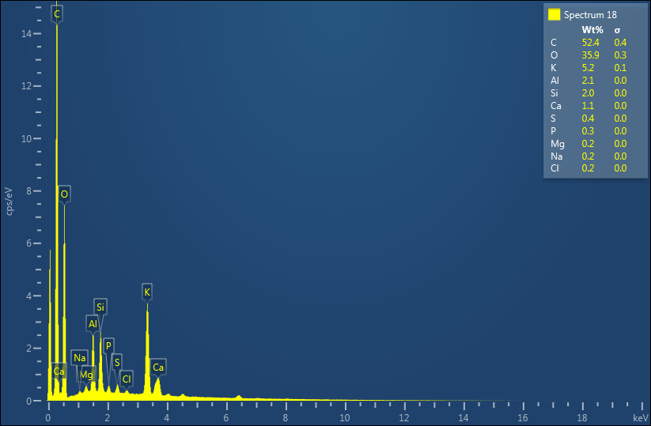

Figure 4.16: EDS of treated BPF.

Physical and Mechanical Characterization of polyester resin andthe developed Composites
Table 4.5a Comparative analysis of the results of the physical and mechanical properties of polyester resin and the developed composites with banana peduncle fibre (BPF)
Composition of composites | Density (g/cm3) | W.A (%) | T.M (GPa) | T.S (MPa) | F.M (GPa) | F.S (MPa) | Impact Energy  J/mm²
Polyester (P) | 1.20 | 0.98 | 247.05 | 5.47 | 1172.93 | 20.22 | 4.90
5wt%BPF : 95wt% P |  | 0.99 | 357.80 | 10.24 | 1770.70 | 22.12 | 5.88
10wt%BPF : 90 wt% P |  | 1.20 | 371.40 | 12.84 | 2416.93 | 25.00 | 6.08
15wt%BPF : 85 wt% P |  | 1.25 | 358.60 | 12.94 | 2794.74 | 31.00 | 6.66
20wt%BPF : 80 wt% P |  | 1.45 | 389.60 | 15.40 | 2522.57 | 31.67 | 6.87
Table 4.5b Comparative analysis of the results of the physical and mechanical properties of polyester
resin and the developed composites with cow horn ash particle (CHAp)
Composition of composites | Density (g/cm3) | W.A (%) | T.M (GPa) | T.S (MPa) | F.M (GPa) | F.S (MPa) | Impact Energy  J/mm²
Polyester (P) | 1.20 | 0.98 | 247.05 | 5.47 | 1172.93 | 20.22 | 4.90
5wt%CHAp : 95wt% P |  | 0.55 | 109.94 | 4.64 | 1476.54 | 18.55 | 4.67
10wt%CHAp : 90wt% P |  | 0.50 | 109.84 | 3.10 | 1213.64 | 16.22 | 3.09
15wt%CHAp :85 wt/% P |  | 0.50 | 97.40 | 3.00 | 1244.90 | 17.70 | 3.00
20wt%CHAp: 80 wt% P |  | 0.47 | 95.40 | 2.08 | 1182.90 | 12.14 | 2.78
Table 4.5c Comparative analysis of the results of the physical and mechanical properties of polyester resin
and the developed composites with CHAp and BPF
Composition of composites | Density (g/cm3) | W.A (%) | T.M (GPa) | T.S (MPa) | F.M (GPa) | F.S (MPa) | Impact Energy  J/mm²
Polyester (P) | 1.20 | 0.98 | 247.05 | 5.47 | 1192.30 | 20.22 | 4.90
2.5wt%CHAp:2.5wt%BPF:95wt% P | 1.18 | 0.67 | 376.10 | 9.02 | 2228.00 | 26.90 | 5.00
5wt%CHAp:5wt%BPF: 90wt% P | 1.05 | 0.53 | 435.00 | 13.40 | 1972.60 | 34.37 | 5.20
7.5wt%CHAp:7.5wt%BPF: 85wt%P | 1.02 | 0.38 | 476.00 | 117.87 | 2522.57 | 59.97 | 5.88
10wt%CHAp:10wt%BPF: 80wt%P | 0.98 | 0.39 | 236.00 | 11.00 | 1614.30 | 25.15 | 5.66
Table 4.5d Comparative analysis of the results of the physical and mechanical properties of polyester resin and the developed composites with CHAp and BPF
Composition of composites | Density (g/cm3) | W.A (%) | T.M (GPa) | T.S (MPa) | F.M (GPa) | F.S (MPa) | Impact Energy J/mm²
Polyester(P) | 1.20 | 0.98 | 247.05 | 5.47 | 1192.30 | 20.022 | 4.90
2.5wt%AH:2.5wt%BPF: 95wt% P | 1.17 | 0.76 | 403.79 | 12.32 | 1815.94 | 25.75 | 5.20
5wt%AH:5wt%BPF: 90wt% P | 1.06 | 0.69 | 478.30 | 12.80 | 1607.17 | 33.61 | 5.70
7.5wt%AH:7.5wt%BPF: 85wt% P | 0.99 | 0.41 | 501.00 | 19.90 | 1727.10 | 63.21 | 6.08
10wt%AH:10wt%BPF: 80wt% P | 0.89 | 0.39 | 345.10 | 11.56 | 1948.53 | 23.14 | 5.66
Source: Researchers compilation 2018

W.A=water absorption, TM=tensile modulus, TS=tensile strength, FM=flexural modulus, FS=flexural strength.

Density of composites

The various result of density values of composites produced with CHAp and BPF are shown in Figure 4.17 and Table 4.5(a-d). From figure 4.18, it was observed that as the wt% CHAp and BPF increased in the polyester matrix the density of the composites produced decreased. This effect was attributed to the fact that the BPF and CHAp have lower densities than the polyester. This observation shows that BPF and CHAp could be used to develop lower density composites for engineering materials applications. Similar observation was made in the work of Hassan et al. (2012).
1.4
1.2
1
0.8
0.6
CHAp:BPF
BPF:AH
0.4
0.2
0
00:00
2.5:2.5
05:05
7.5:7.5
10:10
weight%
Density(g/cm³)

Figure 4.17: Variations of density of the developed composites with varying weight% CHAp, BPF and AH additions.

Water absorption

The results of water absorption percentages are shown in Figures 4.18-

4.19 and Table 4.5(a-d). It was observed from these figures that the composites produced with only BPF had higher water absorption percentages compared to composites produced with combinations of either BPF: CHAp or BPF: AH which had lower water absorption percentages. It was also observed that the water absorption percentages in the composites produced with BPF increased with increase in weight% BPF addition (Figure 4.18).

Waterabsorption percentages of the developed composites are shown in Figure 4.19. The results obtained revealed that the water absorption after 25days of the compositesreduced to minimum levels of 0.40% and 0.38% for composites produced with7.5%CHAp: 7.5%BPF and 7.5%CHAp: 7.5%AH respectively. The incorporations of CHAp and AH additives slightly decreased the void content of the composites and reduced their water absorption levels. Nevertheless the water absorption obtained in this study was less than the maximum 6% acceptable for the production of composites for outdoor engineering applications. (Akindapo et al., 2015).

Figure 4.18: Variations of %water absorption with varying weight % CHAp and BPF additions.
1.6
1.4
1.2
1
0.8
0.6
0.4
0.2
0
CHAp
BPF
0 5 10 15 20
weight%
1.2
1
0.8
0.6
0.4
CHAp:BPF
BPF:AH
0.2
0
00:00 2.5:2.5 05:05 7.5:7.5 10:10
weight%
% of Water absorption
% of Water absorption

Figure 4.19: Variations of %Water absorption of the developed composites with varying weight % CHAp: BPF and BPF: AH additions.

4.15Tensile properties of the developed composites

If a material is subjected to high-strain deformation, it deforms permanently (plastic deformation) and ultimately fails. For sufficiently low stresses ans strains, the polymeric material behaves as a linear elastic solid. The point where the behaviour starts to be non-linear is called the proportional limit.

The local maximum in the stress-strain curve is called the yield point and indicates the permanent deformation. The corresponding stress and elongation are called yield strength and elongation at yield. Beyond the yield point the material stretches out considerably and this region is called the plastic region. Further elongation leads to strain hardening and the ultimate rupture of the material. At the rupture point the corresponding stress and strain are called the ultimate strength and the elongation at break. The stress-strain behaviour of a polymeric material depends on various parameters such as molecular characteristics, microstructure, strain-rate and temperature.
The results of the force-extension curves obtained for the developed composites are displayed in Figures 4.20-4.23, while that of the tensile modulus and strengthare shown in Figures4.24-4.27 and Table 4.5(a-d)respectively. From figures 4.20-4.23 it was observed that the composites produced with BPF had the largest area under the force versus extension plot. This is as a result of tougher properties of BPF compared to CHAp. In all the results, the samples had a slight increment in the proportional region until the maximum forces were obtained in the materials.Beyond this point there was a sharp decreased to point zero. Thesamples had their highest force of 4450N and 4950N with composites produced with 7.5%CHA:7%.BPF and 7.5%AH:7.5%BPF respectively.

4000

0BPF
10BPF
20BPF
15BPF
5BPF

3500

3000

2500
Force (N)

2000

1500

1000

500

0
0.0 0.5 1.0 1.5 2.0 2.5 3.0 3.5 4.0 4.5 5.0 5.5 6.0 6.5 7.0 7.5 8.0
Extension (mm)

Figure 4.20: Variations of Force with Extension for composites produced with varying wt% BPF additions.

4000

0CHAp
10CHAp
20CHAp
15CHAp
5CHAp

3500

3000

2500
Force (N)

2000

1500

1000

500

0
0.0 0.5 1.0 1.5 2.0 2.5 3.0 3.5 4.0 4.5 5.0 5.5 6.0 6.5 7.0 7.5 8.0
Extension (mm)

Figure 4.21: Variations of Force with Extension for composites produced with varying wt% CHAp additions.

5500

0AH:0BPF
2.5AH:2.5BPF
5AH:5BPF
7.5AH:7.5BPF
10AH:10BPF

5000

4500

4000

3500

3000
Force (N)

2500

2000

1500

1000

500

0
0.0 0.5 1.0 1.5 2.0 2.5 3.0 3.5 4.0 4.5 5.0 5.5 6.0 6.5 7.0 7.5 8.0
Extension (mm)

Figure 4.22: Variations of Force with Extension for composites produced with varying wt% BPF: AH additions.

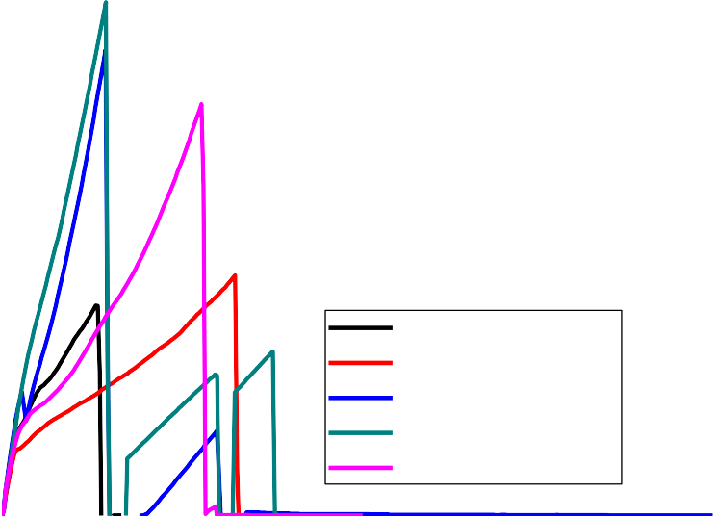4500

0CHAp:BPF
2.5CHAp:2.5BPF
5CHAp:5BPF
7.5CHAp:7.5BPF
10CHAp:10BPF

4000

3500

3000

2500
Force (N)

2000

1500

1000

500

0
0 2 4 6 8 10 12 14 16 18
Extension (mm)

Figure 4.23 Variations of force with extension for composites produced with varying wt% BPF: CHAp additions.

Tensile strength and modulus of natural reinforced polymer composites depend on several factors such as the force–extension behaviors of reinforcement and matrix phases, the phase weight fractions, fillers concentrations and the distribution of the reinforcement in the composites. Modulus is the measure of stiffness of a solid material.A rigid material has an infinite modulus because an infinite force is needed to deform such a material. Figures 4.24-4.25 showed that the tensile modulus of the composite samples increased significantly after reinforcement with BPF and combinations of BPF: CHAp and BPF: AH. For example tensile modulus of 247.05, 476 and 501MPa were obtained for the polyester and composite at 7.5%BPF: CHAp7.5% and 7.5%BPF: 7.5%AH respectively (Tables 4.5). This showed that the stiffness of polyester was enhanced with the addition of BPF and CHAp.
The presence of polar group in the matrix contributed to the electrostatic adsorption between the polyester material and the BPF reinforcement. This phenomenon is driven by different charges acting on matrix or reinforcement surfaces. This mechanism strengthened the polymer-reinforcement interface. It will hold them together and increase their resistance to deformation. The uniformity of reinforcement distribution hindered the chain movement during deformation of the composites. This mechanism increased the stiffness of the composites as well as tensile strength (Akash et al., 2017).

Tensile modulus(Mpa)

Figure 4.24: Variations of tensile modulus with varying weight % CHAp and BPF additions.
450
400
350
300
250
200
150
CHAp
BPF
100
50
0
0
5
10
15
20
weight%
600

500

400

300

200
CHAp:BPF
BPF:AH
100

0
00:00
2.5:2.5
05:05
7.5:7.5
10:10
weight%
Tensile modulus(Mpa)

Figure 4.25: Variations of tensile modulus with varying weight % CHAp: BPF and BPF: AH developed composites additions.
The tensile strength decreased as wt%CHAp addition increased and increased with increased BPF percentage additions. This indicates that addition of BPF to the polyester matrix improved the loadbearing capacity of the composites, while the addition of CHAp lowered their loadbearing capacity.

Similar observations were reported by Akash et al., (2017) forothernatural fibre reinforcedpolymer composites. In addition, the developed composites with BPF: CHAp and BPF: AH deforms less until maximum load, which gave higher tensile strength.

The increase inthe tensile strength with BPF was expected since CHAp is hard its hardness reduced its tensile properties. The tensile strength of the composites increased to maximum values 17.87 and 19.9MPa at 7.5%BPF: 7.5%CHAp and 7.5%BPF: 7.7%AH respectively. The tensile strength obtained at these maximum points was due to the stability of the reinforcement to support stresses transferred from the polymer matrix. Similar results were obtained in the works of Akindapo et al.,(2015); Mohammad, Kuncoro, Mujtahid &Djoko, 2018).
18
16
14
12
10
8
6
4
2
0
CHAp
BPF
0 5 10 15 20
weight%
Tensile Strength(Mpa)

Figure 4.26: Variations of tensile strength of composites developed withvarying Weight % CHAp and BPF additions.

TensileStrength(Mpa)

Figure 4.27: Variation of tensile strength with weight % CHAp: BPF and BPF:
25
20
15
10
CHAp:BPF
BPF:AH
5
0
00:00
2.5:2.5
05:05
7.5:7.5
10:10
weight%

AH addition.

The slightly decreased tensile strength beyond this maximium points increasedinterfacial area of the composites as the particles content increased, which resulted in decreased interfacial bonding between the reinforcement (hydrophilic) and matrix polymer (hydrophobic) components of the composites. Also the reduction in tensile strength may be due to agglomeration of the filler particles in the polyester matrix which formed the domain that looked like a foreign body in the matrix and resulted in physical contact between adjacent aggregates in the composites (Mansour et al., 2011).

4.16Flexural Strength Values of the Developed Composites

The flexural strength values of polyester and the developed composites are shown in Appendices C (1-16) and figures 4.28-4.31. Figures 4.28– 4.31 shows the plots of force versus deflection, while Figures 4.32-4.35 and Table
4.5 displayed the flexural modulus and strengths of the developed composites.

It was observed in Figures 4.28-4.31 that the addition of BPF enhanced the force

before deformation and deflection of the composites. This result is similar to the observation in the tensile properties.The higher the region under deflection, the higher the toughness of the composites. The addition of CHAp decreased the deflection region (compare Figure 4.28 with Figure 4.29), due to its brittle nature for composites produced with CHAp.

1000

0BPF
5BPF
10BPF
15BPF
20BPF

900

800

700

600
Force (N)

500

400

300

200

100

0
0.0 0.5 1.0 1.5 2.0 2.5 3.0 3.5 4.0 4.5 5.0 5.5 6.0 6.5
Deflection (mm)

Figure 4.28: Variations of force with deflection for composites produced with varying w%BPF additions.

1000

0CHAp
5CHAp
10CHAp
15CHAp
20CHAp

900

800

700

600
Force (N)

500

400

300

200

100

0
0 2 4 6 8 10 12 14 16 18
Deflection (mm)

Figure 4.29: Variations of force with deflection for composites produced with varying w%CHAp additions.

1400

0AH:BPF
2.5AH:2.5BPF
5AH:5BPF
7.5AH:7.5BPF
10AH:10BPF
1300
1200
1100
1000
900
Force (N)
800
700
600
500
400
300
200
100
0
0 2 4 6 8 10 12 14 16 18
Deflection (mm)

Figure 4.30: Variations of force with deflection for composites produced with Varying w% BPF: AH additions.

1400

0CHAp:BPF
2.5CHAp:2.5BPF
5CHAp:5BPF
7.5CHAp:7.5BPF
10CHAp:10BPF
1300
1200
1100
1000
900
Force (N)
800
700
600
500
400
300
200
100
0
0 2 4 6 8 10 12 14 16 18
Deflection (mm)

Figure 4.31: Variations of force with deflection for composites produced with Varying w%BPF: CHAp additions.
From the flexural strength and modulus of the composites obtained experimentally from bend tests, itwas observed that flexural strength increased with increase in BPF addition to the composites. (Table 4.6 and Figures 4.33- 4.36).The strongly dispersed CHAp and the uniform random arrangement of the BPF in the composites increased the reinforcement-polyester matrix interaction and consequently increase the ability of the composite to restrain gross deformation of the polyester matrix under bending (Mohanty et al., 2011).
Flexural strength combines tensile and compressive components acting on a composite. Due to the compressive components, which are less dependent on
the interface compared with the tensile component; there was an improvement in

flexural strength of the composites at 7.5%BPF: 7.5%CHAp and 7.5%BPF: 7.5%AH additions. The platy nature and the random-in-plane arrangement of the CHAp and AH particles likely lead to the rigidity and better absorption of compressive forces, leading to increased overall flexural strength of the composites. The higher values of flexural strength obtained at 7.5%BPF: 7.5%CHAp and 7.5%BPF: 7.5%AH additions were within the acceptable limit for outdoor engineering applications and roofing sheets production (Mohammad et al., 2018).
3500

3000

2500

2000

1500

1000
CHAp
BPF
500

0
0
5
10
15
20
weight%
Flexural Modulus(Mpa)

Figure 4.32: Variations of flexural modulus with varying weight % CHAp and BPF additions.

Figure 4.33: Variations of flexural modulus with varying weight % CHAp: BPF and BPF: AH additions.
1.4

1.2

1

0.8

0.6

0.4
CHAp:BPF
BPF:AH
0.2

0
00:00 2.5:2.5 05:05 7.5:7.5 10:10
weight%
35

30

25

20

15

10
CHAp
BPF
5

0
0
5
10
15
20
weight%
Flexural Strength(Mpa)
Flexural Modulus(Mpa)

Figure 4.34: Variations of flexural strength with varying weight % CHA and BPF additions.

Flexural Strength(Mpa)

Figure 4.35: Variations of flexural strength with varying weight % CHAp: BPF and BPF: AH additions.
70

60

50

40

30

20
CHAp:BPF
BPF:AH
10

0
00:00
2.5:2.5
05:05
7.5:7.5
10:10
weight%

Impact Energy Values

High strain rates or impactloads are expected in many engineering applications of composite materials.The suitability of a composite for such applications should therefore be determined not only by usual design parameters, but by its impact or energy absorption. The impact energyv a l u e s of different composites recorded during the impact tests are given in Figures 4.34-4.35 and Table 4.6. From Figures 4.37 and 4.38it was observed that theimpact energy of the composites slightly decreased with increasesd CHAp particles addition.
The increase in impact energy as the weight percent BPF addition increased could be attributed to the facts that increasing BPF loading increased deformability of a rigid interface between the BPF and polyester
matrix. At similar filler loading, composites with CHAp indicated lower

impactenergy than composites of BPF. The impact energy of 5.88 and 6.08J/mm² were obtained at 7.5%BPF: 7.5%CHAp and 7.5%BPF: 7.5%AH addition respectively. The values are within the acceptable limit for engineering applications (Akindapo et al., 2015).
8
7
6
5
4
3
2
CHAp
BPF
1
0
0
5
10
15
20
weight%
Impact Energy(J/mm²)

Figure 4.36: Variations of impact energy with varying weight % CHA and BPF additions.
7

6

5

4

3

2
CHAp:BPF
BPF:AH
1

0
00:00
2.5:2.5
05:05
7.5:7.5
10:10
weight%
Impact Energy(J/mm²)

Figure 4.37: Variations of impact energy with varying weight % CHAp: BPF and BPF: AH additions.

Microstructureof Developed Composites

Microstructure was used to show the interfacial bonding and dispersion of the BPF and CHAp in the polyester matrix. The f r a c t u r e morphologies of the polyester and composites produced with BPF and CHAp are shown in plates 4.0-4.8. Morphological analysis using SEM clearly showed differences in the morphology of the polymer composites when compared with the morphology of the polymer matrix separately (see plate 4.0 with plate 4.1- 4.8).The microstructure clearly showed that when BPF and CHAp were added to the polyester matrix, morphological change in its structure occurred.
The microstructure of the polyester matrix revealed chain of lamellae and interlammeller amorphous structure with linear boundaries between adjacent spherulites boundaries (see Plate 4.0).
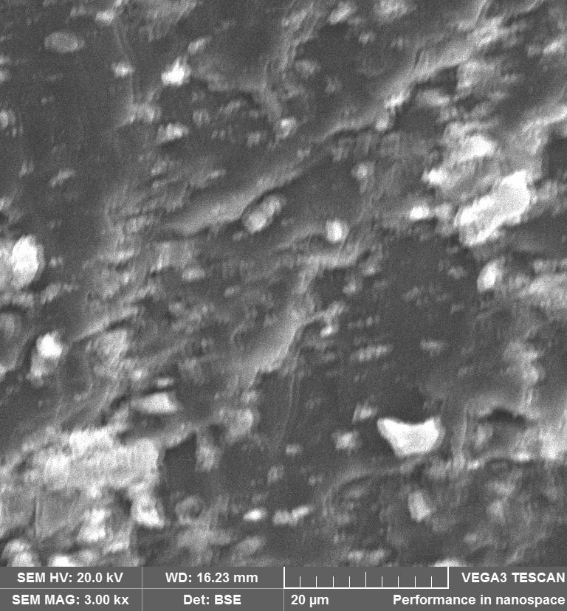
Plate 4.0 SEM image of the polyester matrix.

Plate 4.1-4.2, revealed the microstructure of composites produced with CHAp, it was observed that there was a high amount of agglomerates of CHAp in the matrix of polyester as CHAp loading increased. Those agglomerates acted as obstacles to chains movement and initiated failure under stress. Agglomerates will become stress concentrator and builds up stresses in composites quicker than usual, causing early rupture if compared to unfilled samples. This agglomeration of the particles played a role in the reduction of tensile and flexural strengths.
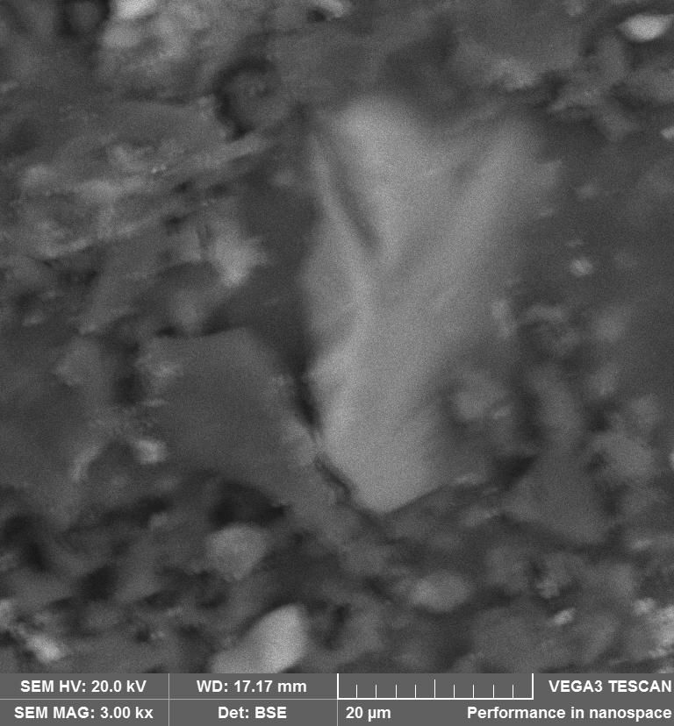

Plate 4.1: SEM image of the polyester matrix with 5%CHAp.

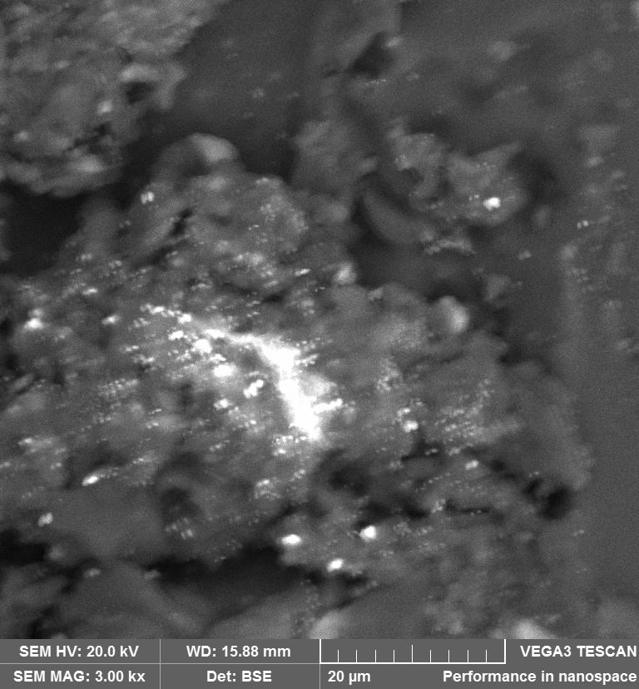

Plate 4.2: SEM image of the polyester matrix with 20%CHAp.

Plates 4.3-4.4, revealed the microstructure of composites produced with BPF. It was observed that there were little amounts of agglomerates as compared with composites with CHAp. This microstructure obtained for BPF played a role in increasing the tensile and flexural strengths (Torquato 2002).

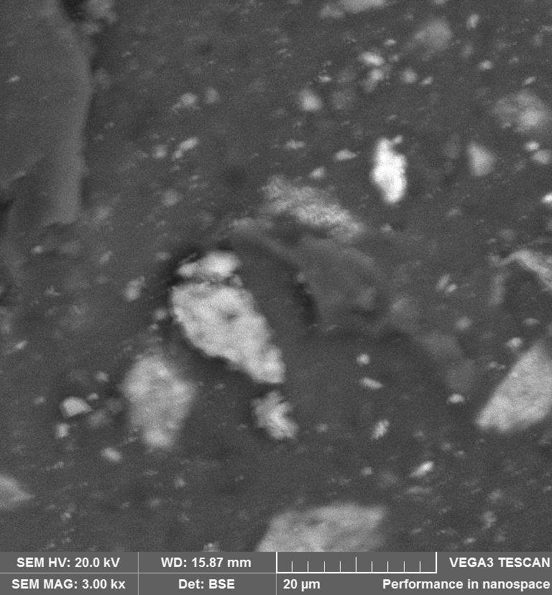

Plate 4.3: SEM image of the polyester matrix with 5%BPF.

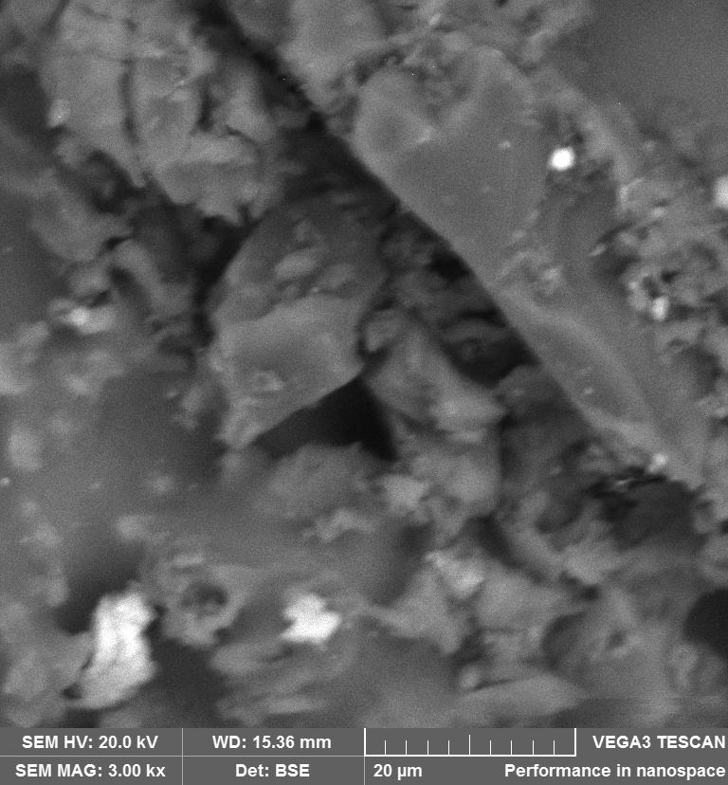

Plate 4.4: SEM image of the polyester matrix with 20%BPF.

The microstructure of the reinforced composite with BPF: CHAp and BPF: AH additions are shown in Plate 4.5-4.8. The microstructure reveals that there were small discontinuities and a reasonably uniform distribution of BPF and CHAp in the polyester matrix. The CHAp, BPF and AH phases are shown as white phase, while the polymer phase is dark. The BPF are embedded within the amorphous matrix composed of randomly distributed particles in the matrix planar boundaries.
It wasseen thatCHAp weredetached from the resin surface as the weight fraction of CHAp and AH particles increased in the polyester matrix , due to poor interfacial bonding between the polyester and the CHAp.This was t he reason why t he s t rength obtained a t 7 . 5 % CHA: 7 . 5 % BPF were h i gher than t hat of 10 % CHAp: 10 % BPF. SEM/EDS micrographs of CHAp: BPF and BPF: AH confirmed that the two systems presented similar microstructures. In particular, a more uniform distribution is achieved in the case of BPF: AH.

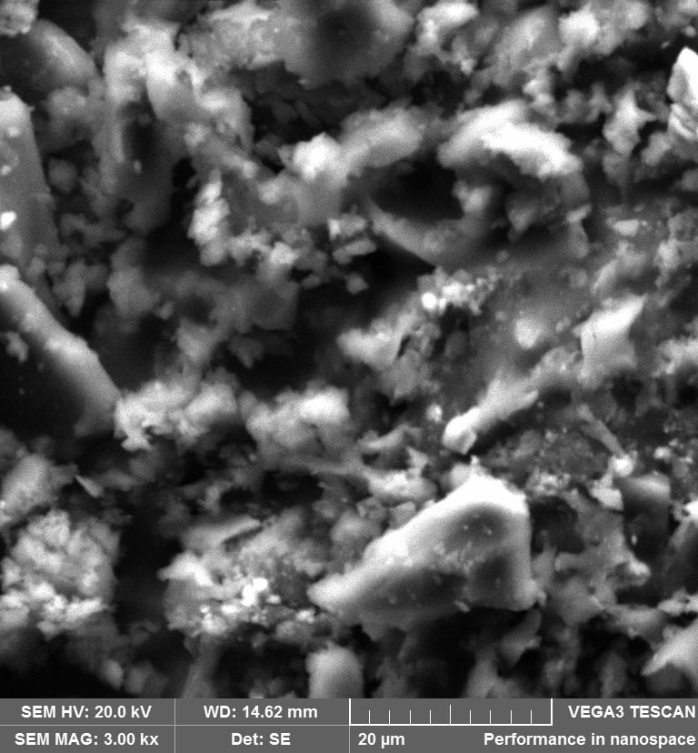

Plate 4.5: SEM image of the polyester matrix with 7.5%CHAp: 7.5%BPF.

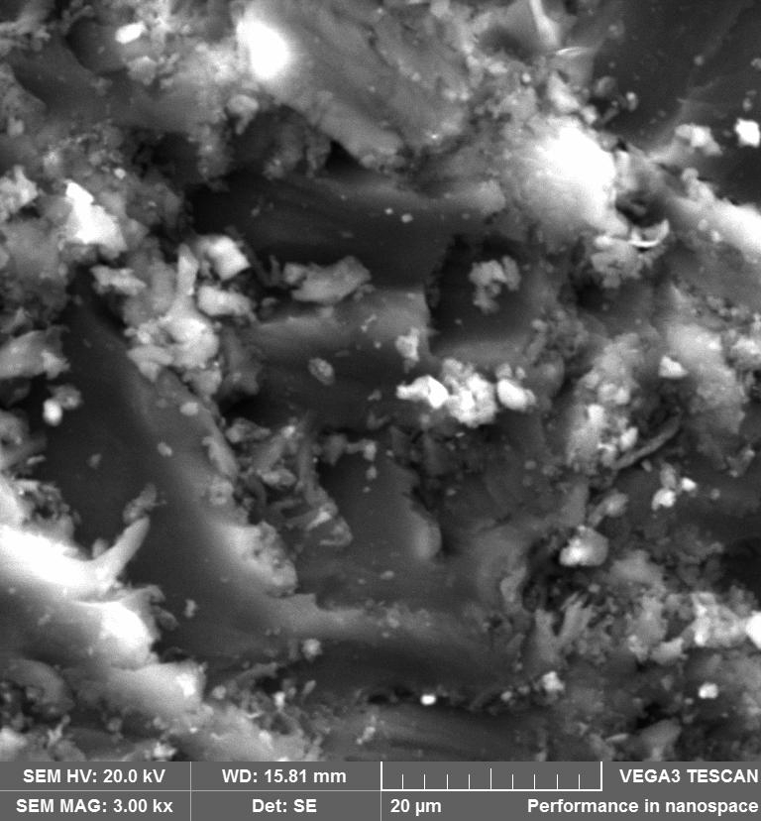
Plate 4.6: SEM image of the polyester matrix with 10%CHAp: 10%BPF.

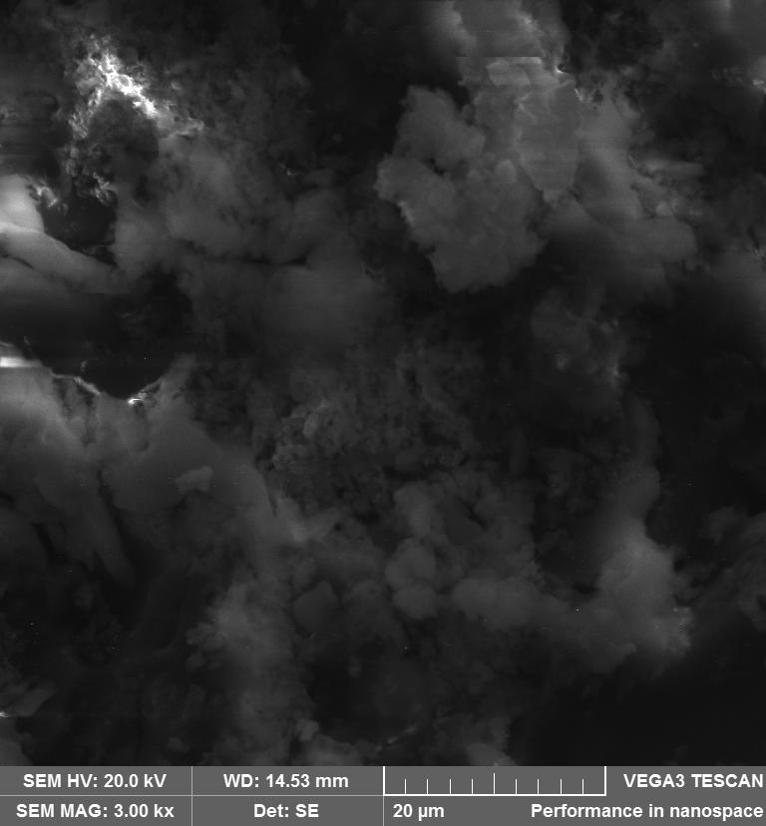

Plate 4.7: SEM image of the polyester matrix with 7.5%AH: 7.5%BPF.

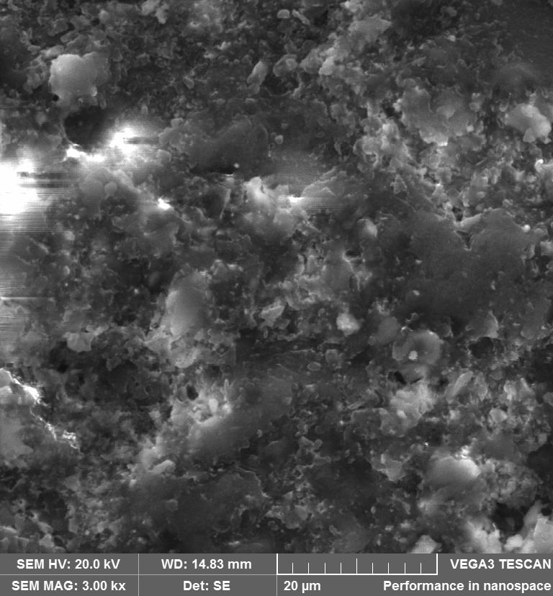

Plate 4.8: SEM image of the polyester matrix with 10%AH: 10%BPF.

FTIR Analysis of the Developed Composites and Materials Table 4.6: Major peaks in the FTIR analysis
WAVENUMBER (cm⁻¹)
CHAp | BPF | Polyester | 7.5%CHAp:7.5BPF | 7.5%AH:7.5BPF
2206.00 | 3697.50 | 3028.00 | 3652.80 | 3652.00
2016.50 | 3336.00 | 2922.00 | 3063.00 | 3026.60
1625.10 | 2914.80 | 2322.00 | 2922.20 | 2922.20
1453.70 | 2165.80 | 1722.00 | 1934.50 | 1722.00
1025.00 | 1423.80 | 1599.00 | 1722.00 | 1599.00
872.20 | 1319.50 | 1490.00 | 1453.70 | 1256.00
700.70 | 1135.50 | 1066.00 | 1066.00 | 1066.00
 | 1028.70 | 909.50 | 77.68 | 83.37
 |  | 86.48 | 69.68 | 76.32

Source: Researchers compilation 2018

FTIR give information on the functional groups in a material. The FTIR results obtained in this research are shown in Figure 4.40 and Table 4.3.

0 500 1000 1500 2000 2500 3000 3500 4000
100
Polyester
7.5AH:7.5BPF
7.5CHAp:7.5BPF
BPF
CHAp
Transmittance Transmittance Transmittance Transmittance Transmittance
95
90
85
80
75
100

90

80

1070

90

80

70
100
90
80
70

100

80

60

0 500 1000 1500 2000 2500 3000 3500 4000
Wave number (cm-¹)

Figure 4.38: Variation of transmittance with wave number for the FTIR analysis.

From Figure 4.38, a great difference was observed in the FTIR curves of the BPF from other samples. The BPF have the higher peak around 1028.7 cm^{–1}. The polyester and the composite have similar streching. The absorption bands of the BPF at 3697.5-336cm^{–1} can be assigned to stretching vibrations and other polymeric associations of hydroxyl groups (alpha cellulose). Symmetric

stretching at 2914.8cm^{–1}is assigned to CH and CH₂ polysaccharides(cellulose and hemicelluloses). Peaks observed between 1423.8-1319.5 cm^{–1} and 1135.5– 1028.7cm^{–1} are due toC=C, and C–O vibrations. These are generally observed in cellulose, hemicellulose and lignin, suggesting an aromatic and ethereal character of the sample. The results indicate a similarity with the composition of banana fibres (Beheshty, Nasiri, & Vafayan, 2015).
FTIR spectrum of the CHAp showed that the major component is hydroxyapatite and collagen (see Table 4.6). In fact, the spectrum of CHAp exhibits all the most intense bands observed in the spectrum of hydroxyapatite (700.7-872.2 cm⁻¹ and 1025.0cm⁻¹) and that of collagen (2016.5-2206 cm⁻ ¹region). Nevertheless, there were some new bands (namely at around 1453.7cm⁻¹) that originated from carbonate substitutions in the crystal lattice of hydroxyapatite.

From Table 4.6 and Figure 4.38, it was observed that in the polyester, the weak C–H stretching, C=H bending and moderately intense C–C out-of- plane bending vibrations of the benzene rings appear at 2922-2322.1cm⁻¹ respectively. The bands appearing at 3028 and 1066 cm⁻¹ are assigned to intermolecular O–H bonded to C=O groups and O–H out-of-plane bending in the terminal carboxylic groups in the polyester chains. Another small peak that appears at 1722 cm⁻¹ in the polyester is assigned to anhydride groups.
For the composite one can see in Figure 4.38, that after the reinforcement of polyester with BPF and CHAp, the intensity of the bands at

2922, 3063 and 1453.7 cm⁻¹ increased, and the band at 10666cm⁻¹ was shifted to 1453.70 cm⁻¹. Presence of band of 3652 cm⁻¹ in the composite and absence in the polyester resulted from the addition of BPF and CHAp. Increases in the band of the composite than that of the polyester was one of the factors for the enhancement in properties of the composite. Composite produced with AH: BPF had similar features with that of CHAp: BPF. Similar observation was reported in the work of Mohanty et al.(2011).

4.20 XRD Analysis

X-ray diffraction technique was used to identify the following: preferred orientation, crystalline areas, and grain size of crystalline materials. Figure 4.49 displayed the XRD spectrum of the X-ray diffraction results of CHAp: BPF and polyester composites.The results showed that the adoption of CHAp: BPF in polyester had two primary effects: the reinforcement and the nucleating effect. The reinforcement effect increased the bulk crystallinity. The addition of the reinforcement to the matrix shifted the characteristic peak position.

The noticeable thing about the XRD patterns was that new peaks were found with the addition of CHAp, BPF and AH. This indicated that, there was strong interaction between CHAp: BPF, BPF: AH and polyester, confirming the results obtained by FTIR and SEM. The absence of new peaks can also be attributed to the homogenous dispersion of CHAp in the matrix. It is worth noting that increases in the broad peak of the composites decreased the intensity corresponding to α- phase at 2Theta = 9.5º with increase in β-phase at 2Theta

=25º. The increase in CHAp: BPF, BPF: AH loading showed that CHAp: BPF, BPF: AH enhanced the strengthening phases of polyester.

It is evident that the composite is crystalline shaped and dense. The polymer showed broad and less intense band in the XRD, which depicted semi crystalline nature. The XRD patterns of the composites showed sharp peaks, indicating crystalline structure. It was evident from the XRD studies, that there were interactions between the reinforcement and polymer making the matrix stronger. The polar groups in the polymers interacted with the polar groups in the reinforcement and the interaction decreased the d-spacing in the composites producing stronger and denser composite.

0 10 20 30 40 50 60 70 80 90

4000
polyester-AH/BPF at Optimum
polyester-CHAp/BPF at Optimum
Polyester
Intensity (counts)

3000

2000

1000
6000
Intensity (counts)

4000

2000

3000
2500
Intensity (counts)
2000
1500
1000
500
0
0

10 20 30

40 50 60 70 80 90

2theta (degrees)

Figure 4.39: XRD spectrum of the polyester and it composites.

4.21 TGA/DTA of the developed composites

Table 4.7(a-d): Degradation Temperatures of composites determined using DTA/TGA

Table 4.7a: Degradation Temperatures of composites with BPF
Composites | T10%  weight  loss | T50%  weight  loss | T80%  weight  loss | Tmax. | Tfinal weight  loss | Residues  weight (%)
0%BPF | 260.64 | 372.48 | 398.54 | 402.00 | 593.57 | 5.28
5% BPF | 253.65 | 363.40 | 391.92 | 400.00 | 593.95 | 4.94
10% BPF | 252.81 | 362.58 | 395.86 | 394.00 | 594.00 | 4.49
15% BPF | 250.12 | 361.01 | 391.01 | 395.00 | 593.99 | 2.82
20% BPF | 239.13 | 360.36 | 390.82 | 392.30 | 593.73 | 1.359
Table 4.7b: Degradation Temperatures of composites with CHAp
0%CHAp | 260.84 | 372.48 | 398.40 | 405.80 | 593.57 | 5.28
5% CHAp | 260.84 | 372.40 | 398.54 | 407.30 | 593.57 | 5.28
10%CHAp | 265.38 | 375.39 | 398.06 | 408.00 | 594.09 | 8.47
15% CHAp | 265.79 | 379.99 | 403.06 | 412.00 | 594.34 | 11.64
20% CHAp | 370.81 | 380.99 | 428.26 | 415.00 | 593.96 | 17.67
Table 4.7c: Degradation Temperatures of composites with CHAp and BPF
0%CHAp:0%BPF | 260.84 | 372.48 | 398.40 | 402.00 | 593.57 | 5.28
2.5%CHAp:2.5%BPF | 267.08 | 376.49 | 400.76 | 402.00 | 593.94 | 9.55
5%CHAp:5%BPF | 309.99 | 384.03 | 407.15 | 404.60 | 593.46 | 9.63
7.5%CHAp:,7.5%BPF | 347.10 | 385.85 | 409.15 | 407.00 | 593.04 | 9.81
10%CHAp:10%BPF | 348.64 | 382.49 | 418.19 | 407.15 | 593.75 | 10.39
Table 4.7d: Degradation Temperatures of composites with AH and BPF
0%AH:0%BPF | 260.84 | 372.48 | 398.40 | 402.00 | 593.57 | 5.28
2.5%AH:2.5%BPF | 257.23 | 373.12 | 397.64 | 405.00 | 594.07 | 8.27
5%AH:5%BPF | 268.09 | 375.81 | 398.35 | 407.50 | 593.83 | 8.56
7.5%AH:7.5%BPF | 347.77 | 382.34 | 406.43 | 409.00 | 593.65 | 8.85
10%AH:10%BPF | 359.01 | 385.32 | 405.13 | 409.00 | 593.97 | 12.63
Source: Researchers compilation 2018

The thermal decomposition of the polyester and its composites were examined by thermogravimetric analysis (TA) in an inert (nitrogen) atmosphere. Nitrogen was used as the atmospheric gas in the TA rather than air or oxygen because (except for the near surface region) the endothermic decomposition reaction of the organic constituents occurs with little or no oxygen present.Figures 4.40-4.43 displayed the TGA curves, while Figures 4.45-4.48 displayed the derivates of their weight. It was observed that the entire TGA curves presented are similar. The decomposition of the materials were characterised by multiple-stage reactions. A small loss in mass occurred in the ﬁrst stage when the sample was heated from50–150ºC and this is due to the loss of moisture absorbed from the atmosphere and the water formed as by-product of the cure reaction. The TGA curve remains relatively ﬂat until the main decomposition reaction occurred over a temperature range of 350-420ºC.
It was observed in Figure 4.40 that the TGA curves of composites produced with CHAp had a higher weight retained (residue) than in Figure 4.42 showing the curve of the composites produced with BPF. Also it was noticed that as the weight percentage of CHAp increased, the weightof residue left increased.In the composites produced with BPF, as the weight percentage increased there was a decrease in weight of residues left. For example the weights of 5.28, 4.94, 4.49, 2.82, 1.359% and 5.28, 5.285, 8.47, 11.64, 17.67%
were left at 0, 5, 10, 15 and 20wt% for CHAp and BPF respectively (Table 4.8).

In Figure 4.40, it was observed that about 20% of the weight remained at around 500ºC as weight percent addition of CHAp increased upto 20wt%. In Figure 4.42 the weight that remained at 500ºC was 0% at 20wt% BPF. The introduction of CHAp particles into the polyester induced a protective barrier against thermal decomposition and retarded the thermal decomposition of polyester/CHAp composite. This phenomenon could be attributed to the physical barrier effect of the incorporated microparticles of CHAp acting as the mass and heat transfer barriers. This result inferred that the thermal stability of polyester/BPF composite could be improved with the addition of CHApmicroparticles.

0 50 100 150 200 250 300 350 400 450 500 550 600 650 700
Weight loss (%W) eight loss (%W) eight loss (%W) eight loss (%W) eight loss (%)
100
20CHAp)
15CHAp
10CHAp
5CHAp)
0CHAp
80
60
40
20
120
100
80
60
40
20
120
100
80
60
40
20
0
100

50

0
120
100
80
60
40
20
0
0

50 100 150 200 250 300 350 400 450 500 550 600 650 700
Temperature (oC)

Figure 4.40: Variation of percentage weight loss with temperature for composite produced with CHAp

0 50 100 150 200 250 300 350 400 450 500 550 600 650 700
20BPF
15BPF
10BPF
5BPF
0BPF
Weight loss (%W) eight loss (%W) eight loss (%W) eight loss (%W) eight loss (%)

100

50

0

100

50

0

100

50

0

100

50

0
120
100
80
60
40
20
0
0

50 100 150 200 250 300 350 400 450 500 550 600 650 700

Temperature (oC)

Figure 4.41: Variation of percentage weight loss with temperature for composite produced with BPF.

Figures 4.42-4.43shows that decomposition of the hybrid composites with polyester-CHAp/BPF and polyester-AH/BPF commenced at about the same temperature.

120
Weight loss (%W) eight loss (%W) eight loss (%W) eight loss (%W) eight loss (%)
100
80
60
40
20
120
100
80
60
40
20
120
100
80
60
40
20
120
100
80
60
40
20
120
100
80
60
40
20
0

0 50 100 150 200 250 300 350 400 450 500 550 600 650 700


10CHAp:10BPF
7.5CHAp:7.5BPF
5CHAp:5BPF
2.5CHAp:2.5BPF
0CHAp:0BPF
0 50 100 150 200 250 300 350 400 450 500 550 600 650 700
Temperature (oC)

Figure 4.42: Variation of percentage weight loss with temperature for composite produced with BPF/CHAp.

120
Weight loss (%W) eight loss (%W) eight loss (%W) eight loss (%W) eight loss (%)
100
80
60
40
20
120
100
80
60
40
20
120
100
80
60
40
20
120
100
80
60
40
20
120
100
80
60
40
20
0
0 50 100 150 200 250 300 350 400 450 500 550 600 650 700


10AH:10BPF
7.5AH:7.5BPF
5AH:5BPF
2.5AH:2.5BPF
0AH:0BPF
0 50 100 150 200 250 300 350 400 450 500 550 600 650 700

Temperature (oC)

Figure 4.43: Variation of percentage weight loss with temperature for composite produced with BPF/AH.

It was observed in Figures 4.43-4.44 that as the weight of CHAp and AH increased in the formulation, there was a rise in the thermal stability of the composites. About 20% weight char or residue remained when 7.5wt% CHAp or AH was added to BPF (see Figures 4.43-4.44). The increase in the thermal stability of the composites could be attributed to the fact that CHAp and AH retarded the decomposition of the composites.

Figures 4.44-4.47 showed the derivates of the weight with temperatures. It was noticed that the decomposition of the materials was an endothermic process dominated by random-chain scission of the main polymer chain (Tsai, 2016). The decomposition temperature shifted to higher temperature for composites produced with CHAp, CHAp/BPF and AH/BPF. The decomposition reactions of composites produced with CHAp, CHAp/BPF and AH/BPF are largely completed at 400ºC.
A higher temperature of thermal decomposition of CHAp, CHAp/BPF and AH/BPF composites, than the polyester resin demonstrated that the resin underwent substantial volatilization, with most of the gases being of low molecular weight combustible hydrocarbons (Sarki, Hassan, Aigbodion and Oghenevweta, 2011). This behavior was determined in the initial stages by scission of highly strained portion of polyester crosslink with consequent formation of free radicals that promoted further decomposition and scission of the polyester backbone. As a result, a large amount of low-molecular-weight volatiles (CO, CO₂) were released rather than char.The decomposition of

polyester/BPF occurred as a single-stage process over a similar temperature range although this material is completely volatized and does not produce any char.

The pronounced single endothermic effects of decomposition as observed inFigures 4.44-4.47corresponds to the oxidative degradation process and to the release of violate matters. The presence of endothermic effects in the sample was results of three processes – intermolecular dehydrogenation, vaporization and solid state decomposition of some additives. This conclusion was confirmed by the decreased mass of the polymer. On the analogy of these results it was assumed that the total burning/ degradation of the residual polymer backbone (dehydrogenation polyester) took place in this temperature interval (300-500ºC), which is different for the individual composites samples. In the last temperature interval the mass loss was minimal. This last step (accompanied by the evolution of CO₂ only) is due to the degradation of the filler material in the composite (Sarki et al, 2011). This result indicated that the CHAp, CHAp/BPF and AH/BPF composites biomass showed less percentage decomposition.

In the case of the CHAp, CHAp/BPF and AH/BPF composites, a slight shift of the degradation onset and a clear evident reduction of mass loss was noticed.

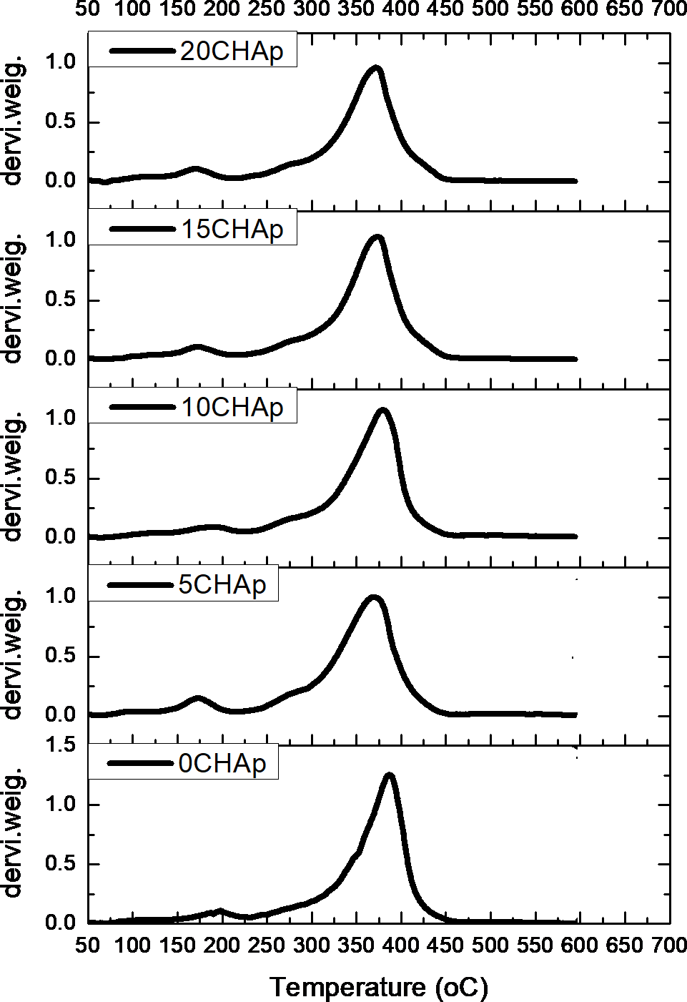
Figure 4.44: Variation of derivate of weight with temperature for composite produced with CHAp.

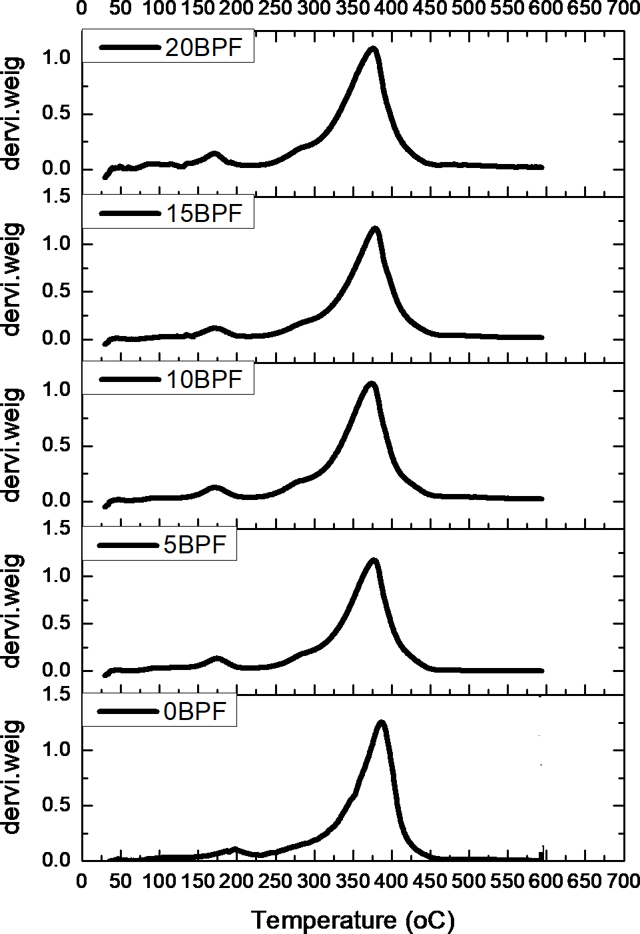
Figure 4.45: Variation of derivate of weight with temperature for composite produced with BPF.

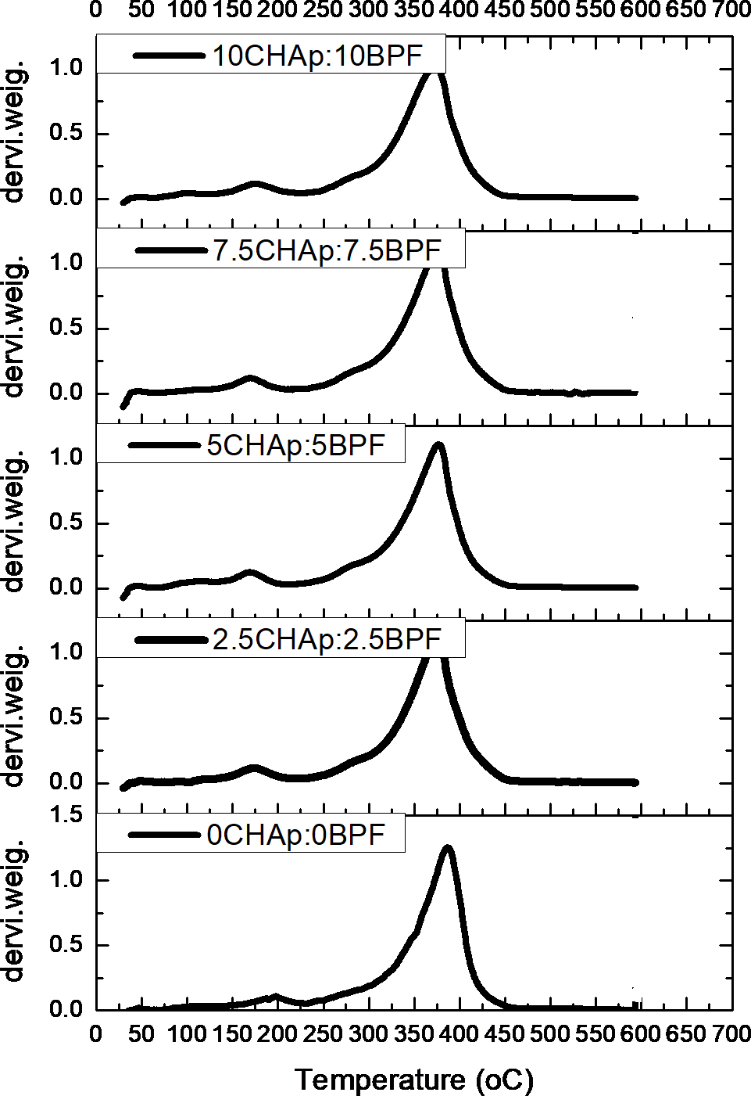

Figure 4.46: Variation of derivate of weight with temperature for composite produced with CHAp/BPF

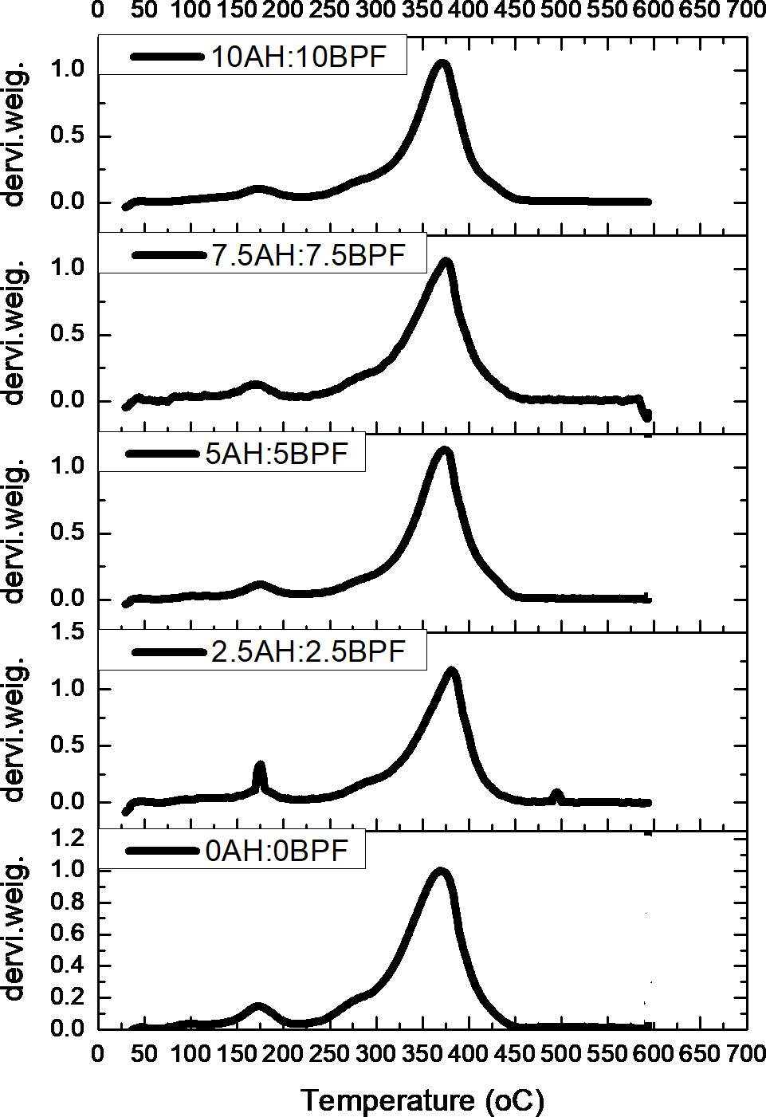

Figure 4.47: Variation of derivate of weight with temperature for composite produced with AH/BPF.

As shown in Tables 4.7(a-d), the incorporation of CHAp and CHAp/BPF into the polyester matrix increased the thermal decomposition temperatures and increased the residue yields of the composite. This result indicated that the presence of CHAp lead to the stabilization of the polyester, resulting in the enhancement of the thermal stability of the composite. The CHAp particles effectively acted as physical barriers and prevented the transport of volatile decomposed products out of the composite during thermal decomposition. It has been established that CHAp addition to polyester matrix enhanced its stability and increased the temperature of maximum decomposition/ destruction rate.
  - Thermal decomposition kinetics of the developed composites

The TGA/DTA curves of polyester and it composite at 7.5wt%CHAp: 7.5wt%BPF and 7.5wt%AH: 7.5wt%BPF were used to evaluate their activation energies. Using the thermal data (Appendices A1- A3), the graphs of
1𝑛{[−1𝑛(1 − 𝛼)]}^{1/3}/𝑇² against ¹Figure 4.48was obtained.
𝑇

-0.000001

polyester 7.5CHAp:7.5BPF
7.5AH:7.5BPF

-0.000002
1𝑛{[−1𝑛(1 − 𝛼)]}^{1/3}/𝑇²

-0.000003

-0.000004

-0.000005

-0.000006
0.0011 0.0012 0.0013 0.0014 0.0015 0.0016 0.0017 0.0018 0.0019
T⁻¹ (⁰K)

Figure 4.48: Variations of degree of conversion (quantity decomposed during heating) with inverse temperature.

From Figure 4.48, the plots, revealed straight lines with high-correlation coefficient (r > 0.98) which were picked to stand as the possible controlling mechanism. At this point, the activation energies were determined from the slope. The activation energies obtained were: 4.4x10⁻², 5.9x10⁻² and 5.86x10⁻ ²kJ/mol for the polyester, composites at 7.5wt%CHAp: 7.5wt%BPF and 7.5wt%AH: 7.5wt%BPF respectively. It was observed that the activation energy (Ea) values of the composites were higher than that of polyester matrix. From literature, high activation energy of thermal decomposition reflects high thermal stability of polymers (Maria et al, 2012).

The higher Ea values of the composites indicated that their thermal decomposition were more difficult because of the addition of CHAp. As previously described, the improvement in the thermal stability of the composites as a result of the introduction of CHAp and AH microparticles may be explained by the effectiveness of CHAp and AH microparticles as physical barriers, retarding thermal decomposition of volatile components and preventing the transport of volatile decomposed products in the polymer composites (Maria et al, 2012).
In conclusion, it was deduced that the Ea values of composite at 7.5wt%CHAp: 7.5wt%BPF and 7.5wt%AH: 7.5wt%BPF exhibited good reliance on describing the thermal decomposition kinetics of the composites.

Conecalorimetricanalysis of the developed composites
Table 4.8(a-d) Results of the Cone calorimeter test: MHR=mean heat release rate, pHRR=peak heat release rate, THR= total heat release rate, TSR=total smoke release, TSP=total smoke produced, TTG=time to ignition, ETT=end of test time, TOC = Total oxygen consumed
Table 4.8a: Fire properties of developed composites with BPF

Samples | MHRR  Kw/m²) | PHRR  (Kw/m²) | THR (MJ/m²) | MASS  loss(g/m²) | TSR  (m²/m²) | TSP (m²) | TOC  (g) | TTG  (s) | ETT  (s)
Polyester | 223.56 | 556.54 | 308.60 | 14142.10 | 9378.20 | 82.90 | 206.30 | 64.00 | 1445.00
5%BPF | 248.89 | 585.49 | 396.20 | 14538.10 | 1006.90 | 87.80 | 217.10 | 59.00 | 1250.00
10%BPF | 285.20 | 587.87 | 403.80 | 14514.60 | 10143.90 | 86.40 | 281.80 | 59.00 | 1171.00
15%BPF | 291.77 | 655.36 | 468.90 | 14282.00 | 10340.80 | 89.60 | 296.10 | 58.00 | 1140.00
20%BPF | 296.47 | 655.47 | 549.20 | 14239.40 | 10498.70 | 93.60 | 365.70 | 47.00 | 1030.00
Table 4.8b:Fire properties of developed composites with CHAp
Samples | MHRR  Kw/m²) | PHRR  (Kw/m²) | THR (MJ/m²) | MASS  loss(g/m²) | TSR  (m²/m²) | TSP (m²) | TOC  (g) | TTG  (s) | ETT  (s)
Polyester | 223.56 | 556.54 | 308.60 | 14142.10 | 9378.20 | 82.90 | 206.30 | 64.00 | 1445.00
5%CHAp | 222.48 | 455.54 | 308.00 | 13836.60 | 9610.20 | 80.00 | 201.70 | 82.00 | 1470.00
10%CHAp | 217.57 | 405.42 | 307.90 | 12580.20 | 9045.20 | 74.80 | 200.90 | 81.00 | 1500.00
15%CHAp | 218.96 | 397.13 | 306.90 | 12308.50 | 8767.30 | 73.30 | 143.60 | 86.00 | 1595.00
20%CHAp | 214.19 | 392.67 | 303.50 | 11516.20 | 8609.70 | 70.60 | 115.45 | 87.00 | 1887.00
Table 4.8c:Fire properties of developed composites of polyester with BPF and CHAp
Samples | MHRR  Kw/m²) | PHRR  (Kw/m²) | THR (MJ/m²) | MASS  loss(g/m²) | TSR  (m²/m²) | TSP (m²) | TOC  (g) | TTG  (s) | ETT  (s)
Polyester | 223.56 | 556.54 | 308.60 | 14142.10 | 9378.20 | 82.90 | 206.30 | 64.00 | 1445.00
2.5%BPF:2.5%CHAp | 223.47 | 534.19 | 308.20 | 13843.10 | 8889.20 | 81.40 | 203.90 | 65.00 | 1540.00
5%BPF:5%CHAp | 222.39 | 516.23 | 301.20 | 13754.50 | 8579.40 | 80.60 | 200.10 | 75.00 | 1585.00
7.5%BPF:7.5%CHAp | 206.84 | 501.80 | 280.90 | 13106.00 | 8161.50 | 78.90 | 129.32 | 80.00 | 1685.00
10%BPF:10%CHAp | 207.57 | 505.42 | 207.90 | 12580.20 | 80582.00 | 70.90 | 121.16 | 82.00 | 1705.00
Table 4.8d: Fire properties of developed composites of polyester with BPF and AH
Samples | MHRR  Kw/m²) | PHRR  (Kw/m²) | THR (MJ/m²) | MASS  loss(g/m²) | TSR  (m²/m²) | TSP (m²) | TOC  (g) | TTG  (s) | ETT  (s)
Polyester | 223.56 | 556.54 | 308.60 | 14142.10 | 9378.20 | 82.90 | 206.30 | 64.00 | 1445.00
2.5%BPF:2.5%AH | 222.90 | 539.44 | 308.30 | 12274.40 | 8517.80 | 75.30 | 205.30 | 72.00 | 1455.00
5%BPF:5%AH | 218.24 | 522.21 | 300.00 | 12364.70 | 8438.50 | 73.40 | 203.50 | 77.00 | 1550.00
7.5%BPF:7.5%AH | 215.46 | 515.94 | 297.40 | 12284.50 | 8335.20 | 75.20 | 164.60 | 81.00 | 1615.00
10%BPF:10%AH | 210.52 | 489.9 | 237.80 | 12225.50 | 8282.60 | 72.10 | 125.90 | 83.00 | 1635.00
Source: Researchers compilation 2018

Heat release rate

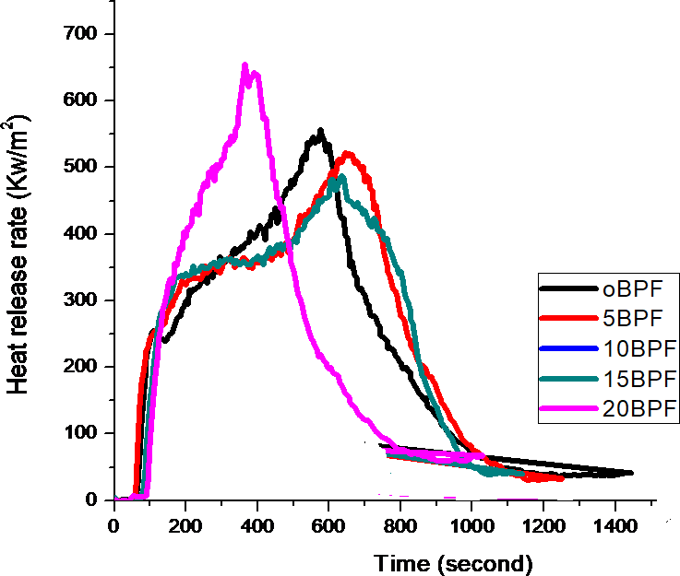
Figures 4.49-4.52 showed the heat release rate (HRR) versus time plots of the polyester and the developed composite.
Figure 4.49: Variation of heat release rate with time for BPF composites

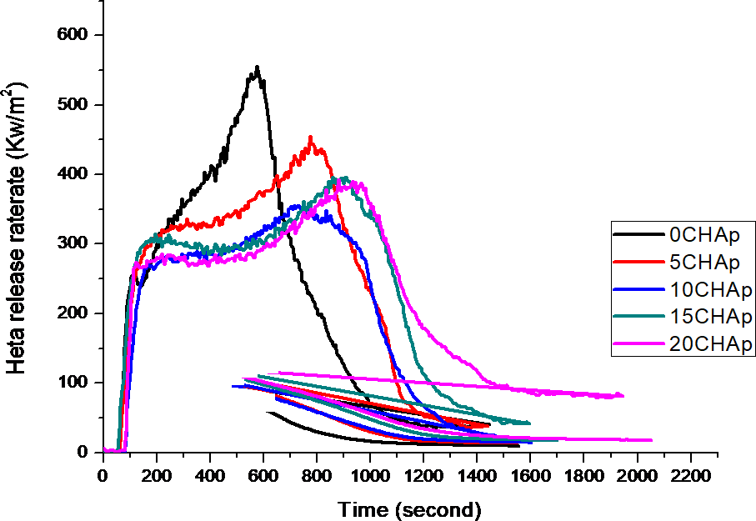

Figure 4.50: Variation of heat release rate with time for CHAp composites

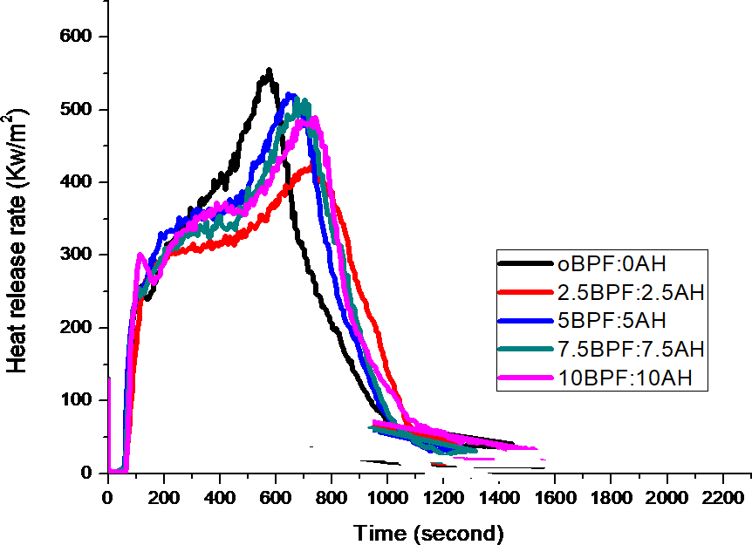

Figure 4.51: Variation of heat release rate with time for BPF:AH composites.

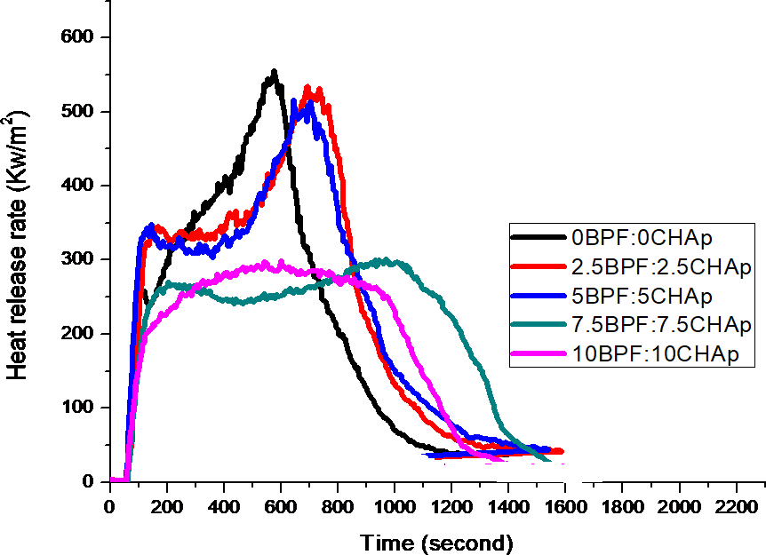
Figure 4.52: Variation of heat release rate with time for BPF: CHAp composites.

From Figures 4.49-4.52 it was observed that there was an initial delay period before the composite released heat, and this was because the temperature

of the composite was below the pyrolysis temperature of the organic matrix. Following this induction period, there was a rapid rise in the heat release rate due to the combustion of volatiles, in this case mainly low molecular weight hydrocarbons, near to the composite/ﬁre interface. Following the peak heat release rate (PHRR), the HRR of the composites with CHAp, CHAp: BPF, and AH:BPF decreased progressively with time, due to the formation and thickening of their surface layer which sloweddown the decomposition reaction rate in the underlying material. The HRR also declined as a result of the declining resin content in the samples. Eventually the heat release rate became negligible, as the last of the resin matrix was decomposed.The heat release rate curves for the composite materials reinforced with CHAp: BPF and AH: BPF were similar inproﬁle.

The heat release rate was substantially higher for composites with BPF (Figure 4.49) compared to composite with CHAp (Figure 4.50). Figures 4.52-
4.58 displayed the plots of peak heat release rate, mean heat release rate and total heat release rate. From Figures 4.54-4.59 it was observed that the composites produced with BPF exhibited different characteristics from that of other composites under investigation, while the hybrid composites with CHAp: BPF, and AH:BPF had similar pattern ( Figures 4.54, 4.59 and 4.58). The high peak, mean and total heat release rates obtained for BPF composites (Figures 4.53, 4.55 and 4.57) was attributed to the fact that polyester/BPF composites, at the surface released heat before the polyester matrix because of their lower

pyrolysis temperature. It was also seen that the heat release rates for the composites containing CHAp was, on average, much lower. This was because the decomposition of CHAp yielded much lower amount of ﬂammable volatiles than BPF (Table 4.5).

600
BPF CHAp

500
peak heat release (Kw/m²)

400

300

200

100

0
0 5 10 15 20
weight (%)

Figure 4.53: Variations of peak heat release rate with varying wt% BPF and CHAp composites.

560
BPF:AH CHAp:BPF

550

540
Peak heat rate (Kw/m²)

530

520

510

500

490

480
0:0 2.5:2.5 5:5 7.5:7.5 10:10
weight (%)

Figure 4.54: Variations of peak heat release rate with varying wt% for BPF:CHAp and BPF:AH composites.

300
BPF CHAp

250

200
Mean heat release (Kw/m²)

150

100

50

0
0 5 10 15 20
weight (%)

Figure 4.55: Variations of mean heat release rate with varying wt% BPF and CHAp composites.

224
BPF:AH
CHAp:BPF

222

220

218
Mean heat rate (Kw/m²)

216

214

212

210

208

206

0:0 2.5:2.5 5:5 7.5:7.5 10:10
weight (%)

Figure 4.56: Variations of Mean heat release rate with varying wt% for BPF: CHAp and BPF: AH composites.

550
BPF CHAp
500
450
Total heat release (MJ/m²)
400
350
300
250
200
150
100
50
0
0 5 10 15 20
weight (%)

Figure 4.57: Variations of total heat release rate with varying wt% BPF and CHAp composites.

320
BPF:AH CHAp:BPF
310
300
290
280
Total heat rate (MJ/m²)
270
260
250
240
230
220
210
200

0:0 2.5:2.5 5:5 7.5:7.5 10:10
weight (%)

Figure 4.58: Variations of total heat release rate with varying wt% for BPF: CHAp and BPF: AH composites.

The results showed that at the end of burning period, polyester released a total heat of 306.6 MJ/m². The composites released 549.2, 303.5, 207.9 and
237.8 MJ/m² at20wt%BPF, 20wt%CHAp, 10wt%BPF: 10wt%CHAp and 10wt%BPF: 10wt%AH respectively. It was observed that the addition of CHAp reduced the THR of the polyester. This suggested mechanism, by which CHAp acted as a fire retardant and reducedTHR of the composite involved the formation of char that served as a potential barrier to both mass and energy transport between the flame and the burning polymer.

Mass loss

The mass loss and average mass loss rates together with the total mass loss were measured using the load cells located beneath the specimen holder of the cone calorimeter equipment. Figures 4.58-4.60, showed the mass loss with time, and were used to validate the results obtained from the TGA/DTA. It was observed that the mass of the samples decreased as time increased. But the mass loss of BPF polyester composite was higher than that of the CHAp composites.

140

oBPF 5BPF
10BPF
15BPF
20BPF

120

100

80
Mass (g)

60

40

20

0
0 200 400 600 800 1000 1200 1400 1600 1800
Time (second)

Figure 4.59: Variations of mass loss withtime for varying wt% BPF composites.

160

0CHAp
5CHAp
10CHAp
15CHAp
20CHAp

140
Mass loss (g)

120

100

80

60

40

20

0
0 200 400 600 800 1000 1200 1400 1600 1800 2000 2200
Time (second)

Figure 4.60: Variations of mass loss with time for varying wt% CHAp

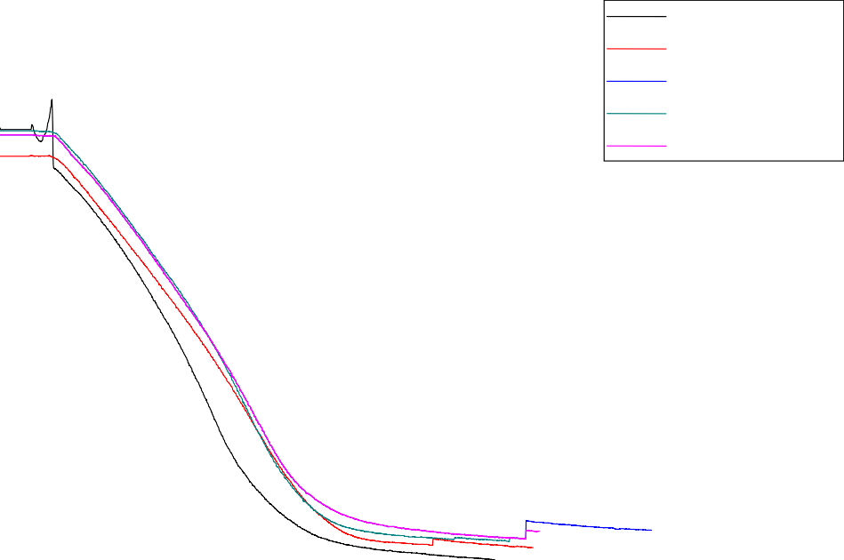140
oBPF:0AH 2.5BPF:2.5AH
5BPF:5AH
7.5BPF:7.5AH
10BPF:10AH

120

100

80

60
Mass (g)

40

20

0
0 200 400 600 800 1000 1200 1400 1600 1800 2000 2200
Time (second)

Figure 4.61: Variations of mass loss with time for varying wt% BPF: AH composites.

140

oBPF:0CHAp 2.5BPF:2.5CHAp
5BPF:5CHAp
7.5BPF:7.5CHAp
10BPF:10CHAp

120

100

80
Mass (g)

60

40

20

0
0 200 400 600 800 1000 1200 1400 1600 1800 2000 2200
Time (second)

Figure 4.62: Variations of mass loss with time for varying wt% BPF: CHAp

From Figures 4.62-4.63 it was observed that the mass loss of the composites with BPF increased with increase in wt%BPF addition, while the mass loss of the composites produced with CHAp, CHAp: BPF and BPF: AH decreased with increased weight% addition to the composites. This was attributed to the increased rate of char formation, which helped in slowing down the rate of burning. Similar observation was observed in the work of Nayra et al, 2016. Also the reduction in mass loss, increased residue formation (Table 4.8), indicating that CHAp decomposition reduced the rate of burning of the composite by decreasing the total heat produced as a result of char formation in the condensed phase. The char formation and the CHAp intumescent behavior was clearly noticed during and after the cone calorimeter test for the CHAp- based composite.

14000
BPF CHAp

12000

10000

8000
Mass loss (g/m²)

6000

4000

2000

0
0 5 10 15 20
weight (%)

Figure 4.63: Variations of mass loss with varying wt% BPF and CHAp composites.

14500
BPF:AH CHAp:BPF

14000

13500
Mass loss (g/m²)

13000

12500

12000
0:0 2.5:2.5 5:5 7.5:7.5 10:10
weight (%)

Figure 4.64: Variations of mass loss with varying wt% BPF: AH and CHAp: BPF composites.

4.23.3 Time to ignition and end of test time

Time-to-ignition is the minimum exposure time required for the specimen to ignite and sustain ﬂaming combustion. The spark igniter of the cone calorimeter was used to induce ignition. Time-to-ignition is an important ﬁre reaction property because it deﬁnes the time that a composite material can withstand the heat ﬂux radiated by a ﬁre before it experiences sustained ﬂaming combustion. Figures 4.64-4.65 displayed time to ignition, while Figures 4.66-
4.67 shows end of test time for the developed composite.

From the Figures 4.64-4.67, it was observed that the time to ignition for the composites with BPF was shorter compared with those of the other composites. Also the composites produced with BPF had short end of test time, because the composites burn faster, which resultedin lower end of test time. It

was concluded that addition of CHAp and AH to the polyester resin, produced a slight delay in the ignition time and reduced PHRR values. In addition, due to the action of the fire retardant (CHAp), the second peak of the HRR was less pronounced, and the total burning time was increased indicating that the fire- retarded composite of CHAp or AH burned for a longer time with a weaker flame than that of the polyester and BPF composites.

However, thetime to ignition (TTI) and end of test time(ETT) values of CHAp composites were increased by the incorporation of CHAp. The increased TTI value resulted from the composites containing CHAp which presented the highest TTI values. This indicated better fire retardant property (Figures 4.64-
4.67 and Table 4.8). This is the major reason, why the oxygen consumed and smoke release rates during burning were higher for the BPF composites than those of CHAp, BPF: CHAp and BPF: AH composites (Table 4.8), as a result of CHAp, BPF: CHAp and BPF: AH composite showing improvements in difficulty to-ignite.

90
BPF CHAp
85
80
75
70
65
Time to Igition (second)
60
55
50
45
40
35
30
25
20
15
10
5
0
0 5 10 15 20
weight (%)

Figure 4.65: Variations of Time to ignition with varying wt% CHAp and BPF composites.

85
BPF:AH CHAp:BPF
80
75
70
65
60
Time to igition (second)
55
50
45
40
35
30
25
20
15
10
5
0
0:0 2.5:2.5 5:5 7.5:7.5 10:10
weight (%)

Figure 4.66: Variations of Time to ignition with varying wt% CHAp: BPF and BPF: AH composites.

1900

BPF CHAp
1800
1700
1600
End of test time (second)
1500
1400
1300
1200
1100
1000
900
800
700
600
500
400
300
200
100
0
0 5 10 15 20
weight (%)

Figure 4.67: Variations of End of test time with varyingwt% CHAp and BPF composites.

1600
BPF:AH CHAp:BP

1400

1200
End of test time (second)

1000

800

600

400

200

0
0:0 2.5:2.5 5:5 7.5:7.5 10:10
weight (%)

Figure 4.68: Variations of end of test time with varying wt% CHAp: BPF and BPF: AH composites.

From the result obtained from cone calorimetric analysis of the composites, it was concluded that polyester composites with 7.5wt%CHAp: 7.5wt%BPF additions produced the best results of fire retardancy and can be used for engineering material applications. This combination delayed the ignition time by 25%, the end of burning time by 14.24% and reduced the total heat release rate by 9.07%.

4.23.4 Photograph of developed composite residue left after cone calorimetric test.

Plate 4.9, showed the photograph of the residues after the cone calorimeter experiment. It was observed that 20wt%BPF and polyester left little or no residue after burning (Plates 4.9a-b). The residue of composite as shown in Plates 4.9c-d showed a compact and intumescent char layer, which was the main reason for obtaining better flame retardancy of the composite. It was observed that the residue of BPF composites was surrounded with soot, while a black swelled char characterized the residue of fire-retarded composites incoporated with CHAp or AH. This confirmed the efficiency of CHAp and AH in foaming and expanding the composites surface, hence, insulating and protecting the underlying material during thermal decomposition.

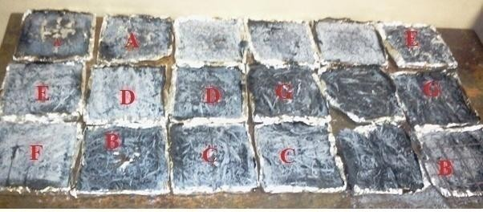

Plate 4.9: Photograph of the sample left after fire test.

(A=20wt%BPF,B=polyester, C=7.5%CHAp: 7.5wt% BPF, D=7.5%AH:7.5wt% BPF, E=10%CHAp: 10wt% BPF, F=10%AH: 10wt% BPF)
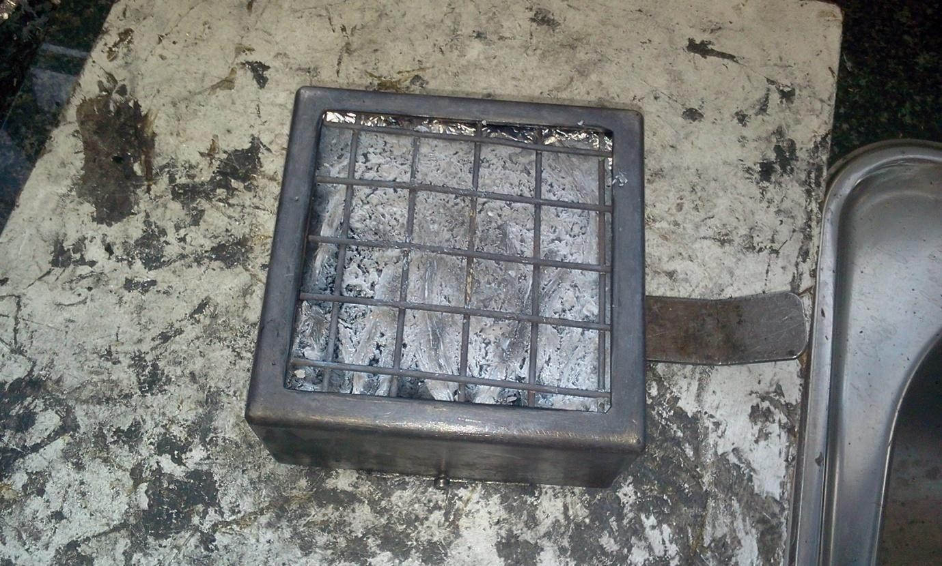
Plate 4.9a: Photograph of the 20wt% BPF sample left after fire test.

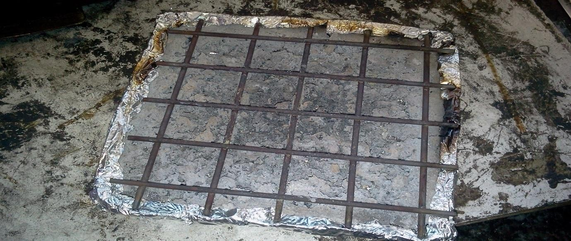
Plate 4.9b: Photograph of the polyester sample left after fire test.

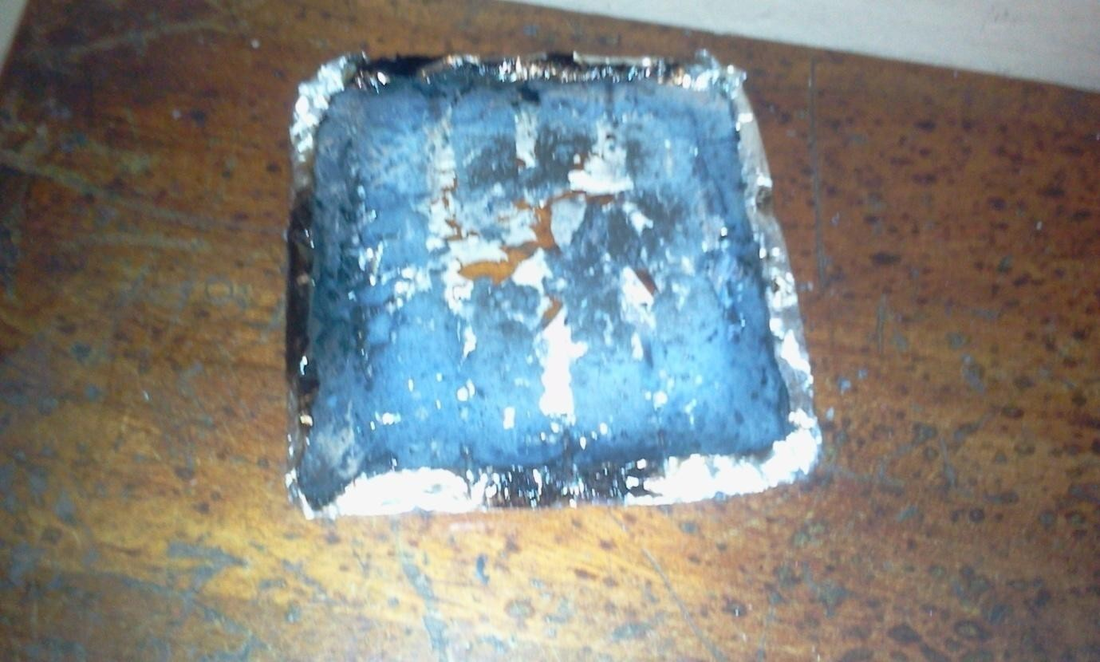
Plate 4.9c: Photograph of the 7.5%CHAp: 7.5wt% BPF sample left after fire test.

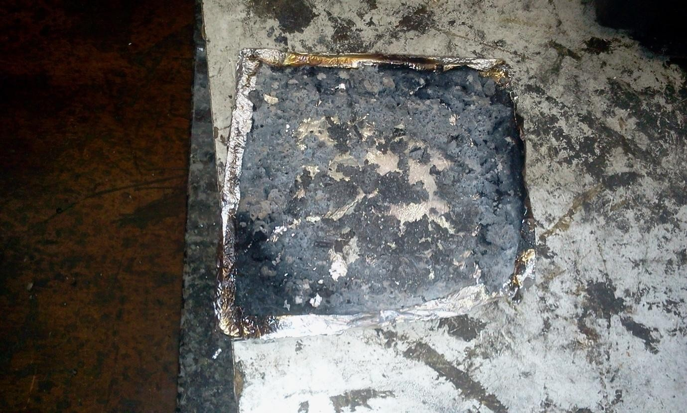
Plate 4.9d: Photograph of the 7.5%AH: 7.5wt% BPF sample left after fire test.

4.24 Morphology of burnt BPF/CHAp/polyester composites

The residues of Polyester with 20% BPF was not expanded (Plate 4.9a). This was also noticed with polyester sample left after fire test (Plate 4.9 b). For the polyester /7.5%CHAp/7.5%BPF and polyester/7.5%AH/7.5% composites, a thick and cohesive residual char was formed. It can be seen that there were some swollen residual char (Plate4.9c and 4.9d), which acted as barrier to prevent the transmission of oxygen and heat.

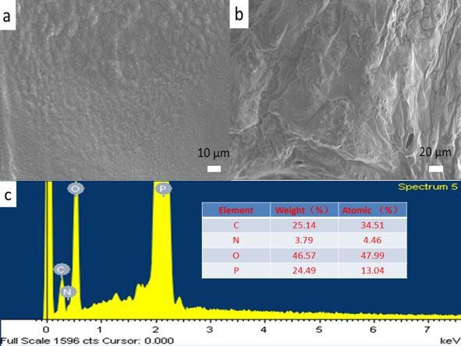

Fig 4.69: SEM images for the (a) outer residues surface (b) inner residues surface of char residue; (c) EDX spectra for char residues.

To further evaluatethe residue of polyester:7.5%CHAp: 7.5%BPF composite for fire properties of CHAp, the microstructures of the residues was tested by SEM and EDX. The SEM images for the residues ofthe outer and inner surface of the composites are shown in Plate 4.72a and 4.72b respectivily. The outer surface of the composites char residues (Plate 4.72a) is continuous, compact and unsmoothed during the combustion process. The inner surface of char residues (Plate 4.72b) exhibits cell structure and the swollen chars are

expanded as the calceolate structure. In addition, closed holes observed in the inner surface might be caused by the gases generated during the combustion. The results of EDX analysis for the char residue are given in Plate 4.72c. The contents of C, O, N and P element of the char residues are 25.1, 3.8, 46.6, and
24.5 wt %, respectively. Consequently, rich P and N-based compounds are formed on the surface via varied decomposition and reconstruction processes.

Flame-retardant properties of studied cowhorn ash (CHAp)

Cone calorimeter was used to obtain combustion information of CHAp. This technique investigates how materials burn when exposed to the typical heat flux of a fire. The heat released rate (HRR), total heat released (THR), smoke production ratio (SPR), total smoke production (TSP), time to ignition (TTI), peak heat release rate (PHRR), etc were the parameters evaluated by the cone calorimeter test.

CHAp delayed TTI of the composites by 25%. This delay could provide valuable time to evacuated a site or extinguish a fire in the event of a fire. The HRR peak value of CHAp was smaller than those of polyester and BPF and reduced further as CHAp loading in the composites formulation increased.

The smoke generated by fire is toxic and opaque and seriously endangers personnel safety. Therefore it is vital to detect the smoke production when materials burn. The TSP and TSR of CHAp decreased progressively as the wt% CHAp loading increased. This indicated that CHAp has smoke suppression

performance. The MHRR is used as an indicator to measure the tendency for fire to develope under real conditions. The MHRR of CHAp decreased unlike those of BPF which increased (Table 4.8). This reduction indicates that CHAp can indeed diminished the tendency for fire to develop. As shown in (Table 4.8), the residue of polyester-BPF composite after burning was mainly greyish white ash with a small amount of carbon (char) blocks. The residue of CHAp/polyester based composites had some white ash on the surface but the carbon or char shape basically maintained the original shape of the the composite, which indicated that CHAp was beneficial to promoting the carbon formation of composites during combustion. In particular, the residues of greater CHAp percentage composites seemed to be more complete and harder. This indicated that the uniform and dense CHAp was more favourable for carbon formation.

The elemental analysis of CHAp revealed uniform and dense Ca, O, N, and P on the composite which showed that CHAp decomposed into calcium and phosphorus oxides after it was burnt and retarded the combustion process of the composites.

Table 4.9: Comparative analysis of flame retardant properties of cow horn ash (CHAp) with some conventional fire retardant polymer additives (Du, Zhou, and Yu 2017; Fu, Medina & Carosio 2017).

Flame Retardant properties | Cow Horn Ash Particle (CHAp) | Magnesium Aluminum Layered double hydroxide  (MgAl-LDH) | Aluminum trihydrate (Al(OH)₃) | Magnesium hydroxide (MgOH₂) | Organo clay
MHRR(kw/m²) | 206.84 | 130.20 | 215.46 | 102.20 | 201.12
PHRR (Kw/m²) | 501.80 | 367.00 | 515.94 | 328.00 | 417.00
THR (MJ/m²) | 280.90 | 299.00 | 297.40 | 66.10 | 637.00
MASS loss (g/m²) | 13106.00 | 10241.20 | 12284.50 | 981.00 | 12101.00
TSR (m³/m²) | 8161.50 | 9701.20 | 8335.20 | 872.00 | 7121.20
TSP ((m³) | 78.90 | 25.00 | 7.20 | 27.00 | 62.40
TOC (g) | 129.32 | 101.32 | 164.60 | 109.72 | 101.10
TTG (s) | 80.00 | 31.00 | 81.00 | 29.00 | 62.00
ETT (s) | 1685.00 | 1436.00 | 1635.00 | 1012.00 | 1453.00
Sources: Author‟s compilation 2018

Table 4.10: EDS elemental comparative analysis of Cow Horn Ash Particle with a conventional fire retardant material.

Element | CHAp (wt%) | (MgAl-LDH) (wt%)
C | 29.40 | 22.60
O | 37.70 | 45.05
N | 46.60 | 11.85
Mg | 0.30 | 8.67
Al | - | 11.83
Ca | 32.60 | -
P | 24.50 | -
Sources: Author‟s compilation 2018
From the comparative analysis of the fire properties of cow horn ash particle and some conventional fire retardant materials, there were close relationship in the assessed properties(Tables 4.9 and 4.10). This signifies that CHAp could successfully be used as a bio-based fire retardant additive and filler in the development of fibre reienforced composites for engineering applications.

Optimal Setting for Total Heat Release Rate

    - Design of experiment

The tested composites materials were successfully prepared using handlay up procedure. The heat release rate of the composite was studied using cone calorimeter and was analyzed for different weight percent of the composite materials (5wt%, 10wt%, 15wt %). The composite materiasl used were CHAp, CHAp/BPF, and BPF/AH. To optimize the total heat release rate, a basis of 200secs, 600secs, and 1000secs burning time was taken and studied. The main factors influencing the total heat release rate (control factors) are:-
      - Reinforcement type, (B)Time,
(C)Weight percent of reinforcement material.

Table 4.11: Level of various control factors

Control factors | Units | Level I | Level II | Level III
A.  Reinforcement type | % | CHAp | CHAp/BPF | BPF/AH
B.  Time | Secs | 200 | 600 | 1000
C.  Wt% of reinforcement material | Wt% | 5 | 10 | 15
Source: Researchers compilation 2018

An orthogonal matrix L9 obtained by application of the Taguchi mixed level design was used in experimental design, Table 4.12. The statistical tool Minitab 18 was used to form the orthogonal matrix.
Generally, there are three types of S/N ratio: “smaller is better”, “larger is better”, and “normal is best”, which are used for measurement of quality

(Velickovic, Stojanovic, Babic, Vencl, Bobic, Vadaszne & Vucetic, 2019). Characteristics S/N ratio “smaller is better” was implemented for the analysis of the total heat release rate in this work. The equation for calculating S/N ratio for Taguchi characteristics “smaller is better” is calculated through the equation (Stojanovic, Blagojevic, Babic, Velickovic, Miladinovic, & Bobic, 2017).

^{𝑆} = −10 log 1
𝑁 𝑛
(∑ 𝑦²
) 4.1

Where: S/N is the signal – to – noise ratio, n is the repetition number of each trial and yi is the result of the i-th experiment for each trial.
The S/N ratio for each level of influencing paramenters is calculated based on the S/N analysis. The statistical analysis of variable is used to consider paramenters statistical worth. The optimal combination of parameters can be predicted.
Experimental values for total heat release rate were obtained by using orthogonal array for different factors combinations and they are given in Table
4.12. Table 4.12 also shows the values of S/N ratio of heat release rate.

Table 4.12: Experimental design using L9 orthogonal array

S/NO | Reinforcementtype | Time (second) | Wt% | THR(MJ/m²) | S/N ratio
1 | 1 | 1 | 1 | 31.94 | -30.0867
2 | 1 | 2 | 2 | 140.36 | -42.9449
3 | 1 | 3 | 3 | 295.52 | -49.4117
4 | 2 | 1 | 2 | 40.05 | -32.0521
5 | 2 | 2 | 3 | 128.07 | -42.1489
6 | 2 | 3 | 1 | 325.30 | -50.2457
7 | 3 | 1 | 3 | 33.12 | -30.4018
8 | 3 | 2 | 1 | 159.31 | -44.0449
9 | 3 | 3 | 2 | 309.00 | -49.7992

Researcher‟s compilation 2018

Reinforcement type: 1=CHAp, 2=CHAp: BPF, 3=BPF: AH, Time: 1=200,

2=600, 3=1000seconds, Wt%: 1=5 or 2.5:2.5, 2=10 or 5:5, 3=15 or 7.5: 7.5.

S/N Ratio Analysis

Process parameter settings with the highest S/N ratio always yield the optimum quality with minimum variance. The control parameter with the strongest influces was determined by the difference between the maximum and minimum value of the mean of S/N ratios. The higher the difference between the mean of S/N ratios, the more influential the control parameter.

Table4.13 Response table for signal to noise ratios for “smaller is better”

Level | Reinforcement type | Time | Wt% reinforcement type
1 | 155.94 | 35.04 | 172.18
2 | 164.47 | 142.58 | 163.14
3. | 167.14 | 309.94 | 152.23
Delta | 11.20 | 274.90 | 19.94
Rank | 3 | 1 | 2

The influence of control parameters on mean of heat release rate is presented in Table 4.13. Based on ranking, it is observed that the value of time is the most dominant parameter influencing the heat release rate, followed by wt% reinforcement type. The reinforment type exerted the least influence on the heat release rate.

Figure 4.70 shows a graph of the main effects of the influence of the various testing parameters on the heat release rate. In the main effect plot, if the line for a particular parameter is near horizontal, then the parameter has no significant effect. In contrast, a parameter for which the line has the highest

inclination has the most significant effect. In this case, time has the greatest infleunce on the heat release rate, followed by wt% of reinforcement type, while reinforcement type has the least influence on the total heat release rate.

Figure 4.70: Main effects plots for means for the total heat release rate
Main Effects Plot for Means
Data Means
Reinforcent type Time(sec)
300

200

100

0
1
2
wt%
3
1
2
3
300

200

100

0
1
2
3
Mean of Means

Figure 4.71: Interaction plot for means and for the total heat release rate
Main Effects Plot for S/N ratios
Data Means
-30
-35
-40
Reinforcent type
Time(sec)
-45
-50
1
2
wt%
3
1
2
3
-30
-35
-40
-45
-50
1
2
3
Signal-to-noise: Smaller is better
Mean of SN ratios

The figure 4.71: shows the interactions between some parameters and their mutual influence on the total heat release rate.

    - Analysis of variance results for the total heat release rate Experimental results were processed by using analysis of variance (ANOVA). This method was used for testing the influence of considered parameters (reinforcement type, time and wt% of reinforcement type) on the total heat release rate. By performing analysis of variance, it was decided which independent factor dominates over the other and the percentage contribution of that particular independent variable.
Table 4.14 shows the ANOVA results for the total heat release rate for three factors and interactions of those factors. This analysis was carried out at a significance level of α=0.05, i.e for a confidence level of 95%. Sources with a P-value less than 0.05 were considered to have a statistically significant contribution to the performance measures. In table 4.14 the last column shows the percentage contribution (Pr) of each parameter on the total variation indication their degree of influence on the result.
From table 4.14, time has the greatest influence on the total heat release rate (81.72%). The wt% reinforcement type (11.07%) and reinforcement type (5.07%) have smaller influence on heat release rate.
As interactions are concerned, the biggest influence is attributed to time (0.83%). Theimpacts of other interactions were smaller.

Table 4.14 Analysis of variance for S/N ratios for total heat release rate.

(DF – Degrees of freedom, Seqq SS – Sum of Squares, Adj SS – Adjusted sum of squares, Adj MS- Adjusted mean of squares, F- ratio, P- value, Pr- Percentage of contribution).

Source | DF | Seq SS | Adj SS | Adj MS | F | P | Pr %
Wt% | 1 | 22.9790 | 22.9790 | 22.9793 | 319.92 | 0.000 | 11.070
Rt | 2 | 10.5220 | 10.5220 | 5.26120 | 73.250 | 0.001 | 5.0700
Time | 2 | 169.659 | 169.659 | 84.8293 | 1181.01 | 0.000 | 81.720
Rt: time | 2 | 1.56100 | 1.56100 | 0.78030 | 10.8600 | 0.024 | 0.7500
Rt:wt% | 2 | 0.88400 | 0.88400 | 0.44190 | 6.1500 | 0.060 | 0.4300
Time:wt% | 4 | 1.71400 | 1.71400 | 0.42840 | 5.9600 | 0.0560 | 0.8300
Residual  Error | 4 | 0.28700 | 0.28700 | 0.07180 |  |  | 0.1400
Total | 17 | 207.606 |  |  |  |  | 100.00

Researcher‟s compilation 2018

S= 19.9152 R-Sq = 98.29% R-Sq(adj) = 97.27% Press = 5931.90 R-Sq (pred) = 94.89%

Figures 4.71 to 4.74 show 2D and 3D diagrams of dependence between the total heat release rate and the influencing parameters.


Surface Plot of THR(MJ/m2) vs Reinforcent type, Time(sec)
300

THR(MJ/m2) 200

100
3
0
2
Reinforcent type
1
2
Time(sec)
1
3
Figure 4.72: 3D plot of THR, reinforcement type and time.


Surface Plot of THR(MJ/m2) vs Reinforcent type, wt%
300

THR(MJ/m2) 200

100
3
0
2
Reinforcent type
1
2
wt%
1
3
Figure 4.73: 3D plot of THR, reinforcement type and wt%.

Reinforcent type
Reinforcent type

Figure 4.74: Contour plot of THR, reinforcement type and time.
Contour Plot of wt% vs Reinforcent type, Time(sec)
3.0
2.5
2.0
1.5
1.0
1.0
1.5
2.0
Time(sec)
2.5
3.0
wt%
< 1.0
1.0 – 1.5
1.5 – 2.0
2.0 – 2.5
2.5 – 3.0
> 3.0

Figure 4.75: Contour plot of THR, reinforcement type and wt%.
Contour Plot of wt% vs Reinforcent type, wt%
3.0
2.5
2.0
1.5
1.0
1.0
1.5
2.0
wt%
2.5
3.0
wt%
< 1.0
1.0 – 1.5
1.5 – 2.0
2.0 – 2.5
2.5 – 3.0
> 3.0

Multiple regression model

Multiple linear regression model was developed using statistical software “MINITAB 18”. This model gives the ratio between parameters and response by setting linear equation for the observed data. Regression equation generated this way establishes the connection between significant parameters obtained by ANOVA analysis, i.e reinforcement type, wt% reinforcement type and time. The regression equation developed for S/N ratio of the total heat release rate is as follows:-
THR (MJ/m²) = 103.641 + 5.6Rt + 137.452 T (Sec) – 9.9725 wt% 4.2

From eqn 4.2 the total heat release rate increases with increase in time and reinforcement type and decreases with increase in wt% of fire retardant reinforcement material.

Figure 4.76 shows the residual plots of THR which determined the adequacy of the model. The difference between experimental values and predicted values is referred to as residuals. Points randomly scattered in residual versus fitted values graph shows that errors are negligible and has constant variance. In the graph of normal probability plot, points were very close to the line which signifies that errors are negligible. Also in residual versus fitted value plots, points were randomly scattered. These points are sufficient to authenticate the adequacy of the mathematical model.

Percent

Figure 4.76: Residual plots for THR.
Normal Probability Plot
(response is THR(MJ/m2))
99
95
90

80
70
60
50
40
30
20

10
5

1
-10
-5
0
Residual
5
10

CHAPTER FIVE

SUMMARY OF FINDINGS, CONCLUSIONS AND RECOMMENDATIONS

Summary of Findings

In this thesis, the development of flame retarded banana peduncle fibre reinforced polyester composites using cow horn ash particle was studied. Major findings showed that:

    - The major constituent of banana peduncle fibre from chemical composition analysis was cellulose, followed by hemicellulose, lignin and pectin. With 63.4%, 10.65%, 8.50%, and 3.56% respectively.
    - Chemical treatment of BPF fibres increased its surface roughness and enhanced its interfacial bonding with polyester matrix.
    - The major constituents of CHAp were CaO from XRF study, CaCO₃ from XRD study and Ca in EDS study. CHAp presented a round solid and irregular shape particle characteristicwith an average particle size of 98.13nm.
    - BPF and CHAp had densities of 0.438 and 0.962g/cm³ respectively while the density of polyester resin was 1.12g/cm³. This showed that composites of BFP, CHAp and polyester matrix will result into lower density materials.

    - The temperature of destruction (Tds) of CHAp and BPF were determined as 700⁰C and 200⁰C respectively. CHAp retained 80% of its mass atthe temperature of 1000⁰C, while BPF left no residue at 495⁰C. Hence CHAp could be used to enhance the thermal stability of polyester composites.
    - Chemical treatment of BPF increased itsmechanical properties (Tensile strength, percentage elongation and elastic modulus) with increase in treatment time. Scouring / Saline treatment was the best treatment method. It enhanced the tensile strenght of the fiber to 143.61N/mm² at 3 hours of treatment. It reduced the hydroxyl group and stabilized covalent bond formation of BPF. Increased BPF fibre loading of the composites decreased its density.
    - Water percentage absorption of the composites decreased with increased CHAp loading as a result of void space reduction in the composite.
    - Addition of BPF to the matrix increased its flexural strength and impact energy while CHAp addition reduced their values.
    - The major functional group identified in CHAp in FTIR analysis were hydroxyloapatite and collagen.
    - The addition of CHAp to the composites improved its thermal stability by producing a protective layer against thermal decomposition.
    - The activation energies (Ea) of the composites with CHAp as a fire retardant (FR) additives, and aluminium hydroxide (AH) as fire retardant and control were higher than that of the polyester matrix. This showed

that CHAp and AH conferred higher thermal stability to the composites on addition.
    - Cone calorimetric analysis of the developed composites showed that CHAp was effective as a flame retardant additive. CHAp incorporation to polyester composites decreased the total heat release of the composite, as a result of char formation which acted as barrier between the flame and the composites. It reduced the total mass lost, increased the time to ignition and increased the end of test time of the developed composites.
    - It was observed that CHAp/BPF/ polyester composites and AH/BPF/ polyester composite had similar fire properties at the same percentage addition of 7.5wt% for CHAp and AH respectively to the polyester matrix.

Conclusions

This research was based on the development and characterisation of banana peduncle fibre reinforced polyester composites using cow horn ash particles as flame retardant additives. From the results and discussion, the following conclusions were made:
- Maximum tensile strength of 143.61N/m²for BPF was achieved with scouring/silane treatment, at the treatment time of 3hours
- The maximum cellulose content of 82.23 % for BPF was achieved with scouring/silane treatment.

- Polyester, cow horn ash particulate (CHAp) and banana peduncle fibre (BPF) composites were successfully produced by hand lay-up method.
- The density of the composites produced was lower than that of the polyester, signifying that lowerer density engeering materials can be made using this composite.
- Water absorption percentage of 0.4% .obtained in this study remained within the 6% acceptable level for comosite engineeringmaterials.
- The tensile and flexural strength of the composites obtained at 7.5%BPF: 7.5%CHAp and 7.5%BPF: 7.5%AH were 117.87MPa and 59.97MPa respectively anddepicts good mechanical property.
- The impact energy of 5.88 and 6.08J/mm² were obtained at 7.5%BPF: 7.5%CHAp and 7.5%BPF: 7.5%AH addition.
- FTIR absorption band of the hybrid composite were higher than that of the polyester which indicated an enhancement in the mechanical properties of the composite.
- CHAp played a vital role in improving the thermal stability of the hybrid composite by acting as an effective physical barrier against thermal decomposition of the polymer composite
- There was maximum endothermic peaks shift to higher temperatures after the increase of weight of the CHAp which reflects an improved thermal stability.

- Activation energy values of the developedcomposite at 7.5wt%CHAp: 7.5wt%BPF and 7.5wt%AH: 7.5wt%BPF exhibited good reliance in describing the thermal decomposition kinetics of the composite.
- The mechanical and fire properties of composites produced at 7.5%BPF/7.5%CHAp and 7.5%BPF/7.5%AH supports the findings of this research that confirmed the effectiveness of CHAp as a fire retardant addictives for safe engineering applications.
- This work showed that 7.5wt%CHAp: 7.5wt%BPF was the best combination for the developed composites production, and flame retardancy, having delayed the ignition time by 25%, the end of burning time by 14.24% and total heat release rate reduced by 9.07%.
- Finally this work has added value in the development and sustainment of fire safe products.

Recommendations and Suggestions for Further Studies

In the course of the investigation, recommendations and new areas of research have been identified.
- Waste cow horn can be used as flame retadrdant materials for the development of polymer composites
- The addition of 7.5%BPF: 7.5%CHAp to polyester matrix can be used to develope flame retarded composites materials for engineering applications.

- Further matrix-particle interface should be investigated using high- resolution transmission electron microscope
- Fibre dry tests during fibre preparation and treatment and other mechanical properties such as fatigue and creep test should be carried out on the fibre and the developed composites respectivily.
- Fibre materials from other bio sources should be investigated as alternative fibre in the developed composite production.
- Federal Government of Nigeria, Raw Materials and Development Council and National Automotive Council are called upon to support further development of this novel material into commercial status.
- Finally, application of Cow horn ash particle as fire retardant additive in products like electronic equipment, specific plastics, paints, textiles, cars and roofing sheet should be investigated.

Contributions to Knowledge

- Fresh alternative potentials of banana peduncle and cow horn agricultural wastes have been established, turning them from wastes to wealth materials and helping to combat the environmental pollution occasioned by thier indiscreminate dumping.
- Cow horn ash particle, has been developed as a novel flame retardant additive that is of bio-origin, eco friendly, locally available,

renewable,sustainable, cost effective, non toxic and engineering material properties friendly.
- Data on mechanical, physical, morphological and thermal properties of polyester/BPF/CHAp composite for fire retardant engineering applications have been experimentally determined.

REFERENCES

Abdullah, N. M., Ahmad, I., & Sains. (2013). Coconut fibre reinforced polyester composite (FRPC) by incorporating sodium hydroxide and silane treated coconut fibre. Malaysian; 42, 811.

Ahma, F.Y., Mai,Y.W.,& Su, Z. (2014).Hybrid Composites for Engineering Application, in Composite Technologies for Editors. Woodhead Publishing, 545-550.

Ahmad, F., (2004). Hybrid Composites for Engineering Application, in Composite Technologies for 2020, L. Ye, Y.W. Mai, and Z. Su, Editors., Woodhead Publishing. p. 545-550.

Aigbodion, V. S. &Hassan, S. B. (2010). Experimental Correlations between Wear Rate and WearParameter of Al-Cu-Mg/Bagasse Ash Particulate Composite. Journal of Materials and Design. 31, 2177–2180,

Akash, Girisha, K.G, Venkatesha, Gupta, N.S., Sreenivas, & Rao, K.V. (2017). A study on flammability and moisture absorption behavior of sisal/coir fiber reinforced hybrid composites, IOP Conf. Series: Materials Science and Engineering 191: 201-210.

Alcock, B., Cabrera, N.O., Barkoula, N.M., Loos, J. & Peijs, T.(2016). The mechanical properties ofunidirectional all-polypropylene composites. Composites Part A;37:716-26.

Almeida Júnior, J.H.S., (2012). Study of hybrid intralaminate curaua/glass composites. Materials & Design, 42(0): p. 111-117.

Al-Moussawi, H., E.K. Drown & L.T. Drzal, (2013). Thesilane/sizing composite interphase. Polymer Composites14(3):195-201.

Amit Kumar, R., Yakubu, M.K. & Anandjiwala, R.D., (2010). Biodegradation of flax fiber reinforced poly lactic acid,Express Polymer Letters;4:423- 30.

Andrzej, K., Bledzki. A. & Chate A, (2014). Natural fiber-reinforced polyurethane microfoams, 61: 2405–2411

Anon, K. (2013). The Competitiveness of Natural Fibre Based Composite in the Automotive Sector, the Sisal Agrobusiness in Brazil. Material Research Society.

Arbelaiz, A., Fernández, B., Cantero, G., Llano-Ponte, R., .Alea, A & I. Mondragon, (2015). Mechanical properties of flax fibrepolypropylene composites. Influence of fibrematrix modifcation and glass fibre hybridization,Composites Part A, 36,(12). 1637–1644,.

Arnold, W.S., Marshall, I.H., & Wood, J. (2015).Optimum design considerations for mechanically fastened composite joints. Composite Structures, 16, 85–101.

Ary Subagia, I.D.G,(2014). Effect of stacking sequence on the flexural properties of hybrid composites reinforced with carbon and basalt fibres. Composites Part B: Engineering, 58(0): 251-258.

Ashori, A. & S. Sheshmani, (2010) Hybrid composites made from recycled materials: Moisture absorption and thickness swelling behavior. Bioresource Technology. 101(12): p. 4717-4720.

Asuke, F. & Aigbodion, V.S, (2016). Experimental and numerical study of dry sliding wear behavior of epoxy/periwinkles shell particulate composites. Journal of the Chinese Advanced Materials Society. 1- 17 DOI: 10.1080/22243682.2015.1124736.

Baljinder, K.K., John R.E. & Kawser, P.C. (2015). Flame Retardance and Physical Properties of Novel Cured Blends of Unsaturated Polyester and Furan Resins, Polymers,21(7): 298-315.

Bárány, T., Izer, A. & Menyhárd, A.(2010). Reprocessability and melting behaviour of self-reinforcedcomposites based on PP homo and copolymers, J Therm AJnal Calorim; 101:255-63.

Barjasteh, E.(2019).Thermal aging of fiberglass/carbon-fiber hybrid composites. Composites Part A: Applied Science and Manufacturing, 40(12): 2038- 2045.

Baysal, E., Yalinkic, M. K., Altinok, A., Sonmez, A., Peker, H., & Colak, M., (2017). Journal of contruction building material., 21, 1879

Beheshty, M., Nasiri, H., & Vafayan, M. (2015). Gel time and exotherm behaviors studies of an unsaturated polyester resin initiated and promoted with dual ^{systems}. Iranian Polymer Journal, 14: 990-999.
Benveniste, Y.,(2018). Revisiting the generalized self-consistent scheme in composites: Clarification of some aspects and a new formulation. Journal of the Mechanics and Physics of Solids,56(10): 2984-3002

Beyer, G., (2011). Flame retardant properties of EVA-nanocompo-sites and improvements by combination of nanoﬁllers with aluminium trihydrate.Fire Material; 25:193–197.

Bharatkumar, Z.D. (2018). Use of non-traditional fillers to reduce flammability of polyester resin composites.ka tegorizirani rado30(1):10-17

Bhattacharyya, D., Maitrot, P. & Fakirov, S. (2019). Polyamide 6 single polymer composites.Express Polymer Letter; 3:525-32.

Bledzki, A. K. & Gassan, J.(2014). Composites reinforced with cellulose based fibres. Program Polymer Science; 24:221–74.

Bocz, K., Bárány, T., Toldy, A., Bodzay B., Csontos, I., Madi, K. & Marosi, G. (2013). Self-extinguishing polypropylene with a mass fraction of 9% intumescent additive– A new physical way for enhancing the fire retardant efficiency. Polymer Degradation and Stability.98: 79-86

BoczK, Víg A., Szolnoki, B., Szabó, L., Erdélyi, H., Zimonyi, E. & Marosi, G. (2012). Flame retardancy of natural fibre reinforced fully biodegradable composites23rd International Federation of Associations of Textile Chemists and ColouristsInternational Congress8-10. Budapest, Hungary.

Boulos, Y., Laurence, L., Wassef, E.l.K., Claude, B. & Bruno .M, (2013). New Phosphonated Methacrylates: Synthesis, Photocuring and Study of their Thermal and Flame-Retardant Properties.Macromolecular Chemistry and Physics, 204:1842-1850.

Bourbigot, S. & Duquesne, S. (2017). Fire retardant polymers: recent developments and opportunities. Journal of Materials Chemistry, 17: 2283-2300.

Bruce Curry, (2013). Fire Retardant Polyester Resin Formulations. Technical paper. 1-3.

Burks, B. & Kumosa M.,(2012) The effects of atmospheric aging on a hybrid polymer matrix composite. Composites Science and Technology. 72(15): 1803-1811.
Callister, W. D. Jr. (2014). Materials Science and Engineering. 511-531 Chapple, S., & Anandjiwala, R.(2010). Flammability of natural fiber-reinforced
composites and strategiesfor fire retardancy: A review, Journal of Thermoplastic Composite Material;23:871-93.

Chen,J.X. & Jiao Ch. (2012). Synergistic effects of hydroxy silicone oil on intumescent flame retardantpolypropylene system. Fire Safety Journal;44:10–40.

Chiu, H.T, JengR.E,& ChngJ.S,(2014). Thermal cure behaviour of
unsaturated polyester/phenol blends, Journal of Applied Polymer Science, 91, 1041–1058

Chow, W.S., Chang L.N & Jaafar .M (2014)Flame retardant epoxy hybrid composite laminates prepared by vacuum-assisted resin infusion technique, Journal of Composite Materials, 1: 1–11,

Chuyun, C., Juan, C., Fei, C., Ping, H.U., Xiang-Fa, W.U., Darrell, H. R. & Haoqing, H. (2014). High-Strength and High-Toughness Polyimide Nanofibres: Synthesis and Characterization.Journal of Applied Polymer Science,116:1581–1586.

Cristiane, M., Aline, D., Fernando, W., & Sandro C., (2011). Mechanical and flame-retardant properties of epoxy/Mg–Al LDH composites. Composites: Part A, 42: 196–202.

Critchley, J.P., Knight, G.J. & Wright, W.W. (2016). Heat-Resistant Polymers.
Plenum Press. New York.

Cyras, V.P, Liliana, B. Manfredi, L.B, Ton-That, M.T. & Vazquez, A., (2013). Physical and mechanical propertiesof thermoplastic starch/montmorillonite nanocomposite films.Carbohydrate Polymer73:55-63.

Dai, L. Song, S. Jiang, B. Yu, W. Yang, K. Richard, K. Yuen, Y. &Hua,(2013). Unsaturated polyester resins modified with phosphorus-containing groups: effects on thermal properties and flammability, Polymer Degradation and Stability, 98, 2033–2040 .

Derouet, D., Morvan, F., & Brosse, J.C., (2011). Journal of application polyscience., 62, 1855

Divya, G.S., Kakhandaki, A.&Suresha, B. (2014).Wear Behavior of Coir Reinforced Treated and Untreated Hybrid Composite, International Journal of Innovative Research & Development, 3, 632-639

Djidjelli, H., Martinez-Vega, J. J., Farenc, J. & Benachour D., (2002). Effect of wood four content on the thermal, mechanical anddielectric properties of poly(vinyl chloride). MacromolecularMaterial Engineering, 287: 9;611–618.

Dong, C., Sudarisman, & Davies .I, (2013) Flexural Properties of E Glass and TR50S Carbon Fiber Reinforced Epoxy Hybrid Composites. Journal of Materials Engineering and Performance.22(1): p. 41-49.

Dutra, R.C (2000), Hybrid composites based on polypropylene and carbon fiber and epoxy matrix. Polymer,. 41(10): 3841-3849.

Faguaga, E., (2012).Effect of water absorption on the dynamic mechanical properties of composites used for windmill blades. Materials & Design, 36(0): p. 609-616.

Fakirov, S., Evstatiev, M. & Friedrich, K., (2010). From polymer blends to particle/short-fiber/polymer composites. Composites Part B: Engineering,.33(4): p. 291-299.

Faruk, O., (2012). Biocomposites reinforced with natural fibers: 2000–2010.
Fu, S.Y., Xu G, and Mai., Y.-W,. On the elastic modulus of hybrid Microfibrillar reinforcedcomposites, In Polymer blends: formulation and performance, Ed. Paul DR, Bucknall CB,Wiley-Interscience Publication, USA, 2: 455-75.

Fernandes, V., Araujo, A. S., Fonseca, V. A., & Silva D.R., (2012). Journal of thermochim acta., 392, 71

Fukunaga, .H., Chou .T-W, & Fukuda .H,(2014.) Strength of Intermingled Hybrid Composites. Journal of Reinforced Plastics and Composites, 3(2): p. 145-160.

Gaan, S. and Sun, G., (2017). Effect of phosphorus flame retardants on thermo- oxidative decomposition of cotton.Polymer Degradation Stability;92:968- 74.

Gallo, E., Schartel, B., Acierno, D. &Russo, P., (2018). Flame retardant composites:Synergism between phosphinate and nanometric metal oxides.European Polymer Journal;47:1390-1401.

Gamze, K., Yesil, N.S., & Aytac, A. (2014). Effect of hybrid carbon nanotube/short glass fiber reinforcement on the properties of polypropylene composites. Composites Part B: Engineering,. 63(0): 154-160.

Gao, C., Yu, L., Liu, H. & Chen, L. (2012). Development of self-reinforced polymer composites.Program Polymer Science;37:767-80.

George, J., Bhagawan, S.S. & Thomas, S. (2012). Improved interactions in chemically modified pineapple leaf fiber reinforced polyethylene composites. Composite Interfaces5(3):201-223.

George, J., Sreekala., M.S & Thomas, S. (2016). A review on interface modification and characterization of natural fiber reinforced plastic composites. Polymer Engineering and Science41(9):1-11

Green, J. (2015). Phosphorus containing flame retardants, In Fire retardancy of polymeric materials.New York, USA, 147-170.

Grenier, (2016). Fire characteristics of cored composite materials for marine use”, MS Thesis, Worcester Polytechnic Institute,

Gronli, M. G., Varhegyi, G. & Di Blasi, C. (2015). Thermogravimetricanalysis and devolatilization kinetics of wood. Industrial & Engineering Chemistry Research, 41(17), 4201-4208.
Gu, P. & R.J. Asaro, (2015).Structural buckling of polymer matrix composites due to reduced stiffness from fire damageComposite Structures,69(1): p. 65-75.

Gungor, G., Demet, E. & Nuri, A. (2015). Mechanical Properties of Unsaturated Polyester–Isocyanate Hybrid Polymer Network and Its E-GlassFiber- reinforced Composite, Journal of Composite Materials, 39: No. 17/2005, 1577-1587

Gurunathan, T., Mohanty, S. & Nayak S.K.(2015). A review of the recent developments in biocompositesbased on natural fibres and their application perspectives, Composites Part A;77:1-25.

Harshvardhan, S., Arun, R. & Alok, K. (2012). Development and Characterization of Particulate Filled Glass Fiber Reinforced Hybrid Composites, International Journal of Mechanical and Industrial Engineering.2 (3); 2231 –6477.

Hapuarachch, T.D. & Peijs, T. (2018). Aluminium trihydroxide in combination with ammonium polyphosphate as flame retardants for unsaturated polyester resin. Express Polymer Letters.3(11); 743-751

Hatta, H., T. Takei, & M. Taya, Effects of dispersed microvoids on thermal expansion behavior of composite materials. Materials Science and Engineering: A, 2000. 285(1–2): p. 99-110.

Hergenrother, P.M., Thompson, G.J., Smith, J.W., Connell, Hinkley, J.A., Lyon, E.R & Moulton R., (2015). Journal of polymer, 46, 5012.

Hornsby, P.R. & Rothon, R. (2016). Fire retardant fillers for polymers, In
Fire retardancy of polymers:new applications of mineral fillers, Ed. Le Bras M, Wilkie CA, Bourbigot S, Duquesne S, JamaC. Royal Society of Chemistry, London, UK, 19-41.

Hilal, M. & Abdullah,(2017).Studying the Effect of Some Inorganic
Phosphors Salts on Fire Retardantand Mechanical Properties of Partially Cross Linked Modified Unsaturated polyester Composite, Tikrit Journal of Pure Science 16 (4) 201

Hine, P.J., Olley, H.R. & Ward, I.M., (2018). The use of interleaved films for optimising the production andproperties of hot compacted, self reinforced polymer composites, Composite Science Technology;68:1413-1421.

Hine, P.J., Bonner, M.J., Ward, I.M. & Riley, D.E. (2016). A new light weight material for cars. Composite Science Technology; 20:15-22.

Horacek, H. & Grabner, R. (2016). Advantages of flame retardants based on nitrogen compounds.Polymer Degradation and Stability, 54: 205- 215,.

Horold, S. (2019). Phosphorus flame retardants in thermoset resins, Polymer Degradation and Stability, 64(3) 427-431,.

Horrocks A.R,&Kandola B.K, (2015). Flammability and fire resistance of composites, Design and manufacture of textile composites, (Ed.), A.C. Long, Woodhead Publishing Ltd, Cambridge, Chapter 9,

Hayaty, M., Beheshty, M. & Shrinkage, H. (2014). Cure characterization and processing of unsaturated polyester resin containing PVAc low-profile additive. Iranian Polymer Journal, 1:389-396.

Hassan, S.B., Aigbodion, V.S. & Patrick, S.N. (2012). Development of Polyester/Eggshell Particulate Composites. Tribology in Industry.34(4):217-225

Ichazo, M.N,Albano, C.,Gonzalez, J.,Perera, R. & Candal, M. V. (2016). Polypropylene/wood flour composites treatments and properties. Composites structures 54: 207 – 214.
Idicula, M., (2015).Dynamic mechanical analysis of randomly oriented intimately mixed short banana/sisal hybrid fibre reinforced polyester composites. Composites Science and Technology.65(7–8): p. 1077- 1087.

Ihueze, C.C., Oluleye, A., Okafor C.E., & Obele, C. (2017). Development of Plantain Fibres for Application in Design of Oil and Gas Product Systems. Petroleum Technology Development journal (ISSN 1595- 9104): An international journal; January. Vol.7 No.1
Ihueze, C.C,& Okafor, C.E., (2014). Response Surface Optimization of the Impact Strenght of Plantain Fiber Reinforced Polyester for Application in Auto Body Works. Journal of Innovative Research in Engineering and Sciences, 4(4), March, ISSN: 2141-8225 (Print); ISSN: 2251-0524.
Ihueze, C.C,& Okafor C.E (2016). Optimal Performance Characteristics and Reinforcement Combinations of Coconut Fibre Reinforced High Desntiy Polyethylene (HDPE) Polymer Matrixes. Journal of Scientifc Reserch and Reports. January.
Ihueze, C. C,& Okafor, E.C. (2012). Optimization of Tensile Strenght Response of Plantain Fiber Reinforced Polyester Composite (PFRP) Applying Taguchi Robust Design. Journal of Innovative Design and Engineering. Vol. 3, No 7.
ISO 5660-1:2002. Reaction to fire tests – Heat release, smoke production and mass loss rate. Part 1. Heat release rate (cone calorimeter method).
Izer, A, Bárány, T.& Varga, J., (2013). Development of woven fabric reinforced all-polypropylenecomposites with beta nucleated homo- and copolymer matrices, Composites Science Technology, 69: (21)85-92.

Jähn, A., Schröder, M.W., Füting, M., Schenzel, K. & Diepenbrock.W. (2016). Characterization of alkali treated flax fibres by means of FT Raman spectroscopy and environmental scanning electron microscopy. Part A: Molecular and Biomolecular Spectroscopy 58(10):2271-2279.

James, P. Schaffer, Ashok Saxena, Stephen D. Antolovich, Thomas H. Sanders, Jr., Steven B. &Warner. (2016). The Science and Design of Engineering Materials, Second Edition. McGraw-Hill International. 578-579

Jang, B. Z., Chen L.C., Hwang, L.R., Hawkes, J.E. & Zee, R.H. (2018). The response of fibrous composites to impact loading. Polymer Composites11(3):144-157.

Jebadurai, S.G, Raj, R.E., Sreenivasan, V.S., & Binoj, J.S.,(2018). “Comprehensivecharacterization of natural cellulosic fiber from Coccinia grandis stem,” Carbohydr.Polym.

Jia, W., Gong, R.H. & Hogg, P.J. (2014). Poly (lactic acid) fibre reinforced Biode-gradable composites, Composites Part B, 62:104-12.
Jin, J., (2013).Enhancing the electrical conductivity of polymer composites.

Joseph, K. & Thomas S. (2017). Dynamic mechanical properties of short sisal fiber reinforced low density polyethylene composites. Journal of Reinforced Plastics and Composites 12(2):139-155.

Joseph, K., Mattoso, L.H.C, Toledo, R.D., Thomas, S., de Carvalho, L.H., L., Pothen, S., Kala, & James, B. (2015). Natural fiber reinforced thermoplastic composites. In Natural Polymers and Agrofibres Composites, ed. E. Frollini, A.L. Leão and L.H.C. Mattoso, 159-201. Sãn Carlos, Brazil: Embrapa, USP-IQSC, UNESP.

Joshua, L.& Jurs. (2017). Development and testing of flame retardant additives and polymers. FAA. U.S. Department of Transportation.European Polymer Journal, 49(5): p. 1066-1072.

Kandare, E. Chukwudolue, C. & Kandola, Baljinder. (2018). The use of fire- retardant intumescent mats for fire and heat protection of glass fibre- reinforced polyester composites: Thermal barrier properties.IMRI: Journal Articles (Peer-Reviewed).Paper 71

Kandola B.K, Horrocks A.R,& Price (2018). (Eds). Fire retardant materials.
Woodhead publishing ltd, Cambridge, chapter 5
Katsoulis, E. Kandare , B.K.& Kandola (2017). The effect of nanoparticles on structural morphology, thermal and flammability properties of two epoxy resins with different functionalities, Polymer Degradation and Stability, 96, 529–540

Karger-Kocsis, J. (2015). Composite composed of polypropylene reinforcement and polypropylenematrix and various production methods 102: 37-80.

Kelly, A. & Tyson, W.R. (2015). Tensile properties of fibre-reinforced metals: copper/tungsten and copper/molybdenum. Journal of Mechanical and Physical Solids. 13, 329-350

Kessler, S.S. (2014). Damage detection in composite materials using Lamb wave methods. Smart Materials and Structures. 11, 278.

Khin, A. T. & Moe, M. T. (2013). Recycling of plastic waste and agricultural waste.Energy Research Journal4 (1): 24-29.

Kiliaris, C.D. Papaspyrides (2010). Polymer/layered silicate (clay) nano composites: an overview of flame retardancy, Progress in Polymer Science, 35, 902–958

Kokta, B.V., Maldas. D, Daneault .C & Beland.P.(2013). Composites of polyvinyl chloride and wood fibres. Part II: effect of chemical treatment. Polymer Composites11(2):84-89.

Kuang, W. (2016). A new amine promoter for low-temperature cure of mekp initiated unsaturated polyester resin systems. Composites Convention and Trade Show American Composites Manufacturers Association, St. Louis, MO USA, October 18-20.

Laachachi, A., Cochez, M., Ferriol, M., Lopez-Cuesta & E. Leroy., (2015).
Mater Science Engineering lett., 59, 36,

Laoutid, F., Bonnaud, L., Alexandre, M., Lopez-Cuesta, J.M. & Dubois, Ph:(2013). New prospects in flame retardant polymer materials: from fundamentals to nanocomposites. Material Science Eng.,63: 100–125.

Levchik S, Piotrowskia A, Weilb E. &Yaob Q. (2015). New developments
in flame retardancy of epoxy resins”, Polymer Degradation and Stability, 88, 57–62

Li .C, Yuan .L, Zhi .H, Gong-Peng .L Bin .Z & Yu-Zhong W,(2017). An efficient halogen-free flame retardant for glass-fibre-reinforced polybutylene terephthalate, Polymer Degradation and Stability. 97: 158- 165.

Liu, N. A., & Fan, W. C. (2012). Modelling the thermal decompositions of wood and leaves under a nitrogen atmosphere.Fire and Materials, 22(3), 103-108.

Louis, R. &Ross, P. J. (2017). Effects of Methyl Ethyl Ketone Peroxide on the Performance of Cast Polymers. Composites Research Journal, 1 (4):14- 23

Lua, J.(2017). Thermal–mechanical cell model for unbalanced plain weave woven fabric composites. Composites Part A: Applied Science and Manufacturing. 38(3): 1019-1037.

Lu, S.Y., & Hamerton, (2015). Journal progression polymerization science., 27.
1661.

Lyons, J. W. (2014). The Chemistry and Uses of Fire Retardants. John Wiley and Sons Inc. NewYork.

Luangtriratana, P. (2019). Study of curing behaviour of different resins and their blends”, MSc Thesis, University of Bolton

Ma, Z.L., Gao, J.G., & Bai, L.G (2014). Journal of application polymer sciences., 92.1388

Mahadeve, B., Alagirusamy, R. & Apurba, D., (2015). Flame Retardant Polymer Composites. Fiber and Polymers, Vol. 16, No.4, 705-717

Mai, F., Tu, W., Bilotti, E. & Peijs, T.(2015). Preparation and properties of
self-reinforced poly(lactic acid) composites based on oriented tapes,
Composites Part A;76:145-53.

Malek, J. (2010). The kinetic-analysis of nonisothermal data.Thermochimica Acta, 200, 257-269

Malek, J., Mitsuhashi, T, & Criado, J. M. (2017). Kinetic analysis of solid-state processes.Journal of Materials Research, 16(6): 1862-1871.

Mallick, P.K. (2016). Fiber-reinforced composites: materials, manufacturing, and design. Third edition”. CRC Press. 1.

Manders, P.W. & BaderM.G.(2014), The strength of hybrid glass/carbon fibre composites. Journal of Materials Science.16(8): 2233-2245.

Manfredi, L., Rodriguez, E., Wladyka-Przybylak, M. & Vazquez, A. (2016). Thermal degradation and fire resistance of unsaturated polyester, modified acrylic resins and their composites with natural fibers. Polymer Degradation Stability;91: 255-261.

Mansour, O.Y., Nagaty, A,. Beshay, V., & Nosseir, M.H.(2017).Graft polymerization of monomers onto cellulose and lignocelluloses by chemically induced initiator. Journal of Polymer Science: Polymer Chemistry.21:715-724.

Mansour, R., Hocine, O., Abdellatif, I. & Noureddine, B. (2017). Effect of Chemical treatment on Flexure Properties of Natural Fiber-reinforced Polyester Composite,Procedia Engineering 10: 2092–2097

Maria, R., Vincenza, A., Michele, G. & Mauro Z., (2012).Thermal decomposition and fire behavior of glass fiber– reinforced polyester resin composites containing phosphate-based fire-retardant additives, Journal of Fire Sciences. 30(4) 318–330.

Maria, R.R., Vincenza, A., Michele, G. & Mauro, Z. (2014). Thermal decomposition and fire behavior of glass fiber– reinforced polyester resin composites containing phosphate-based fire-retardant additives, Journal of Fire Sciences 30(4) 318–330

Marwan, M. & Nasim Uddin., (2015) . Effect of Banana Fibres on the Compressive and Flexural Strength of Compressed Earth Blocks. Journal of buildings. 5, 282-296; doi 10.3390

Mazrouh, S.A, (2014). Fire retardant unsaturated polyester resin reinforced with fiberglass, Pigment & Resin Technology, 30: 114 – 120.

McGeorge, B.& Hoyning, (2012). Fire safety of naval vessels made of composite materials: fire safety philosophies, ongoing research and state- of-the-art passive fire protection, RTO AVT Specialists Conference, Denmark, 23–26.

Meifang, L., Yuan, L.& Qi, W, (2017). Flame-Retarded Poly(propylene) with Melamine Phosphate and Pentaerythritol/Polyurethane Composite Charring Agent, Macromolecular Materials and Engineering.292(2): 206– 213.

Michael, J. & Karter, Jr. (2016). Fire Loss in the United States 2008. NFPA Fire Analysis and Research, Quincy, MA, August 2009.

Mishra, S. C., Nayak, N. B. & Satapathy, A. (2010). Investigation onbio-waste reinforced epoxy composites,Journal of ReinforcedPlastics and Composites,29: 19; 3016–3020

Mishra, S., Misra , M.,Tripathy, S.S., Nayak, S.K. & Mohanty, A.K.. (2014). Potentiality of pineapple leaf fiber as reinforcement in PALF-Polyester composite: surface modification and mechanical performance. Journal of Reinforced Plastics and Composites20(4):321-334.

Mishra, S., Misra, M., Tripathy, S.S, Nayak, V. & Mohanty A.K. (2014). The influence of chemical surface modification on the performance of sisal- polyester biocomposites. Polymer Composites23(2):164-170.

Mishra, S., Mohanty, A.K., Drzal, L.T., Misra, M., Parija, S., Nayak, S.K. & Tripathy S.S. (2013).Composite Science Technology63: 13-85.

Mohammad .Z, Kuncoro .D, Mujtahid .K, & Djoko .S., (2018). The properties degradation of exposed GFRP roof: AIP Conference Proceedings 1931, 030063.

Mohanty, A.K., M. Misra & G. Hinrichsen. (2013). Biofibres, biodegradable polymers and biocomposites: An overview of Macromolecular Materials and Engineering.276/277:1-24.

Mohanty, A.K., Misra .M. & Drzal L.T.. (2018). Surface modifications of natural fibres and performance of the resulting biocomposites: An overview. Composite Interfaces. 8(5):313-343.

Monte, S.J. & Sugerman G. (2014). Processing of composites with titanate coupling agents-a review. Polymer Engineering and Science24(18):1369-1382.

Montgomery, D. C.(2011). Design and Analysis of Experiments, ed. John Wily, New York.

Morgan, A.B.(2016).: Flame retarded polymer layered silicate nanocomposites: a review ofcommercial and open literature systems. Polymer Advantage Technology.17, 206–217.

Morgan, A.B.& Gilman, J.W.(2013). An overview of flame retardancy of polymeric materials:application, technology, and future directions. Fire Material.37, 259–279

Munker, M., Holtman, R. & Michaeli, W. (2012). Improvement of the fiber/matrix adhesion of natural fiber reinforced polymers. Proceeding of the 43rdInternationalsample symposium.
Mouritz, Z. &Mathys, (2013)Post-fire mechanical properties of marine polymer composite, Composite Structures, 47, 643–653.

Mouritz , Z.& Mathys, (2011). Post-fire mechanical properties of glass- reinforced polyester composites, Composites Science and Technology, 61, 475–490

Nayra, U.L. & Javier, S.B. (2016). Enhanced flame retardancy of flax bio- composites for the construction market, Journal of Facade Design and Engineering4: 67–76

Nazare, S., Kandola, B.K & Horrocks, A.R (2016). Flameretardant unsaturated polyester resin incorporating nano clays, Polymer Advantage Technology.17:294–303.

Nelson, Charles A., Wikie. & Gordon, L.(2010). Fire Retardancy in 2009. In Fire and Polymers Materials and Solutions for Hazard Prevention. G.L. Nelson & C.A. Wilkie. American Chemical Society. Washington DC.

Netravali, N. A &Chabba, S. (2013) Mater. Today, 4, 22

Nodo, K.,Leong Y.W., & Hamada, H. (2012). Effect of knitted and woven textile structures on themechanical performance of poly(lactic acid) textile insert injection– compression moldings.Applied Polymer Science;125: 200-207.

Odera, R.S., Onukwuli, O.D. &Atuanya. C.U. (2015). Characterization of the Thermo-microstructural Analysis of Raffia Palm Fibres Proposed for Roofing Sheet Production. Journal of Minerals and Mineral Characterization and Engineering.

Okafor, E. C., Ihueze, Ihueze, C. C., & Nwigbo, S. C., (2014). Optimization of Hardness Strengths Response of Plantain Fibres Reinforced Polyester Matrix Composites (PFRP). Applying Taguchi Robust Design. International Journal of Engineering (IJE).26(1).

Ornaghi, H.L.,(2010.) Mechanical & dynamic mechanical analysis of hybrid composites molded by resin transfer molding. Journal of Applied Polymer Science118(2): p. 887-896.

Ovat, F.A., (2018). Evaluation of Mechanical Properties of Polymer – composite Reinforced with Nigerian Long Bamboo fibres. Arid zone Journal of Engineering, Technology and Enviroment, December. Vol. 14(4): 670-677

Pamela, W. (2017). The Life of Composite Materials, Polymer International3:1- 29.

Panigrahi, S., TabilL.G., Crerar, W.J., SokansanjS., Ward J., PowellT., Kovacs A.J.& Braun.L.(2015). Application of Saskatchewan grown flax fiber in rotational molding of polymer composites.Composites Part B: Engineering9: 295-302.

Park, S.J., Park, W.B.& Lee,J.R. (2018). Roles of unsaturated polyester in the epoxy matrix system.Polymer Journal, 31, 28–31.

Pearce E.M., Weil E. D. & Barinov V. Y. (2011). Fire Smart Polymers. In Fire and Polymers Materials and Solutions for Hazard Prevention. G.L. Nelson & C.A. Wilkie. American Chemical Society. Washington DC.

Peijs T. (2016). Composites for recyclability, Material Today;6:30-45.

Perret, B., Schartel, B., Stob, K., Ciesielski, M., Diederichs, J., Doring, M., Kramer, J. & Altstadt, V. (2019). Novol DOPO-based flame retardants in high-performance carbon fiber epoxy composites for aviation. Journal of European Polymer. 47(5); 1081-1089.

Pradeep, K.J., Sugunakar., & Chetty, N. (2017). Effect of Alkali Treatment on Mechanical Properties of Agave Fibre Reinforced Polymer Composites. IOSR Journal of Mechanical and Civil Engineering (IOSR-JMCE).

Qin C, Soykeabkaew N, Xiuyuan N, &Peijs T (2013). The effect of fiber volume fraction andmercerization on the properties of all cellulose composites, Carbohydrate Polymer71:458-67.

Qin, W.(2015). Mechanical and electrical properties of carbon fiber composites with incorporation of graphene nanoplatelets at the fiber–matrix interphase. Composites Part B: Engineering, 69(0): 335-341.

Rahmanian, S.,(2014). Mechanical characterization of epoxy composite with multiscale reinforcements: Carbon nanotubes and short carbon fibres. Materials & Design, 60(0): 34-40.

Raj, R.G., KoktaB.V., Maldas .V & Daneault V.(2018). Use of wood fibres in thermoplastic composites: VI. Isocyanate as a bonding agent for polyethylene-wood fiber composites. Polymer Composites 9(6):404- 411.

Rao, R. Sreenivas; R.S. Prakasham, K. Krishna Prasad, S. Rajesham, &P.N. Hobbs:(2018). The Taguchi methodology as a statistical tool for biotechnological applications: A critical appraisal. Biotechnology Journal 3 (4): 510–523,

Rao, Ravella Sreenivas; C. Ganesh Kumar, R. Shetty Prakasham, Phil J. & Mauro Pedro: (2019). Electrodeposition of copper on titanium wires: Taguchi experimental design approach.Journal of Materials Processing Technology, 209: 1181-1188,

Ratna Prasad, A.V. & Mohana Rao K. (2011). Mechanical properties of natural fibre reinforced polyester composites: Jowar, sisal and bamboo. Elsevier, March 2011.

Ray, D., Sarkar B.K., Rana A.K. & Bose N.R. (2012). Effect of alkali treated jute fibres on composite properties. Bulletin of Materials Science 24(2):129-135.

Ribeiro, M.C.S. Ribeiro, Sousaa S.P.B. & NóvoaP.R.O. (2015). An investigation on fire and flexural mechanical behaviors of nano and micro polyester composites filled with SiO2 and Al2O3 particles, Materials Today: Proceedings 2: 8 – 19

Rota, K., Huskic. M., Makarovic. M., Ljubic Mlakara.T & Igonb.M,(2019). “Interfacial effects in glass fibre composites as a function of unsaturated polyester resin composition. Composites: Part A,32: 511–516,.

Sain, M., Park, S.H., Suhara, F., & Law, S., (2014). Journal of polymer degradation stabilisation., 83, 363

Sanjay, M. R., ArpithaG. R.,. LaxmanaL. N GopalakrishnaK. &Yogesha.B(2016).Studies on Mechanical Properties of Banana/E- Glass Fabrics Reinforced Polyester Hybrid Composites, Journal Material Environment Science. 7 (9): 3179-3192

Sapieha, S., Allard P., & ZangY.H. (2016). Dicumyl peroxide-modified cellulose/LLDPE composites. Journal of Applied Polymer Science41:2039-2048.

Sarkar, S., & Adhikari, B., (2011). Jute felt composite from lignin modified phenolic resin. Polymers composites., 22. 4

Sarki, J., Hassan, S. B., Aigbodion, V. S. & Oghenevweta, J.E. (2011).Potential of using Coconut shell fillers in Eco-composites Materials, Journal of Alloy & Compounds 509: 2381–2385.

Saravanakumaar, A, Senthilkumar, A,Saravanakumar, S.S, Sanjay,M.R, &Khan, A. (2018). “Impact of alkali treatment on physico-chemical, thermal, structural and tensileproperties of Carica papaya bark fibers,” Int. J. Polym. Anal. Charact., vol. 23, no. 6,pp. 529–536.

Satyanarayana, K.G., Arizaga, G.G.C., & Wypych F. (2016). Biodegradable composites based onlignocellulosic fibres – an overview, Progam Polymer Science;34:982-1021.

Selmy, A.I., (2012) In-plane shear properties of unidirectional glass fiber (U)/random glass fiber (R)/epoxy hybrid and non-hybrid composites. Composites Part B: Engineering, 43(2): 431-438.

Shah, V. (2018). Handbook of Plastics Testing Technology. 2nd ed. New York, NY: John Wiley and Sons.

Shukla, S., Shukla, A.K., Singh, P.K., Singhla, R. & Nagpal, A.K. (2006). Effects of concentration of Methyl Ethyl Ketone Peroxide on gelation characteristics and shrinkage of solventless polyester varnish. Oleo Science, 55(6):299-303.

Shumao, R. Jie, Y. Hua, Y. Taoa, & Y. Weizhong, (2010) Polym. Int., 59, 242

Shyam, Kumar Karna & Dr. Rajeshwar Sahai (2012). An Overview of Taguchi Method. International Journal of Engineering and Mathematics Sciences Jan-June,1: 11-18.

Singh ,V.K., Gope P.C., Chauhan S., Bisht, D.S, &Mater, J.(2012) Environment Science3 (1) 194.

Song, J. & Ehrenstein, G.W. (2015). Friction and wear of self-reinforced hermoplastics. In Advances inComposite Tribology, Ed. Friedrich K, Elsevier, Amsterdam, 2: 19-63.

Sorathia, J. Ness,& Blum M,(1999). Fire safety of composites in the US navy,
Composites - Part A: Applied Science and Manufacturing, 30, 707–713

Sreekala, M.S., Jayamol G., Kumaran M.G. & Sabu .T. (2012).Composite Science Technology62: 353.

Sreekala, M.S., Kumaran, M.G., JosephS., Jacob.M. & Thomas, S. (2012). Oil palm fiber reinforced phenol formaldehyde composites: influence of fiber surface modifications on the mechanical performance. Applied Composite Materials. 7:295-329.

Stojanovic, A., Venc, A., Bobic, I., Miladinovic, S., Skerlic, J., (2018). Experimental optimisation of the tribological behaviour of AI/SiC/Gr hybrid composites based on Taguchi‟s method and artificial neural network, Journal of the Brazilian Society of Mechanical Sciences and Engineering. 40, No.311, pp. 1-14.

Stojanovic, B., Velickovic, S., Babic, M., Vencl, I., Bobic, G., Vadaszne, Bognar, Vucetic., (2019). Parametric optimization of the aluminium nanocomposites total heat release rate, Journal of the Brazillian Society of Mechanical Sciences and Engineering, 41, N0.1, pp. 1-10.

Suppakarn, N. & Jarukumjorn, K. (2016). Mechanical properties and flammability of sisal/PP composites: Effect of flam retardant type and content. Composites: Part B; 40:614

Tai, M. C., Robert, K., & Li Y., (2011). Investigation of mechanical property, flame retardancy and thermal degradation oc fiber composites, Journal Application Polymers Science., 80, 2718

Teodorescu, H., M. &Demiralp (2019).Some averaging methods in the micromechanics of composite materials with periodic structure. ACMOS '08: Proceedings of the 10th Wseas International Conference on Automatic Control, Modelling and Simulation, ed., 210-214.

Teodorescu-Draghicescu, H.,(2019). On the elastic constants of a fibre- reinforced composite laminate. Proceedings of the 2nd WSEAS International Conference on Engineering Mechanics, Structures and Engineering Geology, ed. N.E. Mastorakis, O. Martin, and X.J. Zheng. 155-158.

Thompson, C.M., Smith Jr, J.G., Connell, J.W., Hergenrother, P.M., and Lyon R.E., (2014). Flame Retardant Epoxy Resins, National Aeronautics ans Space Administration Langley Research Center, Virginia, pp. 1-16,

Toldy A., MAtko S.Z., Anna P., Bertala G.Y., & Marosi (2015). Flame retardancy of biodegradable polymers and biocomposites. Journal of polymer degradation stability. 88: 138-145

Troitzsch, J.(2010). International Plastics Flammability Handbook. 2nd Ed.
Hanser Publishing. New York. 1990.

Tsai, Y.I., (2016).Influence of hygrothermal environment on thermal and mechanical properties of carbon fiber/fiberglass hybrid composites. Composites Science and Technology,69(3–4): p. 432-437.

Tsuji, H., Nakano, M., Hashimoto, M., Takashima, K., Katsura, S. & Mizuno A. (2016). Electrospinning ofpoly(lactic acid) stereocomplex nanofibres, Biomacromolecules;7:33;16-20.

Tucker, C. L. & Liang, E. (2017). Stiffness predictions for unidirectional short fiber composites: review an evaluation. Composites Science and Technology.7 (59): 655-671.

Tyberg, C.S, Bergeron, K, Sankarapandian, Shih P, Loos A.C, D.A. Dillard,
J.E. McGrath, J.S. Riffle, U.& Sorathia, (2010), Structure–property relationships of void-free phenolic–epoxy matrix materials”, Polymer, 41, 5053–5062.

Valença, S.L., (2015). Evaluation of the mechanical behavior of epoxy composite reinforced with Kevlar plain fabric and glass/Kevlar hybrid fabric. Composites Part B: Engineering, 70(0): 1-8.

Venkata G.R, & Venkata S. N. (2018). Kapok/Glass Polyester Hybrid Composites: Tensile and Hardness Properties, Journal of reinforced plastics and composites, 27: 16–17

Venkatesh Waran, N., Elaya Perumal A.& Sathiya, G.K. (2011). Prediction of tensile properties of hybrid-natural fiber composites Elsevier,

Vince Weldon (2017). Transcript of Weldon‟s letter to the FAA. The Seattle Times 24 July, 2007.

Wang, E. Han & W. Ke,(2015)An investigation into fire protection and water resistance of intumescent nano-coatings, Surface and Coatings Technology, 201, 1528–1535.

Wang, L., Ding, W. & Sun, Y. (2015). Effect of different fibre materials on mechanical properties of polyurethane composites. In China: 2nd International Workshop on Materials Engineering and Computer Sciences (IWMECS)

Wambua, P., Ivens, J. & Verpoest (2013). Natural fibers: Can they replace glass in fiber reinforced plastics? Composites Science and Tecchnology 63(9): 1259-1264.
Wambua, P., Ivens, J., & Verpoest, I (2013). Compos. Sci. Technol.,63, 1259 Wei P, Li HX, Jiang PK, &Yu HY. (2017). An investigation on the
flammability of halogen-free fire retardant PP-APP-EG systems, Journal
of Fire Science.22:367-77.

Williams, G.I. & WoolR. P. (2010). Composites from natural fibres and soy oil resins.Applied Composite Materials.7:421-432.

Yahaya, R., (2015), Effect of layering sequence and chemical treatment on the mechanical properties of woven kenaf–aramid hybrid laminated composites. Materials & Design, 67(1): 173-179.
Yang, J., Liang, J.Z., & Tang, C.Y., (2019). Journal of polymer test., 28, 907 Yao D, Li R,& Nagarajan, P. (2016). Single-polymer composites based on
Slowlycrystallizing polymers, Polymer Engineering Science;46:1223-30.

Yuan, X., Jayaraman K. & Bhattacharyya .D. (2012). Plasma treatment of sisal fibres and its effects on tensile strength and interfacial bonding. In Proceedings the Third International Symposium on Polymer Surface Modification: Relevance to Adhesion, Journal of Adhesion Science and Technology Special Publication 1(1):1-25. Newark, NJ: MST Conferences, LLC.

Yuxiang, O. U. (2011). Flame-retarded Polymeric Materials. National Defense and Industry Press. Beijing.

Zhang, J.M., Reynolds, C.T. & Peijs T. (2015). All-poly (ethylene terephthalate) Composites by film stackingof oriented tapes, Composites Part A 40:1747-55.

Zhang, H.& Sun, G. (2015).Mod. Appl. Sci., 3, 129

Zhao, C.S., Huang, F.L, Xiong, W.C & Wang, Z., (2011). Journal of polymer degradation stabilization., 88, 138

Zimniewska, M., Wladyka-Przybylak, M., & Mankowski, J. (2011). Cellulosic

bast fibers, theirstructure and properties suitable for composite applications. In Cellulose fibers: Bio-and nano-polymer composite. 97– 119.

APPENDICES
A1: Data used for the Kinetic study of the polyester matrix

S/N | α | T (^{O}K) | T²(^{O}K)² | (1- α) | [-In(1-  α)]1/3 | In{[- In(1-  α)]1/3/T²} | T⁻¹(^{O}K)
1 | 0.01 | 620.77 | 385355.39 | 0.99 | 0.215 | -4.0E-6 | 0.00161
2 | 0.02 | 630.23 | 397189.85 | 0.98 | 0.27 | -3.3E-6 | 0.00159
3 | 0.03 | 645.09 | 416141.11 | 0.97 | 0.312 | -2.8E-6 | 0.00155
4 | 0.04 | 650.40 | 423020.16 | 0.96 | 0.344 | -2.5E-6 | 0.00153
5 | 0.05 | 655.34 | 429470.51 | 0.95 | 0.372 | -2.3E-6 | 0.00153
6 | 0.06 | 670.01 | 448913.4 | 0.94 | 0.396 | -2.1E-6 | 0.00149
7 | 0.07 | 679.43 | 461625.12 | 0.93 | 0.417 | -1.89E-6 | 0.00147
8 | 0.08 | 866.65 | 751082.22 | 0.92 | 0.437 | -1.1E-6 | 0.00115

A2: Data used for the Kinetic study of the 7.5wt%CHAp: 7.5wt%BPF composites

S/N | Α | T (^{O}K) | T²(^{O}K)² | (1- α) | [-In(1-  α)]1/3 | In{[- In(1-  α)]1/3/T²} | T⁻¹(^{O}K)
1 | 0.01 | 533.64 | 284771.65 | 0.99 | 0.215 | -5.4E-6 | 0.0019
2 | 0.02 | 600.34 | 360408.12 | 0.98 | 0.27 | -3.63E-6 | 0.0017
3 | 0.03 | 620.13 | 384561.22 | 0.97 | 0.312 | -3.03E-6 | 0.0016
4 | 0.04 | 635.09 | 403339.31 | 0.96 | 0.344 | -2.65E-6 | 0.00157
5 | 0.05 | 645.48 | 416644.43 | 0.95 | 0.372 | -2.37E-6 | 0.00155
6 | 0.06 | 667.80 | 445956.84 | 0.94 | 0.396 | -2.08E-6 | 0.00150
7 | 0.07 | 671.54 | 450965.97 | 0.93 | 0.417 | -1.94E-6 | 0.00149
8 | 0.08 | 773.00 | 597529.00 | 0.92 | 0.437 | -1.39E-6 | 0.00129

A3: Data used for the Kinetic study of the 7.5wt%AH: 7.5wt%BPF composites

S/N | Α | T (^{O}K) | T²(^{O}K)² | (1- α) | [-In(1-  α)]1/3 | In{[- In(1-  α)]1/3/T²} | T⁻¹(^{O}K)
1 | 0.01 | 620.1 | 384524.01 | 0.99 | 0.215 | -4.0E-6 | 0.0016
2 | 0.02 | 627.9 | 394258.41 | 0.98 | 0.27 | -3.3E-6 | 0.00159
3 | 0.03 | 645.78 | 417031.8 | 0.97 | 0.312 | -2.79E-6 | 0.00155
4 | 0.04 | 650.45 | 423085.22 | 0.96 | 0.344 | -2.52E-6 | 0.00154
5 | 0.05 | 658.85 | 434083.32 | 0.95 | 0.372 | -2.3E-6 | 0.00152
6 | 0.06 | 678.00 | 459684 | 0.94 | 0.396 | -2.2E-6 | 0.00148
7 | 0.07 | 682.15 | 465328.6 | 0.93 | 0.417 | -1.88E-6 | 0.00147
8 | 0.08 | 866.04 | 750025.28 | 0.92 | 0.437 | -1.1E-6 | 0.00116

Appendix B1:Results of mechanical properties and stress-strain curve of 1houracetylene treated banana peduncle fibre

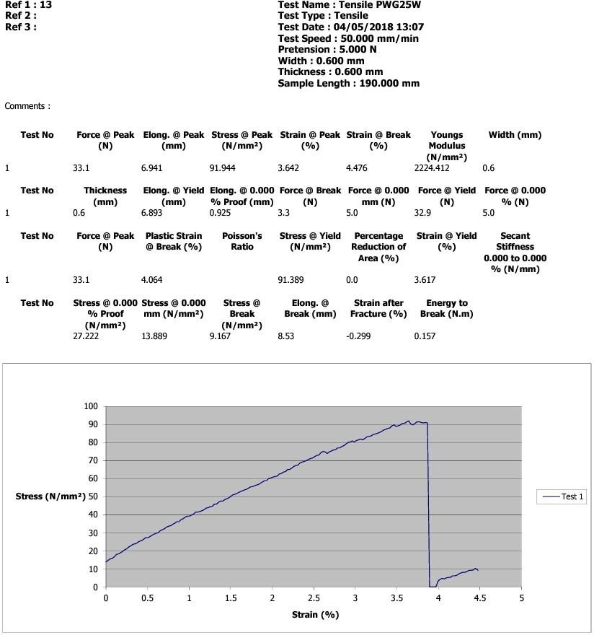

Appendix B2:Results of mechanical properties and stress-strain curve of 2hour acetylene treated banana peduncle fibre

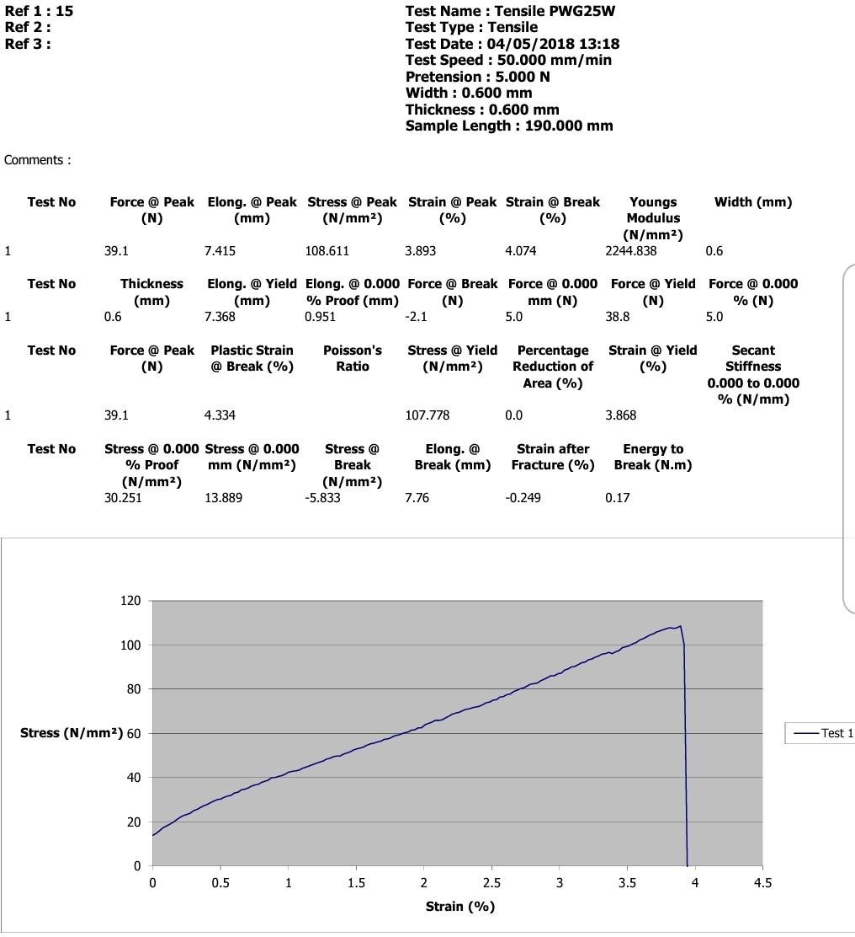

Appendix B3: Fig 4.7c: Results of mechanical properties and stress-strain curve of 3houracetylene treated banana peduncle fibre

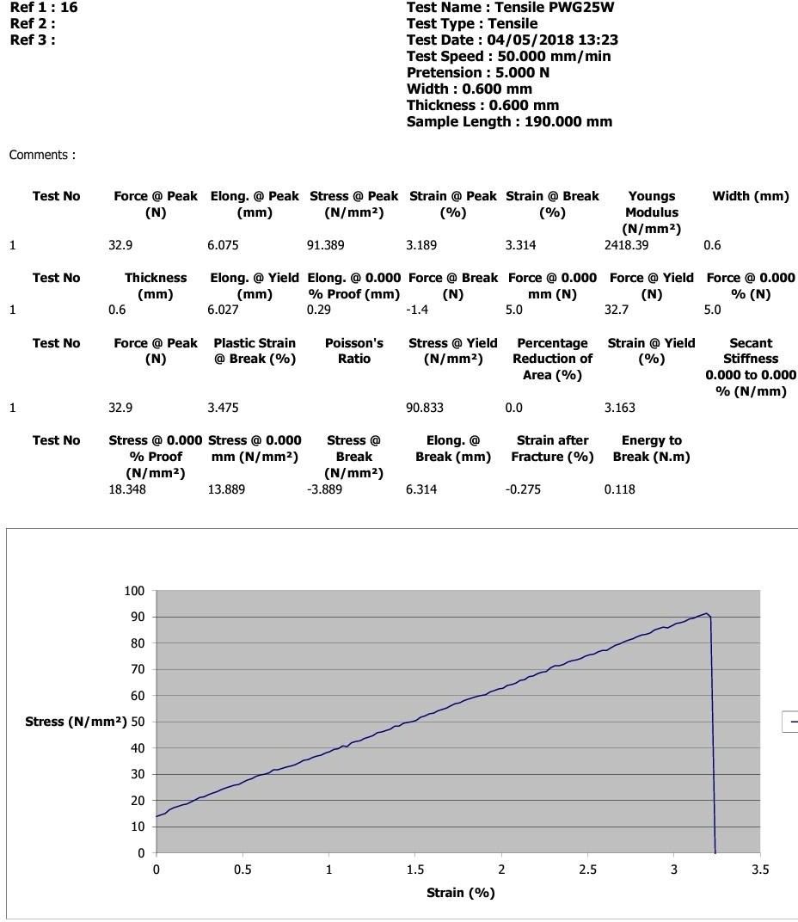

Appendix B4: Results of mechanical properties and stress-strain curve of 4hour acetylene treated banana peduncle fibre

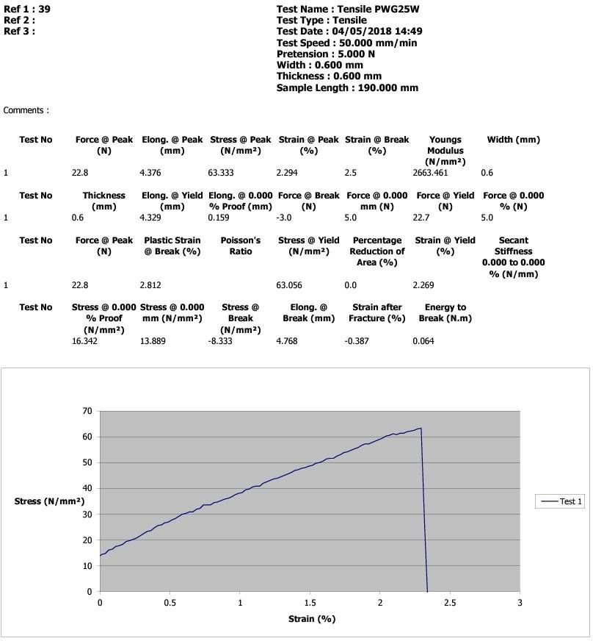

Appendix B5:Results of mechanical properties and stress-strain curve of 1hour silane treated banana peduncle fibre

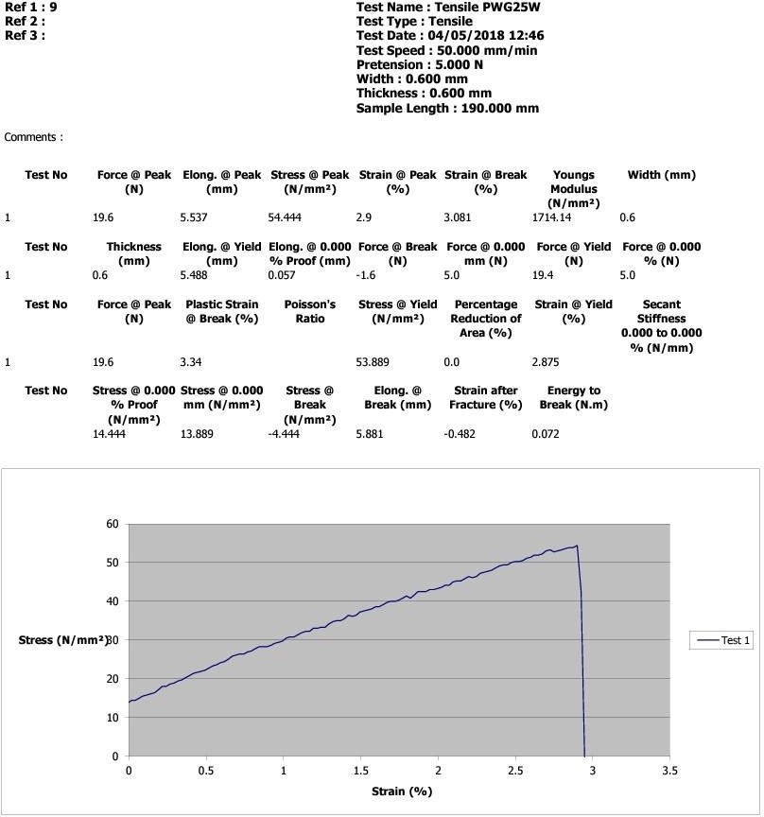

Appendix B6: Results of mechanical properties and stress-strain curve of 2hour silane treated banana peduncle fibre

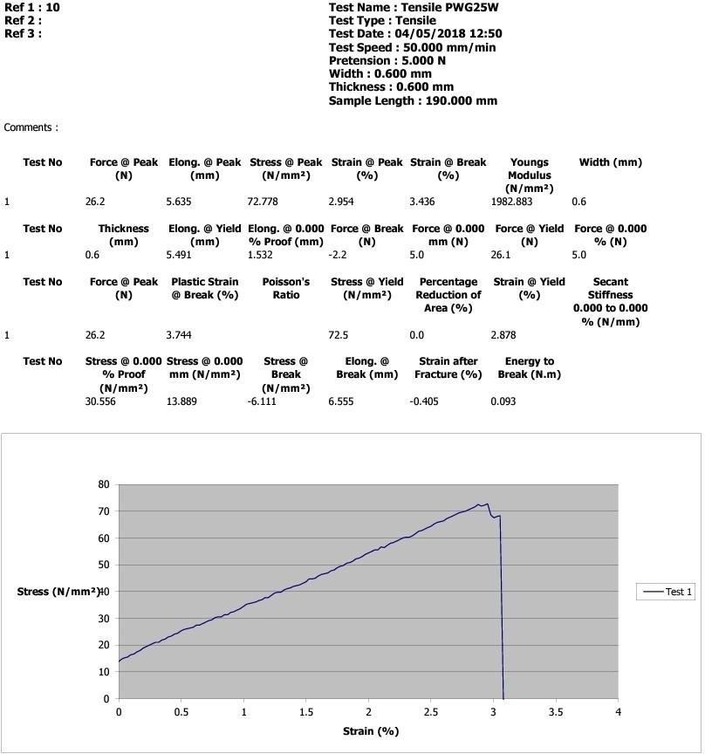

Appendix B7:Results of mechanical properties and stress-strain curve of 3hour silane treated banana peduncle fibre

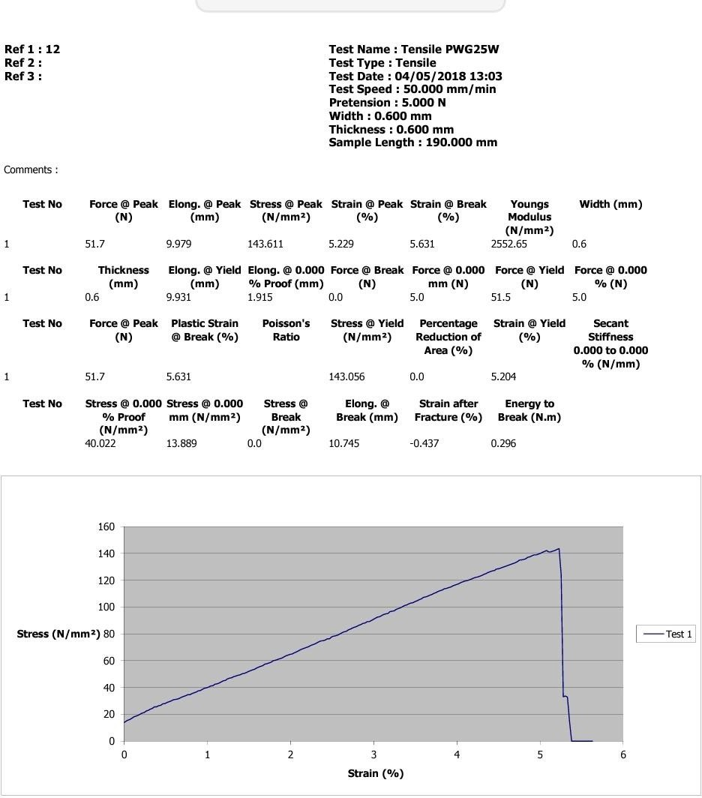

Appendix B8:Results of mechanical properties and stress-strain curve of 4hour silane treated banana peduncle fibre

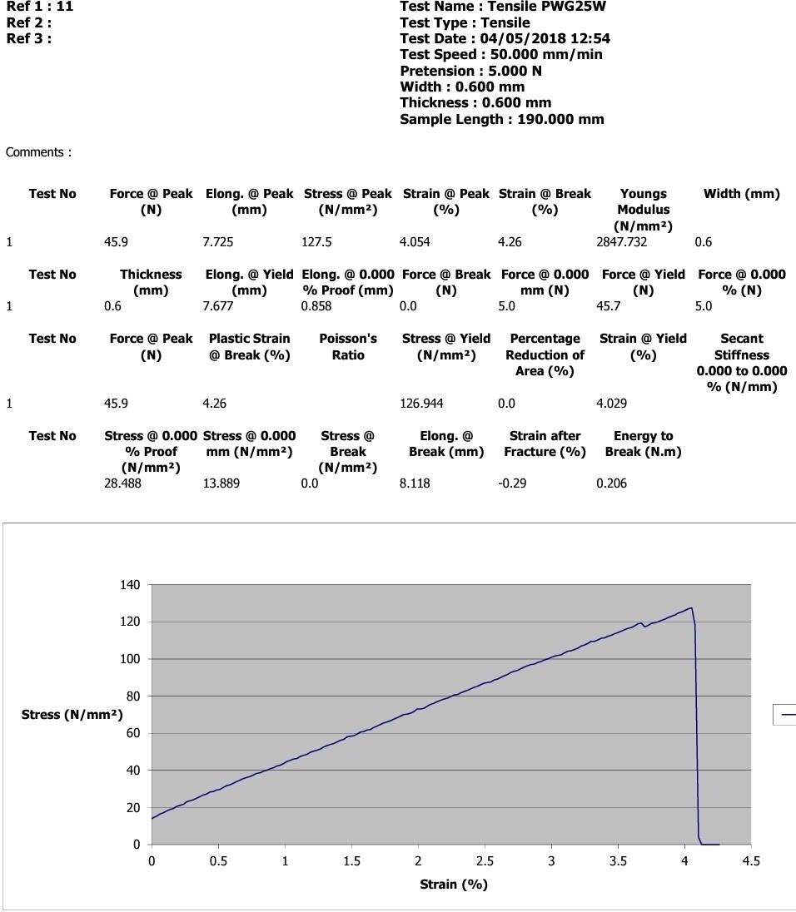

Appendix B9:Results of mechanical properties and stress-strain curve of 1hour KMNO₄ treated banana peduncle fibre

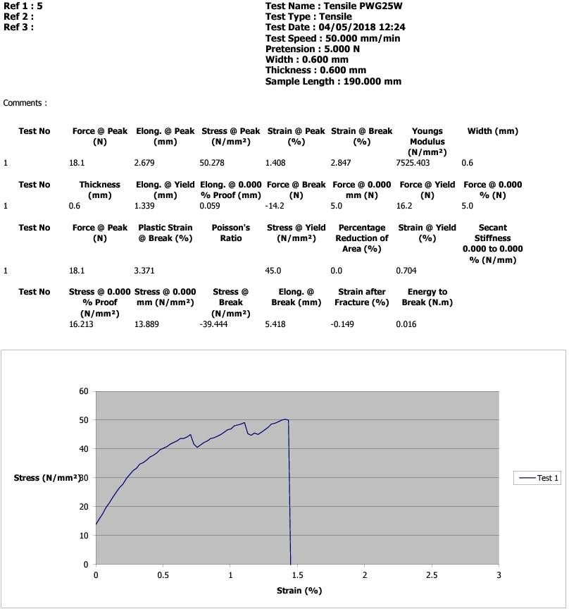

Appendix B10:Results of mechanical properties and stress-strain curve of 2hourKMNO₄ treated banana peduncle fibre

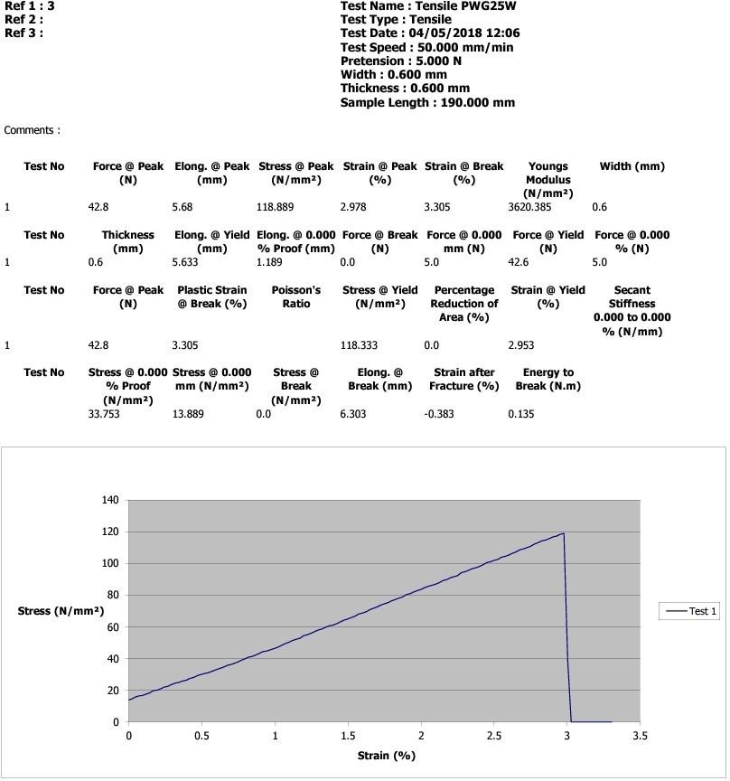

Appendix B11:Results of mechanical properties and stress-strain curve of 3hourKMNO₄ treated banana peduncle fibre

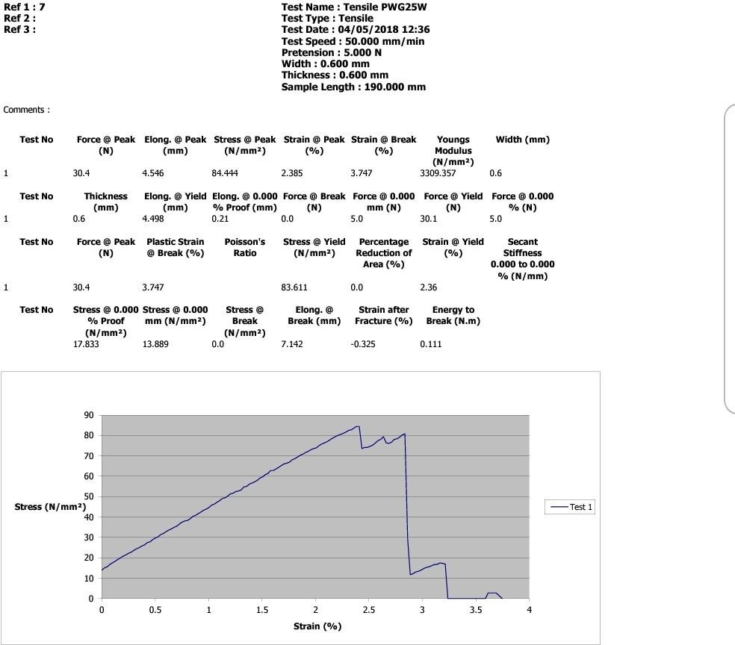

Appendix B12:Results of mechanical properties and stress-strain curve of 4hourKMNO₄ treated banana peduncle fibre

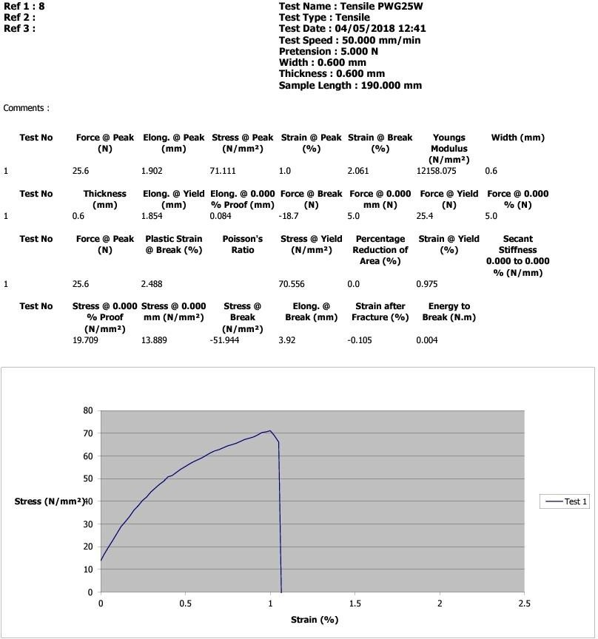

Appendix B13:Results of mechanical properties and stress-strain curve of 1houralkali treated banana peduncle fibre

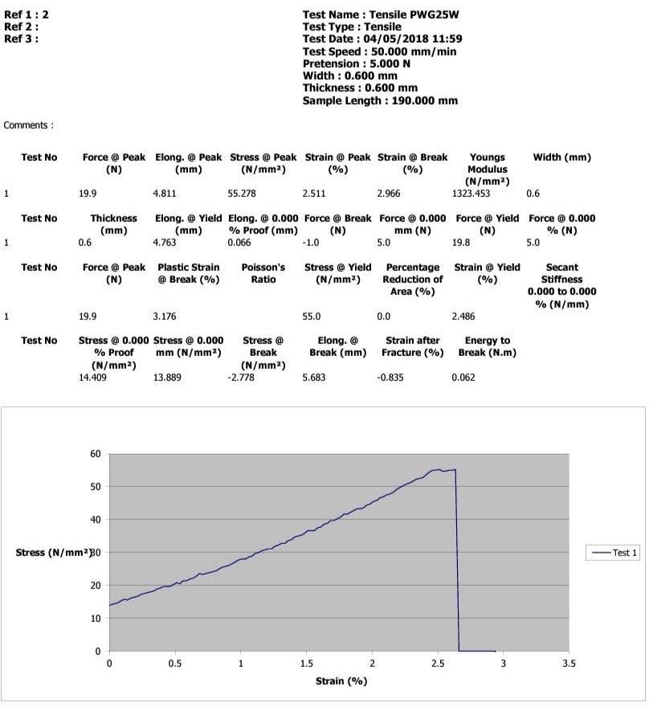

Appendix B14:Results of mechanical properties and stress-strain curve of 2houralkali treated banana peduncle fibre

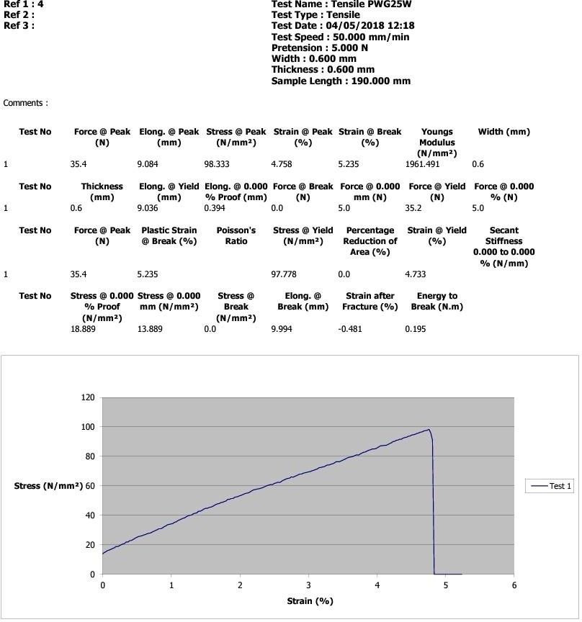

Appendix B15:Results of mechanical properties and stress-strain curve of 3houralkali treated banana peduncle fibre

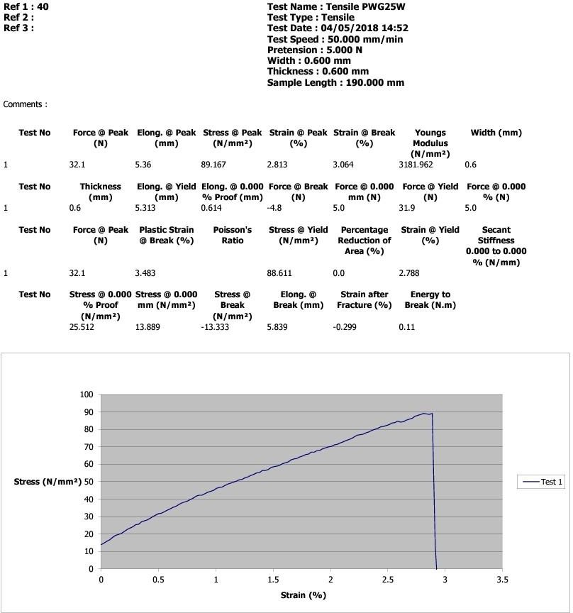

Appendix B16:Results of mechanical properties and stress-strain curve of 4houralkali treated banana peduncle fibre

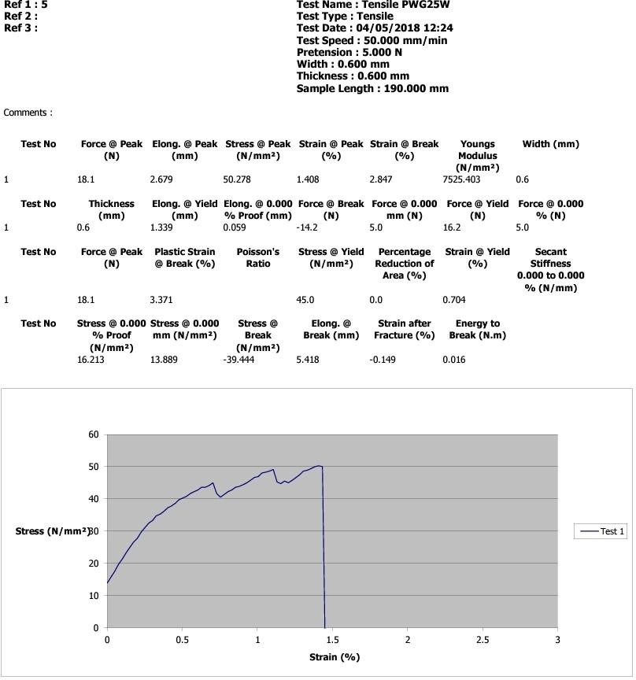

Appendix B17:Results of mechanical properties and stress-strain curve of untreated banana peduncle fibre

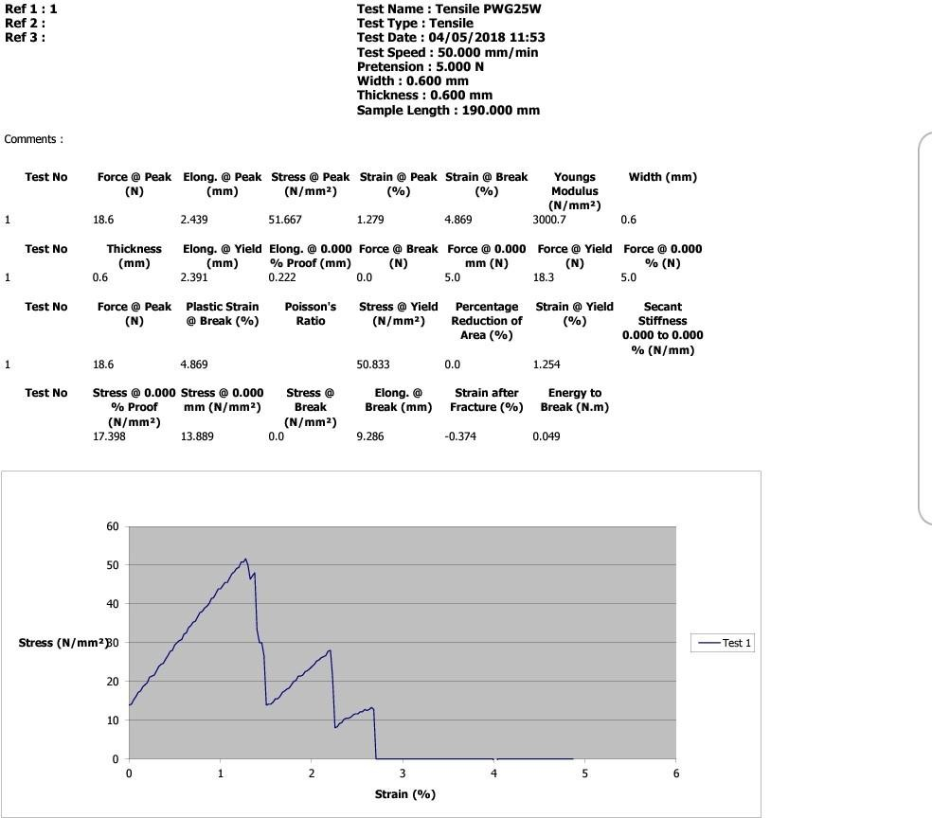

Appendix C1:Results of mechanical properties and stress-deflection curve of polyester composites with 20W% CHAp
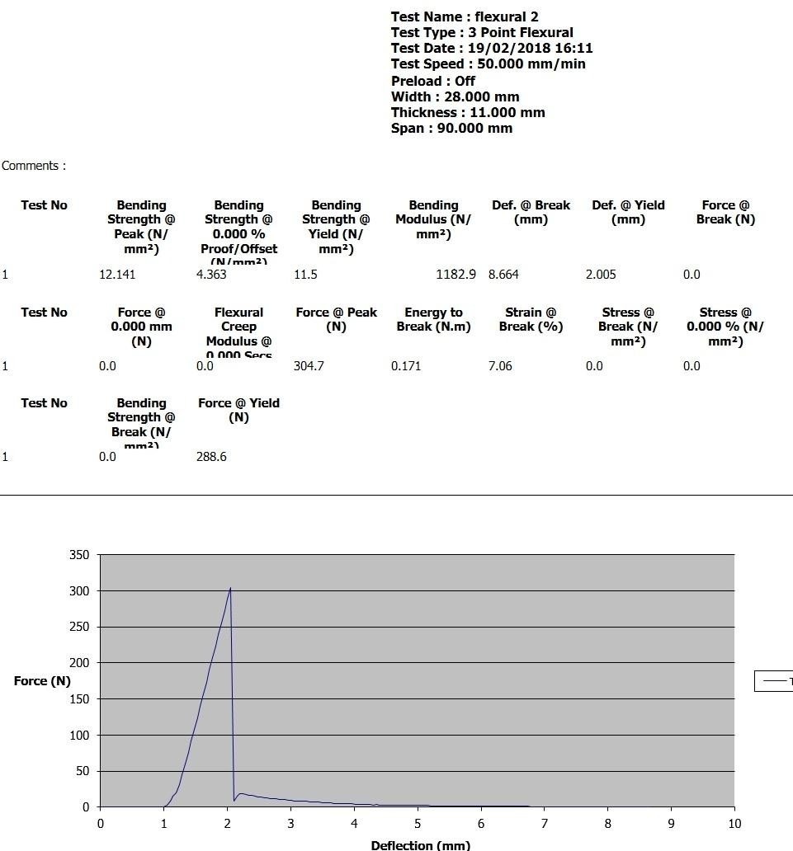

Appendix C2:Results of mechanical properties and stress-deflection curve of polyester resin
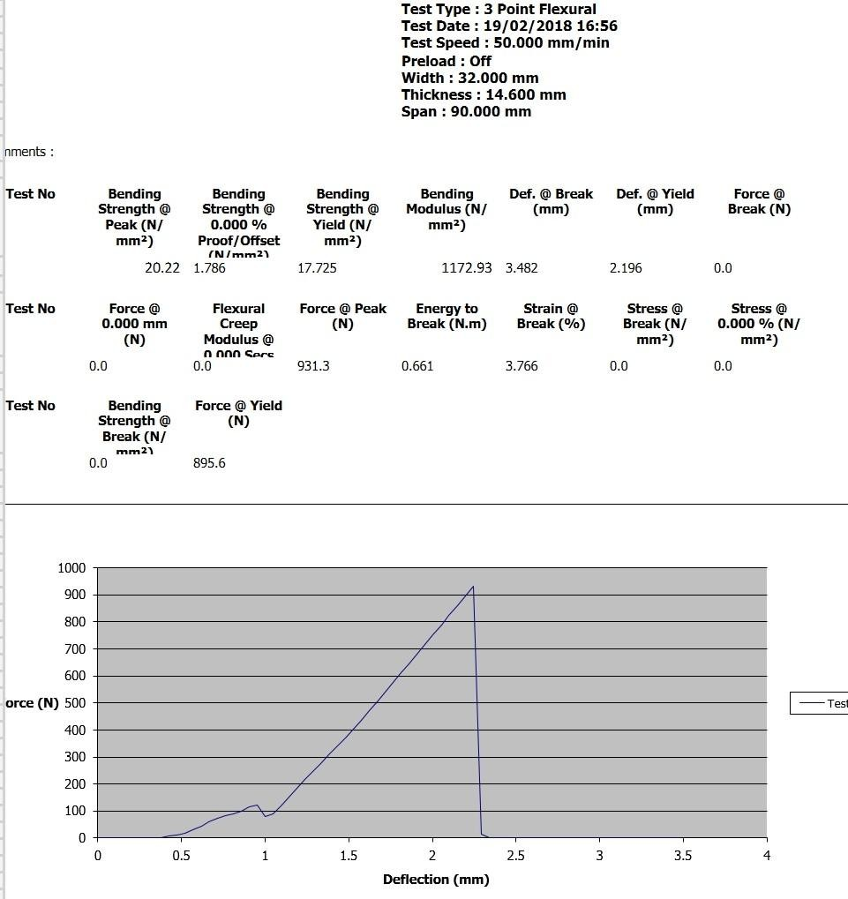

Appendix C3:Results of mechanical properties and stress-deflection curve of polyester composites with 20W%BPF
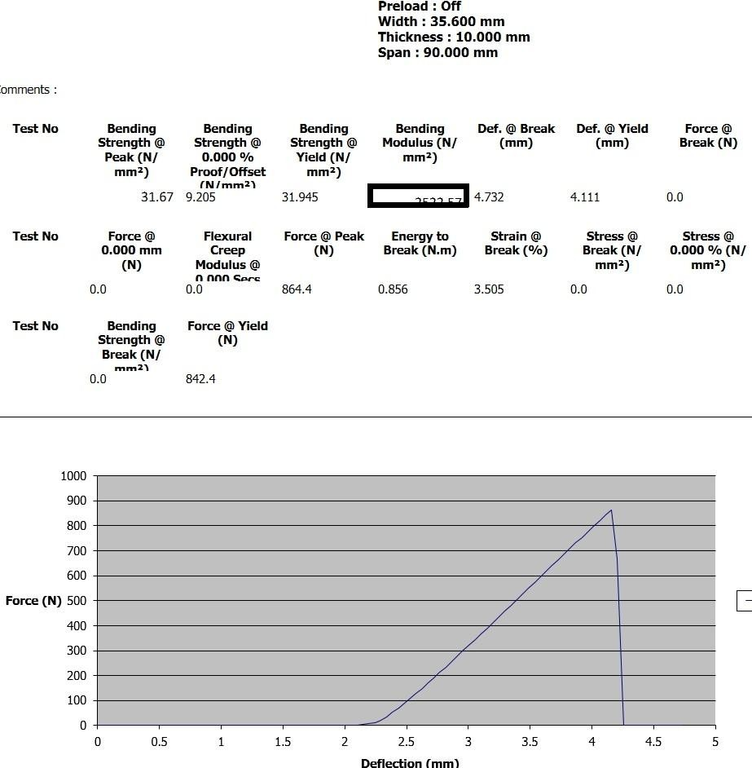

Appendix C4:Results of mechanical properties and stress-deflection curve of polyester composites with 7.5CHAP:7.5BPF wt%
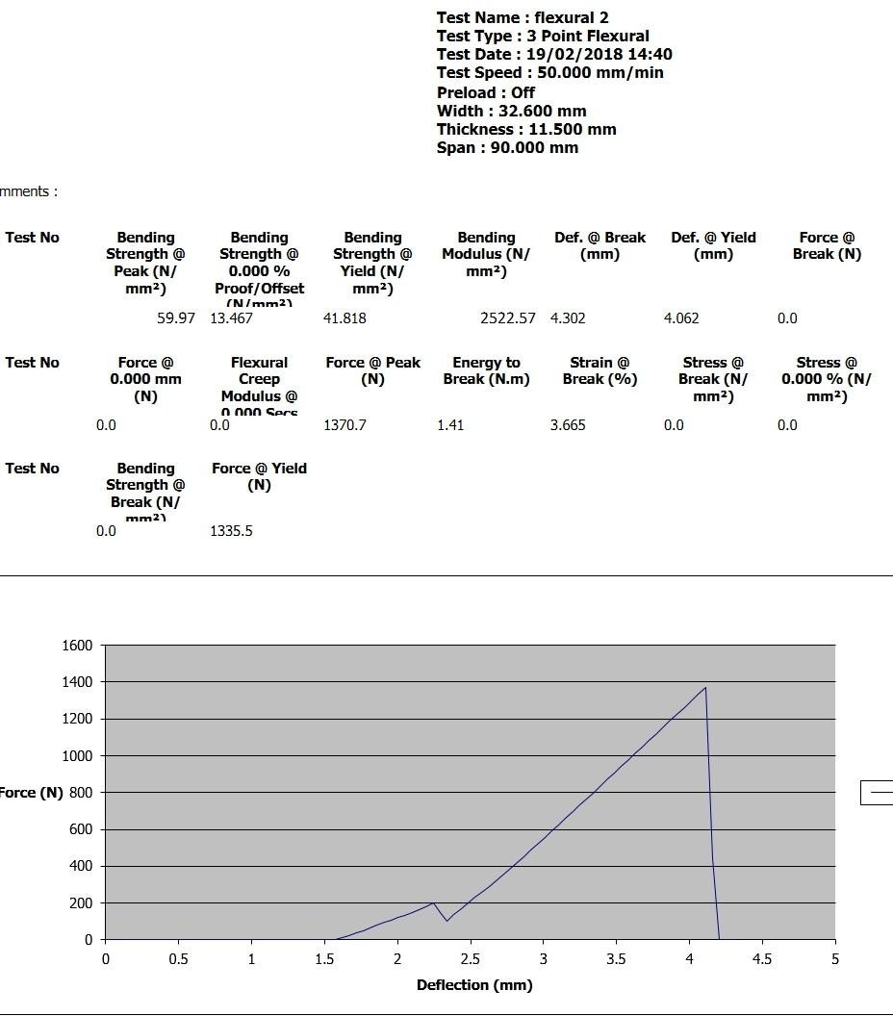

Appendix C5:Results of mechanical properties and stress-deflection curve of polyester composites with 15CHAP wt%
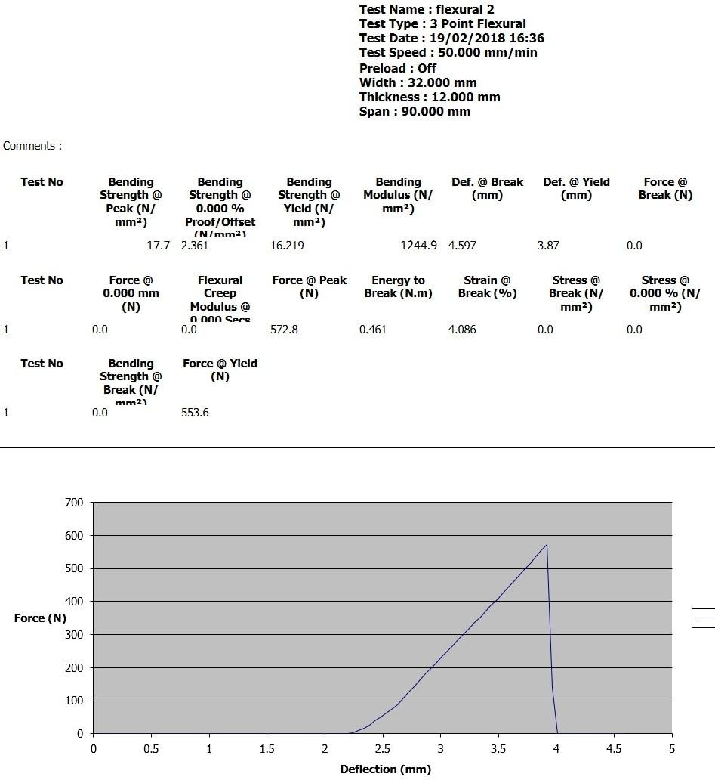

Appendix C6:Results of mechanical properties and stress-deflection curve of polyester composites with 15wt% BPF
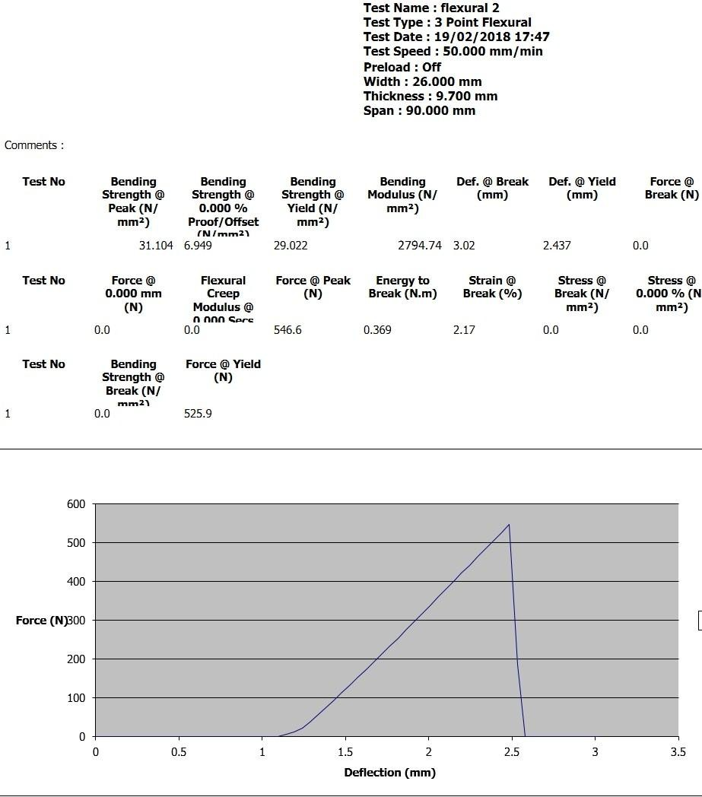

Appendix C7:Results of mechanical properties and stress-deflection curve of polyester composites with 10 wt%BPF
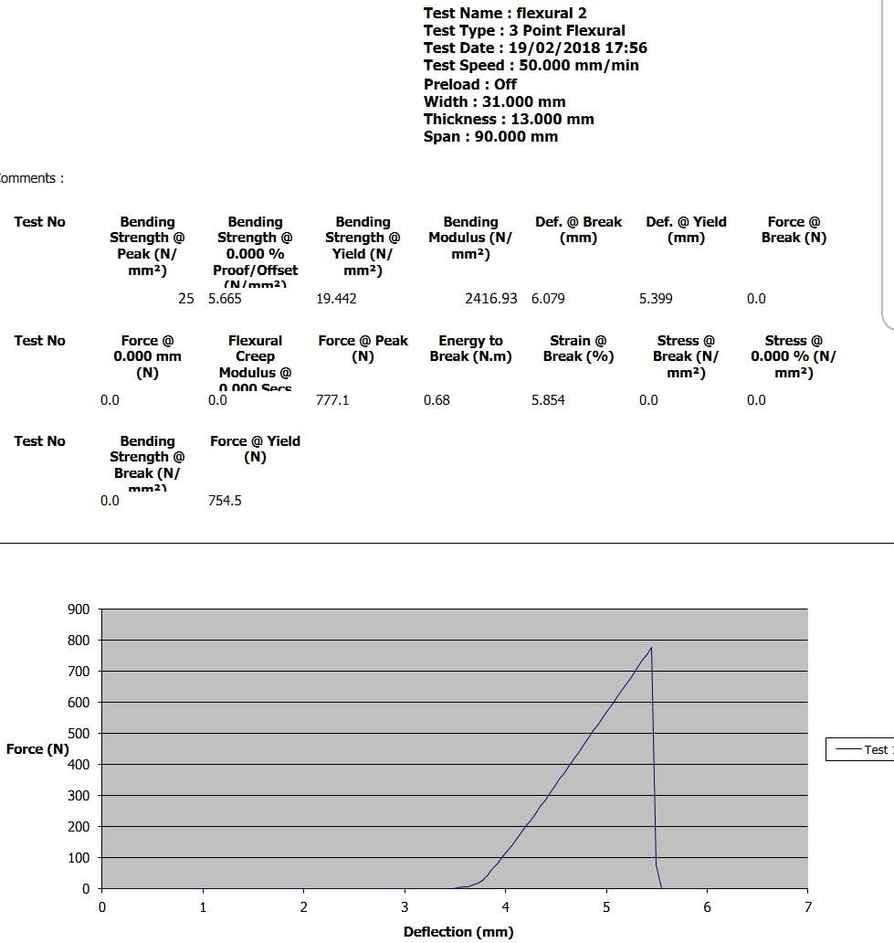

Appendix C8:Results of mechanical properties and stress-deflection curve of polyester composites with 2.5CHAp2.5BPF wt%
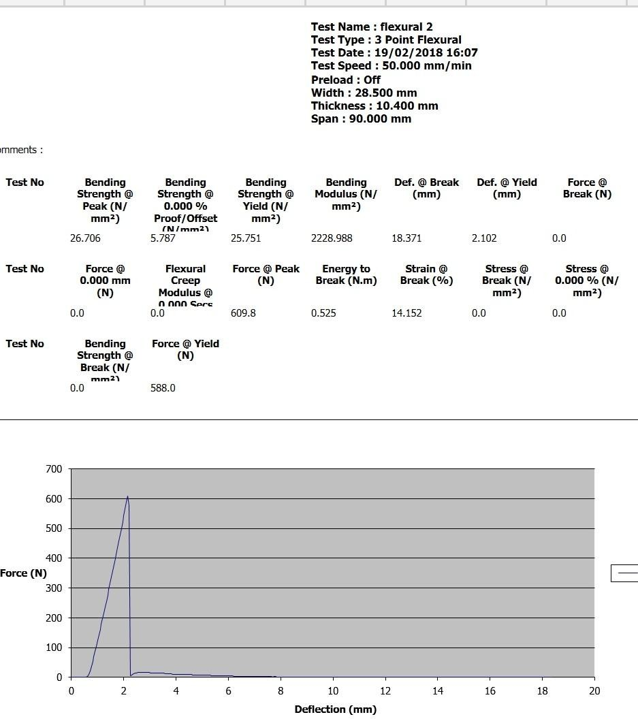

Appendix C9:Results of mechanical properties and stress-deflection curve of polyester composites with 10CHAp:10BPF
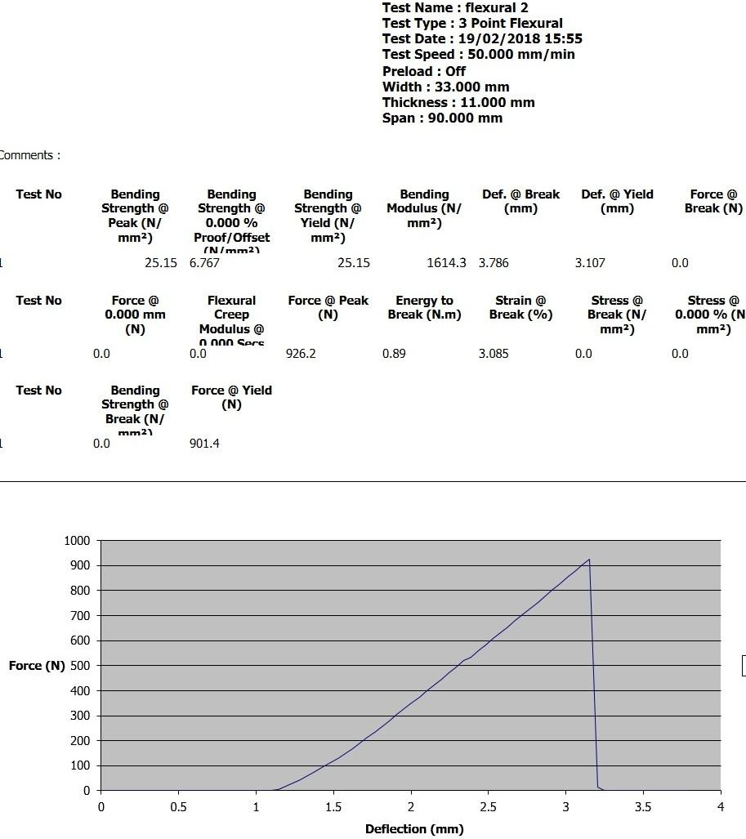

Appendix C10:Results of mechanical properties and stress-deflection curve of polyester composites with 2.5AH:2.5BPF wt%
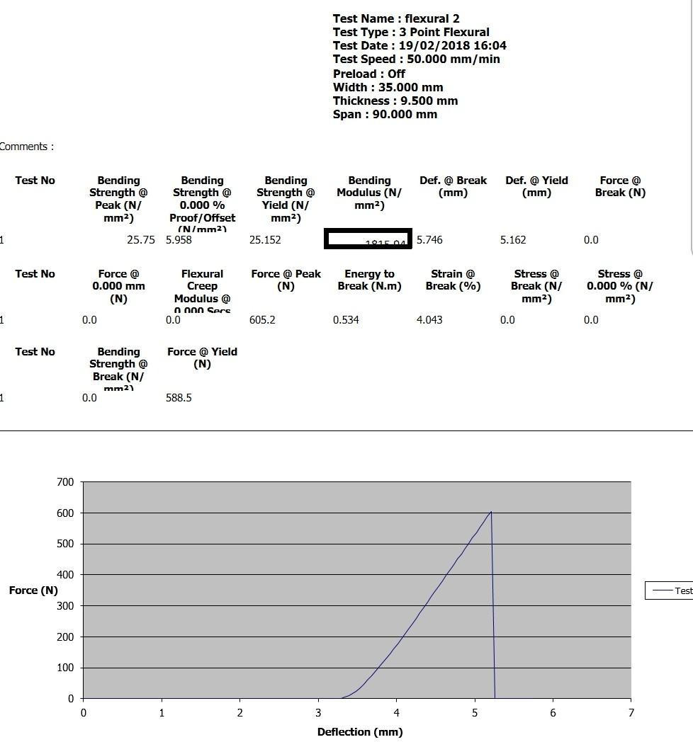

Appendix C11:Results of mechanical properties and stress-deflection curve of polyester composites with 5AH:5BPF
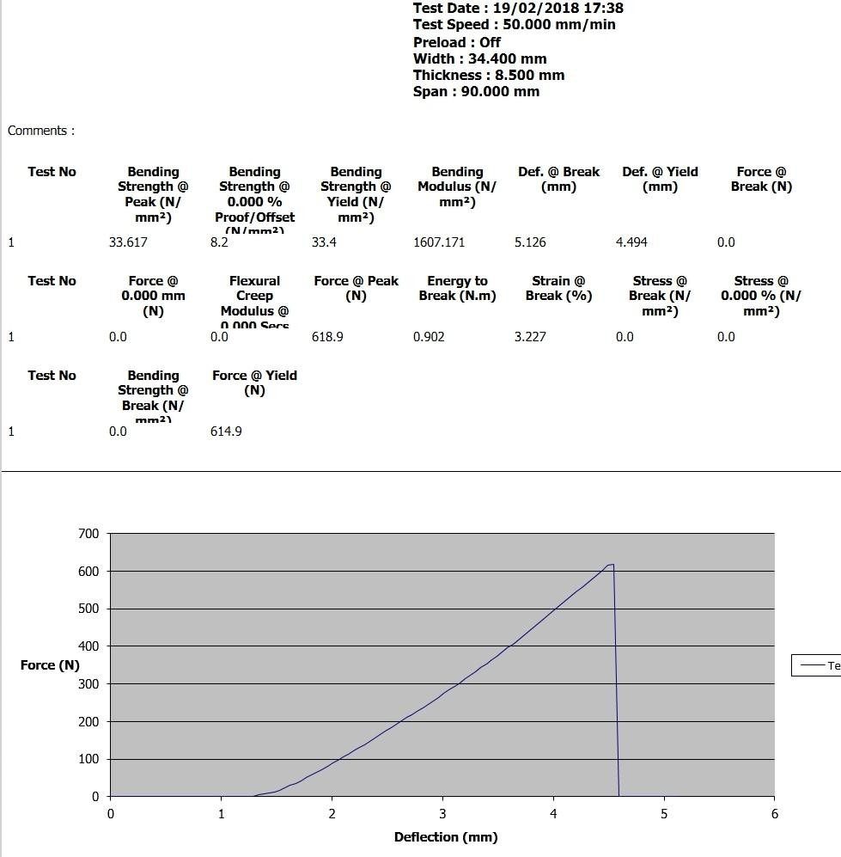

Appendix C12:Results of mechanical properties and stress-deflection curve of polyester composites with 10w%CHAP
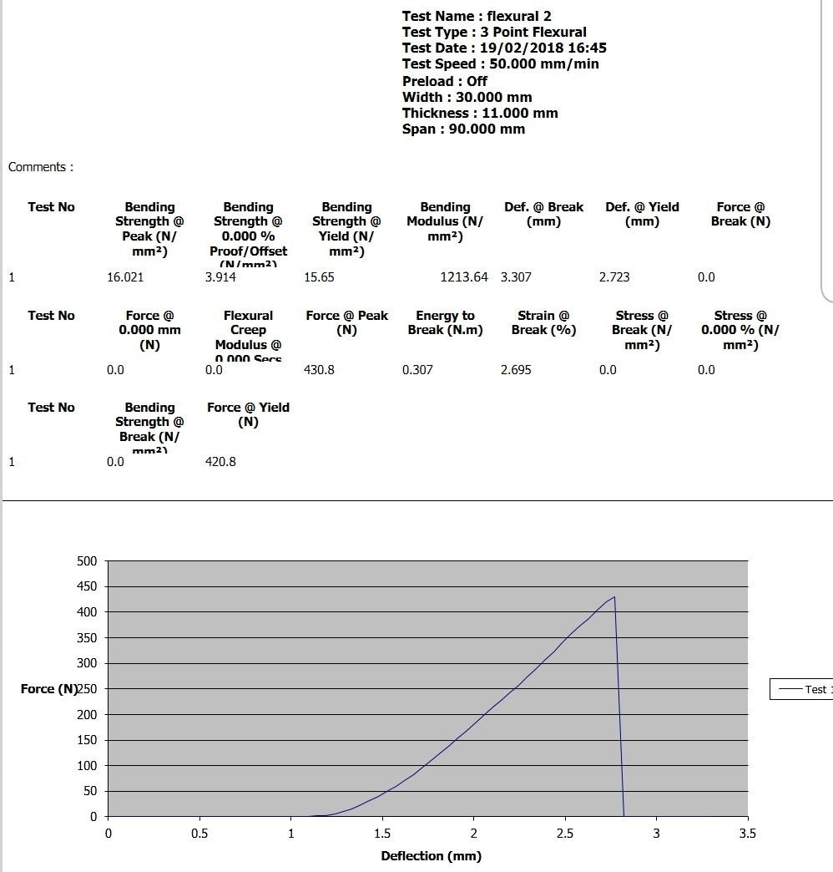

Appendix C13:Results of mechanical properties and stress-deflection curve of polyester composites with 10AH:10BPF wt%
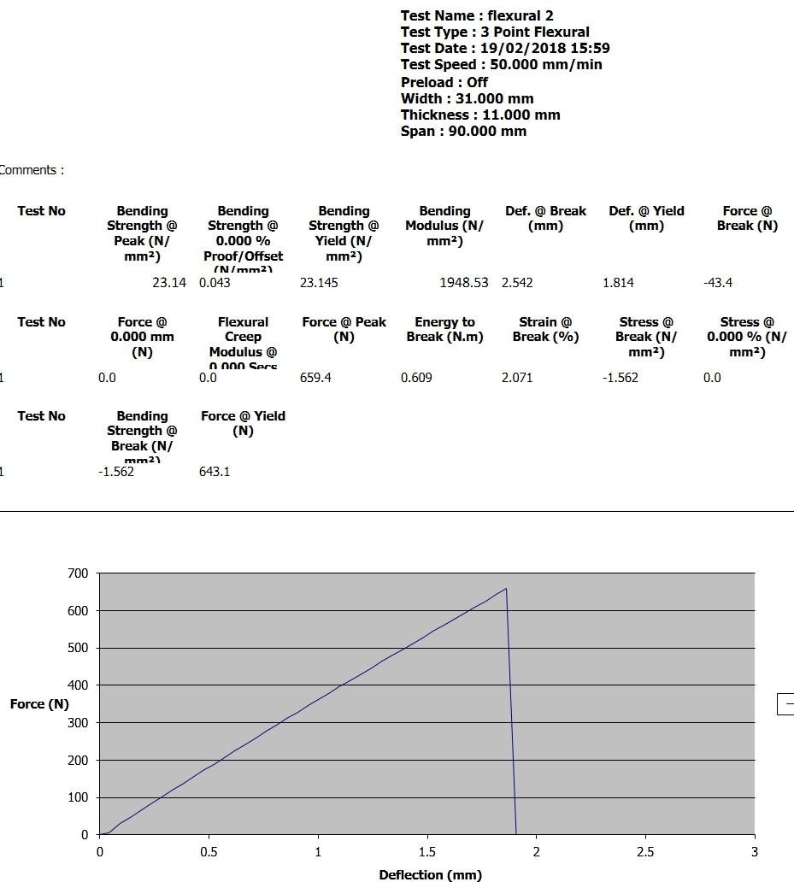

Appendix C14:Results of mechanical properties and stress-deflection curve of polyester composites with 7.5AH7.5BPF
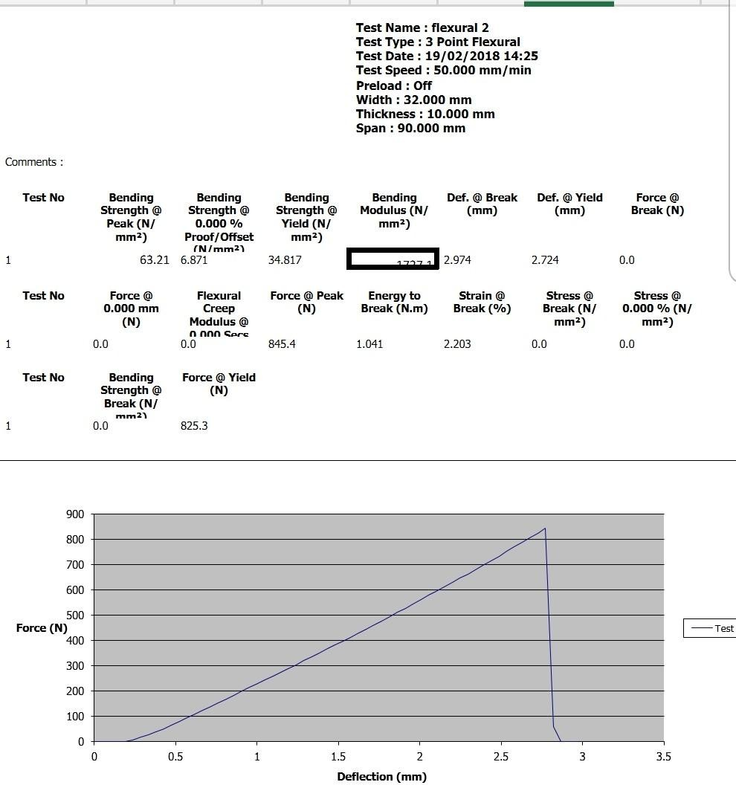

Appendix C15:Results of mechanical properties and stress-deflection curve of polyester composites with 5 w%CHAP
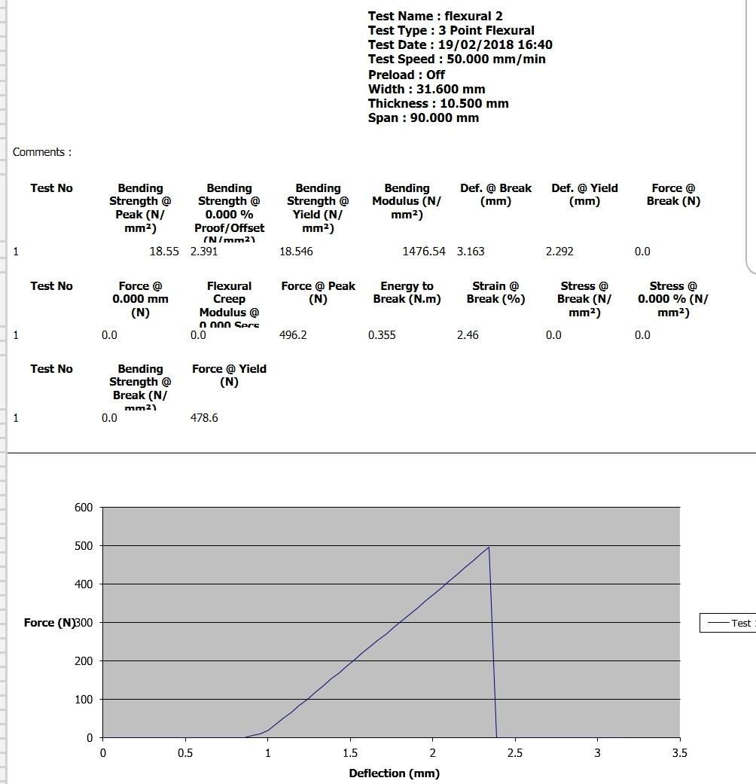

Appendix C16:Results of mechanical properties and stress-deflection curve of polyester composites with 5w%BPF
