# CHAPTER ONE

* 1. **INTRODUCTION**

# Background to the Study

Buildings contributes a very high energy consumption percentage compared to other economic sectors. Although these percentages vary from country to country, buildings are accounts for about 30±45% of the global energy demand. With increasing urbanization (higher in developing countries), the number and size of buildings in urban areas will increase, resulting in an increased demand for electricity and other forms of energy commonly used in buildings (Michael Laar and Friedrich Wilhelm Grimme, 2002).

In many countries, buildings consume more energy than transport and industry. The International Energy Agency (IEA) statistics estimate that globally, the building sector is responsible for more electricity consumption (42%) than any other sector. The building sector encompasses a diverse set of end use activities, which have, different energy use implications. Space heating, space cooling and lighting, which together account for a majority of building energy use in industrialized countries, depend not only on the energy efficiency of temperature control and lighting systems, but also on the efficiency of the buildings in which they operate. Other factors include; the building designs and materials, which have a significant effect on the energy consumed as well as the selection of the set of end use facilities (IEA, 2004).

Among Building services, the growth in Heating Ventilation and Air Conditioning (HVAC) system energy use is particularly significant, contributing 50% of building consumption and 20% of total consumption in the USA (Perez-lombard, Ortiz, and Pout, 2008).

In a sustainable perspective it is of great importance that the energy use stays on a low level the entire lifetime of the building and not only when it is newly built or reconstructed. In order to fulfill the requirement of low energy use over time the factors influencing the energy use need to perform well even in a long perspective (Swedish National Energy Administration, 2001).

,Q VSLWH RI WKH HQYLURQPHQWDO SUREOHPV FRQQ

of the service standards in buildings are much higher now than in the past. In other words,

growth in population, enhancement of building services and comIRUW OHYHOV WRJH ULVH LQ WLPH VSHQW LQVLGH EXLOGLQJV KDYH U

WUDQVSRUW DQ-LGo mbLarQd *e*G*t a*X*l,* V20W08U). \It h as al3sopbeUenHo]bserved the increasing rate of installation of HVAC installations in building which have now become almost essential in parallel to the spread in the demand for thermal comfort, considered a luxury not long ago. Therefore, it is important to also focus on the usage of energy.

The growing trend in building Energy consumption will continue during the coming years due to the expansion of built area and associated energy needs, as long as resources and environmental exhaustion or economic recession allows it. Therefore, private initiative together with government intervention through the promotion of energy efficiency, new technologies for energy production, limiting energy consumption and raising social awareness on the use of energy will be essential to make possible a sustainable future (Luis *et al*, 2008)

The energy used by a building is broadly determined by the building fabric, the building VHUYLFHV DQG WKH PDQDJHPHQW RI WKH EXLOGLQ

Moreover, with growing global concern for environmental sustainability, it is imperative to SURPRWH VXVWDLQDEOH GHVLJQ HQKDQFH EXLOGL

impact (Okafor, Hassan, and Awal*,* 2008).

Energy is used in buildings for various purposes: heating and cooling, ventilation, lighting and the preparation of hot sanitary water. In residences and Public buildings, installed equipment and appliances require energy, as do removable devices like mobile phone chargers and portable computers. However, identification of fixed and fluctuating demand for energy

rarely appears in a bXLOGLQJ¶V FRQVXPSWLRQ PHWULF DV P total amount consumed by the whole building (Sunikka, 2006)

In non-domestic buildings, the type of use and activities make a huge impact on the quality and quantity of energy services needed. Nonresidential building include the Public Building

as well as the industrial buildings which account for a large amount of the energy consumption in the building sector (Energy Information Administration, International Energy, 2006)

According to the National building (NEC) Code (2006) Public Buildings are defined as buildings to which the public is admitted such as assembly halls and theatres, places of worship, etc. taking into consideration the required facilities for the physically challenged persons.

This is consistent with the definition given by the Guideline on the Application of Health

SXEOLF EXLOGLQJ 5HJXODWLRQ RI $XVWAUDOLD

building or place or part of a building or place where persons may assemble for :(i) civic, theatrical, social, political or religious purposes;(ii) educational purposes;(iii) entertainment, recreational or sporting purposes; and (iv) business purposes. An Alternative Definition Stated by the same Australia Health Act, defines Public building as any building, structure, tent, gallery, enclosure, platform or other place or any part of a building, structure, tent, gallery, enclosure, platform or other place in or on which numbers of persons are usually or occasionally assembled, but does not include a hospital.

Public building services (such as: air-conditioning, lighting, fire protection, cabling and telecommunication) is an essential element of every building nowadays. In spite of the pressing need for a sustainable Energy consumption in buildings, it is necessary to accommodate these services and consider the needs of the occupants

$FFRUGLQJ-L omWbaRrd *et* 3*al*p(U20H08]), there has been the intensification of energy consumption in the HVAC systems, which has now become essentially in parallel to the spread in the demand for thermal comfort which is no longer considered a luxury as it use to be. It is the largest energy end use both in the residential and Public Buildings sectors, comprising heating, ventilation and air conditioning. Its predominance is obvious compared with other energy end uses in the building.

However, in Nigeria, most of the efforts are channeled towards developing sustainable energy generation processes with little or no attention given to the energy consumption end uses and the amount these end uses. Therefore, identifying the major end uses of the energy generated

and proper management thereof, ought to be given similar attention for potential energy saving in the building sector for sustainability. Thus, this study is timely as Nigeria is currently experiencing serious energy crisis and massive energy wastage which is accompanied with the environmental depletion.

# Statement of the Problem

Decreasing the energy consumption or reducing the energy wastages of Heating Ventilation and Air Conditioning (HVAC) systems is becoming increasingly important due to rising cost of fossil fuels and environmental concerns. Therefore, finding novel ways to reduce energy consumption in buildings without compromising comfort and indoor air quality is an ongoing research challenge (Vakiloroaya, 2014). The reality of the energy management of HVAC installation lies on the predictive approach adopted in order to envisage the energy consumption and consequently plan the energy consumption.

Heating and cooling of buildings is one of the biggest costs for business. The HVAC systems have business and environmental costs. HVAC system provides year-round indoor comfort in buildings regardless of the type or temperature outside. HVAC systems account for between 40-50% of the Public building energy usage and contribute 34.7 megatoonnes of carbon dioxide emissions every year (Energy Conversation Building Code (ECBC), (2007).

According to a research carried out by Lius *etal,* (2008), on the energy consumption information, it was identified that among building services, the growth in HVAC system energy consumption is particularly significant accounting for 50%of building energy consumption and 20% of total consumption in the USA). Lius *HW*,*¶*ob*D*se*O*rved that the key building services energy end uses in the building envelopes are: HVAC, lighting and appliances and it accounts for 85% of the total energy consumption. Thus, with the consolidation of the demand for thermal comfort, HVAC systems(and its associated energy consumption) alone has become an unavoidable asset, accounting for almost half the energy consumed in buildings and around 10-20% of the energy consumption in developed countries (Lius *et al,* 2008).

The growing reliance on HVAC systems in residential, Public and industrial environments has resulted in a huge increase in energy usage, particularly in the summer months. Developing energy efficient HVAC systems is essential, both to protect consumers from surging power costs and to protect the environment from the adverse impacts of greenhouse gas emissions caused by the use of energy inefficient electrical appliances.

In general, the trend of installing HVAC systems increases in public and public buildings like Hotels even in Nigeria. However, while other countries have taken the lead of sorting out their energy challenges by evaluating the energy usage and its related factors, the case in Nigeria has been focused mainly on developing sustaining energy production measures. Conversely, this study is channeled towards evaluating energy usage and waste in the study area resulting from HVAC system installation in the Hotels.

While facilities managers have saved money by upgrading their visual systems, HVAC systems are largely being neglected even though it promises a large savings because LWo¶neV of the largest energy end use contributor. Thus, if attention is directed towards management of the HVAC installations potential energy can be saved and consequently the cost implication. Unfortunately, in the research area, there is a dense population of people and proliferation of hotels in Owerri municipal. Similarly, owing to the quest for excellent comfort level in these hotels to meet client/customer demand, it has also lead to unparalleled use of HVAC systems in the Hotels irrespective of the energy demand, energy cost and the corresponding environmental impact of the energy demand.

Often times the HVAC installations in this hotels are rarely given maintenance attention as much as it is given to the aesthetics even though the HVAC has both energy and cost implication. Thus, this study seeks to evaluate extent of maintenance of the HVAC systems and its energy implications. The conformation of the HVAC installation to the standards and the possibility of adopting a predictive model that will both predict and optimize the energy consumption. Upon these premises, the study seeks to develop a model that can lead to sustainable/optimized energy consumption in hotel buildings in Owerri municipal.

# Aim and Objectives

The aim of this research is to develop a Model for Sustainable Energy Consumption of HVAC Installations of Hotels in Owerri, Imo state Nigeria with a view of optimizing energy consumption while predicting the consumption.

In view of this, the following are the objectives of the work

* + 1. To determine the type and characteristics of HVAC Building service installations used in Hotels in Owerri, Imo State Nigeria.
    2. Ascertain the level of maintenance of HVAC system components installations and its energy consumption implications
    3. Determine the key strategies for saving or reducing energy wastage using the HVAC installation system in Owerri, Imo State Nigeria.
    4. To ascertain the variations between HVAC installations in the study area and the standard requirement as stipulated by ASHRAE Standard 62.1 and 62.2.
    5. To develop a Model using the Model Predictive Control theory cable of predicting the energy consumption of the HVAC installation while reducing the energy consumption as well.

# Research Questions

1. What are the types and characteristics of HVAC Building Service installations used in Hotels in Owerri Imo State Nigeria?
2. To what extent does HVAC installation maintenance affect energy consumption of the system in the Hotels in Owerri, Imo State Nigeria?
3. What are the key strategies for saving or reducing energy wastage using the HVAC installation system in Owerri Nigeria?
4. What are the variations between HVAC installations in the study area and the standard requirement as stipulated by ASHRAE Standard 62.1 and 62.2?
5. How does the Model Predictive Control (MPC) theory cable to predict the energy consumption of the HVAC installation while reducing the energy consumption as well?

# Research Hypotheses

H01 HVAC components system has not been of adequate maintenance in Hotels in Owerri Nigeria.

H02 There is no HVAC installation components that are better maintained in the Hotels

H03 Maintenance of HVAC installations do not significantly affect Energy Consumptions of the systems in the area

H04 There is no key strategy for saving energy using HVAC system.

# Significance of Study

This research on conclusion is of great importance to managers (facilities manager) and the public building users. It enlightens the management on measure to adopt in rationing energy within the Public building without jeopardizing the functionalities of the building in providing

WKH QHFHVVDU\ VHUYLFHV WR PHHW XVHUV¶ UHTXL

The research enlightens clients and facilities manager on the possible savings that can be made from adequate selection of HVAC installation in Hotels during the construction of new buildings or the retrofitting of existing building considering the fact that the efficiency of new buildings determine the efficiency of existing buildings over time. Consequently, the energy

HIILFLHQF\ RI QHZ EXLOGLQJV GHWHUPLQHV WKH

longer than other end-XVH VHFWRUV FRPSRQHQWV GHWHUPLQH W

*et al*., 2005; Sunikka, 2006). Hence, by improving the efficiency of HVAC systems in the study area, decrease in energy consumption can be actualized. Lowering of operation cost for businesses as well as reducing greenhouse gas emission can be realized.

The research identified the contribution/impact of the poor maintenance of HVAC system installation to the building energy consumption. It also exposes the need to ensure that HVAC installation in new buildings or the improvement of existing building are done in compliance with standards (ASHRAE Standard 62.1 and 62.2)

It also guides organizations on measures to adopt to achieve optimum utilization of energy within the interior without compromising customer satisfaction while reducing the general cost and energy wastage.

It also enlightens the public building user on the attitudes they need to cultivate to avoid misuse of energy resulting from the use of HVAC installations and the consequently environmental implication. The research also provides a qualitative and qualitative data for students who intends to carryout research on similar area of study.

# Scope and Delimitation of the Study

The research focuses on the implication of HVAC building services Installations on the energy consumption of hotels within Owerri Municipal as well as the influence of poor maintenance culture and faulty installation of the HVAC installation as an energy end use in Owerri Municipal only. The study covers the Hotels within the Owerri municipal only, residential buildings was not considered. The research also focuses on the development of a Model Predictive Control for simulation using only metrological (Dry bulb temperature, relative humidity) data peculiar to owerri municipal only. The Model Predictive Control was also developed with the peculiarities of Hotel buildings within the study area only.

# The Study Area

Owerri municipal council is one of the 27 local government areas of Imo State and it is the proposed study area. It is located on the South Eastern part of Nigeria. Owerri Municipal council is located on latitudes: 5°25''50.23'N and longitude 7°2''149°.33'E. Owerri municipal has a population of 127,213 inhabitants, 62,990 males, and 64,223 females with about 17,000 households, including shops and offices (NPC, 2006). It is bounded on the North by Amakohia on the North East by Uratta, on the East by Egbu, on the South East by Naze, on

the South by Nekede and on the North West by Irete. Owerri Municipal, which is an urbancenter is known for its Public activities. Most of the buildings in these densely populated regions are public buildings like: schools, restaurants, shopping centres, banks, hostels and hotels to accommodate the influx of people for Public, academic and social activities (Adeyemi and Ibe, 2014). Obviously, the services to meet the need and purpose of the public building places a high demand on the requirement for energy and its consequent implication on the environment. This therefore means using Owerri municipal as case study is a tremendous success to the research work.

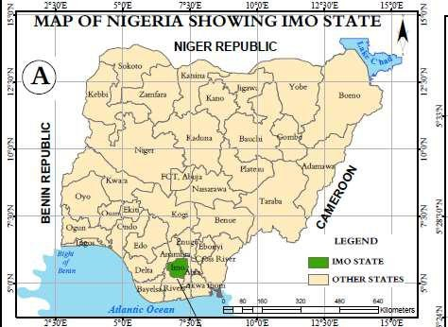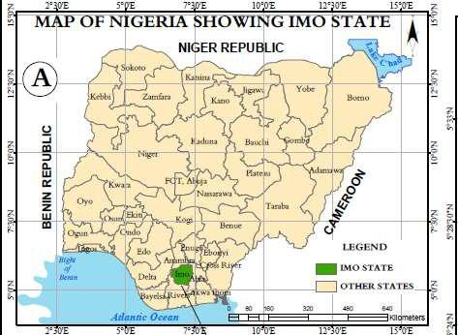

Fig 1.1 Map of |Nigeria Showing Imo State Source: GIS LAB EVM NAU 2018

Source:

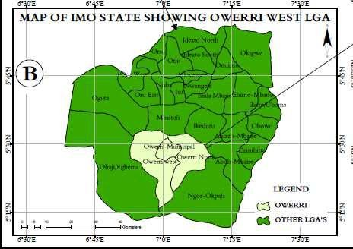Fig 1.2 Map of Imo State Showing Owerri West Source: GIS LAB EVM NAU 2018

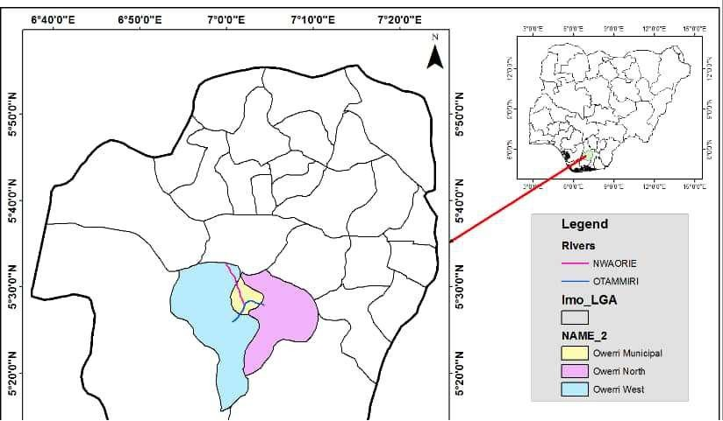

Fig 1.3:Map of Owerri West showing Owerri municipal Source: GIS LAB EVM NAU 2018