**CHAPTER ONE**

* 1. **INTRODUCTION**
  2. **Background To The Study**

Building is a major infrastructure in any hospital and is regarded as an enclosure or “envelope” designed and constructed to provide minimum level of comfort, protection and conveniences for man. Building provides safety, protects human inhabitants, animals, materials and equipment from effects of weather, and gives internal comfort (Ogunoh, 2008). According to Obiegbu (2003) a building is an essential modifier of micro-climate, (that is winds, temperature humidity and so on). He emphasized that buildings are enclosures of space(s), designed for specific uses, meant to control local climate, distribute services and evacuate wastes. Infact, building, being an essential part of human existence, is regarded as a basic need of mankind and ranks second to food. It is a human imperative without which man‟s survival is inconceivable. That is why people and building are inseparable. As Akinsola and Iyagba (2006) put it, “the existence of a building structure is a basic necessity in every society, that their presence in most cases, determines the level of growth and development in any developing society”. In another study, Mohamed (2005) said that adequate residential accommodation and related facilities constitutes one of the essentials of good life and therefore, a major requirement of an efficient and satisfied labour force. Again, this constitutes the foundation of a satisfactory community life. In other words, buildings are elements in the package of basic needs, which a community would like to procure for better living.

Generally, buildings are designed and constructed to provide healthy and comfortable environment, create a conducive atmosphere for working, living

and learning (Okolie, 2011). In addition, a healthy building is one that does not adversely affects the health of its occupants nor the large environment (Hal, 1995). According to Okoye and Ogunoh (2008) buildings are expected to function effectively throughout their expected life span. In a nutshell, a building must function to accommodate the activities for which it is built, and provides comfortable indoor and outdoor climates to its occupants.

Building is the centre for many socio economic activities and stands as a mark of prosperity, social acceptance, and an element of urban development and growth (Federal Ministry of Health Nigeria, 2005). It further stated that the availability of decent building for each family defines the level of development which a country has reached. Therefore, the building is fundamental as an important issue for people in all corners of the world. Similarly, building provides a link between the physical development of a city, and its social and economic out comes. Buildings in the built environment provide accommodation which must be accessible, safe, hygienic, aesthetically pleasing, and also sustainable (Okolie, 2011).

Hospital buildings are used to accommodate the treatment, diagnosis and care of patients, service users and staff and must be provided in a form that the fabrics, fixtures, fittings and services minimize the risk of Health care associated infections (FMHN, 2010). It further concluded that most healthcare organizations recognize that a well maintained, well operated building makes a huge difference when it comes to creating a positive physical environment of care.

Buildings are generally required to provide safe and conducive environment for the performance of various human activities. Odediran, Opatunji and Eghmure, (2012), are of the view that the ability of a building to provide the

required environment for a particular activity is a measure of it‟s ability to perform. They also conclude that as “the components of building begin to deteriorate, it becomes necessary to take measures to ensure that the desired characteristics of that facility which provides safety and convenience are retained.

Maintenance can be defined as a systematic care of (or all works undertaken to keep) a building to a state of preservation and acceptable standard in order to last long (Ogunoh, 2008). While Olusegun (2001) sees maintenance as the general cleanliness, preservation of fittings and fixtures through repairs and replacement. Obiegbu (2003) viewed maintenance as a programmed transformation of a building fabric, services and infrastructure concerned in keeping the building near to its original state, introducing into the existing structure, new technology or changes that will upgrade or refurbish the building to meet the demands of today‟s environment. Oyefeko (1990) clearly puts forward that, maintenance is also a combination of all technical and associated administrative actions intended to retain an item in or, restore it to a state in which it can perform its required functions. Maintenance according to Oladejo (2014) is a combination of both technical and administrative actions which are aimed at keeping the components of a facility in the most appropriate condition for effective use. Unfortunately, building maintenance has until recently been a neglected field of technology in most of our governmental policy formulation and execution, Akinsola and Iyaba (2006).

* 1. **Statement of the Problem**

Hospitals buildings are confronted with unique challenges that threaten their optimal performance, structurally and otherwise. According to Onifade

(2003), installed health facilities in Nigeria are as old as the hospitals themselves. He lamented that most of the buildings are dilapidated and there is no institutional policy for their maintenance. These statements aptly describe the situation at Nnamdi Azikiwe University Teaching Hospital (NAUTH), where the buildings are over 32 years old without any maintenance policy, nor programme to ensure that these buildings function optimally both structurally and aesthetically. The general lack of maintenance tends to be more noticeable in ageing facilities due to the accumulation effect of weather, usage and lack of funds.

In (NAUTH), there is no planned maintenance schedule. Maintenance is carried out arbitrarily and only when defects/breakdowns are critical or when emergencies are involved. Furthermore, at NAUTH, maintenance is in the form of “request and response”, as long as the cost involved can be borne by the maintenance Department; otherwise the maintenance work is delayed until when fund is made available by the management of the hospital. NAUTH has separate buildings housing the following departments or wards/units – Works, Administration, Audit, Accounts, Pediatrics, General outpatient, public Relation, Chemical pathology, Radiology, Microbiology, Histopathology department, Haematology, Psychiatric, Medical outpatient (MOP), Surgical outpatient (SOP), Central sterilization services (CSSD), and Physiotherapy department. The hospital also has other buildings housing the following clinics, units/offices and wards – Obstetric and Gynaecology ward/clinic, Female surgical ward (FSW), Male surgical ward (MSW), Female Medical ward (FMW), Male Medical Ward (MMW), Chairman Medical Advisory committee office (CMAC), Deputy CMAC‟s office, Chief Medical Director‟s (CMD) office, Accident and Emergency (A/E), National Health Insurance Scheme (NHIS) unit, Polymerase Chain Reaction (PCR) Unit, Mortuary unit, Store unit, Special care baby unit

(SCBU), Labour ward, Ante-natal clinic (ANC), Main theatre unit, Intensive care unit (ICU), Renal unit, School of Nursing unit (SON), and School of health information management (SHIM). For the maintenance of these buildings and facilities, each of these departments/units or sections submits her maintenance request in a prototype form to the Works Department whenever they have the need. As a result, there are lots of maintenance requests on a daily basis. The nature of these maintenance requests range from faulty windows/doors, flaking of paints, faulty door keys/handles, leaking roofs, burnt sockets/bulbs/plugs due to partial contacts, leaking plumbing pipes, faulty taps/blockage of waste pipes, faulty air conditioning units and other electrical appliances and accessories; others include: damaged tables/ chairs and various types of furniture, which have aged over time and are in need of repairs/replacement.

The maintenance work in NAUTH is constrained with the following challenges:

1. diversity and volume of work;
2. Inadequacy of competent staff to attend to the myriads and backlogs of maintenance requests;
3. Insufficient fund to take care of all the maintenance needs;
4. Lack of material stocks required for maintenance.
5. etc.

Generally, for public buildings to meet the basic requirements for optimal performance, there is need for regular maintenance based on a well planned schedule to be carried out during holiday periods when the offices are less busy (Okereke, 2014). This is however not the case for hospital buildings especially for buildings used as medical ward/units which most times are in constant use.

According to Akingbohungbe (2002), Rapp and George (1998), Ahmed (2000) and Odediran et al (2012), a cursory observation of most hospital building conditions reveal a pathetic picture of neglect, deterioration, decay, dilapidation and threatening collapse. This may due generally to the above listed challenges, which are regular features in most public establishments. He further posited that this sordid condition may be due to the absence of good maintenance management systems which are *sine qua non* for economically viable and operationally safe buildings. Onibokun (1990) is also of the view that lack of appropriate tool for predictive maintenance of the existing buildings can have a detrimental effect on future housing development.

Oladejo (2014) lamented that the maintenance of hospital buildings is reactive instead of proactive perhaps because of use or nature of building. The reactive approach to maintenance is still subject to the availability of funds, which will be minimized if effective planning and scheduling is carried out. As the operating life of any building progresses, especially, due to high rate of activities as witnessed in NAUTH, degradation is bound to occur. It is immaterial what the reasons are for this degradation; the fact is that the building element can no longer meet its original function and it‟s level of performance reduces. If this reduction in performance level is predicted or detected in advance, it will provide means to forecast a forthcoming failure and then plan by budgeting for it in advance. This is where there is a compelling need for computer-based systems to assist in ameliorating the problem in the maintenance of hospital buildings and facilities.

Hospital buildings are expected to be on red-alert in performing their functions regularly and during emergency services.

The major challenges with such a system are:

1. Its ability to store, retrieve, calculate, organize and present vast amounts of data efficiently and accurately (Teicholz, 1992);
2. The ability of the computer to identify a change in building condition in many ways, that is, by commonly used procedures including detecting change in colour, change in power usage, leaking roof, cracks on walls/floors, leaking pipes, dampness of wall, and so on;
3. The most important aspect of any such system will be its ability to detect or predict in advance failure signs early enough so that the maintenance crew will have sufficient time to plan, budget, prepare and organize correction at the least cost, bearing in mind that once the building breaks down, the establishment is bound to spend whatever time, money and resources it takes to get it back in proper use, or else jeopardize the operation of such establishment, especially a hospital.

Extensive review of extant literature reveals that there is no such computer- based system for now in the Nigeria building industry, specifically prepared for the Nigeria socio-cultural and economic milieu. The nearest to such a programme in existence is the generic application of Building Information Model (BIM). “Building Information Model is a digital representation of physical and functional characteristics of a facility. A BIM is a shared knowledge resource for information about a facility forming a reliable basis for decisions during its life-cycle; defined as existing from earliest conception to demolition” ( [https://en](https://en/).m.wikipedia.org). Its application in maintenance is limited by the following (https//[www.infocomm.org/cps/rde):](http://www.infocomm.org/cps/rde))

1. **High cost of Soft-ware and Hardware –** Every organization currently utilizing 2D or 3D CAD drafting software can attribute a

cost element against purchasing, maintaining and upgrading software licenses to keep a competitive market advantage. Current trend show that the cost of BIM software packages tend to be more expencive than CAD software package available in the market.

1. **Cost of Training-** With new software, there is a great demand to train staff quickly so that the investment can be justified. With the staff disposition in NAUTH , it is unrealistic since there is no professional in the Maintenance unit with CAD proficiency who will be able to learn new BIM software quickly or without specialized training . Given the fundamental differences between BIM and CAD, such training should be considered a basic requirement for the maintenance staff.

The variables of the statement of the problem include:

1. The lack of deliberate planned programmes for preventive and corrective maintenance planning of hospital buildings in NAUTH.
2. The lack of computerized system in use for maintenance planning and scheduling that will make for efficient and effective maintenance which will help in timely preventive maintenance of hospital buildings and avoid interruption of medical services.

The specific problem statement in the maintenance of hospital buildings generally and in NAUTH in particular could be summed up as follows:

1. Rapidity in the degradation and deterioration of buildings and their components due to the nature of their uses;
2. Lack of prior knowledge of when to carry out preventive or corrective maintenance of any component of a building, thereby resulting in the general lack of maintenance culture among the maintenance department of the institution;
3. Shortage of qualified and competent staff in the appropriate trades;
4. Lack of computer-based system that will predict the likely deterioration/degradation period of buildings based on their type, age, uses design, site locations and the materials/components used in their construction for maintenance planning;
5. How to use such a system to inculcate maintenance culture among the management and staff of NAUTH, thus obviating the habit of arbitrariness and subjectivity in decision making in matters of maintenance works;
6. How to create maintenance records and inventory of all the buildings to serve as standard for cost and time estimation and referencing to past building maintenance.
   1. **Aim and Objectives of the Study**
      1. **Aim**

The aim of this study is to develop a computer based system for effective maintenance planning and scheduling of building in NAUTH with a view to establishing the major factors responsible for the rapid deterioration/degradation associated with the buildings.

* + 1. **Objectives**

To achieve the above stated aim the study has set out the following objectives:

1. To identify the factors responsible for the high rate of deterioration/degradation of the buildings in NAUTH;
2. To identify and rank in order of preponderance the factors affecting proper maintenance planning and scheduling in NAUTH.
3. To categorize, code and prepare an inventory (Building Directory) of all the buildings in NAUTH; and
4. Design and develop a computer-based system for proper maintenance planning and scheduling of all NAUTH building.
   1. **Research Questions**

The study intends to provide answers to the following questions:

1. What are the major factors responsible for the high rate of deterioration/degradation of the buildings in NAUTH?
2. What are the factors affecting proper maintenance planning and scheduling of buildings in NAUTH, and their rankings in order of preponderance?
3. Is it possible to categorize, code and prepare an inventory of all the buildings in NAUTH?
4. Is it possible to design and develop a computer-based system for proper maintenance planning and scheduling of all the NAUTH buildings?
   1. **Significance of the Study**

The current state of the buildings in NAUTH calls for urgent measures to curb the high rate of deterioration/degradation through proper inventory of all the buildings which will be used to generate relevant data, capable of being stored and retrieved easily for planning purposes. The development of a computer-based system that can store and retrieve such large volume of data is very significant because, it will ensure availability of data for budgeting and accurate estimations for timely maintenance planning of buildings in NAUTH. The availability of such management tool will also obviate the arbitrariness and subjectivity in decision making on when and how a building is due for preventive and corrective maintenance. This in turn will allow for proper budgeting and bulk purchase and storage of material stock, thereby saving the establishment from panic buying and fire brigade

approach in maintenance works. With the availability of such a system, proper maintenance records could be stored and retrieved at short notice. The major significance of this computer-based system for effective planning and scheduling of building maintenance is that it will inculcate maintenance culture and prudence maintenance to both management, staff, patients/patient relative in NAUTH.

Further more, the outcome of the study will be justified by the following inputs which the development of a computer-based system will bring to the entire Hospital:

1. **Automation of Processes-** The adoption of computerized maintenance system automates the processes of planning of inspections and estimation of maintenance works, thereby preventing the occurrence of maintenance challenges which make arbitrary plans expensive and chaotic.
2. **Removal of subjectivity in management decision making process**- computerized systems improve workflow and efficiency by allowing the maintenance department to schedule, assign, and close work orders quickly and easily. It creates the ability to configure work orders, automatically track all work order in the system and provides data from past records for comparison and guide for the present and future operations associated with every building and components.
3. **Provision of reliable Management data**- with reliable inventory and stored data on each building thus ensuring continuity in the management of the maintenance department which often than not is usually disorganized and disoriented each time there is change of guard in the leadership; the adoption of computer-based system will help to track assets that need to be maintained, and so help in the reorder of their maintenance.
4. **Elimination or reduction in paper work**- it helps in the retrieval of information automatically enabling maintenance staff to view all information related to work orders on their computers or mobile device. Therefore, maintenance technicians don‟t have to search through folders and filling cabinet to find the information they need.
5. **Enhanced productivity-** computer system will enable maintenance staff to access real-time information, check inventory, and initiate work order without returning to the office. Work without delay; this reduces their journey time. It also provides them with details about the procedures, components and tools necessary to perform a job, so they can work without delay or interruption.
6. **Reduced downtime and repair costs**- downtime is costly both in terms of revenue loss and damage to an organizations name and reputation. When you focus on planned preventive maintenance, components, equipment and building downtime is minimized. Computer system enables works department to regularly maintain structures, so that they are less prone to breaking down, which means that repair costs are also reduced.
7. **Increased safety**- computer systems regularly check and maintain building components to meet safety standards and to prevent malfunction and critical failures. This also prevent the loss of work time due to accidents and make the building safe and free from failure and total collapse.
8. **Ability to monitor ‘Key Performance Indicators’ (KPI)**- by computerized system, the computer organize historical data and trends, so that problem areas like increase in cost, low productivity or constant repairs will be noted and solution proffers.
9. **Ensuring compliance with regulatory standards**- building maintenance must comply with National and International regulatory

standards. All maintenance unit/departments face periodic audits or random inspections by regulatory agencies. Computer system allows in the demonstration of regulatory compliance. Computer systems make compliance easily traceable and reduce the risk of non- compliance penalties.

1. **Reduced emergency/overtime-** computer system of building maintenance uses planning and scheduling so that the issue of emergency maintenance and repairs are no longer tenable.
   1. **Research Hypotheses**

The following hypotheses will be tested and verified:

Ho1: The types and periodicity of maintenance of hospital buildings have no relationship with the uses of the buildings.

Ho2: The use of computer based system in maintenance planning and scheduling of hospital buildings will not significantly improve the maintenance culture in public buildings.

Ho3: There is no significant relationship between periodicity and type of building maintenance and the quality of materials/components used in the construction of such buildings.

Ho4: The number of maintenance cycle (Frequency of maintenance) has no significant relationship with the available maintenance staff and material stock.

* 1. **Scope and Delimitation of the Study**

The research specifically covered the buildings in the main station at Nnewi and the six out stations of NAUTH located at Awka, Neni, Oba, Onitsha, Ukpo and Umunya all in Anambra State. The buildings under construction are the Administration block, Obstetric block, Specialized clinic, General Out Patient Department (GOPD), Male Surgical Ward, Theatre block,

Radiology block, Renal Unit and Stores in the permanent site at the confluence of Nnewi, Ozubulu and Oraifite towns. The study concentrated on the most common types of maintenance works, namely: minor repairs and major maintenance works of the exteriors, (external block walls/and their foundations, Roofs/Roof components, wall rendering/painting, door/ window fittings in all the stations. It categorized and classified the buildings according to their different functions/uses and the type of materials/components used in their construction. It used visual inspection to establish the degree of deterioration/degradation of the buildings to determine empirically the likely type and periodicity/frequency of maintenance required. Only buildings completed and occupied for at least twelve calendar months were used in the study for the period spanning between 2014-2017.

* 1. **Limitations of the Study**

There are very few secondary data from journal publications, proceedings from seminars and learners conferences in this study areas in Nigeria, and so lead to the review of very few literatures.

There are also many buildings in NAUTH main and outstations but this study considered sixty-six (66) buildings in this research as outlined in table

4.2. Only buildings completed and occupied for at least twelve calendar months were used in the study.

There are also many types of maintenance, preventive (minor or routine) maintenance and corrective, (or major) maintenance are the two used in this study. The researcher used visual inspection to establish the degree of deterioration/degradation of the buildings in order to determine empirically the likely type and periodicity/frequency of maintenance required.

* 1. **Assumptions of the Study**

According to Leeding and Armrod (2010) assumptions are conditions that are taken for granted. The assumptions also provide a direction to the understanding of the research as conceptualized. The following underlying assumptions were therefore made and held constant in carrying out this research:

1. Financial Resources for design and maintenance of buildings will always be limited;
2. The respondents are qualified and experienced enough in their various fields and well informed to give authoritative feedback on the information sought;
3. The sources of data for this research are authentic and reliable.
   1. **Study Area**

Following the split of Anambra State into two states; Anambra and Enugu, the new Anambra state with capital at Awka inherited the ASUTECH Teaching Hospital which was later renamed NAUTH in 1991. NAUTH was later taken over by the Federal government of Nigeria through an Act CAP. N140 LFN 2004.

NAUTH has seven stations at Nnewi, Neni, Oba, Onitsha, Ukpo, Umunya and Awka, all in Anambra state, as outlined below;

* + 1. **Anambra State**

Anambra State where NAUTH is situated was created on 27th August 1991 with capital at Awka, and with twenty one Local Government Areas (LGAs). Anambra State is one of the States that make up the South East Geopolitical Zone of Nigeria. The State lies approximately between latitudes 5o50‟N and 6o 45‟N(North) of the Equator. It is bounded on both Western and Eastern sides by longitude 6o35‟E and 7o30‟E (East) respectively (Ogunoh 2014).

Anambra State is in the tropical zone of Nigeria, with two distinct seasons, dry and rainy seasons from December to April and May to October. While annual precipitation ranges from 1500mm to 2000mm rainfall with July as the rainiest month (Umenweke, 2000). According to him, humidity is relatively high between 65-80 percent throughout the year; daily temperatures up to 25o are recorded on very hot days in January and March. According to the 2006 National Population Census (NPC), the state had a projected population of 4,055,048 in 2014, with an average density of 837.10km2 Umenweke, (2000). The State shares boundaries with Delta State, Rivers State, Kogi State, Imo State and Enugu State as could be seen in Fig. 1.1

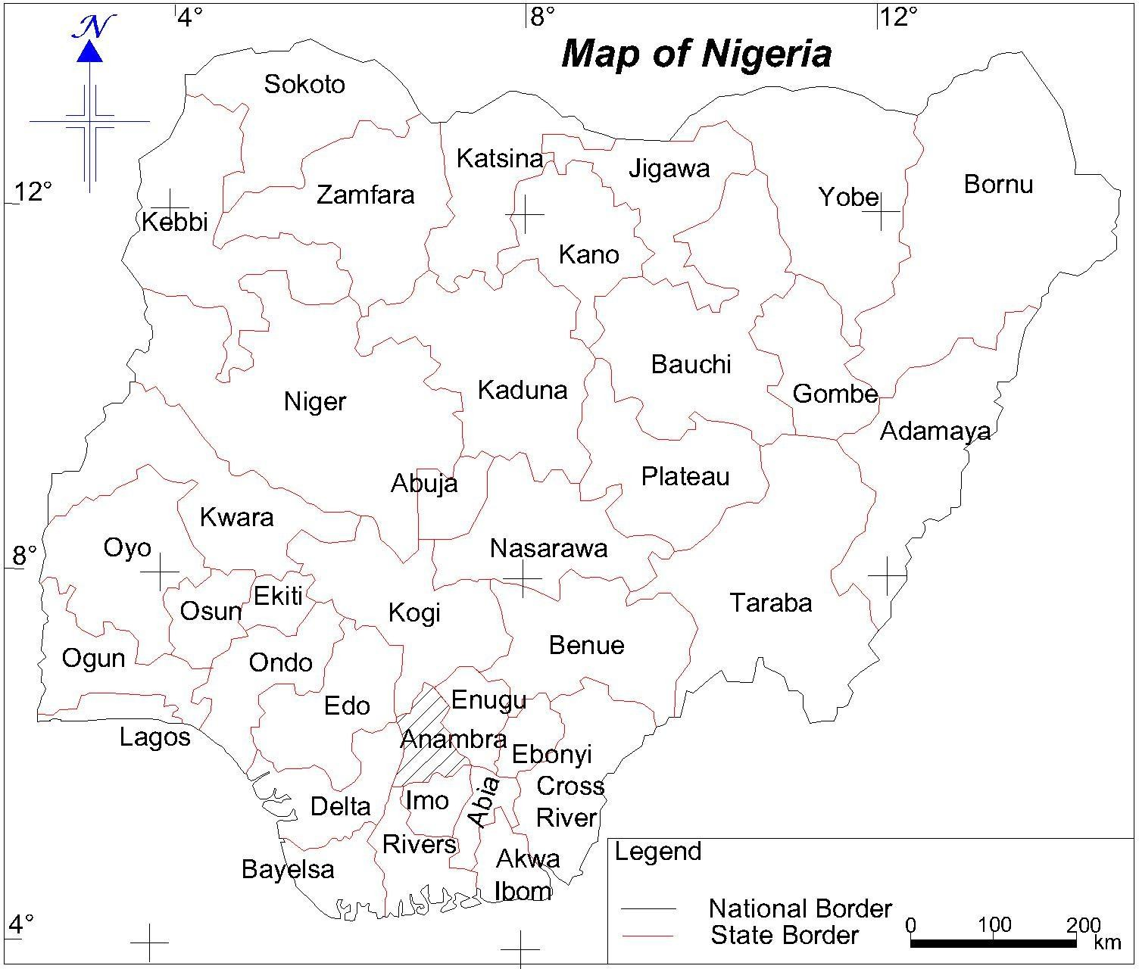

**Fig. 1.1 Map of Nigeria showing Anambra State Source: Onwuzuligbo (2016)**

* + 1. **NAUTH (Nnewi)**

Nnamdi Azikiwe University Teaching Hospital (NAUTH) was named in honour of the late sage and foremost politician, Rt. Hon. Dr. Nnamdi Azikiwe, GCFR, Owelle of Onitsha. It was established by the Anambra State of Nigeria (ASN) Edict No.10 of 1988 as Anambra State University of Technology (ASUTECH) Teaching Hospital, and started at the former General Hospital, Nnewi. The General Hospital, Nnewi, which was then under the State Health Management Board, was officially handed over to the Teaching Hospital Management Board on the 6th of June, 1990. Following the handover, a great number of abandoned hospital buildings and equipment were refurbished and or renovated. The hospital was officially commissioned on Friday, 19th of July, 1991 by the then Anambra State Military Governor, Lt. Col. Herbert Obi Eze. Following the split of Anambra State into two states: Anambra and Enugu, the new Anambra State with capital at Awka inherited the ASUTECH Teaching Hospital which was later renamed Nnamdi Azikiwe University Teachig Hospital in 1991. The Teaching Hospital was, later, taken over by the Federal Government of Nigeria through an Act CAP. N140 LFN 2004.

Nnewi is a town located East of the River Niger. According to the 2006 population census, the estimated population of Nnewi is 391,227 residents with a density of 2800km, and spans over 2,789km2. It is located between latitudes 5o95‟N and 6o05‟N and longitudes 6o50E and 6o57E (Ogunoh 2014). It falls within the tropical rainforest region of Nigeria.

Nnewi is the second largest „city in Anambra State, and a metropolitan city, with two local government areas, namely: Nnewi South and Nnewi North. It consists of four large villages viz: Otolo, Uruagu, Umudim and Nnewichi.

Nnamdi Azikiwe University Teaching Hospital is at Nnewi, in Nnewi North Local Government Area. It is the off-shoot of the former Anambra State University of Technology (ASUTECH). Following the creation of Anambra State in 1991, Nnamdi Azikiwe University Teaching Hospital was taken over by the Federal Government in 1991 (that is the former General Hospital Nnewi). The key activity areas in the hospital are: Paediatrics, General medicine, General Surgery, Obstetrics & Gynaecology, Laboratory Services, Radiology, HIV Services, Pharmaceutical Services, Anesthesiology, Intensive Care Unit, Ophthalmology, Dietetics, Physiotherapy, Psychiatry, Medical Records, School of Nursing, GOPD, CHOP, Heart to heart, Mortuary, Account/Finance, Administration, Audit and Works.

The present location of the Teaching Hospital at Nnewi in Nnewi North Local Government is temporary. It is hoped that the hospital will move over to its permanent site of over 54 hectares landmass at the confluence of Nnewi, Oraifite and Ozubulu towns, which is now being developed.

In order to meet the demands of the national policy on medical education which stipulates that each Teaching Hospital shall be associated with at least one community medical care centre, Centres for community and primary health care services were established at:

1. Neni in Aniocha Local Government Area; commissioned on 27th December, 1991.
2. Ukpo in Dunukofia Local Government Area; commissioned in 1997.
3. Umunya in Oyi Local Government Area; commissioned on 17th June, 2005.
4. Federal Staff Clinic (NAUTH Annex) Awka, handed over in May 2008.
5. Guinness Eye Centre Onitsha, handed over on 26th June, 1991.
6. Trauma centre Oba, ceded to Federal Ministry of Health by Oba

patriotic Union, Lagos branch.

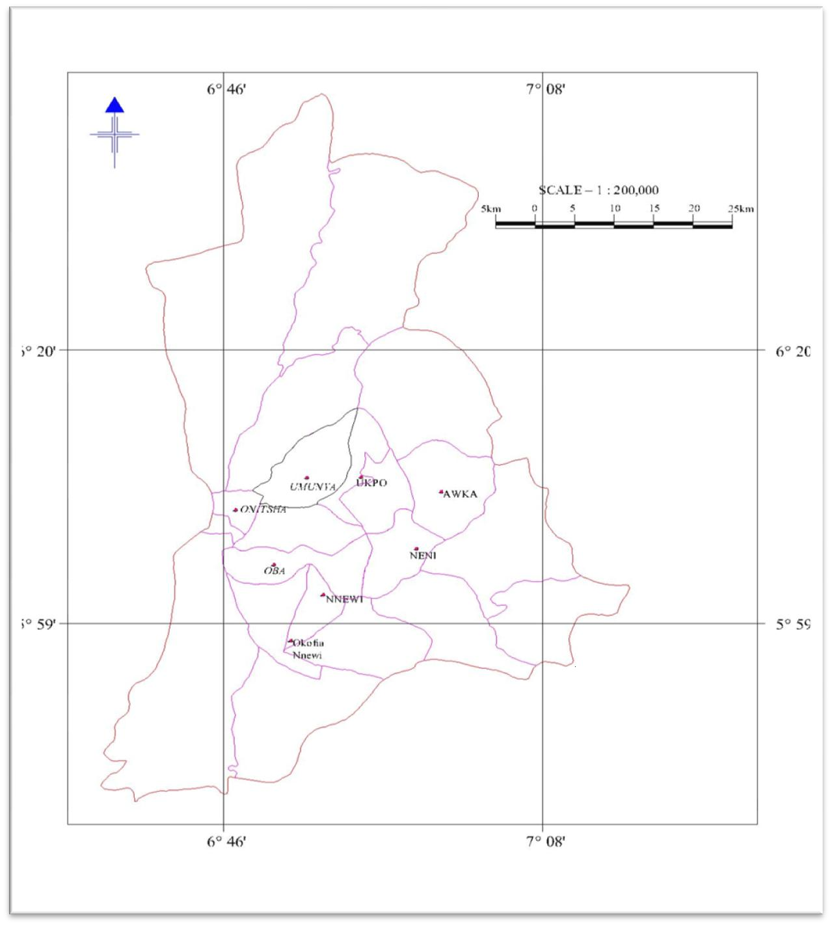**Fig 1.2: Map of Anambra State showing the locations of NAUTH and its Out Stations**

**Source: Onwuzuligbo (2016)**

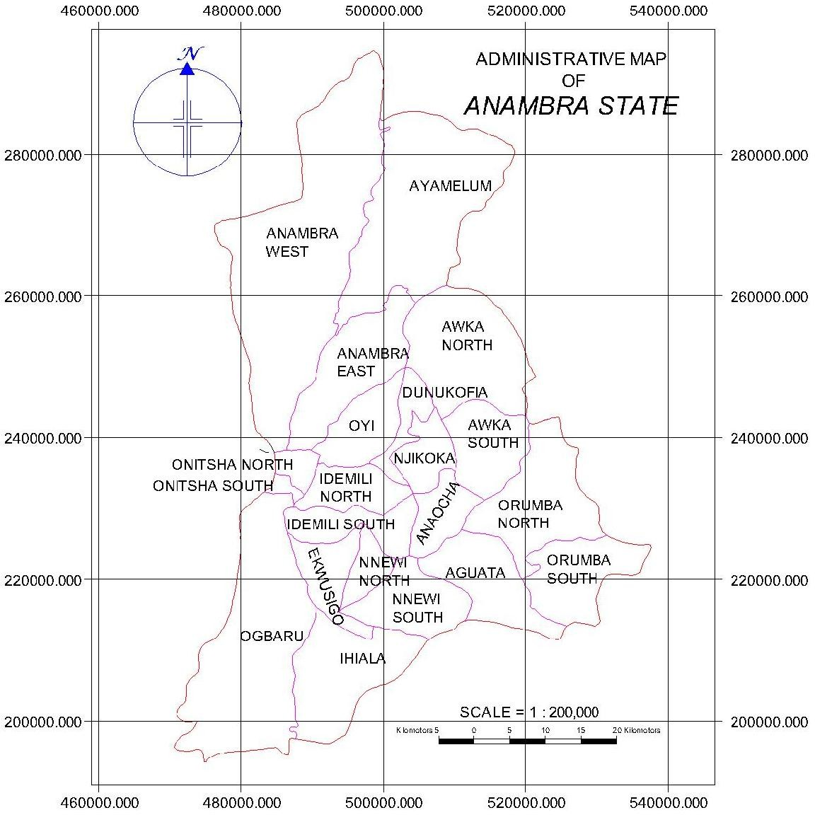

**Fig 1.3: Map of Anambra State showing the Local Government Areas where the Outstations are Located**

**Source: Onwuzuligbo (2016)**

* + 1. **Federal Staff Clinic Awka (NAUTH Awka Annex)**

This Clinic is located at the premises of the Federal Ministry of Works and Housing at Awka in Awka South Local Government Area of Anambra State.

It was established in 1999 as Federal Staff Clinic to serve the staff of federal establishments and their families. Services were later extended to the public. Federal Government ceded the Clinic to NAUTH in May 2008 following the establishment of National Health Insurance Scheme. The scope of services at the Clinic is essentially out-patient with coverage at primary healthcare services level.

This is an outstation of Nnamdi Azikiwe University Teaching Hospital. It is located within the Awka capital territory of Anambra State, along Enugu Onitsha express road, but within Federal Ministry of Works compound Awka, near Anambra State Governors offices, Awka. Awka town is in Awka South Local Government Area, and the state capital of Anambra State. According to the Nigerian Population Commission (NPC) census of 2006, the total population of Awka is 139,654 for male, while 97,725 for female. Awka lies between 6o06‟N and 6o15‟N and longitude 7o05‟E. (Ogunoh 2014) it lies within the tropical rainforest belt of Nigeria, characterized by two distinct climate seasons, dry and raining seasons while the vegetation is semi-rain forest. The relief consists of low lands in the North and uplands in the South, especially the greater parts of the South Western Portion.

* + 1. **Guinness Eye Centre**

This is situated at Onitsha in Onitsha North Local Government Area of Anambra State. It is a specialized centre for treatment of eye diseases. This Centre, which was built by Guiness Nigeria Plc and commissioned by Mr. Peter Guiness on the 8th day of December 1984. It was part of the Anambra State general Hospital Onitsha. This centre was formally handed over to the management Board of the then Anambra State University of technology (ASUTECH), teaching Hospital, Nnewi by the Government of Anambra state on 26th day of June, 1991.

* + 1. **Trauma Centre Oba**

This was formally known as Oba General hospital. It was built by Oba patriotic Union, Lagos branch, and ceded to Federal Ministry of Health. It was commissioned on 13th April 2002 by the then Hon Minister of Health, Prof. A.B.C. Nwosu. This hospital was established to provide good health care to its people, who, before then travelled over 15km to Nnewi, Onitsha or Ogidi to receive medical attention. Later, its name was changed to Accident and Emergency community health centre. Presently, it is called Trauma Centre Oba.

It is located at Oba in Idemili South Local government Area of Anambra State. The centre houses the Orthopaedics and Traumatology Department of the teaching Hospital.

* + 1. **National Diagnostic and Treatment Centre Neni**

The specialist Diagnostic and Treatment Centre (now National Diagnostic Centre) Neni, was established in 1988 by the then Anambra state government under Col. R. Akonobi (Rtd) as the governor and Professor

A.B.C. Nwosu as the Honorable Commissioner of Health. This centre was commissioned on 27th December 1991 by the then Hon. Minister of Health, Prof. A.B.C. Nwosu. The centre was and is still conceived to provide the sophisticated diagnostic investigations (both medical laboratory and radiological investigation), and subsequently provide radio therapy and other therapeutic modalities for the diseases that are diagnosed. Neni town is in Anaocha Local Government Area of Anambra state.

The areas to be covered will include hormone assays, cardiac and liver enzymes, and other very special hematological, biochemical, microbiological

and histopathology/cytology investigation. The centre will be seen to play the role as centre of referral and technical support for the eastern states. The effective and efficient utilization of the Diagnostic centre will provide the only scientific approach to patient management, empowering the medical doctors to make timely and accurate diagnosis, and to rationalize drug use. It will reduce morbidity and mortality and also facilitate proper management of those most at risk.

* + 1. **Community Health Centre Ukpo**

Ukpo Hospital management Board, on behalf of Ukpo Autonomous community (in the former Njikoka local government Area of Anambra state) approved the take-over of the Ukpo general Hospital by the Federal ministry of Health. The Federal Ministry of Health handed it over to Nnamdi Azikiwe University Teaching Hospital Nnewi on 1st January, 1995.

The purpose of establishing this Hospital is for Community Health work in rural areas – especially clinical services to adjoining communities and also a practice area for rural / primary Health care for medical, Nursing and midwifery students. This hospital is now called Comprehensive Health Centre, in Dunukofia local government Area, Anambra State.

* + 1. **Comprehensive Health Centre Umunya**

This was formally called Umunya Health Centre. In order to extend it‟s services to the masses of it‟s catchment areas, NAUTH took it over for the purpose of providing health services and teaching of community medicine to our medical students in a community setting. This centre is located at Umunya town in Oyi Local government area, and was commissioned on 7th June 2005

**CHAPTER TWO**

* + - 1. **0 THEORITICAL AND CONCEPTUAL FRAMEWORK**
         1. **Concept of Maintenance as Cyclic Sets Expressed as Progressive Time Series**

The traditional (conventional) method of maintenance planning and scheduling involves simply the breaking down of the maintenance operation into sequentially related processes or activities and determining the volume of work and the number and composition of the maintenance crew required for a given number of days of work within which to accomplish the maintenance operation. Usually, it involves the use of the Gantt or Bar chart in planning and scheduling to express the interrelationship among the maintenance activities, thereby making the problem of planning and scheduling a straight forward process (Okereke, 2004).

This method of work planning and scheduling does not however differentiate between the different uses of the buildings and the need to have enough time within which to make preparatory arrangement before the commencement of the maintenance operations. Moreover, the conventional method relies on the judgment of the maintenance officer to determine when a building is due for maintenance (minor or major), thus, making the entire process subjective. With the use of computer-based system (programme) as a management tool in maintenance planning and scheduling, it is possible to capture even the minutest details, including incorporating into the programme an automated system that will predict the exact dates within a plan period, when a building is due for preventive and corrective maintenance during its service period (life-cycle). It is obvious that maintenance cycle (periodicity) of a given building is a cyclic process within a time frame and constitutes elements of sets of preventive and corrective maintenance which lie in-between the number of elements of the two sets; there is a certain periodicity, or

repetitiveness of each set of maintenance operation within a given time frame. This periodicity is in fact an indication that with a specified condition of performance or usage of a building, there are sets (cycles or periodicity) of preventive (minor) and corrective (major) maintenance which mathematically can be expressed as progressive time series – starting from zero (initial) time and progressing to a specified end-time.

In this study, the above explained concept illustrated in Figs. 2.1 and 2.2 is the fulcrum underlying the development of a computer-based system.

CMj

PMi

PM3

PM6

PM5

PM7 PM8

Territory or Zone of corrective Maintenance (CM)

Territory (Zone) of the set PM



Element of the set CM

PM2

PM4 CM

PM

1

CM 2

1

**Fig. 2.1: Illustration of PM and CM as Sub-set and Set of Cyclic Time Element (maintenance cycle) respectively.**

**Source: Okereke (2004)**



Xi

Xj

PM

C

OB

OB

PM

OB

Hi

**Fig. 2.2: Illustration of PM and CM expressed as Progressive Time Series**

**Notations**: Xi – Plan Period of maintenance; Hi- Service period;

PM- Preventive Maintenance cycle; CM-Corrective Maintenance cycle; OB- the time it takes to complete maintenance operation; PO- Duration between two concurrent maintenance operations

**Source:** Okereke (2004)

Using the notations in Fig. 2.2, PO represents the interval of time between the occurrences of two consecutive maintenance operations (cycles), while BO is the time within which maintenance operation is carried out; CM is cycle (periodicity) of the corrective maintenance within a time set; Since the elements of the sub-set PM and the set CM are known as definite quantities of elements of the time series, distributed (spread) over time, it is therefore not a problem to arrange them progressively, starting from zero (start-up) time. This could be the time from the commissioning of a building to the period when it is due for the first maintenance operation to be carried out, or it could be the service period between the last maintenance. Its value will depend on the rate of deterioration/degradation of the building and its components.

The length of the service period Xi (expressed in months or years) from the start-up moment O (i.e. the date of commissioning) to the time of the first preventive maintenance is of course equal to OB. To the second preventive maintenance that is from the date of commissioning it will be:

X2 = X1 + PM2 + OB ... (2.1)

where X1 = PM1 + OB – the period subsequent to the preventive maintenance up to the first corrective maintenance in months or years;

Xi = Xj + OB + CM ... (2.2)

where Xj is the number of months or years before jth corrective maintenance. Of a fact is that within a service period-T, exists the relationship:

N = 𝑇

𝑂𝐵

− 1 … (2.3)

Eq. (2.3) gives the number of times (cycles) preventive maintenance operations will have to be undertaken before two consecutive major maintenance is carried within the time span – T, under condition that the duration of the maintenance operation is zero.

The parameter N is a logical quantity to determine which of the sets in the time series will be an additional element. In a subsisting index *i,* where *i* = N + 1, the next element that follows will be corrective maintenance in that order, while the rest will be preventive. By this way, the conditional service period expressed in either months or years is obtained for every preventive and corrective maintenance works to be determined either from the start-up period after commissioning of the building (the initial service period), or after subsequent maintenance within the life-cycle of the building.

In designing a computer-based system based on this concept, it is important to decide *ab-initio* the initial start-up time of a maintenance plan period (for

example 1st January of a year) in the ordering of the elements of the sets. Secondly, it is also important to decide whether to adopt actual calendar date, or work periods in months or years.

For example using the notations in Figs 2.1 and 2.2, with H is indicated the number of service month/year preceding the start of the plan period, and after taking into consideration the element of the set and then add the time taken up by the process of that element. We will therefore have

Hi  H  PO

... (2.4)





or Hi  H  HP

depending on the used set. Thus, by comparing the subsisting value of Xi (or Xj) with Hi, we will arrive at the start of the plan period. Its occurrence will correspond to obtaining the value xi> Hi. The transformation of the service period into normal working period (months/years) is achieved by taking into consideration the prevailing work shift in actual working days (that is, 8hrs/day on the average).

The standard shift coefficient KS depends on the actual work days DC relative to the calendar days within a period T, thus:

KS  DC

DK

= Actual working days ... (2.5) Calendar days

In preparing a monthly/yearly maintenance plan/schedule, it is important that this modification where necessary has to be accomplished by taking into consideration the prevailing working hours, using the actual coefficient of work-shift KC expressed as:

KC 

Hi

8(Pi  Xi )

... (2.6)

where

Hi is the actual service period in months/years before the commencement of the plan/schedule.

Pi,, Xi – calendar and public holiday periods respectively of the plan period T.

**CHAPTER THREE**

* 1. **REVIEW OF RELATED LITERATURE**
  2. **Deterioration/Degradation Of Hospital Buildings**
     1. **State of Buildings in NAUTH**

Hospital buildings as observed in NAUTH are generally in a poor state of disrepair due to age and lack of maintenance. Most of them were built since 1985. Hospital buildings are known to deteriorate faster than normal buildings (FMHN, 2004).The main causes of this rapid degradation and deterioration apart from age, may be attributed to constant usage and lack of fund for maintenance. For example, in spite of NAUTH being over 32years old, none of its buildings (passive or active) has undergone proper maintenance. This is in contrast to what obtains in developed countries, where hospital buildings are regularly maintained. According to Crisp (1997) the hospital portfolios in the United Kingdom as a whole have reached a relatively mature age, with some hospitals dating back to 1898, yet in good shape like in other developed world due to regular maintenance. In NAUTH however, the general lack of maintenance tends to be more noticeable in ageing facilities due to accumulation effect of the weather and usage, causing consequential damage.

At NAUTH, the active buildings are used always, every day for 24 hours and 7 days in a week. These buildings are mainly male and female medical wards, labour wards, male and female surgical wards, special care baby unit, accidents and emergency (male/female), children emergency, paediatric ward, house officer‟s quarters, children outpatients, theatres and call buildings. The use of building facilities such as water, power, taps, doors, windows, wash hand basins, beds, chairs, tables, and other fittings are so high and frequent. Some of these fittings are damaged and are immediately

noticed, while some others are damaged and will cause further damages to other components in the building; for instance, before leakage of water from a tap/pipes are observed, it has caused moisture and deterioration/degradation on walls, resulting in mal-functioning of the electrical fittings and even floor finishes.

* + 1. **Factors Responsible for High Rate of Deterioration/Degradation of Buildings in NAUTH**

The buildings at NAUTH could be grouped into two for purposes of maintenance planning /scheduling. These are “passive” and “active” buildings.

The passive buildings are those such as the Administrative block, School of Nursing blocks, Clinics General outpatient department (GOPD) and other building that are not used in the night. While active buildings are those that provide services for 24hours a day and seven days a week (24/7). These are wards, theatres, intensive care unit (ICU), special care baby unit (SCBU), Central Sterilized service department (CSSD), CT scan, MRI Room, Laboratory complex, A/E, CHER, call Rooms, house officers quarters, and so on. The maintenance requirements of these passive buildings can always be deferred to a later date. Most times it can be postponed, except those that cause security threat like damaged burglary proofs in doors and windows, electric bulbs, leakage of Roof and collapse of walls. On the other hand, the maintenance works on active buildings are always urgent and if not attended to may be detrimental to both patients and staff in the hospital. In the active hospital buildings, services provided in them must be available, regular and uninterrupted (not disrupted), regardless of the type of maintenance works.

Services such as attending to patient in the wards, theatre operations must not be disrupted because of faulty doors, windows, constant leakage of water from the roof, from the A.C. pipes, faulty fittings from taps, blockage of WC, sink, from pipes, lack of water from the Borehole source or from water pump, lack of power supply because of the breaking down of the generators, cracks or potholes on the floor of ward/theatre, and so on. There is the need to have a long term plan and schedule of maintenance work so that uninterrupted services are rendered.

The peculiarities of hospital buildings from which flows the inherent maintenance challenges include but not limited to the following:

1. **Timely Evacuation of Wastes-** the ones from the dump and the ones from Septic Tank and Soak-away pits must be removed at the right time to avoid the risk of spread of diseases.
2. **Regular de-silting of Gutters-** gutters must be maintained to avoid cracks and also for easy flow of waste water which can emit obnoxious odour, if stagnated for a long time, and so cause air borne diseases to people in the hospital.
3. **Operation of shift system of duties-** Doctors and nurses on duties perform their responsibilities both in the day and in the night. Personnel from works department also carry out emergency maintenance work in the night ineffectively because there are some that the lack of materials, lack of water and lack of power might prevent them from accomplishing them. This will make the services rendered by doctors and nurses ineffective. This is why planning in advance and having a tool for knowing when this maintenance is required is necessary.
4. **Urgency of maintenance requests** – all the requests from the wards, that is, Male medical ward, Female medical ward, Male Surgical

ward, Female surgical ward, Paediatric ward, labour ward, Special care baby unit, Accident and Emergency, Children emergency, Main theatre and Obstetric/gynae theatre are urgently required because of their important to life. Lack of fund and personnel can put the maintenance personnel in confusion, and most of the time, not attended to. There is urgent need for a system that will always remind the works staff that each of these buildings require preventive maintenance, so that adequate planning in advance will be put in place. This will make work of all the hospital staff effective and a lot of lives will be saved.

1. **Regular water/Borehole services** – for hospital to function effectively, there must be uninterrupted water and power supply. Without enough boreholes, there will be lack of water. For hospital to have 24hours water supply, there must be adequate borehole. For this borehole to function effectively it has to be maintained from time to time; The pipes, sumour head, the sumour motor, the wires and the water (that is by adding moud dissolver) need effective maintenance.
2. **Regular and reliable source of power (generator) supply**– hospital need 24hours power supply, and so need effective maintenance of its generator set, without this, the ICU, CSSD, theatres, A/E, CHER, Lab will not be able to function well, and so affect the recovery of patients. Knowledge of when the maintenance of this generators/borehole are required in advance so as to make plan for them.
3. **Mortuary services** – most hospital mortuary are not cared for. Most of them have no body fillers (chambers). In this case corpses are littered on the ground and so cause cracks and mucous on the walls and floors. Also, mortuary attendants do not request for this repair until it gets out of hand; attendants in the hospitals with body fillers do not know that the water from the fillers cause dampness on the

walls of the building and cause cracks and stains on it. The hydraulic jack used for lifting corpses into the body fillers get damaged due to over load most times. If repairs of these are known by the maintenance crew in advance, works will be planned so that disruption of the arrangement of corpses will not occur. If the body fillers are faulty, facial identifications will be difficult and in some cases may lead to the release of corpses to the wrong people. It can lead to court cases which will cause loss of money to the hospital management. By regular and planned maintenance this will not happen.

1. **Good Security network –** a hospital must be secured with fence wall and gates, manned by security personnel. The security house and fence must be secured with security lights and block walls. Maintenance of the walls and light need to be planned in advance so that services will not be interrupted.
2. **Uninterrupted service –** In the maintenance of hospital buildings, there should be possibilities for relocation of services – to other buildings where similar services should be relocated so as not to disrupt essential hospital activities. The realization of this should be taken into consideration during the design phase of hospitals; to provide for spaces where temporary services could be provided during maintenance of main building designated for such services. For instance, during corrective maintenance in the main theatre, operations must not be disrupted; a ready-made alternative must be there.

It contains Aneasthetics machine, ventilator, operating table, patient monitor, Diathermy machine, suction machine, oxygen concentrator, operating lamp, laparoscopic machines and so on. Work done in this theatre uses personnel, water and light. The frequency of the use of water through the tap pipes, WHB causes leakages in one form or another. This also happens to the operating light, the bulbs, the

switches, the plugs, the air conditions, the fans, and so on. When these faults are noticed in the theatre, operations will be disrupted. To be sure that there is uninterrupted service in the theatre, planning and scheduling must be done in advance – by preventive before it is due for corrective maintenance. This is also applicable to the laboratory section which houses the following sensitive instrument: autoclave, tissue impeder, microscope, centrifuge, water bath, and so on), labour ward (with incubators, phototherapic machine and so on) and Mortuary (with body filler, hydraulic jack, trolley, and so on). In the X-Ray section which is usually coated with lead linings to prevent the passage of rays through the walls, and cause damage to passers-by, requires special precautionary measures when carrying out any maintenance around it. Protective wears should be used to avoid impairment to health. It contains magnetic Resonance imaging (MRI), Computerize Temographic Scanner (CT-Scan), Fluoroscopic machine, static machine, digitizer (or processor), manography machine and so on with attendant health hazards. All these machines use power for their operation while only the processor/manual machine that uses water. When there is repairs or faults affecting the building like leakages of power or water, maintenance of this section of the building is difficult as it required proper planning in advance so that the professionals expertise in these areas will be around otherwise services will be disrupted.

1. **Activities in the Hospital are Enormous -** A hospital is primarily a complex where various activities go on simultaneously, such as office work, canteen, shops, place of worship, laundry services, cleaning services, security services, hawking, inpatient, outpatient, and so on in addition to the medical activities. This means that too many people come in on daily basis for one thing or the other. This results in the

high rate of consumption of hospital utilities (power, water and hospital conveniences). The rate of usage increases the rate of maintenance of taps, wash hand basins, leakages and rate of accumulation of solid wastes and sewage water in the septic tanks and soak-away. Without evacuation of sewage water, at the right time, fowl air will pollute the hospital environment creating unhealthy condition to both personnel, patients and others who are there for other reasons; this can result to air born diseases. This is why a preplanned system for maintenance is necessary in the hospital.

Hospital involves a lot of human population converging at the same time and place uninterrupted. These people – doctors, nurses, patients, non-doctors, and patients‟ relatives use hospital buildings and facilities at the hospitals. The rate of usage of doors, windows, floors, furniture, fans, Air conditioners, electric switches, bulbs, water closets, taps, sinks, pipes and so on are so high and could result to frequent damage and possible break down of these facilities. There should therefore be a laid down plan on how and when to keep these facilities functioning at all times 24/7.

This is the reason why Douglas (1996), state that, buildings are key functional infrastructure as well as economic resources, and so its maintenance should therefore be regarded as assets rather than liabilities. Hospital buildings most especially, contribute immensely to the functioning, ultimate performance and realization of the goals and objectives of any hospital. According to Akinsola and lyagba, (2006), buildings constitute part of our most valuable assets, providing shelter, security and privacy throughout patients stay in the hospital. Based on this, one can say that, Hospital building refers to a structure specifically designed and used for effective service delivery. According to Okanume, (2005), hospital building

provides the needed identity, purposefulness, comfort and service required for the development, and enhancement of hospital service. This shows that without adequate maintenance and functional hospital building, effective service delivery of life cannot be realized. Kunya, Achuenu, and Kolawole *,* (2007) affirm that, "the condition and quality of buildings in the hospital, reflect public pride, the level of prosperity in the area, social values, behaviours and all the many influences, both past and present, which combine to give the community its unique character. Okolie (2011) maintains that, inadequate facilities, such as buildings and equipments in educational institutions affect not only the number of students attracted each year, but also the academic standards of the institutions. The researcher saw it as also being applicable to hospital institution. Poor maintenance of hospital buildings often lead to the public to question the quality of health provided by such institution, and it also reduces the staff job motivation, and the number of patients that will be attracted to be treated there.

Hospital buildings, therefore be designed, built and maintained to meet specific or group of needs. According to Robinson and Robinson, (2009), the purpose of designed and maintained environment is to provide a climate, conductive to both patient and staff. Studies have shown that an improperly designed and maintained physical environment cause stress to occupants of the facility, both directly and indirectly (Mutlaq, 2000; OECD, 2006; Sanoff, 2003; Robinson and Robinson 2009). They further suggest that, the design of buildings for educational activities must incorporate some key performance variables such as, accessibility, aesthetics, cost effectiveness, functionality, health effectiveness/productivity, safety, security, flexibility/adaptability. These are applicable to hospital activities. In fact, the only rational to prolong the life span of hospital buildings is to maintain them regularly, which in turn will enable the buildings to fulfill their functions. However,

from the fore going, the dynamics of health sector indicates that Success of hospital buildings is influenced by the nature and type of buildings.

Health institutions, especially hospital, therefore, have responsibilities to provide well-developed and adequate functional Health care buildings that will enhance delivery of good health care and conducive working environment. The success of hospital building is assessed by the extent the building is functioning, and how the patients and staff are utilizing the space and the impact on hospital activities. That is what prompted Lackney, (2001) to state that Hospital buildings and learning environments must satisfy the following:

1. Enhance good health delivery and accommodation to the patient and staff;
2. Must provide for health, safety and security;

The Organization for Economic Co-operation and Development OECD, (2006) in its report titled “Organizing Framework for Evaluating Quality in Health Facilities" recommends that hospital buildings must satisfy the following requirements:

1. Increase access and equity to Health;
2. Improve Health effectiveness;
3. Optimize performance operation and cost-effectiveness;
4. Be symbolic, visually pleasing and Healthy;
5. Be fit for purpose.
6. Be environmentally sustainable.

Furthermore, from all indications, hospital buildings and environments must satisfy the following:

1. Provide facilities necessary for human metabolism i.e. removal of Human waste, clean water, air etc;
2. Safe from collapse, fire, storm, and resistant to the physical forces of rain etc;
3. Allow for easy maintenance, alterations and extension;
4. Create the humanized space in which to receive health delivery;
5. Create conductive environment for the attendants of patients.
6. Provide means for easy attendants with necessary medical equipment.
7. Must be delight in terms of aesthetic and psychological appeal;
8. Must be fit for human habitation.

This indicates therefore that, the nature of hospital building in terms of its design; maintenance and operational effectiveness must be considered as factors that positively impact to guide recovery/good service delivery to patients. According to the national philosophy on Health, "Health is the process of expanding consciousness that synthesis diseases and non disease and is recognized by patterns of person‟s environment and interaction. This indicates that Hospital involves activities for the treatment of patient to be well, and this may involve carry out lab tests, x-rays, MRI, C-T Scan, EEG, ECG, physiotherapy, outpatient services, and so on. It stands to reason that, physical facilities especially hospital buildings, comprising various types and shapes, contribute immensely to the functioning, ultimate performance and realization of good health service. This is in line with Okanume, (2005), who maintains, that institutional buildings for educational usage, vary in sizes, types and shapes, are required to facilitate the actualization and objectives of the primary purpose, of establishing higher institutions. This is applicable to health institutions. Hospital buildings provide comfort, convenience, services, accessibility and environmental well being of the patients and staff. Hospital buildings constitute the essential concrete features that enable the patient to be comfortable to receive treatment.

Sanoff, (2003) in his contribution said that, the design of modern hospital buildings strongly emphasizes stimulating and adaptable treatment environment with spaces that support various styles of hospital services. However irrespective of the type, hospital buildings are important, considering the huge financial resources invested in their procurement. Therefore, a functional arrangement needs to be evolved to facilitate their management in terms of maintenance, for continual optimal performance. In fact, adequate and constant maintenance of hospital buildings will always boost the corporate image of the hospital, Shohet (2003) and Smith, (2003.

In NAUTH, installed health facilities are as old as the hospital itself. Most of the buildings are unserviceable and need outright replacement. The colonial architecture, which were hitherto famous for their sturdiness and functionality, has now become less attractive because of the general neglect of building maintenance.

Smith (2003) stated that regardless of the location, size or budget, all hospital buildings should have certain common attributes: efficiency and cost-effectiveness, flexibility and expandability, therapeutic environment, cleanliness and sanitations, accessibility, controlled circulation, aesthetics, security, safety and sustainability. A functional design hospital can promote skill, economy conveniences and comforts; a non-functional design hospital can impede activities of all types detract, from quality of care, and raise costs to intolerable levels (Hardy and Lammer, 1996). Hospital buildings are characterized by major complexity and hospital operations are affected by rapid changes and trends. According to Johassen, Klemenic and Leinenwever (2001), the supply of health and care are continually changing world over and the speed of change is ever accelerating. Planning and design of hospital buildings on all levels are affecting society and patients,

from issues of localization, concept and town planning, down to architecture and patients and hospital employees close surroundings.

According to Kunya et al, (2007), patients‟ enrolment remains one of the major sources of revenue for hospitals. They maintain that, patients/patient relatives are attracted not only by the hospital services but also by the available facilities, including buildings and equipment. Institutions are often identifiable by their facilities (Camillus, 2004). Okolie (2011), therefore advised that, in the current times of high operating costs, increasing competition and rising user-expectations, educational institutions, particularly universities must seek to maximize their return on building investment through constant maintenance of the existing stocks. This is same with hospital buildings. This shows that effective and efficient maintenance management of hospital buildings is imperative for all health institutions.

* + 1. **Nature and Types of Maintenance Requirement in Hospital Buildings**

Maintenance is ensuring that physical assets continue to fulfill their intended functions (Lam, 2007). Maintenance is defined as the combination of all the technical and administrative actions, including supervision, intended to retain an item, or restore it to a state in which it can perform a required function (Parida and Kumar, 2006; Okoye and Ogunoh, 2008).

Horner, El-haram and Munns*,* (1997); Adejimi, (2005); Wahab, (1995); Obiegbu, (2003); and Chanter and Swallow,(1996) defined building maintenance as "work undertaken in order to keep, restore or improve every part of a building, its services and surroundings, to a currently accepted standard, and to sustain the utility and value of the building. Maintenance is not only essential component in the life cycle of a building, but also, to the

life cycle of the occupant of the building. This implies that, there is need to ensure that both the interior and surrounding environment of a building are cleaned and maintained regularly. This is in conjunction with the Biblical saying that cleanliness is next to Godliness. Son and Yuen, (1993), in their view, state that, the performance of any building can be affected by decision taken, and actions performed at any stage of a building project from initial conception, to final demolition. This according to them indicates that maintenance is needed throughout the entire period the building remains in use or occupation, such that the various facilities are kept to a standard consistent with overall policy (Ogunoh 2014). Son and Yuen (1993) went further to say that, existing building stock represents sizeable economic resources that must be managed efficiently, to prevent their premature failure and to extend their useful life. Okolie, (2011), in his contribution, sees maintenance as a systematic supporting service on any device or equipment, so as to ensure the continued operation of the facilities. Ikpo (1993), threw more light on the issue, by saying that, maintenance is the act of embracing all actions, which inject a new or better life into a building or system, so as to bring a building back to its original standard, near to it, or well above such standard. A clear message emerging from the above definitions is that, building and its elements and components, depreciate as a result of lack of maintenance.

Lind and Muyingo (2012) said that maintenance can be divided two major specific types, that is, planned and corrective maintenance as illustrated in Fig. 3.1.

**Maintenance**

Planned Maintenance Maintenance that is planned in time,

nature and scale

Corrective Maintenance (Repairs/replacement) Maintenance that intends to restore a function that unnoticeably has reached an unacceptable

level

Immediate Maintenance Corrective maintenance that needs to

be carried out as soon as possible

Other corrective maintenance

**Fig 3.1: Overview of Maintenance Source:** (Lind and Muyingo, 2012)

However, in the context of this research, studies have shown that, maintenance may be categorized into the followings (Ogunoh 2014).

1. Preventive Maintenance: This is the type of maintenance carried out early at predetermined intervals in building structure or components, so that something bad does not happen, rather than trying to maintain it, after it has happened. As explained by this adage that 'prevention is better than cure', or a 'stitch in time saves nine'. Preventive maintenance for example, include regular and effective inspections of all building fabrics, clearing of septic tank, repainting, fumigation and pest control in buildings, replacement of leaking roofs, ceiling materials, cracks on walls, and so on.
2. Planned Maintenance: As the same suggests, it involves a set of decisions on how to carry out maintenance activities in the future. This type of maintenance can be achieved, based on the designers, manufacturers and suppliers information known as manual or

handbook. It is also known as a scheduled maintenance. Planned maintenance involves a planning programme which can be a short- term planning, and long-term planning.

1. Emergency Maintenance: This is the type of maintenance required to be carried out immediately without delay, because of an unexpected damage or failure of elements or components of a building, which if not maintained would results to further damage, resulting to total loss of the property and none functionality of the component of the facility like – when bulb broke and light is off. It usually arises mostly from eruptions, earth tremors, flood, wind storm and others.
2. Corrective Maintenance: A maintenance work carried out to restore a building to an acceptable standard as a result of failure or breakdown of a building or facility.

In another study, Chanter and Swallow (1996) stated that for practical purposes, it is clear that the maintenance work will consist of planned and unplanned as shown in Fig 3. 2.

Obiegbu, (2003) equally observed that housing maintenance could take any of the following forms:

1. Decoration**:** Painting and decorating, internal and external of building
2. Fabric: The regular maintenance of the structure of building including foundation, walls (external and internal), floors, fittings and fixtures, internal finishes and other structural items.
3. Service: Plumbing and internal drainage, heating and ventilation, light and escalators, electric power and lighting, other services, and cleaning.

Maintenance

Planned Maintenance

Corrective Maintenance (including emergency)

Condition-based Maintenance

Scheduled Maintenance

Preventive Maintenance

Corrective Maintenance (including emergency)

Unplanned Maintenance

**Fig. 3.2 : Types of Maintenance**

**Source**: Chanter and Swallow (1996) in Ogunoh (2014)

Ollila and Malmipuro (1999), identifies four main categories of approaches to maintenance as reactive, preventive, predictive and proactive maintenance. Reactive maintenance can also be referred to corrective while proactive maintenance implies planned preventive with the indication that the four approaches can be summarized instead as three. A broader classification of maintenance groups it as either routine or periodic depending on the timing of its execution. Tse (2002) argues that most maintenance practices are failure driven, time based, reliability centred and are therefore both predictive and condition based. Lekan (2007) views total quality management principles as the answer to the challenges facing the state of deterioration of public buildings in Nigeria while Lateef (2010) argues strongly in favour of the value based approach to maintenance of public universities in Malaysia. Whereas Peterson (1997) has some preference to strategic based asset maintenance for mainly business oriented

industrial assets, Chanter and Swallow (2007) argues that the facilities management concept is ideal for the maintenance of the United Kingdom building stock. The various approaches have both advantages and disadvantages with the applicability depending on the maintenance objectives and therefore influence the content and scope of a maintenance framework to be developed. The contents of each type of maintenance are as explained below:

1. **Conventional Maintenance** - The conventional maintenance approach is widely used in the maintenance of tertiary hospital buildings in Nigeria and most other third world countries. The approach uses procedures that are corrective and condition based (Lateef, 2009). This is reactive rather than proactive and is executed just on the condition of the building as revealed by inspection. This version of maintenance is therefore not planned but only undertaken during breakdowns or when defects have arisen.

Conventional maintenance is just executed when a defect arises or when equipment breaks down and is therefore short term with no long term maintenance objectives. General observations indicate that buildings deteriorate and decay with age and calls for the need to forecast maintenance requirements through life prediction techniques in contrast to conventional maintenance where maintenance action is just taken only when a failure or defect occurs (Chanter and Swallow, 1996). This approach to maintenance is ineffective in that it fails to anticipate costly breakdowns or failure that should have been minimized through preventive actions.

1. **Planned Maintenance -** Planned maintenance is an alternative approach to conventional maintenance and encompasses a wide variety of building maintenance activities. According to East Sussex County Council (2001), planned maintenance is a schedule based maintenance necessary to prolong the life of plant/equipment and

building fabric and can be preventive, routine and/or cyclic. The wider variety and inclusiveness of this approach has the implication that it is a more effective approach as it incorporates planned preventive maintenance (PPM) strategies.

The principle of planned maintenance is derived from compliance to statutory requirements and systematic repair, renewal or, replacement of building components including electrical/mechanical equipment which Encompasses preventive and cyclic maintenance strategies. Straub (2005), Alberta Infrastructure (2004) and Okwemba (1981) indicate that preventive maintenance is proactive and is aimed at preventing unexpected equipment breakdown or building component failure which in the long run reduces total maintenance costs. Planned maintenance offers an opportunity for an effective alternative to conventional building maintenance in that it seeks to maintain structural characteristics of buildings to limit interruptions to functionality through repair or replacement programmes of internal and external decorations, fittings, finishes and so on (Seeley, 1987). The emergence of planned maintenance approach is therefore a significant step towards effective maintenance management.

On the other hand, corrective maintenance is reactive and unplanned and is normally undertaken when a breakdown or a failure has occurred (Cane et al, 1998). The corrective maintenance approach has negative impacts in that it can lead to interruption of services, costly repairs as well as injuries or death to the occupants.

Planned preventive maintenance is essential for proper conservation of buildings. In the long run such practice is more economical than breakdown maintenance. Even so, preventive maintenance is grossly neglected in most

public maintenance agencies and “maintenance by crisis” remains the prevailing norms (Shake, 1995).

1. **Predictive Maintenance -** Predictive maintenance is about using the current deterioration condition of a facility to predict future maintenance requirements through use of a deterioration model designed within its service life. According to Langivine, et al (2006) and Teo and Harikrishna (2006), the life cycle model approach for predicting maintenance requirements determine the timing of all future maintenance programmes including the scope and cost.

The ability to use the predictive maintenance approach to forecast maintenance work scope and budgets is significant not only for planning maintenance programmes but also formulating effective maintenance framework.

According to Seeley (1976), Maintenance work can also been categorized as predictable and avoidable. Predictable maintenance; is regular periodic work that may be necessary to retain the performance characteristic of a product as well as that that may be required to replace or repair the product after it has achieved a useful lifespan. Avoidable maintenance on the other hand is the work required to rectify failures caused by incorrect design, incorrect installation or the use of faulty materials.

* + 1. **Content Evaluation, Procedures, and Periodicity of Building Maintenance in NAUTH**

Maintenance in its broadest sense is a complete set of technological operations carried out in order to restore in good condition all working components of the buildings and elements which had undergone some changes as a result of wear (Tan and Kramer 1997; Okereke, 2006). The

extent of maintenance provided depends to a large extent on the materials used in the construction of the structure and its components, the conditions under which it functions, the quality of workmanship and on the competence of technical manpower involved in the maintenance work (Oguno, 2014).

The main objective of maintenance planning and scheduling is the determination of the type and periodicity of each type, their scope/volume, or quantity of work required and the cost within a given plan period (Okereke, 2014; Wang and Pham 2006; Dekker 1996). In this study, the focus will be directed towards developing computer-based system for planning and scheduling of the following types of maintenance work on buildings: (i) Routine or Preventive maintenance (RM/PM), (ii) Corrective maintenance (CM) or major maintenance (MM). RM/PM are regarded as sub-sets of CM/MM (Wang, 2002). The concept of planning and scheduling of maintenance is therefore aimed at ensuring that buildings remain functional while being maintained and not waiting until when failure occurs before embarking on its maintenance. The essence therefore, is to set up a pro-active system of maintenance planning and scheduling to avoid any form of temporary short down in the services or functions of the buildings, especially for hospital buildings which require to be constantly in serviceable condition.

RM are series of minor regularly carried out maintenance operations (repairs, painting, fittings, etc.) at pre-determined intervals within the building or its components/fittings and so on, for instance, change of bulbs, leaking plumbing pipes, repair of damaged chairs/tables, leaking roof, change of keys, current outage/drop from electric line, faulty sockets, plugs, faulty taps, repair of cracked plaster walls, and so on (Oguno, 2014; Duarte, Craveiro and Trigo, 2006). The periodicity of such operation is determined

from the durability index and likely period before the deterioration/dilapidation of the particular building or some of its components taken as a whole (how often this maintenance is done is determined by the life span of the component of the building involved). In this regards, the characteristic deterioration period would determine the minimum/maximum periodicity of a given type of maintenance operation, the duration and cost as necessary parameters in the planning /scheduling model (Duffuaa, 2000; Wang 2000).

Building maintenance involves the determination of the type and contents of maintenance operation to be carried out. This will depend on the level of deterioration/degradation of the building or any of its components. To arrive at any decision requires carrying out field-survey and inspection. There are two major types of building maintenance in NAUTH. These are Preventive (or Minor or Routine) maintenance and Corrective (or Major) maintenance.

The contents and procedures of the above two types of maintenance, which are the subjects of maintenance at NAUTH constitute the scope of this study. They include the following:

1. Sandcrete blockwalls;
2. Foundations;
3. Roof members and coverings;
4. Doors and Windows;
5. Wall Rendering / Plastering;
6. Finishes (Cladding, Painting and Decoration).
7. Windows Frames and Fixtures
8. Door Frames and Fixtures

At NAUTH, when on inspection, defects are noticed on the buildings by the maintenance unit or users of the buildings, this will be reported to the head of Works Department, who will then decide whether the work will be a minor or major maintenance. Any minor (preventive) work should be done in such a manner that it will not lead to failure of the load bearing components, which may lead to corrective maintenance. Immediately these minor works (wall cracks, paint leaches, scaling of plasters, etc.) are observed, and there is fund for it, the area affected, for example, minor cracks will be hacked and scrapped off and filled up with mortar- a mixture of cement\sand and water. This will be followed by the appropriate paint on hardening of the patch. If there are structural cracks due to unequal settlement or, excessive load pressure on the wall, this may be regarded as minor or major depending on the width and breath of the cracks. If the crack depth is not much, single rods of appropriate lengths are designed and fixed inside the crack and filled with fine concrete to cover up the cracks. Should the cracks be diagonal, usually at 450, is an indication of serious structural failure which may require major works. Here, a resort to shoring and underpinning may be necessary.

The same is the case, when serious structural cracks are noticed in many places on any of the building at NAUTH; this will call for corrective maintenance, as the block walls may show signs of failure. Such areas will be underpinned to allow the damaged blocks to be removed and replaced with new ones before plastering and painting are applied.

Foundation failures are not always noticed, except when there is total collapse of the wall due to unequal settlement. This will require corrective maintenance. Here, underpinning is done with 100mm by 100mm cross section hard wood before new walls are erected. Before this is done, the root

cause of the collapse must be ascertained and treated. For example, if it is as a result of water in the ground bearing, that will be rechanneled and damp proof materials applied.

At NAUTH, preventive or routine maintenance is carried out on roof when there are minor leakages caused by the following:

* 1. the Roofing sheets not lapping properly
  2. removal of Nails on the roofing sheets without closing them properly
  3. Damage of the roofing sheets.

These minor maintenance works are by fixing enough nails on the affected laps or covering the laps with new roofing sheets.

The removal of nails without covering it can be closed with flash-band. If sheets of roofing sheet got damaged by external object or weather, those sheets are changed. But when leakages are everywhere such that it has affected the wood members, this will call for corrective maintenance. In this case, all the roofing sheets will be changed. If roof members are involved, they will also be changed.

Minor/preventive maintenance works on doors include replacement of hinges, handles, keys and some part of the frames. The corrective maintenance done is the complete change of the door positions which may require the introduction of lintels over the new door openings.

The preventive maintenance work on rendering is done on a portion of the wall with minor cracks, or where the plaster has peeled off due to dampness. However, if the entire wall surface is covered with plaster cracks, a corrective maintenance work involving the removing/scrapping off all the old plaster and applying new one.

The preventive maintenance work done on paints on the wall occurs when some portion of the walls are stained usually as a result of human contacts. This is the most common problem among hospital buildings as observed in NAUTH. As a remedy, that portion of the wall is repainted by applying the appropriate type and colour of the paint. When there is flaking and discoloration on the entire wall surfaces as a result of dampness/moisture, the discoloration will be treated, flaked or leached paint scrapped off before new ones are applied.

In the case of NAUTH, all the above described maintenance works are hardly planned and therefore have no schedules whatsoever to show when they are due. They are usually effected only when there are several complaints and at that only when funds are available; otherwise, they will be unattended to until when fund is available. This means that maintenance here is carried out arbitrarily and at the whims and caprices of management.

The major problems of Hospital Building Maintenance (HBM) could be summarized as follows:

1. **Corrective maintenance-** lack of funds is the general problem stalling the effectiveness of the current maintenance practice/management system in NAUTH. This situation has been severally criticized for its attendant consequences and inadequacies. For example, it has resulted to backlog of maintenance and poor user satisfaction as predicted by Olarewaju (2009). He further affirms that most maintenance practices in organisations are budget-driven rather than needs-driven, and is initiated subject to the availability of funds; in most cases, maintenance is put off until such time that funding is available. The maintenance funding allocation for hospital buildings is never adequate and has contributed to the state of

dilapidation/disrepair of most hospital buildings as confirmed by severally studies: Bowles, Dagpuar and Gow (2007), Chanter and Swallow (2007), Adenuga, Odunsanu, and Faremi (2007) and Mbamali (2013). Usually, maintenance is viewed as a "necessary evil", an unavoidable cost burden for projects (Moua and Russel 2001). Thus, maintenance activities are not carried out on the basis of actual need. This will lead to over budget issues during the operations and maintenance stage due to deferral of some maintenance activities. Failure to execute maintenance at the right time is often due to insufficient budget allocation (EI-Haram and Horner 2002), as a result, cause excessive damage, wear and tear and defects (Narayan 2003).

1. **Lack of interest by management-** although the funding allocated to maintenance (if it exists) may not be sufficient, it is equally clear that the available budget is not effectively or efficiently managed. Thus, maintenance cannot be blamed but it is the management system that should be blamed. For instance, even if all the work is carried out correctively, it still requires some more systematic future plan and cost-effective approaches than those currently used, Azlan, Syahrul, Raba and Yong (2010).
2. **Improper reporting system-** Requests for repairs/maintenance are usually departmentalized, with each section or unit‟s reporting system fragmented and complicated; there is need for a streamlined and coordinated single point of contact in reporting all problems. Fragmentation will only encourage delays in responses to reported cases thereby increasing maintenance cost unnecessarily and worsens building users‟ frustration and disappointment, Housley (1997), and Horner et al (1997).
3. **The sequential nature of construction process-** one major hindrance in making “maintenance-free” buildings achievable is however hampered by the fact that our construction processes are still sequential in nature. They are only linked at the terminal tail end of each other rather than overlapping and benefiting from one another. If the design process is to be enhanced, the building team (i.e. architects, planners, engineers, contractors and including the clients, maintenance officers and all major actors in the construction industry) need to come together and contribute towards the building‟s maintainability at the project inception rather than leaving it for the maintenance personnel at the end of construction to battle with the curative measures or emergency maintenance. According to Cornick (1996) “The root cause of the problems that the construction Industry and its clients experience lie in the division of the responsibilities between the design aspect and the construction aspect”. In building, the Architect designs and the contractor produces whereas in most other industries, for example the motor industry, the designer is employed by the producer. The successful completion of any building depends on many things, few of which are as important as the architect-contractor relationship. The two parties must be willing to work together so that the clients get maximum benefit from their joint expertise. The contractor should feel able to contribute to the design processes in matters relating to construction practice and the architect should be willing to receive, analyze and subsequently act on such recommendations. The paramount aim of both parties should be to achieve a building that will serve the client‟s purpose in every way, and which will represent good value for money within the limitations of time and finance available and most importantly forestalling heavy future maintenance problems.

Even with the modern day information Technology, the processes are getting more and more segregated. Computer Aided Design has become mere computer automation for drawing for fancy and visualization rather than for management and for efficiency of the whole construction processes. Different aspects of the industry end up in specializing in segregated parts and each working in as much isolation as possible from others and only meeting at the expiration of one another‟s exercise. The summary of it is that activities are not overlapping and so not benefiting. All these need to be addressed by bringing all the project team together at the inception of the building to make their contributions for a well planned real preventive maintenance.

1. **Design, Construction and Usage and insect manifestation-**

According to Obiegbu (2003), Amobi (2006), Iyagba (2005), Seward

(1994), Olusola (2002), Adenuga (1995), Bin (2006), Mbamali (2013), Eizzatul, Hishamuddin and Islamiah (2012), Saghat-foreush, Trigunarsyah and Too(2012), Fatimah, Zainal and Mohammed (2011), El-haram and Horner (2002), Arain, Low and Assa (2006), Azlan, Syahrud, Raha and Yong (2010), Flores-colen, Briti and Freita (2010), Amusa (2003), Stephen (2002), Lam (2007), Diyana (2009), Al- khatam (2003), National building Agency (1985), Arditi & Nawakarawit (1999), Al-Hammad, Assaf and Al-Shihah (1997), Kamal et al (2007), Hall (209); Onibokun (1990), Olubodun (2001); Assaf, Al-hammad and Al-Shihah (1995), building services rarely perform as desired because of the deficiencies in design, construction, usage, age and insect manifestation. They observed that the causes of maintenance problems could be looked at under three main divisions, namely:

* + Causes initiated during the design stage.
  + Causes initiated during the construction stage.
  + Causes initiated during the usage stage or the users‟ carefree attitudes (Bad maintenance culture).

It is however the researcher‟s opinion that all these could be planned for during the design stage. However, by the provision of the normal contract system, designers of buildings rarely have a long span interest in the buildings they produced; hence, they become divorced from the maintenance problems that follow from their bad designs. Planning at this stage can be employed to incapacitate other causes during the other stages. Maintenance problems though do manifest during the use of the building, their causes might be during the design stage. Seeley (1987) was direct in his assertion that “it is at the design stage that the Maintenance burden can be positively influenced for better or for worse. Where the designer fails to make adequate consideration for minimizing maintenance problems, it always turns out to be a big problem when the building is eventually occupied for usage. The consideration for effective maintenance should therefore start from the design stage.

Cheetham (1972) also described how the occurrence of defects in the building fabric could result from many unrelated designs such as unsuitable materials, incorrect assessment of loads and inadequate assessment of exposures.

According to Arayela & Adams (2001) it is often said that building defects start on the drawing board, but in some cases, they can originate at an earlier stage. Inadequate brief may lay down totally unrealistic cost limits or fail to give vital information on the functional requirements of the building. Design deficiencies could result in a building disaster if adequate attention is not paid to the design of bearing support, calculation errors, deformation, shrinkage problems, errors in assumed loading (especially wind), and

changes in alteration of existing structures, all these could contribute substantially to building failure and disasters. Therefore adequate attention needs to be paid to these factors during design stage.

This factor includes user awareness, delays in reporting problems; and accessibility to the property. Early response to the building failure is necessary to reduce the maintenance cost. However, early response to the building defect or failure cannot be done if there is a delay and failure in reporting the problems.

1. **Management of defects through treatment of symptoms-** timely and accurate diagnosis of defects is a fundamental strategy towards effective management of maintenance of hospital buildings. Ahmad (2004) and Kamal et al (2007) said that building defects should not just be managed through the treatment of symptoms but through accurate diagnosis of their root causes for either elimination or minimization. Al-khatam (2003) and Lee (1987) reinforces this by stressing that failure to identify root causes of a defect would not only do nothing to rectify the original defect but may substantially worsen the coordination of the building which includes:
2. The height of Buildings; the height of the building could have an impact on maintenance cost because of the additional cost of equipment, for instance scaffolding which is needed to carry out maintenance tasks such as external decoration, and window repairs (Skinner 1982). Maintenance cost is significantly subjected to the type of structure in buildings (Azlan *et al.,* 2010). The structure requires a great amount of financial resources for inspection, maintenance, repair, rehabilitation and replacement (Neves, Frangopol and Cruz 2004). The structural stability of a building must be inspected and- maintained from time to time in order to ensure the occupants' safety.
3. Lack of building maintenance guideline and maintenance culture (Sakina Fassman and Wilkinson 2011; Myeda, Shahrul and Pitt 2011; Natasha, Nawawi, Hashim, and Husin 2008).
4. Environmental and biological effects; environmental and biological effects are external factors that cause many major problems during the operations and maintenance phase.
   * **Environmental effects**- This factor include degradation which is caused by physical and operational (utilisation of the building by the occupants) environment; environmental friendliness constraints; and indoor and outdoor environmental changes (weather conditions). The environment acts on a building or component through mechanical, electromagnetic, thermal, chemical and biological agents causing degradation over time. The degradation process is a continuous interaction between durability factors (which counters degradation) and degradation factors (which promotes or cause degradation). One of the degradation factors is indoor and outdoor environmental changes such as external and ' internal climate (Duling *et al,* 2006). During the design phase, the designer should always specify materials that can tolerate existing weather conditions. Aggressive environment, abrasive uses of the facility and weather conditions cause early deterioration to materials (AI- Hammad *et al*, 1997).
   * **Biological effects**- This effect includes biological growth (algae,fungi, lichens, mosses and higher plants which may lead to difficulties of operations and maintenance works); and pests. Excessive biological growth may indicate a serious problem with the structure (Eklund and Young, 2013). Besides, without proactive steps, resources for pests could not be minimized, thus

increasing pest infestation during the building's functional life cycle;

1. **Social and Cultural problems-**Vandalism by patients relations are discussed as a factor that affects building maintenance cost. According to Olubodun (1999), vandalism is one of the factors that causes the defects on building components.
   * **Cultural practices-** People's behaviour and way of living is influenced by their cultural background. Therefore, the way in which people perform their duties and deal with others can differ from one culture to another. There are many problems faced by the maintenance management team to maintain and operate the building due to the influence of culture practices (AI-Arjani 1995). Improper use of toilet bowls due to customaries influenced by culture is one example of how maintenance work becomes more difficult due to cultural practices. Destructive behaviours that are influenced by cultural practices (e.g. urinating idly) can cause high maintenance cost.
   1. **Effective Maintenance Planning and Scheduling**
      1. **Decision Factors in Proper Maintenance Planning and Scheduling of Buildings in NAUTH**

The task of maintenance of buildings in NAUTH is haphazard. What is done is rather crisis maintenance, that is, maintenance by emergency. It is characterized by a system where departments/units and sections such as microbiology department, Histopathology department, Chemical pathology department, Haematology department, PCR unit, IHVN Unit, Male medical section, female medical unit, labour ward section, male surgical section, female surgical section, intensive care unit, store unit, obstetric and gynae unit, renal unit, medical outpatient (MOP) section, surgical outpatient (SOP)

Unit, physiotherapy department, theatre unit, central sterilization service department, public relation department, pharmacy department Dental unit, ENT Unit, ECG Unit, A/E Unit, CHER unit, SON department, Heart to Heart unit, Mortuary unit and so on submit their repair requests whenever they have the need to the maintenance department. At this time these requests are very necessary and without which services will be negatively affected. The maintenance needs that are frequent are the leakages of water from the wall, faulty taps, faulty stop corks, blockage of water closet, spoilt door keys, leakage of roofs, faulty sockets, faulty plugs, leakage of septic tanks, burnt bulbs, faulty fans, faulty Air conditioners, faulty stabilizers, leaking pipes, faulty wash hand basins, collapsing ceilings, cracks on floors, flaking of paints/discolouring of walls, and so on. This is an indication that in the hospital too many uncontrolled requests of maintenance works are submitted to maintenance department almost at the same time, to one department (maintenance department), with limited number of ill-trained personnel and resources. As a result, there are always too many works to be done with very few labour-force. Even with this few available manpower, they lack the required skill and competence. There are lots of repetition of work, causing waste of money and time. It also results in having backlog of maintenance works, which with time increases defects, deterioration and degradation of buildings with the final consequence of building failure. This surge in maintenance requests without commensurate funding is largely responsible to delays to undertake maintenance activities.

All these affect in no small measure the services rendered to patients. There are situations where doctors and nurses could not perform their duties due to power outage, or other essential facilities like fans, basic items like chairs and tables; at times floors flooded with water from faulty taps, and leaking roofs/wall cracks; or from polluted air due to damaged septic tank leakages

from sewers, and so on. This creates uncondusive working environment for staff and patients, endangering lives of people within the hospital premises, thereby defeating the aim of establishing the hospital. This is the reason why the preventive maintenance and corrective maintenance need to be planned and known in advance with an appropriate tool which will help the maintenance department carry out its functions efficiently. As at present, NAUTH does not have a fully developed and implemented planning and scheduling programs for maintenance. Maintenance works are done haphazardly and at huge cost to the hospital. Without a properly developed and defined method or process of planning and scheduling management and operative operate in a reactive mode, that is, under crisis. The overall maintenance costs also increases due to acquisition of unnecessary building materials/components due to unrealistic estimations.

* + 1. **Challenges in Proper Maintenance Planning and Scheduling of Hospital Buildings**

Shake (1995) gives the following reasons for poor maintenance of hospital facilities:

* + - 1. Lack of qualified and experienced staff coupled with little appraisal to guide staff on what standards are expected of them.
      2. Many authorities or organizations lack norms of productivity of specific maintenance operations or on timing of maintenance. Few have realistic maintenance standards or updated tools for costing individual maintenance tasks. Efforts at realistic programming of maintenance therefore rarely succeed.
      3. Budget demands are usually based on ad hoc estimates, often repetitions of last years actual, in the absence of adequate planning

and programming, maintenance effort is often focused on where complaints are loudest rather than where maintenance needs are greatest.

However, the problem, according to Buys (2004), restrictions on government subsidies to Hospital institutions have resulted in frequent reductions in maintenance budgets, resulting in a substantial decline in the condition of building over a number of years. As a result, hospital institutions are being forced to investigate ways and means to reduce building maintenance costs and adopt a more systematic approach to its work (Buys 2004). Buys and Nkado (2006) share the same opinion, by saying that, emerging changes in teaching strategies and funding arrangements for Hospital institutions in most developing countries of the world, have forced the institutions managements to find new and innovative ways of maximizing limited resources and increasing revenue.

It is undoubted that, the success of any hospital depends on the extent of funding, but one of the major problems confronting this in Nigeria is inadequate funding. According to Aina, (2007) this is not surprising, because in recent times, government revenues have reduced considerably, due to dwindling oil revenue and rising debt service overtime. He lamented that, the underfunding in Nigeria hospitals has reduced legitimate activities and quality of service. Aina, (2007) further notes that allocation to the Health sector is grossly inadequate, while patients‟ admissions continue to rise.

* + - 1. Lack of maintenance or improper maintenance planning and budget preparation could have a severe impact on maintenance and ultimately the organization (Miles, 1978). Incompetence in the aspect of maintenance work plan cause difficulties in maintenance job prioritization. Inaccurate timing of work may result to unnecessary

work carried out at the wrong time. This can incur higher maintenance costs when a critical job item has been overlooked. Further to that is the inability to plan and carry out maintenance activities could also worsen the funding problem. Unsystematic maintenance work done always results in budget shortfall. Inadequacy of fund could in return result in disturbance in maintenance work schedule and requires work to be postponed until the fund is there.

The consequence of neglect of building maintenance as warned by Chanter and Swallow (2007), is that, the back log of repair and maintenance work required to bring the country's building stock to a minimum accepted level, continues to grow at unacceptable rate.

* + - 1. Poor Stock Control; a typical reason for delays in response time to even crisis emergency request is that materials, parts and tools are out of stock. This is a sign of fundamental low productivity of maintenance staff operators and poor quality of maintenance arising from poor procedure of stores and stock control. A study by Agbola (1993) found out that delays in response to maintenance request and long procedures in the execution of maintenance work results mainly from poor stock control.
      2. Lack of monitor and evaluator lead staff and management to wander about through their tasks without direction or goal.
      3. Maintenance problems in most organizations are often as a result of institutional inadequacies. Selection of maintenance staff is seldom based on required aptitude or skill. In service training is seldom organized for maintenance staff. At operational level there's a general death of multi-trade skill, a typical maintenance requirement. A poor working morale is also common because of lack of staff incentives.

Oladejo (2014) in a study of healthcare institutions in South East Nigeria takes a closer look at the maintenance units of University of Nigeria Teaching Hospital Enugu, Enugu State, Ebonyi State University Hospital, Federal Medical Centre Owerri, Imo State and Nnamdi Azikiwe University Teaching Hospital Nnewi, Anambra State and observes that the maintenance units lack competent staff considering the nature of the facility they are to maintain. This is linked to failures and delays in rectifying breakdown of crucial building components and medical equipment. With constant research on healthcare resulting in more sophisticated technologies and therapies, hospitals will continue to make use of more sophisticated facility. The present calibre of staff in maintenance units of hospitals are obviously incompetent to carry out maintenance on these components and machinery. With their continued presence, maintenance in hospitals will continue to be a failure.

* + - 1. As technology changes with regard to hospitals, so do maintenance requirements. Technology is time dependent. As time progresses, so does technology changes. With many developments coming to light every day, health care facilities must be prepared to accommodate whatever the future holds (Geisler, 2002). Maintenance management of hospital buildings is one of the complex subjects in the field of facilities management (Shohet, 2005). Contributing to this is the complex nature of hospital buildings, the delicate mechanical and electrical systems, and inadequate maintenance budgets.

Also a Challenge is that Data on maintenance of organizations is usually scattered and untraceable, thus making recording and utilization of it to maximum benefit hardly possible (Baba, 2003). Possibly, this is because systematic maintenance in Nigeria hospitals is still in its infancy. Most maintenance management included in large organizations are still done

manually, there are no building automation system and computer networking facilities. There is also lack of proper record of what is owned, and how much actually was spent to maintain it.

* + - 1. High cost of maintenance; this situation prompted authors, such as Westerkamp [1997), Rapp *&*George (1998) and Wordsworth (2001), to advise organizations to take a hard look at ways to reduce building maintenance costs as they have access to less resources every year. According to Moughalu (2011), in a period of severe economic recession, characterized by under-value naira, extremely high cost of goods and services, made domestically and imported from abroad, the call for maintenance management may sound to many as a 'Distant early warning' but its need is indeed immediate. This problem is compound by the fact that funds for purchase of new or reconstruction works are not readily available, while the cost of building materials has been raising astronomically Moughalu (2011). He therefore, advised that, efforts must be made to enforce a maintenance culture to save available stock.
      2. Hassan (2007) said that there are lacks of government regulations, circulars, acts and by-laws demanding proper conditions of assets. Rotimi and Utallib (1995) said that poor maintenance culture in Nigeria is due to the absence of an appropriate maintenance strategy and regulatory standards.
      3. According to Alberta Infrastructure reports from 2008-14, the most common problems in hospitals include: power outage, leakage of water pipes, leaking taps, leaking roofs, falling windows, doors, faded walls, flaked walls, cracked

floors, cracked wall, warn out ceiling, expired fire safety issues, and so on. These are key and frequent hospital maintenance challenges, and are observed every day in NAUTH, Nnewi, so need to be tackled.

At NAUTH, the maintenance of buildings are not planned. What is done is the crisis maintenance; that is maintenance by emergency. This is the system where departments, units and sections such as microbiology department, Histopathology department, Chemical pathology department, Haematology department, PCR unit, IHVN Unit, Male medical section, female medical unit, labour ward section, male surgical section, female surgical section, intensive care unit, store unit, obstetric and gynae unit, renal unit, medical outpatient (MOP) section, surgical outpatient (SOP) Unit, physiotherapy department, theatre unit, central sterilization service department, public relation department, pharmacy department Dental unit, ENT Unit, ECG Unit, A/E Unit, CHER unit, SON department, Heart to Heart unit, Mortuary unit and so on submit their repair request whenever they have the need to the maintenance department. At this time these requests are very necessary and without which services will be negatively affected. The maintenance need that are frequent are the leakages of water from the wall, faulty taps, faulty stop corks, blockage of water closet, spoilt door keys, leakage of roofs, faulty sockets, faulty plugs, leakage of septic tanks, burnt bulbs, faulty fans, faulty Air conditioners, faulty stabilizers, leaking pipes, faulty wash hand basin, falling ceilings, cracks on floors, flaking of paints/discolouring of walls, and so on. This showed that in the hospital too many uncontrolled requests of maintenance works are submitted to maintenance department at the same time, and in this department (maintenance department), the number of personnel are very few. In NAUTH, there is always too many work with very few labour. Even with these few labour some are not qualified and very few are qualified. This will bring a lot of repetition of work causing waste of money and time. It will also result to backlog of maintenance works, which with time result to defects, deterioration and degradation of buildings and the final consequence is building and component failure. This surge in maintenance requests may

not be attended to; largely due to lack of money or the time it will take Accounts department to release money for maintenance activities.

All these will affect the services the hospital is supposed to render to the patient. Look at a situation where doctors and nurses are on duty to consult and there is no light for them to see, no fan, no door, no chair, tables, floors are flooded with water, taps are ruling uncontrollably, roofs are leaking, wall cracks, foul air are everywhere from the septic tank due to leakage, and so on. They will not work, and patients‟ lives will be in danger. The aim of establishing the hospital will be defeated. This is the reason why the preventive maintenance and corrective maintenance need to be planned and known in advance with an appropriate tool which will help the maintenance department when a building require either of these two maintenance work.

NAUTH does not have fully developed and implemented planning and scheduling programs for maintenance. Maintenance works are still done, but at high cost to the hospital. Without a properly developed and defined planning and scheduling function, maintenance inherently operates in a more reactive mode (that is crisis way) without proper planning and scheduling, work quality, maintenance productivity are not able to affectively plan for the number of technicians that are assigned to each job. The overall maintenance costs also increases due to excessive acquisition of building component and over factor of safety in terms of estimation.

Maintenance planning helps work to be done properly at the right time. It is the actual decision taking in knowing the type of maintenance to use in order to manage this various actions and requirements before the commencement of maintenance work.

According to Adenuga Akinsola (2009), Don and Joel (2006), the primary purpose of maintenance planning is to maximize „tool time‟ of the maintenance crew (that is, keep the maintenance workers on the move straight from one job to the next), and ensure that they do quality work by providing all the parts, (including elements of the buildings), tools, information and procedures needed to deliver a quality job. Don and Joel (2006) and UNIDO (1971) explain that an effective planning and scheduling are the two disciplined approach used on the maintenance resources in order to reduce time and production costs as shown in Fig. 3.3

**The Maintenance Job**

Right Permission

Right Material

Right Tools

Right Information

Right Timin

Right People

Right

Analysis for improvements

**Fig 3.3: Co-Ordination of Maintenance Resources Source: Don and Joel (2006).**

Most maintenance departments in hospitals do not plan to fail, they simply fail to plan and therefore do indeed fail, Adenuga & Akinsola (2009). The major reason behind failure to plan is that putting out today's fires is given priority over planning for tomorrow thereby insuring that future buildings failures will require reactive response. Reactive maintenance is simply a vicious circle, a continuous downward spiral. We plan because planned maintenance reduces waiting and delay times that workers inevitably encounter when performing work that has not been properly prepared for.

Without proper planning and scheduling, maintenance is haphazard, costly and ineffective, and will consistently fail to meet promised dates, Adenuga and Akinsola (2009).

Planning, scheduling & coordination provide significant benefits to management by (Don and Joel (2006):

* Providing a central source of information for improving employee safety
* Improving regulatory compliance
* Achieving the optimal economic level of maintenance
* Challenging the need for work requests
* Accurately forecasting labour and material needs
* Establishing expected workload and analysing the variations
* Improving efficiency through avoiding delays
* Providing factual data
* Identifying problem areas
* Reducing total unit cost
* Increasing useful life of assets
* Improving preparation, management and control of major shut-downs

Scheduling is the locus from which all maintenance activity is executed. When any new maintenance management system is started up, scheduling should be viewed as the "point" function and "marketing arm" of the system because it yields the earliest tangible results UNIDO, (1971).

All individuals and groups perform better and accomplish more with clearly established, communicated and published expectations. When the maintenance function is managed without a weekly schedule, there are no

specific expectations as to what is to be accomplished with the resources provided. Instead, whatever reactive demands are made is what will be done. An effective maintenance plan contains all the elements as illustrated in Fig. 3.4.



Job Request

Cost Work

Identify Parts and Resources

Check Equipment History

Collect Relevant Details

Identify work needed; safety

Checkout Problem

Update KPIs; Do

Reporting

|  |  |  |  |  |  |  |  |  |  |
| --- | --- | --- | --- | --- | --- | --- | --- | --- | --- |
| Order Materials | Develop Job Procedure |  | Build Work Place |  | Collect Materials Together |  | Schedule the Job with Production |  | Issue the Job |

|  |  |  |  |  |  |  |  |
| --- | --- | --- | --- | --- | --- | --- | --- |
| Collect Job History |  | Update Data Bases |  |  | Update Planning Procedures |  | Update Job  Procedures |
|  |  |  |  |

Fig 8: Planning/Schedule Workflow Process Source; [www.lifetime.reliability.com](http://www.lifetime.reliability.com/)

**Fig. 3.4 An Illustration of the Framework in Maintenance Planning Source: Don and Joel (2006).**

Without a detailed planning process flowcharted and fully described in a planning procedure there will be too many variations in how the planning is done. If there is no procedure people will make-up their own, which will not be complete, or thorough enough, to ensure good quality work is done on the building and plant / equipment. Once you have a procedure you can look closely at it and strip-out all the non-value adding actions, to make it

streamlined, quick and effective. With one 'standard way' to do planning every planner in an operation focuses on how to improve it. Instead of having every planner doing planning as they think is right, but in fact producing more and more variations, you have every planner thinking how to do the one way faster and better. With one planning procedure you 'trap' the best ideas for everyone to use as illustrated in Fig. 3.4 above.

* 1. **Requirements for Proper Maintenance Planning and Scheduling of Hospital Buildings**
     1. **Building Inventory and Categorization in Maintenance Planning** The purpose of planning and scheduling is to avoid unscheduled or unplanned breakdown. The advantages of planning and scheduling of Hospital building maintenance are:

1. Once building and its components are regularly checked, there is less risk of breaking down without notice. Therefore, creating a safer work environment for employees.
2. By following a schedule, it is easy to keep to a budget while maintaining the building, and to be able to keep track of all the building components and to point at the times when it is to be replaced.
3. When buildings are being checked and maintained, they will be in best shape and so extend their lifetime. With routine check-ups on building parts such as pipes, roofs, and so on, the beauty of the building will be enhanced.
4. Money will be saved in not doing too much corrective maintenance/total reconstruction. Repair of components of the buildings observed during check-up will cause less than when the whole roof is removed and replaced with new ones.
5. With planning and scheduling, there will be less disruption of services. With regular checks, you won‟t be surprised when something goes wrong. It will be a quick fix because you will know what needs to be done.

Attempts at proper planning and scheduling (PPS) of building maintenance involves the use of management tools to be understood and adopted by well trained and competent maintenance crew. Without this, it is not possible to achieve the desired result. According to (Okereke, 2004), this will however cost a lot of money to achieve by a public establishment like NAUTH. It involves the development of a computer- based system capable of achieving the following following:

1. **Timely signal/warning for the maintenance of hospital buildings:** Because of the need not to disrupt the operations / sources provided in a hospital building, there is need for early warning (at least 3- 6months) that a building is due for maintenance. The type of maintenance (preventive or major) will determine the time interval between the warning and the commencement of the maintenance. Some buildings like the “active” ones such as theatres, wards, etc require longer period to prepare for maintenance. For example there is need to make alternative arrangements without obstructing the operations or services provided in a building during the period of maintenance.

For this purpose, hospital buildings could for convenience be categorized into “Active” and “Passive”. Active hospital buildings are those which provide services 24/7 and do not have to be disrupted as a result of maintenance. For such buildings, enough time is required to make alternative arrangement where those services will be provided. Examples of “Active” buildings are patients ward, theatre for surgery and intensive care

unit. Passive hospital buildings are those which do not provide services 24/7. Such buildings could be maintained during holiday periods, like weekends and public holidays. Examples of passive hospital buildings are Admin blocks, stores, clinics, and workshops.

1. **Proper Maintenance Budgeting in Hospitals:** Since the establishment of NAUTH, building maintenance budget has never been done. Before the end of each year, the CMD and accounts department will carry out financial plan for the incoming year. The major areas included in this plan are personnel costs, capital and other recurrent expenditure. Maintenance costs have never appeared in this plan. Most hospitals depend on the internally generated revenue and overhead for other activities including building maintenance. This showed that there is no plan of budget expenditures, and that maintenance is carried out when there is need and there is money to execute them. In hospital, even if there is no money for maintenance work, once there is urgent need for maintenance the hospital will invite contractors to carry them out and get paid when there is money. More so that the limit of money provided to staff in government agencies is ~~N~~200, 000 (Nigeria financial regulation, 2016). Without budget, resources for the execution of maintenance work will not be certain, and so can cause neglect, defects, backlogs and damage to the building fabrics.

The aim of a maintenance budget is to reduce unplanned maintenance work carried out entirely by the maintenance department (emergency maintenance) and replace it with regular task that occur every year as part of planned maintenance.

Without Budgeting, maintenance personnel will not be effective in discharging their duties. Most time they will be idle because there is not enough money to purchase materials for maintenance works.

Maintenance is an inherent issue with any building system. The costs of maintenance can be unpredictable and unsettling for many building managers/owners. Any part of the building will inevitable fail at one point in future, and this may not happen at a good time when the owner is ready for its repair/maintenance. With proper budgeting there will be increased efficiency, reliability and safety in attending to these problems.

It helps building to be maintained to the condition Standard rating identified Budgeting of maintenance work will show what has been done and what are still outstanding. It also shows difference between maintenance plan and maintenance executed, and corrections done for future ones. With maintenance budgeting, subsequent budgeting plan will be a matter of updating and addition of new works, and so makes maintenance planning/scheduling easy.

With Budgeting, all resources, including labour and materials costs are planned in advance, so that there will be consistent and uninterrupted services.

1. **Ensure quality in the hospital building:** Maintenance is essential to ensure that buildings and other parts of it present a good appearance and operate at optimum efficiency. Apart from decay and degradation of the building itself, inadequate maintenance can reduce performance, affect health, threaten the safety of occupants and those in the vicinity.

Depending on it‟s design, quality of materials and workmanship, function and location, buildings deteriorate at different rates and require different levels of attention. No building will ever be maintenance free, but the quality of the design, specifications and workmanship can minimize the level required. Quality building maintenance can help, according to Wiki (2017) to:

* + Prevent the process of decay and degradation.
  + Maintain structural stability and safety
  + Prevent unnecessary damage from the weather or from general usage
  + Optimize performance
  + Ensure continued compliance with statutory requirements
  + Determine the causes of defects and so help prevent re-occurrence or repetition.
  + Help inform plan for renovation, refurbishment, retrofitting or new buildings.

In order for maintenance to be most effective there must be periodic checks – weekly, monthly, quarterly, semi annually or annually. Qualified personnel must be involved in this if quality is to be achieved. For consistency of maintenance quality, building maintenance manual must be used. This contains the information required for the operation, maintenance decommissioning and demolition of a building. Most times the use of this manual is not effective due to personnel inefficiency. In the hospital maintenance system – that is in-charge of maintenance must be qualified in order to ensure quality. Also other resources to be applied in the maintenance work must be of the required standard so that this output will be at it‟s best. Once this is done the building component involved will perform the function it was initially meant to perform, that is, the same function 100%, as if it is a new component whose life span is also as it were a new

one. An efficient system is required to achieve this since the hospital system is peculiar. In Plates 1-70 are Photographes of Maintenance problems observed in buildings in NAUTH at the Nnewi and out stations numbering over 60 buildings. They were reflected in the preparation of inventory of all the buildings used in the study.

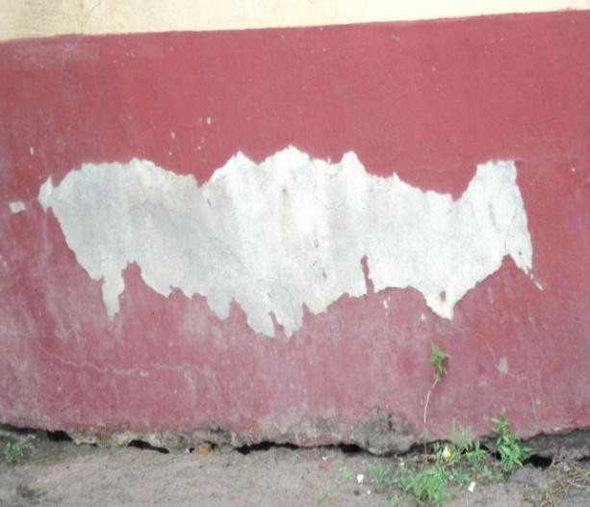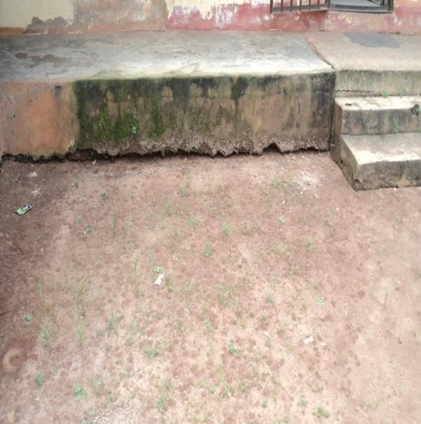

Plates 1: Longitudinal Crack and Dampness at the Plate 2: showing Crack and Dampness at the Foundation level of Audit extension block at Foundation level of PCR Block at NAUTH Nnewi. Nnewi.

Source: Researcher‟s field study (2017) Source: Researcher‟s field study (2017)

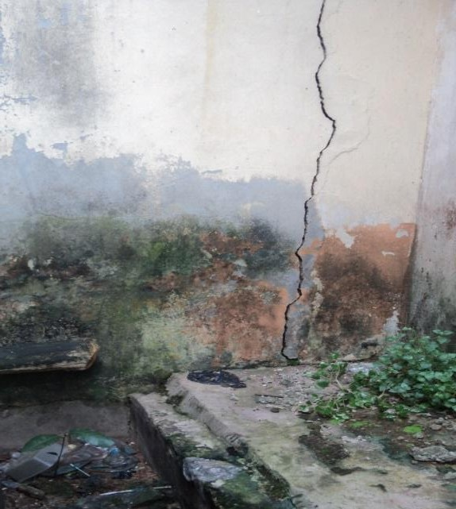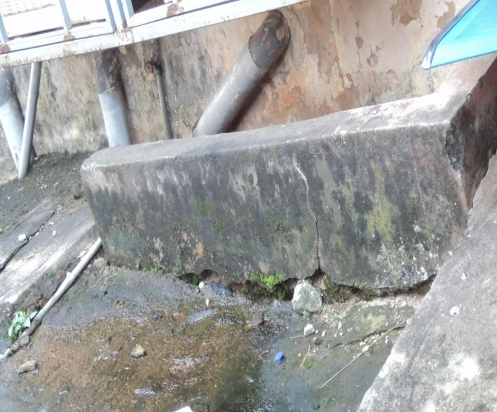

Plate 3:Crack and Dampness at the Foundation Plate 4: Cracks and Dampness at Male Surgical ward, Level of Female Surgical Ward at NAUTH Nnewi NAUTH Nnewi.

Source: Researcher‟s field study (2017) Source: Researcher‟s field study (2017)

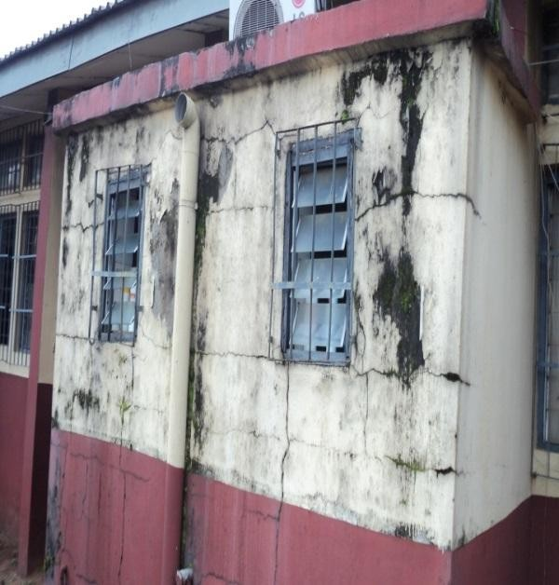 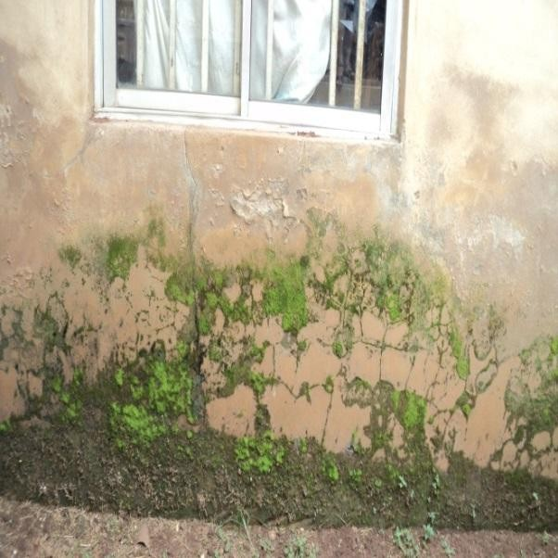

Plate 5: Longitudinal, Vertical and Diagonal plate 6: Cracked walls caused by effloresence at Cracks/Dampness at Administrative block Back of GOPD, NAUTH, Nnewi.

at NAUTH, Nnewi source: Researcher‟s field study (2017) Source: Researcher‟s field study (2017)

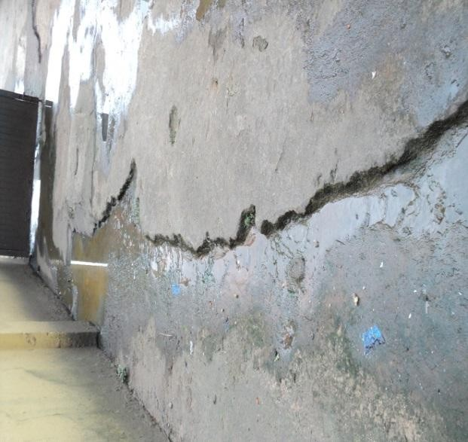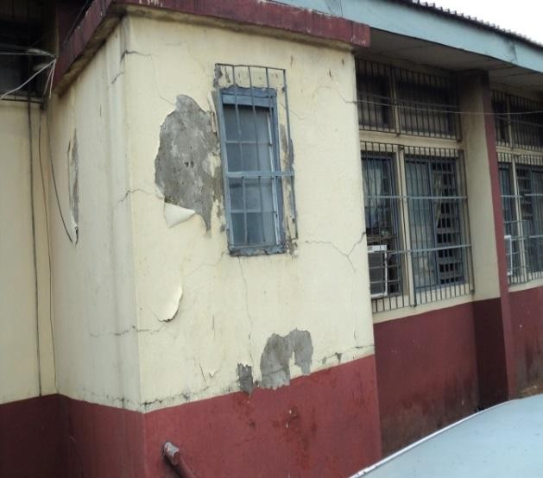

Plate 7: Cracked Floor slab at laboratory Plate 8: Defective wall at the Male ward at CHC Complex at NAUTH Nnewi Umunya NAUTH Outstation

Source: Researcher‟s field study (2017) Source: Researcher‟s field study (2017

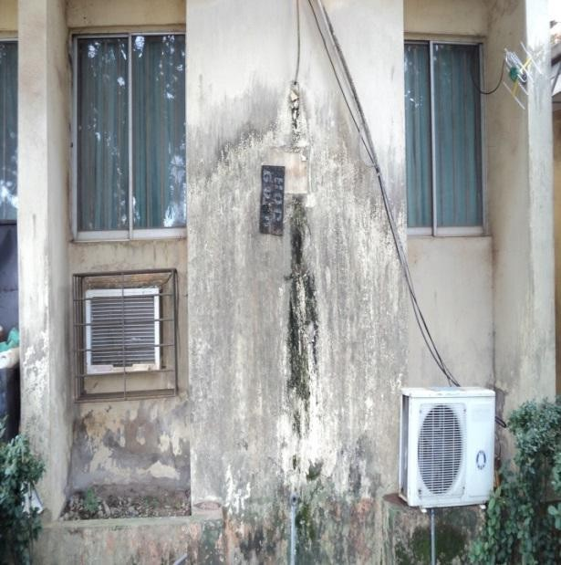 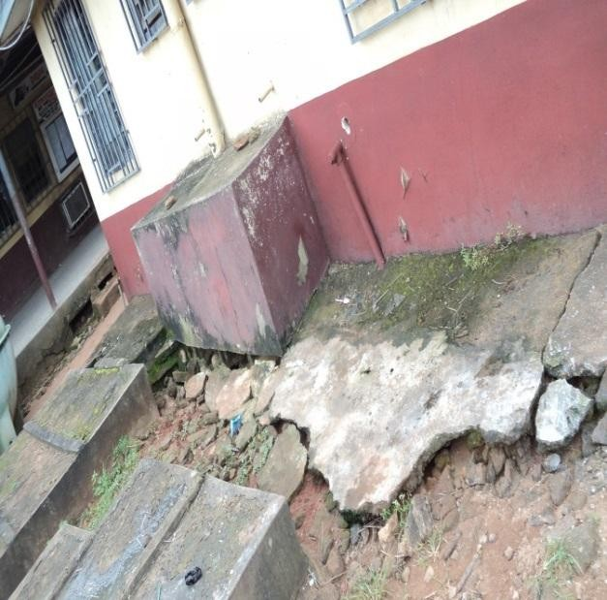

Plate 9: Showing Stain at the back of the main Plate 10: Defective Concrete Pavement Floor at theatre NAUTH,Nnewi the Corper Lodge, CHC, NAUTH Ukpo

Source: Researcher‟s field study (2017) Source: Researcher‟s field study (2017)

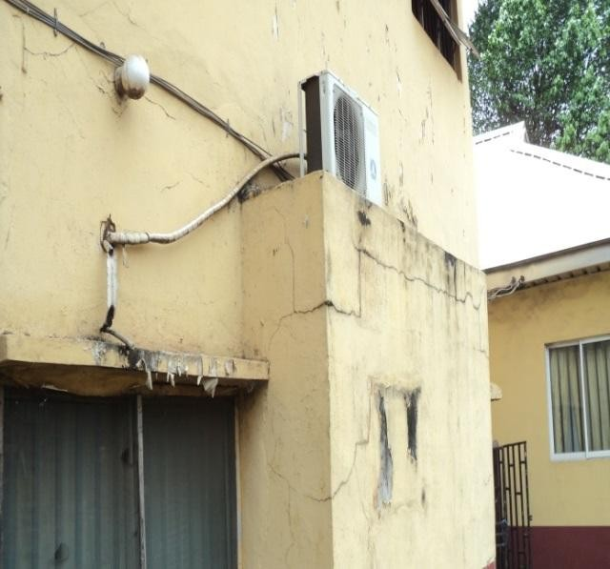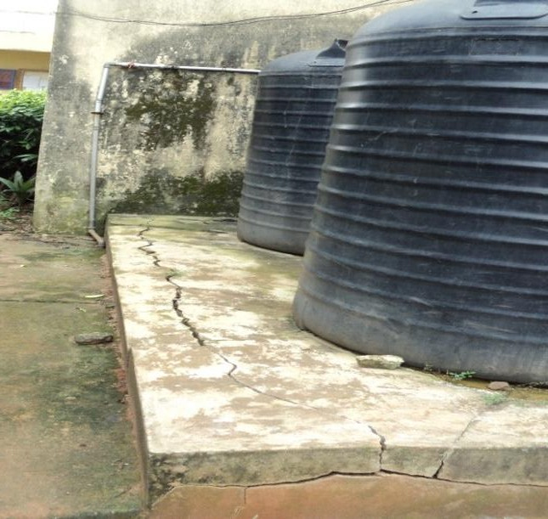

Plate 11: Crack caused by water from air Plate 12: Crack found at the Floor of the pharmacy condition at Radiology Building, at NAUTH Building at NAUTH,Nnewi

Nnewi Source: Researcher‟s field study (2017) Source: Researcher‟s field study (2017)

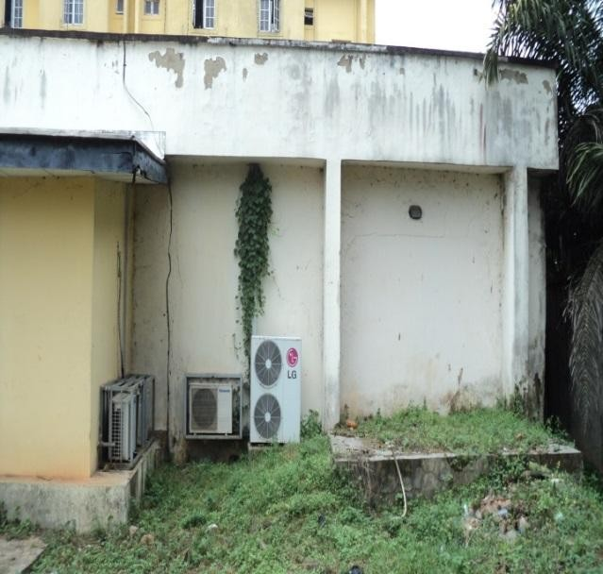 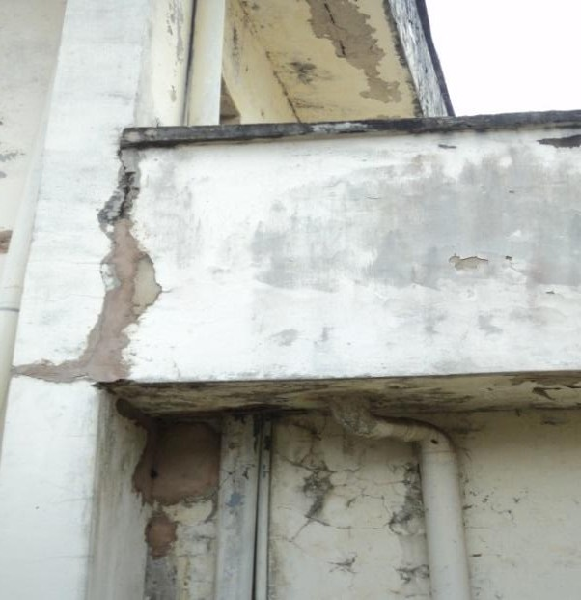

Plate 13: Crack found on the wall of Orthopeadic Plate 14: Crack found on the wall of the Labour Building at the NAUTH Truma centre Oba. Ward at NAUTH CHC Umunya

Source: Researchers field study (2017) Source: Researchers field study (2017)

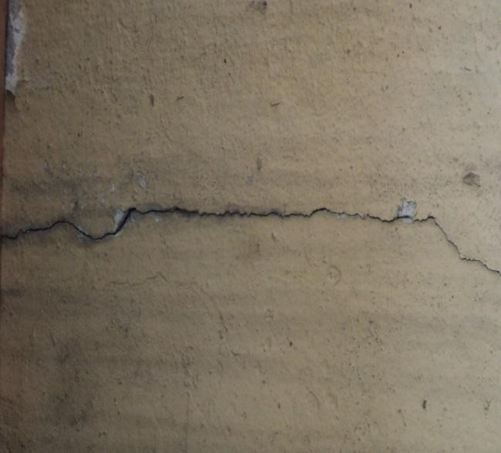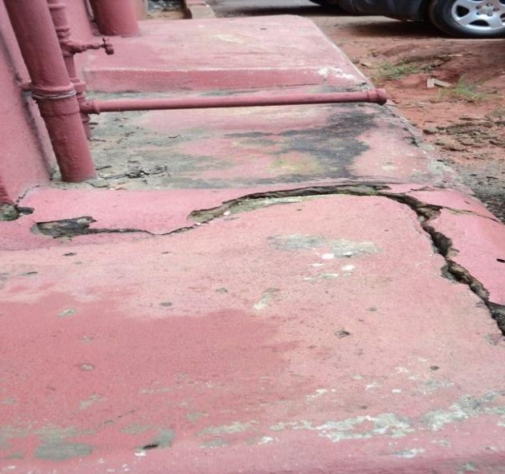

Plate 15: Vertical Crack seen on the External Block Plate 16: Crack Developing on the Internal Wall of the Adminstrative Block at NAUTH CHC wall at the ward of the NAUTH Truma centre Oba NAUTH

Source: Researcher‟s field study (2017) Source: Researcher‟s field study (2017)

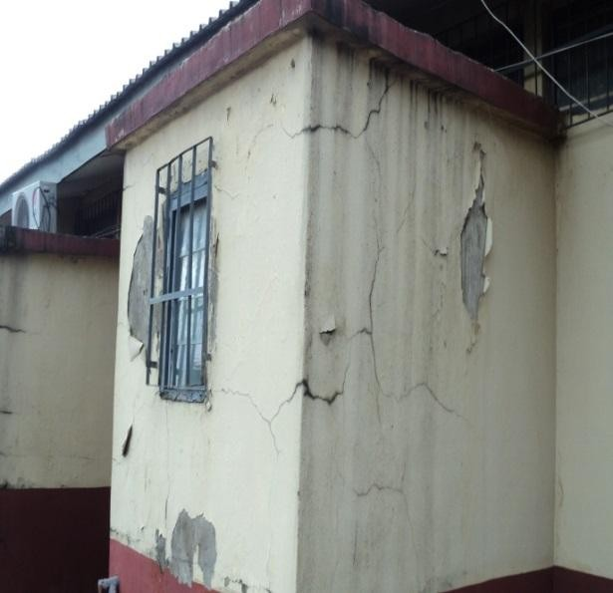 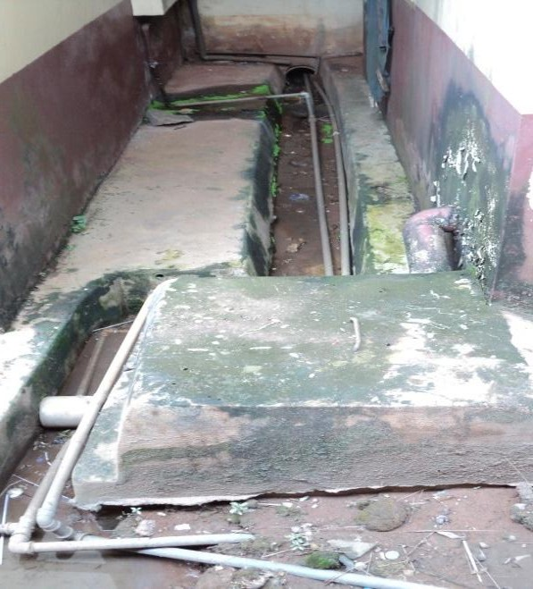

Plate 17: Diagonal Crack discovered on the Plate 18: Crack and Mould stains on the external External Wall of HIV-Lab at NAUTH CHC wall of the Laundary building, at NAUTH Nnewi Ukpo

Source: Researcher‟s field study (2017) Source: Researcher‟s field study (2017)

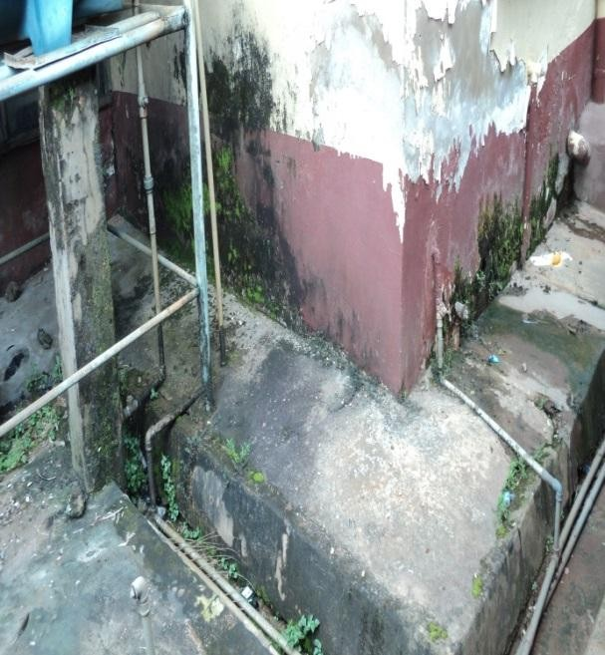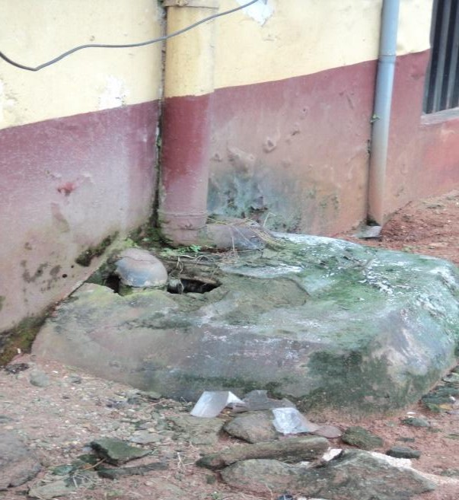

Plate 19: Defects Caused by Efflorescence on the Plate 20: Showing Cracks and wall

Wall of Clinical building at NAUTH GEC Onitsha stains/defects on inspection chamber at

HOQ. NAUTH Nnewi

Source: Researcher‟s field study (2017) Source: Researcher‟s field study (2017)

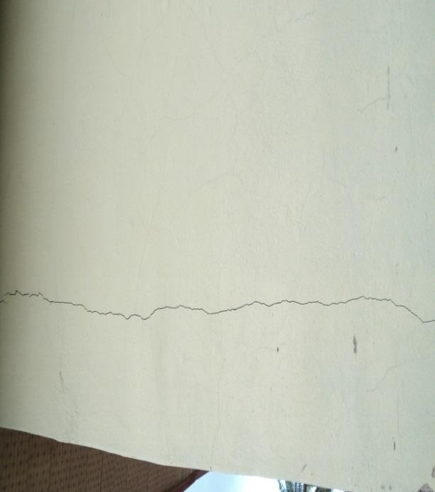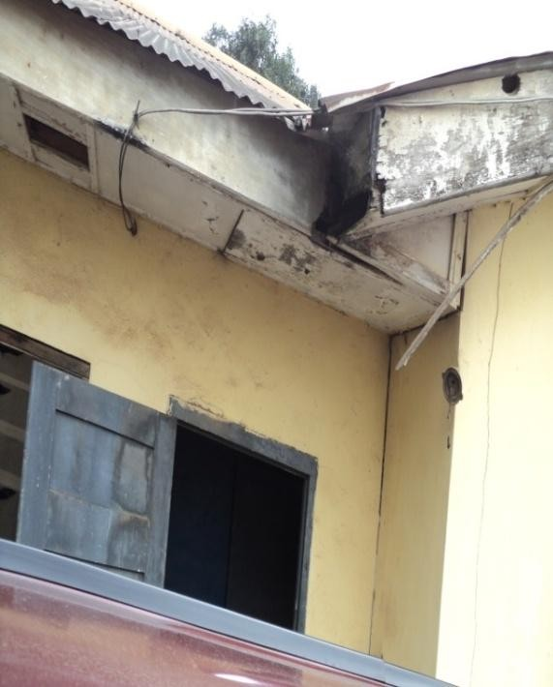

Plate 21: Vertical Crack on the wall at the PCR Plate 22: Vertical Crack at the joint, at Laboratory Building at NAUTH, Nnewi. Administration building at NAUTH GEC

Onitsha.

Source: Researcher‟s field study (2017) Source: Researcher‟s field study (2017)

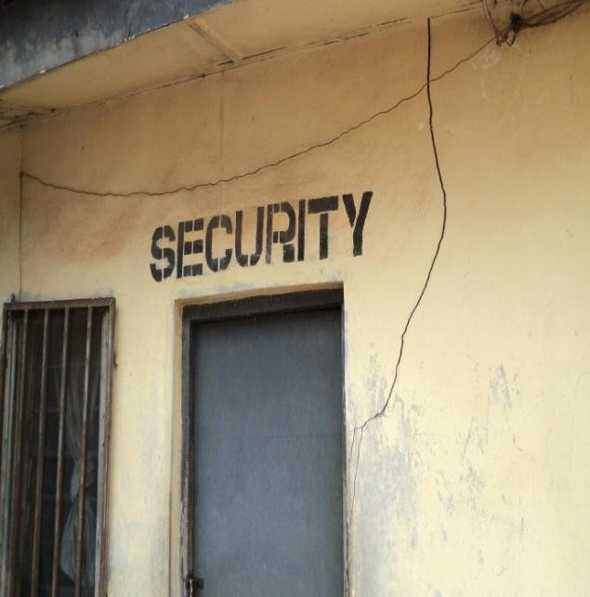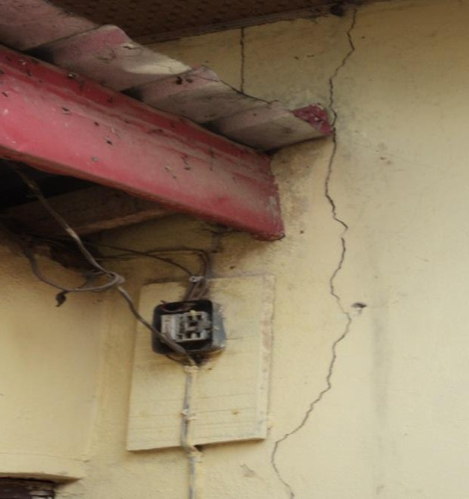

Plate 23: Vertical/Horizontal Crack at the Vertical Crack at the back of the main clinic at security gate at NAUTH,Nnewi. the NAUTH, Awka outstation.

Source: Researcher‟s field study (2017) Source: Researcher‟s field study (2017)

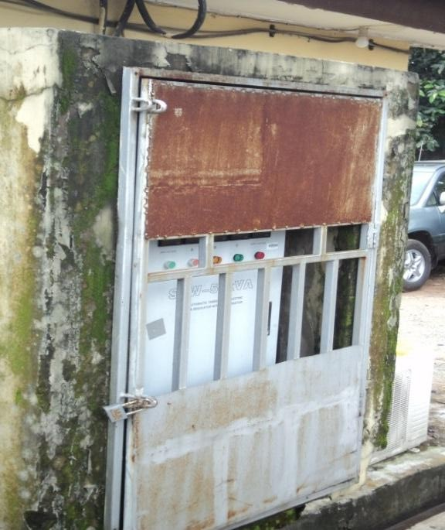 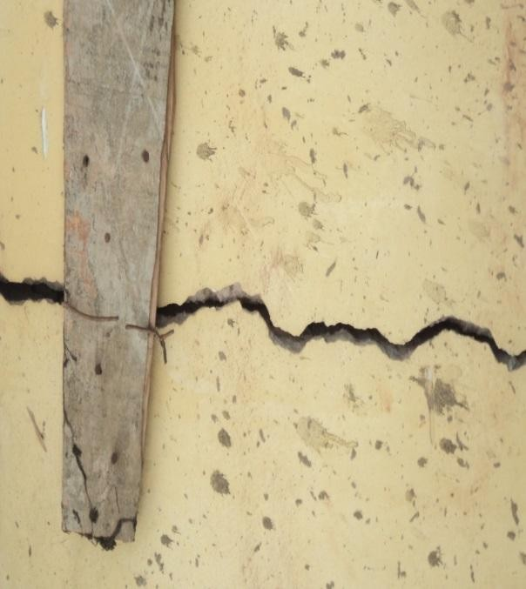

Plate 25: Efflorescence on the wall of the PCR Plate 26:Bold Crack at the wall of the Inverter block at Nauth,nnewi senior registras call building at NAUTH

CHC, Umunya.

Source: Researcher‟s field study (2017) Source: Researcher‟s field study (2017)

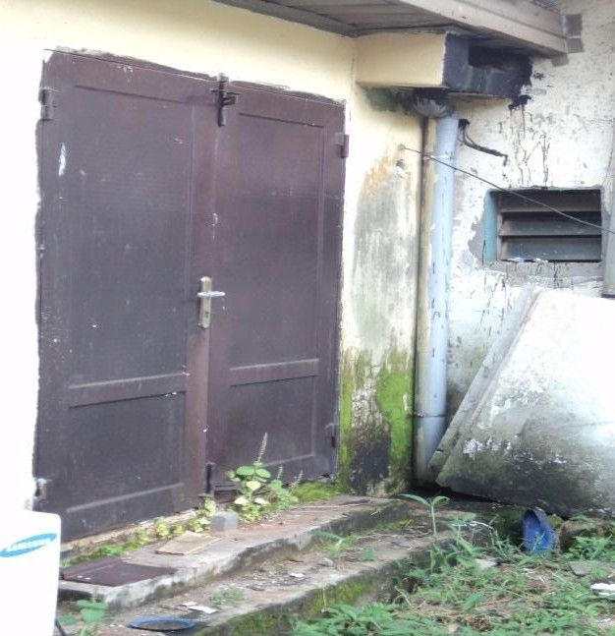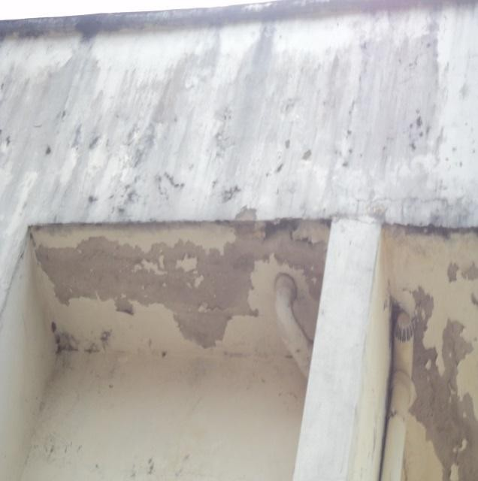

Plate 27:leakage of Concrete Slab and stains at Plate 28: Leakage of concrete slab at Gutter of the the wall of CHER building at NAUTH,Nnewi radiology building at NAUTH,Nnewi.

Source: Researcher‟s field study (2017) Source: Researcher‟s field study (2017)

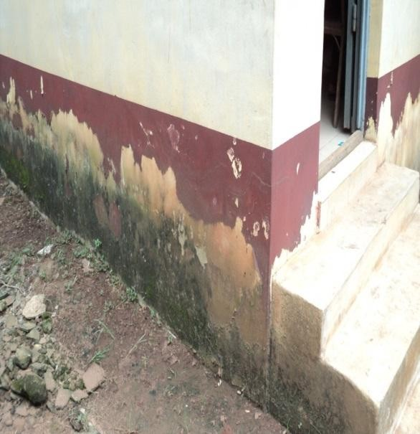 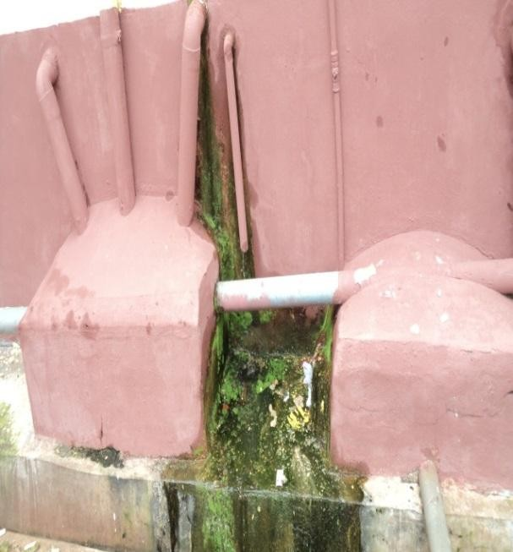

Plate 29:Flaking of Paint wall at the maternity Plate 30:Effloresence caused by dampness and Building,NAUTH,Awka leakage of pipes at the back of medical

Complex, at NAUTH CHC Neni .

Source: Researcher‟s field study (2017) Source: Researcher‟s field study (2017)

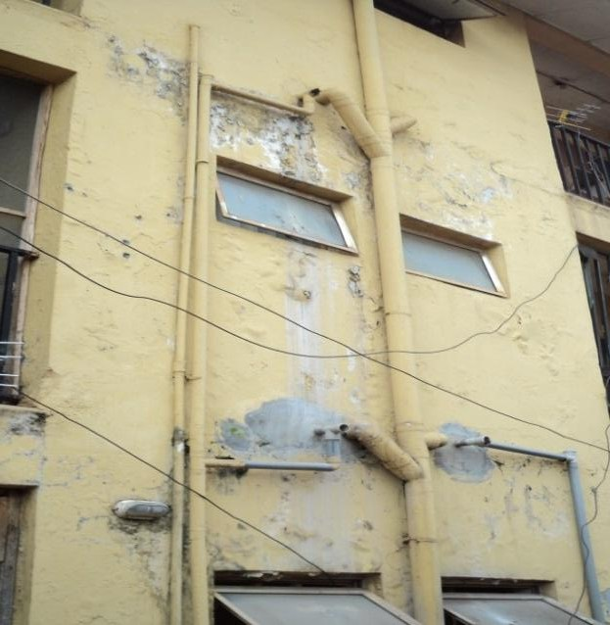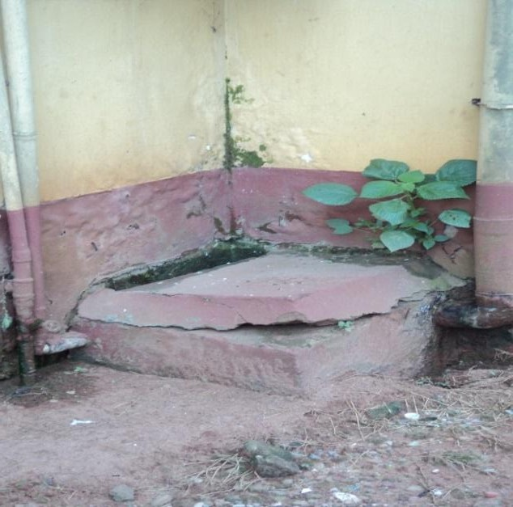

Plate 31:Flaking of paint walls at the walls of Plate 32: Plant Growth on top of Chambers Doctors Call building at NAUTH,Nnewi at NAUTH, Nnewi.

Source: Researcher‟s field study (2017) Source: Researcher‟s field study (2017)

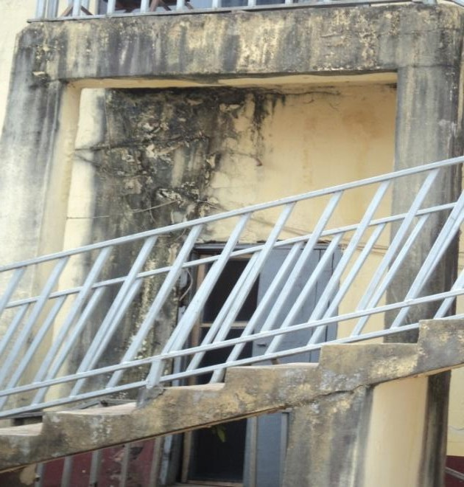 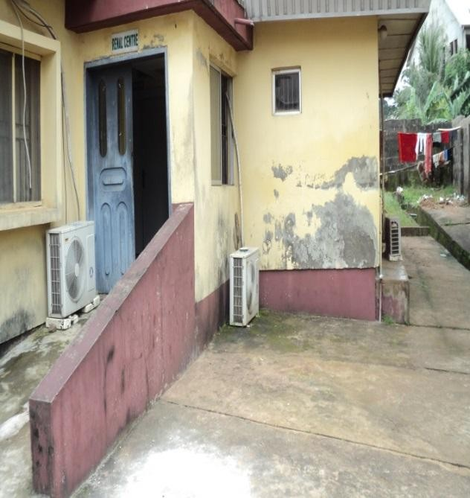

Plate 33: Plant Growth on the wall of Medical Plate 34: Detects and flaking of paint at the wall of Complex at NAUTH,Nnewi. Renal Centre, NAUTH Nnewi.

Source: Researcher‟s field study (2017) Source: Researcher‟s field study (2017)

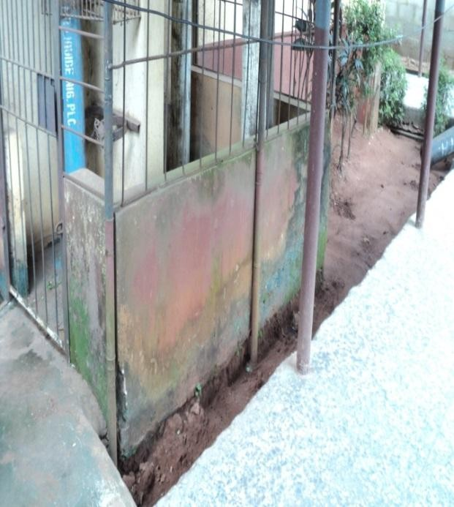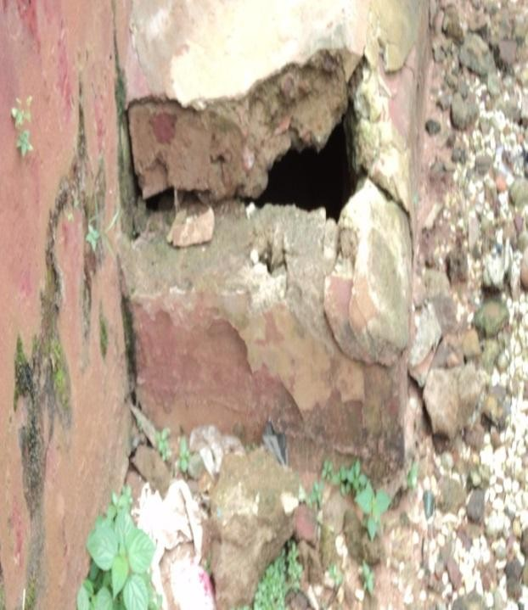

Plate 35: Efflorescence stains at the gas dump at Plate36: Broken Septic Tank/Soakaway pit at NAUTH, Nnewi. House Officers quarters at NAUTH,Nnewi. Source: Researcher‟s field study (2017) Source: Researcher‟s field study (2017)

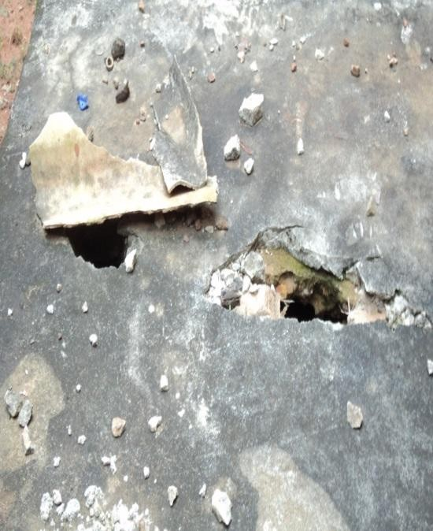 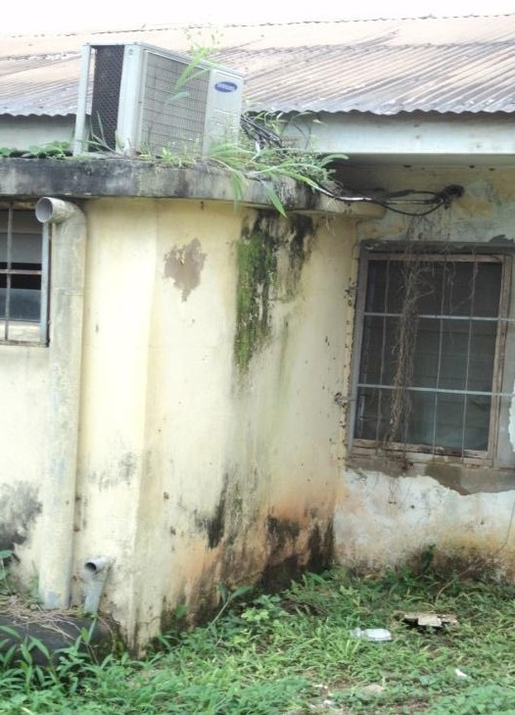

Plate 37: Broken Septic Tank/Soakaway Plate 38: Plant growth on the wall and slab of Pit at the NAUTHGuiness Eye centre Onitsha the IHVN Clinical at NAUTH,Nnewi Source: Researcher‟s field study (2017) Source: Researcher‟s field study (2017)

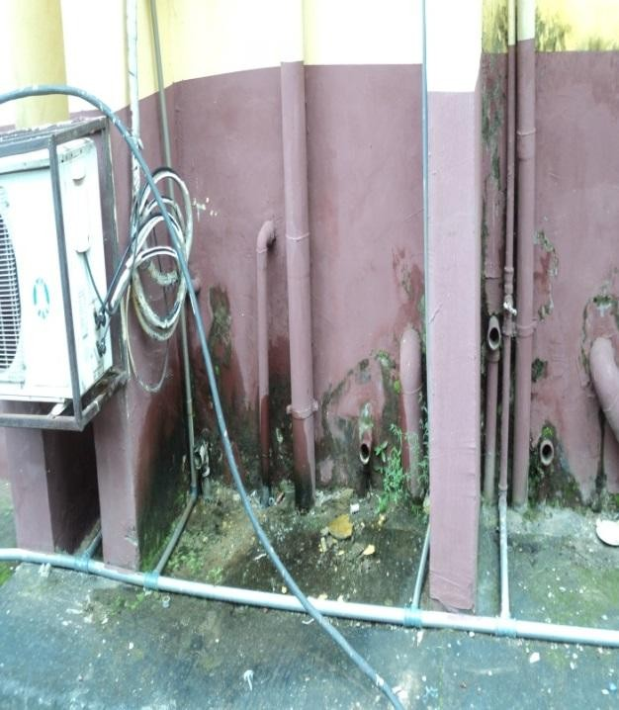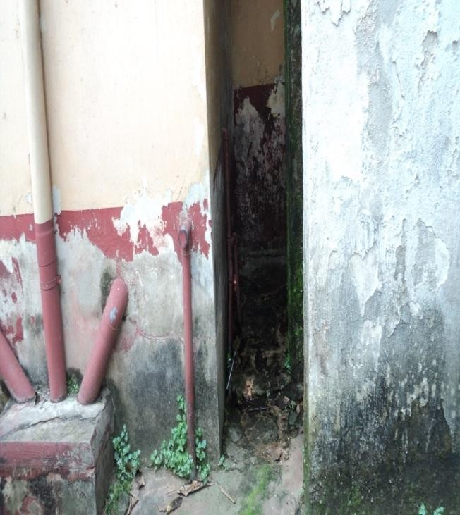

Plate39: Leaking Sanitary Pipes at the Laboratory Plate 40: stains and dampness at the back of Complex, at NAUTH,Nnewi. the Maternity block at NAUTH CHC Umunya Source: Researcher‟s field study (2017) Source: Researcher‟s field study (2017)

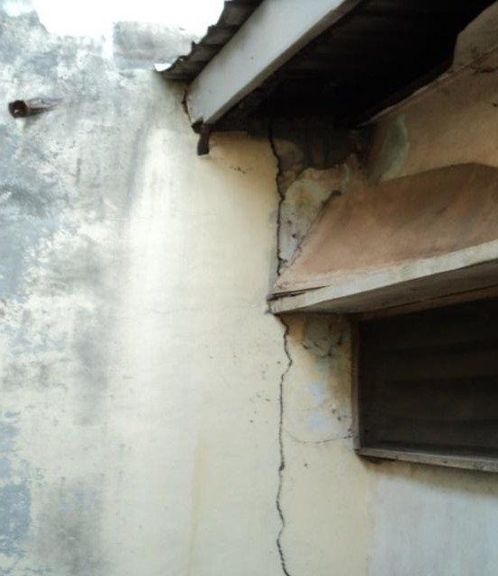 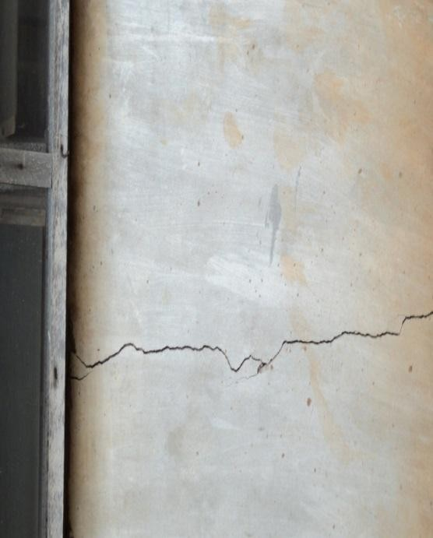

Plate 41: Defective and cracks walls at the Plate 42: Vertical Cracks at the front of the SON Back of the SON building at NAUTH,Nnewi. Building at NAUTH,Nnewi.

Source: Researcher‟s field study (2017) Source: Researcher‟s field study (2017)

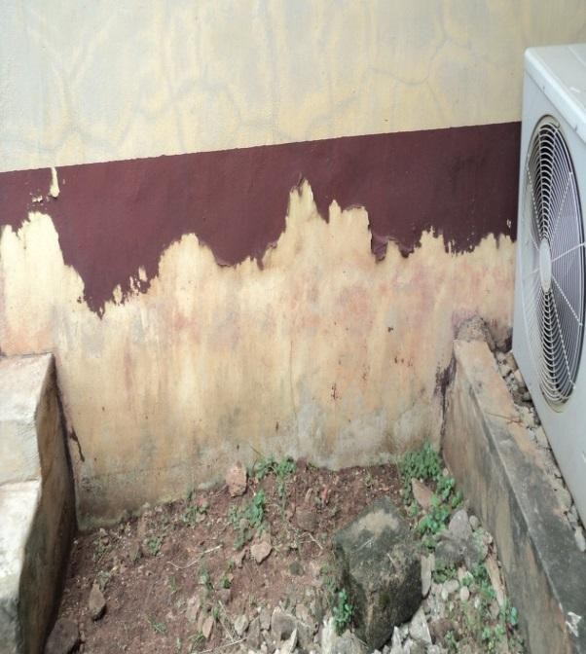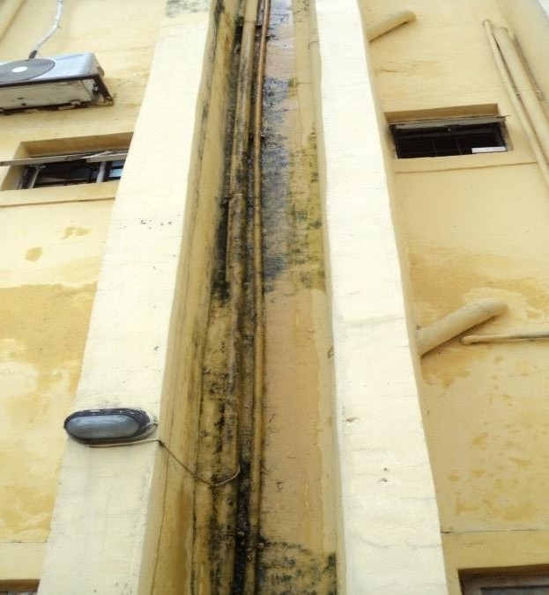

Plate 43: Horrizontal cracks and flacking of Plate 44:Leaking plumbing Pipes at the back of the Paint at the back of the security house at Ward of NAUTH GEC Onitsha.

NAUTH CHC Ukpo.

Source: Researcher‟s field study (2017) Source: Researcher‟s field study (2017)

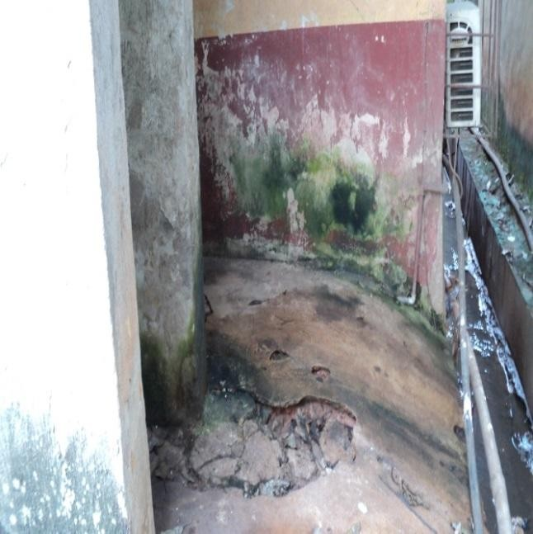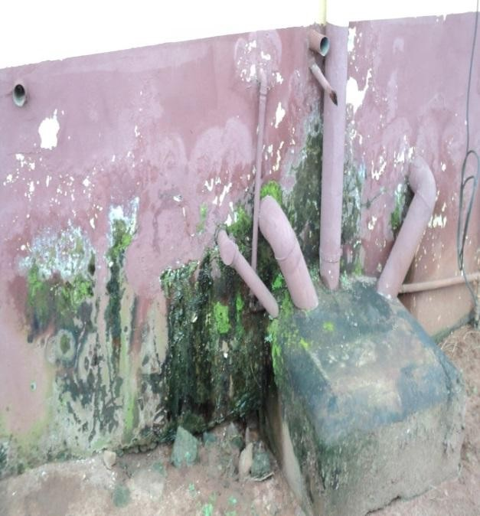

Plate 45: showing Moisture effect on walls/floor Plate 46: Effloresence and dampness at the back Of the Clinic at NAUTH CHC Neni. of physiothrapy building, NAUTH, Nnewi Source: Researcher‟s field study (2017) Source: Researcher‟s field study (2017)

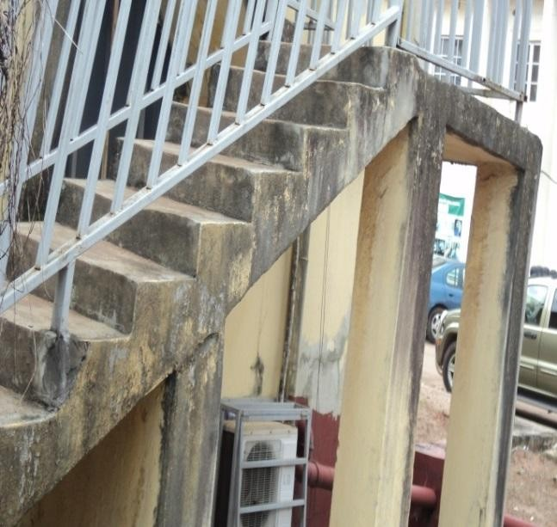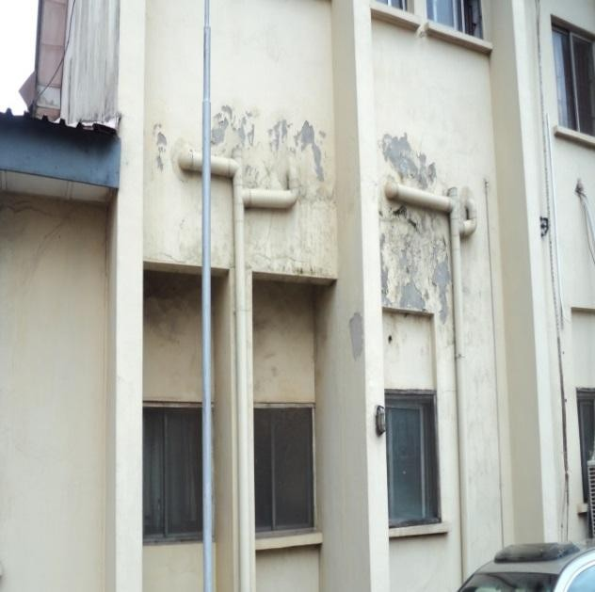

Plate 47: Stain caused by rain on the steps of Plate 48: Peeling and Flaking of paint at the Medical Complex at NAUTH,Nnewi. Radiology building at NAUTH,nnewi Source: Researcher‟s field study (2017) Source: Researcher‟s field study (2017)

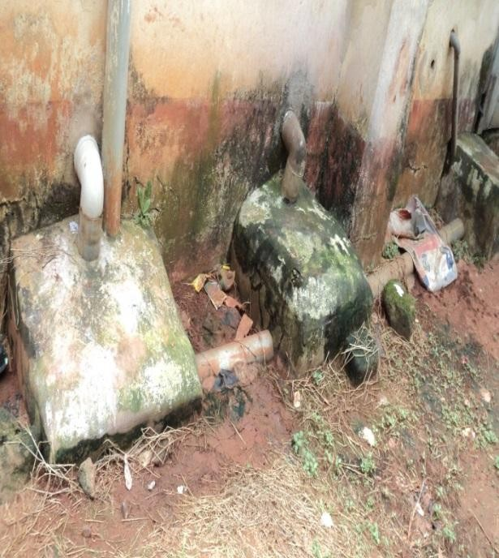 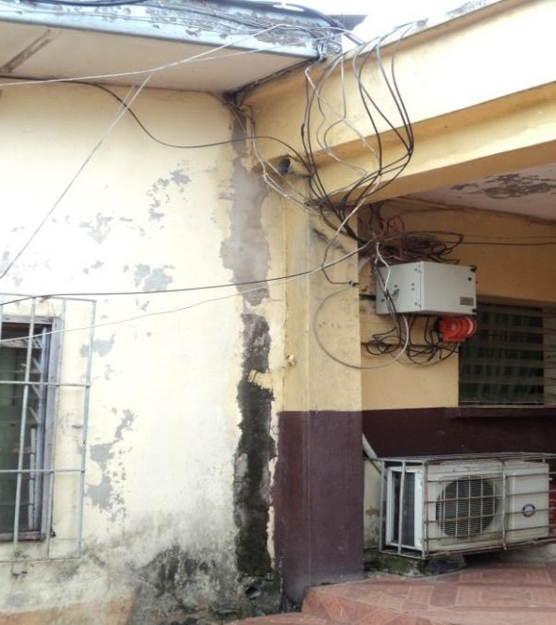

Plate 49: unkept Environment at the back of the Plate 50: Dangling of electrical/Communication Old Head Of Nursing services Block at NAUTH, at the main theatre building NAUTH,Nnewi Nnewi.

Source: Researcher‟s field study (2017) Source: Researcher‟s field study (2017)

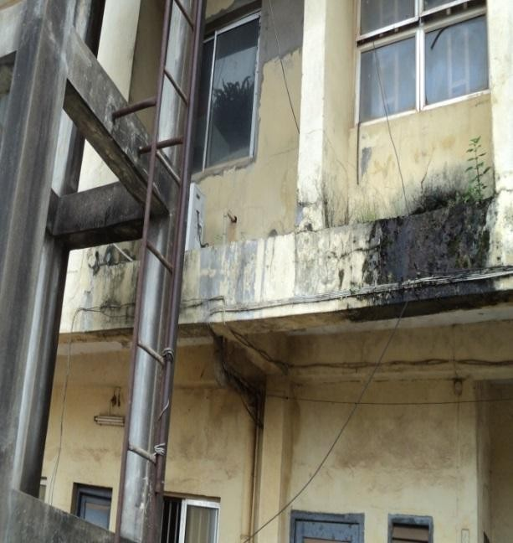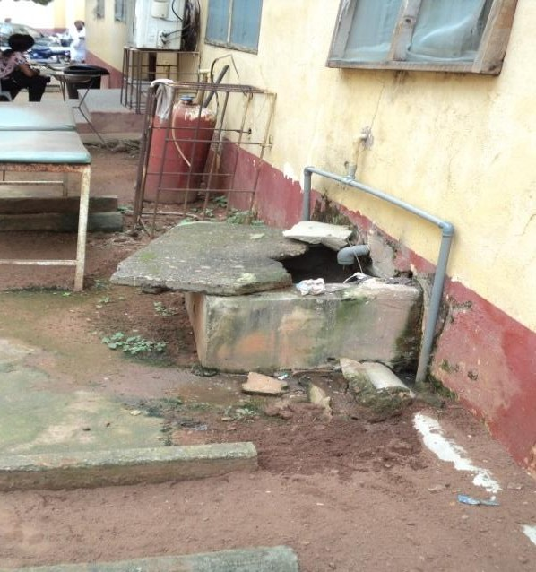

Plate 51: Dampness, Mould stains and weed Exposed inspection Chambers at the back of the Growth on the 1st floor caused by water from store building at NAUTH,Nnewi.

Air conditioners at the Doctors call buiding at NAUTH, Nnewi

Source: Researcher‟s field study (2017) Source: Researcher‟s field study (2017)

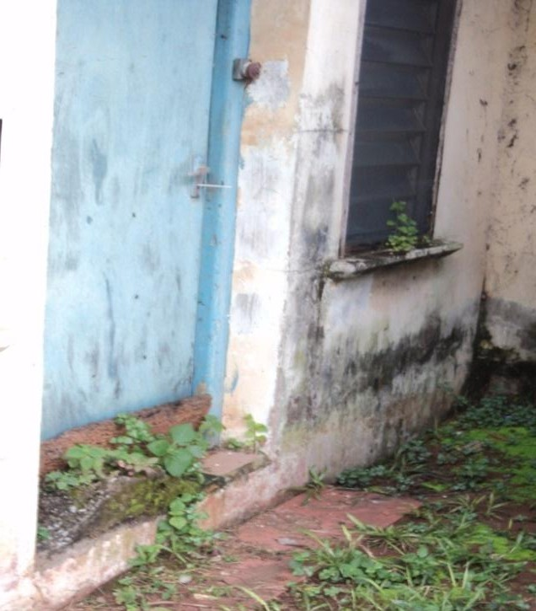 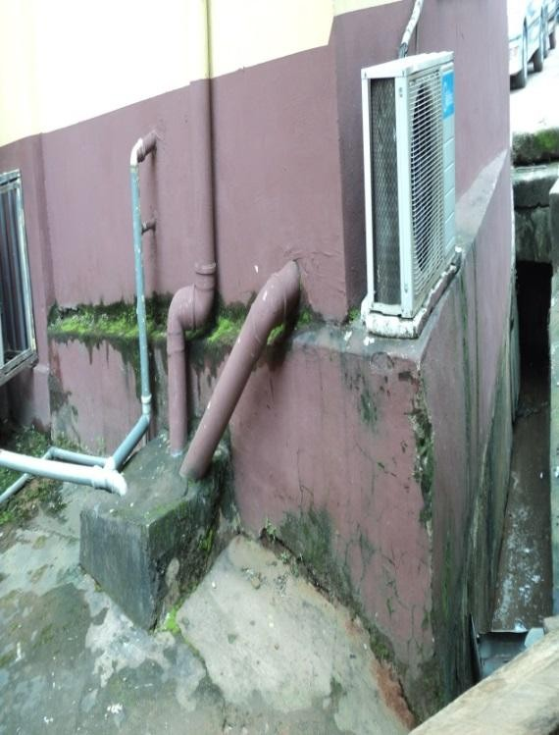

Plate 53: stains and plant growth at the window Plate 54: Stains and Cracks and Hood of the HIV call room at NAUTH,Nnewi. Effloresence at the back walls of the

Laboratory block at NAUTH CHC Umunya Source: Researcher‟s field study (2017) Source: Researcher‟s field study (2017)

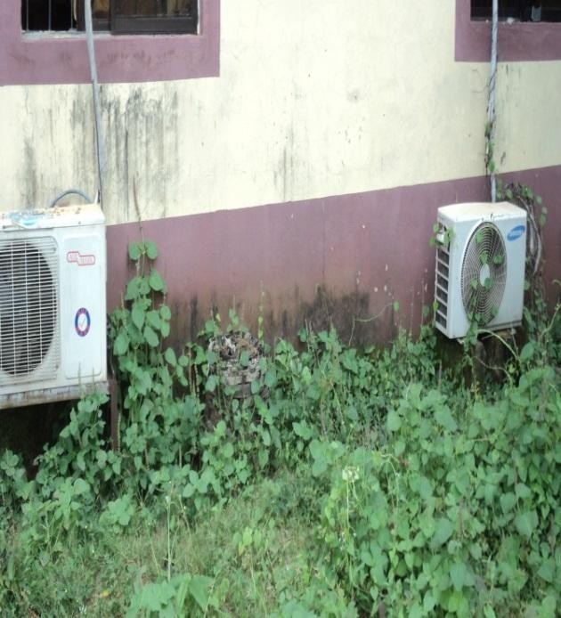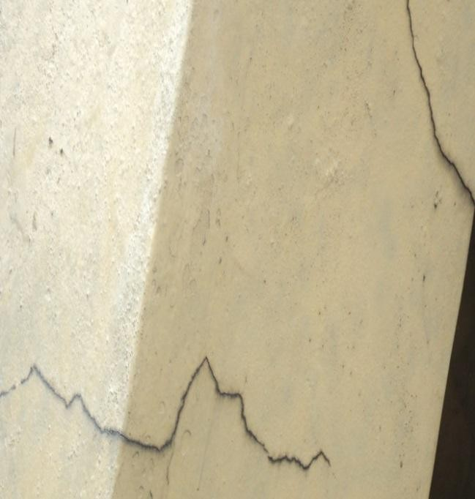

Plate 55: Stains and growth on the pipes of Air Plate 56: Cracks at the exeternal walls of the Conditioners at the back of works department at VAMED block at NAUTH,Nnewi.

NAUTH, Nnewi.

Source: Researcher‟s field study (2017) Source: Researcher‟s field study (2017)

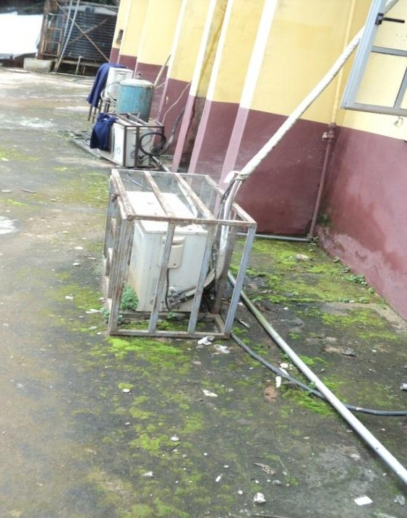 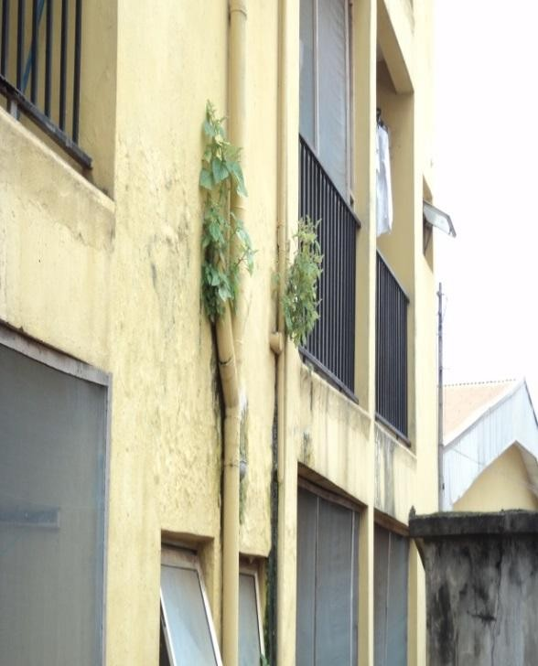

Plate 57: Efflorescenes caused by dampness Plate 58: Plant growth at the wall/pipes of the at the Pavement of the MOP/SOP building house officers quarters at NAUTH,Nnewi.

at NAUTH,Nnewi.

Source: Researcher‟s field study (2017) Source: Researcher‟s field study (2017)

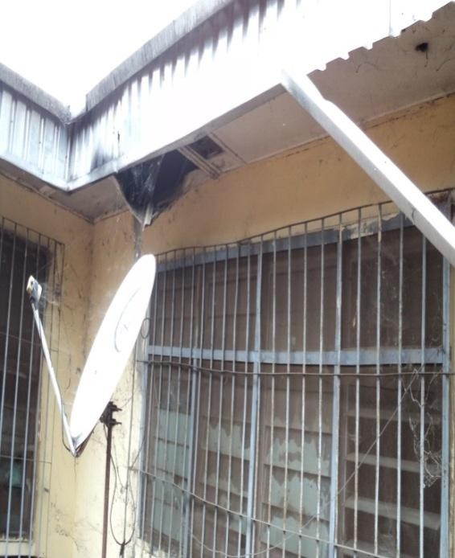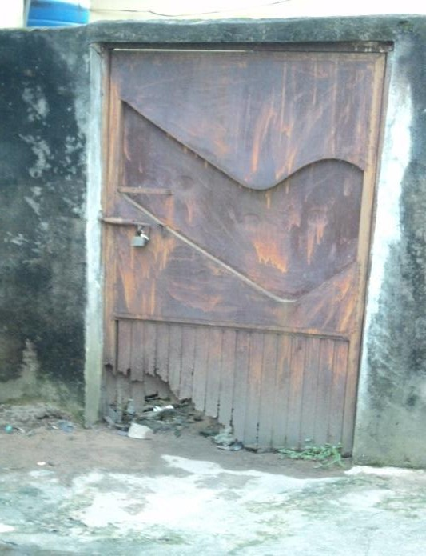

Plate 59: Falling/Bulging of ceiling boards at Plate 60: Rusting of iron door cauesd by rain the back of the female surgical ward at NAUTH at the PCR Laboratory at NAUTH,Nnewi. Nnewi.

Source: Researcher‟s field study (2017) Source: Researcher‟s field study (2017)

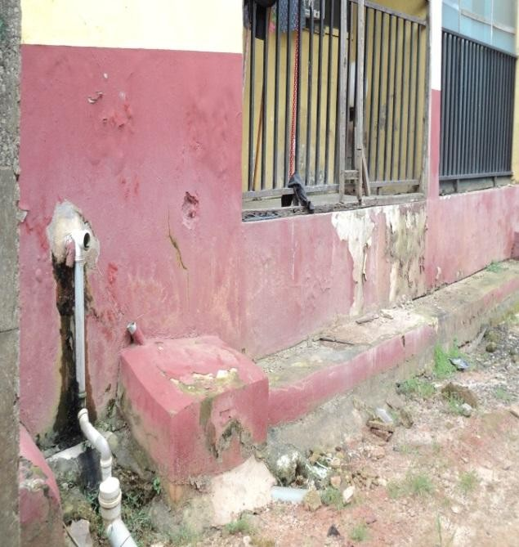 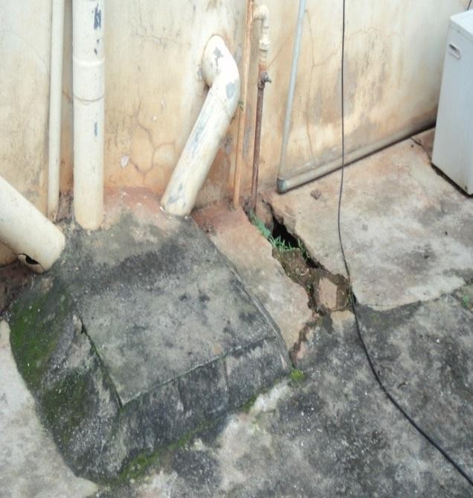

Plate 61: Defects,Flake and stains on external plate 62:Cracks on Floor pavements/chambers an Walls of the quarters at NAUH CHC Ukpo washing away of paint at the Admin extension at

NAUTH, Nnewi

Source: Researcher‟s field study (2017) Source: Researcher‟s field study (2017)

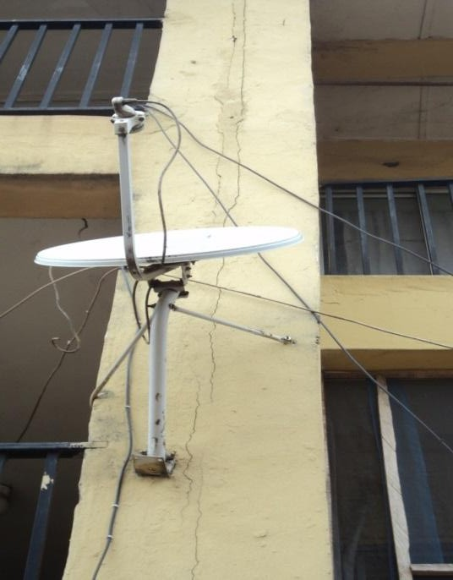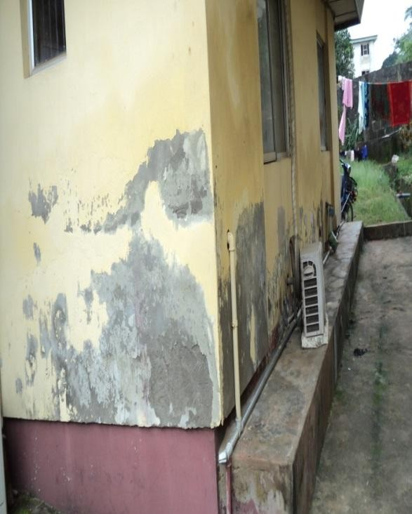

Plate 63: Vertical Cracks on walls at the ward Plate 64: Defects/ Flaking of paint at the external Complex at the NAUTH Truma centre,Oba wall of the Main building at the NAUTH CHC

Neni

Source: Researcher‟s field study (2017) Source: Researcher‟s field study (2017)

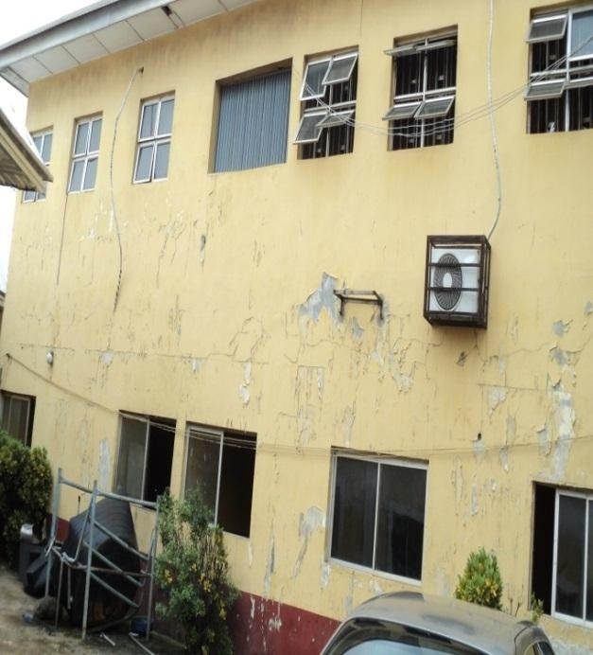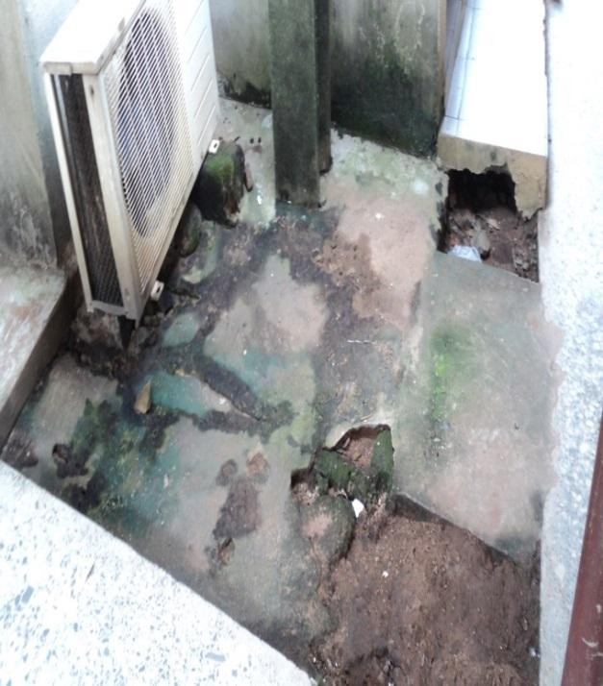

Plate 65: Flaking of paint at the external wall Plate 66: Dampness and Cracks at the floor of the main building of the NAUTH CHC Neni. Pavement of the Psychiatric building at

NAUTH CHC Neni

Source: Researcher‟s field study (2017) Source: Researcher‟s field study (2017)

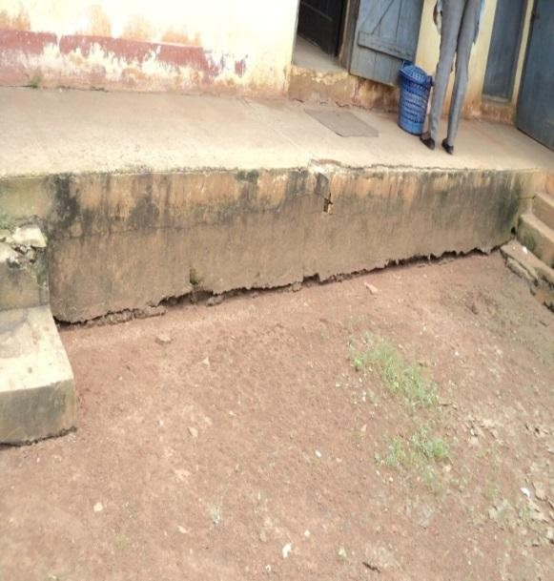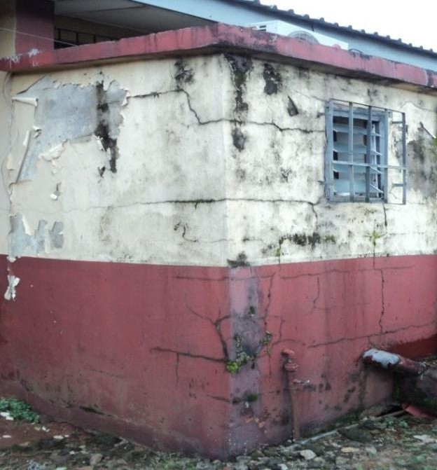

Plate 67: Horizontal Cracks caused by Plate 68: Multiply vertical/horizontal cracks and Stagnated water at dietetic building at stains caused by water leakages in the public NAUTH,Nnewi. Toilet at NAUTH , Nnewi

Source: Researcher‟s field study (2017) Source: Researcher‟s field study (2017)

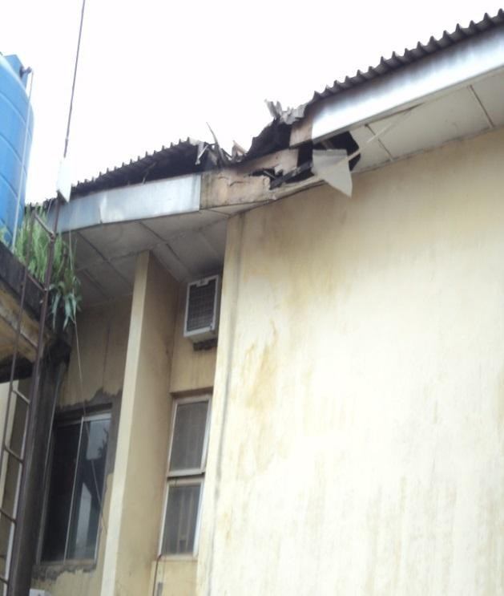 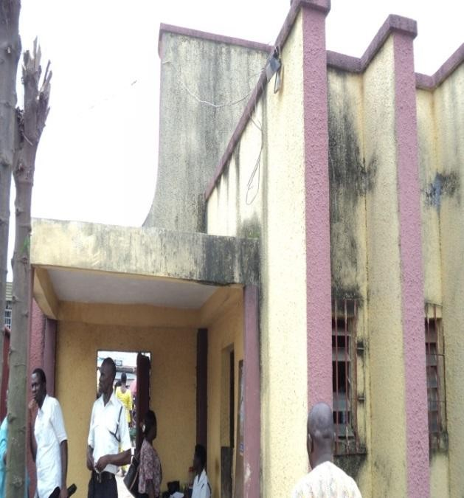

Plate 69: Damaged Aluminun roofing sheets caused Plate 70: Stains caused by rain at external by trees at the back of SON building at NAUTH, walls of the security gate house at .

Nnewi. NAUTH, Nnewi

Source: Researcher‟s field study (2017) Source: Researcher‟s field study (2017)

The state of the buildings in NAUTH was a result of non-maintenance which contributed to defects backlog with the consequences of eminent equipment breakdown or building component failure as predicted by Cane *et al* (1998). The existence of an effective maintenance strategy in NAUTH should have provided for regular maintenance to eliminate or minimize the costly consequences. This according to Olila and Malmipuro (1999) would ensure that they continue to remain in such good state and retain their investment value over a long period of existence

This is the reason why Douglas (1996) state that, buildings are key functional infrastructure as well as economic resources, and so its maintenance should therefore be regarded as assets rather than liabilities. Hospital buildings most especially, contribute immensely to the functioning,

ultimate performance and realization of the goals and objectives of any hospital. According to Akinsola and lyagba, (2006), buildings constitute part of our most valuable assets, providing shelter, security and privacy throughout patients stay in the hospital. Based on this, one can say that, Hospital building refers to a structure specifically designed and used for effective service delivery. According to Okanume (2005) hospital building provides the needed identity, purposefulness, comfort and service required for the development, and enhancement of hospital service. This shows that without adequate maintenance and functional hospital building, effective service delivery of life cannot be realized. Kunya, Achuenu, and Kolawole (2007) affirm that, "the condition and quality of buildings in the hospital, reflect public pride, the level of prosperity in the area, social values, behaviours and all the many influences, both past and present, which combine to give the community its unique character. Okolie (2011) maintains that, inadequate facilities, such as buildings and equipments in educational institutions affect not only the number of students attracted each year, but also the academic standards of the institutions. The researcher saw it as also being applicable to hospital institution. Poor maintenance of hospital buildings often lead to the public to question the quality of health provided by such institution, and it also reduces the staff job motivation, and the number of patients that will be attracted to be treated there.

Hospital buildings, therefore should be designed, built and maintained to meet specific or group of needs. According to Robinson and Robinson, (2009), the purpose of designed and maintained environment is to provide a climate, conductive to both patient and staff. Studies have shown that an improperly designed and maintained physical environment cause stress to occupants of the facility, both directly and indirectly (Mutlaq 2000: OECD 2006: Sanoff 2003: Robinson & Robinson 2009).They further suggest that,

the design of buildings for educational activities must incorporate some key performance variables such as, accessibility, aesthetics, cost effectiveness, functionality, health effectiveness/productivity, safety, security, flexibility/adaptability. These are applicable to hospital activities. In fact, the only rational to prolong the life span of hospital buildings is to maintain them regularly, which in turn will enable the buildings to fulfill their functions. However, from the fore going, the dynamics of health sector indicates that Success of hospital buildings is influenced by the nature and type of buildings.

Health institutions, especially hospital, therefore, have responsibilities to provide well-developed and adequate functional Health care buildings that will enhance delivery of good health care and conducive working environment. The success of hospital building is assessed by the extent the building is functioning, and how the patients and staff are utilizing the space and the impact on hospital activities. That is what prompted Lackney (2001) to state that Hospital buildings and learning environments must satisfy the following:

1. Enhance good health delivery and accommodation to the patient and staff;
2. Must provide for health, safety and security;

The Organization for Economic Co-operation and Development OECD (2006) titled Organizing framework for evaluating quality in Health facilities" recommends that hospital buildings must satisfy the following requirements:

1. Increase access and equity to Health;
2. Improve Health effectiveness;
3. Optimize performance operation and cost-effectiveness;
4. Be symbolic, visually pleasing and Healthy;
5. Be fit for purpose.
6. Be environmentally sustainable.

Furthermore, from all indications, hospital buildings and environments must satisfy the following:

1. Provide facilities necessary for human metabolism i.e. removal of Human waste, clean water, air etc;
2. Safe from collapse, fire, storm, and resistant to the physical forces of rain etc;
3. Allow for easy maintenance, alterations and extension;
4. Create the humanized space in which to receive health delivery;
5. Create conductive environment for the attendants of patients.
6. Provide means for easy attendants with necessary medical equipment.
7. Must be delight in terms of aesthetic and psychological appeal;
8. Must be fit for human habitation.

This indicates therefore that, the nature of hospital building in terms of its design; maintenance and operational effectiveness must be considered as factors that positively impact to guide recovery/good service delivery to patients. According to the national philosophy on Health, "Health is the process of expanding consciousness that synthesis diseases and non disease and is recognized by patterns of person‟s environment and interaction. This indicates that Hospital involves activities for the treatment of patient to be well, and this may involve carry out lab tests, x-rays, MRI, C-T Scan, EEG, ECG, physiotherapy, outpatient services, and so on. It stands to reason that, physical facilities especially hospital buildings, comprising various types and shapes, contribute immensely to the functioning, ultimate performance and realization of good health service. This is in line with Okanume, (2005), who maintains, that institutional buildings for educational usage, vary in sizes,

types and shapes, are required to facilitate the actualization and objectives of the primary purpose, of establishing higher institutions. This is applicable to health institutions. Hospital buildings provide comfort, convenience, services, accessibility and environmental well being of the patients and staff. Hospital buildings constitute the essential concrete features that enable the patient to be comfortable to receive treatment.

Sanoff (2003) in his contribution said that, the design of modern hospital buildings strongly emphasizes stimulating and adaptable treatment environment with spaces that support various styles of hospital services. However irrespective of the type, hospital buildings are important, considering the huge financial resources invested in their procurement. Therefore, a functional arrangement needs to be evolved to facilitate their management in terms of maintenance, for continual optimal performance. In fact, adequate and constant maintenance of hospital buildings will always boost the corporate image of the hospital Shohet (2003) and Smith (2003.

Smith (2003) stated that regardless of the location, size or budget, all hospital buildings should have certain common attributes: efficiency and cost-effectiveness, flexibility and expandability, therapeutic environment, cleanliness and sanitations, accessibility, controlled circulation, aesthetics, security, safety and sustainability. A functional design hospital can promote skill, economy conveniences and comforts; a non-functional design hospital can impede activities of all types, detract from quality of care, and raise costs to intolerable levels (Hardy & Lammer, 1996). Hospital buildings are characterized by major complexity and hospital operations are affected by rapid changes and trends. According to Johassen, Klemenic and Leinenwever (2001) the supply of health and care are continually changing world over and the speed of change is ever accelerating. Planning and design

of hospital buildings on all levels are affecting society and patients, from issues of localization, concept and town planning, down to architecture and patients and hospital employees close surroundings.

According to Kunya et al., (2007) patients‟ enrolment remains one of the major sources of revenue for hospitals. They maintain that, patients/patient relatives are attracted not only by the hospital services but also by the available facilities, including buildings and equipment. Institutions are often identifiable by their facilities (Camillus, 2004). Okolie (2011) therefore advised that, in the current times of high operating costs, increasing competition and rising user-expectations, educational institutions, particularly universities must seek to maximize their return on building investment through constant maintenance of the existing stocks. This is same with hospital buildings. This shows that effective and efficient maintenance management of hospital buildings is imperative for all health institutions

* + 1. **Building Maintenance Models**

A model is defined as a physical or symbolic representation of the relevant aspects of the reality with which we are concerned (Imaga, 2003). It can also be defined as a simplified method of representing an object or situation. Building maintenance model is therefore, a process of showing, representing or depicting how maintenance activities or tasks are to be carried out. Building maintenance model simply means a decision making framework, for the maintenance of buildings. This indicates that, maintenance model defines those tasks, uncertainties, that need to be indenting to show how, when and what information needs to be communicated, for successful execution of maintenance works.

According to Ojedoku, Odewumi and Fasola, (2012), an essential part of modeling maintenance, is taking account of the uncertainties in the deterioration and time of failure, for the purpose of maintenance optimization. However, several factors affect the maintenance of tertiary institutional buildings, and based on previous studies, various models have been developed and thus.

Buildings are essential physical facilities, expected to function effectively to accommodate the activities for which they are constructed. For buildings to meet these basic requirements, they need constant and regular maintenance. The concept of building maintenance is therefore, one of the major theoretical backgrounds of this study. It is the act of embracing all actions which injects a new or better life into a building system, and helps to bring a building back to its original standard or well above such standard Ikpo, (2008).

One of the objectives of this study was to recommend/develop a building maintenance model that would incorporate best practice criteria for maintenance of hospital buildings. The model that will be recommended is based on the best practice criteria identified in the literature and case study investigations. Building maintenance model is a decision making framework for successful execution of building maintenance work. Literature review shows that there exist the following building maintenance models (BMM) with limited application according to valdez –Flores and Feldman (1989), Van Winden and Volelker (1974) :

* + - 1. **Building Conditions and Patient Recovery Model**

The success of hospital building is assessed by the extent the building is functioning, and how the patients and staff are utilizing the buildings and the impact on health recovery. This shows that lack of maintenance of hospital

buildings have adverse impact on patient quick recovery and workers productivity. The maintenance of hospital buildings involved the management, funding, and stakeholders.

The building condition and patient Recovery model (as shown in fig. 3.5) provides a good alternative for the management for implementation of maintenance of hospital buildings. Health institutions could therefore use this model for effective maintenance of buildings. This describes the implementation strategies of building conditions and patient recovery model.

Hospital Staff

Management decisions

Patients Recovery

Patients attitudes and behaviours

Building condition

Lack of building maintenance

Parents Relatives, community attitudes and Behaviours

Funding

**Fig. 3.5 Building Condition and Patient Recovery Model. Source: Modified from Cash (1993) in Ogunoh (2014).**

The model in Fig. 3.5 shows that, there are several factors that affect the Hospital building condition. This indicates that, management decisions, poor funding and lack of building maintenance will have a corresponding effect on building condition. There is no doubt that building condition affects patients attitudes and behaviours as well as their recovery. On the

other hand, building condition affects patient relatives, community attitudes and behaviours which in turn affect patients recovery rate. Consequently, building condition affects the staff productivity in rendering service, maintenance staff and other operatives, which also influence patients quick recovery.

The key issues in the building condition and patient recovery model is that it establishes that management decisions, funding and management decisions determine the building condition of health institution (Hospitals). The development and recommendation of a building maintenance model for this dissertation is therefore guided by the building condition and patient recovery model.

* + - 1. **Building maintenance management model**

The knowledge about the constant use of information to manage maintenance of building in an organization must be considered important. This study has shown that, there is need to provide a model for management and maintenance of buildings in the hospital. Thus, the proposed model focuses on how maintenance managers and other building services providers in the hospital should consciously and continually adopt management model, in order to solve buildings maintenance activities, it also provides the hospital with bases to evaluate maintenance activities. An outline and description of this model is illustrated in Fig. 3.6.

PLANNING

ORGANIZING

CONTROLLING

BUILDING

MAINTENANCE

LEADING OR

DIRECTING

Fig. 3.6 **Building Maintenance Management Model**

**Source:** Adapted from Stoner, Freeman and Gilbert (2004) in Ogunoh (2014)

The building maintenance model describes the relationship among the various variables. This approach recognizes the best practices identified in the study and can transform the current situation in the institution to a systematic method of managing building maintenance. The model is built around the following four perspectives:

* + - * 1. **Planning** implies deciding what type of maintenance work to be done, how it is to be done, who is to do it and at what cost, time and materials required. Planning assists maintenance managers to develop maintenance objectives for organizations and determining how to achieve them. It guides managers on how to obtain and commit the resources required for maintenance activities, carry on these activities consistent with the laid down procedures. Furthermore, it enables managers to monitor and measure progress of maintenance so that corrective action can be taken if progress is unsatisfactory. This means that the building maintenance objectives/criteria developed in

this perspective support the fulfillment of the institutional maintenance strategic objectives.

* + - * 1. **Organizing** is the process of organizing human and material resources, which includes staffing, purchasing materials, securing funds and other logistics for maintenance activities. Organizing perspective defines how authority are structured, how communication flows and how task are accomplished in an organization. Simply put, organizing related to the efficiency and effectiveness of managing building maintenance activities within an organization especially educational institutions.
        2. **Leading or directing**: this is a system in which maintenance managers in organizations direct, influence, and motivates workers to achieve organizational objectives. This shows that, leading concerns with the building of a learning culture by management, in order to ensure that staff, especially those in charge of maintenance activities are trained. Thus, involving skills, competency development, frequency of training and adequate support for change.
        3. **Controlling** is the process in which managers keep things on track by ensuring that standards are attained, measuring current performance and taking corrective action to ensure that there is improved quality of work. In fact, controlling function comes in the form of feedback/feed forward mechanism which ensures that organization performs better and learns from the outcome of their decisions.

the building maintenance management model is an effective, graphical, cognitive and description tool that would guide managers, institutions and other stakeholders in the industry on how to carryout effective and efficient management of maintenance activities. The implication of this model would ensure that activities are focused on the hospital buildings and users (Staff and patients) making sure that they get the satisfaction they desired from

such buildings. Also, that workers are better trained, so that more efficient hospital institutions are available in the environment.

All the variables are integrated into the model. Furthermore, a mathematical model in the form of regression was also developed as supplementary to the graphical models already described.

* + - 1. **Maintenance Feedback Model**

One of the best maintenance practices is feedback information. It is a system of keeping things in track; through analysis of past maintenance information records. It enables for adjustments, so that improved performance of maintenance productivity will therefore, be finally achieved. The model was developed by Seeley in 1987. According to Seeley‟s model, maintenance feedback should be an essential part of any maintenance feedback administration and may be mainly injected into the system in two ways.

1. Directly to design team: particularly information on design faults, faulty workmanship and material failures.
2. By general discussion with the maintenance team, when solutions to problems should be documented and passed on to all appropriate personnel.

His model as shown in Fig. 3.7 shows some of the major stages in the operation of maintenance schemes as:

* 1. Management organization of resource
  2. Work execution
  3. Appraisal of result; and
  4. Corrective action through feedback to design and management team.

According to Seeley, (1987), to assist in the feedback of information, site defects are suitably recorded showing the symptoms, diagnosis, prognosis (projection of defect performance in time), and the agreed remedy. However, through analysis of past maintenance information, sequence of

activities in each task need to be identified, with the type of work done and location in the building, and the cause of failure.

START HERE

MAINTENANCE MANAGER

FEEDBACK TO

BETER DESIGN AND

ORGANISATION ORGANISATION MANAGEMENT TEAMS OF RESOURCES

APPRAISAL OF BETTER

RESULTS DESIGNS

WORK EXECUTION

**Fig 3.7 Maintenance Feedback Model Source: Seeley (1987) in Ogunoh (2014)**

This model advocates the need for integration of building professionals in the design of buildings especially builders so that they can advice on the importance of integrated buildability and maintainability analysis during design stage. The model can be used as a management tool for effective maintenance of buildings in tertiary institutions. Consequently, the development of building maintenance model for this study will be guided by maintenance feedback model in this study. It should be noted that since this study is ongoing. In this regard, other models will be reviewed.

* 1. **Literature Gaps**

From extensive review of related literature, the following were established as the key research gaps which this study intends to fill:

1. The non-existence of computer-based maintenance planning system that will address the rapidity in the degradation and deterioration of buildings and their components due to the nature of their uses;
2. Lack of computer-based system that will predict the likely deterioration/degradation period of buildings based on their type, age, uses, design, site locations and the materials/components used in their construction for maintenance planning;
3. Shortage of well trained staff to use BIM for maintenance operations in NAUTH and the high cost of training of maintenance staff in the use of BIM for maintenance purposes.
4. How to use such a system to inculcate maintenance culture among the management and staff of NAUTH, thus obviating the habit of arbitrariness and subjectivity in decision making in matters of maintenance works;
5. How to create maintenance records and inventory of all the buildings to serve as standard for cost and time estimation and referencing to past building maintenance.

The filling of these research gaps as enumerated above is the main focus of this study and its ultimate realization will be of immense benefit not only to NAUTH but to all other public establishments with similar problems of maintenance.

**CHAPTER FOUR**

**4.0 RESEARCH METHODOLOGY**

This chapter is organized around the following sub-headings: research design, nature and sources of data, study population - sampling frame, determination of sample size, sample techniques, the data collection instruments, and methods of data analysis and evaluation of results. A flow chart of research methodology is shown in Fig 4.1.

|  |  |  |
| --- | --- | --- |
| Methodology  Data collection | Presentation of results and discussion | |
| Data Analysis |  | Summary of findings, conclusions and recommendation |
|  |
|  | |

**Fig 4.1: Structure of Research Design Source: Asika (2009).**

* 1. **Research Design**

The structure of the research design for this study is shown in Figure 4.1. Asika (2009) identified the three main categories of research design to include; survey design, experimental design and Ex post facto design as illustrated in Fig, 4.2.

Research Design

Survey Experiment Ex post facto

**Fig 4.2: Main categories of research design Source**: Asika (2009)

* + 1. **Survey Design**

In this research, which is more of participatory observation, direct observation and case studies, the researcher selected sample of respondents and administered a standardized questionnaire to them. The researcher used this survey because the population is large (around 550), and it help for explanatory and descriptive purposes. Also for economic and quantity of data, this system is more appropriate than other modes of observation. Survey design is quick, easy and cost efficient to develop but the only challenge is the ability to reach the respondents and so makes responses rate low, also is not appropriate to low literacy audiences, and feel discouraged to provide accurate / honest answers.

* + 1. **Ex Post Facto Design**

In this research, the researcher tried to study things that he cannot ethically or physically control or manipulate/alter such as the characteristics of human participation, such as the time to do routine maintenance of the buildings components. The timing of routine and corrective maintenance of the elements of the building cannot be controlled by the researcher because the samples to be used are samples of building professionals (Architects Engineers, Builders, Surveyors, Estate surveyors, Quantity surveyors,

Masons, Painters, Welders, Carpenters and so on) with vast years of experience.

It is used for analyzing the cause and effect in this research design. It is a substitute for experimental research and can be used to test hypotheses about cause and effect or co-relational relationships. By ex post facto research design, building professionals (Architects, Engineers, Estate Surveyors, Land Surveyors, Builders, Quantity Surveyors, Painters, Masons, Carpenters, Welders, and so on) with building experience for some years will provide responses that will be technically necessary, and which the researcher will not influence as to the causes and effect. This study adopts both the survey design and the ex post facto research design.

* 1. **Data Collection Techniques (Methods)**
     1. **Nature and Sources of Data**

Ebhotemhen et al., (2012) and Asika (2009) identified the two broad classes of data to include: primary data, and secondary data. According to Moreuikeji (2006) primary data are those collected by the researcher himself or his assistants in the field, while secondary data are those information extracted from publications. Asika (2009) noted that primary data mainly come from direct observation of the event, manipulation of variables, contrivance of research situations including performance of experiments, and response to questionnaires. Kothari (2004) explained that secondary data are those which have already been collected by someone else and which have already been passed through the statistical process.

1. **Primary Data-** Information gathered from survey design formed the bulk of the primary data. Consequently, data from primary source were obtained from research respondents through a combination of structured questionnaire.

The study intends to generate and collect the following data for analysis:

* + Data on the state of buildings in NATH;
    - Inventory of the buildings showing age and uses in the study area;
    - Data for the classification/categorization of the buildings for purposes of maintenance;
    - Data on the rate of deterioration/degradation of the building and their components;
    - Data on the maintenance cycle (periodicity of the preventive and corrective maintenance) of the building/components;
    - Data on the time and cost of maintenance operations;
    - Data on the properties of materials originally used in the construction and in the maintenance;
    - Data for the development of database for design and implementation of computer-based maintenance planning and scheduling.

These data will be obtained from field survey using questionnaire, direct field observations and oral interviews to be conducted among stakeholders.

1. **Secondary Data-** Secondary data were collected from Ex post facto design. Therefore, they were obtained from extensive review of relevant literature of diverse materials including books, journals, conference and seminar papers, and on-line texts. Secondary data are also collected from the publications of major institutions including the National Bureau of statistics, the Central Bank, and (unclassified) documents.
   1. **Instruments for Data Collection**
      1. **Direct Observations and Walk- through Evaluation**

Direct observations will therefore be adopted in this research. The essence of direct observations and walkthrough evaluations are to enable the researcher to have a visual view of the environment and provide a real life scenario of the buildings in the study area. For this purpose, walkthrough evaluations will be carried out by the researcher on all the buildings and their physical surroundings. In this regards, the following variables observed included type of buildings and the surrounding environment, type of materials used in constructing the buildings, type of defects, causes and their locations. Photographs and paper recordings will be used.

* + 1. **Use of Questionnaire Survey/Interviews**

Personal interview is used in this study as a supplement to questionnaire survey. The main instrument used in this investigation is the questionnaire survey. This study avoided the use of mailed questionnaire for the simple reason that many of the questionnaires are not returned thereby making the attrition level to be high. The personal delivery method of questionnaire administration is used. This strategy has the potential of eliminating attrition since the questionnaire administrator waits for the respondent to complete the questionnaire which he retrieves on the spot. To actualize the personal delivery method of questionnaire completion, one person from each outstation was recruited by the researcher and taught on the techniques of questionnaire administration for one week. At the end of their training, they were given sample copies of the questionnaire to go and administer as a test run. The rationale for a test run is to expose any shortcomings, ambiguities in the training/workings of the questions and/or the options. When the contents of the questionnaire have been perfected and the trained enumerators have mastered the art of questionnaire administration, they will

collect the final version of the questionnaire and moved to the field for data collection under the supervision of the researcher. The exercise will last for two weeks, in each outstation. The usefulness of the field enumerators is that they will act as a guide to the respondents in areas of the questionnaire where a respondent may need an explanation or may ask questions or raise issues. The field enumerators will be directed not to influence the respondents' reactions to the question items in the questionnaire.

The study adopted the structured questionnaire method. The questionnaire was structured into six sections: Sections 'A', 'B', 'C', 'D' „E‟, and „F‟.

**Section 'A'-** information about the respondents' background such as occupation/profession/trade, qualification, working experience, age and sex **Section 'B'-** relates to concepts, types and regularity of hospital building maintenance.

**Section 'C'-** relates to causes for the high rate of deterioration/degradation as characterized by hospital buildings for the purposes of maintenance planning.

**Section ‘D’-**relates to the challenges for proper maintenance planning and scheduling of hospital buildings.

**Section ‘E’** – relates to the categorization and coding of hospital buildings.

**Section ‘F’** – necessary parameters for the design/Development of computer based system in maintenance planning and scheduling of hospital buildings.

* + 1. **Study Population and Sampling Technique**

This study adopted stratified sampling technique which makes use of all the population study, that is, all those directly involved in the design, construction and maintenance of hospital buildings (stakeholders in Hospital management, technical staff and tradesmen responsible for maintenance) at

Nnewi, Awka Neni, Oba, Onitsha, Ukpo and Umunya outstations as shown in Table.4.1.

The seven stations constitute macro-strata in a stratified sampling technique. They are homogeneous. In each macro-stratum, the professionals and tradesmen in NAUTH form micro-strata. The rationale for micro- stratification is to ensure that participants in the study (building professionals, and tradesmen) involved in the building construction subsector in these stations form part of the elements (strata) that stand good chance of being selected to provide the desired information, which is exclusive only to NAUTH.

**Table 4.1: Composition of Study Population/Sample Size**

|  |  |  |  |  |  |  |  |  |
| --- | --- | --- | --- | --- | --- | --- | --- | --- |
| **Professional Main station**  **/tradesmen Nnewi** | | **Outstations** | | | | | | |
| **Neni** | **Awka** | **Oba** | **Onitsha** | **Ukpo** | **Umunya Total** | |
| Masons | 10 | 2 | 2 | 2 | 2 | 2 | 2 | 22 |
| Carpenters | 5 | 2 | 2 | 2 | 2 | 2 | 2 | 17 |
| Welders | 3 | 1 | 1 | 1 | 1 | 1 | 1 | 9 |
| Plumbers | 10 | 2 | 2 | 3 | 3 | 2 | 2 | 24 |
| Painters | 4 | 1 | 1 | 1 | 1 | 1 | 1 | 10 |
| Plant operators | 10 | 1 | 1 | 3 | 3 | 1 | 3 | 10 |
| Contractors | 200 | - | - | - | - | - | - | 200 |
| Builders | 4 | 1 | 1 | 1 | 2 | 1 | 1 | 11 |
| Estate managers | 5 | 1 | 1 | 2 | 2 | 1 | 1 | 13 |
| Professional |  |  |  |  |  |  |  |  |
| Consultants | 99 | - | - | - | - | - | - | 99 |
| Architects | 10 | 1 | 1 | 2 | 2 | 1 | 1 | 18 |
| Instrument |  |  |  |  |  |  |  |  |
| technicians | 15 | 1 | 1 | 1 | 1 | 1 | 1 | 21 |
| Instrument |  |  |  |  |  |  |  |  |
| Engineers | 11 | 1 | 1 | 3 | 2 | 1 | 1 | 20 |
| Electrical |  |  |  |  |  |  |  |  |
| Engineers | 15 | 2 | 1 | 3 | 3 | 2 | 2 | 28 |
| Mechanical |  |  |  |  |  |  |  |  |
| engineers | 7 | 2 | 2 | 3 | 3 | 2 | 2 | 21 |
| Land surveyors | 1 | 1 | 1 | 1 | 1 | 1 | 1 | 7 |
| Quantity |  |  |  |  |  |  |  |  |
| surveyors | 2 | 1 | 1 | 1 | 1 | 1 | 1 | 8 |
| **Total** | **411** | **20** | **19** | **29** | **29** | **20** | **22** | **550** |

**Source: Author's Field Survey (2017)**

**Table 4.2 Composition of the Buildings at NAUTH**

|  |
| --- |
| **Nnewi Neni Awka Onitsha Oba Ukpo Umunya Total** |
| Admin Blocks 3 1 1 1 1 1 1 9  Wards 4 1 - 1 2 1 2 11  Clinics 6 1 1 1 2 2 1 14  Laboratory 2 1 1 1 1 1 1 8  Theatre 2 1 1 1 1 1 1 8  Quarters 1 1 - - - 1 1 4  School of Nursing 4 - - - - - - 4  Laundry 1 - - - - - - 1  Security /  gate house 2 1 - 1 1 1 1 7  Total 25 7 4 6 8 8 8 66 |

**Source; Researchers field survey 2017.**

Within each micro-stratum (stakeholders/tradesmen) were given the opportunity to participate. The method adopted the principle of targeted respondents which is a procedure of giving every element in the population an equal chance of appearing in the selection without any bias. To actualize this, the list of the stakeholders and tradesmen selected from the seven outstation that constitute the study area is as shown in Table 4.1..

This study adopted the probability sampling technique, since the population of the study is made up of stakeholders and tradesmen from Nnewi, Neni, Awka, Oba, Onitsha, Ukpo and Umunya outstations. The selection of the respondents to complete the questionnaire was done by using a Table of Random Numbers. By synthesizing the techniques described so far, the

sampling technique adopted in the study could best be described as randomized stratified sampling, which Eze et al., (2005) believe that the aim is to achieve representativeness of the entire population.

* + 1. **Composition of Respondents**

Based on the value of the sample size, a total of 550 copies of the questionnaire were administered (Tab 4.1), out of which 500 copies were completed and returned, thus representing a response rate of 85.42% (Tab. 4.3). The impressive rate of return was due to the method adopted in the distribution and collection of the questionnaire, using dedicated research assistants (maintenance personnel from the respective outstations) in the field survey.

Also formed part of the study population are sixty-six (66) buildings in main and outstations, as shown in table 4.2.

**Table 4.3: Composition of Respondents**

|  |  |  |  |  |  |  |  |  |  |
| --- | --- | --- | --- | --- | --- | --- | --- | --- | --- |
| **Profession/ Trade** | **Main Station Nnewi** | | **Outstations** | | | | | | |
| **Neni** | **Awka** | **Oba** | **Onitsha** | **Ukpo** | **Umunya** | **Total** |
| Masons | | 10 | 1 | 1 | 2 | 2 | 1 | 1 | 18 |
| Carpenters | | 5 | 1 | 1 | 1 | 1 | 1 | 1 | 11 |
| Welders | | 3 | - | - | - | - | - | - | 3 |
| Plumbers | | 10 | 1 | 1 | 2 | 2 | 1 | 1 | 18 |
| Painters | | 4 | - | - | - | 2 | - | - | 6 |
| Plant operators | | 10 | 1 | 1 | 2 | 2 | 1 | 2 | 19 |
| Contractors | | 195 | - | - | - | - | - | - | 195 |
| Builders | | 4 | 1 | 1 | 1 | 2 | 1 | 1 | 11 |
| Estate managers | | 5 | 1 | 1 | 2 | 2 | 1 | 1 | 13 |
| Professional | | |  |  |  |  |  |  |  |
| Consultant | | 90 | - | - | - | - | - | - | 90 |
| Architects | | 10 | 1 | 1 | 1 | 1 | 1 | 1 | 16 |
| Instrument | | |  |  |  |  |  |  |  |
| technicians | | 15 | 1 | 1 | 1 | 1 | 1 | 1 | 21 |
| Instrument | | |  |  |  |  |  |  |  |
| Engineers | | 11 | 1 | 1 | 3 | 2 | 1 | 1 | 20 |
| Electrical engineers 15 | | | 2 | 1 | 2 | 2 | 2 | 2 | 26 |
| Mechanical engineers 7 | | | 2 | 2 | 2 | 2 | 2 | 2 | 19 |
| Land surveyors | | 1 | - | - | 1 | 1 | - | - | 3 |
| Quantity surveyors | | 2 | - | - | - | 1 | - | 1 | 4 |
| **Total** | **397** | | **13** | **11** | **27** | **24** | **13** | **15** | **500** |

**Source: author’s field survey (2017)**

* 1. **Validity and Reliability Of Instrument**

The questionnaire was validated by ensuring that all the structured questions and statements in the questionnaire were geared towards obtaining concrete and unambiguous answers to the research questions. It also ensured that answers got, formed appropriate instruments for testing of the hypotheses.

* 1. **Method of Data Analysis**
     1. **Introduction**

The data generated from this study were analyzed with the parametric and non-parametric statistical techniques such as relative frequency distribution (percentages), means, standard deviation, index of usage (IOU), relative importance index (RII), Regression Analysis and Analysis of variance (ANOVA) constituted the major statistic tools used. The hypotheses postulated were put in null (Ho) and Alternative (HA). All analysis were done using statistical package for social science (SPSS) version 21.

* + 1. **Relative Frequency Distribution/Means/Standard deviation** Relative frequency used to answer questions raised in general information of section A of the questionnaire. This is the frequency of the respondents on each factor divided by the total frequency of all respondents. It *is* generally expressed as percentage, average or mean. Also how the variables obtained varied from mean (ie standard deviation) is studied.
    2. **Index of Usage (IOU)**

To be able to rank the building materials that are mostly used in NAUTH. This was used in Section B and is expressed with the formula (Okereke 2014):

IOU  fi a i

N

… (4.1)

where

fi - frequency of respondents to ith option

ai- the respective weighting of ith response option; N - the total number of respondents;

i - the severity of weighting according to the Likert scale used (i =1,2,3,4,5).

* + 1. **Relative Importance Index (RII)**

For the determination of the relative importance of respondents on the building materials that are used in buildings at NAUTH, relative importance index was used. The following formula was used to express relative importance index., which is expressed as:

RII =

3 wi x i

… (4.2)

1 x i

Where

wi is the rating given to each factors by the respondents xi - Percentage of respondents scoring;

i - the number of optional weighting with the following scale of severity; 1- not used; 2- used; 3-mostly used.

* + 1. **Regression Analysis**

Regression analysis is a statistical tool used to determine the relationship between two or more variables. It determines the nature, extent or degree and causal relationship between variables (Type of building, uses, Age, Design, poor materials and climatic condition) – Kothari (2004). Here also the regression was used to develop a regression model which predicts the maintenance cycle.

Pearson Correlation Coefficient was used to validate the four hypotheses as it is the most widely used method to measure the extent or relationship between two or more variables and used for both internal and ratio scale. The Pearson Correlation Coefficient was therefore used to assess the respondent‟s opinion on the factors affecting the maintenance planning and scheduling of buildings, and the periodicity of maintenance, and also to evaluate the difference in their responses to these data.

The formula for Pearson Correlation Coefficient is given below as;Type equation here.

r = n ∑𝑥𝑦 - ∑x ∑ - - - - (4.3)

√ n (∑ x2 - (∑ x2) (n ∑y2 - ( ∑y)2

When Y < + 0.5, a weak positive Relationship Exist When Y>+ 0.5, a strong Positive relationship Exist When Y < - 0.5, a strong negative relationship Exist When Y < - 0.5, a weak negative relationship Exist When Y = + 1, a perfect positive relationship Exist When Y = -1, a perfect negative relationship exist When Y = 0, no relationship exist

* + 1. **Analysis of Variance (ANOVA)**

Analysis of Variance (ANOVA) will be used to test at least one of the hypotheses set out in this research. **ANOVA or Fisher** statistics can be calculated using the expression:

S2 B

Fstat  S2 W

… (4.4)

That is the ratio of the variance between groups

B

(S2 ) ;

w

(S2 )

and the within groups

(S2 ) is the sample variance between groups or means square between (MSB) which is a measure or variability of group means around the grand mean and is given as;

B

2 SS

S



B dfB

…..(4.5)

where

SS is the sum of square expressed as;

SS  SS2

B

 k11ni

(xi

− x)2

where

ni = the size of group (i) X = the mean of group (i) x = the grand mean

i

The statistics has degree of freedom (∂ƒβ)

∂ƒβ = k =1, where

k = the number of group

Likewise, 2 represent the sample within groups or means square

S

w

within (MSW) which qualifies the spread of values within groups. It is calculated as:

Sssw = the sum of square within.

* 1. **Determination of Maintenance Cycle**
     1. **Periodicity of Preventive and Corrective Maintenance**

This is the period between the initial time of handing over a building to the first and subsequent intervals during which the building or any of its components is replaced, renovated or refurbished to return it to its normal state of services. This time interval is a probabilistic phenomenon which

depends on the rate of deterioration or degradation of the building components. On its part, it is a variable factor which is a function of the following:

1. **The nature of the building/component and usage/function in the building:** The conditions (climatic or environmental) under which such building or its components are subjected or exposed to
2. **The initial quality or properties of the component in view:** The periodicity of any type of maintenance can be established from users of the building and the maintenance crew of any organization that is involved in the maintenance of the building. To ensure reliability of the maintenance period, the following time frames have been identified:
   1. The earliest time of deterioration/degradation – te in months;
   2. The latest time of deterioration/degradation – tl in months;
   3. The most likely time of deterioration/degradation – tm in months.

According to Okereke (2014), these time frames (intervals) are probabilistic and have to be subjected to statistical analysis using the formula.

t  t e  4tm  t i p 6

… (4.6)

By substituting a, b and c for te, tm and tl respectively in Eq.(4.6), this could be reduced to

tp =

*a*  4*b*  *c*

6

… (4.7)

According to Okereke (2014) this method guarantees 95% level of confidence in the obtained issues.

* + 1. **Development of Database for Maintenance Planning and Scheduling of Hospital Buildings**

For the purpose of developing a computer based system for the maintenance of hospital buildings, the following information are necessary:

1. The type and periodicity of maintenance;
2. The duration of the maintenance operation;
3. The durability of the materials components and fittings used in the building structure.
4. The budgetary allocation for maintenance services in the organization (Works Department of the Teaching hospital). These four basic factors are examined in detail.

In this study, the focus is on “planned maintenance. This includes Routine or Preventive Maintenance (RM) as well as Major Maintenance or Corrective Maintenance (CM). The basic principle in developing computer based maintenance planning/scheduling programe for these two types of maintenance is to ensure proactive maintenance that will minimize as much as a possible disruption in the use of the hospital buildings and their functions or services.

The conceptual framework in this case is the development of a computer programme that will through interface with the maintenance manager inputs historical data on maintenance parameters of a given building or any of its components, and be capable of predicting the next cycle of maintenance needed, its date and cost. This requires the development of organised information in Databases and their management as illustrated in Fig. 4.4. The Manager (Maintenance Officer) needs only to be concerned with the details of data storage and retrieval. The DBM is the software programme that directs the storage, maintenance, manipulation and retrieval of data. Users of this programme retrieve or store data by issuing specific requests to

DBM. The objective of introducing a DBM is to free the user from the detail of exactly how data are manipulated. At the same time, many different users with a wide variety of needs can use the same database by calling independently on the DBM (Wilkinson, 1987).

In Fig. 4.3, the Data Dictionary contains the definitions of the information in the database, while the External models are the means by which the users view the database. One user‟s views may just be a sub-set of the total. The DBM provides a means of translating particular external models or views into the overall data model.

Data

Dictionary

Database

Administration

Data Manager

Programe

Internal Model (Stored Database)

Conceptual Data Model

External Model No. 1

External Model No. 2

External Model No. 3

|  |  |  |  |  |  |  |  |  |
| --- | --- | --- | --- | --- | --- | --- | --- | --- |
| User A |  | User B |  | User C |  | User D |  | User E |
|  |  |  |  |

**Fig. 4.3: Illustration of a Database Management System Architecture**

Source: <http://www.ce.cmu.edu/pmbook.14>

Finally in Fig. 4.3, the Database Administrator is an individual or group charged with the maintenance and design of the database, including approving access to the stored information. The responsibilities of the Database Administrator is very important in the successful application of the computer based system of the entire maintenance and other activities of the organisation like the Teaching hospital, the DBA must be someone in the Works Department trained as an ICT expert (Ohsaki et. al., 1985).

* + 1. **Coding System in Computer Programming of Maintenance Planning and Scheduling in Hospital Buildings**

The use of DBM depends on a coding system which will define the plan within the constraints of a universal coding system for identifying activities in a maintenance plan. Each activity defined for a project would be identified by a pre-defined code specific to that activity.

The use of a common nomenclature or identification system is basically motivated by the desire for better integration of organizational efforts and improved information flow. Coding systems are generally adopted to provide a numbering system to replace verbal descriptions of items. Such systems reduce the length or complexity of the information to be recorded. It is usual for an organization to adopt a common coding system as this will encourage consistency in definitions and categories between projects and among the various parties in a project (Vioceh, 1984). According to Data (1984) common coding systems also aid in the retrieval of historical records of costs, productivities and durations on particular activities.

The most widely used standard coding for the construction industry is the MASTERFORMAT system developed by the Construction Specifications

Institute (CSI) of the United states and the construction specifications of Canada (Wilkison, 2008). After development of separate systems, this combined system was originally introduced as the Uniform Construction Index (UCI) in 1972 and was subsequently adopted for use by numerous firms, information providers, professional societies and trade organisations (Lopez, 2004).

The term MASTERFORMAT was introduced in the 1978 as a revision of the UCI codes (Hendrickson et. al., 2010). MASTERFORMAT provides a standard identification code for nearly all the elements associated with building construction, hence its suitability for maintenance works.

Below is the coding system to be used by the computer for the programming of the planning and scheduling of building maintenance work in hospitals;

8 - digit code

A

B

C

D E

F

G

H

1 2 3 4 5 6 7 8

No of floors Decoration with paint

Load bearing components Rendering/Plastering on walls

Foundation type Type of materials for windows

Roof type Type of materials for Doors

**Fig 4.4.: 8 – Digit code**

**Source: Researcher’s field survey 2017.**

In line with the scope of study which are of eight components of NAUTH buildings (Table 5.13) with 8 – digit code and the code Number of each building (table 5.7) starting from 001 to 066.

For example 008 – A1 B1V C1 D1 E111 F11 G1 H1 is the computer code used to describe the features in the Medical Record /DOT Clinic at Nnewi Main Station (008) that requires maintenance while

A1 = One floor height

B1V = Sandcrete walling material C1 = Strip foundation

D1 = Flat Roof <15% slope E111= Aluminum Roof covering F11 = Aluminum windows

G1 = Rendering / Plastering on wall with c/s H1 = Decoration with emulsion paint

For the purpose of running the computer based program for maintenance of Hospital building the 8-digit code to be used as imput data is denoted as 14113211.

See appendix 4 for the software developed for the planning and scheduling of maintenance of NAUTH building.

* 1. **Developing a Computer-Based System for Hospital Buildings Maintenance Planning/Scheduling (MPLAN)**
     1. **Algorithm for Computer-Based Programme for Maintenance Planning and Scheduling**

The myriad in the varieties of buildings and their uses makes the declaration of input data in a computer-based maintenance planning and scheduling complex. As a matter of fact, no two buildings are the same even among prototypes because of different factors which determine their individual degradation and deterioration. To ameliorate the challenges, there is need to analyse all the necessary data and to separate those that could be obtained through calculation. It was established that in order to prepare periodic maintenance plan and schedule in months/years, of buildings without

corrections (modifications) from actual to calendar period, only seven items are needed, namely:

1. the interval between two subsequent preventive maintenance – OB;
2. the interval separating two subsequent major maintenance – T;
3. number of major (corrective) maintenance O1 (L1), in a given maintenance cycle;
4. the duration (time frame) in the service period (expressed in working days) of the preventive (Pi) and corrective maintenance (Ti);
5. the served period in months/years preceding the maintenance H;
6. number of standard serviced period DC in months/years and the actual (calendar) served period H in months/years which have to the maintenance plan in a given year to the month of the plan.
7. the seventh and eighth parameter is completed with the introduction of three massive F1(J), F2(J) and F3(J) which complete all the possible values.

These massive are integral part of the programme. To obtain the value of the seventh parameter, the massive (Okereke, 2004) are usually stated in an 8-figure code through which are distributed the respective values of the parameters. The code is characteristic for each category of the building, while their figures represent the variables in the three massive as shown in Table 4.4. The distribution of the parameters of the massive is as shown in Table 4.5.

**Table 4.4: The format of the code expressing the parameters** (used for Basic Visual language)

|  |  |  |  |  |  |  |  |  |
| --- | --- | --- | --- | --- | --- | --- | --- | --- |
| Figures in code | Parameters | | |  |  |  |  |  |
|  | OB | T | O1 | T1 |  | P1 | D | C |
| Cells of code | 1 | 2 | 3 | 4 | 5 | 6 | 7 | 8 |
| Alphabetical representation | A | B | C | D | E | F | G | H |

**Source; Okereke 2014**

**Table 4.5: Distribution of Variables** (used for Algol language)

|  |  |  |
| --- | --- | --- |
| Massive | Parameter | |
|  | Single Index | Double Index |
| F1(J)  F2(J)  F3(J) | P1O1  OB T | T1  DC  - |

**Source ; Okereke 2014**

Table 4.4 applies if the algorithm is expressed on Basic visual language while table 4.5 is used when the algorithm is in Algol language. Thus the two methods apply for writing the programme both in Basic visual or in Algol languages. In this study the former language is used for simplicity of the programme.

The determination of the calendar date of every preventive (minor) and corrective (major) maintenance in the plan period is the most vital aspect, of the programme algorithm (Okereke, 2004). This is because it takes the greater part of the time used in calculation operation process and in the usage of the computer time.

Sequentially, the plan month and later the exact date in the month is calculated. This takes place in the cyclic sub-programme in which a comparison is made between the number of calendar period (in months/years) from the beginning of the year X2 up to the period of carrying out any maintenance work with the number of calendar months/years which tallies with each month in that order. If in the last maintenance cycle W1 is the calendar month which corresponds to the end of the cross-checked month, and with W2 – the beginning, thus the possibility of X2 falling within the interval W2 – W1 shows that it is the required month. If however X2>W2, the comparison is continued with the next month and so on. With the concretization of the date in the month, MD is obtained as the difference between W2 and X2, thus:

MD = X2 – W2 whichever is greater.

* + 1. **Flowchart and Description of the Programme**

The maintenance planning/scheduling programme (MPLAN) is designed in BASIC for running using PC. It works in an interface dialogue between the PC and the maintenance officer (personnel), which makes it very ideal for every organisation to adapt. The programme procedure is as follows:

1. Enter the input data in such a way that even those who have no idea of its logic and operations can comfortable work with it;
2. This is possible through the adoption of text form of data inputs;

iv. By simply using a process of questions and answers and the declaration of inputs, the programme can be run by following the sequence as outlined in the flowchart as shown in Fig. 4.5.

As could be seen from the flowchart, the programme runs as follows:

1. Starts with first a declaration of the format of presentation of the plan/schedule, whether in months or years; this is achieved by indicating “Yes” or “No” in the question box;
2. If it is is a monthly plan/schedule, additionally, the programme will require a conversion into months and to indicate the starting date of the plan/schedule period;
3. The programme will then assume the value of the constant B = 1, which will later be used in the calculation of the regime of operation of the programme;
4. Declare and store into memory, the massive Fi which the programme requires the input the transformed clear work days V1 and public holidays V2 within the plan period. These data are inputted once, at the start of the programme;
5. The code of the building under consideration is stated, followed with the age or number of service months which the building had undergone prior to the maintenance plan/schedule;
6. Declare F after every question statement;
7. If the constant B = 1, from the maintenance officer, it is required to the number of months which the building has been in use since it was commissioned, or the number of months H1 since the last maintenance was carried out to the plan/schedule period;
8. After receiving the input data, the programme will then arrange number of both minor (preventive) maintenance-PM as well as major (corrective) maintenance- CM, showing the start and end of each maintenance operation within the plan period into actual number of months preceding every maintenance work, and later if required into calendar days to the end of the plan period;
9. With help of the logical (decision) block of the programme, Xi ≥ 9, it is possible to be appraised if the programme covered Nth number of years of the plan period; with the decision block W1 ≤ W2 and MD ≤ Di- the start of the plan period taking into consideration the prevailing working hours (8hr) in a day.

The programme is titled MPLAN. It is quite simple and fast to run, even by middle and low level maintenance personnel who have limited knowledge of computer operations in any organisation. It has a total capacity of 2Kb.

Basic visual language Algol language

S

B = 1

No

No

month

year ly

B = 1

Yes

Date of maintenance

Sub-program showing plan period month and date

Scheduling of PM and CM in a plan period

KS = KC

F1, F2, F3

Declaration of massive

Sub-programe date, month/year (start – End)

X1 ≥ 9

A1H1F

V1, V2, N

Yes

No

W1< W2

No

MD

<DI

Yes

Yes

PRINT C4, C5, C6,

No B = 1

H1

Yes

Sub-programe:

No Building data

KS = DC/DK

Declaration of PM, CM plan period



Yes

D1

No

PRINT C1(J),C2(J), C3(J)

**Fig. 4.5: Programme Flowchart**

**In Summary of Flow chart and Description of the Programme**

Flowchart – is the physical representation of the software showing how the plan/schedule of the maintenance will be carried out in the computer. It is how the activities of maintenance plan/schedule will be carried out in the computer.

Flowchart is the diagram that represent an Algorithm, workflow, process, steps or order of the maintenance work.

It is designed in Basic or Algol language and fed in text form by maintenance officer.

To start, the maintenance officer decides whether the plan / schedule will be in months or in year, by yes or no in the decision box. If in months (conversion will be applied in the decision box; (B=1), and the starting date of the plan/schedule will be fed; then followed by the subprogram showing the date and months of the plan/schedule. This subprogram will be fed into the massives (ie the variables that will bring out the working days (v1) and public holidays (v2), etc (N) in the plan.

The maintenance officer will feed the building code (F), Age (A) and the periods that have past before this period of maintenance plan/schedule (H1).

The maintenance officer will feed the No of months since the building has been in use or it was since commissioned or number of months since last maintenance was done.

After putting/feeding the above data into the computer. The programme will on it‟s own arrange the number of Pm and Cm, and equally show the start and end of each maintenance operation in months.

With the help of the decision block, if the maintenance period is equal or greater than maximum ie x1 > 9, the programme will continue, but if it is not, then the plan/schedule will be printed for use or stored in the computer for further maintenance plan.

**CHAPTER FIVE:**

**DATA ANALYSIS, PRESENTATION AND DISCUSSION**

* 1. **Introduction**
     1. **Order of Presentation**

The presentation will be carried out in order of the sources and methods of data from field survey (responses on the questionnaire) as follows:

1. Data on the characteristics of respondents
2. Data about the classification and usage of hospital buildings;
3. Data on the identification and ranking of the factors militating against proper planning and execution of maintenance of hospital buildings;
4. Determination of maintenance cycle (periodicity of minor and major maintenance);
5. Verification of research Hypotheses;
6. Development and design of computer-based maintenance programme (MPLAN) for the planning and scheduling of maintenance for hospital buildings in NAUTH;
7. Description and verification of programme.
   1. **Data on General Information on Respondents**
      1. **Study Population**

As was explained under Chapter four - Research Methodology, the study population was determined using stratified probability sampling technique which had representatives from the representatives of NAUTH stations across Anambra State, that is, maintenance operatives (technicians and craftsmen in the five major building trades) project promoters (management/contractors of NAUTH) and building stakeholders (architects, builders, estate surveyors, engineers and others, who are involved in one way or the other in the design, construction and maintenance of buildings in

NAUTH which make up the study population. In Table 4.1 is shown the spread and composition of the study population.

**Table 5.1: Population Distribution of building stakeholders in the study area**

|  |  |  |  |  |  |  |  |  |
| --- | --- | --- | --- | --- | --- | --- | --- | --- |
| **Profession/Trade** | **Main**  **station Nnewi** | **Outstations** | |  |  |  |  |  |
|  | **Neni** | **Awka** | **Oba** | **Onitsha** | **Ukpo** | **Umunya** | **Total** |
| Masons  Carpenters Welders Plumbers Painters  Plant operators Contractors Builders  Estate managers Management staff/Consultants Architects Instrument technicians Instrument  Engineers  Electrical Engineers Mechanical engineers  Land surveyors Quantity surveyors | 10  5  3  10  4  10  200  4  5  99  10  15  11  15  7  1  2 | 2  2  1  2  1  1  - 1  1  - 1  1  1  2  2  1  1 | 2  2  1  2  1  1  - 1  1  -  1  1  1  1  2  1  1 | 2  2  1  3  1  3  - 1  2  - 2  1  3  3  3  1  1 | 2  2  1  3  1  3  - 2  2  - 2  1  2  3  3  1  1 | 2  2  1  2  1  1  - 1  1  - 1  1  1  2  2  1  1 | 2  2  1  2  1  3  - 1  1  - 1  1  1  2  2  1  1 | 22  17  9  24  10  22  200  11  13  99  18  21  20  28  21  7  8 |
| **Total** | **411** | **20** | **19** | **29** | **29** | **20** | **22** | **550** |

**Source: Author’s Field Survey (2017)**

In Table 5.1- shows the Population Distribution of building Stakeholders in the Study Area. There are two categories or groups of tradesmen/craftsmen who participated in the study, namely, those described as tradesmen (general) and those described as technical officers, or technicians. This latter group who are mostly from the Works Department of NAUTH were used in selecting sample respondents of tradesmen/craftsmen to be administered

questionnaire which dealt with the general issues relating to maintenance of hospital buildings. The former group referred to as tradesmen/craftsmen was used in carrying out maintenance works in all the buildings at the various stations of NAUTH. They were mostly tradesmen (masons/bricklayers, carpenters, iron fixers (benders), plumbers and painters) without much knowledge. These two groups of tradesmen constituted the sample size of 21 percent of those that participated in completing the questionnaire.

* + 1. **Composition and Spread of Respondents**

As has been pointed out in the introduction, the population of 550 was determined through the adoption of stratified probability sampling and therefore not by the use of the popular Taro Yameni formula. The reason for this is because the study is not like in other studies which involve the use of the factual population of the study area, but in this case, because of the special nature of the study topic, only persons with specific knowledge of the subject matter will constitute the study population, in this case, the built- environment professionals, building tradesmen, and project participants (clients and contractors). In Table 5.2 is shown the composition and spread of the respondents in this study.

**Table 5.2: Distribution of Respondents by stakeholders and Station**

|  |  |  |  |  |  |  |  |  |  |  |
| --- | --- | --- | --- | --- | --- | --- | --- | --- | --- | --- |
| 1. | **Trade** | **Nnewi** | **Neni** | **Oba** | **Onitsha** | **Ukpo** | **Umunya** | **Awka** | **Total** | **%** |
|  | Mason  Carpenter Welders Plumbers Painters  Plant Operator | 10  5  3  10  4  10 | 2  2  1  2  1  1 | 2  2  1  3  1  3 | 2  2  1  3  1  3 | 2  2  1  2  1  1 | 2  2  1  2  1  3 | 2  2  1  2  1  1 | 22  17  9  24  10  22 |  |
|  | **SUB-TOTAL** | **42** | **9** | **12** | **12** | **9** | **11** | **9** | **104** |  |
| 2. | **Professionals** |  |  |  |  |  |  |  |  |  |
|  | Contractors Builders  Estate surveyor  Management staff/Consultants Architects Instrument Tech Instrument Engineers Electrical engineers Mechanical Engineers  Land Surveyors Quantity Surveyors | 151  4  5  98  10  15  11  15  7  1  2 | - 1  1  - 1  1  1  2  2  1  1 | - 1  2  - 2  1  3  3  3  1  1 | - 2  2  - 2  1  2  3  3  1  1 | - 1  1  - 1  1  1  2  2  1  1 | - 1  1  - 1  1  1  2  2  1  1 | - 1  1  - 1  1  1  1  2  1  1 | 151  11  13  98  18  21  20  28  21  7  8 |  |
|  | **TOTAL** | **319** | **11** | **17** | **17** | **11** | **11** | **10** | **396** |  |
|  | **GRAND**  **TOTAL** | **361** | **20** | **29** | **29** | **20** | **22** | **19** | **500** |  |

**Source: Author’s Field Survey (2017)**

Awka Umunya 4%

Ukpo 4%

4%

Onitsha 6%

Oba 6%

Nnewi Neni Oba Onitsha Ukpo Umunya

Awka

Neni 4%

Nnewi 72%

**Fig. 5.1 Distribution of Respondents by Location Source; Author’s field survey (2017)**

Fig. 5.1 shows the graphical presentation of the sample size by profession/trade and location. As could be seen from the Table 5.2 and Fig. 5.1, more than 72 percent of respondents (occupying 260o)are located in the main station of NUATH in Nnewi, while the rest come from the out stations scattered in parts of Anambra State.

* + 1. **Characteristics of Respondents**

In Tables 5.3, 5.4 and 5.5, figs. 5.2, 5.3 and 5.4 is shown in composite form the characteristics of the respondents and participants in the field survey. The general information of the respondents are contained in Tables 5.3 and

5.4. while in Figs. 5.2, 5.3 and 5.4 are given the graphical interpretations of analysis of the data on the tradesmen used in the field surveys.



40

35

30

25

20

15

10

5

0

18

20

21

27

35

**Fig. 5.2: Composition of Respondents by Percentage Source: Author’s Field Survey (2017)**

**Tradesmen**

**Professional/Consultant**

**Management**

**Contractors**

**Others**

**Table 5.3: Distribution of Respondents by Age bracket**

|  |  |  |  |  |  |  |
| --- | --- | --- | --- | --- | --- | --- |
| **Gender** | **20 – 24** | **25 – 30** | **31 – 34** | **35 – 40** | **41 above** | **Total** |
| Female  Male Total | -  -  - | -  -  - | 4  50  50 | 15  125  140 | 6  255  261 | 25  475  500 |

**Source: Author’s Field Survey (2017)**

Female 18

5%

**Female Male**

Male 342

95%

**Fig. 5.3 Distribution by Gender**

**Source; Author’s field survey (2017)**

As could be seen both from the data on the characteristics of respondents, the figures are highly skewed in favour of the male folk with 95 percent of the total number of respondents at NAUTH. This clearly explains the composition of the non medical technical staff of the Hospital.

**Table 5.4: Distribution of Respondents by Educational Qualification/Training**

|  |  |  |  |  |  |  |  |  |  |  |
| --- | --- | --- | --- | --- | --- | --- | --- | --- | --- | --- |
|  | **Qualification** | **Nnewi** | **Neni** | **Oba** | **Onitsha** | **Ukpo** | **Umunya** | **Awka** | **Total** | **%** |
|  | FSLC  SSCE/WAEC/GCE NABTEB  City and  Guilds/ND Trade Test HND  B.Sc./Above No Information | 4  5  7  27  4  108  231  - | 1  3  5  2  1  10  10  - | -  3  1  3  1  2  5  - | -  0  1  6  2  3  6  - | 1  3  1  2  5  2  3  - | 1  3  1  2  1  1  6  - | 1  4  5  2  1  - 4  - | 8  21  21  44  15  126  265  - | 1.60  4.20  4.20  8.80  3.00  25.20  53.00 |
|  | Total | 386 | 32 | 15 | 18 | 17 | 15 | 17 | 500 | 100 |

**Source: Author’s Field Survey (2017)**

SSCE/WAEC/GCE,

FSLC, 6 15

NABTEB, 15

CITY & GUILD/ND, 32

TRADE TEST, 10

B.Sc and Above, 191

HND, 91

**Fig. 5.4: Distribution by Educational Qualification/Training**

Table 5.4 show that more than 78% of building professionals participated in this study, and are mostly people with HNDs (25.20%) and B.Scs (53%), and so confirm the reliability of this survey.

**Table 5.5: Distribution of Respondents by Years of Experience**

|  |  |  |  |  |  |  |  |  |
| --- | --- | --- | --- | --- | --- | --- | --- | --- |
| **Years of**  **Experience** | **Nnewi** | **Neni** | **Oba** | **Onitsha** | **Ukpo** | **Umunya** | **Awka** | **Total** |
| ≤ 5yrs  6 – 10yrs  11 – 16yrs  16 – 20yrs  Above 20 years  Total  % | 18  59  35  46  211  369  73.80 | 1  2  7  6  19  35  7.00 | 1  2  7  4  1  15  3.00 | 2  5  6  7  5  25  5.00 | 1  2  4  3  10  20  4.00 | 1  2  4  5  6  18  3.60 | 1  1  3  6  7  18  3.60 | 25  73  66  77  259  500  100 |

**Source: Author’s Field Survey (2016)**

Results from the field survey show that 259 out of the total number of 500 respondents, out of which, more than 51% percent staff have more than 20 years working experience, while a paltry number of 5 percent have less than 5 years experience. A situation where the majority of the technical and engineering staff of the Hospital are nearing their retirement age does not auger well for the institution, (Table 5.5) especially since most of them are technicians and tradesmen who form the bulk of the maintenance crew.

**Table 5.6 Demographic characteristics of respondents**

|  |  |  |  |  |  |
| --- | --- | --- | --- | --- | --- |
| **Gender** | **Locations** | **Total (n)** | | **Range**  **(year)** | **Mean+SD**  **(year)** |
|  | Main station | Out stations |  |
| Male | 340 | 135 | 475 | 32-58 | 46+6.2 |
| Female | 21 | 4 | 25 | 30-52 | 38+4.4 |
| Total | 361(72.20%) | 139(27.80%) | 500 | 30-58 | 42+5.1 |

The 500 respondents involved in the study were made up of 475 males and 25 females. The bulk of the respondents (72.20%, n=361) were located at the main station while the remaining (27.80%, n=139) were based at the

outstations. The age range of the respondents was between 30 and 58 years, with a mean + SD age of 42 + 5.1 years. These are shown in Table 5.6.

* 1. **Data on Hospital Buildings and Maintenance**
     1. **Inventory of Hospital Buildings in NAUTH**

It has been established that one of the major constraints in having a proper plan and schedule for an all-year round maintenance of hospital buildings in NAUTH is the absence of data on the type, age and usage of such buildings. To solve this problem as a starting point to developing a computer-based plan for effective maintenance of the buildings, data were collected on each building in the main station of NAUTH and in all the other out stations, resulting on obtaining comprehensive information about each of the buildings as shown in Table 5.7.

**Table 5.7: Inventory of Non- Clinical Buildings at NAUTH-Nnewi (NNE-01)**

Yr of construction /Age of bldg

Defects identified (see appendix)

Type of material for door

Type of materials for window

of

S/N

|  |  |  |  |  |  |  |  |  |  |  |  |  |  |  |  |  |  |  |
| --- | --- | --- | --- | --- | --- | --- | --- | --- | --- | --- | --- | --- | --- | --- | --- | --- | --- | --- |
| I | 1985 |  |  | LB | Firm | Strip | Hip | Treated  wood | Aluminum  long span | Iron  frame | Iron  doors | Iron | Wood | Louvres | Glass | Asbest  os | Cement/  sand | Emulsion  / Gloss |
| Main Admin | 31 001 | Picture 1 | A |  |  |  |  |  |  |  |  |  |  |  |  |  |  |  |
|  |  |  |  |  | Firm | Strip | Hip | Treated | Aluminum | Iron | Iron | Iron | Wood | Louvres | Glass | PVC | Cement/ | Emulsion |
| Ii Admin Extension | 2010 002 |  | B | LB |  |  |  | wood | long span | frame | doors |  |  |  |  |  | sand | / Gloss |
|  | 6 | Picture 2 |  |  |  |  |  |  |  |  |  |  |  |  |  |  |  |  |
|  |  |  |  |  | Firm | Strip | Hip | Treated | Aluminum | Iron | Iron | Iron | Aluminum | Aluminum | Glass | PVC | Cement/ | Emulsion |
| Iii Works Department | 2014 003  2 | Picture 3 | C | LB |  |  |  | wood | long span | frame | doors |  |  | sliding |  |  | sand | / Gloss |

Iv Works department

2014

2

2012

Firm Strip Hip Treated

|  |  |  |  |  |  |  |  |  |  |  |  |  |  |  |  |  |  |
| --- | --- | --- | --- | --- | --- | --- | --- | --- | --- | --- | --- | --- | --- | --- | --- | --- | --- |
|  | | | | Firm | Strip | Flat | Treated | Aluminum | Iron | Iron | Iron | Aluminum | Aluminum | Glass | PVC | Cement/ | Emulsion |
| 004 | Picture 4 | D | LB |  |  |  | wood | long span | frame | doors |  |  | sliding |  |  | sand | / Gloss |

Aluminum

China

China

Iron Aluminum Aluminum

Glass PVC Cement/

Emulsion

V Audit Extension 4

005 Picture 5 E LB

wood

Firm Strip Hip Treated

long span

Aluminum

frame

Wood

doors

Wood

sliding

Wood Wood Louvres Glass Asbest

sand

Cement/

/ Gloss

Emulsion

Vi Pharmacy block

Vii Store block

2010 006 Picture 6 F LB

6

2010 007 Picture 7 G LB

6

wood

Firm Strip Hip Treated

wood

long span

Aluminum long span

-en frame

Wood

-en frame

-en doors

Wood

-en doors

os

Wood Wood Louvres Glass Asbest

os

sand

Cement/ sand

/ Gloss

Emulsion

/ Gloss

Viii Medical record / DOT Clinic

2001 008 Picture 8 H LB

Firm Strip Hip Treated

wood

Aluminum long span

Iron frame

Iron doors

Iron Aluminum Aluminum

sliding

Glass Asbest os

Cement/ sand

Emulsion

/ Gloss

Function

Building code

Identification No

Load (LB) framed (FR)

Type of soil

Type of foundation

Type of roof slope

Type of roof trusses

Type of roof covering

Type of door frame

Type of door

Type of window frames

Type of window

Type of ceiling

Type of plastering

Type decoration/painting

15

**Table 5.7 Contd. Inventory of Clinical Buildings at NAUTH-Nnewi (NNE 02)**

Yr of construction /age of building

Type of materials for window

Type of decoration/ painting

S/N FUNCTION

a. (Clinics)

Building code

Defects contd.

Identification no

LB / Fr structure

Type of soil

Type of foundation

Type of roof slope

Type of roof trusses

Type of roof covering

Type of door frame

Type of door

Type of material for door

Type of window frames

Type of window

Type of ceiling

Type of plastering

Iv MOP / SOP Clinic

31

2004

|  |  |  |  |  |  |  |  |  |  |  |  |  |  |  |  |  |  |  |  |  |
| --- | --- | --- | --- | --- | --- | --- | --- | --- | --- | --- | --- | --- | --- | --- | --- | --- | --- | --- | --- | --- |
| I | Adult RVD clinic | 2012  4 | 009 | Picture 9 | I | LB | Firm | Strip | Hip | Treated  wood | Aluminum  long span | Iron  frame | Iron  door | Iron | Aluminum | Aluminum  sliding | Aluminum  / Glass | Asbestos | Cement /  sand | Emulsion  / Gloss |
|  |  |  |  |  |  |  | Firm | Strip | Hip | Treated | Zinc | Wood- | Flush | wood | Wood | Louvres | Glass | Asbestos | Cement / | Emulsion |
|  |  | 2014 |  | Picture |  |  |  |  |  | wood |  | en frame | door |  |  |  |  |  | sand | / Gloss |
| Ii | Psychiatric clinic | 2 | 010 | 10 | J | LB |  |  |  |  |  |  |  |  |  |  |  |  |  |  |
|  |  |  |  |  |  |  | Firm | Strip | Hip | Treated | Zinc | Wood- | Flush | wood | Wood | Louvres | Glass | Asbestos | Cement / | Emulsion |
|  |  | 1985 |  | Picture |  |  |  |  |  | wood |  | en frame | door |  |  |  |  |  | sand | / Gloss |
| Iii | Dental/ENT Clinic |  | 011 | 11 | K | LB |  |  |  |  |  |  |  |  |  |  |  |  |  |  |

12

012

Picture

12 L FRS

Firm Strip Flat Treated

wood

Aluminum long span

Wood- en frame

Flush door

wood Aluminum Louvres Glass Asbestos Cement /

sand

Emulsion

/ Gloss

|  |  |  |  |  |  |  |  |  |  |  |  |  |  |  |  |  |  |  |  |  |  |  |
| --- | --- | --- | --- | --- | --- | --- | --- | --- | --- | --- | --- | --- | --- | --- | --- | --- | --- | --- | --- | --- | --- | --- |
| V | Obs Clinic | / | Gynae | 2004 | 013 | Picture 13 | M | FRS | Firm | Strip | Flat | Treated wood | Zinc | Wood- en frame | Flush door | wood | Aluminum | Aluminum sliding | Aluminum  / Glass | Asbestos | Cement / sand | Emulsion  / Gloss |
|  |  | | | 12 |  | |  | | |  |  |  |  |  |  |  |  |  |  |  |  |  |
|  |  | | |  |  | | Firm | | | Strip | Flat | Treated | Zinc | Wood- | Flush | wood | Wood | Louvre | Glass | Asbestos | Cement / | Emulsion |
|  | GOPD Clinic | | | 2004 | Picture | |  | | |  |  | wood |  | en frame | door |  |  |  |  |  | sand | / Gloss |
| Vi |  | | | 12 | 014 14 | | N FRS | | |  |  |  |  |  |  |  |  |  |  |  |  |  |
| vii |  | | | 2004 |  | | Firm | | | Strip | Flat | Treated | Zinc | Wood- | Flush | wood | Aluminum | Aluminum | Aluminum | Asbestos | Cement / | Emulsion |

CHOP Clinic

12 015

Picture

15 O FRS

wood

en frame

door

sliding

/ Glass

sand

/ Gloss

**Table 5.7Contd. Inventory of Clinical Buildings at NAUTH-Nnewi (NNE-03)**

Yr of construction /age of bldg

Type of roof covering

Type of material for door

Type of window frames

Type of materials for window

of

S/N FUNCTION

a. (WARDS)

Building code

Defects Contd.

Identification no

LB / FRS

Type of soil

Type of foundation

Type of roof slope

Type of roof trusses

Type of door frame

Type of door

Type of window

Type of ceiling

Type of plastering

Type decoration/painting

|  |  |  |  |  |  |  |  |  |  |  |  |  |  |  |  |  |  |  |  |  |  |
| --- | --- | --- | --- | --- | --- | --- | --- | --- | --- | --- | --- | --- | --- | --- | --- | --- | --- | --- | --- | --- | --- |
|  | | | | | | | Firm | Strip | Hip | Treated | Aluminum | Iron | Iron | Aluminum | Aluminum | Aluminum | Aluminum |  | PVC | Cement / | Emulsion |
| I | Paediatrics | 2015 |  | Picture 16 |  |  |  |  |  | wood | long span |  |  | /Glass |  | sliding | / Glass |  |  | sand | / Gloss |
|  | block | 1 | 016 |  | P | FRS |  |  |  |  |  |  |  |  |  |  |  |  |  |  |  |
|  |  |  |  |  |  |  | Firm | Strip | Hip | Treated | Aluminum | wood | Flush | Wood | Wood | Aluminum | Aluminum |  | Accousti | Cement / | Emulsion |
|  |  | 2013 |  | Picture 17 |  |  |  |  |  | wood | long span |  | Door |  |  | sliding | / Glass |  | c board | sand | / Gloss |
| ii | A/E block | 3 | 017 |  | Q | FRS |  |  |  |  |  |  |  |  |  |  |  |  |  |  |  |
|  |  |  |  |  |  |  | Firm | Strip | Hip | Treated | Aluminum | wood | Flush | Wood | Wood | Aluminum | Aluminum |  | Asbestos | Cement / | Emulsion |
|  |  | 2004 |  | Picture 18 |  |  |  |  |  | wood | long span |  | Door |  |  | sliding | / Glass |  |  | sand | / Gloss |
| iii | CHER Block | 12 | 018 |  | R | FRS |  |  |  |  |  |  |  |  |  |  |  |  |  |  |  |
|  | Male Surgical | 1985 |  | Picture 19 |  |  | Firm | Strip | Hip | Treated wood | Asbestos | wood | Flush Door | Wood | Wood | Louvers | Wood Glass | / | Asbestos | Cement / sand | Emulsion  / Gloss |
| iv | Ward | 31 | 019 |  | S | LB | Firm | Strip | Hip | Treated | Aluminum | wood | Flush | Wood | Wood | Louvers | Wood | / | Asbestos | Cement / | Emulsion |
|  | Female | 1985 |  | Picture 20 |  |  |  |  |  | wood | long span |  | Door |  |  |  | Glass |  |  | sand | / Gloss |
| v | Surgical ward | 31 | 020 |  | T | LB | Firm | Strip | Hip | Treated | Aluminum | wood | Flush | Wood | Wood | Louvers | Wood | / | Asbestos | Cement / | Emulsion |
|  | Medical ward | 1994 |  | Picture 21 |  |  |  |  |  | wood | long span |  | Door |  |  |  | Glass |  |  | sand | / Gloss |
| vi |  | 22 | 021 |  | U | FRS |  |  |  |  |  |  |  |  |  |  |  |  |  |  |  |
| vii |  |  |  |  |  | LB | Firm | Strip | Hip | Treated | Aluminum | wood | Flush | Wood | Wood | Louvers | Wood | / | Asbes- | Cement / | Emul-sion |
|  | Lying - in ward | 2004 | 022 | Picture 22 | V |  |  |  |  | wood | long span |  | Door |  |  |  | Glass |  | tos | sand | / Gloss |
|  | / maternity | 12 |  |  |  |  |  |  |  |  |  |  |  |  |  |  |  |  |  |  |  |

**Table 5.7 contd: Inventory of Hospital Buildings at NAUTH-Nnewi (NNE-04)**

|  |  |  |  |  |  |  |  |  |  |  |  |  |  |  |  |  |  |  |  |  |
| --- | --- | --- | --- | --- | --- | --- | --- | --- | --- | --- | --- | --- | --- | --- | --- | --- | --- | --- | --- | --- |
| S/N | FUNCTION  a. Others | e |  |  |  |  |  |  |  |  |  |  |  | r |  |  | r |  |  | / |
|  | Yr of construction /ag of building | Building code | Defects Contd. | Identification no | FRS / LB | Type of soil | Type of foundation | Type of roof slope | Type of roof trusses | Type of roof covering | Type of door frame | Type of door | Type of material for doo | Type of window frames | Type of window | Type of materials fo window | Type of ceiling | Type of plastering | Type of decoration painting |
|  | Main theatre | 2007 |  | Picture  23 |  |  | Form | Strip | Hip | Treated  wood | Alumin  Long span | Wooden  frame | Flush  Door | Wood | Wooden | Aluminum  sliding | Aluminum  / Glass | Accoustic  ceiling | Cement /  sand | Emulsion  / Gloss |
| i |  | 9 | 023 | W | FRS |  |  |  |  |  |
| ii | Laboratory complex (Heam, Chempath,  Micro, Histo) | 2013 |  | Picture 24 |  |  | Form | Strip | Flat | Treated wood | Alumin Long span | Wooden frame | Flush Door | Wood | Wooden | Aluminum sliding | Aluminum  / Glass | Accoustic ceiling | Cement / sand | Emulsion  / Gloss |
|  | 3 | 024 | X | FRS |  |  |  |  |  |
|  |  | 2013 |  | Picture  25 |  |  | Form | Strip | Flat | Treated  wood | Alumin  Long span | Wooden  frame | Flush  Door | Wood | Wooden | Aluminum  sliding | Aluminum  / Glass | Accoustic  ceiling | Cement /  sand | Emulsion  / Gloss |
| Iii | Radiology Block | 3 | 025 | Y | FRS |  |  |  |  |  |
|  |  | 2004 |  | Picture 26 |  |  | Form | Strip | Flat | Treated wood | Alumin Long span | Wooden frame | Flush Door | Wood | Wooden | Aluminum sliding | Aluminum  / Glass | Asbestos | Cement / sand | Emulsion  / Gloss |
| iv | HIV Care lab | 12 | 026 | Z | LB |  |  |  |  |  |  |
|  |  | 1991 |  | Picture  27 |  |  | Form | Strip | Flat | Treated  wood | Alumin  Long span | Wooden  frame | Flush  Door | Wood | Wooden | Louvres | Wood /  Glass | Asbestos | Cement /  sand | Emulsion  / Gloss |
| v | PCR | 25 | 027 | Z1 | LB |  |  |  |  |  |  |  |
|  |  | 2004 |  | Picture  28 |  |  | Form | Strip | Flat | Treated  wood | Alumin  Long span | Wooden  frame | Flush  Door | Wood | Wooden | Aluminum  sliding | Aluminum  / Glass | PVC | Cement /  sand | Emulsion  / Gloss |
| vi | Auditorium | 12 | 028 | Z2 | FRS | |  |  |  |  |  |
|  | House Officer Quarters | 1994 |  | Picture 29 | Z3 |  | Form | Strip | Flat | Treated wood | Alumin Long span | Wooden frame | Flush Door | Wood | Wooden | Louvres | Wood / Glass | Asbestos | Cement / sand | Emulsion  / Gloss |
| vii | 22 | 029 |  | FRS |  |  |  |  |  |  |  |
|  | Resident doctor‟s call building | 2004 |  | Picture 30 |  |  | Form | Strip | Flat | Treated wood | Alumin Long span | Wooden frame | Flush Door | Wood | Wooden | Louvres | Wood / Glass | Asbestos | Cement / sand | Emulsion  / Gloss |
| viii | 12 | 030 | Z4 | FRS |  |  |  |  |  |  |  |
| ix | School of Nursing  building | 2005 |  | Picture  31 |  |  | Form | Strip | Flat | Treated  wood | Alumin  Long span | Wooden  frame | Flush  Door | Wood | Wooden | Aluminum  sliding | Aluminum  / Glass | Asbestos | Cement /  sand | Emulsion  / Gloss |
|  | 11 | 031 | Z5 | FRS |  |  |  |  |  |  |
|  |  | 1998 |  | Picture 32 |  |  | Form | Strip | Flat | Treated wood | Alumin Long span | Wooden frame | Flush Door | Wood | Wooden | Aluminum sliding | Aluminum  / Glass | Asbestos | Cement / sand | Emulsion  / Gloss |
| x | Laundry building | 18 | 032 | Z6 | LB |  |  |  |  |  |  |
| xi | Security /gate house | 1994 |  | Picture 33 | Z7 | LB | Form | Strip | Flat | Treated wood | Zinc | Wooden frame | Flush Door | Wood | Wooden | Louvres | Wood / Glasss | Asbes-tos | Cement / sand | Emulsion  / Gloss |
|  |  | 22 | 033 |  |  |  |  |  |  |  |  |  |  |

**Table 5.7 contd: Inventory of Hospital Buildings at NAUTH - Oba (Orthopaedic/Trauma Centre) – OBA - 01**

|  |  |  |  |  |  |  |  |  |  |  |  |  |  |  |  |  |  |  |  |  |
| --- | --- | --- | --- | --- | --- | --- | --- | --- | --- | --- | --- | --- | --- | --- | --- | --- | --- | --- | --- | --- |
| S/N | FUNCTION | Yr of construction /age of building |  |  |  |  |  |  |  |  |  |  |  |  |  |  | Type of materials for window |  |  | Type of decoration/ painting |
|  |  |  | Defects Contd. | Identification no |  |  | Type of foundation | Type of roof slope | Type of roof trusses | Type of roof cover-ing | Type of door frame |  | Type of material for door | Type of window frames | Type of window | Type of ceiling | Type of plastering |
|  |  | Building code |  | LB / FRS | Type of soil | Type of door |
| i | Administration, laboratories, Wards, and clinics, theatre, call room complex |  |  |  |  |  |  |  |  | Treated wood | Aluminum long span | Wood | Ply wood door | Ply- wood | Wood | Louvre |  | Asbestos | Cement / sand / screed | Emulsion  / Gloss |
|  | 1993 | 034 | Picture 34 | A | LB | Firm | Strip | Hip |  |  |  | Glass / wood |  |
|  | 23 |  |  |  |  |  |  |  |  |  |  |  |  |  |
|  | Orthopaedic Clinics | 2011 | 035 | picture 35 | B | LB | Firm | Strip | Hip | Treated wood | Aluminum long span | Iron | Metal | Metal | Aluminum | Aluminum slidding window | Aluminum  / Glass |  | Cement / sand screed | Emulsion  / Gloss |
| ii |  | 5 |  |  |  |  |  |  |  |  |  |  | Asbestos |
| iii | Security /gate house | 1993 | 036 | Picture 36 | C | LB | Firm | Strip | Hip | Treated wood | Aluminum long span | Wood | Ply wood | Ply wood | Wood | Louvre | Glass / wood | Asbestos | Cement / sand screed | Emulsion  / Gloss |
|  |  | 23 |  |  |  |  |  |  |  |  |  |  |  |

**Table 5.7 contd: Inventory of Hospital Buildings at NAUTH-Umunya (Community Health Centre)**

|  |  |  |  |  |  |  |  |  |  |  |  |  |  |  |  |  |  |  |  |  |
| --- | --- | --- | --- | --- | --- | --- | --- | --- | --- | --- | --- | --- | --- | --- | --- | --- | --- | --- | --- | --- |
| **S/N** | **FUNCTION** | **Yr of construction/age of bldg** |  |  |  |  |  |  |  |  |  |  |  |  |  |  | **Type of materials for window** |  |  | **Type of decoration/ painting** |
|  |  | **Building code** | **Defects Contd.** | **Identification no** | **LB / FRS** | **Type of soil** | **Type of foundation** | **Type of roof slope** | **Type of roof trusses** | **Type of roof cover-ing** | **Type of door frame** | **Type of door** | **Type of material for door** | **Type of window frames** | **Type of window** | **Type of ceiling** | **Type of plastering** |
| i | Theatre, Clinics, Admin  and Pharmacy Block | 2001 |  | Picture  37 |  |  | Firm | Strip | Hip | Treated  wood | Zinc | Wood  frame | Wood  panel | Wood | Wood | Louvres | Glass /  wood | Asbestos | Cement  / sand | Emulsion  / Gloss |
|  | 15 | 037 | A | LB |  |  |  |  |  |  |  |  |
|  | Laboratories / Male ward Block | 2001 |  | Picture 38 |  |  | Firm | Strip | Hip | Treated wood | Zinc | Wood frame | Wood panel | Wood | Wood | Louvres | Glass / wood | Asbestos | Cement  / sand | Emulsion  /Gloss |
| ii | 15 | 038 | B | LB |  |  |  |  |  |  |  |  |
| Iii | Female Block | 2001 |  | Picture 39 |  |  | Firm | Strip | Hip | Treated wood | Zinc | Wood frame | Wood panel | Wood | Wood | Louvres | Glass / wood | Asbestos | Cement  / sand | Emulsion  /Gloss |
|  |  | 15 | 039 | C | LB |  |  |  |  |  |  |  |  |
|  | Maternity ward | 2001 |  | Picture 40 |  |  | Firm | Strip | Hip | Treated wood | Zinc | Wood frame | Wood panel | Wood | Wood | Louvres | Glass / wood | Asbestos | Cement  / sand | Emulsion  /Gloss |
| iv |  | 15 | 040 | D | LB |  |  |  |  |  |  |  |  |
|  |  | 2001 |  | Picture 41 |  |  | Firm | Strip | Hip | Treated wood | Zinc | Wood frame | Wood panel | Wood | Wood | Louvres | Glass / wood | Asbestos | Cement  / sand | Emulsion  /Gloss |
| v | Quarters | 15 | 041 | E | LB |  |  |  |  |  |  |  |  |
|  |  | 2001 |  | Picture 42 |  |  | Firm | Strip | Hip | Treated wood | Zinc | Wood frame | Wood panel | Wood | Wood | Louvres | Glass / wood | Asbestos | Cement  / sand | Emulsion  /Gloss |
| vi | Doctor‟s call building | 15 | 042 | F | LB |  |  |  |  |  |  |  |  |
|  |  | 2001 |  | Picture 43 |  |  | Firm | Strip | Hip | Treated wood | Zinc | Wood frame | Wood panel | Wood | Wood | Louvres | Glass / wood | Asbestos | Cement  / sand | Emulsion  /Gloss |
| Vii | Security /gate house | 15 | 043 | E | LB |  |  |  |  |  |  |  |  |

**Table 5.7 contd: Inventory of Hospital Buildings at NAUTH-Onitsha (Guiness Eye Centre)**

|  |  |  |  |  |  |  |  |  |  |  |  |  |  |  |  |  |  |  |  |  |
| --- | --- | --- | --- | --- | --- | --- | --- | --- | --- | --- | --- | --- | --- | --- | --- | --- | --- | --- | --- | --- |
| **S/N** | **FUNCTION** | |  |  |  |  |  |  |  |  |  |  |  |  |  |  |  |  |  | TYPE OF  DECORA TN/PAIN  TING |
|  |  | Yr of construction /age of bldg |  |  |  |  |  | Type of foundation |  | Type of roof trusses | Type of roof covering | Type of door frame |  | Type of material for door | Type of window frames |  | Type of materials for window |  | Type of plas-tering |
| Building code | Defects Contd. | Identification no | LB / FRS | Type of soil | Type of roof slope | Type of door | Type of window | Type of ceil-ing |  |
| i | Theatre, Wards, Clinics and laboratories Block | 1985 | 044 | Picture 44 | A | FRS | Firm | Strip | Flat | Treated wood | Aluminum long span | Iron | Iron doors | Wood | Iron | Projected Aluminum | Aluminum / Glass | Asbestos | Cement / sand | Emulsion  / Gloss |
|  | 31 |  |  |  |  |  |  |  |  |  |  |  |  |
| Ii | Office Block | 2005 | 045 | Picture 45 | B | FRS | Firm | Strip | Flat | Treated wood | Aluminum long span | Wood | Wooden panel door | Wood | Iron | Aluminum sliding | Aluminum  /Glass | Asbestos | Cement / sand | Emul-sion  / Gloss |
|  |  | 11 |  |  |  |  |  |  |  |  |  |  |  |
| iii | Security /gate house | 1985 | 046 | Picture 46 | C | LB | Firm | Strip | Flat | Treated wood | Aluminum long span | Wood | Wood | Wood | Iron | Aluminum Glass | Aluminun / Glass | Asbestos | Cement / sand | Emul-sion  / Gloss |
|  |  | 31 |  |  |  |  |  |  |  |  |  |  |  |  |

**Table 5.7 contd: Inventory of Hospital Buildings at NAUTH-Ukpo (Community Health Centre)**

**Yr of construction /age building**

**of**

**Building code**

**Defects Contd.**

**Identification no**

**LB /FRS**

**Type of soil**

**Type of foundation**

**Type of roof slope**

**Type of roof trusses**

**Type of roof cover-ing**

**Type of door frame**

**Type of door**

Type of material for door

Type of window frames

Type of window

Type of materials for window

Type of ceiling

Type of plastering

Type of decoration/painting

**S/N FUNCTION**

|  |  |  |  |  |  |  |  |  |  |  |  |  |  |  |  |  |  |  |  |  |
| --- | --- | --- | --- | --- | --- | --- | --- | --- | --- | --- | --- | --- | --- | --- | --- | --- | --- | --- | --- | --- |
| i Clinic Block | | 1990 | 047 | Picture | A | LB | Form | Strip | Hip | Treated | Aluminum | Wood | Wood | Wood | Wood | Louvres | Glass/ | Asbestos | Cement | Emulsion |
|  | | 26 |  | 47 |  |  |  |  |  | wood | long span |  | panel |  |  |  | wood |  | / sand | /Gloss |
|  | |  |  |  |  |  | Form | Strip | Hip | Treated | Aluminum | Wood | Wood | Wood | Wood | Louvres | Glass/ | Asbestos | Cement | Emulsion |
| ii Maternity block | | 1990 |  | Picture | B | LB |  |  |  | wood | long span |  | panel |  |  |  | wood |  | / sand | /Gloss |
|  | | 26 | 048 | 48 |  |  |  |  |  |  |  |  |  |  |  |  |  |  |  |  |
|  | |  |  |  |  |  | Form | Strip | Hip | Treated | Aluminum | Wood | Wood | Wood | Wood | Louvres | Glass/ | Asbestos | Cement | Emulsion |
| iii Accounts block | | 1990 | 049 | Picture | C | LB |  |  |  | wood | long span |  | panel |  |  |  | wood |  | / sand | /Gloss |
|  |  | 26 | 49 | | | | |  |  |  |  |  |  |  |  |  |  |  |  |  |
| iv | Offices/lab block / theatre / | 1998 | Form | | | | | Strip | Hip | Treated | Aluminum | Wood | Wood | Wood | Wood | Louvres | Glass/ | Asbestos | Cement | Emulsion |

ward block

|  |  |  |  |  |  |  |  |  |  |  |  |  |  |  |  |  |  |
| --- | --- | --- | --- | --- | --- | --- | --- | --- | --- | --- | --- | --- | --- | --- | --- | --- | --- |
| 050 | Picture | D | FRS |  |  |  | wood | long span |  | panel |  |  |  | wood |  | / sand | /Gloss |

|  |  |  |  |  |  |  |  |  |  |  |  |  |  |  |  |  |  |  |  |  |
| --- | --- | --- | --- | --- | --- | --- | --- | --- | --- | --- | --- | --- | --- | --- | --- | --- | --- | --- | --- | --- |
| 18 | | | | 50 |  | | | | | | | | | | | | | | | |
|  |  |  | Form | Strip | Hip | Treated | Aluminum | Wood | Wood | Wood | Wood | Sliding | Glass/ | Asbestos | Cement | Emulsion |
| v Pharmacy Block |  | 1990 | 051 | Picture | E | LB |  |  |  | wood | long span |  | panel |  |  |  | wood |  | / sand | /Gloss |
|  |  | 26 |  | 51 |  |  | Form | Strip | Hip | Treated | Aluminum | Wood | Wood | Wood | Wood | Sliding | Glass/ | Asbestos | Cement | Emulsion |
| vi HIV Care Lab |  | 1990 | 052 | Picture | F |  |  |  |  | wood | long span |  | panel |  |  |  | wood |  | / sand | /Gloss |
|  |  | 26 |  | 52 |  | LB |  |  |  |  |  |  |  |  |  |  |  |  |  |  |
| vii Quarters / doctors | call |  |  | Picture |  |  | Form | Strip | Hip | Treated | Aluminum | Wood | Wood | Wood | Wood | Sliding | Glass/ | Asbestos | Cement | Emul-sion |
| building |  | 1990 | 053 | 53 | G | LB |  |  |  | wood | long span |  | panel |  |  |  | wood |  | / sand | /Gloss |

**Table 5.7 contd. Inventory of Hospital Buildings at NAUTH-Neni**

|  |  |  |  |  |  |  |  |  |  |  |  |  |  |  |  |  |  |  |  |  |  |  |
| --- | --- | --- | --- | --- | --- | --- | --- | --- | --- | --- | --- | --- | --- | --- | --- | --- | --- | --- | --- | --- | --- | --- |
| **S/N** | **FUNCTION** | | **Yr of construction /age of building** |  |  |  |  |  |  |  |  |  |  |  |  |  |  | **Type of materials for window** |  |  | | **Type of**  **decoration/painting** |
|  |  | | **Building code** | **Defects Contd.** | **Identification no** | **LB / FRS** | **Type of soil** | **Type of foundation** | **Type of roof slope** | **Type of roof trusses** | **Type of roof covering** | **Type of door frame** | **Type of door** | **Type of material for door** | **Type of window frames** | **Type of window** | **Type of ceiling** | **Type of plastering** | |
|  |  | | 1991 |  |  |  |  | Firm | Strip | Flat | Treated  wood | Aluminum  long span | Treated  wood frame | Wooden  flush door | Ply  wood | Aluminum | Projected  Aluminum window | Aluminum  Glass | Asbestos | Cement  sand | / | Emulsion /  Gloss |
| I | Clinic/Ward  complex | | 25 | 054 | Picture  55 | A | LB |  |  |  |  |  |
|  |  | | 1991 |  |  |  |  | Firm | Strip | Hip | Treated wood | Aluminum long span | Treated wood frame | Wooden flush door | Ply wood | Aluminum | Projected Aluminum  window | Aluminum Glass | Asbestos | Cement sand | / | Emulsion / Gloss |
| Ii | Psychiatric ward | | 25 | 055 | Picture  56 | B | FRS |  |  |  |  |  |
|  | Administration / Laboratories block | | 1991 |  |  |  |  | Firm | Strip | Flat | Treated wood | Aluminum long span | Treated wood frame | Wooden flush door | Ply wood | Aluminum | Projected Aluminum  window | Aluminum Glass | Asbestos | Cement sand | / | Emulsion / Gloss |
| iii | 25 | 056 | Picture  57 | C | FRS |  |  |  |  |  |
| iv | Quarters | | 1991 | 057 | Picture | D  E  F  G | LB | Firm | Strip | Hip | Treated | Alumi-num | Treated | Wooden | Ply | Aluminum | Projected | Aluminum | Asbestos | Cement / | | Emulsion / |
|  |  | | 25 |  | 58 |  |  |  |  | wood | long span | wood frame | flush door | wood |  | Aluminum | Glass |  | sand | | Gloss |
|  |  |  |  |  |  |  |  |  |  |  |  |  | window |  |  |  | |  |
| 1991 | 058 | Picture | LB | Firm | Strip | Hip | Treated | Alumi-num | Treated | Wooden | Ply | Aluminum | Projected | Aluminum | Asbestos | Cement / | | Emulsion / |
|  |  | | 25 |  | 59 |  |  |  |  | wood | long span | wood frame | flush door | wood |  | Aluminum | Glass |  | sand | | Gloss |
|  |  |  |  |  |  |  |  |  |  |  |  |  | window |  |  |  | |  |
| 1991 |  |  |  |  |  |  |  |  |  |  |  |  |  |  |  |  | |  |
|  |  | | 25 | 059 | Picture | LB | Firm | Strip | Hip | Treated | Alumi-num | Treated | Wooden | Ply | Aluminum | Projected | Aluminum | Asbestos | Cement / | | Emulsion / |
|  |  | 60 |  |  |  |  | wood | long span | wood frame | flush door | wood |  | Aluminum | Glass |  | sand | | Gloss |
|  |  |  |  |  |  |  |  |  |  |  |  |  | window |  |  |  | |  |
| 1991 |  |  |  |  |  |  |  |  |  |  |  |  |  |  |  |  | |  |
|  |  | | 25 | 060 | Picture | LB | Firm | Strip | Hip | Treated | Alumi-num | Treated | Wooden | Ply | Aluminum | Projected | Aluminum | Asbestos | Cement / | | Emulsion / |
|  |  | 61 |  |  |  |  | wood | long span | wood frame | flush door | wood |  | Aluminum | Glass |  | sand | | Gloss |
|  |  |  |  |  |  |  |  |  |  |  |  |  | window |  |  |  | |  |
| v | | |  |  | Picture  62 |  |  | Firm | Strip | Flat | Treated  wood | Aluminum  long span | Treated  wood frame | Wooden  flush door | Ply  wood | Aluminum | Projected Aluminum  window | Aluminum  Glass | Asbestos | Cement  sand | / | Emulsion /  Gloss |
|  | Resident doctor‟s  call building | | 1991 | 061 | H | LB |  |  |  |  |  |
| 25 |  |  |  |  |  |  |  |  |  |  |  |  |  |  |  |  | |  |
| vi | Security house | / gate | 1991 |  | Picture 63 | I | LB | Firm | Strip | Flat | Treated wood | Aluminum long span | Treated wood frame | Wooden flush door | Ply wood | Aluminum | Projected Aluminum window | Aluminum Glass |  |  | |  |
|  |  | 062 |  |  |  |  |  |  | Asbestos | Cement  sand | / | Emulsion /  Gloss |

**Table 5.7 contd. Inventory of Hospital Buildings at NAUTH-Awka**

**Function**

**Yr of construction building**

**/age**

**of**

**Building code**

**Defects Contd.**

**Identification no**

**LB / FRS**

**Type of soil**

**Type of foundation**

**Type of roof slope**

**Type of roof trusses**

**Type of roof covering**

**Type of door frame**

**Type of door**

**Type of material for door**

**Type of window frames**

**Type of window**

**Type of materials for window**

**Type of ceiling**

**Type of plastering**

**Type of decoration/painting**

**S/N**

|  |  |  |  |  |  |  |  |  |  |  |  |  |  |  |  |  |  |  |  |  |  |  |
| --- | --- | --- | --- | --- | --- | --- | --- | --- | --- | --- | --- | --- | --- | --- | --- | --- | --- | --- | --- | --- | --- | --- |
| i | Clinics Administration Lab | /  / | 1999  7 | 063 | Picture 64 | A | LB | Firm | Strip | Hip | Treated wood | Aluminum long span | Aluminum frame | Iron | Metal | Metal | Sliding | Aluminum/ Glass | Asbestos | Cement / sand | Emulsion Gloss | / |
|  |  |  |  |  |  | B |  |  |  |  |  |  |  |  |  |  |  |  |  |  |  |  |
| Ii | Maternity ward | / | 2012 | 064 | Picture |  | LB | Firm | Strip | Hip | Treated | Aluminum | Aluminum | Iron | Metal | Metal | Sliding | Aluminum/ | Asbestos | Cement / | Emulsion | / |
|  | clinics |  | 4 |  | 65 |  |  |  |  |  | wood | long span | frame |  |  |  |  | Glass |  | sand | Gloss |  |

|  |  |  |  |  |  |  |  |  |  |  |  |  |  |  |  |  |  |  |  |  |  |
| --- | --- | --- | --- | --- | --- | --- | --- | --- | --- | --- | --- | --- | --- | --- | --- | --- | --- | --- | --- | --- | --- |
| iii | Security /gate house | 2016 | 065 | Picture | C | LB | Firm | Strip | Hip | Treated | Aluminum | Aluminum | Iron | Metal | Metal | Sliding | Aluminum/ | Asbestos | Cement / | Emulsion | / |
|  |  |  |  | 66 |  |  |  |  |  | wood | long span | frame |  |  |  |  | Glass |  | sand | Gloss |  |

**Source: Author’s Field Survey (2017)**

* + 1. **Classification of Hospital Buildings in NAUTH According to Intensity of Usage**

For the purpose of developing an effective computer-based programme for the planning and scheduling of maintenance work, the need for the classification of buildings according to intensity of their usage is very important. This is to ensure that the maintenance of any building does not disrupt any of the services provided in the building. Also, such classification goes a long way in helping to determine in advance when such maintenance work will be convenient within the maintenance period. A prior knowledge of the degree of how busy each building is will enable both the maintenance crew and the medical personnel to make alternative arrangements for where essential services which would have been affected by the maintenance work could be housed during the period of the maintenance works.

For this purpose, the intensity of usage was determined by obtaining the views of both management and the Works Department personnel on the time of usage of each building on a daily time (scale 24/7) for each week. Results obtained are as shown in Table 5.8.

**Table 5.8 Intensity of Usage of Hospital Buildings**

|  |  |  |  |  |  |  |  |  |  |
| --- | --- | --- | --- | --- | --- | --- | --- | --- | --- |
| S/N | **Building/Usage** |  | **Degree of Usage** | | |  |  |  |  |
|  |  | **VB** | **B** | **UD** | **NB** | **NVB** | **Weight.** | **MSI** | **Rank** |
|  |  | **4** | **3** | **0** | **2** | **1** |  a i ni  N |  |  |
| Gen1  2  3  4  5  6  7  8  9  10 | Admin Block  Obstetric Block Mortuary Medical clinics  Gen, Out Pat. Blk. Male/Fem. Wards Theatre block Radiology block Renal unit Pharm/Store **Total**  **Mean Score** | 80  150  300  200  130  340  305  200  150  80 | 200  150  150  250  150  110  115  100  100  100 | -  -  -  -  -  -  -  -  -  - | 150  100  -  - 170  - 30  50  150  180 | -  50  -  -  -  -  - 100  - 100 | 2.7  2-9  3.6  3.4  2.3  3.7  3.6  2.88  2.6  2.4  **29.08**  **2.91** | 0.93  1.00  1.24  1.17  0.79  1.27  1.24  0.98  0.89  0.82 | **6**  **4**  **2**  **3**  **9**  **1**  **2**  **5**  **7**  **8** |

**Source: Author’s Field Survey (2017)**

Legend:

VA = Very Busy: B = Busy: UD = Undecided: NB = Not Busy NVB = Not Very Busy.

As could be gleaned from Table. 5.8, among the hospital buildings, the most busy within a time-frame of 24 hours in a day and 7 days in a week are male and female wards which both rank first with a mean score index (MSI) of

1.27. This is closely followed by the theatre block with MSI of 1.24; the least busy is the General Out Patients (GOP) Ward with an MSI of 0.79, followed by the Pharmaceutical and General store with MSI of 0.82.

Based on the intensity of usage, hospital buildings could for the purposes of maintenance planning and scheduling be classified as “Passive” and “Active” when the index of usage as expressed in MSI ≤ 1 and MSI ≥ 1 respectively. Thus among the passive buildings are Administrative block, Pharmaceutical, General store, Renal block and Radiology block. Passive hospital buildings may be renovated during public holidays without disrupting normal medical service; on the other hand, for active hospital buildings to undergo any maintenance works, alternative space has to be created where normal medical services could go on during the period of maintenance works.

* 1. **Factors Determining Maintenance Cycle (Periodicity of Maintenance) of Hospital Buildings**
     1. **Rate of Deterioration/Degradation of Hospital Buildings**

A visit to any Hospital in Nigeria will clearly confirm that hospital buildings deteriorate/degrade at a faster rate than buildings used for other purposes. This study has identified some of the factors responsible for the high rate of degradation and dilapidation of hospital buildings. From maintenance practice, the periodicity of carrying out any maintenance (minor or major) depends on the rate of deterioration of the building and its components. In order to determine and rank the preponderance of each of the identified factors, information on the processes of buildings falling into a state of disrepair was obtained using a structured question (Question QB10 of Appendix I). The result from the field survey is shown in Table 5.9

**Table 5.9: Causes of High Rate of deterioration, Degradation/Dilapidation of Hospital Building;**

**S/N Causes Rank Score ∑aiwi/N MSI Mean**

I Human (i.e. failure to carry out routine maintenance by those

**VS S UD I VI**

**4 3 0 2 1**

**Ranking**

ii.

1. ​
2. ​
3. ​
4. Viii

ix.

concerned

Chemical (i.e. use of poor materials that cause disintegration, softening or discoloration)

Atmospheric (i.e. reaction of the building structure or components to wind, rain, sun, forest snow and so on)

Structural (poor or incorrect design of structural elements against structural loads, moisture, settlement and shrinking)

Leakage, due to damaged pipes and defective plumbing

Fire (incidents leading to destruction of building components by fire)

Faulty design of services and utilities

Faulty construction / supervision due to lack of appropriate specifications

Use of poor quality

350

280

150

|  |  |  |  |  |  |  |  |
| --- | --- | --- | --- | --- | --- | --- | --- |
| 250 | 150 | - 50 | | - | 3.22 | 0.99 | 4 |
| 350 | 100 | - - | | - | 3.77 | 1.16 | 1 |
| - | 290 | - | 160 | - | 2.38 | 0.73 | 7 |
| 330 | 80 | - | 40 | - | 3.64 | 1.12 | 2 |

250

100 -

170 -

200 -

100 -

-

-

-

100 -

50- 50

3.78

3.62

3.11

3.22

1.16 1

1.11 3

0.95 6

0.98 5

|  |  |  |  |  |  |  |  |  |  |  |
| --- | --- | --- | --- | --- | --- | --- | --- | --- | --- | --- |
| x. | materials/specification  Vandalism – caused by of building components | insecurity | 300  - | 140  180 | -  - | 10  170 | -  100 | 3.65  2.18 | 1.12  0.67 | 2  8 |
|  | **Total** |  |  |  | **-** |  | **-** | **32.57** |  |  |
|  | **Mean** |  |  |  |  |  |  | **3.26** |  |  |
|  | **Standard deviation** |  |  |  |  |  |  | **2.15** |  |  |

Source: **Author’s Field Survey (2017)**

**Legend:**

VS = Very significant; S = Significant; UD = Undecided; I = Insignificant; VI = Very insignificant.

From the result of data analysis as shown in Table 5.9 it was established that among the factors responsible for the high rate of deterioration/degradation of hospital buildings, the most preponderant (significant) in effect are Human failure in not carrying out routine maintenance by those concerned and leakages due to damaged pipes and defective plumbing. These two factors tied in ranking as first in order of preponderance with an MSI of 1.16.

Anyone familiar with the issue of dilapidation and maintenance of buildings will agree that these two factors are mostly responsible for the high rate of deterioration of not only hospital buildings but generally to most public buildings in Nigeria (Okereke 2014). This could be attributed to the absence of maintenance culture pervading our public life, where government property is no one‟s property. Most times, leakages from pipes, including those from split air conditioning units could be observed in most public buildings with ugly consequences of accelerating decay and degradation of buildings and their components. This is more pronounced with storey buildings, where the leakages cause discoloration of the walls and at times forming Algaes, which with time support plant growth in unwanted places. This further culminates in inevitable dampness with the danger of resulting in the sick building syndrome.

Following close to human failure and leakages due to faulty plumbing is poor quality design of utilities and the use of poor quality materials. Like the first two factors, these latter factors are tied in the second position in ranking with an MSI value of 1.12. Naturally, the two are interconnected. It is

therefore not a surprise that they are tied. Poor design leads to incorrect specifications and of course to the use of materials of low quality. Both combine to contribute to the high rate of degradation of building components thereby needing to be maintained more frequently, or else the buildings will soon fall into a deplorable state of disrepair.

According to the result from the field survey, vandalism and the incident of fire completes the list of factors responsible for the high rate of deterioration of hospital buildings. These two factors although have devastating consequences are usually rare in frequency of occurrence. Both are factors which depend on the efficiency of the security Department in any organisation. Where the security arm lives up to its responsibility of ensuring safety to life and property, incidents of fire and vandalism could be curtailed considerably.

* + 1. **Factors Militating Against Proper Maintenance Planning of Hospital Buildings**

As had earlier been defined in subsequent Chapters, proper maintenance planning implies being able to have an accurate calendar for carrying out both minor and major maintenance works on any building, without waiting until the building is in a near-state of collapse, or dysfunction, both aesthetically and structurally. In order to have such a plan, it requires a complete understanding of the factors which militate against effective maintenance in any organisation. For public buildings like the case of NAUTH, it calls for an examination of decision making process by management and staff responsible for maintenance works. To this end, field survey was resorted to obtain the views of key participants on issues of maintenance management. In Tables 5.12 and 5.10 are shown the summary of the study result.

Table 5.12 deals with issue of the challenges in the maintenance of hospital buildings, while Table 5.13 deals with the problem of putting in place a working plan for the maintenance of hospital buildings within a plan period, in view of the peculiar nature of the services provided inside and outside these buildings.

The result of the study as shown in Table 5.10, indicates that the constant usage of hospital buildings is the major challenge in their maintenance since they are always in use, causing considerable amount of wear and tear, thereby leading to rapid degradation of its components. This in turn requires constant maintenance. Where this maintenance is neglected, the buildings soon fall into sordid state of disrepair.

**Table 5.10: Factors militating against proper Maintenance planning of Hospital Building**

|  |  |  |  |  |  |  |  |  |  |
| --- | --- | --- | --- | --- | --- | --- | --- | --- | --- |
| **S/N** | **Factors** | **Responses/Weighting** | | | | |  |  |  |
|  |  | **VS** | **S** | **U** | **I** | **VI** |  a i wi | **MSI** | Rank |
|  |  | 4 | 3 | 0 | 2 | 1 |  |  |
| i. | Hospital building components are  consistently in use and so wear and tear faster (i.e. deteriorate faster) Maintenance are always urgent and uninterrupted  Regular supply of power and water to avoid disruption of services  Provision of alternative spaces for relocation of services in case of emergency maintenance or critical failure of any building component Medical services must be provided 24/7  Movement of a large population of  people around and are use to compliment other medical services |  |  |  |  |  |  |  |  |
|  | 350 | 80 | - | 20 | - | 3.64 | 0.98 | 4 |
| ii. | 400 | 50 | - | - |  | 3.89 | 1.05 | 1 |
| iii. | 380 | 50 | - | 20 |  | 3.80 | 1.03 | 2 |
| iv |  |  |  |  |  |  |  |  |
|  | 300 | 100 | - | 50 |  | 3.56 | 0.96 | 6 |
| v. | 375 | 25 | - | 50 |  | 3.72 | 1.01 | 3 |
| vi. |  |  |  |  |  |  |  |  |
|  | 295 | 120 | - | 35 |  | 3.57 | 0.97 | 5 |
|  | Total |  |  |  |  |  | **22.18** |  |  |
|  | Mean |  |  |  |  |  | **3.70** |  |  |

**Source: Author’s Field Survey (2016)**

This factor, that is, the constant usage of hospital buildings is ranked first among the factors militating against the maintenance of hospital buildings with an MSI of 1.05. It is closely followed by item (ii)- the need to have uninterrupted provision of services like power and water supply for medical services. The item (iii) in the list of factors is ranked second with an MSI of

1.03 in that order. The fact that there has to be uninterrupted water and power supply makes the carrying out of any form of maintenance almost impossible; it may necessitate shutting down these essential services to allow for any form of maintenance works for safety reasons. This creates a situation which allows for the adoption of special strategy that will not compromise the discharge of medical services to the public.

At the bottom of the ranking are items (iv) and (vi) which are ranked 6th and 5th respectively with MSI value of 0.95 and 0.96 respectively. Item (iv) is the factor that demands that alternative space has to be provided before maintenance work is carried out on any hospital buildings, while (vi) is the problem of large population of people moving about and around the building undergoing maintenance. In accordance with existing Building Codes, with respect to safety measures, there is need to ensure the safety of the public during maintenance operations. The large number of people milling around the hospital premises, place additional demand on how to guarantee the safety of people around the site under maintenance, either by preventing access to (cordoning off) the area from trespass and encroachment by the public on visit to the hospital for one reason or the other, or ensuring that they wear safety gears.

* + 1. **Qualities Required of Hospital Buildings and Facilities**

Unlike buildings used for other purposes like commercial, industrial and residential buildings, hospital buildings in accordance with stipulated

standards by the World Health Organisation (WHO) and other regulatory bodies, must meet certain quality standards, which any maintenance works should aim to restore.

Any maintenance plan should take into consideration these quality requirements in assessing the effectiveness of any maintenance work. To ascertain if the Management and the Estate and Works Department of NAUTH comply with these requirements, information was obtained from respondents using the field survey to generate necessary data. Result from the analysis of these data are shown in Table. 5.11.

**Table 5.11: Quality Requirement of Hospital Buildings and Facilities**

|  |  |  |  |  |  |  |  |  |  |
| --- | --- | --- | --- | --- | --- | --- | --- | --- | --- |
| **S/N** | **Qualities** |  | **Responses** | |  |  |  a i wi |  |  |
|  |  | **VI** | **I** | **U** | **NI** | **NVI** | N |  |  |
|  |  | **4** | **3** | **0** | **2** | **1** |  | MSI | **Rank** |
| i.  ii. iii.  iv.  v.  vi. | Stable and reliable  Provide functional facilities  Optimal performance in operation and cost- effective  Symbolic, without visible defects, stable and pleasant to the eye  Be fit for purposes used Be environmentally  sustainable | 350  300  150  366  290  180 | 70  100  100  60  130  55 | 5  10  20  - 20  8 | 150  10  100 | 25  40  30  14  10  107 | 3.64  3.42  2.73  3.72  3.46  2.65 | **1.11**  **1.04**  **0.834**  **1.14**  **1.05**  **0.81** | **2**  **4**  **5**  **1**  **3**  **6** |
|  | **Total** |  |  |  |  |  | **19.62** |  |  |
|  | **Mean score** |  |  |  |  |  | **3.27** |  |  |

**Source: Author’s Field Survey (2016)**

**Legend: VI =Very Important; I = Important; U = Undecided; NI = Not Important; NVI = Not Very Important.**

The result in table 5.11 shows that out of the six qualities hospital buildings must have to meet international standards, item (iv) in the list, that is “Symbolic, without visible defects, stable and pleasant to the eye” was ranked first, with an index of severity of 3.72 and MSI of 1.14. This was closely followed by item (i)- “stability and reliability” came second with a MSI of 1.11. The least important among the qualities of hospital buildings in the views of Management and stakeholders in NAUTH is “Environmental Sustainability” with a severity index of 2.65 and MSI value of 0.81. This item is ranked a distant sixth. It is followed by item (iii) in the list- Optimal performance in operation and cost-effective. It is ranked fifth in the order of importance. Even with this ranking all these factors are very important qualities for the existence of a good hospital since their mean score index is close (b/w 0.81 – 1.14).

* + 1. **Challenges Against Proper Planning and Scheduling of Hospital Buildings Maintenance**

The need to have a proper plan for the maintenance of hospital buildings have been elaborately explained in the literature review. In order to develop a computer-based system to solve the problem of maintenance planning, opinions were sought from the respondents through the use of structured questionnaire to identify and rank in order of preponderance, those factors considered as major constraints to having proper maintenance planning of hospital buildings at NAUTH. A total of 18 factors were identified. The result of the study is as shown in Table 5.12.

**Table 5.12: Challenges Against proper maintenance planning of Hospital Buildings**

|  |  |  |  |  |  |  |  |  |  |
| --- | --- | --- | --- | --- | --- | --- | --- | --- | --- |
| **S/N** | **Lack of Inventory** |  |  |  | **Responses** | |  |  |  |
|  |  | **SA** | **A** | **U** | **D** | **SD** |  a i wi |  |  |
|  |  | 4 | 3 | 0 | 2 | 1 | N | **MSI** | **Rank** |
| i. | Most hospital buildings are |  |  |  |  |  |  |  |  |
|  | old | 350 | 75 | - |  | 25 | 3.67 | 1.10 | 4 |
| ii. | There are lack of competent |  |  |  |  |  |  |  |  |
|  | maintenance crew | 300 | 90 | - | 40 | 20 | 3.49 | 1.05 | 7 |
| iii. | Subjectivity in maintenance |  |  |  |  |  |  |  |  |
|  | planning and scheduling | 365 | 65 | 7 |  | 10 | 3.70 | 1.11 | 3 |
| iv. | Lack of fund and budget |  |  |  |  |  |  |  |  |
|  | plan for maintenance work | 400 | 50 | - | 50 | - | 3.67 | 1.09 | 5 |
| v. | Lack of stock of building |  |  |  |  |  |  |  |  |
|  | materials for maintenance | 340 | 30 | 10 |  | 20 | 3.48 | 1.04 | 8 |
|  | work |  |  |  |  |  |  |  |  |
| vi. | Irregular monitoring/ |  |  |  |  |  |  |  |  |
|  | inspection and evaluation of | 350 | 100 | - |  | - | 3.78 | 1.13 | 2 |
|  | maintenance works |  |  |  |  |  |  |  |  |
| vii. | Poor working condition for |  |  |  |  |  |  |  |  |
|  | maintenance staff | 300 | 100 | 5 |  | 40 | 3.42 | 1.02 | 9 |
| viii. | Lack of past maintenance |  |  |  |  |  |  |  |  |
|  | records showing cost of | 400 | 40 | 10 |  | - | 3.82 | 1.14 | 1 |
|  | materials and duration |  |  |  |  |  |  |  |  |
| ix. | Lack of statutory |  |  |  |  |  |  |  |  |
|  | regulations and By-laws |  |  |  |  |  |  |  |  |
|  | guiding proper maintenance | 300 | 50 | 88 | 12 | - | 3.05 | 0.91 | 13 |
|  | of public resulting in lack |  |  |  |  |  |  |  |  |
|  | of maintenance of culture |  |  |  |  |  |  |  |  |
| x. | Unreliable power and water |  |  |  |  |  |  |  |  |
|  | supply | 140 | 130 | - |  | 180 | 2.51 | 0.75 | 15 |
| xi. | Sudden and urgent request |  |  |  |  |  |  |  |  |
|  | for repair/maintenance | 360 | 40 | 15 | 30 | 5 | 3.61 | 1.08 | 6 |
| xii. | Uncoordinated inputs by |  |  |  |  |  |  |  |  |
|  | professionals during design, |  |  |  |  |  |  |  |  |
|  | construction and | 250 | 100 | - |  | 100 | 3.11 | 0.93 | 12 |
|  | maintenance of buildings |  |  |  |  |  |  |  |  |
| xiii. | Faulty design, poor quality |  |  |  |  |  |  |  |  |
|  | construction and usage | 150 | 100 | 50 | 50 | 100 | 2.44 | 0.73 | 16 |
| xiv. | Use of high rise buildings |  |  |  |  |  |  |  |  |
|  | which are costly and |  |  |  |  |  |  |  |  |
|  | difficult to maintain | 290 | 150 | - |  | 10 | 2.94 | 0.88 | 14 |

|  |  |  |  |  |  |  |  |  |
| --- | --- | --- | --- | --- | --- | --- | --- | --- |
| Challenges against proper maintenance planning of hospital buildings contd. | | | | | | | | |
| xv. | General lack of maintenance culture and guideline  lack of building inventory and maintenance records in hospitals  Lack of record of actual maintenance expenditure There is no culture of  planned maintenance |  |  |  |  |  |  |  |
|  | 345 | 40 | 50 | 5 | 3.34 | 1.00 | 10 |
| xvi. |  |  |  |  |  |  |  |
|  | 290 | 100 | - | 60 | 3.38 | 1.01 | 11 |
| xvii. |  |  |  |  |  |  |  |
|  | 200 | 150 | - | 100 | 3.00 | 0.89 | 13 |
| xviii. |  |  |  |  |  |  |  |
|  | 370 | 40 | 10 | 30 | 3.62 | 1.08 | 6 |
|  | **Total** |  |  |  |  | **60.03** |  |  |
|  | **Mean** |  |  |  |  | **3.34** |  |  |

**Source: Author’s Field Survey (2017)**

**Legend: SA = Strongly Agree; A = Agree; U = Undecided; D= Disagree; SD = Strongly Disagree.**

Result from the study on the ranking of the factors militating against proper maintenance planning is quite interesting as well as instructive. Out of a total of 18 items listed as likely factors militating against maintenance planning, major ones were identified as those with MSI values greater than 1. Among these in order of importance are the following and their ranking in bracket:

1. Lack of past maintenance records showing cost of materials and duration (1.14);
2. Irregular monitoring/inspection and evaluation of maintenance work (1.13;
3. Subjectivity in maintenance planning by maintenance officers (1.11);
4. Most hospital buildings are old and antiquated without past maintenance records (1.10);
5. Lack of fund and budget plan for maintenance (1.09);
6. Sudden requests for urgent repairs/maintenance (1.08);
7. Lack of competent maintenance crew (1.05);
8. Lack of stock of building materials and components for maintenance works (1.04);
9. Poor working condition for maintenance staff (1.02);
10. General lack of maintenance culture (1.00).

The above 10 items are considered very important and should be taken into consideration in developing any maintenance plan, either manually or computer-based. Such a plan should have as its major objective, the elimination of the negative aspects of these major factors which have been identified to be militating against maintenance plan. For example, the plan when put in place should ensure that there is record of each building showing date of commissioning, details of past maintenance works (whether minor or major), the cost and so on. In the same vein, it should ensure regular inspection and monitoring of the state of the buildings periodically.

With the development of a computer-based system for maintenance of hospital buildings the issue of suddenness and emergency repairs will be avoided as well as the subjectivity in determining when maintenance work on any building is needed. The whole process of decision making will be dictated by the computer based on information fed into the computer programme. The same is true of not having enough stock of materials and components ready for maintenance services. With a laid down plan of maintenance works within a plan period, it will be possible and easy to prepare maintenance budget from where materials and components will be procured and stocked ready to be used when need be.

* + 1. **Classification of Hospital Buildings and Components for Coding and Determination of Maintenance Cycle (Periodicity of Maintenance)**

The main objective of developing a computer-based system for maintenance planning is to automate the period when any type of maintenance (major or minor) will be carried out. This can only be possible if it is known in advance the periodicity of both the minor as well the major (corrective) maintenance within an established maintenance in the life span (service years) of a building.

As has been established from review of related literature, the periodicity of maintenance is a function of the following variables:

1. The type of the building structure;
2. The usage to which the building is put to;
3. The age of the building;
4. The quality of the materials used in the construction; and
5. The buildability and maintenability of the design.

With respect of the buildings in NAUTH, the periodicity of maintenance was based on observations of the respondents on the above variables and were determined using Eq.(4.7). The result is as shown in Table 5.13.

The result of the analysis of collated data shows that the building type in use in NAUTH is predominantly one-storey building, constituting more than 70 percent of all the building structures. The index of usage (IOU) was found to be 2.19.

**Table 5.13: Determination of Maintenance Cycle for Hospital Buildings**

|  |  |  |  |  |  |  |  |
| --- | --- | --- | --- | --- | --- | --- | --- |
| Code |  | Component | Index of  Usage | Percenta ge of  Usage  (%) | Periodicity of maintenance  in months | | Remarks |
| Alph | SNo |  |  | Preventive  (RM) | Corrective  (CM) |  |
| A  B  C  D  E  F  G  8 | 1 | No. of floors; | 2.19  0.25  0.19  0.37  0.26  0.015  0.029  2.59  0.106  2.45  0.16  0.15  0.04  1.35  0.56  1.09  0.28  0.38  2.03  0.31  0.41  2.52  0.07  3.00  2.34  0.59  0.07 |  |  | 84  84  84  84  96  120  72  72  72  12  12  12  -  12  12  -  24  24  24  - |  |
|  | 1/One (1No) floor | 73.0 | 48 | Mostly of one |
|  | 2. Two (2No) floor | 8.3 | 48 | floor buildings |
|  | 3. Three (3No) floor | 6.3 | 48 |  |
|  | 4. Above 3No floor | 12.4 | 48 |  |
| 2 | Load bearing components;  1. Reinf. concrete frame | 8.67 |  |  |
|  | 2. Steel frame | 0.50 |  |  |
|  | 3. Wooden frame | 0.97 | 12 | Mostly of |
|  | 4. Sandcrete Block wall  Others | 86.33  3.53 |  | sandcrete hollow  blocks |
| 3 | Foundation Type;   1. Strip 2. Pad 3. Raft | 88.33  5.33  5.0 | 60 | Mostly of strip foundations |
| 4 | 4. Others  Roof Type; | 1.33 |  |  |
|  | 1. Flat (<15% slope) | 45.0 | 12 |  |
|  | 2. Hip(>15<70%slope) | 18.67 | 12 | Mostly of flat |
| 5 | 3. Pitched (>79%)  Type of materials for | 36.33 | 12 | and pitch roofs |
|  | doors: |  |  |  |
|  | 1.Flush door | 9.33 | 6 | Mostly metal |
|  | 1. Aluminum door 2. Metal doors | 12.67  67.67 | 1  1 | doors are used |
| 6 | 4. Others  Types of materials for | 10.33 | - |  |
|  | window; |  |  | Mostly Alumi- |
|  | 1. Wooden (louvers) | 13.67 | 1 | num windows |
|  | 2. Aluminum | 84.00 | 1 | are used |
| 7 | 3. Others  Rendering/plastering on | 2.33 | - | All contained |
|  | walls; |  |  | cement / sand |
|  | 1/Cement/sandscreed | 100.00 | 12 | screed |
| H | Decoration with paint; | 78.00 | 12 | Mostly Emul- |
|  | 1/ Emulsion paint | 19.67 | 12 | sion paint of |
|  | 2. Gloss paint | 2.33 | - | 3040 |
|  | 3/ Other paints |  |  | are used |

**Source: Researcher Field Survey (2017)**

The study also revealed that the load bearing walls were mostly of sandcrete blocks which constitute more than 86 percent of all the load bearing structural components.

A summary of the major features of buildings in NAUTH are as follows:

* 1. Floor height- single floor (73%);
  2. Load-bearing wall – sandcrete block (86.33%);
  3. Foundation type- strip (88.33%);
  4. Roof type- flat (slope ≤ 15%) – (45%);
  5. Roof truss – treated wood (92.7%);
  6. Roof covering- aluminum sheet (63.33%);
  7. Door type – metal (67.67%);
  8. Window type- aluminum (84%);
  9. Wall rendering/plastering – cement-sand (100%);
  10. Painting/decoration- emulsion paint (78%).

Eight major elements of buildings in NAUTH were used for establishing the 8-digit codes of A B C D E F G H. To avoid duplication of parameters/ Alphabets used in the maintenance cycle, 1, 2, 3, 4, 5, 6, 7, 8 can also be used to replace A B C D E F G H respectively (table 5.7). Also the sixty six buildings selected in NAUTH have codes from 001 to 066 (Table 5.13).

For instance 008 - A1 B1v C1 D1 E111 F11 G1 H1 is the computer code used to describe the name of the building (ie medical record/Do clinic at Nnewi main station) with the following features.

A1 - one floor height

B1v - sandcrete wall material

C1 - strip foundation

D1 - flat Roof < 15% slope

E111 - Aluminum roof covering

F11 - Aluminum window

G1 - Rendering / Plastering on wall with c/s H1 - Decoration with emulsion paint

When this code (008 – A1 B1v C1 D1 E111 F11 G1 H1) is fed into the computer as 008 – 14113211, the physical building where medical record/Dot clinic is housed at Nnewi main station will appear in the computer, and the maintenance personnel in charge will observe the features that require maintenance. The process of their maintenance will be carried out, and maintenance done. The cost, date, day and the number of personnel used for these maintenance will be recorded and stored for future use.

See appendix 4 for the software developed for the planning and scheduling of maintenance of NAUTH buildings.

* 1. **Verification of Research Hypotheses**
     1. **Test of Hypotheses**

A hypothesis is an idea or proposition that can be tested for association or causality by deducing logical consequences which can be tested against empirical evidence. Simply put, a hypothesis is a proposition that is empirically testable. The hypotheses in this research work were postulated to shed light on the key areas of the research from which data were obtained and analysed, with a view to providing answers to the research problems. The testing of the postulated hypotheses and subsequent graphical presentation of the relationship among the variables is based on the values correlation matrices (Tables 5.14- 5.19) of the respective variables.

The following hypotheses were tested and verified:

Ho1: The type and periodicity of maintenance of hospital buildings has no relationship with the uses of the buildings.

Ho2: The use of computer based system in maintenance planning and scheduling of hospital buildings will not significantly improve the maintenance culture in public buildings.

Ho3: There is no significant relationship between periodicity and type of building maintenance and the uses of such buildings.

Ho4: The number of maintenance cycle (frequency of maintenance) has no significant relationship with the available maintenance staff and material stock.

**Hypothesis 1:** The null and alternative hypothesis (Ho1 and HA1) respectively are stated as follows:

Ho1: The type and periodicity of maintenance of hospital buildings has no relationship with the uses of the buildings.

HA1: The type and periodicity of maintenance of hospital buildings has significant relationship with the uses of the building.

The analysis indicates that total number of maintenance cycle within a plan period has a weak correlation with the uses to which a building is put with rho value of 0.200 (Spearman correlation).

**Decision:** The null hypothesis is therefore accepted and the alternative hypothesis is rejected. The implication of this decision is that the type of maintenance as well as the frequency of such maintenance is a function of the type (features) of any building. These features in a way depend on the quality (properties) of the materials from which the components were made of. Buildings that were constructed with poor quality materials were more prone to have need of more frequent maintenance works.

**Hypothesis 2:** The null and alternative hypotheses for the second hypothesis are given as follows:

**HO2**: The use of computer based system in maintenance planning and scheduling of hospital buildings will not significantly improve the maintenance culture in public buildings.

**HA2:** The use of computer-based system in maintenance planning and scheduling of hospital buildings will significantly improve the maintenance culture in public buildings.

The analysis in Table 5.19 indicates that the attitude of management and the maintenance staff to issues of maintenance will be more positively improved with greater awareness of the importance of computer-based maintenance planning and scheduling in the maintenance of hospital buildings. Awareness of the benefits of computerized maintenance planning showed a significant correlation with number of times (frequency) buildings will be maintained within a plan period or service year. Thus, maintenance cycle has a correlation coefficient- rho value of 0.03.

**Hypothesis 3:** The null and alternative hypotheses for the third hypothesis are given as follows:

Ho3: There is no significant relationship between periodicity (frequency) and type of building maintenance and the uses of such buildings.

**HA3:** There is significant relationship between the periodicity (frequency) and type of maintenance and the uses of such buildings.

The number of maintenance cycle within a service period has significant relationship with the uses to which such buildings are put since the P-value (Rho value) is 0.005.

**Decision:** The null hypothesis is rejected and the alternative hypothesis accepted. The implication of this is that the more the intensity and frequents the activities that take place within a given building; the more frequent the maintenance of such building. The implication of this decision is that the activities that take place in any hospital building will determine how frequent such a building will under maintenance works within its service period.

**Hypothesis 4:** The null and its alternative hypotheses are given as follows:

**HO4**: The number of maintenance cycle (frequency of maintenance) has no significant relationship with the available maintenance staff and material stock.

**HA4:** The number of maintenance cycle (frequency of maintenance) has significant relationship with available maintenance staff and material stock.

Result from field survey shows that 89 percent of hospital stations had no maintenance personnel and material stock of their own as shown in Fig.5.5. Most jobs involving the use of maintenance staff depended on the main station at Nnewi for staff and materials to carry out any maintenance work. As a result, some maintenance jobs were usually outsourced and/or sub- contracted. This situation predicates that number of personnel and the availability of material stock do not determine the capacity of staff to carry out maintenance operations in a given period of time.

**Decision:** The null hypothesis is therefore rejected and the alternative hypothesis accepted. By this decision, it implies that the amount of maintenance staff and the availability of material stock determine the capacity of the Works and Estate Department to carry out effective maintenance of hospital buildings.

11

Staff 11%

No. of Mtce 89%

89

**Fig. 5.5: Correlationship between Number of Maintenance Staff and Maintenance Cycle**

Table 5.15 shows that X6(Environmental condition) has the highest mean value of 870.14 score while X1(Building type) has the least mean value of

222.71. On the other hand X5( Quality of Materials) has the highest standard deviation of 502.49, while X1(Building type) equally has the least standard deviation of 110.83.

* + 1. **Regression Analysis**

**Table 5.14: Initial Data of Planned Maintenance**

|  |  |  |  |  |  |  |  |  |
| --- | --- | --- | --- | --- | --- | --- | --- | --- |
|  | **Service year (Month)** | **X1**  **Type** | **X2**  **Usage** | **X3**  **Age** | **X4**  **Design** | **X5**  **Poor Qty materials** | **X6**  **Environment** |  |
|  | 139  163  293  325  365  497  616 | 90  158  175  192  213  303  428 | 101  165  183  205  225  312  489 | 109  189  205  230  256  385  551 | 115  205  230  260  296  454  641 | 350  730  820  919  1021  1601  22 | 300  560  660  750  835  1273  1713 |  |

**Source**: Author‟s Analysis (July 2017).

1. **Preliminary Analysis Table 5.15: Descriptive Statistics**

|  |  |  |  |
| --- | --- | --- | --- |
|  | Mean | Std. Deviation | Analysis N |
| X1 | 222.7143 | 110.83278 | 7 |
| X2 | 240.0000 | 127.03674 | 7 |
| X3 | 275.0000 | 147.48672 | 7 |
| X4 | 314.4286 | 177.15611 | 7 |
| X5 | 780.4286 | 502.49473 | 7 |
| X6 | 870.1429 | 475.00576 | 7 |

**Source**: Author‟s Analysis (July 2017)

**Table 5.16: Correlation Matrix**

|  |  |  |  |  |  |  |  |
| --- | --- | --- | --- | --- | --- | --- | --- |
| Factors |  | X1 | X2 | X3 | X4 | X5 | X6 |
| Correlation | X1 | 1.000 | .996 | .999 | .999 | -.113 | .998 |
|  | X2 | .996 | 1.000 | .996 | .994 | -.201 | .989 |
|  | X3 | .999 | .996 | 1.000 | 1.000 | -.128 | .997 |
|  | X4 | .999 | .994 | 1.000 | 1.000 | -.107 | .998 |
|  | X5 | -.113 | -.201 | -.128 | -.107 | 1.000 | -.057 |
|  | X6 | .998 | .989 | .997 | .998 | -.057 | 1.000 |

**Source**: Author‟s Analysis, (July 2017).

Table 5.16 shows that a very high positive correlation (above 98 percent) exists between X1(Building type), X2(Usage), X3(Age), X4(Bad Design) and X6(Environment). On the other hand, only X5(Quality of Materials) exhibited a very low negative correlation (below 21 percent) with the other five explanatory variables. The implication of the above being that a multi- collinearity problem exist between X1(Building type), X2(Usage), X3(Age), X4(Design) and X6(Environment) rendering them statistically invalid to be introduced as independent variables for relationship model for predicting the dependent variable Y1(Number of maintenance cycle) within the service

period. In order to resolve the above problem, the principal component module of Factor Analysis tool of SPSS package, which employs multi- staged iterative simulation to extract communality coefficients of multiple explanatory variables X1(Building type), X2(Usage), X3(Age), X4(Design), X5(Materials) and X6(Environment) as well as using the extracted coefficients to generate decision factors (Df1), which is a function of principal components weights of the original variables was explored.

**Table 5.17: Result of Factor Analysis (Communalities)**

|  |  |  |
| --- | --- | --- |
|  | Initial | Extraction |
| X1 | 1.000 | .998 |
| X2 | 1.000 | .997 |
| X3 | 1.000 | .999 |
| X4 | 1.000 | .997 |
| X5 | 1.000 | .023 |
| X6 | 1.000 | .991 |

Extraction Method: Principal Component Analysis.

**Source**: Author‟s Analysis, July 2017.

Table 5.17 shows the result of the communality coefficient extraction of the original decision variables, which represents the percentage characteristics of the observations considered suitable for further analysis, that is X1(99.8%), X2(99.7%), X3(99.9%), X4(99.7%), X5(2.3%) and X6(99.1%). The

communality coefficients are further used to generate the decision factors coefficients as shown on Table 5.18.

**Table 5.18: Component Matrixa**

|  |  |
| --- | --- |
|  | Component |
|  | 1 |
| X1 | .999 |
| X2 | .998 |
| X3 | 1.000 |
| X4 | .999 |
| X5 | -.151 |
| X6 | .995 |

**Source**: Author‟s Analysis, (July 2017)

1. **Extraction Method: Principal Component Analysis.**
   1. 1 **Components extracted:** The weight extraction coefficients of the original decision variables are functionalized in the form:

Df1 = 0.999X1 + 0.998X2 + X3 + 0.999X4 - 0.151X5 + 0.995X6 . . . (1)

**Table 5.19: Total Variance Explained**

|  |  |  |  |  |  |  |
| --- | --- | --- | --- | --- | --- | --- |
| Initial Eigenvalues | | |  | Extraction Sums of Squared Loadings | | |
| Component | Total | % of Variance | Cumulative % | Total | % of Variance | Cumulative % |
| 1 | 5.005 | 83.416 | 83.416 | 5.005 | 83.416 | 83.416 |
| 2 | .993 | 16.545 | 99.960 |  |  |  |
| 3 | .002 | .029 | 99.990 |  |  |  |
| 4 | .001 | .009 | 99.998 |  |  |  |
| 5 | 6.429E-5 | .001 | 99.999 |  |  |  |
| 6 | 4.014E-5 | .001 | 100.000 |  |  |  |

**Source**: Author‟s Analysis, ((July 2017)

Table 5.19, shows that decision factor model (Eq. 1) explains 83.416 percent of the joint variations in the initial explanatory variables X1(Building type), X2(Uses), X3(Age), X4(Equipment/Design), X5(Materials) and X6(Environment). The implication being that the weights extracted by the Factor Analysis and the combination thereof (Equation 1) highly represents

the initial explanatory variables and can validly be used to generate quantitative measures of decision factor (Df1) for the corresponding years.

Operationalizing (Eq.1) by substituting observations of X1(Building type), X2(Uses), X3(Age), X4(Design), X5(Materials) and X6(Environment) for the respective years generates the quantitative measure of Df1 as shown on Table 5.20.

**Table 5.20: Quantification of Decision Factor**

|  |  |  |  |  |  |  |  |
| --- | --- | --- | --- | --- | --- | --- | --- |
| **Year** | **X1** | **X2** | **X3** | **X4** | **X5** | **X6** | Df1 = 0.999X1 + 0.998X2 + X3 + 0.999X4 – 0.151X5  + 0.995X6 |
| 2006 | 90 | 101 | 109 | 115 | 350 | 300 | -1.11957 |
| 2007 | 158 | 165 | 189 | 205 | 730 | 560 | -0.60086 |
| 2008 | 175 | 183 | 205 | 230 | 820 | 660 | -0.45568 |
| 2009 | 192 | 205 | 230 | 260 | 919 | 750 | -0.29114 |
| 2010 | 213 | 225 | 256 | 296 | 1021 | 835 | -0.11669 |
| 2011 | 303 | 312 | 385 | 454 | 1601 | 1273 | 0.68322 |
| 2012 | 428 | 489 | 551 | 641 | 22 | 1713 | 1.90071 |

**Source**: Author‟s Analysis, (July 2017).

* + 1. **Regression Modelling of Major Factors on Dependent Variable: Yearly Maintenance Performance of Works (Y1) in NAUTH**

**Table 5.21: Summary of Data**

|  |  |  |
| --- | --- | --- |
| **Year** | **Y1** | **(Df1)** |
| 2006 | 139 | -1.11957 |
| 2007 | 163 | -0.60086 |
| 2008 | 293 | -0.45568 |
| 2009 | 325 | -0.29114 |
| 2010 | 365 | -0.11669 |
| 2011 | 497 | 0.68322 |
| 2012 | 616 | 1.90071 |

**Source**: Author‟s Analysis (July 2017)

Where Df1 = REGR (regression) factor score 1 for analysis 1a

**Table 5.22: Coefficientsa**

|  |  |  |  |  |  |
| --- | --- | --- | --- | --- | --- |
| Unstandardized  Coefficients | | | Standardized  Coefficients |  |  |
| Model | B | Std. Error | Beta | t | Sig. |
| (Constant) | 342.571 | 19.638 |  | 17.445 | .000 |
| REGR factor score1 for analysis (Df1) | 164.353 | 21.211 | .961 | 7.748 | .001 |

Using standardized coefficient for specific of Df on Y leads to: Y1 = 342.571 + 0.961Df1 … (2)

**Table 5.23: Model Summaryb**

|  |  |  |  |  |
| --- | --- | --- | --- | --- |
| Model | R | R Square | Adjusted R Square | Std. Error of the Estimate |
| 1 | .961a | .923 | .908 | 51.95604 |

1. Predictors: (Constant), REGR factor score 1 for analysis 1
2. Dependent Variable: Y

**Source**: Author‟s Analysis (July 2017)

Table 5.23 shows that (Eq. 2) explains 96.1 percent, 92.3 percent and 90.8 percent coefficients of correlation, determination and adjusted coefficient of determination respectively between Y1 (No. of buildings) and Df1 (Maintenance decision factor).

**Table 5.24: ANOVAb**

|  |  |  |  |  |  |  |
| --- | --- | --- | --- | --- | --- | --- |
| Model |  | Sum of Squares | Df | Mean Square | F | Sig. |
| 1 | Regression | 162070.564 | 1 | 162070.564 | 60.039 | .001a |
|  | Residual | 13497.150 | 5 | 2699.430 |  |  |
|  | Total | 175567.714 | 6 |  |  |  |

1. Predictors: (Constant), REGR factor score 1 for analysis 1
2. Dependent Variable: Y1

**Source**: Author‟s Analysis (July 2017).

Table 5.24 equally shows that (Eq, 2) is a reliable and significant model for predicting the effect of decision factor of resources for carrying out number of cycles of maintenance with the Fcal. value of 60.039 is significant at 0.001 that is 99.999 percent, level of significance.

i) **Operationalizing (Eq. 2)**

Substituting the functional form of Df1 as in equation 1 gives:

Y1 = 342.571 + 0.961(0.999X1 + 0.998X2 + X3 + 0.999X4 – 0.151X5 + 0.995X6) … 3

Expanding equation 3 leads to:

Y1 = 342.571 + 0.960X1 + 0.959X2 +0.961X3 + 0.960X4 – 0.145X5 + 0.956X6 … 4

**Table 5.25: Ranking of Importance of Resource Variables on Y1**

|  |  |  |  |
| --- | --- | --- | --- |
| **Variables Code** | **Variable Definition** | **Correlation with Y1** | **Ranking** |
| X1 | **Type of Building** | + 0.960 | **2** |
| X2 | **Uses of the building** | + 0.959 | **3** |
| X3 | **Age of the building** | + 0.961 | **1** |
| X4 | **Quality of the design** | + 0.960 | **2** |
| X5 | **Quality of Materials** | - 0.151 | **5** |
| X6 | **Environmental condit.** | + 0.956 | **4** |

**Source**: Author‟s Analysis (July 2017).

Table 5.25 shows that the age of the building (service year) ranked tops as the most important decision factor to building maintenance. The type (features) of the building as well as the quality of the design of the building ranked second, followed by the uses of the building, the quality of materials and lastly, the environmental condition under which a building situates in that order. The top most ranking of the age (service period) underscores a known fact that time is the changing agent of any system.

1. **Testing the Predictive Ability of (Eq. 4)**

**Table 5.26: Residuals Statisticsa**

|  |  |  |  |  |  |
| --- | --- | --- | --- | --- | --- |
|  | Minimum | Maximum | Mean | Std. Deviation | N |
| Predicted Value | 158.5673 | 654.9587 | 342.5714 | 164.35255 | 7 |
| Std. Predicted Value | -1.120 | 1.901 | .000 | 1.000 | 7 |
| Standard Error of Predicted Value | 19.793 | 44.844 | 26.535 | 8.853 | 7 |
| Adjusted Predicted Value | 169.1855 | 768.7650 | 358.9882 | 198.32850 | 7 |
| Residual | -80.81915 | 42.13900 | .00000 | 47.42916 | 7 |
| Std. Residual | -1.556 | .811 | .000 | .913 | 7 |
| Stud. Residual | -1.742 | .919 | -.105 | 1.130 | 7 |
| Centered Leverage Value | .002 | .602 | .143 | .214 | 7 |

* 1. Dependent Variable: Y1

**Source**: Author‟s Analysis (July 2017)

1. **Testing Predictive Ability of (Eq. 4)**

Tables 5.26 and 5.27 are the results of the prediction of actual value of Y1 using equation 4, while Figure 5.6 fits the actual and predicted values.

**Table 5.27: Correlations Between Actual and Predicted Y1**

|  |  |  |  |
| --- | --- | --- | --- |
|  |  | Yactual | Adjusted Predicted Yvalue |
| Yactual | Pearson Correlation | 1 | .912** |
|  | Sig. (2-tailed) |  | .004 |
|  | N | 7 | 7 |
| Adjusted Predicted Yvalue | Pearson Correlation | .912** | 1 |
|  | Sig. (2-tailed) | .004 |  |
|  | N | 7 | 7 |

**. Correlation is significant at the 0.01 level (2-tailed).

**Source**: Author‟s Analysis (July2017).

Table 5.27 shows that a correlation of 91.2 percent exists between the actual values of Y1 and the predicted value of Y1 using the resource factor model (Eq. 4) developed.

Value



600

500

400

300

Ypredicted

200

100

0

Years

Yactual

**Fig. 5.6: Fitted Actual and Predicted Y1.**

Fig 5.6 shows that actual and predicted values of Y1 are trend fitted.

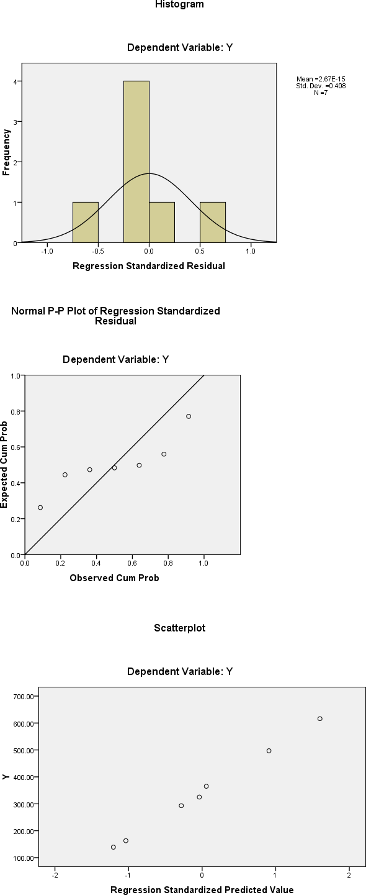

**Fig. 5.7: Descriptive Statistics of (Equation 4) Fitted.**

* + 1. **Assessment of the Management of NAUTH**
       1. **Management Decision Process on Maintenance Budgeting**

The data in Table 5.31 show that the Management Committee is adjudged by the respondents with 41.4 percent response, to be the authority or person that determines the maintenance budget of NATH. To any maintenance works, funds are needed. Such funds are usually approved by the Chief Executive Officer (CEO), who is the Chief Medical Director (CMD)for the purposes of incurring any expenses, under normal practice, funds from any source, or of any magnitude, has to be put in form of a budget, and this is the role of the Management Committee which, thereafter issues directives to the Accountant or Director of Finance on the appropriate modalities for the budget preparation. Thus, budget preparation embodies programme requirements in terms of finance for housing development including other statutory provisions such as salaries and emoluments etc. When this budget preparation receives the approval of the Management Committee, it is now designated the „Budget‟. This is as a result of oral interview conducted by the researcher on key officers and management staff on the vital issue of maintenance budgeting in NAUTH. Analysis of the data is as shown in Fig. 5.8. It shows at a glance the situation with decision making process on maintenance budgeting as it applies to NAUTH.

**Fig. 5.8: Determinant of Maintenance Budgeting at NAUTH**

0

0

3

0

6

3

20

10

21

Nnewi

Outstations

27

30

30

39

37

40

49

80

70

60

50

85

90

**CMD/Chief Executive Officer**

**The Accountant**

**The Management Committee**

**Estate & Works**

**Director, Physical Planning**

**Others**

However, 23.3 percent of the respondents feels that it is the accountant that is responsible for determining the budget while 22. 3 percent says that the Chief Medical Director/Chief Executive has the responsibility of determining the budget. The other variables with less than 10 percent responses are deemed irrelevant and so negligible. It is therefore easy to conclude that the onus of deciding the annual maintenance budgets of NAUTH lies on the Management Committee. It can be conjectured that the accountant and the CMD/Chief Executive are members of the Management Committee. See table 5.28.

**Table 5.28: Determinant of Maintenance Budget of NAUTH**

|  |  |  |  |  |
| --- | --- | --- | --- | --- |
| **Budgeting** | **Nnewi** | **Outstations** | **Total** | **Percent** |
| Managing Director/Chief Executive  Officers  The Accountant  The Management Committee Director of Physical Planning Director Estate and Works  Head of Maintenance Department (Unit)  **TOTAL** | 30  49  39  3  27  3  **151** | 37  21  85  6  0  0  **149** | 67  70  124  9  27  3  **300** | 22.3  23.3  41.4  3.0  9.0  1.0  **100** |

**Source of data:** Author‟s Fieldwork, 2017.

**Table 5.29: Benefits from Computerized Maintenance Planning**

|  |  |  |  |  |  |  |
| --- | --- | --- | --- | --- | --- | --- |
| **S/N** | **Importance** | **Responses** |  |  |  |  |
|  |  | **Strongly**  **agree** | **Agree** | **Undecided** | **Disagree** | **Strongly**  **Disagree** |
| i. | Prevent the occurrence of |  |  |  |  |  |
|  | maintenance problem | 350 | 82 | - | 18 | - |
| ii. | Manage work orders |  |  |  |  |  |
|  | efficiently by allowing the |  |  |  |  |  |
|  | maintenance personnel to | 385 | 45 | - | 20 | - |
|  | schedule, assign and close |  |  |  |  |  |
|  | work orders quickly and |  |  |  |  |  |
|  | easily |  |  |  |  |  |
| iii. | Manage building inventory |  |  |  |  |  |
|  | by tracking assets that need | 450 | - | - | - | - |
|  | to be maintained in order of |  |  |  |  |  |
|  | their maintenance |  |  |  |  |  |
| iv. | Eliminate paper work | 450 | - | - | - | - |
| v. | Enhance productivity as |  |  |  |  |  |
|  | maintenance personnel work | 450 | - | - | - | - |
|  | without delay |  |  |  |  |  |
| vi. | It reduces down time and |  |  |  |  |  |
|  | repair costs | 450 | - | - | - | - |

|  |  |  |  |  |  |  |
| --- | --- | --- | --- | --- | --- | --- |
| Benefit from Computerized maintenance planning contd. | | | | | | |
| vii.  viii.  ix. | Computer system regularly check and maintain building components to meet safety standards and to prevent malfunction and critical failures  Computerized system organize historical data and trends so that problem areas like increase in cost, low productivity or constant repairs will be noted and solution proffers  By use of computer system for planning and scheduling of maintenance work, issue of emergency maintenance  work are no longer tenable | 450  450  450 | -  -  - | -  -  - | -  -  - | -  -  - |

**Source; Author’s field survey, 2017**

Table 5.29 shows that all the factors listed – such as Reduction of maintenance problems, management of work order/inventory, reduce paper work, enhance productivity, reduce down time/repair costs, prevent critical failures, organize historical data for effective maintenance, and remove emergency maintenance work are very important benefiting factors for the computerization of maintenance planning and scheduling of hospital buildings with the percentage of 80% and above.

* + 1. **Direct Observation and Walk through Evaluations**

The researcher carried out direct observations and walkthrough evaluations of the buildings at Nnewi main station and other six outstations as part of the

investigation in this study. All the sixty six buildings, which represent 100% of the total buildings were considered.

The summary of the buildings are shown in table 5.30.

**Table 5.30: Types, Numbers, and locations of buildings observation**

|  |  |  |  |
| --- | --- | --- | --- |
| **S/No** | **Types of Building** | **Numbers** | **Locations** |
| 1  2  3  4. | Admin  Wards  Clinics  Laboratory | 3  1  1  1  1  1  1  4  2  2  1  - 1  1  6  2  1  1  1  2  1  2  1 | Nnewi Oba Umunya Osha Awka Ukpo Neni Nnewi Oba Umunya Osha Awka Ukpo Neni Nnewi Oba Umunya Osha Awka Ukpo Neni Nnewi  Oba |

|  |  |  |  |  |  |  |
| --- | --- | --- | --- | --- | --- | --- |
|  | **Types, numbers and locations of building observation contd.** | | | |  |  |
|  |  |  |  |  | 1 | Umunya |
|  |  |  |  |  | 1 | Osha |
|  |  |  |  |  | 1 | Awka |
|  |  |  |  |  | 1 | Ukpo |
|  |  |  |  |  | 1 | Neni |
| 5. | Theatre |  |  |  | 2 | Nnewi |
|  |  |  |  |  | 1 | Oba |
|  |  |  |  |  | 1 | Umunya |
|  |  |  |  |  | 1 | Osha |
|  |  |  |  |  | 1 | Awka |
|  |  |  |  |  | 1 | Ukpo |
|  |  |  |  |  | 1 | Neni |
| 6. | Quarters |  |  |  | 1 | Nnewi |
|  |  |  |  |  | - | Oba |
|  |  |  |  |  | 1 | Umunya |
|  |  |  |  |  | - | Osha |
|  |  |  |  |  | - | Awka |
|  |  |  |  |  | 1 | Ukpo |
|  |  |  |  |  | 1 | Neni |
| 7. | Classroom | (SON | Block) | and | 1 | Nnewi |
|  | Auditorium |  |  |  | - | Oba |
|  |  |  |  |  |  | Umunya |
|  |  |  |  |  |  | Osha |
|  |  |  |  |  |  | Awka |
|  |  |  |  |  |  | Ukpo |
|  |  |  |  |  |  | Neni |
| 8. | Laundry |  |  |  |  | Nnewi |
|  |  |  |  |  |  | Oba |

|  |  |  |  |
| --- | --- | --- | --- |
|  | **Type , Numbers and locations of building observation contd.** |  |  |
|  |  | - | Umunya |
|  |  | - | Osha |
|  |  | - | Awka |
|  |  | - | Ukpo |
|  |  | - | Neni |
| 9. | Security /gatehouse | 2 | Nnewi |
|  |  | 1 | Oba |
|  |  | 1 | Umunya |
|  |  | 1 | Osha |
|  |  | - | Awka |
|  |  | 1 | Ukpo |
|  |  | 1 | Neni |
|  | Total | 66 |  |

The variables investigated in the buildings included types, nature of buildings, surrounding environment, defects and their locations. Specifically the building elements/components investigated include;

1. Foundation
2. Floor slabs / finishes
3. Colours/ Beams
4. Blockwalls
5. Roofs/ceilings
6. Doors/windows
7. Electrical / plumbing systems

The results and analysis of the data are presented in the following plates, 1-66. These show the photographs of maintenance problems in the whole hospital.

* + 1. **Summary of Direct Observations and Walkthrough Evaluations** Direct observations and walkthrough evaluations carried out by the researcher indicates that the buildings investigated in the study area were mostly of bungalows and storey buildings. The buildings were constructed with 225mm sandcrete block walls, except partition walls in some areas like toilets and some offices, were made of 150mm sandcrete blocks. The walls were rendered and painted. The floors of the building were finished with cement screed, terrazzo or tiles. Direct observations and walkthrough evaluations show that some of the floor screeds have started wearing off.

The roof structures of the buildings were mostly gable and pitched roof, while the roof covering are mostly of long span aluminum and asbestos roofing sheets. Some of the roofs were provide with roof gutters, surrounded by parapet walls. The top of the walls are finished with concrete copings and flashings. The inner face of the walls and roof slabs are provided with mastic felt (bitumen). Asbestos ceiling, PVC and suspended cellotex ceiling materials were used for the ceilings.

The defects found at the foundations of the observed buildings are differential settlement, vertical/longitudinal cracks, and dampness. These defects were likely caused by weak soil, low bearing capacity of soil, seasonal weather changes, and vegetation effect and groundwater penetration. Cracks, dampness and defective floor tiles were also discovered on the floors of the buildings, which were likely caused by rising damp, ageing factor and lack of drainage channels. Although some of the drainage channels seen, were found to be blocked with waste materials and weeds.

In terms of columns and beams, it was discovered that cracks, dampness and mould stains were the type of defects found, especially at the external columns. Causative factors are, movement of soil, dampness, driving rain, leakage of pipe joints, expansion joints and water spouts. The type of defects observed on the external block walls are longitudinal, vertical and diagonal cracks, dampness, mould stains and efflorescence. The causes of these defects are differential settlement, shrinkable clay soil, and poor construction of expansion joints and improper channelization of water from air conditioners. Others are driving rain, moisture penetration, excess growth of weeds, presence of sulphate in the soil and pool of stagnant water around the walls. Furthermore, it was observed that, water dropping from air-conditioners on the walls and slabs continuously, is another factor that contributes to dampness, moulds stains and weed growth in the study area.

**CHAPTER SIX:**

**SUMMARY OF FINDINGS, DISCUSIONS, CONCLUSION AND**

**RECOMMENDATIONS**

* 1. **Summary of Findings**

The following are the summary of the major findings of this study:

1. **Identification and Ranking of Factors in Maintenance Planning-** The study identified and ranked the major factors in housing buildings, with special reference to NAUTH. The major factors identified and ranked in order of preponderance are building type, the uses of the building, age or service year, quality of design and materials and the environment under the building operates (availability of water, road and electricity, climatic condition, etc). The types and uses of a building is a critical factor in the planning its maintenance. It is prime factor that determines the application of other maintenance factors such as funding, number of maintenance cycle (frequency and type of maintenance, etc.). Other factors in building maintenance planning that were identified and ranked in order of importance are the age of the building, the environmental condition under which the building is used, the quality of the design and the materials used in its construction.
2. **Impact of maintenance decision factors on the maintenance of hospital buildings-** Using a multi-factorial regression, the study established the relationship among the variables and how each of the factors affect the maintenance of hospital buildings in NAUTH. The study established the following:
   * **Building type**: The number of maintenance (frequency/periodicity)of hospital buildings is proportional to the type and quality of materials used in its construction and the age, or service year preceding the

maintenance. That is, the greater the intensity of usage of a building, the more the number and type of maintenance and vice versa.

* + **Quality of design and materials**: The number of times a building has need for maintenance works is proportional to the quality of the original building design. This study identified the major causes of the high rate of deterioration or degradation to faulty design of plumbing and other facilities which are sources of water leakages that result in discoloration of the wall surfaces and humidity (dampness) in the building resulting in “sick” building syndrome.
  + **Uses**: In the examination of building typology and architectural design, the study identified the following critical parameters which should be taken into consideration in the developing computer-based system of maintenance planning, vis a vis building features/uses, namely: quality, capacity, comfort, and linkage (connection) with the outside, exteriors, the type of roof structures and roof coverings, types of doors and window fittings as well as the type of foundation used. The study established that one-storey buildings were predominantly used (68%) than others with more floors while more than 70% had load bearing wall of sandcrete blocks. The limitation in the use of low rise structures could be attributed to the difficulties usually encountered with the maintenance of high-rise buildings.
  + **The Impact of maintenance staff and availability of fund on the performance of Maintenance unit:** The study revealed an insignificant relationship between maintenance staff and the availability of material stock and their performance, with regards to the number of maintenance carried out in a year for example.. This may be due to the general lack of maintenance culture which generally perceived to be responsible for the low morale among maintenance personnel in NAUTH.As a result, most of the buildings are in a sordid

state of disrepair. Most time maintenance works were usually outsourced to sub-contractors.

1. **Key Decision-making on Maintenance Budgeting and other Matters Relating to Maintenance Planning in NAUTH:** The study revealed that the Management Committee rather than individual professionals such as builders took major decisions such as budgets and other important issues like the procurement of material stock for maintenance operations in NAUTH.
   1. **Discussions**

Field studies and literature review have established that the issue of maintenance planning of public buildings is a complex one owing to the lack of accurate data on decision factors like inventory of all the building stock in use, details of their features and age. However, observations of the operational processes of most public establishments indicate the absence of science and technology management approach specifically, the application of information and technology models for the articulation and leveraging of their strategic planning and budgeting especially for important issues like maintenance planning for regular maintenance of its building stock. Moreover studies on the operations of NAUTH towards the evolution of a functional management framework are not yet a mainstream activity especially in the Works Department in exploiting the advantages of the potential benefits of management models based on computer-based systems.

* 1. **Conclusion**

From this study, it is therefore safe to conclude that predictive management models for proper planning and scheduling of maintenance of buildings are feasible. The appropriate management models developed in this research are: a multi-factorial regression model for predicting the type and frequency of

maintenance works on all the buildings within a plan period and a computer- based system for carrying out maintenance planning and scheduling of hospital buildings. The application of these management models developed in this study will obviate the arbitrariness in decision-making on type and number of maintenance within a plan period.

It is envisaged as a positive outcome of this study that the new management tool will enhance the capacity of public organizations like NAUTH to cope with the difficult task of timely and effective maintenance of buildings. This will definitely have a transformational effect enhancing the overall service delivery.

* 1. **Recommendations**

Based on the findings of the research study, the following recommendations are proffered.

1. Management and staff of public organizations like NAUTH should aspire to operate on the basic modern principle of maintenance driven by the adoption of the principle of maintenance by objectives (MBO) which relies on information technology in determining in advance the work to be accomplished given available resources within a given time frame. The adoption of computer-based system in maintenance planning is a step in the right direction.
2. Management of NAUTH should adopt scientific approach in decision- making process by the application of the results of this study in the determination of maintenance cycle for each building within the plan period, thus making it possible to arrive at cost estimate necessary for maintenance budgeting within the plan period.
   1. **Contributions to Knowledge**

The key contributions to the body of knowledge in this research are as follows:

1. **Inventory of Hospital Buildings-** The study has for the first time prepared an inventory of all the buildings in NAUTH both in the main station at Nnewi and al the out stations with details such as the age, uses, main features and components. This inventory is considered as *sine qua non* in maintenance planning.
2. **The Development of a computer-based system for maintenance planning-** This programme takes into consideration the uses, age, quality of design and materials used in the construction of buildings to predict the time for carrying out minor and major maintenance within a given plan or service period. With this computer programme, it is possible to plan in advance when there will be need for a building to undergo minor and major maintenance works within a plan period. This will assist greatly in preparing accurate estimate of maintenance cost within a budgeting period. More so, the programme will remove the problem of subjectivity in determining when to carry out maintenance work of all the buildings.
3. **Development of Predictive Multi-factorial Regression Model:**

This model is an integration of all the critical decision factors in maintenance planning peculiar to hospital buildings. With it, it is possible to predict the annual maintenance activities of the maintenance unit and thus assist in budgeting within the plan period. Apart from serving as a predictive tool in decision making by management, the model explains the empirical inter-relationship among the maintenance decision factors with their various degrees of preponderance.

1. **Demonstration of the Need for Reorientation of Management and Staff of Hospitals-** This study has established that there is need for organizational imperative for the reorientation of Management and staff of NAUTH and similar institutions on matters towards their transformation from total dependence on subjective planning by guess work to a more scientific approach of determining type and frequency of carrying out maintenance work on all buildings in use in the hospital, and its out stations.
   1. **Suggestions for Further Research**

The following suggestions for further research are essentially driven by the quest for improved organizational performance in building maintenance and the findings of this research:

1. The case studies in this research was the NAUTH (Public service- based); there is need for research to be extended to other establishments like private housing estates so as to make the application of the computer-based system universal as a new management tool in both public and private institutions in order to increase the generalization of the findings.
2. There is need for a study on public perception and awareness of NAUTH in terms of organizational performance in building maintenance in order to ascertain the level of satisfaction of its service delivery as a public tertiary health care institution.

**REFERENCES**

Abisuga, A. and Oshodi, S.O (2014). Stakeholders participation in University Campus facilities maintenance. *An e-maintenance approach.*

Adejimi, A. (1998).Optimizing management of design processes for effective maintenance of public buildings in Lagos State. Unpublished M.Sc Thesis: Lagos, University of Lagos.

Adejimi, A. (2005). Poor Building maintenance, are Architects Free from Blames? *A paper presented at the ENHR International conference on Housing*: New Challenges and Innovations in Tomorrow‟s cities: Iceland.

Adenuga, 0.A. (1995). "Significance of Maintenance as a determinant of economic value of Buildings. Unpublished M.Sc. Thesis: Lagos, University of Lagos, Nigeria.

Adenuga, O.A. and Akinsola, E.O. (2009). Strategic Approach to Maintenance Practices for Public Buildings in Lagos state. *Journal of the Nigerian institute of building* 0795(8854), 40-53.

Adenuga, A., Odusami, T. and Faremi, O. (2007). Assessment of factors affecting maintenance management of public hospital buildings in Lagos state Nigeria, *The construction and building research conference of the Royal Institution of Chartered Surveyors,* retrieved from:[http://www.rics.org/site/download_feed.aspx?fileED=3339...PDF](http://www.rics.org/site/download_feed.aspx?fileED=3339...PDFSimilar) [Similar](http://www.rics.org/site/download_feed.aspx?fileED=3339...PDFSimilar)

Afolarin, A. (2012). Maintenance managements practices in public hospital built environment Nigeria. Case study: *Journal of Sustainable Development in Africa,* 14,(1), l85-201.

Agbola, S.B. (1993). *"Managing and Financing Urban Infrastructure in Nigeria". Cities.* 71 -122 February*.*

Ahmad, G. (2004). "*Understanding Common Building Defects*", MaJalah Akitek, 16, (1), First Quarter, 19-21.

Ahmed, M. and Dhafr, N. (2002). Establishing and improving manufacturing performance measures: *Robotics and Computer Integrated Manufacturing.* 18 (2),167-171.

Ahmed, A. (2000). Management System in maintenance of Infrastructure Kaduna. Fahimla Publishing Compam, Nigeria.

Aina, O.J. (2007). Alternative modes of financing Higher Education in Nigeria and implication for University Governance. Research Evidence for Sub-Sahara Africa, Lagos; Balobay publication.

AI-Arjani, A. (1995). Impact of cultural issues on the scheduling of housing maintenance in a SaudiArabian urban project. *International Journal of Project Management.* 13(6), 373-82.

AI-Hammad, A., Assaf. S., and Al-Shihah, M. (1997). The Effect of Faulty Design on BuildingMaintenance. *Journal of Quality in Maintenance,* 3(1), 29-39.

Al-Zabaidi, H. (1997). Assessing Demand for Building Maintenance in a Major Hospital Complex. Project Management, 15(3), 173-183.

Akingbohungbe, D.O. (2002). Maintenance Culture and Antidote of Building Decay and Collapse in Building Collapse: causes, prevention and remedies in Nigeria. Ugunsemi D.R. (Ed Akure Nigeria).

Akinsola, O.E. and Iyagba, R.O. (2006). Assessment of the Factors Influencing Maintenance Programme of Tertiary Institutional Building in SouthWest Nigeria.*Journal of the Nigerian Institute of Building, 37- 46*.

Alberta Infrastructure (2004). "Operations and Maintenance Manual: A Guide for School Trustees, Administrators and Consultants", Learning Facilities Branch, Edmonto, Canada.

Al-Khatam, J. A. (2003) Buildings maintenance cost, Dhahran, Saudi Arabia, Unpublished (MSc) thesis, Dhahram, King Fahd University of Pertoleum & Minerals, Saudi Arabia.

Amobi, C.A. (2006). Pro-active Measures to avoid failures and Collapse of Buildings in Nigeria. *Journal of the Nigerian Institute of Buildign (NIOB)*. (0795-8854), 25-29.

Amusa, J. (2003). Evaluation of Factors influencing Hostel maintenance in university of Lagos. B.Sc Building Dissertation. University of Lagos, Nigeria.

Arain, F.M., Low, S.P and Assaf, S.A (2006). Contractors‟ views of the potential causes of inconsistencies between design and construction, *journal of performance of constructed facilities*, ASCE, 20(1), 74-83.

Arayela, O. and Adams, J. J. (2001). Building disasters and failures in Nigeria: Causes and remedies*, AARCHES Journal*, 1 (6),72-76.

Assaf, S., AI-Hammad, A., And Al-Shihah, M. (1995). The effect of faulty construction on building maintenance. *Building Research and Information.* 23(3), 175-181.

Azlan, S.A., Syahrul Nizam, K., Raha, S, and Yong C.P. (2010). Factors Affecting Housing Maintenance Cost in Malaysia. *Journal of Facilities Management, 8(4),* 285-298.

Azika, N. (2009). Research Methodology in Behavioural Sciences, Ikeja, Lagos, Longman.

Babbie, E. (2005). The Basics of Social Research, 3rd Edition, Belmont, C.A., USA, Thomson/wordsworth learning.

Bartleth, J.E., Kotrlik, J.W. and Iggins, C.C. (2001). Organizational Research Determining Appropriate sample size in Survey *Research. Information Technology Learning and Performance Journal,* 19, (1).

Bin Hashem (2006) Maintenance management and services. Case study Perkeso Buildings in Penisular of Malaysia, unpublished M.Sc, Thesis, University of Technology of Malaysia.

Bowles, G., Dagpunar J.S., and Gow, H. (2007). "Financial Management of Planned Maintenance for Housing Associations," *Construction Management and Economics*, 15 (4).

BSI. (1964) British Standard BS 3811: 1964 – Glossary of Maintenance Management Terms in Terotechnology. British Standards Publishing Ltd.

BSI. (1991) British Standard BS 3811: 1991 – Glossary of Maintenance Management Terms in Terotechnology. British Standards Publishing Ltd.

BSI. (1993) British Standard BS 3811: 1993 – Glossary of Maintenance Management Terms in Terotechnology. British Standards Publishing Ltd.

Buhari, M. (2000). “The Role of infrastructural Development and Rehabilitation in Sustainable Economic Growth in Nigeria”; Retrieved from [http://www.anopusa.oralpage14-18.html](http://www.anopusa.oralpage14-18.html/)

Buys, F. (2004). Building maintenance management systems in South Africa tertiary institution. Unpublished Ph.D Thesis. University of Port Elizabeth.

Buys, F. and Nkado, R. (2006). A bench marking Model for maintenance management system in South Africa Tertiary Educational Institutions. *Paper presented at the conference of Royal institute of Surveyors*.

22-24 July.

Camillus, (2004). Building maintenance management Approaches. A case study of university of Jos Student Hostel (unpublished PGD Thesis) ATBU, Bauchi.

Cane, E. Morrison, A. and Ireland, I. (1998). Maintenance and Service costs of commercial Buildings “ASHRAE, Transactions Ontario, Canada.

Cato, W. W., and Mobley, R. K. (2002). Computer-managed maintenance systems, a step-by-step guide to effective management of maintenance, labor, and inventory (2nd ed.). Boston: Butterworth-Heinemann.

Chanter, B. and Swallow, P. (1996). Maintenance Organisation. In: Building Maintenance Management London: Blackwell Science.

Chartered Institute of Building (1990). "Maintenance Management", Chartered Institute of Building, Berkshire, United Kingdom.

Cheetham, D.W. (1972). Defects in Modern Buildings, Building Journal, July,18.

Cobbinah, P. (2010). Maintenance of Buildings of Public institutions in Ghana, case study of selected institutions in the Ashanti Region. Unpublished M.Sc ThesisKwame Nkrumah University of Science and Technology Kumasi. Retrieved from http://dspaces.knust.edu.gh:soso/jspui/outstream/123456789/190/prince/

.20

Coetzee, J.L. (1999). A holistic approach to the maintenance “problem”.

*Journal of Quality in Maintenance Engineering 5 (5); 276-280.*

Cohen, L. and Manion, L. (1989). Research Methods in Education, 2nd Edition, London, Routhledge.

Cornick, T. (1996) Computer integrated Building design, E and F N Spon London, 7 - 23.

Crepo – Marque, A. (2007). The maintenance management framework.

London. Springer Verlag.

Crespo - Marquez A., Gupta J.N.D. (2003). Modern Maintenance management and the organizational efficiency of an intelligent enterprise. Intelligent enterprises of the 21st century. Pennsylvania: Idea Group Publishers.

Dekker, R. (1996). Applications of maintenance optimization models; A review and analysis, *Reliability Engineering and System Safety*, 51, 229-240.

Diyana, M. (2009). “Case study of Taman Seri Indah, Pulau Pinang”. Bachelor of civil Engineering Degrees Thesis, Faculty of civil Engineering and Earth Resources, university of Malaysia, Pahang.

Don, N. and Joel, N. (2006). Maintenance planning, Scheduling and Co- ordination, Industrial Press 200 Madison Avenue NY.

Duarte, J.C., Craveiro, and Trigo, T. (2006). Optimization of the preventive maintenance plan of a series of component system, International Journal of Pressure vessels and piping 83, 244-248.

Duffuaa, S.A. (2000). Mathematical models in maintenance planning and scheduling. In M.Ben Daya et al (eds), maintenance, modeling and optimization, massauchusetts, Kluwer Academic Publisher.

Duling, J.J.M., Cloete, C.E. and Horak, E. (2006). The Application of Neuro-Fuzzy Methodology toMaintenance of Buildings. *The ICEC Cost Management Journal. '*

East Sussex County Council (2001). Corporate Building Maintenance Policy, East Sussex, United Kingdom.

Ebhotenihen, S.E. (2012). Research Methodology in Social and Applied Science, 2nd Edition, Auchi, Proper Publishers.

Eizzatul, A.S., Hishamuddin, M.A. and Islamiah, A.S (2012). A review of the Effect of Building Design on maintenance management *paper presented at the 3rd International conference university of technology, Malaysia.*

Eklund, J.A. and Young, M.E. (2013). Biological Growth on Masonry: Identification andUnderstanding. Historic Scotland.

EI-Haram, M.A., and Horner, M.W. (2002). Factor Affecting Housing Maintenance Cost. *Journal of Quality in Maintenance Engineering,* 8(2), 115-123.

Eyke, M. (1988). Building Automation Systems: A practical Guide to Selection and Implementation, BSP Professional Books.

Eze, J.I., Obiegbu, M.E., Jude-Eze, and E.N. (2005). Statistics and quantitative methods for construction and Business Managers, Lagos. The Nigerian Institute of Building.

Fatimah, Z., Zainal, A.A., and Mohammad Ashraf, A.R. (2011). Civil Engineering and Architectural Building Features Disparity and Presentation of Structural and Fabrics integrity in Heritage Building. *A Review Paper Presented at International Building and Infrastruction Technology Conference. 7-8 June.* Vistane Hotel, Penang, Malaysia, 94-104.

Federal Ministry of Health Nigeria (2010). Health Care Nig. *Annual Bulletin of the Federal Ministry of Health, Abuja, Nigeria.*

Federal Ministry of Health Nigeria (2005). Draft National Health Equipment Policy for Nigeria, Federal Ministry of Health Abuja, Nigeria.

Federal Ministry of Health (2004). Health Care in Nigeria. Annual Bulletin of the Federal Ministry of Health, Abuja, Nigeria.

Foree-colen, J. de Brito, and V. Freita (2010). Discussion of criteria for prioritization of predictive maintenance of Building facades; survey of 30 experts; *Journal of performance constructed facilities, 337-344.*

Gallaton, M.P., Conner, A.C.O., Dettbarn J.L. Jr. and Gilday, L.T. (2004). Cost Analysis of Inadequate Interoperability in the US Capital Facilities Industry, National Institute of Standards and Technology, Gaithersburg, Maryland.

Gay, L.R. (1981). Education Research Competences for Analysis and Application, Columbus, Charles E, Mersil publishing company, ABC and Howell.

Geisler, E. (2002). Trends in hospital and health care Technologies- The future. Hospital Engineering & Fecilities, management, 18-22.

Gilham, B. (2000). Case Study Research Methods, London, Continuum Publishing.

Hal, L. (1995). Building Ecology: An Architect‟s Perspective on Healthy Buildings. *Presented as keynote lecture of Healthy Buildings ’95,* Mclean Italy, September, 10-15.

Hardy, O.B. and Lammers, L.P. (1996). *Hospitals: the planning and design process,* Aspen Publishers.

Horner, R., El-Haram, M. and Munns, A. (1997). Building maintenance strategy: a new management approach, *Journal of Quality in Maintenance Engineering,* Vol. 3 No. 4, pp. 273-280.

Housley, J. (1997). Managing the estate in higher education establishments facilities. 15(3/4), 72-83.

Ikpo, L.M. (2008). Building maintenance culture; The Nigerian experience, journal of the Nigerian institute of Building (NIOB),12 – 18.

lyagba, R.O.A. (2005). The menace of sick buildings: a challenge to all for its prevention and treatment', An Inaugural Lecture delivered at University of Lagos, Lagos.

Johassen, J., Klemenic, R., and Leinenwever, M. (2001). Health Facility flexibility and humanity: an agenda for the 21st Century, Stockholm.

Jones, K. and Collis, S. (2006). „Computerized Maintenance Management Systems‟, Property Management, 14, (4), ISSN 0263-7472.

Kothari C.R (2004). Research Methodology Methods and techniques (Second Revised Edition), New Delhi, New Age International Publishers, India.

Kunya.S.U., Achuenu. K.A. and Kolawale .J.O. (2007). Evaluation of Factors Affecting Maintenance Expenditures of Federal Tertiary Institution in Nigeria. *Construction Focus.*1(1):98-105.

Lackney, J. (2001). Post – occupancy Evaluation in the practice of Educational Design. *Paper presented at the Environmental Design Research Association;* Edinburgh Scotland.

Lam, k. (2007). Design for maintenance from the viewpoint of sustainable hospital buildings. Retrieved from: <http://mail.airah.org.au/downloads/2007-12-02.pdf>

Lateef, O. A. (2009). Case for Alternative Approach to Building Maintenance Management of Public Universities in Nigeria. *Journal of Building Appraisal*. 5(3): 201-212.

Lateef, O. A., Khamidi, M. F., Idrus, A. (2009). *Development of a Value Maintenance Management Model for Malaysian University Campuses.* CIB World Congress. Salford: Machester, UK.

Lee, R. (1987) Building Maintenance Management (3rd Edn). Blackbell Science Publications Limited: Oxford UK.

Leedy, P.D. and Ormrod J.E. (2010). Practical Research: Planning and Design. 9th Edition. New Jersy. Merrill prentice Hall.

Lekan, A. (2007). Sustainability Strategies in Engineering Infrastructure Maintenance in Developing Countries, Building Technology Dept, School of Environmental Sciences, Covenant University, Ogun State, Nigeria.

Lekan, A and Ayo, B. (2005). An approach to Application of Total Quality Management in Building Maintenance Operation. University of Lagos Akoka Yaba, Lagos, Nigeria.

Lewis, A., (2010). Designing for Energy Efficient Operations and Maintenance Engineered Systems. August, 2010.

Longeville, R., Allouche, M. and Abourizk, S. (2006). A paper on Decision Support Tool for the maintenance management of Buildings. *Presented to Joint International Conference of Computing and Decision making in civil and Building Engineering held on 14th June in Montreal, Canada.*

Lung, B. (2009). Conceptual framework for e-maintenance. Illustration by e-maintenance technologies and platforms. *Annual Review in control, 220-229.*

Marver, T. W. (1991). Building Services Design. Adenit Mowbray Ltd Oxford, United Kingdom.

Mbamali, I. (2013). The Impact of Accumulation of Deferred Maintenance on Selected Buildings of Federal Universities in the Northwest Zone of Nigeria. *Journal of Environmental Sciences. 5(* 1 ):77-83.

Miles, D. (1978). A Manual on Building Maintenance Management. United Kingdom. Intermediate Technology Publications Limited: Vol.1.

Mohammed, A (2005). Building as an Essential part of Human Existence.

*Journal of the Nigerian Institute of Building* (16 ) 61-69.

Morenaikeji, W. (2006). Research and Analytical Methods for Social Scientists, Planners and Environmentalists. Jos, Jos University Press.

Moua, B. and Russell, J. (2001). Comparison of two maintainability programs. *Journal of ConstructionEngineering and Management,* 127(3), 239-44.

Muller, A., Crespo-Marquez, A., and Long, B. (2008). On the concept of e- maintenance. Review and current research. *Reliability Engineering and System safety,* 93,1165 – 1187.

Muoghalu N. (2011). Assessing the magnitude of Housing and Environmental maintenance need in a Traditional Nigeria City of Benin. A methology perspective, *Nigeria Journal of Geograph and Environmental. 2 (1-2).*

Murtlag, M. A. (2000). A sturdy of the Relationship between School Building condition and Academic Achievement of the twelfth grade studies in Kuwaiti public High school. (Unpublished Thesis). The Virgina polytechnic institute and the state university USA.

Myeda, N.E., Shahrul Nizam Kamaruzzaman, and Pitt, M. (2011). Measuring the Performance of Office Buildings Maintenance Management in Malaysia. *Journal of Facilities Management,* 9(3), 181-199.

Naoun, R.G (2001). Dissertation Research and Writing for Construction Students, Oxford, Butterworth – Heinemam.

Narayan, V. (2003). Effective maintenance management. Risk and reliability strategies for optimizing performance, industrial press, New York. NY.

Natasha, K., Nawawi, A.M., Hashim, A.E. and Husin, H.N. (2008). Performance analysis of governmentand public buildings via post occupancy evaluation. *Asian Social Science,* 4(9), 103-112.

National Strategic Health Development Plan frame work; from 2009 to 2015 (2009). Technical Working Group – NSHDP/Health Sector Development Team.

Neves, L.C. Frangopol, D.M. and Cruz, P.S (2004). Cost of life Extension of Deteriorating Structures under *Reliability-Based maintenance. Computers and Structures, 82 (13-14), 1077-1089.*

NIBS, (2007). Excellency in Facility Management. National Institute of Building Sciences. Faculty Maintenance and Operations Committee, 5350-1.

Nongida, A.K. (2008). Impact of Health and Safety Management on Safety Performance of SMMEs in Ghana. (Unpublsihed PhD Thesis). Loughborough University.

Nous Hospital Consultants (2002). Generating the master plan for hospitals.

Leading Hospital and Health Care Management Consultants of India.

Nworgu, B.G (1991). Educational Research Basic issues and methodology.

Ibadan: Wisdom Publishers Ltd.

Obiegbu, M.E. (2003). Maintenance of Building Fabric and Infrastructure.

*Paper at The NIOB Annual General Conference held at Lagos.*

Obiegbu, M.E. (2006). Factors Influencing the Defects and Performance of Buildings. *Journal of the National Institute of Building*. (53-61).

OCED (2006) Review of Building Quality Using Post-occupancy Evaluation. The PEB change. Journal of the OECD Programme on Educational Building 1(48): 15-18.

Odediran, S. J., Opatunji, O.Y., and Eghnure, F. O. (2012). Maintenance of Residential Buildings: Users' Practices in Nigeria. *Journal of Emerging Trends in Economics and Management Sciences* 3(3):261-265.

Ogunoh, P.E. (2008) Maintenance of Public Estates in Awka Anambra state. A case study of Iyiagu and Real Housing Estate. (Unpublished M.sc theses, Nnamdi Azikiwe University) Awka.

Ogunoh, P.E. (2014). Evaluation of Building maintenance practice and their impact on University management in Nnamdi Azikwe University Awka, Anambra state. A Ph.D Dissertation, Nnamdi Azikwe university Awka.

Okanume, C.S. (2005). Maintenance management of physical facilities in Nigeria Tertiary Institutions. *A seminar paper to the Department of Building.* Nnamdi Azikiwe University Awka, Nigeria.

Okereke, P.A, (2002). Basic Principles in the Organization of Construction Processes. FUTO Press, Owerri.

Okereke, P.A. (2003). Materials Testing and Quality Control for Nigerian elimatic condition, Crown publishers, Owerri.

Okereke, P.A. (2004). Research Methodology. A Quantitative Approach for Engineers and Scientists. Infrader Associates in Collaboration with African Centre for Housing and Environmental Studies (ACHDES), Port Harcourt. Nigeria.

Okereke, P.A. (2004). Computer Application for Engineers and Scientists.

Diamond Press, Enugu.

Okereke, P. A. (2015). Research methodology. A New Approach for Science and Technology, Port Harcourt. INFRADEV Associates. Nigeria.

Okolie, K.C. (2011). Performance Evaluation of Buildings in Educational Institution. A case of Universities in South-East Nigeria. Published Ph.D Thesis, Port Elizabeth Nelson Mandela Metropolitan University.

Okoye, C.O. and Ogunoh, P.E. (2008). Public Housing Maintenance. A case study of Iyiagu and Real Housing Estates in Awka, Anambra State, Awka; *National Association of the Academics* (NAA). 14 (1).

Okwemba, R. A. (1981). Building Maintenance Manuals and their Application to Building Maintenance Management. Unpublished Dissertation for Masters of Science in Building Maintenance Management, University of Reading, United Kingdom.

Ojedojun, O.Y., Odewumi, T.O. and Fasola, J.K. (2012). Maintenance model of Hostel Buildings for effective performance, and Aesthetics. International *Jounal of modern Engineering Research (IJMER).* [www.ijMER.Com](http://www.ijmer.com/)*,* 2(6), 4138-4143.

Oladapo, Y. (2005). Evaluation of the maintenance management of the staff housing estates of selected first generation Universities in South-West, Nigeria. Unpublished PhD thesis, Nigeria Obafemi Awolowo University.

Oladejo, E.I. (2014). Evaluation of challenges of facilities management in tertiary healthcare institutions in South East, Nigeria. Publish Ph.D Dissertation. Nnamdi Azikiwe University Awka, Anambra State, Nigeria.

Olajide, F. and Afolarin, A. (2012) Evaluation of maintenance management practice in banking industry in Lagos state Nigeria, *International Journal of Sustainable Construction Engineering and Technology,* 3 (1), 45-53.

Olarewaju, A.A. (2009). Maintenance management of university buildings.

*Accepted for publication in Journal of Building Appraisal*.

Ollila, A. and Malmipuro, M. (1999). Maintenance has a Role in Quality.

The TQM Magazine II (1), 17-21.

Olubodun, F. (1999). A multivariate approach to the prediction of maintenance needs in public housing: the tenant dimension. Structural Survey, 19 (2), 133-41.

Olusegun, I.O. (2001). A Comparative Study of maintenance strategies of public and private housing estates in Lagos state. A case study of LSOPC Housing Estate Ogba and Victoria garden, Victoria Island.Unpublished M.Sc Dissertation, University of Ibadan Nigeria.

Olusola, K.O. (2002). Structural Stability of Building Structure, in Building collapse – causes prevention and remedies, Ogusemi D-R. (ED Akure Nigeria) 50-69.

Onibokun, P. (1990). Housing Finance in Nigeria. *Town Planning Review,*

42(3) 7.

Onifade, K. (2003). Informatics in hospital management Unpublished maintenance Research report, University of Lagos.

Oyefeko, S.T. (1990). The Role of Maintenance Culture of Buildings in the Economic Development of Nigeria: *The Registered Builders Journal*, 1(2) 4.

Ozguner, O. (1986). Philosophy of Tall Buildings Tall Buildings in the urban contacts Dicter ACKnnecht and Saai Asset, UPM Press, 11.

Parida, A. and Kumar, U. (2006). Maintenance performance measurement (MPM) issues and challenges, *Journal of Quality in Maintenance Engineering,* 12 (3), 239 - 251.

Peterson, B. (1997). Defining Asset Maintenance Management. Strategic Asset Management INC, Unionville, United States of America.

Pettit, R. (1983). Computers aid in the management of housing maintenance. Proceedings of BMCIS & BRE Seminar, Feedback of Housing Maintenance, 35-40.

Prerskallia W.P. and Voelker J.A. (1994). A survey of maintenance model: control and Surveillance of deteriorating systems. Naval Research Logistics, Wiley Online; Available at; https://[www.infocomm.org/cps/rde](http://www.infocomm.org/cps/rde) (accessed on 16/1/16).

Rapp, R. and George, B. (1998). Maintenance concepts in construction Equipment Curricula. *Journal of Education* 2(2), 155 – 169.

RIBA. (1977). A Research Report for the Architectural Profession. In: Duffy, F.W. (Ed). Architectural Knowledge: the idea of a profession. London. E and FN, Spon.

Robathan, P. (1996). Building Performance, Facilities Management Theory and Practice. K. Alexander. London, E & FN Spon.

Robinson, L. and Robinson, T. (2009). An Australian Approach to school Design. CELE Exchange, 3.

Rotimi, J.A. and Mtallib, M.O. (1995). *A paper title: Economic consideration works, proceedings of the International Conference on Maintenance of Engineering Facilities in Developing countries Gaborne, Botswana.*

Sakina, M.A., Fassman, E. and Wilkinson, S. (2011). Risks Associated in implementation of Green Buildings. Paper presented at 4th international conference on sustainability Engineering and science. Faculty of Engineering, university of Auckland, Auckland, New Zealand.

Sanof, H. (2003). School Building Assessment Methods. Washington.

National Clearance House for Educational space.

Saunders, M., Lewis, P. and Thomhill, A. (2000). Research Methods for Business Studies, Harlow, Pearson Education Limited.

Saunders, M. Lewis, P. and Thornhil, A. (2007). Research methods for Business students. 4th Edition, London, Prentice Hall.

Seeley, I. H. (1976). Quantity Surveying Practice. (2nd Edn.).

Macmillan Publications Limited: Hampshire.

Seeley, I. H. (1987). Building Maintenance. (2nd Edition). London.

Macmillan Press Ltd.

Sellitiz, C., Wrightman, I.S. Cook, S.W. (1976). Research Methods in Social Relations, 3rd Edition, New York, Holt Rinebart and Winston.

Sekaran, U. (2003). Research Methods for Business. A skill Building approach, 4th Edition, New York, John Wiley & Sons.

Shake, R.H. (1995). An Evaluation of Maintenance Management and Organisation in Nairobi City Council. Unpublished B.A Research Project, University of Nairobi.

Shen, Q.P., Lo, K.K., and Wang, Q., (1998). Priority setting in maintenance management of public buildings: a modified multi-attribute approach using AHP. Construction management and Economics, 16, 693-702.

Shohet, I. G., Lavy- Lh, S. and Bar-On, D. (2003). Integrated maintenance monitoring of hospital buildings. *Journal of construction Management and Economics*, 21, 219-228.

Shohet, l.M. (2005). Building evaluation methodology for setting maintenance priorities in hospital buildings. *Construction Management and Economics, 21(3), 681-692.*

Shohet, I.M. (2003). Building evaluation methodology for setting maintenance priorities in hospital buildings. *Construction Management and Economics, 21(3), 681-692.*

Smith, R. (2003). Best maintenance practices. *Journal for Maintenance and Maintenance Management.* 16(1), 10-15.

Son, L.H and Yuen C.S (1993). Building Maintenance Technology London.

The Macmillan Press Ltd.

Stephen, J.H. (2002). Building services Maintenance. The forgotten discipline: Aha management publications: Referenced from [www.aha.com.au/energy/.htmon2](http://www.aha.com.au/energy/.htmon2) .

Straub, A. (2005). Dutch Standard for Condition Assessment of Buildings.

Journal of Structural survey 27(1): 23-35.

Tan j.S. and Kramer, M.A. (1997). A general framework for preventive maintenance optimization in chemical process operations. Computers and chemical Engineering. 21(12),1451-1469.

Teicholz, E. (1992). Computer Aided Facility Management. McGraw-Hill, New York, USA.

Teo, E. A. and Harikrishna, N. (2006). A Quantitative Model for Efficient Maintenance of Plastered and Painted Facades. Department of Building, National University of Singapore, Singapore.

Tse, P. W. (2002). Maintenance practices in HongKong and use of the intelligent schedule. *Journal of quality in maintenance Engineering. 8(4),369-380.*

UN – HABITAT, (2012). Going Green. A handbook of sustainable Housing practices in Developing Countries. Retrieved from [www.un.hatitat.org/publications/](http://www.un.hatitat.org/publications/)

Umenweke, M.O. (2000). Preliminary study of physical Environment of Mid Tertoaru Lignites of Anambra state, Nigeria. “*A multi-disciplinary journal for environmental sciences; 3(1).*

UNIDO, (1971). Maintenance and Repairs in Developing Countries. *In Report of the Symposium Organised by United Nations Industrial Development Organisation (UNIDO). 10-17 November. New York, United Nations.*

Vasiljevic, D. and Cvetic, B. (2012). Towards a new conceptual framework of e-maintenance. *South African Journal of Industrial Engineering*, 23 (2), 73-83.

Valddez .C. and Feldman R.M. (1989). A survey of preventive maintenance models for stochastically deteriorating single-unit system. Naval Research logistics. Wiley only: Available at; Retrived [http://en.m.wikipedia.org](http://en.m.wikipedia.org/).

Wahab, K.A. (1995). Adequate and Affordable Housing for Nigeria in the 21st Century Housing today. *Journal of the Association of Housing Science and its application*. 4, (3).

Wahab, M. B. A. (2005). A Study to Ascertain Customer's Satisfaction on Building Performance and Facilities provided in Polytechnic Kulim. Master Thesis. University Technology Malaysia.

Wang, H. and Pham, H. (2006). Reliability and optimal maintenance, Springer series in Reliability Engineering Springer-Verlag - London.

Wang, H. (2002). A survey of maintenance policies of deteriorating systems. *European Journal of operational Research,* 139(3), 469-489.

WBDG, (2009). Whole Building Design Guide, Facilities Operations & Maintenance, available.

Whawo, D. D. (1992). Basic Educational Research and Statistics, Benin City, Samugo Publishers.

WHO, (2004). World Report on knowledge for better Health. Strengthening Health System. WHO: Geneva. Retrieved from ([http://www.who.Int/rpc/meeting/world on knowledge](http://www.who.int/rpc/meeting/world%20on%20knowlege) for better health.pdf)

Wilkinson, S.J. and Reed, R,G, (2006). *Office Buildings and the Environment. Presented to the 12th Annual Pacific Rim Real Estate Conference held between pp22-25 at the University of Auckland, New Zealand.*

Wireman, T. (1998). Developing Performance indicators for managing maintenance. New York: Industrial Press.

Wireman, T. (1990). World class maintenance management. New York.

Industrial Press.

World health organization, (2010). United nation development programme, and United Nations educational scientific and cultural organization and Ministry of health report. Assessment of public health estate in Gaza, World health organization draft report.

WordSworth, P., Lee S. (2001). Building Maintenance Management.

Fourth Edition. Oxford Black Science.

**Appendix 1**

Department of Building

Faculty of Environmental Sciences Nnamdi Azikiwe University, Awka

March 16, 2017.

Dear Sir/Madam,

QUESTIONNAIRE FOR Ph.D RESEARCH WORK FOR DEVELOPING A COMPUTER BASED SYSTEM FOR MAINTENANCE PLANNING AND SCHEDULING OF HOSPITAL BUILDINGS THE CASE OF NNAMDI AZIKIWE UNIVERSITY TEACHING HOSPITAL, NNEWI, ANAMBRA STATE, NIGERIA.

I am a postgraduate student of the Department of Building, Faculty of Environmental Sciences, Nnamdi Azikiwe University Awka. I am carrying out a research on the above topic in partial fulfillment of the requirements for the award of the degree of Doctor of Philosophy (Ph.D) in Construction Management.

I will be most grateful if you could kindly complete the questionnaire attached herewith for this purpose. Your response will be treated with strict confidentiality and used exclusively for academic purpose.

Thanks for your cooperation. Yours faithfully,

**Bldr Samuel .C. Akabogu**

NATUH – Nnewi GSM 08037892496

**Appendix 2 Questionnaire**

**SECTION A**; **Information on the Characteristics and background of the Respondent**

Please tick in the box  that correctly represents your answer to the

question in the questionnaire.

1. Name and address of Respondent: (Optional)
2. What is your age bracket? 20-24  25-30  31-34  35-40

41 & above

1. Sex: Male  Female
2. Which Out station is your hospital located? Nnewi  Neni Awka  Onitsha  Oba  Ukpo  Umunya
3. What is the type of service? Permanent  Temporary
4. What is your highest educational qualification? FSLC  SSCE NABTEB  GCE  WAEC  City & Guilds  ND Trade T est  No Informal education  HND  B.Sc. Masters & Above
5. How long have you been in this service? Less than 5yrears

6-10years  11-15years  16-20years  over 20years

**SECTION B**: **Concept, Historical Prospective, Types and Regularity of Maintenance of Hospital Buildings**

Indicate by ticking () to the appropriate ones

QB1. Can the use and exposure of buildings to element of weather leads to reduce performance of hospital buildings? Yes  No

QB2. Can non regular maintenance contribute to deterioration, defects, decays, dilapidation of hospital buildings with cost consequences?

Yes  No

QB3. Can the maintenance of hospital buildings help in the effective delivery of health services?

Yes  No

QB4. Are preventive (or routine/minor) and corrective (or major) maintenance the two major types of maintenan Yes

ce?

No

QB5. Is effective maintenance planning and scheduling in advance result in timely, less cost and improved quality of hospital buildings?

Yes  No

QB6. Express your candid opinion by ticking as appropriate the likely, probable and most likely time for carrying out minor and major maintenance works on hospital buildings with the following features:

|  |  |  |  |  |  |  |  |  |
| --- | --- | --- | --- | --- | --- | --- | --- | --- |
| S/N | **Building with the following features:** | **Likely period of minor (preventive) maintenance in months** | | | **Likely period of major (corrective) maintenance in months** | | |  |
| **< 12** | **12 – 36** | **> 60** | **48 – 72** | **84 – 108** | **> 108** |
| 1 | **Number of floors :**   1. One (1 No) floor 2. Two (2 No) floor 3. Three (3 No) floor 4. Above 3 No floor |  |  |  |  |  |  |  |
| 2 | Load bearing components   1. Reinforcement concrete frame 2. Steel frame 3. Wooden frame 4. Sandcrete block wall 5. Others |  |  |  |  |  |  |  |
| 3 | Foundation type   1. Strip 2. Pad 3. Raft 4. Others |  |  |  |  |  |  |  |
| 4 | Roof Type   1. Flat (< 15% slope) 2. Hip (> 15 < 70% slope) 3. Pitched (>79%) |  |  |  |  |  |  |  |
| 5 | Roof Truss   1. Steel 2. Treated wooden 3. Truss 4. Untreated wooden truss |  |  |  |  |  |  |  |

|  |  |  |  |  |  |  |  |  |
| --- | --- | --- | --- | --- | --- | --- | --- | --- |
| 6 | Roof Covering   1. Asbestors sheet 2. Aluminium sheet 3. Corrugated iron sheet 4. Others |  |  |  |  |  |  |  |
| 7 | Type of Materials for doors   1. Flush door 2. Aluminum door 3. Metal doors 4. Others |  |  |  |  |  |  |  |
| 8 | Types of Materials for window   1. Wooden (louvers) 2. Aluminum 3. Others |  |  |  |  |  |  |  |
| 9 | Rendering/plastering on walls   1. Cement/sandcreed |  |  |  |  |  |  |  |
| 10 | Decoration with paint   1. Emulsion paint 2. Gloss paint 3. Other paints |  |  |  |  |  |  |  |

QB7. Express your candid opinion by ticking as appropriate the building components mostly used at NAUTH

|  |  |  |  |
| --- | --- | --- | --- |
| **S/N** | **Building with the following features** | **Mostly used** | **Not used** |
| 1 | Number of floors:   1. One (1No) floor 2. Two (2No) floor 3. Three (3No) floor 4. Above 3No floor |  |  |
| 2 | Load bearing components   1. Reinforcement concrete frame 2. Steel frame 3. Wooden frame 4. Sandcrete block wall 5. Others |  |  |
| 3 | Foundation type:   1. Strip 2. Pad 3. Raft 4. Others |  |  |

|  |  |  |  |
| --- | --- | --- | --- |
| 4 | Roof Type:   1. Flat (<15% slope) 2. Hip (>15<70% slope) 3. Pitched (>79%) |  |  |
| 5 | Roof Truss   1. Steel 2. Treated wooden 3. Truss 4. Untreated wooden truss |  |  |
| 6 | Roof covering   1. Asbestors sheet 2. Aluminium sheet 3. Corrugated iron sheet 4. Others |  |  |
| 7 | Type of materials for doors   1. Flush door 2. Aluminum door 3. Metal door 4. Others |  |  |
| 8 | Types of materials for window   1. Wooden (louvers) 2. Aluminum 3. Others |  |  |
| 9 | Rendering/plastering on walls   1. Cement/sandcreed |  |  |
| 10 | Decoration with paint   1. Emulsion paint 2. Gloss paint 3. Other paints |  |  |

QC7. Tick as appropriate which of the following listed statements in your judgment is peculiar to hospital Buildings for the purpose of maintenance?

|  |  |  |  |  |  |  |
| --- | --- | --- | --- | --- | --- | --- |
| **S/N** | **Items** | **Responses** | | | | |
| **Strongly agree** | **Agree** | **Undecided** | **Disagree** | **Strongly Disagree** |
| 4 | 3 | 0 | 2 | 1 |

|  |  |  |  |  |  |  |
| --- | --- | --- | --- | --- | --- | --- |
| i. | Buildings are consistently in use and so wear and tear faster (i.e. deteriorate faster) |  |  |  |  |  |
| ii. | Maintenance are always urgent  and uninterrupted |  |  |  |  |  |
| iii. | Buildings must have regular supply of power and water to  avoid disruption of services |  |  |  |  |  |
| iv. | Need to have alternative spaces for relocation of services in case of emergency maintenance or critical failure of any building  component |  |  |  |  |  |
| v. | Medical services must be  provided 24/7 in the buildings |  |  |  |  |  |
| vi. | Movement of a large population of people in and aroundthe building in use to compliment  other medical services |  |  |  |  |  |

QC8: Rank the qualities Hospital buildings must satisfy to meet international standard by ticking against each statement you consider to appropriately describes the quality required.

|  |  |  |  |  |  |  |
| --- | --- | --- | --- | --- | --- | --- |
| **S/N** | **Qualities** | **Responses** | | | | |
| **Strongly agree** | **Agree** | **Undecided** | **Disagree** | **Strongly Disagree** |
| 4 | 3 | 0 | 2 | 1 |
| i. | Stable and reliable |  |  |  |  |  |
| ii. | Provide functional facilities |  |  |  |  |  |
| iii. | Optimal performance and  cost-effective |  |  |  |  |  |
| iv. | Be symbolic, visually  pleasing and hygeinic |  |  |  |  |  |
| v. | Fit for purposes used |  |  |  |  |  |
| vi. | Benvironmentally sustainable |  |  |  |  |  |

**SECTION D: CHALLENGES FOR PROPER MAINTENANCE PLANNING AND SCHEDULING OF HOSPITAL BUILDINGS**

QD9. Tick against each statement as you consider appropriate the challenges militating against proper maintenance planning and scheduling by Maintenance Department

|  |  |  |  |  |  |  |
| --- | --- | --- | --- | --- | --- | --- |
| **S/N** | **FACTOR** | **Responses** | | | | |
| **Strongly agree** | **Agree** | **Undecided** | **Disagree** | **Strongly Disagree** |
| 4 | 3 | 0 | 2 | 1 |
| i. | Most hospital buildings are old |  |  |  |  |  |
| ii. | There is lack of competent  maintenance crew |  |  |  |  |  |
| iii. | Maintenance planning and  scheduling is subjective |  |  |  |  |  |
| iv. | Lack of fund and budget plan  for maintenance work |  |  |  |  |  |
| v. | Lack of stock of building  materials for maintenance work |  |  |  |  |  |
| vi. | Irregular monitoring/ inspection and evaluation of maintenance  works |  |  |  |  |  |
| vii. | Poor working condition for  maintenance staff |  |  |  |  |  |
| viii. | Lack of past maintenance  records showing cost of materials and duration |  |  |  |  |  |
| ix. | Lack of statutory regulations and By-laws guiding proper  maintenance of public resulting in lack assets of culture |  |  |  |  |  |
| x. | Unreliable power and water  supply |  |  |  |  |  |
| xi. | Request for sudden and urgent  repair/maintenance |  |  |  |  |  |
| xii. | Uncoordinated inputs by professionals during design, construction and maintenance  of buildings |  |  |  |  |  |
| xiii. | Faulty design, poor quality  construction and usage |  |  |  |  |  |
| xiv. | Use of high rise buildings which are costly and difficult to  maintain |  |  |  |  |  |
| xv. | There is lack of maintenance culture and guideline |  |  |  |  |  |

|  |  |  |  |  |  |  |
| --- | --- | --- | --- | --- | --- | --- |
| xvi. | There is lack of building  inventory and maintenance records in hospitals |  |  |  |  |  |
| xvii. | There is no record of actual  maintenance expenditure |  |  |  |  |  |
| xviii. | There is no culture of planned  maintenance |  |  |  |  |  |

QD10. Tick as appropriate the major causes of defects, decay, degradation or deterioration of Hospital buildings in order of preponderance the following identified factors (causes).

|  |  |  |  |  |  |  |  |  |  |
| --- | --- | --- | --- | --- | --- | --- | --- | --- | --- |
| **S/N** | **Causes** | **Rank Score** | | | | | **Total** | **Mean Score** | **Mean Ranking** |
| **SA** | **A** | **UD** | **PA** | **NA** |
| **5** | **4** | **3** | **2** | **1** |
| I | Human (i.e. failure to carry out routine  maintenance by those concerned |  |  |  |  |  |  |  |  |
| ii. | Chemical (i.e. use of poor  materials that cause disintegration, softening or discoloration) |  |  |  |  |  |  |  |  |
| iii. | Atmospheric (i.e. reaction of the building structure or components to wind, rain, sun, forest snow and  so on) |  |  |  |  |  |  |  |  |
| iv. | Structural (poor or incorrect design of structural elements against structural loads, moisture,  settlement and shrinking) |  |  |  |  |  |  |  |  |
| v. | Leakage, due to damage pipes and  defective plumbing |  |  |  |  |  |  |  |  |
| vi. | Fire (incidents leading to destruction of building  components by fire) |  |  |  |  |  |  |  |  |
| vii. | Faulty design of services and  utilities |  |  |  |  |  |  |  |  |
| Viii | Faulty construction / supervision  due to lack of specification |  |  |  |  |  |  |  |  |
| ix. | Use of poor quality  materials/specification |  |  |  |  |  |  |  |  |
| x. | Vandalism – caused by insecurity of  building components |  |  |  |  |  |  |  |  |
|  | Total |  |  |  |  |  |  |  |  |
|  | Mean |  |  |  |  |  |  |  |  |
|  | Standard deviation |  |  |  |  |  |  |  |  |

Legend;

|  |  |  |
| --- | --- | --- |
| SA | = | Strongly Agreed |
| A | = | Agreed |
| UD | = | Undecided |
| PA | = | Partially |
| NA | = | Not agreed |

**SECTION E: Categorization and Coding of Hospital Buildings**

QE12:Hospital Buildings are categorized into passive and active buildings for effective planning and scheduling of maintenance work.

|  |  |  |
| --- | --- | --- |
|  | Frequency | Percentage |
| Yes |  |  |
| No |  |  |

QE13: Active buildings are those that are used for 24hours a day and 7days in a week, while passive buildings are those that are not used for 24/7.

|  |  |  |
| --- | --- | --- |
|  | Frequency | Percentage |
| Yes |  |  |
| No |  |  |

QE14 Can Hospital buildings be coded for easy maintenance planning and scheduling?

|  |  |  |
| --- | --- | --- |
|  | Frequency | Percentage |
| Yes |  |  |
| No |  |  |

QE15 Coding encourages consistency in description and categorization of buildings

|  |  |  |
| --- | --- | --- |
|  | Frequency | Percentage |
| Yes |  |  |
| No |  |  |

**SECTION F: Necessary Parameters for the Design/Development of Computer Based System in Maintenance Planning and Scheduling of Hospital Buildings**

QF16 Will computer based system for maintenance planning and scheduling be effective in the timely allocation of scarce resources?

|  |  |  |
| --- | --- | --- |
|  | Frequency | Percentage |
| Yes |  |  |
| No |  |  |

QF17 Time and Cost are the basic parameters in the planning of preventive/corrective maintenance in the hospital buildings.

|  |  |  |  |  |
| --- | --- | --- | --- | --- |
| **Strongly agree**  **4** | **Agree**  3 | **Undecided**  **0** | **Strongly Disagreed 2** | **Disagreed**  **1** |
|  |  |  |  |  |

QF18 Computer can assist in the design, visualize, appraise, management of projects, storage of information, retrival of information, Estimating costs, analysis of structures, managing sites/facilities and so on.

|  |  |  |  |  |
| --- | --- | --- | --- | --- |
| **Strongly agree**  **4** | **Agree**  3 | **Undecided**  **0** | **Strongly Disagreed**  **2** | **Disagreed**  **1** |
|  |  |  |  |  |

QF19 What are the importance of the computer based system in planning and scheduling of building maintenance in the hospital?

|  |  |  |  |  |  |  |
| --- | --- | --- | --- | --- | --- | --- |
| **S/N** | **Importance** | **Responses** | | | | |
| **Strongly**  **agree** | **Agree** | **Undecided** | **Disagree** | **Strongly**  **Disagree** |
| i. | Prevent the occurrence of maintenance problem |  |  |  |  |  |
| ii. | Manage work orders efficiently by allowing the maintenance personnel to  schedule, assign and close work orders quickly and easily |  |  |  |  |  |
| iii. | Manage building inventory by tracking assets that need to be maintained in order of their maintenance |  |  |  |  |  |
| iv. | Eliminate paper work |  |  |  |  |  |
| v. | Enhance productivity as maintenance personnel work  without delay |  |  |  |  |  |
| vi. | It reduces down time and  repair costs |  |  |  |  |  |
| vii. | Computer system regularly check and maintain building components to meet safety standards and to prevent  malfunction and critical failures |  |  |  |  |  |

|  |  |  |  |  |  |  |
| --- | --- | --- | --- | --- | --- | --- |
| viii. | Computerized system organize historical data and trends so that problem areas like increase in cost, low productivity or constant repairs  will be noted and solution proffers |  |  |  |  |  |
| ix. | By use of computer system for planning and scheduling of maintenance work, issue of emergency maintenance work  are no longer tenable |  |  |  |  |  |

QF20 For the development of computer-based system for maintenance planning and scheduling of Hospital buildings which tick as appropriate against each of these parameters as you consider necessary .

|  |  |  |  |  |  |  |
| --- | --- | --- | --- | --- | --- | --- |
| **S/N** | **Factors** | **Responses** | | | | |
| **Strongly agree** | **Agree** | **Undecided** | **Disagree** | **Strongly Disagree** |
| i. | The type and periodicity of  maintenance | 203 |  |  |  |  |
| ii. | The duration of the  maintenance operation |  |  |  |  |  |
| iii. | The durability of the material  components and fittings used in the building |  |  |  |  |  |
| iv. | The budgetary allocation for maintenance service in the maintenance department |  |  |  |  |  |

QF21 What are the factors necessary for the determination of the maintenance cycle? Rank in order of propenderance

|  |  |  |  |  |  |  |  |  |  |
| --- | --- | --- | --- | --- | --- | --- | --- | --- | --- |
| **S/N** |  | **Rank Score** | | | | | **Total** | **Mean Score** | **Mean Ranking** |
| SA | A | UD | PA | NA |
| 4 | 3 | 0 | 2 | 1 |
| i. | The nature of the building  components and usage |  |  |  |  |  |  |  |  |
| ii. | The functions into which the  building is put (i.e. building type) |  |  |  |  |  |  |  |  |
| iii. | The climatic condition under which the building is subjected  or exposed to |  |  |  |  |  |  |  |  |
| iv. | The initial quality of the building component in view (quality of  material) |  |  |  |  |  |  |  |  |
| v. | The workmanship |  |  |  |  |  |  |  |  |
|  | Total |  |  |  |  |  |  |  |  |
|  | Mean |  |  |  |  |  |  |  |  |
|  | Standard deviation |  |  |  |  |  |  |  |  |

Q22 Tick against those sections of building that are necessary for maintenance in order of prepondence

|  |  |  |  |  |
| --- | --- | --- | --- | --- |
| S/No | Building sections | Important | Not important | undecided |
| 1 | Foundation/floor |  |  |  |
| 2 | Walls |  |  |  |
| 3 | Windows and doors |  |  |  |
| 4 | Ceilings |  |  |  |
| 5 | Roofs |  |  |  |
| 6 | Electrical features |  |  |  |
| 7 | Plumbing features |  |  |  |
| 8 | Painting and decoration |  |  |  |
| 9 | Landscaping |  |  |  |

Q 23 Tick against those factors necessary for proper maintenance of hospital buildings

|  |  |  |  |  |
| --- | --- | --- | --- | --- |
| S/No | Buildings | Yes | No | Undecided |
| 1 | Exposure of buildings to weather leads to wear  and tear |  |  |  |
| 2 | Non-regular maintenance leads to faster  deterioration |  |  |  |
| 3 | Maintenance leads to effective healthcare delivery |  |  |  |
| 4 | Maintenance can be symptomatic, preventive or  corrective |  |  |  |
| 5 | Inventory /classification of hospital building  according to functions |  |  |  |
| 6 | Maintenance planning and scheduling is okay for  service delivery |  |  |  |
| 7 | From experience maintenance is usually done  reactively and not proactively |  |  |  |
| 8 | Well planned maintenance is cost effective |  |  |  |
| 9 | Hospital buildings wear and tear fast because of  constant use |  |  |  |
| 10 | Hospital buildings can be categorized into active  and passive ones |  |  |  |
| 11 | Active buildings are used for 24hours/day while  passive ones are used less than that |  |  |  |
| 12 | Will coding of hospital buildings help in effective  maintenance |  |  |  |

Q24. Tick on the challenges in maintenance planning of hospital buildings

|  |  |  |  |  |
| --- | --- | --- | --- | --- |
| S/No | Buildings | Yes | No | Undecided |
| 1 | Poor maintenance culture increases workload of  building staff |  |  |  |
| 2 | Maintenance workers are poorly paid |  |  |  |
| 3 | Lack of budget plans for maintenance |  |  |  |
| 4 | Poor record keeping on previous maintenance |  |  |  |
| 5 | Absence of regulation concerning maintenance |  |  |  |
| 6 | High cost of maintenance |  |  |  |
| 7 | Inadequate tools for building staff |  |  |  |
| 8 | The buildings are old |  |  |  |
| 9 | Absence of stock of building materials |  |  |  |
| 10 | No plan for maintenance in the hospital |  |  |  |
| 11 | Inadequate number of Works department staff |  |  |  |

Q25 Tick the causes of building degradation and rank them in order of prepondence

|  |  |  |  |  |  |  |
| --- | --- | --- | --- | --- | --- | --- |
| S/  No | Variables | Response | | | | |
|  |  | **Agree** | **Disagree** | **Undeci-**  **ded** | **Partial-**  **ly** | **Not**  **Agreed** |
| 1 | Human factor (dereliction of duty) |  |  |  |  |  |
| 2 | Weather |  |  |  |  |  |
| 3 | Structural (reaction to moisture) |  |  |  |  |  |
| 4 | Faulty supervision / construction |  |  |  |  |  |
| 5 | Faulty / poor design |  |  |  |  |  |
| 6 | Poor building material/chemical |  |  |  |  |  |
| 7 | Vandalization |  |  |  |  |  |
| 8 | Use of wrong cleaning materials |  |  |  |  |  |

Legend;

|  |  |  |
| --- | --- | --- |
| SA | = | Strongly Agreed |
| A | = | Agreed |
| UD | = | Undecided |
| PA | = | Partially |
| NA | = | Not agreed |

Q26 Tick in accordance to the importance of the quality Requirements of Hospital buildings and facilities.

|  |  |  |  |  |  |  |  |
| --- | --- | --- | --- | --- | --- | --- | --- |
| **S/No** | **Qualities** | **Responses** | | | | | **Remark** |
|  |  | **Vi** | **I** | **U** | **NI** | **NVI** |
| 1 | Stable and Reliable |  |  |  |  |  |  |
| 2 | Provide functional facilities |  |  |  |  |  |  |
| 3 | Optimal performance in  operation and cost – effective |  |  |  |  |  |  |
| 4 | Symbolic without visible  defects, stable, and pleasant to the eye |  |  |  |  |  |  |
| 5 | Be fit for purposes used |  |  |  |  |  |  |
| 6 | Be environmentally sustainable |  |  |  |  |  |  |

Q27 Tick the categorization of Buildings by components and Periodicity of Maintenance in NAUTH

|  |  |  |  |
| --- | --- | --- | --- |
| **Code** | **Component** | **Periodicity of maintenance in months** | |
|  |  | Preventive(PM) | Corrective(CM) |
| A | 1. No. of floors One (1No) floor Two (2No) floor  Three (3No) floor Above 3No floor |  |  |
| B | 2. Load bearing components: Reinf. Concrete frame Steel frame  Wooden frame Sandcrete Block wall Others |  |  |
| C | 3. Foundation Type: Strip  Pad Raft Others |  |  |
| D | 4. Roof Type:  Flat (<15% slope)  Hip (>15<70% slope)  Pitched (>79%) |  |  |
| E | 5. Roof Truss: Steel  Treated wooden truss Untreated wooden truss |  |  |
| F | 6. Roof Covering: Asbestos sheet Aluminum sheet Corrugated iron sheet  Others |  |  |
| G | 7. Type of materials for doors: Flush door  Aluminum door Metal doors  Others |  |  |
| H | 8. Types of materials for window: Wooden (louvers)  Aluminum Others |  |  |
| I | 9. Rendering /plastering on walls:  Cement / sandscreed |  |  |
| J | 10. Decoration with paint: Emulsion paint  Gloss paint Other paints |  |  |

**Appendix 3**

**Definition of Terms**

Degradation - reduction in function and appearance of the

building /building element due to usage and effect of weather.

Dilapidation - denotes decay, damage or waste state of

disrepair caused by continuous neglect of maintenance. It means that the building is approaching a condition which would render it unfit for use, meaning that the physical life of the building is tendering to be expired.

Deterioration - when buildings are used without caring for it

by maintenance, it deteriorates, and dysfunctional. Deterioration is the downgrading of the effectiveness or physical characteristics (colour, consistency, usage, etc) of the building or its component due to design, weather, construction, and so on.

Decay - is the change in appearance of any building by the agent of weather.

Maintenance cycle - is how many times a preventive (minor)

maintenance is done on a component of a building before that component is due for a corrective maintenance over a maintenance period. It is a progressive set or series for all the building components.

Active/Passive buildings active buildings are buildings in the hospital

that are used for 24/7 while passive buildings are buildings in the hospital that are not used for 24/7.

Preventive maintenance this is regular routine maintenance on

buildings or components of buildings to prevent it from failure, ie to prevent it from breaking down that will cause disruption or interrupted services.

Corrective maintenance this is the maintenance task performed to

identify, isolate and rectify fault so that the failed component of the building is restored to a functional condition.

Trauma - is psychological or emotional damage. It is a

serious bodily injury or shock resulting from violence or accident.

Polymerase chain reaction is a technique used in molecular biology to

amplify a single copy or a few copies of a segment of DNS across several orders magnitudes.

Periodicity of maintenance is the frequency of the maintenance cycle.

Maintenance schedule is the list of pre determined maintenance

actions carried out at regular time intervals that are aimed at the prevention of building component breakdown or failure.

Maintenance schedule is the decision of when and who will do the job.

Electro Encephalogram is a test used to find problems related to

electrical activity of the brain.

Maintenance plan - maintenance plan is the decision of what and

how and the time estimate for a maintenance job.

Building maintenance model is a decision making framework for the

successful execution of building maintenance work.

Building maintenance budgeting – is the task for creating the maintenance

expenditure plan for a specific maintenance activities in a period, mostly for one year period.

Electro Cardiogram is a test which measures the electrical

activity of your heart to show whether or not it is working normally.

Algorithm - is a set of rules to be followed in calculations

or solving other problem by a computer.

Flow chart - is a graphical representation of a computer

program in relation to its sequence of functions (as distinct from the data it processes).

Coding - is the process of changing sentences to figure

for the process of creating computer software.

Massives - are lots of minor variables which affects

maintenance planning and scheduling. These are different from the major ones – Building types, Age, uses, design, climatic conditions and poor quality of materials.

Preponderance - means superiority in weight or superiority of

influences or power or an outweighing superiority.

Correlation - is a mutual relationship, relation,

interconnection, interrelationship, interaction, interdependence or more variables.

Correlation matrix - is a table showing correlation coefficients

between sets of variables. Is simply a table of correlations.

Hypothesis - is a specific statement of prediction that can

be tested. It describes in concrete terms, what you expect will happen in your study.

Research Question - a research question is the fundamental core of

a research project, study or review of literature. It focuses the study, determines the methodology, and guides all stages of inquiry, analysis, and reporting. It is a statement that identifies the phenomenon to be studied.

Residual - in regression analysis, the difference between

the observed value of the dependent variable

(Y) and the predicted value.

Regression - is a measure of the relation between the mean

value of one variable and the corresponding values of other variables. Is a measure of the relationship between one dependent variable

(Y) and a series of other changing variables (known as independent variables).

ANOVA - analysis of variance or Fisher Analysis of

Variance. It is a statistical models used or method to test the different between two or more means.

Haematology - is the branch of medicine concerned with the

study of the cause, diagnosis, treatment, and prevention of diseases related to blood.

Histopathology - is the microscopic examination of biological

tissues to observe the appearance of diseased cells and tissues in very fine detail.

Cytology - is a branch of pathology, and medical

specialty that deals with making diagnosis of diseases and conditions through the examination of tissue samples from the body.

**Appendix 4**

**Program output**

**The splash Screen**

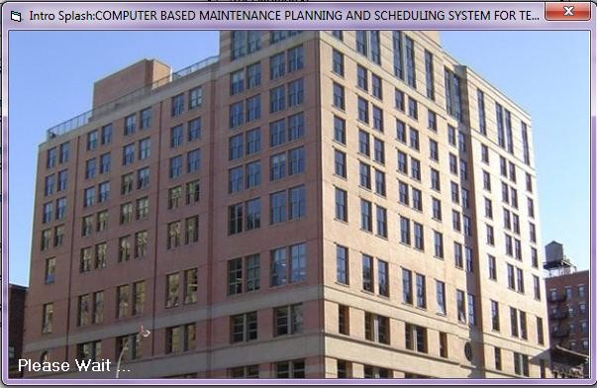

**The Login Screen**

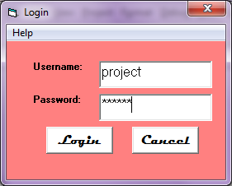

**The main module/program menu**

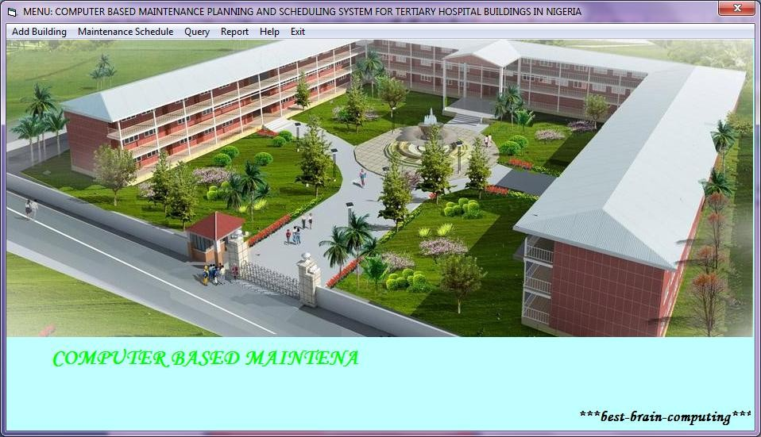

**Building registration form**

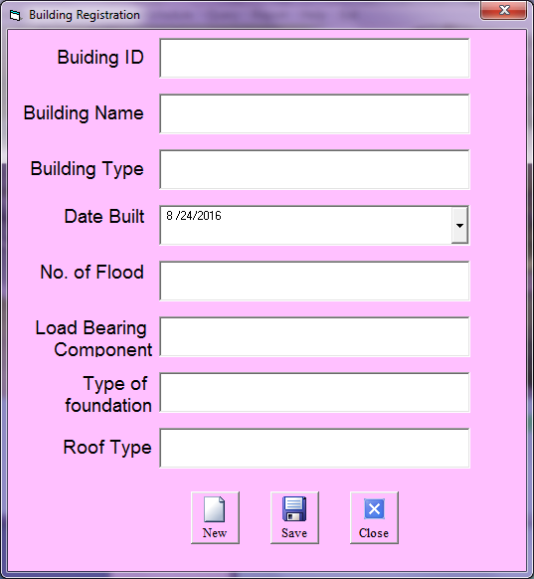

**Maintenance Schedule input form**

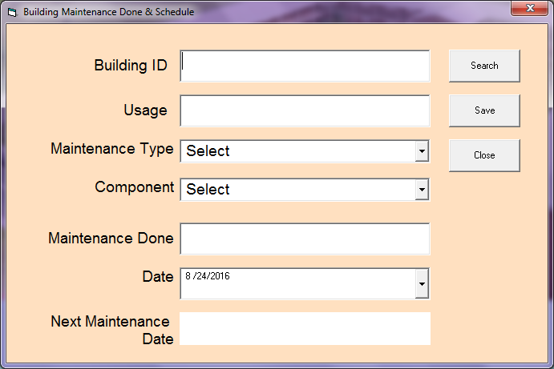

**Building information**

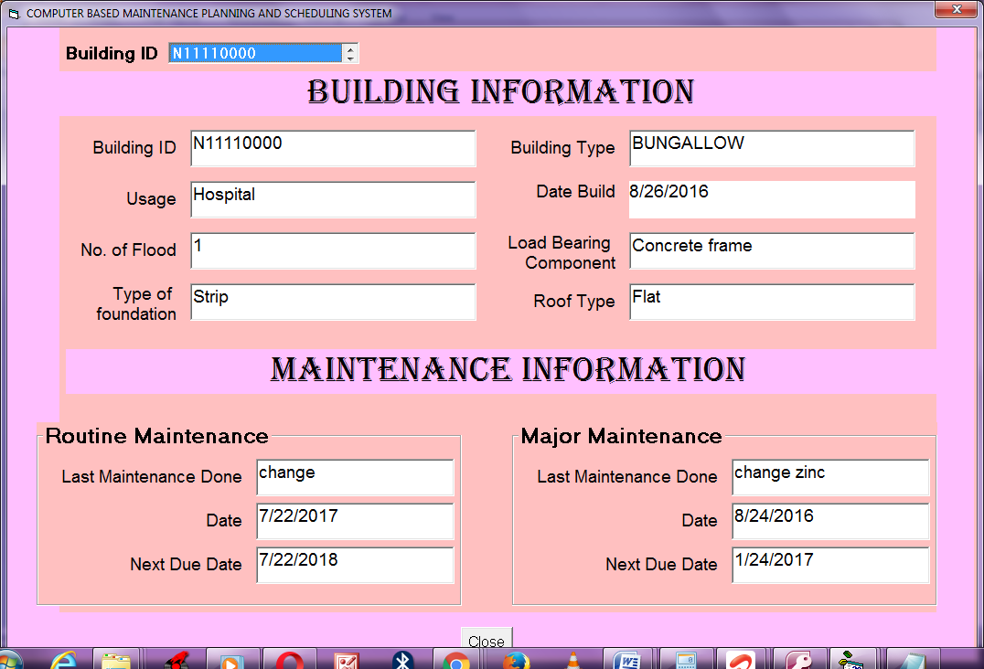

**Output data for maintenance scheduling**

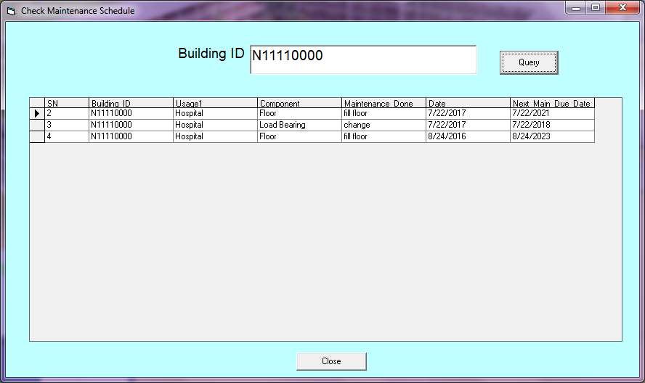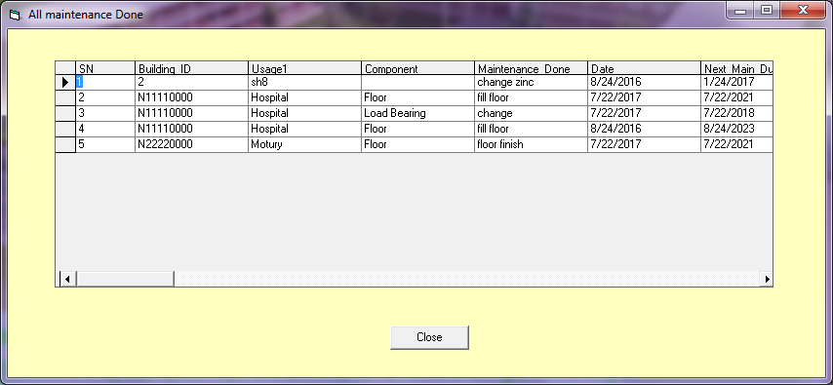

**All building registered in the database**

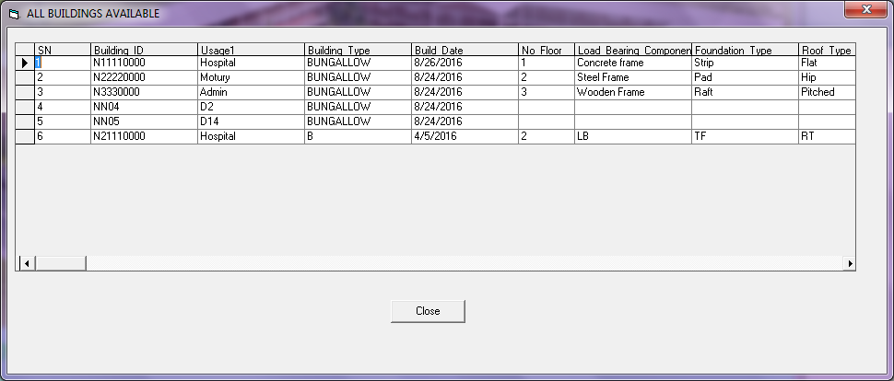

Appendix 5

**The causes of defects,** decay or deterioration in buildings in general according to Al-hamed (2016) include the following:

**Human causes** – the include the following:

* Failure to clean and carry out routine maintenance
* Ignorance of the causes of deterioration and decay; Poor planning for proper maintenance
* Failure to promote awareness of maintenance needs by all who use the buildings

Adopting a negative attitude of waiting until emergency measures are required.

**Chemical causes**- these involve the following operations:

* Interaction of certain cleaning agents with materials and or components causing disintegration, softening or discoloration.
* Promoting Corrosion
* Interaction of certain dissimilar materials in close contact with one another in a corrosion environment.

**Atmospheric causes**- these are degradations involving the following: Reaction of the structure, external fabric, finishes and claddings to the atmospheric elements due to wind, rain, sun, frost/snow from cold weather and pollution in the atmosphere.

**Structural causes**- this is defect(s) as result of any or all of the following:

* Reaction of the structural elements to settlement, moisture, shrinkage and thermal movements.
* Reaction of the structural elements to the change of loading patterns.
* Natural aging of the structural elements.
* Reaction to the corrosive elements in the atmosphere.
* Deterioration due to inadequate inspecting and maintenance.

**Moisture** - this is due to any or all of the following conditions:

* Penetration of the external fabric of claddings, or through ground floor constructions giving to dampness which may create a suitable condition for fungi growth and attack.
* Excessive moisture in the internal atmosphere which may lead to excessive condensation and corrosion.
* Irrigation.
* Faulty plumbing.

**Fire -** Defects or degradation of building or its components may be due to the following causes:

* Aftermath of a fire in many possibilities which may require replacement of materials directly effected by the fire;
* Damage can be done by the fire fighters in their efforts to control the fire;
* Water used during the fire fighting can not only damage but also set up deteriorating process in materials not directly involved;
* The heat and the combination of heat and water can lead to the swelling, distortion, spilling and cracking of nearby materials and components which need replacement / refurbishing.

**Faulty Design** - The incident of faulty design may lead to the following;

* Poor detailing at the design stage including: Insufficient allowance for expansion or contraction, Absence of weathering, Incorrectly placed damp – proof courses, Poor jointing between different materials or components, and Poor specification
* Lack of adequate consideration of future maintenance problems

- Inadequate provisions for access to carry out maintenance activities.

**Faulty Construction** - in most cases, poor quality work may be due to:

* + Lack of supervision during construction period.
  + Failure to understand or follow exactly the specification and/or drawings.
  + Failure to replace defective work.
  + Failure of Designer/Architect/or Engineer to monitor works in progress.
  + Lack of skilled labour.
  + Over emphasis or need for quantity rather than quality.
  + Failure to fully appreciate the consequences of shady or poor materials.

**Poor quality materials** - the use of sub-standard materials may be due to the following:

* Failure of client, builder, designer or architect to reject sub-standard materials.
* In adequate inspection of materials by supplier or receiver.
* In adequate storage facilities on site.
* Inadequate/or inconsistent mixing of materials on site.

**Faulty Components**- Similar condition to those given above for faulty material can lead to deterioration and decay of the fabric, services or finishes of the structure of building.

**Faulty Systems** – these have the same or almost similar effects as faulty components which may be due to any or all of the following:

* Inadequate knowledge on the part of the designer or architect leading to an unsatisfactory design, detail of system.
* Inability of the installer to follow the specifications and/or drawings.
* Inadequate testing of the system before commissioned.
* Failure of maintenance personnel to follow maintenance instructions provided by manufacturer or designer.
* Inability of the maintenance personnel to operate the system as instructed.

**Sanitation/Cleaning** - This is the system of making sure that the hospital buildings and environment are clean. The hospital cannot be clean if there is no regular system to:

* carry out routing cleaning operations
* Use of incorrect cleaning materials and/or techniques.
* Inadequate supervision of cleaners to ensure that cleaning is thorough.
* Failure of management to provide sufficient space, enough time or the correct equipment and materials for cleaning operations.
* Failure to employ specialists for cleaning special fittings and equipment.

**Vandalism** – This is the removal of hospital building fittings and other properties, and is caused by:

* Lack of security
* Failure to promote awareness among patient and patient relatives of the consequences of vandalism
* Incorrect selection of materials and finishes in circulation areas which are prone to vandalism.
* Failure to maintain or repair areas of damage by vandals thus encouraging more vandalism.

All these factors as stated by Al-hamed (2016) are applicable to buildings in NAUTH. It is impossible to control all the above factors during design, construction and occupation stages of buildings. However, considering these factors and minimizing their effect will definitely reduce the amount and need for maintenance. Adenuga (1995) summarized the reasons for maintenance as illustrated schematically in Fig.3.1.

Atmospheric gases

Driving Rain

Wind

Moisture

Solar Radiation

Chemical Agents

Mechanical Agents

Biological Agents

Agents of Deterioration

Weathering Agents

Design Maintainability

Orientation of Building

Environmental factors

Building Shapes and Form

Selection/Choice of Material

Approach to Design

Design Deficiencies

Crystallization of Salt

Sulphate Attack

Cause of Maintenance

|  |  |  |
| --- | --- | --- |
| Common Factors of Deterioration | |  |
|  |
| Aging Stock of Building |  | |
|  | |
|  | | |
| Obsolescence of Building |  | |
|  | |
|  | | |
| Advent of New Technologies |  | |
|  | |
|  | | |
| Rising Social Expectations and Aspiration |  | |
|  | |
|  | | |
| New Legal Developments |  | |
| Environmental Issues |
|  | |

Vandalism

Change of use of Building

Control of Materials

Aging Stock of Building

Control of work on Site

**Causes of Maintenance Source:** Adenuya (1995).

Lack of Maintenance