**DETERMINATION OF SOME HEAVY METALS IN FISH AND LIVESTOCK FEEDS, MANURE AND RIVERS IN SELECTED STATES IN NORTHERN NIGERIA**

**BY**

**YAHAYA SALAWU**

**DEPARTMENT OF PHARMACEUTICAL AND MEDICINAL CHEMISTRY**

**AHMADU BELLO UNIVERSITY, ZARIA NIGERIA**

**FEBUARY 2018**

# DETERMINATION OF SOME HEAVY METALS IN FISH AND LIVESTOCK FEEDS, MANURE AND RIVERS IN SELECTED STATES IN NORTHERN NIGERIA

**BY**

**Yahaya SALAWU B. Pharm 1998 (ABU); M.Sc Pharm. Chemistry 2010 (ABU) Ph. D/Pharm. Sci/20913/2012-2013**

**A THESIS SUBMITTED TO THE SCHOOL OF POSTGRADUATE STUDIES AHMADU BELLO UNIVERSITY, ZARIA**

**IN PATTIAL FULFILMENT OF THE REQUIREMENT FOR THE**

**AWARD OF A DOCTORATE DEGREEE IN PHARMACEUTICAL CHEMISTRY**

**DEPARTMENT OF PHARMACEUTICAL AND MEDICINAL CHEMISTRY FACULTY OF PHARMACEUTICAL SCIENCES AHMADU BELLO UNIVERSITY, ZARIA**

**NIGERIA**

**FEBUARY, 2018**

## Declaration

I declare that the work in the project report entitled **DETERMINATION OF SOME HEAVY METALS IN FISH AND LIVESTOCK FEEDS, MANURE AND RIVERS IN SELECTED**

**STATES IN NORTHERN NIGERIA** has been performed by me in the Department of Pharmaceutical and Medicinal Chemistry under the supervision of Prof. I. A. Yakasai, Prof. M. Garba and Dr. M. A. Usman of the Department of Pharmaceutical and Medicinal Chemistry, Faculty of Pharmaceutical Sciences, Ahmadu Bello University, Zaria. The information derived from the literature has been duly acknowledged in the text and a list of references provided. No part of this thesis was previously presented for another degree or diploma at any university.

**-----------------------------------**

## Yahaya Salawu

Department of Pharmaceutical and Medicinal Chemistry, Ahmadu Bello University, Zaria, Nigeria

## Certification

This thesis entitled **DETERMINATION OF SOME HEAVY METALS IN FISH AND LIVESTOCK FEEDS, MANURE AND RIVERS IN SELECTED STATES IN**

**NORTHERN NIGERIA** by YAHAYA SALAWU meets the regulations governing the awards

of the degree of Doctorate of science of Ahmadu Bello University Zaria, Nigeria and it‟s approved for its contribution to knowledge and literary presentation.

------------------------------ Date: -------------------

Prof. Ibrahim A. Yakasai Chairman, Supervisory Committee

------------------------------ Date: --------------------

Prof. Garba Magaji

Member, Supervisory Committee

----------------------------- Date: --------------------

Dr. M. A. Usman

Member, Supervisory Committee

----------------------------- Date: --------------------

Prof. A. M. Musa Head of Department

----------------------------- Date: ------------------

Prof. A. Z. Abubakar Dean, Postgraduate School

Ahmadu Bello University, Zaria.

## Acknowledgement

All praises be to Allah the Omnipotent. I am very grateful to Allah who in His infinite mercy allow me accomplish my studies successfully.

I specially acknowledge and appreciate the relentless efforts made by my supervisors Prof. I. A. Yakasai Prof. Magaji Garba and Dr. M. A. Usman for their guidance, concern, experience, kindness, patience and conspicuous sacrifices in the course of this study. They have been a major contributor to the success of this work.

Special thanks to Mallam Ilyasu Salisu and Musa Mohammed of the Pharmaceutical and Medicinal Chemistry department, Ahmadu Bello University, Zaria. I give thanks to Mr. Pius Ikokoh and other members of staff of the Chemistry department, Shetco-Sheda, Abuja for the great assistance rendered to the successful completion of this work.

My sincere gratitude goes to the Head of department of Pharmaceutical and Medicinal Chemistry, Ahmadu Bello University, Zaria and the entire staff of the department for the support and encouragement throughout the course of my study.

I humbly dedicate this thesis to my late mother Fatima Abdullahi Salawu. I also express my profound gratitude to my family, colleagues and good friends especially Dr. U. Ejike and Abubakar Muhammad for their understanding, encouragement and moral support.

Above all, I remain very grateful to the Almighty Allah.

## Abstract

The increasing levels of environmental pollution by toxic metals from various sources have generated a great concern on their impact on human health. Rapid developments, increase in mining activities, farming, insurgency, industrial activities and waste disposals have gradually redistributed many of the toxic metals from the earth crust to the environment, raising the chances of exposure through ingestion, inhalation or skin contact. This study is aimed at determining the concentrations of zinc, copper, nickel, lead and arsenic metals in four compound fish feeds [FA, FB, FC and FD] poultry feeds [PA, PB, PC and PD], forage grasses; animal manure and major rivers (Kaduna, Sokoto and Ngadda) obtained in northern Nigeria. Brands of compound fish and poultry feed samples were collected from five different distributors of the feeds. Forage grass and manure samples from five different grazing pasture stations in north central, north western and north eastern zones of Nigeria were collected. Water samples were also collected from the rivers Kaduna, Sokoto and Ngadda. The samples were digested with concentrated nitric acid (HNO3), concentrated sulphuric acid (H2SO4) and perchloric acid (HCIO4) in the ratio 1:2:1 (Uba *et al..,* 2000). The Percentage recovery of the metals using the analytical method adopted gave range of 92.07 to 101.02% for feeds and 92.22 to 103.13% for manure was determined for the heavy metals by atomic absorption spectrophometry. The results obtained expressed in mg/kg for livestock feeds showed mean concentration ranges between 5.10

± 0.04 – 6.38 ± 1.50 mg/kg for zinc as the highest concentrated heavy metal, followed by 3.06 ±

1.08 mg/kg – 3.16 ± 1.65 mg/kg for copper, then 0.14 ± 0.08 – 0.38 ± 0.25 mg/kg for lead, 0.10

± 0.44 – 0.19 ± 0.07 mg/kg for nickel, and 0.01 ± 0.02 - 0.05 ± 0.04 mg/kg for arsenic as the lowest concentrated metal in the compound fish feeds. For compound poultry feeds, the same trend as in fish feeds was observed with a concentration range of 5.06 ± 1.67 - 8.45 ± 1.91 mg/kg for zinc, 3.00 ± 3.06 - 35 ± 1.08 mg/kg for copper, 0.72 ±0. 81 - 1.41 ± 0.08 mg/kg for lead 0.04

± 0.02z - 0.10 ± 0.06 mg/kg for nickel and non detection - 0.03 ± 0.01 mg/kg for arsenic. FA and PB feed brands contained higher concentrations of the essential metals than the other brands sampled. The levels of the metals in the feeds were below the permissible limit stipulated by European Union. The mean concentrations of these metals in forage grasses being grazed by cattle in northern Nigeria had highest zinc and copper levels (7.00 ± 2.04 mg/kg and 6.61 ± 0.82 mg/kg) respectively and highest arsenic concentration (0.33 ± 0.06 mg/kg) was obtained in Kagara areas while highest nickel level (0.83 ± 0 .56 mg/kg) was obtained in Zungeru area, all in

North central zone. The levels were below the permissible limit (100 mg/kg) stipulated by European Union. The mean lead value 6.53 ± 0.51 mg/kg and 5.82 ± 0.63 mg/kg were obtained in Anka area, North west and Zungeru, North central Nigeria respectively and were above 5mg/kg stipulated by European Union for lead in feeds. The trend of the metal levels in poultry and cattle manures were Zn > Cu > Ni > Pb > As and Pb > Zn > Cu > Ni > As respectively. The highest mean concentration 4.15 ± 2.64mg/kg was obtained in poultry manure related to zinc in North central while highest mean concentration 3.22 ± 0.01mg/kg in cattle manure is related to lead in Anka area in North western Nigeria. The feeds are relatively safe for aquaculture and livestock production. However, the forage grasses are relatively not safe for grazing by animals due to high lead levels. The high lead values in water samples indicate that Northern Nigerian environment is critically contaminated with respect to this toxic metal and thus pose serious environmental concern and may pose as risk to public health.

# TABLE OF CONTENT

Cover ……………………………………………………………………………. i Fly leaf ………………………………………………………………………….. ii

Title …………………………………………………………………………….. iii

Declaration ………………………………………………………………………. iv

Certification …………………………………………………………………….. v

Acknowledgement ………………………………………………………………. vi

Abstract …………………………………………………………….................. vii

Table of Content ……………………………………………………………...... viii

List of Figures ……………………………………………………………………… ix

List of Tables …………………………………………………………………..... x

List of Appendices ……………………………………………………………….. xi

Abbreviations ……………………………………………………………………. xii

CHAPTER ONE 1

* 1. INTRODUCTION ……………………………………………………… 1
  2. Background ……………………………………………………………. 1
  3. Heavy Metals and Human Health ……………………………………… 12
  4. Routes of Heavy Metal Exposure ………………………………………… 14
  5. Hazardous Effects of Heavy Metal on Human Health ……………… 15
  6. Statement of the Problem 15
  7. Justification of Study ………………………………………………… 18
  8. Research Hypothesis ………………………………………………… 20
  9. Research Aim and Specific Objectives 20
  10. Research Limitations 21

CHAPTER TWO

* 1. LITERATURE REVIEW ………………………………………………… 22
  2. Selected Heavy Metals ……………………………………………………… 22
     1. Zinc ……………………………………………………………………… 22
     2. Copper ……………………………………………………………………. 23
     3. Nickel ……………………………………………………………………… 24
     4. Lead ……………………………………………………………………… 25
     5. Arsenic ……………………………………………………………………. 29
  3. Heavy Metal Toxicity …………………………………………………… 33
  4. Sources of Heavy Metal Contamination…………………………………… 34
     1. Heavy metal in water ……………………………………………………… 34
     2. Heavy metal in soil ……………………………………………………… 38
     3. Heavy metal in fodder ……………………………………………………… 40
     4. Heavy metal in air …………………………………………………………… 43
     5. Animal manure ……………………………………………………………… 43
  5. Mechanism of Action of Heavy Metals 44
  6. Management of Heavy Metal Poisoning 44

CHAPTER THREE 46

* 1. MATERIALS AND METHODS ………………………………………….. 46
  2. Materials …………………………………………………………………… 46
     1. Compound fish feeds ………………………………………………………… 46
     2. Compound poultry feeds ……………………………………………………. 46
     3. Feedstuffs for cattle ………………………………………………………… 47
  3. Reagents …………………………………………………………………… 47
  4. Equipment ………………………………………………………………….. 47
  5. Methods ……………………………………………………………… 48
     1. Study area ………………………………………………………………… 48
     2. Sample collection …………………………………………………………… 58
  6. Sample Preparation 59
     1. Feeds and manure samples 59
     2. Water samples 59
  7. Analytical Method 60
     1. Procedure …………………………………………………………………….. 60
     2. Calibration curves …………………………………………………………… 60
     3. Method validation …………………………………………………………… 60

CHAPTER FOUR 63

* 1. RESULTS …………………………………………………………………… 63
  2. Method Validation …………………………………………………………… 63
  3. Fish Feeds …………………………………………………………………… 64
  4. Poultry Feeds…………………………………………………………… 70
  5. Pasture Grasses 76
  6. Animal Manure 82
  7. Water Samples ………………………………………………………… 88

CHAPTER FIVE 95

* 1. DISCUSSION 95
  2. Method Validation 95
  3. Livestock Feeds ……………………………………………………………… 95
  4. Animal Manure 98
  5. Water Samples 100

CHAPTER SIX 102

* 1. SUMMARY, CONCLUSSION AND RECOMMENDATION…………… 102
  2. Summary ……………………………………………………………………. 102
  3. Conclusion ………………………………………………………………….. 102
  4. Recommendations ………………………………………………………. 103

## List of Figures

Figure Page

* 1. Livestock feeds and manure sampling areas in North central Nigeria 49
  2. Livestock feeds and manure sampling areas in North western Nigeria 50
  3. Livestock feeds and manure sampling areas in North eastern Nigeria 51
  4. River Kaduna water sampling points 52
  5. Pictures of river Kaduna during raining and dry seasons 53
  6. River Sokoto water sampling points 54
  7. Pictures of river Sokoto during raining and dry seasons 55
  8. River Ngadda water sampling points 56
  9. Pictures of river Ngadda during raining and dry seasons ………………… 57
  10. Calibration curves 62
  11. Mean concentrations of zinc in brands of compound fish feeds in North central, North western and North eastern Nigeria compared to

maximum permissible limit by European Union, 2007 ………………….. 65

* 1. Mean concentrations of copper in four brands of compound fish feeds in North central, North western and North eastern Nigeria compared to

maximum permissible limit by European Union, 2007 66

* 1. Mean concentrations of nickel in four brands of compound fish feeds in North central, North western and North eastern Nigeria compared to

maximum permissible limit by European Union, 2007…………………… 67

* 1. Mean concentrations of lead in four brands of compound fish feeds in North central, North western and North eastern Nigeria compared to

maximum permissible limit by European Union, 2007 68

* 1. Mean concentrations of arsenic in four brands of compound fish feeds in North central, North western and North eastern Nigeria compared to

maximum permissible limit by European Union, 2007 69

* 1. Mean concentrations of zinc in four brands of compound poultry feeds in North central, North western and North eastern Nigeria compared to

maximum permissible limit by European Union, 2007 71

* 1. Mean concentrations of copper in four brands of compound poultry feeds in North central, North western and North eastern Nigeria compared to

maximum permissible limit by European Union, 2007 72

* 1. Mean concentrations of nickel in four brands of compound poultry feeds in North central, North western and North eastern Nigeria compared to

maximum permissible limit by European Union, 2007 73

* 1. Mean concentrations of lead in four brands of compound poultry feeds in North central, North western and North eastern Nigeria compared to

maximum permissible limit by European Union, 2007 74

* 1. Mean concentrations of arsenic in four brands of compound poultry feeds in North central, North western and North eastern Nigeria compared to

maximum permissible limit by European Union, 2007 75

* 1. Mean concentration of zinc in forage grasses across grazing areas in

Northern Nigeria and maximum permissible limit by European Union, 2007 …… 77

* 1. Mean concentration of copper in forage grasses across grazing areas in

Northern Nigeria and maximum permissible limit by European Union, 2007 ……. 78

* 1. Mean concentration of nickel in forage grasses across grazing areas in

Northern Nigeria and maximum permissible limit by European Union, 2007……. 79

* 1. Mean concentration of lead in forage grasses across grazing areas in

Northern Nigeria and maximum permissible limit by European Union, 2007 80

* 1. Mean concentration of arsenic in forage grasses across grazing areas in

Northern Nigeria and maximum permissible limit by European Union, 2007 81

* 1. Mean zinc concentrations in poultry and cattle manure in Northern Nigeria 83
  2. Mean copper concentrations in poultry and cattle manure in Northern Nigeria… 84
  3. Mean nickel concentrations in poultry and cattle manure in Northern Nigeria 85
  4. Mean lead concentrations in poultry and cattle manure in Northern Nigeria 86
  5. Mean arsenic concentrations in poultry and cattle manure in Northern Nigeria 87
  6. Seasonal mean concentrations of zinc in Rivers Kaduna, Sokoto and Ngadda

and maximum permissible limit by World health organization, 2007 90

* 1. Seasonal mean concentrations of copper in Rivers Kaduna, Sokoto and Ngadda

and maximum permissible limit by World health organization, 2007 91

* 1. Seasonal mean concentrations of nickel in Rivers Kaduna, Sokoto and Ngadda

and maximum permissible limit by World health organization, 2007 92

* 1. Seasonal mean concentrations of lead in Rivers Kaduna, Sokoto and Ngadda

and maximum permissible limit by World health organization, 2007 93

* 1. Seasonal mean concentrations of arsenic in Rivers Kaduna, Sokoto and Ngadda

and maximum permissible limit by World health organization, 2007 94

## List of Tables Page

* 1. Percentage recovery and precision for zinc, copper, nickel, lead and arsenic

in feeds and manure samples ………………………………………… ……… 63

4.6 Levels of pH and Temperature ºC measured in water samples …………………. 89

## List of Appendices Page

1. Atomic absorption Spectroscopic print out (AAS) from Advanced chemistry laboratory Sheda, Abuja of zinc concentrations in

fish feed samples in Northern Nigeria xviii.

1. Atomic absorption Spectroscopic print out (AAS) from Advanced chemistry laboratory Sheda, Abuja of zinc

concentrations in fish feed samples in Northern Nigeria xix.

1. Atomic absorption Spectroscopic print out (AAS) from Advanced chemistry laboratory Sheda, Abuja of copper

concentrations in poultry feed samples in Northern Nigeria xx.

1. Atomic absorption Spectroscopic print out (AAS) from Advanced chemistry laboratory Sheda, Abuja of copper

concentrations in poultry feed samples in Northern Nigeria xxi.

1. Atomic absorption Spectroscopic print out (AAS) from Advanced chemistry laboratory Sheda, Abuja of lead concentrations

in water samples from major rivers in Northern Nigeria xxii.

1. Atomic absorption Spectroscopic print out (AAS) from Advanced chemistry laboratory Sheda, Abuja of lead concentrations

in water samples from major rivers in Northern Nigeria xxiii.

7 Mean concentrations in mg/kg of zinc, copper, nickel, lead and arsenic in different brands of fish feeds sampled in North central,

North west and North east, Nigeria and statistical difference

at P<0.05 ……………………............................................................ xxiv

8. Mean concentrations in mg/kg of zinc, copper, nickel, lead and arsenic in different brands of poultry feeds sampled in North central,

North west and North east, Nigeria and statistical difference at P<0.05 xxv

9 Mean concentrations of zinc, copper, nickel, lead and arsenic in mg/kg in different forage grasses at grazing areas across Northern Nigeria

and statistical difference at P<0.05 xxvi

10, Mean concentration (mg/kg) of zinc, copper, nickel, lead and arsenic

in manure samples in Northern Nigeria xxvii

11 Mean seasonal concentrations (mg/l) of zinc, copper, nickel, lead and arsenic in water samples from Rivers Kaduna, Sokoto and Ngadda

in Northern Nigeria and statistical difference at P<0.05 …........................ xxviii

## Abbreviations

|  |  |
| --- | --- |
| UNDP | United Nations Development Programme |
| EPA | Environmental Protection Agency |
| FDA | Food and Drug Administration |
| BDCP | Bioresource Development and Conservative Programme |
| FAO | Food and Agriculture Organization |
| CDC | Centre for Disease Control |
| WHO | World Health Organization |
| ZMOH | Zamfara state ministry of health |
| MSF | Medecines Sans Frontieres |
| EU | European Union |
| ATSDR | Agency for Toxic Substances and Disease Registry |
| MPL | Maximum Permissible Limit |
| A.A.S | Atomic Absorption Spectroscopy |

# CHAPTER ONE INTRODUCTION

## Background

Environmental problems are becoming global issues because of their effects on all nations of the world. These are present day major interests of political, economic, social and environmental concerns because of their potential negative impacts to our lives and the ecosystem in general (Costa, 2000). Environmental pollution is a major global problem posing serious risk to man and animals. From 1900 to 2000 have seen an increase in global concern over the public health impacts attributed to environmental pollution, in particular, the global burden of disease United Nations Development Project (UNDP, 2010). The development of modern technology and the rapid industrialization are among the foremost factors for environmental pollution. The environmental pollutants are spread through different channels, many of which finally enter into food chain of livestock and man ([Kaplan](http://scialert.net/fulltext/1336_op)

[*et al*., 201](http://scialert.net/fulltext/1336_op)0). There is increasing concern about environmental pollutants emanating from the livestock production systems ([Kaplan *et al*., 2010](http://scialert.net/fulltext/1336_op)). Pollution of the environment has significant impact on living organisms. Various anthropogenic activities such as burning of fossil fuel, mining and metallurgy, industries and transport sectors redistribute toxic heavy metals into the environment, which persist for a considerably longer period and are translocated to different components in environment affecting the biota ([Kaplan *et al*., 2010](http://scialert.net/fulltext/1336_op)). These toxicants are accumulated in the vital organs including liver and kidney and exert adverse effects on domestic and wild populations (Khan *et al*., 2012). The effluents from livestock systems can affect the micro and macro environment, viz., water, atmosphere and

food chain. Heavy metals or trace elements are a large group of elements with higher density generally greater than 5 gm/cm3.

These elements are important both industrially and biologically. Heavy metals occur naturally in earth‟s crust and surface soils in varying concentrations. Natural Processes like weathering, erosion remove small amounts of metals from the bed rocks and allow them to circulate in water and air. Heavy metals like Zn, Se, Cu, and Fe are essential to maintain the metabolism of the human body and play important role in chemical, biological, biochemical and enzymatic reactions in the cells of plants, animals and human beings. Heavy metals are also known as „trace inorganic‟ micronutrients‟, „toxic elements‟ etc. More than 60 elements in various parts of human body have been detected, but only 17 are available in living cells.

Heavy metals like Mn, Mo, Fe are more important as micronutrients while Ni, Cu, Co, V, Zn, W and Cr are of lower importance and can be toxic beyond the limits (Duruibe *et al*., 2007). Heavy metals like Cd, Pb, Mg, As, Sb, have no biological functions, but are rather toxic to living organisms (Duruibe *et al*., 2007). Injury to human caused by heavy metals has been well recognized in many botanical and chemical investigations during past years. Heavy metals occur in all ecosystems of the world. The total concentration of heavy metals in soil and water however varies from local to regional and further to continental level. Heavy metals are very harmful in reference to their non biodegradable nature, long biological half lives and their potential to accumulate in different body parts. Most of the heavy metals are extremely toxic. Even at low concentrations heavy metals can have damaging effects in human beings and animals as there is no good mechanism for their elimination from the body. The heavy metals are taken up faster than they are metabolized or excreted. Even those

heavy metals which are considered to be essential can become toxic when present in excessively high levels (Gabriel *et al*., 2007).

The heavy metals can impair important biochemical processes posing a threat to human health (UNDP, 2010). As the usage of metals increased inexorably, so did the pollution associated with it. Changes in the environment due to anthropogenic activities may have strong impact on the physiology and ecology of the organisms. Human activities and consequent developments have brought about degradation of all facets of the natural environment; physical, chemical, biological and social which are adversely affecting the quality of life (Morison, 2011). Rapid developments, increase in mining, industrial activities, have gradually redistributed many of the toxic metals from the earth crust to the environment, raising the chances of exposure through ingestion, inhalation or on skin contact. Heavy metals can have different sources or origin e.g. smelters, tannery, mines, steel mills, coal fired power plants which can lead to metal pollution. Other sources of metal pollution are sewage sludge, compost refuse, fly ash, industrial wastes or effluents. Emission of heavy metals as particulate matter and gases from volcanoes, forest fires, crusted materials and continental dust have always been a natural input sources to soils and ecosystems. The spreading of urban waste and sewage sludge in agricultural fields has been a common practice since decades. Sewage sludge, live stock manure, waste water irrigation are feasible alternatives for reutilization of residual resource of high nutrient and organic matter contents representing a good fertilizer or soil conditioner for plants and soil (Singh *et al.,* 2012). Cattle and poultry manure generally contains elevated concentrations of Cu and Zn which improve food conversion efficiency. Arsenic was also used for this purpose (Giacomino *et al.,* 2007). Beneficial properties of sludge and manures are limited by their contents of potentially harmful substances such as heavy metals and organic micro pollutants (Nicholson *et al.,* 2000).

Sludge and manure Atmospheric emissions are also a matter of great concern. Leaded gasoline in vehicles is one of the major sources of Pb pollution in the cities worldwide (Azeez *et al.,* 2012). Ramadan (2007) reported that only 3% of Pb in the soil is translocated through roots to the shoots and fruits, rest are due to absorption through foliage. Sources like engine oils, corrosion of batteries, wear and tear of tyres, vehicular parts contribute for Cu, Pb and so on (Duruib *et al*., 2007). Moreover bitumen, mineral filler materials in asphalt road surfaces has also been reported to contain metals like Cu, Zn, Cd and Pb (Haque *et al.,* 2005). It is not completely possible to avoid exposure to toxic metals because people who are not occupationally exposed carry certain heavy metals into their body due to food, beverages or inhalation of air. It is however possible to reduce metal toxicity risk through life style choices that diminish the probability of harmful heavy metals uptake such as dietary measures that may promote safe metabolism or excretion of ingested heavy metals. Food chain contamination by heavy metals has become a blazing issue in recent years because of their accumulation in the bio-system through contaminated water, soil and air. Fertilizers may be responsible for heavy metal addition in very small amounts however on the other hand sewage sludge may add them 100 times more in short duration (Cang *et al.,* 2012). Toxic metals in the atmosphere also get accumulated in soils through precipitation and fallout. Availability of heavy metals to plants is due to mining activities, industrial exhausts and effluents, atmospheric depositions, waste disposals, agro-chemicals. However availability of heavy metals to plants depends on various physicochemical properties of soil. Metal toxicity in plants is aggravated at higher temperature and low pH as it facilitates the mobility from roots to shoots. Therefore a better understanding of heavy metal sources, their accumulation in Soil and water and their effect on the ecosystem is an important issue of the present day researches or risk assessment (Abulude *et al.,* 2000).The

heavy metals which are a great threat to the environment and the biosphere as a whole are being derived from various anthropogenic sources. The heavy metals are biopersistent, once absorbed by an organism, may remain resident for years or over decades. In humans, most eventually excreted but on exposure causes various ailments. It may disturb the normal functions of central nervous system, liver, lungs, heart, kidney and brain; it produces hypertension, abdominal pain, skin eruption, intestinal ulcer & different types of cancer (Arogunjo *et al.,* 2006).To protect public health, Nigerian government has developed guidelines as well as regulations that can be enforced by laws. Many agencies that have developed regulations for toxic substances include the United States Environmental Protection Agency (EPA), and Food and Drug Administration (FDA). Federal organizations that develop guide lines or recommendations for toxic substances include the National Agency for Foods, Drugs, Administration and Control (NAFDAC). Earlier studies by researchers have inferred that rapid urbanization, increased transportation, industrial revolution have posed a serious threat to the environment (Menzi and Kessler, 2001). Among other heavy metals, Pb and Cd have more hazardous effects on the environment and have widely polluted the urban agricultural lands (Menzi and Kessler*,* 2001). Thus it has been recommended earlier as well as from recent studies that leafy vegetables should be grown at least 30 m away from roads having high traffic. Studies revealed that plants accumulated small amount of Pb when the density of traffic was about 5000 vehicles per day, but there was a substantial increase in absorption of Pb when it reached to approx 35,000 vehicles per day (Menzi and Kessler, 2001).

Heavy metals like Fe, Cu, Zn, Ni and other trace elements are important for proper biological functions. However, their deficiency or excess may cause a number of disorders (Akan *et al.,* 2010). Prolonged consumption of food stuffs having higher concentration of heavy metals may

result in various types of problems, disruption of numerous biochemical processes leading to cardiovascular, nervous, renal, kidney, liver and bone diseases (Akan *et al.,* 2010). Under EPA regulations, public drinking water supplies are expected not to exceed 5 ppb of Cadmium (Cd) in it. EPA also restricts the use of Cd in pesticides, so that they are not washed off into lakes, rivers, reservoirs, agricultural lands. Different techniques were used by different researchers to determine heavy metal contents including modern analytical techniques such as AAS and ICP- AES. However, there was no established quantitative method for determining directly the exact or fractional amount of metals that are bio-available to plants. Many factors such as variation in pH, temperature, nature of soil, redox condition, plant species, maturity or plant age play important role in the uptake of heavy metals (Menzi and Kessler, 2001). Climate change is characterized by increased frequency and intensity of extreme weather patterns including storms, floods, droughts and irregular rain over time (FAO, 2006). Nigeria‟s population has doubled in the past quarter of a century to 200 million, thus putting greater strain on natural resources (Uba *et al.,* 2013). The infrastructure is still poor and the means of agricultural production and marketing remain the same. The agricultural sector in Nigeria contributes 50% to the Gross Domestic Product (GDP) and is a way of life for 85% of the population according to 2011 census).The major land uses in Nigeria are livestock grazing and crop production causing depleted natural conservation in forests and woodlands. According to Bioresource development and conservative programme (BDCP) in 2001, more than 50% of Nigeria‟s land is used for livestock grazing. Grazing occurs mainly in open grasslands, around cultivated areas, shrub lands, road sides and wetlands. Crop production forms the second largest (± 23%) land use while forests and woodlands cover about 7% of the country. Bare lands constitute 16% in the form of exposed rock, salt flats and sand dunes.

According to Food and Agricultural Organisation (FAO, 2012) the population of livestock in Nigeria in 2012 was estimated at 50.9 million Chicks, 26 million cattle and 22 million goats; that is a total of 108 million heads, which is ranked the largest in West Africa and the 10th in the world. About 95% of the livestock population is kept by subsistence farmers. It forms a large component of the Nigerian agricultural sector and is well integrated with the crop production systems in the highlands and provides the sole means of subsistence for the nomadic pastoralists in the lowlands. It is the source of many social and economic values such as food, draught power, fuel, cash income, security and investment in both the highlands and the lowlands/pastoral systems (Haque *et al*., 2005). Livestock production accounts for 27% of total agricultural GDP. Livestock is a key development sector because it involves the livelihoods of the poor as much as it is the source of animal protein for the emerging middle class who consume 5 increasing amounts of meat, milk and eggs. Thus livestock serves the interest of both the poor and the middle class (FAO, 2012). However, the livestock sector has also been identified as one of the top two or three most significant contributors of the most serious environmental problems from local to global scale (FAO, 2012). The sector has gradually evolved to become an environmental threat to the survival of ecosystems. The danger of to the environment varies according to whether the country is developed and developing as wells as to the type of production systems. Food safety is a major public concern worldwide. During the last decades, the increasing demand of food safety has stimulated research regarding the risk associated with consumption of food stuffs contaminated by pesticides, heavy metals and/or toxins (Igwebe*,* 2013). The implication associated with heavy metal contamination is of great concern. Heavy metals, in general are not biodegradable, having long biological half-lives and

having the potential for accumulation in the different body organs leading to unwanted side effects (Mamud *et al*., 2004).

As developing countries of' West African become industrialized and urbanized, heavy metal pollution is likely to reach disturbing levels, It has been pointed out that African' s contribution to global lead pollution has increased from just 5% in 1980's to 20% in 1996 (WHO, 1996). The critical issues however are that preparations are not being made towards the protection of the environment. Excessive levels of heavy metals may occur in the biosphere as a result of normal geological phenomena such as ore formation, weathering of rocks and leaching. Other activities that could contribute to excessive release of these metals into the environment include burning of fossil fuels, smelling, and discharges of industrial, agricultural and domestic wastes as well as deliberate application of pesticides. Coastal areas are sites of discharge and accumulation of a range of environmental contaminants. Studies on heavy metals in rivers, lakes, fish and sediments have been a major environmental focus especially during the last decade (Ikem *et al*., 2012). Heavy metals contamination of coastal water and sediment has been identified as a serious pollution resulting from industrialization (Ramos *et al*., 2000). Heavy metals contamination of river water is one of the major quality issues in fast growing cities because maintenance of water quality and sanitation infrastructure do not increase along with population and urbanization growth especially in developing countries. There are five major sources of heavy metals namely geological weathering through natural phenomenon, industrial processing of ore and metals, the disposal of metals and metal components, leaching of metals from garbage and solid waste heaps and animal and human excretions. The single largest source of heavy metals in most coastal ecosystems in the United States is residential waste water effluents (Ramos *et al*., 2000).

Over the last few decades, there has been growing interest in determining heavy metal levels in the marine environment and attention was drawn to the measurement of contamination levels in public food supplied, particularly fish. Although heavy metal is a loosely defined term, it is widely recognized and usually applied to the wide spread contaminants of terrestrial and fresh water ecosystems. Some examples of heavy metal include lead, zinc, cadmium, copper and manganese. Many of these heavy metals are toxic to organisms at low concentration (Ramos *et al*., 2000).

The concentration of metals in bio-available form is not necessarily proportional to the total concentration of the metal. The concentration of various elements in the air, water and land may be increased beyond their natural level due to the agricultural, domestic and industrial effluents. These substances are described as “contaminants” when discharged to the environment (Dike *et al*., 2004). In water, insoluble heavy metals may be bound to small silt particles. Metals and other fluvial contaminants in suspension or solution, do simply flow down the stream, they form complexes with other compounds settle to the bottom and ingested by plants and animals or adsorbed to sediments (Dike *et al*., 2004). Consequently, aquatic organisms may acquire heavy metals in body directly from the water via gills or food chain mechanisms. Water, a prime need for human survival and industrial development is being affected by various activities of man which alters its composition physically, chemically or biologically. Pollution of coastal waters by heavy metals has been widely reported (Oduemeran, 2005). Sources of pollution by trace metals include atmospheric release from fossil fuels burning domestic sewage discharge, land run-off and release from industrial operations such as mining, canning and electroplating (Akan *et al*., 2010). With increased diversification in industrialization and particularly with the extensive

farming activities in Northern Nigeria, especially in the urban areas, the concentration of metal pollutants in the ecosystem has risen (Akan *et al*., 2010).

Northern Nigeria lies between 10‟ North latitude and 8‟ South longitude with a total area 660,000 square kilometers. The main rivers are Niger and Benue Rivers which converge at Kabba province and empty into the Atlantic ocean. The expansive valleys of the Niger and Benue River valleys dominate the Northern areas of the country. To the southeast of the Niger and Benue Rivers, hills and mountains which form the Mambilla Plateau create the highest Plateau in Northern Nigeria. This plateau extends to the border with Cameroon, this montane land forms part of the Bamenda Highlands in Cameroon. The Great savannah belt of the Great Plains of Hausa land dominates much of the rest of the country. This region experiences rainfall between 20 and 60 inches (508 and 1,524 mm) per year. The savannah zone's three categories are Guinean forest-savanna mosaic, Sudan savannah, and Sahel savannah. Guinean forest-savanna mosaic is plains of tall grass which are interrupted by trees. Sudan savannah is similar but with shorter grasses and shorter trees. Sahel savannah consists of patches of grass and sand, found in the northeast. In the Sahel region, rain is less than 20 inches (508 mm) per year and the Sahara Desert is encroaching. In the dry north-east corner of the country lies Lake Chad, which Northern Nigeria shares with Niger, Chad and Cameroon. Thus much of Nigeria and the region to the west experiences two rainy periods as the inter tropical convergence move north or south; but in the north the two rainy seasons merge to give a single wet season between July and September. The major rivers are rivers Niger and Benue with confluence at Lokoja, North central Nigeria (Arogunjo, 2006).

According to 1991 census total population of Northern Nigeria is put at about 86,950,491 covering 62% of Nigeria total land mass. The main occupation of the populace is fishing and

farming. There is object poverty and illiteracy among the people. In the desire to make quick money for survival out of anything available mining activities of abundant natural resources especially Gold is being embark upon by communities without any regard for environmental implications. There are well known industrial cities having big commercial centers along with hundreds of small scale industries. The old cities being comparatively congested due to search for better livelihood is favored by economically weaker sections of the society and most of the people of these sections are unresponsive to the environmental quality. The climate of Northern Nigeria is characterized with a long and intense hot summer, medium rainfall and a short mild

winter. The temperature normally varies from 32 – 48oC in April/May to 18 – 30 ºC in July/August. The hot weather usually extends from the beginning of March to the end of June. The area is agriculturally rich, and use of fertilizers, insecticides and pesticides is common. In northern Nigeria highlands, negative livestock-environment interaction impacts are mainly associated with overgrazing and use of organic fertilizer from animal dung (Webber *et al.,* 2004). Overgrazing causes chemical and physical soil degradation which reduces infiltration and increases run-off into our rivers and streams. Moreover, socio-economic changes in the rural

areas such as population growth, has forced people to turn to cultivating crops with increasing use of organic fertilizer (FAO, 2006). Livestock play an important role as a source of power for crop production and manure as organic fertilizer (Webber *et al.,* 2004). However, no detail study has so far been done on the contribution of manure as a source of environmental heavy metal pollution. The shift in the use of manure as a fertilizer to a source of soil manure became evident very recently, because of continuous deforestation for firewood and increased level of poverty in the rural areas that compelled farmers to use animal farm manure in place of modern chemical fertilizers (Gabriel *et al*., 2007).

The vast majority of small-scale farmers in northern Nigeria highlands are into nutrient recycling through manure, to compensate for lack of access to chemical fertilizer (Konegay *et al.* 1976). The traditional practice of adding manure to the soil and allowing crop residues to decay in the fields has also dropped due to use of animal dung (Konegay *et al*., 1976). Nutrients and heavy metals are moved from the soil through plant root systems, transported to plants tissues and leaves being consumed as vegetable, exported in the form of grain and straw. Therefore, organic matter and metal content in the soil is increasing fast. Farmers rely on organic fertilizer from animal feaces to meet crop needs for nutrients over short term, but over the long-term large off- farm fertilizer inputs would be required to maintain soil nutrient balance and crop yields. The current prices of commercial fertilizer are beyond the reach of resource-poor farmers, which will force some farmers to drop the use of chemical fertilizers (Endale, 2014).

## Heavy Metals and Human Health

Strictly speaking, heavy metals are defined as those with higher density than 5 mg ml-1 (Duda, 2008) but the collective term now includes arsenic, cadmium, chromium, copper, lead, nickel, molybdenum, vanadium and zinc. Some interest also exists in aluminium, cobalt, strontium and other rare metals (Ihedioha and Okoye, 2012). A heavy metal is not toxic per se and it is only toxic when its concentration in the plant and animal exceeds a certain threshold (it is the dose that makes the effect). Some elements, called trace elements or micronutrients, have essential functions in plant and animal cells. This has been shown for Co, Cu, Fe, Mn, Mo, Ni and Zn. Only when the internal concentration exceeds a certain threshold do they demonstrate toxic effects, and then they are commonly termed “heavy metals.” Studies of heavy metal in water, sediments and plants carried out in Sosiani River, Uasin Gishu County, Kenya reveal that the plants found in the study area showed a preferential zinc metal uptake and may lead to

accumulation in exposed plants posing Zn exposure risks along the food chain (Duda *et al,* 2008). The same study showed that the site near the Moi Teaching and Referral Hospital (MTRH) Uasin Gishu County in Kenya had the highest total heavy metals concentrations in water : Cu (0.18 ppm); Pb (0.46 ppm) and Zn (0.70 ppm) and sediments: Cu (1.62 ppm); Pb (1.27 ppm) and Zn (6.73 ppm) respectively. Other studies carried out to monitor exposure to heavy metals among children in Lake Victoria reported significant correlations between Pb, Cd and Cu in hair, nails and heavy metals from fish consumed. The study suggested fish consumption as a possible pathway of heavy metals in humans and possible health risks from heavy metals toxicity. This was due to consumption of higher quantities of fish from the geological basins. Concentration of Pb and Cu in water reflected anthropogenic pathways; while Cd and Cr reflected accumulation from the catchment basin (Ogabiola *et al*., 2013) reported that there was evidence of bioaccumulation of heavy metals in the fish. The study also showed that the concentrations of heavy metal found in the water from the Athi River tributaries and gills of the tilapia fish examined was higher than the WHO limits, therefore posing potential risk for inhabitants that depended on the river (Eddy *et al.*, 2006).

## Routes of Heavy Metal Exposure

Heavy metals enter the human body mainly through two routes which are inhalation and ingestion. Ingestion is the main route of exposure to these elements in human population (Cui *et al*., 2007). Absorption through the skin is another route of exposure when the metals come in contact with humans in agriculture and in manufacturing, pharmaceutical, industrial, or residential settings. Industrial exposure accounts for a common route of exposure for adults (Dimerizen, 2006). Ingestion is the most common route of exposure in children. Children may acquire toxic levels from the normal hand-to-mouth activity with contaminated soil or by

actually eating objects that are not food (Uba *et al.,* 2013). Exposure to toxic heavy metals is generally classified as acute, 14 days or less; intermediate, 15-354 days; and chronic, more than 365 days. Chronic low level intakes of heavy metals have adverse effects on human beings and other animals due to the fact that there is no effective mechanism for their elimination from the body (Fatoki, 2000). Metals such as lead, mercury, cadmium and copper are cumulative poisons. These metals cause environmental hazards and are reported to be exceptionally toxic (Finster *et al*., 2004). Additionally, acute toxicity is usually from a sudden or unexpected exposure to a high level of the heavy metal. Chronic toxicity results from repeated or continuous exposure, leading to an accumulation of the toxic substance in the body. Chronic exposure may result from contaminated food, air, water, or dust; living near a hazardous waste site; spending time in areas with deteriorating lead paint; maternal transfer in the womb; or from participating in hobbies that use lead paint or solder. Chronic exposure may occur in either at home or workplace. Symptoms of chronic toxicity are often similar to many common conditions and may not be readily recognized (Miranda *et al*., 2005). Chronic accumulation of heavy metals in the kidney and liver of humans causes disruption of numerous biochemical processes, leading to cardiovascular, nervous, kidney and bone diseases. Furthermore, the consumption of heavy metal-contaminated food can seriously deplete some essential nutrients in the body causing a decrease in immunological defenses, intrauterine growth retardation, impaired psycho- social behaviour, disabilities associated with malnutrition and a high prevalence of upper gastrointestinal cancer (Garcia *et al*., 2007).

## Hazardous Effects of Heavy Metals on Human Health

Food safety issues and potential adverse health risks made metal consumptions one of the most serious environmental concerns (Bakare-Odunola, 2005). Mercury and lead are associated with

the development of abnormalities in children (Finster *et al*., 2004) also reported that long term intake of cadmium causes renal, prostate and ovarian cancers.

Generally, at the biochemical levels, the toxic effects caused by excess concentrations of heavy metals include competition for sites with essential metabolites, replacement of essential ions, reactions with –SH groups, damage to cell membranes and reactions with the phosphates groups (Finster *et al*., 2004).

## Statement of Research Problem

Environmental pollution is one of the problems that pose serious health threats to animals and humans worldwide. Metals and metalloids tend to bioaccumulate in the environment and biomagnified in food chains where their levels might reach toxic limits even when found in low concentrations in environmental samples (Caggiano *et al*., 2004). Therefore monitoring the levels of heavy metals in the food chain is of great importance for the well being of all life forms. The traditional system of management of livestock, free ranging, which involves animals taken from place to place in search for water and pasture, has remained the most practiced in the country. Free ranged animals can pick toxicants such as heavy metals from the environment by feeding on fodder in the open or from waste dumps, drinking polluted water from drains and streams, and intake of atmospheric depositions especially from vehicular emission and fumes from open burning of wastes (Ihedioha and Okoye, 2012). The water sources in northern Nigeria also get contaminated with the heavy metals as a result of leaching and from rain water which drains into them. This water is then used for irrigating crops around and domestic use including drinking and may directly cause heavy metal poisoning to the consumer.

Animal manure is applied to agricultural land to improve the soil fertility and organic matter content. However, this practice also results in serious environmental problems, such as heavy

metal contamination of surface waters through runoff and also promotes metal migration through leaching to the underground waters. Another important problem induced by animal manure application is metal pollution as residues of heavy metals in manure can be accumulated in surface soils as a result of long-term agricultural use and in plants through uptake in crops and being primary producers contaminate the eco system. The metals present in animal manure are largely derived from feeds.

**1.5 Justification of the study**

Nigeria as a developing country, currently depend on fish and livestock for her primary source of protein but animal feed supplies also have to cope with increasing safety concerns, optimized by contaminations from chemicals e.g. heavy metals. In Northern Nigeria, the farming communities contribute about imminent environmental contaminations and the likely impacts on our livelihoods. There is the need for people and government bodies to be aware of the consequences of our activities and the need to safeguard health. There has been indiscriminate local gold mining activities in North central and Northwest Nigerian communities by the inhabitants evident in 2010 Medecins Sans Frontieres (MSF) discovery of an epidemic of lead poisoning in Zamfara state in North–Western Nigeria particularly in Anka and Bukkuyum Local Government Areas of the state (MSF, 2010). Subsequent investigations by the Centers for Disease Control (CDC), the World Health Organization (WHO) and the Zamfara State Ministry of Health (ZMoH) confirmed that hundreds of children under ages of five were at risk of death or serious acute and chronic health effects due to extremely high levels of lead and mercury (WHO, 2011). At least 10,000 people were estimated to be affected overall (MSF, 2010). The source of the

outbreak was associated with artisanal gold ore processing that occurs in the villages (Udiba *et al*., 2013). The medium through which the people were affected include drinking water, food, and inhalation of contaminated dust, oral ingestion of particles especially by children and through breast feeding. Mining of gold has being left in the hands of artisanal miners who do not have enough resources and adequate equipment and technology required for the mining activities. Many of these communities make their living from subsistence farming, growing food from the surroundings, and obtaining drinking water from nearby surface and sub-surface water sources. Farming is the main occupation of Northern populace primarily due to poverty leading to extensive use of animal manure on farm lands which is the major route of heavy metal inputs to agricultural soils. Expansion of processing industries, farms and abattoirs produce chemical discharge into the soil and water bodies that are used by livestock and people. These animals when exposed to toxic metals accumulate them in their tissues and organs which are considered delicacies in Nigeria. Meat produced from these animals is considered rich and convenient source of nutrients such as proteins and micronutrients and consumption of these contaminated meat may pose public trait to human health. Despite the high concentrations of heavy metals in some environmental samples from Nigeria, no precise studies to the best of my knowledge have been conducted to determine metal contamination levels in animal feeds for fish, poultry and cattle and from major rivers as the source of drinking water in Northern part of the country.

## Research Hypothesis

The levels of heavy metal concentration in livestock feeds, manure and rivers and streams in Northern Nigeria have reached detrimental levels to animals and human.

## Aim of research

The aim of this study was to determine the level of some heavy metals (Zn, Cu, Ni, Pb and As) in fish and livestock feeds, animal manure and rivers in selected states in northern Nigeria.

## Specific objectives of the study

The objectives of this study were:

* + - 1. Adopt and validate atomic absorption spectrometric method for determination of heavy metals via percentage extraction recovery and precision of the method adopted.
      2. Determine the heavy metal concentrations in compound fish and livestock feeds in selected states in northern Nigeria.
      3. Determine the heavy metal concentrations in major rivers in selected states in northern Nigeria
      4. Assess the heavy metal concentrations in poultry and cattle manures in selected states in northern Nigeria
      5. Compare all the heavy metals concentrations determined in fish and livestock feeds, manures and rivers within the selected states of northern Nigeria

## Research Limitations

The forage grasses collected for sampling excludes those identified as poisonous to the ruminants that are not palatable or grazed by the cattle. These include lupine (*Lupinus spp*), death camas (*Amsinckia intermedia*), nightshades (*Solanum spp*), poison hemlock (*Apocynum spp*), water hemlock (*Aconitum spp*) and larkspurs (*Asclepias spp*). It is critical that overgrazing pastures that contain these plants are avoided to prevent livestock toxicity and the right pastures that are being grazed by the animals are analyzed.

# CHAPTER TWO

# LITERATURE REVIEW

## Selected heavy metals

* + 1. Zinc

Zinc is a bluish white soft metal, belongs to group I-B of the periodic table, it has atom weight of 65.38, and density of 7.13. The oxidation state of zinc in nature is 1. The most common minerals of zinc are zinc sulphide (ZnS), zincite (ZnO), and smith- sonite (ZnCO3). Zinc is fourth among metals of the world in annual consumption after Fe, Al, and Cu. Zinc is used in many industries as manufacture of dry cell batteries, production of alloys such as bras or bronze, producing a galvanized coating (Coleman *et al* ., 2002). The main sources of Zn pollution in the environment are zinc fertilizers, sewage sludge, and mining (Gabriel *et al*., 2007). Zinc is an essential nutrient in humans and animals and is necessary for the function of a large number of metallo enzymes. These enzymes include alcohol dehydrogenase, alkaline phosphatase, carbonic anhydrase, leucine aminopeptidase, superoxide dismutase, and deoxyribonucleic acid (DNA) and ribonucleic acid (RNA) polymerase. An acute oral dose of zinc may cause symptoms such as

tachycardia, vascular shock, dyspeptic nausea, vomiting, diarrhea, pancreatitis and damage of hepatic parenchyma (ATSDR, 2007). When high levels of zinc are ingested, there is inhibition of copper absorption through interaction with metallothionein at the brush border of the intestinal lumen occurs. Both copper and zinc appear to bind to the same metallothionein protein; however, copper has a higher affinity for metallothionein than zinc and displaces zinc from metallothionein protein. Copper complexes with metallothione and is retained in the mucosal cell, relatively unavailable for transfer to plasma, and is excreted in the feces when the mucosal cells are sloughed off. Thus, an excess of zinc can result in a decreased availability of dietary copper, and the development of copper deficiency (ATSDR, 2005). On the other hand zinc deficiency has been associated with dermatitis, anorexia, growth retardation, poor wound healing, hypogonadism with impaired reproductive capacity, impaired immune function, and depressed mental function; increased incidence of congenital malformations in infants has also been associated with zinc deficiency in the mothers (Ihedioha and Okoye, 2012).

* + 1. Copper

Copper belongs to group I-B of the periodic table, it has an atomic weight of 63.5 with a specific gravity of 8.96 with oxidation states of +2, +1. The important ores of Cu are Chalcocite (CuFeS2), Cuprite (Cu2O) and Malachite [CuCO3. Cu(OH)2]. Copper is widely used for wire production and in the electrical industry. Its main alloys are bras (with zinc) and bronze (with tin). Other applications are kitchenware, water delivery systems, and copper fertilizers. Copper is considered as an essential constituent of metal enzymes of living organisms and is required in hemoglobin synthesis and in catalysis of metabolic reactions (Lyaka *et al.,* 2005). It plays a crucial role in many biological enzyme systems that catalyze oxidation/ reduction reactions. However, if present at relatively high concentrations in the environment, toxicity to aquatic

organisms may occur. Copper under ionic forms is toxic to fish (Nnaji *et al*., 2003). High copper levels lead to an increase in the rate of free radical formation, teratogenicity, and chromosomal aberrations (Nnaji *et al*., 2003). Copper is an essential nutrient that is incorporated into a number of metallo enzymes involved in hemoglobin formation, drug metabolism, carbohydrate metabolism, catecholamine biosynthesis, the cross linking of collagen, gelatin, and hair keratin, and the antioxidant defense mechanism. Copper-dependent enzymes, such as cytochrome C oxidas superoxide dismutase, ferroxidases, monoamine oxidase, and dopamine β monooxygenate, function to reduce activated oxygen species or molecular oxygen. Symptoms associated with copper deficiency in humans include normocytic, hypo chromicanemia, leucopenia, and osteoporosis (Uba *et al*, 2013). .Although copper homeostasis plays an important role in the prevention of copper toxicity, exposure to excessive levels of copper can result in a number of adverse health effects including liver and kidney damage, anemia immunotoxicity, and developmental toxicity. Many of these effects are consistent with oxidative damage to membranes or macromolecules. Copper can bind to the sulfhydryl groups of several enzymes, such as glucose-6-phosphatase and glutathione reductase, thus interfering with their protection of cells from free radical damage (Oforka *et al*., 2012).

* + 1. Nickel

Nickel is a silvery white, hard and malleable metal. It belongs to the so-called iron- cobalt group (group VII) of the periodic table; Ni has atomic weight of 58.71, with specific gravity of 8.9. It is very abundant element. It is found in al soils and is emitted from volcanoes. It normally occurs in oxidation states 0 and I. Nickel is used as an alloy in the steel industry, electroplating, Ni/Cd batteries, arc-welding, rods, pigments for paints and ceramics, surgical and dental prosthesis, molds for ceramic and glass containers, computer components, and catalysts. At very trace

levels, Ni is considered as an essential trace element (Duda *et al*., 2008). It acts asan activator of some enzyme systems but its toxicity at higher levels is more prominent. There is evidence of uptake and accumulation in certain plants. Nickel is an essential trace element in animals, although the functional importance of nickel has not been clearly demonstrated. It is considered essential based on reports of nickel deficiency in several animal species. Nickel deficiency is manifested primarily in the liver; effects include abnormal cellular morphology, oxidative metabolism, and increases and decreases in lipid levels. Decreases in growth and hemoglobin concentration and impaired glucose metabolism have also been observed. The essentiality of nickel in humans has not been established, and nickel dietary recommendations have not been established for humans (Uba *et al*., 2013). Nickel compounds are known carcinogens in both human and animal models (Duda *et al*., 2008). There is evidence that the genotoxic effects of nickel compounds may be indirect through the inhibition of DNA repair systems. As a result of this inhibition it has been suggested that accumulation of nickel in breast tissue may be closely related to malignant growth process (Costa, 2000).

* + 1. Lead

Lead is a naturally occurring element; it is a member of Group 14 (IVA) of the periodic table, has an atomic weight of 207.2 with specific gravity of 1.34 and exists in three states: Pb (0), the metal; Pb (I); and Pb (IV). Lead is a bluish-gray heavy metal and it is usually found combined with two or more other elements to form lead compounds (Al-Jassir et al, 2005). Lead is found in small amount in the earth‟s crust. It can be found in al parts of our environment. Most of it came from human activities, like mining, manufacturing and the burning of fossil fuels. The principal source of Pb in the marine environment appears to be the exhaust of vehicles run with leaded fuels that reaches the sea water by a way of rain and wind blown dust (Udiba *et al*., 2013). Lead

is found at high concentration in muscles and organs of fish. When accumulates in the human body, it replaces calcium in bones (Udiba *et al*., 2013). An estimated 1.52 million metric tons of lead were used for various industrial applications in the United Stated in 2004. Of that amount, lead-acid batteries production accounted for 83 percent, and the remaining usage covered a range of products such as ammunitions (3.5 percent), oxides for paint, glass, pigments and chemicals (2.6 percent), and sheet lead (1.7 percent) (Udiba *et al*., 2013). In recent years, the industrial use of lead has been significantly reduced from paints and ceramic products, caulking, and pipe solder. Despite this progress, it has been reported that among 16.4 million United States homes with more than one child younger than 6 years per household, 25% of homes still had significant amounts of lead-contaminated deteriorated paint, dust, or adjacent bare soil (Aluko *et al.,* 2003). Lead in dust and soil often re-contaminates cleaned houses and contributes to elevating blood lead concentrations in children who play on bare, contaminated soil. Today, the largest source of lead poisoning in children comes from dust and chips from deteriorating lead paint on interior surfaces. Children who live in homes with deteriorating lead paint can achieve blood lead concentrations of 20µg/dL or greater (Udiba *et al*., 2013). Exposure to lead occurs mainly via inhalation of lead-contaminated dust particles or aerosols, and ingestion of lead-contaminated food, water, and paints (Caggiano *et al*., 2004). Adults absorb 35 to 50% of lead through drinking water and the absorption rate for children may be greater than 50%. Lead absorption is influenced by factors such as age and physiological status. In the human body, the greatest percentage of lead is taken into the kidney, followed by the liver and the other soft tissues such as heart and brain, however, the lead in the skeleton represents the major body fraction. The nervous system is the most vulnerable target of lead poisoning. Headache, poor attention spam,

irritability, loss of memory and dullness are the early symptoms of the effects of lead exposure on the central nervous system (Lyaka *et al.,* 2005).

Since the late 1970‟s, lead exposure has decreased significantly as a result of multiple efforts including the elimination of lead in gasoline, and the reduction of lead levels in residential paints, food and drink cans, and plumbing systems. Several federal programs implemented by state and local health governments have not only focused on banning lead in gasoline, paint and soldered cans, but have also supported screening programs for lead poisoning in children and lead abatement in housing. Despite the progress in these programs, human exposure to lead remains a serious health problem. Lead is the most systemic toxicant that affects several organs in the body including the kidneys, liver, central nervous system, hematopoetic system, endocrine system, and reproductive system (Lyaka *et al.,* 2005). There are many published studies that have documented the adverse effects of lead in children and the adult population. In children, these studies have shown an association between blood level poisoning and diminished intelligence, lower intelligence quotient-IQ, delayed or impaired neurobehavioral development, decreased hearing acuity, speech and language handicaps, growth retardation, poor attention span, and anti social and diligent behaviors (Udiba *et al.,* 2013). In the adult population, reproductive effects, such as decreased sperm count in men and spontaneous abortions in women have been associated with high lead exposure (Ogabiola *et al*., 2013). Acute exposure to lead induces brain damage, kidney damage, and gastrointestinal diseases, while chronic exposure may cause adverse effects on the blood, central nervous system, blood pressure, kidneys, and vitamin D metabolism (Arugonji, 2006). One of the major mechanisms by which lead exerts its toxic effect is through biochemical processes that include lead's ability to inhibit or mimic the actions of calcium and to interact with proteins (Uba *et al*., 2013). Within the skeleton, lead is

incorporated into the mineral in place of calcium. Lead binds to biological molecules and thereby interfering with their function by a number of mechanisms. Lead binds to sulfhydryl and amide groups of enzymes, altering their configuration and diminishing their activities. Lead may also compete with essential metallic cations for binding sites, inhibiting enzyme activity, or altering the transport of essential cations such as calcium. Many investigators have demonstrated that lead intoxication induces a cellular damage mediated by the formation of reactive oxygen species (ROS) (Musa *et al*., 2004). In addition, Jiun and Hseien (Uba *et al*., 2013) demonstrated that the levels of malondialdehyde (MDA) in blood strongly correlate with lead concentration in the blood of exposed workers. Other studies showed that the activities of antioxidant enzymes, including superoxide dismutase (SOD), and glutathione peroxidase in erythrocytes of workers exposed to lead are remarkably higher than that in non-exposed workers. A series of recent studies in our laboratory demonstrated that lead-induced toxicity and apoptosis in human cancer cells involved several cellular and molecular processes including induction of cell death and oxidative stress, transcriptional activation of stress genes, DNA damage, externalization of phosphatidylserine and activation of caspase-3 (Udiba *et al*., 2013). A large body of research has indicated that lead acts by interfering with calcium-dependent processes related to neuronal signaling and intracellular signal transduction. Lead perturbs intracellular calcium cycling, altering release ability of organelle stores, such as endoplasmic reticulum and mitochondrin. In some cases lead inhibits calcium-dependent events, including calcium-dependent release of several neurotransmitters and receptor-coupled ionophores in glutamatergic neurons. In other cases lead appears to augment calcium-dependent events, such as protein kinase C and calmodulin (Alonso *et al*., 2002). Experimental studies have indicated that lead is potentially carcinogenic, inducing renal tumors in rats and mice (Udiba *et al*., 2013), and is therefore

considered by the IARC as a probable human carcinogen. Lead exposure is also known to induce gene mutations and sister chromatid exchanges, morphological transformations in cultured rodent cells, and to enhance anchorage independence in diploid human fibroblasts (Nwude *et al*., 2010). *In vitro* and *in vivo* studies indicated that lead compounds cause genetic damage through various indirect mechanisms that include inhibition of DNA synthesis and repair, oxidative damage, and interaction with DNA-binding proteins and tumor suppressor proteins. Lead is a toxic element that can be harmful to plants, although plants usually show ability to accumulate large amounts of lead without visible changes in their appearance or yield. Lead is a well-known neurotoxin. Impairment of neurodevelopment in children is the most critical effect. Exposure in uterus, during breastfeeding and in early childhood may all be responsible for the effects. Lead accumulates in the skeleton and its mobilization from bones during pregnancy and lactation causes exposure to fetuses and breastfed infants (ATSDR, 2007). In many plants, lead accumulation can exceed several hundred times the threshold of maximum level permissible for human (Duruibe, 2007). It has been suggested that lead on a cellular and molecular level may permit or enhance carcinogenic events involved in DNA damage, DNA repair, and regulation of tumour suppressor and promoter genes (ATSDR 2007). A study carried out by (Finster *et al*., 2004) demonstrated that plants grown in lead-contaminated soils accumulate low levels of lead in the edible portions of the plant from adherence of dusts and translocation into the tissues.

* + 1. Arsenic

Arsenic is a ubiquitous element that is detected at low concentrations in virtually all environmental matrices (Ndiokwere *et al*., 2009). The major inorganic forms of arsenic include the trivalent arsenite and the pentavalent arsenate. The organic forms are the methylated metabolites – monomethylarsonic acid (MMA), dimethylarsinic acid (DMA) and trimethylarsine

oxide. Environmental pollution by arsenic occurs as a result of natural phenomena such as volcanic eruptions and soil erosion, and anthropogenic activities. Several arsenic-containing compounds are produced industrially, and have been used to manufacture products with agricultural applications such as insecticides, herbicides, fungicides, algicides, sheep dips, wood preservatives, and dye-stuffs. They have also been used in veterinary medicine for the eradication of tapeworms in sheep and cattle (ATSDR 2007). Arsenic compounds have also been used in the medical field for at least a century in the treatment of syphilis, yaws, amoebic dysentery, and trypanosomaiasis (ATSDR 2005). Arsenic-based drugs are still used in treating certain tropical diseases such as African sleeping sickness and amoebic dysentery, and in veterinary medicine to treat parasitic diseases, including filariasis in dogs and black head in turkeys and chickens (Odai *et al*., 2008). Recently, arsenic trioxide has been approved by the Food and Drug Administration as an anticancer agent in the treatment of acute promeylocytic leukemia. Its therapeutic action has been attributed to the induction of programmed cell death (apoptosis) in leukemia cells (Odai *et al*., 2008). It is estimated that several million people are exposed to arsenic chronically throughout the world, especially in countries like Bangladesh, India, Chile, Uruguay, Mexico, Taiwan, where the ground water is contaminated with high concentrations of arsenic. Exposure to arsenic occurs via the oral route (ingestion), inhalation, dermal contact, and the parenteral route to some extent. Arsenic concentrations in air range from 1 to 3 ng/m3 in remote locations (away from human releases) and from 20 to 100 ng/m3 in cities. Its water concentration is usually less than 10µg/L, although higher levels can occur near natural mineral deposits or mining sites. Its concentration in various foods ranges from 20 to 140 ng/kg (Ibeto *et al.*, 2010). Natural levels of arsenic in soil usually range from 1 to 40 mg/kg, but pesticide application or waste disposal can produce much higher values (Ibeto *et al*., 2010).

Diet, for most individuals, is the largest source of exposure, with an average intake of about 50 µg per day. Intake from air, water and soil are usually much smaller, but exposure from these media may become significant in areas of arsenic contamination. Workers who produce or use arsenic compounds in such occupations as vineyards, ceramics, glass-making, smelting, refining of metallic ores, pesticide manufacturing and application, wood preservation, semiconductor manufacturing can be exposed to substantially higher levels of arsenic. Arsenic has also been identified at 781 sites of the 1,300 hazardous waste sites that have been proposed by the U.S.

E.P.A for inclusion on the national priority list (Christopher *et al*., 2009). Human exposure at these sites may occur by a variety of pathways, including inhalation of dusts in air, ingestion of contaminated water or soil, or through the food chain. Contamination with high levels of arsenic is of concern because arsenic can cause a number of human health effects. Several epidemiological studies have reported a strong association between arsenic exposure and increased risks of both carcinogenic and systemic health effects (Christopher *et al*., 2009). Interest in the toxicity of arsenic has been heightened by recent reports of large populations in West Bengal, Bangladesh, Thailand, Inner Mongolia, Taiwan, China, Mexico, Argentina, Chile, Finland and Hungary that have been exposed to high concentrations of arsenic in their drinking water and are displaying various clinico-pathological conditions including cardiovascular and peripheral vascular disease, developmental anomalies, neurologic and neuro behavioural disorders, diabetes, hearing loss, portal fibrosis, hematologic disorders (anemia, leukopenia and eosinophilia) and carcinoma. Arsenic exposure affects virtually all organ systems including the cardiovascular, dermatologic, nervous, hepatobilliary, renal, gastro-intestinal, and respiratory systems (Zhang *et al*., 2006). Research has also pointed to significantly higher standardized mortality rates for cancers of the bladder, kidney, skin, and liver in many areas of arsenic

pollution. The severity of adverse health effects is related to the chemical form of arsenic, and is also time- and dose-dependent (Zhang *et al*., 2006). Although the evidence of carcinogenicity of arsenic in humans seems strong, the mechanism by which it produces tumors in humans is not completely understood. Analyzing the toxic effects of arsenic is complicated because the toxicity is highly influenced by its oxidation state and solubility, as well as many other intrinsic and extrinsic factors. Several studies have indicated that the toxicity of arsenic depends on the exposure dose, frequency and duration, the biological species, age, and gender, as well as on individual susceptibilities, genetic and nutritional factors (Raji *et al*., 2010). Most cases of human toxicity from arsenic have been associated with exposure to inorganic arsenic. Inorganic trivalent arsenite (AsIII) is 2–10 times more toxic than pentavalent arsenate (AsV). By binding to thiol or sulfhydryl groups on proteins, As (III) can inactivate over 200 enzymes. This is the likely mechanism responsible for arsenic‟s widespread effects on different organ systems. As (V) can replace phosphate, which is involved in many biochemical pathways (Okoronkwo *et al*., 2006). One of the mechanisms by which arsenic exerts its toxic effect is through impairment of cellular respiration by the inhibition of various mitochondrial enzymes, and the uncoupling of oxidative phosphorylation. Most toxicity of arsenic results from its ability to interact with sulfhydryl groups of proteins and enzymes, and to substitute phosphorous in a variety of biochemical reactions (Raji *et al*., 2010). Arsenic *in vitro* reacts with protein sulfhydryl groups to inactivate enzymes, such as dihydrolipoyl dehydrogenase and thiolase, thereby producing inhibited oxidation of pyruvate and betaoxidation of fatty acids . The major metabolic pathway for inorganic arsenic in humans is methylation. Arsenic trioxide is methylated to two major metabolites via a non-enzymatic process to monomethylarsonic acid (MMA), which is further methylated enzymatically to dimethyl arsenic acid (DMA) before excretion in the urine. It was

previously thought that this methylation process is a pathway of arsenic detoxification, however, recent studies have pointed out that some methylated metabolites may be more toxic than arsenite if they contain trivalent forms of arsenic.Tests for genotoxicity have indicated that arsenic compounds inhibit DNA repair, and induce chromosomal aberrations, sister-chromatid exchanges, and micronuclei formation in both human and rodent cells in culture and in cells of exposed humans (Okoronkwo *et al*., 2006).

## Heavy Metal Toxicity

Heavy metal toxicity is one of the major current environment health problems and is potentially dangerous because of bio-accumulation through the food chain and this can cause hazardous effects on livestock and human health ([Awowunmi *et al.,* 2002](../Documents/Ph%20D%20Thesis%205.htm#562956_ja)). In general, the hazardous effects of these toxic elements depends upon the dietary concentration of the element, absorption of the element by the system, homeostatic control of the body for the element and also the species of the animal involved ([Underwood, 1977](../Documents/Ph%20D%20Thesis%205.htm#38136_b)). Heavy metal pollution has become a serious health concern in recent years, because of industrial and agricultural development. [Heavy metals](http://www.scialert.net/asci/result.php?searchin=Keywords&cat&ascicat=ALL&Submit=Search&keyword=Heavy%2Bmetals) of industrial bio-waste contaminate drinking water, food and air. The toxic heavy metals of great concern are Cd, Pb and Hg which are usually associated with harmful effects in men and animals. It is recognized that heavy metals may exercise a definite influence on the control of biological functions, affecting hormone system and growth of different body tissues ([Teresa *et*](../Documents/Ph%20D%20Thesis%205.htm#563181_ja)

[*al*., 1977](../Documents/Ph%20D%20Thesis%205.htm#563181_ja)). Many heavy metals accumulate in one or more of the body organs with differing half- lives. These heavy metals apart from acute or chronic poisoning can be transferred to next generation and have potential toxicity from the viewpoint of public health.

## Sources of Heavy Metal Contamination

* + 1. Heavy metals in water

Pollution of water bodies with heavy metals from variety of sources is becoming a matter of global concern (Dike *et al*., 2004). Though effects of chemical contamination of drinking water are not felt on short-term bases, their accumulation over a long period in the body has significant health effects (Musa *et al*., 2004). Water contamination by heavy metals in some areas is practically inevitable due to natural process (weathering of rocks) and anthropogenic activities (industrial, agricultural and domestic effluents) (Sawidis *et al.*, 2001). Rivers passing along urban centers are used for irrigation of the vegetables grown on their banks. Waters of such rivers have often been reported to be polluted by heavy metal and most of these lands are contaminated with heavy metals through industrial effluents, sewage and sludge, and vehicular emission. Vegetables grown in such lands, therefore, are likely to be contaminated with heavy metals and unsafe for consumption (Singh *et al.,* 2012). Industrial or municipal waste water is mostly used for irrigation of crops mainly in per urban ecosystem. This is because waste water is easily available coupled with disposal problems and scarcity of fresh water (Atora *et al*., 2008). The waste water from the industries of mining, electroplating, and paint or chemical laboratories often contains high concentrations of heavy metals, including cadmium, copper and lead. These elements, at concentrations exceeding the physiological demand of the plants, not only could administer toxic effect in them but also could enter food chains, get biomagnified and pose a potential threat to human health (Sawidis *et al.,* 2001). Waste water is known to contribute significantly to the heavy metal contents of soils; hence disposal of sewage and industrial waste into agricultural lands leads to contamination of crops including vegetables grown on that land. This is because these effluents that are considered a rich source of organic matter and other nutrients also have high levels of heavy metals such as iron, manganese, copper, zinc, lead,

cadmium, nickel and cobalt. About five million people die of diseases caused by drinking impure water and the incidence of water pollution from heavy metals has reached such an alarming level that environmentalists are finding it difficult to enforce effective control measures ([WHO, 1995](../Documents/Ph%20D%20Thesis%205.htm#49141_b)). The non-essential heavy metals have, directly or indirectly, an adverse effect on biological activities. The presence of these metals in water degrades their quality, which eventually affects human health. Even the essential metals at higher concentration are toxic. The livestock systems are prone to general problems of pollution emanating from industrial activity. The extent of heavy metal contamination which was higher in untreated sewage water of Musi River near Hyderabad, India was studied by ([Raji *et al*., 2010).](../Documents/Ph%20D%20Thesis%205.htm#563118_ja) Sewage water collected all along the Musi river at different sites was contaminated with Cd, Cr, Ni, Pb, Co, Zn, Cu, Fe and Mn with a mean content of 0.025, traces, 0.062, 0.21, 0.053, 0.003, 0.011 ppm, traces respectively. Samples analyzed had excess amounts of heavy metals than the WHO permissible limits. In the same state, [Bhat and Krishnamachari (1980)](../Documents/Ph%20D%20Thesis%205.htm#562973_ja) measured the Pb concentration in well water which contained 0.1 to 1.5 ppm of Pb). The distribution and characterization of heavy metals in water in Jeedimetla industrial area in Andhra Pradesh showed concentration of some of the trace elements as follows: As (1.5- 23.3 ppb), Cu (4.2 -13.7 ppb), Cd (0.60-31.8 ppb) and Pb (0.10- 0.50 ppb). The concentration of these elements was found to be far above the permissible level in water ([Govil, 2001](../Documents/Ph%20D%20Thesis%205.htm#563030_ja)). In another study, [Piska *et al*. (2004)](../Documents/Ph%20D%20Thesis%205.htm#563110_ja) assessed the heavy metal pollution and its toxic effect on ground water quality of Jeedimetla in Andhra Pradesh and found that the concentration of heavy metals were above the permissible limits of WHO. The ground water was highly polluted and was unfit for domestic, irrigation and fishery uses. The concentration of As from water tube wells in a residential area polluted due to industrial effluent discharge from a chemical factory in Calcutta, India, ranged from 0.05 to 23.08 ppm ([Chakraborti *et al*., 1998](../Documents/Ph%20D%20Thesis%205.htm#562981_ja)),

which was above the WHO recommended value of 0.01 ppm. The estimated mean concentration of Zn, Cu, Pb and Cd were 2.500, 0.500, 1.464, 0.006 ppm, respectively in regions around a fertilizer factory in Punjab. [Dey *et al*. (1997](../Documents/Ph%20D%20Thesis%205.htm#208484_ja)) examined heavy metals in polluted water of Pipriya town-ship in Madhya Pradesh, India and found that surface water has been contaminated with heavy metals like Cu and Hg. The concentration of Cu, Cd, Fe, Cr, Mn, Pb and Zn in ground water at Dhanbad, Bihar was studied by [Prasad and Jaiprakas (1999).](../Documents/Ph%20D%20Thesis%205.htm#563114_ja) The concentration of heavy metals was found to be below the permissible levels although concentration of Fe and Mn was found above the permissible limits at a few stations. The Heavy Metal Pollution Index (HPI) of ground water was found to be far below the index limit of 100 points indicating that the ground water was not polluted with heavy metals in spite of the prolific growth of mining and allied industrial activities near the town. Monitoring and assessing the heavy metals like Fe, Cd, Ni, Zn, Cu and Pb contents in the industrial effluents from Ambarnath area in Maharashtra state, India revealed that Cd concentration varied from 1.0 to 9.1 ppm, Cu varied from 8.0 to 10.2 ppm and Pb content ranged from 0.1 to 10.4 ppm ([Lokande and Sathe, 2001](../Documents/Ph%20D%20Thesis%205.htm#563068_ja)). In Lucknow district of Uttar Pradesh, India, most of the water bodies are being used for the cultivation of edible aquatic plants. It was found to be contaminated with a variety of toxic metals like Fe, Cu, Cr, Mn and Pb. The concentrations of Cr, Pb and Fe in the water were much higher than the recommended permissible limits by WHO ([Rai *et al*., 2001](../Documents/Ph%20D%20Thesis%205.htm#563120_ja)). Water samples in industrially polluted areas in Bangalore, Karnataka, India had higher Pb (0.17 ppm), Cd (0.05 ppm), Cu (33.63 ppm) and Zn (41.09 ppm). [Gowda *et al*. (2003](../Documents/Ph%20D%20Thesis%205.htm#563033_ja)) examined the concentration of Cr, Mo, Pb, Co, Cd and Fe in the highly polluted Hussain Sagar lake, Hyderabad, India. The results showed that the concentration of Fe, Zn and Co is high when compared to W.H.O standards. [Sinha (2004)](../Documents/Ph%20D%20Thesis%205.htm#563167_ja)

analyzed the level of Cu, Pb, Ni, Co, Mn and Zn in water from Sai River at Rae Bareli in Uttar

Pradesh, India during different seasons. Moderate concentration of Cu was found in the river water whereas Pb (0.05-0.1 ppm) and Mn (0.100-2.200 ppm) were present in higher concentrations. In Bhopal, India, the surface water of lower lake had Cu (0.12 to 0.165 ppm), Zn (0.086 to 0.163 ppm), Pb (0.03 to 0.12 ppm) and Cd (0.014 to 0.41 ppm). Concentration of heavy metals like Cd and Pb in surface water was found to be above permissible limits. Heavy metal contamination of the lake water was found to occur due to a high degree of anthropogenic stress including idol immersion activity during religious festivals. [Gupta and Gupta (2005](../Documents/Ph%20D%20Thesis%205.htm#563040_ja)) estimated the heavy metal concentration in surface water of the rivers and estuaries of Sundarbans mangrove forest in Bangladesh, India. The concentrations of Cu, Pb and Cd seasonally varied from 0.025 to 0.136, 0.205 to 0.598 and 0.0045 to 0.013 ppm, respectively. In Nigeria, [Barone *et*](../Documents/Ph%20D%20Thesis%205.htm#562967_ja)

[*al.* (2005)](../Documents/Ph%20D%20Thesis%205.htm#562967_ja) analyzed the water samples in different areas of Benue around Lokaja, North central Nigeria. The results indicated biologically significant contamination of water by heavy metals. Various sources contributed to the levels of heavy metals in the rivulet and harbour water, the major part came from industrial outfalls. Analyzing water used for irrigating fodder fields near a refinery factory. [Li-wenfan *et al*. (1995)](../Documents/Ph%20D%20Thesis%205.htm#563065_ja) found that the Pb, Cd, Cu and Zn concentration from polluted areas was significantly higher than that of unpolluted controls. [Koklu *et al*. (1981)](../Documents/Ph%20D%20Thesis%205.htm#563052_ja)

evaluated the concentration of heavy metals like Cd, Pb, Cr, Cu and Zn in sea water collected from Istanbul. The concentration ranges of Cr, Cd, Pb, Cu and Zn in sea water were 0.89-3.93, 0.32- 2.00, 1.29- 4.41, 0.60- 35.2 and 0.13-1.38 ppm, respectively. In China, [Ping (2005)](../Documents/Ph%20D%20Thesis%205.htm#563107_ja)

measured the concentration of heavy metals in water in the vicinity of the Baiyin mining area

and found that the waste gases and waste water produced by melting metals in factories caused Pb, Cd, Cu and Zn pollution in the surrounding environment.

* + 1. [Heavy metals](http://www.scialert.net/asci/result.php?searchin=Keywords&cat&ascicat=ALL&Submit=Search&keyword=Heavy%2Bmetals) in soil

When plants decay, heavy metals that had been taken into the plants are redistributed so the soil is then again enriched with the pollutants (Sawidis *et al*., 2001). It has been established that heavy metals in soil are associated with various chemical forms that relate to their solubility which directly bear on their mobility and biological availability. Heavy metals in soluble form have high relation to their uptake by plants (Atora *et al*., 2008). Apart from the source of heavy metal, the physical and chemical properties of the soil also affect the concentration of heavy metals in soils (Moore, 2007). The uptake and bioaccumulation of heavy metals in vegetables is influenced by many factors such as climate, atmospheric depositions, the concentrations of heavy metals in soils, the nature of soil and the degree of maturity of the plants at the time of the harvest (Scott *et al*., 1996). The soil contaminants of heavy metals were studied in different parts of India ([Singh *et al*., 20](../Documents/Ph%20D%20Thesis%205.htm#563165_ja)12). Also the micronutrient content of soil in the different villages and their availability to lactating cows were studied by many researchers in different parts of India ([Prasad *et al*., 2005](../Documents/Ph%20D%20Thesis%205.htm#563117_ja)). Lead concentration examined in soil of Andhra Pradesh was 24 to 183 ppm ([Bhat and Krishnamachari, 1980](../Documents/Ph%20D%20Thesis%205.htm#562973_ja)). Fodder plot soil showed 36.8 ppm of lead in industrial area of Punjab ([Singh *et al*.,](../Documents/Ph%20D%20Thesis%205.htm#563164_ja) 2012). Examination of soil samples in Jeedimetla industrial area of Andhra Pradesh, India by [Govil (2001)](../Documents/Ph%20D%20Thesis%205.htm#563030_ja) revealed very high concentrations of Cu (400 ppm), Zn (1000 ppm), Pb (1600 ppm) and Ni (700 ppm). [Singh *et al*. (2012)](../Documents/Ph%20D%20Thesis%205.htm#563171_ja) found higher concentrations of heavy metal in soil sample from a lake in Mysoreand Karnataka, indicating metal toxicity. [Gowda *et al*. (2003)](../Documents/Ph%20D%20Thesis%205.htm#563033_ja) studied the status of pollutants in soil in industrial area in Bangalore. The average [soil pH](http://www.scialert.net/asci/result.php?searchin=Keywords&cat&ascicat=ALL&Submit=Search&keyword=soil%2BpH) was acidic (6.54 ppm) in industrial areas as compared to normal areas. The Pb (35.30 ppm), Cu (95.30 ppm), Zn (69.0) and Fe levels in soil of industrial areas was much higher than those of non-industrial areas. [Bansal *et al.* (2004)](../Documents/Ph%20D%20Thesis%205.htm#562965_ja) found that the soils under sewer water irrigation had higher concentrations of Zn, Cu, Pb and Cd when compared to fields irrigated by

underground water. Soils irrigated with the effluents had higher contents of micronutrients and heavy metals as compared to the corresponding well irrigated soils ([Patel *et al*., 2004](../Documents/Ph%20D%20Thesis%205.htm#18319_ja)). Heavy metal accumulation, movement and distribution in the soil profiles near Zn smelter plant in Udaipur, India was studied by [Garg and Totawat (2005).](../Documents/Ph%20D%20Thesis%205.htm#563025_ja) They found higher levels of heavy metals in the area which was situated in the close proximity of the effluent discharge point. [Ahmed *et al.* (2009)](../Documents/Ph%20D%20Thesis%205.htm#562953_ja) investigated the heavy metal concentration in soil in the vicinity of industries around Coimbatore city in Tamil Nadu, India. The concentration of Cd in all the industrial areas was found above the normal level. Pb was found above maximum tolerable concentration in all sites except in the textile industrial area. The content of heavy metals in soil of Jharia coal field of Jharkhand was estimated by [Nwude *et al*. (2010)](../Documents/Ph%20D%20Thesis%205.htm#563090_ja) and noticed that the polluted soil was substantially contaminated with metals including Cr, Fe, Ni, Pb, Zn and Cu present in significant level. Soil samples in the area near a refining factory had higher content of Pb, Cd and Cu ([Li-wenfan *et al*., 1995](../Documents/Ph%20D%20Thesis%205.htm#563065_ja)). [Burhenne *et al*. (2008)](../Documents/Ph%20D%20Thesis%205.htm#562979_ja) found high level of heavy metal concentrations in soil. Pb, Cd, Cu and Hg were 1360, 29.7, 817 and 40.8 ppm of soil [dry matter](http://www.scialert.net/asci/result.php?searchin=Keywords&cat&ascicat=ALL&Submit=Search&keyword=dry%2Bmatter), respectively. [Lemos *et al*. (2004)](../Documents/Ph%20D%20Thesis%205.htm#563078_ja) measured the concentration of As, Cd, Cu and Pb in New Zealand pastoral topsoil in both farmed and non-farmed sites. Results showed that there was a significant enrichment of Cd in the farmed soils over non-farmed soils.

* + 1. [Heavy metals](http://www.scialert.net/asci/result.php?searchin=Keywords&cat&ascicat=ALL&Submit=Search&keyword=Heavy%2Bmetals) in fodder

In India, [Rozso *et al*. (2003)](../Documents/Ph%20D%20Thesis%205.htm#563162_ja) detected Pb content of forages and roughages produced in agricultural regions and the neighboring cities, industrial plants and busy highways. Pb contamination of plants from industrial areas and nearby busy roads was higher than that of plants from agricultural areas. [Dey *et al*. (1997)](../Documents/Ph%20D%20Thesis%205.htm#562983_ja) examined the fodder samples in a polluted area

and recorded the mean Pb concentration in forages as 706 ppm and the mean Cu, Pb, Cd concentration in forages as 1.116, 46, 1.075 ppm, respectively ([Dey *et al*., 1997](../Documents/Ph%20D%20Thesis%205.htm#208484_ja)). The fodder fed to animals in industrial areas of Punjab, India contained Pb concentration of 102 to 382 mg kg-1 ([Singh *et al*.,](../Documents/Ph%20D%20Thesis%205.htm#563164_ja) 2012). The Pb (2.40-145 ppm), Cd (0.50-10 ppm) and Cu (43- 251 ppm), Zn (19-50 ppm) and Iron (338-11600 ppm) content in the vegetation in an industrial area was found higher as compared to normal areas ([Gwoda *et al*., 2003](../Documents/Ph%20D%20Thesis%205.htm#563033_ja)). Plants grown on sewer water irrigation had higher concentration of Zn, Cu, Cd, Cr and Ni as compared to fields irrigated by underground water in Aligarh district of Uttar Pradesh, India ([Bansal *et al.*, 2004](../Documents/Ph%20D%20Thesis%205.htm#562965_ja)). The Cu content in various tree leaves in Akola district of Maharashtra state, India ranged between 106.25 to 220.00 ppm ([Dike *et al*., 200](../Documents/Ph%20D%20Thesis%205.htm#563004_ja)4). The concentration of Cr, Cu, Zn, Fe and Mn in the green roughage fed to Black Bengal goats had mean values of 0.80±0.01, 49.13, 36.89, 353.71 and 96.58 ppm, respectively ([Paul *et al*., 2005](../Documents/Ph%20D%20Thesis%205.htm#563104_ja)). The fodder samples fed to the dairy animals in Coimbatore, India was analyzed by  [Saad and Fahmy (1996)](../Documents/Ph%20D%20Thesis%205.htm#563169_ja) for micronutrient and heavy metal concentration. The mean values of micronutrients were Cu, Zn, Fe and Mn; 15.99, 48.4, 379.60, 47.16 mg kg-1 and that of heavy metals were Cr, Ni, Pb, Cd; 134.8, 202.9, 64.02, 15.92 mg kg-1, respectively. The concentration of micronutrients was in the normal range and hence no toxicity, whereas the heavy metal concentration fell under toxic level based on the critical level of trace metal in plants. [Raji *et al*. (2010)](../Documents/Ph%20D%20Thesis%205.htm#563118_ja) analyzed plants for Cd, Cr, Ni, Pb, Co, Zn, Cu, Fe and Mn in sewage contaminated area. Plants grown on polluted soil irrigated with sewage water recorded higher level of heavy metals. The average value of Cd in plants was 0.79 mg kg-1, Pb 19.22 mg kg-1, Cu

12.76 mg kg-1, Cr 4.90 mg kg-1, Ni 4.34 mg kg-1, Co 2.39 mg kg-1, Zn 44.88 mg kg-1, Fe 459 mg kg-1 and Mn 92.86 mg kg-1. [Prasad *et al*. (2005)](../Documents/Ph%20D%20Thesis%205.htm#563094_ja) monitored Pb and Cd contamination in grazing land located near a highway. Grass had a Pb and Cd content of 0.76 to 6.62 ppm and 0.17 to 0.73

ppm, respectively. They found that plants growing nearer to the highway are usually exposed to more heavy metal accumulations than those away from the highway. [Prasad *et al*. (2005)](../Documents/Ph%20D%20Thesis%205.htm#563117_ja)

examined the micronutrient content of feeds in the adopted villages and assessed their availability to lactating cows. The fodder and paddy straw contained more silica and low in Cu content whereas in green fodders Cu, Fe and Mn was present above the critical level. The inter- relationship of soil micro-nutrient with feed stuffs was studied by  [Morrison (2011)](../Documents/Ph%20D%20Thesis%205.htm#563187_ja) in Jind district of Haryana, India. The concentration of Cu, Zn, Fe and Mn in sorghum stover samples were in the range of 4.41-41.20, 27.12-40.96, 235.80-442.25 and 27.33-62.02 respectively. Soil Cu content had significant positive correlation with Cu content of green berseem, sorghum, stover and [wheat straw](http://www.scialert.net/asci/result.php?searchin=Keywords&cat&ascicat=ALL&Submit=Search&keyword=wheat%2Bstraw)**.** They reported that the Cu and Fe content of soil significantly affected their respective concentrations in feedstuffs. [Duruibe *et al*. (2007)](../Documents/Ph%20D%20Thesis%205.htm#19589_con) assessed the effect of pollution from Cu industry on heavy metals concentration in green forage used in dairy cattle of Poland. Green forage from different farms within the copper mining area of Legnica-Glogow had twice the content of Cu, Pb and Cd than samples from another area. The influence of Pb, Cd, Cu and Zn pollution of the environment on the health of sheep and goats was studied by [Li-wenfan *et al*.](../Documents/Ph%20D%20Thesis%205.htm#563065_ja)

[(1995)](../Documents/Ph%20D%20Thesis%205.htm#563065_ja) and found that the concentration in samples of grass from polluted areas was significantly higher than that of unpolluted controls. [Saad and Fahmy (1996)](../Documents/Ph%20D%20Thesis%205.htm#563163_ja) investigated the accumulation of Mn, Cu, Zn and Cd in the zooplanktons of Bankalah region in Saudi Arabia. The mean concentration of Cu, Zn, Mn and Cd was 195.92, 179.18, 40.72 and 3.82 mg g-1 dry weight respectively. The Cd level in organic and conventional pig production systems was studied by [Linden *et al*. (2002)](../Documents/Ph%20D%20Thesis%205.htm#563063_ja). The Cd levels in organic and conventional feeds were 39.9 and 51.8 μg kg-1 respectively. Organic feed contained two per cent potato protein which contributed 17% of the Cd content and conventional feed contained 5% beet fibre, which contributed 38% of the total

Cd content. [Bansal *et al*. (2004)](../Documents/Ph%20D%20Thesis%205.htm#563092_ja) reported Pb poisoning of horses in the vicinity of a battery recycling plant based on clinical signs and as well as on laboratory findings. Pb levels in the aerial part of herbage samples ranged from 113 to 4741 mg kg-1. [Bansal *et al*. (2004)](../Documents/Ph%20D%20Thesis%205.htm#562976_ja) measured the Cd, Pb and Zn concentrations in hay, green Lucerne and feed grains fed to horses in Copsa Mica, Romania near a ferrous metal processing plant. It was detected that there were very high Pb and Cd levels in the hay, Lucerne, feed grains and maize stalks. [Moore (2007)](../Documents/Ph%20D%20Thesis%205.htm#563088_ja) examined the Pb content in livestock feed taken from four agricultural areas of Bursa, Turkey. Among the live stock feed used, green grass was found to have higher level of Pb than straw. The concentration of heavy metals in forage fed to animals in the vicinity of the Baiyin mining area in China was analyzed by [Ping (2005).](../Documents/Ph%20D%20Thesis%205.htm#563107_ja) The contents of Pb and Cd were 9 and 680 times higher in forages and 10 and 35 times higher in grain, respectively, as compared with the control area.

* + 1. Heavy metal in the air

Vegetables can absorb metals from soil as well as from deposits on the parts of the vegetables exposed to the air from polluted environments (Caggiano *et al.,* 2004). Emission of heavy metals from the industries and vehicles may be deposited on the vegetable surfaces during their production, transport and marketing. Raji *et al*. (2010) have reported elevated levels of heavy metals in vegetables sold in the market of Riyadh city in Saudi Arabia due to atmospheric deposition. Similarly, Sinha (2004) reported that atmospheric deposition can significantly elevate the levels of heavy metals

* + 1. Animal manure

The crude protein content of animal manure can be more than 20% and this makes it appropriate for use in farming. In addition the energy content of animal manure is in the range of 110-1400 kcal kg-1 manure and it contains a high concentration of synthesized soluble vitamins ([Teressa *et*](../Documents/PhD%20Thesis%201.htm#25685_con)

[*al.,*, 1992](../Documents/PhD%20Thesis%201.htm#25685_con)). Animal manure seem to lead to faster plant growth since the plants feed directly on manure detritus and also products of nutrient release into the system ([FAO, 2003](../Documents/PhD%20Thesis%201.htm#40072_an); [Wobber *et al*.,](../../USER/Documents/PhD%20Thesis%201.htm#40272_an)

2004). Animal manure when added into soil, undergo microbial decomposition releasing nutrients for the growth of green plants which is the base of the trophic level (food chain) in terrestrial systems. Green plants are eaten by herbivorous animals. These are in turn consumed by the carnivores and thus, addition of manure and other fertilizers stimulates the production of the primary producers. The primary nutrients released by microbial decomposition of manure are N, P and K ([Bansal *et al.,*](../Documents/PhD%20Thesis%201.htm#73309_b)2004). Secondary nutrients are calcium (Ca), magnesium (Mg) and sulphur (S) while minor nutrients include heavy metals like copper (Cu), zinc (Zn), iron (Fe) and so on. Nitrogen and phosphorus are the nutrients most likely to be limiting for plants growth. Uptake of contaminated nutrients by plants as primary producers especially of heavy metals affects the eco system entirely.

## Mechanism of Action of Heavy Metals

The heavy metal ions form complexes with proteins, in which carboxylic acid (–COOH), amine (–NH2), and thiol (–SH) groups are involved. These modified biological molecules lose their ability to function properly and result in the malfunction or death of the cells. When metals bind to these groups, they inactivate important enzyme systems, or affect protein structure, which is linked to the catalytic properties of enzymes. This type of toxin may also cause the formation of radicals, dangerous chemicals that cause the oxidation of biological molecules (Garcia *et al.*, 2002).

## Management of Heavy Metal Poisoning

Metal toxicity is unique in that the toxic agent may not be metabolized. Compounds containing metals may certainly be metabolized to hasten their excretion and the properties of metals may change, but the body cannot reduce a toxic metal to a non-toxic metal. One mechanism that may reduce the toxicity of metals is a metal carrier protein, metallothionein, which may complex with the metal, preventing it from exerting a toxic effect, and transport it to the kidney where it may be filtered and excreted (Gabriel *et al.,* 2007). A common treatment for metal intoxication is the use of chelators. A chelator is a flexible molecule with two or more electronegative groups that can form stable complexes with cationic metal atoms. The complexes are then eliminated from the body. The most widely used chelator is ethylenediaminetetraacetic acid (EDTA). It has four binding positions (two nitrogen atoms and two oxygen atoms) that focus on the metal ion. It works very well on many metals, the most notable being calcium, magnesium, and lead (Garcia *et al.,* 2000) Chelating with drugs is indicated primarily for acute poisonings by some metals, especially lead, arsenic, mercury, and iron. Though the drugs may have dangerous side effects, the risks are considered worthwhile in the face of toxicity which may be fatal or cause serious, even permanent injury (Aluko *et al.,* 2003). Approved chelating drugs include succimer, dimercaprol (BAL), edetate calcium disodium, deferoxamine, and penicillamine. They are given only for diagnosed metal toxicity because they may have serious side effects, even when their use is needed; and they are non-specific and can bind even essential “trace” metals in the body, for example copper and zinc. They can sometimes bind calcium, too. Chelation of these substances can cause symptoms related to their deficiency (Ibeto *et al*., 2010)

# CHAPTER THREE MATERIALS AND METHODS

## Materials

Compound fish feeds sampled composed of crayfish, rice mill/ corn flour/ wheat flour, vegetable oil, soya beans, gum arabic/seaweed, butylated hydroxyanisole (BHA) and condensed fish soluble.

Compound fish feeds sampled were FA, FB, FC and FD

Compound poultry feeds sampled composed of cereal grains from Wheat/ Sorghum/ Barley/ Oats, oil seed/ cotton seed, peas/ lupins meat mill/fish mill/blood mill/feather mill, groundnut cake.

Compound Poultry feeds sampled were PA, PB, PC and PD

## Reagents

The reagents used were concentrated Nitric acid, concentrated Sulphuric acid, Perchloric acid and deionized water, all were Analar grade.

## Equipment

Atomic absorption spectrometry (AAS) model ICE3000 Jena, Germany, Kjeldahl digestion flask, pH meter( Millipore S.A. 67120 molsheim, France), Polythene bags, Plastic bottles,

Funnel, Beakers, Volumetric flasks, Glass rods from Pyrex company and Electronic Balance model UX3200 G of Shinadzu Corporation, Japan.

## Methods

* + 1. **Study area**

Northern Nigeria (07°47′–12°23′N, 10°43′–20°05′E) is a geographical region of Nigeria consisting of three zones: North west, North central and North east. North central and North western Nigeria have a long history of illegal mining, highly influenced by metal pollution sourced from the mining activities. The major districts implicated were Zungeru, Beji and Kagara areas in the North central shown in figure 3.1 while Anka and Bukkuyum Local Government areas in Zamfara state in North western Nigeria shown in figure 3.2. Bama and Konduga in Borno state under present study in figure 3.3 are part of North eastern Nigeria that have environmental pollution due to activities of Boko Haram insurgency. Water was sampled from rivers Sokoto, Kaduna and Ngadda during raining and dry seasons (Figures 3.5 to 3.9).

.

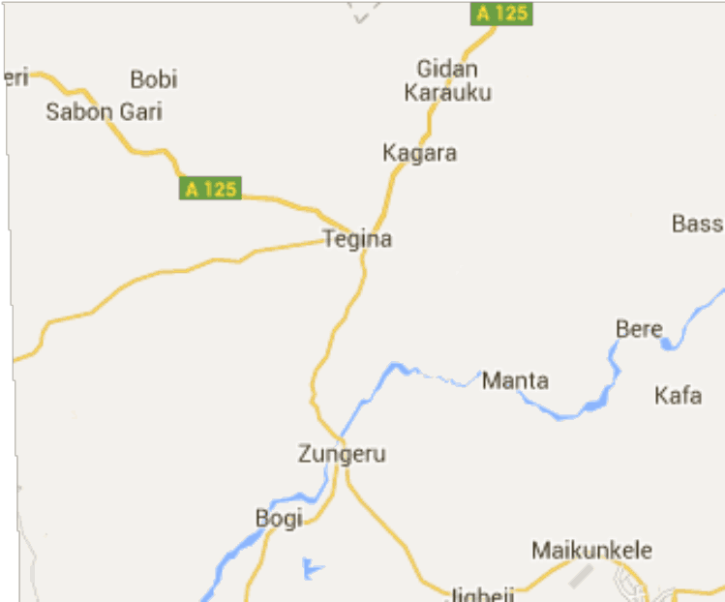

Keys Sampling area

Figure 3.1 Livestock feeds and manure sampling areas in North central Nigeria

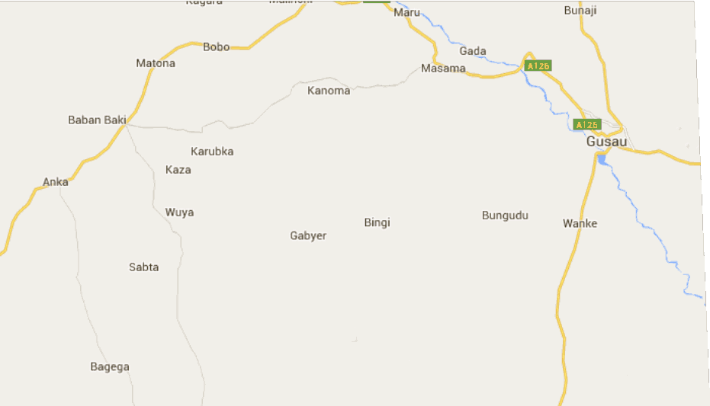

.

Keys

Sampling areas

Figure 3.2 Livestock feeds and manure sampling areas in North western Nigeria

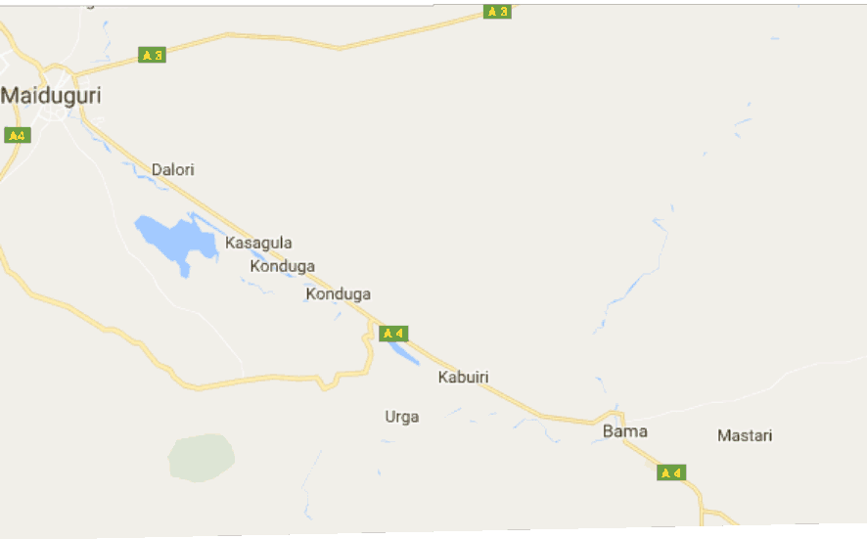

Keys

Sampling areas

Figure 3.3 Livestock feeds and manure sampling areas in North eastern Nigeria

.

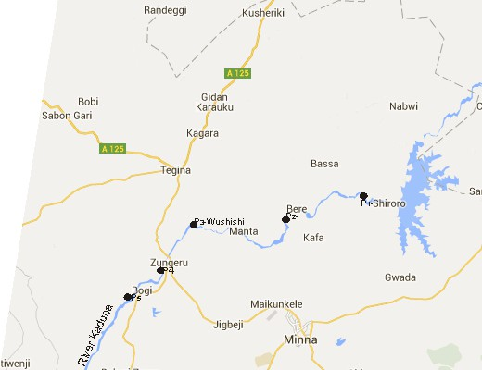

**Keys**

* Sampling points

Figure 3.4 River Kaduna sampling points

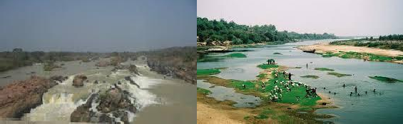

a b

Figure. 3.5 Pictures of river Kaduna during (a) raining and (b) dry seasons

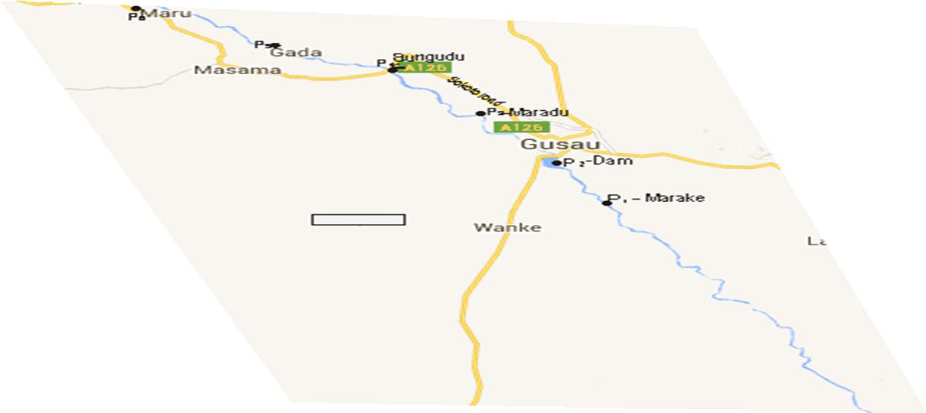

**Keys**

* Sampling points

Fig 3.6 River Sokoto sampling points

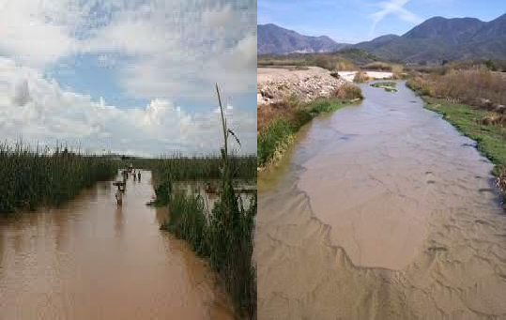

a b

Figure. 3.7 Pictures of river Sokoto during (a) raining and (b) dry seasons

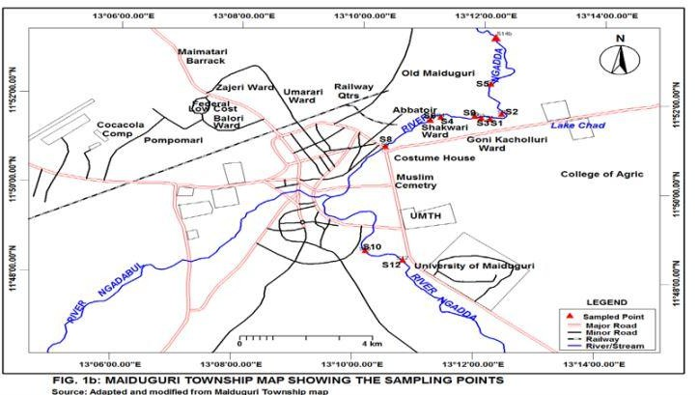

**Keys**

* Sampling points

Fig. 3.8 River Ngadda water sampling points

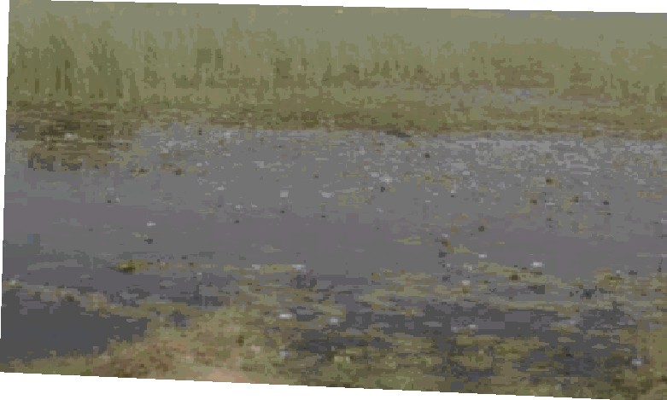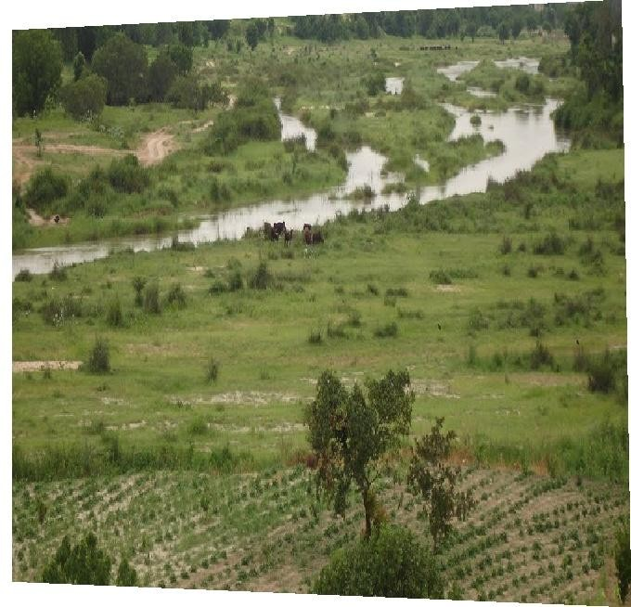

a b

Figure. 3.9 Pictures of river Ngadda during (a) raining and (b) dry seasons

## Sample collection

* + - 1. *Compound feeds*

Four types of compound mill-mixed fish feeds[FA, FB, FC and FD] Poultry feeds [PA, PB, PC and PD] sold commercially were sampled from five major distributors of the compound feeds in the designated towns in the three zones (North western, North central and North eastern) of Nigeria collected direct from the bags.

* + - 1. *Pastures*

.Five feeding areas or pastures where cattle are grazed freely were designated as sampling stations in each of the designated towns. Grazing animals were followed and forage samples corresponding to those consumed by the ruminants were collected from each pasture. Forage grasses were collected from five different points per sampling station, stored in polyethylene bags and transported to advanced chemistry laboratory, Sheda, Abuja Nigeria for analysis.

* + - 1. *Manure*

Poultry and cattle manure samples were collected from poultry farms and Fulani held‟s settlements respectively from the two designated towns/areas for the animal feeds sampled in each of the three zones of Northern Nigeria, by first removing surface-weathered manure from cattle manure samples. These were then placed on a tray, the lumps broken up by hand and then thoroughly mixed before being transferred into polythene bags. Approximately 10 kg of manure samples was collected as appropriate from each site visited.

* + - 1. *Water sampling*

Water samples were collected from rivers Sokoto (Northwest zone), Kaduna (north central zone) and Ngadda (north east zone) in northern Nigeria during the raining season (July 2014 to September 2014) and dry season (October 2014 to April 2015). The water samples from each of

the rivers were collected after recording the pH in-situ using portable digital pH meter and temperature using thermometer. Plastic containers were used to collect the water samples. The containers were rinsed thoroughly with the water twice before collection. Water samples were collected from five (5) different points from each of the rivers and at depths of at least two (2) meters at each of the five sampling locations from the rivers under investigation. The water samples were collected with plastic bottles, pooled, before taking one (1) liter into the previously cleaned plastic bottles. The samples were acidified with 10% Nitric acid (HNO3) to keep the metals in solution and minimize their adsorption on the plastic bottles (Igwegbe, 2013).Precautions were taken to minimize risks of contamination.

## Sample preparation

* + - 1. *Feeds and manure samples*

The feeds and manure samples collected were dried in the shade, then ground and passed through a 0.25-mm mesh sieve. Subsamples of 0.5 g were used for digestion.

* + - 1. *Water samples*

Fifty milliliters (50) ml of water from each location was measured and filtered into the PFTE plastic bottles using the ashless filter papers and then stored until analyzed by the atomic absorption spectrometer.

## Analytical method

Method of Atomic Absorption Spectroscopy for the determination of heavy metals by Uba *et al.,* 2000 was adopted for feeds and manure samples while by USEPA, 2002 was adopted for water samples and were validated via percentage extraction recovery and precision both within day and between days precision.

* + - 1. *Digestion of feeds and manure samples*

10ml of concentrated nitric acid (HNO3) was added to 0.5g subsamples followed by 5 ml each of concentrated sulphuric acid (H2SO4) and perchloric acid (HCIO4) in a digestion flask. The flask was heated in the fume cupboard until dense white fumes were observed. The flask was cooled, and the content was made up to 100ml mark with distilled water and transferred into plastic bottles. The sample solutions were then analyzed for zinc, copper, nickel, lead and arsenic at require wavelengths using GBC atomic absorption spectrophotometer, model no ICE 3000 AA from Advanced Chemistry laboratory, Sheda.

* + - 1. *Digestion of water samples*

Five ml of concentrated HCl (10 M) was added to 250 ml of each water sample placed

in 60 ml beaker, and evaporated to 25 ml. The concentrate was transferred to a 50 ml volumetric flask and diluted to mark with deionized water. Prior analysis, the solutions were filtered through Whatman paper.

* + - 1. *Calibration curve*

Five working standard zinc solution of concentrations 0.20, 0.40, 0.60, 0.80 and 1.00 mg/l,

standard copper solution of concentrations 0.15, 0.30, 0.45, 0.60 and 0.75 mg/l, standard lead

solution of concentrations 0.10, 0.20, 0.30, 0.40 and 0.50 mg/l, standard nickel solution of

concentrations 0.04, 0.08, 0.12, 0.16, and 0.20 mg/l and for arsenic concentrations of 0.02, 0.04, 0.06, 0.08 and 0.10 mg/l were prepared respectively to obtain the calibration curves for the determination of the respective zinc, copper, nickel, lead and arsenic.

## 3.4.5 Validation of analytical method

The validation of the analytical procedure for quantitative determination of Zn, Cu, Pb, Ni, and As in feed and manure was performed by evaluating accuracy (recovery) and precision (repeatability and reproducibility).

* + - 1. *Accuracy (% recovery)*

A recovery experiment involving the digestion of 0.5 g of spiked powdered feed and manure samples was carried out to validate the method of analysis. The samples were spiked with

1.0 mg/kg standard solutions of all metals considered in present study. All mixtures were then subjected to the digestion procedure used in present study, and then digested samples were transferred to a 10 ml volumetric flask and diluted to mark with deionized water. The resulting solutions were analyzed three times for metal concentration. The amount of spiked metal recovered after the digestion of the spiked samples was used to calculate percentage recovery as follows:

% Recovery = T – C x 100

T

Where ;

T = Concentration of a metal in treatment sample C = Concentration of a metal in control sample

* + - 1. *Precision*

The precision was determined by assessing the repeatability and reproducibility of instrument response to analyte. In order to assess the repeatability, measurements were done for three different concentrations levels (0.5, 1.0, and 1.5 mg/kg), and in each level, the analysis was performed with six replicates. The steps were repeated on two other occasions. The mean concentration, relative standard deviation and the coefficient of variation (precision) were calculated.

Coefficient of Variation = SD x 100

X

Where;

S.D = Standard Deviation X = Mean value

# CHAPTER FOUR RESULTS

## Method Validation

The results of the percentage extraction recovery and precision of the analytical procedure is shown in table 4.1 below.

## Table 4.1 Mean Percentage recovery and Precision for Zn, Cu, Ni, Pb and As in feeds and manure samples

|  |  |  |  |  |  |
| --- | --- | --- | --- | --- | --- |
| Metals | Percentage recovery (%)  N=3 | | Precision (Coefficient of  variation)% | | Wavelength  (nm) |
|  | Feeds | Manures | Feeds | Manure |  |
| Zn | 97.45±1.38 | 98.03±0.06 | 1.24 | 1.64 | 232.1 |
| Cu | 92.07±1.41 | 103.13±1.42 | 1.05 | 1.07 | 283.3 |
| Ni | 98.51±2.13 | 93.60±0.22 | 1.57 | 0.58 | 193.7 |
| Pb | 101.02±1.02 | 92.22±1.30 | 1.63 | 1.22 | 422.7 |
| As | 95.41±2.03 | 94.32±1.02 | 1.18 | 1.60 | 217.5 |

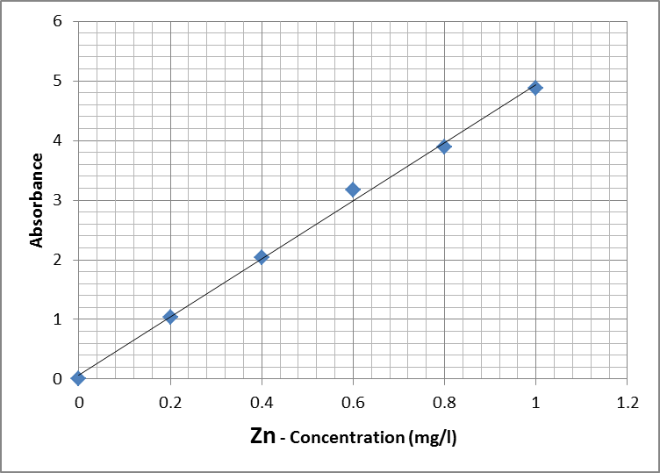 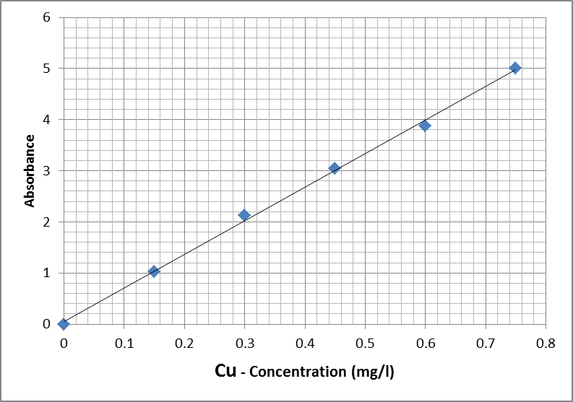

a b

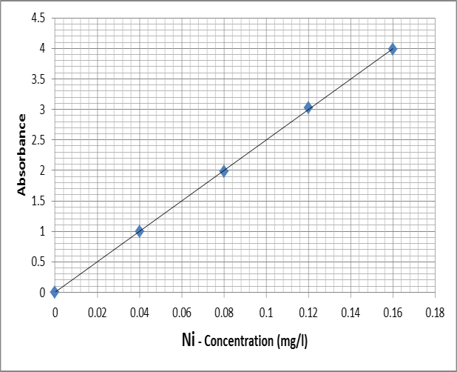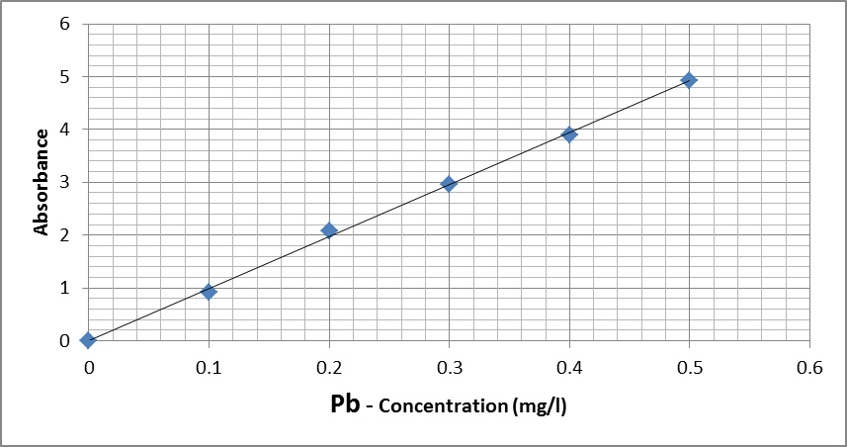

c d

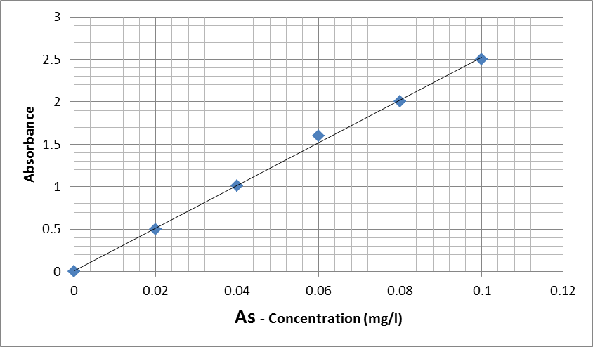

e

Figure 3.10. Calibration curves of the standard solutions of (a) Zn, (b) Cu, (c) Ni, (d) Pb and (e) As for determining the concentrations of the respective metals in feeds, manure and water samples

## Concentrations of Metals in Fish Feeds

Results for the determination of the concentrations of Zn, Cu, Ni, Pb and As in four compound fish feeds (FA), (FB), (FC) and (FD) obtained in northern Nigeria are shown in Figures (4.1 – 4.5) below. The mean concentrations of Zn > Cu > Ni > Pb > As in all compound fish feed samples were in the ranges of 5.10 ± 0.04 to 6.38 ± 1.50 mg/kg, 3.06 ± 1.0 to 3.16 ± 1.65 mg/kg,

0.10 ± 0.44 to 0.19 ± 0.07 mg/kg, 0.14 ± 0.08 to 0.38 ± 0.25 mg/kg and 0.01 ± 0.02 to 0.05 ±

0.04 mg/kg respectively.

## Concentrations of Metals in Poultry Feeds

The results of the mean concentrations of Zn, Cu, Ni, Pb and As in four compound poultry feeds (PA, PB, PC and PD) are of the same trend as in fish feed sampled in northern Nigeria and are presented in figures 4.6 – 4.10 below.

## Concentrations of Metals in Forage Grasses

The mean concentrations of Zn, Cu, Ni, Pb and As in forage grasses across the grazing areas in Northern Nigeria are presented in figures 4.11 – 4.15. The forage lead values in Zungeru and Anka areas are above the maximum permissible limit stipulated by European Union for lead in animal feeds.

## Concentrations of Metals in Animal Manure

The results of the contents of zinc, copper, nickel, arsenic and lead values in animal manure sampled in Northern Nigeria are presented in figures 4.16 - 4.20. The concentrations of Zn, Cu and Ni were higher in poultry manure samples while lead and arsenic values were higher in cattle manure samples.

## Concentrations of Metals in Water Samples

The pH and temperature of water samples at the point of collection are presented in table 4.6. The seasonal mean metal concentrations in water samples from rivers Kaduna. Sokoto and Ngadda in Northern Nigeria are presented in figures 4. 21 – 4.25.

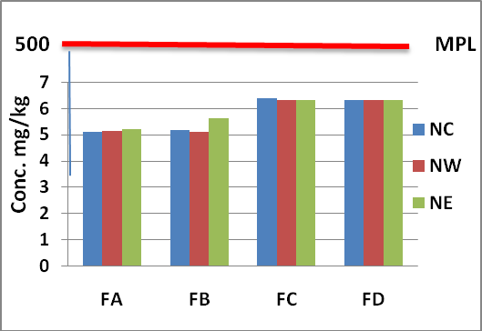

## Figure 4.1 Mean concentrations of Zn in four brands of compound fish feeds [(FA), (FB), (FC) and (FD)] in North central (NC), North western (NW) and North eastern (NE) Nigeria compared with maximum permissible limit (MPL) by European union, 2007.

.

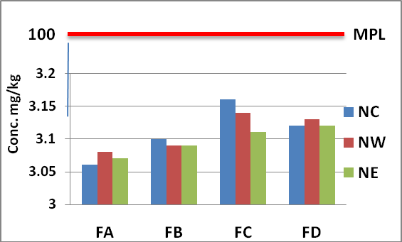

**Figure 4.2 Mean concentrations of Cu in four brands of compound fish feeds [(FA), (FB), (FC) and (FD)] in North central (NC), North western (NW) and North eastern (NE) Nigeria compared with maximum permissible limit (MPL) by European union, 2007.**

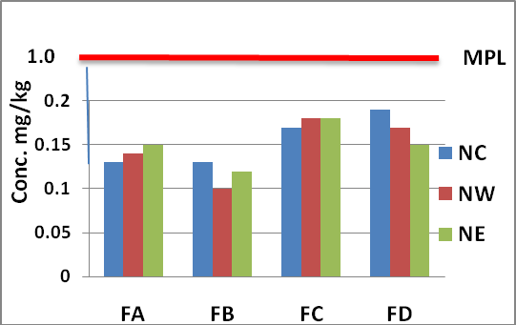

**Figure 4.3 Mean concentrations of Ni in four brands of compound fish feeds [(FA), (FB), (FC) and (FD)] in North central (NC), North western (NW) and North eastern (NE) Nigeria compared with maximum permissible limit (MPL) by European union, 2007.**

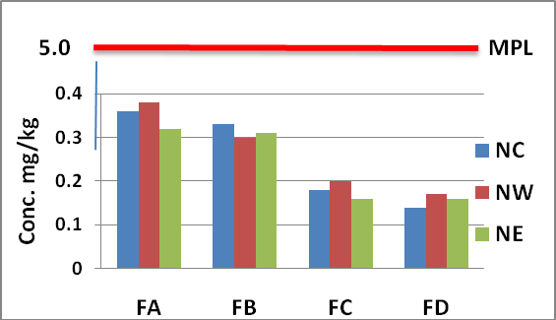

**Figure 4.4 Mean concentrations of Pb in four brands of compound fish feeds [(FA), (FB), (FC) and (FD)] in North central (NC), North western (NW) and North eastern (NE) Nigeria compared with maximum permissible limit (MPL) by European union, 2007.**

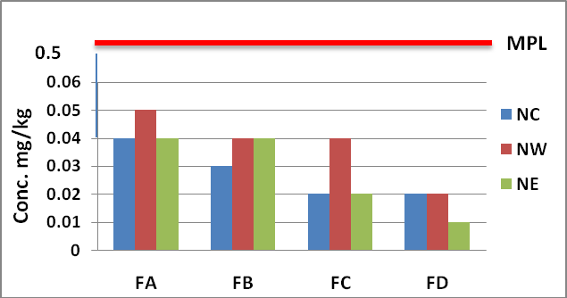

**Figure 4.5 Mean concentrations of As in four brands of compound fish feeds [(FA), (FB), (FC) and (FD)] in North central (NC), North western (NW) and North eastern (NE) Nigeria compared with maximum permissible limit (MPL) by European union, 2007.**

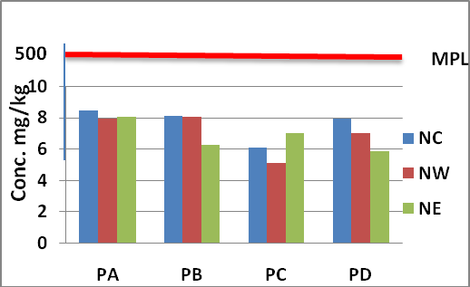

**Figure 4.6 Mean concentrations of Zn in four brands of compound Poultry feeds [(PA), (PB), (PC) and (PD] in North central (NC), North western (NW) and North eastern (NE) Nigeria and maximum permissible limit (MPL) by European union, 2007.**

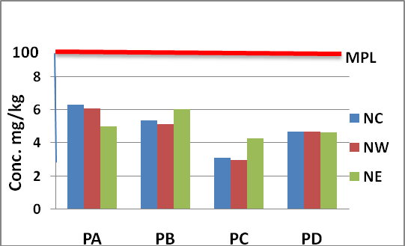

**Figure 4.7 Mean concentrations of Cu in four brands of compound Poultry feeds [(PA), (PB), (PC) and (PD] in North central (NC), North western (NW) and North eastern (NE) Nigeria and maximum permissible limit (MPL) by European union, 2007.**

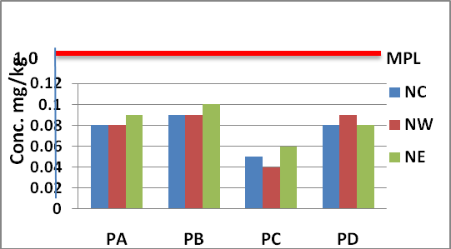

**Figure 4.8 Mean concentrations of Ni in four brands of compound Poultry feeds [(PA), (PB), (PC) and Gold (PD] in North central (NC), North western (NW) and North eastern (NE) Nigeria and maximum permissible limit (MPL) by European union, 2007.**

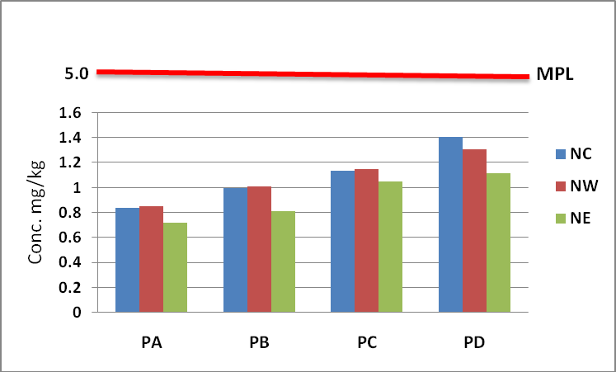

**Figure 4.9 Mean concentrations of Pb in four brands of compound Poultry feeds [(PA), (PB), (PC) and (PD] in North central (NC), North western (NW) and North eastern (NE) Nigeria and maximum permissible limit (MPL) by European union, 2007.**

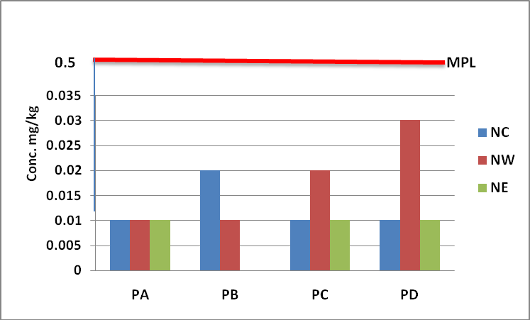

**Figure 4.10. Mean concentrations of As in four brands of compound Poultry feeds [(PA), (PB), (PC) and (PD] in North central (NC), North western (NW) and North eastern (NE) Nigeria and maximum permissible limit (MPL) by European union, 2007.**

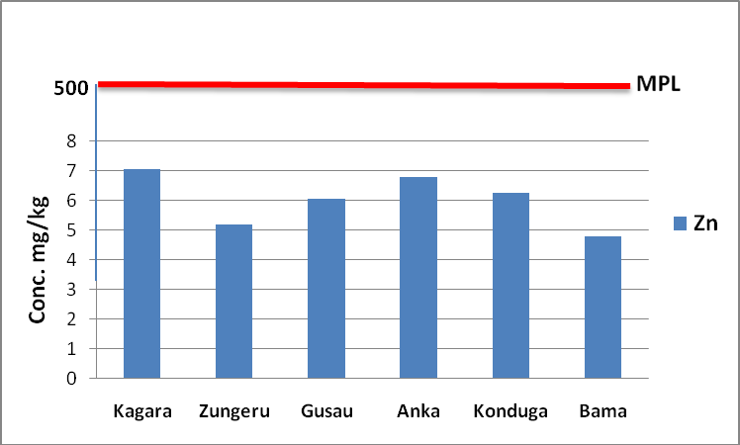

**Figure 4.11 Mean concentration of zinc in forage grasses across grazing areas in Northern Nigeria and maximum permissible limit (MPL) by European Union, 2007.**

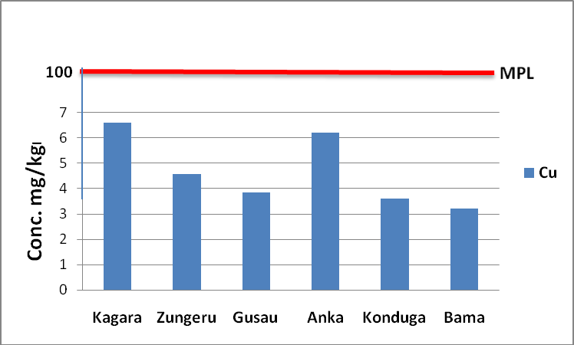

**Figure 4.12 Mean concentration of copper in forage grasses across grazing areas in Northern Nigeria and maximum permissible limit (MPL) by European Union, 2007**

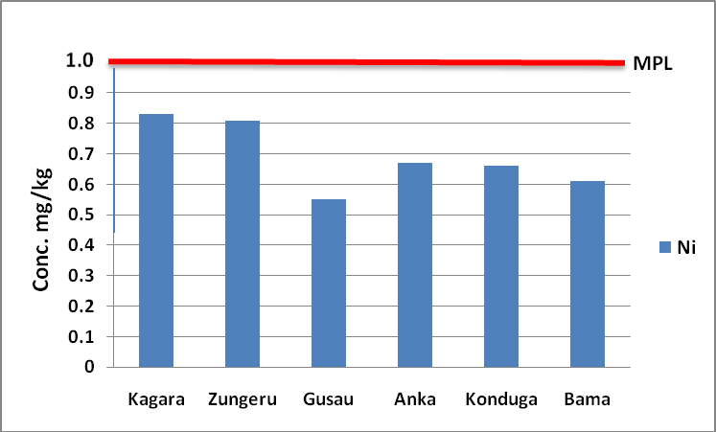

**Figure 4.13 Mean concentration of nickel in forage grasses across grazing areas in Northern Nigeria and maximum permissible limit (MPL) by European Union, 2007**

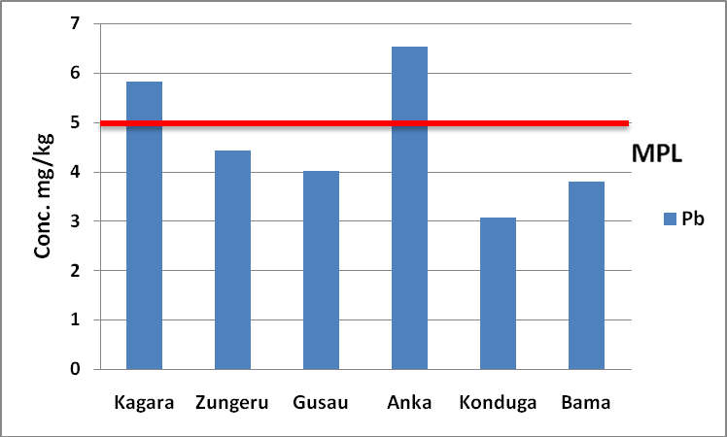

**Figure 4.14 Mean concentration of lead in forage grasses across grazing areas in Northern Nigeria and maximum permissible limit (MPL) by European Union, 2007**

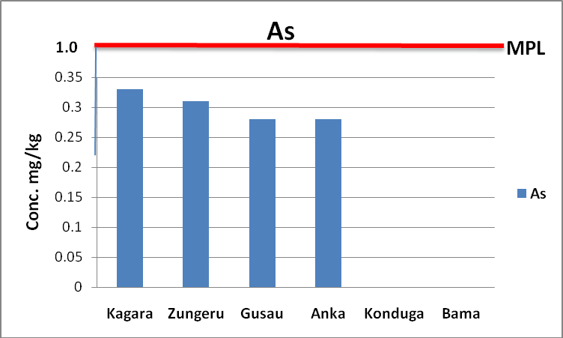

**Figure 4.15 Mean concentration of arsenic in forage grasses across grazing areas in Northern Nigeria and maximum permissible limit (MPL) by European Union, 2007**

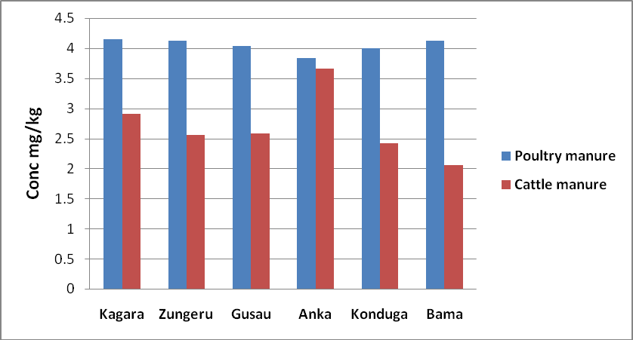

**Figure 4.16 Mean zinc concentrations in poultry and cattle manure in Northern Nigeria**

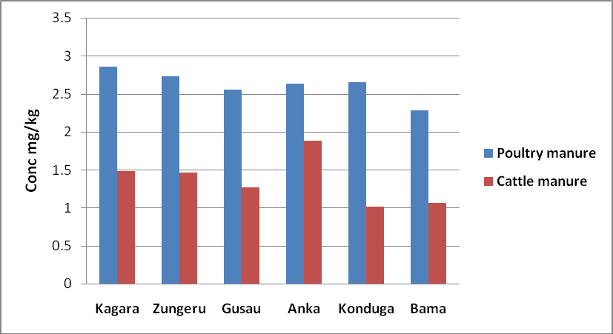

**Figure 4.17 Mean copper concentrations in poultry and cattle manure in Northern Nigeria**

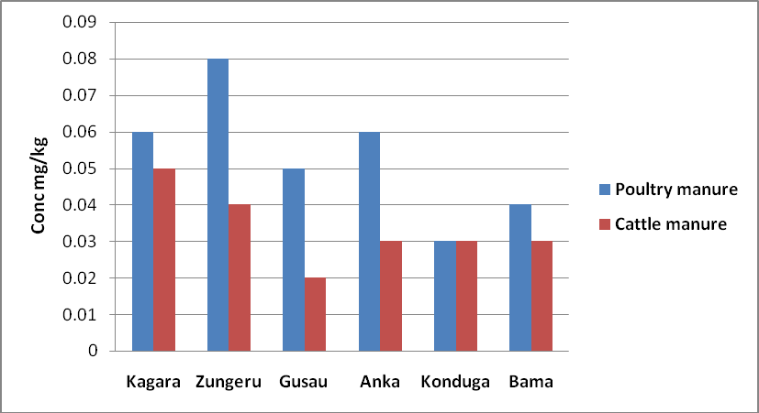

**Figure 4.18 Mean nickel concentrations in poultry and cattle manure in Northern Nigeria**

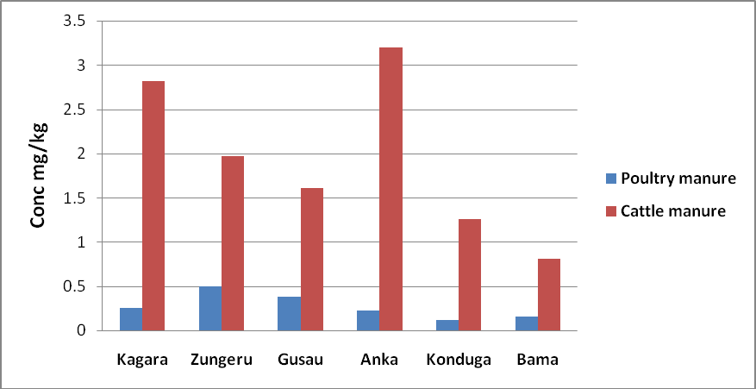

**Figure 4.19 Mean lead concentrations in poultry and cattle manure in Northern Nigeria**

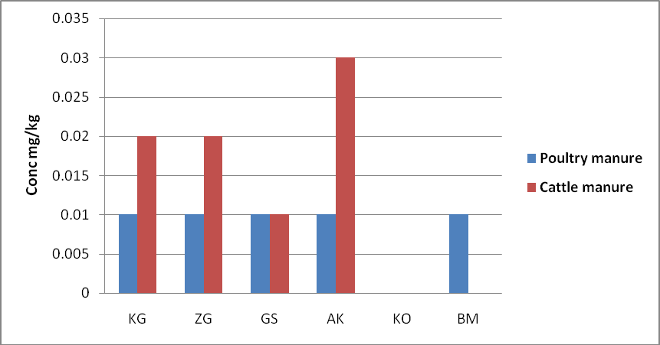

**Figure 4.20 Mean arsenic concentrations in poultry and cattle manure in Northern Nigeria**

**Table 4.6 Levels of pH and TemperatureºC measured in Water samples**

|  |  |  |  |  |
| --- | --- | --- | --- | --- |
| River | Mean pH  Raining | Dry | Mean TempºC Raining | Dry |
| Kaduna | 5.7 ± 0.02 | 6.1±1.44 | 21 ± 12.16 | 28±17.53 |
| Sokoto | 5.8 ± 0.11 | 5.9±2.05 | 26 ± 4.42 | 31±11.64 |
| Ngadda | 5. 7 ± 0.24 | 6.2±1.08 | 28 ± 8.26 | 36 ±42.01 |

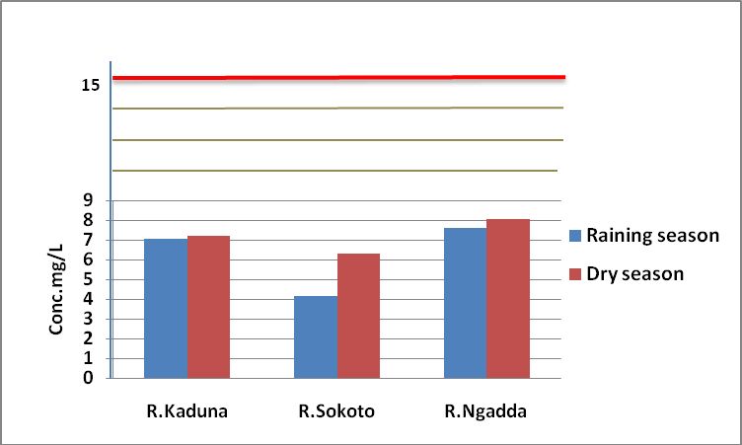

**Figure 4.21 Seasonal mean concentrations of zinc in rivers Kaduna, Sokoto and Ngadda and maximum permissible limit (MPL) by World Health Organization, 2007.**

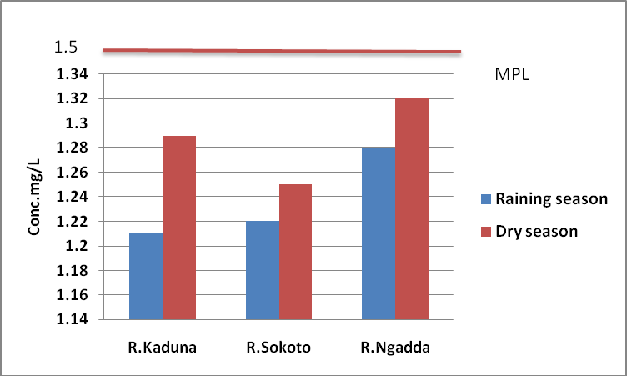

**Figure 4.22 Seasonal mean concentrations of copper in rivers Kaduna, Sokoto and Ngadda and maximum permissible limit (MPL) by World Health Organization, 2007.**

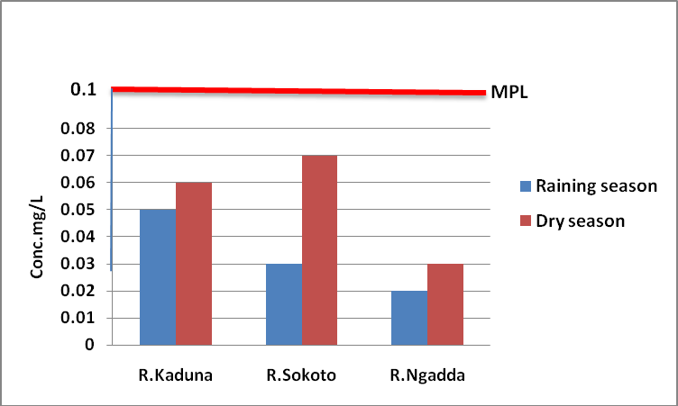

**Fiure.4.23 Seasonal mean concentrations of nickel in rivers Kaduna, Sokoto and Ngadda and maximum permissible limit (MPL) by World Health Organisation, 2007.**

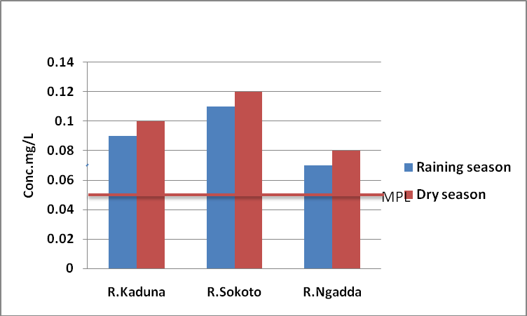

**Figure 4.24 Seasonal mean concentrations of lead in rivers Kaduna, Sokoto and Ngadda and maximum permissible limit (MPL) by World Health Organization, 2007.**

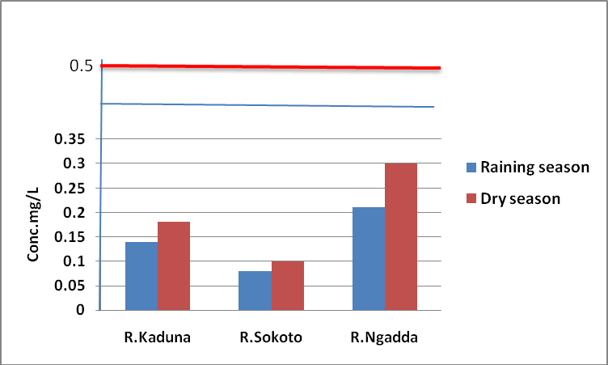

**Figure 4.25 Seasonal mean concentrations of arsenic in rivers Kaduna, Sokoto and Ngadda and maximum permissible limit (MPL) by World Health Organisation, 2007.**

# CHAPTER FIVE

**DISCUSSION**

## Method Validation

The recovery for the metals examined ranged 92.07% to 101.02% for feeds and 92.22% to 103.13% for manures indicating good recoveries of the metals (Table 4.1) thereby demonstrating accuracy of the analytical method employed. The results of the recovery of the metals used in present investigation of the analytical technique were similar to the report by Okoye *et al.,* (2011) in validating a method employed in metal analysis of poultry feeds sold in eastern Nigeria.

## Heavy Metals in Livestock Feeds

There are some heavy metals required as micro-nutrient in animal feeds but could be toxic at levels exceeding standard maximum acceptable limit stipulated for the metal in feeds. Copper and zinc are metals included in the requirement as micro-nutrient. The results obtained from this study on compound fish and poultry feeds showed that FA fish feeds and PA poultry feed brands contain the highest concentrations of zinc and copper, however, as essential micro-nutrient the levels were far below the required limit in all brands of compound animal feeds sampled. Zinc (mostly in the form of zinc oxide) and copper (mostly in the form of copper sulphate) are added to compound fish and poultry feeds. There is no significant (p<0.05) difference in levels of the respective metals across the three zones of Northern Nigeria. The values for compound fish feeds from this study were comparable higher than 1.21 – 3.32 mg/kg obtained by (Anhwange *et al*., 2012) in their analysis of fish feeds in Makurdi metropolis, north central Nigeria. The zinc and copper values obtained for poultry feeds were also lower than those obtained by Okoye *et al.,* (2011) in eastern part of Nigeria. These essential trace mineral are required for many biological processes. Nickel has been implicated as an essential trace metal in experimental animals (Costa,

2000). The nickel contents were higher in FC fish feed and PD poultry feed brands of all the compound feeds sampled and were found to be within required European union range. However, the difference in the recorded values could be as a result of unharmonised nutritional requirements of fish and poultry which differ from one area to another and errors during processing and mixing of ingredients in the feeds. Also, low concentrations of some of these essential metals as shown in this study, when compared with the recommended values stipulated by European Union, also revealed inadequate supplementation of these metals in the feed. Lead is a non-essential element that is of direct health concern to animals and humans (Costa, 2000). Highest concentrations were recorded in FA fish feeds and PD poultry feeds but were below the stipulated limits by European Union for leads in animal feeds and lower than 1.02 mg/kg reported by Anhwange *et al*.,( 2012) in their analysis of fish feeds in Makurdi metropolis. The levels were however lower than 2.86 mg/kg reported by Okoye *et al*.,( 2011) in poultry feeds analyzed in eastern part of Nigeria respectively. Arsenic concentrations were generally less than

0.5 mg/kg in all fish and poultry feeds sampled as stipulated by European Union. Some organic arsenic compounds have been used in swine and poultry to improve weight gain (Giacomina *et al.,* 2007).

The metal concentrations in forage grasses revealed that zinc, copper and nickel metal concentrations were highest in grazing grasses across Kagara (north central zone) but are lower than the respective metal concentrations stipulated by European Union in animal feeds. Mean forage zinc concentrations across northern Nigeria are in the range of 4.80 ± 2.43 - 7.08 ± 0.66 mg/kg. Zinc is present in the body as a co-factor for enzymes such as arginase and diaminase. It takes parts in the synthesis of DNA, proteins and insulin. It is an essential element required for many biological processes, including protein synthesis, carbohydrate metabolism, cell growth

and cell division in humans and animals. High zinc levels between 80 mg/kg – 180 mg/kg was reported for forage grasses in Dareta village, Zamfara, North central, Nigeria by (Udiba *et. al*., 2013) after the remediation exercise due to lead poisoning crisis of 2010 in the area.

Exposure to excess amount of zinc can result to zinc poisoning, though is most commonly added as mineral supplements to the animal ration. The low concentration of zinc in this study implies that forage grasses sampled does not pose a toxicity problem for the grazing animals.

Copper was detected in all the grass samples with same trend as observed in mean forage zinc concentrations across the stations though, recorded at lower values. The mean copper concentrations ranged from 3.20 ± 1.36 mg/kg to 6.61 ± 0.33 mg/kg .The Cu concentrations of forages obtained in each zone were not significantly (P>0.05) different from each other and were found to be within the permissible limit of 100 mg/kg stipulated by European union, 2007 for copper in feeds. Copper is essential for enzyme function and stabilization of collagen and elating, in energy metabolism, pigmentation, antioxidant defense system, and iron metabolism (Lopez- Alonzo *et. al*., 2002). Cattle are sensitive to copper toxicity than by goats. Ruminants typically develop hemolytic anemia, with liver and kidney lesions common to all species. A low level of

4.55 mg/kg reported for forage grasses in Ibadan, Nigeria was similar to mean copper levels obtained in this study. The nickel concentration in forages harvested in North central areas differed significantly (P<0.05) from sampling stations in North eastern Nigeria (Solomon *et al*., 2000).

Lead values were higher in Anka grazing area than in other sampling areas in Northern Nigeria. Lead as a non-essential metal is more of toxic and as non nutritious, therefore should be our main concern in discussing heavy metals in animal feeds. Generally, the mean lead value recorded for north central was almost twice the acceptable limit, while mean value for North west grazing

areas is almost four times the maximum limit of 5mg/kg stipulated by European Union as compared to values obtained in grazing areas in North east zone. The higher Pb concentrations in Anka and Zungeru areas in this study could be a result of an underlying contamination source. However, these values were less than mean lead concentrations distributed in forage grasses across Dareta village in Zamfara state sampled by (Udiba *et. al*., 2013). The correlation (P<0.05) in forage lead concentrations across the grazing areas in each zone suggest same lead source of contamination in grazing grasses across the sampling stations in the respective zones. Grazing animals are affected by the consumption of forage contaminated by lead dust particles and possibly through plants up-take of lead through their roots from contaminated soil. Lead content can result in higher levels of intake by grazing animals and subsequently accumulation along the food chain. Consumption of lead contaminated animals constitutes serious risk to public health. There is no exposure limit below which lead is said to be safe. It induces reduced cognitive development and intellectual performance in children, increase blood pressure, and cardiovascular diseases in adult as well as liver and kidney dysfunction (Singer *et al*., 1990). The different concentrations of lead obtained from this evaluation could be as a result of difference in environment and environmental activities. The presence of these heavy metals could be attributed also to the ubiquitousness.

## Animal Manure

The metal contents of animal manure being largely a reflection of their content in the feeds consumed and the efficiency of feed conversion by the animals. From this study, there is significant correlation p<0.05 between metal concentrations in animal feeds and metal contents in the respective poultry and cattle manure sampled in the three zones in Northern Nigeria.

However, there is no tolerance limit stipulated officially for heavy metal concentrations in animal manure. Highest mean concentrations of 4.15 ± 2.64 mg/kg and 2.86 ± 1.41 mg/kg for zinc and copper respectively were recorded for poultry manure in this study with corresponding lowest mean zinc and copper contents of 2.05 ± 0.89 mgZn/kg and 1.01±0.35mg Cu/Kg in cattle manure. This is due to the addition of zinc and copper being essential elements to compound poultry feeds by manufacturers. Comparing with similar studies from other countries, zinc and copper contents in this study are lower than those reported by (Fleming and Mordenti, 1991) who reported mean Zn concentrations in Belgian cattle manure of 580 mg/kg dm and a survey of Swiss manure (Menzi and Kessler, 2001) generally found <200 mg Zn/kg dm in cattle manure from cattle farms in Hangzhou.

Higher Pb concentrations were generally obtained in cattle manure samples as a result of the grazing in contaminated forage grasses due to environmental and anthropogenic activities than in poultry manure samples since the chicken were fed with processed compound feeds. In General, lead values obtained in cattle manure in North west farms were higher than values from cattle farms in North central and lowest in cattle manure from North east zones. The same trend was obtained in lead concentrations in forage grasses across the zones in Northern Nigeria. These values were lower than 47 ± 511 mg Pb/kg dm recorded in Belgia and 45 ± 511 mg Pb/kg dm Swiss cattle manure studies. Arsenics were undetected in cattle manure sampled in North east cattle farms in Northern Nigeria. Similarly, lower values of nickel contents were recorded in the cattle manure samples for the respective zones compared to the nickel contents in the poultry manure.

## Water Samples

There was no uniformity in the distribution of the metals in water samples from the three rivers. Higher levels of the heavy metals were generally observed in water samples collected during the dry season than that of the rainy season (Figures 2 to 5). The possible reasons for this could be

(a) concentration of the metals due to reduced volume of the water bodies associated with higher evaporation rate induced by the higher water temperatures during the dry season, and (b) seasonal variations in the nature of anthropogenic sources of pollutants, such as application of fertilizers by dry season farmers, farming along the banks of these water bodies, in addition to the burning of bushes and waste incinerations which are very common around the areas during the dry seasons. Ahmed *et al.* (2007) recorded high levels of ammonia and dissolved oxygen as well as high pH in river Ngadda, associated with extensive application of fertilizers by dry season farmers, particularly along the riverbanks. The concentrations of zinc and copper were higher in river Ngadda in this study. These high zinc concentrations could be attributed to Zn particles from suspended domestic wastes and roofs of houses close to the river located along Maiduguri metropolis. The high concentration of copper could be attributed to the dumping of wood treated with chemicals. The river receives copious amounts of wastes from both residential houses and abattoirs sited along its course.

Lead concentration levels recorded in the rivers generally exceeded the recommended 0.05mg/L by WHO for surface waters as an indication of pollution. The lowest limit of Pb in the water samples was determined in river Ngadda while the highest concentration in river Sokoto. This signifies the level of environmental pollution from leaded materials being washed off after rains into the rivers and possibly the nature of soil along the river path.

The excessive lead levels in the rivers is a great concern since lead is extremely toxic and consumption of water with high lead concentration could cause health adverse effect to end users since, lead has been found to be toxic to aquatic organisms, animals and human which conforms with similar reports of (Friberg *et al*., 1986, Akan *et al*., 2010 and Ideria *et al*., 2012).

The general trend in the concentrations of the heavy metals in the water samples during the dry and rainy seasons were Pb > Cu > Zn > Ni > As. It is a fact that the major use of water in Northern Nigeria is fishing and domestic. In general, the concentrations of zinc, copper, nickel and arsenic recorded in this study are within the WHO stipulated ranges, and below the values obtained in some similar studies in Nigeria rivers. This study is in line with the notion that the rains may wash down intercontinental contaminants including heavy metals into rivers, lakes and ponds, leading to gradual build up of these toxicants in the aquatic systems. The presence heavy metals in the water samples may also be as a consequence of the channeling of flood water from all corners of the fishing communities, with its attendant contaminants from waste dumps and flowing through farm areas where pesticides, fungicides, and other agrochemicals, may have been applied, to these bodies of water, during the rainy season; in addition to the atmospheric deposits of the heavy metals from both the natural and anthropogenic sources as indicated earlier,. However, the study was in good agreement with other studies reported by (Ikem *et al.,* 2012) in their study of metal concentrations in river Niger and (Ogundiran, *et al.*, 2012) in their evaluation of heavy metals in river Ijana in Benue State, Nigeria

# CHAPTER SIX

**SUMMARY, CONCLUSION AMD RECOMMENDATIONS**

## Summary

The metals zinc, copper, nickel, lead and arsenic determined from compound feed samples from fish and poultry feeds obtained in northern Nigeria were within the international permissible limits stipulated for the metals in animal feeds. The lead value in forage grasses grazed across

northern Nigerian is at toxic level affected possibly through processes such as agriculture and mining activities. There are varying proportions of heavy metals in animal manure samples from poultry farms and cattle manure from Fulani held‟s settlement in northern Nigerian. The water samples from northern Nigerian rivers have high lead values above recommended levels and as such critically contaminated with respect to this toxic metal.

## Conclusion

The results from this study showed levels of zinc, copper, nickel, lead and arsenic in animal feeds are within the international permissible limits. Therefore, these feeds are relatively safe for aquaculture and livestock production. The low concentrations of the essential elements (zinc and copper) in the feeds shows that supplements were not added to the feeds as should have been expected. However, presence of lead in forage grasses grazed across northern Nigeria at toxic levels could pose health risk to human since consumption of these contaminated animals and their products can lead to toxicity due to bioaccumulation. Farm manure is a valuable source of major plant nutrients and organic matter. The varying proportions of heavy metal in animal manure samples in northern Nigeria consequently could pose a higher risk of heavy metal pollution to farm lands and long-term soil contamination. The heavy metals in water samples from major rivers in northern Nigeria were significantly (P>0.05) affected by seasonal variation. In this study, the high lead values in northern Nigerian rivers could pose serious environmental concern. Effluents from anthropogenic activities through industrial and domestic activities such as faming, sewage and solid wastes disposals as run offs influence the metal levels in these rivers. From the above observations, it is clear that the concentrations of the toxic metals in Northern Nigeria showed pronounced levels of environmental pollution.

## Recommendations

In order to protect Northern Nigeria environment from further heavy metal contamination, safeguard the environment and preserve human health. The following approaches are suggested:

* + - Public enlightment on effects of heavy metal contamination on our environment
    - Educating the populace on indiscriminate disposal of lead containing materials
    - Legal laws designed to monitor network of artisan mining activities in Northern Nigeria.
    - Restricting the locations where animals are grazed.
    - Effectively manage sewage and industrial waste disposals system
    - Treatment of waste waters introduced into the rivers.
    - The need to determine official heavy metals tolerance limits in animal manures.
    - Remediation of the environment so as to prevent further heavy metal contamination

# REFERENCES

Abulude, F.O., Eluyode, S.O and Jegede, A. (2000). An investigation into the effect of traffic pollution on the levels of some heavy metals in goats‟ urine samples in Kotoni province*. Asian Journal of Chemistry, 20 (4*): 2663-2672.

Ahmad, K., Khan, Z., Ashraf, M., Valeem, E. E., Shah, R. and Mcdowell, E. (2007). Levels of total amino acids, soluble proteins and phenolic compounds in forages in relation to requirements of ruminants grazing in the salt range (Punjab), Pakistan, *Journal of Botany,* 41(3), 1521-1526.

Akan, A. A., Ojomolade, O.O., Ayoola, G. A. and Coker, A. B. (2010). Quantitative analysis of some toxic metals in domestic water obtained from Lagos metropolis. *The Nigerian Journal of Pharmacy,* 42 (1): 57-60.

Alexieva, D., S., Chobanova, D. and Ilchev, A. (2007). Study on the level of heavy metal contamination in feed materials and compound feed for pigs and poultry in Bulgaria. *Journal of Science*, 5: 61-66.

Anhwange, O., Alkhalaf, N.A., Osman, A. and Salama, K. A. (2012). Study on the level of heavy metal contamination in fish feeds sold in Markudi Municial area. *Bulletin of Environmental Contamination and Toxicology,* 4: 192-199.

AL-Jassir, M. S., Shaker, A. and Khaliq, M. A. (2005). Deposition of heavy metals on green leafy vegetables sold on roadsides of Riyadh city, Saudi Arabia. *Bulletin of Environmental Contamination and Toxicology, 75, 1020-1027.*

Alonso, M. L., Benedito, M., Miranda, C., Castillo, J. A. and Hernandez, Z. (2002. Interactions between toxic and essential trace metals in cattle from region with low levels of pollution. *Journal of Environmental Contamination and Toxicology*, 42: 165-172

Aluko, O.O., Sridha, M.K.C. and Oluwande, E. P. (2003). Characterization of leachates from a municipal solid waste landfill site in Ibadan, Nigeria. *Journal of Environmental Health Research,* 2, 32-37.

Arogunjo, A. M. (2006). Heavy metal composition of some solid minerals in Nigeria: Any Health Implication to inhabitants around the Mining sites. *International Journal of Applied and Environmental Sciences*, 2(2): 143-145

Ataro, A., Crindle, R. I., Botha, B. M .E. and Ndibewu, P. P. (2008). Quantification of trace elements in soils by inductively coupled plasma mass spectrometry (ICP-MS). *Food Chemistry*, 111, 243–248.

Agency for Toxic Substances and Disease Registry (ATSDR, 2005). Toxicology profile for Copper. Atlanta, Georgia, United States Department of Health and Human Services.

Agency for Toxic Substances and Disease Registry (ATSDR, 2007). Toxicology profile for Zinc. Atlanta, Georgia, United States Department of Health and Human Services. Awowunmi, E.E., Asaolu, S.S. and Ipinmoroti, K. (2002). Effect of leaching on heavy metals concentration of soil in some dumpsites. *African Journal of Environmental Science and Technology, 4(8), 495-499.*

Azeez, J.O., Adekunle, I.O., Atiku, O.O., Akande, K.B.; Jamiu, U. and Azeez, S.O. (2012). Effect of nine years of animal waste deposition on profile distribution of heavy metals in

Abeokuta, South-western Nigeria and its implication for environmental quality. *Waste Management,* 29, 2582–2586.

Barone, A., Ebesh, O., Harper, R.G. and Wapnir, R.A. (2005). Placental copper transport in rats: effects of elevated dietary zinc on fetal copper, iron and metallothionien. *Journal of Nutrition,* 128, 1037-1041.

Bakare-Odunola, M. T. (2005). Determination of some metallic impurities present in soft drinks marketed in Nigeria. *The Nigeria Journal of Pharmacy*, 4(1):51-54.

Bansal, N.U., Etesin, J.P., Essien, I.U., Umoren, J. and Umoh, M. (2004). Tissue elemental levels in fin-fishes from Imo river system, Nigeria: Assessment of liver/muscle concentrations ratio. *Journal of Fisheries, Aquatic Science,* 1: 277-283.

[Bhat, M. and Krishnamachari, S. (1980](../../USER/Documents/Ph%20D%20Thesis%205.htm#562973_ja)). Heavy metal concentrations in ground waters and soils of Thane Region of Maharashtra, India. *Environmental Monitoring and Assessment*, 173(1-4), 643-652.

Burhene, F., Ogundiran, M. B. and Osibanjo, O. (2008). Heavy metal concentrations in soils and accumulation in plants growing in a deserted slag dumpsite in Nigeria. *African Journal of Biotechnology,* 7 (17), 3053-3060.

Cang, L., Wang, Y.J., Zhou, D.M. and Dong, Y.H. (2012). Heavy metals pollution in poultry and livestock feeds and manures under intensive farming in Jiangsu Province, China. *Journal of Environmental Sciences*, 16, 371–374**.**

Caggiano, J., Biney, C., Amuzu, D., Calamari, N. and Mbome, L. (2004). Review of Heavy Metals. In: Review of Pollution in the African Environment. Calamari D. (Ed.). CFA/FAO, Rome, pp: 293-300.

Carrington, G., Mor, F.H. and Nisha, K. (2000). Cadmium and lead in livestock feed and cattle manure from four agricultural areas of Bursa, Turkey. *Toxicology and Environmental Chemistry*, 87: 329-334.

Chakraborti, D., Samanta, B.K., Mandal, T., Roy-Chowdhury, S. and Chanda, R. (1998). Calcutta industrial pollution: Groundwater arsenic contamination in a residential area and sufferings of people due to industrial effluent discharge-An eight-year study report. *Current Journal of Science,* 74: 346-355.

Centers for Disease Control and Prevention (2001). Managing Elevated Blood Lead Levels Among Young Children: Recommendations From the Advisory Committee on Childhood, Lead Poisoning Prevention. Atlanta.

Christopher, A.E., Vincent, I., Grace, E., Rebecca, O. and Joseph, E. (2009). Distribution of heavy metals in bones, gills, livers and muscles of (Tilapia), *Oreochromisniloticus* from Henshaw Town Beach market in Calabar Nigeria. *Journal of Nutrition*, 8: 1209-1211.

Coleman, M. E., Elder, R. S. and Basu, P. (2002). Trace metals in edible tissues of livestock and poultry. *Journal of the Association of Official Analytical Chemists International*, 75(4): 615-625.

Costa, D. (2000). Trace elements; Aluminum, Cadmium, Arsenic and Nickel. In: *Environmental Metal Toxicants, Human Exposure and their Health affect*, New York City. Pp 811-850.

Cui, N., Aycicek,, M., Kaplan, O. and Yaman, M. (2007). Effect of cadmium on germination, seedling growth and metal contents of sunflower (*Helianthus annus* L.). *Asian Journal of Chemistry,* 20: 2663-2672.

Dey, S., Dwivedi, K. and Swarup, D. (1997). Lead concentration in blood, milk and feed of lactating buffaloes after acute poisoning. *Journal of Veterinary Records*, 138: 336-336.

Dike, N. I., Ezealor, A. U. and Oniye, S. J. (2004). Concentrations of Pb, Cu, Fe, and Cd during the dry season in river Jakau, Kano Nigeria*. Journal of Chemclass*, 1, 78-81

Duda, K,. Blas, Z. and Christopher, Y. K. (2008). The Impact of Nickel on Human Health.

*Journal of Elementology*, 13, 685-696.

Demirezen, U., Dauda, C. and Aksoy, A. (2006). Heavy metal levels in vegetables in Turkey are within safe limits for Cu, Zn, Ni and exceeded for Cd and Pb. *Journal of Food Quality*, 29, 252- 265.

Duruibe, J., Ogwuebu, M. and Egwurugwu, J. N. (2007). Heavy metal pollution and human biotoxic effects. *International Journal of Physical Sciences*, (5):112-118.

Eddy, N.O., Odoemelem, S.A. and Mbaba, A. (2006). Elemental composition of soil in some dumpsites. *Journal of Environmental Agricultural Food Chemistry,* 5, 1349-1365.

Endale, M. (2014). Evaluating the Effects of Fertilizers on Bioavailable Metallic Pollution of soils, Case study of Sistan farms, Iran. *International Journal of Environmental Resources*, 6 (2), 565-570.

Emoyan, D. P., Machát, J., Szkandera, R. and Dočekalová, H. (2008). In situ Measurement of Bioavailable Metal Concentrations at the Downstream on the Benue River using Transplanted Aquatic mosses and DGT Technique. *International Journal of Environmental Resources*, 6 (1), 87-94.

European Commission (2007). Opinion of the scientific committee on animal nutrition on the use of zinc in feedstuffs. European Commission, Health and Consumer Protection Directorate, Brussels, Belgium..

European Commission (2007). Opinion of the scientific committee on animal nutrition on the use of copper in feedstuffs. European Commission, Health and Consumer Protection Directorate, Brussels, Belgium.

European Commission (2007). Opinion of the scientific committee on animal nutrition on undesirable substances in feed. European Commission, Health and Consumer Protection Directorate, Brussels, Belgium.

European Commission (2003)). Health and Consumer Protection Directorate - General, Belgium Opinion of the Scientific Committee on Animal Nutrition on Undesirable Substances in Feed [http://ec.europa.eu/food/fs/sc/scan/out126_bis_en.pdf,](http://ec.europa.eu/food/fs/sc/scan/out126_bis_en.pdf) retrieved 10-04-2015.

Food and Agriculture Organization (FAO, 2006). Integrated fish farming in China. Technical Manual 7. A World Food Day Publication of the Network of Agriculture Centre in Asia and the Pacific, Bangkok, Thailand, pp: 1-278.

Food and Agriculture Organization (FAO, 2012). Report on the workshop on research needs in sustaining the agriculture sector in Africa to Year 2025 and beyond, 4-7th June 2012. Network of Agricultural Centres in Africa and Asia, Nigeria. pp: 10.

Fatoki, O. S. (2000). Toxic elements in road side vegetation and surface soils: A measurement of local atmospheric pollution in Alice, South Africa. *International Journal of Environmental Studies,* 57(3), 501-513.

Finster, M. E., Gray, K. A. and Binns, H.J. (2004). Lead levels of edibles grown in contaminated residential soils: A field survey*. Science Total Environment*, 230, 245-257.

Fleming, B. and Modeni, F. (1991). Zinc Pollution and Ecology of the Environment: In Zinc in the Environment and Ecological Cycling. John Wiley, New York, pp: 337-417.

Friberg, M., Willman, R., Halwatt, M. and Barg, K. (1986). Integrating fisheries and agriculture to enhance fish production and food security. FAO Aquaculture. Newsletter, 20: 3-12. Gabriel,U. U., Akinrotimi, D.O., Bekibele, P.E., Anyanwu, S. and Onunkwo, D. (2007). Economic benefit and ecological efficiency of integrated fish farming in Nigeria. *Journal of Science Resource Essay, 2: 302-308.*

Garg, T. and Tatawat, B. (2005). Meat products and soil pollution caused by livestock and poultry feed additive in Liaoning, China. *Journal of Environmental Science*, 2011, 23, S135– S137.

Garcia, L., Leyva-perez, J. and Jara-marini, M.E. (2000). Content and daily intake of copper, zinc, lead, cadmium, and mercury from dietary supplements in Mexico. *Food and chemical toxicology,* 45(9), 1599–1605.

Giacomino, A., Malandrino, M., Abollin, O., Velayutham, M., Chinnathangavel, T. and Mentast,

E. (2007). An approach for arsenic in a contaminated soil: Specification. *Environmental Pollution,* 158: 12-13.

Govil, H.K. (2001). Evaluation of issues relating to the carcinogens risk assessment of toxic metals. *The Science of the Total Environment*, 86, 181-186.

Gupta, U. C. and Gupta, D. (2005). Trace elements toxicity relationships to crop production and livestock and human health: Implication for management*. Common Soil Science, Plant Anatomy*, 29, 1491-1522.

Gwoda, S., Guyo, H., Saegerman, C., Lebreton, P., Sandersen, C. and Rollin, F. (2003). Epidemiology of trace elements, deficiencies in Belgian beef and dairy cattle herds. *Journal of Trace Element in Medical Biology,* 23, 116–123.

Haque, R.M., Ahamad, M. D., Chowdhury, M. K., Ahmed, S. and Rahman, M. (2005). Seasonal variation of heavy metals concentration in surface water of the rivers and estuaries of urban mangrove forest. *Pollution Resource*, 24: 463-472.

Ibeto, C.N., Okoye, C.O.B., Moses, M. F. and Prabakaran, J. J. (2011). Human and Ecological Risk Assessment: *An International Journal of Toxicology,* 16:5, 1133-1144.

Ideria, S., Poulsen, H. D. and Hosman, F. (2012). Zinc and copper as feed additives, growth factors or unwanted environmental factors. *Journal of Animal Feed Science*, 7, 135–142

Igwegbe, A.O. (2013). Effects of Location, Season, and Processing on Heavy Metal Contents in Selected Locally Harvested Fresh Fish Species from Borno State of Nigeria. A Ph.D Thesis, Department of Food Sciences and Technology, Faculty of Engineering, University of Maiduguri.

Ihedioha, A. and Okoye, P. C. (2012). Heavy metals in feeds, growth factors or unwanted environmental factors. *Journal of Animal Feed Science*, 7: 135-142.

Ikem, A., Osibanjo, O., Sridhart, M.K. and Sobanle, A. (2002). Evaluation of ground water quality characteristics near two waste sites in Ibadan and Lagos, Nigeria. *Water, Air and Soil Pollution*, 140, 307-333.

Kaplan, O., N.,. Yildirim, N., Yildirim, N. and Cimen, M. (2010). Toxic elements in animal products and environmental health Asian. *Journal of Animal Vetenary*, 6: 228-232.

Kessler, J. (2001). Heavy metal content of manures in Switzerland. In: Proceedings of the Eighth International Conference of the FAO Network on Recycling of Agricultural. Municipal and Industrial Residues in Agriculture (Impress).

Khan, Z., Ashraf, M., Ahmad, K., Mustafa, I. and Danish, B. (2012). Evaluation of micro minerals composition of different grasses in relation to livestock requirement. *Journal of Botany,* 39(3), 719-728.

Konegay, E.T., Hedges, J.D., Martens, D.C. and Kramer, C.Y. (1976). Effect on soil and plant mineral levels following application of manures of different copper contents. *Journal of Plant and Soil,* 45, 151-162.

Koklu, W.E., Carr, L.E., Carter, T.A. and Bossard, E.H. (2000). The levels of nutrients and heavy metals in sea water. *Journal of Science,* 60, 1160-1164.

Linden, R.A., Driemeier, E.B., Guimaraes, I.S., Dutra, A.E., Mori, G. and Barros, C. (2002). Lead poisoning in cattle grazing pasture contaminated by industrial waste. *Journal of Veterinary and Human Toxicology*, 46: 326-328.

Li-wenfan, Z., Ping, M., Zhou, H. and Yosuf, W. (1995). Influences of heavy metal pollution of the environment on the health of sheep. *Chinese Journal of Veterinary Science*, 25: 15-17

Lokande, R.S. and Sathe C. N. (2001). Monitoring and assessment of heavy metal contents in the industrial effluents from Ambarnath M.I.D.C. area Maharashtra. *Pollution Resources*, 20: 239- 243.

Lemos, R.A., Driemeier, E.B., Guimaraes, I.S., Dutra, A.E., Mori, F. and Barros, C. (2004). Lead poisoning in cattle grazing pasture contaminated by industrial waste. *Journal of Veterinary and HumanTo xicology.* 146: 326-328.

Lopez - Alonso, M. L., Benedito, M., Miranda, C., Castillo, P. and Hernandez, F. (2002). Interactions between toxic and essential trace metals in cattle from a region with low levels of pollution. *Archives of Environmental Contamination and Toxicology*, 42: 165-172.

Lyaka, Y.A., Nda-Umar, U.I., Muhammad, M.N. and Ajai, A.I. (2005). Contents of lead and copper in poultry feeds in Niger State. *Polymath Journal*, 6, 107-111

Mamud, M. O., Yusuf, L. and Babayemi, J. (2004). Assessment of heavy metal concentrations in the liver of cattle at slaughter during three different seasons. *Resource Journal of Environmental Science* 43; 54 - 70

Menzi, H. and Kessler, J. (2001). Heavy metal content of manure in Switzerland. In: Proceedings of the Eighth International Conference of the FAO Network on Recycling of Agricultural. Municipal and Industrial Residues in Agriculture (Inpress).

Miranda, M., M., Lopez-Alonso, C., Castillo, J., Hernandez, H. and Benedito, L. (2005). Effects of moderate pollution on toxic and trace metal levels in calves from a polluted area of Northern Spain. *Environmental International Journal*, 31: 543-548

Moore, S. A. (2007). Soil and Plants as biomonitor of the environmental pollution. *Toxicology Bulletin*, 74: 2914-2914.

Morrison, J. L. (2011). Distribution of arsenic from poultry litter in chickens, soil and crops.

.*Journal of Agricultural and Food Chemistry.* 17, 1288-1290.

Medecins Sans Frontieres (MSF, 2010). Doctors without Borders: MSF Article on [health care](http://www.msf.org/msfinternational/invoke.cfm?component=article&objectid=F8F896F8-C409-4E0E-A6ECE6F5C2034F9B&method=full_html)

[crucial in emergency situations.](http://www.msf.org/msfinternational/invoke.cfm?component=article&objectid=F8F896F8-C409-4E0E-A6ECE6F5C2034F9B&method=full_html) Retrieved 28 December 2010.

Musa , H., Yakasai, I. A. and Musa, H. H. (2004). Determination of Lead concentration in well and Bore hole water in Zaria, Nigeria. *Journal of Chemclass*, 1, 14-18.

NACA. (200)7. Report on the workshop on research needs in sustaining the aquaculture sector in Asia-pacific to Year 2025 and beyond, 4-7th June 2007, Rayong, Thailand. Network of Aquaculture centers in Asia and the Pacific, Bangkok. pp: 10.

Ndiokwere, C. Godwin C. and Ezehe, C.A. (2009). The occurrence of heavy metals in the vicinity of industrial complexes in Nigeria*. Environmental International*, 16, 291-295

Nicholson, F., Chambers, B., Alloway, B., Hird, A., Smith, S., Carlton-Smith, C. (2000). An inventory of heavy metal inputs to Agricultural soils in England and Wales. In: Proceedings of the 16th World Congress of Soil Science. Montpellier, France.

Nnaji, C. J., Okoye, F. and Ogunseye, J. (2003). Integrated fish farming practices with special reference to combination rates production figures and economic evaluation, Proceedings of the 18th Conference of Fisheries Society of Nigerian (FISON). December 8-12, Owerri, page 173- 178.

NRC. (1994). Nutrient Requirements of Poultry.9th revised edition, National Academy of Sciences, Washington, DC. Pages 19-34.

Nwude, D., Okoye, P. and Benjami, O. (2012). Metal accumulation in cattle raised in a serpentine-soil area: Relationship between metal concentrations in soil, forage and animal tissues. *Journal of Trace Elements Medical Biology*, 23: 231-238

Odai, S.N., Mensah, E., Sipitey, D., Ryo, S. and Awuah, E. (2008). Heavy metals uptake by vegetables cultivated on urban waste dumpsites: Case study of Kumasi, Ghana*. Research Journal of Environmental Toxicology*, 2, 92-99.

Oduemeran, P. (2005). Study of heavy metal pollution of River Antau, Keffi, Nasarawa State, Nigeria, *India Journal of Multinational Resource.,* 4 **(**1**),** 8-18**.**

Oforka, N. C., Osuji, L.C. and Onwuachu, U. I. (2012). Estimation of dietary intake of cadmium, lead, manganese, zinc and nickel due to consumption of chicken meat by inhabitants of Port- Harcourt Metropolis, Nigeria. *Archives of Applied Science Research*, 4(1): 675-684.

Ogabiola, E., Yabpella, G., Adesina, O. B., Udiba, U., Ade – Ajayi, A., Agomya, M., Hammuel, C. and Abdulahi, M. (2013). Effects of heavy metal contamination in river Yatsman in Borno state, Nigeria. *Journal of Applied Environmental and Biological sciences*, (4) pp 69 – 73.

Ogundiran, M. B., Ogundele, D. T., Afolayan, P. G. and Osibanjo, F. (2012).Heavy Metals Levels in Forage Grasses, Leachate and Lactating Cows Reared around Lead Slag Dumpsites in Nigeria *International Journal of Environmental Resource,* 6(3):695-702.

Okoronkwo, N.E., Odemelam, S. A. and Amos, O. A. (2006). Levels of toxic elements in soils of abandoned waste dumpsite. *African Journal of Biotechnology*, 5, 1241-1244

Okoye, C.O. B., Ibeto, C. N. and Ihedioha, J. N. (2011). Assessment of heavy metals in chicken feeds sold in south eastern Nigeria. *Advances in Applied Science Research,* 2(3):63-68.

Obasohan, B. and Egwavon, R. (2008). Lead poisoning in cattle- transfer of lead to milk. *Science and total Environment*, 111, 83-94.

Oliver, T. N. (2007): Heavy metals pollution profiles in river Nasarawa and its distributaries.

*African Journal of Environmental Science Technology,* 2 (11), 354-359

Patel, K.P., Pandya, P. R., Maliwal, K.C., Patel, V.P. and George, D. (2004). Heavy metal content of different effluents and their relative availability in soils irrigated with effluent waters around major industrial cities of Gujarat. *Journal Indian of Social Soil Science,* 52: 89-94.

Paul, T.K., Ghosh, T. K. and Haldar, S. (2005). Assessment of trace element status in common goat feeds and in vital body tissues of black bengal bucks (*Capra hircus*) with special reference to chromium. *Indian Journal of Animal Science*, 75: 429-432. |

Ping, Z.L. (2005). Effect of environmental lead and cadmium pollution on animal health.

*Veterinary Bulletin*, 75: 5040-5040. Piska, R.S., Swamy, P. Y. and Parvathi, H. (2004). Heavy metal pollution and its toxic effect on ground water quality of Jeedimetla IDA, Hyderabad. *Indian Journal of Environmental Protocol*, 24: 177-181.

Prasad, B. and Jaiprakas, C. K. (1999). Evaluation of heavy metals in ground water near mining area and development of heavy metal pollution index. *Journal of Environmental Health Science*, 34: 91-102.

Prasad, C.S., Gowda, J.V., Ramana K. S. and Singh, K. (2005). Micronutrient content of soil, water, feeds and fodders in the adopted villages under IVLP and assessing their availability to lactating cows. *Indian Journal of Dairy Science*, 58: 44-48.

Rai, V., Xavier, F., Saseendran, P. C. and Oommen, G. T. (2001). Study of heavy metal level in beef sample in industrial area of Palakkad, Kerala, India. Proceedings of National Symposium on Safe Meat for Good Health and Environment, July 4-5, Bangalore, pp: 37-38.

Raji, M.I.O., Ibrahim, Y.K.E. and Ehinmidu, J.O. (2006). Physico-chemical characteristics and Heavy metal levels in Drinking Water sources in Sokoto metropolis in North-western Nigeria. *Journal of Applied Sciences and Environmental Management*, 14, 81-85.

Ramadan, M.A.E. (2007). The effect of chicken manure and mineral fertilizers on distribution of heavy metals in soil and plant organs. *Indian Journal Basic Applied Science, 1: 226-231*.

Ramos, M.A., Essen, J. and Adam, S. M. (2000). The effect of chicken manure and mineral fertilizers on distribution of heavy metals in soil and tomato organs. *Australian Journal of Basic Applied Science*, 1: 226-231.

Rozso, K., Varhegyi, A.R., Mocsenyi, K., Fugli, H. (2003). Lead content of the forages and the effect of lead exposure on ruminants. *Veterinary Bullettin*, 73: 510-510.

Saad, M.A.H. and Fahmy. M. (1996). Heavy metal pollution in coastal Red sea waters, Jeddah.

*Journal of King Abdulaziz*, University of Science, 7: 67-74.

Sawidis, S.D., Sathyanarayanan, S. P., Satish, F. G. and Nagaraju, D. (2001). A sewage and sludge treated lake and its impact on the environment Mysore, *Journal of India Environmental Geology*, 40: 1209-1213.

Scot, D.S., Dwivedi, K. N., Pandey, N. and Sharma, S. (1996). Lead in feed and blood of bovine in varied environmental sites. *Indian Journal of Veterinary Resource*, 2: 34-37.

Singh, R., Randhawa, S. S. and Randhawa, S. H. (2012). Trace element status of crossbred cattle from sub-mountainous belt of Punjab in relation to soil and fodder. *Indian Journal Animal Science*, 73: 1072-1076.

Sinha, D.K. (2004). Level of some heavy metals in waters from Sai River at Rae Bareli India for the pre-monsoon period and after onset of monsoon*. Pollution Resource,* 23: 113-116.

Singer, D., Patra, R., Naresh, P., Kumar, R. and Shekhar, P. (1990). Blood lead levels in lactating cows reared around polluted localities; transfer of lead into milk. *Journal of Science Total Environment*, 347: 67-71.

Solomon, G., Smith, K. M., Dagleish, M. P. and Abrahams, P. W. (2000). The intake of lead and associated metals by sheep grazing mining-contaminated floodplain pastures in mid-Wales, United Kingdom: II. Metal concentrations in blood and wool. *Science and Total Environment*, 408, 1035–1042.

Teresa, M. S., Vasconcelos, D. S. and Tavares, H. M. (1977). Trace element concentrations in blood and hair of young apprentices of a technical-professional school. *Science of Total Environment*, 205: 189-1999.

Uba, A. S., Ahmad, K., Mustafa, I. and David, C. (2008). Comparison of digestion methods for trace metal determination in moss samples, Proceeding of the 1st National Conference of the Faculty of Science, University of Jos, Nigeria, 77-8.

Udiba, U. U., Hassan, D. B., Odey, D., Michael, O., Bashir, I.,L., Aisha, L. (2013). Toxicological implications of grazing on forage grasses in Dareta Village, Zamfara, Nigeria. *Archives of Applied Science Research,* 5 (3): 220-228

Underwood, C. K. (1977). Toxicological Interactions among arsenic, cadmium, chromium and lead in human keratinocytes. *Toxicology Science*, 63: 132-142.

United Nations Development Programme (UNDP, 2010). Commission on Sustainable Development, Report on the Ninth Session. E/CN.17/2001/19. [www.un.org/esa/sustdev/csd/](http://www.un.org/esa/sustdev/csd/)ecn172001-19e.htm.

.United States Environmental Protection Agency (USEPA, 2007). United States Environmental Protection Agency acid digestion of Sediments, Sludge and Soils, Method 3050B *2nd ed.* Washington, DC, USA.

United States Environmental Protection Agency (USEPA, 1996). Drinking Water Regulations and Health Advisories Table. [http://ca-nvawwa.org](http://ca-nvawwa.org/) accessed on 19 April, 1996.

Webber, M.D., Webber, L.R. and Uzaira, A. (2004). Micronutrients and heavy metals in livestock and poultry manures. In: Farm Animal Manure in the Canadian Environment. Publication No. NRCC 18976 of the Environmental Secretariat, Ottawa, Canada page. 59.

World Health Organisation (WHO, 1996). Food safety issues associated with products from aquaculture. Report of a Joint FAO/NACA/WHO Study Group. World Health Organisation Technical Report Series 883: i-vii, 1-55.

World Health Organisation (WHO, 2007). Guidelines for Drinking Water Quality. World Health Organization, Geneva, Switzerland, Pages: 121

World Health Organisation (WHO, 2011) Department of Environmental and Social Affairs, World health Council. Toxicological Assessment and the Challenge of poisons. New York: pp 104

Yaba, S. A., Musa, H. and Hassan, D. (2010). Effects of lead pollution on growth, nitrogen metabolism and tissue in humans and animals. *Journal of Nutrition*, 116: 1873-1882.

Zhang, B.J., Kan, J.R. and Raji, R.J (2006). Heavy metal contents of livestock feeds and animal manure from farms in Jiangu province in China, *Bioresource Technology,* 70, 23-31.

## Appendix 7

Mean concentrations in mg/kg of zinc, copper, nickel, lead and arsenic in different brands of fish feeds sampled in North central, North west and North east, Nigeria and Statistical difference at P<0.05

|  |  |  |  |  |  |  |
| --- | --- | --- | --- | --- | --- | --- |
| Fish  Feeds | Zone | Zn | Cu | Ni | Pb | As |
|  | NC | 5.12±1.91 | 3.06±1.08 | 0.13±0.09 | 0.36±0.09 | 0.04±0.02 |
| FA | NW | 5.15±1.87 | 3.08±1.81 | 0.14±0.05 | 0.38±0.25 | 0.05±0.04 |
|  | NE | 5.22±0.46 | 3.07±2.13 | 0.15±0.01 | 0.32±0.21 | 0.04±0.02 |
|  | NC | 5.18±2.02 | 3.10±1.46 | 0.13±0.06 | 0.33±0.14 | 0.03±0.02 |
| FB | NW | 5.10±0.04 | 3.09±2.07 | 0.10±0.04 | 0.30±0.08 | 0.04±0.01 |
|  | NE | 5.61±1.06 | 3.09±1.21 | 0.12±0.06 | 0.31±0.22 | 0.04±0.02 |
|  | NC | 6.38±1.50 | 3.16±1.65 | 0.17±0.13 | 0.18±0.04 | 0.02±0.02 |
| FC | NW | 6.30±4.67 | 3.14±2.06 | 0.18±0.05 | 0.20±0.42 | 0.04±0.01 |
|  | NE | 6.32±0.96 | 3.11±0.91 | 0.18±0.08 | 0.16±0.03 | 0.02±0.02 |
|  | NC | 6.30±3.59 | 3.12±2.00 | 0.19±0.07 | 0.14±0.08 | 0.02±0.01 |
| FD | NW | 6.31±1.41 | 3.13±0.05 | 0.17±0.11 | 0.17±1.62 | 0.02±0.01 |
|  | NE | 6.32±0.55 | 3.12±1.22 | 0.15±0.05 | 0.16±1.30 | 0.01±0.02 |
| MPL [EU(2007)] 500.0 100.0 1.0 5.0 0.5 | | | | | | |
| MPL -maximum permissible limit; E.U –European union;  NC- North central; NW-North west; NE- North east  [FA, FB, FC and FD] for Aqua® , Multi®, Top® and Vital® fish feeds respectively | | | | | | |

## Appendix 8

Mean concentrations in mg/kg of zinc, copper, nickel, lead and arsenic in different brands of Poultry feeds sampled in North central, North west and North east, Nigeria and Statistical difference at P<0.05

|  |  |  |  |  |  |  |
| --- | --- | --- | --- | --- | --- | --- |
| Poultry Feeds | Zone | Zn | Cu | Ni | Pb | As |
|  | NC | 8.45±1.91 | 6.35±1.08 | 0.08±0.06 | 0.84±0.69 | 0.01±0.02 |
| PA | NW | 7.91±1.87 | 6.12±1.81 | 0.08±0.05 | 0.85±0.35 | 0.01±0.04 |
|  | NE | 8.03±0.46 | 5.00±3.13 | 0.09±0.01 | 0.72±0.81 | 0.01±0.08 |
|  | NC | 8.11±2.02 | 5.40±1.46 | 0.09±0.06 | 1.00±0.14 | 0.02±0.02 |
| PB | NW | 8.05±0.04 | 5.14±2.07 | 0.09±0.04 | 1.01±0.08 | 0.01±0.91 |
|  | NE | 6.22±1.06 | 6.05±3.21 | 0.10±0.06 | 0.81±0.22 | nd |
|  | NC | 6.06±1.50 | 3.12±1.65 | 0.05±0.03 | 1.14±0.54 | 0.01±0.02 |
| PC | NW | 5.06±1.67 | 3.00±3.06 | 0.04±0.02 | 1.15±0.02 | 0.02±0.01 |
|  | NE | 7.00±0.96 | 4.31±0.91 | 0.06±0.01 | 1.05±0.03 | 0.01±0.02 |
|  | NC | 7.91±3.59 | 4.72±2.00 | 0.08±0.07 | 1.41±0.08 | 0.01±0.01 |
| PD | NW | 7.00±1.41 | 4.70±0.05 | 0.09±0.11 | 1.31±1.02 | 0.03±0.01 |
|  | NE | 5.81±0.55 | 4.66±3.22 | 0.08±0.05 | 1.12±1.30 | 0.01±0.02 |
| MPL [E.U.(2007)] 500.0 100.0 1.0 5.0 0.5 | | | | | | |
| MPL -maximum permissible limit; E.U –European union; NC- North central; NW-North west; NE- North east.  Nd – Non detected  PA, PB, PC and PD for Vital®, Top® Hybrid® and Gold medal® poultry feeds respectively | | | | | | |

## Appendix 9

Mean concentrations of zinc, copper, nickel, lead and arsenic in mg/kg in different forage grasses at grazing areas across Northern Nigeria and Statistical difference at P<0.05

|  |  |  |  |  |  |  |
| --- | --- | --- | --- | --- | --- | --- |
| Zone | Sampling  area | Zn | Cu | Ni | Pb | As |
| NC | Kagara | 7.08±1.80 | 6.61±3.38 | 0.83±0.11 | 5.82±1.92* | 0.33±0.04 |
|  | Zungeru | 5.20± 1.64 | 4.57± 0.21 | 0.81± 0.01 | 4.42±0.02 | 0.31± 0.54 |
| NW | Gusau | 6.08±0.11 | 3.86±2.51 | 0.55±0.12 | 4.02±1.96 | 0.28±2.14 |
|  | Anka | 6.80±0.65 | 6.21±0.65 | 0.67± 0.20 | 6.53± 0.03* | 0.28± 0.12 |
| NE | Konduga | 6.26±4.86 | 3.60±1.00 | 0.66±0.10 | 3.06±1.06 | Nd |
|  | Bama | 4.80±1.06 | 3.20±0.32 | 0.61±0.02 | 3.80±0.03 | nd |
| MPL [E.U.(2007)] 500.0 100.0 1.0 5.0 0.5 | | | | | | |

MPL -Maximum permissible limit; E.U –European union; NC- North central; NW-North west; NE- North east

*(P<0.05) Significant Nd –Non detected

## Appendix 10

Mean concentration (mg/kg) of zinc, copper, nickel, lead and arsenic in manure samples in Northern Nigeria

|  |  |  |  |  |  |  |
| --- | --- | --- | --- | --- | --- | --- |
| Sampling  Areas | Manure | Zn | Cu | Ni | Pb | As |
| Kagara | Poultry | 4.15±0.02 | 2.86±0.08 | 0.06±0.02 | 0.25±1.01 | 0.01±0.01 |
|  | Cattle | 2.91±0.03 | 1.48±0.02 | 0.05±0.01 | 2.82±0.07 | 0.02±0.01 |
| Zungeru | Poultry | 4.13±0.05 | 2.73±0.07 | 0.08±0.03 | 0.50±0.02 | 0.01±0.07 |
|  | Cattle | 2.56±0.10 | 1.46±0.17 | 0.04±0.01 | 1.97±1.04 | 0.02±0.02 |
| Gusau | Poultry | 4.04±1.01 | 2.55±0.31 | 0.05±0.03 | 0.38±0.01 | 0.01±0.01 |
|  | Cattle | 2.58±0.11 | 1.27±1.05 | 0.02±0.01 | 1.61±0.02 | 0.01±0.03 |
| Anka | Poultry | 3.84±0.12 | 2.63±0.61 | 0.06±0.03 | 0.22±0.03 | 0.01±0.01 |
|  | Cattle | 3.66±1.03 | 1.88±0.19 | 0.03±0.02 | 3.20±1.17 | 0.03±0.02 |
| Konduga | Poultry | 4.00±0.15 | 2.65±0.03 | 0.03±0.01 | 0.12±0.01 | Nd |
|  | Cattle | 2.42±2.01 | 1.01±1.00 | 0.03±0.02 | 1.26±0.16 | Nd |
| Bama | Poultry | 4.12±0.18 | 2.28±0.71 | 0.04±0.03 | 0.16±0.05 | 0.01±0.01 |
|  | Cattle | 2.05±0.22 | 1.06±0.01 | 0.03±0.01 | 0.81±0.01 | Nd |

Nd – Non detected

## Appendix 11

Mean seasonal concentrations(mg/l) of zinc, copper, nickel, lead and arsenic in water samples from Rivers Kaduna, Sokoto and Ngadda in Northern Nigeria and Statistical difference at P<0.05

|  |  |  |  |  |  |  |
| --- | --- | --- | --- | --- | --- | --- |
| Rivers | Season | Zn | Cu | Ni | Pb | As |
| Kaduna | Raining | 7.07±2.80 | 1.21±0.38 | 0.05±0.01 | 0.09±0.02* | 0.14±0.04 |
|  | Dry | 7.22± 1.64 | 1.29± 0.21 | 0.06± 0.03 | 0.10±0.02* | 0.18± 0.54 |
| Sokoto | Raining | 4.14±0.11 | 1.22±0.51 | 0.03±0.02 | 0.11±0.06* | 0.08±0.04 |
|  | Dry | 6.32±0.65 | 1.25±0.65 | 0.07± 0.02 | 0.12±0.03* | 0.10± 0.02 |
| Ngadda | Raining | 7.62±2.86 | 1.28±1.00 | 0.02±0.01 | 0.07±0.04* | 0.21±0.05 |
|  | Dry | 8.05±1.06 | 1.32±0.23 | 0.03±0.02 | 0.08±0.03* | 0.30±0.08 |
| MPL [W.H.O.(2007)] 15.0 1.5 1.00.05 0.5 | | | | | |  |

MPL -Maximum permissible limit; WHO World Health Organization;

*(P<0.05) Significant