# DETERMINATION OF NATURAL RADIOACTIVITY OF SOME SELECTED ECONOMIC MINERALS FROM QUARRY SITES IN IGARRA AREA, EDO STATE, NIGERIA

**BY**

**OJO, Emmanuel Osiewundo MTech/SPS/2017/6946**

**DEPARTMENT OF PHYSICS FEDERAL UNIVERSITY OF TECHNOLOGY**

**MINNA**

**SEPTEMBER 2021**

**DETERMINATION OF NATURAL RADIOACTIVITY OF SOME SELECTED ECONOMIC MINERALS FROM QUARRY SITES IN IGARRA AREA, EDO STATE, NIGERIA**

**BY**

**OJO, Emmanuel Osiewundo MTech/SPS/2017/6946**

**A THESIS SUBMITTED TO THE POSTGRADUATE SCHOOL FEDERAL UNIVERSITY OF TECHNOLOGY, MINNA, NIGERIA IN PARTIAL FULFILLMENT OF THE REQUIREMENTS FOR THE AWARD OF THE DEGREE OF MASTER OF TECHNOLOGY (MTech) IN APPLIED NUCLEAR PHYSICS**

# SEPTEMBER 2021

**ABSTRACT**

Activity concentrations of radionuclides in rocks and minerals are of vital importance in geosciences and health physics especially that primordial radionuclides constitute the main source of radiation exposure risks externally in soil, rocks and minerals. In this study, samples of four (4) economic minerals, namely dolomite, feldspar, limestone and calcite, were collected from quarry sites in Igarra area, Edo State, Nigeria and analysed using gamma ray spectrometric technique. From the analytical results, the specific activity concentrations of 226Ra, 232Th and 40K for dolomite ranges from 0.79±0.1 to 4.3±0.24 Bq/kg, 0.27±0.09 to

3.65±0.30 Bq/kg and 27.4±1.91 to 505.19±8.19 Bq/kg with respective mean of 2.88 Bq/kg,

1.61Bq/kg and 227.33 Bq/kg. In feldspar, the activity values range from 0.69±0.09 to 2.01±0.15 Bq/kg for 226Ra, 0.52±0.11 to 1.06±0.15 Bq/kg for 232Th and 49.29±2.30 to 248.42±4.99 Bq/kg for 40K with respective mean of 1.40, 0.76 and 152.28 Bq/kg. Also in calcite, the activity concentration ranges from 0.54±0.09 to 10.57±0.41 Bq/kg for 226Ra,

1.28±0.19 to 6.12±0.44 Bq/kg for 232Th and 81.37±3.32 to 795.16±11.02 Bq/kg for 40K with respective mean of 5.54, 3.81 and 466.62 Bq/kg. Similarly, in limestone, the activity concentrations range from 0.63±0.09 to 3.91±0.22 Bq/kg for 226Ra, 0.67±0.13 to 2.67±0.26 Bq/kg for 232Th and 57.49±2.60 to 421.39±7.17 Bq/kg for 40K with respective mean of 2.05,

1.59 and 220.02 Bq/kg. Mean specific activities of 226Ra, 232Th and 40K in the four economic minerals were below the world average values of 30, 35 and 400 Bq/kg respectively as stated by the United Nation Scientific Committee on the Effect of Atomic Radiation except calcite that exceeded slightly the value of 40K. Mean absorbed dose computed for dolomite, feldspar, calcite and limestone are 9.99, 7.08, 23.58 and 10.70 nGy/h respectively, which are below the world average of 58 nGy/h. Computed mean annual effective dose equivalent outdoor (occupational) for dolomite, feldspar, calcite and limestone are 0.02, 0.01, 0.04 and 0.02 mSv/y respectively, with corresponding average indoor (residential) values of 0.05, 0.04,

0.12 and 0.05 mSv/y in sequence. Mean external hazard index computed for dolomite, feldspar, calcite and limestone are 0.06, 0.03, 0.12 and 0.05 respectively, which are below unity. Similarly calculated excess lifetime cancer risk for both residential and occupational exposures to dolomite, feldspar, calcite and limestone are (0.06, 0.14, 0.43, 0.21)×10-3 and

(0.22, 0.04, 0.13, 0.06)×10-3 respectively. These values agree with the worldwide average value of 0.29×10-3. The usage of these economic minerals as aggregate of building materials or for any domestic purposes does not pose any risk to the public from the point of radiation protection. Continuous radiological check of the economic minerals is however recommended to always ensure that the radiation doses are as low as reasonably achievable.

|  |  |  |
| --- | --- | --- |
|  | **TABLE OF CONTENTS** |  |
| Cover page |  | i |
| Title page |  | ii |
| Certification page |  | iii |
| Declaration |  | iv |
| Acknowledgements |  | v |
| Abstract |  | vi |
| Tables of Contents |  | vii |
| List of Tables |  | x |

List of Figures xi

List of Plates xii

CHAPTER ONE: INTRODUCTION Page

* 1. Background to the Study 1
  2. Statement of the Research Problem 4
  3. Justification of the Study 5
  4. Aim and Objectives of the Study 6

1.8 Scope of the Study 6

CHAPTER TWO: LITERATURE REVIEW

* 1. Background Study of Economic Minerals 7
  2. Radioactivity 10
  3. Gamma Ray Spectrometry 13
  4. Radiation Physics 13
  5. Radiations associated with Rock Types 14
  6. Effects of Radiation in Biology System 23
  7. Radiation Dosimetry 25
  8. Sources of Radiation Exposure 31
  9. Radiation Protection and Dose Limits 33

CHAPTER THREE: MATERIALS AND METHODS

* 1. Sample Site 36
  2. Samples Collections 38
  3. Sample Preparations 40
  4. Instrumentations 44
  5. Measurement of Radionuclide Concentrations 47
  6. Uncertainty 48
  7. Assessment of Radionuclide Hazards Indices 48

CHAPTER FOUR: RESULTS AND DISCUSSION

* 1. Activity Concentrations 53
  2. Assessment of Radiological Hazard Indices 57

CHAPTER FIVE: CONCLUSION AND RECOMMENDATION

* 1. Conclusion 66
  2. Recommendation 67

REFERENCES 69

# LIST OF TABLES

**TABLES PAGE**

|  |  |  |  |
| --- | --- | --- | --- |
| 2.1 | Chemical composition and their various properties of studied minerals |  | 9 |
| 3.1 | Physical examination of the economic minerals |  | 38 |
| 3.2 | Data for energy calibration of NaI (Tl) detector |  | 46 |
| 4.1 | Activity concentration of dolomite sample |  | 53 |
| 4.2 | Activity concentration of feldspar sample |  | 54 |
| 4.3 | Activity concentration of calcite sample |  | 55 |
| 4.4 | Activity concentration of limestone sample |  | 56 |
| 4.5  average | Mean activity concentration of the economic minerals compared | with | worldwide  57 |
| 4.6 | The calculated absorbed dose rate and hazard indices for dolomite |  | 61 |
| 4.7 | The calculated absorbed dose rate and hazard indices for feldspar |  | 62 |
| 4.8 | The calculated absorbed dose rate and hazard indices for calcite |  | 63 |

* 1. The calculated absorbed dose rate and hazard indices for limestone 64
  2. Mean radiological hazard indices compared with worldwide mean 65

# LIST OF FIGURES

**FIGURES PAGE**

* 1. Summarizes of the type radiation, nuclear equation, representation and any changes in the mass or atomic numbers for various types of decay 13
  2. Ionizing, and non-ionizing radiation frequency 24
  3. Schematic diagram of how radiation can harm biological systems by damaging the DNA of cells 25
  4. Possible theoretical dose-response curves 35
  5. The location map of the study area 37
  6. Geological map of the study area 38
  7. Energy caliberation curve of the source 47

# LIST OF PLATES

**PLATES PAGE**

* 1. Packaged economic mineral from one of the quarry 7
  2. Truck been loaded for onward transportation to other destination 8
  3. Solid dolomite before quarry activity 39
  4. Solid feldspar before quarry activity 39
  5. Solid calcite before quarry activity 40
  6. Solid limestone before quarry activity 40
  7. Side view of the quarry machine at Ipeshi 41
  8. Front view of the quarry machine at Ipeshi 41
  9. Quarry machine at Igarra 42
  10. Raw samples collected and labeled at the point of collection 42
  11. The empty containers used for the packaging 43
  12. Final package before the laboratory analysis 44
  13. Laboratory setup of the detector 45
  14. RSS8 Gamma-ray source set 45

**CHAPTER ONE**

* 1. **INTRODUCTION**

## Background to the Study

Natural occurring radioactive materials (NORM) are acceptable and commonly used words to express substances that contain radionuclides of a natural source. The primordial radio-nuclides 40K, 238U, 235U, 232Th and their radioactive decay products are typically recognized as NORM. These radio-nuclides are all over in the surroundings and they present, with a broad distinction of concentration levels, in raw rocks, minerals, materials, by-products, products, equipment, residues and waste, as well as in several industrial processes. Individual radionuclides comprise much importance in different aspects of radiological and medical sciences. Dolomite, feldspar, calcite and limestone herein called economic minerals contain natural radioactive materials (UNSCEAR, 2000). Exposure to this ionizing radiation emitted by individual NORM can be harmful to both the living and non-living things in the surroundings especially at level above the threshold. The radiation gamma dose rate owing to exposure to NORM is generally small in their undisturbed state in the surroundings ( Fabiano *et al.,* 2011); nevertheless, certain human activities can enhance the concentration of NORM and/or alter exposure circumstances. Examples are mining and quarrying. Subsequently, these can give increase to above background emission dose rate to receivers. Such exposures need to be studied and also controlled through regulations by various bodies to ensure that adequate protections are given to individuals both occupational and residential as well as to the environment.

Though, more than three decades, there has been a rising consciousness resulting from the identification of amplified levels of NORM in non-nuclear industries, such as phosphate mining, coal and petroleum industries (Kolo 2014; Fabiano *et al.,* 2011;

Hazou *et al.,* 2018; Kolo *et al.,* 2016; Ali and Ibraheem, 2017). The study and control of exposure rate encompasses both indoor and outdoor surroundings, whether in dwellings (residential) or in workplaces (occupational), as well as in manufacturing companies involving NORM (such as cement, construction and glass companies).

Estimating the activity levels of NORM plays a crucial role in the administration of radiation exposure rate. In fact, the determination of activity concentration is a precondition at all levels of a regulation system, beginning from the testing of radio- nuclides to intermittent monitoring checks. It is furthermore essential for the appraisal of radiation dose rate received by non-human biota or certain group of humans. However, the measurements of NORMs are connected with limitations and difficulties since the wider range of radio-nuclides concerned are in huge variations in their physical and chemical properties (UNSCEAR 2000). Generally speaking, quarry sites all the globe are transit point for NORM as the case with Igarra area but occupational radiological and subsequently the residential radiological hazards must be quantified, so as to know the level of exposure of these group mentioned above. These economic minerals are selected because of their uses which range from medicine, animal food, cement aggregates, building materials, glasses, ornament, kitchen utensils, to interior decorations in our homes. Obviously, there is need to quantify these radiological hazards so as to be able to advice the general public of appropriate measures to be taken in limiting exposures rates. Human beings exposure to natural occurring radiations arises principally from two diverse origins (UNSCEAR, 2000). The primary source comes straight from cosmic radiation from the outer space; the interactions of cosmic ray particles in the atmosphere can generate a number of radioactive nuclei such as 3H, 14C and 7Be. The secondary main contributor is the terrestrial radioactive substances that begin from the configuration of the earth and are available universally in the earth’s crust and in the human body itself.

Abdu *et al.*, (2017) has reported that “exposure rate due to external radiation is caused mostly by the activity concentrations of radio-nuclides of natural origin of uranium series, thorium series and natural potassium. These primordial radio-nuclides have long half-lives, they have survived since their formation and decaying to achieve the steady state and produce ionizing radiation in different degrees. The study of the radioactive mechanism in soil, rocks and minerals is a fundamental link to the understanding of the behavior of radioactivity on the ecology since these substances emit radiation by the natural disintegration of natural radio-nuclides and added to the entire absorbed dose rate via inhalation, ingestion and external radiation.

Aside the natural exposure from direct cosmic rays and cosmogenic radionuclides, natural exposures also arises mainly from primordial radionuclides that are spread broadly and are available in nearly all geological substances (dolomite, calcite, feldspar and limestone) in the earth’s surroundings (UNSCEAR, 2000).

The greater part of the natural occurring radionuclides belong to the radio-nuclides in the 238U (226Ra which is the daughter), Thorium 323 series, and the single decay radio- nuclides, 40K. Those radionuclides which emit either beta or alpha particles can be fed into the body by inhalation or ingestion and can give growth to internal exposures. Furthermore, nuclear species of some kinds can emit gamma rays following their radioactive decay; these represent one of the main origins of external (whole-body) exposures to humans systems (UNSCEAR, 2000).

Environmental problems allied with NORM in solid mineral mines such as dolomite, calcite, feldspar and limestone occurs during the processes of blasting, drilling, grinding, handling, storage, leaching, transportation of mineral rocks/ ores and the use of waste media without controls or contaminated equipment. This frequently leads to the stretch of NORM contaminating the surroundings, leading to potential radiation exposure of

general public. An instance of negative consequence of contaminated environment on humans, as a result of mining and quarry activities was reported by UNEP (2010).

Dolomite, calcite, feldspar and limestone are among the numerous natural rocks that contains naturally occurring radioactive materials (NORM) today, these NORM or sources deliver a large collective dose to the world population than do all man-made (artificial) sources combined (Fabiano *et al.,* 2011) .

However, rocks contain high activity concentration of radionuclides like uranium, radium, potassium and thorium. Thorium and uranium are integrated into the rocks in the crystallization of the previous magma and residual solutions since their large ionic radii stop them from crystallizing out in the early silicates (Shiva *et al*., 2008). Quarry activities, involving NORM are potentially sources of radiation exposures to workers and the member of the general public (Mustapha *et al*., 2007).

Besides, the radio-nuclides contained in these rocks emit ionizing radiation to the environment around the quarry; the workers are also subjected to radiation exposure and also the farming communities. The inhabitants around such sites are also susceptible to radiation exposure.

In order to protect and monitor the health of the public and staff against the radiation hazards originating from NORM, in these cases, dolomite, calcite, feldspar and limestone, therefore, it is important to measure the radiation exposure rate level at these quarry sites.

## Statement of the Research Problem

Quarry and mining activities can enhance the radiation exposure level by bringing out large amount of buried materials containing natural occurring radionuclide materials (NORM) on to the surface of the earth (Saleh *et al.*, 2007; Karangelos *et al.*, 2004). Blasting, crushing and processing of these economic minerals releases radionuclides as

that paticles at the quarry sites. these dust particles suspended in the atmosphere forms particulate matter of different sizes and are transported to various locations such as water bodies, communities, farm lands and settlements by air current, thus exposes the general public and the workers to internal and external radiation hazards. The workers in these quarry sites and the general public are exposed through ingestions and inhalations of these radio-nuclides emanating from the NORM at these quarry sites. The ingestion and inhalation of these radioactive dust particles could lead to serious health concern if the radioactive level of the dust is high. Furthermore, the use of calcite for drugs and limestone for animal feed and other consumer goods suggests that these mineral stones can become a source of internal radiological contaminant. Also, the use of some of these economic stones for building material implies that they can act as a source of external radiological risk. The radiological levels of these materials (dolomite, feldspar, calcite and limestone) from Igarra area, Edo State, Nigeria have not been reported in the literature so far. This study thus intends to establish the presence, activity concentration of radio-nuclides materials and the radiological hazard in these economic minerals form these quarry sites using gamma ray spectrometric technique so that the general public and staff of these quarry sites could be educated on the potential threats pose by these radiological pollutants and to also provide baseline data for future investigation and for regulatory bodies.

## Justification of the Study

This research is basically aim at assessing radiological hazards indices from NORM at selected quarry sites in Igarra area, Edo State, Nigeria. It is imperative that radiation exposure emanating from these minerals are investigated and measured, to ensure that the radiological conditions of these minerals, quarry workers and end users remain acceptable. The data from the study will help to put in place the appropriate control

measures with respect to basic radiological protection and will also serve as useful database for regulatory bodies, quarries operators and the general public.

## Aim and Objectives of the Study

The research is aimed at assessing the level of exposure of quarry workers and the general public to ionizing radiation due to quarry activities of economic minerals in Igarra area, Edo State, Nigeria using gamma-ray spectrometric technique.

The objectives of this study are to;

* + 1. determine the activity concentrations of 226Ra, 232Th and 40K in selected minerals (dolomite, feldspar, calcite and limestone) from the quarry sites in Igarra area,
    2. evaluate the absorbed dose rate and radiological hazard indices due to the radionuclides in these economic minerals, and
    3. evaluate the occupational and residential excess lifetime cancer risk arising from exposure.

## Scope of the Study

The research was conducted at two major quarry sites in the Study Area. The first quarry site is located at Igarra town called GeoWorks Plc, which houses other quarry companies. The second one is located at Ekpeshi town called Bees Plc, still within the Igarra area, Edo State, Nigeria. Samples are collected at these sites and the radiological analysis was restricted to the measurement of the three primordial radionuclide 40K, 232Th and 226Ra using gamma spectrometer.

# CHAPTER TWO

* 1. **LITERATURE REVIEW**

## Background Study of the Economic Minerals

These economic minerals (dolomite, feldspar, calcite and limestone) are used for so many things; as an aggregate in road constructions, treatment of poisoned water body, manufacturing of glasses and for drugs. Hence, these minerals are use locally and internationally, these minerals are exported to other countries, because of their economic values of these minerals. The falling crude oil price had made Nigeria to begin to focus her attention on the solid mineral sectors and subsequently, the Federal University of Technology, Minna, has established a department in this field recently. Plate 2.1 shows how these minerals are packaged to be moved to other destinations from the study locations (Plate 2.2).

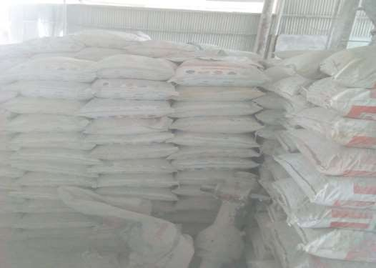

**Plate 2.1:** Packaged economic minerals from one of the quarry site

## Dolomite rock composition, physical properties and uses

Dolomite is a regular rock-forming mineral. It is a calcium magnesium carbonate with a chemical composition of CaMg(CO3)2. It is the principal component of the sedimentary rock identified as dolostone and metamorphic rock known as dolomite marble. Limestone that contains some dolomite is identified as dolomitic limestone.

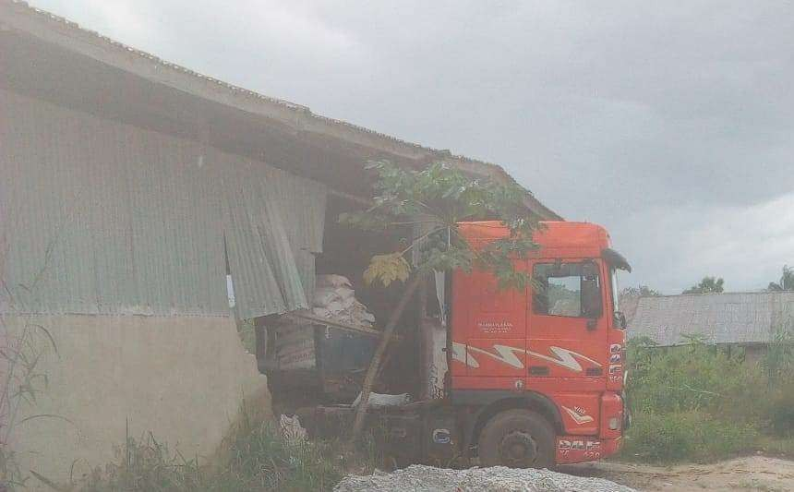

**Plate 2.2:** Truck being loaded for onward transportations to other destination

Dolomite is very akin to the mineral calcite where calcite is composed of calcium carbonate (CaCO3), dolomite is calcium magnesium carbonate (CaMg(CO3)2). These are two minerals that are one of most common pairs to present a mineral classification challenge in the field or classroom (www.geology.com). Table 2.1 show the chemical and physical properties of the minerals studies in this study.

Dolomite rocks are used for road base material, an aggregate in concrete and asphalt, railroad ballast, cements, acid neutralizer, glass, bricks and ceramics (www.geology.com).

## Feldspar rock composition, physical properties and uses

It is the name of a large assembly of rock-forming silicate minerals rock that make up over 50% of earth’s crust. They originate in igneous, sedimentary and metamorphic rocks in all part of the world. Feldspar minerals have very akin structures, chemical composition and physical properties. Common feldspar includes orthoclase (KAlSi3O8), Albite (NaAlSi3O8) and anorthite (CalAl2Si2O8). Feldspar minerals have lots of uses in the industry; they are used to produce a wide range of glass and ceramics products also fillers in paints, plastic and rubber industries (www.geology.com).

**Table 2.1:** Chemical composition and their various properties of the studied mineral (source: www.geology.com)

|  |  |  |  |  |  |  |  |  |
| --- | --- | --- | --- | --- | --- | --- | --- | --- |
|  | **Dolomite** | | **Calcite** | **Feldspar** | |  | **Limestone** |  |
| Chemical composition | CaMg(Co3)2 | | CaCo3 | X(Al1Si)4O8  X can  potassium. Sodium calcium | | be or | Same calcite | as |
| Color | White, gray, black, yellow, brown, | colorless,  pink, green, blue,  orange | White, colorless, gray, green, yellow, brown,  orange | red, blue, | White, colorless, gray, red, green, yellow, blue, brown, orange, black, pink | | Same calcite | as |

Specific gravity

2.8 – 2.9 2.7 2.5 – 2.8 Same as

calcite

Crystal system

Hexagonal Hexagonal Triclinic, Monoclinic

Same as calcite

Luster Vitreous, pearly Vitreous Same as calcite

## Calcite rock composition, physical properties and uses

It is a rock-forming mineral having the chemical formula of CaCO3. It is exceptionally common and found throughout the earth in igneous, sedimentary and metamorphic rocks. It is considered ‘ubiquitous mineral’ – one that is found in all places by geologist. It is the primary constituent of limestone and marble. It properties make it one of the

mainly and widely used mineral. It is used as a construction material, abrasives, agricultural soil treatment, construction aggregate, pigment, pharmaceutical, building material, acid neutralizer, and more. Table 2.1 shows the chemical and physical properties of calcite. In area where streams are plagued with acid excavate drainage; crushed limestone is dispensed into the streams to neutralize the water. It is also use in medicine for stomach acid neutralizer and sorbent materials (www.geology.com).

## Limestone rock composition, physical properties and uses

Limestone is a sedimentary rock composed principally of calcium carbonate (CaCO3) in the type of the mineral calcite. It is commonly forms in clear, warm, shallow marine waters. It is usually organic sedimentary rock that forms from the gathering of shell, coral, algal, and faecal debris. Obviously, it has the same chemical composition and physical properties as calcite (see Table 2.1). Limestone, by definition is a rock that contains at least 50% calcium carbonate in the form of calcite by weight and it also contain at least few of other materials includes feldspar, quartz, clay mineral, siderite, pyrite and more. It is used for road base, rail road ballast, aggregate in concrete, cement, floor tiles. It is used for heat - resistant coating on asphalt-impregnated shingles and roofing, acid neutralizer, fertilizer, medicine, paints, toothpaste, ornaments, feedstock and many more (www.geology.com)

## Radioactivity

Subsequent to the discovery of radio-activity in 1896 by A. H. Becquerel (Allisy, 1996), the sciences of radio-activity and radiation have been comprehensively studied. Radionuclides are the sources of radio-activity and emit ionizing (nuclear) radiations which have become component of our daily lives. Radioactivity can be said to be the spontaneous nuclear transformations in unstable atoms that result in the creation of new elements. These transformations are characterized by numerous mechanisms, which

include alpha-particle emission, beta-particle and positron emission, and orbital electron capture. It is worth noting that radio-activity and radioactive properties of radio-nuclides are determined by nuclear considerations only and are independent of the chemical and physical state of the radio-nuclides (Cember and Johnson, 2009). Humans, living on the Earth’s surface, have always been exposed to natural ionizing radiations such as terrestrial and extra-terrestrial radiations. The origin of terrestrial radiation is owing to the presence of naturally occurring radio-nuclides such as potassium and the decay chains of thorium and uranium, that are in varying amounts in rock-forming minerals and soils; while extra-terrestrial radiation is owing to high-energy cosmic-ray particles. It is well known that the Earth’s surface is covered with rock and rock-forming minerals such as dolomite, granite, marble, feldspar and others and these are the principal terrestrial sources of radiation in the surroundings that contribute to natural occurring radio-nuclides (NOR) (Nanjundan *et al*., 2018). Naturally occurring radio-active materials (NORMs) of Thorium series, Uranium series and Potassium series are present all over in the earth’s surface and their concentration depends on the composition of earth materials and all these radio-nuclides produces radiological hazards either below or above recommended limits (Ali and Ibraheem, 2017). Radiological exposure to the general public arises from two pathways: external and internal radioactive sources. Irradiation of the human body by external sources is mainly owing to gamma radiation from 238U (226Ra) and 232Th decay series and 40K series. At undisturbed state of these NORM, the level of natural environmental radioactivity is low compared to world mean activity concentrations of 226Ra, 232Th and 40K given by UNSCEAR (2010) but it can be increased by anthropogenic activities (Dallou *et al.*, 2017). The properties of radiations have been extensively applied to diverse purposes such as health, biology, industry, agriculture, medicine and electric power generation (Eisenbud and Gesell, 1997). As a

result of the uses of radiation, human beings can be exposed to the radiation emitting from different radioactive sources depending upon their activities and the environments (Klement, 1982). However, not all of the inhabitants is subjected to all the diverse sources of radiation exposure. For instance, patients who are treated with health irradiation or members of the staff who work in the quarry industries may receive higher radiation exposure levels than members of the public (Watson *et al*., 2005).

Nearly all noticeable radiation sources to which all persons are exposed (both in working and public domains) are the ionizing radiation originating from radio-nuclides in the earth’s surface and the interaction of cosmic rays on the earth’s surrounding (UNSCEAR, 2000). According to the National Council on Radiation Protection and Measurements (NCRP) the foremost source of radiation exposure to human beings is due to radiation of natural origin in the environment (NCRP, 1975).

## Radioactivity decay law

The spontaneous transform of an unstable nuclide into another is called radioactive decay. The unstable nuclide is called the parent nuclide while the nuclide that results from the decay is identified as the daughter nuclide. The daughter nuclide possibly will be stable, or it may decay itself.

The radiation created during radioactive decay is such that the daughter nuclide lies closer to the band of stability than the parent nuclide, so the location of a nuclide relative to the band of stability can serve as a guide to the type of decay it will undergo Although the radioactive decay of a nucleus is too small to see with the bare eye, we can indirectly view radioactive decay in a setting called a cloud chamber.

## Types of radioactivity

Figure 2.1 show briefly the types of radioactivity.

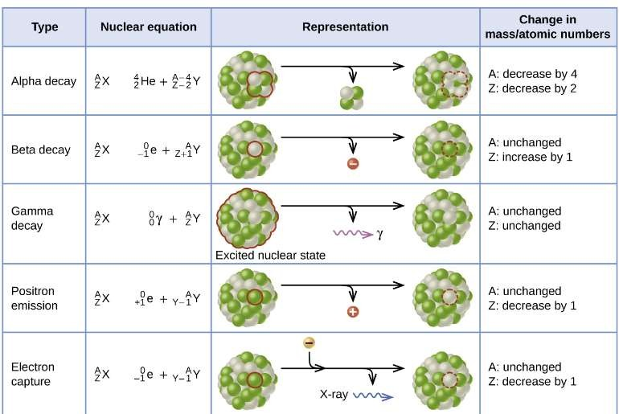

**Figure 2.1;** Summary of the form radiation, nuclear equation, representation, and any changes in the mass or atomic numbers for different types of decay (https://opentextbc.ca/chemistry/chapter/21-6-radioactive-decay/)

## Gamma Ray Spectrometer

* + 1. **Gamma - ray spectrometry technique**

Gamma ray spectrometry is a radio-chemistry measurement technique that estimates the energy and count rate of gamma rays emitted by radio-active materials. Gamma spectroscopy is an exceptionally important measurement. A comprehensive analysis of the gamma ray energy spectrum is used to establish the identity and quantity of gamma emitters available in the samples. The apparatus in gamma spectrometer includes a gamma detector, a pulse sorter (Multi Channel Analyzer) and associated amplifiers and data readout devices. The detector is a sodium iodide NaI(Tl) thallium scintillation counter.

## Radiation Physics

Radiation can be defined as the propagation and emission of energy in the appearance of rays or waves from the atoms and molecules of a radioactive substance as a result of

nuclear decomposition. It is said to be classified into two major types; namely ionizing and non-ionizing. Ionizing radiation is the type of radiation that is capable of ionizing an atom. Ionization occurs when one of the orbital electrons of an atom is been entirely removed. Radiation or radiological physics can be studied naturally in two parts: physics of the atomic and nuclear physics. Radiological physics is the study of the science of ionizing radiation and its interaction with material matter, with unique interest in the energy that is absorbed. Radiological physics has it origin with the discoveries; of radioactivity by Henri Becquerel, the x-rays by Wilhelm Rontgen, of radium by the Curies in the 1890s. Within a very little time both x-rays and radium became useful apparatus in the practice of medical science. The historical development of radiological physics since then is in itself interesting and has aided scientists in understanding the quantities and units used in this area today.

## Radiations Associated with Rock Types

Radioactivity of a natural origin is wide stretch in the earth’s surroundings and it exists in various geological formations in soils, rocks, water, plants and air (Kolo *et al*., 2017). The major radioactive materials are long-lived radio-nuclides as listed 238U, 232Th, and 40K known as NORM. These and other radio-nuclides comprise the terrestrial sources of ionizing radiation. The activity concentrations of these radio-elements ranges considerably and depend on the formation types of the mineral rock. For example in sand stone and limestone regions, the concentrations are much lower than in granite areas. All human beings are exposed to this ionizing radiation by external sources (e.g. terrestrial and cosmic radiations) which irradiate the human body with gamma while the internal hazard requires the integration of radioactive materials into the body through ingestion or inhalation.

In addition to the inevitable natural background radiation sources, man is exposed to various other sources of radiation resulting from man-made human activities such as mining, blasting, medical uses of radiation, radioactive wastes and occupational exposures from nuclear reactors, quarries and nuclear facilities. In current times, there is a better awareness of the effects of environmental background radiation from natural radioactivity which has been increased by some environmental fields such as soil, rocks, air, water, mining and quarry activities. Attention has been set to radioactivity contents and radiation exposure levels in different types of solid materials owing to natural occurring radioactivity. Radiation, by its very character, is detrimental and also useful to life. Depending on the doses, it can induce cancer, genetic and organ damages, killing of cell and also rapid death.

Gulcin *et al.* (2017) studied the radioactivity concentration levels and radiological risk in some building materials (limestone, clay, trac, iron core, gypsium and other) at the province of Kars, Turkey and the study shows some level of hazards present in the area also the same approach was also used in investigating the radiological implication of coal-mining at Maiganga coalfield by Kolo *et al.* (2017) and found presence of radiological hazards even though less than the world standard.

Assessment of these radio-nuclides in soil, rock and buiding material in numerous parts of the earth has been on the increase in the past few decades because of their hazards on the health of the general population (Belivermis *et al*., 2009; Mc-Aulay and Morgan, 1988; Sesana *et al*., 2006; Gbadebo and Amos, 2010; Matiullah *et al*., 2004; Tahir and Alaamar, 2008; Veiga *et al*., 2006, Penabbei *et al*., 2018). Through the past few years, particular attention has been committed to the effect of natural radiation in construction materials (dolomite, granite, calcite, feldspar and others) in Asian, European and some African Countries (Shittu *et al.,* 2015; Ebiad and Bakr, 2012; Adagunodo *et al*., 2018).

Rafique et al. (2014) reported a studied done in the Azad Kashmir state, Pakistan, a state that is rich in three in these rock types, namely; metamorphic, sedimentary and igneous rocks. These rocks types contain extensive deposits of graphite, limestone, marble, quartzite, dolerite, granite and sandstone, that are commonly use in construction industries in Azad Kashmir, Pakistan. The report shows that thirty (30) rock samples were collected from diverse geologic formations of the Muzaffarabad Division, Azad Kashmir and the specific activities concentration of 226Ra, 232Th and 40K in them were determined using a P-type coaxial high-purity germanium detector. It was observed that the highest gamma dose rate values for metamorphic, sedimentary and igneous rocks were found to be 83.16 ± 1.08, 135.87 ± 1.18, and 115.98 ± 1 nGy/h, respectively. The radium equivalent activity (Raeq) varied from 23.76 ± 1.15 for dolomite sample (igneous rock) to 293.69 ± 2.60 Bq/kg for marble (metamorphic rock). The Raeq values of all rock samples were lower than the limit mentioned in the Organization for Economic Cooperation and Development (OECD, 1979) report (370 Bq/kg, equivalent to γ-dose of 1.5 mSv/y). The external (Hex) and internal hazard indices (Hin) values were less than one (1). The average outdoor and indoor annual effective dose equivalents are 0.073 mSv/y and 0.29 mSv/y, respectively. The average (over all types of rock samples) annual effective dose equivalent was reported as 0.36 mSv/y.

Tzortzis *et al*. (2003) investigated the gamma-ray measurements of naturally occurring radio-active samples from Cyprus characteristic geological rocks using high resolution gamma ray spectroscopy (HPGe) detector and found out that the specific activity concentrations for 232Th ranges from (1.3 to 52.8) Bq/kg, 238U from (0.9 to 90.3) Bq/kg and 40K from (13 to 894) Bq/kg. The gamma absorbed dose rates in air (outdoors) were calculated to be in the range of 0.1-50 nGy/h with an general average value of 14.7±7.3 nGy/h. The equivalent effective dose were also estimated to be in the range from 0.1-

61.4 µSv/y which is below the worldwide mean value of 70µSv/y (UNSCEAR, 2008).

The studies concluded that the inhabitants of the Island are open to a radiation exposure, that is not significant.

El-Arabi *et al*. (2007) examined the assessment of terrestrial radiation doses rate level for some Egyptian granite rock samples and found out that the mean dose rates values for outdoor and indoor air for granites of Egypt tripple the world average. while the corresponding mean values for Qash Amir and Hamra dome granites (both in Egypt) are five and six times greater than the world average respectively.

Ebiad and Bakr (2012) did a comprehensive studies on the radiological hazards resulting from granite and marble that are used in building industries in Eqypt using HPGe and the studies showed that the spaecific activity concentrations of natural radio-nuclides in the collected samples were within the measured values when compared with similar samples studied in Egypt and other countries. The absorbed dose rate level in most of the samples collected were higher than the world average value owing to the high activity of 40K. Other dose rate criteria, that is radium equivalent (Raeq), external hazard index and gamma index were lower than the international safety recommendations. It was observed that neither the marble nor granite samples under studied shown any indications of doses exceeding the regulatory restrictions.

Ibrahim *et al.* (2014) did carried out the assessment of natural radioactivity of some quarries raw products in the Governorate of El-Minya, Egypt using a high purity germanium (HPGe) detector. The studied was conducted in (10) quarries sites located in 5 different districts at El-Minya and found out that the activity concentrations of 238U, 232Th and 40K ranged from (25.0±0.3 to 68.0 ± 0.9) Bq/kg, (37.0 ± 0.4 to 88.0 ± 2.0) Bq/kg, and (480.0 ± 11.0 to 820.0 ± 13.0) Bq/kg. The research revealed that the highest activity concentrations of 232Th and 238U were found in Gabal El-Tire whereas 40K was

found in Nazlet Hussain. The lowest activity concentration of 232Th, 238U and 40K were observed in Zawyet Sultan.

Alnour *et al.* (2012) carried out the determination of the activity concentration of natural radio-nuclides in the granite from selected quarry sites in the state of Johor, Malaysia and their likely radiological effects using gamma spectrometry detector. The studies found out that the activity concentrations of 238U, 232Th and 40K in the areas studied which indicated varying values of 238U, 232Th and 40K. The maximum values of 238U and 232Th concentrations (67±1 and 85±2 Bq/kg) respectively and were observed at Kamad Quarry (IJM), whereas the maximum value of 40K concentration (722±18 Bq/kg) was detected in Kim Seng Quarry, while the values of activity concentration are minimum in Hanson Quarry Products (Kulai) (25±0.5 for 238U, 24±0.5 for 232Th and 429±11 for 40K). Generally, 40K has the maximum specific concentration in the granite rocks of the quarry sites. The gamma absorbed dose rate was found to be 75 ± 2 nGy/h and effective dose ranged from 58 to 137 μSv/h. Moreover, the internal and external hazard index values were lower than unity.

Kinyua *et al*. (2011) investigated the activity concentration of primordial radio-nuclide in stone quarries in Kenya using a P-type intrinsic germanium detector. Stones at various depths were collected for the gamma spectrometry analysis. The results of the radionuclides concentration of 238U, 232Th and 40K obtained varied at different depth and locations. According to their finding the variation of natural radioactivity levels at different sampling sites was due to the variation of concentrations of radio-nuclides in the geological formations. Furthermore, the concentrations of the primordial radio- nuclides were all above the worldwide value as recommended (UNSCEAR, 2010). The presence of such high radioactivity was ascribed to the presence of mineral rocks such as zircon, iron oxides, fluorite and other radioactive associated minerals also Caspah *et al*.

(2015) studied the radiological hazards index arising from gold mine tailings in the Geuteng province, South Africa, where it was found that the parameter calculated exceeded the recommended safe limits, posing serious health risk to humans and the environment.

Penabbei *et al.* (2018) investigate the radiological hazards associated with some construction materials at Mayor-Kebbi region in Chad which confirmed that bricks (soils) from some parts of the country did exceed the recommended safe limits but this same method was used for the investigation of building materials at Bangladesh and it was found that the hazards indices was below the recommended safe limits (Khatun *et al*., 2018).

In Nigeria, several measurements of radiation levels in some parts of the country have been carried out by different investigators. Adagunodo *et al.* (2018) observed high pesence of thorium at Ifonyintedo kaolin mining site and Usikalu *et al*. (2018) also revealed the radiactivity concentration and it radiological implication on the dwellers which fell below the world standard. Gbenu (2011) examined the radiological effects of quarry products in southwestern, Nigeria using NaI(Tl) detector. Five (5) quarry products (gravels/dust) each were collected at ten (10) quarry sites in Ogun, Oyo, Osun, Ekiti State and Ondo. The results obtained shows that 40K has the highest activity concentration ranged from (20.76 ± 2.64 to 2003.70 ± 12.08) Bq/kg, 238U ranges from (5.35 ± 0.44 to 71.35 ± 1.13) Bq/kg, while 232Th ranges from (11.04 ± 7.59 to 560.59 ± 37.90) Bq/kg. Also the annual effective dose equivalent of all the samples collected at these quarries were below the safety limit as suggested by International Commission on Radiological and Protection (ICRP, 2010), except that of Igede quarry which is above the safety limit and could pose a health situation to the member of the public.

Gbadebo (2011) examined the assessment of radiation level within and around stone bridge quarry site located close to Ibadan, South-western, Nigeria using a radiation meter. Radiation measurements were done at a depth ans at a distance of 2.0m up to 500m away from the quarry sites. The radiation level was found to be higher in the freshly quarried coarse aggregates than previously quarried crude rock aggregate and also higher in muscovite coarse aggregate than in biotite crude aggregate. The study also reveals that the dose rate and annual effective dose (47.7 nGy/h and 58.5 µSv/y) were below the recommended value. The study concluded that habitual monitoring of the levels of radiation and determination of diverse types of radio-nuclides in the area is recommended in order to put in position suitable policy on health of the populace.

Ademola (2011) investigated occupational exposure rate in quarry industry due to the presence of NORM using gamma-ray spectroscopy detector and found out that the annual effective dose equivalent of workers through different exposure pathways varied from 21.48 to 33.69µSv/y.

Odunaike *et al.* (2008) monitored radiation exposure to workers and villagers in and around some selected quarry sites in ogun state of Nigeria and revealed that the highest annual dose rate or exposure of 49.1 µSv/y was measured which is below the recommended limit of 70 µSv/y.

Ademola *et al.* (2010) reported an increase in the activity concentrations of 238U, 232Th and 40K in mineral and soil samples from a mining site in Ibadan, South-Western Nigeria. The results show that gamma emitting radio-nuclides are associated with rocks and their activity concentrations could be more than the world benchmark values for radiation safety. Essien and Akpan (2016) studied and investigated the soil around

selected quarry sites in part of Akwa Ibom State Nigeria for radiological hazards and found that it was below the recommeded level.

Ndinwa and Ohwona (2014) reported the environmental and health impact of quarrying/ mining in Igarra Area. The report revealed the state of health hazard emanating from the exploration of earth resources by quarrying technique and subsequent processing, notable amongst other health challenges are radiological health challenges, hence the report suggested that prominence should be shift to sustainable exploration of the earth’s resources while the enforcement agencies should ensure that quarrying and mining of these economic minerals by prospectors are in line with quarry act of Nigeria 1979.

Similarly Osahon and Abiola (2014) assessed the background gamma radiation of GeoWork quarry site in Igarra Area using digital Geiger counter GCA-07 model, calibrated with cesium -137 (137Cs) with a radiation monitor. It was found that the radiation value were lower than dose limit prescribed by ICRP for all persons other than those occupationally exposed. The report however concluded that the continuous exposure of the staff, environment and the general populace may constitute health hazards in the near future.

Also Ademila (2018) reported that feldspar is rich in uranium and thorium, a research done at Ikole Ekiti State, Nigeria. The report revealed that the absorbed gamma dose rate, the external hazard and the internal hazard index as well as the annual effective dose equivalent of the study area were below the world standard limit for radiological hazard studies.

In Egypt, Mohamed *et al*. (2016) determined the presence of radionuclide in raw material used in cement manufacturing in Eqypt. These raw materials are limestone, clay, slag and gypsum. The study revealed that limestone has values 238U (0), 232Th (47x10-5

Bq/kg) and 40K (682x10-5 Bq/kg) with external dose rate of 85 (nSv/h) which shows that limestone component of the raw material does not poses any risk to the public.

Elsaman *et al*. (2018), did a study on the natural radioactivity of some selected Eqyptian materials use in glass manufacturing and ceramic. These materials includes limestone, fifteen samples were collected at five location. The activity concentration was determined using gamma-ray spectrometer. The mean values of the activity concentration ranged from 28±2 to 163±12, 2.8±0.7 to 40±3 and from 49±4 to 1337±47 Bq/kg for 226Ra, 232Th and 40K, respectively. The values of gamma absorbed dose rate, radium equivalent and annual effective dose equivalent due to 226Ra, 232Th and 40K respectively are ranged from 22.05 to 101.59 nGy/h, 45.90 to 224.22 Bq/kg and 27.04 to

124.89 μSv/y, hence the study show that limestone as one of the material would not pose any considerable radiological health hazard.

In Turkey, Yapici *et al*. (2017) did a radiological investigation on some selected stones (calcite, dolomite, limestone and others) in Turkey and discovered that the average activity concentrations of 226Ra, 232Th and 40K measured were 28.9, 30.8 and 355.0 Bq/kg respectively. For each stone samples, the activity concentration index, the absorbed dose rate and the annual effective dose were estimated and are shown to meet the exclusion annual dose criterion with the exception of sample “Aksaray 1”.

In Yemen, Mohamed *et al*. (2016) reported the natural radioactivity concentration of Precambrian rocks (gneissic granite, alkali feldspar granite and pegmatite-apltes) and revealed that the absorbed dose, the radium equivalent, the external and the internal hazard indices, the gamma representation index and the excess lifetime cancer risk for alkali feldspar granite were 148.28 nGy/hr, 279.94 Bq/kg, 0.81. 0.98. 1.32, 7.19, respectively. These results shows that the potential of people having cancer is very low.

Shittu *et al*. (2015) investigated hazards emanating from granite at selected quarry sites in FCT Abuja, Nigeria using gamma spectrometry technique and showed that the activity concentration of the 226Ra, 232Th and 40K were greater than the safety limits while radium equivalent (Raeq) and annual effective dose equivalent (AEDE) were below the safety level. Kolo (2014) carried out gamma spectrometry technique on phosphate rock and found that all the studied hazard parameters were greater that the safety limits, also Aborisade *et al*. (2018) using the same technique on sample from a mining site in Nasarawa state, Nigeria discovered that the annual gonadial dose equivalent and other hazards indices were greater than the safe limits as recommended. Abdullahi *et al*. (2018) showed that the safety levels were not exceeded by their evaluated hazard parameters of tiles in Malaysia. Kolo *et al*. (2017) worked on a samples from a mining site at Maiganga, Nigeria and the investigated hazard parameters were below the safety limits.

## Effects of Radiation in Biological System

When the human being is exposed to some radiation, of either external or internal sources, excitation and ionisation of atoms and molecules can be formed. Subsequently, the interaction of radiation with biological organisms can result in the harm and death of living cells and or the mutation of genetic substance. The variation of the biological effects of radiation depends on form of radiation and its energy that is transferred to the irradiated parts of tissues and organs during the exposure time (Noz and Maguire, 2007). The quantification of the total number of ionisation which occurred and the energy absorbed by particular cells related with biological effectiveness can be considered in terms of radiation dosimetry.

## Ionizing and non-ionizing radiation

There is a great difference in the degree of the effects on biological systems of **non- ionizing radiation** (for example, light and microwaves) and **ionizing radiation** (Figure 2.2) that has energy enough to remove electrons out of molecules (for example, α and β particles, X-rays, γ rays and high energy ultraviolet radiation). Energy absorbed from non-ionizing radiation speeds up the movement of atoms and molecules, which is comparable to heating the sample. Although biological systems are receptive to heat (as we might recognize from touching a hot stove or spending a day under the sun in Minna, Nigeria), a huge amount of non-ionizing radiation is required before dangerous levels are reached. Ionizing radiation, on the other hand, may cause much more severe harm by breaking bonds or removing electrons in biological molecules, disrupting their structure and function (https://opentextbc.ca/chemistry/chapter/21-3-biological-effect-of- radiation/).

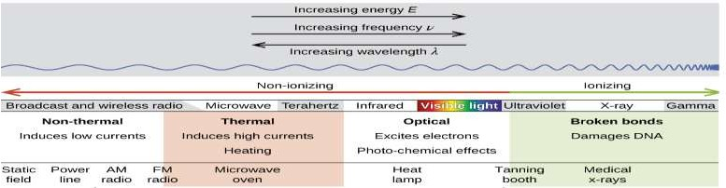

**Figure 2.2;** Ionizing radiation and non-ionizing frequency (https://opentextbc.ca/chemistry/chapter/21-3-biological-effect-of-radiation/).

## Physiochemistry of biological effects of radiation

The rise in the uses of radioisotopes for medical purposes and NORM in various home have resulted to increased concerns over the effects of these resources on biological systems. When this radiation encounters living cells, it can cause damages such as

heating, break chemical bonds, or ionize molecules. The most serious biological damage results when these radioactive emissions fragment or ionize molecules. For example, alpha and beta particles emitted from nuclear decay reactions possess much higher energies than ordinary chemical bond energies. When these particles strike and penetrate matter, they produce ions and molecular fragments that are extremely reactive (Figure 2.3). The damage this does to biomolecules in living organisms can cause serious malfunctions in normal cell processes, taxing the organism’s repair mechanisms and possibly causing illness or even death (https://opentextbc.ca/chemistry/chapter/21-3- biological-effect-of-radiation/).

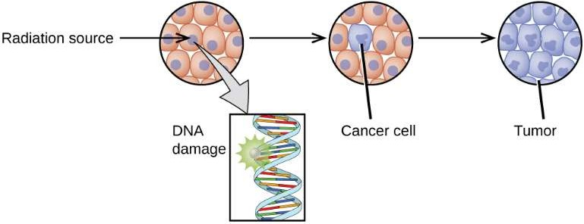

**Figure 2.3;** Schematic diagram of how radiation can damage biological systems by damaging the DNA of cells. (https://opentextbc.ca/chemistry/chapter/21-3-biological- effect-of-radiation/).

## Radiation Dosimetry

Radiation dosimetry deals with the measurement of the absorbed gamma dose or gamma dose rate resulting from the interaction of ionizing radiation with material matter. More generally it refers to the determination (i.e., by measurement, estimation or calculation) of these quantities, as well as any of the other radiological relevant quantities such as exposure rate, fluence, kerma, dose equivalent, energy imparted and so on. A dosimeter can be defined as any gadget that is capable of providing a reading (**r)** that is a measure

of the absorbed dose (**D)** that is deposited in its sensitive volume (**V)** by ionizing radiation. (Frank, 2004)

## Types of dosimeter

Radiation survey is associated with the detection of radiation contamination, measurement of natural radiation levels, monitoring the effectiveness of shielding arrangements as well as measuring radiation exposure to staff. There are two major categories of radiation monitoring devices. They include gas filled and scintillation detectors. Gas detection equipments are based on the principle that ions are created when radiation goes through a gas-filled chamber. Electrons released in the chamber are attracted to the center electrode (anode) by a positive voltage potential while positive ions are attracted towards the walls (cathode) of the chamber. This creates an electrical pulse or current which can then be detected and recorded by a scaler or ratemeter (Handloser, 1959; Price, 1964; Fenyves and Haiman, 1969; Ouseph, 1975). Gas filled detectors are of three types; namely proportional counters, ionization chambers and Geiger-Mueller detectors. The principal difference between these detectors is the applied voltage to the chamber, and the class of detector to be used depends on the intensity and the type of radiation field encountered (Martin and Harbison, 2016).

**Ionization Chambers -** Ionization chambers function at very low applied voltage. At very low voltages, ion pairs produced by radiation passing through the chamber may recombine before they are collected and counted. As the voltage of a gas filled detector is increased, virtually every ion pair produced by the incident radiation will be captured. The electric current flowing through the meter is therefore directly proportional to the activity of the source. This feature makes ionization detectors very useful as radiation monitoring devices. Survey equipments operating at this voltage are called ionization chambers. Since almost all ion pairs are collected, this equipment is used when it is

necessary to accurately establish exposures rate. Ionization chambers still, are relatively ineffective for measuring rates less than 1 mR/hr, and are slow to respond to changing fields. For this reason, ion chambers are not helpful for detecting radiological contamination. They are principally used to determine exposures level in areas of high radiation intensity (Noz and Maguire, 2007; Cember and Johnson, 2009; Lilley, 2001).

**Proportional Counters -** As the applied voltage of the tube is increased, electrons are accelerated quicker and achieve adequate energy to create secondary ionizations in the gas. This magnification is called an avalanche and dramatically increases the size of the electrical pulse at the central anode. Gas multiplication can create millions of ion pairs per ionizing event, in contrast to the ionization chamber which creates one ion pair. Even though an avalanche has occurred, gas magnification is proportional to the energy of the initiating event in this voltage region. Radiation monitoring equipments operating in this state are therefore called proportional counters. With adequately thin windows, alpha particles which produce a large number of ions in the gas, can be distinguished from beta particles. In addition, the counter can be used to measure the energies of incoming gamma rays (Noz and Maguire, 2007; Cember and Johnson, 2009; Lilley, 2001).

**Geiger-Mueller (GM) Counters -** The Geiger-Mueller counter is the most commonly used area survey equipment for the detection of low-level radioactive contamination and exposure. It is very sensitive, rugged and relatively inexpensive. Radiation passing into a Geiger-Mueller tube (naturally containing helium, neon, or argon) produces ions that are accelerated by a high voltage potential of approximately 1200 volts. Secondary ionizations are produced from collisions with the accelerated ions. These ions are also accelerated and achieve adequate energy to form additional ions. This practice eventually produces an avalanche of billions of ion pairs from the initial ionization and creates a large electrical pulse at the anode. The magnitude of the output pulse is

autonomous of the nature of the particle or its energy because gas magnification has reached its maximum potential (Noz and Maguire, 2007; Cember and Johnson, 2009; Lilley, 2001).

A key disadvantage of Geiger-Mueller counters is their limitation to low radiation fields, typically below 200mR/hr. This is however within the expected values for radioactivity from natural origin. Once ionizations have been initiated in a Geiger-Mueller tube, it becomes insensitive for a short time, termed the dead time, and will not respond to further ionizing events. Subsequently, the number of counts recorded will be less than the true count rate. This error is relatively very small at low radiation intensities (Noz and Maguire, 2007; Cember and Johnson, 2009; Lilley, 2001).

**Scintillation Detectors –** These detectors operate on the principle that some materials scintillate or give off light when subjected to radiation. Scintillation detectors use a crystal that releases light when exposed to X-rays or gamma rays. There are two forms of scintillation detectors namely; liquid and solid. Nearly all solid scintillation crystals are made of sodium iodide with a little amount of thallium added as an "activator". The crystal is coupled to a photomultiplier tube that converts the light flashes to magnified electrical pulses and magnification factors of a million or more are achieved. The numbers of pulses are directly proportional to the intensity, and the size of the pulse is directly proportional to the energy of the incident radiation. These pulses can then be analyzed by a counter, oscilloscope, spectrometer or computer programs (Noz and Maguire, 2007; Cember and Johnson, 2009; Lilley, 2001).

Since scintillation crystals are solid, rather than gaseous, their higher density and atomic number makes them very efficient and sensitive equipments for the measurement of x- rays and gamma rays. The crystal in a solid scintillation detector can be thick or thin. The thick crystal has a range from about 50KeV to 1 MeV while the thin crystal has an

energy range of approximately 10-60 KeV. Scintillation detectors, are not as rugged as Geiger counters because the crystal is hygroscopic and can absorb water from the atmosphere.

Liquid scintillation detectors use organic compounds that give off light when radioactive substances are added to a liquid scintillation cocktail (LSC).

Material from a swipe is suspended or dissolved in the solution, and nearly all of the emitted radiation passes through some portion of the scintillator. The light is detected by photomultiplier tubes, analyzed and counted in a manner comparable to solid scintillation detectors (Noz and Maguire, 2007; Cember and Johnson, 2009; Lilley, 2001).

## Basic radiation quantity and unit of exposure

The ‘roëntgen’ (R) is the unit to express the radiation exposure that can be defined as the amount of ionisation that *X*- or  radiation produces in air. This unit accounts for the production of 1*esu* of electrical charged of either sign in 1 cm3 or 0.001293 g of air at standard temperature and pressure. Since 1 *esu*= 3.3 x 10-10 coulomb, the exposure unit can be expressed in the SI system as (Knoll, 2000).

(2.1)

The exposure unit is designated only for restricted energy range *X*- or  radiation interacting with air.

## Absorbed dose

One limitation of the exposure unit is that it does not reflect the biological significance of the radiation. A unit considering the quantity of energy absorption by any form of ionising radiation in any kind of material was introduced. The absorbed dose is measured

in units of ‘gray’ (Gy) where 1Gy equals to one joule of absorbed energy per one kilogram of irradiated target (Cember and Johnson, 2009). The absorbed dose can be expressed in another unit called the ‘rad‘(radiation absorbed dose). The rad is the original unit and is defined as an absorbed energy of 100erg per gram. It is related to the gray as follow:

Since 1 *J* = 107ergs.

(2.2)

The total absorbed energy is not the only factor which determines the level of biological damage from the radiation. The type of radiation and its energy also have to be considered. In general, the biological effect of highly ionizing radiation in a tissue is more severe per unit absorbed dose than those of radiation which produce low ionization. For this reason, the term relative biological effectiveness (RBE) was introduced as a dimensionless quantity of the amount of absorbed dose of ionising radiation relative to that of X- or  radiation of a particular energy to provide the same biological response (Cember and Johnson, 2009). Due to the difficulty in applying such complicated functions of energy, RBE has been normalized to a factor known, as the radiation weighting factor (WR) by the ICRP and NCRP (Noz and Maguire, 2007). This factor is derived from the RBE over the range of energies for a particular type of radiation.

## Equivalent and effective dose

In order to determine the effect of the nature of the radiation by the weighting factor, a unit called the equivalent dose (HT) is specified. This is the amount of the dose (DT,R) absorbed over a tissue or organ (T) due to radiation (R) and is given by (Cember and Johnson, 2009).

(2.3)

The “Sievert” (Sv) is used to express the equivalent dose when the absorbed dose is in units of Gray (*Gy*); thus one Sievert is also equal to one joule per kilogram. An older unit of the equivalent dose is the ‘rem’ (radiation equivalent man) with the absorbed dose expressed in units of rad, hence, 1Sv equals 100rem (Knoll, 2000).

In addition to the radiation types and energy, the biological effect to radiation is concerned with the sensitivities of irradiated organs or tissues. The variation of radiation sensitivity of each organ is taken into account in the contribution of the equivalent dose in all tissues and organs of the body. The new terms the effective dose (E) and the tissue weighting factor (WT) are introduced. The definition of the effective dose is the sum of the equivalent doses weighted by the tissue weighting factors for each tissue, as given in the following expression (Cember and Johnson, 2009; Noz and Maguire, 2007; Martin and Harbison, 2006).

(2.4)

Considering equations 2.3 and 2.4,

(2.5)

## Sources of Radiation Exposure

Human beings are unavoidably exposed to ionising radiation either from external exposure arising from radioactive sources outside the body or internal exposure which comes from radioactive substance inside the body (UNSCEAR, 2000; UNSCEAR, 2010; Martin and Harbison, 2006). Both internal and external radiation exposure to living things mainly arises from the natural sources. In addition to the natural sources, the use of radiation and radioactive substances by human activities is an added source of radiation exposure to living things (UNSCEAR, 2000).

## Natural sources

The natural sources of radiation exposure are cosmic radiation from the outer space and radioactive materials present in the earth’s environment and wider environment, including the body of humans itself. About 85% of the average annual exposure dose rate of 2.4 mSv received by the world inhabitants is from the sharing of these natural radiation sources (Lilley, 2001; WNA, 2011; UNSCEAR, 2008). Fifteen percent (15%) of the total dose from natural sources is owing to cosmic ray interactions at sea level. Latitude and particularly altitude are the parameters which give rise to dose rate variations from these environmental exposures (UNSCEAR, 2010). Exposure dose from cosmic radiation /rays at the cruising altitude of commercial or other aircraft is considerably higher than those at the sea level (Lilley, 2001; UNSCEAR, 2010). In addition to cosmic-ray induced radiation, primordial radio-nuclides are a major contribution to the annual exposure dose owing to natural sources. These naturally occurring radioactive materials include radio-nuclides which belong to the uranium and thorium decay chains, and natural radioactive potassium (40K) are present in at least trace amounts in largely geological materials in the earth’s crust (NCRP, 1975). Gamma radiation arising from these radio-nuclides is the major source of natural, background, external exposure to human beings. The concentrations of such radio-nuclides at different places are a factor in the variation of external exposure due to gamma radiation from one place to another (UNSCEAR, 2000; UNSCEAR, 2010). Ingestion and inhalation of primordial radio-nuclides can give rise to irradiation of organs inside the body. Airborne radio-nuclides, such as 222Rn from the 238U decay chain, can enter the human body by inhalation and symbolize a significant source of internal exposure to human system (Lilley, 2001; UNSCEAR, 2010).

## Artificial sources

Human activity involving the uses of radiation is another source of radiation exposure to human body. Some of these activities can give rise to an enhance level of exposure from natural sources such as the discharge of radioactive materials into the environment from nuclear power plants, the global dispersion of radio-nuclides from the nuclear weapon testing or the atmospheric fall-out resulting from the nuclear reactor accidents at Chernobyl (Martin and Harbison, 2006; UNSCEAR, 2010) and more lately Fukushima. Nevertheless, the main artificial source of the annual dose rate received by the worldwide population is the application of radiation in medical and health sectors (UNSCEAR, 2008). Also, some special groups of people who work in radiological industries, medicine and research may be occupationally exposed to radiation used in their daily activities.

The mean dose rate arising from occupational exposure is relative little when compared with the radiation exposure from natural origin (UNSCEAR, 2008).

## Radiation Protection and Dose Limits

Since ionising radiation can harm biological systems or organs in the human body, there have been numerous studies relating to the biological effects of radiation. The aims of these studies were to institute dose rate limits in order to protect radiation workers and the general public from radiation exposure. A lot of the understanding of radiation effects on humans has been obtained from a group of people who survived from the atomic bombs in Hiroshima and Nagasaki and those persons who received radiation exposure from schedule work or accidents (Eisenbud and Gesell, 1997; Cember and Johnson, 2009). The correlation between biological effect and radiation exposure was investigated by the Biological Effect of Ionising Radiation (BEIR) in harmony with the United Nations Scientific Committee on the Effect of Atomic Radiation (UNSCEAR)

and the International Commission on Radiological Protection (ICRP), as shown in Figure 3.6. Early reports used a linear relationship between the effect and the amount of exposure (shown in curve A) as a ‘linear, no-threshold’ hypothesis. Further reports also allowed the possible hypothesis of a different trend (curve B) with the radiation exposure at very low levels not significant to cause harmful effects; this is referred to as the ‘threshold effect’. Curve C represents the hypothesis with the opposite effect, where absorbed doses of ionising radiation at low levels are extra dangerous (Cember and Johnson, 2009; Noz and Maguire, 2007).

The consequence of radiation exposure can be classified into deterministic effects and Stochastic effects **(**Cember and Johnson, 2009; Noz and Maguire, 2007; Martin and Harbison, 2006). The effects which can be seen when organs of the body received a certain level of dose or threshold are called deterministic effects, less than this threshold, detrimental effects are not seen. The response of the effect is similar to curve B in Figure 2.4.

The brutality of the consequence increases with the size of the dose level (Cember and Johnson, 2009; Martin and Harbison, 2006). Stochastic effects occur haphazardly and the probability of occurrence is dependent of the size of dose (Cember and Johnson, 2009). Cancer induction and genetic effects in upcoming generation are thought to possibly outcome from these types of the effects. The expected association between the probability of the stochastic effect and the size of dose is along the lines of curve A in Figure 2.4.

To avoid avoidable exposure causing the biological effects of radiation to radiation staff and the public in general, all doses have to be kept as low as reasonably achievable (ALARA) with the dose limits suggested by the ICRP (Cember and Johnson, 2009). The

recommendations of the ICRP for radiation protection principles are based on three broad principles as follow:

1. Justification – any practice which does not produce an adequate benefit to the exposed individuals should not be adopted.
2. Optimisation – all exposures within a practice shall be kept as low as reasonably achievable (ALARA) considered with economic and social factors.
3. Dose limitation – individuals should receive exposure dose within the recommended limits.

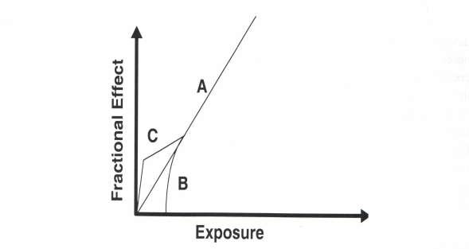

**Figure 2.4:** Possible theoretical dose-response curves, as cited by (Shittu, 2014) These curves show theoretical associations between radiation exposure and the biological effect. Curve A shows the linear relationship between the effect and the exposure. The threshold effect represents the cut-off curve at the low levels of radiation exposure as shown in curve B. Curve C shows a possible increased effect at the low level of exposure (Noz and Maguire, 2007).

# CHAPTER THREE

* 1. **MATERIALS AND METHODS**

## Sample Site

The location of the study area is Igarra Area in Edo State of Nigeria. The Igarra Area lies within Latitudes 7o24′5″N-7o30′N and Longitudes 6o00′E-6o10′5″E at the northern fringe of Edo State, Nigeria. It is the headquarters of Akoko Edo Local Government Area (Figure 3.1). The main public road in the study area runs from Auchi through Ikpeshi, Igarra to Ibillo (Oloto and Anyanwu, 2013).

The study area is situated in the southern region of Nigeria and is underlain in the north by Precambrian Basement Complex and in the south by Cretaceous and Tertiary sediments. The rocks in the area consist of largely crystalline rocks of slightly migmatised to unmigmatised schist belt (compose mica schist, quartz-biotite schist, calc- silicate and marble, quartzite and quartz schist and metaconglomerate) which are enclosed by the migmatite-gnesis complex and intruded in some places by the pan-africa older granite form a good topography (Obiadi *et al*., 2012).

According to Olaniran and Ogbonnaya (2018), Igarra area lies (Figure 3.2) inside the schist belt of Southwestern Basement Complex of Nigeria and the rocks in the study area can be separated into three main groups as follows:

1. Migmatites, biotite and biotite-hornblende gneisses.
2. Low grade metasediments (calc-silicate gneisses, schists, marbles, polymict meta-conglomerate and quartzites).
3. Syn-to-ate tectonic porphyritic biotite and biotite-hornblende granodiorites and adamellites charnokites and gabbros unmetamorphosed dolerite, pegmatite, phyllite and syenite dykes.

Igarra area has undergone more than one epoch of metamorphism and deformation, shearing movements and stress action. Migmatite gneiss is most likely the oldest rock group and might be the foundation rock for the metasediments (quartzites, schists, metaconglomerate and calc-gneisses). Metasediments is similar to fine grained flaggy gneiss, metaconglomerate and quartz-biotite schist. Marble is the early formed by probably medium grade metamorphism from pre-existing rocks such as argillaceous, arenaceous and pellitic rocks and these metasediments occur as supracrustal covers on the migmatites gneiss. The metasediments are later intruded by porphyritic and non- porphyritic varieties of granites and other igneous rocks. Magmatic intrusion into the pre-existing rocks led to the formation of syenite, dolerite and lamprophyle occurring as dykes and sills.

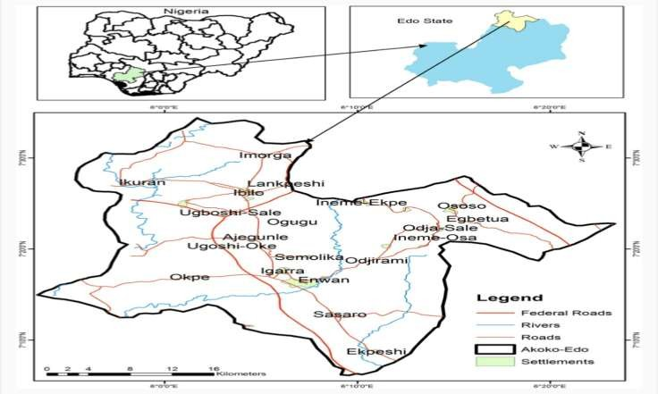

**Figure 3.1:** The Location map of the study area (Olaniran and Ogbonnaya, 2018)

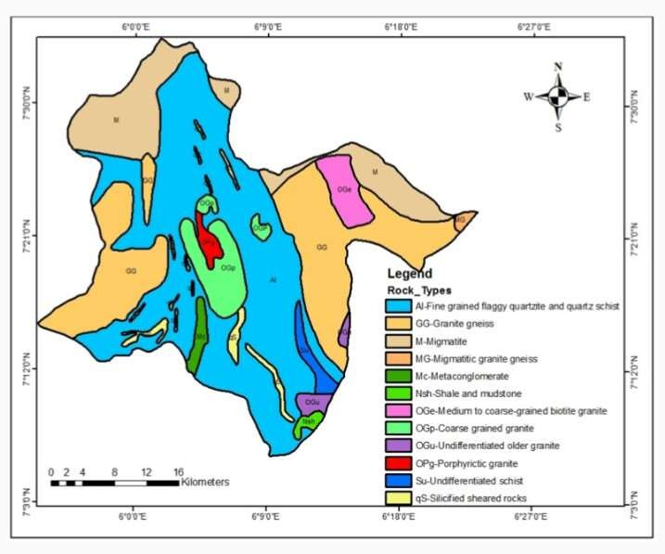

**Figure 3.2:** Geological map of the study area (Olaniran and Ogbonnaya, 2018)

## Sample Collections

The minerals as identified by the geologists and staff on the sites of collection are shown in Table 3.1.

**Table 3.1:** Physical examination of the economic minerals

|  |  |  |  |
| --- | --- | --- | --- |
| **Sample name** | **Sample identity** | **Colour** | **Specific density** |
| Dolomite | DLM | White | 2.8 |
| Dolomite | DLM | Gray | 2.9 |
| Feldspar | FLP | White | 2.6 |
|  | FLP | Brown | 2.8 |
| Calcite | CLT | White | 2.7 |
|  | CLT | Gray | 2.7 |
| Limestone | LME | White | 2.7 |

Plates 3.1 to 3.4 gives the physical representation of four economic minerals used in this study

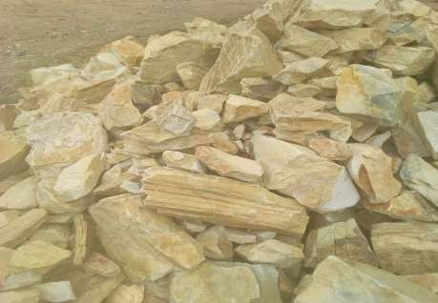

**Plate 3.1**: Solid dolomite before quarry activity

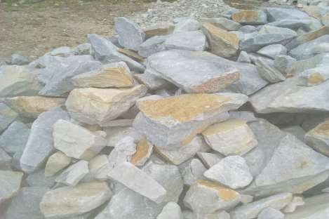

**Plate 3.2:** Solid calcite form before quarry activity

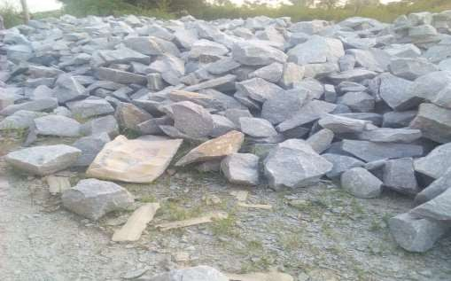

**Plate 3.3:** Solid feldspar before quarry activity

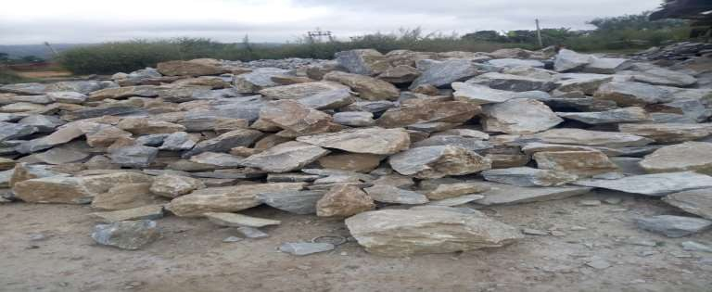

**Plate 3.4**: Solid limestone before quarry activity

## Sample Preparation

Plate 3.5 to 3.7 shown the machines used to pulverized all the economic mineral samples. Ten (10) samples each of the pulverized economic minerals were collected from the quarry .

The collected samples were packed in accurately labelled polythene bags (Plate 3.8), sealed and then transported to the laboratory for further processing.

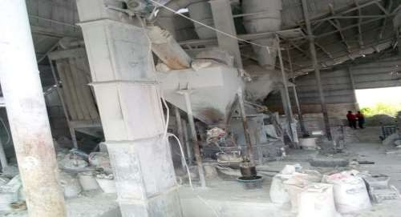

**Plate 3.5:** Side view of the quarry machine at Ipeshi

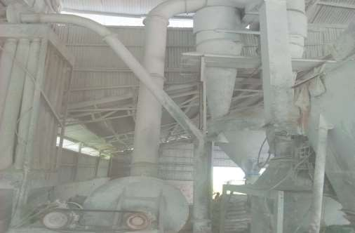

**Plate 3.6**: Front view of the quarry machine at ipeshi

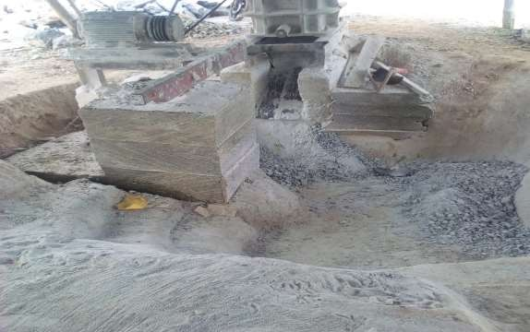

**Plate 3.7**: Quarrying machine at Igarra

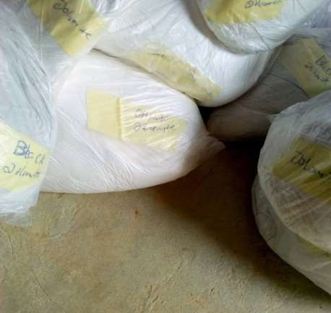

**Plate 3.8**: Samples collected and labelled at the point of collection

The collected samples were air dried at room temperature in the laboratory, sieved and homogenized. An amount of 50±0.1g of each sample was filled into sample containers (Plate 3.9) which were then hermetically sealed using masking tape to avoid the escape of airborne 222Rn and 220Rn from the samples (Plate 3.10). An empty container was weighed and sealed for the measurement of the background.

The sealed samples were stored for at least 28 days prior to measurement in order to attain radioactive secular equilibrium between 226Ra and 228Ac and their short lived progeny (Olarinoye *et al.,* 2014). After the secular equilibrium was attained, the gamma spectrometry measurement of the samples was carried out at the Ladoke Akintola University of Science and Technology, Ogbomosho (LAUTECH).

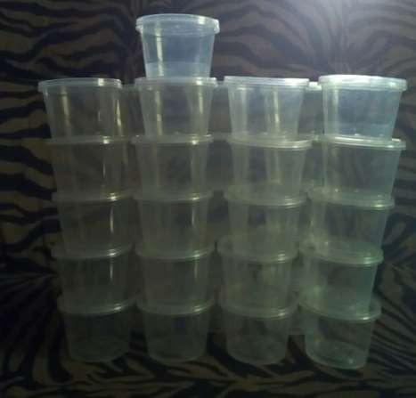

**Plate 3.9**: The empty containers used for the packaging

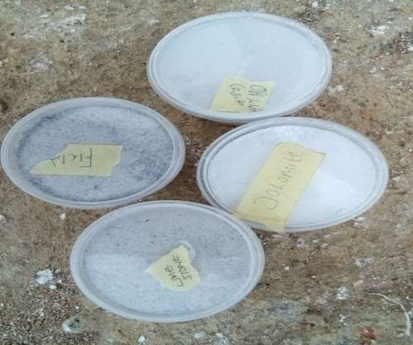

**Plate 3.10**: Final package before the laboratory analysis

## Instrumentation

* + 1. **Sodium Iodide Thallium NaI(Tl) Gamma Spectroscopy**

In this study, the activity concentration of radionuclides in the economic minerals sample was analysed using NaI(Tl) scintillation detector. The experimental set up is shown in Plate

3.11. It was coupled through an amplifier base to a GS-2000-Pro plus Multichannel analyser used for samples analysis. The detector was enclosed in a 10 cm thick cylindrical lead shield to reduce the background radiation from various natural radiation sources and to isolate it from other radiation sources used in nearby surroundings. The crystal size 3 inches by 3 inches. Each of the samples was mounted on the detector surface and each counted for 36,000 seconds. The configuration and the geometry were maintained throughout the analysis. A computer-based multichannel analyzer (MCA GS-2000-Pro) was used for the acquisition and analysis of gamma spectra using comparative method of analysis. The activity concentration, expressed in Bq/kg, of 232Th concentration in these economic

minerals was determined by the 2614.7 KeV gamma lines of 208TI while the 226Ra concentrations were determined by the 1764.5 KeV gamma lines of 214Bi. The activity concentration of 40K was determined from its characteristic gamma line 1460.0 KeV.

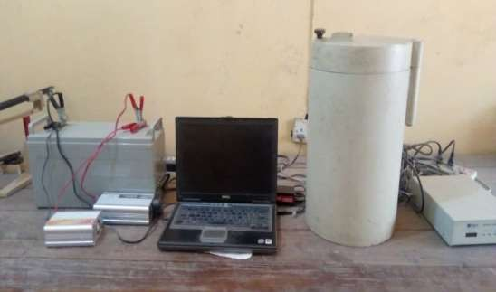

**Plate 3.11:** Laboratory Setup of the detector

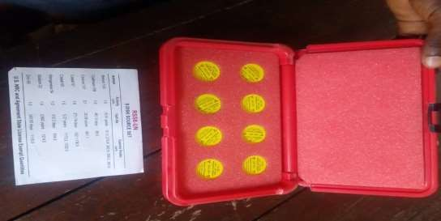

**Plate 3.12**: RSS8 Gamma Source Set

## Energy calibration of Sodium Iodide detector

In order to appropriately identify different peaks in the spectrum, the Sodium Iodide detector was calibrated for its energy and efficiency.

Standard energy sources with recognized gamma-ray energies and activities that are broadly different from those to be measured in the unknown spectrum, supplied by the RSS8 Gamma Source Set (Plate 3.12), Spectrum Techniques, LLC, USA, were used for the energy calibration of the detector. These standard calibration sources used for the calibration are 137Cs and 60Co. The sources were counted for 10 minutes to obtain a well defined photopeak whereas the gain of the system was adjusted so that the photopeak of 137Cs was about one- third the full scale. This ensured that the range of all radio-nuclides of interest was covered. The channel number that corresponds to the centroid of each Full Energy Peak (FEP) of the radionuclide was noted and recorded, as shown in Table 3.2. The recorded values were used to obtain the calibration curve shown in Figure 3.3.

The energy calibration curve assures an precise comparison of the known full energy peaks (FEP) of the standard with the unknown FEP in the samples.

## Table 3.2: Data for energy calibration of NaI(Tl) detector

|  |  |
| --- | --- |
| **Radionuclide Energy (keV)** | **Channel Number** |
| 137Cs 662 | 236 |
| 60Co 1173 | 408 |
| 60Co 1332 | 461 |

Figure 3.1: Energy calibration curve

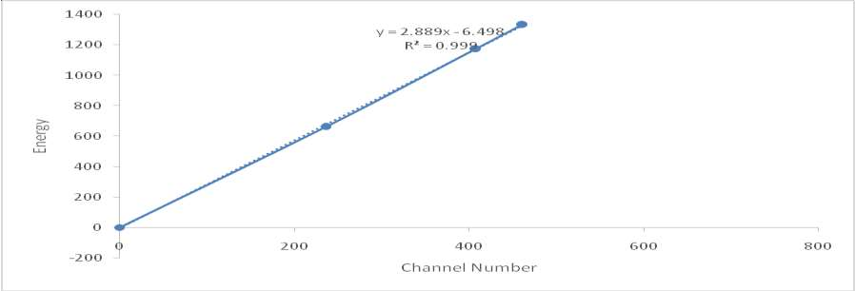**Figure 3.3**: Energy caliberation curve of the source

## Measurement of Radionuclide Concentration

Each of the sample was counted for 36,000 s in order to get appreciable counts under the photopeaks. Canberra S100 gamma ray acquisition software was used for the gamma counting process after which the spectra information was retrieved and the analysis was carried out using the comparative method.

In comparative method, the specific activity of a radio-isotope is obtained by direct comparison with the same radionuclide in a given standard. The specific radioactivity Cx in the sample and the corresponding specific radioactivity Cs in the standard are calculated using the following formula (Gbenu, 2011).



(3.1)

where x denote the sample, s the standard, while M and A, are the mass and the net area under the peaks respectively. This method is used, the sample containers are of the same geometry as the standard and the counting times are the same. Each sealed sample was placed on the shielded NaI(TI) detector and counted for 36000 s. The IAEA reference sample (IAEA-TECDOC-1472, 2005) and the sealed container were counted for 36000 s.

This data analysis routine subtracted a linear net background distribution from the corresponding net peaks area for a particular radionuclide in the spectra of the samples.

## Uncertainty

Uncertainties in gamma ray spectrometry could be as a result of error in the estimation of the nuclides’ specific counting efficiency and the statistical counting errors. These errors were noted in the final determination of radio-nuclide activity concentration from the laboratory.

## Assessment of Radiological Hazards

One of the central objectives of the radioactivity measurement in environmental samples is not basically to determine the activity concentrations of 226Ra, 232Th and 40K but also to estimate the radiation exposure dose rate and to assess the biological effects on humans and environment. The assessment of radiological threat can be considered in diverse provisions. In the current study nine (9) related parameters were estimated, these being: (i) the absorbed gamma dose rate (*D*) in air at 1 metre above the ground surface; (ii) the radium equivalent activity (Raeq), (iii) the annual effective dose (outdoor) from terrestrial gamma radiation,

(iv) the annual effective dose (indoor) from terrestrial gamma radiation, (v) the external hazard index (Hext), (vi) the internal hazard index (Hin) (vii) gamma index and (viii) excess lifetime cancer rate for residential and (ix) excess lifetime cancer rate for occupational dwellers. These radiological parameters are calculated from the measured activity

concentrations of these three major primordial radio-nuclides in these economic minerals, using the equations 3.2 to 3.9 as stated below.

## Absorbed dose rate in air (D)

To assess any radiological hazards, the exposure to radiation resulting from radionuclides present in rock and mineral can be determined in terms of numerous parameters. A direct relationship between radioactivity concentrations of natural radio-nuclides and their exposure is recognized as the absorbed dose rate in the air at 1 metre above the earth surface. The mean activity concentrations of 226Ra, 232Th and 40K (Bq/kg) in the interpreted (analyzed) samples were used to calculate the absorbed dose rate following the formula (UNSCEAR, 2010);

D(nGy/h) = (0.462CRa + 0.604CTh + 0.0417CK) (3.2)

where CK, CRa, and CTh are the activity concentrations of 40K, 226Ra, and 232Th respectively and 0.0417, 0.462 and 0.604 are the dose conversion factors for 40K, 226Ra and 232Th in units of nGy/h per Bq/kq.

## Annual effective dose equivalent for outdoor (AEDEo)

In order to convert the absorbed dose in air to effective dose received by grown-up human, two conversion factors provided by UNSCEAR (2010) are employed. They are 0.7 SvG/y conversion coefficient and 0.25 (6hours/24hours) for the outdoor occupancy factor since the working durations in the quarry site is six hours shift, this factor suggested that an individual spends an average of 20% of his/ her day outdoor. The annual effective dose equivalent is in unit of mSv/y was obtained using the formula (UNSCEAR, 2000; Tzortzis *et. al*., 2003):

AEDE (mSv/y) = D (nGyh-1) x 8760h x 0.25 x 0.7 x 10-6 (3.3)

## Annual effective dose equivalent for indoor (AEDEi)

Also UNSCEAR (United Nations Scientific Committee on the Effects of Atomic Radiation (UNSCEAR 1993 and 2010) used 0.7SvG/y for the conversion coefficient from absorbed dose in air to effective dose received by grown up human and 0.8 for the indoor occupancy factor, this factor suggested that an individual spends an average of 80% of his/ her day indoor. The annual effective dose equivalent is in the unit of mSv/y was obtained by using the following formula (UNSCEAR, 2000; Tzortzis*et. al*., 2003):

AEDE (mSv/y) = D (nGyh-1) x 8760 h x 0.8 x 0.7 x 10-6 (3.4)

where D in equations (3.3 and 3.4 ) has been computed using equation (3.2)

## Radium equivalent activity (Raeq)

Due to a non-uniform circulation of naturally occurring radio-nuclides in environmental samples, consistency with respect to the exposure to radiation has been defined in terms of Raeq measured in Bq/kg to compare the specific activity of materials containing different amounts of 226Ra, 232Th and 40K. Raeq is computed using the equation (Beretka and Mathew, 1985):

Raeq (Bq/kg) = CRa+1.43CTh + 0.077CK (3.5)

where CRa, CTh and CK are the respective activities concentration of 226Ra, 232Th and 40K in Bq/kg respectively. The allowable maximum value of the radium equivalent activity is 370Bq/kg, which corresponds to an effective dose of 1mSv/y for the general public (UNSCEAR, 2000).

## External hazard index (Hext)

The external hazard index is an assessment of the hazard of the natural gamma radiation level. The principal intention of this index is to limit the radiation dose to the acceptable permissible dose equivalent of 1 mSv/y. The external hazard index must be below unity (1).

The external hazard index owing to the emitted gamma-rays of the samples is calculated following relation (Huda, 2011):

(3.6)

## Internal hazard index (Hint)

The internal hazard index must also be less than unity to present safe levels of radon and its short-lived daughters for the respiratory organs of persons living in residential location. The internal hazard index should be less than unity for the radiation hazard to be considered negligible according to Huda (2011) relations

(3.7)

## Representation Gamma Index

This index was estimated based on the European Commission standard. Gamma index (Iγ) is the factor that assesses the γ-radiation hazard(s) associated with the naturally occurring radio-nuclides in a given material. The Iγ is determined using the Equation (Kolo *et al.,* 2017).

Iγ = 0.3333CRa + 0.0050CTh + 0.0003CK (3.8)

where CRa, CTh and CK are the same as for previous estimated hazards. The permissible range of the outdoor annual effective doses’ contributions to the γ-radiation is 0.3 to 1mSv/y. Outside this range it should be exempted from use as a finished products or as raw materials (Adagunodo *et al.*, 2018).

## Excess lifetime cancer risk

Excess lifetime cancer risk ELCR is defined as the prospect that an individual will develop cancer over his or her lifetime of exposure to radiation. The excess lifetime cancer rate was

computed using the equation (Kolo *et al.,* 2017) and was used to estimate the occupational and residential exposure of public.

ELCR = AEDE x DL x RF (3.9)

where DL is the average lifespan (70 years) and RF is risk factor (Sv−1) with value of 0.057, for stochastic effects from low-dose background radiation, the permissible limits is 0.29 x 10-3 (Kolo *et al.*, 2015; Kolo, 2014).

# CHAPTER FOUR

* 1. **RESU LTS AND DISCUSSION**

## Activity Concentration

The specific activity concentrations of the radionuclides226Ra, 232Th and 40K in the selected economic minerals at selected quarry sites across Igarra Area, in Akoko-Edo Local Government Area of Edo State, Southern Nigeria are presented in Table 4.1 to 4.4: The activity concentrations of dolomite (DLM) samples are presented in Table 4.1. The activity concentration of 226Ra ranges from 0.79 to 4.30 Bq/kg with an average value of 2.88 Bq/kg, the activity of 232Th from 0.27 to 3.65 Bq/kg with an average value of 1.61 Bq/kg while that of 40K ranges from 27.41 to 505.19 Bq/kg with an average value of 227.33 Bq/kg. These values are below the world wide average (Table 4.5) by UNSCEAR (2010).

## Table 4.1: Activity concentration of the dolomite (DLM) samples

|  |  |  |  |  |
| --- | --- | --- | --- | --- |
| **Mineral** | **ID** | **226Ra (Bq/kg)** | **232Th (Bq/kg)** | **40K (Bq/kg)** |
| **DLM 1** |  | BDL | 0.27±0.09 | 202.62 ± 3.19 |
| **DLM 2** |  | 4.21±0.23 | 3.65±0.30 | 454.93 ± 7.46 |
| **DLM 3** |  | 4.3±0.24 | 2.29±0.25 | 505.19± 8.19 |
| **DLM 4** |  | 0.79±0.10 | 1.19±0.18 | 267.82±5.96 |
| **DLM 5** |  | 3.28±0.21 | BDL | 27.41±1.91 |
| **DLM6** |  | BDL | BDL | 199.19±4.98 |
| **DLM7** |  | 2.56±0.19 | BDL | 97.36±3.64 |
| **DLM 8** |  | BDL | 0.99±0.17 | 214.34±5.52 |
| **DLM 9** |  | 3.05±0.16 | 0.35±0.11 | 243.24±1.04 |
| **DLM 10** |  | 1.97±0.20 | 2.56±0.28 | 36.52±2.11 |
| **Mean** |  | **2.88** | **1.61** | **227.33** |
| **Min** |  | **0.79±0.10** | **0.27±0.09** | **27.41±1.91** |
| **Max** |  | **4.3±0.24** | **3.65±0.30** | **505.19±8.19** |

BDL = below detectable limit.

Similarly the activity concentration of feldspar (FLP) samples are presented in Table 4.2. The activity concentration of 226Ra ranges from 0.69 to 2.01 Bq/kg with an average value of

1.39 Bq/kg, 232Th. The activity concentration 232Th ranges from 0.52 to 1.06 Bq/kg with an average value of 0.76 Bq/kg while that of 40K ranges from 49.29 to 248.42 Bq/kg with an average value of 152.28 Bq/kg. These values are below the world wide average (Table 4.5) by UNSCEAR (2010).

## Table 4.2: Activity concentration of the feldspar samples

|  |  |  |  |
| --- | --- | --- | --- |
| **Mineral ID** | **226Ra (Bq/kg)** | **232Th (Bq/kg)** | **40K (Bq/kg)** |
| **FLP** 1 | BDL | BDL | 139.93±3.91 |
| **FLP** 2 | 0.69±0.09 | 0.78±0.13 | 224.47±4.95 |
| **FLP** 3 | 1.28±0.11 | 1.06±0.15 | 248.42±4.99 |
| **FLP** 4 | 1.06±0.11 | 0.75±0.13 | 212.45±4.86 |
| **FLP** 5 | BDL | 0.52±0.11 | 164.17±4.16 |
| **FLP** 6 | 1.88±0.15 | BDL | 58.55±2.55 |
| **FLP** 7 | BDL | BDL | 117.66±3.52 |
| **FLP** 8 | 2.01±0.15 | BDL | 49.29±2.30 |
| **FLP** 9 | 1.32±0.14 | 0.83±0.13 | 121.61±4.05 |
| **FLP** 10 | 1.51±0.11 | 0.61±0.15 | 186.28±3.97 |
| **Mean** | **1.40** | **0.76** | **152.28** |
| **Min** | **0.69** | **0.52** | **49.29** |
| **Max** | **2.01** | **1.06** | **248.42** |

BDL = below detectable limit

Also, the activity concentrations of calcite (CLT) samples are presented in Table 4.3. The activity concentration of 226Ra ranges from 0.54 to 10.57 Bq/kg with an average value of

5.54 Bq/kg. 232Th from 1.28 to 6.12 Bq/kg with an average value of 3.81 Bq/kg and 40K from 81.37 to 795.16 Bq/kg with an average value of 466.62 Bq/kg, which shows that the activity concentrations are below the world wide average (Table 4.5) by UNSCEAR (2010).

## Table 4.3: Activity concentration of the calcite samples

|  |  |  |  |
| --- | --- | --- | --- |
| **Mineral ID** | **40K (Bq/kg)** | **226Ra (Bq/kg)** | **232Th (Bq/kg)** |
| **CLT** 1 | 438.77±7.63 | 3.79±0.23 | 3.02±0.29 |
| **CLT** 2 | 795.16±11.02 | 10.57±0.41 | 6.12±0.44 |
| **CLT** 3 | 402.18±7.31 | BDL | 3.01±0.28 |
| **CLT** 4 | 261.13±5.89 | 0.54±0.09 | 1.28±0.19 |
| **CLT** 5 | 633.83±9.17 | 7.79±0.33 | 4.82±0.36 |
| **CLT** 6 | 437.47±7.38 | 4.01±0.23 | 2.94±0.27 |
| **CLT** 7 | 81.37±3.32 | BDL | BDL |
| **CLT** 8 | 678.06±9.81 | 8.33±0.35 | 5.15±0.39 |
| **CLT** 9 | 416.95±7.42 | 3.09±0.21 | 3.11±0.30 |
| **CLT** 10 | 521.32±8.02 | 6.22±0.29 | 4.86±0.35 |
| **Mean** | **466.62** | **5.54** | **3.81** |
| **Min** | **81.37**±3.32 | **0.54**±0.09 | **1.28**±0.19 |
| **Max** | **795.16**±11.02 | **10.57**±0.41 | **6.12**±0.44 |

BDL = below detectable limit

In the same vein, the activity concentrations of limestone (LME) samples are presented in Table 4.4. The activity concentration of 226Ra ranges from 0.63 to 3.91 Bq/kg with an

average value of 2.05 Bq/kg. The activity concentration of 232Th from 0.67 to 2.67 Bq/kg with an average value of 1.59 Bq/kg while that of 40K ranges from 57.49 to 421.39 Bq/kg with an average value of 220.02 Bq/kg. All the mean values were below the world wide mean activity concentrations of 226Ra, 232Th and 40K which are 35, 30 and 400 Bq/kg respectively except 40K (Table 4.5) content of calcite that exceeded slightly (UNSCEAR, 2010).

## Table 4.4: Activity concentration of the limestone samples

|  |  |  |  |  |  |  |  |  |
| --- | --- | --- | --- | --- | --- | --- | --- | --- |
| **Mineral** | | **ID** | **226Ra** | **(Bq/kg)** | **232Th** | **(Bq/kg)** | **40K** | **(Bq/kg)** |
| **LME** | **1** |  | | |  | |  | |
|  |  | 0.63±0.09 | | | 0.92±0.15 | | 231.61±5.32 | |
| **LME** | **2** |  | | |  | |  | |
|  |  | 0.85±0.10 | | | 1.41±0.18 | | 209.2±4.96 | |
| **LME** | **3** |  | | |  | |  | |
|  |  | BDL | | | BDL | | 147.51±4.43 | |
| **LME** | **4** |  | | |  | |  | |
|  |  | 2.46±0.17 | | | BDL | | 57.49±2.60 | |
| **LME** | **5** |  | | |  | |  | |
|  |  | 2.08±0.16 | | | BDL | | 58.88±2.74 | |
| **LME** | **6** |  | | |  | |  | |
|  |  | 3.91±0.22 | | | 2.22±0.23 | | 398.03±6.84 | |
| **LME** | **7** |  | | |  | |  | |
|  |  | 0.95±0.11 | | | 0.67±0.13 | | 236.33±5.27 | |
| **LME** | **8** |  | | |  | |  | |
|  |  | 3.8±0.22 | | | 2.67±0.26 | | 421.39±7.17 | |
| **LME** | **9** |  | | |  | |  | |
|  |  | 2.1±0.16 | | | 1.25±0.17 | | 300.14±6.05 | |
| **LME** | **10** |  | | |  | |  | |
|  |  | 1.67±0.14 | | | 2.01±0.20 | | 139.6±4.20 | |
| **Mean** |  |  | | |  | |  | |
| **Min** |  | **2.05** | | | **1.59** | | **220.02** | |
|  |  | **0.63**±0.09 | | | **0.67**±0.13 | | **57.49**±2.60 | |
| **Max** |  |  | | |  | |  | |
|  |  | **3.91**±0.22 | | | **2.67**±0.26 | | **421.39**±7.17 | |

BDL = below detectable limit

From Table 4.1 to 4.4, the mean activity concentrations of the 226Ra, 232Th and 40K in these economic minerals samples collected from the selected quarries are below worldwide mean

by UNSCEAR (2010), as can be seen in table 4.5 except calcite that exceeded slightly its potassium content by 66.62 Bk/kg. The radium, thorium and potassium concentrations in mineral rocks samples vary, whereas 40K has the highest concentration in all areas of the study due to its relative abundance. The higher concentrations of radionuclides in some of the samples collected may be ascribed to geological areas consisting of granites and gneisses, which have higher concentrations of thorium and potassium (Shittu, 2014).

**Table 4.5: Mean activity concentration of the economic minerals compared with world average**

|  |  |  |  |
| --- | --- | --- | --- |
| **Sample ID** | 226Ra(Bq/kg) | 232Th(Bq/kg) | 40K(Bq/kg) |
| **DLM** | 2.88 | 1.61 | 227.33 |
| **FLP** | 1.39 | 0.75 | 152.28 |
| **CLT** | 5.54 | 3.81 | 466.63 |
| **LME** | 2.05 | 1.59 | 220.02 |
| **UNSCEAR(2010)** | 33 | 45 | 420 |

## Assessment of Radiological Hazard Indices

* + 1. **Absorbed dose (D)**

From Table 4.6 to Table 4.9, the estimated values for the absorbed dose rate ranges from

2.66 to 24.44 nGy/h with an average of 9.99 nGy/h, 2.98 to 11.59 nGy/h with an average of

7.06 nGy/h, 3.39 to 41.74 nGyh with an average of 23.58 nGyh and 3.42 to 20.94 nGy/h with an average of 10.70 nGy/h for dolomite, feldspar, calcite and limestone respectively, which are less than the world wide mean of 58 nGy/h as seen in Table 4.10 (UNSCEAR, 2010). Hence, the studied economic minerals do not present any radiological problem presently.

## Radium equivalent (Raeq)

The results for the calculated (Raeq) from this work are presented in Table 4.6 to 4.9. The values of (Raeq) ranges from 5.39 to 46.47 Bq/kg with a mean of 19.04 Bq/kg, 6.39 to 19.09 Bq/kg with a mean of 13.35 Bq/kg, 6.27 to 80.55 Bq/kg with a mean of 45.27 Bq/kg and

6.61 to 40.07 Bq/kg with a mean of 20.38 Bq/kg for dolomite, feldspar, calcite and limestone respectively. It can be observed that the (Raeq) values for all the mineral samples in this work are lower than the safe limit of 370Bq/kg as recommended by the Organisation for Economic Cooperation and Development (OECD, 1979) as seen in Table 4.10. Therefore, the uses of these mineral rocks products as raw materials for ornamental, drug, animal feed, building and construction purposes does not pose a health risk to an individual, general public and the environment.

## Annual effective dose equivalent for outdoor (AEDEo)

The annual effective dose equivalent for outdoor is as presented in Table 4.6 to 4.9 varies from 0.004 to 0.037 mSv/y with average mean of 0.017 mSv/y, from 0.005 to 0.018 mSv/y with average mean of 0.011 mSv/y, from 0.005 to 0.064 mSv/y with average mean of 0.036 mSv/y and from 0.005 to 0.032 mSv/y with average mean of 0.016 mSv/y for dolomite, feldspar, calcite and limestone respectively. The mean annual effective dose rate in all the samples were lower than the worldwide average value of 0.07 mSv/y (UNSCEAR, 2010) and also are less than 1 mSv/y which is the annual effective dose rate limit for the public exposure as recommended by (ICRP, 2010) as seen in Table 4.10. It implies that the members of the general public which includes the workers in the quarry vicinity are within the safety limit.

## Annual effective dose equivalent for indoor (AEDEi)

The annual effective dose equivalent for residential is as presented in Table 4.6 to 4.9 varies from 0.013 to 0.120mSv/y with average of 0.05 mSv/y, from 0.015 to 0.057 mSv/y with average of 0.035 mSv/y, from 0.017 to 0.205 mSv/y with average of 0.116 mSv/y and from

0.030 to 0.097 mSv/y with average of 0.051 mSv/y for dolomite, feldspar, calcite and limestone respectively. The mean annual effective equivalent dose rate for residential in all the samples were lower than the worldwide average value of 0.07 mSv/y except calcite which has value higher than the worldwide average (UNSCEAR, 2010) and also are less than 20 mSv/y which is the annual effective dose rate limit for occupational exposure suggested by (ICRP, 2010) as seen in Table 4.10. It implies that the members of the staff in the quarry vicinity of the by-products from these mineral rocks are averagely within the safety limit.

## External radiation hazard (Hext) index

The external hazard index for these economic minerals are presented in Table 4.6 to table 4.9, was calculated using Equation (3.6). The value varies from 0.01 to 0.12 with a mean value of 0.05, 0.02 to 0.06 with a mean value of 0.03, 0.02 to 0.21 with a mean value of 0.12 and 0.02 to 0.11 with a mean value of 0.05 for dolomite, feldspar, calcite and limestone respectively. These values are lower than the acceptable mean value of unity (ICRP, 2010) as seen in Table 4.10, and hence the minerals do not pose any radiological challenge presently.

## Internal radiation hazard (Hint) index

The internal hazard index for these economic minerals are presented in Table 4.6 to 4.9, was calculated using Equation (3.7). The value varies from 0.01 to 0.12 with a mean value of 0.05, 0.02 to 0.06 with a mean value of 0.04, 0.02 to 0.25 with a mean value of 0.06 and 0.02

to 0.12 with a mean value of 0.01 for dolomite, feldspar, calcite and limestone respectively. These are lower than the acceptable average value of unity (ICRP, 2010) as seen in Table 4.10

## Representative gamma index (Iγ)

This estimates the gamma radiation hazards connected with the natural radio-nuclides in investigated samples and associate the annual dose rate owing to the excess external gamma radiation caused by superficial substances. It can be a vetting tool for identifying minerals that might become of health challenge when used for constructions, as these materials studied here are used as composite in the construction industry. The representative gamma index presented in Tables 4.6 to 4.9 was calculated using equation (3.8) as given by OECD (1979). The value varies from 0.06 to 1.60 with a mean value of 0.68, 0.04 to 0.69 with a mean value of 0.37, 0.02 to 3.79 with a mean value of 1.64 and 0.04 to 1.43 with a mean value of 0.69 for dolomite, feldspar, calcite and limestone respectively, but averagely calcite exceeded the standard limit of unity (Table 4.10). Hence, calcite should be exempted from been use as a raw materials for building residential structures.

## Occupational excess lifetime cancer rate (ELCRo)

This reveals the possibility of the workers in the quarry site to develop cancer over a lifetime at a certain exposure rate. The occupational excess lifetime cancer rates are presented in Tables 4.6 to 4.9 and were calculated using equation (3.9). The value varies from 0.05 to

0.48 with a mean value of 0.22 for dolomite; 0.02 to 0.06 with a mean value of 0.04 for feldspar; 0.02 to 0.22 with a mean value of 0.13 for calcite and 0.02 to 0.11 with a mean value of 0.06 for limestone. As shown in Table 4.10, these are all less than the safety limit

and this implies that the workers in the quarry sites are free from radiological contaminations.

## Residential excess lifetime cancer rate (ELCRr)

This reveal the possibility of the workers and general public who are the end users of the by products from the quarry activity of developing cancer over a lifetime at a certain exposure rate. The excess life cancer rate presented in tables 4.6 to 4.9 was calculated using equation (3.9). The value varies from 0.01 to 0.13 with a mean value of 0.06 for dolomite; 0.06 to

0.23 with a mean value of 0.14 for feldspar; 0.02 to 0.69 with a mean value of 0.43 for calcite and 0.07 to 0.41 with a mean value of 0.21 for limestone.

## Table 4.6: The calculated absorbed dose rate and hazard indices for dolomite

|  |  |  |  |  |  |  |  |  |  |  |
| --- | --- | --- | --- | --- | --- | --- | --- | --- | --- | --- |
| **Sample**  **ID** | **D**  **(nGy/h)** | **Raeq**  **(Bq/kg)** | **AEDE (mSv/y)** | | **H** | | **Iγ** | | **ELCR(x10-3)** | |
|  |  |  | **Out** | **In** | **Internal** | **External** | |  | **In** | **Out** |
| **DLM 1** | 8.61 | 15.99 | 0.013 | 0.042 | 0.044 | 0.04 | | 0.06 | 0.17 | 0.05 |
| **DLM 2** | 23.12 | 44.46 | 0.035 | 0.113 | 0.132 | 0.12 | | 1.56 | 0.45 | 0.12 |
| **DLM 3** | 24.44 | 46.47 | 0.037 | 0.120 | 0.138 | 0.12 | | 1.60 | 0.48 | 0.13 |
| **DLM 4** | 12.25 | 23.11 | 0.019 | 0.060 | 0.065 | 0.06 | | 0.35 | 0.24 | 0.07 |
| **DLM 5** | 2.66 | 5.39 | 0.004 | 0.013 | 0.023 | 0.01 | | 1.10 | 0.05 | 0.01 |
| **DLM 6** | 8.31 | 15.34 | 0.013 | 0.041 | 0.042 | 0.04 | | 0.06 | 0.16 | 0.04 |
| **DLM 7** | 5.24 | 10.06 | 0.008 | 0.026 | 0.034 | 0.03 | | 0.88 | 0.10 | 0.03 |
| **DLM 8** | 9.54 | 17.92 | 0.015 | 0.047 | 0.049 | 0.05 | | 0.07 | 0.19 | 0.05 |
| **DLM 9** | 11.76 | 22.28 | 0.018 | 0.058 | 0.069 | 0.06 | | 1.09 | 0.23 | 0.06 |
| **DLM 10**  **Mean** | 3.98  **9.99** | 8.44  **19.04** | 0.006  **0.017** | 0.020  **0.05** | 0.028  **0.06** | 0.02  **0.05** | | 0.68  **0.68** | 0.08  **0.22** | 0.02  **0.06** |
| **Min** | 2.66 | 5.39 | 0.004 | 0.013 | 0.023 | 0.01 | | 0.06 | 0.05 | 0.01 |
| **Max** | 24.44 | 46.47 | 0.037 | 0.120 | 0.138 | 0.12 | | 1.60 | 0.48 | 0.13 |

**Table 4.7: The calculated absorbed dose rate and hazard for feldspar**

|  |  |  |  |  |  |  |  |  |  |  |
| --- | --- | --- | --- | --- | --- | --- | --- | --- | --- | --- |
| **Sample ID** | **D**  **(nGy/h)** | **Raeq (Bq/kg)** | **AEDE (mSv/y)** | | **H** | | **Iγ** | | **ELCR(x10-3)** | |
|  |  |  | **Out** | **In** | **External** | **Internal** | |  | **Out** | **In** |
| **FLP 1** | 5.84 | 10.77 | 0.009 | 0.029 | 0.03 | 0.03 | | 0.04 | 0.03 | 0.11 |
| **FLP 2** | 10.15 | 19.09 | 0.016 | 0.050 | 0.05 | 0.05 | | 0.30 | 0.06 | 0.20 |
| **FLP 3** | 11.59 | 21.92 | 0.018 | 0.057 | 0.06 | 0.06 | | 0.51 | 0.06 | 0.23 |
| **FLP 4** | 9.80 | 18.49 | 0.015 | 0.048 | 0.05 | 0.05 | | 0.42 | 0.05 | 0.19 |
| **FLP 5** | 7.16 | 13.39 | 0.011 | 0.035 | 0.04 | 0.04 | | 0.05 | 0.04 | 0.14 |
| **FLP 6** | 3.31 | 6.39 | 0.005 | 0.016 | 0.02 | 0.02 | | 0.64 | 0.02 | 0.07 |
| **FLP 7** | 4.91 | 9.06 | 0.008 | 0.024 | 0.02 | 0.02 | | 0.04 | 0.03 | 0.10 |
| **FLP 8** | 2.98 | 5.81 | 0.005 | 0.015 | 0.02 | 0.02 | | 0.69 | 0.02 | 0.06 |
| **FLP 9** | 6.18 | 11.87 | 0.010 | 0.030 | 0.03 | 0.04 | | 0.48 | 0.03 | 0.12 |
| **FLP 10** | 8.83 | 16.73 | 0.014 | 0.043 | 0.04 | 0.05 | | 0.56 | 0.05 | 0.17 |
| **Mean** | **7.08** | **13.35** | **0.011** | **0.035** | **0.03** | **0.04** | | **0.37** | **0.04** | **0.14** |
| **Min** | 2.98 | 6.39 | 0.005 | 0.015 | 0.02 | 0.02 | | 0.04 | 0.02 | 0.06 |
| **Max** | 11.59 | 19.09 | 0.018 | 0.057 | 0.06 | 0.06 | | 0.69 | 0.06 | 0.23 |

As shown in Table 4.10, they are all less than the safety limit except calcite that exceeded the limit; it implies that the general public are free from radiological contaminations originating from dolomite, feldspar and limestone while calcite and its by-products are not safe for use in the construction of residential building.

## Table 4.8: The calculated absorbed dose rate and hazard indices for calcite

|  |  |  |  |  |  |  |  |  |  |  |
| --- | --- | --- | --- | --- | --- | --- | --- | --- | --- | --- |
| **Sample**  **ID** | **D**  **(nGy/h)** | **Raeq**  **(Bq/kg)** | **AEDE (mSv/y)** | | **H** | | **Iγ** | | **ELCR(x10-3)** | |
|  | |  | **Out** | **In** | **External** | **Internal** | |  | **Out** | **In** |
| **CLT 1** 21.87 | | 41.89 | 0.034 | 0.107 | 0.11 | 0.12 | | 1.41 | 0.12 | 0.43 |
| **CLT 2** 41.74 | | 80.55 | 0.064 | 0.205 | 0.21 | 0.25 | | 3.79 | 0.22 | 0.82 |
| **CLT 3** 18.59 | | 35.27 | 0.029 | 0.091 | 0.09 | 0.10 | | 0.14 | 0.10 | 0.36 |
| **CLT 4** 11.91 | | 22.48 | 0.018 | 0.058 | 0.06 | 0.06 | | 0.27 | 0.06 | 0.23 |
| **CLT 5** 32.94 | | 63.49 | 0.051 | 0.162 | 0.17 | 0.19 | | 2.81 | 0.18 | 0.64 |
| **CLT 6** 21.87 | | 41.90 | 0.034 | 0.107 | 0.11 | 0.13 | | 1.48 | 0.12 | 0.43 |
| **CLT 7** 3.39 | | 6.27 | 0.005 | 0.017 | 0.02 | 0.02 | | 0.02 | 0.02 | 0.07 |
| **CLT 8** 35.23 | | 67.91 | 0.054 | 0.173 | 0.18 | 0.21 | | 3.01 | 0.19 | 0.69 |
| **CLT 9** 20.69 | | 39.64 | 0.032 | 0.102 | 0.10 | 0.12 | | 1.17 | 0.11 | 0.41 |
| **CLT 10** 27.55 | | 53.31 | 0.042 | 0.135 | 0.14 | 0.16 | | 2.25 | 0.15 | 0.54 |
| **Mean 23.58** | | 45.27 | **0.036** | **0.116** | **0.12** | **0.14** | | **1.64** | **0.13** | **0.43** |
| **Min** 3.39 | | 6.27 | 0.005 | 0.017 | 0.02 | 0.02 | | 0.02 | 0.02 | 0.07 |
| **Max** 41.74 | | 80.55 | 0.064 | 0.205 | 0.21 | 0.25 | | 3.79 | 0.22 | 0.69 |

**Table 4.9:** The calculated absorbed dose rate and hazard indicesfor limestone

|  |  |  |  |  |  |  |  |  |  |  |
| --- | --- | --- | --- | --- | --- | --- | --- | --- | --- | --- |
| **Sample**  **ID** | **D**  **(nGy/h)** | **Raeq**  **(Bq/kg)** | **AEDE (mSv/y)** | | **H** | | **Iγ** | | **ELCR(x10-3)** | |
|  |  |  | **Out** | **In** | **External** | **Internal** | |  | **Out** | **In** |
| **LME 1** | 10.51 | 19.78 | 0.016 | 0.052 | 0.05 | 0.06 | | 0.28 | 0.06 | 0.21 |
| **LME 2** | 9.97 | 18.98 | 0.015 | 0.049 | 0.05 | 0.05 | | 0.35 | 0.05 | 0.20 |
| **LME 3** | 6.15 | 11.36 | 0.009 | 0.030 | 0.03 | 0.03 | | 0.04 | 0.03 | 0.12 |
| **LME 4** | 3.53 | 6.89 | 0.005 | 0.017 | 0.02 | 0.03 | | 0.84 | 0.02 | 0.07 |
| **LME 5** | 3.42 | 6.61 | 0.005 | 0.017 | 0.02 | 0.02 | | 0.71 | 0.02 | 0.07 |
| **LME 6** | 19.75 | 37.73 | 0.030 | 0.097 | 0.10 | 0.11 | | 1.43 | 0.11 | 0.39 |
| **LME 7** | 10.70 | 20.11 | 0.016 | 0.05 | 0.05 | 0.06 | | 0.39 | 0.06 | 0.21 |
| **LME 8** | 20.94 | 40.07 | 0.032 | 0.103 | 0.11 | 0.12 | | 1.41 | 0.11 | 0.41 |
| **LME 9** | 14.24 | 27.00 | 0.022 | 0.070 | 0.07 | 0.08 | | 0.80 | 0.08 | 0.28 |
| **LME**  **10** | 7.81 | 15.29 | 0.012 | 0.038 | 0.04 | 0.05 | | 0.61 | 0.04 | 0.15 |
| **Mean** | **10.70** | 20.38 | **0.016** | **0.051** | **0.05** | **0.01** | | **0.69** | **0.06** | **0.21** |
| **Min** | 3.42 | 6.61 | 0.005 | 0.030 | 0.02 | 0.02 | | 0.04 | 0.02 | 0.07 |
| **Max** | 20.94 | 40.07 | 0.032 | 0.097 | 0.11 | 0.12 | | 1.43 | 0.11 | 0.41 |

## Table 4.10; Mean radiological hazard indices compared with world mean

**Sample**

**Ranges D**

**Raeq (Bq/kg)**

**AEDE**

**H Iγ ELCR(x10-3)**

|  |  |  |  |  |  |  |  |  |  |  |
| --- | --- | --- | --- | --- | --- | --- | --- | --- | --- | --- |
| **ID** | **(nGy/h)** | | **(mSv/y)** | | | | | | | |
|  |  |  |  | **Out** | **In** | **External** | **Internal** |  | **Out** | **In** |
| **Dolomite** | Mean | 9.99 | 19.04 | 0.017 | 0.05 | 0.06 | 0.05 | 0.68 | 0.22 | 0.06 |
|  | Min | 2.66 | 5.39 | 0.004 | 0.013 | 0.023 | 0.01 | 0.06 | 0.05 | 0.01 |
|  | Max | 24.44 | 46.47 | 0.037 | 0.120 | 0.138 | 0.12 | 1.60 | 0.48 | 0.13 |
| **Feldspar** | Mean | 7.08 | 13.35 | 0.011 | 0.035 | 0.03 | 0.04 | 0.37 | 0.04 | 0.14 |
|  | Min | 2.98 | 6.39 | 0.005 | 0.015 | 0.02 | 0.02 | 0.04 | 0.02 | 0.06 |
|  | Max | 11.59 | 19.09 | 0.018 | 0.057 | 0.06 | 0.06 | 0.69 | 0.06 | 0.23 |
| **Calcite** | Mean | 23.58 | 45.27 | 0.036 | 0.116 | 0.12 | 0.14 | 1.64 | 0.13 | 0.43 |
|  | Min | 3.39 | 6.27 | 0.005 | 0.017 | 0.02 | 0.02 | 0.02 | 0.02 | 0.07 |
|  | Max | 41.74 | 80.55 | 0.064 | 0.205 | 0.21 | 0.25 | 3.79 | 0.22 | 0.69 |
| **Limestone** | Mean | 10.70 | 20.38 | 0.016 | 0.051 | 0.05 | 0.01 | 0.69 | 0.06 | 0.21 |
|  | Min | 3.42 | 6.61 | 0.005 | 0.030 | 0.02 | 0.02 | 0.04 | 0.02 | 0.07 |
|  | Max | 20.94 | 40.07 | 0.032 | 0.097 | 0.11 | 0.12 | 1.43 | 0.11 | 0.41 |
| **Safe limit** |  | **58** | **370** | **1** | **0.3** | **1** | **1** | **1** | **0.29** | **0.29** |

# CHAPTER FIVE

* 1. **CONCLUSION AND RECOMMENDATIONS**

## Conclusion

The natural radioactivity content of four economic minerals in Igarra area of Edo State, Nigeria namely dolomite, feldspar, calcite and limestone were assessed using gamma-ray spectroscopy technique which employ NaI(Tl) detector. The possible radiological effects due to the usage of these materials were also computed. The results obtained show that mean activity concentration of 226Ra, 232Th and 40K for dolomite, feldspar, limestone and calcite were 2.88, 1.61 and 227.33 Bq/kg, 1.40, 0.76 and 152.28 Bq/kg, 5.54, 3.81 and

466.62 Bq/kg, 2.05, 1.59 and 220.02 Bq/kg respectively. From these results it is clear that the mean values of the activity concentrations were below the recommended safe limit except calcite that has its mean in 40K exceeding the limit slightly. The mean radiological hazard indices (absorbed dose rate, radium equivalent, annual effective dose equivalent for both indoor and outdoor, external and internal hazard index, representation gamma index and excess life cancer rate) estimated show that the mean absorbed dose for dolomite, feldspar, calcite and limestone are 9.99, 7.08, 23.58 and 10.70 nGy/h respectively, which are lower than world average of 58 nGy/h according to UNSCEAR (2010). The mean radium equivalent for dolomite, feldspar, calcite and limestone are 19.04, 13.35, 45.27 and

20.38 Bq/kg respectively, and these values are lower than world average of 370 Bq/kg according to OECD (1979). The mean annual effective dose equivalent outdoor (occupational) for dolomite, feldspar, calcite and limestone are 0.02, 0.01, 0.04 and 0.02 mSv/y respectively, and these values are lower than worldwide average of 1 mSv/y according to UNSCEAR (2010) The mean annual effective dose equivalent indoor (residential) dolomite, feldspar, calcite and limestone are 0.05, 0.04, 0.12 and 0.05 mSv/y

values that are lower than world wide average of 0.3 mSv/y (ICRP, 2010). The mean external hazard index for dolomite, feldspar, calcite and limestone are 0.06, 0.03, 0.12 and 0.05, while the internal hazard index are 0.05, 0.04, 0.14 and 0.01 respectively and all these values are below the worldwide average of 1 (IGRP, 2010). The gamma representation index for dolomite, feldspar, calcite and limestone are 0.68, 0.37, 1.64 and 0.69 and they are below worldwide average of 1 except for the value for calcite that exceeded the limits by 0.69 (UNSCEAR, 2010). The residential excess lifetime cancer risk for dolomite, feldspar, calcite and limestone are 0.06, 0.14, 0.43, 0.21 respectively while the occupational excess lifetime cancer risk 0.22, 0.04, 0.13, 0.06 respectively are below the world wide average of 0.29 except calcite which exceeded the limit slightly in residential structures, hence it should not be use as a raw material for building.

In conclusion, the findings in this study show that the activity concentration and radiation exposure levels of the studied area are averagely below the world wide average except for calcite which possess radiological challenge to the workers on the quarry site.

## Recommendations

The evaluation of radiation dose indices of these economic mineral samples from selected quarry sites in Igarra area suggested that the workers and inhabitants with the end-user of the by-product originating from these mineral rocks in the study areas are safe from radiation hazards presently.

Consequently, in line with radiation protection and recommendation by (ICRP, 2010) for best practices, in such areas, it is recommended that:

* + 1. Constant radiation monitoring exercise of the economic minerals and other mineral are carried out from time to time so as to ensure that these minerals and quarrying are within as low as reasonably achievable (ALARA).
    2. Radon gas level of the quarry environment be monitored constantly both at mining and quarry sites.
    3. The principle of time, distance and shielding (wearing of mask and protective clothing in some cases) should be employed to reduce occupational exposure.
    4. Further study should be done on the mining sites where these economic minerals are native such as in-situ measurement of the background radiation and more.
    5. Radiological hazard studies should be done on the quarry environment such as the soil and background in-situ measurement in other to know the level of radiological contaminations of quarry site.
    6. Calcite and its by-products be discouraged and discontinued as a raw material in building constructions since they pose radiological hazards.
    7. Finally, the water bodies around the mining and quarry sites in Igarra area should be investigated to ascertain the level of radiological contaminations.

# REFERENCES

Abd El-mageed, I.A., El-Kamel, H.A., Abbady, A., *et a*l. (2011). Assessment of natural and Anthropogenic radioactivity levels in rocks and soils in the environments of Juban town in Yemen. *Radiation Physics and Chemistry 80, 710-715.*

Abdu Hamoud Al-Khawlany, A. R. Khan, P. P. Pawar, J. M. Pathan. (2017). Measurement of activity concentration levels of radionuclides and associated hazard Indices in soil samples collected from Aurangabad, Maharshtra-India. International Journal of Scientific & Engineering Research, Volume 8, Issue 1, ISSN 2229-5518.

Aborisade, A., Gbadebo, A. M., & Adedeji, O. (2018). Excess lifetime Cancer risk and Radiation Pollution hazard indices in rocks and soil of some selected mining sites in Nasarawa State , Nigeria.

Adagunodo, T. A., George, A. I., Ojoawo, I. A., Ojesanmi, K., & Ravisankar, R. (2018). Radioactivity and Radiological Hazards from a Kaolin Mining Field in MethodsX Radioactivity and radiological hazards from a kaolin mining field in Ifonyintedo , Nigeria. *MethodsX*, *5*(April), 362–374. <https://doi.org/10.1016/j.mex.2018.04.009>.

Ademila Omawumi (2018), Intergrated Geophysical Methods for Subsurface Charaterization and Health Hazard Assessment in parts of Southwestern Basement Nigeria, IOP Conferences Series: Earth and Environment Sciences, 173 (0102024).

Ademola, J.A. (2011). Occupational exposure in granite quarry industry due to the presence of naturally occurring radionuclide material using gamma-ray spectroscopy detector

Ademola, J. A. and Okpalaonwuka, N. E. (2010). Occupational exposure to natural radionuclides due to mining activities in Ibadan, Southwestern Nigeria.

Ajayi, O. S. (2009). “Measurement of Activity Concentrations of 40K, 226Ra and 232Th for Assessment of Radiation Hazards from Soils of the South western Region of Nigeria”, *Radiation and Environmental Biophysics 48, 323-332*

Ali K. K and Ibraheem D. B. (2017). Radiological hazard Assessment Due to Natural Occurring Radioactive Materials (NORM) in Oil and Gas Production Industry –East Baghdad Oil Field, Iraqi. Journal of Science, 2017, Vol. 58, No.1A, pp: 115-126.

Allisy, A. (1996). “Henri Becquerrel: The discovery of radioactivity”, *Becquerrel’s Legacy: A Century of Radioactivity. Proceedings of a Conference*, London: Nuclear Technology Publishing, pp. 3-10.

Alnour, I., Wagiran, N., Laili, Z., Omar, M., Hamzah, S., Bello, Y. I. (2012). Natural Radioactivity Measurements in the granite rock of quarry sites, Johor, Malaysia. *Radiation physics and chemistry, vol. 81, issue 12, December 2012, pages 1842-*

*1847.*

Asgharizadeh, F., Abbasi, A., Hochaghani, O., Gooya, E.S., 2011. Natural radioactivity in granite stones used as building materials in Iran. *Radiation Protection Dosimetry, 1- 6.*

Beretka J. and Mathew P.J. (1985). “Natural Radioactivity of Australian Building Materials, Industrial Wastes and By-products”, *Health Physics48, 87-95.*

Belivermis, M., Yavus, K.C. & Sayhan T. (2009). The effects of physiochemical properties on gamma emitting natural radionuclide levels in the soil profile of Istanbul. *Environmental Monitoring Assessment 10.1007/s10661-009-0812-1.*

Caspah Kamunda, Manny Mathuthu and Morgan Madhuku, (2015). An Assessment of Radiological Hazards from Gold Mine Tailings in the Province of Gauteng in South Africa, *International Journal on Environment Research*. Public Health. 2016, 13, 138; doi:10.3390/ijerph13010138.

Cember, H. and Johnson T.E. (2009). Introduction to Health Physics (4thedition), *New York: McGraw-Hill Companies, Inc.*

Christopher Mmaduabuchi Odoh, Nurudeen Nasiru Garba, Rabiu Nasiru, Muneer Aziz Saleh, Yangde Andekwe Ezekiel, (2018). The Effect of Geological Formations on Natural Radioactivity and Radiological Hazards in the Northern Zamfara State, Nigeria, Open Science Journal of Modern Physics 2018; 5(1): 18-23 [http://www.openscienceonline.com/journal/osjmp.](http://www.openscienceonline.com/journal/osjmp)

Dallou, G. B., Ngoa Engola, L., Ndjana Nkoulou, J. E., Saïdou., *et al*., (2017) NORM measurements and radiological hazard assessment in the gold mining areas of Eastern Cameroon, Radiation, Environmental Med., 6, 22–28.

Dave Jassey & Don Tarman, (2010). Igneous Rock Identification-Nature’s Fiery Cauldron,

[*http://geology.csupomona.edu/alert/igneous/granite.htm*](http://geology.csupomona.edu/alert/igneous/granite.htm)

Ebaid Y. Y.& BakrW. F. (2017). Investigating the Effect of Using Granite and Marble as a Building Material on the Radiation Exposure of Humans. *Radiation Protection Dosimetry*. pp. 1–8, doi:10.1093/rpd/ncs044.

Elsaman R., Ali G. A. M., Uosif M. A. M., Shaaban K. H. S., Saddeek Y. B., Aly K. A., Chong K. F., (2018), Natural Radioactivity of Some Eqyptian Materials used in Glass Manucfacturing and Glass Cramics, International Journal of Radiation Research, 16 (2).

Eisenbud, M. and Gesell, T. (1997). Environmental Radioactivity from Natural, Industrial, and Military Sources (4th edition), *London: Academic Press.*

El-Arabi, A.M., Ahmed, N.K. and Salahel, Din K. (2007). Assessment of Terrestrial Gamma Radiation Doses for some Egyptian Granite Samples. *Radiation Protection Dosimetry 4(2007).*

Essien Imeh E. & Akpan Emmanuel N. (2016). Evaluation of Radiological Hazard Indices Due to Radioactivity in Quarry Sites in Itu, Akwa Ibom State, Nigeria, International Journal of Scientific Research in Environmental Sciences, 4(3), pp. 0071-0077, 2016 Available online at <http://dx.doi.org/10.12983/ijsres-2016-p0071-0077>.

Fabiano Tomazini da Conceic¸a˜o, Maria Lucia Pereira Antunes, Steven F. Durran. (2011). Radionuclide concentrations in raw and purified phosphoric acids from Brazil and their processing wastes: implications for radiation exposures. Environ Geochem Health (2012) 34:103–111.

Frank H. A., (2004), Introduction to Radiological Physics and Radiation Dosimetry. Wiley- Vch Verlag GmbH & Co, KGaH.

Fenyves, E. and Haiman, O. (1969). The physical principle of nuclear radiation measurements.Academic, New York.pp256

Gbadebo A.M. & Amos A. J. (2010). Assessment of radionuclide pollutants in bedrocks and soils from ewekoro cement factory, Southwest Nigeria. *Asian Journal Applied Science*, 3:135-144. https://doi.org/10.3923/ajaps.2010.135.144

Gbadebo, A.M. (2011). Natural radionuclides distribution in the granite rocks and soils of abandoned quarry sites, Abeokuta Southwestern Nigeria. *Asian journal Applied Science 4(2): 176-185.*

Gbenu, S.T. (2011). M.Sc. Engineering physics, O.A.U., Ile-Ife, Department of physics. Gülçin Bilgici Cengiz1, İlhami Aras1, Hüseyin Ertap1, Mevlüt Karabulut. (2017).

Evaluation of Natural Radioactivity and Radiological Hazards in Some Building

Materials Used in Kars, AKÜ FEMÜBİD 17 (2017) 021102 (406-414) DOI:

10.5578/fmbd.57162, AKU J. Sci. Eng. 17 (2017) 021102 (406-414).

Handloser, J. S. (1959). Health physics instrumentation. *Pergamon*, New York.338p.

Hazou E., C. J. G. Shouop, E. J. N. Mekongtso, M. N. Moyo, J. F. B Ateba and P. K. Tchakpte.(2018). Preliminary assessment of natual radioactivity and associated hazards in a phosphate minning site in southern area of Togo, *Radiation technology and methods*, 3 (16).

Huda, A., 2011. Determination of Natural Radioactivity Levels in the State of Qatar using High-Resolution Gamma- ray Spectrometry. Ph.D. Thesis. University of Surrey, UK.

Ibrahim, M.S., Atta, E.R., ZakariaKh M. (2014). Assessment of natural radioactivity of some quarries raw materials in El-Minya Governorates Egypt. *Egyptian Nuclear and Regulatory Authority, Arab Journal of Nuclear Science and Applications. 47(1), (208-216).*

ICRP (2010). Protection of the public in situations of prolonged radiation exposure; ICRP Publication 82; pergamon press, *Oxford Annex ICRP, 29(1-2).*

International Atomic Energy Agency. (2005). “IAEA-TECDOC-1472”, Proceedings of an International Conference on Naturally Occurring Radioactive Materials (NORM) Poland: *IAEA, Vienna.*

Isinkaye, M. O., & Emelue, H. U. (2015). Natural radioactivity measurements andevaluation of radiological hazards in sediment of Oguta Lake, South EastNigeria. *Journal of Radiation Research and Applied Sciences*, 8(3), 459 - 469.

Karangelos, D.J., N.P. Petropoulos, M.J. Anagnostakis, E.P. Hinis and S.E. Simopoulos, (2004). Radiological characteristics and investigation of the radioactive equilibrium in the ashes Produced in lignite-fired power plants. *Journal of Environmental Radioactivity 77: 233-246.*

Khatun Azmary M., J. Ferdous, M. M. Haque (2018), Natural Radioactivity Measurement and Assessment of Radiological Hazards in Some Building Materials Used in Bangladesh, *Journal of Environmental Protection*, (9) 1034-1048 <http://www.scirp.org/journal/jep> ISSN Online: 2152-2219 ISSN Print: 2152-2197

Kinyua, R., Atambo, V.O. & Ongeri, R. M. (2011). Activity Concentration of 40K, 232Th, 226Ra and radiation exposure levels in the Tabaka soapstone quarries of the Kisii Region, Kenya.

Klement, A.W. (1982). CRC Handbook of Environmental Radiation, Florida: *CRC Press, Inc.*

Knoll, G. F. (2000). Radiation Detection and Measurement (3rd edition), USA: *John Wiley &Sons Inc.*

Kolo Matthew Tikpangi, Mayeen Uddin Khandaker, Wan Hasiah Binti Abdullah, Yusoff Mohd Amin (2017). Radiological Implications of Coal-Mining Activities in Maiganga Coalfield of North-Eastern Nigeria, *Earth System Environment*. 1:14 DOI; 10.1007/s41748-017- 0013.

Kolo M. T., (2014). Natural Radioactivity and Environmental Risk Assessment of Sokoto Phosphate Rock, Northwest Nigeria, *African Journal of Environmental Science and Technology*, Vol. 8(9), pp. 532-538, DOI: 10.5897/AJEST2014.1750.

Lilley, J. (2001). Nuclear Physics: Principles and Applications, Chichester: *John Wiley &Sons, Ltd.*

Martin, A. & Harbison S. (2006). An Introduction to Radiation Protection (5th edition),

*London: Hodder Arnold.*

Matiulla, A., Ur- Rehmansh, S. and Faheem, M. (2004). Measurement of radioactivity in the soil of Behawalpur Division Pakistan. *Radiation protection dosimetry. 112:443- 447.*

Mc-Aulay I. R. and D. Morgan (1988). National radioactivity in soil in republic of Ireland

*Radiation Protection dosimetry, 24:47-49.*

Mohamed M. E., Osama M. K., Asmaa E., Salama S., (2016), Determination of some Radionuclides and Heavy Elements Concentrations in Concrete Raw Materials, Proc. Of SPIE, 9584. DOI: 10.1117/12.2195658.

Mustapha, A.O., P. Mbuzukongira and M.J. Mangala(2007). Occupational radiation exposures of artisans mining columbite-tantalite in the Eastern Democratic Republic of Congo. *Journal of radiology Protection, 27: 187-195.*

National Council on Radiation Protection and Measurements, (1975). “Natural Background Radiation in the United States”, *NCRP Report No.45. NCRP, Washington, D.C.*

Ndinwa G. C.C. & Ohwona C. O., (2014), Environmental and health impact of Solid Mineral Exploration and Exploitation in South-Northern Nigeria: A case study of Igarra in Edo State, *Review of Environmental and Earth Sciences*, 1, 24-36.

Nimat Omowumi Abdulazeez, Emmanuel Osiewundo Ojo, Hammed Olanrewaju Shittu, (2017). Assessment of Radiological Hazards Accompanied with Naturally Occurring Radioactive Materials (NORM) at Selected Boreholes in the FCT, Abuja. *Public Health and Preventive Medicine*. Vol. 3, No. 2, pp. 10-15 <http://www.aiscience.org/journal/phpm>ISSN: 2381-778X (Print); ISSN: 2381-7798 (Online)

Noz, M. E. and Maguire Jr. G. Q. (2007). Radiation Protection in the Health Sciences, London: *World Scientific Publishing Co. Pte. Ltd.*

Nanjundan Krishnamoorthy, Basavaraj Rachappa Kerur, Sundaram Mullainathan, Marcos Adrian Eduardo Chaparro, Sugumaran Murugesan, Mauro Alejandro Eduardo

Chaparro.

(2018). Behavior of Natural Radionuclides, Radiological Hazard Parameters and Magnetic Minerals in Rock Samples of Kolli Hills, Eastern Ghats, India.

International Journal of Environmental Research.

Obiadi, I.I., Onwuemesi, A.G., Anike, O.L., Obiadi, C.M., Ajaegwu, N.E., Anakwuba, E.K., Akpunonu, E.O. & Ezim, E.O. (2012). Modelling Crystalline Rock Porosity and Permeability from Geological and Geophysical Field Studies: The Igarra Example. *International Journal of Environmental Engineering Research*, Volume 1, Issue 1, 5-15

Odunaike R. K., Ozebo V. C., Alausa S. K. and Alausa I. M. (2008). Radiation exposure to workers and villagers in and around some quarry sites in Ogun state of Nigeria. *Environmental Research Journal 2(6): 348-350, 2008.*

Olaniran E. Aluko and Ogbonnaya Igwe. (2018). Automated Geological lineaments mapping for groundwater exploration in the basement complex terrain of Akoko- Edo area, Edo-State Nigeria using remote sensing techniques. *Modeling Earth Systems and Environment* (2018) 4:1527–1536.

Olarinoye, I. Oyeleke, Aladeniyi Kehinde, Sharifat Ibrahim Kolo M.T. (2014). Gamma spectrometric analysis of different brands of cement used in Nigeria. South pacific Journal of Technology and Science, *1.(2),102-109*

Oloto I. N. & Anyanwu, D. E., (2013), Petrology of Ibillo-Mangongo area of Igarra, Edo State, Nigeria, *Advances in Applied Science Research*, 4(3):140-145 ISSN:*4*(3), 140–145.

Organisation for Economic Cooperation and Development (1979). “Exposure to Radiation from the Natural Radioactivity in Building Materials”, *Report by a Group of Experts of OECD Nuclear Energy Agency. Paris, France: OECD.*

Osahon O. D. & Abiola J. A., (2014), Assessment of Background Gamma Radiation within GeoWorks Quarry Sites in Igarra Akoko Edo Local Government Area, Edo State, Nigeria, *Journal of the Nigerian Association of Mathematical Physics*, 28(1), 213- 222.

Ouseph, P. J. (1975). Introduction to nuclear radiation detectors. Vol. 2. *Plenum Press*, New York.

Penabbei S., D. Bongue, P. Maleka, T. Dlamini, Saïdou, C.J. Guembou Shouop, Y.I. Halawlaw, A. Ngwa Ebongue& M.G. Kwato Njock (2018). Assessment of natural radioactivity levels and the associated radiological hazards in some building materials from Mayo-Kebbi region, Chad, Radioprotection EDP Sciences, <https://doi.org/10.1051/radiopro/2018030>.

Price, W. J. (1964). Nuclear Reaction Detection. 2nd edition. *McGraw-Hill*, San Francisco. Rafique M., A. R. Khan, A. Jabber, S. U. Rahaman, S. J. A. Kazmi, T. Nasir, W. Arshed,

Matiullah. (2014). Evaluation of radiation dose due to naturally occurring

radionuclides in rock samples of different origins collected from Azad Kashmir.

*Russian geology and geophysics*, 55; 1073 - 1082

Saleh, I.H., A.F. Hafez, N.H. Elanany, H.A. Motaneh & M.A. Naim (2007). Radiological study of soils food stuff and fertilizers in the Alexandria Region, Egypt, *Turkey Journal of Engineering Environmental Science, 31: 9-17.*

Sesana, I., M. Fumagalli, M. Carnevale, G. Polla & U. Facchini*et al*. (2006). Natural radionuclides in the rocks of the Valle del cervo pluton in Piedmont. *Radiation protection Dosimetry, 118:337-377.*

Shittu Abdullahi, Aznan Fazli Ismail, Supian Samat, (2018). Determination of indoor doses and excess lifetime cancer risks caused by building materials containing natural radionuclides in Malaysia*, Nuclear Engineering and Technology*, XXX, 1-12.

Shittu H. O., I. O. Olarinoye, A. N. Baba-Kutig, S. F. Olukotun, E. O. Ojo, A. Egga, (2015), Determination of the radiological risk associated with naturally occurring radioactive materials (NORM) at selected quarry sites in Abuja FCT, Nigeria: Using gamma-ray spectroscopy, *Physics Journal*. Vol. 1, No. 2, pp. 71-78 <http://www.aiscience.org/journal/pj>

Shiva, N.G., N. Prasad, G.V. Nagaish, T. H. Ashok, Karunakara (2008). Concentration of 226Ra, 232Th, and 40K in the soils of Bangalore region, India*. Health physics, 94(3): 246 – 271.*

Tahir, S. N. A. and Alaamer, A. S. (2008). Determination of Natural Radiation in rock salt and Radiation Dose due to its ingestion. *Journal of Radiology protection 28:233- 236.*

Tzortzis, M., Tseros, H., Christofides, S. & Christodulides, G. (2003). Gamma Radiation Measurement and Dose rates in commercially used tiling rocks (granites). *Journal of environmental radioactivity, 70(3) pg 223-235, 2003.*

United Nations Environment Programme (UNEP, 2010). Lead pollution and poisoning crisis, Report of environmental emergency response mission in Zamfara State,

*Nigeria; 2010.*

United Nations Scientific Committee on the Effects of Atomic Radiation (UNSCEAR,2000). *Radiological Protection Bulletin No. 224, New York; 2000.*

United Nations Scientific Committee on the Effects of Atomic Radiation (UNSCEAR, 2008). Sources and effects of ionizing radiation, Report to the General Assembly with Scientific annexes, *Vol. 1 United Nations New York: 2008.*

United Nations Scientific Committee on the Effects of Atomic Radiation (UNSCEAR, 2010). “Sources and Effects of Ionizing Radiation”, UNSCEAR 2010 Report Vol.1 to the General Assembly, with scientific annexes, *United Nations Sales Publication, United Nations, New York.*

Usikalu M. R., C. A. Onumejor, A. Akinpelu, J. A. Achuka, M. Omeje & O. F. Oladapo. (2018). Natural Radioactivity Concentration and Its Health Implication on Dwellers in Selected Locations of Ota, 2nd International Conference on Science and Sustainable Development, IOP *Conference Series: Earth and Environmental Science* **173** 012037 doi :10.1088/1755-1315/173/1/012037.

Veiga, R., Sanches, N., Anjos, R.M., Makarioa, K. & Bastosa J. *et al*. (2006). Measurement of Natural Radioactivity in Brazilian beach sands. *Radiation measurement 41: 189- 196.*

Walley EL-Dine, N., EL-Shershaby, A., Ahmed, F., Abdel-Haleem, A.S., 2001. Measurement of radioactivity and radon exhalation rate in different kinds of marbles and granites. *Applied Radiation Isotopes. 55, 853-860.*

Watson, S.J., Jones, A.L., Oatway, W. B. & Hughes, J. S. (2005). “Ionising Radiation Exposure of the UK population: 2005 Review”, Health Protection Agency, Centre for Radiation, Chemical and Environmental Hazards, *Radiation Protection Division, Chilton, Didcot, Oxfordshire, OX11 0RQ, UK.*

Yapici N., Gezer F., Nurlu N., Turhan S., Ufuktepe Y., (2017), Radiological, Geochemical and Mineralogical Characterization of Natural Stone used in Turkey, Nuclear Technology and Radiation Protection, 32 (3), 267-274

<https://opentextbc.ca/chemistry/chapter/21-3-biological-effect-of-radiation> (assessed on 14 November, 2019).

<https://opentextbc.ca/chemistry/chapter/21-6-radioactive-decay> (assessed on 14 November, 2019)

[www.geology.com](http://www.geology.com/)