DETERMINATION OF Cd, Co, Cu, AND Fe
IN WATER AND SOME VEGETABLE CROPS CULTIVATED AROUND GALMA AND KUBANNI

RIVERS, ZARIA

BY

MOHAMMED AUWAL FAROUK (MSc/PHARM.SC./31563/01-02)

A THESIS SUBMITTED TO THE POSTGRADUATE SCHOOL, AHMADU BELLO UNIVERSITY, ZARIA IN PARTIAL FULFILLMENT OF THE REQUIREMENT FOR THE AWARD OF MASTER OF SCIENCE (MSc) (PHARMACEUTICAL CHEMISTRY) DEGREE.

DEPARTMENT OF PHARMACEUTICAL AND MEDICINAL CHEMISTRY, FACULTY OF PHARMACEUTICAL SCIENCES, AHMADU BELLO UNIVERSITY, ZARIA

SEPTEMBER 2006

DECLARATION

I here by declare that the work reported in this thesis has been carried out by me under the supervision of Dr. Magaji Garba and Dr.(Mrs) M.T. Odunola.

It has not been presented in any previous application for higher degree. The work of other investigators are referred to and acknowledge accordingly.

Mohammed Auwal Farouk
Department of pharmaceutical and medicinal chemistry, Faculty of pharmaceutical sciences,
Ahmadu Bello University, Zaria-Nigeria

CERTIFICATION

This thesis entitled, “ DETERMINATION OF Cd, Co, Cu, AND Fe IN WATER AND SOME VEGETABLE CROPS CULTIVATED AROUND GALMA AND KUBANNI
RIVERS, ZARIA’, meets the regulations governing the award of the degree of Msc.( Bsc.(pharm)Ph.D. MPSN
Deputy Dean student Affairs
A.B.U. Zaria
Chairman, supervisory committee

Prof. J.A. Kolawole Date
B.Pharm(Benin) Msc(Unilag) Ph.D(ABU) Dept. of Pharm.chem.and medicinal chemistry. University of Jos
External Examiner

Dr. M.I .Sule Date
Head of Department
Dept. of Pharm. Chem.and medicinal chemistry ABU. Zaria

Prof. J.O .Umoh Date
Dean, Post Graduate school ABU,

DEDICATION
This work is dedicated to my parents, wife and children.

ACKNOWLEDGEMENT

Glory be to Allah for sparing me the health and ability to cope with the demands of the study. I will like to express my sincere gratitude to my major supervisor Dr. Magaji Garba and my second supervisor Dr.M. T. Odunola for their patience, understanding and guidance without which this project could not have been successfully completed.
I wish to express my sincere gratitude to Dr. I. A. Yakasai for his untiring and valuable suggestions towards the successful completion of this research work. To have the opportunity of working with him has been a great privilege.
My sincere gratitude to all my colleagues in the department, especially Mohd.
Auwal Tijjani for his understanding, support and for accommodating my shortcomings.
I shall not reserve my profound gratitude to my friends and well wishers back at home. Worthy of mention are Jibrin Ali Giginyu and Hamisu Umar Farouk and a host of others.
I shall not conclude without expressing my gratitude to all academic staff, technical staff of the pharmaceutical chemistry department, my uncle Sa’ad G. Farouk, and my family for their perseverance and support throughout the period of the study.

To all I say thank you and God Bless.

ABSTRACT

The level of some trace elements including cadmium, cobalt, copper and iron in water and vegetable samples of cabbage (Brassica oleracea var capitata); lettuce (lactuca sativa L); maize (zea mays); okra (Abelmoschus esculent L ); onion (Alium spp) and spinach(Amarantus spp) along the banks of Galma and Kubanni rivers in zaria were determined during the rainy and dry seasons,(June to August 2005 and January to March 2006 respectively), by Atomic Absorption Spectrometry (AAS). High levels of cadmium(Cd) (0.0057-0.087 mg/l ) and cobalt(Co) (1.208-2.863 mg/l) above the WHO guideline for drinking water were found at site E (old Jos road bridge T/Wada) in water samples analyzed for both seasons. And also higher levels of cadmium(Cd)(0.055-0.291 mg/l) above the FAO guideline for crops production were recorded in the spinach(Amarantus spp) analyzed in both seasons and levels of copper(Cu)(0.277-5.60 mg/l) above the FAO guideline were recorded in maize(zea mays), okra(Abelmoschus esculent L) and spinach(Amarantus spp) at site A,C and D during the rainy season.

TABLE OF CONTENTS

Declaration ii
Certification iii
Dedication iv
Acknowledgement v
Abstract vi
Table of contents vii
List of Figures x
List of Tables xi
List of Appendices xii
Abbreviation xiii
CHAPTER ONE: INTRODUCTION
1.0 Introduction…………………………………………………… 1
1.1 Air pollution…………………………………………………… 1
1.2 Soil…………………………………………………………… 2
1.3 Water pollution……………………………………………… 3
1.4 Biological pollution…………………………………………… 4
1.4.1 Feacal coliforms…………………………………………… 4
1.4.2 Pathogens…………………………………………………… 4
1.5 Heavy metals…………………………………………………… 5
1.5.1 Cadmium……………………………………………………… 6
1.5.2 Cobalt…………………………………………………………… 7
1.5.3 Copper………………………………………………………… 7
1.5.4 Iron……………………………………………………………… 8
1.6 Location of study Areas………………………………………… 8
1.6.1 Zaria…………………………………………………………… 8
1.6.2 Kubanni river Basin……………………………………………… 9
1.6.3 Galma river Basin……………………………………………… 9
1.7 Sample site………………………………………………………… 9
1.7.1 Description and location sample site…………………………… 10
1.7.2 Samples………………………………………………………… 11
  - Physicochemical parameters…………………………………… 12
1.8.1 Conductivity…………………………………………………… 12
1.8.2.Total Solids……………………………………………………… 12
1.8.3 PH ……………………………………………………………… 13
1.8.4 Phosphorous…………………………………………………… 13
1.8.5 Nitrate………………………………………………………… 14
  - Atomic Absorption Spectroscopy(AAS)……………………… 14
1.9.1 Instrumentation……………………………………………… 14
1.9.2 Application………………………………………………… 15
1.9.2.1 Waters and effluents……………………………………… 15
1.9.2.2 Plants……………………………………………………… 15
CHAPTER TWO : LITERATURE REVIEW
2.0 Introduction………………………………………………… 19
  - Heavy metals and their toxic effects………………………… 19
2.1.1 Cadmium…………………………………………………. 22
2.1.2 Cobalt……………………………………………………… 23
2.1.3 Copper……………………………………………………… 24
2.1.4 Iron………………………………………………………… 24
  - Heavy metal uptake by plants……………………………… 24
2.3 Aims and scope……………………………………………… 27
CHAPTER THREE: MATERIAL AND METHOD
3.1 Material……………………………………………………. 28
3.2 Reagent…………………………………………………… 28
3.2.1 Element Cadmium……………………………………… 28
3.2.2 Element Cobalt………………………………………… 28
3.2.3 Element Copper………………………………………… 29
3.2.4 Element Iron…………………………………………… 29
3.2.5 Digestion mixture……………………………………… 29
3.3 Method…………………………………………………… 30
    - Treatment of water samples…………………………… 30
    - Treatment of vegetable samples……………………… 30
    - Digestion of vegetable samples……………………… 30
3.3.4 Ashing………………………………………………… 30
3.3.5 Wet Digestion…………………………………………… 31
3.4 Physicochemical parameters…………………………… 31
3.4.1 pH measurement……………………………………… 31
    - Conductivity measurement…………………………… 32
      - Determination of the conductivity of standard……… 32
      - Determination of the conductivity of samples……… 32
    - Determination of total solids………………………… 32
    - Determination of Nitrate……………………………… 33
    - Procedure for determination of concentration……… 33
CHAPTER FOUR: RESULTS AND DISCUSSIONS
4.0 Results………………………………………………… 34
4.1 Physicochemical parameters…………………………… 34
4.1.1 pH…………………………………………………… 34
4.1.2 Phosphorous………………………………………… 35
4.1.3 Nitrates……………………………………………… 36
4.1.4 Conductiviy………………………………………… 37
4.1.5 Total solids………………………………………… 38
4.2 Heavy metals………………………………………… 39
  - Histograms representation………………………. 41
4.4 Discussion……………………………………… 45
CONCLUTION……………………………………… 48
RECOMMENDATION……………………………… 48
REFERENCES……………………………………… 49
APPENDICES……………………………………… 56

LIST OF FIGURES

Figure 1 | Map of the sample sites………………………………………… | 11
Figure 2 | Block diagram of an Atomic Absorption Spectrophotometer… | 15
Figure 3.1 | Site C…………………………………………………………… | 16
Figure 3.2 | Site E…………………………………………………………… | 16
Figure 3.3 | Site D…………………………………………………………… | 17
Figure 3.4 | Site E…………………………………………………………… | 17
Figure 3.5 | Site A………………………………………………………….... | 18
Figure 3.6 | Site B…………………………………………………………… | 18
Figure 4 | Mean pH-values………………………………………………… | 34
Figure 5 | Mean values for phosphorous………………………………… | .35
Figure 6 | Mean concentration of Nitrogen……………………………… | 36
Figure 7 | Mean conductivity values……………………………………… | 37
Figure 8 | Mean Total Solid values……………………………………… | 38
Figure 9.a | Mean concentration of cadmium…………………………… | 41
Figure 9.b | Mean concentration of cobalt……………………………… | 42
Figure 9.c | Mean concentration of copper……………………………… | 43
Figure 9.d | Mean concentration of Iron………………………………… | 44

LIST OF TABLES

Table I: WHO and EU drinking water Quality guidelines
for Heavy metals and Threshold values leading to crops damage 21
Table II: Heavy metals and their effects on plants and Human Health 22
Table III: AAS Instrumentation condition 28
Table IV: The mean pH values of water samples collected… 34
Table V: The mean phosphorous concentration of water samples 35
Table VI: The mean Nitrogen concentration of water samples 36
Table VII: The mean conductivity values of water samples 37
Table VIII: The mean Total solids values of water samples 38
Tables IX: The mean concentrations of Heavy metals in water and vegetable crops along rivers Galma and Kubanni in the rainy
season 39
Table X: The mean concentrations of Heavy metals in water and vegetable
crops along rivers Galma and Kubanni in the dry season 40
Table XI: Summary of mean concentrations range of the four metals and
% of water and vegetable samples above the WHO and FAO guideline 40

LIST OF APPENDICES

    - PH-values taken at different period of the year 53
    - Phosphorous values taken at different period of the year 54
    - Nitrate values taken at different period of the year 55
    - Conductivity values taken at different period of the year 56
    - Total solid values taken at different period of the year 57
    - Calibration plot for Cd, Co, Cu, and Fe 58-60

ABBREVIATIONS

Ca | = | Calcium
Cd | = | Cadmium
Co | = | Cobalt
Co(NO₃)₂ .6H₂O = Hydrated cobalt (II) Nitrate CdO = Cadmium (II) Oxide
CO |  | = | Carbon (IV) Oxide
Cr |  | = | Chromium
Cu |  | = | Copper
Fe |  | = | Iron
HCl |  | = | Hydrochloric acid
Hg |  | = | Mercury
H₂SO₄ |  | = | Tetraoxosulphate (VI) acid
HNO₃ |  | = | Trioxonitrate (V) acid
Mn |  | = | Manganese
MgO |  | = | Magnesium oxide
Ni |  | = | Nickel
NO₃ ⁻ |  | = | Trioxonitrate (V) ion
Pb PO4 3- |  | =  = | Lead  Tetraoxophosphate(V) ion
Zn |  | = | Zinc
CM³ |  | = | Centimeter cube
Mg/l |  | = | Milligram per litre
Mg/Kg |  | = | Milligram per kilogram
Ml |  | = | Millitre
M |  | = | Molar concentration
nM |  | = | Nanometre
Kg =  ⁰C = |  |  | Kilogram  Degree centigrade
V/V | = |  | Volume by volume
% | = |  | Percentage
Fig | = |  | Figure
WT | = |  | Water
CB | = |  | Cabbage
LT | = |  | Lettuce
OK | = |  | Okra
ON | = |  | Onion
SP | = |  | Spinach
ABU | = |  | Ahmadu Bello University.

CHAPTER ONE

INTRODUCTION

Air, soil and water possess physical and chemical properties which make them suitable for life processes. The composition of each by nature, volume and mass is constant. However, if the composition of any of these is altered by the presence of some other material in the mixture, it could become unsuitable for life processes. Such substance as enter air, soil or water and render them unsuitable for life processes are called pollutants. The phenomenon is known as environmental pollutions. Rapid population growth and development of technology is outstripping our ability to preserved an environment suitable for our survival. Air, soil and water become increasingly more polluted and the survival of all living things is threatened.

AIR POLLUTION

Air pollution is said to occur when there is a reduction in the essential constituents of air or toxic substances are duced into the atmosphere as a result of man activities (Mellanby, 1980).
intro
Koshal and Koshal (1973) reported that a 10% increase in air pollution would cause an increase in the mortality rate by 1.2 – 1.9%. The pollutant in the air can either be particulate or gaseous. The gaseous pollutants include oxides of nitrogen, carbon, sulphur, ammonia, hydrogen fluoride and various organic vapours and chlorides (Mellanby, 1980). Motor vehicles produce exhaust gases containing a high concentration of poisonous carbon monoxide and an

appreciable amount of volatile lead compounds. Lead compounds are harmful because they coagulate body proteins.
The effect of heavy metals was studied by Kusaka et al 1986, and reported that certain diseases like asthma are caused by heavy metal dust. Similarly the effect of sulphur dioxide and fluoride pollution was investigated on plants in China (Cao Hong Fa 1989). His work indicated that growth and yield of crops could be reduced by 5-25%.
Yoshiaki and Kauro (1986) studying the long term effect of air pollution on rats reported that rats exposed to such pollution six months suffered a reduction in sensitivity to food.
Automobile exhaust constitutes 25-80% of the gross air pollution in Nigeria while the remaining comes from dust arising from untarred roads, smoke and gases from industries and the burning of bush and refuse.

SOIL POLLUTION

When a substance is introduced to a soil which reduces the capacity of that soil to grow healthy plants, the soil is said to become polluted. Soil become polluted by human where (i) by product of industry are dumped into the soil (ii) pesticides are applied to the soil which do not beak down quickly (iii) fertilizers are applied at a rate too much for some plant and (iv) chemical release into the air are washed into the soil with rainfall.
The uncontrolled input of heavy metals in soil is undesirable because once accumulated in the soil, the metals are generally very difficult to remove (Smith et al 1996). Subsequent problems may be toxicity to the plant growing on the

contaminated soil and uptake by the plants resulting in high metal level in plant tissues.
Studies of polluted soils have shown heavy metal contamination of the soil as well the uptake of those toxic elements by plants (Okoronkwo et al 2005). This can ultimately result in high human and animal exposure to these toxic element through food-chain transfer, ingestion of wind blown dust or direct ingestion of soils.
Chaney (1980) and Smith et al (1996) cautioned on the use of wastes in crop production since it may be possible for heavy metal from the waste to accumulate in soils and thereby enter the food chain, contaminate surface and underground water, thus cause health hazard.

WATER POLLUTION

Water pollution refers to the degradation of water quality. Water quality can be affected by different form of pollution. Chemical, biological and physical pollution. These polluting factors can influence natural and human environment whether directly or indirectly by creating conditions that limits water utilization for specific purposes. Indicators of water quality degradation include physical, chemical and biological parameter. Example of physical and chemical parameters induce pH, turbidity and temperature.
Chemical pollutants can be divided into non-persistent (degradable) and persistent (degrade slowly). Persistent pollutants include some pesticides, petroleum and petroleum products, metals such as lead, cadmium etc. Non- persistent pollutants include domestic sewage, fertilizers and some industrial

wastes. These compounds can be broken down by chemical reactions or by natural bacteria into simple, non-polluting substances such as carbon dioxide and nitrogen. However if the pollution load is high this process can lead to low oxygen levels.
Pesticides and herbicides used on cropland, lawns and termite control can be washed into ground and surface waters by rainfall and irrigation practices. These contaminant are generally very persistent in the environment.
The pollution of river water not only results in harm to fish and other aquatic life due to depletion of oxygen in the water, it can also lead to gastrointestinal complaints when water is subsequently used for drinking.

BIOLOGICAL POLLUTION

Biological pollution of water may be as a result of presence of fecal coliforms or pathogen.

FECAL COLIFORMS

Total coliform–bacteria are collection of relatively harmless microorganisms that live in large number in the intestines of man and warm and cold blooded animals. They aid in the digestion of food. A specific subgroup of this collection is the fecal coliform bacteria, the most common member being Escherichia coli, which is considered to be the best indicator of fecal pollution.
The presence of fecal coliform bacteria in aquatic environments indicates that the water has been contaminated with the fecal material of man or other animal and therefore there is a risk of contamination by pathogens or disease producing bacteria or viruses which can also exist in fecal material. The presence

of fecal contamination is an indicator that a potential heath risk exists for individual exposed to this water. Fecal coliform bacteria may occur in ambient water as a result of the overflow of domestic sewage or nonpoint sources of human and animal waste.

PATHOGENS
Pathogens (certain water borne bacteria, viruses and protozoans) can cause human illnesses that include typhoid fever, dysentery, viral and bacterial gastroenteritis and hepatitis as well as minor respiratory and skin diseases.
These organisms can enter water ways through a number of routes, including inadequately treated sewage, storm water drains, septic systems, runoff from livestock and boats that dump sewage. Because it is impossible to test for every types of disease – causing organism, states usually measures indicator bacteria such as fecal coliforms that suggest the water may be contaminated with untreated sewage and that other, more dangerous organisms may be present.

HEAVY METALS

Heavy metals are defined as metals having densities greater than 5g/cm³ and these include transition metals and higher atomic weight metals of group III to V
of the periodic table..

Advancement in technology has led to high levels of industrialization leading to the discharge of effluent containing heavy metals into our environment. Warren (1981) noted that various activities of man in recent years have increased the quality and distribution of heavy metals in atmosphere, land and water bodies.

The extent of this widespread but generally diffused contamination has caused concern about its possible hazards on plants, animals and human beings generally.
Pollution by heavy metals occur largely from industries, trade wastes, agricultural wastes and automobiles exhaust. It has been found that these wastes are large in magnitude and varies in types. They include large quantities of raw materials, by – products, co-products and final products. Many of these wastes are toxic and they find their way to land, water / sediment and air.
The dumping of carcasses of old damaged vehicles on land occurs in all towns and villages. In municipal sewage, the metallic contents are often absorbed on the sewage solid or sewage sludge. When sludge in disposed off to farmland, the metallic content are taken up by plants in some amounts which may have unpleasant effects on the fruits they produce as they may be rendered unsuitable for human consumption. In some cases, they may have adverse effects on the growth of the plants. The grass produced on the farmland is readily consumed by grazing animals. These grazing animal as well as fruit of the plant serve as food for man.
In effect, the heavy metals are passed on to man by the food chain and the cumulative effects of these metals most of which are toxic are generally adverse.
When heavy metals toxicants find their way into the body, they attack the proteins, notably the enzymes at the enzymes sulphur atoms and also the face free amino (-NH₃) and carboxyl groups if found in the protein in cell membrane in

the body by the heavy metals interferes with the working order of the body system and the combined result of this attack leads to a variety of health problems ranging from cancer to heart disease (Luckey et al 1978).

CADMIUM
Cadmium enters air from mining, industry and burning coal and household wastes. Cadmium particles in air can travel long distance before falling to the ground or waters. It enters water and soil from waste disposal and spills or leak at hazardous waste sites. It binds strongly to soil particles.
Cadmium may be present in natural water, however, it is usually present as a result of contamination by an industrial waste. Cadmium adversely affects several important enzymes. It is believed that much of the physiological action of cadmium arises from its chemical similarity to zinc (Cotton et al 1972).
Specifically, cadmium may replace zinc in some enzyme thereby altering the stereo-chemistry of the enzyme and impairing its catalytic activity.
Long term exposure to lower levels of cadmium in air, food or water leads to a build up of cadmium in the kidney and possible kidney disease.

COBALT

Cobalt always occur in nature in association with Nickel and usually also with arsenic. Some natural source of cobalt in the environment are soil, dust and sea water. Cobalt is also released from burning coal and oil and from car and truck exhaust. Cobalt enters the environment from natural sources and from the burning of coal and oil.
Cobalt is an essential element to human and animal life, being present in vitamin B₁₂ which catalyzed red blood cells production (Cotton et al, 1972).

COPPER

Copper occurs naturally in elemental form and as a component of many different compounds. The most toxic form of copper is thought to be that in the divalent state cupric (Cu²⁺).
Copper is released into the environment primarily through mining, sewage treatment plant solid waste, welding and electrical processes, electrical wiring material, plumbing supplies and agricultural processes. Its common component of fungicides and algaecides and agricultural use of copper for these processes can result in its presence in soil and ground water.
Though copper is an essential trace element required by the body for normal physiological processes increased exposure to copper containing substances can result in copper toxicity and a wide variety of complications.
Absorption of copper occurs through the lungs, gastrointestinal tract and skin. The degree to which copper is absorbed in the gastrointestinal tract largely depends upon its chemical state and the presence of other compounds like Zn. Once absorbed copper is distributed primarily to the liver, kidney, heart, stomach intestines, nails and hairs. Individual with copper toxicity show an abnormally high level of copper in the liver and kidneys.
Chronic exposure to copper can produce numerous physiological and behavioral disturbances copper toxicity has been characterized in patient with Wilson’s disease, a general disorder that causes an abnormal accumulation of copper in body tissues (Lawal, 2004).

IRON

Iron is the second most abundance metal, after Aluminum, and the fourth most abundant element in earth’s crust. The core of the earth is believed to consist mainly of iron and nickel.
Iron is by far the most widespread and important metal with a functional role in living systems. Iron – containing proteins participate in two main processes: oxygen – transport and electron-transfer. Most of the body iron exist in complex forms bond to proteins, either as porphyrin or heeme compounds particularly haemoglobin, ferritin and transferrin (Cotton et al, 1972).
Exposure to iron dust causes respiratory disease such as chronic bronchitis. The effect of iron and manganese fumes on welders has been reported by Moravik et al (1986) who stated that such workers suffer from respiratory disorders and pneumonia. Deficiency of iron causes anemia while its excess causes haemochromatosis and siderosis (Bowen 1979).

LOCATION OF STUDY AREAS

ZARIA
Zaria is located on a Plateau at a height of about 732m above sea level in the centre of Northern Nigeria, and more than 200km away from the sea. More precisely, the area lies between latitude 10º25’ N’ and 11º 3’ N and longitude 7º 6’ E and 8º 35’ E (Manga, 1997).
Zaria enjoys a reasonably comfortable tropical savanna climate with distinct wet and dry seasons. The rainy seasons normally starts in April and ends in early October, with maximum rainfall occurring around August. October to April are relatively dry months.
The entire basin is underlain by deeply weathered igneous rocks and metamorphic rocks, including biofite gneisses, quartzites and schists which are

found mainly in steam valleys. Allubial deposits of lateriate overlie most of the area (Savanna, 1979).

KUBANNI RIVER BASIN

The Kubanni river basin, covering an area of about 130km² is drained by the river Kubanni which rises to the west of Samaru village, ABU and its institute for Agricultural research.
The river basin is bounded by latitudes 11⁰ 02’ and 11⁰ 12’ and longitude 7⁰ 35’ and 7⁰ 45’ north of the equator. Most of the areas is at elevation of 670m above sea level. It empties its waters into the Galma river basin the river Galma joining the Kaduna river near Kaduna (Ismail, 1989).
1.6.3. GALMA RIVER BASIN

The Galma river basin is bounded by latitude 10º25’ and longitude 7º31’ and 8º45’ north of the equator. The whole of Kubanni river basin is contained in it (Ismail, 1989).

SAMPLE SITES

With the limited resource available on small number of sampling site were selected to provide and indication of the changes in water quality and to quantify the level of pollution at sites though to be highly polluted.

DESCRIPTION AND LOCATION OF SAMPLE COLLECTION SITES USING GLOBAL POSITIONING SYSTEM (GPS)

SN SITE ID DESCRIPTION Altitude above sea level (metres) Geographic co-ordinates

Farm River Farm River
1 A Kings Road, Cikaji 623 621 11⁰ 07’28.5”N 11⁰
07’28.5”N
After NTC, Sabon Gari 007⁰ 44’14.7”E 007⁰ 44’16.3”E
2 B Near Sabon Gari Main 638 626 11⁰ 06’13.7”N 11⁰
06’11.9”N

43’42.7”E
main Market, S/Gari 007⁰ 43’40.0”E 007⁰

3 C New Kongo Road 622 620 11⁰ 5’42.9”N 11⁰
005’40.2”N
bridge,S/G Tudun Wada 007⁰ 43’13.1”E 007⁰
43’17.0”E
4 D Kwarin Dan Goma, 633 630 11⁰ 05’35.2”N 11⁰
05’35.6”N
Tudun Wada. 007⁰ 42’55.2”E 007⁰
42’53.9”E
5 E By old Jos Road 622 613 11⁰ 04’52.4”N 11⁰
04’48.3”N

44’14.8”E
Bridge, Tudun Wada. 007⁰ 44’11.2”E 007⁰

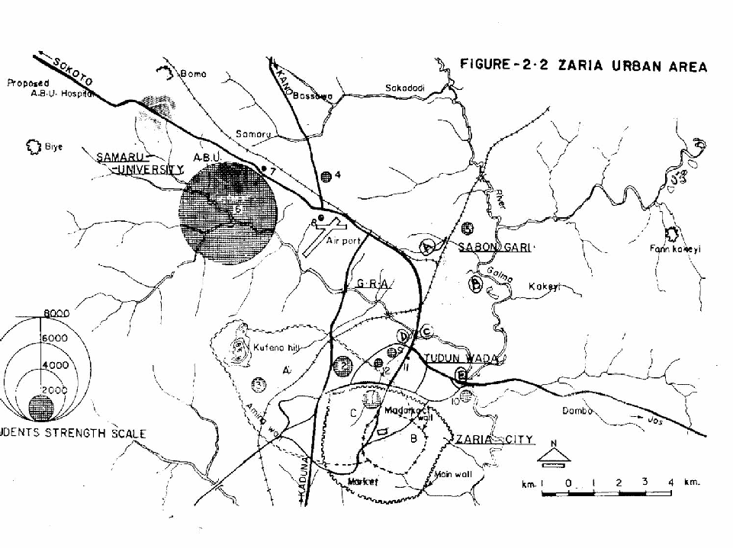

Fig. 1: Map of the Sampling Sites – A, B, C, D, and E = Sampling Point.

  - SAMPLES

Vegetables are herbaceous non-woody plants or plant parts eaten with the main course rather than as a desert. Most people can improve their health by eating at least five serving of fruits and vegetables each day, as well as eating more whole grains and less refined carbohydrates. The chief nutritive significance of vegetable is their richness is minerals and vitamins (Ojeka 2004).
Lettuce (Lactuca Sativa L) is the most widely planted vegetable. Stem lettuce is used mainly in stewed, creamed and Chinese dishes. Cabbage (Brassica oleracea L. var capitata) is a good sources of vitamins with disease preventive properties as well. Spinach (Amarantus spp) contains high concentration of oxalic acid which can interfere with utilization of calcium or magnesium in the diet (Ojeka 2004). Maize (zea mays) is cultivated throughout

the tropics and is one of most important food crops planted, mainly by small scale farmers. The grains provide a rich source of carbohydrates, protein and oils. Onions (Alium spp) are used in the preparation of soups and salads. Okra (Abel moschus esculent L.) is a vegetable crop which is cultivated by mostly small-scale farmers. Fresh okra is often dried, then grind and used for thickening soup. The leaves may also be boiled and eaten (Akinyosoye 1984).

PHYSICOCHEMICAL PARAMETERS

    - CONDUCTIVITY (µS cm⁻¹)

The conductivity of a solution is a measure of its capacity to convey an electric current. Conductivity is related to the nature and concentration of ionized substances present in solution and the temperature of the solution. After absorbing CO₂ from the air, and other substances from the glass in which water is kept, the conductivity of distilled water is normally about µs Cm⁻¹ = 10⁻⁶ Cm⁻¹ Where S = siemens = ohm
Gotterman (1978) has measured a value as low as 0.05µscm⁻¹ of water which acts as a weak binary electrolyte according to the following equation.
H₂O = H⁺ + OH⁻
The mobility of the ions depends on the temperature so the conductivity of a solution depends on temperature. The conductivity also depends on the concentration and the degree of ionization of the salts involved (Golterman (1978). This causes a non linear relationship between conductivity and concentration.

TOTAL SOLIDS (Mg /L)

Total solids reported in mg/l is the amount of residue left in the vessel after evaporation of a sample and its subsequent drying in an oven at a specified temperature; or is the summary amount of non-volatile substances present in water in a colloidal and a molecular – dispersed state primarily salts, carbonates and metals. Total solids determination is a test conducted on industrial waste to have an idea of the extent of dissolved inorganic salts.

pH

pH is a measure of the hydrogen ion concentration of water, which determines whether the water is acidic or “basic” (alkaline). The pH of most natural waters range from 6.5 to 8.5. Deviation from the Neutral 7.0 is largely the result of the interaction between acids and bases. Industrial and community waste, acid rain, bedrock type, and the biological processes of photosynthesis, respiration, and decomposition all influence pH levels. The pH of water is extremely important to aquatic life. If waters became too acidic, the metals such as Al and Pb, can be leached from the surrounding soil and bottom sediments contaminating fish and other aquatic organisms. Water that are highly alkaline are not suitable for irrigation (Vermani 1989).

PHOSPHOROUS (PO ³⁻)
4

Phosphorous is present in waters in several particulate and soluble forms including organically bound phosphate inorganic condensed phosphate and organic or the phosphate (PO ³⁻).
4
Aquatic plant and animals take in dissolved inorganic phosphate and convert them to an organic form. Increase in phosphorus levels, however slight,

can result is major changes in lakes and rivers. Concentration of total phosphorus in unpolluted waters are usually less than 0.1mg/l. As little as 0.015mg/l total phosphorus can causes accelerated plant growth. Elevated concentration of phosphorus are primarily associated with human contamination from laundry detergent, fertilizers, domestic sewage and land clearing activities. Rainfall can cause varying amount of phosphates to wash from soils into nearby waterways.

Nitrate (NO ⁻)
3

Pollution of river, seas and drinking water by nitrates from fertilizers and traditional organic waste has become a serious problem. Nitrate gets into the river by addition of artificial fertilizer to the soil. High level of nitrate can be found in water bodies which receive runoff of percolation from heavy or improper fertilized soils. Nitrites level are normally very low as bacteria in water quickly convert nitrites to nitrates. If it is present in excessive amounts in drinking water, nitrate can contribute to the illness in infants known as methomoglobinemia.

ATOMIC ABSORPTION SPECTROSCOPY (AAS)

The study of the emitted radiation when the excited state returns to the ground state is called emission spectroscopy, whilst atomic absorption is based on the measurement of the intensity of a spectral line absorbed by the element under study.

INSTRUMENTATION

AAS operation consists of atomization of the metallic element present in a liquid sample and exposing the atoms to a source of radiation of proper energy provided by the hollow cathode lamp for absorption to take place.

A specific atomic transition is isolated by the monochromator so that light of only that wavelength enter the detector, usually a photomultiplier tube and thence a recorder. Known concentration of standard solutions and the unknown are then sprayed into the flame. Absorbance values are recorded and used to calculate the concentrations of the unknown. (Ajibola, 2000)

Holow Cathode Modulated Detector

Power Radiation Chopper Flame-burner Monochromator Signal
Supply Source Wheel Processor

and readout

Fig. 2 Block diagram of an atomic absorption spectrophotometer

APPLICATIONS

Waters and Effluents

Natural waters containing little or no suspended matter may often be analysed without pretreatment. It is however, usual to acidify with nitric acid in order to ensure that element are present in only one oxidation state and that the pH of sample and standard solutions is the same. Standard solution are prepared by taking a sample of de-ionized water and adding appropriate amounts of stock solutions of the elements to be determined (Whiteside, 1979).

PLANTS

Ashing procedure is used for determination of metals in plant materials. Plant materials should be air dried at 40ºC, crushed to pass through a 0.5-0.7min sieve and the result powder oven dried at 105ºC. Sample solution should be prepared in duplicate and a digestion blank, also in duplicate, should be included with each batch of samples. (Whiteside 1979).

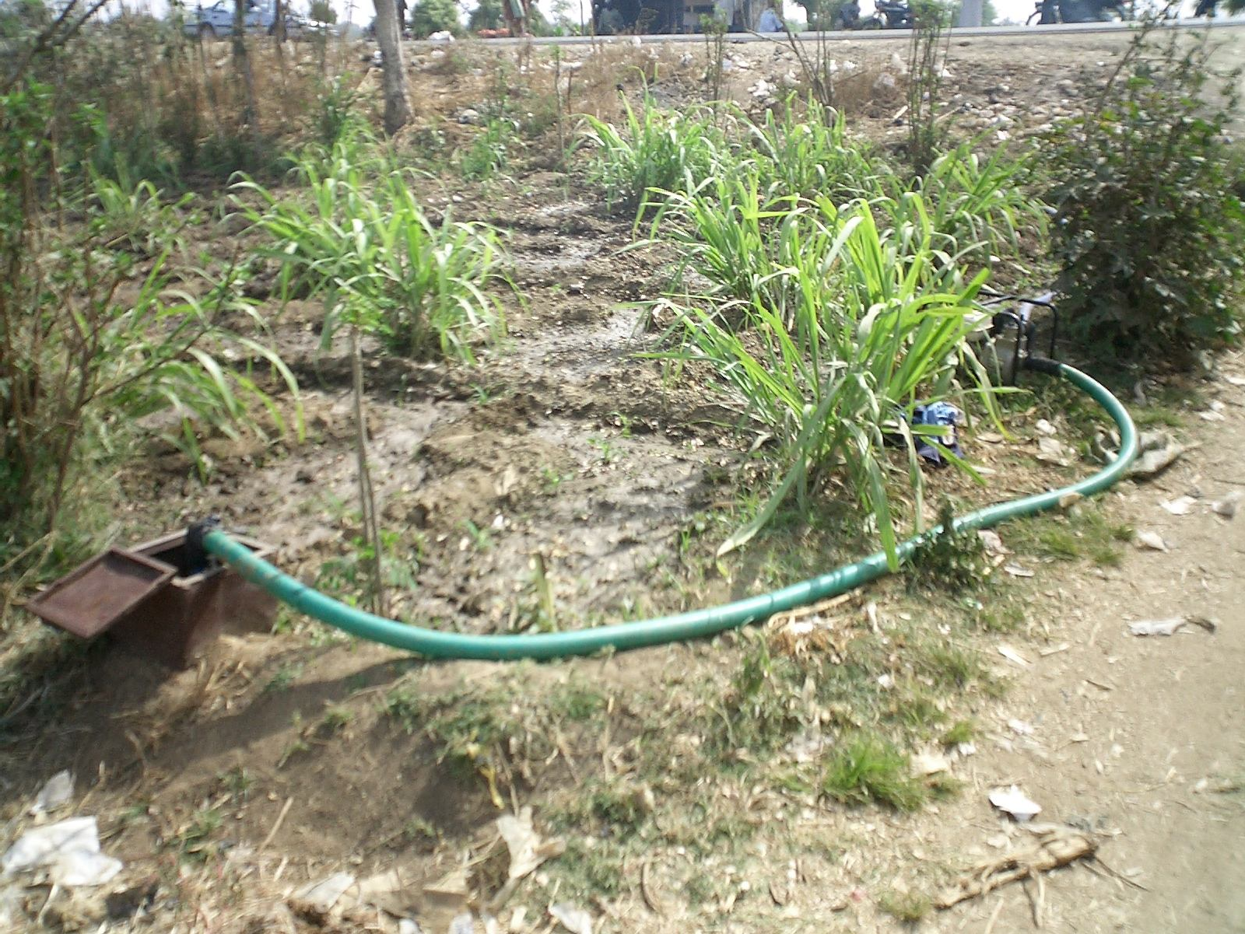

Figure 3.1: Site C showing one of the wells used for irrigation during Dry Season along River Kubanni.

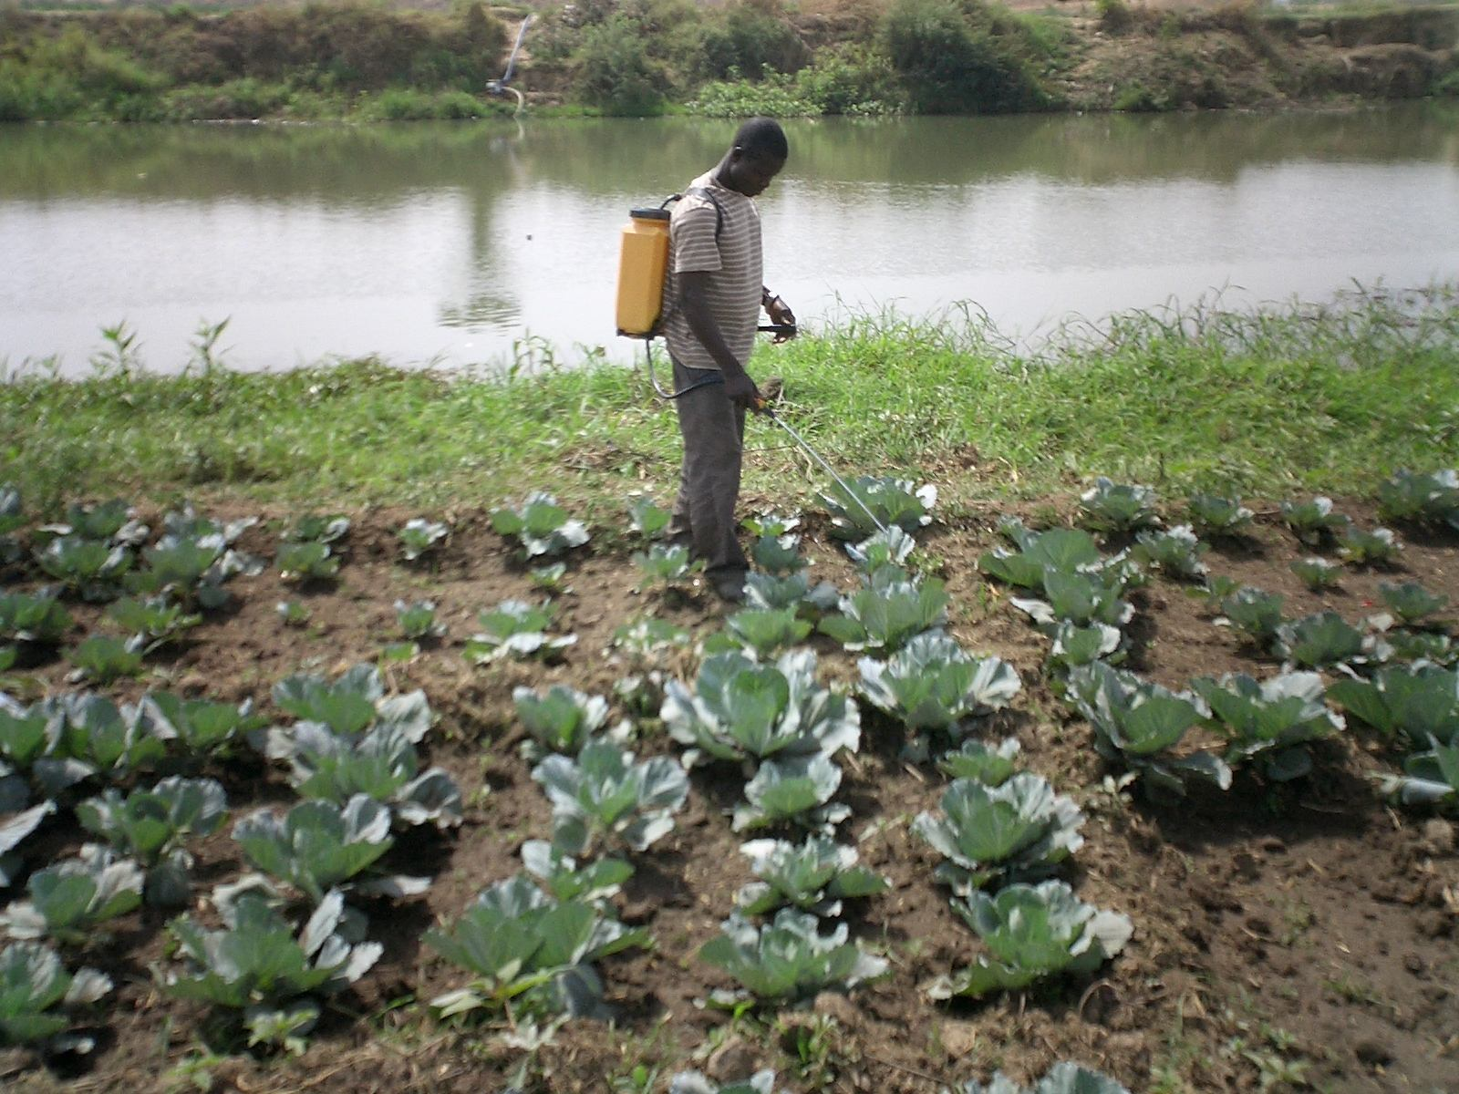

Figure 3.2: A farmer applying pesticide on one of the sampled farms at Site E.
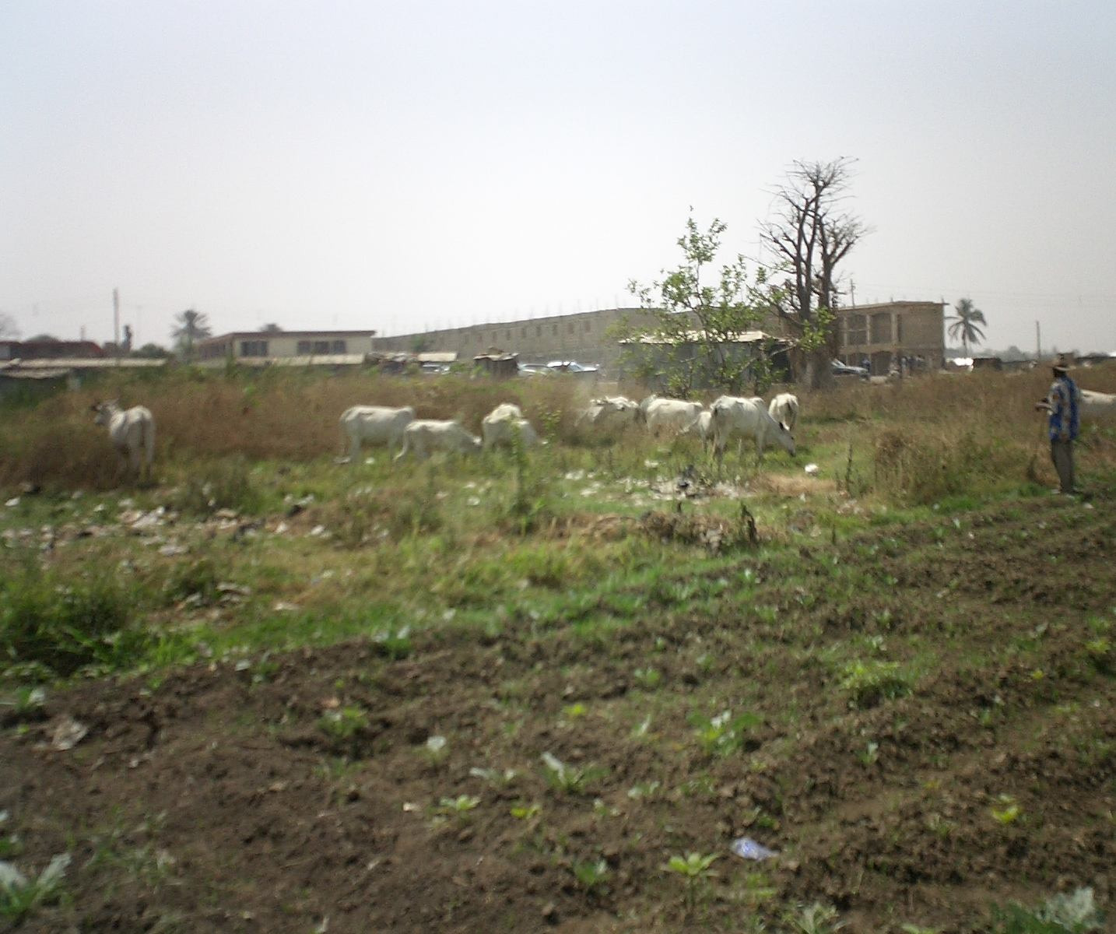
Figure 3.3: A cattle herder grazing close to one of the farms at Site D.

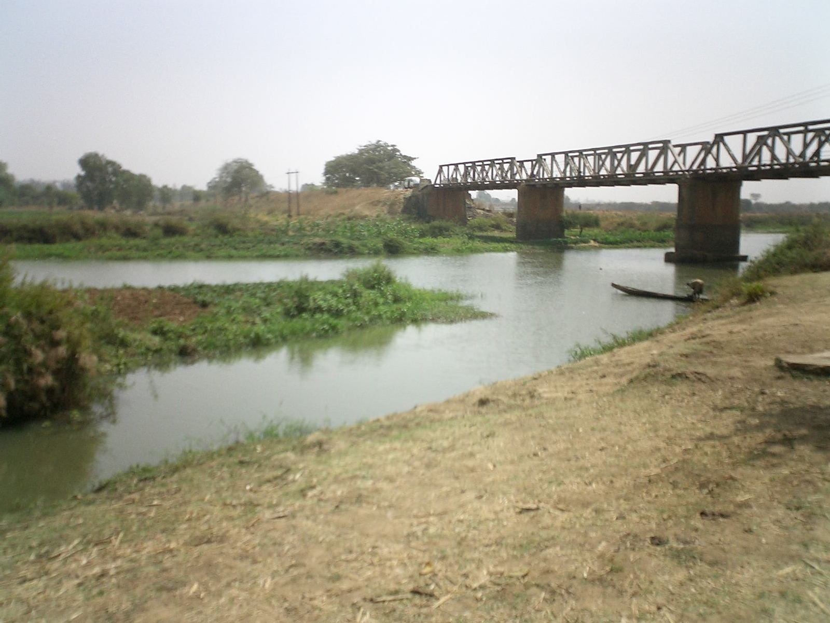

Figure 3.4: Site E where Kubanni River empties into River Galma at old Jos Road Bridge (down stream of River Galma).

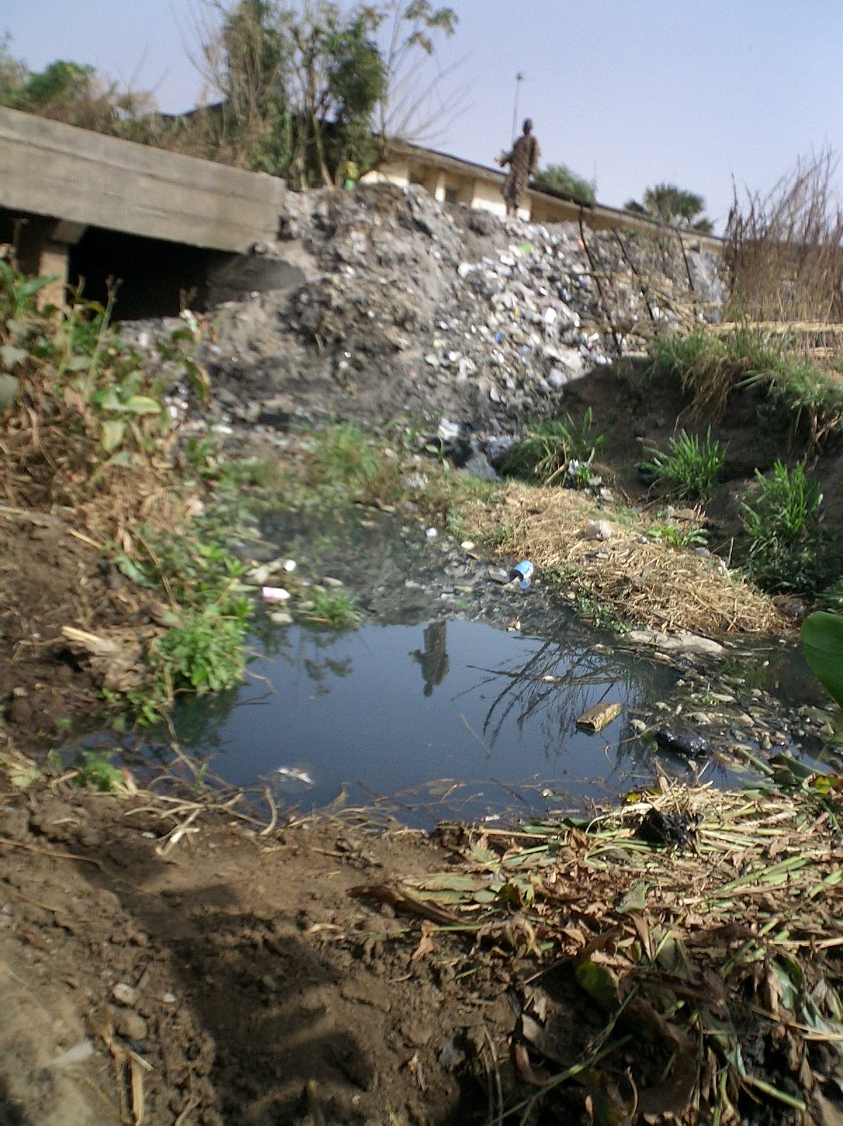

Figure 3.5: Site A (one of the tributaries of River Galma) during Dry Season.

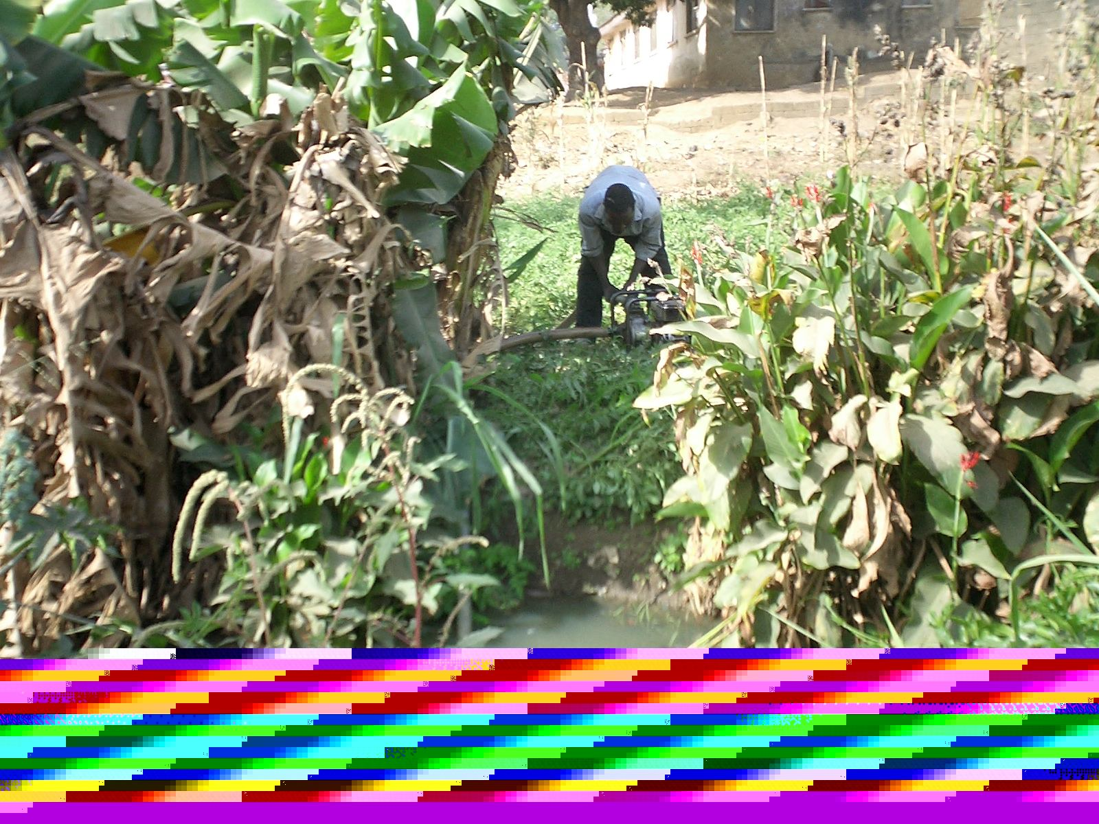

Figure 3.6: Site B (also one of the tributaries of River Galma) during Dry Season.

CHAPTER TWO LITERATURE REVIEW

INTRODUCTION

Increase in population, coupled with other factors such as urbanization, rapid industrial development, mining, agriculture etc. result in huge accumulation of waste and pollutants which end up in water such as rivers, streams and lakes thereby polluting them..
More than two billion of the world population are affected by disease caused by contaminated drinking water (Bishnupada Roy et al, 1999). Nigeria generates over 500,000 tons of waste annually and Lagos alone generates over 200,000 tons much of which are dumped into the Lagos lagoons creek and the sea ( Itah, 1998).
In the Kaduna River, heavy metals such as Fe, Co, Cd, Hg and Ar were recorded in the surface water in very high concentrations ( Sani, 1990). The concentration of Fe, Cu, Zn and Pb in the upper Kubanni Basin in high concentrations above recommended standards for drinking have also been revealed ( Jeb 1996). Skinner (1985), determined various concentrations of trace elements in four different fish species living in five different polluted waters. Result obtained showed that the concentrations of these metals in them were high enough to warrant detailed analysis of these fishes as far as human health is concerned.

HEAVY METALS AND THEIR TOXIC EFFECTS

Environmental pollution by heavy metals is not only an environmental problem but also a public health matter. The effect of pollution by heavy metal can be assessed directly, by measuring heavy metal concentration in soils or water, or using indirect methods, by measuring heavy metal contents on living beings of regional ecosystem in particular on plants (Carme et al 2005). Heavy metals are found in tissues of both plant and animals. They occur in soils as natural deposits in water and air as pollutants. Plants take in mineral nutrient from soil and by so doing absorb heavy metals. Animals take in heavy metals through respiration, foods and water that are contaminated by industrial effluent especially when there is a high concentration of contaminants in the sewage system (Keller and Smith 1967).
Toxicity of a metal depends on its route of administration and the chemical compound with which it is bonded (Karle, 1977). A metal is hence regarded as toxic at a given concentration if it injured growth or metabolism of cells at that concentration. The toxic effects of heavy metal on plants and animals have received considerable attention due to their occurrence in nature (Burton and Patterson 1979). Particular pollutants can attack specific sites or organ and disease can develop as a result of exposure to such pollutant. Heavy metals damage protein molecules and bio-enzyme process in plant (Janica, 1992). Einsenberge et al (1984) analysed some African plants specie and osysters for trace element. Their studies confirmed existence of seven toxic elements Cr, Cu, Cd, Pb, Mn, Zn and Hg in plants. The effects of heavy metals such as Cu, Ni and Co on algae specie was studied by Dooren (1975) who reported that these

element inhibited the growth of these plant in doses as low as 0.004ppm. Karle (1977), reported the effect of metals such as Ni, Co and Cd inducing cancer of the muscles (rhabdomyo sorchoma). Recently, it was been shown that certain plants can hyper accumulate metals such as Zinc, (Zn), Nickel (Ni), Cadmium (Cd) and lead (Pb) (Baker et al 1994). There are currently no guidelines for permissible levels of trace elements and heavy metals in waste water used for irrigation which relate to the potential risk to human health as a consequence of crop uptake and bio-accumulation. Most authors refers to the WHO drinking water guideline (WHO 1993) (Cornish, G. A. et al, 1999). These data are reproduced in Table 1.

Table I: WHO and EU Drinking Water Quality Guidelines for Heavy Metals and Threshold Values Leading to Crop Damage (mg/l).
Element | WHO drinking water guideline A | EU drinking water guideline B | Recommended maximum concentrations for crop  C
Arsenic | 0.01 | 0.05 | 0.1
Cadmium | 0.003 | 0.005 | 0.01
Chromium | 0.05 | 0.05 | 0.1
Copper | 2 | 0.1 – 3.0 | 0.2
Iron | 0.3 | 0.2 | 5.0
Mercury | 0.001 | 0.001 | -
Manganese | 0.5 | 0.05 | 0.2
Nickel | 0.02 | 0.05 | 5.0
Lead | 0.01 | 0.05 | 5.0
Zinc | 3 | 0.1 – 5.0 | 2.0

Sources:

a WHO (1993)

b Cited by Chapman (1996) c Cited by Pescod (1992)
Ghlesquiere (1999) prepared a summary of the effect of heavy metals on plants and human health which is reproduced below in Table 2.
Pescod (1992), in a review of waste water treatment and use in agriculture acknowledges that municipal waste water may contain toxic levels of trace elements (heavy metals and other chemical elements).

Table II: Heavy metals and their effects on plants and human health.
Element | Sources |  | Agronomic effects |  |  |  | Effect on health
As | Industrial effluents,  in impurity in some detergents |  | Toxicity widely | to | plants | varies | Very harmful, cumulative  poison. Carcinogenic, skin disease.
Cd | Washing powders as an impurity in zinc steel industry, paint, plastic |  | Toxic to beans, beets and turnips at concentrations as low as 0.1 mg/l in nutrient solutions. Risk of accumulation in plants and  soils. |  |  |  | Very harmful, cumulative poison. Food main source of intake.
Cu | Plumbing, animal wastes, pesticides,  earth’s crust |  | Toxic to a number of plants at 0.1 to 1.0 mg/l in  nutrient solutions. |  |  |  | Liver cirrhosis food main source of intake uncertain  toxicity in humans.
Fe | Plumbing  crust | earth’s | Essential element of  nutrition, not toxic to plants |  |  |  | Not a major hazard to health.
Hg | Pesticides, industrial effluents |  |  |  |  |  | Very harmful, for pregnant  women, cumulative poison, neurological disease.
Mn | Industrial effluents |  | Toxic to a number of crops at a few-tenths to a few  mg/l |  |  |  | No convincing data of human toxicity
Ni | Industrial effluents |  | Toxic to a number of plants  at 0.5 mg/to 1mg/l |  |  |  | Carcinogenic, lack of data on  carcinogenic by the oral route
Pb | Lead-acid batteries, solder, alloys |  | Decrease respiration of soil organisms and inhibit |  |  |  | Accumulate in skeleton, harmful for children and

 |  | plant cell growth at very  high concentration | pregnant women
Zn | Plumbing, animal wastes, pesticides | Toxic to many plants at  widely varying concentrations | Not a major hazard to health.

    - CADMIUM (Cd)

Cadmium may be present in natural water, however, it is usually present as a result of contamination by an industrial waste.
Cadmium affects metabolisms and may substitute Ca²⁺ in the bone structure. “Itai-itai” disease is a seriously crippling condition observed in Japan as a result of Cd replacing calcium in the bone structure (Sunderman 1971). Inges of Cd 1.5-9g/day results in sudden nausea, vomiting, diarrhea, abdominal pain and discomfort, weakness and loss of consciousness. Human cases of Cd poisoning have been reported from the use of beverages or food prepared or stored in Cd plated containers.
A survey carried out (Neuberger et al 1990) of the health problem in Galina city which was exposed to environmental pollution which include Pb and Cd in drinking water shows a statistically significant excess of deaths from hypertension disease, heart disease and stroke.
Cadmium is one of the most toxic elements with reported carcinogenic effects in human (Goering et al 1994). It accumulate mainly in the kidney and liver and high concentration have been found to lead to chronic kidney dysfunction. It induces cell injury and death by interfering with calcium regulation in biological systems. It has been found to be toxic to fish and other aquatic

organisms. Cadmium has been implicated in endocrine disrupting activities, which could pose serious health problems.
Awofolu et al 2005 found high levels of Cd in tyume river South Africa which may be detrimental to the “health” of the aquatic ecosystem and the rural communities that utilize the river water for domestic purposes without any treatment.

COBALT (Co)

Cobalt is an integral part of vitamin B₁₂ cobalamin, which support red blood cell production and the formation of myelin nerve covering (Elson and Haas 2001). Its essential for nitrogen fixation by rhizobium in legume nodules (Reisenaver 1960). There is no evidence that higher plant have a direct requirement for the metal (Russeli, 1988). However, cobalt has been found in legumes, spinach, cabbage, lettuce and figs (Elson and Haas, 2001). The cobalt content of normal plants is usually within the range 0.01 – 1.00mg/kg dry matter (Walsh 1971). Toxicity can occur from excess inorganic cobalt found as food contaminant. High levels of cobalt were reported in the kidney, liver and testes.
Bear drinkers cardiomyopathy (enlarge heart) and congestive heart failure have been traced to cobalt introduced into beer during manufacturing. Dermatitis is caused by excessive cobalt in the body and skin sensitivity was noted when in contact with the body (San, 1978). Toxicological effect of larger amount of cobalt include vasolidilation, flushing and cardiomyopathy in humans and animals (OR Awofolu et al, 2005).

CORPER (Cu)

The copper content of normal plant tissues varies according to specie but in usually within the range 1-25mg/kg dry matter (Walsh, 1971). It is toxic to man at concentration of 250mg/day. Continued high intake of copper by man at concentration of 250mg/day may cause damage to liver brain and nervous system, vomiting and sometimes diarrhea (Czaudema 1985). Chronic exposure to copper may lead to skeletal lesion and severe psychiatric disturbance (Walsh 1987). Excess copper cause jaundice and Wilson’s disease while its deficiency causes anaemia and hair kinky (Bowen (1979).

IRON (Fe)

The iron content of normal plant tissue varies according to species but is usually within the range 20-200mg/kg dry matter (Walsh 1971). WHO action level of iron in drinking water is 0.3mg/l and it is toxic to man at concentration of 200mg/l. Most of the body iron exist in complex forms and bound to protein either as porphyrin or haeme compound particularly haemoglobin. Iron dust can cause conjunctivitis chloroiditis, retitis and siderosis of tissue of the iron remain in these tissues.

HEAVY METAL UPTAKE BY PLANTS
Determination of the chemical compositions of plants is one of the most frequently used methods of monitoring environmental pollution. Various plants have been used as bio-indicators (Grodzinska and Kazmier-Czakowa 1977).
Several studies have been reported on the accumulation of environmental pollutants in plants. Olaofe and Sani (1988) analysed the mineral content of corn, sorghum, cowpea, soyabean and reported high concentration of potassium and magnesium but low concentration of Ca, Zn, Hg and Pb.

The accumulation of heavy metals by plants: roots, stem and leaves grown in polluted soil have been reported. Okoronkwo et al (2005) reported the levels of Pb, Ni, Cr, Cd, and As present in the soil and also the uptake of Pb, Ni and Cd in the roots and leaves of cocoyam and cassava harvested from an abandoned waste dump soil in Umuahia, Abia State.
Anikwe and Nwobodo (2002) also reported high level of heavy metals (Pb, Fe, Cu, and Zn) in their study on long term effect of municipal waste disposal on soil properties and productivity of sites used for urban agriculture in Abakaliki. Amusan et al (1999) studied plant uptake of heavy metal on a similar site at University of Ife garbage dump and found out that Pb uptake by waterleaf and Okra increased in leaves and roots of waterleaf and in the fruit of okra relative to those grown in non-dump sites.
Batagarawa (2000) using atomic absorption spectrometry, analysed moss plant in Kano metropolis for heavy metals and reported high levels of Pb, Zn and Cd. Also Osubor, C. C. and Anoliefi (1999) reported absorption of Cd into plant tissues through the roots either in ionic form (Cd²⁺) or as metal chelates and tends to accumulate at a level exceeding that of the growth media.
Ademoronti (1995) showed that vegetable accumulate considerable amount of heavy metal (Pb, Cr, Cu, Zn) in roots and leaves.

Furthermore, Alloway and Ayres (1997) reported that Cd, although present in quite low concentration (< 10mg/kg), is relatively taken up by food crops

especially leaf vegetables and enters the human diets. Chiroma et al (2003) studied heavy metal contamination of vegetable and soils irrigated sewage water in Yola, and reported high concentration of the metals (Fe, Zn, Cu, mg, Mn and Pb) suggesting heavy metal contamination of the soil irrigated with sewage water and their accumulation in different parts of plants cultivated in the soil. They also showed that the metal concentration vary in the different parts of the plants. Moreover, the result indicated that Fe tends to accumulate in roots and leaves but Zn accumulate in roots and translocates gradually to the leaves while Mn and Mg shows greater accumulation in unwanted leaves.
Nuhu (2000) also analyzed for heavy metals content of mango leaves in Kano metropolis and reported high levels of Cd, Mn and Pb in the industrial areas of Bompai, Challawa and Sharada. Bonneaus and Souchier (1982) reported that excessive heavy metal absorption by plant resulted from artificial additions to soil either by bad management in correcting a deficiency or accidental disposal of waste atmospheric pollution etc.
Furthermore, studies have revealed that Pb does not readily accumulate in the fruiting part of vegetable and fruit crops (e.g. corn, beans, squash, tomatoes, straw berries, apples); high concentration are most likely to be found in leafy vegetable (e.g. lettuce) and on the surface of root crops (Rosen, 2002). Also Spitter and Feder (1979) reported lead contamination in vegetable grown on contaminated soils.

Aims and scope of the study

Despite the fact that water is one of the basic requirement of our life and also essential in any agricultural practices, other factors like water quality, soil qualities and management practices are important consideration.
Peri-urban farmers using water from streams and rivers of urban centers are re- using urban waste water. As this water is often polluted with untreated municipal and industrial effluent there is a potential threat to health of both consumers and irrigators.
It has also been the interest of the public to know whether vegetables, fruits and food crops cultivated in polluted soils are safe for human consumption especially now the environmental quality of food production are of major concern.(Chiroma et al 2003)
The aims and scope of this study are to

- determine some physicochemical parameters of the water in the two rivers

-determine the levels of some heavy metals ( Cd, Co, Cu and Fe ) present in the waters of the two rivers and their tributaries
-determine the levels of these metals in some vegetable crops cultivated along the banks of these rivers.

CHAPTER THREE

3.0 MATERIAL AND METHOD

3.1.0 Material

In preparing the standard solutions used in the study, chemicals of analytical grade obtained from British Drug House (BDH) and deionised water were used. All glasswares and plastic containers were washed with detergent solution followed by 20% (v/v) nitric acid and then rinsed with deionised water before drying it in the oven. Atomic Absorption Spectrophotometer (AAS) with model PYE UNICAM Sp9 equipped with Cd, Co, Cu and Fe hollow cathode lamp at wavelengths 228.80nm (Cd), 240.72nm (Co), 324.75nm (Cu) and 248.83nm (Fe), Band pass 0.4nm with flame type consisting of Air/Acetylene and Stoichiometric fuel flow at 0.9 – 1.10min⁻¹ for Cd, Co, and Cu and 1.10 – 1.30min⁻ ¹ for Fe was used (Whiteside 1979).

Reagent

Analytical grade reagent were used. Stock solutions (100mg/l) of each elements were prepared as follows:

Element Cadmium (Cd)

A 1.142g of CdO was dissolved in 20cm³ of 5M HCl and made up to one litre with distilled water. Standards of 0.25, 0.50, 1.00, 2.00, 4.00mg/l were prepared from 50mg/l stock solution obtained by diluting 50cm³ of the original solution in a litre volumetric flask.

3.2.2. Element Cobalt (Co)

A 4.94g of Co (NO₃)₂ 6H₂O was dissolved in distilled water and made up to 1 litre with distilled water. Standards of 0.25, 0.50, 0.75, 1.00mg/l were prepared as described in 3.2.1 above.

Element Copper (Cu)

A 1.00g of copper wire was dissolved in 50cm³ 5M HNO₃ and made up to one litre with distilled water. Standards of 0.25, 0.50, 1.00, 2.00mg/l were prepared as described in 3.2.1.

Element Iron (Fe)

A 1.00g of iron dust was dissolved in 20cm³ 5M HCl and 5cm³ conc. HNO₃, it was diluted with distilled water up to 1 litre. Standards of 1, 2, 3, 6 mg/l were prepared as described in 3.2.1.

Table III. AAS Instrumental Conditions

Element | Wavelength (nm) | Slit- width | Lam p current (MA) | Gain | Burner height | Oxidant
Cd | 228.8 | 3 | 2 | 7 | 7 | Co
Co | 240.7 | 1 | 6 | 8 | 7 | Air
Cu | 324.7 | 2 | 4 | 5 | 7 | Acetylene
Fe | 248.3 | 1 | 8 | 8 | 6

    - Digestion mixtures

44.40cm³ of perchloric acid (S.G = 1.67; 70% v/v) was piped into 500cm³ volumetric flask containing 444.40cm of concentrated Nitric acid (S.G = 1.42;

70% v/v/). This was followed by pipetting 11.10cm³ of concentrated sulphuric acid 5.9 = 1.83; 98% v/v) into the flask to form 500cm³ of the digestion mixture containing sulphuric acid, perchloric acid, and Nitric acid in the ratio 1:4:40 respectively by volume (Erwin and Ivo 1992)

Methods

Treatment of water samples

Water samples were collected directly into polyethylene bottles and were not filtered. Samples were analysed for pH immediately after the collection by glass electrode, preserved by acidification to pH < 2 with 0.1M HNO₃ and stored in ice-packed coolers.

Treatment of vegetable samples

In the laboratory, each sample was washed separately with distilled water (Burton and Paterson 1979) to remove sand and gravel particles, rinsed several times with distilled water and then dried in an oven at 80ºC (Larry and Morgon 1986). Okra and onions were sliced into smaller pieces prior to drying. Each sample was then grinded into powdery form using pestle and mortar and finally stored in screw capped plastic jar and labeled appropriately.

Digestion of vegetable samples

In the digestion of the vegetable samples, both Ashing and wet methods were used for rainy and dry seasons respectively.

Ashing

The powdered sample was put into a crucible and ashed in a muffle furnace for 8hours at 500ºC. A 1.0g of the ashed sample was weighed out to

250ml content in the beaker were heated to 100ºC for 45mins. The about to dry sample was put into a 100ml volumetric flask and made up to the mark with distilled water. The sample solutions were then filtered through a filter paper into a screw capped polyethylene bottle ready for analysis. This procedure was repeated for all the other samples (Whiteside 1979).

Wet Digestion

A 2.0g of the powdered vegetable sample (in duplicate) was weighed out into flasks mixed with 20cm³ of the acid mixture and left to stand overnight (to prevent excessive foaming). Thereafter the flasks were heated moderately at 70ºC for about 40 minutes. Then the heat was increased to 120ºC. The mixture turned black after a while. The digestion was complete when the solution became clear and white fumes appears. Thereafter, the digest were diluted with 20cm³ of distilled water and boiled for about 15mins. After cooling, each solution was transferred into 100cm³ volumetric flask and diluted to the mark with distilled water. The sample solutions were then filtered through a filter paper into a screw capped polyethylene bottle, ready for analysis. This procedure was repeated for all other samples (Erwin and Ivo, 1992).

3.4.0. PHYSICOCHEMICAL PARAMETERS

PH Measurement

Samples of water were analysed for pH immediately after collection by glass electrode. The electrode was first immersed in distilled water until the

reading becomes stable. The electrode was brought out, wiped with tissue paper in and out and then dipped in the sample whose pH was to be measured. When the pH of the sample was reached, the reading will be stable
.

Conductivity (µScm⁻¹) measurement

A Jenway 4010 conductivity meter was used for this purpose.

Determination of the conductivity of standard.

The cell was placed in the standard solution of kCl after switching and allowing the instrument to warm up. A cell constant knob was adjusted to read the conductivity of the standard solution as (1413 µs cm⁻¹) at 25ºC (as recommended by the manufacturer).

Determination of the conductivity of samples.

The cell was rinsed in distilled water and shaken to remove internal droplets. It was then suspended in air and the display was set to zero on the 20µs range. The cell was then dipped into the samples, one at a time. The display was recorded as the conductivity of the sample at a point when the reading stabilizes (Lawal 2004).

Determination of total solids

50cm³ of the water sample was taken in a clean pre-weighed pyrex- beaker of 100ml capacity. The content was evaporated to dryness at 110ºC in an oven. Further heating was done until a constant weight was obtained. The total solid was computed using the expression.
Total solids (mg/l) = (A – B) x 1000
Sample volume (ml) A = weight of beaker + sample
B = weight of an empty beaker

Determination of nitrate (NO⁻ ⁾
3

30ml of the water sample and 1g of Devarda’s Alloy was added and distilled into 20ml 2% Boric acid mixed with indicator. 50ml was collected and titrated against 0.025M H₂SO4 from green to purple end
% NO₃ = 0.014 x 0.025 x 100
10ml

3.5.0 Procedure for determination of concentration

All concentration were determined using the absorbance made with air- acetylene flame. Each set of standard was aspirated into the flame after the wavelength of absorption of the metal being determined has been set. The absorbance of each set of standard was plotted against the concentration of the standard from which calibration curve was obtained. The samples were

aspirated into the flame, from which the absorbance was interpolated from the calibration plot to get the corresponding concentration.

CHAPTER FOUR RESULTS AND DISCUSSIONS
    - Physicochemical parameters

pH
The mean pH-values for all the water samples for both seasons are shown below

9

8

7

6

5
pH
Rainy season Dry season
4

3

2

1

0
A B C D E
SITE

Fig. 4: Mean pH values
Table III: The mean pH values of water samples collected.

Season | Mean ± SEM(%) | Mean ± SEM(%) | Mean ± SEM(%) | Mean ± SEM(%) | Mean ± SEM(%)
Rainy Season | 6.45± 0.008 | 6.52± 0.12 | 6.86± 0.12 | 6.71± 0.097 | 6.10± 0.14
Dry Season | 7.1± 0.025 | 7.65± 0.008 | 7.6± 0.010 | 7.69± 0.008 | 7.98± 0.018

Samples during the raining seasons were consistently slightly acidic whilst those collected on the dry season were very mildly alkali or partially neutral. The likely explanation for this acidic reaction may be due to acid rain, soil leaching etc.

    - Phosphorus

Phosphorus was measured as PO ⁻³. Mean values for elemental phosphorous as PO ⁻³ in mg/l are shown below:
4
4

12

10

8

6

4
Rainy season
Dry season
PO4 (mg/l)

2

0
A B C D E
SITE

Fig. 5: Mean values for phosphorous.

Table IV: The mean phosphorous concentrations mg/l of water samples.

Season | Mean ± SEM(%) | Mean ± SEM(%) | Mean ± SEM(%) | Mean ± SEM(%) | Mean ± SEM(%)
Rainy Season | 9.67± 0.020 | 4.68± 0.025 | 5.46± 0.10 | 7.02± 0.025 | 3.12± 0.019
Dry Season | 4.00± 0.056 | 3.50± 0.020 | 2.40± 0.089 | 5.30± 0.056 | 4.60±0.019

These levels indicate low level of phosphate at all sites sampled. The high level of phosphate in the rainy season compared to the dry season may be due to addition of fertilizer by the farmers washed down into the rivers by rain.

    - Nitrate
Nitrate was measured as NO⁻₃. The mean concentrations of Nitrogen (mg/l) for both dry and rainy season are shown below:

16

14

12

10
Nitrgen(mg/l)

8

6
Rainy season
Dry season

4

2

0
A B C D E
SITE

Fig. 6: Mean concentrations of Nitrogen.

Table V: The mean concentrations of Nitrogen (mg/l) in water samples

Season | Mean ± SEM(%) | Mean ± SEM(%) | Mean ± SEM(%) | Mean ± SEM(%) | Mean ± SEM(%)
Rainy Season | 11.00± 0.16 | 14.00± 0.82 | 7.00± 0.13 | 11.00± 0.72 | 7.00± 0.133
Dry Season | 6.00s±0.18 | 8.00±0.25 | 4.00±0.34 | 6.00±0.018 | 3.50±0.33

The result indicated high levels of Nitrate in the rainy season compared to the dry season at all sites sampled. This may also be due to addition of fertilizer and faecal contaminants which were washed down into the rivers by rains.

Conductivity (µscm⁻¹)
1.4
Rayny season
Dry season

1.2

1

0.8
Conductivity

0.6

0.4

0.2

0
A B C D E
SITE

Fig. 7: Mean conductivity values.

Table VI: Mean conductivity values.

Season | Mean ± SEM(%) | Mean ± SEM(%) | Mean ± SEM(%) | Mean ± SEM(%) | Mean ± SEM(%)
Rainy Season | 0.41±0.0033 | 0.79±0.019 | 0.17±0.017 | 0.37±0.009 | 0.17±0.017s
Dry Season | 0.70±0.032 | 1.15±0.023 | 0.69±0.0032 | 0.10±0.0032 | 0.10±0.0032

Though there is no linear relationship between conductivity and concentration (Golterman, 1978). The above result showed an increase in conductivity with increase in concentration due to evaporation during the dry season in site A, B, and C, compared to the rainy season, where concentration is less due to dilution by the rainfall.

4.1.4 Total Solids (mg/l)

1.2

1

0.8

0.6

0.4
Rainy season
Dry season
Total solids(mg/l)

0.2

0
A B C D E
SITE

Fig. 8: Mean total solids values. Table VII: Mean total solids values.

Season | Mean ± SEM(%) | Mean ± SEM(%) | Mean ± SEM(%) | Mean ± SEM(%) | Mean ± SEM(%)
Rainy Season | 0.20±0.006 | 0.39±0.0032 | 0.08±0.006 | 0.18±0.006 | 0.08±0.11
Dry Season | 0.70±0.0032 | 0.99±0.0071 | 0.68±0.009 | 0.68±0.009 | 0.70±0.016
The lower values obtained generally may be due absence of more industries especially textiles and tanneries close to the bank of the rivers which are associated with particle

4.2.0 Heavy metals

The results of the heavy metal analysis for the four (4) elements (Cd, Co, Cu and Fe) in water and vegetable crops sampled in both the rainy and dry seasons along rivers Galma and Kubanni are shown below.

Table VIII: The mean concentrations of Heavy metals in water and vegetable Crops (mg/l) along rivers Galma and Kubanni in the rainy season (June – August 2005).

SITE | SAMPLE | Cd | Co | Cu | Fe
 |  | Mean + SEM (%) | Mean + SEM (%) | Mean + SEM (%) | Mean + SEM (%)
A | WT | 0.0025+0.01 | 1.208+0.86 | 5.094+0.86 | 2.272+0.84
 | MZ | 0.0028+0.01 | 1.289+0.86 | 4.310+0.86 | 2.114+0.86
 | OK | 0.0034+0.02 | 1.460+0.86 | 4.646+0.86 | 2.197+0.84
 | SP | 0.0033+0.02 | 1.618+0.86 | 4.986+2.88 | 2.434+0.86
B | WT | 0.0036+0.02 | 1.628+0.86 | 5.190+2.84 | 2.705+0.88
 | MZ | 0.0035+0.02 | 1.652+0.87 | 5.620+0.86 | 2.765+0.86
 | OK | 0.0039+0.02 | 1.865+0.85 | 0.169+0.86 | 2.745+0.86
 | SP | 0.0044+0.33 | 2.036+0.87 | 0.435+0.86 | 0.283+0.87
C | WT | 0.0042+0.34 | 2.133+0.87 | 0.719+0.86 | 0.938+0.85
 | MZ | 0.0041+0.03 | 2.305+0.86 | 0.944+0.86 | 0.0711+0.87
 | OK | 0.0050+0.03 | 2.349+0.85 | 1.378+0.87 | 0.355+0.84
 | SP | 0.0047+0.02 | 2.471+0.87 | 1.705+0.87 | 0.119+0.84
D | WT | 0.0047+0.03 | 2.461+0.86 | 1.935+0.86 | 0.265+0.84
 | MZ | 0.0058+0.03 | 2.567+0.86 | 2.138+0.86 | 0.400+0.86
 | OK | 0.0047+0.03 | 2.599+0.86 | 2.489+0.86 | 0.295+0.86
 | SP | 0.0052+0.03 | 2.711+0.86 | 2.743+0.91 | 0.333+0.86
E | WT | 0.0057+0.03 | 2.863+0.86 | 0.277+0.86 | 0.529+0.84
 | MZ | 0.0049+0.02 | 3.015+0.87 | 0.455+0.86 | 2.501+0.86
 | OK | 0.0054+0.01 | 3.215+0.86 | 0.700+0.86 | 2.501+0.86
 | SP | 0.055+0.02 | 3.217+0.86 | 0.926+0.86 | 2.050+0.86

WT = Water, MZ = Maize, OK = Okra, SP = Spinach

Table IX: Mean value of Heavy metals in Water and Vegetables (mg/l) in the dry season (January to March 2006).

SITE | SAMPLE | Cd | Co | Cu | Fe
 |  | Mean + SEM (%) | Mean +SEM (%) | Mean +SEM (%) | Mean +SEM (%)
A | WT | 0.029+0.86 | ___ ____ | 0.040+0.86 | 0.38+0.86
 | CB | 0.029+0.81 | 0.125+0.84 | 0.081+0.86 | 5.63+0.86
 | LT | 0.029+0.25 | 0.038+0.86 | 0.081+2.39 | 5.25+0.86
 | ON | 0.029+1.07 | 0.063+0.86 | 0.081+0.86 | 3.50+0.86
 | SP | 0.029+0.84 | 0.125+0.86 | 0.081+2.21 | 3.25+18.08
B | WT | 0.029+0.84 | ___ ____ | 0.0403+0.02 | 0.25+0.86
 | CB | ____ ____ | 0.125+0.84 | 0.0807+0.02 | 2.00+0.86
 | LT | 0.029+0.80 | 0.125+0.86 | 0.121+0.67 | 4.88+0.86
 | ON |  | 0.250+0.86 | 0.043+0.86 | 2.00+0.84
 | SP | 0.029+0.25 | 0.0625+0.81 | 0.0403+0.02 | 2.25+0.86
C | WT | 0.029+0.50 | ____ ___ | 0.0403+0.02 | 1.00+0.86
 | CB | 0.029+0.84 | 0.250+0.67 | 0.081+0.87 | 2.13+0.86
 | LT | 0.029+1.07 | 0.250+0.87 | 0.081+0.84 | 4.25+0.87
 | ON | 0.029+0.50 | 0.125+0.84 | 0.040+0.84 | 2.13+0.84
 | SP |  | 0.125+0.84 | 0.081+0.84 | 3.13+0.84
D | WT | 0.029+1.07 | ___ ____ | ___ ____ | 0.88+0.86
 | CB | 0.058+0.86 | 0.125+0.17 | 0.081+0.17 | 3.13+0.84
 | LT | 0.029+0.86 | 0.250+0.86 | 0.242+0.86 | 4.88+0.86
 | ON | __ ___ | ___ ___ | ____ ____ | ___ __
 | SP | 0.117+0.84 | 0.125+0.84 | 0.081+0.86 | 2.63+1.058
E | WT | 0.087+0.86 | ___ ___ | ___ _____ | 0.250+0.18
 | CB | 0.058+0.84 | 0.250+0.17 | 0.081+0.84 | 3.88+0.86
 | LT | 0.291+0.86 | 0.250+0.86 | 0.121+0.86 | 5.00+0.86
 | ON | 0.058+0.17 | 0.125+0.86 | 0.081+0.86 | 4.00+0.84
 | SP | 0.291+0.86 | 0.125+0.96 | 0.121+0.16 | 3.88+0.17

WT = water, ON = Onion, CB = Cabbage, SP = Spinach, LT = Lettuce

The results are compared with the threshold levels given by World Health Organisation (WHO) for trace elements in drinking water and that of Food Agricultural Organisation (FAO) for crop production as shown below in Table X. Table X: Summary of conc. Range of the four metal and percentage of water and vegetable samples above the WHO and FAO guideline.
Metals | Cd |  | Co |  | Cu |  | Fe
Sample | Water | Crops | Water | Crops | Water | Crops | Water | Crops
Mean conc. Range  mg/l | 0.002  5 –  0.087 | 0.00–  0.117 | 0.00 – 2.86 | 0.063–  3.22 | 0.00–  5.19 | 0.00 - 5.60 | 0.09–  2.70 | 0.029 – 5.63
Rec.  Conc. Mg/l | 0.003 | 0.01 | 0.06 | Nvg | 2.00 | 0.20 | 0.30 | 5.00

% above  guideline | 50.00 | 45.70 | 50.00 | - | 20.00 | 42.90 | 10.00 | 4.44

4.3.0 HISGRAMS FOR THE MEAN CONCENTRATION OF THE FOUR METALS IN BOTH RAINY AND DRY SEASONS

Mean conc.(Cd) in Rainy season

0.007

0.006

0.005

0.004
WT MZ OK SP
Conc.(mg/l)

0.003

0.002

0.001

0
A B C D E
SITE

Mean conc. (Cd) mg/ in Dry seasonl

0.35

0.3

0.25

0.2
WT CB LT ON SP
Conc. mg/l

0.15

0.1

0.05

0
A B C D E
SITE

Figure:9a Mean concentration of Cadmium (mg/l)

Mean conc.(Co) mg/l in rainy season

3.5

3

2.5

2
WT MZ OK SP
Conc.mg/l

1.5

1

0.5

0
A B C D E
SITE

Mean conc. (Co) mg/l in Dry season

0.3
CB LT ON
SP

0.25

0.2

0.15
Conc. mg/l

0.1

0.05

0
A B C D E
SITE

Fig. 9b: Mean concentration of Cobalt (mg/l)

Mean conc (Cu) in rainy season

6

5

4

3

2
WT MZ OK SP
Conc. mg/l

1

0
A B C D E
SITE

Mean conc.(Cu) mg/l in Dry season

0.3

0.25

0.2

0.15
WT CB LT ON SP
Conc. mg/l

0.1

0.05

0
A B C D E
SITE

Fig.9c: Mean Concentration of Copper (mg/l)

Mean conc. (Fe) in rainy season

3

2.5

2

1.5

1
WT MZ OK SP
Conc. mg/l

0.5

0
A B C D E
SITE

Mean conc.(Fe) in Dry season

6

5

4

3
WT CB LT ON SP
Conc. mg/l

2

1

0
A B C D E
SITE

Fig. 9d: Mean concentration of Iron (mg/l).

From the results above, the mean concentrations of cadmium were found to be slightly higher ( 0.0025-0.087 mg/l ) than the WHO recommended value ( 0.003 mg/l ) for drinking water in 50% of the water sample collected. The cadmium concentration ranged from 0.000-0.117 mg/l with 45.7% of the samples above the 0.01 mg/l FAO recommended maximum concentration for crops as shown in table VIII, IX and X.
Moreover, the concentrations of the Cobalt in 50% of the sample collected were higher ( 0.00-2.86 mg/l ) than the WHO recommended value of 0.06 mg/l for drinking water. And the concentration in the vegetables (0.063-3.22 mg/ ) far exceed the FAO recommended guideline in all the vegetable samples collected as shown in table VIII, IX and X.
Also, the results indicated that the concentrations of the Copper (0.000- 5.19mg/l) in the water samples exceeded the WHO guideline (2 mg/l) with 80% of the samples below the guideline. The recorded results in the vegetables (0.00-
5.6 mg/l) were above the FAO guideline (0.2 mg/l) with only 42.9% above the guideline as shown in table VIII, IX and X.
The mean concentration of iron (0.09-2.7 mg/l) also exceeded the WHO (0.3 mg/l) recommended for drinking water in all the water samples collected. The results in the vegetables (0.029-5.63 mg/l) in all the samples collected are below the 5.0mg/l recommended guideline by FAO as shown in table VIII, IX and X.
DISCUSSION

Water is an important medium for the transmission of microbiological and chemical contaminants. Trace elements have been shown to play vital roles in metabolism, nutrition and immunization. Heavy metals such as nickel,

chromium, mercury, lead and cadmium are not known to be essential or beneficial, and adversely affect metabolism at very low concentrations (Bishnupada et al 1999).
Cadmium, Cobalt, copper and iron in water and vegetable samples were monitored in order to provide a tool for estimating the level of contamination, the source and habitat. Concentrations of these metals in water and vegetable samples depends on the proximity of the rivers to roads with high traffic density, degree of urbanization, topography, climatic condition and solid waste disposal (Yakasai et al 2004). Land based urban and industrial waste sources have also been implicated as major sources of metal enrichment in some Nigerian rivers (Okoye 1991, Udeh et al 1997 and Olofin 1999) and rivers in other African countries (Oteko 1987 and Mohd. 1998).
The concentration of Cd uptake in plants that may eventually be consumed by man raises serious health concern. (Dike et al 2004) Cadmium is suspected to have carcinogenic and mutagenic effect in humans that are exposed to Cd contaminated foods or water (Flynn 1999).
The mean concentration of Cadmium was highest in spinach (0.117 mg/l) and lowest in maize (0.0028 mg/l). Thus spinach accumulate cadmium much more than other vegetables understudy. This observation is similar to that reported by Ojeka and Achi (2004). Cadmium concentration in all the sites may appear low, it could be attributed to the high mobility of the metal, and that huge amount of it is required for its accumulation .S

Cobalt is an integral part of vitamin B₁₂ which enters the environment from natural source (soil dust) and from burning of coal and oil. Cobalt has been found in legumes, spinach cabbage, lettuce and figs (Elson and Haas 2001). Toxicological effect of larger amount of cobalt include vasodilation, flushing and cardiomyopathy in humans and animal (Awofolu et al 2005).
In the vegetable samples under study, spinach recorded highest cobalt concentration 3.22 mg/l and lowest in lettuce (0.038 mg/l). A high Cobalt content above the maximum WHO permissible guideline was found in 50% of the water samples analysed.
Levels of Fe in the river water and the vegetables ranges between 0.09 –

2.7 mg/l and 0.029 – 5.63 mg/l respectively. Iron compounds are generally reduced from ferric (Fe³⁺) to ferrous (Fe²⁺) in the absence of oxygen and presence of organic matter. Ferrous (Fe²⁺) is more soluble than Fe³⁺ and this account for the higher concentration of Fe in all the sites than other elements (DiKe et al 2004). High iron levels above WHO desirable guideline in the surface water of the upper Kubanni Basin in Kaduna State and Challawa River in Kano State were reported by Jeb 1996 and Udeh et al 1997.
Although iron is an essential nutrient of blood and skeleton, ingestion of large amounts can lead to hyperhaemogluburia (Robintech 2002). The high concentration of iron recorded in all the vegetables analyzed can also be attributed to its role in plants (i.e. synthesis of chlorophyll) and an essential part of the cytochrom (Brown 1982; Ruckett et al 1973, Oniawa 1983, Ruhling and Tyler 1976).

Generally, the mean concentrations range for copper in all vegetables analyzed was 0.040 – 5.6 mg/l, with the highest concentration recorded in maize and the least in spinach. Miller and Miller (2002) noted that Zn and Cu are toxic to plants before they accumulate in sufficient concentration to affect animals or human. Copper is released into the environment primarily through mining, sewage treatment plant, solid waste, welding and electrical processes. Chronic exposure to copper can produce numerous physiological and behavioral disturbances. The levels of copper in the water samples analyzed ranged from
0.00 – 5.19 mg/l which exceeded the permissible guideline by WHO.

The ranges of Co, and Cu in the vegetable crops were relatively higher than those in river water and the range of Cd obtained in the vegetable samples were lower than the range in river water. This is correlated with observation by Awofolu et al 2005, who reported similar results.
The mean levels of metals in all the vegetable analysed showed the trend Fe > Cu> Co> Cd. This correlated with the observation by Pushpanjali and Sartosh (1995), whose reported the levels of Fe, Zn, Cu and Mn in fresh vegetables in the order Zn > Fe > Mn > Cu.
CONCLUSION

The present study has indicated that all the samples of water analyzed are not safe for human consumption since the values obtained for Cd (0.0025 – 0.08 mg/l); Co (0.038 – 2.86mg/l); Cu (0.040 – 5.99 mg/l) and Fe (0.09 – 2.7 mg/l) were far above the WHO allowable guideline. Also available standards have shown that cobalt has been accumulated to toxic level in all the vegetable

samples analyzed, so also 50% of the samples have high concentration of Co and Cd in them. Therefore the vegetables crop cultivated around Galma and Kubanni rivers may have a long term effect on the consumers of the products.

RECOMMENDATION

Routine monitoring including biological fluids of consumers is highly recommendable. Government agencies should encourage used of local manure instead of artificial fertilizers and to stop used of excess fertilizers .

References

Abiodun, O; Tiwalade, O; Njau; E; Ajibola ,A.O (2000) .Spectroscopic methods 1. Chapter 10. In: Principles of Drug Quality Assurance and Pharmaceutical analysis. 1st edition .Mosuro Publishers Ibadan pp. 263- 271

Ademoronti, C.M.A (1995)Bioaccumulation of Heavy metals in some mangrove Pauna and Flora in: Environmental Chemistry and toxicology March Prints and Consultancy, Benin pp 180-182.

Akiyosoye, V. O. (1984) Senior Tropical Agriculture. BAS Printres Ltd Wallop Hampshire.

Allowoy B.J. (1990) Heavy Metals in Soils. Blackie Glasgow U.K

. Alloway, B.J. And Ayres D.C. (1997) Chemical Principles for environmental pollution.
Blackie Academic and professional pp 190-220.

Amusan, A.A; Ige, Pv; Olawala R (1999) Preliminary investigation on the use of municipal waste dump for farming. Paper presented at the 25th annual conference of soil science society of Nigeria. Held Nov. 21-25, 1999 Benin City Nig.

Anikwe, Man; Nwobodo, Kca (2002) Long term effect of municipal waste disposal on soil properties and productivity of sites used for urban Agriculture in Abakaliki, Nigeria.
Bioresources Technol 83: 241-251

Ayodele, J. T. And Ahmed A. (1996) Monitoring air pollution in Kano by Chemical analysis of scots pine (pinus sylvestric L) needle for Heavy metal. J. Chem. Soc. Nigeria 21: 81-86.

Batagarawa, S.M (2000) Funaria hygrometrica as Biondicator of heavy metals in Kano metropolis. M.Sc. Thesis Bayero University Kano, Nigeria

Baker, A.J.M; Reeves, R.D; Hajar A.S.M (1994) Heavy metal accumulation and tolerance in British populations of the metallophyte Thlaspi cearulescens
J and C Press. New Phytologist 127: 61-68

Bishnupad R. And Darlando T. K (1999) Quality of surface water and its possible impact on public Health in shilong India. Health and Hygiene Vol. 20 No. 2 59 – 64

Bonneaus, M And Soucher, B (1982) Constituents and properties of soils, London Acad. Press Inc. Ltd pp. 93 – 127

Bowen, H.J.M (1979) Environmental chemistry of element. London Acad. Press Inc. Ltd pp 213 – 273

Brown, D H (1982) Mineral nutrition in Bryophyte ecology. A.J.E. Smith Chapman and Hall, London pp 12
.
Burton, M.A.S And Paterson P.J. (1979) Mineral accumulation by aquatic bryophyte from polluted stream. Environ Pollute 19: 39-45.

Cao Hongfa (1989) Journal Appl. Ecol. 26(3) 263-273

Champman, D (1996) Water Quality Assessment. 2nd edition E & F.N.spon.London

Chaney, R. I. (1980) Health risk associated with toxic metals in municipal Sludge in: Bilton, G. et al (ed) sludge Health Risk of land application. Ann Arbor Sci. Publi. Ml pp 59-83

Carme Harvada, S; Eusebi J.B; Yulian G. T. Oleg, B.B. (2005) Indirect Geostatistical Method to Assess Environment Pollution by Heavy metals. Case Study Ukraine

Chiroma, T.M; Hymore, Fk; EbaWele, R. O. (2003) Heavy metal contamination of vegetables and soil with sewage water in Yola. NJERD Vol. 2, No. 3.

Cornish, G And Aidoo, J.B (1999) Informal irrigation in the peri-urban zone of Kumasi, Ghana. Findings from an Initial Questionnaire survey. OD / TN 97, HR Wallingford, Walingford UK.

Cotton, F.A And Geoffrey;W (1972) Advanced Inorganic Chemistry. A comprehensive text 3rd edition. Wiley Eastern Ltd New Delhi. PP 801-923

Czauderna, M (1985) Multi element neutron activation analysis of biological materials. J. Radioanal, Nuclear Chem. 89, 13 – 22.
.
Dike N.I.; Ezealor A.U; Onyiye S.J. (2004 ) Concentration of Pb, Cu, Fe and Cd during the dry season in River Jakara, Kano. Chemclass Journal 2004 (78-81).

Dooren, K (1975) Heavy Metals in Algae. J. Environ Pollute 46, 78-82.

Elsenberg, M. J; Topping, J; Saper, A (1984) The effect of heavy metals on marine and estuarine organisms. J. Environ. Sec Health 63 47-51

Elson, M And Haas, M. D. (2001) Excerpted from staying Healthy with nutrition: The complete guide to Diet and Nutritional Medicine htt://www healthy net./asp/templates/articles asp.

Erwin, J.M. And Ivo, N. (1992) Determination of lead in plant tissues: A pitfall due to wet digestion procedures in the presence of sulphuric acid. Analyst, 17: 23-26.

Food and agriculture organization (FAO) (1993) .Prevention of water pollution by agriculture and related activities. Proc. Of Expert consultation, Chile. Rome: FAO

Flynn, K. (1999) Cities Feeding People Report Services. http:www.Idrc.

Ghes Quiere P. (1999) Indirect wastewater reuse for peri-urban irrigation in kumasi, Ghana. An assessment of surface water quality for irrigation and its implication for humans health. Thesis submitted in partial fulfillment of a Diploma in water and environment ENGESS, Strasburg, France / HR Walling ford UK.

Goering Pl. Waalkes M.P ; Klaassen C.D (1994) Toxicology of Metals. In: Goyer RA and cherian MG (eds). Hand book of experimental pharmacology. Vol. 115 Springer. New York. p189.

Gotterman, H.L.; Clymo, R.S; Ohnstad, M.A.M (1978) Methods for physical and Chemical Analysis of fresh water. Blackwell Scientific Publications London.

Grodzinska, K And Kazmierzakowa, R (1977) Heavy metals content in the plants of Cracow Parks. Bull Acad. Pol. Sci. Biol 25: 227-34.

Ismail, A (1989) Basin Characteristics of Galma and Kubanni Catchments. Unpublished Thesis. Department of Water Resources and Environmental Engineering, Faculty of Engineering ABU Zaria.

Itah, A.Y (1998) Creating Public Awareness in Environmental and Public Halth Education. The Nigerian Situation. 39th Annual Conference Proceeding of Science Teachers Association (STAN) 186-189.

Jeb, D.N. (1996) Analysis of concentration of some metals in stream water of the upper Kubanni Drainage Basin. An unpublished M.Sc. Thesis, Dept. of Geography ABU Zaria pp 72

Janica, M.G (1992) Bryophytes and lichens in a changing environment. Edited by Jefferey. London: Bates and Andrew Farmer Oxford Sci pub. Pp69.

Karle, N. M. (1977) Manganese poisoning. Mc Grow-Hill Encyclopaedia of Sci and Tech. 3rd edition 8:4120-7.

Keller, W. D. And Smith, G. E. (1967) Contamination of streams and well water by NO₃ J. Soc. Am. Spec. 90: 48-51

Koshal, R. K. And Koshal, M. (1973) Assessing toxic effects of environmental pollutants. Environ pollut. 4: 247-50

Kusaka, Y; Yoikoiyama, Y; Sera, Y; Yamatoto, S; Sone, H, Kyono, T; Shirawa, L (1986) Environmental pollution. J. Ind. Med. 43: 10968-74

Larry, R. W And Morgan, J.T (1986) Determination of plant Iron, manganese and Zinc by wet digestion procedures. J. Food Agric. 37, 839- 844.

Lawal, A. O. (2004) Estimation of metal contents in vegetables cultivated in some irrigated gardens around Kano Metropolis. Bayero University Kano-Nig. M. sc Thesis.

Luckey, T.D. And Venugopel, B.C. (1978) Metal toxicity in mammals. Vol. II; Plenum Press N.Y.

Manga, H. A. (1997) The socio-economics impact of Kubanni Dam to its surrounding settlements. Unpublished thesis. Department of geography, faculty of science, ABU Zaria

Miller And Miller, W. P. (2002) Land application of wastes. Summer ME(ed). Hand book of soil science CRC Books New York

Mohammad, M.AM; Osman, M.A; Potter, T. L; Levin R. E (1998). Environmental international, 24 (7) 767-772.

Moravik, J. Malik, E; Morihlad, K. V. And Papayova, A (1986) Influences of discharged materials from motor vehicles on the growth and heavy metal contents of plants. Cask Hyg 31 (27), 77-88

Nwuberger, John S. (1990) “Sci. total Environ” Vol. 94 (30,261-72)

Nuhu, A (2000). Heavy metal determination in mango leaves (magnefera indica) from Kano metropolis as bio-indicator of environmental pollution.
M. Sc. Thesis Bayero University Kano Nigeria.

Ojeka, E. O. And Achi, E. G. (2004) Determination of trace elements in vegetable crops by slurry method. Chemclass journal, (2004) 201-203

Okoronkwo, N. E. Igwe, K; Onwuchekwa, Ec (2005) Risk and health implications of polluted soils for crop production. Afric .J. Biotochnology Vol 4 (13) 1521-1524
Okoye, B. C. O. (1991). Int. J. Environ. Stud. (3): 285-292

Olaofe, O And Sani, O. C. (1988) Mineral content of Agriculture. Food chem. 1: 261-6
.
Olofin E. A. (1991) Surface water pollution: a menace to the quality of life in urban area. Paper presented at the 34th Annual conference of the Geographical Association, Owerri April. 7-11.

Or Awofolu, Z; Mbolekwa, V.M ; Futoki, O.S (2005) Levels of trace metal in water and sediment from tyme river and its effect on an irrigated Farmland. Water SA ol. 31 No.1 http: // www. Wrc. Org.za.

Onianwa, P.C. And Egunuyomi, A.(1983). Trace metal level in some Nigerian mosses used as indicators of atmospheric pollution. Environ. Pollut. Series B1 – 71 – 81

Osubor, C.C And Anoliefo,G.O. (1999) Cadmium toxicity on seedling growth and activity of hydrolytic enzymes in Okra. Tropical Journal of environmental science and health 2: 28-32

Oteko D. (1987) Analysis of some major and Trace metals in the sediments of Gazi, Makupa and Tudor Creeks of the Keyan Coast: A comparative investigation into the Anthropogenic input levels. M.Sc Thesis Tree University of Brussels, Belgium 112pp.

Pescod, M (1992) Waste water treatment and use in Agriculture. FAO, irrigation and dramage paper n’ 47 Rome

Push, P And Santosh, K. (1995) The composition of Indian Foods – mineral composition and intakes of Indian vegetarian populations. J. Sci. Food Agric: 67: 267 – 76

Puckett, Kj. Nieboer, E; Gorzynski, M.J And Richard Son, D.H (1973) The uptake of metal ions by lichens. New phytol, 72: 329 – 47

Resenaver, H.M (1960) Nitrification in the activated – sludge process. Nature lond: 186 :325 – 8

Robintech (2002) Inc/National pipe co. New York http: //atsdr. Astsdr. Cdc.

Rose, C. (2002) Lead in the home garden and urban soil environment http: //www. Extension. Umn. Edu/distribution horticulture/ DG 2543 html

Ruhling, A And Tyler, G (1976) Heavy metal deposition in Scandinavia. Water, Air and soil pollut 2: 445 – 55

Russel, E (1988) Soil conditions and plant growth. Allan Wild 11th (ed) New York: John Wiley and Sons Inc. pp 782 – 801

San, N.I (1978) Industrial pollution: London: YEM Nostrand Reinhold company pp 75

Sani, S.A (1990) Environment quality in the Kaduna Region. Readings in financial and regional economics. Veritas press col. Onitsha Nig. Okeke
C.C.S (ed).

Savanna (1979) A journal of the environments and social sciences. Published by ABU press Ltd.

Skinner, W.F. (1985) Trace metals in fishes living in waste water. Prol. Pa. Acade. Sci 59(2) 155-6

Smith, C.J; Hopmans, P; Cook, Fj (1996) Accumulation of Cr, Pb, Cu, Ni, Zn and Cd in soil following irrigation with untreated urban effluent in Aust. Environ pollut 94(3); 317 – 323

Sunderman F.W (1971) Method Carcinogenesis in Experimental Animals. Vol 9 105 – 20 pp

Udeh, M.U. Lawal, F.A, Owoeye, O.D.O, And Okonkwo, E.M. (1997) The effects of discharged industrial pollutants on the quality of Challawa river in Kano. A seminar paper presented at NARICT, Basawa Zaria.

Walsh, C. G. (1987) Monograph on Evaluation of Carcinogenic risks to humans. Free. Radical Biol and Med. 18: 321-26

Walsh, L.M (1971) Instrumental methods of Analysis of soils and plant tissues. Soil science society of America, Inc. madison wisconsin USA pp 26 – 30

Warren, L. J. (1981) Contamination of sediments by lead, Cadmium and Zinc A review: Environ. Pollut. 2: 401-436.

Whiteside, P.J (1979) An introduction to Atomic Absorption Spectrometry. Published by Pye unicam ltd.

World Health Organization(WHO) (1993) Guidelines for drinking water quality. vol. 1 recommendations. France: WHO ISIP ISBN 92-4-154460-0

Yakasai, I.A; Salawu, F; Musa, H. (2004) The concentration of lead in Ahmadu Bello University Dam Raw, Treated (Tap) and ABUCONS pure water. Chemclass. Journal, (2004) 86 – 90.

Yoshiak, I And Kauro, O (1986) Metal content is rat tissues following long term exposure to air pollutants. Igakuto Seibutouigaka 112 (30), 125 – 8.

APPENDIX I

pH-values taken at different periods of the year. Rainy Season (JULY 2005 – MARCH 2006)
SITE | A | B | C | D | E
1 | 6.40 | 5.89 | 5.73 | 6.90 | 5.89
2 | 6.46 | 6.52 | 6.85 | 6.74 | 6.10
3 | 6.46 | 5.86 | 6.85 | 7.00 | 5.89
4 | 6.48 | 6.52 | 6.97 | 5.89 | 6.10
5 | 6.45 | 7.00 | 6.82 | 6.74 | 5.86
6 | 6.47 | 6.83 | 6.82 | 6.74 | 6.10
7 | 6.50 | 6.52 | 6.86 | 6.65 | 5.77
8 | 6.46 | 6.65 | 6.86 | 6.90 | 6.50
9 | 6.46 | 6.52 | 6.96 | 6.80 | 6.70
10 | 6.47 | 6.90 | 6.90 | 6.74 | 6.10
Mean ± SEM(%) | 6.45 ±0.008 | 6.52 ±0.12 | 6.86 ±0.12 | 6.71 ±0.097 | 6.10 ±0.14

Dry Season
SITE | A | B | C | D | E
1 | 7.10 | 7.60 | 7.53 | 7.63 | 7.90
2 | 7.12 | 7.66 | 7.60 | 7.69 | 8.00
3 | 6.90 | 7.66 | 7.60 | 7.69 | 8.00
4 | 7.10 | 7.68 | 7.60 | 7.71 | 7.90
5 | 7.10 | 7.65 | 7.63 | 7.68 | 8.00
6 | 7.20 | 7.67 | 7.66 | 7.70 | 7.98
7 | 7.10 | 7.70 | 7.61 | 7.73 | 7.98
8 | 7.18 | 7.66 | 7.60 | 7.69 | 7.98
9 | 7.10 | 7.66 | 7.58 | 7.69 | 7.98
10 | 7.10 | 7.67 | 7.60 | 7.70 | 8.10
Mean ± SEM(%) | 7.10 ±0.025 | 7.65 ±0.008 | 7.60 ±0.010 | 7.68 ±0.008 | 7.98 ±0.018

APPENDIX II
Phosphorous values mg/l taken at different periods of the year (July 2005-March 2006)
Rainy Season

SITE | A | B | C | D | E
1 | 9.692 | 4.707 | 5.46 | 7.047 | 3.142
2 | 9.711 | 4.687 | 5.86 | 7.027 | 3.161
3 | 9.722 | 4.673 | 5.06 | 7.013 | 3.172
4 | 9.673 | 4.724 | 5.46 | 7.064 | 3.123
5 | 9.651 | 4.678 | 6.00 | 7.018 | 3. 101
6 | 9.649 | 4.649 | 4.92 | 6.969 | 3.099
7 | 9.642 | 4.673 | 5.46 | 7.013 | 3.092
8 | 9.644 | 4.440 | 5.30 | 6.78 | 3.094
9 | 9.497 | 4.672 | 5.62 | 7.012 | 2.947
10 | 9.664 | 4.684 | 5.46 | 7.024 | 3.114
Mean ± SEM(%) | 9.67 ±0.020 | 4.68 ±0.025 | 5.46 ±0.10 | 7.02 ±0.025 | 3.12 ±0.019

Dry Season
SITE | A | B | C | D | E
1 | 4.00 | 3.522 | 2.40 | 5.30 | 4.62
2 | 4.10 | 3.541 | 2.60 | 5.30 | 4.64
3 | 4.20 | 3.552 | 2.30 | 5.60 | 4.65
4 | 3.90 | 3.503 | 2.20 | 5.00 | 4.602
5 | 3.80 | 3.481 | 2.10 | 5.50 | 4.58
6 | 3.70 | 3.479 | 2.40 | 5.10 | 4.579
7 | 4.30 | 3.472 | 2.40 | 5.30 | 4.579
8 | 4.00 | 3.474 | 3.00 | 5.40 | 4.574
9 | 4.00 | 3.327 | 2.10 | 5.20 | 4.427
10 | 4.00 | 3.494 | 2.10 | 5.30 | 4.594
Mean ± SEM(%) | 4.00 ±0.056 | 3.50 ±0.020 | 2.40 ±0.089 | 5.30 ±0.056 | 4.6 ±0.019

APPENDIX III
Nitrate values (mg/l) taken at different periods of the year (July 2005-March 2006)
Rainy season

SITE | A | B | C | D | E
1 | 11.00 | 14 | 7.0 | 11 | 7.0
2 | 12.00 | 16 | 6.5 | 14 | 6.9
3 | 10.00 | 19 | 6.9 | 15 | 6.5
4 | 11.00 | 13 | 7.5 | 9 | 7.5
5 | 10.90 | 15 | 7.1 | 7. | 7.0
6 | 11.10 | 12 | 7.0 | 11 | 6.8
7 | 11.00 | 15 | 6.8 | 10 | 7.1
8 | 11.00 | 09 | 7.2 | 12 | 7.20
9 | 11.50 | 14 | 6.3 | 11 | 6.30
10 | 10.50 | 14 | 7.7 | 11 | 7.7
Mean ± SEM(%) | 11.00 ±0.16 | 14 ±0.82 | 7.0 ±0.13 | 11 ±0.72 | 7.0 ±0.133

Dry Season
SITE | A | B | C | D | E
1 | 6.0 | 8.0 | 4.0 | 6.0 | 3.5
2 | 6.0 | 8.0 | 5.0 | 6.0 | 2.5
3 | 6.5 | 8.9 | 6.0 | 6.5 | 4.5
4 | 6.5 | 7.1 | 4.0 | 5.5 | 3.5
5 | 5.5 | 8.8 | 4.0 | 6.5 | 5.5
6 | 5.5 | 6.8 | 3.5 | 7.0 | 1.5
7 | 7.0 | 7.2 | 4.5 | 5.5 | 3.5
8 | 5.0 | 9.2 | 4.0 | 5.0 | 3.5
9 | 6.0 | 8.0 | 2.0 | 6.0 | 3.5
10 | 6.0 | 8.0 | 3.0 | 6.0 | 3.5
Mean ± SEM(%) | 6.0 ±0.18 | 8.0 ±0.25 | 4.0 ±0.34 | 6.0 ±0.18 | 3.5 ±0.33

APPENDIX IV
Conductivity values (µSCM⁻¹) taken at different periods of the year (July 2005- March 2006)
Rainy Season

SITE | A | B | C | D | E
1 | 0.41 | 0.79 | 0.17 | 0.37 | 0.17
2 | 0.45 | 0.85 | 0.12 | 0.37 | 0.15
3 | 0.50 | 0.73 | 0.15 | 0.40 | 0.22
4 | 0.37 | 0.80 | 0.22 | 0.034 | 0.19
5 | 0.31 | 0.78 | 0.19 | 0.37 | 0.12
Mean ± SEM(%) | 0.408 ±0.03 | 0.79 ±0.019 | 0.17 ±0.017 | 0.37 ±0.009 | 0.17 ±0.17

Dry Season

SITE | A | B | C | D | E
1 | 0.70 | 1.15 | 0.69 | 0.10 | 0.10
2 | 0.70 | 1.10 | 0.70 | 0.10 | 0.10
3 | 0.60 | 1.20 | 0.68 | 0. 09 | 0.09
4 | 0.80 | 1.10 | 0.69 | 0.11 | 0.11
5 | 0.70 | 1.20 | 0.69 | 0.10 | 0.10
Mean ± SEM(%) | 0.70 ±0.032 | 1.15 ±0.023 | 0.69 ±0.003 | 0.10 ±0.003 | 0.10 ±0.003

APPENDIX V
Total solids (mg/l) taken at different periods of the year (July 2005-March 2006) Rainy Season
SITE | A | B | C | D | E
1 | 0.20 | 0.39 | 0.08 | 0.18 | 0.08
2 | 0.20 | 0.39 | 0.08 | 0.20 | 0.06
3 | 0.18 | 0.40 | 0.10 | 0.18 | 0.05
4 | 0.22 | 0.38 | 0.06 | 0.16 | 0.10
5 | 0.20 | 0.39 | 0.08 | 0.18 | 0.11
Mean ± SEM(%) | 0.20 ±0.006 | 0.39 ±0.003 | 0.08 ±0.006 | 0.18 ±0.006 | 0.08 ±0.011

Dry Season

SITE | A | B | C | D | E
1 | 0.70 | 0.99 | 0.68 | 0.68 | 0.70
2 | 0.70 | 0.97 | 0.68 | 0.65 | 0.65
3 | 0.69 | 1. 01 | 0.65 | 0. 71 | 0.75
4 | 0.71 | 0.98 | 0.71 | 0.68 | 0.71
5 | 0.70 | 1.00 | 0.68 | 0.68 | 0.69
Mean ± SEM(%) | 0.70 ±0.003 | 0.99 ±0.007 | 0.68 ±0.009 | 0.08 ±0.009 | 0.70 ±0.016

