DETERMINANTS OF ICTs INFLUENCE ON LITERACY AND CULTURE: A CASE STUDY OF SECONDARY SCHOOLS IN YOLA, ADAMAWA STATE, NIGERIA

# Submitted in Partial Fulfilment of the Requirement for the Award of the Degree of

MASTER OF SCIENCE

IN

**INFORMATION SYSTEMS**

BY

**Sumayya Babangida Sabo (A00010367)**

**Under the Guidance of**

***Mr. Emmanuel Ukpe and Dr. Ago K. MacGranaky Quaye***



**SCHOOL OF INFORMATION TECHNOLOGY & COMPUTING**

# AMERICAN UNIVERSITY OF NIGERIA

**YOLA, ADAMAWA STATE, NIGERIA 2017**

# CERTIFICATION

I certify that the work in this document has not been previously submitted for a degree nor has it been submitted as a part of a requirement for a degree except fully acknowledged within this text.

Student Date

(Sumayya Babangida Sabo)

Supervisor Date

(Mr. Emmanuel Ukpe)

Supervisor Date

(Dr. Ago Quaye)

Graduate Coordinator, SITC Date

(Dr. Rajesh Prasad)

Dean, SITC Date

(Dr. Mathias Fonkam)

# DEDICATION

This thesis is dedicated to my husband, Muhammed Bashir Ribadu, and my two daughters Aisha Muhammed Ribadu and Maimunah Muhammed Ribadu.

# ACKNOWLEDGEMENT

I wish to thank Almighty God for giving me the courage and strength to work on this thesis. This thesis could not have been possible without much contribution from a number of people.

I would like to thank the following people: My supervisors, Mr. Emmanuel Ukpe and Prof. Ago K. Quaye for their professional guidance throughout this thesis. My Sincere gratitude goes to Dr. Rajesh, Dr. Chidi, Dr. Ferdinand Che and the entire department and faculty members of SITC and SBE for their help and support directly or indirectly.

Also, I am indebted to my family members for their love, support and guidance. My special thanks and warm appreciation goes to my extraordinary mother Hajiya Ramatu Mamman Katsina, my beloved father Alhaji Babangida Sabo, my awesome sisters Aisha and Amra Bint Babangida Sabo, and all my wonderful brothers for their unlimited help and support during my studies, I love you all and may ALLAH bless you all.

Finally, I would like to thank all my friends who encouraged and supported me through this journey, words cannot express how grateful I am. Thank you for being there when I needed you.

# ABSTRACT

Integrating technology into the educational sector is progressively influenced by different multicultural settings across the world. Accordingly, this research employed a modified Unified Theory of Acceptance and Use of Technology (UTAUT) to investigate how culture directly affects the acceptance of ICT in education. This study focused on the Hausa-Fulani cultural group in Jimeta-Yola, questionnaires were administered to gather data (quantitative approach) which was analysed using smart PLS. The gathered data uncovered the presence of cultural barriers amongst the selected sample towards the acceptance of ICT in education. Findings indicated that culture directly affects acceptance of ICT in education within Jimeta- Yola area of Adamawa State. The research concludes by providing recommendations for research and practice.

# LIST OF TABLES

Table 3.3.1 Ontology and epistemological differences of positivism and interpretivist 27

Table 3.3.2 Positivist Evidence 28

Table 3.6 Definition of research construct 31

Table 4.1.1 Demographic Information 35

Table 4.1.2 Teaching experience 35

Table 4.1.3 Educational Level 36

Table 4.1.4 Religion 37

Table 4.1.5 Computer Experience 37

Table 4.3.1 Reliability 38

Table 4.3.2.1 Average Variance 39

Table 4..3.2.2 Criterion 40

Table 4.4 Bootstrapping **Error! Bookmark not defined.**

Table 4.5 Summary of Hypothesis Testing Results 444

# LIST OF FIGURES

Figure 2.6.2 Theory of Reasoned Action. 13

Figure 2.6.3 Theory of Planned Behaviour Adapted from Pavlou, 2001. 14

Figure 2.6.4 Technology Acceptance Model 16

Figure 2.6.5 Research Model 18

Figure 4.4 Path Model 41

# TABLE OF CONTENTS

Contents

CERTIFICATION II

DEDICATION III

ACKNOWLEDGEMENT IV

ABSTRACT V

LIST OF TABLES VI

LIST OF FIGURES VII

TABLE OF CONTENTS VIII

CHAPTER ONE: INTRODUCTION 1

* 1. BACKGROUND 1
  2. PROBLEM STATEMENT 3
  3. AIM AND OBJECTIVES 4

1.5 SCOPE AND LIMITATION 4

CHAPTER TWO: LITERATURE REVIEW 6

* 1. INTRODUCTION 6
  2. INFORMATION AND COMMUNICATION TECHNOLOGY (ICT) 6
  3. THE NEED FOR ICT IN SECONDARY SCHOOLS 7
  4. CULTURE AND ITS PRESENCE IN LEARNING 9
  5. THE INFLUENCE OF CULTURE ON EDUCATIONAL TECHNOLOGY ACCEPTANCE 11
  6. HYPOTHESIS DEVELOPMENT AND THEORETICAL FRAMEWORK 12
     1. SOCIAL PSYCHOLOGY 12
     2. THEORY OF REASONED ACTION (TRA) 12
     3. THEORY OF PLANNED BEHAVIOUR (TPB) 13
     4. TECHNOLOGY ACCEPTANCE MODEL (TAM) 15
     5. THE UNIFIED THEORY OF ACCEPTANCE AND USE OF TECHNOLOGY (UTAUT) 16

CHAPTER THREE: METHODOLOGY 24

* 1. INTRODUCTION 24
  2. RESEARCH DESIGN 24
  3. RESEARCH PARADIGM 25
  4. RESEARCH REASONING APPROACH 28
  5. QUALITATIVE AND QUANTITATIVE APPROACH 30
  6. MEASUREMENT OF CONSTRUCT 30
  7. SOURCES OF DATA 31
  8. SAMPLING 32
     1. Sample Size 32
  9. DATA QUALITY 33
     1. Reliability 33
     2. Validity 33
  10. MEASURE 33

CHAPTER FOUR: DATA PRESENTATION 35

* 1. DEMOGRAPHIC INFORMATION 35
  2. PARTIAL LEAST SQUARE 37
  3. TESTING RELIABILITY AND VALIDITY 38
     1. Reliability 38
     2. Validity 39
  4. PATH MODEL 40
  5. HYPOTHESIS TESTING 42

CHAPTER FIVE: CONCLUSION AND RECOMMENDATION 46

* 1. INTRODUCTION 46
  2. DISCUSSION 46
  3. LIMITATION OF THE STUDY 47

5.5 FURTHER RECOMMENDATION 47

REFERENCES 48

# CHAPTER ONE: INTRODUCTION

## Background

The world as we know it today, continues to rapidly evolve with the impact of the digital age across various sectors (educational, personal, business, social, professional etc.) as we navigate through our daily interactions in the new age. One of such remarkable impact of technology in this new millennium is the progressive growth in the educational sector spurred by the integration of Information and Communications Technology (Apena, 2012). Thus, within this period, ICT is considered among the essential constructs of the present progressive societies and thus, leading numerous countries to its adoption (UNESCO, 2002). People are becoming more skilled in using ICT as a tool for enhancing essential education as supporters of ICT advocate that, as the rapid development and use of technology increases daily, technology knowledge will become a necessity in education, work, community and private activities (Erumban & de Jong, 2006). Consequently, people from different cultural backgrounds would support ICT and its application would slowly and gradually be implanted into day-to-day operations.

Technology continues to spread across the globe leading millions of people to appreciate and adopt its use in their daily operations. Therefore, the digital revolution is gradually making the world more inter-connected. The technology used today has resulted in the volume of data we produce which keeps multiplying every year (Cukier & Mayer-Schoenberger, 2013b). The amount of Google searches particularly in the educational sector has increased over the last two decades. Thus, studies show that in the near future, even more activities and operations will be linked directly to technology and Artificial Intelligence (AI), such as houses, vehicles, educational sectors, home appliances and lots more (Cukier & Mayer- Schoenberger, 2013a). Therefore, if we can employ technology in our daily lives to link our

computers, phones, homes, vehicles, work places using ‘smart’ technology, why not our educational sectors? Why not adopt technology into education and have a smart education system?

To achieve continuous success in ICT’s impact in the educational sector, a proper review of the needs, opportunities and challenges being faced in the educational sector is necessary to frame the solutions and gaps that ICT will be able to fill within education in society. ICT in education should focus on teaching the application of critical thinking, creativity, innovation and how technology can be used to improve learning and interactions within and outside the classroom. Robots and computer algorithms are already performing some human tasks, so it is of great importance that ICT in education should enlighten people to control the critical use of digital technologies, and be aware of the benefits and the disadvantages. Integrating digital technologies well into our social lives, especially into cultural settings, will have positive impact on culture (Nistor, Lerche, Weinberger, Ceobanu, & Heymann, 2014). This affects understanding and appreciation of cultural diversity as global barriers continuously merge into one global village. Thus, such exposure and knowledge would lead many communities and cultures to be more predisposed to accept ICT readily into their lives. To achieve this great success, the cultural setting of a society should play a vital part in ICT acceptance (Erumban & de Jong, 2006).

The adoption and use of ICT in education is observed to involve people with diverse cultural characteristics which cut across regions and national boundaries. However, there is a lower chance of ICT incorporation into education across rural communities, especially in developing countries, such as Nigeria. A keen interest in this study is to investigate the relationship between ICT acceptance and culture in the multi-cultural communities in Jimeta- Yola of Adamawa State in North-East Nigeria. Therefore, there is need to understand the effect of culture on the acceptance and use of ICT in education and identify the cultural

barriers associated with the acceptance of educational technologies within Secondary Schools in Jimeta-Yola of Adamawa State. The “Unified Theory of Acceptance and Use of Technology (UTAUT)” by Venkatesh (2003) is adopted in exploring and validating factors that can reduce cultural barriers to the acceptance and use of ICT in education within Jimeta- Yola Secondary Schools.

## PROBLEM STATEMENT

It is interesting to find that the Nigerian government, according to the National Information Technology Development Agency (NITDA) in 2015, established that when ICT is given strong emphasis, it will have a great impact on knowledge and economic growth, which has already been observed in some developed countries. Furthermore, ICT in education provides a firm basis which can influence the Nigerian economy and society. Human capital (quality of labour force) is usually expected to be a key component for national development and economic growth. Therefore, it is imperative to promote the application of technological tools in education, mainly in rural Nigeria, where acceptance of technology experiences severe challenges due to cultural beliefs.

The connection between ICT-supported education system and socioeconomic development has been explored in literature (Ngoma, 2013). Studies show that the introduction of technology is often faced with constraints and challenges like cultural barriers using the technology, limited computer literacy, power failure, out-of-date systems, lack of competent ICT instructors, etc. before reaching its target and after acceptance (Harbor, 2004; Ngoma, 2013). If correctly implemented, ICT in education can expressively and categorically impact learning and the economic landscape of Jimeta-Yola in Adamawa state, Nigeria and beyond.

Therefore, to guarantee genuine acceptance of ICT tools in the classroom, this study investigates how ICT-supported educational improvement would be accepted given the

identified cultural barriers in Jimeta-Yola Secondary Schools. Thus, the research questions are as follows:

1. What are the cultural barriers impeding the adoption of ICT in Secondary Schools in Jimeta-Yola?
2. What are the factors that can overcome the cultural barrier to the acceptance of ICT tools in rural classrooms?

## AIM AND OBJECTIVES

This research is aimed at discovering the cultural challenges impeding acceptance and the use of ICT by testing a framework for effective ICT integration into the classroom of Jimeta-Yola schools of Adamawa state.

## The objectives are:

To investigate how ICT tools can be adopted in the Secondary Schools in the Jimeta-Yola in Adamawa State.

To examine the influence of culture on the acceptance and use of ICT in education by testing a framework that would enhance the acceptance and use of ICT within classrooms of the Secondary Schools in Jimeta-Yola of Adamawa State.

## 1.5 SCOPE AND LIMITATION

The scope of this study covered the population of one culture in Adamawa State which is the Hausa-Fulani culture. Survey questionnaires were distributed to the Yola and Jimeta target population. Also, the target included women and men of those selected population localities.

The limitation of this research was the time frame to conduct the study. Also, it does not cover all the cultures in Adamawa State and is limited to only one culture, the Hausa-Fulani culture.

# CHAPTER TWO: LITERATURE REVIEW

## INTRODUCTION

The review of the literature is discussed in this section which consists of the related review of previous studies in Information Communications Technology (ICT) and culture. The theoretical and conceptual frameworks are also discussed in this chapter. The conceptual framework entails the ideas regarding the research and theories that are related to the study are also described in the theoretical framework. The area of focus in this study includes ICT in education, and culture. Hence, the conceptualization starts with Information and Communications Technology (ICT).

## INFORMATION AND COMMUNICATION TECHNOLOGY (ICT)

ICT has different definitions and thus can be interpreted in many ways; therefore different perceptions of ICT have been reviewed by scholars (Oyserman, Kemmelmeier, & Coon, 2002). ICT can be defined as a passing of information or communication via technologies that allows the sharing of information via telecommunications medium, an example of this medium could be the cell phones, wireless networks, and much more. The World Bank Klees (2002) sees ICT as "hardware, software, networks, and media collection, storage, processing, transmission, and presentation of information (voice, data, text, images)." Another definition of ICT is "understood as the technologies that help in gathering, manipulating, storing and circulating of information in so many ways in such a way that sound facilities are present." Talking about these technologies, it encompasses computers, cell phones, geographical information services and radios. Player-Koro (2012) defined ICT as the blending of hardware and software, networks together with the medium of communication, partnership and engagement that aids in the process of managing and converting of data and knowledge. Krause, Pietzner, Dori, & Eilks (2017) categorized ICT into three parts which are; the use of

computers; which includes information technology, networking technologies that handle the cell phones we use daily and the internet we use on it, and lastly, telecommunication technologies that deal with the broadcasting of radio and television.

In this study, ICT is defined as the collection, storage and dissemination of data and information via the use of educational application software by students and teachers in their teaching and learning activities within and outside the classroom.

## THE NEED FOR ICT IN SECONDARY SCHOOLS

There is no doubt that ICT is altering the lifestyle of the present society such as in the education and day-to-day activities in the way that people interact with one another (Cukier & Mayer-Schoenberger, 2013a) . ICT has brought about the free flow of information and communication of knowledge to millions of people via its knowledge applications and this has generated new thoughts, choices, and opportunities. As a result, ICT has produced an information society or knowledge society as is referred to by some scholars. The South African Institute for Distance Education Kofi (2007) indicates that not all part of the world population has reached the digital level, there is what is called a ‘’digital divide’’ which means that some of the world population have not or very little access to ICT while some have full access to ICT. Therefore, the need for ICT within education can help close this digital divide/ gap.

Any nation that needs to progress and be productive needs to put more effort into its educational system in such a way that quality education is provided together with necessary resources that needs to support the ICT. By providing quality education, it will help to convey various skills as a tool that will enhance the productivity of the nation and this can be achieved by infusing ICT into the educational system. Hawkins (2002) states that a progression of skills in information reasoning is that in which the resources are consistent,

excellently accessed, recognized, understood, contextualized and clearly informed to colleagues. ICT in education has to be uniformly understood and the infrastructural devices readily available to be accessed at any time when needed. UNESCO (2002) states that any nation that desire to be effective in giving quality learning methods in schools needs to adopt ICT into its educational system. According to UNESCO (2002), all governments should aim to provide the most comprehensive education possible for their citizens within the constraints of available finance. Because of the essential position of ICT in modern societies, its introduction into education will be high on any political agenda.

Gaining information by means of ICT in education is of high standing (Baartman & De Bruijn, 2011). For youth to function well in this digital world or information world, they need to be introduced to ICT from a very young age in their education so that they would have the opportunity to explore and progress. ICT in education can help students improve their communication skills and help one another with their studies, it can also bring about cultural exchange. An example is the language and cultural learning amongst peers with the use of the internet which can also lead them to socialize amongst themselves and share lots of ideas about so many cultural practices. ICT in education can also serve as an excellent method of introducing new curriculum across schools, and scholars would have the opportunity to access and utilize various sources of information via the Internet thus extending learning beyond the classrooms. (Harbor, 2004) also welcomed ICT in education as it gives the opportunity to have a uniform curriculum across all schools in a national education system that will enhance equity, transparency, and participation of all schools across the nation.

ICT in education is considered as the bridging gap of gender inequality, this is because with the help of ICT in education every student especially women and young girls will have access to the endless pool of information out there on the internet, giving voice to their struggles and enlightening them of the fundamental rights of every child, male or female to a sound

education without being discriminated based on gender. In some cultures, women are not allowed many opportunities because of gender. For instance, in Hausa-Fulani cultures, most women are not allowed to be leaders or empowered as they are expected to depend on their husbands or fathers to cater for their needs; but with the introduction of ICT in education, women will be empowered in such ways that they can be at home and still run their businesses without going out of their houses. Here, ICT can bring about women empowerment.

The need for ICT in education is justified, this is because ICT in education has brought about several opportunities and innovation within the educational system compared to the old- fashioned way of education. ICT in education engages students more and gives them the chance to think outside the box than traditional methods of teaching and learning with the aid of current educational applications and software.

## CULTURE AND ITS PRESENCE IN LEARNING

Culture has different connotations, Geert Hofstede & McCrae (2004) states that “culture is the pattern of ways in which people think, how they potentially act, how they feel; and this can continuously be learned during lifetime which cannot possibly be changed by the individual”. The pattern of culture could be evident in social environments like the ethnicity, profession and the nation as a whole. Erumban & de Jong (2006) identified culture as static because it handles the way a set of people share the same attitudes, beliefs, and goals. Nevertheless, culture can be dynamic as well because it can change, as some people in the set might have different view from the rest of the group. Hofstede & McCrae (2004) also claimed that culture is “the shared programming of the way people think in such a way that it differentiates the people from one another’’.

“The world views the role of culture in learning as a challenging control of ideologies” (Geert Hofstede & McCrae, 2004). Here, the selection of instructional approaches commences as culture defines a key character involved in learning processes, culture in learning deals with recognizing the approaches and methods of learning which would be concerned by specific people or individuals. Sulkowski & Deakin (2009) saw a positive relationship between learning preferences and culture, and that culture encourages learners to choose trail of learning”. Hence, proving that placing learners within culture-based contexts is advised for learning to take place naturally (Sulkowski & Deakin, 2009). Hofstede (2010) indicates that culture is the major centre of learning and it determines learner’s preferences towards learning activities.

Hofstede & McCrae (2004) categorized culture into six which are as follows:

* + - (PDI) Power distance index: This signifies that people who are not powerful in a certain culture accepts the unsatisfactory delivery of control inside similar culture.
    - UAI: “Uncertainty avoidance deals with the structures that are not tolerant, this can be unknown, surprising or unusual behaviour that a member displays in a particular set of culture”.
    - IDV: Individualism (vs. collectivism) refers to the value of relationships among members of the same culture, this relationship can lead to corporate unity within the cultural society.
    - MAS: Masculinity (vs. femininity) refers to the allocation of sensitive responsibilities among both genders. Women in male culture tends to be more competitive with the men in the culture than the women in the female culture, the women in the feminine culture tend to be more caring and modest so no much competition is needed.
    - LTO: Long-term orientation (vs. short-term orientation) includes ethics like carefulness and determination, as conflicting to esteem for ethnicity, thus the execution of social duties is typical of short-term positioning.

## THE INFLUENCE OF CULTURE ON EDUCATIONAL TECHNOLOGY ACCEPTANCE

There are other socio-cultural influences that might influence the individual in a society concerning technological perceptions, and enhance their impact, and economic technological adoption decision (Erumban & de Jong, 2006). Cultural setting of an environment plays a major role part in the acceptance of ICT in general which has so far not been explored in- depth in the available literature (Lenartowicz, Johnson, & Konopaske, 2014). Enhancing individual innovations through using technology may provide ICT use and adoption that can also be possible with the influence in cultural behaviour and attitudinal individual norms (G. Hofstede, 2001).

The effect of culture on the use of technology in education can be enamours. Edmunds, Thorpe, & Conole (2012) saw the usefulness of information and communication technology (ICT) towards social activities, and aimed at increasing the role of information and communication technology (ICT) in higher education amongst students. Again, the study further concluded that usefulness and the ease of use are the key determinant dimension in the context. Different individuals, both professional and traditional will, however, exhibit diverse usage, and attitude towards acceptance and use of technology systems (Nistor et al., 2014). Some studies have considered the difference between the cultural and technological acceptance within variance groups (Harbor, 2004; Geert Hofstede & McCrae, 2004; Ngoma, 2013) . Technology acceptance is based on models and view of acceptance as attitude

towards technology. Cultures have numerous definitions, so *technological culture* is defined

as a way of lifetime learning process which is unlikely to be found to change by the individual.

The influence of culture on education technology based on UTAUT shows it affects performance as well as effort expectancy (Venkatesh & Zhang, 2010). There is also a direct influence of technological ambiguity and technology avoidance by users (Veltri & Elgarah, 2009). Thus it is observed that technology users tend to show less use and attention in some unfamiliar areas where less attention is given to the users of the technology culture.

## HYPOTHESIS DEVELOPMENT AND THEORETICAL FRAMEWORK

## SOCIAL PSYCHOLOGY

Technological applications are financially accessible as a result of better and improved raw power of computer technology (Zakour, 2007). Individuals are enthusiastic to use these applications created by the expanding power of computer technology despite the technical barriers surrounding it. Researchers are trying to know why some users are not ready to accept this information technology or are slow when it comes to using it, and to determine how users will react to the technology and how they behave when using the technology. Again, researchers have recommended a suitable model that suit the user’s intention and behaviour on the use of technology from the social psychology theory (Swanson, 1982).

## THEORY OF REASONED ACTION (TRA)

TRA has extensively been considered by social psychology researchers, the researchers found out that the user's consciousness on behavioural intention is another contributing element on user intention (Ajzen & Fishbein, 1980). These elements include attitude, intention variable, and social influence to guess behaviour. TRA has been broadly used in different fields as it has proven to be an excellent validated intention model that can be used

in predicting and explaining behaviour (Fishbein & Ajzen, 1975). TRA was extended by adding perceived behaviour control construct to the theory as a result of limitation and decision control, so, making up the new model namely Theory of Planned Behaviour (TBP).The combining of these two theories has shown the suitability for studying the determinants of IT usage behaviour (Burrows & Stepanczuk, 2013) (Fishbein & Ajzen, 1975). Figure 2.6.2 shows the Theory of Reasoned Action.

Figure 2.6.2 Theory of Reasoned Action.

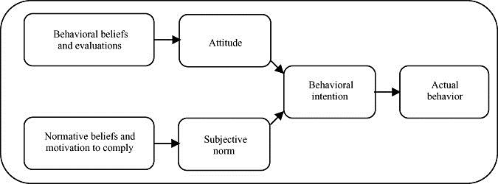

According to TRA, for individual behavioural intention (BI) to take place, the Attitude Towards performing Behaviour (ATB) has to be triggered directly by the individual, therefore, the Subjective Norm (SN) will be the final perception of how other people would view or judge why the individual should act or not (Swanson, 1982). Most importantly, the Behavioural domain varies when the prediction of behavioural (PI), ATB and SN are in place. Another aspect of this theory is that any researcher using it would have to specify the beliefs that are relevant for what is been studied, this is because the theory does not lay down the beliefs that are effective for a certain behaviour.

## THEORY OF PLANNED BEHAVIOUR (TPB)

Theory of Planned Behaviour (TPB) is an extension of Theory of Reasoned Action (TRA) as it has been adapted from the current model by Ajzen & Fishbein (1980), the context that was

added to TPB which Perceived Behavioural Control (PBC) focuses more on an individual

behaviour in which individuals do not have full control over their behaviours. Behavioural Intention (BI) and Perceived Behavioural Control (PBC) are determined by individual behaviour. This behavioural quality is determined in the direction of behaviour such as liking and disliking performance towards a behaviour, subjective norms that signifies the desire of an individual on performing or not performing a certain behavioural; including perceive behavioural control (PBC).

TPB has two problems that are pointed out by (Sheppard, Hartwick, & Warshaw, 1988) which are:

Any researcher that is using this theory would have to differentiate clearly between intention and behaviour, thus leading the researcher to spend more time in the research as there are variety of factors in accumulation leading to one’s intentions to determine how well the behaviour is achieved. It is difficult to understand in the model as to if one is probably failing due to individual intention or individual behaviour.

In order to provide a possible solution to the problems of the model, Fishbein & Ajzen (1975) decided to add some additional content to the model by extending TRA with a construct of perceived behaviour control. The added constructs control and predict an individual behaviour and intention. Figure 2.6.3 shows the Theory of Planned Behaviour.

Figure 1.6.3 Theory of Planned Behaviour Adapted from Pavlou, 2001.

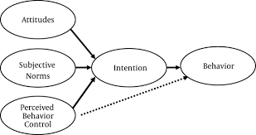

## TECHNOLOGY ACCEPTANCE MODEL (TAM)

F. Davis (1989) presented the technology acceptance model (TAM), TAM is adapted from the Theory of Reasoned Action (TRA), because it was geared towards user acceptance of information systems. Theory of Technology Acceptance was aimed at more details of the elements of “computer acceptance that is capable of explaining user behaviour across a broad range of end-user computing technologies and user populations, while at the same time being both parsimonious and theoretically justified (F. Davis, 1989)”. Most researchers would prefer to have a model that can predict and then explain a given phenomenon, in such ways that researcher can easily understand the methods of a particular system so as to come up with better solutions. Internal beliefs, intentions, and attitude are used to identify the influence of external factors, thus, TAM came in existence to support these factors.

TAM suggests two specific beliefs, these are the Perceived ease of use (PEOU) and Perceived usefulness (PU) which are regarded as the key elements of technology acceptance behaviour (F. D. Davis, Bagozzi, & Warshaw, 1989).

Perceived Usefulness (PU); this is known as the “degree to which a prospective user believes that using a particular system so as to would enhance his or her job performance(F. Davis, 1989)”. From the meaning of the word ‘’useful’’ ‘’ability to be used valuably’’. If a system is

said to have a high rate of perceived usefulness, then it is regarded as the individual using it believes that a positive use-performance relationship exist.

Perceived Ease of Usefulness (PEOU): “refers to a degree to which a prospective user believes that using a particular system would be free of effort.” From the word ease, a user thinks or perceives that effort is determined by him/her, thus making the user responsible for every action taken by him/her. In an ideal world, any computer application that is simple to use is extra possible to be recognized by operators than that which is difficult to use. TAM is a powerful and model for expecting user acceptance. Figure 2.6.4 shows Technology Acceptance Model.

Figure 2.6.4 Technology Acceptance Model

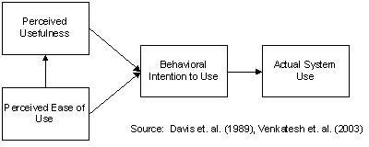

## THE UNIFIED THEORY OF ACCEPTANCE AND USE OF TECHNOLOGY (UTAUT)

UTAUT is viewed as the most appropriate model in the technology acceptance studies and is utilized in this study (Alawadhi & Morris, 2008). The extensiveness, validity, and dependable quality of the UTAUT have energized the researcher of this study to embrace and use it with regards to ICT in literacy education and culture in Jimeta-Yola, the Adamawa State, Nigeria. Various studies have used UTAUT to connect to the acceptance of technology in both the

developing and developed countries, with many elements that are seen to be compelled (Alawadhi & Morris, 2008). It is critical in this study to consider these variables when exploring users' aim to the acceptance of ICT in education within Jimeta-Yola of Adamawa State.

Likewise, it is fundamental for this research to consider other factors into the UTAUT model which would be particularly identified with the cultural setting of Hausa-Fulani to the acceptance of ICT in education in Jimeta-Yola. The element that was added to the UTAUT model is cultural barriers. All things considered, the model designed is to consider culture in Jimeta-Yola and to offer a further clarification of the acceptance of ICT in education in the Hausa-Fulani cultural setting.

Cultural values have been added in the model of UTAUT by applying the Hofstede view which adopts that cultural dimensions vary when dealing with attitudes concerning educational technology. When depending on UTAUT variables, Nistor et al. (2014) believe the consequence of performance expectancy on behavioural intention to be improved, and the effect of effort expectancy to be reduced by personal masculinity or cultural belief. Zakour (2004) expect that person can act as moderator of social influence on ETA, i.e. in individualistic cultures the social influence on ETA should be weaker (Nistor et al., 2014). The UTAUT model additionally considers moderators with the ability to affect four extra direct determinants; to be a specific, age, experience, gender, and voluntariness of use.

In order to fit in the research context, the model experienced some change which is the addition of cultural behaviour to it. The UTAUT model is shown in Figure 2.6.5.

Figure 2.6.5 Research Model

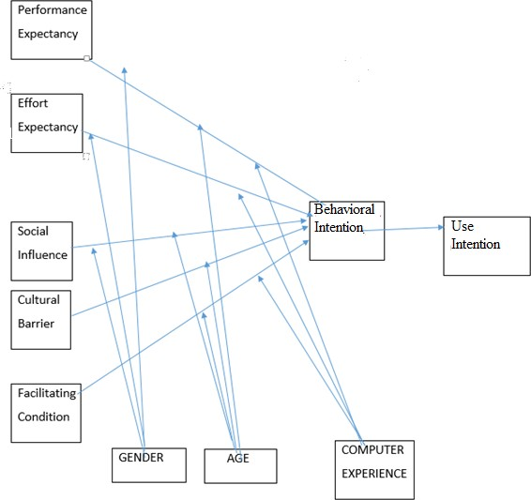

**Performance Expectancy:** This is known as the degree to which an individual believes that using a system will provide a benefit or enhance job performance (Venkatesh, 2003). Again, this construct stimulates the behavioural intention of a new user to make use of ICT in education. This study aims to discover the benefits of using ICT in education, therefore, the first hypothesis in this proposed framework is as follows:

H1- There would not be a positive relationship between performance expectancy and behavioural intentions to use ICT in education and this relationship would be moderated by gender, age, and computer experience.

The following four questions are derived to investigate the performance expectancy of the user perception:

PE1: Using Educational App in my job/study would enable me to accomplish knowledge more quickly

PE2: Using Educational App would enhance my effectiveness on my job/study PE3: Using Educational App would make it easier to do my job/study

PE4: I would find the Educational App useful in my job/study

**Effort Expectancy:** This is known as the degree of ease that an individual is associated with when using the system (Venkatesh & Zhang, 2010). From past experience, it is known that individuals’ find new technology easy to use when it is user friendly. This research wants to explore the ease of using ICT in education and the second hypothesis goes by:

H2- There would be a positive relationship between effort expectancy and behavioural intentions to use ICT in education, and this relationship would be moderated by gender, age, and computer experience.

In order to examine user perception, there are four questions for effort expectancy in this research:

1. EE1: Learning to operate the Educational App is easy for me
2. EE2: My interaction with the Educational App is clear and understandable
3. EE3: It is easy for me to become skilful at using the Educational App
4. EE4: Overall, I believe that the Educational App is easy to use

Social Influence: Social influence describes the condition by which an individual perceives that it is important that others believe the person should use the new technology (Venkatesh & Zhang, 2010). For the proposed model, the third hypothesis states that:

H3-There would be a positive relationship between social influence and behavioural intentions to use ICT in education, and this relationship would be moderated by gender, age, and computer experience.

For the research perfection to be examined, four questions are asked as follows:

1. SI1: People who influence my behaviour (such as teachers, friends, actors, singers, etc.) think that I should use the Educational App
2. SI2: People who are important to me (such as family members, supervisors, friends, etc.) think that I should use Educational App
3. SI3: I use the Educational App because many people in my school are doing so.
4. SI4: In general, Hausa-Fulani culture support Educational App in education.

**Facilitating Condition:** This is the degree of belief in the presence of the technical and organizational infrastructure to manage and maintain the usage of a new technology (Venkatesh & Zhang, 2010). This construct differs from other constructs, because it has no direct effect on behavioural intention. The facilitating condition in the UTAUT model does not have a positive influence usage on behavioural intention rather on it is directly on the actual user.

The perception of being able to access required resources was measured by facilitating condition in this study, as well as to gain information and all the support desired to use ICT in education systems. The awareness of the technology fitting into the lifestyle of the user is also influenced by age and computer experience. In order to explore these facilitating conditions toward the behaviour of ICT in education users, the researcher proposes the following hypothesis:

H4- There would be a positive relationship between facilitating conditions and ICT in education use behaviour, and this relationship would be moderated by gender, age, and computer experience.

In this study four questions were issued:

1. FC1: I have the resources necessary to use the Educational App.
2. FC2: I have the knowledge necessary to use the Educational App. Given the resources, opportunities, and knowledge it takes to use the App, it would be easy for me to use the App.
3. FC3: I think that using the Educational App fits well with the way I like to work/study.
4. FC4: Using the Educational App fits into my job/study style.

**Cultural Barrier:** This is considered to be one of the most important barriers in accepting technology because most educational applications are established using the English language, as language is part of the cultural barrier. Considering the Hausa-Fulani culture, most of the individuals speak and practice more of their language than English language, so this will make it difficult in understanding the educational applications in such cases.

H5- There would be a negative relationship between cultural barrier and behavioural intentions to use ICT education and this relationship would be moderated by gender, age, and computer experience.

In this study four questions were issued:

CB1: Hausa-Fulani culture influence my behaviour towards how I think about using the Educational App.

CB2: Hausa-Fulani people influence my behaviour and think that I should use the Educational App

CB3: Hausa-Fulani language support me in understanding the Educational App

CB4: In general, the Hausa-Fulani culture have supported my use of the Educational App

**Behavioural Intention**: This is defined as a customer‘s intention to make use of the certain tool and adapt it in the future (Ajzen & Fishbein, 1980) suggests that behavioural intention is tallied to have a direct influence on adoption. The capacity of behavioural intention includes the intention and predicted use of ICT in education. To explain behavioural intention toward the behaviour of ICT in education use, the researcher proposes the following hypothesis:

There would be a positive relationship between awareness and behavioural intentions to use ICT in education, and this relationship would be moderated by gender, age, and computer experience.

The following questions are constructed in order to explore the study:

1. FC1: I intend to use the Educational App onwards
2. FC2: I predict I will use the Educational App onwards
3. FC3: I plan to use the Educational App onwards

# CHAPTER THREE: METHODOLOGY

## INTRODUCTION:

This study follows a quantitative research methodology guided by a primary analysis research design. The quantitative research method is the right approach for this study, this is because it entails and measures the attitudes, behaviours, opinions and other variables related to the targeted sample population of this research. Also, it strives to understand the problem statement of the research by looking at the perception of the sample population (Kickul & Neuman, 2000). Therefore, the aim is to know the extent of the impact of ICT on literacy education and culture. Quantitative research methodology is powerful when it comes to acquiring social and cultural information about the qualities, practices, opinions, behaviours and cultural settings of a specific population (Neuman, 2000).

## RESEARCH DESIGN

Primary data is used in gathering data in this research. Primary data are data that are gathered directly from the source by the researcher (Marshall & Rossman, 1995). Subsequently, the research endeavoured to cover Jimeta-Yola metropolis making it appropriate for the author to make use of primary data in an effective way. The researcher has total control on who to participate in the research (Hox & Boeije, 2005).

This strategy for gathering data was utilized in light of the fact that it enabled the researcher to break down the impact of ICT on literacy education with reference to cultural barriers. Thus, making it visible to understand that ICT is of advantage in educational system with respect to culture.

## RESEARCH PARADIGM

Many researchers have the capacity to pick the most appropriate research approach from various strategy and techniques. In information systems there are distinctive philosophical methodologies concentrates, for example, positivist, interpretivist and critical realism (Collier, 1994).

Orlikowski & Baroudi (1991) found it more valuable to isolate from the positivist studies and the descriptive studies. This is because theoretical grounding is not found towards establishing the situation of a descriptive study; rather some demonstrations are made after a thorough observation of a situation that interests the researcher. In the descriptive studies, developing theory and testing the theory is limited, in this case theory building and theory testing is possible. The positivist philosophical approach depends on measuring pieces of evidence.

The ontological stand for a positivist approach is the belief that the world is not internal but rather external which has a single reality aim to investigate situations regardless of the researchers viewpoint or beliefs (Valtonen, 2011), A positivist researcher is isolated from the research reality by keeping distance which is regarded as important (Weber, 2004) .The approach keeps up a prompt extraordinary difference between the science, individual encounters, condition and esteem choice (Stahl, 2004).

The positivist research entices to concentrate on the scientific procedures and measurements which take after a particular research structure in other to draw out the single target reality (Weber, 2004). The positivist relies upon measuring actualities that are clearly recognized from the analyst. The positivist approach is an epistemology that utilizes theories and hypothesis in other to pick up an understanding learning of the exploration.

The interpretive research approach is that which has its own particular ontology view that the researcher and the truth are not separated, and an interpretivist’s learning can be increased through life encounters (Weber, 2004). It's a system that is intended to access the importance of the subject in other to pick up an understanding of the circumstance under perception (Orlikowski & Baroudi, 1991). The kind of information required in this kind of approach is socially configured not objectively decided (Stahl, 2004) . Interpretive escape from a firm auxiliary structure which is in the positivist research but instead receives adaptable and individual research.

Table 3.3.1, adopted from Stahl (2004), summarizes the ontological and epistemological differences of positivist and interpretivist paradigms.

Table 3.3.2 Ontology and epistemological differences of positivism and interpretivist

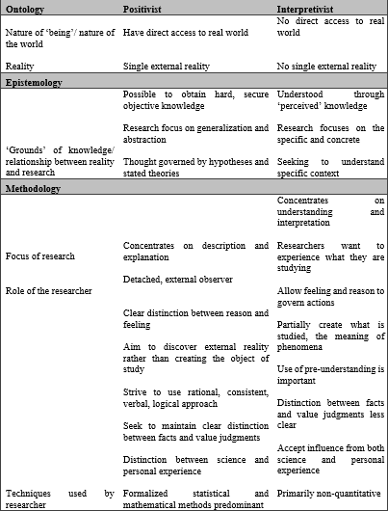

To distinguish the reasoning that supports the choice and choice to be made in wandering into conducting a research, a great research position will have an impact for what, how and why inquire about is completed. Understanding the most fitting reasoning of research is to embrace help in contributing further and more extensive perspective of research, this exploration venture can have a particular express reason inside the unique situation. The

distinctions of positivism and interpretivism are additionally featured by (Weber, 2004) that the distinctions can be found in the choice of the approach. Information System (IS) research can be perceived as positivist research if the examination has a certainty of testing theory quantifiable factors, formal recommendation and a decision about the circumstance (Orlikowski & Baroudi, 1991). Table 3.3.3 shows the positivist evidence by Orlikoski &Baroudi 1991

Table 3.3.4 Positivist Evidence

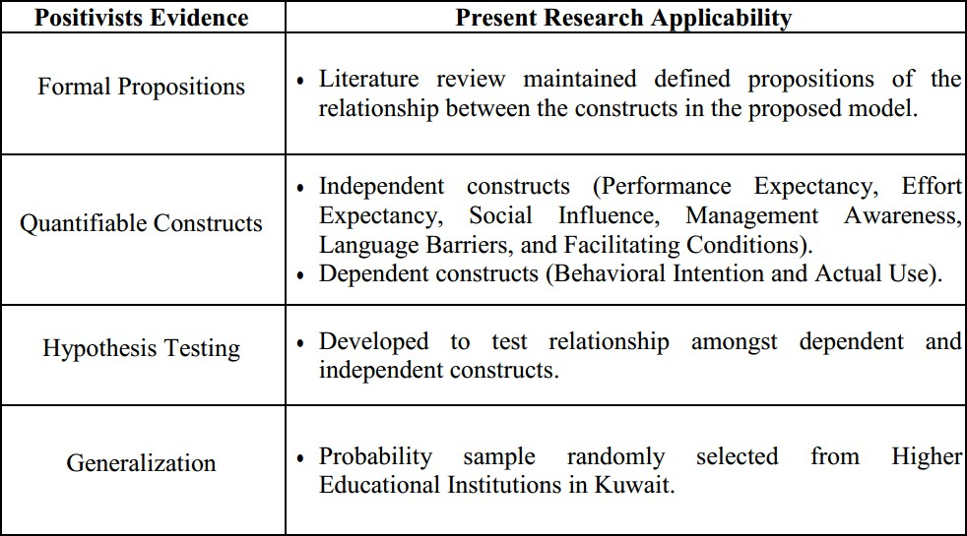

This study will embrace the positivist custom in the research field, the study requires testing of speculations and utilizing hypothesis building. The positivist convention is fitting in testing speculations and utilizing of hypothesis for increasing within the discoveries. The research venture has for fill the prerequisite of positivism convention as featured by (Orlikowski & Baroudi, 1991).

## Research Reasoning Approach

The researchers connected the thinking approach that goes before as a feature of their essential logical process, with the distinctive strategy as consistent to the thinking of methodology (Ochara, 2013). Walsham (1995) suggest that hypothesis might be a piece of

research in various routes as a rule to the exploration outline and information accumulation subsequently, the iterative piece of the information gathering, the examination, and the discoveries result of the examination venture. The thinking styles, for example, inductive, deductive and reproductive in explore must be plainly found keeping in mind the end goal to position the logical commitment to the field of study (Ochara, 2013).

Deductive thinking styles are connected straightforwardly to positivism approach (Ochara, 2013). The deductive thinking utilizes hypothesis in connection to explore which is utilized to manage circumstance request. The deductive approach hypothesis and the theory start things out before the procedure of information gathering (Bryman, 2007) . The way toward connecting the hypothesis and the information is identified with quantitative research approach of gathering information. Inductive thinking approach is specifically inverse to other deductive methodologies. A hypothesis in inductive is frequently grounded hypothesis way to deal with a watch and to manufacture speculations. Be that as it may, the inductive approach of connecting information with a hypothesis is identified with a quantitative methods (Bryman, 2007).

A deductive hypothesis is devoted to the exploration of critical thinking by demonstrating the speculations that are inexistent, where the theory is tried by the discoveries. Speculations that are pertinent can be amended by tolerating or dismissing theory which was expressed toward the start of the study (Bryman & Bell, 2007).

Deductive reasoning is adapted into this research. Therefore, making the unified theory acceptance of user technology (UTAUT) to examine the impact of literacy education and culture in Adamawa State Jimeta-Yola. Data is gathered after recognizing a hypothesis of the research as well as the right theory for the study.

## Qualitative and Quantitative Approach

The qualitative technique is manufactured based on the positivism with the ontological position of backings and present reality. It seeks to find the actual reality, which is not quite the same as the researcher's bits of knowledge. From the epistemological point of view, the researcher and the study theme that are under perception are self-deciding when understanding that the researcher has the capacity to investigate the circumstance paying little mind to there being and impact (Ononiwu & Brown, 2013).

The two methods of gathering data are qualitative and quantitative methods, quantitative methods deal with administering of questionnaires to collect data while qualitative deals with getting information from experience/interviews. The types of interview include open-minded, focused and structured interview (Yin, 2003). Focused interview deals with a short interview that has predefined questions. Open minded interview is easy to change discussions in such a way that an individual’s opinion is asked on a particular phenomenon.

## Measurement of Construct

The aim of this research is to know the impact of culture on ICT literacy education and in Jimeta-Yola of Adamawa State. From the literature review, the research construct was developed in an appropriate manner established from past papers studied. Table 5.6 represents the developed construct together with relevant measurement sources used in setting up the questioner of this research.

Table 6.6 Research construct.

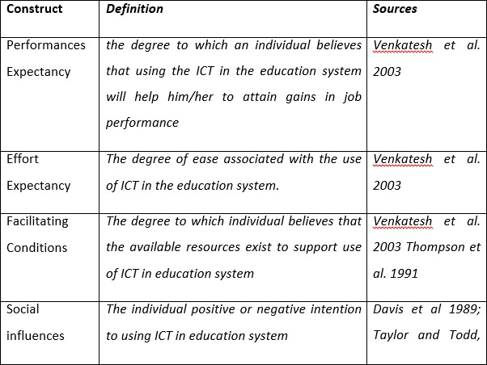

## Sources of Data

Since a quantitative method of approach is used in this study, the data was gathered with the aid of administering questioners that is developed to suit the research work to the targeted population within Jimeta-Yola metropolis. The research questions were developed based on the research theory construct studied in the work. Hence, the questionnaire has two sections (A and B), which consist of the demographic information, and the latter consists of the theoretical construct adapted for the research. The reason why the English language is selected is that the respondents understand English, and in the case of difficulty to understand, the researcher explains in Hausa-Fulani language for a proper understanding of the questionnaire.

## Sampling

Since the target population is obviously selected, the limitation of financial funding and time constraints are also considered in the study. The characteristics of a population are not totally reflected by the sample rather shows the attribute of the sampling target. The two kind of sampling techniques are probability sampling and non-probability sampling (Saunders, 2007). Probability sampling is a method that has to do with the attribute that represents the whole population, thus could be used to determine the characteristic of a population. While non-probability methods do not have a chance of a member of a targeted population to represent the character of a population. So, this study is using a probability method to find the target population.

## Sample Size

When dealing with larger sample size, it is suitable to use complex statistical analysis (Shukla, 2008).The required sampling size like any other statistical techniques of Structural Equational Modelling (SEM) is 200 and should not exceed 400 due to its sensitivity, this enhances to get proper reliable estimates in result findings (Hair, Sarstedt, Ringle, & Mena, 2012). In order to achieve this, 300 questionnaires were distributed and 205 were to be significant among those returned. Below is the formula for calculating sample size.

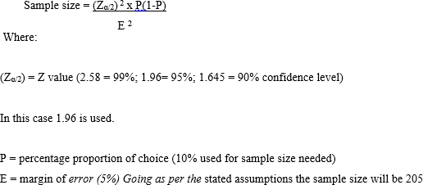

The above formula is gotten from Cochran (1977), where it shows how population sample can be gotten in a research.

## Data Quality

Quality of data and integrity in research is very important. To achieve that, two standard qualities are measured; this comprises of the validity and the reliability testing (Saunders, 2007).

## Reliability

Saunders (2007), explains well-defined reliability as the degree to which the gathered data produces excellent results. Transparency is another element that is really considered in the gathering of data. To accomplish this, the inconsistency ratio is calculated in order to get a successful data. Therefore, respondent’s answers were processed by logical inconsistency.

## Validity

Validity is the degree to which information gathering techniques for a decision, is what is planned to be, that is the discoveries reflects what is proposed to be (Saunders, 2007).The accompanying was utilized to guarantee the validity of information gathered:

Sources of gathering data were from the reliable ground.

The researcher made the questions clear to the respondents both by interpreting and explaining to them. In order to succeed with the data gathering process, the time used was clearly defined, planned and implemented. The research questions and hypothesis were derived from the question designed.

## Measure

Students and teachers are the users of the educational applications used in this research, therefore the questioners were distributed among the Hausa-Fulani students of three (3)

Secondary Schools (two private and one public) within Jimeta-Yola. The questionnaire for this study comprises of five (5) questions in the first part and nineteen (19) questions in the second part. The second part questions are measured using a Likert scale of five points that range between “Strongly Disagree = 1”, “Disagree = 2”, “Neutral = 3”, “Agree = 4” and “Strongly Agree = 5”.

# CHAPTER FOUR: DATA PRESENTATION

## Demographic Information

This section of the work describes the data collected from the target population. The information helps the researcher to know details about the target population.

## Gender (Staff and Student)

Table 4.1.1 shows the gender involvement for the staff and student responders. From the quantitative study, the results indicate that 205 respondents which about 65.85 % of the respondents are male while 34.14 % are Female respondents

Table 7.1.1 Demographic Information

|  |  |  |
| --- | --- | --- |
| **Gender** | **Frequency** | **Percentage** |
| Male | 135 | 65.85 |
| Female | 70 | 34.14 |
| Total | 205 | 100% |

## Teaching Experiences (Only Staff)

Table 4.1.2 shows the teaching experiences of only teachers from the result of the quantitative study of 60 respondents which is 13.3 % of the respondents that are from year 0- 2., 18.3% respondent that are 3-4, 38.3 respondents that are 5-9, 24% of the respondent that are 10-14, 6% of the respondents that are 15 years above.

Table 4.1.2 Teaching experience

|  |  |  |
| --- | --- | --- |
| **Years** | **Frequency** | **Percentage** |
| 0-2 | 8 | 13.3 |
| 3-4 | 12 | 18.3 |
| 5-9 | 23 | 38.3 |

|  |  |  |
| --- | --- | --- |
| 10-14 | 13 | 24 |
| 15 years above | 4 | 6 |
| Total | 60 | 100% |

## Educational Level (Staff and Student)

Table 4.1.3 shows all the educational level for both the students and the teachers’ respondent of 205. From the result about 68.29 % of the respondents are secondary school students,

13.63 % of the respondent have NCE, 14.73 % of the respondents have BSc and about 3.90

% of the respondent are MSc holders.

Table 4.1.3 Educational Level

|  |  |  |
| --- | --- | --- |
| **Educational Level** | **Frequency** | **Percentage** |
| Secondary School Student | 140 | 68.29 |
| NCE | 34 | 13.63 |
| BSc | 23 | 14.73 |
| Msc | 8 | 3.90 |
| Total | 205 | 100% |

## Religion (Staff and Students)

The table 4.1.4 above shows the different religions of the respondents both teachers and students 205. 77.6 % of the respondents are Islam, 20.51 % of the respondents are Christians and about 2.43 % are other religion.

Table 4.1.4 Religion

|  |  |  |
| --- | --- | --- |
| **Religion** | **Frequency** | **Percentage** |
| Islam | 155 | 77.6 |
| Christianity | 45 | 20.51 |
| Other | 5 | 2.43 |
| Total | 205 | 100% |

## Computer Experiences (Staff and Students)

Table 4.1.5 above shows the computer experiences of all the respondents 205. From the quantitative study result, about 78.94% of the respondent have computer experiences while about 21% of the respondents have no computer experiences.

Table 4.1.5 Computer Experience

|  |  |  |
| --- | --- | --- |
| **Computer Experiences** | **Frequency** | **Percentage** |
| Yes | 185 | 78.94% |
| No | 20 | 21 |
| Total | 205 | 100% |

## PARTIAL LEAST SQUARE

Partial least square popularly known as (Smart PLS) is the second generation of structural equation modeling (SEM) which enables researchers to answer a set of research questions. This software is mostly used in social science research because of it robustness and explanatory power. The analysis is done by modeling the constructs of a theory in the software with the data gotten from the distributed questionnaires. The software is also very good in finding the relationships between variables or constructs. The independent and dependent variables are compared simultaneously (Gefen, 2000). Smart PLS is widely used

by information systems and social sciences to test statistical quality and result. Smart PLS is used because of its robustness for explanatory and confirmatory analysis and reporting.

## Testing Reliability and Validity

## Reliability

In order to know the internal consistency of the research model, validity and reliability have to be measured. Internal consistency is used to evaluate the acceptable measures of reliability and validity. Composite reliability will be used to test the reliability of the research model. The internal consistency measures the acceptable reliability of the data measured. The standard way of measuring the internal consistency is through the cronbach’s alpha and composite reliability. The acceptable value of composite reliability and cronbach’s alpha is

0.7. The values of the composite reliability are summarized in the table below. From the table the values are above the acceptable range of 0.7 which shows that the constructs are statistically reliable.

Table 4.3.1 below shows the composite reliability which is within the acceptable range. The composite reliability of behavioural intention is 0.9, which shows the internal consistency of the construct. The Cultural barrier has the composite reliability of 0.8999, effort expectancy has 0.949, facilitating condition has 0.798, performance expectancy has 0.729 and social influence has 0.873 which are all within the acceptable range.

Table 4.3.1 Reliability

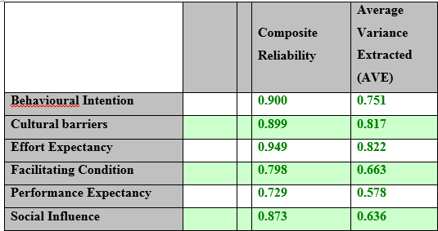

## Validity

There two ways of measuring validity which is convergent validity and discriminant validity. This two methods of measuring validity shows the best fit of the model. The convergent validity shows that each variable correlates strongly with another variable of the model. Loadings are used to show the convergent validity. The acceptable range for loading of the indicator is 0.6. Table 4.3.2 shows the loading of each item that correlates strongly with another project. Another way of accessing validity is discriminant validity, it is when an item correlates strongly with its associated construct of the model.

Table 4.3.2.1 Average Variance

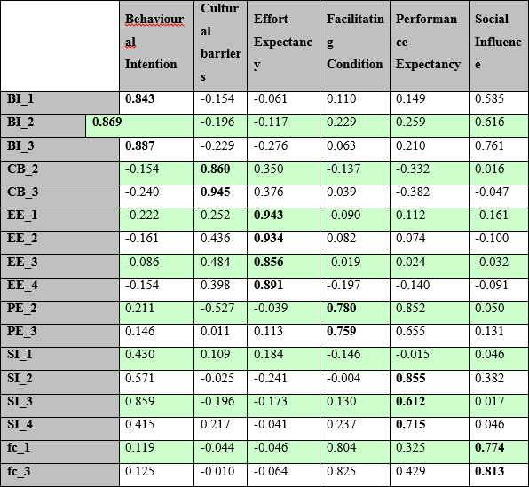

Table 4.3.2.2 shows the Fornell-Lacker criterion in which the values in the diagonal are the square root of the average variance extracted. The validity is measured using the square root of average variance extracted of every latent variable.

Table 4.3.2.2 Criterion

|  |  |  |  |  |  |  |
| --- | --- | --- | --- | --- | --- | --- |
| Fornell-Larcker  Criterion | **Behavioural**  **Intention** | **Cultural**  **barriers** | **Effort**  **Expectancy** | **Facilitating**  **Condition** | **Performance**  **Expectancy** | **Social**  **Influence** |
| **Behavioural**  **Intention** | **0.866** |  |  |  |  |  |
| **Cultural barriers** | -0.226 | **0.904** |  |  |  |  |
| **Effort Expectancy** | -0.186 | 0.402 | **0.907** |  |  |  |
| **Facilitating**  **Condition** | 0.150 | -0.033 | -0.068 | **0.814** |  |  |
| **Performance**  **Expectancy** | 0.239 | -0.397 | 0.030 | 0.465 | **0.760** |  |
| **Social Influence** | 0.764 | -0.024 | -0.120 | 0.078 | 0.108 | **0.797** |

## Path Model

Figure 4.4.1 is a Path Model which shows that performance expectancy has a positive influence on behavioural intention (β= 0.069), Effort expectancy has a negative relationship with the behavioural intention (β= -0.028). Cultural barrier also has a negative influence on behavioural intention (β= -0.168). Social influence is also influencing behavioural intention positively (β= -0.745). Facilitating condition has path coefficient of (β= 0.058).

The value of R square shows the explanatory power of the model. It explains 64% of the variance of behavioural intention, which is 0.64 coefficient of determination to use. The value of R square in this study is high which shows the predictive and explanatory power of the model.

Figure 4.4 Path Model

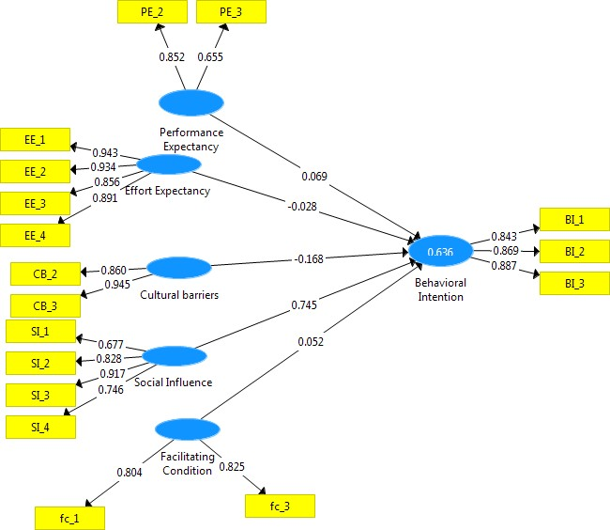

After bootstrapping the original sample 5000 times, the result was shown in the table above. The original sample in the table indicate the path coefficient which is the beta values. The T statistics was used to test the significant of the path coefficient. The T statistics will also be used to support and reject a hypothesis. The significant will be acceptable if it is above 90% confidence level which is 1.645. From table 4.4.1, cultural barriers and socials influence have high significant on behavioural intention.

Table 4.4 Bootstrapping

|  |  |  |  |
| --- | --- | --- | --- |
|  | **Original Sample (O)** | **Standard Deviation (STDEV)** | **T Statistics (|O/STDEV|)** |
| **Cultural Barriers -> Behavioural Intention** | -0.170 | 0.069 | -2.457 |
| **Effort Expectancy -> Behavioural Intention** | -0.024 | 0.071 | -0.338 |
| **Facilitating Condition -> Behavioural Intention** | 0.054 | 0.062 | 0.862 |
| **Performance Expectancy -> Behavioural Intention** | 0.064 | 0.072 | 0.889 |
| **Social Influence -> Behavioural Intention** | 0.749 | 0.064 | 11.765 |

## Hypothesis Testing

*H1- There would not be a positive relationship between performance expectancy and behavioural intentions to use ICT in education and this relationship would be moderated by gender, age, and computer experience.*

According to the research model, performance expectancy was hypothesized to have a negative influence on behavioural intention. From the findings of this study, performance expectancy has a positive (β= 0.069, p value < 0.05 ) effect on behavioural intention which rejected the hypothesis.

*H2- There would be a positive relationship between effort expectancy and behavioural intentions to use ICT in education, and this relationship would be moderated by gender, age, and computer experience.*

Effort expectancy has a positive influence on the behavioural intention and the result of this research rejected the hypothesis. The findings in this study show that effort expectancy has a negative influence on the behavioural intention (β= -0.028, p value < 0.001).

*H3-There would be a positive relationship between social influence and behavioural intentions to use ICT in education, and this relationship would be moderated by gender, age, and computer experience.*

Social influence is hypothesized to have a positive influence on behavioural intention. The result of this study also shows social influence has a positive effect on behavioural intention (β= -0.168, p value < 0.01).

*H4- There would be a positive relationship between facilitating conditions and ICT in education use behaviour, and this relationship would be moderated by gender, age, and computer experience.*

Facilitating condition is predicted to have a positive influence on the behavioural intention to use ICT in education. The findings in this study also show that facilitating condition is positively influencing the behavioural intention (β= 0.058, p value < 0.05).

*H5- There would be a negative relationship between cultural barrier behavioural intentions to use ICT education and this relationship would be moderated by gender, age, and computer experience.*

A Cultural barrier is negatively influencing the behavioural intention to use an ICT in education. The result of this study also shows that cultural barrier is affecting the behavioural intention to accept ICT in education (β= -0.745, p value < 0.001). A summary of hypothesis testing results is shown in table 4.5.

Table 4.5 Summary of Hypothesis Testing Results

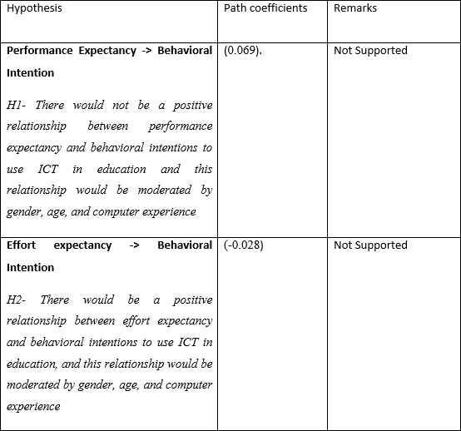

|  |  |  |
| --- | --- | --- |
| **Social Influence -> Behavioural Intention**  *H3-There would be a positive relationship between social influence and behavioural intentions to use ICT in education, and this relationship would be moderated by gender, age, and computer experience.* | (0.745) | Supported |
| **Facilitating Condition -> Behavioural Intention**  *H4- There would be a positive relationship between facilitating conditions and ICT in education use behaviour, and this relationship would be moderated by gender, age, and computer experience* | (0.052) | Supported |
| **Cultural Barrier -> Behavioural Intention**  *H5- There would be a negative relationship between cultural barrier and behavioural intentions to use ICT education and this relationship would be moderated by gender, age, and computer experience.* | (-0.168) | Supported |

# CHAPTER FIVE: CONCLUSION AND RECOMMENDATION

## Introduction

The summary of theoretical and practical implications will be discussed in this chapter and some recommendations for Secondary schools. The research limitation, contributions, and future research are as well discussed in this chapter.

## Discussion

Technology in education is an activity that has been in existence for decades in developed countries. In order to breach the gap of acceptance of technology in the developing countries, certain barriers that are holding it needs to be addressed. So, this research focused on the cultural barriers hindering the acceptance of technology in secondary schools of Jimeta-Yola of Adamawa state, Nigeria. For technology acceptance to be successful in Jimeta-Yola, certain steps need to be followed; such as training and creating awareness for usefulness of this educational application software in teaching/learning activities, there is also need to create specific periods to teach the students on how to use the educational applications. Also, school authorities need to be cross checking on both teachers and students on how effective they carry out their teaching/learning activities in the schools. The study found that cultural barrier is one of the factors that affect the acceptance of technology. As the cultural barrier was discussed in the literature review as a weakness to the acceptance and adoption of technology in education. So, with such the UTAUT model was modified with an external factor to suit the context of the study which is the cultural barrier the quantitative findings clearly specify that cultural barriers had a negative influence on behavioural intention to accept technology into education.

## Limitation of the Study

As any other research has its own limitations, so does this research. The time factor was an element that hindered the study as the time frame of gathering data and analysing the data was limited. If time was not an issue, the researcher would have used another method of analysing data in order to have reliable and accurate results, though the method used in the study is valid and reliable. Another limitation is that some teachers and students were not willing to participate in the filling of the questioner as they were not aware of the importance of the research. Another important limitation is that the research only studied one culture in Adamawa State, it would have been better if other cultures within the State are studied as well.

## 5.5 Further Recommendation

In order to tackle some of the limitations listed above, more studies and investigations need to be carried out in terms of validation and generalization especially towards the barriers hindering the acceptance of educational technologies into educational systems of developing countries. UTAUT model was tested in this study in order to fit into the context of the impact of literacy education and culture in Adamawa State. UTAUT model can be used as a guide and frame of reference for additional investigation by challenging the model using several contexts and States within Nigeria. Some of the elements that need to be addressed could be security, language and religious influences, peer pressure and social influences.

# REFERENCES

Ajzen, I., & Fishbein, M. (1980). Theory of Reasoned Action. *Social Psychology*. https://doi.org/10.4135/9781483346427.n552

Alawadhi, S., & Morris, A. (2008). The use of the UTAUT model in the adoption of e- government services in Kuwait. In *Proceedings of the Annual Hawaii International Conference on System Sciences*. https://doi.org/10.1109/HICSS.2008.452

Apena, T. T. . (2012). Information and Communication Technology and Open Distance Learning, Impact and Challenges. *International Journal of Social Sciences & Education*, *2*(1), 440–446. Retrieved from https://libproxy.library.unt.edu:9443/login?ur[l=http:](http://search.ebscohost.com/login.aspx?d)//[search.ebscohost.com/login.aspx?d](http://search.ebscohost.com/login.aspx?d) irect=true&db=eue&AN=70492301&scope=site

Baartman, L. K. J., & De Bruijn, E. (2011). Integrating knowledge, skills and attitudes: Conceptualising learning processes towards vocational competence. *Educational Research Review*. https://doi.org/10.1016/j.edurev.2011.03.001

Bryman, A. (2007). Barriers to Integrating Quantitative and Qualitative Research. *Journal of Mixed Methods Research*, *1*(1), 8–22. https://doi.org/10.1177/2345678906290531

Bryman, A., & Bell, E. (2007). *Business Research Methods*. *Social Research*. https://doi.org/10.4135/9780857028044

Burrows, T., & Stepanczuk, D. (2013). Gauge of Readiness for Internet-Based Language Learning: An 800 Pound GORILLa. *JALT CALL Journal*, *9*(2), 197–217. Retrieved from <http://search.ebscohost.com/login.aspx?direct=true&db=eric&AN=EJ1107982&site=eh> ost-live

Cochran, W. G. (1977). Sampling Techniques. *John Wiley & Sons*, *20*(1), 1–10. https://doi.org/10.2307/1268167

Collier, A. (1994). Critical Realism. *International Studies in Philosophy*, *20*, 120–122.

Retrieved from <http://www.amazon.co.uk/dp/0860916022>

Cukier, K., & Mayer-Schoenberger, V. (2013a). Rise of Big Data: How it’s Changing the Way We Think about the World, The. *Foreign Affairs*, *92*(3), 28–40. https://doi.org/10.1007/s13398-014-0173-7.2

Cukier, K., & Mayer-Schoenberger, V. (2013b). The rise of big data : how it â€TM s changing the way we think about the world. *Foreign Affairs*, *92*, 1–7.

Davis, F. (1989). Perceived usefulness, perceived ease of use, and user acceptance of information technology. *MIS Quarterly*, *13*(3), 319–340. https://doi.org/10.2307/249008

Davis, F. D., Bagozzi, R. P., & Warshaw, P. R. (1989). User acceptance of computer technology: a comparison of two theoretical models. *Management Science*. https://doi.org/10.1287/mnsc.35.8.982

Edmunds, R., Thorpe, M., & Conole, G. (2012). Student attitudes towards and use of ICT in course study, work and social activity: A technology acceptance model approach. *British*

*Journal of Educational Technology*, *43*(1), 71–84. https://doi.org/10.1111/j.1467- 8535.2010.01142.x

Erumban, A. A., & de Jong, S. B. (2006). Cross-country differences in ICT adoption: A consequence of Culture? *Journal of World Business*, *41*(4), 302–314. https://doi.org/10.1016/j.jwb.2006.08.005

Fishbein, M., & Ajzen, I. (1975). Belief, Attitude, Intention and Behaviour: An Introduction to Theory and Research. *Reading MA AddisonWesley*, (August), 480. https://doi.org/10.2307/2065853

Gefen, D. (2000). Structural Equation Modeling and Regression : Guidelines for Research Practice Structural Equation Modeling and Regression : Guidelines for Research Practice. *Structural Equation Modeling*, *4*(August), 7. https://doi.org/10.1.1.25.781

Hair, J. F., Sarstedt, M., Ringle, C. M., & Mena, J. A. (2012). An assessment of the use of partial least squares structural equation modeling in marketing research. *Journal of the Academy of Marketing Science*, *40*(3), 414–433. https://doi.org/10.1007/s11747-011- 0261-6

Harbor, B. (2004). U.S. Department of Education 2003-2004. *National Center for Education Statistics*, (September 2003), 1–19. https://doi.org/10.4135/9781412963916.n394

Hawkins, R. J. (2002). Ten Lessons for ICT and Education in the Developing World. *Most*, (Benckert), 38–43.

Hofstede, G. (2001). Values and culture. In *Culture’s Consequences: Comparing Values, Behaviors, Institutions, and Organizations Across Nations* (pp. 1–36). https://doi.org/10.1016/S0005-7967(02)00184-5

Hofstede, G., & McCrae, R. R. (2004). Personality and Culture Revisited: Linking Traits and Dimensions of Culture. *Cross-Cultural Research*, *38*(1), 52–88. https://doi.org/10.1177/1069397103259443

Hox, J. J., & Boeije, H. R. (2005). Data Collection, Primary vs. Secondary. In *Encyclopedia of Social Measurement* (pp. 593–599). https://doi.org/10.1016/B0-12-369398-5/00041-4

Kickul, J., & Neuman, G. (2000). Emergent leadership behaviors: The function of personality and cognitive ability in determining teamwork performance and KSAs. *Journal of Business and Psychology*, *15*(1), 27–51. https://doi.org/10.1023/A:1007714801558

Klees, S. J. (2002). World Bank education policy: New rhetoric, old ideology. *International Journal of Educational Development*, *22*(5), 451–474. https://doi.org/10.1016/S0738- 0593(02)00006-8

Kofi, E. (2007). *The Integration of Information and Communication Technology Into Rural Schools of South Africa : a Case Study of Schools in Malamulele*. STELLENBOSCH UNIVERSITY.

Krause, M., Pietzner, V., Dori, Y. J., & Eilks, I. (2017). Differences and developments in attitudes and self-efficacy of prospective chemistry teachers concerning the use of ICT in education. *Eurasia Journal of Mathematics, Science and Technology Education*, *13*(8), 4405–4417. https://doi.org/10.12973/eurasia.2017.00935a

Lenartowicz, T., Johnson, J. P., & Konopaske, R. (2014). The application of learning theories to improve cross-cultural training programs in MNCs. *The International Journal of Human Resource Management*, *25*(12), 1697–1719. https://doi.org/10.1080/09585192.2013.860384

Marshall, C., & Rossman, G. B. (1995). Data Collection Methods. *Designing Qualitative Research*, (1997), 97–150. https://doi.org/10.3390/s110707188

Neuman, W. L. (2000). *Social Research Methods: Qualitative and Quantitative Approaches*.

*Book*.

Ngoma, S. (2013). ICT in Education: Catalyst for Economic Growth in Nigeria. *International Journal of Education and Research*, *1*(10), 79–86. Retrieved from <http://www.ijern.com/journal/October-2013/38.pdf>

Nistor, N., Lerche, T., Weinberger, A., Ceobanu, C., & Heymann, O. (2014). Towards the integration of culture into the Unified Theory of Acceptance and Use of Technology. *British Journal of Educational Technology*, *45*(1), 36–55. https://doi.org/10.1111/j.1467-8535.2012.01383.x

Ochara, N. M. (2013). Linking Reasoning to Theoretical Argument in Information Systems Research. *Amcis 2013*, 1–11. Retrieved from <http://aisel.aisnet.org/cgi/viewcontent.cgi?article=1501&context=amcis2013>

Ononiwu, C. G., & Brown, I. (2013). Theorisation In Critical Realist Is Research And Its Implications On Structure And Agency Interplay : A Morphogenetic Approach.

Orlikowski, W. J., & Baroudi, J. J. (1991). Studying information technology in organizations: Research approaches and assumptions. *Information Systems Research*, *2*(1), 1–28. https://doi.org/10.1287/isre.2.1.1

Oyserman, D., Kemmelmeier, M., & Coon, H. M. (2002). Cultural psychology, a new look: Reply to Bond (2002), Fiske (2002), Kitayama (2002), and Miller (2002). *Psychological*

*Bulletin*, *128*(1), 110–117. https://doi.org/10.1037//0033-2909.128.1.110

Player-Koro, C. (2012). Factors Influencing Teachers’ Use of ICT in Education. *Education Inquiry*, *3*(1), 93–108. https://doi.org/10.3402/edui.v3i1.22015

Saunders, C. (2007). Information Systems in Developing Countries. *MIS Quarterly*, *31*(2), iii–vi. Retrieved from <http://search.ebscohost.com/login.aspx?direct=true&db=buh&AN=24837911&site=ehos> t-live

Sheppard, B. H., Hartwick, J., & Warshaw, P. R. (1988). The theory of reasoned action: Meta-analysis of past research with recommendations for modifications and future research. *Journal of Consumer Research*, *15*(3), 325–343. https://doi.org/10.1086/209170

Shukla, P. (2008). *Essentials of marketing research*. *Essentials of Marketing Research*. https://doi.org/10.1016/S1441-3582(04)70101-9

Stahl, B. C. (2004). Positivism or non-positivism – tertium non datur: a critique of philosophical syncretism in IS research. In *Ontologies* (pp. 1–28). https://doi.org/9780387370224

Sulkowski, N. B., & Deakin, M. K. (2009). Does understanding culture help enhance students’ learning experience? *International Journal of Contemporary Hospitality Management*, *21*(2), 154–166. https://doi.org/10.1108/09596110910935651

Swanson, E. B. (1982). Measuring user attitudes in MIS research: a review. *Omega*, *10*(2), 157–165. https://doi.org/10.1016/0305-0483(82)90050-0

Unesco. (2002). Information and communication technology in education. *Dera.Ioe.Ac.Uk*,

148. Retrieved from <http://dera.ioe.ac.uk/5144/1/ict-education-report-e.pdf?lang=en>

Valtonen, J. M. & A. (2011). Qualitative Marketing Research. *Reading*, 1–16. https://doi.org/10.4135/9781849209632

Veltri, N. F., & Elgarah, W. (2009). The Role of National Cultural Differences in User Adoption of social Networking. *Proceedings of the Southern Association for Information Systems Conference*, *2007*(January 2007), 169–174. Retrieved from <http://aisel.aisnet.org/sais2009/33/>

Venkatesh, V. (2003). User Acceptance of Information Technology: Toward a Unified View.

*MIS Qarterly*, *27*(3), 425–478. https://doi.org/10.1017/CBO9781107415324.004

Venkatesh, V., & Zhang, X. (2010). Unified theory of acceptance and use of technology: U.S. vs. China. *Journal of Global Information Technology Management*, *13*(1), 5–27. https://doi.org/10.1080/1097198X.2010.10856507

Walsham, G. (1995). Interpretive case studies in IS research: nature and method. *European Journal of Information Systems*, *4*(2), 74–81. https://doi.org/10.1057/ejis.1995.9

Weber, R. (2004). The Rhetoric of Positivism Versus Interpretivism: A Personal View. *MIS Quarterly*, *28*(1), iii–xii. https://doi.org/Editorial

Yin, R. K. (2003). Case Study Research . Design and Methods. *SAGE Publications*. https://doi.org/10.1097/FCH.0b013e31822dda9e

Zakour, A. Ben. (2004). Cultural Differences and Information Technology Acceptance. In

*Southern Association for Information Systems* (pp. 156–161).

Zakour, A. Ben. (2007). *Information Resources Management*. *Information Resources Management: Global Challenges*. https://doi.org/10.4018/978-1-59904-102-5