# DESIGN, FABRICATION AND EVALUATION OF A

**BENISEED (Sesamum indicum L.) OIL EXPELLER**

# BY

**Tajudeen Muraina Adeniyi OLÁYANJÚ**

*B. Sc., M.Sc. Agric. Engineering (Ibadan) M.N.S.A.E., M.N.S.E., M.N.I.F.S.T., R.Engr. (COREN)*

A **Thesis** in the Department of AGRICULTURAL ENGINEERING

Submitted to the Faculty of Technology, in Partial Fulfilment of the Requirements for the Degree of

## DOCTOR OF PHILOSOPHY

of the

## UNIVERSITY OF IBADAN

February, 2002

# ABSRACT

Some physical and mechanical properties of two Nigerian beniseed accessions (Yandev-55 and E8) were determined at 5 moisture content levels of 5.3, 10.6, 16.1, 22.4, and

28.3 per cent (wet basis). These were used as inputs into designing a beniseed oil expeller, as available ones could not perform effectively with the seed.

The determined physical properties were linear dimensions, size, sphericity, bulk and true densities, porosity, thousand kernel weight and coefficient of friction between the seed and different structural surfaces while the determined mechanical properties were the required force, sustained deformation and energy needed to rupture and express oil from the seed.

The linear dimensions in terms of major, intermediate and minor diameters were found to be 2.80, 1.83 and 0.66mm for Yandev-55; 3.30, 2.13 and 0.75mm for E8 respectively. The corresponding geometric mean sizes were 1.49 and 1.73mm for the two accessions at 5.3% moisture content levels. These parameters were found to increase with increase in moisture content. The sphericity values for the two accessions were determined to be in the range 0.52 to 0.55 (0.03). It was found that moisture content had no significant effect on sphericity.

The bulk and true densities decreased from 688 to 613kg/m3 and 1042 to 981kg/m3 for Yandev-55; 674 to 528kg/m3 and 1050 to 988kg/m3 for E8 respectively with increase in moisture content from 5.3 to 28.3% wb. The porosity and thousand kernel weight increased with the increase in moisture content from 5.3 to 28.3% and are within the range of 34.52 to 46.56% and 2.63 to 3.50g respectively. The static coefficients of friction between beniseed

and four structural surfaces show that glass has the least value of 0.32, while for mild steel, plywood and concrete, frictional coefficients with beniseed were between 0.39 to 0.59 within the 5.3 and 22.4% moisture content levels.

The applied force, resulting deformation and required energy ranged from 7.73 to 29.40N, 0.17 to 0.54mm and 0.0013 to 0.0100J for whole and dehulled seeds respectively within 4.1 and 7.7% moisture content (wet basis).

A portable expeller for beniseed oil expression was designed and fabricated, based on the results of the determined properties. The expression chamber has a barrel of 60mm diameter and a special wormshaft of length 600mm rotating at a speed of 45rpm through a 1- hp electric-gear reduction motor. The average capacity of the expeller was 10kg beniseed per hour. A-50litres/h oil filter press was also designed and fabricated for improved oil recovery and better cake utilization.

The efficiency of the expeller in terms of oil recovery from the seed as influenced by wormshaft speed and seed moisture content was evaluated. Increasing wormshaft speed from 30 to 45rpm increased the oil recovery from 37.56 to 79.63% and 33.70 to 74.28% for Yandev-55 and E8 respectively. A further increase to 75rpm decreased the respective oil recovery for the two accessions to 32.47 and 31.92%. The residual oil-in-cake increased from 14.43 to 43.54% and 17.73 to 43.88% for the two accessions, with the increase in seed moisture content from 4.1 to 10.3% wb.

The maximum filtered oil recovery of 79.63 and 74.28% and minimum oil-in- cake of 14.43 and 17.73% were obtained for Yandev-55 and E8 respectively from a – one pass crushing. These values were obtained at wormshaft speed of 45rpm and

moisture content of 5.3% and are in agreement with what obtained for other oilseeds.

The oil quality attributes in terms of relative density, free fatty acid and colour varied from 0.915 to 0.922, 0.98 to 1.01 and pale yellow to golden yellow respectively while the respective moisture and protein contents of the expressed cake were in the range 3.3 to 6.7% and 31.68 to 33.98%.

#### CERTIFICATION

I certify that this work was carried out by Mr. T.M.A. Olayanju in the Department of Agricultural Engineering, Faculty of Technology, University of Ibadan, Nigeria.

………………………………………………………….

Supervisor

The Rev’d Prof. E. Babájídé Lucas FNSE, Dip. Th.

Retired Professor in the Department of Agricultural Engineering, University of Ibadan,

Nigeria.

#### DEDICATION

This work is dedicated to my wife Martina Onyemechi and my children, Ayòmídé, Ayòmíkún and Tòmíwá Oláyanjú for their love and understanding.

#### ACKNOWLEDGEMENTS

I am most grateful to GOD, who by His grace, mercy and love brought this work to successful completion.

My indebtedness goes to my supervisor, the Rev’d Prof. E. Babájídé Lucas for his guidance, advice and thorough supervision of this work. May God continue to guide him in all his ways.

My profound gratitude goes to the Head, Agricultural Engineering Department, Prof. J.C. Igbeka for his special interest, and meaningful contribution to this research work. I also want to thank all the members of staff of Agricultural Engineering Department, especially Engr. K. Ogedengbe, Drs. Y. Mijinyawa, E.A. Ajav, A.O. Raji and Bro. Ademola Adeleke for their assistance and support.

I appreciate the financial and moral supports offered by the Management of Federal Institute of Industrial Research, Oshodi (FIIRO) Lagos, specifically the immediate past and incumbent Directors; Prof. S. A. Odunfa and Dr. O. Olatunji and the supports received from Engr. A. A. Adeagbo, ADR (E) and Dr. F.A.O. Osinowo, ADR (CFT). My special thank goes to Mrs. Mojisola O. Oresanya, the CRO (CFT) FIIRO whom I worked closely with; for her provision of necessary information at the initial stage of the work and for her assistance in processing the beniseed samples into dehulled form. God bless you.

My sincere appreciations go to Dr. S. M. Misari, the Director, National Cereal Research Institute, (NCRI) Badeggi, Niger State; Drs. A.A. Idowu, G. A. Iwo, G.

Agidi, Mr. J. Anuonye and Bro. Ifekodi, for their support and assistance. I also want to thank Engrs. O. Ogunjinrin, A.K. Kamal, Y. Ademiluyi and C. Ozumba, all of the National Centre for Agricultural Mechanisation (NCAM) Ilorin, Kwara State for their assistance during the experimental stage of the research work. I cannot but appreciate Mr. H. Crowbar of AfriAgric. Products Ltd., Apapa, Lagos; Chief Bankole of Nova Tech., Ibadan; and the entire members of staff, FIIRO Design Unit for their assistance during the fabrication stage of this work. The special assistance received from Drs.

S.D. Kulkarni, R. K. Gupta and R. K. Varma of the Central Institute of Agricultural Engineering (CIAE) Bhopal, M.P, India, and Mr. V. K. Desai, Managing Director, Tiny Tech, Rajkot, India during my stay with them, is highly appreciated.

I acknowledged the role played by my friends and colleagues, especially, Messrs. W.B. Asiru, J. A. V. Famurewa, O.O. Awoliyi, O. Aremu, O. M.Yusuff, R. Akinoso, A. Olapade, T. Ajayi, A. Ademuyiwa and N. O. Adekunle. You have been very supportive. To the households of faith; Vine Branch Charistmatic Church, Mokola, Ibadan, Fountain of Life Church, Ilupeju, Lagos and Agape Christian Assembly, Ejigbo, Lagos for their prayers, I say a big Thank You. The secretariat assistance of Mrs. A. I. Badmos is highly appreciated.

Finally, I cannot but express my sincere love and appreciation to my DARLING WIFE, without you beside me, I wonder what would have become of this golden objective of my life. Thanks for being there, all the time and God bless you.

#### TABLE OF CONTENT

**PAGE**

TITLE PAGE 1

ABSTRACT 2

CERTIFICATION 5

DEDICATION 6

ACKNOWLEDGEMENTS 7

TABLE OF CONTENTS 9

LIST OF TABLES 13

LIST OF FIGURES 17

LIST OF PLATES 20

LIST OF SYMBOLS AND ABBREVIATIONS 21

CHAPTER ONE

* 1. INTRODUCTION 22
  2. Background Information 22
  3. Objectives of Work 23
  4. Justification of Work 24
  5. Scope of Work 25

CHAPTER TWO

* 1. LITERATURE REVIEW 26
  2. Historical Background 26
  3. Beniseed Cultural Practices and Management 30
  4. Beniseed Structure and Nutritional Composition 36
  5. Beniseed Products Utilization 38
  6. Physical Properties of Agricultural Materials 43
  7. Beniseed Oil Expression Technology and Equipment 49
  8. Factors Affecting Oil Expression from Oilseed 62

CHAPTER THREE

* 1. MATERIALS AND METHODS 78
  2. Experimental Plan 78
  3. Research Materials 78
  4. Material Preparation 80
  5. Experimental Procedures 88
  6. Experimental Design and Performance Evaluation of the

Fabricated Beniseed Oil Expeller 93

* 1. Standard Tests for Analysis 101
  2. Statistical Analysis 104

CHAPTER FOUR

* 1. RESULTS 106
  2. Size and Shape 106
  3. Gravimetric Properties 109
  4. Coefficient of Friction 116
  5. Mechanical Behaviour of Beniseed Under Compression Loading 119
  6. Existing Oil Expellers 125
  7. Machinery Design Analyses 126
  8. Machinery Fabrication 149
  9. Cost Estimation of the Oil Expression Plant 158
  10. Technical Information on the Fabricated Oil Processing Plant 162
  11. Machine Performance Operational Tests 165

CHAPTER FIVE

|  |  |  |  |
| --- | --- | --- | --- |
| 5.0 | DISCUSSIONS | 182 | |
| 5.1 Size and Shape | |  | 182 |
| 5.2 Gravimetric Properties | |  | 184 |
| 5.3 Coefficient of Friction | |  | 184 |
| 5.4 Mechanical Behaviour of Beniseed Under | | Compression Loading | 189 |
| 5.5 Existing Oil Expellers | |  | 190 |
| 5.6 Machine Operational Performance | |  | 191 |

CHAPTER SIX

* 1. CONLUSIONS AND RECOMMENDATIONS 196
  2. Conclusions 196
  3. Recommendations 198

REFERENCES 199

APPENDICES 211

1.0 Some Physical Characteristics of two Beniseed Accessions 211

2.0 Mechanical Behaviour of Beniseed under Compession Loading Using Universal Testing Machine (UTM M350 - 5KN AX RANGE) 226

3.0 Information on Fabrication of Oil Expellers 235

4.0 Mechanical Expression of Oil from Beniseed

Using the Fabricated Oil Expeller 237

5.0 Isometric and Orthographic Projections of the Fabricated

Oil Expression Plant 242

6.0 Letters and Correspondence on Mechanical Oil Expression 248

#### LIST OF TABLES

**Table Title Page**

|  |  |  |
| --- | --- | --- |
| 2.1 | Leading Accessions in Nigerian Beniseed Germplasm Collection |  |
|  | Evaluated at Nsukka (Plant Density = 172,218/ha) | 29 |
| 2.2 | Nutritional Composition of Beniseed | 39 |
| 2.3 | Constants and Exponents for General Oilseed Equation | 63 |
| 3.1 | Experimental Variables and their Levels | 79 |
| 3.2 | The Split-Split Plot Design Experimental Layout | 96 |
| 3.3 | Outline of Analysis of Variance | 105 |
| 4.1 | Standard V – Belts Pitch Lengths | 136 |
| 4.2 | Determination of Average Oil Volumetric Flow Rate | 146 |
| 4.3 | Bill of Materials for the Construction of the Designed Oil Expeller | 158 |
| 4.4 | Bill of Materials for the Construction of the Designed Oil Filter Press | 160 |
| A1-1 | Some Physical Characteristics of Yandev-55 Accession at 5.3% |  |
|  | Moisture Content, wb | 211 |
| A1-2 | Some Physical Characteristics of E8 Accession at 5.3% Moisture |  |
|  | Content, wb | 212 |
| A1-3 | Spatial Dimension of two Beniseed Accessions at Different Levels of |  |
|  | Moisture Contents | 213 |
| A1-4 | Analysis of Variance for Size and Shape Parameters | 214 |
| A1-5 | Regression Equations for Size and Shape Parameters | 217 |

A1-6 Gravimetric Properties of two Beniseed Accessions at Different Moisture Content Levels 218

A1-7 Analysis of Variance for Gravimetric Properties 219

A1-8 Regression Equations for Gravimetric Properties 221

A1-9 Coefficient of Static Friction of two Beniseed Accessions with

respect to Different Surfaces 222

A1-10 Summary of Analysis of Variance for Coefficient of Static Friction of

two Beniseed Accessions with respect to Different Surfaces 223

A1-11 Regression Analysis for for Coefficient of Static Friction 225

A2-1 Mechanical Behaviour of Undehulled Yandev-55 Beniseed Accession

at 5.3% Moisture Content (wb) 226

A2-2 Mechanical Behaviour of Dehulled Yandev-55 Beniseed Accession

at 5.3% Moisture Content (wb) 227

A2-3 Mechanical Behaviour of Undehulled E8 Beniseed Accession

at 5.3% Moisture Content (wb) Under Compression Loading 228

A2-4 Mechanical Behaviour of Dehulled E8 Beniseed Accesion

at 5.3% Moisture Content (wb) Under Compression Loading 229

A2-5 Mean Values of Rupture Force, Deformation and Energy Requirements

of the two Beniseed Accessions at Different Moisture Content Levels 230

A2-6 Analysis of Variance for the Mechanical Characteristics

of Beniseed at 5% Significance Level 231

|  |  |  |
| --- | --- | --- |
| A2-7 | Regression Equations for the Mechanical Characteristics | 234 |
| A3-1 | Some Manufacturers of Cottage Scale Oil Expellers | 235 |
| A3-2 | Design Specifications of Some Cottage Scale Oil Expellers | 236 |
| A4-1 | Effect of Wormshaft Speed and Moisture Content of two Beniseed |  |
|  | Accessions on Machine Throughput | 237 |
| A4-2 | Effect of Wormshaft Speed and Moisture Content of two Beniseed |  |
|  | Accessions on Oil Recovery | 238 |
| A4-3 | Effect of Wormshaft Speed and Moisture Content on the Oil |  |
|  | and Cake Quality | 239 |
| A4-4 | Analysis of Variance for Oil Recovery at 5% Significance Level | 240 |
| A4-5 | Regression Equations for Beniseed Oil Recovery within 4.1 to 10.32% |  |
|  | Moisture Content (wb) and 30 to 75rpm Wormshaft Speed | 241 |
| A4-6 | Results of Duncan Mean Range Test for Oil Recovery |  |
|  | at 5% Significant Level | 241 |
| A5-1 | Orthographic and Isometric Projections of the |  |
|  | Fabricated Beniseed Oil Expeller | 242a |
| A5-2 | Exploded View of the Fabricated Beniseed Oil Expeller | 242a |
| A5-3 | Detailed Drawing of Parts of the Fabricated Beniseed Oil Expeller | 242a |
| A5-4 | Orthographic and Isometric Projections of Worms |  |
|  | and Wormshaft Assembly | 242 |
| A5-5 | Orthographic and Isometric Projections of Expeller’s Press Worm | 243 |

|  |  |  |
| --- | --- | --- |
| A5-6 | Orthographic and Isometric Projections of Expeller’s Cone | 244 |
| A5-7 | Isometric Projection of the Fabricated Oil Filter Press | 245 |
| A5-8 | Orthographic Projection of the Fabricated Oil Filter Press | 246 |
| A5-9 | Isometric Projection of the Fabricated Oil Filter Plate | 247 |

#### LIST OF FIGURES

**Figure Title Page**

* 1. Map of Nigeria Showing Beniseed Production Area 31
  2. The Transverse Section of Beniseed 37
  3. Kit Screw Press (4.5 – 9.0kg / Press) 54
  4. Hydraulic Press (1 – 5kg / Press) 55
  5. Traditional Animal Powered Ghani (1 – 2kg / h) 57
  6. Power Ghani (12 – 15kg / h) 58
  7. Power Cecoco Expeller (30 – 50 kg / h) 60
  8. Mini 40 Expeller (45 – 65 kg / h) 61

3.1 Flow Chart for Beniseed Oil and Cake Production 81

* 1. Effect of Moisture Content on the Size of Yandev 55 Beniseed Accession 107
  2. Effect of Moisture Content on the Size of E8 Beniseed Accession 108
  3. Effect of Moisture Content on the Sphericity of two Beniseed Accessions 110
  4. Effect of Moisture Content on Bulk Density of the two Accessions 112
  5. Effect of Moisture Content on True Density of the two Accessions 113
  6. Effect of Moisture Content on Porosity of two Beniseed Accessions 114
  7. Effect of Moisture Content on Thousand Kernel Weight

of two Beniseed Accessions 115

* 1. Effect of Moisture Content on Coefficient of Friction of Yandev 55

Beniseed Accession 117

* 1. Effect of Moisture Content on Coefficient of Friction

of E8 Beniseed Accession 118

* 1. Force – Deformation Curve of Individual Yandev 55

Beniseed Kernel under Compression Loading 120

* 1. Force – Deformation Curve of Individual E8 Beniseed Kernel

under Compression Loading 121

* 1. Rupture Force as a Function of Seed Moisture Content

for the two Accessions 122

* 1. Mean Specific Deformation at Seed Rupture as a Function of Moisture Content for the Pre-Conditined Beniseed Accessions 123
  2. Mean Energy as a Function of Seed Moisture Content for the two

Pre-Conditioned Beniseed Accessions 124

* 1. Forces Acting on Screw Thread 130
  2. Effective Power of Belts as a Function of RPM of Small Sheaves 135
  3. Geometry of Belt Drive 138
  4. Bending Loads on the Wormhaft 142
  5. Shear Force and Bending Moment Diagrams 143
  6. The Graph of t/(V/A) against V/A 148
  7. Plant Lay-out for the Cottage Scale Beniseed Oil Mill 164
  8. Effect of Wormshaft Speed on Machine Throughput

for Yandev 55 Beniseed Accession 166

* 1. Effect of Wormshaft Speed on Machine Throughput for E8

Beniseed Accession 167

* 1. Effect of Moisture Content on Machine Throughput for Yandev 55

Beniseed Accession 168

* 1. Effect of Moisture Content on Machine Throughput for E8

Beniseed Accession 169

* 1. Wormshaft Speed and Oil Recovery for Various Moisture Contents

Using Yandev-55 171

* 1. Wormshaft Speed and Oil Recovery for the two Beniseed Accessions

Using 5.3% Moisture Content 172

* 1. Moisture Content and Oil Recovery for the two Beniseed Accessions

Using Wormshaft Speed of 45 rpm 173

* 1. Actual and Predicted Plots of Oil Recovery at Various

Wormshaft Speeds Using Yandev-55 at 5.3% Moisture Content 175

* 1. Actual and Predicted Plots of Oil Recovery at Various Moisture Contents Using Yandev-55 at 45rpm Wormshaft Speed 176
  2. Effect of Moisture Content on Residual Oil in Yandev 55 Cake 178
  3. Effect of Moisture Content on Residual Oil in E8 Cake 179
  4. Effect of Moisture Content on Residual Moisture in Yandev 55 Cake 180
  5. Effect of Moisture Content on Residual Moisture in E8 Cake 181

#### LIST OF PLATES

**Plate Title Page**

1. Beniseed at Flowering 33
2. Beniseed at Harvesting 34
3. Some Common Varieties of Beniseed 40
4. Specific Gravity Separator 82
5. Debittering of Beniseed in an Aluminium Pot 83
6. Draining of Beniseed in a Plastic Basket 84
7. Mechanical Dehulling of Beniseed 85
8. Separation of Seed from Hull Using Brine 86
9. Drying of Dehulled Beniseed on a Concrete Slab 87
10. Beniseed Kernel Under Compression Loading 92
11. The Fabricated Oil Expeller in Operation 97
12. The Fabricated Oil Filter Press in Operation 98
13. The Oil and Cake Produced by the Expeller 99
14. The Fabricated Beniseed Oil Expeller 151
15. Worms and Wormshaft Assembly 153
16. The Fabricated Oil Filter Press 156

#### LIST OF SYMBOLS AND ABBREVIATIONS

Symbol/Abbreviation Meaning

|  |  |
| --- | --- |
| Y | Oil yield, % |
| Yo | Initial oil content of the seed |
| t | Pressing time, minute |
| M | Seed moisture content, % |
| wb | Wet basis |
| P | Applied pressure, MPa |
| L | Major diameter (longest intercept), mm |
| B | Intermediate diameter (longest intercept normal to L),mm |
| T | Minor diamaeter (longest intercept normal to L and B), mm |
|  | Sphericity |
| TKW | Thousand-kernel weight, g |
| FFA | Free fatty acids |
| Q | Expeller capacity, kg/h |
| D | Mean diameter of screw |
| N | Wormshaft speed, rpm |
| P | Pitch of screw, mm |
| H | Depth of worm, mm |
| e | Thickness of worm, mm |
|  | Helix angle, deg. |
| W | Axial load, N |
| F | Applied force normal to W, N |
| s | Coefficient of static friction, deg |
|  | Angle of friction |
| T | Torque, Nm |

#### CHAPTER ONE

#### INTRODUCTION

#### Background Information

Beniseed, also known as Sesame seed **(*Sesamun indicum L.*)** belongs to the family ***Pedaliaceae***. It is one of the oldest cultivated oilseed crops in the world (Langhan, 1985). It is grown in the tropical and subtropical countries of the world. The major beniseed-producing countries include India, Mexico, the Sudan, China, Burma and Nigeria (Salunkhe and Desai, 1986). The seed is a staple food of many ethnic groups in Nigeria and it is cultivated in most of the local government areas of the Middle Belt and some Northern States of Nigeria, with Benue, Taraba, Plateau, Nassarawa, Kogi, Katsina, Jigawa and Kano States as major centres (Misari and Iwo, 2000).

Recent works have shown that beniseed is an excellent source of high quality oil and protein. The seed is free from undesirable components such as protease inhibitors in soybean, gossypols in cotton, lectins in peanuts and ricin in castor beans (Share, 1998). Beniseed oil contains natural antioxidants in the form of sesamol and tocopherol which make it the most resistant to oxidative rancidity among the several vegetable oils (Yen and Shyu, 1989; Jaswant and Shukla, 1991).

In the places where beniseed plant is cultivated, it has been crowned the “Queen of oilseed crops”. This is because the crop fetches much money for the producers and premium world price that exceeds other oilseeds in more than

threefolds (Uzo, 1998). For example, the wholesale price of refined beniseed oil in New York, in 1997 ranged from 33 to 39 cents per pound weight as compared to cottonseed oil – 13 to 17 cents; corn oil – 12 to19 cents and soybean oil – 10 to 13 cents. (Uzo, op. cit). In quality, the best brands of beniseed oil are close to olive oil.

It has no odour and after refining, it becomes straw-like in colour and tasty.

Beniseed oil is widely employed as cooking oil and raw materials in the manufacture of margarine and pharmaceuticals. After burning, beniseed oil yields top-quality, black ink. Its protein has a desirable amino acid profile and is nutritionally as good as soybean protein (Johnson et al., 1979).

The usual method of beniseed oil extraction at domestic level involves pounding the seeds in a wooden mortar and treating the product with hot water. This makes the oil to float to the surface from where it is skimmed off. This method is slow, of low oil yield and the oil produced is of unpleasant odour and bitter taste (UNIFEM, 1987).

#### Objectives of Work

The specific objective of this work is to determine some physical and mechanical properties of beniseed that will serve as inputs in the design and fabrication of an oil expression plant for the seed. In pursuance of this, the following tangential objectives arise:

* to determine some physical properties of beniseed including the linear dimensions, size, sphericity, bulk and true densities, porosity, thousand kernel weight and coefficient of friction between it and different structural surfaces,
* to determine some of the mechanical properties of beniseed, these being the force required, resulting deformation and energy needed to rupture and express oil from the seed,
* to apply the determined parameters in the design and fabrication of an oil expression plant for the seed,

and

* to investigate the effect of some machine operational parameters such as moisture content and wormshaft speed on the performance of the fabricated oil expeller.

#### Justification of Work

The increasing population rate of Nigeria (put at about 2.8 percent per annum

- EPW, 1999) and the urge to look in-ward for alternative sources of vegetable oil from groundnuts and palm kernels have created interest in developing machinery to process the lesser known oilseeds such as beniseeds, (Odunfa, 1993).

Beniseed has a long history of cultivation and utilization in some agricultural zones of the country. The production and utilization scenario had been that of era of production mainly for exports, to that of limited household processing and utilization, and now to that of medium to large – scale industrial processing coupled with expanded export promotion drives (Misari and Iwo, 2000).

However, research has shown that beniseed has a bitter tastes and the hull contains oxalic acid (about 2-3%) which reacts with calcium and thus reduces calcium availability from the seed (Kinsella and Mohite, 1985).

According to Oresanya (1990), the Federal Ministry of Science and Technology in 1984 formed an inter-institutional task force consisting of the Institute of Agricultural Research (I.A.R), Samaru; Federal Polytechnic, Idah; Federal Institute of Industrial Research, Oshodi (FIIRO); Benue Polytechnic and the University of Ibadan. One of the tasks assigned to the body was for FIIRO, Lagos to develop technology and machinery for dehulling beniseed and expressing oil from it.

FIIRO, as reported by Oresanya and Koleoso, (1990) has developed a mini processing plant for the debittering and dehulling of beniseed. However, it was observed that further investigation into the physical and mechanical properties of beniseed and studies of factors affecting oil expession as well as optimisation of those factors will be needed in order to develop a complete pilot plant that will be able to produce beniseed oil and cake, and eventually augment the conventional oilseed products.

#### Scope of Work

There are many beniseed accessions in Nigeria. However, this work is limited to the two common accessions: Yandev – 55 (from Benue State) and E8 (from Kano State). These two accessions represent the Southern and Northern zones of Nigeria respectively.

#### CHAPTER TWO

#### LITERATURE REVIEW

#### Historical Background

Beniseed originated in Africa and spread through West Asia to India, China, Japan and from there to other parts of the world (Uzo, 1998). The tiny seeds have been known as a highly prized source of oil in Babylon, Assyria and many other eastern countries for at least 4000 years (BHI, 2000). Beniseed oil was first referred to in the sixth century as ***moa*** in Chinese and ***koba*** in Japanese (BHI, op. cit.) The

seed is commonly known as ***sesame*** in America, ***simsim*** in East Africa, ***til*** in India and ***gingely*** in Sri-Lanka. Its other names are ***benne*** or ***benni***. Different tribes in Nigeria have different names for the seed such as ***riidi*** in Hausa, ***igogo*** in Igala, ***ishwa*** in Tiv, ***isasa*** in Igbo and ***ekuku*** in Yoruba (Voh, 1998)

According to Thangavelu, (1992), the total world crop area under beniseed is about 6 million hectares. Sixty-six per cent of this is concentrated in the countries of Asia (India, China and Burma) but most of the output are consumed locally and do not enter world trade. Twenty-five percent of this is planted in Africa and eight per cent in America mostly in Venezuela, Mexico, Guatemala and Columbia. In Europe, commercial cultivation of beniseed is carried out in Bulgaria and Greece.

In Nigeria, the land area under beniseed is estimated at 80,000 hectares and the yield is between 200 and 450 kg/ha of dry seed in peasant farming while yield of

800-2000 kg/ha have been reported on research farms (Ogunbodede and Ogunremi, 1986).

National production figures for beniseed in the 1960s and early 1970s fluctuated between 10,000 and 20,000 metric tonnes; by 1980s it got to the 40,000 metric tonnes mark and above 50,000 tonnes by 1993/94 (CBN 1994, FOS 1995). Production figures in 1996 and 1997 were estimated to be 64,000 and 67,000 metric tonnes respectively. It has been estimated that production will increase from 70,000 metric tonnes in 1998 to about 139,000 metric tonnes by the year 2010 (PRSD, 1997). The international trade outlook for sesame as reported by Coote (1998) amounts to 360,000mt per annum ex-world, Nigeria sharing about 10% of the export compared to other competitors from Europe (30,000mt), Mid-East/Mediterranean

(60,000mt), North America (60,000mt) and Far East, Japan (210,000mt).

According to Voh (1998) research on beniseed production and processing in Nigeria was stimulated by the great demand for oilseeds in Europe after the World War II. The West African Oilseed Mission was mandated to investigate in 1947, the possibility for the production of groundnut and other oil seeds in Nigeria. The Nigerian government selected Mokwa as one of the sites for the production of oilseeds. The production of the oilseeds began under the Colonial Development Co- operation that later withdrew its activities from the venture in 1954 and handed over to the Northern Nigerian Government to initiate research activities so as to broaden the scheme.

Consequently in 1959, Mokwa experimental station of IAR became the center of sesame research in Nigeria. Some research activities on the crop were later initiated in IAR, Samaru. In 1987, there was a re-organization of National Agricultural Research Institutes in Nigeria. In the process, the National Cereals Research Institute, (NCRI) Badeggi was given the national mandate to conduct research work into the genetic improvement of beniseed, among other crops.

According to Uzo and Ojiako (1981) about 20 species in the genus have been identified (Table 2.1). Nineteen of these species are indigenous to Africa. This and other evidences suggest that beniseed was domesticated in Africa probably in West Africa. Improved varieties have been tested at many farm centres in Northern Nigeria. Yandev Farm Center with its catchment areas seemed to have been more successful in terms of release and adoption. The major breakthrough was the replacement of the black seeded varieties with the white colour types.

The research efforts over the years have resulted in the development of several lines presently grown in different parts of Nigeria. Some of these include 69B-392, N68-1-5, 65B-28, Yandev- 55, 65B-58, 60/2-3-8B, PBTIL.No.1, E8, Cross No. 3 and

73A-58 (Adeyemo and Ojo, 1983).

Table 2.1: Leading Accessions in Nigerian Sesame Germplasm Collection Evaluated at Nsukka (Plant density = 172,218/ha).

|  |  |  |  |  |  |  |  |
| --- | --- | --- | --- | --- | --- | --- | --- |
| Accession | Other Names | Origin | Seed Wt./ Plant | *Seed Color | Seed Yield | Oil  %  kg/ha | Oil kg/ha |
| UNN 161 | Morada | Venezuela | 12.64 | W | 2177 | 56.4 | 1228 |
| UNN 63 | Morada Ind. | Venezuela | 17.07 | W | 2940 | 52.1 | 1532 |
| UNN 155 | Kaffer-S | Sudan | 20.60 | Br | 3548 | 47.3 | 2033 |
| UNN 87 | X34/38-4 | Zaria | 15.04 | PW | 2590 | 55.6 | 1440 |
| UNN 28 | N128 | Zaria | 16.10 | W | 2773 | 59.2 | 1641 |
| UNN 99 | Queelain | Zaria | 15.00 | LBr | 2583 | 51.9 | 1341 |
| UNN 27 | B-9 | India | 22.55 | C | 3884 | 45.9 | 1783 |
| UNN 65 | Morada-9 | Venezuela | 15.07 | W | 2595 | 55.7 | 1446 |
| UNN 4 | T 12 | Zaria | 15.51 | PW | 2671 | 54.2 | 1448 |
| UNN 34 | 1029-2 | Sudan | 15.20 | PW | 2618 | 54.7 | 1484 |
| UNN 32 | E 40 | Zaria | 13.32 | BW | 2294 | 52.2 | 1197 |
| UNN 30 | 68A-22 | Zaria | 14.20 | BW | 2446 | 55.1 | 1348 |
| UNN 50 | A/1/7 | Sudan | 16.33 | PW | 2812 | 53.9 | 1516 |
| UNN 151 | Texas #10 | Sudan | 11.45 | Br | 2101 | 56.1 | 1187 |
| UNN 52 | Huria | Sudan | 11.97 | BrW | 2061 | 58.3 | 1202 |
| UNN 5 | N-128 | Zaria | 11.32 | W | 1950 | 55.1 | 1074 |
| UNN 47 | E 8 | Zaria | 11.38 | W | 1960 | 55.0 | 1078 |
| UNN 95 | Texas N-51 | Sudan | 11.22 | BrW | 1932 | 54.9 | 1061 |
| UNN 57 | Rio-S | Zaria | 10.52 | W | 1812 | 55.8 | 1011 |
| UNN 170 | Tuvan | Yandev | 14.97 | W | 2578 | 60.2 | 1552 |
| UNN 129 | 89/2 | Zaria | 16.90 | PW | 2911 | 54.9 | 1598 |
| UNN 51 | KRR-2 | India | 13.46 | BrW | 2318 | 60.8 | 1409 |
| UNN 80 | 128(1) | Zaria | 11.43 | W | 1969 | 52.2 | 1028 |
|  | NIC-1 | California | 20.93 | BrW | 3605 | 49.7 | 1791 |
| UNN 89 | Yandev-55 | Yandev | 11.88 | PW | 2046 | 56.7 | 1160 |
|  | S549 | California | 18.20 | BrW | 3134 | 54.1 | 1696 |
|  | Tetra | California | 12.50 | W | 2153 | 58.2 | 1253 |
|  | 234sh | California | 12.46 | LBr | 2146 | 54.1 | 1161 |
|  | Longest | California | 13.83 | DW | 2382 | 55.3 | 1329 |
| UNN | Kenya | Kenya | 17.15 | BBr | 2954 | 55.2 | 1630 |
| Mean |  |  | 14.67 |  | 2531 | 55.1 | 1389 |

* Legend: B = Black, Br = Brown, C = Chocolate, D = Dull L = Light, P = Pure and W = White

Source: Uzo and Ojiako (1981)

#### 2.2. Beniseed Cultural Practices and Management

Beniseed is an annual herbaceous, mucilaginous erect plant, which is characterized by bell-shaped flowers and opposite leaves. It matures within 4 months and reaches height of 0.6 to 0.8m with a well-developed root system. The fruits are dehiscent axial capsules, 3 to 4cm long containing 4 segments with each housing 20 to 25 small flat seeds (Douglas and Considine, 1982). The seeds are very small and tender with the weight of about 1,000 seeds being 2.0 to 3.5g.

Beniseed normally requires fairly warm conditions during growth to produce maximum yield, and the average daily temperature required during the critical three to four months of growth period is 23 – 300C (Weiss 1983). A temperature range of 25 – 270C encourages rapid germination, initial growth and flower germination. The seed is usually grown in areas with an annual rainfall of 625 – 2,250mm.Once established, it can tolerate short periods of drought. It grows in the plains and at elevations up to 1,200m. It cannot withstand frost, continued heavy rainfall or prolonged drought (Uzo and Adedzwa, 1985).

The seed is not exacting in its soil requirement thus, it is adapted to many types of soil. This explains its wide range of production area from Yandev in Benue State to Nguru in Yobe State (Figure 2.1). However, it does best on well-drained fertile soils of barry texture and neutral reactions (Hamman, 1998). It can also grow on permeable clays or dark alluvial soils where moisture is not limiting and water logging not pronounced.

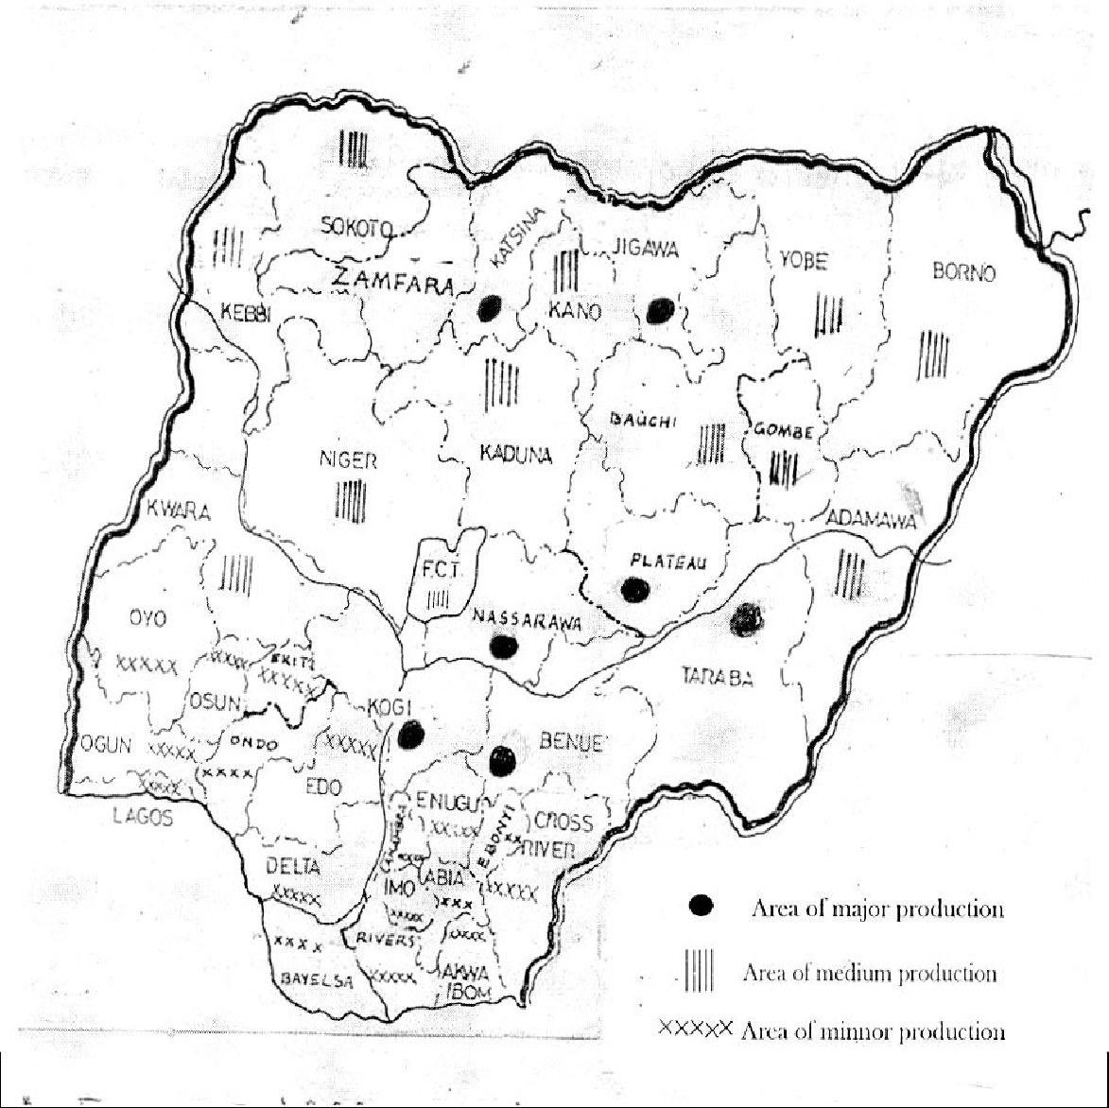

**Figure 2.1: Map of Nigeria Showing Beniseed Production Area**

**Source: NCRI (1998)**

There is no large-scale mechanized production of the crop in Nigeria. Only small peasant farmers are involved. A wide range of cultural practices exists within the beniseed growing areas of the country. In Kogi, Benue and Taraba States the crop is sown at the on set of the early rains in March-April. In Nassarawa state, it is sown two to three months to the end of rainy season (Hockman, 1998).

Beniseed is always grown from seed, usually in pure stand. The seed is either broadcast or drilled in rows 30cm apart at a rate of 10kg/ha on a well-prepared, weed free seedbed (Plate1). In mixed cropping, the seed is planted with maize, sorghum or millet (Desai and Goyal, 1980).

Maturity is reached 80 – 81 days after planting, depending on the varieties. Early crop is harvested in July to August while the late crop is harvested in November to December. The seeds mature from the bottom upwards and are cut and dried as soon as the bottom pods turn from green to yellow (Gibbon and Pain, 1985). Traditional practice is to harvest and gather the crop manually using sickles (Plate 2). Tractor rear and side mounted reaper can be used for harvesting the broadcast crop. Vertical conveyor reapers have been used for harvesting crop, raised in rows and at optimum moisture level of 15 – 20 per cent, to avoid shattering of pods (Devnani, et

al., 1993).

The harvested bunches after drying, are gathered together on a clean platform, mat or tarpaulin and carefully beaten with sticks. Sometimes the dried bunches are gathered in bunches and hit on the platform or mats where the seeds are shed out.

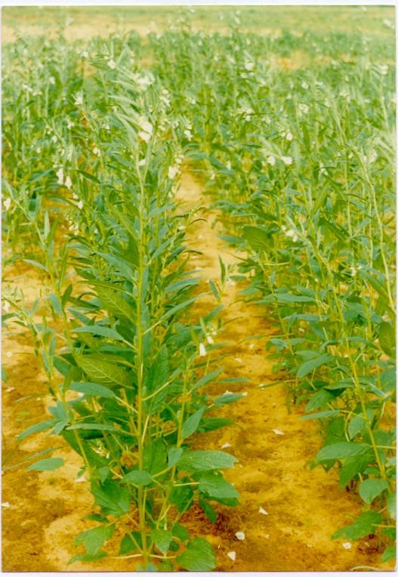

## Plate 1: Beniseed at Flowering Location: NCRI Farm, Badeggi, Niger State

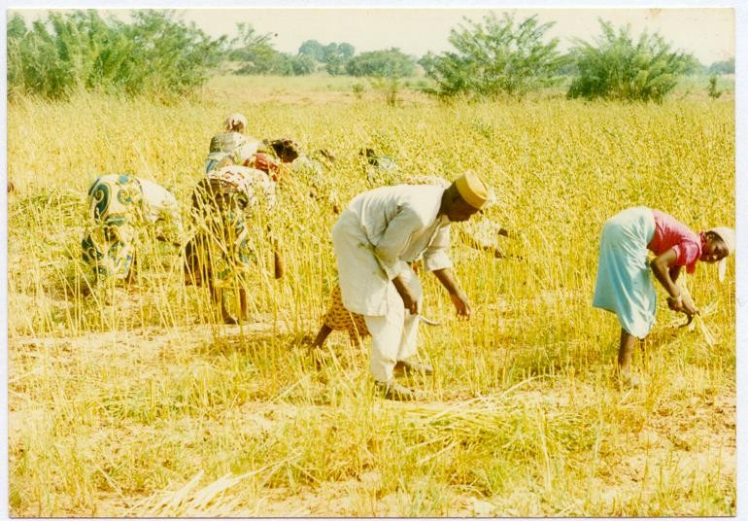

**Dried**

**Plant**

**Sickle**

**Plate 2: Beniseed at Harvesting Location: NCRI Farm, Badeggi, Niger State**

The seeds are winnowed and gathered together and parked into bags where they are stored (Omolohunu, 1998).

The yield is usually low and it ranges between 300kg – 900 kg/ha. Most of the seeds are sold in the local market as fresh or toasted seeds. The price ranges from N4000 – N6000 per 100kg bag depending on the location and times of sales (Omolohunu, op. cit.). The storage of beniseed is easy because it does not run the risk

of out-door storage and the losses are easily controlled. Length of storage depends on individual purpose, and could be up to a year or more. The seeds must not be stored in very hot conditions after harvesting because heat can render the oil in the seed rancid. If stored at 18 degrees Celsius and at a relative humidity of 50 percent, beniseeds will keep for a year. They are usually packed for export in 50-kilograms bags. Small quantities are stored by farmers in the pots, gourds and sacks. Its transportation is less costly compared with other oilseed troops (Voh, 1998).

Beniseed production has been limited because of the fact that all commercial varieties are dehiscent and thus has a high labour requirement at harvest. The discovery of a non-dehiscent type of the seed has raised hopes that high-yielding non- dehiscent varieties could be developed, which could be harvested mechanically, this prospect has stimulated renewed interest in sesame breeding (Yermanos, 1985).

#### 2.3 Beniseed Structure and Nutritional Composition

Beniseeds are pear shape, ovate, small, slightly flattened and thinner towards hilium (figure 2.2). The hull of beniseed which is lower in oil content and rich in fibre, constitute 15-20 per cent of seed weight (Gandhi, 1998). Each cell is surrounded by a thin cell wall mainly composed of cellulose and oil globules, which are in small droplets of 10 to 80m in diameter and are scattered throughout the cytoplasm. The oil globules, well spread in all the cells of the seed, remain in the form of emulsion. When pressure is applied on the cell walls, it reduces in size and the seed cotyledons start rupturing, resulting in generation of heat. The heat, so generated, is sufficient to break the emulsion and coagulate the liquid protein, which results in the release of the oil droplets (Mrema and McNulty, 1985).

Beniseed contains fatty and non-fatty constituents. The relative amount of each depends upon variety and quality of seeds (Ohaba and Ketiku, 1983). Fatty acid compositions of a typical beniseed oil sample as reported by Weiss (1983) are 7 to 11% of palmitic acid; 2 to 6% of stearic acid; 32 to 54% of oleic acid and 39 to 56% of linoleic acid. Other fatty acids occur in amounts less than 1 per cent. Several steroids have been found in beniseed oil, which make it increase the insecticidal potency of pyrethroids. Investigations on the two of its minor constituents, sesamin and sesamolin show that the seed contain 0.34 to 1.13 per cent sesamin and 0.13 to

0.58 per cent sesamolin. A third important minor compound of the seed, which is a strong antioxidant, is sesamol. It occurs in a free form but it is also liberated from sesamolin by dilute mineral acids or by hydrogenation (Uzo, op. cit.).

**Hilium** Innermost layer with highest oil

**Endocarp**

(Inner Layer with Oil)

**Pericarp**

(Hull, One Cell Thick)

#### Figure 2.2: The Transverse Section of Beniseed

Protein content of whole beniseed of over 100 selections ranged from 26 to 30 per cent while that of the meal on the basis of 8 per cent moisture and 1 per cent oil, varies from 48 to 59 per cent (Johnson et al., 1979). The protein is high in methoinine, an essential amino acid with sulphur (up to 3.4%). This is unusual for most plant proteins and the defatted meal prepared from dehulled seed does not contain undesirable pigment. These unique properties render beniseed an excellent protein source for supplementing soybean, peanut, and other vegetable proteins, which lack sufficient methionine, to increase their nutritive qualities (Johnson et al.,, op. cit.).

Analysis of beniseed found in various parts of the world for their composition gave values as shown in table 2.2

#### Beniseed Products Utilization

There are different types and qualities of beniseeds. Their colour varies from white through brown to black (Plate 3). White seeds received a higher market price and are used primarily in raw form because of their aesthetic value, whereas mixed seeds are generally crushed into oil (Market Asia, 2000).

Beniseed is a prized seed in the world because of the by-product that are derived from it. These are the dehulled seed, the oil and the cake. The seed is a rich source of oil, protein, phosphorous and calcium. The value of beniseeds depends on their purity, expressed as a percentage, and oil content, which should exceed 50 percent. The oil reacts fairly rapidly on exposure to air, but forms a soft film after

Table 2.2: Nutritional Composition of Beniseed

Constituent Amount

Moisture 4.1 – 6.5 (% mass)

Protein 17.6 – 26.4 (“ “)

Fat 43.0 – 56.8 (“ “)

Carbohydrate 21.6 – 25.3 (“ “)

Crude Fibre 6.3 – 8.6 (“ “)

Ash 4.8 – 5.3 (“ “)

Calcium 1.06–1.45(mg/100g)

Phosphorus 0.47 – 0.62 (“ “)

Iron 0.01 – 0.02 (“ “)

Thiamin 0.98 (Ug %)

Riboflavin Vitamins 0.25 (“ “)

Niacin 5.40 (“ “)

Energy 590Kcal/100g.

Source: Weiss, 1983.

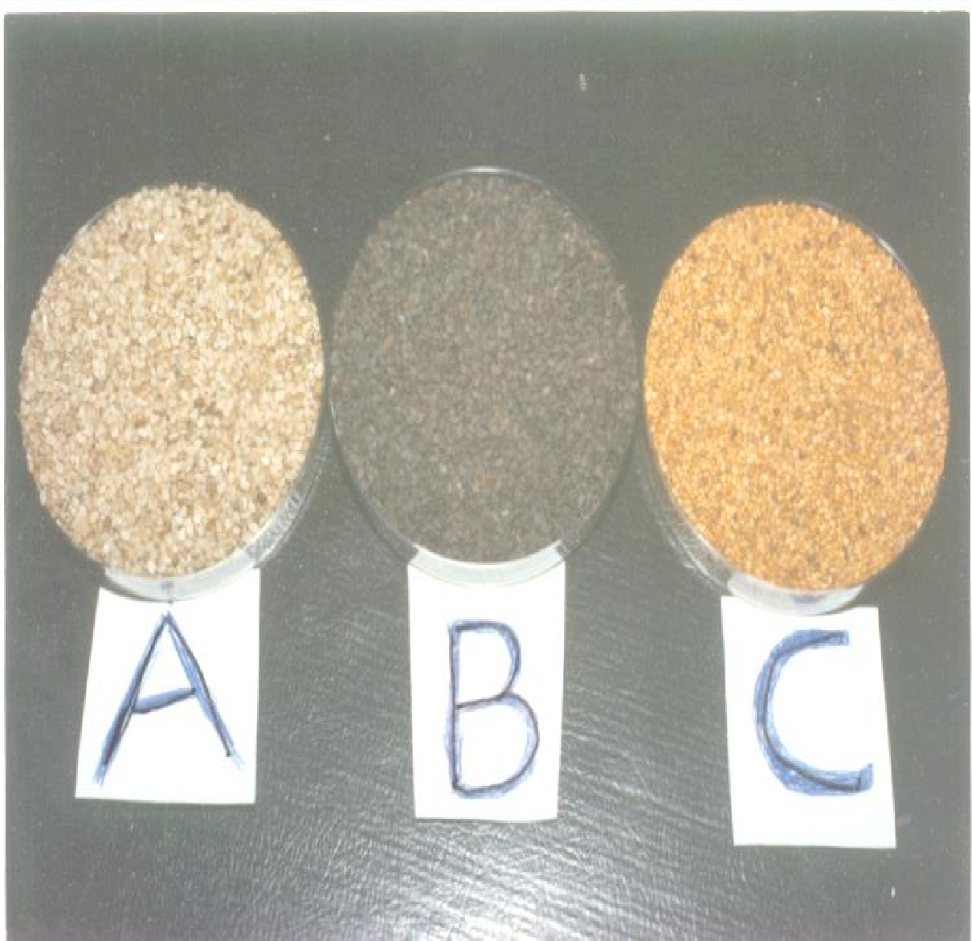

**White Variety**

**Black Variety**

**Brown Variety**

## Plate 3: Some Common Varieties of Beniseed

long exposure. This unique characteristic makes itone of the major edible oils in the semi – drying oil (Yen and Shyu, 1989). The oil content vary from 35% to 57% with 50 to 57% in the creamy, white variety, 48% in the black and 46% in the brown variety (Tashito et al., 1990; Patil, 1998).

The white variety has lower levels of hull than the other two, which are not so popular in this country but are found in India. Dehulling the seeds, or removing their thin husk, increases their value as does bleaching of the dehulled seeds. Moisture content and free fatty acid content are also important in assessing value. The highest quality beniseeds are found in Central America, primarily in Guatemala (Market Asia, op.cit.).

Weiss (1983) classified Nigeria among major producers of beniseed for export. The seed has high economic potential both as source of oil, protein and foreign exchange earner for the country. It ranked second to only cocoa in export volume. Raw beniseed is sold in world market at a price of US550/MT while the processed oil from the seed can be sold at a price of about US*S*3, 500/MT (Coote, 1998).

Beniseeds are supplied to markets in North America, Europe, and East Asia by countries in Africa, Latin America and South Asia. Cooking oil can be extracted from beniseeds and this is their main use, especially in Asia. In North America and Europe, raw sesame seeds generally are used for toppings on breads such as hamburger buns, bagels, bread sticks, and other baked goods. Restaurants and natural food store customers purchase beniseeds for use in ethnic dishes. Middle Eastern

countries use beniseeds for tahini paste and halvah, as well as for oil. (Market Asia, op. cit.).

Beniseed oil is used for edible purposes and for the manufacture of soap, insecticides and paints. In India, the oil forms the basis of most of the fragrant and scented oils used in perfumery. Approximately, 500,000 tons of sesame oil is produced annually, which is about 4% of the estimated world production of liquid edible vegetable oil (Katung, 1998).

The seed cake is an excellent supplement for cattle, sheep, poultry and pigs, when given with a lysine rich supplement. The cake left after the oil extraction is of high nutritional value and it is a good source of methoinine, which is deficient in many cakes of leguminous origin. Tribe (1967) as reported by Katung (1998) stated that mixture of beniseed and groundnut cakes gave better rat growth rates than groundnut cake alone and that the beniseed and soybean was superior to soybean alone in chick diets.

The whole seed can be used in confectionery. In Nigeria, the seeds are mostly used in soup preparation or taken as snacks with groundnuts or roasted maize and in South America, the seed meal is mixed with corn to produce a traditional type of bread made from corn (Oresanya and Koleoso, 1990).

The young leaves of beniseed could be used as vegetable in soup preparation. The stalk after harvesting are mostly used as fuel woods, while the dried shrub is sometimes burnt and ashes left behind are used as raw materials for local soap production (Omolohunu, 1998). Indeed, there is use for virtually all the parts of the plant.

#### Physical Properties of Agricultural Materials

Peleg and Bagly (1982) have defined the physical properties of agricultural materials as those properties that lend themselves to description and quantification by physical means. These properties include the linear dimensions, size, shape, bulk and true densiities, porosity, weight and volume. Others are angle of repose, specific gravity, colur and coefficient of friction. The knowledge of these physical properties constitutes an essential engineering data in the design of machines, structures, processes and control, in analysing the performance and the efficiency of a machine, as well as in developing new consumer products (Mohsenin, 1986).

Mohsenin, op. cit. used a technique, which related the volume of a set of

specimens of pebbles to the axial dimensions of 50 kernels, dry shelled corn by measuring the major, minor and intermediate axes as well as weight and specific gravity of each kernel. The volume of the kernel was taken as one of the parameters defining the shape of the kernel and the three mutually perpendicular axes were taken as a measure of the size of the kernels. Tracings of shape and designation of the three intercepts for seeds and grains obtained by a photographic enlarger were presented. He stated that the sphericity of most agricultural particles is within the range of 0.32 to 1.00. The criteria used for describing shapes and size include charted standards, roundness, sphericity, measurement of axial dimensions, resemblance to geometric bodies and average project area.

Igbeka and Sagi (1970) as reported by Fashina (1986) used a Nikon profile to measure the lengths and diameters of citrus flower particles. This instrument is good, in that two micrometers could be mounted on it and the specimen could be magnified to the user’s specification. The projected area could be calculated from the dimensions of length and average diameter.

Muir and Macnoroe (1987) studied physical properties of cereal and oilseed cultivars grown in Western Canada and concluded that standard bulk densities were significantly different among cultivars of the same cereal grains and oilseed. They observed that porosity based on the compacted bulk densities ranged from 34-38% for rapeseed, mustard, flex and soybean and 56% for sunflower.

Fornal et al. (1989) made an attempt to apply scanning electron microscopy in

interpreting the results of some selected physical properties of triticale grain. A study on the association between variation in the main physical properties of Bolero, Dagro and Largo varieties, and differences in their microstructure were performed. The bulk density was in the range 590.7-714.9 kg/cm3, the range being greatest in Bolero and least in Dagro.

Gowda et al. (1990) studied the effects of moisture contents of 4.5-15.0%

(wb) on the physical properties of lineseed (***Linum usitatissimum***) cv. S-36 seeds. Bulk density and specific gravity decreased linearly with increasing moisture content. Size, volume, porosity and 100-grain weight increased linearly with increasing moisture content.

Kanawade et al. (1990) determined the effects of moisture content on certain

selected physical properties of pulse seeds. Particle density, bulk density and porosity of pigeonpea, chickpea, cowpea, pea, green gram (***Vigna radiata***) black gram (***v. mungo***), soybean and moth bean (***Vigna aconitifolia***) seeds were determined at 5 moisture content levels. The relationship between the moisture content and bulk density was curvilinear. The particle density was not affected by moisture content while the porosity increased with increasing moisture content in all species.

Hsu et al. (1991) evaluated the physical properties of pistachios (***Pistacia vera***

***L.****)* as functions of moisture content at room temperature. The moisture content of pistachios ranged from 40% w.b. at harvest time to a minimum of 5.5% (wb). The length, width and thickness of pistachios increased with increasing moisture content as represented by third-degree regression equations. The bulk density increased linearly with moisture content.

Chode-Gowda et al. (1991) measured seeds sizes and seed weights of 8

pigeonpea cultivars. The average length was in the range 5.09-6.52 mm; width - 4.80-6.19mm; thickness - 3.93-5.33 mm; and seed weight - 70.67-157.90 mg.

Oje and Ugbor (1991) measured some physical properties of oilbean seeds relevant to dehulling as the initial stage in developing a machine for dehulling oilbean (***Pentaclethra macrophylla***) seeds. At a moisture content of 4.55% (db), oilbean seeds have a major diameter ranging from 60-70mm and thickness ranging from 9- 19mm. A low average sphericity of 0.60 and roundness of 0.4 are characteristically

unfavourable for rolling of the seeds to take place. With an average density of 1.12 g/cm3, the seed is unable to float in water. The least in size was found to be more than 50% smaller than the largest, considering all principal dimensions.

Arora (1991) determined engineering properties like size, diameter, volume, bulk density, particle density, and porosity of 3 vaireites of rough rice (***Oryza sativa L*.)** at 5 moisture content levels of 8.10, 14.20, 18.23, 23.40 and 27.23% d.b. These properties were found to be linearly dependent upon moisture content.

Arora and Singh (1991) investigated the interrelations of physical properties of sunflower and groundnut with moisture content. Physical properties such as size, shape, density, porosity, colour and 1000-grain weight of sunflower seeds, groundnut pods and groundnut kernels were determined at different moisture contents (3.95 to 25% d.b). The equation for volume determination was developed and the various properties related with moisture content by linear regression method. The properties were found to be linearly dependent upon moisture content.

Irvine et al. (1992) determined experimentally bulk and particle densities for

McGregor flaxseed, Eston and Laird lentils and Ackerpelle fababeans, at various moisture contents. Both bulk and particle densities decreased with an increase in moisture contents for all seed types.

Kaleemullah (1992) adjusted Groundnuts cv. ICGS-44 seeds to moisture contents of 7.0, 14.4, 22.2 and 32.2% (db) and determined their physical properties. The seed shape was regarded as oval. As moisture content increased, seed

dimensions increased by amount 5% of the minor and medium axes and less than 1% in the major axis. Mean values of roundness and sphericity at 7% moisture content were 64.8 and 63.7%, respectively. Bulk and seed densities decreased curvilinearly, and porosity increased as moisture content increased.

Sethi et al. (1992) measured physical properties like shape, sphericity, bulk

density and porosity of Raya, Toria and Gobi Sarson seeds. Sphericity increased with increase in moisture content, whereas density and porosity were observed to decrease.

Oje (1993) carried out studies on Locust bean pods and seeds. Studies on some of the properties relevant to dehulling indicated that the pods had a major diameter ranging from 76 to 277 mm, compared to 8-12 mm for the seeds. The seed thickness ranged from 5.75 to 7.0 mm. Rolling of the seeds occurs when average sphericity and roundness are 0.67 and 0.65 respectively.

Latunde-Dada (1993) investigated 12 Nigerian cowpea (***Vigna unguiculata***) varieties for physical properties. The seed coat accounted for 5.8 to 11.4% of the weight of the seeds, leached solids 5.1 to 13.6%, swelling capacity 43.9 to 94.5% and the seed density ranged between 0.91 to 1.28 g/cm3.

Joshi et al. (1993) investigated several physical properties of pumpkin seeds

and kernels to facilitate the development of equipment for processes such as dehulling. The average length, width, thickness and unit mass of the seed were 16.91mm, 8.67mm, 3.00mm and 0.203g respectively. Corresponding values for the kernel were 14.62mm, 6.89mm, 2.50mm and 0.160g respectively. In the moisture

range from 4 to 40% d.b, studies on re-wetted seed showed that the bulk density increased from 404 to 472 kg/m3, true density decreased from 1179 to 1070 kg/m3, and porosity decreased from 65.73 to 55.45%. For the kernel, the corresponding values changed from 481 to 554 kg/m3, 1080 to 1143 kg/m3 and 55.46 to 51.535 respectively.

Kulkarni et al. (1993) determined the moisture content of soybean cv. JS7224 by exposing the seeds to 105oC for 16 hours and then adding calculated amounts of water to attain desired moisture contents between 8 and 11.4% d.b after 24 hours. Seeds were randomly selected and spatial dimensions calculated. Seed dimensions increased linearly with increasing moisture content up to 11.4% d.b with a 60% increase in seed length, 26% increase in size and 20% increase in breadth at the maximum moisture content.

Gowda et al. (1995) studies the effects of moisture contents of 8.24-27.07%

on the physical properties of soybean cv. Maple Belle seeds. The seed length, width and thickness, sphericity, volume and 1000-seed weight increased with increasing moisture content while solid density and bulk density decreased. Increasing seed moisture content had greater effect on seed thickness (11.98%) than on length (10.90%) or width (6.88%).

Sokhansanj and Lang (1996) developed an equation for predicting kernel and bulk volume of wheat and canola during adsorption and desorption. The changes in kernel and bulk density of canola were small compared with those measured in wheat

during the adsorption/desorption cycle. In an almost linear increase, the bulk density of wheat decreased from 790 to 686 kg/m3 when kernel moisture content increased from 8 to 22.5% w.b. The bulk density of canola decreased by only 672 to 661 kg/cm3 due to moisture increase from 5 to 19% w.b.

Pan et al. (1996) evaluated and compared physical properties and dry-milling

characteristics of six low-temperature-dried, high-oil maize hybrids (HOC) to three regular yellow dent hybrids (YDC) representing a range of endosperm hardness that were not selected from dry-milling characteristics. The test weights, true densities, and 100-kernel weights of the six Hoc hybrids ranged from 732.8 to 758.6 kg/m3,

1.27 to 1.29 g/cm3, and 26.6 to 28.2g, respectively.

#### Beniseed Oil Processing Technology and Equipment

Cleaning is a pre-requisite operation in beniseed oil production. The Federal Produce Inspection Service (FPIS) enforces FAO prescribed grades and standards recommended by International Commodities Board for cleaning beniseed especially those intended for export (Hockman, 1998). The standard for the two types of beniseeds produced in Nigeria – the Benue and Kano varieties have the same quality standards termed as “Exportable Quality” which means beniseeds that contain:

* not more than 2% by weight of stones, literite and other mineral or vegetable extraneous matter; and
* not more than 5% by weight of seed other than sesamum indicum.

Beniseeds that fail to meet this standard are rejected for export. Simple machines such as air-screen cleaners and specific gravity separators are available for medium scale cleaning of beniseeds.

In conventional processing where oil is the major product, the whole seed is usually crushed and the oil is extracted. The by-product (meal) is usually fed to animals as a protein source (Inyang and Ekanem, 1996). In areas, where the meal is eaten by human beings, dehulling is necessary. This is because the hull contains undesirable oxalic acid (2-3%), which could complex with calcium and reduce its availability (Kinsella and Mohite, 1985). The hull also contains undigestible fiber, which imparts a dark colour to the meal.

According to Gupta (1998) dehulling improves the nutritional and flavour characteristics of the meal and leads to the production of a glossy white product irrespective of the hull colour (black, white or red). From experiments on oil extraction, it has been discovered that dehulling of beniseed leads to a higher oil yield, increased protein content, and reduced fiber content (Johnson et al., 1979;

Olayanju, 1998).

The small size of beniseed makes its dehulling difficult. Various investigators have reported several dehulling methods. Toma et al., (1979) as reported by

Oresanya and Koleoso (1990) used a lye solution to dehull 5 varieties of beniseed. They stated that 6% sodium hydroxide at 60oC with seed to lye ratio of 1:3 (w/v) was sufficient to decorticate all the beniseed varieties in 10 seconds. Another method

according to Moharam (1981) consisted of contacting beniseed with boiling solution of 0.6% sodium hydroxide at 96oC for 1 to 2 minutes to facilitate the rupturing of the outer coat. The coat was then removed by washing. A yield of 85% of dehulled material on the weight of raw seeds was obtained.

Beniseed dehulling by alkali treatment is associated with the following problems: the difficulty of having to source the chemical locally, hazard of handling the alkali during processing, and high cost of processing (Odunfa, 1993). Tontisirin et al. (1980) subjected water soaked beniseeds to a rubbing action of two vertically

mounted discs in order to peel off the hull, which was then separated by floatation in brine. Traditional method of dehulling beniseed involves soaking in cold water overnight followed by partial drying and rubbing against a rough surface. The hulls separated from the kernels are removed by winnowing (Gow-chin, 1990; Badifu and Abah, 1998). This method is laborious and suitable for handling only small batches of seed.

FIIRO as reported by Olayanju et al. (2000) had improved on these methods

by developing a mechanical dehuller that can handle up to 10kg of beniseed per batch of 10 minutes. The machine consists of a shaft carrying three blades. The high speed of the rotating blades in excess water brought about the dehulling of the seed without breakage. Separation of the hull from the kernel was done by floatation in brine.

Drying studies on the dehulled wet beniseed containing 42 to 45% moisture contents (wb) have been carried out. According to Ramachandral (1971) as reported

by Oresanya and Koleoso op.cit., the studied methods were sundrying, cross-flow

drying, through-flow drying and pneumatic flash drying. The study indicated that for drying of the dehulled seed, through-flow drying was the ideal and economical method. He recommended hot air drying temperature of 80oC and a tray loading (tray with wire mesh bottom) of 42 kg/m2 with air entry at the top of the bed of material and discharge at the bottom.

The removal of oil from beniseed can be achieved by either solvent extraction or mechanical expression. Acccording to Jaswant and Shukla (1991) solvent extraction is the act of extracting oil from oil – bearing materials thruogh the process of diffusion with the help of low boling point solvent. It is capable of removing nearly all of the available oil from the seed meal and produce high protein meal with good preservation qualities. However, the expensive nature of extraction equipment and its proness to fire explosion hazards make the extraction process unsuitable for the small and medium scale farmers who form the majority of oil processors in the developing countries (David and Vincent, 1980).

The mechanical expression according to Fellow (1988) is the most widely used method for oil extraction from vegetable oilseeds. It can be achieved either in two stages - size reduction to produce a paste, followed by separation in a press or in a single stage, which both ruptures the cells and expresses the oil. In general, the single stage is more economical, permits higher throughputs and has low capital and

operating costs. However, for some oilseeds that are especially hard, a – two stage expression is more effective.

UNIFEM (1987) classified expression devices in three categories viz: plate presses, ghanis and expellers. Oil plate presses are of two types: screw press and hydraulic press. In a screw press, steamed beniseed is pressed slowly and with pressure by a plunger force down by screw and into a cylinder with large number of small holes (Figure 2.3). Capacities of screw presses depend upon the size of the cage, an average being about 1.5 kg per batch. In an hydraulic press, pressure is exerted by an hydraulic device such as a lorry jack. It requires a heavy - rigid framed structure (Figure 2.4). Hydraulic presses generate greater pressure than plate presses. However, the hydraulic fluid should be prevented from coming in contact with the oilseed.

Ghanis originated in India and they denote names given to machines which are primarily used to express oil from beniseed. Traditional ghanis are normally operated by animals and can be manufactured locally. TDRI (1984) described a ghani as consisting of a wooden mortar and wood or stone pestle. They stated that the mortar is fixed to the ground while the pestle, driven by one or a pair of bullocks (or other draught animals) is located in the mortar where the seeds are crushed by friction and pressure (Figure 2.5).

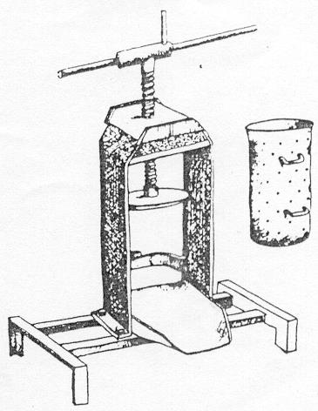

**Threaded Shaft**

**Plunger**

**Perforated Cylinder**

**Oil Outlet**

## Figure 2.3: Kit Screw Press (4.5 – 9.0kg / Press) Adapted from UNIFEM (1987)

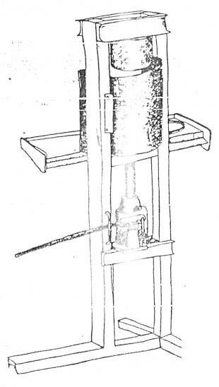

**Expression Chamber**

**Hydraulic Jack**

**Rigid Frame**

**Figure 2.4: Hydraulic Press (1 – 5kg / Press) Adapted from UNIFEM (1987)**

The oil runs through a hole at the bottom of the mortar while the residue is scooped out. Depending on the size of the mortar and type of seeds, an animal- operated ghani can process about 5kg of seeds every 1hour.

Srikanta (1980) described the mechanical versions as consisting of pestle and mortar which are usually arranged in pairs with either the pestle or mortar held stationary while the other is rotated (Figure 2.6). Power ghanis have a greater capacity and can process up to 100kg of seeds per day.

Oil expeller has been described by UNIFEM op. cit.as having a horizontal

rotating metal screw, which feeds oil-bearing raw materials into a barrel-shaped outer casting using perforated wall. The pressure produced grinds and crushes the solid material and presses the oil out of the ruptured cells in the oilseeds. The oil flows through the perforations in the casing and this is collected in a trough placed underneath the machine. The cake is removed from the unit through a special outlet provided for it.

Although, a number of oil expellers have been developed, only two designs developed by Anderson and French Oil Mill Company are popular (Srivastava and Kachru, 1995). In Anderson’s expeller, the pressing is achieved by means of a wormshaft continuosly rotating within cylinder or cage composed of closely spaced bars. The French expeller differs considerably from Anderson’s expeller in details of construction as well as in operation. Instead of vertical worms for pre-pressing the material before it enters the main barrel, it uses two screws revolving within the same

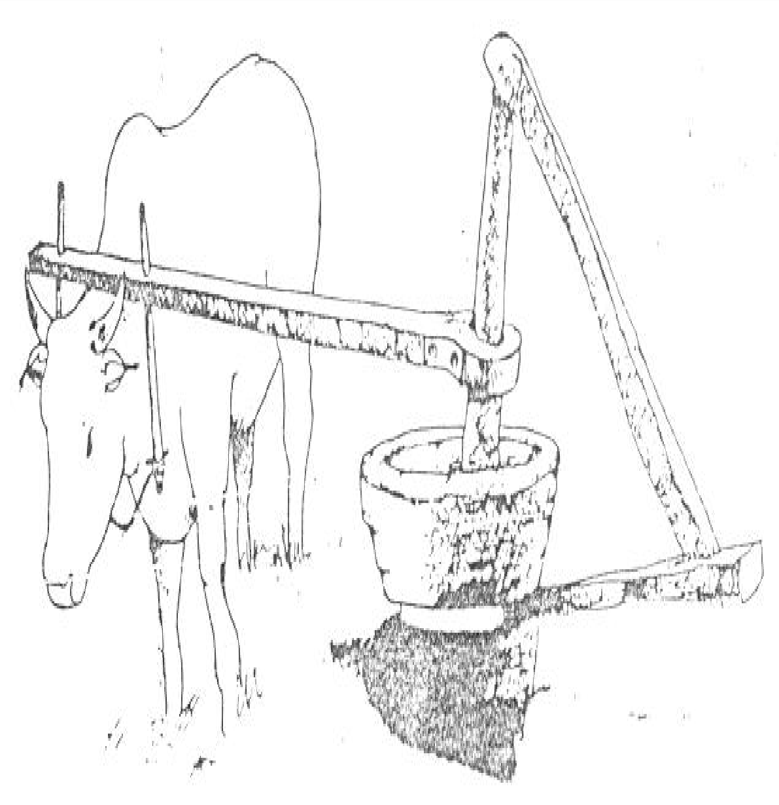

**Bullock**

**Wooden**

**Pestle**

**Wooden Mortar**

**Oil Outlet**

## Figure 2.5: Traditional Animal Powered Ghani (1 – 2kg / h) Adapted from UNIFEM (1987)

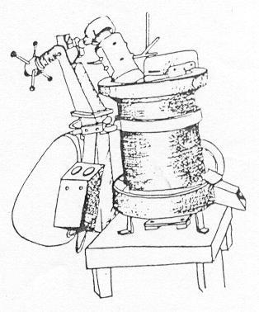

**Motorised Pestle**

**Power Drive**

**Metallic Mortar**

**Raised Platform**

**Figure 2.6: Power Ghani (12 – 15kg / h) Adapted from Srikanta (1980)**

horizontal barrel. These mechanical expellers may be used as pre – presses or as high- pressure expellers. The difference being that, high-pressure expeller uses higher temperature for material preparation and greater number of screw conveyors.

Some expellers have supplementary heaters fitted to the barrel to improve yields. Most small expellers are power-driven requiring about 3hp and are able to process between 10 to 50 kg per hour of raw beniseed depending on the type of expeller used (Figures 2.7 and 2.8). Bigger units processing greater quantities are available for use in large mills. The expressed cake has 5 – 18% (w/w) residual oil, depending on the type of oilseed and operating conditions (Rosedown, 1990 and Desai, 1998).

Most mechanically expressed oils are generally not clear. This is because some of the fine solid particles formed by pulverization during pressure application become a solid solution with the extracted oil. As a result, the extracted oils are usually cloudy in appearance due to the suspended solid particles in the fluid. Even in some cases, the oil is in slurry form (Olayanju, 1999). Therefore, the mechanically expressed oils have to be filtered to obtain clear liquids, which can be packaged for domestic and industrial uses.

The usual method of removing small impurities from vegetable oil at cottage level is by using an ordinary cloth stretched over a frame onto a tank of sufficient capacity. The filtered oil is left in the tank for a few hours in order to allow the settling down of any other impurities still suspended in the oil. The oil is then

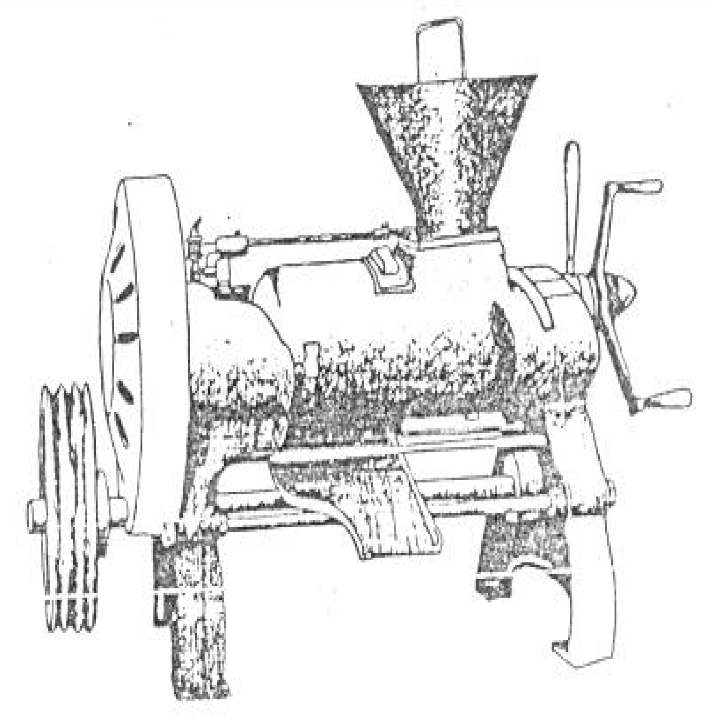

**Cone Adjuster**

**Expression Chamber**

**Power Drive**

**Oil Outlet**

## Figure 2.7: Power Cecoco Expeller (30 – 50 kg / h) Adapted from UNIFEM (1987)

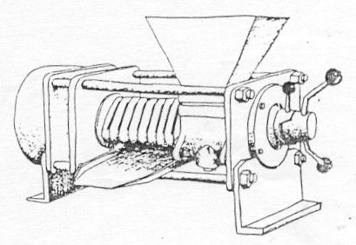

**Power Drive**

**Feeding Hopper**

**Cake Outlet**

**Oil Outlet**

**Cone Adjuster**

**Figure 2.8: Mini 40 Expeller (45 – 65 kg / h) Adapted from UNIFEM (1987)**

transferred into tins or bottles via a funnel from a tap attached over the sediment layer. This is a slow process and finds little application in food industry (Svarosky, 1981). A post extraction equipment, the filter press will be needed to improve the quality of the expressed oil.

Moss and Durger (1979) as reported by Olayanju op. cit. stated that oil

filtration can be achieved through pressure, vacuum and centrifugal forces applications. They observed that vacuum and centrifugal filtrations have high capital cost and produce cakes, which have high moisture contents and that they are best suited for materials that form a free draining cake.

Earle (1983) described the two commonly used pressure filters as the plate and frame; and the shell and leaf. He stated that the shell and leaf filters are best suited to routine filtration of liquor, which have similar characteristics. Jones et al.

(1983) stated that plate and frame filter press is considered for commercial purposes because it has low capital cost, high flexibility for different foods, reliable and easily maintained.

#### Factors Affecting Oil Expression from Oilseed

Koo (1942) as reported by Khan and Hannah, (1983) investigated the effects of pressing temperature, pressure, time and moisture content on oil recovery for seven oilseeds in a laboratory hydraulic press and developed the following general equation for oilseeds:

W = CW0 P1/2 t1/6 -z 2.1

Where, W is the oil yield (in wt%), C is a constant for the kind of seed (unit consistent with unit analysis). W0 is the initial oil content of seed (in wt. %), P is applied pressure in (MPa), t is pressing time (hr.),  is the kinematic viscosity of oil at press temperature (m2/s) and z is an exponent of kinematic viscosity (1/6 to 1/2). A summary of the C, Wo and Z values is given in table 2.3.

The experimental data revealed that for any oilseed, there was an optimum range of moisture content for maximum oil yield. This was between 5 to 13% dry basis for all the seeds.

Table 2.3: Constants and Exponents for General Oilseed Expression Equation

|  |  |  |  |  |
| --- | --- | --- | --- | --- |
| Oil seed | C x 103 | Wo (%) | Z |  |
| Soybean | 5.40 | 19.5 | 1/2 |  |
| Cottonseed | 6.42 | 34.7 | 1/2 |  |
| Rapeseed | 15.00 | 42.2 | 1/3 |  |
| Peanut | 19.40 | 51.9 | 1/3 |  |
| Tungnut | 23.40 | 64.5 | 1/3 |  |
| Sesame Seed | 46.50 | 53.0 | 1/6 |  |
| Castor bean | 51.30 | 64.2 | 1/6 |  |

Source: Khan and Hannah (1983)

Ward (1976) visualised that the oil in the seed is contained in fibrous capillaries. When pressure is applied, the volume of the capillaries is reduced to expel the oil. At the same time, the capillaries are narrowed, sheared and eventually sealed by the increasing pressure and therefore, screw pressing operation at high pressure becomes self defeating. He emphasised the need for seed preparation, cooking, screw pressing and separation of solid from expelled oil for re-feeding to the screw press to achieve high press efficiency.

Tindale (1976) reviewed the range of screw presses available to processors with their technical features. The smallest available range was stated to be of 5 tonnes per day capacity with a single barrel of 838.2mm length and it is driven by a - 20hp motor through a V-belt drive. The largest expeller available was of 200 tonnes per day capacity and was used as a pre-press prior to solvent extraction.

Bredson (1977) described the use of mechanical screw press as principal means of oil extraction in United States from 1930 to 1950 and listed three steps for oil recovery from oilseeds. The first step was to roll the oilseed in a machine to rupture substantial percentage of oil cell walls and to provide homogenous flakes for cooking. The second step was to cook the flakes in a cooker for rupturing oil cell walls as to coagulate the protein and to inhibit the destructive enzyme. The third step was to press the flakes in an efficient screw press to finally express the oil.

He reported that in French press, the feed screw usually starts with 152.4mm pitch and ends with 114.3mm pitch. The maximum pressure in full press varies

between 96 to 108 MPa and the variable size orifice at discharge end finally controls the backpressure. The press has a screw of increasing root diameter and decreasing pitch revolving in a cylindrical drainage cage.

Khan and Hanna (1983) reviewed the expression of oilseed in an expeller. The result indicates that pressure, temperature, pressing time and moisture content are the factors which affect the oil yield during expression of oilseed. The yield data reported mostly in the literature correspond to the hydraulic presses while the current technology for oil expression is the screw press. They emphasised that research is still needed to determine if these factors affect the screw press process in the same way and to the same extent as they do in static pressing operation.

Khan and Hanna (1984) reported the effects of pressure (P), temperature (T), pressing time (t) and moisture content (M) on oil yield (Y) from soybean during mechanical expression. They developed prediction equation for ground soybean with hulls, flakes with hulls and flakes without hulls. The predicted equation for soybean flakes with hulls was:

Y = 199.6 + 2.81 T – 0.007 T2 + 32.26 M – 1.20 M2 + 1.399 P + 1.23 t – 0.143TM – 0.013 T P - 0.005 Tt – 0.076 M P (r = 0.95; ESS = 3.67) 2.2

In general, the results showed that best oil yields were achieved by increasing the temperature, pressure and pressing time at moisture content of 9 – 10 per cent. The maximum oil yield of 85 per cent was obtained from soy flakes at a temperature of 60oC, pressure of 35-65MPa and moisture content of 9 – 10 per cent. The

temperature, moisture and inter-action terms of moisture and temperature in the regression analysis were highly significant. The effect of pressing time on oil yield had little effect. The soybean hulls play an important role in oil expression.

Singh et al. (1984) developed a mathematical model to predict oil expression

from sunflower seed. Moisture content, pressure, pressing time and seed temperature prior to pressing were considered as factors of oil expression in a hydraulic press. The models developed for different types of seed materials are presented below: Whole sunflower seed:

RO = -77 + 13.8M + 0.25 P + 0.47 T - 0.35 M2 – 0.0038 P2 +

0.002 T2– 0.056 MT 2.3

(r = 0.97, Se = 2.07)

The above model revealed that moisture content of seed was the most important factor affecting the residual oil in cake.

Dehulled seed:

RO = 23 + 4.6M – 2.3 t + 0.17 T – 0.180 M2 – 0.0008 P2 + 0.10 t2 + 0.006MP + 0.09 M t - 0.013 MT 2.4

(r = 0.93, Se = 1.00)

Finely ground seed:

RO = -10 + 4.5 M + 0.29 P – 1.7 t + 0.13 T – 0.13 M2 – 0.001 T2 – 0.011 MP + 0.11 Mt – 0.012 MT – 0.012 P t – 0.002 P T + 0.017 t T (r = 0.98, Se = 0.68) 2.5

Coarsely ground seed:

RO = 70 + 11.5 M + 0.26 P + 1.5 t + 0.53 T – 0.347 M2 – 0.0025 P2 – 0.13 t2 – 0.0014 T2 –0.038M T – 0.0014 P T ( r = 0.99, Se = 0.76) 2.6

where,

RO - residual oil in cake, per cent

M - moisture content of seed, per cent

T - seed temperature before pressing, oC t - pressing duration, min

p - applied pressure, MPa

The study indicated that although, pressure, time and temperature were significant factors, moisture content was found to be the most single important factor. In general, coarsely ground material gave better oil expression than others. The maximum oil expression was achieved at moisture content of 5% in the whole seed, at a pressure of 70 MPa and a temperature of 20oC.

Mrema and McNulty (1985) developed a mathematical model for oil expression from oilseeds based on three fundamental equations – Hagen Poiseulle equation for flow of fluids in pipes, to describe the flow of oil through the pores on cell wall; Darcy’s law of fluid flow through porous media, to describe the flow of oil through the inter-kernel-voids; and a modified form of Tersaghi’s equation for the consolidation of saturated soils, to describe the behaviour of consolidating oilseed cake.

A good agreement was obtained between experimental data and predicted data for oil expression in the constant load regime. The model revealed that rate of oil expression was dependent on the flow of oil across cell wall. The model may be used to predict the performance of commercial hydraulic presses and screw expellers.

Sivakumarah et al. (1985) reported the effect of peanut moisture content,

temperature and period of pre-heating, and the pressure applied on oil expression in a small expeller. The maximum oil expression (Y) determined by response surface analysis was as follows:

Y =376.661 – 8.214 X1 + 7,419 X2 – 29.072 X3 – 0.118 X1 X2 + 0.271 X1 X3

– 0.302 X2 X3 + 0.052 X 2 – 0.100 X 2 + 1.056 X32 2.7

1 2

where X1, X2, X3 and Y refer to the peanut temperature, preheat time, moisture content, and oil yield respectively. The maximum oil expression efficiency of 91.4 per cent was obtained at temperature of 95.4oC, 27.4 min duration and 5.42 per cent moisture content.

Sukumaran and Singh (1985) reported the effect of moisture content and rate of deformation on modulus of elasticity of bulk rapeseed under uniaxial compression. The moisture content has maximum effect on the secant modulus at any given pressure. They emphasised the existence of collapse point, which occurs due to interlocking of the deformed broken solids such that the total beds behaves as one porous matrix. This may occur before or after the oil point. As the moisture content increased, the pressure and deformation, needed to release the oil, from the cellular

structure of the seed also increased. This is mainly because of plasticising effect of the moisture. They explained that this phenomenon could be due to the cushioning effect caused by the moisture induced swelling of the mucilage of the outer epidermal cells.

Tikkoo et. al. (1985) evaluated the performance of a baby oil expeller for oil

recovery and energy consumption at moisture content of 5.9 to 14.2 per cent (wb). It was concluded that oil recovery and energy consumption was significantly influenced by moisture content. The maximum oil recovery and minimum specific energy consumption were found at the moisture content of 9-10 per cent and 10 – 12 per cent respectively.

Champanwat (1986) evaluated the performance of an expeller for oil recovery from mustard oilseed at initial moisture content of 6-15 per cent (wb). The maximum oil recovery and minimum specific energy consumption were found at moisture content of 8.6 – 9.5 per cent and 10 – 12 per cent respectively. The final cake moisture content was reported to be lower by about 3 per cent from the initial moisture content.

Jacobson and Baker (1986) reported the oil recovery of sunflower oilseed from a small screw expeller. They stated that high efficiency can be obtained if oilseeds with low moisture content are pressed at higher expeller pressure and if high capacity with high oil output is desired from low moisture content sunflower seed, preheating of oilseed will be necessary.

Sukumaran and Singh (1987) reported the effect of moisture content and applied pressure on oil expression from a-10mm thick bed of rapeseed. They gave a maximum oil recovery of 62.32 per cent at 9.88 MPa for rapeseed of 4.56 per cent moisture content (wb). It was stated that with the increase of moisture content, the oil expression decreases at all applied pressure. The oil expression above 9.35 per cent moisture content was found to be insignificant.

Sivakumaran and Goodrum (1987) reported that peanut feed rate, oil expression rate, meal oil content and expression efficiency can be controlled in a small screw press by varying the internal pressure of the screw press. They stated that a reduction in internal pressure led to the increased peanut feed rate and increased meal oil extraction rate in the initial stages, increased cake oil content and lowered oil expression efficiency. They related the expression efficiency, E to the meal oil content, Mo with the equation

E = 103 – 1.62 Mo 2.8

The variation of pressure along the screw axis was found to be significantly different from the behaviour found in commercial expellers.

Vadke and Sasulski (1988) reported the effect of shaft speed, choke opening and seed pre-treatment i.e. moisture conditioning, flaking and preheating of canola seed in a small screw press. With reduction of choke opening and shaft speed, maximum pressure increased and both press throughput and residual oil in the cake decreased. When either the whole seed or flakes were preheated in the range of 40-

100 oC, the pressure and throughput increased and residual oil in the cake decreased. The press throughput and oil output were maximum at 5% seed moisture content while the residual oil showed a continuous rise with increasing seed moisture content. Vadke et al. (1988) developed a mathematical model of an oilseed press by

superimposition of filtration analysis on screw extrusion theory to calculate press throughput and residual oil in the cake for a given press geometry and physical properties of oilseed. The model predicted that press performance would improve i.e. the throughput would increase and residual oil in cake would decrease if it was cooled during operation. The longer barrel press would give higher output with lower residual oil in cake. The predicted effects of wormshaft speed and choke opening on screw press performance agreed reasonably well with the experimental results obtained on a small laboratory model.

Sukumaran and Singh (1989) stated that the effective applied pressure for oil expression is considered to correspond to some value above the oil point pressure while pressure below this point relate the effort required to mobilise oil flow from the seed cells to the surface. The oil-point pressure for mustard seed increased from 5.93 MPa to 8.84 MPa at 5mm/min rate of deformation for moisture range of 4.6 to 12.4 per cent (wet basis).

Sivala (1989) studied the effect of applied pressure, pressing time and moisture content on oil yield for sieved and unsieved rice bran and developed prediction equations. He stated that maximum oil recovery of 55 per cent was

obtained in case of unsieved bran for treatment combination of 25.5 MPa, 35 minutes and 11% moisture content, whereas in case of sieved bran maximum oil recovery of only 50 per cent was observed for treatment combination of 30 MPa, 25 minutes and 10 per cent moisture content (wb).

Fasina and Ajibola (1989) investigated the effect of moisture content, heating temperature, heating time, applied pressure and duration of heating on the oil yield from conophor nut using a laboratory press. The oil yield at any pressure was dependent on the moisture content of the sample after heating, heating temperature and heating time. High oil yields were obtained from the samples with moisture contents between 8 and 10 per cent (wb) after heating. The maximum oil yield of 66 per cent was obtained when milled conophor nut was conditioned to 11 per cent moisture heated at 65 oC for 28 min and expressed at a pressure of 25 MPa. The oil expressed under this condition was of good quality with 1.18 per cent FFA.

Mandhyan (1990) studied the effect of pressure, pressing duration, moisture content, temperature and particle size of soybean on oil recovery in a hydraulic press and reported that the maximum oil recovery of 85 per cent was possible at 2.36 mm particle size, 119oC temperature, 127 MPa pressure, 5.76 per cent moisture content and 7.5 seconds pressing duration. The final temperature and moisture content of soybean particles were found to be 131oC and 8.5% after heat treatment to the soybean particles having initial moisture content of 25%, barrel temperature of 300oC, and holding time of 40 seconds.

Mahendra (1990) reported the performance of a commercial expeller of 152.4mm barrel diameter for mustard oilseed. The expeller was fitted with 5 worms of 152.4, 114.3, 76.2, 63.5 and 63.5 mm pitches. The average cake thickness and barrel temperature varied from 2-4.3mm and 60-91 oC in different passes respectively. Adeeko and Ajibola (1990) studied the effect of particle size, heating temperature, heating time, pressure and pressing time on oil yield and quality of finely and coarsely shelled groundnut. Oil yield increased with increased pressure up to 20MPa beyond which it either leveled off or decreased. The rate of oil expression increased by an increase in temperature, time of heating and particle size. Heating time at any temperature did not affect the oil yield. About 90 per cent oil was

expressed in 3 minutes.

Ajibola et al. (1990) investigated the mechanical expression of oil from melon

seeds in a laboratory press. The processing variables were particle size, moisture content, heating temperature and heating time. The oil yield was affected by moisture content, heating temperature and heating time. However, the oil yield was mostly dependent on the amount of moisture reduction achieved during heating. The highest oil yield of 80 per cent was obtained at a pressure of 25 MPa when the samples conditioned to initial moisture content of 9 and 15 per cent (wb) were heated to achieve a reduction of moisture content of about 5 per cent.

Sivala et al. (1991) reported the effect of moisture content on oil expression

from rice bran using response surface methodology. The oil recovery from unsieved

bran increased from 35.6 per cent to 55.9 per cent with the increase of moisture content from 7.2 per cent to 10.5 per cent and decrease in pressing time from 45 to 35 min when pressure of 25.5 MPa was applied. Further increase of moisture content to 11 per cent resulted in decline in oil expression.

Sivala et al. (1991) developed a mathematical model of rice bran oil

expression based on one-dimensional consolidation theory with suitable assumptions: Q = K [ 1 – e-(Pi2t/4)] 2.9

or, Qsat = K ( 1 – e-βt) 2.10

where,

Q - Oil yield.

t - pressing time

β - (Pi2Co)/( 4 H2).

K - Describes the rice bran cake properties. Co - Coefficient of consolidation, cm2/s

H - Rice bran bed height under consolidation, cm. P - Applied pressure, MPa

The application and validity of the above model were verified by using the experimental data obtained from the rice bran oil expression through hydraulic pressing. The value of Qsat was taken equal to K at the end of 45 min at a given constant pressure and then value of β was calculated. There was a good agreement

between observed and calculated values with correlation coefficient of 0.9397 – 0.9968.

Vermal et al. (1992) reported the performance of a commercial oil ghani for

oil expression from mustard oilseed in India. The study was undertaken to optimise the seed conditioning factors such as pressure and crushing time to obtain maximum oil recovery and minimum specific energy consumption. It was concluded that moisture content for maximum oil recovery was 8.5 per cent (wb).

Shukla et al. (1992) reviewed the technology and equipment developed in

India for oil expression from mustard oilseed. The review of baby oil expellers (extruder type) tested at different universities revealed that maximum oil recovery of

77.56 to 80.91 per cent was achievable at a moisture content of 9.5 to 10 per cent (wb).

Verma et al. (1993) reported the performance of an expeller with rapeseed for

oil recovery and energy consumption at moisture contnet of 6-15 per cent (wb). Maximum oil recovery of 82 per cent was reported at 9 – 9.5 per cent for oilseed without cooking, whereas, oil recovery of 84 per cent was obtained when rapeseed was cooked with steam at 0.1 MPa for 60 minute duration. The minimum specific energy consumption of 0.15kwh per kg oil was achieved for cooked oilseed as compared to 0.19kwh per kg oil at 10.0 per cent (wb) in cold expression.

Hamzat and Clarke (1993) reported the effect of process variables such as moisture content, pressing time, pressure particle size and bed depth on oil yield to

the parameters studied. The development of the equation was based on the concept of quasi-equilibrium oil yield. The general equation for oil yield was as follows:

Y = Ye Mc Pd Hf (1 – a e –b t) 2.11

where, Y is oil yield (per cent) Ye is quasi-equilibrium oil yield (per cent), M is seed moisture content (per cent-db), P is applied pressure (MPa), H is bed depth (mm) and a, b, c, d and f are constants.

A multiple regression analysis was performed on the data obtained during experiments and values of constants were calculated. The maximum oil yield was obtained from coarsely ground samples of 5 per cent moisture content at 31 MPa pressure in 10 min pressing duration. The oil yield from 25mm-bed depth was higher than 98mm bed depth. They reported that the difference in the percentage of oil yield obtained was insignificant for bed depth in the range of 12.5 to 35mm. Thus, they selected bed depth of 25 and 98 mm for their experiments.

Faborede and Favier (1996) in a study of oil expression in seeds developed a theory relating seedbed compression with seed kernel properties. A threshold compressive pressure at which oil first emerges from a seed kernel in a seedbed during mechanical seed-oil expression (referred to as the oil-plant) is theoretically related to the kernel density, which enables its determination from the initial bulk properties of the seedbed. They stated that the potential advantage of identifying the oil-point include the need to predetermine the effective pressure required for oil expression.

Patil and Sinha (1998) studied the effect of thermal and hydrothermal pretreatments on oil-point of raw soybean, blanched soy-splits and extruded soybean that were mechanically compressed in a developed oil-point tester using the carver press. Their results indicated that minimum pressure was required for reaching the oil-point of extruded soybean samples followed by that of blanched soy-splits. They stated that increasing moisture content increased the oil-point pressure for all the three soybean samples considered. They also reported that minimum pressure requirement of 19.9Mpa was observed in case of soy-splits, which was reported to be more than double (8.8Mpa) that was required for raw rapeseed sample. They explained that this was due to the fact that soybean has a low oil content (18-20% oil) and is hard to press compare to the soft rapeseed which contains over 40% oil.

From the foregoing, it is important that optimum processing conditions for the expression of oil from beniseed be identified for higher oil yield and improve cake quality at minimum production cost. This will also assist the designers and manufacturers in selecting appropriate materials and mechanisms, which will invariably sustain and promote product quality.

#### CHAPTER THREE

#### MATERIALS AND METHODS

#### Experimental Plan

A series of experiments were carried out to determine some physical and mechanical properties of beniseed and to study the effect of some machine operational parameters on the expressed beniseed oil and cake. The quality of oil and residual oil content of the cake was also determined.

The levels and range of independent variables in various studies were selected on the basis of review of literature and preliminary experiments conducted. These are presented in table 3.1.

#### Research Materials

One – 50kg bag, each of the two common beniseed accessions under the local names – Benue (Native) and Kano (Agric.) were obtained from a company that exports beniseed from Nigeria- the AfriAgric Products Limited, Apapa, Lagos. The seed samples were taken to the National Cereal Research Institute, (NCRI), Badeggi in Niger State for proper identification. The Benue sample was identified as Yandev- 55 while that of Kano was identified as E8. The variation in the grain sizes and physico - mechanical properties could affect the oil expression quality of beniseed. As a result, the two accessions representing the two geographical zones of the country

– the South and North respectively were selected.

Table 3.1: Experimental Variables and their Levels

|  |  |  |  |  |  |
| --- | --- | --- | --- | --- | --- |
| S/N Quantity Independent | Dependent | Treatment | Levels | Interval | Replication |
| Variables | Variables |  |  |  |  |

|  |  |  |  |  |  |  |
| --- | --- | --- | --- | --- | --- | --- |
| 1. Spatial | Moisture | Major Diameter,mm | 5 | 5-30 | 6 | 50 |
| Dimensions | Content | Intermiadiate Dia,mm |  |  |  |  |
|  | %, wb | Minor Diameter., mm |  |  |  |  |
|  |  | Geometric Mean, mm |  |  |  |  |
|  |  | Sphericity, % |  |  |  |  |
| 2. Gravimetric Properties | Moisture Content | Bulk Density, kg/m3 True Density, kg/m3 | 5 | 5-30 | 6 | 3 |
|  | %, wb | Porosity, % |  |  |  |  |
|  |  | Thousand Kernel – |  |  |  |  |
|  |  | Weight, g |  |  |  |  |
| 3. Static | Moisture | Coefficient friction | 5 | 5-20 | 5 | 3 |
| Coefficient | Content | on Mild Steel, |  |  |  |  |
| of friction | %, wb | Plywood, Concrete |  |  |  |  |
|  |  | and Glass |  |  |  |  |
| 4.Compression Moisture | | Rupture Force, N | 3 | 4 - 8 | 2 | 10 |
| Behaviour Content | | Deformation, mm |  |  |  |  |
| %, wb | | Energy, Nm |  |  |  |  |
| 5.Expeller Wormshaft | | Machine Cap.,kg/h | 4 | 30-75 | 15 | 1 |

Performance Speed, rpm Oil Recovery, %

Residual Oil in Cake,% Moisture in Cake, % Colour of Oil

Moisture Machine Capacity,kg/h 4 4-10 2 1

Content Oil Recovery, %

%, wb Residual Oil in Cake, % Moisture in Cake , % Colour of Oil

#### Material Preparation:

Dehulled beniseed sample was prepared by using FIIRO established method as reported by Oresanya and Koleoso (1990). The sequence of the process is given in figure 3.1 and briefly described below:

The procured beniseeds with approximate moisture content of 5.3% were cleaned using a specific gravity separator (Plate 4) to remove dust, sand, dry leaves and empty capsules of fruits from the seeds.

Beniseed has bitter taste that remains even after dehulling and oil extraction. The bitterness according to Oresanya and Koleoso, op. cit., contains alkaloids such as caffeine in coffee and tea. However, it is extractable in water. In line with this, the beniseed was cooked in water at 100oC for about 20 minutes in a covered container (Plate 5).The water was drained off and the seed washed twice in cold water (Plate 6).

The debittered seeds were poured into a mechanical dehuller consisting of 3 blades rotating in a container of excess water (Plate 7). The high speed of the dehuller brought about the dehulling of the seeds without breakage.

Separation of the hulls from the seed was done by draining the hull-kernel moisture on a 1.2mm sieve and then poured into a container of brine (15% Solution) and mixed thoroughly (Plate 8). This was allowed to stand for about 30 minutes. The hulls sink while the kernels float on water. The floating kernels were drained on a sieve. Drying of the wet kernels was done on a clean concrete slab under a shade in order to ensure gradual drying of individual kernels (Plate 9). This was preferred to open sun drying because of stress gradient in the dried kernels, which may result in high breakage.

**R a w B e n i s e e d s**

✵

Cleaning

✵

Debittering

✵

Dehulling

✵

Hull Separation

✵

Drying

✵

Expelling

✵ 

✵ 

**Oil**

**Cake**

Filtering Drying

✵ 

Degumming Milling/Peletizing

✵ 

Packaging → Storage

## Figure 3.1: Flow Chart for Beniseed Oil and Cake Production Adapted from Oresanya and Koleoso (1990)

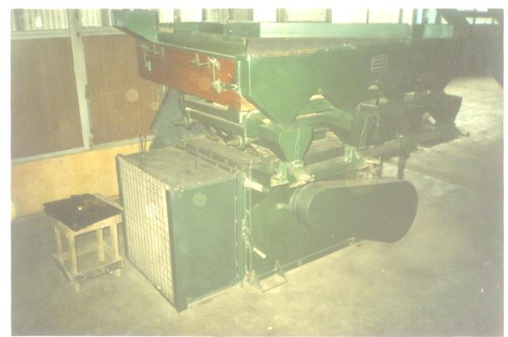

**Feeding Spout**

**Collection Points**

**Plate 4: Specific Gravity Separator**

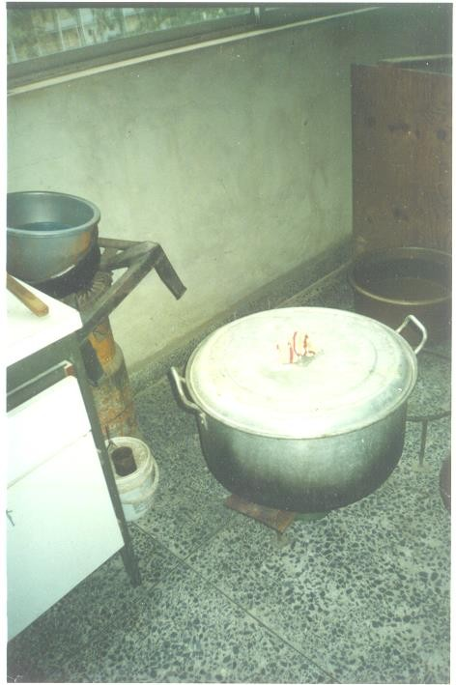

**AluminiumPot Containing Beniseed**

**Cooking**

**Stove**

## Plate 5: Debittering of Beniseed in an Aluminium Pot

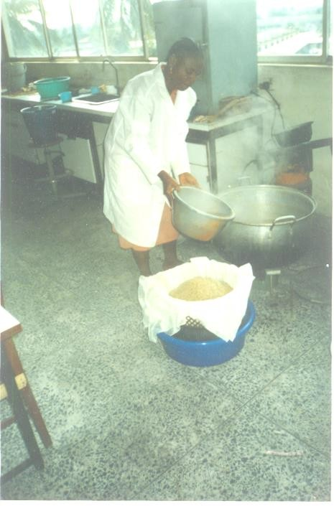

**Cooked Beniseed**

**Plate 6: Draining of Cooked Beniseed in a Plastic Bucket**

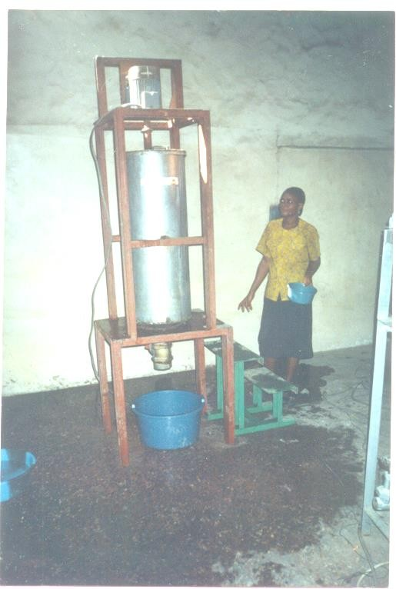

**Electric**

**Motor**

**Dehull Ch**

**Collection Point**

## Plate 7: Mechanical Dehulling of Beniseed

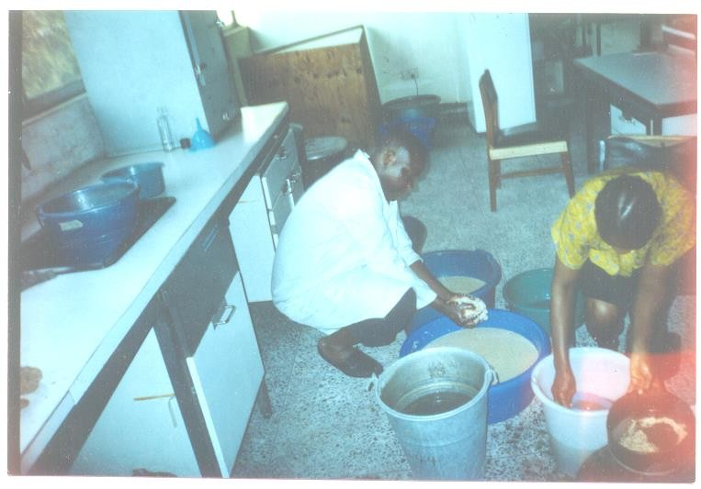

**Wet Dehulled Beniseed**

**Separated Hulls**

**Plate 8: Separation of Seed from Hull using Brine**

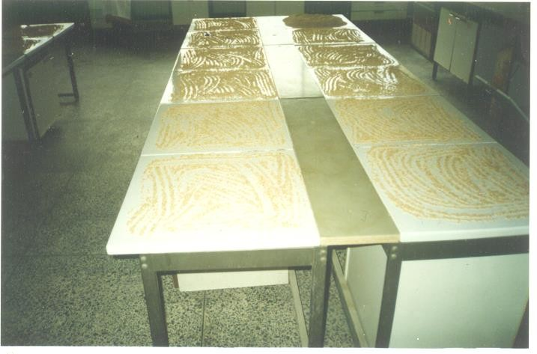

**Dried Beniseed**

**Drained Beniseed Kernels**

## Plate 9: Drying of Dehulled Beniseed on a Concrete Slab

#### Experimental Procedures

The methods used for determining the physical and mechanical properties of beniseed are those that have been established in literatures.

#### Size and Sphericity

Fifty replicate samples of undehulled beniseeds were randomly selected. The three linear dimensions of each seed namely major, intermediate and minor diameters were measured with a micro meter screw gauge, reading to 0.01mm.The equivalent diameter and sphericity of each seed were determined using the following equation proposed by Mohsenin (1986)

Equivalent Diameter, D= (L X B X T) 1/3 3.1

and Sphericity,  = (LXBXT) 1/3 3.2

L

where: L = Longest intercept, (Length) in mm; B = Longest intercept normal to ‘L’ (Breadth) in mm; T= Longest intercept normal to ‘L’ and ‘B’(Thickness) in mm.

A-2 x 5 factorial in Completely Randomized Design, CRD experimental design was used with a total of 500 observations (2 accessions x 5 moisture content levels x 50 samples) each for major, intermediate, minor and equivalent diameters; and sphericity.

#### Bulk Density:

The bulk density of beniseed at different moisture content was determined by filling a container of known self-weight and volume to the brim with beniseeds and weighing to determine the net weight of the seeds. Uniform density was achieved by

tapping the container 10 times in the same manner in all measurements. The bulk density was calculated as

Bulk Density (g/cm3) = Weight of sample (g) 3.3

Volume occupied (cm3)

#### True Density

The true or solid density defined as the ratio of a given mass of sample to its volume was determined by the water displacement method. Accordingly, a known weight (50g) of sample was poured into a 100cm3 fractionally graduated cylinder containing 50cm3 distilled water. The volume of water displaced by the seeds was observed. The true density was calculated as

True Density (g/cm3) = Weight of the sample (g) 3.4

Volume of distilled water displaced (cm3)

The representative values of bulk and true densities were taken as the average of 3 replications. A-2 x 5 factorial in CRD experimental design was used with a total of 30 observations (2 accessions x 5 moisture content levels x 3 replications) each for bulk and true densities.

#### Porosity

The porosity of an unconsolidated agricultural material can either be determined experimentally using the porosity tank method or theoretically from bulk and true densities of the material. Results from both methods have been found to be in close agreement (Waziri and Mittal, 1983). The porosity of beniseed in this work was determined using the relationship presented by Mohsenin (1986) as follows;

Porosity = (1 – (Bulk Density/ True Density) )/100 3.5

A-2 x 5 factorial in CRD experimental design was used with a total number of 30 observations (2 accessions x 5 moisture content levels x 3 replications).

#### Thousand Kernel Weight

For small seeds like beniseed, 1000 kernels were weighed and a parameter known as the thousand-kernel weight (TKW) was determined. An electronic weighing balance having a sensitivity of 0.10g was used.

A-2 x 5 factorial in CRD experimental design with a total number of 30 observations (2 accessions x 5 moisture content levels x 3 replications) was used.

#### Coefficient of Friction

The static coefficient of friction was obtained on four structural surfaces namely mildsteel, plywood, concrete and glass. In the case of plywood the direction of movement was parallel to the grain. A tilting table constructed by the Engineering Drawing Office of the Federal Institute of Industrial Research, Oshodi (FIIRO) was used. The surface to be tested was fixed on the tilting table and the beniseeds were poured into a cardboard paper ring of diameter 10cm by 2cm deep until the ring was full. Care was taken to raise the ring slightly so that it did not touch the surface. The table was then slowly tilted by a gentle screwing device until movement of the seeds down mounted against the edge of the tilting table. The tangent of the angle of friction is the coefficient of friction.

A-2 x 4 factorial in CRD experimental design with a total of 24 observations (2 accessions x 4 moisture content levels x 3 replications) was utilised.

#### 3.4.7. Mechanical Behaviour of Beniseed under Compression Loading

Compression tests were performed on beniseed kernels using the Monsanto Universal Testing Machine of the National Centre for Agricultural Mechanization, (NCAM) Ilorin, Kwara State. Testing Conditions for the lnstron Machine were loading range: 0 - 500N; chart speed – 50rpm/mm; Crosshead speed – 1.5mm/min. The procedure used by Braga et. al. (1999) was followed.

Ten samples, each of the two beniseed accessions in both dehulled and undehulled form and at three moisture content levels were used for the test. Each seed was placed between the compression plates of the tensonometer (Plate 10). The seed was compressed at a constant deformation rate of 1.25mm/min. The applied forces at bioyield and oil points and their corresponding deformations for each seed sample was read directly from the force-deformation curve. The mechanical behaviour of beniseed was expressed in terms of force required for maximum strength of the seed, energy required to deform the seed to initial rupture and seed specific deformation. The rupture force was determined as the force on the digital display when the seed under compression makes a clicking sound. Each process was often completed whenever the break point of the positioned seed is reached.

**Beniseed Kernel**

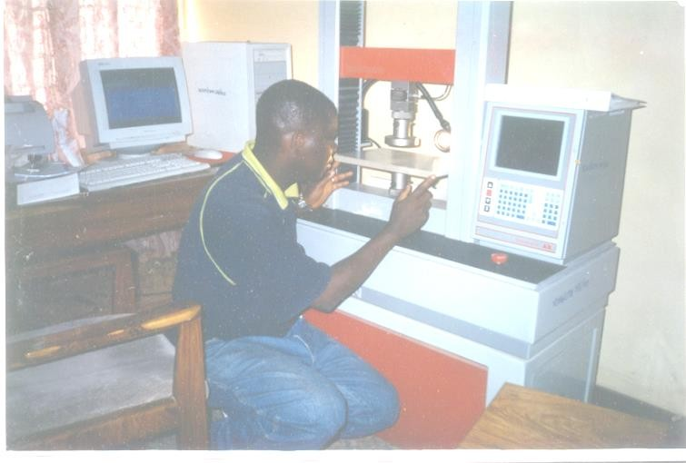

**Beniseed Kernel**

## Plate 10: Beniseed Kernel under Compression Loading

A– 2 x 2 x 3 Factorial design in CRD with a total of 120 observations (2 accessions in 2 different forms x 3 moisture content levels x 10 replications) was used to evaluate the force applied, deformation sustained and energy required.

#### Experimental Design and Performance Evaluation of the Fabricated Beniseed Oil Expeller

According to Oresanya and Koleoso (1990), NCRI (1995) and Tunde- Akintunde (2000), plate and hydraulic presses can be used for expressing oil from vegetable oilseeds but they are more laborious, time consuming and less effective while an oil expeller expresses oil at higher per cent than the two presses.

Though, oil expellers are presently in use, in this country, most of them could not perform effectively with beniseed. Therefore, there is need for modifications and local production of these expellers in order to perform efficiently on the seed, eliminate or reduce the problem of shortage of spare parts, maintenance personnel and the cost of importation. This has necessitated the design and fabrication of this expeller, which is deemed appropriate for use locally as far as simplicity and effectiveness of operation are concerned.

In the light of the above, a functional-power-operated oil expeller containing a special wormshaft rotating in cylindrical barrel with perforations was designed and fabricated based on the application of parameters obtained from the determined physical and mechanical properties of the seed. A post extraction equipment, the oil filter press was also developed in order to improve the quality of oil expressed from

the seed. The plates are provided with individual valves, which allows the filterates to collect into a common draining system and storage.

In order to evaluate the performance of the fabricated oil expeller, three sets of experiments were carried out as follows:

* varying the wormshaft speed of the expeller and determining how this affects the oil recovery and cake quality
* varying the seed moisture content and noting how this affects the yield and quality of the expressed oil and cake; and
* determining how beniseed accession affects the quality of oil expressed from it.

These three experiments were designed as factorial experiments involving an interactive study of the effects of the three independent variables on the quality of expressed oil and cake. The three independent variables viz: Wormshaft Speed (N), Moisture Content (M) and Beniseed Accession (A) were combined in a split plot experiment. Four levels of wormshaft speed, four levels of moisture content and two levels of beniseed accession were employed.

The wormshaft, N was considered as the mainplot, while the moisture content, M and beniseed accession, A were considered as the sub-plot and sub-sub plot respectively (Table 3.2).

Two kilograms, each of the dehulled beniseed samples was poured into the hopper. The electric motor was switch on. The speed was then adjusted with the aid of a belt/pulley arrangement to the first speed. When a constant speed was indicated

by the tycometer attached to the wormshaft, the feed control gate was opened for the seed to pass onto the expression chamber where the seed was crushed and compressed (Plate 11). The crushing time was noted.

The expressed oil was clarified using the developed oil filter press (Plate 12). The operation was repeated for the other samples. The dehulled seed, filtered oil and expressed cake were as shown in Plate 13.

The volumes of the expressed and filtered oil were measured by using a graduated cylinder while the weight of the expressed cake was measured on a chemical balance.

The expression efficiency of a laboratory press was given by Ajibola and Fasina (1989) as:

where:

E = Y 3.6

Co

Y = Oil yield in per cent = W1 –W2 X 100 3.7

W2

W1 = Weight of unexpressed sample W2 = Weight of expressed sample

Co = The initial oil content of the seed

However, equation 3.7 has to be modified in order to obtain the actual expression efficiency, E of the fabricated oil expeller. This was evaluated in terms of oil recovery as follows:

E = V1 3.8

V2

where; V1= Volume of expressed and filtered oil

V2 = Volume of expressable oil = the initial oil content of the seed and is the total sum of (i) volume of expressed and filtered oil; (ii) volume of residual oil-in-cake and (iii) volume of oil loss in the expeller and filter press.

Table 3.2: The Split-Split Plot Design Experimental Layout

|  |  |  |  |  |
| --- | --- | --- | --- | --- |
| Wormshaft | Moisture Content | Beniseed Accessions | | |
| Speed (rpm) | %, wb | A1 | | A2 |
| N1 | M1  M2 | N1M1A1  N1M2A1 | N1M1A2  N1M2A2 | |
|  | M3  M4 | N1M3A1  N1M4A1 | N1M3A2  N1M4A2 | |
| N2 | M1  M2 | N2M1A1  N2M2A1 | N2M1A2  N2M2A2 | |
|  | M3  M4 | N2M3A1  N2M4A1 | N2M3A2  N2M4A2 | |
| N3 | M1  M2 | N3M1A1  N3M2A1 | N3M1A2  N3M2A2 | |
|  | M3  M4 | N3M3A1  N3M4A1 | N3M3A2  N3M4A2 | |
| N4 | M1  M2 | N4M1A1  N4M2A1 | N4M1A2  N4M2A2 | |
|  | M3 M4 | N4M3A1 N4M4A1 | N4M3A2 N4M4A2 | |

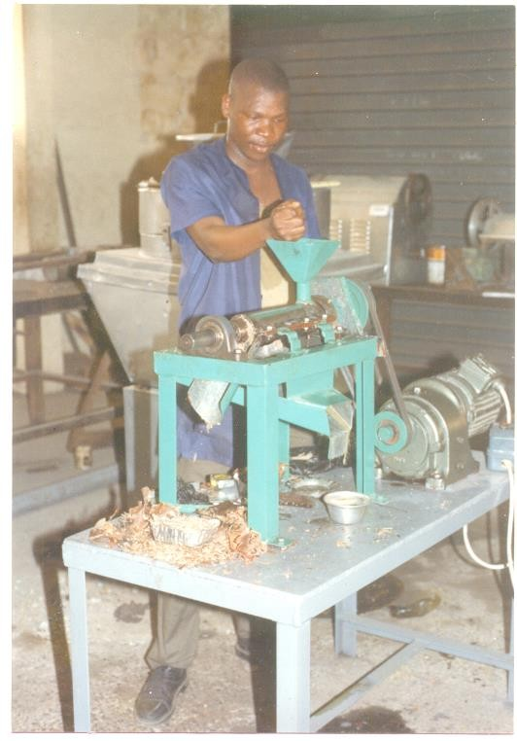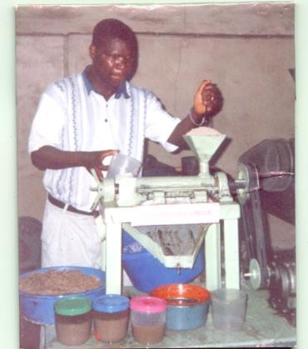

**Undehulled Seeds**

**Undehulled Cake**

Raw Oil

Oil Expression from Dehulled Beniseed

Oil Expression from Undehulled Beniseed

## Plate 11: The Fabricated Oil Expeller in Operation

**Expressed Beniseed Oil**

**Filtered Oil**

**Oil Pump**

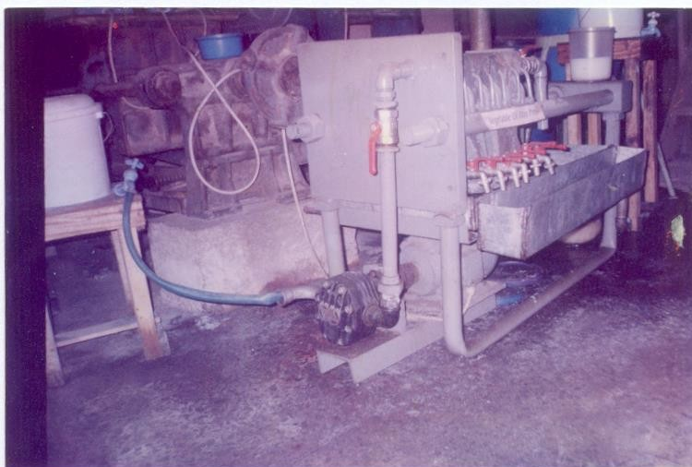

**Expressed Beniseed Oil**

**Filtered Oil Taps**

**Oil Pump**

**Plate 12: The Fabricated Oil Filter Press in Operation**

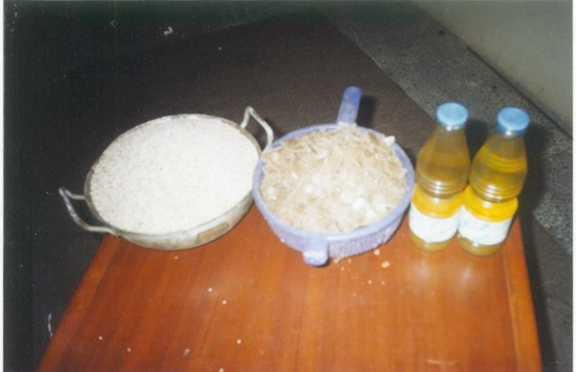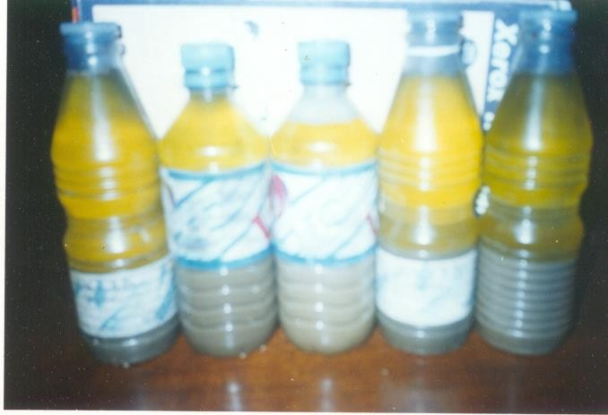

Settling Oil

Slurry

**Dehulled**

**Beniseed**

**Produced**

**Cake**

**Filtered**

**Oil**

**Mechanically Expressed Beniseed Oil with Fine Particles**

## Plate 13: The Oil and Cake Produced by the Expeller

#### Standard Tests for Analysis:

In order to examine the yield and quality of expressed beniseed oil and cake, some standard test / analyses were carried out to determine their physical and chemical properties.

#### Moisture Content Determination

The experimental samples were prepared at different moisture content for the experiments. For obtaining the desired moisture content in the sample, calculated amount of water was added, the samples were thoroughly mixed and sealed in polythene bags. The bags were kept in a cool place and allowed to equilibrate for 4 hours to enable the seed to absorb the water. High moisture samples were dried in shade for short duration to bring down the moisture content and then kept in plastic bottles.

The moisture content of beniseed samples used for various experiments was determined as per the method suggested by ASAE (1998) for oilseed. Beniseed sample of 2.5 g was weighed accurately and then dried in an air oven at 130oC for 4 hours. The aluminium dish containing the sample was removed from the oven and transferred into a desicator for cooling for about 30 min. The loss in weight was noted and the moisture content was calculated on wet basis from the formular:

Moisture Content, % wb = W1 + W2 – W3 x 100 3.9

W2

where, W1 = Initial weight of empty can, g

W2 = Sample weight,g and W3 = Final weight of can + sample

#### Oil Content Determination

The oil content of beniseed was determined by soxhlet extraction apparatus with normal hexane as solvent. For this purpose, 5g ground beniseeds was taken in a thimble and extracted with 200-ml n-hexane for about 4 hours. After extraction, the chloroform was added in the round bottom flask to dissolve the extracted oil. The oil- chloroform mixture was poured into a clean and dry glass panchet and solvent was evaporated at a temperature of 80-85oC for 1 hour in an oven. The average of 3 samples was expressed as percentage content as follows:

% Oil content = wt. of oil in solution x 100% 3.10

wt. of seed sample

The residual oil content in the cake was also determined using the same procedure.

#### Relative Density Determination

The relative density of beniseed oil was determined by using the density (specific gravity) bottle. The density bottle was cleaned, dried and weighed (W1) on a chemical balance. This was completely filled with pure water and the excess was carefully wiped off with a cloth. The bottle was then reweighed (W2). The bottle was emptied and the inside was dried. It was then fill with beniseed oil and weighed (W3). The relative density, R.D. of the oil was given as:

R.D. = Weight of Oil 3.11

Weight of same volume of water

= W3 – W1 3.12

W2 – W1

#### Free Fatty Acid Content Determination

The free fatty acid (FFA) content of the expressed oil was determined using the standard test recommended by the Association of Official Analytical Chemists (AOAC, 1984). 10g of the expressed and filtered beniseed oil was weighed into a conical flask. An equal volume of diethyl ether and ethanol (the FFA solvent) was measured into a beaker. Three drops of 1% phenophtalin was added to the solvent and neutralised with a few mls of NaOH (0.1N) until the colour turned pink.

50mls of FFA solvent was added to the sample in the conical flask. The final solution was titrated agaist 0.1N NaOH until the colour turned to reddish pink. The calculation for the FFA content is given as follows:

FFA = Tv X 5.61 3.13

Sw

where, Tv = Titre value

Sw = Sample weight

#### Oil Colour Determination

The colour of oil collected from each experiment was determined by tintometer. It gives colour in terms of Lovibond units for red, yellow and blue. The matching colour for visual description was taken from the Lovibond system chart.

#### Protein Content Determination

The protein content of expressed beniseed cake was detrmined using the method recommended by AOAC and it is the automated (macrokjeldahl method). The appratus used includes, a digester with an in-built temperature controller, digestion tubes, heat resistant ploves, automatic pipettes, measuring cylinders, complete filration unit, weighing balance, kjeldahl flasks, conical flasks and a distilling (a Tecator 1030 automatic analyser) unit.The chemicals used areconcentrated Sulphuric acid, kjeldahl copper catalyst tablets, Sodium hydroxide (40%) and Boric acid (4%) with bromocresol green methyl red indicator solution.

1g of beniseed cake, ground into fine powder was weighed into a digestion tube and 15mls of concentrated sulphuric acid and 5 kjeldahl tablets were added. The tube was then placed in a preset digester at 410oC and digested for 45minutes. 75mls of distilled water was added to the tube after cooling to prevent caking. The tube was then placed in the distilling uni, with 50mls of 40% NaOH dispensed into it to dilute the solution. The mixture in the tube was further distilled into 25mls of 4% boric acid for 5minutes. After this, the mixture was titrated against 0.47N HCL until a grey colour was obtained. A blank sample (i.e without beniseed cake) was also subjected to the above procedures. The percentage total Nirogen is calculated as follows:

% Total Nitrogen = (14.01 + St –Bt X N) 3.14

10 X Sw

where, St = Sample titre; Bt = Blank titre;

N = Normality of HCL; Sw = Sample weight.

#### Statistical Analysis

* + 1. **Analysis of Variance**

The analysis of variance (ANOVA) which is one of the major statistical research tools in almost all the scientific discipline was used to examine the variation in the results of all the experiments obtained under the various independent variables and their interactions. Thus, it is a summary of complex pattern of data provided in tabular form. Statistical software with split plot programme was used for the analysis on private computer. The wormshaft speed, N was considered as the main plot, while the moisture content, M and beniseed accession, A were considered as the sub-plot and sub-sub plot respectively. The outline of the format used by Gomez and Gomez (1984) is presented in table 3.3.

#### Comparison between Treatment Means

The Duncan Multiple Range Test (DMRT) was used for comparing the treatment means. The DMRT has been found useful in selecting the best and optimal treatment means. Thus, it is recommended for comparing all possible pairs of treatment means without a control when a large number of data are to be tested (Obi, 1986).

#### Regression Analysis

Regression analysis was used to indicate the effects of independent variables, wormshaft speed, moisture content and beniseed accession on the quality of oil and cake. A software (Microsoft Excel) was used to develop regression equations that relates the independent variables with the dependent variables.

Table 3.3: Outline of Analysis of Variance

Source of Variation DF SS MS Fvalue

Replication (r)

Main Plot factor, A (a-1)

Error (a) (r-1) (a-1)

Sub-Plot factor, B (b-1)

A X B (a-1) (b-1)

Error (b) (r-1)(a-1)(b-1)

Sub-Sub Plot, C

A X C (a-1)(c-1)

B X A (b-1)(c-1)

A X B X C (a-1)(b-1)(c-1)

Error (c) (r-1)(b-1)(c-1)

Total (r)(a)(b)(c)

Main Plot

Sub-Plot

Sub-Sub Plot

#### CHAPTER FOUR

#### RESULTS

The results of the different experiments carried out in the present work are presented.

#### Size and Shape

The results obtained on the determination of axial dimensions, equivalent diameter and sphericity at 5.3% for the two beniseed accessions are shown in appendices A1-1 and A1-2. A summary of the results at different moisture content is shown in table A1-3. The analysis of variance (ANOVA) tables are summarized in table A1-4. The regression Equations in the moisture range of 5 to 30% are presented in table A1-5.

Figures 4.1 to 4.3 show the effect of moisture content on the size and sphericity of the two beniseed accessions. From the figures, it was observed that the size and equivalent diameter of the two beniseed accessions increased with increase in moisture content.

For Yandev-55 (Figure 4.1), the length increased from 2.80 to 3.30mm; the width from 1.83 to 2.05mm; the thickness from 0.66 to 0.84mm and the size from

1.50 to 1.78mm while for E8 (Figure 4.2), the length increased from 3.30 to 3.93mm, the width from 2.13 to 2.62mm, the thickness from 0.75 to 1.00mm and the size from

1.74 to 2.18mm as the moisture content increased from 5.3 to 28.3% respectively.

3.5



**Major Diameter, mm**

**Minor Diameter, mm**

**Intermediate Diameter, mm**

**Geometric Mean, mm**

3

2.5

2

**Grain Size, mm**

1.5

1

0.5

0

0 5 10 15 20 25 30

**Moisture Content, % wb**

#### Figure 4.1: Effect of Moisture Content on the Size of Yandev 55 Accession

4.5



**Major Diameter, mm**

**Minor Diameter, mm**

**Intermediate Diameter, mm**

**Geometric Mean, mm**

4

3.5

3

2.5

**Grain Sizr, mm**

2

1.5

1

0.5

0

0 5 10 15 20 25 30

**Moisture Content, % wb**

**Figure 4.2: Effect of Moisture Content on the Size of E8 Beniseed Accession**

For the two accessions, sphericity decreased as the moisture content increased from 5.3 to 16.1% and then increased with a further increase in moisture content to 28.3% (Figures 4.3). For Yandev-55, sphericity decreased from 0.541 at 5.3% to

0.536 at 16.1% moisture content and then increased to 0.547 at 28.3% while for E8, it decreased from 0.537 to 0.518 and then increased to 0.554 at the above moisture levels respectively.

Table A1-4 shows that there is a difference in accession means for major and intermediate diameters while for minor diameter, geometric mean and sphericity, the accession means are not different at the 0.050 level. Also, there is a difference in moisture content means for intermediate diameter, minor diameter and geometric mean while for major diameter and sphericity, the moisture content means are not different at the 0.050 level for Yandev-55 and E8 . The interaction between accession and moisture content is non-significant in all the parameters.

#### 4.2 Gravimetric Properties

The results of the experiments on gravimetric properties (bulk and true densities, porosity and thousand kernel weight) of the two beniseed accessions at different moisture contents are summarized in table A1-6. The analysis of variance (ANOVA) tables are summarized in table A1-7. The regression equations in the moisture content range of 5 to 30% are represented in table A1-8.

**Y-55 Sphericity, % E8 Sphericity, %**

56

55.5

55

54.5

54

**Sphericity, %**

53.5

53

52.5

52

51.5

0 5 10 15 20 25 30

**Moisture Content, % wb**

**Figure 4.3: Effect of Moisture Content on the Sphericity of two Beniseed Accessions**

Figure 4.4 shows that the bulk density decreased with increase in moisture content. For Yandev-55, it decreased from 688kg/m3 at 5.3% moisture content to 613kg/m3 at 28.3% moisture content while for E8, the decrease was from 674 to 528kg/m3 at the same moisture content levels respectively.

Figure 4.5 shows that the true density also decreased with increase in moisture content. For Yandev-55, it decreased from 1042kg/m3 at 5.3% moisture content to 981kg/m3 at 28.3% moisture content, while for E8, it decreased from 1050 to 988kg/m3 at the same moisture content levels respectively.

Figure 4.6 shows that porosity increased with increase in moisture content for the two accessions. For Yandev-55, porosity increased from 33.97 at 5.3% moisture content to 37.51 at 28.3% moisture content while for E8, the increased was from

35.81 to 46.56 at the same moisture content levels.

Figure 4.7 shows that thousand-kernel weight (TKW) increased with increase in moisture content. For Yandev-55, TKW increased from 2.63g at 5.3% moisture content to 2.96g at 28.3% moisture content while for E8, it was from 2.98 to 3.50g at the same studied moisture content levels.

**Y-55 Bulk Density, kg/m3 E8 Bulk Density, kg/m3**

700

680

660

640

620

**Bulk Density, kg/ m3**

600

580

560

540

520

500

0 5 10 15 20 25 30

**Moisture Content, % wb**

#### Figure 4.4: Effect of Moisture Content on the Bulk Density of two Beniseed Accessions

**Y-55 True Density, kg/m3 E8 True Density, kg/m3**

1060

1050

1040

1030

**True Density, kg/m3**

1020

1010

1000

990

980

970

0 5 10 15 20 25 30

**Moisture Content, % wb**

#### Figure 4.5: Effect of Moisture Content on the True Density of two Beniseed Accessions

**Y-55 Porosity, % E8 Porosity, %**

48

46

44

42

40

**Porosity, %**

38

36

34

32

30

0 5 10 15 20 25 30

**Moisture Content, % wb**

### Figure 4.6: Effect of Moisture Content on the Porosity on two Beniseed Accessions

3.6

3.4

3.2

3

2.8

2.6

2.4

2.2

2

0

5

10

15

20

25

30

**Figure 4.7: Effect of Moisture Content on the Thousand Kernel Weight of two Beniseed Accessions**

**Thousand Kernel Weight, g**

**Y-55 Thousand Kernel Weight, g E8 Thousand Kernel Weight, g**

**Moisture Content, % wb**

#### Coefficient of Friction

The coefficient of friction for the two beniseed accessions on four structural surfaces and at different moisture contents are summarized in table A1-9. The analysis of variance (ANOVA) table is summarized in table A1-10. The regression equations in the moisture content range of 5-3% are represented in table A1-11.

Figures 4.8 and 4.9 show the effect of moisture content on the coefficient of friction on different structural surfaces for the two beniseed accessions. It was observed that the coefficient of friction decreased from 0.5095 at 5.3% moisture content to 0.4621 at 10.6% moisture content and increased to 0.5392 with a further increase in moisture content to 22.4% for mild steel surface. Similar trends were observed for plywood, concrete and glass for the two accessions.

**Mildsteel Plywood Concrete Glass**

0.6



0.55

0.5

0.45

**Coeff. of Friction**

0.4

0.35

0.3

0 5 10 15 20 25

**Moisture Content, % wb**

### Figure 4.8: Effect of Moisture Content on the Coefficient of Firction of Yandev 55 Beniseed Accession

**Mildsteel Plywood Concrete Glass**

0.6



0.55

0.5

**Coefficient of Friction**

0.45

0.4

0.35

0.3

0 5 10 15 20 25

**Moisture Content, % wb**

**Figure 4.9: Effect of Moisture Content on the Coefficient of Friction of E8 Beniseed Accession**

#### Mechanical Behaviour of Beniseed under Compression Loading

The results of the tests on mechanical behaviour of beniseed under compression loading are given in appendices A2-1 to A2-5. The analysis of variance tables are summarized in table A2-6. The regression equations in the moisture content range of 5-3% are represented in table A2-7.

Figures 4.10 and 4.11 show the variation in force required to rupture and to reach the oil-point of individual kernels and their corresponding deformations. The effect of moisture content on the rupture force, specific deformation and energy requirement of the two beniseed accessions are shown in figures 4.12 - 4.14.

The bioyield point in the force deformation curves denote the seed rupture point and this point was determined by a visual decrease in force as deformation increases. The oil-point indicates the threshold force and deformation at which the oil emerges from an oilseed kernel when pressed mechanically. Tables A2-1 to A2-4 present the raw data obtained from the evaluation of the effect of seed pre- conditioning at storage moisture content of 5.3%, wb on the force applied, deformation sustained and energy required to rupture the seed. Table A2-5 summarized the results obtained at different moisture content levels.

Figures 4.10 and 4.11 show that the applied force required to rupture and express oil from beniseed is greater when the seed was dehulled than when left undehulled. For dehulled Yandev-55 and E8, the values are 10.9 and 9.4N at rupture and 29.4 and 28.4N at oil-point respectively.

**Load, N**

|  |  |  |
| --- | --- | --- |
| **Load, N** | | |
|  | **Deformation,mm** |  |

#### Figure 4.10: Load Deformation Curve of Individual Yandev Kernels

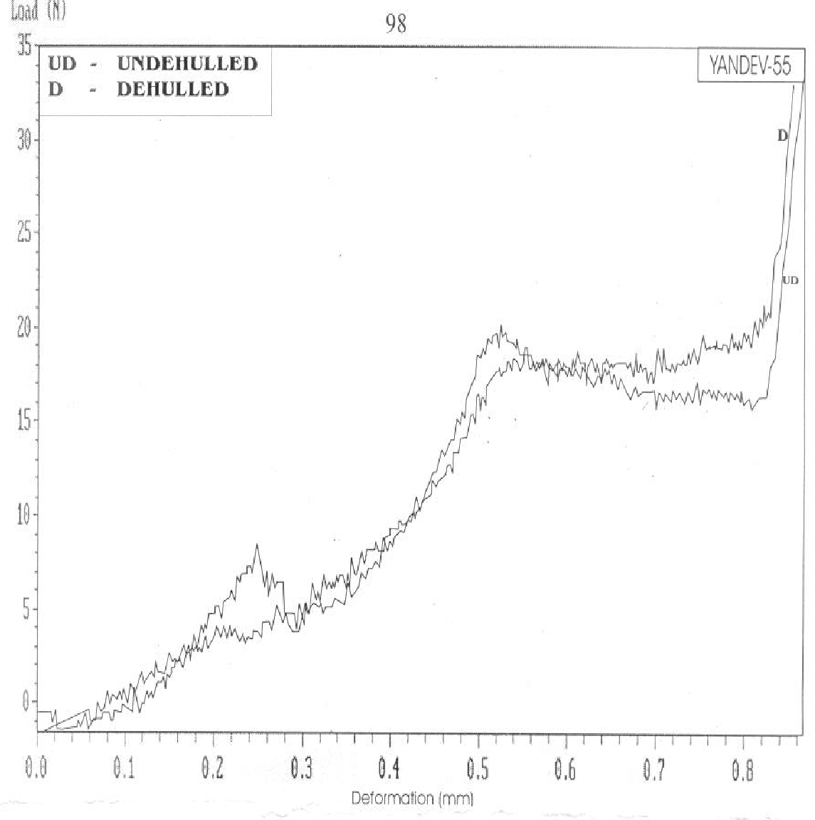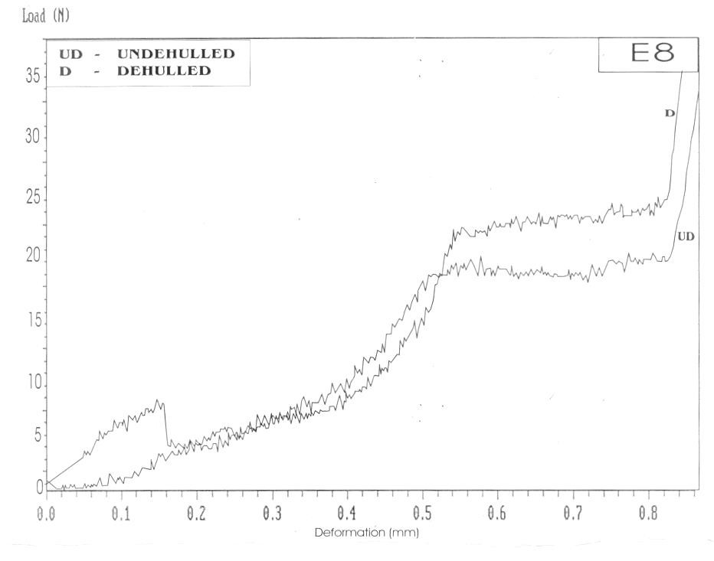

**Deformation, mm**

**Load, N**

**Figure 4.11: Load – Deformation Curve of Individual E8 Kernels**

**Load, mm**

**Deformation, mm**



**Y - 55 Undehulled**

**Y - 55 Dehulled**

**E8 Undehulled**

**E8 Dehulled**

16



14

12

10

**Rupture Force, N**

8

6

4

0 1 2 3 4 5 6 7 8 9

**Moisture Content, % wb**

#### Figure 4.12: Rupture Force as a Function of Seed Moisture Content for the two Pre – Conditioned Beniseed Accessions



**Y - 55 Undehulled**

**Y - 55 Dehulled**

**E8 Undehulled**

**E8 Dehulled**

0.5



0.45

0.4

0.35

**Specific Deformation, mm**

0.3

0.25

0.2

0.15

0.1

0 2 4 6 8 10

**Moisture Content, % wb**

#### Figure 4.13: Mean Specific Deformation at Seed Rupture as a Function of Moisture Content for the two Pre – Conditioned Beniseed Accessions



**Y - 55 Undehulled**

**Y - 55 Dehulled**

**E8 Undehulled**

**E8 Dehulled**

1.8



1.6

1.4

1.2

**Energy, J (10-3)**

1

0.8

0.6

0.4

0.2

0 1 2 3 4 5 6 7 8 9

**Moisture Content, % wb**

#### Figure 4.14: Mean Energy as a Function of Moisture Content for the two Pre – Conditioned Beniseed Accessions

However, for undehulled seeds, the values for Yandev-55 and E8 are 8.7 and 9.0N for rupture and 18.6 and 20.8N for oil point respectively. The corresponding deformations follow a similar trend with values that ranged between 0.123 to 0.494mm and 0.46 to 0.54mm for rupture and oil-point respectively. Figures 4.12 –

4.14 show that all the studied mechanical property - applied force, specific deformation and energy increased with increase in moisture content for the two beniseed accessions.

#### Existing Oil Expellers

Some information on oil expellers manufactured by a number of manufacturers in Nigeria and abroad is presented in appendix three, tables A3-1 and A3-2. The list covers a wide range of expellers and gives good information that may be needed by oil processors.

Analysis of the data on the available oil expellers indicates that there is no correlation among the capacity, power input and weight of the expeller. Over 75% of the models had capacity less than 75kg/h, which reflect a trend towards manufacture of smaller capacity expellers.

#### Machinery Design Analyses

An oil expression plant consisting of an oil expeller and a filter press was designed based on the results of the determined properties and information obtained from sections 4.1 to 4.5.

#### Oil Expeller

* + - 1. **Theoretical Considerations**

An expeller is considered as an equipment with discontinuous flight called wormshaft. The following assumptions were made for design consideration.

* The maceration of oilseed was complete in the feed section leaving the homogenous mixture of oil and solids in the ram section.
* No pressure development would take place in the feed section. The pressure development and the expression of oil start at the beginning of the ram section.
* The temperature of oilseed mass remained constant in the ram section. In reality, the temperature would increase along the ram section due to shearing action of the shaft.

As the oil solid mixture passes through the section, it is subjected to radial pressure exerted by the wormshaft. The pressure causes flow of oil in the radial direction through the solid matrix and out through the barrel slots. The oil-flow in turn changes the flow rate of mixture in the axial direction.

#### Design Conception

Based on the above assumptions, preliminary work and analysis of information received on the existing oil expellers (Appendix, A1-2), the following specifications were made:

Length of chamber, L (mm) = 300 Number of worms, n = 6

Worm pitches, P (mm) = 2 x 25, 37.5, 37.5, 37.5, 37.5, 37.5

Depth of worm, H (mm) = 6.25 Thickness of worm, e (mm) = 6.25 Helix angle,  (degree) = 10

Screw Diameter at the Feed Section, DF = 47.5mm Screw Diameter at the Discharge Section, DD = 60mm Mean diameter of screw, Dm = 54

Speed of rotation, N (rpm) = 45

#### Design Capacity

The capacity of an expeller is controlled by drag flow, pressure flow and leak flow in the barrel assembly. The theoretical capacity of an expeller with single flight in feed section was given by Varma (1998) as:

Q = DN cos  (Pcos  – e) H 4.1

where; Q = volumetric flow

D = mean diameter of screw

N = rotational speed of wormshaft P = pitch of the screw

H = depth of the screw e = flight width

 = helix angle From section 4.6.1.2,

Q = 3.142 x 54 x 45 x Cos 10 (25Cos10 – 6.25) 6.25

= 8.63 x 105 mm3/min

= 0.05178m3/h (for single start in 3 passes)

 35.26kg/h (for average bulk density of 681kg/m3, section 4.2)

= 11.75kg/h (in a - single pass operation) Say 10kg/h in real conditions and 0.25 metric tonne/day.

#### 4.1.6.4 Compression Ratio

Oil expeller works on the principle of a pressure differential applied to incoming oilseed against that applied to the discharge material. This may be termed as compression ratio. According to Shukla et. al.(1992), compression ratio, C.R. is

defined as ratio of the volume displaced per revolution of the shaft at the feed section to the volume displaced per revolution of the shaft at the plug or discharge section. They gave the theoretical equation as:

C.R = (DB2 – D 2) 4.2

F

(DB2 – D 2)

D

where,

DB = Diameter of the expression chamber = 61mm

DF = Diameter of the wormshaft at feed section = 47.5mm

DD = Diameter of the wormshaft at Discharge section = 60mm Therefore, C.R = (612 – 47.52)

(612 – 602)

= 3721 – 2256

3721 – 3600

= 12.1

This is within the range specified for oilseed with high oil content.

#### Forces Acting on Screw Thread

The two main forces acting on the screw thread are.

* + - * + Force required to translate and compress the beniseed charge.
        + Frictional force resulting from the screw’s motion.

The shaft has six worms, each of which is subjected to pressure due to compression of beniseed kernels. This pressure increases from a minimum value at the feed end to a maximum at the discharge end (Ward, 1976).

Consider a portion of the screw as shown in Figure 4.15, under the static condition, the direction of load on the unit length of the thread will be normal to the thread surface along line AO.











😐



## Figure 4.15: Forces Acting on Screw Thread

where: K = Elemental load, N

 = Helix angle, deg

 = Friction angle, deg

When the screw is rotated so that the load is moved, the line of action AO will be rotated through the angle of friction,  to BO. For equilibrium of forces, the component BO parallel to the axis of the screw,

W = Kcos ( + ) 4.2

Similarly, the component BO perpendicular to the axis of the screw.

F = Ksin ( + ) 4.3

then, F = Ksin ( + ) W Kcos ( + )

⇒ F = W tan ( + ) 4.4

The friction angle,

 = tan-1 s 4.5

Where

s = coefficient of static friction.

= 0.486 (section 4.3)

  = tan-1 (0.486)  25o

W is the axial force required to expel a great deal of the oil at the oil-point and has been determined to be 29.4N on the average (section 4.5)

 F = 29.4 tan (10 + 25) = 20.59N/kernel

Based on the average size of beniseed (section 4.2) about 100 seeds are crushed at the considered feed end portion. Therefore a force of 2.059KN will be required to express the oil.

#### Torque on screw thread

Torque and axial load are related to each other through the following equation for advance against load (Hall, et al., 1980):

T = W ( rmtan(+) + fcrc) 4.6

With the use of a well-lubricated bearing, the frictional force, fc at the collar will be neglected, thus, the quantity fcrc will be zero. Hence, the equation becomes;

T = W rmtan(+) 4.7

⇒ T = Frm 4.8

where: rm = Dm 4.9

2

m = 54

2

= 27mm

 T =2.059 x 103 x 27 x 10-3

= 55.59Nm

#### Power Requirements

The power input to the expeller is used to convey and heat the material for oil expression.

The power drive mechanism incorporates the use of a reduction gear motor coupled to the expeller shaft by pulley and belts arrangement. The chosen speed for the expeller Ne is 45rpm

 the angular speed, e = 2N 4.10

60

= 2 x 3.142 x 45 = 4.71rads/s

60

The power input to the expeller can be computed as given below:

Pe = Te 4.11

= 55.59 x 4.71

= 261.8W or 0.262KW or 0.349Hp

To give allowance for power used in driving pulleys and shaft, a - 1hp electric reduction gear motor with a speed of about 180rpm is chosen.

#### Belt Design

For a chosen 1hp,180rpm electric gear motor, the belt type is a - B section with dimension 17 x 11mm2 (Figure 4.16). The diameter, d =75mm is used at the gear motor shaft. The expeller pulley's diameter,

D = Nmd 4.12

Ne

where,

Nm = Speed of the electric motor = 180rpm d = Diameter of Driving Pulley = 75mm

Ne = Wormshaft Speed = 45rpm (Section 4.6.1.2)

 D = 180 x 75

45

= 300mm

The minimum centre distance,

Cd = d + D + d 4.13

2

= 75 + 330 + 75

2

= 263mm.

To take care of the bigger pulley, a – 500mm centre distance is chosen.

The pitch length of the belt,

L = 2cd + 1.57 (d + D) + (D – d)2 4.14

2 4Cd

L = 2 x500 + 1.57 (75 + 300) + (300 – 75)2

2 4 x 500

= 873mm

From table 4.1, the nearest standard pitch length is 932.2mm for which the nominal length is 838mm. A – 2 B33 - synchronous (toothed) belt arrangement which combines the characteristics of belts and chains will be used. This will guide against slippage, hence maintaining a constant speed ratio between the driving and the driven shafts.

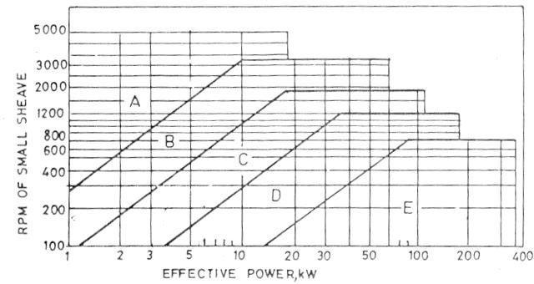

#### Figure 4.16: Effective Power of Belts as a Function of RPM of Small Sheaves Source: Mubeen, 1998

Table 4.1: Standard V – Belts Pitch Lengths

Nominal Length Standard Pitch Length, mm (inches)

mm (inches)

|  |  |  |  |
| --- | --- | --- | --- |
|  | A – Section | B – Section | C – Section |
| 660 (26) | 696 (27.4) | ------- | -------- |
| 787 (31) | 823 (32.4) | ------- | -------- |
| 838 (33) | 874 (34.4) | ------- | -------- |
| 889 (35) | 925 (36.4) | 932.2 (36.7) | -------- |
| 965 (38) | 1001 (39.4) | 1008.4 (39.7) | -------- |
| 1067 (42) | 1102 (43.4) | 1110 (43.7) | -------- |
| 1168 (46) | 1204 (47.4) | 1212 (47.7) | -------- |
| 1219 (48) | 1252 (49.4) | -------- | -------- |
| 1295 (51) | 1331 (52.4) | 1339 (52.7) | 1351 (53.2) |
| 1295 (53) | 1382 (54.4) | 1389 (54.7) | -------- |
| 1397 (55) | 1433 (56.4) | 1440 (56.7) | -------- |
| 1524 (60) | 1561 (61.4) | 1567 (61.7) | 1580 (62.2) |
| 1575 (62) | 1610 (63.4) | 1618 (63.7) | -------- |
| 1625 (64) | 1661 (65.4) | 1669 (65.7) | -------- |
| 1727 (68) | 1762 (69.4) | 1770 (69.7) | 1783 (70.2) |
| 1905 (75) | 1941 (76.4) | 1948 (76.7) | 1961 (77.2) |
| 1981 (78) | 2017 (79.4) | 2024 (79.7) | -------- |
| 2032 (80) | 2067 (81.4) | -------- | -------- |
| 2057 (81) | -------- | 2101 (82.7) | 2113 (83.2) |
| 2108 (83) | 2144 (84.4) | 2151 (84.7) | -------- |
| 2159 (85) | 2195 (86.4) | 2202 (86.7) | 2215 (87.2) |
| 2286 (90) | 2322 (91.4) | 2329 (91.7) | 2342 (92.2) |
| 2438 (96) | 2474 (97.4) | -------- | 2499 (98.2) |
| 2464 (97) | 2499 (98.4) | 2507 (98.7) | -------- |
| 2667 (105) | 2702 (106.4) | 2710 (106.7) | 2723 (107.2) |
| 2845 (112) | 2880 (113.4) | 2888 (113.7) | 2901 (114.2) |
| 3048 (120) | 3084 (121.4) | 3091 (121.7) | 3104 (122.2) |

Source : Mubeen, 1998.

#### Determination of Tensions in the Belt

Figure 4.17 shows the belt geometry and according to Hall et.al. 1980, the

angle of wrap

 = 180  2sin-1{(R - r)/C} (3.19)

where :

R = radius of the larger pulley =150mm r = radius of the smaller pulley = 37.5mm

C = centre distance = 500mm

  = 180 + 2sin-1{(150 – 37.5)/500}= 206deg. = 3.6rad

and  = 180 - 2sin-1{(150 – 37.5)/500}= 154deg. = 2.7rad.

To obtain T and T, the following equations are solved simultaneously : (T - T) V = P 3.20

and T - mv = e sin( 3.21

T - mv

where :

T = tension in the tight side T = tension in the slack side m = bte

b = belt width = 17mm

t = belt thickness = 11mm

e = belt density 970kg/m3 for leather belt

 m = 17 x 11 x 10-3 x 970 = 0.18kg/m



**R**

**C**

**r**



**d**

**D**

## Figure 4.7: Geometry of Belt Drive

❍ = coefficient of friction between belt

= (0.15 for leather belt on steel )

v = belt velocity = r  = 2rNm/ 60 m/s

=2x 3.142 x 37.5 x 10-3 x 180

60

= 0.71m/s

❑  40deg. (most common angle of groove)

For small pulley, e   sin( = e 0.15 x 2.7/ sin 20 = 3.27 and For big pulley, e   sin( = e 0.15 x 3.6/ sin 20 = 4.80

 

 

The pulley with smaller value governs the design. In this case, the smaller pulley governs the design.

T - mv = 3.27 T - mv

T  0.18 x 0.7162 = 3.27

T  0.18 x 0.7162

T  0.093 = 3.27 T  0.302 3.27 T  T 0.302 0.093

3.27 T  T  0.209 3.23

But Power (Kw) = (T  T V 3.24

P = 1Hp = 0.746KW

V = 0.71m/s

 T  T = 1.042

T = 1.042 + T 3.25

3.27 T  1.402  T)  0.209

3.27 T  T)  0.209 + 1.402

T = 0.55KN

and T  1.042 + 0.55 = 1.593KN

#### The Power Transmission Shaft

The shaft is design based on strength and rigidity criteria.

#### Strength Criterion

The required diameter for a solid shaft having combined bending and torsional loads is obtained from ASME code equation (Hall, et al. 1980) as

D3 = 16  (KbMb) 2 +( KtMt) 2 3.26

Ss

Where, at the section under consideration :

Ss = Allowable combined shear stress for bending and torsion

= 40MPa for steel shaft with keyway.

Kb= Combined shock and fatigue factor applied to bending moment

= 1.5 to 2.0 for minor shock.

Kt = Combined shock and fatigue factor applied to torsional moment

= 1.0 to 1.5 for minor shock.

Mb = Bending moment (Nm)

Mt = Torsional moment (Nm) = 55.59Nm (section 4.6.1.5) D = Diameter of solid shaft (m).

The bending load is due to the weight of the pulley, the summation of

tensions on the belts acting vertically downward, and the weight of the threaded shaft as shown in Figure 4.18.

The shaft is supported at point A and C by two bearings. The reactions RA and Rc at the two supports are determined as follows :

RA + Rc = W s + ( T 1 + T 2) + W p 3.27

where : W s = weight of threaded shaft =50N (preliminary survey)

T 1 + T 2 = sum of tensions on vertical belts = 1030N (section 4.6.1.8) W p = weight of pulley = 50N (preliminary survey)

RA + Rc = 50 + 2144 +50 RA + Rc= 2244

Taking moment about A,

Rc (0.485) = 50( 0.3025) + 2194(0.605) Rc = 1343N

RA = 2244 – 1343 = 902N

The shear force and bending moment diagrams are shown in Figure 4.19. The maximum bending moment occurs at B and it is 273Nm.

**Ws T1+T2+Wp**



0.1825m

0.3025m

0.1825m

0 120m

**RA RC**

## Figure 4.18: Bending Loads on the Wormshaft

50N

2194N

**A**



902N

0.3025m

C

B 0.1825m 0.1200m D 1342N

1342N

902N

50N

S. F.

274Nm

263Nm

1. M.

## Figure 4.19: Shear Force and Bending Moment Diagrams

From equation 3.26, D3 = 16  (1.0 x 273) 2 +( 1 x 55.6) 2

3.142 x 40 x 106

= 2.259 x 10-5

D = (2.259 x 10-5)1/3

= 28.77mm

The calculated diameter is less than the least chosen diameter (30mm).

Therefore, strength critarion is satisfied.

#### B. Rigidity Criterion

The design of shaft for torsional rigidity is based on the permissible angle of twist. This is 3deg/m for steel shaft (Hall et. al., op. cit.). For a tapered shaft,

 = 2TL {(1/Di3) - (1/Do3)} 3.28

3G

where :  = angle of twist (deg)

T = Torsional moment = 55.6Nm

L = Length of tapered section = 0.325m

G = Modulus of rigidity = 80GN/m2 for steel shaft Di= Inlet diameter of tapered section = 0.0475m D0 = Outlet diameter of tapered section = 0.0600m

  2 x 55.6 x 0.325 {(1/0.04753) - (1/0.06003) } 3 x 3.142 x 80 x 106

= 4.14 x 10-6deg

This is less than the permissible angle of twist (3deg/m). Hence, torsional deflection is satisfied.

#### Oil Filter Press

* + - 1. **Design Conception**

The proposed oil filter press has the following conceived specifications:

* + - * + Plate and frame dimensions = 300 X 300 X 25mm3
        + Number of plates and frames = 6 each
        + Oil pump power requirement = 1hp at 180rpm

#### 4.6.2.3 Design Analyses

At the beginning of plate and frame filter press operation, the whole pressure drop available is across the medium itself since as yet no cake is formed. Thus, Darcy's basic filration equation can be applied.

Q = KAP 4.12

L

However, as the cake becomes thicker and offers more resistance to the flow, the pressure developed by the pump becomes a limiting factor and the filtration proceeds at a nearly constant pressure (Tiller et al., 1979; Fellows, 1988). A modified Darcy's equation for constant pressure which gives a straight-line equation as quoted by Olayanju, 1999 is then applied.

tA = rV V + rL 4.13

c

V 2P A P

Where:

3

Q (m /s) = Oil flow rate

K = Permeability of the bed

2

A (m ) = Face area of the filter medium

3

V (m ) = Volume of filtrate

Vc = Fractional volume of filter cake in feed liquid volume, V

2

❍

(Ns/m ) = Viscosity of the oil

-2

r (m ) = Specific resistance of the filter cake

L (m) = Equivalent thickness and initial cake layer

2



P (KN/m ) = Pressure drop which is a function of pump characteristics

t (s) = Filtration time

2

A model filtration experiment was carried out on a filter press area 0.0929m

to which slurry is fed at a constant rate. The result is as shown in table 4.2.

Table 4.2: Determination of the Average Oil Volumetric Flow Rate

|  |  |  |  |
| --- | --- | --- | --- |
| Time | Volume of | V | t |
| t (minute) | Filtrate, V (l) | A | V/A |
| 10 | 18 | 193.76 | 0.052 |
| 20 | 30 | 322.93 | 0.062 |
| 30 | 39 | 419.82 | 0.071 |
| 40 | 48 | 516.68 | 0.071 |
| 50 | 54 | 581.27 | 0.086 |

From the graph of t/ (V/A) against V/A (Figure 4.20), the slope is 0.0123 and the intercept is 0 42. These are equivalent to rV /2P and rL/P from equation 4.13

c

respectively. Substituting for this in the equation tA/V =0.0123 (V/A) + 0.42

Rewriting the equation gives a quadratic equation in V/A as

2

t = 0.0123 (V/A) + 0.42(V/A) - t =0

2

Substituting t = 60 0.0123 (V/A) + 0.42(V/A) - 60 = 0

2

Therefore, V = -0.42 + 0.42 + 4 x 5 x 0.0123 x 60

A 2 ( 0.0123 )

V/A = 54.83m

For 300mm-filter plate, effective filtration area is 0.096m2 for cast iron.

V/A = 54.83 x 0.096m2 = 52.63 litres ~ 50litres/hour.

0.1

0.09

0.08

0.07

0.06

0.05

**t/(V/A)**

0.04

0.03

0.02

0.01

0

0 100 200 300 400 500 600 700

**V/A**

## Figure 4.20: The Graph of t /(V/A) against V/A

#### Machinery Development

The designed oil expeller and filter press were fabricated based on the reported design specifications. Appendix five shows the orthographic and isometric projections; exploded view and detailed drawings of parts of the machines. The part numbers used in the following description are indicated in the appendix together with their respective materials of construction.

#### Oil Expeller

The expeller consists of seven main parts namely: - the feeding assembly, the expression barrel, the worms and wormshaft assembly, the cone mechanism, the power transmission unit, the oil and cake troughs and the main frame (Plate 15 and Appendix A5-1). The salient features of the fabricated oil expeller are:

* It has been developed to meet an increasing demand for simple, small capacity expeller suitable for village / cottage industry or on – farm applications.
* High compression ratio (little or no clearance between the barrel and wormshaft) which enables squeezing of oil out of the crushed seed.
* Utilization of special wormshaft with reverse worm.
* The design enables cold expression of beniseed without size reduction or coooking operation.

#### The Feeding Assembly

It consists of a hopper, which is mounted on the mainframe of the expeller (Appendix A5-1, Part no 1). The oilseed flows down the feed hopper through a sliding gate provided on the hopper. The sliding gate is adjusted manually to control feed rate.

#### The Expression Chamber

The expression chamber is made of 60mm diameter, 300mm long and 12.7mm thick stainless steel pipe. This was splitted into two equal halves viz: top and bottom parts (Appendix A5-3, Part nos. 3 and 7). A slot was made at the left end of the top face (Appendix A5-3). 30 – 1.0mm perforations are provided on the bottom part of the barrel (Appendix A5-3) so that expressed oil can drain through. The two halves are bolted together using 6 – 12.5mm bolts and nuts. The expression chamber is enclosed in a cover to prevent expressed oil from coming in contact with dust and foreign materials.

#### Worms and Wormshaft Assembly

The continuos wormshaft designed for other oilseeds was replaced with a special wormshaft fitted with six worms of different pitches (Plate 15 and Appendices A5-1 to A5-4). The worm flight design along pressure and discharge section is such that the material does not wrap around more than 3200 (Appendix A5-5). This leaves an axial gap in the flight that enables the compressed material to slide in either direction relative to velocity generated by worm pitch. This balances the pressure

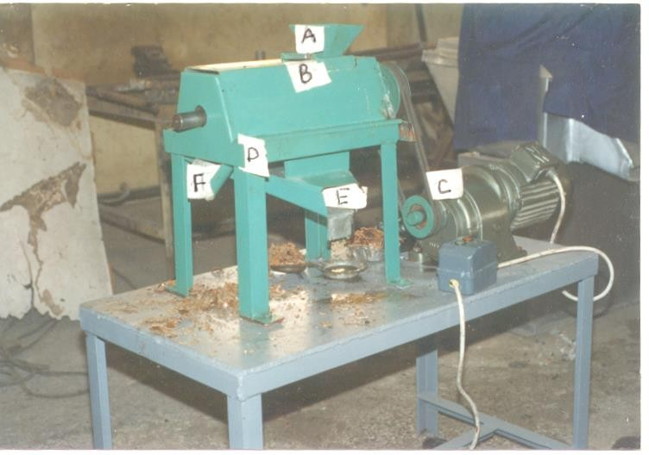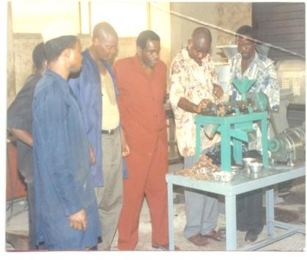

**A**

**B**

Demostration of Oil Expression from Beniseed

**E**

**C**

**F**

**D**

## Plate 14: The Fabricated Beniseed Oil Expeller

#### A – The Hopper; B – The Expression Chamber; C – The Power Drive; D – The Frame; E – The Oil Outlet; F – The Cake Outlet

over a group of worm section and reduces a tendency of material to lock in individual section and rotate with the shaft.

The configuration of the worm section is such that the volume displacement at the feed end of the press is greater than the discharge end. The whole assembly rotates in the barrel. The worms have a dual role of conveying the oilseeds through the barrel and at the same time exerting pressure on the material. Besides increasing the pressure in the barrel, the shear action on the barrel breaks the oilseeds into smaller particles.

The modified worms of the expeller have flight leading to discharge

end. In the reverse worm set-up, one of the original worms in the middle of the shaft is replaced by another of worm of similar dimensions but with flight running in the opposite direction i.e towards the feed end. Due to pressure created by the worms and choke, the oil flows out of the oil – solid matrix through the holes in the cage bar.

#### Choke Mechanism

The choke mechanism consists of a revolving cone, sleeve and a check nut (Appendix A5-6). The check nut is mounted on the thread of the worm shaft and rotates with it. However, it can be adjusted manually to move on the wormshaft axially during the setting of the cone position. The annular space between the revolving cone and the sleeve (mounted on the discharge end support) controls the final adjustment of pressure in the barrel and the ultimate cake thickness. The cake breakers are fixed on the cone end to cut the cake into smaller sizes for successful crushing.

|  |  |  |
| --- | --- | --- |
| 1 – Feed Worm 1 | 2 – Feed Worm 2 | 3 – Press Worm 1 |
| 4 – Press Worm 2 | 5 – Reverse Worm | 6 - Discharge Worm |
| 7 – Spacer | 8 – Regulating Cone | 9 – Main Shaft |

## Plate 15: Worms and Wormshaft Assembly

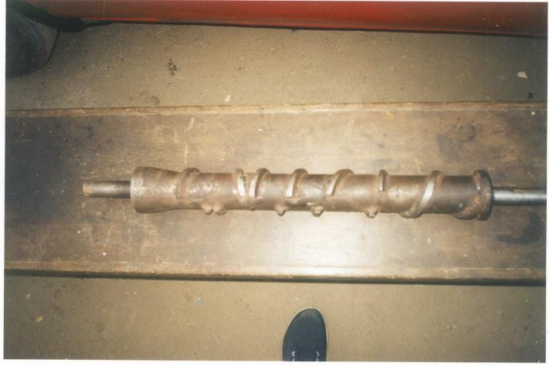

**9**

**8**

**6**

**5**

**4**

**3**

**2**

**1**

**7**

**Profile 2: Special (Piecewise) Wormshaft for Beniseed Oil Expression**

**Profile 1: The Common (Continuous) Wormshaft for Vegetable Oil Expression**

#### Power Drive Unit

This consists of a - 1hp, 180rpm, 3-phase a.c motor, control panel with a star/delta starter, a set of belts and pulleys. The desired speed was obtained by fixing V-groove pulleys on the main shaft.

#### Power transmission accessories

|  |  |
| --- | --- |
| A.C motor | : 0.745kw |
| Voltage, 3-phase | :440v |
| Ampere Rating | 24A |
| Electric Motor Speed | : 180rpm |
| Wormshaft Speed | :45rpm |
| Diameter of motor pulley | : 75mm |
| Diameter of main expeller pulley | : 300mm |

**Overall Dimensions**

Length : 1000mm

Width : 720mm

Height : 1500mm

#### Oil and Cake Troughs

The oil and cake trough (Appendix A5-1, Part nos. 10 and 11) are made of gauge 13 (1.2mm) galvanized sheet metal. They are inclined at an angle of 60 degrees to the horizontal so as to allow for free flow of oil and cake.

#### The Mainframe

It is a table-type frame which supports the barrel, clamping bars, worm assembly, gear drive, feed end support, die end support, bearings and feeder assembly. It consists of a base and supports, which are made from mild steel (Appendix A5-1).

#### Oil Filter Press

The filter press is made of nine main components viz.; the filter plates, the end plates, the filter cloth, the screw shaft and follower, the operating handle, the standing rame, the filter pump drive and the piping materials (Plate 16 and Appendices A5).

The filtration chamber is made of 12-filter plates (6 solid and 6 Hollow) cast, machined and arranged on a framework. Each solid plate has grooves on its surfaces for oil drainage after passing through the filter cloth (Appendix A5-9). A-4hp electric gear pump forces the oil into the press.

#### The Filter Plates and Frames

The filter plates was cast and the border had a thin - central portion, the surface of which is in the form of ridges or designs in relief, between which the oil can flow in spite of the pressure. This tends to force the cloth against the plate. There are 6 of them in all each having dimension (300 x 300 x 25) mm3 (Appendix A5-9). The frame has a similar machined border, but its interior is open. They are also 6 in number.

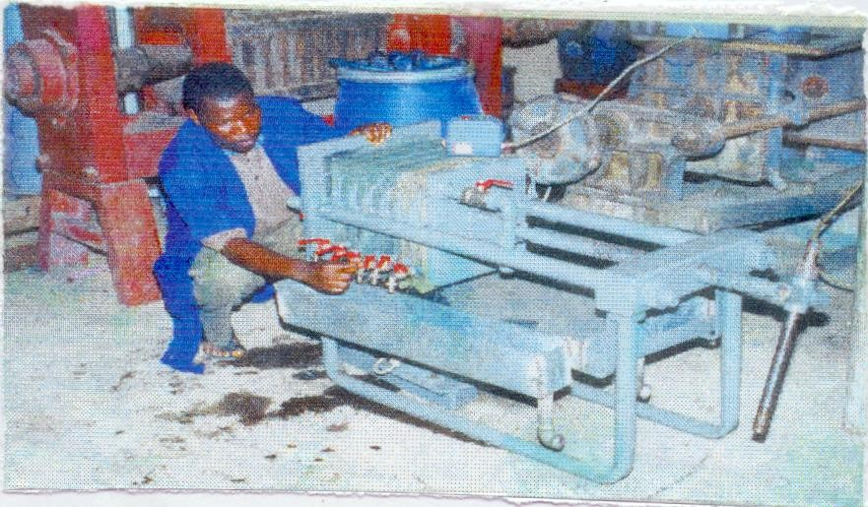

**Recycling Line**

**OilTaps**

**Final Collection Point**

## Plate 16: The Fabricated Oil Filter Press

#### Supporting Bars

The plates and frames are supported by two steel bars which also serve as cross braces and absorb tensile force produced between the two end members by the pressure exerted in closing the press (Appendix A5-8, Part no 5).

#### Other Components

There is an electric motor and a gear pump coupled together with the aid of sprockets and chain. The are six taps on the filter plates discharging oil into a longitudinal trough through which the clear filtered oil is removed. Each face of every plate is covered with a filter cloth to create a series of cloth-walled chambers into which slurry can be forced under pressure.

#### Cost Estimation of the Developed Beniseed Oil Plant

The developed plant is made of two major equipment viz: the oil expeller and the oil filter press. The cost of materials for the constuction of these equipment are as shown in tables 4.3 and 4.4.

#### Table 4.3: Bill of Materials for the Construction of the Designed Oil Expeller

|  |  |  |  |  |
| --- | --- | --- | --- | --- |
| **Qty.** | **Material** | **Specifications** | **Rate** | **Amount** |
|  |  |  | **(#)** | **(#)** |

**MECHANICAL COMPONENTS**

6 Angle Iron One Length, 50mm x 50mm2 800 4800

1 Galvanized Metal Sheet 240cm x 120cmx 2mm 5200 5200

1 Mild Steel Solid Shaft 100cm long, 65mm 5000 5000

6 Mild Steel Bar 10mm x 10mm x 1m 400 2400

|  |  |  |  |
| --- | --- | --- | --- |
| 1 | Hollow Pipe 80mm x 25mm thick x 50cm long, | 1000 | 1000 |
| 1 | Driven Pulley 75mm Double Groove | 500 | 500 |
| 1 | Driving Pulley 300mm Double Groove | 2200 | 2200 |
| 2 | Pillow Bearings 30mm Inner Bore | 3200 | 6400 |
| 2 | Leather Belts B35; V – Type | 800 | 1600 |
| 1 | Mild Steel Plate 120cm x 60cmx 5mm | 5000 | 5000 |
| 1Pkt. | Mild Steel Electrode Gauge 10 | 1200 | 1200 |
| 1Pkt. | Mild Steel Electrode Gauge 12 | 900 | 900 |

#### Qty Material Specifications Rate (#) Amount (#)

|  |  |  |  |  |
| --- | --- | --- | --- | --- |
| 24 | Bolts & Nuts | M10 Hex. (50mm) | 25 | 600 |
| 4 | Cutting Stones | 300mm Size | 180 | 180 |
| 2 | Grinding Stones | 300mm Size | 150 | 150 |
| 2 | Hack Saw Blades | 300mm Long | 120 | 240 |
| 4 | Drill Bits | 3, 5, 7 & 10mm | 110 | 440 |

**Sub Total #38,440**

#### ELECTRICAL COMPONENTS

|  |  |  |  |
| --- | --- | --- | --- |
| 1 Electric Gear Motor | 3 – Phase, 2Hp @ 180rpm | 30000 | 30000 |
| 1 Motor Starter | 2 Buttons (ON & OFF) | 5000 | 5000 |
| 1 Switch Gear Box | 30Amp. (MEM) | 5000 | 5000 |
| 15Pcs. PVC Cables | 3 - Core X 6mm X 1m | 60 | 900 |

|  |  |  |
| --- | --- | --- |
|  | **Sub Total** | **#40,900** |
| Machining of Wormshaft and Barrel |  | 15000 |
| Fabrication (Bending, Rolling, Shearing) |  | 5000 |

**TOTAL #99,340**  



#### Table 4.4: Bill of Materials for the Construction of the Designed Oil Filter Press

**Qty Material Specifications Rate Amount (#) (#)**

#### COMPONENTS TO BE CAST AND MACHINED

|  |  |  |  |  |
| --- | --- | --- | --- | --- |
| 6 | Solid Plates | 30cm x 30cm x 25mm | 4500 | 27000 |
| 6 | Spacing Plates | 30cm x 30cm x 25mm | 2500 | 15000 |
| 2 | End Plates | 30cm x 30cm x 50mm | 3500 | 7000 |
| 1 | Back Plate | 30cm x 30cm x 50mm | 3500 | 3500 |
| 1 | Screw End Shaft/Nut | 100cm long, 50mm | 5000 | 5000 |
| 2 Supporting Rods 100cm long, 50mm | | | 1000 1000 | |
| **Sub Total** | | | **#58,500** | |
| **FABRICATION MATERIALS** | | | | |
| 3 | Angle Iron | One Length, 50mm x 50mm | 1500 | 1500 |
| 1 Galvanized Metal Sheet 240cm x 120cm x 1.8mm 3800 3800 | | | | |
| 2Pkt. | Mild Steel Electrodes | Gauges 10 & 12 | 2100 | 4200 |
| 12 | Bolts & Nuts | M10 Hex. (50mm) | 25 | 300 |
| 4 | Cutting Stones | 300mm Size | 180 | 180 |
| 2 | Grinding Stones | 300mm Size | 150 | 150 |
| 2 | Hack Saw Blades | 300mm Long | 120 | 240 |
| 4 | Drill Bits | 3, 5, 7 & 10mm | 110 | 440 |

**Sub Total #11,170**

#### Qty Material Specifications Rate (#) Amount (#) ELECTRICAL COMPONENTS

|  |  |  |  |  |
| --- | --- | --- | --- | --- |
| 1 | Filter Pump | Gear; 2Hp @ 180rpm | 26000 | 26000 |
| 1 | Motor Starter | 2 Buttons - ON & OFF | 5000 | 5000 |
| 1 | Switch Gear Box | 20Amp. (MEM) | 3600 | 3600 |
| 10Pcs. PVC Cables | | 3 - Core X 6mm X 1m  **Sub Total** | 60 600  **#35,200** | |
|  |  | **ACCESSORIES** |  |  |
| 1 | Pressure Gauge | 0 – 100Psi | 6000 | 6000 |
| 6 | Outlet Taps | 25mm Size | 1000 | 6000 |
| 6 | Connection Joints | (Circular, Elbow, Tee) | 500 | 3000 |

2 Storage and Distribution Tanks 150 Litres (Plastic) 3100 6200 4yrds. Filter Cloth 1200 4800

|  |  |  |
| --- | --- | --- |
|  | **Sub Total** | **#26,000** |
| Machining of Plates and Screw |  | 7500 |
| Fabrication (Bending, Rolling, Shearing) |  | 2500 |

**TOTAL #140,870**  



#### Technical Information on the Fabricated Oil Processing Plant

This section is intended for potential oil millers wishing to take up the plantas a means of extracting oil for a cottage-scale production. The expeller considered has a capacity of 10 to 25kg/h. Therefore by working only one day shift (8hours) which is normal for such cottage plants, the units can process between 80 and 200kg of raw beniseed per day. In a few cases, such units do work 2 or 3 shifts per day, and may then process up to half a tonne (I.L.O.,1984).

#### Equipment Requirement

The following equipment will be needed for a plant processing 200kg/h of raw beniseed per eight – hour working day

* One seed cleaner of the air – screen type (50kg/h);
* One seed dehuller of the centrifugal/seratted teeth type (10kg / batch);
* One seed separator (10kg / batch);
* One oil expeller (25kg/h);
* One oil filter Press (50lit/h);
* Movable scale, capable of weighing up to 50kg;

#### Labour Requirement

A family of five people can suffice for the running of the plant. The mill owner should have necessary skills for the running of the equipment, as well as maintaining and repairing them.

#### Layout of Operations

This scale is typically a family enterprise. Therefore, the floor plan in figure 4. 26 is only an indicative of good practise.

#### Getting the Equipment Set for Use

* Install the equipment on level and clean environment.
* Make sure belt tensions are adequate.
* Check all bolts and nuts for tighness.
* Lubricate all moving parts.
* Clean all surfaces that may come in contact with oil or cake.

#### Operating the Equipment

* Press the green button to start the Equipment.
* Idle the expeller by circulating a small of the seeds untill the expeller’s barrel is heated up.
* Pour cleaned and dehulled beniseed into the expeller at a regulated rate.
* Place containers at the troughs to collect oil and cake.
* When satisfied with the degree of expression and filtration, press the red button to stop the equipment.
* Clean the equipment and the floor properly.
* Do not leave the machine uncleaned to avoid undesirable odour and visit of flies.

#### Machine Performance Operational Tests:

The results of the performance operational tests carried out on the developed oil expeller are given in appendix four, tables A 4-1 to A 4 –3.

#### Machine Throughput:

Table A4 – 1 gives the data on the machine throughput from the samples at different wormshaft speeds and moisture content levels. Generally, the two operational factors had effect on the machine throughput. Figures 4.22 and 4.23 show that there was an increase in the throughput as the wormshaft speed increased from 30 to 75 rpm at all the studied moisture content levels.

Figures 4.24 and 4.25 show the effect of moisture content on the machine throughput. It was observed that the throughput increased as moisture content increases from 4.1 to 5.3%. Further increase in moisture content to 10.32% led to a decrease in the press throughput. This is a general trend for all the studied wormshaft speeds and for the two beniseed accessions.

The maximum machine throughputs of 13.21 and 13.14kg/hour were obtained at wormshaft speed of 75 rpm and 5.3% moisture content for Yandev 55 and E8 respectively.

**4.1 % Moisture Content**

**7.69 % Moisture Content**

**5.31 % Moisture Content**

**10.32 % Moisture Content**

13.5

**YANDEV 55**

13

12.5

12

**Machine Throughput, kg/h**

11.5

11

10.5

10

9.5

9

0 10 20 30 40 50 60 70 80

**Wormshaft Speed, rpm**

## Figure 4.22: Effect of Wormshaft Speed on Machine Throughput for Yandev – 55 Accession



**4.1 % Moisture Content**

**7.69 % Moisture Content**

**5.31 % Moisture Content**

**10.32 % Moisture Content**

13



**E8**

12.5

12

11.5

11

**Machine Throughput, kg/h**

10.5

10

9.5

9

8.5

8

0 10 20 30 40 50 60 70 80

**Wormshaft Speed, rpm**

## Figure 4.23: Effect of Wormshaft Speed on

**30rpm 45rpm 60rpm 75rpm**

13.5



**YANDEV 55**

13

12.5

12

**Machine Throughput, kg/h**

11.5

11

10.5

10

9.5

9

0 2 4 6 8 10 12

**Moisture Content, % wb**

## Machine Throughput for E8 Accession Figure 4.24: Effect of Moisture Content on Machine

**Throughput for Yandev - 55 Accession**

**30rpm 45rpm 60rpm 75rpm**

13



**E8**

12.5

12

11.5

**Machine Thruoghput, kg/h**

11

10.5

10

9.5

9

8.5

8

0 2 4 6 8 10 12

**Moisture Content, % wb**

## Figure 4.25: Effect of Wormshaft Speed on Machine Throughput for E8 Accession

#### Oil Recovery:

The effect of wormshaft speed, moisture content and beniseed accession on oil recovery is presented in table A4-2. The oil recovery from Yandev 55 increased with increase in wormshaft speed from 30 to 45 rpm when the seed moisture content and accession were kept constant (Figures 4.26 and 4.27).

A further increase in worm shaft speed to 75 rpm led to a decrease in oil recovery. Moreover, at the initial /level of moisture content (i.e. at 4.1%), the rate of increase in oil recovery with corresponding change in wormshaft was very sharp with curvilinear relationship indicated on the graph. Also, a sharp increase in oil recovery was observed between worm shaft of 30 and 45 rpm at all the studied moisture contents.

The maximum oil recovery of 79.63% was observed at wormshaft speed of 45 rpm and 5.3% moisture content while the minimum of 32.47 was recorded at 75 rpm and 10.32% moisture content. The same trend was obtained for E8 accession with a maximum oil recovery of 74.28%.

The moisture content affected oil recovery at all the studied wormshaft speeds for the two beniseed accessions as indicated in Figure 4.26. Oil recovery increased with increase in moisture content of seed between the first (4.10%) and second (5.30%) levels of moisture content and decreased with further increase in moisture content of seed to the fourth (10.32%) level, for all wormshaft speeds and for the two accessions (Figures 4.27 and 4.28).

**4.1 % Moisture Content**

**7.69 % Moisture Content**

**5.31 % Moisture Content**

**10.32 % Moisture Content**

90

80

70

60

**Oil Recovery, %**

50

40

30

0 10 20 30 40 50 60 70 80

**Wormshaft Speed, rpm**

#### Figure 4.26: Wormshaft Speed and Oil Recovery for Various Moisture Contents of Seed Using Yandev – 55 Accession

YANDEV 55 E8

90

80

70

60

**Oil Recovery, %**

50

40

30

0 10 20 30 40 50 60 70 80

**Wormshaft Speed, rpm**

#### Figure 4.27: Wormshaft Speed and Oil Recovery for the two Beniseed Accessions Using Moisture Content of 5.3%, wb

**Yandev 55 E8**

85

80

75

70

**Oil Recovery, %**

65

60

55

50

0 2 4 6 8 10 12

**Moisture Content, % wb**

#### Figure 4.28: Moisture Content and Oil Recovery for the two Beniseed Accessions Using Wormshaft Speed of 45rpm

Beniseed accessions also affected oil recovery when expressed at constant wormshaft speed and moisture content. Oil recovery was higher for Yandev - 55. Generally the maximum oil recovery for the two beniseed accessions were recorded at wormshaft speed of 45 rpm and 5.3% moisture content while minimum oil recovery was obtained at 75 rpm and 10.32% moisture content (wb).

The result of analysis of variance for oil recovery is presented in table A4-4. It shows that only the wormshaft speed (N) and its interaction with moisture content (N X M) are significantly different at the 0.050 level. Other factors - moisture content (M), Seed accession (A); and their interactions M X A, N X A and N X M X A are not significantly different.

The regression equations developed to predict oil recovery at known wormshaft speed and moisture content are shown in table A4-5. The graphical representations of the predicted and actual values are shown in Figures 4.29 and 4.30. The result of the Duncan Multiple Range Test (DMRT) is presented in table

A4-6. It indicated that the oil recovery mean at wormshaft speed N1 (38.8862%) is not significantly different from the mean at N4 (36.3475%) level. However, both oil recovery means are significantly lower than that at N3 (41.1188%) which is also significantly lower than that at N2 (66.9012%) level. The oil recovery means at all the moisture content levels are not significantly different. It was also observed that the second (45 rpm) level of wormshaft speed and the second (5.3%) level of seed moisture content produced the maximum oil recovery mean.

**Actual Oil Recovery Predicted Oil Recovery**

90

**Predicted Equation : E = -0.0097N + 0.113N – 1.616N + 55.3**

80

70

60

**Oil Recovery, %**

50

40

30

0 10 20 30 40 50 60 70 80

**Wormshaft Speed, rpm**

#### Figure 4.29: Actual and Predicted Plots of Oil Recovery at Different Wormshaft Speed Using Yandev - 55 at 5.3% Moisture Content

**Actual Oil Recovery Predicted Oil Recovery**

85

**Predicted Equation : E = -35.48M + 24.76M – 18.59M + 56.18**

80

75

70

**Oil Recovery, %**

65

60

55

50

0 2 4 6 8 10 12

**Moisture Content, % wb**

#### Figure 4.30: Actual and Predicted Plots of Oil Recovery atDifferent Moisture Content Using Yandev - 55 at Worm shaft Speed of 45 rpm.

* + 1. **Oil and Cake Qualities**

The relative density and the Free fatty acid (FFA) content of the expressed oil and protein content of the produced cake from Yandev 55 and E8 at the optimum condition of 45rpm and 5.3% moisture content were 0.919, 0.922, 0.84, 0.98, 58.50% and 57.75% respectively. The effect of wormshaft speed and seed moisture content on colour of oil, residual oil and moisture content of cake are presented in table A4-3.

The colour of the expressed oil darkened from light yellow to golden yellow and finally to yellow as the wormshaft speed increases from 30 to 75rpm. The intensity increased with an increase in moisture lost from beniseeds as the wormshaft speed and seed moisture content increased.

The effect of moisture content on residual oil in cake is shown in figures 4.31 and 4.32 for the two accessions. Generally, the residual oil in the cake increased with the increase in moisture content at all the wormshaft speeds and ranged from 14.43 to 43.54% and 17.73 to 43.88% for Yandev – 55 and E8 respectively.

The minimum residual oil in cake was obtained at 45rpm and at moisture content of 5.3% for the two beniseed accessions. The foot formation was very high (about 30%) at the initial wormshaft speed of 30rpm.

The cake moisture content increased with the increase of moisture addition (Figures 4.33 and 4.34). The minimum cake moisture of 3.20 and 3.39 were obtained at wormshaft speed of 45rpm and 4.1% seed moisture content for the two accessions.

**30rpm 45rpm 60rpm 75rpm**

50

**YANDEV 55**

45

40

35

30

**Residual Oil in Cake, %**

25

20

15

10

5

0

4.1

5.31

7.69

10.32

**Moisture Content, % wb**

#### Figure 4.31: Effect of Moisture Content on Residual Oil in Y– 55 Cake

**30rpm 45rpm 60rpm 75rpm**

50

**E8**

45

40

35

30

**Residual Oil in Cake, %**

25

20

15

10

5

0

4.1 5.31 7.69 10.32

**Moisture Content, % wb**

#### Figure 4.32: Effect of Moisture Content on Residual Oil in E8 Cake

**30rpm 45rpm 60rpm 75rpm**

8

**YANDEV 55**

7

6

**Residual Moisture Content of Cake, %**

5

4

3

2

1

0

4.1

5.31

7.69

10.32

**Seed Moisture Content, % wb**

## Figure 4.33: Effect of Moisture Content on Residual Moisture in Yandev – 55 Cake

30rpm 45rpm 60rpm 75rpm

8

**E8**

7

6

**Residual Moisture Content of Cake, %**

5

4

3

2

1

0

4.1

5.31

7.69

10.32

**Seed Moisture Content, % wb**

## Figure 4.34: Effect of Moisture Content on Residual Moisture in E8 Cake

#### CHAPTER FIVE

* 1. **DISCUSSIONS**

The discussions on the experimental results are presented.

#### Size and Shape

From the results obtained, the size indices exhibit linear increase with increase in moisture content. The analysis of variance indicates that moisture content has highly significant effect on the dimensional parameters of beniseed. The regression analysis of the experimental data shows a positive correlation of major, intermediate, minor and equivalent diameters with moisture content with high R2 values. This could be due to increase in axial dimensions while gaining moisture.

Similar results have been presented by other investigators such as Gowda et

al. (1990) for Linseed (***Linium usitatissinum***) CV. S-36 in the moisture range of 4.5

– 15%; Hsu et al. (1991) for pistachiost; Arora (1991) for 3 varieties of rough rice

(*Oryza sativa L.)* at 5 moisture content levels; Arora and Singh (1991) for sunflower and groundnut; Kulkarmi et al. (1993) for soybeans CV. Js7244 and Gowda et al.

(1995) for Soybeans CV. Maple Belle seeds.

Handling losses during cleaning and oil expression are affected by size and shape of beniseed. If the screen hole is too big, this may result in uncleaned seeds while too small a hole may lead to lesser efficiency. If the oil barrel clearance is too wide, this may result in partial crushing of seed while too small a clearance may lead to excessive choking of the discharge section as the seeds are crushed. For optimum

performance of the cleaner and oil expeller, the size of perforations and barrel clearance have to be carefully selected. The obtained results are therefore useful in developing cleaning and oil expression machinery.

The information on the interaction between beniseed accession and moisture content is necessary in knowing whether a screen specified for Yandev-55 at a given moisture content can be used for E8 at the same or different moisture content, thus reducing the number of screens in processing the two accessions in the moisture content range of 5-30%.

The accession and moisture content had effects on beniseeds, thus, making them to differ in size. Therefore, screens and barrel clearance for use in cleaning and oil expression will have to be specified to take care of these variations.

Sphericity was observed to decrease between 5.3 and 16.1% moisture content and increased at a further increase in moisture content to 28.3% for the two beniseed accessions. This is unlike the results obtained by Sethi et al. (1992) where the

sphericities of Raya, Tora and Gobi Sarson seeds were reported to increase with increase in moisture content throughout the range of moisture contents studied. A similar trend as Sethi et al. opp. cit. has been reported for soybeans CV. Maple Belle Seeds by Gowda et al. (1995) in the moisture range of 8.24 to 29.07%. The

observation for the studied accessions could be attributed to the large increase in seed length relative to width and thickness between 5.3 and 16.1% moisture content for the

two accessions. There exists a positive linear correlation between sphericity and moisture content with low R2 values.

The sphericity values of beniseed for the two accessions are within the range

0.52 and 0.53 and this fall within the range of 0.32 and 1.00 reported by Mohsenin (1986) for most agricultural crops. Beniseed can be said to have a mean sphericity of

0.52 and ovate in the analysis of rate process. As sphericity is nearly constant within the harvest and storage moisture content range, beniseed can also be said to exhibit isometric shrinkage during drying.

The medium sphericity values for beniseed indicate characteristics not that favourable for rolling of seeds to take place and thus has practical implication in the design of processing and storage equipment, especially in handling operations such as conveying and discharge from chutes.

#### Gravimetric Properties

The bulk density of the two beniseed accessions decreased with an increase in moisture content. This is due to the fact that as the moisture content increase, the particle volume increases, thus the same weight of material occupies more volume of the cylinder and hence leading to a decrease in bulk density.

The result is in agreement with Gowda et al. (1990) for linseed (*Linum*

*usitatissimum*) CV. S-36 seeds; Kanawade et al. (1990) for pigeon pea, chickpea,

cowpea, pea, greengram, soybean and moth bean seeds at 5 moisture levels; Arora (1991) for 3 varieties of rough rice (*Oryza sativa L*.) at 5 moisture levels; Arora and

Singh (1991) for sunflower seeds and groundnut kernels; Irvine et al. (1992) for

flaxseed, lentis and faba beans; Sethi et al. (1992) for Raya, Toria and Gobi Sarson

seeds; Gowda et al. (1995) for soybeans CV. Maple Belle Seeds; Sokhansanj and

Lang (1996) for wheat and canola seeds.

However, for pista chios (*Pistachio Vera L.),* Hsu et al. (1991) reported that

bulk density increased linearly with moisture content while Kaleemullah (1992) reported a curvilinear decrease as moisture content increased in case of groundnuts CV. ICGS-44.

The reason for the different trends for agricultural products could be that some seeds, on application of moisture, increase in volume much more than the corresponding weight gain and vice versa. In comparison, beniseed with bulk density ranging from 528 to 688kg/m3 has similar values with triticale grain reported by Fornal et al. (1989) as 590 – 715kg/m3 and canola reported by Sokhansanj and Lang, op. cit. as 661 to 672kg/m3. It has lesser values of bulk density than 1120kg/m3 reported for oil bean seeds by Oje and Ugbor (1991); 686 –790kg/m3 reported for wheat by Sokhansanj and Lang (1996); 732 – 759kg/m3 reported for high – oil maize hybrids (HOC) and yellow dent hybrids (YDC) by Pan et al. (1996). It has higher values than 404 – 472kg/m3 reported for pumpkin by Joshi et al. (1993).

The decrease in true density is analogous to decrease in bulk density, which is due to increase in volume of the material (more than weight increase), at higher moisture content levels. Regression analysis shows that true density is negatively

correlated and depicts the linear dependency of true density on moisture content. Pan et al. (1996) reported that for high oil/maize hybrids (HOC) density ranged from 1270 to 1290kg/m3 at 12.5% moisture content. The true density of beniseed of 1050kg/m3 at 5.3% for E8 can be compare with that of pumpkin of 1070kg/m3 at 40% moisture content (db) as reported by Joshi et al. (1993).

The analysis of variance tables shows that there is a highly significant difference in moisture content means. The interaction between accession and moisture content is non-significant for bulk and true densities. Muir and Macnoroe (1987) had concluded that bulk densities were significantly different among cultivar of the same cereal grains and rapeseed.

Bulk density values for beniseed has practical applications in calculating thermal properties in heat transfer problems, in determining Reynolds number in pneumatic and hydraulic handling of the material, in separating the product from undesirable materials and in predicting physical structures and chemical composition. It plays important role in other application, which include design of silos and storage bins, maturity and quality evaluation of products, which are essential to grain marketing.

The porosity of the two beniseed accessions increased with increase in moisture content. This observation could be due to large increase in bulk density relative to true density as the moisture content increases for the two accessions. Regression analyses indicates that porosity is positively correlated with moisture

content and that it is linearly dependent on moisture content in the given range of 5.3 to 28.3% moisture content (wb).

Arora and Singh (1991) have reported a similar, longer dependency trend for sunflower and groundnut. Gowda et al. (1990) reported increase in porosity with

increases in moisture content for linseed (*Linum usitatissimum*) CV. S-36 Seed. Kanawade et al. (1990) observed a similar trend for pigeon pea, chickpea, cow pea,

pea, green gram, black gram, soybean and moth bean seeds while Kaleemular (1992) also reported a similar behaviour for groundnuts CV. ICGS-44 seeds. These trends are similar to that of beniseed.

However, for Raya, Toria and Gobi Sarson Seeds, Sethi et al. (1992) reported

a decrease in porosity with increasing moisture content. Joshi et. al. (1993) reported a

similar behaviour for pumpkin seeds and kernels. These differences may be attributable to the size and shape of individual seeds at high moisture contents. Muir and Macnoroe (1987) reported porosity values of 34-38% for rapeseed, mustard flex and soybean. Beniseed therefore fall within this group.

The E8 accession has higher porosity values that Yandev-55. This could be attributable to the larger size of E8 seeds. However, the analysis of variance table shows that there is a no significant difference between the accession and moisture content means as well as their interactions.

The knowledge of the percent void of unconsolidated agricultural materials such as beniseed is important in heat and air flow studies, marketing of seeds and

grains, storage and processing of agricultural products, and in design of seed planting devices.

The increase in thousand-kernel weight (TKW) with increase in moisture content is because increase in moisture content increases the water content (by weight) of the grain and also leads to an increase in the size of the grain. The analysis of variance table shows that there is a significant difference in accession means. There is no significant interaction between accession and moisture content for these two parameters. Regression analysis shows a linear relationship and positive correlation between TKW and moisture content.

Similar results have been reported by Gowda et al. (1990) for *linseed* ***(****Linum*

*usitatissimum*) CV. S-36. They reported linear increase in 1000-grain weight with moisture contents of 4.5 – 15%. Gowda et al. (1995) also reported a similar trend for

soybeans CV. Maple Belle seeds. Pan et al. (1996) reported 100-kernel weight of six

low – temperature dried, high – oil maize hybrids (HOS) as ranging from 26.6 – 28.2g at 12.5% moisture content. 1000-kernel weight for beniseed was 2.96g for Yandev-55 and 3.5 for E8 at 28.3%. The reported values for most of the seeds are very much higher than beniseed in relative comparison.

#### Coefficient of Friction

The coefficient of friction on all the studied surfaces decreased with increase in moisture content from 5,3% to 10.6% and then increased with a further increase in moisture content to 28.3%. Glass has the least values of 0.345 for Yandev-55 and

0.323 for E8 at 10.6% moisture content. The values of coefficient of friction for beniseed on mild steel, plywood and concrete do not differ significantly from each other and they are not significantly affected by moisture content. Their values lie between the range 0.41 to 0.58. These values are within the range of values specified for other seeds and grains as summarized by Mohsenin (1986). This is expected as the seeds have very smooth surfaces. The analysis of variance shows a highly significance difference between the moisture content means for all the structural surfaces but the effects of accession and its interaction with moisture content is not significant.

#### Mechanical Behaviour of Beniseed under Compression Loading

The results of the analysis of variance had shown that the seed accession, pre- conditioning method and moisture content levels have significant effects on the applied force, specific deformation and energy characteristics of beniseed.

It was also observed that the mean values of all the rheological characteristics were higher when the seeds were dehulled than when left undehulled. This may be due to the fact, when the seed has been dehulled and dried, it shrinks and becomes hard, thus requiring a higher force, longer distance and more energy to deform and rupture the seed.

Changes in moisture content also affect the force-deformation behaviour of the seed. The interactions of all the factors showed significant effect on all the characteristics.

Similar results have been obtained for mustard seed by Sukumaran and Singh (1988) in which the oil-point pressure increased from 5.93 to 8.8Mpa at 5mm/minnte rate of deformation for moisture range of 4.6 to 12.4 per cent (wet basis). Braga et al.

(1999) also reported that the compression position and moisture content affect the rupture force, specific deformation and energy requirement of macadamia nut. Olaoye (2000) also reported that variation in moisture content, variety and axis of orientation of castor nut affected the force-deformation behaviour of the seed.These rheological characteristics are essential in designing of oil expression plant for beniseed.

#### Existing Oil Expellers

Most of the studied expellers have continuous helical threads while few have interrupted helical threads revolving concentrically within stationary cylindrical barrels which usually have axially arranged slots through which oil flows out.

In general, the type of expellers depend on the power applied per kg of material being crushed, the types of barrel, the form of expeller’s feed end, the form of choke section and worm configuration. The cone mechanisms on the expellers are identical. Furthermore, all the expellers have a compression ratio in the order of 5, which indicates that the basic design features of most of the expellers are similar.

Tikkoo et al. (1985) and Agrawal et al. (1987) made different observations for oil

expellers available in India. The difference in observations may be due to the fact that most of the expellers are used for different oilseeds, some of which are hard like soybean and mustard seed; and some which are soft like groundnut and sesame seed.

#### Machine Operational Performance:

The results of the performance operational tests carried out on the developed oil expeller are discussed below.

#### Machine Throughput:

The result shows that the machine throughput increased with increase in wormshaft speed at all the studied moisture content levels. The throughput also increased as moisture content increased from 4.1 to 5.3% and decreased with a further increase in moisture content.

Similar results had been reported by Tikko et al. (1985) while evaluating the

performance of a baby oil expeller for oil recovery and energy consumption in relation to seed moisture (5.9 – 14.2% db) and wormshaft speed. Sivakumaran and Goodrum (1987) while working on peanut feed rate reported that a reduction in internal pressure led to an increased in peanut feed rate. Vadke and Salsulski (1988) also reported the effect of wormshaft speed, choke opening and seed pre-treatment on press throughput. They observed that as the wormshaft speed and choke opening increased, the press throughput also increased. They further stated that the maximum press throughput was obtained at 5% seed moisture content.

The observation in the present study may be due to the fact that as the wormshaft rotates, the beniseed material at 4.1 and 5.3% moisture contents wet basis (which are very dried) offered least resistance to the wormshaft movement, thereby leading to an increase in press throughput as the wormshaft speed increased.

However, at 10.32% moisture content, the material is relatively wet, thereby creating a resistant effect on the wormshaft movement and thus leading to a decrease in machine throughput.

#### Oil Recovery

The results had shown that the wormshaft speed, moisture content and seed accession had significant effect on oil recovery. The oil recovery increased as wormshaft speed increased from 30 to 45 rpm and decreased with a further increase in wormshaft speed to 75 rpm at all the studied moisture content. The maximum oil recovery of 79.63% was obtained for Yandev – 55 at wormshaft speed of 45 rpm and 5.3% moisture content.

This observation seems to conform to the results of an earlier study conducted by Shukla et al. (1992) at the Central Institute of Agricultural Engineering (CIAE)

Bhopal, India. Best oil recoveries of 55.11% at 5.13% moisture content (wb) was obtained for groundnut; 71.50% at 9% m.c for soydal; 74.29% at 9% m.c. for linseed; 77.56% at 9.5% m.c. for rapeseed; 81% at 9.4% m.c. for safflower; and 85.2% at 8.9% m.c. for sunflower. In a related study, Varma et al. (1992) while working on the

performance of an expeller with rapeseed had also reported a similar trend. They reported maximum oil recovery of 82 percent at 9-9.5% moisture content for cooked rapeseed and oil recovery of 84 per cent when the seed was steamed at 0.1 MPa for 60 minutes.

The phenomenon may be attributed to the fact that at 5.3% moisture level, the shear and compression are relatively better than at the other moisture levels. This is because moisture also works as heat transfer medium. So the total heat generated by wormshaft during pressing might be fully transferred to the individual fat globules, which results in breakdown of the emulsion form of the fat and helps in releasing more oil droplets. While low moisture causes britleness, higher moisture content causes plasticising effect, which reduces the level of compression and gives poor recovery.

The observation may also be due to the fact as the wormshaft speed increased from 30 to 45 rpm, there was an increase in barrel temperature which invariably led to the heating and rupturing of the oil cell and thus a decrease in oil viscosity and moisture content and hence an increase in oil recovery. However, as the wormshaft speed was further increased to 75 rpm, there was little or no residence time for the seed material to undergo enough cell rupturing, this eventually led to a decrease in oil recovery. Also a higher oil recovery for Yandev – 55 accession may be due to the fact the seed is relatively hard and smaller in size when compared to E8 accession. This improves its ability to resist rupture force and thus yield more oil.

#### Oil and Cake Qualities:

The minimum residual oil in the expressed cake of 14.43% is about 6% lower than the difference between the amount of oil available in the seeds and oil expelled as some of the oil sticks to the periphery of the expeller’s barrel and the filter plates.

Further oil can be recovered from the expressed cake in multiple passes / crushing of the cake in the expeller. However, this choice depends on the economics of the process and end use of the cake. According to Jaswant and Shukla (1990), high pressure can be used to express more oil from the seed in a single pass, but the quality of the oil and the nutritional value of the cake may be affected. It will also reduce the capacity of the expeller.

Alternatively, the press – solvent extraction technique can be used. In this case the oil is first expelled at low pressure from the seed, the cake, which contain more than 8% oil, is then extracted in a solvent extraction plant. This technique is advantageous as more oil is expelled using less energy. The quality of the oil is good from nutritional and consumption point of view.

The results had also shown that the wormshaft seed and moisture content had effect on the colour of oil, residual oil and moisture in cake. The residual oil and moisture content in cake was found to increase with increase in moisture content at all wormshaft speed. A similar trend had been reported by Tikkoo et al. (1985) while

evaluating the performance of a super deluxe model expeller manufactured by M/S.

S.P. Engineering Corporation, Kanpur (U.P.) in terms of residual oil in cake in relation to seed moisture (5.9 to 14.2% db) and wormshaft speed. They reported that residual oil in cake was significantly influenced by moisture content of seed and the values are in the range 8-10% in two passes. Sivakumaran and Goodrum (1987) while working on the effect of internal pressure of screw press on cake oil content also

observed a similar trend. They reported that a reduction in internal pressure led to an increase in cake oil.

The relative density of the expressed oil is within the range of 0.915 and 0.923 specified for beniseed oil by Codex Alimentarius, 1992. The FFA values of 0.84 and

0.98 indicate the care and control exercised during processing of the seed and it is also an indication of freshness of the oil. Typical value for crude beniseed oil is 1.01% (Johnson et. al., 1979). High levels of FFA values (about 3-4%) are avoided

because it can result in excessive smoking and unsatisfactory flavour in the oil.

The colour intensity of the oil increased as the seed moisture content increased. Feather (1977) as reported by Tunde – Akintunde (2000) observed a similar phenomenon. He reported that colours are formed from carbohydrates in food where there is a loss of one or more molecules of water from the carbohydrate.

The highest wormshaft speed of 75 rpm and moisture content of 10.32% gave a yellow colour for expressed oil. This according to Rosell and Pritchad (1991) is still within the standard for crude oil. In an earlier report, Weiss (1983) had stated that high quality oils must be pale or colourless and therefore dark coloured oils are undesirable. This is because they will need to be specially refined and this invariably will increase the cost of production. This implies that during oils production, the wormshaft speed and seed moisture content should not be too high such that the moisture loss will result in dark oils.

#### CONCLUSIONS AND RECOMMENDATIONS

* 1. **Conclusions**

The specific objective of this work was achieved. Vital numeric values of some physical properties of beniseed such as the linear dimensions, size, sphericity, bulk and true densities, porosity, thousand kernel weight and coefficient of friction on different structural surfaces, and mechanical properties such as the force required, resulting deformation and energy needed to rupture and express oil from the seed had been established. The design and fabrication of an oil expression plant was carried out based on the application of the determined properties. The effects of wormshaft speed and moisture content on the yield and quality of the expressed oil and cake were also investigated. The following conclusions are drawn:

* The linear dimensions, equivalent diameter and thousand kernel weight of beniseed increased with increase in moisture content while porosity, bulk and true densities decreased with increased in moisture content. Sphericity decreased with increase in moisture content from 4.1 to 5.3% and then increased with further increase in moisture content to 10.3%.
* The two beniseed accessions (Yandev 55 and E8) are different with respect to linear dimensions, equivalent diameter, bulk and true densities, porosity, individual grain weight and volume but not statistically different with respect to sphericity.
* The mean sphericity of 0.53 is medium enough to assume an ovate shape for beniseed during the analysis of rate processes. Also as sphericity does not vary significantly with moisture content, beniseed can be said to exhibit isometric shrinkage during drying.
* Bulk density of the whole-beniseed ranges from 528 – 682 Kg/m3 and decreases with the increase in moisture content. The true density is higher than the bulk density and has high negative linear correlation with moisture content.
* The mean coefficient of friction between beniseed and glass is 0.32 while that on other structural surface lies between 0.45 to 0.59.
* The rupture strength of beniseed ranges from 7.73 – 13.96 N and it decreases with the increase in moisture content from 4.10 – 10.32 per cent.
* The barrel diameters of all the studied expellers were in the range of 60 to 90mm and most of them are of 75kg/h capacity. The worm dimensions fitted on the wormshaft were very close to each other. The cone mechanism on each expeller is identical in design. Furthermore, all the expellers have a compression ratio in the order of 5, which indicates that the basic design features of most of the expellers are similar.
* The statistical analysis for oil recovery showed that the second level of wormshaft speed (45 rpm), the second level of moisture content (5.3%, wb) and Yandev-55 accession are the optimum experimental levels that yielded 12.81kg/h throughput, 79.63% oil recovery and 14.43% oil-in-cake in a single crushing.
* The machine throughput, oil recovery, oil and cake qualities of dehulled beniseed were highly affected by wormshaft speed, moisture content and seed accessions. These parameters were found to be greater at lower levels of wormshaft speed and moisture content.
* The residual oil in beniseed cake produced from a single crushing increased from

14.43 to 43.54% with the increase of moisture content from 4.1 to 10.3% per cent.

* The residual moisture content in cake increased with the increase of initial moisture content of beniseed. It was lower by 1 to 3 per cent as compared to initial moisture content of oilseed.

#### Recommendations

From the above conclusions, the following recommendations are made for further studies with a view to coming up with comprehensive processing and operational parameters that affect oil expression from beniseed.

* The aerodynamics properties of beniseed should be investigated.
* Investigation on the effect of other operational parameters apart from wormshaft speed and moisture content should be carried out.
* The capacity of the oil plant should be increased so that larger quantities can be produced per unit time.

#### REFERENCES

Adeeko, K. A. and O. O. Ajibola 1990: Processing Factors Affecting Yield and Quality of Mechanically Expressed Groundnut Oil. Journal Agric. Engrg. Res; 45: 31-43.

Adeyemo, M. O. and A. A. Ojo 1993: Evaluation of Germplasm of Sesame (Sesamum indicum L.) at Makurdi, Nigeria.Tropical Oilseeds Journal;1(2):1-8.

Ajibola O. O., S. E Eniyemo, O. O. Fasina and K. A. Adeeko, 1990: Mechanical Expression of Oil from Melon Seeds. J. Agric. Engrg. Res; 45: 45-53

AOAC, 1984: Official Method of Analysis. Association of Official Analytical Chemists, Washigton. 11th Edition.

ASAE Standards, 1998. Moisture Measurement – Unground Grain and Seeds.

American Society of Agricultural Engineers (ASAE); S352.2 DEC 97: 551.

Arora, S. 1991: Physical and Aerodynamic Properties of Rough Rice (Oryza sativa).

Indian Journal of Agricultural Engineering. Vol. 1: 17-22.

Arora S. and K. Singh, 1991: Physical Properties of Sunflower and Groundnut and their Interrelations with Moisture Content. J. Res. Punjab Agric.Univ:

28 (1): 91-96.

Badifu, G.I.O. and M.C.O. Abah, 1998: Physicochemical Properties and Storage Stability of Oils from Sesame Seed and Sheanut Kernels. Nigerian Journal of Science and Technology. 1(1): 116 – 123.

BHI, 2000: Extra Virgin Cold Pressed – Sesame Oil. Vegetarian Healthy Food. Bay Hill Impex. Ltd. 60 Weybright Court, Unit 4, Toronto, Ontario, MIS. 4E4 Canada.

Bredson, D. K. 1977: Mechanical Pressing. Journal of the American Oil Chemist’ Society. 54:480-490.

Braga, G.C., S.M. Couto, T. Hara, T. P. Jayme and A. Neto, 1999: Mechanical Behaviour of Macadamia Nut under Compression Loading. J. Agric. Engrg. Res. 72: 239-245.

CBN, 1994: Annual Report and Statement of Accounts. Central Bank of Nigeria.

Codex Alimentarius, 1992: Codex Standard for Edible Sesame Seed Oil. Fats, Oils and Related Products. Joint FAO / WHO Food Standards Programme

Vol 8: 33 – 36.

Champawant, P. S. 1986: Performance Study of Mechanical Oil Expeller with Mustard Seed. An Unpublished M. Tech. Thesis, Indian Institute of Technology Kharagpur.

Chode-Gowda, M., R. Ramaiah, and A. S. Banakar, 1991: Engineering Properties

of Pigeon pea Seeds. Mysore Journal of Agricultural Science.25 (2): 224-228.

Coote, C. J. 1998: The Market for Nigerian Sesame Seeds. In Pre – Conference Proceedings of First National Workshop on Beniseed held at the National Cereal Research Institute (NCRI) Badeggi, Niger State. Pp 33 – 35.

Davie, J. and L. Vincent, 1980: Extraction of Vegetable Oils and fats. In R.J. Hamilton and A. Bhati (eds.), Fats and Oils, Chemistry and Technology. Applied Science. London. : 123 – 134.

Desai, V. K. 1998: Private Communication. Tiny Tech. Plants, Tagore Road, Rajkot 360000 2, India

Desai, W. D. and S. N. Goyal, 1980: Intercropping of sesame with other Oil Crops.

Indian Journal of Agricultural Science. 58(8): 603 – 605.

Devnani, R. S., B. K. Garg, J. Prasad, H. S. Bisen and K. L. Majunder, 1993: Improved Machinery for Production of Oilseeds. AICRP on Farm Implement and Machinery. Central Institute of Agricultural Engineering (CIAE). Bhopal, M.P., India.

Douglas, M. and F. Considine 1982: Food and Food Production. Van Nostrand Reinhold Inc.: 1776 – 1790.

Earle, R. L. 1983: Unit Operations in Food Processing. Pergamon Press, Oxford; 143-158.

EPW, 1999: The Nigerian Labour Market, Job Creation and the Reduction of Unemployment. Economic Policy Watch. No. 3.

Faborede M. O. and J. F. Favier, 1996: Identification and Significance of the Oil Point in Seed-Oil Expression. J. Agric. Engrg. Res. 65: 335-345.

Fashina, A.B. 1986: Some Physical and Aerodynamics Properties of Egusi (Colocynthis citrullus L.) Seeds As Related to Mechanical Decortication. An Unpublished Ph.D Thesis in the Department of Agricultural Engineering, University of Ibadan.

Fasina, O. O. and O. O Ajibola,. 1989: Mechanical Expression of Oil from Conophur Nut (Tetracarpidium conophorum). J. Agric. Engrg. Res. 44. 275 –287.

Fellows, P. 1988: Food Processing Technology - Principles and Practice. Ellis Horward Series in Food and Technology. Pp 130 – 147.

Fornal, J., E. Wodecki, J. Sadowska, A. Ornowski and Z. Dziuba, 1989: Attempt to Apply Scanning Electron Microscopy in Interpreting the Results of Determining Selected Physical Properties of Triticale Grain. Acta Academiae Agriculturae ac Technicae Olstenensis, Technologia Alimentorum. 23:159– 170.

FOS 1995: Annual Report. Federal Office of Statistics.

Gandhi, A. P. 1998: Composition of Oilseeds and Oils and their Nutritional Significance. In Processing and Storage of Oilseeds and Products for Food Uses. Central Institute of Agricultural Engineering. Bhopal-M.P. India,2.1-10.

Gibbon, D. and A. Pain 1985: Sesame. .In Crops of the Drier Regions of the Tropics.

Tropical Sscience; 128.

Gomez, K. A. and A. A. Gomez, 1984: Statistical Procedure for Agricultural Research.. Second Edition John Wiley and Sons, New York

Gow-Chin. Y. 1990: Influence of Seed Roasting Process on the changes in composition and Quality of Sesame (Sesamum indicum L.) Oil. Journal of the Science of Food and Agriculture. Vol. 50; No. 4 : 563-570.

Gowda. M. C., G.S.V Raghava, B. Ranganna and Y. Gariepy, 1995: Some PhysicalProperties of a Soybean Cultiva in Canada. International Agricultural EngineeringJournal 4 (4): 197-206.

Gowda, M. C., R. Ramaiah, and B.C. Channakeshava, 1990: Effect of Moisture Content on Physical Properties of Linseed. Mysore Journal of Agricultural Sciences. 24; (3): 365-370.

Gupta, R. K. 1998: Decortation/Dehulling of Oilseeds - Equipment and Approaches. In Processing and Storage of Oilseeds and Products for Food Uses. Central Institute of Agricultural Engineering. Bhopal, M. P. India.

Hall, A.S.; A.R. Holowenko, and Laughlin, H.G. 1980: Schaum’s Outline Theory and Problem of Machine Design. McGraw- Hill Book Company, London.

Hamman, A. W. 1998: Traditional Production Practices and Utilization of Beniseed – What Potentials for Large Scale Production. In Pre-Conference Proceedings of the First National Workshop on Beniseed. NCRI, Badeggi, Niger State.

Hamzat, K. O. and B. Klarkhe, 1993: Prediction of Oil Yield from Groundnuts Using the Concept of Quasi-Equilibrium Oil Yield. J. Agric. Engrg. Res. 39: 70-87.

Hockman, M. 1998: Processing, Marketing and Uses of By-Products of Sesame Seed.

African Sesame Seed Forum, Lagos. Nigeria.

Hsu, M.H., J.D. Mannapperuma, and R.P. Singh, 1991: Physical and Thermal Properties of Pistachios. J. Agric. Engrg. Res. 49 (4): 311-321

.

I.L.O., 1984: Small Scale Oil Extraction from Groundnut and Copra. Technical Memorandum (5). International Labour Office, Geneva. Pp 21 - 26.

Inyang, U. E. and J. O Ekanem 1996: Effect of Dehulling Methods and Desolventizing Temperatures on Promximate Composition and Some Functional Properties of Sesame (Sesame Indicum. L.) Seed Flour. Journal of the American Oil Chemists’ Society Vol. 73. No. 9 pg. 1133-1136.

Irvine, D. A., D. S Jayas, N.D.G. White, and M. G. Britton, 1992: Physical Properties of Flaxseed, Lentils, and Ababeans. Canadian Agricultural Engineering

34: (1):75 –81.

Jacobson, L. A. and F. K. Backer, 1986: Recovery of Sunflower Oil with a Small Screw Expeller. Energy in Agriculture,;15: 199-203.

Jaswant, S. and B. D. Shukla, 1991: Post Harvest Technology of Oilseeds.

Technology Mission on Oilseeds, CIAE. Bhopal, India.

Johnson, L. A., J. M. Suleiman and E. W. Lusas, 1979: Sesame Protein: A Review and Prospectus. Journal of the American Oil Chemists’ Society. Vol. 56.

Jones, H., N. Jones and R.J. Swienthek, 1983: Plate and Frame Filters Clarified Apple Juice. Food Process. USA October Pp 104 - 105

Joshi, D. C., S. K., Das and R. K. Mukherjee, 1993: Physical Properties of Pumpkin Seeds.Journal of Agricultural Engineering Research; 54 (3): 219-229.

Kaleemular, S. 1992. The Effect of Moisture Content on the Physical Properties of Groundnut Kernels. Tropical Sicence; 32(2): 129-126.

Kanawade, L. R., B. W. Bhosale and M. S. Kadam, 1990: Effects of Moisture Content on Certain Selected Physical Properties of Pulse Seeds. Journal of Maharashtra Agricultural Universities 15(1): 60-62.

Katung, P. D. 1998: Production, Management and Utilization of Sesame (Sesamum indicum L.). Pre-Conference Proceeding of the First National Workshop on Beniseed, NCRI, Badeggi, Niger State.

Khan, L.M. and Hanna, M. A. 1983: Expression of Oil from Oilseeds – A Review.

Journal of Agric. Engrg. Res.; 28: 495-523.

Khan, L. M. and Hanna, M. A. 1984: Expression of Soybean Oil. Transactions of the American Society of Agricultural Engineer; 27: 190 - 194.

Kinsella, J. S. and R. R. Mohite, 1985: The Physico-Chemical Characteristics and Functional Properties of Sesame Proteins. In New Protein Foods, Vol. 5, Academic Press Inc. New York. Pp. 435-456.

Kulkarni, S. D., N.G. Bhole and S. K. Sawarkar, 1993: Spatial Dimensions of Soybeans and their Dependence on Grain Moisture Conditions. Journal of Food Science and Technology. Mysore 30(5): 335-338.

Langham, R. 1985: USA – Growing Sesame in the Desert Southwest. In Sesame and Safflower Status and Potentials. Ed. A. Ashiri. Proceeding of Expert Consultation. FAO Plant Production and Protection. Paper No 66. Pg. 75.

Latunde-Dada, G. O. 1993: Iron Contents and Some Physical Components of Twelve Cowpea Varieties. J. Food Sciences and Nutrition; 43(4): 193 - 197.

Mahendra, N. 1990: A Report on Base Line Study of Existing Oil Expeller.

Development and Consulting Services, Butwal, Nepal.

Mandhyan, B. K. 1990: Mechanical Expression of Soyoil and Utilization of Soycake as Food. An Unpublished Ph.D Thesis Submitted to Indian Institute Technology, Kharangpur, India.

Market Asia, 2000: Word Market for Sesame Seeds. Agric Business Information.

[Http://www.marketasia.org/news/archieve/v35/sesame.htm](http://www.marketasia.org/news/archieve/v35/sesame.htm).

Misari, S.M. and G. A. Iwo, 2000: Beniseed Research Development and Prospect, In Nigeria. In Genetics and Crop Improvement in Nigeria in the Twenty-First Century. A-25 Year Commerotative Publication of Genetic Society of Nigeria; 152-161.

Moharram, Y. G. 1981: Studies on Wet Dehulling of Egyptian Sesame Seeds by a Lye Solution. Lebens Wissensch. Technology 14 (3).

Mohsenin, N. N. 1986: Physical Properties of Plant and Animal Materials. Structure, Physical Characteristics and Mechanical Properties. Revised Edition. Gordon and Breach Science Publishers. New York. Pg. 94-96, 798-804.

Mubeen, A. 1998: Machine Design. Khanna Publishers, 2 – B Nath Market, Naisarak Delhi – 11 00 06 : 698 – 730.

Muir, W. E and J. A Macnoroe, 1987: Physical Properties of Cereals and Oilseed Cultivars Grown in Western Canada. Canadian Agric. Eng; 30: 51-55.

Mrema, G. C. and P.B. Mc Nulty, 1985: Mathematical Model of Mechanical Oil Expression from Oilseeds. J. Agric. Engrg. Res; 31: 361-370.

NCRI, 1995: “NCRI Develops Vegetables Oil Extractor”. National Cereasl Research Institute, Badeggi Niger State. Newsletter Vol : Number 1.

NCRI 1998: In – House Review Meeting. Oilseed Research Programme, National Cereals Research Institute.Badeggi, Niger State.

Obi, I. U. 1986: Statistical Methods of Detecting Differences between Treatments Means. SNAAP Press Ltd. Enugu, Nigeira.

Odunfa, S. A. 1993: Nigerian Lesser Known Crops. University of Agric. Abeokuta.

Conference Proceeeding. Series No. 3 : 155-163.

Ogunbodede, B. A. and E. A. Ogunremi, 1986: Estimation of Sesame (Sesame indicum L.) Yield Parameters. Nigerian Journal of Agronomy 1 (1): 9 – 13.

Ohaba, J. A. and A. O. Ketiku, 1983: The Nutritive Value of Nigerian Beniseed (Sesamum indicum L.). 2nd African Nutrition Congress.

Olaoye, J.O. 2000: Fracture Resistance of Castor Nut to Mechanical Damage.

Proceedings of the First International Conference of the Nigerian Institution of Agricultural Engineers;Volume 22: 44 – 47.

Olayanju, T.M.A. 1998: Design, Development and Evaluation of a Vegetable Oil Expeller. An Annual Report Submitted to the Federal Institute of Industrial Research, Oshodi (FIIRO) Lagos

Olayanju, T.M.A. 1999: Design, Development and Evaluation of a Vegetable Oil Filter Press An Annual Report Submitted to the Federal Institute of Industrial Research, Oshodi (FIIRO) Lagos

Olayanju, T.M.A., M. O Oresanya and A. A. Adeagbo, 2000: Development of a Processing Plant for Beniseed. Proceedings of the First International Conference and the Millenium General Meeting of the Nigerian Institution of Agricultural Engineers; Volume 22: 48 -51

Oje, K. 1993: Locust Bean Pods and Seeds: Some Physical Properties of Relevance to Dehulling and Seed Processing. Journal of Food Science and Technology, Mysore 30: (4): 253-255.

Oje, K and E.C. Ugbor, 1991: Some Physical Properties of Oilbean Seed. Journal of Agricultural Engineering Research; 50 (4): 305-313.

Omolohunu, E. B. 1998: Status of Beniseed in the Federal Capital Territory (FCT) Abuja. In Pre - Conference Proceedings of the First National Workshop on Beniseed; 159 –162.

Oresanya, M.O. 1990: Literature Review of Beniseed (Sesame seed) Its Processing and Utilization. Chemical and Fibre Sectional Report, Federal Institute of Industrial Research, Oshodi, Lagos.

Oresanya, M. O. and O. A.Koleoso 1990: Beniseed Processing and Utilization.

An Annual Report Submitted to the Federal Institute of Industrial Research, Oshodi (FIIRO) Lagos

Pan. Z., S. R. Eckhoff,, M. R Paulsen, and J. B. Litchfield, 1996: Physical Properties and Dry-Milling Characteristics of Six Selected High-Oil Maize Hybrids. Cereal Chemistry; 73 (5): 517-520.

Patil, R. T. 1998: Mechanical Oil Expression – Mechanics, Process and Equipment. In Processing and Storage of Oilseeds and Products for Food Uses. Central Institute of Agricultural Engineering. Bhopal, M. P. India.

Patil, R. T. and L. K. Sharma, 1998: Studies on Oil-point Measurement of Soybean.

IFCON; T-01: 200.

Peleg, M. and E.B. Bagly, 1982: Physical Properties of Foods. AVI Publishing Co.

Inc. West Port Connectiut.

PRSD, 1997: Visioning for Agricultural Production in Nigeria by the year 2010.

Planning, Research and Statistics Dept, Federal Ministry of Agriculture and Natural Resources, Abuja.

Ramachandra, B. S., L. S. SubraRao, A. Ramesh and P.K. Ramanathan, 1971: Drying Studies on the Dehulled Wet Sesame Seed. J. Food Sci. Technology; 8(1):

17-19.

Rosedown, S., 1990: The Compact Solution to Oilseed Processing. A Simon – Rosedown Food Engineering Company Puiblication, England, 10: 1 - 8.

Rosell, J.B. and J.L.R. Pritchard, 1991: Analysis of Oilseeds, Fats and Fatty Food.

Elsevier Applied Science. Elsevier Science Publications.

Salunkhe, D. K. and B. B. Desai, 1986: Postharvest Biotechnology of Oil seeds.

CRC Press Inc. BocaRaton, Florida.

Sethi, P. S., P. C Grover, and B.C. Thakur, 1992: Selected Engineering Properties of Oilseeds: Raya, Toria and Gorbi Sarson. J. Res. Punjab Agric. Univ; 29 (1): 99-110.

Share, S. K. 1998: Anti Nutritional Factors in Oilseeds. In Processing and Storage of Oilseeds and Products for Food Uses. Central Institute of Agricultural Engineering. Bhopal, M. P. India.: 211-218.

Shukla, B.D., P. K. Srivastava and R. K. Gupta, 1992: Oilseed Processing Technology. Technology Mission on Oilseed, Central Institute of Agricultural Engineering, Bhopal, India : 155-156.

Singh, M. S., L.E. Farsaire, L. W. Stewart and W. Douglas, 1984: Development of Mathematical Models to Predict Sunflower Oil Expression. Trans. ASAE: 1190 - 1194.

Sivakumaran, K. and Goodrum, J. W. 1987: Influence of Internal Pressure on Performance of a Small Screw Expeller. Trans. ASAE ; Vol.30, No.4 : 1167 1171.

Sivakumaran, K., J. W. Goodrum, and A. B. Ralph, 1985: Expeller Optimization for Peanut Oil Production. Trans. ASAE : 316 – 320.

Sivala, K. 1989: Studies on Rice Bran Oil Expression. An Unpublished Ph.D. Thesis Submitted to the Post Havest Technology Centre, Indian Institute of Technology. Kharagpur.

Sivala, K., N.G. Bhole and R.K. Mukherjee, 1991: Effect of Moisture Content on Rice Bran Oil Expression. J. Agric. Engng. Res; 50: 81-91.

Sivala, K., R. V.Vasudeva, S. Sorangi, R. K**.** Mukherjee, and N.G.Bhole, 1991: Mathematical Modelling of Rice Bran Oil Expression. Journal of Food Process Engineering;14 :51 – 68.

Sokhansanhj, S and W. Lang, 1996: Prediction of Kernel and Bulk Volume of Wheat and Canola During Adsorption and Desorption. Journal of Agricultural Engineering Research; 63 (2): 129-136.

Srikanta, R.P. 1980: A Search for Appropriate Technology for Village Oil.

Appropriate Technology Development Association (ATDA) Publications.

Srivastava, P.K., and R.P. Kachru, 1995: Compedium of Technologies for Oilseed Processing and Utilization. Technology Mission on Oilseeds, Central Institute of Agricultural Engineering, Bhopal, India, 6: 69-84.

Sukumaran, C.R. and B.P.N. Singh, 1985: Effect of Moisture Content and Rate of Deformation on Apparent Modulus of Elasticity of Bulk Rapeseed.

Proceedings India Society of Agricultural Engineers (ISAE); SJC 3: 41-51.

Sukumaran, C.R. and B.P.N Singh, 1987: Oil Expression Characteristics of Rapeseed under Uniaxial Bulk Compression, Journal of Food Science and Technology; 24: 11-16.

Sukumaran, C. R. and B.P.N. Singh, 1989: Compression of a Bed of Rapeseed – The Oil Point. J. Agric. Engng. Res; 46: 77-83.

Svarosky, L. 1981: Solid- Liquid Separation. Butterworths Monographs in Chemistry and Chemical Engineering; 242 - 264.

Tashiro, L., Y. Fukuda, J. Osawa and M. Namiko, 1990: Oil Minor Components of Sesame (Sesamum indicum L.) Strains. J. Am. Oil Chemists’ Soc.; 67: 508 511.

TDRI, 1984: Oil Palm News. Tropical Development and Research Institute (TDRI); Publications, London.

Thangavelu, S. 1992: Brief Review of Sesame Network. Proceeding of a Steering Committee Meeting and Workshop on Oilcrops. Ed. W. A. Navaro. Nairobi, Kenya.11 – 14 August.

Tikko, A. K. D.K. Gupta, and B.P.N. Singh, 1985: Cold Pressing of Rapeseed.

Research Bulletin PHT 01: 2. Pant Nagar, India.

Tindale. L. H. and S. R. Hill-Hass, 1976: Current Equipment for Mechanical Oil Extraction. J. Am. Oil Chemists’ Soc.; Vol. 53: 265-274.

Tontisirin, K., M. Benlawon, S. Dhanamitta and A. Valyasevic 1980: Formulation of Supplementary Infant Foods at the Home and Village Levels in Thailand. Ramathibodi Hospital and Institute of Nutrition. Mahidol University Bangkok, Thailand. Food and Nutrition Bulletin.Vol. 3, No. 3.

Tunde – Akintunde, T. Y. 2000: Predictive Models for Evaluating the Effect of Some Processing Parameters on Yield and Quality of Some Soybean {Glycine max

(L) Merril} Products. An Unpublished Ph.D Thesis in the Department of Agricultural Engineering, University of Ibadan.

U.N.I.F.E.M., 1987: Oil Extraction. Food Cycle Technology Source Book One.

United Nation Industrial Fund for Women Publications, New York.

Uzo, J. O. 1998: Beniseed – A Neglected Oil Wealth of Nigeria. Pre-Conference Proceeding of the First National Workshop on Beniseed, NCRI, Badeggi:1-17.

Uzo, J. O and D. K. Adedzwa, 1985: A Search for Drought Resistance in the Wild Relative of the Cultivated Sesame (Sesamum indicum L.). In Sesame and Safflower Status and Potentials. Ed. A. Ashiri. Proceeding of Expert Consultation, FAO Plant Production and Protection. Paper No 66. Pg. 166.

Uzo, J. O. and G. U. Ojiako, 1981: Breeding and Selection Method for Sesame on the Basis of Assessment of Major Nigerian Sesame Strains, F. Hybrids and Segregating Generations. F.A.O. Plant Production and Protection Paper No.

29, 90-96.

Vadke, V. S. and F.W. Sasulski, 1988: Mechanics of Oil Expression from Canola.

J. Am. Oil Chemists’ Soc.; 65: 1169-1176.

Vadke, V. S., F. W. Sasulski and S. A. Shook, 1988: Mathematical Simulation of an Oilseed Press. J. Am. Oil Chemists’ Soc.; 65: 1610-1616.

Varma, R. K. 1998: Design of an Oil Expeller. In Processing and Storage of Oil seeds and Products for Food Uses. Course Manual for Summer School. Central Institute of Agricultural Engineering Bhopal M.P India: 378 - 388.

Varma, R.K., R.S. Sawant and N.G. Bhole, 1992: Studies on Commercial Oil Ghani.

Proceeding of 7th National Convention of Agricultural Engineers, held at Bhubaneswar, India. Pp 138-144.

Voh, J.P. 1998: An Overview of Beniseed Research and Production in Nigeria and Prospect for Increased Production. Pre - Conference Proceedings of the First NationalWorkshop on Beniseed; 18 – 29.

Ward, J. A. 1976: Processing High Oil Content Seeds in Continuous Screw Presses.

J. Am.Oil Chemists’ Soc.; Vol. 53: 201 –264.

Waziri, A.N. and J.P. Mittal, 1983: Design Related Physical Properties of Selected Agricultural Products. Journal of Agric. Mechanization in Asia, Africa and Latin America.Vol. 14 (1).

Weiss, E. A. 1983: Oilseed Crops. Longman Group Limited, London.

Yen, G.C. and S. L. Shyu, 1989: Oxidative Stability of Sesame Oil Prepared from Sesame Seed with Different Roasting Temperature. Food Chemistry 34: 215 – 224.

Yermanos, D. M. 1985: Sesame Growing: An Idealised Overview. Oilcrops Newsletter, N.C.R.I Badeggi. No. 2: 61-62.

|  |  |  |  |  |  |
| --- | --- | --- | --- | --- | --- |
| **APPENDIX ONE** | | | | | |
| **1.0 SOME PHYSICALCHARACTERISTICSOFBENISEED** | | | | | |
| Table A1-1: Spatial Dimensions,Size and Sphericity of Yandev – 55 Beniseed Accession at 5.3% m.c,w.b | | | | | |
| Test No | Major | Intermediate | Minor | Equivalent | Sphericity |
|  | Dia., L (mm) | Dia., B(mm) | Dia., T (mm) | Dia. (LBT)1/3 | ((LBT)1/3)/L |
| 1 | 2.56 | 1.99 | 0.82 | 1.61 | 0.629 |
| 2 | 2.57 | 2.01 | 0.69 | 1.53 | 0.594 |
| 3 | 2.79 | 1.93 | 0.7 | 1.56 | 0.558 |
| 4 | 2.62 | 1.65 | 0.66 | 1.42 | 0.541 |
| 5 | 2.79 | 1.77 | 0.81 | 1.59 | 0.569 |
| 6 | 2.78 | 1.78 | 0.73 | 1.53 | 0.552 |
| 7 | 2.6 | 1.64 | 0.74 | 1.47 | 0.564 |
| 8 | 2.94 | 1.87 | 0.73 | 1.59 | 0.541 |
| 9 | 2.56 | 1.82 | 0.66 | 1.45 | 0.568 |
| 10 | 2.95 | 1.97 | 0.76 | 1.64 | 0.556 |
| 11 | 3.2 | 1.87 | 0.74 | 1.64 | 0.513 |
| 12 | 2.94 | 1.99 | 0.4 | 1.33 | 0.452 |
| 13 | 2.57 | 1.66 | 0.52 | 1.30 | 0.507 |
| 14 | 2.55 | 1.74 | 0.52 | 1.32 | 0.518 |
| 15 | 2.93 | 2.02 | 0.73 | 1.63 | 0.556 |
| 16 | 2.82 | 1.88 | 0.58 | 1.45 | 0.516 |
| 17 | 2.67 | 1.98 | 0.67 | 1.52 | 0.571 |
| 18 | 3.09 | 1.96 | 0.72 | 1.63 | 0.529 |
| 19 | 2.74 | 1.72 | 0.44 | 1.28 | 0.465 |
| 20 | 2.7 | 1.73 | 0.6 | 1.41 | 0.522 |
| 21 | 2.92 | 2 | 0.62 | 1.54 | 0.526 |
| 22 | 2.93 | 1.87 | 0.68 | 1.55 | 0.529 |
| 23 | 2.88 | 1.91 | 0.41 | 1.31 | 0.455 |
| 24 | 2.75 | 1.67 | 0.38 | 1.20 | 0.438 |
| 25 | 2.81 | 1.94 | 0.66 | 1.53 | 0.545 |
| 26 | 2.91 | 1.98 | 0.68 | 1.58 | 0.542 |
| 27 | 2.74 | 1.75 | 0.58 | 1.41 | 0.513 |
| 28 | 2.95 | 1.99 | 0.76 | 1.65 | 0.558 |
| 29 | 2.89 | 1.83 | 0.73 | 1.57 | 0.543 |
| 30 | 2.92 | 1.8 | 0.66 | 1.51 | 0.518 |
| 31 | 2.87 | 1.84 | 0.55 | 1.43 | 0.497 |
| 32 | 2.81 | 1.81 | 0.71 | 1.53 | 0.546 |
| 33 | 2.98 | 1.83 | 0.76 | 1.61 | 0.539 |
| 34 | 2.74 | 1.55 | 0.54 | 1.32 | 0.481 |
| 35 | 2.77 | 1.72 | 0.62 | 1.43 | 0.518 |
| 36 | 2.81 | 1.71 | 0.76 | 1.54 | 0.548 |
| 37 | 2.86 | 1.76 | 0.73 | 1.54 | 0.540 |
| 38 | 2.94 | 1.89 | 0.77 | 1.62 | 0.552 |
| 39 | 2.9 | 1.75 | 0.63 | 1.47 | 0.508 |
| 40 | 2.81 | 1.73 | 0.69 | 1.50 | 0.533 |
| 41 | 2.71 | 1.7 | 0.56 | 1.37 | 0.506 |
| 42 | 2.66 | 1.73 | 0.7 | 1.48 | 0.555 |
| 43 | 2.74 | 1.84 | 0.61 | 1.45 | 0.531 |
| 44 | 2.81 | 1.74 | 0.78 | 1.56 | 0.556 |
| 45 | 2.56 | 1.74 | 0.65 | 1.43 | 0.557 |
| 46 | 2.96 | 1.93 | 0.72 | 1.60 | 0.541 |
| 47 | 2.72 | 1.68 | 0.69 | 1.47 | 0.539 |
| 48 | 2.88 | 1.87 | 0.61 | 1.49 | 0.516 |
| 49 | 2.82 | 1.98 | 0.69 | 1.57 | 0.556 |
| 50 | 2.62 | 1.74 | 0.63 | 1.42 | 0.543 |
| Minimum | 2.55 | 1.55 | 0.38 | 1.20 | 0.438 |
| Mean | 2.80 | 1.82 | 0.65 | 1.49 | 0.533 |
| Maximum | 3.20 | 2.02 | 0.82 | 1.65 | 0.629 |
| Std.Dev | 0.14 | 0.11 | 0.10 | 0.11 | 0.034 |

|  |  |  |  |  |  |
| --- | --- | --- | --- | --- | --- |
| Ta ble A1-2: Spatial Dimensions,Size and Sphericity of E8  Beniseed Accession at 5.3% m.c,w.b | | | | | |
| Test No | Major Diameter L (mm) | Intermediate Diameter B(mm) | Minor Diameter T (mm) | Equivalent Diameter (LBT)1/3 (mm) | Sphericity ((LBT)1/3)/L |
| 1 | 3.91 | 2.17 | 0.85 | 1.93 | 0.494 |
| 2 | 3.35 | 2.27 | 0.70 | 1.75 | 0.521 |
| 3 | 3.26 | 1.95 | 0.76 | 1.69 | 0.519 |
| 4 | 3.30 | 1.97 | 0.70 | 1.66 | 0.502 |
| 5 | 3.61 | 2.30 | 0.75 | 1.84 | 0.510 |
| 6 | 3.40 | 2.24 | 0.65 | 1.70 | 0.501 |
| 7 | 3.15 | 2.14 | 0.66 | 1.64 | 0.522 |
| 8 | 3.14 | 2.35 | 0.81 | 1.81 | 0.578 |
| 9 | 3.48 | 2.22 | 0.76 | 1.80 | 0.518 |
| 10 | 3.10 | 2.10 | 0.61 | 1.58 | 0.511 |
| 11 | 3.44 | 1.96 | 0.77 | 1.73 | 0.503 |
| 12 | 3.39 | 2.44 | 0.92 | 1.97 | 0.580 |
| 13 | 3.39 | 2.49 | 0.69 | 1.80 | 0.531 |
| 14 | 3.19 | 2.44 | 0.67 | 1.73 | 0.544 |
| 15 | 3.05 | 2.43 | 0.60 | 1.64 | 0.539 |
| 16 | 3.40 | 2.24 | 0.89 | 1.89 | 0.557 |
| 17 | 3.07 | 2.28 | 0.83 | 1.80 | 0.586 |
| 18 | 3.56 | 2.57 | 0.94 | 2.05 | 0.576 |
| 19 | 3.48 | 2.22 | 0.66 | 1.72 | 0.495 |
| 20 | 3.40 | 2.44 | 0.63 | 1.74 | 0.510 |
| 21 | 3.35 | 2.18 | 0.84 | 1.83 | 0.546 |
| 22 | 3.45 | 2.24 | 0.75 | 1.80 | 0.521 |
| 23 | 3.09 | 1.87 | 0.52 | 1.44 | 0.467 |
| 24 | 2.65 | 1.62 | 0.69 | 1.44 | 0.542 |
| 25 | 3.50 | 2.04 | 0.92 | 1.87 | 0.535 |
| 26 | 3.45 | 2.35 | 0.80 | 1.86 | 0.541 |
| 27 | 3.40 | 2.10 | 0.91 | 1.87 | 0.549 |
| 28 | 3.01 | 2.11 | 0.77 | 1.70 | 0.564 |
| 29 | 2.92 | 1.91 | 0.62 | 1.51 | 0.518 |
| 30 | 3.44 | 2.25 | 0.77 | 1.81 | 0.527 |
| 31 | 3.45 | 2.08 | 0.94 | 1.89 | 0.548 |
| 32 | 3.52 | 2.25 | 0.81 | 1.86 | 0.528 |
| 33 | 3.47 | 2.24 | 0.69 | 1.75 | 0.504 |
| 34 | 3.43 | 2.09 | 0.78 | 1.77 | 0.517 |
| 35 | 3.25 | 1.89 | 0.64 | 1.58 | 0.486 |
| 36 | 3.29 | 2.03 | 0.68 | 1.66 | 0.503 |
| 37 | 3.33 | 2.08 | 0.79 | 1.76 | 0.529 |
| 38 | 3.37 | 1.93 | 0.74 | 1.69 | 0.501 |
| 39 | 3.39 | 1.94 | 0.71 | 1.67 | 0.493 |
| 40 | 3.25 | 2.06 | 0.85 | 1.79 | 0.549 |
| 41 | 3.20 | 1.97 | 0.73 | 1.66 | 0.520 |
| 42 | 3.13 | 2.00 | 0.70 | 1.64 | 0.523 |
| 43 | 3.53 | 2.19 | 0.78 | 1.82 | 0.516 |
| 44 | 3.52 | 2.24 | 0.77 | 1.82 | 0.518 |
| 45 | 3.32 | 2.11 | 0.76 | 1.75 | 0.526 |
| 46 | 3.24 | 1.78 | 0.71 | 1.60 | 0.494 |
| 47 | 3.07 | 1.98 | 0.66 | 1.59 | 0.518 |
| 48 | 3.12 | 1.99 | 0.77 | 1.68 | 0.540 |
| 49 | 3.08 | 1.93 | 0.74 | 1.64 | 0.532 |
| 50 | 3.20 | 1.94 | 0.75 | 1.67 | 0.522 |
| Minimum | 2.65 | 1.62 | 0.52 | 1.44 | 0.467 |
| Mean | 3.31 | 2.13 | 0.75 | 1.74 | 0.525 |
| Maximum | 3.91 | 2.57 | 0.94 | 2.05 | 0.586 |
| Std.Dev | 0.21 | 0.19 | 0.09 | 0.12 | 0.025 |

Table A1-3: Spatial Dimensions, Size and Sphericity of two Beniseed Accessions at Different Levels of Moisture Contents

|  |  |  |  |  |  |  |
| --- | --- | --- | --- | --- | --- | --- |
| Material Moisture  Content | | Spatial Dimensions, mm Major Intermediate Minor | | | Geometric Mean Sphericity (LBT)1/3, mm LBT1/3/L | |
| Yandev 55 | 5.30 | 2.80 | 1.83 | 0.68 | 1.52 | 0.541 |
|  | 10.60 | 2.91 | 1.88 | 0.71 | 1.57 | 0.539 |
|  | 16.10 | 3.07 | 1.93 | 0.75 | 1.64 | 0.536 |
|  | 22.40 | 3.15 | 2.00 | 0.80 | 1.71 | 0.544 |
|  | 28.30 | 3.30 | 2.05 | 0.87 | 1.81 | 0.547 |
| E8 | 5.30 | 3.30 | 2.13 | 0.75 | 1.74 | 0.537 |
|  | 10.60 | 3.42 | 2.21 | 0.78 | 1.81 | 0.528 |
|  | 16.10 | 3.66 | 2.24 | 0.83 | 1.89 | 0.518 |
|  | 22.40 | 3.85 | 2.38 | 0.87 | 1.99 | 0.519 |
|  | 28.30 | 3.93 | 2.62 | 1.00 | 2.18 | 0.554 |

Table A1-4: Analysis of Variance for Size and Shape Parameters at 5% Significance Level

|  |  |  |  |  |  |  |
| --- | --- | --- | --- | --- | --- | --- |
|  | (1) | Major | Diameter (mm) |  | | |
| Source of Variation | Degree of Freedom, DF | | Sum of Squares, SS | Mean Squares, MS | Fvalue |  |
| Accession (A) | 1 |  | 0.858 | 0.858 | 7.944* |  |
| Moisture Content (M) | 4 |  | 0.433 | 0.108 | 2.700NS |  |
| Interaction (A X M) | 4 |  | 0.014 | 0.004 | 0.028 NS |  |
| Total | 9 |  | 1.306 | 0.145 |  |  |

(2) Intermediate Diameter (mm)

|  |  |  |  |  |
| --- | --- | --- | --- | --- |
| Source of Variation | Degree of Freedom, DF | Sum of Squares, SS | Mean Squares, MS | Fvalue |
| Accession (A) | 1 | 0.357 | 0.357 | 9.154* |
| Moisture Content (M) | 4 | 0.155 | 0.039 | 65.00** |
| Interaction (A X M) | 4 | 0.025 | 0.006 | 0.100 NS |
| Total | 9 | 0.537 | 0.060 |  |

**\*** Significant Difference

**\*\*** Highly Significant Difference NS Non Significant

|  |  |  |  |  |
| --- | --- | --- | --- | --- |
|  | (3) | Minor Diameter (mm) |  | |
| Source of Variation | Degree of Freedom, DF | Sum of Squares, SS | Mean Squares, MS | Fvalue |
| Accession (A) | 1 | 0.018 | 0.018 | 1.200 NS |
| Moisture Content (M) | 4 | 0.059 | 0.015 | 60.00** |
| Interaction (A X M) | 4 | 0.001 | 0.003 | 0.028 NS |
| Total | 9 | 0.07 | 0.009 |  |

|  |  |  |  |
| --- | --- | --- | --- |
|  | (4) Geometric Mean (mm) |  | |
| Source of Variation | Degree of Sum of  Freedom, DF Squares, SS | Mean Squares, MS | Fvalue |
| Accession (A) | 1 0.185 | 0.185 | 4.512 NS |
| Moisture Content (M) | 4 0.164 | 0.041 | 20.50** |
| Interaction (A X M) | 4 0.007 | 0.002 | 0.051 NS |
| Total | 9 0.355 | 0.039 |  |

**\*** Significant Difference

**\*\*** Highly Significant Difference NS Non Significant

|  |  |  |  |  |
| --- | --- | --- | --- | --- |
|  | (5) | Sphericity (%) |  | |
| Source of Variation | Degree of Freedom, DF | Sum of Squares, SS | Mean Squares, MS | Fvalue |
| Accession (A) | 1 | 0.0001 | 0.00010 | 0.400NS |
| Moisture Content (M) | 4 | 0.0010 | 0.00030 | 0.250 NS |
| Interaction (A X M) | 4 | 0.0001 | 0.00003 | 0.300 NS |
| Total | 9 | 0.0010 | 0.00010 |  |

**\*** Significant Difference

**\*\*** Highly Significant Difference NS Non Significant

Table A1-5: Regression Equations for Size and Shape Parameters in the Moisture Content Range of 4.1 to 28.3% wb.

|  |  |  |  |  |
| --- | --- | --- | --- | --- |
| Property | Beniseed Accession | Linear Regression Equation | R– Square | Correlation Coefficient |
| Major Dia. (mm) | Yandev 55 | 2.692 + 0.021M | 0.989 | 0.995 |
| Major Dia. (mm) | E8 | 3.096 + 0.029M | 0.896 | 0.946 |
| Intermediate Dia. (mm) Yandev 55 | | 1.778 + 0.009M | 0.998 | 0.999 |
| Intermediate Dia. (mm) E8 | | 1.984 + 0.020M | 0.907 | 0.953 |
| Minor Dia., mm Yandev 55 | | 0.627 + 0.008M | 0.981 | 0.991 |
| Minor Dia., mm E8 | | 0.676 + 0.010M | 0.922 | 0.961 |
| Geometric Mean (mm ) Yandev 55 | | 1.444 + 0.012M | 0.990 | 0.995 |
| Geometric Mean (mm ) E8 | | 1.617 + 0.018M | 0.962 | 0.981 |
| Sphericity (%) Yandev 55 | | 0.536 + 0.0003M | 0.427 | 0.653 |
| Sphericity (%) E8 | | 0.523 - 0.0004M | 0.082 | 0.287 |

M = Moisture Content, % wb

Table A1-6: Gravimetric Properties of two Beniseed Accessions at Different Moisture Content Levels

|  |  |  |  |  |  |
| --- | --- | --- | --- | --- | --- |
| Material | Moisture Content  %, wb | Bulk Density kg/m3 | True Density kg/m3 | Porosity  % | Thousand Kernel Weight  g |
| Yandev 55 | 5.30 | 688 | 1042 | 33.97 | 2.63 |
|  | 10.60 | 682 | 1031 | 34.11 | 2.72 |
|  | 16.10 | 668 | 1017 | 34.32 | 2.88 |
|  | 22.40 | 645 | 1010 | 36.13 | 2.93 |
|  | 28.30 | 613 | 981 | 37.51 | 2.96 |
| E8 | 5.30 | 674 | 1050 | 35.81 | 2.98 |
|  | 10.60 | 638 | 1025 | 37.76 | 3.02 |
|  | 16.10 | 594 | 1015 | 41.48 | 3.08 |
|  | 22.40 | 553 | 1002 | 44.81 | 3.46 |
|  | 28.30 | 528 | 988 | 46.56 | 3.50 |

Table A1-7: Analysis of Variance for Gravimetric Properties at 5% Significance Level

|  |  |  |  |  |
| --- | --- | --- | --- | --- |
|  | (1) | Bulk Density (kg/m3) |  | |
| Source of Variation | Degree of Freedom, DF | Sum of Squares, SS | Mean Squares, MS | Fvalue |
| Accession (A) | 1 | 9548.10 | 9548.10 | 2.390 NS |
| Moisture Content (M) | 4 | 15977.60 | 3994.40 | 7.607* |
| Interaction (A X M) | 4 | 2100.40 | 525.10 | 0.171 NS |
| Total | 9 | 27626 | 3069.57 |  |
|  | (2) | True Density (kg/m3) |  |  |
| Source of Variation | Degree of Freedom, DF | Sum of Squares, SS | Mean Squares, MS | Fvalue |
| Accession (A) | 1 | 0.100 | 0.100 | 0.00009 NS |
| Moisture Content (M) | 4 | 4272.40 | 1068.10 | 39.41** |
| Interaction (A X M) | 4 | 108.40 | 27.10 | 0.056 NS |
| Total | 9 | 4380.90 | 486.77 |  |

**\*\*** Highly Significant Difference NS Non Significant

|  |  |  |  |  |
| --- | --- | --- | --- | --- |
|  | (3) | Porosity (%) |  |  |
| Source of Variation | Degree of Freedom, DF | Sum of Squares, SS | Mean Squares, MS | Fvalue |
| Accession (A) | 1 | 92.294 | 92.294 | 5.124 NS |
| Moisture Content (M) | 4 | 72.052 | 18.013 | 3.547 NS |
| Interaction (A X M) | 4 | 20.315 | 5.079 | 0.247NS |
| Total | 9 | 184.661 | 20.518 |  |

(4) Thousand Kernel Weight (g)

|  |  |  |  |  |
| --- | --- | --- | --- | --- |
| Source of Variation | Degree of Freedom, DF | Sum of Squares, SS | Mean Squares, MS | Fvalue |
| Accession (A) | 1 | 1.600 | 1.600 | 16.00* |
| Moisture Content (M) | 4 | 0.400 | 0.100 | 1.00 NS |
| Interaction (A X M) | 4 | 0.400 | 0.100 | 0.375 NS |
| Total | 9 | 2.400 | 0.267 |  |

**\*** Significant Difference

**\*\*** Highly Significant Difference NS Non Significant

Table A1-8: Regression Equations for Gravimetric Properties in the Moisture Content Range of 4.1 to 28.3% wb.

|  |  |  |  |  |
| --- | --- | --- | --- | --- |
| Property | Beniseed Accession | Linear Regression Equation | R– Square | Correlation Coefficient |
| Bulk Density, kg/m3 | Yandev 55 | 713.08 – 3.258M | 0.943 | -0.971 |
| Bulk Density, kg/m3 | E8 | 705.06 – 6.509M | 0.989 | 0.944 |
| True Density, kg/m3 | Yandev 55 | 1057.17 – 2.477M | 0.949 | -0.974 |
| True Density, kg/m3 | E8 | 1057.86 – 2.531M | 0.966 | 0.983 |
| Porosity, % | Yandev 55 | 32.57 + 0.159M | 0.878 | 0.937 |
| Porosity, % | E8 | 33.12 + 0.494M | 0.985 | 0.933 |
| 1000-Kernel Wt., g | Yandev 55 | 2.577 + 0.015M | 0.917 | 0.958 |
| 1000-Kernel Wt., g | E8 | 2.780+ 0.026M | 0.885 | 0.941 |

M = Moisture Content, % wb

Table A1-9: Coefficient of Static Friction of two Beniseed Accessions with respect to Different Structural Surfaces

|  |  |  |  |  |  |
| --- | --- | --- | --- | --- | --- |
| Material | Moisture Content  % w.b | Mildsteel (Normal- Surface Finish) | Plywood (Normal- Surface Finish) | Concrete (Normal- Surface Finish) | Glass (Plain) |
| Yandev-55 | 5.3 | 0.5095 | 0.4706 | 0.5704 | 0.3672 |
|  | 10.6 | 0.4621 | 0.4473 | 0.5140 | 0.3477 |
|  | 16.1 | 0.4797 | 0.4586 | 0.5217 | 0.3524 |
|  | 22.4 | 0.5392 | 0.5236 | 0.5872 | 0.3805 |

|  |  |  |  |  |  |
| --- | --- | --- | --- | --- | --- |
| E8 | 5.3 | 0.4625 | 0.4142 | 0.5498 | 0.3424 |
|  | 10.6 | 0.4157 | 0.3904 | 0.4932 | 0.3226 |
|  | 16.1 | 0.4326 | 0.4017 | 0.5011 | 0.3273 |
|  | 22.4 | 0.4925 | 0.4667 | 0.5665 | 0.3554 |

Table A1-10: Analysis of Variance for the Coefficient of Static Friction at 5% Significance Level

|  |  |  |  |  |  |
| --- | --- | --- | --- | --- | --- |
|  | (1) | Mild Steel |  | | |
| Source of Variation | Degree of Freedom, DF | Sum of Squares, SS | Mean Squares, MS | Fvalue |  |
| Accession (A) | 1 | 0.004 | 0.004 | 2.00 NS |  |
| Moisture Content (M) | 3 | 0.007 | 0.002 | 66.67** |  |
| Interaction (A X M) | 3 | 0.0001 | 0.00003 | 0.015 NS |  |
| Total | 7 | 0.011 | 0.002 |  |  |
|  | (2) | Plywood |  |  |  |
| Source of Variation | Degree of Freedom, DF | Sum of Squares, SS | Mean Squares, MS | Fvalue |  |
| Accession (A) | 1 | 0.006 | 0.006 | 3.00 NS |  |
| Moisture Content (M) | 3 | 0.007 | 0.002 | 66.67** |  |
| Interaction (A X M) | 3 | 0.0001 | 0.00003 | 0.015 NS |  |
| Total | 7 | 0.013 | 0.002 |  |  |

**\*** Significant Difference

**\*\*** Highly Significant Difference NS Non Significant

|  |  |  |  |  |
| --- | --- | --- | --- | --- |
|  | (3) | Concrete |  | |
| Source of Variation | Degree of Freedom, DF | Sum of Squares, SS | Mean Squares, MS | Fvalue |
| Accession (A) | 1 | 0.001 | 0.001 | 0.333 NS |
| Moisture Content (M) | 3 | 0.008 | 0.003 | 100.00** |
| Interaction (A X M) | 3 | 0.0001 | 0.00003 | 0.030 NS |
| Total | 7 | 0.009 | 0.001 |  |
|  | (4) | Glass |  |  |
| Source of Variation | Degree of Freedom, DF | Sum of Squares, SS | Mean Squares, MS | Fvalue |
| Accession (A) | 1 | 0.001 | 0.001 | 0.333 NS |
| Moisture Content (M) | 3 | 0.001 | 0.0003 | 10.00* |
| Interaction (A X M) | 3 | 0.0001 | 0.00003 | 0.069 NS |
| Total | 7 | 0.003 | 0.0004 |  |

**\*** Significant Difference

**\*\*** Highly Significant Difference NS Non Significant

Table A1-11: Regression Equations for Static Coefficient of Friction in the Moisture Content Range of 5.3 to 22.4% wb.

|  |  |  |  |  |
| --- | --- | --- | --- | --- |
| Property | Beniseed Accession | Linear Regression Equation | R– Square | Correlation Coefficient |
| Mild Steel | Yandev 55 | 0.972 - 0.0165M | 0.0647 | -0.254 |
| Mild Steel | E8 | 0.423 + 0.002M | 0.196 | 0.443 |
| Plywood | Yandev 55 | 0.432 + 0.003M | 0.465 | 0.682 |
| Plywood | E8 | 0.376 + 0.003M | 0.458 | 0.677 |
| Concrete | Yandev 55 | 0.532 + 0.001M | 0.061 | 0.247 |
| Concrete | E8 | 0.511 + 0.001M | 0.061 | 0.246 |
| Glass | Yandev 55 | 0.350 + 0.001M | 0.179 | 0.423 |
| Glass | E8 | 0.325 + 0.001M | 0.172 | 0.414 |

M = Moisture Content, % wb

#### APPENDIX TWO

* 1. **MECHANICAL BEHAVIOUR OF BENISEEDS UNDER COMPRESSION**

**LOADING USING UNIVERAL TESTING MACHINE (UTM-M350-5KN AX RANGE)**

Table: A2 – 1: Mechanical Behaviour of Undehulled Yandev – 55 Beniseed Accession under Compression Loading

…………………………………………………………………………………………

S/N Height of Load Deformation Energy Load Deformation Energy Loading at Yield at Yield at Yield at Break at Break at Break mm N mm J (10-3) N mm J (10-3)

…………………………………………………………………………………………

|  |  |  |  |  |  |  |  |
| --- | --- | --- | --- | --- | --- | --- | --- |
| 1. | 2.1000 | 8.1000 | 0.0840 | 0.0004 | 37.400 | 0.7640 | 0.0155 |
| 2. | 2.1000 | 7.0000 | 0.0920 | 0.0004 | 34.100 | 0.6950 | 0.0100 |
| 3. | 2.1000 | 8.3000 | 0.0530 | 0.0003 | 39.300 | 0.7140 | 0.0128 |
| 4. | 2.4000 | 6.8000 | 0.2450 | 0.0002 | 28.600 | 0.9750 | 0.0130 |
| 5. | 2.2000 | 7.0000 | 0.2330 | 0.0002 | 33.800 | 0.8590 | 0.0094 |
| 6. | 2.3000 | 7.8000 | 0.3960 | 0.0013 | 38.500 | 0.8800 | 0.0114 |
| 7. | 2.2000 | 7.0000 | 0.0920 | 0.0003 | 34.100 | 0.7740 | 0.0104 |
| 8. | 2.4000 | 9.7000 | 0.5660 | 0.0015 | 43.400 | 1.0130 | 0.0104 |
| 9. | 2.1000 | 8.1000 | 0.2290 | 0.0010 | 37.200 | 0.7710 | 0.0109 |
| 10 | 2.4000 | 7.5000 | 0.3370 | 0.0015 | 31.400 | 0.8630 | 0.0090 |

…………………………………………………………………………………………

|  |  |  |  |  |  |  |
| --- | --- | --- | --- | --- | --- | --- |
| Min. 2.1000 | 6.8000 | 0.0530 | 0.0002 | 28.600 | 0.6950 | 0.0094 |
| Mean 2.2300 | 7.7300 | 0.2327 | 0.0007 | 35.780 | 0.8308 | 0.0109 |
| Max. 2.2400 | 9.7000 | 0.5660 | 0.0015 | 43.400 | 1.0130 | 0.0130 |
| S.D 0.1338 | 0.8820 | 0.1642 | 0.0006 | 4.253 | 0.1062 | 0.0012 |

………………………………………………………………………………………

Height of Loading - Cross Head Position / Travel, Excluding Grips (mm)

Load at Yield – Force at Point of Yield , (N). Yield is the Point at which Initial Straight Line Portion of Load / Deformation Curve Dips, i.e Drop off

Deformation at Yield – Distance Travelled at Point of Yield Energy at Yield – Work Done to Point of Yield (Nm)

Load at Break – Force at which Maximum Deformation is reached (N) Deformation at Break – Maximum Deformation (mm)

Energy at Break – Energy at Point of Maximum Deformation (Nm)

Table: A2 – 2: Mechanical Behaviour of Dehulled Yandev – 55 Beniseed Accession under Compression Loading

…………………………………………………………………………………………

S/N Height of Load Deformation Energy Load Deformation Energy Loading at Yield at Yield at Yield at Break at Break at Break mm N mm J (10-3) N mm J (10-3)

…………………………………………………………………………………………

|  |  |  |  |  |  |  |  |
| --- | --- | --- | --- | --- | --- | --- | --- |
| 1. | 2.4000 | 14.600 | 0.5190 | 0.0021 | 59.300 | 1.0210 | 0.0192 |
| 2. | 2.1000 | 10.900 | 0.3250 | 0.0017 | 47.100 | 0.7750 | 0.0124 |
| 3. | 2.4000 | 16.100 | 0.5830 | 0.0015 | 51.800 | 0.7260 | 0.0058 |
| 4 | 2.4000 | 11.600 | 0.6330 | 0.0007 | 54.100 | 0.8180 | 0.0059 |
| 5. | 2.5000 | 12.700 | 0.4070 | 0.0010 | 59.800 | 0.9620 | 0.0207 |
| 6. | 2.2000 | 12.400 | 0.3890 | 0.0014 | 61.100 | 0.5840 | 0.0077 |
| 7. | 2.2000 | 13.200 | 0.2630 | 0.0012 | 63.100 | 0.7890 | 0.0132 |
| 8. | 2.2000 | 13.800 | 0.3720 | 0.0019 | 66.300 | 1.9010 | 0.0155 |
| 9. | 2.3000 | 15.900 | 0.7030 | 0.0005 | 70.200 | 0.1230 | 0.0101 |
| 10 | 2.1000 | 18.400 | 0.3710 | 0.0015 | 70.500 | 0.8170 | 0.0218 |

…………………………………………………………………………………………

|  |  |  |  |  |  |
| --- | --- | --- | --- | --- | --- |
| Min. 2.1000 10.900 | 0.2630 | 0.0005 | 47.100 | 0.0058 | 0.0058 |
| Mean 2.2800 13.960 | 0.4565 | 0.0013 | 60.330 | 0.0132 | 0.0132 |
| Max. 2.5000 18.400 | 0.7030 | 0.0021 | 70.500 | 0.0218 | 0.0218 |
| S.D 0.1398 2.310 | 0.1445 | 0.0005 | 7.693 | 0.0060 | 0.0060 |

…………………………………………………………………………………………

Table: A2 – 3: Mechanical Behaviour of Undehulled E8 Beniseed Accession under Compression Loading

…………………………………………………………………………………………

S/N Height of Load Deformation Energy Load Deformation Energy Loading at Yield at Yield at Yield at Break at Break at Break

mm N mm J (10-3) N mm J (10-3)

…………………………………………………………………………………………

|  |  |  |  |  |  |  |
| --- | --- | --- | --- | --- | --- | --- |
| 1. 2.2000 | 13.500 | 0.0570 | 0.0006 | 39.300 | 0.6890 | 0.0115 |
| 2. 2.4000 | 7.300 | 0.1050 | 0.0004 | 34.900 | 0.9070 | 0.0157 |
| 3. 2.1000 | 9.900 | 0.1050 | 0.0006 | 47.100 | 0.6330 | 0.0115 |
| 4. 2.3000 | 7.300 | 0.0730 | 0.0002 | 36.100 | 0.8290 | 0.0141 |
| 5. 2.2000 | 6.500 | 0.0150 | 0.0001 | 32.000 | 0.6910 | 0.0114 |
| 6. 2.3000 | 8.100 | 0.1230 | 0.0006 | 40.400 | 0.8300 | 0.0120 |
| 7. 2.4000 | 9.400 | 0.1820 | 0.0005 | 45.000 | 0.9770 | 0.0137 |
| 8. 2.3000 | 9.100 | 0.2480 | 0.0013 | 26.800 | 0.8570 | 0.0135 |
| 9. 2.5000 | 10.600 | 0.2830 | 0.0011 | 46.300 | 0.9530 | 0.0147 |
| 10. 2.7000 | 7.500 | 0.5440 | 0.0010 | 33.600 | 0.1590 | 0.0107 |

…………………………………………………………………………………………

|  |  |  |  |  |  |
| --- | --- | --- | --- | --- | --- |
| Min. 2.1000 6.500 | 0.0150 | 0.0001 | 26.800 | 0.0058 | 0.0107 |
| Mean 2.3400 8.920 | 0.1735 | 0.0006 | 38.150 | 0.0132 | 0.0129 |
| Max. 2.7000 13.500 | 0.5440 | 0.0013 | 47.100 | 0.0218 | 0.0157 |
| S.D 0.1713 2.077 | 0.1548 | 0.0004 | 6.693 | 0.0060 | 0.0017 |

…………………………………………………………………………………………

Table: A2 – 4: Mechanical Behaviour of Dehulled E8 Beniseed Accession under Compression Loading

…………………………………………………………………………………………

S/N Height of Load Deformation Energy Load Deformation Energy Loading at Yield at Yield at Yield at Break at Break at Break mm N mm J (10-3) N mm J (10-3)

…………………………………………………………………………………………

|  |  |  |  |  |  |  |
| --- | --- | --- | --- | --- | --- | --- |
| 1. 2.2000 | 14.300 | 0.3980 | 0.0016 | 60.900 | 0.6370 | 0.0092 |
| 2. 2.4000 | 9.400 | 0.3740 | 0.0005 | 45.800 | 0.9080 | 0.0128 |
| 3. 2.4000 | 8.600 | 0.4350 | 0.0007 | 42.300 | 1.0010 | 0.0134 |
| 4. 2.3000 | 10.700 | 0.2810 | 0.0014 | 47.300 | 0.7790 | 0.0119 |
| 5. 2.4000 | 10.400 | 0.5250 | 0.0010 | 50.700 | 1.0780 | 0.0154 |
| 6. 2.4000 | 14.600 | 0.4950 | 0.0023 | 58.500 | 0.7420 | 0.0110 |
| 7. 2.3000 | 10.100 | 0.2890 | 0.0013 | 48.900 | 0.8410 | 0.0143 |
| 8. 2.4000 | 10.700 | 0.5430 | 0.0011 | 52.000 | 0.7830 | 0.0071 |
| 9. 2.3000 | 9.400 | 0.4940 | 0.0013 | 46.600 | 0.9920 | 0.0141 |
| 10. 2.4000 | 12.400 | 0.5860 | 0.0009 | 55.700 | 0.8200 | 0.0078 |

…………………………………………………………………………………………

|  |  |  |  |  |  |  |
| --- | --- | --- | --- | --- | --- | --- |
| Min. 2.2000 | 8.600 | 0.2810 | 0.0005 | 42.300 | 0.6370 | 0.0071 |
| Mean 2.3500 | 11.060 | 0.4420 | 0.0012 | 50.870 | 0.8581 | 0.0117 |
| Max. 2.4000 | 14.500 | 0.5860 | 0.0023 | 60.900 | 1.0780 | 0.0154 |
| S.D 0.0707 | 2.055 | 0.1050 | 0.0005 | 5.939 | 0.1355 | 0.0029 |

…………………………………………………………………………………………

Table A2 -5: Mean Values of Rupture Force, Specific Deformation and Energy Requirement of two Beniseed Accessions at Different Moisture Content Levels

Pre – Conditioning Moisture Rupture Specific Energy Requiement, Content Force, N Deformation, mm J (10-3)

%,wb

Yandev 55 E8 Yandev 55 E8 Yandev 55 E8

|  |  |  |  |  |  |  |  |
| --- | --- | --- | --- | --- | --- | --- | --- |
| Undehulled | 4.10 | 5.77 | 7.09 | 0.19 | 0.13 | 0.5 | 0.4 |
|  | 5.31 | 7.73 | 8.92 | 0.23 | 0.17 | 0.7 | 0.6 |
|  | 7.69 | 9.71 | 10.89 | 0.26 | 0.19 | 1.0 | 0.8 |
| Dehulled | 4.10 | 11.79 | 8.74 | 0.37 | 0.35 | 1.1 | 1.0 |
|  | 5.30 | 13.96 | 11.06 | 0.46 | 0.44 | 1.3 | 1.2 |
|  | 7.69 | 15.12 | 13.01 | 0.48 | 0.46 | 1.6 | 1.4 |

Table A2 – 6: Analysis of Variance for the Mechanical Characteristics of Beniseed at 5% Significance Level

* + 1. Rupture Force (Newton)

Source of Degree of Sum of Mean Fvalue

Variation Freedom, DF Squares, SS Squares, MS

Main Effects: Accession (A) 1 1.591 1.591 0.0344NS

Conditioning (C) 1 46.295 46.295 3.141 NS

Moisture Content (M) 2 29.476 14.738 1.281 NS

2 – Way Interactions (A X C) 1 11.505 11.505 221.25**

(A X M) 2 0.104 0.052 1.019 NS

|  |  |  |  |  |
| --- | --- | --- | --- | --- |
| (M X C) | 2 | 0.101 | 0.051 | 0.646 NS |
| 3 – Way Interactions (A X C X M) | 2 | 0.157 | 0.079 | 0.0097 NS |
| Total | 11 | 89.231 | 8.112 |  |
| **\*** Significant Difference  **\*\*** Highly Significant Difference NS Non Significant |  |  |  |  |

* + 1. Specific Deformation (mm)

|  |  |  |  |
| --- | --- | --- | --- |
| Source of Degree of  Variation Freedom, DF | Sum of Squares, SS | Mean Squares, MS | Fvalue |
| Main Effects: Accession (A) 1 | 0.005 | 0.005 | 0.0311NS |
| Conditioning (C) 1 | 0.161 | 0.161 | 20.13* |
| Moisture Content (M) 2 | 0.017 | 0.008 | 8.000 NS |
| 2 – Way Interactions (A X C) 1 | 0.001 | 0.001 | 1.00 NS |
| (A X M) 2 | 0.0001 | 0.00005 | 20.00* |
| (M X C) 2 | 0.002 | 0.001 | 0.050 NS |
| 3 – Way Interactions (A X C X M) 2 | 0.0001 | 0.00005 | 0.0029 NS |
| Total 11 | 0.186 | 0.017 |  |
| **\*** Significant Difference |  |  |  |
| **\*\*** Highly Significant Difference |  |  |  |
| NS Non Significant |  |  |  |

* + 1. Energy Requirement (Joule)

|  |  |  |  |
| --- | --- | --- | --- |
| Source of Degree of  Variation Freedom, DF | Sum of Squares, SS | Mean Squares, MS | Fvalue |
| Main Effects: Accession (A) 1 | 0.053 | 0.053 | 0.0491N |
| Conditioning (C) 1 | 1.080 | 1.080 | 5.320 NS |
| Moisture Content (M) 2 | 0.407 | 0.203 | 203.00** |
| 2 – Way Interactions (A X C) 1 | 0.001 | 0.001 | 10.00NS |
| (A X M) 2 | 0.007 | 0.003 | 0.333 NS |
| (M X C) 2 | 0.0001 | 0.00005 | 1.00 NS |
| 3 – Way Interactions (A X C X M) 2 | 0.0001 | 0.00005 | 0.0004 NS |
| Total 11 | 1.547 | 0.141 |  |
| **\*** Significant Difference |  |  |  |
| **\*\*** Highly Significant Difference |  |  |  |
| NS Non Significant |  |  |  |

Table A2-7: Regression Equations for the Mechanical Characteristics of Beniseed in the Moisture Content Range of 5.3 to 28.3% wb.

|  |  |  |  |
| --- | --- | --- | --- |
| Property | Beniseed Linear Regression Accession Equation | R–Square | Correlation Coefficient |
| Rupture Force, N | Y-55 (Undehulled) 1.692 + 1.061M | 0.967 | 0.983 |
| Rupture Force, N | Y-55 (Dehulled) 8.685 + 0.866M | 0.876 | 0.936 |
| Rupture Force, N | E8 (Undehulled) 3.116 + 1.026M | 0.973 | 0.987 |
| Rupture Force, N | E8 (Dehulled) 4.450 + 1.138M | 0.945 | 0.972 |
| Spe. Deform.., mm | Y-55 (Undehulled) 0.121 + 0.019M | 0.930 | 0.964 |
| Spe. Deform.., mm | Y-55 (Dehulled) 0.279 + 0.028M | 0.737 | 0.859 |
| Spe. Deform.., mm | E8 (Undehulled) 0.075 + 0.016M | 0.865 | 0.930 |
| Spe. Deform.., mm | E8 (Dehulled) 0.259 + 0.028M | 0.737 | 0.859 |
| Energy Reqd., J(10-3) | Y-55 (Undehulled) -0.050 + 0.137M | 0.995 | 0.998 |
| Energy Reqd., J(10-3) | Y-55 (Dehulled) 0.549 + 0.137M | 0.995 | 0.998 |
| Energy Reqd., J(10-3) | E8 (Undehulled) -0.013 + 0.108M | 0.966 | 0.983 |
| Energy Reqd., J(10-3) | E8 (Dehulled) 0.587 + 0.107M | 0.966 | 0.983 |

M = Moisture Content, % wb

#### APPENDIX THREE

**3.0 INFORMATION ON OIL EXPELLERS DEVELOPMENT**

Table A3-1: Some Manufacturers of Cottage Scale Oil Expellers

|  |  |  |  |
| --- | --- | --- | --- |
| **S/N** | **Name and Address** | **S/N** | **Name and Address** |
| 1. | Techo Quip Ltd. Techno Industrial Estate  15, Olushola Ikare Street Alake Bus Stop  P. O. Box 5323, Ikeja, Lagos | 2. | Indev Ltd.  3/5 Adebambo St. Obanikoro, Lagos Tel. 964498 |
| 3. | Chidi Aguba Nig. Ltd. 55, Western Avenue Surulere, Lagos | 4. | Nucleus Ventures (Nig.) Ltd. Ariwoola House  Opp. Olona Motors, Polytechnic Road,  P. O. Box 19910, U. I. Tel: 02-2413501 |
| 5. | Ultra Unique Eng. Ltd. 36/38 Winners way, Off Basorun MKT Orita Basorun, Ibadan | 6. | Nova Technologies (Nig) Ltd. Ajibode Bus Stop, U.I., Ojoo Road Ibadan  Tel (02) 8103960 |
| 7. | Lawod Metals Ltd. 9, Alekuwodo Road Okefia, Osogbo.  Tel: 035 – 232241 | 8. | Tiny Tech Plants Tagore Road, Rajkot 360 000 2 India  Tel: 91 – 281 477466 |
| 9. | Marthias Reinartz Neuss Industrie Str. 14, England  Tel: 0482 – 29864 | 10. | Simon Rosedowns Ltd. CannonStreet, Hull, P.O.Box 100950  Fed. Rep. Germany Tel: 02101 – 272028 |

Table A3-2: Design Specifications of Some Cottage Scale Oil Expellers

|  |  |  |  |  |  |  |  |  |
| --- | --- | --- | --- | --- | --- | --- | --- | --- |
| **No** | Name | Capacity Kg/h | Power Requirement  Hp | Wormshaft Speed Rpm | Inner Diameter of Chamber mm | Length of Chamber mm / No of Bars | Overall Dimension Mm  L, B, H | Total Wt. Kg |
| 1.  2. | Table Oil Expeller (S)  Mini 40 Oil Expeller | 30  40 | 3  3 | -  120 | 58  62 | 16  234 | 1060, 530, 890  760, 450, 550 | 203  250 |
| 3. | Table Oil Expeller (Du) | 40 | 5 | - | 69 | 18 | 1060, 530, 890 | 208 |
| 4. | Infant Oil Expeller | 40 | 5 | 45 | 78 | 406 | 1625, 700,1145 | 440 |
| 5. | TableOil Expeller (De) | 50 | 5 | - | 73 | 20 | 1140, 550, 960 | 230 |
| 6. | TableOil Expeller | 55 | 5 | - | 80 | 22 | 1140, 550,960 | 255 |
| 7. | BabyOil Expeller No1 | 56 | 7.5 | 33 | - | 610 | 2083, 610, 1370 | 1000 |
| 8. | Baby Oil Expeller(SOL) | 60 | 7 | 35 | - | - | 1880, 610,1370 | 1000 |
| 9. | BabyOil Expeller (SDG) | 72 | 15 | 22 | - | - | 2753,1066,2051 | 2400 |
| 10. | BabyOil Expeller (NO2) | 83.3 | 10 | - | 126 | 686 | 2436,1066,2055 | 1500 |
| 11.  12. | Tiny Tech Oil Expeller  Young Oil Expeller | 100  180 | 10  15 | - 22 | 89  124 | - 762 | 1960 ,460, 500  2250,1060,2220 | - 2500 |

#### APPENDIX FOUR

**4.0 MECHANICAL EXPRESSION OF OIL FROM BENISEED USING THE FABRICATED OIL EXPELLER**

Table A4-1: Effect of Wormshaft Speed and Moisture Content of two Beniseed Accessions on Machine Throughput

|  |  |  |  |  |
| --- | --- | --- | --- | --- |
| S/N | Wormshaft | Mositure | Crushing Time | Machine |
|  | Speed | Content | min. sec. | Throughput |
|  | rpm | %, wb |  | kg/h |

|  |  |  |  |  |  |  |  |  |  |
| --- | --- | --- | --- | --- | --- | --- | --- | --- | --- |
| Yandev – 55 | | | | | E8 | |  | Yandev – 55 E8 | |
| 1 | 30 | 4.10 | 12 | 02 | 13 | 28 | | 9.97 | 9.06 |
| 2 | 30 | 5.31 | 10 | 06 | 10 | 25 | | 11.88 | 11.22 |
| 3 | 30 | 7.69 | 11 | 20 | 11 | 50 | | 10.59 | 10.14 |
| 4 | 30 | 10.32 | 11 | 26 | 12 | 26 | | 10.49 | 9.42 |
| 5 | 45 | 4.10 | 10 | 35 | 12 | 14 | | 11.33 | 9.88 |
| 6 | 45 | 5.31 | 9 | 22 | 10 | 02 | | 12.81 | 11.96 |
| 7 | 45 | 7.69 | 10 | 15 | 10 | 26 | | 11.71 | 11.50 |
| 8 | 45 | 10.32 | 10 | 19 | 11 | 07 | | 11.63 | 10.79 |
| 9 | 60 | 4.10 | 10 | 21 | 11 | 10 | | 11.59 | 10.75 |
| 10 | 60 | 5.31 | 9 | 14 | 9 | 56 | | 12.99 | 12.08 |
| 11 | 60 | 7.69 | 10 | 08 | 10 | 24 | | 11.84 | 11.54 |
| 12 | 60 | 10.32 | 10 | 17 | 10 | 35 | | 11.67 | 11.34 |
| 13 | 75 | 4.10 | 10 | 12 | 10 | 46 | | 11.56 | 10.46 |
| 14 | 75 | 5.31 | 9 | 05 | 10 | 17 | | 13.21 | 11.85 |
| 15 | 75 | 7.69 | 10 | 01 | 10 | 26 | | 11.98 | 11.50 |
| 16 | 75 | 10.3 2 | 10 | 05 | 10 | 44 | | 11.90 | 11.18 |

Table A4-2: Effect of Wormshaft Speed and Moisture Content of two Beniseed Accessions on Oil Recovery

|  |  |  |  |  |  |  |  |  |
| --- | --- | --- | --- | --- | --- | --- | --- | --- |
| S/N | Wormshaft Speed | Mositure Content | *Expressed Oil cc | | Filtered Oil cc | | **Oil Recovery, % | |
|  | rpm | %, wb | Yandev 55 E8 | | Yandev 55 E | | Yandev 55 E8 | |
| 1 | 30 | 4.10 | 656 | 477 | 450 | 397 | 37.56 | 33.70 |
| 2 | 30 | 5.31 | 560 | 601 | 510 | 524 | 42.57 | 44.48 |
| 3 | 30 | 7.69 | 647 | 594 | 498 | 495 | 41.57 | 42.02 |
| 4 | 30 | 10.32 | 488 | 566 | 415 | 407 | 34.64 | 34.55 |
| 5 | 45 | 4.10 | 874 | 920 | 846 | 764 | 70.62 | 64.85 |
| 6 | 45 | 5.31 | 999 | 936 | 954 | 875 | 79.63 | 74.28 |
| 7 | 45 | 7.69 | 931 | 910 | 793 | 724 | 66.19 | 61.43 |
| 8 | 45 | 10.32 | 790 | 807 | 718 | 696 | 59.13 | 59.08 |
| 9 | 60 | 4.10 | 667 | 646 | 610 | 588 | 50.92 | 49.91 |
| 10 | 60 | 5.31 | 732 | 696 | 657 | 621 | 54.84 | 52.72 |
| 11 | 60 | 7.69 | 565 | 552 | 519 | 508 | 43.32 | 43.12 |
| 12 | 60 | 10.32 | 478 | 472 | 436 | 461 | 42.99 | 39.13 |
| 13 | 75 | 4.10 | 509 | 484 | 482 | 457 | 40.23 | 38.79 |
| 14 | 75 | 5.31 | 513 | 495 | 496 | 478 | 41.40 | 40.58 |
| 15 | 75 | 7.69 | 418 | 407 | 394 | 383 | 32.88 | 32.51 |
| 16 | 75 | 10.3 2 | 406 | 395 | 389 | 376 | 32.47 | 31.92 |

* Expressed oil was from each 2kg sample and on a – one pass / crushing basis.

** The initial oil content of Yandev – 55 and E8 Samples were determined to be

55.12 and 54.20% with an average relative density of 0.92. Thus, the respective volumes of expressable oil are 1198 and 1178cc respectively.

Table A4-3: Effect of Wormshaft Speed and Moisture Content of two Beniseed Accessions on the Oil and Cake Qualities

S/N Wormshaft Mositure Residual Oil Moisture Content Colour

|  |  |  |  |  |  |  |  |  |
| --- | --- | --- | --- | --- | --- | --- | --- | --- |
| Speed | | Content | in Cake, % | | in Cake, % | | of Oil | |
| rpm | | %, wb |  | |  | |  | |
|  | |  | Yandev 55 E8 | | Yandev 55 E8 | | Yandev 55 E8 | |
| 1 | 30 | 4.10 | 40.39 | 42.77 | 3.30 | 3.52 | Light | Light |
| 2 | 30 | 5.31 | 37.30 | 36.12 | 4.60 | 4.64 | Light | Yellow |
| 3 | 30 | 7.69 | 37.92 | 37.64 | 6.05 | 6.25 | Yellow | Yellow |
| 4 | 30 | 10.32 | 42.19 | 42.25 | 6.22 | 7.09 | Light | Light |
| 5 | 45 | 4.10 | 19.98 | 23.55 | 3.20 | 3.39 | Light | Light |
| 6 | 45 | 5.31 | 14.43 | 17.73 | 4.60 | 4.60 | Golden | Golden |
| 7 | 45 | 7.69 | 22.72 | 25.64 | 6.16 | 6.18 | Golden | Golden |
| 8 | 45 | 10.32 | 27.08 | 27.11 | 6.44 | 6.52 | Yellow | Light |
| 9 | 60 | 4.10 | 32.15 | 32.77 | 3.20 | 3.38 | Light | Light |
| 10 | 60 | 5.31 | 29.73 | 31.08 | 4.65 | 4.68 | Golden | Golden |
| 11 | 60 | 7.69 | 36.84 | 36.96 | 6.18 | 6.21 | Golden | Light |
| 12 | 60 | 10.32 | 37.04 | 39.43 | 6.68 | 6.59 | Light | Golden |
| 13 | 75 | 4.10 | 38.75 | 39.64 | 3.30 | 3.55 | Light | Light |
| 14 | 75 | 5.31 | 38.02 | 38.53 | 3.30 | 3.57 | Light | Light |
| 15 | 75 | 7.69 | 43.28 | 43.51 | 6.16 | 6.19 | Light | Yellow |
| 16 | 75 | 10.3 2 | 43.54 | 43.88 | 6.70 | 6.73 | Yellow | Yellow |

Table A4-4: Analysis of Variance for Oil Recovery at 5% Significance Level

|  |  |  |  |  |
| --- | --- | --- | --- | --- |
| Source of Variation | Degree of Freedom (DF) | Sum of Squares (SS) | Mean Squares (MS) | F - value |
| Main Effects: Accession (A) | 1 | 24.308 | 24.308 | 0.117NS |
| Moisture Content (M) | 3 | 624.571 | 208.190 | 0.136 NS |
| Wormshaft Speed (N) | 3 | 4599.917 | 1533.306 | 117.19** |

NS NS

|  |  |  |  |  |
| --- | --- | --- | --- | --- |
| 2 – Way Interactions (A X M) | 3 | 4.586 | 1.529 | 0.297 |
| (A X N) | 3 | 15.455 | 5.152 | 0.263 |
| (M X N) | 9 | 176.213 | 19.579 | 9.209* |
| 3 – Way Interactions (AX M X N) | 9 | 19.138 | 2.126 | 0.0121NS |
| Total | 31 | 5464.187 | 176.264 |  |

**\*** Significant Difference

**\*\*** Highly Significant Difference NS Non Significant

Table A4-5: Regression Equations for Beniseed Oil Recovery within 4.1 to 10.32% Moisture Content (wb) and 30 to 75rpm Wormshaft Speed

|  |  |  |  |
| --- | --- | --- | --- |
| Beniseed Accession | Cubic Regression Equation | R–Square | Correlation Coefficient |
| Yandev 55 | E = -0.0097N3 + 0.113N2 – 1.616N + 55.3 | 0.0815 | -0.2876 |
|  | E = -35.48M3 + 24.76M2 – 18.59M + 56.18 | 0.1024 | -0.3903 |
| E8 | E = -0.0084N3 + 0.097N2 – 1.359N + 52.49 | 0.0734 | -0.2771 |
|  | E = -33.05M3 + 23.32M2 – 17.94M + 54.03 | 0.1114 | -0.4033 |

E = Oil Recovery, % N = Wormshaft Speed, rpm M = Moisture Content, % wb.

Table A4-6: Results of Duncan Mean Range Test for Oil Recovery at 5% Significant Level*

|  |  |  |
| --- | --- | --- |
| Levels | Wormshaft Speed | Moisture Content |
|  | (N) | (M) |
| 1 | 38.8862a | 48.3225a |
| 2 | 66.9012b | 53.8125a |
| 3 | 47.1188c | 45.3800a |
| 4 | 36.3475a | 41.7388a |

*Any two means with a common letter in the same column

are not significantly different

#### APPENDIX FIVE

**5.0 ISOMETRIC AND ORTHOGRAPHIC PROJECTIONS OF THE DEVELOPED OIL EXPRESSION PLANT**

#### A5-4: Isometric and Orthographic Projections of the Special Worms and Wormshaft Assembly

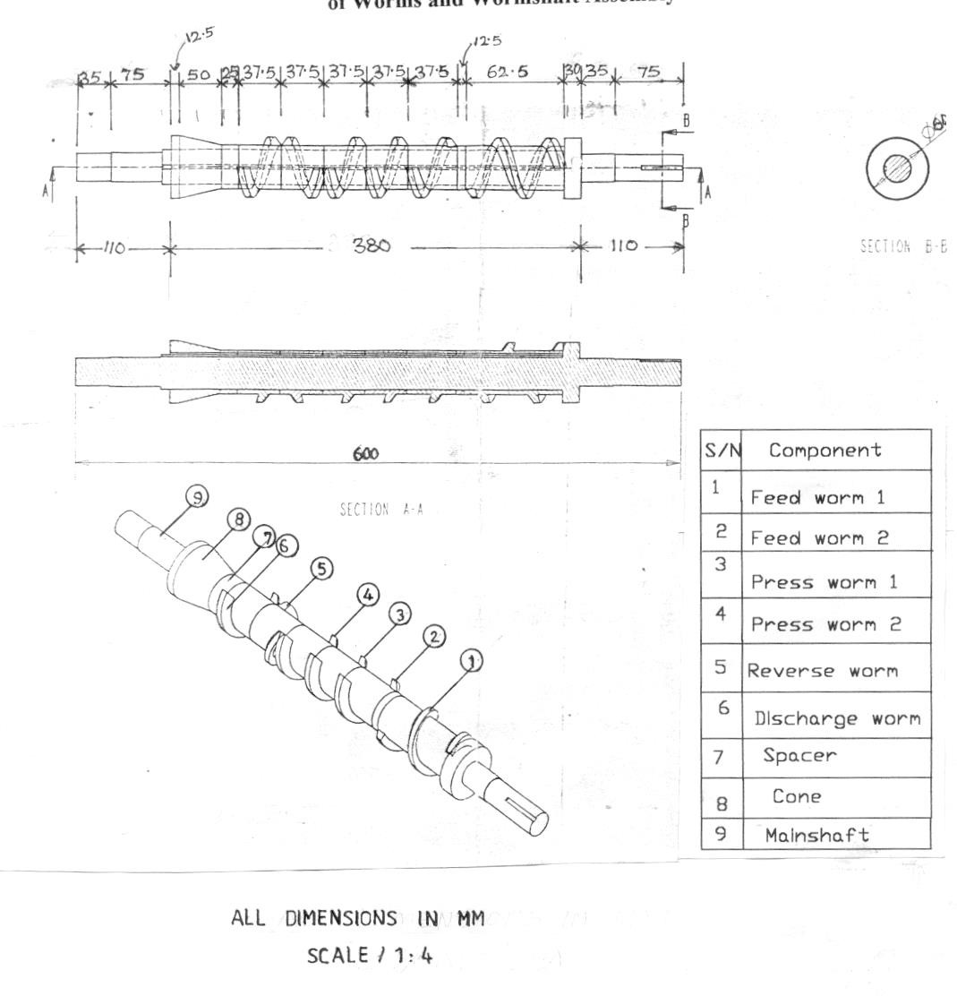

35 75 12 50 25 37.5 37.5 37.5 37.5 37.5 12 62.5 30 35 75

B

B

380

110

Ø60

SECTION B - B

A A

600

SECTION A - A

ALL DIMENSIONS IN MM SCALE / 1:4

110

**A5-5: Isometric and Orthographic Projections of Expeller’s Press Worm**

60 35

PITCH 37.5

47.5

6

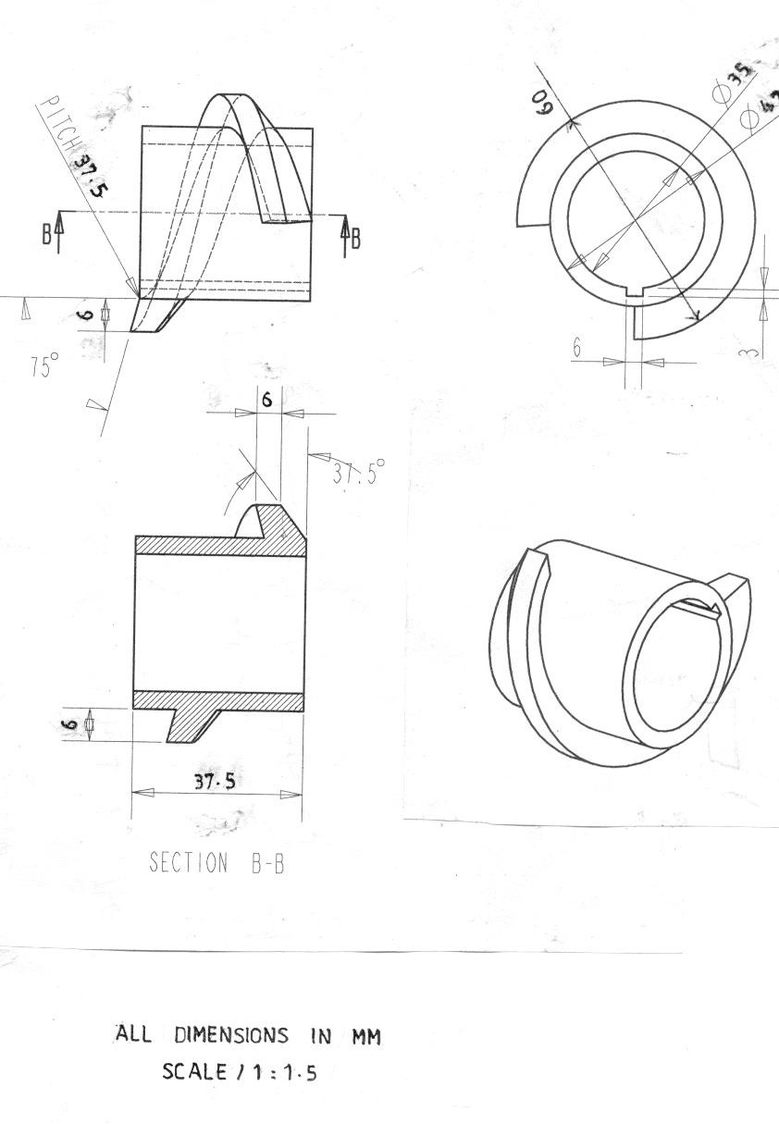

Pitch 37.5

6

3

6

6

37.5

ALL DIMENSIONS IN MM SCALE 1 / 1.5

37.50

Ø35

Ø60

750

6

SECTION B- B

#### A5-6: Isometric and Orthographic Projections of Expeller’s Cone

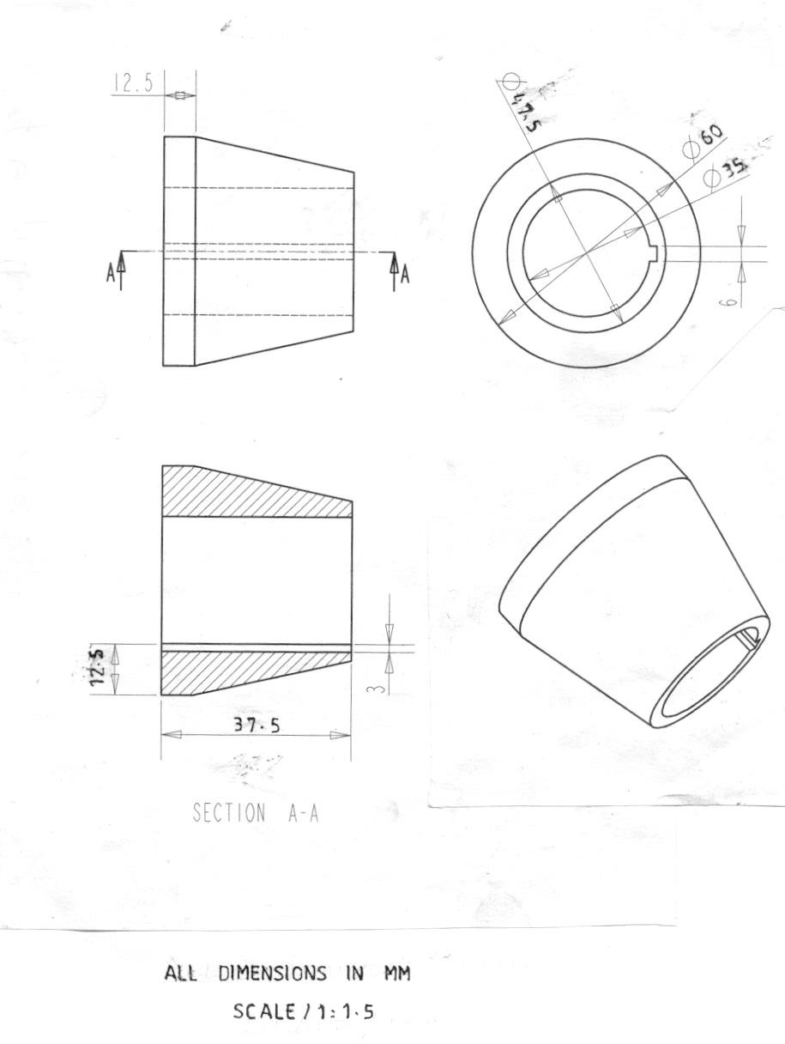

ø47.5

ø60

ø35

12.5

3

37.5

SECTION A - A

ALL DIMENSIONS IN MM SCALE 1: 1.5

6

12.5

**A5-7: Isometric Projection of the Fabricated Oil Filter Press**

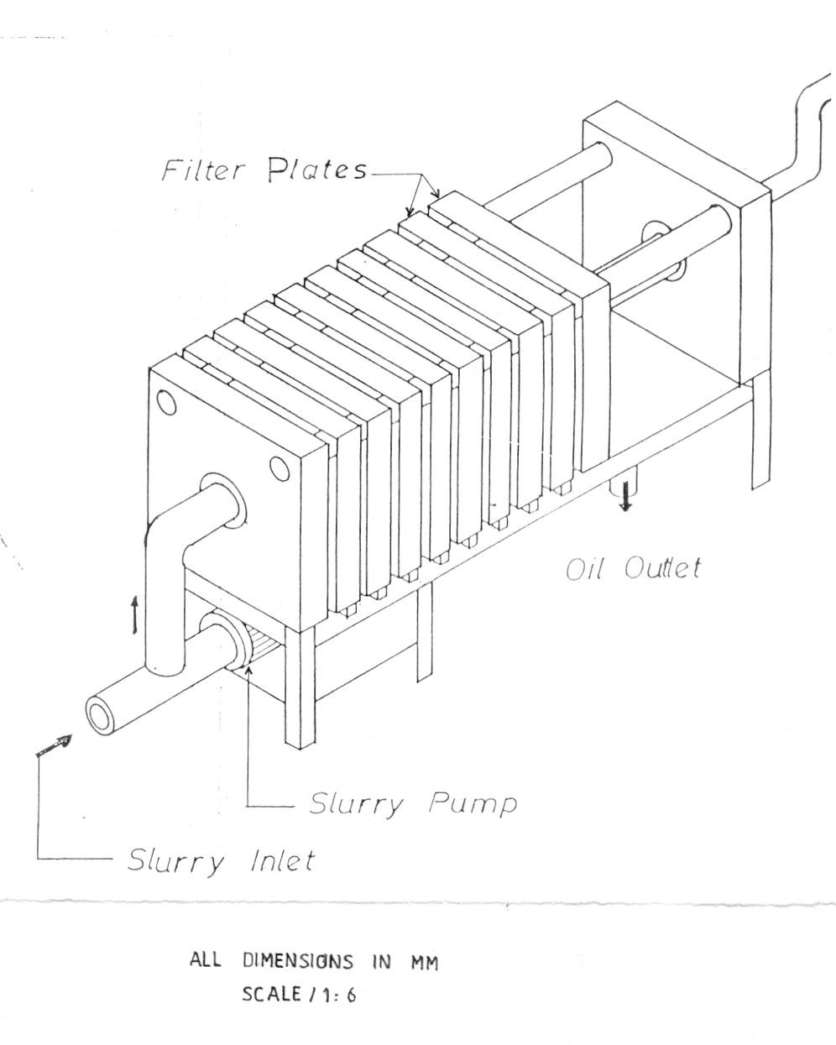

Oil Inlet

Oil Pump

SCALE 1: 6

Oil Outlet

Filter Plates

#### A5-8: Orthographic Projection of the Fabricated Oil Filter Press

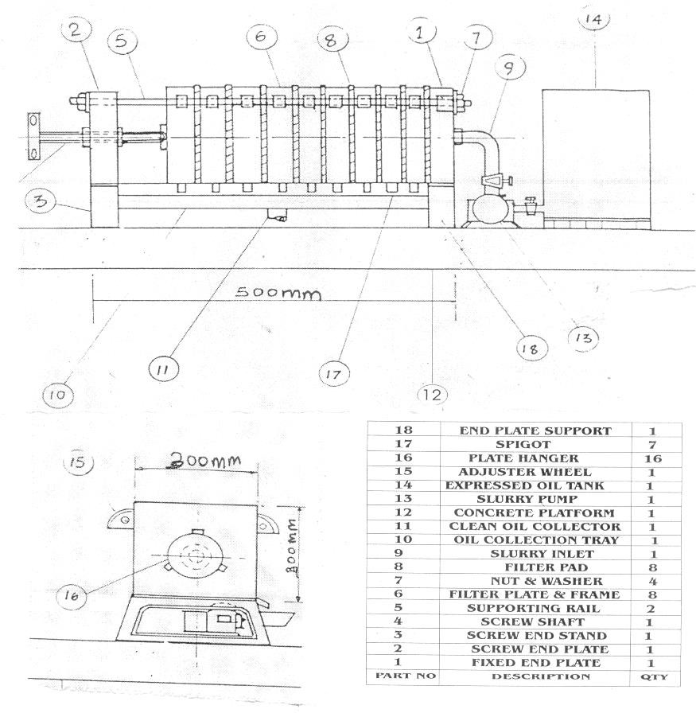

**2**

**5**

**6**

**8**

**1**

**7**

**9**

**14**

500mm

**18**

**4**

**3**

**12**

**11**

**17**

**13**

300mm

**15**

300mm

**16**

**A5-9: Isometric Projection of the Fabricated Oil Filter Plate**

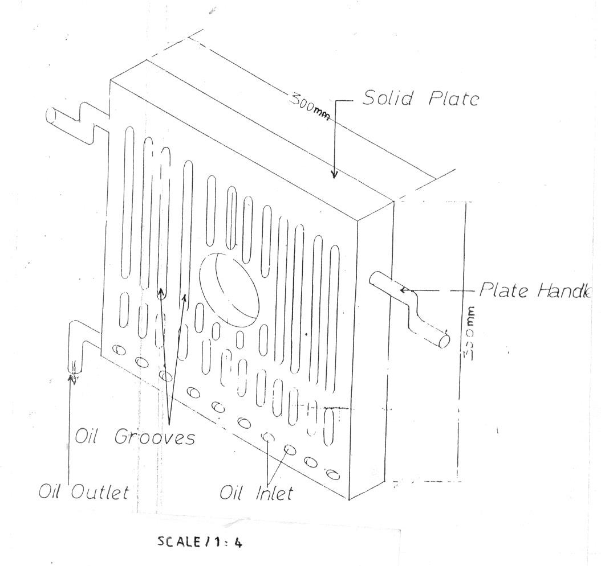

Oil Inlets

SCALE 1 : 4

Oil Outlet

Oil Grooves

300mm

Plate Handle

Solid Plate

300mm

**APPENDIX SIX**

**6.0 LETTERS AND CORRESPONDENCE ON MECHANICAL OIL EXPRESSION**

