## DESIGN, DEVELOPMENT AND PERFORMANCE EVALUATION OF A MULTIPLE SANDCRETE BLOCKS MOULDING MACHINE

**BY**

## RAFIU ADEBAYO KOLAWOLE

**DEPARTMENT OF MECHANICAL ENGINEERING FACULTY OF ENGINEERING**

## AHMADU BELLO UNIVERSITY, ZARIA, NIGERIA

**DESIGN, DEVELOPMENT AND PERFORMANCE EVALUATION OF A MULTIPLE SANDCRETE BLOCKS MOULDING MACHINE**

## BY

**Rafiu Adebayo KOLAWOLE, B.Eng. (FUT, 1998) (M.Sc/ENG /47289/2012-2013)**

## [rakolawole01@yahoo.com](mailto:rakolawole01@yahoo.com)

**A THESIS SUBMITTED TO THE SCHOOL OF POSTGRADUATE STUDIES, AHMADU BELLO UNIVERSITY, ZARIA IN PARTIAL FULFILLMENT OF THE REQUIREMENTS FOR THE AWARD OF MASTER OF SCIENCE (MSc) DEGREE IN MECHANICAL ENGINEERING**

## DEPARTMENT OF MECHANICAL ENGINEERING FACULTY OF ENGINEERING

**AHMADU BELLO UNIVERSITY, ZARIA, NIGERIA**

## DECLARATION

I hereby declare that the work in this dissertation entitled “Design, Development and Performance Evaluation of a Multiple Sandcrete Blocks Moulding Machine” has been performed by me in Department of Mechanical Engineering. The information derived from the literature have been duly acknowledged in the text and a list of references provided. No part of this dissertation was previously presented for another degree or diploma at this or any other Institution.

Rafiu Adebayo KOLAWOLE

Signature Date

## CERTIFICATION

This dissertation titled “DESIGN, DEVELOPMENT AND PERFORMANCE EVALUATION OF A MULTIPLE SANDCRETE BLOCKS MOULDING MACHINE” by Rafiu Adebayo

KOLAWOLE meets the regulations governing the award of degree Master of Science (MSc) in Mechanical Engineering of the Ahmadu Bello University, and is approved for its contribution to knowledge and literary presentation.

Prof. D. S. Yawas .............................. ................................

Chairman, Supervisory Committee (Signature) (Date)

Prof.S. Y. Aku .............................. ................................

Member, Supervisory Committee (Signature) (Date)

Dr. F.O. Anafi .............................. ................................

Head of Department (Signature) (Date)

Prof.S. Z. Abubakar .............................. ................................

Dean, School of Postgraduate Studies (Signature) (Date)

## DEDICATION.

This dissertation is dedicated to Almighty God and to my Late Father, Alhaji M. A. Kolawole.

## ABSTRACT

This work presents the design, fabrication and performance evaluation of a multiple sandcrete blocks moulding machine (MSBMM) for simultaneously moulding three of 6 inches sandcrete blocks of size 450 x 150 x 225mm. The machine was designed to operate at speed of 151.8 rad/s, and provided the vibration right through compactor drive shaft (CDS)-eccentric system that compressed the three sandcrete blocks with 1.26 X 10-6 N/mm2 with the aid of automatically controlled ram. Machine parts like frame, chassis, lever, vibration compaction chamber, ram, mould, handle as well as rack and pinion were designed while standard parts like electric motors and wheel were simply chosen after calculation during the fabrication of MSBMM. The performance of the machine was compared to that of a conventional sandcrete block moulding machine (CSBMM) by using them to mould blocks from same concrete mix sample. MSBMM was able to produce 90 sandcrete blocks per hour by two (2) workers while CSBMM can produce 125 blocks by minimum of five (5) workers. Average compressive strength produced by these machines were determined then blocks produced from these machines were subjected to water absorption test. Results obtained showed that the average compressive strength test for MSBMM was found to be 1.78 N/mm2 while blocks produced from it have average water absorption of 10.35%. However, CSBMM has average compressive strength of 0.62 N/mm2 while blocks produced from it has average water absorption of 9.29%. The cost of fabricating the machine was one hundred and five thousand, six hundred naira (N

105, 600:00) only, whereas, CSBMM in Nigeria cost about two hundred fifty thousand naira (N

250, 000.00) only based on current market price. This is about 57.76% reduction in price of commercial machine available in market. Thus, the machine is very affordable for small and medium enterprise (SME) based on the price difference.

## ACKNOWLEDGEMENT

Is there anything a man has that he is not given? On this note, I sincerely appreciate the Almighty God for this award that He is giving me and the grace He has given me to complete my Masters’ programme despite my imperfections and shortcoming, He has proven Himself faithful and I return every Glory back to Him.

Words alone cannot just express how much inspirations from an inexhaustible source tapped from the chairman of my supervisory team Professor D.S. Yawas who brought his numerous years of professional and academic experience to bear on the outcome of this work, I also thank Professor

S.Y. Aku, a member of my supervisory team who literarily walked me from first principle through the processes of scholastic erudition which have in no small way guided me every step of the way, May God almighty bless them both and also send you an unusual help in your times of need. Amen.

My sincere gratitude also goes to the Head of Department and the immediate past PG coordinator Dr. F.O. Anafi for fostering a favourable academic climate for learning and the development of his administrative acumen in mitigating the various encumbrances encountered, May God almighty bless him richly.

My appreciation, in no particular order of gratitude, also goes to the other senior members of staff of the Department of Mechanical Engineering ABU Zaria in the persons of Professor M. Dauda. Dr. U. Sumaila, Dr. D. M. Kulla, Dr. M. O. Afolayan, Prof. G. Y. Pam, Dr. M. Sumaila, Prof. C.

O. Folayan, for their immense contributions and creating time out of their busy schedule. I am also grateful to all other academic staff of the Department; Dr. K. L. Shettima, Engr. A .A. Alabi, Engr.

M. A. Adamu, Engr. M. Balogun. My gratitude also goes to all the administrative and support staff for their cooperation and support.

I also extend my gratitude to all my colleagues and friends; Engr. I. Joel, Engr. V. Nwobia, Engr.

A. John, Dr. A. Bakare, Engr. A. Shittu, Engr. J. Omotowa, Engr. Yor, Engr. T. Okey, Engr. W. Akanbi, Engr. Mrs. H. A. Muazu, Engr. A. Otori, Engr. F. Adeyeye, Engr. E. Adetiba, Mahmud. M, Kayode. O and others not mentioned herein for their moral support and encouragement.

My sincere gratitude goes to my Mummy, Mrs A. Kolawole for the love, support and prayers, all my family member for being an inspiration and my loving wife Folashade whose encouragement spurred me on every inch of the way, May God Almighty preserve them all.

**Rafiu Adebayo KOLAWOLE April, 2018**

# TABLE OF CONTENTS

Contents Page

title Page i

Declaration ii

Certification iii

Dedication iv

Abstract v

Acknowledgement vi

Table of Contents viii

List of Figures xi

List of Tables xii

List of Plates xiii

List of Appendices xiv

Lists of Abbreviations xv

Chapter One: Introduction 1

* 1. Background of the Study 1
  2. Statement of Research problem 3
  3. Present Research Work 4
  4. Aim and Objectives 4
  5. Significance of the Study 5
  6. Justification 5
  7. Scope of the study 6

Chapter Two: Literature Review 7

* 1. Block Making Concepts 7
  2. Blocks 8
  3. Sandcrete Block Making Technologies 10
     1. Batching and Mixing 10
     2. Compaction 11
     3. Curing 12
     4. Storage of cured blocks 13
  4. Types of Block Moulding Machines 13
     1. Hand-operated block moulding machines 13

2.4.2. "Egg-laying" mobile machines 14

2.4.3 Fully mechanized, stationary machines 15

* 1. Methods of producing Sandcrete Block in Nigeria 16
     1. Manual Compaction 16
     2. Mechanized Compaction 17
  2. Common Components of the sandcrete block moulding machine 18
     1. Wheel 18
     2. Chassis 19
     3. Mould box 19
     4. Rammer 19
     5. Handle (ejector) 19
     6. Rack and Pinion Mechanism 19
     7. Electric motor 20
  3. Review of Past Works on Sandcrete Block Moulding Machine 20
  4. Conclusion and Research Gap 25

Chapter Three: Materials And Methods 27

* 1. Introduction 27
  2. The Description of the Multiple Sandcrete Blocks Moulding Machine 27
  3. Design Considerations and Specifications 29
  4. Design Theory 30
     1. Design for Ram Weight 30
     2. Design for mould box 32
     3. Design of vibrator-compactor chamber (mould compartments) 33
     4. Design for shaft diameter for compactor drive shaft (CDS) and the eccentric system 35
     5. Torque (T) and shear stress (τ) generated in the rack and pinion shaft 37
     6. Design for lever of the machine 38
     7. Design for machine chassis 40
  5. Material Selection 41
  6. Working Principle of the Multiple Sandcrete Blocks Moulding Machine 41
  7. Cost Evaluation of the Multiple Sandcrete Block Moulding Machine 42
  8. Performance Evaluation of the Multiple Sandcrete Block Moulding Machine 42
     1. Sample Preparations and Testing 42
     2. Production Rate 43
     3. Compressive Strength Test Procedure 44
     4. Water Absorption Test Procedure 44

Chapter Four:Results and Discussion 46

* 1. Introduction 46
  2. Design Calculations 46
  3. Material Selection 50
  4. Fabrication Processes 50
  5. Cost Evaluation of the Multiple Sandcrete Block Moulding Machine 54
  6. Performance Evaluation Results 56
     1. Production rate 56
     2. Compressive Strength 57
     3. Water Absorption 59

Chapter Five:Conclusion And Recommendations 61

* 1. Conclusion 61
  2. Recommendations 61

REFERENCES 62

|  |  |  |
| --- | --- | --- |
|  | **LIST OF FIGURES** |  |
| **Figure No.** | **Title** | **Page** |
| Figure 3.1 | Isometric View of the Multiple Sandcrete Blocks Moulding Machine | 28 |
| Figure 3.2 | Standard 6 inches Sandcrete Block | 31 |
| Figure 3.3 | Isometric View of the Ram | 32 |
| Figure 3.4 | Sandcrete Mould Illustration and Dimensioning | 32 |
| Figure 3.5 | Free Body Diagram for the VCC | 33 |
| Figure 3.6 | Free-body Diagram and load condition ofCompactor Drive Shaft | 36 |
| Figure 3.7 | Free-body Diagram and load condition ofRack and Pinion Shaft | 37 |
| Figure 3.8 | Free-body Diagram for Lever | 38 |
| Figure 3.9 | Free-body Diagram and load condition of the Chassis | 40 |

## LIST OF TABLES

**Table No. Title Page**

Table 4.1 Design Calculations for the Multiple Sandcrete Blocks Moulding Machine 46 Table 4.2 Material Selection Chart 50

Table 4.3 Fabrication Processes for the Multiple Sandcrete Blocks Moulding Machine51 Table 4.4 Bill of Material for the Multiple Sandcrete Blocks Moulding Machine 54

Table 4.5 The production rate of the machine 56

Table 4.6 Compressive Strength for Samples from Fabricated Machine 57

Table 4.7 Compressive Strength for Samples from Commercial Machine 58

Table 4.8 Water Absorption for Samples from Fabricated Machine 59

Table 4.9 Water Absorption for Samples from Commercial Machine 60

|  |  |  |
| --- | --- | --- |
|  | **LIST OF PLATES** |  |
| **Plate No.** | **Title** | **Page** |
| Plate 2.1 | A Manually Operated Prefabricated Steel Mould Box | 17 |
| Plate 2.2 | Diesel Power Engine Machine Compacted Mould | 18 |
| Plate 3.1 | Sample Block Preparation using the Fabricated Moulding Machine | 43 |
| Plate 4.1 | Pictorial view of the multiple sandcrete blocks moulding machine | 53 |

|  |  |  |
| --- | --- | --- |
|  | **LIST OF APPENDICES** |  |
| **Appendix No.** | **Title** | **Page** |
| Appendix A | Prototype Production and Testing | 66 |
| Appendix B | Experimental Test-Rigs | 69 |
| Appendix C | Test Results | 70 |
| Appendix D | Working and Assembly Drawing | 72 |

## LISTS OF ABBREVIATIONS

**Acronyms Definition Unit**

*σ* Operating Stress N/m²

*ρ* Density of CDS kg/m³

*Ƭ* Drive Torque N/m

*ω* Rotational Speed rad/s

*As* Area of CDS m²

BMD Bending Moment Diagram KN/m

*CF* Coupling force KN

CDS Compactor Drive Shaft nil

CDSF Compactor Drive Shaft force KN CSBMM Conventional Sandcrete Block Moulding Machine nil

1. Young’s Modulus N/m²

*EI* Flexural Rigidity of CDS N/m²

ESF Eccentric Shaft force KN

*e* Length OG m

*ew* Eccentric Weight N

1. Maximum force N

*FG* Gear force KN

*FT* Total force on Chassis N

*Fc* Centrifugal force N

*Ff* Force Due to Flexural Rigidity N

*Fp* Centripetal force N

*Fs* Spring force N

*Fwb* Force Due to wet Block mix N

*g* Acceleration Due to Gravity m/s²

*I* Moment of Inertia m4

|  |  |  |
| --- | --- | --- |
| *K* | Stiffness of CDS | N/m |
| *Le* | Length of the Eccentric | m |
| *Ls* | Length of CDS | m |
| MSBMM | Multiple Sandcrete Blocks Moulding Machine | nil |
| *Me* | Mass of Eccentric | kg |
| *Mwb* | Mass of the wet block mix | kg |
| *Pcr* | Critical Load | N |
| RB | Bearing force | KN |
| *re* | Radius of Eccentric Weight | m |
| *rs* | Radius of CDS | m |
| SF | Support force from wheel | N |
| SFD | Shear force Diagram | KN |
| Sv | Sandcrete Volume | mm³ |
| *y1* | Length OD | m |
| *y2* | ½ CDS Diameter and line of action of EI | m |

## CHAPTER ONE INTRODUCTION

## Background of the Study

Housing is recognized world-wide as one of the basic necessities of life and a pre-requisite to survival of man (Onibokun, 1983; Salau, 1990; United Nations, 1992). In the traditional African setting, in particular, housing is, in fact, one of the greatly cherished materials need. Thus, the importance of providing adequate housing in any country cannot be overemphasized.

However, in spite of the fundamental role of housing in the life of every individual and the nation, and in spite of the United Nations’ realization of the need to globally attain adequate shelter for all, the housing crisis remains one of the global problems posing great challenge to both urban and rural residents, particularly in most developing countries (Samuel, 2014). The Nigerian Government as part of its effort of overcoming housing problem has initiated the building of low cost houses for workers, especially low income earners since 1979 by Shehu Shagari Administration(Ademiluyi, 2010).

Even with more recent initiatives by the government up till 2014, the problem of affordable housing has been a source of concern to all and sundry especially in Nigeria. In fact there is an estimated deficit of between 17 and 18 million housing units in Nigeria in 2012 (Chuku, 2014). However, the cost of housing can be reduced through reduction in the cost of the building materials by developing our indigenous technology.

The need for locally manufacturing of building materials has been emphasized in many countries of the world. There is imbalance between the expensive conventional building materials coupled with depletion of traditional building materials. To address this situation, attention has to be focused on the production of low cost alternative building material such as sandcrete blocks (Aguwa, 2009).

Sandcrete blocks are the most common type of blocks used in forming walls units and over 90% of houses in Nigeria today are being constructed using sandcrete blocks (Baiden and Tuuli, 2004). The importance of the sandcrete blocks as part of the local building materials cannot be over emphasized in the building and construction industry.

Sandcrete blocks are usually produced using a semi-mechanised stationary type machine. The other production systems are manual moulds that require hand tamping, a mobile semi-mechanised egg- laying machine and fully mechanised system that combines compression and vibration. These requirements are of fundamental importance since the homogeneity of the product, its surface finished and its mechanical strength depend directly upon these parameters (Segun, *et al*. 2009).

Although there are sophisticated and cheap block moulding machines available at international markets, the challenge is the requirement for high level operation skills which are scarce among many labour force used in block industries. Examples of such machines are the CINVA RAM, the Montgomery’s dynamic CEB making machine and so on. They cost between N120.000 and N180.000 (Yakubu and Umar, 2015).

To indigenize the technology and make the operation simplerand reducing cost of imported products such as Hydrafoam which is sold at about six million Naira (N6,000,000:00), considerable efforts have been made at designing and construction of sandcrete block making machine by local industries in recent years. Some of the locally fabricated mechanical block moulding machine costs between N 250, 000 and N 300, 000 depending on the quality of the fabrication (Field Survey, 2016), however, they possesssome constrains such as high level of physical labour (fatigue stress) and increase in operation cost due to the use of pallet. This has led to increased interest in quest for developing alternatives to traditional moulding practices.

## Statement of Research problem

In many developing Countries, including Nigeria, housing crisis is escalating unabated despite a number ofpolicies, programs and strategies being engaged in by public and private sectors in addressing this problem.

Some of the major stumbling blocks in achieving the goal providing affordable home to the populace of Nigeria can be summarized as follows:

* + 1. The current commercial block moulding technology is found to be labour intensive especially in transferring green bodied block from moulding machine to curing place.
    2. An average of 6-8 semi-skilled labourers is requiring for an average production of 800 – 1000 blocks per day.
    3. The current production process is very slow and time wasting as it involves lot of processes done manually. These processes includepicking off the ejected block on the supporting wooden pallet as ejected from themould, taking them to curing place and placing a fresh wooden pallet each time into the mould box from a pallet-stack.
    4. Also, there is no locally made block moulding machine that can produced more than two blocks at a time thereby working at low efficiency.
    5. On the other hand, the imported block making machine which could serve as alternative required high capital and operational costs. This machines require specialists for maintenance and repairs; spare parts are usually difficult to get and are usually expensive.
    6. Finally, the general production conditions make the price of average soundcrete to be between N120.00 to N250.00 (6 inch hollow block) which makes building construction more expensive.

From the afore-mentioned factors, making block moulding machine locally and more efficient will go a long in solving some of the problems as it is considered to be the major equipment of sandcrete block production. This serves as the main reason for undergoing this research work.

## Present Research Work

In order to solve the problem of low efficiency of moulding operation as well as that of labour intensiveness and the use of foreign technology, this research work tends to produce sandcrete moulding machine that can mould multiple blocks simultaneously and use less number of labour making the operation more efficient and less labour intensive.

## Aim and Objectives

The aim of this research work is to design and fabricate a multiple sandcrete block moulding machine that can simultaneously mould three (3) blocks suitable for use by small and medium scale enterprises (SMEs).

The specific objectives of this dissertation are:

* + 1. To carry out design analysis of the multiple blocks moulding machine.
    2. To fabricate and assemble the block moulding machine that will produce three (6 inch hollow) standard blocks in a single operation locally.
    3. To carry out performance evaluation of the machine.
    4. To carry out the comparative cost analysis of the design machine with the conventional block mould machine.

## Significance of the Study

The design and development of a multiple sandcrete block moulding machine is significant in the following ways.

* + 1. It will reduce the cost of producing sandcrete block by reduction in the overhead cost of sandcrete block as results of reduction in labours and elimination of pallet for curing the blocks.
    2. It will also contribute significantly to theeffort in the development of indigenous technology especially in the block production industries.
    3. It will improve working conditions and encourage our youths to venture into block moulding business.

## Justification

Shelter is one of the basic human needs and is usually ranked third after food and clothing. Building materials form one of the main constraints that restrict the supply of housing and between 60-70 percent accounts for the cost of building (Ogunsemi, 2010). Recently, in the many developed countries, it has been verified that the traditional and conventional technologies used for construction and maintenance of buildings are inefficient and resource wasteful due to enormous amount of resources consumed (Ghosh, 2002).

The colossal waste associated with traditional and conventional technologies facilitated the search for more appropriate sandcrete block moulding technology that can accommodate three 6 inch blocks (450 x 150 x 225 mm). This research work is borne out of the desire to solve housing problem in Nigeria through reduction in the cost of the building materials like the sandcrete block. Efforts made in proper design and fabricated will be justified owing to the increasing need for more alternative methods for producing sandcrete block as reported by Lawal (2010). This will eliminates or at least minimizes the challenges that are encountered during the production of sandcrete block.

## Scope of the study

The scope of the research work is limited to:

1. Designing of a sandcrete block moulding machine for simultaneous production of three

(3) 6 inches blocks.

1. Construction of the essential components such as chassis, moulds, ram and handle (ejector mechanism).
2. Carrying out performance evaluation on the machine.

## Block Making Concepts

## CHAPTER TWO LITERATURE REVIEW

Blocks were first known to have been in use at the river basin region of Mesopotamia as early as about 10,000 BC. The region had no stone or marble as those of ancient Egypt and Greece. So instead of using stones and marble, clay, mud, silt, and straw were used to make blocks that were baked before use (Swamy, 1986).

However, the durability became possible when blocks were fired in kilns. Excavations have uncovered perfectly fired blocks as far back as 5000 BC. Clay, silt and stave mix blocks, fired in kilns were used for a very long period up till 3000 BC when gypsum and lime mortar were used in the construction of the pyramids in Egypt. Many other similar materials were used, leading to the discovery of Portland cement and the production of concrete (Encarta, 2004).

Cement is one of the oldest forms of building materials which had existed for over 12 million years. It originated when the earth underwent an intensive geological change, as a result of chemical reaction which occurred between limestone and oil shale as they burned. Natural deposits of cement are found in Israel while interest in cement as a building material began in 1970s.

In 1973, John Smeaton found that the calcinations of limestone containing clay gave hydraulic lime which harden when water was added in controlled amount. In 1824 Joseph Aspdin invented Portland cement by burning finely grounded lime stone (chalk) with finely divided clay in a lime kiln until carbon dioxide was removed. This was the composition and method of producing cement, but modern methods have varied the compounds and controlled the composition (Olaf, 1974).

Concrete is an example of artificial engineering material made from cement, fine aggregate sand, coarse aggregate gravel mixed in the environment of air and water. Sometime a precise volume of air is introduced into the concrete mixture to produce desired properties such as improved workability, ductility, durability and also reduction to crack. Today, moulded concrete shapes are delivered to sites in plastic forms (Parry, 1979).

Fresh concrete is thoroughly mixed to adequate thickness desirable for the moulding process. This is followed by the filling of die cavity with the mixture, compacting and ejection of the green block from the cavity. Die cavities or moulds come in various sizes according to desired block size. Curing and drying complete the block production process.

The coarse and fine aggregate that make up part of the concrete are known as fillers while cement and water serve as binders. The fillers make up 70 to 80% of the concrete volume. Thus the binders which are expensive make up a smaller percentage, which lower cost (Swamy, 1986).

Two types of cement in the market are Portland and Ashpatic cements. Portland cement is used extensively as structural material. Asphatic cement is used for pavings. Concrete is reinforced before curing, with glass, fibres, and steel rods, to prevent cracks, and improve tensile and compressive strength.

## Blocks

Blocks are the dominant units for modern wall construction in Nigeria and indeed West Africa. They are of many types depending on the constituent materials. The constituents also determine the structural characteristics of the blocks. The major types are sandcrete blocks (water, cement and river sand), soilcrete blocks (water, cement and laterite), concrete blocks, bricks (burnt clay and additives) and mud blocks.

The blocks come in various sizes and shapes and can also be classified as hollow or solid blocks and are bonded with binders, usually sand-cement mortar or lime. Blocks, according to Project National de Researche/Development (1994), can be regarded as a member of the concrete family. This is especially true for sandcrete blocks which differ from concrete by the non-inclusion of coarse aggregate in the mix.

Sandcrete blocks are composite material made up of cement, sand and water, moulded into different sizes (Barry, 1969). Nigerian Industrial Standard (NIS): 87- 2004) defined sandcrete as a composite material made up of water, cement and sand. It differs from concrete in terms of material composition because of the non-inclusion of coarse aggregate in the mix, and from mortar in that the slump is zero. As a matter of fact, sandcrete is often referred to as zero slump concrete. The behaviour of sandcrete is similar to that of concrete and for that reason the terms concrete and sandcrete will be used interchangeably in this work.

Sandcrete blocks are by far the most common type of block used in modern day construction in Nigeria. The sand, according to the NIS 87: (2004) “Shall be river, crushed or pit sand, clean and sharp and free from loam, dirt, organic or chemical matter of any description.” Their major advantages as compared to the other types of block are their easy mode of production and the speed of laying them. Their major setback is obviously their poor thermal and hygrometric properties. This can greatly affect their durability especially when they are permanently exposed to the elements.

To improve these properties, the walls formed with sandcrete blocks are normally rendered with cement-sand mortar. Sandcrete blocks are classified as solid or hollow blocks. Hollow blocks have cavities in them while the solid ones have no cavities. The length, width and height of the major sizes of sandcrete blocks produced in Nigeria are as follows:

1. 450 x 225x 225mm (hollow)
2. 450 x 150 x 225mm (hollow)
3. 450 x 150 x 225mm (solid)
4. 450 x 125 x 225mm (solid).
5. The 450 x 225 x 225mm hollow blocks are usually used in load bearing walls.

## Sandcrete Block Making Technologies

The production of sandcrete blocks can be discussed under the following subheadings:

* + 1. Batching and Mixing (ii) Compaction and Demoulding (iii) Curing and (iv) Storage and Transportation.

## Batching and Mixing

Batching is the process of measuring out the various quantities of the components. This can be done by mass or by volume. Of the two, batching by mass is professionally preferable as it eliminates errors due to the variations contained in a specific volume. However, most producers, especially those that batch manually, use the volume batching process because it is simpler and much more convenient than weight batching. Manual batching is done using head pans, wheel barrows or specially constructed wooden gauge boxes with a bag of cement taken to be twice the volume of a head pan and the same volume as a wheel barrow. However, the use of the wooden boxes for batching is becoming obsolete.

Cements is usually supplied in bags of 50kg net weight. Batching using head pans or wheel barrows does not make for uniformity as these volumes measured are greatly dependent on the state and size of the head pans or wheel barrows. It should be noted that sand is usually supplied wet and it is in this wet condition that it is most often used. The quantity of water added to the mix must therefore be adjusted to compensate for the water in the wet sand.

Furthermore, since sandcrete is a zero slump concrete, the amount of mixing water added is of great importance. Too little or too much water will cause the block to fail immediately after demoulding. Mixing is done either manually (with shovels or spades) or mechanically (using concrete mixers of various capacities). Large producers generally use mixers. This offers a more uniform and homogenous mix, especially when the volume is large. In manual mixing the components are mixed using shovels or spades and turned over several times until a homogenous mix is obtained. Whatever method is adopted, adequate mixing is necessary to achieve uniform colour and texture between block batches, prevent variations in strength and minimize web cracks (Portland Cement Association, 1975).

## Compaction

Compaction is a very important process in block production. Compaction is achieved by mechanical vibration or manual (hand) compaction. Manual compaction is less effective and is adopted by small scale producers. One block is produced at a time using a locally manufactured mould. The compaction is effected using a tamping rod. Great care is needed in demoulding the block in order not to introduce cracks in it. There are basically three types of machines used in block moulding in Nigeria. Some of these in addition to compaction also vibrate the blocks. The machine type greatly affects the quality and the required water used in the block production.

The three major types of machines are (i) Egg laying machines (ii) Electric vibrating machine and (iii) Manual hand press machines.

## Egg laying machine.

The egg laying machines are usually of the Rosa Commetta type that can lay up to ten blocks at a time. This is usually used for mass production and the process can be automated, leading to great hourly output of about 300 -500 blocks. Both pressure and vibration are applied and blocks of high quality can be produced with these machines. The blocks are usually laid on bare surfaces without pallets and are removed for storage after 2-3 days of production.

## Vibrating machines

These machines are commonly used by medium scale producers. They are electrically operated or diesel powered. The majority of the machines are designed to produce one block at a time with the block vibrated for about 10 to 15 seconds. Few, however, can produce up to three blocks at a time. The blocks are produced on pallets and carried to the place of temporary storage. They can provide adequate compaction. Care must be taken while moving the green blocks on the pallet to the place of temporary storage so as to prevent cracks resulting from vibration while moving the blocks.

## Hand press machine

The hand press machine is manually operated. Demoulding is achieved through a series of levers. The hand press machine does not compact as well as the egg laying and vibrating machines and hence produces blocks of lower quality. One block is moulded at a time.

## Curing

Curing of sandcrete blocks is necessary to enable the blocks develop adequate or optimum strength by allowing for proper hydration of the cement. Green blocks that are exposed to high temperatures loose water rapidly by evaporation, resulting in weak blocks. Thus it is recommended that newly produced blocks be placed in covered shades and protected from the

adverse effect of the elements. Works by Uzomaka(1977) and Rahman (1968) suggest curing by sprinkling with water as the best method of curing, from strength and convenience point of view. This is the most common method employed by commercial block producers. Sprinkling should be done at least twice in a day. NIS 87 (2004) requires that the blocks be left on the pallets for at least 24 hours and be cured for at least 3 days. Adequate care must be taken when removing the pallets for another production so that cracks are not induced in the blocks.

## Storage of cured blocks

Cured blocks are removed to storage to provide space for new productions. The blocks need adequate care at this stage. Many blocks are normally damaged at this stage due to poor handling. NIS 87: (2004) requires that the blocks be stacked not more than 5 courses high. The blocks are now ready for use.

## Types of Block Moulding Machines

Several types of sandcrete block moulding machines are available, ranging from simple hand- operated ones to complex stationary or mobile plants. The simpler machines are generally mechanically operated using electric, petrol or diesel power, while the larger machines are usually electrically operated. In most of the block making machines, the block is compacted by vibration(Lennart and Whitaker, 1988).

## Hand-operated block moulding machines

These are relatively inexpensive, simple and robust devices, which are especially suited for on- site production of blocks. Output rates for blocks can range from 10 to 80 blocks per hour, depending on the efficiency of the machine, rate of supply of mix and number of workers involved. There are basically three typeshand-operated block moulding machines, they are(Guilland*, et al., 1995*)

* + - 1. Steel moulds that can be carried around by one person and used on a raised working surface (e.g. table) or on the ground; the mix is stamped with the help of special tampers that fit on the mould, but is more usually compacted by means of a vibrator fixed to the mould or to the working surface (vibrating table).
      2. Stationary machines with the block mould (into which a wooden pallet is inserted) at about table height; the mix is usually compacted by the tamper lid-plate, which is brought down with a few sharp blows; after compacting, the sides of the mould fold back to release the block, or it is ejected by means of a lever, which pushes the base plate upwards, so that the fresh block can be taken away on the pallet for drying. Some of these machines are equipped with a tray above the mould for preparing the mix and filling it directly into the mould.
      3. Stationary machines fitted with engine operated jolting mechanism or vibrator for more efficient compaction.

However, problems of hand-operated equipment include:

1. Low production rate.
2. In case of manual tamping, possibility of non-uniform compaction of concrete; since production rate is low and the use of fresh mixes is limited to the setting time, relatively few blocks are produced per mix, which can differ in quality each time.
3. Tiring operation, which can lead to a drop in the quality of blocks, if the work is carried out by a single person for too long?

## 2.4.2. "Egg-laying" mobile machines

These are machines designed for medium-scale production, either on-site or in a factory. The name was given to these machines, because they leave the blocks to dry where they are produced on a flat production surface and move a short distance away to produce the next batch

of blocks, and so on. The machines, which can be manually operated or fully automatic, have output rates of blocks ranging from 60 to 400 blocks per hour, depending on the size of machine, the degree of automation, availability of continuous supplies of mixes and production site organization(Smith and Webb, 1987).

Problems of egg-laying machines include:

1. Rarely available locally in Nigeria, usually imported.
2. It has higher capital and operational costs than those of hand-operated equipment.
3. Requirement of large flat production area.
4. Dependency on the weather, if not under a roof: in dry regions, if the blocks are not covered with plastic sheets, premature drying and cracking are inevitable; if it rains, production must cease, otherwise the blocks will disintegrate.
5. The higher the degree of automation, the greater the dependency on energy supplies.
6. Repairs not likely to be possible in local workshops, if spare parts are not available.

## 2.4.3 Fully mechanized, stationary machines

These are automatic and very versatile machines used for the medium- and large-scale production of superior quality concrete components. They can be of various sizes, but are generally far more expensive than egg-laying machines of comparable sizes. The filling of the moulds, the compaction (vibration) and ejection of the blocks is done automatically, and output rates of blocks can range from 200 to 800 blocks per hour. These high output rates are only possible with sophisticated ancillary equipment for transportation, handling, stacking, etc, a well-trained staff, efficient management and sound financial base. Space is saved by stacking the blocks in shelves, where they are usually steam cured for better product quality and quicker turnover(Smith and Webb, 1987).

Problems of fully mechanized machines:

1. Not available locally, have to be imported.
2. Very high capital and operational costs.
3. Dependency on uninterrupted energy supplies, high standard of ancillary equipment, skilled labour, good management and, above all, continuous high demand for the products.
4. Limited mobility.
5. Need for specialists for maintenance and repairs; spare parts usually expensive and difficult to get, or only after long delivery time.

## Methods of producing Sandcrete Block in Nigeria

Property development and building construction have been on the increase in Nigeria as far back as 1970. It was an era which marked the crude oil boom which still today financed over 80% of Nigeria’s capital project. The Nigerian cities have experienced transformation by way of infrastructure development in urban and rural areas (Olusegun and Ajiboye, 2009).

Presently in Nigeria, there are two common methods of producing the sandcrete block they are;

* + 1. Manual compaction by hand ramming method and
    2. Mechanically compaction diesel engine method

## Manual Compaction

For manual compaction, the equipment consists of a prefabricated steel mould box formed to the required dimensions. It is constructed such that after ramming the cement/aggregate mixture for the manufacture of blocks, the resulting shape exactly fits the mould and hence conforms to the dimensions required. A removable steel plate resting at the bottom allows removal of the compacted unit after hand ramming. Two curved steel handles on either side of the mould box aids the removal of the compacted unit. The means of compaction is a wooden bat, in a shape of a chisel. The flat end of the bat is brought against the cement/aggregate mix, rammed over it and

loaded into the steel mould. The compacted unit is removed by turning the box upside down and with impact. The opened end finally rests on a wooden pallet to receive the block. The removable steel plate that now lies on the upturned unit is removed.

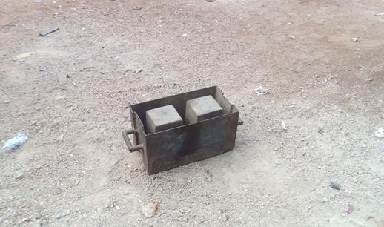

## Plate 2.1: A Manually Operated Prefabricated Steel Mould Box (field survey Zaria, 2016).

Manual block production is the cheapest but most laborious method, and the blocks are not likely to attain the superior qualities that are achieved by the far more expensive mechanized production(Olugbenga *et al.*, 2007).

## Mechanized Compaction

The mechanically compacted equipment is built for easier use and can be operated by unskilled labour. It requires little maintenance and hence the design is very suitable for remote areas. Both electric motors and diesel engines can support it. Its design principle includes the use of solid frames for safe handling and stability. Three levers operate it and produce a hydraulic pressure, which is constant.

The framework is about 1.85m high.It operates on a motor placed underneath the wooden pallet upon which the mould rests. The diesel types incorporate the use of a fan belt fixed over the motor and a roller, which actually turns the roller. Actual vibration occurs when the fixture on the motor, a metallic mass, hits underside of the wooden pallet. The moulded unit is removed by the operation of the longest lever, which is normally on the right side of the machine (Olugbenga *et al.*, 2007).

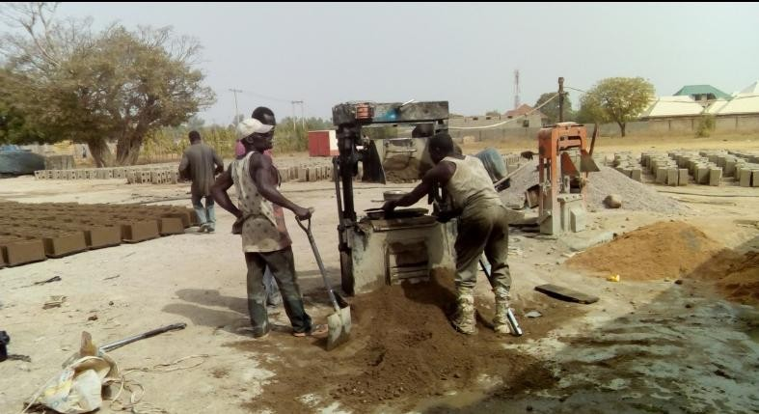

**Plate 2.2: A Diesel Power Engine Machine Compacted Mould (field survey Zaria, 2016).**

# Common Components of the sandcrete block moulding machine

Some of the most important component parts commonly found on sancrete block moulding machine include the following:

## Wheel

A wheel is a circular component that is intended to rotate on an axle. Wheel is a device that enables efficient movement of an object across a surface where there is a force pressing the object to the surface. It’s also assists in the distribution of force from an object to the ground(Bernd, 2010).

## Chassis

A chassis also known as frameis the backbone of the machine. It acts as the main supporting structure of machine to which all other components are attached. It allows flow of vibration from machine components to damper or the ground and deal with static and dynamic loads within allowable level of deflection or deformation(Bernd, 2010).

## Mould box

Mould box is a rectangular metal box designed for the purpose of holding the sandcrete mixtures (sand, aggregate, cement and water) after it is poured over and around mould cavities to gives the desired size and configuration of the block (Bugayev, *et al*., 2001).

## Rammer

A [rammer](http://www.aussietools.net.au/product-info/a-tamping-rammer-is-a-must-for-landscapers.aspx) is a specialised device which is often used to flatten or compact an aggregate, granular or powdery material. The purpose of the process is to make the material more compact as well as to enhance the density (Barber, 1997).

## Handle (ejector)

A handle or arm is a part of, or attachment to, an object that can be used to eject moulded block and drag the machine. Itusually consists of a fulcrum which gives mechanical advantage to the machine. This allows the operator tolift or lower heavier load with less effort(Bugayev, *et al*., 2001).

## Rack and Pinion Mechanism

Rack and pinion mechanism consists of a pinion engaging and transferring motion to or from a special kind of spur gear, called a rack, consisting of a series of teeth in a straight line on a flat surface. A rack and pinion gear set is used to convert rotational motion into linear motion, In some cases, the rotation of the pinion gear is used to drive the linear motion of the rack gear in facilitating the lifting and lowering of rammer assembly(Rathan, 2009)

## Electric motor

An electric motor is an electrical machine that converts electrical energy into mechanical energy. Some electric motors have single phase while some have three (3) phases. An electric motor can be driven by direct or alternating current.(Olusegun and Ajiboye, 2009).

## Review of Past Works on Sandcrete Block Moulding Machine

Simpson(1900) developed the first commercial machine for the producing sandcrete blocks. The blocks were so large (76.2 x 20.32 x25.4cm) and heavy that they had to be set in the walls at the job site with the help of hand craned derricks. An improvement to this machine was made in 1904, which consisted of a vertical placed core with collapsible sides for block removal. The blocks produced varied in consistency and quality, and three men working at top speed produced only 200 blocks in a 10 hour day (Palmer, 1984).

Raheem *et al.*, (2012) considered the production and testing of sandcrete hollow blocks and laterite interlocking blocks with a view to comparing their physical characteristics and production cost. Some units of sandcrete hollow blocks and laterite interlocking blocks were made using machine vibrated sandcrete block mould and hydraulic interlocking block making machine respectively. The blocks were tested to determine their density and compressive strength. The results obtained from the tests were compared with the specifications of Nigerian Building and Road Research Institute (2006), Nigerian Building Code (2006), and Nigerian Industrial Standards (2000).

The results indicated that the compressive strength of 225mm and 150mm sandcrete hollow blocks varies from 1.59 N/mm2 to 4.25 N/mm2 and 1.48N/mm2 to 3.35N/mm2 respectively, as the curing age increases from 7 to 28 days. For laterite interlocking blocks, the strength varies from 1.70N/mm2 at 7 days to 5.03N/mm2 at 28 days. All the blocks produced satisfied the minimum requirements in terms of compressive strength, by all available codes. The cost per square metre of 225mm and 150mm sandcrete hollow blocks are ₦2,808:00 and ₦2,340:00 respectively, while that

of laterite interlocking blocks is ₦2,121:20. It was concluded that laterite interlocking blocks have better strength and are cheaper than sandcrete hollow blocks.

Yakubu and Umar (2015) reported that in the developing nation like Nigeria, the problem of shelter is more pronounced than as it is in developed countries. This is because there isabout eighteen (18) million housing units’ deficit in Nigeria. Like other researchers block/brick was identified as one of the most important materials used forbuilding of a shelter but majority of the people cannot afford these materials (blocks or bricks)due high cost. Therefore, the production of high quality and affordable blocks/bricks is paramount to solvinghousing problems in developing countries especially in Nigeria. Hence, a multipurpose machine that produces high quality blocks/bricks for low costhousing was designed construction and tested for low income communities/earners. The constructed motorized compressive earth brick(CEB)/block making machine can produce an average a total of 2,215 bricks per day and 950 blocks per day.The cost of production of the machine was two hundred and eighty six thousand, eight hundred ninety (N286,890.00) naira only. Whereas, the most common high-tech motorized CEB machine in Nigeria (Hydraform®)with an average capacity of about 3,000 bricks per day costs about six million naira (N6,000,000.00K) only.Thus, the machine is very affordable for small scale enterprise (SME). In other words, bricks or blocksproduced by using this machine are relatively cheap and affordable for those in the rural areas and for lowincome earners.

Herman (1904) invented the first automatic block making machine, which was improved upon by incorporating a mixer, a skip loader, and a self discharger. This eliminated the laborious job of hand tamping. In 1939, he introduced the new and radial machine which did not ram but vibrated under pressure to compact block. This eliminated the costly practice of having to frequently replace moulds because of wear experience during ramming (Basser, 2004).

In an attempt to improve the production of clay bricks for housing and general construction purposes, a 215 X 102.5 X 65 mm manual brick moulding machine was designed and fabricated by Kolawole and Odusote (2013). The machine parts were made of mild steel, because of its availability and versatile machinability. The efficiency of the machine was examined using local clay, sourced within the University of Ilorin, Ilorin, Nigeria. Water was added to the clay after sieving to form a paste, and then packed into a mould box, before manually rammed and compacted with the machine mould cover. This process allowed for the formation of required shape, which was sent to kiln for baking to obtain stronger bricks. The machine is capable of producing a total of four bricks at a time using the available four mould boxes. The production time of the four bricks was found to be relatively equal to the time used by an automated one to produce equal number of bricks, indicating favourable efficiency. Thus, the fabricated manual machine can be used for mass production of clay bricks for improved and effective housing delivery.

Gusah (1994) carried out a modification of the stabilized earth block making machine, a compromise between the CETA-RAM press and the CINVA-RAM press using locally available material. In his work, wooden mould box was used for the production of blocks instead of steel mould box, the wooden mould failed to withstand pressure, in addition to its very low production rate. The machine produced blocks at a lesser efficiency per man-hour.

Onyeakpa and Onundi (2014) proposed an improved form of mortar-less blocks which is an innovative structural component for masonry building construction called interlocking block which can be produced mechanically or manually using interlocking block production machine, particularly an improved interlocking block machine with dual mould. This brings about the elimination of the use of mortar in laying of blocks making them best candidate for producing temporary walls as they can easily be dismantled and reassembled. Moulding machine for the mortal-less blocks which is manually operated was briefly described as well as the procedure for using it. It was concluded that interlocking blocks produced from available local materials such as

lateritic clay, river sand, Madube gravel, port-land cement and water using the machine attained ample compressive strength of 4.8 N/mm2 and can resist impact of bullets and other sharp objects.

Kofoworola (1995) designed and constructed a stabilized earth block making machine, an improvement on CINVA-RAM press by constructinga machine with a force of 120KN to be exerted manually before the product will be ejected with low rate of production on average between 40 and 100 blocks per hourwith lower compressive strength of (averaging 0.5 to 2.5 N/mm²)

Asafa (2006) designed and constructed a manual concrete block moulding machine, the machine produces hollow block with removable core and adjustable slide for block removal. The aggregate were shovelled into the mould and hand tamped around core the blocks produced varied in consistency and quality as result of manual compression (Olugbenga *et al*., 2007)...

Olusegun and Ajiboye (2009) designed and constructed a vibrator-compactor block making machine (VCM). The VCM was designed to operate at 151.86 rad/s and provided the right vibration through a CDS - eccentric system, which compacted sandcrete block with strength of 0.99N/mm2. By comparism, the VCM produced sandcrete blocks of same strength as those produced by universal block making machines but did better when water absorption was found to be less than 10%. The VCM produced 500 blocks for an 8 hours working day.

Segun *et al*., (2009)designed and constructed a twin–block making machine, an improvement on the single manual block making machine (locally). The machine is powered manually by a chain operated lever arm, which is capable of producing twin solid blocks of two different sizes (457.2x127x228.6mm) and (457.2x152x228.6mm) per operation. An average of 20 blocks were produced from the machine during the performance test, the test results indicated visible cracks in the 5 samples from the machine which was attributed to the dynamic stress experienced in transit due to the person lifting the block out of the machine the ground (Anosike and Oyebade, 2012).

Adejugbe *et al*., (2014) developed a double mould vibration-compaction block moulding machine that can accommodate two (2) different sizes of block (a 9 inch block with dimension 0.46×0.23×0.22m and a 6 inch blocks of dimension 0.46×0.15×0.22m). The designed machine costs about fifty thousand naira (N50,000) which is quarter of the price of commercial universal block moulding machine was able to produce sandcrete block with the same load per unit area as the commercial one. Sandcrete blocks produced had an average of 0.95N/mm2 after curing. The water absorption tests carried out on sample sandcrete blocks revealed that they absorbed 7% less water than those produced with commercial universal block moulding machine. It was also reported that the production capacity of the machine is an average of 400 blocks in 8hours. However, they recommend that in order to reduce production downtime and make the machine efficient, the machine should be made automated and more moulds should be incorporated.

Panigrahi *et al.*, (2011) identified that rapid industrialization and the need for built space and constructed facilities in hostile and aggressive environmental regions has necessitated a quantum jump in the performance of the construction materials in African region. It was also identified that bricks is one of the largest used materials in construction today and it occupies a pride place. Hence, a simple framework for the mechanisation of manufacturing of building bricks in Botswana from fly ash, generated during the combustion of coal for energy production, which is an environmental pollutant was presented. The machine proposed was modelled and a prototype was fabricated. Blocks produced from the machine has an average strength of 10 N/mm2 and cost about

$ 0.60 which was relatively cheap compared to block prices in the region.

Yakubu and Umar (2015) designed and constructed a block moulding machine. The machine was designed to produce a solid block 220mm x 220mm x 100mm at a time. The constructed motorized compressive earth (CEB)block making machine produced a total of 12 blocks during the trail with the compressive strength above minimum 1.65N/mm as propose by Nigerian Building and Road

Research Institute (NBRRI) with an estimated of 950 blocks per day. The cost of production of the machine was N286, 890.00 naira only.

Mogaji (2011) identify that many naturally occurring substances, such as clay, sand, wood, and rocks are over 90% available in these rural areas while the cost of sophisticated modern brick moulding machines ranges between $2,500 and $3,000. This necessitate the development and evaluation of performance of a hydraulic brick moulding machine that can be used to produce large quantities of bricks at an affordable cost by the people in the rural areas. Performance evaluation of the machine carried out on the machine revealed that it can produce an average number of 86 bricks per hour with machine efficiency of 75%. The machine was effective, easy to operate, relatively cheap with a production cost of $700 only.

In order to determine the minimum force required to compact sandcrete during moulding, force per unit volume was obtained from a commercial sandcrete moulding machine as researches available do not state value used in their designs. Compressive strength of the sandcrete after curing is the most common method used to determine if the compaction force produced by machine is enough during compaction. After analysis of parameters supplied about the moulding machine considered, it was obtained that an average of 1.26 X 10-5 N/mm3was used commercially to effectively produce sandcretes (m.alibaba.com, 2016).

## Conclusion and Research Gap

From the above review, it can be deduced that and average of1.26 X 10-5N/mm3 compaction force per unit volume is required for successful moulding of sandcrete blocks. Also, compressive crushing strength and water absorption rate are the most common properties tested for in sandcrete during performance evaluation of moulding machine. However, there is no research work has been done on multiple sandcrete blocks moulding machine that can simultaneously produce three (3)

blocks, mobile and elimination of pallet for curing the sandcrete blocks. Hence the study is undertaken to bridge this gap.

## Introduction

## CHAPTER THREE MATERIALS AND METHODS

This chapter outlines the procedures adopted for implementation of this dissertation in order to achieve the stated objectives

## The Description of the Multiple Sandcrete Blocks Moulding Machine

The multiple sandcrete block moulding machine has a rectangular shaped chassis that provides support for the machine as well as space for attaching some of the components of the machine. The machine also has a U-shaped frame attached to the chassis vertically at the midpoint., this arrangement helps in guiding both the moulds box and the ram when they are been lifted or lowered during operation. The machine mould box has three compartments for simultaneous casting of blocks. However, two (2) vertical rod were used to link it to the chassis with the aid of bearing for easy lifting and lowering during block production.

The chassis provides rigid support while the bearing provides lubrication and impact translatory motion to the mould box. These vertical rods connected to the box are extended to form the arm of the machine which is used by the operator to lift or lower the box during casting. In order to exert the required compaction pressure on the mixed sancrete, aram with six (6) pressure platens was arranged just above the mould box which keeps the sandcrete mix pressed in the mould box during vibration. Since vibration of the mix is vital to aid the agglomeration and compaction of the block, it was achieved by an assembly of eccentric weight and a compactor drive shaft driven by 3-phase electric motor at 1450 rpm which is higher than the speed used by Olusegun and Adeboye (2009). The eccentric weight was welded off the centre of the shaft to create an off-centre-rotation thereby generating vibration in the machine.

The reciprocal (upward and downward) movement of the ram was achieved through rack and pinion mechanism driven by another 3-phase electric motor at 200 rpm. This speed was selected to give operator proper control over the ram motion since the motion was not automated. Finally, since the machine is intended to move from one place to another during operation, a set of four (4) wheel was attached to the chassis for the purpose of moving the machine around during the production blocks.A labelled isometric drawing of the multiple sandcrete moulding machine is presented on Figure 3.1

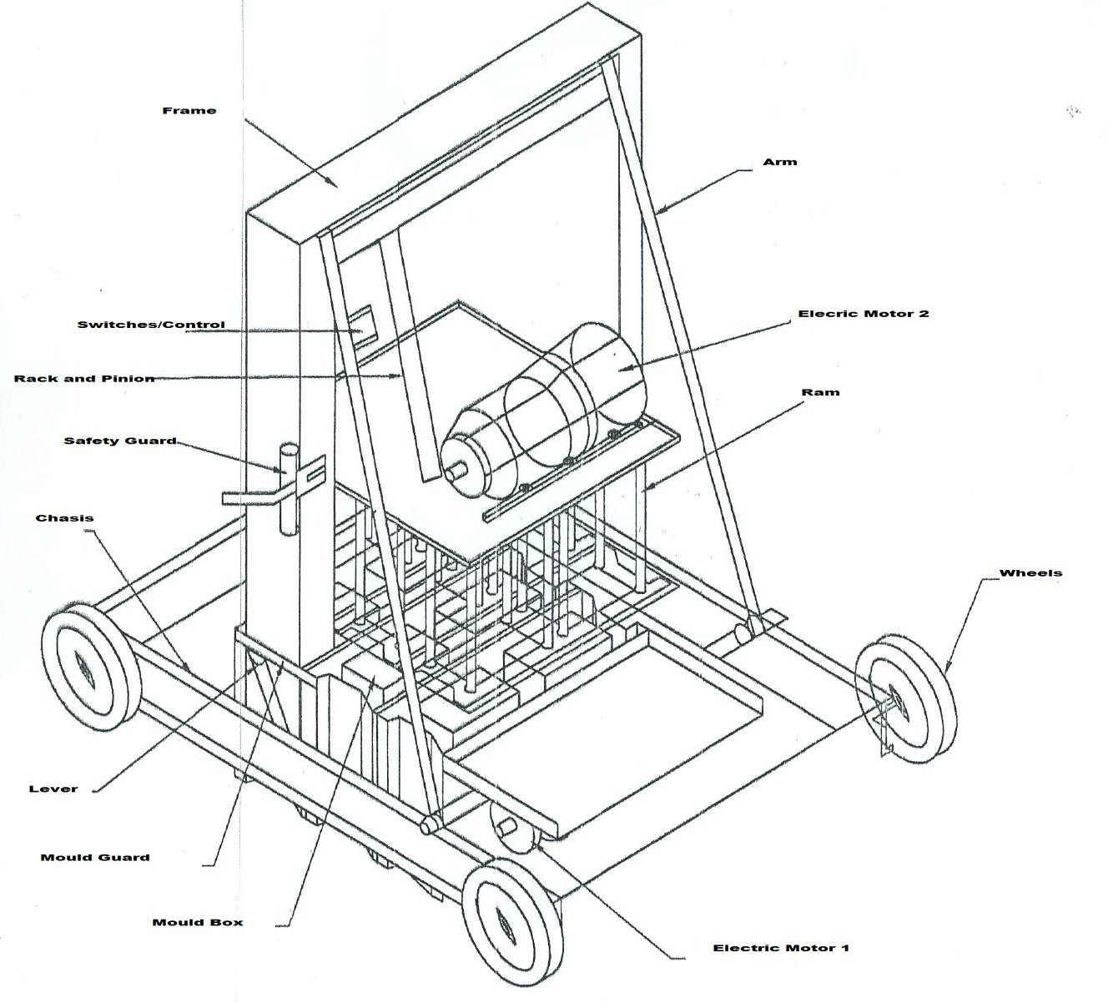

Rack and Pinion

Safety Guard

Wheels

Lever

Moulding Box

Mould Guard

Electric Motor II

Chassis

Ram

Electric Motor I

Switches

Arm

Frame

## Figure 3.1: Isometric View of the Multiple Sandcrete Block Moulding Machine

## Design Considerations and Specifications

The following factors were considered the design of the machine. They are:

* + 1. **Compactness:** the machine was designed to be compact for ease of movement and handling by operator during operation.
    2. **Mobility**: the machine was designed to be mobile so as to eliminate the use of pallet and labour intensity.
    3. **Cost**: material selection was optimized to reduce the cost of production as compared to other locally produced machines.
    4. **ProductionRate**: the machine was designed to simultaneously mould three (3) 6 inches sandcrete blocks to increase the product rate per hour.
    5. **Operating Condition**: corrosion and other problems associated with humid working condition was considered during the selection of finishing operations for the machine.

## Design Theory

Theories applicable to the design of multiple sandcrete moulding machine for this research work is presented as follows:

## Design for Ram Weight

From literature, a compressive force per unit volume of 1.26 X 10-5N/mm3 is sufficient to press wet sandcrete mix during moulding hence it was used to determine the weight of the ram (WR) using the following expression.

𝑊𝑅 = 1.26 𝑋 10−5 𝑋 𝑆𝑉 (3.1)

Where, SV is the sandcrete volume. To the determine SV, differences in volumes of rectangle was used. Figure 3.2 illustrates the isometric view and dimension of a standard 6 inches block with an height of 225mm

455 mm

|  |  |
| --- | --- |
| A |  |
| 150 mm | F I J  H L K  G |

B

|  |  |
| --- | --- |
| E | 150 mm |
| 87 mm |  |

C

D

## Dimensions of a Standard 6 inches block in 2D

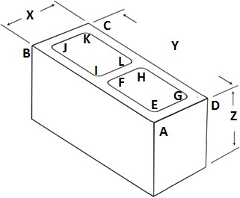

* + - 1. **Isometric View of a Standard 6 inches block Figure 3.2: Standard 6 inchesSandcrete Block**

Hence, SV is given as:

𝑆𝑉 = (𝐴𝑟𝑒𝑎 𝐴𝐵𝐶𝐷 − ( 𝐴𝑟𝑒𝑎 𝐸𝐹𝐺𝐻 + 𝐴𝑟𝑒𝑎 𝐼𝐽𝐾𝐿)) 𝑋 225 𝑋 3 (3.2)

The factor of 3 in Equ. 3.2 was introduced since the machine was designed to simultaneously mould three blocks. Also, since Area EFGH is equal to Area IJKL, equation 3.2 becomes;

𝑆𝑉 = (𝐴𝑟𝑒𝑎 𝐴𝐵𝐶𝐷 − (2 𝑋 𝐴𝑟𝑒𝑎 𝐸𝐹𝐺𝐻)) 225 𝑋 3 (3.3)

In order to ensure that the ram does not deform during operation, maximum deflection (δmax) expected at the centre of the ram was calculated using the expression:

𝑃𝑙3

𝛿𝑚𝑎𝑥 = 48𝐸𝐼 (3.4)

Where P is the load (weight of ram), *l* is the ram length, I is the moment of inertial and E is the modulus of the material for the ram. Isometric diagram of the ram is presented on Figure 3.3.

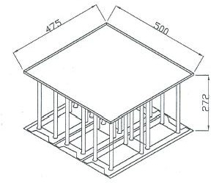

## Figure 3.3: Isometric View of the Ram

## Design for mould box

The mould box was designed based on pressure exerted by the ram and those exerted by wet compressed sandcrete due to its weight. Isometric view of the mould and direction of forces is presented on Figure 3.3.

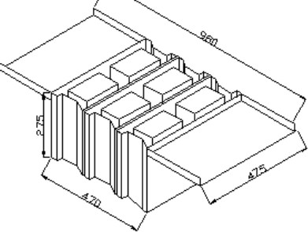

## Figure 3.4: Isometric View of Sandcrete Mould

Hence, the relationship between the loading of the mould and modulus of the material (E) used to produce it is given as:

Where

P𝑐𝑟 =

𝐶𝜋²𝐸𝑚 𝐼

(3.5)

𝐿²

Pcr = critical load,

C = constant depending on end conditions, i.e. either fixed of free. C = 0.25 was used for this research work since the mould end was not fixed while,

L = length of each mould box compartment.

Moment of inertial for a rectangular section is given by (Khurmi and Gupta, 2013):

𝐼 =

𝑏𝑕3

12 (3.6)

Where, b= breadth and h= heigth

In order to compute the value of load (force exerted by ram and wet blocks) to ensure it does not exceed thecritical load, Pcr.

The critical load was obtained using the expression by (Khurmi, 2008):

P𝑐𝑟 = (3 X M𝑤𝑏 + 𝑊𝑅 ) 𝑋 𝑔 (3.7)

Where g is acceleration due to gravity in m/s2 and mwb = average mass of the wet block.

## Design of vibrator-compactor chamber (mould compartments)

Arrangement of structures used to obtain vibration on the moulding machine is called the vibrator compactor chamber (VCC) which is illustrated on Figure 3.5.



Compactor Drive

Welded Joint

Fwb

Eccentric Weight

Shaft (CDS) D F

s

1. O Fc

Ff

## Figure 3.5: Free Body Diagram for the VCC

From Figure 3.5, point O is the geometric centre of the eccentric weight, G is the centre of gravity of the CDS and D is the centre of CDS. For the analysis, Mewas used to represent the mass of the eccentric system, Mwbfor the mass of the wet block mix, y1 is the length OD which can lead to additional deflection of the centre of the CDS when it rotates at *w*rad/s, e is the length OG which is the initial distance of the centre of the eccentric system from the combined centre of gravity of the CDS and the eccentric weight.

Also, EI is the flexural rigidity of CDS, E is the Young’s modulus of the CDS, I is the moment of inertia of the CDS, Ls is taken as the length of the CDS, Le is the length of the eccentric system, y2 is half the diameter of the CDS and the line of action of the flexural rigidity while g is the acceleration due to gravity.Considering the length of the moulding box, y1, y2 and e was allocated to 0.45 m, 0.15 m and 0.225 m respectively to make the machine compact. Finally, a spring of stiffness K (5kN/m) was introduced to the CDS to balance the effects from the rotation of the eccentric weight and provide stiffness for the CDS.

During the operation of the machine, four (4) different forces are expected to be activated in the VCC, they are:

* 1. The centrifugal force (Fc) due to the CDS and the eccentric weight, Fcwas obtained using the expression:

F𝑐 = Me w2(y1 + e) (3.8)

Where Me, *w*, y1, and e are as defined and Fc acted away from the axial centre of the CDS perpendicularly.

* 1. The spring force in the CDS, Fs.This was obtained using the expression (Olusegun and Ajiboye,2009):

F𝑠 = Ky1 (3.9)

Where K and y1 are as defined.

* 1. The force due to the flexural rigidity of the CDS, Ff which was obtained using the expression (Olusegun and Ajiboye,2009) :

Ff =

K𝐸𝑉𝐶𝐶 I

L 2y

(3.10)

𝑠 2

Where E is the Young’s modulus of the CDS and other terms remain as defined

* 1. The force due to the wet block mix, Fwb, was obtained using the expression:

Fwb = 3 X M𝑤𝑏 𝑋 𝑔 (3.11)

For the VCC to be in equilibrium, Fs must be equal to Fc while Ff must be equal to Fwb. Angular velocity (w) can also be determined using the expression:

𝑤 =

2𝜋𝑁

60 (3.12)

Where N is the rotating speed of the motor driving the eccentric system in rpm.

* + 1. **Design for shaft diameter for compactor drive shaft (CDS) and the eccentric system** Shaft is a rotating machine element which is used to transmit power from one place to another.The attachment of the eccentric to the CDS causes an out-of-balance rotation that sets the whole of the mould to vibrate, a process which will eventually compact the wet block mixture. The material used for shaft should have the following properties:

1. It should have good strength and good machinability.
2. It should have good heat treatment properties.
3. It should have high wear resistance properties.

The CDS carried the weight of the wet blocks in bending under minimum tension with a combined shock and fatigue factor of 1.5. Free body diagramand load condition of the CDS is presented on Figure 3.6.

T

CF

CDSF

ESF

T

2rs

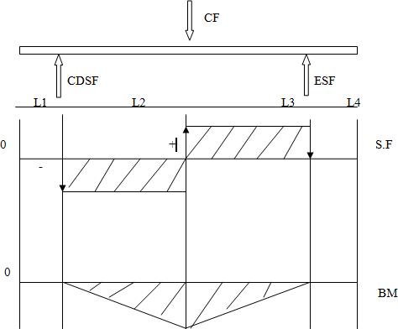

## Figure 3.6: Free-body Diagram and load condition ofCompactor Drive Shaft

The drive torque transmitted to the shaft by the electric motor is given by (Khurmi, 2008):

𝑇 =

𝑃60 2𝜋𝑁

(3.13)

Where

T = torque P = power

N = rotation (rpm)

The CDS diameter in bending is however obtained by(Olusegun and Ajiboye. 2009)

3 X M𝑤𝑏 𝑋 𝑔 × 𝑟𝑠 = 𝑇(3.14)

Where rs is radius of the CDS. From this expression, minimum diameter for the CDS was determined which was multiplied by shock and fatigue factor to determine the real diameter of the shaft.

## Torque (T) and shear stress (τ) generated in the rack and pinion shaft

The rack and pinion are used to convert between rotary and linear motion. Free body diagram with Load condition of the rack and pinion is presented on Figure 3.7.

T



FG

RB

T

D

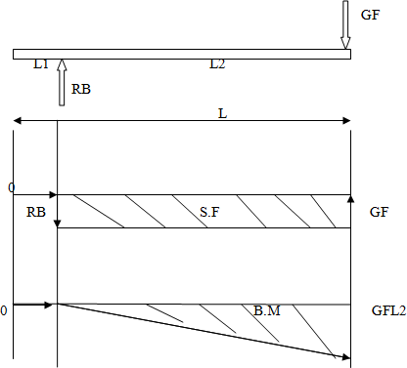

## Figure 3.7: Free-body Diagram and load condition of Rack and Pinion Shaft

The Torque transmitted to the shaft by the electric motor is determined using Equ. 3.13, while the shear stress generated in the shaft was obtained by (Khurmi, 2008):

16𝑇

𝑟 = 𝜋𝐷3 (3.15)

Where τ is shear stress generated in the shaft and D is diameter of the rack and pinion motor shaft.

## Design for lever of the machine

The lever of the machine is used to lift the mould after compaction of the wet block to leave green bodied sandcrete on the floor. In determining the length of the lever, average height of a man which is 1.77 m was considered ([www.livestrong.com,](http://www.livestrong.com/) 2017). It is supported by a hinged joint at the chassis and give users some mechanical advantage when lifting the mould. The length of 0.5 was chosen for the hinge joint to allow complete lift of the mould when releasing green body of the sandcrete. The free body diagram of the lever is presented on Figure 3.8.

0.5 m



FM

RX

0.5 m

FM RY

1.19 m

E

1.19 m

E

## Figure 3.8: Free-body Diagram for Lever

From Figure 3.8, forces acting on the lever are FM (force due to the weight of the mould) and E (effort provided by the operator). These forces led to the generation of two (2) reaction forces at the joint (RX and RY). For the lever to be at equilibrium. The sum of forces must be equal to zero in all direction while the sum of moments about any point must be equal to zero. Using these conditions, the relationship between these forces is given as follows:

∑ 𝐹𝑋 = 0; 𝑅𝑋 = 0𝑁 (3.16)

## +

∑ 𝐹𝑌 = 0; 𝐹𝑀 + 𝐸 − 𝑅𝑌 = 0

𝑅𝑌 = 𝐹𝑀 + 𝐸 (3.17)

∑ 𝑀 = 0; 𝐹𝑀𝑋 0.5 − 𝐸 𝑋 1.19 = 0

𝐸 = 𝐹𝑀 𝑋 0.5 (3.18)

1.19

Hence, mechanical advantage (M.A.) provided by the lever is given as:

𝑀. 𝐴. = 𝐹𝑀 (3.19)

𝐸

## Design for machine chassis

When considering the chassis that carries the bulk of the machine, loads due to deflection must be considered. The chassis carries the weight of wet sandcrete and rammer but not that of mould as mould rest on the floor during compaction. In presenting the free body diagram of the chassis asshown on Figure 3.9, total force acting on it based on the weight of wet sandcrete and rammer it carries was represented with FT while support force received from wheel was represented with SF.

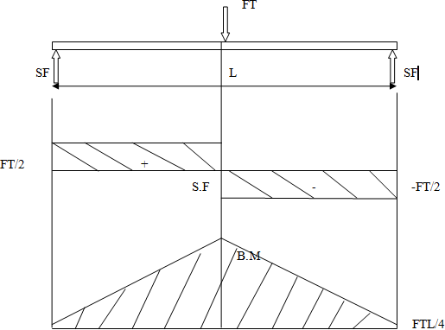

## Figure 3.9: Free-body Diagram and load condition of the Chassis

For the optimum production of the machine, the machine must be firm, unyielding to bending forces and reasonably stiff. This calls for stiffness of the chassis member; since by stiffness, the measure of resistance of a component or machine members to deflection is given by (Khurmi, 2008):

𝑌 =

𝐹𝑇𝐿 3

48𝐸𝐼

(3.20)

## Material Selection

Possible materials which could be used to construct the moulding machine were considered under the following headings:

* + 1. Strength
    2. Availability
    3. Machinability
    4. Cost and
    5. Resistance to corrosion

Based on these criteria, best candidate material was selected for the fabrication of parts of the machine.

## Working Principle of the Multiple Sandcrete Blocks Moulding Machine

The machine during operation will be pushed to a smooth concrete or a well levelled surface then separating material such as waste paper or polythene sheets will be placed on the surface for easy removal of the block after solidifying before lowering the mould using lever. After this, mixed sandcrete will be feed into the mould boxes then screeding of sandcrete will be done manually to level mixed sandcrete in all mould cavities.

Furthermore, rammer assembly is lowered onto the sandcrete in the mould boxes with the aid of rack and pinion assembly driven by electric motor controlled by a switch. This compresses the sandcrete mixture in the mould cavities before vibration is introduced by the VCC driven by another electric motor controlled by a separate switch. The vibration is maintained till the full height of the compacted sandcrete blocks is achieved then the rammer is raised before the mould is carefully lifter using lever to release the block on the ground. Finally, the moulding machine is pushed to the next point for another round of moulding.

## Cost Evaluation of the Multiple Sandcrete Block Moulding Machine

The summation of the machine cost comprises of material, labour and overhead costs. Material cost is the sum of expenses incurred during the procurement of materials used for the fabrication of the machine while labour cost includes expenses incurred during the machining and processing of these material to form required shape and dimension as well as assembly and consultancy fees. On the other hand, overhead and miscellaneous cost include principally transportation and contingency cost.

## Performance Evaluation of the Multiple Sandcrete Block Moulding Machine

Compressive strength and water absorption tests were conducted on blocks samples to determine if the moulding machine was able to impact adequate compaction force on the mix sandcrete during compaction. These tests are conducted as they are the two (2) major characteristic requirements that the NIS specified for testing and verifying the quality of sandcrete block, apart from the appearance and dimension (NIS 587:2007.P8-9)

## Sample Preparations and Testing

In order to test the fabricated moulding machine, samdcrete mix was prepared according to the related standard (NIS 87: 2004). The mix was introduced to the machine to produce some blocks. These blocks were cured for 7 days by sprinkling them with water twice daily. Plate 3.1 presents the moulding machine during sample preparation.

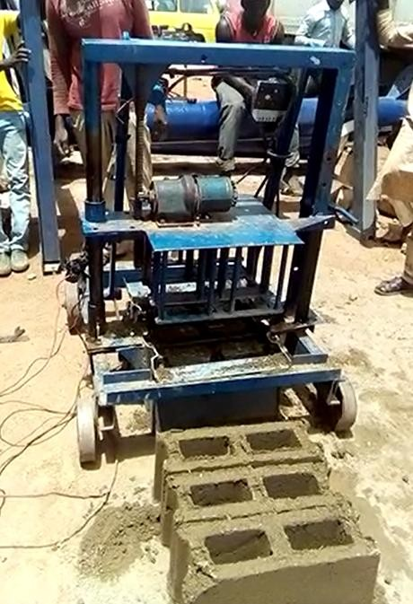

## Plate 3.1: Sample Block Preparation using the Fabricated Moulding Machine

Samples were also obtained from a commercial sandcrete moulding making machine which were also cured for same days. These samples were subjected to crushing strength and water absorption tests.

## Production Rate

This is the average number of sandcrete blocks that can be produced using the fabricated moulding machine within a given period of time. However, the actual production rate dependscapacity of the operators of the machine. The number of sandcrete blocks made was recorded for a period of twenty-two minutes at an interval of two (2) minutes. Then average production rate was determined per minute.

## Compressive Strength Test Procedure

Five (5) sample sandcrete blocks were subjected to compressive strength test separately in a universal testing machine to determine their compressive strength in accordance with standard (NIS 87: 2004). The effective base area of the block was determined by removing the hollow area from the whole base area as done during design calculation.

Since the dimensions of the sample blocks are not the same, they were estimated separately in square meter for the determination of their compressive strength. The compressive strength was determined by dividing compressive load they were able to bear before failing by their effective area.

During the loading, block was positioned with its base on the floor of universal testing machine thena flat metal plate was placed at the top of the block to ensure even distribution ofcrushing load applied. At the sign of the first crack, the reading of the machine was noted and recorded. The compressive strength, *Yc of* the blocks was determined using the relation:

𝐶𝑟𝑢𝑠𝑕𝑖𝑛𝑔 𝑙𝑜𝑎𝑑 (𝑁)

Yc = 𝑒𝑓𝑓𝑒𝑐𝑡𝑖𝑣𝑒 𝑎𝑟𝑒𝑎 (𝑚2) (3.21)

## Water Absorption TestProcedure

All specimens were first subjected to water absorption test before compressive strength tests were conducted. According to Neville (2002), the rate of water absorption of aggregate influences the bond between aggregates and the cement paste, the resistance of concrete to freezing and thawing, chemical stability, resistance to abrasion and specific gravity. Water absorption is the ratio of the decrease in mass to mass of dry sample. This is determined by measuring the percentage decrease in mass of saturated block from mass of surface dry sample.

During the test, three (3) sandcrete blocks were weighed and placed in a tank. Water at room temperature was poured into the tank until the blocks were submerged. They were left for 24 hours,

after which they were removed and dried with a piece of cloth. They were then weighed and recorded.

This was computed using the following expression:

𝑴𝟐 − 𝑴𝟏

𝑴𝟏

× 100% (3.22)

Where

M1 = mass of dry sample M2 = mass of wet sample

## Introduction

## CHAPTER FOUR RESULTS AND DISCUSSION

This chapter presents the design calculations for the multiple sandcrete blocks moulding machine and analyses the results of the compressive strength and water absorption tests carried out on samples produced from the newly designed and fabricated sandcrete block moulding machine as compared with those obtained from a conventional machine.

## Design Calculations

**Table 4.1: Design Calculations for the Multiple Sandcrete Blocks Moulding Machine**

|  |  |  |
| --- | --- | --- |
| **Initial Data** | **Calculations &Sketches** | **Results** |
| **Calculation for Ram Weight** | | |
| |AB| = |DC| = 455 mm | From Equ.3.3,  𝐴𝑟𝑒𝑎 𝐸𝐹𝐺𝐻 = 150 𝑋 87 = 13050 𝑚𝑚2  𝐴𝑟𝑒𝑎 𝐴𝐵𝐶𝐷 = 455 𝑋 150 = 68250 𝑚𝑚2  𝑆𝑉 = (68250 − (2 𝑋 13050)) 225 𝑋 3  𝑆𝑉 = 28461250 𝑚𝑚3  From Equ.3.1,  𝑊𝑅 = 1.26 𝑋 10−5 𝑋 28461250  𝑊𝑅 = 358.486 𝑁 358.486  𝑊𝑅 = 9.81 = 36.54 𝑘𝑔 |  |
| |AD| = |BC| = 150 mm |  |
| |EF| = |GH| = |IJ| = |LK| |  |
| = 150 mm |  |
| |EG| = |FH| = |IL| = |JK| |  |
| = 87 mm | SV = 28461250 mm3 |
| g = 9.81 m/s2 |  |
|  | WR = 36.54 kg |
| **Calculation for mould box** | | |
| Em= ? | From Equ.3.6,  0.15 𝑋 0.2253  𝐼 = 12  𝐼 = 1.42 𝑋 10−4𝑚4  Also from Equ. 3.7,  P𝑐𝑟 = (3 X 18 + 36.54) 𝑋 9.81  P𝑐𝑟 = 888.20 𝑁 Operating Stress of the mould was obtained using Equ. 3.5 as follows: |  |
| C = 0.25 |  |
| b= 0.15m |  |
| h =0.225m | I = 1.42 X 10-4 m4 |
| l= 0.455 m |  |
| g = 9.81 m/s2 |  |
| WR = 36.54 kg  Mwb=18kg | Pcr = 888.20 N |
| (average mass of |  |
| the wet block) |  |

|  |  |  |
| --- | --- | --- |
|  | P𝑐𝑟 𝐿²  𝐸𝑚 = 𝐶𝜋2𝐸𝐼  535.05 𝑋 0.455²  𝐸𝑚 = 0.25 𝑋 𝜋2 𝑋 0.000142  𝐸𝑚 = 524814.06 𝑁/𝑚2  𝐸𝑚 = 0.525 𝑀𝑁/𝑚2 | Em = 0.525 MN/m2 |
| **Calculation for vibrator-compactor chamber (mould compartments**) | | |
| y1 = 0.45 m | In order to determine the angular velocity Equ. 3.12 was used as follows:  2 𝑋 𝜋 𝑋 1450  𝑤 = 60  𝑤 = 151.84 𝑟𝑎𝑑/𝑠  Equating Equ. 3.8 to 3.9, minimum mass of the eccentric weight was determined as follows:  Ky1 = Mew2(y1 + e)  Ky1  Me = w2(y + e)  1  50000 𝑋 0.45  Me = 151.842(0.45 + 0.225)  Me = 1.45 𝑘𝑔  Also, equating Equ 3.10 and 3.11,  K𝐸𝑉𝐶𝐶 I  L 2 y = 3 X M𝑤𝑏 𝑋 𝑔  𝑠 2  3 X M𝑤𝑏 𝑋 𝑔 𝑋 L𝑠2y2  𝐸𝑉𝐶𝐶 = 𝐾𝐼  3 𝑋 18 𝑋 9.81 𝑋 0.62 X 0.15  𝐸𝑉𝐶𝐶 = 50000 𝑋 1.42 𝑋 10−4  𝐸𝑉𝐶𝐶 = 40.29 N/𝑚2 |  |
| y2 = 0.15 m |  |
| e = 0.225 m |  |
| Mwb=18kg | w = 151.84 rad/s |
| I = 1.42 X 10-4 m4 |  |
| K = 5 kN/m |  |
| L = 0.6 m |  |
| N = 1450 rpm |  |
| g = 9.81 m/s2 |  |
|  | Me = 1.45 kg |
|  | EVCC = 40 N/m2 |

|  |  |  |
| --- | --- | --- |
| **Calculation for shaft diameter for compactor drive shaft (CDS)** | | |
| P = 2hp = 1492 W | From Equ. 3.13;  1492 𝑋 60  𝑇 = 2𝜋 𝑋 1450  𝑇 = 9.83 𝑁 − 𝑚  From Equ. 3.14, minimum radius of CDS is obtained as follows:  𝑇  𝑟𝑠 = 3 X M 𝑋 𝑔  𝑤𝑏  9.83  𝑟𝑠 = 3 X 18 X 9.81  𝑟𝑠 = 0.018 𝑚  Using the fatigue factor of 1.5, the real radius of the CDS (Rs) is calculated as:  𝑅𝑠 = 𝑟𝑠 𝑋 1.5  𝑅𝑠 = 0.018 𝑋 1.5  𝑅𝑠 = 0.028 𝑚 |  |
| Mwb=18kg |  |
| g = 9.81 m/s2 |  |
| N = 1450 rpm | T = 9.83 N – m |
| Fatigue factor = 1.5 |  |
|  | rs = 0.018 m |
|  | Rs = 0.028 m |
| **Calculation for torque (T) and shear stress (τ) generated in the rack and pinion shaft** | | |
| P = 1 hp = 746 W | Also from Equ. 3.13;  746 𝑋 60  𝑇 = 2𝜋 𝑋 200  𝑇 = 35.62 𝑁 − 𝑚  Then, the shear stress generated within the rack and pinion motor shaft is calculated using  Equ. 3.15 as follows:  16 𝑋 35.65  𝑟 = 𝜋 𝑋 0.0163  𝑟 = 44.29 𝑋 106 𝑁/𝑚2 |  |
| WR = 36.54 kg |  |
| Nr&p = 200 rpm | T = 35.62 N – m |
| D = 16 mm (from |  |
| motor specification) |  |
|  | τ = 44.29 MN/m2 |

|  |  |  |
| --- | --- | --- |
| **Calculation for lever of the machine** | | |
| FM = 482.3 N (from | From Equ. 3.18, effort required to lift the mould after compaction of wet sandcrete is obtained as follows;  482.3 𝑋 0.5  𝐸 = 1.19  𝐸 = 202.65 𝑁  Also, from Equ. 3.19, mechanical advantage gained using the lever is calculated as follows:  482.30  𝑀. 𝐴. = 202.65  𝑀. 𝐴. = 2.38 |  |
| 3D modelling |  |
| Measurement |  |
|  | E = 202.65 N |
|  | M.A. = 2.38 |
| **Calculation for machine chassis** | | |
| l = 1.075 m | Total weight on the chassis is the addition of ram and wet sandcrete block weight. Then, FT is calculated as follows:  𝐹𝑇 = (3 X M𝑤𝑏 + 𝑊𝑅 ) 𝑋 𝑔  𝐹𝑇 = (3 X 18 + 36.54) 𝑋 9.81  𝐹𝑇 = 888.20 𝑁  Also, *I* was determined using Equ. 3.6 as follows:  0.775 𝑋 0.13  𝐼 = 12  𝐼 = 6.46 𝑋 10−5𝑚4  Then, deflection expected om the chassis is given as;  888.2 𝑋 1.0753  𝑌 = 48 𝑋 210 𝑋 106 𝑋 6.46 𝑋 10−5  1103.41  𝑌 = 651168  𝑌 = 0.0017 𝑚  Since the deflection is less than 1/240 of the chassis length, the material selected (mild steel) would serve for its construction |  |
| b = 0.775 m |  |
| h = 0.1 m |  |
| WR = 36.54 kg |  |
| Mwb=18kg |  |
| g = 9.81 m/s2 |  |
| E = 210 MN/m2 | FT = 888.20 N |
|  | I = 6.46 X 10-5 m4 |
|  | Y = 0.0017 m |

## Material Selection

Possible materials which could be used to construct the moulding machine were considered under the headings presented in Section 3.5 as summarized on Table 4.2.

## Table 4.2: Material Selection Chart

|  |  |  |  |  |  |
| --- | --- | --- | --- | --- | --- |
| Factors | Strength | Availability | Machinability | Cost | Resistance to  corrosion |
| Material |
| Mild steel | √ | √ | √ | √ | - |
| Aluminium | √ | - | √ | - | √ |
| Stainless Steel | √ | - | - | - | √ |
| Plastic | - | √ | √ | - | √ |

However, cost, strength and resistance to corrosion are the most important factors. Following the design calculation and material selection chart, mild steel has only one drawback which is its non-resistance to corrosion. This drawback could be mitigated against using appropriate finishing process hence, it was selected for the fabrication of the moulding machine.

## Fabrication Processes

The fabrication processes that were used to produce block moulding machine are described on Table 4.3.

## Table 4.3: Fabrication Processes for the Multiple Sandcrete Blocks Moulding Machine

|  |  |  |  |  |
| --- | --- | --- | --- | --- |
| **S/No** | **Component** | **Material** | **Description of process** | **Machine/ Tool used** |
| 1 | Chassis | i. 8mm thick mild steel plate | The work piece was cut into the required dimensions, assembled then welded to the required shape. The weldments were grinded to finish (see  Drawing 7) | 1. Hand grinding machine 2. SMA welding 3. Measuring tape |
| 2 | Mould box | i. 4mm thick mild steel plate | Work piece was processes as above to finish (see Drawing  4) | Same as in 1 |
| 3 | Rammer | 1. 18mm Φ mild steel rod 2. 8mm thick mild   steel plate | Work piece was processes as above to finish (see Drawing 3) | 1. Same as in 1 2. Hack saw 3. Bench vice |
| 4 | Eccentric shaft (vibrator) | i. 30 mm Φ mild steel rod | The work piece was cut in to the required dimensions, then welded to an existing shaft of electric motor driving the vibrator | 1. Hack saw 2. Drilling   machine   1. SMA welding machine 2. Grinding   machine |
| 5 | Ejector mechanism (Lever) | i. 50 mm Φ mild steel rod | The work piece was cut in to the required dimensions and was joined by fasteners (see Drawing 2) | 1. Hack saw 2. Drilling   machine   1. Grinding   machine |
| 6 | Frame | 1. 50mm Φ mild steel rod. 2. 6mm thick U channel mild steel plate | The work piece was cut into the required dimensions, assembled then welded to the required shape. The weldments were grinded to finish (see  Drawing 5) | 1. Hack saw 2. Drilling   machine   1. SMA welding machine 2. Grinding |

|  |  |  |  |  |
| --- | --- | --- | --- | --- |
|  |  |  |  | machine |
| 7 | Fasteners | Standard | Standard | Nill |
| 8 | Electric  motor | Standard | Standard | Nill |
| 9 | Rack and  Pinion | Standard | Standard | Nill |
| 10 | Wheel | Standard | Standard | Nill |
| 11 | Springs | Standard | Standard | Nill |

After successful fabrication of each part of the multiple sandcrete blocks moulding machine, they were assembled as shown on the assembly drawing (see Drawing 1) using appropriate tools and operations such as welding, screwing, force-fitting etc. In summary, four wheel trolley were welded to the chassis then frames were attached vertically to each side of the chassis to facilitate reciprocating movement of the rammer plate assembly. Also, the prepared mould having three (3) cavities was placed centrally inside the chassis for casting the sandcrete blocks.

In addition, handle was attached to the sides of the chassis to ease the movement of the machine from one point to another during operation. Then, ejector mechanism was attached to the edges of mould box at both sides and lower end of handle, this arrangement helps to lift or lower the mould box. Finally, electric motors were attached to the machine; one was used for the control of mould vibration while the second motor was used to control the reciprocating movement of the rammer assembly. Assembled moulding machine is presented on Plate 4.1.

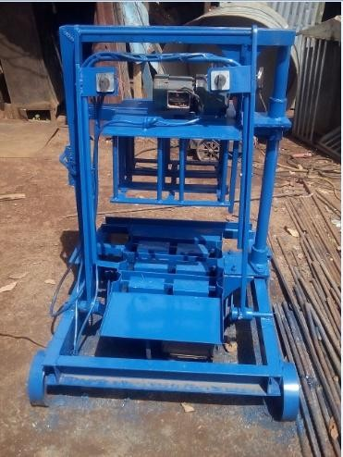

## Plate 4.1: Pictorial view of the multiple sandcrete blocks moulding machine

## Cost Evaluation of the Multiple Sandcrete Block Moulding Machine

It took a total of one hundred and five thousand six hundred naira (N105,600:00) to build a physical prototype of the designed multiple sandcrete moulding machine as summarized on Table 4.4.

## Table 4.4: Bill of Material for Multiple Sandcrete Block Moulding Machine

|  |  |  |  |  |
| --- | --- | --- | --- | --- |
| **S/n** | **Material Description** | **Quantity** | **Unit Cost (N)** | **Price (N)** |
| **Material Cost** | | | | |
| 1 | 1 length of 6 mm thick 50mm X 100mm mild steel  U-channel | 1 | 9700 | 9700 |
| 2 | 1/2 sheet of 4 mm thick  mild steel plate | ½ | 17000 | 8500 |
| 3 | 1 length of Φ16mm mild steel rod  1/8 sheet of 12 mm thick  mild steel plate | 1  1/8 | 8600  24000 | 8600  3000 |
| 4 | 1/2 length of 8 mm thick Mild steel  Flat bar | ½ | 10000 | 5000 |
| 5 | 1/6 length of Φ50mm  mild steel rod | 1/6 | 21000 | 3500 |
|  | **Total** | **-** | **-** | **38,300** |
| **Component Cost** | | | | |
| 1 | 2Hp electric motor | 1 | 6000 | 10,000 |
|  | 1HP electric motor | 1 | 4000 |  |
| 2 | Wheel 4 pcs Φ200mm x 50  mm cast iron | 4 | 1000 | 4,000 |
| 3 | Rack and Pinion | 1 | 4500 | 4500 |
| 4 | Spring | 1 | 600 | 600 |
| 5 | M 20 | 6 | 200 | 1200 |
|  | M 12 | 8 | 150 | 1200 |
|  | M 8 | 8 | 50 | 400 |
|  | **Total** | **-** | **-** | **21,700** |

|  |  |  |  |  |
| --- | --- | --- | --- | --- |
| **Labour and Over-head Cost** | | | | |
| 1 | Cost of fabrication  and assembly | Num | - | 25,000 |
| 2 | Cost of transportation  and miscellaneous | Num | - | 20,000 |
|  | **Total** | **-** | **-** | **45,000** |
|  | **Sub-total** | **-** | **-** | **105,600** |
|  |  |  |  |  |
|  | **Ground-Total** | **-** | **-** | **105, 600** |

The total cost of producing the machine is one hundred and five thousand six hundred naira (N105,600). This is lower to the price of commercial moulding machine available in market which costs two hundred and fifty thousand naira (N250,000). Hence, percentage reduction in price is calculated as follows;

% 𝑝𝑟𝑖𝑐𝑒 𝑟𝑒𝑑𝑢𝑐𝑡𝑖𝑜𝑛 =

250000 − 105600

250000 𝑋 100

% 𝑝𝑟𝑖𝑐𝑒 𝑟𝑒𝑑𝑢𝑐𝑡𝑖𝑜𝑛 = 57.76%

Therefore, the percentage price reduction by the newly fabricated machine is 57.76%

## Performance Evaluation Results

## Production rate

Table 4.5 presents the number of sandcrete blocks that were produced during at different intervals by two (2) workers.

## Table 4.5: The production rate of the machine as recorded for the period of 22 (min)

|  |  |  |  |  |  |
| --- | --- | --- | --- | --- | --- |
| Trial | Time (min) | Cumulative Production | Trial | Time (min) | Cumulative Production |
| 1 | 2 | 3 | 7 | 14 | 21 |
| 2 | 4 | 6 | 8 | 16 | 24 |
| 3 | 6 | 9 | 9 | 18 | 27 |
| 4 | 8 | 12 | 10 | 20 | 30 |
| 5 | 10 | 15 | 11 | 22 | 33 |
| 6 | 12 | 18 | Total | 22 | 33 |

From Table 4.5, average rate of sandcrete production is given by was determined by dividing the total number of sandcrete produced by total time used as follows;

33

Average blocks produced per minute = 22 = 1.5 sandcrete per minute

Table 4.5 revealed the production rate of the multiple sandcrete blocks moulding machine for the duration of 22 minutes with a total numbers of 33 sandcrete blocks with 2 workers. The average production rate per minutes was 1.5 which implies that a total number of 90 sandcrete blocks will be produced in 60 minutes. Also, for 8 hours working day, a total number of 720 sandcrete blocks will be produced. In contrast, the conventional sandcrete block moulding machine produced between 450-500 sandcrete blocks in 8 hours with average number of 3 -5 workers. The production rate is a direct function of the capacity of the machine as well as the ability of the operators as posted by Yakubu and Umar (2015).

## Compressive Strength

Compressive strength which is the capacity of a material or structure to withstand loads tending to reduce size. Some materials fracture at their compressive strength limit, so a given amount of deformation may be considered as the limit for compressive load. The results of the compressive strength are presented onTables 4.6 and 4.7for samples from fabricated and commercial moulding machines respectively.

## Table 4.6: Compressive Strength for Samples from Fabricated Machine

|  |  |  |  |  |  |
| --- | --- | --- | --- | --- | --- |
| **Trial** | **1** | **2** | **3** | **4** | **5** |
| Average base area of block (m2) | 0.06992 | 0.06992 | 0.06992 | 0.06992 | 0.06992 |
| Average hole area of block (m2) | 0.02814 | 0.02814 | 0.02814 | 0.02814 | 0.02814 |
| Effective base area of block (m2) | 0.04178 | 0.04178 | 0.04178 | 0.04178 | 0.04178 |
| Crushing load of block (KN) | 61 | 71 | 93 | 80 | 68 |
| Compressive strength of block (N/mm2) | 1.46 | 1.70 | 2.22 | 1.91 | 1.62 |

From Table 4.6, average compressive strength of blocks was determined as follows;

Average compressive strength =

1.46 + 1.70 + 2.22 + 1.91 + 1.62

5

Average compressive strength = 8.91 = 1.78 𝑁/𝑚𝑚2

5

## Table 4.7: Compressive Strength for Samples from Commercial Machine

|  |  |  |  |  |  |
| --- | --- | --- | --- | --- | --- |
| **Trial** | **1** | **2** | **3** | **4** | **5** |
| Average base area of block (m2) | 0.0713 | 0.0713 | 0.0713 | 0.0713 | 0.0713 |
| Average hole area of block (m2) | 0.0275 | 0.0275 | 0.0275 | 0.0275 | 0.0275 |
| Effective base area of block (m2) | 0.0437 | 0.0437 | 0.0437 | 0.0437 | 0.0437 |
| Crushing load of block (KN) | 35 | 28 | 23 | 29 | 21 |
| Compressive strength of block (N/m m2) | 0.80 | 0.64 | 0.52 | 0.66 | 0.48 |

From Table 4.7, average compressive strength of blocks was determined as follows;

Average compressive strength =

0.80 + 0.64 + 0.52 + 0.66 + 0.48

5

Average compressive strength = 3.10 = 0.62 𝑁/𝑚𝑚2

5

From this analysis as presented on Tables 4.6 and 4.7, it could be derived that the fabricated moulding machine was able to impact the required amount of compaction force to wet sandcrete during moulding. This is deduced from the compressive strength obtained from samples made by the fabricated machine which is higher than the strength from those made with the commercial one.

Also, the value obtained falls within the range stated by Raheem *et al.*, (2012) as acceptable values for sandcrete blocks and is higher than a minimum value of 1.75N/mm2 as stipulated by the National Building Code (2006) but lower than the values specified by the NIS 87:2004 of 2.5N/mm2 for non-load bearing.

By comparison the sandcrete blocks from MSBMM have a higher compressive strength more than the sandcrete blocks CSBMM. The poor quality of block could be attributed to poor mix ratio and inadequate curing of the sandcrete blocks as observed by Anosike,( 2011).

## Water Absorption

The purpose of this test is to provide a means for comparing relative water absorption tendencies between different cellular materials. It is intended for use in specifications, product evaluation, and quality control. The results of water absorption test were presented on Tables

4.8 and 4.9 respectively.

## Table 4.8: Water Absorption for Samples from Fabricated Machine

|  |  |  |  |
| --- | --- | --- | --- |
| **Trial** | **1** | **2** | **3** |
| Mass of dry block, M1 (kg) | 17.50 | 17.90 | 17.65 |
| Mass of soaked block, M2 (kg) | 19.73 | 19.30 | 19.50 |
| Water absorption (%) | 12.74 | 7.82 | 10.48 |

From Table 4.8, the average water absorption of blocks was determined as follows;

Average water absorption =

12.74 + 7.82 + 10.48

3

Average water absorption =

31.04

3 = 10.35 %

## Table 4.9: Water Absorption for Samples from Commercial Machine

|  |  |  |  |
| --- | --- | --- | --- |
| **Trial** | **1** | **2** | **3** |
| Mass of dry block, M1 (kg) | 16.10 | 16.30 | 16.60 |
| Mass of soaked block, M2 (kg) | 17.70 | 17.80 | 18.05 |
| Water absorption (%) | 9.93 | 9.20 | 8.73 |

From Table 4.9, the average water absorption of blocks was determined as follows;

Average water absorption =

= 9.93 + 9.20 + 8.73

3

Average water absorption =

27.86

3 = 9.29 %

Table 4.8 and 4.9 show percentage water absorption for samples from both fabricated and commercial machine. From Table 4.8, it can be observed that the samples produced from the fabricated machine have water absorption of between 7.82 - 12.74% with average absorption of 10.35%. On the other hand, samples produced from commercial machine have water absorption between 8.73 - 9.33% with average value of 9.29%.

Although the results obtained revealed that level of water absorbed by samples from fabricated machine is higher than those from commercial machine, the average of 10.35% is still lesser than 12% recommended in the NIS 87: 2004. Higher water absorption rate implies less density for the sandcrete which is a non-desirable properties since Shohana, (2015) reported that mechanical properties of sandcrete block are highly influenced by its density. A denser sandcrete block generally provides higher strength and fewer amounts of voids and porosity. Smaller the voids in sandcrete block, it becomes less permeable to water and soluble elements.

## CHAPTER FIVE CONCLUSION AND RECOMMENDATIONS

## Conclusion

From the design analysis and performance evaluation, the following conclusions were drawn:

1. A mobile multiple sandcrete block moulding machine was successfully designed and developed which can be operated by only two (2) semi-skilled labours without the use of pallet for curing the sandcrete blocks.
2. The newly developed sandcrete block moulding machine was able to produce three (3)standard 450mm x 225mm x 150mm (6 inches) sandcrete blocks simultaneously at the rate of 1.4 block per minute leading to total production of 664 blocks per eight hours working day.
3. The performance evaluation tests carried out on sample sandcrete blocks from the developed machine revealed that they have average compressive strength of 1.78N/mm2 and water absorption of 10.35%, which compare favourably with samples from commercial machine.
4. The cost of production for the multiple sandcrete block moulding machine was estimated to be N 105,600.00.

## Recommendations

For further work and improvement on this research, the following are recommended:

* + 1. Design should be optimized to accommodate mould with higher number of cavities of other sizes (e.g. 9 inches) to increasethe production rate of the machine.
    2. The ejection mechanism of the machine should be automated by the use of electric motor for the safety of the operator.
    3. A tray should be incorporated directly opposite the mould box for easy feeding of the sandcrete mix into the mould.

## REFERENCES

Adejugbe, I.T., Ukoba, O.K., Idowu, A.S., Oyelami, A.T., and Olusunle, S.O.O., (2014), Development of Double Mould Vibration –Compactor Block Moulding Machine for Developing Countries *Physical Science International Journal 4(10):*

Ademiluyi, I. A.,(2010), Public Housing Delivery Strategies In Nigeria: A Historical Perspective Of Policies And *Programmes Journal of Sustainable Development in Africa (Volume 12, No.6, 2010) ISSN: 1520-5509*

Aguwa, J.I., (2009), Performance of Laterite-Cement Blocks as Walling Units in Relation to Sandcrete Blocks. *Leonardo Electronic Journal of Practice and Technologies, Issue 16, January – June, 2010, pp 189 – 200*

Anosike, M.N., and Oyebade, A.A., (2012), Sandcrete Blocks and Quality Management in Nigeria Building Industry. *Journal of Engineering, Project and Production Management 37-46*

Anosike, M.N., (2011), Parameters for Good Site Concrete Production Management Practice in Nigeria. *Unpublished PhD Thesis,* Covenant University, Ota, Nigeria.

Asafa, K.A., (2006), Design and Construction of a Manual Concrete Block Moulding Machine”B.Eng. Project Report, Department of Mechanical Engineering, University of Ilorin.

Baidan, B.K., and Tuuli, M.M., (2004), Impart of Quality Control Practice in Sandcrete Blocks Production, *Journal of Architectural Engineering*

Barber, .A, (1997),Pneumatic Handbook, Elsevier, [Technology & Engineering](https://www.google.com.ng/search?tbo=p&tbm=bks&q=subject%3A%22Technology%2B%26%2BEngineering%22&source=gbs_ge_summary_r&cad=0)

Barry, R., (1969), The Construction of Buildings. Vol Pp.54-55 & 94 Cross by Lock wood, London, England

Basser, J.H., (2004), 100 Years of Blocks tcm 77-1307782 Publication #J04C039, Copyright © 2004 Hanley Wood, LLC. All rights reserved

Bernd, H., and Metin, E., (2010), Chassis Handbook Fundamentals, Driving Dynamics, Components, Mechatronics, Perspectives Springer Science & Business Media, [Technology & Engineering](https://www.google.com.ng/search?tbo=p&tbm=bks&q=subject%3A%22Technology%2B%26%2BEngineering%22&source=gbs_ge_summary_r&cad=0)

Budynams R.G. and Nisbett J.K. (2013), Shingly’s Mechanical Engineering Design, Mc Graw Hill Companies Inc., New Delhi

[Bugayev,](https://www.google.com.ng/search?tbo=p&tbm=bks&q=inauthor%3A%22K.%2BBugayev%22) K. , Konovalov,Y., [Bychkov,](https://www.google.com.ng/search?tbo=p&tbm=bks&q=inauthor%3A%22Y.%2BBychkov%22) Y., [Tretyakov,](https://www.google.com.ng/search?tbo=p&tbm=bks&q=inauthor%3A%22E.%2BTretyakov%22) [E., Savin,](https://www.google.com.ng/search?tbo=p&tbm=bks&q=inauthor%3A%22Ivan%2BV.%2BSavin%22) V., (2001): Iron and Steel Production The Minerva Group, Inc., - [Technology & Engineering](https://www.google.com.ng/search?tbo=p&tbm=bks&q=subject%3A%22Technology%2B%26%2BEngineering%22&source=gbs_ge_summary_r&cad=0)

Building Code, (2006), Federal Republic of Nigeria: National Building Code First Edition.

Nigeria: National Building Code

Chuku, L., (2014), Addressing Housing Deficit in Nigeria, [http://www.pmnewsnigeria.com/2015/01/16/addressing-housing-deficit.](http://www.pmnewsnigeria.com/2015/01/16/addressing-housing-deficit) accessed on the (26/02/2015 09:17)

Ghosh, S. K., (2002), Low-cost building materials*.* I*n* O. Ural, V. Abrantes & A. Tadeu (Ed.), XXX World Congress on Housing, University of Coimbra, Portugal.

Global Comparison of Average Adult Male Height.Retrieved on 19/10/2017 from [www.livestrong.com,](http://www.livestrong.com/) 2017

Gusah, D.T., (1994), Modification of the Compressed Earth Block-Making Machine “B.Eng project report, Department of Mechanical Engineering, Ahmadu Bello University, Zaria.

John, S., (1793), A Narrative of the Building and a Description of the Construction of the Edystone Light House with Stone: [www.mhs.ox.ac.uk/collection/library/ephemera/auction -](http://www.mhs.ox.ac.uk/collection/library/ephemera/auction%20-) cataloguues.accessed on the (26/02/2015 09:17)

Khurmi R.S, Gupta J.K., (2005), A textbook of machine design. 14th Edition. Eurasia Publishing House (PVT) Ltd, Ram Nagar. New Delhi, India. P5098-511.

Khurmi R.S,. (2008), A textbook of machine design. Eurasia Publishing House. New Delhi, India. P5098-511.

Kofoworola, O.F., (1995), Construction and Analysis of the Modified Ceta –Ram Press Machine “B.Eng project report, Department of Mechanical Engineering, Ahmadu Bello University, Zaria.

Kolawole S.K. and Odusote J.K. (2013). Design, Fabrication and Performance Evaluation of a Manual Clay Brick MouldingMachine, Journal of Engineering Science and Technology Review 6 (1); 17-20

Lawal P.O,, Olayemi O.O, and Fagbenle O.I, (2010). Costs of Alternative Methods of Acquiring Sandcrete Blocks for Walling, Proceedings of International Conference on Engineering, Project, and Production Management, 164-171

Lennart, P.B., and Whitaker, H.J., (1988), Farm Structures in Tropical Climates, FAO, Rome Italy, PP 69-77.

McIntosh, J.D, (1973), The Manufacture and Use of Concrete Blocks for Walls, Overseas Building Notes, No 150, Building Research Station, Garston, U.K.,

Microsoft Encarta Encyclopaedia (2004), Construction Materials, Third Edition

Mogaji P B (2011). Development and Performance Evaluation ofHydraulic Brick Moulding Machine, AU J.T. 14(4): 308-312

Mukerji, K., and Worner, H., (1991), “Concrete Block Producing Equipment. SKAT German Appropriate Technology Exchange. Federal Republic of Germany.

Neville, A.M., (2000), Properties of Concrete. (4thed.). 39 Parker Street, London, Pitman Publishing Ltd.

NIS 87: (2004) *Nigerian Industrial Standard: Standard for Sandcrete Blocks*. Standards Organisation of Nigeria, (SON).

Ogunsemi, D.R., (2010). The use of enough quality and quantity materials for building a durable edifice. A Lecture delivered at Campus Transformation Network, Federal University of Technology, Akure.

Olaf, A.H., (1974), “Fundamental Approach to Concrete Making”, Fourth Edition, John willey and Sons Ltd; New York.

Olugbenga, A.K., Olusola, O.O., and Abiodun, O., (2007), A Study of Compressive Strength Characteristics of Laterite / Sand Hollow Blocks. Published in Civil Engineering Dimension Vol 9, No 2.

Olusegun, H.D, and Ajiboye, T.K., (2009), Design Construction and Testing of Vibrator- Compactor Block Machine for Rural Application, University of Ilorin, *Inter. Journal of Engineering Vol.s No1. 1-14*

Onibokun, A.G., (1983), Housing Needs and Responses: A planner’s view. *Journal of the Nigerian Institute of Town Planners. 11(1&2).*

Onyeakpa C and Onundi L. (2014). Improvement on the Design and Construction of InterlockingBlocks and its Moulding Machine, *IOSR Journal of Mechanical and Civil Engineering (IOSR-JMCE)*, 11(2): 49-66

Oyekan, G.L., and Kamiyo, O.M., (2011), A study on the Engineering Properties of Sandcrete Blocks Produced with Rice Husk Ash Blended Cement. *JETR* 3(3), 88-98.

Palmer, H.S., (1984), 'Cheap, Quick, and Easy: the Early History of Rockfaced Concrete Block Building', in Thomas Carter & B L Herman [eds], *Perspectives in Vernacular Architecture, III* (Columbia, Missouri), pp 108-115.

Panigrahi S. K., Parasuram K. V. and Ketlogetswe C. (2011). Design and Development of a Low Cost Brick Making Machine forProducing Fly ash-Sand-Cement Bricks, International Journal of Manufacturing Science and Engineering, 2(1): 47-51

Parry, J.P.M., (1979),” Brick Making In Developing Countries”; Building Research Establishment, Gartson, Watford.

Project National de Recherche/Developpement. (1994): Project National de Rechererche/Developpement, Bétons de Sable, Presses de l’Ecole Nationale des Ponts et Chaussées, Paris, pp 237

Portland Cement Association (1975): *Special Concretes, Mortars and Products*. John Wiley. QTF Manual Concrete Block Making Machine. Retrieved on 20/10/2017 from m.alibaba.com

Raheem A. A., Momoh A. K., Soyingbe A. A. (2012). Comparative Analysis of Sandcrete Hollow Blocksand Laterite Interlocking Blocks as Walling Elements, International Journal of Sustainable Construction Engineering & Technology, 3(1): 79-88

Rahman, M. M (1968): Curing of Rice Husk Ash mix sandcrete blocks. *International Journal of Engineering,* Vol.8 No 87, pp 57-66.

Rathan, S.S., (2009). Theory of Machines, tata McGraw – Hill Education, New Delhi

Salau, A.T., (1990), The Environmental context of urban housing-public services and infrastructural facilities in Nigerian urban centres.

Samuel, S. O., (2014), An Assessment of The Compressive Strength Of Solid Sandcrete Blocks -In Idiroko Area Of Nigeria Research Journal in Engineering and Applied Sciences 3(1) [www.emergingresource.org](http://www.emergingresource.org/)

Segun, R.B., Okafor, E.C., Onyekwere, P.S.N and Adegbulugbe, T.A, (2009), Design, Construction and Evaluation of a Twin-Block Making Machine for Farm Structure. Journal of Engineering and Applied Sciences. 4(5-6): 303-309

Sharma, P.C., (2008), A textbook of Production Engineering. S. Chand and Company limited. Shohana Iffat (2015) Relation Between Density and Compressive Strength of Hardened

Concrete Department of Civil Engineering Bangladesh University of Engineering &

Technology,Dhaka-1000, BANGLADESH Concrete Research Letters Vol. 6(4) Swamy, R.N., (1986), Replacement Materials” University Press, London

United Nations. (1992), Promoting Sustainable Human Settlement Development, Chapter 7. In Earth Summit Agenda 21, the United Nations Programmes of Action from Rio. UN Department of Public Information, New York

Uzomaka, O. J. (1977): The Effect of mix proportions and curing condition on shrinkage of Sandcrete Blocks, *RILEM Bulletin, New Series* No 34, pp. 87-90.

YakubuS.O. and Umar M.B. (2015). Design, Construction and Testing Of a Multipurpose Brick/BlockMoulding Machine, *American Journal of Engineering Research (AJER)*, 4(2): 33-43.

## Appendix A

**Prototype Production and Testing**

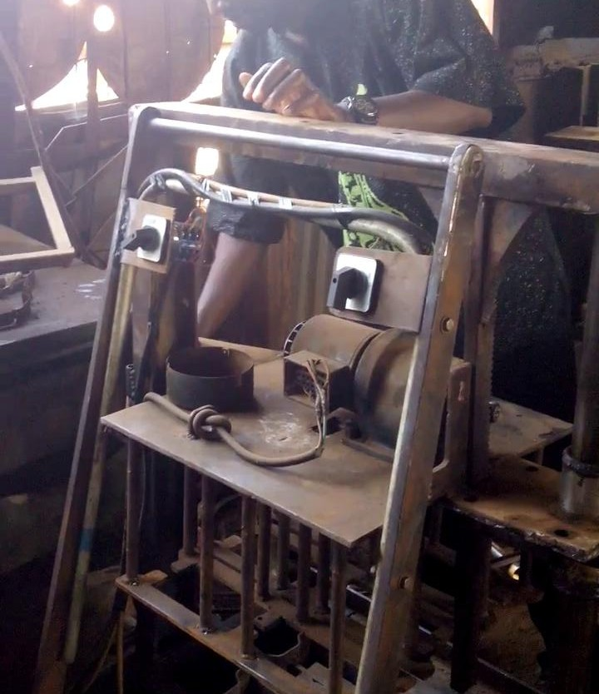

## Plate A1: Early Stage of the Construction Work

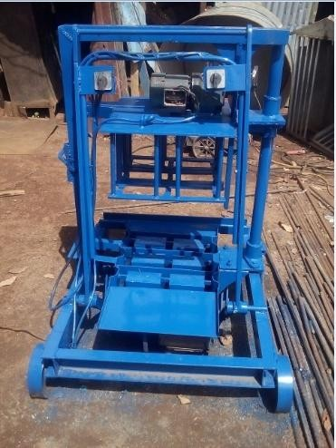

**Plate A2: Constructed Multiple Sandcrete Block Moulding Machine**

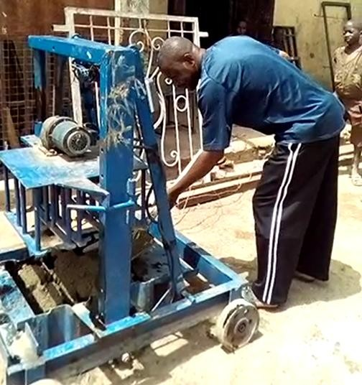

**Plate A3: Testing of Multiple Sandcrete Block Moulding Machine**

## Appendix B Experimental Test-Rigs

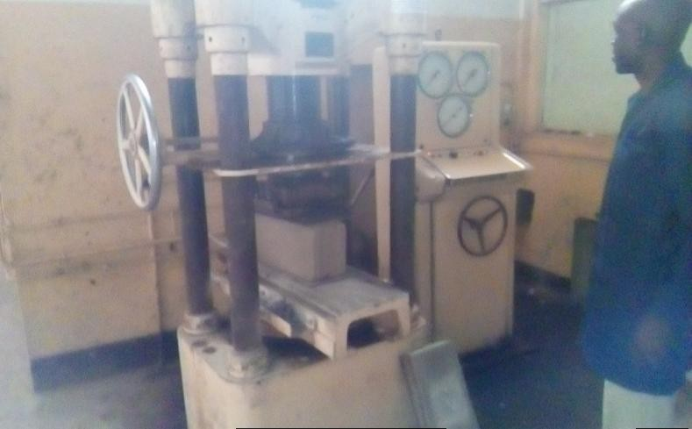

**Plate B1: Compressive Strength Testing Machine (Civil Engineering Department A.B.U Zaria)**

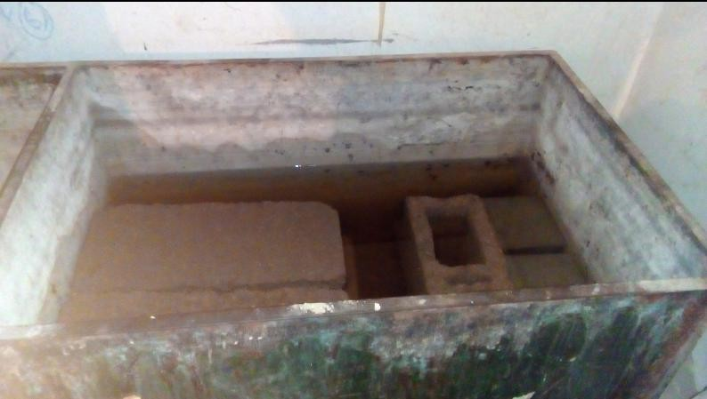

**Plate B2: Water Absorption Test Rig (Civil Engineering Department A.B.U Zaria)**

## Appendix C Test Results

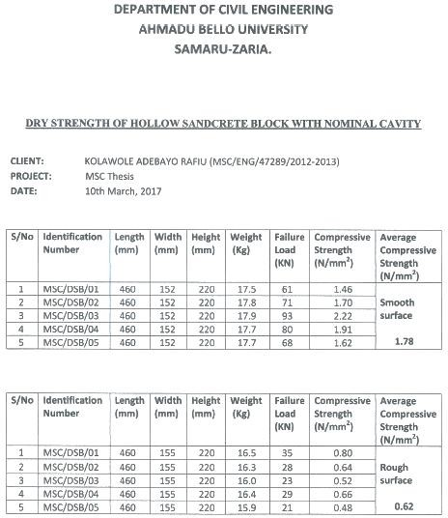

**Plate C1: Compressive test result certificate for both the design machine (MSBMM) and conventional machine (CSBMM)**

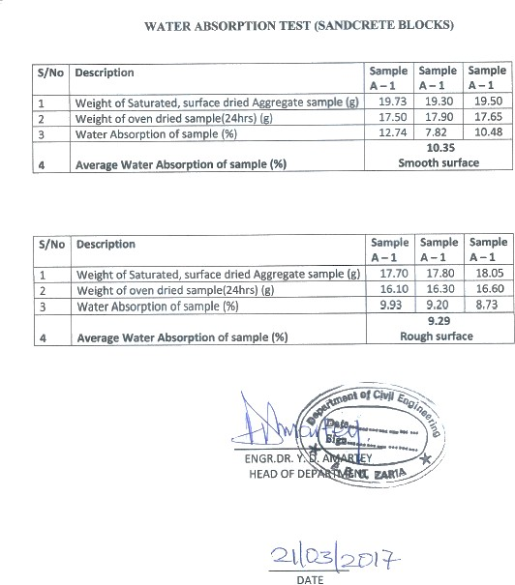

## Plate C2: Water absorption test result certificate for both the design machine (MSBMM) and conventional machine (CSBMM)

Appendix D

Working and Assembly Drawing

