DESIGN, CONSTRUCTION AND TESTING OF AN IMPROVED CASTING POURING LADLE

BY

EMMANUEL STEPHEN

DEPARTMENT OF MECHANICAL ENGINEERING AHMADU BELLO UNIVERSITY,

ZARIA, NIGERIA

DECEMBER, 2017

DESIGN, CONSTRUCTION AND TESTING OF AN IMPROVED CASTING POURING LADLE

BY

Emmanuel STEPHEN, B. ENG., (A.B.U.), 2011 P13EGME8053

A THESIS SUBMITTED TO THE SCHOOL OF POSTGRADUATE STUDIES, AHMADU BELLO UNIVERSITY, ZARIA

IN PARTIAL FULFILLMENT OF THE REQUIREMENTS FOR THE AWARD OF MASTER DEGREE IN MECHANICAL ENGINEERING

DEPARTMENT OF MECHANICAL ENGINEERING, FACULTY OF ENGINEERING

AHMADU BELLO UNIVERSITY, ZARIA, NIGERIA

DECEMBER, 2017

DECLARATION

I declare that the work in this dissertation entitled “Design, Constructionand Testing of anImproved Casting Pouring Ladle”has been carried out by me in the Department of Mechanical Engineering. The information derived from the literature has been duly acknowledged in the text and a list of references provided. No part of this thesis was previously presented for another degree or diploma at this or any other Institution.

Emmanuel Stephen Name of Student Signature Date

CERTIFICATION

This dissertation entitled “Design, Construction and Testing of an Improved Casting Pouring Ladle”by Emmanuel STEPHEN meets the regulations governing the award of the degree of Production Engineering of the Ahmadu Bello University, and is approved for its contribution to knowledge and literally presentation.

Prof. S.A. Yaro

Chairman Supervisory Committee SignatureDate

Prof. M. Dauda

Member, Supervisory Committee Signature Date

Dr. F.O. Anafi

Head of Department Signature Date

Prof.S.Z. Abubakar

Dean, School of Postgraduate Studies Signature Date

DEDICATION

I dedicate this research dissertation to my late brother Late Ijai G. Stephen and to my family (the family of Mr and Mrs. Stephen P.M. Gadzama).

ACKNOWLEDGEMENTS

I give glory and thanks unto God Almighty for the gift of life, privilege and opportunityto complete my studies from Nursery school up to this Postgraduate level.
My profound gratitude goes to my supervisors; Engr. Prof.S.A. Yaroand Engr. Prof.M. Daudafor given me their time, interest, useful suggestions, and constructive criticism. Indeed, they have been the pillars to the success of this dissertation. Also, my appreciation goes to Mr H.Elisha, Mr M.Ebiloma, Mr.J. Dogara, Mr A.Mbaratan, Mr O. Danjuma, Mr M. Dalis, Engr. Prof. D.S. Yawas, Engr.Dr. D.M. Kulla, Engr. Dr. U.Samaila, Engr. K. Laminuetc for their contributions towards the success of this thesis.
Equally, my gratitude goes to the entire staff of the Department of Mechanical Engineering, Ahmadu Bello University, Zaria-Nigeria, especially my lecturers, the Technologists and the Non-academic staff. Also, my appreciation goes to my colleagues for their suggestions and contributions.
I shall forever be grateful to my Head of Department/Coordinator NADDC Zaria Office, Engr. Dr. F.M. Achiv, HOD T&S/ Head Training Committee NADDC Zaria Office, Engr. Dr. L.S. Isah, Engr. Dr. N. Omisanya, Engr. A.N. Ayinde,Engr. O.A. Oyetade, Mr A.T. Ezekiel, MrY.O. Shoyoye, Mr S. Adamu, Mr S.O. Babarinsa, Mr
M.A. Suleiman, Mr O.O. Jolaiya,Mr A. Bawa, Mr. J. Maimolo, Mr S. Ambi, Mal Suleiman, Mr S. Bashir, Mr I. Ishola, Mrs. I. Rejina, Miss. A.C. Juliet, Mr T.T. KyumNomand all the staff of National Automotive Design and Development Council.
I am grateful to God Almighty for the life of my family, my parent, Mr and Mrs Stephen P.M. Gadzama for their immerse contributions, support, love and prayerstowards my success. Also to my brothers Mr. Sunday, Mr. Bulus, Mr. Luka, Mr Ijulu and my sister Miss. Kellu Stephen Gadzama. You are all wonderful and supportive. You are part of my success I life. My gratitude goes to Rev. A.M. Gadzama for his concern and contribution to the success of my research, the Prayer Unit of EYN Church and the entire members of the church for contributing to my success in life.
I want to appreciate Mr Zamani and Mr Danladi of the Dept. of Metallurgical and Material Engineering A.B.U. Zaria, Mal Mu’azu and Mal Aminu of the Dept. of Mechanical Engineering A.B.U. Zaria, Dr.Mumah and Dr. Hassan of Centre for Solid Mineral Research and Development Kaduna Polytechnic. To as many that contributed in one way or the other towards the success of this thesis whose names are not mentioned, am saying a big thank you. May God Almighty richly reward you all.

ABSTRACT

A ladle is a foundry tool or equipment specially designed to pour molten metal into a prepared mould. The pouring rate or consistency is one of the factors that may lead to a defect in a cast. To avoid casting defects (cold shut and misrun) associated with pouring, there is need for the design of a suitable pouring ladle that will reduce the time to be spent in crucible lifting, to pouring the molten metal from the crucible to fill the mould at consistent rate. In this research, a pouring ladlemachine of 50 kg molten Aluminium alloy was successfully designed, constructed and tested. The result of this research showed that the total time spent in lifting the crucible containing molten Aluminium alloy from the furnace to filling the mouldusing the pouring ladle was 53.48 sec while when using the hand-shank ladle was 81.80 sec. The speed of pouring when using the pouring ladle machine and hand-shank ladle were 0.42cm/s, 0.43cm/s respectively.The micrograph of both samples show visible well defined coarse grains. This could be due to the even distribution of the constituents as cooling takes place since no too much time was taken to pour the liquid metal into the mould. The result of the XRF tests shows the presence of the various elements detected in the alloy with their percentages at different energy level with the high percentage of Silicon detected. Thedesigned ladle machinewas able to give casts with no cold shut and misruns cast defects with less time spent and fatigue during pouring.There was time difference of
28.32 sec (34.62 % time saving) and speed difference of 0.01 cm/s (2.33 % speed increase).

TABLE OF CONTENTS
Page

Title Page - - - - - - - - - ii
Declaration - - - - - - - - - iii
Certification - - - - - - - - - iv
Dedication - - - - - - - - - v
Acknowledgements - - - - - - - - vi
Abstract - - - - - - - - - vii
Table of Contents - - - - - - - - viii
List of Figures - - - - - - - - - xii
List of Plates - - - - - - - - - xiii
List of Tables - - - - - - - - - xv
List of Appendices - - - - - - - - xvi
CHAPTER ONE: INTRODUCTION
  - Background of the Study - - - - - - - 1
  - Statement of the Problem - - - - - - - 1
  - The Present Work - - - - - - - - 2
  - Aim and Objectives - - - - - - - 2
  - Significance of the Research - - - - - - 3
  - Justification of the Research - - - - - - 3
  - Scope and Limitations of the Research - - - - - 4
CHAPTER TWO: LITERATURE REVIEW

2.1 Founding or Casting | - - - - - - - | 5
2.2 Advantages of Casting | Process - - - - - - | 5
2.3 Description of Ladle | - - - - - - - | 6
2.4Ladle and their Types | - - - - - - - | 7

    - Hand casting ladle - - - - - - - 7
    - Hand-shank Casting Ladle - - - - - - 7
    - Transfer Ladle - - - - - - - - 7
    - Treatment Ladle - - - - - - - - 8
  - Ladle Pour Design- - - - - - - - 9
    - Lip Pour design - - - - - - - - 9
    - Teapot Spout design - - - - - - - 9
    - Lip-axis Design - - - - - - - - 9
    - Bottom Pour Design - - - - - - - 9
  - Review of Related Past Works - - - - - - 10
  - Knowledge Gap - - - - - - - - 11
CHAPTER THREE: MATERIALS AND METHODS
  - Description of the Pouring Ladle Machine - - - - 12
  - Design Consideration - - - - - - - 14
  - Design Theory and Procedure of the Pouring Ladle and its Components 15
    - Design of the tong gripping system - - - - - 15
    - Design of the lifting/lowering mechanism - - - - 16
    - Design of the tilting mechanism - - - - - 18
    - Design of the railing mechanism - - - - - 19
    - Design of the machine frame - - - - - - 20
    - Factor of safety - - - - - - - - 21
  - Results of Design Calculation - - - - - - 22
    - Tong gripping System - - - - - - - 22
    - Lifting/lowering Mechanism - - - - - - 22
    - Tilting Mechanism - - - - - - - 24
    - Railing Mechanism - - - - - - - 25
    - Machine Frame - - - - - - - - 26
    - Factor of Safety - - - - - - - 26
  - Selection of Materials for the Fabrication and Assembly of the Pouring Ladle 26
    - Tong Gripping System - - - - - - - 27
    - Lifting/lowering Mechanism - - - - - - 27
    - Tilting Mechanism - - - - - - - 28
    - Railing Mechanism - - - - - - - 28
    - Machine Frame - - - - - - - - 28
  - Fabrication and Assembly of the Pouring Ladle - - - - 28
    - Fabrication Process Plan of the Ladle Components - - - 28
    - Assembly of the Ladle Component Parts - - - - 33
    - Principle of Operation of the Ladle - - - - - 33
    - Cost Analysis of the Pouring Ladle - - - - - 34
  - Performance Evaluation/Testing of the Pouring Ladle Machine - - 36
    - Performance Evaluation using Water and Aluminium Alloy Molten Metal 36
    - Determination of the Speed of Pouring - - - - - 38
    - Non-destructive Test - - - - - - - 38
CHAPTER FOUR: RESULTS AND DISCUSSION
4.1 Results - - - - - - - - - 40
    - Result of the Pouring Ladle Machine - - - - - 40
    - Determination of the Speed of Pouring - - - - - 41
    - Non-destructive Test - - - - - - - 42
  - Discussion of Results - - - - - - - 47
    - Result of Performance Evaluation of the Pouring Ladle - - 47
    - Non-destructive Test - - - - - - - 49
CHAPTER FIVE: CONCLUSION AND RECOMMENDATIONS
5.1 Conclusion - - - - - - - - 51
  - Recommendation - - - - - - - - 52
  - Contribution to Knowledge - - - - - - 52
REFERENCES - - - - - - - - 54
APPENDICES - - - - - - - - 56

LIST OF FIGURES

Figures Page

Figure 2.1: Hand-shank casting ladle - - - - - - 7

Figure3.1: Sketch (Orthographic views) of the casting pouring ladle machine 13

Figure 3.2: Schematic diagram of the shaft - - - - - 16

Figure 3.3: Schematic diagram of shafts - - - - - 17

Figure 3.4: Schematic diagram of crank lever arm - - - - 18

Figure 3.5: Schematic diagram of I-beam - - - - - 19

Figure 3.6: Schematic diagram of the plate - - - - - 20

Figure 3.7: Schematic diagram of standing frame - - - - 21

Figure 4.1: Average pouring time for the ladle machine andhand-shank

ladle using water - - - - - - - - 48

Figure 4.2: Average pouring time for ladle machine and hand-shank

ladle using Aluminiumalloy molten metal - - - - - 49

LIST OF PLATES

Plates Page
Plate 2.1: Transfer ladle - - - - - - - 8
Plate 2.2: Treatment ladle - - - - - - - 8
Plate 3.1: Pattern used for the production of mould for the casting - - 37
Plate 3.2a: Sand mould for pouring ladle - - - - - 37
Plate 3.2b: Sand mouldfor hand-shank ladle - - - - - 37
Plate 3.3: Cast sample of improved casting pouring ladle - - - 38
Plate 3.4: Cast sample of hand-shank ladle - - - - - 38
Plate 3.5: Samples for metallography test. Where sample A was from
pouring ladle and sample B from hand-shank ladle - - - - 39
Plate 3.6: Using the metallurgical microscope model NJF-1 for snap
capturing of the samples - - - - - - - 39
Plate 3.7: Samples for metallography test. Where sample A was from
pouring ladle and sample B from hand-shank ladle - - - - 39
Plate 3.8: Using the XRF machine model XL3t 950 for snap capturing

of the samples - - - - - - - | - | 39
Plate 4.1: Cope side of the water jacket cast using ladle machine | - | 42
Plate 4.2: Drag side of the water jacket cast using ladle machine | - | 42
Plate 4.3: Front side of the crank lever cast using ladle machine | - | 43
Plate 4.4: Rear side of the crank lever cast using ladle machine | - | 43
Plate 4.5: Cope side of the bearing cap cast using ladle machine | - | 43
Plate 4.6: Drag side of the bearing cap cast using ladle machine | - | 43
Plate 4.7: Cope side of the water jacket cast using manual hand-shank ladle |  | 43
Plate 4.8: Drag side of the water jacket cast using manual hand-shank ladle |  | 43

Plate 4.9: Front side of the crank lever cast using manual hand-shank ladle 44
Plate 4.10: Rear side of the crank lever cast using manual hand-shank ladle 44
Plate 4.11: Cope side of the bearing cap cast using manual hand-shank ladle 44
Plate 4.12: Drag side of the bearing cap cast using manual hand-shank ladle 44
Plate 4.13a: Micrograph test for sample using pouring ladle machine (X100) 45
Plate 4.13b: Micrograph test for sample using hand-shank ladle (X100) - 45
Plate 4.14: Spectra for cast sample from machine ladle at different energy levels 46
Plate 4.15: Spectra for cast sample from hand-shank ladle at different
energy levels - - - - - - - - - 47

LIST OF TABLES

Tables Page

Table 3.1: Design calculations for the components of the ladle machine - 22

Table 3.2: Material Components for tong gripping system - - - 27

Table 3.3: Material Componentsfor lifting/lowering mechanism - - 27

Table 3.4: Material Componentsfor tilting mechanism - - - 28

Table 3.5: Material Componentsfor railing mechanism - - - 28

Table 3.6: Material Components for machine frame - - - - 28

Table 3.7: Fabrication process plan of the pouring ladle and the

tools/machines used - - - - - - - - 30

Table 3.8: Bill of Materials for the pouring ladle machine - - - 34

Table 3.9: Labour and cost of production of the pouring ladle machine - 36

Table 4.1: Result of Pouring Time for Ladle Machineusing water - - 40

Table 4.2: Result of Pouring Time for Hand-shank Ladle using Water - 40

Table 4.3: Result of Pouring Timefor Ladle Casting Machine using

Aluminnium Alloy - - - - - - - - 41

Table 4.4: Result of Pouring Time for Hand-shank Ladle usingAluminium Alloy 41

LIST OF APPENDICES

Appendices Pages
Appendix A (Drawings of the machine and machine components) - - 56
Appendix B (Fabrication Process and Performance Evaluation of the
Ladle Machine) - - - - - - - 57
Appendix C (Result of XRF Test from Centre for Minerals Research and Development, Kaduna Polytechnic) - - - - - - 58

CHAPTER ONE INTRODUCTION
  - Background of the Study

Metal casting is one of the most widely used techniques for the production of metal parts. It is the process of forming metallic objects by melting metal, pouring it into a shaped cavity called a mould and allowing it to solidify. Heat is absorbed by and transferred through the mould wall during pouring of molten metal in mould cavity (Choudhari et al., 2014).
Pouring of molten metal into a prepared mould is one of the processes involved in the casting process in a foundry. The ladle is the foundry tool or equipment specially designed to pour the molten metal into a prepared mould. This makes the ladle to play a very significant role in the casting process. The pouring process can affect the quality of the casting or cause defect to the cast or fatigue or even injury to the foundry men due the Manual Material Handling (MMH). Some of the factors that can lead to casting defects (such as misruns and cold shut) include; the ladle design or the type of ladle used, the pouring rate or consistency, the shaking or vibration by the foundry men when tilting the casting ladle for pouring process due to tiredness and fatigue and the delay in lifting the crucible from the furnace to pouring of the molten metal into the prepared mould (Konz, 1995).

Statement of the Problem

It is usually desired that a cast product should not have any defect. But defects occur which may be as a result of the many activities that are involved during casting process. The pouring rate or consistency is one of these factors that may lead to a defect in a cast. In order to avoid a defect which may be as a result of pouring of the molten metal from the crucible (casting defect such as cold shut and misrun), there is need for the design of a suitable ladle that will reduce the time to be spent in crucible lifting, to pouring the molten metal from the crucible into the mould at consistent rate.

Manual Material Handling (MMH) is one of the major causes of severe industrial injury (Ciriello, 2005; Dempsey and Hashemi, 1999). It has been estimated that more than a quarter of all injuries related to industrial work are directly associated with MMH activities (Konz, 1995).
Also, fatigue resulting from lifting of the ladle by two or more operators and bending to tilt it to pour the molten metal from the crucible into the mould affect the pouring rate or consistency. To solve these problems, the ladle was designed to assist the operators to lift and lower the crucible and tilt the fork lift for pouring Aluminium alloy molten metal from the crucible into the prepared mould using crank lever mechanism.

The Present Work

The research work was focused on the design, construction and testing of an improved casting pouringladlewhich would be used to lift a crucible containing 50kg molten Aluminium alloy metalfrom acrucible furnace and poured it into a prepared mould at a relatively consistent pouring rate with less fatigue on the operators while pouring the molten metal. The time taken for the pouring and speed of pouring from both the ladle machine and manual hand-shank ladle were computed and compared.

Aim and Objectives

The aim of this research is to design, construct and test an improvedcasting pouring ladle that could be used in a foundry workshop to cast 50 kg liquidAluminium alloy.
The specific objectives are:

    - To carry out the design analysis of the improved casting pouring ladle.

    - To construct the various component parts of the pouring ladle and assemble them.

    - To carry out performance evaluation in determining the pouring time and speed of the ladle.

    - To carry out non-destructive test on the Aluminium alloy casts.

Significance of the Research

To solve the problems associated with pouring process such as misrun and cold shut, the ladle was designed to assist the operators to lift and lower the crucible and tilt the fork lift for pouring the molten metal from the crucible into the prepared mould using crank lever mechanism.
The cost to be incurred in designing a mechanically automated ladle would be reduced to minimum because in this research work, there would be no need for electricity or electric motor, pneumatic or hydraulic system.
The operators involved in the pouring process are reduced to one (1) when using this machine because only one operator would be required to operate the machine instead of two or more operators as in the case of using the manual hand-shank ladle for the pouring process.

Justification of the Research

This research was carried out to design, construct and test an improved casting pouring ladle for Aluminium alloy that would reduce the time delay in lifting and pouring process of casting from a crucible into a mould with less stress and fatigue as in the case of manual hand-shank ladle.
There is need for the pouring to be relatively consistent, because inconsistent pouring may cause turbulence or sudden solidification of the molten metal in the gate. Also, when too much time is spent in between lifting of crucible from the furnace to pouring, the molten metal may start to solidify inside the crucible or when it is poured into the mould. These can cause cold shut or misrun.

Krzystof et al. (2013), stated that one of the most important faults occurring during casting is a misrun, which may be caused both by pouring temperature being too low and insufficient castability of the liquid metal.
The posture and heat from the crucible and molten metal induces stress to the operators when using the hand shank ladle for pouting process. This stress makes the operators’ hands to be shaking while pouring. This makes the pouring not to be consistent, thereby causing a casting defect such as cold shut or misrun.

Scopeand Limitations of the Research

The scope and limitations of this research are:

- To design and construct a casting ladle of 50 kg charge capacity of molten Aluminium alloy metal for use in sand casting only where the metal is melted in crucible pit furnace.
- There would be no use of electric motor or hydraulic cranes in design and construction of the improved casting pouring ladle.
- Only one direction of pouring and so the moulds should be arranged linearly with their sprue basin placed close to the ladle machine.

CHAPTER TWO LITERATURE REVIEW
  - Founding or Casting

Founding or casting produces casts that are close to the final product shape, i.e., ―near-net shape‖components. Castings are produced by pouring molten metal into moulds, with cores used to create hollow internal sections. After the metal has cooled sufficiently, the casting is separated from the mould and undergoes cleaning and finishing techniques as appropriate.
According to Richard et al. (1967), founding or casting may be defined as a metal object obtained by allowing molten metal to solidify in a mould. The shape of the object is being determined by the shape of the mould cavity. Founding or casting is the process of forming metal objects by melting metal and pouring it into moulds. A foundry is a commercial establishment for founding. Practically all metal is initially cast.
According to Baker (1997),Foundry Engineering is one of the earliest methods of manufacturing of products. The history of precision foundry began around 5000 years ago, together with the beginning of the demand for shaped metal products, tools and weapons.
Kalpakjian, (1995) stated that metal casting has always been one of the most important and widely used manufacturing processes. Egyptians used solidification processing to create near net-shaped components 5100 years ago.

Advantages of Casting Process

Certain advantages are inherent in the metal casting process. These may form the basis for choosing casting as a process to be preferred over other metal shaping process in a particular case. Some of the main advantages of the casting process can be given as follows:
- Most intricate shapes both internal and external may be cast.

- Because of their nature, some metals can only be cast since they cannot be shaped by other methods

- Construction may be simplified. A number of separate items in an assembly can sometimes be integrated to be cast as a single piece.
- Highly adaptable to mass production.

- Extremely large, heavy metal objects may be cast that would be difficult and/or economically impossible to produce otherwise.
- Some engineering properties are obtained more favourably in cast metals: in general, a wide range of alloy compositions and properties is produced in cast form, and the properties available are generally isotropic.
- Generally, casting cost low when compared with the other metal forming processes(Derya, 2005).

Description of Ladle

Ladles in the steel plant environment are used with refractory linings to hold the molten metal for casting, temperature control, deoxidation, addition of alloys and inclusion floatation. Ladles are designed to be heat resistant and strong. Moreover, it is also necessary that a ladle be heat insulated. Proper heat insulation is required so that the molten steel contained in the ladle remains at a proper temperature. The ladle is consisting of ladle housing; thermal insulation, lifting sling and mechanical gear mechanism. The ladle structure is multi-layered because of the fact that a ladle should be strong and heat insulated. The inner face of the ladle is built from specialized refractory bricks. These bricks are resistant to high temperature, thus making it possible for the ladle to hold molten steel. Two types of bricks are used to construct the inner surface. One type of brick is used to construct part of the surface that will interact with the liquid steel while the other type of brick is used to construct the surface that will interact with the slag layer above the molten metal (Niraj, 2013).

Ladleand their Types

The basic ladle design includes many variations that improve the usage of the ladle for specific tasks. Ladles can be classified depending upon applications (Niraj, 2013).

Hand casting ladle

The hand ladle is a small ladle which can be handled by a single individual/operator. It is usually used to carry small crucibles for the pouring operation.

Hand-shank (or Bull Ladle) casting ladle

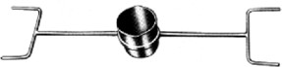
A ladle used to pour molten metal into mould(s) to produce the casting. This type of ladle requires two operators to handle it. The crucible to be carried is usually larger than that to be carried using the hand ladle. (Niraj, 2013). See Figure 2.1.

Figure 2.1: Hand-shank casting ladle (Niraj, 2013)

Transfer Ladle

A ladle used to transfer molten metal from a primary melting furnace to either a holdingfurnace or an auto‐pour unit. For the transportation of very large volumes of molten metal, such as in steel mills, the ladlecan runonwheels, apurpose‐built ladle transfer car or be slung froman overhead crane and will be tilted using a second overhead lifting device (Niraj, 2013). See Plate2.1.

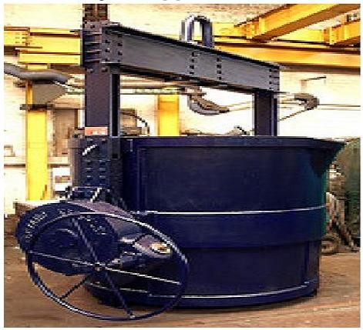

Plate2.1:Transfer ladle (Niraj, 2013)

TreatmentLadle

A ladle used for a process to take place within the ladle i.e. to change some aspect of the molten metal. A typical example is the conversion of cast iron to ductile iron by the addition of various elements into the ladle (Niraj, 2013).Ladles are often designed for special purposes such as adding alloys to the molten metal. Ladles may also have porous plugs inserted into the base, so inert gases can be bubbled through the ladle to enhance alloying or metallic treatment practices. See Plate2.2.
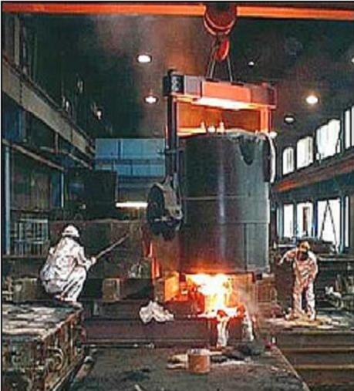

Plate 2.2:Treatment ladle (Niraj, 2013)

Ladle Pour Design

Ladles pour design can be:

Lip Pour Design

For lip pour design, the ladle is tilted and the molten metal pours out of the ladle like water from a pitcher.The molten metal flows or pours from the top of the ladle (Sharma, 2001).

Teapot Spout Design

The teapot spout design, like a teapot, takes liquid from the base of the ladle and pours it out through a lip-pour spout. Any impurities in the molten metal will form on the top of the metal so by taking the metal from the base of the ladle, the impurities are not poured into the mould. The same idea is behind the bottom pour process (Sharma, 2001).

Lip-Axis Design

Lip-axis ladles may also use hydraulic rams to tilt the ladle. The largest ladles are un-geared and are typically poured using a special, two-winch crane, where the main winch carries the ladle while the second winch engages a lug at the bottom of the ladle. Raising the second winch then rotates the ladle on its trunnions. Lip-axis ladles have the pivot point of the vessel as close to the tip of the pouring spout as can be practicable. Therefore, as the ladle is rotated the actual pouring point has very little movement. Lip-axis pouring is often used on molten metal pouring systems where there is a need to automate the process as much as possible and the operator controls the pouring operation at a remote distance (Sharma, 2001).

Bottom Pour Design

For bottom pour ladles, a stopper rod is inserted into a tapping hole in the bottom of the ladle. To pour metal, the stopper is raised vertically to allow the metal to flow out the bottom of the ladle. To stop pouring, the stopper rod is inserted back into the drain hole. Large ladles in the steelmaking industry may use slide gates below the tap-hole (Sharma, 2001).
Medium and large ladles which are suspended from a crane have a bail which holds the ladle on shafts, called trunnions. To tilt the ladle a gearbox is used and this is typically a worm

gear. The gear mechanism may be hand operated with a large wheel or may be operated by an electric motor or pneumatic motor. Powered rotation allows the ladle operator to be moved to a safe distance and control the rotation of the ladle via a pendant or radio remote control. Powered rotation also allows the ladle to have a number of rotation speeds which may be beneficial to the overall casting process. Powered rotation obviously also reduces the effort required by the ladle operator and allows high volumes of molten metal to be transferred and poured for long periods without operator fatigue.

Review of Related Past Works

Ndaliman and Pius (2017), stated that ―Specific casting parameters such as pouring temperatures, rate of pouring, fluidity and composition of metals are of topmost importance for consideration if sound casting is to be achieved.‖ They concluded that the optimum pouring temperature for Aluminium alloy was in the range of 700⁰C and 750⁰C, while the pouring speed ranged between 2.0 cm/s and 2.8 cm/s.
Peter (2001), stated that cold shuts are more serious, the discontinuity extending completely through a casting member in which streams of metal have converged from different directions. A contributing cause to these defects can be an inadequate rate of mould filling relating to the freezing rate of the casting which is a function of pouring temperature and speed. He concluded that slow mould filling may result from low pouring speed and the main rules in pouring are to maintain a smooth and uninterrupted flow of metal for the avoidance of cold shuts.
According to Yoshiyuki and Kazuhiko (2007), casting industry sometimes uses a pouring process in which molten metal is poured from a ladle into a mould by tilting the ladle. Since the process involves high-temperature molten metal, the process creates a dangerous environment for workers. Therefore, an automatic pouring system has recently been exploited to improve the working environment. The pouring process requires that the molten metal is

poured quickly and precisely into the mould and is not spilled over the sprue cup or basin. It was discovered that the proposed control system can improve the accuracy of the flow rate, and enables flow rate control to be designed systematically for the various types of ladles used in casting plants.
Robinson (2012), investigated the effect of runner size, mould temperature and pouring temperature on the mechanical properties of Aluminium alloy part produced through sand casting. He observed that the pouring temperature significantly affect the mechanical properties of sand cast aluminium alloy. Ultimate strength, hardness and elongation increases in pouring temperature.

Knowledge Gap

From the above review, it can be seen that literatures on improved pouring ladle is scarce. Hence, this study is set to fill the gap.

CHAPTER THREE MATERIALS AND METHODS

Description of thePouring Ladle Machine

The ladle machine consisted of the following as shown in Figure 3.1:

Gripping system: The gripping system holds the crucible firmly as it picks the crucible from the crucible pit furnace. As it holds the crucible, it is also flexible so as to allow the crucible to be tilted for pouring. The gripping system consists of the following components; chains, fork lift system, bearing cones, bearing seats.
Lifting/lowering mechanism: This mechanism allows for the lifting of the gripped crucible from the pit furnace and lowering it to the height of the sprue basin of the mould for pouring. The lifting and lowering is controlled manually using the crank lever arm and helical gears which turns a one (1) tonne chain hoist. The components of this system are as follows; lifting/lowering guide angle irons, chain hoist drive mechanism, bearings, helical gear drive system, keys, shafts, lifting/lowering lever crank handle, metal plate, bearing seat.
Tilting mechanism: This mechanism is used for the tilting of the crucible to pour the molten metal from the crucible. The tilting is done by using the crank lever arm and helical gears to turn a shaft and link mechanism which in turn tilts the gripping arm for the pouring. After the pouring, the crank lever could be used to tilt upright the crucible. This mechanism has the following components; tilting lever crank handle, helical gear system, tilting link mechanism, keys, shafts, bearings, bearing seats.
Rail mechanism: The rail mechanism helps the movement/sliding of the gripping system, lifting/lowering and tilting mechanisms from one point to another linearly i.e. from the point of pit furnace position to point of sprue basin position. The movement/sliding could be achieved by moving/sliding a system of bearings on an I-beam. The various components of the rail mechanism are as follows; rail track (I-beam), metal plate, bearings, angle irons to guide the lifting/lowering guide angle irons.

Machine frame: This is the frame that houses the machine. The frame can be moved linearly so as to allow for the pouring of molten metal from the crucible into several moulds arranged linearly. This movement could be done using the bearing sliding into the U-channel beam. The following are the components of the machine frame; standing frame, roof frame, base frame, bearings, U-channel beams, machine concrete floor and walls.
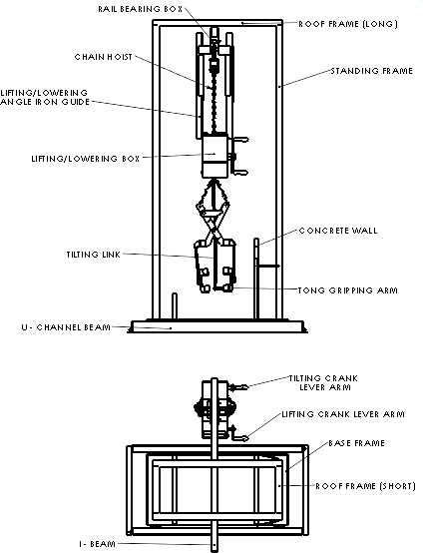

Figure 3.1: Sketch (Orthographic views) of the Casting Pouring Ladle Machine

Design Consideration

The followingfactors are considered in the design of the machine:

    - Specification: The capacity of the machine is for a crucible with 50 kg molten Aluminium alloy. Since the crucible is to hold 50 kg of molten Aluminium alloy, the tong gripping arm was forged to hold/grip the crucible. This accounts for the specification of the pouring ladle to be for 50 kg molten Aluminium alloy charge capacity.
    - Compact design: The machine was designed to be simple and operated manuallyby turning the crank lever armmanually for lifting/lowering and/or for tilting to pour the liquid metal.
    - Mobility: The machine was designed to be mobile (linearly) so that pouring into several moulds can be carried out from a single crucible especially if the crucible charge capacity can accommodate several castings to be produced. The mould should be arranged linearly.
    - Environment: The environment in which the pouring ladle would be used is the foundry. The ladle would be used to pick and hold a hot crucible containing molten Aluminium alloy inside it. Since the pouring ladle machine was not to be slided over an overhead rail and there are sands on the floor, the bearings for the mobility (through sliding) were protected from the sand particles in a U-channel beam.
    - Ergonomics: The pouring ladle was to be used by adults, ergonomics was considered in the design of the ladle especially in the height, crank lever arm, etc. of an average height adult.
    - Safety: Safety was also considered in the design and fabrication of the ladle. The arms of the gripping tong were forged to firmly grip the crucible with some extensions of rods to guard the crucible during pouring. Also, the concrete walls and sand at the floor of the machine base were to protect the operator’s feet/body against any molten

metal splash in case it occurs. Furthermore, sharp edges and corners were avoided to protect the operator against injury.
    - Material selection: The materials used were carefully selected, with their availability, machinability, interchangeability, mechanical properties and thermal properties considered.
    - Cost of design and construction: This accounts for the cost incurred in the design and fabrication of the machine. The costs are material cost, labour cost and cost of maintenance.
    - Maintenance: Maintenance was considered in the design and fabrication of the ladle because most of the components were locally sourced. Some of the components such as bearings, helical gears and their keys can easily be purchased and replaced if worn out. While some components such as shaft, angle iron etc. could be purchased and machined/fabricated to the dimensions and used to replace worn out/failed components. The maintenance of the ladle does not require a special skill or rigorous procedure because applying grease to contact surfaces such as gears and bearings is not difficult to do.

Design Theory and Procedure of the Pouring Ladle and its Components 3.3.1Design of the Tong Gripping System
The gripping system is use for holding firmly the hot crucible and molten metal as it lifts them from the pit furnace up to the point of pouring and after pouring.
3.3.1.1 Design of Shaft Design: This shaft connects the gripping arm and tong system. The shaft was designed to be free to rotate as one end is fixed.

W
x

Figure 3.2: Schematic Diagram of the Shaft

The bending moment M of the shaft is given by(Khurmi and Gupta, 2005 and Rajput, 2013) M = Wx (3.1)

The bending stress σ_{b} is given by

σ_{b} = ^{𝑀}
𝑍

Where the section modulus Z for the shaft is given by Z = ^{𝜋} ^{𝑑}3
32

(3.2)

(3.3)

The shear stress τ on shaft cross section is given by

τ = 𝑃𝑡
𝐴𝑟
The shear strain Ø_{s} is given by Ø_{s} = ^{𝑟}
𝐺

The thermal σ_{th} stress is given by

(3.4)

(3.5)

σ_{th} = α_{te}t_{rf}E (3.6)

Where: W = Weight (N) x = Length of shaft (mm)

d = Diameter of shaft(mm) P_{t} = Tangential force (N)

A_{r} = Resisting Area (mm²) G = Modulus of rigidity (kN/mm²) α_{te} = coefficient of thermal expansion t_{rf} = Rise or fall in temperature (⁰C) E = Young’s Modulus (kN/mm²)

Design of the Lifting/lowering Mechanism

The lifting/lowering mechanism controls the lifting and lowering of the gripped hot crucible from the pit furnace and to the point of pouring quickly without delay.

      - Design of Shaft: The shaft transmits motion from the crank lever to the chain hoist (Shaft 5 and Shaft 7). There are other shafts that don’t transmit motion, but are used to carry load. In such a case, only the maximum bending moment and deflection are computed (Shaft 2 and Shaft 4).
In Figure 3.3a below, the load (W) is applied not at the centre of the shaft. While Figure 3.3b below, the load is applied at the centre of the shaft.
W
L/2
L/2

R1 R₂
W
T
a
b
L
R1 R₂

        - (b)

Figure 3.3: Schematic Diagram of Shafts

The torque T transmitted by shaft is given by (Khurmi and Gupta, 2005 and Rajput, 2013)

T = 𝑟 𝑥 𝐽
𝑟

Maximum bending moment M = ^{𝑊𝐿}
4
(3.7)

(3.8)

Or M = ^{𝑊𝑎𝑏}
𝐿
for a point load that is not at the centre (3.9)

Maximum deflection can be calculated as Y = ^{𝑊𝐿}3
48𝐸𝐼
(3.10)

Or Y = ^{𝑊𝑎}2 𝑏2
3𝐸𝐼
for a point load that is not at the centre (3.11)

Where: J = Polar moment of inertia (mm⁴) r = Radius of the shaft (mm) L = Total length of shaft (mm) W = Load on the shaft (N)
a = Length of shaft from one end (mm) b = Length of shaft from the other end (mm)

      - Design of Crank lever: The crank leverwas used to transmit rotational motion from the operator to the chain hoist to lift or lower the gripped crucible through the gears and shafts.

B L
t

Figure 3.4: Schematic Diagram of Crank Lever Arm

For the design of the crank lever, the maximum bending moment M is given by (Khurmi and Gupta, 2005)

M = 1.25 WL (3.12)

Where the shear modulus for the lever arm Z is given by Z = ^{𝑡} ^{𝐵}2
6

(3.13)

The permissible bending stress σ_{b} is given by

σ_{b} = ^{𝑀}
𝑍

The twisting moment T_{m}= ^{2𝑊𝐿}
3
And the shear stress τ is given by τ = 16 𝑇𝑚
𝜋 𝑑3

(3.16)

(3.14)

(3.15)

Where: W = Weight/load (N) L = Length of crank lever (mm) t = Thickness of lever (Nm) B = Width of lever arm(mm)
d = Diameter of lever arm shaft (mm)

Design of the Tilting Mechanism

The tilting mechanism was design to aid the tilting of the gripped crucible for pouring as well as tilting upright of the same after pouring. The control could be carried out using the crank lever to rotate a set of two helical gears. The shaft of the lever bears the small gear the other

shaft bears the big gear and link mechanism pipe. The other link mechanism pipe was connected freely to the lower part of the gripping arm.
The designs of the components are as follows.

      - Design of Crank lever: The equations for the design of this crank lever is same as those of the lifting/lowering crank lever. i.e. same as equations. 3.12 to 3.16
      - Design of Shaft: The design equations for the design of these shafts are similar to those of lifting/lowering mechanism. i.e. same as equations. 3.7 to 3.11

Design of the Railing Mechanism

The rail mechanism was designed to permit the movement or sliding of the gripping system as well as the lifting/lowering and tilting mechanisms. The rail box housing houses a set of four (4) bearings on four (4) short shafts and a shaft which holds the chain hoist hook.
      - Design of Rail track: The rail track is the I-beam which allows the bearings of rail box
housing to slide freely. The rail track was centralized on the longer roof frame with both ends of the track as over hangs.
W
R₁
R₂
L
Figure 3.5: Schematic Diagram of I-Beam

For the design of the track, the maximum bending moment Mat the fixed end is given by (Rajput, 2013)
M = WL (3.17)

While the maximum deflection Y at the free end is given by

Y = 𝑊𝐿3
3𝐸𝐼

(3.18)

Where: W = Weight/load (N) L = Length of hang over I-beam (mm)

E = Young’s Modulus (kN/mm²) I = Moment of inertia (mm⁴)

Design of Shaft:The shaft was fixed/welded at one end while the other free. The bearing was fixed at the free end. The design of the shaft was same as equations 3.1 to 3.5
      - Design of Metal plate: The metal plate was used for the rail box housing. See Figure 3.6.
P
Figure 3.6: Schematic Diagram of the Plate

The tensile strength σ_{T} is given by (Khurmi and Gupta, 2005)

σ_{T} = ^{𝑃}
𝐴

(3.19)

Where: W = Weight (N) A = Cross sectional Area (mm²)

Design of the Machine frame

The machine frame consisted of the parts which houses the machine. Hollowed pipes and angle irons were used for the machine frame. The hollowed pipe was used for the standing ad roof frame while the angle iron for the base frame. The roof frame carries the rail track while the base frame carries the concrete floor and wall.
      - Design of Standing frame: The hollowed pipe was used for the standing frame which carries the roof frame with other attachment and base frame.

P
Figure 3.7: Schematic Diagram of Standing Frame

The compressive strengthσ_{C}of the frame is given by (Khurmi and Gupta, 2005)

σ_{C} = ^{𝑃}
𝐴
(3.20)

      - Design of Roof frame:The roof frame was welded to the standing frame and the rail track which carries the lifting/lowering mechanism, tilting mechanism and tong gripping system. The theoretical design of the frame is same as equations. 3.8 and3.10.
      - Design of Base frame: The angle iron forms the base frame which carries the concrete floor and wall. The angle irons were welded together to form a rectangular frame and also welded to the bottom of the standing frame. The theoretical design of the frame is same as equations 3.20.

Factor of Safety

The factor of safety (FOS) of the machine can be calculated using the equation (Khurmi and

Gupta, 2005)

FOS = 𝑌𝑖𝑒𝑙𝑑 𝑝𝑜𝑖𝑛𝑡 𝑠𝑡𝑟𝑒𝑠𝑠
𝑤𝑜𝑟𝑘𝑖𝑛𝑔 𝑜𝑟 𝑑𝑒𝑠𝑖𝑔𝑛 𝑠𝑡𝑟𝑒𝑠𝑠

(3.21)

Results of Design Calculations

Table 3.1: Design calculations for the components of the ladle machine

Initial Data | Calculations | Results
W = 392.4 N  x = 10 mm d = 24 mm P_{t} = 392.4 N  G = 80 kN/mm² t_{rf} = 750 ⁰C  E = 200 kN/mm² α = 11.7 x 10⁻⁶  per ⁰C | 3.4.1 Tong gripping system  i. Shaft: Using eqs. 3.1 to 3.6 for the shaft design M = Wx = 392.4 x 0.5 x 10 = 1,962 Nmm  3 3  Z = ^{𝜋} ^{𝑑} = ^{3.142} ^{𝑥} ²⁴ =1,357.1680 mm³  32 32  σ_{b}= ^{𝑀} = ¹⁹⁶² = 1.4457N/mm²  𝑍 1357 .1680  τ = ^{𝑃𝑡} = ^{392.4} = 0.8674N/mm²  𝐴𝑟 3.142 𝑥 122  Ø_{s} = ^{𝑟} = ^{0.8674} = 1.0843 x 10⁻⁵  𝐺 80 𝑥 103  σ_{th} = αt_{rf}E = 11.7 x 10⁻⁶ x 750 x 200 x 10³  = 1.755 kN/mm² | M = 1,962 Nmm  σ_{b} =1.4457N/mm²  τ = 0.8674 N/mm² Ø_{s} = 1.0843 x 10⁻⁵  σ_{th} = 1.755 kN/mm²
W = 3.924 N  d = 17 mm a = 80 mm b = 122 mm  E = 200 kN/mm²  a =50 mm b = 33 mm  d = 15.8 mm  Initial Data | 3.4.2 Lifting/Lowering mechanism  i. Shaft: Using eqs. 3.7 to 3.11 for the shaft design. For shaft 5, torque transmitted is  T = 𝑟 𝑥 𝐽 = 0.0173 𝑥 8199 .6550 = 16.6887 Nmm  𝑟 8.5  M = 𝑊𝑎𝑏 = 3.924 𝑥 80 𝑥 122 = 189.5952 Nmm  𝐿 202  2 2 2 2  Y = 𝑊𝑎 𝑏 = 3.924 𝑥 80 𝑥 122 = 0.1520 mm  3𝐸𝐼 3 𝑥 200 𝑥 103 𝑥 4099 .8275  For shaft 7, the torque, maximum bending moment and deflection is  T = 𝑟 𝑥 𝐽 = 0.005 𝑥 6118 .2644 = 3.8723 Nmm  𝑟 7.9  M = 𝑊𝑎𝑏 = 0.981 𝑥 50 𝑥 33 = 19.5018 Nmm  𝐿 83  2 2 2 2  Y = 𝑊𝑎 𝑏 = 0.981 𝑥 50 𝑥 33 = 0.0015 mm  3𝐸𝐼 3 𝑥 200 𝑥 103 𝑥 3059 .1322 | T = 16.6887 Nmm M = 189.5952Nmm Y = 0.1520 mm  T = 3.8723 Nmm M = 19.5018 Nmm Y = 0.0015 mm  Results

d = 25 mm  d = 21 mm  W = 98.0665 N  (10 kg)  L = 135 mm  d = 17 mm  t = 8 mmm B = 35 mm | Calculations  For shaft 4, the maximum bending moment and deflection is  M = ^{𝑊𝐿}= ⁴⁷⁰ ^{.88} ^{𝑥} ¹⁶³ = 19,188.36 Nmm  4 4  3 3  Y = 𝑊𝐿 = 470 .88 𝑥 163 = 0.0111 mm  48𝐸𝐼 48 𝑥 200 𝑥 103 𝑥 19,174 .7599  For shaft 2, the maximum bending moment and deflection is  M = ^{𝑊𝐿}= ⁶⁷⁶ ^{.89} ^{𝑥} ⁹⁷ = 16,414.5825 Nmm  4 4  3 3  Y = ^{𝑊𝐿} = ⁶⁷⁶ ^{.89} ^{𝑥} ⁹⁷ = 6.7409 mm  48𝐸𝐼 48 𝑥 200 𝑥 103 𝑥 9,546 .5638  ii. Crank lever: for the big (lifting/lowering) crank lever arm,using eqs. 3.12 to 3.16 for the design, the maximum bending moment M of the lever arm is  M_{max} = 1.25 WL= 1.25 x 98.0665 x 135  = 16,548.7219 Nmm  The shear modulus for the lever arm Z is given by  2 2  Z = ^{𝑡} ^{𝐵} = ⁸ ^{𝑥} ³⁵ = 1,633.3333 mm³  6 6  The permissible bending stress σ_{b}  σ_{b} = ^{𝑀} = ¹⁶⁵⁴⁸ ^{.7219} = 10.1319 N/mm²  𝑍 1633 .3333  The twisting moment  Tm = 2𝑊𝐿= 2 𝑥 98.0665 𝑥 135 = 8,825.985 Nmm  3 3  and the shear stress τ is  τ = 16 𝑇𝑚 = 16 𝑥 8825 .985 = 9.1493 N/mm2  𝜋 𝑑3 3.142 𝑥 173 | M = 19,188.36  Nmm  Y = 0.0111 mm  M = 16,414.5825  Nmm  Y = 6.7409 mm  M_{max} = 16,548.7219  Nmm  σ_{b} = 10.1319  N/mm²  τ = 9.1493 N/mm²

Initial Data  W = 98.0665 N  (10 kg)  L = 106 mm  d = 15.8 mm  t = 8 mmm B = 35 mm  d = 15.8 mm a = 132 mm b = 67 mm L = 199 mm  E = 200 kN/mm² | Calculations  3.4.3 Tilting Mechanism  - Crank lever: for the design of the small (tilting) crank lever arm, using eqs. 3.12 to 3.16, the maximum bending moment M of the lever arm is  M_{max} = 1.25 WL= 1.25 x 98.0665 x 106  = 12,993.8113 Nmm  The shear modulus for the lever arm Z is given by  2 2  Z = ^{𝑡} ^{𝐵} = ⁸ ^{𝑥} ³⁵ = 1,633.3333 mm³  6 6  The permissible bending stress σ_{b}  σ_{b} = ^{𝑀} = ¹²⁹⁹³ ^{.8113} = 7.9554 N/mm²  𝑍 1633 .3333  The twisting moment  T_{m} = ^{2𝑊𝐿} = ² ^{𝑥} ^{98.0665} ^{𝑥} ¹⁰⁶ = 6,930.0327 Nmm  3 3  and the shear stress τ is  τ = 16 𝑇𝑚 = 16 𝑥 6930 .0327 = 8.9482 N/mm2  𝜋 𝑑3 3.142 𝑥 15.83  - Shaft: Same as eqs. 3.7 to 3.11 for shaft 8, torque transmitted is  T = 𝑟 𝑥 𝐽 = 0.0050 𝑥 6118 .2644 = 3.8723 Nmm  𝑟 7.9  M = 𝑊𝑎𝑏 = 0.981 𝑥 132 𝑥 67 = 43.5978 Nmm  𝐿 199  Y = 𝑊𝑎 2 𝑏2 = 0.981 𝑥 1322 𝑥 672 = 0.0418 mm  3𝐸𝐼 3 𝑥 200 𝑥 103 𝑥 3059 .1322  For shaft 9, the torque, maximum bending moment and deflection is | Results  M_{max} = 12.9938  kNmm  σ_{b} = 7.9554 N/mm²  τ = 8.9482 N/mm²  T =3.8723 Nmm M = 43.5978 Nmm Y = 0.0418 mm

Initial Data  W = 3.924 N  d = 17 mm a = 132 mm b = 67 mm L = 178 mm | Calculations  T = 𝑟 𝑥 𝐽 = 0.0173 𝑥 8199 .6550 = 16.6887 Nmm  𝑟 8.5  M = 𝑊𝑎𝑏 = 3.924 𝑥 132 𝑥 67 = 194.9655 Nmm  𝐿 178  2 2 2 2  Y = 𝑊𝑎 𝑏 = 3.924 𝑥 132 𝑥 67 = 0.1248 mm  3𝐸𝐼 3 𝑥 200 𝑥 103 𝑥 4099 .8275 | Results  T =16.6887 Nmm  M = 194.9655  Nmm  Y = 0.1248 mm
W = 686.7 N L₁ = 550 mm L₂ = 250 mm  E = 200 kN/mm²  W = 676.89 N  x = 15 mm d = 25 mm P_{t} = W  G = 80 kN/mm²  P = 678.852 N L = 185 mm  b = 5 mm | 3.4.4 Rail Mechanism  - Rail track: Using eqs. 3.17 to 3.18,  M_{max1} = WL₁= 686.7 x 550 = 377,685 Nmm M_{max2} = WL₂ = 686.7 x 250 = 171,675 Nmm  3 3  Y₁ = ^{𝑊𝐿1} = ^{686.7} ^{𝑥} ⁵⁵⁰ = 0.0208 mm  48𝐸𝐼 48 𝑥 200 𝑥 103 𝑥 571850 .6667  Y = ^{𝑊𝐿}3 = ^{686.7} ^{𝑥} ²⁵⁰3 = 0.0020 mm  1  2 48𝐸𝐼 48 𝑥 200 𝑥 103 𝑥 571850 .6667  - Shaft: using eqs. 3.1 to 3.5  The bending moment M of the shaft is  M = Wx = 676.89 x 0.25 x 15 = 2538.3375 Nmm  Using eq. 3.3 and 3.2, the bending stress σ_{b} is given by  Z = ^{𝜋} ^{𝑑}3 = ^{3.142} ^{𝑥} ²⁵3 = 1,533.9808 mm³  32 32  σ_{b}= ^{𝑀} = ²⁵³⁸ ^{.3375} = 1.6547 N/mm²  𝑍 1,533 .9808  τ = ^{𝑃𝑡} = ⁶⁷⁶ ^{.89} = 0.7455 N/mm²  𝐴𝑟 4 𝑥 3.142 𝑥 8.52  the shear strain is  Ø_{s} = ^{𝑟} = ^{0.7455} = 9.3188 x 10⁻⁶ N/mm²  𝐺 80 𝑥 103  - Metal plate: Using eq. 3.53, the tensile strength σ_{T} is  σ_{T} = ^{𝑃} = ⁶⁷⁸ ^{.852} = 0.3669 N/mm²  𝐴 2 𝑥 185 𝑥 5 | M_{max1} = 377,685  Nmm  M_{max2} =171,675  Nmm  Y₁ =0.0208 mm  Y₂ =0.0020 mm  M = 2,538.3375  Nmm  σ_{b}= 1.6547 N/mm²  τ = 0.7455 N/mm²  σ_{T} =0.3669 N/mm²

Initial Data  D = Ø48 mm  d = Ø41 mm  P = 1,196.82 N  W = 735.75 N L = 920 mm  E = 200 kN/mm²  l = 992mm b = 492 mm  P = 402.21N | Calculations  3.4.5 Machine frame  - Standing frame: Using eq. 3.39, the compressive strength σ_{C} is  σ_{C} = ^{𝑃} = ¹¹⁹⁶ ^{.82} = 0.6115 N/mm²  𝐴 4 𝑥 3.142 𝑥 (242 − 20.52 )  - Roof frame: Using eqs. 3.8 and 3.10, the maximum bending moment M_{max} is  Mmax = 𝑊𝐿 = 735 .75 𝑥0.5 𝑥 920 = 84,611.25 Nmm  4 4  Maximum deflection  3 3  Y = 𝑊𝐿 = 735 .75 𝑥 0.5 920 = 0.2449 mm  48𝐸𝐼 48 𝑥 200 𝑥 103 𝑥 121867 .0423  - Base frame: Using eq. 3.9  σ_{C} = ^{𝑃} = ⁴⁰² ^{.21} = 8.2409 x 10⁻⁴ N/mm²  𝐴 992 𝑥 492 | Results  σ_{C} =0.6115 N/mm²  M_{max} =84,611.25  Nmm  Y = 0.2449 mm  σ_{C} =8.2409 x 10⁻⁴  N/mm²
σ_{y} = 2.5299N/mm²  σ_{w} =  1.4457N/mm² | 3.4.6 Factor of safety of the machine  FOS = 𝑌𝑖𝑒𝑙𝑑 𝑝𝑜𝑖𝑛𝑡 𝑠𝑡𝑟𝑒𝑠𝑠 = 2.5299 ≈ 2  𝑤𝑜𝑟𝑘𝑖𝑛𝑔 𝑜𝑟 𝑑𝑒𝑠𝑖𝑔𝑛 𝑠𝑡𝑟𝑒𝑠𝑠 1.4457 | FOS = 2

Selection of Materials for the Fabrication and Assembly of the Pouring Ladle Machine
The choice of materials was carefully considered since the machine would be used to cast molten Aluminium metal. Most or majority of the component parts (hollowed pipe, metal plate, bar, rod, U-channel beam, I-beam, angle iron)were purchased at the ―Yan karfe‖ market in Zaria, chain hoist (1 tonne) was purchased at Kakuri market, cement, stones and

helical gears at Samaru and bearing at Tudun wada Zaria. Below are tables (Table 3.2 to Table 3.6) listing the various components of the machine.

The Tong Gripping System

Table 3.2: Materialcomponents of tong gripping system

 | S/N | COMPONENT | MATERIAL | DESCRIPTION
 | 1 | Chains | Mild steel | Standard component
 | 2 | Fork lift | Mild steel | Mild steel bar, purchased and fabricated
 | 3 | Bearing inner cone | Stainless steel | Standard component
 | 4 | Bearing seat | Mild steel | Mild steel pipe, purchased and  fabricated

The Lifting/lowering Mechanism

Table 3.3: Material componentsof lifting/lowering mechanism

S/N | COMPONENT | MATERIAL | DESCRIPTION
1 | Lifting/lowering  guide angle irons | Mild steel | Mild steel angle iron, purchased  and fabricated
2 | Chain hoist | Mild Steel | Standard
3 | Bearings | Stainless steel | Standard
4 | Helical gear system | Medium carbon steel | Standard
5 | Keys | Mild steel | Standard
6 | Shafts | Mild steel | Mild steel rod, purchased and  fabricated
7 | Lifting/lowering  crank lever | Aluminium alloy | Cast
8 | Metal plate | Mild steel | Mild steel plate, purchased and  fabricated
9 | Bearing seat | Mild steel | Mild steel pipe, purchased and  fabricated

The Tilting Mechanism

Table 3.4: Material componentsof tilting mechanism

 | S/N | COMPONENT | MATERIAL | DESCRIPTION
 | 1 | Tilting crank lever | Aluminium alloy | Cast
 | 2 | Helical gear system | Medium carbon steel | Standard
 | 3 | Tilting link mechanism | Mild steel | Mild steel pipe, purchased and  fabricated
 | 4 | Keys | Mild steel | standard
 | 5 | Shafts | Mild steel | Mild steel rod, purchased and fabricated

The Railing Mechanism

Table 3.5: Material componentsof railing mechanism

 | S/N | COMPONENT | MATERIAL | DESCRIPTION
 | 1 | Rail track (I-beam) | Mild steel | Mild steel I-beam, purchased and fabricated
 | 2 | Metal plate | Mild steel | Mild steel plate, purchased and fabricated
 | 3 | Bearings | Stainless steel | Standard
 | 4 | Angle iron | Mild steel | Mild steel angle iron, purchased and fabricated

Machine Frame

Table 3.6: Material components of machine frame

 | S/N | COMPONENT | MATERIAL | DESCRIPTION
 | 1 | Standing frame | Mild steel | Mild steel pipe, purchased and  fabricated
 | 2 | Roof frame | Mild steel | Mild steel pipe, purchased and  fabricated
 | 3 | Base frame | Mild steel | Mild steel angle iron, purchased  and fabricated
 | 4 | Bearings | Stainless steel | Standard
 | 5 | U-channel beam | Mild steel | Mild steel U-channel beam,  purchased and fabricated
 | 6 | Machine concrete  floor | Metal rods, cement, sand,  gravels and water | Cast

Fabricationand Assembly of the Pouring Ladle

FabricationProcess Plan of the Ladle Components

Some components of the pouring ladle machine were purchased from the market and used directly such as helical gears and keys, bearing etc. while others such as angle iron, hollowed pipe, metal plate, bar, rod, etc. were fabricated based from the design calculation in Table 3.1. These machines and tools used for the fabrication are from the National Automotive Design and Development Council (NADDC) Zaria and are listed below.
      - Electric arc welding machine

      - Hand hacksaw

      - Lathe machine (Model: TOS Trencin SN. 32, SCH: 307982823)

      - Horizontal Milling machine (Model: FA3B, No. 332000666)

      - Vertical drilling machine (Model: Boxford Model No. CF18)

      - Hand grinding/cutting machine

      - Forging tools (anvil and hammer)

      - Vices and clamps

      - Weighing scales to measure the weight of crucible, Aluminium allot scraps, some components of the ladle

The fabrication process plan of the pouring ladle is as shown in Table 3.7 below.

Table 3.7: Fabrication process plan of the pouringladle and the tools/machines used

S/N | Component | Description | Tools/Machines
1 | Tong guide  Tong gripping system  Gripping arm | - Cut 2 pieces of metal plates and flat bar. Drill one end of the plates and weld the flat in between the plates for M12 bolt and nut (Appendix A, Drawing No. 7).  - Cut flat bars, forge and weld to form the  ―X‖ shape gripping tong. Cut and weld the inner bearing seat to the lower end of the gripping tong. Fix the bearing cone inside the bearing seat. Drill holes on the upper end and weld chain to the holes. Fasten bolt and nut to hinge the two halves of the bars (Appendix A, Drawing No. 7). Weld chains to the upper part of the gripping tong and also weld a hook to the free end of the chains. Attach the hook to the shaft 4 on the gear box housing.  - Cut flat bars (8 pcs), forge and weld to another flat bar to form an ―H‖ shaped gripping arm. On the middle of the flat bar, weld a shaft to enter the inner bearing cone. Cut and weld a rod on one flat bar of the lower arm which will link with the tilting link pipe (Appendix A, Drawing No. 6.  i.e right and left part of tong gripping arm) | Hand cutting machine, Hack saw, Forging hammer, Anvil, Charcoal furnace, Lathe machine, Electric arc welding machine, Vice and Clamps, Hand files
2 | Lifting/ lowering box | - Cut metal plates (2 similar pcs and a dissimilar piece), cut and weld two pcs ofgalvanized pipe on one side of the similar plate. While on the other plate, drill a hole to allow the welded bolt on the other end to pass through. Cut, machine and weld bearing seatson the inner sides of the plates. Drill holes on the plates. Cut, machine  and weld one end of shaft 2 and 3and 4 on one side | Hand cutting machine, Hack saw, Lathe machine, Milling machine, Electric arc welding machine, Vice and Clamps,

S/N | Component  Lifting/lowe ring crank  lever and shaft | of the similar plate (Appendix A, Drawing No. 5, 6, and 7).  - Cut 2 pcs of angle irons (730 mm) and weld to the outside part of the similar plates. Cut and weld  Description  3pipes on one side of the middle plate (the dissimilar plate) and a shaft on the opposite side of the plate. Drill Ø30 mm hole to allow for the shaft 7 to pass through. Weld bearing seat on one side of the plate (Appendix A, Drawing No. 5).  - Cut and machine shaft 5, weld key slot (Appendix A, Drawing No. 5 and 7)for bigger gear on the shaft. Cast lever crank handle with Aluminium alloy metal using sand casting method (Appendix A, Drawing No. 7). Fasten the lever crank handle firmly to the shaft 5 using the bolt and nut. Fix the big gear to the shaft.  - Cut and machine shafts 6 and 7. Drill hole on shaft 7. Weld key slot for bigger gear on shaft 6. Machine key ways on both shafts.Fix both bigger and smaller gears and keys on shaft 6 while a smaller gear on shaft 7 (Appendix A, Drawing No. 7). | Hand files  Tools/Machines
3 | Tilting link  Tilting crank lever and | - Cut and machine shaft 9. Cut and weld pipe  (pipe has both ends flattened and a hole drilled). Weld one of the pipes (short) to the shaft and the key slot for bigger gear on the shaft. Fix the bigger sear on the shaft. Fasten the two pipes (liking pipes) using an M10 bolt and nut. Attached the free end of the linking pipe to the rod at the base arm of the tong gripping arm (Appendix A, Drawing No. 6).  - Cut and machine shaft 8and weld a bolt on  one end. Machine key way on the shaft. Fix a small | Hand cutting machine, Hack saw, Lathe machine, Milling machine, Electric arc welding machine, Vice and Clamps, Hand files

 | shaft | helical gear and key to the shaft. Fix the small cast crank handleusing the bolt and nut (Appendix A, Drawing No. 6).
S/N  4 | Component  I-beam | Description  - Cut I-beam and weld to the roof frame of the | Tools/Machines  Hand cutting
 | frame | machine frame (Appendix A, Drawing No. 4).  - Cut 2 pcs of metal plates, pipes (2 pcs) and | machine, Hack  saw, Lathe
 | Rail box | shafts (4 similar pcs) and shaft 1. Weld the shafts | machine, Milling
 | (left and | and galvanized pipe on one side of one of the metal | machine, Electric
 | right part of | plate. Drill holes on the other plate (Appendix A, | arc welding
 | rail box) | Drawing No. 4).  - Cut smaller metal plates (4 pcs), shafts (2 | machine, Vice  and Clamps,
 |  | pcs) and angle irons (4 pcs). Weld a shaft on one | Hand files
 |  | side of a plate whiles the other side, weld two angle
 |  | irons. On the other plate weld two angle irons on
 |  | one side.Weld these plates to the other sides (outer
 |  | side) of the left and right metal plates above
(Appendix A, Drawing No. 4)
- Attached/hook the chains hoist hook (from
 |  | the lifting/lowering gear box housing) on shaft 1.

5 | Standing and roof frame  Base frame  U-channel base frame | - Cut 4 pcs of hollowed pipe to a length of  2140 mm and weld to other pipes i.e. long and short roof bar to form a frame (Appendix A, Drawing No. 3).  - Cut and weld 4 pcs of angle iron i.e. 2 long and 2 short to form a base frame. Weld to the lower end of the standing frame. Cast a concrete floor and walls on the base frame (Appendix A, Drawing No. 3)  - Cut U-channel beams (2 pcs) and angle irons (2 pcs). Weld them together to form a base frame so that the bearing on the standing frame can easily slide in the U-groove. Also weld an M10 bolt at the free end of the angle iron welded to the U-  channel beam (Appendix A, Drawing No. 3). | Hand cutting machine, Hack saw, Forging  tools, Lathe machine, Milling machine, Electric arc welding machine, Vice and Clamps,  Hand files, Shovel, Weighing scale,

Assembly of the Ladle Component Parts

The various components were assembled together to form the ladle machine. Some parts of the machine are welded for permanent joint while other parts were temporary joined using bolts and nuts so as to allow for interchangeability. The bearings for the sliding movement of the ladle at the base frame were fixed to the shafts. The bearings were the guided into the U- channel beams then screwed using bolts and nuts.
The rail box was fixed at the I-beam with the bearing freely rolling along the beam. The lifting/lowering box was then coupled and fixed to the angle iron guide of the rail box. This was to aligned and allow for the movement of the lifting/lowering system up and down. The tong gripping and tilting mechanisms were coupled together and attached to the lifting/lowering box. The hook was to hang on the shaft attached at the base of the lifting/lowering box while the tilting link was connected to the other link rod using a bolt and nut joint.

Principle of Operation of the Ladle

The machine was designed to be mobile through the use of the bearings to slide to the linearly array prepared moulds. The rail mechanism can be slide to one side (e.g. right) to ensure that the gripping tong is aligned to the crucible in the furnace. The lifting/lowering mechanism would be used to lower the gripping tong to make contact in form of gripping the crucible. The tong would grip the crucible using the weight of the crucible and liquid Aluminiumas the lifting/lowering mechanism is lifted up from the furnace. The rail system would be used to slide the crucible to the other side (e.g. left) or middle of the machine frame. The machine would then be slide to the location of the prepared mould for pouring by using the lifting/lowering mechanism to lift or lower the crucible to the height of the pouring sprue basin and then tilt the crucible so that the molten metal will flow or pour into the mould. After pouring, the crucible would be tilted back to upright position lowered and dropped by releasing the gripping tong and placed to a suitable location (safe place) as desired.

Cost Analysis of the Pouring Ladle

The cost analysis or Bill of Engineering Measurement and Evaluation of the pouring ladle machine was based on the material, labour and overhead cost. The material cost comprises of the cost incurred to purchase the material from the market (see Table 3.8). The labour cost comprises of the cost incurred in cutting, machining and welding of the machine parts to form the machine. The overhead cost comprises of the cost of transportation and other miscellaneous during the process of fabrication of the machine. Tables 3.9 shows the cost evaluation of the pouring ladle machine
Table 3.8: Bill of Materials for the pouring ladle machine

S/N | Component | Material | Dimensions | Quantity | Unit Cost(₦) | Total (₦)
1 | Hollowed pipe | Mild steel | 5,486.4 mm length, outside diameter of Ø48 mm and inner  diameter of Ø41 mm | 2 | 4,750 | 9,500

2 | Plate | Mild steel | 1,830 mm x 610 mm  x 5 mm | 1 | 2,000 | 2,000
3 | Shaft | Mild steel | 500 mm x Ø28 mm | 1 | 200 | 200
 |  |  | 1000 mm x Ø25 mm | 1 | 500 | 500
 |  |  | 1100 mm x Ø21 mm | 1 | 600 | 600
4 | Concrete rod | Mild steel | 1,000 mm x Ø8 mm | 7 | 100 | 700
5 | Quarter rod | Mild steel | 500 mm x Ø5 mm | 1 | 150 | 150
6 | I-beam | Mild steel | 1300 mm x 76 mm x  45 mm | 1 | 1,200 | 1,200
7 | U-Channel beam | Mild steel | 48 mm x 80 mm x 5  mm of 2400 mm length | 1 | 3,000 | 3,000
8 | Flat bar | Mild steel | 3210 mm x 40 x 10  mm | 1 | 2,000 | 2,000
9 | Angle iron | Mild steel | 40 mmx 40 mm x 4  mm of 1200 mm length | 4 | 250 | 1,000
 |  |  | 38 mm x 38 mm x 2 mm of 3,200 mm  length | 2 | 350 | 700
10  S/N | Pipe  Component | Mild steel  Material | Ø21 mm and Ø17 mm outside and inner diameter x 800  mm length | 1 | 50 | 50
 |  |  | Dimensions  Ø16 mm and Ø12 mm outside and inner diameter x 810  mm length | Quantity  2 | Unit Cost (₦)  125 | Total (₦)  250
11 | Electrode | E6038 | Gauge 10 | 1 packet | 1,600 | 1,600
12 | Cutting disc | Abrasive  materials | 125 x 1.2 x 22.2 mm | 2 | 650 | 1,300
13 | Grinding disc | Abrasive  materials | Standard | 2 | 300 | 600
14 | Hack saw blade | High carbon  steel | 12 inches | 3 | 300 | 900
15 | Bearing | High carbon steel | Ø68 mm, Ø26 mm outside and inner diameter x 18 mm  length | 4 | 300 | 1,200
 |  |  | Ø52 mm, Ø25 mm outside and inner diameter x 15 mm  length | 4 | 100 | 400

 |  |  |  |  | Ø35 mm, Ø17 |  | mm | 11 | 200 | 2,200
 |  |  |  |  | outside and |  | inner
 |  |  |  |  | diameter x 10 |  | mm
 |  |  |  |  | length
 |  |  |  |  | Ø32 mm, Ø15 |  | mm | 2 | 100 | 200
 |  |  |  |  | outside and |  | inner
 |  |  |  |  | diameter x 9 |  | mm
 |  |  |  |  | length
16 |  | Chain hoist |  | Nil | 1 tonne |  |  | 1 | 4,500 | 4,500
17 |  | Helical Gears |  | Mild steel | Nil |  |  | 3 each | 350 | 1,050
 |  | and keys
18 |  | Crank | lever | Aluminium | 162 | mm length | x 8 | 2 | 300 | 600
 |  | handle |  | alloy | mm | thickness | and
 |  |  |  |  | 132 | mm length | x 8
 |  |  |  |  | mm thickness
 | 19 | Bolts and two |  | Medium | M8 |  |  | 1 | 30 | 30
 |  | nuts |  | carbon | M10 |  |  | 11 | 30 | 330
 |  |  |  | steel | M12 |  |  | 1 | 100 | 100
 | 20 | Washers |  | Medium | Ø39.5 mm, Ø21 mm |  |  | 3 | 30 | 90
 |  |  |  | carbon | x 2.5 mm
 |  |  |  | steel | Ø30 mm, Ø12.5 mm |  |  | 4 | 15 | 60
 |  |  |  |  | x 2.5 mm
 |  |  |  |  | Ø24 mm, Ø10.5 mm |  |  | 2 | 10 | 20
 |  |  |  |  | x 2.5 mm
 | S/N | Component |  | Material | Dimensions |  |  | Quantity | Unit Cost (₦) | Total (₦)
 | 21 | Greece |  | Standard | 200 g |  |  | 1 | 300 | 300
 | 22 | Stones |  | Rock | Sieve size of 9.5  mm² opening |  |  | ½ bag | 700 | 300
 | 23 | Cement |  | Lime stone | 11.55 kg |  |  | 11.55 kg | 150 | 450
 | 24 | Austine oil |  | Nil | 4 kg |  |  | 10 kg | 1,600 | 800
 |  | Paint
 | 25 | Paint brush |  | Nil | Medium |  |  | 1 | 60 | 60
 |  | Total Cost |  |  |  |  |  |  |  | 38,940

Table 3.9: Labour and cost of production of the pouring ladle machine

S/N | Item | Total Cost (₦)
1 | Cost of materials | 38,940.00
2 | Cost of labour (cutting of metal, machining, welding and  fabrication etc.) | 25,000.00
3 | Cost of transportation and other miscellaneous | 3,000.00
 | Grand Total Cost | 66,940.00

Performance Evaluation/Testing of the Pouring Ladle Machine

Performance evaluation using water and Aluminium alloy molten metal

The machine was tested using water inside the crucible and poured into a five (5) L―Jerry can‖ through a funnel. This was carried out to first of all see how the pouring ladle machine would perform before using it for the casting of the Aluminium alloy metal. The time taken for the lifting and pouring using water was taken and recorded using both ladle machine and hand-shank ladle (see Plate V and VI, Appendix B).
Water and Aluminium were used to evaluate the ladle machine because Yoshiyuki and Kazuhiko (2007), verified the effectiveness of a proposed control system, which was applied to an automatic pouring system and was tested experimentally using both water and molten metal. Also,Aluminium flows like water and the ladle machine was designed to cast Aluminium metal.
Since the ladle machine’s performance was as desired, the machine was then used to cast the Aluminium alloy metal. The total time taken to lift the crucible from the furnace to filling the mould with the liquid Aluminium alloy metal was noted by a stop watch and recorded. The same was carried out for the manual hand-shank ladle.
The moulds for the Aluminium alloy casting were made from water jacket and bearing cap of a 4-stroke 800cc engine block, crank lever and a pipe pattern. The sand mould was used in this research because it is cheaper,most common and available at the foundry.
One of the most versatile methods is sand casting. Virtually any pattern can be pressed into a fine sand mixture to form a mould into which the aluminium could be poured. This is by far thehighest productivity of any casting process, and highly economical. Variants of the processare also suitable for small quantities, intricate designs and one-off and large castings (Derya, 2005).
The casting was carried out at NADDC foundry shop. See Plate 3.1 for the pattern used and Plate 3.2a and 3.2b for the moulds used for the ladle machine and manual hand-shank ladle.

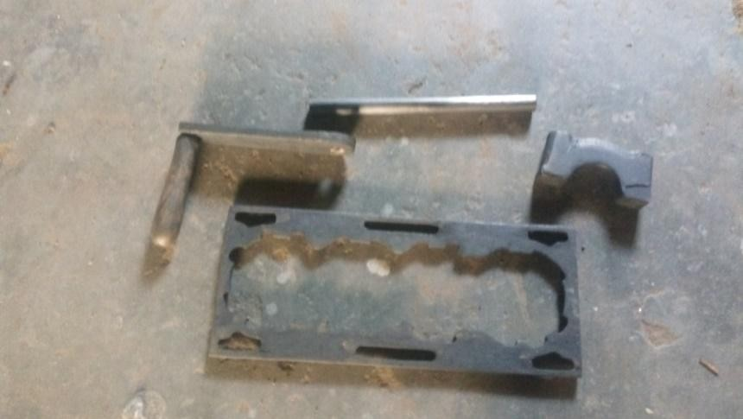Bearing cap
Hollowed
pipe
Crank
lever arm

Water jacket

Plate 3.1: Patterns used for the production of mould for the casting
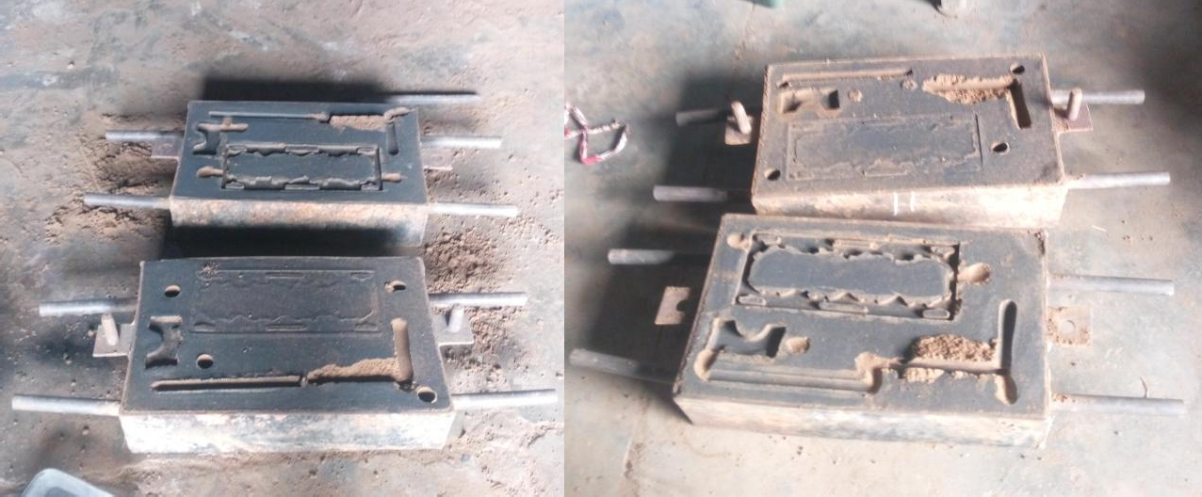
Plate 3.2a:Sand mould for pouring ladlePlate 3.2b: Sand mould for hand-shank ladle

Determination of the speed of pouring

The speed of pouring of Aluminium alloy molten metal using the ladle machine and manual

hand-shank were calculated using the equation (Ndaliman and Pius, 2007)

V = ^{𝐻}
𝑇𝑝

3.22

Where: H = Height from crucible to sprue basin (cm) T_{p} = Time taken for pouring (sec)

Non-destructive Test

      - Visual inspection of the cast

Two cast samples produced using the pouring ladle machine and hand-shank ladle pouringwere visually inspected to check for misrun, cold shot and other casting defects.

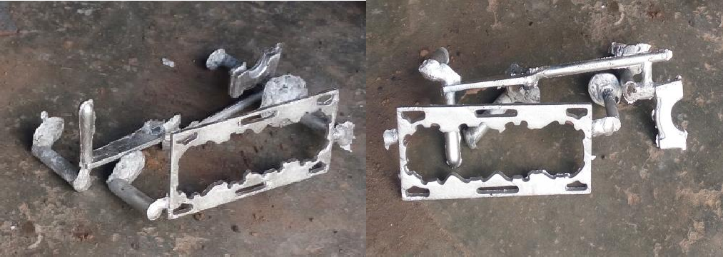

Plate 3.3: Cast sample of improved casting Plate 3.4: Cast sample of hand-shank ladle pouring ladle

      - Metallography examination of the cast:

A sample from both casts was cut from the solid rod with the end surface ground and polished. The preparation of both samples for the test involved mainly cutting of sample to a suitable size and shape,grinding, polishing and etching. The snap capturing was carried out using the Metallurgical microscope model NJF-1 machine (Plate 3.6) at the departmental lab of Metallurgical and Material Engineering department, A.B.U. Zaria. The samples used for the metallography test are shown in Plate 3.5 below.
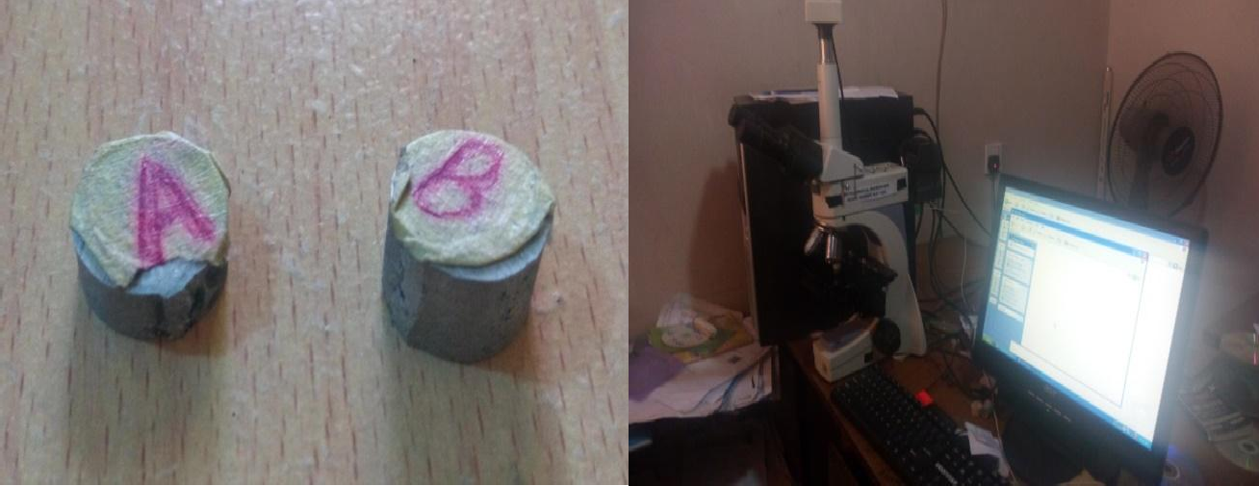

Plate 3.5: Samples for metallography test. Plate 3.6: Using the metallurgical microscope Where sample A was from pouring ladlemodel NJF-1 for snap capturing of the samples
and sample B from hand-shank ladle

      - X-Ray Fluorescence (XRF) test of the cast:

The cut transverse section of samples from both casts (Plate 3.7) were mounted in contact with the lens of the XRF machine where the rays projected on the surface. Each sample was subjected to XRF test at four (4) different energy levels. The XRF test was carried out at the Centre for Minerals Research and Development, Kaduna Polytechnic and the machine model was XL3t 950 (Plate 3.8).
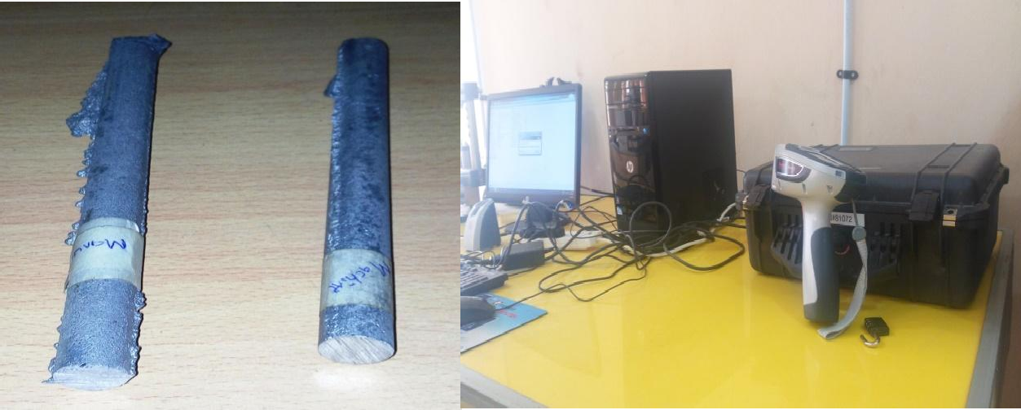

Plate 3.7: Samples for XRF test. Plate 3.8: Using the XRF machine model XL3t 950 for snap capturing of the sample

CHAPTER FOUR RESULTS AND DISCUSSION

Results

Result of thePouring LadleMachine

      - Result of Performance Evaluation using Water

For the evaluation of the ladle machine, the ladle machine was tested with water. Similarly, the same was done using the hand-shank ladle.Table 4.1 shows the pouringtimesfor the ladle castingmachine. While Table 4.2 shows that for using the hand-shank ladle.
Table 4.1: Result of Pouring Time for Ladle Machineusing water

No. of trials |  | Time (sec) |  | Total Time  (sec)
 | Lifting & Movement | Lowering & Movement | Pouring
1 | 33.05 | 7.97 | 54.69 | 95.71
2 | 30.03 | 8.90 | 50.58 | 89.51
3 | 30.97 | 7.54 | 47.73 | 86.24
4 | 28.66 | 8.35 | 51.16 | 88.17
5 | 31.09 | 8.59 | 48.51 | 88.19
6 | 31.24 | 8.71 | 50.08 | 90.03
7 | 28.98 | 8.83 | 47.22 | 85.03
8 | 30.02 | 7.90 | 50.58 | 88.50
9 | 30.71 | 8.41 | 49.37 | 88.49
10 | 29.89 | 8.26 | 49.82 | 87.97
AVERAGE | 30.46 | 8.35 | 49.97 | 88.78

Table 4.2: Result of Pouring Time forHand-shankLadle usingWater

No. of trials |  | Time (sec) |  | Total Time  (sec)
 | Lifting & Movement | Lowering & Movement | Pouring
1 | 36.68 | 40.01 | 49.93 | 126.62
2 | 30.51 | 37.04 | 51.09 | 118.64
3 | 31.72 | 34.83 | 50.95 | 117.50
4 | 34.16 | 36.96 | 54.38 | 125.50
5 | 30.69 | 37.90 | 50.84 | 119.43
6 | 33.30 | 35.17 | 49.35 | 117.82
7 | 34.12 | 35.31 | 51.77 | 121.20
8 | 31.73 | 34.79 | 50.20 | 116.72
9 | 32.55 | 34.63 | 50.08 | 117.26
10 | 32.13 | 36.28 | 52.14 | 120.55
AVERAGE | 32.76 | 36.29 | 51.07 | 120.12

      - Result of Performance Evaluation using Aluminium Alloy

Result of the casting of the Aluminium alloy molten metal are given in Tables4.3 and 4.4. Table 4.3: Result of Pouring Timefor Ladle Casting Machine usingAluminnium Alloy
Pouring  Temperature (⁰C) |  | Time (sec) |  | TotalTime  (sec)
 | Lifting & Movement | Lowering& Movement | Pouring
726 | 26.16 | 7.72 | 17.85 | 51.73
730 | 30.05 | 7.54 | 19.37 | 56.96
716 | 26.91 | 7.80 | 17.03 | 51.74
Average | 27.71 | 7.69 | 18.08 | 53.48

Table 4.4: Result of Pouring Time forHand-shankLadle usingAluminium Alloy

Pouring  Temperature (⁰C) |  | Time (sec) |  | Total Time  (sec)
 | Lifting & Movement | Lowering & Movement | Pouring
729 | 29.63 | 34.89 | 20.13 | 84.65
725 | 28.25 | 33.98 | 17.40 | 79.63
718 | 29.31 | 34.08 | 17.72 | 83.11
Average | 29.06 | 34.32 | 18.42 | 81.80

Determination of the Speed of Pouring

The result of the calculations for speed of pouring the molten metal into the mould until it was filled for both the ladle machine and manual hand-shank ladle are calculated using equation 3.22. The height from crucible to sprue basin (H) was maintained in both at 8 cm while the time taken (T_{p}) forpouring the moltenAluminium alloy metal into the mould until it fills the mould are 18.08 sec and 18.42 sec(from Tables 4.3 and 4.4) respectively.
The speed of pouring for the ladle machinewas,

V_{LM} = ^{𝐻} = ⁸
= 0.44cm/s

𝑇𝑝 18.08

The speed of pouring when using the hand-shank ladle,

V_{HL} = ^{𝐻} = ⁸
= 0.43cm/s

𝑇𝑝 18.42

Non-destructive Test

      - Visual Inspectionof the Casts

This test was carried out by observing the two castings using the physical eye inspection to detect the casting defects especially misrun and cold shut. From the visual inspection, the following were observed.
        - For the cast using the pouring ladle, there were very few or no sand blows on the cope side of the water jacket (Plate 4.1 and 4.2) and crank lever (Plate 4.3 and 4.4) castwhile some little sand blows were seen on the bearing cap (plate 4.5 and 4.6). But on the drag side, some sand blows were seen on the water jacket, crank lever and bearing cap cast. Although the sand blows in the cast of pouring ladle machine are few compared to those of thehand-shank ladle.Also on the crank lever cast, joint flash defect was observed.
        - While for the cast using the hand-shank ladle, there were some noticeable sand blows on the cope side of the water jacket (Plate 4.7 and 4.8), crank lever (Plate 4.7 and 4.10) and bearing cap (Plate 4.11 and 4.12). There was splash seen on the left side of the crank lever. Joint flash defect was observed on crank lever and bearing cap casts.

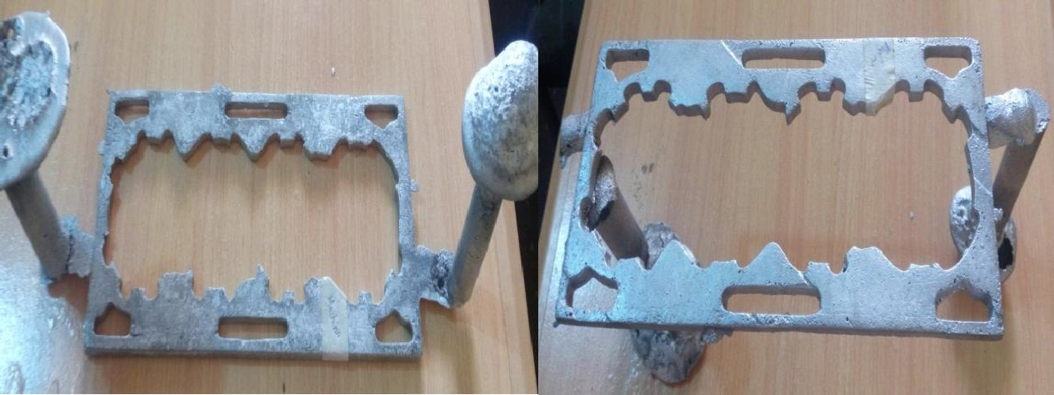
Plate 4.1: Cope side of the water jacket Plate 4.2: Drag side of the water jacket cast using ladle machinepouringcast using ladle machine pouring

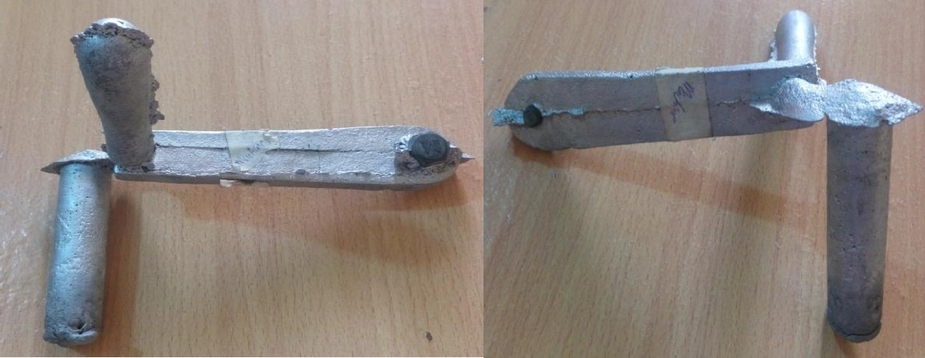

Plate 4.3: Front side of the crank lever Plate 4.4: Rear side of the crank lever cast using ladle machine pouringusing ladle machine pouring

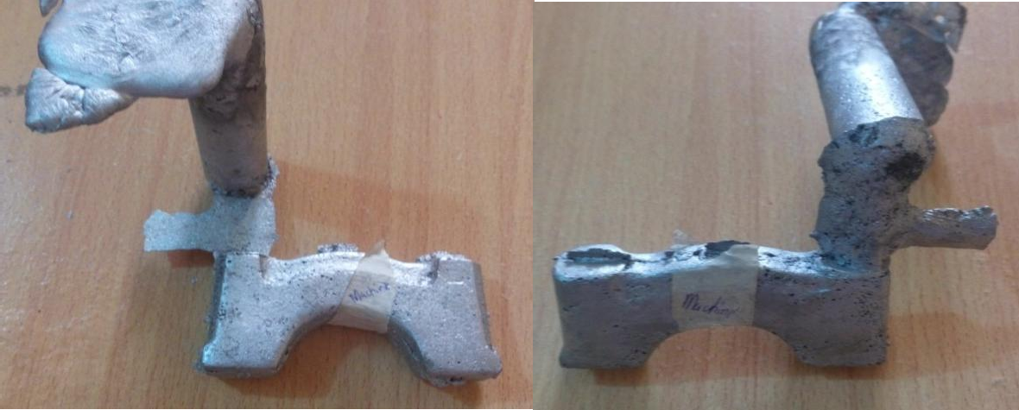
Sand
blow
Plate 4.5: Cope side of the bearing cap cast Plate 4.6: Drag side of the bearing using ladle machine pouringcap cast using ladle machine pouring

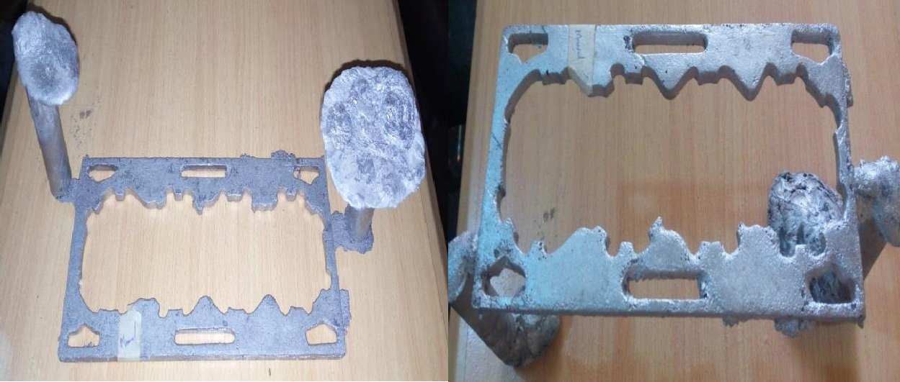
Plate 4.7: Cope side of the water jacket Plate 4.8: Drag side of the water jacket cast using hand-shank ladle pouring cast using hand-shank ladle pouring

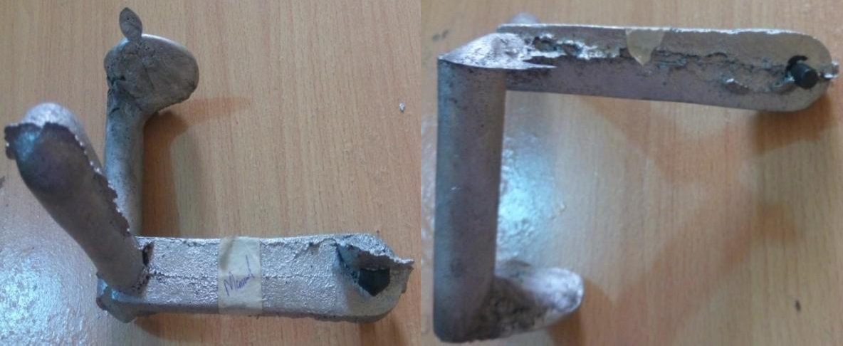
Splash

Plate 4.9: Front side of the crank leverPlate 4.10: Rear side of the crank lever cast using hand-shank ladle pouring cast using hand-shank ladle pouring

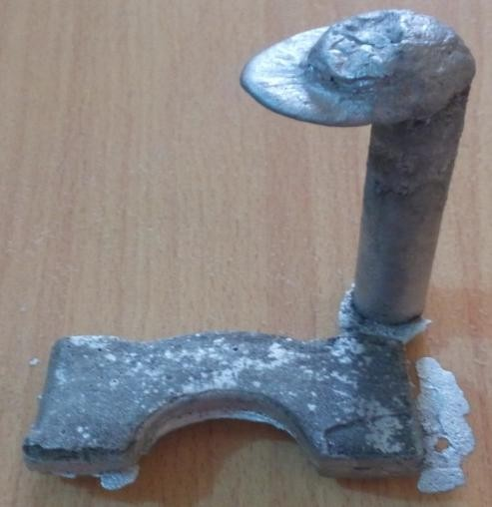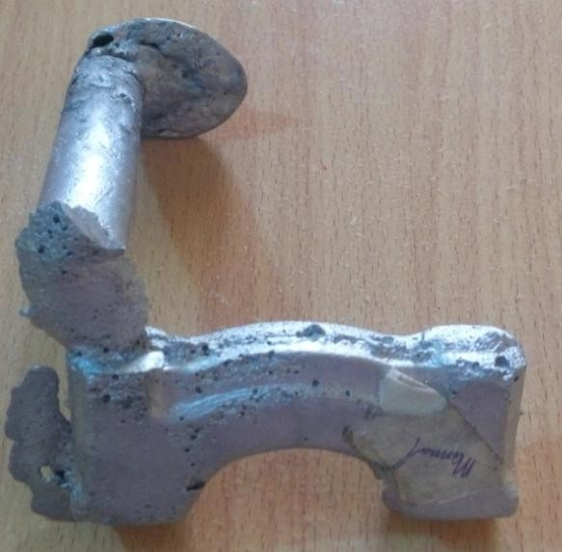
Joint flash

Plate 4.11: Cope side of the bearing cap Plate 4.12: Drag side of the bearing cap cast using hand-shank ladle pouring cast using hand-shank ladle pouring

      - Metallography examination of the cast

The result of the metallography examination for the cast samples produced from both pouring ladle and hand-shank ladle shows clearly thespherical dimplescharacteristics of grain type (Plate 4.13a and b). In these microstructures, the hypoeutectic structure consists of primaryalpha solid solution of silicon in aluminium α (white patches) in a matrix of eutectic α +Si (dark patches).

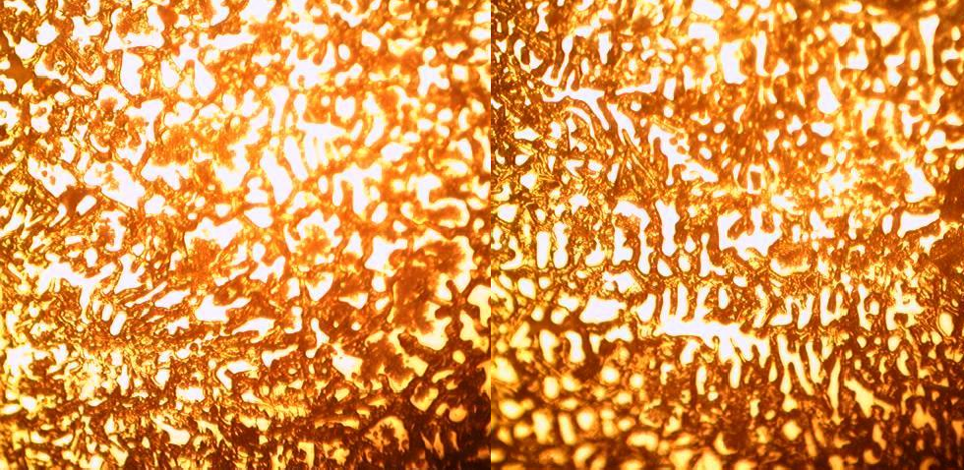Plate 4.13a: Micrograph test for sample using Plate 4.13b: Micrograph for sample using pouring ladle machine (X 100) hand-shank ladle(X 100)
α
α +Si

      - X-Ray Fluorescence (XRF) test of the cast

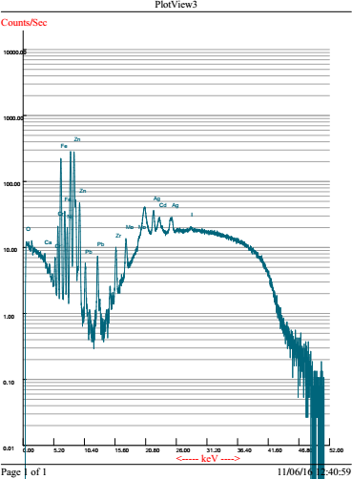
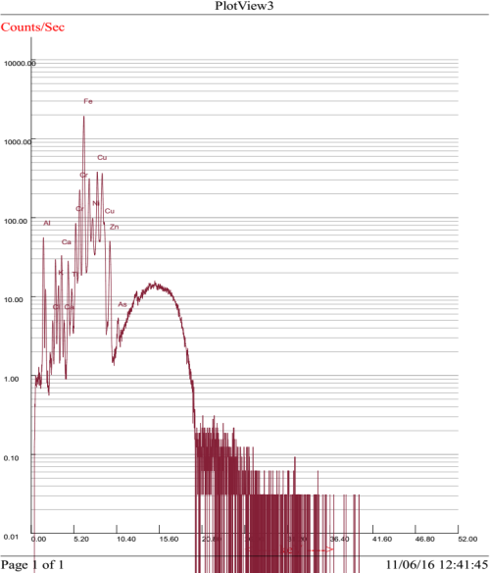
The result of the XRF at different energy levels reveals the chemical compositions of the various samples. Plates 4.14 and 4.15 shows the spectra of the cast sample of pouring ladlemachine and that of the hand-shank ladle. Also, Table 1 (in Appendix C) shows the chemical composition of both samples using.

(a) (b)

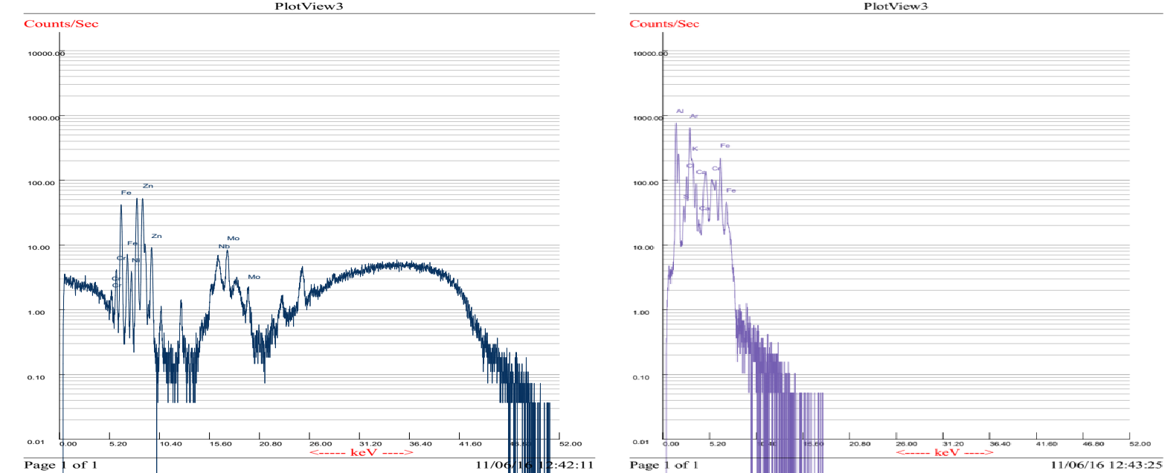

(c) (d)

Plate 4.14: Spectra for cast sample from machine ladle at different energy levels

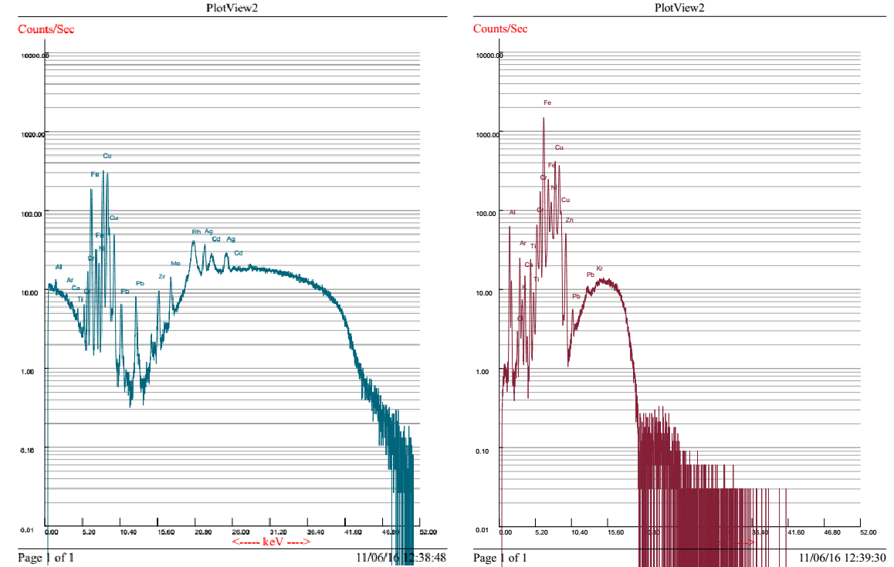
(a) (b)

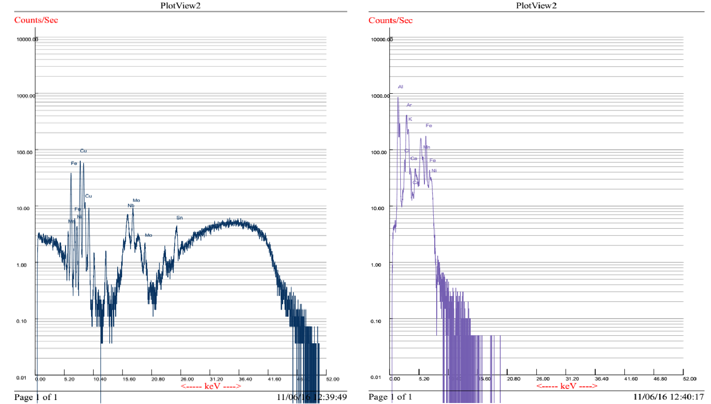

(c) (d)

Plate 4.15: Spectra for cast sample from hand-shank ladle at different energy levels

Discussion of Results

Result of Performance Evaluation of the Pouring Ladle

      - Result of Performance Evaluation Using Water

From Tables 4.1 and 4.2, the total time spent from lifting the crucible from the furnace to filling the ―Jerry can‖using both the ladle casting machine and hand-shank ladle were 88.78 sec, 120.12 sec respectively. It was discovered that when using the ladle casting machine, time spent on lifting of the crucible from the furnace to pouring to fill the ―Jerry can‖was shorterby 31.34 sec. This was because there was too much time used in lowering the crucible, removing the tong from gripping the crucible and then lifting it using the hand-shank ladle to the location of the mould for pouring of the molten metal. While when using the ladle casting machine, it was discovered that little time was spent in lowering and movement of the crucible for pouring. There will be no need of dropping the crucible then removing the tong from gripping the crucible.Therefore, there was a time saving of about 26.1%. Figure 4.1 shows the result of the average time of pouring water using both ladle casting machine and hand-shank ladle at the various activities.

Time (sec)

Figure 4.1: Average pouring time for the ladle machine andhand-shank ladle using water
60

50

40

30

20
Ladle Machine
Hand-shank Ladle
10

0
Lifting and
movement
Lowering and Pouring
movement
Activity

      - Result of Performance Evaluation Using Aluminium Alloy Molten Metal

Similarly, from Tables 4.3 and 4.4, the total time spent from lifting the crucible from the furnace to filling the mouldusing both the ladle casting pouring ladle and hand-shank ladle were 53.48 sec, 81.80 sec respectively.The time difference in lifting of the crucible from the furnace to pouring to fill the mould can was shorterby 28.32 sec. Thetime saving was about
34.62 %. Figure 4.2 shows the result of the average time of pouring molten Aluminium alloy metal using both ladle casting machine and hand-shank ladle at the various activities.

Time (sec)

Figure 4.2: Average pouring time for ladle machine and hand-shankladle using Aluminium alloy molten metal
40
35
30
25
20
15
10
5
0
Ladle Machine
Hand-shank Ladle
Lifting and movement
Lowering and movement
Activity
Pouring

      - Result of the Speed of Pouring

The results of the pouring speed when using the ladle casting machine and hand-shank ladle from Table 4.3, Table 4.4 and Equation 3.22 were 0.44 cm/s and 0.43 cm/s respectively. The pouring speed when using the ladle casting machine was faster than that of the hand-shank ladle by 0.01cm/sec (2.33 % speed increase). This was because the time taken to fill the mould when using the ladle casting machine was less as compared to when using the hand- shank ladle. When using the gearing system, the pouring was at a relatively consistent flow unlike the manual method where the pouring was inconsistent as a result of different persons (operators) handling the hand-shank ladle.

Non-destructive Test

      - Visual Inspection of the Casts:

There was no any misrun or cold shut in both machine and manual casts. This was because the pouring temperature was adequate enough not to allow for sudden solidification as the

molten metal enters the mould. Also, the pouring speed was not too slow to allow for the solidification of the molten metal as it enters the mould.
The physical defect that was observed from the casts was sand blows especially on the drag side of the casts which are numerous in the casts of manual hand-shankladle as compared to the casts of ladle machine. The defects may be as a result of gases entrapped in the casts as well as mould sand particles which were entrapped on the surface of the casts. Gases are entrapped in casting when there is no proper venting in the mould, while mould sand are entrapped or attached to the surface of the casting if loosed i.e. sand not properly bounded together.
      - Metallography Test:

The micrograph of both samples show visible well defined coarse grain boundaries. This could be due to the even distribution of the constituents as cooling takes place since no too much time was taken to pour the liquid metal into the mould. In these microstructures, the samples were ofhypoeutectic structure consisting of primaryalpha solid solution of silicon in aluminium α (white patches) in a matrix of eutectic α +Si (dark patches).
According to Raji and Khan (2006), the results of metallographic studies ofthe cast samples showed that in all cases, themicrostructure of the cast samples were ofhypoeutectic structure consisting of primaryalpha solid solution of silicon in aluminium(α) in a matrix of eutectic (α
+Si). However,the grain sizes differed for various castings.The results of micro- examinationrevealed that the dendrites of aluminium insqueeze castings are fine with the fineness increasing with increase in squeeze pressure forall pouring temperatures.
      - X-Ray Fluorescence (XRF) test of the cast:

The result of the XRF tests shows the presence of the various elements detected in the alloy with their percentages at different energy level. It can be observed the percentage of Silicon detected is high; therefore, the alloy is Aluminium-silicon alloy.

Conclusion

CHAPTER FIVE CONCLUSION AND RECOMMENDATIONS

To obtain a cast with little or no cast defects such as cold shut and misruns resulting from pouring of liquid/molten metal from a crucible into a prepared mould,there is a need to design and fabricate a manual ladle machine for casting.
From this research, the following conclusion could be drawn:

    - A ladle casting machine of 50 kg charge capacity of molten Aluminium alloy was successfully designed and constructed. The pouring ladle was designed such that it would be used to pick the crucible from the furnace and pour the molten Aluminium alloy directly without delay. The delay in time spent to drop the crucible, remove the tong from gripping the crucible then picking it up by using the hand-shank ladle is eliminated.
    - The construction/fabrication of the components/parts of the ladle machine was successfully carried out. The various component parts were assembled together to form the pouring ladle. The ladle was used to cast molten Aluminium alloy into a prepared sand mould.
    - The pouring ladle was used for casting as well as the hand-shank ladle. The results of the castings were compared. From the results obtained, the pouring ladle recorded a few pouring time in the casting activity using both water and molten Aluminium alloy. The time difference is not too much except in the activity of lowering and movement were in the case of hand-shank ladle, too much time (34.32 sec) was spent while less time (7.69 sec) spent when using the pouring lalde to cast the Aluminium alloy. Also, the pouring speed when using the ladle casting machine was faster(2.33
% speed increase)than that of the hand-shank ladle by 0.01 cm/sec. This was because

the time taken to fill the mould when using the ladle casting machine was less as compared to when using the hand-shank ladle.
    - The results of the non-destructive tests showed no casting defect like cold shut or misrun. This was because the pouring temperature was adequate enough with no delay in the pouring from both the pouring ladle and hand-shank ladle which may result into sudden solidification inside the mould without completely filling the mould cavity. The micrograph of both samples show visible well defined coarse grains. This could be due to the even distribution of the constituents as cooling takes place since no too much time was taken to pour the liquid metal into the mould. The result of the XRF tests shows the presence of the various elements detected in the alloy with their percentages at different energy level and showed that the percentage of Silicon detected was high.

Recommendations

    - Further research, designand fabrication could be carried outfor casting of cast iron metal since this design was for 50 kg molten Aluminium alloy only.
    - Designand construction/fabrication could be carried out to automate similar design for 100 kg and above charge capacity by using electric motor with remote control.

Contribution to knowledge

The following are the contributions to knowledge

- Percentage time saving (about 35.28%) in the pouring process of casting molten Aluminium alloy since lifting and pouring of hot crucible containing molten metal can be done directly without delay.
- Reduction of labour and cost since one person (operator) can handle the work of two or more persons (operators) and no need of electricity or electric motor.When using the pouring

ladle to cast, only one operator is needed unlike when using the hand-shank ladle where two or more operators are needed. This reduces the labour cost. Also, if the pouring ladle were to be driven by an electric motor, the cost of using electricity to drive electric motor will increase cost of production. But this pouring ladle doesn’t need electric motor because it is operated manually by using crank lever arms.

REFERENCES

Baker, J. (1997). Five Thousand Years of Investment Castings. BICTA Bulletin, No.26, p.6-8. Choudhari, C. M., Narkhede, B. E. and Mahajan, S. K. (2014). Methoding and Simulation of
LM 6 Sand Casting for Defect Minimization with its Experimental Validation. 12th global congress on manufacturing and management (GCMM), 2014. Institute of Technology, Navi Mumbai, 400703 India. Procedia Engineering 97(2014) 1145– 1154. Retrieved from www.sciencedirect.com/science/article/pii/S1877705814034614
Ciriello, V.M. (2005). The Effects of Box Size, Vertical Distance, and Height on Lowering Tasks for Female Industrial Workers. International Journal of Industrial Ergonomics 35, 857–863.
Dempsey, P.G., Hashemi, L. (1999). Analysis of worker’s compensation claims associated with manual materials handling. Ergonomics 42, 183–195.
Derya D. (2005). Determination of Metal Quality of Aluminium and Its Alloys.School of Metallurgy and Materials. University of Birmingham.
Kalpakjian, S. (1995). Manufacturing Engineering and Technology. 3rd Ed. Addison Wesley. Khurmi, R.S. and Gupta, J. K. (2005). Machine Design. Eurasia Publishing House (PVT) Ltd.
Ram Nagar, New Delhi – 110055.

Konz, S. (1995). Manual Material Handling. In: Proceedings of the Annual Conference— Human Factors Association of Canada, vol. 27, pp. 13–26.
Krzysztof, G., Marcin, W. and Kamil, S. (2013). The Effect of the Method of Pouring Liquid Metal into Mould on Misrun Formation in the Castings Made with Lost-Wax Casting Technology. Archives of Mechanical Technology and Automation vol. 33 no, 4, 2013.
Ndaliman, M.B. and Pius, A. (2007). Behavior of Aluminum Alloy Casting under Different Pouring Temperatures and Speeds. Leonardo Electronic Journal of Practices and Technologies.ISSN 1583-1078. pp. 71-80.

Niraj, M. (2013). Review of Ladle Furnace. Proceedings of 7th ICEECSME-2013. BMIT, Maharashtra, India. ISBN:978-93-82702-43-6. Retrieved from www.iraj.in/up_proc/pdf/32-138601653665-70.pdf.
Peter, R.B. (2001). Foundry Technology. 2nd Ed. Butterworth-Heinemann, Lancre House, Jordan Hill, Oxford OX2 8DP, 225 Wildwood Avenue, Woburn, MA 01801-2041, A division of Reed Educational and professional Publishing Ltd. ISBN 0750645679
Raji, A. and Khan, R.H. (2006). Effects of Pouring Temperature and Squeeze Pressure on Al- 8%Si Alloy Squeeze Cast Parts. Department of Mechanical Engineering, Federal University of TechnologyYola, Adamawa State, Nigeria .AU J.T. 9(4): 229-237 (Apr. 2006)
Rajput, R. K. (2013). Strength of Materials. (Mechanics os Solid SI unit). S. Chand and Company ltd. Ram Nagar, New Delhi – 110055.
Richard, W.H., Carl, R.L. (Jr) and Philip, C.R. (1967). Principles of Metal Casting. 2nd Ed.

McGraw-Hill Book Company.

Robinson, E. (2012). Effect of Sand Casting Process Parameters on Mechanical Properties of Aluminium Alloy. International Journal of Metallurgical and Materials Science and Engineering (IJMMSE). ISSN 2278-2516. Vol.2, Issue 3 September 2012 pp32-41.
Sharma, P.C. (2001).A Textbook of Production Technology (manufacturing Processes). 3rd Ed. S. Chad and Company Ltd. Ram Nagar, New Delhi-110055. ISBN: 8121911141
Yoshiyuki, N. and Kazuhiko, T. (2007). Modeling and Feedforward Flow Rate Control of AutomaticPouring System with Real Ladle. Toyohashi, Aichi 441-8580, Japan.Journal of Robotics and Mechatronics Vol.19 No.2.

APPENDIX A

DRAWINGS OF THE MACHINE AND MACHINE COMPONENTS (ENCLOSED)

  - Drawing 1: Casting pouring ladle

  - Drawing 2: Casting Pouring Ladle

  - drawing 3: Machine Frame

  - drawing 4: Components of Rail Mechanism

  - drawing 5: Components of Lifting/Lowering System

  - drawing 6: Components of Tilting System

  - drawing 7: Components of Gripping System

APPENDIX B

FABRICATION PROCESSES AND PERFORMANCE EVALUATION OF THE LADLE MACHINE
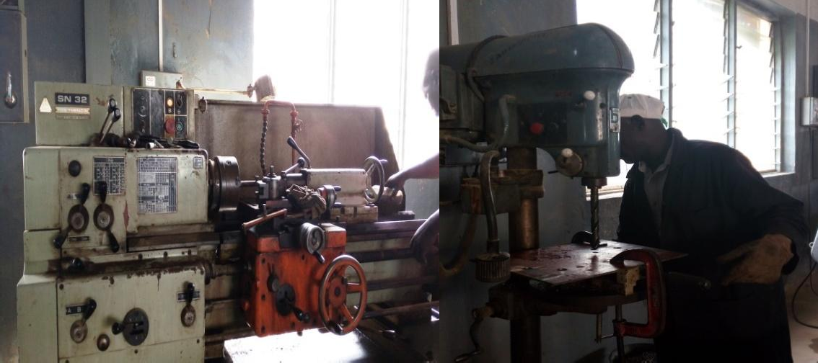

Plate I: Turning of shafts using lathe Plate II: Drilling of plate using drilling machine machine
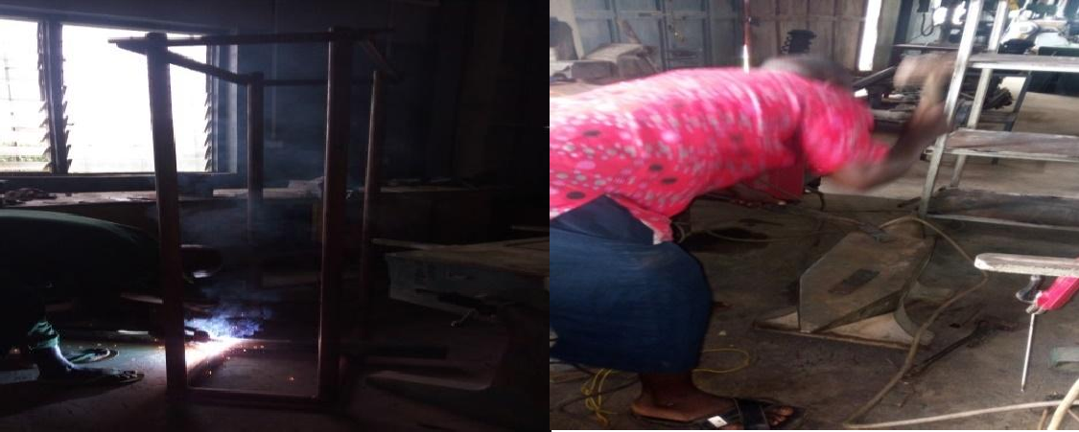
Plate III: Welding of the rail track Plate IV: Forging of gripping tong
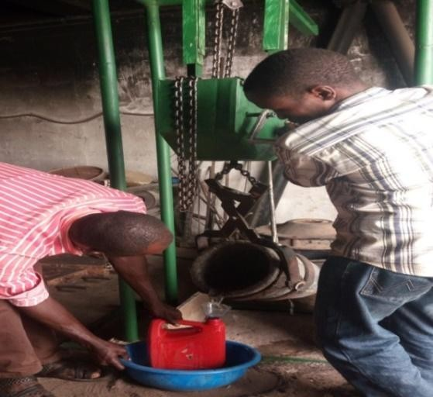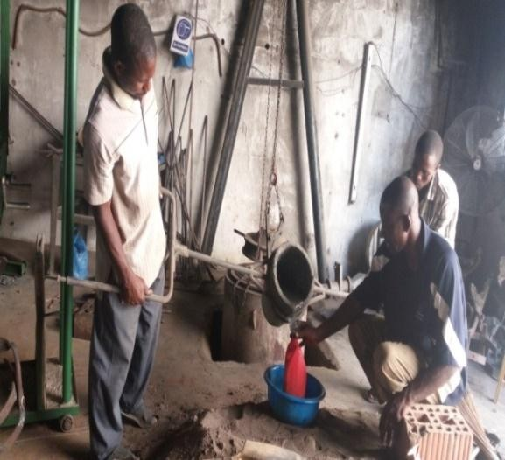
Plate V: Using the pouring ladlefor Plate VI: Using the hand-shank ladle for performance evaluation using water performance evaluation using water

APPENDIX C

RESULT OF XRF TEST FROM CENTRE FOR MINERALS RESEARCH AND DEVkLOPMENT, KADUNA POLYTECHNIC
