**DESIGN, CONSTRUCTION AND PERFORMANCE EVALUATION OF A FIXED BED PYROLYSIS SYSTEM**

**By**

**Joel Olaposi OGUNKANMI, B.Tech. (LAUTECH, Ogbomoso) 2010 P14EGME8019**

**A DISSERTATION SUBMITTED TO THE SCHOOL OF POSTGRADUATE STUDIES, AHMADU BELLO UNIVERSITY, ZARIA**

**IN PARTIAL FULFILLMENT OF THE REQUIREMENTS FOR THE AWARD OF A**

**MASTER OF SCIENCE DEGREE IN MECHANICAL ENGINEERING**

**DEPARTMENT OF MECHANICAL ENGINEERING FACULTY OF ENGINEERING**

**AHMADU BELLO UNIVERSITY, ZARIA NIGERIA**

**FEBRUARY, 2018**

# DECLARATION

I Joel Olaposi OGUNKANMI hereby declare that the work in this dissertation entitled “**DESIGN, CONSTRUCTION AND PERFORMANCE EVALUATION OF A FIXED**

**BED PYROLYSIS SYSTEM**” has been carried out by me in the Department of Mechanical Engineering. The information derived from literature has been duly acknowledged in the text and a list of reference provided. No part of this dissertation was previously presented for another degree or diploma at this or any other institution.

Joel Olaposi OGUNKANMI

Signature Date

# CERTIFICATION

This Dissertation entitled “**DESIGN, CONSTRUCTION AND PERFORMANCE EVALUATION OF A FIXED BED PYROLYSIS SYSTEM**” by Joel Olaposi

OGUNKANMI meets the regulations governing the award of degree of Master of Science (M.Sc.) in Mechanical Engineering of the Ahmadu Bello University, and is approved for its contribution to knowledge and literary presentation.

|  |  |  |
| --- | --- | --- |
| Dr. D.M. Kulla  Chairman, Supervisory Committee | Signature | Date |
| Dr. N.O. Omisanya |  |  |
| Member, Supervisory Committee | Signature | Date |
| Dr. M. Sumaila |  |  |
| Member, Supervisory Committee | Signature | Date |
| Dr. F.O. Anafi |  |  |
| Head of Department | Signature | Date |
| Prof. S.Z. Abubakar |  |  |
| Dean. Postgraduate School | Signature | Date |

# DEDICATION

This dissertation is dedicated to my loving family for the love and care you have given me throughout the period of my studies. The support and endurance you have shown, making this dissertation much easier to be completed cannot pass unmentioned. Our journey together has not only given me success in this work but has also strengthened my love for all of you. Thank you and may the Almighty God repay your generosity abundantly.

# ACKNOWLEDGEMENT

This dissertation has become a reality due to the assistance and support of many individuals and organization. First and foremost, I would like to express my deep gratitude to my supervisory committee; Dr. D.M. Kulla, Dr. N.O. Omisanya and Dr. M. Sumaila. Their guidance and knowledge have been critical to the achievements and success of this project.

Special thanks are given to Industrial Development Centre Chief Technologist, Mr. Kauje and his staff for their support particularly while I was carrying out my experimental work. In addition, I appreciate Mr. David and Mr. Tunde, technicians at the Metallurgical and Materials Engineering Department, who have inadvertently, and without, given me their undivided attention and exceptional skills to procure materials and make the construction aspect of this project a success.

Finally, my profound gratitude goes to my family for their unflagging love and unconditional support throughout my life and my studies. You made me live the most unique, magic and carefree childhood that has made me who I am now! Thank you all.

# ABSTRACT

A fixed bed pyrolysis system has been designed and constructed for obtaining liquid fuel from palm kernel shell. The major components of the system are: fixed bed reactor and condensate unit. The palm kernel shell in particle form was pyrolized in an externally heated 90mm diameter and 360mm high fixed bed reactor. The reactor is heated by means of a rectangular shape manual forge blower with charcoal as the energy source. The products are char, oil and gas. The parameters varied are feed particle size, reactor bed temperature and running time. The reactor bed temperature was found to influence the product yields. The maximum liquid yield was 38.67wt % at 4500C for a feed particle size of 1.18mm with a running time of 95minutes. The maximum char yield was 70.67wt% at 5500C for a feed particle size of 5mm with a running time of 120minutes. The calorific value of the palm kernel shells (22.81 MJkg-1) and bio-oil (43.19MJkg-1) were determined. The reactor efficiency was evaluated at various temperatures. Maximum efficiency of 73.21% indicated that the reactor is efficient enough to produce bio-oil. The bio-oil products were analysed by Fourier Transform Infra-red Spectroscopy (FTIR) and Gas Chromatography Mass Spectrometry (GCMS). The FTIR analysis showed that the bio-oil was dominated by phenol and its derivatives. The phenol, 2-methoxy-phenol and 2, 6- dimethoxyl phenol that were identified by GCMS analysis are highly suitable for extraction from bio-oil as value-added chemicals. The highly oxygenated oils need to be upgraded in order to be used in other applications such as transportation fuels.

|  |  |  |
| --- | --- | --- |
|  | **TABLE OF CONTENTS** |  |
| **DECLARATION** |  | **ii** |
| **CERTIFICATION** |  | **iii** |
| **DEDICATION** |  | **iv** |
| **ACKNOWLEDGEMENT** |  | **v** |
| **ABSTRACT** |  | **vi** |
| **LIST OF FIGURES** |  | **xi** |
| **LIST OF TABLES** |  | **xiii** |
| **LIST OF PLATE** |  | **xiv** |
| **LIST OF APPENDICES** |  | **xv** |
| **NOMENCLATURE** |  | **xvi** |

# CHAPTER ONE: INTRODUCTION

* 1. Background of the Study 1
  2. Statement of the Research Problem 2
  3. The Present Research 3
  4. Aim and Objectives of the Research 3
  5. Justification of the Study 3
  6. The Scope of the Research 4

CHAPTER TWO: LITERATURE REVIEW

* 1. History of Pyrolysis 5
  2. Principle of Pyrolysis 5
     1. Slow Pyrolysis 7
     2. Fast Pyrolysis 8
     3. Flash Pyrolysis 9
  3. Pyrolysis Reactor 9
     1. Fixed Bed Reactor 10
     2. Fluidized Bed Reactor 11
        1. Bubbling Fluidized Bed Reactor 11
        2. Circulating Fluidized Bed Reactor 12
     3. Ablative Reactor 13
     4. Vacuum Pyrolysis Reactor 14
     5. Rotating Cone Reactor 15
     6. Pyros Reactor 16
     7. Auger Reactor 17
     8. Plasma Reactor 18
     9. Microwave Reactor 19
     10. Solar Reactor 20
  4. Factors Affecting Pyrolysis of Biomass 21
     1. Feedstock Composition 22
     2. Feedstock Preparation 23
     3. Pyrolysis Temperature Control 24
     4. Residence Time 26
     5. Moisture Content 26
  5. Biomass 27
     1. Biomass Conversion Technology 28
     2. Feed stock/ material background 29
  6. Fourier Transform infra-red (FTIR) 30
  7. Gas Chromatography/ Mass Spectroscopy (GC-MS) 30
  8. Review of related past works 31
  9. Research gap 34

CHAPTER THREE: MATERIALS AND METHODS

* 1. Materials 35
     1. List of Materials 35
  2. Methods 36
     1. Description of the fixed pyrolysis system 36
     2. Design Theory and Equation 37
        1. Initial design parameters 37
        2. Stresses in the fixed bed reactor 38
        3. Reactor Thickness 39
        4. Insulation 39
           1. Insulation Thickness 39
        5. Design of the Reactor 42
        6. Design of the Condenser 45
        7. Design calculation of the fixed bed pyrolysis system 48
     3. Construction of the fixed bed pyrolysis system 51
     4. Assembly of the pyrolysis system 53
     5. Experimental procedure 55
        1. Preparation of Feedstock 55
        2. Operational procedures of the fixed bed pyrolysis system 55
     6. Characterization of Palm kernel Shells (PKS) 56
        1. Proximate analysis of PKS 56
        2. Ultimate analysis of palm kernel shell 57
        3. Determination of the calorific value of the palm kernel shell 57
     7. Performance evaluation of the fixed bed pyrolysis system 58
     8. Effect of pyrolysis parameters 59
        1. Effect of particle size 59
        2. Effect of temperature 59
        3. Effect of running time 59
     9. Characterization of bio-oil 59
        1. Ultimate analysis of the bio-oil 60
        2. Determination of the calorific value of the bio-oil 60
        3. Fourier Transform infra-red (FTIR) 60
        4. Gas Chromatography/ Mass Spectroscopy (GC-MS) 60

CHAPTER FOUR: RESULTS AND DISCUSSION

* 1. Characterization of palm kernel shells (PKS) 62
  2. Variation of pyrolysis parameters 63
     1. Effect of Particle Size 63
     2. Effect of Temperature 65
     3. Effect of Running time 67
  3. Performance evaluation of the fixed bed pyrolysis system 68
  4. Characterization of bio-oil product 69
     1. Ultimate analysis of the bio-oil 69
     2. FTIR analysis of bio-oil 69
     3. GCMS analysis of the Bio-oil 70
  5. Cost Estimate 72

CHAPTER FIVE: CONCLUSIONS AND RECOMMENDATIONS

* 1. Conclusions 74
  2. Recommendations 75
  3. Significant Contributions 75

REFRENCES 77

APPENDICES 86

**LIST OF FIGURES**

Figure 2.1: Representation of the research paths for wood pyrolysis 6

Figure 2.2: Sub processes of fast pyrolysis 9

Figure 2.3: Process Schematic for fixed bed pyrolysis 11

Figure 2.4: Process schematic for bubbling fluidized-bed reactor 12

Figure 2.5: Process schematic for circulating fluidized-bed reactor 13

Figure 2.6: Ablative reactor 14

Figure 2.7: Process schematic for vacuum pyrolysis 15

Figure 2.8: Rotating cone reactor 16

Figure 2.9: Schematic process for PyRos- reactor 17

Figure 2.10: Schematic process for auger reactor 18

Figure 2.11: Schematic process for plasma reactor 19

Figure 2.12: Schematic process for microwave pyrolysis device 20

Figure 2.13: Schematic process for solar reactor 21

Figure 2.14: Utilization of biomass resources 28

Figure 2.15: Biomass conversion technology 29

Figure 3.1: A Schematic diagram of the fixed bed pyrolysis system 37

Figure 3.2: Stresses in the fixed bed reactor 38

Figure 3.3: Insulated cylindrical pipe exposed to convection from the outer surface

and its thermal resistance network 40

Figure3. 4: The variation of heat transfer rate with the outer radius of the insulation 42

Figure 3.5: The line drawing of the fixed bed reactor 43

Figure 3.6: The working drawing of the fixed bed reactor 44

Figure 3.7: The line drawing of the condenser 46

Figure 3.8: The working drawing of the condenser 47

Figure 4.1: Variation of product yield (wt%) with particle size 64

Figure 4.2: Variation of product yield (wt%) with temperature 65

Figure 4.3: Variation of product yield (wt%) with running time 67

Figure 4.4: Variation of Reactor efficiency with reactor temperature 68

Figure 4.5: FTIR Spectrum of the Bio-oil 70

Figure 4.6: Identification and Peak areas of Chemical Compounds in the bio-oil 72

# LIST OF TABLES

|  |  |
| --- | --- |
| Table 2.1: Typical operating parameters and products for pyrolysis process | 7 |
| Table 2.2: Lignin, Cellulose and Hemicellulose content of selected biomass | 22 |
| Table 3.1: List of Materials used | 35 |
| Table 3.2: List of Instruments and equipment used | 36 |
| Table 3.3: The variation of heat transfer rate with the outer radius of the insulation | 86 |
| Table 3.4: Design calculation of the fixed bed pyrolysis system | 48 |
| Table 3.5: Construction process | 52 |
| Table 4.1: Proximate and Ultimate analysis of the palm kernel shell (wt%) | 63 |
| Table 4.2: The Comparison of Pyrolysis Product Yields at Different Particle Size | 86 |
| Table 4.3: The Comparison of Pyrolysis Product Yields at Different Temperature | 86 |
| Table 4.4: The Comparison of Pyrolysis Product Yields at different running time | 87 |
| Table 4.5: Reactor Efficiency (%) at generating bio-oil | 87 |
| Table 4.6: Ultimate analysis of the bio-oil produced | 69 |
| Table 4.7: Identification and peak areas of chemical compounds in PKS pyrolysis oil | 88 |
| Table 4.8: The cost estimate of the fixed bed pyrolysis system | 73 |

**LIST OF PLATE**

Plate I: A bunch of Oil pail and crushed of palm kernel shell 30

Plate II: Pictorial view of the fixed bed pyrolysis setup with manual forge blower 54

Plate III: A model of the fixed bed pyrolysis system 89

Plate IV: Condenser, Ice and Ice bath 90

Plate V: Pictorial view of the manual forge blower 91

Plate VI: palm kernel shells of particle size 1.18mm 91

Plate VII: Palm kernel shells of particle size 2.35mm 92

Plate VIII: Palm kernel shells of particle size 5mm 92

Plate XIV: Maximum bio-oil yield at Dp = 1.18mm 93

Plate XX: Char yield at Dp = 5mm 93

|  |  |  |
| --- | --- | --- |
| Appendix A: | **LIST OF APPENDICES**  Lists of Tables | 86 |
| Appendix B: | Working Drawing of the Fixed Bed Pyrolysis System | 89 |
| Appendix C: | Equipment, Materials and Measurement of the Pyrolysis Products | 91 |

# NOMENCLATURE

**Abbreviations**

BBD Box-Behnken Design

EFB Empty Fruit Bunch

FTIR Fourier Transform Infrared

GCMS Gas Chromatography Mass Spectroscopic KBr Potassium bromide

OPF Oil Palm Fronds

OPT Oil Palm Trunks

PPF Palm Press Fibre

PKS Palm Kernel Shell POME Palm Oil Mil Effluent

RSM Response Surface Methodology

# Symbols

A Cross sectional area (m2)

1. Carbon (%)
2. Diameter (m)

Dp Particle size (mm)

h Convection heat transfer coefficient (W/m2.0C) H Hydrogen (%)

k Thermal conductivity of the material used (W/m.0C) L Length of the reactor (m)

N Nitrogen (%)

|  |  |
| --- | --- |
| O P  𝑃𝑑  Q | Oxygen (%)  Product volatile and gases pressure in the reactor (N/m2) Internal design pressure of the reactor (N/𝑚2)  Overall heat transfer (W) |
| rcr | Critical radius of insulation for the reactor (m) |
| *r1* | Outer radius of the cylinder before insulation (m) |
| r2 | Outer radius of the cylinder after insulation (m) |
| S | Sulphur (%) |
| t | Wall thickness of the reactor (m) |
| T1 | Outer surface temperature of the reactor (0C) |
| 𝑡𝑣 | Vapor residence time (s) |
| T∞ | Temperature at which heat lost from the cylinder to the surrounding medium (0C) |
| Tc1 | Water inlet temperature (0C) |
| 𝑇𝑐2 | Water outlet temperature (0C) |
| 𝑇ℎ1 | Vapour inlet temperature (0C) |
| 𝑇ℎ2 | Vapour outlet temperature (0C) |
| 𝑈0 | Overall heat transfer coefficient (W/m2°C) |
| 𝑉𝑅 | Total volume of the reactor (𝑚3) |
| 𝑉𝑟 | Free space in the reactor (𝑚3) |
| 𝑉ƒ | Volume flow rate(m3/s) |
| W | Mass of sample (g) |
| w | Mass of ash (g) |
| W0 | Weight of sample before heating (g) |

W1 Weight of sample after heating at 1150C (g) W2 Weight of sample after heating at 7500C (g) W3 Weight of sample after heating at 9000C (g)

ℎg Enthalpy of the gas at operating pressure (kJ/kg)

ℎ𝑙 Enthalpy of the liquid (kJ/kg) HHV Higher heating value (kJ/kg)

# Greek Symbols

𝜎h Hoop stress (N/𝑚2)

𝜎L Longitudinal stress (N/𝑚2)

Q̇ The rate of heat loss from the insulated reactor to the surrounding (W)

𝜂𝑅 Reactor Efficiency (%)

∆Tm Minimum log-mean temperature difference (0C)

∆𝑥 Thickness of metal wall (m)

# Background of the Study

**CHAPTER ONE INTRODUCTION**

Uninterrupted energy supply is a vital issue for all countries today. Future economic growth crucially depends on the long-term availability of energy from sources that are affordable, accessible, and environmentally friendly. Security, climate change, and public health are closely interrelated with energy (Ramchandra and Boucar, 2011). The standard of living of a given country can be directly related to the per capita energy consumption. The recent world's energy crisis is due to two reasons: the rapid population growth and the increase in the living standard of societies. The per capita energy consumption is a measure of the per capita income as well as a measure of the prosperity of a nation (Chikaire et al., 2015).

Energy supports the provision of basic needs such as cooked food, a comfortable living temperature, lighting, the use of appliances, piped water or sewerage, essential health care (refrigerated vaccines, emergency and intensive care), educational aids, communication (radio, television, electronic mail, the World Wide Web), and transport. Energy also fuels productive activities including agriculture, commerce, manufacturing, industry, and mining. Conversely, lack of access to energy contributes to poverty and deprivation and can contribute to the economic decline. Energy and poverty reduction are not only closely connected with each other, but also with the socioeconomic development, which involves productivity, income growth, education, and health (Nnaji et al., 2010).

The high rate of extracting the crude oil from the earth-crust demands for an alternative

and dependable source of obtaining energy (Rajput, 2005). This alternative is the energy derived via pyrolysis (a thermal decomposition process that occurs at moderate

temperatures with a high heat transfer rate to the biomass particles and a short hot vapour residence time in the reaction zone) of agricultural and forest residues (generally called biomass). Biomass has been recognized as a major renewable energy source to supplement declining fossil fuel sources of energy. It is the most popular form of renewable energy and currently biofuel production is becoming very much promising. Transformation of energy into useful and sustainable forms that can fulfil and suit the needs and a requirement of human beings in the best possible way is the common concern of the scientists, engineers and technologists. In this contest, bio fuels can be realised through fixed bed pyrolysis system using palm kernel shells as biomass. Fixed bed pyrolysis is more attractive among various thermo-chemical conversion processes because of its simplicity and higher conversion capability of biomass and solid wastes to yield char, liquid and gases (Hossain et al., 2014).

# Statement of the Research Problem

From the literature reviewed, it is obvious that a lot of research works have been conducted on fixed bed pyrolysis system powered by electric heater. However, it is obvious from the review that fixed bed pyrolysis system powered by electric heater can only be efficiently used where there is steady electricity supply which is the major limitation of this system (especially in Nigeria).

The use of stainless steel for the construction of the reactor has a significant effect on the cost of the pyrolysis products. Therefore, there is a need to source for alternative material to minimize the cost at optimum production.

# The Present Research

The current work focuses on the design, construction and performance evaluation of a fixed bed pyrolysis system, which will use palm kernel shells to produce bio-fuels. The bio-oil produced can then be used to generate heat and power from small stationary diesel engines, gas turbines and boilers. The agricultural by-products include maize cobs, groundnut shells, palm kernel shells, rice and millet husks, millet stalks, sorghum stalks, sugar cane bagasse, maize stalks and cotton stalks among others. However, this research will focus on palm kernel shells because of its availability.

# Aim and Objectives of the Research

The aim of this research is to design and construct an externally heated fixed bed pyrolysis system for the production of alternative liquid oil from palm kernel shells.

Therefore, the specific objectives of this research are to:

* + 1. design a fixed bed pyrolysis system.
    2. construct the fixed bed pyrolysis system.
    3. evaluate the performance of the fixed bed pyrolysis system to determine its effectiveness in bio-oil production.
    4. characterise the bio-oil produced from the fixed bed pyrolysis system using FTIR and GCMS analyses.

# Justification of the Study

Nigeria is blessed with abundant renewable energy resources such as hydroelectric, solar, wind, tidal, and biomass, there is a need to harness these resources and chart a new energy future for Nigeria. To enhance the developmental trend in the country, there is every need to support the existing unreliable energy sector with a sustainable source of power supply through pyrolysis of biomass.

There are several benefits of introducing electricity to rural communities. While obvious reasons include social gains like lightening, cooking and water pumping, electricity will help to stem the flow of rural-urban migration which is a common problem in many developing countries like Nigeria. Introduction of electricity also helps to provide productive employment in rural areas thereby creating a positive impact on economic as well as social growth. Fixed bed pyrolysis when combined with a boiler can provide efficient and affordable source of energy thereby boosting rural education and development, since it uses agricultural waste as a fuel source. Bio-oil generated can either be used for electricity production in a gas turbine or generate steam in a boiler.

# The Scope of the Research

The scope of this research is:

* + 1. Design, construction and performance evaluation of a fixed bed pyrolysis system, which will use palm kernel shells as feed materials to produce bio- fuels.
    2. The emphasis of the study is on the production of a liquid fuel from 1.5kg per sample of palm kernel shells using fixed bed pyrolysis system. The char product will be also quantified.

# History of Pyrolysis

# CHAPTER TWO LITERATURE REVIEW

Pyrolysis is the thermal decomposition of materials occurring in the absence of oxygen. The word is derived from the Greek words “pyro” meaning fire and “lysis” meaning decomposition or breaking down into constituent parts. More than 5500 years ago in Southern Europe and the Middle East, pyrolysis technology was used for charcoal production (Chiaramonti *et al.*, 2007). Pyrolysis has also been used to produce tar for caulking boats and certain embalming agents in ancient Egypt (Mohan *et al.*, 2006). Since then, use of pyrolysis processes has been increasing and is widely used for charcoal and coke production. This is because only the burning of charcoal allowed the necessary temperatures to be reached to melt tin with copper to produce bronze (Jahirul *et al.*, 2012).

# Principle of Pyrolysis

The process of pyrolysis of organic matter is very complex and consists of both simultaneous and successive reactions when organic material is heated in a non-reactive atmosphere. In this process; thermal decomposition of organic components in biomass starts at 350°C–550°C and increases up to 700°C–800°C in the absence of air/oxygen (Fisher *et al.*, 2002). The long chains of carbon, hydrogen and oxygen compounds in biomass break down into smaller molecules in the form of gases, condensable vapours (tars and oils) and solid charcoal under pyrolysis conditions. Rate and extent decomposition of each of these components depends on the process parameters of the reactor (pyrolysis) temperature; biomass heating rate; pressure; reactor configuration; feedstock; *etc* (Jahirul et al., 2012).

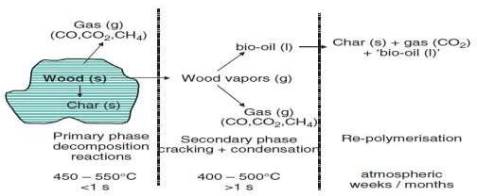Figure 2.1 shows possible reaction pathways for the pyrolysis of wood biomass. These include three lumped product categories, starting with a first order reaction. Lanzeta and Blasi (1998) found that, at the beginning of the pyrolysis (250°C–300°C) process, most of the volatiles gases are released at a rate 10 times faster than the next step.

Figure 2.1: Representation of the reaction paths for wood pyrolysis (Venderbosch and Prins, 2010 & Jahirul et al., 2012).

Depending on the operating condition, pyrolysis can be classified into three main categories: conventional (slow), fast and flash pyrolysis. These differ in process temperature, heating rate, solid residence time, biomass particle size, *etc.* However, relative distribution of products is dependent on pyrolysis type and pyrolysis operating parameters as shown in Table 2.1.

Table 2.1: Typical operating parameters and products for pyrolysis process (Balat et al., 2009; Bridgwater, 2007).

|  |  |  |  |  |  |  |
| --- | --- | --- | --- | --- | --- | --- |
| **Pyrolysis process** | **Residence time (Second)** | **Particle Size (Millimet**  **re)** | **Reaction Temp. (0C)** | **Product yield (%)** | | |
| **Oil** | **Char** | **Gas** |
| Slow | 450-550 | 5-50 | 150-350 | 25 | 70 | 5 |
| Fast | 0.5-10 | < 6 | 300-700 | 65 | 20 | 15 |
| Flash | < 0.5 | < 0.2 | 600-1100 | 10 | 15 | 75 |

In addition, different types of pyrolysis processes are described in the following three sub- sections.

# Slow Pyrolysis

Slow pyrolysis has been used for thousands of years to enhance char production at low temperature and low heating rates. In this process, the vapour residence time is too high (5 min to 30 min) and components in the vapour phase continue to react with each other which results in the formation of solid char and other liquids (Bridgwater *et al.*, 2001). However, slow pyrolysis has some technological limitations which made it unlikely to be suitable for good quality bio-oil production. Cracking of the primary product in the slow pyrolysis process occurs due to high residence time and could adversely affect bio-oil yield and quality. Moreover, long residence time and low heat transfer demands extra energy input (Hilal, 2005; Tippayawong *et al.*, 2008).

# Fast Pyrolysis

In the fast pyrolysis process, biomass is rapidly heated to a high temperature in the absence of oxygen. The basic characteristics of the fast pyrolysis process are particle size, short residence time, rapid cooling of vapours for high bio-oil yield and precision control of reaction temperature (Table 2.1) (Demirbas and Arin, 2002).

This technology is receiving incredible popularity in producing bio-oil and a range of speciality and commodity chemicals. This liquid product can be easily and economically transported and stored, thereby de-coupling the handling of solid biomass from utilization (Brammer *et al.*, 2006). It also has potential to supply a number of valuable chemicals that offer the attraction of much higher added value than fuels. Fast pyrolysis technology can have relatively low investment costs and high energy efficiencies compared to other processes, especially on a small scale. Production of bio-oil through fast pyrolysis has received more attention in recent year due to the following potential advantages (Bridgwater and Peacocke, 2000;Chiaramonti *et al.*, 2007; Venderbosch and Prins, 2010). Renewable fuel for boiler, diesel engine, turbine, power generation and processes; Low

cost and neutral CO balance; Utilisation of second generation bio-oil feed stocks and

2

waste materials (forest residue, municipal and industrial waste, *etc.*); Storability and transportability of liquid fuels; High energy density compared to atmospheric biomass gasification fuel gases; Possibility for separating minerals on the site of liquid fuel production to be recycled to the soil as a nutrient; Secondary conversion to motor-fuels, additives or special chemicals; Primary separation of the sugar and lignin fractions in biomass with subsequent further upgrading. The sub-processes of fast pyrolysis are illustrated in Figure 2.2.

Biomass

Char Bio-oil

Drying

<10% water

Size reduction

<6 mm

Gas combusted for heat

Liquid collection

Char separation

Fast pyrolysis reactor

Figure 2.2: Sub processes of fast pyrolysis (Bridgwater *et al.*, 2002)

# Flash Pyrolysis

The flash pyrolysis of biomass is a promising process for the production of solid, liquid and gaseous fuel from biomass which can achieve up to 75% of bio-oil yield (Bridgwater andPeacocke, 2000). This process can be characterized by rapid de-volatilization in an inert atmosphere, high heating rate of the particles, high reaction temperatures between 450°C and 1000°C and very short gas residence time (less than 1s) (Aguado *et al.*, 2002). However this process has some technological limitations, for instance: poor thermal stability and corrosiveness of the oil, solids in the oil, Increase of the viscosity over time by catalytic action of char, alkali concentrated in the char dissolves in the oil and production of pyrolytic water (Cornelissen *et al.*, 2008).

# Pyrolysis Reactor

The reactor is the heart of any pyrolysis process. Reactors have been the subject of considerable research, innovation and development to improve the essential characteristics of high heating rates, moderate temperatures and short vapour product residence times for liquids. At first, pyrolysis reactor developers had assumed that small biomass particles size

(less than 1mm) and very short residence time would achieve high bio-oil yield, however later research has found different results. Particle size and vapour residence time have little effect on bio-oil yield, whereas those parameters greatly affect bio-oil composition (Wang *et al.*, 2006; Wang *et al.*, 2005). With the continuation of pyrolysis technology development, a number of reactor designs have been explored to optimize the pyrolysis performance and to produce high quality bio-oil. However, each reactor type has specific characteristics, bio-oil yielding capacity, advantages and limitations. Of the various reactor designs, the most popular types are described in the following sub-sections.

# Fixed Bed Reactor

Fixed bed pyrolysis is a system consisting of a reactor with a fuel feeding unit, an ash removal unit, a cooling unit (condenser) and a gas exit. These types of reactor are being considered for small scale heat and power application (Jahirul et al., 2012).

In fixed bed pyrolysis, a fixed bed pyrolyser is used. The feed material in the reactor is fixed and heated at high temperature. As the feed is fixed in the reaction bed (reactor), it is called fixed bed pyrolysis. In this process, the feed material is fed into the reactor and heat is applied externally. Liquid petroleum or other inert gas is used for making inert condition and for helping the gaseous mixture to dispose of the reactor (Hossain *et al.*, 2014). The fixed bed reactor is of simple construction and easy to operate with short solid residence time, low ash carry over and biomass independent. In this technology tar removal is a major problem, however recent progress in thermal and catalytic conversion of tar has given credible options (Pathak, 2005; Rao *et al.*, 2004; Yang *et al.*, 2006).

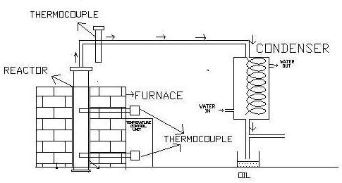

Figure 2.3: Process Schematic for fixed bed pyrolysis (Natarajan, 2009)

# Fluidized-Bed Reactor

The fluidized-bed reactor consists of a fluid-solid mixture that exhibits fluid like properties. This is generally achieved by the introduction of pressurized fluid through the solid particulate substance. Fluidized-bed reactors appear to be popular for fast pyrolysis as they provide rapid heat transfer, good control for pyrolysis reaction and vapour residence time, extensive high surface area contact between fluid and solid per unit bed volume, good thermal transport inside the system and high relative velocity between the fluid and solid phase (Lv *et al.*, 2004). Different types of fluidized-bed reactors are described.

# Bubbling Fluidized-Bed Reactors

Bubbling fluidized-beds are complex to construct and operate compares to fixed bed reactor (Hossain *et al.*, 2014). Although they provide better temperature control, solids-to- gas contact, and heat transfer and storage capacity because of the high solids density in the bed (Jahirul *et al.*, 2012). Heated sand is used as the solid phase of the bed which rapidly heats the biomass in a non-oxygen environment, where it is decomposed into char, vapour, gas and aerosols. The fluidizing gas stream conveys the decomposed biomass constituents produced out of the reactor (Jahirul *et al.*, 2012). After the pyrolytic reaction, the charcoal

is removed by a cyclone separator and stored. The remaining vapour is then rapidly cooled with a quenching system, condensed into bio-oil and stored. Bubbling fluidized-bed pyrolysis is very popular because it produces high quality bio-oil and liquid yield is about 70% - 75% weight of the biomass on a dry basis. Char does not accumulate in the fluidized bed, but it is rapidly separated. The residence time of solids and vapour is controlled by the fluidising flow rate. One important disadvantage of bubbling fluidizing bed reactors is that they need small biomass particle sizes (less than 2–3 mm) to achieve high biomass heating.

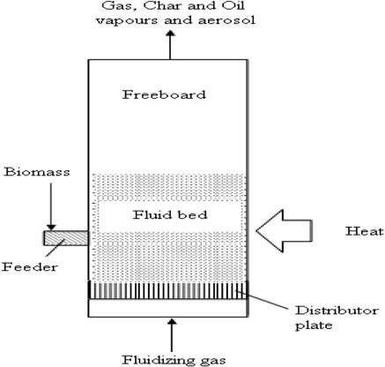

Figure 2.4: Process schematic for bubbling fluidized-bed (Isahak et al., 2012).

# Circulating Fluidized-Bed Reactor

Circulating fluidized-bed has similar features to bubbling fluidized-bed reactor except shorter residence times for chars and vapours. This results in higher gas velocity and char content in bio-oil than in bubbling fluidized bed reactors. One advantage is that this type of

reactor is suitable for very large throughputs, even though the hydrodynamics are more complex (Li *et al.*, 2004).

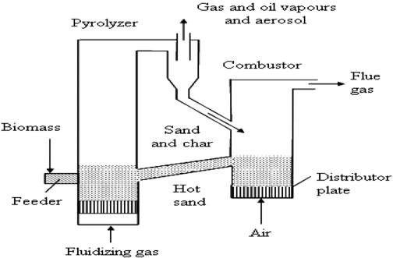

Figure 2.5: Process schematic for Circulating fluidized bed (Henrich, 2007; Isahak et al., 2012).

# Ablative Reactor

Ablative pyrolysis is fundamentally different from fluid bed processes with the mode of heat transfer being through a molten layer at the hot reactor surface and the absence of a fluidizing gas. Mechanical pressure is used to press biomass against a heated reactor wall. Material in contact with the wall essentially “melts” and, as it is moved away, the residual oil evaporates as pyrolysis vapours (Jones *et al.*, 2009). Advantages of ablative reactors are that feed material does not require excessive grinding, and the process allows much larger biomass particle size than other types of pyrolysis reactors. These types of reactor can use particle sizes up to 20 mm in contrast to the 2mm particle size required for fluidized bed designs. On the other hand, this configuration is slightly more complex due to mechanical

nature of the process. Scaling is a linear function of the heat transfer as this system is surface area controlled. Therefore ablative reactors do not benefit from the same economies of scale as the other reactor types (Bridgwater, 2007).The commonly used ablative reactor types are ablative vortex and ablative rotating disk.

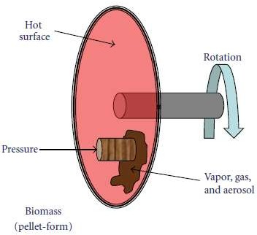

Figure 2.6: Ablative reactor (Vernael et al., 2012).

# Vacuum Pyrolysis Reactor

Vacuum reactors perform a slow pyrolysis process with lower heat transfer rates which results in lower bio-oil yields of 35%–50% compared to the 75wt% reported with the fluidized bed technologies. The pyrolysis process in vacuum reactor is very complicated mechanically and requires high investment and maintenance costs. A moving metal belt conveys biomass into the high temperature vacuum chamber. On the belt, biomasses are periodically stirred by a mechanical agitator. A burner and an induction heater are used with molten salts as a heat carrier to heat the biomass (Roy *et al.*, 1997). Because of operating in a vacuum, these types of pyrolysis reactors require special solids feeding and discharging devices to maintain a good seal at all times. The main benefit of vacuum

reactors is that they can process larger sized biomass particles (2–5 cm) than fluidized bed reactors.

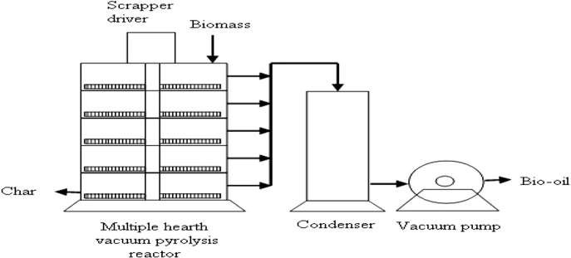

Figure 2.7: Process schematic for vacuum pyrolysis (Isahak et al., 2012).

# Rotating Cone Reactor

Intense mixing of biomass and hot inert particles is the most effective way to transfer heat to biomass in the pyrolysis process. However fluidised bed mixing requires too much ineffective inert gas. In the rotating cone reactor the pyrolysis reaction takes place upon mechanical mixing of biomass and hot sand, instead of using inert gas. The biomass feedstock and sand are introduced at the base of the cone while spinning causes centrifugal force to move the solids upward to the lip of the cone. As the solids spill over the lip of the cone, pyrolysis vapours are directed to a condenser. The char and sand are sent to a combustor where the sand gets re-heated before again being introduced at the base of the cone with the fresh biomass feedstock. Although the design of the rotating cone reactor is complex, it demonstrates high bio-oil yield (Wagenaar *et al.*, 2001)

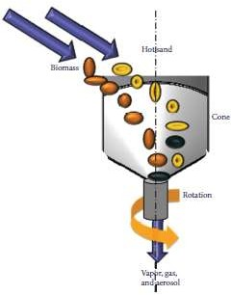

Figure 2.8: Rotating cone reactor (Verna et al., 2012)

# PyRos Reactor

PyRos pyrolysis is implemented in a cyclonic reactor with an integrated hot gas filter (the rotational particle separator) in one unit to produce particle free bio-oil. The biomass and the inert heat carrier are introduced as particles into the cyclone and the solids are transported by recycled vapours from the process. By centrifugal force the particles are moved downwards to the periphery of the cyclone. During the transport downwards in the reactor, the biomass particles are dried, heated up and devolatilized. The average process temperature is 450°C–550°C. The typical gas residence time in the reactor is 0.5 to 1second, so secondary cracking reactions of tars in the reactor can be reduced. Evolved vapours are transported rapidly to the centre of the cyclone and leave the cyclone via the rotating filter. The remaining gases and char can be used to heat up the heat carrier and transportation gas. This reactor is complex in design although it has 70%–75% bio-oil yield capability (Bramer and Holthuis, 2005).

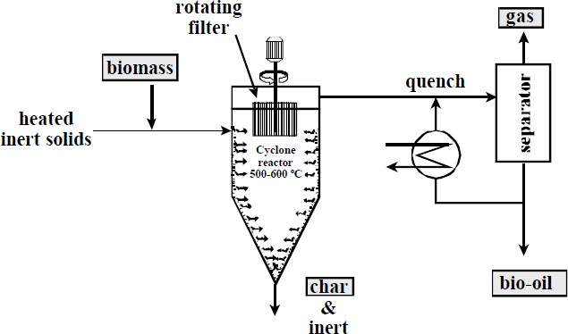

Figure 2.9: Schematic process for PyRos- reactor (Bramer and Brem, 2005)

# Auger Reactor

In this type of reactor, augers are used to move biomass feedstock through an oxygen free cylindrical heated tube. A passage through the tube raises the feedstock to the desired pyrolysis temperature ranging from 400°C to 800°C which causes it to devolatilize and gasify. Char is produced and gases are condensed as bio-oil, with non-condensable vapour collected as bio-gas. In this design the vapour residence time can be modified by changing the heated zone through which vapour passes prior to entering the condenser train (Mohan *et al.*, 2006).

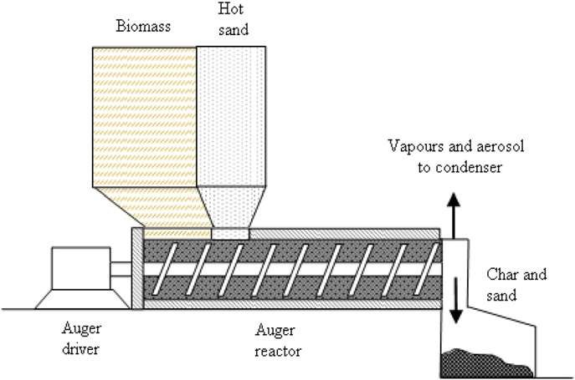

Figure 2.10: Schematic process for auger reactor (Isahak et al., 2012)

# Plasma Reactor

The plasma pyrolysis reactors are usually made with a cylindrical quartz tube surrounded by two copper electrodes. Biomass particles are fed at the middle of the tube using a variable-speed screw feeder located on the top of the tube. Electrodes are coupled with electrical power sources to produce thermal energy to gas flows through the tube. Oxygen is removed by an inert gas incorporated in the reactor. This inert gas also serves as working gas to produce plasma. The pyrolysis product vapours are evacuated from the reactor by means of a variable speed vacuum pump (Tang and Huang, 2005).

Although consuming high electrical power and having high operating costs, plasma reactors offer some unique advantages in biomass pyrolysis compared with conventional reactors. The high energy density and temperature produced in plasma pyrolysis

corresponds with a fast reaction which provides a potential solution for the problems that

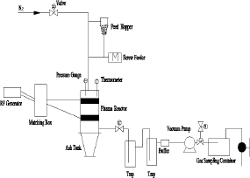occur in slow pyrolysis such as the generation of heavy tarry compounds and low productivity of syngas (Chen et al., 2003; Yaman, 2004). In this type of reactor, tar formation is eliminated due to the cracking effects of the highly active plasma environment with a variety electron, ion, atom and activated molecule species (Tang and Huang, 2005). However, a significant proportion of heat from the thermal plasma is released to the surrounding environment by means of radiation and conduction.

Figure 2.11: Schematic process for plasma reactor (Tang and Huang, 2005)

# Microwave Reactor

The microwave reactor is one of the recent research focuses in pyrolysis application in which energy transfer occurs through the interaction of molecules or atoms using a microwave-heated bed. The drying and pyrolysis processes of biomass are carried out in a microwave cavity oven powered by electricity. Inert gas is flowing continuously through the reactor to create an oxygen free atmosphere and to serve as the carrier gas as well. Aside from high electrical power consumption and high operating cost, microwave reactors offer several advantages over slow pyrolysis systems which make them an effective method of recovering useful chemicals from biomass. These advantages include efficient heat transfer, exponential control of the heating process and an enhanced chemical

reactivity that reduces the formation of undesirable species. Additionally, unexpected physical behaviours such as “hot spots” appear in microwave reactors which increases syngas yield (Fernández and Menéndez, 2011). Therefore a wide range of biomass and industrial wastes are possible to process in microwave reactors with high yields of desirable products such as syngas and bio-oil (Lam *et al.*, 2010).

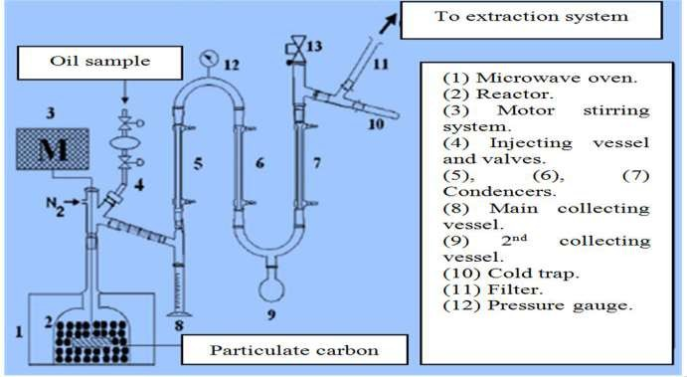

Figure 2.12: Schematic process for microwave pyrolysis device (Abo-dief et al., 2014)

# Solar Reactor

The use of solar reactor in pyrolysis provides a suitable means of storing solar energy in the form of chemical energy. This type of reactor is usually made with a quartz tube which has opaque external walls exposed to concentrated solar radiation. A parabolic solar concentrator is attached with the reactor to concentrate the solar radiation. The concentrated solar radiation is capable of generating high temperatures (>700°C) in the reactor for pyrolysis processes (Boutin *et al.*, 2002; Hofmann andAntal, 1984). However,

solar reactors have some advantages over slow reactors. In slow pyrolysis a part of the feedstock is used to generate the process heat. Therefore it reduces the amount of feedstock available and, at the same time, causes pollution. Hence utilization of solar energy in the pyrolysis process maximizes the amount of feedstock available and overcomes the pollution problem. Moreover, solar reactors are capable of faster start up and shut down periods compared to slow reactors (Shakya, 2007). The efficient of this reactor is weather dependent which as is greatest challenge (Lam *et al.*, 2010).

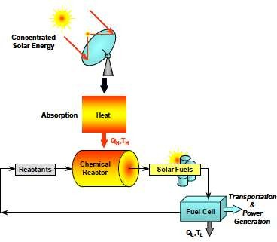

Figure 2.13: Schematic process for solar reactor (Steinfeld and Plumbo, 2001)

# Factors Affecting Pyrolysis of Biomass

This section describes the effect of the main controllable factors affecting the distribution of products from pyrolysis processes. The effect of feedstock composition and preparation is discussed first followed by the effects of process operating conditions. Slow, fast and flash pyrolysis are affected in a related manner but the importance of factors and the effect of changes on product yield distribution differ between process types.

# Feedstock Composition

Biomass is generally composed of three main groups of natural polymeric materials (cellulose, hemicellulose and lignin), each of which is different in their decomposition behavior (Table 2.2).

Table 2.2: Lignin, Cellulose and Hemicellulose content of selected biomass

|  |  |  |  |  |
| --- | --- | --- | --- | --- |
| Feedstock | Lignin (%) | Cellulose (%) | Hemicellulose  (%) | Source |
| *Soft wood* | *27-30* | *35-40* | *25-30* | Bridgeman *et al.* (2010) |
| *Hard wood* | *20-25* | *45-50* | *20-25* | Bridgeman *et al.* (2010) |
| Sugar cane bagasse | 24 | 43 | 25 | Merino andCherry  (2007) |
| Corncob | 15 | 50.5 | 31 | Bridgeman *et al.* (2010) |
| Corn stalks | 17 | 43 | 24 | Raveendran *et al.* (1995) |
| Rice husk | 14 | 31 | 24 | Raveendran *et al.* (1995) |
| Rice straw | 18 | 32.1 | 24 | Howard *et al.* (2003) |
| Banana waste | 14 | 13.2 | 14.8 | Sánchez (2009) |
| Barley straw | 14–15 | 31–34 | 24–29 | Naik *et al.* (2010) |
| Bamboo | 21-31 | 26-43 | 15-26 | Sánchez (2009) |
| Millet husk | 14 | 33 | 27 | Raveendran *et al.* (1995) |
| Palm kernel shell | 53.85 | 6.92 | 26.16 | Ndoke (2006) |
| Switch grass | 5–20 | 30–50 | 10–40 | Bridgeman *et al.* (2010) |

Other typical components are grouped as „extractives‟ (generally smaller organic molecules or polymers) and minerals (inorganic compounds). These are present in differing proportions in different biomass types and these proportions influence the product distributions on pyrolysis (Antal and Grønli, 2003; Mohan et al., 2006).

In the pyrolysis process, the main components are not decomposed at the same time. Hemicellulose would be the easiest one to be pyrolysed, next would be cellulose, while lignin would be the most difficult one (Wang et al., 2008).

Yang et al. (2006) Observed that bio-oil mainly derived from the cellulose component of biomass (around 500 °C), whereas the solid residue (bio-char) came from the lignin. This is also evident from the composition of bio-char, which has an element composition close to that of lignin (Venderbosch and Prins, 2010).

# Feedstock Preparation

Moisture content can have different effects on pyrolysis product yields depending on the conditions (Antal and Grønli, 2003). In traditional charcoal kilns heated internally by wood combustion, high moisture levels lead to reduced charcoal yields as a greater quantity of wood must be burnt to dry and heat the feed. For externally heated equipment the reported effect of steam on the yield of char varies depending on the conditions. Increased moisture present when pyrolysis reactions are performed under pressure has been shown to systematically increase char yields (Antal and Grønli, 2003).

Fast and flash pyrolysis processes in general require a fairly dry feed, around 10% moisture (Bridgwater and Peacocke, 2000), so that the rate of temperature rise is not restricted by evaporation of water. Slow pyrolysis processes are more tolerant of moisture, the main issue being the effect on process energy requirement. For charcoal making, wood moisture contents of 15-20% are typical (Antal and Grønli, 2003). In all pyrolysis processes water is also a product and is usually collected together with other condensable vapors in the liquid product.

Moisture in the reaction affects char properties and this has been used to produce activated carbons through pyrolysis of biomass (Minkova *et al.*, 2001).

Feed particle size can significantly affect the balance between char and liquid yields. Larger particle sizes tend to give more char by restricting the rate of disengagement of primary vapor products from the hot char particles, so increasing the scope for secondary char forming reactions (Antal and Grønli, 2003). Hence larger particles are beneficial in processes targeting char production and small particles are preferred to maximize liquid yields in fast pyrolysis.

# Pyrolysis Temperature Control

The Pyrolysis temperature is the most important aspect of operational control for pyrolysis processes. Material flow rates, both solid and gas phase, together with the reactor temperature control the key parameters of heating rate, peak temperature, residence time of solids and contact time between solid and gas phases. These factors affect the product distribution and the product properties.

For fast/flash pyrolysis a rapid heating rate and a rapid rate for cooling primary vapors are required to minimize the extent of secondary reactions. These reactions not only reduce the liquid yield but also tend to reduce its quality, giving a more complex mixture, an increased degree of polymerization and higher viscosity (Bridgwater and Peacocke, 2000). Conversely, in slow pyrolysis there is some evidence that slow heating leads to higher char yields (Antal and Grønli, 2003).

Peak temperature, however, has an unequivocal effect on char yields and properties. Higher temperatures lead to lower char yield in all pyrolysis reactions. This results from

the main controlling variable of pyrolysis reaction kinetics being temperature (Antal and Grønli, 2003).

The effect can be thought of as more volatile material being forced out of the char at higher temperatures reducing yield but increasing the proportion of carbon in the char. Temperature also has an effect on char composition, chars produced at higher temperatures having higher carbon contents both total- and fixed-carbon (Antal and Grønli, 2003).

Solid residence time is also important but to a lesser degree than peak temperature, longer time at temperature leading to lower char yield (Antal and Grønli, 2003).

The effect of temperature on liquid and gas yields is more complex. Liquid yields are higher with increased pyrolysis temperatures up to a maximum value, usually at 400- 550°C but dependent on equipment and other conditions. Above this temperature secondary reactions causing vapor decomposition become more dominant and the condensed liquid yields are reduced. Gas yields are generally low with irregular dependency on temperature below the peak temperature for liquid yield; above this gas yields are increased strongly by higher temperatures, as the main products of vapor decomposition are gases. For fast pyrolysis the peak liquid yields are generally obtained at a temperature of around 500°C (Tsai et al., 2007). Peak liquid yields for slow pyrolysis are more variable. Weerachanchai *et al.* (2011) reports peak liquid yields of 54.3wt% and 42.4wt% (for palm kernel cake and cassava pulp residue, respectively) at temperature between 300°C and 500°C, when studying the Characterization of products from slow pyrolysis of palm kernel cake and cassava pulp residue. A fast pyrolysis process in fluidized bed reactor yields a peak of 62-66wt% liquid at temperature of 420-580°C with maize stalk feed (Zheng, 2008).

# Residence Time

This is also known as retention time and this can be defined as the duration the pyrolysis products remain in the reactor chamber before they are discharged out of the reactor.

According to Zanzi et al. (2002), the residence time has an influence on products of pyrolysis. The increase in retention time may lead to the secondary reactions thereby resulting in secondary products. Mohamed et al. (2013) varied the pyrolysis time during fixed bed pyrolysis of empty fruit bunch (EFB) and it was discovered that char yield decreases slightly, why the gas yield increases with an increase in pyrolysis time. However, contrary results were obtained by Gan and Yuan (2008) which reported that increase in the retention time had no significant effect on gas yield during the hydrothermal pyrolysis of mixed crop residues. Their work further revealed that there was drastic effect on the char yield, which decreases with increase in retention time. The study also established optimal retention time for production of bio-oil. The oil yield was found to reach its maximum of 21wt% at 20 minutes retention time and then decrease when retention time was longer than 20 minutes.

# Moisture Content

Moisture content can have different effects on pyrolysis product yields depending on the conditions (Antal and Grønli, 2003). In traditional charcoal kilns heated internally by wood combustion, high moisture levels lead to reduced charcoal yields as a greater quantity of wood must be burnt to dry and heat the feed. Increased moisture present when pyrolysis reactions are performed under pressure has been shown to systematically increase char yields (Antal and Grønli, 2003). As noted by Bridgwater and Peacocke (2000), fast pyrolysis processes in general require fairly dry feed, around 10% moisture, so that the rate

of temperature rise is not restricted by evaporation of water. However, slow pyrolysis is more tolerant of moisture, the main issue being the effect on process energy requirement.

# Biomass

The term biomass refers to non-fossilized and biodegradable organic material originating from plants, animals, and microorganisms derived from biological sources. Biomass includes products, by-products, residues and waste from agriculture, forestry and related industries, as well as the non-fossilized and biodegradable organic fractions of industrial and municipal solid wastes. Biomass also includes gases and liquids recovered from the decomposition of non-fossilized and biodegradable organic material. Biomass residues mean biomass by-products, residues and waste streams from agriculture, forestry, and related industries (Demirbas, 2009).

Demirbas (2008) simply defined the term “biomass” as wood, short-rotation woody crops, agricultural wastes, short-rotation herbaceous species, wood wastes, bagasse, industrial residues, waste paper, municipal solid waste, sawdust, bio solids, grass, waste from food processing, aquatic plants and algae animal wastes, and a host of other materials. Biomass is the plant and animal material, especially agricultural waste products, used as a source of fuel. Biomass as the solar energy stored in chemical form in plant and animal materials is among the most precious and versatile resources on Earth. It is a rather simple term for all organic materials that stem from plants, trees, crops and algae. This biomass can be converted into energy and power by adopting appropriate method. Figure 2.5 shows the utilization of biomass to get various different outputs (Kaushik et al., 2010).

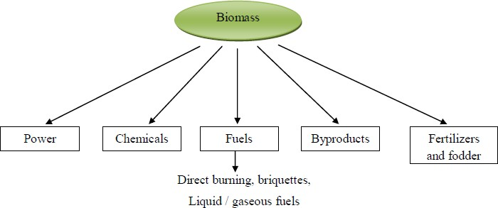

Figure 2.14: Utilization of biomass resources (Kaushik et al., 2010).

# Biomass Conversion Technology

Wide variety of conversion technologies is available for the production of premium fuels from biomass. Conversion process generally depends on the physical condition of biomass and the economics of competing process. Biomass conversion technology can be basically grouped into three categories. (1) Direct combustion (2) Thermo-chemical conversion (3) Biochemical conversion. In direct combustion, oxygen supplied is generally higher than that of stoichiometric limit. In the thermo-chemical conversion method the biomass is raised to high temperature and depending on the quantity of oxygen supplied the process such as pyrolysis or gasification takes place. The biochemical conversion process is a low energy process and relies upon the action of bacteria which degrade complex molecules of biomass into simpler ones. Production of biogas (a mixture of CH4 and CO2) from animal dung by anaerobic digestion is a good example of biochemical process (Demirbaş, 2000b). According to Pandey (2011) brief discussion of biomass conversion process is described in Figure 2.15.

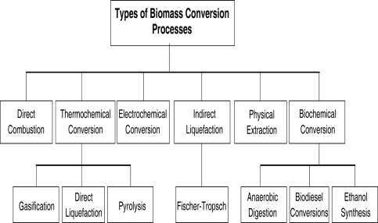

Figure 2.15: Biomass conversion process (Pandey, 2011)

# Feed stock/ material background

Oil Palm (*Elaeis guineensis*) is the most important species in *Elaeis* genus which belongs to the family Palamae (Teoh, 2002). It is cultivated in all tropical areas especially in Nigeria, Malaysia, Indonesia and Thailand (Abdullah *et al.*, 2011). The oil palm fruit is reddish in color and has a size of large plum, and grows in large bunches. A bunch usually has the weight of 10 to 40 kg. Each fruit consists of a single seed (the palm kernel) and surrounded by a soft oily pulp mesocarp. Oil is extracted from both the fruit pulp and the kernel (Abdullah *et al.*, 2011). The oil extracted from fruit pulp is used for edible purposes, while the extracted oil from kernel is used for the manufacturing of soap (Evbuomwan *et**al.*, 2013). The by-products from oil palm processing consist of oil palm trunks (OPT), oil palm fronds (OPF), empty fruit bunches (EFB), palm pressed fibers (PPF) and palm kernel shells (PKS), less fibrous palm kernel cake and liquid palm oil mill effluent (POME) (Singh *et al.*, 2010).

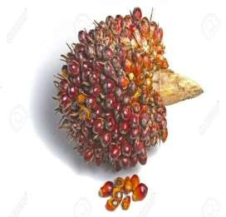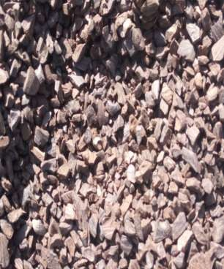

(a) (b)

Plate 1: (a) A bunch of Oil palm and (b) crushed of Palm Kernel Shell (Oyejobi et al., 2012; Singh et al., 2010)

# Fourier Transform infra-red (FTIR) Spectroscopy

FTIR spectroscopy is a non-destructive method of analysis that determines functional groups present in materials. FTIR is based on interferometry and thus differs fundamentally from traditional dispersive infrared spectroscopy (Singh and Shadangi, 2011). The spectra/data is used to identify organic compounds by matching the fingerprint of a sample with those on the computer. In addition, the functional groups and structural characteristics of a compound enable one to elucidate possible structural types.

# Gas Chromatography/ Mass Spectrometry (GC-MS)

GC-MS is used to separate and analyse various chemical compounds that are formed during the pyrolysis process. From the GC-MS spectra, each peak has its own retention time and percentage area. With the system, a library search on each components of the

mixture can be conducted. If the components are known compounds, they can be identified by comparisons with compounds found in the computer library. (Singh and Shadangi, 2011).

# Review of related past works

Akinola (2016) presented the evaluation of a thermochemical reactor for wood pyrolysis. Biomass from seven tropical wood species (*Triplochiton scleroxylon, Melicia excelsa, Nesogordonia papaverifera, Khaya ivorensis, Cordia platythyrsa, Mansonia altissima and Terminalia superba*) were (fast) pyrolysed in a fixed-bed batch thermal reactor. Thermodynamic principles were used to obtain the reactor efficiency at various temperatures. In his findings, the overall average reactor efficiency at generating gas was 86% leading to the conclusion that the thermochemical reactor is highly efficient.

Sukumar et al. (2015) carried out fast pyrolysis experiments on sweet lime empty fruit bunch in an electric furnace fixed bed reactor to produce bio-oil. The effects of particle size, temperature and nitrogen gas flow rate on the product yields were investigated. These pyrolysis parameters are optimized by response surface methodology (RSM) with a Box- Behnken Design (BBD). The results showed the bio-oil yield is 28.3% for experimental and 28.2% for statistical method at optimum temperature of 5500C, 4mm of particle size and 300cm3min-1 of gas flow rate.

*Hossain et al. (2014)* were able to design and fabricate an electric heated fixed bed fast pyrolysis system using stainless steel for obtaining liquid fuel from devdaru (*Cedrus deodara*) seeds. They varied reactor bed temperature, running time and feed particle size and found out that these parameters influenced the product yields significantly. They

concluded that the heating value of devdaru seeds oil is moderate after analysed the

properties of the pyrolysis oil obtained and got the higher heating value of devdaru seeds oil at 24.22MJ/kg.

Aysu and Küçük (2014) constructed a fixed-bed tubular reactor from stainless steel, heated externally by electric furnace and performed slow pyrolysis of eastern giant fennel (Ferula orientalis L.) stalks with the system to investigates the effects of pyrolysis parameters such as temperature, catalyst and ratio of catalyst, particle size and sweeping gas flow rate on product yields. The highest liquid yield (45.22%) was obtained with 15% zinc oxide catalyst at 5000C temperature, heating rate of 500Cmin-1, particle size 0.224 > Dp> 0.150mm and sweeping gas flow rate of 100cm3/min. The results indicated that temperature and catalyst are the main factors effecting the conversion of this biomass into solid, liquid and gaseous products.

*Mohamed et al. (2013)*conducted two series of the empty fruit bunch (EFB) pyrolysis experiments using an electric heated fixed-bed reactor to determine the effects of holding time and the sweeping nitrogen gas flow rates on the pyrolysis yields. In each experiment, the pyrolysis temperature was raised to 442.15 °C with a heating rate of 50 ºC/min and

3

nitrogen flow rate of 150cm

-1

min

. The first series of experiment was conducted to

determine the effect of holding time on the distribution of pyrolysis products. Therefore, the holding time was varied at 6, 8, 10 and 12 minutes. It was identified that at 10 minutes holding time, the highest bio-oil yield of 45.72% was obtained with bio-char yield of 25.88% and 28.40% gas produced. In the second series of experiments, the effect of nitrogen flow rates was investigated by varying the nitrogen flow rates at 150, 200, 300,

3

400 and 500cm

-1

min

3

. It was identified that at nitrogen flow rates of 200cm

-1

min

, the bio-

oil yield of 46.02% was at its maximum with bio-char and gas production of 26.69 % and 27.29% respectively.

*Kim et al. (2010)* studied the influence of pyrolysis parameters on the bio-oil yield for fast pyrolysis process of Palm Kernel Shells (PKS) using an electric-heater fluidized bed reactor to pyrolyze the sample. From this study, the highest yield of bio-oil (40.3%) is gained at temperature of 490 °C. They concluded with the fact that this type of heating source only generates 40% efficiency of the biomass. Besides, sources for electric are very costly and limited to access at certain area. So, the search for a system that is used direct heated reactor which is compatible with the current system available is really essential in saving the energy and cost.

*Uzun et al. (2006)*studied the role of important parameters influencing pyrolysis yields from soybean cake. The fast pyrolysis experiments were conducted under nitrogen atmosphere in a well-swept resistively fixed-bed reactor with a length of 90 cm and an inner diameter of 8 mm, made of 310 stainless steel. Experiments were carried out at temperatures ranging from 400 to 700 °C, for various nitrogen flow rates, heating rates and particle sizes. The maximum liquid yield was 42.83% at a pyrolysis temperature of 550 °C

3 -1 -1

with a sweeping gas rate of 200 cm min and heating rate of 700°Cmin

for a soybean

cake sample having 0.425 - 0.85 mm particle size.

Acikgoz et al. (2004) constructed a fixed-bed reactor using 310 stainless steel. This reactor was used to perform fast pyrolysis experiments on Linseed (*Linum usitatis- simum* L.) to determine the effect of pyrolysis temperature, heating rate, particle size and sweep gas flow rate on the pyrolysis product yields and their composition. The maximum oil yield (57.7wt%) was obtained at a final pyrolysis temperature of 550 °C, particle size range

0.6mm< dp <1.8mm, with a heating rate of 3000Cmin-1 and sweep gas flow rate of 100cm3min-1. The pyrolysis products were characterised by elemental analysis, chromatography and spectroscopic techniques. Chromatographic and spectroscopic studies on oil showed that it can be used as a renewable fuel and chemical feedstock, with a calorific value of 38.45 MJ/kg

# 2.9 Research gap

From the review of related past studies, it can be seen that most of the system performance is evaluated in terms of bio-oil yield, heating rate and temperature but other parameters such as thermal efficiency and heat flow path through the system were not carried out.

# MATERIALS

* + 1. **List of Materials**

# CHAPTER THREE MATERIALS AND METHODS

In selecting appropriate materials for the fixed bed pyrolysis system, it is necessary to consider the metallurgical properties and their availability. The materials selected include the following:

Table 3.1: List of Materials used

|  |  |  |  |
| --- | --- | --- | --- |
| **S/N** | **COMPONENT** | **MATERIAL** | **REMARKS** |
| 1 | Reactor | Galvanized steel pipe | High melting temperature resistance, malleability, low cost and readily  available |
| 2 | Insulator | Sand | Available at low cost  and durability |
| 3 | Condenser | Mild-steel | Good condensing  quality |
| 4 | Seal | Fibre | Low cost and readily  available |
| 5 | Fasteners | Bolt and Nuts (10& 13 mm) and clips | Easy to assemble, High tensile strength, low cost  and readily available |
| 6 | Connecting Pipes | Mild steel and  rubber holes | Low cost and readily  available |
| 7 | Ice-bath | Plastic bowl | Low cost and readily available |

Table 3.2: List of Instruments and Equipment Used

|  |  |  |
| --- | --- | --- |
| INSTRUMENTS AND  EQUIPMENT | SPECIFICATION | FUNCTION |
| Thermocouple | Digital (Kane- May  KM340, -50° ≈1500° C) | For temperature measurement |
| Stop watch | Digital (N1280) | For pyrolysis time  measurement |
| Test Sieves | U.K Standard (S-01, particle sizes of 1.18 mm,  2.35mm and 5 mm) | Used to sieve the biomass to desired particle sizes |
| Weight balance | Digital (TCS-100-ZE11) | Used to measure the weight  of bio-oil and bio-char produced |
| Forge blower | Manual (MB-9L) | Used as biomass heater |
| Fourier transform infrared  analyser | Nicolet madison (Magna-  IR550) | Used to identify functional  groups present in the bio-oil |
| Gas Chromatography and Mass Spectrometric analyser | Agilent Technologies (GC6890N-MS5973N) | Used to identify the chemical composition found  in the bio-oil |

# METHODS

* + 1. **Description and working principle of the Fixed Bed Pyrolysis System**

The fixed bed pyrolysis system consists of two units. These are the fixed bed reactor and the condensate unit.

The insulated fixed bed reactor containing 1.5kg palm kernel shell is heated by a coal furnace. A thermocouple was placed inside the reactor to monitor the reaction temperature. As the temperature increases, vapour is produced which flows through the connecting pipe into the condenser. The ice bath contains ice water to cool the vapour into liquid. The non- condensed gas is released to the atmosphere through pressure relief valve. The schematic diagram of the fixed bed pyrolysis system is shown in Figure 3.1.

Elbow

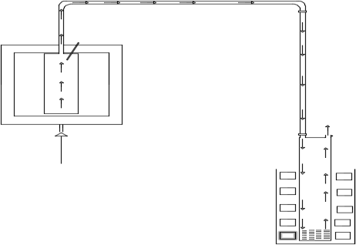

Thermocouple

Clip

Connecting pipe Fixed bed Reactor

Insulator

Rubber hose

Flared gas

Heat Supplied from manual forge blower

Condenser/Liquid

collector Ice bath

Ice water

Pressure relief valve

Bio-oil

Figure 3.1: A Schematic diagram of the fixed bed pyrolysis system

# Design Theory and Equation

The basic objective in designing a fixed bed pyrolysis system is to produce specified products (bio-oil, char and gas) at a given rate.

# Initial design parameters:

The pyrolysis system has been designed based on the following considerations:

* + - * 1. Pyrolysis temperature range of 350 to 550 °C
        2. Reactor design pressure ≤ 101325N/m2
        3. Particle size of 1.18mm, 2.35mm and 5mm (at 1.5kg per sample)
        4. Total volume of the reactor (VR = 0.002290m3)
        5. Reactor thickness of 4mm
        6. Calorific value of palm kernel shell feed (22.81MJ/kg)

# Stresses in the fixed bed reactor

Stresses are induced in different parts of a fixed bed pyrolysis system by the pressure and temperature of pyrolysis vapours. The magnitudes of these stresses must be known so that the plant will be operated under safe conditions. These stresses are hoop (circumferential) stress and longitudinal stress.

The hoop stress, 𝜎ℎ as given by Khurmi and Gupta (2005) is;

𝜎ℎ

= 𝑃𝑑× 𝐷 2𝑡

(3.1)

Where, 𝑃𝑑 = Internal design pressure of the reactor (N/𝑚2)

𝜎h= hoop stress (N/𝑚2)

t = wall thickness of the reactor (m)

D= diameter of the reactor (m) Also, the longitudinal stress, 𝜎L;

𝜎L

= 𝑃𝑑×D 4𝑡

Where 𝜎L= longitudinal stress (N/𝑚2)

(3.2)

L



L

D

𝑃𝑑

𝜎L

t

𝜎h

h

Figure 3.2: Stresses in the fixed bed reactor

# Reactor Thickness

A cylinder is regarded as thin walled when the wall thickness (t) is less than 1/20 of the diameter D. When the wall is thicker than this, it is regarded as a thick wall (Den-Hartog, 1952).

Mathematically;

For a thin walled cylinder, t < 1 𝐷 (3.3)

20

# Insulation

Insulation serves to minimize loss of heat to the environment. Although the lower the thermal conductivity of a material the better the insulation, Sand with a thermal conductivity of 0.27 is less expensive compared to glass fiber was used in this work due to durability and availability of the materials at the time of this experiment as well as the operating temperature of the fixed bed pyrolysis plant.

# 3.2.2.4.1 Insulation Thickness

It is known that heat loss in a wall can be minimised through insulation. This is expected, since the heat transfer area A is constant, and adding insulation always increases the thermal resistance of the wall without increasing the convection resistance.

Adding insulation to a cylindrical pipe or a spherical shell, however, is a different scenario. The additional insulation increases the conduction resistance of the insulation layer but decreases the convection resistance of the surface because of the increase in the outer surface area for convection.

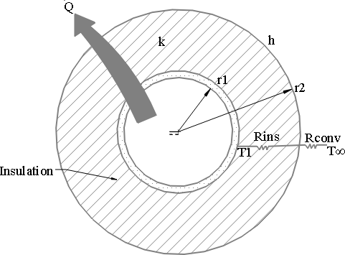

Figure 3.3: Insulated cylindrical pipe exposed to convection from the outer surface and its thermal resistance network.

From Figure 3.3, (Totala et al. , 2013)

𝑄̇ = 𝑇1−𝑇∞

𝑅i𝑛𝑠+𝑅conv

= 𝑇1−T∞ (3.4)

ln( ) r1 +

r2

1

2𝜋𝐿𝐾 ℎ(2𝜋r2𝐿)

Where;

Q̇ = The rate of heat transfer from the insulated cylinder to the surrounding (W) T1 = Outer surface temperature of the cylinder (0C)

T∞ = Temperature at which heat is loss to the surrounding (0C)

𝑅i𝑛𝑠 = Conduction resistance of the insulation (0C/W)

𝑅𝑐𝑜𝑛𝑣 = Convection resistance of its surface (0C/W) r1 = Outer radius of the cylinder before insulation (m) r2 = Outer radius of the cylinder after insulation (m) L = Length of the cylinder (m)

k = Thermal conductivity of the material used (sand) (W/m.0C)

h = Convection heat transfer coefficient (W/m.0C)

The variation of the rate of heat transfer with the outer radius of insulation *r2* (Table 3.3 in Appendix D) is plotted in Figure 3.4. The value of *r2* at which heat transfer rate reaches

maximum is determined from the requirement that dQ

dr2

= 0 (zero slope).

The critical radius of insulation thickness for a cylindrical body according to Cengel, (2008) is:

rcr, = k (m*)* (3.5)

h

Figure 3.4: The variation of heat transfer rate (Q̇ ) with the outer radius of the insulation (*r2)*



169

168

167

166

165

164

163

162

161

160

159

158

157

50

55

60

65

70

75

80

**Thickness of Insulation (mm**)

**Heat transfer rate (W)**

# Design of the Reactor

Vapor residence time (𝑡𝑣) in reactor is an important parameter to achieve maximum yield of liquid. The apparent vapor residence time usually less than 5 seconds for fast pyrolysis otherwise secondary cracking of vapor product would occur resulting in higher amount of gases and lower amount of liquid production (Bridgwater and Bridge, 1991). The vapor residence time which is basically the ratio of the volume of the reactor to the volumetric flow rate (Metcalfe, 2002) was calculated using the following equation:

Total volume of the reactor, 𝑉 = A×L = 𝜋𝐷2 × 𝐿 (3.6)

Where;

𝑅 4

A = area of the reactor (m2) L = length of the reactor (m)

D = diameter of the reactor (m)

Free space in the reactor, 𝑉𝑟 = 30% of the total reactor volume.

𝑉𝑟

= 30

100

× 𝑉𝑅

(3.7)

The volume of the volatile and gas generated according to Kader et al., (2013) is,

(V) = mR𝑇𝑎𝑣𝑒 - (3.8)

P

Where P = product volatile and gases pressure in the reactor (101,325N/𝑚2), m = mass of volatile and gases (assumed 60% of biomass feed), T is the average operating temperature and R is the universal gas constant (for hydrocarbon, R=518.3J/kgK)

Volume flow rate (𝑉 ) = volume of the volatile and gas generated (V) (3.9)

ƒ

Vapour residence time (𝑡𝑣

Total time of reaction (t)

) = ƒ𝑟𝑒𝑒 𝑠𝑝𝑎𝑐𝑒 i𝑛 𝑡ℎ𝑒 𝑟𝑒𝑎𝑐𝑡𝑜𝑟 (𝑉r) (3.10)

𝑉𝑜𝑙𝑢𝑚𝑒 ƒ𝑙𝑜w 𝑟𝑎𝑡𝑒 (𝑉ƒ)

The line and working drawing of the fixed bed reactor are shown in Figure 3.5 and Figure

3.6 respectively.

Φ19.05mm

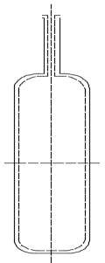

360mm

Φ90mm

Figure 3.5: The line drawing of the fixed bed reactor

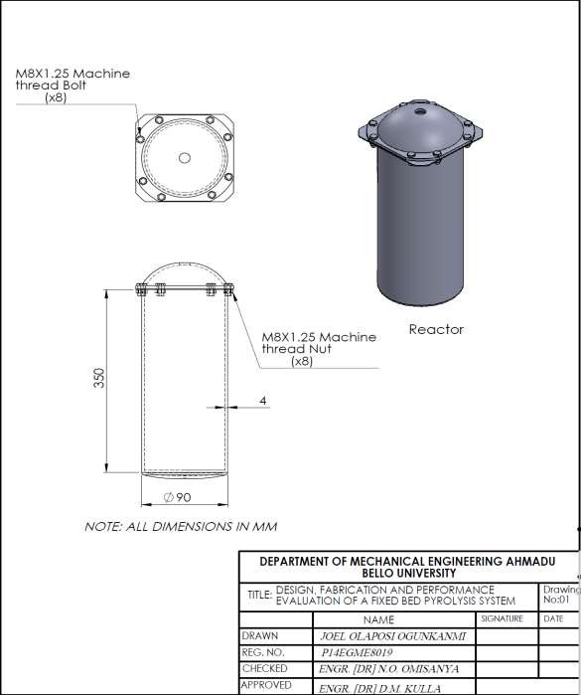

Figure 3.6: The working drawing of the fixed bed reactor

# Design of the Condenser

A rapid quenching of pyrolysis vapour promotes high liquid yield. Water cooled condenser has been designed and used to cool down the pyrolysis vapour. The line and the working drawing of the condenser are shown in Figure 3.7 and Figure 3.8 respectively.

For proper cooling of the vapour, the assumed parameters were water inlet temperature (𝑇𝑐1), Water outlet temperature( 𝑇𝑐2), vapour inlet temperature( 𝑇ℎ1) and Vapour outlet temperature(𝑇ℎ2*).*

So the minimum log-mean temperature difference,

∆Tm

=(Th2 −Tc2) −(Th1 −Tc1) (3.11)

ln(Th1 −Tc1)

(Th2 −Tc2)

According to Rajput (2012), the overall heat transfer between water and vapour can be

calculated from the equation*,* Q = U0×A× ∆Tm

Q= A× ∆Tm

(3.12a)

(3.12b)

1 + ∆x + 1

hg k hl

Where Q is the overall heat transfer (W), 𝑈0 is the overall heat transfer coefficient (W/m2°C), A is the heat transfer/cross sectional area (m2), ∆𝑥 is the thickness of metal wall (m), k is the thermal conductivity (W/𝑚0𝐶), ℎg is the enthalpy of the gas at operating

pressure (kJ/kg), ℎ𝑙 is the enthalpy of the liquid (kJ/kg) and ∆Tm is the mean temperature difference (°C).

2mm



620mm

ϕ120mm

Figure 3.7: The line drawing of the condenser

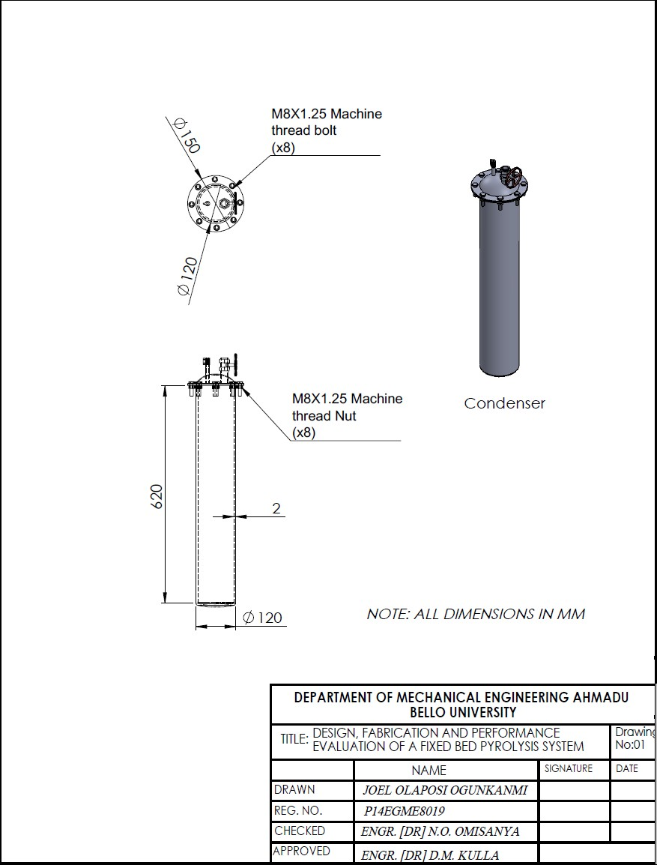

Figure 3.8: The working drawing of the condenser

# Design calculation of the fixed bed pyrolysis system

All the calculations relating to the design of the fixed bed pyrolysis system are shown in Table 3.4.

Table 3.4: Design calculation of the fixed bed pyrolysis system

|  |  |  |
| --- | --- | --- |
| **Initial Data** | **Calculations** | **Remarks** |
| Type of reactor | Fixed bed reactor |  |
| Table 3.4.1: Design of the fixed bed reactor | | |
| L = 0.36m | From equation 3.6 Total volume of the reactor  2  (𝑉 )= A×L = 𝜋𝐷 × 𝐿  𝑅 4  𝜋(0.09)2  𝑉𝑅 = 4 × 0.36  𝑉𝑅=0.002290𝑚3  Also from equation 3.7 Free space in the reactor  (𝑉 ) = 30 × 𝑉  𝑟 100 𝑅  𝑉 = 30 × 0.002290  𝑟 100  𝑉𝑟 = 0.000668𝑚3  Also from equation 3.8 Volume of the volatile and  gas generated (V) = mR𝑇𝑎𝑣𝑒  P  V = 1.5×518.3×723  101325  V = 5.547459𝑚3  From equation 3.9  Volume flow rate (𝑉 ) = V  ƒ t  = 5.54746 =0.000770𝑚3/𝑠  7200  From equation 3.10  Vapour residence time (𝑡𝑣) | The calculated vapor residence |
| D = 0.09m | time is approximately 1second. |
| m = 1.5kg | This agreed with Hossain et. al |
| R = 518.3J/kgK | (2014) finding.. |
| Tave= 723K |  |
| P = 101325N/𝑚2 |  |
| t = 120min |  |

|  |  |  |  |
| --- | --- | --- | --- |
|  | = 𝑉r  𝑉ƒ  = 0.000668 = 0.891737s  0.00077  ≈ 0.89 seconds |  | |
| Table 3.4.1.1: Thermal stresses in the reactor | | | |
| 𝑃𝑑=101325 N/𝑚2 | From equation 3.1 | 𝜎ℎ= hoops stress (N/𝑚2). | |
| t = 0.004m | 𝜎 = 𝑃𝑑× 𝐷 = 101325× 0.09  ℎ 2𝑡 2 ×0.004 | Calculated as | |
| D = 0.09m | =1139906.25N/𝑚2 | 𝜎ℎ= 1139906.25N/𝑚2 | |
|  | **≈** 1.14MN/𝑚2 | 𝜎L= longitudinal stress (N/𝑚2). | |
|  | Also, from equation 3.2 | Calculated as | |
|  | 𝜎 = 𝑃 𝑑× 𝐷 = 101325×0.09 | 𝜎L= 569953.125N/𝑚2 | |
|  | L 4𝑡 4 × 0.004 |  | |
|  | = 569953.125N/𝑚2 |  | |
|  | ≈ 0.57MN/𝑚2 |  | |
| Table 3.4.1.2: Insulation thickness | | | |
| 𝑟1= 0.045m | From equation 3.4:  *At r2 = 0.050m,*  𝑄̇ = 350−25.5  ln 0.050  ( )  0.045 + 1  2 ×0.36×0.27 5(2 ×0.050×0.36)  =167.19W  *At r2 = 0.055m,*  𝑄̇ = 350−25.5  0.055  ln( ) 1  0.045 +  2𝜋×0.36×0.27 5(2𝜋×0.055×0.36)  =167.60W  *At r2 = 0.060m,*  𝑄̇ = 350−25.5  ln 0.060 1  ( .04 ) +  0 5  2𝜋×0.36×0.27 5(2𝜋×0.060×0.36) | | The value of the critical radius |
| *r2 = 0.050, 0.055,* | *rcr* will be the largest when *k* is |
| *0.060, 0.065, 0.070,* | large and *h* is small. With h |
| *0.075 and 0.080m* | =4.91W/m2 K and k |
|  | =0.27W/m.K, the critical radius |
| *T1= 3500C* | was calculated to be 0.055m as |
| *T∞= 25.50C (Ambient air temperature)* | shown in Table 3.3. and Figure 3.4. |
| *L = 0.36m* |  |
| *k= 0.27 (k factor of* |  |
| *sand)* |  |
| *h = 5W/m2.0C* |  |

|  |  |  |
| --- | --- | --- |
|  | =166.86W  *At r2 = 0.065m,*  𝑄̇ = 350−25.5  ln 0.065 1  ( )  0.045 +  2 ×0.36×0.27 5(2 ×0.065×0.36)  =165.36W  *At r2 = 0.070m,*  𝑄̇ = 350−25.5  ln 0.070 1  ( .04 ) +  0 5  2 ×0.36×0.27 5(2 ×0.070×0.36)  =163.35W  *At r2 = 0.075m,*  Q̇ = 350−25.5  ln 0.075 1  ( )  0.045 +  2 ×0.36×0.27 5(2 ×0.075×0.36)  =161.01W  *At r2 = 0.080m,*  Q̇ = 350−25.5  ln 0.080 1  ( .04 ) +  0 5  2 ×0.36×0.27 5(2 ×0.080×0.36)  =158.50W  From equation 3.5  𝑘  *from rcr =* where k=0.27, *rcr=*  ℎ  *r2= 0.055m*  0.  *h =* = 4.91W/m2.0C  0.055  The minimum insulation thickness is given by |  |

|  |  |  |
| --- | --- | --- |
|  | 𝑟𝑐𝑟- 𝑟1= 0.055m- 0.045  =0.01m = 10mm |  |
| Table 3.4.2: Design of the condenser | | |
| 𝑇𝑐1= 0°C  𝑇𝑐2=1 0°C  𝑇ℎ1=350°C  𝑇ℎ2=68°C  𝐷i=0.12m  ∆𝑥 = 0.002m  k =31.4224W/m°C  ℎg= 2675.7kJ/kg ℎ𝑙= 419.06kJ/kg (from Haar (1984) steam table at  1.01325bar) | From equation 3.11  ∆𝑇 *=*(𝑇ℎ2 −𝑇𝑐2) −(𝑇ℎ1 −𝑇𝑐1)  𝑚 (𝑇ℎ2 −𝑇𝑐2)  𝑙𝑛 (𝑇ℎ1 −𝑇𝑐1)  ∆𝑇 *=*(68 −10) −(350 −0)  𝑚 𝑙𝑛(68 −10)  (360 −0)  *= 162..44874*  ≈163°C  Also from equation 3.12b  *Q=* 𝐴× ∆𝑇𝑚  1 + ∆𝑥 + 1  ℎ𝑔 k ℎ𝑙  *=* 0.01131× 163  1 + 0.002 + 1  2675.7 31.4224 419.06  ≈654W | For this design specification, the overall heat transfer between water and vapour was calculated as  *Q =* 654W |

# Construction of the fixed bed pyrolysis system

The construction process was performed using the design details (Figure 3.6 and Figure 3.7). Considering the practical aspects like the availability of raw materials in the market, the cost of production, ease of the manufacturing process, skill of technician and machines in the workshop and taking into consideration other necessary factors; the techniques used are as follows in Table 3.5.

Table 3.5: Construction Processes

|  |  |  |  |  |
| --- | --- | --- | --- | --- |
| S/no | Component | Materials | Fabrication process | Equipment  /tools used |
| 1 | Fixed bed reactor | Galvanized steel pipe | -Mark out 360mm × ϕ90mm on the 4mm thick hollow pipe.  -Mark out 90mm x ϕ 90mm on the 4mm thick flat sheet to make cover plate at both ends  -Weld the free ends of the bottom together with a gas welding  -Make a flange of 210mm x 210mm on the top cover plate  -Drill 8 holes of ϕ13mm each at equal distance for bolt and nut on the top cover plate and the flange  -Drill a hole of | Scriber, center punch, pencil, tape rule, cutting machine and 9” cutting disc.  Oxygen gas, ethane gas, gas welding torch, filler rod metal |
|  |  |  | ϕ19.05mm at the |  |
|  |  |  | centre of the top |  |
|  |  |  | cover plate and weld |  |
|  |  |  | a galvanized pipe of |  |
|  |  |  | 300mm (1ft). See |  |
|  |  |  | drawing in page 44. |  |
| 2 | Condenser/ liquid collector | Mild steel sheet | -Mark out 620mm × ϕ120mm on the 2mm thick flat sheet.  -Roll the 620mm × ϕ120mm into hollow cylinder.  -Weld the free ends together with a gas  welding to form a hollow cylinder. | Scriber, center punch, pencil, tape rule, cutting machine, rolling machine and 9” cutting disc.  Oxygen gas, ethane gas, gas welding torch, |

|  |  |  |  |  |
| --- | --- | --- | --- | --- |
|  |  |  | -Drill 14 holes on the top of the cylinder : 12 of ϕ10mm for bolt and nuts, 1of ϕ8mm for pipe connection and 1 of ϕ19.05mm for pressure relief valve (see drawing in  page 47) | filler rod metal |
| 3 | Connecting pipe | Galvanized steel pipe and nipples | -Mark out 900mm by ɸ 19.04mm on the 2mm thick hollow pipe  -fasten the 900mm by ɸ 19.04mm to the galvanize pipe on the cover plate of the reactor at both ends with the help of nipples (see drawing  in page 88). |  |
| 4 | Gasket | Fibre | -Mark out two circles of ϕ210mm and ɸ140mm on the 2mm thick flat fibre for the reactor and condenser respectively  -Drill 8 holes (on ϕ210mm fibre) and 12 holes (on ϕ140mm fibre) each of equal distance to one  another. |  |

# Assembly of pyrolysis unit

Assembly of various components of pyrolysis unit is the most important task for better performance of the plant. At first the fixed bed reactor‟s lid (on which connecting pipe was welded for easy handling) was bolted (with air-tight cover (gaskets) to prevent emission of gases to the atmosphere and air entrance) to the reactor. The connecting pipe was extended to the condensing unit with the help of rubber hose clipped at both ends.

The reactor was placed on a coal furnace to supply heat uniformly. A hollow cylinder lined with sand (in which the reactor was placed) was used to prevent heat loss to the atmosphere. Then the condenser was placed inside the ice bath and iced up for rapid cooling. The constructed assembly is shown in plate II:

Plate II: Pictorial view of the fixed bed pyrolysis setup with manual forge blower

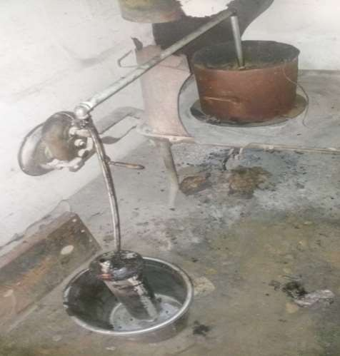

Reactor

Insulator

Thermocouple

connector

Connecting pipe

Tuyere

Blower

Hearth

Rubber hose

Ash gate

Pressure relief

valve

Condenser

Ice bath

# Experimental procedures

Experiments were performed in the foundry workshop, Industrial Development Centre, Ministry of Industry, Samaru, Zaria with the fixed bed pyrolysis system to determine its effectiveness. The procedures were carried out as follows:

# Preparation of Feedstock

A variety of organic solid wastes and agricultural biomass can be used as the feedstock for fixed bed pyrolysis process. Palm kernel shell was selected as the primary feedstock for the system that has been fabricated. It is a preferred raw material among Nigeria‟s biomass not

only for its availability but also for its high contents of ligno-cellulose compositions. The sample was collected from a traditional oil palm industry Odeomu in Ayedaade local government area of Osun State, South Western Nigeria.

The Palm kernel shells used in this experiment were washed severally with water in order to remove dirt‟s and dusts. The biomass sample was sun-dried for 7 days and dried in an oven at 1150 C for 120minutes to reduce the moisture content below 10wt. %, crushed and sieved to a particle size of 1.18mm, 2.35mm and 5 mm through U.K. Standard Test Sieve from Building department, Ahmadu Bello University, Zaria

# Operational Procedures of the fixed bed pyrolysis system

Dry and weighted palm kernel shells (1.5kg) of particle size 1.18mm were fed into the reactor for pyrolysis. Then the reactor was closed by lid with steam gasket to ensure leak proof of gases and was placed on the manual forge blower. The manual forge blower was loaded with charcoal to heat the reactor. A thermocouple was inserted at the top of the reactor to measure the temperature inside the reactor. Ice cube was placed in the bath. The liquid oil and the solid char were collected separately and non-condensable gas was flared into atmosphere. The procedures were repeated for the particle size of 2.35mm and 5mm. Then, the bio-oil and the char were weighed (using digital weight scale), recorded and carefully kept (separately) in well-sealed containers under room temperature. The bio-oil and bio-char are calculated as the weight per cent to the feedstock consumed. The composition of the bio-oil was further characterized using chromatographic and spectroscopic techniques (FTIR and GCMS) at Multi-User Science Research Laboratory, Chemistry Department, Ahmadu Bello University, Zaria.

# Characterization of Palm Kernel Shells (PKS)

# Proximate analysis of PKS

The proximate analysis is defined as the loss in weight of the palm kernel shells (PKS) sample heated under the test condition specified. The proximate analysis was done (at Biochemical Laboratory Unit, Animal Science Department, A.B.U, Zaria) in accordance with ASTM E871 and E872 to determine the moisture content, volatile matter, fixed carbon and ash content in the palm kernel shells. The sample was heated in a covered crucible (to prevent oxidation) at 7500C and held at this temperature for 7 minutes. The weight loss is referred to as volatile matter. The remaining sample was then placed in the oven at 9000C with cover off so that the sample was combusted. The weight loss upon combustion is termed fixed carbon. The remaining residue is defined as ash.

Calculation:

Moisture content (wt %)

W0−W1

× 100 ------------------------------------------------ (3.13)

= ( )

W0

Volatile matter (wt %) =

W1−W2

× 100 --------------------------------------------------- (3.14)

( )

W1

Fixed carbon (wt %) =

W2−W3

× 100 ------------------------------------------------------ (3.15)

( )

W2

Where;

W0 is the weight of sample in g before heating

W1 is the weight of sample in g after heating at 1150C W2 is the weight of sample in g after heating at 7500C W3 is the weight of sample in g after heating at 9000C

The mass of the ash was calculated as a percentage of the original sample as followed:

Ash, mass %

= (w

𝖶

) × 100

(3.16)

Where;

w = mass of ash (g)

W = mass of sample (g)

# Ultimate Analysis of the palm kernel shell

The purpose of this test is to determine element per cent of carbon, hydrogen, nitrogen, sulphur and oxygen in the PKS. The ultimate analysis was conducted according to ASTM standards E777 and E778.

# Determination of the calorific value of the palm kernel shell

Knowledge of calorific value of feedstock is essential when considering the thermal efficiency of equipment for producing either heat or power. The calorific value of the palm kernel shell was determined according to ASTM standard E955 using the elemental composition of the PKS.

CV = 0.3491.C+ 1.1783.H + 0.1005.S – 0.1034.O – 0.0151.N – 0.0211.ASH (MJkg-1)

(Kieseler et al., 2013) (3.17)

Where;

C = Carbon (%)

H = Hydrogen (%) S = Sulphur (%)

O = Oxygen (%) N = Nitrogen (%)

# Performance Evaluation of the fixed bed pyrolysis system

The weight of the palm kernel shell (PKS) was measured (1.5kg per sample) using weight balance (Table 3.2). The weight of the bio-oil, char and gas yield were determined in

weight percentage using equation 3.18, 3.19 and 3.20 respectively. The calorific value of the PKS was determined using Table 4.1 and equation 3.17. Also the calorific value of the bio-oil was determined using Table 4.2 and equation 3.17.

Bio-oil yield (wt %) = wi𝑒gℎ𝑡 𝑜ƒ 𝑏i𝑜−𝑜i𝑙(𝑘g) × 100 (3.18)

weight of PKS(kg)

Char yield (wt %) = wi𝑒gℎ𝑡 𝑜ƒ 𝑐ℎ𝑎𝑟(𝑘g) × 100 (3.19)

weight of PKS(kg)

Gaseous yield (wt %) = 100 – Oil yield – Char yield (3.20)

The reactor efficiency, 𝜂𝑅 was calculated using the relation, (Akinola, 2016; Capunitan and Capareda, 2012)

(Bio−oil weight ×Bio−oil𝘍s Heating value)

= -------------------- (3.21)

𝜂𝑅 (Weight of palm kernel shell ×palm kernel shell𝘍s heating value) × 100

The efficiency of the system in producing bio-oil was calculated at different reactor temperatures at which the reactor was tested.

# Effect of pyrolysis parameters.

# Effect of particle size

The first series of experiment was performed to investigate the effect of particle size on the pyrolysis yields. These experiments were conducted using three different particle sizes, namely 1.18mm, 2.35mm and 5mm at 1.5kg/sample. (See section 3.2.6.2 for the procedures)

# Effect of temperature

The second series of experiments were performed to determine the effect of the pyrolysis temperature on pyrolysis yields. For each experiment, 1 . 5 k g of p a lm k e r n e l s h e l l s were sieved to the particle size o f 1 . 1 8 m m and placed in the

reactor. The temperature was raised to a temperature of 350, 400, 4 5 0 , 500 or 550°C. The gas was f l a r e d into the atmosphere as the temperature of the pyrolysis was increased.

# Effect of running time

The effect of the running time on pyrolysis yield (from section 3.2.8.2) was determined by taken proper record of time; 60, 82, 95, 110 and 120 (minutes) for pyrolysis yield at each final temperature of 350, 400, 450, 500 and 5500C respectively.

# Characterization of bio-oil

The ultimate analysis of carbon, hydrogen, nitrogen, sulphur, ash and oxygen were conducted according to ASTM standards E777 and E778 to determine the calorific value of the bio-oil. The chemical compositions of the yield bio-oil were investigated using chromatography and spectroscopic techniques comprise FTIR and GC/MS at Multi-User Science Research Laboratory, Chemistry Department, A.B.U Zaria.

# Ultimate Analysis of the bio-oil

Refer to section 3.2.6.2

# Determination of the calorific value of the bio-oil

Refer to section 3.2.6.3

# Fourier Transform infra-red (FTIR) Spectroscopy

In this study, functional groups analysis of the bio-oil was carried out using Fourier transform infra-red (FTIR) spectroscopy, Magna-IR550 (Nicolet, Madison). FTIR with an online pen plotter was used to produce the infra-red (IR) spectra of the derived liquids. A small amount of the bio-oil was mounted on a potassium bromide (KBr) disc. The FTIR spectrum in the ranges of 500-3500cm-1 was measured and recorded. The

absorption frequency spectra were recorded and plotted. The standard IR- spectra of

organic compounds were used to identify the functional group of the components of the derived bio-oil.

# Gas Chromatography/ Mass Spectrometry (GC-MS)

In this study, the gas chromatography/mass spectroscopy (GC-MS) analysis of the bio-oil product was performed in accordance with ASTM E2997 standards using Agilent Technologies GC 6890N with 5973N mass selective detector (MS), using a 30 mm x 250 mm x 0.25 mm SGE BPX5 capillary column supplied by scientific Glass Engineering SGE Pty Ltd. The oven temperature was started at 35 °C for 2 minutes, increased to 250

°C at a rate of 20 °C min-1 and held at this temperature for 20 minutes. The injector port temperature and the detector temperature was set at 280 °C. The carrier gas, helium, was set at a flow rate of 47.5 liter per minutes and the split ratio of the injector port was set at 50:1. 0.03 g of bio-oil was used and diluted with methanol HPLC grade to the volume of 0.5 ml using a vial. After that, the mixture was shaked and filtered. Finally, 1.0 µl of mixture was injected with a 5.0 µl syringe into the GC-MS apparatus. The chemical compounds identified are presented in Figure 4.6

# CHAPTER FOUR RESULTS AND DISCUSSION

# Characterization of palm kernel shells (PKS)

The results of proximate and ultimate analysis of palm kernel shells are listed in Table 4.1. By comparing the moisture content in PKS (5.69 wt%) with Sugarcane bagasse, it has been found that the moisture content of PKS is lower than the moisture content of sugarcane bagasse (16.07 wt%) (Sukumar et al., 2015). For pyrolysis, higher water content in the feedstock has some adverse role such as an extra heat is required for vaporizing the moisture (Asadullah et al., 2008).

The proximate analysis shows that the sample is high in volatile content and low in ash content. To express the suitability of biomass for thermochemical conversion, high volatile matter content with low sulphur and ash content is the main criterion to be taken into consideration (Bridgwater and Bridge, 1991). From the ultimate analysis, the PKS was found to be high in carbon content and low in sulphur and nitrogen making good fossil fuel substitutes.

The calorific value of the palm kernel shells was determined in order to evaluate the energy content of the biomass used during pyrolysis. The result obtained showed that the calorific value of the Palm kernel shells was 22.81MJ/kg. This indicates that PKS has a great potential to be a feed stock for the production of alternative fuel.

Table 4.1: Proximate and Ultimate analysis of the palm kernel shell (wt%)

|  |  |
| --- | --- |
| **Characteristics** | **PKS** |
| Proximate analysis (wt. %) | |
| Moisture | 5.69 |
| Volatile matters | 69.10 |
| Fixed Carbon | 23.49 |
| Ash | 1.72 |
| Ultimate analysis (wt. %) | |
| Carbon | 46.92 |
| Hydrogen | 08.95 |
| Nitrogen | 1.15 |
| Sulphur | 2.35 |
| Oxygen* | 40.63 |
| Calorific value (MJ Kg-1) | 22.81 |

# Variation of pyrolysis parameters 4.2.1Effect of Particle Size

In this study, the experiments were conducted by using three different particle sizes, namely 1.18mm, 2.35mm and 5mm with maximum temperature of 5500C and running time of 120 minutes. The results are presented in Table 4.2 (Appendix A) and Figure 4.1.

**Yield (wt %)**

Figure 4.1: Variation of product yield (wt.%) with particle Size



80

70

60

Bio-oil

Char Gas

50

40

30

20

10

0

1.18

2.35

**Sample size (mm)**

5



From Figure 4.1, it is observed that the percentage of liquid collection is a maximum of 28

% of total biomass feed for particle size of 1.18mm. A less amount of liquid is obtained from the larger particle size feed. This may be due to the fact that larger size particles are not sufficiently heated up so rapidly causing incomplete pyrolysis that reduced liquid product yield.

As shown in Figure 4.1, the highest char yield was 70.67% obtained at the particle size of 5mm. And the lowest char yield was 19.33% obtained at the particle size of 1.18mm. Also, the highest and lowest gas yields were obtained at the particle size of 1.18mm (52.67%) and 5mm (14.67%), respectively. An increase in particle size causes greater temperature gradients inside the particle so that at a given time the core temperature is lower than that

of the surface, which possibly gives rise to an increase in the char yields and a decrease in liquids and gases. Particle size is known to influence pyrolysis products yield. If the particle size is sufficiently small it can be heated uniformly, as the results obtained was consistent with the earlier studies (Encinar et al., 2000).

# Effect of Temperature

In this study, the pyrolysis processes were carried out at different temperatures; 350, 400, 450, 500 and 5500C with particle size of 1.18mm to determine the effect of varying temperature on the pyrolysis products obtained from the PKS.



60

50

Bio-oil

Char Gas

40

30

20

10

0

300

350

400

450

500

550

600

**Temperature (0C)**



**Yield (wt%)**

Figure 4.2: Variation of product yield (wt.%) with temperature

As shown in Table 4.3 (Appendix A) and Figure 4.2, at the lowest pyrolysis temperature (3500C), a decomposition process was relatively slow and the char was the major product. As the temperature increased from 3500C to 4500C, the amount of condensable liquid product increased to a maximum value in the range of 34.67 – 38.67%. At a higher pyrolysis temperature of 5000C and 5500C, the bio-oil yield decreased to 30.67 – 28%.This indicated the same trend with Hossain et al., (2014) and Uddin et al., (2012) findings. The results obtained from this series of experiment showed that the maximum bio-oil yield obtained was 38.67% of the total biomass feed at the pyrolysis temperature of 4500C. The lowest of bio-oil yield was 28% of the total biomass feed at temperature of 5500C.

The char yield significantly decreased as the final pyrolysis temperature was raised from 3500C to 5500C. The highest char yield was 38.67% of the total biomass feed at the temperature of 3500C. And the lowest char yield was 19.33% of the total biomass feed obtained at the temperature of 5500C. The decrease in char yield with an increase in temperature could either be due to the greater primary decomposition of the PKS at higher temperatures or through secondary decomposition of the char residues.

The highest and lowest of gas obtained was 52.67% and 29.33% at the temperature of 5500C and of 3500C, respectively. The gas product increased with an increase in pyrolysis temperature. An increase in gas products is thought to occur predominantly due to the secondary cracking of the pyrolysis vapours at higher temperatures.

# Effect of running time

The effect of variation of running time and pyrolysis product yield is presented in Table

4.4 (Appendix A) and Figure 4.3 at a final temperature of 5500C and feed particle size of

1.18 mm.

60



Bio-oil



50 Char



Gas



40

30

**Yield (wt %)**

20

10

0

40 50 60 70 80 90 100 110 120 130

**Running time (minute)**

Figure 4.3: Variation of product yield (wt %) with running time

The plotted result shows the maximum liquid (38.67 wt %) and the char products (28 wt

%) at 95 minutes. As observed, higher or lower than this pyrolysis time leads to a decrease in the liquid yield. This is due to the insufficient pyrolysis reaction and higher rate of gas discharge.

# The performance evaluation of the fixed bed pyrolysis system in producing bio-oil

The reactor efficiency was determined using equation 3.14 (See Table 4.5 in Appendix A)

A graph of the reactor efficiency was plotted with the varying reactor temperatures (Figure 4.4). The graph shows that the efficiency of the reactor at generating bio-oil increases to a maximum of 73.21% at a temperature of 4500C.

However, the efficiency was decreasing at temperatures above 4500C because the weight of the bio-oil generated at these temperatures was low. At the end an overall average of 62.00% efficiency was achieved for the reactor.

80



75

70

**Reactor Efficiency %**

65

60

55

50

300 350 400 450 500 550 600

**Reactor temperature (0C)**

Figure 4.4: Variation of Reactor Efficiency with Reactor Temperature

# Characterisation of Bio-oil Product

# Ultimate Analysis of the bio-oil

The results obtained from the ultimate analysis of the bio-oil are presented in Table 4.6. The calorific value of the bio-oil is found to be 43.19 MJKg-1, which is higher than 20.07MJKg -1 obtained from sugarcane bagasse as established by Islam et. al (2001) and very much closer to 45.28MJKg-1 obtained from diesel as published by Andrews and Patniak (1996). Therefore, the bio-oil obtained from the PKS can be considered as an important potential source of alternative liquid fuel.

|  |  |
| --- | --- |
| Ultimate analysis (wt. %) | |
| Carbon (C) | 49.69 |
| Hydrogen (H) | 23.71 |
| Nitrogen (N) | 0.56 |
| Sulphur(S) | 2.95 |
| Ash | 0.07 |
| Oxygen* (O) | 23.02 |
| Calorific value (MJ Kg-1) | 43.19 |

# FTIR Analysis of bio-oil

The Fourier transform infra-red spectroscopy (FTIR) analysis was conducted on the bio- oil obtained from the optimum pyrolysis parameter to know the functional group present in the pyrolysis oil. The O-H between 3200 and 3355cm-1 indicate the presence of phenol and alcohols. The C-H between 2922 and 2848cm-1 and C-H deformation vibrations

between 1384 and 1222cm-1 indicates the presence of alkanes. The C=O between 2140 and 1703cm-1 represent the presence of ketones, aldehydes, carboxylic acids and their derivatives.

The absorbance peaks between1595 cm-1 and 1502 cm-1 represent C=C stretching vibrations indicative of alkenes and aromatics. Absorptions possibly d][ue to C-O vibrations from carbonyl components occur between 1111 cm-1 and 887 cm-1 of the bio- oil. The absorbance peaks between 753 and 693 cm-1 indicate the possible presence of single, polycyclic and substituted aromatic groups. Figure 4.5 shows the FTIR analysis of the bio-oil

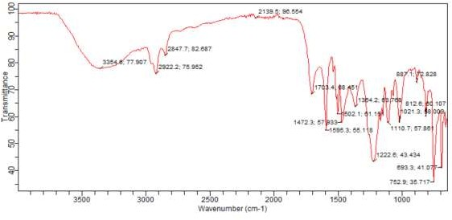

**C=O**

**C-O**

**C=C**

**C-H**

**O-H**

Figure 4.5: FTIR Spectrum of the Bio-oil.

# GCMS Analysis of Bio-oil

Gas chromatography-mass spectroscopy (GCMS) analysis was carried out on the optimum parameter of bio-oil yield in order to get an idea of the nature and type of possible compounds found in the bio-oil. All the possible compounds obtained from bio-oil

identified at the Multi-User Science Research Laboratory, A.B.U Zaria (search libraries:

NIST14.L). The possible compounds of bio-oil detected using GCMS analysis are shown in Figure 4. 6 (Table 4.7 Appendix A). The results indicated that the highest values of the peak areas of possible compounds were Phenol, Phenol, 2-methoxy- and Phenol, 2, 6- dimethoxy-, with 38.44%, 17.34% and 8.65% respectively. The concentrations of phenol and its derivative were very high, indicating the suitability of the oil to be considered for value-added chemicals. In addition, it is possible to deoxygenate the bio-oil to obtain higher-grade fuel as suggested by Nasrul et al., (2014).

45

A- Furfural

B- 2-Furanmethanol

C- Phenol

D- Phenol, 2-methoxy-

E- 2-Methoxy-5-methylphenol

F- Phenol, 4-ethyl-2-methoxy-

G- Phenol, 2,6-dimethoxy

H- Benzoic acid, 3,5-dimethoxy- I- Phenol, 2,6-dimethyl-4-nitro-

J- Heptadecanolide, cis-vaccenic acid

K- Linoelaidic acid, 9,12-Octadecadienoic acid(Z,Z)-

L- Cyclopropaneoctanal, 2-octyl-

40

35



30

25

**Peak area (%)**

20

15

10

5

0

A B C D E F G H I J K L

# Chemical Compounds



Figure 4.6: Identification and Peak areas of Chemical Compounds in the bio-oil

# Cost Estimate

The detail cost estimates for the material used for the construction of the fixed bed pyrolysis system are provided in Table 4.11.

Table 4.11: The cost estimate of the fixed bed pyrolysis system

|  |  |  |  |  |  |  |  |  |  |
| --- | --- | --- | --- | --- | --- | --- | --- | --- | --- |
| S/no | Component | | Material | | Quantity | | Unit cost  (Naira) | Total  (Naira) | cost |
| 1 | Fixed reactor | bed | Galvanized steel pipe | | 360mm x 130mm  x 4mm (L x B x T) | | 5,000 | 5,000 | |
| 2 | Condenser | | Mild steel | | 620mm x 120mm x2mm | | 3,000 | 3,000 | |
| 3 | Connecting pipe | | Galvanize pipe | | 300mm 19.05mm  2.4mm | x x | 500 | 500 | |
| 4 | Connecting pipe | | Galvanize  pipe | | 900mm x  12.7mm x 2.4mm | | 1,500 | 1,500 | |
| 5 | Connecting pipe | | Rubber  hose | | 730mm x 10mm  x 1mm | | 300 | 300 | |
| 6 | Connector | | Clips | | 2 | | 25 | 50 | |
| 7 | Connector | | Elbow | | 2 | | 250 | 500 | |
| 8 | connector | | Bolt  nut | and | 20 | | 15 | 300 | |
| 9 | Gaskets | | Fibre | | 8 | | 50 | 400 | |
| 10 | Ice bath | | Plastic  bowl | | 450mm x 300mm  x 2mm | | 1,10  0 | 1,100 | |
| 11 | Spray paint | | Al. paint | | 1litre | | 500 | 500 | |
| 12 | heater | | Charcoal | | 1.5 bags | | 2,500 | 2,500 | |
| 13 | Pressure relief  valve | | Valve  (3/4”) | | 1 | | 1,800 | 1,800 | |
| 14 | Pressure relief  valve connector | | Nipple  (3/4”) | | 1 | | 300 | 300 | |
| 15 | Labour cost | | - | | - | | 8,000 | 8,000 | |
| 16 | Transportation and  Miscellaneous | | - | | - | | 4,000 | 4,000 | |
| Grand total | | | | | | | | 27,250 | |

# Conclusions

# CHAPTER FIVE CONCLUSIONS AND RECOMMENDATIONS

A fixed bed pyrolysis system was designed and constructed to study the effects of operating parameters on the yields and quality of products from the pyrolysis of palm kernel shells. The following conclusions were drawn based on this research work;

* + - The design and fabrication of the fixed bed pyrolysis system was successfully carried out.
    - The performance of the system was successfully evaluated. The efficiency of the fixed bed pyrolysis system to yield maximum and minimum bio-oil was evaluated to be 73.21% (at 4500C) and 53.02% (at 5500C) respectively. The effect of particle size on the products yield had shown that 1.18mm is the optimum particle size to produce bio-oil and gas products, and 5mm is the optimum particle size to produce char at the same temperature (5500C). Also, the effect of temperature and running time on products yield showed that 4500C (at 95minutes) was the optimum temperature to produce the bio-oil product, 3500C (at 60 minutes) was the best temperature to produce the char and 5500C (at 120 minutes) is the maximum temperature to produce the gas product under the same conditions of particle size.
    - The bio-oil was successfully characterised. The FTIR spectrum showed that the bio-oil composition was dominated by Phenol. GCMS analysis showed that the concentration of phenol and its derivative were very high, indicating the suitability of the oil to be considered for value-added chemicals.

# Recommendations

The liquid yield of palm kernel shells from the fixed bed pyrolysis system is quite satisfactory. However, the performance of the system could be improved further to produce more reliable and better results. The following recommendations are suggested for such improvement;

* + - Proper waste management committee be set up which will rigorously collect agricultural waste from rural farmers after harvest for energy productions.
    - The process bed temperature would be easier to control at uniform value if the system could be well insulated and supplied uniform rate of air by the blower.
    - The char product from pyrolysis of palm kernel shell is reasonably high. The high char yield has a potential values as a solid fuel or as activated carbon or further characterisation of the char are suggested. The energy content of the char could be utilized. The gaseous product may be taken into consideration.

# Significant Contributions

The significant contributions of this research work are as follows:

* + - Designed and Fabrication of a fixed bed pyrolysis system with a thermal efficiency of 73.21%.
    - The bio-oil produced from palm kernel shell is mostly composed of phenol (38.44%), 2-methoxy phenol (17.34%) and 2, 6-dimethoxy phenol (8.65%). Hence, the bio-oil can be used as a source of phenol and its derivatives.

# REFERENCES

Abdullah, M., Nazir, M., and Wahjoedi, B. (2011). *Development of value-added biomaterials from oil palm agro-wastes*. IPCBEE, 7, 32-35.

Abo-Dief, H. M., Altalhi, A. A., and Mohamed, A. T. (2014). *Waste Oil Recycling Using Microwave Pyrolysis Reactors.* Journal of Industrial and Intelligent Information Vol, 2(4), 301-306.

Acikgoz, C., and Kockar, O. (2007). *Flash pyrolysis of linseed (Linum usitatissimum L.) for production of liquid fuels*. Journal of analytical and applied Pyrolysis, 78(2), 406-412.

Acıkgoz, C., Onay, O., & Kockar, O. M. (2004). *Fast pyrolysis of linseed: product yields and compositions*. Journal of analytical and applied pyrolysis, 71(2),417-429.

Aguado, R., Olazar, M., Gaisán, B., Prieto, R., and Bilbao, J. (2002). *Kinetic study of polyolefin pyrolysis in a conical spouted bed reactor*. Industrial & engineering chemistry research, 41(18), 4559-4566.

Akinola, A. O. (2016). *Evaluation of the efficiency of a thermochemical reactor for wood pyrolysis*. European Journal of Engineering and Technology, Vol. 4,, 20-22.

Andrews, R.G. and Patniak, P.C. (1996). *Feasibility of Utilizing a Biomass Derived*

*Fuel for Industrial Gas Turbine Applications*. Bio-Oil Production & Utilization, Berkshire: CPL Press, PP 236-245.

Antal, M. J., and Grønli,M. (2003). *The art, science, and technology of charcoal production*. Industrial & Engineering Chemistry Research, 42(8), 1619-1640.

Asadullah, M., Rahman, M. A., Ali, M. M., Motin, M. A., Sultan, M. B., Alam, M. R., & Rahman, M. S. (2008). *Jute stick pyrolysis for bio-oil production in fluidized bed reactor*. Bioresource Technology, 99(1), 44-50.

Aysu, T., and Küçük, M.M. (2014). *Biomass pyrolysis in a fixed-bed reactor*. Effects of pyrolysis parameters on product yields and characterization of products. Energy, 64, 1002-1025.

Balat, M., Kırtay, E., and Balat, H. (2009). *Main routes for the thermo-conversion of biomass into fuels and chemicals*. Part 1: Pyrolysis systems. Energy Conversion and Management, 50(12), 3147-3157.

Barker, S. (1996). *Gasification and pyrolysis-routes to competitive electricity production from biomass in the UK*. Energy Conversion and Management, 37(6), 861-866.

Boutin, O., Ferrer, M., and Lédé, J. (2002). *Flash pyrolysis of cellulose pellets submitted to a concentrated radiation: experiments and modelling*. Chemical Engineering Science, 57(1), 15-25.

Bramer, E., and Holthuis, M. (2005). *Clean liquid fuel through flash pyrolysis*. The Development of the PyRos Process, 10(1), 104-132.

Brammer, J., Lauer, M., and Bridgwater, A. (2006). *Opportunities for biomass-derived*

*―bio-oil‖ in European heat and power markets*. Energy policy, 34(17), 2871-2880.

Bridgwater, A., and Bridge, S. (1991). *A review of biomass pyrolysis and pyrolysis technologies;Biomass pyrolysis liquids upgrading and utilization*. Springer, pp. 11- 92

Bridgwater, A., Czernik, S., and Piskorz, J. (2001). *An overview of fast pyrolysis*. Progress in thermochemical biomass conversion, 977-997.

Bridgwater, A., and Peacocke, G. (2000). *Fast pyrolysis processes for biomass*. Renewable and sustainable energy reviews, 4(1), 1-73.

Bridgwater, A., Toft, A., and Brammer, J. (2002). *A techno-economic comparison of power production by biomass fast pyrolysis with gasification and combustion*. Renewable and sustainable energy reviews, 6(3), 181-246.

Bridgwater, T. (2007). *Pyrolysis of Biomass*. IEA Bioenergy: Task 34. Bioenergy Research Group, Aston University, Birmingham, UK.

Capunitan, J. A., and Capareda, S. C. (2012). *Assessing the potential for biofuel production of corn stover pyrolysis using a pressurized batch reactor*. *Fuel*, *95*, 563-572.

Cengel, Y. A. (2008). *Introduction to Thermodynamics and Heat Transfer, Second Edition*.

McGraw-Hill Publishers, New York, pp 426-428.

Chen, G., Andries, J., Luo, Z., and Spliethoff, H. (2003). *Biomass pyrolysis/gasification for product gas production: the overall investigation of parametric effects*. Energy Conversion and Management, 44(11), 1875-1884.

Chiaramonti, D., Oasmaa, A., and Solantausta, Y. (2007). *Power generation using fast pyrolysis liquids from biomass*. Renewable and sustainable energy reviews, 11(6), 1056-1086.

Chikaire, J., Ani, A., Nnadi, F., and Godson-Ibeji, C. (2015). *Energy extension and energy literacy for sustainable energy development in rural Nigeria*. Agricultural Advances, 4(8), 84-92.

Cornelissen, T., Yperman, J., Reggers, G., Schreurs, S., and Carleer, R. (2008). *Flash co- pyrolysis of biomass with polylactic acid*. Part 1: Influence on bio-oil yield and heating value. Fuel, 87(7), 1031-1041

.

De Filippis, P., Borgianni, C., Paolucci, M., and Pochetti, F. (2004). *Gasification process of Cuban bagasse in a two-stage reactor*. Biomass and Bioenergy, 27(3), 247-252.

Demirbas, A. (2008). *Biodiesel*: Springer 42(8), 2320-2332

Demirbas, A. (2009). *Biofuels securing the planet’s future energy needs*. Energy Conversion and Management, 50(9), 2239-2249.

Demirbas, A. , and Arin, G. (2002). *An overview of biomass pyrolysis*. Energy sources, 24(5), 471-482.

Den-Hartog, J. P. (1952). *Strenght of Materials Cylinders and Curved Bars*, pp136.

Encinar, J. M., Gonzalez, J. F., & Gonzalez, J. (2000). *Fixed-bed pyrolysis of Cynara cardunculus L. Product yields and compositions*. Fuel Processing Technology, 68(3), 209-222.

Evbuomwan, B., Agbede, A., and Atuka, M. (2013). *A comparative study of the physico- chemical properties of activated carbon from oil palm waste (Kernel shell and fibre)*. International Journal of Science and Engineering Investigations, 2(19), 75- 79.

Fernández, Y., and Menéndez, J. (2011). *Influence of feed characteristics on the microwave-assisted pyrolysis used to produce syngas from biomass wastes*. Journal of analytical and applied Pyrolysis, 91(2), 316-322.

Fisher, T., Hajaligol, M., Waymack, B., and Kellogg, D. (2002). *Pyrolysis behavior and kinetics of biomass derived materials*. Journal of analytical and applied Pyrolysis, 62(2), 331-349.

Gan, J., and Yuan, W. (2008). *Thermochemical conversion of mixed biomass and crude glycerol to produce bio-oil*. Paper presented at the 2008 Providence, Rhode Island, June 29–July 2, 2008.

Hilal, D. A. (2005). *Yields and heating values of liquids and chars from spruce trunkbark pyrolysis*. Energy sources, 27(14), 1367-1373.

Hofmann, L., and Antal, M. J. (1984). *Numerical simulations of the performance of solar fired flash pyrolysis reactors*. Solar energy, 33(5), 427-440.

Hossain, A., Hasan, M. R., and Islam, M. R. (2014). *Design, fabrication and performance study of a biomass solid waste pyrolysis system for alternative liquid fuel production*. Global Journal of Researches In Engineering, 14(5).

Howard, R., Abotsi, E., Van Rensburg, E. J., and Howard, S. (2003). *Lignocellulose biotechnology: issues of bioconversion and enzyme production*. African Journal of Biotechnology, 2(12), 602-619.

Isa, A., Hamisu, S., Lamin, H., Yarsquo, M., and Olay, J. (2013). *The perspective of Nigerias projected demand for petroleum products*. Journal of Petroleum and Gas Engineering, 4(7), 184-187.

Isahak, W. N. R. W., Hisham, M. W., Yarmo, M. A., and Hin, T.-y. Y. (2012). *A review on bio-oil production from biomass by using pyrolysis method*. Renewable and sustainable energy reviews, 16(8), 5910-5923.

Islam, M.R., Nabi, M.N., and Islam, M.N. (2001). *Characterization of Biomass Solid Waste for Liquid Fuel Production*.4th International Conference on Mechanical Engineering (ICME 2001), Bangladesh, PP 77-82.

Jahirul, M. I., Rasul, M. G., Chowdhury, A. A., and Ashwath, N. (2012). *Biofuels production through biomass pyrolysis—a technological review*. Energies, 5(12), 4952-5001.

Jain, A., and Chopra, S. (2007). *A Review of Fixed Bed Gasification Systems for Biomass*. Jones, S. B., Valkenburg, C., Walton, C. W., Elliott, D. C., Holladay, J. E., Stevens, D. J.,

Czernik, S. (2009). *Production of gasoline and diesel from biomass via fast*

*pyrolysis, hydrotreating and hydrocracking*: a design case: Pacific Northwest National Laboratory Richland, WA.

Kader, M., Islam, M., Hossain, M., & Haniu, H. (2013). *Development of a pilot scale pyrolysis plant for production of liquid fuel from waste tire*. Mechanical Engineering Research Journal, 9, 54-59.

Karaosmanoğlu, F., Tetik, E. , and Göllü, E. (1999). *Biofuel production using slow pyrolysis of the straw and stalk of the rapeseed plant*. Fuel Processing Technology, 59(1), 1-12.

Kaushik, N., Biswas, S., and Basak, P. (2010). *New Generation Biofuels Technology & Economic Perspectives*. Technology Information, Forecasting & Assessment Council (TIFAC) Department of Science & Technology (DST), 1-6.

Kieseler, S., Neubauer, Y., and Zobel, N. (2013). *Ultimate and proximate correlations for estimating the higher heating value of hydrothermal solids*. Energy & Fuels, 27(2), 908-918.

Kim, S.-J., Jung, S.-H. , and Kim, J.-S. (2010). *Fast pyrolysis of palm kernel shells: influence of operation parameters on the bio-oil yield and the yield of phenol and phenolic compounds*. Bioresource technology, 101(23), 9294-9300.

Lam, S. S., Russell, A. D. , and Chase, H. A. (2010). *Microwave pyrolysis, a novel process for recycling waste automotive engine oil*. Energy, 35(7), 2985-2991.

Lanzetta, M. , and Blasi, D. C. (1998). *Pyrolysis kinetics of wheat and corn straw*. Journal of Analytical and Applied Pyrolysis, 44(2), 181-192.

Li, X., Grace, J., Lim, C., Watkinson, A., Chen, H., and Kim, J. (2004). *Biomass gasification in a circulating fluidized bed*. Biomass and Bioenergy, 26(2), 171-193.

Lv, P., Xiong, Z., Chang, J., Wu, C., Chen, Y., and Zhu, J. (2004). *An experimental study on biomass air–steam gasification in a fluidized bed*. Bio-resource technology, 95(1), 95-101.

Merino, S. T., and Cherry, J. (2007). *Progress and challenges in enzyme development for biomass utilization.* Biofuels (pp. 95-120): Springer.

Metcalfe, S. (2002). *Chemical reaction engineering*. New York:|Oxford Science Publications., 1-20.

Mohamed, A. R., Hamzah, Z., Daud, M. Z. M., and Zakaria, Z. (2013). *The Effects of Holding Time and the Sweeping Nitrogen Gas Flowrates on the Pyrolysis of EFB using a Fixed–Bed Reactor*. Procedia Engineering, 53, 185-191.

Mohan, D., Pittman, C. U., and Steele, P. H. (2006). *Pyrolysis of wood/biomass for bio- oil: a critical review*. Energy & fuels, 20(3), 848-889.

Naik, S., Goud, V. V., Rout, P. K., Jacobson, K., and Dalai, A. K. (2010). *Characterization of Canadian biomass for alternative renewable biofuel*. Renewable Energy, 35(8), 1624-1631.

Nasrul, H., Umi Fazara, M. A., Che Zulzikrami Azner, A., and Razi, A. (2014).

*Characterization of bio-oil from palm kernel shell pyrolysis*, 38(4), 203-211.

Natarajan, E. (2009). *Pyrolysis of rice husk in a fixed bed reactor*, 9(1), 108-119.

Ndoke, P. N. (2006). *Performance of palm kernel shells as a partial replacement for coarse aggregate in asphalt concrete*. Leonardo Electronic Journal of Practices and Technologies, 5(9), 145-152.

Nnaji, C., Uzoma, C., and Chukwu, J. (2010). *The role of renewable energy resources in poverty alleviation and sustainable development in Nigeria*. Continental Journal of Social Sciences, 3, 31.

Ohimain, E. I., and Izah, S. C. (2014). *Possible Contributions of Palm Oil Mill Effluents to Greenhouse Gas Emissions in Nigeria*. British Journal of Applied Science & Technology, 4(33), 4705.

Okerenke, D. (2016). *The Niger Delta Imbroglio: Why they struck again*. Retrieved June 2016, from <http://donokereke.blogspot.com.ng/2016/05/analysis-niger-delta-> avengers-and.html

Oyejobi, D., Abdulkadir, T., Yusuf, I., and Badiru, M. (2012). *Effects of Palm Kernel Shells Sizes and Mix Ratios on Lightweight Concrete*. USEP: Journal of Research Information in Civil Engineering, 9(2), 2-3.

Pandey, A. (2011). *Biofuels: alternative feedstocks and conversion processes*: Academic Press, 2(1), 1-12.

Pathak, B. (2005). *Biomass to power rural development*. Paper presented at the Proc. of National Seminar on Biomass Based Decentralized Power Generation, 3(1),3-6.

Rajput, R. K. (2005). *A textbook of power plant engineering*: Laxmi Publications Limited, 113 Golden House, Daryaganj, New Delhi, pp 407-415.

Rajput, R. K. (2012). *Heat and mass transfer (8th Edition)*: Laxmi Publications Limited, 113 Golden House, Daryaganj, New Delhi, pp 503-527

Ramchandra, P., and Boucar, D. (2011). *Green energy and technology*: Springer, London Dordrecht Heidelberg New York, 20(1), 145-163.

Rao, M., Singh, S., Sodha, M., Dubey, A., and Shyam, M. (2004). *Stoichiometric, mass, energy and exergy balance analysis of countercurrent fixed-bed gasification of post-consumer residues*. Biomass and Bioenergy, 27(2), 155-171.

Raveendran, K., Ganesh, A., and Khilar, K. C. (1995). *Influence of mineral matter on biomass pyrolysis characteristics*. Fuel, 74(12), 1812-1822.

Roy, C., Yang, J., Blanchette, D., Korving, L., and De Caumia, B. (1997). *Development of a novel vacuum pyrolysis reactor with improved heat transfer potential Developments in thermochemical biomass conversion* (pp. 351-367): Springer.

Sánchez, C. (2009). *Lignocellulosic residues: biodegradation and bioconversion by fungi*.

Biotechnology advances, 27(2), 185-194.

Shakya, B. D. (2007). *Pyrolysis of waste plastics to generate useful fuel containing hydrogen using a solar thermochemical process*, 14(2), 184-192

Singh, R., Ibrahim, M. H., Esa, N., and Iliyana, M. (2010). *Composting of waste from palm oil mill: a sustainable waste management practice*. Reviews in Environmental Science and Bio/Technology, 9(4), 331-344.

Singh, R.K., and Shadangi, K.P. (2011). *Liquid fuel from castor seeds by pyrolysis*. Fuel, 90, 2538-2549.

Steinfeld, A., and Palumbo, R. (2001). *Solar thermochemical process technology*.

Encyclopedia of physical science and technology, 15(1), 237-256.

Sukumar, V., Sivaprakasam, S. and Manieniyan, V. (2015). *Optimization Studies on Bio Oil Production from sweet lime Empty Fruit Bunch by Pyrolysis Using Response Surface Methodology*. International Journal of Engineering trends and Technology, 25(4), 196-201.

Tang, L., and Huang, H. (2005). *Plasma pyrolysis of biomass for production of syngas and carbon adsorbent*. Energy & Fuels, 19(3), 1174-1178.

Teoh, C. H. (2002). *The palm oil industry in Malaysia*. From seed to frying pan, 1(1), 16- 21

Tippayawong, N., Kinorn, J., and Thavornun, S. (2008). *Yields and gaseous composition from slow pyrolysis of refuse-derived fuels*. Energy Sources, Part A, 30(17), 1572- 1580.

Tsai, W., Lee, M., and Chang, Y. (2007). *Fast pyrolysis of rice husk: Product yields and compositions*. Bioresource technology, 98(1), 22-28.

Uddin, M. S., Joardder, M. U. H., and Islam, M. N. (2012). *Design and construction of fixed bed pyrolysis system and plum seed pyrolysis for bio-oil production*. International Journal of Advanced Renewable Energy Research, 7(1), 405-409.

Uzun, B. B., Pütün, A. E., and Pütün, E. (2006). *Fast pyrolysis of soybean cake: product yields and compositions*. Bioresource technology, 97(4), 569-576.

Venderbosch, R., and Prins, W. (2010). *Fast pyrolysis technology development*. Biofuels, bioproducts and biorefining, 4(2), 178-208.

Wagenaar, B., Venderbosch, R., Carrasco, J., Strenziok, R., and Van der Aa, B. (2001). *Rotating Cone Bio‐Oil Production and Applications*. Progress in thermochemical biomass conversion, 1268-1280.

Wang, J., Wang, G., Zhang, M., Chen, M., Li, D., Min, F., and Yan, Y. (2006). *A comparative study of thermolysis characteristics and kinetics of seaweeds and fire wood*. Process Biochemistry, 41(8), 1883-1886.

Wang, X., Kersten, S. R., Prins, W., and Van Swaaij, W. P. (2005). *Biomass pyrolysis in a fluidized bed reactor. Part 2: Experimental validation of model results*. Industrial & Engineering Chemistry Research, 44(23), 8786-8795.

Weerachanchai, P., Tangsathitkulchai, C., and Tangsathitkulchai, M. (2011). *Characterization of products from slow pyrolysis of palm kernel cake and cassava pulp residue*. Korean Journal of Chemical Engineering, 28(12), 2262-2274.

Yaman, S. (2004). P*yrolysis of biomass to produce fuels and chemical feedstocks*. Energy Conversion and Management, 45(5), 651-671.

Yang, H., Yan, R., Chen, H., Lee, D. H., Liang, D. T., and Zheng, C. (2006). *Pyrolysis of palm oil wastes for enhanced production of hydrogen rich gases*. Fuel Processing Technology, 87(10), 935-942.

Zanzi, R., Sjöström, K., and Björnbom, E. (2002). *Rapid pyrolysis of agricultural residues at high temperature*. Biomass and Bioenergy, 23(5), 357-366.

Zheng, J.-L. (2008). *Pyrolysis oil from fast pyrolysis of maize stalk.* Journal of Analytical and Applied Pyrolysis, 83(2), 205-212.

# APPENDIX A

LIST OF TABLES

Table 3.3: The variation of heat transfer rate with the outer radius of the insulation

|  |  |  |
| --- | --- | --- |
| *SN* | *r2 -*radius of Insulation (mm) | 𝑄̇ - heat transfer rate (W) |
| 1 | 50 | 167.19 |
| 2 | 55 | 167.60 |
| 3 | 60 | 166.86 |
| 4 | 65 | 165.36 |
| 5 | 70 | 163.35 |
| 6 | 75 | 161.01 |
| 7 | 80 | 158.50 |

Table 4.2: The Comparison of Pyrolysis Product Yields at Different Particle Size.

|  |  |  |  |  |
| --- | --- | --- | --- | --- |
| SN | Particle Size (mm) | Yields (wt %) | | |
| Bio-oil | Char | Gas* |
| 1 | 1.18 | 28.00 | 19.33 | 52.67 |
| 2 | 2.35 | 25.33 | 48.00 | 26.67 |
| 3 | 5 | 14.67 | 70.67 | 14.67 |

Table 4.3: The Comparison of Pyrolysis Product at Different Temperature.

|  |  |  |  |  |
| --- | --- | --- | --- | --- |
| SN | Temperature (0C) | Yields (wt %) | | |
| Bio-oil | Char | Gas* |
| 1 | 350 | 32.00 | 38.67 | 29.33 |
| 2 | 400 | 34.67 | 35.33 | 30.00 |
| 3 | 450 | 38.67 | 28.00 | 33.33 |
| 4 | 500 | 30.67 | 24.00 | 50.00 |
| 5 | 550 | 28.00 | 19.33 | 52.67 |

Table 4.4: The Comparison of Pyrolysis Product Yields at different running time

|  |  |  |  |  |
| --- | --- | --- | --- | --- |
| SN | Running Time (minutes) | Yields (%) | | |
| Bio-oil | Char | Gas* |
| 1 | 60 | 32.00 | 38.67 | 29.33 |
| 2 | 82 | 34.67 | 35.33 | 30.00 |
| 3 | 95 | 38.67 | 28.00 | 33.33 |
| 4 | 110 | 30.67 | 24.00 | 50.00 |
| 5 | 120 | 28.00 | 19.33 | 52.67 |

Table 4.5: Reactor Efficiency (%) at generating bio-oil

|  |  |  |
| --- | --- | --- |
| Reactor Temperature (0C) | Weight of Bio-oil (kg) | Reactor efficiency ηR, (%) |
| 350 | 0.48 | 60.59 |
| 400 | 0.52 | 65.64 |
| 450 | 0.58 | 73.21 |
| 500 | 0.46 | 58.07 |
| 550 | 0.42 | 53.02 |
| **Average** | **0.49** | **62** |

Table 4.7: Identification and peak areas of chemical compounds in PKS pyrolysis oil

|  |  |  |
| --- | --- | --- |
| Peak No. | Chemical compounds | Peak area (%) |
| 1 | Furfural | 3.66 |
| 2 | 2-Furanmethanol | 2.42 |
| 3 | Phenol | 38.44 |
| 4 | Phenol, 2-methoxy- | 17.34 |
| 5 | 2-Methoxy-5-  methylphenol | 8.09 |
| 6 | Phenol, 4-ethyl-2-methoxy- | 5.87 |
| 7 | Phenol, 2,6-dimethoxy- | 8.65 |
| 8 | Benzoic acid, 3,5-  dimethoxy- | 5.78 |
| 9 | Phenol, 2,6-dimethyl-4-  nitro- | 2.90 |
| 10 | Heptadecanolide, cis-  vaccenic acid | 1.79 |
| 11 | Linoelaidic acid, 9,12-  Octadecadienoic acid (Z,Z)- | 3.98 |
| 12 | Cyclopropaneoctanal, 2 –  octyl- | 1.08 |

# APPENDIX B

WORKING DRAWING OF THE FIXED BED PYROLYSIS SYSTEM AND ITS COMPONENTS

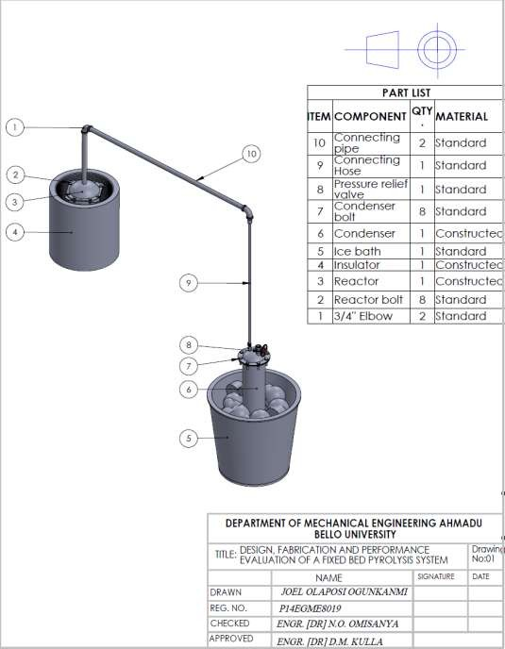

Plate III: A model of the fixed bed pyrolysis system

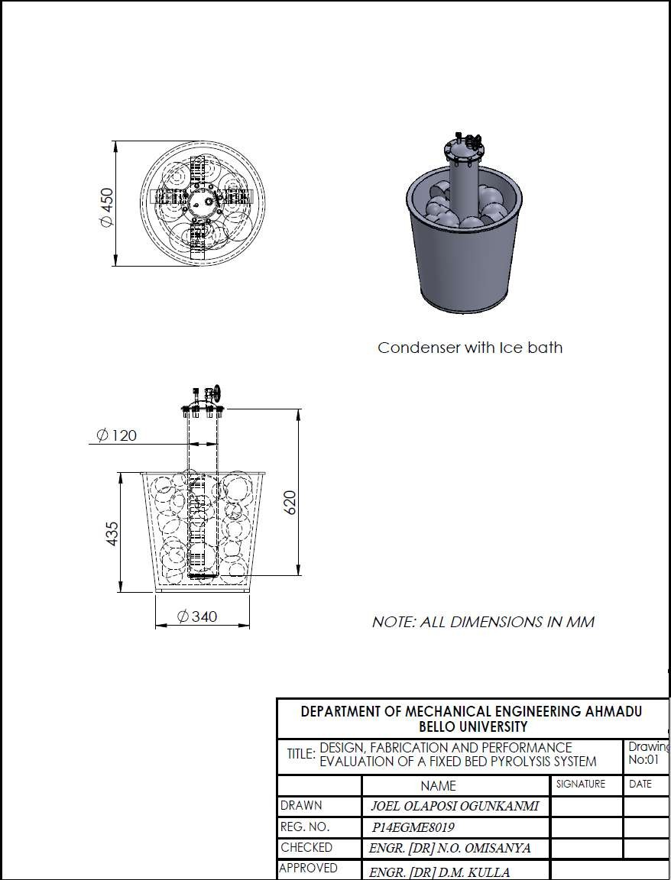

Plate IV: Condenser, Ice and Ice bath

# APPENDIX C

EQUIPMENT, MATERIALS AND MEASUREMENT OF THE PYROLYSIS PRODUCTS

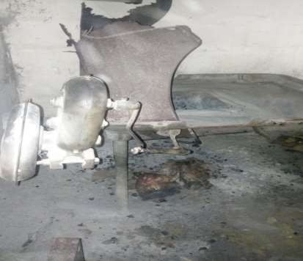

Plate V: Pictorial view of the manual forge blower

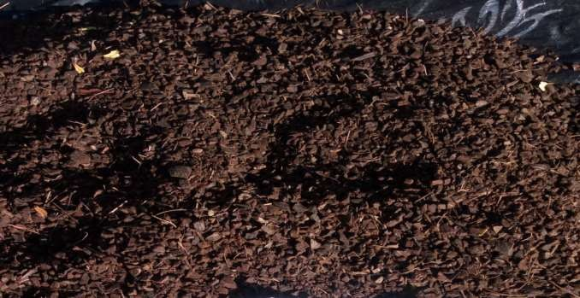

Scale 1:1

Plate VI: Palm kernel shells of particle size 1.18mm

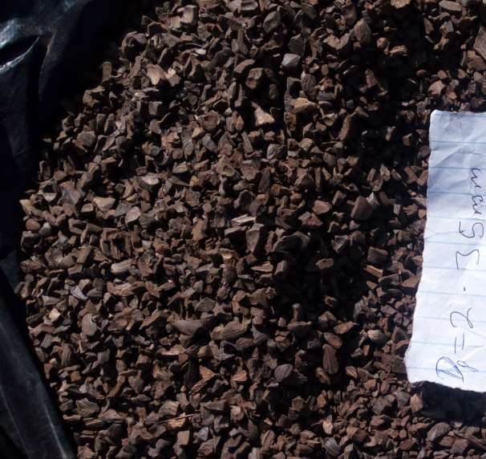

Scale 1:1

Plate VII: Palm kernel shells of particle size 2.35mm

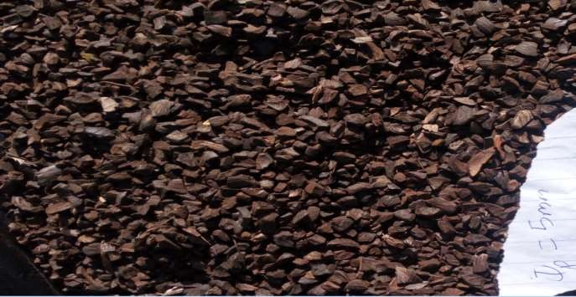

Scale 1:1

Plate VIII: Palm kernel shells of particle size 5mm

**APP**

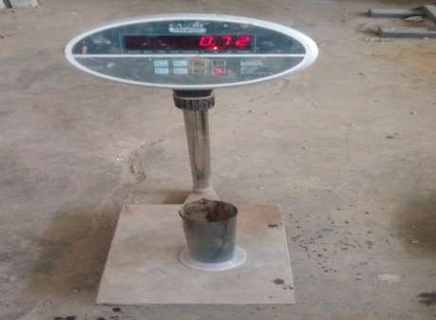

Plate IX: Maximum bio-oil yield at Dp = 1.18mm

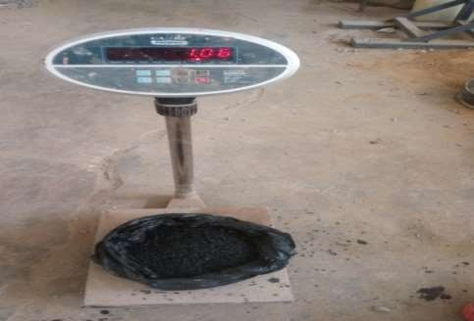

Plate XX: Char yield at Dp = 5mm