DESIGN AND USE OF A MODEL CONSTRUCTED HORIZONTAL SUBSURFACE FLOW WETLAND FOR TREATING TANNERY WASTEWATER BY MEANS OF AQUATIC PLANTS

# BY

DOOFAN JUDITH ASHLEY BAKO

# DEPARTMENT OF WATER RESOURCES AND ENVIRONMENTAL ENGINEERING

**AHMADU BELLO UNIVERSITY, ZARIA, NIGERIA**

# AUGUST, 2016

DESIGN AND USE OF A MODEL CONSTRUCTED HORIZONTAL SUBSURFACE FLOW WETLAND FOR TREATING TANNERY WASTEWATER BY MEANS OF AQUATIC PLANTS

BY

Doofan Judith Ashley BAKO,

B.Eng. (Federal Univ.of AgricultureMakurdi, 2008) M.Sc/ENG/46219/12-13

A THESIS SUBMITTED TO THE SCHOOL OF POSTGRADUATE STUDIES, AHMADU BELLO UNIVERSITY, ZARIA

IN PARTIAL FULFILLMENT OF THE REQUIREMENTS FOR THE AWARD OF MASTERS OF SCIENCE DEGREE IN

WATER RESOURCES AND ENVIRONMENTAL ENGINEERING (M.Sc. WREE)

DEPARTMENT OF WATER RESOURCES AND ENVIRONMENTAL ENGINEERING FACULTY OF ENGINEERING

AHMADU BELLO UNIVERSITY, ZARIA, NIGERIA

AUGUST, 2016

# DECLARATION

I, Doofan Judith Ashley BAKO declare that this dissertation entitled “Design and Use of a Model Constructed Horizontal Subsurface Flow Wetland for Treating Tannery Wastewater by Means of Aquatic Plants” has been carried out by me in the Department of Water Resources and Environmental Engineering under the supervision of Prof. Charlse Amen Okuofu and Dr. Don Begianpuye Adie.The information derived from the literature has been duly acknowledged in the text and a list of references provided. No part of this dissertation was previously presented for another degree or diploma at this, or any other institution.

–––––––––––––––––––– –––––––––––––––––– –––––––––––––––

Name of Student Signature Date

# CERTIFICATION

This dissertation entitledDESIGN AND USE OF A MODEL CONSTRUCTED HORIZONTAL SUBSURFACE FLOW WETLAND FOR TREATING TANNERY

WASTEWATER BY MEANS OF AQUATIC PLANTS by Doofan Judith AshleyBAKO meets the regulations governing the award of the degree of Masters of Science in Water Resources and Environmental Engineering of Ahmadu Bello University, and is approved for its contribution to Knowledge and literary presentation.

Prof. Charlse Amen Okuofu –––––––––––––––––– ––––––––––––––– Chairman supervisory committee Signature Date

Dr. DonBegianpuye Adie –––––––––––––––––– –––––––––––––––

Member supervisory committee Signature

Prof. Abubakar Ismail –––––––––––––––––– –––––––––––––––––

Head of Department Signature Date

Prof. S. Z. Abubakar –––––––––––––––––– –––––––––––––––

Dean, School of Post Graduate Signature Date

# DEDICATION

This work is dedicated to God the Father, Son and Holy Spirit; He who was, who is, and who is to come; He that gave me life, strength, perseverance, grace and providence from the very beginning to the end of this program.

And also to the loving memory of my late father Francis Y. Bako, who now rests with the Lord.

# ACKNOWLEDGEMENT

My profound and sincere gratitude goes to my research supervisors- Prof. C.A. Okuofu and Dr. D.B. Adie for their technical expertise and support, guidance, encouragement and kindness throughout the duration of this work.

My appreciation also goes to Dr. Johnson Otun, Dr. Igboro, Dr. Adeogun, Dr. Ajibike and Mallam Mujahid for their various academic contributions and encouragement.

I sincerely thank Mr. P.C Alika, Mallam Yahaya and Mr. Geoffrey for their immense contributions and support especially with respect to the laboratory-related aspects of this dissertation.

My heartfelt appreciation to Mr. Tanko Bala for his show of support, kindness and complete involvement in almost all field-related aspects of this work. Also my thanks to Mr. Sabo Kajan for his support and contributions in the construction and set-up related aspects of this research.

I indeed appreciate and thank all staff (academic and non-academic) of the Department of Water Resources and Environmental Engineering, Ahmadu Bello University Zaria for their various contributions, support, encouragement and kindness shown me throughout the period putting together this work.

My heartfelt appreciation to Dr. H. A. Shaba who has been a mentor in various aspects of my life for his encouragement, support and kindness in ensuring this work reached a successful conclusion.

I appreciate my friends Meshach I. Alfa and Daniel Akali Martins for their encouragement, moral support, contributions and kindness as I marched on with this work.

My appreciation to Prof Emmy Idegu and his wife, and to Prof Derry Yakubu and his wife for their encouragement, kindness, support and prayers throughout the course of this work.

I also appreciate my uncles and aunties, especially Mr. T. Iornienge and his wife Priscilla Iornienge, Mr. Isaiah Umburga and his wife Barr. Comfort Umburga, and many other relatives for their prayers, encouragement and concern as they closely followed up on the progress of this research.

My love and heartfelt gratitude to my parents Late Mr.Francis Bako and Mrs. Lydia Bako whose love, sacrifice, moral support, financial support, encouragement and prayers has seen me through to this point in my life. It was my late fathers‟ wish to see me finish this program but deaths cruel hands snatched him from us too early. I believe his soul will rejoice that one of his many dreams for me has finally come true.My love also goes to my siblings George, Edith, Queen, Jude and Isaac for their love, prayers, sacrifice, encouragement and moral support through my life‟s journey. You have all been truly awesome.

Finally, my love and heartfelt gratitude to my hero and loving husband Cyril Friday Oluwaseun for his love, kindness, sacrifice, prayers, encouragement, financial and moral support. Your shoulder to lean on lent me strength to trudge on with this work despite the many hurdles life threw my way. Am sincerely thankful to God to have a true friend and husband in you.

# TABLE OF CONTENTS

Cover Page i

Title Page ii

Declaration iii

Certification iv

Dedication v

Acknowledgements vi

Table of Contents vii

List of Figures x

List of Tables xi

List of Plates xii

List of Appendices xiii

Acronyms xiv

Abstract xv

CHAPTER ONE: INTRODUCTION

* 1. Background of Study 1
  2. Statement of Research Problem 5
  3. Justification of the Study 6
  4. Aim and Objectives 7
  5. Scope of Study 8

CHAPTER TWO: LITREATURE REVIEW

* 1. Tanning and Characteristics of Tannery Wastewaters 9
  2. The Sources of Chromium in Tannery Effluent 10
     1. Toxicity and environmental impacts of chromium 11
  3. Treatment Methods of Tannery Wastewater 14
     1. Physicochemical methods 14
     2. Biological treatment methods 14
     3. Constructed wetland technology 16
     4. Configuration, zones and components of constructed wetlands 26
  4. Waste Removal Mechanisms and Efficiency of a Horizontal Subsurface 27

Flow Constructed Wetland

* + 1. Heavy metals removal by subsurface flow wetlands 28
    2. Biological oxygen demand (BOD) and chemical oxygen demand (COD) 29

removal

* + 1. Nitrogen removal 31
    2. Phosphate removal 32
    3. Removal of suspended solids 33
    4. Influenceof non-biological (Physical and Chemical) factors in wetlands 34
  1. Role of Plants in Constructed Wetlands 36
     1. Selection of plants for wetlands 37
     2. Characteristics of the wetland plant Phragmites australis 38
     3. Other wetland plants considered 41
  2. Types of Constructed Wetland Design and Design Parameters 43
     1. Rule of thumb 44
     2. First-order plug flow models 45
     3. Hydraulic design consideration 45
     4. Aspect ratio 47
     5. Bed slope 47
     6. Hydraulic retention time 47
     7. Hydraulic loading rate (HLR) and organic loading rate (OLR) 48
     8. Flow velocity and flow depth 49

CHAPTER THREE: MATERIALS AND METHODS

* 1. Materials 50
  2. Methods 52
     1. Tannery effluent collection site 52
     2. Experimental set-up 53
     3. Laboratory analysis 57
     4. Design considerations and parameters determination 61
     5. Management of wetland plants used 66

CHAPTER FOUR: RESULTS AND DISCUSSION

* 1. The Aquatic Plants and Model Constructed Wetlands 67
  2. Wastewater Characteristics 68
  3. Biological Oxygen Demand and Chemical Oxygen Demand Removal 69
  4. Suspended Solids Removal 71
  5. Nutrient Removal 74
  6. Chromium Removal 77

CHAPTER FIVE: CONCLUSIONS AND RECOMMENDATIONS

* 1. Conclusions 80
  2. Recommendations 82

REFERENCES 84

APPENDICES 103

# LIST OF FIGURES

* 1. ASurface Flow Wetland 22
  2. A Vertical subsurface flow constructed wetland 24

2.3a. Horizontal subsurface flow wetland 25

2.3b. Horizontal subsurface flow wetland 25

* 1. Horizontal- Section View of the Horizontal Sub-surface Flow Constructed 55

Wetland

* 1. Full view of laboratory set- up of the Horizontal Sub-surface Flow 56

Constructed

4.1. BOD, COD and SS Removal Efficiency 73

# LIST OF TABLES

2.1. Rule of thumb design criteria for Horizontal Subsurface Flow Constructed Wetland 44

3.1. Model Constructed Wetland Design Parameters and their respective Values 65

4.1 Average composition of Influent Wastewater in mg/l 69

4.2. BOD and COD Removal Efficiency 70

* 1. TSS Removal Efficiency 72
  2. BOD, COD and TSS Effluent Concentrations against NESREA and WHO 74

Discharge Limits

* 1. Average Nitrate and Phosphate Effluent Concentrations and Removal Efficiencies 76
  2. Average Chromium Effluent Concentration and Removal Efficiency in CWs 78

# LIST OF PLATES

1. *Phragmites australis* 41
2. *Polygonum salicifolium* 42
3. *Ipomoea carnea* 43
4. Empty Model Constructed Wetland Setup 67
5. Model Constructed Wetland Setup with Aquatic Plants 68

# LIST OF APPENDICES

Appendix I.National Environmental Standards and Regulations Enforcement Agency (NESREA) for tannery effluent discharge into surface waters.

Appendix II.Photo Gallery.

Appendix III. Raw concentrations of pollutants for each batch of tannery wastewater, and pH.

Appendix IV. Reduced concentrations of pollutants and pH after treatment in each of the three model horizontal subsurface flow constructed wetlands.

# ACRONYMS

|  |  |
| --- | --- |
| APHA | American Public Health Association |
| BOD | Biological Oxygen Demand |
| COD | Chemical Oxygen Demand |
| Cr | Chromium |
| CW | Constructed Wetland |
| DO | Dissolved Oxygen |
| DWLC | Department of Land and Water Conservation |
| EPA | Environmental Protection Authority |
| FWS | Free water Surface flow |
| HLR | Hydraulic Loading Rate |
| HRT | Hydraulic Retention Time |
| HSSF CW | Horizontal Subsurface Flow Constructed Wetland |
| IAR | Institute of Agricultural Research |
| ITRC | Industrial Technology Research Center |
| IWA | International Water Association |
| NESREA | National Environmental Standards and Regulations Enforcement |
| NILEST | Nigerian Institute of Leather and Science Technology |
| PVC | Polyvinylchloride (plastic pipe) |
| SF | Surface Flow |
| SSF | Sub Surface Flow |
| TSS | Total Suspended Solid |
| UNESCO | United Nations Educational, Scientific and Cultural Organization |
| UNIDO | United Nations Industrial Development Organization. |
| UNEP | United National Environmental Programme |
| USEPA | United States Environmental Protection Authority |
| USPHS | United States Public Health Service |
| VSB | Vegetated Submerged Bed |
| WPCF | Water Pollution Control Federation |
| WHO | World Health Organization |

***Abstract***

*In this study, a Laboratory-scale Horizontal Subsurface Flow Constructed Wetland has been designed, and three replicas constructed, cultivated with selected locally available aquatic plants Phragmites australis,Polygonum salicifolium + Ipomoea carnea, respectively, with the third cell un-vegetated, and used to treat tannery effluent. The capacity or treatment efficiency or performance of the laboratory-scale Constructed Wetland in reducing the level of physicochemical parameters (Biological Oxygen Demand, Chemical Oxygen Demand, Nitrates, phosphates, suspended solids and chromium) under a 6day Hydraulic Retention Time was evaluated.Physicochemical parameters were analyzed using standard methods.Highest removal efficiency for BOD (97.9%), COD (94.2%),NO-3(54.4%), PO43- (44.1%) and Cr (98.4%) was observed in the wetland cell planted with Phragmites australis, while highest removal efficiency for TSS (92.6%) was observed in cell panted with a mix of Polygonum salicifolium + Ipomoea carnea. The un- planted cell showed lesser removal efficiency across all the selected parameters. Generally, through the 60 days of operation, the vegetated or planted cells showed better removal efficiency over the un-vegetated cell indicating that the selected aquatic plants are potential candidates for large-scale tannery wastewater treatment in Horizontal Subsurface Flow Constructed wetlands.However, evaluation of the system over longer period is required before concluding whether these plants in subsurfaceconstructed wetland are efficient for primary treatment of tannery wastewater.*

# CHAPTER ONE INTRODUCTION

# Background of Study

The quantity of fresh water resources on earth is diminishing rapidly as a result of increasing World population andurbanization, especially in developing countries(Bruch et al.,2011). Already, many developing countries are facing acute scarcities of water due to rapid and unplanned development. In many developing countries, industrial effluents, sewage and municipal wastewaters are discharged directly into water bodies, and such indiscriminate discharges further intensify the shortage of water supply due to pollution of freshwater sources. In developing countries the situation has become more severe and critical because of lack of adequate sanitation. According to WHO (2009),1.5 million children die annually world-wide, from water-borne diseases, especially diarrhoea, as a result of lack of clean drinking water. The scarcity of safe drinking water is more severe in Africa and South Asia, where more than 80% of children deaths each year occur due to diarrhoea(WHO, 2008).

According to Mara (2004), wastewater is water supply after it has been used. Industrial activities produce large volumes of wastewater which is a major source of pollution to surface and ground water. Industrial pollution isoneof theproblems presently facing Nigeria. Effluents generated by the industries arethe major sources of water pollution. Contaminated air,soil andwater by effluents from the industries are associated with a heavydisease burden. Some heavy metals contained in these effluents (either in free form or adsorbed inthe suspended solids) have been found tobe carcinogenic (Tamburlini etal.,2002); while other chemicals equally present, are poisonous depending onthedoseandexposure duration.These chemicals

arenot onlypoisonous tohumans, butare alsofound to be toxictoaquatic life, andmay result infood contamination (Novick, 1999). Inaddition tothe above mentioned pollutants, plant nutrients suchasphosphates andnitrates arepollutants because huge quantities enter the hydrosphere in runoffs from industrial effluents (Matsuo et al.,2001).The WorldBank (1995)reported thatabout19, 000tonnesof hazardouswasteisproducedannually inNigeriaand thatthewastecomesmainly fromsteel,metal processing, pharmaceuticals, textiles, tanneries, and oil refiningindustries.

Industrial processes generate a wide variety of pollutants. The characteristics and level of pollutants vary from industry to industry (Davis, 2010). Wastewaterfromleatherprocessingindustriesisverycomplexandleadstowaterpollution if discharged untreated, especially due to its high organic loading and chromium content (Tadesse, 2010). This uncontrolled discharge of tannery wastewater has caused the deterioration of water quality in many waterways (Calheiros et al., 2009) especially in countries like Nigeria where the leather industry is one of the oldest cottage industries.

The problemof environmentalpollutionreceived serious consideration onlyinrecentyears.Thepollutantsfromtannerieshavecaused considerable damage to water courses, affecting drinking water supply, irrigation and aquaticlife.Theuntreatedtannery wastewater,givesrise to odour nuisance, unsightly appearance creating ground and surface water pollution when untreated. Againstthisbackground, pollutioncontrolisjustunavoidableforthe tanningindustryin order to keeptheenvironmentcleanandpollutionfree (Daryapurkar et al., 2005).

InNigeria,the formal sector accounts for over 40 tanneries, while the informal sector accounts for a largernumberofsmalland medium-scale tanneries. Most of the tanneriesarelocatedin theindustrialestatesofKano, Sokoto,Plateau,Zaria,and Maiduguri.Manyofthebig tanneries aremechanizedandexport-oriented especially thoseinKano.Tanneriesproducewastewater, solidwasteand gaseo us emissions. Of these,wastewateris by farthe mostimportantenvironmentalchallenge due to tanneries world-wide(Sarkar, 1981).Tannery wastewatersarecharacterizedbyhighchemical oxygen demand (COD)and biochemical oxygen demand (BOD) because of theorganiccontentsof the raw material(Wangetal.,2009). According to Oke et al., (2006),Nigeria is one of the main leather producers in West Africa accounting for about forty tanneries that process about 1, 860 tonnes of hides and skins per day. There is one leather institution in Nigeria (Zaria) with extension centers in (Kano, Sokoto, Maiduguri and Jos) plus the many small to medium scale tanneries in the country that cannot affordinvestmentsinpollutionremediationequipment and technologies, because oftheirlow profit margin (EPA,1997). They therefore discharge their wastewaters with hardly any form of treatment into the environment. As a result of this practice, thereis that grave need to enforce environmental protection measures and monitoring of tanneries in Nigeria.

Thepaucityofwater resourcesand sustainable useofalternativewatersourceshaveled to demandforthe development of wastewater treatment methods (Kaseva, 2003; Kyambadde, 2005;Doostietal., 2012). Thereare differentconventionalmethods forwastewaterstreatment such as Activated Sludge Process(ASP),Rotating Biological Contactor(RBC),Stabilization Ponds, Oxidation Ditch, TricklingFilter(TF),Sequence BatchReactors(SBR),Aerated LagoonsandUp- flow AnaerobicSludgeBlanket(UASB) and Micro-algaeTechniques among others.Thesemethodshavelimitationslikeenergy needs,economic needs,needforlarge land areas,

complexconstructionandoperation methods,sensitivityto temperature andexcessivesludge generation (SimiandMitchell, 1999; TannerandSukias,2003;Sayadietal.,2011).Currently,theglobalinterestin simple,safe,cost- effectiveand greentechnologyis paramount. Constructedwetlandsasanaturalprocess,environmentfriendly, eco- friendlywith simpleconstructionand lowmaintenanceis one of thetechniques of interest (Vymazal,2002; Rousseau, 2008;Kadlecand Wallace,2009).

Constructed Wetlands (Subsurface Flow) are also referred to as rock-reed filters, vegetated submerged beds (VSB), reed beds and root-zone method amongst others (Crites and Tchobanoglous, 1998). The potential for Constructed Wetlands for wastewater treatment in developing countries has been described as enormous (Denny, 1997; Harberl, 1999; Kivaisi, 2001). This assessment was made on the basis of their low cost and ease of operation and maintenance when compared to conventional treatment systems, and that they represent an appropriate and sustainable technology for wastewater treatment - properties which have been widely documented.

The warm tropical and subtropical climates found in many developing countries are also ideal for productive biological systems such as Constructed Wetlands, particularly in small rural communities (Kivaisi, 2001; Rivera et al., 1995). And yet the uptake of this technology has been slow (Denny, 1997). According to Kivaisi (2001), Constructed Wetland systems have not found widespread use in developing countries, due to lack of awareness and local expertise in developing the technology on a local basis.

The potential of using plants for wastewater treatment has been intensively studied and has

highly been examined all over the world, (Vymazal 2000; Vacca et al, 2005). One of the

treatment techniques which has been deeply examined is the Constructed Wetland (CW). The use of CWs is now recognized as an accepted low cost eco-technology, especially beneficial to small communities that cannot afford expensiveconventional treatment systems (White, 1995; Billore et al., 1999).

Tanneries and Leather Scienceinstitutions can therefore use this technology to improve the quality of their effluents before discharge into surface waters.

# Statement of Research Problem

Theincreasing number of tanneries in Northern Nigeria,coupledwith a lackoftechnologyfor theefficienteffluent treatment and lack of enforcement of National Environmental Standards and Regulations Enforcement Agency(NESREA)effluent standards and policies, have led to seriousconsequencesforsurface and ground watersreceivingtanneryeffluents.

Wastewaters from leather processing are very complex, containing high organic loading and heavy metals, especially chromium, which is toxic to plants, animals and micro-organisms evenat lowconcentrations. It disrupts the food chain, causing soil salinityinirrigatedfarmlandsand possibly affects aquaticorganisms (Alves etal.,1993,Asaye,2009).

Also, the discharge of untreated tannery effluents leads to a gradual depletion of dissolved oxygen (DO) in soil and water. This also poses a serious threat to the lives of aquatic animals and micro-organisms.Consequently, human and animal lives are affected through direct or indirect consumption of polluted drinking water and polluted aquatic or land animals. Thus, discharged untreatedinto the environment, tannery effluentscause increased pressure on

ecology, health andenvironmental resources.

# Justification of the Study

The Leatherindustryisoneofthe oldestcottageindustriesinNigeria and althoughtanninghasbeen in existencefora long time, the problemof environmentalpollutionh a s received serious considerationsonlyinrecentyears.

Many treatment methods that have been developed, end up failing due to the ambiguous techniques involved and lack of proper operation, management, complexconstruction,sensitivityto temperature andexcessivesludge production (SimiandMitchell, 1999; TannerandSukias,2003;Sayadietal.,2011).Conventional high-technology wastewater treatment systems are, in many situations, not suitable in developing countries because they are not sustainable. They require uninterruptedpower supply, replaceable spare partsand highly skilled labour for operation and maintenance (Konnerup et al., 2009). Another issue is thetreatment requirement- In developed countries, the goal is the eliminationof all pollutants likepathogens, nutrients, organic and inorganic chemicals (advanced wastewater treatment); whereas, the aim of treatment indeveloping countries is the reduction of pollutants to limits that can protect public health by controlling pathogens and preventing transmission of water borne diseases (Kivaisi, 2001). For these purposes, constructed wetlands are suitable since they can be efficient in removal of BOD, pathogens and nutrients(Konnerup et al., 2009).

The use of properly designed and constructed wetlands isthe ideal alternative for treating tannery wastewater, giving that it is relatively cheap to establish, and requires little or no skills

in their operation and maintenance.Added benefits of constructed wetlands, according to the UNESCO-IHE (2006) are that, constructed wetland systems directly support millions of people by providing services and use to people for agriculture,in fishery, for timber;also CW reeds for mats making and thatch roofs. Direct use may also take the form of recreation, such as bird watching or scientific study.

# Aim and Objectives

The aim of this study is to investigate the potential use and efficiency of a model constructed horizontal sub-surface flow wetland, in treating tannery wastewater.

The specific objectives of this research are to-

* + 1. Design and construct a laboratory scale horizontal sub-surface flow wetland.
    2. Evaluate the potential of the aquatic plants *Phragmites australis*(common reed) and *Polygonum salicifolium*(slender knot weed) + *Ipomoea carnea*(morning glory) as suitable wetland plants.
    3. Assess the capacity of the modelConstructed Wetland in reducing physicochemical parameters (Biological Oxygen Demand, Chemical Oxygen Demand, Nitrates, phosphates, suspended solids and chromium) from tannery wastewater obtained from The Nigerian Institute of Leather and Science Technology (NILEST) using *Phragmites australis*, ( common reed) *Polygonum salicifolium*(slender knot weed) and*Ipomoea carnea*(morning glory) as the aquatic plants in the systems.
    4. Evaluate the treated effluent against recommended National Environmental Standards and Regulations Enforcement Agency (NESREA) and World Health Organization (WHO)standards, andmake valid recommendations dependent on the results of the study.

# Scope ofthe Study

This study was restricted to a modelhorizontal sub-surface flow wetland. The tannery wastewater to be treated was collected fromThe Nigerian Institute of Leather and Science Technology(NILEST) and the aquatic plantsfor the wetlands are*Phragmites australis*,*polygonum salicifolium* and *Ipomea carnea*which were sourced locally from the banks of the Ahmadu Bello University dam. All the requirements for the construction and set-up of the wetland will be locally sourced in Zaria. The construction and set-up of the wetland was within the premises of The Department of Water Resources and EnvironmentalEngineering, Faculty of Engineering, Ahmadu Bello University Zaria.

# CHAPTER TWO LITERATURE REVIEW

* 1. **Tanning andCharacteristicsofTanneryWastewater**

Despite the slaughter of nearly 7 million cattle annually, the majority of Nigerian hides are used to produce „pomo‟ (the local term for edible hide). Therefore most leather produced in Nigeria is from sheep and goat skins (GEMS, 2012).

Tanningisaprocessof treating skins and hides of animals to produce leather, which is more durable and less susceptible to decomposition. The biological materials (skin and hide), are converted into a stable material (leather) which is resistant to microbial attack and has been enhanced by wet and dry heat.Tanningconsistsof aseriesofsuccessiveoperationsconvertingrawhideandskininto leather.During the tanning process at least 300 kg of chemicals are added per tonne of hides (Anthony,1997). Theuncontrolledreleaseoftanneryeffluentsintonaturalwaterbodies increases health risks for human beings as well as environmental pollution.

Theproductionprocess in a tannerycanbe splitintofourmaincategories,namely,beam house,tanning(tan-yard),post-tanningandfinishingoperation.Thebeam-houseisasource ofanimportantpollutantcharge,notonlybecause of theorganicmatter producedbutalsowith respecttothe solidmaterialsandsulfides(JochimsenandJekel,1997).Effluentsfrom tan-yardare thehighestsourceofAmmonia-Nitrogen (N-NH4+),Sulphate (SO4–2) and Chromium (Cr)inthewastewaters.TheCODcontentis also veryrelevantintheeffluentsrangingfrom 1.1 to15gCOD/L(JochimsenandJekel,1997, Infogate/GTZ, 2002).

Thecharacteristicsofthewastewatervaryconsiderablyfrom tannerytotannerydepending onthesizeofthetannery,chemicalsusedfor thespecificprocesses,amountofwaterused, typeoffinalproductandtechnologyemployed.Accordingto Seyoum etal.,(2004),acompositetannerywastewaterhasBOD5 of1900-4800mg/L,COD of 7900 - 15200 mg/L, sulfide of 325 - 930 mg/L and total chromiumof 12 - 64 mg/L.

AnotherstudyinPakistan revealed thatBOD5 was 840-18620mg/L,COD,1320–5400 mg/L, Total Nitrogen 236 - 350 m/L, sulphate 800 - 6480 mg/L, sulfide 800 - 6480 mg/L and chromium 41-133mg/L.

# SourcesofChromiuminTannery Effluent

Theuseofchromium (Cr)inchrometanning,plating,paints,corrosioninhibitors,reinforced steel, textiles, and fungicides contributes to Cr discharge into the environment. However, tanning is one of the major contributorsofCrpollutioninmanywaterresources (Palmer and Wittbrodt, 1991).

Tannerywastewaterischaracterizedbybeingstronglyalkalinewithahighsaltcontent,one ofwhichischromiumsalts (BajzaandVreck,2001). In thepresentchrometanningpractice,only50- 60%of chromium appliedistakenbytheleatherwhilethebalanceisdischargedaswaste (Rajamanickam,2000).Twoforms of chromium associated with tanningare trivalent chromium (Cr3+) and hexavalentchromium (Cr6+).

Trivalentchromiumismainlyfoundinwastefrom thechrometanningprocess andoccursas partof the tanningprocess. Itisdisplacedfrom leathersduring the re-tanningand dyeing process.Thischromiumisdischargedfrom the processesinsolubleform. Whenwastewater from the chrome tanning process is mixed withtannerywastewatersfrom otherprocesses,

andifproteinsarepresent, there is a rapid occurringreaction that form precipitates,mainly protein- chrome, which add to sludge generation. Tanneryeffluentsareunlikelytocontainhexavalentchromium(Perk,2006).T he di-chromates are toxic to fish life because they swiftly penetrate cell walls; and are mainly absorbed through the gills. The effect iscumulative (Perk, 2006).

# Toxicity and environmental impacts of chromium

Chromium exists in several forms; Cr(VI) being the most stable and abundant in the environment, with the added threat of being able to bio-accumulate (Hyde and Wiegand, 2011). Chromium hasa„chronic‟toxiceffectupon aquaticlife(Bosnic et al,2000).Cr(VI) has been linked to various problems in fish including: physiological, histological, biochemical, enzymatic, and genetic toxicity (Hyde and Wiegand, 2011). Studies on Chromium‟s toxicity to fish have shown some dramatic results: Cr has been found to disrupt immune cells, specifically lymphocytes and phagocytes, in Carp; stimulate reactive oxygen species (extremely dangerous) in Goldfish; alter glucose transport in epithelial cell in the intestine in Rainbow Trout, and alter osmo-regulatory functions in several other species of freshwater fish(Hyde and Wiegand, 2011).

Concentrationsofchromium innaturalwaterthat hasnotbeenaffectedbywastedisposalis commonlyfrom 0.1-0.6μg/mL(Perk,2006).TheWHOstandardfortheacceptable amount of Chromium in drinking water is 0.05 mg/L and 0.2mg/L in river water. The NESREA standardfortheacceptableamountofChromium in industrialwastewateris2mg/L for Cr (III) and 0.1mg/L for Cr (VI). Averagedailyintakeof50-200μg/dayofCr(III)issafeandadequateforadults (USPHS, 1997). Cr(III)isanessentialnutrient,requiredfornormal energymetabolismsinanimals

(Perk, 2006). However, the consumption of contaminated fish, other foodstuffs and drinking watercouldincrease thedailyintake levels far beyond the recommended levels.

IngestingsmallamountsofCr(both Cr3+andCr6+forms)willgenerallynot do anyharm.Currently, the biological target for the essential effects of chromium(III) is unknown.However, ingesting above recommended levels over long periods of time can result in adverse health effectsincludinggastro-intestinalirritation, stomachulcers,heartburn,respiratorytract infections,severecough,feverandlossofeyesight. Lung cancerand kidneyfailure due to Cr(IV)were the reported causes of death in many cases (USPHS, 1997; Infogate/GTZ, 2002; and Perk, 2006).

Skincontactmayresultinsystemicpoisoning,damageorevensevereburns,interference with the healing of cuts or scrapes which, ifnot treated properly, may lead to ulceration and severechronicallergies.Eye exposuremaycausepermanentdamage.Ingeneral,Cr(VI)is moretoxic,moresoluble,moremobileandhenceabsorbed intocellsmorereadilythanCr (III)(James,1996).Chromium canreplaceothermetalsinbiologicalsystemswithtoxic effectsanditsaccumulationthroughoutthefoodchainleadstoseriousecologicaland health problems (Bosnic et al, 2000).

Investigations (unspecified) have been performed on fish under conditions of exposure insufficient to cause severetoxicity,yetsufficienttocausevisiblechangesinbehavior,at adosageof0.2mg/L (Bosnic et al,2000). Itisunderstoodthatdaphniaareevenmoresusceptibleatthisdosage,thusposinga potential hazard to the food chain for fish (USPHS, 1997).

Effluentsfromrawhideprocessingtanneries,whichproducewetblue,crustleather and/orfinished

leather, contain compounds of trivalent chromium (Cr3+),high BOD and sulfidesinmostcases.

Chromium compoundsarenotbiodegradable and arethusregarded aslong- termenvironmentalpollutants.

Chromium isalsotoxictoagronomicplantsatabout5to100μg/gofavailableCrinthesoil (Perk,2006).PlantsabsorbCr(VI)betterthanCr(III);andCr (VI)ismoretoxic.Plant growthstudiesofsolutioncultures by Huffman and Alloway(1973), withlowlevelsofCrindicatedthatCrisnotan essential component of plant nutrition. Although some crops arenotaffectedbylow concentrationsofCr,itistoxicathighconcentrationsandmayreduce crop yield. Sk**i**ffington etal.(1976)observedthatcropscould barelytolerate aCrlevel ofupto5 mg/Lbuta75%reductionin yield wasobserved.Higherapplicationsofchromium tothe soilbroughtabout poorquality andpoorgrowthoftheseedlings (Tesfaye, 2006). Since most heavymetalsarenon- biodegradableand may leadto toxic end products, their concentrationsmust bereducedtoacceptablelevelsbefore dischargingthemintotheenvironment.Otherwisetheycouldpose athreattopublichealth and affect the quality of natural water bodies. The metals of most immediate concern are chromium, zinc, mercury and lead (Masudet al.,2001).

Cr(VI) compounds are responsible for the majority of the health problems which include gastro-intestinal irritation, stomach ulcers, heart burn, respiratory tract infection, severe cough, fever and loss of eyesight,lung cancer and kidney failure. If chrome dischargesareexcessive,thechromium mightremaininsolution.Even atlow concentrations,ithasatoxiceffectonaquaticlife,disruptingthefoodchainof aquaticlife.Italsocausesundergroundwaterpollution(Perk,2006).Chromium insoils affects plant

growth, it is non-essential for microorganisms and other life formsand when in excess amounts,

it exerts a toxic effect onthemafter cellular uptake (Singanan,et al., 2007).

* 1. **TreatmentMethodsof TanneryWastewater** Treatmentoftanneryeffluentsisachallengebecausethe effluent isamixtureofbiogenicmatterof hides, inorganic chemicals and a large variety of organic pollutants.Chromium and organic matter removal methods are both physicochemical and biological.

# Physicochemicalmethods

Physicochemical methods forremoving chromiuminclude precipitation, coagulation/flocculation, adsorption, membrane filtration,ion exchange,advancedoxidation,among others.Chemicalprecipitation methods areused mainly for the removal of chromiumand organic matter, but the method has the disadvantage of producing secondary by-products (USEPA, 1999).

Conventionaltreatmentmethodsforremovalofchromium andorganicmatteraresimplein principle;but,theyareexpensive (highoperatingandmaintenancecost,and consumptionof chemicals)andmay produceharmfulsecondaryproducts such as chrome-bearingsolid wastes. Using the precipitation method, there is a 99% Crremoval,85 - 90% BODremovaland60- 70%removalofCOD(KornariosandLyberatos, 2006).

# Biologicaltreatmentmethods

There is a growing interestin the development of new technologies and methods for the purification of industrial waste. Among thesemethods,biologicalmethodshavebeen recognizedasaviablepossibilityforthetreatmentofwastewaters(Del Pozoand Diez, 2003).

Inbiologicaltreatment,micro-organismsconvertmetalsandorganicwastes into stabilized compounds. Typical biological treatment processes include (but not limited to) trickling filters,

activated sludge, Sequencing Batch Reactor(SBR) and Phytoremediation.

* + - 1. ***Trickling filter*:**Thetricklingorbiologicalfiltersystemis a process that converts dissolved and colloidal waste material into solids. Trickling filter effluents flow intoclarifiers or settling tanks where the solid separation takesplace. They are classified on the basis of their hydraulic and organic loads. They may be classified as low or standard, intermediate, high, or super high rate.

The trickling filter utilizes slime producing organisms to convert liquid wastes into solid form. Slime growth is one of the main functions of a trickling filter.The slime is also called “bio- mass” or “microbial layer” (zoo-algea) which at the end of the purification process are called “sludge” when the solids are disposed.

* + - 1. ***Activated sludge*:** Activated sludge refers to biological treatment processes that use a suspended growth of organisms to remove BOD and suspended solids. The Activated sludge process is a continuous or semi-continuous flow system containing a mass of activated micro- organisms that are capable of stabilizing organic matter.
      2. ***Sequencing batch reactor (SBR)*:** The Sequencing Batch Reactor(SBR)isafillanddrawactivatedsludgesystemforwastewater treatmentusing a settling tank, anaerobic tank, aeration tank andequalizertank. In this system wastewaterisaddedtoasinglebatchreactor,treatedtoremoveundesirable componentsandthendischarged.Sequencingbatchreactorsoperateby acycleofperiods consistingof fill,react, settleand decant.Theduration,oxygenconcentrationandmixingin these

periods could be altered according to the needs of the particular treatment plant.

* + - 1. ***Phytoextraction*:** It is the use of plants to partially or substantiallyremediate selected contaminants in contaminated soil, sludge,sediment, ground water, surface water, and waste water. It is a green technology, and the process is natural, cost effective, and multiple contaminants can be removed by a single species. Itutilizes a variety of plant biological processes and the physicalcharacteristics of plants to aid in site remediation.

Phytoremediation has also been called green remediation,botano-remediation, agro- remediation, and vegetativeremediation. Phytoremediation is a continuum of processes,with the different processes occurring to differing degrees fordifferent conditions, media, contaminants, and plants.

Phytoextraction, is the use of plants to extract toxic metals from contaminated soils. Theremediationofchromium by means ofwetlands is throughthe naturalabilitiesof certainplantspeciestoremoveorstabilizechemicals bymeansofbioaccumulation, phytoextraction,rhizofiltrationor phytostabilisation.Highremovalefficiency of totalCr of up to 98% canbeachieved by means of wetlands (Asaye, 2009).

Theprocessofphytoextractioninvolvestheuptakeofmetalcontaminantsfrom thewateror soilbytherootsandtheirtranslocationintotheabove-groundregionsof theplantsinvolved. Certainspecies,termedhyperaccumulators,have aninnateabilitytoabsorbexceptionally large amounts of metalstypically 50–100 times as much compared to most ordinary plants (Chaney et al., 1997, Brooks et al., 1998).

# Constructedwetlandtechnology

Constructed wetlandsaresystemscomposedofoneormore cells in a built and partially controlled environment, designed and constructed to provide wastewatertreatment.Ithasbeenusedtotreat manytypesofwastewateratvariouslevelsof treatment(USEPA, 1999).

Constructed wetlands (CWs) are planned systems designed and constructed to employ wetland vegetation to assist in treating wastewater in a more controlled environment than occurs in natural wetlands (Kayombo etal., 1998). Wetlands are areas on land where the ground maintains saturated conditions for much of the year. Hammer (1990) defined constructed wetlands as a designed, manmade complex of saturated substrate, emergent and submerged vegetation, animal life, and water that simulate natural wetlands, for the use and benefits of man.

Constructedwetlandscanbe builtwith a muchgreaterdegreeof control, allowingthe establishmentof experimentaltreatmentfacilitieswithawell-definedcompositionof substrate, type of vegetationand flow pattern. In addition, constructed wetlands offer several additionaladvantagescomparedwithnaturalwetlands, l i k e siteselection,flexibility i n sizing;andmostimportantly,controlofthehydraulicpathwaysandretentiontime(Asaye, 2009).

Studies (unspecified)onthefeasibilityofusingwetland forwastewatertreatmentwere initiated duringthe early1950‟s inGermany (DeBusk and DeBusk, 2001).Thefirstoperatinghorizontalsubsurfaceflow constructedwetland was established in 1974 (Kadlec and Knight, 1996). In the United States, wastewater to wetlandresearchbeganinthelate1960‟sandincreaseddramaticallyinscopeduringthe 1970‟s. As aresult,theuse of wetlands for waterandwastewatertreatmenthas gained considerable popularity worldwide (Joseph, 2005).

Wetlands utilize the ecological processes found in natural wetland ecosystems. The system

utilizes wetland plants, soils and associated micro-organisms to remove contaminants from wastewater. As with other natural treatment systems, they are capable of providing immense benefits. They are reliable due to their low energy requirements, and require no chemical addition. The use of CWs for wastewater treatment also provides an opportunity to create or restore wetlands for environmental enhancements, such as wildlife habitats, greenbelts, passive recreation associated with ponds and other environmental amenities (USEPA, 2000). Wetlands add aesthetic value and provide recreation opportunities (Lorion, 2001). CWs are attributed to be low-cost, low-maintenance and are capable of removing organic matter and other pollutants simultaneously (Lin et al., 2002).

CWs can be created in non-wetland sites intentionally for the sole purpose of wastewater and storm water treatment. They are used worldwide to treat just about any wastewater imaginable, including that from mines, animal and fish farms, highway run off, industries of all types, and municipal and domestic sewage (Mitsch and Gosselink, 2000a and Vymazal, 2002).

CWs are an “eco-friendly” alternative to secondary and tertiary municipal and industrial wastewater treatment. The pollutants removed by CWs include organic materials, suspended solids, nutrients, pathogens, heavy metals and other toxic or hazardous pollutants. Different types of constructed wetlands can effectively treat secondary or tertiary sewage. However, wetlands should not be used to treat raw sewage and, in industrial situations, the wastes may need to be pre-treated so that the biological elements of the wetlands can function effectively with the effluent. CWs are practical alternatives to conventional treatment processes for domestic sewage, industrial and agricultural wastes, storm water runoff, and acid mine drainage (Kayombo etal., 1998).

According to Keraita et al.(2006), CWs consist of shallow reservoirs with water depths less than 0.6m with plants growing there. The CW is almost erected on a slope so that water flows through the bed by gravity.

According to USEPA, (1988), CWs can be built anywhere and they usually perform better than natural wetlands having the same size.

CW systems have capacity to produce effluent quality comparable to conventional wastewater treatment systems but at lower cost; as well as promote the development of community responsibility (Mashauri et al.,2000). The CW system is a sand-gravelfilter cultivated with emergent plants such as cattails, which has already proved to be an efficient and low-cost technology for sludge and wastewater treatment (Metcalf and Eddy, 1991).

CW,which is considered one of the natural treatment systems, is currently gaining considerable attention as it has been successfully used in secondary and tertiary treatment of effluent from aerated lagoons (Machlum, 1995). With careful design and planning, a CW can efficiently remove a variety of contaminants, and the cost of design, construction and implementation can become considerably lower than other wastewater treatment options (Lorion, 2001).

Reed bed treatment systems have been used successfully to provide polishing of biologically treated leachates and have achieved very high effluent quality (Robinson et al., 1999). The many functions and values of wetlands are widely recognized, particularly with regards to their ability to improve wastewater quality. It has recently been acclaimed to be one of the cost effective means of leachate and wastewater management (Machlum, 1995; Gearheart, 1998; Kladec, 1999 and El-Gendy, 2008). With the increasing knowledge of the importance of wetlands in nature‟s life cycle over the past decades, created wetlands are being developed innon- wetland sites to simulate natural wetlands (Hoddinott, 2006).

According to Tadesse (2010), compared with the conventional wastewater treatment system currentlyin use, the CWhasitsownadvantageand limitations. CWsarecost effective,eco- friendlyand atechnicallyfeasibleapproach fortreatingwastewater.CWsarelessexpensiveto build,operate and maintain. A study conducted in Ireland by Reddy(2004),showedthatthecostofatypical CWwithasurface area of4650m2is about $122,000 which was cheaper by 30% than conventionaltreatmentmethods of thesame size;consideringthedesigned lifeandreplacement valueofthewetland.Furthermore, operation and maintenance require only periodic rather than continuous, on-site labour.

Also, CWattractswildlifesuchas birds,mammals,amphibiansand a variety of dragon flies and other insects whichmake the wetland home (Martha, 2003). For instance,theUSEPA(1999)publications indicatedthatmorethan1,400speciesof wildlifewereidentifiedatconstructedandnaturaltreatmentwetlands.Ofthese,more than 800 species were observed in CWalone. Moreover, CW plants provide a more aestheticallypleasing alternative tomany other conventional wastewater treatment systems (Richard, 1998).

However,CWshavelimitations in their application inthetreatmentof wastewaters.

1. They, generallyrequirelargerlandareasthandoconventionalwastewatertreatment systems. Wetland treatment may be economical relative to other options only where land is available and affordable.
2. PerformanceofCWsmaybelessconsistentthanconventional treatment. Wetland treatment efficiencies may vary seasonallyin responseto changing environmental conditions includingrainfallanddrought.Wetlandtreatment cannotbereliedupon ifeffluentqualitymustmeet stringent discharge standards at all times (Mitsch and Gosselink, 1993).

According to Kayombo et.al, 1998, Waste Stabilization Ponds (WSP) and Constructed Wetlands (CW), both have proven to be effective alternatives for treating wastewater. They both are low energy-consuming systems that use natural processes, in contrast to complex high- maintenance treatment systems, and so lead to more ecologically sustainable wastewater treatment in the future. CWs and WSPs also have the capability of meeting the demand for a high percentage removal of pathogenic organisms, compared to conventional technologies. CWs and WSPs combined, and joined with other technologies, may be important for even more improved performance of water cleaning systems. WSP‟s and CW‟s are now well-established methods for wastewater treatment in tropical climates. Their many advantages include: simplicity, low cost, low maintenance, low energy consumption, robustness, and sustainability. While WSPs are most commonly used for treating domestic wastewaters, they are also successfully used for treating industrial wastewater, including water that contains agro- industrial wastes.

In comparison with WSP, one of the potential advantages of using constructed wetlands is that they do not allow mosquitoes to breed (sub-surface flow wetland). Also, comparing land area requirements and costs to achieve a required effluentquality can be useful in deciding whether to use a Horizontal SSF CW or a WSP (Mara, 2006).

In general the vast majority of wetlands constructed for wastewater treatment are classified as surface flow or free water surface (FWS) systems and subsurface flow (SSF) system.

* + - 1. ***Surface flow (SF) wetland*:**Surface flow (SF) or free water surface (FWS) wetlands resemble natural wetlands both in the way they look and the way they provide treatment. Both designs (i.e. SF and SSF) can be used to treat wastewater from individual and community

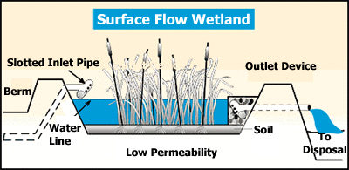sources, but SF wetlands are usually more economical for treating large volumes of wastewater (Sinclair, 2000). SF wetland stay saturated enough to maintain a shallow level of water and wastewater (10 to 45 cm deep) above the soil.Wetland plants also are present in SF, and natural forces such as wind, sun, rain and temperature affect the plants, water and the treatment processes in these systems (Pipeline, 1998). Figure 2.1 shows a surface flow constructed wetland.

*Figure 2.1: A Surface Flow Wetland(Source:www.wateronline.com)*

As soon as wastewater enters a SF cell, natural processes immediately begin to break down and remove the waste materials in the water (Renee, 2001; Kaseva, 2003). Before the wastewater has moved very far in the wetland, small suspended waste particles are physically filtered out by submerged plants, plant stems, roots and plant litter in the wetland (Hammer, 1992). The roots, stems, leaves, and litter of wetland plants also provide a multitude of small surfaces where wastes can become trapped and waste-consuming bacteria can attach themselves to the plant and degrade the organics (USEPA, 1993; Sinclair, 2000).

Bacteria provide the majority of wastewater treatment (Christina, 2005). Aerobic bacteria thrive in wetlands wherever oxygen is present, especially near the surface. Wind, rain, wastewater and anything else that agitates the water surface can add oxygen to the system. Anaerobic bacteria thrive where there is little or no oxygen. In surface flow cells, oxygen is

scarce in the lower substrate and soil. When these bacteria consume waste particles in the water they convert them by anaerobic digestion into other substances, such as methane, carbon-dioxide and new cellular materials. Some of these substances are used as food by plants and other bacteria (Christina, 2005).

* + - 1. ***Subsurface flow (SSF) Wetlands*:**The pollutant removal performance of subsurface flow (SSF) or vegetated submerged bed (VSB) systems depends on many factors including influent wastewater quality, hydraulic retention time, pollutant loading, climate, and the physical characteristics of the system. The main advantage of a SSF system over a surface flow (SF) wetland system is the isolation of the wastewater from vectors, animals and humans. Concerns with mosquitoes and pathogen transmission are greatly reduced with a SSF system (USEPA, 1993), as the wastewater level is maintained below the filter media surface thus preventing direct contact of mosquitoes with the wastewater that if otherwise, support their breeding.

There are two basictypes of SSF CWs; Horizontal SSF CW and Vertical SSF CW systems.

In a horizontal flow system, water continuously flows horizontally through substrate from inlet to outlet while vertical flow system is watered intermittently and air is allowed to refill the wetland.A Vertical SSF CW is a filter bed that is planted with aquatic plants. Wastewater is poured or dosed onto the wetland surface from above using a mechanical dosing system. The water flows vertically down through the filter matrix. The important difference between a vertical and horizontal wetland is not simply the direction of the flow path, but rather the aerobic conditions. (Morel and Diener, 2006).

Purification of wastewater by horizontal SSF CWs is based on the interaction between plants, micro-organisms, the soil medium, and pollutants in a complex system of physical, chemical

and biological processes that are not yet fully understood (Hoddinott, 2006). It is called “Horizontal Flow'' because the wastewater is fed in an inlet and flows slowly through the porous media in a more or less horizontal path until it reaches the outlet zone, where it is collected and discharged at the outlet (Chew, 2006). Figure 2.2 shows a vertical subsurface flow constructed wetland.

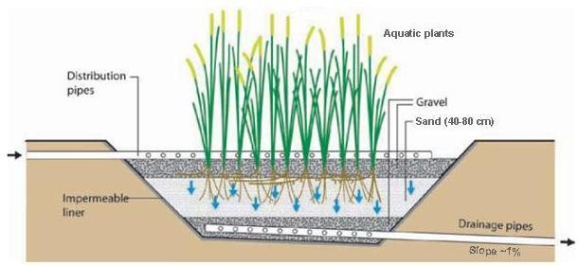

*Figure 2.2: A Vertical subsurface flow constructed wetland(Source: Morel and Diener, 2006).*

In SSF wetland, cells are filled with a treatment media, such as clay and rock or gravel, which is placed on the cell bottom. In properly functioning systems, the wastewater flows just below the media surface and remain unexposed to the atmosphere while it saturates the layer below (Figure 2.3). The saturated media and soil, together with the wetland plants roots, create both aerobic and anaerobic conditions below the surface of the system that are conducive for treatment.

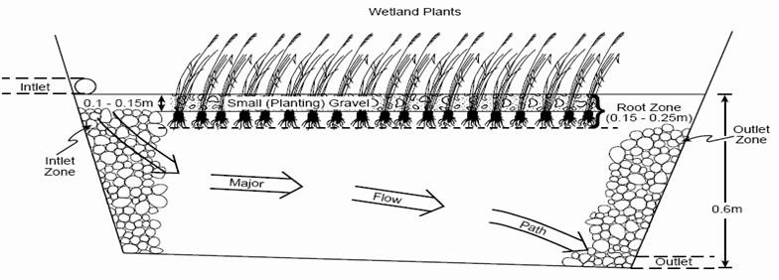

*Figure 2.3a: Horizontal subsurface flow constructed wetland(Source: USEPA, 2000).*

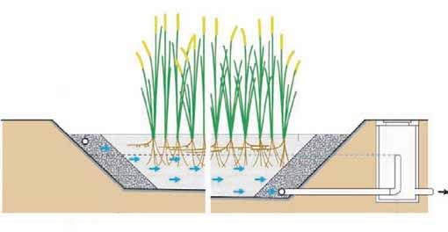

*Figure 2.3b: Horizontal subsurface flow constructed wetland(Source: Morel and Diener, 2006).*

Treatment in the SSF system is more efficient than in the SF wetland because the media provides a greater number of small surfaces, pores and crevices where treatment can occur. Waste-consuming bacteria attach themselves to the various surfaces, and waste materials in the water become trapped in the pores and crevices on the media and in the spaces between media (USEPA, 1993). Vegetation in a wetland (roots, stems, and leaves) provide a substrate upon which microorganisms can grow as they break down organic materials.This is similar to what happens in trickling filters,only that there are no plant surfaces for microbialgrowth to occur,

but stoneorplasticmedia surfaces only, as the case may be. This community of micro- organisms is known as the periphyton. The periphyton and natural chemical processes are responsible for approximately 90% of pollutant removal and waste breakdown (Wikipedia, 2007).

The submerged plant roots can provide substrate for microbial processes and most emergent macrophytes can transmit oxygen from the leaves to their roots(USEPA, 2000). There are aerobic micro-sites on the rhizome and root surfaces. Wetland macrophytes transport oxygen into the root zone through lenticles, which are small openings on the above portions of these plants, and aerenchymous (spongy) tissue, which transport gases to and from the roots (Hammer, 1992; Brix, 1994; Kadlec and Knight, 1996; Newman et al., 2000). The remainder of the submerged environment in the SSF wetland tends to be devoid of oxygen. This shows that biological treatment in SSF wetlands is mostly anaerobic because somepart of the layers of media and soil remain saturated and unexposed to the atmosphere (Pottir and Karathanosis, 2001). SSF constructed wetlands are recommended for areas where an exposed wastewater treatment site may not be suitable due to potential health and safety concerns. Odours, mosquitoes and flies are not a problem with proper system design, construction and maintenance (sludge level checks and de-slugging;regular plant trimming, harvests and vegetation replants where necessary; alsothorough flush and cleanout of inlet, outlet, and distribution medium).

# Configuration, zones and components of constructed wetlands

Most CWs have inlet zone, macrophytes zone, littoral zone and outlet zone. The components associated with each zone are substrates with various rates of conductivity, plants, water column, invertebrate animals and an aerobic and anaerobic microbial population. The water

column is usually maintained at 15-30cm below the bed surface (Kayombo et al, 2010), by means of the influent pipe diameter connected to the wetland, and control valves.

The plants are viewed as nutrient storage components where nutrient uptake is related to plant growth and production. Within the water column, the stem and roots of the wetland plants significantly provide the surface area for the attachment of microbial population. The wetland plants have the ability to transport atmospheric oxygen and other gases down to the root of the water column. The media used includes crushed stones, gravel and different soils either alone or in combination. The beds are lined with impermeable material to prevent seepage as well as assuring water level control. The wastewater flows laterally and is purified through contact with the media surface and vegetation roots. The subsurface zone is saturated and generally anaerobic even though excess dissolved oxygen (DO) conveyed through the plant root system supports aerobic micro sites adjacent to roots and rhizomes.

# Waste Removal Mechanisms and Efficiency of a Horizontal Subsurface Flow Constructed Wetland

CWs are highly complex systems that separate and transform contaminants by physical, chemical, and biological mechanisms that may occur simultaneously or sequentially as the wastewater flows through the system.

According to Bavor and Adcock(1994), wetlands can effectively remove or convert large quantities of pollutants from point sources (industrial, municipal and agricultural wastewater) and non-point sources (mines and urban runoff), including organic matter, suspended solids, metals and nutrients. The focus on wastewater treatment by CWs is to optimize the contact of microbial species with substrate; the final objective is the bio-conversion to carbon (IV) oxide,

biomass and water. Wetlands are characterized by a range of properties that make them attractive for managing pollutants in water.

These ranges of wetland properties include high plant productivity, large adsorptive capacity of sediments, and high rates of oxidation by micro-flora associated with plant biomass and a large buffering capacity for nutrients and pollutants (Mitchell, 1996).

Most contaminants are removed from wastewater through several mechanisms like sedimentation, microbial degradation, precipitation and plant uptake(Lorion, 2001).

The performance of CWs involves six major reactions viz; photosynthesis, respiration, fermentation, nitrification, denitrification and microbial nutrients removal.

# Heavy metals removal by subsurface flow wetlands

Heavy metals is a collective name given to all metals above calcium in the periodic table of elements, some of which can be highly toxic, and have densities greater than 5g/cm3(Skidmore and Firth, 1983). The heavy metals of concern are lead, copper, chromium, zinc, mercury, cadmium and arsenic; the main heavy metal of concern being chromium since tannery wastewater is the effluent of concern in this study.

There are four main wetland processes that remove heavy metals namely binding to soils, sedimentation of particulate matter, precipitation as insoluble salts and uptake by bacteria, algaeand other plants (Kadlec and Knight, 1996). These processes are very effective, and have removal rates of up to 99% (Reed et al, 1995). Wetlands have a buffering capacity for toxins, and various processes dilute and breakdown the toxins to some degree(Reed et al., 1995).

* + 1. **Biological oxygen demand (BOD)and chemical oxygen demand (COD) removal** Biological oxygen demand is the amount of oxygen needed by bacteria to stabilize decomposable organic matter under aerobic conditions. It isthe amount of dissolved oxygen needed by aerobic biological organisms in a body of water to break down organic material present in a given water sample at a certain temperature over a specific time period (Clair et. al, 2003).BOD is defined as the quantity of oxygen required during the stabilization of decomposable organic and oxidizable inorganic matter byaerobic biological action under standard conditions, usually over only five days instead of 20 days.

Chemical Oxygen Demand (COD) is the measure of the pollution strength of both domestic and industrial wastes in terms of oxygen required to oxidize organics to carbon IV oxide and water. COD is the quantity of oxygen consumed for the total oxidation of the oxidizable matter (organic and inorganic) with dichromate as the oxidizing agent. The COD is always greater than its BOD (UNIDO, 2011).

BOD is similar in function to COD, in that both measure the amount of organic compounds in water. However, COD is less specific, since it measures everything that can be chemically oxidized, rather than just levels of biologically active organic matter.

The removal of settleable organics is very rapid in all wetland systems and is due to deposition and filtration in the SSF systems. The major oxygen source for the subsurface components is the gases transmitted by the vegetation to the root zone. In most cases the system is designed to maintain flow below the surface of the bed, so there can be very little direct atmospheric re- aeration. The selection of plant species can therefore be an important factor.

True BOD removals only occur when the materials causing the BOD are completely converted by anaerobic biological processes to gaseous end products. The two most likely anaerobic

pathways are methane fermentation and sulphate reduction. Because fermentation is severely inhibited at a temperature below 10 degree centigrade, sulphate reduction probably dominates for soluble BOD removal during colder months. However, seasonal performance does not vary as much as would be expected based on the typical temperature dependence of biological reactions. Biodegradable particles that are physically removed during colder months are degraded more slowly and accumulate (Kadlec and Knight, 1996). Horizontal SSF CWs are thus unsuitable for use in temperate zones because treatment would not be as efficient.

According to Kadlecet.al, (2003), two adjacent horizontal flow systems in Minnesota had the highest BOD5 removal during autumn and summer with substantial inefficiency during winter and spring, at an average annual air and wetland temperatures of 5oC and 9oC with air temperature reaching below 4oC. Also, with respect to bed areaaffecting BOD removal in SSF systems, Diederik et.al, (2004), in a study, observed that with a bed area of 0.1m2, the predicted effluent concentrations stayed below 25mg/l BOD for most of the time;the result for a larger bed area of 18m2 showed very little variations in BOD effluent concentrations to the former, which is not surprising since hydraulic residence time of 2.57 days was more than sufficient to cause a buffering influence on the remaining dissolved BOD.

In a research in Czech Republic where 38 CWs were observed, average removal of five day BOD in the wetlands was 88%. The average outflow concentrations were 10.5 mg/l, which fall within Ohio Environmental Protection Agency limit of 15mg/l (Vymazal, 2002). Average BOD removals in horizontal flow systems were 98% and 71% when young and stabilized leachate at hydraulic loading rate of 10mm a day was applied to horizontal SSFsystems (Chiemchaisri et. al, 2006).

# Nitrogen removal

The important removal mechanisms for the removal of Nitrogen are microbial. (Ammonification, Nitrification and Denitrification), plant uptake, sedimentation and ammonia volatilization. Nitrification/Denitrificationammonification occur simultaneously in most CWs, but the extent of individual processes varies within the system (Sarafraz et al., 2009). Most conventional SSF systems have been designed, built and operated to remove ammonia from various wastewaters, while partial ammonia removal has been achieved in some systems. (George, 2000, Liehr, 2000, Young et al., 2000).

Ammonia removal is by microbial reactions or plant uptake;and since SSF systems are predominantly anaerobic, microbial removal through nitrification is very limited. Also, the uptake by plants is very limited. Very lightly loaded systems have achieved partial ammonia removal (George, 2000, Young et al., 2000). Nitrogen removal in CWs is accomplished primarily by physical settlement, denitrification and plant or microbial uptake. The plant uptake does not represent permanent removal unless the plants are regularly harvested (Healy et al., 2006).

The anaerobic condition of the SSF systems becomes ideal for microbial removal of nitrate through denitrification, but there are relatively few studies to document the use for this specific purpose (Gersberg et al., 1983, Stengel and Schulltz-Hook, 1989). Significant denitrification of municipal wastewater can occur in a submerged system at a detention time of 2 to 4 days, as suggested by Crites and Tchobanoglous (1998). But Stengel and Schultz-Hook (1989) demonstrated that denitrification was carbon limited with methanol addition.

Alternative SSF systems should achieve higher oxygen transfer rates, so they should be more efficient for nitrate removal (denitrification), than conventional systems (George, 2000; Reed

and Giarusso 1999; Behrends et al., 1996; May et al., 1990).

In a study conducted by Chiemchaisri et al., (2006), average removal efficiency of the range 43% to 46% of Total Nitrogen was observed, while using horizontal SSF CW system. According to a study by Chew (2006), removal efficiency for nutrients from land fill leachate in the form of ammonical nitrogen and nitrate by aquatic plant (*Typha Angustifolia*) in a horizontal SSF CW ranged from 42.6% to 88.9%. Chew also observed that the high nitrogen characteristic in the stabilized leachate adversely affected performance and plant life in the system.

# Phosphate removal

Phosphorous is an essential requirement for biological growth; but an excess of phosphorus can have the effect of triggering eutrophication within a wetland. This could lead to algal blooms and other water quality problems. Phosphorus may enter wetlands in dissolved and particulate forms and exit in outflows by leaching into the sub-soil and removal by plants and animals. The primary processes responsible for phosphorus removal in horizontal SSF CWs are adsorption, filtration and sedimentation. Other processes include precipitation and assimilation. The filtration materials mostly used in horizontal SSF CWs is gravel or crushed rock which provides only limited adsorption; and the plants, since not regularly harvested lead to usually low removal of phosphorusof ranges of 40% to 60% during the treatment of municipal or domestic sewage (Vymazal, 2004).

Several studies on CWs have reported on the potential use of horizontal SSF CWs to removephosphorus from wastewater (Sakaderan and Bavor 1998; Molle et al., 2003). Total phosphorus removal in wetlands is in various ways. There are physical, chemical and

biological functions effective for the removal of different total phosphorous components (Kadlec et al., 2000; Vymazal, 2002). Phosphorous is removed through short term or long term storage, uptake by bacteria. Algae and duckweed, and the macrophytes provide an initial removal mechanism (Kadlec, 1997). There is only a short-term storage of phosphorous because 35% to 75% of the stored phosphorous is eventually released back into the water upon die-back of algae and microbes (Richardson and Craft, 1993; White et al., 2000).

Anaerobic conditions which exist at the soil-water interface may also cause the release of phosphorous back into the water column (Patrick and Khald, 1974). The only long-term storage of phosphorous in wetlands is through peat accumulation and substrate fixation. The efficiency of the long-term peat storage is a function of the loading rate and is dependent on the amount of native iron, calcium, aluminium, and organic matter in the substrate (Shatwell and Cordery, 1999), as well as water temperature in the system; since phosphorus retention is endothermic, and colder water temperature decreases the sorption capacity of the bed aggregate (Kadlec and Wallace,2008).

Lake and reservoir sediments have been shown to act as phosphorous sinks (Richardson and Craft, 1993; White et al., 2000). At a phosphorous loading rate of less than 5g m-2yr-1, wetland sediments can absorb greater than 90% of total incoming phosphorous (Faulkner and Richardson, 1989).

# Removal of suspended solids (SS)

The presence of solids in a wetland can be from outside (inflow and atmospheric inputs) and from within the wetland from plankton (phytoplankton and zooplankton) and also from plants and animals detritus. With low wetland water velocities and appropriate composition of the

influent solids, suspended solids will settle from water column within the wetland. Sediment re-suspension not only releases pollutants from sediments it also increases turbidity and reduces light penetration. Flocculation and settling of particulates is one of the primary mechanisms of suspended solids removal in a SSF CW. Due to their relatively low velocities and high surface area, the systems are relatively effective in total suspended solids (TSS) removal. This is particularly so since the systems act like horizontal gravel filters thereby providing opportunities for TSS separation by gravity sedimentation, straining and physical capture, and adsorption in biomass film attached to gravel and root systems (USEPA, 1999).

A study by Pucci et al., (2000) showed that about 81% removal efficiency of TSS, in a horizontal SSF CW in Chianti Countryside, Italy, was achievable.

# Influence of non-biological (Physical and chemical) factors in wetlands

Non- biological factors areenvironmental factors. The most important non-biological factors influencing wetlands are oxygen, temperature and pH. Their effects on wetlands is further explained briefly in the sub-sections below;

* + - 1. ***Oxygen*:** Oxygen is very important for bacterial oxidation and growth in wetland systems, and is also an essential component for many wetland pollutant removal processes such as nitrification, decomposition of organic matter and other biologically mediated processes. Oxygen finds its way into wetlands through inflows, diffusion in the surface when it is turbulent and photosynthetically by algae. Also plants release oxygen by exudation into the root zone around the sediments. Many emergent plants have hollow stem to allow for the passage of oxygen to the root tissues (UNEP, 2011). According to Kadlec and Knight (1996),

the oxygen demand processes in wetland includes sediment-litter oxygen demand

(decomposition of detritus), respiration, dissolved carbonaceous BOD and dissolved nitrogen that utilizes oxygen through nitrification processes.

* + - 1. ***Operating temperature*:** Temperature is a widely fluctuating factor that can vary both daily and seasonally.Temperature of the tannery wastewater is a major factor in its treatment, as a result of the effect of temperature on the chemical reactions in the wastewater. Temperature also affects aquatic life and micro-organisms. It increases their BOD rate (El- Monayeri et al., 2007). Temperature also affects solubility of oxygen in wastewater.The optimum temperature for bacterial activity ranges from 25oC to 35oC, while the nitrifying bacteria and some aerobic bacteria stop action at 50oC (Metcalf et al., 1995). Temperature exerts a strong influence on the rate of chemical and biological processes in wetlands including BOD removal, nitrification and denitrification. Apart from settling of solids, which is dependent on velocity and flow, all other wastewater processes are greatly affected by temperature.Generally, temperature has two effects on wastewater. Firstly, it affects the rate of biological processes and secondly, it can either evaporate or freeze the liquid part of wastewater.

The effect of temperature on the rate of biological processes can be deduced using equation 2.1

𝐾𝑇 = 𝐾20 𝑄(𝑇−20) (2.1)

Where KT is the reaction rate at ToC, K20 is reaction at 20oC, Q is the temperature activity coefficient which varies from 1.020 to 1.028, and T is the various temperature at which various biological processes occur. At higher temperatures, anaerobic degradation occurs faster because the micro-organisms are favoured by high temperature.

* + - 1. ***pH*:** The wetland pH is correlated with the calcium content of water (pH 7-20mgCa/L).

Wetland waters usually have a pH of around 6-8 (Kadlec and Knight, 1996). The living organisms (plants and animals) in wetlands can be impaired by sudden changes in pH.The pH of wastewater is an important parameter in the treatment of wastewater. This is because of its influence on the biological life of wastewater.

# Role of Plants in Constructed Wetlands

In SSF wetlands, emergent macrophytes grow in a saturated substrate which may be intermittently flooded and drained. One of the most important mechanisms for pollutant removal in wetlands is by biological means (Debusk, 1999a), in which plants play a partial role. Plants can be involved, either directly or indirectly, in the removal of pollutants from wastewater. When plants directly uptake contaminants into their root structures, this process is called **phytodegradation** or **phytoextraction.**When plants produce substances that add to biological degradation, this process is called **rhizodegradation**. The process by which contaminants enter the plant biomass and are transpired through the plant leaves is called **phytovolatization** (ITRC, 2003).

Wetland plants take up macro-nutrients (such as N and P) and micro-nutrients through their roots during active plant growth. At the beginning of plant senescence most of the nutrients are translocated to the rhizomes and roots (Mitsch and Gosselink, 1993).

Aquatic plants have both structural and physiological adaptations to water logging, which allows them to tolerate anoxia in saturated substrates (Mitsch and Gosselink, 1993).

Emergent macrophytes that have been used successfully in surface flow treatment wetlands and subsurface flow treatment wetlands are adapted to cope with anoxia associated with permanent water logging or saturated solids respectively.

Plants capacity to supply oxygen to the root zone and nutrient uptake varies among species due to the difference in vascular tissue, metabolism and root distribution (Gersberg et al., 1986; Steinberg and Coonrod, 1994; Jackson and Armstrong, 1999). This also suggests that, if the plant is expected to play a major role, the depth of the bed should not exceed the potential root development for the plant species selected. In addition, apart from providing attachment sites and diffusible oxygen to bacteria, root- mats increase wastewater residence time and retention of suspended organic particles, which upon degradation provide nutrients to bacteria and plants (Joseph, 2005). Furthermore, during the active growth period, plants are able to significantly reduce pollutants than in the senescent phase, even though it still contributes some (Myers *et al*., 2001). Kadlec and Knight(1996) listed 37 families of vascular plants that have been used in water quality treatment. These include reeds (*Phragmites spp*), Cattails (*Typha spp*), rushes (*Juncus spp.*), bulrushes (*Scirpus spp*.) and sedges (*Carex spp*.).

# Selection of plants for wetlands

The choice of plants is an important issue in constructed wetlands, as they must survive the potential toxic effects of the wastewater and its variability. The major criteria for plant selection are based on their adaptation to that particular site, the type of contaminants, and pollution concentration of that specific area.

The selected plant species for phytoremediation should be a fast growing, deep rooted, high biomass production, large transpiration rates and preferably indigenous species. It is a

combination of high pollutant and metal accumulation, with high biomass production that results in most pollutant and metal removal. In addition, plants considered for phytoremediation must tolerate the targeted pollutant or pollutants, and be efficient in translocation of metals from roots to the harvestable above ground portions of the plant (Blaylock and Hang, 2000).

Other desirable plant characteristics include the ability to tolerate difficult soil conditions, the production of dense root system, ease of care and establishment. Several researchers have screened for use, fast growingand high biomass accumulating plants, with ability to tolerate and accumulate in shoots **(**Raskin, et al., 1997). In the case of organic phyto-transformation, species of vegetation which are hardy and fast growing, easy to maintain, have a high transpiration pull and transform the pollutants present to non-toxic or less toxic products are preferred. In addition, for many such applications, deep rooting plants are particularly valuable. The wetland plants used in this study are *Phragmites australis*, (common reed) *Polygonum salicifolium* (slender knot weed) and *Ipomoea carnea*(morning glory).

* + 1. **Characteristics of the wetland plant *Phragmites australis*(Common reed)**

Vegetation is the principal component of a wetland system. In general, there is a broad group of plants that could possibly be used in constructed wetlands. However, field experience has shown that only a few plants are commonly used. By far the most frequently used plant in horizontal subsurface flow around the world is *Phragmites australis* (common reed) (Cooper et al., 1996; Vymazal et al., 1998; Kadlec et al.,2000). The common plants in wetlands are common reed (*Phragmites* spp.), cattail (*Typha* spp.), rush (*Juncus* spp.), and bulrush (*Scirpus* spp.). However, the most common plant species worldwide is *Phagmites australis* (IWA, 2000;

Scholz, 2006). *Phragmites*, the common reed, is a large perennial grass found in wetlands throughout temperate and tropical regions of the world. Itis the most widely used plant species in European systems (USEPA, 1993). *Phragmites australis* is also one of the main wetland plant species used for phytoremediation water treatment. According to a study by Badejo, (2012), wheretertiary hospital wastewater from University College Teaching Hospital, Ibadan, Nigeria was treated in a pilot natural treatment system (reed bed),*Phragmites karka*, a specie of common reedshowed higher treatment efficiency than *Vetiverianigritana***.**

*Phragmites australis*, or Common Reed, is a large perennial rhizomatous grass that grows 1.5 to 3 meters tall. Its leaves are broad and sheath like, 1-4 cm wide at their base. *Phragmites* has grey-green foliage during the growing season. New stems grow in the rainy season, and its rhizomes spread horizontally during the growing season. It flowers in late June, with bushy panicles and seeds forming by August. During this time, energy stores are translocated from the leaves and stems to the rhizomes of the plant (Jason, 2006).

The common reed *Phragmites australis* is a cosmopolitan plant species that flourishes in wetlands and easily dominates other plant species, forming a mono-specific reed bed (Hartog et al. 1989). It employs aggressive and persistent survival strategies, like most other grasses, making it one of the earliest and most successful colonisers of disturbed or newly reclaimed wetlands (Van der Werff 1991; Havens et al. 1997; Massacci et al. 2001). It reproduces most effectively by vegetative means through rhizomes and regenerative shoots that emerge from the nodes of damaged stems.

*Phragmites australis* is a plant species with a high annual productivity (Granéli 1984; Massacci et al.2001). The biomass is produced seasonally above ground, but it also

accumulates perennially in the below ground parts. The rhizome‟s perennating nature is based on the nutrient and carbohydrate translocation and cycling which is characteristic of all clonal plants (Hara et al. 1993). The common reed grows in almost any type of soil as long as the ground is wet enough, but seems to perform best in rich mineral soils with a high clay content (Jason, 2006).

*Phragmites australis* is an important component in the ecology and maintenance of wetland integrity. It has many valuable attributes, such as an extensive root system that consolidates and maintains substrates, minimising the effects of water erosion. It also has the ability to withstand high levels of environmental contamination and it can assimilate heavy metals, nitrogen and phosphorous. In addition, it tolerates varying degrees of salinity and acidity (Massacci et al. 2001). It is a halophyte, especially common in alkaline habitats, and it also tolerates brackish water, and so is often found at the upper edges of estuaries and on other wetlands (such as grazing marsh) which are occasionally inundated by the sea. The establishment and continued existence of *Phragmites australis* reed beds in disturbed wetlands with these attributes facilitate hydrological succession, initiating the restoration of the wetland so as to render it a productive entity (Van der Werff, 1991). Plate I shows the aquatic plant *Phragmites australis*.

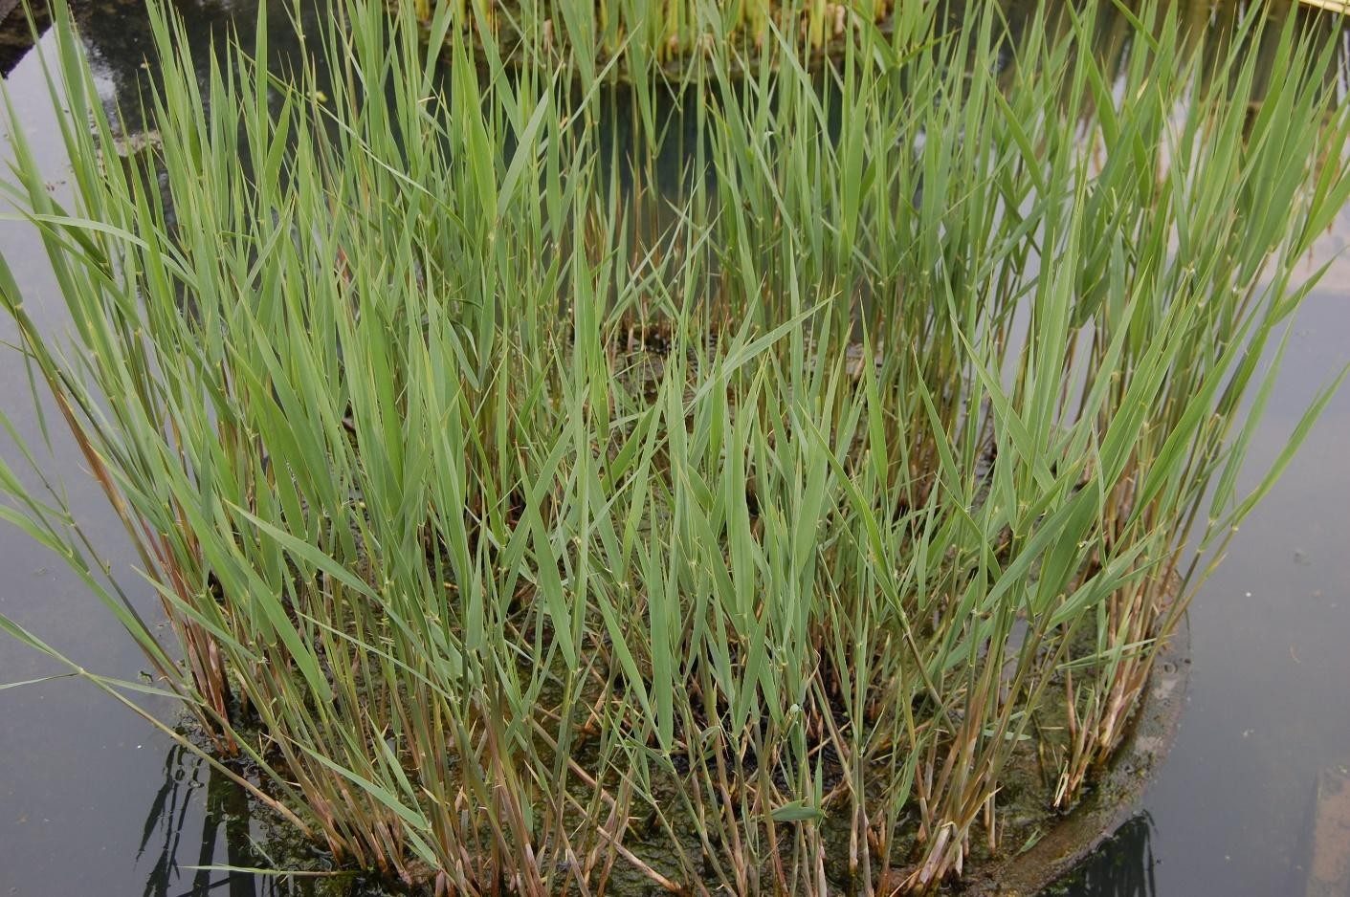

*Plate I: Phragmites australis (Source: www.google.com; accessed March 24th, 2014).*

# Other wetland plants considered

* + - 1. ***Polygonum salicifolium*(Slender knot weed):** The aquatic plant slender knot weed is of the species *Polygonum salicifolium*, and family Polygonaceae. It is an annual plant erect or semi-decumbent, sometimes spread, which measures 90cm to 1m in height and produces from seed. The stem are segmented into swollen nodes with each node bearing a long hairy sheath. The plant is broad-leaved and flowers are whitish-pink. It is a weed of lowland rice but also grows in marshy places, along banks of streams, rivers and lakes. Akobundu and Agyakwa (1998). Plate II shows the aquatic plant *Polygonum salicifolium*.

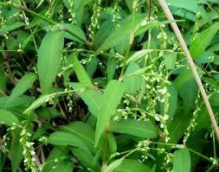

*Plate II:Polygonum salicifolium* (*Source: www.google.com; accessed March 24th, 2014).*

* + - 1. ***Ipomoea carnea*(Morning glory):** *Ipomoea carnea*, is of the family *Convulvulaceae* and is a native of South America, though a gregariously growing short shrub available all over the world. It grows in dense populations along river beds, banks, canals and other waterlogged (wetland) areas. This plant propagates vegetatively either by stems which are capable of rooting within a few days or sexually by seeds. Its reproduction by seeds have aided the plant to disseminate into new regions, especially in terrestrial habitats. It is 2-3 meters high with spreading branches, containing milky juice. It is a poisonous shrub therefore cannot be used as fodder for animals(Kamal 2013). Plate III shows the aquatic plant *Ipomoea carnea*.

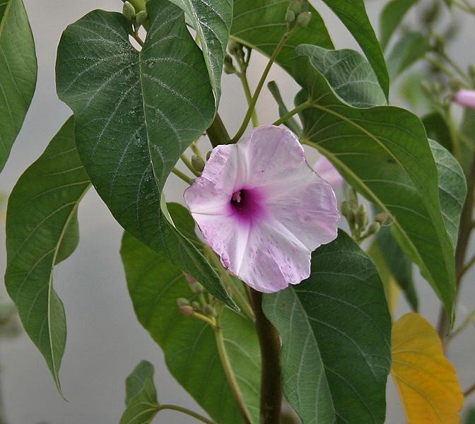

*Plate III:Ipomoea carnea* (*Source: www.google.com; accessed March 24th, 2014).*

# Types ofConstructed Wetlands Design and Design Parameters

The design of CWs based on treatment performance relates to BOD, TSS, nutrient removal or disinfection performance. The limiting parameter will then determine the minimum size required. Sizing is generally based upon first-order plug-flow kinetic models which assume that wetlands can best be considered as attached growth biological reactors (Crites and

Tchobanoglous, 1998) or „Rule of thumb‟ (DLWC, 1998).

# Rule of thumb

The sizing of SSF CWs based on this method has been estimated from a range of studies. Areal requirements are generally given as square meter of wetland per cubic meter of effluent or per person equivalent (PE).

The level of effluent pre-treatment, the controlling CW design parameter and climatic condition greatly influence the range of values given. In general, sizing by rule of thumb tends to result in more conservative designs as it consistently predicts larger surface areas (Rousseau et al., 2004b). Table 2.1 shows some common data on the rule of thumb design method.

*Table 2.1: Rule of thumb design criteria for Horizontal Subsurface Flow Constructed Wetland*

|  |
| --- |
| Criterion Value Range |
| Wood (1995) Kadlec and Knight (1996) |

|  |  |  |
| --- | --- | --- |
| Hydraulic retention time (days) | 2-7 | 2-4 |
| Max. BOD loading rate (kgBOD/ha/day) | 75 | - |
| Hydraulic loading rate (cm/day) | 0.2-3.0 | 8-30 |
| Areal requirement (ha/m3day) | 0.001-0.007 | - |

*Source: UNESCO-IHE Institution for Water Education, 2006*.

# First-order plug flow models

Two principal models exist which are differentiated by the choice of rate constant which is either volumetric and temperature dependent („„Reed‟‟ model) or area based and independent of temperature („„Kadlec and Knight‟‟ (1996) model). First-order models presume ideal plug- flow behaviour with steady-state conditions for influent, flow and concentrations and predict an exponential profile between inlet and outlet (Rousseau et al., 2004b).

The general form of the equation is given in equation (2.2)

𝐶𝑖

𝐼𝑛 ( ) = −𝑘𝑡 (2.2)

𝐶

𝑒

Where Ci = influent pollutant concentration (mg/L), Ce = outlet effluent pollutant concentration (mg/L), k = reaction rate constant and t = hydraulic residence time (days).

For Reeds model, this equation is used to calculate BOD, ammonia (NH3) and nitrate (NO3) removal only with the following rate constants for SSF wetlands at 20oC respectively: 0.678 day-1, 0.2187 day-1, 1.000 day-1.

# Hydraulic design consideration

It is common practice to use Darcy‟s law to determine flow through a porous medium. This is expressed as equation (2.3).

𝑄 = −𝐾𝑠𝐴𝑆 (2.3)

Where, Q = average flow rate (m3d-1), Ks =hydraulic conductivity of a unit area of the medium perpendicular to the direction of flow (m3/m2/d), A = total cross-sectional area, perpendicular to flow (m2) and S = hydraulic gradient of the water surface in the flow system (m/m).

Darcy‟s law is not strictly applicable to subsurface flow. It assumes laminar flow condition and the flow Discharge (Q) is constant and uniform. But turbulent flow occurs in the very coarse gravel media. The input versus output Q may vary due to precipitation, evaporation, and seepage. And short circuiting of flow may occur due to unequal porosity. The theoretical applicability of Darcy‟s law can be limited by these factors, but it remains as the only reasonable accessible model for design of these subsurface flow systems. The moderate sized substrate can be used as the media in the experimental constructed wetland system (USEPA, 1993).

Mannings equation given by equation (2.4) is also used to determine flow through a channel as well as channel dimensions.

𝑄 = 𝐴 𝑅2/3𝑆1/2 (2.4)

𝑛

Where, Q = flow rate (m3/s), A = cross-sectional area perpendicular to flow direction (m2), n = manning‟s roughness coefficient which is dimensionless, S = bottom slope of the wetland, R = hydraulic radius.

# Aspect ratio

The hydraulic gradient defines the total head available in the system to overcome the resistance to horizontal flow in the porous media. In Darcy‟s law the maximum potential hydraulic gradient is related to the available depth of the bed divided by the length of the flow path. So, the important consideration in the hydraulic design of SSF CW is the aspect ratio (L: W). To avoid surface flow in subsurface flow constructed wetland, an aspect ratio less than 10:1 has to be provided(USEPA, 1993).

# Bed slope

An acceptable hydraulic gradient needs very light slope on the bottom of the bed to ensure drainage (USEPA, 1993).

# Hydraulic retention time

Residence time is the estimated average time for wastewater to flow completely through the wetland and is a function of the “reactive” volume of the wetland divided by the flow rate. The reactive volume is the volume of water above the substrate for SF wetlands, and the volume of water below the substrate for SSF systems. Treatment performance in constructed wetlands is a function of retention time, among other factors. A retention time of 6-7 days has been reported to be optimal for the treatment of primary and secondary wastewater (USEPA, 1988). Shorter retention time does not provide adequate time for pollutant degradation to occur; longer detention times can lead to stagnant, anaerobic conditions.

# Hydraulic loading rate (HLR) and organic loading rate (OLR)

Wastewater loading rate is a critical design factor for wastewater treatment systems. The HLR, which is the flow rate per unit area, in order words, the volume per day applied over a surface area, generally varies from 2–20 cm/d for constructed sub-surface wetlands (WPCF, 1990). The estimated surface area required can be calculated from the hydraulic loading rate using the equations (2.5 and 2.6):

𝐴

𝑄

= 𝐻𝐿𝑅 (2.5)

Where

A = surface area for the constructed wetland (m2), Q = average flow rate (m3/day) HLR = hydraulic loading rate (cm/day)

OLR is the weight of organic matter per day applied over a surface area. It is given by the equation below:

𝑂𝐿𝑅

𝐵𝑂𝐷

= 𝑄𝐴 (2.6)

Where

OLR = organic loading rate (mg/l BOD/m2/d), Q = average flow rate (m3/day), A = surface

area of constructed wetland (m2).

To achieve the outflow BOD5 and TSS concentrations of 30g/l, the USEPA recommend the respective inflow loads of 6g/m2/d and 20g/m2/d.

# Flow velocity and flow depth

Flow velocity should be low (less than 0.15 m/s) and laminar to provide sufficient contact time to attain target removal rates. Flow depths typically range from 0.49 to 0.79 m for sub-surface flow systems (Cooper et al., 1998).

# CHAPTER THREE MATERIALS AND METHODS

# Materials

The materials that were used for the construction and setupof the laboratory scale wetland, and apparatus, instruments, equipment and reagents that were used for the laboratory analysis in this study are;

* + 1. Perspex sheets for construction of the laboratory scale wetland (4mm sheets).
    2. Gravel of different sizes (10-30mm for inlet and outlet zones to prevent clogging, and 2mm-5mm betwixt as substrate).
    3. Valves for control of wastewater flow through the setup (Rosvil ball valves- 2mm).
    4. Plastic buckets of different capacities as storage and sedimentation tank, control and effluent tanks.
    5. Polyvinyl chloride (PVC) pipes for connecting the various units of the setup (2mm)
    6. Scissors, saw and gum for cutting and -attaching.
    7. Raised platforms of different heights for support of structure.
    8. Tannery wastewater from NILEST.
    9. Common reed (*Phragmites australis*), *Polygonum salicifolium* and *Ipomea carnea*; aquatic plants for the wetlands obtained from the banks of the Ahmadu Bello University dam.
    10. Conical flasks (Pyrex, England)
    11. BOD bottles (Wheaton, USA)
    12. Pipettes (Technico BS, 700)
    13. Burettes (Technico BS, 846)
    14. Beakers (Pyrex, England)
    15. Refluxing apparatus (Gallenkamp, Quickfit England)
    16. Incubator (Gallenkamp; Cooled CO2)
    17. Thermometer: (2/1 0C made in England)
    18. pH meter,model pHS-2S, (Shanghai Jinyke Rex, China)
    19. Funnels (LABPLEX England)
    20. Spectrophotometer (HANNA Instrument)
    21. Refrigerator (Haier Thermocool HRF-300N)
    22. Weighing balance (Mettler P160N)
    23. Water bath (Gallenkamp, England)
    24. Oven (Griffin)
    25. Nesslers reagents (East Anglia Chemicals)
    26. Silver nitrate (Griffin and George, England)
    27. Potassium chromate (AnalaR, BDH Chemicals Ltd, England)
    28. Ferrous ammonium sulphate (M&B Laboratory Chemicals, England)
    29. Silver sulphate (Kem Light Laboratory Ltd)
    30. Potassium dichromate (M&B Laboratory Chemicals, England)
    31. Methyl orange (BDH Chemicals Ltd, England)
    32. Sulphuric acid(AnalaR, BDH Chemicals Ltd, England)
    33. Phenolphthalein(BDH Chemicals Ltd, England)
    34. Sodium thio-sulphate(VOLUCON, Standard Volumetric concentration M&B Laboratory Chemicals, England)
    35. Starch solution (FISONS Scientific Apparatus and M&B Laboratory Chemicals, England)
    36. Alkali-iodide azide ( made up of NaOH, Sodium Iodide and Sodium Azide; Avondale Laboratories, England; BDH Chemicals Ltd, England; Laboratory Technology Chemicals, Avishkar respectively)
    37. Manganese sulphate (M&B Laboratory Chemicals, England)
    38. Distilled water (Water Still Aquation /A4000/)
    39. Desiccator (MONAX, Scotland)

xl. Measuring cylinder (KIMAX, USA) xli. Petri-dishes (Pyrex)

xlii. Filter paper (Whatman qualitative circles, Ashless; 15.0cm).

# Methods

# Tannery effluent collection site

The Nigerian Institute of Leather and Science Technology (NILEST) is located in Samaru, Zaria in Kaduna State of Nigeria. The Institute is on latitude N11o 9.4430' and Longitude E7o

39. 4399' and approximately 670m ASL.

Their tannery is made up of a beam house, lime yard, tan yard and finishing yard. The type of tannages used in the tannery are mineral and vegetable tannages, though the mineral tannage is the most frequently used process which utilizes chrome.

The effluent for this study was obtained from NILEST throughout the period (60 days) of conduct of theexperiment. A volume of 100 litres of wastewater was collected every six (6) days (HRT) for batch loading into the model CWs. At the end of 60 days, a total volume of 1000 litres of the tannery effluent had being collected for the experiment. Every batch of the wastewater obtained from NILEST was collected in five (5) of 20 litres capacity jerry cans, and transported by car to the experimental site.

# Experimental set-up

The methods applied in order to carry out the experiment and analysis for this research are outlined below.

A horizontal sub-surface flow constructed wetland (SSF CW) was the wetland type selected.The reduction performance of SSF constructed wetland has already been proved by many researchers around the globe. So, the SSF constructed wetland was chosen to determine the performance in a tropical environment. It was preferred for their simple technology and reliable operating conditions (Kusch et al., 2003). The wetland was constructed using materials locally sourced as listed in 3.1. Three identical wetlands were constructed and fine gravel (2mm-5mm) was used as the substrate in the threesystems, the differences being thatthe first wasplanted with *Polygonum salicifolium*, and *Ipomea carnea*, the second was planted with vegetation - *Phragmites australis*(All the aquatic plants were obtained from the banks of the

Ahmadu Bello University dam and identified in the herbarium of the Biological Sciences department of the university)and the thirdremainedunplanted.

The three model wetlands were constructed and fitted with all the necessary plumbing works.

The components of the systems were

* + - 1. The treatment media (2mm-5mm) and the inlet and outlet gravels (10mm-30mm) in the HSSF CWs. These ranges of gravel were obtained by using sieve sizes of effective size D10mm of 32 and effective size D10mm of 16 respectively.
      2. A storage tank for collection of the tannery wastewaterwhich doubled as a sedimentation or settling tank;a plastic container of 100 liters capacity.
      3. A plastic container of 30 liters capacity served as a control tank from which wastewater was fed into the treatment media. The control tank maintained water level in the system and prevented shock loading from the storage tank as a result of pressure differences in the tank.
      4. Three plastic containers of 9 liters capacity served as effluent tanks.

Other relevant methods included the following;

* + - 1. The three wetlands were setup as models under existing atmospheric conditions, within the premises of the Department of Water Resources and Environmental Engineering, main campus of Ahmadu Bello University Zaria.
      2. The tannery effluent was collected from the effluent pit (where the wastewater from all the tan processes in the tannery are channeled) from NILEST, in 20 liters capacity containers.
      3. All the physico-chemical parameters analyzed in this study used effluents that were collected at the inlet and outlet of the wetland and their analysis carried out in the Water Resources and Environmental Engineering laboratory and the Soil and Water Management Laboratory, Institute of Agricultural Research (IAR) Ahmadu Bello

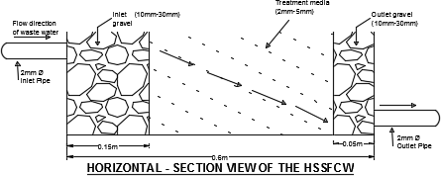

University in Zaria, using standard methods. The temperature and pH was measured on-site, for every batch loading of the designed retention period of the wetland.

Figure 3.1 and 3.2 shows the horizontal section view and full view of the setup of a horizontal subsurface flow constructed wetland respectively.

*Fig 3.1: Horizontal- Section View of the Horizontal Sub-surface Flow Constructed Wetland*

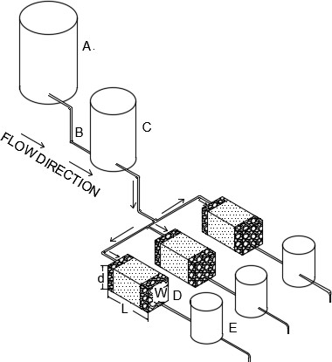

**KEY**

**A – Storage/Sedimentation Tank (100 Ltrs)**

**B – PVC Pipe (2mm)**

**C – Control Tank (30 Ltrs)**

**D – Model Constructed HSSF Wetland of Capacity 0.054m3 (L=0.6m, W=0.3m, D=0.3m)**

**E – Effluent Tank (9 Ltrs)**

*Fig 3.2: Full view of laboratory set- up of the Horizontal Sub-surface Flow Constructed Wetland.*

The efficiency of the SSF CW was based on the removal of the parameters measured. The measured parameters were:

* + - * 1. Chromium
        2. Biological Oxygen Demand (BOD)
        3. Chemical Oxygen Demand (COD)
        4. Suspended Solids (SS)
        5. Nitrate - Nitrogen
        6. Phosphate
        7. Temperature
        8. pH.

# Laboratory analysis

The physico-chemical parameters of influent and effluent was determined using Standard Laboratory Methods for Examination of Water and Wastewater (APHA, 1995).

* + - 1. ***Determination of chromium*:** To determine chromium in the tannery wastewater, the Atomic Absorption Spectroscopy (AAS) method was used. Samples were first digested using the Acid Digestion Method, then analyzed using the AAS method.

The predominant use of chromium in tannery industries unfortunately introduces an environmental concern.

* + - 1. ***Biological oxygen demand determination*:**In determining the BOD of tannery wastewater samples, the Azide modification of the Wrinkler method was used.

The BOD was measured by incubating the sample at a constant temperature for a five (5) day period within which the Dissolved Oxygen was measured before and after incubation.

The difference in dissolved oxygen (DO) before and after incubation multiplied by the dilution factor that was used resulted in five day BOD of the sample. This is based on the fact that each milligram of sodium thiosulphate titrant used is equivalent to 1mg/l of DO if a volume of 100ml original sample is titrated with starch as indicator.

BOD5= (DO0-DO5) x dilution factor Where

BOD5 = Biological Oxygen Demand after five days of incubation DO0 = Dissolved Oxygen on day zero

DO5 = Dissolved Oxygen on day five

* + - 1. ***Determination of chemical oxygen demand (COD)*:** In determining the COD of the tannery wastewater sample, 0.4g of sulphuric acid was placed in a refluxing flask to which 20ml of the sample was added and mixed. 10ml of standard potassium di-chromate solution and several purice granules already heated to 600oC in an hour was added. The flask was then attached to the reflux condenser. 30ml of concentrated sulphuric acid containing silver sulphate was added slowly through the open end of the condenser by swirling as the acid was added and the whole mixture was refluxed for 1 hour.

The mixture was then diluted with 100ml of distilled water and was allowed to cool to room temperature to which 3 drops, about 0.15ml of ferroin indicator was added. The mixture was then titrated with ammonium iron sulphate, and the end point (sharp colour change from blue- green to reddish brown) reading taken. The entire procedure was repeated with a blank and the end point readings also taken.

The COD of the tannery sample was then calculated using the equation below: Ml/L COD = (A-B)N x 800/ml sample

Where:

COD = COD from dichromate

A = ml Fe (NH4)2 – (SO4)2 used for blank B = ml Fe (NH4)2 – (SO4)2for sample

N = Normality of Fe (NH4)2 (SO4)2= 0.25N

= ml K2Cr2O7 x 0.25

= ml Fe (NH4)2 (SO4)2

* + - 1. ***Suspended solids determination*:** The amount of suspended solids was determined by filtering the tannery wastewater sample through a glass fibre filter, and the residue dried and weighed.
         1. The filter paper was weighed to get its initial weight, it was then placed into a funnel inserted into a conical flask.
         2. A well-mixed volume of the sample was passed through the filter paper until the liquid portion drained leaving the residue on the paper.
         3. The paper was then removed oven dried at a temperature of 105 degrees centigrade for an hour and then weighed.
         4. The difference between the initial and the final weights gave the amount of the suspended solids in milligrams per liter (mg/l).
      2. ***Determination of nitrate –nitrogen(N-NO3)*:** In determining nitrate nitrogen, the colour development method was used. The spectrophotometer was used at 410nm to measure the intensity of the colour developed. The transmittance was read and the results interpreted using standard curves. Concentration of N-NO3 was computed using this formula:

(Mg/l) N-NO3 = mg nitrate N x 100ml of sample

For 100% transmittance, concentration of N-NO3 equal to X mg/l. Hence, for say 85% transmittance, concentration of N-NO3 = X * 85/100.

Nitrate nitrogen is the highly oxidized form of nitrogen found in wastewater and because of the effect of nitrate on infants, the allowable concentration varies.

* + - 1. ***Determination of phosphate*:** In measuring the phosphate, the colour development method was used. The spectrophotometer was used at 690nm to measure the intensity of the colour developed. The results or transmittance was interpreted with the help of standard curves for this purpose.

Concentration of PO4 was computed using the formula below:

(Mg/l) PO4 = mg PO4 x 1000/ml of sample

N.B: For 100% transmittance, let PO4 concentration equal X mg/l. Hence at say 85% transmittance, concentration of PO4 = X * 85/100.

The value of the amount of phosphate present in the tannery wastewater was measured by the use of spectrophotometer (colour development method).

* + - 1. ***Determination of temperature*:** The temperature of the tannery wastewater was

measured by means of thermometer.

* + - 1. ***pH determination*:** The pH of each sample was taken and recorded using the pH meter.

# Design considerations and parameters determination

* + - 1. ***Hydraulic designs*:** To determine the dimensions of the horizontal SSF CW used for experiment (a rectangle shape),Mannings equation was used as given in equation (3.1).

Based on information from literature and plausible assumptions, let flow rate Q, be 0.063x10-3 cubic meters per seconds ie 0.063x10-3m3/s.

𝐴 2 1

𝑄 = 𝑛 𝑅3 𝑆2 (3.1)

Where

Q = flow rate (m3/s), A = cross-sectional area perpendicular to flow direction (m2), n = manning‟s roughness coefficient which is dimensionless, S = bottom slope of the wetland, R = hydraulic radius.

But hydraulic radius is given by equation (3.2) as:

𝑅

𝐴

= 𝑃 (3.2)

Where

A= cross-sectional area perpendicular to flow direction (m2), and P = wetted perimeter For a rectangular channel design, area is expressed as in equation (3.3).

𝐴 = 𝑏𝑦 (3.3)

And wetted perimeter (P) by equation (3.4).

𝑃 = 𝑏 + 2𝑦 (3.4)

Hence, the hydraulics expressed in equation (3.5).

𝑅

𝑏𝑦

= 𝑏 + 2𝑦 (3.5)

Where

b = wetland width and y = wetland depth Substituting equation 3.5 into 3.1 gives

𝐴 𝑏𝑦 2 1

𝑄 =

𝑛 (

𝑏 + 2𝑦

)3 𝑆2 (3.6)

Since channel is to be designed, the equation (3.7) is rearranged from equation 3.1 such that the left hand side is simply based on channel geometry

2

𝐴𝑅3 =

𝑛𝑄

1

𝑆2

(3.7)

It is known that normal depth 𝑦 = 1 the channel width b, implying that 𝑦 = 𝑏. Thus, expressing

2 2

area and hydraulic radius in terms of width b gives equation (3.8).

𝐴 = 𝑏𝑦

𝑏2

= 2 (3.8)

And equation (3.9)

𝑃 = 𝑏 + 2𝑦 = 2𝑏 (3.9)

Therefore, R is given in terms of b as equation (3.10).

𝐴

𝑅 = 𝑃

𝑏

= 4 (3.10)

Hence substituting equations (3.8) and (3.10) into (3.7) gives equation (3.11).

𝑏2 2

𝑏 2

(4)3 =

𝑛𝑄

1 (3.11)

𝑆2

Where

𝐴 = 𝑏2 , Q = 0. 063x10-3m3/s, n = 0.009 (n value for plastic), S = 0.005, and b is iterated until

2

both sides of the equation are equal. Substituting values into equation 3.11 therefore gives

Wetland width b = 0.30m. But wetland depth y = 0.30m is taken to conform to HSSF CW depth ranges from literature review.

The governing principles underlying the design of wetland is the basic Darcy‟s equation that describes the flow through a porous media according to equation (3.12).

𝑄 = −𝐾𝑠𝐴𝑆 (3.12)

Where

Q = average flow rate (m3d-1)

Ks =hydraulic conductivity of a unit area of the medium perpendicular to the direction of flow (m3/m2/d)

A = total cross-sectional area, perpendicular to flow (m2)

S = hydraulic gradient of the water surface in the flow system (m/m)

* + - 1. ***Aspect ratio*:**Adopted from USEPA, 1993, an aspect ratio of 2:1 was used in the horizontal SSF CW design. Therefore, length of the wetland (L) = 0.60m.
      2. ***Bed slope*:** Adopting idea from USEPA, 1993, all threemodel wetlands were constructed with a bed slope of 0.5% (0.005).
      3. ***Media types*:**The types of media that was used in the CWs is medium gravel (effective size D10mm of 32) and fine gravel (effective size D10mm of 16) as adopted from USEPA 1993.
      4. ***Hydraulic retention time* (HRT):** As adopted from (USEPA, 1988), HRT of 6 days was adopted in this work since shorter retention time does not provide adequate time for pollutant degradation to occur and longer detention times can lead to stagnant, anaerobic conditions.
      5. ***Hydraulic loading rate (HLR) and organic loading rate (OLR)*:**The HLR, generally varies from 2–20 cm/d for constructed sub-surfacewetlands (WPCF 1990).A HLR of 5cm/day was adopted.

To achieve the outflow BOD5 and TSS concentrations of 30mg/l, the US EPA recommend the respective inflow loads of 6g/m2/d and 20g/m2/d forBOD5 and TSS respectively. Thus, these inflow OLRs were adopted.

* + - 1. ***Flow velocity and flow depth*:** A Flow velocity of less than 0.15 m/s which is laminar was adoptedto provide sufficient contact time to attain target removal rates. A Flow depth of 0.25m was adopted (Cooper et al., 1998).Table 3.1 shows all the design parameters and respective values used for the model CW at a glance.

*Table 3.1: Model Constructed Wetland Design Parameters and their respective Values*

|  |
| --- |
| **Design Parameter Value** |
| Flow rate (m3/s) Q 0.063 x10-3 |

Aspect ratio (m) L: W 0.6:0.3 Bed slope (%) S 0.5

|  |  |  |
| --- | --- | --- |
| Flow depth (m) | d | 0.25 |
| Hydraulic Retention time (days) | HRT | 6 |

# Management of wetland plants used

The CWs having being setup were tested by passing ordinary water daily for a week through them, and to prepare the treatment media for receiving the wetland plants.

*Phragmites australis, Polygonum salicifolium and Ipomoea carnea*the wetland plants, were all harvested from the banks of the Ahmadu Bello University dam, placed in large polyethene bags (the root ends) and transported immediately to the experimental site for immediate

transplanting on two of the three CWs.*Phragmites australis*only was transplanted in one CW,

and *Polygonum salicifolium and Ipomoea carnea*were transplanted in the other wetland. After transplanting, the wetlands were successfully managed by continually watering them for three weeks to ensure proper establishment of the plants. Thereafter, tannery wastewater was introduced into the wetlands to commence treatment.

# CHAPTER FOUR RESULTS AND DISCUSSION

* 1. **The Aquatic Plants and Model Constructed Wetlands**

The aquatic plants *P. australis* (common reeds), *P. salicifoium* (slender knot weed) and *I. carnea* (morning glory) were obtained from the banks of the Ahmadu Bello University dam. The already matured plants were uprooted and carefully transported to the experimental site for immediate transplanting in two out of the three model constructed wetlands. Plate IVshows the constructed wetland setup empty, and plate Vwith the transplanted aquatic plants.

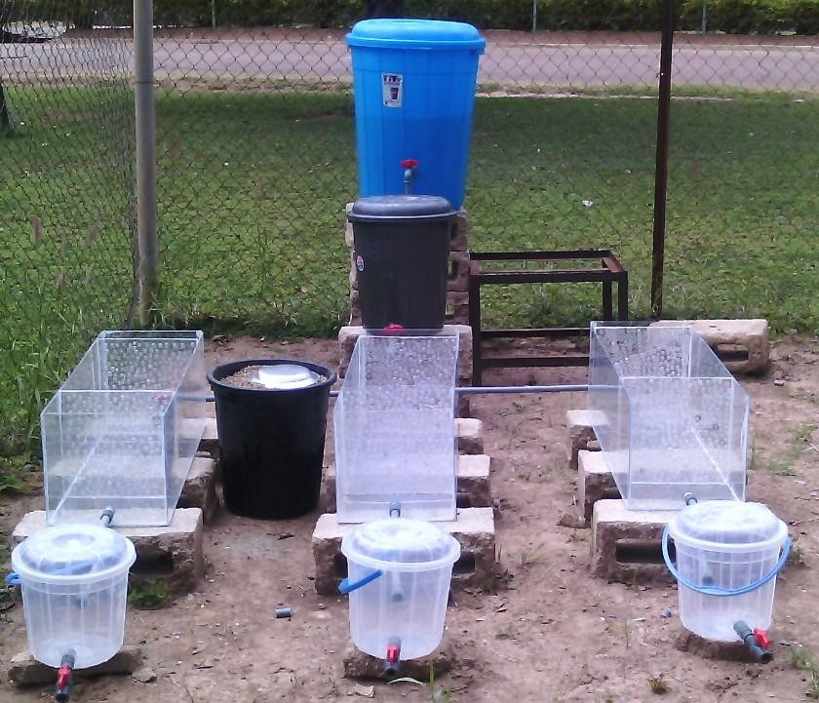

*Plate IV: Empty Model Constructed Wetland Setup*

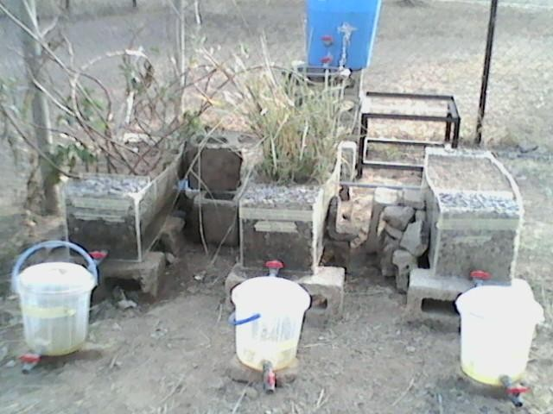

*Plate V: Model Constructed Wetland Setup with Aquatic Plants*

The entire experiment took a total of 60 days, and 4 samples per batch (6 days HRT) was collected; that is, one raw sample and three treated samples (1sample each for the 3 CWs). Hence, the total sample size was 40 by the end of the experiment. The soil fertility status before and after the experiment was however not taken into cognizance.

# Wastewater Characteristics

The results obtained were analysed using statistical methods presented in tables and a chart and discussed below.

Average influent characteristics of the tannery wastewater (only parameters considered) treated by the CWs are shown in Table 4.1. The average pH of the influent was 8.55 and temperature,

31.10 oC.

*Table 4.1: Average composition of Influent Wastewater in mg/l*

|  |  |  |  |  |  |
| --- | --- | --- | --- | --- | --- |
| Cr | BOD | COD | SS | NO-  3 | PO43- |
| 28 | 1405 | 2821 | 391 | 84 | 22 |

The average effluent pH for the three CWs utilized in this study i.e CW planted with *Phragmites autralis*, CW planted with *Polygonum salicifolium* +*Ipomoea carnea*, and the CW un-vegetated (control) were 7.6, 7.8 and 7.9 respectively. Both NESREA and WHO ranges of pH discharge limits of 6-9 and 7-8.5 respectively, were not exceeded. Average effluent temperatures for the CWs did not also exceed NESREA and WHO discharge standards of 40oC.

# Biological Oxygen Demand and Chemical Oxygen Demand Removal

Microbial degradation plays a dominant role in the removal of biodegradable organic matter. Organics are often lumped as chemical oxygen demand (COD) and biological oxygen demand (BOD), because they can create oxygen deficiencies in receiving waters. In the wetland the aquatic plants supply oxygen to the wetland floor through their roots, thereby promoting the aerobic digestion of organic material. Some anaerobic degradation of organic material also occurs in the bottom sediments.

Various processes occur within the Wetland. HSSF wetlands essentially function as attached growth biological reactors otherwise known as biofilms. Biofilms are formed as bacteria and microorganisms attach themselves to the plant stems, the plant roots and the substrate matrix to form a biological filter. As wastewater passes through the thick growth of plants, it is exposed to this living biofilm, which provides a treatment process similar to that found in conventional

treatment plants.

In this study, the organic matter removal efficiency of the three wetlands were evaluated, and summarized in Table 4.2. Emphasis on discussion of results will however be on comparison between vegetated cells (their upper limits of treatment efficiencies) and un-vegetated or control cell.

*Table 4.2 BOD and COD Removal Efficiency*

|  |  |  |  |  |
| --- | --- | --- | --- | --- |
| **Parameters** |  | **%Removal** |  |  |
|  | *P. australis* | *P. salicifolium + I. carnea* | Upper limit of vegetated  cells | Control (un- vegetated  cell) |
| **BOD (mg/l)** | 98 | 97 | 98 | 90 |
| **COD (mg/l)** | 94 | 72 | 94 | 55 |

As shown, maximum BOD removal was obtained in the wetland cell planted with *P. australis* (98%), followed closely by the cell planted with a combination of *Polygonum salicifolium*, and *Ipomoea carnea* (97%). Minimum removal efficiency(90%) was obtained in the control (un- vegetated) cell.

The maximum COD removal efficiency was obtained in the cell planted with *P. australis* (94%), followed by cell with *Polygonum salicifolium* +*Ipomoea carnea* (72%) and lastly, the un-vegetated or control cell (55%).

From the results in Table 4.2, it can be inferred that the cells planted with aquatic plants (i.e. vegetated cells) adequately removed organic matter (BOD and COD) better than the cell without aquatic plants (control). It is generally accepted that plants in HSSF wetlands improve organic matter removal due to a combination of mechanisms favoured by the plants (Soto *et al*, 1999; Stottmeister *et al*, 2003), and this improvement may have being caused by factors such as the growth of biofilms on the root surface, adsorption of certain organic pollutants or the aeration potential of the plants. According to Brix (1994), plants contribute to the reduction of high level of organic matter due to the oxygen transfer, by the aerenchymatic (spongy) tissue, to their roots. In addition, organic matter can also be degraded when taken up by plants (Renee, 2001). It can be reasonably argued therefore that the improvement in removal of BOD and COD in the vegetated CWs over the control is largely because of adsorption of pollutants onto plants surfaces (stems, roots rhizomes) which provided added surface area for the growth of biofilms by bacteria attachment and their ability to transfer oxygen from the leaves through the stems to their roots for aerobic microbial activity which causes reduction in concentration of the organics in the wetland.

# Suspended solids Removal

The removal of suspended solid (SS) in wetland systems is usually a concomitant aspect of system design in the typical wastewater treatment situation. In most applications, a sedimentation pond is added upstream of the wetland cells to promote the removal of larger sediment particles and minimize the chance of clogging the wetland cells. Most of the solids are removed through sedimentation and filtration, as vegetation obstructs the wastewater flow and reduces velocity. These processes remove a significant portion of the BOD, nutrients

(mostly nitrogen and phosphorus) and pathogens as well.

In this study, the SS removal efficiency of the three wetlands were evaluated, and summarized in Table 4.3. Emphasis on discussion of results will however be on comparison between vegetated cells and un-vegetated or control.

*Table 4.3 TSS Removal Efficiency*

|  |  |  |  |  |
| --- | --- | --- | --- | --- |
| **Parameters** |  | **%Removal** |  |  |
|  | *P. australis* | *P. salicifolium + I. carnea* | vegetated cells | Control (un- vegetated  cell) |
| **Suspended Solids (mg/l)** | 93 | 93 | 93 | 92 |

TSS removal efficiency was highest in the cells planted with*P. australis* and*Polygonum salicifolium*, +*Ipomoea carnea,* both93%,and lastly, the control or un-vegetated cell (92%). Though it can be clearly seen that the difference between the vegetated CWs and the control CW is 1%.

The TSS removal efficiency in this study was high, and could be due to the fact that the TSS concentration in the influent was high. Suspended solid removal is very effective in subsurface flow constructed wetland (USEPA, 2000), effective removal is observed when high concentration of suspended solids is present in the influent. Plants however contribute little to suspended solids removal in subsurface constructed wetland since the primary mechanisms

involved are filtration and sedimentation (IWA, 2000). This is reflected in the removal

efficiency between the vegetated CWs and the un-vegetated CW, the difference between them is only 1% (93% and 92% respectively).

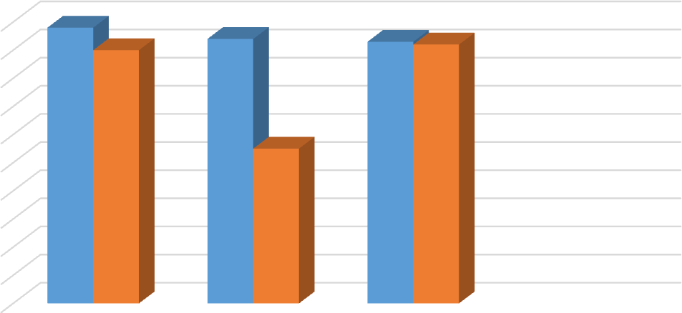Figure 4.1 replicates BOD, COD and SS Removal Efficiency as shown in Table 4.2 and 4.3.

BOD, COD and SS Removal Efficiency

Vegetated CW

Un-vegetated (control) CW

Efficiency (%)

|  |  |  |  |
| --- | --- | --- | --- |
| 100 |  | | |
| 90 |  |  |  |
| 80 |  |  |  |
| 70 |  |  |  |
| 60 |  |  |  |
| 50 |  |  |  |
| 40 |  |  |  |
| 30 |  |  |  |
| 20 |  |  |  |
| 10 |  |  |  |
| 0 | BOD | COD | SS |

*Figure 4.1 BOD, COD and SS Removal Efficiency*

The BOD, COD and TSS effluent discharge limit set by NESREA and WHO for tanneries into water bodies, are the standards that have been considered in this work. A summary of the outcomes are as represented in the Table 4.4.

*Table 4.4 BOD, COD and TSS Effluent Concentrations against NESREA and WHO Discharge Limits*

|  |  |  |  |  |  |
| --- | --- | --- | --- | --- | --- |
| **Parameters** | **Effluent**  **Average** |  |  | **Standards** |  |
|  | *P. australis* | *P. salicifolium*  *+ I. carnea* | Un- vegetated  CW | NESREA | WHO |
| **BOD (mg/l)** | 30 | 50 | 148 | 50 | 50 |
| **COD (mg/l)** | 163 | 797 | 1264 | 164 | 40 |
| **Suspended Solids (mg/l)** | 30 | 29 | 30 | 30 | 30 |

The cellplanted with *P. australis*met NESREA BOD and WHO effluent discharge standard. For COD, NESREA effluent limits was also met by the CW planted with *P. australis*while WHO effluent limits for COD were not met. However, these findings still show that the vegetated CWs in this study have an edge over the un-vegetated CW for organic matter. The effluent discharge limits for both standards were met by the planted and un-planted CWs for TSS.

# Nutrient Removal

Nitrogen and Phosphorus are referred to as nutrients. The principal nitrogen removal mechanism operative in wetland systems is bacterial nitrification/ denitrification (not plant

uptake); therefore, nitrogen removal in wetland systems is a function of climatic conditions.

The bacteria present in the wastewater (Nitrosomonas) oxidizes ammonia to nitrite in an aerobic reaction. The nitrite is then oxidized aerobically by another bacteria called Nitrobacter,thus forming nitrate. Denitrification occurs as nitrate is reduced to gaseous form under anaerobic conditions deep in the wetland substrate. This reaction is catalyzed by the denitrifying bacteria *Pseudomonas spp*. and other bacteria.

Phosphorus and Nitrogen are stored in new wetland sediments, though Nitrogen in larger measure, is sequentially transformed thus, ultimately leaving the wetland as ammonia through volatilization. The mechanism by which phosphorus is reduced in wetlands is by adsorption and uptake by plants. Phosphorus removal in wetlands is based mainly on the phosphorus cycle and can involve a number of processes such as adsorption, filtration, sedimentation, precipitation and assimilation/uptake. Phosphorusremoval in wetlands is less effective than nitrogen removal. Hence, a post wetland polishing step may be required in the form of vegetated filter strips, irrigation or phosphorus adsorption media to enhance added removal.

The average influent concentrations for the considered nutrients were; nitrates (84 mg/l) and phosphates (22 mg/l). The CW cells showed a reduction in the nitrate and phosphate concentrations after a 6 day HRT. Their removal efficiencies is as shown in Table 4.5.

*Table 4.5 Average Nitrate and Phosphate Effluent Concentrations and Removal Efficiencies*

|  |  |  |  |  |  |  |
| --- | --- | --- | --- | --- | --- | --- |
| **Parameters** | **Effluent Average** | |  | **% Removal** | |  |
|  | *P.*  *australi s* | *P.*  *salicifolium*  *+ I. carnea* | Control | *P.*  *australi s* | *P.*  *salicifolium*  *+ I. carnea* | Control |
| **NO-3 (mg/l)** | 31 | 44 | 46 | 54 | 48 | 29 |
| **PO43- (mg/l)** | 12 | 15 | 16 | 44 | 35 | 28 |

Highest nitrates removal was observed in the cell planted with *Phragmites australis* (54%), likewise phosphates removal (44%). Then followed by the cell planted with a vegetative mix of *Polygonum salicifolium* +*Ipomoea carnea* for both nitrates (48%) and phosphates (35%); and lastly by the control cell; nitrates (29%) and phosphates (28%). This implies that the vegetated CWs had better nitrates and phosphates removal efficiencies compared to the un- vegetated (control) CW. In a similar study by Tadesse, A. (2010) (where vegetated cells and a control were observed), the Control had a lower NO3- removal efficiency (44.6%) compared with *B. aetiopium* (57.3%) and *P. karaka* (53%).

The high NO-

3

removal in the vegetated cells against the control was likely due to the biomass

content and root mat, which enabled plants to take up more NO- .Nitrates is the form of Nitrogen taken up by plants. Emergent plants use it during the growing season (Renee,

3

2001).The absorbedNO-

3

is then converted and stored in organic form of nitrogen in wetland

plants. This clearly indicates that plants enhance NO-

3

removal in CWs though a temporal

removal, because a large portion of this nitrogen may later be released and recycled, as plants die and decompose.

When compared against Standards, the CW planted with *Phragmites australis* met the WHO

effluent discharge limits (<45mg/l) for NO-

3

as it was obtained as 31mg/l. So also the cell

planted with *P. Salicifolium* + *I. Carnea* (44mg/l). The control cell however exceeded the WHO effluent discharge limits slightly; it was obtained as 46mg/l. Both the vegetated CWs un-vegetated CW did not meet the NESREA effluent discharge limit of 20mg/l for NO- . This could be as a result of the transplanted aquatic plants in the model wetlands being already mature (Nitrates is a macro nutrient that enhances the healthy growth of young plants).

3

In this experiment, phosphate removal was generally low in all the wetland cells.This is because Phosphorusremoval in wetlands is not so effective except where a post wetland polishing step in the form of vegetated filter strips, irrigation or phosphorus adsorption media is incorporated. The vegetated cells however, stillshowed better removal efficiencies since phosphate removal occurs majorly through adsorption, precipitation and plant uptake. All the cells observed in this study failed to meet the NESREA effluent discharge limit of 5mg/l for phosphates. This too could be explained as resulting from the transplanted aquatic plants in the model wetlands being already mature as phosphorous is a macro nutrient required to enhance young plants growth.

# Chromium Removal

Metals (chromium, being the metal of interest in this study) are removed in treatment wetlands by three major mechanisms; binding to soil, sediments, particulates and soluble organics by

cation exchange and chelation, precipitation as insoluble salts (principally as sulfides and

oxyhydroxides); and uptake by plants, including algae and by bacteria (Kadlec and Knight, 1996).

The average chromium influent concentration into the CWs was 28mg/l. After a 6 day HRT the average effluent concentrations and removal efficiencies are as shown in Table 4.6.

*Table 4.6 Average Chromium Effluent Concentration and Removal Efficiency in CWs*

|  |  |  |  |  |  |  |
| --- | --- | --- | --- | --- | --- | --- |
| **Parameters** | **Effluent Average** | |  | **% Removal** | |  |
|  | *P.*  *australis* | *P.*  *salicifolium +*  *I. Carnea* | Control | *P.*  *australi s* | *P.*  *salicifolium +*  *I. Carnea* | Control |
| **Cr (mg/l)** | 0.44 | 0.66 | 1.43 | 98 | 98 | 95 |

The observed maximum removal efficiency for chromium in this experiment was from the cells planted with *P. australis*, and that planted with *P. salicifolium* + *I. carnea* both at 98%. The minimum removal was by the un-vegetated or control cell (95%) implying therefore that the planted or vegetated CWs had a better chromium removal efficiency of 98% compared to the un-planted or un-vegetated CW.

High removal of chromium obtained in this study could be because constructed wetlands remove heavy metals using different processes. Inconstructed wetlands, metals tend to accumulate on the root surfaces of plants, rather than being absorbed by the plants (Debusk, 1999b). Macrophytes roots release oxygen to the rhizosphere (Reddy *et al*., 1989) and produce the precipitation of iron to form the so called iron plaque. Metal binding affinity to iron

oxyhydroxides causes metal accumulation near the macrophytes roots (Otte *et al*., 1995). This

therefore infers or indicates that the presence of well-developed root mat is essential to have good chromium removal.

Metals can also be removed through a process called chemisorption. Chemisorption is a process which enables metals, such as chromium, copper, lead and zinc to form strong chemical complexes with the organic material that is present in the constructed wetland.

Furthermore, the metals, chromium and copper, can be chemically bound to clays and oxides that finally can settle out (USEPA, 1999). This is the process through which most of the chromium removal occurs in constructed wetland. This may explain the high removal efficiency of chromium also obtained in the un-planted or control cell, which was 95%.

Results of this experiment agree with a similar research by Asaye Ketema (2009) who worked with tannery wastewater in CWs. A 95%, 97% and 99% removal of total Cr using SSF wetlands planted with *C. papyrus*, *C. alopcuroidus* and *S. croymbosus* for tannery wastewater, respectively was achieved. Also, another similar work by Tadesse, A. (2010) showed a maximum chromium removal observed in CWs planted with *B. aethiopium* (99.3%) followed by *T. domingensis* (99%), *C. alternifolius* (98%) and *P. Karka* (97.7%); and the minimum Cr removal observed in the un-vegetated CW (control) (97.4%).

Compared against NESREA effluent standards for chromium discharge, the planted CWs in this work failed to meet the requirement. On the other hand however, effluent discharges from the cell planted with *P. australis*(0.44mg/l), and the cell planted with *P. salicifolium* + *I. carnea* (0.66mg/l) met the Cr effluent discharge limit for WHO (1.0mg/l). The control cell exceeded the WHO discharge limit as it was obtained as 1.43mg/l. Hence, the planted CWs yet having an edge over the un-planted CW.

# CHAPTER FIVE CONCLUSIONS AND RECOMMENDATIONS

# Conclusions

The aim of this work was to investigate the potential use and efficiency of a constructed horizontal sub-surface flow wetland, in treating tannery wastewater. The results of this experiment led to the following conclusions;

* + 1. Horizontal subsurface flow (SSF) CW planted with aquatic plants is capable of efficiently removing Cr from tannery wastewater (Removal efficiency 98% for both*P. australis*and*P. salicifolium + I. carnea*). Hence, it can be inferred that vegetated CWs have very high Cr removal efficiency of 98%. Also, Cr effluent concentrations have not exceeded the WHO standards for the vegetated CWs.
    2. Horizontal SSF CWs can be a viable alternative for the removal of Cr (> 95%) from tannery wastewater (*P. australis* - 98%, *P. salicifolium + I. carnea* – 98%; and control or un-vegetated CW- 95%).
    3. Horizontal SSF CWs are also a viable alternative for removal of organic pollutants and SS from tannery wastewater. BOD removal efficiencies for the vegetated CWs are 98% and 97%for *Phragmites australis*and*P. salicifolium + I. carnea*respectively; and for the un-vegetated CW - 90%.CODremoval for the planted cells are 94% and 72% for *Phragmites australis* and *P. salicifolium + I. carnea* respectively; and control or un- vegetated CW - 55%. The SS removal for the planted CWs are both 93%. The un- planted CW - 92% for SS.

The BOD effluent concentration for the CW planted with the aquatic plant*phragmites australis* (30mg/l) has not exceeded bothNESREA and WHO discharge limits

(50mg/l); and COD effluent concentration (163mg/l) has also not exceeded NESREACOD discharge limits (164mg/l). For SS on the other hand, all three CWs have not exceeded NESREA and WHO discharge limits of 30mg/l.

* + 1. Nutrients (Nitrates and Phosphates) removal by Horizontal SSF CWs have also been successful. Nitrates removal, 54% and 48% for*Phragmites australis* and *P. salicifolium*

*+ I. carnea* respectively and control - 29%;Phosphates removal, 44% and 35% for*Phragmites australis* and *P. salicifolium + I. carnea* respectively and control – 28%. However, removal efficiencies for the nutrients are not as high when compared with removal efficiencies for Cr, organic pollutants and SS by Horizontal SSF CWs. On the whole, results obtained from this study show clearly that Horizontal SSF CWs can remove and retain nutrients, Cr, organic pollutants and SS from tannery wastewater; especially HSSF CWs augmented with aquatic plants.

* + 1. The difference in the removal efficiencies between the vegetated and the un-vegetated CWs during the study period for SS was only 1% This may be because plants contribute little to suspended solids removal in SSF CWs since the primary mechanisms involved are filtration and sedimentation.
    2. Average pH of effluents for the three CWs considered in this study did not exceed NESREA discharge limits range (6 - 9) or WHO discharge limits range (7 – 8.5). The average temperature of effluents from the CWs too did not exceed NESREA and WHO discharge limits of 40oC.
    3. Small tanneries can hardly afford conventional treatment methods for treating tannery effluents from their activities before discharge into surface waters or the surrounding

environment. These effluents are highly toxic especially as they contain Cr.

Resultsfrom this study showed that Horizontal SSF CWs planted with aquatic plants like *phragmites australis*, *Polygonmsalicifolium,Ipomoea carnea* and other plant species with similar characteristics to these can be a viable consideration for small tanneries (located where land is not a scarce resource) to efficiently reduce effluent concentrations. Also, the development of this Laboratory scale system into a large- scale working unit offers an attractive alternative for low-level income countries to protect their environment since it is cost effective compared to conventional treatment methods, and also environmentally friendly.

# RECOMMENDATIONS

* + 1. Developing or low-level income countries should consider the development of this laboratory scale Horizontal SSF CW system into a large-scale working unit which is an attractive alternative to protect their environment because it is cheaper when compared to conventional treatment methods, and also environmentally friendly.
    2. Results from this study show that aquatic plants like*Phragmites australis*,*Polygonumsalicifolium*and*Ipomoea carnea*are very important aquatic plants for the treatment of tannery wastewater but especially *Phragmites australis*. Further studies should be carried out using each of these plants in combination with other wetland plants to improve overall removal efficiency of pollutants in Horizontal SSF CWs. Since various types of plants tolerate tannery wastewater differently, their abilities to remove pollutants from effluent will also differ.
    3. Further studies should check soil fertility status for nutrients level before commencing

treatment, and after treatment. Also, the roots and stems of the aquatic plants should be

tested for chromium concentration before and after treatment.

* + 1. The efficiency of Horizontal SSF CW systems as secondary or tertiary treatment after the reduction of pollutants in tannery wastewater should also be studied.
    2. Further studies should be carried out on Horizontal SSF CWs using a combination of more than two types of aquatic plant, since various types of aquatic plant tolerate tannery wastewater differently and their ability to remove nutrients from the effluent also differ.In addition, composite HSSF CWs should be considered in further researches.

# REFERENCES

Akobundu I.O. and Agyakwa C.W. (1998). A handbook of West African Weeds. International Institute of Tropical Agriculture, Ibadan, Nigeria 106p.

Alves, M. M., Gonzalez, C.G., Guedes De Carvalho, R., Castanheira, J.M., Sol Pereira, M.C., Vasconcelos, L.A.T. (1993). Chromium Removal in Tannery Wastewaters:„Polishing‟, Pinus Sylvestris Bark.Water Research, 27(8), pp-1333-1338.

Anthony,D.C.(1997).ModernTanningChemistry,BritishSchoolofLeatherTechnology,

Nene College of higher education, Boughton Green Road. Mountain Park Northampton, UK NN2 7AL.Chemical Society Review. pp. 111 - 126.

APHA (1995). Standard methods. 19th Edition. American Public Health Association, Washington, DC; USA

Asaye, K. (2009).Evaluation of Selected Plant Species for the Treatment ofTannery Effluent in a Constructed Wetland System; (Unpublished Thesis), AAU, Addis Ababa. Available at: en.wikipidia.org/winki/ITRC

Badejo, M. A. (2012). Ecosystem Engineering as a concept: The Significance of functional Classification of the true engineers. Environtropica, 8: 194 – 199.

Bajza, Z. and Vreck, I. V. (2001). Water Quality Analysis of Mixture Obtained From Tannery Waste Effluent.Ecotoxicology and Environmental Safety; pp 15 - 18.

Bavor, H. J. and Adcock P. W. (1994). Relating Phosphorous Distribution within Wetlands to their long term Performance. Proceedings, 2nd Annual Conference, Soil and Water Management for Urban Development – Creative Storm-water Management, Sydney, Australia, September.

Behrends, L. L., Kingsley, J. B and Bulls, M. J. (1996). Cold Tolerance in Maternal Mouth Brooding Tilapias: Heritability estimates and correlated growth responses at suboptimal temperatures. In: Pullin, R.S.V., Lazard, J. M., J. B. Legendre, A. Kothias, and D. Pauly (Eds.), The Third International Symposium on Tilapia in Aquaculture, ICLARM Conference Proceedings, vol. 41, pp. 257– 265.

Billore, S. K., Singh, N., Sharma, J.K., Dass, P., Nelson,R.M., (1999). Horizontal Subsurface Flow Gravel Bed Constructed Wetland with Phragmites Karka in Central India. Wat. Sci. Technol. 40 (3), 63–171.

BlaylockM.J.andHang,M.(2000).EnhancedAccumulationofPbinIndianmustered Family by Soil-Applied Chelating Agents.Environm-Sci.-Techno.31: 860-8.

Bosnic M, Buljan, J. and Daniels, R. P. (2000); Pollutants in Tannery Effluents. Regional Programme for Pollution Control in the Tanning Industry in South-East Asia, UNIDO.

Brix, H. (1994). Functions of Macrophytes in Constructed Wetlands: Water Sciences Technology. 29 (4), 71 – 78.

Brooks, R., Chambers, M., Nicks, L. and Robonson, B. (1998). Phytomining: Trends in Plant Science, **3**:359–62.

Bruch I, Fritsche J, Banninger D, Alewell U, Sendelov M, Hurlimann H, Hasselbach R,

Alewell C. (2011). Improving the Treatment Efficiency of Constructed Wetlands with Zeolite- Containing Filter Sands. Bio-resources. Technol., 102(2): 937-941.

Calheiros, C.S.C., Rangel, A.O.S.S., and Castro, P.M.L. (2009). Treatment of Industrial Wastewater with Two-stage Constructed Wetlands Planted with Typha latifolia and Phragmites australis. Bio-resource Technol., 100, 3205–3213.

Chaney R. L., Malik, M., Li, Y. M., Brown, S. L., Brewer, E. P, Scott, A. J., Baker A. J. M. (1997). Phytoremediation of Soil Metals. Curr Opin Bio-technol.; 8(3):279–284. doi: 10.1016/S0958-1669(97)80004-3.

Chew, Ai-Ling (2006). Nutrient Removal from Leachate Using Horizontal Subsurface Constructed Wetlands. M. Eng. Project, Dept. of Civil Engineering University of Technology Malaysia.

Chiemchaisri, C., Chiemchaisri, W., Junsod, J., Threedeach, S., Koottatep, T. and Visvanathan,

C. (2006). Treatment Performance and Bacterial Populations in Subsurface Horizontal Flow Constructed Wetland Systems Treating Young and Stabilized Leachate. Dept of Environmental Engineering Kasetsart University, 50 Phaholyothin Rd. Bangkok 10900 Thailand.

Christina, L. (2005). Nutrient Removal using a Constructed Wetland; In Southern Quebec. MSc Thesis. Department of Bio-resource engineering. McGill University, Montreal.

Clair, N. S., Perry, L. M., Gene, F. P. (2003). Chemistry for Environmental Engineering and Science (5th ed.). New York: McGraw-Hill. ISBN 0-07-248066-1.

Cooper, P. F., Job, G. D., Green, M. B and Shutes, R. B. E. (1996). Reed Beds and Constructed Wetland for Wastewater Treatment. WRc Swindon, UK.

Cooper, P., Green B., and Thornton A. (1998). “Reed Beds and Constructed Wetlands for Wastewater Treatment,” in Course Creating and Using Wetlands for Wastewater Stormwater Treatment and Water Quality Improvement. University of Wisconsin-Madison.

Crites, R. and Tchobanoglous, G. (1998). Small and decentralized wastewater management Systems. Water Resources and Environmental Engineering, 1. WCB/McGraw-Hill, Boston.

Davis, M. L., (2010). Water and Wastewater Engineering; Design Principles and Practice. McGraw-Hill Inc., USA.

DeBusk, W.F. (1999a).Wastewater Treatment Wetlands; Contaminant Removal Processes: Soil and Water Sciences. Department; University of Florida. SL155.

DeBusk, W. F. (1999b). Wastewater Treatment Wetlands; Applications and Treatment Efficiency: Soil and Water Sci. Department. University of Florida. SL156.

DeBusk, T. A. and DeBusk, W. F., (2001). Wetlands for Water Treatment in D.M Kent (ed), Wetlands science and Technology, 2nd edn, CRC Press, Boca Raton, USA.

Del Pozo, R. and Diez, V. (2003). Organic Matter Removal in Combined Anaerobic–aerobic Fixed-film Bioreactors. Wat. Res. 37, 3561 – 3568.

Denny, P. (1997). Implementation of Constructed Wetlands in Developing Countries. Wat.Sci.Tech. 35 (5), 27-34.

Diederick, P., Peter, A.V and Niels, D. P. (2004). Model Based Design of Horizontal Subsurface Flow Constructed Wetland: A Review. Dept. of Applied Ecology and Environmental Biology, Glent University, J. Plateaustraat 22. 9000 Ghent, Belgium. Water Research 38 1484-1493.

DLWC. (1998).The Constructed Wetlands Manual, Department of Land and Water Conservation, New South Wales, Australia.

Doosti, M. R., Kargar, R. and Sayadi, M. H. (2012). Water Treatment using Ultrasonic Assistance: A review. Proceedings of the International Academy of Ecology and Environmental Sciences, 2(2): 96-110

EPA (1997). Environmental Protection Authority. Annual Report; Addis Ababa, Ethiopia.

El-Gendy, A. S.Modelling of Heavy Metals Removal from Municipal Landfill Leachate using Living Biomass of Water Hyacinth (2008). International Journal of Phytoremediation. Vol.10, Pp 14-30. Taylor and Francis.

El-Monayeri D. S, Atta, N. N., El- Mokadem, S. and Abdul-fotoh, A. M. (2007). Effect of Organic loading on the Performance of Horizontal Bio-filters; Eleventh International Water Technology Conference (IWTCII) pp 671-682

Faulkner, S. P. and Richardson, C. J. (1989). Physical and Chemical Characteristics of Fresh Water Wetland Soils, In: Hammer D. A. (Ed.), Constructed Wetlands for Wastewater Treatment. Lewis Publishers Chealsea, MI.

Gearheart, R. A. (1998). The Use of Free Surface Constructed Wetland as an alternative Process Treatment Train to meet unrestricted Water reclamation Standards. In: AWT98 Proceedings.

GEMS (Growth and Employment in States) (2012). Midi-brief: Transforming the Nigerian Leather Industry.

George, D. B., (2000). Development of Guidelines and Design Equations for Subsurface Flow Constructed Wetlands Treating Municipal Wastewater. USEPA Office of Research and Development, Cincinnati, Ohio.

Gersberg, R. M., Elkins, B. V., Goldman, C. R. (1983). Nitrogen Removal in Artificial Wetlands. Water Resources, 17:1009-1014.

Gersberg, R. M., Elkins, B. V., Lyon, S. R. and Goldman, C. R. (1986). Role of Aquatic Plants in Wastewater Treatment by Artificial Wetlands. Water Res. 20, 363 - 368.

Graneli W., (1984). Reed Phragmites australis (Cav.) Trin. Ex Steudel as an Energy Source in Sweden, Biomass 4, 26-52.

Haberl R. (1999).Constructed Wetlands: A Chance to Solve Wastewater Problems in Developing Countries. Water Science and Technology, Vol: 40(3).

Hammer, D. A. (1990). Constructed Wetlands for Wastewater Treatment: Municipal, Industrial and Agricultural. CRC press, Roca Raton, FL.

Hammer, D. A. (1992). Designing Constructed Wetland Systems to Treat Agricultural Nonpoint Source Pollution. Ecological Engineering 1:49-82.

Hara T, van der Toorn, J. and Mook, J. H. (1993) Growth Dynamics and Size Structure of Shoots of Phragmites australis, a clonal plant. Journal of Ecology 81: 47–60.

Hartog, C. D., Kvet, J. and Sukopp, H. (1989). Reed: A Common Species in Decline. Aquatic Botany 35: 1–4.

Havens, K. J., Priest III, W. I and Berquist, H. (1997). Investigation and Long-term Monitoring of Phragmites australis within Virginia‟s Constructed Wetland Sites. Environmental Management 21(4): 599-605.

Healy, M. G., Rodgers, M and Malqueen, J. (2006). Treatment of Diary Wastewater Using Constructed Wetland and Intermittent sand filter, Department of Civil Engineering, National University of Ireland, Galway, Ireland. Bio Resources Technology, 98 2268-2281.

Hoddinott, B. C. (2006). Horizontal Subsurface Flow Constructed Wetlands for On-site Wastewater Treatment, Unpublished Mph Thesis, Department of Community Health, School of Medcine, Wright University, Dayton Ohio.

Huffman EW. D and Alloway, W.H. Jr. (1973). Growth of Plants in Solution Cultures Containing Low Levels of Chromium; Plant Physiology. 53: 72-75.

Hyde, M. and Wiegand, J. (2011). Trace Element Analysis of Fish Tissues from Bluegill (Lepomis macrochirus) in West Point Lake, GA using Particle Induced X-ray Emission (PIXE) “An Interdisciplinary Biology and Physics. Undergraduate Research Project.”

Infogate/GTZ (2002). Treatment of Tannery wastewater. Germen Appropriate Technology (GATE) information system. Available at: [http://www.gtz.de/gate/gateid.afp.](http://www.gtz.de/gate/gateid.afp)

ITRC (2003). Industrial Technology Research Center; India.

IWA (2000) Specialist Group on Use of Macrophytes in Water Pollution Control.Constructed Wetlands for Pollution Control - Processes, Performance, Design and Operation, Scientiﬁc and Technical Report No. 8. Kadlec R. H., Knight R.L., Vzmayal, J., Brix, H., Cooper P. and Haberl R. (eds), International Water Association, London.

Jackson, M. B. and Armstrong, W. W. (1999). Formation of Aerenchyma and the Process of Plant Ventilation in Relation to Soil Flooding and Submergence Plant. Biol.1 pp 274 - 287.

James, B. R. (1996). The Challenge of Remediating Chromium-Contaminated Soil. Environ, Sci. Techn.30: 248A-51A

Jason, A. C. (2006). Wetlands in the Petroleum Industry.

Jochimsen, J. C. and Jekel, M. R. (1997). Partial Oxidation Effects during the combined Oxidative and Biological Treatment of separated streams of Tannery Wastewater. Water Science and Technology 35, 337–345.

Joseph, K. (2005). Optimizing Processes for Biological Nitrogen Removal in Nakivubo Wetland. Uganda. Stocholm, Sweeden.

Kadlec, R. H. and Knight, R. L. (1996). Treatment Wetlands. CRC press. LLC, Baco Rabon, Florida.

Kadlec, R. H. (1997). An Autobiotic Wetland Phosphorous Model. Ecol. Eng.

Kadlec, R. H. (1999). Constructed Wetlands for treating landfill leachate. Lewis Publishers,Boca Raton, FL. 17-31.

Kadlec, R. H., Knight, R. L., Vymazal, J., Brix, H., Cooper, P. and Haberl, R. (2000). Constructed Wetlands For Pollution Control Processes, Performance, Design And Operation. IWA Scientific and Technical Report, No. 8. IWA Publishing, London, UK.

Kadlec R. H., Axler, R., McCarthy, B. and Henneck, J. (2003).Subsurface Treatment Wetlands in the cold climate of Minnesota. In: Constructed Wetlands for Wastewater Treatment in Cold Climates, Mander U., Jenssen P. (eds.) WIT Press: Southampton, United Kingdom, pp. 19–52.

Kadlec, R. H. and Wallace, S. D. (2008). Treatment Wetlands, 2nd ed.; CRC Press: Boca Raton, FL, USA.

Kadlec, R. H., and Wallace, S. D. (2009). Treatment Wetlands. Second edition. Taylor and Francis Group, LLC, 978.

Kamal K. B. (2013). Investigation into Mechanical and Tribological Properties of *Ipomoea carnea* Reinforced Epoxy Composite. A Thesis of Master of Technology in Mechanical Engineering (Specialisation-Machine Design and Analysis)submitted to National Institute of Technology, Rourkela- India.

Kaseva, M. (2003). Performance of Subsurface Flow Constructed Wetland in Polishing Pre- treated water. A tropical case study. J. Water Research. 38, 681 - 687.

Kayombo, S., Mbwette, T. S. A., Katima, J. H. Y. (1998). Waste Stabilization Ponds and Constructed Wetlands Design Manual Research.

Keraita B.N., Klutse A., Kouassi E., (2006). Low-Cost on Farm Wastewater Treatment Technologies. International Water Management Institute, West Africa Sub-Regional office, Kumasi-Ghana. pp 15-22.

Kivaisi, A. K. (2001). The potential for Constructed Wetlands for Wastewater Treatment and reuse in Developing Countries: a review. Ecol. Eng., 16(4): 545-560.

Konnerup, D., Koottatep, T. and Brix H. (2009). Treatment of Domestic Wastewater in Tropical, Subsurface Flow Constructed Wetlands Planted with Canna and Heliconia. J. of Ecological Engineering, vol. 35; 248-257.

Kornarios, M. and Lyberato, G. (2006). Biological Treatment of Wastewater from a Dye Manufacturing Company using a Trickling Filter. Journal of Hazardous Material. Pp 95-102.

Kusch, P., Kappelmeyer, A. U., Weißbrodt, E., Kästner, M. and Stottmeister. U. (2003).

Annual Cycle of Nitrogen Removal by a Pilot-scale Subsurface Horizontal Flow in a Constructed Wetland under moderate climate. Water Research Volume: 37, Issue: 17, October, 2003, pp. 4236-4242.

Kyambadde, J. (2005). Optimizing Processes for Biological Nitrogen Removal in Nakivubo Wetland, Uganda. Royal Institute of Technology, Department of Biotechnology. PhD thesis. Stockholm, Sweden.

Lin, Y., Jing, S. R., Lee, Y. D and Wang, T. W. (2002). Nutrient Removal from Aqua Cultural Wastewater Using a Constructed Wetlands System. Aquaculture 209: 169-184.

Lorion, R. (2001). Constructed Wetlands: Passive Systems for Wastewater Technology Status Report Prepared for the USEPA Technology Innovation Office, Under a National Network of Environmental Management Studies Fellowship.

Machlum, T. (1995). Treatment of Landfill Leachate in On-site Lagoons and Constructed Wetlands. Wat. Sci. Tech. 32 (3): 129-135.

Mara, D. (2004). Domestic Wastewater Treatment in Developing countries. Earthscan Publication, London.

Mara, D. (2006). Constructed Wetlands and Waste stabilization Ponds for Small Rural Communities in the United Kingdom: A comparison of land area requirements, performance and cost. Environmental Technology; 27: 753-757

Martha, S. (2003). Habitat Value of Natural and Constructed Wetlands Used To Treat Urban Runoff. Literature Review; A Report Prepared for the California State Coastal Conservancy, Southern California coastal water research project.

Massacci, A., Pietrini, F., Iannelli, M. A., (2001). Remediation of wetlands by Phragmites australis. Minerva Biotecnologica 13, 135–140.

May, E., Bulter, J. E., Ford, M. G., Ashworth, R. F., Williams, J. S. and Baghal, M. M. M. (1990). Comparison of Chemical and Microbiological Processes in Gravel Bed Hydroponic (GBH) Systems for Sewage Treatment in Constructed Wetlands in Water Pollution Control. Cooper and Findlater (Eds) Pergmon UK.

Mashauri, D. A., Mulungu, D. M. M. and Abdulhussein, B. S. (2000). Constructed wetland at the University of Dar es Salaam. Water Research 34 (4): 1135-1144.

Masud, M., Baig, M., Hassan, I., Qazi, A., and Malik, M. (2001). Textile Wastewater Characterization and Reduction of its COD & BOD by Oxidation. Electronic Journal of Environment, Agriculture and Food chemistry.

Matsuo, T., Hanaki, K., Takizawa, S. and Satoh, H. (2001). Advances in Water and Wastewater Treatment Technology: Molecular Technology, Nutrient removal, Sludge Reduction and Environmental Health. Elsevier, Amsterdam, London, New York, Oxford, Paris, Shanon, Tokyo, pp: 129-139.

Metcalf and Eddy Inc. (1991). Wastewater Engineering: Treatment, Disposal and Reuse, 3rdEd. McGraw Hill, New York, p. 1334.

Metcalf and Eddy, Inc. (1995). Wastewater Engineering: Treatment, Disposal and Reuse. McGraw-Hill Ltd. New Delhi.

Mitchell, C. (1996). Pollutant Removal Mechanisms in Artificial Wetlands. Course Notes for the IWES International Water Environmental School, Gold Coast.

Mitsch, W. J., and Gosselink, J. G. (1993). Wetlands, 2nd Edition. Van Nostar and Reinhold, New York.

Mitsch, W. J., Gosselink J. G. (2000a). The Value of Wetlands: Importance of Scale and Landscape setting. Ecological Economics 35: 25–33.

Molle, P., Lienard, A., Grasmic, A. and Iwema, A. (2003). Phosphorous Retention in SubsurfaceFlow Constructed Wetlands: Investigation Focused on Calcareous Material and their Chemical Interactions. Water Sci and Technol., 48 77-83.

Morel, A. and Diener, S. (2006): Greywater Management in Low and Middle-Income Countries. Review of different treatment systems for households or neighbourhoods.

Myers, J. E., Texaco S. H. and Jackson, E. L. M. (2001). Evaluation of Subsurface Flow and Free Water Surface Wetlands Treating NPR-3 Produced Water. Prepared For The US Department Of Energy/Rocky Mountain Oil Field Testing Centre. Critique Inc.

Newman, J. M., Clausen, J. C. and Neafsey, J. A. (2000). Seasonal Performance of a

Wetland Constructed to Process Dairy Milk house Wastewater in Connecticut: Ecological Engineering 14, 181 - 198.

Novick, R., (1999). Overview and the Health in Europe in the 1990s, World Health Organization, Europe Regional Office, Copenhagen, EURilCPIEHiCO 02 02 05/6, pp: 20.

Oke, I. A., Okuofu, C. A., Otun, J. A., and Olarinoye, N.O. (2006). Characteristics of Tanning Industries in Nigeria for Aquatic Animals and Plants. Research Journal of Agricultural and Biological Sciences 2(5): 209-217.

Otte, M., Kearns, C. and Doyle, M., (1995). Accumulation of arsenic and zinc in the rhizosphere of wetland plants. Bull. Environ. Contam. Toxicol. 55, 154 – 161.

Palmer, C. D. and Wittbrodt, P. R. (1991). Processes Affecting the Remediation of Chromium Contaminated Sites. Environ. Health Perspect. 92**,** 25–40.

Patrick, W. H. and Khald, R. A. (1974). Phosphate Releases and Sorption by Soil and Sediments:Effects of Anaerobic and Aerobic Conditions. Science 186.

Perk, M.V.D. (2006). Soil and Water Contamination: From Molecular to Catchments Scale. London; JK.

Pipeline, (1998). Constructed wetlands: A Natural Treatment Alternative. National Small Flows Clearing House. 9 (3), 1 - 8.

Pottir, C. and Karathanosis, A. (2001). Vegetation Effect on the Performance of Constructed Wetlands Treating Domestic Wastewater. Proceeding of the 9th National Symposium on On- site Wastewater Treatment (11 - 14 March, 2001 Forth Worth, Texas, USA).American Society of Agriculture and Biological Engineers. pp. 662 - 672.

Pucci, B., Conte, G., Martinuzzi, N., Giovannelli, L., and Masi, L. (2000). Design and Performance of a Horizontal Flow Constructed Wetland for Treatment of Diary and Agricultural Wastewater in the Chianti Countryside. Proc. 7th International Water Association Conference on Wetland Systems for Water Pollution Control. Lake Buena Vista, Florida. Gainesville, USA: University of Florida. Pp 1433-1436.

Rajamanickam, S. V. (2000). A Successful and Sustainable Hazardous Waste Management Technology Chromium Recovery and Reuse System in Tanneries of South Asia and Africa. Pollution Prevention/ Waste Minimization. India.

Raskin I., Smith, R. D., and Salt, D. E. (1997). Phytoremediation of Metals: Using Plants to Remove Pollutants from the Environment; Curr.Opin.Biotechnol.8221-226.

Reddy, K., Patrick, W. and Lindau, C. (1989). Nitrification-denitrification at the plant root– sediment interface in wetlands. Limnol. Oceanogr. 34 (6), 1004 – 1013.

Reddy, K. (2004). Nitrification-Denitrification at the Plant Root–Sediment Interface in Wetlands. Limnol. Oceanogr. 34 (6), 1004 – 1013.

Reed, S. C., Crites, R. W., Middlebrooks, E. J. (1995). Natural Systems for Waste Management and Treatment; 2nd edition. McGraw - Hill, New York

Reed, S.C. and Giarrusso, S. (1999). Sequencing Operation Provides Aerobic Conditions in a Constructed Wetland. In: Proceedings of the Water Environment Federation 72th Annual Conference. New Orleans, LA.

Renee, L. (2001). Constructed Wetlands; Passive System for Wastewater Treatment. Technology Status Report, Prepared for the USEPA Technology Innovation

Office under a National Network of Environmental Management Studies Fellowship.

Richard, E. (1998). Demonstration/Evaluation of Constructed Wetland as an Alternative Onsite Wastewater Treatment System. Texas Agricultural Extension Service Project, Department of Agricultural Engineering. Galveston Bay information.

Richardson, C. J and Craft, C. B. (1993). Effective Phosphorous Retention in Wetlands: Facts or Fiction. In: Moshiri G. A. Edition; Constructed Wetlands for Water Quality Improvement. Boca Raton FL Lewis publishers, London.

Rivera, F., Warren, A., Ramirez, E., Decamp, O., Bonilla, P., Gallegos, E., Calderon, A. and Sanchez, J. (1995). Removal of Pathogens from Wastewaters by the Root Zone Method, RZM. Wat. Sci. Tech. 32 (3), 211-218.

Rousseau, D. P. L., Vanrolleghem, P. A. and De Pauw, N. (2004b). Model-based Design of Horizontal subsurface Flow Constructed Treatment Wetlands: A review. Wat. Res. 38, 1484- 1493.

Rousseau, D. P. L., (2008). Constructed Wetlands for Water Reclamation. Desalination 218: 181-189.

Sakaderan, K., and Bavor, H. J., (1998). Phosphate Absorption Characteristics of Soil, Slag and Zeolite to be used as a Substrate in Constructed Wetland Systems. Water Res., 32 393-399.

Sarafaz, S., Thamer, A. M., Megat, J. M., Noor, M. and Linghat, A. (2009). Wastewater Treatment Using Horizontal Subsurface Flow Constructed Wetland. American Journal of Environmental Sciences 5 (1) 90-105. ISSN 1553-345X.

Sarkar, K. T. (1981). Theory and Practice of Leather Manufacture. Ajoysorcar madras India pp.98-90.

Sayadi, M. H., Ghatnekar, S. D., Kavian, M. F. (2011). Algae a Promising Alternative for Biofuel. Proceedings of the International Academy of Ecology and Environmental Sciences, 1(2): 112-124

Scholz, M., (2006). Wetland Systems to Control Urban Runoff. Elsevier, Amsterdam. The Netherlands.

Seyoum, F. A., Gumaelius. L, and Dalhammar G. (2004). Biological Nitrogen and Organic Matter Removal from Tannery Wastewater in Pilot Plant Operations in Ethiopia. Appl. Microbiol Biotechnology. Springer-Verlag.

Shatwell, T. and Cordery, L. (1999). Nutrient Storage in Wetlands, In: Ellis, B. (Ed.) Impact of Urban Growth on Surface Water and Ground Water Quality, Publishers 259, IAHS, Wallingford, UK 831-847.

Simi, A. and Mitchell, C. (1999). Design and Hydraulics Performance of a Constructed Wetland Treating Oil Refinery Wastewater. Water Science and Technology, 40: 301 307

Sinclair, K. (2000). Guidelines for Using Free Water Surface Constructed Wetlands to Treat Municipal Wastewater Sewage. Queensland Department of Natural Resources.

Singanan, M., Alemayehu A. and Singanan, V. (2007). Studies of the Removal of Hexavalent Chromium from Industrial Wastewater by Using Biomaterials. ISSN; 1579-4377. EJEAFChe. 6 (11), 2557 - 2564.

Skiffington, R., Shwery, P. A. and Peterson, P. J. (1976). Chromium Uptake and Transport in Barely Seedlings (Hordeum vulgare L.). Plantrta (Ber) 132:209-214.

Skirdmore, J. F. and Firth, I. C.(1983). Acute Sensitivity of Selected Australian Freshwater Animals to Copper and Zinc. Paper No. 81, Australian Water Resources Council, Australian Government Publishing Service, Canberra.

Soto, F., García, M., de Luis, E. and Bécares, E. (1999). Role of *Scirpus lacustris* in bacterial and nutrient removal from wastewater. Water Sci. Technol*.*, 40(3), 241 - 247.

Steinberg, S. L. and Coonrod, H. S. (1994). Oxidation of the Root Zone by Aquatic Plants Growing in Gravel-nutrient Solution Culture. J. Environ. Qual. 23, 907 - 913.

Stengel, E. and Schulltz-Hook, R. (1989). Denitrification in Artificial Wetlands. In: D. A. Hammer (Ed.). Constructed Wetlands for Wastewater Treatment. Chelsea, MI: Lewis publishers, pp. 484-492.

Tadesse, A. (2010).Evaluation of Selected Wetland Plants for the Removal Efficiency of Chromium and Organic Pollutants from Tannery Wastewater inConstructed Wetlands at Modjo Tannery.

Tamburlini, G., Ehrenstein, O.V. and Bertollini, R. (2002). Children's Health and Environment: A Review of Evidence, In: Environmental Issue Report No. 129, WHO l European Environment Agency, WHO Geneva, pp: 223.

Tanner C., Sukias J. (2003). Linking Pond and Wetland Treatment: Performance of Domestic and Farm Systems in New Zealand. Water science and Technology, 48: 331-339.

Tesfaye, M. A. (2006). Uptake and Phyto-accumulation of Chromium at Seedling Stage for Three Commonly Grown Tree Species in Ethiopia. (Unpublished Thesis).AAU. Addis Ababa.

UNEP (United National Environmental Programme) (2011). Waste Stabilization Ponds and Constructed Wetlands Design Manual.

UNESCO – IHE, (2006). Wetlands for Water Quality. Institute for Water Education. Pp 1-6.

UNIDO (2011). Introduction to Treatment of Tannery Effluents. United Nations IndustrialDevelopment Organization. Vienna Pp. 29.

USEPA (United States Environmental Protection Agency) (1988).Design Manual: Constructed Wetlands and Aquatic Plant Systems for Municipal Wastewater Treatment, EPA

625/1-88/022, U.S. EPA Oﬃce of Water: Cincinnati, OH, United States.

USEPA (1993). Subsurface Flow Constructed Wetland for Wastewater Treatment. A Technology Assessment. EPA/832/R/93/008.

USEPA (1999). Constructed Wetlands Treatment of Municipal Wastewaters. EPA/625/R/99/010. Cincinnati, Ohio.

USEPA (2000). Introduction to Phytoremediation; Office of Research and Development, EPA/600/R99/107, Available at: [http://www.itrcweb.org/PHYTO2.pdf.](http://www.itrcweb.org/PHYTO2.pdf)

USPHS (1997). Toxicological Profile for Chromium. Agency for Toxic Substances and Disease Registry. U.S. Public Health Service.

Vacca, G., Wand, H., Nikolausz, M., Kuschk P. and Kastner M. (2005). Effect of Plants and Filter Materials on Bacteria Removal in Pilot-scale Constructed Wetlands. Water Research 39(7): 1361–1373.

Van der Werff, M. (1991).Common Reed. In: Rozema J, Verkleij J. A. C, eds. Ecological Responses to Environmental Stress. The Netherlands, Kluwer Academic Publishers, 172-182.

Vymazal, J., Brix, H., Cooper, P.F., Green, M.B. and Haberl, R. (Eds.) (1998).Constructed Wetlands for Wastewater Treatment in Europe. Backhuys Publishers, Leiden

Vymazal J. (2000). The use of Sub-surface Constructed Wetlands for Wastewater treatment in the Czech Republic: 10 years‟ experience, Ricanota 40.16900 Prague 6, Czech Republic. Ecological Engineering 18(2002).pp 633- 636.

Vymazal, J. (2002). The use of Sub-surface Constructed Wetlands for Wastewater Treatment in the Czech Republic: 10 years‟ experience. Ecol. Engineering. 18, 633-646.

Vymazal, J. (2004). Removal of Phosphorous in a Constructed Wetland with Horizontal Subsurface Flow in Czech Republic. Water, Air and Soil Pollution Focus, Earth and Environmental Science, Springer Netherlands. Volume 4, No. 2-3.

Wang S. B, Ma Q, Zhu Z. H, (2009). Characteristics of Unburned Carbons and theirApplication for Humic Acid Removal from Water. Fuel Processing Technology, 90(3): 375-380.

White, K.D. (1995). Enhancement of Nitrogen Removal in Subsurface Flow Constructed Wetlands employing a 2-stage Configuration, an Unsaturated Zone and Recirculation. Wat. Sci. Technol. 32 (3), 59–67.

White, J. S., Bayley, S. E and Curtis, P. J. (2000). Sediment Storage of Phosphorous in a Northern Pacific Wetland Recovering Municipal and Agro-Industrial Wastewater. Ecol. Eng. 14, 127-138.

WHO, (2002).Water Pollutants: Biological Agents, Dissolved Chemicals, Non-dissolved Chemicals, Sediments, Heat, WHO CEHA, Amman, Jordan.

WHO, (2008). Estimating Child Mortality due to Diarrhoea in Developing Countries. Bull World Health Organ vol.86 n.9 Genebra.7.

WHO (2009). Diarrhea: Why Children are still dying and what can be done. The United Nations Children's Fund (UNICEF)/World Health Organization (WHO), Switzerland.

Wikipidea (2007). Constructed Wetland. Accessed on March 19th, 2014.

http;//en.wikipedia.org/wiki/constructedwetland.

World Bank (1995). Nigeria Strategic Options for Redressing Industrial Pollution World Bank, Industry and Energy Division. 1st Edn, West Central Africa Department, Annexes, pp: 60-62

WPCF (Water Pollution Control Federation) (1990). Natural Systems for Wastewater Treatment. Manual of Practice FD- 16, Chapter 9. Alexandria, VA.

[Www.wateronline.com.](http://www.wateronline.com/) Accessed on March 21st, 2014. [Www.google.com.](http://www.google.com/) Accessed March 24th, 2014,

Young, T. C., Collins, A. G., Theis, T. L. (2000). Subsurface Flow Wetland for Wastewater Treatment at Minoa, NY. Report to NYSERDA and USEPA. Clarkson University, NY.

**Appendix I:** National Environmental Standards and Regulations Enforcement Agency (NESREA) for tannery effluent discharge into surface waters.

|  |  |
| --- | --- |
| Parameters | Discharge to Surface Water |
| BOD (Mg/l) | 50 |
| COD (Mg/l) | 164 |
| TSS (Mg/l) | 30 |
| NO- (Mg/l)  3 | 20 |
| PO43- (Mg/l) | 5 |
| Cr (Mg/l) | 0.1 |
| pH | 6-9 |
| Temperature (oC) | 40 |

Source: National Environmental Standards, FEPA 1991a.

**A**A**ppendix II**: Photo Gallery

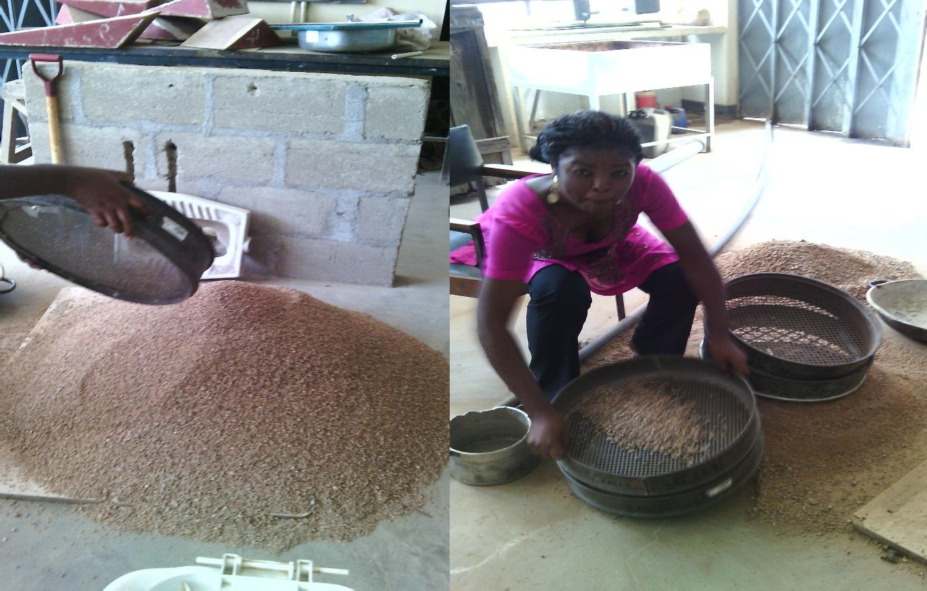

aaaaaa

aa

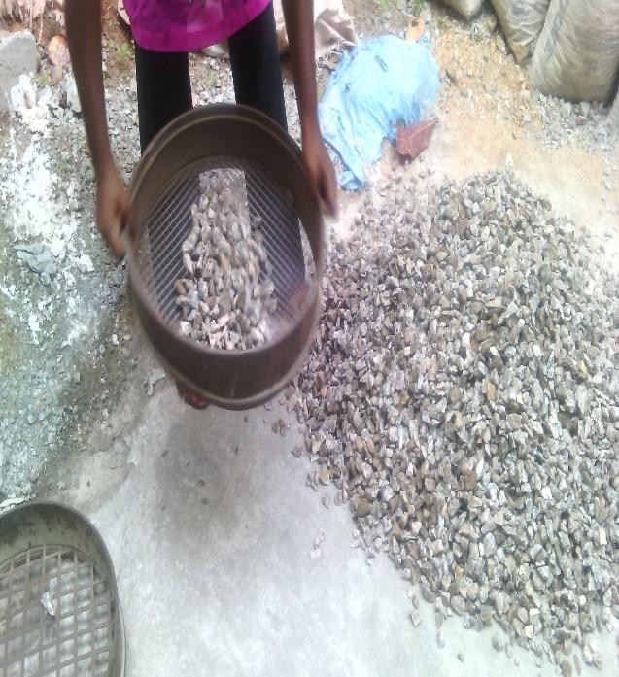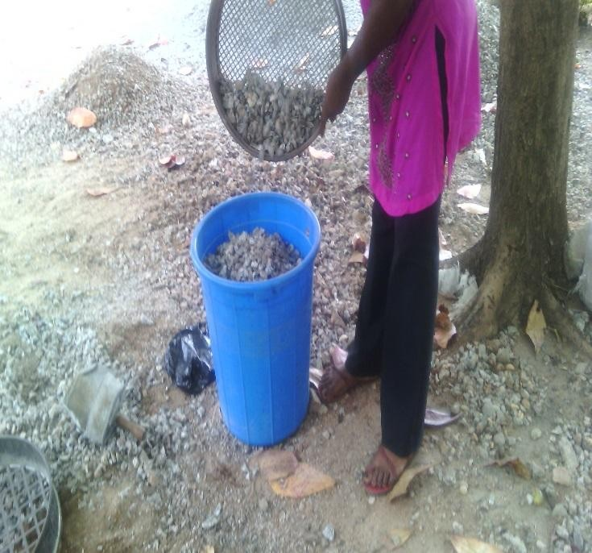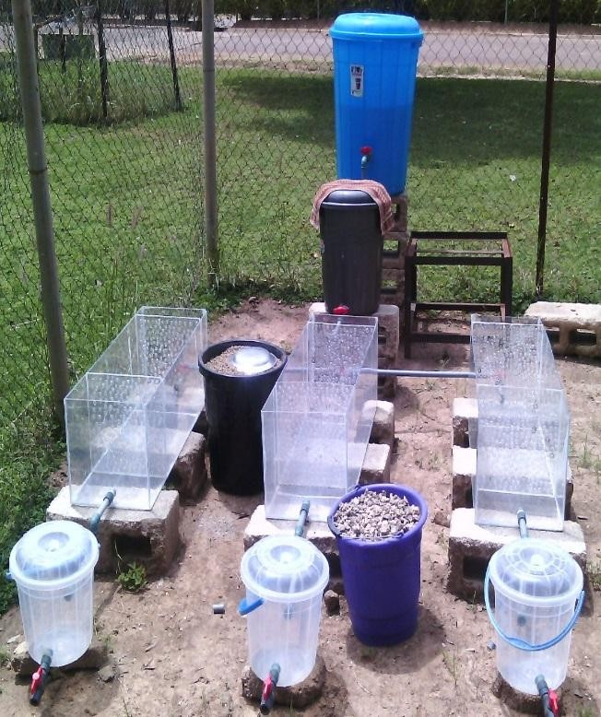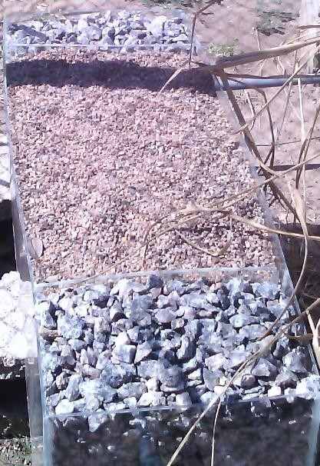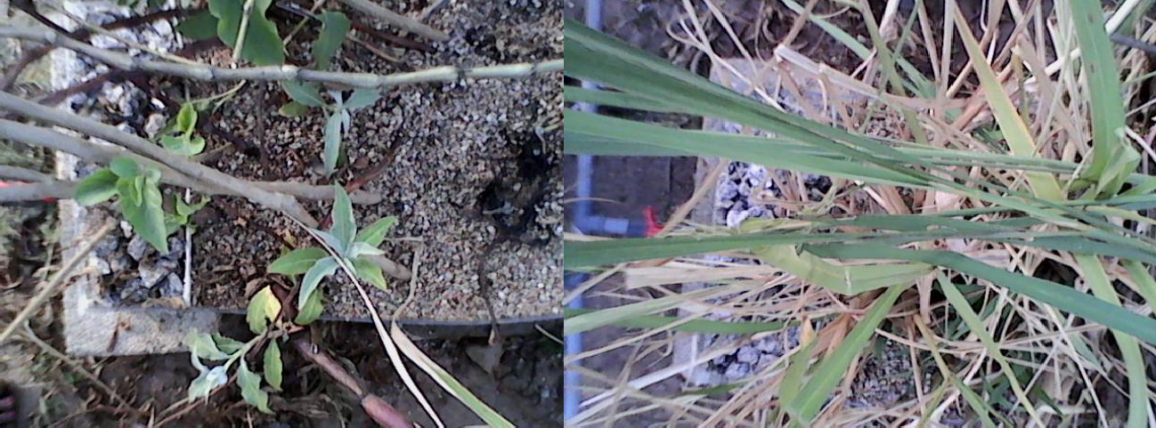

**Appendix III:** Raw concentrations of pollutants for each batch of tannery wastewater, and pH

|  |
| --- |
| Parameters |
| Date Cr mg/l BOD mg/l COD mg/l SS mg/l NO- mg/l PO 3-mg/l pH  3 4 |

|  |  |  |  |  |  |  |  |
| --- | --- | --- | --- | --- | --- | --- | --- |
| 11-02-2015 | 29.44 | 1510 | 3520 | 350 | 90 | 18.08 | 8.60 |
| 18-02-2015 | 21.84 | 1572 | 2870 | 400 | 88 | 26.69 | 8.54 |
| 25-02-2015 | 27.84 | 1350 | 3100 | 385 | 71 | 23.65 | 8.60 |
| 04-03-2015 | 25.84 | 1592 | 2850 | 450 | 85 | 20.35 | 8.74 |
| 11-03-2015 | 29.86 | 1152 | 2210 | 375 | 95 | 19.69 | 8.66 |
| 18-03-2105 | 27.84 | 1428 | 2450 | 420 | 78 | 25.50 | 8.64 |
| 25-03-2015 | 29.00 | 1080 | 2810 | 408 | 82 | 18.08 | 8.20 |
| 01-04-2015 | 28.62 | 1250 | 2450 | 370 | 93 | 21.00 | 8.34 |
| 08-04-2015 | 27.80 | 1600 | 2950 | 350 | 78 | 22.30 | 8.80 |
| 15-04-2015 | 28.24 | 1520 | 3000 | 400 | 83 | 26.43 | 8.42 |

**Appendix IV:** Reduced concentrations of pollutants and pH after treatment in each of the three model horizontal subsurface flow constructed wetlands.

# Reduced concentrations of pollutants and pH after treatment in CW planted with *P. australis.*

|  |
| --- |
| Parameters |
| Date Cr mg/l BOD mg/l COD mg/l SS mg/l NO- mg/l PO 3-mg/l pH  3 4 |

|  |  |  |  |  |  |  |  |
| --- | --- | --- | --- | --- | --- | --- | --- |
| 11-02-2015 | 0.40 | 30.50 | 140 | 30 | 32 | 12.25 | 7.76 |
| 18-02-2015 | 0.54 | 30.00 | 105 | 30 | 31 | 15.30 | 7.43 |
| 25-02-2015 | 0.64 | 30.00 | 154 | 29 | 32 | 11.13 | 8.00 |
| 04-03-2015 | 0.22 | 30.08 | 175 | 28 | 30 | 9.37 | 7.26 |
| 11-03-2015 | 0.80 | 29.00 | 185 | 30 | 31 | 11.12 | 7.50 |
| 18-03-2105 | 0.30 | 30.10 | 174 | 28 | 31 | 9.37 | 8.12 |
| 25-03-2015 | 0.46 | 30.00 | 180 | 30 | 32 | 12.52 | 7.15 |
| 01-04-2015 | 0.28 | 29.00 | 150 | 30 | 31 | 10.08 | 7.17 |
| 08-04-2015 | 0.34 | 30.00 | 180 | 30 | 31 | 12.35 | 8.00 |
| 15-04-2015 | 0.40 | 30.80 | 180 | 30 | 30 | 20.43 | 7.75 |

**Reduced concentrations of pollutants and pH after treatment with the CW planted with**

***P. salicifolium + I. carnea***

|  |
| --- |
| Parameters |
| Date Cr mg/l BOD mg/l COD mg/l SS mg/l NO- mg/l PO 3-mg/l pH  3 4 |

|  |  |  |  |  |  |  |  |
| --- | --- | --- | --- | --- | --- | --- | --- |
| 11-02-2015 | 0.54 | 60.00 | 620 | 29 | 45 | 15.69 | 7.81 |
| 18-02-2015 | 0.82 | 64.20 | 890 | 30 | 47 | 19.40 | 7.70 |
| 25-02-2015 | 0.86 | 48.50 | 740 | 28 | 40 | 12.52 | 8.00 |
| 04-03-2015 | 0.58 | 51.50 | 945 | 28 | 41 | 13.91 | 7.50 |
| 11-03-2015 | 1.05 | 42.80 | 460 | 30 | 50 | 14.48 | 7.56 |
| 18-03-2105 | 0.74 | 38.20 | 750 | 31 | 42 | 12.37 | 8.00 |
| 25-03-2015 | 0.64 | 40.50 | 958 | 28 | 41 | 12.50 | 7.73 |
| 01-04-2015 | 0.44 | 47.80 | 720 | 28 | 40 | 10.69 | 7.51 |
| 08-04-2015 | 0.43 | 50.00 | 895 | 30 | 42 | 13.00 | 8.14 |
| 15-04-2015 | 0.47 | 54.00 | 995 | 28 | 50 | 20.21 | 7.87 |

# Reduced concentrations of pollutants and pH after treatment with the un-vegetated (control) CW

|  |
| --- |
| Parameters |
| Date Cr mg/l BOD mg/l COD mg/l SS mg/l NO- mg/l PO 3-mg/l pH  3 4 |

|  |  |  |  |  |  |  |  |
| --- | --- | --- | --- | --- | --- | --- | --- |
| 11-02-2015 | 0.70 | 165.00 | 849 | 30 | 71 | 16.60 | 8.10 |
| 18-02-2015 | 1.14 | 145.10 | 1200 | 30 | 62 | 18.69 | 8.05 |
| 25-02-2015 | 1.94 | 87.50 | 1450 | 29 | 51 | 18.08 | 8.10 |
| 04-03-2015 | 2.16 | 96.50 | 1835 | 20 | 53 | 16.60 | 7.40 |
| 11-03-2015 | 2.20 | 168.40 | 900 | 30 | 65 | 14.48 | 7.57 |
| 18-03-2105 | 1.84 | 145.00 | 1180 | 31 | 58 | 15.56 | 8.05 |
| 25-03-2015 | 1.75 | 170.50 | 1162 | 30 | 58 | 12.90 | 7.75 |
| 01-04-2015 | 0.80 | 162.50 | 960 | 33 | 60 | 11.30 | 7.94 |
| 08-04-2015 | 0.74 | 176.00 | 1705 | 32 | 58 | 13.50 | 7.97 |
| 15-04-2015 | 1.04 | 159.00 | 1402 | 35 | 60 | 22.30 | 7.78 |