**[DESIGN AND IMPLEMENTATION OF WEB-BASED PATIENT MANAGEMENT SYSTEM USING](https://www.researchgate.net/publication/375796284_Design_and_Implementation_of_Web-Based_Patient_Management_System_Using_C?enrichId=rgreq-f44870223b92fd37dd5830c9e0180d94-XXX&enrichSource=Y292ZXJQYWdlOzM3NTc5NjI4NDtBUzoxMTQzMTI4MTIwNjIwOTg1MUAxNzAwNTk3MDA3NzQ2&el=1_x_3&_esc=publicationCoverPdf) [C#](https://www.researchgate.net/publication/375796284_Design_and_Implementation_of_Web-Based_Patient_Management_System_Using_C?enrichId=rgreq-f44870223b92fd37dd5830c9e0180d94-XXX&enrichSource=Y292ZXJQYWdlOzM3NTc5NjI4NDtBUzoxMTQzMTI4MTIwNjIwOTg1MUAxNzAwNTk3MDA3NzQ2&el=1_x_3&_esc=publicationCoverPdf)**

**ABSTRACT**

This work is ondesign and implementation of Web-Based Patient Management System (PMS). The system provides the benefits of efficient tasks, improved administration & control, patient care, and improved effectiveness. . The paper describes about an knowledge of a web-based platform that make many medical/patient processes online using Web, networking technology that can be very important in implementing the functionality of online patient management. The system was designed inC# as the front-end software, which is an Object Oriented Programming language and has connectivity with the back-end software in MySQL database.

**CHAPTER ONE**

**INTRODUCTION**

**1.1 Overview**

The patient Management system comprises creating account for patients, storing their information into the system; everything is computerized compare to the previous system. The software has the facility to give a search facility for every patients and the staff automatically. m. User can search about the doctor whether they are available or not and the details of a patient. The patient management system can be login using a username, password and staff designation. It is available, by either an administrator or any staff that has an account in the system. Individual they can add data into the database. The data can be saved easily. The interface is precise and user-friendly. The data is well protected for individual use and fast data processing. Patient Management System (PMS) is designed for multispecialty patients, to cover a wide range of patient administration processes.

**1.2 Motivation**

The real inspiration for the patient management system development is to create easy process of all the administration process like patient’s registration, drug management, doctor’s prescription, etc. We continuously see that to find out the patient’s and staff’s history, the user has to go through various records. This marks in consumption of time. Therefore, by this system it will develop easy to accomplish all process.

**1.3 Objectives**

1. Design a system for better patient care.
2. Reduce patient-operating costs and expenses on storing records in a paper.
3. Drug management (checking drug availability, expiry date).
4. Better co-ordination among the different departments.
5. Patient management (scheduling, registration, long-term care and tracking daily inpatient/outpatient)
6. Patient care management and departmental modules.
7. Maintain the medical records of the patient

**CHAPTER TWO**

**LITERATURE REVIEW**

Hospitals can also be regarded as organizations based on high technology and information intensive processes. According to Lawrence and Dyer (1982), such organizations are not hierarchically structured bureaucracies, but are often based on democratic control mechanisms with institutionalized stakeholder influence in decision processes. [1], [2] A Hospital Information System (HIS) is defined as a comprehensive,integrated information system that managesthe administrative, financial, and clinical aspects of a hospital. Hospital Management System (computerized) is increasingly becoming an emerging tool in health care arena to efficiently enable delivery of high quality health services. These systems have large computerized data bases intended primarily for communication and storing health and administrative information. HMS has different components and includes broad scope and level of systems from departmental (a system limited to a specific clinical or financial domain) to knowledge based systems that provide diagnostic support and intervention for patient care activities.

**CHAPTER THREE**

**METHODOLOGY**

**3.1 Problem Definition**

* Lack of fast retrievals: - It is very tough to recover information and to find particular information like E.g. - To find out the patient’s history, the user has to go through many registers. This marks in consuming a lot of time.
* Lack of quick updating: - Several changes to information like patient are challenging to make as paper work is involved.
* Patients are coming day-to-day to the clinic, it is a daily activity in the health center and it is manually manageable, and it is very difficult to store and process huge volumes of data and information manually in paper. In addition, it consumes more time and space**,** less security was provided for the valuable information of patients and staffs.

**3.2 Proposed Approach**

Nowadays Patient Management system in varioussickbay is time consuming and prolonged process. Patients goes to sickbay and they have to go through various process for treatment. After this patients goes for registration and patients have to wait there in queue where the files is generated manually by receptionist, this process is more time consuming and lengthy. To overcome such drawbacks we design patients Management System. This PMS is built on the C#, database, and object-oriented programming language techniques. My SQL (Structure Query Language) is used in areas where keeping the records in the database is required, this system uses C# as the Front-endsoftware, which is an object-oriented programming technique and has connectivity with My SQL, the back-end software.

**Patient Management System DFD**

|  |  |  |
| --- | --- | --- |
|  | Data Out Put Stage |  |
|  | Data Input Stage |  |
| ADMIN | Admin |  |
|  |  |
|  | Employee |  |
| Doctor | Doctor |  |
|  |  |

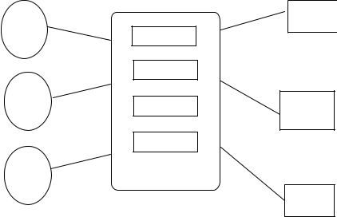

Data Storage

Receptionist

UI Screens

Emplo.

Reports

1. **SYSTEM IMPLEMENTATION**
2. **1 Software Requirement** Database: MySQL Framework: ASP.Net Coding: C#
3. **2 Hardware Requirement** Dual core processor

RAM 1GB HDD min 40GB

**CHAPTER FOUR**

**RESULT AND DISCUSSION**

In figure 4.1, there is a login page, which is common for each module. User of each module must go through this page with their own username and password.

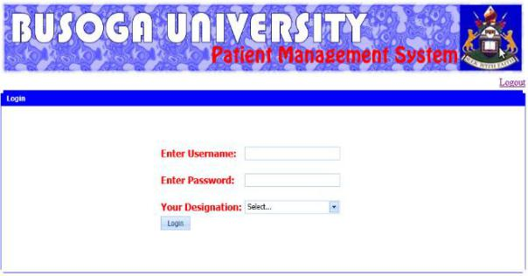

Figure 4.1: Login Page

Figure 4.2 shows Patients Registration. In this page registration of patients is done by using their details like name, department, registration number, etc.

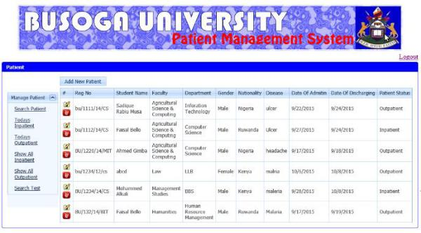

Figure 4.2: Patients Registration

In Figure 4.3, in this page admin create account for employees as shown in below figure 4.3.

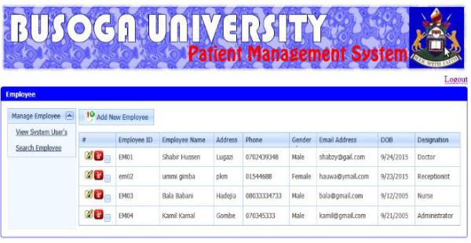

Figure 4.3: employee account

In Figure 4.4, in this page pharmaciststores the record of medicine as shown in below figure 4.4.

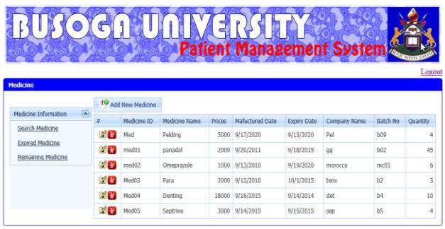

Figure 4.4: storing medicine record

In Figure 4.4, in this page pharmacistchecks available record of medicine as shown in below figure 4.4.

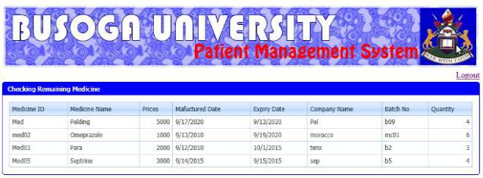

Figure 4.5: checking medicine record

**Conclusion**

The developed web-based patient management system solves the challenges of data redundancy, time wastage in records retrieval, employeemanagement, and drug management at BusogaUniversitysickbay in eastern Uganda. Additionally, there is enhanced security as access to the system entails authentication with a valid system username and password.The Hospital Management System software meets user requirement relating to entering patient data (figure 2). It shows the number of patients registered in the hospital database (figure 3). The system also gives the number of in-patients in the hospital at that particular time and what they are being treated for (figure 3). A drug database was also established; where the pharmacy can input the particular type of drug available at that particular time so that doctors can know which drugs are readily available to be prescribed to patients (figure 4).

**REFERENCE**

1. Hospital Management Information System, Gujarat Informatics System (2012)
2. Praveen K.A and Gomes L.A, 2006: “A Study of the Hospital Information System (HIS) In the Medical Records Department of A Tertiary Teaching Hospital” Journal of the Academy of Hospital Administration, Vol. 18, No. 1 (2006-01 - 2006-12).
3. Smith M. and Gert van der Pijl, 1999: “Developments in Hospital Management and Information Systems”. Tilburg University

School of Economics, Netherlands.

1. Adebisi, O.A, Oladosu D.A, Busari O.A, and Oyewola, Y.V(2015).Design and Implementation of Hospital Management System. International Journal of Engineering and Innovative Technology (IJEIT) Volume 5,Issue 1.
2. Design and Implementation of Hospital Management System Using Java, IOSR Journal of Mobile Computing & Application (IOSR-JMCA,