**DESIGN AND IMPLEMENTATION OF VEHICLE MAINTENANCE AND SERVICES SYSTEM FOR HALLMARK AUTOMOBILE SERVICES**

# ABSTARCT

*The vehicle maintenance and service system is an automation of the various vehicle services needed by a vehicle user in a mobile application. This application provides vehicle service reminder while providing vehicle related solution. The vehicle maintenance and service system provide repair cost estimates to help mitigate the rigged system vehicle users pass through for vehicle repairs and maintenance. This project work contains a review of existing systems related to the proposed system and the prototype development methodology used to develop the system. And also provides the design of the system using the Unified Modelling Language as well as testing of the system. The examination of the literature uncovered a number of empirical evidence areas, and the resulting discussion provides the basis for the design and implementation of vehicle maintenance and services system.*

**TABLE OF CONTENTS**

ABSTARCT vi

LIST OF FIGURES ix

LIST OF ABBREVIATIONS x

CHAPTER ONE 1

INTRODUCTION 1

1.1 Overview 1

1.2 Background and Motivation 1

1.3 Statement of the Problem 2

1.4 Aim and Objectives 2

1.5 Significance of the Project 2

1.6 Project Risks Assessment 3

1.7 Scope/Project Organization 3

CHAPTER TWO 5

LITERATURE REVIEW 5

2.1 Introduction 5

2.2 Historical Overview 5

2.3 Related Work 7

2.4 Summary 8

CHAPTER THREE 9

REQUIREMENTS ANALYSIS AND DESIGN 9

3.1 Overview 9

3.2 Proposed Methodology 9

3.3 Approach to Chosen Methodology/Methods 10

3.4 Tools and Techniques 10

3.5 Ethical Consideration 10

3.6 Requirement Analysis 11

3.7 Requirements Specifications 11

3.7.2 Non-Functional Requirement Specifications 13

3.8 System Design 14

3.8.1 Application Architecture 14

3.8.2 Use Case 16

3.8.3 Sequence Diagram 18

3.8.4 Context Diagram 23

3.8.6 Entity-Relationship Diagram (ERD) 24

3.8.7 User Interface Design 25

3.9 Summary 26

CHAPTER FOUR 27

IMPLEMENTATION AND TESTING 27

4.1 Overview 27

4.2 Main Features 27

4.3 Implementation Problems 31

4.4 Overcoming Implementation Problems 32

4.5 Testing 34

4.5.1 Tests Plans 34

4.5.2 Test Traceability Matrix 36

4.5.3 Test Report Summary 38

4.6 Use Guide 38

4.7 Summary 38

CHAPTER FIVE 39

DISCUSSION, ENHANCEMENT, AND RECOMMENDATIONS 39

5.1 Overview 39

5.2 Objective Assessment 39

5.3 Limitations and Challenges 40

5.4 Future Enhancements 40

5.5 Recommendations 41

5.6 Summary 41

References 42

Appendix 44

# LIST OF FIGURES

Figure 1: Application Architecture 14

Figure 2: Services Details Architecture 14

Figure 3: Admin System Architecture 15

Figure 4: Use Case 16

Figure 5: Admin System Use Case 17

Figure 6: Login Sequence Diagram 18

Figure 7: Requesting Breakdown Service Sequence diagram 19

Figure 8: Repair Sequence diagram 20

Figure 9: Service Sequence diagram 21

Figure 10: Purchase Parts Sequence diagram 22

Figure 11: Context diagram 23

Figure 12: Entity Relationship Diagram (ERD) 24

Figure 13: User Interface Design 26

Figure 14: Requesting Breakdown Service 27

Figure 15: Requesting Repair 28

Figure 16: Requesting Regular Service 29

Figure 17: Ordering Parts 30

Figure 18: Service Reminder 30

Figure 19: Estimate Requests 31

Figure 20: Drawer Implementation Problem 31

Figure 21: Service Requests Implementation Problem 32

Figure 22: Drawer Implementation Solution 33

Figure 23: Notification Implementation Solution 33

Figure 24: Service Requests Implementation Solution 34

Figure 25: Work Plan 44

Figure 26: Gantt Chart 44

# LIST OF ABBREVIATIONS

UML Unified Modelling Language

ERD Entity Relationship Diagram

JS JavaScript

HDD Hard Disk Drive

# CHAPTER ONE

# INTRODUCTION

## 1.1 Overview

As microcomputers become increasingly common in our day to day lives, the aim is to utilize these devices to ease ouractivities and optimize efficiency.The vehicle and maintenance services system is a system which offers a range of services while also tracking the schedule of proposed maintenance.As much as most of us wish our vehicles would just remain forever perfect, that is not likely to happen. Being in possession of a vehicle means you’ll have to dedicate your time and money to maintaining it. Hallmark Automobile offers vehicle related services such as repairs, service, body works and tow truck services.This project will help vehicle users exploit the services rendered by Hallmark Automobile, whenever they meet with an unforeseen incident on the road or at any point in time. Most times drivers are negligent and forgetful when it comes to when maintaining their vehicles. The vehicle maintenance and services system will help keep track of these maintenance such as when service is due.

## 1.2 Background and Motivation

Over the years the use of vehicles has played a vital role in the lives of humans in entirety, cutting down days and weeks of journey to hours. Since the introduction of vehicles there has been a need for regular maintenance for each and every manufactured vehicle, such maintenance is necessary to guarantee safety and longer lifetime for these vehicles. In the course of this regular maintenance, the engine oil and filter are replaced. The schedule of this maintenance differs depending on the vehicle, the manufacturer of each vehicle recommends the schedule of the maintenance based on factors like distance travelled, time intervals and weather conditions (Collins, 2018). Other than regular maintenance, the need for repair arises due to breakdown, faulty parts and auto crash.In Nigeria today with a vehicle population of 11.6 million there has been non-stop need for such repairs. In 2018 According to (Adesoji, 2019), 18,729 people were involved in road accident in Q4 2018 as opposed to 15,696 people in Q4 2017 noticing a 19% increase. These accidents are majorly linked to bad and faulty vehicles.

## 1.3 Statement of the Problem

The purpose of a maintenance and services system is to track and acquire relevant information for vehicle related services and maintenance, while also tackling arising problems. Problems such as break down and faulty parts such as wear and tear of tire, brake pads, tie rods, sharp etc which might come up while on the move leaving the vehicle user stranded. The proposed system will provide a go to for stranded individuals to request for immediate help. In tackling these problems both mechanics and vehicle users face tremendous challenges with the vehicle users taking a fair share of these challenges. In our environment today the vehicle users end up paying exorbitant amount of money on spare parts hiked by both the mechanics and those that sell these spare parts. The vehicle maintenance and services will provide an interface to purchase these parts at the exact retails price while also providing repair estimates.

## 1.4 Aim and Objectives

The project is aimed at implementing a vehicle maintenance and services system. Specific objectives of the research paper are:

1. To review related materials onvehicle servicing and maintenance systems.
2. To identify the requirements for the proposed system.
3. To design models for the proposed system using the unified modelling language.
4. To implement the design.

## 1.5 Significance of the Project

The implementation of this program would be particularly useful to the Nigerian society as a whole. This research project will help curb the ever-growing unprofessionalism in dealing with mechanics. It will help vehicle users gain access to experienced mechanics to work on their vehicles which will eliminate the possibility of poor maintenance and irregular fixing of appropriate parts. In the Nigerian society today, a lot of vehicle accidents are attributed to ill fixing of vehicles which makes such a vehicle not road worthy. This study will also contribute to the existing knowledge about the relative contributions of previous computer-related experience on vehicle maintenance and services. This project will also encourage and give room for more research.

## 1.6 Project Risks Assessment

Table 1: Risk Assessment

|  |  |
| --- | --- |
| Inability to carry out research due to loss of hardware/software resources | Be aware of and observe security procedures  Secure Android mobile phone when not in use. |
| Loss of work due to equipment failure /loss | Weekly data backup to Google drive |
| Software availability (Unavailability of API’s) | Alternative API’s will be checked for. Software requirements will be identified in good time for possible contentious software’s |
| Late delivery of hardware component | Hardware requirements will be identified in good time to be able to order them in good time |

## 1.7 Scope/Project Organization

The scope this project is to develop an application which offers vehicle service notification, book repair and service appointments, a 24/7 breakdown service, repair estimates and online shop for vehicle spare parts and accessories.The remaining parts of this project describe the literature review in Chapter two, requirements analysis and design in Chapter three, implementation and testing in Chapter four, discussion, conclusion and recommendations in Chapter five. The Chapter two looks at a historical overview of the system and related systems made by other researchers and entrepreneurs towards automating the vehicle services and repairs. The chapter three includes the analysis and design of the system, development methodology and approach to chosen methodology. The chapter looks at the requirements of the system gathered and diagrams showing visualizing the design of the system and flow of data in the system. The chapter four covers the implementation of the system, tools and technologies, problems encountered and solutions to mitigate the encountered problems as well as tests carried out on the system. The chapter five evaluates the project, conclude and gives recommendation on the project. The chapter five delivers an objective assessment on the proposed system stating future enhancements to be made on the system and limitations of the system.

# CHAPTER TWO

# LITERATURE REVIEW

## Introduction

According to (Akaigwe, 2010) automobile maintenance, repairs and servicing systems are designed to provide car users the ability to request for various solutions to automobile related problems. Vehicle workshops are shops that specialize in vehicle parts such as tie rod, compressors, brake pads, exhaust systems, transmissions, vehicle body, automobile electrification, wind screen and side mirrors, wheel alignment and wheel balancing or those who specialize only on specific brands of vehicle or vehicles manufacture in specific parts of the world (Aganga, 2013). Other vehicle workshops specialize in customization and modification vehicle. Oftentimes, various specialized auto workshops have diverse equipment’s and facilities aimed at an exact job or vehicle, as well as mechanics with different skills. In Nigeria, the vehicle management and repair segments has experienced a notable development by way of smart repair companies providing a range of repair services, such as Fuel pump repairs, auto body repair, body paint, and all other vehicle parts to private and commercial car users, typically within the industry framework of refinishing vehicle damage on a localized basis (Chamberlain, 2013).

## Historical Overview

Since the dawn of time one of man’s main goal is to make moving from one place to another easier and more efficient. As such, man has come up with a wide range of ideas ranging from riding horses, carts, canoe to the present-day cars, airplane, boats etc. The first internal combustion four-cycle, gasoline fueled engine was manufactured in 1876 in Germany, Carl Benz commenced the first commercial production of vehicles with combustion engine. Vehicles reached modern stage of development by the 1890s. The models in the 1980s were so successful which has led to no significant transformation in the principles of the automobile engine used then (Melosi, n.d.). Cars today are used throughout the world as the most popular mode of transportation, making it highly important to people. Although the car was to have its greatest impact to man, making journey easy, like any other mode of transportation it has its flaws, the constant need for maintenance and the non-ending need for repairs. Though there are many types, model, brand, make of cars, they all require these services.

The history of Automobile in Nigeria can be traced back prior to 1960 when Nigeria had her independence (Aganga, 2013). The use of vehicles was introduced to Nigeria when oil was flourishing in the 70’s by the western world. The Nigerian government in partnership with some advanced economies like Germany, Britain, America, and France, issued license of operation and control policy, built six Vehicle assembly plants in various states of the country, Peugeot Automobile Nigeria limited (PAN) established in the year 1975 in kaduna, Volkswagen of Nigeria Limited (VWON) Lagos 1978, Anambra Motor Manufacturing Limited (ANAMMCO) Emene – Enugu (1980); Steyr Nigeria Limited Bauchi in Bauchi, National Truck manufacturers (NTM) Kano Fiat Production in Kano, LeyLand Nigeria Limited (LNL) Ibadan, between 1970 and 1980 (Akaigwe, 2010). The launch of the six-vehicle plant in Nigeria served as an economical boost to the country (Aganga, 2013). Former minister of trade and investment (Aganga, 2013) said that “automobile industry is an engine of growth and stimulus to other economic activities like creating of employment opportunities growth of other satellite industries, enhancement of technology transfer of skill acquisition” since the establishment of the vehicle assembly plants in Nigeria, the country’s economy has recognized an enormous improvement as a result of the ease in transporting finished products of crude oil from the factories to fuel filling stations. Farm produce are transported with ease between the six geopolitical zones. Humans were able to move from one point to another with ease. Compared to when man was using other means of transportation such as horses, camels, etc. Over the years there has been a sharply decline of vehicle manufacture in the country, some of the assembly plants manufactured in the 70s and 80s are not operational, due two challenges that has befall them (Okuhit, 2015). Majority of automobile companies in Nigeria in present times deal only on car sales, about 80% of vehicle on the roads today are fairly used vehicles popularly known as Tokumbo, as a result of the decline in vehicles manufactured in Nigeria (Chamberlain, 2013). According to (Izogo & Ogba, 2016), the need for vehicle repair services have been on the rise due to the change from manual to automatic transmissions having more complex systems due to technological variations.

## 2.3 Related Work

There have been numerous numbers of applications related to incorporating the services required by drivers and maintenance reminder into Smartphone applications, applications such as Repair Pal, Car Minder Cartisan and Autobot servicing system. Repair pal is an application whose main concern is to checkmate the overcharge of parts and services offered by dealerships and mechanics. Repair pal ensures that drivers never pay excess when it comes to services be it an oil change, part replacement or repair. With repair pall all you need to do is to input the car details such as the make and model, and the repair needed. Repair Pal does the rest of the work for you and comes up with a rough estimate for your service based on average costs in your area.

Car Minder is a mobile application for managing vehicle related maintenance, tracking fuel economy and providing repair solutions. This application support not one but multiple cars, and repairs services. Car minder keeps track of tire rotations, oil changes, and other maintenance tasks for cars added to the system. The car minder notifies you when the need to schedule maintenance based on data you input right from your vehicle’s manual. It also lets you log a history of all services rendered on your car, for you to be able to keep track of costs for repairs as well as scheduled maintenance. Another related system is cartisan, which is an Indian based car service and repair mobile and web application. This application provides car owners with a convenient way to take advantage of a variety of services for their car. Cartisan specialize in providing quality car service and repair such as disc and brake pad replacement, suspension overhauls, battery replacement, etc. The application provides a 24/7 breakdown assistance. Services rendered by Cartisan include 24/7 breakdown assistance, regular services, repairs, dents & paint (body work) and car cleaning. Autobot servicing System is a complete module developed to manage daily Business-to-Consumer and Business-to-Business activities. It contains everything you need for professionally managed automobile sales environment, no matter the number of enquiries generated, booking made or vehicles parts you sell, the system is designed to handle the request. The Autoboot servicing system has a user-friendly interface i.e. any non-computer savvy can work on it. It is a beneficial instrument for growing your automobile business in terms of profit and resources. It is collecting data in relation with whole sale car order, procurement of spare parts, potential customer (Individual / Corporate) enquiry details car parts retail sale order and maintenance estimate etc. Based on information collected through this module, one can extract various maintenance reports which contain valuable vital and meaningful information for decision making by the user.

## Summary

The examination of the literature uncovered a number of empirical evidence areas, and the resulting discussion provides the basis for the design and implementation of a vehicle maintenance and services system. The review looks at academic literature on the historic development of the automobile industry in Nigeria and application of technology to automate maintenance activities. The review reveals that a lot of systems are being used to handle automotive issues in Nigeria. However, the systems are design to solve a particular problem or to perform a specific task. Which means a car user must use multiple application software to preserve the integrity of a vehicle. It should be noted that the literature identified, predominantly emerges from related system used for automobile maintenance and repairs.

# CHAPTER THREE

# REQUIREMENTS ANALYSIS AND DESIGN

## 3.1 Overview

This chapter consists of the list of the requirements that drive the system: functional and non-functional. It contains the Unified Modelling Language (UML) diagrams that aid in the design and implementation of the system and the methodology used to develop the proposed system.

## 3.2 Proposed Methodology

The Prototype development methodology will be adopted in the development of the Vehicle Maintenance and Services system. The methodology process allows developers to create only the prototype of the solution to assess its functionality and make necessary modifications before developing the actual application. The best feature of this software development methodology is that it solves many issues which often occur in a traditional waterfall model. It is an example of a plan-driven process in principle, one must plan and schedule all of the process activities before starting work on them. This method drastically decreases the risk of failure, as probable risks can be detected in early stage and moderation steps can be taken quickly. Other than the prototype model there are other models such as the Waterfall, Agile, Spiral model etc. The waterfall model is based on a sequential flow requiring the previous phase to be completed before moving onto the next phase. Unlike the prototype model the waterfall model can only be adopted in the development of projects whose requirements are clearly stated. Agile software development methodology is a blend of both incremental and iterative process models which allows recurrent modification in development. One drawback in the agile development methodology is the possibility of drifting from the path to required goal as a result of ambiguity in the customers understanding of the outcome of the project. The prototype development methodology helps in requirement gathering and requirement analysis when there is absence of requirement documents. When a prototype is shown to the clients, they get a vibrant understanding and whole sense of the functionality of the software. Thus, the prototype methodology has been chosen to be the methodology to be used in the development of the Vehicle Maintenance and Services System.

## 3.3 Approach to Chosen Methodology/Methods

The approach in developing the project will be in an iterative, trial and error method with the users. Requirements will be gathered and analyzed by interviewing users and know their expectations of the system. The second phase paves way for a quick design of the system. It gives an idea to the user of the system and a guide for building the prototype. A prototype of the proposed system is built and presented to the user for evaluation. In this stage, comments and suggestions from the user are noted and any alteration to the system requirement are put into consideration when refining the prototype. A refined prototype is built with all requirements as specified by the user and sent for final evaluation. The system will then be developed based on the final prototype

## 3.4 Tools and Techniques

The tools to be used during the course of this project are

* A computer of 2.4GHz, 8GB of RAM, and 500GB SSD
* Visual Studio Code
* Microsoft Office
* Firebase Cloud Firestore
* Visual Paradigm

Technologies include

* React
* React Native
* Node JS
* JavaScript

## 3.5 Ethical Consideration

The ethical consideration is the accumulation of values and principles that address questions of what is good or bad during the process of conducting this research. Firstly, handling, storing, and sharing of user data only under the circumstances and for the research. Energy consumption of the system artifact will be regulated, caring about energy throughout the development process and in the documentation. Also, the decisions on which bugs to fix and how quickly, will be done to ensure the quality of the code before release. Should the system cause any harm, the administrators will be held responsible.

## 3.6 Requirement Analysis

To analyze the system requirements, responses was collected from the users of the system. More specifically they were consulted to establish the goals, requirements, and services that are expected from the system. This involved a proper definition of the nature scope and peculiarity of the problem. The problem with which this project is based on, is the design and implementation of a vehicle maintenance and services system that does not suffer the setbacks of the initial prototype. An interview was conducted to collect feedback from the users, which served as an additional requirement of the proposed system.

## 3.7 Requirements Specifications

Table 2: Functional Requirements Specification

|  |  |  |
| --- | --- | --- |
| **Req. No.** | **Description** | **Type** |
| R-101 | The system shall allow a new User to create an account. | Configuration |
| R-102 | The system shall allow a User to log in to the system. | Functional |
| R-103 | The system shall allow a user to enter his/her vehicle details. | Functional |
| R-104 | The System shall allow a User to request breakdown. | Functional |
| R-105 | The system should be able to collect User location. | Configuration |
| R-106 | The system shall allow a User to book a repair. | Functional |
| R-107 | The system shall allow a User to book a service. | Functional |
| R-108 | The system shall allow a User request estimate. | Functional |
| R-109 | The system should allow a User purchase parts. | Functional |
| R-110 | The system should be able to get service dating using mileage details | Configuration |
| R-111 | The system should send notifications when a User’s vehicle is set for service. | Configuration |
| R-112 | The system should allow a User view order details. | Functional |
| R-113 | The system should allow a User view breakdown details. | Functional |
| R-114 | The system should allow a User view booking details. | Functional |
| R-115 | The system should allow User to make payments online. | Configuration |
| R-116 | The system should allow Admin view estimate request details. | Functional |
| R-117 | The system should allow Admin view booked repair details. | Functional |
| R-118 | The system should allow Admin view booked service details. | Functional |
| R-119 | The system should allow Admin view breakdown details. | Functional |
| R-120 | The system should allow Admin view order details. | Functional |
| R_121 | The system should allow Admin send estimate price to user. | Functional |
| R_122 | The system should allow Admin add a product | Functional |
| R_123 | The system shall run on iOS 10.0 and Android 4.1 or later. | Configuration |

### 3.7.2 Non-Functional Requirement Specifications

Table 3: Non-Functional Requirements Specification

|  |  |  |
| --- | --- | --- |
| **Req. No.** | **Description** | **Type** |
| R-101 | When launched, the application shall stay running unless there is an intentional shutdown of the application or the platform. | Performance |
| R-102 | The system screens should load in not more than 5 seconds. | Performance |
| R-103 | Online payments should be made secure. | Security |
| R-104 | The system shall ensure a user can view only his/her details. | Security |
| R-105 | The system shall have a user-friendly interface. | Usability |
| R-106 | The system should not be restricted to a single OS. | Portability |

## 3.8 System Design

### 3.8.1 Application Architecture

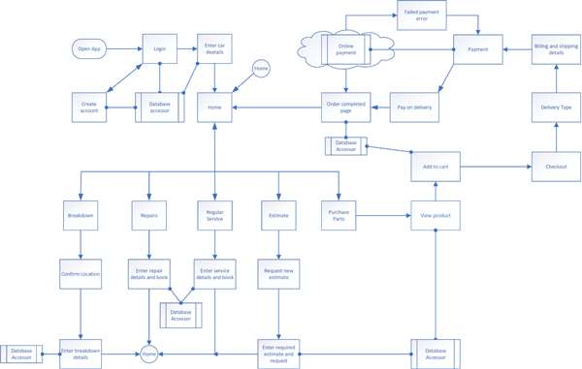

Figure 1: Application Architecture

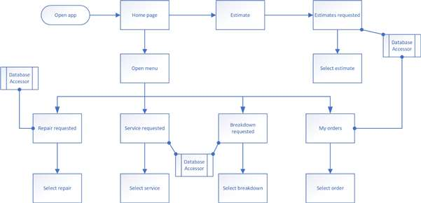

Figure 2: Services Details Architecture

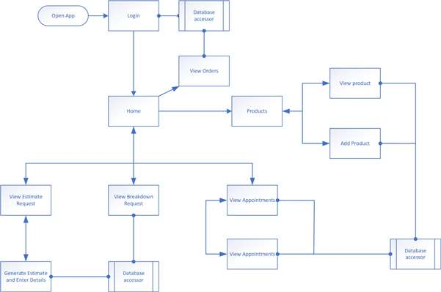

Figure 3: Admin System Architecture

Figures 1–3 are the applications architecture. These architectures give a high-level representation of the vehicle maintenance system for both the client and admin applications.

### 3.8.2 Use Case

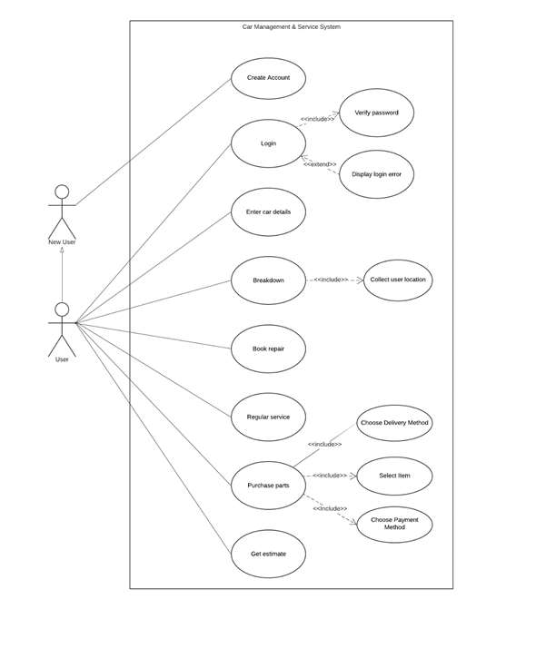

Figure 4: Use Case

The figure 4 shows the interactions between the system and the user of the system. The stick figure at the top left side of the rectangle represents a new user of the system who initially creates an account to gain access to the system while the stick figure underneath the new user represents an existing user. The rectangle defining the scope of the system. The oval shape (use case) within the rectangle represents actions that accomplish some task within the system.

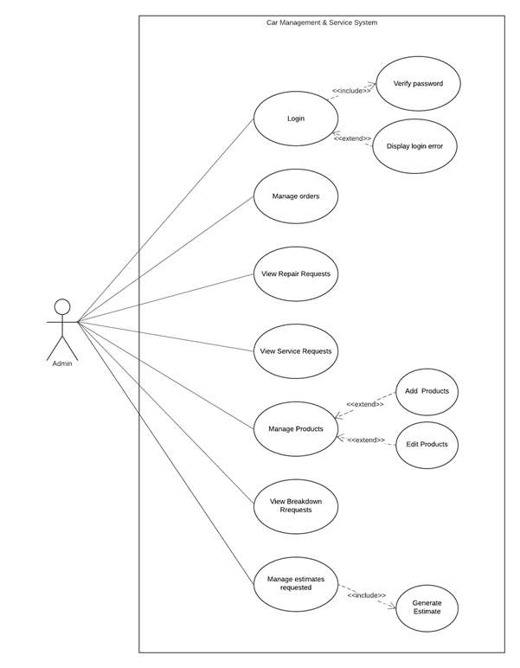

Figure 5: Admin System Use Case

The figure 5 shows the interactions between the system and the admin of the system. The stick figure at the left side of the rectangle represents the admin and the rectangle defining the scope of the system. The oval shape (use case) within the rectangle represents actions that accomplish some task within the system.

### 3.8.3 Sequence Diagram

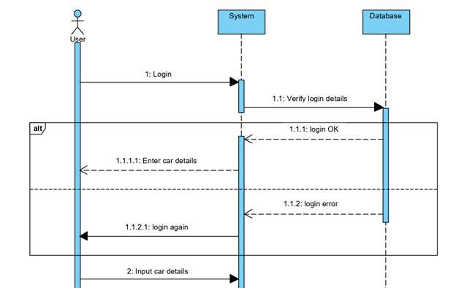

Figure 6: Login Sequence Diagram

The figure 6 shows the login process and interactions in the order they take place.

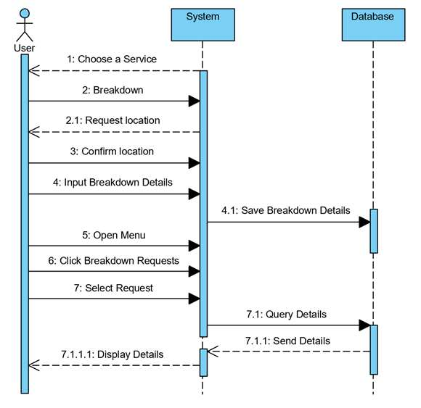

Figure 7: Requesting Breakdown Service Sequence diagram

The figure 7 shows the process of requesting and viewing a breakdown service and interactions in the order they take place.

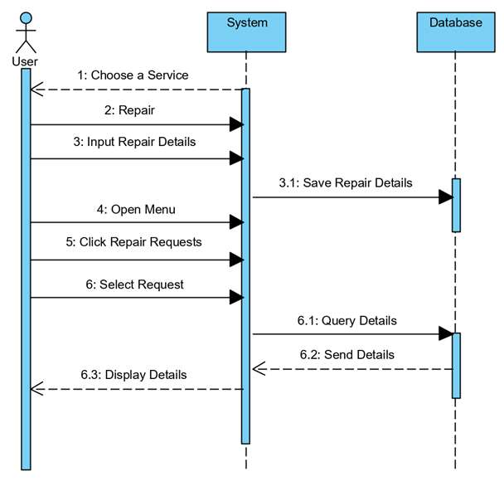

Figure 8: Repair Sequence diagram

The figure 8 shows the process of booking and viewing details of repair and interactions in the order they take place.

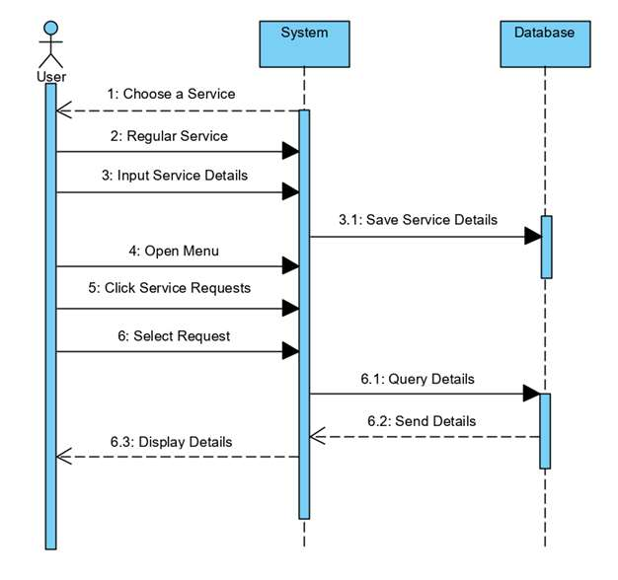

Figure 9: Service Sequence diagram

The figure 9 shows the process of booking and viewing details of a service and interactions in the order they take place.

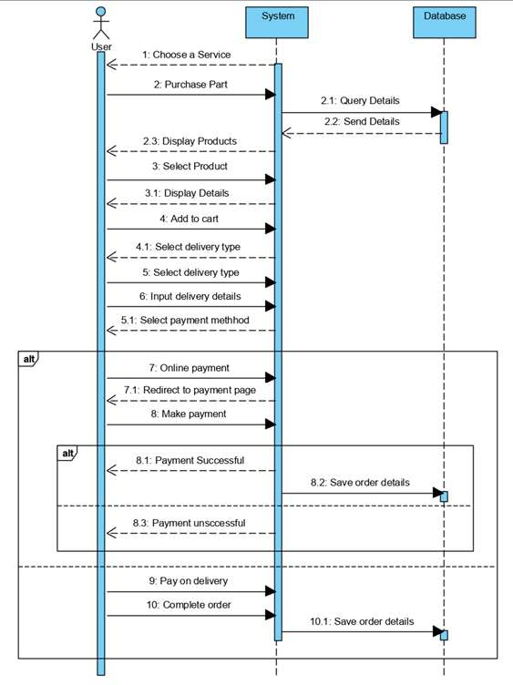

Figure 10: Purchase Parts Sequence diagram

The figure 10 shows the process of placing an order for spare parts with different delivery and payment options.

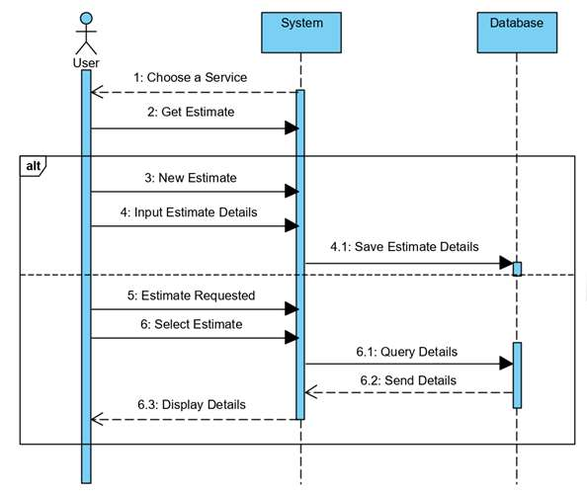

Figure 11: Estimate Request Sequence Diagram

The figure 11 shows the process of requesting an estimate and viewing estimate details and interactions in the order they take place.

### 3.8.4 Context Diagram

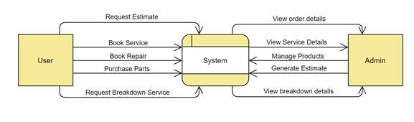

Figure 12: Context diagram

The figure 12 is a context diagram of the Vehicle Maintenance and Service System. The diagram defines the boundaries of the Vehicle Maintenance and Service System. It depicts the flow of information in the system.

### 3.8.6 Entity-Relationship Diagram (ERD)

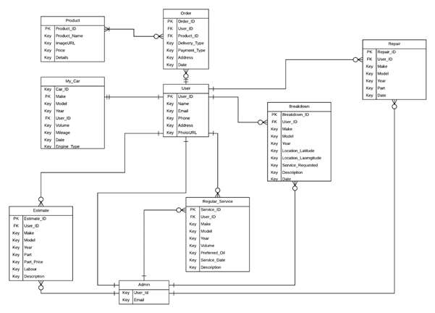

Figure 13: Entity Relationship Diagram (ERD)

The figure 13 shows The Vehicle Maintenance and Service System ERD. The ERD shows the entities, it’s attributes and relationship between them.

### 3.8.7 User Interface Design

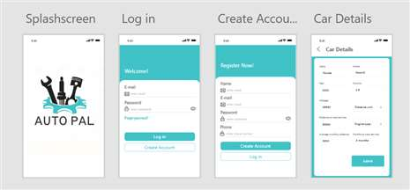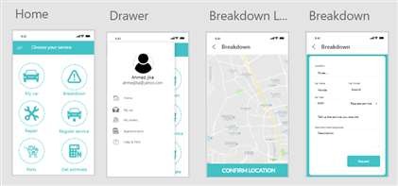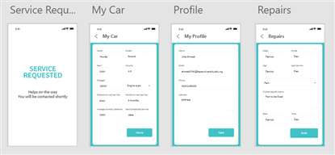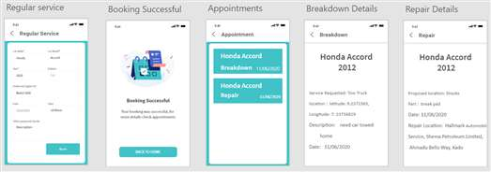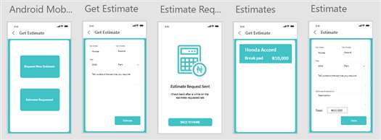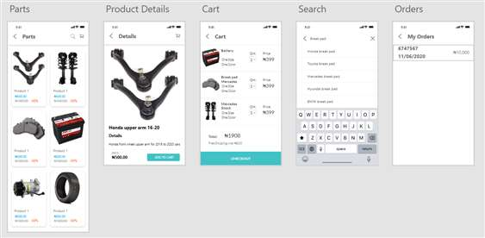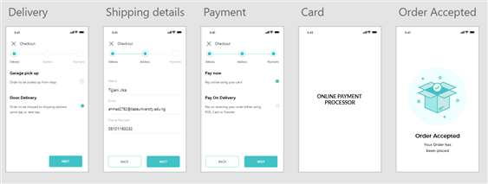

Figure 14: User Interface Design

## 3.9 Summary

This chapter of the research work talks about the methodology used in the development of the system, the requirements of the system both functional and non-functional, UML diagrams (Activity Diagram, use case diagram, sequence diagram etc.)used to model the requirements of a system.

# CHAPTER FOUR

# IMPLEMENTATION AND TESTING

## 4.1 Overview

This chapter lays emphasis on the implementation and testing of the system, illustrating the tools and technologies used for the development and testing of the system. Test suite, test cases, test report, and error reports related to the system. This chapter also shows the problems encountered during the implementation, and how the problems were overcame.

## 4.2 Main Features

Breakdown: in times of an unforeseen breakdown a user can request a breakdown service which will provide professional help. A user’s location and other relevant details will be collected using Google maps API for an accurate pinpoint.

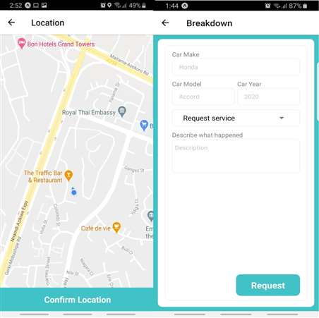

Figure 15: Requesting Breakdown Service

Repair: the repair service collects information such as vehicle make, model, year, part to be fixed, date, and time for the repair to take place. This service is in the form of an appointment.

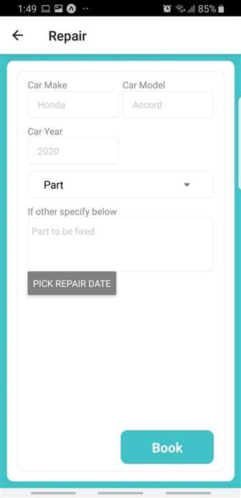

Figure 16: Requesting Repair

Regular service: the regular service collects information such as vehicle make, model, year, part to be fixed, date and time for the repair to take place. This service is in the form of an appointment.

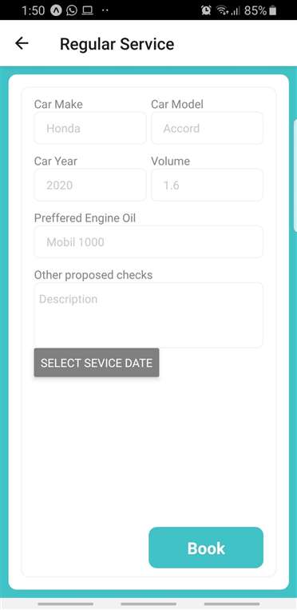

Figure 17: Requesting Regular Service

Purchase parts: just like a conventional ecommerce application the purchase part service serves as an online shop for buying vehicle spare parts with the option of either home delivery or garage pick up and also payment options of either online payment or pay on delivery.

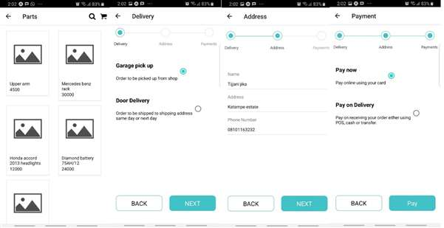

Figure 18: Ordering Parts

Service reminder: the application provides an email notification to a user’s email on the services date entered by the user in my vehicle section.

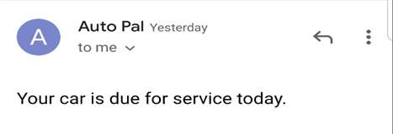

Figure 19: Service Reminder

Get estimate: estimate for repairs will be generated by collecting user input of vehicle make, model and year, part to be fixed, and a detailed description. This estimate will be generated by a professional (system admin) who has access to the details of the requested estimate. The admin will provide a detailed breakdown (the parts price, labour, etc) of the cost of the repair which will be forwarded to the user.

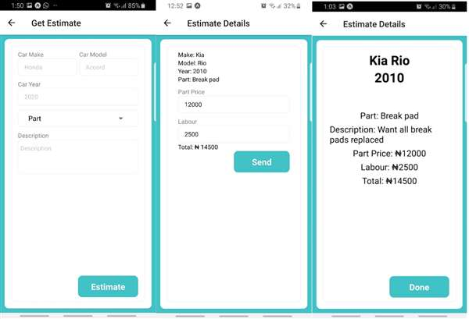

Figure 20: Estimate Requests

## 4.3 Implementation Problems

The first problem encountered is as a result of nesting a navigation drawer in to the HomeStackNavigator. The problem associated with the navigation drawer was it not opening on click of the drawer icon; this is associated to the HomeStackNavigator nested in the AuthStackNavigator.

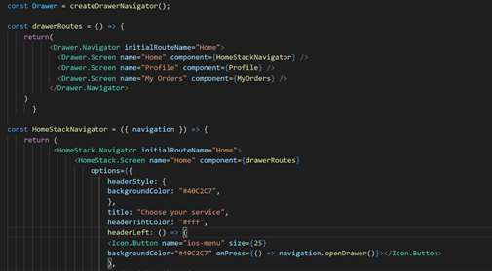

Figure 21: Drawer Implementation Problem

The second implementation problem is with the notification. The application was developed using Expo which is a platform for making native Android, IOS, and web applications with JavaScript, react and react native. At the time of developing this system, React Native Push Notifications on Expo application are triggered only when application is running.

The third implementation problem is located in the RegularServiceRequest.js. The problem is located in useEffect which is supposed to get user requested service details, PUT was passed into method because of that service details is not requested from firestore.

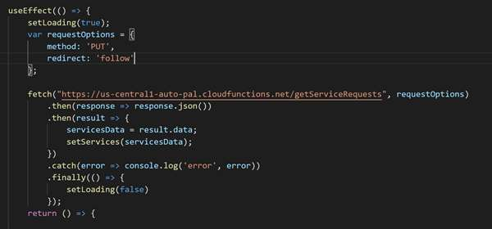

Figure 22: Service Requests Implementation Problem

## 4.4 Overcoming Implementation Problems

The problem with the drawer navigation was solved by creating a menu screen and adding a navigation to the menu screen on click of the menu icon.

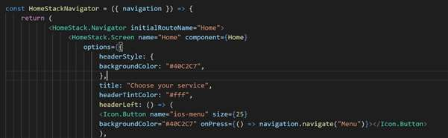

Figure 23: Drawer Implementation Solution

The second implementation problem was overcame by integrating firebase cloud functions email notification as opposed to push notifications.

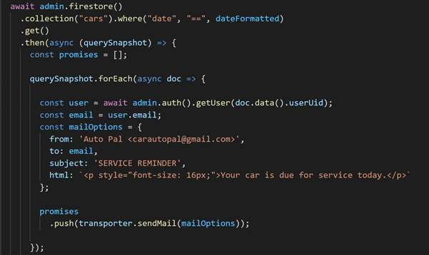

Figure 24: Notification Implementation Solution

The third implementation problem was navigated through by passing GET to method.

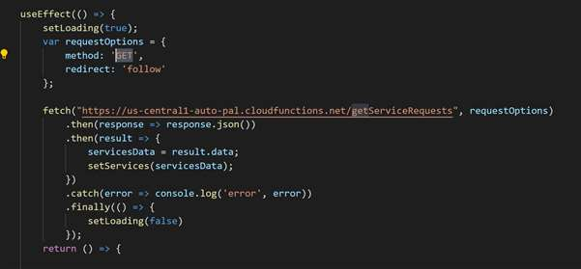

Figure 25: Service Requests Implementation Solution

## 4.5 Testing

Tests are to be conducted on the system with the motive of tracking the availability of errors.

### 4.5.1 Tests Plans

Table 4: Test Plans

|  |  |  |
| --- | --- | --- |
| **Req. No.** | **Description** | **Type Case Id** |
| R-101 | The system shall allow a new User to create an account. | T_01 |
| R-102 | The system shall allow a User to log in to the system. | T_02 |
| R-103 | The system shall allow a user to enter his/her vehicle details. | T_03 |
| R-104 | The System shall allow a User to request breakdown. | T_04 |
| R-105 | The system should be able to collect User location. | T_05 |
| R-106 | The system shall allow a User to book a repair. | T_06 |
| R-107 | The system shall allow a User to book a service. | T_07 |
| R-108 | The system shall allow a User request estimate. | T_08 |
| R-109 | The system should allow a User purchase parts. | T_09 |
| R-110 | The system should be able to get service dating using mileage details | T_10 |
| R-111 | The system should send notifications when a User’s vehicle is set for service. | T_11 |
| R-112 | The system should allow a User view order details. | T_12 |
| R-113 | The system should allow a User view breakdown details. | T_13 |
| R-114 | The system should allow a User view booking details. | T_14 |
| R-115 | The system should allow user to make payments online. | T_15 |
| R-116 | The system should allow admin view estimate request details. | T_16 |
| R-117 | The system should allow admin view booked repair details. | T_17 |
| R-118 | The system should allow admin view booked service details. | T_18 |
| R-119 | The system should allow admin view breakdown details. | T_ 19 |
| R-120 | The system should allow admin view order details. | T_20 |
| R_121 | The system should allow Admin send estimate price to user. | T_21 |
| R_122 | The system should allow Admin add a product | T_22 |
| R_123 | The system shall run on iOS 10.0 and Android 4.1 or later. | T_23 |

### 4.5.2 Test Traceability Matrix

Table 5: Traceability Matrix

|  |  |  |  |  |
| --- | --- | --- | --- | --- |
| **Type Case Id** | **Description** | **Priority** | **Test Date** | **Test Result** |
| T_01 | The system shall allow a new User to create an account. | H | 13/09/2020 | PASS |
| T_02 | The system shall allow a User to log in to the system. | H | 13/09/2020 | PASS |
| T_03 | The system shall allow a user to enter his/her vehicle details. | H | 13/09/2020 | PASS |
| T_04 | The System shall allow a User to request breakdown. | H | 13/09/2020 | PASS |
| T_05 | The system should be able to collect User location. | H | 13/09/2020 | PASS |
| T_06 | The system shall allow a User to book a repair. | H | 13/09/2020 | PASS |
| T_07 | The system shall allow a User to book a service. | H | 13/09/2020 | PASS |
| T_08 | The system shall allow a User request estimate. | H | 13/09/2020 | PASS |
| T_09 | The system should allow a User purchase parts. | H | 13/09/2020 | PASS |
| T-10 | The system should be able to get service date using mileage details | L | 13/09/2020 | FAIL |
| T_11 | The system should send notifications when a User’s vehicle is set for service. | H | 13/09/2020 | PASS |
| T_12 | The system should allow a User view order details. | H | 13/09/2020 | PASS |
| T_13 | The system should allow a User view breakdown details. | H | 13/09/2020 | PASS |
| T_14 | The system should allow a User view booking details. | H | 13/09/2020 | PASS |
| T_15 | The system should allow user to make payments online. | H | 13/09/2020 | PASS |
| T_16 | The system should allow admin view estimate request details. | H | 13/09/2020 | PASS |
| T_17 | The system should allow admin view booked repair details. | H | 13/09/2020 | PASS |
| T_18 | The system should allow admin view booked service details. | L | 13/09/2020 | PASS |
| T_19 | The system should allow admin view breakdown details. | L | 13/09/2020 | PASS |
| T_ 20 | The system should allow admin view order details. | H | 13/09/2020 | PASS |
| T_21 | The system should allow Admin send estimate price to user. | H | 13/09/2020 | PASS |
| T_22 | The system should allow Admin add a product | H | 13/09/2020 | PASS |
| T_23 | The system shall run on iOS 10.0 and Android 4.1 or later. | H | 13/09/2020 | PASS |

### 4.5.3 Test Report Summary

Table 6: Test Report

|  |  |
| --- | --- |
| SUMMARY OF TEST VEHICLERIED OUT | RESULTS |
| Number of tests executed: | 23 |
| Number of tests not executed: | 0 |
| Number of tests passed: | 22 |
| Number of tests failed: | 1 |
| Percentage of test passed: | 96% |
| Percentage of tests failed: | 4% |

## 4.6 Use Guide

The user guide contains instructions on how the intended users of the software can use it with ease to achieve their objectives. The user guide also serves as a tool for referencing if users encounter difficulties while using the software. The user guide for the software can be referred to in Appendix B.

## 4.7 Summary

The chapter four provides details on the implementation of the system, technologies used in the implementation of the system and problems encountered in the course of implementing the system. The chapter also covers the various tests executed on the system to track the availability of errors.

**CHAPTER FIVE**

# DISCUSSION, ENHANCEMENT, AND RECOMMENDATIONS

## 5.1 Overview

This system was developed with the aim of automating vehicle related services to enhance transparency and efficiency. This chapter elaborates on the evaluation of the system from an objective view point through adequate testing and a subjective view point through an appraisal. It also talks about the limitations of the project as well as challenges encountered. Future enhancements to be made on the project. Finally, recommendations were made followed by conclusion.

## 5.2 Objective Assessment

The application has achieved some of its main goals, the application;

1. USER APPLICATION

The application allows a user register with the system.

The application allows a user login to the system.

The application allows users add vehicle details and send notification when service is due.

The application allows a user to request for a breakdown service.

The application allows a user book for service and repairs.

The application allows a user request repair estimate.

The application allows a user purchase parts.

The application allows a user make online payments for parts purchased.

The application allows a user view breakdown request details.

The application allows a user view booked service and repair details.

The application allows a user view estimates requested details.

The application allows a user view order details.

The application sends service notification to user.

1. ADMIN APPLICATION

The application allows an admin add products.

The application allows an admin view breakdown requests.

The application allows an admin view service and repairs booked.

The application allows an admin view breakdown estimates requested.

The application allows an admin view and send repair estimates.

The application allows an admin view orders made.

## 5.3 Limitations and Challenges

During the course of the study the researcher was faced with some limitations and constraint which has impeded the progress of the project. Such limitations are:

1. Financial constraint: Insufficient fund tends to impede the efficiency of the researcher in sourcing for the relevant materials, hardware, software, literature or information and in the process of data collection through the internet and interview.
2. Time constraint: The researcher simultaneously engaged in his studies with other academic related work which consequently, cut down on the time devoted for the research work.
3. Global pandemic (Corona Virus): With the movement restrictions in place, data collection was not properly and sufficiently obtained.

## 5.4 Future Enhancements

The vehicle maintenance and services system are vast application with room for improvements, such improvements are;

* User should be able to include more than one vehicle.
* The system should book a regular service when a vehicles service is due.
* The system should track arriving help on the map when a user requests a breakdown service.
* The system should be able to track order delivery.

## 5.5 Recommendations

This paper titled Design and Implementation of Vehicle Maintenance and Services System

recommends:

1. The full adoption and implementation of this system as an integrated enterprise software in the country for evaluation purposes and success quantifiable matrix visibility.
2. Collecting the statistics about vehicles (e.g., frequency of maintenance, period of usage, parts prone to malfunction etc.) enables organization and researchers to do some machine learning research to improve the method of design and development of the auto parts.

## 5.6 Summary

The research undertaken was aimed at implementing a simple vehicle maintenance and services system. The study sought to design a solution to vehicle management by observing and interviewing the users of the system. An analysis of the manual system was carried out to discover the prerequisite conditions for the proposed system. The proposed system provides a user-friendly platform for service reminder, booking for repairs and servicing, requesting estimate etc. The proposed system was developed using React Native. Firebase database was used for the database design. The actual coding was done using NodeJS. The system has reached a steady-state where all bugs have been eliminated. The system would be operated at a high level of efficiency and all the user associated with the system understands its advantage.

# References

*17 Easy Vehicle Repairs and Maintenance Projects You Can Do Yourself*. (2016). Retrieved July 8, 2020, from The News Wheel: https://thenewswheel.com/easy-vehicle-repairs-and-maintenance/

Adesoji, B. D. (2019, March 11). *Number of vehicles on Nigerian roads hit 11.8m in a year*. Retrieved March 10, 2020, from Nairametrics: https://nairametrics.com/2019/03/11/data-on-the-total-number-of-on-nigerian-roads/

Aganga, O. (2013). *New Auto Policy is Ready*. Retrieved May 7, 2020, from The Punch Nigeria: http://www.punchng.com/business/industry

Akaigwe. (2010). Auto industry @ 50. *Nigerian Journal of Engineering Science*.

Chamberlain, O. (2013). History of Automobile Past and Present Challenges Facing. *IOSR Journal of Research & Method in Education (IOSRJRME)*, 11-16.

Collins, D. (2018, January 16). *Vehicle Bibles*. Retrieved April 23, 20202, from Vehicle Bibles: https://www.vehiclebibles.com/vehicle-maintenance-tips/

*Dealer Management System*. (2018). Retrieved August 12, 2020, from Iterate.in: http://www.iterate.in/dealer-management-software-system.html

Hiraki, S., Inshii, K., & Katayama, H. (n.d.). Designing of a production ordering system for automobile repair parts. *International Journal of Production Economics*.

Izogo, E. E., & Ogba, I.-E. (2016). Service quality, customer satisfaction and loyalty in automobile services sector. *International Journal of Quality & Reliability Management*.

Melosi, M. (n.d.). *Automobile and the Environment in American History: Energy Use and the Internal Combustion Engine*. Retrieved June 3, 2020, from Autolife.umd.umich.edu: http://www.autolife.umd.umich.edu/Environment/E_Overview/E_Overview3.htm

Morell, M. J. (2020, August 8). *Disadvantages Of Embedded Systems*. Retrieved from easysiteaussie: https://easysiteaussie815.weebly.com/disadvantages-of-embedded-systems.html

Okuhit, J. (2015). Sweet New Vehicles. *Huge Maintenance Cost*.

*Prototyping Model in Software Engineering: Methodology, Process, Approach*. (2017). Retrieved April 16, 2020, from Guru99.com: https://www.guru99.com/software-engineering-prototyping-model.html#6

*Top 12 Software Development Methodologies & its Advantages / Disadvantages*. (2015, April 15). Retrieved May 5, 2020, from Custom Software Development & Enterprise Mobile Apps: https://www.tatvasoft.com/blog/top-12-software-development-methodologies-and-its-advantages-disadvantages/

# Appendix

**Appendix A – Work Plan**

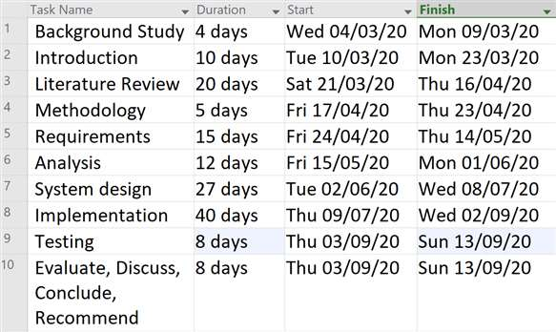

Figure 26: Work Plan

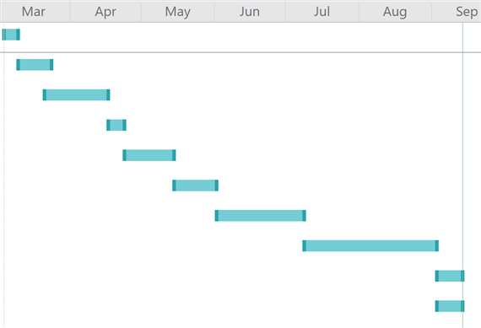

Figure 27: Gantt Chart

**Appendix B– User Guide**

Logging into to the system.

On opening the application, a login in page will be rendered. The login in page contains two text inputs which will collect a user’s email and password to allow a user gain access into the application.

NOTE: One needs to create an account before proceeding to log into the system.

Create an account.

For a user to be recognized by the application he/she needs to create an account. A user can proceed to create an account by clicking on the create account button on the initial page which is the login page.

Adding a vehicle.

On the home screen with title Choose your service, click the icon with my vehicle written underneath it and proceed to entering your vehicle information and then clicking the save button to save your vehicle information.

Requesting for breakdown service.

Requesting for a breakdown service, a user needs to click on the icon with breakdown written underneath it on the home page. The system collects user’s location and directs the user to a page to collect breakdown details such as vehicle info. A user can also request for a tow truck by selecting tow truck in choose service picker.

Booking a repair.

To book a repair, a user needs to click the icon with repair written underneath it and proceed to enter the information on the repair intended to be made on the vehicle and the date and time for the repair.

Booking a service.

To book a service, a user needs to click the icon with service written underneath it and proceed to enter the information on the service intended to be made on the vehicle and the date and time for the service as well the preferred oil to be used.

Requesting an estimate.

To request an estimate, a user needs to click the icon with Get estimate written underneath it then click on Request New Estimate and proceed to enter the information on the service to be rendered. After requesting such estimate, it will take a short while for the estimate to be generated which can be seen by clicking the estimate icon and opening the estimates requested page.

Purchase parts

To make an order for a part, a user needs to click the icon with Purchase parts written underneath it and proceed to select the product you wish to purchase and follow the process.

**Appendix C – Proceedings of Interview**

1. What is your name?
2. What is your current position at Hallmark Automobile Services?

Interview

Questions

Interview questions for the collection of data for the Design and Implementation of

Car Maintenance and Services System.

1. How does the current system work at Hallmark Automobile Services?
2. What are the challenges faced with the manual mode currently used?
3. How effective is the system?

1 2 3 4 5

Very Poor

Very Good

**Appendix D – Source Code**

import React, { useState, useEffect } from 'react'

import { StyleSheet, Text, View, TextInput, TouchableOpacity, Picker, TouchableWithoutFeedback, Keyboard, Button } from 'react-native'

import * as firebase from 'firebase';

import DateTimePicker from "react-native-modal-datetime-picker";

let userVehicleData;

const MyVehicle = ({ navigation }) => {

const userUid = firebase.auth().currentUser.uid

const [vehicleMake, setVehicleMake] = useState("");

const [vehicleModel, setVehicleModel] = useState("");

const [vehicleYear, setVehicleYear] = useState("");

const [volume, setVolume] = useState("");

const [mileage, setMileage] = useState("");

const [unit, setUnit] = useState("Distance unit");

const [engineType, setEngineType] = useState("Engine type");

const [isDateTimePickerVisible, setIsDateTimePickerVisible] = useState(false);

const [dateValue, setDateValue] = useState("");

const [loading, setLoading] = useState(false)

const [vehicleExists, setVehicleExists] = useState(false)

useEffect(() => {

setLoading(true);

var requestOptions = {

method: 'GET',

redirect: 'follow'

};

fetch(`https://us-central1-auto-pal.cloudfunctions.net/getUserVehicle/${userUid}`, requestOptions)

.then(response =>response.json())

.then(result => {

userVehicleData = result.data;

// console.log(userUid, result);

if (userVehicleData) {

setVehicleExists(true);

setVehicleMake(userVehicleData.make || '');

setVehicleModel(userVehicleData.model || '');

setVehicleYear(userVehicleData.year || '');

setVolume(userVehicleData.volume || '');

setMileage(userVehicleData.mileage || '');

setUnit(userVehicleData.distanceUnit || '');

setEngineType(userVehicleData.engineType || '');

setDateValue(userVehicleData.date || '');

}

})

.catch(error => console.log('error', error))

.finally(() => {

setLoading(false)

});

return () => {

}

}, [])

const showDateTimePicker = () => {

setIsDateTimePickerVisible(true)

};

const hideDateTimePicker = () => {

setIsDateTimePickerVisible(false)

};

const handleDatePicked = (date) => {

setDateValue(date)

hideDateTimePicker();

};

const vehicleMakeText = (inputMake) => {

setVehicleMake(inputMake)

}

const vehicleModelText = (inputModel) => {

setVehicleModel(inputModel)

}

const vehicleYearText = (inputYear) => {

setVehicleYear(inputYear)

}

const volumeText = (inputVolume) => {

setVolume(inputVolume)

}

const engineTypeText = (inputEngineType) => {

setEngineType(inputEngineType)

}

const mileageText = (inputMileage) => {

setMileage(inputMileage)

}

const save = () => {

var myHeaders = new Headers();

myHeaders.append("Content-Type", "application/json");

var raw = JSON.stringify({ userUid, "make": vehicleMake, "model": vehicleModel, "year": vehicleYear, "volume": volume, "engineType": engineType, "mileage": mileage, distanceUnit: unit, date: dateValue });

var requestOptions = {

method: 'POST',

headers: myHeaders,

body: raw,

redirect: 'follow'

};

fetch("https://us-central1-auto-pal.cloudfunctions.net/createUserVehicle", requestOptions)

.then(response => response)

.then(result => {

navigation.navigate("Home")

})

.catch(error => console.log(error))

}

return (

<TouchableWithoutFeedbackonPress={Keyboard.dismiss}>

<View style={styles.container}>

<View style={styles.innerContainer}>

<View style={styles.borderLine}>

<View style={styles.body}>

<View style={styles.inputContainer}>

<Text style={styles.text}>Vehicle Make</Text>

<TextInput

placeholder="Honda"

style={styles.textInput}

onChangeText={(inputMake) =>vehicleMakeText(inputMake)}

value={vehicleMake}

/>

</View>

<View style={[styles.inputContainer, { marginLeft: "2%" }]}>

<Text style={styles.text}>Vehicle Model</Text>

<TextInput

placeholder="Accord"

style={styles.textInput}

onChangeText={(inputModel) =>vehicleModelText(inputModel)}

value={vehicleModel}

/>

</View>

<View style={styles.inputContainer}>

<Text style={styles.text}>Vehicle Year</Text>

<TextInput

placeholder="2020"

style={styles.textInput}

onChangeText={(inputYear) =>vehicleYearText(inputYear)}

value={vehicleYear}

/>

</View>

<View style={[styles.inputContainer, { marginLeft: "2%" }]}>

<Text style={styles.text}>Volume</Text>

<TextInput

placeholder="1.6"

style={styles.textInput}

onChangeText={(inputVolume) =>volumeText(inputVolume)}

value={volume}

/>

</View>

<View style={styles.picker}>

<Picker

selectedValue={engineType}

onValueChange={(inputEngineType) =>engineTypeText(inputEngineType)}

itemStyle={{ fontSize: 10 }}

>

<Picker.Item label="Engine type" value="Engine type" />

<Picker.Item label="Petrol" value="Petrol" />

<Picker.Item label="Diesel" value="Diesel" />

</Picker>

</View>

<View style={styles.picker}>

<Picker

selectedValue={unit}

onValueChange={(unitValue) =>setUnit(unitValue)}

itemStyle={{ fontSize: 10 }}

>

<Picker.Item label="Distance unit" value="Distance unit" />

<Picker.Item label="km/h" value="km/h" />

<Picker.Item label="m/h" value="m/h" />

</Picker>

</View>

<View style={[styles.inputContainer, { marginLeft: "2%" }]}>

<Text style={styles.text}>Mileage</Text>

<TextInput

placeholder="90000"

style={styles.textInput}

onChangeText={(inputMileage) =>mileageText(inputMileage)}

value={mileage}

/>

</View>

<Button title="Pick date" color="grey" marginToponPress={showDateTimePicker} />

<DateTimePicker

isVisible={isDateTimePickerVisible}

onConfirm={handleDatePicked}

onCancel={hideDateTimePicker}

mode='date'

/>

</View>

{

!vehicleExists&& (

<TouchableOpacity style={styles.button}

onPress={save}

>

<Text style={styles.save}>Save</Text>

</TouchableOpacity>

)

}

</View>

</View>

</View>

</TouchableWithoutFeedback>

)

}

export default MyVehicle