**DESIGN AND IMPLEMENTATION OF STUDENT-CENTRED SPEAKING PROFICIENCY (*KALAM*) LEARNING THROUGH THE ARABIC INTENSIVE PROGRAMME**

**ABSTRACT**

**Background:** Student-centered Arabic-speaking learning (Kalam) is important to be carefully and precisely designed so that Arabic learning is easier and more enjoyable according to the needs of students.

**Purpose:** This study aims to present the concept design, implementation, and experimentation of the teaching and learning process of Arabic speaking proficiency centered on the needs of students through intensive training programs.

**Method:** This type of research uses quasi-experimental experiments with a control group pretest-posttest design. The population of this study is even semester 2022-2023 students totaling 205 students and a sample of 35 students. The sampling technique uses random sampling from class III-A and III -B units. Data collection techniques are observation, experimentation, interviews, and documentation. Data analysis in this study was carried out repeatedly with a data reduction system, data presentation, and verification of conclusions.

**Results and Discussion:** The design and implementation of speaking skills a very important skills in learning foreign languages, but to obtain maximum results, the lecturers' ability techniques and methods used are determining factors in achieving an increase in student speaking proficiency. The calculation results showed that the effectiveness rate and difference in students' kalam skills was 83.13%, and the use of student-centered active speaking methods did not experience significant obstacles, which was an average of 9.52%, this showed that the intensive Arabic training program was very effective in learning and improving proficiency (kalam).

**Conclusions and Implications:** The design and implementation of lectures are more effectively carried out by being student-centered through brainstorming. The formulation of learning targets by individual students implements lectures more student-centered. It takes *takrar, tazawudd, and ta'awwun* techniques to develop Arabic speaking skills in a continuous intensive program. This research implies that the application of *kalam* learning patterns through training intensity programs is very well carried out gradually and continuously So that the material that has been designed can be developed with actual themes according to the needs of students.

**CHAPTER ONE**

**BACKGROUND**

In the old paradigm, language learning was carried out with a uniform approach (*unitary*). [1] In this approach, learners are given the same linguistic presentation. Language learning programs are designed to be applied to all learners, regardless of their communication goals. This uniform approach has drawn criticism from the communicative approach. According to the communicative approach, the content of language learning should reflect the learner's goals. Learning is designed to be tailored to the needs of the learner, not the learner to adapt to the learning design.[2]

The effectiveness of language learning activities can be achieved if lecturers are aware of the needs of learners. Their needs and choices are important for developing learner autonomy and are important in designing learner-based syllabi. This means that it is also important in learning evaluation (MK). In the Journal of Ethical Lingua Vol X Number X Year 2022, Shifani stated that in the process of designing the curriculum, the needs and choices of learners need to be considered.[3]

Needs analysis is a set of procedures for specifying MK, which includes criteria or reasons for grouping learners, selection and sequence of material, methodology, intensity, and duration required.[4] In the Journal of Ethical Lingua Vol X Number X Year 2022, it is also stated that the flow of needs analysis can guide MK designers to provide a clear and precise definition of the content of MK for certain groups of learners. Requirements analysis is the starting point of MK design.

Needs can be defined as the difference between what learners can do using language today and what learners should be able to do using language in the future.[5] The conventionally simple definition of needs is the mismatch between current and future desires and circumstances. Needs in the context of language needs are also often described as language skills or proficiency necessary to survive in the target language community.[6]

According to research findings, learners and lecturers may have different needs. Therefore, Robinson suggests that needs analysis needs to be done by gathering information from various sources.[7] There are at least three sources in needs analysis, namely learners, *student employers*, and academic organizations. The needs interpreted by the sponsor may differfrom the needs felt by the learner. Nonetheless, the needs of learners need to be carefully considered. Determining the needs of learners will be able to help learners learn and apply what they are a student.[8]

Richards agrees that needs analysis needs to involve learners, lecturers, administrators, and implementers of the planning process so that it can help in identifying language-specific needs and language program content.[9] In addition, it is necessary to evaluate the ongoing program. During this time research emphasizes the importance of needs analysis for planning learnings, writing textbooks, or teaching materials. Needs analysis not only needs to be done at the beginning of the program, but it needs to be done during the language program because learning attitudes and approaches can change during the program.

In starting lectures at the beginning of each semester, lecturers are required to prepare a semester lecture plan (RPS). Based on the observations and experiences of researchers while teaching at the Department of Arabic Language Education IAIN Sultan Amai Gorontalo, the preparation of RPS is carried out by lecturers unilaterally without involving students. This means that the preparation of the RPS has not paid attention to the needs of students. The needs, wants, and opinions of students have not been explored and adopted into RPS. At the beginning of the semester, lecturers prepare and distribute RPS to students. In this case, the lecturer also asks students to put forward certain proposals. However, students tend to take for granted the designs that have been made by lecturers.[10]

Similar conditions occur in the process of implementing *Kalam* learning. Student activities tend to depend on the scenario from the lecturer. In other words, students accept even waiting for the lecturer's design. Student activities are limited to activities instructed by lecturers. In this case, students carry out a learning activity not because they are encouraged to develop themselves, but simply to fulfill the instructions of the learning supervisor. As a small example, if the lecturer gives a certain homework, students try to do it. However, if the lecturer does not provide homework, students do not do any activities. So it can be said that students lack the initiative to develop their abilities in lectures.

In line with the dependence of students on the lecturer scenario, students generally do not have goals or targets in attending lectures. It could be that they have a final target to pass the learning, but do not target a specific passing score. They also do not set intermediate targets that will lead them to graduation. The intermediate targets referred to here are targets on each subject, subsubject, meeting, or even each activity.

On the other hand, during lectures, lecturers as learning supervisors may also lack attention to student learning targets. Lecturers do not pay attention to what is the target of students in the lectures fostered. Moreover, lecturers pay less attention to whether students have certain targets to be achieved in a face-to -face activity or not. This lack of attention has an impact on the absence of lecturers' efforts to know, moreover, familiarize students with formulating learning targets.

This reality is not in line with the paradigm shift in learning that increasingly emphasizes the existence of learners. Students as one of the main components of learning need to be more empowered starting at the lecture design stage. Based on this reality and the importance of observing the needs and choices of learners, *Kalam's* experimental learning research focused on the needs of students through an intensive Arabic program*.*

**CHAPTR TWO**

**LITERATURE REVIEW**

**1. Arabic Language Learning**

The opinion of Thobroni and Musthofa in Learning and Learning, suggests that learning is an effort in which there is a conscious and permanent change in behavior. The manifestation of these efforts is that there is active student interaction and response with lecturers, friends, and their environment. [11] Learning is the acceptance of a learning, which results in the growth of skills through experience, students, and teaching.[12] Interpreting learning as a process of relationship between students and the environment, so that there are behaviors that change for the better. In line with that, he also explained that learning is the construction of the learning process by lecturers, in increasing mastery of the material and developing students' thinking creativity. [13]

Arabic language learning is a learning process that conditions students to understand and understand four language skills, the four language skills namely, *maharat istima', al-kalam, alqira'ah,* and *al-kitabah* in a balanced manner.[14] There is an emphasis on mastering languageskills after studying, making practitioners of Islamic Religious Education practice skilled in reading, writing, translating, and speaking Arabic properly and correctly. [15]

**2. Arabic Learning Objectives**

The purpose of learning Arabic is for students to have the following competencies:

1. Students understand the laws and teachings of Islam through the Qur'an and al-Hadith.
2. Understanding and understanding, Islamic culture and books of Islamic religious knowledge that speak Arabic.
3. Have the skills to write, compose, and speak Arabic.
4. Provide additional skills for students.
5. Guiding professional Arabic linguists [16].

Based on the explanation above, it can be understood that Arabic learning at high doses is in line with the objectives of learning Arabic in general, namely first to student religious sources from authentic sources, namely the Qur'an and al-Hadith. Second, understand the concept of Arabic writing. Third, to be able to read and understand the content of Arabic books/texts to increase scientific insight about Islam, Islamic culture, and Arabic culture.

**3. Arabic Learning Approach**

Anthoni in Andri et al. said that a set of ideas related to learning, teaching, and the nature of language is called an approach. [16] The approaches applied in learning Arabic according to Subur are the *aural-oral approach,* communicative approach, and humanistic approach. The following is the explanation:

1. *Aural-oral approach* An approach that focuses on listening and pronunciation, language learning is believed to be what is heard and what is said. The *aural-oral approach* is also said to be a habitual language learning, therefore there must be repetition in language learning.[18] Thus, it can be understood that language learning is a word or a pursuit.
2. The communicative approach assumes, that language functions as a means of communication, so the emphasis on this approach is the active activity of communication and its communication practice. The characteristics of a person who has good communication are, using good grammar, having pronunciation that is understood and understanding the pronunciation of others, having accuracy between the content of speech and the situation occurs, and the continuity and continuity of language practice. That is, the communicative approach seeks to emphasize, that language becomes a communication tool that is well practiced according to the rules of good and correct language.
3. The humanistic approach is an approach that makes students the most important subject in learning. The assumption believed in the humanistic approach is that students have the strength, potential, and competence to develop. Humanistic approach, considering emotional aspects, attitude aspects, and values. This approach gives freedom to students, to be responsible for themselves, and their creative development.[18]

The language learning approach in addition to the above approach is the *All-in-One System* Approach ( *Nadzariyyatul wihdah*). An *all-in-one* system can also be referred to as anintegrated system. As Yufridal said, language is a system that is interconnected with one another, not a separate system. The assumption adopted in the *all-in-one system* approach is that language learning starts from listening and listening to words or sentences first, then saying words and sentences before reading and analyzing them.[19] That is, *Maharat lughowiyah* taught first of all, listening or listening skills (*istima'*), speaking (*kalam*), readingskills, then writing skills (*kitabah*).

**4. Arabic Learning Techniques**

Speaking of the word technique, what comes to mind is the tool and how to use it. This is similar to what is referred to in the Big Dictionary of Indonesian, which states that "technique" is a way of doing something and or a step of doing something with art.[20] Thus, technique is a way of practice and a specific form of method applied in learning activities. As for learning Arabic, there are many techniques used. Here are some techniques used in learning Arabic;

1. *Takrar.* Yunus in Fitriani, explains the meaning of takrar taken from Arabic means to do something repeatedly or repeat something. The technique of *takrar* means the attempt to practice something with systematic repetition, sequentially and regularly to acquire the expected ability. Repetition is in the form of a process of repetition in memorization, either by listening or listening to other people's words or reading by yourself repeatedly.[20] *Takrar* is defined as repetition. Learning foreign languages and Arabic requires repetition in practicing, listening, pronouncing, and applying
2. *Al-Tazawwud.* The technique *of al-tazawwud*, is defined in the Indonesian of debriefing. This technique is applied by transferring materials into Arabic, especially in materials related to science about Islam. So, armed with knowledge about Islam, students learn Arabic in terms of content, as well as sentence preparation.[22] A technique that applies a debriefing system about Islamic religious science from Indonesian to Arabic, so that in this way students can understand the content, and how to arrange sentences.
3. *Al-Ta’awun*

This technique prioritizes language as a means of communication between others, so cooperation is needed to improve language skills.[22] Rifki in the Arabiyat Journal defines *al-ta'awun* as cooperative learning, where in the process students work with each other in groups to build a team that has the spirit of learning to achieve learning goals.[23] That is, the aspect emphasized in *ta'awun* technique is cooperation or team*work*.

**5. Arabic Speech Proficiency (*Kalam*)**

Speaking proficiency (*Kalām/speaking*) is the ability to express articulated sounds or words to express thoughts in the form of ideas, opinions, desires, or feelings to the interlocutor. In a broader sense, speaking is a system of signs that can be heard and seen that utilize several muscles of the human body to convey thoughts to meet their needs.[24]

*Al -Kalām* is linguistically derived from Arabic which means words.[25] In terms of speech is the ability to express articulated sounds or words to express thoughts in the form of ideas, opinions, desires, or feelings to the interlocutor. In a broader sense, speaking is a system of signs that can be heard and seen that utilizes several muscles and tissues of the human body to convey thoughts to meet their needs.[26] Speaking is a language skill that develops in a person's life that is only preceded by listening skills, during which time the ability to speak or speak is students. Speaking is certainly closely related to the development of vocabulary obtained by a person through previous listening activities.[27]

Speaking skills are the most important language skills. Because speaking is part of the skills learned by teachers, speaking skills are considered a very basic part of learning foreign languages.[27] *Mahārah al-Kalām*, on the other hand, is to speak continuously without stopping without repeating the same vocabulary using sound expressions.[29] Speaking proficiency is one type of language proficiency to be achieved in the teaching of modern languages including Arabic. Speaking is the main means of fostering mutual understanding, and mutual communication, using language as a medium.

Speaking skills are considered a very important skill in learning foreign languages because speaking is an application of the language and is the initial goal of someone who learns a language. It's just that, what needs to be considered in learning to speak to get maximum results is the ability of a lecturer and the method he uses, because these two factors dominate the success of learning to speak.[30]–[32]

As to teach speaking skills (*Mahārah Al-Kalām*) as presented by Mahmud Yunus is:

1. Familiarize students to be fluent in Arabic
2. Train students to be good at explaining what goes through their hearts and what is captured by their five senses in the right and properly arranged words
3. Train students to be able to form the right opinion and explain in clear and unhesitating words
4. Familiarize students to be good at choosing words and arranging them according to grammar and good at putting each word in its place.[33]

**CHAPTER THREE**

**METHOD**

The research method used is field research with a quasi-experimental approach with a control group pretest-posttest design. The data used in this study is data with a quantitative approach which is statistical analysis figures using experimental methods to look for the effect of certain treatments under controlled conditions. The population of this study is even semester 2022-2023 students totaling 150 students. The sample technique used was random sampling with the number of samples in this study being 53 students from units III-A and III-B. Data collection techniques are observation, experimentation, interviews, and documentation. Data analysis in this study was carried out repeatedly with a data reduction system, data presentation, and verification of conclusions. Data analysis techniques consist of qualitative and quantitative data. Qualitative data displays the results of analysis of current learning conditions through intensive programs, while quantitative data in the form of pre-test and post-test data both in the control class and experimental class are presented in the form of diagrams.

**RESULTS AND DISCUSSION**

The results of the initial reflection show that *Kalam* lectures are generally carried out *top-down*. At the beginning of the semester, lecturers compile and distribute RPS to students. Inthis case, students also tend to follow the RPS. This makes students feel less ownership and less responsibility for the design. In addition, the tasks given to students both at the design and implementation levels are more emphasized on the theme and pay less attention to the language activities to be carried out. For example, students are always asked to prepare themselves in *Kalam* lectures with certain themes, for example with the theme of Arabic learning problems.

However, students are not told what form of language activity is required of them to do with the theme. Will students be asked to dialogue by role-playing lecturers who consult Arabic learning experts, verbally report Arabic learning problems, or have free dialogue on themes? Without clarity about the language activities to be carried out, student learning targets tend to be limited to obtaining materials or materials relevant to the theme. As a result, students do not have specific learning targets in the form of practice or language skills. Furthermore, students' efforts to practice language are relatively less.

Based on these problems, three actions were carried out in *Kalam* lectures, namely (a) collaborative lecture design by inviting students to brainstorm ideas about the form of language activities they want and the themes that contain them, (b) familiarize students to formulate learning targets, and (c) familiarize students to develop learning strategies. The results of the three actions are stated as follows.

**1.** ***Kalam Lecture Design* is Student-Centered Through Brainstorming**

To be able to accommodate students' needs, choices, and/or opinions into *Kalam*'s lecture design, in this study students are involved in the design process. Student involvement is carried out in the form of brainstorming activities. In brainstorming, students are asked to express the form of language activities and communication themes that they think need to be trained for them through *Kalam proficiency lectures.*

Brainstorming ideas about the form of language activities and the theme of communication is carried out on the first day of lectures in stages. First brainstorming is carried out in the form of language activities, then continued with brainstorming on the theme of communication. The phasing of the brainstorming is intended so that students can focus on one particular thing.

In brainstorming, the researcher acts as a guide. Each proposal is recorded or recorded on the board in circles. Proposals in the form of language activity are recorded on the board on the right. Instead, proposals on the theme of communication are recorded on the board on the left. The brainstorming notes are then transferred to the field note paper. The brainstorming results in question are re-displayed as follows:

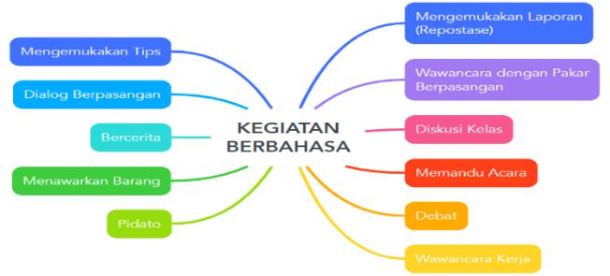

**Picture 1:** Results of Brainstorming on the Form of Language Activities

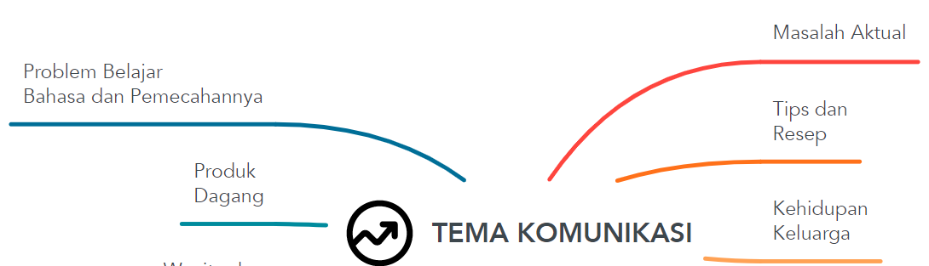

**302**

**Picture 2:** Results of Brainstorming on Communication Themes

Brainstorming activities are carried out on the first day of lectures. Given the similarity, closeness, or perhaps coverage in language activities and communication themes raised by students, focusing is needed. The focus is carried out in the second stage of brainstorming by reselecting student choices that have been previously stated. As a reconstruction step, the results of the refocus are then paraded with the theme of communication and included in the face-to-face lecture schedule as presented in Table 1.

**Table 1: Lecture Meeting Schedule *Kalam* 2022-2023**

|  |  |  |  |  |  |  |  |  |  |  |  |  |  |  |
| --- | --- | --- | --- | --- | --- | --- | --- | --- | --- | --- | --- | --- | --- | --- |
|  | N |  |  | **Day/Date** |  |  | **Language Activities** |  |  | **Communication Theme** |  | |  | |
|  |  |  |  |  |  |  |  | |  | |
|  | o |  |  |  |  |  |  |  |  |  |  | |  | |
|  | 1 |  |  | 4 Feb. 08 |  |  | Lecture design through |  |  | **What to see** |  | |  | |
|  |  |  |  |  |  |  | brainstorming |  |  |  |  | |  | |
| 2 | |  |  | 6, 11, 13 Feb. 08 |  |  | Student consultation with |  |  | Problems in learning Arabic, especially | |  | |
|  |  |  |  |  |  |  | lecturers or experts |  |  | speaking skills: Goals, efforts, and | |  | |
|  |  |  |  |  |  |  |  |  |  | problems | |  | |
|  | 3 |  |  | 18, 20, 25 Feb. 08 |  |  | Expressing thoughts and |  |  | Flood Disaster in Indonesia: Causes, |  | |  | |
|  |  |  |  |  |  |  | comments |  |  | losses, and solutions |  | |  | |
| 4 | |  |  | 27 Feb., 3 dan 5 |  |  | Bring up tips individually or in |  |  | Tuition Fees (between quality and | |  | |
|  |  |  |  | Mar. 08 |  |  | an interactive consultation |  |  | Business) | |  | |
|  |  |  |  |  |  |  | program |  |  |  |  | |  | |
|  | 5 |  |  | 10, 12, 17 Mar. 08 |  |  | Offer goods |  |  | Trade products |  | |  | |
| 6 | |  |  | 19, 24, 26 Mar. 08 |  |  | Describe |  |  | SAC | |  | |
|  | 7 |  |  | 31 Mar., 2 dan 7 |  |  | Using expressions of anger, |  |  | Family life |  | |  | |
|  |  |  |  | Apr. 08 |  |  | ridicule, and praise |  |  |  |  | |  | |
| 8 | |  |  | 9, 14, 16 Apr. 08 |  |  | Exchange information |  |  | Arabic time media | |  | |
|  | 9 |  |  | 21, 23, 28 Apr. 08 |  |  | Host events and give speeches |  |  | free |  | |  | |
| 10 | |  |  | 30 Apr., 5 dan 7 |  |  | Debate |  |  | Women Careers | |  | |
|  |  |  |  | Mei |  |  |  |  |  |  |  | |  | |
|  | 11 |  |  | 12 Mei 08 |  |  | Review and explanation of |  |  | Test |  | |  | |
|  |  |  |  |  |  |  | language activities in the final |  |  |  |  | |  | |
|  |  |  |  |  |  |  | semester exam |  |  |  |  | |  | |
| 12 | |  |  | 14, 19, dan 21 Mei |  |  | Offers merchandise |  |  | E- Commerce | |  | |
| 13 | |  |  | Pekan Ujian |  |  | **End-of-term exam** |  |  | Free: from each theme of communication | |  | |
|  |  |  |  |  |  |  |  |  |  | are taken five words. The collected words | |  | |
|  |  |  |  |  |  |  |  |  |  | are used as basic capital to form a new | |  | |
|  |  |  |  |  |  |  |  |  |  | story with a certain theme (free) | |  | |

From the face-to-face schedule of lectures, it appears that there are several points of brainstorming results about unscheduled communication activities in lecture activities. This is solely due to the limited allocation of time available. The determination of items that are included or not included in the face-to-face schedule is carried out with students.

Brainstorming has been done, in addition to identifying content needs also to identify process needs. According to Nunan, content needs are needs related to topical issues, grammar, function, thoughts, and vocabulary, which are traditionally in the field of syllabus design. Instead, process needs are needs related to the selection and presentation of tasks and learning experiences needed by learners to develop their communication competencies. Thus, the brainstorming carried out to identify forms of language activities can be said to be a process that needs analysis. The brainstorming carried out to identify the theme of communication can be glued as an analysis of content needs. So through this brainstorming, students are involved in designing the material that will be studied as well as the activities that will be carried out during lectures.

In addition to identifying initial needs, brainstorming is also carried out to identify ongoing needs, namely needs that arise when the lecture period is in progress. The results of the identification of ongoing needs are included in the face-to-face schedule table, at no. 7, that is, practicing the expressions of anger, ridicule, and praise obtained from the film. The activity was raised because, in the middle of the semester, students submitted a proposal to watch a film together. Therefore, a language activity is included based on Arabic film material that is by certain communication themes that have been proposed by students, namely family life. The language activity in the seventh part should be a job interview with the theme of job market communication.

Language activities and communication themes identified by these students can also be categorized as perceived needs. *Felt needs* are the needs that learners have. Brookfield defines *felt needs* as the learner's *wants*, *desires,* and wishes. So it can be said that the brainstorming done may not fully explore the needs of learners. But most can at least identify their desires.

1. **Implementation of *More Student-Centered* Kalam Lectures**

In accordance with the research objectives, the presentation of research results on the implementation of more student-centered kalam lectures is grouped into two, namely (a) the implementation of student-centered kalam lectures through the formulation of student-centered learning targets and (b) the implementation of student-centered kalam lectures through the development of learning strategies by students.

1. **Implementation of Kalam Lectures through the Formulation of Learning Targets**

Brainstorming activities are relatively more effective for involving students in learning design than distributing RPS to students followed by offers to submit proposals. In the old pattern, students tended to be passive and immediately agreed to the design that had been made by the lecturer. Conversely, in brainstorming students actively put forward their proposals. However, in brainstorming that is 100% done orally, there are still students who do not put forward their proposals. When many proposals have emerged, other students are reluctant to identify and submit their proposals. This can be avoided if previously each student was asked to write on paper one proposal about the form of language activities and one proposal on the theme of communication.

Based on the results of reflection in cycle 1, in the second cycle improvements were made in the research steps. For each student to be active, students are asked to formulate their learning targets (goals) in writing. Actions in the form of assignments to formulate learning targets are given for one semester by language activities that have been designed together. The formulation of the learning target is collected on the next meeting day before the bill for language activities with the intended theme is implemented.

This second action was given so that the implementation of *Kalam* lectures was more student-centered. In RPS *Kalam* which is designed collaboratively between lecturers and students, student involvement is limited to the analysis of content and process needs which results in forms of language activities and communication themes. Apart from the content and process components, RPS has another main component, namely the learning objectives. The purpose of the learning is usually a reformulation of the learning description listed in the department catalog. That means the purpose of the learning does not come from students. As a result, the purpose of the learning is not directly the goal of students. In other words, students do not automatically feel they have this purpose.

The implementation of lectures can be more student-centered if each student has a clear learning target (goal). Therefore, for students to be aware of the goals and feel they have a purpose, students are asked to formulate their learning targets in the form of language activities and the theme of communication that will be passed. As stated in the research procedure, this task is integrated with the task of learning to prepare in writing the draft or concept of speech to be put forward which fully includes the following components: (a) task identity consisting of the title of language activities *(an-nasyath allughawi)* and the theme of communication *(al-mawdhu'), (b) learning targets (al-ahdaf), (c) efforts taken to achieve* targets (*al*-*muhawalat* ) that describe learning strategies, (d) new and important vocabulary and itsdevelopment in sentences, and (e) drafts or speech concepts.

The results of data collection show that student learning targets are quite varied and tiered. Several general learning target formulations were obtained as stated below.

**Table 2.** Student Learning Target

|  |  |  |
| --- | --- | --- |
| **No** | **Target** | **Action Indicators** |
|  |  |  |
| 1 | Getting used to speaking Arabic | Spontaneous |
|  |  |  |
| 2 | Speak fluently | Relax |
|  |  |  |
| 3 | Speak without text | Fluent |
|  |  |  |
| 4 | Mastering the material to be delivered | Confidence |
|  |  |  |
| 5 | Provides a quick response when talking | Reactive |

The learning targets that students are asked to formulate are learning targets in the context of various activity task forces and certain communication themes. A language activity assignment accommodated in a particular theme is carried out in 2-3 lectures. So students are not asked to formulate targets for one semester. Therefore, the formulation of the learning target above can be said to be general because it is not directly related to a language activity task to be carried out or to the theme of communication that accommodates it. Moreover, the bottom three target formulations are more general than others and are not very clear.

In addition to not being directly related to a form of language activity or communication theme, the generality of the learning target above lies in the absence of certain limitations, such as limitations on time, place, and frequency. For example, the bottom formulation that is re-quoted below Can familiarize yourself with speaking Arabic and will be more specific if given a time limit, for example, modified to Get used to speaking Arabic with students he first meets on campus.

Some students formulate more specific learning targets. Students who originally formulated general targets in end after reflection formulated targets more specifically. They associate it with the language activities assigned to it. Here are some examples of more specific learning target formulations.

1. Can promote an item to consumers.
2. Able to express as well as a *salesperson.*
3. Being able to perform in front of friends as if I were a *salesperson*.
4. Dialogue or question and answer with consumers smoothly. speak Arabic directly without text Can speak Arabic in front of others, especially in front of the class.
5. Can provide answers to questions about problems learning Arabic by reflecting on yourself. Can speak Arabic by acting as a student who consults with lecturers on ways to improve Arabic speaking proficiency

These various learning targets are more specific than the series of learning targets that have been stated in the points in front of him. Each target is associated with the form of language activities and/or the theme of communication. From the formulation of the learning target, it can be seen that some students target to be able to demonstrate the speech of a magazine salesman, a lecturer who provides consulting services, or students who are consulting with their lecturers. The various activities listed on the lecture meeting schedule are the result of student brainstorming. Through brainstorming, they designed the *Kalam* II lecture to contain the tasks of language activities. Therefore, the association of learning targets with language activities shows that there is clarity in students about the tasks to be carried ou**t**.

**b. Kalam Lecture Training through Learning Strategy Development**

As with the second action, the third action, namely the development of learning strategies to achieve learning targets, is given for one semester and carried out in writing. Learning strategies developed by students to achieve learning targets are classified based on the O'Malley model which includes three types of learning strategies, namely cognitive strategy, metacognitive strategy, and socio-affective strategy.

The O'Malley model is used as a basis for classification because it is more adequate for learning strategies developed by students. While the Oxford classification model in the context of the results of this study is relatively too detailed. That is, the learning strategies developed by students do not include all types of strategies in the Oxford model. In this case, no strategy can be categorized as a semem and compensation strategy. Strategies included in the Sosaf category are also more likely to be social strategies. Thus, O'Malley's classification model is seen as more significant. The various strategies in question are presented in Table 3.

**Table 3:** Learning Strategies Developed by Students

|  |  |  |  |  |  |  |  |  |  |  |  |  |  |
| --- | --- | --- | --- | --- | --- | --- | --- | --- | --- | --- | --- | --- | --- |
|  | **Learning Strategies** |  |  |  |  |  | **Kind** | |  |  |  |  |  |
|  |  |  |  |  |  |  |  |  |  |
|  |  |  | **Sekog** |  |  | **Semet** |  |  | **Sesosaf** | |  |  |
|  |  |  |  |  |  |  |  |  |  |
|  | Look for magazines whose language is easy to understand | |  |  |  |  | √ | |  |  |  |  |  |
|  | Choose a section that discusses new things and if presented to |  |  |  |  |  | √ |  |  |  |  |  |  |
|  | potential customers they will be interested |  |  |  |  |  |  |  |  |  |  |  |
|  |  |  |  |  |  |  |  |  |  |  |  |  |
|  | Read the headlines in the magazine and understand their meaning | |  | √ | |  |  |  |  |  |  |  |  |
|  | Looking up the meaning of difficult words in the dictionary |  |  |  |  |  |  |  |  |  |  |  |  |
|  | Identify words about promotional activities | |  |  |  |  | √ | |  |  |  |  |  |
|  | Record all rubrics and understand their contents |  |  | √ |  |  |  |  |  |  |  |  |  |
|  | Interpret and understand sources in the form of BA magazines. | |  | √ | |  |  |  |  |  |  |  |  |
|  | Create sentences from identified words. |  |  | √ |  |  |  |  |  |  |  |  |  |
|  | Correct whether the sentence is relevant to the language task | |  |  |  |  | √ | |  |  |  |  |  |
|  | Recreate sentences that don't match the theme |  |  | √ |  |  |  |  |  |  |  |  |  |
|  | Identify the physical description, advantages, and disadvantages of | |  | √ | |  |  |  |  |  |  |  |  |
|  | the magazine and describe it by highlighting its advantages | |  |  |  |  |  |  |  |  |  |
|  |  |  |  |  |  |  |  |  |  |  |  |
|  | Trying to promote (talk to yourself) in the room, in the bathroom, |  |  | √ |  |  |  |  |  |  |  |  |  |
|  | in front of the glass (spontaneously) perceiving objects in the room |  |  |  |  |  |  |  |  |  |  |  |
|  | as consumers |  |  |  |  |  |  |  |  |  |  |  |  |
|  |  |  |  |  |  |  |  |  |  |  |  |  |  |
|  |  |  |  |  |  |  |  |  |  |  |  |  |  |
|  |  |  |  |  |  |  |  |  |  |  |  |  |  |
|  |  |  |  |  |  |  |  |  |  |  |  |  |  |

|  |  |  |  |  |  |  |  |  |  |  |  |  |
| --- | --- | --- | --- | --- | --- | --- | --- | --- | --- | --- | --- | --- |
|  | Describe the magazine in your own language | | |  | √ | | | | | |  | |
|  | Conceptualize what to say | |  |  |  |  |  |  |  |  | |  | |
|  | Read over and over again until memorized | | |  | √ | | | | | |  | |
|  | Practice out loud |  |  |  | √ |  |  |  |  |  | |  | |
|  | Practice conveying ideas without looking at the text | | |  | √ | | | | | |  | |
|  | Improvise | in | the practice of offering magazines to |  | √ |  |  |  |  |  | |  | |
|  | roommates |  |  |  |  |  |  |  |  | |  | |
|  |  |  |  |  |  |  |  |  |  | |  | |
|  | Trying to talk to myself about speaking skills by asking my | | |  | √ | | | | | |  | |
|  | questions and I answered myself | | |  |  | |
|  |  |  |  |  |  |  |  | |  | |
|  | Convince myself that I can (because I sometimes hesitate in | | |  |  |  |  |  | √ |  | |  | |
|  | speaking) |  |  |  |  |  |  |  |  | |  | |
|  |  |  |  |  |  |  |  |  |  | |  | |

*Note: Sekog: strategi kognitif, semet: strategi metakognitif, Sesosaf: strategi sosio-afektif*

The actions given in this study more or less contain training on learning strategies. Integrated into lectures, students are trained to apply metacognitive strategies that are tangible in designing lectures and formulating learning targets. Through the study of metacognitive strategies, students become more responsible in learning. Rasekh and Ranjbary suggest that learning strategy training helps learners in three aspects, namely (a) helping learners become better, (b) making them more independent and confident, and (c) increasing learning motivation.

1. **Trial Data for Arabic Speech Proficiency (Kalam) Achievement through Intensive Program**
   1. **Control Group**

The *kalam* learning control group in this study was a group from semester III-A with a total of 25 students whose learning was carried out not using the *Takrar, Tazawwud, and Ta'awwun* Techniques in the Intensive Program. The group of this unit conducted apretest for Kalam skills. The results of this pretest, it show that the highest Kalam skill score achieved by students is 23 and the lowest score is 0.

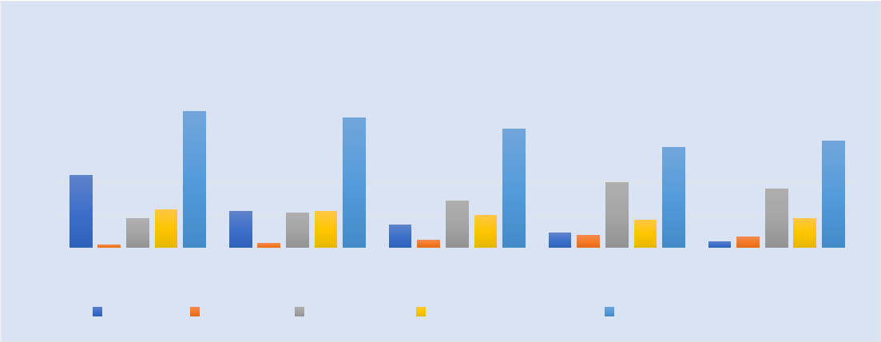

**Control Group Pretest Score**

|  |  |  |  |  |  |  |  |  |  |  |  |  |
| --- | --- | --- | --- | --- | --- | --- | --- | --- | --- | --- | --- | --- |
| 100 |  |  |  |  |  |  |  |  |  | |  | |
| 82.34 | | 78.57 |  |  | 71.43 |  |  |  | |  | |
|  |  |  |  |  |  | |  | |
| 80 |  |  |  |  |  |  |  | |  | |
|  |  |  |  |  |  |  |  | |  | |
|  |  |  |  |  |  |  | 60.71 | 64.29 | |  | |
|  |  |  |  |  |  |  |  |  | |
| 60 |  |  |  |  |  |  |  |  | |  | |
|  |  |  |  |  |  |  |  |  | |  | |
| 44 |  |  |  |  |  |  | 39.29 | 35.71 | |  | |
|  |  |  |  |  |  |  |  | |
| 40 |  |  |  |  |  | 28.57 |  |  | |
| 23 |  |  |  |  |  |  |  | |
| 22 | 21.4322 |  |  |  |  |  | |  | |
|  | 14 |  | 20 |  | 17 | 18 | |  | |
|  | 17.66 |  |  |  |  |  | |
| 20 | 2 | 3 |  |  | 5 | 9 | 8 | 4 | 7 | |  | |
|  |  |  |  | |
| 0 |  |  |  |  |  |  |  |  |  | |  | |
| 1 |  | 2 |  |  | 3 |  | 4 | 5 | |  | |
|  |  |  |  |  |  | |
|  | Interval | Students | Presentatic |  | Remaining Students | |  | Remaining Presentation | |  | |

**Graphic 1**. Control Group Pretest Score

The graphic above shows that the students from the control unit who scored 0-4 were 7 people, 5-9 were 8 people, 10-14 were 5 people, 15-22 were 3 people and 23-44 were 2 people, This shows that the highest interval score (23-44) was the interval with the least frequency, which was only 2 people. Therefore, it can be seen that the average score of the control group students is 28.57% and the rest is below the average, namely; 71,43%.

**b. Pretest Experimental Group**

The experimental group of *Kalam* learning in this study was a group from class III-B with a total of 28 students whose learning was carried out using the active debate method, Similar to the control group, the group from this unit also carried out an initial test (pretest) for Kalam skills, From the results of this pretest showed that the highest Kalam skill score achieved by students was 24 and the lowest score was 0.

|  |  |  |  |  |  |  |  |  |  |  |  |  |  |  |
| --- | --- | --- | --- | --- | --- | --- | --- | --- | --- | --- | --- | --- | --- | --- |
|  |  |  | **Experimental Group Pretest Score** | | | | | | |  |  | |  | |
| 100 |  |  |  |  |  |  |  |  |  |  |  | |  | |
|  | 89.29 | | 82.14 |  |  |  |  |  | 85.71 |  | |  | |
| 90 |  |  |  |  |  |  |  | |  | |
|  |  |  |  |  |  |  |  |  | |  | |
|  |  |  |  |  | 74.43 |  |  |  |  | |  | |
| 80 |  |  |  |  |  |  |  | 71.43 |  |  | |  | |
|  |  |  |  |  |  |  |  |  |  | |  | |
| 70 |  |  |  |  |  |  |  |  |  |  |  | |  | |
|  |  |  |  |  |  |  |  |  |  |  | |  | |
| 60 |  |  |  |  |  |  |  |  |  |  |  | |  | |
| 44 |  |  |  |  |  |  |  |  |  |  | |  | |
| 50 |  |  |  |  |  |  |  |  |  |  | |  | |
|  |  |  |  |  |  |  |  |  |  |  | |  | |
| 40 |  |  |  |  |  |  |  |  |  |  |  | |  | |
| 25 | | 22 | 23 |  |  | 25.57 |  | 28.57 |  |  | |  | |
| 30 |  |  |  |  |  | |  | |
|  |  |  |  | 20 |  | 17 | 18 |  | |  | |
|  |  |  |  | 17.86 |  |  |  |  | |  | |
| 20 | 10.71 |  | 5 |  | 14 | 8 | 9 | 8 |  | 14.29 |  | |  | |
| 10 | 3 |  |  |  |  |  |  | 4 | 4 |  | |  | |
| 0 |  |  |  |  |  |  |  |  |  |  |  | |  | |
| 1 |  |  | 2 |  |  | 3 |  | 4 | 5 |  | |  | |
|  |  |  |  |  |  |  | |  | |
|  | Interval |  | Students | Presentatic |  | Remaining Students | |  | Remaining Presentation | | |  | |
|  |  |  |  |  |  |  |  |  |  |  |  | |  | |

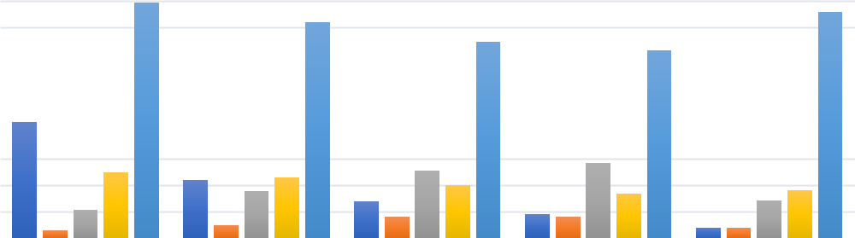

**Graphic 2**. Experimental Group Pretest Score

From the graphic above, it can be seen that students from the experimental unit who scored 0-4 were 4 people, 5-9 were 8 people, 10-14 were 8 people, 15-22 were 5 people and 23-44 were 3 people, this shows that the highest interval score (23-44) is the interval with the least frequency, which is only 3 people. Therefore, it can be seen that the average score of experimental group students is 20.00% and the rest is below the average, namely; 80,00%. It can also be seen that the average score of students in both the control group and the experimental group is 24.28% and the rest is below the average, namely; 75,71 %

.

1. **Posttest *Control Group***

For the final activity in the Kalam learning control group in *this study, a final test*

*(*posttest*)* was carried out for *Kalam* skills*.* The results of this posttest, show that *Kalam’s skill* score is no different from *the pretest* score, namely*;* The highest achieved by a student is 23 and the lowest score is 0.

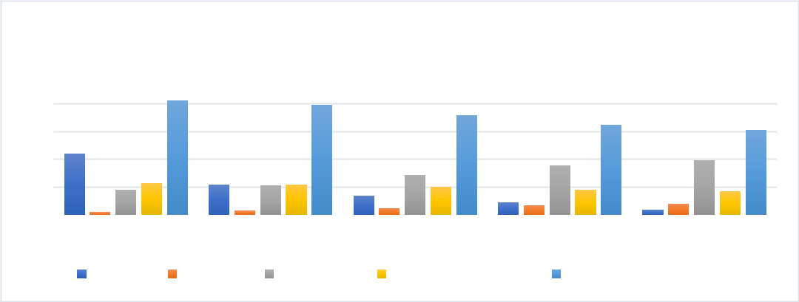

|  |  |  |  |  |  |  |  |  |  |  |  |  |  |
| --- | --- | --- | --- | --- | --- | --- | --- | --- | --- | --- | --- | --- | --- |
|  |  | **Control Group Posttest Score** | | | | | | |  |  | |  | |
| 100 |  |  |  |  |  |  |  |  |  |  | |  | |
| 82.14 | | 78.57 |  |  | 71.43 |  |  |  |  | |  | |
|  |  |  |  |  |  |  | |  | |
| 80 |  |  |  |  |  | 64.29 |  |  | |  | |
|  |  |  |  |  |  |  | 60.71 | |  | |
|  |  |  |  |  |  |  |  |  | |
| 60 |  |  |  |  |  |  |  |  |  |  | |
| 44 |  |  |  |  | 28.57 |  | 35.71 |  | 39.29 | |  | |
| 40 |  |  |  |  |  |  |  |  | |
| 17.8623 | 22 | 21.4322 |  |  |  |  |  | |  | |
|  |  |  |  |  |  | |  | |
|  | 14 |  | 20 |  | 18 |  | 17 | |  | |
| 20 | 2 |  | 3 | 5 | 9 | 7 | 4 | 8 |  | |  | |
|  |  |  | |  | |
| 0 |  |  |  |  |  |  |  |  |  |  | |  | |
| 1 |  | 2 |  |  | 3 |  | 4 |  | 5 | |  | |
|  |  |  |  |  |  |  | |
|  | Interval | Students | Presentatic |  | Remaining Students | |  | Remaining Presentation | | |  | |

**Graphic 3**. Control Group Posttest Score

The graph above shows that students from the control unit who got a *posttest* score of 0-4 were 8 people, 5-9 were 7 people, 10-14 were 5 people, 15-22 were 3 people and 23-44 were 2 people, This shows that the highest interval score (23-44) was the interval with the least frequency, which was only 2 people. Therefore, it can be seen that the average ***posttest*** score of control group students is 28.57% and the rest is below the average, namely; 71.43%.

1. **Posttest *Experimental Group***

The experimental group of Kalam learning in this study was a group from unit III-B with a total of 28 students whose learning was carried out using the active debate method, showing differences compared to the control group, from the results of this posttest showed that the highest Kalam skill score achieved by students was 43 and the lowest score was 4.

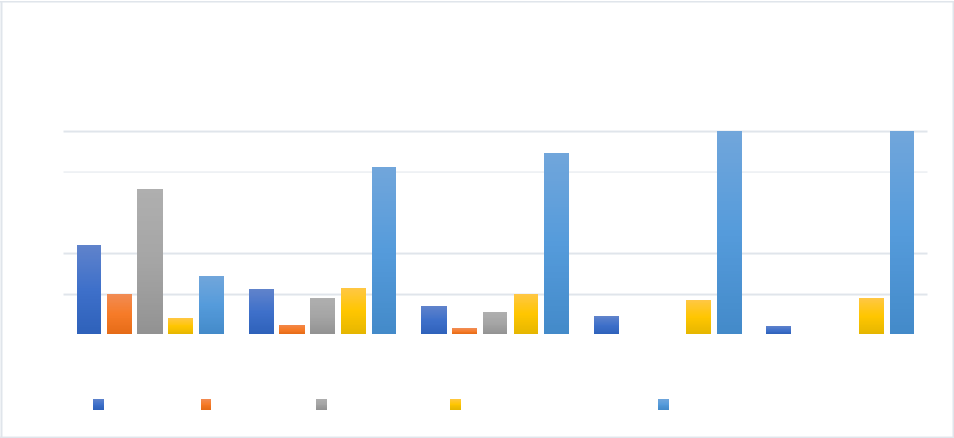

**Experimental Group Posttest Score**

|  |  |  |  |  |
| --- | --- | --- | --- | --- |
| 120 |  |  |  |  |
|  | 100 | 100 |  |
|  |  |  |
| 100 | 82.14 | 89.29 |  |  |
|  |  |  |  |

1. 71.43

|  |  |  |  |  |  |  |  |  |  |  |  |  |  |  |  |  |
| --- | --- | --- | --- | --- | --- | --- | --- | --- | --- | --- | --- | --- | --- | --- | --- | --- |
| 60 |  |  |  |  |  |  |  |  |  |  |  |  |  | |  | |
| 44 |  |  |  |  |  |  |  |  |  |  |  |  | |  | |
|  |  |  |  |  |  |  |  |  |  |  |  |  | |  | |
| 40 | 20 |  | 28.57 | 22 | 17.8623 | 14 |  | 20 |  |  | 17 |  | 18 | |  | |
|  |  |  |  |  |  |  |  | |
| 20 |  | 8 |  | 5 |  | 3 | 10.71 | 9 |  | 4 |  |  | |  | |
|  |  |  |  |  |  |  | |  | |
|  |  |  |  |  |  |  | 0 | 0 | 0 | 0 | |  | |
| 0 |  |  |  |  |  |  |  |  |  |  | |
|  |  |  |  |  |  |  |  |  |  |  |  |  | |  | |
| 1 |  |  |  | 2 |  |  | 3 |  | 4 |  |  | 5 | |  | |
|  |  |  |  |  |  |  |  |  |  | |
|  | Interval |  | Students | | Presentatic |  | Remaining Students | | |  | Remaining Presentation | | |  | |

**Graphic 4**. Experimental Group Posttest Score

The graphic above shows that students from the experimental unit who got a *posttest* score of 0-4 were 0 people, 5-9 were 0 people, 10-14 were 3 people, 15-22 were 5 people and 23-44 were 20 people, This shows that the highest interval score (23-44) was the interval with the most scores, which was only 20 people. Therefore, it can be seen that the average *posttest* score of experimental group students is 96.43% and the rest is below the average, namely; 3.57%.

**CHAPTER FOUR**

**CONCLUSION AND IMPLICATIONS**

Based on the results of research and discussion, several conclusions can be formulated. *First,* Kalam*'s lecture design* is more effectively done by focusing on students throughbrainstorming. Through brainstorming, content, and process needs, students can be accommodated into the Semester Lecture Plan in the form of communication themes and forms of language activities.

*Second*, the formulation of learning targets by individual students implements *Kalam lectures* more student-centered. By formulating their learning targets, students feel they have these targets and realize them as competencies that must be achieved. The formulation of learning targets develops more and more specifically and leads to the form of language activities required of them.

*Third*, by having specific learning targets, students develop a variety of relevant and significant learning strategies to develop Arabic speaking skills. The development of learning strategies to achieve these learning targets implements *Kalam* lectures more student-centered. To succeed in lectures that are represented by achieving the learning targets that have been set, students develop their learning strategies more independently in the sense that they do not rely much on the lecturer's instructions.

The level of effectiveness and difference in learning skills using the active debate method in Kalam learning in the experimental group of this study showed that there was a significant difference between the control group whose learning did not use the active debate method and the experimental group whose learning was carried out through the active debate method by 62.50% or an increase of 38.22% from the previous 24.28% and the rest was below average, that is; 37.50% or down by 38.00% from the previous 75.71%.

This study implies that the application of Kalam's learning pattern using the active debate method did not experience extensive obstacles and only a few received obstacles, namely an average of 9.52%, while an average of 90.48% did not experience problems

**BIBLIOGRAPHY**

1. S. Malik, “Implementasi Manajemen Pendidikan Multikultural di Pondok Pesantren Al Muqoddas Tukmudal Sumber Kabupaten Cirebon,” *Eduprof Islam. Educ. J.*, vol. 2, no. 1, pp. 128–148, 2020, [doi: 10.47453/eduprof.v2i1.34.](doi:%2010.47453/eduprof.v2i1.34)
2. K. Sholeh, “Pembelajaran Bahasa Indonesia Dalam Buku Ajar Berbasis Multiple Intelligences Dalam Kurikulum 2013,” *Progr. Stud. Bhs. dan Sastra Indones. FKIP*, vol. 1, no. 2, p. 345, 2013.
3. S. Shilfani and M. E. Limbongan, “Needs Analysis of Edupreneurship Learning in the English Language Education Study Program,” *Ethical Ling. J. Lang. Teach. Lit.*, vol. 9, no. 2, pp. 793–801, 2022, [doi: 10.30605/25409190.450.](doi:%2010.30605/25409190.450.)
4. Takdir, “Problematika Pembelajaran Bahasa Arab,” *Naskhi*, vol. 2, no. 1, pp. 40–58, 2020, [doi: https://doi.org/10.47435/naskhi.v2i1.290.](doi:%20https://doi.org/10.47435/naskhi.v2i1.290.)
5. S. Suryadi, “Peranan Perkembangan Teknologi Informasi Dan Komunikasi Dalam Kegiatan Pembelajaran Dan Perkembangan Dunia Pendidikan,” *J. Inform.*, vol. 3, no. 3, pp. 9–19, 2019, [doi: 10.36987/informatika.v3i3.219.](doi:%2010.36987/informatika.v3i3.219.)
6. A. Weatherall, “‘Oh my god that would hurt’: Pain cries in feminist self-defence

classes,” *Lang. Commun.*, vol. 90, pp. 1–13, 2023, [doi: 10.1016/j.langcom.2023.01.004.](doi:%2010.1016/j.langcom.2023.01.004.)

1. H. Badu, S. W. Ali, and M. E. walidayni Kau, “Analisis Kebutuhan Belajar Bahasa Inggris Berbasis English for Spesific Purposes pada Mahasiswa Fakultas Teknik Universitas Negeri Gorontalo,” *Ideas J. Pendidikan, Sos. dan Budaya*, vol. 6, no. 4, p. 309, 2020, [doi: 10.32884/ideas.v6i4.308.](doi:%2010.32884/ideas.v6i4.308.)
2. A. Syarifuddin, “Analisis Kebutuhan Materi Ajar ‘Berbicara Bahasa Arab’ Berbasis Pendekatan Komunikatif bagi Pembelajar Non-Bahasa Arab,” *Intizar*, vol. 23, no. 2, pp. 261–270, 1970, [doi: 10.19109/intizar.v23i2.2261.](doi:%2010.19109/intizar.v23i2.2261.)
3. M. Syaifulloh, “Motivasi Belajar yang Bersumber dari Kebutuhan dan Nilai-nilai Keagamaan Pembelajar,” *Ilmu Pendidik. J. Kaji. Teor. dan Prakt. Kependidikan*, no. Vol 22, No 2 (1995), 1995.
4. I. Tabroni *et al.*, “Quality Development of Islamic Religious Colleges: Changing the DNA of Higher Education,” *Int. J. Membr. Sci. Technol.*, vol. 10, no. 2, pp. 121–130, 2023, [doi: 10.15379/ijmst.v10i2.1161.](doi:%2010.19109/intizar.v23i2.2261.)
5. M. Tobroni and Arif Mustofa, “Belajar dan Pembelajaran,” Yogyakarta: AR-Ruzz Media, 2013.
6. F. S. Sundari and E. Sukmanasa, “Analis Minat Belajar Mahasiswa Pgsd Pada Mata Kuliah Strategi Pembelajaran Berbasis E-Learning,” *JPPGuseda | J. Pendidik. Pengajaran Guru Sekol. Dasar*, vol. 1, no. 01, pp. 19–25, 2018, [doi: 10.33751/jppguseda.v1i01.867.](doi:%2010.19109/intizar.v23i2.2261.)
7. F. Noor, “Kurikulum Pembelajaran Bahasa Arab di Perguruan Tinggi,” *Arab. J. Bhs. Arab*, vol. 2, no. 1, p. 1, 2018, [doi: 10.29240/jba.v2i1.305.](doi:%2010.19109/intizar.v23i2.2261.)
8. M. Taubah, “Maharah dan Kafa’ah Dalam Pembelajaran Bahasa Arab,” *Stud. Arab*, vol. 10, no. 1, pp. 31–38, 2019, [doi: 10.35891/sa.v10i1.1765.](doi:%2010.19109/intizar.v23i2.2261.)
9. D. Febrianingsih, “Keterampilan Membaca Dalam Pembelajaran Bahasa Arab,” *Salimiya J. Stud. Ilmu Keagamaan Islam*, vol. 2, no. 2, pp. 21–39, 2021.
10. D. Syafaah, “Inovasi Pembelajaran Bahasa Arab pada Prodi Bahasa dan Sastra Arab IAIN Tulungagung dalam Menghadapi Tantangan Era Industri 4.0,” *Pros. Konfrensi Nas. Bhs. Arab*, no. 5, pp. 849–859, 2019.
11. A. Prasetyo and R. Susanti, “Sistem Informasi Penjualan Berbasis Web Pada PT. Cahaya Sejahtera Sentosa Blitar,” *J. Ilm. Teknol. Inf. Asia*, vol. 10, no. 2, pp. 1–16, 2015.
12. S. Subur, “Pendekatan dan Strategi Pembelajaran Bahasa Arab,” *Insa. J. Pemikir. Altern. Kependidikan*, vol. 11, no. 2, pp. 164–175, 1970, doi:10.24090/insania.v11i2.165.
13. Y. Fitri and N. Salam, “Signifikansi Pendekatan All in One,” *CendekiaJurnal Pendidik. dan Kemasyarakatan*, vol. 9, no. 1, 2011.
14. E. Sriningsih, A. I. Abstrak, K. Kunci, P. Belah, and D. Paikem, “Pecah Belah Bunyikan Melodi Indah Untuk Meningkatkan Keterampilan Pembelajaran Seni Musik Siswa Kelas Ix 1 Smp Negeri 4 Mataram,” vol. 4, pp. 334–343, 2019.
15. L. Fitriani, D. Tresnawati, and S. Rahayu, “Design of geographic information system for tracer study,” *IOP Conf. Ser. Mater. Sci. Eng.*, vol. 434, no. 1, 2018, [doi:](doi:%2010.19109/intizar.v23i2.2261.) [10.1088/1757-899X/434/1/012064.](doi:%2010.19109/intizar.v23i2.2261.)
16. S. Lakshmanasenthil, T. Vinothkumar, D. Geetharamani, T. Marudhupandi, G. Suja, and N. S. Sindhu, “Fucoidan—a novel α-amylase inhibitor from Turbinaria ornata with relevance to NIDDM therapy,” *Biocatal. Agric. Biotechnol.*, vol. 3, no. 3, pp. 66–70, 2014, doi: https://doi.org/10.1016/j.bcab.2014.02.003.
17. R. A. M. Maswani, “ATSAR ITBAA’ MADKHAL AL-TA’ALLUM AL-

TA’AWUNIY FII TA’LIIM AL-NAHW,” *Arab. J. Pendidik. Bhs. Arab dan Kebahasaaraban*, no. Arabiyat : Jurnal Pendidikan Bahasa Arab dan Kebahasaaraban |Vol. 2 No. 1 June 2015, pp. 130–143, 2015.

1. Andi Saputra and Feri Wahyudi, “Pembelajaran Maharah Al-Kalam Untuk Meningkatan Keterampilan Berbicara Mahasantri Program Study Pendidikan Bahasa Arab Di Pon-Pes Madarijul ‘Ulum,” *Pros. Ta’dib STIT Pringsewu*, vol. 1, no. 1, p. 2, 2019.
2. Kuswoyo, “Konsep Dasar Pembelajaran Mahārah Al-Kalam,” *An Nuha*, vol. 4, no. 1, pp. 49–56, 2017.
3. Agus Setyonegoro, “Hakikat, alasan, dan tujuan berbicara (dasar pembangun kemampuan berbicara mahasiswa),” *J. Pena*, vol. 3, no. 1, pp. 67–80, 2013.
4. M. Hilmi, “Penerapan Metode Role Playing dalam Meningkatkan Keterampilan Berbicara Anak dan Kecerdasan Sosialnya,” *Palapa*, vol. 6, no. 2, pp. 138–144, 2018, [doi: 10.36088/palapa.v6i2.71.](doi:%2010.19109/intizar.v23i2.2261.)
5. D. Nalole, “Meningkatkan Keterampilan Berbicara (Maharah al-Kalam) Melalui Metode Muhadatsah dalam Pembelajaran Bahasa Arab,” *J. Al Minhaj*, vol. 1, no. 1, pp. 129–145, 2018.
6. Y. Yunita and R. Pebrian, “Metode Komunikatif dalam Pembelajaran Bahasa Arab Maharah Al-Kalam di Kelas Bahasa Center for Languages and Academic Development,” *J. Pendidik. Agama Islam Al-Thariqah*, vol. 5, no. 2, pp. 56–63, 2020, [doi: 10.25299/al-thariqah.2020.vol5(2).5838.](doi:%2010.25299/al-thariqah.2020.vol5(2).5838.)
7. I. R. N. Hula, N. H. Basarata, and S. Sarif, “The Effectiveness Of The Al-Ta’bir Al-Mushawar Strategy In Improving Maharah Al-Kalam,” *ULIL ALBAB J. Ilm. …*, vol.

1, no. 6, pp. 1763–1774, 2022, [Online]. Available: https://ulilalbabinstitute.com/index.php/JIM/article/view/405%0Ahttp://ulilalba

binstitute.com/index.php/JIM/article/download/405/343[https://journal-](https://journal-nusantara.com/index.php/JIM/article/view/405)[nusantara.com/index.php/JIM/article/view/405](https://journal-nusantara.com/index.php/JIM/article/view/405)

1. I. R. N. Hula, Z. Yasin, M. S. Inaku, and N. Basarata, “Arabic Speaking Skills Training through Intensive Program Activities for Boarding Students in Pone Village , West Limboto District,” vol. 3, no. 3, 2023. <https://doi.org/10.55606/nusantara.v3i3.1607>
2. N. Hasaniyah *et al.*, “Development of Arabic Speaking Teaching Materials based on Tourism Anthropology: A Validator’s Assessment,” *Int. J. Membr. Sci. Technol.*, vol. 10, no. 2, pp. 1130–1143, Jun. 2023, doi: <https://doi.org/10.15379/ijmst.v10i2.1161.>
3. M. Y. Salam, “Durûs Perspektif Nazariyyah 10.31958/jt.v11i2.144.

Al-Lughah Al- ‘Arabiyyah Karya Mahmud Yunus Dalam Al-Wahdah,” *Ta’dib*, vol. 11, no. 2, 2008, doi:

