1

DESIGN AND IMPLEMENTATION OF STUDENT EVALUATION PROGRAM (A CASE STUDY OF DAUGHTERS OF DIVINE LOVE JUNIORATE)

6

TABLE OF CONTENT

Certification page-----------------------------------------------------------

----i

Dedication-------------------------------------------------------------------

-----ii

Acknowledgement----------------------------------------------------------

----iii

Table of content-------------------------------------------------------------

----iv

Abstract ----------------------------------------------------------------------

-----v

CHAPTER ONE

INTRODUCTION

1.1 Background of study---------------------------------------------------

------1

1.2 Statement of problem---------------------------------------------------

-----2

1.3 Aims and objective-----------------------------------------------------

------4

1.4 Justification of study---------------------------------------------------

------4

1.5 Scope of study-----------------------------------------------------------

-----4

1.6 Limitations---------------------------------------------------------------

-----5
7

1.7 Project report organization--------------------------------------------

------5

CHAPTER TWO

LITERATURE REVIEW

2.1 The nature of teacher’s decision making in evaluation-----------

----6

2.2 Policy and guiding principles-----------------------------------------

-----7

2.3 Curriculum goals-------------------------------------------------------

-----8

2.4 Assessment literacy----------------------------------------------------

----11

2.5 Multiple purpose of evaluation---------------------------------------

---17

2.6 Professional development and teacher training--------------------

--18

2.7 Key question------------------------------------------------------------

---19

CHAPTER THREE

SYSTEM ANALYSIS AND DESIGN

3.1 Methodology------------------------------------------------------------

---21

3.1.1 Proposed system------------------------------------------------------

---21
8

3.1.2 Feasibility study------------------------------------------------------

---22

3.1.3 System analysis-------------------------------------------------------

---22

3.2 Date collection----------------------------------------------------------

---23

3.3 Analysis of the existing system---------------------------------------

--23

3.4 Limitation of the existing system------------------------------------

---24

3.5 System design-----------------------------------------------------------

---24

3.5.1 The input design------------------------------------------------------

---25

3.5.2 The output design----------------------------------------------------

---26

3.5.3 Logical and physical design----------------------------------------

---27

3.6 Database design--------------------------------------------------------

----32

3.7 System flowchart-------------------------------------------------------

---39

3.8 Top down design-------------------------------------------------------

---40

CHAPTER FOUR
9

SYSTEM IMPLEMENTATION, TESTING AND INTEGRATION

4.1 Choice of development tools-----------------------------------------

---38

4.2 System requirement----------------------------------------------------

----38

4.2.1 Hardware requirements----------------------------------------------

---38

4.2.2 Software requirement------------------------------------------------

---39

4.3 Implementation---------------------------------------------------------

---39

4.4 Testing-------------------------------------------------------------------

----43

4.4.1 Unit testing------------------------------------------------------------

---43

4.4.2 System testing--------------------------------------------------------

----44

4.5 Executing the application---------------------------------------------

----44

4.6 Security------------------------------------------------------------------

----45

CHAPTER FIVE

SUMMARY, RECOMMENDATION, AND

CONCLUSION
10

5.1 Summary of findings---------------------------------------------------

--46

5.2 Limitation of the project-----------------------------------------------

--46

5.3 Recommendation-------------------------------------------------------

---47

5.4 BEME (Bills of engineering measurement of engineering) -----

---48

5.5 Conclusion--------------------------------------------------------------

----48

References-------------------------------------------------------------------

----51

Appendix A: Source code-------------------------------------------------

---52

Appendix B: Sample out--------------------------------------------------

----57
11

LIST OF TABLES

Table 3.6: Database Table------------------------------------------------

28

Table 3.6.1 payment table-------------------------------------------------

28

Table 3.6.2 student personal table----------------------------------------

29

Table 3.6.3 junior secondary school-------------------------------------

30

Table 3.6.4 science student------------------------------------------------

31

Table 3.6.5 subject table for art student---------------------------------

32
12

LIST OF FIGURES

Figure 3.5: System design-------------------------------------------------

----31

Figure3.7 system flowchart------------------------------------------------

---39

Figure3.8: Top down Design----------------------------------------------

----40

Figure 4.3.1 login in page--------------------------------------------------
--------40
Figure 4.3.2 main menu----------------------------------------------------

-------40
Figure 4.3.3 registration form---------------------------------------------
----41

Figure 4.3.4 compute result-----------------------------------------------
-----42
13

ABSTRACT

Student achievement is profoundly influenced by the evaluation practice used by teachers in the classroom. Research in education has consistently shown achievement monitoring and feedback to be extremely important factors in the teaching learning process. This project is designed with the help of computer base program that has five sub systems: the file sub system that helps the administrator to change their password and also register new students, compute result sub system which is where all the student results are recorded and save to data base, and report sub system, where students profile, results and the number of students in the school can be viewed. All this helps classroom teachers with direct support to classroom instruction with information on good classroom evaluation practices with daughters of divine love juniorate secondary school as a case study. This program was achieved with the help of visual basic 6.0 and Microsoft access database.
14

CHAPTER ONE

INTRODUCTION

1.1 BACKGROUND OF STUDY

Evaluation of student achievement is a crucial and pervasive issue of concern in every classroom. Traditional evaluation activities were used to certify or promote students. Currently, evaluation is recognized, as a comprehensive process not just something that occurs only at the end of some learning episode, it is an integral part of the teaching learning process.

Evaluation activities provide information for the identification of student’s performances, a basis for the assessment of teaching strategies and data for important decision regarding corrective or enrichment activities.

If a classroom is to function effectively, a well planned system of evaluation is essential. Without such plan, it will be difficult to determine the ability of students and to decide which methods of instruction are most appropriate for a particular class or group of students.

School Structure

Daughters of divine love juniorate school is a female private school, it was founded in 1969 at Ihiala in Anambra state, by the late Bishop Godsfrey Mary Paul Okonye, then Bishop of port Harcourt. The number of students that were enrolled in 1969 is seven with about four members of the staff, including the principal.
15

The school was later moved to Isienu Nsuka in the 1976, the second campus of the junior ate was started in Enugu which is the head quarters of the congregation with its first principal as Sr .M. Chizoba Eke.The junior ate school made its first external examination in the year 1972. Daughters of divine love comprise both the junior secondary and the senior secondary sections and runs a six year formal education programme. Each of the 6 classes is made up of either 2 or 3 or 4 streams depending on the size of the class. Because of the nature of the school which informs it’s home: Daughters of divine love junior ate, equal attention, more or less, is giving to both the academic and character formation of the students.

Administration and Staff

The administrative structure of the school comprises the principal, two vice principal (Academic & Administration, School Bursar, Matron, Dean of Studies, Heads of Department, Form Teachers and other teachers. The tutorial staff strength of the school is forty – three permanent teachers and seven part-time teachers. These teachers are qualified. The non academic staff section comprises about thirty workers mainly non-professionals. The motto of the school is “FAITH AND LOVE”

1.2 STATEMENT OF PROBLEM

Education is concerned with the integral formation of students. Hence, it should be directed toward their physical emotion, social, moral, intellectual and spiritual development.
16

Any system of evaluation has to be based on who students are and how they know and act as learners. The following principles of evaluation should be evident from the philosophy. These are:

- Evaluation takes it direction from a definition education which stated in it’s broadcast since is to enable student to realize their potentials as human beings

- Evaluations involve teacher’s judgment.

- Evaluation is an integral part of the teaching learning process.

- Students and education program.

- Students should play an active role in their evaluation.

- Evaluation procedure should take into consideration individual difference among students.

- Evaluation procedure is important for the guidance of individual

students.

However, it should be noted that the main purpose of evaluation is to determine the extent to which student have archived the intended outcome of the education program. There evaluation must be student centered where it process and subsequent decisions reflect a genuine concern for the interest of each student.
17

1.3 AIMS AND OBJECTIVE OF THE PROJECT

The main aim of this project is to provide an information tracking system along with evaluation system for evaluating students based on written examination, thus providing the positions for every student and to eradicate the problems uncounted in education environment that are timed consuming in the file system.

The design system holds the following features over the previous manual system.

- Enhanced easy retrieval and access to records.

- Highly secured student results.

- Accuracy of result processing

- Accurate report for decision making by the school management.

1.4 JUSTIFICATION OF THE STUDY

This project will provide basis for developing a planned system of evaluation for the school academic staffs.

1.5 SCOPE OF THE STUDY

This project is centered on student academic performance for daughters of divine love juniorate secondary school. This project was implemented to show the scores and total average of each student at the end of academic year, and also help to keep proper record of student data. This helps the
18

teachers to know the students that are not performing well, so that they can help them to improve in the subjects they are lagging behind.

1.6 LIMITATIONS

The result can be altered by any individual that has access to the software. No individual can be able to access the result without the aid of the teacher of that particular class.

1.7 PROJECT REPORT ORGANIZATION

The project has different chapters, from one to five which will explain the various aspects of the system.

The first chapter gives an introduction of the project along with the project aims and objectives, scope and limitations of the study. Chapter two is an overview of the literature review.

Chapter three is the details of the system analysis and design and the major components used.

Chapter four deals with the implementation and the testing. This chapter contains the major world of the project.

Chapter five recommendations and conclusion of the project work on student Evolution.
19

CHAPTER TWO

LITERATURE REVIEW

2.1 THE NATURE OF TEACHER’S DECISION MAKING IN

EVALUATION:

Teachers make many decisions throughout all phases of the evaluation process. First, they decide how to interpret the curriculum goals and objectives and determine what data or criteria provide evidence of the learning. Next, they must decide what forms of assessment are most appropriate for collecting data and measuring achievement. How will these assessments be weighted in determining a final grade? What standards will be used to judge achievement? How will this information be used? And how will this information be communicated to students and parents?

Throughout the phases of the evaluation process, various demands, interpretations, and beliefs influence each decision. Wilson (2000) identifies a number of considerations likely to influence teachers' assessment practices: For example, teachers' concerns for individuals and their growth, not only in learning but also in their social and emotional development.

The preliminary review of the literature and categories that emerged during the data collection phase of the study contributed to the identification of
20

several key factors that influence teachers' decisions about how to evaluate their students' achievements. These are:

- Policy and guiding principles,

- Curriculum goals,

- Assessment literacy,

- Multiple purposes of evaluation.

This review of the literature concludes with references to professional development in classroom assessment and student evaluation, and identifies several essential questions emerging from the literature which provide structure for the data collection phase of the study.

2.2 Policy and Guiding Principles

Wilson (2006) identifies five key principles from Principles for Fair Student Assessment Practices for Education in Canada (2003), and characteristics of a quality assessment environment are also described by Stiggins (2005).

The essence of these guiding principles is that student evaluation should be an integral part of good teaching practice. It should be treated as an ongoing and comprehensive process that is pervaded by careful planning and systematic implementation. Evaluation is considered a critical element that influences teacher decision-making and guides student learning.

In Saskatchewan/ the Office of the Registrar administers policies related to:

- Credit requirements for secondary level completion;

- Grade 12 departmental examinations;
21

c) Teacher certification and accreditation, and;

The policies and regulations in the handbook address the blending of

marks from teacher and provincial assessments, issues of test

security, special provisions, and measures to ensure consistency and comparability. Pagan and Spurrell (2005) found that 88% of Canadian school boards or divisions studied had a relatively comprehensive set of student evaluation policies in place covering the last three years of high school. The areas most frequently addressed were:

- Purpose of evaluation;

- Grading;

- Reporting;

- Promotion/ retention and placement;

- Methods and sources of evaluation.

The school division involved in this study has a policy in which the intentions for evaluation are framed as six goals, each with a set of objectives to guide the evaluation process. The goals in the policy refer to

- The variety and quality of evaluation methods,

- Purpose of evaluation,

- Alignment with curriculum and instruction,

2.3 Curriculum Goals

Saskatchewan's Core Curriculum includes seven Required Areas of Study, the Common Essential Learning, the Adaptive Dimension, and Locally-
22

Determined Options. Core Curriculum initiatives also include Gender Equity; these initiatives reflect the principles which guide the development of curriculum and classroom instruction. Teachers are expected to incorporate the Common Essential Leanings (C.E.L.s) in an authentic manner when they plan instruction in the various areas of study with the purposes of enhancing understanding of the particular content/ and preparing students for future learning in school and beyond grade 12, Decisions about which of the C.E.L.s are to be included in any particular lesson and how they will incorporated is guided by the needs and abilities of the students and the demands of the content or skills to be learned.

The curriculum document for Mathematics C 30 discusses instructional strategies and approaches that are responsive to the initiatives of Core Curriculum, offers a number of suggestions for incorporating C.E.L.s, such as the development of personal and social values and the development of communication skills/ and recognizes the addressing of C.E.L.s through mathematics instruction has implications for assessment and evaluation.

The mathematics curriculum guide identifies attributes of learning to be assessed. These include traditional objectives related to knowledge and understanding of concepts and problem solving skills. There are also several non-traditional objectives identified in the document. These include: a) The ability to communicate mathematically;
23

- The ability to communicate through the use of computers and software; and

- The development of a positive attitude towards mathematics. Templates are included for teachers to use in gathering assessment data indicating:

  - Ability to gather information and then to evaluate both the information and the sources of information;

  - Ability to make an informed decision.

Traditionally, these dimensions of learning have not been addressed in evaluating mathematics achievement. The curriculum guide for Biology 30 encourages the expansion and refinement of assessment strategies to provide a more comprehensive evaluation of student achievement based on a broader range of learning objectives. Questioning that is open-ended and that prompts reasoning and analysis is recommended to "promote and challenge higher order thinking." Teachers are encouraged to include "practical tasks", oral responses, and interpretations of graphs and photographs among their assessments. The document recommends less emphasis on multiple choice, true-false, and fill-in-the-blank tests, and more emphasis on essays and alternatives such as illustrations or art projects, oral reports, concept maps, projects, and journal writing.

The foundational and learning objectives in Saskatchewan's newly implemented curriculum include a number of dimensions of learning and
24

outcomes which have not traditionally been measured by classroom assessments. Various sources point to the challenges of addressing attributes such as ability, effort, attitudes, values and habits of mind in classroom assessments (Ryan, 2007; Stiggins, Frisbie and Griswold, 2009; Sizer, 2002; Gaskell, 2005).

To focus on the academic alone would assume some agreement on the social norms that make academic knowledge important. It would assume that students agree on the value and meaning of school assignments and those that come to the classroom happy, motivated, and fed. For many young people, this cannot be assumed. But even in academic classrooms with well-motivated students, teachers want more than good answers from students. They want responsibility, effort, and a balance of independence and concern for others. One challenge all these schools confront is how to extend course content and grading to include the wide set of concerns that confront students (Gaskell, 2005).

2.4 Assessment Literacy

Teachers cite colleagues and their own experiences as students as key sources for learning about assessment strategies. They almost never cite teacher training. Most teacher training programs do not require a course in educational measurement, and many do not offer one. Evaluation courses which are offered emphasize developing paper-and-pencil tests, using standardized tests, and understanding the statistical aspects of assessment.
25

Most teacher training courses, when offered, virtually ignore daily assignments, performance assessments, tests that accompany textbooks, and oral questions. In-service training in assessment is rare. Many teachers said they neither need nor want more training in testing, but report a strong desire for practical help with specific measurement topics that relate to their students and classroom needs (Stiggins, 2008). Bol, Stephenson, Nunnery, and O'Connell (2008) report that "if teachers felt well prepared to develop traditional assessment methods, they were also more likely to feel well prepared to develop alternative assessment methods" and that teachers who used alternative assessments were just as likely to use traditional methods of assessment in their classrooms. Their research showed that elementary teachers were significantly more likely to use alternative assessments than high school teachers, and that elementary teachers had more confidence in the accuracy of alternative methods than middle years teachers. The authors of the study suggest that since high school teachers have greater numbers of students for shorter periods of time than elementary teachers do, "they may be reluctant to use alternative assessments because of time pressures and workload".

Stiggins, Griswold and Wikelund (2009) cite the findings of previous research in the measurement of thinking skills. Teachers reported a heavy reliance on items written from knowledge, comprehension and application levels, and an increasing level of discomfort in writing test items
26

at progressively higher levels of thinking skills. One study analyzed 9,000 test items from 6 subject areas to find that over 90% of the items measured recall of facts and information. The study focused on mathematics, science, social studies, and language arts, and found that the largest proportion of test items tested recall. With the exception of mathematics, little or no attention was given to analysis, comparison, and evaluation, and there was only limited use of inference. The analysis of oral questions indicated that teachers focused about half their questions on recall. Inference and analysis were fairly common in oral questioning, but little or no attention was given to evaluation and comparison. The authors of the study offer this observation about high school assessment.

In a study designed to identify discrepancies between the practices of teachers and recommendations of measurement experts, Stiggins, Frisbie and Griswold (2009) studied the grading practices of 25 high school teachers in four subject areas. Information was gathered on 19 dimensions of grading practices addressing student characteristics considered, measurement methods used, and the manner in which grading data were managed and reported. Descriptions for recommendations for each of the dimensions were gleaned from measurement texts, when these recommendations were compared with a synthesis of actual practice, discrepancies were noted in 11 of the 19 dimensions studied. Three general possible explanations for discrepancies are suggested:
27

- Best practice may be a matter of opinion or philosophical position rather than established fact.

- Recommendations of measurement experts may fail to take into account the realities and limitations of the classroom.

- Teachers may not be aware of the recommendations or they may lack

the expertise to implement them.

Stiggins (2007), Wiggins (2003a), and Wilson (2006) question the practice of using composite scores or combined grades. A common practice is to assign a numerical value for the level of achievement in each of a number of dimensions or criteria, then add or average the scores. Although this approach is efficient, it does not necessarily provide an accurate or clear representation of student achievement. Wilson (2006) identifies reporting to parents as a major influence on assessment practices. Most policies and procedures emphasize simplicity, consistency, and standardization. This means that teachers must accumulate information in ways that respond to these criteria without taking up too much time from other activities. Wilson recognizes the usefulness of numbers for the sake of efficiency but adds that "this capacity of numbers to be relatively free of definition in and of themselves allows them to accumulate different meaning to different people. He cautions that while numbers seem to be neutral, objective, and have the appearance of fairness, the use of numbers to ensure objectivity, carries certain responsibilities. It is possible to manipulate numbers efficiently and
28

correctly, but the validity of these operations depends upon where the numbers came from. Wilson argues that although quantifying assessment data gives the appearance of objectivity, it is likely that the procedures involved in arriving at the numbers are not objective.

In Wilson's view, most classroom tests merely confirm what teachers expected to find because the expectations are built into the design of the test. He adds that many teachers believe that the total number of marks awarded is a direct reflection of that component's weight in a composite score. Consequently, sometimes teachers are actually weighting scores on a different basis than they think.

Ryan (2007) argues that because of the difficulty of objective evaluation in various dimensions of learning not traditionally evaluated, subjective evaluation by teachers will grow in importance. Teachers will need to develop understanding and skill in a variety of alternative assessments in order to gain confidence in subjective evaluation and inspire trust in their assessment methods among students, parents, administrators and the public.

Ryan (2007) reports that some teachers view evaluation of process as "soft" and less objective than evaluation of achievement, while other teachers are able to perceive process dimensions as another type of product. When teachers doubt* test results or the quality or value of particular tests, they will rely on professional judgment based on their basic feelings about a student derived from observation. Wilson (2006) concurs that "when a
29

teacher has developed an expectation for a student and finds that a particular piece of work is not consistent with that expectation, there will be a tendency to discount the example”.

Wilson (2006) observes that much of what teachers learn about students, they learn informally. Often teachers trust these observations more than more formal testing, although testing also shapes teachers' views on how students are progressing. Through looking at assignments and observing students at work, teachers pick up information that informs- what they teach, how they teach, and for what length of time.

Wilson (2006) also points out that while "some teachers report being very confident in their ability to quickly size up a student's ability" acting on those perceptions may result in poor judgments. Interpretations of events may vary greatly/ from one individual to another because of the expectations that each brings to the situation. Teachers may support the "correctness of their view by referring to the consistency of a student's work over time. Wilson says, "This finding is persuasive, but only if the assessment of the quality of that work is done independent of previous judgments" which he adds is "an unlikely occurrence". Wilson explains that teachers' values systems are reflected in the way they establish classroom procedures. While teacher preferences may be compatible with some students' expectations, they may conflict with others.
30

2.5 Multiple Purposes Of Evaluation

Understanding the purposes of evaluation helps teachers make decisions about the types of assessments and criteria they will use in evaluating student progress. The purpose of an assessment may be clarified by asking "who is this information for and how will it be used?" Wiggins

(2003) asserts that "assessment should improve performance, not just audit it. Costa and Kallick (2007) state that the "whole point of education" is missed if students graduate dependent upon others to "tell them when they are adequate, good or excellent". In their

view the "ultimate purpose of evaluation is to have students be self-evaluative”.

Wilson (2006) lists multiple and various goals for assessment including, but not limited to: Feedback to students, Diagnostic information; Summary data for record keeping; Evidence for reports; curriculum revision. Stiggins (2011) reports that teachers use assessments in their classrooms to serve at least three different categories of purposes:

- To inform decisions related to evaluation, grading, diagnostics and referrals, sorting and grouping.

- To support teaching and learning through the communication of expectations, and the involvement of students in self- and peer-

evaluation; and
31

- To maintain classroom management or behavior control.

Natriello (2007) identifies four generic functions thought to be served by evaluation: Certification, Selection, Direction and Motivation.

The design of an evaluation system for the purpose of enhancing student motivation might involve a differentiated task structure in the classroom, a mix of more and less predictable tasks, clearly articulated criteria, challenging yet attainable, self-referenced standards, relatively frequent collection of information on students performance, appraisals that truly reflect student effort and performance, and differentiated and encouraging feedback. An evaluation system designed for purposes of certification would look quite different

2.6 PROFESSIONAL DEVELOPMENT AND TEACHER

TRAINING

Stiggins, Frisbie and Griswold (2009) refer to the need to address beliefs and values as a preliminary step in professional development. Stiggins (2008) also refers to the need for teachers to be aware of the various goals and purposes of assessment. These two conditions for improving teachers' assessment literacy are strongly connected to the concept of professional obligement. Based on current understanding of good practice, Stiggins, Frisbie and Griswold make four recommendations for teacher training and professional development. The first of these is that training should help
32

teachers explore their own philosophical positions and the implication of those positions for the meaning of grades and their grading practices,

Lock (2010) reports two case studies conducted to explore the classroom assessment practices of teachers and to understand how different perspectives and philosophies of learning can influence these practices. The data indicated that for the two teachers in the study, "perceptions of knowledge and their theories of learning (both conscious and tacit) shaped how they interacted with students and how they structured their teaching and assessment practices". This study suggests that "the internal consistency with which teachers teach, assess, and interact with students" may need to be taken into account in any effort to change or develop teachers' assessment and evaluation practices. She adds that "if teachers" perceptions of knowledge and learning form a core set of beliefs upon which their classroom practices are based, then a change in practice might require a close examination of those core beliefs".

2.3 KEY QUESTIONS

The purpose of this study was to develop an understanding of how teachers make decisions related to student evaluation. Four essential questions that would contribute to the understanding of emerged from the review of the literature are:

- What do these three teachers believe about the purposes of evaluation?
33

- What are the connections between curriculum goals and evaluation methods?

- To whom do these teachers feel accountable?

- How do these teachers manage conflicting responsibilities and goals within the process of student evaluation?
34

CHAPTER THREE

SYSTEM ANALYSIS AND DESIGN

3.1 METHODOLOGY

Methodology is usually a guideline system for solving a problem, with specific component such as phases, tasks, methods, techniques and tools. A methodology can also be considered to include multiple methods, each as applied to various facets of the whole scope of the methodology. The research can be seen into two parts; they are qualitative research and quantitative research.

3.1.1 PROPOSED SYSTEM

The proposed system is a computer-based application. It involves the development of a computer package using Visual Basic that works with an information tracking system (Data base). Thus, providing an interface for teachers to evaluate students at the end of every term and session respectively.

The system makes use of user-friendly interface which makes the entire system easy to use and understand.

Among the objectives of this proposed system are;

1. An information tracking system that will hold information concerning students in the school.

- Enhanced easy retrieval and access to records.
35

- A program that accurately evaluates students and provide highly secured students results.

- Provide adequate and accurate report to enhance decision making by management.

3.1.2 FEASIBILITY STUDY

In addition to suggesting a solution, I carried .out a feasibility study to determine whether the proposed solution in feasible or achievable given the school's resources and constraints.

The major areas that address during the course of this project are:

i. Technical feasibility: Whether the proposed solution can be implemented with the available hardware, software and technical resources.

- Economic feasibility: Whether the benefits of the proposed solution outweigh the cost.

- Operational feasibility: Whether the proposed solution is desirable within the existing managerial and organization framework

3.1.3 SYSTEM ANALYSIS

System analysis is the identification and analyzing of the problem that the organization will try to solve with an information system. It consists of defining the problem, identifying it cause, specifying the solution and identifying the information requirement that must be met by the system solution. From the organizational analysis, I was able to identify the
36

problem, and or limitation of the existing system by examine, documents, work papers and procedures, observing system operations and interviewing key users of the proposed system solution. I also identified problem areas and objectives to be achieved by the proposed system.

3.2 DATA COLLECTION

During this work data collection was basically from two sources that helped as a source of information in the research. They are; a) Primary source b) Secondary source

Primary source Primary source is sources were collection of data is made by the individual who is carrying out the project work. Here personal interview is carried out by the researcher; this involves face to face conversation between the student and respondent who have the vital information. Secondary source

Secondary source is obtained by the researcher with the help of journals, internet, library source and also observing interaction between the teachers and there students, and also grading system.

3.3 ANALYSIS OF THE EXISTING SYSTEM

The existing system is a system that has been operated manually. The existing system is the methods were student evaluation has been carried out in manual approach. Analysis has shown that information and data of student kept was not properly retrieve due to the manual way the system has been handled. Since the system is not computerized, it is prone to error,
37

student evaluation cannot be taking properly, data and information can be misplace or lost.

3.4 LIMITATION OF THE EXISTING SYSTEM

The following are the problems identified in the existing system are as follows: a. Results are being altered due to d manual process of evaluation that is no adequate security.

b. Documentation of data is prone to errors.

c. It is difficult sorting student’s files from the filing cabinets.

d. Having much files, drawers, and filing cabinet, can lead to losing the student data unintentional, And also occupying much space.

3.5 SYSTEM DESIGN

System design describes what a system should do to met information requirement; system design shows how the system will fulfill his objective, and also shows the input, and output design of this system.
38

3.5.1 The Input Design


Surname

Other name

Date of birthday 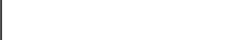

Sex

Origin

Name of parents 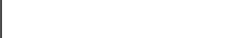

Permanent address 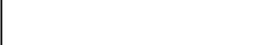

Phone number

Year of admission

Class of entry
House

figure 3.5.1 Student registration form.

Designing the input is another major step in the system design. Input

makes up the computer files and database. What type of input to design depends largely on how data will be processed and on the required output; the operators enter most of the input used by the system into tables that correspond to store them. The table contains fields that correspond to row and column of data that are recorded in forms and ordinary sheet of papers.
39

3.5.2 The Output Design
 | Name |  | Class
 | Subject | 1st term |  | 2nd term | 3rd term | average
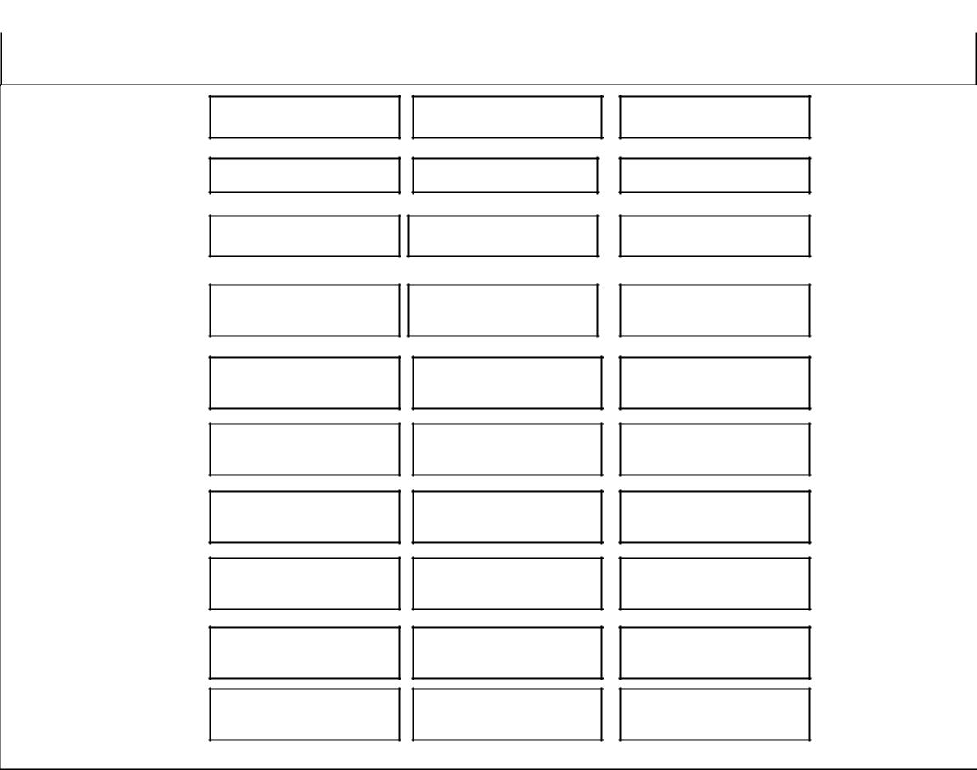

Mathematic

English

Introduction Tech

Social science

Agricultural science

Business studies

Home economies

CRS

Integrated science

Computer

Fine art

Literature in English

Figure 3.5.2 compute result.

The output design is the most important aspect of any system design to the user. The user is less concerned about what goes on behind the screen. It is the information displayed on the screen that will determine the user-friendliness to software.

Reliability and acceptability of a system is determined by the quality of its output, screen display and hardcopy versions. The information system delivers the end output i.e. the "information" to the user(s). The effective interpretation of this output information is largely dependent upon its design.
40

Designing student's personal data forms, student's registration and result processing output are the steps in the design phase. The completions of these phases are very important because it determines what input data should be. The output provides the information to the user needs and basically justifies the system. The outputs of these systems are in different forms which are basically the video display screen and the hardcopy report. The most predominant of them is the visual display screen also referred to as user interface. The output of this system was designed with the objective of user-friendliness.

3.5.3 Logical and Physical Design

During the course of this project/ the design of the proposed system was broken down into logical and physical design specification. The logical design lays out the component of the system and their relationship to each other as they would appear to users. It shows what the system will do as opposed to how it is actually be implemented physically. It also describes inputs and outputs, processing function to be performed and controls - (controls specify standard for acceptable performances and methods for measuring actual performance).

The physical design is the process of translating the abstract logical model into the specific technical design for the new system. It produces the actual specification for hardware, software, physical, database, input/output, manual procedure, and specific controls.
41

3.6 Database Design

The table design is the layout of how the tables and each field in the database are set. It involves the data type, field size and field name. TABLE 3.6.1PAYMENT TABLE
Field Name | Data type | Field size
Admission ID | Test | 10
Surname | Test | 20
Other name | Test | 50
Present class | Test | 06
Session | Test | 20
Amount paid | Currency | Standard
Balance | Currency | Standard
Date paid | Date/time | Standard
Bank | Test | 20

This table is a payment table for all students at the beginning of every term and also for new entries to the school before they can assign student to their various class.
42

TABLE3.6.2 STUDENT PERSONAL DATA

Field Name |  | Data type | Field size
Admission ID |  | Text | 10
Surname |  | Text | 20
Other name |  | Text | 50
Date of birth |  | Date/time | Standard
sex |  | Text | 08
State of origin |  | Text | 50
Religion |  | Text | 20
Name of Parent/guardian |  | Text | 50
Permanent home address |  | Text | 50
Telephone | number(s) | Text | 50
(mobile)
Year of entry |  | Text | 20
Class of entry |  | Text | 20
House |  | Text | 20
Year of graduation |  | Text | 50
Reason(s) of withdrawal |  | Text | 20
Position held

43

This database table has 16 fields where student personal data, their year of graduation, reasons for withdrawal and position are recorded for each student in the school.

TABLE3.6.3 JUNIOR SECONDARY SCHOOL

Field Name | Data type | Field size
Admission ID | Text | 10
Surname | Text | 20
Other name | Text | 50
Class (Arm) | Text | 10
sex | Text | 10
Mathematics | Text | 25
English language | Text | 25
Introductory technology | Text | 25
Social studies | Text | 25
Agricultural science | Text | 25
Business studies | Text | 25
Home economics | Text | 25
C.R.S | Text | 25
Integrated Science | Text | 25

44

Fine Art | Text | 25
Computer Science | Text | 25
French | Text | 25
Music | Text | 25
P.H.E | Text | 25

This database table has 19 fields that contain all the name of the student in that particular class, subjects offered by junior secondary class in DDL.

TABLE3.6.4 SCIENCE STUDENTS

Field Name | Data type | Field size
Admission ID | Text | 10
Surname | Text | 20
Other name | Text | 50
Class (Arm) | Text | 10
sex | Text | 10
Mathematics | Text | 25
English language | Text | 25
Biology | Text | 25
Chemistry | Text | 25
Physics | Text | 25
Technical, drawing | Text | 25
Agricultural Science | Text | 25

 |  | 45
Geography | Text |  | 25
Economics | Text |  | 25
Further Mathematics | Text |  | 25
Computer Science | Text |  | 25
This database table contains 14 fields |  | were all their names and also the

science subjects offered by students in senior secondary class in DDL.

TABLE3.6.5 SUBJECT TABLE

Field Name | Data type | Field size
Admission ID | Text | 10
Surname | Text | 20
Other name | Text | 50
Class (Arm) | Text | 10
sex | Text | 10
Mathematics | Text | 25
English language | Text | 25
Biology | Text | 25
Literature in English | Text | 25
Commerce | Text | 25
Government | Text | 25
C.R.S | Text | 25
Food & Nutrition | Text | 25

46

Agricultural science | Text | 25
Economics | Text | 25
Computer Science | Text | 25
French | Text | 25
This database table contains 16 fields that have students name and profile

and the art subject offered by the students of DDL.
47

3.7 SYSTEM FLOWCHART

Start

Input Student

Is student
in JSS

Class

Yes
48
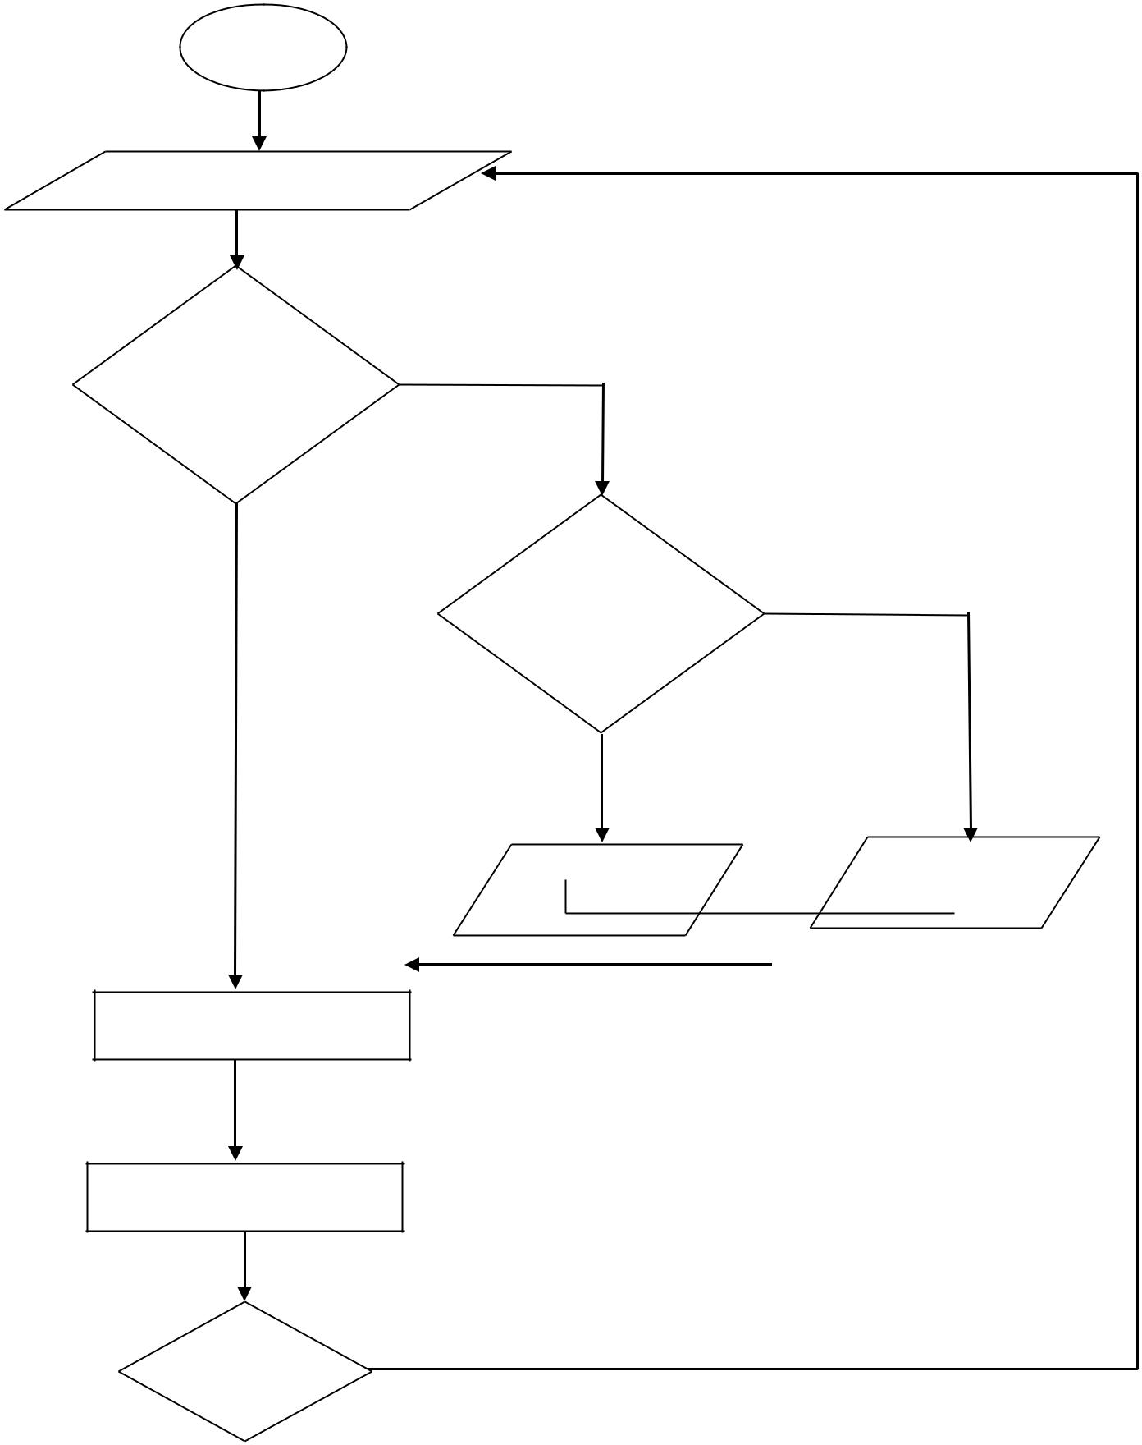

No

^{Is} No

student

in Science

Yes

Input Student | Input Student
Input Student | form for Arts
form for Sciences | form for Arts

Compute Result

Report

Next Yes
Person

No
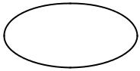


Sto

Figure 3.7. System flow chart

49

Figure 3.7 shows the system flowchart details, the flow of data throughout an entire information system. Program flowcharts describe the process taking place with an individual program in the system and the system in which they must be executed. A flowchart is an old design tool that is still in use today. Though it is no longer recommended for program design because it does not provide top down modular structure as effectively as other techniques but is still being used to document physical design specification because they can show all input, major files processing and output for a system and they can document procedures.

3.8 TOP DOWN DESIGN

Figure 3.8 shows that the system have been into six functional sub system, the DBMS sub system which are the user DBMS administrator, file sub system is where new students are been registered, we also have a sub system were all the result are computed.
50
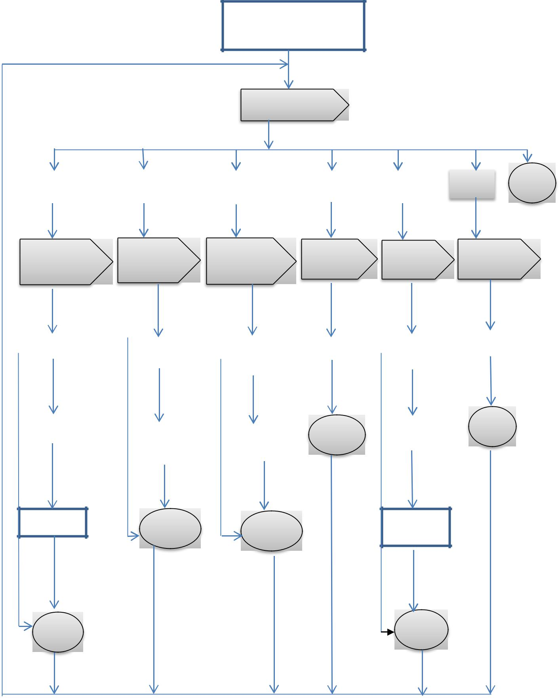

Student evaluation program

SYSTEM DRIVER

DBMS |  | FILES |  | COMPUTE |  | UPDATE |  | Repor |  | Help |  | quit
 |  |  |  | RESULT |  |  |  | t
DBMS SUB |  | File sub |  | Compute result |  | Update sub |  | Report sub |  | Help sub
SYSTEM |  |  |  | sub system |  | system |  | system
 |  | system driver |  |  |  | system |  |  |  | system driver
DRIVER |  |  |  | driver |  | driver |  | driver

 |  |  |  |  |  |  |  |  |  | FAQ
Create new user |  | New student |  | Compute |  | Search |  | All |  | FAQ
 |  | New student |  | Compute |  |  |  | students
 |  | New student |  | for JSS |  |  |  | students

save |  |  |  |  | Exit | Student | Exi
save |  | Change |  | Compute | Exit | Student | t
 |  | Change |  | Compute | Exit | profile | t
 |  | password |  | for SSS

Delete | Exit | Exit | View
 | Exit | Exit | result

Exit | Exit

Figure 3.8 Top down design

THE GRADING SYSTEM
51

The grading system used in DAUGHTERS OF DIVINE LOVE

JUNIORATE is as follow:

SCORE GRADE

70-100 A

60-69 B

45-59 C

0-44 F

CHAPTER FOUR
52

SYSTEM IMPLEMENTATION, TESTING AND INTEGRATION

4.1 CHOICE OF DEVELOPMENT TOOLS

During the development of this program, I used visual basic 6.0 and Microsoft access. They are use to ensure effective program.

4.2 SYSTEM REQUIREMENT

System requirement has to do with the hardware and software requirement for any application system. The platform and speed on which the system will be exerted are basically important because if not considered or well planned for might affect the application execution. Thus, the two system specifications for the proposed system application are the hardware and software specification or requirement.

4.2.1 Hardware Requirements

The hardware requirement refers to the tangible (physical) gadgets needed

for the efficient running of the system.

Thus, the requirements needed are:

- Pentium III processor, 128MB RAM and 40GB HDD.

- SVGA 14" Monitor

- CD ROM

- Laser Jet Printer

- Keyboard and Mouse.

4.2.2 Software Requirement
53

While hardware's is physical components and devices, software is specially written code needed to instruct the hardware to carryout the needed operation. The software facilities that would aid the usage of this system are:

- Windows XP

- Visual basic 6.0

- Microsoft office

- Anti-virus (Norton, AVG, P.C tools etc).

- Macro media flash

4.3 IMPLEMENTATION

This is where all the result of this of this project work is implemented; this phase consists of source code, together with documentation to make the code more readable, we have the interfaces were the teachers have to register new student in order to compute there student’s result at the end of every term, and also access student performance to know where they are lacking in academics. The software does not only have to be considered from the point of view of logistics functionality but from the technical perspective.

Login page
54
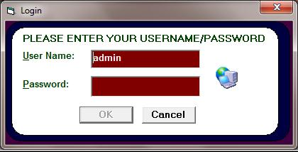

Figure 4.3.1 login page

The login page enables the administrator to enter their username/ password. If the password entered is valid, the system will then open the program menu. But if the password is not valid the user will be denied access to the program.

The main menu
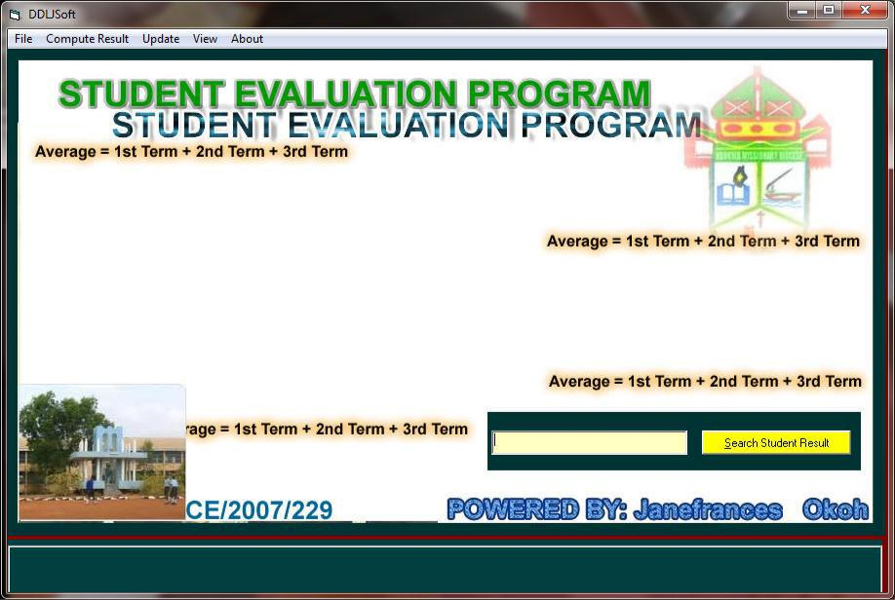

Figure 4.3.2 main menu
55

The main menu contains all the available commands and serves as a link to all other modules in the program. To access any of the menu command, click at the modules to view all the sub modules.

Registration form
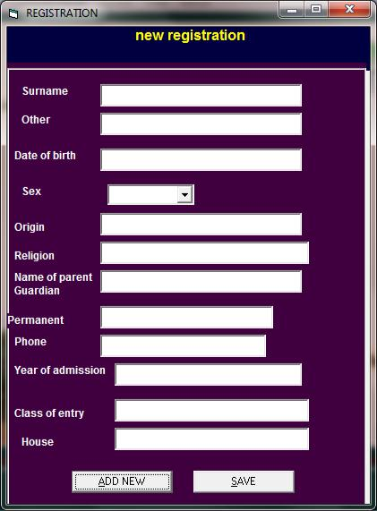

Figure 4.3.3 registration form

Registration form is where the entire new students profile are register after the necessary payment.

Compute result form.
56
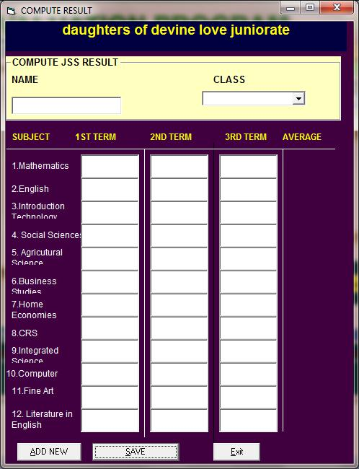

Figure 4.3.4 compute result

Figure 4.3.4 show how student results are computed each term and average

at the end of the academic year. This is saved to the database.

4.4 TESTING
57

The system evaluation phase is vigorous and time consuming. It is also known as system testing in which the system developed (new system) is tested and accessed, thereby correcting any error (debug) for better performance.

All aspects of the system i.e. both hardware and software need to be secured and testing.

4.4.1 UNIT TESTING

The unit testing interfaces of this system shown below allow the user to perform operation on the program. The testing interfaces for this program are:

- Add New Student: This interface allows you to add a new student into the database of the school. It appears with a registration from where you can enter student's personal data.

(2) Edit/Find Student: This interface allows you to edit student information. Where there are changes like promotion or withdrawal of a particular student. It also allows us to find information regarding a particular student even after graduation or contact number(s).

- Enter Result Values: This interface allows you to enter values of all subjects (scores) for student from first term to third term of every subject.

58

- View All Students: This student allows you to view all the students in the school regardless of their classes.

- View Summary: This interface allows you to view summary of all students in either SSS classes or JSS classes.

- View Result: this interface allows you to view the result of a particular class that was computed in section (iii) by specifying their position.

  - Position of every student in the class.

  - Remark that indicates if a student is to be promoted or not.

- EXIT: Takes you out of the main - menu (home page).

4.4.2 SYSTEM TESTING

The system was tested with some data. This assures that the new system has achieved its aims and objectives.

4.5 EXECUTING THE APPLICATION

The application comes in a CD-form, which is an executable or installable CD. Below are the procedures for installing the application.

- Turn on your computer.

- Slot in the CD into the CD-ROM.

- On the desktop, open my computer.

- From my computer, open the CD-ROM drive (Usually D-drive).

- On the D-drive, double click on student evaluation.
59

- Double click on package.

- Double click on setup and then the application will be installed on your computer.

4.6 SECURITY

The new system provides passwords and log-on information which prevents unauthorized access to the files stored in system. The files are well secured and kept under supervision of the proprietor of daughter of divine love.
60

CHAPTER FIVE

SUMMARY, RECOMMENDATION, AND CONCLUSION

5.1 SUMMARY OF FINDINGS

Evaluation of student should promote sound education principles, and effective student work so that the educational needs of students are served. Written policies and procedures should be developed, implemented and made available so that evaluations are consistent, and fair. Access to a student’s evaluation information should be provided but limited to the student and others with established legitimate permission to view the information so that confidentiality is maintained and privacy protected. Evaluation of students should be consistent with applicable law and basic principles of fairness and human right so that student’s right and welfare are protected. It also provides information that identifies both strength and weaknesses so that the strength can be built upon and the problem areas addressed.

5.2 LIMITATION OF THE PROJECT

Due to way the system was design some can’t log in without the use of password. Also the major problem encountered during the course of this study was the issue of gathering information from the members and staff of the school.
61

5.3 RECOMMENDATIONS

The need for information and materials to guide teachers in their evaluations of students is well known. Over the past 40 years, studies have documented the need for additional training and support for teachers in their assessment of student. Despite the identified needs, to data no comprehensive widely accepted has been prepared.

Student’s evaluation is a comprehensive and complex subject involving many philosophical and political discussions. This study has focused on teacher decision making in classroom assessment practices within the context of daughters of divine love. After the analysis of several data collected, I suggest the following recommendation.

Management should examine the proper relationship, moral responsibilities and the influence of personal community values in the evaluation of student progress and achievement.

- Examine the feasibility or case of use of alterative assessment in the context of contemporary high school class.

- Examine the role of students in the evaluation of their progress and achievement.

- Identify develop and determine appropriate use of subjective and high inference assessment.
62

5.4 BEME (BILLS OF ENGINEERING MEASUREMENT OF

ENGINEERING)

PROJECT COSTING

The expenses are shown as follow:

Item | Amount
Computer operator | 25,000
Computer system | 150,000
Transport | 2000
CD | 250
Printing | 2,500
Binding | 500
Total | 180,250

5.5 CONCLUSION

Student evaluation is a complex and essential aspect of our education experience. There is a need for congruency between the goals and purposes of curriculum. Instruction and assessments of student evaluation is to be meaningful and fair.

School boards and administration can promote improvement in student evaluation by establishing environment of support and trust in which teachers can engage in collaborative reflection and professional dialogues that will lea them to examine their purpose, clarify values, and identify and
63

develop the skills and strategies needed for sound assessment and evaluation practices. School boards and administration can further assist by developing school division and school policies of assessment and evaluation based on principles that reflect shored beliefs and values about purpose of education and evaluation, and that include recommended practices which are well aligned with the goals of core curriculum.
64

BIBLIOGRAPHY

David N. Smith (20011). Concept of Object Oriented Programming.

McGraw Hill Series Programming Languages.

Fagan. L., & Spurrell. D. (2005). Evaluating achievement of senior high school students. Toronto: Canadian Education Association

Haas, J. (2005). Standards, assessments, and students: Encouraging both equity and excellence. Bulletin, 79 (573), 95 - 101.

Ierence. J. Crook (2011). The Impact of Classroom Evaluation Practices on Student. (University of Otage).

Kenneth C. Landon (2008). Management Information System, 6th Edition.

Nancy A. Lynch, Micheal Merit (2004). data Management System, Morgan Kaufman, New York. U.S.A.

Natriello, G. (2007). The impact of evaluation processes on students. Educational Psychologist, 22 (2), 155 - 175.
65

Ornstein, A. C., & Cienkus, R. (2005). Evaluation of students:

- practitioner's perspective. The High School Journal, 79 (1), 65-71.

Ryan, A. (2007). A dimension of how teachers evaluate their

Students. Journal of Curriculum and Supervision/ 12 (2), 118-134

.

Saskatchewan Education. (2006). A curriculum guide for the secondary level. Regina, SK: Author.

Saskatchewan Education. (2007). Accreditation (Initial and Renewal):

Policies and procedures, Regina, SK: Author.

Stiggins, R. 1 (2007). Student-centered classroom assessment. 2nd edition.

Toronto: Prentice-Hall.

Wilson, R. (2006). Assessing Students in classroom and Schools.

Toronto, ON: Allyn and Bacon Canada.
66

APPENDIX A:

SOURCE CODE

NEW REGISTRATION
Private Sub Command1_Click()
Text1.Text = ""
Text2.Text = ""
Text3.Text = ""
Text4.Text = ""
Text5.Text = ""
Text6.Text = ""
Text7.Text = ""

Text8.Text = ""
Text9.Text = ""
Text10.Text = ""
Text11.Text = ""

End Sub

Private Sub Command2_Click()
With Form8.Data1
.DatabaseName = App.Path & "\me.mdb"
.RecordSource = "select * from record"
.Refresh

Do Until .Recordset.EOF

If Form8.Text1.Text = .Recordset.Fields("surname") And Form8.Text2.Text =
.Recordset.Fields("other_name") Then
MsgBox ("The Name already exist")
GoTo 20
Exit Do
End If

.Recordset.MoveNext

Loop
End With

If Text9.Text = "" Then
MsgBox "Please fields are empty"
Else

With Form8.Data1
.DatabaseName = App.Path & "\me.mdb"
.RecordSource = "select * from record"
.Refresh
.Recordset.AddNew
.Recordset.Fields("surname") = Text1.Text
67

.Recordset.Fields("other_name") = Text2.Text
.Recordset.Fields("dob") = Text3.Text
.Recordset.Fields("sex") = Combo1.Text
.Recordset.Fields("origin") = Text4.Text
.Recordset.Fields("religion") = Text5.Text
.Recordset.Fields("name_parent") = Text6.Text
.Recordset.Fields("permanent") = Text7.Text
.Recordset.Fields("phone") = Text8.Text
.Recordset.Fields("yoadmin") = Text9.Text
.Recordset.Fields("classent") = Text10.Text
.Recordset.Fields("house") = Text11.Text
.Recordset.Update

End With

End If
20 End Sub

Private Sub Form_Load()
Text1.Text = ""
Text2.Text = ""
Text3.Text = ""
Text4.Text = ""
Text5.Text = ""
Text6.Text = ""
Text7.Text = ""
Text8.Text = ""
Text9.Text = ""
Text10.Text = ""
Combo1.AddItem "male"
Combo1.AddItem "Female"
End Sub
COMPUTE RESULT
Private Sub Command1_Click()
Dim aves As Integer

Lab19(0).Caption = Val((0.2 * Val(Text1(0).Text))) + Val((0.3 * Val(Text1(1).Text))) + Val((0.5 * Val(Text1(2).Text)))

Lab19(1).Caption = Val((0.2 * Val(Text1(3).Text))) + Val((0.3 * Val(Text1(4).Text))) + Val((0.5 * Val(Text1(5).Text)))

Lab19(2).Caption = Val((0.2 * Val(Text1(6).Text))) + Val((0.3 * Val(Text1(7).Text))) + Val((0.5 * Val(Text1(8).Text)))

Lab19(3).Caption = Val((0.2 * Val(Text1(9).Text))) + Val((0.3 * Val(Text1(10).Text)))
+ Val((0.5 * Val(Text1(11).Text)))
Lab19(4).Caption = Val((0.2 * Val(Text1(12).Text))) + Val((0.3 * Val(Text1(13).Text)))
+ Val((0.5 * Val(Text1(14).Text)))
Lab19(5).Caption = Val((0.2 * Val(Text1(15).Text))) + Val((0.3 * Val(Text1(16).Text)))
+ Val((0.5 * Val(Text1(17).Text)))
Lab19(6).Caption = Val((0.2 * Val(Text1(18).Text))) + Val((0.3 * Val(Text1(19).Text)))
+ Val((0.5 * Val(Text1(20).Text)))
Lab19(7).Caption = Val((0.2 * Val(Text1(21).Text))) + Val((0.3 * Val(Text1(22).Text)))
+ Val((0.5 * Val(Text1(23).Text)))
68

Lab19(8).Caption = Val((0.2 * Val(Text1(24).Text))) + Val((0.3 * Val(Text1(25).Text)))
+ Val((0.5 * Val(Text1(26).Text)))
Lab19(9).Caption = Val((0.2 * Val(Text1(27).Text))) + Val((0.3 * Val(Text1(28).Text)))
+ Val((0.5 * Val(Text1(29).Text)))

ave = Val(Fix(Val(Lab19(0).Caption)) + Val(Fix(Lab19(1).Caption)) + Val(Fix(Lab19(2).Caption)) + Val(Fix(Lab19(3).Caption)) + Val(Fix(Lab19(4).Caption))

+ Val(Fix(Lab19(5).Caption)) + Val(Fix(Lab19(6).Caption)) +
Val(Fix(Lab19(7).Caption)) + Val(Fix(Lab19(8).Caption)) +
Val(Fix(Lab19(9).Caption)))
average.Caption = ave
With Form11.Data1
.DatabaseName = App.Path & "\me.mdb"
.RecordSource = "select * from result"
.Refresh

Do Until .Recordset.EOF

If Form11.Text37.Text = .Recordset.Fields("name") And Form11.Combo1.Text =
.Recordset.Fields("class") Then
MsgBox ("RESULT already exist")
GoTo 20
Exit Do
End If

Private Sub Command3_Click()

Text1(0).Text = ""
Text1(1).Text = ""
Text1(2).Text = ""
Text1(3).Text = ""
Text1(4).Text = ""
Text1(5).Text = ""
Text1(6).Text = ""
Text1(7).Text = ""
Text1(8).Text = ""
Text1(9).Text = ""
Text1(10).Text = ""
Text1(11).Text = ""
Text1(12).Text = ""
Text1(13).Text = ""

Text1(14).Text = ""
Text1(15).Text = ""
Text1(16).Text = ""
Text1(17).Text = ""
Text1(18).Text = ""
Text1(19).Text = ""
Text1(20).Text = ""
Text1(21).Text = ""
Text1(22).Text = ""
Text1(23).Text = ""
69

Text1(24).Text = ""
Text1(25).Text = ""
Text1(26).Text = ""
Text1(27).Text = ""
Text1(28).Text = ""
Text1(29).Text = ""
End Sub

Private Sub Form_Load()

Combo1.AddItem "1A"
Combo1.AddItem "1B"
Combo1.AddItem "1C"
Combo1.AddItem "1D"

Combo1.AddItem "2A"
Combo1.AddItem "2B"
Combo1.AddItem "2C"
Combo1.AddItem "2D"
Combo1.AddItem "3A"
Combo1.AddItem "3B"
Combo1.AddItem "3C"
Combo1.AddItem "3D"
End Sub

Private Sub Label19_Click()

End Sub

Private Sub Form_Load()
Text1.Text = ""
Text2.Text = ""
Text3.Text = ""
Text4.Text = ""
Text5.Text = ""
Text6.Text = ""
Text7.Text = ""
Text8.Text = ""

Text9.Text = ""
Text10.Text = ""
Text11.Text = ""

Text14.Text = ""
Text12.Text = ""
Text13.Text = ""
Combo1.AddItem "Male"

Combo1.AddItem "Female"
70

On Error Resume Next

With Form3.Data1
.DatabaseName = App.Path & "\me.mdb"
.RecordSource = "select * from record"
.Refresh
.Recordset.MoveFirst
Do Until .Recordset.EOF

If Form12.Text1.Text = .Recordset.Fields("surname") Then

Text1.Text = .Recordset.Fields("surname")

Text2.Text = .Recordset.Fields("other_name")
Text3.Text = .Recordset.Fields("dob")
Combo1.Text = .Recordset.Fields("sex")
Text4.Text = .Recordset.Fields("origin")
Text5.Text = .Recordset.Fields("religion")
Text6.Text = .Recordset.Fields("name_parent")
Text7.Text = .Recordset.Fields("permanent")
Text8.Text = .Recordset.Fields("phone")
Text9.Text = .Recordset.Fields("yoadmin")
Text10.Text = .Recordset.Fields("classent")
Text11.Text = .Recordset.Fields("house")

Text12.Text = .Recordset.Fields("yrgrad")
Text13.Text = .Recordset.Fields("yearwit")
Text14.Text = .Recordset.Fields("reasonwith")
Exit Do
End If

.Recordset.MoveNext

Loop

Exit Sub
71

APPENDIX B:

SIMPLE OUTPUT
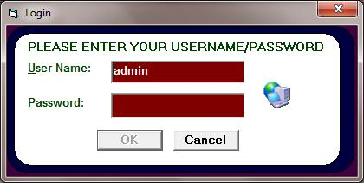

Appendix 1 login page

This figure shows Login Page where users will be authenticated to provoide username and password
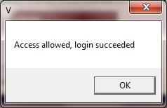

Appendix 2 permission message

This figure show access permission message.
72
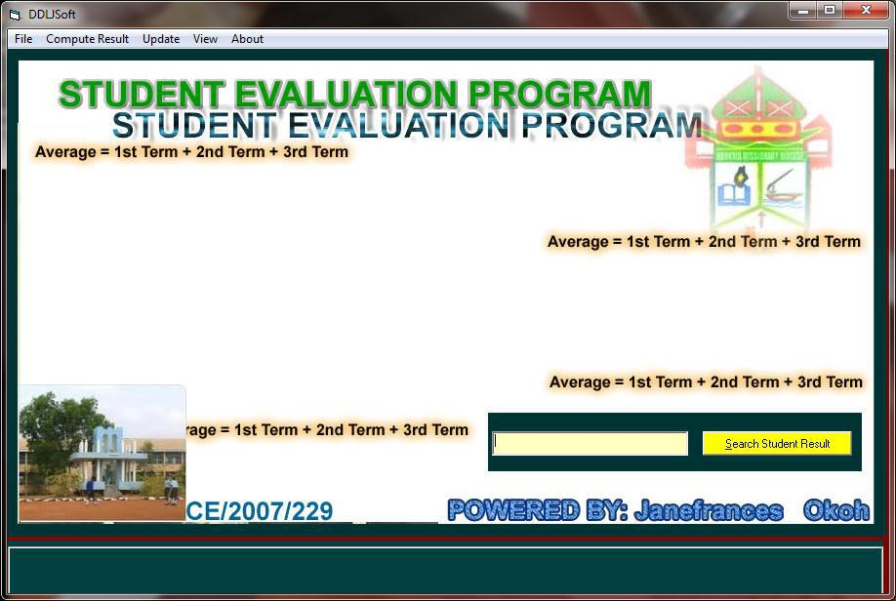

Appendix 3 main menu

This figure is the menu form where user will select any action that he/she want to perform
73
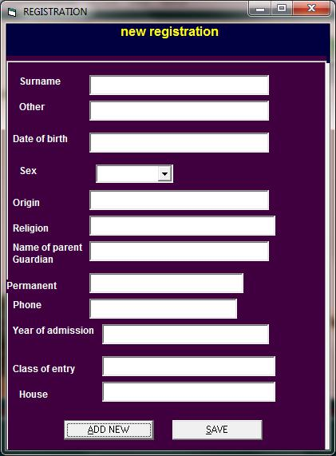

Appendix4 registration form

This is a form where new students will be registered
74

Appendix 5 result computational form

This form shows how Junior Students results can be computed.
75
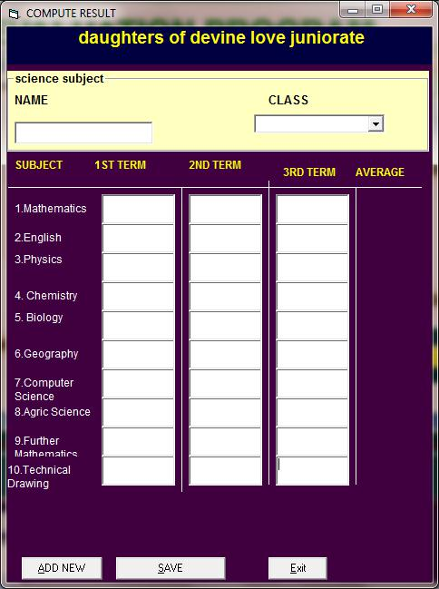

Appendix 6 result computational form(SSS)

This form shows how Senior Students results can be computed.
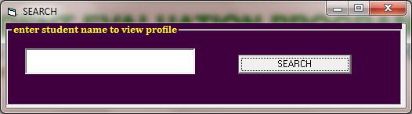

This form shows how to Seach for students profile

