**DESIGN AND IMPLEMENTATION OF ROAD TRANSPORT BOOKING SYSTEM**

**ABSTRACT**

Most transactions in the world are now being electronic, in light of the fact that it gives effectiveness, security, precision and unwavering quality. In Nigeria, travelling companies still use the manual system of transport management which involves the use of paper/pen to sell tickets and manage seat bookings. They spend substantial costs in managing the seat reservation process. This project presents an implementation of a software program; Bus Ticket Reservation System that will be used in a transportation system, for bus seat reservation. Road Transport Booking System tends to computerize the traditional ticket booking by using web-based technologies for booking management. In order to achieve the design, ABC Transport, Anambra State was chosen as a case study because of its strategic importance in Anambra State. Structured Systems Analysis and Design Methodology (SSADM) was adopted. In addition, PHP Hypertext Pre-processor (PHP) language was used for the front-end design of the software while data storage was done using MySQL. The software achieved its capability in improving the customer relationship within the company. It is recommended that despite the present functionality of the designed software, an additional functionality such as the use of E-mail to send tickets and notifications to the customer and an online payment using credit cards/debit cards should be implemented into the system.

**CHAPTER ONE**

**INTRODUCTION**

* 1. **BACKGROUND OF THE STUDY**

The word transport means movement of people or goods from one place to another, through the means of human, cars, ship, trains, animals e.t.c. According to (Adewumi, 2010), transport modes are the means by which people and freight achieve mobility. They fall into one of three basic types, depending on over what surface they travel- land (road, rail and pipeline), water (shipping) and air. Each mode is characterized by a set of technical, operational and commercial characteristics. The transport of a person or of cargo may involve one mode or several modes, with the latter case called intermodal or multimodal transport. The human powered transport makes use of human muscle-power in the form of walking and running. However, modern technologies have been used to create machines that enhance human-power. Human-power transport remains popular for reasons of cost saving, leisure and physical exercise. The human-power transport is sometimes the only type available, especially in underdeveloped or inaccessible regions. It is considered as an ideal form of sustainable transportation. Although, humans are able to walk without infrastructure, the transport can be enhanced through the use of roads, especially when using the human-power with vehicles, such as bicycles and inline skates. We also have other means of transport including aviation, which is transport by air; Marine transport which is the means of transportation that make use of river or sea where the mode of movement is through the use of canoes, ship; transport by rail which makes use of railways and the means of transport is by train.

The prevalent view in various global circles is that man is presently living in an age growth of information gathering, processing and dissemination, popularly called the information age. For this reason, managers and other users of information especially in transport industries are demanding more kinds of information to support management and operations. They must therefore respond to the increasing requirement for information and data management. Electronic tickets, or e-tickets, gives evidence that their holders have the permission to enter a place of entertainment, use a means of transportation, or have access to some Internet services. The design of this online system will be beneficial to the company because it has not existed before. Therefore, ABC Transport, Anambra State, a viable investment whose primary objectives are: to spread comfort and hospitality to passengers away from their home, to make profit, will definitely appreciate a system which can automate its manual operations in the area of bus ticket reservation in order to meet customers increasing demand during peak and off peak seasons. The ultimate expectation is to inspire a feasibility study aimed at providing proper guidance and awareness to any future potential investors, particularly those in the bus industry, to consider utilizing the Imo transport, as a gateway to the fertile soil of unlimited opportunities in the south-east Nigeria. (Asogwa S.E, 2008).

Currently, staff at the bus ticket counter is using an internal system to sell tickets at the counter and customers who are unable to buy bus ticket online at this moment would have to go to the counter to a buy bus ticket. Sometimes, customers’ needs to queue up a long queue to buy bus ticket and ask for information and this brings a lot of inconveniences to customers. However, Online Bus Ticket Reservation System enables the customer to buy bus ticket, make payment, and ask for information online easily. Furthermore, staff can sell bus ticket using Bus Ticket Reservation System after checking the bus ticket availability for the customer and print the bus ticket to the customer.

* 1. **STATEMENT OF THE PROBLEM**

ABC Transport, Anambra State still uses the manual system of transport management. Many flaws have been identified in this system ranging from human errors (e.g. miscalculations in ticket price, mistakes in noting passenger data, etc.), the fluctuation of passengers during certain periods of time that causes a bottleneck in the check-in process because of the inability of the front officer to multitask and the lack of overview or report of the on-going business; making it difficult for the company to judge past/current performance or plan future improvements. Other problems identified in the current scenario include:

1. The travel agent wastes a lot of time recording booking information when there are more customers than he can handle at a time and this usually results in queuing and standing for a long time when buying tickets.
2. Due to stress on the staff, over-booking for a limited number of seats is a daily problem.
3. The head office and branch offices are at different locations. Contact must be made by each branch’s front-office to the head office for each customer’s enquiry in order to get the latest update on schedule, seat availability and other reservation-related information.
4. There is also a physical limit to the reservation availability as each branch  
   only operates during certain hours and reservations can only be made on-the-spot. These limitations are not the only issues the company is currently facing.
5. There is lack of proper information for decision making. With the increased number of staff and agents in the company, staff nominal roll does not give easy and fast access to staff information like grade level, year of employment, salary e.t.c. Some staff may be omitted when such names are needed like in the case of staff promotion and salary payment due to loss or neglect of staff files.

Looking at these problems and limitations, it is clear that both the company and the customers require an integrated reservation system that is more efficient in information update and reservation handling and also easy to use. The web-based information system is developed to tackle the above problems.

* 1. **OBJECTIVES OF THE STUDY**

The main purpose of this study is to automate the manual procedures of reserving a bus ticket for any journey made ABC Transport, Anambra State. The web-based system is designed in a way where customers can book seats by themselves irrespective of location. To achieve the stated objective, the following specific objectives were laid out:

1. Provide a web-based bus ticket reservation function where a customer can buy bus ticket through the online system without a need to queue up at the counter to purchase a bus ticket.
2. Enable customers to check the availability and types of busses online. Customer can check the time departure for every EUMT bus through the system.
3. Provide easy bus ticket payment by obtaining a bank pin after payments is made to the various designated banks.
4. Provide ability of customers to cancel their reservation.
5. Make the system secured by limiting user privileges in updating and canceling payment, route and vehicle records.
   1. **SCOPE OF THE STUDY**

This project, Road Transport Booking System is a generic web portal application that is used for the management of ticketing, seat reservation and staff information of ABC Transport. This system aids travelers in reserving seat in a bus from anywhere. Varieties of buses that satisfy the customer’s requirements, price, and bank accounts are provided by the company managers. Travelers who wish to use the system are registered into the system. From user homepage, they can make a reservation and payment. The project used software like Visual Studio Code as a development tool, MySQL for the database, Apache as the web server. For the main effects, it used jQuery.

* 1. **SIGNIFICANCE OF THE STUDY**

This project work will be of utmost importance to transport companies. The project, can serve as a marketing strategy and aids in efficient processing and delivery of itinerary receipts. This thesis is also beneficial to the world at large as it will ease the tedious processes of bus seat reservation.

Also the result of this study will be of importance to scholars researching the field of information system as it will serve as a reference to them. As a reference material, it could generate other researchers’ interests in the unfinished part of this research, especially in the full implementation and deployment of the system.

* 1. **LIMITATION OF THE STUDY**

The major limitation faced during the course of this project research is during the actual software development. PHP codes required for efficient bus reservation were difficult to obtain. This made me go for the available but less preferred code for the implementation. Although the developed system met the intended objectives, better logic algorithms would have produced a more secured system.

Furthermore, Payment with smart card will not be possible due to lack of fund to get the intereswitch facilities that are expected in this area. However payment will be done by direct payment into bank account

The inability to lay hands on previous materials on the topic slowed down my research speed. Quality materials needed for reference were difficult to obtain. Available materials did not have enough resources to be used as reference.

Also much finance was required to purchase resourceful intelligence and owing to the financial meltdown globally, the research was limited by finance and hence concentrated on the available materials.

* 1. **PROJECT METHODOLOGY**

For any project to be completed, it has to go through stages called Development Life Cycles. System Development Life Cycle (SDLC) is the process of understanding how an Information System (IS) can support business needs, designing the system, building it and delivering it to users. The SDLC composes of four phases: Planning, Analysis, Design and Implementation. In order for this project to be developed, the methodology that will be used is the System Structured Analysis and Design Methodology. The SSADM is classified as a Waterfall Development. With Waterfall Development, analyst and users proceed sequentially from one phase to the next and each phase can be mapped out and evaluated (Hevner, 2004). Below, in figure 3.1 is a diagram on the waterfall methodology.

* 1. **ORGANISATION OF THE STUDY**

This thesis would be presented in five (5) chapters in well-structured and coordinated order as outlined below:

Chapter one (Introduction): is a general introduction of the project, it gives the general idea of the project and its objectives. Also the problem statement, which is a clearly defined problem to be tackled. Finally the organization of the thesis

Chapter two (Literature Review): This chapter presents description and explanation for various technologies used , definition of payment system and its forms, the history of electronic payment, the types of electronic payments, security and authentication in electronic payment, and the e-payment in public transport

Chapter three (Methodology): This chapter introduces a brief description of the system. And approaches overall framework used in building the system. Also it includes a brief description of the software and hardware components that were used, system functional and non-functional requirements, database design, and the payment process.

Chapter four (Results and test): This chapter shows the results obtained when the system executed, and discusses tests performed on the system

Chapter five (Conclusion and future work): This chapter provides the project conclusion, limitations, and future work will be performed to improve this project.

* 1. **DEFINITION OF TERMS**
* **System**: A system is a group of interrelated component working together  
  toward a common goal by accepting input and producing output in an  
  organized transformation process. (Brine, 1996).
* **Information Management**: This involves the utilization of material  
  equipment and human resources to identify, generate, process and store  
  information for eventual retrieval and dissemination to be used by management or individual reception objective.
* **Information System**: Information system is defined as a set of interrelated components that collects or retrieves, process and store information to support decision making and control in an establishment.
* **Management Information System (MIS):** which is a computer-based  
  information system that uses data recorded by TPS as input to produce routine reports to assist managers in tactical decision making?
* **Transportation**: Transportation is the movement of people from one place to another.
* **Booking**: This is the arrangement of seat on a bus made by a travel agent for passengers.
* **Passengers**: A passenger is a person who travels from one place to another by the means of a transporting system.
* **Ticket**: Ticket is a printed paper that entitles the holder to board a particular means of commercial transportation.
* **Manifest**: This is a form that passengers fill their personal information, next of kin and also his or her departure place and destination respectively

**CHAPTER TWO**

**REVIEW OF RELATED LITERATURE**

**2.1 OVERVIEW OF TRANSPORTATION**

According to Adewumi W. (2010) transportation is the movement of people and goods from one place to another. Transport on roads can be grouped into two categories namely; Transportation of goods and Transportation of people. In many countries licensing requirements and safety regulations ensure a separation of the two services. The nature of road transportation of goods depends, apart from the degree of development of the local infrastructure, on the distance the goods are transported by road, the weight and volume of the individual shipment and the type of goods transported. For short distances and light, small shipments a van or pickup truck may be used. For large shipments even if less than a full truckload (Less than truckload) a truck is more appropriate. People (the passengers) are transported on roads either in individual cars or automobiles, or in mass transit by bus or coach. Transportation system is referred to as the equipment and logistics of transporting passengers and goods. It covers movement by all forms of transport, from cars and buses to boats, aircraft and even space travel. Transportation systems are employed in troop movement logistics and planning, as well as in running the local school bus services.

**2.2 TYPES OF TRANSPORTATION SYSTEM**

The following are known categories of transportation systems.

1. **Aviation Transport**: With the help of invention of airplane in 1903,  
   transportation of people and goods from one city or country to another in a few minutes or hours came to reality. According to the history of aviation, two brothers Orville and Wisdom Wright finally came up with the best air craft of A11. They built and rested many gliders using different wings designers and added a gasoline engine and propeller. Orville piloted the plane on its first successful flight in 1903 and killy Hawk, North Caroline and the ancient of joining the birds in flying came true. And among all the means of transportation aviation happens to be the fastest because it travels through air and it is used for long distance journey, say from one country to another, in a few hours. Marion (2000).
2. **Marine Transport**: Marine transport is the means of transportation system that makes use of river or sea for transportation of people or goods from one town to another or country to another country. This means of transportation makes use of canoes, ships and it also makes use of sea surface while submarine makes use of inside water for their operation. And during early rafts for water transportation system pioneers transporters used long raft for whatever was possible. Because water was easier to travel on rather than land. A large float boat could carry two or three families down and a river with their livestock and everything else they owned.
3. **Rail Transport:** Rail Transport is more advantageous to take this means of transportation system is particularly true in Europe or Japan. In various regions around the world trains may be an excellent means of transportation and when planning a trip abroad or within the country.
4. **Transit Road Transport:** Transit Road Transport is the means of transportation system which is the transit road transport, and it is also the means of transportation that makes use of road for transportation of people or goods from one place, one town to another. This means of transportation makes use of Cars, Buses or Lorries. This means of transportation is cheaper, common and also will be the cardinal focus of this research work. So many land transportation industries or company are employed in carrying, traveling through a short or long distance such as the ABC Transport, Anambra State which can help human to their various destinations.

**2.3 INFORMATION SYSTEM**

This is the process of combining people, hardware, software, communication devices, network and data resources to process (which can be storing, retrieving or transforming information) data and information for a specified purpose. Hevner A et al. (2010). According to Wikipedia.org, (IS) is a complimentary network of hardware and software that people and organizations use to collect, filter, process, create and distribute data.

**2.3.1 Types of Information System**

There are about six types of information system but only three will be discussed here.

1. **Transaction Processing System (TPS)**: The transaction processing system helps to record the day to day transaction for Transport companies, such as the passengers’ tickets, customer orders, bills inventory level and the production output. The transaction processing system (TPS) helps the transportation company to supervise and generate data base that will act as the foundation for the other information system.
2. **Management Information System (MIS)**: Is the computer-based information system that uses data recorded by TPS as input to produce routine reports to assist middle managers in tactical decision making. Ekanem.BA. (2010)
3. **Executive Support System (ESS):** This is an easy to use system that presents information in a very highly summarized form for the transport company. And it helps the top-level managers to oversee the company’s operation and develop strategic plans for the transportation company. The ESS combines the internal data from TPS, MIS, and DSS with external data. (Laudin and Laudin 1996)

**2.4 PAYMENT SYSTEMS**

A payment system is any system used to settle financial transactions through the transfer of monetary value, and includes the institutions, instruments, people, rules, procedures, standards, and technologies that make such an exchange possible. A common type of payment system is the operational network that links bank accounts and provides for monetary exchange using bank deposits. (Rachna And P. Singh, 2013).

* + 1. **Forms of Payment**

1. **Cash payment:** There are many problems with the traditional payment systems that are leading to its fade out.

**Disadvantages of Cash System**

* Lack of Convenience: Traditional payment systems require the consumer to either send paper cheques by snail-mail or require them to physically come over and sign papers before performing a transaction. This may lead to annoying circumstances sometimes.
* Lack of Security: This is because the consumer has to send all confidential data on a paper, which is not encrypted, that too by post where it may be read by anyone.
* Lack of Coverage: When we talk in terms of current businesses, they span many countries or states. These business houses need faster transactions everywhere. This is not possible without the bank having branch near all of the company’s offices. This statement is self-explanatory.
* Lack of Eligibility: Not all potential buyers may have a bank account.
* Lack of support for micro-transactions: Many transactions done on the Internet are of very low cost though they involve data flow between two entities in two countries.

**Advantages of cash:**

* Easy to transport and transfer.
* No transaction costs (no third party is involved directly).
* No audit trail is left behind (that’s why criminals like it).
  + 1. **Electronic payment**

Electronic Payment is a financial exchange that takes place online between buyers and sellers. The content of this exchange is usually some form of digital financial instrument (such as encrypted credit card numbers, electronic cheques or digital cash) that is backed by a bank or an intermediary, or by a legal tender. There are four main types of electronic payment: namely, the online credit card payment system, the electronic-cash payment system, the electronic-check payment system, and the smart-card- based electronic-cash payment system. The characteristics of the payment device can have an important bearing on how easy the system is to use. The payment device could be a Contactless Smart Card. Another technology development involves the use of near field communication (NFC). NFC enables use phone to make payments just like a smart card. Make it easier and more convenient for consumers by making it simpler to make transactions, exchange digital content, and connect electronic devices with a touch. These days you can pay for calls, for transit, and for parking using a transponder or tag, a smart card, or a smartphone. The latest in smart card technologies allows the card to be held close to the reader or to a reading plate, with no contact required. The card does not need to be inserted into a slot. Short-range communication technologies allow data to be transferred from the smart card to the reader and vice versa. This avoids customer issues related to difficulties in inserting a card in a slot and makes the system mechanically more reliable. Needless to say, the wireless messages communicated are required to be secured through the use of encryption. (Princewill Aigbe and Jackson Akpojaro, 2014).

* 1. **HISTORY OF ELECTRONIC PAYMENT**

Electronic systems were used at first to process checks between one bank and another. And afterward later used to process different sorts of electronic exchanges amongst shoppers and shippers (for example, a client educates a bank to automatically deduct their checking account to pay a monthly bill of a service organization). The origin of e-payment is related to the beginning of the web. Alongside the web development, pioneer online payment services started to operate in the first half of the 90s. In 1983, a research paper by David Chaum introduced the idea of digital cash. In 1990, he founded DigiCash, an electronic cash company, in Amsterdam to commercialize the ideas in his research In 1994 Stanford Federal Credit Union was established – the first financial institution which offered online internet banking services to all of its members. but, first online payment systems weren’t user- friendly at all and required specific learning of encryption or data transfer protocol.

Furthermore, the systems weren't adjusted to steady changing of clients' number and their exchanges. In 1997, Coca-Cola offered buying from vending machines using mobile payments. After that PayPal emerged in 1998. Other system such as e-gold followed suit, but faced issues because it was used by criminals and was raided by US Feds in 2005. In 2008, bitcoin was introduced, which marked the start of Digital currencies. At the outset, the main players on the e-payment market were Millicent (founded in 1995), E- Cash or Cyber-Coin (both in 1996). The majority of the first online services were using micropayment systems and their common attribute was the endeavor to implement the electronic cash alternatives (such as e-money, digital cash or tokens.

In addition, in 1994, the Amazon is founded (one of the e-commerce pioneers) and Pizza Hut starts accepting online food ordering. [S. Sumanjeet, 2008]Although, in all nations cashes still the overpowering decision as a shopper installment system, especially for exchanges of little volumes (less than $100 USD). In creating nations—and to be sure in some created ones, for example, the United States—and speak to a moderately direct approach to start an installment.

* 1. **TYPES OF E-PAYMENT:**

It is important to note that electronic payment systems rely on a number of transfer options. Today, there exist a wide variety of electronic payment systems, the main types of electronic payment system represent different ways to transfer money:

* + 1. **Smart card-based electronic payment system:**

A smart card was first produced in 1977 by Motorola. It is a thin, credit card sized piece of plastic which contains a half-inch-square area that serves as the card’s input-output system. A smart card contains a programmable chip, a combination of RAM and ROM storage and can be refilled by connecting to the bank. It is known as smart card because the ability of chip to store the information in its memory makes the card smart. [D.U.P.S.B.V. Goyal, 2012] The smart card as a payment instrument has processing power that allows the smart card payment system to be used for multiple functions and/or applications. This of course, reduces the overall number of cards in the consumer’s wallet, though there are many arguments and issues about whether or not smart card is secured and safe enough to store such information. International standards for the smart card procedures and the smart card itself are both still evolving. In general, smart cards currently cannot display information or directly accept input from the user. For the user to access the information the smart card contains, the card needs an interface to communicate with a reader or terminal, such as a merchant point-of-sale.

* + 1. **Online payment system:**

Online payments are based on Internet Banking and involve transferring money or making a purchase online via the Internet. Consumers can transfer money to third parties from their bank account, or they can use credit, debit and prepaid cards to make purchases online. [A.Y.A.M.S. Uddin, 2016] Credit card is the most used in online payment; a credit card is an account that lends money to the consumer, meaning consumers are allowed to purchase goods or services on credit. The credit card, being a token of trust, transfers the risk of granting credit from a merchant to the card-issuing bank. Both consumers and merchants must register with a bank. The participants involved in credit card payments include:

* Customer/Cardholder: The consumer doing the purchase, using a credit card that has been issued by its issuer.
* Issuer: The financial institution (i.e. bank) that issues the card to the cardholder. The issuer guarantees payment for authorized transactions.
* Merchant: The merchant offers the goods and services, and has a financial relationship with the acquirer.
* Acquirer: The financial institution of the merchant. The acquirer processes credit card authorizations and payments.
  + 1. **Mobile Phone Based Payment System**

This system allows consumers to use their mobile phone in order to pay for transactions in several ways. Consumers can send an SMS message, transmit a PIN number, and use WAP to make online payments, or perform other segments of their transaction with the phone. As phones developfurther, consumers are likely to be able to use infrared, Bluetooth, NFC and other to transmit full account data in order to make payments securely and easily from their phone.

Mobile devices may include mobile phones, PDAs, wireless tablets and any other device that connect to the mobile network and allow payments to be made. Mobile payments can become be an alternative to paper money, cheques, credit cards and debit cards. It can also be used for payment of bills, electronic funds transfer, Internet banking payments, direct debit and electronic bill presentment [Winston O.F. (2005)]. SMS banking is a service that is offered from banks to its customers, permitting them to operate selected banking services over their mobile phones using SMS messaging.

**2.6.4 Electronic Cash (e Cash) Payment System**

Electronic cash (e-Cash) also called digital cash is digital money that provides private customers with a safe, fast and low-cost means of payment on the Internet. Created by lots of individual parties, it moves through multiple networks instead of the current bank system and is best suited for micropayments. Electronic cash is independent of any network or storage device and portable. The electronic cash units and their values can be defined independently of real currency.The application of e-cash requires that both the merchant and the customer establish e-cash accounts at the issuing bank, which issue tokens to their customers. In this electronic payment system, tokens are the payment instruments that represent monetary values. A customer must install a "cyber wallet" onto his computer, which will store the money requested from the bank. In e-cash transactions, the payee does not know the payer's identity and the issuing bank may or may not keep the identity of the recipient of the electronic bank notes, which makes the customer to remain anonymous.

Anonymity of users and double spending of the same tokens have been the major security holes of e-cash payment system. The only security mechanism provided by e-cash payment system is the encryption of payment instruments (tokens or coins) generated by a given customer. It makes use of single-factor authentication mechanism, which is not adequate for electronic payment systems involved in critical portions of payment processing.

* + 1. **Electronic Cheque (e Cheque) Payment System**

Electronic cheques are the equivalent of paper-based cheques. The electronic cheques are initiated during an on-screen dialog and the funds are transferred over a computer network at the time of the transaction. Authorized users are assigned a portable electronic cheque book which is an amalgam of a secure hardware device and specialized software.The payer writes the e-Cheque on a computer, cryptographically signs it, and e-mails it via the Internet. The payer signs the e-Cheque using the secure hardware device, and includes its authenticating certificate, signed by the issuing bank. The payee receives the e-Cheque, verifies the payer's signature on the e-Cheque, endorses it, writes a deposit slip, and signs the deposit slip.The e Cheque is protected by PIN and digital signature. This means that it makes use of a two-factor authentication mechanism in verifying the users during payment process [S. Sumanjeet, 2008].

* 1. **SECURITY IN E PAYMENT SYSTEMS**

The security is a critical aspect of any payment system, today the security issues that threaten Electronic payment systems are changing constantly, and often extremely quickly. The most common threats include:

1. **Viruses**: spread via email or by downloading infected files. Nowadays there are thousands of different types of computer viruses and internet malicious programs. Malicious software can easily attack the mobile banking payment system by taking up passwords on the web browser or any cached information on operating system
2. **Worms:** They are standalone programs that do not require a host program for activation and spread themselves independently from computer to computer by exploiting security vulnerabilities or configuration errors in operating systems or applications.
3. **Trojan horse programs:** the greatest threat to the e-Payment systems because they can bypass or subvert most of the authentication and authorization mechanisms used in an electronic transaction. The Trojan horses aim to spy on sensitive data (e.g. passwords, confidential data, etc.) and send it back to their owners to gain access to third-party computers and thus take control of them remotely.
4. **Denial-of-service attack (DoS):** is attempting to make computer resources unavailable to its intended users (for example "flooding" a network in order to prevent access to a service or a particular device by disrupting the service and not allowing access to a specific device). The DoS attacks typically target sites or services hosted on web servers such as banks or credit card payment gateways.
5. **Phishing and Pharming:** methods used to solicit personal information by posing as a trustworthy organization. Phishing attacks use email or malicious websites to solicit personal information. Usually the attacker sends an email seemingly from a reputable credit card company or financial institution that requests account information, often suggesting that there is a problem. When users respond with the requested information, attackers can use it to gain access to the accounts. Pharming is a type of fraud that involves diverting the client Internet connection to a counterfeit website, so that even when he enters the correct address into his browser, he ends up on the forged site.
6. **Man-In-The-Middle (MITM):** a type of attack where attackers intrude into an existing connection to intercept the exchanged data and inject false information. It involves eavesdropping on a connection, intruding into a connection, intercepting messages, and selectively modifying data [12].
7. **Spoofing:** is a situation in which one person or program successfully masquerades as another by falsifying data and thereby gaining an illegitimate advantage. A common method of spoofing consists in sending a message that appears to be from someone else.
   * 1. **Solutions:**
8. **Encryption**: Most online payment systems use an encryption system to add security to the transmission of personal and payment details. There are various encryption schemes in use to prevent from frauds of online payments.
9. Digital Signatures: The parties involved in online payments, transactions should use digital signatures in order to ensure authentication of transactions.
10. Firewalls: A firewall is an integrated collection of security measures designed to prevent unauthorized electronic access to a networked computer system to protect private network and individuals machines from the dangers of the greater internet, a firewall can be employ to filter incoming or outgoing traffic based on a predefined set of rules called firewalls policies.
    1. **OPERATION OF THE ABC TRANSPORT SYSTEM**

In this place the finance and administration department oversees the operation of the entire department in the ABC Transport, Anambra State. And each department has to send their accounts to this department at the end of every day transaction. The department takes care of the staff welfare, manages the income of the company, audit all departments of the company, as well as take care of the day to day administration work, such as the recruitment of staff and inspection of new vehicles to ascertain their roadworthiness. The machines undertake the repair and maintenance of vehicle owned by the ABC Transport. Also each vehicle goes for registration or booking as it comes into the terminal and it is this registration number that is used in arranging the turn scheduling. This is done on first come first serve (FCFS) order. For the loading day, routes are classified into two categories which are long and short distance road. Long distance town e.g. are Lagos, Kano, Abuja, Kaduna e.t.c. while short distance roads and routes within the state or to nearby states. With the help of the online registration by passengers the passenger presents his or her slip to the booking officer at the booking section. Booking is well arranged and co-ordinate in a first come first serve manner and tickets or invoices are issued for long distance journey after payment is made by the passengers and the ticket is a must for all passengers embarking on long distance travels e.tc. This serves as passengers benefit incase of accident for easy location of passenger.

* 1. **ANALYSIS OF THE EXISTING SYSTEM**

The present form of operation of ABC Transport booking is done manually by personnel in the booking office, wherethe passengers will registered as soon as they arrive the bookingoffice. They have to give their personal data like name, address, phone numbere.t.c to the booking officers and the passenger or customer will be asked to paytheir fare, after an invoice has been issued to the passenger and the passengersare not complete they will be asked to wait or comeback to reconfirm his or herseat and the passenger’s name will be written in the passenger’s manifestwhich is a legal name list of passengers who have completed the necessaryformalities to go on the journey.

Furthermore, I found out that ABC Transport, Anambra State ishaving hectic time managing their staff information because of the manual method of documentation. So I am introducing a web-baseddevelopment system to help themcarry out their operation effectively, the passengers should just go online to make seat reservations from the comfort of their homes. The website will also give customers information on how they carry out their operations such as the seatarrangement, how many vehicles travels per day, the various destinations they travel to and also the particular time the vehicle that the passenger booked forwill be ready for the journey. So in this case all the passenger need is to fill the form online, submit and print his or her own copy then 30munite before the journey the passenger will go tothe ABC Transport, Anambra State office and present his/herregistration slip that has been printed out from the company web site for themto cross check. This system will help the transportcompany to solve their current problems they face.

**2.9.1 Disadvantages of the Present System**

1. Retrieval of information is very slow.
2. The system is not dynamic; it does not have a database.
3. The information of passengers can be easily misplaced.
4. There is slow satisfaction of customers.
   1. **ANALYSIS OF THE PROPOSED SYSTEM**

The proposed system have the following modules for passengers so that theycan apply for booking, order for vehicles that have been uploaded, for buyingof tickets that have been uploaded for sale and placement of information aboutbookings. This system also provides an administrative environment where byadministrators can manage information on the system.

* + 1. **Advantages of the Proposed System**

The designing of a passenger friendly website with an electronic

1. Form where passengers can apply for seats and obtain other information online.
2. The information about passenger’s interest and other information
3. Will be easily stored in the database of the system for easy retrieval.

**2.10.2 Disadvantages of the Proposed System**

This system is expected to improve the operations of the firm, but the only challenges expected to be faced by the firm with the new system is to carry out proper maintainers of the system.

**CHAPTER THREE**

**SYSTEM ANALYSIS AND DESIGN**

* 1. **RESEARCH METHODOLOGY**

The system of collecting data for research project is known as research methodology. The data may be collected for either theoretical or practical research for example management research may be strategically conceptualized along with operational planning method and change management. For any project to be completed, it has to go through stages called Development Life Cycles. System Development Life Cycle (SDLC) is the process of understanding how an Information System (IS) can support business needs, designing the system, building it and delivering it to users. The SDLC composes of four phases: Planning, Analysis, Design and Implementation. In order for this project to be developed, the methodology that will be used is the System Structured Analysis and Design Methodology. With SSADM, analyst and users proceed sequentially from one phase to the next and each phase can be mapped out and evaluated (Hevner, 2004). Below, in figure 3.1 is a diagram on the SSADM methodology.

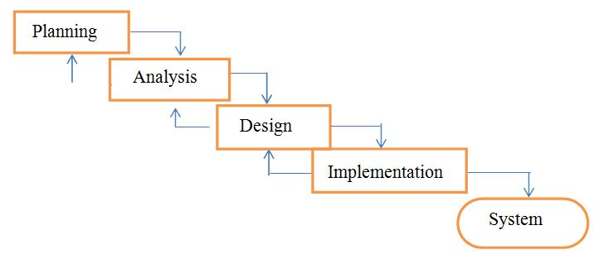

Figure 3.1 the waterfall development Methodology (Wee, 2007)

* 1. **DATA COLLECTION**

Data for this project were collected from different source through different means which are listed below

1. **lnterview**:-The researcher held interview session with the Transport manager of ABC Transport, Mr. Fidelis. The aim was to understand the steps taken in the transport sector and also understand the type of research the country has made in regard to transport management.
2. **Documentation**:-The researcher did a document scan of various journals as attached in the references. These articles were screened by title, screened by abstract and screened by full text. The articles that were relevant to the topic and those that could answer the research question were selected for inclusion and exclusion in the research.
3. **Online Sources:** Data was gotten from difference websites like Wikipedia and online repositories on transport management.

**3.3 SYSTEM REQUIREMENTS**

1. **Functional requirements**

Functional requirements define the specific functions that the system performs, along with the data operated on by the functions. The functional requirements are presented in scenarios that depict an operational system from the perspective of its end users. Included are one or more examples of all system features and an enumeration of all the specific requirements associated with these features:

* The system shall incorporate mechanism to authenticate its users.
* The system shall verify and validate all user input and should notify in case of error detection and should help the user in error correction.
* The system shall allow sharing of files in the system.
* The system shall allow quick messages to be exchanged without face to face interaction.

1. **Non-Functional Requirement**

Non-functional requirements address aspects of the system other than the specific functions it performs. These aspects include system performance, costs, and such general system characteristics as reliability, security, and portability. The non-functional requirements also address aspects of the system development process and operational personnel. It includes the following:

* The system shall be user friendly and consistent.
* The system shall provide attractive graphical interface for the user.
* The system shall allow developer access to installed environment.
* The system shall target customer base.

**3.4 SYSTEM DESCRIPTION**

The system is a web-based application that allows visitors to reserve seats, buy and pay ticket online. The proposed bus reservation system was developed using PHP Hypertext Processor (PHP), Structure Query Language (SQL), and Cascading Style Sheet (CSS). The design will take the following approach: designing the database, creating relationships, designing the user interfaces and the system processes. The system will work in almost all configurations. It has got following features:

* It will guarantee information precision.
* Availability of seats can be enquired.
* Passengers can reserve seats easily.
* Passengers can also pay for tickets easily.
* Minimum time required for the different preparing.
* It will provide better Service.

**3.5 SYSTEM DESIGN**

* + 1. **Data Flow Diagram (DFD)**

A data flow diagram (DFD) is a graphical representation of the "flow" of data through an information system, modeling its process aspects. A DFD shows what kind of information will be input to and output from the system, where the data will come from and go to, and where the data will be stored. The development of DFD’S is done in several levels. Each process in lower level diagrams can be broken down into a more detailed DFD in the next level. The Top-level diagram is often called context diagram. It consist a single process bit, which plays vital role in studying the current system. The process in the context level diagram is exploded into other process at the first level DFD.

**Level 0**

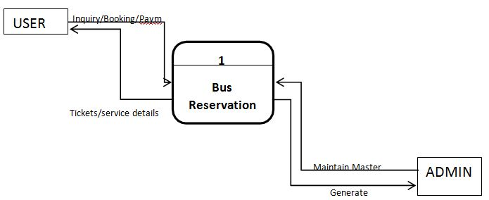

Figure 3.2 Context View of Online Bus Ticket Reservation System

**Level 1**

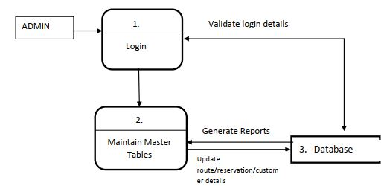

Figure 3.3 User view of Online Bus Ticket Reservation System

**Level 2**

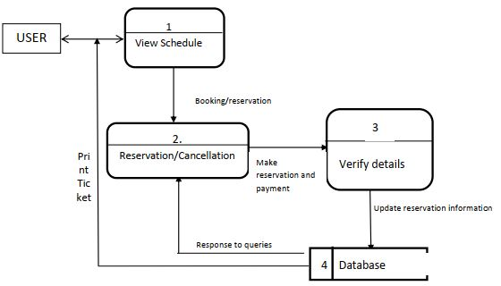

Figure 3.4 Admin view of Online Bus Ticket Reservation System

**3.5.2 USE CASE DIAGRAM FOR USERS AND ADMIN**

A use case is a description of a system’s behavior as it responds to a request that originates from outside of that system (the user). In figure 3.4, a use case of the activities in a bus transport system is shown.

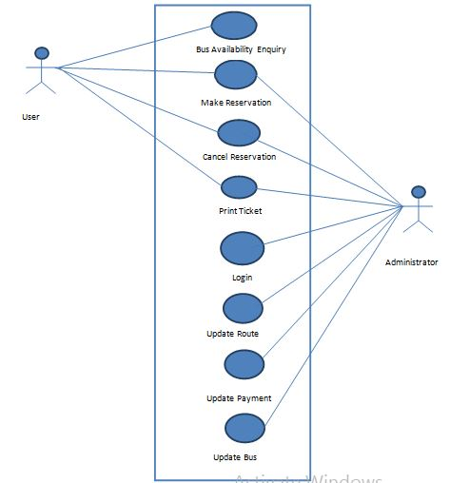

Figure 3.5 Use case diagram for users and admin

In other words a use case describes “who” can do “what” with the system in question. The use case technique is used to capture a system’s behavioural requirements by detailing scenario-driven threads through the functional requirements.

* 1. **DATABASE DESIGN**

Database design is the process of producing a detailed data model of database. This data model contains all the needed logical and physical design choices and physical storage parameters needed to generate a design in a data definition language, which can then be used to create a database. The database will be implemented using MySQL Te database that was used for this project was the database name is ticket, it consists of four tables:

* + 1. **Customer table:**

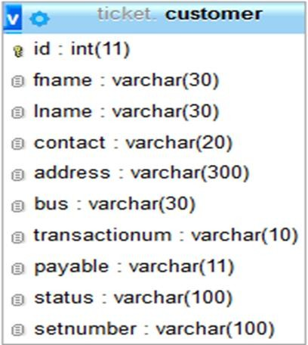The customer table is used to store the customer details, which are the ID (the primary key), the first name, the last name, the contact of the customer, the address, the bus, the transaction number which is randomly generated, the payable value, the status, and the reserved seat numbers.

*Figure 3-6: customer table*

* + 1. **Admin table:**

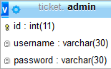The admin table contains admin details, which are the ID (the primary key), the user name, and the password.

*Figure 3-7: admin table*

* + 1. **Route table:**

The route table is used to store route details, it contains the following fields: route ID, the route, route price, number of seats, the vehicle type, and the route time.

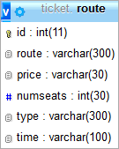

*Figure 3-8: route table*

* + 1. **Reserve table:**

The reserve table contains the reserve details, which are reserve ID, reserve date, the bus, number of reserved seats, transaction number, and seat.

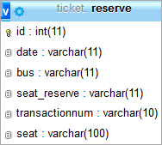*Figure 3-9: reserve table*

* 1. **PAYMENT PROCESS**

For the payment customers have to pay in the required amount in the specified bank account and payment reference number noted. The number will be used to verify the validity of the payment, and handles the transaction process. The redirection will be with the total amount calculated according to the number of seats reserved, and then it will be deducted from the account of the customer in the specific bank, and added to the bus company bank account, and then the booking process done, the customer will be notified that the reservation has done by SMS or email.

**CHAPTER FOUR**

**SYSTEM IMPLEMENTATION**

System testing involves checking each of the system modules to make sure that they are functioning properly. System implementation is done after successful system testing to incorporate the new system into an organization using any of the various changeover methods. A design may be implemented in various ways depending on the priorities of the software developer. In this work, several factors were taken into consideration during implementation. These factors include:

* Correctness: The implementation was carried out with the aim of the final product meeting the user’s need.
* Robustness: Robustness is the quality of being able to withstand stresses, pressures or changes in procedure or circumstance. Robustness was emphasized extensively in the implementation of this work. Defensive programming techniques were applied. Strict checking procedures were included to eliminate the possibility of unacceptable effects on system response.
* Performance: Software performance is the extent to which a product meets its constraints with regard to response or space requirements. Performance optimization especially as regards speed / response time and appropriate search techniques were employed to ensure good response time.

**4.1 CHOICE OF IMPLEMENTATION TOOLS AND PLATFORM**

This section is broadly divided into system platform, Integrated Development Environment and Programming Language. These are discussed below.

* **System Platform:** The system was on the Windows 10 Operating System which meets the entire requirement for the proper functioning of the project.
* **Integrated Development Environment (IDE):** The JetBrains Visual Studio Code IDE was used in implementing this project. It cross platform IDE for PHP. This editor makes the work pretty easier to handle as it provides an editor for PHP, HTML and JavaScript with on-the-fly code analysis, error prevention and automated refactoring for PHP and JavaScript code.

**4.1.2 Choice of Programming Language**

HTML (Hypertext Markup Language) is used for the model design of this system. The HTML is now the most widely used graphical representation scheme for modeling object systems. An attractive feature of the HTML is its flexibility. HTML modelers are free to use various processes in designing systems. The HTML is a complex, feature-rich graphical language. The HTML specifies diagram for documenting the system behavior. In this paper work, three HTML diagrams (use case, class and activity diagrams) are used to explain the behavior of the components of the database system. We employed MYSQL as the database engine because of its extreme power, security and scalability, speed, which makes it an ideal database solution for web sites, its ability used in both embedded system and large scale information system, available of its APIs in various programming language platforms including Java, C++ and PHP. The MySQL engine is available for both transactional and non-transactional operations

PHP was chosen as the programming language which serves as the client to enable me to create the input and output forms while the MySQL database was used as the database server. PHP is a framework (programming) for development of enterprise application using object oriented programming. For most software applications there exists a wide variety of languages in which the application may be implemented. Apart from mere suitability of the programming languages, many factors influenced the use of PHP as the programming language for the source code shown in the APPENDIX and the oracle database as the server.

* + 1. **Reasons for Choosing PHP**

1. Speed: Being a compiled language, it is very fast and speed is important in database application.
2. Environment: It can run in windows.
3. Efficient: The final code tends to be compact and run quickly.
4. Portability: If compiled, it can be executed in different machines with alteration of source code.
5. Maintainability: To ensure maintainability, this program is broken into modules and each module is assigned a specific function. This will make maintenance of the system easier.
6. Security: it has proper backups, quality control mechanism for all modules and unauthorized access to sensitive data is prohibited.
   1. **SYSTEM REQUIREMENTS**
      1. **Hardware Requirements**

The following hardware resources are needed to be put in place in order to power the application: A host for the system and clients to connect to it via intranet.

1. Pentium IV Computer (2.6 GHz processor’s speed)
2. 40GB or harder disk space requirement
3. 1GB or more of RAM
4. A high-speed intranet connection
5. 1024*768 pixels screen resolution
6. Mouse
7. Keyboard
   * 1. **Software Requirement**
8. Any operating system that support GUI e.g. Windows.
9. WAMP Server
10. Browser such as (Firefox, internet explorer, chrome)

**4.3 SYSTEM INTERFACE**

Below is the home page of the website, shows all the information users need to reserve seats. Also it has ADMIN LOGIN which leads to admin page.

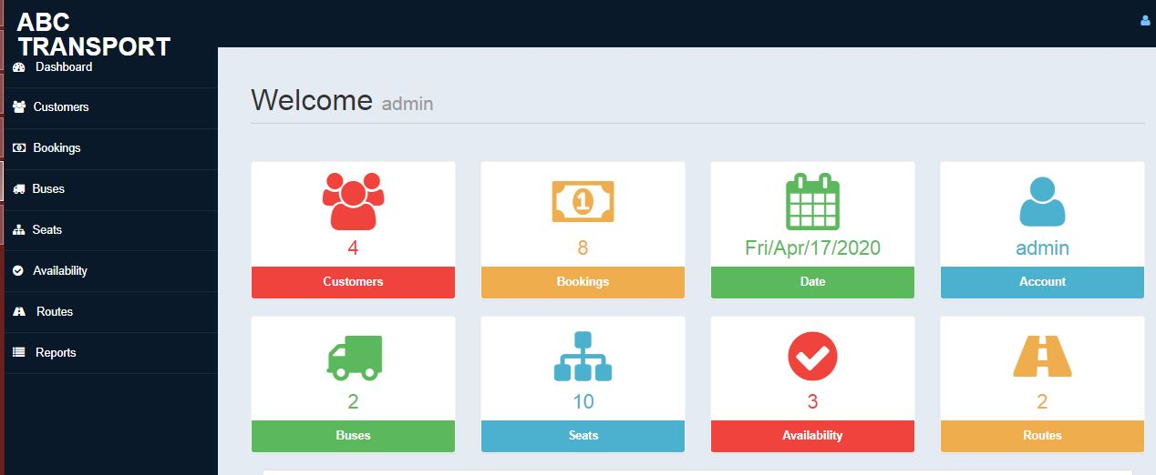*Figure 11 Home page*

* **Customer Side**

First of all, users choose the journey details. They choose route, type of Bus, time of departure, date of travel, and number of seats they attempt to reserve. Maximum seats he could reserve is nine. as shown in figures 11 and 12.

Then they should enter their personal information: First name, last name, address, and contact number, Figure 13. And show bus layout figure 14

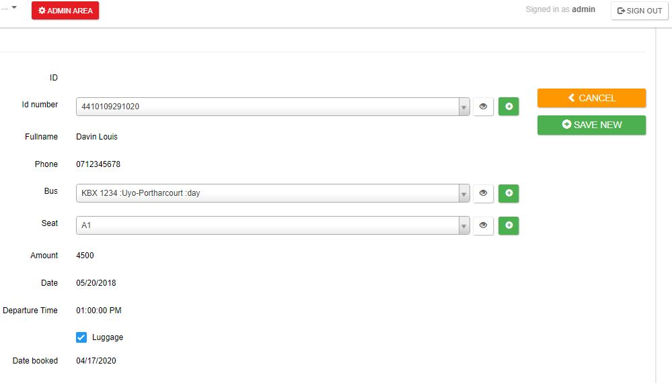

*Figure 12 Ticket Booking 1*

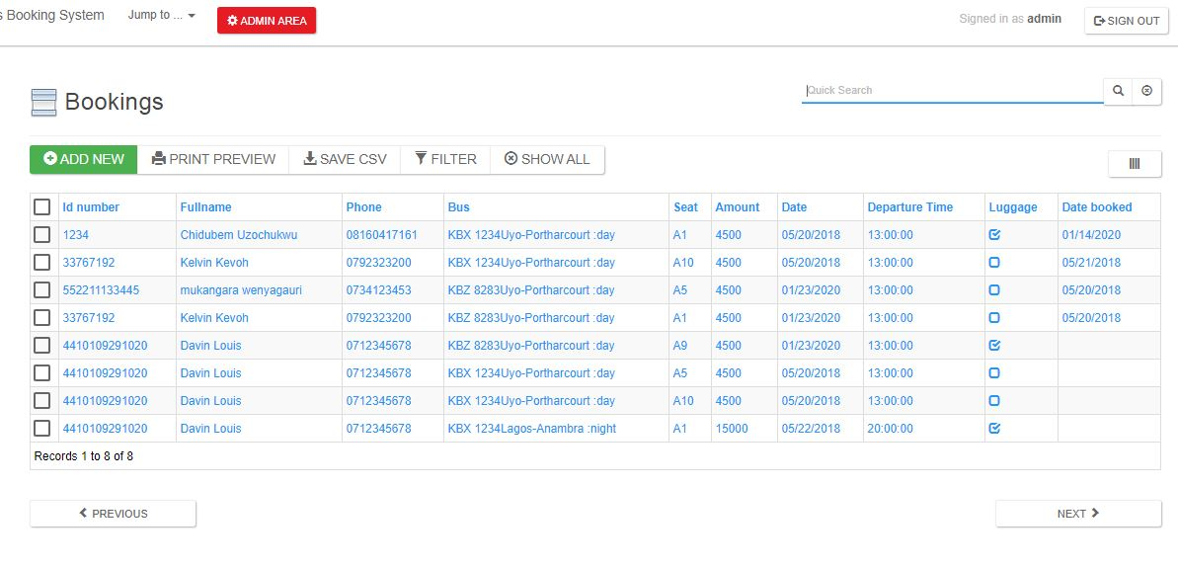

*Figure 13 All Ticket Booking 2*

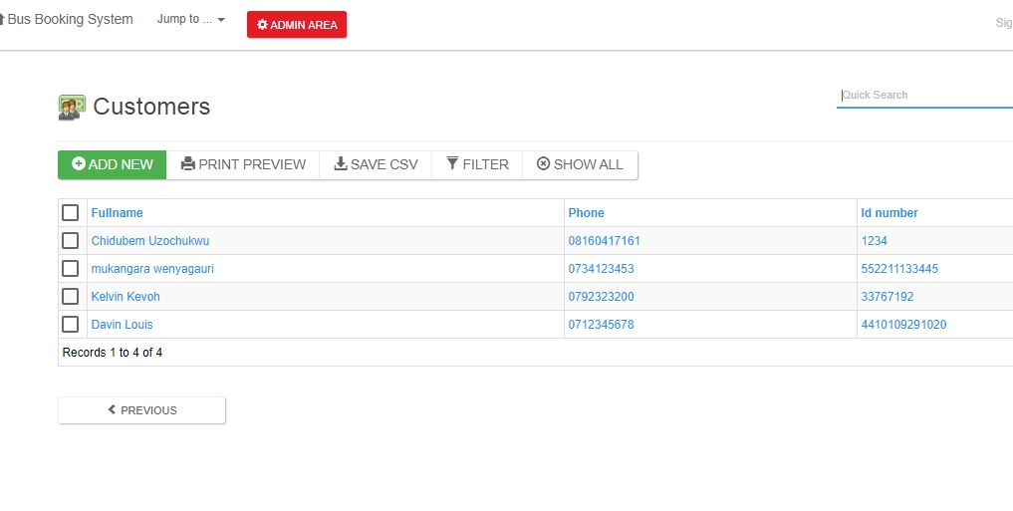*Figure 14 Customers page*

* **Admin Side**

To access to admin page administrator should login by entering the correct user name and password

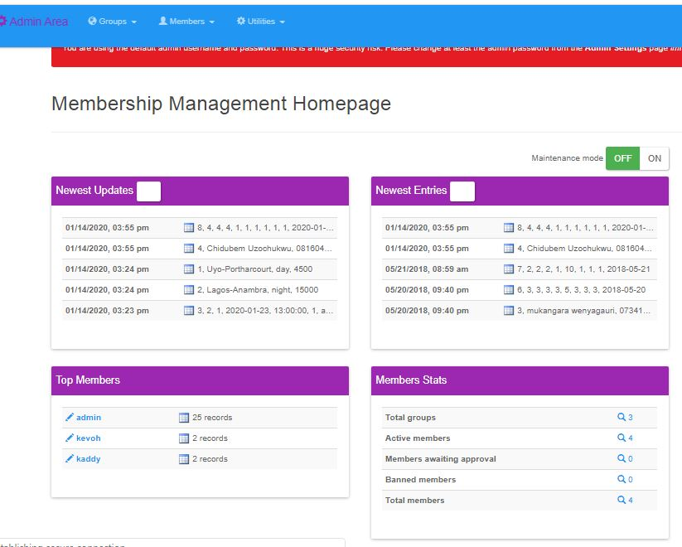*Figure 19 Admin Page*

If the login process went well the administrator could access to all system information, Every reserved ticket information as shown at. And the information of all buses in the system image. also the seats inventory; seats that are reserved till this moment

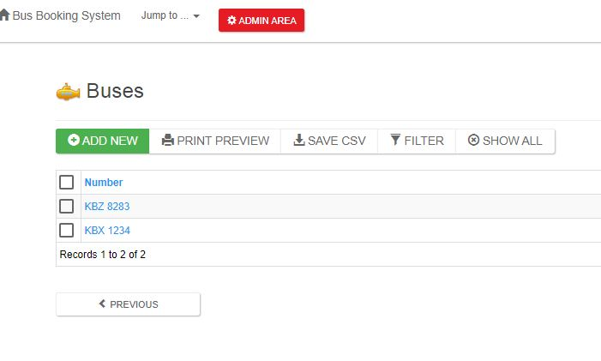

*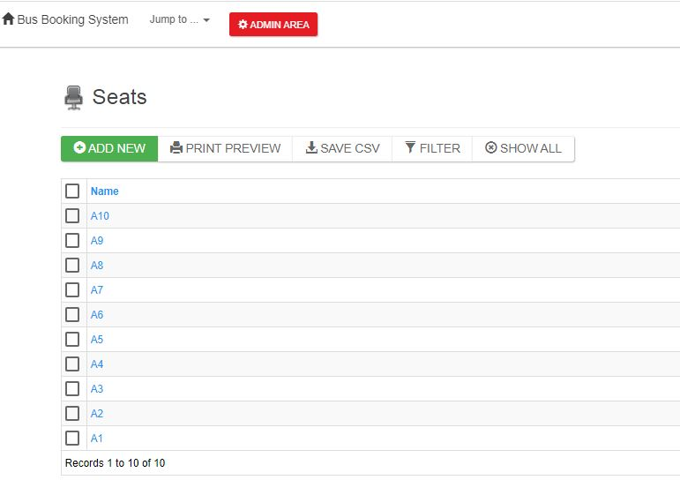Figure 26 Buses*

*Figure 27Seats*

Moreover he can add and delete routes, modify and delete existing bus information

Figure 28

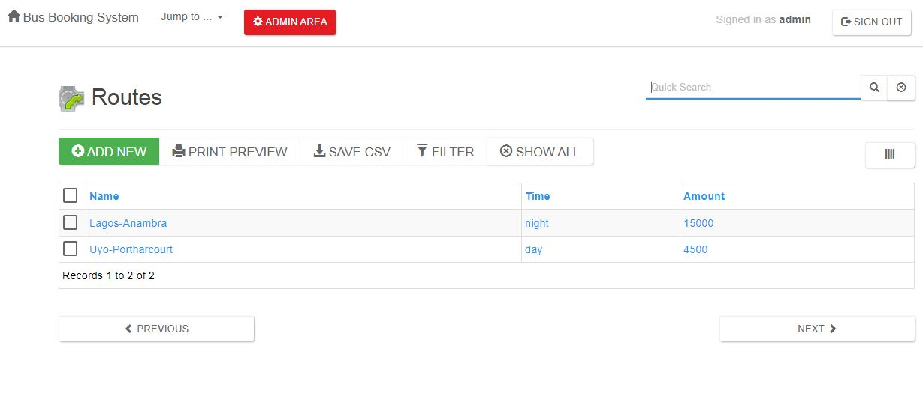

*Figure 29 Routes*

**4.4 SOFTWARE VALIDATION (TESTING)**

Computer system validation (sometimes called computer validation or CSV) is the process of documenting that a computer system meets a set of defined system requirements. Validation of computer systems to ensure accuracy, reliability, consistent intended performance, and the ability to discern invalid or altered records is a critical requirement of electronic record compliance. [14]

The following types of test were performed on the system:

* + - Unit Testing: Testing that each component works very well separately; Each module has been tested separately and passed the test.
    - Acceptance (Validation) Testing: make Sure that system really does the imposed requirements. Provides final assurance that software meets all functional, behavioral, and performance requirements.
    - Stress testing: put greater emphasis on robustness, availability, and error handling under a heavy load, rather than on what would be considered correct behavior under normal circumstances. to determine the stability of the system.
    - Recovery testing: the failure which is forced into an application to check how well the recover process is performed

**4.4.1 Test Cases**

* **Admin Case:**

The table below show all test cases for admin and how the system responds:

|  |  |  |  |  |  |
| --- | --- | --- | --- | --- | --- |
| Case ID | Test case | Expected output | Actual output | Pass / fail | Remarks |
| 1 | Login test | Login with proper details | Successfully | pass | Good |
| 2 | Exception handling for fail login | Showing a message with a cause of failure i.e wrong user name or password | Not Successfully | fail | Poor |
| 3 | Add route | Add route properly | Successfully | Pass | Excellent |
| 4 | Add and update bus  information | Add and update bus  information correctly | Successfully | Pass | Excellent |
| 5 | Filtering information | Filter information displayed  based on the choosing criteria | Successfully | Pass | Excellent |
| 6 | Managing details | Manage information properly  stored | Successfully | Pass | Good |
| 7 | View details of a reserved  ticket | View reservation information  properly | Successfully | Pass | Good |

*Table 2 Test Case, Admin Case**]*

* ***Customer Case:***

Next table show all test cases for user and how the system responds:

|  |  |  |  |  |  |
| --- | --- | --- | --- | --- | --- |
| Case ID | Test case | Expected output | Actual output | Pass / fail | Remarks |
| 1 | Search information | Search information properly | Successfully | pass | Excellent |
| 2 | View bus information | View bus information properly | Successfully | pass | Good |
| 3 | Enter personal information | Enter personal information properly | Successfully | pass | Good |
| 4 | Exception handling for no enough seats | Showing a message with cause of failure i.e no enough seats | Successfully | pass | Good |
| 5 | Reserve ticket information | Reserve ticket information  properly | Successfully | Pass | Excellent |

*Table 3Test Case, Customer Case*

**CHAPTER FIVE**

**SUMMARY, CONCLUSION AND RECOMMENDATION**

**5.1 SUMMARY**

In 1974, American airlines were the first to use an automated booking system, which was still almost manual. Technology grew, and a computer reservation system was developed. In this present era, online booking or reservation system has improved the operations of various sectors of a nation’s economy deploying this system. Online Bus Ticket Reservation System being a web based system that ensures that the company would be able to transform most of the processes carried out manually into automated, error-free and easy to use operations in the organization especially in the area of transportation; also it would be able to generate report for the management decision purpose. This system will be developed using a waterfall methodology for research and design purposes, PHP as the programming language because of its server-side processing capabilities that makes data process less on the client personal computer, an implementation strategy as well as testing and maintenance strategies suitable for efficient deployment of the system.

**5.2 RECOMMENDATIONS**

Research and development are continuous processes; this is the same in computer and software development. However, this work is recommended for ABC Transport since their operation are still carried out manually and it can also be useful to other Bus Transportation industries whose processes are still manually done. The system can contribute more on those bus representatives handling the account if it can generate reports by trip so that they will no longer go to a certain module to check the reservation and its details. Also, it will be more beneficial to both clients and bus representatives if clients can create an account just like in airlines websites. With that, the system can record the modifications made. Other functionalities such as E-Mail facility for sending Ticket to passenger, Online Payment with Credit Card / Debit Card etc. could also be integrated into the system in order to enhance user friendliness and interactions

**5.3 CONCLUSION**

It can be observed that computer applications are very important in every field of human endeavor. Here all the information about customer that made reservation can be gotten just by clicking a button with this new system, some of the difficulties encountered with the manual system are overcome. It will also reduce the workload of the staff, reduce the time used for making reservation at the bus terminal and also increase efficiency. The application also has the ability to update records in various files automatically thereby relieving the company’s staff the stress of working from file security of data. This project, as a whole, will give a new way in bus reservations and ticketing processes. The automation and management of seats and reservations will be done online. However, this project does not limit the walk-in passengers that are passengers who visit the company’s counter because it also caters for them. This also lessens the use of papers like in the traditional way of ticketing.

**REFERENCES**

Adewumi W. (2010). Introduction to Road Traffic Safety and Record Keeping. Ibadan press, Oyo State.

Asogwa S.E (2008). Some Characteristics of Drivers and Riders in Accidents in Nigeria: Level of Alcohol in the Blood of Automobile Drivers. Center Africa Journal Medicine. Pp171-174.

Austin, T. (2006). Learning Web Design Process Unicode GSB Publisher.s Dr.Jean-Paul Rodrigue, Dr. Brian Slack and Dr. Claude Comtois-The geography of transport systems,Pp1(page 1)

Jennifer R. (2010). The Conceptual Framework of Personnel Management,  
Lagos, ABC Publishing, Pp55 Laudon W. and Laudon P. (2004). Elementary Data Communication Course, London, University Press LTD, Pp99.

Niederest, J. (1999). Web Design in a Nutshell, O. Reilly and Associates, Inc.  
Cambridge, USA

Badre, A. (2002): *Shaping Web Usability*. Boston: Pearson Education, Inc.

Banfield, E. G. (1989): *International Social Science*. New York: Vander Buschmann, .F., Meunier .R., Rohnert H., Sommerlad P., and Stal M. (1996):

*Pattern-oriented Software Architecture.* London: SAGE Publication California: Mayfield Publishing Company.

Cunningham, W. G. (1982): *Systematic Planning for Educational Change.*

Eckermann, E. (2001): World History of the Automobile, SAE, pp. 67–68, ISBN 9780768008005, retrieved October 6, 2013).

Fernando Pedone ( 2001): Optimistic Validation of Electronic Tickets.20th IEEE Symposium on Reliable Distributed Systems (SRDS'2001) [BibTeX]

Flick, U. (2009): *An Introduction to Qualitative Research.* London: SAGE

Hevner A., March S., Park J., and Ram, S. (2010): *Design Science in Information Systems Research. MIS Quarterly.*

Kevin O. C., (2012): Web-Based Bus Reservation and Ticketing System: College of Computer Studies, Ateneo de Naga University, Naga City, Philippines February 26, 2012

Laweb,(2010): "Central Reservation System | Online Hotel Marketing Services, Hong Kong and Philippines Hotel, Spa and Restaurant Software". Iaweb.net. 2010. Retrieved 2012-11-08. *Information Technology, Decision Support Systems.* pp 251-266.

Oates, B. (2006): *Researching Information Systems and Computing.* London: Publications.

Rainer, R., Roberts, T., Gibson, M., Fields, K., and (2008): *Factors that Impact Implementing a System Development Methodology. IEEE Transactions on Software*. vol. 24. SAGE Publications.

Marion. T. (2009): *Aviation Transport System*. San Franciso: Morgan Kaufmann Publishers, Inc. University Press

Wee K. L. (2007): Bus Reservation System: Faculty of Information and Communications Technology,Universiti teknikal Malaysia Melaka

Winston O.F. (2005): Information Management and Computer Processing. *Journal of Information Technology*, Massachusetts. Vol.2, pag 35-43,

Wikipedia, (2014): http:/!en.wikipedia.ordwiki,Web application

RACHNA and P. SINGH, "Issues and Challenges of Electronic Payment Systems," International Journal for Research in Management and Pharmacy, 9, December 2013.

Princewill Aigbe and Jackson Akpojaro, "Analysis of Security Issues in Electronic Payment Systems," International Journal of Computer Applications (0975 – 8887), 10, December 2014.

S. Sumanjeet, "Emergence of Payment Systems in the age of Electronic Commerce: The State of Art," Asia Pacific Journal of Finance and Banking Research. 2008

D.U.P.S.B.V. Goyal, "Mobile Banking in India: Practices, Challenges and Security Issues," International Journal of Advanced Trends in Computer Science and Engineering, 2012

A.Y.A.M.S. Uddin, "E-Wallet System for Bangladesh an Electronic Payment System". 2016

**APPENDIX**

PHP CODES

$currDir=dirname(__FILE__);

    include("$currDir/defaultLang.php");

    include("$currDir/language.php");

    include("$currDir/lib.php");

    @include("$currDir/hooks/availability.php");

    include("$currDir/availability_dml.php");

    // mm: can the current member access this page?

    $perm=getTablePermissions('availability');

    if(!$perm[0]){

        echo error_message($Translation['tableAccessDenied'], false);

        echo '<script>setTimeout("window.location=\'index.php?signOut=1\'", 2000);</script>';

        exit;

    }

    $x = new DataList;

    $x->TableName = "availability";

    // Fields that can be displayed in the table view

    $x->QueryFieldsTV = array(

        "`availability`.`id`" => "id",

        "IF(    CHAR_LENGTH(`buses1`.`number`), CONCAT_WS('',   `buses1`.`number`), '') /* Bus */" => "bus",

        "IF(    CHAR_LENGTH(`routes1`.`name`) || CHAR_LENGTH(`routes1`.`time`), CONCAT_WS('',   `routes1`.`name`, '  :', `routes1`.`time`), '') /* Route */" => "route",

        "IF(    CHAR_LENGTH(`routes1`.`amount`), CONCAT_WS('',   `routes1`.`amount`), '') /* Amount */" => "amount",

        "if(`availability`.`date`,date_format(`availability`.`date`,'%m/%d/%Y'),'')" => "date",

        "TIME_FORMAT(`availability`.`time`, '%r')" => "time",

        "`availability`.`status`" => "status"

    );

    // mapping incoming sort by requests to actual query fields

    $x->SortFields = array(

        1 => '`availability`.`id`',

        2 => '`buses1`.`number`',

        3 => 3,

        4 => '`routes1`.`amount`',

        5 => '`availability`.`date`',

        6 => '`availability`.`time`',

        7 => 7

    );

    // Fields that can be displayed in the csv file

    $x->QueryFieldsCSV = array(

        "`availability`.`id`" => "id",

        "IF(    CHAR_LENGTH(`buses1`.`number`), CONCAT_WS('',   `buses1`.`number`), '') /* Bus */" => "bus",

        "IF(    CHAR_LENGTH(`routes1`.`name`) || CHAR_LENGTH(`routes1`.`time`), CONCAT_WS('',   `routes1`.`name`, '  :', `routes1`.`time`), '') /* Route */" => "route",

        "IF(    CHAR_LENGTH(`routes1`.`amount`), CONCAT_WS('',   `routes1`.`amount`), '') /* Amount */" => "amount",

        "if(`availability`.`date`,date_format(`availability`.`date`,'%m/%d/%Y'),'')" => "date",

        "TIME_FORMAT(`availability`.`time`, '%r')" => "time",

        "`availability`.`status`" => "status"

    );

    // Fields that can be filtered

    $x->QueryFieldsFilters = array(

        "`availability`.`id`" => "ID",

        "IF(    CHAR_LENGTH(`buses1`.`number`), CONCAT_WS('',   `buses1`.`number`), '') /* Bus */" => "Bus",

        "IF(    CHAR_LENGTH(`routes1`.`name`) || CHAR_LENGTH(`routes1`.`time`), CONCAT_WS('',   `routes1`.`name`, '  :', `routes1`.`time`), '') /* Route */" => "Route",

        "IF(    CHAR_LENGTH(`routes1`.`amount`), CONCAT_WS('',   `routes1`.`amount`), '') /* Amount */" => "Amount",

        "`availability`.`date`" => "Date",

        "`availability`.`time`" => "Departure Time",

        "`availability`.`status`" => "Status"

    );

    // Fields that can be quick searched

    $x->QueryFieldsQS = array(

        "`availability`.`id`" => "id",

        "IF(    CHAR_LENGTH(`buses1`.`number`), CONCAT_WS('',   `buses1`.`number`), '') /* Bus */" => "bus",

        "IF(    CHAR_LENGTH(`routes1`.`name`) || CHAR_LENGTH(`routes1`.`time`), CONCAT_WS('',   `routes1`.`name`, '  :', `routes1`.`time`), '') /* Route */" => "route",

        "IF(    CHAR_LENGTH(`routes1`.`amount`), CONCAT_WS('',   `routes1`.`amount`), '') /* Amount */" => "amount",

        "if(`availability`.`date`,date_format(`availability`.`date`,'%m/%d/%Y'),'')" => "date",

        "TIME_FORMAT(`availability`.`time`, '%r')" => "time",

        "`availability`.`status`" => "status"

    );

    // Lookup fields that can be used as filterers

    $x->filterers = array(  'bus' => 'Bus', 'route' => 'Route');

    $x->QueryFrom = "`availability` LEFT JOIN `buses` as buses1 ON `buses1`.`id`=`availability`.`bus` LEFT JOIN `routes` as routes1 ON `routes1`.`id`=`availability`.`route` ";

    $x->QueryWhere = '';

    $x->QueryOrder = '';

    $x->AllowSelection = 1;

    $x->HideTableView = ($perm[2]==0 ? 1 : 0);

    $x->AllowDelete = $perm[4];

    $x->AllowMassDelete = true;

    $x->AllowInsert = $perm[1];

    $x->AllowUpdate = $perm[3];

    $x->SeparateDV = 1;

    $x->AllowDeleteOfParents = 0;

    $x->AllowFilters = 1;

    $x->AllowSavingFilters = 1;

    $x->AllowSorting = 1;

    $x->AllowNavigation = 1;

    $x->AllowPrinting = 1;

    $x->AllowCSV = 1;

    $x->RecordsPerPage = 10;

    $x->QuickSearch = 1;

    $x->QuickSearchText = $Translation["quick search"];

    $x->ScriptFileName = "availability_view.php";

    $x->RedirectAfterInsert = "availability_view.php?SelectedID=#ID#";

    $x->TableTitle = "Availability";

    $x->TableIcon = "resources/table_icons/accept.png";

    $x->PrimaryKey = "`availability`.`id`";

    $x->DefaultSortField = '1';

    $x->DefaultSortDirection = 'desc';

    $x->ColWidth   = array(  150, 150, 150, 150, 150, 150);

    $x->ColCaption = array("Bus", "Route", "Amount", "Date", "Departure Time", "Status");

    $x->ColFieldName = array('bus', 'route', 'amount', 'date', 'time', 'status');

    $x->ColNumber  = array(2, 3, 4, 5, 6, 7);

    // template paths below are based on the app main directory

    $x->Template = 'templates/availability_templateTV.html';

    $x->SelectedTemplate = 'templates/availability_templateTVS.html';

    $x->TemplateDV = 'templates/availability_templateDV.html';

    $x->TemplateDVP = 'templates/availability_templateDVP.html';

    $x->ShowTableHeader = 1;

    $x->TVClasses = "";

    $x->DVClasses = "";

    $x->HighlightColor = '#FFF0C2';

    // mm: build the query based on current member's permissions

    $DisplayRecords = $_REQUEST['DisplayRecords'];

    if(!in_array($DisplayRecords, array('user', 'group'))){ $DisplayRecords = 'all'; }

    if($perm[2]==1 || ($perm[2]>1 && $DisplayRecords=='user' && !$_REQUEST['NoFilter_x'])){ // view owner only

        $x->QueryFrom.=', membership_userrecords';

        $x->QueryWhere="where `availability`.`id`=membership_userrecords.pkValue and membership_userrecords.tableName='availability' and lcase(membership_userrecords.memberID)='".getLoggedMemberID()."'";

    }elseif($perm[2]==2 || ($perm[2]>2 && $DisplayRecords=='group' && !$_REQUEST['NoFilter_x'])){ // view group only

        $x->QueryFrom.=', membership_userrecords';

        $x->QueryWhere="where `availability`.`id`=membership_userrecords.pkValue and membership_userrecords.tableName='availability' and membership_userrecords.groupID='".getLoggedGroupID()."'";

    }elseif($perm[2]==3){ // view all

        // no further action

    }elseif($perm[2]==0){ // view none

        $x->QueryFields = array("Not enough permissions" => "NEP");

        $x->QueryFrom = '`availability`';

        $x->QueryWhere = '';

        $x->DefaultSortField = '';

    }

    // hook: availability_init

    $render=TRUE;

    if(function_exists('availability_init')){

        $args=array();

        $render=availability_init($x, getMemberInfo(), $args);

    }

    if($render) $x->Render();

    // hook: availability_header

    $headerCode='';

    if(function_exists('availability_header')){

        $args=array();

        $headerCode=availability_header($x->ContentType, getMemberInfo(), $args);

    }

    if(!$headerCode){

        include_once("$currDir/header.php");

    }else{

        ob_start(); include_once("$currDir/header.php"); $dHeader=ob_get_contents(); ob_end_clean();

        echo str_replace('<%%HEADER%%>', $dHeader, $headerCode);

    }

    echo $x->HTML;

    // hook: availability_footer

    $footerCode='';

    if(function_exists('availability_footer')){

        $args=array();

        $footerCode=availability_footer($x->ContentType, getMemberInfo(), $args);

    }

    if(!$footerCode){

        include_once("$currDir/footer.php");

    }else{

        ob_start(); include_once("$currDir/footer.php"); $dFooter=ob_get_contents(); ob_end_clean();

        echo str_replace('<%%FOOTER%%>', $dFooter, $footerCode);

    }

?>