## TITLE PAGE

**DESIGN AND IMPLEMENTATION OF ONLINE CLEARANCE SYSTEM**

***A CASE STUDY OF CARITAS UNIVERSITY BY***

***OJUKWU EMMANUEL IFEANYI CST/2009/350***

***SUBMITTED TO THE DEPARTMENT OF COMPUTER SCIENCE & INFORMATION TECHNOLOGY***

***CARITAS UNIVERSITY, ENUGU.***

## IN PARTIAL FULFILMENT OF THE REQUIREMENTS FOR THE AWARD OF BSc. IN COMPUTER SCIENCE

**JULY 2013**

## APPROVAL PAGE

This project work was written, arranged and compiled by **OJUKWU EMMANUEL IFEANYI CST/2009/350** in partial fulfillment of the requirements for the award of BSc. in computer science.

Supervisor Signature Date Mrs Nonso Njoku

HOD Signature Date Dr. Arinze Nwaeze

External supervisor Date

## DEDICATION

I dedicate this project to God Almighty for giving me the opportunity in making this project successful and also to my parents for their love and financial support also to my Beloved supervisor Mrs Nonso Njoku for her advice and encouragement and tireless effort in making this successful.

## ACKNOWLEDGEMENT

My profound gratitude goes to God Almighty for his grace, favour and mercies upon my life. I would be very ungrateful if I fail to acknowledge my caring parents Sir&Lady E.C Ojukwu for their financial and moral support all through my stay in school.

I am also grateful to my supervisor Mrs Nonso Njoku who has always attended to me with great patience throughout the period of this study. Also the Head of Department Dr Arinze Nwaeze and my lecturers Mr Ejike and Mrs Chizoba Ezema with few others not mentioned.

I appreciate the efforts of my brother and siblings for their love and understanding. May God almighty richly bless and reward you all, Amen

## ABSTRACT

Online clearance system is a research work that will help build an effective information management for schools. It is aimed at developing a system for making clearance after graduation hitch free. The designed software will serve as a more reliable and effective means of undertaking students clearance, remove all forms of delay and stress as well as enable you understand the procedures involved as well as how to do your clearance online. This project work made use of data collected from the University, materials and journals from various authors and software was developed to effectively achieve the aims of this project. In this project, the implementation of the computer-based system was carried out using PHP, CSS, APACHE and MYSQL for the database. In conclusion, the work met all the objectives intended. It is, however, recommended for use by all tertiary institutions.

## Keywords: Implementation, Clearance, Software, Design, Information, Procedure.

|  |  |  |
| --- | --- | --- |
|  | **TABLE OF CONTENT** |  |
|  | **Pages** |
| **Title page** |  | **i** |
| **Approval page** |  | **ii** |
| **Dedication** |  | **iii** |
| **Acknowledgement** |  | **iv** |
| **Abstract** |  | **v** |
| **Table of content** |  | **vi** |

**CHAPTER ONE 1**

## INTRODUCTION

* 1. **Introduction**

## Background of the study

* 1. **Statement of the study**

## Objectives of the study

* 1. **Scope of the study**

## Limitations

* 1. **Significance of the study**

## Definition of terms

**CHAPTER TWO LUTERATURE REVIEW**

## Role of information technology in the academic system

* 1. **Data and information**

## Computer based information systems

* 1. **Databases**

## CHAPTER THREE

**Description and analysis of the existing system**

## General analysis of the existing system

* 1. **Method of data collection**

## Organisational structure

* 1. **Input analysis**

## Process Analysis

* 1. **Output analysis**

## Information flow diagram

* 1. **Problems of the existing system**

## Justification of the new system

**CHAPTER FOUR SYSTEMS DESIGN**

## Design standards

* 1. **Output specification**

## Input specification and design

* 1. **File design**

## Procedure chart

* 1. **System flowcharts**

## System specification

* 1. **Program flowcharts**

## CHAPTER FIVE

**SUMMARY, RECOMENDATION AND CONCLUSION**

## Summary

* 1. **Conclusion**

## Recommendation REFRENCES

**APPENDICES**

## Appendix A Welcome page

**Appendix B Home page Appendix C Input forms Appendix D Output forms Appendix E Codes**

## CHAPTER ONE INTRODUCTION

* 1. **BACKGROUND OF STUDY**

Clearance is a status granted individuals, typically members of the military, university graduates and employees of governments and their contractors, allowing them access to classified information, i.e. state secrets. The term "clearance” is also sometimes used in private organizations that have a formal process to vet employees for access to sensitive information. A clearance by itself is normally not sufficient to gain access; the organization must determine that the cleared individual has a "need to know" the information. No one is supposed to be granted access to classified information solely because of rank or position, but once a clearance is obtained, access to certain information or gain of freedom will be granted.

As many universities have choosing to pursue the dynamic educational options available online. The advantages of e-learning are many. As people of all ages and backgrounds become increasingly reliant on the internet for information, online learning becomes more convenient and efficient here the need for an online clearance system. The skills needed to

access and comprehend information online are becoming commonplace, and the flexibility of wireless computing means that any coffee shop, airport or bedroom can become a classroom. Online courses, registrations, clearance have few, if any scheduling restrictions, well-integrated learning resources and competitive degree options, with an online clearance system.

The changing online college landscape now includes online clearance system, traditional undergraduate and general studies programs. However, career learning is still the most popular online training option.

## STATEMENT OF STUDY

The processes of clearing students after their graduation requires that the students be cleared in various departments and information units. Among which are:

* + - Library fines and overdue or lost library materials from the University
* Departmental Dues
* Infirmary and bookstore charges
* Residence hall damage charges
* Return of athletic equipment
* Student Union Fee
* Bursary and all other charges

For a graduating student to carry out his or her clearance from all these departments, it normally takes a lot of time and a lot of processes and delays in clearing the student for youth service as well as collection of statement of result. Hence it became imperative for an online clearance system to eliminate the shortcomings of the manual system in place.

## OBJECTIVES OF THE STUDY

The objectives of this project include:

 To effectively and efficiently process students clearance  To provide a reliable and transparent system devoid of personal

inclinations and interest

 To provide borderless access  To ensure prompt clearance

 To alleviate the problems and stress of travelling and queuing up of students during clearance.

## SIGNIFICANCE OF THE STUDY

The project work will help in a good number of ways to ease the queuing system in the university as the online clearance system will help

students to achieve whatever they want to achieve without coming to the various offices for clearance.

Clear advantages of Internet information processing over those of traditional manual system are higher yields. Online clearance system allows the users to check their clearance status as whether they are in any way indebted to the school, fill and submit their clearance form, and obtain their clearance letter. There are many other advantages of online clearance system and some of them are listed below.

* It saves a lot of time.
* It is very convenient to use it right from the bedroom, office or anywhere in the World.
* Information processing are very fast and delays can be avoided.
* It is inexpensive to students and school management.

 Help the school in reducing costs such as labour and stationary.

## SCOPE OF THE STUDY

This research work is limited to clearance system for graduating students from Caritas University. The software developed will be carried out using HTML, Visual Basic and Ms Access to manage both the database and at the same time make the software online.

## LIMITATIONS

This project covers all aspect of online clearance system using Caritas University as a case study. However, the following were the constraints:

**Time constraints**: Due to time constraint, the web – page developed covers only clearance from various departments by the graduating students.

**Financial constraints**: It would cost a lot to develop a full web – based clearance system.

## DEFINITION OF TERMS

**Computer Network:** Computer Network is a system that connects two or more computers together using a communication link.

**World Wide Web:** World Wide Wed simply called www is the most

important tool of the Internet. It was created in the late 1980s in Europe and was used limitedly in academic cycle.

**Clearance:** Official certification of blamelessness, trustworthiness, or suitability for graduation and issue of certificates in degree course.

**Databases:** A systematically arranged collection of computer data,

structured so that it can be automatically retrieved or manipulated. It is also called databank.

**File Transfer:** Any kind of computer file can be sent via the Internet from one Internet user to another. Table of accounts on spreadsheets, design by a graphic artists, music sound files etc, can all be exchanged in this way.

**Web Brower:** This is a special kind of software that processes hypertext make-up language (HTML) document. In other words, a web browser is a computer program that interprets HTML command to collect, arranged and display the parts of a

web page.

**Web Site:** A website is a collection of many interconnected web pages organized by a specific college, organization company etc, containing web pages (good and commodities) on the Internet. Web site are stored on web servers. There are many web site and thousand of HTML pages on each web site. A web site is a treasure of information and entertainment.

**Hyperlinks:** Hyperlinks are highlighted words and phrase you find on web documents that you can click on as to jump to some other documents or Internet services.

**Online:** Connected via a computer attached to or available via a central computer network.

**Offline**: Disconnected from computer network; describes a computer

terminal or peripheral device disconnected from a computer network.

**System:** Set of computer components that is, an assembling of hardware, software and peripherals functioning together.

## CHAPTER TWO

* 1. **ROLE OF INFORMATION TECHNOLOGY IN THE ACADEMIC SYSTEM**

The introduction of computer into information technology has massively improved the information need of organization; the success of this machine is dependent on the knowledge base. Therefore, one can be prompted to ask aloud “what is a computer”. Funk, (1980) defined a computer as an electronic device that can perform automatically and at a high speed a sequence of logical operations according to instructions given to it inform of a pre-arranged program.

Anigbogu (2000) defined a computer as an electronic device capable of accepting data and instructions, processing the data based on the instructions to generate results or output in such a manner that is yet to be equalled by any other known machine to mankind.

Chimezie (1990), defined it by saying that “Computers are looked upon as obedient servants who are ever ready to free man from tedious procedures and produce results as compared with human computing time”.

Obilikwu (1995), defined computer as a machine that is capable of accepting input data, store and process the data based on instructions given by the computer user and in this way produce expected results, generally called output.

World Net describes an information system (I.S) as “a system consisting of the network of all communication channels used within an organization, and includes software and hardware”. It may also be defined as “a system that collects and processes data (information) and provides it to mangers at all

levels that use it for decision making, planning, program implementation and control.

The aim of information system to admission, registration, result processing and clearance in universities is improving the quality and accuracy of information provided to all involved as well as assisting universities in compiling and reporting information.

Information Technology has been an integral part of academic system since almost four decades. According to, Hewlett (1993), the world is entering “an era in which technology will literally transform every aspect of business, every aspect of life and every aspect of society.

Since the arrival of Internet technology, school system has taken a new shape and style with a blend of convenience and satisfaction. Taylor (1980) said that computer-based education includes both computer- assisted instruction programs that interact with students in a dialogue and a broader array of educational computer applications such as simulations or instruction in computer programming**.** Learning from a

student‟s bedroom, office or anywhere in the World has made its way into university system with the advent of Internet technology. Information technology has always helped the university system to educate students in better way. To explain few examples, student online clearance is a method where the student obtains his/her clearance letter without carrying files around. This is only possible with the help of information technology. This feature is safe, fast and has no hazels. Filling out the documents and

comparing options and waiting for approval is a time consuming process. Through the Internet, this process is made much easier and some times the approval is made within minutes. This explains an efficient way of obtaining clearance and saves time and money for students.

## DATA AND INFORMATION

The concepts of data and information are very important in understanding issues that go with development and implementation of a computer-based information system. The term „data‟ and „information‟ are used interchangeably in everyday conversation as meaning the same thing. To many managers and information specialists, however, these terms have distinct meanings. According to O‟Leary (1996), data simply consists of raw, unprocessed facts while information is data that have been processed by the computer. Hordeski (1986) gives the following definition of data:

A graphic or textual representation of facts, concepts, numbers, letters,

symbols, or instructions suitable for communication, interpretation, or

processing. Data is the basic element of information that is used to described

objects, ideas, conditions, or situations.

Lucey (1991), defines data and information as follows:

Data are facts, events, transactions, and so on, which have been recorded. They are the raw materials from

which information is produced. Information is data that has been processed in such a way as to be used by the recipient.

Data are facts obtained by observation, counting, measuring, weighing, etc., which are then recorded. Frequently, they are called raw or basic data and are often records of day-to-day transactions of the organisation. For example, the date, amount, and other details of an invoice or cheque, payroll details of pay, the number of students living in a particular hostel and so on. Enwere(1992) argues that the concept of information in an organisation sense is more complex and difficult than the frequent use of this common word would suggest. Oketunji(2002) emphasised that information is data that have been processed, transmitted to the recipient, interpreted and understood by the recipient. Here it should be noted that the user, not just the sender is involved in the transformation of data into information. There is a process of thought and understanding involved and it follows that a given message can have different meanings to different people. Based on this, one can conclude that the data which has been analysed, summarised, or processed in some other fashion to produce a message or report which is

conveniently deemed „management information‟ only becomes information if it is understood by the recipient. Therefore, it is the user who determines whether a report contains information or just processed data.

## COMPUTER-BASED INFORMATION SYSTEMS

An information specialist, Lucey (1991) defines computer-based management information system as:

The combination of human and computer-based resources that results in the collection, storage, retrieval, communication and use of data for the purpose of efficient management of operations and for business planning.

Computer-based information system is a feature of all large organisations nowadays. The literature identifies four kinds of computer-based information system: Transaction Processing System (TPS), Management Information System (MIS), Decision Support System (DSS), and Executive Support System (ESS). Some systems record routine activities: employees hired, material purchased or produced, and the like. Such recorded events are called **transactions**. Other systems use these recorded events to

help managerial planning and control. The systems form a pyramid,

each primarily supporting one another level of management to another.

1. **Transaction Processing System (TPS):** This system records day-to-day transactions such as customer orders, bills, inventory levels, and production outputs. The TPS helps supervisors by generating database that act as foundation for other information system.
2. **Management Information System (MIS):** MIS summarises the detailed data of the transaction processing system standard reports for middle-level managers. Such reports might include production schedules and budget summaries.
3. **Decision Support System (DSS): T**he DSS provides a flexible tool for analysis. The DSS helps middle-level managers and others in the organisation to analyse a wide range of problems, such as effects of events and trends outside the organisation. Like the MIS, the DSS draws on the detailed data of transaction processing system.
4. **Executive Support System (ESS):** The ESS is an easy-to-use system that presents information in a very highly summarised form. It helps top-level management oversee the company‟s operations and develop strategic plans. The ESS combines internal data from TPS and MIS with external data.

## DATABASES

In the early days of computerisation, it was normal to maintain specific files for individual applications. Data were processes centrally in batches and there was little or no online interrogation of data. This approach is wholly inefficient for most of today‟s data processing systems. Supporting this, Vossen (1991) enumerated the problems that result from organising data using the file system:

1. There exists a high redundancy between files, which result from the fact that the information is replicated in different places, and that these replications are not controlled by a central monitor.
2. Inconsistencies might result from the possibilities that a program makes changes on the files it uses without these changes being made (at the same time) by all other programs that uses the file.
3. There exists inflexibility against changes in the application: if new actions or events arise in the course of time, these can be realised at a substantial expense of time.
4. The work of many programmers involved is characterised by low productivity, since program maintenance is expensive: if the structure of an existing file has to be modified during its lifetime, then all application programs has to be modified correspondingly.
5. Finally, there is the problem of adopting and maintaining standards (with respect to coding, data formats, etc.), which is important for exchanging data or for migration to a new operating system release, or even to a new computer system.

To overcome these problems, databases were developed. It is now common for large organisations to organise their operational data using the database technology.

The subject of database is adequately covered in many works on database technology. Clifton (1983) briefly defines database as a collection of data supporting the operation of an organisation. Quoting CIMA, Lucey (1991) provides a more detailed definition:

A database is a file of data structured in such a way that it may serve a number of applications without its structure being dictated by any one of those applications, the concepts being that programs are written round the database rather than files being structured to meet the needs of particular programs.

Russell, M. (1987) dealt extensively on the need for the use of computers on such database system like computerized clearance system. In the words of Dimorji (2003).

*“At the center of any information system is a*

*database, which is any collection of related information grouped together as a simple item. The term can also apply to the ways in which information is catalogued,*

*analyzed, stored and used manually”.*

Russell (2005) was also of the view that without a computer, effective handling of Candidates‟ records cannot be achieved effectively.

In a database, all the data is defined together rather than each file being defined separately. In fact, all the literature consulted seem to support the fact that a database is a collection of structured data with the structure of data being independent of any particular application. Specifying the need for databases, O‟Leary(1996) listed the following advantages:

1. **Sharing:** In an organisation, information from one department can be readily shared with others.
2. **Security:** Users are given passwords or access only to the kind of information they need to know. Thus, the Payroll department may have access to employees‟ pay rate, but other departments would not.
3. **Fewer Files:** With several departments having access to one file, there are fewer files. Therefore, excess storage or what is called „redundancy‟ is reduced.
4. **Data Integrity:**Older filing systems many times did not have „integrity‟.

That is, a change made in the file in one department might not be made in the file in another department. As one might expect, this can cause serious problems and conflicts when data is used for important decisions affecting both departments.

To the advantages enumerated above, Vossen (1991) adds:

1. Standards/access protocols can be enforced.
2. Currency of data can be maintained.
3. Data/program independence can be maintained.
4. Conflicting requirements can be balanced among users.

In these days of integrated networks, the database appears as the most logical method for organising the operational data of large organisations. One may as well say that these advantages give the database the attractions over the traditional file processing method.

## CHAPTER THREE

**SYSTEM ANALYSIS AND METHODOLOGY**

## ANALYSIS OF THE EXISTING SYSTEM

When a student is about to graduate, he/she will take his/her degree exam after which he obtains a clearance letter from various departments and units. The Registrar's Office carefully reviews each degree candidate's academic record and certifies to the faculty that the candidate has completed requirements for the degree. Also the bursary has to certify that the student has completed all payments.

The current clearance system of the university is a manual one. This makes the system so tedious and time consuming. Here, students have to visit all the clearance offices with a form for them to sign. Once these forms are signed, it proves that the student has been cleared. This process takes some months to be completed and posses a lot of stress to both staff and students involved.

In the manual system, the clearance forms are documented in a file cabinet. Each time the clearance form is needed, a search operation is conducted on the file cabinets to locate a particular student‟s clearance form.

## INPUT ANALYSIS

The input to the system is the payment forms for paying dues or levies. These forms are filled by students and submitted to the various offices for issuing of receipts.

## PROCESS ANALYSIS

The payments made by the students are collected and analysed to certify that the student have completed all the necessary fees due. Hence a certificate issued to show that the student have completed all the fees.

## OUTPUT ANALYSIS

The output from the system is the certificate of clearance issued to the student stating that the student have fulfilled all financial obligation and is now free to pass out from the school.

## METHOD OF DATA COLLECTION

During the research work, data needed for the project was gathered from various sources. In gathering and collecting necessary data and information needed for system analysis, two major fact-finding techniques were used in

this work and they are:

## Primary Source

This refers to the sources of collecting original data in which the researcher made use of empirical approach such as personal interview and questionnaires.

## Secondary Source

The secondary data were obtained by the researcher from magazines, Journal, Newspapers, Library source and Internet downloads. The data collected from this means have been covered in literature review in the chapter two of the project.

## Study of Manuals

Manuals and report based on clearance were studied and a lot of information concerning the system in question was obtained. The clearance forms were gathered and information relating to clearance fee and other requirements were also obtained.

## Evaluation of Forms

Some forms that are necessary and available were assed. These include clearance form, fee receipts, etc. These forms help in the design of the new system.

## ADVANTAGES OF THE EXISTING SYSTEM

The objective of the existing system is to enable student pay all their fees before leaving the school. Some levies are charged for processing student‟s files and others for departmental dues or otherwise. The clearance system is designed to help students pay all the dues and obtain a clearance certificate.

## DISADVANTAGES OF THE EXISTING SYSTEM

Due to the manual means being used by the University, in keeping information about student‟s clearance, a lot of problems are encountered which includes:

* + - 1. Delay in processing clearance form
      2. Unavailability of some key staff while processing clearance form, which leads to students repeatedly visiting a particular office in other to sign his/her clearance form.
      3. Loss of vital documents as the filing system is manual
      4. Damage of documents due to fire incident.
      5. Illegal removal of forms by fraudulent staff leading to insecurity.
      6. Takes a lot of time to retrieve a particular clearance form.

## ORGANISATIONAL STRUCTURE

**3.4 ORGANIZATIONAL STRUCTURE**

Vice Chancellor

Deputy V.C Academics

Deputy V.C Administration

Security

Librarian

Deans of Faculty

Bursar

Registrar

Heads of Department

Faculty Officers

**Figure 3.1 Organisational structure of Caritas University**

## 3.4.1 JUSTIFICATION FOR THE NEW SYSTEM

The new system is designed to solve problems affecting the manual system in use. It is design to be used online thereby relieving both the students and staff from much stress as experienced in the manual system.

This system will do the analysing and storing of information either automatically or interactively. It will make use of online access to Internet.

The proposed system will also have some other feature like:  Accuracy in the handling of data.

 Fast rate of operation and excellent responses time

 Flexibility (i.e.) it can be accessed at any time.

 Easy way of back up or duplicating data in diskettes in case of data loss.

 Better storage and faster retrieval system.  Accessibility from any part of the world

## 3.6 DATA FLOW DIAGRAM

Finance Office

Library

Admission Office

Definition

Student Affairs

Security

Department

Faculty

Online Clearance System

Alumni

Register

Activities

Exams & Records

Clearance

## Figure 3.2 Data Flow Diagram

**CHAPTER FOUR SYSTEM DESIGN**

## DESIGN STANDARDS

In order to achieve effective online clearance system, Structured System Analysis and Design Methodology (SSADM) were used. This is because; SSADM is an internationally accepted software engineering model mainly used in most result oriented analysis and design

## OUTPUT SPECIFICATION AND DESIGN

The sequence of the report is one of the important features that should be concluded. This is emphasized because it forms the basis of the school management decision. It aims at providing the management with adequate, effective, well documented up-to- date and formatted output to help as a tool in planning and decision making / based on the student clearance form.

There are methods of generating reports in the new package.

**Hardcopy –** This is a process of printing from the printer to paper, and

**Softcopy –** It is the process of displaying an output on the computer screen.

The reports generated by the system include:  Student Clearance Status

 Student clearance certificate

## INPUT SPECIFICATION AND DESIGN

It is also necessary to denote that data inputted in the computer for processing determines what the output will be. Screen designs are generally or basically made for data entry or capture. Since data are captured from a hardcopy form, the sequence of data capture should be identical to the hardcopy form made for data collection.

The new system is composed mainly of two forms of input form, they

are:-

* + 1. Student Register
    2. Clearance Form

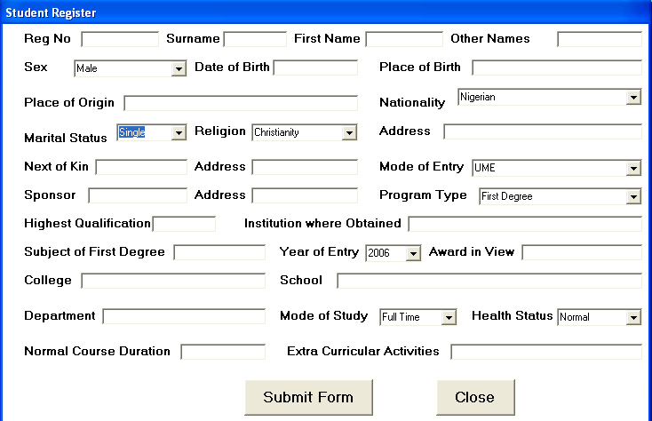

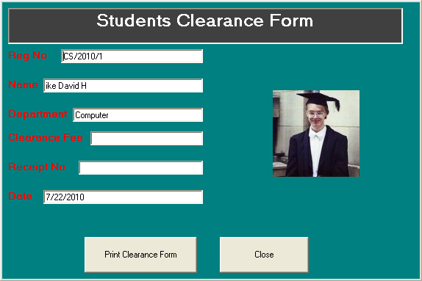

## FILE DESIGN

The file used in the design is stored in a database file. The database is created using Microsoft Access database. The database Structure is as follows:

## Student Register Database Structure

|  |  |  |
| --- | --- | --- |
| FIELD NAME | DATA TYPE | FIELD SIZE |
| Surname | Text | 20 |
| First Name | Text | 20 |

|  |  |  |
| --- | --- | --- |
| Other Names | Text | 50 |
| Reg No | Text | 30 |
| State of origin | Text | 20 |
| Home Town | Text | 20 |
| Marital Status | Text | 15 |
| Nationality | Text | 30 |
| Gender | Text | 10 |
| Session | Text | 20 |
| Level | Text | 20 |
| Birth | Date\time | 8 |
| Dept | Text | 50 |
| Religion | Text | 30 |
| Address | Text | 50 |
| Kin | Text | 30 |
| Kin Address | Text | 50 |
| Entry Mode | Text | 20 |
| Sponsor | Text | 50 |
| Sponsor Address | Text | 50 |
| Type | Text | 20 |
| Qualification | Text | 50 |
| Institution | Text | 50 |
| Subject | Text | 50 |
| Award | Text | 50 |
| School | Text | 50 |
| Study | Text | 30 |
| Year | Text | 10 |
| Duration | Integer | 2 |

|  |  |  |
| --- | --- | --- |
| Activities | Text | 50 |

**Table 4.1 Students Register Database Structure Student Clearance Database Structure**

|  |  |  |
| --- | --- | --- |
| FIELD NAME | DATA TYPE | FIELD SIZE |
| Surname | Text | 20 |
| First Name | Text | 20 |
| Other Names | Text | 50 |
| Reg No | Text | 30 |
| Finance | Single | 4 |
| Library | Single | 4 |
| Student Affairs | Single | 4 |
| Security | Single | 4 |
| Department | Single | 4 |
| Exams and Records | Single | 4 |
| Clearance | Single | 4 |
| Date | Date\time | 8 |
| Receipt | Text | 20 |
| Remark | Text | 30 |

## Table 4.2 Students Clearance Database Structure

File

Clearance officer

Report

Exit

Registration

Debit/credit student

Clearance certificate

Students

Clearance

Main Menu

* 1. **PROCEDURE CHART**

## SYSTEM FLOWCHARTS

***Input data***

Input From the Keyboard

Report

Disk Storage

Output

**CPU**

Figure 4. System flowchart

Figure 4.1 System flow chart

## SYSTEM SPECIFICATION

The specification needed to implement this system is as follows.

## Hardware Specification

For the effective operation of the newly designed system, the following minimum hardware specifications are recommended.

* + - 1. The computer system in used should be IBM compatible since they are considered clone systems.
  1. The Random access memory (RAM) should be at least 128KB.
  2. The system should have a hard disk of at least 50GB and at least a diskette drive of high density of 1.44MB (3.5 inches)
  3. The system should be equipped with an E.G.A/V.G.A, a coloured monitor.
  4. An uninterruptible power supply (UPS) units
  5. It should be internet ready.

These listed configurations are the minimum requirements but if the configurations are higher the reports derived will definitely be better and the program will run much faster.

## Software Specification

The software specifications required on the computer system are:-  A window 98 or higher version for faster processing

 HTML

 Text Editor  Font Page

 Visual Basic 6.0

## Operational Requirement

A conducive computer office is required. The office has to be equipped with air conditioners, stabilizers, and ups.

## Personnel Requirement

A total of 2 computer operators are needed to manage the computer centre. They will oversee the entry of data into the system.



K

Does data exist

N

Y

Does data exist

N

Y

Does data exist

N

Y

Does data exist

N

Y

Y

Stop

Alumni Interface

Faculty Officer Interface

Departmental Interface

Security



**PROGRAM FLOWCHART**

Start

Is Password Correct ?

N

Y

Does

data exist in data here ?

N

Does data exist

N

Y

Does data exist

N

Y

Student affairs Interface

Admission officer‟s Interface

Librarian‟s Interface

Finance Officer‟s Interface

Password Check

* 1. 4.8

39

**CHAPTER FIVE**

# SUMMARY, CONCLUSION AND RECOMMENDATIONS

* 1. **SUMMARY**

The researcher have been able to achieve the following at the completion of this work

 The researcher was able to replace the error prone manual system with the new automated online clearance system.

 Data can now be processed with great speed and efficiency  The application has the ability to update records in various

files automatically thereby relieving the University staff the stress of working from file to file.

 Security of data is ensured.

# CONCLUSION

Research and development are continuous processes; this is same in computer and software development. However, the effectiveness and efficiency of this new system provides room for

further improvements. As earlier mentioned, some of the objectives of this project were not actualised due to some limitations. So these objectives could be improved upon. Nevertheless, the online clearance system developed will offer greater opportunities in school management. All transactions or payments with regards to student clearance can be carried out online.

# RECOMMENDATIONS

The research work carried out is limited to online clearance only. It will be better if a full portal is developed for an effective and wholesome implementation of information management technology in our universities. When this is done the following modules are recommended to be included in the portal.

* + 1. Developing an online student admission system to enable full tracking of students records..
    2. Automation of student‟s academic record to enable the management has access to student academic performance.
    3. Maintaining a central database for accessing all information

relating to students.

## REFERENCES

Anigbogu, G. (2000). *Systematic Planning for Educational Change.*

California: Mayfield Publishing Company.

Chimezie, F. (2000). *Use of local area networks in schools.* New York: ERIC Clearinghouse on Information Resources.

Clifton, E. B. (1983). Management of records in Nigerian Universities: Problems and prospects*. The Electronic Library* 23 (30)

Enwere, J. C. (1992). *Records Management in Nigeria: To be or not to be?*

*Nigeria Library and Information Science Review.* Lagos, Nigeria: Akin Publishing Ltd.

French, C. S. (1996). *Computer Science.* U. K: T.J International.

Funk, M. (1980). *Perspective in Educational Planning.* Ibadan, Nigeria: Odun Prints and Pack.

Hewlett, M. (1993). The Internet in Education*.* [Special issue]. "*Internet World*," 6(10).

Iwhiwhu, E. B. (2005). *The Feature of Records Management in Nigeria.* The Nigerian Archivist. *Journal of the society of Nigerian Archivists* 1(2$3)

Lucey, I. (1991). Managing Records in the Modern Office: Training the Wild Frontier*. Archivaria* 39 (Spring)

Nwankwo, J. I. (1982). Establishment of Management Information in Sind Province, UNESCO *Technical Report*: Project PAK/77/038

Obilikwu, N. (1995). *Records Management Programme.* Ibadan, Nigeria: Adeyomi Printing Press.

Omenyi, A. S. (1997). *Effective Records Management: a tool for effective counseling in the school systems.* Journal of counseling and Communication.

Oketunji, S. F. (2002). Information Provision to Academic Research and Development organizations in the 21st century. *The Information Manager* 2(1)

Taylor, M. (1980). *Education and Training Achieves and Records Manager in Africa.* Ibadan, Nigeria: Odun Publishing Company.

Uju, J. O. (1997). *Research Methods: Application of Scientific Research Methodology and Documentation.* Trans-Ekulu, Enugu: Joen Publishers.

Vossen, G. (1991). *Data Models, Database Languages and Database Management Systems*. London: Adison-Wesley Publishing Computer.

## APPENDIX A WELCOME PAGE

**APPENDIX B HOME PAGE**

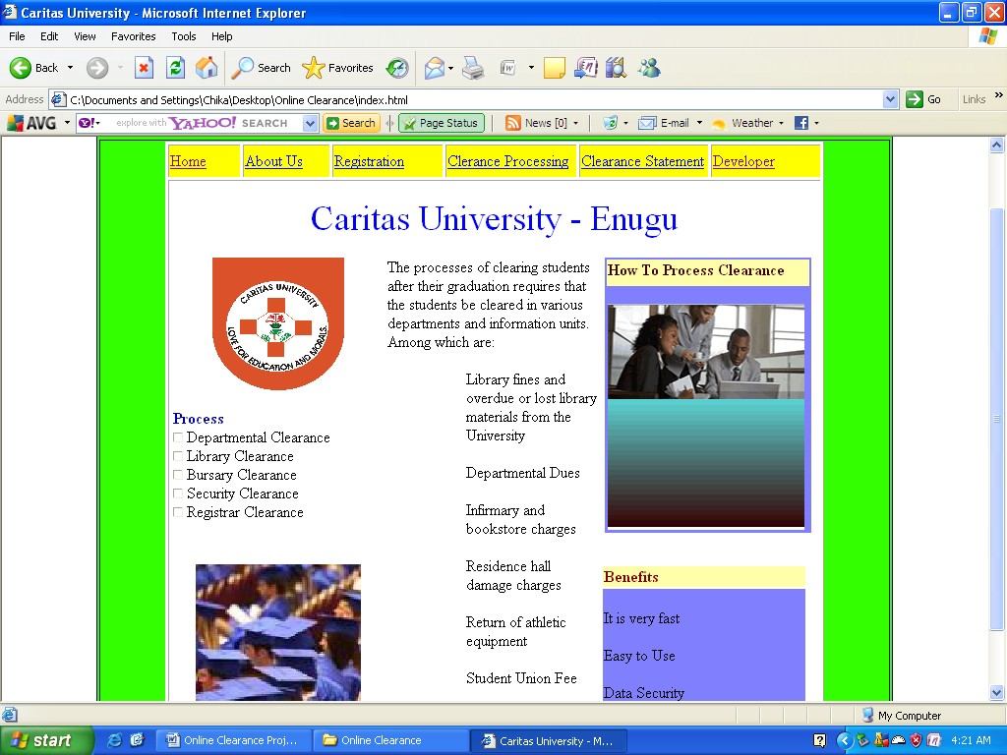

## APPENDIX C INPUT FORMS

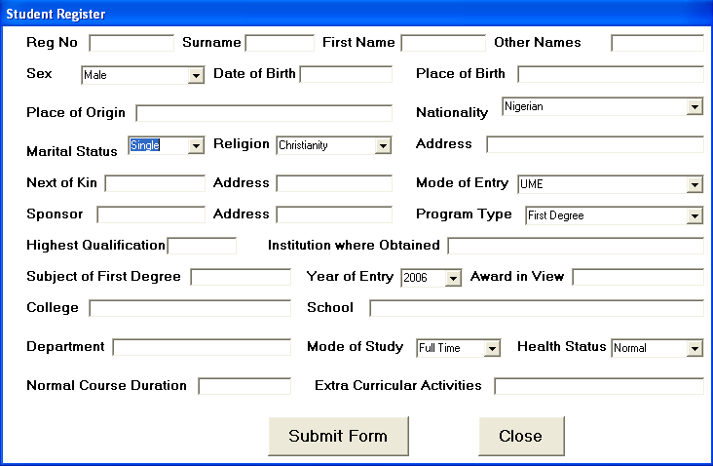

**Students Registration Form**

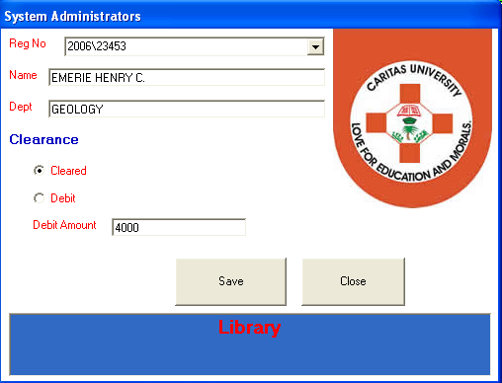

## Clearance form

**APPENDIX D OUTPUT FORMS**

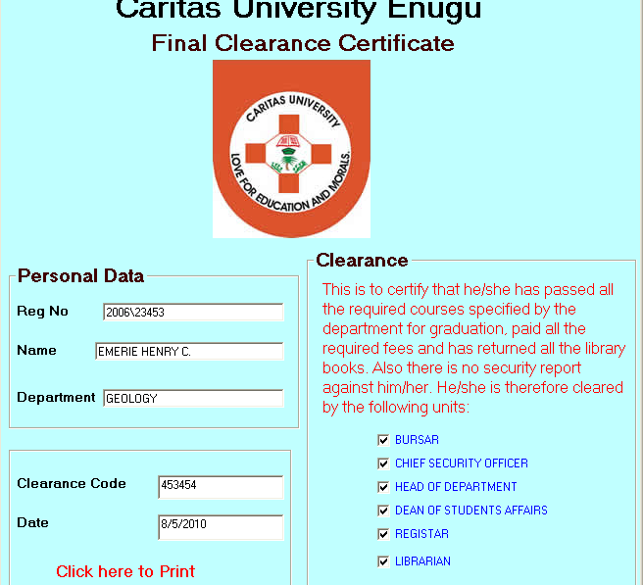

## Clearance Certificate

**APPENDIX E SOURCE CODE**

<!DOCTYPE html PUBLIC "-//W3C//DTD XHTML 1.0 Transitional//EN" ["http:/](http://www.w3.org/TR/xhtml1/DTD/xhtml1-transitional.dtd)/[www.w3.org/TR/xhtml1/DTD/xhtml1-transitional.dtd](http://www.w3.org/TR/xhtml1/DTD/xhtml1-transitional.dtd)">

<html xmlns="<http://www.w3.org/1999/xhtml>">

<head>

<meta http-equiv="Content-Type" content="text/html; charset=iso-8859-1"

/>

<title>Caritas University</title>

<style type="text/css">

<!--

.style2 {color: #000040; }

.style3 {

color: #0000A0; font-weight: bold;

}

.style6 {

color: #400000;

font-weight: bold;

}

.style8 {

font-size: 12px; color: #0000A0;

}

.style9 {

color: #800000; font-weight: bold;

}

.style10 {

color: #0000FF; font-size: 12px;

}

.style11 {

font-size: 36px; color: #0000FF;

}

-->

</style>

</head>

<body>

<table width="700" height="600" border="1" align="center" bordercolor="#000040" bgcolor="#33FF00">

<tr bgcolor="#004080">

<td height="50" bordercolor="#33FF00" bgcolor="#00FF00"><div align="right" class="style2">

<div align="center"><img src="online.png" width="800" height="52"

/></div>

</div></td>

</tr>

<tr>

<td><table width="500" height="350" border="1" align="center" bgcolor="#FFFFFF">

<tr>

<td width="68" height="30" bgcolor="#FFFF00"><a href="index.html">Home</a></td>

<td width="98" bgcolor="#FFFF00"><a href="About.html">About Us</a></td>

<td width="80" bgcolor="#FFFF00"><a href="Register.exe">Registration</a></td>

<td width="138" bgcolor="#FFFF00"><a href="officeclearance.exe">Clerance Processing </a></td>

<td width="143" bgcolor="#FFFF00"><a href="Studentclearance.exe"> Clearance Statement </a></td>

<td width="93" bgcolor="#FFFF00"><a href="developer.html">Developer</a></td>

</tr>

<tr>

<td height="500" colspan="6" valign="top"><table width="660" height="400" border="0" align="right">

<tr>

<td height="70" colspan="3"><div align="center" class="style11">Caritas University - Enugu </div></td>

</tr>

<tr>

<td width="220" valign="top"><div align="center"><img src="Caritas Logo.jpg" width="134" height="135" /></div>

<p><span class="style3">Process</span><br />

<img src="dot.png" width="10" height="10" /> Departmental Clearance <br />

<img src="dot.png" width="10" height="10" /> Library Clearance<br />

<img src="dot.png" width="10" height="10" /> Bursary Clearance<br />

<img src="dot.png" width="10" height="10" /> Security Clearance<br />

<img src="dot.png" width="10" height="10" /> Registrar Clearance </p></td>

<td width="220" rowspan="2" align="left" valign="top"><p>The processes of clearing students after their graduation requires that the students be cleared in various departments and information units. Among which are:</p>

<ol>

<ol>

<p align="left">Library fines and overdue or lost library materials from the University</p>

<p>Departmental Dues </p>

<p>Infirmary and bookstore charges </p>

<p>Residence hall damage charges </p>

<p>Return of athletic equipment </p>

<p>Student Union Fee</p>

<p>Bursary and all other charges </p></td>

<td width="220" valign="top"><table width="210" border="0" align="center" bgcolor="#8080FF">

<tr>

<td height="25" valign="top" bgcolor="#FFFFAA"><span class="style6">How To Process Clearance </span></td>

</tr>

<tr>

<td height="237" valign="top"><span class="style8"><br />

</span><img src="howtoshow.gif" width="200" height="230"

/></td>

</tr>

</table></td>

</tr>

<tr>

<td height="150" valign="top"><div align="center">

<p><img src="images4.jpg" width="168" height="165" /></p>

</div></td>

<td width="220" valign="top"><table width="210" border="0">

<tr>

<td bgcolor="#FFFFAA"><span class="style9">Benefits</span></td>

</tr>

<tr>

<td bgcolor="#8080FF"><p><br />

It is very fast</p>

<p>Easy to Use</p>

<p>Data Security </p>

</td>

</tr>

</table> </td>

</tr>

</table></td>

</tr>

</table></td>

</tr>

</table>

</body>

</html> Option Explicit

Public LoginSucceeded As Boolean Private Sub cmdCancel_Click()

'set the global var to false 'to denote a failed login LoginSucceeded = False Me.Hide

End Sub

Private Sub cmdOK_Click() 'check for correct password

If txtPassword = "office" Then 'place code to here to pass the 'success to the calling sub 'setting a global var is the easiest LoginSucceeded = True Me.Hide frmclearanceoffice.Show

frmclearanceoffice.display.Caption = frmLogin.Combo1.Text frmclearanceoffice.Comboregno.Clear

frmclearanceoffice.Data1.Refresh frmclearanceoffice.Data1.Recordset.MoveFirst

Do Until frmclearanceoffice.Data1.Recordset.EOF frmclearanceoffice.Comboregno.AddItem frmclearanceoffice.Data1.Recordset.Fields("Reg No") frmclearanceoffice.Data1.Recordset.MoveNext

Loop

Else

MsgBox "Invalid Password, try again!", , "Login"

txtPassword.SetFocus SendKeys "{Home}+{End}"

End If End Sub

Private Sub cmdclose_Click() End

End Sub

Private Sub cmdsubmit_Click() frmstudent.Data1.Recordset.AddNew

frmstudent.Data1.Recordset.Fields("Surname") = frmstudent.Text1.Text frmstudent.Data1.Recordset.Fields("Other Names") = frmstudent.Text2.Text frmstudent.Data1.Recordset.Fields("First Name") = frmstudent.Text20.Text frmstudent.Data1.Recordset.Fields("Name") = frmstudent.Text1.Text + " " + frmstudent.Text20.Text + " " + frmstudent.Text2.Text frmstudent.Data1.Recordset.Fields("Birth") = frmstudent.Text6.Text frmstudent.Data1.Recordset.Fields("Reg no") = frmstudent.Text3.Text frmstudent.Data1.Recordset.Fields("state of origin") = frmstudent.Text5.Text

frmstudent.Data1.Recordset.Fields("home town") = frmstudent.Text4.Text frmstudent.Data1.Recordset.Fields("level") = "100"

frmstudent.Data1.Recordset.Fields("marital status") = frmstudent.Combo5.Text

frmstudent.Data1.Recordset.Fields("nationality") = frmstudent.Combo1.Text frmstudent.Data1.Recordset.Fields("gender") = frmstudent.Combo2.Text frmstudent.Data1.Recordset.Fields("session") = frmstudent.Combo4.Text frmstudent.Data1.Recordset.Fields("dept") = frmstudent.Combo26.Text frmstudent.Data1.Recordset.Fields("religion") = frmstudent.Combo6.Text frmstudent.Data1.Recordset.Fields("address") = frmstudent.Text7.Text frmstudent.Data1.Recordset.Fields("kin") = frmstudent.Text8.Text frmstudent.Data1.Recordset.Fields("kaddress") = frmstudent.Text9.Text frmstudent.Data1.Recordset.Fields("sponsor") = frmstudent.Text10.Text frmstudent.Data1.Recordset.Fields("Saddress") = frmstudent.Text11.Text frmstudent.Data1.Recordset.Fields("entry") = frmstudent.Combo7.Text frmstudent.Data1.Recordset.Fields("type") = frmstudent.Combo8.Text frmstudent.Data1.Recordset.Fields("qual") = frmstudent.Text12.Text frmstudent.Data1.Recordset.Fields("inst") = frmstudent.Text13.Text frmstudent.Data1.Recordset.Fields("subject") = frmstudent.Text14.Text frmstudent.Data1.Recordset.Fields("award") = frmstudent.Text15.Text frmstudent.Data1.Recordset.Fields("college") = frmstudent.Text16.Text frmstudent.Data1.Recordset.Fields("school") = frmstudent.Text17.Text frmstudent.Data1.Recordset.Fields("duration") = frmstudent.Text18.Text

frmstudent.Data1.Recordset.Fields("activities") = frmstudent.Text19.Text frmstudent.Data1.Recordset.Fields("study") = frmstudent.Combo9.Text frmstudent.Data1.Recordset.Fields("health") = frmstudent.Combo10.Text frmstudent.Data1.Recordset.Update

frmstudent.Data2.Recordset.AddNew frmstudent.Data2.Recordset.Fields("Reg No") = frmstudent.Text3.Text frmstudent.Data2.Recordset.Fields("dept") = frmstudent.Combo26.Text frmstudent.Data2.Recordset.Fields("Name") = frmstudent.Text1.Text + " " + frmstudent.Text20.Text + " " + frmstudent.Text2.Text frmstudent.Data2.Recordset.Fields("finance") = 0

frmstudent.Data2.Recordset.Fields("library") = 0 frmstudent.Data2.Recordset.Fields("student affairs") = 0 frmstudent.Data2.Recordset.Fields("security") = 0

frmstudent.Data2.Recordset.Fields("department") = 0

frmstudent.Data2.Recordset.Fields("faculty") = 0 frmstudent.Data2.Recordset.Fields("exams and records") = 0 frmstudent.Data2.Recordset.Fields("clearance fee") = 0 frmstudent.Data2.Recordset.Fields("receipt") = "-" frmstudent.Data2.Recordset.Fields("date") = Date frmstudent.Data2.Recordset.Fields("remark") = "Not Cleared"

frmstudent.Data2.Recordset.Update frmstudent.Text1.Text = "" frmstudent.Text2.Text = "" frmstudent.Text6.Text = "" frmstudent.Text3.Text = "" frmstudent.Text5.Text = "" frmstudent.Text4.Text = "" frmstudent.Text7.Text = "" frmstudent.Text8.Text = "" frmstudent.Text9.Text = "" frmstudent.Text10.Text = "" frmstudent.Text11.Text = "" frmstudent.Text12.Text = "" frmstudent.Text13.Text = "" frmstudent.Text14.Text = "" frmstudent.Text15.Text = "" frmstudent.Text16.Text = "" frmstudent.Text17.Text = "" frmstudent.Text18.Text = "" frmstudent.Text19.Text = "" frmstudent.Text20.Text = ""

End End Sub



Clearance Certificate