**DESIGN AND IMPLEMENTATION OF ONLINE CINEMA BOOKING SYSTEM**

**(A CASE STUDY OF SILVERBIRD CINEMA, UYO)**

**CHAPTER ONE**

**INTRODUCTION**

**1.1 Background of the Study**

Online cinema booking system is basically made for providing the movie ticket anywhere and anytime and get information about the movies online. The user can easily be able to know about the movies released and then make a choice.

It is a web-based system. The customers can buy ticket online and cancel the seat at a suitable time (2 days before the show to 1hour before the show). To enhance the refund function, all the customers have to register to become a number before buying the ticket. Staff can use the system to insert and delete data (example film description, time table) which will update the webpage. Also staff can check the statistic information from the system.

The system is to provide an alternate and convenient way for a customer to buy movie tickets. It is an automatic system. After the data has been fed into the database, the staff does not need to do anything with the order once it is received through the system.

The name “movie” originates from the fact that photographic film (also called film stock) has historically been the medium for recording and displaying motion pictures. Many other terms exist for an individual motion picture, including picture, picture show, moving picture, photoplay and flick.

Today, it is believed that the application of computer technology in any activity would go a long way in making that activity much easier.

To the researcher, this statement remains a theory until proven otherwise by the implementation of online movie ticket reservation system.

It also believed that the benefit and advantages of using computer out weight that of the manual methods beyond doubt by the researcher through the implementation of the new system.

**1.2 Statement of the Problem**

The major problem that give rise to this research project faced by silverbird, Uyo.

1. Late seats reservation by customers.
2. Fluctuation of network service.
3. Inability to book seat by computer illiterate customers.

(iv)Corrupt and tactical customers who have ways of sneaking into the cinema hall with fake seats number printout.

**1.3 Objectives of the Study**

The study sought to provide an alternate and convenient way for a customer to buy movie tickets. Specifically, the study sought to;

1. To establish an efficient way to promote the film on the internet.
2. To minimize the number of staff at the ticket box.
3. To increase the profit and obtain statistical information from the booking record.
4. To provide an anytime, anywhere service for the customers to book their movie ticket.
5. To create a reliable database of movies in the case study with their description.

**1.4 Research Questions**

1. How can cinema online booking system establish an efficient way to promote the film on the internet?

2. Can cinema online booking increase the profit and obtain statistical information from the booking record?

**1.5 Significance of the Study**

This research project will be unnecessary if it does not have significance to humanity. The newly designed system is faster, more convenient and you do not have to go to station twice. Online ticket reservation is always a safe option, unless the website is insecure. Booking online ticket is safe if the company you plan to use, uses a Secure Server Software (SSS). This basically hides year private information from there. It saves a lot of money in printing cost because the company do not need to printout ticket to give to customers which get binned after the film anyway. It also saves a lot of time for the customers because, they do not need to arrived early to queue for ticket in case they are all sold out.

**1.6 Scope/Limitations of the Study**

This research project is restricted to the design and implementation of cinema online system using Silverbird cinema Uyo as the case study.

**Limitations of study**

1. **Financial constraint**- Insufficient fund tends to impede the efficiency of the researcher in sourcing for the relevant materials, literature or information and in the process of data collection (internet, questionnaire and interview).
2. **Time constraint**- The researcher will simultaneously engage in this study with other academic work. This consequently will cut down on the time devoted for the research work.

**1.8 Definition of Terms**

In order to do away with ambiguity, some terms and keywords in the context of this research are here by defined.

**Implementation:**  Is the building of system and installation to ensure that it solve a particular task.

**System:** Is a combination of related parts into a complex whole.

**Database:** It is a collection of interrelated data stored together with controlled redundantly to serve one or more application in an optional fashion.

**Reservation:** Is the act of reserving something e.g hotel accommodation, a seat on an aero plane, in a theatre.

**Ticket:** Is a piece of paper, cardboard, etc, showing that the holder is entitled to certain rights, such as travel on a train or bus, entry to a place of public.

**CHAPTER TWO**

**REVIEW OF RELATED LITERATURE**

**2.1 Introduction**

This chapter will discuss the background research which was carried out within the relevant areas of the design. Traditional Multimedia and Intelligent Multimedia will also be outlined along with information on Visually Impaired Users. A sub section regarding Speech technologies will also be discussed with reference to the CSLU toolkit which is the software being used to implement the Ticket Reservation System for the Millennium Forum. Similar systems will also be discussed.

**2.2 Traditional Multimedia**

Traditional Multimedia consists of objects such as video and audio types. Traditional multimedia middleware such as:

• DirectShow from Microsoft.

• Apple's Quick time.

The above provides access only to multimedia devices directly connected to the same PC an application is running on. The network is supported as a source of data but the middleware cannot extend its control to other devices on the network. For example, it is impossible to transparently watch TV via the TV card in your colleague's PC, or control remote cameras attached to other PCs or directly to the network. (Lohse, Slusallek &Wambach 2001).

**2.3 Intelligent Multimedia**

Mc Kevitt (1997, p.1) notes “Intelligent Multimedia is a growing area which involves the computer processing of language and vision information and representing it in terms of its semantics”. Semantics is identifying the study of meaning in communication. Intelligent Multimedia is a computer’s ability to process and understand an input in text, speech, images etc and responding to it.

**2.4 Visually Impaired Users**

Visual Impairment is when individuals have reduced vision and therefore can find it difficult to view certain types of computer interfaces. Lehman (2007) notes “Many 5 people have some type of visual problem at some point in their lives. Some can no longer see objects far away. Others have problems reading small print”. Therefore it is important to recognize the needs of visually impaired users.

**2.5 CSLU Toolkit**

“The CSLU Toolkit was created to provide the basic framework and tools for people to build, investigate and use interactive language systems. These systems incorporate leading-edge speech recognition, natural language understanding, speech synthesis and facial animation technologies. The toolkit provides a comprehensive, powerful and flexible environment for building interactive language systems that use these technologies, and for conducting research to improve them.” CSLU Toolkit (2008). The CSLU Toolkit development started in 1992 and it has progressed to meet different needs. Hoson (2008) has outlined the main goals of the CSLU Toolkit as:

• “easy to use”;

• “powerful for research and development use”;

• “systems that work in the real world”;

• “incorporates research advances”.

**2.5.1 What is the CSLU Toolkit?**

There are three main sections of the CSLU Toolkit. The first section is the ‘Fundamental Components’ which includes:

• Audio Tools;

• Display Tools:

• Speech Recognition;

• Speech Generation;

• Animated Faces.

The second section is the ‘System Integration’, at this point the components of the system are brought together and system functionality is ensured. The third section is the ‘Technology Transfer’, here the system ensures that the technology which has been developed can be accessed by a range of users. The users include High Schools, Universities, Researchers and the Industries.

**2.5.2 CSLU Toolkit Core Technologies**

As you can see form the above picture the core technologies of the CSLU toolkit are:

• Facial Animation: used in order to show emotions.

• Text to Speech Synthetic voice: used to translate the text which is required to be spoken by the toolkit.

• Speech Recognition: used by the toolkit in order to understand the end user.

**2.6 Speech Technologies**

Speech technologies are used to make the system more acceptable and usable by its users. The first choice of speech technology which could be used is Clear Voice. Clear voice is the technology of noise cancellation for speech signals. This is used in call centers and helps block out background noise which could interfere with the system or responses given by the caller. As they will be new shows being added and deleted each week the use of clear voice would be effective in creating a new list of shows. Once a user makes a purchase using the system they can set up an account which means that they details will be saved. One way of doing this securely is by using Biometric Voice Verification (Voice Key) which is a voice-based access control algorithm performing user authentication by voice password. In just 0.5 sec Voice Key will identify a user and define his/her access rights to information and services.

**2.7 Theatre background**

Theatre is the division of the performing arts that acts out stories in front of an audience using a mixture of speech, gesture, music, dance, sound and spectacle. Together with the narrative dialogue style, theatres also takes the forms as opera, ballet, mime, kabuki, classical Indian dance, Chinese opera, mummers' plays, and pantomime.

**2.8 Relevant Papers**

This section outlines a number of relevant papers that have been reviewed, discussed and critically analysed in our Intelligent Multimedia module. These papers relate to areas such as language, vision and speech.

Computational Models for Integrating Linguistic and Visual Information, surveys research in developing computational models for integrating linguistic and visual information. It discusses the importance of linking language and vision in order for a system to exhibit intelligent behaviour. This paper includes an examination of existing computational models, computationally motivated theories of human cognition and major research issues, which arise in the task of integrating visual and linguistic information. This paper acknowledges that more research is required in developing an intelligent agent that has both language and perceptual abilities. The Behaviour Expression Animation Toolkit (BEAT) allows animators to input typed text that they wish to be spoken by an animated human figure, and to obtain as output appropriate and synchronized nonverbal behaviours and synthesized speech in a form that can be sent to a number of different animation systems. The toolkit is extensible, so that new rules can be quickly added.

**2.9 Human Computer Guidelines (HCI)**

As the system which will being created is intended to be as user-friendly as possible, in the design of the system, HCI must take centre place in order to design and develop a system which will be as usable as possible and will meet the requirements of all its users. The system will be the creation of an automated ticket booking system for the Millennium Forum which will be fully automated. This means that in order for someone to book tickets for a show they will simple speak to the system and the system will do all the work for them. These will be discussed in more detail in chapter four. When designing this system the team will take into consideration the following factors:

• People with speech problems

• People with Visual Impairment.

**2.10 Analysis of Similar Systems**

In this section similar systems to the Ticket Reservation System for the Millennium Forum will be discussed.

**Online Booking Systems:**

An online booking system is a system on the internet where users can book products or services. Usually customers are required to fill out web-forms with details such as their name, address and telephone number and are also required to provide payment details such as credit/debit card details.

**Online Availability Systems:**

Online availability systems are systems on the internet where users can check the availability of a product or service. If the required product/service is available customers may be able to reserve it. Both systems are similar to the system which is to be developed, as the two main requirements of the Ticket Reservation System for the Millennium Forum are to be able to check the availability of a show and to reserve a number of tickets.

**Reservation system**

Reservation systems are electronic systems that allow users to check the availability of a product or service and then if available, allows the end user to reserve the product or service without payment. These types of systems can be used for reserving hotel rooms or reserving tables at a restaurant.

**2.11 Conclusion**

This chapter provided a background on the relevant areas for this project, detailing information on the different areas of Multimedia, the CSLU Toolkit, Speech Technologies, Theatre, Reservation Systems, Visual Impairment and the HCI Guidelines. Also included is a sub-chapter detailing the papers which were discussed in class which are relevant to this project. Chapter three will now discuss the Requirements Specification. An analysis of similar systems to the Ticket Reservation System have also been discussed, which has helped to identify useful elements that could be included in the design of the Ticket Reservation System

**CHAPTER THREE**

**SYSTEM DESIGN**

* 1. **INTRODUCTION**

This chapter describes in detail the system design methodology. It focuses on the system structure and interactions. The proposed system is an insurance service support system. It is created to be deployed on the web and is aimed at providing application processing services for an insurance company. This chapter begins by examining the Systems Requirement Specification (SRS) document which is majorly focused on only the functional requirements to be provided by the system. It proceeds to the system design which consists of the logic design. The logic design consists of various user interfaces and the chapter also explains the system design using UML diagrams.

* 1. **SYSTEM REQUIREMENT SPECIFICATION**

The system requirement specification is a structured document that collects information which encompasses the requirements of a system. This section would focus mainly on the functional requirements of the proposed system and these include:

1. The system should be able to validate all user input and respond to exceptions appropriately.
2. The system should enforce the policy of non-multiple users of an account using standard authentication processes.
3. The system should allow users to create and maintain vehicle insurance policies
4. The system should allow for secure financial transactions as related to user payment.
5. The system should be able to track insecure penetrations and prevent unauthorized intrusions.
6. The system should also allow users to maintain an online profile.
   1. **SYSTEM DESIGN**

This section explains the design methodology, data and modules for the proposed system. The system design incorporates both UML diagrams and user interface designs.

* + 1. **LOGICAL DESIGN**

The logical design of the system is concerned with the underlying logic of the proposed system which would be abstracted from the various interfaces of the system. The interfaces discussed would be the input design, output design and menu design.

* + 1. **INPUT DESIGN**

This section includes the various input design interfaces in the system. The input design interfaces are listed below.

INPUT SCREEN

Welcome screen

ADMIN LOGIN

Next

Select Movie Category

Date

No of Sales

TICKET WINDOW

Seat Number

Auto Generated view seat:

First Name

Enter First name:

Last Name

Enter Last name:

Address

Email address:

Contact

Enter contact Number:

COMFIRM

PRINT VIEW

Ticket Reservation Detail:

Transaction Number:

Name:

Address:

Contact:

Payable:

Movie and theatre Category

Seat Number:

Date of Movie:

* + 1. **OUTPUT DESIGN**

This section includes the various output design interfaces in the system. The output design interfaces are listed below.

**ADMIN PANEL**

GALLERY

Now

Showing

Now

Showing

Now

Showing

Now

Showing

Now

Showing

Now

Showing

Now

Showing

Now

Showing

Now

Showing

DASHBOARD

|  |  |  |  |  |  |  |  |  |  |  |
| --- | --- | --- | --- | --- | --- | --- | --- | --- | --- | --- |
| First Name | Last Name | address | Contact | Movies | Theatre Section | Time | Seat No | Payable | Status | Action |
|  |  |  |  |  |  |  |  |  |  |  |
|  |  |  |  |  |  |  |  |  |  |  |
|  |  |  |  |  |  |  |  |  |  |  |
|  |  |  |  |  |  |  |  |  |  |  |

MOVIES

|  |  |  |  |  |  |
| --- | --- | --- | --- | --- | --- |
| Type | Movies | Seat Number | price | Time | Action |
|  |  |  |  |  |  |
|  |  |  |  |  |  |
|  |  |  |  |  |  |

SEAT INVENTORY

|  |  |  |  |  |  |
| --- | --- | --- | --- | --- | --- |
| Date | Type | Movies | Seat Number | Transaction Code | Action |
|  |  |  |  |  |  |

* 1. **DATA FLOW DIAGRAM**

**RECORD MODIFICATION**

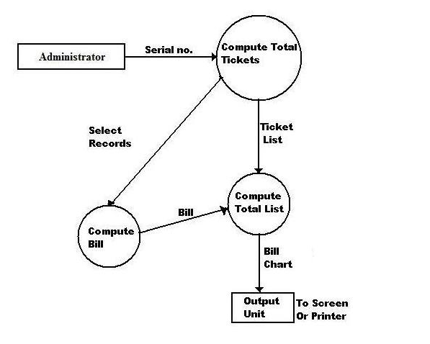

**NEW TICKET BOOKING**

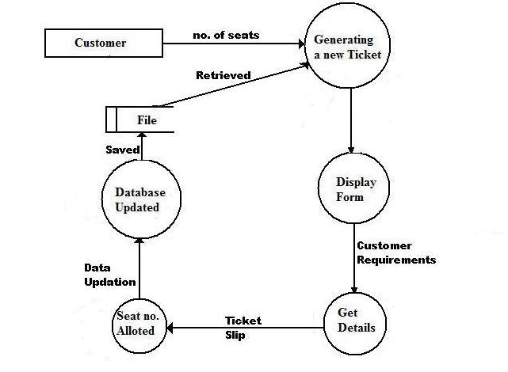

**NUMBER OF CUSTOMER**

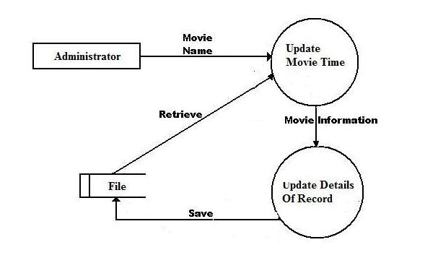

**Generating Customer Bill**

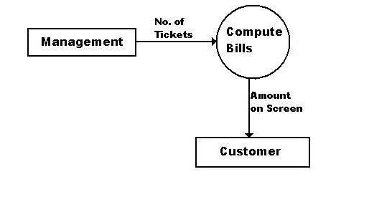

* 1. **DATABASE STRUCTURE**

**DATABASE TABLE**

ADMIN

|  |  |  |
| --- | --- | --- |
| Field | Data type | Description |
| Id | Int (11) | Auto-increment |
| Username | Varchar (30) | Varchar username |
| Password | Varchar (30) | Password phrase to access the system |

CUSTOMER

|  |  |  |
| --- | --- | --- |
| Field | Data type | Description |
| Id | Int (11) | Auto-increment |
| F-name | Varchar (30) | First name |
| L-name | Varchar (30) | Last name |
| Contact | Varchar (20) | Contact Details |
| Address | Varchar (300) | Address detail |
| Bus | Varchar (30) | Movie details |
| Transaction | Varchar (10) | Transaction number |
| Payable | Varchar (11) | Money paid |
| Status | Varchar (100) | Details of validity |
| Set-number | Varchar |  |

RESERVE

|  |  |  |
| --- | --- | --- |
| Field | Data type | Description |
| Id | Int (11) | Auto-increment |
| Date | Varchar (11) | Post date |
| Bus | Varchar (11) | Ticket |
| Seat-reserve | Varchar (11) | Seat allocated |
| Transaction number | Varchar (11) | Transaction number |
| Seat | Varchar (100) | Available seat |

This section describes the various output of the system to the user. The format of output for the system is majorly text. The output that would be discussed would be the cover and certificate.

* 1. **INTRODUCTION**

This chapter focuses on the implementation of the system. The features of the implementation languages used in this research- PHP and MYSQL will be discussed extensively. The system testing strategies, the target computer requirements as well as the software maintenance issues that would arise in the system would be discussed also.

* 1. **FEATURES OF IMPLEMENTATION LANGUAGES**

The programming languages used in the implementation of this project are PHP (Hypertext Preprocessor) and MYSQL programming languages. PHP is a general purpose server side scripting language originally designed for web development to produce dynamic web pages. It has also evolved to include a command line interface capability and can be used in stand-alone graphical applications.

The following features make PHP a preferred implementation language for this project:

1. PHP has its root in C and C++. PHP syntax is most similar to C and C++ language syntax, so programmers find it easy to learn and manipulate.
2. PHP can run on both UNIX and windows. Hence it is compatible across various operating systems.
3. PHP has powerful output buffering that further increases over the output flow. PHP internally rearranges the buffer so that the header comes before the content.
4. PHP is platform independent: this is because it is parsed by the web browser hence compatibility issues do not arise when code written in PHP is ported to a different platform.
5. PHP can be used with a large number of relational database management systems, runs on all of the most popular web servers and is available to many different operating systems.
6. PHP is fully an object oriented programming language and its platform independence and speed on LINUX servers help to build large and complex web applications.
7. PHP has also attracted the development of many frameworks that provide building blocks and design structure to promote Rapid Application Development (RAD). Some of these include cake PHP, code igniter, Yii framework and Zend framework.
8. PHP IDS add security to any PHP application to defend against intrusion. PHPIDS detects cross-site scripting (XSS), SQL injection, header injection, directory traversal, remote file execution, local file execution and Denial of Service (DOS).

MYSQL is a relational database management system written in C and C++, that runs as a server providing multi user access to a number of databases. MYSQL is used basically to create a relational database structure on a server in order to store data or automate procedures. The following features make MYSQL also a preferred implementation language in this research:

1. MYSQL is written in C and C++ and tested with a broad range of different compilers. It also functions on different platforms.
2. It uses multi-layered server design with independent modules.
3. It is designed to be fully multi-threaded using kernel threads to easily use multiple CPUs if they are available.
4. It is a server/client system. The database server (MYSQL) and the arbitrary many clients (application programs) which communicates with the server to query data and save changes.
5. MYSQL is designed to make it relatively easy to add other storage engines. This is useful if you want to provide an SQL interface for an in-house database.
6. It provides transactional and non-transactional storage engines, uses very fast B-tree disk tables with index compression and a fast thread-base memory allocation system.
7. It executes very fast joins using an optimized nested loop join; implements in-memory hash tables which are used as temporary tables.
8. It implements SQL functions using a highly optimized class library that should be as fast as possible.
9. It provides the server as a separate program for use in a client/server networked environment and as a library that can be embedded (linked) into stand-alone applications. Such applications can be used in isolation or in environments where no network is available.
   1. **SYSTEM TESTING STRATEGIES**

This section is concerned with testing and debugging of the programs and general processes involved in achieving the objectives of the system requirement. System testing is conducted on a complete integrated system to evaluate the system’s compliance with its specified requirements. System testing falls within the scope of black box testing and as such should require no knowledge of the inner design of the code or logic. During system testing, the focus is on the software design, behavior and even the believed expectations of the customer. So we can also refer to the system testing phase as investigatory testing phase of the software development life cycle. The system testing strategies used in this system include the unit test and integration test.

* + 1. **UNIT TEST**

The primary goal of unit testing is to take the smallest piece of testable software in the application, isolate it from the remainder of the code and determine whether it behaves exactly as it is expected to behave. Each unit is tested separately before integrating them into modules to test the interfaces between modules. Unit testing has proven its value in that a large percentage of defects are identified during its use.

The most common approach to unit testing requires drivers and stubs to be written. The driver simulates a calling unit and the stub simulates a called unit. The investment of developer time in this activity sometimes results in demoting unit testing to a lower level of priority and that is almost always a mistake. Even though the drivers and stubs cost time money, unit testing provides some undeniable advantages. It allows for automation of the testing process, reduces difficulties in discovering errors contained in complex pieces of the application. During the unit testing of the application, errors uncovered by the researcher were rectified and the result was satisfactory.

* + 1. **INTEGRATION TESTING**

Integration testing is a logical extension of unit testing. In its simplest form, the units that have already been tested are combined into a component and the interface between them is tested. A component, in this sense, refers to an integrated aggregate of more than one unit. In a realistic scenario, many units are combined into components, which are in turn aggregated into even larger parts of the program. The idea is to test combination of pieces and eventually expand the process to test your modules with those of other groups. Integration testing can be done in a variety of ways which include top-down approach, bottom-up approach and the umbrella approach.

In the integration testing of the software, satisfactory results were obtained from the test using the bottom-up approach.

* 1. **TARGET COMPUTER SYSTEM REQUIREMENTS**

This section considers the requirements that must be met by the target system to enable the developed software application function as required. The target computer system requirement will be discussed in the area of software and hardware requirements.

|  |  |
| --- | --- |
| **Component** | **Requirement** |
| Operating system | Windows 2000, XP, Vista |
| Memory | 128MB or higher |
| Database | MySQL 5 |
| Web server | WAMP server |

**Table 4.1: software requirement for target computer system**

|  |  |
| --- | --- |
| **Component** | **Requirement** |
| RAM | 256MB of RAM |
| Hard disk | 10GB of hard disk space |
| Processor | 333Hz or higher |

**Table 4.2: hardware requirements for target computer system**

* 1. **SOFTWARE MAINTENANCE ISSUES**

This section focuses on software maintenance issues. Software maintenance is the modification of a software product after delivery to correct faults, improve performance or other product attributes or to adapt the product to a new or changing environment. It also serves as an opportunity to improve the performance o the software to suit the needs of the users if it becomes necessary for the user requirements to be improved upon or changed.

Maintenance would be seen in three areas in this research; corrective maintenance, preventive maintenance and adaptive maintenance.

* + 1. **CORRECTIVE MAINTENANCE**

Corrective maintenance is a maintenance task performed to identify, isolate and rectify a fault so that the failed system can be restored to an operational condition within the tolerances or limits established for in-service operations. Necessary corrections in the form of removal, modification or addition of program modules should be permitted by the software to allow for optimal use of the application.

* + 1. **PREVENTIVE MAINTENANCE**

This is a schedule o planned maintenance actions aimed at the prevention of breakdowns and failures. The primary goal of preventive maintenance is to prevent the failure of software before it actually occurs. It is designed to preserve and enhance software reliability by replacing error-prone components before they actually fail. Recent technological advances in tools for inspection and diagnosis have enabled more accurate and effective software maintenance. Measures like regular diagnosis, database backups, creating system mirrors preserve the integrity of information stored in the application. If these are strictly followed, limited instances of such occurrences would be noticed in the use of the software application.

* + 1. **ADAPTIVE MAINTENANCE**

This involves enhancing the system by adding features, capabilities and functions in response to new technology, upgrades, new requirements or new problems. Since the environment in which the application would be running is dynamic, it should be made to suit whatever requirements that may change in the long run.

**CHAPTER FIVE**

1. **SUMMARY, CONCLUSION AND RECOMMENDATION**

**5.1 SUMMARY**

This project highlighted the practical implementation of computer system with view of demonstrating the success and utility of the knowledge base on system in order to gain the practitioners who are the ultimate users of the system.

Also, the use of computer assisted techniques lead to more accurate and easy administration and to improve the quality of sales and customer care system through reduction in mobility and increase interaction with all unit in the galleria.

**5.2 CONCLUSION**

The experimental study has clearly revealed the role of computer system as an intermediary between the end users and the system admin / sales person for the company. The computer system facilitates fast and accurate information retrieval, which may help to reduce the problem of manual work through of voluminous movies ticket computed per day.

* 1. **RECOMMENDATION**

5.3 RECOMMENDATION

The efficiency of the software security can be improved by the following recommendations:

1. Continuous updates on tools used in developing the system.

2. Scheduled security checks on the system should be done by an experienced database administrator to ensure nothing has been changed.

3. All inputs into the database should be screened properly to avoid SQL injectioins

**REFERENCES**

Anon, (2008) SoftwareTestingClub.com, 2009, "Is Integration A Phase?", http://www.softwaretestingclub.com/forum/topics/is-integration-a-phaseIs

Chitnis, M; Tiwari, P; Anathamurphy, L (2009). Creating Use Case Diagrams. [online]. Available from: http://www.developer.com/design/article.php/2109801. [Accessed 15th April 2009].

CSLU Toolkit (2008). Welcome. [online]. Available from: http://www.cslu. ogi.edu/toolkit~ [Accessed 29/10/2007].

Hoson, J.P. (2008). The CSLU Toollkit: A Platform for Research and Development of Spoken Language Systems. [online]. Available from: http://cslu.cse.ogi.edu/toolkit/ Toolkit_slideshow.htm. [Accessed: 21st March 2009].

Lehman, S. (2007). Visual Impairment. [online] Available from: http://kidshealth.org/teen/diseases_conditions/sight/visual_impairment.html. [Accessed: 12th March 2009].

Manner, W. (1997). Rapid Application Development. [online]. Available from: http:// csweb.cs.bgsu.edu/maner/domains/RAD.htm. [Accessed: 13th February 2009]

Paul mc kevitt, 2009. Intelligent Multimedia. University of Ultser. Magee. .

Pressman, R. (1997), Software Engineering, A Practitioner’s Approach, Fourth Edition, Mc Graw Hill.

Pressman, R. (2000), Software Engineering, A Practitioner’s Approach, sixth Edition, Mc Graw Hill.

Smith-Atakan, S (2006), Human-Computer Interaction, Thomson Learning. 36

Sommerville, I., (2001), Software Engineering, 6th Edition, Pearson Education Ltd.

Sommerville, I., (2007), Software Engineering, 6th Edition, Pearson Education Ltd.

Sommerville, I. (2007). Software Engineering. 8th Edition. Essex: AddisonWesley.

Wiley, 2002.,. Encyclopedia of Software Engineering, 2nd. Edition, 993-1005

Wysteria (2008). Rapid Application Development. [online] Available from: http://wysterdesir.com/2008/09/28/using-rapid-application-development-for-yoursoftware-project/. [Accessed 21st March 2009].

Lohse, Slusallek &Wambach 2001