**[DESIGN AND IMPLEMENTATION OF INVENTORY MANAGEMENT SYSTEM FOR UNIVERSITY](https://www.researchgate.net/publication/371989579_Design_and_Implementation_of_Inventory_Management_System_for_University?enrichId=rgreq-1ced9ef6124c8b8aaf7725da3b076d79-XXX&enrichSource=Y292ZXJQYWdlOzM3MTk4OTU3OTtBUzoxMTQzMTI4MTE3MTY5MTE2MEAxNjg4MzU4NzIzNTQy&el=1_x_3&_esc=publicationCoverPdf)**

**ABSTRACT**

This paper aims to develop a web-based application project for the finance department of a college using HTML, Bootstrap, CSS, JavaScript, PHP, Ajax, and SQL. The application provides a user-friendly interface for managing financial records, tracking transactions, generating reports, and facilitating communication between the finance department and the college community. The frontend of the application is built using modern web technologies like HTML, Bootstrap, CSS, and JavaScript, while the backend is developed using PHP and Ajax. The application stores data in a SQL database and provides real-time updates to users through dynamic web pages. This project report provides an overview of the design, functionality, implementation, testing, and results of the application. The design section describes the user interface design, while the functionality section discusses the features and functionalities of the application. The implementation section provides a detailed description of how the application was developed, and the testing section describes the various tests conducted to ensure proper functioning. The results section discusses the final outcomes of the project, including any improvements made based on user feedback. Overall, this project has the potential to improve the efficiency and accuracy of financial management within the college and enhance the user experience for both the finance department and the college community. This project report concludes with recommendations for future work, including potential areas for improvement and expansion of the application.

**CHAPTER ONE**

**Introduction**

Inventory management is a crucial part of any organisation, including educational institutions like universities. It is necessary to manage inventory information such as supply to the department, purchases, and balance-stock information. The interior of storage management can be considered to be a kind of layered management and its exterior, together with related entities, such as supplier and customer, etc, forms a dynamic network system [2].

The Inventory Management System (IMS) project aims to create a desktop application for managing inventory at your university. The primary goal of the project is to create an inventory management system model that would show all of the University’s stock information. It is a desktop programme that runs on the intranet and contains an admin component for managing inventory and keeping the inventory system up to date.

The application includes information on the university's general profile, sales information, purchase information, and the stock that is still available. The system is designed to automate the inventory management process, reducing the risk of errors while recording the stock. Additionally, this programme provides information on the stock's remaining balance and the total amount of transactions. This project's main objective is to create an application that addresses the daily needs of the university's stock management. The application is designed to be simple to use and manage inventory information, such as supply to the department, purchases, and balance-stock information. It aims to provide comprehensive stock balance information and make the inventory manageable and easy for the institution. This management provides centralization of the most basic and necessary warehouse functions. With the help of this, traders will be able to see the complete inventory details like stock levels, product details, add/manage sales, procurements [3]. Stock Management is basically the procedure by which an association is provided with the products and enterprises that it needs to accomplish its goals of purchasing, stockpiling and development of materials. Stock administration frameworks are key to how organisations track and control inventories [1].

Overall, the IMS project aims to provide a solution that can streamline the inventory management process at the university, making it more efficient and effective. The application's user-friendly interface, combined with its powerful features, is designed to meet the daily needs of the university's stock management.

**1.1. Purpose**

The purpose of the Inventory Management System (IMS) project is to create a computer-based system that enables the university to manage its inventory efficiently. The primary goal of the project is to develop an application that can store inventory information, maintain stock levels, update the inventory based on sales information, and provide sales and inventory reports on a daily or weekly basis.

The IMS will provide an automated and accurate method of tracking and managing inventory, thereby reducing the errors that can arise when manually recording stock levels. It will also provide a means of storing historical data related to inventory levels, which can be used to generate insights into stock movement and trends over time.

Additionally, the IMS will allow the university to transition from manual processes to digital processes, thereby increasing efficiency and reducing the workload of staff. The system will also provide comprehensive stock balance information and make inventory management easier for the university.

The project aims to create a user-friendly desktop application that can be accessed through the intranet. It includes an admin component that allows for the management of inventory and the updating of the inventory system. There is also an employee login, which provides a level of security to protect against misuse of inventory information.

Overall, the purpose of the Inventory Management System project is to provide the university with a reliable, accurate, and efficient system for managing its inventory. By creating this system, the university can ensure that it maintains adequate stock levels and provides timely and accurate information about its inventory to staff, students, and other stakeholders.

**1.2 Scope**

The scope of the Inventory Management System project is quite significant, as it aims to provide an effective solution for managing inventory in a university environment. The system's primary function is to manage stock, purchase information, and balance-stock information of the university. It is also designed to provide comprehensive stock balance information, as well as generate reports and update the inventory based on sales information.

Furthermore, the system provides a user-friendly interface for the administrators and employees to easily manage the inventory. With the employee login, the system also ensures that the inventory data is protected and only authorized individuals can access and update the data.

The scope of the project extends beyond the university setting as the IMS can be customized and implemented in various industries such as manufacturing, healthcare, and retail. The project's use of HTML, Bootstrap, CSS, JavaScript, PHP, Ajax, and SQL, makes it highly adaptable and customizable to meet the specific requirements of different organizations.

Moreover, the system's ability to automate and streamline the inventory management process can save time, minimize errors, and enhance productivity. This project can also serve as a foundation for future enhancements such as integrating the IMS with other systems like accounting and sales systems.

In summary, the scope of the project is to provide an effective and user-friendly solution for managing inventory in a university setting, with the potential to be customized and adapted for use in different industries. The project can also enhance productivity, minimize errors, and serve as a foundation for future enhancements.

**1.3 Overview**

The Inventory Management System (IMS) is a desktop application developed using PHP, HTML, CSS, JavaScript, and Ajax technologies. The primary objective of this project is to create an inventory management system that can manage the stock information of the university. The application has an admin component that allows the management of the inventory and keeps it up-to-date. The application is designed to automate the manual inventory management system and to provide comprehensive information about the inventory to the university management.

The IMS includes information on the university's general profile, sales information, purchase information, and available stock. The application allows the management of inventory information such as supply to the department, purchases, and balance-stock information. The inventory can be updated by authorized personnel using the employee login feature. The login page is created to protect the management of the stock of the organization to prevent any misuse or theft.

The scope of this project is to create an inventory management system that can manage the university's inventory system. The IMS can store inventory information, maintain stock levels, update the inventory based on sales information, and provide sales and inventory reports on a daily or weekly basis. The project is focused on creating a fully functional desktop application that can automate the manual inventory management system and provide comprehensive information about the inventory to the university management.

The purpose of this project is to provide a simple inventory management system that can help the university management in managing the stock efficiently. The application will enable the university to minimize errors while recording the stock and it will make the inventory manageable and easy for the institution. The IMS will also provide transformation from manual work to digital and offer comprehensive stock balance information.

In summary, the IMS is essential software required for the university's stock management, and it automates the manual work and simplifies the stock management process. The application is designed to provide comprehensive information about the inventory to the university management and to make the inventory manageable and easy for the institution.

1. **Previous Work**:
   1. According to Fetrina [4] a literature review is an essential component of any research project. It involves identifying, analysing, and synthesising existing published work on a particular research topic.
2. S. Karnan and J. A. Chishti [19] stated that PHP is considered as one of the most popular scripting languages to be used in developing web applications due to the fact that it is dynamic, provides a large amount of flexibility, it’s easy to use and is easy to learn.
3. Joshi, J., & Bhirud, D [3] indicated that Cost and time have always been a prime focus and efficiency to be taken into consideration. Various research work has been carried out on the management work of the Inventory system.
4. Fetrina, E., Rustamaji, E., Nuraeni, T., & Durrachman [5] stated that a computer-based inventory management system can help businesses reduce the risk of stockouts, overstocking, and other inventory-related issues that can impact the bottom line.
5. According to O. Y. Iliashenko and S. V. Shirokova [11] implementing a computer-based inventory management system can be a game-changer for businesses looking to improve efficiency, accuracy, and profitability.
6. Nicolle da Silva Panzuto [12] indicated that this work allowed one to observe the weaknesses in managing the supply chain and at what points to work should be improved.
7. A. K. Saksena and R. Agarwal [7] say that Association rules are used for finding associations among multi- items by mining sale transaction data. Inventory for getting better profits and to minimize inventory cost replenishment policy can be created using association rules.
8. V. S. L. Daracan, R. J. E. Latayan, C. L. D. Padilla and M. N. Young [9] stated that the lockout of large parts of society and economic life has arrived as an exogenous shock to many economic actors, not least innovative startups.
9. According to Fan Y [2] The interior of storage management can be considered to be a kind of layered management and its exterior, together with related entities, such as supplier and customer, etc, forms a dynamic network system.
10. X. Li, S. Karnan and J. A. Chishti [19] stated that there is a study conducted a series of experiments to compare the performance and reusability of three selected frameworks by implementing the same token web application using three PHP frameworks: CakePHP, Laravel and CodeIgniter respectively.
11. Devi Ajeng Efrilianda, Mustafid and R. Rizal Isnanto [10] says that Minimization of supply chain cost using martingale model of forecast evaluation, and the result as the basis for calculation of safety stock and reorder point.

**CHAPTER TWO**

**SYSTEM REQUIREMENTS**

This project is developed using PHP technology, with HTML, Bootstrap, CSS, and JavaScript used for frontend development. The database used for storing inventory information is SQL. The application is developed to run on a web server, with a minimum requirement of 2GB hard disk, 1GB RAM, and a Dual-Core processor. The system is designed to be compatible with Windows, MAC, and Android operating systems.

**3.1 System Design:** The system design phase is a crucial step in the development of an inventory management system. It involves defining the system's functional and technical specifications, creating modules for various tasks, and designing the database that will store and manage the inventory data.

**3.1.1 Architecture Design:**

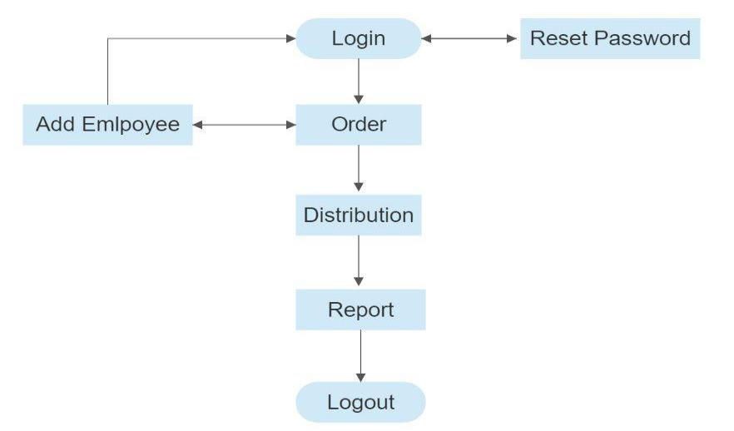

**Fig- Flow Chart of our Proposed System**

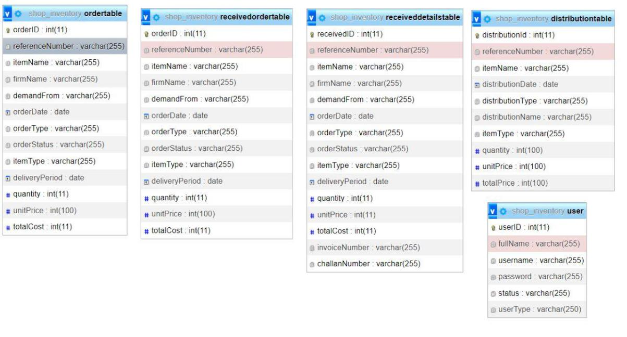

Fig- Architectural Details of Proposed System **3.1.2 Functional Description:**

The functional description outlines the inventory management system's capabilities and how it will meet the user's requirements. The system's primary function is to track and manage inventory levels, orders, and shipments. It will also provide real-time data on inventory status, including product availability, location, and quantity.

**3.2 Module description:**

The system will be divided into two modules: a general module and an admin module.

**3.2.1 General module:**

The general module will be accessible to all users and will include features such as inventory search, product tracking, and order status updates. The module will also generate reports on inventory levels, sales, and profits.

**3.2.2 Admin module:**

The admin module will be accessible only to authorized personnel and will include features such as user management, inventory management, and order management. It will also allow admins to add new products, update existing product information, and manage supplier information.

**3.3 Database:**

**3.3.1 Defining a Database:**

Defining a database involves selecting the appropriate database management system (DBMS) and determining the data fields and relationships needed to store and manage inventory data.

**3.3.2 Database Design:**

The database design phase involves creating a logical and physical data model for the inventory management system. The logical data model defines the data fields, relationships, and constraints required to store and manage inventory data[11]. The physical data model involves translating the logical data model into a physical database schema.

By accessing the database the user can generate the report in pdf, csv, .xlsx , format [13]. The report can help in getting the report of a particular time segment that can be generated in a single click.

**3.4 Testing:**

**3.4.1Validation testing:** This testing is utilized in our project to make sure that it is what is desired by comparing each page, form, view, and report to the requirement document.

**Validation:**

The main goal of the validation activity is to make sure that the SRS correctly and clearly reflects the Actual requirements. According to the Admin module, this project has utilised three different methods of validation in total. They do;

**3.4.2 Required Validator Field:**

This kind of validation is utilized to ensure that the fields on the web page are not left empty. Some of the fields on the website must be completed with no blanks. It is utilized for this objective. It's applied. It may be used for text boxes, radio button lists, drop-down menus, and other items. The control to verify which field the validator's control must be supplied to is to be defined.

There will be a place where the appropriate error message can be entered. The validation group must be given the value "0," as there should be no obstacles to navigating the web pages.

The validation group must also be set to the buttons that will work for the existing fields (often insert and update).

**3.4.3 Regular Expression Validator:**

When a particular type of expression is not entered, this type of validator is used. When a particular type (character, integer, phone number, or email address) is not provided to the field present, an error message appears on the screen. Here, the control to validate, error message, and the validate group must be specified. Along with this, the validation expression is defined in the field where character type, integer type, contact information, and email id format are input.

**3.4.4 Range Validator:**

The range validator is the next type of validator and it is used to enter precise values inside a certain range. An error message is shown on the screen when the set range is crossed. This validator is often used for fields that include integers. It is necessary to provide the control to validate, the error message, and the validate group within which the number must be present.

**4. Existing System:**

Currently, the inventory management system at the university is completely manual, which means that all inventory-related tasks, such as stock entry, inventory update, and sales, are recorded manually. This system is time-consuming, and the probability of errors is high, which can lead to inaccurate stock levels and delayed supply chain management.

**4.1 Restrictions on the Present System:**

The existing manual inventory management system has several limitations, including: Time-consuming: The manual inventory management system is time-consuming and requires a lot of effort to keep track of inventory.

Increased errors: The probability of errors is high due to manual data entry, which can lead to inaccurate stock levels and delayed supply chain management.

Difficulty in generating reports: Manual inventory management system makes it difficult to generate sales and inventory reports on a daily or weekly basis.

Limited access: Only authorized personnel can access the inventory records due to confidentiality concerns, which can lead to delays in stock replenishment and supply chain management.

**5. The Proposed System:**

The proposed system is a desktop application that automates the inventory management system at the university. It aims to eliminate the limitations of the existing system and streamline inventory-related tasks. The proposed inventory management system includes the following functionalities:

Inventory information storage: The system stores inventory-related information such as supply to the department, purchases, and balance-stock information.

Automated updates: The system automatically updates the inventory based on sales information, eliminating the need for manual updates.

Sales and inventory reports: The system generates sales and inventory reports on a daily or weekly basis, which helps in decision-making and supply chain management.

User access control: The system includes a login page that allows authorized personnel to access inventory records, while restricting unauthorized access, ensuring data confidentiality.

**5.1 Advantages of the Current System:**

The proposed inventory management system has several advantages over the current manual system, including:

Reduced manual effort: The proposed system reduces manual effort by automating inventory-related tasks, thereby increasing efficiency and reducing the probability of errors.

Real-time updates: The system updates the inventory in real-time, ensuring that the stock levels are always accurate, and supply chain management is streamlined.

Easy report generation: The proposed system generates sales and inventory reports on a daily or weekly basis, which makes decision-making and supply chain management easier. Improved accessibility: The proposed system includes a login page that allows authorized personnel to access inventory records, while restricting unauthorized access, ensuring data confidentiality.

**5.2 Disadvantage:**

Cost: Implementing a computerized inventory management system can be expensive, particularly if it requires purchasing new hardware or software. Additionally, ongoing maintenance and updates may require additional costs.

Training: Employees may require training to learn how to use the new system, which could take time and resources away from other tasks.

Technical issues: Technical issues can arise with any new system, including glitches, crashes, and compatibility issues. This can cause delays and frustration for employees and customers alike.

Security risks: Any computerized system carries some level of security risk, such as the potential for data breaches or cyber attacks. This could put sensitive information, such as customer data or inventory details, at risk.

Resistance to change: Some employees may be resistant to the change, particularly if they have been working with the existing manual system for a long time. This could cause delays in implementation and potentially lead to errors during the transition period.

It's important to note that these potential disadvantages can be mitigated through careful planning, effective training, and ongoing maintenance and support.

**6. Requirements and Specification**

|  |  |  |  |  |  |
| --- | --- | --- | --- | --- | --- |
| **6.1 Software Requirements:** | | |  |  | |
| **Operating System** |  | **:** | Windows XP/2003 or Linux/Solaris | |
| **Client Script** |  | : | HTML, CSS, JavaScript | |
| **Model** |  | : | visual studio 2010 | |
| **Database** |  | : | SQL Server 2008 | |
| **6.1.1 Technical skills**: | |  |  |  | |
| **Front end technology** | | : | HTML, CSS, BootStrap | |
| **Website Technology** |  | : | PHP | |
| **Programming Language** | | : | HTML, CSS, JavaScript | |
| **Back end technology** |  | : | SQL | |
| **6.1.2 Client-Side Requirements:** | | | |  | |
| **Operating System** |  |  | : | Any Operating | |
| **System Browser** |  |  | : Any Browser (IE, Opera, Mozilla, etc.) | |
| **6.2 Hardware Requirements:** | | | |  | |
| **6.2.1 Server-Side Requirements**: | | | |  | |
| **Processor** |  |  | : | Pentium IV or above | |
| **Hard Disk** |  |  | : | 40GB | |
| **RAM** | : |  | 256MB | |
| **6.2.2 Client-Side Requirements:** | | | |  | |
| **Processor** |  |  | : | Pentium II (And more PowerFull) | |
| **Hard Disk** |  |  | : | 20GB | |
| **RAM** |  |  | : | 128MB | |

1. **MODEL USED Waterfall Model** SDLC - Waterfall Model

The first Process Model to be introduced was the Waterfall Model. The term "linear-sequential life cycle model" is also used to describe it. It is incredibly easy to use and comprehend. There is no overlap between stages in a waterfall model; each step must be finished before the subsequent phase can start.

The first SDLC methodology for software development was the waterfall model.

The software development process is depicted using the waterfall model, which follows a linear sequential flow. This implies that a phase of development can only start if the one before it is finished. The stages in this waterfall model do not cross over [5].

Waterfall Model - Design

The first widely used SDLC Model in software engineering to assure project success was the waterfall methodology. The entire software development process is split into several phases using "The Waterfall" technique. Typically, the results of one step in this waterfall model serve as the input for the subsequent phases in turn.

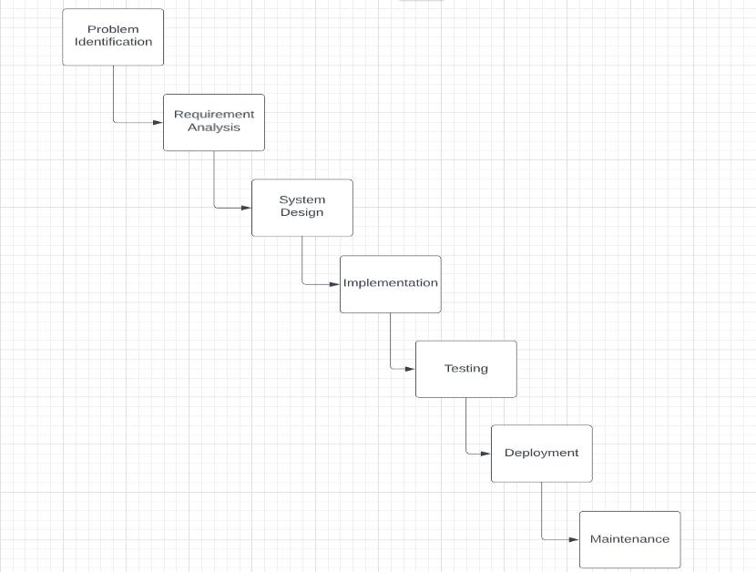

**Fig- Several stages of the Waterfall Model**

**CHAPTER FOUR**

**RESULTS**

**Snapshots of different Module-**

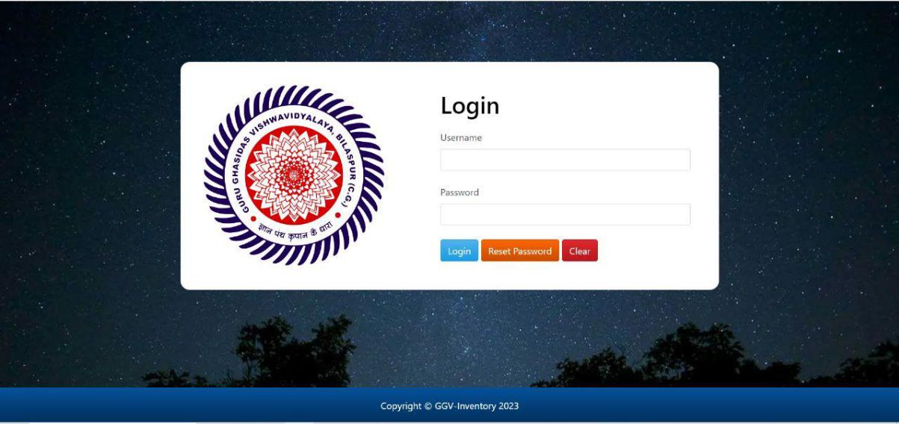

**Fig.- Login Module**

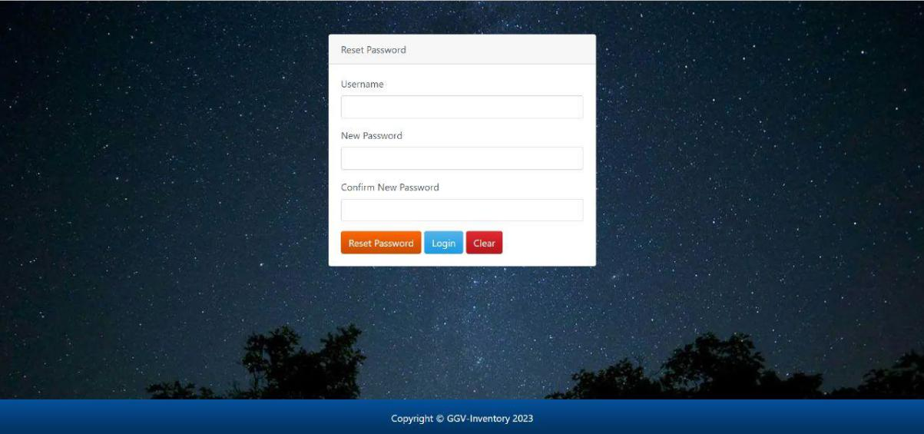

**Fig. Login Module**

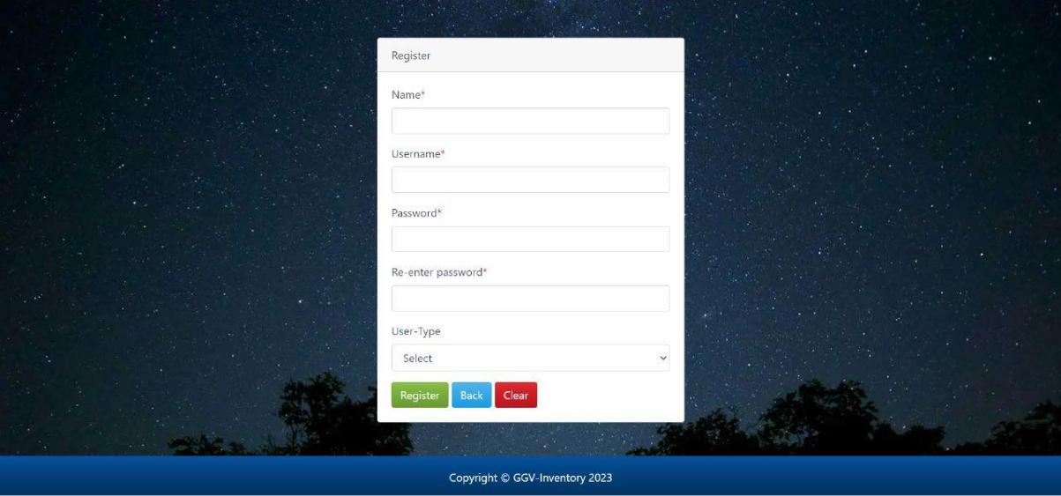

**Fig.- Registration Module**

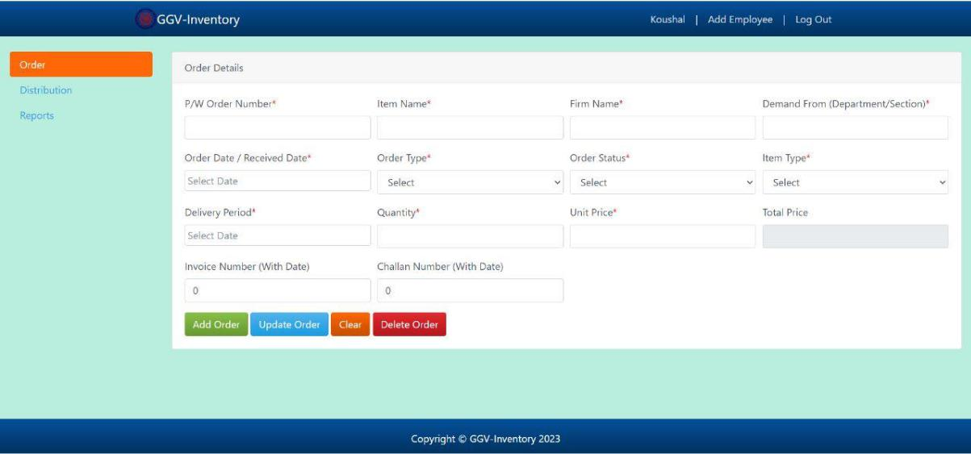

**Fig- Order Module**

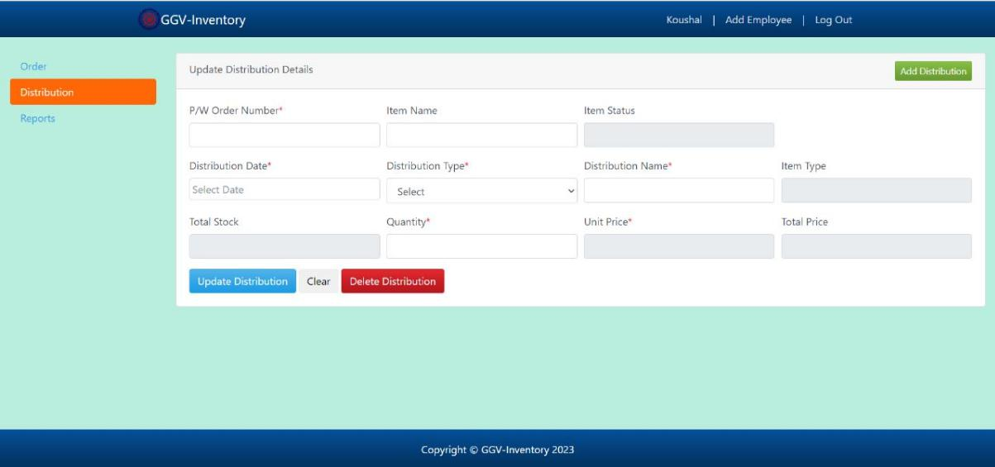

**Fig.- Distribution Module**

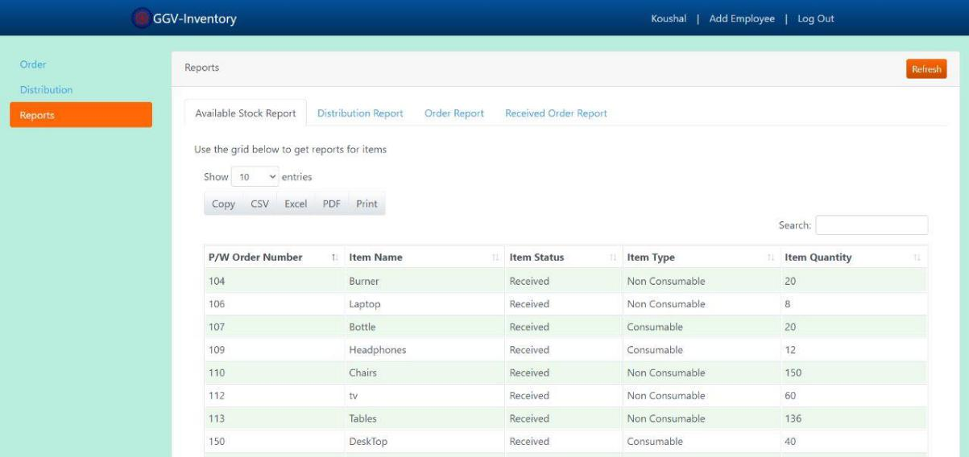

**Fig.- Report Module**

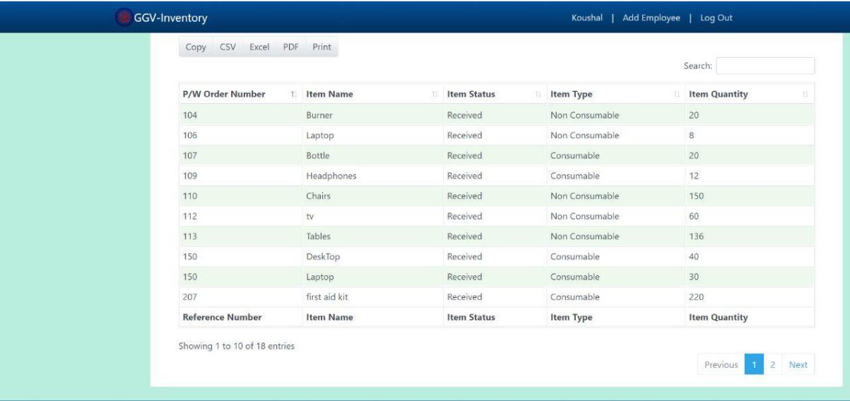

**Fig. - Detail Module**

**CHAPTER FIVE**

**Conclusion and Future Scope**

In conclusion, the proposed inventory management system is an efficient and effective solution to the manual inventory management system. The system addresses all the issues that are associated with manual inventory management, including errors, delays, and inefficiencies. The proposed system is designed to automate the entire inventory management process, including tracking inventory levels, generating purchase orders, and managing stock movements. The system is easy to use and can be customized to meet the specific needs of the organization. The implementation of the proposed system is expected to reduce costs and improve operational efficiency. The project has the potential to benefit the organization and its stakeholders by streamlining inventory management processes.

The following are some possible future enhancements that could be considered for the inventory management system:

* Integration with barcode scanning technology to improve inventory tracking accuracy.
* Implementation of a real-time inventory tracking system to improve inventory control.
* Integration with financial management software to improve financial reporting and analysis.
* Implementation of an automated reorder system based on inventory levels and usage trends.
* Integration with a customer relationship management (CRM) system to manage customer orders and inquiries.
* Implementation of a mobile app to enable inventory management on the go.
* Integration with a supplier management system to manage supplier relationships and performance.
* Implementation of a predictive analytics system to forecast inventory demand and optimize stock levels.
* Integration with an electronic data interchanges (EDI) system to improve supply chain management.
* Implementation of a block-chain-based system to improve transparency and traceability of inventory movements.

**Reference:**

1. Talmale, M. (2018, April). Research paper on Inventory management systems. *International Research Journal of Engineering and Technology (IRJET)*, *05*(04), 3.Online. https://www.irjet.net/archives/V5/i4/IRJET-V5I448.pdf
2. Fan, Y. (2010). Development of inventory management system. *2010 2nd IEEE International Conference on Information Management and Engineering*, *2nd*(03 June2010), 10.1109/ICIME.2010.5478077
3. Joshi, J., & Bhirud, D. (2023). Inventory and Attendance Management System for Construction Firm with Voice Assistant. *2022 6th International Conference On Computing, Communication, Control And Automation (ICCUBEA*, *6th*(1),10.1109/ICCUBEA54992.2022.10010844.
4. Fetrina, E., Rustamaji, E., Nuraeni, T., & Durrachman, Y. (2017, october). Inventory management information system development at BPRTIK KEMKOMINFO Jakarta. *2017 5th International Conference on Cyber and IT Service Management (CITSM)*,10.1109/CITSM.2017.8089303
5. Shashwati Singh, Kavva Kunder, Varshil Jain, Vidya Sagvekar, "Inventory Management System for Education Institutions", 2022 5th International Conference

on Advances in Science and Technology (ICAST), 10.1109/ICAST55766.2022.10039520.

1. Gunther Misahuaman, Alfredo Daza, Emily Zavaleta, "Web-based systems for inventory control in organisations: A Systematic Review", 2021 IEEE/ACIS 22nd International Conference on Software Engineering, Artificial Intelligence,

Networking and Parallel/Distributed Computing (SNPD), 10.1109/SNPD51163.2021.9704993.

1. A. K. Saksena and R. Agarwal, "Methods for Classification of Items for Inventory Management", International Conference on Computer Communication and Informatics (ICCCI), 2021, 10.1109/ICCCI50826.2021.9402588.
2. Jay Kiruthika et al., "User Experience design in web applications", 2016 IEEE Intl Conference on Computational Science and Engineering (CSE) and IEEE Intl Conference on Embedded and Ubiquitous Computing (EUC) and 15th Intl Symposium on Distributed Computing and Applications for Business Engineering (DCABES), 2017,10.1109/CSE-EUC-DCABES.2016.253
3. V. S. L. Daracan, R. J. E. Latayan, C. L. D. Padilla and M. N. Young, "Designing an Inventory Database Software Suitable for Small Business", 2020 IEEE 7th International Conference on Engineering Technologies and Applied Sciences (ICETAS), 2020. 10.1109/ICETAS51660.2020.9484166.
4. Devi Ajeng Efrilianda, Mustafid and R. Rizal Isnanto, "Inventory Control Systems with Safety Stock and Reorder Point Approach", pp. 844-847, 2018. 10.1109/ICOIACT.2018.8350766.
5. O. Y. Iliashenko and S. V. Shirokova, "Application of database technology to improve the efficiency of inventory management for small businesses'', WSEAS Trans. Bus. Econ., vol. 11, pp. 810-818, 2014.
6. N. Da Silva Panzuto and P. C. C. Rodrigues, "Analysis of inventory management in small business auto parts", 2011 4th International Conference on Logistics, pp. 186-191, 2011, 10.1109/LOGISTIQUA.2011.5939424
7. J. W. M. BERTRAND, M. ZUIJDERWIJK and H. M. H. HEGGE, "Using hierarchical pseudo bills of material for customer order acceptance and optimal material replenishment in assemble to order manufacturing of non modular products' , International Journal of Production Economics, no. 66, pp. 171-184, 2000.
8. A. Persona, "Optimal safety stock levels of subassemblies and components manufacturing", International Journal of Production Economics, vol. 110, pp. 147-159, 2007.
9. K. Funaki, "Strategies safety stock placement in supply chain design with due-date based demand", International Journal of Production Economics, vol. 135, pp. 4-13, 2012.
10. W. Cui, L. Huang, L. Liang and J. Li, "The Research of PHP Development Framework Based on MVC Pattern," 2009 Fourth International Conference on Computer Sciences and Convergence Information Technology, Seoul, Korea (South), 2009, pp. 947-949, doi: 10.1109/ICCIT.2009.130.
11. X. Yu and C. Yi, "Design and Implementation of the Website Based on PHP & MYSQL," 2010 International Conference on E-Product E-Service and E-Entertainment, Henan, China, 2010, pp. 1-4, doi: 10.1109/ICEEE.2010.5661595.
12. N. Yadav, D. S. Rajpoot and S. K. Dhakad, "LARAVEL: A PHP Framework for E-Commerce Website," 2019 Fifth International Conference on Image Information

Processing (ICIIP), Shimla, India, 2019, pp. 503-508, doi: 10.1109/ICIIP47207.2019.8985771.

1. X. Li, S. Karnan and J. A. Chishti, "An empirical study of three PHP frameworks," 2017 4th International Conference on Systems and Informatics (ICSAI), Hangzhou, China, 2017, pp. 1636-1640, doi: 10.1109/ICSAI.2017.8248546.
2. <https://www.softwaretestinghelp.com/resources/>
3. <https://www.php.net/docs.php>
4. <https://www.w3schools.com/sql/sql_intro.asp>
5. <https://www.geeksforgeeks.org/software-development-life-cycle-sdlc/>