DESIGN AND IMPLEMENTATION OF INTERNET HOSPITAL LOCATION SYSTEM USING GOOGLE MAPS

ABSTRACT
It is estimated that an average human being will fall ill more than three times every year. People are always looking for different hospitals to solve their health challenges and they don’t know the directions and the route to be followed to get to this places. Without knowing the right routes and directions, this may cause ill persons to get to the wrong way, which might lead to death, in cases of emergency. To avoid this situation, this research is to provide an INTERNET hospital location system, developed to help users to get the right directions to different health centers. This paper introduces an application that can be easily accessed, which is implemented to provide the routes, directions, traffic update and see other hospital users reviews about the hospitals using Google map. The proposed system additionally presents automated navigation activities, with providing directions to users with the optimal path between start point and destination and ascertaining the driving duration with distance. Google Maps APIs, Google Direction APIs, PHP, JSON and MySQL have been implemented and utilized in this system to provide solutions. This application uses the client/server architecture, the users serve as the client and the combination of PHP and MySQL database serve as a server.

CHAPTER ONE
INTRODUCTION
1.1 BACKGROUND OF THE STUDY

Location-based services are quickly becoming one of the most valuable capabilities available on today's smartphones (LBS). Because of a specialized chip that is installed on the inside of smartphones and provides support for the Global Positioning System (GPS), location apps on smartphones can be effectively used and recognized (Akash, 2022). Users can quickly locate nearby businesses such as bookstores, restaurants, bus stops, movie theaters, and other similar establishments by utilizing the GPS capabilities of their smartphones in conjunction with Google Maps. The vast majority of people in today's world use their mobile phones to easily navigate and discover new areas within cities (Sana,2022). A significant portion of these users are making use of location-based apps in order to look up directions, local businesses, and many other types of information that is relevant to their present location (Google Play Store, 2020). Because of the widespread use of location-based services (LBS) for smartphones, a relevant application that may assist healthcare facilities and individuals who are ill has recently been developed. A significant portion of these free software programs do not fulfill the requirements of their users in terms of locating hospitals and acquiring quick routes in the event of an emergency involving patients (Apoorva , 2022). The primary goal of these programs is either navigation, the identification of local locations, or the presentation of geographic data on a map. Moreover, programs for internet map guides do not improve users' ability to add or remove a particular place from the map (Amit , 2021). This paper presents an automated method for building an interactive navigation map of an Internet hospital location system that is dependent on Google map (Bota, 2021). This may be accomplished by employing a centralized database called MySQL, which resides on a server, along with the apps used by users (in smartphones).
  - STATEMENT OF THE PROBLEM
It is estimated that an average human being will fall ill more than three times every year. People are always looking for different hospitals to solve their health challenges and they don’t know the directions and the route to be followed to get to this places. Without knowing the right routes and directions, this may cause ill persons to get to the wrong way. To avoid this situation, this research is to provide an INTERNET hospital location system, developed to help users to get the right directions to different health centers.
  - AIM AND OBJECTIVE OF THE STUDY
The main aim of the research is to analyze internet of hospital location system using google maps, developed to help users to get the right directions to different health centers using Google maps, with the following objective:
- Provide a system that users can access whenever they need to find a hospital in a new city.
- Reduce death rate in cases of emergency, hospitals can be easily found using the system.
- Find hospital routes and estimated arrival time with the system.
  - SCOPE OF THE STUDY
The scope of the research is focused on designing a system to assist sick patients and other users to easily find hospitals and other health facilities, and the system will solve the challenges of people going to the wrong hospital, since each hospital on the system will have previous users’ reviews and recommendations.
  - LIMITATION OF THE STUDY
The INTERNET hospital system will be a web based system and can only be accessed with internet connection, users with poor or no internet connection cannot use the platform for navigation.
  - DEFINTION OF TERMS
Hospital- an institution that is built, staffed, and equipped for the diagnosis of disease; for the treatment, both medical and surgical, of the sick and the injured; and for their housing during this process.
Google Map - Google Maps is a web mapping service developed by Google. It offers satellite imagery, aerial photography, street maps, 360° interactive panoramic views of streets, real-time traffic conditions, and route planning for traveling by foot, car, bicycle and air, or public transportation.

CHAPTER TWO
LITERATURE REVIEW
2.1 INTRODUCTION
Now days it is necessary to have a proper system which will help user to quickly find nearby hospitals or doctors. This application is based on Android operating system. It helps user to get the hospital’s location, doctor’s location, contact details and address provided by social organization and the location of medical stores. We are implementing Google Maps on android devices. This android application uses GPS of android device to access location and compass sensor to easily map physical objects with camera. Augmented reality (AR) is one type of virtual reality. This technology mainly works with the help of various sensors which are embedded in the mobile device. It can be used on any type of connected devices and screen. AR is used in many applications like medical, manufacturing and repair, engineering design, entertainment, manufacturing, robotics, military training etc. In Our application first user selects the radius, after selecting radius, user will select the category of doctors, process the data, plot the location of selected category, and provide doctor‘s contact details with the help of Google Services and JSON parsing.

2.2 GOOGLE MAPS TECHNOLOGGY
The latest Smartphones made dramatic breakthroughs in processing power, higher random access memory, and secondary storage along with the number of extra features like internet access have opened doors to a broad range of applications development. An Android operating system (AOS) commonly used by Smartphone manufactures because it is an open source operating system based on the Linux kernel and designed primarily for touch screen mobile devices such as Smartphones and tablet computers. The internal hardware of Smartphones especially sensors like proximity, accelerometer and gyroscope sensors are used by some applications to respond to additional user actions (Akash, 2014).
There are different applications (apps) categories available for download from the INTERNET Google play store. Everyday thousands of new apps are uploaded in their INTERNET database. A number of applications related to healthcare are available in the medical category which is helpful in the diagnosis of vital sign parameters, vaccinations schedule, medicine reminder etc (Google Play Store, 2015). These kinds of applications are lies in mobile-health (m-health) technology. Some applications determine the location of health clinics, healthcare centers and city hospitals. Search the nearest hospital with the specialty in the city of Karachi is the unique idea of this application. Authentic and up-to-date information are available about each hospital and doctor. Below is the background information about choosing the AOS platform for this application.
2.3 ANDROID DEVICES
Generally, AOS devices are available with a merger of open source programming and proprietary software but with AOS source code released by Google Inc. under the open source licenses agreement (Amit, 2015). Originally AOS was developed by Android Inc. in October 2003 that Google supported financially and later purchased it in 2005. Android was revealed in 2007 in conjunction with the founding of the Open Handset Alliance; an association of hardware, software and telecommunication companies dedicated to moderate open standards for Smartphone and other cellular devices (Sana et al, 2014).
Android is popular in all kinds of technical fields that require a user friendly, low-cost and customizable software or applications for high-tech devices. Due to Android open source style, it encouraged software developers worldwide and devoted them to use the Android platform as a base for Smartphones and PC tablets related projects that add new features for advanced users (Apoorva, 2014). The other operating system's developers are also making their project in AOS for android devices to achieve more success. This kind of accomplishment made a target for patent litigation as part of Smartphone wars between technology manufacturers (Botía, 2013).
AOS based devices find more consumer demands comparatively to Microsoft Windows, Apple iOS and Mac OS X devices combined in last three years. As of July 2013 the Google Play store has had over one million Android apps published and over fifty billion times apps downloaded. A developer survey has been conducted in April–May 2013 where 71% of apps developers develop for Android devices (Okediran, 2014). In 2014, Google Inc. disclosed that there were over one billion Android users that have been active for a month, up from 538 million in June 2013 (othumarthy, 2014).

2.4 GPS IN SMARTPHONE
Global Positioning System (GPS) enabled navigation in devices that precisely determines geographical location by receiving GPS co-ordinates information from the GPS satellites. Originally, it was only used by the United States military, but later this service is available freely worldwide.

2.5 GOOGLE MAP APIS
Google Maps are commonly used to determine the destination location, calculate distance and approximate time to reach a destination point from your current location. Basically, Google Maps have an extensive array of application program interfaces (APIs) that let you embed the great functionality and effectiveness of Google Maps into your Smartphone applications. Google gives by means of Google play a library for using Google Maps into Smartphones application. At present, Google Maps Android API V2 are available that provides improvements to the older API version (Muhammad, 2014).
The Google Map library gives the com.google.android.gms.maps.MapFragment class and the MapView class for displaying the map component. To access the Google Maps servers through the Maps API we have to add a Maps API key to Smartphone application. The key is free and can be used with any application that calls the Maps API, and it supports many users. Maps API key can be achieved from the Google APIs Console by providing application of signing certificate and its package name. The key is included in the application by adding an element AndroidManifest.xml file.

CHAPTER THREE
SYSTEM DESIGN AND ANALYSIS
3.0 INTRODUCTION
A system is a set of things working together as parts of a mechanism or an interconnecting system. It is a set of interacting or interdependent component forming an integrated whole or a set of elements to other elements.
Some characteristics of a system include:
- A system has behaviour, it contains processes that transform inputs into outputs
- A system has interconnectivity; the parts and processes are connected by structural and or behavioural relationship
3.1 SYSTEM ANALYSIS
This is a process by which an old system is analysed and the flaws of the old system are documented and procedures are taken to develop a new system with a better functionality. There are several steps taken to achieve this; these steps are called “SYSTEM DEVELOPMENT LIFE CYCLE”
3.2 EXISTING SYSTEM
Existing system refers to the system that is being followed till now. Presently, all the hospitals functionalities are done manually. That is if a patient wants to consult a doctor, he can sit in the waiting room till his chance is called. This procedure makes things very difficult. The main disadvantage is that it is time consuming.
3.3 LIMITATIONS TO EXISTING SYSTEM
- Lack of security of data
- Time consuming
- Consumes large volume of paper work
- Manual work
- No direct role for the higher officials
To avoid all these limitations and make the system working ore accurately, it needs to be computerized.
3.4 RESEARCH METHODS
Basically, I used two methods of research to gather the necessary information I used to do this project:
- Interview method: - This entails the face to face questions asking and replies between two individuals. At some stages in the project research, it was necessary for me to interview some workers in the hospital so as to get some really important details. The advantage of this method is that it is more accurate and you tend to get a more accurate and faster reply.
- Questionnaire method: - This involves passing or giving out questions typed in a sequence for individuals to fill and return. A questionnaire is a set of printed or written questions with a choice of answers, devised for the purposes of a survey or statistical study.
These questionnaires where passed round to staff in the hospital and collected. The replies were then compared and information gathered to fulfil this project.
3.5 SYSTEM DESIGN
The system was designed with vb 2008 (.net frame work)
- Dashboard

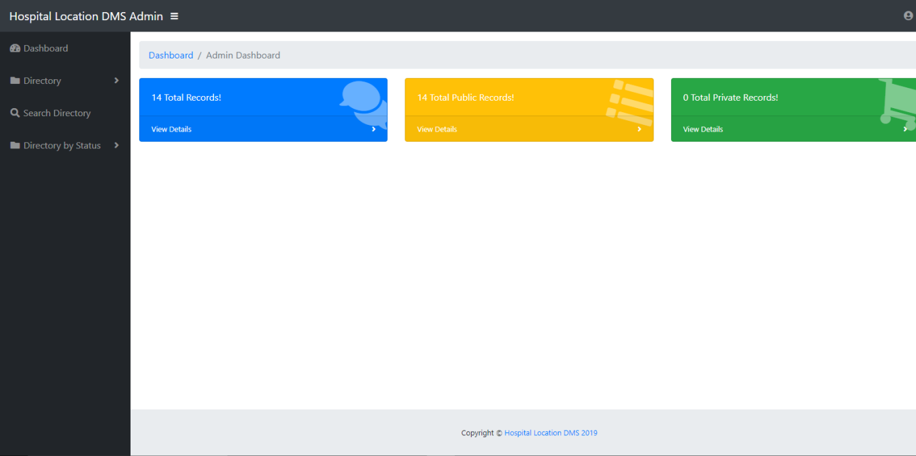
- Edit Location
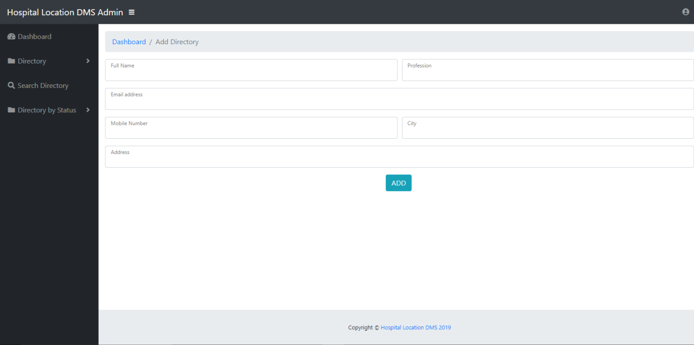
- Search Location
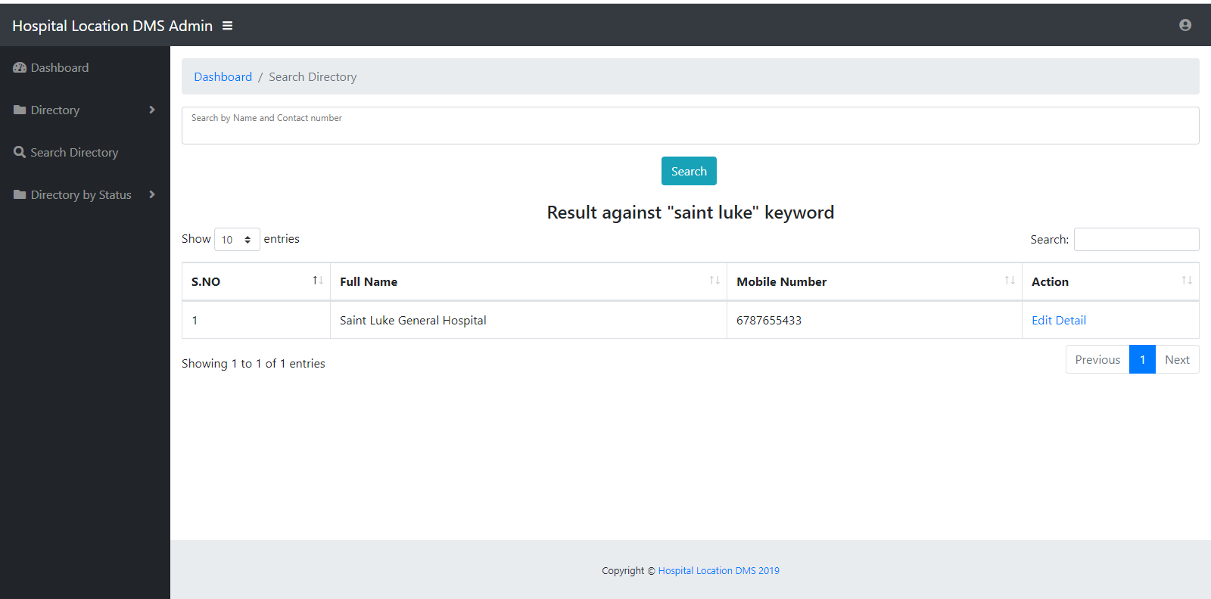
- Location List
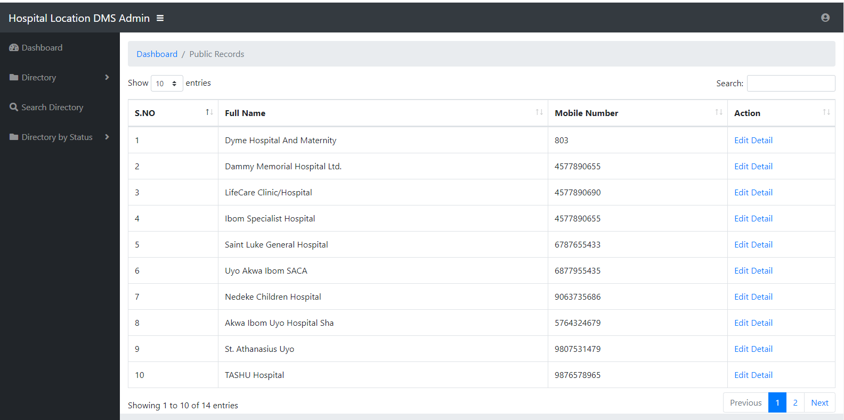
- Admin Profile
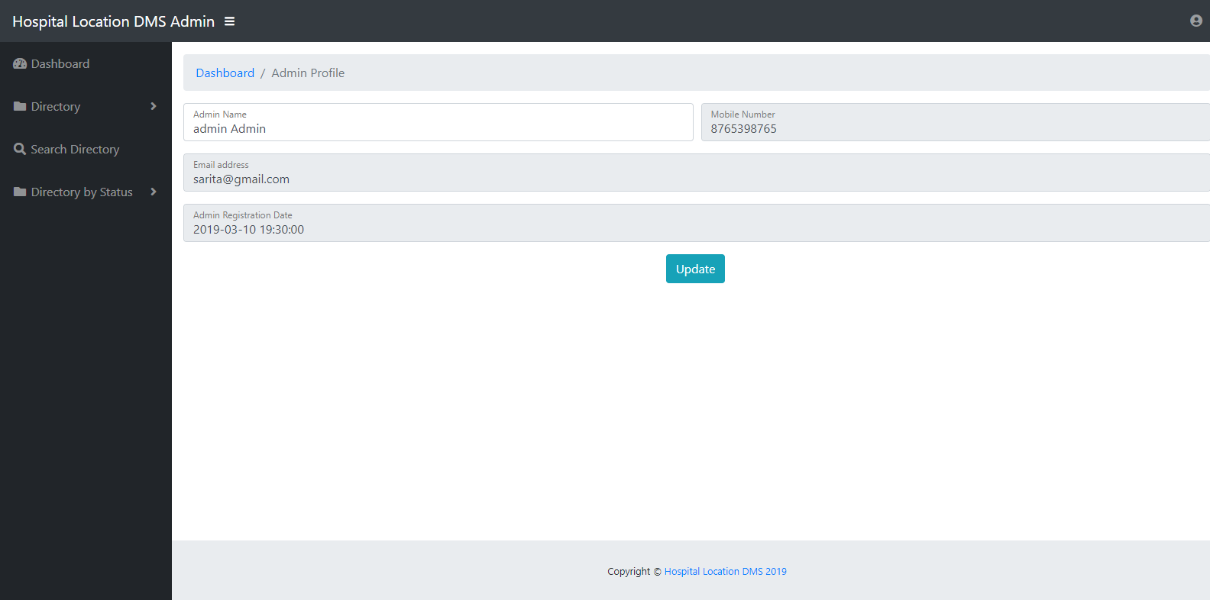
- Admin Login
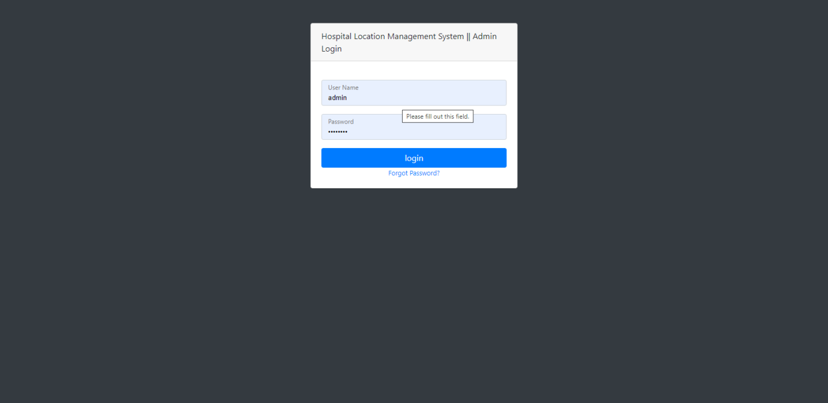
- Forgot Password
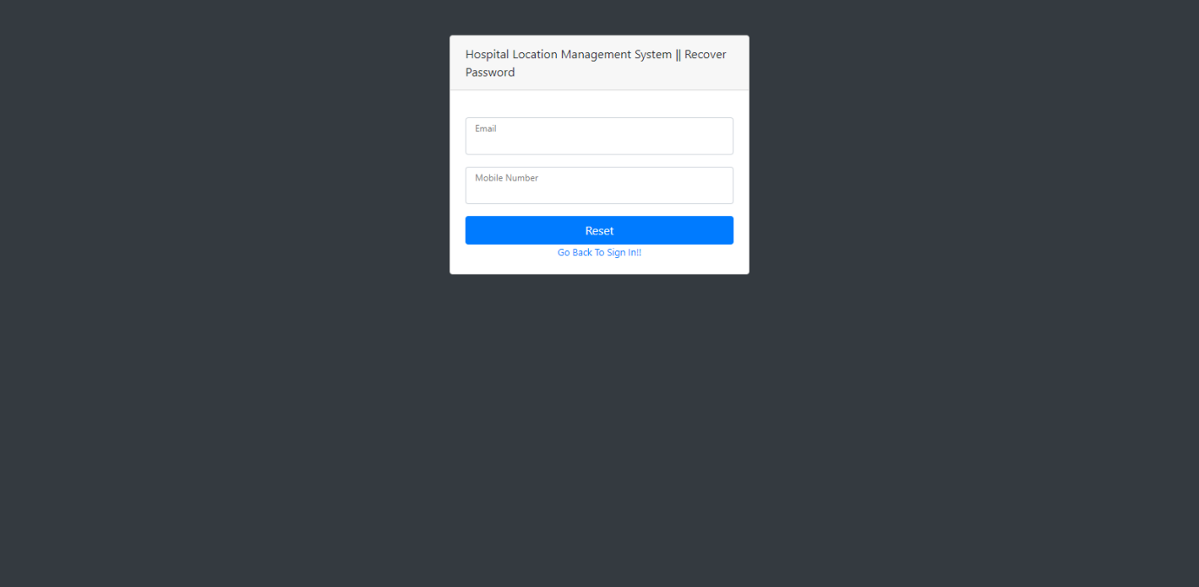
- Home Page
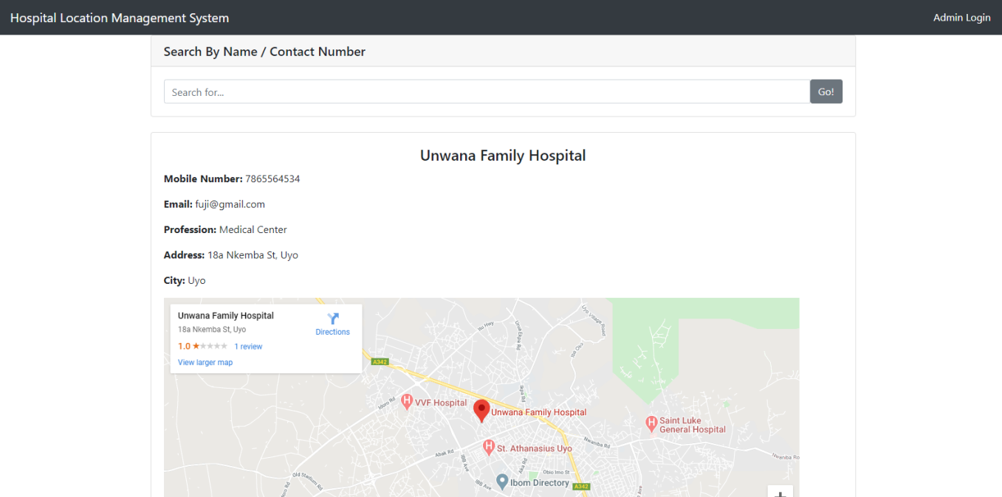

CHAPTER FOUR
SYSTEM IMPLEMENTATION AND DOCUMENTATION
4.0 INTRODUCTION
This section will show the user how the system can be implemented and the importance of documentation.
4.1 IMPLEMENTATION
This system can be implemented by simply following the following steps;
- Put the installation CD into the disk drive
- Run the installation setup
- Allow the program to install
- Launch the program from the program list in your system.
4.2 SYSTEM TESTING
The goal of software testing is to detect before it is delivered, installed and make operation.
Defects include bugs as well as inefficiencies that may cause a system not to satisfy all its requirements.
Test is done in other to discover if there is any inherent logical error, eventually the whole system is tested for efficiency and reliability.
After the whole system might have been affirmed reliable, it is finally installed for the user and it has been successfully completed.
There are two types of testing
- Unit testing: - has to do with testing the individual components in the system using test data.
- System testing: - Parts are linked together and test data is also used to see if the part works together.
4.3 SYSTEM DOCUMENTATION
This has to do with documentation of the proposed system together with the maintenance of the newly designed system.
Documentation is an important element in the development and running of any computer project, the documentation of the system may also be received for performance standard based on records of time and resource budgeted and used in developing as compared to a system type, scope and complexity. Proper documentation helps when the analyst is not available, another analyst can easily take over instead of starting all over again.
Documentation provides information that describes a product to user including a user’s guide or reference manual that provides a narrative and graphical description of the program.
4.4 CHOICE OF PROGRAMMING LANGUAGE
The choice of programming language for this project is PHP and MySQL. It is an object oriented programming language.
4.5 DATABASE DESIGN
MYSql server database was used. The name of the database created is “dbmsdb”. Below shows the table created with columns and their data types:

4.5.1 Structure for table “tbladmin”
FIELD NAME | DATA TYPE | SIZE
id | int | 200
AdminName | varchar | 200
UserName | varchar | 200
MobileNumber | varchar | 200
Email | varchar | 200
Password | varchar | 200
AdminRegdate | varchar | 200

4.5.2 Structure for table “tbldirectory”
FIELD NAME | DATA TYPE | SIZE
ID | int | 200
FullName | varchar | 200
Profession | varchar | 200
Email | varchar | 200
MobileNumber | varchar | 200
Address | varchar | 200
City | varchar | 200
Status | varchar | 200

  - PROGRAM FLOWCHART

Start
Search Hospital Location
Is Location found?
Display Location with google map
Stop
No Hospital Found
Start
Enter username and password
Is User found?
Display Dashboard
Stop
No User found
Load and display Hospital Location with google map
Yes
No
Load Admin Login
Yes
No

CHAPTER FIVE
5.1 Summary
This study makes a basic and up-to-date medical system, designed to help the patients and caregivers to determine the nearest hospital with a specific specialization field. It was built with web-based technologies. The hospital names along with their address and routes are determined by INTERNET GPS receiver within five km of radius. With the help of Google Map, the distance and route to each of the hospital is displayed for the user. This website is greatly useful in emergency cases as well as for the non-resident person of the city.
5.2 Conclusion
The project Hospital Location Management System (HLDMS) is for locating the nearest hospital in uyo. The software takes care of all the requirements of an average hospital and is capable to provide easy and effective storage of information related to patients that come up to the hospital.
It generates map of hospital location from Google so as to make it easy to locate nearby hospital for medical treatment.
The system also provides the facility of backup as per the requirement.

5.3 Recommendation
Although the developed system met the intended objectives, some recommendations are paramount. The future scope of this system is to develop and add features that determines the availability of specialist doctor on a real-time basis near patient’s location. Also. INTERNET appoint can be integrated into the app to enable patients book appointment with the hospital if the hospital doctors are busy at the moment of search.

APPENDICES
APPENDIX ONE – SYSTEM FLOW CHART

Hospital Location Management System

Processor

Disk
Storage
Output (Report)
Result to Screen
Input From the
Keyboard

REFERENCES
- Akash Borate, Ketan Bhapkar, Darpan Sharma.(2022 ) "Android Based Fuzzy Inference System to Control the Fan Speed". Journal of Harmonized Research in Engineering 2(1), pg 69-74,
- Google Play Store,(2020) https://play.google.com/store/apps/category/MEDICAL Accessed on April 25, 2020
- Amit M. Farkade, Sneha R. Kaware.(2021) "The Android- A Widely Growing Mobile Operating System With its Mobile based Applications". International Journal of Computer Science and Mobile Applications", Vol.3 Issue. 1, pg. 39-45, January ,
- Sana, Dr. Ravindra Kumar,(2022) "Application Development in Android". International Journal of Advanced Research in Computer and Communication Engineering Vol. 3, Issue 6, June
- Apoorva Prakash M V, Dr. M C Padma.(2022) "Battery-Bandwidth Based Handover Framework for 3G/WLAN Using Android Handheld Devices". Int. Journal of Engineering Research and Applications, Vol. 4, Issue 6( Version 5), pp.33-38, June
- Botía, D. Charitos.(2021) Workshop Proceedings of the 9th International Conference on Intelligent Environments. IOS Press, pg 208-209,
- [1] Akash Borate, Ketan Bhapkar, Darpan Sharma. "Android Based Fuzzy Inference System to Control the Fan Speed". Journal of Harmonized Research in Engineering 2(1), pg 69-74, 2014
- [2] Google Play Store, https://play.google.com/store/apps/category/MEDICAL Accessed on April 25, 2015
- [3] Amit M. Farkade, Sneha R. Kaware. "The Android- A Widely Growing Mobile Operating System With its Mobile based Applications". International Journal of Computer Science and Mobile Applications", Vol.3 Issue. 1, pg. 39-45, January 2015,
- Sana, Dr. Ravindra Kumar, "Application Development in Android". International Journal of Advanced Research in Computer and Communication Engineering Vol. 3, Issue 6, June 2014
- Apoorva Prakash M V, Dr. M C Padma. "Battery-Bandwidth Based Handover Framework for 3G/WLAN Using Android Handheld Devices". Int. Journal of Engineering Research and Applications, Vol. 4, Issue 6( Version 5), pp.33-38, June 2014
- J.A. Botía, D. Charitos. Workshop Proceedings of the 9th International Conference on Intelligent Environments. IOS Press, pg 208-209, July 2013
- Okediran O. O., Arulogun O. T. and Ganiyu R. A. "Mobile Operating Systems and Application Development Platforms: A Survey". Journal of Advancement in Engineering and Technology, Volume 1/Issue 4 August 08, 2014
- Pothumarthy Dharmeendra, B. Chinna Subbanna, "Design of a Portable Touchscreen Interface for Home Automation". International Journal of Scientific Engineering and Technology Research, Vol. 3 Issue 30. October 2014
- Muhammad Wasim Munir, Semi Perälä and Kari Mäkelä. “Utilization and Impacts of GPS Tracking in Healthcare: A Research Study for Elderly Care”. International Journal of Computer Applications 45(11):35-37, May 2012
- Munir Muhammad Wasim, Mäkelä Kari, Perälä Sami. Assessment of GPS Tracking Devices for Elderly Care. International Hyvite Symposium on Wellbeing Technology, Tampere 2010:4;21
- Yimeng Wu, Zhixue Liang, Liming Liu. "Design and implementation of tourism information system based on Google Maps API". 21st International Conference on Geoinformatics, June 2013
- Tsai, V.J.D., Chun-Ting Chang. "Three-dimensional positioning from Google street view panoramas" IET Image Processing (Volume:7 , Issue: 3 ) pg 229-239 April 2013
- Google Maps Android API v2. https://developers.google.com/maps/documentation/android/start Accessed on April 25, 2015
- Android Studio IDE. https://developer.android.com/sdk/index.html Accessed on April 20, 2015
- Installing the Eclipse Plugin. http://developer.android.com/sdk/installing/installing-adt.html Accessed on April 20, 2015

APPENDIX 2
<?php
session_start();
error_reporting(0);
include('include/dbconnection.php');
if (strlen($_SESSION['pdaid']==0)) {
header('location:logout.php');
} else{

if(isset($_POST['submit']))
{
$fullname=$_POST['fullname'];
$profession=$_POST['profession'];
$email=$_POST['email'];
$mobilenumber=$_POST['mobilenumber'];
$address=$_POST['address'];
$city=$_POST['city'];
$admsta=1;

$query=mysqli_query($con, "insert into tbldirectory(FullName,Profession,Email,MobileNumber,Address,City,Status) value('$fullname','$profession','$email','$mobilenumber','$address','$city','$admsta')");
if ($query) {
$msg="Person detail has been added.";
}
else
{
$msg="Something Went Wrong. Please try again";
}

}
?>

<!DOCTYPE html>
<html lang="en">

<head>

<meta charset="utf-8">
<meta http-equiv="X-UA-Compatible" content="IE=edge">
<meta name="viewport" content="width=device-width, initial-scale=1, shrink-to-fit=no">
<meta name="description" content="">
<meta name="author" content="">

<title>DMS</title>

<!-- Custom fonts for this template-->
<link href="vendor/fontawesome-free/css/all.min.css" rel="stylesheet" type="text/css">

<!-- Page level plugin CSS-->
<link href="vendor/datatables/dataTables.bootstrap4.css" rel="stylesheet">

<!-- Custom styles for this template-->
<link href="css/sb-admin.css" rel="stylesheet">

</head>

<body id="page-top">

<!-- Navbar -->

<?php include('include/header.php');?>
<div id="wrapper">

<!-- Sidebar -->
<?php include('include/sidebar.php');?>

<div id="content-wrapper">

<div class="container-fluid">

<!-- Breadcrumbs-->
<ol class="breadcrumb">
<li class="breadcrumb-item">
<a href="#">Dashboard</a>
</li>
<li class="breadcrumb-item active">Add Directory</li>
</ol>
<p style="font-size:16px; color:red" align="center"> <?php if($msg){
echo $msg;
} ?> </p>
<!-- Icon Cards-->

<!-- Area Chart Example-->

<!-- DataTables Example -->
<form name="directory" method="post">
<div class="form-group">
<div class="form-row">
<div class="col-md-6">
<div class="form-label-group">
<input type="text" id="fullname" name="fullname" class="form-control" required="required" autofocus="autofocus">
<label for="firstName">Full Name</label>
</div>
</div>
<div class="col-md-6">
<div class="form-label-group">
<input type="text" id="profession" name="profession" class="form-control" required="required">
<label for="lastName">Profession</label>
</div>
</div>
</div>
</div>
<div class="form-group">
<div class="form-label-group">
<input type="email" id="email" name="email" class="form-control" required="required">
<label for="inputEmail">Email address</label>
</div>
</div>
<div class="form-group">
<div class="form-row">
<div class="col-md-6">
<div class="form-label-group">
<input type="text" id="mobilenumber" name="mobilenumber" maxlength="10" class="form-control" required="required">
<label for="inputPassword">Mobile Number</label>
</div>
</div>
<div class="col-md-6">
<div class="form-label-group">
<input type="text" id="city" name="city" class="form-control" required="required" autofocus="autofocus">
<label for="firstName">City</label>
</div>
</div>

</div>
</div>
<div class="form-group">
<div class="form-label-group">
<input type="text" id="address" name="address" class="form-control" required="required">
<label for="inputEmail">Address</label>
</div>
</div>

<p style="text-align: center; "><button type="submit" name="submit" class="btn btn-info btn-min-width mr-1 mb-1">ADD</button></p>
</form>

</div>
<!-- /.container-fluid -->

<!-- Sticky Footer -->
<?php include('include/footer.php');?>

</div>
<!-- /.content-wrapper -->

</div>
<!-- /#wrapper -->

<!-- Scroll to Top Button-->
<a class="scroll-to-top rounded" href="#page-top">
<i class="fas fa-angle-up"></i>
</a>

<!-- Logout Modal-->
<div class="modal fade" id="logoutModal" tabindex="-1" role="dialog" aria-labelledby="exampleModalLabel" aria-hidden="true">
<div class="modal-dialog" role="document">
<div class="modal-content">
<div class="modal-header">
<h5 class="modal-title" id="exampleModalLabel">Ready to Leave?</h5>
<button class="close" type="button" data-dismiss="modal" aria-label="Close">
<span aria-hidden="true">×</span>
</button>
</div>
<div class="modal-body">Select "Logout" below if you are ready to end your current session.</div>
<div class="modal-footer">
<button class="btn btn-secondary" type="button" data-dismiss="modal">Cancel</button>
<a class="btn btn-primary" href="logout.php">Logout</a>
</div>
</div>
</div>
</div>

<!-- Bootstrap core JavaScript-->
<script src="vendor/jquery/jquery.min.js"></script>
<script src="vendor/bootstrap/js/bootstrap.bundle.min.js"></script>

<!-- Core plugin JavaScript-->
<script src="vendor/jquery-easing/jquery.easing.min.js"></script>

<!-- Page level plugin JavaScript-->
<script src="vendor/chart.js/Chart.min.js"></script>
<script src="vendor/datatables/jquery.dataTables.js"></script>
<script src="vendor/datatables/dataTables.bootstrap4.js"></script>

<!-- Custom scripts for all pages-->
<script src="js/sb-admin.min.js"></script>

<!-- Demo scripts for this page-->
<script src="js/demo/datatables-demo.js"></script>
<script src="js/demo/chart-area-demo.js"></script>

</body>

</html>
<?php } ?>

Manage-directory.php

<?php
session_start();
error_reporting(0);
include('include/dbconnection.php');
if (strlen($_SESSION['pdaid']==0)) {
header('location:logout.php');
} else{

?>

<!DOCTYPE html>
<html lang="en">

<head>

<meta charset="utf-8">
<meta http-equiv="X-UA-Compatible" content="IE=edge">
<meta name="viewport" content="width=device-width, initial-scale=1, shrink-to-fit=no">
<meta name="description" content="">
<meta name="author" content="">

<title>DMS</title>

<!-- Custom fonts for this template-->
<link href="vendor/fontawesome-free/css/all.min.css" rel="stylesheet" type="text/css">

<!-- Page level plugin CSS-->
<link href="vendor/datatables/dataTables.bootstrap4.css" rel="stylesheet">

<!-- Custom styles for this template-->
<link href="css/sb-admin.css" rel="stylesheet">

</head>

<body id="page-top">

<!-- Navbar -->

<?php include('include/header.php');?>
<div id="wrapper">

<!-- Sidebar -->
<?php include('include/sidebar.php');?>

<div id="content-wrapper">

<div class="container-fluid">

<!-- Breadcrumbs-->
<ol class="breadcrumb">
<li class="breadcrumb-item">
<a href="#">Dashboard</a>
</li>
<li class="breadcrumb-item active">Manage Directories</li>
</ol>
<table class="table table-bordered" id="dataTable" width="100%" cellspacing="0">
<thead>
<tr>
<th>S.NO</th>
<th>Full Name</th>
<th>Mobile Number</th>
<th>Action</th>
</tr>
</thead>
<?php
$ret=mysqli_query($con,"select * from tbldirectory");
$cnt=1;
while ($row=mysqli_fetch_array($ret)) {

?>

<tr>
<td><?php echo $cnt;?></td>

<td><?php echo $row['FullName'];?></td>
<td><?php echo $row['MobileNumber'];?></td>

<td><a href="edit-directory.php?editid=<?php echo $row['ID'];?>">Edit Detail</a>
</tr>
<?php
$cnt=$cnt+1;
}?>

</table>
</div>
<!-- /.container-fluid -->

<!-- Sticky Footer -->
<?php include('include/footer.php');?>

</div>
<!-- /.content-wrapper -->

</div>
<!-- /#wrapper -->

<!-- Scroll to Top Button-->
<a class="scroll-to-top rounded" href="#page-top">
<i class="fas fa-angle-up"></i>
</a>

<!-- Logout Modal-->
<div class="modal fade" id="logoutModal" tabindex="-1" role="dialog" aria-labelledby="exampleModalLabel" aria-hidden="true">
<div class="modal-dialog" role="document">
<div class="modal-content">
<div class="modal-header">
<h5 class="modal-title" id="exampleModalLabel">Ready to Leave?</h5>
<button class="close" type="button" data-dismiss="modal" aria-label="Close">
<span aria-hidden="true">×</span>
</button>
</div>
<div class="modal-body">Select "Logout" below if you are ready to end your current session.</div>
<div class="modal-footer">
<button class="btn btn-secondary" type="button" data-dismiss="modal">Cancel</button>
<a class="btn btn-primary" href="logout.php">Logout</a>
</div>
</div>
</div>
</div>

<!-- Bootstrap core JavaScript-->
<script src="vendor/jquery/jquery.min.js"></script>
<script src="vendor/bootstrap/js/bootstrap.bundle.min.js"></script>

<!-- Core plugin JavaScript-->
<script src="vendor/jquery-easing/jquery.easing.min.js"></script>

<!-- Page level plugin JavaScript-->
<script src="vendor/chart.js/Chart.min.js"></script>
<script src="vendor/datatables/jquery.dataTables.js"></script>
<script src="vendor/datatables/dataTables.bootstrap4.js"></script>

<!-- Custom scripts for all pages-->
<script src="js/sb-admin.min.js"></script>

<!-- Demo scripts for this page-->
<script src="js/demo/datatables-demo.js"></script>
<script src="js/demo/chart-area-demo.js"></script>

</body>

</html>
<?php } ?>

Index.php

<?php

error_reporting(0);
include('admin/include/dbconnection.php');

?>

<!DOCTYPE html>
<html lang="en">

<head>

<meta charset="utf-8">
<meta name="viewport" content="width=device-width, initial-scale=1, shrink-to-fit=no">
<meta name="description" content="">
<meta name="author" content="">

<title> Hospital Location Management System</title>

<!-- Bootstrap core CSS -->
<link href="vendor/bootstrap/css/bootstrap.min.css" rel="stylesheet">

<!-- Custom styles for this template -->
<link href="css/heroic-features.css" rel="stylesheet">

</head>

<body>

<!-- Navigation -->
<nav class="navbar navbar-expand-lg navbar-dark bg-dark fixed-top"
<div class="container">
<a class="navbar-brand" href="index.php"> Hospital Location Management System</a>
<button class="navbar-toggler" type="button" data-toggle="collapse" data-target="#navbarResponsive" aria-controls="navbarResponsive" aria-expanded="false" aria-label="Toggle navigation">
<span class="navbar-toggler-icon"></span>
</button>
<div class="collapse navbar-collapse" id="navbarResponsive">
<ul class="navbar-nav ml-auto">
<li class="nav-item active">
<a class="nav-link" href="admin/">Admin Login
<span class="sr-only">(current)</span>
</a>
</li>

</ul>
</div>
</div>
</nav>

<!-- Page Content -->
<div class="container">
<form name="search" method="post" action="searchdata.php">
<!-- Jumbotron Header -->
<div class="card my-4">
<h5 class="card-header">Search By Name / Contact Number</h5>
<div class="card-body">
<div class="input-group">
<input type="text" class="form-control" name="searchdata" placeholder="Search for.." required="true">
<span class="input-group-btn">
<button class="btn btn-secondary" type="submit">Go!</button>
</span>
</div>
</div>
</div>
</form>

<!-- Page Features -->

<div class="row text-left">
<?php
$ret=mysqli_query($con,"select * from tbldirectory where (FullName like '$sdata%'|| MobileNumber like '$sdata%') and (Status=1) order by id desc limit 12 ");
$num=mysqli_num_rows($ret);
if($num>0){
$cnt=1;
while ($row=mysqli_fetch_array($ret)) {

?>
<div class="col-lg-12 col-md-12 mb-4">
<div class="card h-100">
<div class="card-body">
<h4 class="card-title" align="center"><?php echo $row['FullName'];?></h4>
<p ><b>Mobile Number:</b> <?php echo $row['MobileNumber'];?></p>
<p class="card-text"><b>Email:</b> <?php echo $row['Email'];?></p>
<p class="card-text"><b>Profession:</b> <?php echo $row['Profession'];?></p>
<p class="card-text"><b>Address:</b> <?php echo $row['Address'];?></p>
<p class="card-text"><b>City:</b> <?php echo $row['City'];?></p>
<div class="card-text">
<iframe width="1000" height="400" id="gmap_canvas" src="https://maps.google.com/maps?q=<?php echo $row['FullName'], $row['Address'], $row['City'];?>&t=&z=13&ie=UTF8&iwloc=&output=embed" frameborder="0" scrolling="no" marginheight="0" marginwidth="0"></iframe> </div> </div>
</div>
</div>

</div>
<?php } }?>

</div>
<!-- /.row -->
<iframe src="https://www.google.com/maps/embed?pb=!1m18!1m12!1m3!1d63591.303719785545!2d7.898396805578585!3d5.029468617251238!2m3!1f0!2f0!3f0!3m2!1i1024!2i768!4f13.1!3m3!1m2!1s0x105d57c1f8da6a51%3A0xe71e33ab2276d451!2sUyo!5e0!3m2!1sen!2sng!4v1585081188618!5m2!1sen!2sng" width="1200" height="450" frameborder="0" style="border:0;" allowfullscreen="" aria-hidden="false" tabindex="0"></iframe>
</div>
<!-- /.container -->

<!-- Footer -->
<footer class="py-5 bg-dark">
<div class="container">
<p class="m-0 text-center text-white"> <span>Copyright © <a href="https://springlight.ng" target="_blank">Hospital Location DMS 2019</a></span></p>
</div>
<!-- /.container -->
</footer>

<!-- Bootstrap core JavaScript -->
<script src="vendor/jquery/jquery.min.js"></script>
<script src="vendor/bootstrap/js/bootstrap.bundle.min.js"></script>

</body>

</html>

