DESIGN AND IMPLEMENTATION OF HEALTH CARE REMINDER APPLICATION

BY

NASIB, IDRIS

BU/19C/IT/3807

THE DEPARTMENT OF COMPUTER SCIENCE

BAZE UNIVERSITY ABUJA

October, 2022

i

DESIGN AND IMPLEMENTATION OF HEALTH CARE REMINDER APPLICATION

Thesis Submitted in Partial Fulfillment of the Requirement

For the Degree of

B.Sc.

In Computer Science

By NASIB IDRIS

To

The Department of Computer Science

Baze University, Abuja

October, 2022

# DECLARATION

This is to certify that this Thesis entitled Reminder healthcare application, which is submitted by NASIB IDRIS in partial fulfilment of the requirement for the award of degree for B.Sc. in Information Technology to the Department of Computer Science, Baze University Abuja, Nigeria, comprises of only my original work and due acknowledgement has been made in the text to all other materials used.

Date: 15th October 2022 Name of Student: NASIB IDRIS

**APPROVED BY** …………………

# HOD

Dept. of Computer Science

# CERTIFICATION

This is to certify that this Thesis entitled Reminder healthcare application, which is submitted by NASIB in partial fulfilment of the requirement for the award of degree for B.Sc. in Information Technology to the Department of Computer Science, Baze University Abuja, Nigeria is a record of the candidate’s own work carried out by the candidate under my/our supervision. The matter embodied in this thesis is original and has not been submitted for the award of any other degree.

Date: 15th October 2022 Supervisor: Amina Fadila Shehu

# APPROVAL

This is to certify that the research work, Reminder healthcare application and the subsequent preparation by NASIB IDRIS with BU/19C/IT/3807 has been approved by the Department of Computer Science, Faculty of Computing and Applied Science, Baze University, Abuja, Nigeria.

By

Amina Fadila Shehu Date/Sign

1st Supervisor

Full name Date/Sign

2nd Supervisor

Dr. C. V. Uppin Date/Sign

Head, Department of Compuer Sciences

Prof. Peter Ogedebe Date/Sign

Dean, Faculty of Computing and Applied Science

Prof. CHOJI Davou Nyap

External Examiner Date/Sign

# DEDICATION

I dedicate this report to the almighty ALLAH (SWT) and also to my parents, my uncle and my aunty for their support.

# ABSTRACT

Patients on constant medication usually find difficulty in remembering the particular time their prescription is going to finish. Failure to refill a prescription that needs a regular intake can cause serious negative impact on a patient’s health. This project focuses on implementing a method to remind its users the particular time a prescription is going to end provided that the user registers that particular prescription on the system. Patients often forget the exact time and dosage of a particular medicine, patients need not remember their medicine dosage timings as this system provides them with a platform they can set an alarm on their dosage timings. This application is also helpful to users as it also provides the functionality of setting a reminder for a doctor’s appointment, this functionality provides users with the use of a map to pinpoint the particular location of the appointment and can also navigate to Google maps application to show the navigation from the user’s location to the doctor’s appointment location. The system was achieved by designing and developing an Android Application.

# TABLE OF CONTENTS

ABSTRACT VII

* 1. Overview 1
  2. Background and Motivation 1
  3. Statement of the Problem 2
  4. Aim and Objectives 2
  5. Significance of the Project 2
  6. Project Risks Assessment 3
  7. Scope/Project Organization 3

CHAPTER 2: LITERATURE REVIEW 5

* 1. Introduction 5
  2. Historical Overview 5
  3. Related Work 6

CHAPTER 3: REQUIREMENTS, ANALYSIS, AND DESIGN 10

* 1. Overview 10
  2. Proposed Model 10
  3. Methodology 11
     1. METHOD 1 (E.G. INTERVIEW) 11
     2. METHOD 2 (E.G. OBSERVATION) 12
  4. Tools and Techniques 12
  5. Ethical Consideration 12
  6. Requirement Analysis 12
  7. Requirements Specifications 13
     1. Functional Requirement Specifications 13
     2. Non-Functional Requirement Specifications 14
  8. System Design 15
     1. Application Architecture 15
     2. Use Case 17
     3. Data Design 18
     4. Activity Diagrams 19

3.8.6 Control Flow Diagram 21

3.8.8 User Interface Design 22

* 1. Summary 24

CHAPTER 4: IMPLEMENTATION AND TESTING 25

* 1. Overview 25
  2. Main Features 25
  3. Implementation Problems 32
  4. Overcoming Implementation Problems 32
  5. Testing 32
     1. Tests Plans (for Unit Testing, Integration Testing, and System Testing) 32
     2. Test Suite (for Unit Testing, Integration Testing, and System Testing) 33
     3. Test Traceability Matrix (for Unit Testing, Integration Testing, and System Testing) 34
     4. Test Report Summary (for Unit Testing, Integration Testing, and System Testing) 34
     5. Error Reports and Corrections 34
  6. Use Guide 37
  7. Summary 37

CHAPTER 5: DISCUSSION, CONCLUSION, AND RECOMMENDATIONS 38

* 1. Overview 38
  2. Objective Assessment 38
  3. Limitations and Challenges 38
  4. Future Enhancements 39
  5. Recommendations 39
  6. Summary 39

REFERENCES 40

Statement of the Problem 42

**LIST OF TABLES**

Table 1 Functional Requirement Specifications **Error! Bookmark not defined.**Table 2 Non-Functional Requirement Specifications 27

# LIST OF FIGURES

Figure 1 Use Case diagram **Error! Bookmark not defined.**Figure 2

Activity Diagram 32

Figure 1 Entity Relationship Diagram **Error! Bookmark not defined.**

# LIST OF ABBREVIATIONS

CPU Central Processing Unit

ERD Entity Relationship Diagram

IT Information Technology

**CHAPTER 1: INTRODUCTION**

* 1. Overview

This application is a mobile software application, this application provides users with various functionalities, and this system enables you to keep progress on all your medications and reminds you when it’s time to refill prescriptions. This application also helps to tell you when it’s time to take your pills (pills reminder) and reminds you of doctor appointments. This is a very simple and useful app with a great user interface and user experience architecture that allows users to record each drug taken by the patient(old or young)providing an efficient reminder of when to take their medications.

This project is developed for an Android system. Android is a Linux based operating system, designed for touchscreen mobile devices such as smartphones and tablets. Android is compatible with multiple hardware and supports various features.

* 1. Background and Motivation

Patients on persistent medication usually find difficulty in remembering the specific time their prescription is supposed to be taken or when it’s going to finish. Failure to take the prescription at its required time might lead to other complicated health issues and medical related reactions, and failure to refill a prescription that need a regular intake can also cause serious negative impact on a patient’s health. This project focuses on providing a procedure to remind its users the particular time a prescription is going to end given that the user registers that particular prescription on the application. Patients usually forget the required time and dosage of a particular prescription/medicine, patients no, longer need to go through the hassle of remembering their medicine dosage schedule as this application provides them a medium where they can set an alarm on their dosage timings. This application is also pleasant to users as it also provides the relevance of setting a reminder for a doctor’s appointment.

* 1. Statement of the Problem

This project confronts a vital problem that stops patients from taking their prescription regularly, this issue is absent-mindedness. People that take medicine regularly should endeavor to take their medication to ensure that there is presence of productive amount of drug in their body at all times.

Inability to take their drugs/medication on a regular basis results in a situation whereby the level of the required amount of drug in their body becomes low or too low to effectively stop their ailment from becoming persistent.

Therefore this application is aimed at helping patients to be in charge of their prescriptions in order for them to maintain the best state of health possible.

It also assists in reminding them when to take a pill and also when they have a doctor’s appointment.

* 1. Aim and Objectives

This project aims to introduce/develop an application that can be used to keep record and maintain a patient’s prescription that is needed to be taken regularly.

* + - These project objectives point out methodology needed to prognosticate the time a patient needs to refill their prescription.
    - Enables patients to monitor their prescription and reminds them to take their prescription at the specified/required time.
    - It also reminds them about their doctor’s appointment.
  1. Significance of the Project

As an individual with some friends and family members on persistent prescription/medication. I have watched and seen how difficult of a task it is for them to keep track of their drugs and also how they struggle to refill their prescription.

Problems are frequently encountered when they only happen to find out a specific medicine has finished at the moment they are about to or want to take it, and in a situation where something like this happens they often omit that particular dosage and always procrastinate to refill the prescription and keep on forgetting.

Leaving out or skipping doses can have a critical negative impact on a patient’s health. This application will assemble the prescription of a patient and also structure other necessities required to boost and maintain the patient’s best health status in cases of refilling their prescription, reminding them to take their drugs and booking doctor’s appointments.

* 1. Project Risks Assessment

[This section briefly explains the risks of the study – those aspects the researcher cannot control.]

**RISKS**

|  |  |
| --- | --- |
| Inability to carry out research due to loss of hardware/software resources | Be aware of and observe school IT security procedures  Secure Android mobile phone when not in use. |
| Loss of work due to equipment failure /loss | Weekly data backup to H drive |
| Software availability (Unavailability of API’s) | Alternative API’s will be checked for. Software  requirements will be identified in good time for possible contentious software’s |
| Late delivery of hardware  component | Hardware requirements will be identified in good  time to be able to order them in good time |

* 1. Scope/Project Organization

The scope of this project is to design and implement an android mobile application that keeps progress of patient’s prescription and doctor’s appointment when necessary. This system when built is applicable to only Android Smartphone/Tablets users and other platforms such as iOS and java based mobile devices and computer systems are not supported.

The organization of this project work is divided into five (5) chapters.

Chapter (1) introduces Overview (the general idea of the work), statement of the problem, background and motivation, aim and objectives of the project, significance of the project, as well as the scope and project organization of the study.

Chapter (2) comprises the literature review which creates an intellectual understanding of the problem domain and talks about related work in order to generate an added value to the topic of interest.

Chapter (3) designs the system and discusses requirement, analysis and specification

Chapter (4) discusses the system implementation and demonstrates the functionality of the system with screen shots of the interfaces of the proposed system to give a visual display of its appearances as the user navigates through different activities of the system.

Chapter (5) summarizes the whole project

# CHAPTER 2: LITERATURE REVIEW

* 1. Introduction

Many Medication Systems have been developed based upon different platforms and concepts. Use of healthcare related apps is growing but there are many issues related to their functionality.

The Prescription Manager And Doctors Appointment Reminder is a computerized medical information system that collects, stores and displays prescription information. They are a means to create and organize prescription data and to access clinical information about particular prescriptions.

Patients on constant prescription usually keep track of their dosage times off head and also refill their prescription only when they notice that the prescription has finished. In contrast, Prescription managers and doctor’s appointment reminders provide an easy solution in which the users store and monitor their prescriptions on their mobile devices, android devices to be specific.

* 1. Historical Overview

In 1995 van der Loo conducted a literature review to classify evaluation studies of information systems in health care. The primary objective was to get an insight into the variety of evaluation methods applied. In all, 76 studies published between 1974 and 1995 were included in the review. Many different performance measures or success factors were applied in the studies reviewed. The review’s main conclusion was that the evaluation methods and effect measures depended on the characteristics of the information system under evaluation. However, the range of identified evaluation methods and effect variables was

broad for every type of system. Among the effect variables were costs, changes in time spent by patients and health care personnel, changes in care process, database usage, performance of users of the system, patient outcomes, job satisfaction, and the number of medical tests ordered. Several authors have suggested approaches to evaluating information technology in health care (Anderson et al 1997). These approaches concerned assessment of technical, sociological, and organizational impacts. According to Delone and McLean 1992 in the field of management information systems aimed at identifying determinants for system success.

The purpose of their review was to analyze evaluation studies of inpatient patient care information systems requiring data entry and data retrieval by health care professionals, published between 1991 and May 2001, to determine the attributes that were used to assess the success of these systems and to categorize these attributes according to the Delone and McLean framework. They also examined how the attributes were measured and what methodologies were used in the evaluation studies.

* 1. Related Work

Numerous Medication Systems have been created in light of various stages and ideas. Utilization of medical care related applications is developing however there are many issues connected with their usefulness.

The Prescription Manager And Doctors Appointment Reminder is a modernized clinical data framework that gathers, stores and shows medicine data. They are a way to make and sort out solution information and to get to clinical data about specific remedy.

Patients on consistent medicine generally monitor their dose times off head and furthermore reorder their medicine just when they notice that the remedy has finish. Conversely, Prescription managers and physical checkup updates gives a simple arrangement in which the clients store and screen their solutions on their cell phones, android gadgets to be explicit.

A significant number of patients, especially the crippled and the older don't adhere to directions in taking prescription. This can bring about understanding neglecting to take medicine, taking some unacceptable prescription, taking a mistaken measure of prescription, or taking the medicine at an off-base time, prompting either a medication glut or an insufficient use of drug to the patient. The old are particularly inclined to issues since they frequently take a few medications and have non retentive memories. In the majority of the clinics the prescription is composed on a piece of paper which the patient should maintain securely in order to appropriately take their drug properly.

The significant issue with the current framework is that the patient will have to go through the paper where the prescription is written, over and over for consuming their medicine. This strategy is extremely tedious. The patient will likewise need to recall where this paper is kept each time he really wants to take his prescriptions.

The objective of this project is to make an android application that assists its client with monitoring his drug. Past works obviously have been completed in making this cycle simpler for clients. Numerous Medication Systems have been created in view of various stages and ideas. The framework centers around simple navigation and great UI. Numerous Medical Reminder Systems For example, Medisafe Medication Management, Pill Reminder-pilltracker, Reminder pro- med reminder, Medication reminder and tracker, Pill box, iCare, Round Health, Tablets application have been created where another hardware is required yet in my work I made an endeavor to develop a system which is conservative, efficient and upholds medicine adherence. It runs explicitly on android gadgets giving UIs to arrange remedy timetables and client alarms for reminding clients about the time and kind of medication according to the configured prescription schedule.

The past works reviewed for this project includes a few projects that explicitly centers around Medication reminder and adherence, one of them is the Medisafe Medication Management, which allows you track measurements such as blood pressure and other parameters and also add “Med friends” for additional support from people you know, it reminds you to take medication doses on time even if your device is asleep and has time zone support, no need to worry while traveling, your reminders are always on time, medisafe is free to download and use and gives you unlimited medfriend supporters, unlimited family and friend profiles, access

to 20+ health measurements, choice of a dozen medtone reminder voices, ability to pick color themes and pillbox shapes, medisafe does not provide medical advice, diagnosis or treatment.

Evaluation of a reminder system for pill reminder-pill tracker app stated that it allows you to create any type of recurring reminders (every x hours, specific times, daily, weekly, monthly, every x days, etc.). Rack of dozens of measurements – such as blood pressure, weight, and glucose all in one place. It tracks the remaining quantity of each medication and shows a refill alert when running low. You can choose from a library of free medication reminder sounds, custom your remind tune, mark medications as taken or not taken and handle very complicated dosing or dosage schedules easily, and benefit from years of tip.

Reminder Pro-Med Reminder, this app is for those who need reminders for health conditions like diabetes, heart diseases and cancer, it is capable of managing complex conditions, it is a free and use to use application that keep you reminded about the time to take pills and their usage management, you can add a medication for reminders for taking pills and receive constant tracking of your health progress.

Features:*View your medication reminder list to see what’s due for today

*Medication history check

*Change the status of your medication to either taken or skipped

Medication reminder and tracker, this medication reminder allows you to manage all of the medications and pills you take on a regular basis, so that you don’t forget to take them ever again.

Pill trackers main features:-Customize the pillbox: customize all of the medications you take, the quantity, the frequency, start date, etc.

Pill reminder alarm: - the pill reminder app will send you a notification based on the time entered for the medication alarm. You’ll be able to add a medicine reminder for each medication or pill individually each with their respective alarm.

Medicine tracker: - using a convenient calendar you will be able to see the pills you need to take them and when you need to take them.

-Compatible with all types of medications: whether you want to track your birth control pills or medications you need to take continuously, this medicine reminder app allows you to customize settings for any type of pill.

As examined, techniques for overseeing solution and setting updates incorporate, pen and paper strategy and programming on cell phones strategy among others. The beneath are a portion of the current frameworks.

* Proficiency (Paper and Pen strategy): While the pen and paper technique is modest, it is dreary and can result in deferments and reluctances in doing the cycle. It is tedious.
* Cost: Some of the solution watcher applications are intended to run on the World Wide Web. Admittance to such applications requires the utilization of web perusing information assets. This information is typically sold by Internet Service Providers (ISPs) for an extreme price to the client. This cost frequently frustrates and puts the patronization of web applications, particularly in this region of the planet down.
* Straightforward entry and Operations: Some of the planned and carried out applications hush up convoluted to work, and clients need to have specific information on a sort to have the option to utilize them. All in all, a portion of these applications are not easy to understand, subsequently making it challenging for clients to work.
* A portion of the applications don't give a medium to booking of arrangements to the specialists.

Taking into account this multitude of issues and constraint as related with the current framework, the requirement for a framework that will actually want to consolidate the great characteristics of existing techniques, with end of their misfortunes gave catalyst to the plan of a proficient, compact, Mobile based medicine supervisor and regular checkup application at very nearly Zero expense for the client.

Besides, the greater part of the applications are focused on specialists, and now and again the two specialists and patients. This venture is just focused on for patients, it is made to make the existence of patients on consistent prescription more straightforward. For example a patient that is old and incapable to utilize the new innovation the world gives can get somebody youthful to assist him with dealing with his remedy and measurements timings. Different

functionalities are made accessible as well, for instance the Google place picker API is utilized to give a guide which makes it more straightforward to pick the area of a regular checkup.

# CHAPTER 3: REQUIREMENTS, ANALYSIS, AND DESIGN

* 1. Overview

A software development methodology is a collection of many practices used to organize, schedule, and manage the software development process (i.e., conception, requirement collecting, design, coding, and testing). A procedure or set of methods used in software development is called a methodology. The history of software development approaches extends back to the 1950s. Terms like "framework" and "approach" were not really used prior to then. The system's development lifecycle was regarded as the sole official methodological framework at the time. "To construct large-scale functioning business systems in an age of large-scale company enterprises," was the fundamental goal of this technique in the 1960s.

Patterns involving intensive data processing and numerical processing dominated information systems activity (Oleksandrova, 2018).

Software development methodology includes: Agile development methodology, DevOps development methodology, Waterfall development methodology, Rapid application development methodology.

* 1. Proposed Model

This project uses the typical waterfall method to software development as it was carried out in a sequential manner from beginning to end. For projects with clearly specified needs and no anticipated modifications, the waterfall methodology is perfect. The strict, sequential waterfall technique is simple to maintain. The business analyst just defines the requirements once in a waterfall model.

Because it was the first widely used software development life cycle, the waterfall software life- cycle model is referred to as the conventional model. It is a component of the greater of the two initial methods of formal software engineering, known as Structured Software Design or the Structured Paradigm (Curtis & Longworth, 1998). Improvements were made based on the results of tests conducted at each level of the development.

The project also uses agile development methodology as it is best suited where there is a high probability of requirement changes/adjustments, the agile development methodology allows you to apply changes in any segment and it is flexible. In Agile methodology requirements can be changed often.

* 1. Methodology

The following steps will be employed so as to meet the objectives of this project:

1. A review and analysis on how to create reminders or alarms on Android.
2. A database capable of storing registered prescriptions will be designed.
3. Flutter programming language will be used to develop this application
4. Visual studio code will be used as the integrated development environment (IDE) for the software development.
   * 1. Method 1 (e.g. Interview)

Interviews were carried out amongst audiences of both old and young, after explaining how the app works and how user friendly it is the audience were shown the overview of the application in regards to what they will like to experience while using the application after which I was provided with the options of making the application more easier to navigate for the elderly ones so as to enable them to be more familiar to the application.

* + 1. Method 2 (e.g. Observation)

It was observed that both the young and the old preferred the application to be more easier to navigate and also wanted the application to be more user friendly, the older ones requested for a medium whereby patients would be able to start or have conversations with their doctors and book appointments and this led to the motivation to create an alarm system which will enable the users to set a reminder for doctor’s appointment.

* 1. Tools and Techniques

Whilst creating the application, the project made use of various tools which included:

1. Visual studio code: A code editor redefined and optimized for building and debugging modern web and cloud applications.
2. Flutter: An open source framework by Google for building beautiful, natively compiled, multi-platform applications from a single codebase.
3. Dart: A programming language designed for client development, such as for the web and mobile applications.
4. Laravel and firebase for backend
   1. Ethical Consideration

The ethical consideration counted on confidentiality and authentication processes, the confidentiality process was implemented in the registration process whereby the user has to provide his/her password to be able to log in to their accounts successfully, while the authentication process was implemented in registering and login and also the ability to enable users to recover past progress whilst using another device.

* 1. Requirement Analysis

Requirement analysis includes tasks that define the demands or conditions that must be addressed for a new product while taking into consideration the competing policy requirements of various stakeholders such as customers or consumers.

The first stage in the systems engineering and software development processes is requirement analysis.

The study of requirements is important to the achievement of a development project. Requirements must be written, actionable, measurable, testable, relevant to recognized business

requirements or opportunities, and detailed enough for system design. Architectural, structural, behavioral, functional, or non-functional requirements are all possible.

* 1. Requirements Specifications

This part of the project differentiates between the functional and non-functional requirements which are the essential parts that are required for the application to be fully functional and also makes the application standard.

* + 1. Functional Requirement Specifications

The functional requirement specifies how a system or one of its parts must function. An explanation of a function includes the terms inputs, the function, and outputs. Functional requirements explain what a system is expected to do through computations, technical details, data manipulation and processing, and other specialized functionality (Defense Acquisition University, 2001). The functional prerequisites for this application include:

## Table 1 Functional Requirement Specifications

|  |  |  |
| --- | --- | --- |
| **Req.**  **No.** | **Description** | **Type** |
| R-101 | The system should be able to allow users to  register | Configuratio  n |
| R-102 | The system should be able to allow users to login | Functional |
| R-103 | The system should allow users to change  password | Configuratio  nal |
| R-104 | The system should be able to allow users to  change their profile | Configuratio  nal |
| R-105 | The system should be able to allow users to input  their prescriptions and prescriptions details | Configuratio  nal |
| R-106 | The system should be able to maintain list of  registered prescription. | Functional |
| R-107 | The would be system should allow users to set  reminder | Configuratio  nal |

|  |  |  |
| --- | --- | --- |
| R-108 | The system should be able to remind users to take their medicine and refill their prescriptions. | Functional |
| R-109 | The system should be able to allow users delete stored prescription | Functional |
| R-110 | The system should be able to allow users to delete appointments and reminders | Functional |
| R-111 | The system should be able to remind users when prescription finishes | Functional |
| R-112 | The system should be able to allow users view the list of all prescriptions | Functional |
| R-113 | The system should be able to allow users to create doctor’s appointment reminder | Functional |
| R-114 | The system should be able to maintain users registration details | Functional |
| R-115 | The system should be able to display the total number of prescription, finished medicine. | Functional |

* + 1. Non-Functional Requirement Specifications

The definition for a non-functional requirement is that it essentially specifies *how the system should behave* and that it is a constraint upon the system's behavior. One could also think of non-functional requirements as quality attributes for a system. Non-functional requirements cover all the remaining requirements which are not covered by the functional requirements.

## Table 2 Non-Functional Requirement Specifications

|  |  |  |
| --- | --- | --- |
| **Req.**  **No.** | **Description** | **Type** |
| R-101 | The system should stay running unless there is an  intentional shutdown of the application or the platform. | Performance |
| R-102 | The system should be able to allow users to log in  using their email and password | Usability |
| R-103 | The system should be able to allow users log out | Usability |
| R-104 | The system should allow users to be able to access  the application on their mobile device | Accessibility |
| R-105 | The should be easy to navigate around | Accessibility |
|  |  |  |

* 1. System Design
* REGISTRATION: This is the back-end activity that authorizes new app users, registers them in the user database, and allows for subsequent notifications and analysis.
* LOGIN: This complements registration and is designed for recurring users, enabling
  + 1. Application Architecture

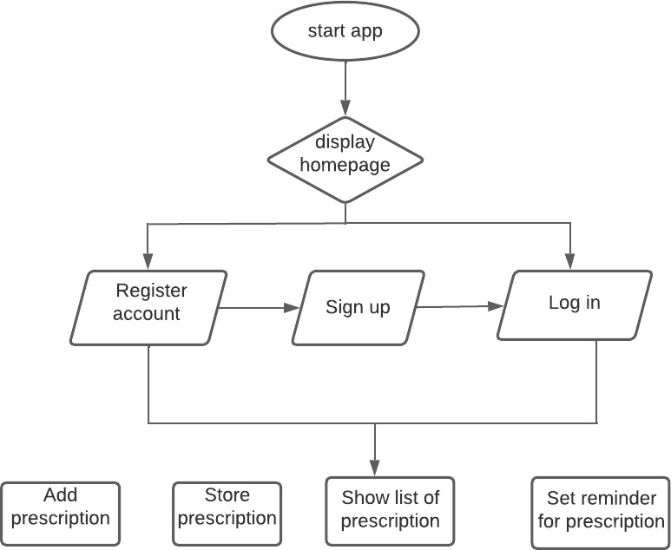

* + 1. Use Case

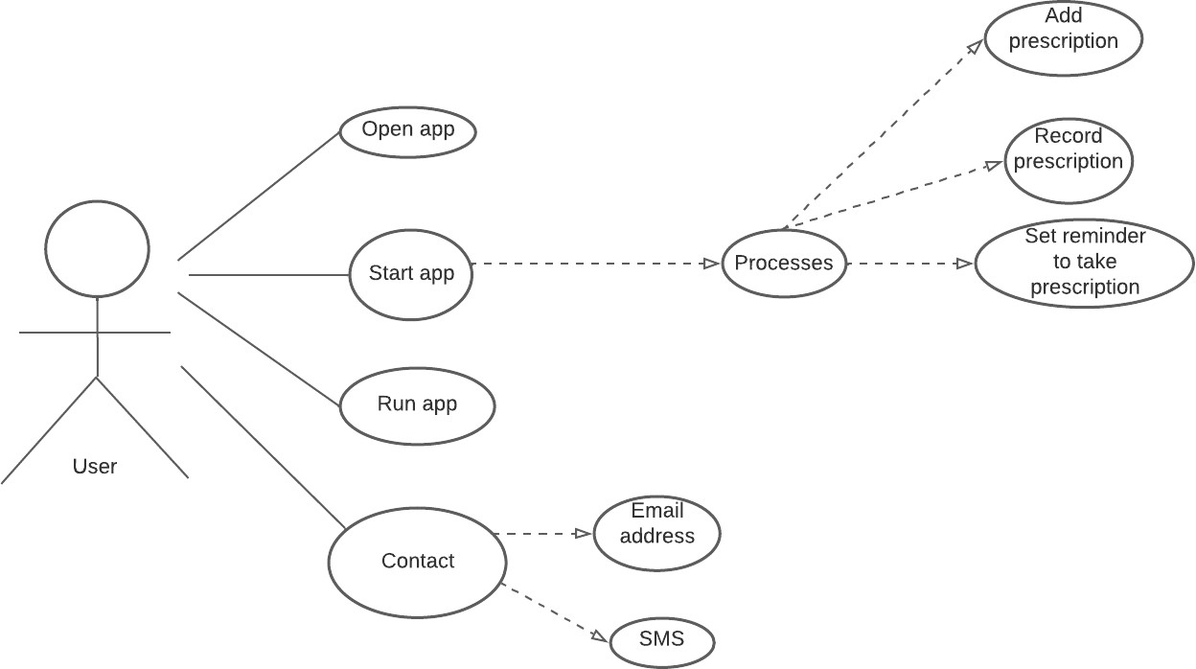

## Figure 1 Use Case diagram

*[A Use Case diagram depicts the interaction between the users and the system. It shows the functions of the system from the user’s point of view and the various actions the user as the actor carries out.]*

* + 1. Data Design
    2. Activity Diagrams

An activity diagram is a model that shows the process of a task or action from a use case.

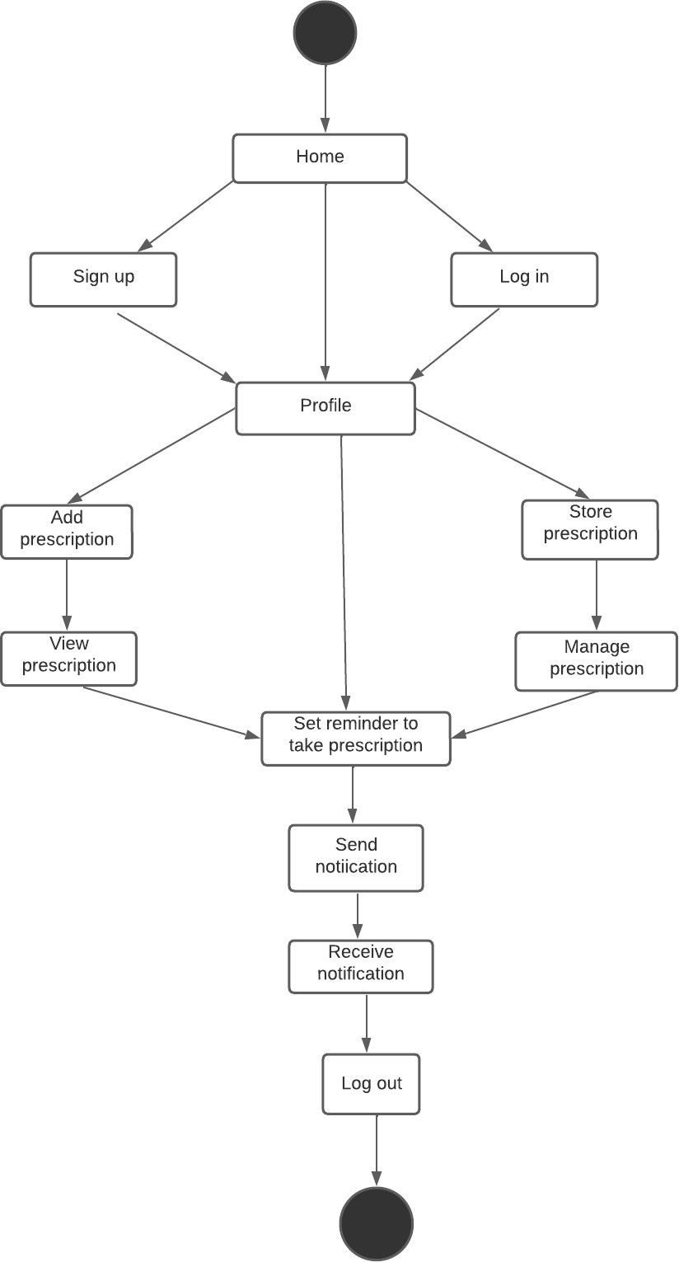

## Figure 2 Activity Diagram

* + 1. Control Flow Diagram



Start

Invalid Account

Validate User

User Login



Is User valid?

NO

Yes

Is User Registered

NO

Yes



Perform

Start reminder



Close



Stop

Register User

## Entity-Relationship Diagram (ERD)

[Entity-relationship diagrams show the entities and attributes of tables in a database. Linked ERDs show the relationship between tables or tables. Entities can only have a many-to-one or one-to-many relationship, e.g., in Figure A below.]

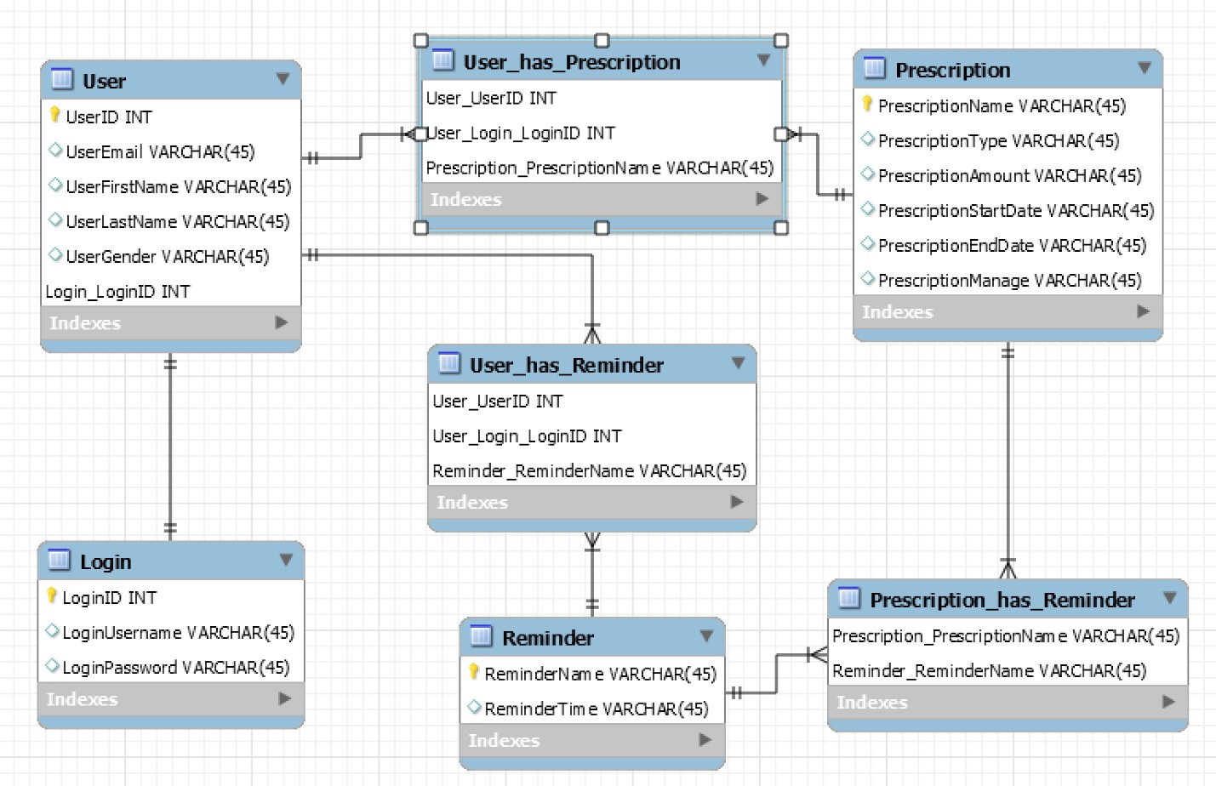

## Entity Relationship Diagram

* + 1. User Interface Design

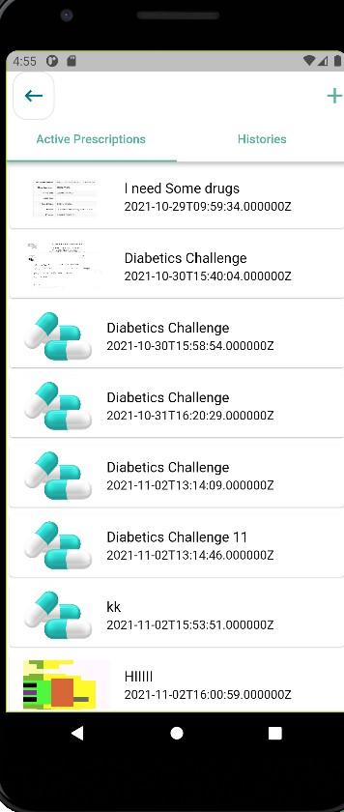

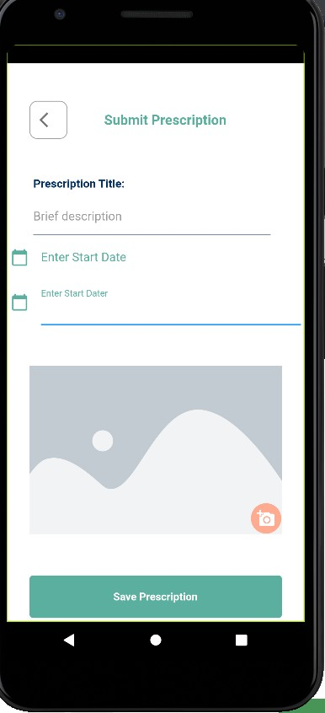

* 1. Summary

# CHAPTER 4: IMPLEMENTATION AND TESTING

* 1. Overview

The realization of a technical specification or method into a program or software component is known as implementation. It entails accurately converting the software design into executable computer code using any programming language of choice. Depending on the software developer's goals, a design can be executed in a variety of ways. Several aspects were considered throughout the implementation of this job. These elements are as follows:

1. Performance: The degree to which a product satisfies its limitations in terms of response time or available space is referred to as software performance. A satisfactory response time was ensured via performance optimization, particularly with regard to speed response time, and the use of effective search strategies.
2. Correctness: The operation was carried out with the purpose of the final result fulfilling the user’s demand.
3. Robustness: The ability to tolerate pressures, shocks, or modifications in policy or circum stances is a sign of robustness. Durability was heavily emphasized in the execution of this job.
   1. Main Features

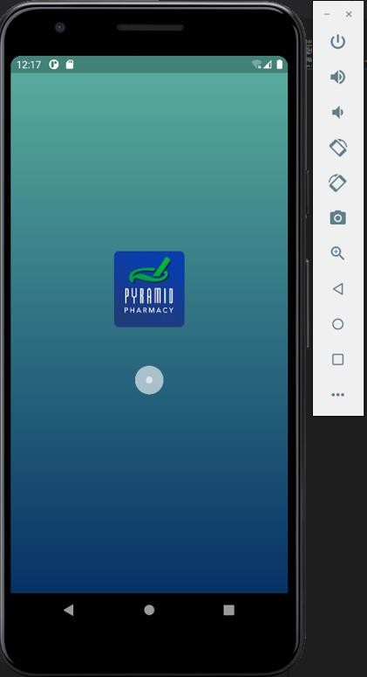

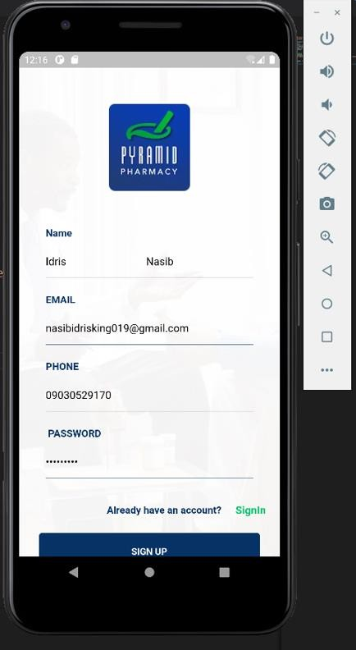

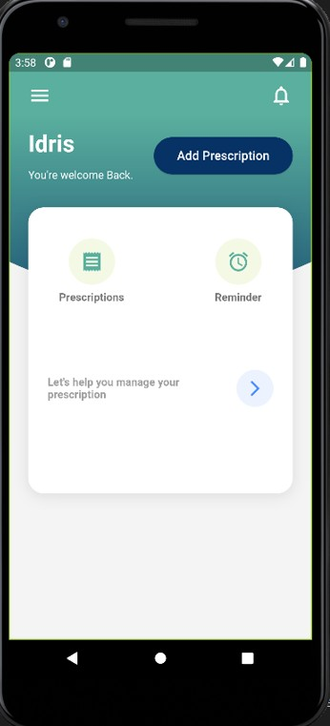

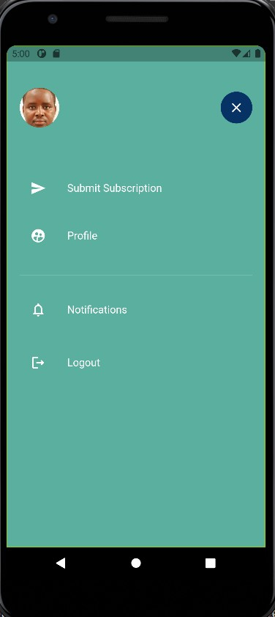

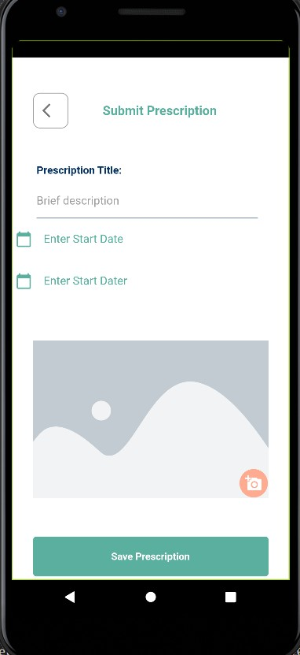

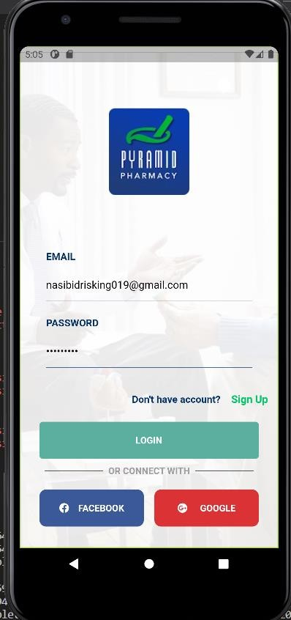

* 1. Implementation Problems

1. EMULATOR: On my own computer, I regularly ran into emulator problems; the emulator was not wholly functioning and would not display the screen completely in its original screen resolution. Additionally, it had a shaky interface that prevented me from clicking on the icons that would have allowed me to operate the phone.
2. The use of flutter presented a small but noticeable challenging problem, The main challenges with this are the package versions, would have to be suitable with the continuously updated flutter version, which necessitated a physical change with all the other versions to collaborate together.
   1. Overcoming Implementation Problems
3. I used a mobile device, an Android smartphone, to assist with the representation of the program while looking for a good emulator.
4. I reinstalled different versions of the same packages for the flutter problem
   1. Testing

Testing was performed to verify that the application's efficiency and dependability were truly tested. It was personally tested during the testing period, allowing it to be seen from the user point of view. Other methods of testing, such as unit testing, allow the program to be evaluated and tested for each of its constituent functions, from front-end to back-end.

* + 1. Tests Plans (for Unit Testing, Integration Testing, and System Testing)

|  |  |  |
| --- | --- | --- |
| **S/N** | **Test Summary** | **Case ID** |
| 1 | Sign up process should register new users | T-01 |

|  |  |  |
| --- | --- | --- |
| 2 | The would be app should ensure the buttons can navigate to  specific locations | T-02 |
| 3 | The signup section should be able to admit/accept new users | T-03 |
| 4 | The would be app login page must accept users that are  already registered | T-04 |
| 5 | The would be app login page should process error when no  data is inputted by the user | T-05 |
| 6 | The would be app login page must indicate invalid/error when  an invalid data is inputted by the user | T-06 |
| 7 | The would be app registration page must indicate  invalid/error when an invalid data is inputted by the user | T-07 |

* + 1. Test Suite (for Unit Testing, Integration Testing, and System Testing)

## Table xx Test Suite Performed

|  |  |  |
| --- | --- | --- |
| **Req.**  **No.** | **Description** | **Type** |
| T-101 | When launched, the application shall stay running unless there is an intentional shutdown of the  application or the platform. | Performance |
| T-102 | The application must have a fast reaction time | Performance |
| T-103 | The application should have an easy navigation  system | Performance |
| T-104 | When launched, the application should have a rapid  response time when icons are tapped | Performance |
| T-105 | The application should not forcefully log user out | Performance |

* + 1. Test Traceability Matrix (for Unit Testing, Integration Testing, and System Testing)
    2. Test Report Summary (for Unit Testing, Integration Testing, and System Testing)

|  |  |  |  |  |
| --- | --- | --- | --- | --- |
| **Requirement** | **Description** | **Priority** | **Test**  **Case** | **Test**  **Result** |
| R-101 | The app shall have a working  reminder | high | 1 | Pass |
| R-102 | The app must be able to allow new  users register | high | 2 | pass |
| R-103 | The app shall provide varieties of  functional operations | high | 3 | pass |
| R-104 | The app must function without  connecting to the internet | low | 4 | pass |
| R-105 | The app should properly set reminders | high | 5 | pass |

These details will be found on the next section of this chapter

* + 1. Error Reports and Corrections

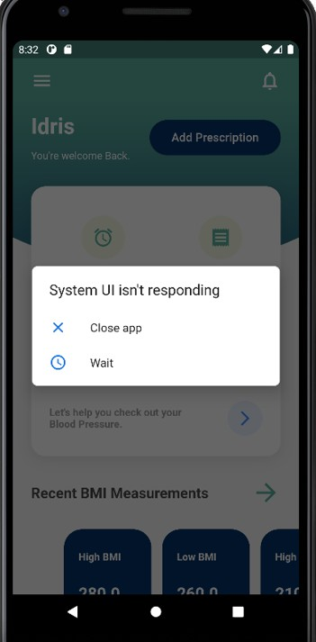

* + - * I closed the app and restarted it again.

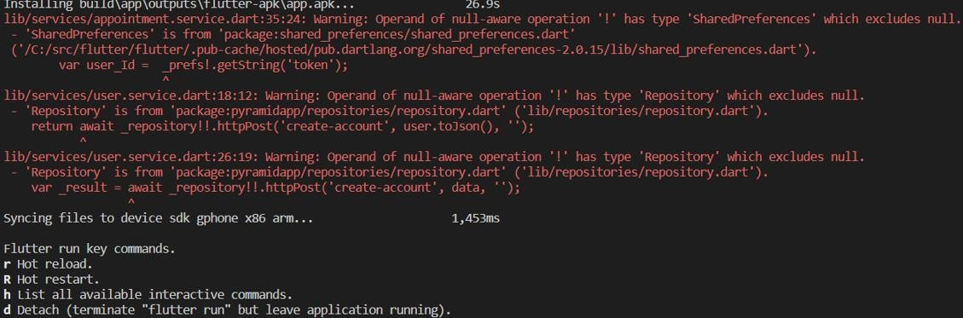

* + - * I ran command flutter clean, flutter pub get and flutter run after which it ran successfully.

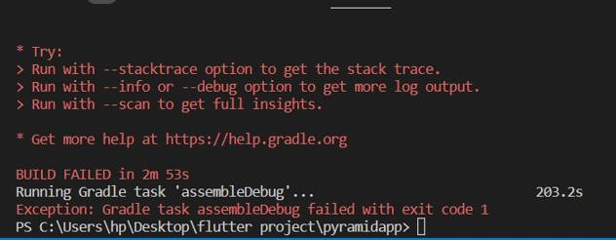

* + - * I ran command flutter clean, flutter pub get and flutter run after which it ran successfully.

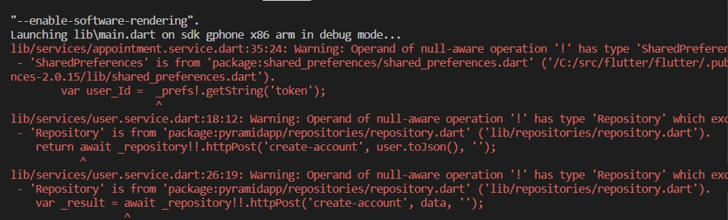

* + - * I ran command flutter clean, flutter pub get and flutter run after which it ran successfully.
  1. Use Guide

The following has to be active in order to use the application's components:

1. Internet access for backend services
2. To launch, click on the application icon.
3. Android 9.0 above
   1. Summary

The main components, testing procedures, and implementation procedures of the application's development life cycle have been discussed in this chapter. The project will be briefly summarized and recommendations will be provided in the next chapter.

# CHAPTER 5: DISCUSSION, CONCLUSION, AND RECOMMENDATIONS

* 1. Overview

This is the last chapter, which provides an overall review of the project, information on the obstacles and constraints faced during the project's development process, and ideas for how the project may be improved in the future. Finally, proposals for the project's direction will be evaluated depending on the project's findings.

* 1. Objective Assessment

The majority of the project's goals, including testing users' understanding of what they learnt and providing feedback, were met. To expand the app's functionality and enable a more seamless and interactive performance, more needs to be included.

.

* 1. Limitations and Challenges

Limitations:

* + - Registration and Login functions require internet connections.
    - Only android OS is required to run the program or access the application

Challenges:

* + - Constant Upgrades of flutter packages were required to match the current flutter version
    - Flutter was a new programming language to me, so I had to learn how to code using flutter and I realized that flutter comes with a programming language called “Dart”.
  1. Future Enhancements
     + Progression chart
     + BMI calculator
     + Blood sugar readings
     + Booking doctor’s appointment
     + A review and analysis on how to integrate the Google calendar API into an Android app.
     + Video chat with doctors
  2. Recommendations
     + Upgrading Android Operating system
     + Downloading the application
     + Suggesting possible adjustments to the application
  3. Summary

The project documentation comes to an end with this chapter. It included the project's goals, scope, risk evaluations, requirements, analysis, and design in addition to the development life cycle methodology and how it was put into practice and evaluated in the real world. Finally, recommendations and changes that may be made in the near future were assessed. Finally, recommendations for changes that may be made soon were considered.

# REFERENCES

*[APA Style Referencing.]*

1. Anderson, J. G., & Aydin, C. E. (1997). Evaluating the impact of health care information systems. *International journal of technology assessment in health*

*care*, *13*(2), 380-393.

1. Van der Loo, R. P., Van Gennip, E. M. S. J., Bakker, A. R., Hasman, A., & Rutten, F. F. H. (1995). Evaluation of automated information systems in health care: an approach to classifying evaluative studies. *Computer methods and programs in biomedicine*, *48*(1-2), 45-52.
2. McLean, S. M., Booth, A., Gee, M., Salway, S., Cobb, M., Bhanbhro, S., & Nancarrow, S. A. (2016). Appointment reminder systems are effective but not optimal: results of a systematic review and evidence synthesis employing realist

principles. *Patient preference and adherence*, *10*, 479.

1. Seddon, P., & Kiew, M. Y. (1996). A partial test and development of DeLone and McLean's model of IS success. *Australasian Journal of Information Systems*, *4*(1).
2. Ameta, D., & Mudaliar, K. (2015). Medication Reminder and Healthcare. Retrieved 11 May2022,from [https://www.researchgate.net/publication/281379567_Medication_Reminder_and_Heal](https://www.researchgate.net/publication/281379567_Medication_Reminder_and_Healthcare_-_An_Android_Application) [thcare_-_An_Android_Application](https://www.researchgate.net/publication/281379567_Medication_Reminder_and_Healthcare_-_An_Android_Application)
3. Clayton, B. (2018). Evaluation of reminder system. Retrieved 14 July 2022, from https://scholar.google.com/scholar?q=clayton+2018+evaluation+of+reminder+system &hl=en&as_sdt=0&as_vis=1&oi=scholart
4. Sravani, K., & Guha, K. (2013). Prescription viewer app 2013. Retrieved 7 June 2022, from https://scholar.google.com/scholar?q=sravani.k+et+al+2013+prescription+viewer+app &hl=en&as_sdt=0&as_vis=1&oi=scholaAPPENDICES

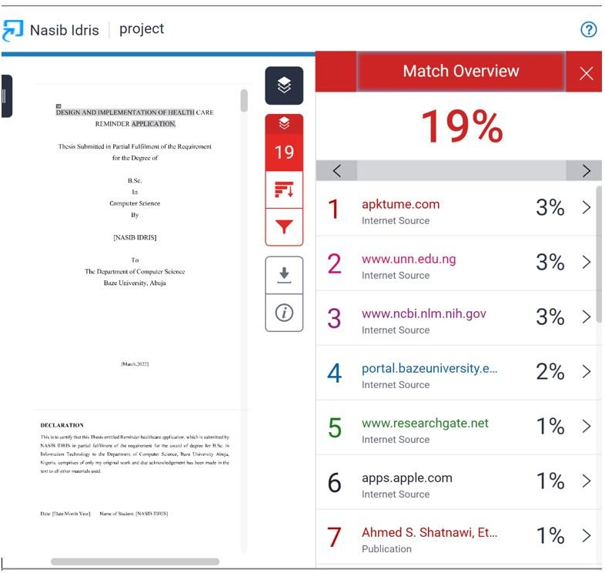

**Appendix A - Project Document**

# IN-DEPTH PROJECT DOCUMENTATION

**Full Candidate Name**: NASIB IDRIS

**Student ID**: BU/19C/IT/3807

**Title**: HEALTH CARE REMINDER APPLICATION

**Course of Study**: B.Sc. COMPUTER SCIENCE

**Background and Motivation**

Patients on persistent medication usually find difficulty in remembering the specific time their prescription is supposed to be taken or when it’s going to finish. Failure to take the prescription at its required time might lead to other complicated health issues and medical related reactions, and failure to refill a prescription that needs a regular intake can also cause serious negative impact on a patient’s health. This project focuses on providing a procedure to remind its users the particular time a prescription is going to end given that the user registers that particular prescription on the application. Patients usually forget the required time and dosage of a particular prescription/medicine, patients no longer need to go through the hassle of remembering their medicine dosage schedule as this application provides them a medium where they can set an alarm on their dosage timings. This application is also pleasant to users as it also provides the relevance of setting a reminder for a doctor’s appointment.

Statement of the Problem

This project confronts a vital problem that stops patients from taking their prescription regularly, this issue is absent-mindedness. People that take medicine regularly should endeavor to take their medication to ensure that there is presence of a productive amount of drug in their body at all times.

Inability to take their drugs/medication on a regular basis results in a situation whereby the level of the required amount of drug in their body becomes low or too low to effectively stop their ailment from becoming persistent.

Therefore this application is aimed at helping patients to be in charge of their prescriptions in order for them to maintain the best state of health possible.

It also assists in reminding them when to take a pill and also when they have a doctor’s appointment.

## Appendix B - Questionnaire

Proceedings of Interview or Observation Reports etc.

An interview took place between both the Young and the Old and the questionnaire was provided for both.

QUESTIONNAIRE

1. How old are you?
2. How many prescriptions are you on?
3. Do you care to manage your prescriptions on an APP?
4. Have you been missing any prescription you are taking?
5. How often do you remember to take your medicine?
6. Are you a very forgetful person?
7. Do you remember to take your medicine on time?
8. Is there difficulty in remembering the exact time you should take your prescription?
9. Have you been going late to your doctor’s appointment?
10. Do you want manage few of your health care related problems on an app?
11. What would you consider a health care app like?

## Appendix C – Source Codes

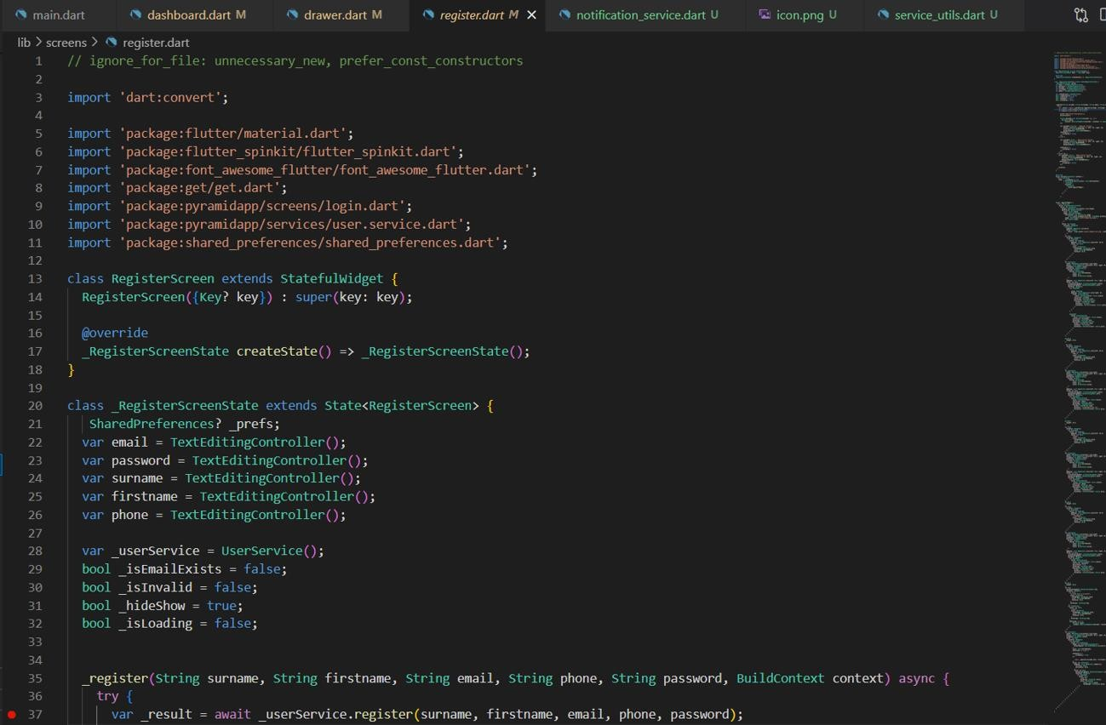

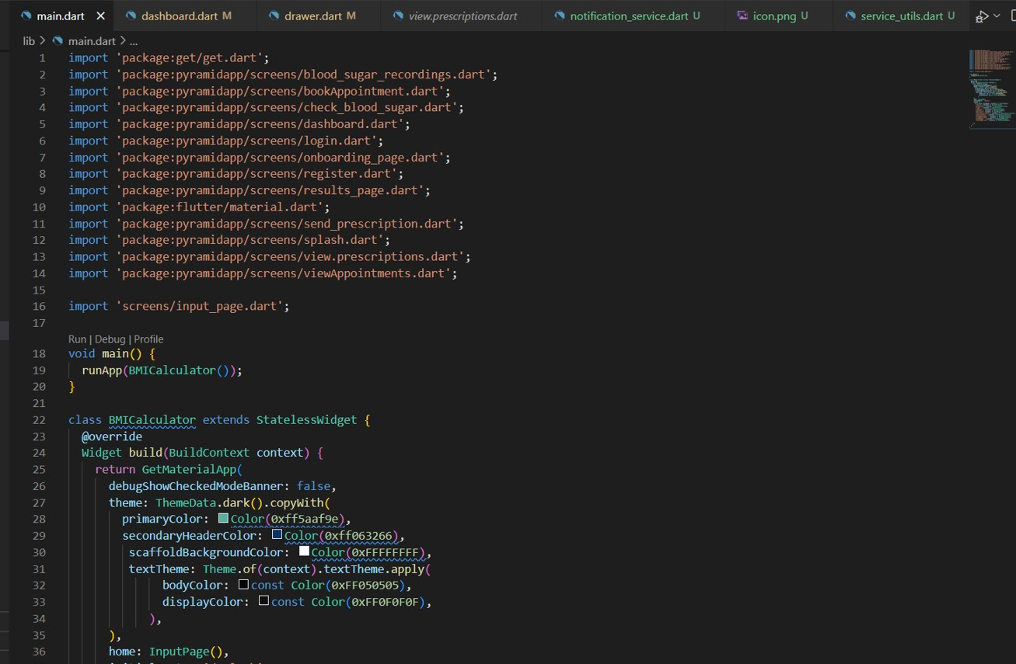

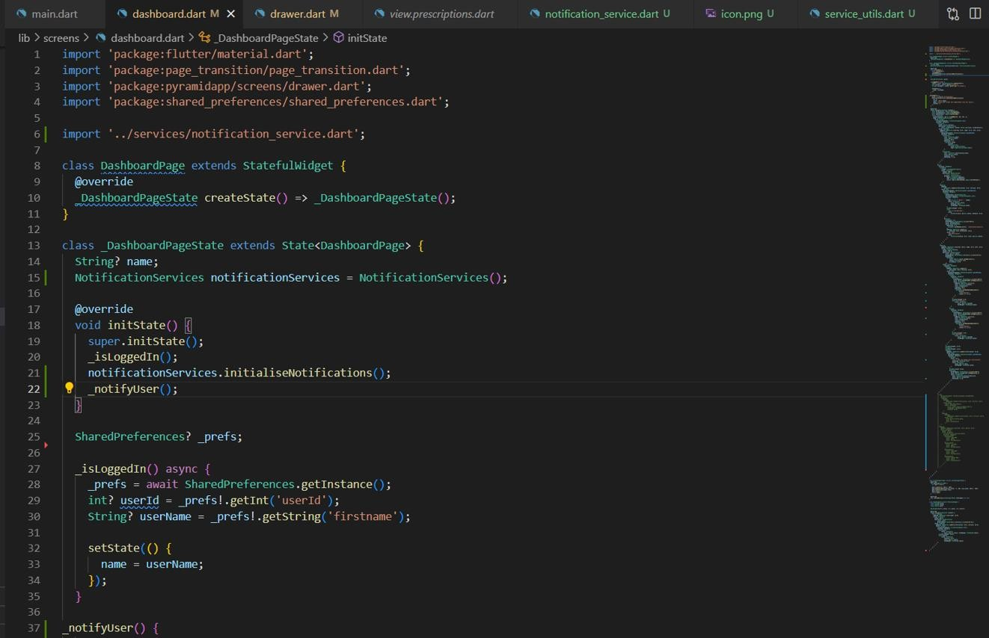

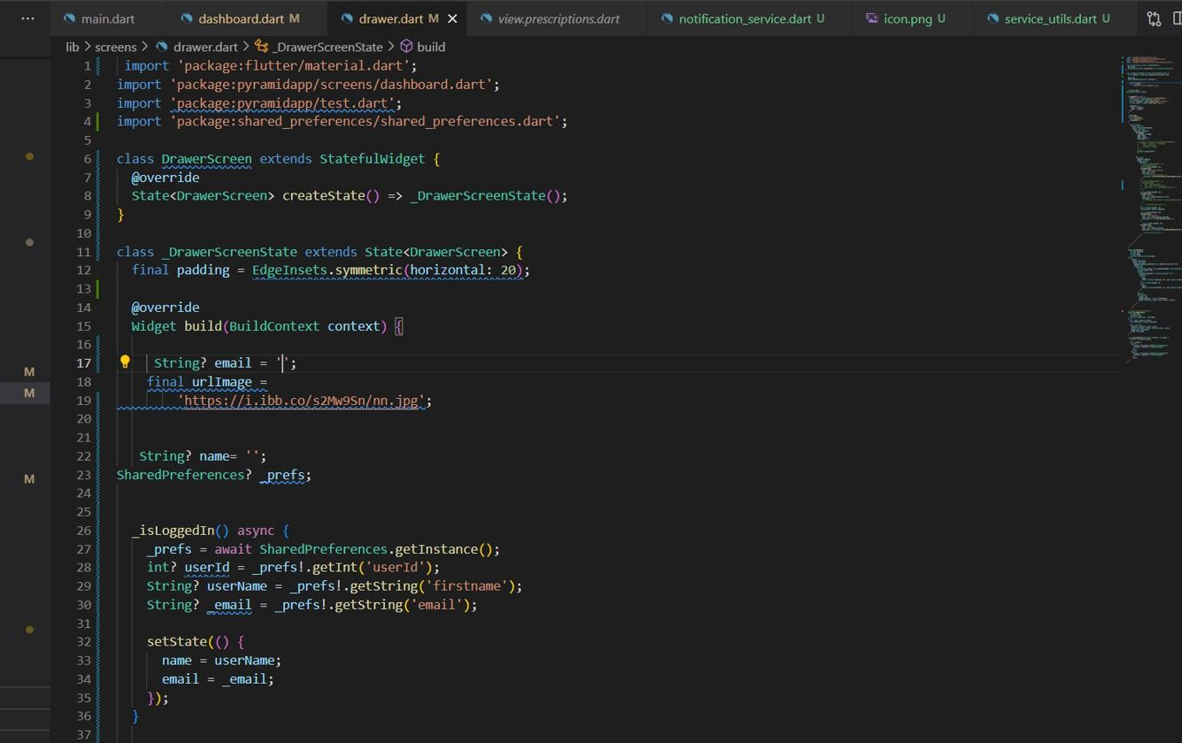

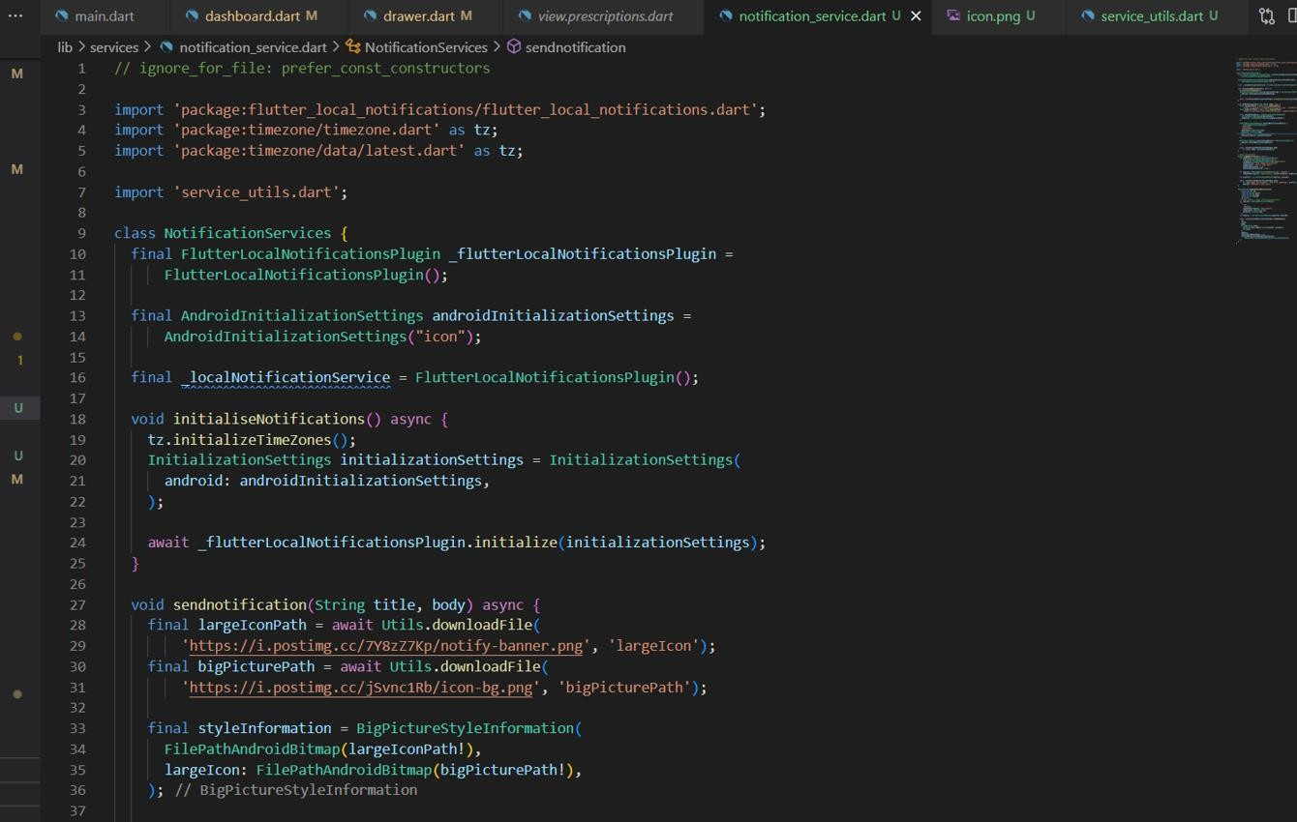

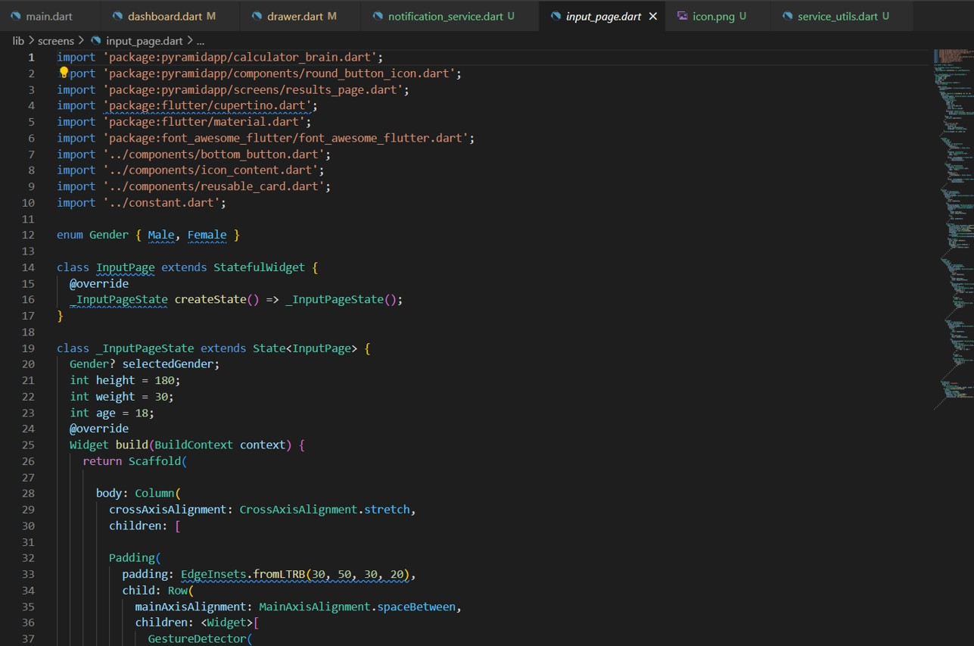

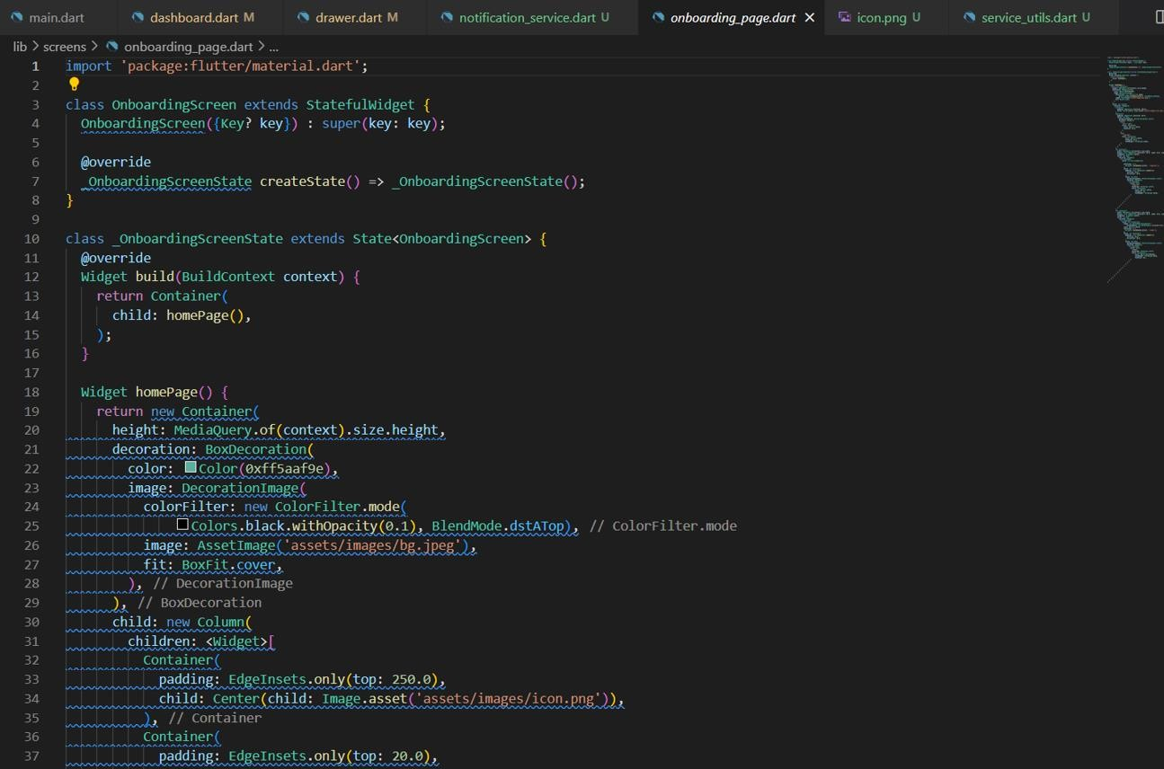

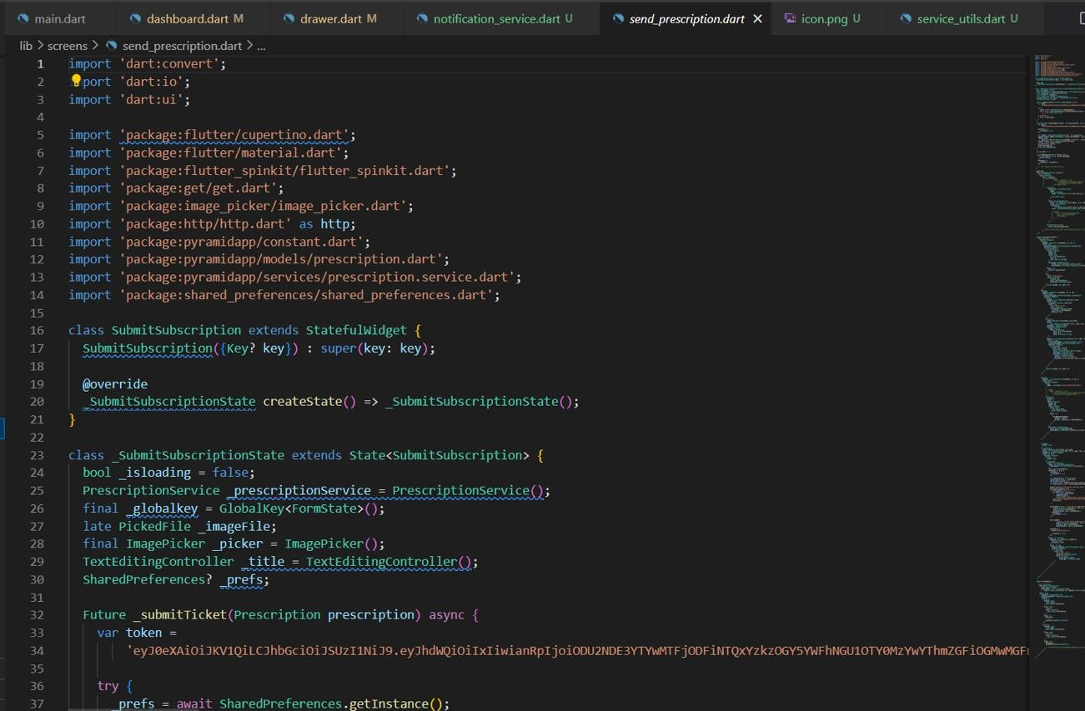

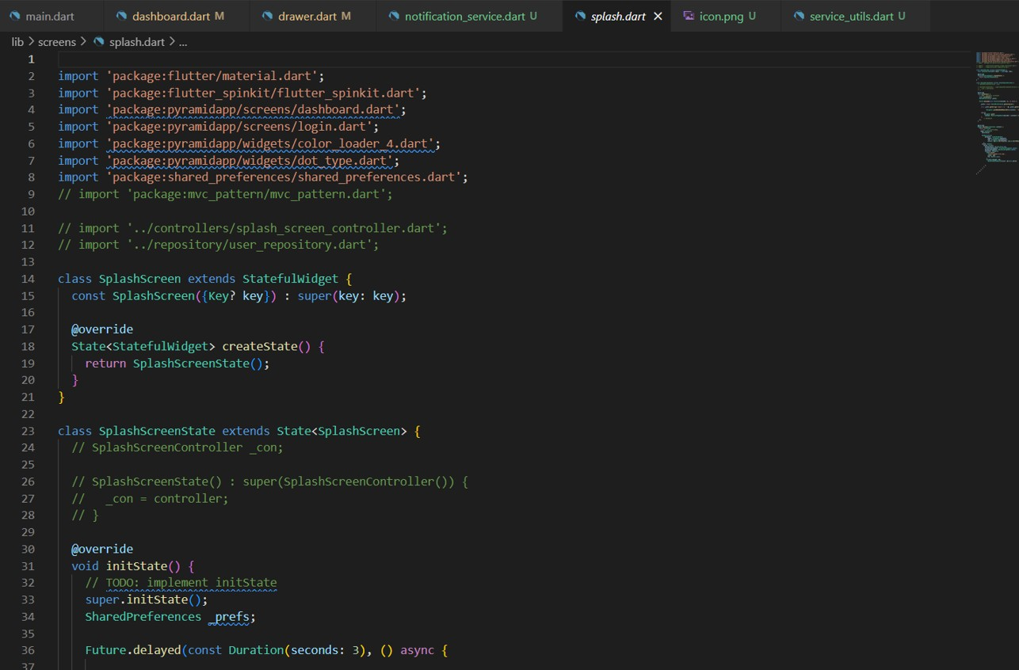

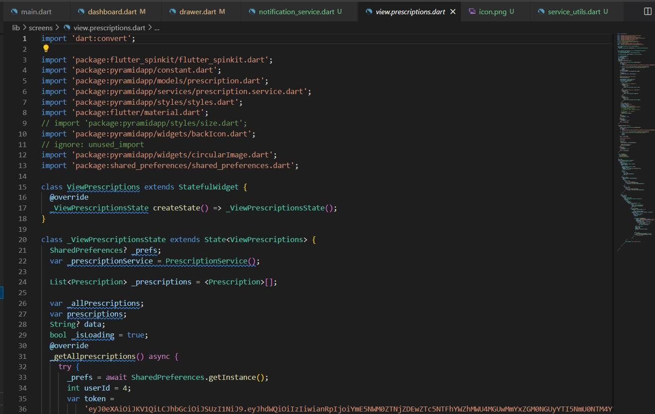

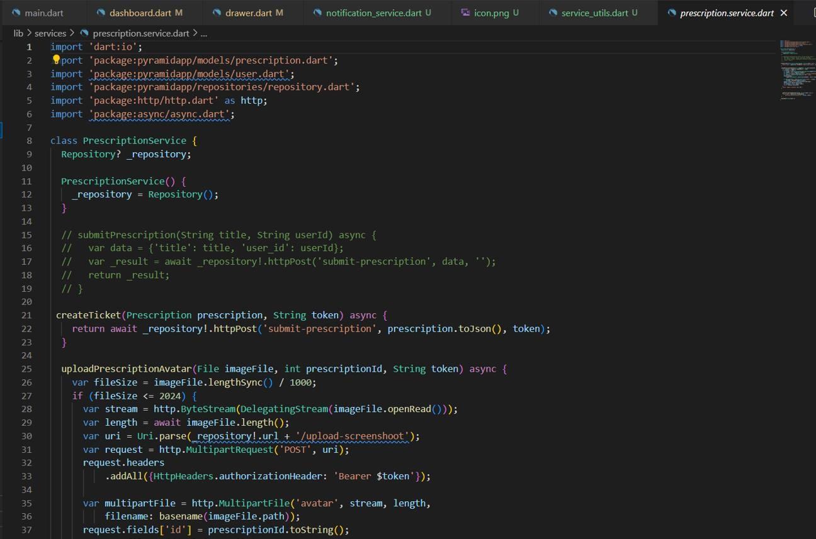

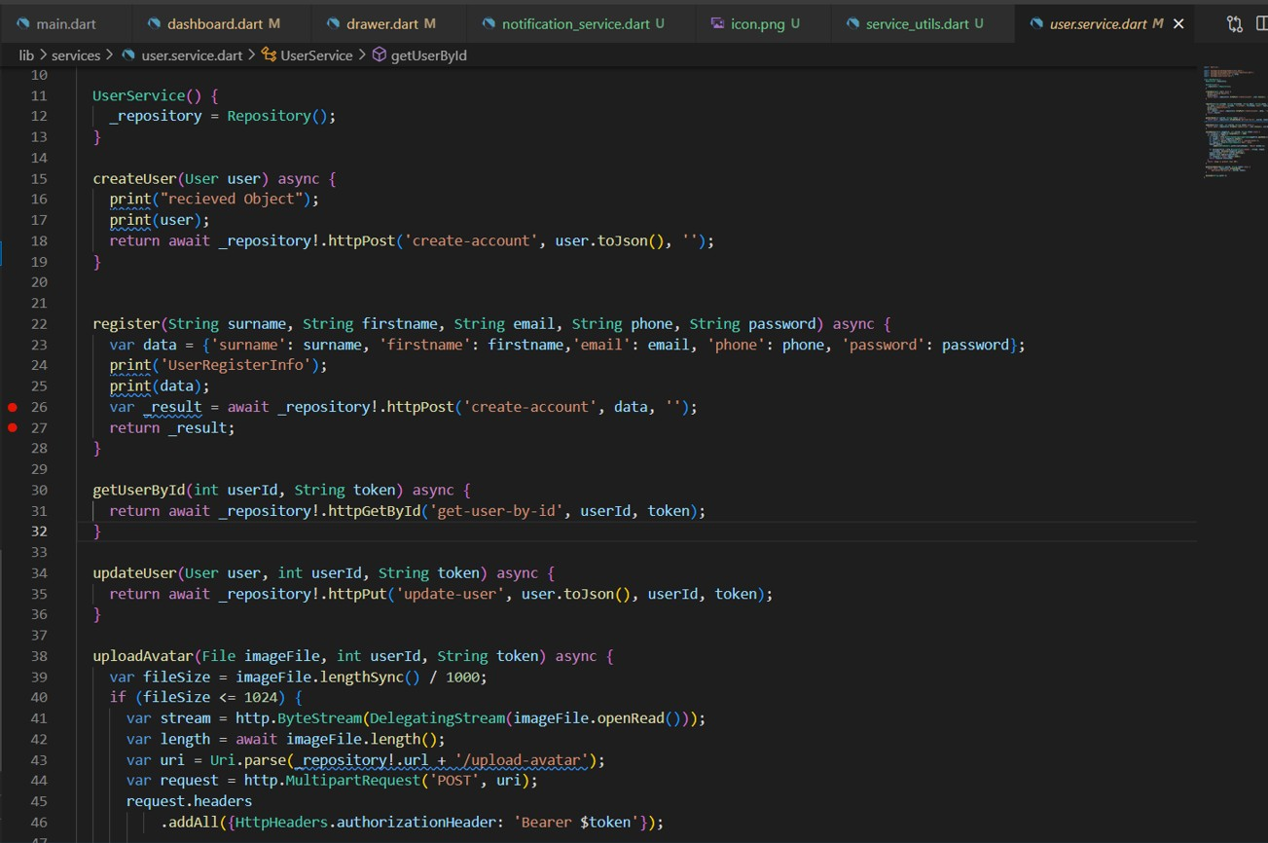

**Appendix E – User Guide/Manual**

1. To use the app
   1. Download the app
   2. Sign up
   3. Create an account
   4. Login with account details
2. To navigate around the app
   1. Click on add prescription button to add your prescription
   2. Click on manage prescription to view details of all prescriptions added
3. To terminate action
   1. Click on delete button to delete any added prescription
4. To use the reminder
   1. Click on appointment reminder to set reminder for doctor’s appointment
   2. Click on notification button to view all notifications
5. To quit app
6. Go to menu bar to log out