DESIGN AND IMPLEMENTATION OF EXAMINATION TIMETABLING SOFTWARE USING GENERIC ALGORITHMS AND SIMULATED ANNEALING

CHAPTER ONE
1.0 INTRODUCTION
1.1 General Overview
The difficulties of developing appropriate examination time table for institutions and tertiary is increasing. Institutions are enrolling more students into wider variety of courses in many different fields. For example, at Osun State Polytechnic, Iree, approximately 14,000 students have to be filled into about 150 exams over two and a half weeks period.
The examination timetable problem regards the scheduling for the exams of a set of polytechnic courses, avoiding overlaps of exams of courses having common students, and spreading the exams for the students as much as possible.
Examination scheduling (timetabling) is a very important process in education institutions. The main challenge is to schedule examinations to timeslots and rooms over a specific period while satisfying a set of constraints. The previous attempts were based on the graph coloring concept. In this case the vertices represent causes, and join two vertices only if they cannot be scheduled at the same time. The problem is therefore to find the chromatic number of resulting graph.
One of the major approaches in exam timetabling over the years has been constraint programming approach (Simulated Annealing). This method constraint programming logic language (chip) also to solve exam timetabling problem. Constraint programme phase provide an initial solution and a simulated annealing phase to improve the quality of solutions.
The local search approaches play an important role in the exam timetabling literature. White and Xie and Di Gaspero and Schaef used tabu search method in exam timetabling. White and Xie Kept two table lists, the used short-term table list, and the long-term tabu lists keeps tracks of the most moved exams, Di Gaspero and Scheaf used a single table list, but when exams are added to this list, its for a randomly determined number of iterations.
The polytechnic has two semesters per each academic year. Each semester per each academic year. Each semester is made up of up to fifteen weeks of teaching, by followed by two weeks of examination. There are two examination sessions per day except on Saturday where student are allowed to rest and start of Sabbath for seventh day Adventist. Examinations are mostly three hours long with a few exceptions which deviates for half an hour or two hours.
There are an increasing number of courses which cut across facilities and polytechnics-wide courses which are offered to more than a thousands students at the same time. The problem is also complicated by the freedom of choices by students on optimal courses, where students have wide range of choices which cut across department and faculties.
The Examination Timetable Problem (ETP) is usually modeled as an NP-Hard (non-deterministic polynomial time hard problem) combinatorial optimization problem. The problem demands that a given number of exams are scheduled in a limited number of periods and venues in such a way that no student will have more than one exam at a time and other constraint are satisfied.
Although consideration will be based in particular on exams timetabling, the ideas presented here can be extended to many other application, which include not only other scheduling problems but also multi-criteria problems. In general, the reason to present an application to exams time tabling is justified by the affiliation of the auditors and their awareness of the increased difficulty that some recent strategies have introduced in this academic task. Just as an example monitoring the tendency forwards the flexibility of curricular and the increase of the number of students enrolled in each course.

1.2 Statement of the Problem
In this project work, we present a new solution method for examination timetabling, consisting of two phase: a generic algorithm phase to improve provide an initial solution and a simulated annealing phase to improve the quality of solution. The simulated annealing applies kempe chain neighborhood and includes a mechanism that allow the user to define a certain period of time in which the algorithm should run. We perform preliminary experiments of the algorithm on the real data set from the OSUN STATE POLYTECHNIC, IREE.
However, the main different between the two approach is that our simulated annealing phase is equipped with more refine mechanisms that help to determine crucial cooling schedule parameter.

1.3 Aim and Objective of the Study
The principle aim of this project aim of this project work is develop examination timetabling software that will be useful to our education institutions, using Generic Algorithms and simulated annealing.
The following are the set objective
- Exploratory study of Generic Algorithm and simulated annealing in resolving conflicts associated with exam timetabling.
- Develop a computer software to automatically generate exam timetable using the two appropriate by considering Osun State Polytechnic exam time table data.
- To evaluate and compare the performance of the two algorithms in term of their computational complexity.
1.4 Limitation of the Project
The project is developed to cover the fixing of examination timetables for all students in this institution of Osun State Polytechnic, Iree but it can be implemented in any other tertiary institution, this can be achieved by merely adjusting the input design of the program.

1.5 Scope of the study
In this project, attention is focused in formulating mathematical models for the examinations timetable at Osun State Polytechnic, Iree. This will act as a benchmark for testing heuristic algorithms (describe an algorithm that modifies itself in response to the user) and help future reformations of the problem models. The Examination Timetabling Problems (ETP) differ considerably from the polytechnic curse scheduling problem.

1.6 Significant of the project
The significant of the research work is to assist to curb the examination timetable problems that may arise in the future, based on the following concussion and recommendation made by the researcher.
The finding of this study will enable us to understand and the importance of good examination timetable system for the tertiary institution easy and effective also with the used of appropriate examination timetable tom stimulate the timetable of various resources combination so as to encourage better timetable planning and information gathering.
To minimize the length of examination period with the constraint given to used rate determine every student academic performance and also to allocate inugolator to time and venues.
To give a technical knowledge and the competence of each student.
CHAPTER TWO
2.0 LITERATURE REVIEW

2.1 Simulated Annealing
The Simulate Annealing theory has been investigated over the last few year for exam timetabling with some level of success. In (1991). Abramson applied stimulated annealing to construct high school timetables. In (1996) Thompson and Dows land considered an adaptive cooling technique depending upon the success of the move the two authors employed Kempe chain as neighborhood structure. In 2001, burke et al proposed a time Pre-defined variant of simulated annealing.
Simulated annealing is a variant of the well known modern heuristic strategy for finding good solution to a global stochastic optimization technique that has been widely used in several types of combinatorial optimization problems. It variant of local search which allows up till move to be accepted in a controlled manner. The basic significant amount of heuristic technique such as genetic algorithm tabu search and simulated annealing (SA). Of these simulated annealing had been tested on an increasing number of real life which have been tackled successfully. Some of the earliest practical application of simulated annealing is on very large scale integration (VLSI). Design packages of thunderbird and thunder wolf. Recently (Kelly etal, 1999,) applied simulated Annealing (SA) to the controlled rounding problem in the three dimension. The simulated annealing technique is essentially local search in which the probability which decreases as the process progresses according, to some Boltzmann type distribution.
In tradition local search an initial solution is gradually improved by considering small perturbation or change. For combinatorial optimization problems in which a solution is defined by a set of zero - one variable this usually involves charging the value of two variables. If such a change results in a better solution the current is replaced.
According to (Dows land 1993), simulated annealing technique derive its name from its origin in statistical thermodynamics where it forms the basis of a simulated of the energy function of material being cooled in a heat bath.

2.3 Annealing Process Stages
The three stages involved in an annealing process are:-
1. Healing to the desired temperature.
2. Holding or soaking at that temperature
3. Cooling to room temperature.
Once of two important parameter to be considered is time. During heating and cooling temperature between the outside and interior to the Piece exist their magnitude depend on the size and geometry of the piece temperature gradient and interval stresses may be long included if the area of temperature is too high.
The actual annealing time must be long enough to allow for the unnecessary transformation reaction. Annealing temperature is also considered (Williams,1997) from the aforementioned, the could be seen that, these techniques have all been in the research literature for a decade or more. It is really only recently that they are becoming widely used by industry and commerce to solve important and difficult real world problem in many situation they are turned to as a last resort when other method have failed.
Finally, the problem of SA approach is the lack of convincing theory and it could be concluded that simulated annealing would be a thing of research work until a better theoretical base is full understood and established.
In this project we will evaluate the performance of two prototypes, simulated annealing based timetable system, which will allow feasible timetable to be optimized as the particular department, faculty, and institution sees fit through the use of an appropriate graphical use interface.
Genetic Algorithms have seen successfully used to schedule exams in a number of cases. Corn et al, use a fairly traditional approach where each gene represents the time at which its particular place with crossover and mutation operation packer takes different approach where the gene for each exam not only specifies when it is to be taken but also how to search for a new period if after crossover. The exam is causing a conflict. If the exam may not be placed in any of the periods system which allows infeasible timetables.
Several researchers on the other hand, have attempted the use of simulated annealing in solving various projects of timetable generation. Simulated annealing is a global heuristic technique which tries to avoid falling into local optima by accepting bad solution when specific conditions have been satisfied for the time table generation. The algorithm is a simulated of the physical cooling process called annealing, where a physical object cools down by following particular cooling schedule. A temperature value is defined initially, which is the initial state of the timetable to be derived, and cools slowly until an equilibrium point is achieved reeves (1993)

2.4 Hard and Soft Constraints
A timetable is essentially a schedule which must suit a number of constraints are almost universally employed by people dealing with timetable problems. Constraints, in turn, are almost universally broken into two categories: soft and hard constraints burke and roses (1995).
Hard Constraints are Constraints. Of which in an y working timetable, there will be no breaches. For example, a student can not be in two places at once. Soft constraints are constraints which may be broke, but of which breaches must be minimized. For example no students should have to give exam in adjacent periods.
Also their order of importance appears of contention. I addition to constraints, there a number of exceptions which must be taken into consideration when constructing on automated timetabling system.
Many constraints involved in exam scheduling very from university to university, Department to department and faculty. However it is generally accepted that the following three constraints are fundamental to any time tabling problems
- No entity must be demanded to be at more than one place at a same time. In exam timetabling this would mean that no standard could sit more than one exam at any time
- For each period in the timetable, the resource demands made by the events, scheduled for that period must not exceed the resources available. In exam timetabling it is important not to schedule more exam sitting in a room that there are no desks.
- No students should have to give exams in adjacent periods.

First two rules define a feasible timetable and they must be satisfied, so they are known as hard constraint when the objective is to find a feasible timetable, the problem colouring heuristics assignment (Burke et al, 1996). But these methods do not take care about third constraints, which is known as soft constraint because it is excepted that any student should not have exams in adjacent time periods. So we are interested to find out a feasible practical timetable, which makes students happy.
The optimization capabilities of SA and GA (chambers 1999) have been found to well on various timetabling problems (Burke et al 1996), usually by first ensuring satisfaction of the conditions for a feasible timetable, and then optimizing for the soft constraint as the generation passes.

2.4.1 Hard Constraints
1. No entity is demanded to be at more than one please at a time. In exam timetabling this would mean that no student can sit for more than one exam at any time.
2. For each period in the timetable, the resources demand made by the events scheduled for that period must not exceed the resources available. In exam timetabling, it is important not to schedule more exam sittings in a room that there are no desks.

2.5 Timetables
The timetable for a single room is a two dimensional array as shown in FIGURE. The timetable for an entire polytechnic is therefore a collection of room timetable  one every room in the polytechnic. Times at which there is no class booked hold a Null booking, which has a value of zero.
TIME/DAY | DAY 1 | DAY 2 | DAY 3 | DAY 4 | DAY 5
9am-12pm
2pm-5pm

Figure 2.1: Example of a single room timetable
A Polytechnic, timetable stores information about what classes are booked in each room, at any hour of the day, on any day of the work.
For GA each of these booking (or NULL bookings) is one gene. A timetable also has field which stores it cost. It also has field which store the number of breaches of each type of hard constraint. A population (or colony) is a collection of timetables. A population is itself a structured type with a number of fields. It contains a porter to the least costly timetable in the population (which has, in turn, a porter to the next least costly)
A colony of creatures is therefore a single linked list of structured types (creatures) containing timetable date (genes) in a three dimension array the timetable are kept order from least costly to most costly. This method of gene representation means that its not possible to have two classes booked to the same room at the same time. As such there is one less hard constraint to be considered when evaluating timetable.
Similarly, there are four operators used in simulated annealing. They are described below,
- Configuration: In a stand polytechnic session, there are two semesters per academic year each semester is made up of fifteen or fourteen weeks of teaching/textures followed by a two weeks of examination. There are two examinations (Monday-Saturday). Examinations are mostly three hour s pre slot with a few exception which deviates for two hours. There are increasing number of courses across the departments and faculties which can be offered to more that a thousand students at the sometime. Due consideration is also made in view of available room spaces. A room can be assigned to more than are one examination during the same time slot depending on the room space availability. On the other hand, an examination can be spited into more than one room depending on the size of the course and capacity of the available space all on respective to the hard and soft constraints.
- Move Set/ Structure: for a more is also an important decision as it affects the cooling process and ultimately the quality of the solution to be derived. The following two options describe the move sell.
1. Changing the time of an examination by a random time as follows.
(a) Select a random examination e ∑ E
(b) Select randomly a new timeslot t ∑ {1,2,…28}
(c) Assign the new timeslot t to the examination e.
These move selections have precisely suggested by Thomason (1986), ELMohammed (1998) and reeves (1999) and have worked well for similar problem. It shows a simple line of movement yet it allows a well balanced mix of events among all timeslots, the size of the neighbors hard associated with this king of move is [NCS)1=n*(T-1)
2. Change of timeslot followed by a swap of two randomly selected timeslots.
(a).Select two examination e,e2,at random in E
(b). Selected a timeslot t at random {1,2, 28}.
(c). Replace a timeslots of examination e, by t.
(d). Swap timeslots of e, and e2.
This move affects two examinations at a time and it is therefore a longer move than the previous case. The sole reason for this move is basically to create a longer pattern of changes in a move in anticipation of better exploration of the neighborhood is [NCS) 1=T *n (n-1) which is larger
3. Cost function.
What cost function does is to evaluate or weight a solution in order to test whether or not it could be accepted. The mathematical model cannot be easily defined Nevertheless the evaluate is made according to the given rule that each department registered must have a free period for optimal performance. for a particular group to be favoured in the scheduling there must be a free period for their department. However the evaluation of the cost function in the algorithm requires that a numerical value (0,1) be returned. Thus the evaluation is done as follows: If each grouping the session array exist in the free period array, (I e rule obeyed) it is assigned , else (rule not obeyed) this assigned value O.
4. Cooling Schedule
Its important that the cooling function allows sufficient time to explore many possible solution in one level before moving into lower temperature and ultimately freezing point It is also important not to spend too much time on high temperatures, where most neighborhood moves are accepted as this can lead to a wastage of running time. A good schedule is expected to spend more time on lower temperature so as to allow for convergence. However, it is not advisable to spend much time on low temperature where most neighborhood moves are rejected (Eglese 1990) the most commonly used schedule involves geometric reduction function.
α (t) =at, where a < 1
For comparison purpose another cooling scheduler as suggested by laundry and mess (1986) which involves a must slower cooling rate:
α (t) = t/ (1+ β t), where β < l

2.6 Breeding Timetables in GA
Timetables are randomly selected from the population and used for breeding. No favoritism is given to fitter timetables. A child timetable is breed by performing unity order based crossover on the parents this means that each parent has an equal chance of providing each gene.

2.6.1 Parameters
1) Course description: Each course is described by five fields.
- Course code
2. Course property.
3. No .of slots for an exam
4. Name
5. Course type.
2) Room description: Each room is described by five fields.
1. Room code
2. Name
3. Room type
4. Room property
(3). Slot Description: Each slots is described by four fields
1. Slot code
2. End time
3. Start time
4. Name
(4) Days need no: Specification and have been built in the code

2.6.2 Representation in GA
A slot (time-space slot ) was used to represent each 3 hours ( We assume that time is in three hours granules), for every room of every room of everyday before 8am and should finish before 8pm (12 hour total) and working days are from Monday and Saturday ( 6 days total) but on rare occasion some examination may be fixed for time that is below 8am says 7am ( courses carried over previous semester).

2.6.3 Creation of initial population
Initially chromosomes are generated randomly as per below:
For each chromosome
Generate a random ordering of exam one by one in their random order. find the first period in which the exam may be placed without violation of hard constraints, place exam in that period.
Initially we have only considered first and second hard constraint. Because they must be satisfied to generate feasible timetable and once we have feasible timetable and once we have feasible timetable then, as the generation passes, the population we become better with less number of violation of soft constraint using gendre operators especially crossover.

(A,) Fitness Function
For each chromosomes produced there must be a fitness value which must be assigned to it, in order to know if the chromosome can actually survive the test of time.
In order to determine the fitness function the following procedures are followed;
Each class or examination venue can have points between 0 and 5
If exam venue uses spear classroom, increase exam value score.
If exam centre require computers and its located in classroom with them, or it doesnt require them, increment score of the class.
If exam is scheduled in classroom with enough available seats, the score is then increased.
If the entity (student) has no other exam scheduled for a particular time, the class score is incremented.
If exam scheduled for a particular time brakes at any time-space slot that it occupies, its score is not incremented for that rule,
Total score of class schedule is sum of points of all classes.
Fitness value is then calculated as
F(X) = (Schedule_score/maximum_score)X6
Fitness value are represented by single-precision floating point number (float)in range from 0 to 1

B. Reproduction
According to Darwins theory the best one should survive and create new offspring. The primary objective of the production is to emphasize good solution and eliminate bad solution in a population. Therefore, overall fitness of production becomes better chromosomes from current population to next generation population.

(C) Cross-Over
Cross (recombination) is inspired by the role of sexual recombination in the evolution of living things. It could be said that the main distinguishing feature of a GA is the use of crossover and it plays major role for producing better solution. Two chromosomes are selected randomly from mating pool to do cross over are new offspring are produced. Our crossover operator works as per below:
- Copy first time slot of fitness chromosome of two parent in the offspring
- Place the remaining exams from the first timeslot of second parent to the offspring, which dont conflict with already placed exams
- Select each timeslot from parent chromosomes and place those exams in the same timeslot of offspring, which have less number of violation of third soft constraint.
- Select feasible timeslot and place remaining exams in it.

(D). Mutation
Mutation is a Genetic operator that takes a probability and a schedule. We loop over the course with the given probability, each or is set to a random room at a random time.

(E) Repair Strategy
A repair strategy is used, to ensure that all classes appear exactly once. For robustness, this is done in two stages. Firstly any class which appear than once are (non- deterministically) altered such that they appear only once.
Secondly, any class which did not appear at all are booked to a spare (regardless of room size, e.t.c)
For each class
Set the count to 0
For each time:
For each room
If the current class booked at this location
Add I to the count
Add the location of this class to a linked list
If the class occurred more than once then:
Keep doing the following until there is only one booking left
Randomly choose one of the bookings.
Turn it into a NULL booking

If this repair strategy is applied to an empty timetable with each class booked to a random time and place. As such, the strategy is also used for initializing a random population. The use of repair strategy ensure that class is booked exactly once. Hence, the number of hard constraints which must be considered when timetables are being evaluated is further reduced, It has far been shown that the hard constraints  classrooms must be double booked and every class must be scheduled exactly once have been satisfied by genetic means,

2.7 Generating Time Table in SA
SA, one of the most widely known heunstie algorithms, exploits an analogy between the way in which metal cools and freezes into a minimum energy crystalline structure (the annealing process) and search for a minimum in a more general system (xianghua et al 2007). In the optimization process, the solution randomly walks its neighborhood with a probability determined by metropolis principle while the system temperature is close to zero the solution stays at the global best solution in a high probability (Xinghua et al 2007)

2.7.1 The Basic Iteration
The SA heuristic considers some neighbours of the current states, and probability decides between moving the system to states and staying in states. The probabilities are chosen so that the system ultimately tends to move state of lower energy. Typically, this step is repeated until the system reaches a state that is good enough for the application, or until a given computation budget has been exhausted.

2.7.2 The Neighbors Of A State
The neighbors of a state are new state of the problem that are produced after altering the giving state in some particular way. Each state is typically defined as a particular permutation of the rooms to be used. The neighbors of some particular permutation are the permutations that are produce for the example by interchange a pair of adjacent rooms. The action taker to alter the solution in order to find neighboring solution is called move and different moves give different neighbors these moves usually result in minimal alterations of the solution, as the previous example depicts in order to help an algoriltion to optimize the solution to the maximum extent and also to retain the already optimum parts.

2.7.3 The Annealing Schedule
Another essential feature of SA method is that the temperature is gradually reduce as the simulation proceeds. Initially, 7 is set to a high value (or infinity), and it is decreased at each step according to some annealing schedule which may be specified by the user but must end with T=O towards the end of the allotled time budget. In this way, the system expected to wander initially towards a broad religion of the search space containing good solution ignoring small features of the energy function then drift towers lowenergy religion that become narrower and narrower: and finally move downhill according to the steepest descent heuristic.

2.7.4 Selecting the Parameters for SA
In order to select parameter for the simulated Annealing method to a specific problem, one must specific the following parameter: the state space the energy (goad) function EC), the candidate gene3ration procedure neighbor C), the acceptance probability function PC), and the annealing schedule temp (). These choices can have significant impact on the methods effectiveness unfortunately,
These choices of these parameter that will by good for all problem and there is no general way to find the best choice for a given problem. The following sections give some general guideline.
- Acceptance probabilities
The specification of neighbor (), P(), and temp(), is partially redundant in practice, its common to use the same acceptance function P() for many problem, and adjust the other two function according to the specific problem. In the following formulation of the method by Kirk, patrilaetal, the acceptance probability function P (e, e¹, T) was defined as I If e<e, and , and exp (ee¹) /T) otherwise. This formula was superfroially justified by analogy with the transition of a physical system. However, this acceptance probability is often used for simulated Annealing even when the neighbour () function, which is analogous to the proposal distribution in metropolis Hastings is not symmetric or not probabilities of the all. As a result the transition probabilities of the simulated annealing algorithm do not correspond to the analogous physical system, and the long time distribution of states at a constant temperature T need not bear any resemblance to the thermodynamic equilibrium distribution over states of that physical system, at any temperature. Nevertheless most description of SA assumes the original acceptance function, which is probability hard coded in many implementation of SA.

B. Efficient candidate generation
When choosing the candidate generation neighbour () , one must consider that after a few iterations of the SA algorithm the current state is expected to have much lower energy that a random state.
Therefore, as a general rule one should skew the generator towards candidate moves where the energy of the distribution states is likely to be similar to that of the current state. This heuristic (which is the main principle of the metropolis- hasting algonthm) tends to exclude very good candidate moves as well as very bad ones. However the former so the heuristic is generally quite effective thus the consecutive-swap neighbour generator is expected to perform better than the arbitrary swap one, even through the latter could provide a somewhat shouter path to the optimum (with n-l swaps, instead of n(n-l)/2}.
C. Barrier Avoidance.
When choosing the candidate generator neighbour () one must also try to reduce the number of deep local minima states (or sets of connected states) that have much lower energy than all its neighboring states. Such closed catchments basins of the energy function may trap the SA algorithm with high probability (roughly proportional to the number of states in the basin) and for a very long time (roughly exponential on the energy difference between the surrounding states and the bottom of the basins)
As a rule, it is impossible to design a candidate generator that will satisfy this goal and also prioritize candidates with similar energy on the other hand one can often vastly improve the efficiency of SA by relatively simple changes to the generator. It the traveling salesman problem for instance it is not hard to exhibit two hours. A,B, with nearly equal lengths, such that () A is optimal, every sequence of city pair swaps that are much longer than both, and 2 A Can be transformed into b by flopping (reversing the order of ) a set of consecutive cities. In this example A, B lie in dependent deep basins If the generator performs only random pair  swaps, but they will be in the same basin if the generator performs random segment flips.
D. Cooling schedule
The physical analogy that is used to justify SA assumes that the cooling rate is low enough for the probability distribution of the current state to the near thermodynamic equilibrium at all times. Unfortunately the relaxation time the time one must wait for the equilibrium lobe restored after a change in temperature strongly depends on the topography of the energy restored after a change in temperature. Strongly depends on the topography of the energy function and on the current temperature. In the SA algorithm the relaxation time also depends on the candidate generator in a very complicated way Note that all these parameters are usually provided as block box function to the SA algorithm.
Therefore in practice the ideal cooling rate cannot be determined before hand, and should be empirically adjusted for each problem. The variant of SA know as thermodynamic simulated annealing tries to avoid this problem by dispensing with the cooling schedule and instead automatically adjusting the temperature at each step based on the energy difference between the two states according to the laws of thermodynamics.
E. Restarts
Sometimes it is better to move back to a solution that was significantly better rather than always moving from current states. This is called restarting. To do this we sets and e to best and best and perhaps restart could be based on a fixed number of steps, or based on the current energy being too high from the energy so far.

CHAPTER THREE
3.0 METHODOLOGY
3.1 Timetable Generation
There are various constraints that are considered in the generation of a timetable. From the types, there are two fundamental constraints that govern the generation of examination timetable. These means that no student can be in more than one place at a time and that there must be sufficient seats to accommodate the students for examination. We will call a timetable that satisfies these constraints a feasible timetable. That a timetable is feasible does not give the assurance that it is good enough to be used. There are many criteria used to ascertain the quality of a timetable. Most common is that a student is not expected to sit for two examinations in adjacent examination periods, but the only real way to know whether a timetable is a good one or not if it is usable by the department, the faculty and the university.

3.2 Genetic Algorithm and Simulated Annealing
3.2.1 Genetic Algorithm
Genetic algorithms were inverted by john Holland in the 1960s and were developed by Holland, his students and colleagues at the University of Michigan (Mitchell 1991). GA is an optimization technique based on nature evolution. It maintains a population of strings called chromosomes that encode candidate solutions to a problem. The algorithm select some parent chromosome from the population set according to their fitness value, fitness values are calculated using fitness function, which performs major role in GA. Although GA is probabilistic, in most cases it produces better population which compare to their parent population because selected parents are the fittest among the whiter population set, and the worse chromosomes die off in successive generation. This produce is continued until some user defined termination criteria are satisfied.

3.2.2 The Genetic Algorithm Process.

Initialization
A random population of feasible timetables is created using a variation on a graph colouring algorithm.

Each timetable is evaluated according to a set of criteria e.g the length of the timetable, how many students have to sit two exams in a row or how many seats are there

Evaluation
Timetables are randomly selected to be the basis of next generation. Good timetables are most likely to be choosing than bad ones.

Selection

The mutation operator changes the period and room the exam is to be held in. Always maintaining a feasible timetable
X

Operators
The crossover operator take cares of timetables selecting the early exams from 1 and the late exams from the other to produce a new timetable. Any that cannot be placed this way are put in the earliest available period

A new population is thus generated. The process will be repeated until a good solution is found
Fig. 3.1 Generic Algorithm Process
3.3 Simulated Annealing
Simulated annealing was developed in the mid1970s by Scott Kirkpatrick, along with a few other researchers. Stimulated annealing was original developed to better optimize the design of integrated circuit (IC) chips stimulated annealing.
Annealing is the metallurgical process of heating up a solid and then cooling slowly until it crystallizes. The atoms of this material have high energies at very high temperatures. The atoms of this material have high energies at very high temperature. This gives the atoms a great deal of freedom in their ability to restructure themselves. As the temperature is reduced the energy of these atoms decreases. If this cooling process is carried out too quickly many regularities and defects will be seen in the crystal structure. The process of too rapid of cooling is known as rapid quenching.
Ideally the temperature should be deceased at a slower rate. A slower fall to the lower energy rates will allow a more consistent crystal structure to form. This mare stable crystal form will allow the mental to be much more durable. Simulating annealing seeks to emulate this process. Simulate annealing begins at a very high temperature where the input values all and are allowed to assume a great range of random values. As the training progresses the temperature is allowed to fall.
When simulated annealing was first introduced the algorithm was very popular for integrated circuit (I c) chip design. Most I C chip are composed internally of many logic gates. These gates allow the chip to perform tasks and that the chips were designed perform. Just as algebraic equation can often be simplified so too can the I C chip layout. Simulated annealing is often used to find a I C chip design that has fewer logic gates than the original. This causes the chip to generate less heat and run faster.
General Simulated Annealing Algorithm.
Select an initial solution So;
Select an initial temperature to>0;
Select a temperature reduction function
Repeat
Randomly select S Є N (So);
Ә=f(s) – f (So);
IF
Ә<O then So=S
Else Generate a random X Є U (0, 1)
If X < exp (Є/t) then
So=S;
End if
Until iteration – count = n
Repeat T = ∞ (t);
Until stopping Condition = True.
So is the approximation to the optimal solution. The parameter t, is a control parameter which is usually referred to as temperature, in line with the analogy of the physical cooling process. A solution that results in an in an increase of Ә (configuration) in the cost function is accepted with probability exp (Ә/t). Thus, if it is allowed to become sufficiently small no further up hill moves will be accepted and the algorithm will converge to a local optimum.
If it is deceased slowly enough, then the process will converge to local optimum solution .However, A cooling rate which is slow enough to satisfy any performance guaranteed will usually require a prohibitive amount of computer time.
Examination Timetable Problem Simulated
Annealing Algorithm. (ETP)
ETP_SA Algorithm
Initialize parameters (Temperature, Freezing point);
Get initial solution So;
While temperature T > freezing point F
ε
Get solution in the neighborhood of
S (SЄN (So));
δ=S – So;
If (δ<0)
Accept new solution (S - So);
Else
ε
Generated a random value X between 0 and 1;
If (X <e^{- δ/T}) accept new solution (S - So);
Else reject new solution
З
Update temperature (T = f (T));
End ETP_SA;

Using the above explanation in explaining how to generate a feasible exam time table for a department, faculty, and university the algorithm stated below should be capable and comprehensive enough to execute the task;
Declaring the following variables;
P (t) be parent population
C (t) be offspring produce from P (t) in current generation
T is the number (s) of generation
M is the number of chromosomes in P (t).
Procedure: G A for examination timetabling
Begin
T O;
Initialize P (t);
Evaluate P (t);
While (termination condition not satisfied) do apply genetic operators on the basis of their probability to yield c (t)
Reproduction (p (t));
Crossover (p (t));
Mutation (p (t));
Evaluate c (t);
Select p (t +1) from p (t) and c (t);
T t + 1;
End while (termination condition is satisfied)
End
CHAPTER FOUR
RESULT AND DISCUSSION
4.0 Analysis of Result
4.1 Results for GA / SA
The program was to be run from the start menu if the program is been loaded into the system without using the Microsoft visual basic application so as to run the program.
We start from the start menu, select all programs, under the select programs point to examination time table folder and double click on it to run the program.
The first interface displayed the project topic and the names of the student who wrote the program with the progressive bar indicating the loading of the system to the logging window which has the supply password and user status, the user status has two options which is either AD or US and press enter to load into the environment.
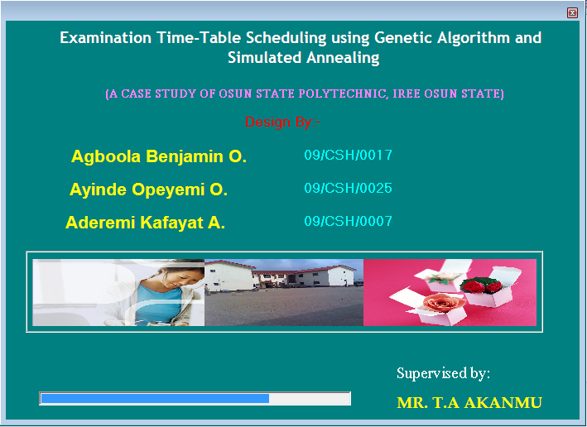
Figure 4.1 Loading interface
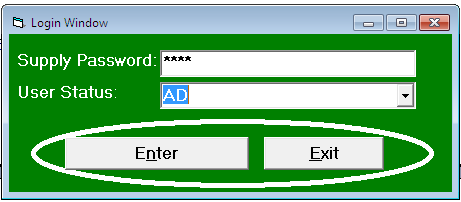
Figure 4.2: password login window login interface

The operations briefly described above have been implemented to replace the standard operators in the early system. Test problems with fifty exams to be scheduled in four rooms with capacities 400, 480, 560, 600 were generated.
In this project Microsoft visual basic was used in writing the code, which the generated the given result. The code was debugged in the Microsoft visual studio 2005 environment. The code is loaded into Microsoft visual studio 2005 environment from visual studio file menu then the code is debugged from the debug menu, and then selects the start debugging menu. Alternatively this can be done by pressing f5

Figure 4.3: Time table running interface.
The program environment has on it, menu bar, and the system setup menu, sitting arrangement menu, time table sheet menu, report menu and exit menu. Under the system setup menu we have faculty and department specification, specify class for re-runner students, supervisor section and the password section.
Under sitting arrangement we have student sitting arrangement and under the time table we have school time table form while under the report we have time table sheet, supervisor and venue sheet session sitting arrangement while under the exit we have quit. Under configuration module, from the interface select system setup menu and then select the faculty and departmental specification.

Figure 4.4: Faculty and departmental report menu: Interface.

The interface then configure in order to load the configuration module for entering of faculty and department, in order to save it for reference purpose as shown in the figure below.

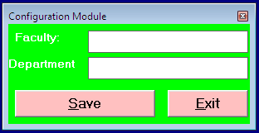
Figure 4.5: Configuration module for entering faculty $ department
From the same setup menu, select your specific class to supply venue for examination as shown below.

Figure 4.6: Specific class popup menu interface
From the same system setup menu select supervisor section to enter number of needed supervisor, venue, hall capacity and the number of student to be on a seat. As shown below
Figure 4.7: Supervisor section interface
From the system setup menu, select the password section either to assign password or change password.
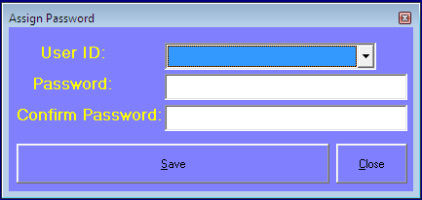
Figure 4.8 Assign password menu interface
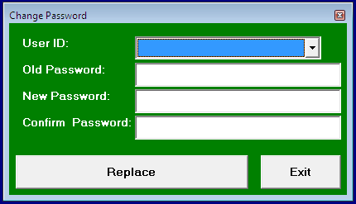
Figure 4.8.1 Change password menu interface
From the sitting arrangement we select from the start menu, sitting arrangement, session, Matric no revenue level, semester row, column and location for the sitting arrangement of student for examination.
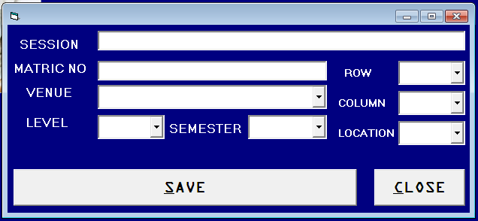
Figure 4.9 Student sitting arrangement interface
From the time table sheet menu select school time table form to generate the date, time, department, venue and courses for each student as shown below.
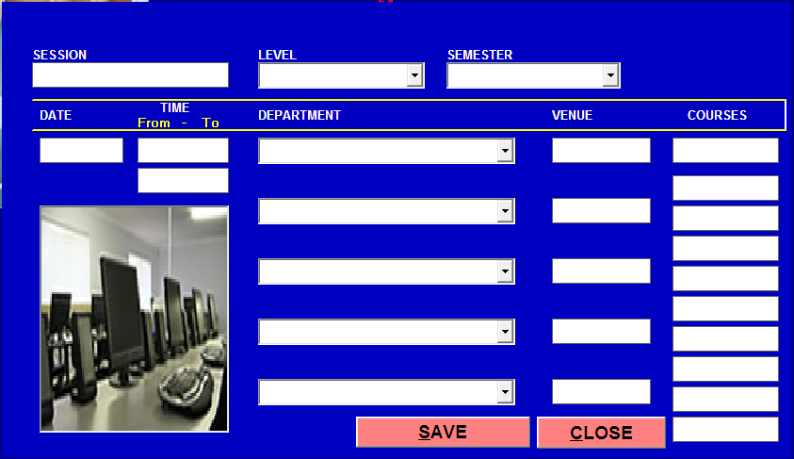
Figure 4.9.1 Time table from interface
From the report select the time table sheet to view the modified examination time-table for the semester as shown below.
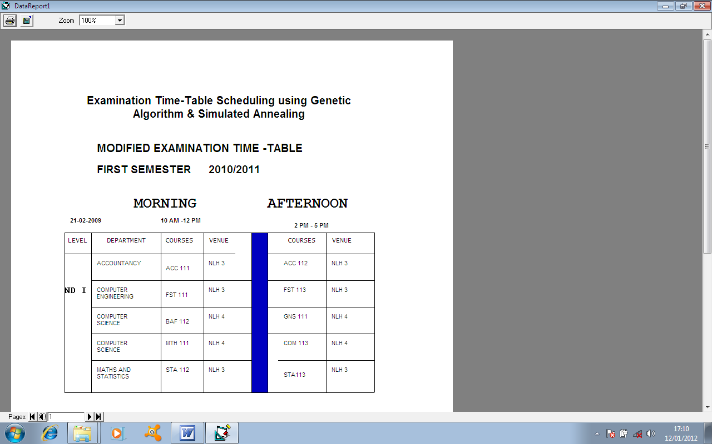
Figure 4.9.2 Time table sheet report interface
From the report menu select supervisor and venue sheet to view sheet the supervisors venue list as shown below
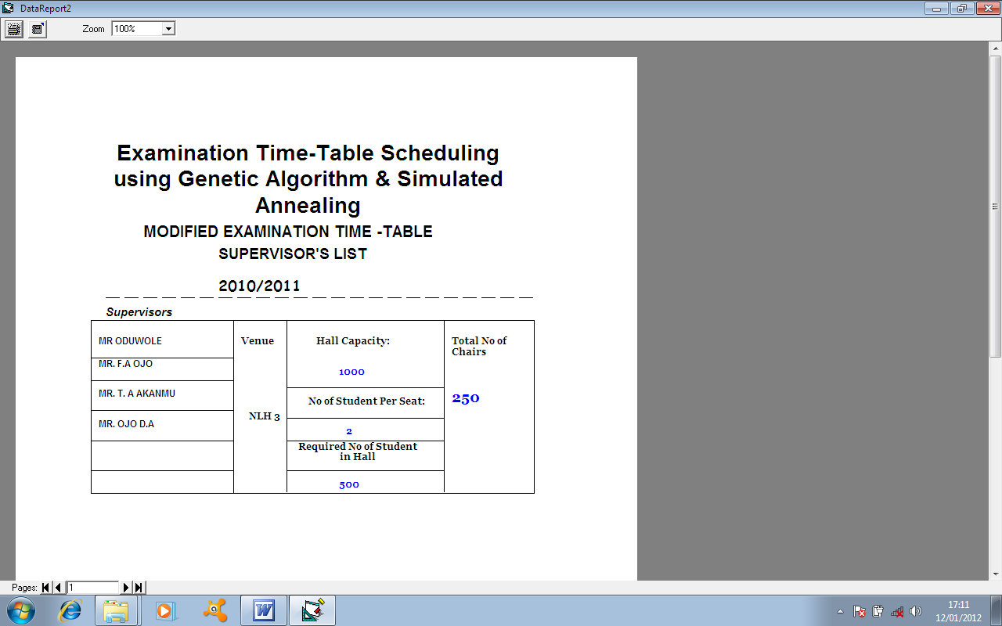
Figure 4.9.3: Supervisor and venue sheet report interface
From the report menu select session sitting arrangement to view the report of each hall sitting arrangement. As shown below.
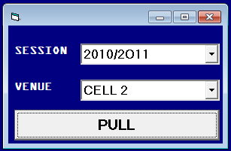

Figure 4.9.4: Session sitting arrangement report interface
From the exist menu, select quit to log out of the program environment, when you have nothing to do in the interface environment and after selecting the quit from the exit menu, a box will be pop up asking you, whether you are intending to quit from the main menu, or not . As shown below
Figure 4.9.5: from the exit menu, select quit to log out of the program environment, when you have nothing to do in the interface environment and after selecting the quit from the Exit menu, a box will be pop up asking you, weather you are intending to quit from the main menu, or not as show below
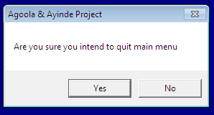
Figure 4.9.5 Exit menu interface

Discussions
Using the following Analytical measure, it is necessary to define the various parameters that are used in determining the function of analysis used in the evaluation of various differences in the performance of simulated annealing and genetic algorithms in the development of automated examination timetable generation. The following parameters are defined below:
-Line of code: the number of lines of lines used in writing the codes.
-Time to run: the time used in generating the time table.
-For all the halstead metrics the following is true
n1 = count of unique operations
n2 = count of unique operands.
n1 = total number of operands.
n2 = total number of operands.
The program vocabulary, n, is given by n = n1+n2
Program length (N): N = N1+N2
Program volume (v): N log n,
Program level (L):L =(2/n1)*(n2/n2);
Program difficulty (D): D =1/L
Cyclomatic complexity: a module corresponds to a single function or subroutine in typical languages, has a single entry and exit point and is able to be used as a design component via a call/return mechanism. Cyclomatic complexity is precisely the minimum number of paths that can, in (linear) combination, generate all possible paths through the module.

Asymptotic Time Complexity Measure
This is an analytical measurement in which relevant aspects of a program are analyzed in order to find out its efficiency and factors that affects its efficiency. Example: amount of memory required number of additions, multiplication and so on.

ANALYTICAL MEASURES FOR PERFORMANCE EVOLUTION OF SA AND GA
4.0 Summary of The Result
ANALYTICAL MEASURE SA GA
FIG. 4.1 Line of Code 396 500
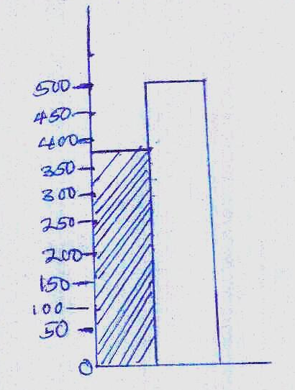

Line of Code (*10)
SA GA
FIG 4.2 EXECUTING TIME (SEC) 5 SEC 12 SEC
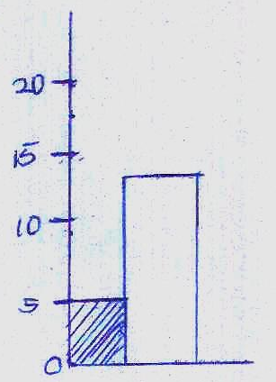
Executing time (Sec)
FIG 4.3
HALSTEAD METRICS SA GA
Program Length(N) 22 29
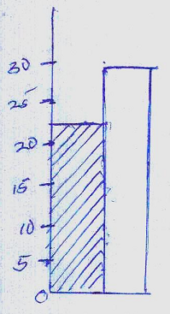
Program Length (N)
SA GA
FIG 4.4 PROGRAM VOLUME (V) 22 33
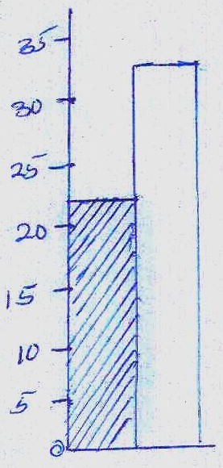
Program Volume (v)
FIG 4.5 PROGRAM DIFFICULTIES (O)
SA GA
0.21 0.14
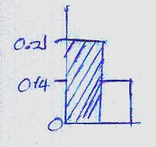
Program Difficulty (o)

FIG 4.6 CYCLOMATIC COMPLEXITY
SA GA
25 28
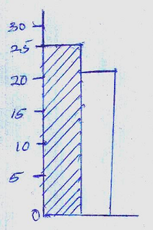
Cyclomatic Complexity

FIG 4.7 ASYMPTOTIC TIME COMPLEXITY
Measure (mb) SA GA
11 70
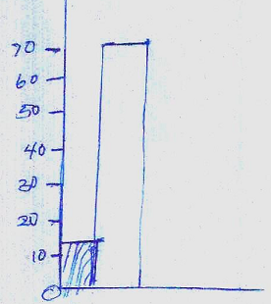
Asymptotic Time Complexity Measure (mb)

80

70

60

50

40

30

20

10

0
Line of Executing Program Program Program Cyclomatic Asymptotic
Code (*10) Time (s) Length (n) Volume(v) Difficulty Complexity (mb)

FIG. 4.8 GRAPH OF SA AND GA ANALYSIS

Table 4.1 Significant Differences for GA And SA
GENETIC ALGORITHM | SIMULATED ANNEALING
It has a longer line of code for the time table generation | It has shorter line of code for the time table generation.
It takes longer time for that generation of time tables | It takes a shorter period of time to generate time tables.
Inputs are inserted from the code line. | Inputs are inserted directly from the output format.
It takes large amount of the processor. | It takes lesser amount of the processor.
It occupies larger memory space in the hard disk. | It occupies minimal memory space in the hard disk.

CHAPTER FIVE
5.0 SUMMARY, CONCLUSION AND RECOMMENDATION

5.1 Summary and Conclusion
Its is clearly shown that in the performance evaluation of SA and GA in the design and implementation of automated timetable generation, that the performance of SA is better than that of GA. We shall have to check; in particular, which combination of new operators will be the best in performing the iteration steps of algorithms. The idea is that first in GA few periods are used regardless of the number of clashes. However, in SA large population of courses are used in order to determine factors was increase in the if the courses offered by the students of the institution.

5.2 Recommendation
It is recommended that test and analysis should be performed in order to ascertain the probabilisation efficiency of both Genetic Algorithm and simulated annealing so as to be able to use the algorithm for further implementation to other various problems and to present significant results to the problems.

REFERENCES
Cerny V. (1985); A thermodynamical approach to the travelling salesman
problems: an efficient Simulation Algorithm. Journal of Optimization
theory and applications, 45:41-51
Carter M. Laporte G., Chinneck J. (i1994); Interfaces Vol. 24,3 May-June,
109-120.
Carter M. Laporte G., Lee S. (1996); Examination Timetabling Alogrith
Strategies and applications, Journal of the Operational Research
Society, Vol. 47, pp. 373-383.
Dimopoulou M., Milliots P. (2001): Implementation of a University Course
and Examination Timetabling Systtem, European Journal of
Operational Research, Vol. 130, pp 202-213. AJST, Vol. 8, No. 2:
December 2007, 32 A. R. Mushi
Duong T., Lam K. (2004). Combining constraint programming and
Simulated Annealling of University Exams Timetabling, 2nd
International Confrence, Associating Enquiring Vietnamese and French speaking people in Data processing (RIV 04), February 2-5 Hanoi,
Vietnam.
Eglese R. W. (1990): Simulated Annealling; A tool for Operational
Research, European Journal of Operational Reseach, Vol. 46, pp. 217-
281-7. ElMohammeds., Coddington P.42 (1998). A comparison of Anealling techniques for academic course scheduling Lectures Notes in
Computer Science, Vol 1408, pp. 92-114.

