DESIGN AND IMPLEMENTATION OF ENCRYPTED DATABASE SYSTEM
CHAPTER ONE

1.0 INTRODUCTION
Historically, ensuring security mostly involved employing rudimentary measures such as securing physical access through door locks or safeguarding sensitive documents within secured filing cabinets or safes. In contemporary times, paper has ceased to be the exclusive medium for storing and disseminating information. Files are stored in both computer databases and physical file cabinets. Hard disc drives and floppy discs serve as repositories for a significant amount of our confidential data.

In the realm of physicality, the concept of security can be considered quite straightforward. A property can be considered secure if the locks on its doors and windows are sufficiently robust to prevent unauthorised access and theft of its contents. In order to enhance security measures against unauthorised access, the implementation of security alarms may be considered. In a comparable scenario, in the event that an individual attempts to illicitly take funds from your bank account, the teller's request for identification and scepticism towards the thief's narrative ensures the safeguarding of your monetary assets. When individuals enter into a contractual agreement, the act of affixing their signatures serves as the legally binding mechanism that compels both parties to fulfil their respective obligations.

In the realm of digital technology, security operates in a comparable manner. One fundamental notion is that of privacy, which is the prevention of unauthorised access to personal files containing sensitive information, such as medical records, or the unauthorised acquisition of financial resources by means such as collecting credit card numbers or online brokerage account details. Privacy can be conceptualised as a metaphorical lock that safeguards personal information and restricts unauthorised access. Data integrity is a conceptual framework that pertains to the identification of any modifications made to a given entity. The sound indicates the activation of an alarm system. Through the use of authentication protocols, it becomes possible to validate and confirm the identities of individuals or entities. This requirement is analogous to the identification needed for the purpose of withdrawing funds from a bank account or engaging in a transaction with an internet broker. Lastly, non-repudiation serves as a legal imperative that compels individuals to uphold their commitments.

With the increasing ubiquity of the Internet in everyday activities, the importance of ensuring electronic security becomes increasingly paramount. It is imperative for any organisation involved in online operations to evaluate and effectively handle the electronic security threats that are inherent to such activities. The utilisation of cryptographic techniques plays a central role in numerous risk-management measures. Cryptography is often regarded as the foremost security tool.

  - BACKGROUND OF THE STUDY
Before the modern era, cryptography was concerned solely with message confidentiality (i.e., encryption) — conversion of messages from a comprehensible form into an incomprehensible one, and back again at the other end, rendering it unreadable by interceptors or eavesdroppers without secret knowledge (namely, the key needed for decryption of that message). In recent decades, the field has expanded beyond confidentiality concerns to include techniques for message integrity checking, sender/receiver identity authentication, digital signatures, interactive proofs, and secure computation, amongst others.

Encryption attempts to ensure secrecy in communications, such as those of spies, military leaders, and diplomats, but it have also had religious applications.

Steganography (i.e., hiding even the existence of a message so as to keep it confidential) was also first developed in ancient times. An early example, from Herodotus, concealed a message - a tattoo on a slave's shaved head - under the regrown hair. More modern examples of steganographyk include the use of invisible ink, microdots, and digital watermarks to conceal information.

1.2 STATEMENT OF THE PROBLEM

The problem is security. The password method used in almost all commercial operating systems is probably not very strong against a sophisticated or unsophisticated attacker. The choice of data encryption comes next in the minds of those that want reduction of unauthorized access on confidential files or data.

Security provided by the computer operating systems come with a preset super user account and password. The super user may have a password to control network functionality, another to conduct or access nightly backups, create accounts, and so on. For a cracker, logging on to a system as the super user is possibly the best way to collect data or do damage. If the super user has not changed an operating system’s preprogrammed passwords, the network is vulnerable to attack. Most crackers know these passwords, and their first attempt to break into a network is simply to try them. If an attacker cannot log on as the super user, the next best thing might be to figure out the user name and password of a regular user. It is used to be standard practice in most Universities and colleges, and in some commercial companies, to assign every student or employee an account with user name and initial password – the password being the user name. Everyone was instructed to log on and change the password, but often, hackers and crackers logged on before legitimate users had a chance.

1.3 OBJECTIVES OF THE STUDY

- To understand and improve the computer data security through encryption of data.
- To provide a means of safeguarding data in a system
- To enhance the integrity of data
- To facilitate the use of more sopheasted tool against hacking, cracking, bugging of a system.
- To develop a platform to complement physical security.

1.4 SIGNIFICANCE OF THE STUDY
Data security in these contemporary times is a must. For your secrets to be secure, it may be necessary to add protections not provided by your computer operating systems. The built-in protections may be adequate in some cases. If no one ever tries to break into or steal data from a particular computer, its data will be safe. Or if the intruder has not learned how to get around the simple default mechanisms, they’re sufficient. But many attackers do have the skills and resources to break various security systems. If you decide to do nothing and hope that no skilled cracker targets your information, you may get lucky, and nothing bad will happen.

One of the most important tools for protecting your data from an authorized access is Data Encryption, any of various methods that are used to turn readable files into gibberish. Even if an attacker obtains the contents of the file, it is gibberish. It does not matter whether or not the operating system protections worked.

  - LIMITATIONS OF THE STUDY
Technology constraint: The problem encountered here is searching information about computer security through Data Encryption and Key Hash Algorithm and another problem is since the secret key has to be send to the receiver of the encrypted data, it is hard to securely pass the key over the network to the receiver.
Time constraint: the time giving for the submission of this project work was not really enough for the researcher to extensively carry out more research on this work.
Financial constraint: there was not enough money to extensively carry out this work.

  - SCOPE OF THE STUDY
Computer Security has been defined as the art of protecting computer system and information from harm and unauthorized use .the most important security tool beyond human integrity used is cryptography. which is used to hide data from public view and to ensure that the integrity and privacy of any data sent across a network is not compromised. cryptography involves encryption and decryption process .the scope of this study covers the message security ,message integrity, user authentication and key management of messages.

1.6 DEFINITION OF TERMS

SECURITY: The set of accesses controls and permission that are used to determine if a server can grant a request for a service or resource from a client.

PASSWORD: An identity that defines an authorized users of a computer in order to access to the system.

SOFTWARE: A collection of computer programs that runs as a group to accomplish a set of objectives which could be referred to as job.

SYSTEM: An organized unit which composed of two or more inter related parts that functions together to achieve a particular goal.

ENCRYPTION: The process of converting ordinary information (plaintext) into unintelligible gibberish (that is, cipher text).

DECRYPTION: The reverse, moving from unintelligible cipher text to plain text.

ALOGRITM: This is a sequential way of solving a problem.

CRYPTOGRAPHY: This is used to hide data from public view and to ensure that the integrity and privacy of any data sent across a network has not been compromised.

CHAPTER TWO

2.0 LITERATURE REVIEW

2.1 THE CONCEPT OF CRYPTOSECURITY
Security is the quality or state of being secure: - a relief from exposure to danger, and making safe against adverse contingencies. But encryption alone is not sufficient. Proper key selection, key management, physical security, people security and procedures to ensure that the plaintext does not leak out of the system via loopholes are all essential for a secure computer data system. The strength of a good cryptosystem does not depend on keeping its algorithm secret; the security of the cipher text relies solely on the secrecy of the key.

2.2 CRYPTOGRAPHY
Stewart, Ed Tiltel and Mike(2000) defined Cryptography as added security to data during processing, storage and communications. They further described the various types of cryptography such as Symmetric Key Cryptography and Asymmetric Key Cryptography or Public Key.

Kessler (1998), described cryptography as the science of writing in secret code. He further describes it as one essential aspect for secure communication.

In data communication and telecommunication, cryptography is necessary when communicating over any untrusted medium, which includes just about any network, particularly the internet. Cryptography, then, not only protects data from theft or alteration, but can also be used for user authentication.
Burnett and Panini(2004) outline the security requirement which include the following:

- Authentication
- Privacy/confidentiality
- Integrity
- Non-repudiation
Liddell and scolt(1996) stated in their book that in the famous Greek drama the 'Iliad', cryptography was used when Bellerophon was sent to the king with a secret tablet which told the king to have him put to death. The king tried to kill him by having him fight several mythical creatures, but he won every battle.
The Spartans used a system which consisted of a thin sheet of papyrus wrapped around a staff (now called a "staff cipher"). Messages were written down the length of the staff, and the papyrus was unwrapped. In order to read the message, the papyrus had to be wrapped around a staff of equal diameter. Called the 'skytale' cipher, this was used in the 5th century B.C. to send secret messages between greek warriors. Without the right staff, it would be difficult to decode the message using the techniques available at that time. The following version of the alphabet demonstrates the technique. First we see the wrapped version of the alphabet, then the unwrapped version.

ADGJMPSVY
BEHKNQTWZ
CFILORUX
ADGJMPSVYBEHKNQTWZCFILORUX
Fig, 2.1 skytale cipher
Another Greek method was developed by Polybius (now called the "Polybius Square"). The letters of the alphabet would be laid out in a five by five square (similar to the later Playfair method) with i and j occupying the same square. Rows and columns are numbered 1 to 5 so that each letter has a corresponding (row,column) pair. These pairs could easily be signaled by torches or hand signals. Decryption consists of mapping the digit pairs back into their corresponding characters. This system was the first to reduce the size of the symbol set, and in a loose sense it might be considered the forerunner of modern binary representations of characters. Try decoding the message on the right.
\ 1 2 3 4 5
\_________
1|A B C D E T=54
2|F G H I J H=32 5344 44 4435
3|K L M N O I=42 4224 24 3211
4|P Q R S T S=44
5|U V W X Y/Z
Fig.2.2 The Polybius Square
Julius Ceasar used a system of cryptography (i.e. the 'Caesar Cipher') which shifted each letter 2 places further through the alphabet (e.g. Y shifts to A, R shifts to T, etc.). This is probably the first cipher used by most school children. In figure 2.4, the first row is plaintext, while the second row is the equivalent ciphertext. The distance of the displacement is not important to the scheme, and in fact, neither is the lexical ordering chosen. The general case of this sort of cipher is the "monoalphabetic substitution cipher" wherein each letter is mapped into another letter in a one to one fashion. Try decoding VJKU.
ABCDEFGHIJKLMNOPQRSTUVWXYZ
CDEFGHIJKLMNOPQRSTUVWXYZAB
Fig.2.3 : The Caesar Cipher
Cryptanalysis is the practice of changing ciphertext into plaintext without complete knowledge of the cipher. The Arabs were the first to make significant advances in cryptanalysis. An Arabic author, Qalqashandi, wrote down a technique for solving ciphers which is still used today. The technique is to write down all the ciphertext letters and count the frequency of each symbol. Using the average frequency of each letter of the language, the plaintext can be written out. This technique is powerful enough to cryptanalyze ANY monoalphabetic substitution cipher if enough cyphertext is provided.
El Gamely(1989) in his book stated how cryptography started to progress. All of the Western European governments used cryptography in one form or another, and codes started to become more popular. Ciphers were commonly used to keep in touch with ambassadors. The first major advances in cryptography were made in Italy. Venice created an elaborate organization in 1452 with the sole purpose of dealing with cryptography. They had three cipher secretaries who solved and created ciphers that were used by the government.

Shamir (1977) in his book declared Leon Battista Albert as "The Father of Western Cryptology" in part because of his development of polyalphabetic substitution. Polyalphabetic substitution is any technique which allows different ciphertext symbols to represent the same plaintext symbol. This makes it more difficult to interpret ciphertext using frequency analysis. In order to develop this technique, Alberti analyzed the methods for breaking ciphers, and devised a cipher which would try to render these techniques invalid. He designed two copper disks that fit into each other, each with the alphabet inscribed upon it. To start enciphering, a predetermined letter on the inner disk is lined up with any letter on the outer disk, which is written as the first character of the ciphertext. The disks are kept stationary, with each plaintext letter on the inner disk aligned with a ciphertext letter on the outer disk. After a few words of ciphertext, the disks are rotated so that the index letter on the inner disk is aligned with a new letter on the outer disk, and in this manner, the message is enciphered. By rotating the disk every few words, the cipher changed enough to limit the effectiveness of frequency analysis. Even though this technique in its stated form is very weak, the idea of rotating the disks and therefore changing the cipher many times within a message was a major breakthrough in cryptography.

Rivest(1990) explained how the next major step was taken in 1518, by Trithemius, a German monk who had a deep interest in the occult. He wrote a series of six books called 'Polygraph', and in the fifth book, devised a table that repeated the alphabet with each row a duplicate of the one above it, shifted over one letter. To encode a message, the first letter of the plaintext is enciphered with the first row of the table, the second letter with the second row, and so on. This produces a message where all available ciphers are used before being repeated. Figure 2.5 shows a changing key cipher of this sort. Notice that the assignment of code symbols to plaintext symbols changes at each time step (T1,T2,...). In this system, the key repeats every 26 letters of cipher text.

ABCDEFGHIJKLMNOPQRSTUVWXYZ Plaintext
FGUQHXSZACNDMRTVWEJBLIKPYO T00
OFGUQHXSZACNDMRTVWEJBLIKPY T01
YOFGUQHXSZACNDMRTVWEJBLIKP T02
PYOFGUQHXSZACNDMRTVWEJBLIK T03
...
GUQHXSZACNDMRTVWEJBLIKPYOF T25
Fig.2.4 A Changing Key Cipher

Behrouz and forouzan(2004) in their book stated that in 1553, Giovanni Batista Belasco extended this technique by choosing a keyword that is written above the plaintext, in a letter to letter correspondence. The keyword is restarted at the beginning of each new plaintext word. The letter of the keyword above the letter of the plaintext is the first letter of the cipher line to be used. In other words, if the plaintext letter is 'b', and it's keyword letter is 'r', then the line of the Trithemius cipher beginning with 'r' is used to encipher the letter 'b'.
The most famous cryptographer of the 16th century was Blaise de Vigenere (1523-1596). In 1585, he wrote 'Tracte des Chiffres' in which he used a Trithemius table, but changed the way the key system worked. One of his techniques used the plaintext as it's own key. Another used the ciphertext. The manner in which these keys are used is known as key scheduling, and is an integral part of the "Data Encryption Standard" (DES) [DESDOC77] which we will discuss later.
Robshaw (1994) stated in his book that in the year 1628, a Frenchman named Antoine Rossignol helped his army defeat the Huguenots by decoding a captured message. After this victory, he was called upon many times to solve ciphers for the French government. He used two lists to solve his ciphers: "one in which the plain elements were in alphabetical order and the code elements randomized, and one to facilitate decoding in which the code elements stood in alphabetical or numerical order while their plain equivalents were disarranged." When Rossignol died in 1682, his son, and later his grandson, continued his work. By this time, there were many cryptographers employed by the French government. Together, they formed the "Cabinet Noir" (the "Black Chamber").
Shamir and Adleman(1978) stated in their book that the father of American cryptology is James Lovell. He was loyal to the colonies, and solved many British ciphers, some which led to Revolutionary victories. In fact, one of the messages that he deciphered set the stage for the final victory of the war.
According to Panini(2004) he stated that the 'wheel cipher' was invented by Thomas Jefferson around 1795, and although he never did very much with it, a very similar system was still in use by the US navy only a few years ago. The wheel cipher consisted of a set of wheels, each with random orderings of the letters of the alphabet. The key to the system is the ordering in which the wheels are placed on an axle. The message is encoded by aligning the letters along the rotational axis of the axle such that the desired message is formed. Any other row of aligned letters can then be used as the ciphertext for transmission. The decryption requires the recipient to align the letters of the ciphertext along the rotational axis and find a set of aligned letters that makes linguistic sense as plaintext. This will be the message. There is a very small probability that there will be two sensible messages from the decryption process, but this can be checked simply by the originator. Without knowing the orderings of symbols on the wheels and the ordering of wheels on the axle, any plaintext of the appropriate length is possible, and thus the system is quite secure for one time use. Statistical attacks are feasible if the same wheels are used in the same order many times.
GJTXUVWCHYIZKLNMARBFDOESQP
W1
IKMNQLPBYFCWEDXGZAJHURSTOV
W2
HJLIKNXWCGBDSRVUEOFYPAMQZT
W3
...
BDFONGHJIKLSTVUWMYEPRQXZAC
Wn
Fig 2.5: A Wheel Cipher
Schneider (1996) stated that In 1844, the development of cryptography was dramatically altered by the invention of the telegraph. Communication with the telegraph was by no means secure, so ciphers were needed to transmit secret information. The public's interest in cryptography blossomed, and many individuals attempted to formulate their own cipher systems. The advent of the telegraph provided the first instance where a base commander could be in instant communication with his field commanders during battle. Thus, a field cipher was needed. At first, the military used a Vigenere cipher with a short repeating keyword, but in 1863, a solution was discovered by Friedrich W. Kasiski for all periodic polyalphabetic ciphers which up until this time were considered unbreakable, so the military had to search for a new cipher to replace the Vigenere.
El Genial (1985) stated that the 'Playfair' system was invented by Charles Wheatstone and Lyon Playfair in 1854, and was the first system that used pairs of symbols for encryption. The alphabet is laid out in a random 5 x 5 square, and the text is divided into adjacent pairs. The two letters of the pair are located, and a rectangle is formed with the two letters at opposite corners. The letters at the other two corners are the two letters of ciphertext. This is very simple to use, but is not extremely difficult to break. The real breakthrough in this system was the use of two letters at a time. The effect is to make the statistics of the language less pronounced, and therefore to increase the amount of work and the amount of ciphertext required to determine a solution. This system was still in limited use in world war II, and was very effective against the Japanese.
IKMNQ
LPBYF
PLAINTEXT = PL AI NT EX TZ
CWEDX = =
GZAHU
LPMGMOXEAS = LP MG MO XE AS
RSTOV
Fig 2.6: A Playfair System
Vigenere (1972) stated that in 1859, Pliny Earle Chase, developed what is known as the fractionating or topographic cipher. A two digit number was assigned to each character of plaintext by means of a table. These numbers were written so that the first numbers formed a row on top of the second numbers. The bottom row was multiplied by nine, and the corresponding pairs are put back in the table to form the cipher text.
Hellman’(1976) started in his book that Kasiski developed a cryptanalysis method in 1863 which broke almost every existing cipher of that time. The method was to find repetitions of strings of characters in the ciphertext. The distance between these repetitions is then used to find the length of the key. Since repetitions of identically ciphered identical plaintext occur at distances which are a multiple of the key length, finding greatest common divisors of repetition distances will lead to the key length. Once the key length (N) is known, we use statistics on every Nth character and the frequency of use implies which character it represents in that set of ciphertext symbols. These repetitions sometimes occur by pure chance, and it sometimes takes several tries to find the true length of the key using this method, but it is considerably more effective than previous techniques. This technique makes cryptanalysis of polyalphabetic substitution ciphers quite straight forward.
The story of cryptography would be at an end if it weren't for the practical problem that in order to send a secret message, an equal amount of secret key must first be sent.

2.3 DES – DATA ENCRYPTION STANDARD
In 1972 the US NATIONAL BUREAU OF STANDARDS began the search for an encryption algorithm that could be tested and certified. After several false starts in 1974 IBM offered the US government an algorithm which was based on the early 1970’s LUFICER algorithm. The offer was accepted and the algorithm was tested and ‘adjusted’ by the NSA and eventually released as a federal standard in 1976.
DES is a SYMMETRIC BLOCK cypher based on a 64 bit block. The user feeds in a 64 block of plain text and is returned 64 bits of cyphertext. The same algorithm and key are used for the encrypt and decrypt operations.

2.4 PGP – PRETTY GOOD PRIVACY
This software package is designed to provide an encryption capability for e-mail and was originally developed by PHILIP ZIMMERMANN who began working on the algorithm in the late 1980’s. The development of this system was as much about Zimmermann’s distrust of the US Federal Government and its ability to intercept electronic communication as the development of a commercial cryptographic product. The history of this system has two interesting facets. Initially, an unlicensed implementation of RSA was used to provide key management while the IDEA algorithm was used to provide the actual data encryption layer. Because of Zimmermann’s distrust of the US government, the complete package was downloaded onto the internet so that it could be distributed as freeware. This, of course, created maximum heart-burn for the US government and led to their ill considered use of pressure on him which in turn reinforced his position.

2.5 DIFFE-HELLMAN-MERKEL KEY EXCHANGE
WHITFIELD DIFFE was already considering the problems of e-commerce when the US defence department’s ARPA Net, the forerunner of the internet, was still in its infancy. In 1974 he teamed with MARTIN HELLMAN and later RALPH MERKLE to begin research into the problem of key exchange. By 1976, using one-way functions and modular arithmetic, Hellman had developed a strategy to solve the key exchange problem. In June 1976 at the US National Computer Conference, they demonstrated that Bob no longer had to meet John to exchange a secret key. While this was a fundamental breakthrough in conceptual terms, it did not offer a ‘real world’ solution to the problem of key exchange. While working on the key exchange problem with Hellman and Merkel, Diffe had continued to ponder a solution for the obvious problems of the key exchange technique. In 1975 he developed the concept of the ASYMMETRIC KEY which opened the possibility of operating a cryptosystem with a PUBLIC (published) and PRIVATE (secret) key. He also published a paper on his work in the same year while continuing to look for the one way function that would make his theory a reality. He never made that connection and the first (then) known developers of an asymmetric key system would be the inventors of RSA.

2.6 RSA- Rivest, Shamir and Adleman
This algorithm, based on the original work of Diffe, was named after the three inventors Ron Rivest, Adi Shamir and Leonard Adleman. This is an ASYMMETRIC cypher and as such is able to be used for PUBLIC KEY CRYPTOGRAPHY. In simple terms you can send Bob a message encrypted with his PUBLIC/PUBLISHED key and when he has received it he can decrypt it with his SECRET/PRIVATE key (from which his public key was derived). The security of this system is based on the difficulty in FACTORING large numbers. The private and public keys can be functions of large (300-400 digit) prime numbers. While the process is known, recovering the plaintext from the public key is considered to be the equivalent to factoring the product of the two prime numbers. With large numbers this is considered a MAJOR computational task,even by to-days standards, and is believed to be, in terms of time, beyond the capability of any existing technique/computer combination.

2.7 THE IMPACT OF MODERN ELECTRONICS ON CRYPTOGRAPHICAL SYSTEMS
In the years immediately following World War II, the electronic technology that had been developed in support of radar and the recently discovered digital computer were adapted to crypto machines. The first of such devices are little more than rotor machines in which the rotors had been replaced by electronically realized substitutions. The advantage of electronic crypto machines were speed of operation; the disadvantage was the crypto analytic weakness inherited from the mechanical rotor machines and the principle of cyclically shift in simple substitutions. It was quickly recognized, however, that electronics made possible the practical realization of more cryptographic functions that had previously been feasible.

The emergence of the transistor, in the 1960s, permitted the implementation of complex transformations in special-purpose circuitry. The most reliable indication of cryptographic developments in the period from the first generation of rotor machines developed by the U.S for the North Atlantic Treaty Organization (NATO) to the appearance of the Data Encryption Standard (DES) and public key systems is to be found in commercial equipment.

  - APPLICATION OF CRYTOLOGY IN PRIVATE AND COMMERCIAL LIFE
Cryptology protects the rights and interests of individuals in several reas of human Endeavour. For example, the Personal Identity Number (PIN) that must be entered into the Automated Teller Machine (ATM), along with a bankcard to corroborate that the card is being used by an authorized bearer, may either be stored in the computer systems in the bank in an encrypted form (i.e. as a cipher), or it may be encrypted on the bankcard itself. The transformation used in this type of cryptography is called one-way; this means that it is easy to compute a cipher given the bank’s key and the customer’s PIN, but computationally infeasible to compute the plaintext PIN from the cipher, even though the key is known. This is to protect the individual who owns the said bank account from being impersonated by an imposter who has access to the bank files. As an added security check, the communications between – this is to prevent a would be thief from tapping into the phone lines and recording the signals sent to the ATM to authorize the issuing of cash in response to the legitimate user request and then later feeding the same signal to the ATM repeatedly to deceive it into dispensing cash illegitimately.

Another way that cryptography applies in commercial life is in the prevention of criminals from forging winning lottery tickets. Unlike currency (take naira for instance), which involves –
- specially compounded ink,
- watermarked or tagged paper and
- state-of-the-art engraving

Lottery tickets are printed on ordinary paper with ordinary ink, thereby making them very prone to counterfeiting by unscrupulous persons. To check this loophole, each lottery ticket has two numbers printed on it; one is the identification number that will be announced if that ticket wins and the other is the encrypted version of this identifying number. Therefore, when this number is announced, the would-be forger will not be able to print an acceptable forgery-unless he also has successfully cryptanalyzed the lottery’s cryptosystem.

CHAPTER THREE

3.0 RESEARCH METHODOLOGY AND SYSTEM
ANALYSIS

3.I SYSTEM INVESTIGATIONS AND ANALYSIS

System investigation is concerned with the in-depth and comprehensive study carried out upon the old system so as to find out relevant facts that will be of help in designing the new system.

The task of investigation comprises the following:-
- Fact finding
- Analysis of data collected

3.2 FACT FINDING

This involves gathering facts about the existing system. The purpose of fact finding is to identify the application and the implication of system to the management.

3.3 RESEARCH METHODOLOGY

This research is based on the investigation undertaken in order to discover new facts information. The methodology studies the methods that are necessary to achieve the required subjects and facts. Meanwhile, the method adopted for this research is data collection to ensure authenticity of the final research. Whereas, methodology is a structured approach to a particular task. Therefore, research methodology is a detailed description of what the researcher planned and procedures adopted in gathering new facts relevant to the project work.

  - SOURCES OF DATA

The major source of data in this research is the secondary, which represents work already done in the research and includes the following information from:
- Textbooks
- Computer journals
- Newspapers
- Magazine
- Articles
- Library
- Internet

3.5 METHODS OF DATA COLLECTION

Here, the researcher undergoes his data collection through browsing the internet, reading related newspapers, magazines, text books and articles.

3.6 ANALYSIS OF DATA

It is vital to analyze facts collected. The collection of facts is not the end of study. However, the result of the investigation has to be analyzed and presented in orderly manner for easy comprehensive or understanding. The information gotten from the secondary data was analyzed.

3.7 SYSTEM ANAYSIS

This involves the study of the activity procedure and method of the existing system in order to have a full knowledge of the problems. The major activities that go on in the cryptosystems includes:-

  - Cryptography key
  - Cipher
  - Plaintext
  - Message Security
  - Digital Signature
  - Hash Function

3.8 CRYPTOGRAPHY KEYS

3.9 SYMMETRIC-KEY CRYPTOGRAPHY
In symmetric key cryptography, the same key is used by both parties. The sender uses this key and an encryption algorithm to encrypt data; the receiver uses the same key and the decryption algorithm to decrypt the data as shown in the figure below:
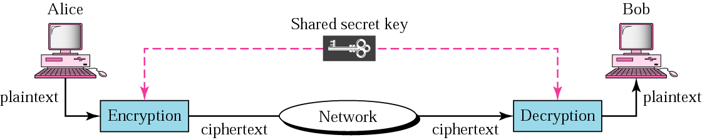
John
Fig3.1: symmetric key cryptography
In symmetric cryptography, the algorithm used for decryption is the inverse of the algorithm used for encryption. This means that if the encryption algorithm uses a combination of addition and multiplication, the decryption algorithm uses a combination of division and subtraction.
NB: the symmetric–key cryptography is so named because the same key is used in both directions. Symmetric key algorithms are efficient; it takes less time to encrypt a message using symmetric-key algorithm than it takes to encrypt using a public-key algorithm. The reason is that the key is usually smaller. For this reason, symmetric key algorithms are used to encrypt and decrypt long messages.
A symmetric key algorithm has two major disadvantages. Each pair of users must have a unique symmetric key. This means that if N people in the world want to use this method, there need to be N (N-1)/2 symmetric keys. For example, for 1 million people to communicate, 500billion people will need the symmetric keys. Secondly, the distribution of the keys between two parties can be difficult.

3.10 Ciphers
Ciphers are the secret codes used to encrypt plaintext messages. Ciphers of various types have been devised, but all of them are either substitution or transposition ciphers. Computer ciphers are ciphers that are used for digital messages. Computer ciphers differ from ordinary substitution and transposition ciphers in that a computer application performs the encryption of data. The term cryptography is sometimes restricted to the use of ciphers or to methods involving the substitution of other letters or symbols for the original letters of a message.
Ease of use makes ciphers popular. There are two general types of ciphers. Substitution ciphers require a cipher alphabet to replace plaintext with other letters or symbols. Transposition ciphers use the shuffling of letters in a word to make the word incomprehensible.

3.10.1 Substitution Ciphers:
A cipher using substitution method substitutes one symbol with another. If the symbols in the plaintext are alphabetic characters, we replace one character with another. For example we can replace character A with D and character T with Z. If the symbols are digits (0-9), we can replace 3 with 7 and 2 with 6. There are two types of substitution ciphers namely;
- Monoalphabetic substitution
- Polyalphabetic substitution.

3.10.2 Transposition Cipher:
In a transposition cipher, the characters retain their plaintext form but change their positions to create the cipher text. The text is organized into a two-dimensional table, and the columns are interchanged according to a key. For example, we can organize the plaintext into an 8-column table and then reorganize the columns according to a key that indicates the interchange rule. The key defines which columns should be swapped. This method can be combined with other methods to provide more sophisticated ciphers.

3.11 PUBLIC KEY CRYPTOGRAPHY
In public key cryptography there are two keys; the private key and the public key. The private key is kept by the receiver. The public key is announced to the public. Imagine John, as shown in figure below wants to send a message to Bob. John uses Bob’s public key to encrypt the message. When the message is received by Bob, his (Bob) private key is used to decrypt the message.
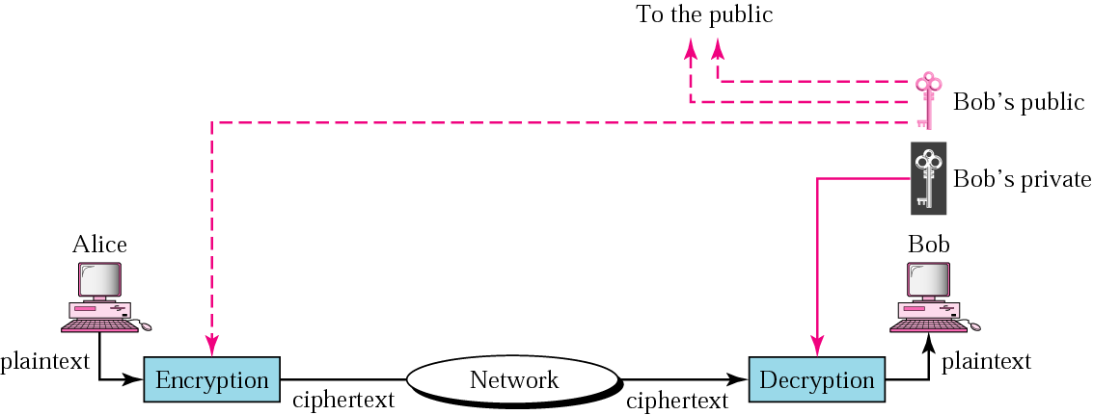

John
Fig 3.2:Public-key Cryptography

In public key encryption/decryption the public key that is used for encryption is different from the private key that is used for decryption. The public key is available to the public; the private key is available only to an individual.

Public key encryption/decryption has two advantages. First, it removes the restriction of a shared symmetric key between two entities (e.g.; persons) that needs to communicate with each other. A shared symmetric key is shared by the two parties and cannot be used when one of them wants to communicate with a third party. In public key encryption/decryption, each entity creates a pair of keys; the private one is kept and the public one is distributed. Each entity is independent, and the pair of keys created can be used to communicate with any other entity. The second advantage is that the number of keys needed is reduced tremendously. In this system, for one million users to communicate, only two million keys are needed and not 500 billion, as was the case in symmetric key cryptography.
Public key cryptography also has two disadvantages. The big disadvantage is the complexity of the algorithm if we want the method to be effective, the algorithm needs large numbers. Calculating the ciphertext form plaintext using the long keys takes a lot of time. That is the main reason that public key cryptography is not recommended for large amount of text.

The second disadvantage of public key method is that the association between an entity and its public key must be verified. If John sends her public key via an e-mail or over a network to Bob, then Bob must be sure that the private key really belongs to John and nobody else. We will see that the certification is really important when we use public-key cryptography for authentication. However, this disadvantage can be overcome using a certification authority (CA). The one most common type of public key cryptography today is based on the RSA algorithm.

3.11.1 Public-Key Certification
In public key cryptography, entities do not need to know the symmetric shared key. If John wants to send a message to Bob, he only needs to know Bob’s public key, which is open to the public and available to everyone else. If Bob needs to send a message to John, he only needs to know John’s public key, which is also known to everyone. In public key cryptography, everyone shields a private key and advertises a public key. The main problem here is how to advertise the public key and make it safe from Toni’s (the intruder) interference. If Bob sends his public key to John, Toni may intercept it and send his own public key to John. John, assuming that this is Bob’s public key, encrypts a message for Bob with this key and sends it to Bob. Toni again intercepts and decrypts the message with his private key and knows what John has sent to Bob. Toni can even put his public key online and claim that this is Bob’s public key. This is a very big problem with distribution of keys especially over the internet as it is prone to being intercepted by an intruder. As a result of this, a certification authority was put in place for key distribution and management.

3.11.2 Certification Authority (CA)
A certification authority is a federal or state organization that binds a public key and issues a certificate. The CA has a well known public key itself that cannot be forged. The CA checks Bob’s identification and asks for Bob’s public key and writes it on the certificate. To prevent the certificate itself from getting forged, the CA creates a message digest from the certificate and encrypts the message digest with its private key. Now Bob can upload the certificate as plaintext and the encrypted message digest. Anybody who wants Bob’s public key downloads the certificate and the encrypted digest. A digest can be created from the certificate. The two digest are then compared. If they are equal, the certificate is valid and no imposter has posed as Bob.

3.12 MESSAGE SECURITY

We can say that security provides four services: privacy (confidentiality), message authentication, message integrity, and non-repudiation as illustrated in the diagram shown below;
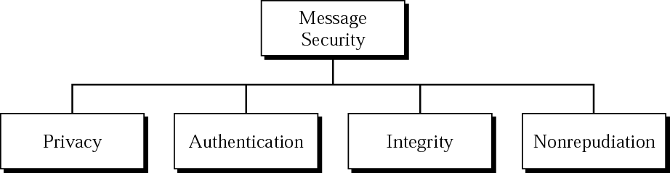

Fig3.3: Message security

3.12.1 Message Privacy
Privacy means the sender and the receiver expects confidentiality. The transmitted message must make sense only to the intended receiver. To all others, the message must be unintelligible. Encrypted information is virtually hidden from everyone who doesn't know how to decrypt it or doesn't have the appropriate key. This makes it possible to share secret information over insecure communication channels, such as the Internet, thus providing confidentiality even though the network itself is quite open. The same applies to data stored on disk. Encryption ensures confidentiality of stored data even if the computer itself gets compromised or stolen. To achieve privacy, the message must be encrypted. That is, the message must be rendered unintelligible to unauthorized parties. A good privacy technique guarantees to some extent that a potential intruder cannot understand the contents of the message.

3.12.2 Privacy with Symmetric-Key Cryptography
Privacy can be achieved using symmetric-key encryption and decryption, as shown in the figure below. As discussed earlier, in symmetric key cryptography the key is shared between John and Bob as shown below;

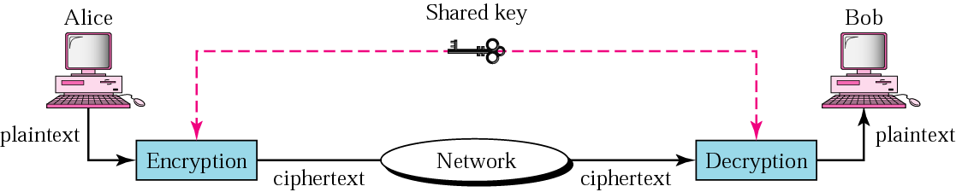
John
Fig3.4: Privacy with symmetric key

3.12.3 Privacy with Public Cryptography
Privacy can also be achieved using public key encryption. There are two keys: a private key and a public key. The private key is kept by the receiver and the public key is announced to the public as shown in the figure below;

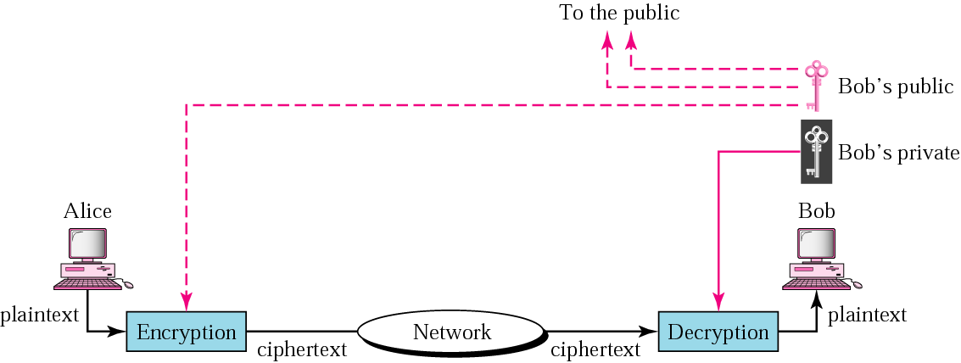
John
Fig3.5: Privacy with public cryptography

3.12.4 Message Authentication
Message authentication means that the receiver needs to be sure of the sender’s identity and that an imposer has not sent the message. In message authentication the identity of the user is verified once for each message or data sent across the network. Shortly digital signature which can be used to provide authentication will be discussed.

3.12.5 Integrity
Integrity means that data must arrive at the receiver exactly as they were sent. There must be no changes during transmission, either accidental or malicious. Nowadays, as more and more business transactions occur over the internet, integrity is crucial. For example, it would be disastrous if a request for transferring #100 changed to a request of #10,000. This is avoided by introducing various forms of error control mechanisms such as the Parity check, Checksum and the most reliable CRC (Cyclic redundancy check) codes when forwarding a data string or a packet over a network. These error detection codes enable the receiving station to know if the original message that was sent across the network is intact by inserting parity bits to the original message for error detection, thus preserving its integrity. The integrity of a message must be preserved in a secure communication.

3.12.6 Non-repudiation or Data origin
Non-repudiation means that a receiver must be able to prove that a received came from a specific sender. The sender must not be able to deny sending a message that he in fact, did send. The burden of this proof falls on the receiver. For example, when a customer sends a message to transfer money from one account to another, the bank must be able to prove that the customer actually requested this transaction. We shall see how digital signature can solve this. A physical signature on paper, along with the visually observable state of the paper, proves the authenticity of the document and is legally binding. Public key cryptography-based digital signature performs the same role for electronic documents.

3.13 DIGITAL SIGNATURE
Earlier, it was discussed that security provides four services in relation to a single message: privacy, authentication, integrity, and non-repudiation. Privacy has already been discussed. The other three can be achieved by using what is called digital signature. The idea of digital signing is similar to the signing of a document, but this time it is in form of an electronic signing. A message signed with a sender's private key can be verified by anyone who has access to the sender's public key, thereby proving that the sender signed it and that the message has not been tampered with. This is used to ensure authenticity. We have two options; either the whole document is signed or a digest (condensed version) of the document is signed.

Signing the Whole Document Public key encryption can be used to sign a document. However, the roles of the public and private keys are different here. The sender uses its private key to encrypt (sign) the message just as a person uses a signature (which is private in the sense that it is difficult to forge) to sign paper documents. The receiver, on the other hand, uses the public key of the sender to decrypt the message.

In digital signature, the private key is used for encryption and the public key is used for decryption. This is possible because the encryption and decryption algorithms used today, such as RSA, are mathematical formulas and their structures are familiar. This is illustrated in the figure below.

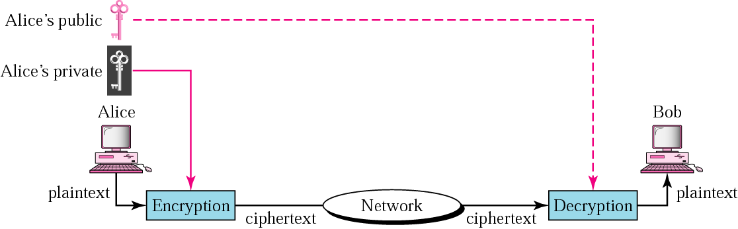
John
John’s public

John’s private
Fig 3.6: Digital signatures using public and private key cryptography

Digital signatures can provide integrity, authentication, and non-repudiation.
- Integrity: the integrity of the message is preserved because if Toni intercepted the message and partially or totally changed it, the decrypted message would be unreadable.
- Authentication: the following reasoning can be used to show how a message is authenticated. If Toni sends a message while pretending that it was coming from John, he must use his own private key for encryption. The message is then decrypted with the public key of John and therefore will be unreadable. Message encryption with Toni’s private key and decryption with John’s public key will result in garbage.
- Non-repudiation: digital signatures also provides for non-repudiation. Bob saves the message received from John. If the John later denies sending the message, Bob can show that encrypting and decrypting the saved message with John’s private and public key can create a duplicate of the saved message. Since only John knows his private key, he cannot deny sending the message.

3.14 Signing the Digest:
We said that public key encryption is efficient if the message is short. Using a public key to sign the entire message is very inefficient if the message is very long. The solution is to let the sender sign a digest of the document instead of the whole document. The sender creates a miniature version or digests of the document and signs it; the receiver then checks the signature on the miniature.
To create a digest of the message, we use a hash function. The hash function creates a fixed-size digest from a variable-length message, as shown below.

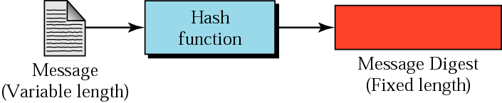
[
Fig3.7: Siging message digest using key hash function
NB: hashing function must have two properties to guarantee its success. First, hashing is one-way; the digest can only be created from the message, not vice versa. Second, hashing is a one-to-one function as there is little probability that two messages will create the same digest. After the digest has been created, it is encrypted (singed) using the sender’s private key. The encrypted digest is attached to the original message and sent to the receiver. The figure below explains this.
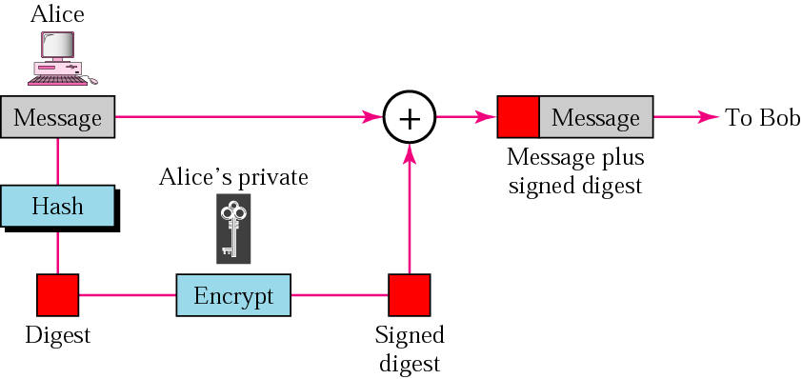
Sender site
John
John’s private
Fig 3.8: Siging message digest using key hash function
At the receiver site, the receiver receives the message and the encrypted digest and then separates the two. He applies the same hash function to the message to create a second digest. He also decrypts the received digest, using the public key of the sender. If the two digests are the same, all three security measures are preserved otherwise the message is invalid. The figure below shows the operation of the receiving site.
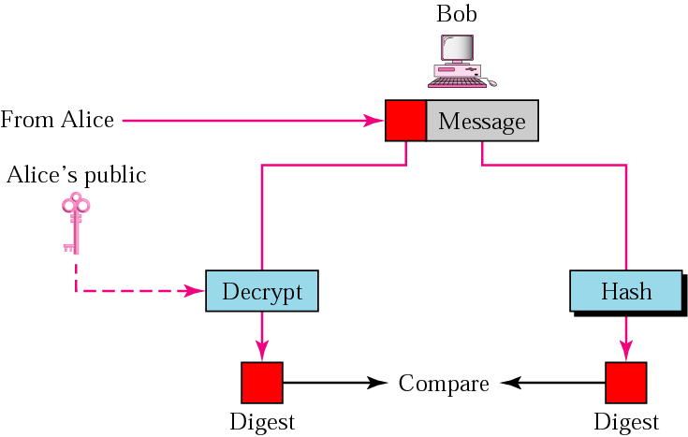
Receiver site

John

John’s public
Fig 3.9: Signing message digest using key hash function

3. 15 KEY MANAGEMENT

3.16 SYMMETRIC KEY DISTRIBUTION
There are three problems with symmetric keys.
[
- First, if n people want to communicate with one another, there is need for n (n-1)/2 symmetric keys. Consider that each of the n people may need to communicate with n-1 entity; this means that we need n (n-1) keys. However, symmetric keys are shared between two communicating entity; therefore, the actual number of keys needed is n (n-1)/2. This is usually referred to as the n²problem. If n is a small number, this is acceptable. For example, if 5 people need to communicate only 10 keys are needed. The problem is aggravated if n is a large number. For example, if n is 1 million, almost half a trillion keys are needed.
- Second, in a group of n people, each person must have and remember (n-1) keys, one for every other person in the group. This means that if one million people want to communicate with each other, each must remember almost 1 million keys in his or his computer.

3.16.1 Certification Authority (CA)
A certification authority is a federal or state organization that binds a public key and issues a certificate. The CA has a well known public key itself that cannot be forged. The CA checks Bob’s identification and asks for Bob’s public key and writes it on the certificate. To prevent the certificate itself from getting forged, the CA creates a message digest from the certificate and encrypts the message digest with its private key. Now Bob can upload the certificate as plaintext and the encrypted message digest. Anybody who wants Bob’s public key downloads the certificate and the encrypted digest. A digest can be created from the certificate. The two digest are then compared. If they are equal, the certificate is valid and no imposter has posed as Bob.

3.16.2 Session Keys
Considering the above problem, a symmetric key between two parties is useful if it is dynamic; created for each session and destroyed when the session is over. It does not have to be remembered by the two parties.

3.16.3 Diffie – Hellman method
One protocol, the Diffie-Hellman (DH) protocol, devised by Diffie and Hellman provides a one time session key for two parties. The two parties use the session key to exchange data without having to remember or store it for future use. The parties do not have to meet to agree on the key, it can be done through the internet. Let us see how the protocol works when John and Bob need a symmetric key to communicate.
3.16.4 Prerequisites:
Before establishing a symmetric key, the two parties needs to choose two numbers N and G. the first number N, is a large prime number with restriction that (N-1)/2 must also be a prime; the second number G is also a prime number but it has more restrictions. These two numbers need not be confidential. They can be sent through the internet; they can be public. Any two numbers, selected properly, can serve the entire world. There’s no secrecy about these numbers; both John and Bob know these magic numbers.
3.16.5 Procedure:
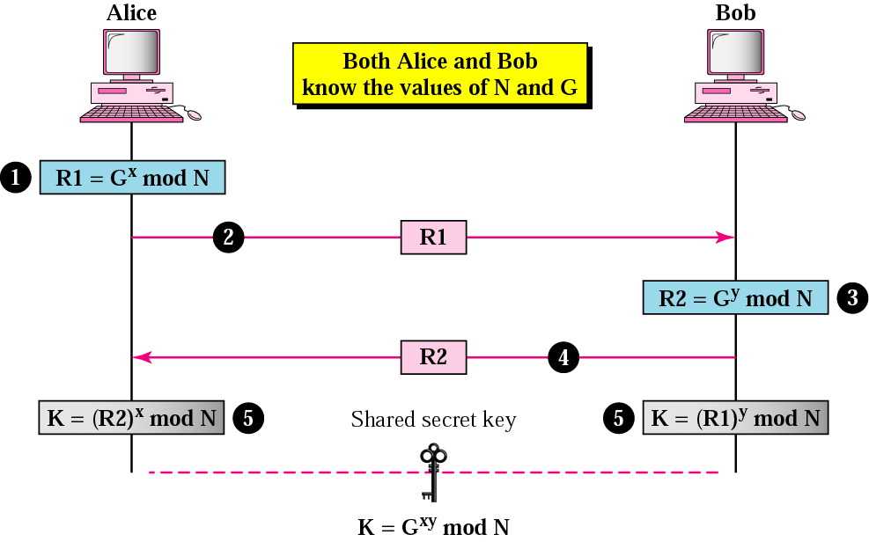
John
Both John and Bob knows the value of N and G
Figure 3.10: Shows the procedure;
The steps are as follows:
- John chooses a large random number x and calculates R1 = G^{x} mod N.
- John sends R1 to Bob. Note that John does not send the value of x; he only sends R1.
- Bob chooses another large number y and calculates R2 =G^{y} mod N.
- Bob sends R2 to John. Note that Bob does not send the value of y.
- John calculates K = (R2)^{x} mod N. Bob also calculates K = R1^{y} mod N, and K is the symmetric key for the session. The relationship between this equation is given as;
(G^{x} mod N)^{y} mod N = (G^{y} mod N )^{x} mod N = G^{xy} mod N
3.17 DESIGN OF THE NEW SYSTEM
System design can be described as the application of judgment skill and knowledge, which enables the analyst in interpretation requirement specification to creating one or more designs. The aim of system design is to establish specification, which ensures the complete and proper implementation of the system.
3.18 PROPOSAL OF THE NEW SYSTEM
Because of the set back of the old system. From investigation, the new system will provide the users with all the relevant information about the new system and adequate security on the data stored or data in transit, incomprehensible to authorized persons.

3.19 OBJECTIVES OF THE NEW SYSTEM
A lot of benefits are derived from the proposed system, they include:-
. Confidentiality of data.
. Data integrity.
. Message authentication.
. Non-repudiation of data.
. Preventing secret key from unauthorized person.
. Preventing cipher text from unauthorized person.
3.20 DESIGN OF THE NEW SYSTEM
The impact of the new system depends upon the cryptographic algorithm type adopted. The algorithm type adopted in the design of the new system is symmetric cryptography algorithm which includes:-
DES - Data Encryption Standard
AES - Advance Encryption Standard
3DES - Triple Data Encryption Standard

3.21 The Algorithm
The private key here is a pair of numbers (N, d), and the public key is a pair of numbers (N, e). Note that N is common to the private and public keys.
The sender uses the following algorithm to encrypt the message:

C = P^{e}mod N
In this algorithm, P is the plain text, which is repBobented as a number; C is the number that repBobents the ciphertext. The two numbers e and N are components of the public key. Plaintext P is raised to the power e and divided by N. the mod term indicates that the remainder is sent as the ciphertext.
The receiver uses the following algorithm to decrypt the message:

P = C^{d} mod N
In this algorithm, P and C are the same as before. The two numbers “d” and “N” are components of the private key. Figure below describes this.
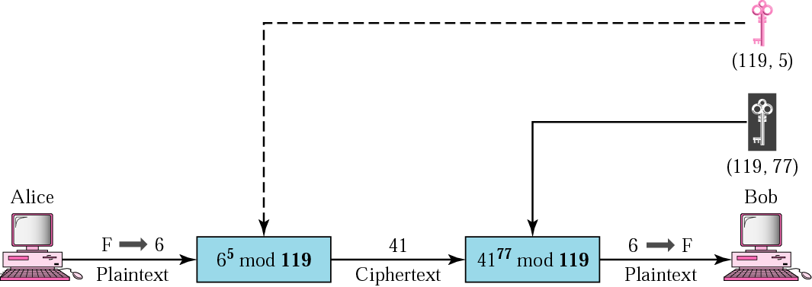
John
Bob
Figure 3.11: Algorithm

CHAPTER FOUR
4.0 PROGRAMMING, IMPLEMENTATION AND TEST RUN
4.1 CHOICE OF PROGRAMMING LANGUAGE
The programming language used in the development of this project is Microsoft C sharp (C#). The C# programming language is one of those intermediate languages that Programmers use to create executable programs. C# fills the gap between the powerful-but-complicated C++ and the easy-to-use-but-limited Visual Basic well, versions 6.0. A C# program file carries the extension .CS.
C# is
_ Flexible: C# programs can execute on the current machine, or they can be transmitted over the Web and executed on some distant computer.
_ Powerful: C# has essentially the same command set as C++, but with the rough edges filed smooth.
_ Easier to use: C# modifies the commands responsible for most C++ errors so you spend far less time chasing down those errors.
_ Visually oriented: The .NET code library that C# uses for many of its capabilities provides the help needed to readily create complicated display frames with drop-down lists, tabbed windows, grouped buttons, scroll bars, and background images, to name just a few.
_ Internet friendly: C# plays a pivotal role in the .NET Framework, Microsoft’s current approach to programming for Windows, the Internet, and beyond. .NET is pronounced dot net.
_ Secure: Any language intended for use on the Internet must include serious security to protect against malevolent hackers.
C# is an integral part of .NET.

.NET is a framework, in many ways similar to Java’s libraries, because the C# language is highly similar to the Java language. Just as Java is both the language itself and its extensive code library, C# is really much more than just the keywords and syntax of the C# language. It’s those things empowered by a thoroughly object-oriented library containing thousands of code elements that simplify doing about any kind of programming you can imagine, from Web-based databases to cryptography to the humble Windows dialog box.

  - PROGRAM DEVELOPMENT
PROGRAM DESIGN
The program for the new system was coded using Microsoft C sharp (C#). One of the most intermediate languages that programmers use to create executable programs. A C# programs carries the extension c.s. it is flexible, powerful, easier to use, visually oriented, internet friendly and secure. It is an integral part of .NET. The program have been designed and stored in a CD recordable. The program code can be seen in the appendix. To view the designed program, insert the CD recordable into CD drive, double click on my computer on the desktop, and then double click on the Cryptography project in order to browse the CD. Double click on Computer Security to lunch the program.

4.3 CREATING THE SOURCE PROGRAM
using ...
namespace ConsoleAppTemplate
{
class Program
{
static void Main(string[] args)
{
}
}
}

4.4 TAKING IT OUT FOR A TEST RUN
using System;
using System.Collections.Generic;
using System.Text;
  - Build started: Project: ConsoleAppTemplate, Configuration: Debug Any CPU - Csc.exe /noconfig /nowarn ... (and much more) Compile complete -- 0 errors, 0 warnings ConsoleAppTemplate -> C:\C#Programs\ ... (and more)==Build: 1 succeeded or upto- date, 0 failed, 0 skipped==

The key point here is the 1 succeeded part on the last line.
As a general rule of programming, “succeeded” is good; “failed” is bad.

4.5 THE PROGRAM FRAME WORK
using System;
using System.Collections.Generic;
using System.Text;
namespace ConsoleAppTemplate
{
public class Program
{
// This is where our program starts
public static void Main(string[] args)
{
// your code goes here
}
}
}

4.6 PROGRAM FLOWCHARTS
The program flowcharts which consists of Main Menu, Windows, About Us, Encryption, Decryption and Key Hash Algorithm. The program flowcharts can be seeing in the appendix II.
4.7 PROGRAM IMPLEMENTATION
4.7.1 INTRODUCTION
The program implementation includes all the activities that are carried out in order to put the program designed into a functional or practical state. All activities like programming, installation, etc are co-ordinate to put the new system in operation. The implementation stages include data conversion, system testing, system changeover, system maintenance etc.
- Data Conversion
This involves the conversion of manual data to electronic data, which are stored in the disk. And the data can be used as desired by the user.
- System Changeover
To ensure the workability of the system after the implementation, an appropriate mode of change over to the new system has to be adopted. The mode of changeover; that is the concurrent running of the old and new system for sometime in order to compare the output of both systems and the carryout amendment where necessary.
- System Maintenance
On the system maintenance aspect, all the network system components should be maintained and managed as the operation continues. Maintenance of a system is to enable the continuos performance of the system as expected and if includes:-
. Hardware Maintenance:- These involves all the activities carried out on the computer and network hardware in order to anticipate the outset of incipient faults on the hardware. Hardware technology, engineers or information technology professionals.
. Software Maintenance:- These include all the activities carried out in updating and modifying the programs in order to suit future challenges in software development.
. Adaptive Maintenance:- These involve the changes and modifications in the programs to suit the operating environment.
. Corrective Maintenance:- These involve the process of detecting bugs in the programs and other faults and the subsequent removal functioning and operation.

CHAPTER FIVE
5.0 SUMMARY, RECOMMENDATIONS AND
CONCLUSION
5.1 SUMMARY
The researcher has been studying the workability and profitability of ensuring that information transmitted between two or more parties involved in a conversation enjoys the benefits of privacy. Cryptography, then, not only protects data from theft or alteration, but can also be used for user authentication. There are, in general three types of cryptographic schemes typically used to accomplish our goal: Secret key (or symmetric) cryptography, Public key (or asymmetric) cryptography, and Hash functions. Cryptography is one tool that will be able to ensure more privacy if been carefully implemented, more especially preventing the algorithm from an unauthorized person. The ability to encrypt data, communications, and other information gives individuals the power to restore personal privacy. Cryptography ensures that a user’s privacy is intact while making sure that the integrity, authentication and non – repudiation of the user information is taken care of.

5.3 RECOMMENDATION:
Having presented all that is needed for the successful implementation of this project. The following recommendations are suggested by the researcher aim at improving / correcting some lapses.
* Developers and engineers need to understand crypto in order to effectively build it into their products.
* Sales and marketing people need to understand crypto in order to prove the products they are selling are secure.
* The customers buying those products, whether end users or corporate purchasing agents, need to understand crypto in order to make well-informed choices and then to use those products correctly.
* IT professionals need to understand crypto in order to deploy it properly in their systems.
* Even lawyers need to understand crypto because governments at the local, state, and national level are enacting new laws defining the responsibilities of entities holding the public’s private information.
5.2 CONCLUSION:
Today the importance of security in communication and network systems have come a long way to ensure that information transmitted between two or more parties involved in a conversation enjoys the benefits of privacy. In spite of the technological advancements to promote a secure path for communicating parties, most communication still leaves some kind of recorded trail. For example, communications over telephone lines, including faxes and e-mail messages, produce a record of the telephone number called and the time it was called. Financial transactions, medical histories, choices of rental movies, and even food choices may be tracked by credit card receipts or insurance records. Every time a person uses the telephone or a credit card, the telephone company or financial institution keeps a record of the number called or the transaction amount, location, and date. In the future, as telephone networks become digital, even the actual conversations may be recorded and stored. All of this amounts to a great potential loss of privacy. Cryptography is one tool that will be able to ensure more privacy.

BIBLIOGRAPHY
Becket, B.(1998), Introduction to Cryptography. London, Blackwell
Scientific Publication.

Behrouz, A., & Forouzan, P.(2004), Data Communication and Networking.
New York. Nashville, TN: Vanderbilt University Press.

Burnett, S., & Paine, S.(2001), RSA Security Official Guide To
Cryptography. Berkeley, CA: Osborne/McGraw-Hill Press.

Burton, S., Kaliski, J., Matthew, B., & Robshaw, J.(1994), Linear
Cryptography Using Multiple Approximations. London: MIT Press.

El Gamal, T.(1985), A Public Key Cryptosystem and a Signature Scheme
Based On Discrete Logarithms. New York: Macmillan Publishing
Company.
Lars, R., Knudsen, J., and Erik, M.(2000), A Chosen Plaintext Linear Attack
On DES. New Jersey: Prentice Hall Inc. Press.

Liddell, D., & Scolt, L.(1996), Definition of Cryptography. London:
Oxford University Press.

Menezes, A., Van, O., and Vanstone, A. (1976), Guide To Cryptography.
Berkeley, CA: Osborne/McGraw-Hill.

Pascal Junod: (2001), On the Complexity of Matsui's Attack."
Selected Areas in Cryptography, New York, Mc-Craw –Hill Book
Company.

Rivest, R.L., Shamir, A., and Ad leman, L.: (1978), On a Method For
Obtaining Digital Signatures and Public Key Cryptosystems. California:
Wadsworth Publishing Company.
Schneier, B. (1996), Applied Cryptography (2nd Edition)
New York, ACM Press.

Susan K. Langford, Martin E. Hellman: (1994), Differential-
Linear Cryptanalysis. New York, Bantain Publishing Company.

Sutton, William G., and Rubin, Aviel D. (2006), Cryptography.
Microsoft® Student . Redmond, WA: Microsoft Corporation,

Stewart, T. Ed Tiltel and Mike, G.(2000), An Overview of Cryptography on
Security. New York: West Publishing Company.

APPENDIX

MAIN MENU

CRYPTOGRAPHY

DECRYPTION

ENCRYPTION

KEY HASH

