**DESIGN AND IMPLEMENTATION OF EMPLOYEE MANAGEMENT SYSTEM**

**THESIS SUBMITTED IN PARTIAL FULFILMENT OF THE REQUIREMENT FOR THE DEGREE OF**

**B.Sc. IN**

**COMPUTER SCIENCE BY**

**ALI MAHMUD MOHAMMED BU/17C/IT/2767**

**TO**

**THE DEPARTMENT OF COMPUTER SCIENCE BAZE UNIVERSITY, ABUJA**

**SEPTEMBER, 2020**

## DECLARATION

I, Mahmud Ali Mohammed with the registration number BU/17C/IT/2767 declare that this report is an original work undertaken by me under the supervision of Dr. Moses Ubaru and Mrs. Mubaraka Sani Ibrahim, submitted to the Department of Computer Science, Baze University Abuja, Nigeria. Information have been duly acknowledged by means of reference and I accept sole responsibility for any errors contained in this report.

Date: 21 September 2020 Name of Student: Mahmud Ali Mohammed

**APPROVED BY** …………………

### Head

Department of Computer Science

## CERTIFICATION

This is to certify that this Project entitled Employee Management System, which is submitted by Mahmud Ali Mohammed [BU/17C/IT/2767] in partial fulfilment of the requirement for the award of degree for B.Sc. in Information Technology to the Department of Computer Science, Baze University Abuja, Nigeria is a record of the candidate’s own work carried out by the candidate under my/our supervision. The matter embodied in this thesis is original and has not been submitted for the award of any other degree.

Date: Supervisor:

## APPROVAL

This is to certify that the research work, Employee Management System and the subsequent preparation by Mahmud Ali Mohammed with [BU/17C/IT/2767] has been approved by the Department of Computer Science, Faculty of Computing and Applied Science, Baze University, Abuja, Nigeria.

By

Dr Moses Ubaru

1st Supervisor Date/Sign

Mrs. Mubaraka Sani Ibrahim

2nd Supervisor Date/Sign

Dr. C. V. Uppin

Head of Department of Computer Sciences Date/Sign

Prof. Mohammed Hammawa Baba

Dean, Faculty of Computing and Applied Science Date/Sign

Prof. Ahmed Baita Garko

External Examiner Date/Sign

## DEDICATION

This report is dedicated to Almighty God the omnipresence, omniscience, the cherisher and sustainer of the world who gave me the opportunity to witness this moment and the strength to put this report together. My gratitude also goes to My lovely family who gave me all the support both morally and financially to achieved the goal, May Allah reward and protect them all, amen.

## ABSTRACT

Over the years, paper-based system for information management has been carried out across most of business and organizational sectors. Overcoming this problem is the main focus of this project in order to reduce the risk of redundancy. This thesis describes the design and implementation of a system that will have the capability for storing related information about employees through database. The system serves as a bridge between the database and the users that helps in maintaining and retrieving records, it also focuses on each employee’s attendance and number of leaves taken by employee per year with the help of full-edged computer software and computerized tools, so that personal data can be stored for future reference. The required system is amiable to users and easy to work with without any redundant entries. After implementation of the objective modules, all functions were tested and successful.

## TABLE OF CONTENTS

ABSTRACT VI

LIST OF TABLES IX

LIST OF FIGURES X

LIST OF ABBREVIATIONS XI

CHAPTER 1: INTRODUCTION 1

* 1. Overview 1
  2. Background and Motivation 1
  3. Statement of the Problem 2
  4. Aim and Objectives 3
  5. Significance of the Project 3
  6. Project Risks Assessment 4
  7. Scope 4
  8. Project Organization 4

CHAPTER 2: LITERATURE REVIEW 6

* 1. Introduction 6
  2. Related Work 7
     1. Employee Information Management System 7
     2. Computerize EMS 8
     3. Wireless Iris Recognition Attendance Management System 8
     4. Attendance System 8
     5. Staff Management System 8
     6. Employee Database and Payroll Management System 9
     7. System Scheduling Activities 9
     8. Proposed System 9
  3. Summary 10

CHAPTER 3: REQUIREMENTS ANALYSIS AND DESIGN 10

* 1. Overview 11
  2. Proposed Methodology 11
     1. The Waterfall Mode 12
     2. The Prototype Model 12
     3. The Spiral Model 13
  3. Approach to Chosen Methodology/Methods 13
  4. Tools and Techniques 14
  5. Requirement Analysis 14
  6. Requirements Specifications 15
     1. Functional Requirement Specifications 15
     2. Non-Functional Requirement Specifications 16
  7. System Design 17
     1. Application Architecture 18
     2. Use Case 19
     3. Class Diagram 21
     4. Activity Diagrams 22
     5. Dataflow Diagram 23
     6. Entity-Relationship Diagram (ERD) 24
     7. User Interface Design 25
  8. Summary 25

CHAPTER 4: IMPLEMENTATION AND TESTING 26

* 1. Overview 26
  2. Main Features 26
  3. Implementation Problems 28
  4. Overcoming Implementation Problems 30
  5. Testing 30
     1. Tests Plans (for Unit Testing, Integration Testing, and System Testing) 31
     2. Test Suite (for Unit Testing, Integration Testing, and System Testing) 36
     3. Test Traceability Matrix (for Unit Testing, Integration Testing, and System Testing) 37
  6. Use Guide 38
  7. Summary 38

CHAPTER 5: DISCUSSION, CONCLUSION, AND RECOMMENDATIONS 39

* 1. Overview 39
  2. Objective Assessment 39
  3. Limitations and Challenges 40
  4. Future Enhancements 40
  5. Recommendations 41
  6. Conclusion 41

REFERENCES 42

1. APPENDICES 44
   1. Appendix A - Project Document 44
   2. APPENDIX B – SOURCE CODES 45
      1. Database Connectivity 45
      2. User Authentication 45
      3. Leave application 46
      4. Sending Email Notification 48
   3. APPENDIX C – TEST CASES 49
      1. Test plan for login table 49
      2. Test plan for staff table 50
      3. Test plan for registry table 50
      4. Test plan for leave table 51
   4. APPENDIX D – USER GUIDE/MANUAL 52

## LIST OF TABLES

Table 1 Functional Requirement Specifications 15

Table 2 Non-Functional Requirement Specifications 16

## LIST OF FIGURES

Figure 3. 1 Incremental Development Model 12

Figure 3. 2 Application Architecture 18

Figure 3. 3 Use Case Diagram 19

Figure 3. 4 Class Diagram 21

Figure 3. 5 Admin Activity Diagram 22

Figure 3. 6 Staff Activity Diagram 22

Figure 3. 7 DataFlow Diagram 23

Figure 3. 8 Entity Relationship Diagram 24

Figure 3. 9User Interface Design 25

## LIST OF ABBREVIATIONS

|  |  |
| --- | --- |
| EMS | Employee Management System |
| IMS | Information Management System |
| SDLC | Software Development Life Cycle |
| CPU | Central Processing Unit |
| ERD | Entity Relationship Diagram |
| IT | Information Technology |
| DFD | Data Flow Diagram |
| HR | Human Resources |
| GUI | Graphical User Interface |
| OS | Operating System |
| NWRI | National Water Resources Institute |
| MAC | Media Access Control |

## CHAPTER 1: INTRODUCTION

### Overview

The Employee Management System (EMS) is designed to automate the manual paper/file ssystem. The Desktop Application is developed to get rid of the problems faced by the manual system. The System makes smooth and efficient operation of keeping records in the organization.

The application reduces possible errors when entering data. It also prompt an error message when entering a wrong data. It doesn’t require any formal knowledge in order for a user to use the system. Thus with all the above description it proves its user friendly.

### Background and Motivation

In any organization, there is existence of a system that manages its staff information effectively. This brings the need to develop a database that stores and retrieve relevant information of a staff. In the development of the management system, the storing of data of the organizational staffs is prioritized. The database management which controls the creation and maintenance of records together with the leave and attendance management provides efficient and flexible way to manage the organization’s personnel information. The combination of these modules into one application assures the perfect platform for aligning Human resources processes in the organization.

The Human Resources office in any organization contributes to the organizational mission of public service by facilitating informed decision making regarding employee benefits by providing accurate, timely, accessible information. Of the many benefits available to the employees, leave is one of the most valuable.

Leave management system is an electronic online stage that circles all sort of leave applications and leave regard, and the methodology to record numerous types of leaves (Nucleus, 2008). The

interface is designed to reduce data redundancy and automate leave application process and their endorsements. It eliminates the paper work process and spares time.

The attendance management aspect of the Employee Management System (EMS) keeps track of the presence or absence of someone from an event or place (Priya, 2014). The manual attendance system is not efficient and requires more time to arrange record and to calculate the average attendance of each staff. Hence there is a requirement of a system that will solve the problem of staff record.

As an IT student I was motivated to conduct research on this study and design a desktop application because of an encounter through experience during my internship in an organization. I was motivated by this topic when I witness the process through which employee are given leave, even in a difficult situation. As I witness one of my supervisors applying for his leave and the vigorous process he went through and I saw the need for a change in this process, despite the health status of the employee seeking for the leave. Then as an IT companion I had the thought of developing a system that will help to accomplish this task within the unit.

### Statement of the Problem

Challenges are faced when handling employee record manually. This is evident in procedures such as leave management where an employee is required to fill in a form which may take several weeks or months to be approved. Another problem is observing and recording the attendance of employees in the organization using book and due to that an employee can put a wrong time that he/she arrived at the organization. The use of paper work in handling some of these processes could lead to human error. Another challenge is that most of the organizations have their employee records kept at the big file room in the admin block of the organization making it difficult to access the employee information remotely when needed at short notice.

The above identified problems can be resolved using the employee management system. The system will store and maintain employee record in a database with privacy only accessed by the admin. The system makes it easy for the admin to monitor the attendance of the employee systematically and the employee can only sign using the un-editable time generated process through a password protected system.

### Aim and Objectives

The project “Employee management system” seeks to develop a system that will maintain the day to day attendance of staffs. The aim for developing this app is to create a computerized method of leave and attendance management instead of the existing manual paper process which will help to minimize storage space and keep all saved records in the computer for future use. At the end of the implementation, the app shall deliver a good functionality providing efficiency and accuracy over the paper-based system. It is designed to achieve the following objectives:

* + - To provide users with user-friendly interface
    - To develop a robust database for employees records
    - Easy access to employee information.
    - To make it easy for employees to write a leave letter instead of the long paper process.
    - Automate the approval of leave.
    - To make it easy for the admin to view the attendance of staffs and also for staffs to sign in and out systematically.

### Significance of the Project

The implementation of this exclusive employee and leave system that linked to the organization’s requirements, offers access to records as well as services such as systematic leave management, employee attendance and schedule report generation which will make it easy for the organization to operate. The automated proposed system will upgrade the existing system and will be of important to the users by eliminating the leave manual system process, the authorities in charge of the approval of leave request will also not operate manually. Without the system, it is going to be a tiresome job for the employer to keep track of each and every employee. The software will be developed to give access and provide information of employees and many other features with the click of a button, as we all know employees are the backbone of any organization and the society.

### Project Risks Assessment

**RISKS**

|  |  |
| --- | --- |
| Inability to carry out research due to loss of hardware/software resources | Replaced the hardware/software resources |
| Loss of work due to System crash and failure | Weekly data backup to External drive |
| Software availability  ( Unavailability of API’s) | Alternative API’s will be checked for. Software  requirements will be identified in good time for possible contentious softwares |
| Late delivery of hardware  component due covid19 | Hardware requirements will be identified in good  time to be able to order them in good time |

### Scope

This project is limited to focus on creating a system using csharp programming language that will handle and store employee record and keep track of day to day attendance of staff. It will also focus on eliminating the long paper process for leave system, giving an employee the ability to apply for his/her leave and also check their leave report via the software. This will also help the manager to accept/reject leave application via the software.

### Project Organization

The project write-up will be carried out based on the following chapters:

**Chapter one**: gives the background of the study and covers issues such as the Aims and Objectives of the project, the Statement of Problem, and the Significance of the study.

**Chapter two**: highlights the Literature Review of this paper and also a research on related works. Evaluation is also done on previous systems or existing systems of similar nature enumerating possible features which the current project had identified.

**Chapter three**: discusses the methodology used to implement the project, system analysis and design, tools and techniques as well as description of the mechanisms. It displays the Technical details such as the software architecture, Class Diagrams, Use-case, Sequence, Activity Diagram are all captured in this chapter.

**Chapter four**: this is the chapter that discuss the development and implementation of the system. It also analysis user’s response as highlighted in the third chapter, displaying screen-shoots of the interfaces.

**Chapter five:** it consist of the conclusion of both the system development process and documentation of the write-up. It also summarizes the entire project including the challenges encountered.

## CHAPTER 2: LITERATURE REVIEW

### Introduction

This chapter briefly describes the literature review relevant to the Employee Management System (EMS). It provides sufficient background knowledge based on relevant literature reviews of related works. The chapter reviewed literatures that were relevant to the proposed project and identifies the gaps in the related systems that could be addressed by the proposed system.

Information management system (IMS) is a system used for managing, maintaining, decision making and compiling of information in a particular organization (Wilson, 2002). The system mainly is in form of software application for processing and collecting information required in an organization to carry out task easily and successfully and used it for their own benefit. IMS was first introduced by IBM in 1968 to serve as a database and record management system information [2]. IMS has become the foundation of most organizations for executing prominent role in sectors like education, businesses, health care centers, government, banking and finance e.t.c each using the appropriate types of information management system. Modern supermarkets use inventory management and control system to keep track of incoming stocks, shipments and record sales. Organizations on the other hand use employee management system to keep track of every day activity of employees inside the environment which brings us to the main focus of this paper.

Nowadays many organizations are using a manual system especially when dealing with attendance and leave record which most of the time leads to loss of record. The employee management system consists of important personal information about employees in an organization. The EMS software is designed to analyze and manage employee activities which is open to regular employees, admin, human resources and managers.

The Employee Management System consist of important personal information about employees in an organization. The EMS application is designed to analyze and manage the staffs of National Water Resources Institute (NWRI) activities and the application is open to admin, human resources, managers and regular employees with fingerprint user authentication. The institute is in charge of training and applied research in the water sector. This institute, located in Kaduna, was created in 1979 under the supervision of the Nigerian Ministry of Agriculture and Water Resources (Alayande, 2020). At first, the main purpose of building this software for the institute is for internship and NYSC trainees to record their attendance instead of the paper-based process I

experienced there. But after, I realized the staff of the organization are also encountering such problem as they also use paper form process in requesting for a leave.

The software only allows the admin to have privilege in accessing all the information of the EMS. Therefore, the admin will update, insert, delete employees, generate reports and monitor attendance while other users are only allowed to perform certain functions and once a user login they perform the task assigned to their role.

The NWRI's main activities and missions are basic and professional training, basic and applied research, documentation and database management.

The study of this system is important because many organizations faces the same problem. It may be a stepping stone to help new businesses run in an organized and effective system procedure. It may also help future proponents that will involve or support this kind of study.

### Related Work

In every company or organization there exists a very large number of employees that are been managed by the HR department and this activity is carried out using the current system which can be daunting without a more sophisticated tool to store and retrieve data. The various levels of sophistication are examined looking at the current HR technology i.e the Paper-based systems. A number of related works exist for the application of EMS in different areas and specifically to the area of organizational attendance and leave monitoring problems.

### Employee Information Management System

(Kanchev, 2006), presents a report that describes the development and presentation of an information system for managing the staff data within a small company or organization. It comprises of functions relating to application programming and database. The system as such that has been designed is called the Employee Management System. The designed system will be responsible for keeping records and storing data of the staff within an organization and generating reports when requested. The choice of the programming tools is individual and particular.

### Computerize EMS

(Nucleus, 2008), presented a research that creates a computerized EMS, which can eliminate repetitive work and human data entry mistake. This system increase productivity, reduced payroll error, and elimination of paper costs, and which can provide all the reports on demand. In this system, departments has to take attendance manually, only these records have to be entered into the computerized system. But in this also, the problem of data entry mistake may possibly still occur.

### Wireless Iris Recognition Attendance Management System

(Arulogun, 2013), has proposed a system that lays its focus on wireless iris recognition attendance management system which was designed and implemented using Daugman’s algorithm (Daugman, 2003). Building the system requires hardware for executing the iris recognition which may lead to another expenses. Therefore a final version of the system was not made.

### Attendance System

The paper presents an attendance system for staffs which can mark attendance using Bluetooth. Under the description of this paper, the attendance is being taken using the staff’s mobile device. Therefore, an application software will be installed in all of the staff’s mobile device which will enable it to query staff’s mobile device via Bluetooth connection and through transfer of the staff’s mobile telephone Media Access Control (MAC) through that the presence of the staffs can be confirmed. The problem of this proposed system is staff’s phone is required for attendance. In case of staff absent a colleague can mark the attendance. So presence of student is not necessary only phone should be in coverage area.

### Staff Management System

(Simaanya, 2014), presented a research which aim is to see how Staff management can be improved to produce efficiency and flexibility. The methodology used was incremental method which helped to reduce risk when changing requirements. This research identified critical system factors that contributed most significantly to organization performance, also the research present how the system will enable HR professionals to focus on transforming information into knowledge that can be used by the organization for decision making and identified strengths and weaknesses in the organization. This research represents a first step in developing Staff management systems for HR relief.

### Employee Database and Payroll Management System

(Rozario, 2018), designed an employee database and payroll management system to make the existing manual system automatic with the help of computerized equipment and full-edged computer software, fulfilling their requirements, so that their valuable data and information can be stored for a longer period with easy access and manipulation of the same. This web application can maintain and view computerized records without getting redundant entries. The purpose of this document is to describe the functionality and specifications of the design of a web application for Managing Employees and their payroll. The expected audiences of this document are the developers and the admin of the web application. Now with the help of this system the admin has the information on his finger tips and can easily prepare a good record based on their requirements.

### System Scheduling Activities

(Pratik, 2019), this study designed system scheduling activities in a work center. The system shall be responsible for maintaining information about employees, thus their personal profile. The system shall incorporate leave management all the way from application to acceptance/rejection of leave requests as well as all employee projects with close monitoring of the projects from creation to completion and trainings to assist in monitoring active and inactive employees. Making the existing system fully automatic which will save lots of human resources work. As the current system is all human resource work is needed to maintain and keep the record and details of every employee under and organization to keep track of every employee in staff working in an organization.

### Proposed System

The Proposed Employee Management System is a desktop application using Microsoft SQL Server as the database in which the application serves as a bridge between the users and the database, where all data is stored. It is designed to allow the admin to create and save employee details and records. The application also carries out the leave management system task that keeps leave record of all the employees in the organization, it enables quick retrieval of information without any intervention and allow managers to manage the leave of its staffs and mark their leave dates. In addition, it will eliminate the paper/file system which will overcome the challenges of the current system. This proposed system also include the Attendance management system that stores the

presence of staffs systematically so that management of attendance becomes easy. The Attendance management interface was designed to use fingerprint to mark your presence using a fingerprint device. During this process the system takes in the fingerprint as an input using the fingerprint sensor and stores it to the database as a template for attendance management using ToLongString conversion method. The system automates the whole attendance process by generating the staff information automatically from the database and creates an immediate report upon the staff’s signing out which will mark his/her presence for the day. Therefore, in a case where the staff signed in and forgot to sign out, the system will not mark his presence for the day. Finally, it is brought to light that this system will not only automate the whole process but also saves time of the admin, which can be well utilized for his institute.

### Summary

The literature reviewed elaborate a clear and concise overview of the current system briefing us on how difficult the current paper based system is, for example the current leave offer is done in a way that employees have to fill paper forms and chase it around for approval by the human resource manager. Therefore, the literature reviewed in this chapter shows the brief overview of the current system and highlighted some of the project related works in correspondence with the proposed system.

Chapter Three lays its focus on describing the requirement analysis and design, follow by the methodology used in developing the application program and database. It also discuss the development tools used and utilized for the project.

## CHAPTER 3: REQUIREMENTS ANALYSIS AND DESIGN

### Overview

The system development generally consists of two major components which are the system requirement analysis and system requirement design. The system analysis helps to understand details of an existing system or an envisioned system and deciding whether the existing system needs improvement and also deciding if the envisioned system is desirable or not. The system design is the process of using the fact finding techniques to build and plan a new system or to replace an existing system.

This Chapter will present the Requirements Analysis and Design of the proposed system of the Employee Management System in details. It will also focus on how the new proposed system will be established and also view the fact finding techniques used during the system design and development. The paper will also give us a brief outline of the methodology used during the system development and add up with alternative methodologies to show adequate understanding of the approaches carried out. The functional and non-functional requirements of the proposed system are explained, showing the data modeling of the system using a class diagram which will be translated into codes and the use cases diagram to list the steps of the system and other corresponding useful diagrams.

### Proposed Methodology

Software development life circle (SDLC) is a framework defining tasks performed at each step in the software development process. SDLC is a structure followed by a development team within the software organization and consists of detailed plan describing how to develop, maintain and replace software.

In this project the SDLC chosen is the Incremental development method because the processes are agile, therefore planning should be incremental to change the process to reflect changing customer requirement in order to reduce risk of changing requirements. There is user’s involvement in the project and the project manager is experienced. This approach interleaves the activities of specification, development, and validation. The system is developed as a series of versions (increments), with each version adding functionality to the previous version.

Concurrent Activities

Specification

Development

Validation

Intermediate Version

Final version

Outline Description

Initial Version

### Figure 3. 1 Incremental Development Model

There are several types of SDLC which choose to take up some number of factors based on the project e.g. Requirement elicitation during the development, complexity of the system, agile process between the customers and developers, time management. These related models give the idea on the process that can be used to help user understand how different approaches are carried out during software development. They can be seen as process frameworks to create more specific software engineering processes. Below are few selected models discussed.

### The Waterfall Mode

The waterfall model is a sequential design model process, often used in dividing software development processes. It divides them into phases (requirements specification, software design, implementation, testing etc.) of which each phase must be complete before starting a new phase with each phase performing a specific role. It was introduced in 1970 by Winston Royce.

### The Prototype Model

The prototype model is defined as a software development process in which a prototype is designed and built several times until an acceptable prototype is achieved and approved. It also creates a base to produce the final system. It is best used in scenarios where the customer and developer do

not know the necessary requirements needed. It is a repetition of trial, and error method which take place between the developer and the client.

### The Spiral Model

The spiral model consists of the waterfall model and iterative model both combined in which each phase of the spiral model starts with a design goal and ends with the customer reviewing the progress of the software development process. The spiral model was first mentioned by Barry Boehm in his 1986 paper.

### Approach to Chosen Methodology/Methods

Using the Incremental Model as the SDLC, the approach to carry out each phase of the chosen methodology is define listing the set of activities carried out below and stating the chosen method used for each stage.

|  |  |
| --- | --- |
| Incremental Phases | Activities Carried out |
| Requirement Analysis | For this project, Requirements and  specifications where obtained using interview and observation technique. |
| Design | In this project, some high-end functions are used to design the system in terms of objects and classes and how their interaction was carried out, explaining the structure of the Entity Relationship Diagram (ERD) and Use  case activity. |
| Code | The coding of the project was conducted during this stage using C sharp programming as the code behind and object oriented  programming (OOP) approach |
| Test | And finally the testing phase was carried out  after the system was deployed. |

### Tools and Techniques

Before any software could be programmed decisions are needed to be made on which programming language should be used. The software been a desktop application, visual studio 2019 was used as the IDE and to ensure a standardized object oriented program in its entire ramification, C sharp programming language was used, after Microsoft ADO.Net was used to connect to the database which was created using Microsoft SQL Server. The implementation was carried out using C# .Net Framework with windows applications which serves as the Graphical User Interface (GUI). The software will also support Google Email Address as a 3rd party API, that enables user to login using his or her Google email credentials and send notifications via email. This will also enable the user to send emails through from the app. The application was built on windows 10 operating system, with visual studio a good graphical user interface was design, then using the C sharp programming as code behind to perform all the functionalities.

Table shown below:

|  |  |
| --- | --- |
| CATEGORY | SOFTWARE USED |
| OPERATING SYSTEM | Windows |
| Programming Language | C sharp |
| IDE | Visual Studio |
| Framework | .NET and ADO.Net |
| Database | Microsoft SQL Server |

### Requirement Analysis

Requirement analysis which is also known as requirement engineering is the process of determining the belief of a user to carry out the process of creating a new or modified application. It involves the process of studying all the task conducted to identify the needs of different stakeholders with their goals and purposes of creating systems and procedures that will achieve them in an efficient way.

### Requirements Specifications

Requirement is a singular documented physical or functional need that a particular design, product or process aims to satisfy. It is a broad concept that could speak to any necessary function, attribute, capability and quality of a system for it to have value to customer, organization and stakeholders.

Requirement specification consist of all the necessary requirement needed to build or develop a project. It describes the software system in details and capture the goal of the system to be developed and creates a connection between the stakeholders and users to be part of the development. It consist of Functional and Non-functional Requirement.

### Functional Requirement Specifications

Functional Requirement defines the functions of a system and its corresponding components. It deals with the services the system should deliver to do user.

### Table 1 Functional Requirement Specifications

|  |  |  |
| --- | --- | --- |
| **Req.**  **No.** | **Description** | **Type** |
| R-101 | The application shall include a user interface. | Functional |
| R-102 | The system shall allow user to login or prompt error  based on the login credentials. | Functional |
| R-103 | The system shall allow update and retrieval from the  database. | Functional |
| R-104 | The system shall allow administrator to manage the  user logins. | Functional |
| R-105 | The system shall allow the administrator to add or  delete user credentials. | Functional |
| R-106 | The system shall allow the administrator to add, update  and delete staff details. | Functional |

|  |  |  |
| --- | --- | --- |
| R-107 | The system shall allow administrator to keep track of  attendance records, leave management and generate report. | Functional |
| R-108 | The system’s attendance shall allow the staff to sign in  and out | Functional |
| R-109 | The system’s attendance shall provide necessary details  needed | Functional |
| R1010 | The system shall allow the staff to apply for leave | Functional |

### Non-Functional Requirement Specifications

Non-functional Requirement defines the requirement that specify criteria that can be used to judge the operation of a system.

### Table 2 Non-Functional Requirement Specifications

|  |  |  |
| --- | --- | --- |
| **Req.**  **No.** | **Description** | **Type** |
| R-101 | When launched, the application shall stay running  unless there is an intentional shutdown of the application or the platform. | Performance |
| R-102 | The system should be available to the users at all time. | Availability |
| R-103 | The system should be secured to avoid unwanted  access. | Security |
| R-104 | The system should be reliable in such a way that it performs its tasks properly at all time without  producing any ambiguous result. | Reliability |
| R-105 | The system should be able to handle the task as number of user increases. | Scalability |

### System Design

System Design is the process of describing the components, interfaces and architecture of a system that meet or satisfy the required specifications. It defines how the system operates and interacts with external users with the intention of describing how the system is in nature and what it does which in general captures the system’s behavior.

Attendance Management

Leave Management

Admin/HR

Staff

Employee Management System

### Application Architecture

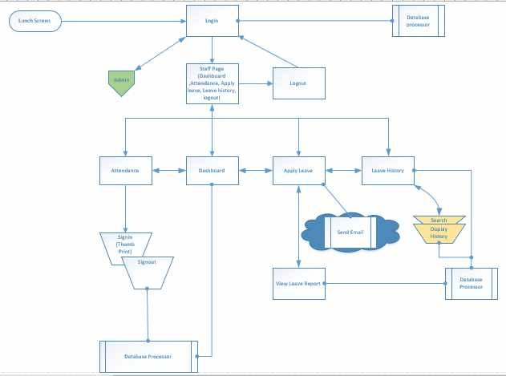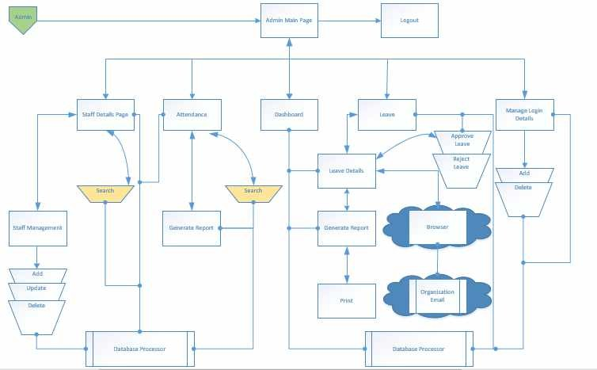

**Figure 3. 2 Application Architecture**

### Use Case

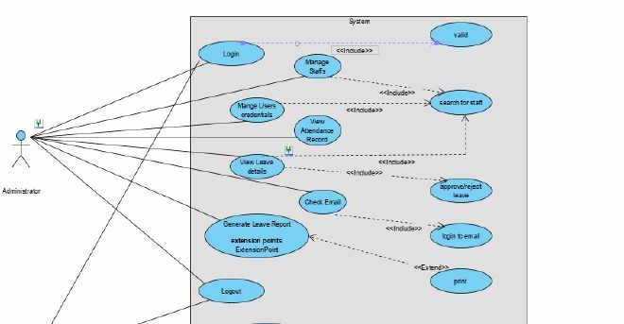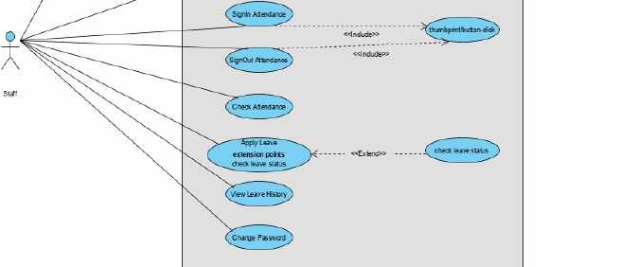

**Figure 3. 3 Use Case Diagram**

Actors:

* + - * Administrator
      * Staff

Precondition:

* + - * Administrator must be logged into the system

Post condition:

* + - * If the user is successful, the user is logged into the system otherwise the system state is unchanged.
      * If the Admin logged in successful, the Admin add, delete and view the login credentials of the entire users of the system, otherwise the system state is unchanged
      * If the Admin logged in successful, the Admin will add||delete||update the staff record in the system, otherwise the system state is unchanged

Flow of Events:

Basic Flow

* + - * The system requests that the actor enters his/her username and password.
      * The actors enters username and password.
      * The system validates the username and password.
      * The user is logged into the system
      * Admin user click on manage login credentials button.
      * System respond with a manage credentials page.
      * Admin add or delete or view login credentials
      * System save or retrieve from the database
      * System pop out successful message
      * Admin clicks on Manage staff button.
      * System respond with staff page.
      * Admin add||delete||update and submit staff record
      * System save record to the database
      * System pop out successful message

Alternate Flow

* + - * The system requests that the actor enters his/her username and password.
      * The system validates the username and password.
      * The username or password is invalid; an error message is displayed.
      * Admin click on manage login credentials button.
      * System respond with a manage credentials page.
      * Admin add or delete or view login credentials
      * System fail to save or retrieve from the database
      * System pop out Error message
      * Admin add||delete||update and submit staff record
      * System fails to save to the database
      * System pop out Error message

### Class Diagram

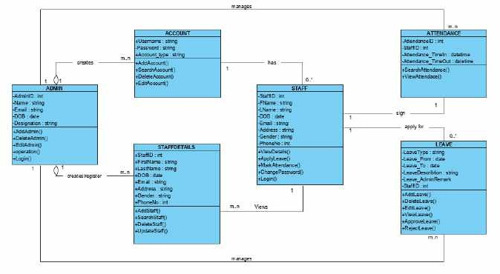

**Figure 3. 4 Class Diagram**

### Activity Diagrams

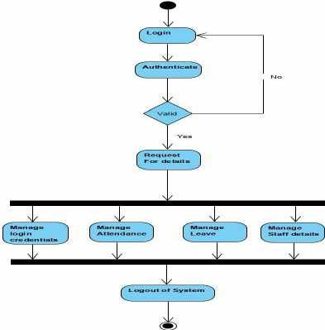

**Figure 3. 5 Admin Activity Diagram**

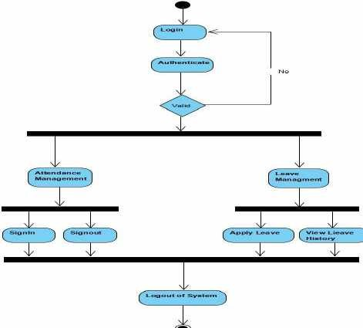

**Figure 3. 6 Staff Activity Diagram**

### Dataflow Diagram

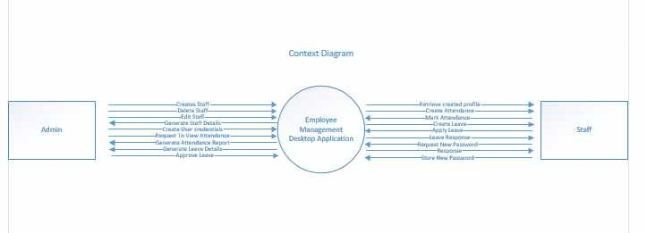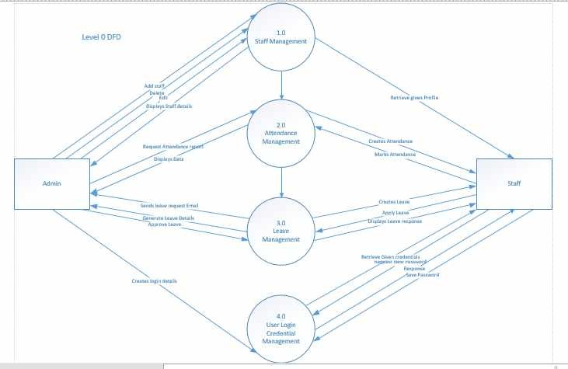

**Figure 3. 7 Data-Flow Diagram**

### Entity-Relationship Diagram (ERD)

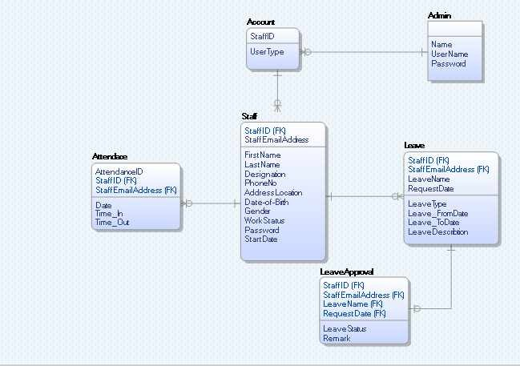

**Figure 3. 8 Entity Relationship Diagram**

### User Interface Design

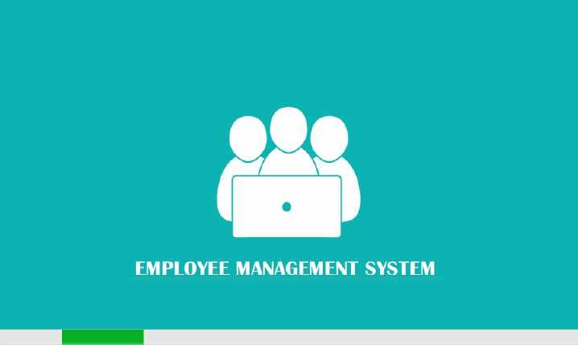

**Figure 3. 9 Splash Screen Design**

### Summary

This Chapter presents the analysis of the proposed system showing the various technology and development tools used in creating the system. To ensure the deliverability of the system, UML specifications are also presented, describing how the system is modelled.

Chapter 4 will present the design features and parts of the system to be developed which involves the actual installation of the system and how some aspects of the system are put in place which will help to define the workability of the new system.

## CHAPTER 4: IMPLEMENTATION AND TESTING

### Overview

Implementation is a realization of technical specification or algorithm as a program, software component through computer programming and deployment (Joshua., 2016).

This chapter describes the different phases of the EMS with regards with how the system is developed, implemented and tested using the suitable tools, programming language and technology. At the previous chapter, the paper began with the description of requirements analysis and design of the proposed system in details, and in this chapter the paper shall explore the several aspects of the joined system that weighs the leave and attendance management combined, outlining the procedures carried out during the testing procedure and finger print implementation which refines the function of the system and guide users on how to operate. The following materials listed below are the hardware and software components used for the implementation of the system for which this report has been written.

### Main Features

The main features added to the system include:

* Employee profiles
* Leave management
* Attendance management
* Employee Self-Service(ESS)

All these added features have the function of adding user, updating, deleting and retrieving data through the search function. It also has the ability to generate report automatically and sends email notifications to the admin. The system is implemented under the following hierarchy of access, it has two main access levels:

* The Administrator
* Employee

All the users are warped to one login interface making each user to login through the means of valid user-ID, password and user type combination. After accessing the system, the administrator has the ability to perform various task like assigning role to a user which will determine his access level. The employee on the other hand has a unique fingerprint template preserved in the system during registration which enables him to mark his attendance on daily work days.

Consistent, the application was built with similar look on every page having the same navigation, header, background image and logo.

Easy navigation for users in order to amble around the system with the help of the system’s navigation buttons which are clearly presented and labelled pointing user to the intended page. The use of text font and colours where carefully considered to provide visual appeal.

Database structure, after a careful analysis of the database, design and implementation was brought to light but in order for users to interact and communicate with it, a simple and understanding GUI was built as the basic structure of the system with the controls to add and retrieve information based on the user’s need.

The Application Programming Interface (API): API is the list of all methods of control and property within a program GUI [18]. All required APIs including text boxes, labels, combo boxes, buttons, links, panels, picture boxes, data grid view, group boxes etc are taken into consideration to boost the function of the system and enable users to reach the forms and perform desired purpose that concerns the functionality of the app.

### Implementation Problems

1. The first problem encountered was establishing the connections with the database, at each point, when executing a particular query.
2. The second problem encountered was having an error when a staff signed in twice both the first and the second signing are saved to the registry table in the database.

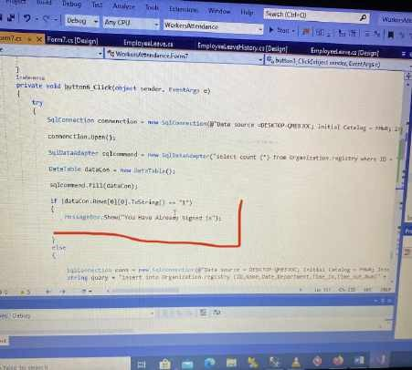

1. Another problem was during the Implementation of the registry table Update and count, when checking out the staff presence should be marked using int count variable created in the registry table which will enable the admin to count the number of days a staff was

present between a particular period of time.

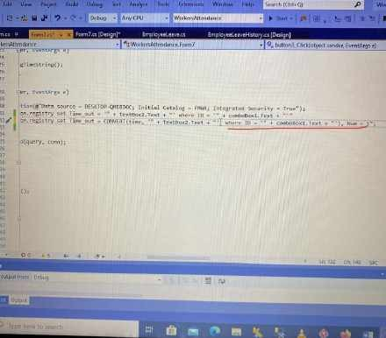

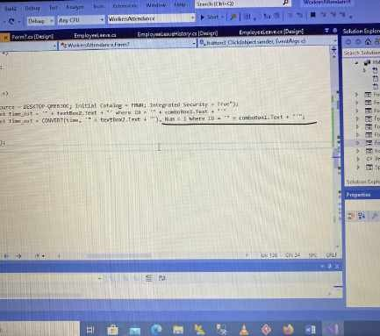

1. Using wrong conversion method

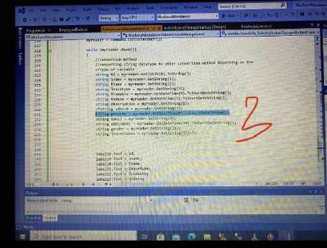

### Overcoming Implementation Problems

Exception-handling was taken into account during the system’s development and

implementation to prompt error message due to eventual exceptions that may occur.

### Testing

The overall aim for testing a system is to ensure that the system meets all of its functional requirements and to check its performance. The accuracy of the program can be tested with some varying data, testing gives assurance that the new system will achieve its objectives and purpose. Testing is basically an attempt of executing programs to find bugs. Testing ensures the success of any program that aims at delivering a robust system. Testing consist of various types for which a system is subjected to but the ones to be carried out are the ones in the testing objectives.

The test plan presents the test in details through identifying the test case areas within the system.

### Tests Plans (for Unit Testing, Integration Testing, and System Testing)

Unit Testing

* + - 1. **Login**

|  |  |  |  |  |  |
| --- | --- | --- | --- | --- | --- |
| **Test ID** | **Test**  **Description** | **Input** | **Expected**  **result** | **Actual Result** | **Status** |
| Login | This test the login module with correct input to access  the system | Account type: Admin Username: admin Password: 12345 | Allow the user to log in to the system | The user logged into the system | Pass |
| Login | This test the login module with incorrect input to access the system | Account type: Staff Username: admin Password: 12345 | Deny the  user access to the system | The user was unable to log into the  system. Error message incorrect username or  password | Pass |

* + - 1. **Attendance**

|  |  |  |  |  |  |
| --- | --- | --- | --- | --- | --- |
| **Test ID** | **Test**  **Description** | **Input** | **Expected**  **result** | **Actual Result** | **Status** |
| Attendance | This test the Attendance with correct input | Staff ID: 101  Time in: 9:00 Date: 07/09/2020  Finger-Print: Matched | Input the following in the registry database | Signed In | Pass |

|  |  |  |  |  |  |
| --- | --- | --- | --- | --- | --- |
| Attendance | This test the Attendance with incorrect input | Staff ID: 101  Time in: 9:00 Date: 07/09/2020  Finger-Print: Not Matched | Invalid | Invalid | Pass |

* + - 1. **Apply Leave**

|  |  |  |  |  |  |
| --- | --- | --- | --- | --- | --- |
| **Test ID** | **Test**  **Description** | **Input** | **Expected**  **result** | **Actual**  **Result** | **Status** |
| Apply Leave | This test the Apply Leave  process with correct input to request for leave | Staff ID: 101  Leave Type: Annual From Date: 05/09/20 To Date:20/09/20 Description: Sick | Allow the user to apply request | The request  saved into leave history record with a message ‘request submitted  succesful’ | Pass |
| Apply Leave | This test the Apply Leave  process with  incorrect input to request for leave | Staff ID: 101  Leave Type: Annual From Date:  To Date:05/09/20  Description: | Prompt an error “please fill in the required  spaces. | The request not saved into leave history record | Pass |

* + - 1. **Add Users**

|  |  |  |  |  |  |
| --- | --- | --- | --- | --- | --- |
| **Test ID** | **Test Description** | **Input** | **Expected**  **result** | **Actual**  **Result** | **Status** |
| Add Users | This test the Add user record with correct input | User ID: 101 User type: Staff Password: 111 | Allow the user to save into the record | The user saved into the record with a message  ‘successful’ | Pass |

|  |  |  |  |  |  |
| --- | --- | --- | --- | --- | --- |
| Add Users | This test the Add user record with incorrect input | User ID: 101(already in the database)  User type: Staff Password: 111 | Prompt an error “invalid record found. | The user was Prompt with an error “Invalid. | Pass |

* + - 1. **View Staff**

|  |  |  |  |  |  |
| --- | --- | --- | --- | --- | --- |
| **Test ID** | **Test Description** | **Input** | **Expected**  **result** | **Actual**  **Result** | **Status** |
| View Staff | This test the View Staff record with correct input to search for a record | Staff ID: 101 | Retrieve record of the staff with that Id | The user retrieved record of the staff with the  Id | Pass |
| View Staff | This test the View Staff module with incorrect input to search for a record | Staff ID: 002 | Retrieve an empty record. | The user retrieved an empty record. | Pass |

Integration Testing

1. Login and Account page

|  |  |  |  |  |  |
| --- | --- | --- | --- | --- | --- |
| **Test ID** | **Test**  **Description** | **Input** | **Expected result** | **Actual Result** | **Status** |
| Login and | This test the | Account type: Admin | Allow the user to | The user | Pass |
| Account | login and | Username: admin | log into the | logged into the |  |
| Page | account module | Password: 12345 | account page in | account page in |  |
|  | with correct | Then click on Login | the system | the system |  |
|  | input to access |  |  |  |  |
|  | the system |  |  |  |  |

|  |  |  |  |  |  |
| --- | --- | --- | --- | --- | --- |
| Login and | This test the | Account type: Admin | The system will | The system | Pass |
| Account | login and | Username: admin | be stagnant | was stagnant |  |
| Page | account module | Password: 12345 |  |  |  |
|  | with incorrect | And don’t click on Login |  |  |  |
|  | input to access |  |  |  |  |
|  | the system |  |  |  |  |

1. Attendance and Report generation

|  |  |  |  |  |  |
| --- | --- | --- | --- | --- | --- |
| **Test ID** | **Test**  **Description** | **Input** | **Expected result** | **Actual Result** | **Status** |
| Attendance | This test the Attendance with correct input | Staff ID: 101  Time in: 9:00 Date: 07/09/2020  Finger-Print: Matched Then click on sig-in button | The attendance of the staff will be stored with the name and Id and automatically  generate a report | The record will be updated | Pass |
| Attendance | This test the Attendance with incorrect input | Staff ID: 101  Time in: 9:00 Date: 07/09/2020  Finger-Print: Not Matched  Then don’t click on sig-in button | Nothing happens to the records in the attendance records table | The attendance record table did not change | Pass |

1. Apply Leave

|  |  |  |  |  |  |
| --- | --- | --- | --- | --- | --- |
| **Test ID** | **Test**  **Description** | **Input** | **Expected result** | **Actual Result** | **Status** |
| Apply Leave | This test the Apply Leave process with correct input to request for  leave | Staff ID: 101  Leave Type: Annual From Date: 05/09/20 To Date:20/09/20 Description: Sick  Then click the Apply Button | The information of the leave should be added to the leave history table | The request will be added | Pass |
| Apply Leave | This test the Apply Leave process with incorrect input to  request for  leave | Staff ID: 101  Leave Type: Annual From Date: 05/09/20 To Date:20/09/20 Description:  Then don’t click on the  Apply Button | Nothing happens to the records in the leave history table | The leave history table did not change | Pass |

1. **Add Users and View Table**

|  |  |  |  |  |  |
| --- | --- | --- | --- | --- | --- |
| **Test ID** | **Test**  **Description** | **Input** | **Expected result** | **Actual Result** | **Status** |
| Add Users and View Table | This test the Add user record with correct input | User ID: 101 User type: Staff Password: 111  Then click on Add Button | The record of the user will be stored with the username, user type and  password | The record of the user will be updated and viewed in the user details  table | Pass |
| Add Users and View Table | This test the Add user record with incorrect input | User ID: 101 User type: Staff Password: 111  Then Don’t click on the  Add Button | Nothing happens to the records in the user details table | The user  details table did not change | Pass |

* + 1. **Test Suite (for Unit Testing, Integration Testing, and System Testing) Table xx Test Suite Performed**

|  |  |  |
| --- | --- | --- |
| **Req.**  **No.** | **Description** | **Type** |
| R-101 | When launched, the application shall stay running unless there is an intentional shutdown of the  application or the platform. | Performance |
| R-102 | The system should be available to the users at all time. | Availability |
| R-103 | The system should be secured to avoid unwanted  access. | Security |
| R-104 | The system should be reliable in such a way that it  performs its tasks properly at all time without producing any ambiguous result. | Reliability |
| R-105 | The system should be able to handle the task as number of user increases. | Scalability |

### Test Traceability Matrix (for Unit Testing, Integration Testing, and System Testing)

|  |  |  |  |  |
| --- | --- | --- | --- | --- |
| **Req. No.** | **Description** | **Priority** | **Test Date** | **Test**  **Result** |
| R-101 | The application shall include a  user interface. | H | 11/09/2020 | Pass |
| R-102 | The system shall allow user to  login or prompt error based on the login credentials. | H | 11/09/2020 | Pass |
| R-103 | The system shall allow update  and retrieval from the database. | H | 11/09/2020 | Pass |
| R-104 | The system shall allow  administrator to manage the user logins. | H | 11/09/2020 | Pass |
| R-105 | The system shall allow the administrator to add or delete  user credentials. | H | 11/09/2020 | Pass |
| R-106 | The system shall allow the  administrator to add, update and delete staff details. | H | 11/09/2020 | Pass |
| R-107 | The system shall allow administrator to keep track of attendance records, leave management and generate  report. | L | 11/09/2020 | Pass |
| R-108 | The system’s attendance shall  allow the staff to sign in and out | H | 11/09/2020 | Pass |
| R-109 | The system’s attendance shall  provide necessary details needed | H | 11/09/2020 | Pass |
| R1010 | The system shall allow the staff  to apply for leave | H | 11/09/2020 | Pass |

### Use Guide

Please find attached below in Appendix D

### Summary

The chapter lays its focus on describing the implementation process of the proposed system, problems faced during implementation and how it was resolved by the developer. It also presented how the system was subjected to the various types of testing to ensure the usability, reliability, validity, quality and performance of the system which is very prominent before introducing the system on the main stream.

## CHAPTER 5: DISCUSSION, CONCLUSION, AND RECOMMENDATIONS

### Overview

The aim of this chapter is to present the conclusions of the overall work achieved and also give an assessment on the completed application and describe the limitation of the project, the problems faced and recommendations for future work on how the application can be improved.

### Objective Assessment

At the end, the application has archived the main assessment that was taken into account, which relates to the client and project’s environment. In this project, the desktop EMS include several modules and features, as listed below. The application was able to:

* + - To allow the administrator and employee to sign in using the system’s login interface.
    - To allow account setting and management for the two users.
    - Access user profile information.
    - Apply leave request.
    - Approve and Deny leave.
    - View leave history.
    - Mark attendance using fingerprint scanner.
    - Search for staff information.
    - Create, view, update and remove staff report.
    - Staff information maintenance.
    - Send email leave request notification.
    - Immediate feedback.
    - Generate and print information.
    - To archive transparency for all the users.
    - To progress in removing redundancy and paper work.
    - To make the entire system available and interactive.

### Limitations and Challenges

The analysis, design, implementation, testing, and building of a software is not an easy task and it present numerous challenges, along the line of the research work some limitations and challenges were faced which affects and hinder the development of the system.

* + - Time constraint, was one of the major challenge faced during the system development period due to involvement with other academic related works and the allotment time given for the project, the system didn’t meet up to its full robustness.
    - The COVID 19 Pandemic, due to restriction of movement around the country, interaction with the client, getting hold of employee information from the initial source of this work and also the hardware requirements needed for the work becomes a challenge.
    - Leave Management Notification, sending a leave request notification via email was challenging since google have improved their security and limits the apps that can access their web server.
    - Custom report generation, the Admin can generate a report containing all the employee information from his/her personal profile. Sometimes, the admin may be looking for specific employee in cases where a transfer is to be made, this poses a challenge because the admin will always have to generate a report of all the information about an employee, which some those might not be needed.

### Future Enhancements

For the future enhancement of the system, some additional features could be implemented into the system to make it more flexible and reliable.

The leave management module can be enhanced by making all leave requests pass through the head of department before submission rather than going straight to the admin. This feature will make HOD of department to know which of their employees are gone on a leave.

Employee details archiving, since the system is holding information of all the employees, the system should have an archiving system interface so that suspended and retired staffs information can be archived rather than deleting the information completely from the system so that in some cases where details of an ex-employee is needed for future reference can easily be obtained.

### Recommendations

For the furtherance of this project to ensure the robustness of the system and improve the system to its full potential and greater height, the following features are recommended for future expansion in order to fill the rift of the project.

For the effective usage of this system and having a good management of it, it is advisable to provide computer to the vital centres where staffs can be trained to understand and acquire knowledge on how to use the computer and the new system.

### Conclusion

In this paper, the development of an EMS was carried out to reduce the stress of paper based method in managing attendance and leave request process with the use of computerized software and good product design which arrive at archiving most of the user requirements. The project was implemented using C# programming language and Microsoft SQL Server for database and it starts with a login interface which contains staff and admin login. The system was developed after analyzing and reviewing the current manual system at the fact finding stage and a Use Case diagram was used to understand the actors of the system.

## REFERENCES

1. Kanchev, Kancho D., (2006.) Development and presentation of an information system.
2. Wilson, (2002). Key Concepts in Information and Knowledge Management. Retrieved from: [www.tlu.ee](http://www.tlu.ee/)
3. Maltoni D, D. Maio, A. Jain, S. Prabhaker. (2003). Handbook of Fingerprint Recognition”,

Springer, New York, Pp 13-20.

1. Unati, A., Swaminarayan, P. (2014). Development of a Student Attendance Management System Using RFID and Face Recognition: A Review. Vol. 2. ISSN: 2321-7782.
2. Newman-Ford, L.E., Fitzgibbon, K., Llyod, S. & Thomas, S.L. (2008). A Large-Scale Investigation into the Relationship between Attendance and Attainment: A Study Using an Innovative, Electronic Attendance Monitoring System, Studies in Higher Education.
3. Mweemba Simaanya. (2014). Employee Management System
4. Nucleus. (2008). AUTOMATING TIME AND ATTENDANCE: LOW HANGING ROI.
5. k Udayshankar Singh1, Mr. Hemant Singh Fartyal2, Mr. Khan Abdul Ahad Zubair3, Prof. Akshata Laddha4 (2019). The study to design system for scheduling activities in a work centre,
6. Marcus A., D. Rozario. (2018). Designing an employee database and payroll management system.
7. Marr, Liz & Lancaster, Guy. (2005). Attendance System, Learning and Teaching in Action. [11]Mazza, R. & Dimitrova, V. (2004), Visualising student tracking data to support instructors in web-based distance education, Proceedings of the 13th International World Wide Web Conference on Alternate Track Papers & Posters Press, pp.154-161.
8. Mujaheed Baita. (2019). Attendance Management System (Case Study Bayero University Kano). Retrieved from: [http://www.academia.edu.](http://www.academia.edu/)
9. Joshua O. (2016, January). Office Management System (Case Study Faculty of Computer Science and Information Tech., Bayero University Kano).Retrieved from: [http://www.academia.edu](http://www.academia.edu/).
10. Vishal B., Tapodhan S., Ankit G., Vijay G. (2013). Bluetooth Based Attendance Management System, International Journal of Innovations in Engineering and Technology (IJIET) Vol. 3 Issue 1, ISSN: 2319 – 1058.
11. Arulogun O., Olatunbosun A., Fakolujo A., and Olaniyi O. (2013, February 2). RFID-Based Students Attendance Management System. Vol. 4. ISSN 2229-5518.
12. Connolly, T, Begg, C. (2005). Database Systems a Practical Approach to Design Implementation and Management, 4th Edition, Dorling Kindersley, India
13. Avison, D. and Fitzgerald, G. (2003). Information systems Development Methodologies,

Techniques and Tools, 3rd Edition, McGraw-Hill Education Limited, Berkshire

1. ASP.NET. (2010). Retrieved from: <http://www.startvbdotnet.com/aspsite/asp/>
2. Introducing JSON. (2014), Retrieved from: [http://www.json.org.](http://www.json.org/)
3. Henry. S, S. Arivazhagan and L. Ganesan. (2003). Fingerprint Verification Using Wavelet Transform, International Conference on Computational Intelligence and Multimedia Applications.

# APPENDICES

### Appendix A - Project Document

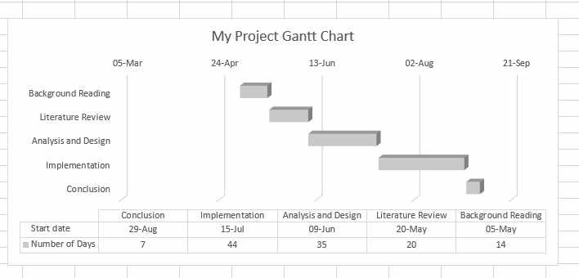

# Appendix B – Source Codes

* + - 1. **Database Connectivity**

SqlConnection conn = new SqlConnection(@"Data source = DESKTOP-QMEBJOC; Initial Catalog = FMWR; Integrated Security = True");

conn.Open();

SqlDataAdapter sqlcommand = new SqlDataAdapter("select count (*) from Organization.signin where Username = '" + textBox1.Text + "' and Password = '" + textBox2.Text + "' and Usertype

= '" + comboBox1.Text + "'", conn); DataTable dataCon = new DataTable();

* + - 1. **User Authentication**

if (dataCon.Rows[0][0].ToString() == "1")

{

if (comboBox1.Text == "Admin")

{

//calling the method SetTextFromTextbox1 = textBox1.Text;

Form2 admin = new Form2(); admin.Show();

this.Hide();

}

else if (comboBox1.Text == "Staff")

{

//calling the method

SetTextFromTextbox1 = textBox1.Text;

}

}

else

{

EmployeeDash staff = new EmployeeDash(); staff.Show();

this.Hide();

MessageBox.Show("Incorrect Username or Password");

}

* + - 1. **Leave application**

string name = combo_id.Text + Environment.NewLine + " " + textBox3.Text + Environment.NewLine + " " + textBox2.Text + Environment.NewLine + " " + combo_Ltype.Text;

text_info.Text = name;

string body = "From: " + textBox2.Text + " " + textBox3.Text + Environment.NewLine

+

"Leave Type: " + combo_Ltype.Text + Environment.NewLine + "Leave Reason: " + textBox8.Text + Environment.NewLine + "Personal Email: " + text_email + Environment.NewLine;

textBox_Body.Text = body;

if (combo_Ltype.Text == "" && textBox8.Text == "")

{

MessageBox.Show("Please Fill in Leave Type and Description");

}

else if (combo_Ltype.Text == "" || textBox8.Text == "")

{

MessageBox.Show("Please Fill The Required Space");

//label6.ForeColor = Color.Red;

}

else

{

if (MessageBox.Show("Do you want to Apply for this Leave", "Apply Leave", MessageBoxButtons.YesNo, MessageBoxIcon.Question) == DialogResult.Yes)

{

SqlConnection conn = new SqlConnection(@"Data source = DESKTOP-QMEBJOC; Initial Catalog = FMWR; Integrated Security = True");

String query= "insert into Organization.ApplyLeave (ID,Name,Sname,LeaveType,FromDate,ToDate,LDescription,AdminRemark,PhoneNo,Email, AdminDate,Gender,Status,LeaveInfo)" + "Values('" + combo_id.Text + "','" + textBox3.Text + "','" + textBox2.Text + "','" + combo_Ltype.Text + "','" + dateTimePicker1.Text + "','" + dateTimePicker2.Text + "','" + textBox8.Text + "','" + text_adminR.Text + "','" + text_number.Text + "','" + text_email.Text + "','" + text_adminD.Text + "','" + text_gender.Text

+ "','" + text_status.Text + "','" + text_info.Text + "');"; SqlCommand command = new SqlCommand(query, conn); SqlDataReader myreader;

try

{

conn.Open();

myreader = command.ExecuteReader(); sendEmail();

MessageBox.Show("Leave Request Submitted");

}

catch (Exception ex)

{

MessageBox.Show("invalid");

}

finally

{

conn.Close();

}

* + - 1. **Sending Email Notification**

public void sendEmail()

{

try

{

MailMessage message = new MailMessage(); message.From = new MailAddress(textBox_To.Text); message.Subject = textBox_Subject.Text; message.Body = textBox_Body.Text;

foreach (string s in textBox_To.Text.Split(';')) message.To.Add(s);

SmtpClient client = new SmtpClient();

client.Credentials = new NetworkCredential(textBox_From.Text, textBox_Pass.Text);

client.Host = "smtp.gmail.com"; client.Port = 587; client.EnableSsl = true; client.Send(message);

MessageBox.Show("Email sent successful");

}

catch (Exception ex)

{

MessageBox.Show("Error Sending Mail, Check yout internet connection");

}

}

# Appendix C – Test Cases

* + - 1. **Test plan for login table**

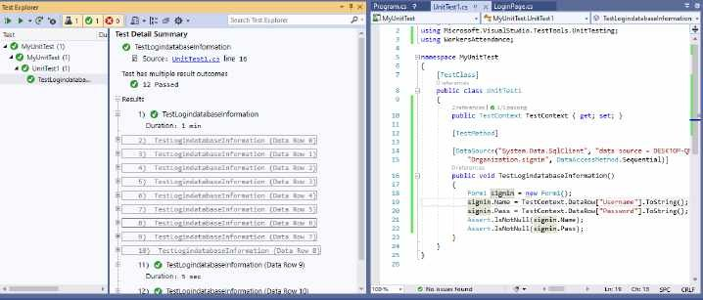

* + - 1. **Test plan for staff table**

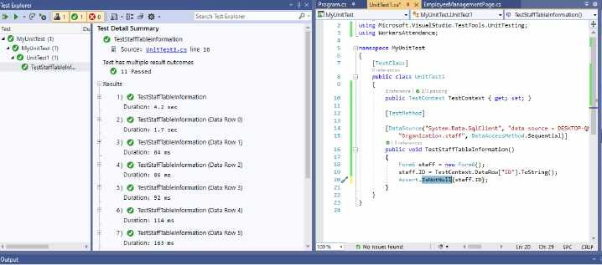

* + - 1. **Test plan for registry table**

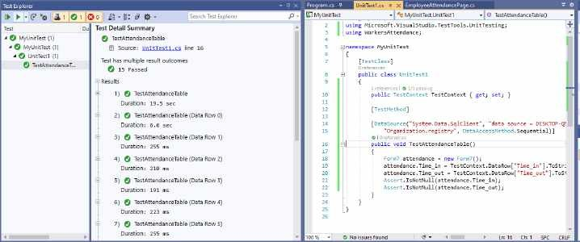

* + - 1. **Test plan for leave table**

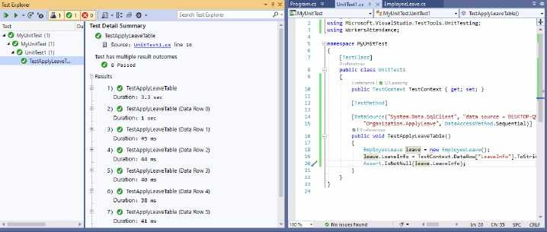

# Appendix D – User Guide/Manual

When a user runs the application the first interface that comes up is the login interface, the login interface enables different users such as staffs and the administrator to select their account type by choosing from the combo-box option available at the interface and login with their login credentials (username and password) using the text-boxes to fill the information and click on the login button to proceed.

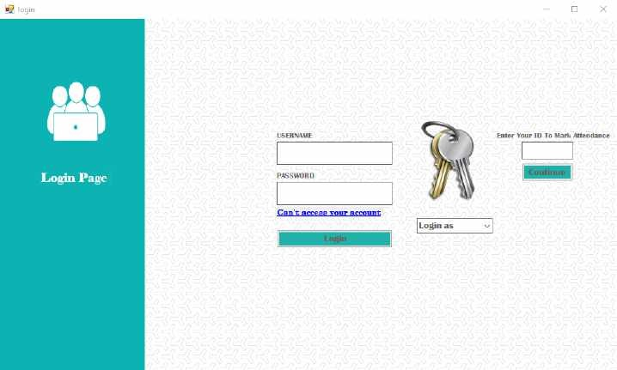

Suppose a user select his account type as “Administrator” and fills in the correct login credentials on the login interface and then click on login button, the system will log him into the Admin interface, the Admin page allows a user to navigate around the admin interface easily which enables him to manage login credentials, view dashboard, add staffs to the system, view staff records, manage leave and also manage attendance by simply clicking on any of the buttons below.

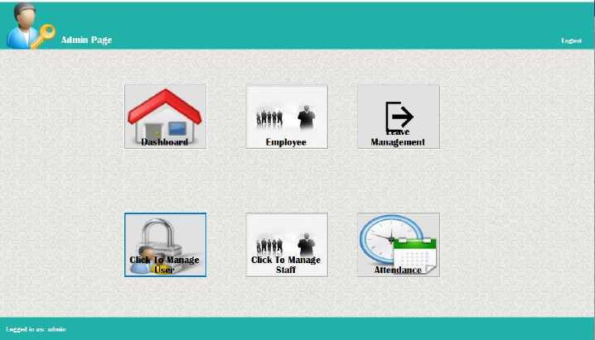

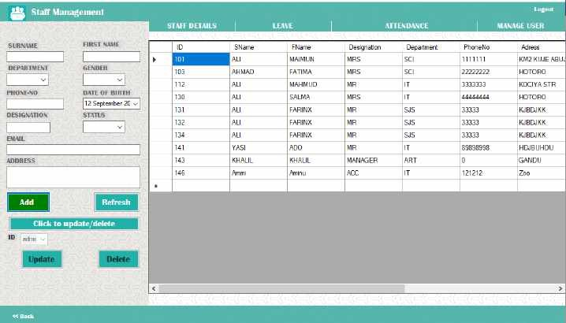

Suppose a user is logged in as an administrator and then clicks on “Dashboard” button, the system will display dashboard page containing information about the admin and the system and also includes navigation bar to navigate to other pages.

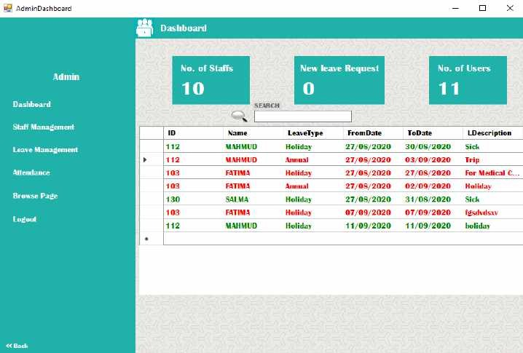

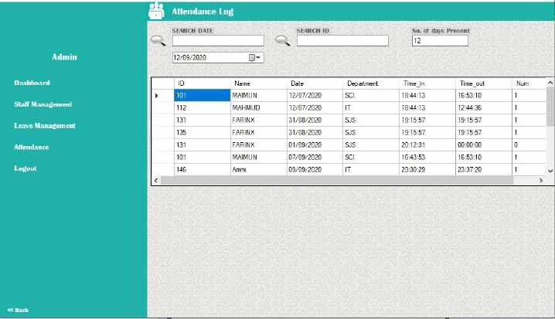

Suppose a user is logged in as an administrator and then clicks on “manage login credential” button, the system will display the interface shown below. Manage users page enables the administrator to add, delete and view users that have been authorized to access the system, an administrator can delete a user based on only the user-id of that particular user.

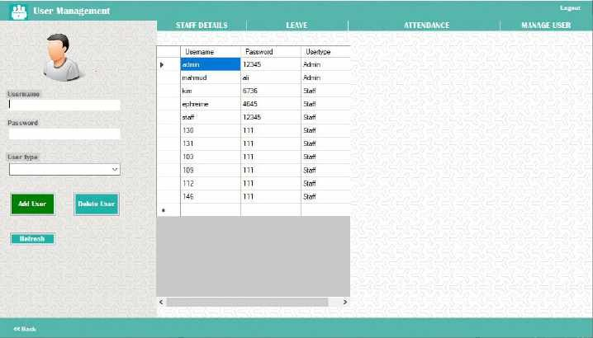

Suppose a user is logged in as an administrator and then clicks on “leave management” button, the system will display the interface shown below. On the page the admin will select a radio button based on the information he wants to display (pending leaves, approved leaves and not approved leaves). After selecting a radio button, list of staff option will display upon dropping down the combo-box which will enable the admin to choose a particular staff leave information using his ID then click on the “Take action” button to approve or dis-approve leave request.

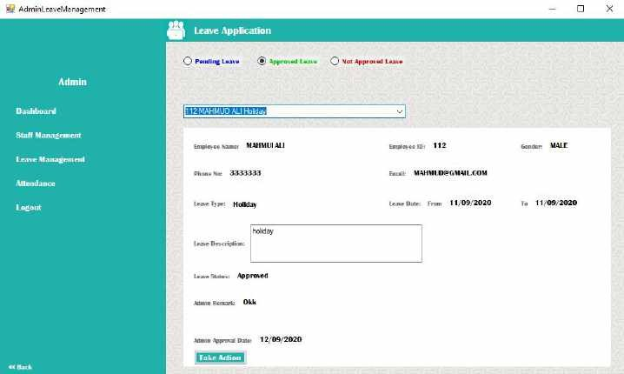

Suppose a user select his account type as “Staff” and fills in the correct login credentials on the login interface and then click on the login button, the system will log him into the staff interface which contain the staff details and navigation bar to take him/her to other intended page with just a click away.

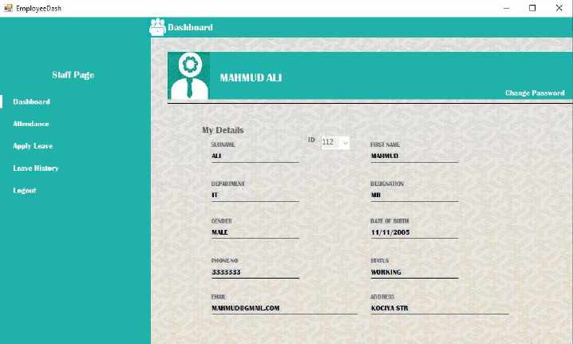

Under the staff dashboard interface, when a user clicks on change password which will allow the user to change password. The change password page contain three text-boxes (old password, new password and confirm password) and a “change” button. The user is required to fill the given space correctly in order to change the password.

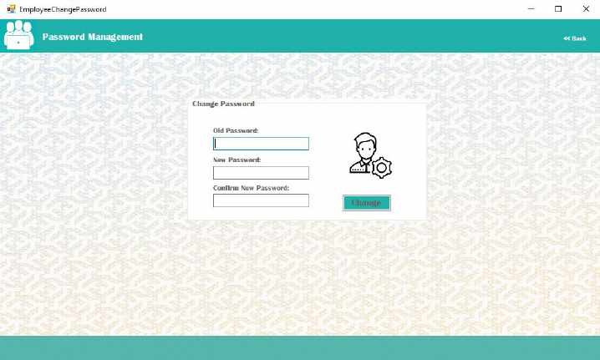

Under the staff dashboard interface, when a user clicks on “attendance” button, the user is required to mark his/her attendance by clicking on the “sig-in” button and scan his/her finger print using the finger scanner given and check out by clicking the “sign-out” button.

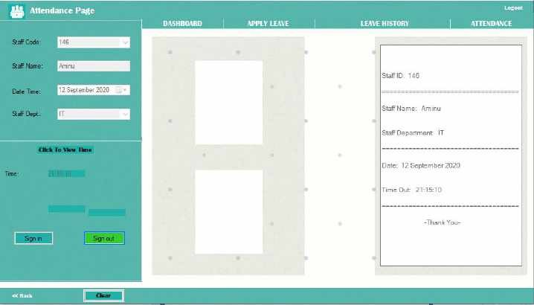

Under the staff dashboard interface, when a user clicks on “leave” button, the user is can request for leave by filling in the required spaces which include the leave type, from date, to date and leave description. The user can submit the request by clicking the “apply” button.

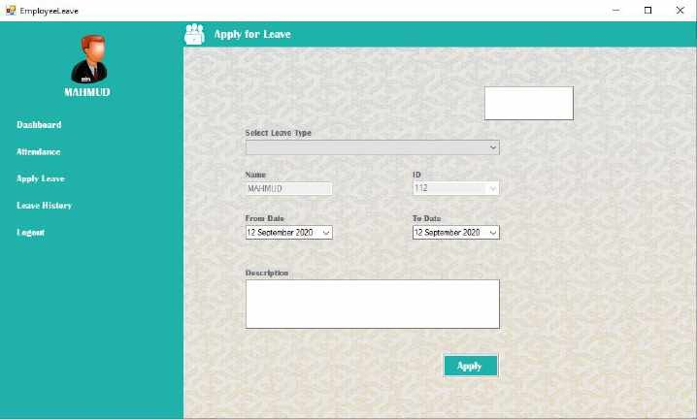

Suppose a user clicks on the “leave history” button, the system will navigate the user to the leave history page and displays all of his/her leave records and a search function to enable the user to search for a particular leave details.

