**DESIGN AND IMPLEMENTATION OF DATA MINING FOR MEDICAL RECORD SYSTEM.**

**(A CASE STUDY OF OWERRI GENERAL HOSPITAL)**

**A RESEARCH PROJECT BY**

**ADEGEYE IDOWU NIFEMI CST/2009/338**

**SUBMITTED TO THE FACULTY OF NATURAL SCIENCES, DEPARTMENT OF COMPUTER SCIENCE AND INFORMATION TECHNOLOGY,**

**CARITAS UNIVERSITY ENUGU**

**IN PARTIAL FULFILMENT OF THE REQUIREMENT FOR THE AWARD OF BACHELOR OF SCIENCES DEGREE IN COMPUTER SCIENCE AND INFORMATION TECHNOLOGY**

**SUPERVISOR**

**Mrs. IBEGBULEM CHINONSO JULY 2013.**

**APPROVAL PAGE**

# The undersigned certify that they have read, approved and hereby recommend to the Faculty of Natural Science for acceptance, a research project titled “Design and Implementation of a Medical Diagnostic System” originally written by Adegeye Idowu Nifemi in partial fulfillment of the requirements for the award of a Bachelor of Science Degree (B. Sc) in Computer Science and Information Technology.

_ _

## Mrs. Ibegbulem Chinonso Date

**(Project Supervisor)**

**_ _**

**Dr Nwaeze A.S. Date**

**(Head of Department)**

**_ _**

**Dr. B.O.N. Ekechukwu Date**

**(External Examiner)**

## CERTIFICATION

This is to certify that the project Design and Implementation of a Medical Diagnostic System was carried out by:

_

## NAME OF STUDENT SIGNATURE

_

## DATE

**DEDICATION**

This work is dedicated to the Almighty God, who in his infinite mercy made this work to be a success. And also to my parents Mr.F.R. Adegeye and Mrs. Oke Morenikeji

**ACKNOWLEDGEMENT**

# Firstly I want to thank God for his strength, grace and sufficiency, I cannot appreciate him enough. Receive all the glory and honor.

Appreciation goes to my project supervisor and academic mentor Mrs. Ibegbulem Chinonso for her motherly advice, attention and interest shown in my affairs, without which this work would not have been a success. Mammy words may not be enough to convey my level of indebtedness to you. God shall surely pay you back. Also to all the lectures in computer science department especially the HOD Dr A.S.Nwaeze, Ugwu Ejike, Eng Onu Solomon, Mr. Tochukwu Umeasiegbu for their words of advice and encouragement. Words may not be enough to convey my appreciation and indebtedness to my parents Mr .F.A Adegeye who made so many sacrifices at the altar of my education and provide all that I ever needed in the course of my career. You showed my love, care and a sense of belonging. God shall keep you to reap the fruit of your labor.

# Great appreciation goes to my brother Mr. Adegeye Oluwaseun, and my auntie‟s Miss. Olanisimi Oluwafunke, Mrs. Abdul Modupeoluwa, Mr.Oke Oluwashina, Mr. Oke Oluwaseun. Your support for me can never be quantified. The success of this programme today was largely due to your untiring support to me.

I am also grateful to my friends especially Mbah Adaeze, jide, Dami, Alex for their support and encouragement is invaluable. I say many thanks to you.

## TABLE OF CONTENTS

Title Page

Approval Page i

Certification Page ii

Dedication iii

Acknowledgement v

Table of Contents vi

Abstract x

## CHAPTER ONE INTRODUCTION

* 1. Background of Study 1
  2. Statement of the Problem 2
  3. Objectives of Study 3
  4. Significance of Study 4
  5. Scope of Study 4
  6. Limitations of Study 4
  7. Definition of related terms 5

CHAPTER TWO

REVIEW OF RELATED LITERATURE

* 1. Introduction 7
  2. Review of related literature… 11

CHAPTER THREE

SYSTEM ANALYSIS AND METHODOLOGY

* 1. System analysis 16
  2. Method of data collection 17
     1. Interviewing key officer… 17
     2. Observation method 18
     3. Examination of document 18
  3. Analysis of the existing system 18
     1. Organization profile chart 18
     2. Advantages of the existing system 20
     3. Disadvantage of the existing system 21
  4. Analysis of the proposed system 21
     1. Justification of the proposed system 22
  5. Methodology 23
     1. Recommended appropriate mode… 24

**CHAPTER FOUR**

## SYSTEM DESIGN AND IMPLEMENTATION

* 1. Overview of design 25
  2. Main menu 26
  3. Program modules specification 27
     1. Database design and specification 27
     2. Input/output specification 28
     3. Input form 29
     4. Output form 31
        1. Medical record system 32
  4. Flowchart of the proposed solution 34
  5. Choice and justification of programming language… 35
  6. System requirement 37
  7. Implementation plan 37
     1. Testing 38
     2. Conversion 39
     3. Training 40
  8. Maintenance details 40

## CHAPTER FIVE

## SUMMARY, RECOMMENDATIONS, CONCLUSION

* 1. Summary 41
  2. Review of achievements 42
  3. Areas of application 42
  4. Suggestion for further studies 42
  5. Recommendation 43
  6. Conclusion 43

## REFERENCES 45

APPENDIX A (Program codes) APPENDIX B (Sample, output forms)

**ABSTRACT**

# Data mining is the extraction of hidden predictive information from large database which helps in predicting future trend and behavior thereby helping management make knowledge driven decisions. The data mining tool designed is to aid in quick access and retrieval of patients information to avoid time wasted in retrieving of such data from hospitals data warehouse. The data mining tool was also designed to discover hidden pattern that helps in decision making by management.

Structured System Analysis and Design Methodology were used in the analysis of the existing system which also provided a guide for the design of the proposed system.

# PHP programming language and my SQL was used in the creation of a data warehouse for patient‟s information and data mining tool for the retrieval of such information when needed.

## CHAPTER ONE INTRODUCTION

## BACKGROUND OF STUDY

Data mining, is the extraction of hidden predictive information from large database, is a powerful new technology with great potential to help companies focus on the most important information in their data warehouses. Data mining tools predict future trends and behaviors, allowing businesses to make proactive, knowledge driven decisions. The automated, prospective analysis offered by data mining move beyond the analyses of past events provided by retrospective tools typical of decision support systems. Data mining tools can answer business questions that traditionally were too time consuming to resolve. The scour databases for hidden patterns, finding predictive information those experts may miss because it lies outside their expectations.

Most companies already collect and refine massive quantities of data. Data mining techniques can be implemented rapidly on existing software and hardware platforms to enhance the value of existing information resources, and can be integrated with new products and system as they are brought on-line. Which implemented on high performance client/server or parallel processing computers, data mining tools can analyze massive database to deliver answers to questions such as “Which client are most likely to respond to my next promotional mailing, and Why?”

Data mining techniques are result of a long process research and product development. This evolution began when business data was first stored on computers, continued with improvement in data access, and more recently,

generated technologies that allow users to navigate through their data in real time. Data mining takes this evolutionary process beyond retrospective data access and navigation to prospective and proactive information delivery.

Data mining is ready for application in the business community because it is supported by three technologies that are sufficiently mature: massive data collection, powerful multiprocessor computers and data mining algorithms. In this evolution from business data to business information, each new step has built upon the previous one. For example, dynamic data access is critical for drill-through in data navigation applications, and the ability to store large database is critical to data mining.

The file management is obsolete in developed countries like the United States where and in developing countries like Nigeria the file system is still processed manually in most medical centers; this is as a result of low standard of technology. It was clear that computer is everywhere in Nigeria. These computers are for money making and as a result of this, our hospitals lack computerized services, but with the help of data mining we can also computerize our hospitals.

## STATEMENT OF THE PROBLEM

The problem of data mining has become very crucial in areas of privacy of data. Specifically regarding the source of the data analyzed for certain purpose. My research in Owerri General Hospital here reveals that patients visit the hospital and they waste a lot of time. The patients waits for the nurses or the attendants to get their data and there are volumes of files to search through before the patients files is finally retrieved or the patients might forget his/her card when visit the hospital. It there means that the patient‟s data cannot be found due to the fact that the Nurse

does not know the patients number. In this case it is either that the patients is denied treatment by the Doctor or the Nurses will check through the volumes of files in order to retrieved his/her data, this is time consuming problem. There is a problem of misplacing of patients data, the non-availability of relevant forms like x-ray/laboratory forms and chats (pressure chats temperature) and requirement of more workers to carry the folders into the consulting rooms as an evident.

Moreover, there are mistakes in entering patient‟s records. Two patients might be given the same number and there could be wrong spelling and loss of important information. There is also lack of space for storing all the files and also due to carelessness on the part of staff.

Furthermore, volume of work for the hospital staff is much; this is because the ratio of patients to staff of Owerri General Hospital is so much. So staffs are over worked and they hurry through their duty, hence they carry out such duties lousily which makes the Doctors unfriendly to their patients.

## OBJECTIVE OF STUDY

Objectives of this research work are to:

 Create a data warehouse for storage of patient‟s information thereby eliminating manual file storage of patient‟s records.

 Design a good data mining tool that will help in easy retrieval of patient information thereby reducing time wastage and improve service delivery.

 The data mining tool will be able to discover hidden pattern in large volume of data which will help in good decision making.

## SIGNIFICANCE OF STUDY

This research will cover the creation of good database system for the management of patient‟s records in Owerri general hospital and also provide efficient data mining tool for easy retrieval of data and discovery of hidden patterns in large volume of data.

## SCOPE OF STUDY

This research work will be carried out on data mining for medical record system of Owerri General Hospital. The work reported in this research could be viewed as a step towards enhancing databases with functionalities.

## LIMITATION OF STUDY

Data mining record is limited in that; some manual operation will still be needed to carry out the operation effectively. There was some constraints encountered during collection of data, poor data collection becomes apparent due to interviewing of hospital representatives like the consultants. Nurses, Doctors, Hospital attendants who were reluctant to disclose important information and statistical data which otherwise would have been relevant to this research, due to hospital secret which breeds some indifferent attitudes towards that.

It takes a long time and large commitment of resources to get a good result, unavailability of text and materials on this topic, made gathering of facts very difficult, some of the facts were gathered from the internet, which is quite expensive.

## DEFINITION OF TERMS

**Data Mining:** Can be defined as “The nontrivial extraction of implicit, previously unknown, and potentially useful information from data, and “The science of extracting useful information from large data set or databases”.

It involves sorting through large amounts of data and picking out relevant information.

**Information Retrieval:** The act of locating quantities of data stored in a Database and producing useful information from the data.

**Information Processing:** A method of organizing, processing and extracting information to be easily stored, retrieved, searched and updated.

**Record:** It is a unit of data representing a particular transaction or a basic element of a file consisting in turn a number of interrelated data elements.

**Hospital:** A hospital is an institution of medical treatment of the sick and injured people.

**Model:** Is a pattern or mathematical/symbolic representation of real life System and or abstract system behaviors.

**Artificial Intelligence:** It is a branch of computer science that is dedicated to the study of the ways in which computers can be used to emulate or duplicate most human function.

**Knowledge Base:** Is an organized collection of declarative and procedural relationships that represents expertise in a focused area

## CHAPTER TWO LITERATURE REVIEW

## INTRODUCTION

In the early 1990s some sectors of the computer science community were developing the idea of understanding as a discovery-driven, systematic and iterative process. This “Data Mining” Research and development area was expected to take advantage of the expansion of traditional statistical analysis and database management strategies. The main goal was to identify relevant, interesting and potentially novel information pattern and relationships, in large data to support system in areas such as finance (E.g. credit approval and fraud detection application), marketing and sales analysis (E.g. shopping patterns and sales prediction) were showing a great deal of enthusiasm about the business value of data mining applications. During the next few years international conferences, journals and books were more frequently reporting advances, tools and applications of other areas such as biomedical informatics, engineering, physics, law enforcement and agriculture.

Today, Data mining has become a fundamental research topic in the progression of computing applications in health care and biomedicine. Advances in data mining have applications and implications in areas ranging from information management in healthcare originations, consumer health informatics, public health and epidemiology, patient care and monitoring systems, large-scale image analysis to information extraction and classification of scientific literature. Approaches, techniques and applications associated with data mining has also significantly supported different data understanding and decision support tasks in bio-signal

processing, Such as the classifications, visualization and identification of complex relationships between diagnostic variables or groups of patients.

Data mining is an inter-disciplinary subject formed by the intersection of many different areas, researchers in knowledge acquisition, artificial intelligence, machine learning, statistics, spatial database, and data visualization have also shown great interest in data mining. Since data mining poses many challenging research issues, direct applications of methods and techniques developed in related studies of machine learning, statistics and database systems cannot solve these problems, it is necessary to perform dedicated studies to invent new data mining methods or to develop integrated techniques for efficient and effective data mining. In this sense, data mining itself has performed an independent new field. The database research community has observed that data mining, together with warehousing and data repositories, is a new use of database technology, which are considered as important areas in database research.

Due to its complexity, data mining technology has traditionally been used in scientific and engineering settings since it originated in university labs. Data mining is now growing common in business environments, particularly in companies with large volumes of data, communities of users, who are not data analysis specialists, and co-operate data that is detailed and multifaceted, with data relationships that are changeable, not predetermined or even logical.

In the business worlds, the most successful application of data mining is the “Market Basket” application. It is used to analyze transaction database and look for patterns among existing customer transaction. Those patterns are used to help make business decisions, such as what to put on sale, how to design coupons, how

to place merchandise on shelves in order to maximize the profit. Several successful applications have been developed for analyzing and reporting data changes. These include supermarket sale data and healthcare database.

A number of interesting and important scientific applications of data mining have also been developed. Example application areas in science include astronomy, molecular biology and global climate change modeling. Here we shall note that the manual search of data, search assisted by queries to a database management system (DBMA) or humans visualizing patterns in data are not referred to as data mining. This is how some authors examine data mining for Medical Record System of Hospital.

Donald (1981), Observed that the application of computer to an organization such as making use of data mining in medical department provides individuals with better services, high quality of products and greater efficiency. He went further to say that the use of computer would avoid wastage of time and files. Improved efficiency and productivity reduce cost of goods and services.

According to Rosenberg J. (1997), Computerization is a computer application to any activities formerly done by hand or without the use of computers. It can be drawn from the above that in data mining for medical record system of a hospital, the fundamental devices requires is the computer.

Davis (1987), Data Processing principle and concept stated that computer is known for the speed and accuracy in processing information and such speed is not achieved manually or by any other device except the computer. He noted that data mining involves the use of sophisticated data analysis tools to discover previously unknown records, valid patterns and relationships in large data sets. These tools

can include statistical models and machine learning methods (algorithms that improve their performance automatically through experience).

Foster O. (1992), Expert System in Health for Developing Countries, Stated that the technology is applied to help find the data of patient been treated in other to cure the present disease. When all the above is considered you say that health care industry is a technology industry. Modern medical practice is based on vast amount of scientific investigation the evaluation of computer in healthcare industry is taking its time. It has advance to a great level in the aspect of data handling, stating that computers are supposed to be used to fill any record about a patient.

Advancement has also been made in connection with equipment in the hospital. There are machines like electrocardiograph system, blood cell separators, breathing aids, scan machines, heart monitoring machines etc. The theaters are filled with various life saving devices, many years ago these was not a reality about 26years ago you could access huge computers at a central location in some countries. Nigeria is not yet developed in computer industry unlike countries U. S, Germany etc. we are not yet developed into networking and most of the equipments mentioned above can only be found in few selected hospitals and at exorbitant prices with the effort government is making towards the computerization of every sector of the economy. It is believed that in no distant time the computer problem will become a thing of past.

Korpela, M. (1994), Nigeria Practice in Computer System Development, Stated that, medical record system is an essential resource indispensable in the operation of management information system. Without a record, there would be no complete information to work with. Patients‟ record must be accurate, reliable and timely for

decision-making. The record system demands a reasonable level of expertise in its handling and management.

Hill, D.W. (1978) Computer in Medical Services London, Stated that the use of manually medical record data of patient registration and drugs placed on the patient supposed to be documented on a computer, so that the mode of operation will be fast. In making use of the manually operated, the patient stand at risk, because before his/her data will be recovered life may be loss. He strongly recommend in the use of computer in keeping of patients data.

Macdonald Onuma (2001) Introduction to Artificial Intelligence (Unpublished lecture Note), Noted that, several emerging application for information providing services, such as on-line services and the World Wide Web (WWW), also call for various data mining techniques to better understand user behavior, to meliorate the services provided, and to increase the business opportunities.

Chris Naylor (2001) Expert System Shell Research Limited, Stated that, one shall note that the manual search assisted by queries to a database management system (DBMA), or humans visualizing pattern in data are not referred to as data mining. Data mining community has focused mainly on automated method for extracting patterns and/ or models from data.

## THE REVIEW OF RELATED LITERATURE

Nowadays, the human ability of collecting and creating data has been growing. The business and scientific devices can easily produce gigabytes of data per day. Such amount of data has far exceeded the human capacity of analyzing and understanding it. Such situation calls for powerful tools to analyze the data

efficiently, data mining emerged when the needs for such tools were more and more.

The rapid development of algorithm and methodology in data mining for medical record system, together with the quick expand of hardware capacities driven by Moore‟s Law, enables the data mining experts now to handle far more data than ten years ago.

The major questions asked by a hospital attendant to any patients as he or she step into the hospital are: Are you a new patient? What is your hospital card number? If he/she is an old patient, the folder is retrieved and he or she is asked if the person has a previous appointment with the Doctor. Then his folder is then sent to the Doctor and he or she is asked to wait for his turn, but if the patient is a new person, he is told to pay the bill for the folder, and then he asked for his first and last name, sex, age, address, he is then given a card number which he is expected to bring whenever he visits the hospital.

When it is the patient‟s turn to see the Doctor, he is ushered in by the hospital attendant. If on appointment, the Doctor asks for his ailment and how he is responding to treatment then the Doctor will now observe the patient and from his observation, he can issue more drugs or tell the patient he/she is finally healed. In the other hand of the patient is not on appointment, the doctor enquires about the patient‟s health conditions. The Doctor will find out the patient‟s family‟s health history and based on that he will find out whether the patient is suffering from certain illness. The patient will tell the doctor his problems and after oral examination the patient is sent to the laboratory if the patient is not critical, the result will determine whether he will be admitted or not. If the patient is to be

admitted, it is stated and the patient goes through the admission procedure and if not he/she prescribed treatment throughout the patient stay in the hospital on admission. The process is recorded along with the treatment given in the medical record would be most helpful in the treatment of the patient.

The use of data mining for medical record system would be of help in serving an unusual case if not easily accessible. All these are what the new system purposes to climate or minimize.

Data mining researchers are mostly thinking of creating some data mining systems which can automatically do the entire knowledge discovery tasks without human participation. The user can get the result after a „start‟ button. But when we think of the problem practically, quite often the computers do not work so well as we expect because currently computers having human-level intelligence are only a dream. If we have computer do all the knowledge discovery work, sometimes we will have the task done in a “stupid” way by the computers, while an experienced human worker can do it more efficiently and with better result if the data amount is within human ability, thus human guidance, expertise, and experiences are currently irreplaceable in discovering and understanding knowledge.

Data mining for medical record system excludes the informal (manual) collection of data, it exists as a separate entity within an organization, and it could be simply viewed as the container of data. The healthcare service being the most delicate important aspect of service being rendered to the people at the hospital deals with life and must be treated with care. It has gone through various developments over the years.

File maintenance is possible with medical record system by computer. Furthermore, the reports compiled by the computer are more reliable than the medical data kept by most record unit workers.

Another help of data mining for medical record system in medical information system (MIS) of patient that need to transplant of one organ or the as well as the record of voluntary donors through a network database system, hospitals all over the world are able to receive and send information through the network. For instance, when a kidney is available for transplanting, through the network they are able to get in touch with a patient that needs the kidney living in other part of country. This saves time and life of the patient unlike in a situation where information has to be sent by post.

This has really saved the life of many patients who would have died due to the prolonged time lapses in the course of waiting for information. Not too long ago, the popular Nigeria broadcaster, Steve Kadiri was one of such patient who was in need of kidney transplant. The kidney type was not match with many donors type present in the country and information was gotten from the network as to the most fitted and available kidney.

Marcia Dould (1969), from Phoenix, Arizona, was also one of such patient in need of a new kidney, when a kidney of a rare of tissue was given to the University of Califomian‟s San Francisco medical centre, the information was entered into a computer and compared with the records of sixty patients who were waiting for new organs. Marcia kidney was gotten, flown in for surgery, the operation was completed, and her kidney restored to normal.

Nigerian‟s hospital lack a lot of infrastructures, understaffing, lack educated personal etc. which nevertheless leads non chalance on the part of staff, lack of disciplines and inefficiency. In data mining for medical record system can help human personnel save life, which would have been lost. It also helps in reducing inefficiency. With this system I am proposing a lot of unnecessary wasting of life and time.

## CHAPTER THREE SYSTEM ANALYSIS AND DESIGN

* 1. **INTRODUCTION**

Although research into the study of the manual process of medical record system, which includes control record keeping, access to vital information and diagnosis; has shown some lapses, this project work attempts to minimize if not eradicate problems encountered by Doctors and other medical personnel being a tool of assistance to them. To achieve this standard, data mining for medical record system will be applied.

Before we proceed, we have to look into a system investigation.

**System:** This may be seen as a group of unit or as an arrangement of many parts. It could be in terms of machines that work together as a whole.

**Investigation**: It can be seen as a process of examining or inquiring facts into something carefully.

Therefore, from the above statement or definition given, system investigation can be define as a method of carrying out feasibility study of a particular organization or environment as to discover impediments on the already existing and militating against the existing system.

Since data mining for medical record system will be applied in other to get the collection of patient record for easy analysis, processing of data for admitting sick patient as at when needed within the shortest possible time in admission and

records and to reduce the manual method of admitting patient as a result of this high demand of computer operators and analyst.

The equipment and facilities must be noted in a way that will portray their relation to the system. Investigation was carried out on some of the forms, manuals, folders, records and files in Owerri general hospital and necessary information was gathered they include hospital cards, hospital folders, registration form, and admission / discharge forms.

## METHOD OF DATA COLLECTION

* 1. ,1 INTERVIEW OF KEY OFFICERS

The researcher came in contact with the chief medical director who gave the following information.

1. That the medical record of patient in Owerri general hospital is not electronic system.
2. That there is need for data mining for medical record of patient in the hospital.
3. That the effect of computer security system in the hospital is such that the computer will have username and password so that unauthorized people or intruders will not have access to the record of the hospital.
4. That the manual system used in keeping records has not been efficient in the sense they experience lose of patient‟s record due to improper documentation of patients data.

## OBSERVATION METHOD

In this mode of facts collecting, the researcher went to the office to observe the workers at work. Thus observations discover what the interviewer was not able to make clear to the researcher.

## EXAMINATION OF DOCUMENTS

This mode of facts collection involves examination of the document used by the Owerri general hospital in processing patient‟s record in order to admit them and give them adequate treatment.

## ANALYSIS OF THE EXISTING SYSTEM

When the patients has finished supplying his data needed for filling up his form, the staff in charge goes through the information / details submitted to the hospital for the treatment of the patient. The nurse in charge will now pick up the patient data for his/her treatment to commence.

## ANALYSING OPERATION DOCUMENT:

Operation document used in Owerri general hospital include the following.

1. Biodata form
2. Medical laboratory test result
3. X –rays film

## BIO-DATA FORM

This is the printed form designed in such a way that all the necessary information that will be needed from the patient will have gap where the patient will complete it, when the nurse will ask him/ her about his data.

## MEDICAL LABORATORY REPORT

The laboratory attendant takes the blood, urine or any other sample specimen depending on the nature of the sickness of the patient, after the experiment has been made by the medical laboratory attendant, they nurses will now take it to the doctor for his to prescribe drugs and injections to the patient.

## X-RAY FILM

This is usually used to check the status of the bone, when someone has dislocation of the bone or broken bone, and also chest pain depending the location of the problem, so that the doctor will study the X-ray film and know the next step to follow for the treatment of the patient.

## ORGANIZATION CHART

Matron

Medical officer

Accountant

Cashier

MANAGEMENT BOARD



Medical consultant

Laboratory attendance

Residence doctor

Doctors

Chief medical director

Cleaners

Gateman security

Gardeners

Nurses

* + 1. **ADVANTAGES OF THE EXISTING SYSTEM**

 Lack of power supply cannot affect the operations of the existing system.

 The hospital staff are already used to the existing and they will not need to be retrained unlike the new system that require retraining of staff.

 The existing system is easier to use.

## DISADVANTAGES OF THE EXISTING SYSTEM

1. Patients waste a lot of time at the waiting room before he/she receives medical treatment. Patients are delayed.
2. Inaccurate information is a problem due to the manual method recording, so the information gotten from the staff is rarely.
3. Sorting the files into their respective department is very difficult because records of patients are kept in a discordantly manner thereby making it extremely difficult to retrieve information.
4. Misplacement of medical records as a result of negligence on the part the hospital records‟ keeper.
5. Inability to get report about the medical record of the patient.
6. Uncontrolled redundancy of information
7. Lose or damage of files by pest
8. Lack of staff
9. Lack of space for sorting large number of returned files.

## ANALYSIS OF THE PROPOSED SYSTEM

This part is concerned with detailed examination of all the facts gathered in order to make a proper assessment of the existing system. Its aim is to ensure that all feasible alternatives are considered. System analysis in the procedural study of operation of a system with an attempt to discover its basic problem areas, it determines why a system is not working properly and finds way of alleviating the problem.

According to Oliver and Chapman (2002), Define Analysis of the system as the method of determining how best to use computer with other resources to perform tasks which meets the need of an establishment. On the course of the investigation which is carried out, the research made the following analysis.

(i.) The Owerri general hospital should not waste time implementing a data mining for medical record system, So as to ease the existing problems in the current system.

1. The hospital now have a computer department which shows that, they have gotten medical record system.
2. The recording unit has the basic requirement being computerized base on the facts collected, this would go along way in reducing the cost and increase benefit of the propose medical record system. That means after the analysis of the current system of Owerri general hospital, it was found out that most of the problems could be alleviated with the proposed system.

## JUSTIFICATION OF THE PROPOSED SYSTEM

The new system has the following advantages over the existing system:

1. Reduction in the waste of time on the part of patients before they receive treatment.
2. Reports will be prepared much faster when the doctor needs it.
3. Misplacement of patient‟s record is totally eradicated.
4. Frequent damage of cards and folders by pest is minimize.
5. Provide immediate feedback concerning medical record of patient‟s cases
6. Provide accurate documentation of medical record of patient‟s record.
7. Improve file maintenance: The new system is capable of storage and maintenance of lounge volume of patients files without occupying unnecessary space and any of the file could be access at any time.
8. Back-ups of all medical recorded data and information can be easily generated for future reference.
9. File updating becomes easier and reduction in paper work within the hospital.
10. Interrelationship within the Owerri general hospital will be highly promoted

Obviously, the gains to be generated from the use of data mining for medical record system are unparallel when compared with that of the existing manual system. Lastly my objective of the new system is to facilitate a proper functioning of the management which can easily be achieved instead of spending huge amounts in manual system which yields nothing but a low and inefficient output.

## METHODOLOGY

There exist different methodologies that can be used in carrying out research of information systems which includes Structured System Analysis and Design Methodology (SSADM), Object Oriented methodology (OOM), Prototyping methodology and Expert System methodology.

This system was designed using Structured System Analysis and Design Methodology which helped in well articulated analysis of the existing system, feasibility study, system design, implementation and proper documentation of the design details.

## RECOMMENDED APPROPRIATE MODE

The following are recommendation for the mode of the new system to operate for efficiency and maximum result, utilization of patients records. The new system should run on an ideal speed, it should be reliable so as to minimize error and mistakes made on the current system based on the processing mode, the services of an on-line processing mode is recommended for incoming new system due to the following reasons:

1. Availability of up-to-date information
2. It saves time and energy
3. It eliminates tedious clerical data
4. It improves the services to our patients.

## CHAPTER FOUR

**SYSTEM DESIGN AND IMPLEMENTATION**

## OVERVIEW OF DESIGN

The purpose of this chapter is to produce specification by the researcher, which will enable the user to use the new system easily without going to the designer for more information.

The input of the new system for a complete and concise basis for medical record system while the output contains the relevant information needed by the recording unit.

The principle of GIGO is applied that in Garbage in Garbage out. What you input into the system is what the system will bring out as output. Then if you input wrong data, wrong output will be realized. The researcher stands on the favourable side of the GIGO‟S principle, so every input and output design in the research work is accurate and relevant.

## MAIN MENU

EXIT

PATIENT’S RECORD

ADMIN

MAIN MENU

CREATE USER

ENTER NEW RECORD

DELETE USER

VIEW PATIENT’S RECORD

VIEW USER

CHANGE PASSWORD

Figure 4.2.1 **Main Menu**

The main menu is made up of 1 modules which is made up of Command Buttons. These Command Buttons include: The Admin Command button which is made up Four sub-command buttons, The Patient‟s Record Command button which is also made up two sub-command buttons. The Admin Command button takes care of the management of the general system. The Patient‟s Record Command button manages patients information,

## PROGRAM MODULES SPECIFICATION

The program was designed using Top – Down Approach. It makes use of the fundamental program solving techniques. The software is structured in such a way that each subsystem is selected and executed independently. The task is divided into several modules, which come together to give the solution to the problem.

## DATABASE DESIGN AND SPECIFICATION

SQL Database was used in the design of the new system database. Below is the database structure and specifications.

|  |  |  |
| --- | --- | --- |
| **Field Name** | **Data Type** | **Size** |
| PATIENT_SURNAME | Text | 15 |
| PATIENTS_FULL_NAME | Text | 15 |
| PATIENT_MIDDLE_NAME | Text | 15 |
| PATIENT GENDER | Text | 15 |
| PHONE NUMBER | Number | 14 |
| E-MAIL ADDRESS | Text | 20 |
| HOME ADDRESS | Text | 50 |
| USERNAME | Text | 5 |
| PASSWORD | Text | 20 |

Table 4.3.1: New User

|  |  |  |
| --- | --- | --- |
| **Field Name** | **Data Type** | **Size** |
| CARD NUMBER | Text | 5 |
| From | Text | 10 |
| To | Text | 10 |

Table 4.3.1: Treatment Record

## INPUT AND OUTPUT SPECIFICATION Input Specification and Design (Format)

The approach of key to disk approach of capturing data. In this situation, the input mediums are the computer, mouse and the keyboard to make selections. The word “input” refers to the data, which the user submits to the computer. It can be done through the computer keyboard or mouse. But in this research, the keyboard will be needed more than the information needed for a favorable output; this is because of the principle of GIGO which states that what you give the computer is what you will expect from it.

This input of the new system design is made in such a way that the variables either real or integer needed to compute on data mining for medical record system of Owerri general hospital, patients records are made in such a way that the computer will request for it. These variables keyed into the computer are called input of the new system

## INPUT FORM DESIGN OF THE NEW SYSTEM MEDICAL RECORD SYSTEM OF GENERAL

**HOSPITAL OWERRI PATIENTS DOCUMENTATION FORM**

**Patient Bio Data**

Patient Card Number: Patient Full Name: Patient Address: Patient Gender: Patient Next Of Kin: Patient Date of Birth:

Patient Doctors Report:

Name of Doctor: Type in The Diagnoses:

Drugs Placed By the Doctor: Date of Admission And Discharge:

PATIENT‟S SURNAME: PATIENTS FULL NAME: PATIENT‟S MIDDLE NAME: PATIENT GENDER:

PHONE NUMBER: E-MAIL ADDRESS: HOME ADDRESS: USERNAME: PASSWORD:

CONFIRM PASSWORD:

**New User**

MANAGER:

CARD NUMBER: FROM (DATE): TO (DATE):

ADMINISTRATOR:

SUBMIT

**PATIENT TREATMENT RECORD**

VIEW RECORDS

FIRST NAME: DATE OF BIRTH:

PROCEED

PROCEED

**SEARCH PATIENT INFORMATION**

PROCEED

USERNAME: PASSWORD:

**ADMINISTRATI0N LOGIN**

LOGIN

* + 1. **Output Specification and Design (Format)**

The output of the new system of data mining for medical record system are the variables the patients may likely to see on his/her card when he/she finds himself/herself at Owerri general hospital.

The desired result which the user wants to get after processing the input. In this research work, it includes the following.

## MEDICAL RECORD SYSTEM OF GENERAL

**HOSPITAL OWERRI PATIENTS DOCUMENTATION FORM**

## PATIENT DATA SHEET

Patient card number: Patient Surname: Patient Last name: Patient Middle names:

Date of birth: Patient Sex:

Patient Address: Diagnosis of patient:

Drugs prescribed: Date of Admission: Date of Discharge:

## MEDICAL RECORD SYSTEM OF OWERRI GENERAL HOSPITAL

**PATIENT DATA SHEET**

Patient card number: Patient Surname: Patient Last name: Patient Middle names: Date of birth: Patient Sex: Patient Address: Diagnosis of patient: Drugs prescribed: Date of Admission: Date of Discharge: Doctor‟s report of the patient: Name of Doctor: Next of kin of the patient:

## FLOWCHART OF THE PROPOSED SYSTEM



START

ENTER ADMIN USER

NAME AND PASSWORD

IS PATIENT

NEW ACCOUNT CREATED

NO

?

YES

REGISTER PATIENT

CREATE PATIENT NEW ACCOUNT



DISPLAY PATIENT STATUS

STOP

VIEW PATIENT

INFORMATION

* 1. **CHOICE AND JUSTIFICATION OF THE PROGRAMMING LANGUAGE USED**

The programming language used is PHP web programming language. It is an extremely flexible programming language designed for variety of applications meant for the world wide web. PHP can even be used for desktop applications though it is not best suited for this.

It is also built to support virtually all kinds of databases using either ODBC or database vendor specific connection strings. MYSQL was chosen for the new system.

The programmer chooses PHP and MYSQL for the following reasons:

1. It is easy to setup and requires little support after setup.
2. It has support for all kinds of data objects and is especially suited for biometric applications if the hospital decides to implement such modules.
3. It is network oriented. Can be accessed over the hospital network with little setup.
4. Support a graphically user interface using browsers and can be accessed from Many kind of Operating platform including mobile devices.
5. Application can be deployed on the internet with proper security considerations thereby making the application available from anywhere around the world.
6. MYSQL is extremely simple to manage. Backups and maintainance can be done easily.

## SYSTEM REQUIREMENT

**HARDWARE AND SOFTWARE REQUIREMENTS**

**Hardware requirement:** Hardware refers to physical components and devices that make the computer system.

The department needs at least one Pentium (iii) with the following configuration PROCESSOR INTEL PROCESSOR

PROCESSOR SPEED 512 MHZ

RAM SIZE 32MB (LG OR PANASONIC) HARD DISK 8.4GB

CD-ROM 48* CDROM

SPEAKERS 240 WATTS SPEAKER DISK DRIVE 1.44 MB

SERIAL PORT FOUR PARALLEL PORTS TWO

MONITOR 14” COLOR MONITOR

KEYBOARD ENHANCED WINDOW 98, WINDOW 2000

SOUND CARD POWERFUL / SOUND CARD PRINTER LASER JET 1100L

MOUSE SERIAL MOUSE AND PAD

VOLTAGE REGULATOR CENTURY OR SAMTEX STABILIZER (1000 WATTS)

UNINTERRUPTIBLE POWER SUPPLY (U.P.S)

## SOFTWARE REQUIREMENT

DOS 6.0 and above Antivirus tool kits, Visicales

Lotus 1-2-3

MICROSOFT EXCEL AND MICROSOFT ACCESS

Operating system WIN 2000, XP, NT, VISTA VB 6.0 Enterprise Edition is the main application software package used in developing the program.

## IMLEMENTATION PLAN

After the system has been developed, a lot of work is done to put to test. The development system.

Implementation is putting into effect of intension depicted in the design stage and realized from the development stage. It has the sole aim of integrating a proven functional system development through test with hypothetical input into the operation of organization.

Before a new system is implemented, all of its component must be subjected to extensive test to establish a logical correctness; efficiency and adherence to design specification operations are simulated and are used to test the system.

## TESTING

To achieve this, the researcher re-checks the logic of the design tool to correct any flaw if any, and also makes sure that the logic of the actual program corresponds with the logic of the design tool.

Hence, the researcher carefully prepared test data valid or invalid. The valid test data of this research work for the medical record system development of a software package of medical record were first manually processed and then processed with the program. The researcher then compares the manual output with the program output. All to make sure that the errors in the program is detected before the changeover.

Then, the valid test data were used in this project work to stimulate the type of errors like the syntax and logical errors the user might commit during the use of the new system and to check if the program will respond in a appropriate manner.

## CONVERSION

It is the systemic way of converting the existing files into magnetic form, if after testing and it was found that there are no errors.

There are several ways used in converting to a new system, parallel changeover, direct changeover, phase and and pilot changeover when the new and old systems operates at the sometime.

To make this research work more advantageous, a parallel changeover method or procedure would be recommended because with parallel changeover method, the old and new systems are run concurrently, using the same input.

Data is processed or moved through both systems at the same time. only when the new system is fully debugged and operational in the new system included. Changeover should not disturb normal medical records operations.

The reasons also include the following:

1. It permits for a longer comparism of all aspects of the new and old system.
2. The high sensitivity of the work and large volume of data involved in processing the medical nature of information technology, it might become inevitable for other researchers to modify this program due to changes and necessity of keeping records of recent technologies and innovations. The program of this research work is written in such away that it can be modified at anytime as to make the current standard.

## TRAINING

After converting from old system (manual) to the new system

(computerized), it is important to train the staff with regards to the operational procedure involved in the software developed.

The amount of training requires various levels of staff depending on the complexity of the system and skills presently available. The users of the new system were given adequate training with the use of computer with particular reference on entering data procedure, correcting mistakes in the new system, editing, formating etc.

## SYSTEM MAINTENANCE DETAILS

The aim of any software developer is to write a correct and maintainable program. The program is said to be maintained if it can be easily amended whenever crises called for it.

That is, it may need modification in future due to discovery of errors in the system, change of software and hardware, academic practice and legal implications. Because of the dynamic stages of conversion depends on the method currently used for keeping files (manually in shelves).

Moreover, these conversions of the existing master files into a new (magnetic) form involves the comparism of the new file system to check the feasibility of the new magnetic file system.

## CHAPTER FIVE

**SUMMARY, RECOMMENDATION AND CONCLUSION**

## SUMMARY

This started with introducing the background of the study, statement of the problem, objective of the study, scope of study and the significant of the study. This project work went further to study the related literature review, the existing system was analyzed in order to discover the weakness that existed within the establishment. These include difficulties in retrieving patients information, duplication of patients number and solution was also made in order to curb this illness in the establishment. After all these, the justification for data mining was also suggested; the reasons why the existing system should be computerized were made known to the organization.

Infact, if implemented according to the given instructions would serve as an aid to eliminate all constraints in the manual system presently being faced in Owerri General Hospital.

Furthermore, there was a look into design of the new system, analysis made on how the new system will take care of the enumerated problems in the new system and these were taken care of.

Finally, documentation was also provided in case there is need for future changes. Above all, there was also user‟s documentation which will serve as a guide to anybody that wants to use the package.

## REVIEW OF ACHIEVEMENT

This system has been tested and found to achieve the following:

* + 1. Creation of a data warehouse for storage of patient‟s information thereby eliminating manual file storage of patient‟s records.
    2. Design of a good data mining tool that helps in easy retrieval of patient information thereby reducing time wastage and improve service delivery.
    3. The data mining tool can discover hidden pattern in large volume of data which helps in good decision making.

## AREAS OF APPLICATION

This work can be used in large different medical hospital and large database organization.

## SUGGESTION FOR FURTHER STUDIES

A potential researcher who might be interested in this topic in the nearest future to use any of the following high level languages, example C++, Java.

The researcher urge the management of Owerri General Hospital, to do all it can to have staff computer literate; this will make it easy for the hospital management to switch over to the new system instead of the present out dated out-of-fashioned manual system.

Finally, it can be redesign for use in a networked environment, and can also be upgraded in areas such as the pharmacy section, online registration and payment scheme.

## RECOMMENDATION

The system designed can be used by other organizations which have large volume of data that needs to be retrieved from time to time to aid in easy retrieval and also help in discovering of hidden pattern that can be used for informed and intelligent decision making by management.

## CONCLUSION

The existing system had been studied and the new one has designed from the analysis drawn after the design of the new system. There is no doubt that to design a new system, it has a lot of advantages over the existing manual system. The new designed system has helped in achieving the following:

1. Patient‟s records and reports are now easily retrieved with increased data security.
2. The contact time between a Doctor and a patient in the needed information by the doctor starting from the registration and consultation is highly reduced to its barest minimum. This is as a result of high processing speed of the computer.
3. An easy access to clinical reports for decision making and research purpose is assured.
4. The amount of resources such as materials and money is reduced, hence covering cost of Medical Services.

## REFERENCES

Akukwe, A.C., & Uzoma, J.P. (1999). *A Practical Approach to Electronic Data Processing*. Owerri: Cherry Ben Publisher.

Anderson, R.G. (2002). *Data Processing, Information System And Technology*. London: Pitman Publishing Ltd.

Commer, J.M.A. (1987). *Computer Model for Sales Territory Planning Decision Services*. U.S.A: American marketing Association.

Ezeano, A.N. (1993). *Computer User Resistance And Misconception*. Britain: Minner‟s Press.

Hill, D.W. (1978). *Computer in Medical Services.* London: Macdonald And Evans.

Igwe, S.O. (2002). *Introduction to Information Processing and Basic Programing”.* India: Micbad Publishers.

Korpela, M. (1994) “*Nigeria Practice in Computer System Development.* Lagos: ACM Press.

Osigwelem, K.U. (2008). *Electronic Data Processing and Communication Foundation*. Britain: Office Print Publishers.

Resenbery, J.M. (1987). *Doctrinaire of Computer Information Processing Processing and Telecommunication*. New York: Vintage Books.

## APPENDIX A SAMPLE OUTPUT FORMS

Programming the new system involves the writing series of instructions in the PHP language after the logic has been designed using appropriate designing tools.

The system is accessible only through a successful login. There are two kinds of users, Admin and Managers. Managers represent front desk operators who can view records or enter records after a patient completes treatment. The modules integrated in the program and what each of the modules does is as follows:

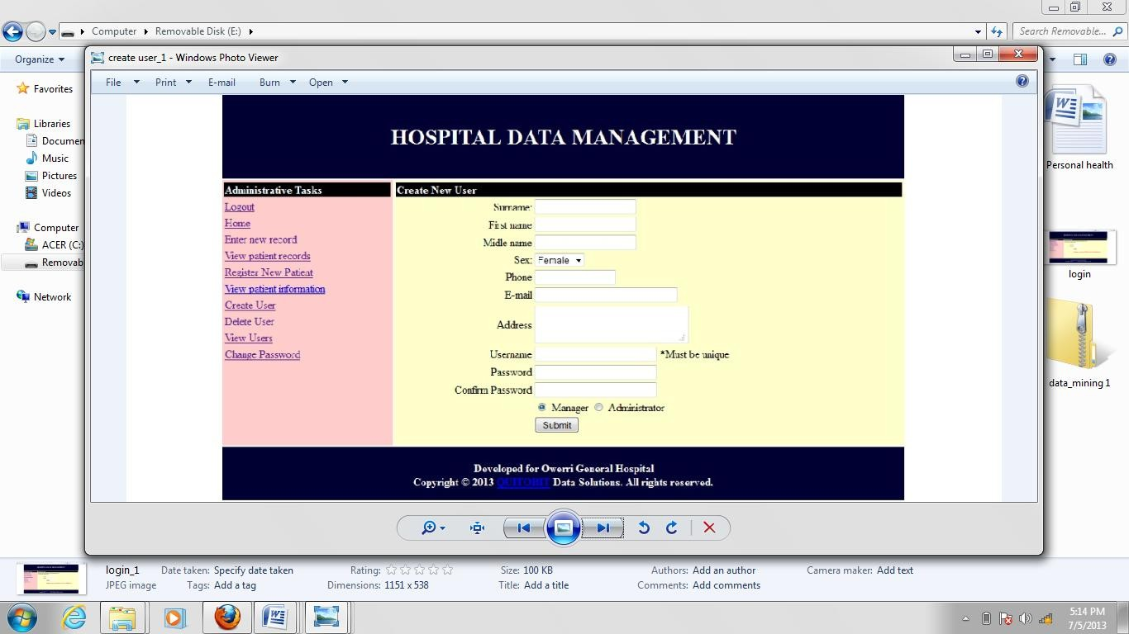

Admin index: The homepage is where you will see the environment of Owerri General Hospital general administration tasks.

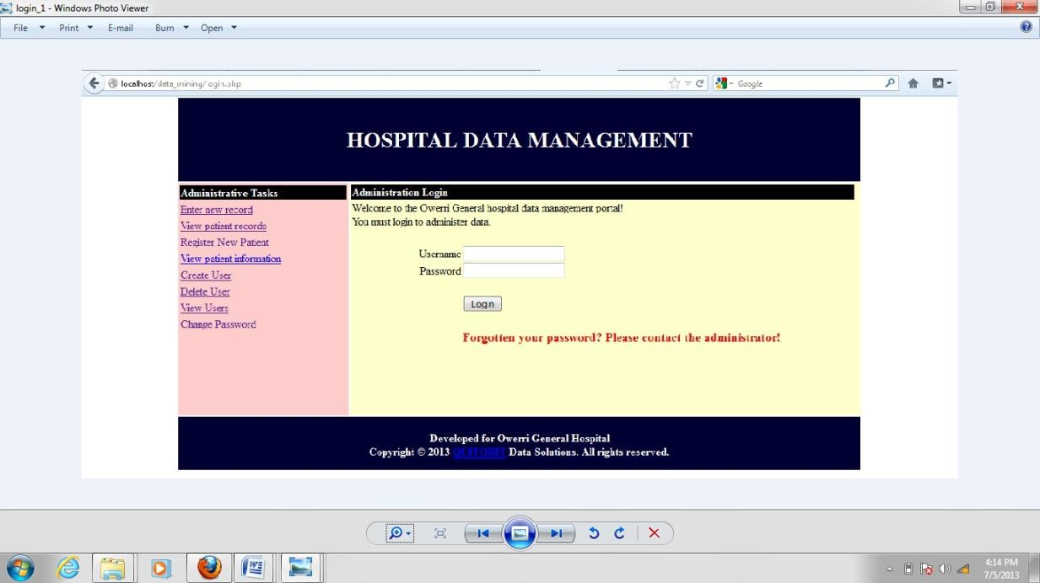

Login: This is for security access. Called once someone tries to access any page in the system, the user will remain logged in until he logs out and will be able to access pages allowed based on his role.



New patient: Used to create a new entry for patients. Records can only be updated for a registered patient. Only admin users have access.

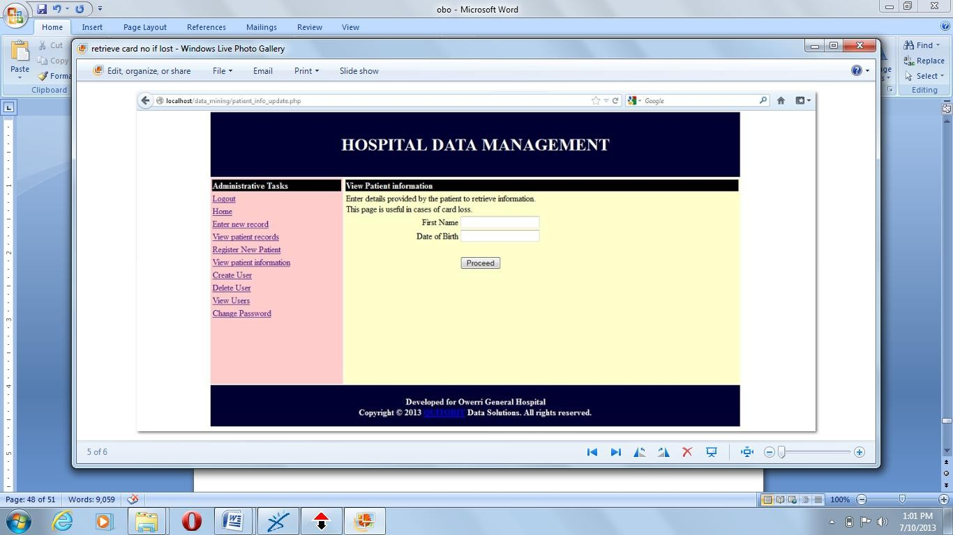

ViewRecord: This is where the record of the patient will be viewed.

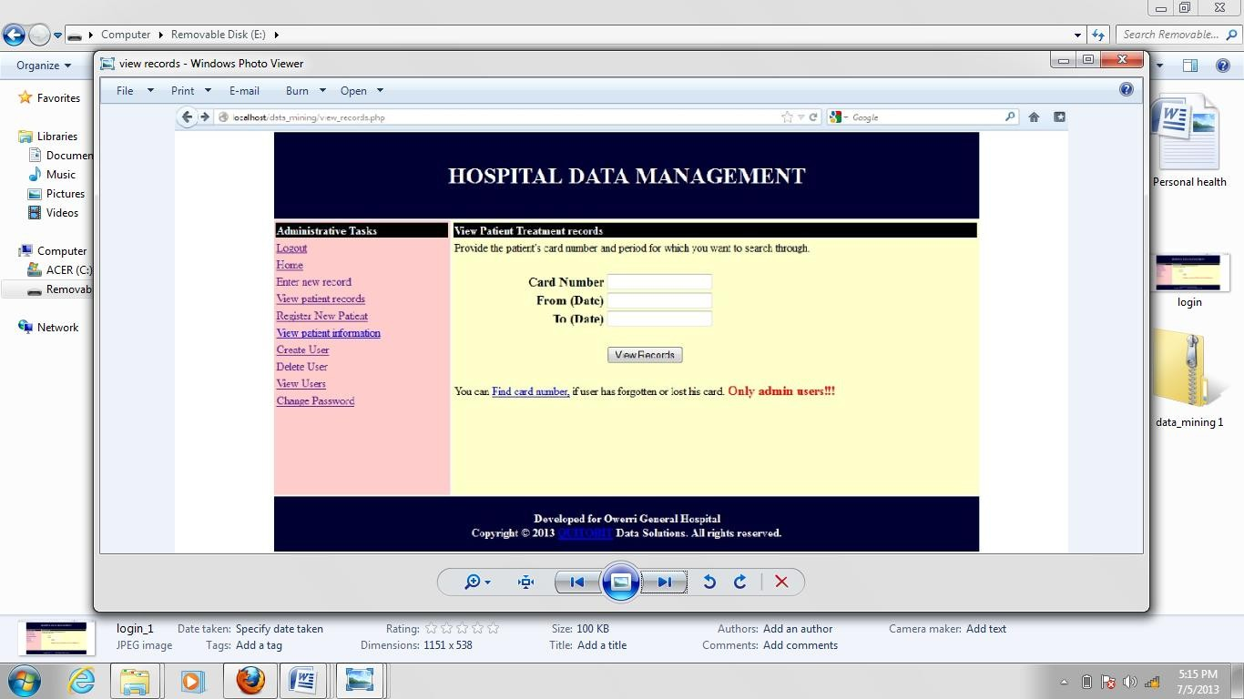

Patient info update: used to view patients information.

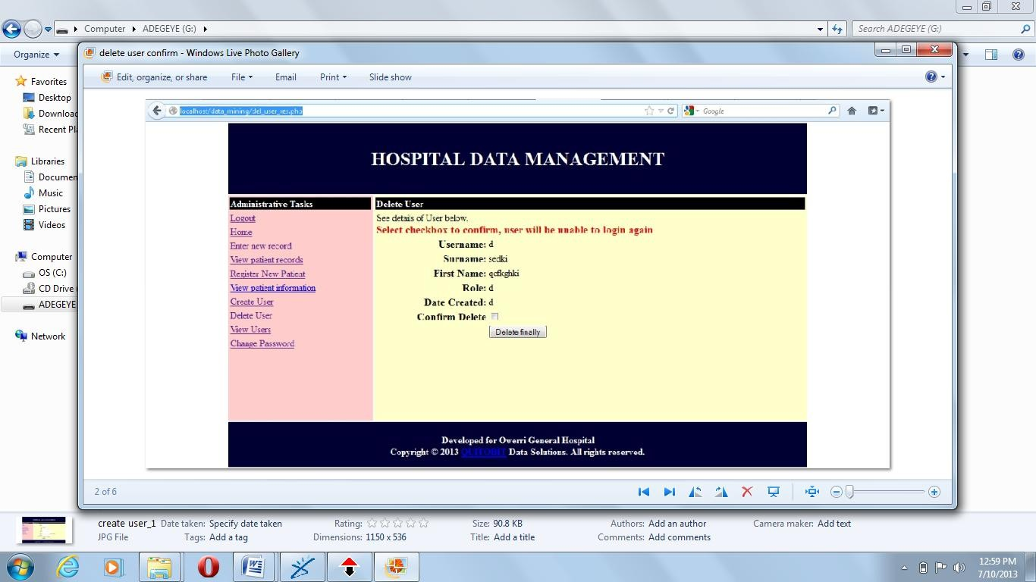

Del_user: This is where an admin user can remove other users including admins (the user called „admin‟ cannot be removed)



Patient_info_update: used to view a patients information.

NewRecord: This is where the operator will key in the data of patient treatment.

View_users: This is where an Admin user can view all users in the system. Managers have no access.

Add_user: Addition of new admin/manager. Only an admin can access this page Change_password: It is used by every user to change their passwords

Other supporting pages (such as searching for a patient, if patient has lost his card number), exist to help these modules.

<?php session_start();

require("verify_login.php");

## APPENDIX B PROGRAM CODE

$loginuser= $_SESSION['username'];

$loginrole= $_SESSION['Role'];

?>

<!DOCTYPE html PUBLIC "-//W3C//DTD XHTML 1.0 Transitional//EN" ["http:/](http://www.w3.org/TR/xhtml1/DTD/xhtml1-transitional.dtd)/[www.w3.org/TR/xhtml1/DTD/xhtml1-transitional.dtd](http://www.w3.org/TR/xhtml1/DTD/xhtml1-transitional.dtd)">

<html xmlns="<http://www.w3.org/1999/xhtml>">

<head>

<meta http-equiv="Content-Type" content="text/html; charset=iso-8859-1" />

<title>Administrative home - For admins!</title>

<link rel="stylesheet" type="text/css" href="css/styles.css" />

<script type="text/JavaScript" src="js/validate.js" /></script>

</head>

<!-- Copyright, QUITOBIT Data Solutions. 08032572937,08025108711 -->

<body>

<table width="1000px" border="0" align="center">

<tr>

</tr>

<tr>

<?php require("header.php"); ?>

<td width="25%" valign="top" bgcolor="#FFCCCC">

<?php require("navigation.php"); ?>

</td>

<td valign="top" bgcolor="#FFFFCC">

<form id="form1" name="form1" method="post" action="" onsubmit="MM_validateForm('Sname','','R','Fname','','R');return document.MM_returnValue">

<table width="100%" border="0" cellpadding="1"

cellspacing="2">

<tr>

<td colspan="2" bgcolor="#000000"><span

class="style1"> COMMON ADMINISTRATIVE TASKS </span></td>

</tr>

</table>

</form>

</td>

</tr>

<tr>

<?php require("footer.php"); ?>

</tr>

</table>

</body>

</html>v

New Patient form code

<?php session_start();

require("verify_login.php"); require("verify_admin.php");

$loginuser= $_SESSION['username'];

$loginrole= $_SESSION['Role'];

?>

<!DOCTYPE html PUBLIC "-//W3C//DTD XHTML 1.0 Transitional//EN" ["http:/](http://www.w3.org/TR/xhtml1/DTD/xhtml1-transitional.dtd)/[www.w3.org/TR/xhtml1/DTD/xhtml1-transitional.dtd](http://www.w3.org/TR/xhtml1/DTD/xhtml1-transitional.dtd)">

<html xmlns="<http://www.w3.org/1999/xhtml>">

<head>

<meta http-equiv="Content-Type" content="text/html; charset=iso-8859-1" />

<title>Admin - New patient!</title>

<link rel="stylesheet" type="text/css" href="css/styles.css" />

<script type="text/JavaScript" src="js/validate.js"></script>

<script type="text/javascript" src="calendar/htmlDatePicker.js"></script>

<link rel="stylesheet" href="calendar/htmlDatePicker.css" />

</head>

<!-- Copyright, QUITOBIT Data Solutions. 08032572937,08025108711 -->

<body>

<table width="1000px" border="0" align="center">

<tr>

</tr>

<tr>

<?php require("header.php"); ?>

<td width="25%" valign="top" bgcolor="#FFCCCC">

<?php require("navigation.php"); ?>

</td>

<td valign="top" bgcolor="#FFFFCC">

<form id="form1" name="form1" method="post" action="new_patient_res.php" onsubmit="MM_validateForm('Sname','','R','Fname','','R','Mname','','R','Sex','','R','

DOB','','R','cardno','','R','address','','R','telephone','','R','allergy','','R');return document.MM_returnValue">

cellspacing="2">

<table width="100%" border="0" cellpadding="1"

<tr>

<td colspan="2" bgcolor="#000000"><span

class="style1"> Create new patient! </span></td>

</tr>

<tr>

new patient </span></td>

</tr>

<tr>

<td colspan="2"><span>Enter details for

<td colspan="2"

align="left"><strong>BIODATA</strong></td>

</tr>

<tr>

align="right">Surname</td>

<td width="29%"

<td width="71%" align="left"><input

name="Sname" type="text" id="Sname" /></td>

</tr>

<tr>

Name</td>

<td width="29%" align="right">First

<td width="71%" align="left"><input

name="Fname" type="text" id="Fname" /></td>

Name</td>

</tr>

<tr>

<td width="29%" align="right">Middle

<td width="71%" align="left"><input

name="Mname" type="text" id="Mname" /></td>

</tr>

<tr>

<td align="right">Sex</td>

<td align="left">

<select name="Sex" id="Sex">

<option value="Female"

>Female</option>

<option value="Male" >Male</option>

</select>

</td>

</tr>

<tr>

<td align="right">Date of Birth</td>

<td align="left"><input name="DOB"

type="text" id="DOB" onfocus="GetDate(this);" /></td>

</tr>

<tr>

<td colspan="2" align="left" valign="top"><strong>CONTACT INFORMATION</strong></td>

</tr>

<tr>

<td align="right">Card Number</td>

<td align="left"><input name="cardno"

type="text" id="cardno" /></td>

</tr>

<tr>

<td align="right">Telephone No </td>

<td align="left"><input name="telephone" type="text" id="telephone" /> Insert only numbers(do not use +, -, etc.)</td>

</tr>

<tr>

<td align="right">E-mail </td>

<td align="left"><input name="email"

type="text" id="email" /></td>

</td> id="Loc"></textarea></td>

</tr>

<tr>

</tr>

<td align="right" valign="top">Address

<td align="left"><textarea name="address"

<tr>

<td align="right">Next of Kin Full Name </td>

<td align="left"><input name="nokname" type="text" id="nokname" /></td>

</tr>

<tr>

<td align="right">NOK Phone Number </td>

<td align="left"><input name="noknumber" type="text" id="noknumber" /></td>

</tr>

<tr>

<td colspan="2" align="left" valign="top"><strong>OTHER INFORMATION</strong></td>

</tr>

<tr>

<td align="right">Known Allergies/Reactions

</td>

<td align="left"><textarea name="allergy"

id="allergy"></textarea> Enter NIL if none</td>

</tr>

<tr>

<td align="right">Created By </td>

<td align="left"><input name="createdby" type="text" readonly="readonly" id="createdby" value='<?php echo "$loginuser"

?>' /></td>

</tr>

value="New Patient" />

<tr>

<td align="right">&nbsp;</td>

<td align="left"><label>

<input type="submit" name="Submit"

</label></td>

</tr>

<tr>

</td>

</tr>

<tr>

<td align="right">&nbsp;</td>

<td align="left">&nbsp;</td>

</tr>

</table>

</form>

<?php require("footer.php"); ?>

</tr>

</table>

</body>

</html>