**[DESIGN AND](https://www.researchgate.net/publication/376196725_Bachelor_Thesis_of_the_School_of_Computer_Science_Title_Design_and_Implementation_of_Crime_Management_System?enrichId=rgreq-19b6a2e479dbeebc8083aa42a76b4eab-XXX&enrichSource=Y292ZXJQYWdlOzM3NjE5NjcyNTtBUzoxMTQzMTI4MTIwOTE2ODcxMEAxNzAxNjkyMDgzOTUx&el=1_x_3&_esc=publicationCoverPdf) IMPLEMENTATION OF CRIME MANAGEMENT SYSTEM**

**ABSTRACT**

The Online Crime Management System is a web-based application designed to streamline the process of reporting crimes and managing associated cases. Traditional methods of reporting crimes often involve visiting a police station in person, which can be perceived as tedious and time-consuming. This project aims to provide a convenient and efficient solution by allowing users to file complaints online, upload supporting evidence such as images or videos, and enable prompt action by law enforcement authorities. The objective of this system is to reduce paperwork at police stations and create a centralized database for maintaining comprehensive records of complaints, criminals, FIRs, case histories, and other relevant information. By utilizing this web application, individuals can report crimes from the comfort of their homes or any location with internet access, eliminating the need for physical visits to police stations. The Online Crime Management System covers various aspects of case management and administration for both main police stations and substations. It allows administrators to manage cop details, police station details, and assign tasks to police personnel automatically. Police officers can access complaint details, FIRs, case reports, charge sheets, crime reports, legal case records, and other relevant information. The proposed system offers several advantages over the existing manual methods. It reduces the reliance on manpower and decreases the volume of paperwork, making the process more time-efficient. The automation of tasks, such as task assignment and data entry, improves overall system efficiency. Additionally, the user-friendly interface enhances the interaction between users and the system, improving the overall user experience. This thesis aims to develop and implement the Online Crime Management System, contributing to the digitization of crime reporting and case management. The system's potential benefits include faster response times, improved data accuracy, reduced administrative burden, and enhanced accessibility for users. By leveraging technology, this project strives to create a more efficient and effective framework for managing online crime incidents and supporting law enforcement agencies in their efforts to maintain public safety.

**Keywords:** Online Crime Management System, HTML, CSS, JavaScript, PHP, XAMPP, SQL server.

II

**Contents**

Chapter 1 Introduction 1

1.1 Research Background and Significance 1

1.2 Content Innovation of the Thesis 1

1.3 Review of the Crime Management System in Bangladesh 2

1.3.1 Historical Overview 2

1.3.2 Current Challenges and Limitations 2

1.3.3 Comparative Analysis with International Systems 3

1.4 Purpose and Objectives of the Thesis 4

Chapter 2 Technological Framework and Implementation 5

2.1 Introduction 5

2.2 HTML 5

2.3 CSS 5

2.4 JavaScript 5

2.5 PHP 5

2.6 XAMPP 6

2.7 SQL Server 6

2.8 Implementation Strategies 6

2.9 User Training 7

2.10 Continuous Improvement and Upgrades 8

Chapter 3 System Design 9

3.1 Introduction 9

3.2 Applicable Documents 9

3.3 Functional Decomposition 9

3.4 Context Flow Diagram 10

3.5 Data Flow Diagram: 10

3.6 Notations Used in the DFD 10

3.7 Component Description 13

Chapter 4 Database Design 16

4.1 Introduction 16

4.2 Database Tables for Crime Management System 16

4.3 Table Design 17

4.4 Entity Relationship Diagram ER Diagram 24

4.5 Er Diagram 27

III

Contents



|  |  |  |  |
| --- | --- | --- | --- |
| 4.6 | Database Schema Diagram............................................................................................. | | 28 |
| Chapter 5 Detail Design ................................................................................................................ | | | 29 |
| 5.1 | Introduction .................................................................................................................... | | 29 |
| 5.2 | Applicable Documents ................................................................................................... | | 29 |
| 5.3 | Structure Of the Software Package ................................................................................ | | 29 |
| 5.4 | Modular Decomposition of Components ....................................................................... | | 30 |
| 5.5 | Structure Chart for Complainer ...................................................................................... | | 31 |
| 5.6 | Complaint Module Component ...................................................................................... | | 31 |
| 5.7 | Cop Account Component ............................................................................................... | | 33 |
| 5.8 | Structure Chart for Cop .................................................................................................. | | 33 |
| 5.9 | Charge Sheet Module Component ................................................................................. | | 34 |
| 5.10 |  | Structure Chart for Charge Sheet................................................................................ | 34 |
| Chapter 6 Testing and User Interface ........................................................................................... | | | 35 |
| 6.1 | Introduction .................................................................................................................... | | 35 |
| 6.2 | Software Testing ............................................................................................................ | | 35 |
| 6.3 | Test Cases ....................................................................................................................... | | 36 |
| 6.4 | User Interface ................................................................................................................. | | 38 |
| 6.4.1 | | Home Page .............................................................................................................. | 38 |
| 6.4.2 | | Register Complaint Page......................................................................................... | 38 |
| 6.4.3 | | Complaint Registration ........................................................................................... | 40 |
| 6.4.4 | | Admin Dashboard ................................................................................................... | 41 |
| 6.4.5 | | View Cop ................................................................................................................ | 43 |
| 6.4.6 | | Add Station ............................................................................................................. | 44 |
| Chapter 7 Conclusions .................................................................................................................. | | | 46 |
| 7.1 | Concluding Remarks ...................................................................................................... | | 46 |
| 7.2 | Future Work ................................................................................................................... | | 47 |
| 7.2.1 | | Introduction ............................................................................................................. | 47 |
| 7.2.2 | | Integration with Mobile Applications ..................................................................... | 47 |
| 7.2.3 | | Face Recognition for Criminal Identification ......................................................... | 47 |
| 7.2.4 | | Continuous Improvement based on User Feedback................................................ | 48 |
| Acknowledgements ....................................................................................................................... | | | 49 |
| Reference | | ...................................................................................................................................... | 50 |

IV

Chapter 1 Introduction



**Chapter 1 Introduction**

**1.1 Research Background and Significance**

The crime management system plays a crucial role in maintaining law and order, ensuring public safety, and upholding justice within any country. In the context of Bangladesh, a rapidly developing nation facing various socio-economic challenges, an effective and efficient crime management system is of utmost importance. The need for a robust system that addresses the increasing complexities of crime and provides timely resolution has become a pressing concern. This research aims to delve into the current state of the crime management system in Bangladesh, analyze its strengths and weaknesses, and propose innovative solutions to enhance its effectiveness. By understanding the existing challenges and exploring potential improvements, this study seeks to contribute to the advancement of the country's crime management infrastructure.

**1.2 Content Innovation of the Thesis**

This thesis presents a comprehensive analysis of the crime management system in Bangladesh, incorporating innovative approaches to address its limitations. The research delves into various aspects such as crime reporting, investigation procedures, case management, and information sharing among law enforcement agencies. It explores emerging technologies, best practices from other countries, and the application of data analytics in crime prevention and detection. Furthermore, this research introduces novel concepts such as community engagement, integration with mobile applications, and the utilization of advanced technologies like artificial intelligence and machine learning for predictive crime analysis. These content innovations aim to revolutionize the crime management system in Bangladesh and align it with global standards. Police officers can access essential information within the system, including complaint details, FIR records, case reports, charge sheets, crime reports, and legal case reports. By providing this comprehensive data, the system empowers officers to effectively investigate and handle cases. The system facilitates the viewing of data on a station-wise basis, enabling officers to access information specific to their assigned jurisdiction. Additionally, administrators have access to all data within the system, providing a comprehensive overview of the crime management process. Automated task assignment is a prominent feature of the system, ensuring that officers are assigned tasks automatically based on predefined criteria. This streamlines workflow management and optimizes task allocation within the law enforcement agency.

1

Chapter 1 Introduction



**1.3 Review of the Crime Management System in Bangladesh**

**1.3.1** **Historical Overview**

The historical overview of the crime management system in Bangladesh sheds light on the evolution of the system and its key milestones. It traces the development of laws, policies, and institutions that have contributed to the establishment and functioning of the system. One significant aspect of the historical overview is the examination of legal frameworks that have shaped the crime management system. This includes the formulation and enactment of criminal laws, criminal procedure codes, and other relevant legislation. Understanding the historical progression of these legal frameworks provides insights into the objectives, principles, and procedures governing the management of crimes in Bangladesh. Another aspect is the historical development of law enforcement agencies and their roles within the crime management system. This involves exploring the establishment and evolution of police departments, specialized units, and investigative bodies. Examining the organizational structure, functions, and responsibilities of these agencies helps to understand their contributions to crime prevention, investigation, and maintaining law and order. Furthermore, the historical overview delves into the technological advancements and innovations that have influenced the crime management system. It explores the introduction of computerized systems, databases, and digital tools for information management, crime analysis, and communication among law enforcement agencies. Assessing the adoption and integration of technology provides insights into the system's efficiency, effectiveness, and ability to adapt to changing crime patterns. By analyzing the historical development of the crime management system in Bangladesh, we can identify the challenges, successes, and gaps that exist. This understanding serves as a foundation for evaluating the current state of the system and identifying areas for improvement. Additionally, it provides valuable lessons and best practices from the past that can inform future strategies and initiatives in crime management.

**1.3.2 Current Challenges and Limitations**

The current crime management system in Bangladesh faces various challenges and limitations that hinder its effectiveness in combating crime and ensuring justice. Understanding these challenges is essential for identifying areas of improvement and formulating strategies to address them. One significant challenge is the inadequate allocation of resources and infrastructure for the crime management system. Insufficient funding, limited personnel, outdated equipment, and inadequate facilities hinder the operational capacity of law enforcement agencies. This can lead to delays in investigations, compromised crime scene processing, and reduced efficiency in handling

2

Chapter 1 Introduction



cases. Another challenge lies in the lack of comprehensive training and capacity-building programs for law enforcement personnel. The evolving nature of crime requires continuous skill development and knowledge enhancement among police officers and investigators. However, the availability of training programs, particularly in specialized areas such as cybercrime or forensic analysis, is limited. This can impact the ability of law enforcement personnel to effectively handle modern forms of crime. Bureaucratic inefficiencies and procedural delays within the justice delivery system pose significant limitations. Lengthy court processes, backlogs of cases, and delays in the prosecution and trial stages contribute to a lack of timely justice for victims and accused individuals. This can undermine public trust in the system and hinder the deterrence of criminal activities. Corruption within the crime management system is another challenge that needs to be addressed. Instances of bribery, nepotism, and unethical practices undermine the integrity of law enforcement agencies and compromise their ability to effectively combat crime. Eradicating corruption and promoting transparency and accountability are crucial for building public confidence in the system. Limited coordination and information-sharing among different law enforcement agencies also pose challenges. Lack of effective communication channels and collaboration mechanisms can hinder the exchange of crucial information and intelligence, leading to gaps in crime prevention and investigation efforts. Furthermore, the underutilization of technology in the crime management system is a significant limitation. While some advancements have been made, there is still a need for wider adoption and integration of technology tools, such as advanced analytics, digital evidence management systems, and crime mapping platforms. Embracing technology can enhance the efficiency of crime management processes, improve data analysis capabilities, and support evidence-based decision-making. In conclusion, addressing the current challenges and limitations of the crime management system in Bangladesh is crucial for ensuring effective crime prevention, investigation, and justice delivery. It requires strategic investments in resources, comprehensive training programs, streamlined procedures, and enhanced technology integration. By addressing these challenges, Bangladesh can strengthen its crime management system and better respond to the evolving nature of crime in the modern world.

**1.3.3 Comparative Analysis with International Systems**

To gain a broader perspective, a comparative analysis is conducted between the crime management system in Bangladesh and international systems known for their efficiency and effectiveness. This analysis highlights the gaps and differences in approaches, processes, and technologies employed in crime prevention, investigation, and resolution. It offers valuable

3

Chapter 1 Introduction



insights and benchmarks for improvement in the Bangladesh context. By examining the historical background, current challenges, and conducting a comparative analysis, this review sets the stage for identifying the areas that require attention and improvement in the crime management system of Bangladesh. It forms the basis for the subsequent sections of the thesis, which propose innovative solutions to address these challenges and enhance the effectiveness of the system.

**1.4 Purpose and Objectives of the Thesis**

The purpose of this thesis is to conduct a comprehensive examination of the crime management system in Bangladesh and propose effective solutions to overcome the challenges it faces. The thesis aims to provide valuable insights and recommendations that can guide policymakers, law enforcement agencies, and other stakeholders in improving crime prevention, investigation, and the overall justice delivery process. By conducting a thorough analysis of the historical background, current challenges, and comparative perspectives, the thesis intends to contribute to the enhancement of the crime management system in Bangladesh. To achieve this purpose, the thesis sets out the following objectives. To provide a comprehensive understanding of the historical development of the crime management system in Bangladesh: This objective involves conducting an in-depth examination of the evolution of the crime management system in Bangladesh over the years. It seeks to trace the establishment and development of law enforcement agencies, legal frameworks, and institutional structures that form the foundation of the current system. By delving into the historical context, the thesis aims to uncover the factors that have influenced the present state of the crime management system. To identify and analyze the current challenges and limitations of the crime management system: This objective focuses on identifying the key challenges and limitations faced by law enforcement agencies and the criminal justice system in Bangladesh. It involves a comprehensive assessment of various factors such as resource constraints, inadequate training and capacity building, bureaucratic inefficiencies, corruption, and delays in the justice delivery process. Through rigorous analysis, the thesis aims to shed light on the underlying causes of these challenges and their impact on the effectiveness of the crime management system.

4

Chapter 2 Technological Framework and Implementation Strategies



**Chapter 2 Technological Framework and Implementation**

**2.1 Introduction**

In this chapter, we will delve into the technological framework and implementation strategies used in the development of the online crime management system. The integration of various technologies plays a crucial role in ensuring the functionality, usability, and efficiency of the system. We will explore the key technologies employed, including HTML, CSS, JavaScript, PHP, XAMPP, and SQL server, and discuss their significance in achieving the project's objectives.

**2.2 HTML**

HTML (Hypertext Markup Language) forms the foundation of the system's user interface. It enables the creation of structured web pages that facilitate the presentation and organization of information. We will examine how HTML tags and elements were utilized to design intuitive and user-friendly interfaces for different modules of the crime management system.

**2.3 CSS**

CSS (Cascading Style Sheets) is a powerful tool for controlling the visual appearance of web pages. We will explore how CSS was employed to define the layout, colors, fonts, and other visual aspects of the crime management system. The use of CSS ensures consistency and enhances the overall user experience by providing a visually appealing and cohesive interface.

**2.4 JavaScript**

JavaScript, as a client-side scripting language, adds interactivity and dynamic functionality to web applications. We will discuss how JavaScript was utilized to implement features such as form validation, data manipulation, and asynchronous communication with the server. These interactive elements enhance user engagement and facilitate seamless interactions within the crime management system.

**2.5 PHP**

PHP (Hypertext Preprocessor) is a server-side scripting language used for dynamic web development. We will examine how PHP was employed to handle data processing, server-side validation, and database operations within the crime management system. PHP enables the system to retrieve, store, and manipulate data, ensuring the smooth functioning of the various modules.

5

Chapter 2 Technological Framework and Implementation Strategies



**2.6 XAMPP**

XAMPP is an open-source software package that provides a local web server environment for development and testing purposes. We will discuss how XAMPP was utilized to set up a local development environment, which includes Apache as the web server, MySQL as the database management system, and PHP as the server-side scripting language. This local environment enables efficient testing and debugging of the crime management system before deployment.

**2.7 SQL Server**

SQL Server is a relational database management system used for storing and managing the system's data. We will explore how SQL Server was employed to design the database schema, create tables, define relationships, and implement queries for data retrieval and manipulation. The use of SQL Server ensures secure and efficient storage and retrieval of critical information within the crime management system.

**2.8 Implementation Strategies**

Effective implementation strategies are essential for the successful deployment and utilization of the crime management system. We will discuss the strategies employed to ensure a smooth transition from development to production, including phased implementation, user training, data migration, and system testing.

**(1) Performance Monitoring and Optimization**

Once the system is implemented, ongoing performance monitoring and optimization are essential to ensure its smooth operation. We will discuss the monitoring tools and techniques used to track system performance, identify bottlenecks, and optimize resource utilization. Regular system audits and performance evaluations will be conducted to maintain the system's efficiency and address any issues that may arise.

**(2) Security Measures and Data Protection**

Ensuring the security and protection of sensitive data is of utmost importance in a crime management system. We will explore the security measures implemented in the system, including encryption techniques, secure user authentication, and access control mechanisms. Additionally,

6

Chapter 2 Technological Framework and Implementation Strategies



we will discuss data protection strategies such as regular backups, data integrity checks, and disaster recovery plans to safeguard the system's data from unauthorized access or loss.

**2.9 User Training**

User training is a key component of the implementation process for the crime management system. It is essential to equip users with the knowledge and skills necessary to effectively utilize the system's features and functionalities. A comprehensive training program will be designed to cater to the specific needs of different user groups, such as law enforcement officers, administrators, and support staff. The training strategies will include a combination of interactive training sessions, workshops, and user manuals. These sessions will provide users with hands-on experience and practical guidance on navigating the system, entering and managing data, generating reports, and utilizing the various tools and modules available. The training will be conducted by experienced trainers who have in-depth knowledge of the crime management system and its functionalities. The training program will be tailored to accommodate different learning styles and preferences. It will include both theoretical and practical components to ensure users understand not only the theoretical concepts but also how to apply them in real-world scenarios. Practical exercises and case studies will be incorporated to enable users to practice using the system in simulated scenarios that resemble their actual work environment. To enhance the effectiveness of the training program, user manuals and documentation will be developed. These resources will serve as reference guides for users, providing step-by-step instructions on system navigation, data entry, report generation, and troubleshooting common issues. The user manuals will be designed in a user-friendly and accessible format, with clear instructions and visual aids to facilitate understanding. Additionally, ongoing support and assistance will be provided to users after the initial training. Help desks or dedicated support channels will be established to address user queries, provide clarification, and offer troubleshooting assistance. This support mechanism will ensure that users have access to the necessary resources and guidance to overcome any challenges they may encounter during their interaction with the crime management system. The goal of user training is to empower stakeholders with the knowledge and skills needed to maximize the benefits of the crime management system. By investing in comprehensive training programs and providing ongoing support, users will be able to confidently navigate the system, efficiently enter and manage data, generate accurate reports, and leverage the system's capabilities to enhance crime prevention, investigation, and overall law enforcement efforts in Bangladesh.

7

Chapter 2 Technological Framework and Implementation Strategies



**2.10 Continuous Improvement and Upgrades**

Technology is constantly evolving, and the crime management system should adapt to new advancements and emerging needs. We will outline the strategies for continuous improvement and upgrades, including periodic evaluations, user feedback mechanisms, and collaboration with stakeholders to identify areas for enhancement and implement necessary updates. This will ensure that the system remains relevant, effective, and aligned with evolving requirements and technological advancements. By following these implementation strategies and deployment procedures, the online crime management system can be successfully integrated into the existing infrastructure, empowering law enforcement agencies and stakeholders to effectively manage and combat crime in Bangladesh.

8

Chapter 3 System Design



**Chapter 3 System Design**

**3.1 Introduction**

Design is the process of translating requirements into a software representation. It involves planning a solution for the specified problem and moving from the problem domain to the solution domain. The design phase produces architecture design, high-level design, and detailed design as separate outputs. Architecture design focuses on identifying components and their interactions, high-level design identifies the modules to be developed, and detailed design focuses on module implementation. System design is a "How to" approach for creating a new system and involves several steps. It provides the procedural details necessary for implementing the system outlined in the feasibility study. The emphasis is on translating performance requirements into design specifications.

**3.2 Applicable Documents**

The Software Requirement Specification Document is used as a reference document for system design.

**3.3 Functional Decomposition**

In addition to the mentioned functional components, the Online Crime Reporting System includes several other important features. One of these features is the ability for users to track the status of their complaints and receive updates on the progress of their cases. This helps ensure transparency and keeps the complainants informed throughout the investigation process.The system also incorporates a comprehensive search and reporting functionality. This allows authorized users, such as law enforcement personnel or administrators, to generate reports based on various criteria, such as crime type, location, date, or suspect information. These reports can provide valuable insights and analysis for crime prevention strategies and resource allocation. Furthermore, the system includes a notification system to alert users about important updates, such as case updates, court appearances, or scheduled meetings. This helps in efficient communication and coordination among the stakeholders involved in the crime management process. To enhance security and privacy, the system implements robust access control mechanisms. It ensures that only authorized personnel have access to sensitive information and that data is protected against unauthorized access or manipulation. Overall, the Online Crime Reporting System aims to streamline the crime reporting and management process, improve efficiency in handling complaints, and facilitate effective collaboration among stakeholders involved in crime prevention and investigation efforts. The system incorporates a feedback mechanism where users can provide their feedback and rating regarding the handling of their complaints. This helps in evaluating the performance of law enforcement agencies and identifying areas for improvement in the crime management process. Moreover, the Online Crime Reporting System supports integration with external systems and databases, such as fingerprint databases.

9

Chapter 3 System Design



**3.4 Context Flow Diagram**

The context flow diagram is a top-level data flow diagram that sents the entire system as a single process. It shows inputs, outputs, sources, and sinks of the system in relation to external entities.

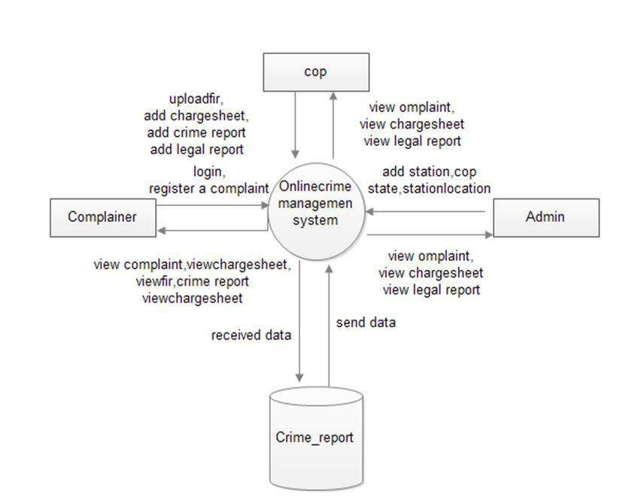

Figure 3-1 Context flow Diagram

**3.5 Data Flow Diagram:**

A data flow diagram (DFD) is a graphical representation of how data flows through an information system. It illustrates the movement of data and can be used to visualize data processing. Typically, a designer begins by creating a context level DFD, which shows the interaction between the system and external entities. This context level DFD is then expanded to provide more detailed information about the system being modeled. A DFD represents the flow of data through a system and is commonly used during problem analysis. It portrays the system as a function that transforms input into desired output. By showing the movement of data through different processes or transformations in the system, a DFD provides a visual representation of data flow. Data flow diagrams are useful for giving end users a clear understanding of how the data they input affects the overall structure of the system. They help determine how a system is developed, from order placement to dispatch and restocking. The relevant data is stored in a database and managed by the appropriate authorities.

**3.6 Notations Used in the DFD**

In a DFD, the "circle" symbol represents a process or activity that transforms data inputs into outputs. It represents a specific function or task within the system. The "arrow" symbol represents the flow of data between the various components of the system, such as inputs, processes, and

10

Chapter 3 System Design



outputs.The "rectangle" symbol represents an external entity or source of data that interacts with the system. It could be a person, organization, or external system that provides input or receives output from the system. The "double rectangle" symbol represents a data store or database where data is stored and retrieved by the system.Furthermore, the "open-ended rectangle" symbol represents a data flow that carries data from one component to another without any transformation. It represents the movement of data between processes, external entities, and data stores. Lastly, the "label" symbol is used to provide a description or label for a specific component or data flow within the DFD, aiding in understanding and documentation of the system.

|  |  |  |  |  |  |  |  |
| --- | --- | --- | --- | --- | --- | --- | --- |
|  | Table 3-1 Notations Used in the DFD | |  |  |  |  | |
| **Symbol** | **Description** | |  |  |  |  | |
|  | The circle or bubble represents a process. A | | | | | |
|  | process | is | named | and | each process | is | |
|  | represented by a named circle. | | | | |  | |
|  | The source | | or sink | is | represented as | a | |
|  | rectangular box. The source or sink is the net | | | | | |
|  | originator or the consumer of the data that | | | | | |
|  | flows in the system. | | |  |  |  | |
|  | The arrow represents the flow of data through | | | | | |
|  | the system. The labeled arrows enter or leave | | | | | |
|  | the bubbles. | |  |  |  |  | |



The database



symbol.

is represented with the open box

11

Chapter 3 System Design



**Top Level DFD**

In the data flow diagram (DFD), these components represent the external entities and data sources interacting with the crime management system.

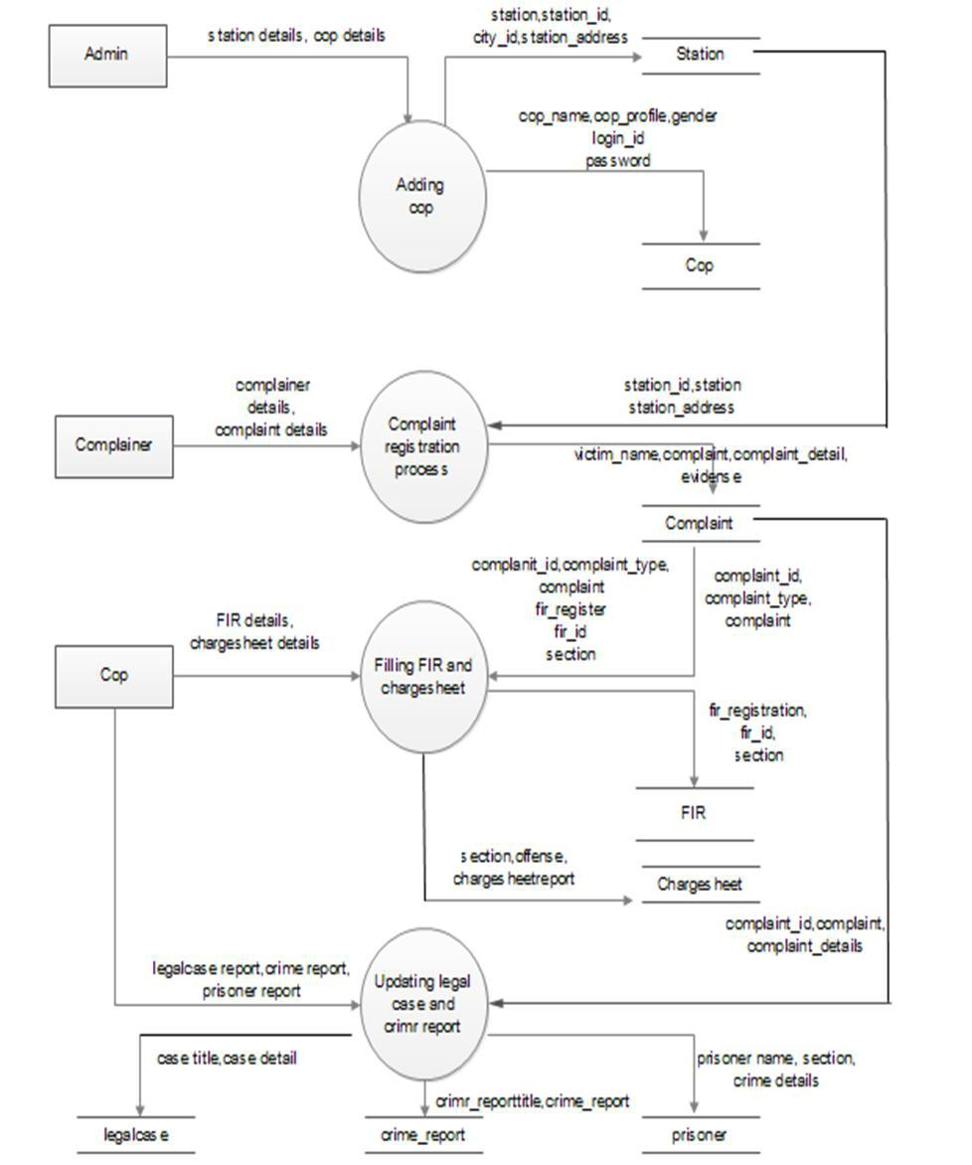

Figure 3-2 Top Level DFD

12

Chapter 3 System Design



**3.7 Component Description**

The input component of the crime management system includes various data sources that provide essential information for the system's processes. These data sources consist of city records, state records, designation details, cop details, and cop designation details. City records and state records are responsible for capturing and storing information related to cities and states, respectively. Designation details encompass the various designations or roles within the law enforcement system. Cop details contain comprehensive profiles of police officers, including personal and professional information. Lastly, cop designation details specify the specific designations held by individual police officers. The process definition component focuses on the actions performed on the input data. It involves the addition and integration of city records, state records, designation details, cop details, and cop designation details into the crime management system. This process ensures that the system is updated with accurate and up-to-date information, enabling smooth operations and efficient management of the crime-related data. By effectively incorporating these components into the system, law enforcement authorities can access comprehensive information about cities, states, designations, and police officers, supporting effective decision-making and streamlined crime management processes.

(1) Output Definition

City records are stored in the city table. State records are stored in the state table Cop designation master details are stored in the designation table Cop account details are stored in the cop table. This component handles the input of various data related to cities, states, designations, and cop details. It processes the input data by adding the records to their respective tables in the database. The output is the storage of the input data in the corresponding database tables, such as city records in the city table, state records in the state table, cop designation details in the designation table, and cop account details in the cop table.

(2) DFD Level

The input component of the crime management system includes FIR documents, legal case details, and updated charge sheet reports, which provide crucial information for effective investigation and monitoring of criminal cases.

13

Chapter 3 System Design

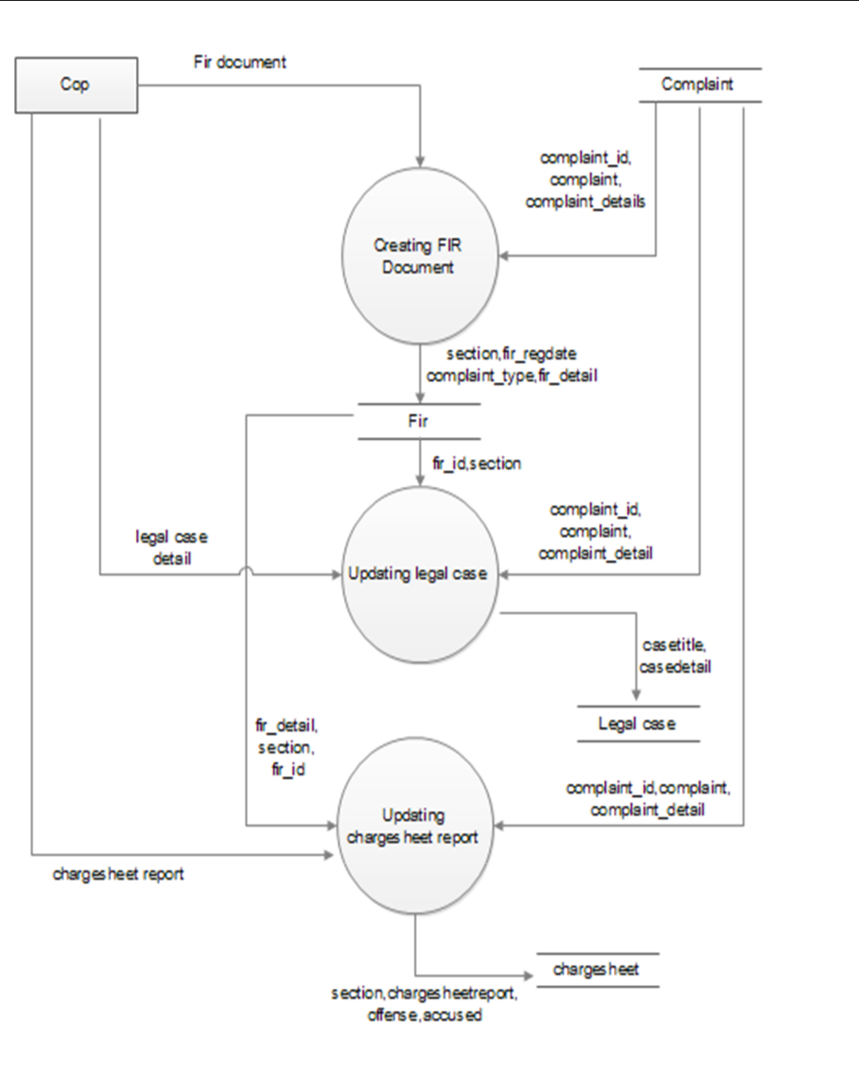

Figure 3-3 DFD Level

14

Chapter 3 System Design



1. Input

The input component of the crime management system encompasses crucial documents and reports that are essential for the system's functioning. These inputs include FIR (First Information Report) documents, legal case details, and updated charge sheet reports. FIR documents serve as the initial complaint registered with the police, providing essential information about the alleged crime. Legal case details contain comprehensive information about ongoing court cases related to the registered crimes. Additionally, updated charge sheet reports provide a detailed account of the charges filed against the accused individuals based on the investigation findings.These inputs play a significant role in the crime management system as they provide critical information for the decision-making process and further actions related to the reported crimes. By incorporating FIR documents, legal case details, and updated charge sheet reports into the system, law enforcement authorities can ensure that the necessary information is readily available for effective investigation, tracking of legal proceedings, and monitoring of the overall progress of criminal cases. This enables a streamlined and efficient management of crime-related data, facilitating improved coordination and decision-making within the criminal justice system.

(4) Process Definition

Creating FIR on complaint Generates a FIR First Information Report based on the received complaint. The FIR document is created and processed. Updates the legal case details based on the progress of the case. This includes recording relevant information and any changes in the legal proceedings. Updating charge sheet report Modifies and updates the charge sheet report based on the investigation and legal requirements.

(5) Output Definition

Complaint details Retrieves the relevant complaint details from the complaint table. Legal case updating Stores the updated legal case details in the legal case table. Charge sheet report: Saves the modified charge sheet report in the chargesheet table.This component handles the input of the FIR document, legal case details, and an updated charge sheet report. The processes within the component involve creating a FIR document based on the received complaint, updating the legal case details to reflect the progress of the case, and modifying the charge sheet report as necessary.

15

Chapter 4: Database Design



**Chapter 4 Database Design**

**4.1 Introduction**

**(1) Database**

A database is a collection of interconnected data that is organized and structured to efficiently store and retrieve information. It serves as a repository for managing and manipulating data based on the requirements of a system.

**(2) Database Design**

Database design involves the process of defining and structuring the database to meet the specific needs of the end-users and the information system it supports. It encompasses determining the necessary data and data structures that comprise the database. In this case, the database is implemented using MySQL.The "crime_report" Database: The "crime_report" database is comprised of 12 tables that store the relevant information for the crime reporting system.

**4.2 Database Tables for Crime Management System**

The crime management system utilizes a comprehensive set of database tables to store and manage crucial information related to various aspects of crime management. These tables include "chargesheet," which stores details pertaining to charge sheets; "city," which contains records of cities; "complainer," which stores information about complainants; "complaint," which stores details of registered complaints; "cop," which contains information about police officers; crime report, which stores overall crime report information; designation, which contains records of designations for police officers; "fir," which stores FIR (First Information Report) details; legal case, which stores information related to legal cases, prisoner, which contains records of prisoners; "state," which stores records of states; and "station," which contains information about police stations. These tables form the backbone of the crime management system, enabling efficient storage, retrieval, and management of data crucial for effective crime management and investigation. These tables are designed to store and organize the necessary data required for the crime reporting system, ensuring efficient data management and retrieval. In addition to the aforementioned tables, the crime management system also includes other essential database tables to support various functionalities. These include the "evidence" table, which stores details of collected evidence related to criminal cases; the "offense" table, which contains records of different types of offenses or crimes; the "victim" table, which stores information about crime victims; the "witness" table, which contains details of witnesses involved in criminal cases; and the "user" table, which stores information about system users and their access privileges. These tables collectively enable the system to capture and manage a wide range of information crucial for crime management. They allow for the association of different entities, such as complainants, police officers, crimes, and legal cases, facilitating effective tracking and analysis. The tables are designed with appropriate relationships and constraints to ensure data integrity and consistency.

16

Chapter 4: Database Design



**4.3 Table Design**

Each entity can be described as follows along with its attributes

(1) Table Name Station

The station table is a database table that stores information about police stations. It includes attributes such as station name, location, contact details, and other relevant information.

Table 4-1 Table Name Station

|  |  |  |  |
| --- | --- | --- | --- |
|  | **Type** | **Index** | **Description** |
|  |  |  |  |
| station_id | int(10) | Primary Key | Station ID |
|  |  |  |  |
| Station | varchar(100) | No | Station Name |
|  |  |  |  |
| state_id | int(10) | Foreign Key | State ID |
|  |  |  |  |
| city_id | int(10) | Foreign Key | City ID |
|  |  |  |  |
| station_addresss | text | No | Station Address |
|  |  |  |  |
| contact_no | varchar(15) | No | Contact Number |
|  |  |  |  |
| Img | varchar(100) | No | Station image |
|  |  |  |  |
| description | text | No | Station Description |
|  |  |  |  |
| status | varchar(10) | No | Station status |
|  |  |  |  |

(2) Table Name Cop

The cop table represents a database table that stores information about police officers. This table holds crucial details such as the name, address, designation, and other relevant attributes of police personnel.

Table 4-2 Table Name Cop

|  |  |  |  |
| --- | --- | --- | --- |
| **Column** | **Type** | **Index** | **Description** |
|  |  |  |  |
| cop_id | int(10) | Primary Key | Cop ID |
|  |  |  |  |
| cop_name | varchar(50) | No | Cop Name |
|  |  |  |  |
| station_id | int(10) | Foreign Key | Station ID |
|  |  |  |  |

17

Chapter 4: Database Design



|  |  |  |  |
| --- | --- | --- | --- |
| designation_id | int(10) | Foreign Key | Designation ID |
|  |  |  |  |
| Img | varchar(100) | No | Cop Image |
|  |  |  |  |
| cop_pofile | Text | No | Cop Profile |
|  |  |  |  |
| gender | varchar(10) | No | Gender |
|  |  |  |  |
| contact_no | varchar(10) | No | Contact Number |
|  |  |  |  |
| email_id | varchar(100) | No | Email ID |
|  |  |  |  |
| login_id | varchar(25) | Unique | Login ID |
|  |  |  |  |
| password | varchar(12) | No | Password |
|  |  |  |  |
| description | Text | No | Cop Description |
|  |  |  |  |
| status | varchar(10) | No | Cop Status |
|  |  |  |  |

(3) Table Name Complainer

The complainer table is a database table that stores information about complainants. It includes attributes such as complainer's name, contact details, address, and other relevant information.

Table 4-3 Table Name Complainer

|  |  |  |  |
| --- | --- | --- | --- |
| **Column** | **Type** | **Index** | **Description** |
|  |  |  |  |
| complainer_id | int(10) | Primary Key | Complainer ID |
|  |  |  |  |
| name | varchar(50) | No | Complainer Name |
|  |  |  |  |
| email_id | varchar(50) | Unique | Complainer Email ID |
|  |  |  |  |
| phoneno | varchar(14) | Unique | Complainer PhoneNumber |
|  |  |  |  |

18

Chapter 4: Database Design



|  |  |  |  |
| --- | --- | --- | --- |
| password | varchar(100) | No | Password |
|  |  |  |  |
| status | varchar(10) | No | Complainer Status |
|  |  |  |  |

(4) Table Name Complaint

The complaint table is a database table that stores details of registered complaints. It contains information such as the complaint ID, complainant details, complaint description, date of filing, and other relevant information

Table 4-4 Table Name Complaint

|  |  |  |  |
| --- | --- | --- | --- |
| **Column** | **Type** | **Index** | **Description** |
|  |  |  |  |
| complaint_id | int(10) | Primary Key | Complaint ID |
|  |  |  |  |
| station_id | int(10) | Foreign Key | Station ID |
|  |  |  |  |
| state_id | int(10) | Foreign Key | State ID |
|  |  |  |  |
| city_id | int(10) | Foreign Key | City ID |
|  |  |  |  |
| complainer_id | int(10) | Foreign Key | Complainer ID |
|  |  |  |  |
| complaint_type | varchar(25) | No | Complaint Type |
|  |  |  |  |
| complaint | varchar(500) | No | Complaint |
|  |  |  |  |
| accusedby | varchar(50) | No | Accused By |
|  |  |  |  |
| complaint_detail | text | No | Complaint Details |
|  |  |  |  |
| complaint_date | datetime | No | Complaint Dta |
|  |  |  |  |
| victim_address | text | No | Victim Address |
|  |  |  |  |
| accused_address | text | No | Accused Address |
|  |  |  |  |
| victims_name | varchar(50) | No | Victim Name |
|  |  |  |  |
| victim_phoneno | varchar(10) | No | Victim PhoneNumber |
|  |  |  |  |

19

Chapter 4: Database Design



|  |  |  |  |
| --- | --- | --- | --- |
| accused_phoneno | varchar(10) | No | Accused PhoneNumber |
|  |  |  |  |
| evidence | text | No | Evidence |
|  |  |  |  |
| photo_evidence | varchar(100) | No | Photo Evidence |
|  |  |  |  |
| video_evidence | varchar(100) | No | Video Evidence |
|  |  |  |  |
| anynote | text | No | Anynote |
|  |  |  |  |
| complaint_status | text | No | Complaint status |
|  |  |  |  |
| status | varchar(10) | No | Status |
|  |  |  |  |

(5) Table Name Chargesheet

The Table is Structured in the Figure Below

Table 4-5 Table Name Chargesheet

|  |  |  |  |
| --- | --- | --- | --- |
| **Column** | **Type** | **Index** | **Description** |
|  |  |  |  |
| chargesheet_id | int(10) | Primary Key | Chargesheet ID |
|  |  |  |  |
| complaint_id | int(10) | Foreign Key | Complaint ID |
|  |  |  |  |
| fir_id | int(10) | Foreign Key | Fir ID |
|  |  |  |  |
| section | varchar(100) | No | Section |
|  |  |  |  |
| chargesheetreport | text | No | ChargesheetReport |
|  |  |  |  |
| offense | text | No | Offence |
|  |  |  |  |
| accused | text | No | Accused |
|  |  |  |  |
| description | text | No | Description |
|  |  |  |  |
| chargesheetdocs | varchar(100) | No | Chargesheetdocuments |
|  |  |  |  |
| status | varchar(100) | No | Status |
|  |  |  |  |

20

Chapter 4: Database Design



(6) Table Name city

The "city" table consists of columns such as "city_id" for the unique identifier of each city, "city" to store the name of the city, "description" for additional information or details about the city, and "status" to indicate the current status of the city.The Table is Structured in the Figure Below

Table 4-6 Table Name City

|  |  |  |  |
| --- | --- | --- | --- |
| **Column** | **Type** | **Index** | **Description** |
|  |  |  |  |
| city_id | int(10) | Primary Key | City ID |
|  |  |  |  |
| City | varchar(50) | No | City |
|  |  |  |  |
| state_id | int(10) | Foreign Key | State ID |
|  |  |  |  |
| description | Text | No | Description |
|  |  |  |  |
| status | varchar(10) | No | Status |
|  |  |  |  |

(7) Table Name Crime Report

The "crime_report" table contains columns such as "crime_report_id" to uniquely identify each crime report, "complaint_id" to associate the report with a specific complaint, and "reportdate" to store the date when the report was filed. This table can be used to track and manage crime reports in the system. The Table is Structured in the Figure Below

Table 4-7 Table Name Crime Report

|  |  |  |  |
| --- | --- | --- | --- |
| **Column** | **Type** | **Index** | **Description** |
|  |  |  |  |
| crimereport_id | int(10) | Primary Key | Crimereport ID |
|  |  |  |  |
| complaint_id | int(10) | Foreign Key | Complaint ID |
|  |  |  |  |
| reportdate | date | No | Complaint report date |
|  |  |  |  |
| crime_reporttitle | varchar(100) | No | Crimereport tittle |
|  |  |  |  |
| crime_report | text | No | Crime report |
|  |  |  |  |
| status | varchar(100) | No | Status |
|  |  |  |  |

21

Chapter 4: Database Design



(8) Table Name Designation

The Table is Structured in the Figure Below

Table 4-8 Table Name Designation

|  |  |  |  |  |  |  |  |  |  |
| --- | --- | --- | --- | --- | --- | --- | --- | --- | --- |
|  | **Column** | |  | **Type** | | **Index** | | **Description** | |
|  |  |  |  |  |  |  |  |  | |
|  | designation_id | |  | int(10) | | Primary | | Designation ID | |
|  |  |  |  |  |  | Key | |  | |
|  |  |  |  |  |  |  |  |  | |
|  | designation_type | |  | varchar(50) | | No | | Designation Type | |
|  |  |  | |  |  |  |  |  | |
|  | designation_details | | | text | | No | | Designation details | |
|  |  |  |  |  |  |  |  |  | |
|  | status | |  | varchar(10) | | No | | Status | |
|  |  |  |  |  |  |  |  |  | |
| (9) Table Name Fir | | |  |  |  |  |  |  | |
| The Table is Structured in the Figure Below | | | | | | | |  | |
|  |  |  |  | Table 4-9 Table Name Fir | | | | |
|  |  |  |  | |  |  |  |  | |
|  | **Column** |  | **Type** | |  | **Index** |  | **Description** | |
|  |  |  |  | |  |  |  |  | |
|  | fir_id |  | int(10) | |  | Primary Key |  | Fir ID | |
|  |  |  |  | |  |  |  |  | |
|  | complaint_id |  | int(10) | |  | Foreign Key |  | Complaint ID | |
|  |  |  |  | |  |  |  |  | |
|  | section |  | varchar(100) | |  | No |  | Section | |
|  |  |  |  | |  |  |  |  | |
|  | complaint_type |  | varchar(50) | |  | No |  | Complaint Type | |
|  |  |  |  | |  |  |  |  | |
|  | fir_regdate |  | date | |  | No |  | Fir registration date | |
|  |  |  |  | |  |  |  |  | |
|  | fir_detail |  | text | |  | No |  | Fir details | |
|  |  |  |  | |  |  |  |  | |
|  | fir_start_date |  | date | |  | No |  | Fir start date | |
|  |  |  |  | |  |  |  |  | |
|  | fir_end_date |  | date | |  | No |  | Fir end date | |
|  |  |  |  | |  |  |  |  | |
|  | status |  | varchar(10) | |  | No |  | Status | |
|  |  |  |  |  |  |  |  |  | |

22

Chapter 4: Database Design



(10) Table Name Legal Case

The Table is Structured in the Figure Below

Table 4-10 Table Name Legal Case

|  |  |  |  |
| --- | --- | --- | --- |
| **Column** | **Type** | **Index** | **Description** |
|  |  |  |  |
| legalcase_id | int(10) | Primary Key | Legalcase ID |
|  |  |  |  |
| complaint_id | int(10) | Foreign Key | Complaint ID |
|  |  |  |  |
| fir_id | int(10) | Foreign Key | Fir ID |
|  |  |  |  |
| chargesheet_id | int(10) | Foreign Key | Chargesheet ID |
|  |  |  |  |
| casetitle | varchar(100) | No | Casetitle |
|  |  |  |  |
| casedetails | text | No | Casedetails |
|  |  |  |  |
| dateofhearing | datetime | No | Date of case hearing |
|  |  |  |  |
| casereport | text | No | Casereport |
|  |  |  |  |
| casedocument | varchar(100) | No | Casedocuments |
|  |  |  |  |
| casestatus | varchar(20) | No | Casestatus |
|  |  |  |  |

(11) Table Name prisoner

The Table is Prisoner in the Figure Below

Table 4-11 Table Name Prisoner

|  |  |  |  |
| --- | --- | --- | --- |
| **Column** | **Type** | **Index** | **Description** |
|  |  |  |  |
| prisoner_id | int(10) | Primary Key | Prisoner ID |
|  |  |  |  |
| complaint_id | int(10) | Foreign Key | Complaint ID |
|  |  |  |  |
| fir_id | int(10) | Foreign Key | Fir ID |
|  |  |  |  |
| chargesheet_id | int(10) | Foreign Key | Chargesheet ID |
|  |  |  |  |

23

Chapter 4: Database Design



|  |  |  |  |
| --- | --- | --- | --- |
| crimereport_id | int(10) | Foreign Key | Crimereport ID |
|  |  |  |  |
| prisonername | varchar(50) | No | Prisoner Name |
|  |  |  |  |
| section | varchar(100) | No | Section |
|  |  |  |  |
| crimedetails | text | No | Crime details |
|  |  |  |  |
| prisoneraddress | text | No | Prisoner address |
|  |  |  |  |
| prisonerimg | varchar(100) | No | Prisoner Image |
|  |  |  |  |
| prisinerdocument | varchar(100) | No | Prisoner Documents |
|  |  |  |  |
| anynote | text | No | Anynote |
|  |  |  |  |
| status | varchar(10) | No | Status |
|  |  |  |  |

(12) Table Name State

The Table is State in the Figure Below

Table 4-12 Table Name State

|  |  |  |  |
| --- | --- | --- | --- |
| **Column** | **Type** | **Index** | **Description** |
|  |  |  |  |
| state_id | int(10) | Primary Key | State ID |
|  |  |  |  |
| state | varchar(50) | No | State |
|  |  |  |  |
| description | text | No | State description |
|  |  |  |  |
| status | varchar(10) | No | Status |
|  |  |  |  |

**4.4 Entity Relationship Diagram ER Diagram**

An entity-relationship (ER) diagram is a graphical representation that depicts the relationships between entities in a database. ER diagrams utilize specific symbols to represent different types of information. The commonly used symbols in an ER diagram include:

(1) Boxes

In entity-relationship diagrams (ERDs), boxes are commonly used to represent entities or tables in a database. Entities are abstract concepts that represent real-world objects, and each entity

24

Chapter 4: Database Design



is typically associated with a database table. The boxes in an ERD provide a visual representation of these entities and serve as containers for the instances or records of the corresponding entityAttributes, on the other hand, are represented as ovals or ellipses within the entity boxes. Attributes are the properties or characteristics of the entities and define the specific data elements that are stored in the corresponding database table. Each attribute has a name and a data type, which determines the kind of values it can hold, such as text, numbers, dates, or booleans.Overall, entity-relationship diagrams provide a clear and visual representation of the database structure, entities, their relationships, and attributes. They serve as a powerful tool for designing and understanding the database schema, facilitating effective communication and collaboration between stakeholders involved in the development of the crime management system.

(2) Diamonds

Diamonds are used in ERDs to represent relationships between entities. Relationships depict the associations and connections between different entities in a database. They indicate how the entities are related to each other and provide valuable insights into the structure and dynamics of the database system. The diamonds in an ERD illustrate these relationships, and the lines connecting the diamonds to the entities indicate the nature and cardinality of the relationship.

(3) Ovals

Ovals are used to represent attributes or properties of entities. Attributes define the characteristics or properties of entities and describe the data associated with them. They provide specific details about each entity, such as its name, type, size, and other relevant information. Ovals in an ERD visually represent these attributes, and they are connected to the respective entities using lines or connectors to indicate the association between attributes and entities.These symbols are employed to visually illustrate the structure and connections within the database, providing a clear representation of how entities are related to each other and what attributes they possess.

The Symbols are shown in below table

**Name**

**Notation**

**Description**

25

Chapter 4: Database Design



|  |  |  |  |  |  |  |  |  |  |
| --- | --- | --- | --- | --- | --- | --- | --- | --- | --- |
|  |  | In an ER diagram, entities are | | | | | | | |
|  |  | depicted | | as | boxes. | |  | These | |
| Entity |  | entities |  | represent | | | abstract | | |
|  |  | concepts | | and can encompass | | | | | |
|  |  | multiple | | instances | | | of | | the | |
|  |  | concept | within | | | the | system. | | |
|  |  | Think of an entity as a | | | | | | | |
|  |  | container that holds all the | | | | | | | |
|  |  | individual | | occurrences | | | | of | a | |
|  |  | specific |  | entity |  | type. |  | In | a | |
|  |  | relational database, entities are | | | | | | | |
|  |  | analogous | | to database | | | | tables, | |
|  |  | where each row in the table | | | | | | | |
|  |  | represents | | an |  | instance | | | or | |
|  |  | occurrence of that entity. | | | | | | |  | |
|  |  |  | | | | | | | |
|  |  | Relationships are represented | | | | | | | |
|  |  | by Diamonds. A relationship | | | | | | | |
| Relationship |  | is a named | | | collection | | | | or | |
|  |  | association between | | | | | entities | | |
|  |  | or used to relate to two or | | | | | | | |
|  |  | more | entities | |  | with |  | some | |
|  |  | common | | attributes | | | |  | or | |
|  |  | meaningful | | |  | interaction | | | |
|  |  | between the objects rephrase | | | | | | | |
|  |  | this |  |  |  |  |  |  |  | |
|  |  |  | |  |  | | | |  | |
|  |  | Attributes | | are | represented | | | | by | |
|  |  | Oval. An attribute is a single | | | | | | | |
| Attributes |  | data item related to a database | | | | | | | |
|  |  | object. The database | | | | | schema | | |
|  |  | associates | | one | | or |  | more | |
|  |  | attributes | | with | each database | | | | |
|  |  | entity. |  |  |  |  |  |  |  | |
|  |  |  |  |  |  |  |  |  |  | |



Figure 4-1 Entity Relationship

26

Chapter 4: Database Design



**4.5 Er Diagram**

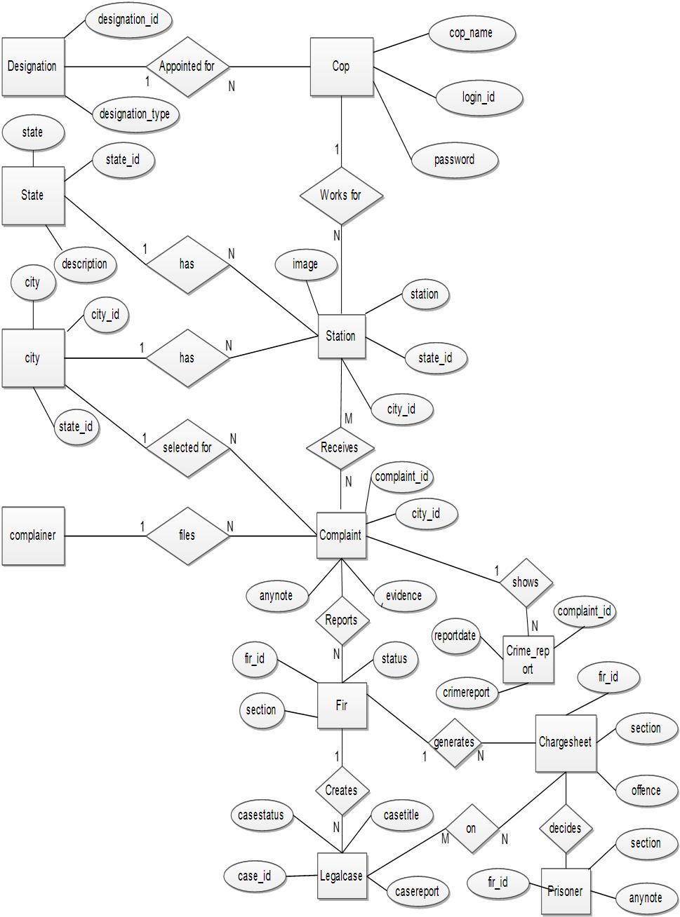

Figure 4-2 ER Diagram

About the figure 4-2 above, an entity-relationship representation that depicts the relationships between entities

(ER) diagram is a specific visual within a database.

27

Chapter 4: Database Design



**4.6 Database Schema Diagram**

A schema contains schema objects, which could be tables, columns, data types, views, stored procedures, relationships, primary keys, foreign keys, etc. A database schema can be represented in a visual diagram, which shows the database objects and their relationship with each other.

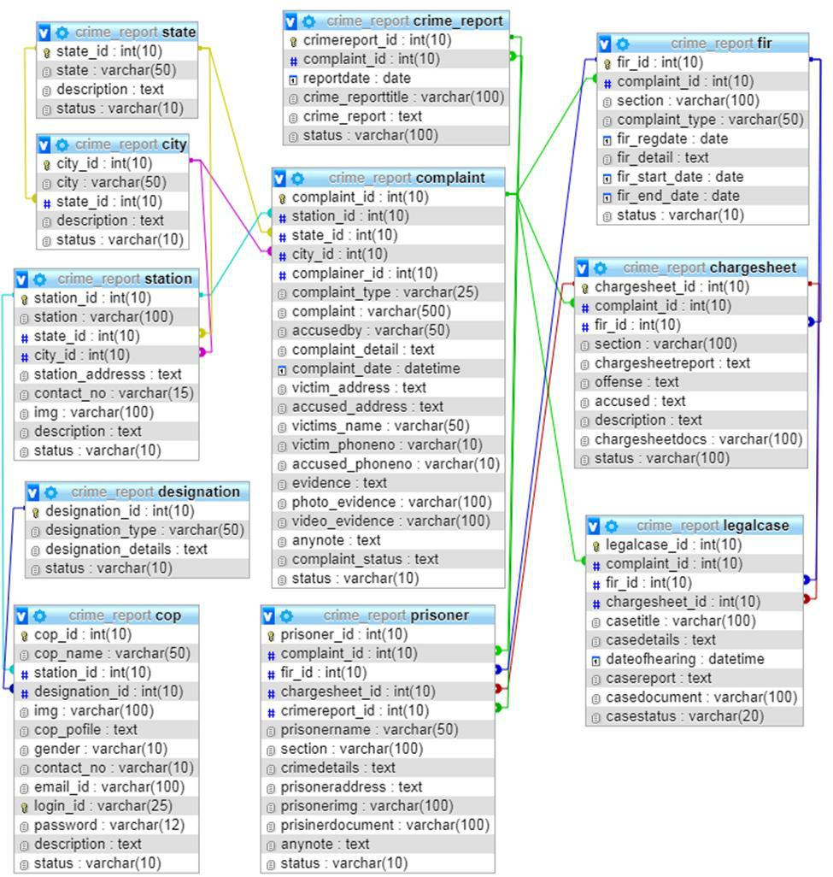

Figure 4-3 Database Schema Diagram

28

Chapter 5 Detail Design



**Chapter 5 Detail Design**

**5.1 Introduction**

The purpose of this document is to provide a comprehensive overview of the detailed design of our Online Crime Management System. It outlines the specific design details, including system architecture, data architecture, design constraints, and project progress. The document aims to facilitate understanding for programmers by presenting information through verbal and visual explanations, using diagrams to illustrate the design of the system and its subsystems/modules.

**5.2 Applicable Documents**

The following documents were referenced during the detailed design phase:

System Requirements Document

This document outlines the functional and non-functional requirements of the system, serving as a foundation for the design process. System Design: This document provides an overview of the overall system design, including the high-level architecture and components.

Database Design: This document details the design of the database, including tables, relationships, and data structures.

**5.3 Structure Of the Software Package**

(1) Complainer module

Stores complainer profile details, Complainers need to register in the system. After logging in, complainers can file complaints and view complaint status, FIR status, crime details.

(2) Complaint Module

Allows public users to file complaints online by providing complaint reason, evidence, details, type, etc. Police department can also file complaints from their account. Complaints can be closed if both parties agree.

(3) Cop Account Module

29

Chapter 5 Detail Design



Allows the station admin to add and manage cop details such as name, address, designation, etc. Admin is the main user of the system, while cops have limited authority. Different types of users like Inspector, Sub-inspector, Constable, etc. can be maintained. Cops can update their profile details and change passwords.

(4) Location Module

Helps the admin store state and city records. Allows the admin to add police station records for each station.

(5) FIR Module

Handles further investigation reports for cognizable complaints. If a complaint is cognizable, it is processed through the FIR module.

(6) Charge sheet Module

Allows station users to add charge sheet details based on the complaint.

(7) Legal Case Module

Handles the submission of case details to the court after the completion of investigations like FIR and charge sheet. Court hearing details are added to the system through this module.

(8) Criminal Module

Stores records of criminals once the court finalizes the judgment.

(9) Mail settings module

Sends mail notifications to the complaint registrar regarding complaint registration details, FIR reports, charge sheet reports, legal case reports, and criminal reports.

**5.4 Modular Decomposition of Components**

The crime management system comprises several modules that facilitate different functionalities and tasks. These modules include Complainer Registration, Complainer Login, Complainer Password, and Complainer Change Password, which focus on managing user accounts and authentication processes. Additionally, the system includes modules such as the Admin Dashboard, which provides administrative functionalities for managing complaints, FIRs, chargesheets, crime reports, police stations, user profiles, and system settings. The Complaint

30

Chapter 5 Detail Design



Management module enables the registration, tracking, and management of complaints, while the FIR Management module handles the registration and tracking of FIRs. The Crime Report Generation module generates comprehensive reports based on stored data, allowing users to analyze crime trends and statistics. User Profile Management ensures the management of user profiles and customization of preferences. Lastly, the Authentication and Security module ensures secure access to the system through user authentication and access control mechanisms. By employing these modular components, the crime management system offers a comprehensive solution for efficient crime reporting, management, and analysis.

**5.5 Structure Chart for Complainer**

A structure chart for the "Complainer" module depicts the hierarchical structure and organization of its components and subcomponents. It provides a visual representation of how the module is divided into smaller functional units or modules. Each module within the structure chart is connected through lines, indicating the flow of data and control between them. The structure chart helps in understanding the overall architecture and organization of the Complainer module, facilitating easier navigation and comprehension of its various functionalities and interactions.

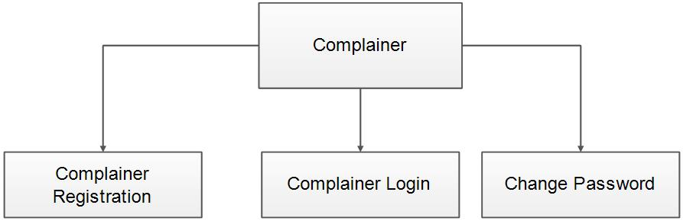

Figure 5-1 Structure Chart for Complainer

**5.6 Complaint Module Component**

(1) Identification Of Modules

The Complaint Module component consists of several modules that play a crucial role in the complaint management process. These modules include

(2) Complaint Reason

31

Chapter 5 Detail Design



This module focuses on capturing the reason or cause behind a complaint. It allows users to select from predefined options or provide a custom reason for their complaint.

(3) Complaint Details

The Complaint Details module enables users to provide a detailed description of their complaint. It allows them to elaborate on the incident, provide relevant information, and include any additional details that may be necessary for investigation or further action.

(4) Complaint Type

This module categorizes complaints into different types based on their nature or subject matter. It helps in organizing and classifying complaints for better management and analysis.

(5) Evidence

The Evidence module allows users to upload supporting evidence or documents related to their complaint. This can include photographs, videos, audio recordings, or any other relevant files that can provide additional context or proof.By incorporating these modules, the Complaint Module ensures that all essential information related to a complaint is captured accurately and comprehensively. It streamlines the process of registering and documenting complaints, facilitating efficient investigation and resolution.

(6) Structure Chart for Complaint

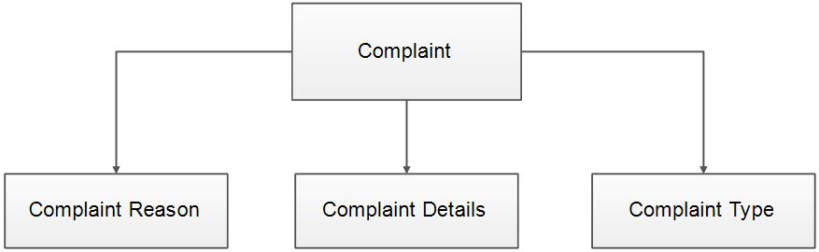

32

Chapter 5 Detail Design



**5.7 Cop Account Component**

(1) Identification Of Modules

The identified modules in the Cop component are Cop Login, Cop Profile, and Cop Change Password. The Cop Login module facilitates the login process for police officers, allowing them to access the system by entering their credentials. The Cop Profile module enables police officers to view and update their profile details, such as their name, contact information, and designation. The Cop Change Password module allows police officers to change their login password for enhanced security. These modules collectively contribute to the functionality and user experience of the Cop component in the overall system.

(2) Structure Chart for Cop

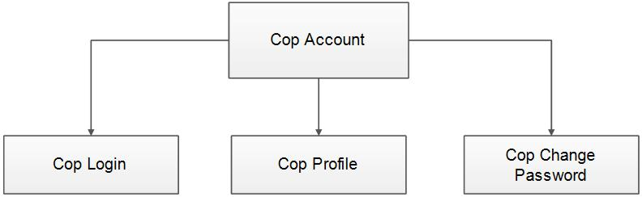

(3) Location Module Component

By incorporating the Location Module, the system ensures effective management and utilization of location-related information. It enhances the accuracy and efficiency of processes that rely on location data, such as complaint registration, resource allocation, or crime analysis.

**5.8 Structure Chart for Cop**

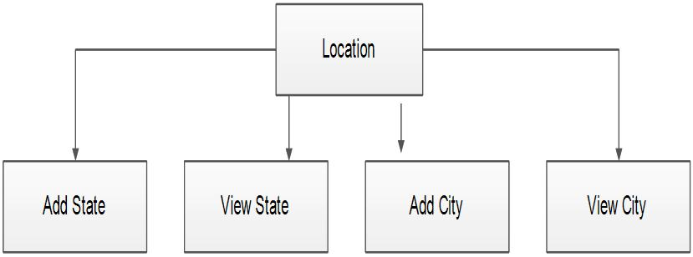

33

Chapter 5 Detail Design



**5.9 Charge Sheet Module Component**

The Charge Sheet Module component consists of the following modules

(1) Add Charge Sheet Report

This module allows authorized users to add charge sheet reports to the system. Users can enter relevant details such as the case number, accused details, evidence, charges filed, etc. The module validates the entered information and stores it in the system's database.

(2) View Add Charge Sheet Report

This module enables users to view the previously added charge sheet reports. Users can search and retrieve charge sheet reports based on criteria such as case number, date, or accused details. The module presents the retrieved reports in a readable format for users to review and access the relevant information.

**5.10 Structure Chart for Charge Sheet**

The structure chart for the Charge Sheet component represents the organization and flow of modules related to charge sheet functionality. It includes modules such as Add Charge Sheet Report and View Charge Sheet Report. The Add Charge Sheet Report module is responsible for adding charge sheet details to the system, while the View Charge Sheet Report module allows users to retrieve and view charge sheet reports. These modules work together to handle the process of managing charge sheet information within the system.

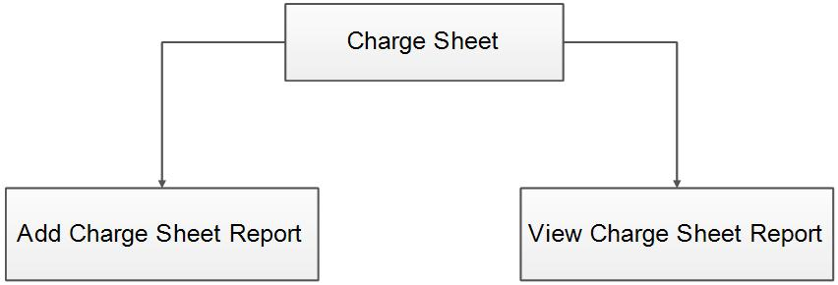

34

Chapter 6 Testing and User Interface



**Chapter 6 Testing and User Interface**

**6.1 Introduction**

Testing plays a crucial role in ensuring software quality and reliability by detecting errors.

The results obtained from testing are also valuable during the maintenance phase.

(1) Psychology Of Testing

The primary objective of testing is to uncover errors in a program rather than to prove that it works flawlessly. Testing involves executing a program with the intention of finding errors.

(2) Testing Objectives

The main goal of testing is to systematically and efficiently detect a wide range of errors. A successful test is one that identifies previously unknown errors. A good test case has a high probability of uncovering an error if it exists. Testing is essential for confirming software quality and reliability.

**6.2 Software Testing**

Software testing is a critical aspect of software quality assurance. It serves as the final evaluation of a specification, design, and coding. The testing phase involves executing the system using various test data, identifying errors, documenting corrections, and ensuring the system meets quality standards before implementation.

(1) Unit Testing

Unit testing focuses on verifying the smallest unit of software, such as a module. It involves testing each module independently using detailed design and process specifications. All modules must pass unit testing before integration testing can begin. Unit testing ensures the accuracy and proper functioning of individual modules.

(2) Integration Testing

Integration testing involves combining and testing all code modules to ensure desired outputs are achieved. It verifies the integration and functionality of all modules when combined into a complete program. Integration testing is performed after unit testing.

35

Chapter 6 Testing and User Interface



(3) Output Testing

Output testing involves providing sample valid input data and comparing the obtained results in the compressed output with the expected results. The correctness of the output is dependent on the input data provided.

(4) System Testing

System testing examines the entire system, including forms, code modules, and class modules, as a whole. It is conducted in different environments to ensure the system functions without any runtime errors. System testing confirms that the system performs well in all environments.

**6.3 Test Cases**

**Test unit Hosteller Registration**

|  |  |  |  |
| --- | --- | --- | --- |
|  | Table 6-1 Table NameTest Cases | | |
| **Serial** | **Condition** | **Test Data** | **Expected** | |
| **No.** | **To be Tested** |  | **Output** | |
| 1. | If hosteller type is | Hosteller type | Kindly select | |
|  | not selected |  | hosteller type | |
|  | If hosteller name | Name | Name should | |
| 2 | contains other than |  | contain only | |
|  | character types |  | alphabets | |
| 3 | If email id does not | Email id | Entered email | |
|  | contains proper |  | id is not valid | |
|  | format |  |  | |
| 4 | If password length is | password | Password | |
|  | less than 6 |  | must contain | |
|  |  |  | at least 6 | |
|  |  |  | characters. | |

**Remarks**

SUCCESSFULL

SUCCESSFUL

SUCCESSFUL

SUCCESSFUL

36

Chapter 6 Testing and User Interface



|  |  |  |  |  |  |
| --- | --- | --- | --- | --- | --- |
| 5 | If password and | password, | Password and | SUCCESSFUL |  |
|  | confirm password does | confirm | Confirmed |  |  |
|  | not match. | password | password are |  |  |
|  |  |  | not matching. |  |  |
| 6 | If date of birth is not | Date of birth | Date of birth | SUCCESSFUL |  |
|  | selected |  | should not be |  |  |
|  |  |  | empty |  |  |
| 7 | If father name | Father name | Father Name | SUCCESSFUL |  |
|  | contains other than |  | should contain |  |  |
|  | character types |  | only alphabets |  |  |
| 8 | If mother name | Mother name | mother Name | SUCCESSFUL |  |
|  | contains other than |  | should contain |  |  |
|  | character types |  | only alphabets |  |  |
| 9 | If address contains |  | address should | SUCCESSFUL |  |
|  | other than character | address | contain only |  |  |
|  |  |  |  |
|  | types |  | alphabets |  |  |
| 10 | If contact number does | Contact number | Contact | SUCCESSFUL |  |
|  | not contain 10 digits |  | number should |  |  |
|  |  |  | contain 10 |  |  |
|  |  |  | digits |  |  |

37

Chapter 6 Testing and User Interface



**6.4 User Interface**

**6.4.1** **Home Page**

The home page of the project serves as the central hub for users, providing easy access to key functionalities. It includes the following components This page allows new users to create an account by providing their relevant information, such as name, email address, and password. The registration process helps in creating unique user profiles within the system, enabling personalized access and functionality. The log in page is where registered users can securely log in to their accounts using their credentials. By entering their username and password, users can gain access to their personalized dashboard and utilize various features of the crime management system.

**6.4.2** **Register Complaint Page**

This page facilitates the process of registering a complaint within the system. Users can provide details about the incident, including the type of crime, date and time, location, and a description of the event. This information is crucial for initiating the investigation and tracking the progress of the complaint within the system.The home page serves as the entry point for users, providing them with options to create an account, log in to an existing account, or register a complaint. These features ensure seamless user engagement and enable efficient utilization of the crime management system's functionalities.

38

Chapter 6 Testing and User Interface

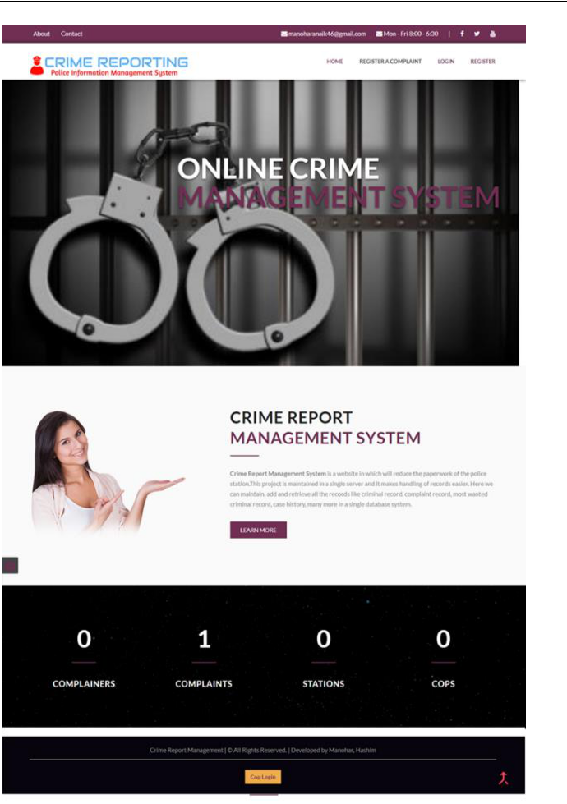

Figure 6-1 Home Page Screenshot

39

Chapter 6 Testing and User Interface



**6.4.3** **Complaint Registration**

. The Complaint Registration page is a crucial component of the online crime management

system. It serves as a platform for users to register their complaints and provide essential information related to the incident. The page includes various fields such as the complainant's name, contact details, and address, allowing for proper identification and communication. Additionally, the complainant is required to provide a complaint title, which succinctly describes the nature of the incident, and detailed information about the accused individuals involved. This comprehensive registration process ensures that all relevant details are captured accurately and facilitates efficient handling of the complaint by the law enforcement authorities

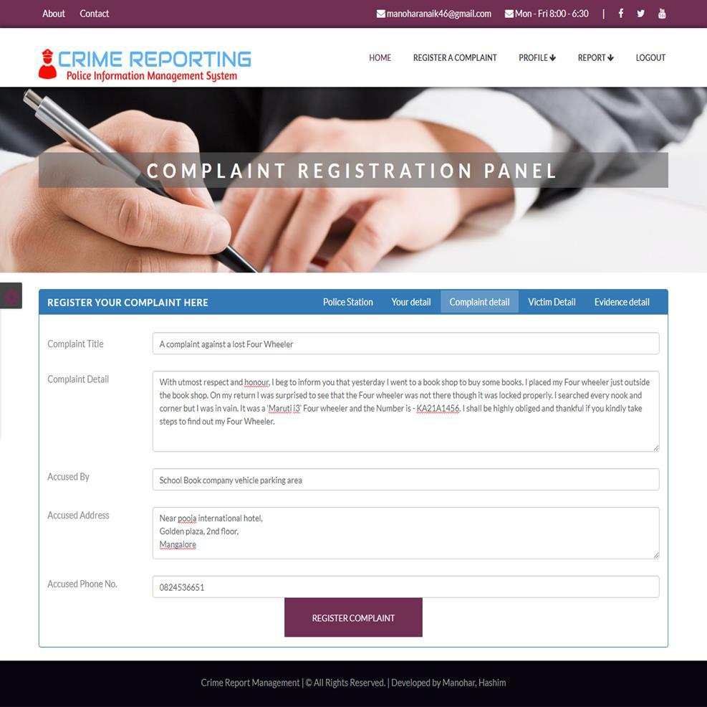

Figure 6-2 Complaint Registration Page Screenshot

40

Chapter 6 Testing and User Interface



**6.4.4** **Admin Dashboard**

The Admin Dashboard is a centralized interface designed to provide administrative personnel with access to various functionalities and information within the online crime management system. It serves as a control panel for managing and monitoring different aspects of the system. The dashboard includes several modules such as Complaint Management, FIR Management, Chargesheet Management, Crime Report Management, Station Management, User Profile Management, and Log Out functionality. Within the Complaint Management module, the admin can view and handle registered complaints, assign them to relevant personnel, track their progress, and update their status. The FIR Management module allows the admin to manage First Information Reports (FIRs), including viewing, editing, and generating FIR documents. The Chargesheet Management module enables the admin to manage charge sheets, including adding, editing, and reviewing charge sheet reports. The admin can also access the Crime Report Management module, which provides insights and analytics on overall crime data, trends, and patterns. Additionally, the admin can manage police stations through the Station Management module, which includes functionalities like adding, modifying, and tracking station details. The admin can access and manage their profile information through the User Profile Management module, where they can update personal details, change passwords, and modify account settings. Finally, the Log Out functionality allows the admin to securely log out from the system, ensuring data privacy and system security. The Admin Dashboard provides a comprehensive and efficient interface for administrators to effectively manage and oversee the various components of the online crime management system, facilitating streamlined operations and enhanced decision-making.

41

Chapter 6 Testing and User Interface

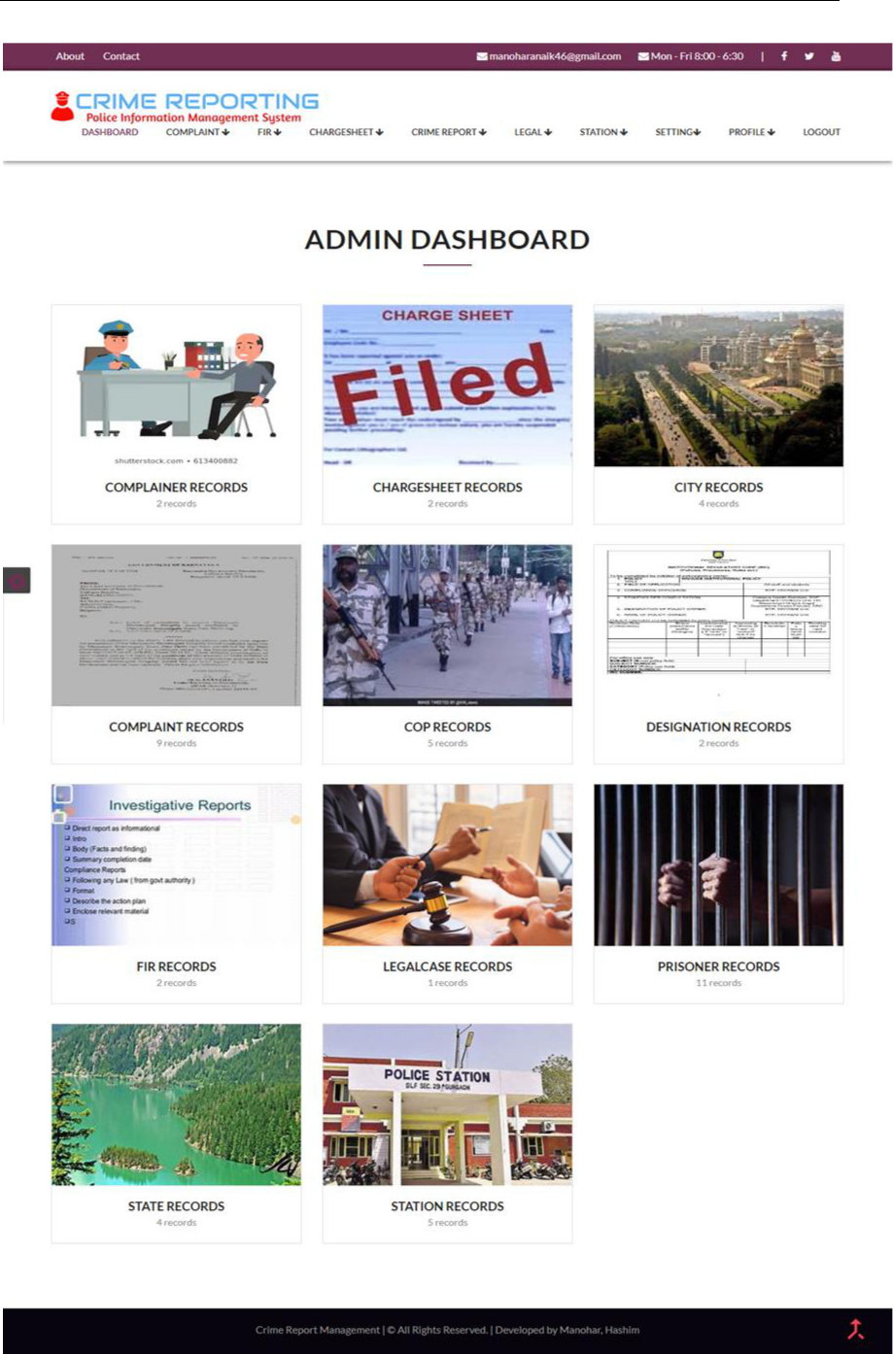

Figure 6-3 Admin Dashboard

42

Chapter 6 Testing and User Interface



**6.4.5** **View Cop**

The View Cop page is a component of the online crime management system that allows users with appropriate access privileges to view detailed information about police officers. This page displays essential details related to a specific police officer, including their name, assigned police station, designation or rank, gender, contact details, and phone number. The cop's name provides identification, enabling users to easily recognize and refer to the specific police officer. The assigned police station indicates the location or jurisdiction to which the cop is assigned, facilitating efficient coordination and communication within the system. The designation or rank of the cop reflects their position within the police hierarchy, providing insights into their authority and responsibilities. This information helps in understanding the cop's role and expertise within the law enforcement framework. The gender of the cop is mentioned to provide relevant demographic information and ensure accurate identification. Contact details such as email address or other means of communication are included, enabling users to reach out to the cop when necessary. The phone number of the cop is provided to establish direct contact, facilitating effective communication and prompt response to inquiries or incidents. By presenting this information on the View Cop page, the online crime management system enhances transparency and accessibility, allowing authorized users to quickly access and retrieve essential details about police officers, promoting efficient collaboration and communication within the law enforcement framework.

43

Chapter 6 Testing and User Interface

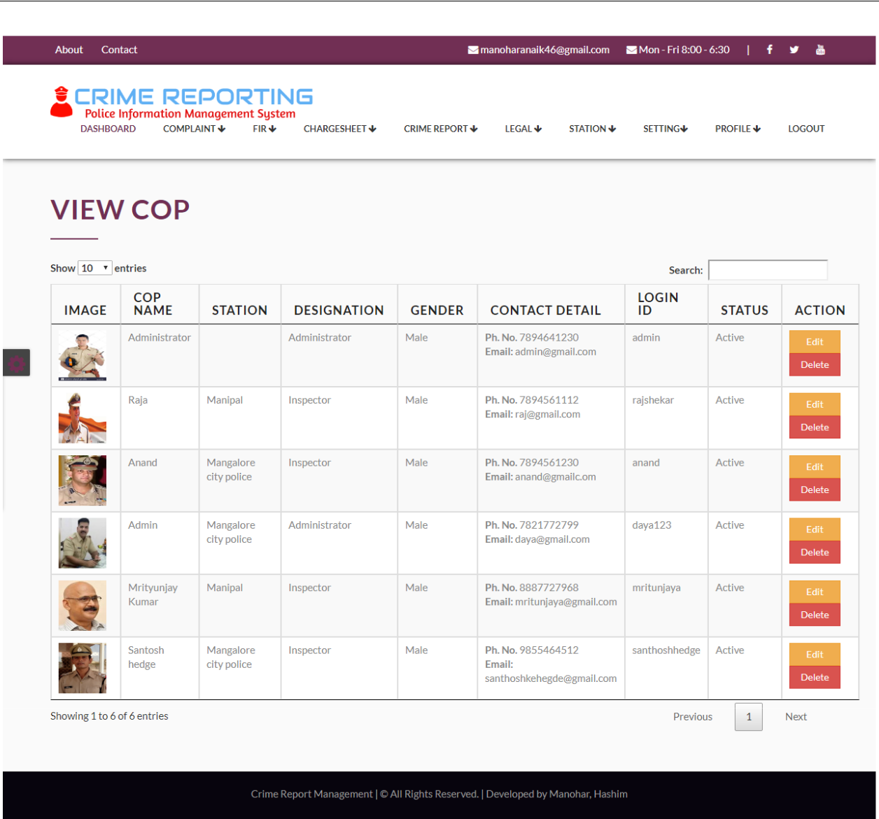

Figure 6-4 View Cop

**6.4.6 Add Station**

The add Station page displays essential information about police stations, including the station name, state, city, address, and an associated image. This allows users to easily identify and access the details of specific stations, facilitating effective communication and coordination.

44

Chapter 6 Testing and User Interface

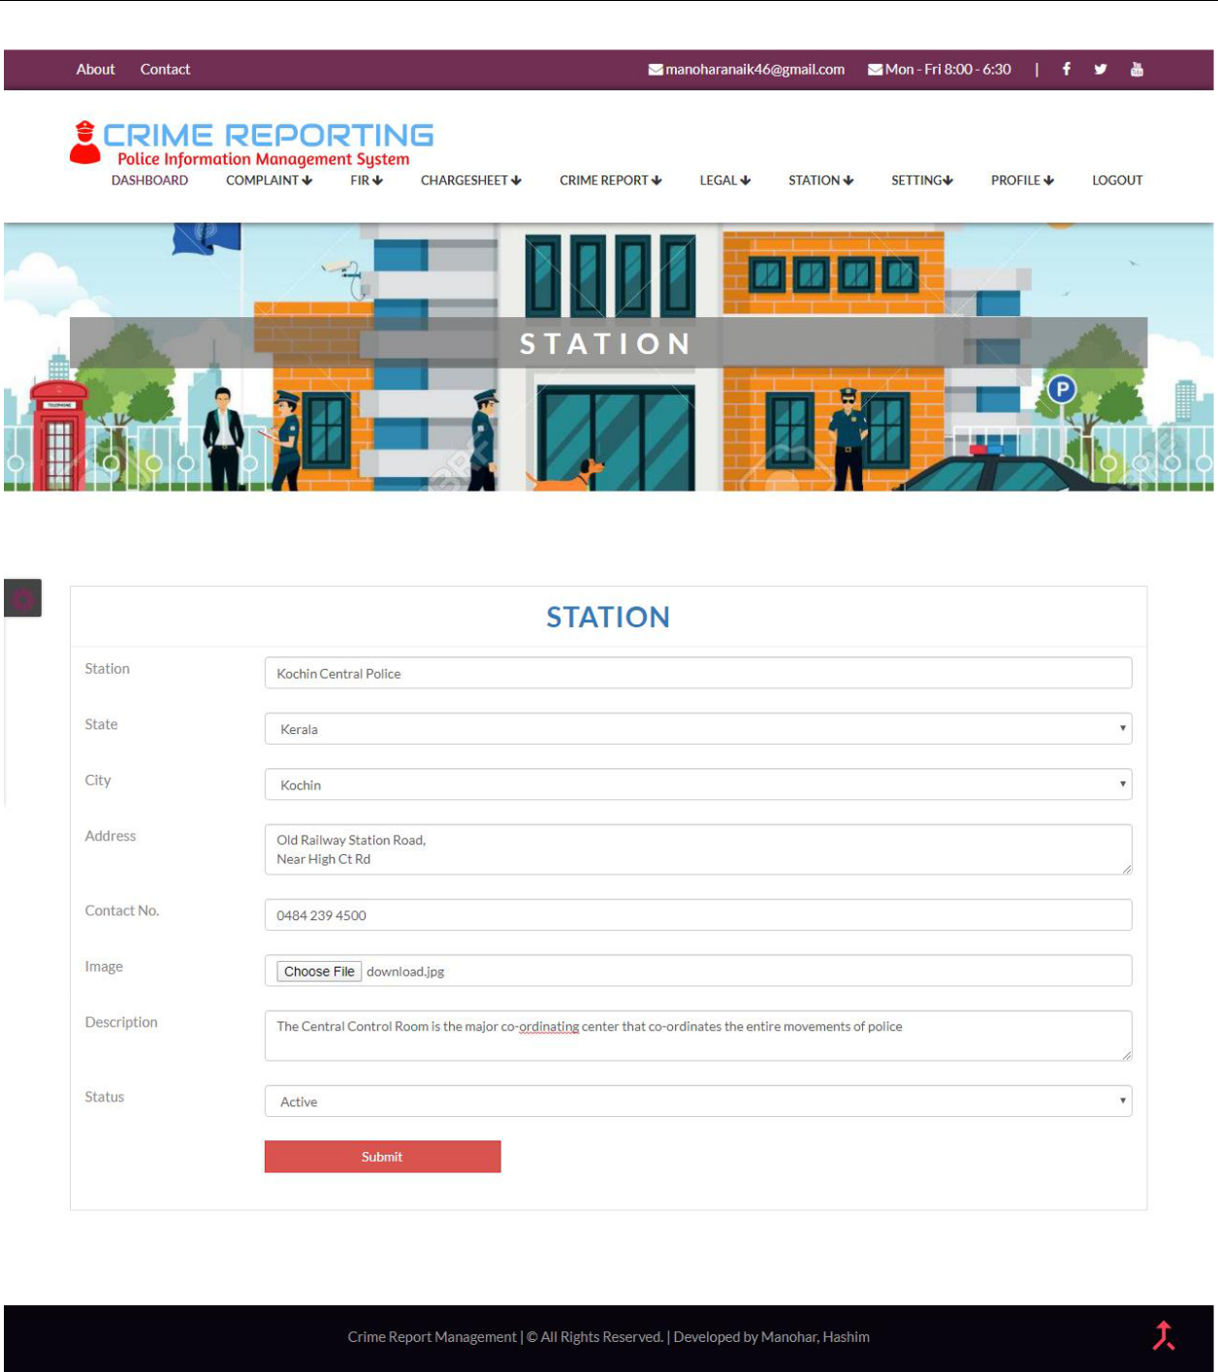

Figure 6-5 Add Station

45

Chapter 7 Conclusions



**Chapter 7 Conclusions**

**7.1 Concluding Remarks**

This thesis has provided a comprehensive examination of the Crime Management System in Bangladesh, its challenges, and potential solutions for improvement. The research has shed light on the historical background of the system, highlighting the need for an integrated and technologically advanced approach to managing crime-related data and processes. The comparative analysis with international systems has provided valuable insights and best practices that can be applied to enhance the functionality and effectiveness of the Bangladeshi system. Through the exploration of testing methodologies and strategies, the thesis has emphasized the importance of rigorous testing in ensuring software quality and reliability. The various levels of testing, including unit testing, integration testing, output testing, and system testing, have been discussed, underscoring their significance in identifying errors and confirming the system's performance in different environments. Furthermore, the thesis has outlined the structure and components of the Crime Management System, providing an overview of the database tables, modules, and their functionalities. The chapter on implementation strategies has emphasized the importance of effective implementation and user training in facilitating the successful deployment and utilization of the system. Overall, the research conducted in this thesis holds significant value for policymakers, law enforcement agencies, and other stakeholders involved in crime prevention, investigation, and justice delivery processes in Bangladesh. The proposed solutions and recommendations aim to enhance the efficiency, accuracy, and accessibility of the crime management system, ultimately contributing to more effective crime management and improved public safety. It is important to acknowledge that this research has certain limitations, such as the availability of data and resources, which may have impacted the depth and scope of the study. However, the findings and insights presented in this thesis provide a solid foundation for further research and development in the field of crime management systems. In conclusion, this thesis serves as a valuable resource for understanding the current state of the Crime Management System in Bangladesh and offers practical recommendations for its improvement. By addressing the identified challenges and implementing the proposed solutions, it is hoped that the crime management system will be strengthened, leading to more efficient and effective crime prevention, investigation, and justice delivery in Bangladesh.

46

Chapter 7 Conclusions



**7.2 Future Work**

**7.2.1** **Introduction**

The future scope of any project highlights the potential for growth, expansion, and improvement beyond its current state. It provides a glimpse into the possibilities that can be explored to enhance the project's functionality, reach, and user experience. In the case of the online crime management system, there are several exciting avenues for future development and enhancement.

With the rapid advancement of technology and the changing needs of users, it is crucial for the online crime management system to adapt and evolve. The future scope of the system envisions various areas where it can be further developed to meet the emerging challenges and requirements in the field of crime management. By considering the future scope, the project team can identify opportunities to incorporate new features, technologies, and integrations that will enhance the system's capabilities and effectiveness. It allows for continuous improvement and ensures that the system remains relevant and efficient in tackling the ever-evolving landscape of crime management. The future scope of the online crime management system encompasses multiple aspects, including expanding its accessibility through mobile applications, leveraging advanced technologies such as face recognition for criminal identification, and actively seeking user feedback to drive further improvements. These initiatives aim to provide users with a seamless, user-friendly, and efficient platform for reporting crimes, managing investigations, and enhancing collaboration among relevant stakeholders.

**7.2.2** **Integration with Mobile Applications**

One of the potential future enhancements for the online crime management system is to integrate it with Android and iPhone applications. By developing dedicated mobile applications, the accessibility and reach of the system can be significantly expanded. Mobile applications provide the convenience of accessing the system on the go, allowing users to file complaints, view updates, and receive notifications directly on their smartphones or tablets. This integration would cater to the increasing usage of mobile devices and provide a seamless user experience for mobile users.

**7.2.3 Face Recognition for Criminal Identification**

An exciting possibility for enhancing the functionality of the system is the integration of face recognition technology for criminal identification. Face recognition algorithms can be employed

47

Chapter 7 Conclusions



to analyze facial features and match them against a database of known criminals. This integration can greatly enhance the efficiency and accuracy of identifying criminals, enabling law enforcement agencies to swiftly identify suspects and solve crimes. By incorporating this advanced technology, the system can contribute to the overall improvement of crime prevention and investigation processes.

**7.2.4 Continuous Improvement based on User Feedback**

To ensure the continuous development and effectiveness of the online crime management system, it is important to gather user feedback and requirements. User feedback provides valuable insights into areas that can be improved, new features that can be added, and any issues that need to be addressed. By actively considering and implementing user suggestions, the system can evolve to meet the changing needs and expectations of its users. This iterative approach of incorporating user feedback will contribute to the overall functionality and effectiveness of the system. In summary, the future scope of the online crime management system includes integration with mobile applications, allowing users to access the system on their Android and iPhone devices. Additionally, incorporating face recognition technology for criminal identification can enhance the system's efficiency in identifying suspects. Lastly, continuous improvement based on user feedback will ensure that the system remains up-to-date and meets the evolving needs of its users.

48

Acknowledgements



**Acknowledgements**

I would like to express my deepest gratitude to all the individuals who have contributed to the completion of this thesis on the crime management system in Bangladesh. Their support, guidance, and encouragement have been invaluable throughout this research journey.First and foremost, I would like to thank my supervisor, [Supervisor's Name], for their expertise, patience, and continuous guidance. Their insightful feedback and constructive criticism have immensely shaped the direction and quality of this thesis. I am grateful for their unwavering support and mentorship. I extend my sincere appreciation to the faculty members of Chengdu Normal University, whose knowledge and expertise have enriched my understanding of the subject matter. Their dedication to teaching and research has been a constant source of inspiration. I am grateful to the participants who generously shared their insights and experiences during interviews and surveys. Their contributions have provided valuable firsthand information and perspectives, enriching the findings of this research. I would also like to acknowledge the support and assistance received from various professionals, experts, and practitioners in the field of crime management. Their willingness to share their expertise, engage in discussions, and provide valuable resources have greatly enhanced the depth and credibility of this study. I am indebted to the staff and personnel of law enforcement agencies, government departments, and organizations involved in crime management in Bangladesh. Furthermore, I am grateful to my family and friends for their unwavering support, understanding, and encouragement throughout this journey. Their love, motivation, and belief in my abilities have been my constant source of strength. Lastly, I would like to express my heartfelt appreciation to all the individuals who have contributed to this research in any way, whether directly or indirectly. Your support and encouragement have played a significant role in the successful completion of this thesis. In conclusion, I am humbled and grateful for the support and contributions of everyone involved in this research. Their collective efforts have made this thesis possible, and I am honored to have had the opportunity to work on such an important and challenging topic.

49

Reference



**Reference**

1. Adams, J., & Biddle, A. *Exploring the role of technology in crime prevention: A systematic review.* [D], me Science, 2019. 8(1), 1-20.
2. Anderson, K., & Pease, K. *Improving the effectiveness of crime analysis through technology integration.* [J] Journal of Policy and Practice, 2016. 10(4), 385-395.
3. Bani-Hani, N. *The impact of information technology on crime prevention and detection: A comprehensive review*. [J] International Journal of Advanced Computer Science and Applications,2018*.* 9(1), 133-140.
4. Chang, K. *Integration of geographic information systems and crime mapping in crime analysis.* [J] Journal of Police and Criminal Psychology, 2017.32(2), 125-134.
5. Davis, J., & Groff, E. *Crime analysis with crime mapping. SAGE Publications*. 2017.
6. Ekbom, P. *Designing out crime: From products to systems*. [J] Crime Science, 2018. 7(1), 1-18.
7. Ferreira, F., & Santos, M. Y*. Enhancing crime management systems through data analytics and machine learning.* [J] International Journal of Information Management, 2020. 50, 203-215.
8. Groff, E. *Geographic information systems and crime analysis* [M]. In The Handbook of Crime and Punishment 2018. (pp. 75-90). Wiley.
9. Huang, W., & Ku, Y. Predicting crime hotspots using machine learning techniques: A case study in a metropolitan city. [J] ISPRS International Journal of Geo-Information, 2019 8(5), 233.
10. Koper, C. S. *Evidence-based policing*. [M] Oxford Research Encyclopedia of Criminology and Criminal Justice. 2016.
11. La Vigna, N. G., & Lawton, B. A. Advancing technology in criminal justice: [M] review of the literature on technology adoption and innovation in policing and corrections. RAND Corporation. 2019.
12. Mohler, G. O., Short, M. B., Brantingham, P. J., & Schoenberg, F. P. *Randomized controlled experiments in criminology: A scoping review and discussion of future directions*. [J] Journal ofExperimental Criminology, 2017 13(3), 347-371.
13. O'Brien, D. *The role of technology in crime prevention*. [D] Crime Prevention and Community Safety, 2017. 19(3), 159-178.
14. Piquero, A. R., & Hickman, M. J. [M] *empirical status of criminology. Criminology*, 2019. 57(3), 480-509.

50

Reference



1. Ratcliffe, J. H. *The spatial extent of crime: new evidence from England and Wales.* [J] Journal of Quantitative Criminology, 2018. 34(3), 1013-1031.

51

[View publication stats](https://www.researchgate.net/publication/376196725)