**DESIGN AND IMPLEMENTATION OF CHARITY MANAGEMENT SYSTEM (A CASE STUDY OF ZAMFARA YOUTH CHARITY ORGANISATIONS)**

**ABSTRACT**

Being charitable involves showing kindness by providing assistance to those in need through financial support and resources. Contributing to charity is a selfless act, with no expectations in return. This seminar presents a plan for developing and executing a web-based management system. This system functions as a mediator connecting individuals who wish to assist the less fortunate with those in need of help. This system ensures that donations are distributed fairly, ensuring that all those in need receive the respect they deserve based on their needs. By addressing this problem, the system contributes to creating a more equitable society where everyone receives fair support. This Charity web application is poised to bring significant benefits to the people of Zamfara state through facilitating thoughtful and generous wealth distribution.

**CHAPTER ONE**

**INTRODUCTION**

1. **Overview**

Charity is a benevolent act that provides assistance to individuals in need through financial aid and resources. Charity is characterised by selfless giving without expecting anything in return. This charity's purpose is to alleviate people's sorrow and improve their lives. In Zamfara state, charity encompasses several activities like providing essential needs such as food, housing, and clothing, as well as supporting medical research, education, environmental issues, and other causes. Assisting the impoverished and destitute has consistently held significance in Muslim culture and legacy (Kshetri, 2018). It transforms and enhances one's life. The poverty rate in our country has decreased due to the presence of these services. Over time, issues have emerged in the foundation, leading to dissatisfaction among the donors.

The challenges encountered by donors and contributors highlighted the issue addressed in this study. Supporting charity is a fundamental aspect of our culture as it aids the underprivileged. Over time, trust and transparency difficulties have arisen, leading to a decrease in support from local and foreign donors (Liao & Wei, 2019). The charity management system is designed to address the technical, bureaucratic, and psychological barriers faced by donors when contributing to charity in Zamfara state, Nigeria. A dependable donation management system is urgently required in Zamfara state to solve issues faced by both donors and recipients. Creating and executing the Charity online management system aims to enhance the charity giving and receiving process in Zamfara state, with the ultimate objective of alleviating poverty and bridging the gap between the affluent and the impoverished. We want to regain donors' trust and enhance a charitable giving strategy that is more successful and efficient via the use of our technologies.

1. **Statement of problem**

Charity is a generous act aimed at helping and supporting those in need. However, it is evident that a large number of individuals in Zamfara state do not receive the help they require. Although many individuals are in need of help, only a few actually receive it. Charitable donations in Zamfara state are unevenly distributed. Identifying and addressing the needs and concerns of individuals in their daily lives through the development of a web application is the main challenge in this research study.

Following that, it's important to link these individuals with others who are generous and have the resources to help those in need. This system acts as a mediator, connecting individuals who want to help the less fortunate with those who are in need of assistance. Ensuring the system's implementation would guarantee fair distribution of donations and respectful treatment for those in need based on their requirements. By solving this issue, we can create a more equitable society where everyone can build a community that receives equal support.

1. **Aim and objectives**

The goal of this Web Management System is outlined as follows:

1. Assessing the effectiveness of the charity organisation web application in streamlining the donation management process for donors, needy individuals, and charity organisations.
2. Assessing the quality and precision of the verification process set up by the administrator to ensure the legitimacy and reliability of the charity organisation utilising the platform.
3. Identifying the main benefits and limitations of utilising centralised web applications for donation management in comparison to traditional fundraising and donation management methods.
4. Exploring the role of translucency and accountability in fostering trust among platform users, such as charity organisations, donors, and underprivileged individuals.
5. Investigating the safety and privacy measures in place on the platform to ensure confidentiality of user data and financial transactions.
6. Examining the ethical significance of utilising a web application for donation management, particularly in terms of charity selection, donation budget, and personal data privacy.
7. Providing recommendations to improve the efficiency, reliability, and importance of the charity community web application to meet user requirements and expectations.
8. **Significance of the study**

The Charity web application aims to provide significant benefits to the people of Zamfara state by facilitating thoughtful and generous wealth distribution. Creating and launching this web application will support various private and government initiatives aimed at alleviating poverty. Making this web application known and accessible could bring hope to those in need.

1. **Scope and limitation**

The web application is designed to provide a platform for charity organisations to register, log in, and showcase their events on the website. The application allows donors to sign up and donate to their chosen charity events listed on the charity website. Individuals in need can sign up and request essential items from charitable organisations. An administrator can manage and verify the legitimacy of organisations and their events. Nevertheless, the web application will simply provide a platform for charity organisations to sign up and showcase their events. No responsibility will be taken for any transactions between the donors and the charity organisations. Needy individuals must provide the necessary documents to request assistance from charity organisations. Unfortunately, the web application is unable to guarantee that the charity organisations will meet their demands. The validation process for the charity organisations will be carried out by the web application administrator. However, the web application is unable to guarantee the accuracy of the organisations. The web application will not be responsible for any legal issues that may arise between the charity organisations and the donors or recipients. The web application will only be accessible online and may not be available in areas with limited internet connectivity.

**CHAPTER TWO**

**LITERATURE REVIEW**

1. **Review of the existing system**

According to a study by Govindaraju, S., Indirani, M., & Senthi, N. (2023), the current charity web management system is based on four core principles.

1. Direct bank transfers involve donors contributing directly to a specific bank account through money transfers.
2. Direct mail donations are contributions sent through direct money order or post office.
3. Donors can contribute by sending checks through mail or courier service.
4. Donors can demonstrate their commitment to a cause by contributing major gifts of a specified monetary value.
5. **Review of the propose system**

The primary objective with the Charity Web Management System is to facilitate connections between those in need in Zamfara state and potential donors within the same region. This will contribute to reducing poverty burdens among the people, minimising wastage among the very-sufficient, and ensuring basic human needs (Alkhatib & Taani, 2019). This system's features guarantee that individuals can request charity even if there are leftover food items in any location. This system facilitates the donation of essential items such as unused clothes and medicine. Admins and volunteers can access various reports from their dashboard as soon as they log in. This system aids charities in enhancing operational efficiencies and cutting costs by eliminating a significant amount of manual paperwork. Donors and charity administrators have access to donor names, donation amounts, payment date and time, and transaction details. Donors or public visitors have access to all charity information online.

1. **Study gap**

Research on past donation systems in Zamfara state indicates a lack of a state-focused Charity Web management system. At a national level, charity web management systems are in place, but Osiobe(2022) discovered that donation/charity organisations encounter difficulties in managing their donations and transactions, including issues with clarity and accountability. This gap calls for the development of a modern charity web management system specifically tailored for Zamfara state, Nigeria.

1. **Methodology**

The Scrum technique is recommended for designing and implementing this system. The scrum methodology is rooted in the Agile mindset, which was originally created for the management and development of products (Nyembe, Poll & Lotriet, 2023). Scrum has been widely utilised across several corporate sectors globally since the 1990s. In Scrum, the team determines the implementation of tasks, omitting documentation and specification drafting. The client delegates documentation and focuses solely on outlining the desired outcome (Azanzi, Tapamo & Camara, 2023). The Scrum team is supervised by a Scrum Master and a Product Owner (PO).

The Scrum Master serves as a coach to assist the development team in delivering a high-quality product. The Scrum Master is prohibited from assigning tasks directly to the Scrum team members. The Product Owner (PO) is a representative on the client-side who embodies the customer's vision and prioritises the tasks at the start of the sprint based on the customer's preferences. Time is divided into intervals of 2-4 weeks, as stated by Lee & Chen (2023). As soon as a sprint is over, a team must offer a ready-to-market app/product. The Scrum sprint commences with the creation of a Sprint backlog, which consists of multiple ideas that the team will develop into a coding solution.

During a Sprint, daily Scrum meetings are held with all team members, the Scrum Master, and the Product Owner to review progress and strategize for efficient delivery. Every meeting has a 15-minute time limit. If the Product Owner is unable to attend a meetup, their responsibilities typically transfer to the Scrum Master. With Zoom and numerous chat platforms available, communication is not an issue. At the conclusion of the sprint, a retrospective meeting is held where team members, the Scrum Master, and the Product Owner discuss the results of the sprint, what was accomplished, what was not, and how to improve the next sprint. The object produced during the sprint must be capable of being shipped, as previously stated.

**CHAPTER THREE**

**SYSTEM ANALYSIS AND DESIGN**

1. **Introductions**

In this chapter, I combined the understanding of the reasoning behind the system and its goals to determine the requirements, then subsequently suggested a design that offers an optimal solution to meet the recognised need.

1. **Analysis of the existing system**

Research conducted by Perera (2019) and Park & Lee (2019) has demonstrated the presence of a Charity web management system. The following describes the procedure governing this existing system:

* Identification of need: This is the first stage where the donor visits the website after recognising the need to donate or contribute to a cause.
* Registration and verification include the donor completing a brief form with minimal personal information.
* Donate: The donor provides billing details and specifies the donation amount and frequency (One-time or Monthly). The donor can also make a direct bank transfer to the charitable organization's bank account.

1. **Analysis of the proposed system**

The proposed system in this seminar contains the following processes. These processes adequately captures the true essence of this system.

* **Identify and verify charitable organisations.**

A registration form is available to verify the credibility of organisations and donations. Donors and charity organisers must provide personal information, contribution purpose, contact details, how they learned about the donation system, legal documents, and proof of domicile. The admins will verify and authenticate this data. Upon successful registration and confirmation, the organisation will gain access to the web application.

* **Determine and verify the beneficiaries**

There is a specific section in the web application for beneficiaries. The recipient must select that choice and access that page. Administrators have designated a registration form for the recipient. Beneficiaries must complete the form by providing the necessary details, including information on the hardships they have faced throughout their lives. Submitted information will be reviewed by administrators who will determine the eligibility of the beneficiary to receive donations.

* **Assess donors.**

Donors must provide their contact information and payment details to establish a donor profile. The application will monitor the donation history and provide a payment receipt to the contributors, which is beneficial for them.

* Monitor and assess total donations and any losses incurred

The web application administrator will monitor all donated amounts/items to assure direct receipt by the recipient. If there is any loss or distortion, the administrators will take necessary actions.

This innovative system proposes a method for detecting and confirming charities, gifts, and financial losses. This web application establishes a clear connection between donations and charitable organisations.

1. **Requirement analysis**

When creating a system, a variety of technologies and tools can be applied. When employing particular tools and technologies, the requirements are taken into account. Both functional and non-functional criteria may be present.

**Languages for Programming**

This web application can be developed using a variety of programming languages, but developers are advised to take into account a number of factors when selecting the right language, including the project requirements, the developers' skill levels, community support, scalability, security, performance, and cost. These elements are included in several widely used programming languages, including Java, Python, PHP, C, and JavaScript.

**Integrated Development Environments**

IDEs are platforms and software used to write, test, and debug computer programmes. A few of them provide developers a variety of helpful features. IDEs that are often used include PyCharm, Eclipse, Visual Studio, VS Code, and IntelliJ IDEA.

**Functional requirement**

* The system will enable the Administrator to have the utmost authority to add, delete, modify, update donations, and view donations made.
* Users will be able to access and view orders in the system.
* The system will enable the administrator to access individuals' funds and send them mail.
* Users can select their preferred payment method, either cash or card, to complete the transaction.
* Users must register before they can access the Web app's functionality.
* Users can revisit any stage of registration without losing data or having to repeat the process.
* Users can modify fields that are not in the finalised status.
* Upon deletion of a profile, the system will prompt the user with a confirmation dialogue.
* The system is set up to automatically send a confirmation email whenever a new user profile is created.
* Users need the ability to export report results in CSV format.

**Non-functional requirement**

* The application shall Process data, load pages, browser refresh times, etc... promptly
* Description of colors, screen size, button size, etc.
* Reliability and availability (24/7/365)
* Maximum Page opening time (3 seconds)
* Number of concurrent user sessions: 1 to 10000
* Supported browsers: Google Chrome, Safari, Microsoft Edge, Firefox
* Performance: Each request to the server must be processed within 5 seconds.
* Security: The payment processing gateway must be PCI DSS compliant. The clinical software must comply with HIPAA (Health Insurance Portability and Accountability Act) and GDPR (General Data Protection Regulation). Cloud data centers must comply with security certification ISO 27001.

1. **System Design**

This section outlines the system's design principles. Explained are use case diagrams, activity diagrams, application architectures, entity relationship diagrams, and data flow diagrams.

**Application Architecture**

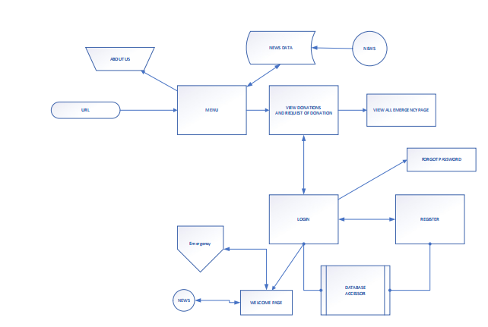

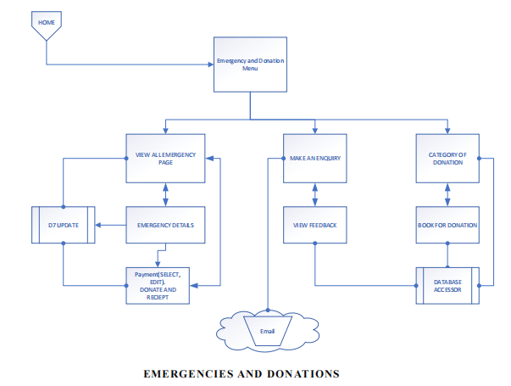

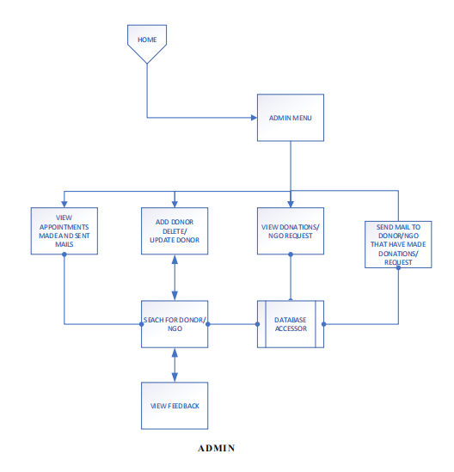

**Use Case**

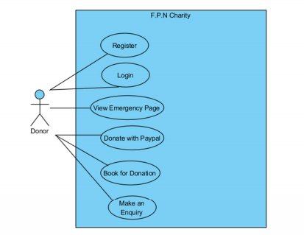

Figure 1 Use Case diagram [A Use Case diagram illustrates the communication between users and the system. It demonstrates the system's functions from the user's perspective and the different actions the user takes as the actor.]

**Activity Diagrams**

An activity diagram is a model that shows the process of a task or action from a use case.

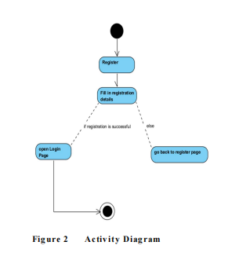

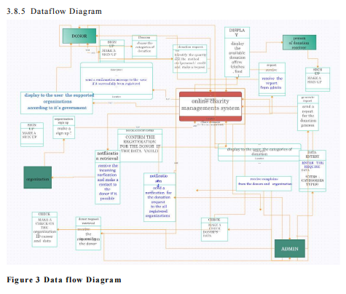

**Entity-Relationship Diagram (ERD)**

[Entity-relationship diagrams display the entities and attributes of tables within a database. Linked ERDs illustrate the connection between tables or entities. Entities can only have a many-to-one or one-to-many relationship, for example, as shown in Figure A below.]

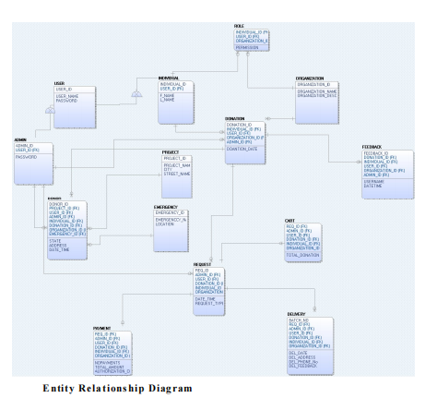

1. **Database design**

Web applications heavily rely on databases, and developers have several options to choose from. Centralised, Relational and NoSQL are just a few examples. The system is capable of storing new information, retrieving existing data, updating necessary details, and removing unnecessary records. MySQL, MongoDB, Oracle, Firebase, and Microsoft SQL Server are popular databases.

**References**

Alkhatib, R., & Taani, H. (2019). Building an Online Donation Management System for Charitable Organizations. International Journal of Computer Science and Information Security, 17(4), 106-112.

Azanzi, J., Tapamo, H., & Camara, G. (2023). Combining Scrum and Model Driven Architecture for the development of an epidemiological surveillance software. Revue Africaine de Recherche en Informatique et Mathématiques Appliquées. Volume 39 - 2023. 10.46298/arima.9873.

Govindaraju, S., Indirani, M., & Senthi, N. (2023). Online Charity Management Systems Using Web Based Systems. https://ymerdigital.com/uploads/YMER221285.pdf

Kasım, Ö. (2023). Secure Agile Software Development with Scrum Strategy. 10.21203/rs.3.rs-2788523/v1.

Kshetri, N. (2018). Blockchain's roles in meeting key supply chain management objectives. International Journal of Information Management, 39, 80-89.

Lee, W. & Chen, C. (2023). Agile Software Development and Reuse Approach with Scrum and Software Product Line Engineering. Electronics. 12. 3291. 10.3390/electronics12153291.

Liao, L., & Wei, C. (2019). The Influence of Transparency on Donor Trust in Charity Organizations: Evidence from China. Sustainability, 11(9), 2671.

Nyembe, F., Poll, J., & Lotriet, H. (2023). Formal Methods for an Agile Scrum Software Development Methodology. Proceedings of the International Conference on Advanced Technologies. 10.58190/icat.2023.35.

Osiobe, E. U., (2022). Reforming and Creating a Business-Friendly Environment: An Empirical Case Study of (Non-Profit Organization) in Nigeria (June 23, 2022). Journal of Social and Political Sciences, Vol.5 No.2 , Available at SSRN: https://ssrn.com/abstract=4144248

Park, H., & Lee, D. (2019). Impact of perceived usefulness and trust on charitable donation intention in mobile social commerce. Sustainability, 11(20), 5635

Perera, R. A. A. N. (2019). A Study on the Implementation of an Online Donation Management System for Charitable Organizations in Sri Lanka. International Journal of Advanced Research in Computer Science, 10(3), 30-36