DESIGN AND IMPLEMENTATION OF AN ONLINE THERAPY APPLICATION

BY

MUKHTAR, Khadijah Kamba BU/19C/IT/3901

DEPARTMENT OF COMPUTER SCIENCE BAZE UNIVERSITY
ABUJA

October, 2022

Online Therapy Application

Thesis Submitted in Partial Fulfilment of the Requirement for the Degree of

B.Sc.
In
Software Engineering By

MUKHTAR, Khadijah Kamba

To
The Department of Computer Science Baze University, Abuja

[October, 2022]

DECLARATION

This is to certify that this Thesis entitled Design and Implementation of an Online Therapy Application, which is submitted by Khadijah Kamba Mukhtar in partial fulfilment of the requirement for the award of degree for B.Sc. in Software Engineering to the Department of Computer Science, Baze University Abuja, Nigeria, comprises of only my original work and due acknowledgement has been made in the text to all other materials used.

Date: 10th October 2022 Name of Student: Khadijah Kamba Mukhtar

APPROVED BY …………………

HOD
Dept. of Computer Science

CERTIFICATION

This is to certify that this Thesis entitled Design and Implementation of an Online Therapy Application, which is submitted by KHADIJAH KAMBA MUKHTAR in partial fulfilment of the requirement for the award of degree for B.Sc. in Software Engineering to the Department of Computer Science, Baze University Abuja, Nigeria is a record of the candidate’s own work carried out by the candidate under my/our supervision. The matter embodied in this thesis is original and has not been submitted for the award of any other degree.

Date: Supervisor:

APPROVAL
This is to certify that the research work, Online Therapy Application and the subsequent preparation by Khadijah Kamba Mukhtar with BU/19C/IT/3901 has been approved by the Department of Computer Science, Faculty of Computing and Applied Science, Baze University, Abuja, Nigeria.
By

Mrs. Amina Fadila Shehu Date/Sign
1st Supervisor

Date/Sign
2nd Supervisor

Dr. C. V Uppin Date/Sign
Head, Department of Computer Science

Prof. Peter Ogedebe Date/Sign
Dean, Faculty of Computing and Applied Science

Prof. CHOJI Davou Nyap Date/Sign
External Examiner

DEDICATION

This project is dedicated foremost to The Omnipotent Allah (SWT) who has given me the willpower and perseverance to not only complete this project, but to succeed through the entirety of my years in school.
To my loving and ever-supportive parents, to my family who pushed me past points I never imagined I could scale through, to my friends and course mates who always provided me a listening ear and uplifted whenever I was discouraged, and to my beautiful nieces Zainab & Tasneem, I love you. This is for you.

ABSTRACT

There is great concern for the mental and psychological well-being of the Nigerian populace. With Nigeria ranking as the most depressed country in the continent of Africa according to research carried out by Africa Check in 2018, it is pertinent that we find practical answers and solutions to the issue. This project tries to determine the breadth of the literature on the subject, synthesize recent studies, and identify research gaps. It aims to provide a platform where Nigerians are encouraged to speak up about their feelings and talk more about the things that go on in their heads. In order to ensure mental wellbeing and reduce suicide and depression rates among Nigerians, therapists of different genders, religions and socio-cultural backgrounds are readily available and offering a listening ear.

TABLE OF CONTENTS
ABSTRACT VII
LIST OF TABLES X
LIST OF FIGURES XI
LIST OF ABBREVIATIONS… XII

CHAPTER 1: INTRODUCTION |  | 1
1.1 |  | 11.2
 |  | 11.3
 |  | 11.4
 |  | 21.5
 |  | 21.6
31.7
3CHAPTER 2: LITERATURE REVIEW
4
2.1 | 42.2 | 62.3 RELATED WORK
 | 8
2.4 |  | 12CHAPTER 3: REQUIREMENTS, ANALYSIS, AND DESIGN  14
3.1 |  | 133.2
 |  | 143.3
 |  | 143.3.1
 |  | 163.3.2
 |  | 173.4
 |  | 173.5
 |  | 183.6
 |  | 183.7
 |  | 183.7.1
 |  | 183.7.2
 |  | 203.8
 |  | 213.8.1
 |  | 223.8.2
 |  | 233.8.3
 |  | 233.8.4
 |  | 243.8.5
 |  | 253.8.6
 |  | 263.8.7
 |  | 263.8.8
273.9
30CHAPTER 4: IMPLEMENTATION AND TESTING
30
4.1 |  | 304.2
 |  | 304.3
 |  | 314.4
 |  | 324.5

 | 324.5.1
 | 334.5.2
 | 334.5.3
 | 344.5.4
 | 354.5.5
 | 354.6
354.7
36CHAPTER 5: DISCUSSION, CONCLUSION, AND RECOMMENDATIONS
37
5.1 | 375.2
 | 375.3
 | 375.4
 | 375.5
385.6
38REFERENCES
39
APPENDICES | 41

LIST OF TABLES

TABLE 1 FUNCTIONAL REQUIREMENT SPECIFICATIONS18TABLE 2 NON-FUNCTIONAL REQUIREMENT SPECIFICATIONS 20

LIST OF FIGURES

FIGURE 1 | USE CASE DIAGRAM | 23
FIGURE 2 | ACTIVITY DIAGRAM DATA FLOW DIAGRAM | 24FIGURE 3  25
FIGURE 4 | ENTITY RELATIONSHIP DIAGRAM | 26
FIGURE 5 | USER INTERFACE | 27

LIST OF ABBREVIATIONS

FCM Firebase Cloud Messaging

ERD Entity Relationship Diagram

UI User Interface

OS Operating System

SQL Structured Query Language

  - Overview

CHAPTER 1: INTRODUCTION

This project focuses on providing a solution to people suffering from mental health problems. The online therapy application is a mobile application which serves to provide access to professional therapy and counseling services to anyone in need of it. This chapter covers the background of the project, its aims and objectives, the scope, possible risks, and its significance.

Background and Motivation
The emotional, psychological, and social well-being of an individual, which has an impact on how they feel, think, and act, is referred to as their mental health. It is a behavior that is clinically recognizable and typically linked to distress that interferes with functioning. There are risk factors for emotional disease, some of which may be life events like natural catastrophes, the death of loved ones, the loss of a job, or the loss of property. Recent statistics as of October 2021 show that for an estimated population of 206 million, WHO says one in four Nigerians, which is an average of 50 million people, is suffering from mental illnesses. (Alabi & Kanabe, 2021) According to Africa Check, Nigeria ranks 15th in the number of suicides per year, and that it is the most depressed country on the continent of Africa. (Muanya & Onyedika-Ugoeze, 2017)

Additionally, subsequent research has revealed that because of Nigeria's antiquated legislation and inadequate funding support for the field, less than 10% of people suffering from mental illness have access to mental healthcare. (Aborode, et al., 2021). For individuals who require it, this effort attempts to make mental healthcare accessible. I conducted an online survey of my friends, family, and coworkers, and the results revealed that 93% of them have at least one mental condition.

Statement of the Problem
A lot of Nigerians, young and old are likely to be suffering from a mental illness. According to a report in the Integrative Journal of Global Health, in parts of Nigeria, it is common to attribute mental illness to supernatural factors such as witchcraft or repercussion for sins against God.

(Okpalauwaekwe, 2017). People with mental health disorders are sometimes chained and locked up in unconventional facilities around the nation, including traditional healing and religious institutions, because mental health illness is so poorly understood. They are then treated with various sorts of abuse, such as lashing and forcing the administration of medication and herbs. A significant portion of Nigerians seek religious leaders like pastors and imams to express their burdens because they have limited access to mental healthcare facilities. Lack of knowledge about mental health concerns in the nation is one of the reasons individuals seek treatment for mental illness at religious and conventional healing clinics. The problem is that, despite having a deep understanding of religion, those religious leaders do not always have the resources to treat mental illnesses. By delaying mental care by not going to the hospital right away, the patient extends the amount of time they go without proper care and may likely have the worst outcome.

Aim and Objectives
The system in question will serve as a platform for connecting mental healthcare professionals to patients/ people in need of help. The application will provide every user with the opportunity of speaking to either a professional therapist, counselor, life coach or psychologist regardless of their proximity. The user also has the option of joining support groups and

The application will also serve as a platform for users to create support groups for their issues/shared experiences e.g. drug addiction, disability, depression, attention deficit hyperactivity disorder (ADHD), Post-traumatic Stress Disorder (PTSD), Obsessive Compulsive Disorder (OCD), cancer and anxiety support groups. Users can have one-on-one sessions with professionals via chat.

Significance of the Project
Individuals, both young and old, as well as Nigerian society at large, would gain from this project. It contributes to making professional counseling convenient, accessible, and inexpensive so that everyone who struggles with life's difficulties can receive assistance whenever they need it. If someone has previously been hesitant to talk to a therapist, this is a method for them to dip their toe into the water. The fact that this research effort is the first of its kind to be published offers up new possibilities for further study in this field. Because it highlights how prevalent, often disregarded, and misunderstood mental illness is in Nigeria, this study endeavor is extremely

important. Patients who struggle to get therapeutic and counseling services will find a remedy with this project.

Clients who reside in remote places, have limited mobility, or don't have access to transportation might be more inspired to engage in online therapy. This project attempts to reduce absences brought on by poor weather or illness, enabling patients to take part in therapy on a regular basis. This project will make it possible for people in remote locations to seek assistance from specialists who might not be nearby. Finally, it will aid in removing the social stigma attached to seeking mental counseling or other therapy in a nation like Nigeria where there is a lack of understanding of mental diseases.

Project Risks Assessment
RISKS

Inability to carry out research due to loss of hardware/software resources | Be aware of and observe school IT security procedures  Secure Android mobile phone when not in use.
Loss of work due to equipment failure /loss | Weekly data backup to Hard drive
Project failure due to lack of  interest shown by users | Mental health campaigns
Therapist breaking  confidentiality agreement | Report to appropriate authorities

Scope/Project Organization
In the following sections of this project report, the literature study is covered in Chapter 2, the requirements and design are covered in Chapter 3, the implementation, testing and technique is covered in Chapter 4, conclusions, constraints, and suggestions for system development are other topics discussed in the remaining final chapters.

CHAPTER 2: LITERATURE REVIEW

Introduction

There are several online therapy and counseling systems in existence. In this chapter, we will be reviewing those systems and why they don’t solve the main problem this project is targeted towards resolving. In addition to that, there is a very limited number of Psychotherapy and Counseling Associations existing in Nigeria. A person seeking psychotherapy in Nigeria will have a slightly difficult time in locating a therapist or counselor in close proximity to him.

Psychotherapy Associations in Nigeria

CASSON (Counseling Association of Nigeria)
The Counseling Association of Nigeria is a national professional organization for licensed, certified, and trained counselors. All educational institutions, prisons, the health industry, schools, NGOs, rehabilitation centers, the media, governmental organizations, private citizens, religious organizations, etc. are represented among its membership. Counselors may also apply for licenses from them. (Casson, 2022)

APROCON (Association of Professional Counselors in Nigeria)
Association of Professional Counselors in Nigeria is devoted to:
        - Improving societal quality of life by fostering the competence and wellbeing of Nigerian professional counselors

        - It is also purpose-driven and attentive to the requirements of counseling clients in (ACMPN, 2017)promoting their wellbeing with the overarching goal of making them highly active participants in Nigeria's quest for a just and egalitarian nation.

        - Their main goal is to provide mental health counseling for individuals, young people, and families who are in need of assistance to overcome the behavioral, emotional, and mental health issues they or the person in their care are going through. (APROCON, n.d.)

ACMPN (Association for Counselors, Matchmaking & Psychotherapy of Nigeria)

The Association for Counsellors, Matchmaking & Psychotherapy of Nigeria was founded with the intention of identifying, creating, and upholding the highest professional standards in psychotherapy, matching, and counseling. They serve as a conduit between persons seeking counseling, matchmaking, and psychotherapy services and those who offer these qualified services. Additionally, they establish and uphold practice and training standards and offer a platform for members to discuss ideas, facts, methods, and strategies. Members of ACMPN include doctors, psychologists, clinical social workers, coaches, stress consultants, NLP practitioners, clergy, educators, mental health therapists, and others in the helping, healing industry. Matchmaking services are also provided by members of ACMPN and are essential for the health and wellbeing of romantic relationships. (ACMPN, 2017)

Benefits of Online Therapy
- Convenience: You can communicate with a therapist at any time from the comfort of your home using text, voice, or audio or video calls rather than traveling to their office. Online counseling is a tremendous blessing for persons with limited mobility or those who live in rural places.

- Choice of therapist: Your options for an in-person therapist are geographically constrained. With online therapy, you have more possibilities to find the appropriate fit because you may pick from (or be intelligently matched with) hundreds of certified therapists, each with their own area of expertise, therapeutic approach, communication style, and timetable.

- Communication. You get to decide which method—text messaging, audio messages, phone calls, or video conversations—works best for you. Most teletherapy services offer unlimited messaging, which lets you express your thoughts and feelings whenever you want. This feature alone can be beneficial.

- Price: Compared to in-person treatment, online counseling is often far less expensive. (Association, 2015)

Historical Overview

    - Brief History of Therapy

Therapy has long been in existence since the beginning of time. People have been telling their problems to someone for centuries although it didn't always look the way it does now. The ancient Greeks were the first to put a label on "mental illness" as a medical condition rather than a sign of an evil spirit. Their treatment for mental illness was quite peculiar. Bathing was used for depression, bloodletting (the removal of blood for medical treatment) was used for psychosis and torture was used to gain confessions of demonic possessions. They did not recognize the treatment value of encouraging support and consoling words until during the sixteenth century when a form of psychotherapy emerged as a treatment of the insane. (Haggerty, 2016)

Sigmund Freud, an Austrian neurologist who invented psychoanalysis in 1896, made significant advances to knowledge through his research. Freud claimed that holding memories or thoughts in the unconscious was what led to mental disease. He thought that effective therapy involved listening to the patient and offering interpretations to assist bring memories to the fore. This, according to Freud, would lead to a reduction in symptoms.

In order to address emotional and behavioral issues, American psychology started to incorporate more active therapies around 1950, such as behavioral psychology. Cognitive behavioral therapy became a popular kind of treatment for many psychiatric problems by incorporating the therapy with a focus on thoughts and feelings. (Cherry, 2021)

Brief History of Therapy in Nigeria
There is a large misconception and misinformation on the context of the subject amongst Nigerians. The general belief is that preternatural or supernatural forces, witches, evil spirits and even God cause mental illness. These beliefs have influenced the attitude of Nigerians towards the mentally ill. Historically, people with mental illnesses were burned, hanged, mutilated, abandoned and restrained with chains, all in the bid to save their souls, or bring redemption to their families and curb the iniquities causing mental illness within the families. These beliefs on the etiology of mental illness shape attitudes and have been

shown to have a huge impact on the acceptance of the mentally ill amongst Nigerians. (Okpalauwaekwe, 2017)

Occupational therapy in Nigeria can be traced to the 1950s when two British trained occupational therapists were employed at the University College Hospital, Ibadan, Nigeria. They subsequently formed the Nigerian Association of Occupational Therapists (NAOT) in 1965 and the association is now known as the Occupational Therapists Association of Nigeria (OTAN).

When modern psychology arrived on our shores, we naturally adopted the Euro- American models of psychotherapy. All that makes psychotherapy necessary can be found in our country: trauma due to child abuse, and neglect, abuse of human dignity, tribal wars, political conflict, poverty, migration and stress-provoking lifestyles, among others.

However, long before the coming of the Europeans, therapy was usually offered by respected old men of wisdom in most Nigerian villages and towns. Consultations with them were concerned dream interpretations and covered a wide range of concerns that burdened the human mind. The practices of these indigenous practitioners were often laced with proverbs to which the patients could relate, because they made sense to them. Psychotherapy is indigenous to Nigerians and has been with us long before the advent of the Europeans. (Awaritefe, 2017)

Today, modern psychotherapy services are available in private clinics/consultations, schools, hospitals and medical centers. The services are offered by a wide variety of professionals ranging from clinical psychologists and psychiatrists to social workers, nurses and pastors. At present, focused training in psychotherapy is inadequate, in spite of the efforts by the universities and associations.

Related Work

In this project, we will be reviewing online therapy systems that are already in existence, their strengths and weaknesses.

Features of an efficient online therapy service
There are a few important factors that could either make or break an online therapy service:
- Cost - Find the plan that costs the least while providing the most significant features and benefits for you by comparing them. Do video calls count? Have you got unlimited texting? Are there any financial aid options or will your insurance cover your sessions?
- Features - Compare both core features, such as end-to-end encrypted messaging and video chat, and ancillary services, such as journaling and mental health resources.
- Privacy - Online counseling is less strictly governed than other telehealth services. Some service providers, like Facebook, divulge specific data to outside parties. Do some web research to find out what kind of data is being gathered and disseminated.
- Communication - Do you prefer voice calls over text messages? Do video calls exist? Can you text your therapist whenever you want? Is it a smartphone application?
- Ease of use - You'll probably use the app a lot and for a very long time. Ensure that it is simple to use, comprehend, and that user help is offered if necessary.

Evaluation of Online Therapy Systems
      - BetterHelp
The biggest therapeutic platform in the world is called BetterHelp. BetterHelp provides access to clinical social workers (LCSW / LMSW), psychologists (PhD / PsyD), marital and family therapists (LMFT), and board-certified professional counselors (LPC). Users of BetterHelp have 24/7 access to assistance and the option to text for updates and check-ins. If a user doesn't feel a connection with one therapist, they can change at any moment. A monthly subscription can cost anything between
$60 and $90 per week. (BetterHelp, 2011)

Strengths
        - Versatility: BetterHelp offers a platform for couples and teen treatment in addition to solo therapy.
        - BetterHelp provides you with access to counseling sessions at any time, unlike in- person counseling, using live video, phone conversations, chat room messages, and live chat. There is no need to travel. Additionally, there is no minimum or

maximum amount of sessions that can be reserved, allowing you to take care of your mental health whenever you like.
        - Put the user's requirements first because they can easily ask for a different counselor at any time.
        - Compatibility: Online and mobile apps that are compatible with iOS and Android are accessible for communication.

Weaknesses
- Cost: One of the major goals of this project is to provide therapy services to as many people (Nigerians to be exact) as possible. BetterHelp prices while considered cheap to Americans and citizens of other countries, are not cheap for Nigerians. Simply put, the average Nigerian cannot afford N30k - N45k weekly for therapy services.
- Efficiency: You won’t get immediate help. BetterHelp isn’t for crisis situations. You won’t be immediately matched with a counselor. According to the platform, the onboarding process can take a few hours or days, depending on counselor availability.
- Therapists with BetterHelp do not offer medical diagnoses.
- BetterHelp is not covered by insurance.
- Users have no choice over the therapist the platform chooses for them (though you can switch).

Controversies surrounding BetterHelp
Concerns over the app's purported use of unfair pricing, negative user experiences, paid evaluations from actors, and terms of service that reportedly did not line up with advertisements promoted by professional YouTubers led to BetterHelp receiving media attention in October 2018.

BetterHelp has faced criticism for allegedly giving Facebook access to the personal information of its users. BetterHelp stated: "We may share your information in connection with an asset sale, merger, bankruptcy, or other business transaction" in their most recent privacy policy update. The company's terms of service at first

claimed that it could not guarantee a licensed therapist. Only a therapist, who should theoretically be licensed to be part of BetterHelp's network, is connected to the user. The platform, however, cannot guarantee this.

ReGain
Regain is a website for relationship counseling. By giving people easy, private, and cheap access to a certified therapist, they transform the way people receive assistance for relationship problems. Through a computer, tablet, or phone, Regain makes expert counseling accessible whenever and wherever one may need it. Individuals or couples seeking counseling for marriage or relationship problems may use Regain. There is an option of a combined account that two users can utilize to connect with the therapist. All written communication is visible to the therapist as well as to users. An individual live session can be booked if either partner wishes to chat alone with the therapist. (ReGain, n.d.)

Strengths
        - Both the website and the app are incredibly user-friendly and simple to use.
        - Relationship therapy is a specialty of counselors.
        - It provides limitless messaging and round-the-clock counselor access.
        - It's private and secure.
        - A detailed questionnaire can evaluate your requirements..

Weaknesses
          - Insurance is not accepted by ReGain for therapy.
          - The only objective of the site is relationship therapy.
          - Some customers have complained that it's difficult to get a counseling appointment.
          - Finding a counselor takes a few days in most cases.
          - Response times from counselors can be very long.
          - Most Nigerians cannot afford their fees.

Controversies surrounding ReGain
Regain bills the first month in advance ($260 up-front), at a rate of $65 per week. Your first month must be paid in full up ahead, which can be a sizable sum of money all at once.

TalkSpace

Talkspace is a New York City-based provider of mobile and online therapy. Users of Talkspace receive access to licensed therapists via the website or a mobile iOS or Android app. Over a million individuals have already used their subscription service, which offers high-quality mental health care to anyone ages 13 and older. enables customers to communicate with their therapist indefinitely by text, audio, picture, or video from any location at any time, with the assurance that they will hear back at least once per day, five days a week. (Mona, Braun, & Caplan, 2022)

Strengths
        - The program can put you in touch with a psychiatrist who will assess you and give you a prescription for medicine that you can pick up at your neighborhood drugstore.
        - Talkspace services are frequently covered by health insurance.
        - To protect the privacy of your data, the platform includes a password-secured login process and encrypts your communications.
        - At no additional expense, you are free to change therapists whenever you choose.

Weaknesses
- Exact pricing information for Talkspace isn’t available until you sign up.
- Live sessions with a therapist are available only with higher-priced plans.
- You may find the service pricey, especially if you don’t have health insurance.
- Talkspace may analyze your conversations with your therapist using artificial intelligence (AI).
- This service is not available to people living in Nigeria
- Though you may be able to get help from a therapist within a few hours of signing up, Talkspace isn’t for those in a crisis.
- TalkSpace plans are within a range of $260 - $396 a month which is very expensive for the average Nigerian.

Controversies surrounding TalkSpace
The live sessions, according to users, last just 30 minutes. A 30-minute session may seem brief and inadequate to thoroughly address all of your concerns when compared to other in-person and online counselling options.
Age limitations apply to Talkspace. Although Talkspace does offer counseling to kids aged 13 to 17 with parental permission, it is not intended for usage by youngsters.

No sliding scale exists. There is no sliding scale or financial aid offered by Talkspace, despite the fact that some insurance plans and employee assistance programs might cover its services.
Not everyone should use Talkspace. Talkspace does not provide legal paperwork for treatment other disability programs that are mandated by courts. This may imply that Talkspace isn't your best choice if your company or school have asked that you seek counseling.

Evaluation of Nigerian Based Online Therapy Systems
      - PsychNG
PsychNG Services provides online, mobile and concierge therapy services allowing you have access to mental health care in the comfort of your home. They offer psychological services for affective disorders such as depression, anxiety, addiction, PTSD and other related mental health conditions. Their website also provides guided Audio lessons for stress relief, coping with anxiety, boosting self-esteem and more. Their prices are N15k for a session or N100k for 12 sessions. (PsychNg, 2021)

Strengths
        - They give the option of a virtual service option or an office appointment.
        - They have fair pricing

Weaknesses
- A 24-48 hours appointment reservation is required to see a psychologist
- They do not have a mobile application
- There is a limited number of therapists available
- Their prices, while being fair will still be considered pricy by a large majority of Nigerians.

MANI(Mentally Aware Nigeria Initiative)

Mentally Aware Nigeria Initiative (MANI) is the largest youth-focused, youth-run mental health organization in Nigeria. They are a group of young people who are leading the charge against discrimination and fostering an atmosphere that allows people to receive mental health care without being afraid of being judged. WhatsApp and Twitter are used by MANI. Volunteer

psychiatrists and medical officers serve as counselors for the nonprofit mental health program. The program is operated by volunteers, thus a patient is limited to five sessions. (MANI, 2020)

Summary

The literature reviewed in this chapter shows that while there are several Online Therapy Systems,
- There isn’t one that caters specifically to Nigerians.
- The ones in existence are too expensive for Nigerians to use
- There is no therapy service that allows users to join support groups with other people sharing similar experiences.
- There is no therapy platforms that allows for lenient payment plans for people with financial issues
- There is no therapy service that allows the user to select their choice of a therapist at the initial stage.
- There is no therapy service that has immediate crisis handling service for those in immediate risk
- There is no therapy service where users allowed to change therapists at any point in time without paying extra cost.
Therefore, there is a need for creation of a Nigerian Based Online Therapy Application that is not only readily available but also one that will solve the aforementioned issues of already existing therapy services.

CHAPTER 3: REQUIREMENTS, ANALYSIS, AND DESIGN

Overview
Several studies have found that teletherapy is just as effective as in-person sessions for treating a range of mental health disorders. (Program, 2020). This project is aimed solely at giving Nigerians a platform for teletherapy. This application is designed to aid users to solve problems related to the upkeep of their mental health. This Chapter covers the requirements gathering

and analysis process of the application, the application architecture, methodology used and state diagrams.

Proposed Model
The proposed model for the application was Iterative Model.

Methodology
The methodology used in the making of this application was the ITERATIVE lifecycle model. Up until the full system is developed and prepared for deployment, iterative improvements are made to the evolving versions starting with a straightforward implementation of a small set of the software requirements.

It is not the goal of an iterative life cycle model to begin with a complete set of criteria. Instead, only a portion of the software is specified and implemented at the beginning, and then it is inspected to find any additional requirements. After each iteration of the model, this procedure is repeated to create a new version of the software. (TutorialsPoint, 2021)

Stages
    - Requirement and Planning Stage: Setting a minimal initial set of requirements and expanding them as you go is the iterative model. Customers' basic requirements are collected during this phase, and an analyst determines whether they will be met or not.

    - Design: In this stage, the project developer gathers all of the necessary materials to start working in a specific direction. They employ a variety of diagrams, including state transition diagrams, class diagrams, activity diagrams, data flow diagrams, and others to gain a thorough understanding of the program architecture and assist in the development process. Based on their investigation, developers come up with a variety of potential solutions.

    - Implementation: In the process of implementation, requirements are defined in a coding language and turned into software, which are computer programs. At this stage of the project, the system's real construction starts. The analysis and design that were produced

during the design stage will serve as the stage's guidelines. Every necessity, strategy, and design plan has been carried out and coded. The developer will use established coding and measurement standards to execute the selected design. They must put in place a unit test at each level of code development. For that iteration, this stage should work toward producing a fully tested, functional system.

    - Testing: Software testing begins utilizing various test methodologies after the coding phase is complete. This sort of testing includes, but is not limited to, performance testing, stress testing, security testing, requirements testing, usability testing, multi-site testing, disaster recovery testing, and others. A developer or tester must make sure that correcting one bug doesn't cause the system to create new bugs.

    - Deployment: The software is then deployed to its working environment once all the processes have been completed.

    - Review: This phase involves doing a review of the generated product to assess its behavior and viability following product deployment. And if an error is discovered, the process restarts with the requirement gathering.

    - Maintenance: After the software has been deployed in a functional environment, there may be some issues, errors, or new updates that are needed during the maintenance phase.

Debugging and new addition possibilities are all part of maintenance.
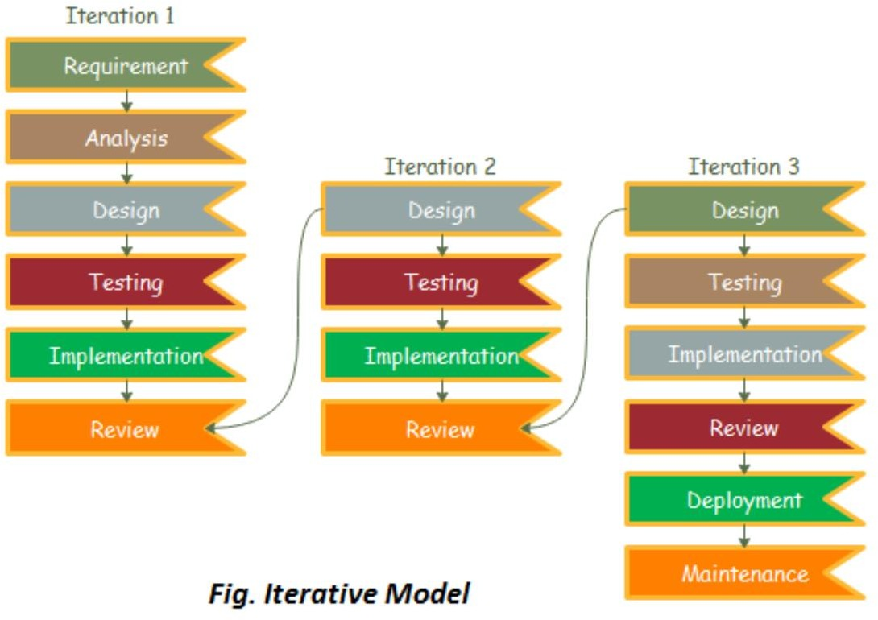

Advantages of using an Iterative Model
- It is simple to test and troubleshoot throughout shorter iterations.
- One can arrange a parallel development.
- It is simple to adapt to the project's constantly changing needs.
- Throughout iteration, risks are located and dealt with.
- A short amount of time on documentation and more effort on design.

Method 1 (e.g Survey)

I created an online survey titled “Do Nigerians need Therapy?” which was sent out to a large number of people. The survey served as an assessment of how relevant this project will serve and the need to implement it. The survey provided useful answers as to the current mental state of most Nigerians. It helped in identifying the classification of some of the major mental issues a variety of Nigerians are suffering from.

Method 2 (e.g Observation)

From the results of the survey carried out which received a sum total of 290 responses, it was observed that Nigerians within the age group (18 - 25) were shown to have been experiencing the most issues. Communication problems, Isolation/Loneliness, Social anxiety, Self-love, Trust issues, Depression, Self-esteem, Sleeping disorders and coping with life changes were seen to be the more common issues people were facing. However, out of the 290 people who responded to the survey, 64.6% were seen to be suffering from Stress and Anxiety which was the most common issue of them all. The survey provided a brilliant idea for the user interface which was to make a questionnaire within the app which will be taken by users at the point of registration. This questionnaire will serve as a way of identifying the user’s current mental state and any possible issues he/she may likely be experiencing.

Tools and Techniques
The making of this project required the use of several tools such as:

Flutter(DART):
Google created the programming language DART. An object-oriented language with C-style syntax is called Dart. In contrast to other programming languages, Dart does not provide arrays but does support programming concepts like interfaces and classes. It is the language for creating flutter applications. A mobile UI framework for building apps for iOS and Android is called Flutter. In addition to a rendering engine, pre-made widgets, testing and integration APIs, etc., Flutter offers a complete SDK. One codebase, or using one programming language and one codebase to generate two separate apps, is all that is required to create a native mobile application (for iOS and Android). (JavaTpoint, 2019)

Flutter consists of two important parts:
      - An SDK (Software Development Kit): A set of instruments that will aid in the development of applications. Tools for converting your code to native machine code are also included (code for iOS and Android).
      - A Framework (UI Library based on widgets): A set of reusable user interface (UI) components that you may customize for your own purposes, such as buttons, text inputs, sliders, and other elements.

Firebase
Developers can create iOS, Android, and Web apps using the Google-sponsored application development platform known as Firebase. Tools are available from Firebase for monitoring

analytics, reporting and resolving app errors, as well as developing marketing and product experiments. Among the services provided by Firebase are the following:
- Authentication: The sign-in and onboarding experiences for users are improved by Firebase Authentication, which makes it simple for developers to create secure authentication systems.

- Cloud messaging: Firebase Cloud Messaging (FCM) is a free, cross-platform messaging application that enables businesses to transmit and receive messages on iOS, Android, and the web with reliability.

- Realtime database: Data may be stored and synced in real time across users thanks to the Firebase Realtime Database, a NoSQL database hosted in the cloud. When an app is offline, the data is still accessible because it is continuously synced across all clients.

- Performance - The Firebase Performance Monitoring tool offers developers insight into the iOS and Android performance characteristics of their apps, enabling them to pinpoint where and when their apps' performance may be enhanced.

Android Studio
- Android Emulator

Ethical Consideration
The ethical consideration of this application relied on:
- Privacy, confidentiality, and security issues
- Therapist competence and
- Emergency issues.

Requirement Analysis
In the requirement analysis phase of this application, a questionnaire was sent out which enabled us to understand and fully articulate user requirements for the application.

Requirements Specifications
This section includes the functional and non-functional requirements for the application.

Functional Requirement Specifications

The requirements that define what the application is aimed to achieve i.e. its features and functions.

Table 1 Functional Requirement Specifications

Req.  No. | Description | Type
R-101 | The system should be able to capture user details  e.g. email and password | Functional
R-102 | The system should be able to determine user type  e.g. Normal User or Therapist at the point of data capture | Functional
R-103 | The system should allow user view all the  professionals, their specialties and their details then subsequently select a professional to work with | Functional
R-104 | The system should be able to allow users join  support groups of their choice | Functional
R-105 | The system should be able to allow user contribute  or respond to other issues in support groups | Functional
R-106 | While registering the user professional, the system should be able to capture other related professional details (service provision, years of experience, location, certification, work experience, place of  work etc.) | Functional
R-107 | The system should be able to allow user view Book  Recommendation and Inspirational Quotes | Functional
R-108 | The system should have a “Panic Button” for crisis  handling in which a user that is at immediate risk can click on to be attended to urgently | Functional
R-109 | The system should allow users to communicate  with therapists by sending messages back and forth | Functional
R-110 | The system should allow users to view their  profiles | Functional

R-111 | The system should allow users to create new  account. | Functional
R-112 | The system should allow users to login to  previously created account. | Functional

    - Non-Functional Requirement Specifications

The requirements that describe the system’s operation capabilities and constraints.

Table 2 Non-Functional Requirement Specifications

Req.  No. | Description | Type
R-101 | When launched, the application shall stay running  unless there is an intentional shutdown of the application or the platform. | Performance
R-102 | When icons are tapped, the application must  respond quickly. | Performance
R-103 | The system should be able to register new users or  allow users create new accounts | Operational
R-104 | The system should be able to allow users log in/log  out to and from the system | Operational
R-105 | The system should have a quick text message send  time | Performance
R-106 | The system should be able to keep record of  messages between users. | Security
R-107 | The system should be able to run on at least two  different types of Operating Systems | Operational
R-108 | The system should be able to adapt to different  phone screen sizes | Scalability

System Design
The major components of the system will include
    - Registration: Allows users and professionals to register/ create accounts on the application and provides authentication for new accounts. Everything the user sees is based on the account type the user is creating (either user account or professional account).
    - Login: Allows users to sign in to their previously created account using Firebase as authentication service.
    - Chatbox: the application section where a user and professional discuss or hold sessions via text messaging.
    - The support groups section: Allows users to communicate with other users sharing similar issues as them.
    - Profile section where users and professionals can make changes to or log out of their accounts.
    - Panic button for crisis handling: which notifies the user’s therapist when the user is in need of immediate attention.

Application Architecture
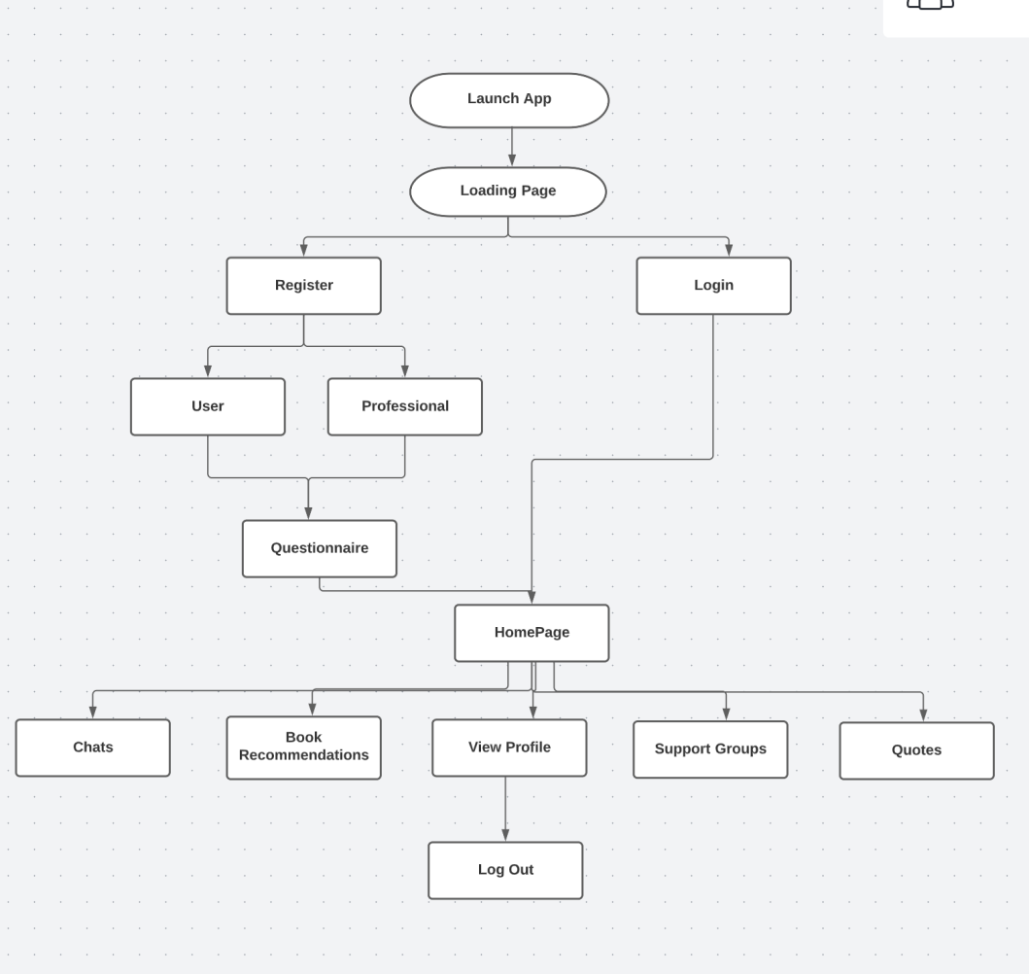

    - Use Case
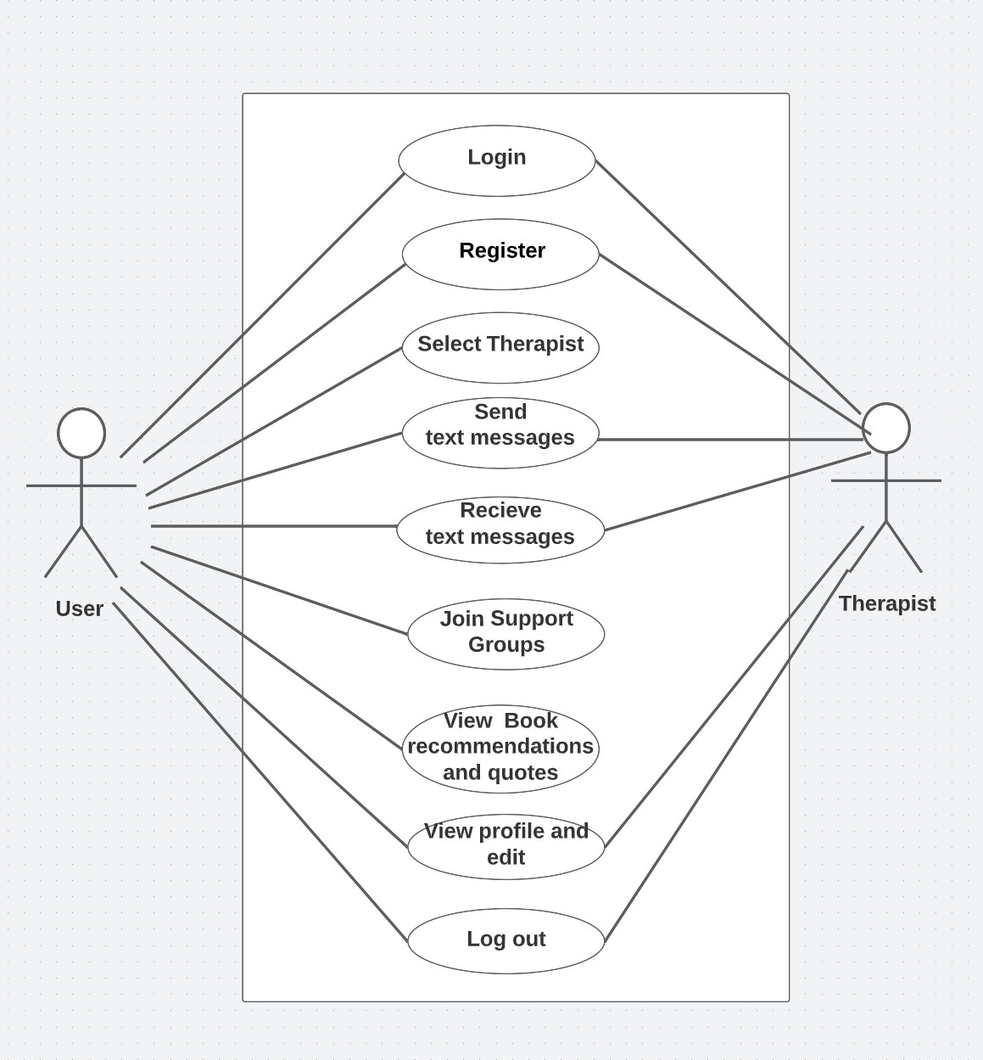

Figure 1 Use Case diagram

Activity Diagrams

An activity diagram is a model that shows the process of a task or action from a use case.

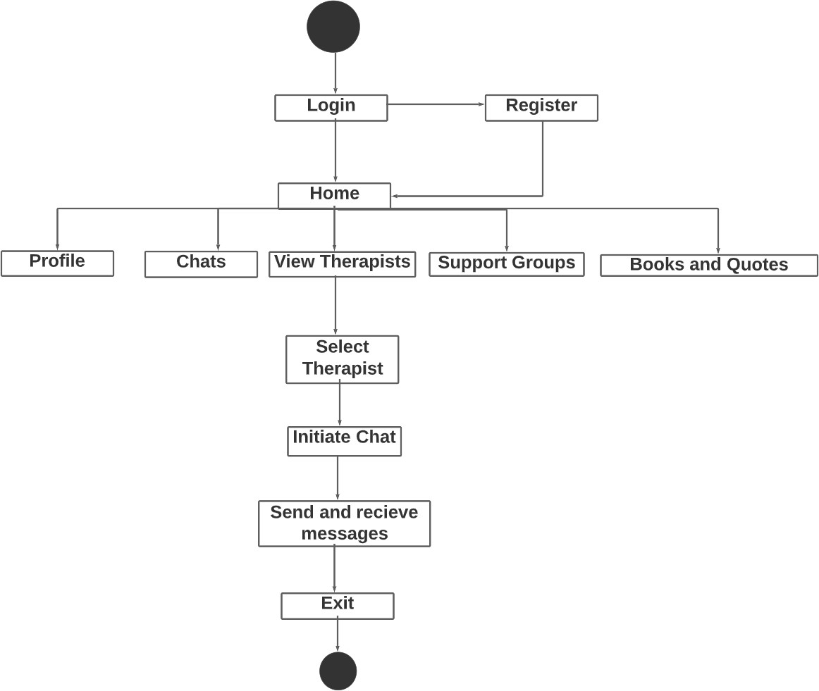

Figure 2 Activity Diagram

Dataflow Diagram
Zero level Data Flow Diagram
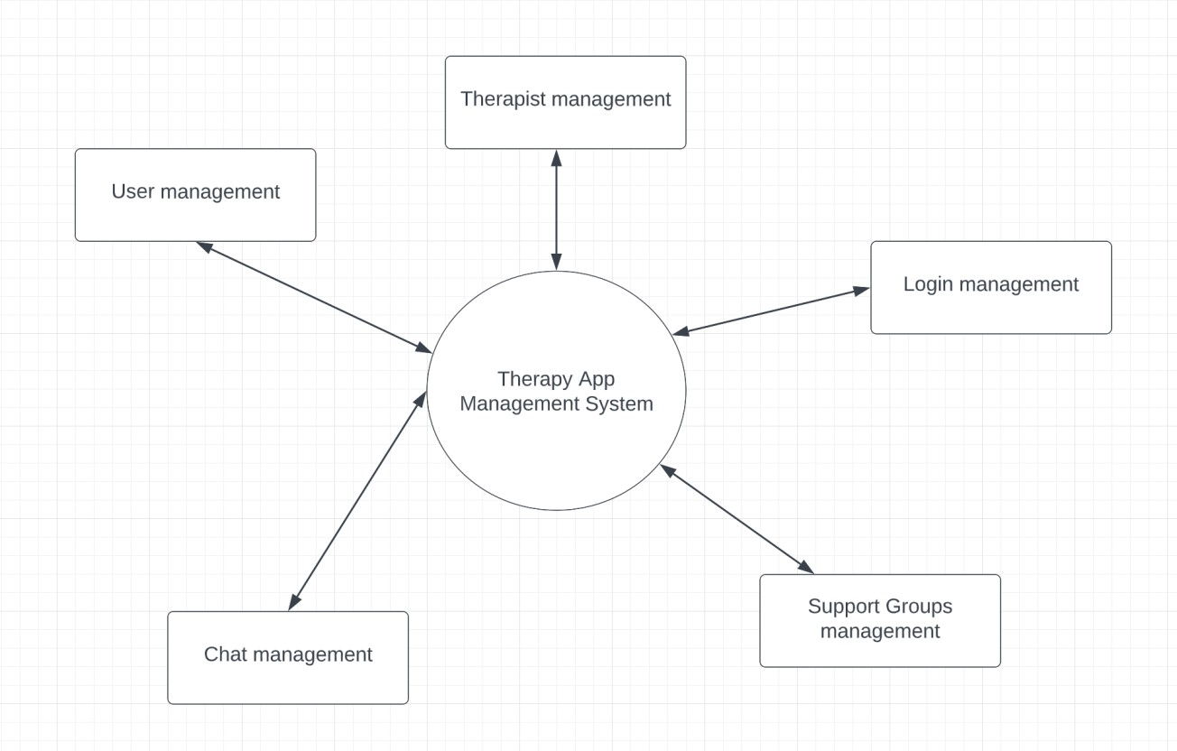
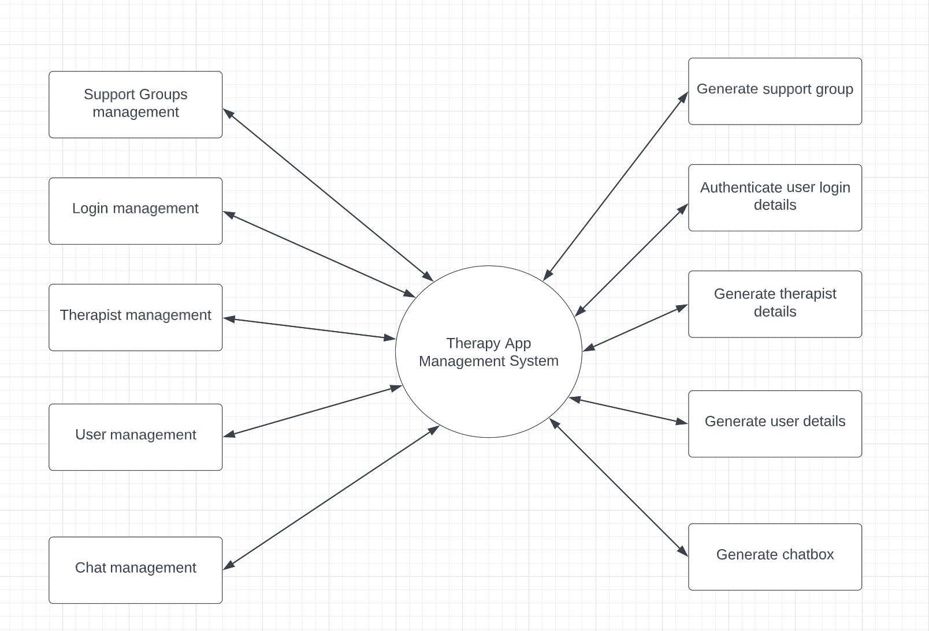
First level Data Flow Diagram

Entity-Relationship Diagram (ERD)

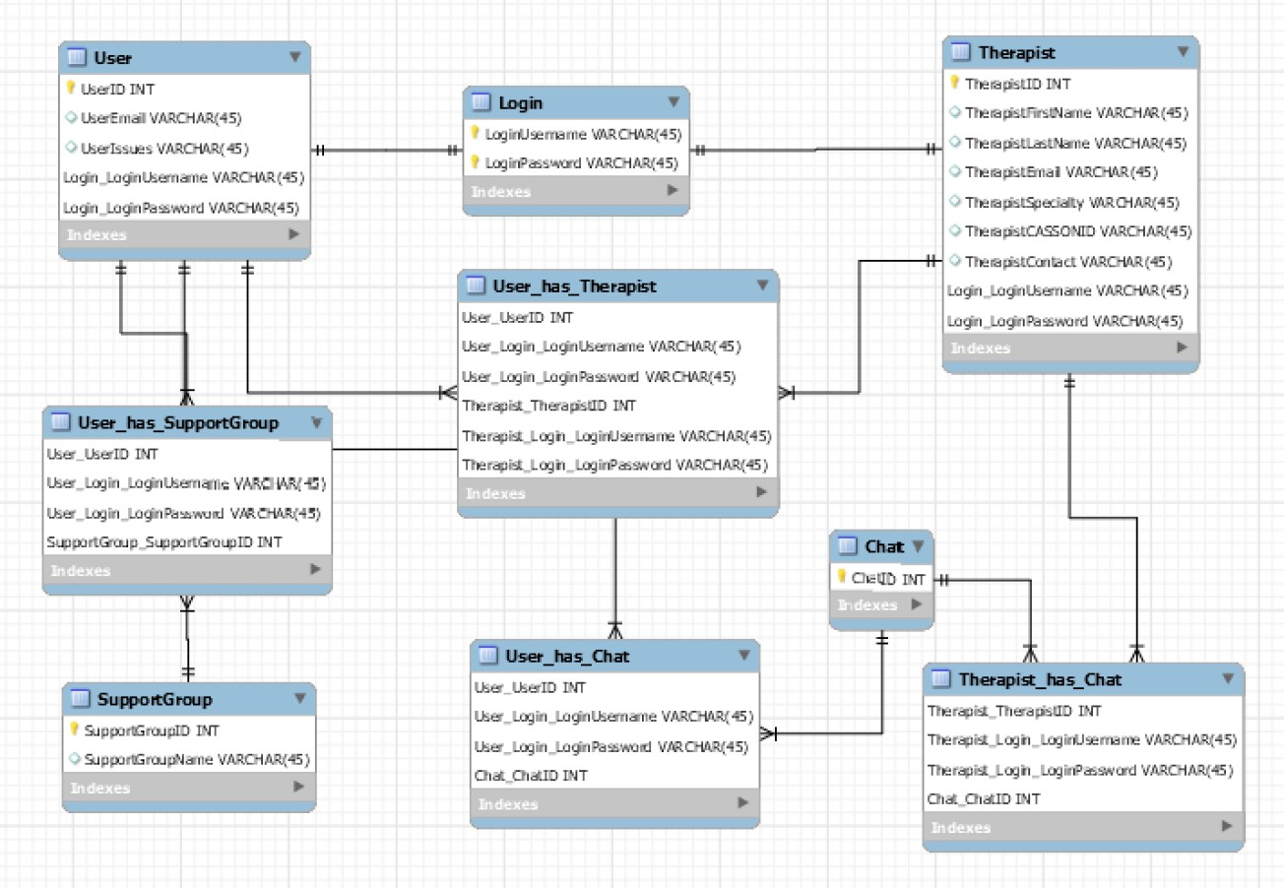

Entity Relationship Diagram

User Interface Design
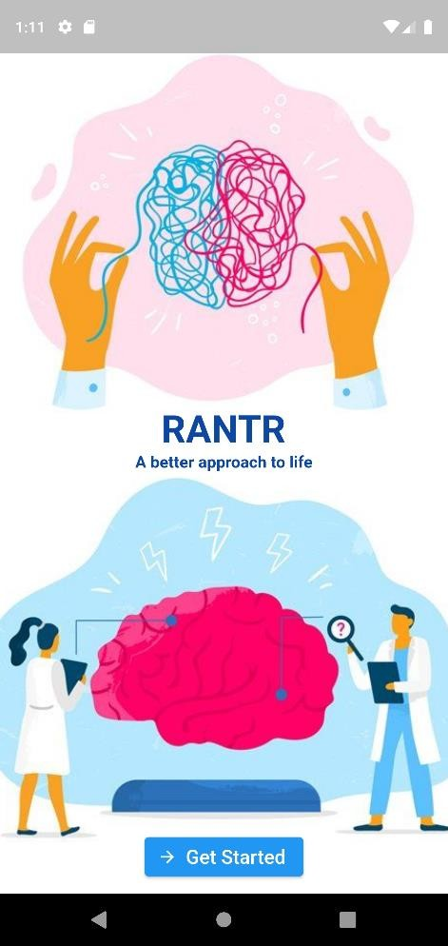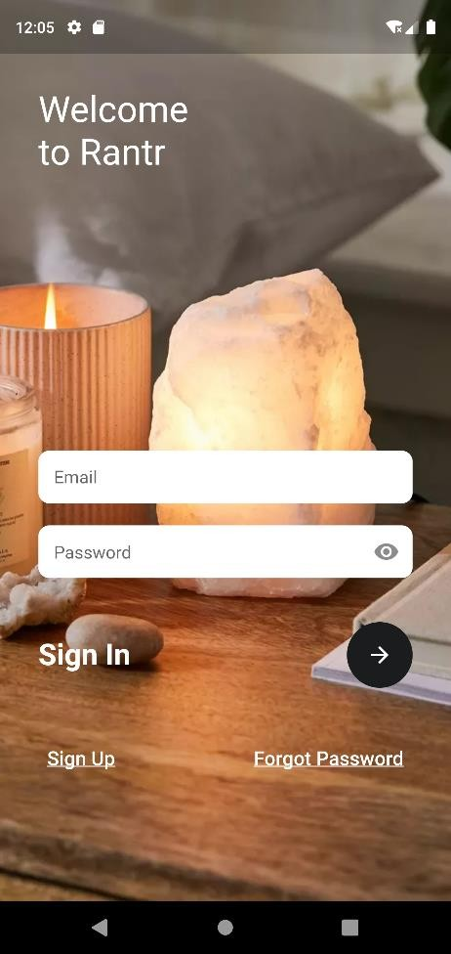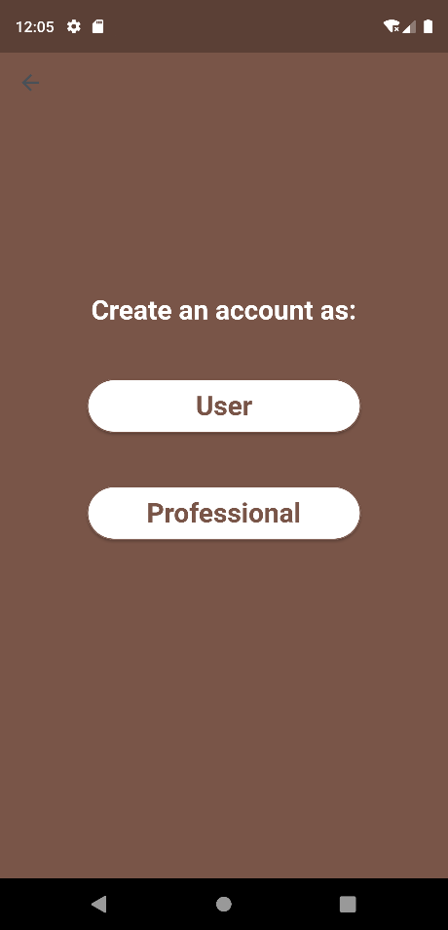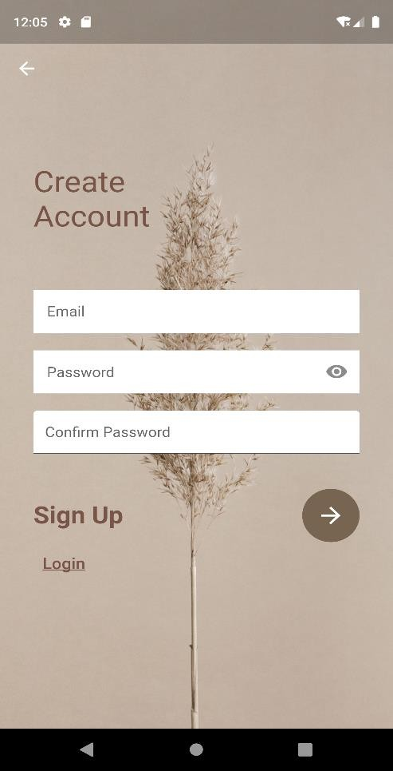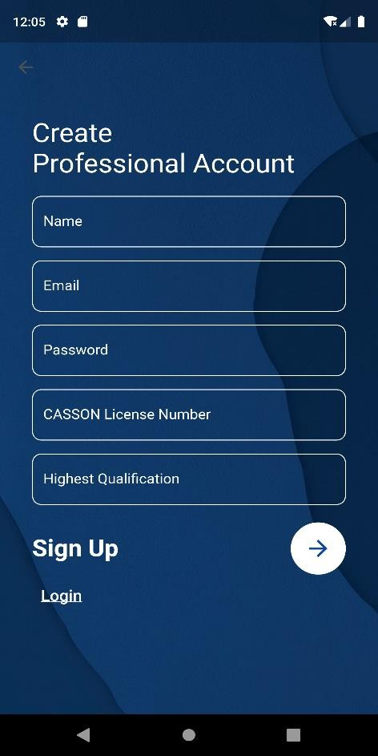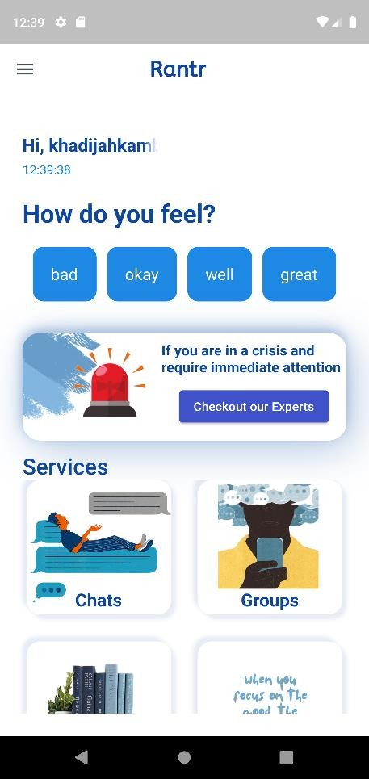

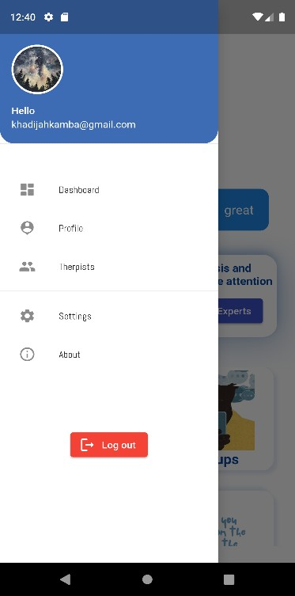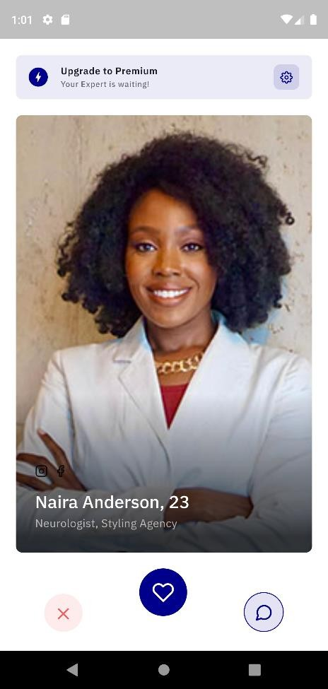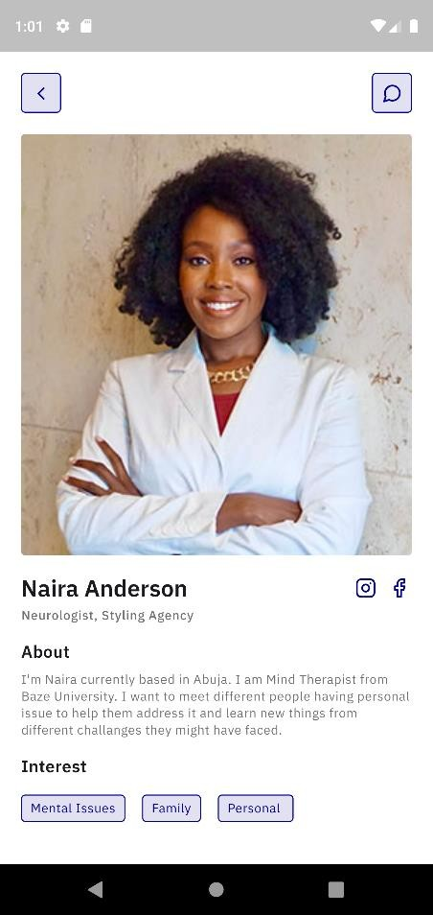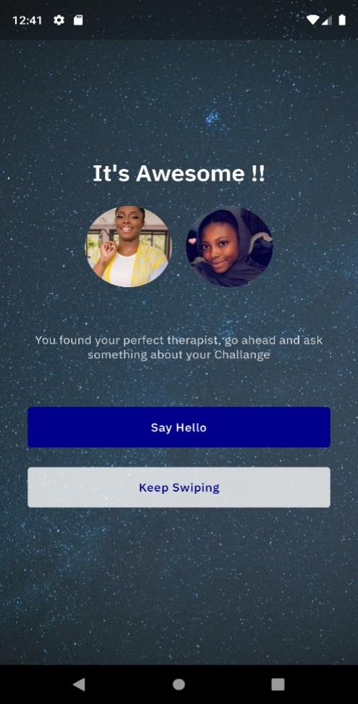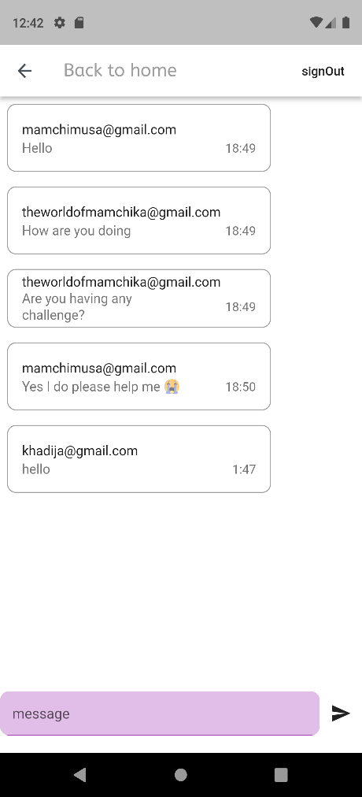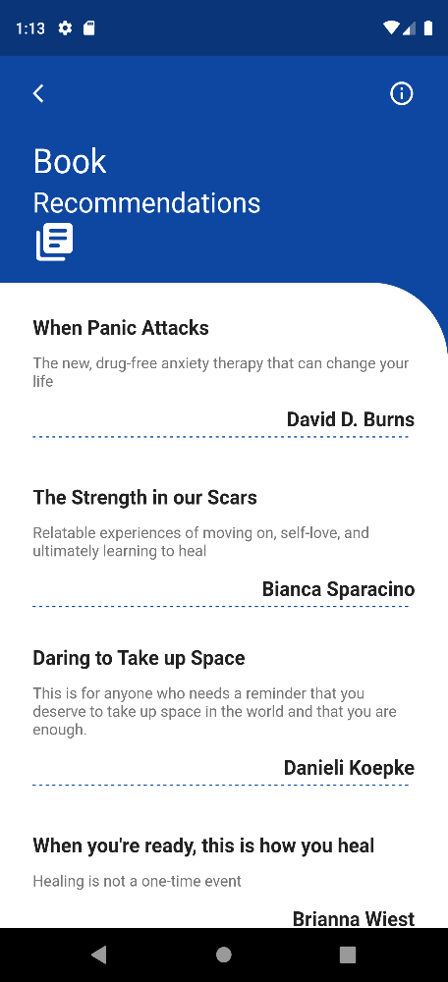

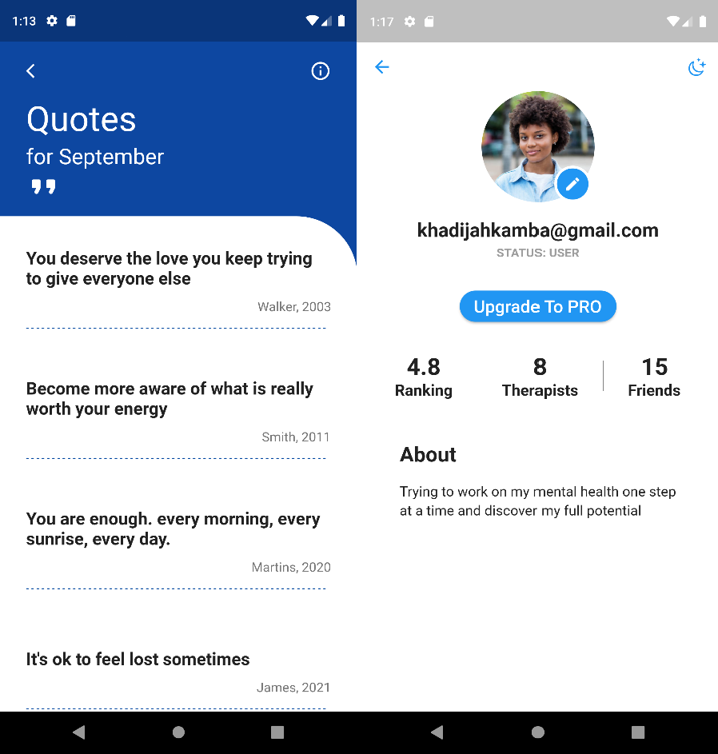

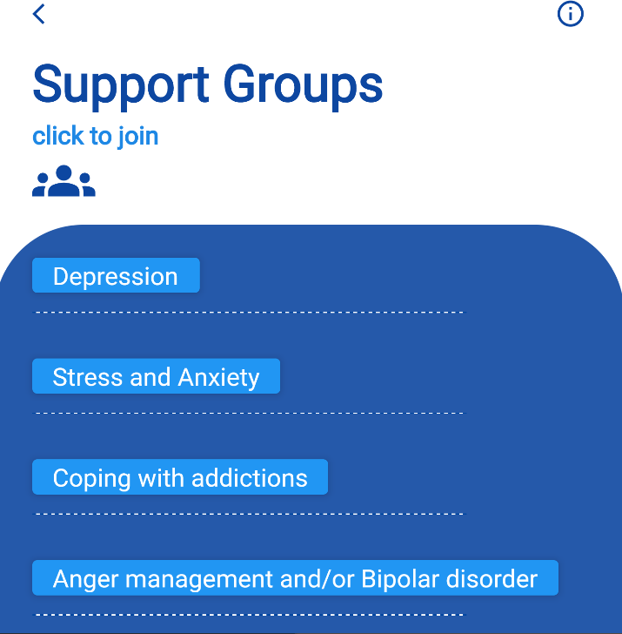

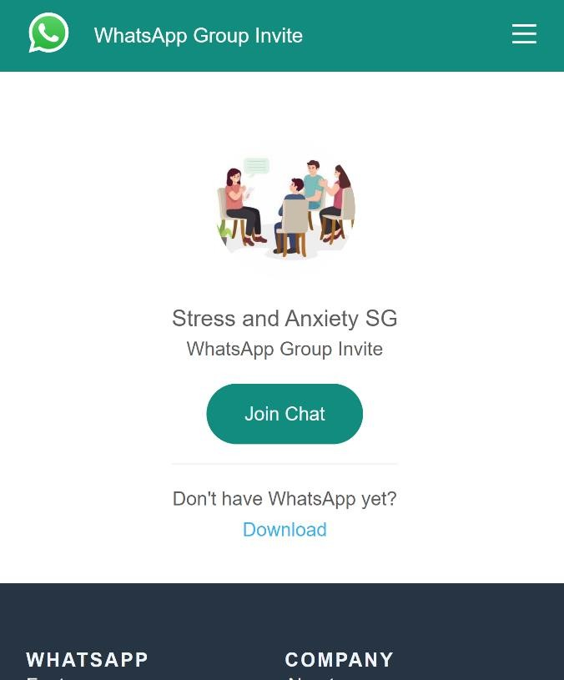

  - Summary
The development of this application was executed using the Iterative lifecycle model. This chapter covers the methodology used, the requirements gathering process and specifies the functional and non-functional requirements for the application. It covered the tools and techniques used and ethical consideration. This chapter also explained why the Iterative lifecycle model was chosen for this project, as well as some UML diagrams.

CHAPTER 4: IMPLEMENTATION AND TESTING

Overview
This chapter focuses on the actual development of the application including its main features, implementation problems faced in the making of the application, overcoming the implementation problems faced, testing process, error report and use guide of the application.

Main Features

    - LOGIN: This is one of the first screens that are navigated to the user. Here, the user will be required to login to their account using their email and password which is then authenticated and navigates to the homepage if the user exists.

    - REGISTER: For a user that does not have an account, they will be prompted to sign up/ create an account. Account Creation is dependent on whether the user is registering as a normal user or as a professional. This is to allow for distinction between the two user types. Users will select their issues from here and therapists will select their specialty areas.

    - HOMEPAGE: the homepage is the main screen of the application which allows users to navigate to several screens on the app e.g. the Chatbox, the Support Groups, Book Recommendations and Inspirational Quotes. It also has a dashboard which allows users to navigate to their profiles and log out.

    - CHATBOX: This allows users to send text messages back and forth. It allows a user to communicate with his therapist and vice versa. It was implemented using Firebase Cloud Messaging Service.

    - CHOOSE THERAPIST: This screen allows users to view all the therapists and select one of their choice. Users can also send a text to the therapist from this screen.

Implementation Problems
There were several issues faced in the implementation of this application.

NULL SAFETY: Flutter recently added a new feature called null safety check which prevents errors that result from unintentional access of variables set to null. The issue with this feature is that it makes variables non-nullable and as a result, they cannot be assigned null. Rather, you can specify that the type of variable is nullable. This caused a few errors in the code of this application.

EMULATOR: Several issues were faced with the emulator. Emulator storage space was insufficient. Several emulators were tested to find one that worked efficiently. Emulator’s System UI was not responding several times.

DEPENDENCIES: In the adding of dependencies in the pubspec.yaml file, several issues were faced in the aligning of added dependencies, project could not recognize added dependencies.

OVERFLOW: ‘RenderBox was overflowed by (a number) pixels’ This error was faced several times due to the widgets on the screen being extended outside of the screen size.

ROUTING: Issues were faced when routing and navigating from one screen to another. Routes were not defined properly and navigation failed as a result.

Overcoming Implementation Problems
NULL SAFETY: To overcome null safety errors, variable types had to be declared as nullable by adding ? mark. E.g. String? username; When calling the variables, an ! mark had to added at the end of the variable called. See below:

EMULATOR: I had to manually increase the RAM storage space of the emulator to allow the project to run on it. To Fix the system UI not responding, I had to change the emulator’s graphics from Software GLES to Hardware GLES. Tested several emulators to get one that worked well.

DEPENDENCIES: In the pubspec.yaml file, indentation was very important and defining dependencies had to be in a specific way. Two tabs for package prefix and four tabs for the package name.

OVERFLOW: To fix the renderbox issue, I had to wrap widgets in a flutter defined widget called SingleChildScrollView.

ROUTING: fixed the routing issue by defining routes in the appropriate way
'routename': (context) => const ClassName(),

Testing
During the testing stage, the application was manually tested, which allowed one to view it from the perspective of the user. Testing was done to guarantee that the application's effectiveness and dependability were put to the test. Other types of testing, including unit

testing, made it possible to inspect and test the application's individual features from the front end to the back end.

Tests Plans (for Unit Testing, Integration Testing, and System Testing)

S/  N | Test Summary | Case ID
1 | Buttons must navigate to specified locations | T-01
2 | Chatbox must allow users to send text messages back and forth | T-02
3 | Therapist CASSON ID number must only be integers | T-03
4 | Register form must accept new users | T-04
5 | Register form must indicate error when no information is  inputted | T-05
6 | Register form must indicate error when invalid information is  inputted | T-06
7 | Login form must only accept registered users | T-07
8 | Login form must indicate when no information is inputted | T-08
9 | Login form must indicate when invalid information is inputted | T-09
10 | Crisis button must alert user’s therapist | T-10

Figure xx Test Plan Tree

Test Suite (for Unit Testing, Integration Testing, and System Testing)

Table xx Test Suite Performed

Req.  No. | Description | Type
R-101 | When launched, the application shall stay running unless there is an intentional shutdown of the  application or the platform. | Performance

R-102 | When icons are tapped, the application must  respond quickly. | Performance
R-103 | The system should be able to register new users or  allow users create new accounts | Operational
R-104 | The system should be able to allow users log in/log  out to and from the system | Operational
R-105 | The system should have a quick text message send  time | Performance
R-106 | The system should be able to keep record of  messages between users. | Security
R-107 | The system should be able to run on at least two  different types of Operating Systems | Operational
R-108 | The system should be able to adapt to different  phone screen sizes | Scalability

Test Traceability Matrix (for Unit Testing, Integration Testing, and System Testing)

Requireme nt | Description | Priorit y | Test Cas  e | Test Resul  t
R-101 | The app shall have a working Chatbox | high | 1 | Pass
R-102 | The app database must identify when a user is new, existing or not in the  database | high | 2 | pass
R-103 | The app shall provide several  functionalities for users to explore | mediu  m | 3 | pass
R-104 | The app support groups url  launchers must be active | high | 4 | pass

    - Test Report Summary (for Unit Testing, Integration Testing, and System Testing)

The next section of this chapter will focus on these

Error Reports and Corrections

S/  N | Error | Corrections
1 | Register and Login not storing user info | Initialized firebase within the  application
2 | Wrong positioning of images and icons | Used expanded widget to fix wrong  positioning
3 | Widgets placed too close to each other | Used a SizedBox widget to put space between several widgets on the  screen
4 | RenderBox Overflowing by a number of pixels | Wrapped container widget in a  SingleChildScrollView widget to allow scrolling
5 | Support group links do not navigate to whatsapp | Installed a “Url-launcher” Package and implemented it in the code, then subsequently navigated to the url on  pressing the links

  - User Guide

To be able to use the contents of the application the following must be required:
- Tapping on Application icon to launch app
- Android OS or IOS
- Internet connection
- A functioning email

Summary
The main components, testing procedures, and implementation procedures of the application's development life cycle have been discussed in this chapter. The project will be briefly summarized and recommendations will be provided in the next chapter.

CHAPTER 5: DISCUSSION, CONCLUSION, AND RECOMMENDATIONS

Overview
The project's overall evaluation, information on the challenges and constraints faced during the project's development life cycle, and recommendations for how the project may be improved going forward are all included in this last chapter. Finally, suggestions for the project's direction will be taken into consideration depending on the project's findings.

Objective Assessment
The majority of the project's goals were achieved, including allowing users and therapists to communicate effectively by sending text messages back and forth. The app's capabilities can yet be enhanced, allowing for a smoother and more interactive performance.

Limitations and Challenges
These are some of the major Challenges faced:
    - Messaging Service: to enable users to send chats effectively, I had to find a messaging service that worked seamlessly and had to learn all about the Firebase Cloud Messaging Service.
    - Packages: working with elements of the application required constant upgrades or downgrades of all packages to match the current flutter version.
As for the Limitations of the app:
    - Must require internet connection
    - Availability on Apple App Store and Android Play Store

Future Enhancements
There is always space for improvement given the time available; these enhancements could be:
    - User’s progress chart
    - Support Group chatbox to be implemented within the app
    - User and therapists should be able to edit their profiles

    - Enable two-factor authentication for users
    - Allow users to login with 4 digit pin-only
    - Allows users to recover/reset password
    - Perfect therapist register and authentication
    - Include terms and conditions

Recommendations
Some of the recommendations may include:
    - Updating Android OS
    - Using a relational Database
    - Using a bigger server to handle support groups chatbox.

Summary
The project documentation comes to a close with this chapter. It included the project's goals, scope, risk evaluations, requirements, analysis, and design in addition to the development life cycle methodology and how it was put into practice and tested in the real world.
Recommendations and changes that could be made in the near future were also assessed. Finally, recommendations for changes that might be made in future were considered.

[APA Style ]

REFERENCES

- Okpalauwaekwe U, Mela M, Oji C. Knowledge of and Attitude to Mental Illnesses in Nigeria: A Scoping Review. Integr J Glob Health. 2017, 1:1.
- Awaritefe, A. (2017). Psychotherapy in Nigeria. Retrieved 8 July 2022, from https://sphs.com.ng/wp- content/uploads/2019/12/Psychotherapy-In-Nigeria.pdf
- Alabi, M., & Kanabe, M. (2022). World Mental Health Day: How outdated legislation, COVID-19 worsen situation in Nigeria. Retrieved 10 June 2022, from
https://www.premiumtimesng.com/news/headlin es/489202-world-mental-health-day-how- outdated-legislation-covid-19-worsen-situation- in-nigeria.html
- Muanya, C., & Onyedika-Ugoeze, N. (2017). Nigerians are most depressed in Africa, says WHO | The Guardian Nigeria News - Nigeria and World News. Retrieved 21 March 2022, from https://guardian.ng/news/nigerians- are-most-depressed-in-africa-says-who/
- Haggerty, J. (2015). History of Psychotherapy. Psych Central. Retrieved on May 27, 2016, from http://psychcentral.com/lib/history-of- psychotherapy/

- Aborode, A. T., Corriero, A. C., Mehmood, Q., Nawaz, A., Aayush, Upadhyay, P., Badri, R., & Hasan, M. M. (2022). People living with mental disorder in Nigeria amidst COVID-19: Challenges, implications, and recommendations. The International journal of health planning and management, 37(3), 1191–1198. https://doi.org/10.1002/hpm.3394
- American Psychological Association. (2015, October 7). What you need to know before choosing online therapy. https://www.apa.org/topics/telehealth/online- therapy

APPENDICES

Appendix A - Project Document

IN-DEPTH PROJECT DOCUMENTATION
Full Candidate Name: Khadijah Kamba Mukhtar
Student ID: BU/19C/IT/3901
Title: An Online Therapy Application
Course of Study: B.Sc. Software Engineering

Statement of the Problem
A lot of Nigerians, young and old are likely to be suffering from a mental illness. According to a report in the Integrative Journal of Global Health, in parts of Nigeria, it is common to attribute mental illness to supernatural factors such as witchcraft or repercussion for sins against God. Mental health illness is so poorly understood that in some cases, people with these conditions are chained and locked up in unorthodox facilities across the country including traditional healing and religious centers. They are then subjected to different forms of abuse including force- feeding them medicine and herbs and whipping as part of their treatment. With poor access to mental healthcare facilities, a huge fraction of Nigerians turn to religious leaders such as Pastors and Imams to share their burdens. One of the reasons people visit religious and traditional healing centers for mental illness is a lack of understanding of mental health issues in the country. However, delaying mental care by not immediately going to hospital prolongs the time the patient stays without appropriate care and may likely create the worst outcome for the patient as they have more symptoms, The problem lies in that, those religious leaders, while having a wide understanding of religion, do not necessarily have the means to cater for mental illnesses.

Appendix B - Questionnaire

Questions
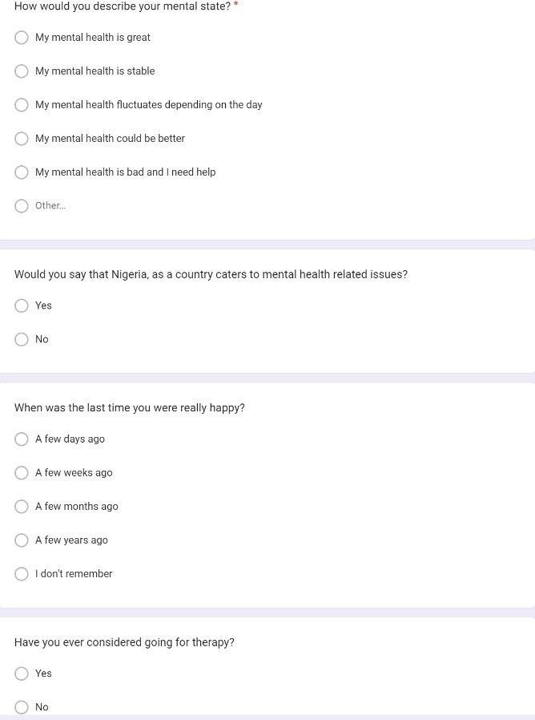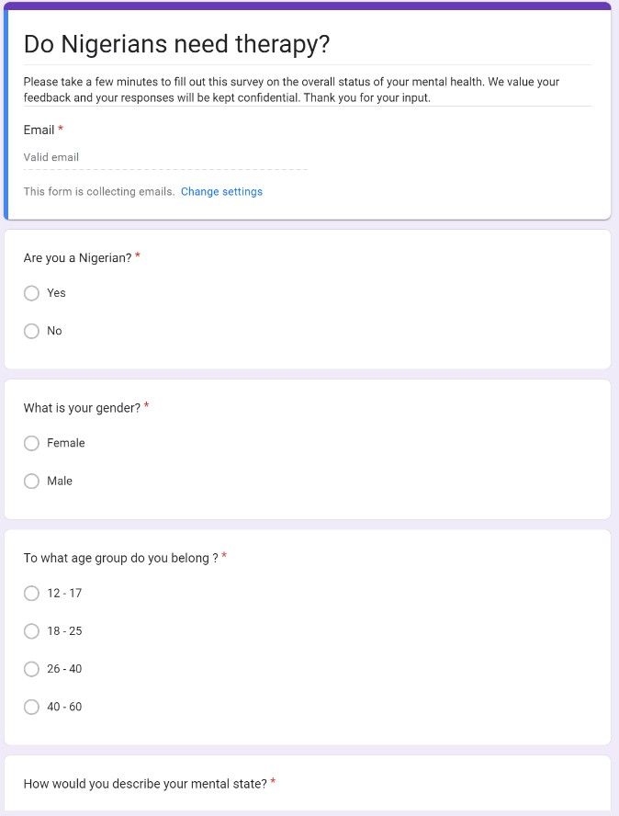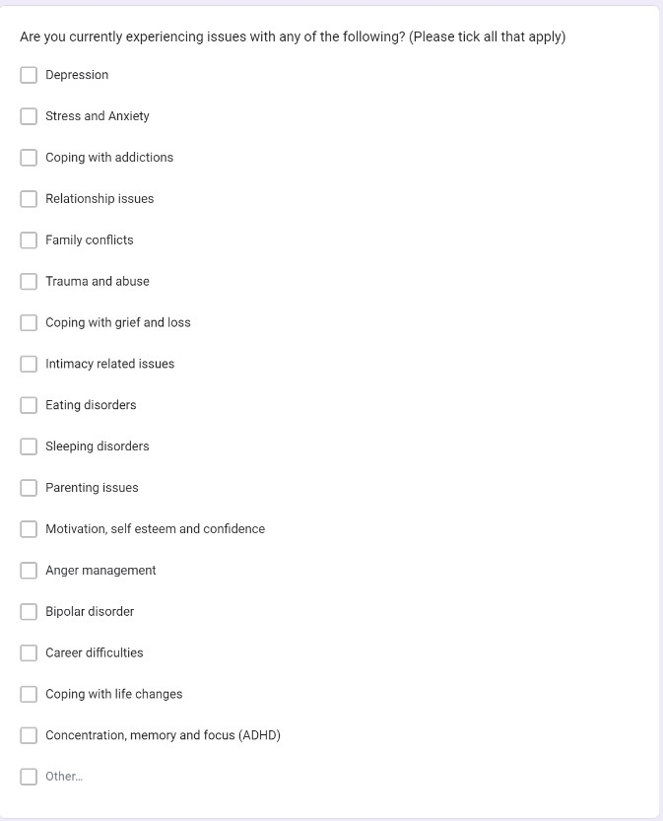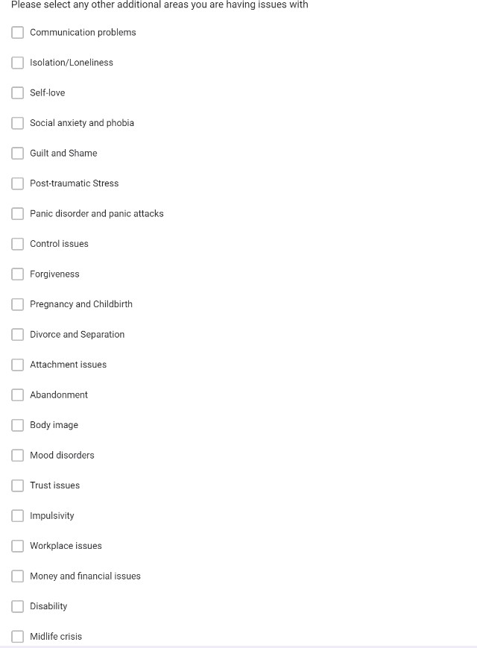

ANSWERS
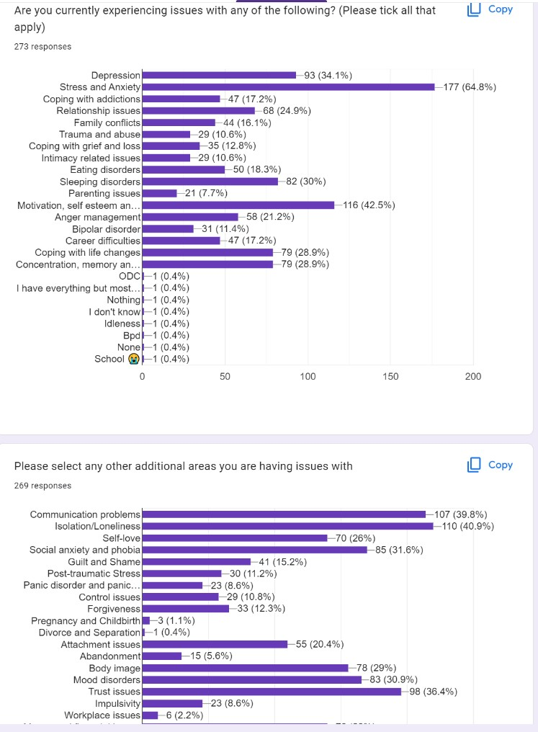
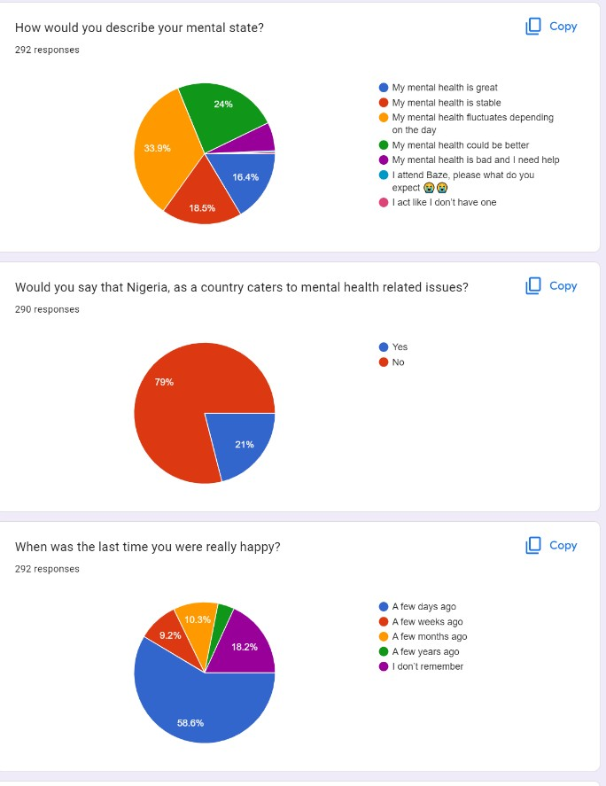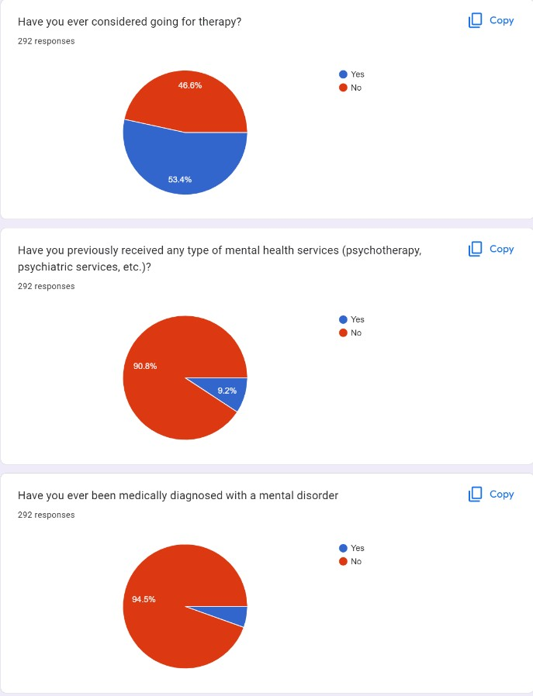

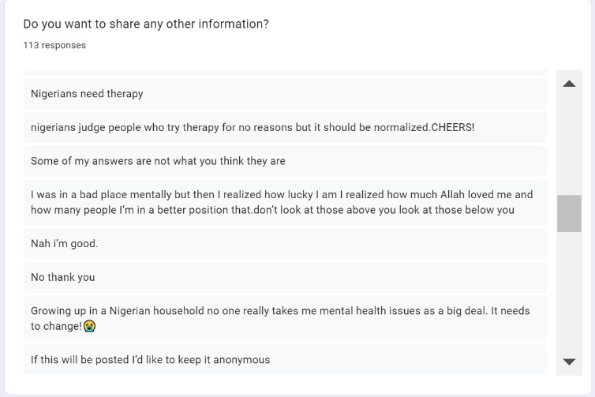
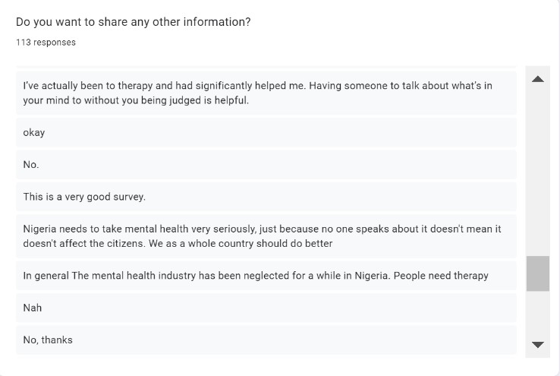

Appendix C – Source Codes



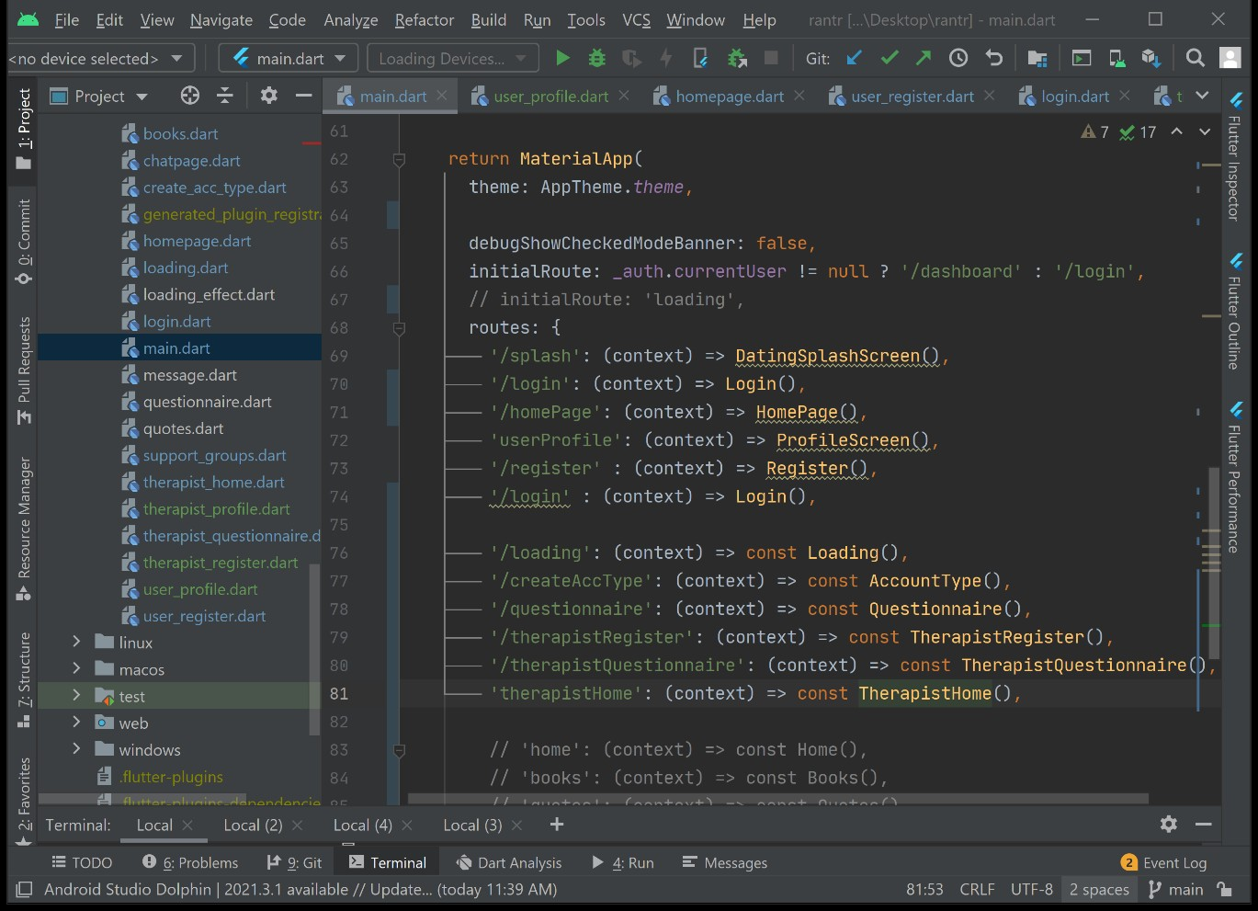

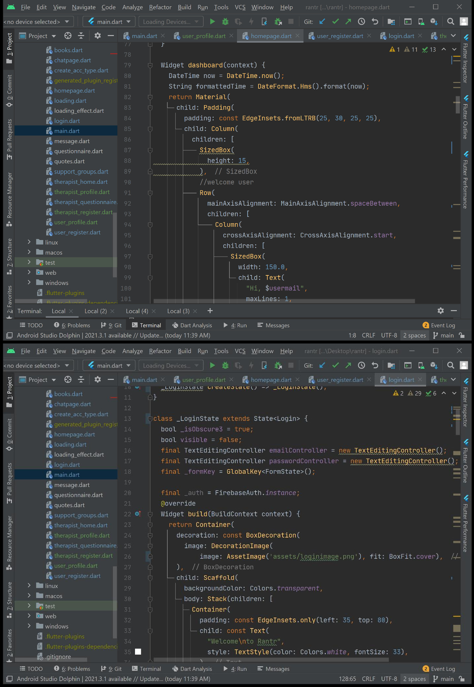

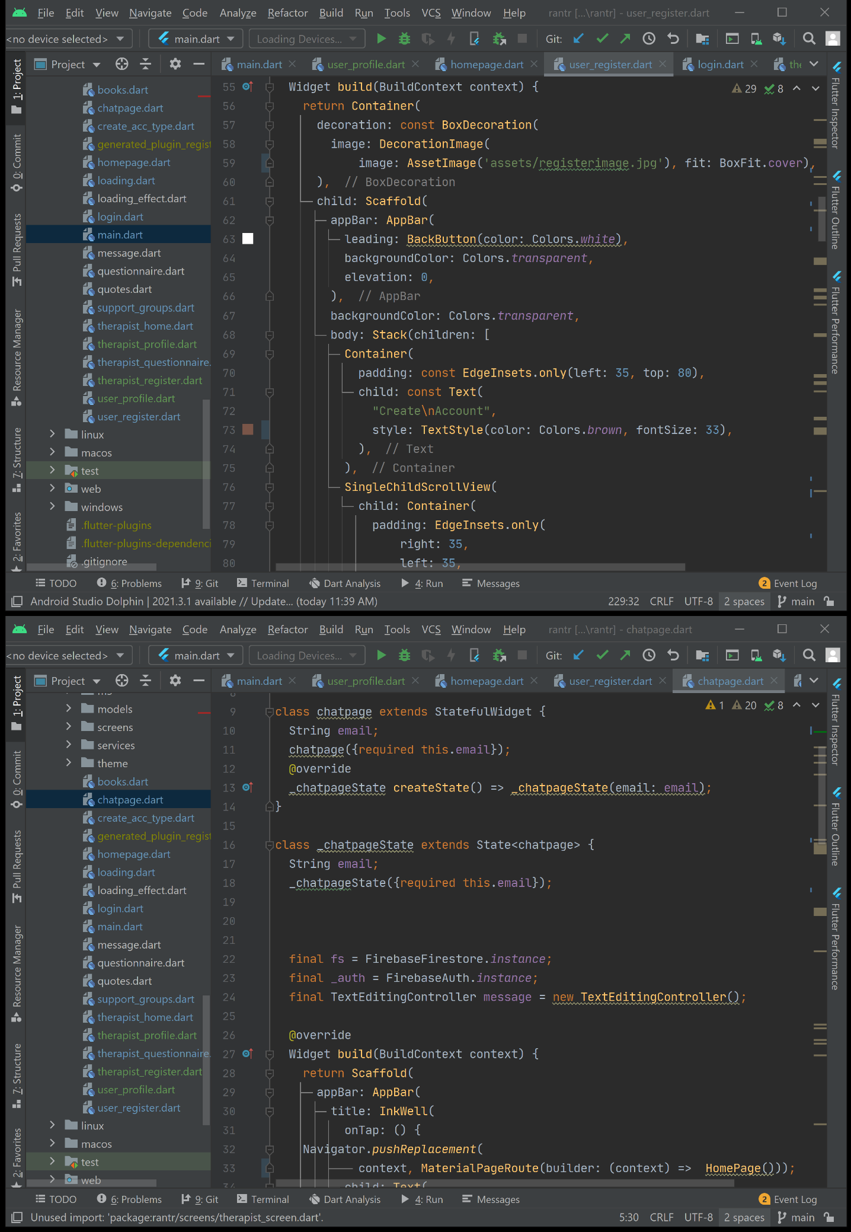

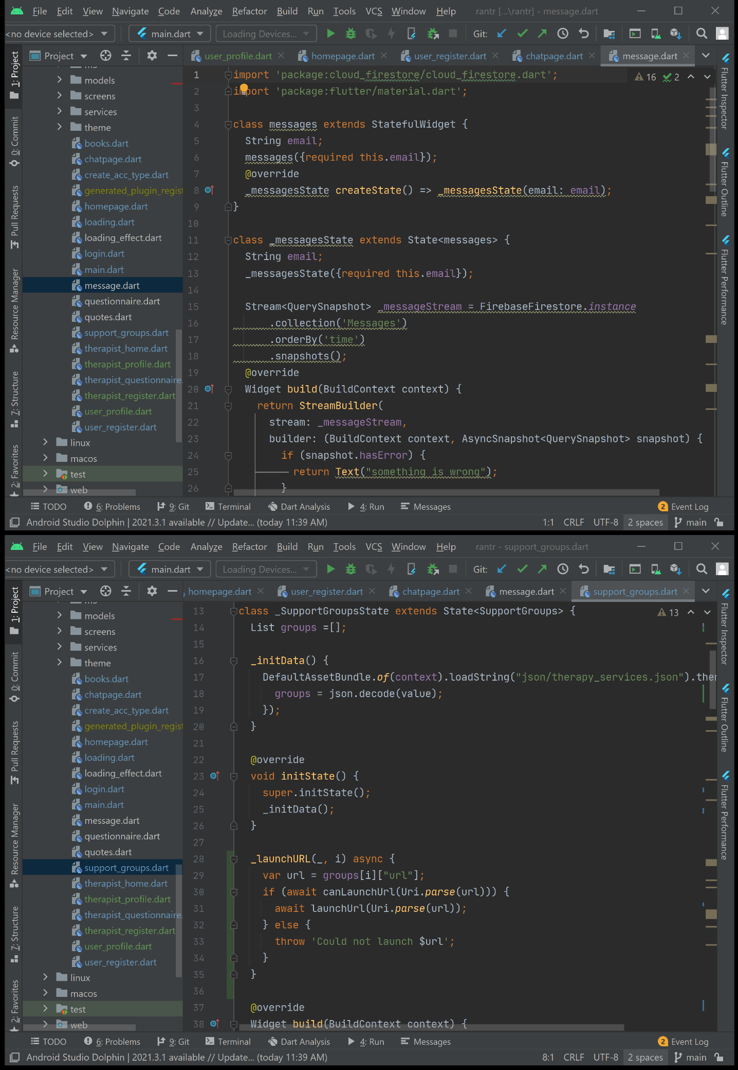

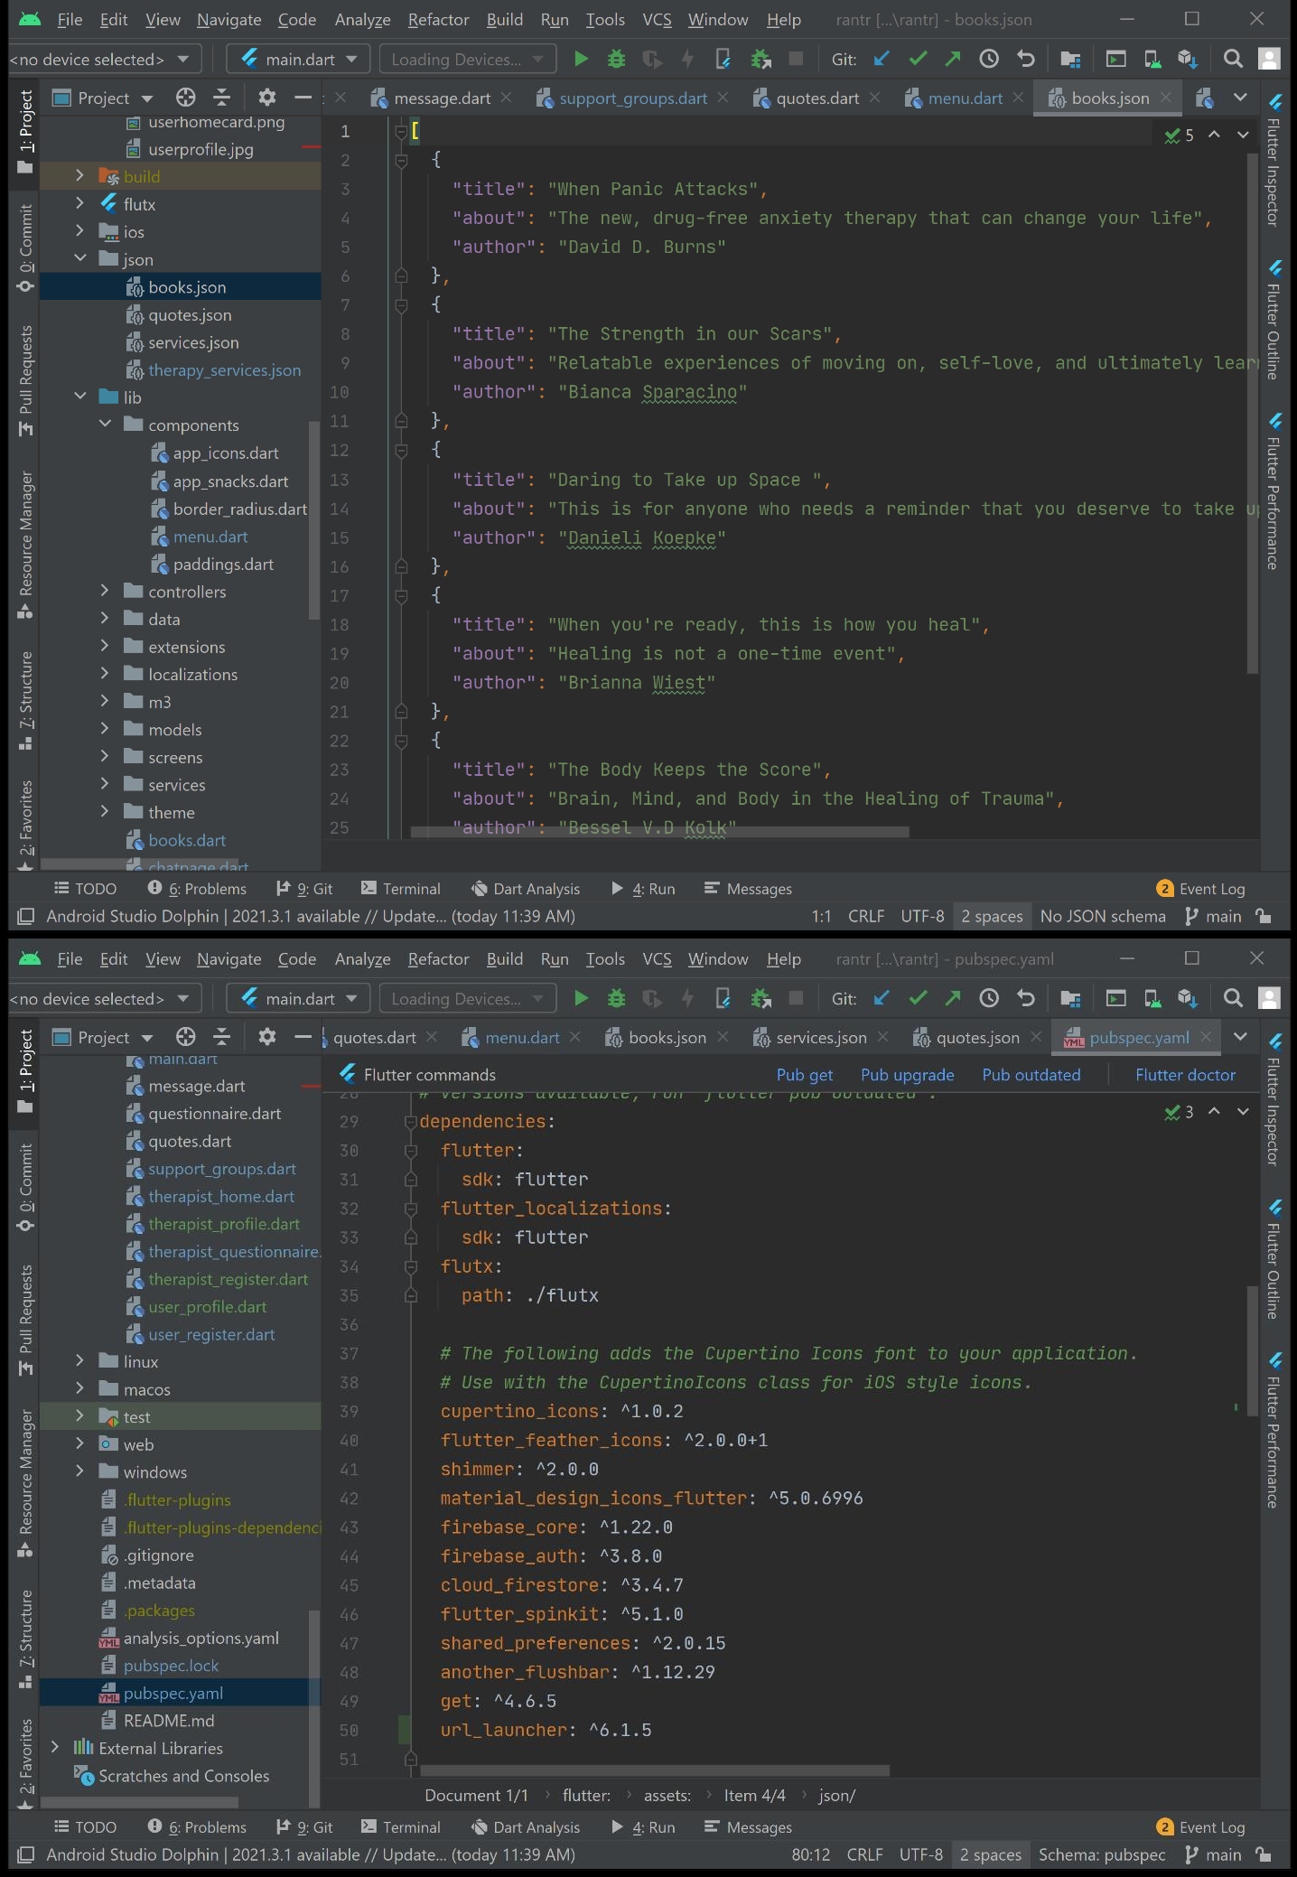

Appendix C – Plagiarism

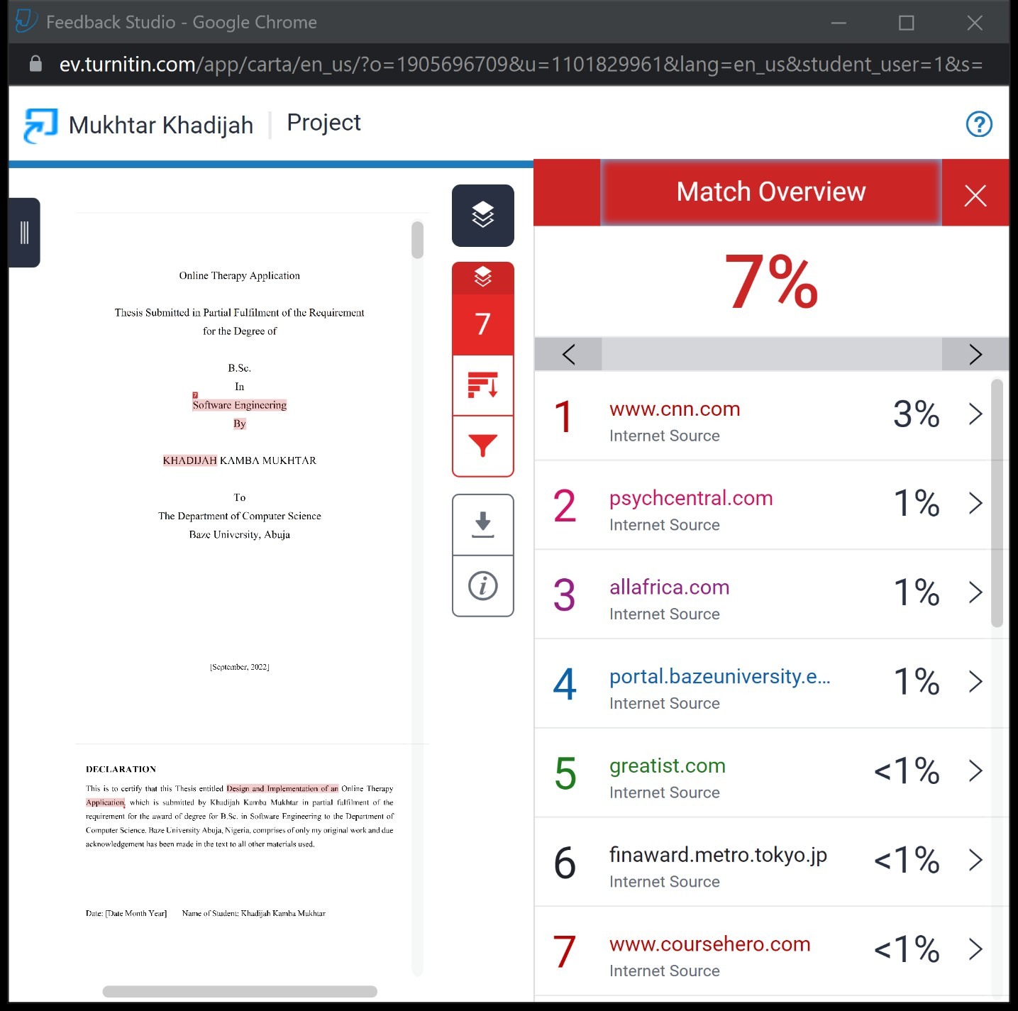

Appendix E – User Guide/Manual

- Launch app
- Create account as User
- Select issues faced
- View Homepage
- Select Therapist
- Send a text, wait for reply
- View other functionalities such as Support Groups, Book Recommendations and Quotes
- View Profile
- Log Out.

