**DESIGN AND IMPLEMENTATION OF AN ONLINE STORE MANAGEMENT SYSTEM**

**ABSTRACT**

The research work “Online Store Management System” includes sales, stock keeping, warehouse management, staff update, vendors update, clients management and point of sales (POS). This work was done as a result to solve the problems usually encountered in most companies in managing their stores. The Store Management System was achieved using two programming environment: PHP and MYSQL, with php as front-end and mysql as the backend database. The system can be entered using a username and password. It is accessible either by an administrator or staffs. The interface is very user-friendly. Protected for personal use and the data processing is fast.

**CHAPTER ONE**

**INTRODUCTION**

**1.1 Background of the Study**

Store management system like central supermarket store, Jane Store, Shoprite Store enterprise and spring light supermarket etc., these establishments require efficient and brilliant technique and flexible system for proper management of all their goods, clients, staff, stocks, warehouse and services. Their main objective is to offer quality services in sales, stock keeping, warehouse management, staff update, vendors update and management, clients management and point of sales (POS). Chapter one introduces the research work and the problem definition of the research, and to know the aim of this research work, research justification tells us why it is important to research on this topic; it also covers areas like scope and limitation of study which entails the boundary of this work. Definition of terms gives summarize what each chapter entails.

**1.2 Statement of the Problem**

This research work was undertaken to uncover some of the problems with conventional way of managing store and warehouse. Where products and are written on paper these document are only access by one person at a time and is prone to human errors. Using these conventional method pose lots of constraint on sales manager, warehouse manager, store manager as well as the overall manager of the establishment as each section has to compare records from time to time thereby slowing the growth of the establishment.

**1.3 Objective of the Study**

In view of the problems mentioned above, this project is aimed at implementing a Store and warehouse management system which will exclusively:

* Automate every sales of all product in stock
* Manage different products and category in store
* Manage different store own by the establishment
* Mange warehouse and vendors
* Manage every client details
* Product daily and monthly report
* Manage every users of the system
  1. **Research Justification**

This research work will provide a reliable way of handling all stores and warehouse own by an establishment also incorporate is the point-of-sales system which will aid in sales management and also eliminate the lag time in file. Furthermore, it will aids structural document representation and eliminates the tedium of performing monotonous transaction. This research will also contribute to existing literature in this area and will serve as a guild or blueprint for an undergraduate student.

**1.5 Research Methodology**

This research work “design and implementation of a store and “warehouse management system” will be a web-based application and will be implemented on a relational database system (MySQL). Html (hypertext markup language), css(cascading style sheet) and Jquery will be used to design the web-user interface, php (hypertext preprocessor) will be used as the serve- side script language to link the interface and the database.

**1.6 Scope and Limitation of the Study**

This research work is to develop a system capable of stores and warehouse task such as sales, stock keeping, warehouse management, staff update, vendors update and management, clients’ management and point of sales (POS). The system will not incorporate in its development all the functions of a store and warehouse management system but will focus only on the aforementioned functionalities. The system will not be responsible for any loss of data if its environment (network/system installed on) is corrupt.

**1.7chapter Layout**

This section was put in place to explain what each chapter does, chapter one introduces the project to the reader by explaining the problems the project is supposed to solve, objective of the study and research justification is to describe to the reader the purpose and the importance of researching on this topic, research methodology is all about the method used in implementing the research work, scope and limitation describes the boundary of the research work and where the project work can be put into use.

Chapter two deals with the literature review and state-of-the-art. This chapter discusses literature review, what people have published related to this research work and their shortcoming, how this present research can improve their shortcomings.

Chapter three deals with the system design methodology i.e. collection of tools methods and practices for achieving a task; the requirement specification states the expectation of the system analysis, and design which is the blueprint of what the system would carry out.

Chapter four has to do with the implementation, system testing strategies, target computer system requirement, software maintenance etc.

Chapter five discusses the recommendations and conclusion part of the research work and how this work can be applied to the problem domain.

**CHAPTER TWO**

**REVIEW OF RELATED LITERATURE**

**2.1 CORE CONCEPT OF ONLINE COMMERCE**

Electronic commerce is about doing business electronically. It is based on the electronic processing and transmission of data, including text, sound and video. It encompasses many diverse activities including electronic trading of goods and services, online delivery of digital content, electronic fund transfers, electronic share trading, electronic bills of lading, commercial auctions, collaborative design and engineering, on-line sourcing, public procurement, direct consumer marketing, and after-sales service. It involves (e.g. consumer goods, specialized medical equipment) and services (e.g. information services, financial and legal services); traditional activities (e.g. healthcare, education) and new activities (e.g. virtual malls).” (Lincoln, 1997)

Electronic commerce is the exchange of information across electronic networks, at any stage in the supply chain, whether within an organization, between businesses, between businesses and consumers, or between the public and private sectors, whether paid or unpaid (Edward, 1999).

E**v**ery one of the definitions is quite expansive, including not only the actual commercial transaction between buyer and seller but also the upstream and downstream activities that made that transaction possible. The need for such an expansive definition is a reflection of the embryonic state of electronic commerce today, where it is difficult to quantify the contribution of electronic commerce totally separated from the traditional activities. Most analysts include only transactions actually carried out on the Internet; but many consumers research their purchases online and then buy in some other way.

As a result of different definitions of electronic commerce, the forecasts presented by various analysts are very widely spread. “Only 3% of business-to-business Web sites is designed for direct sales, rather than for marketing and customer service, says (Benjamin, 1997). Even for consumer businesses, only 9% of sites offer online transactions.” Another survey carried out by (Nielsen, 1997) found that “whereas 53% of Internet users in the United States and Canada had used the Internet to reach a decision on a purchase, just 15% carried out the final transaction on the Internet”

Despite the slowing penetration of regular Internet users, the number of consumers using the Internet to shop for consumer goods and services is still growing (Forrester, December 2001). Research from the (GFK, 2002) shows that the number of online shoppers in six key European markets has risen to 31.4 percent from 27.7 percent last year. This means that 59 million Europeans use the Internet regularly for shopping purposes. However, not only does the number of online shoppers grow, the volume of their purchases also increases over-proportionally. In the US, online sales are forecasted to exceed $36 billion in 2002, and grow annually by 20.9 percent to reach $81 billion in 2006. Europeans are spending more money online as well. For instance, Europe’s largest discount carrier, easyJet Airline Co., sold $80 million more tickets online in the six months ended March 31 than it did a year earlier (Reinhardt and Passariello, 2002), whereas combined revenues for Amazon.com’s European operations grew at more than 70 percent annually in each of the past three quarters, topping $218 million.

While these figures show that a large number of consumers in the US and Europe frequently use the Internet for shopping purposes, it is not clear what drives them to shop online and whether these numbers could be even increased if more attractive online stores were developed. This raises the issue of examining what factors affect consumers to shop online. Therefore, a framework is needed to structure the complex system of effects of these different factors, and develop an in-depth understanding of consumers’ attitudes toward Internet shopping and their intentions to shop online.

In this study, we build up such a framework based on previous research on consumer adoption of new self-service technologies and Internet shopping systems (Dabholkar and Bagozzi, 2002; O’Cass and Fenech, 2002; Childers et al., 2001; Davis, 1993). This research suggests that consumers’ attitude toward Internet shopping first depends on the direct effects of relevant online shopping features (Davis, 1993). Online shopping features can be either consumers’ perceptions of functional and utilitarian dimensions, like “ease of use” and “Usefulness” or their perceptions of emotional and hedonic dimensions like “Enjoyment” (Menon and Kahn, 2002; Childers et al., 2001; Mathwick et al., 2001). by including both utilitarian and hedonic dimensions, aspects from the information systems or technology literature, as well as the consumer behavior literature are integrated in our framework.

In addition to these relevant online shopping features, also exogenous factors are considered that moderate the relationships between the core constructs of the framework. Relevant exogenous factors in this context are “consumer traits” (Burke, 2002; Dabholkar and Bagozzi, 2002; Brown et al., 2001; Eastin and LaRose, 2000), “situational factors” (Wolfinbarger and Gilly, 2001; Avery, 1996), “product characteristics” (Grewal et al., 2002; Elliot and Fowell, 2000), “previous online shopping experiences” (Shim et al., 2001; Eastlick and Lotz, 1999), and “trust in online shopping” (Yoon, 2002; Lee and Turban, 2001). By incorporating these exogenous factors next to the basic determinants of consumers’ attitude and intention to use a technology, the framework is applicable in the online shopping context. Together, these effects and influences on consumers’ attitude toward online shopping provide a framework for understanding consumers’ intentions to shop on the Internet. An important note to our proposed framework is that throughout this paper we will define Internet shopping or online shopping as the use of online stores by consumers up until the transactional stage of purchasing and logistics.

**2.2 ELECTRONIC PAYMENT SYSTEM IN B2C AND C2C EC**

Electronic cash: electronic cash is a method of payment in which a unique identification number is associated with a specific amount of money. Electronic cash is often referred to as e-cash or cyber cash (jewson, 2001). This method was developed as an alternative to the use of credit cards for internet purchases of goods or services. For using this payment system, customers purchase electronic digital-cash from the issuing company (Abrazhevich, 2004). The cash may then be transferred through computers or other telecommunications channels (Hsieh, 2001). The digital-cash method involves a single organization for the issuance and redemption of cash. The low cost characteristic of electronic cash makes it one of the most promising methods.

Electronic payment system (EPS)

Cash –Based systems

Account-based systems

Electronic cash

Pre-paid card

Credit card

Debit card

Electronic check

B2C & C2C

B2B

**Fig. 2.1 Classification of electronic payment systems**

**2.2.1 Pre-paid card:**  Pre-paid cards are issued for a particular value by a particular merchant and are frequently used in store transactions. The card can be given as a gift or just used as a convenient way of making purchases. Ease of use and convenience are the primary reasons. Consumers to use this card, the pre-paid card are also favorable for merchants because customers tend to spend more freely when using it (Kniberg, 2002).

**2.2.1 Credit card:** credit card payments originate from offline credit card mechanisms (Lawrence, 2002). Credit cards are the most frequently used form of e-payment (Hsieh, 2001). Two important issues associated with the credit card method involve an irreducibly complex transaction- structure (Hsieh, 2001). Compared to other EPS, it is not appropriate for small-value transactions, i.e., transactions involving less than a dollar (Kalakota and Whinston, 1996).

**2.2.1 Debit card:** Debit card is one of the most widely used systems for e-payment. The debit card method combines the features of the Automatic Teller Machine (ATM) card with internet banking. When customers pay with a debit card, money is automatically deducted from their bank accounts. In contrast with credit cards, the expended money comes directly from a bank account. Many banks issue a debit card that can be used in places where credit cards are not accepted. When users pay with a debit card, the payment is processed as a debit transaction (Abrazhevich, 2004).

**2.3 HISTORY OF CREDIT CARD (EARLY DEVELOPMENT)**

This meaning of electronic commerce has changed over the last 30 years. Originally, electronic commerce meant the facilitation of commercial transactions electronically, using technology such as Electronic Data Interchange (EDI) and Electronic Funds Transfer (EFT). These were both introduced in the late 1970s, allowing businesses to send commercial documents like purchase orders or invoices electronically. The growth and acceptance of credit cards, automated taller machines (ATM) and telephone banking in the 1980s were also forms of electronic commerce. Another form of online shopping was the airline reservation system typified by Sabre in the USA and Travicom in the UK.

Online shopping is an important component of electronic commerce. From the 1990s onwards, electronic commerce would additionally include Enterprise resource planning systems (ERP), Data mining and Data warehousing. An early example of many-to-many electronic commerce in physical goods was the Boston Computer Exchange, a marketplace for used computers launched in 1982. An early online information marketplace, include online consulting, was the American Information Exchange, another pre internet online system introduced in 1991.

In 1990 Tim Berners-Lee invented the World Wide Web browser and transformed an academic telecommunication network into a world wide everyman everyday communication system called internet/www. Commercial enterprise on the internet was strictly prohibited until1991. Although the internet became popular worldwide around 1994 when the first internet online shopping started, it took about five years to introduce security protocols and DSL allowing continual connection to the internet. By the end of 2000, many European and American business companies offered their services through the worldwide web. Since then people began to associate a word “online shopping” with the ability of purchasing various goods through the internet using secure protocols and electronic payment services.

**2.4 ADVANTAGES OF ONLINE SHOPPING:**

Electronic commerce is defined simply as commerce that is transacted electronically, as over the internet (The American Heritage Dictionary of the English Language, fourth Edition). While technology, consumers and organizations are increasingly moving in this direction because of the many advantages such as: time saving, access to wider range of goods and services for the consumer and access to wider markets for the company. Although there are still a great number of disadvantages of electronic commerce, of most concern are those associated with crime. This essay will bring to light the pros and cons of this relatively new form of commerce.

One of the most obvious advantages of online shopping is that it is time saving, (Rutter & Southernton, 2000) studies show that time saving is the number one reason for using electronic commerce. People now have access to their money from home and work all from a desktop computer, paying monthly bills to large organization that implement electronic transactions no longer requires you to stand in lines or withdraw large sums of money from your account to carry around in your wallet and pay at a point of sale. Not only a bills be paid you can shop online for groceries, clothing and hobbies, the work is endless as most things these days can be purchased right from a store by engaging yourself onto an internet site from your home computer. This is why some saving is the single most reason online shopping has grown and incorporated in a large organization in the last few years.

Another advantage of online shopping is that consumers have access to a wider range of products, now that company’s can use internet sites as shop fronts the consumer can browse and buy from many different sellers, making it easier to and exactly what they are looking for.

(Keeney, 1999) argues that consumers are no longer restricted to what is available in their local area; they now have access to a wider range of goods and services through electronic commerce that also provides them with more competitive prices and greater value. No longer can a company hold a monopoly with pricing on a region just because it is remote and there are no competitors near. Online shopping gives the remote consumer an option to shop somewhere else therefore driving prices down and quality of goods up in the local region. Electronic commerce also has its advantage in that it allows small businesses to mix with the big business online, for a relatively small cost a new business can set its self up to conduct transaction s online. (Wood, 2004) explains that for as little as $2000 a new business can start trading online, the website also goes on to say that by trading online smaller businesses are often preferred over the larger well established organizations just because of the level of personal service the smaller organizations provide.

Another advantage of online shopping is that organizations can now target a wider variety of consumers even take the product or service international, allowing them a means of supplying their goods to places that were before unreachable. An example of a company using this method is the computer store cyberian Outpost. (Peck, 1996) explains how this computer store was able to double its business every 90 days, where it used to make only $400 a day it was able to make that in twelve seconds in the online market place.

**2.5 DISADVANTAGES OF ONLINE SHOPPING**

Fraud is a big problem on the internet and a careless consumer can be targeted. Web sites may look legitimate can be deceiving, emails can be nothing but a hoax hoping to gain a bank account number or credit card information, (Goldsborough, 2003) explains that most email scams originate from Nigeria and all use the same type of scam, hoping to trick a gullible user into thinking they are helping a less fortunate person. (Goldsborough, 2003) shows that online auction sites are the main target of fraudsters and account for 46% of all internet fraud, the fact is that ‘while it may be convenient and anonymous it does have its price’ (valentine, 2003). Most of the time you are making a transaction across the internet you will never see who the other person is selling the product or service, how do you know that the reviews for a site are legitimate and secure information you are providing really is secure. The truth is you won’t ever know for sure that the company or person you are trading with will actually come through with their part of the deal.

Theft of credit card and personal information is often all somebody needs to be able to spend all your money on the internet. Being able to purchase and buy items with very little proof of your identity is another big downside to online shopping. Where as in a shop front using a credit card at least requires a signature as well as for the offending criminal to show himself. Using a credit card in an online transaction all you need is what is already printed on the card, and the offender can cover their tracks a lot easier, no one will have to see them to make the transaction. (Valentine, 2003) shows that although there have been many new ideas for improving the security of online transactions, most have never left the drawing board due to the increase in cost for the consumer and company. Losing the information stored on such a valuable piece of plastic can be a major headache for some unlucky consumers and this is why online shopping does have its disadvantages.

As well as being able to thieve credit card information from the consumer, a lot of companies that provide some sort of electronic transactions require the consumer to provide a host of information about themselves. This information is often stored on databases within the company, so effectively you are entrusting your personal information to the company. (Gow, 2005) article explains that this is the information that hackers often try to take, giving them a wealth of personal information allowing them to set up bogus credit cards and accounts in your name. Having to entrust your personal information with an organization you might only deal with once in your lifetime is also another major disadvantage to electronic commerce.

It is not only the consumer that is at risk on the internet, extortion is a major problem for company’s using online transactions from customers. (Gow, 2005) informs us that recent studies show that it is estimated more then 2/3 of organizations that have been the victims of computer attacks don’t report the incident to the federal police or FBI. Instead they just pay the offending criminal sometimes in the millions of dollars in an attempted to keep the offender from publicly displaying the consumer’s personal information on other websites. If such information was ever released it has the potential to destroy the company’s business and opens the company up to privacy lawsuits, which is why the FBI is kept in the dark on these, sought of attacks.

While it is easy to see that there are many advantages to conducting transactions online to saving time and money by using the ever increasing service of online shopping it is clear that consumers and companies need to be vigilant and cautious. With the emergence of this relatively new form of trading a whole new type of fraud, theft and extortion has started to exist that consumers now need to be aware of which is a major disadvantage for online trading. In concluding it is clear that both the advantages and disadvantages of electronic commerce need to be taken into consideration, while there are benefits there are also problems.

**2.6 TYPES OF ONLINE SHOPPING MODELS.**

Online shopping is the use of internet and the web to transact business but when we focus on digitally enabled commercial transactions between and among organizations and individuals involving information systems under the control of the firm it takes the form of e-business. Nowadays, ‘e’ is gaining momentum and most of the things if not everything is getting digitally enabled. Thus, it becomes very important to clearly draw the line between different types of commerce or business integrated with the ‘e’ factor.

**There are mainly five types of online shopping models:**

1. **Business to Customer (B2C):** as the name suggests, it is the model involving business and consumers. This is the most common online shopping segment. In this model, online businesses sell to individual consumers. When B2C started, it had a small share in the market but after 1995 its growth was exponential. The basic concept behind this type is that the online retailers and marketers can sell their products to the online consumer by using crystal clear data which is made available via various online marketing tools. E.g. an online pharmacy giving free medical consultation and selling medicines to patients is following B2C model.
2. **Business to Business (B2B):** it is the largest form of online shopping involving business of trillions of dollars. In this form, the buyers and sellers are both business entities and do not involve an individual consumer. It is like the manufacturer supplying goods to the retailer or wholesaler. E.g. Dell sells computers and other related accessories online but it is does not manufacture all those products. So, in order to sell those products, it first purchases them from different businesses i.e. the manufacturers of those products.
3. **Consumer to Consumer (C2C):** it facilitates the online transaction of goods or services between two people. Though there is no visible intermediary involved but the parties cannot carry out the transactions without the platform which is provided by the online market maker such as eBay.
4. **Peer to Peer (P2P):** though it is an online shopping model. But it is more than that. It is a technology in itself which helps people to directly share computer file and computer resources without having to go through a central web server. To use this, both sides need to install the required software so that they can communicate on the common platform. This type of online shopping has quite low revenue generation as from the beginning it has been inclined to the free usage due to which it sometimes got entangled in cyber laws.
5. **M-Commerce:** it refers to the use of mobile devices for conducting the transactions. The mobile device holders can contact each other and can conduct the business. Even the web design and development companies optimize the websites to be viewed correctly on mobile devices.

**2.7 ONLINE SHOPPING SECURITY**

“The unique nature of the threats to online shopping companies requires new technologies and systems to provide a secure transaction environment.” (James, 2004) Trying in with many payment issues, the security of websites can never be 100% assured, however several technologies can be employed to help reduce the risk of information being compromised when conducting online shopping transactions.

1. **Passwords:** password protection is the most common form of security found online. There are passwords for email accounts, bank accounts, store account, eBay account and more. Passwords are used to protect information which is stored online, and allows or prevents access to secured areas by asking users for a Username/ID and password before entering the site. By setting up accounts, customers can store personal details and information to avoid having to enter it in for every single transaction. The main disadvantage of this is that passwords are often not protected people tell others their password, write them down or choose ones that are easy for others to guess (birth date, name spelt backwards, etc). Even if the person trying to hack into your account doesn’t know you that well, clues like Hotmail as a secret question it can make it easier to obtain or change the current password.
2. **Encryption:** To ensure information is kept private whilst it is being transferred across the internet, the data is encoded or encrypted into another language (some form of mathematical formula usually) and is then decoded at the receivers end. Most encryption software uses formulas so complex that it would take most powerful computers years to decode the messages. (James, 2004)
3. **Public key infrastructure:** PKI is an added form of security which prevents a third party who steals encrypted information from decrypting it with any type of software. Encryption software uses pieces of additional software known as keys to ensure that only the creators and recipients of information are able to access it. A set of two keys, a public key and a private key are required to transmit encrypted data from one computer to another. Firstly the public key encrypts the data, and it is sent to the computer with the corresponding private key for decryption. In online shopping, these keys are installed on web servers and then sent to users of websites (browsers) automatically. The only involvement the user has in the process is agreeing that he or she trusts the web server. A tunnel is established between the browser and the server (called the secure sockets layer, or ssl) and the user can then confidently send encrypted information that only that server can decrypt. (School of International Business, 2004, p. 87)
4. **Securing Companies from External Attack:** It is not only consumers that potentially suffer from fraud or viruses online and through online shopping. Companies need to protect themselves against a host of criminals’ worldwide thieves, hackers and virus makers to name a few. To prevent against these threats companies use several tools.
5. **Firewalls:** A firewall is a computer and a software combination that is installed at the entry point of networked system. The firewall provides a defense, sometimes the first line of defense, between a network to be protected and the internet or other network that could pose a threat, all corporate access to and from the internet flows through firewall. The network and computers being protected are inside the firewall. Firewalls are computers that have the following characteristics:

* Only authorized, as defined by the local security policy is allowed to pass through it.
* All traffic from inside to outside and from outside to inside the network must pass through it.
* The firewall itself is immune to penetration.
* Those networks inside the firewall are often called trusted, whereas networks outside the firewall are called untrusted.

**CHAPTER THREE**

**SYSTEM DESIGN METHODOLOGY**

**3.1 INTRODUCTION**

This chapter focuses on the system design methodology and covers areas such as requirement specification, which is aimed at stating the system requirements meant for the proposed system.System design will also be looked at, it covers areas like activity diagram, class diagram and program specification. At the end of this chapter the structure of the database design will be shown.

**3.2 SYSTEM REQUIREMENT SPECIFICATION**

In order to design and implement an efficient system, there are some basic requirements that are crucial and must be considered; this system requirements includes the following:

* The system should have security access control that enforce users to sign in before accessing any function or feature of the system.
* For any member to access the system he/she should be dully registered as a staff on this platform.
* The system should have a staff management page through which the system admin can dully administrate the entire system process.
* The system should have a list of registered client
* The system should also allow users to maintain an online profile.

.

**3.3 SYSTEM DESIGN**

Designing a project management system entails translating the requirements specification into a physical form which requires using different patterns to realize the intended system.

**3.3.1 LOGICAL DESIGN**

The logical design converts the system requirements specification into system model, by implementing the major features of the system

**Dashboard**

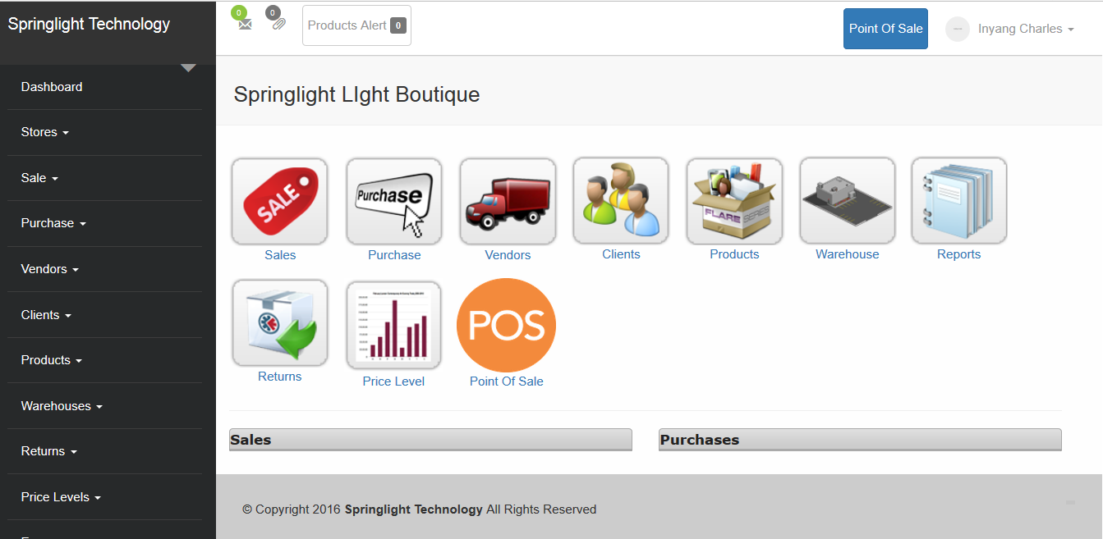

**Store**

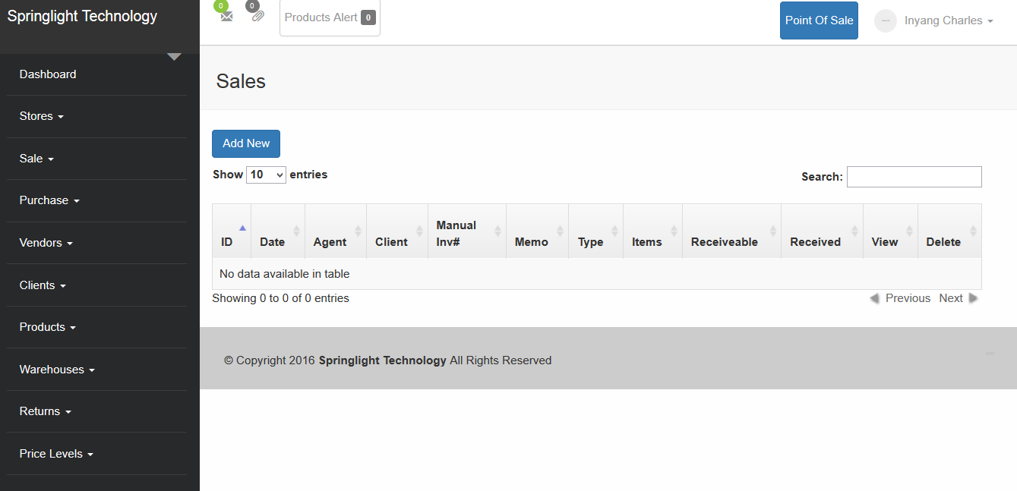

**Store User**

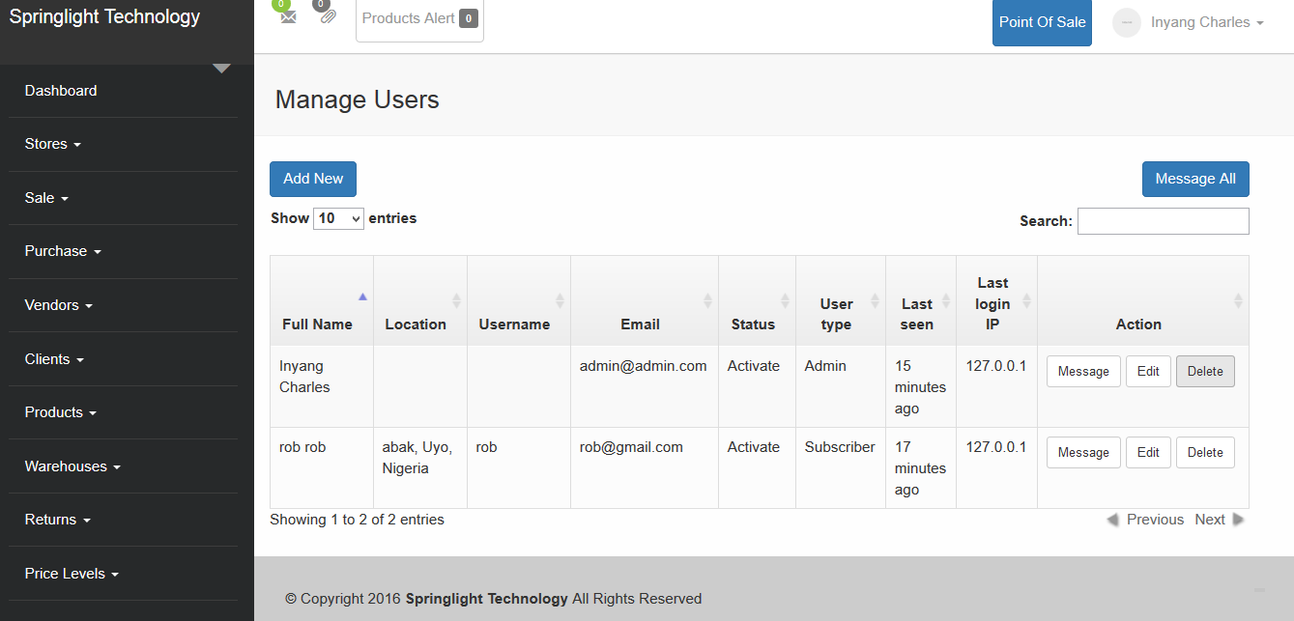

**Add Vendor**

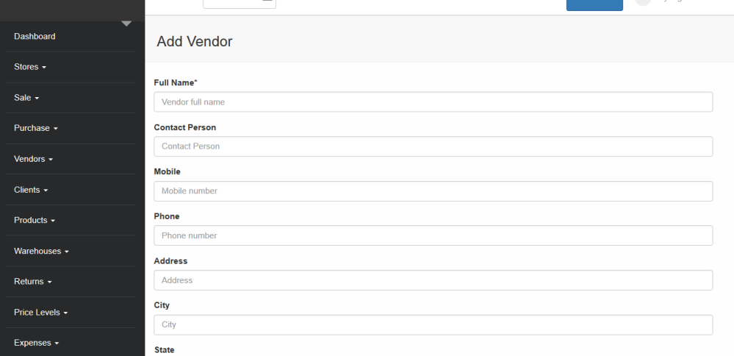

**Client**

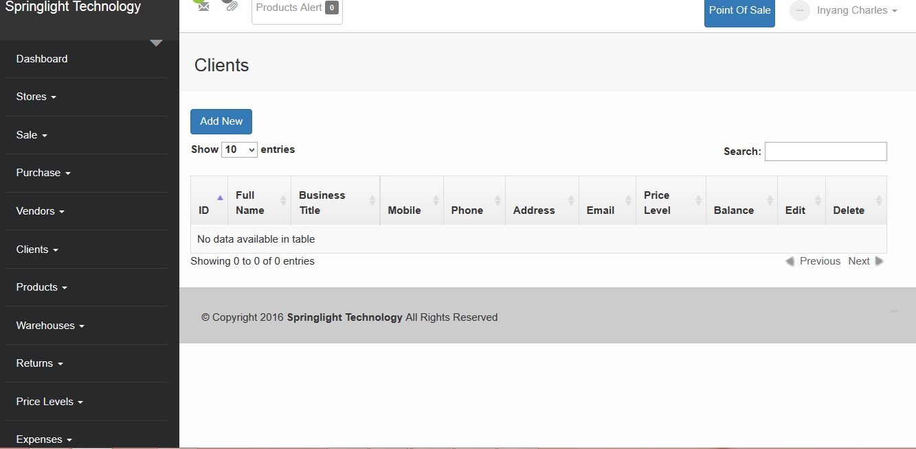

**Products**

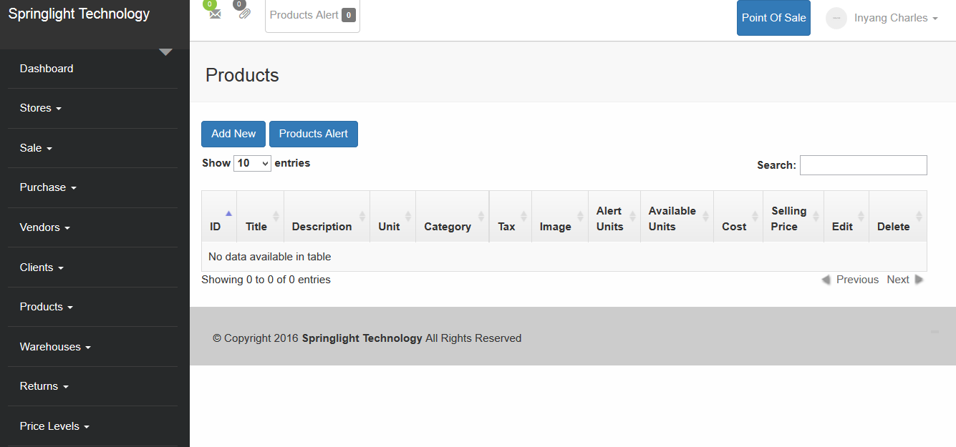

**Warehouse**

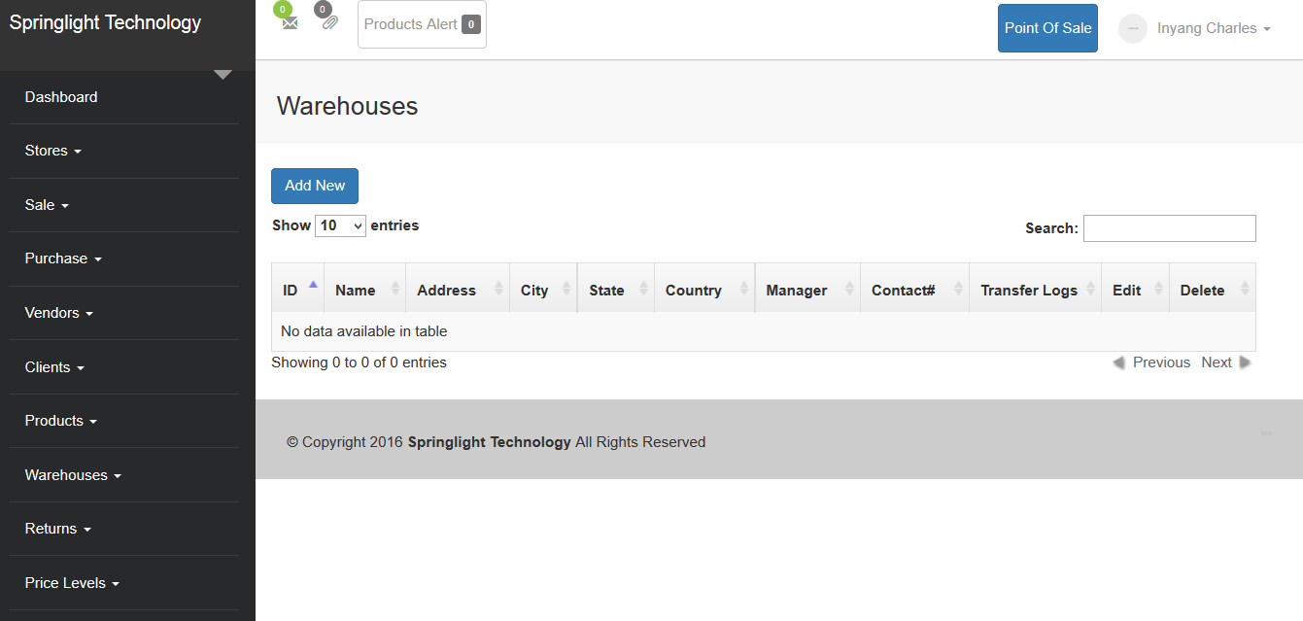

**3.3.2 ACTIVITY DIAGRAM**

**LOGIN**

**CORRECT**

**RETURN TO LOGIN PAGE**

**SELECT ACTION**

**CLIENT REGISTRATION**

**VIEW PROJECT HISTORY**

**ADD TEAM MEMBERS**

**VERIFY STAFF DATA**

**CREATE AND MANAGE MILESTONES**

**MODIFY CLIENT**

**INFORMATION**

**CREATE PROJECT**

**ASYNCHRONOUS MESSAGES**

**REGISTER STAFF**

**EVALUATE PROJECTS   
TASK AND FILESHARING**

**LOGOUT**

**3.3.3 SYSTEM CONTROLS**

The input and output is controlled through the use of automatic validation of input password access to the system sessions are used to keep track of user and data from one page to another.

**3.3.4 STRUCTURE OF DATABASE**

The structure of relational database shows the different tables that make up the database and links among the fields, the database consists of seven tables which are:

**3.3.5 Flowchart (Admin)**

Start

Login?

NO

YES

Add client

Add warehouse

Add products

Add store

Display warehouse details

Display

Display products

Add user

Manage warehouse

Manage products

Display

Details

Manage clients

Manage users

End

**USERS**

Start

No

Login ?

Yes

Edit profile

Manage sales

Manage picture

Store Deduction

Make sale

Edit picture

Update user detail

End

**CHAPTER FOUR**

**SYSTEM IMPLEMENTATION**

* 1. **INTRODUCTION**

This chapter focuses on the implementation of the system. The features of the implementation languages used in this research- PHP and MYSQL will be discussed extensively. The system testing strategies, the target computer requirements as well as the software maintenance issues that would arise in the system would be discussed also.

4.2 **FEATURES OF IMPLEMENTATION LANGUAGES**

The programming languages used in the implementation of this project are PHP (Hypertext Preprocessor) and MYSQL programming languages. PHP is a general purpose server side scripting language originally designed for web development to produce dynamic web pages. It has also evolved to include a command line interface capability and can be used in stand-alone graphical applications.

The following features make PHP a preferred implementation language for this project:

1. PHP has its root in C and C++. PHP syntax is most similar to C and C++ language syntax, so programmers find it easy to learn and manipulate.
2. PHP can run on both UNIX and windows. Hence it is compatible across various operating systems.
3. PHP has powerful output buffering that further increases over the output flow. PHP internally rearranges the buffer so that the header comes before the content.
4. PHP is platform independent: this is because it is parsed by the web browser hence compatibility issues do not arise when code written in PHP is ported to a different platform.
5. PHP can be used with a large number of relational database management systems, runs on all of the most popular web servers and is available to many different operating systems.
6. PHP is fully an object oriented programming language and its platform independence and speed on LINUX servers help to build large and complex web applications.
7. PHP has also attracted the development of many frameworks that provide building blocks and design structure to promote Rapid Application Development (RAD). Some of these include cake PHP, code igniter, Yii framework and Zend framework.
8. PHP IDS add security to any PHP application to defend against intrusion. PHPIDS detects cross-site scripting (XSS), SQL injection, header injection, directory traversal, remote file execution, local file execution and Denial of Service (DOS).

MYSQL is a relational database management system written in C and C++ that runs as a server providing multi user access to a number of databases. MYSQL is used basically to create a relational database structure on a server in order to store data or automate procedures. The following features make MYSQL also a preferred implementation language in this research:

1. MYSQL is written in C and C++ and tested with a broad range of different compilers. It also functions on different platforms.
2. It uses multi-layered server design with independent modules.
3. It is designed to be fully multi-threaded using kernel threads to easily use multiple CPUs if they are available.
4. It is a server/client system. The database server (MYSQL) and the arbitrary many clients (application programs) which communicates with the server to query data and save changes.
5. MYSQL is designed to make it relatively easy to add other storage engines. This is useful if you want to provide an SQL interface for an in-house database.
6. It provides transactional and non-transactional storage engines, uses very fast B-tree disk tables with index compression and a fast thread-base memory allocation system.
7. It executes very fast joins using an optimized nested loop join; implements in-memory hash tables which are used as temporary tables.
8. It implements SQL functions using a highly optimized class library that should be as fast as possible.
9. It provides the server as a separate program for use in a client/server networked environment and as a library that can be embedded (linked) into stand-alone applications. Such applications can be used in isolation or in environments where no network is available.
   1. **SYSTEM TESTING STRATEGIES**

This section is concerned with testing and debugging of the programs and general processes involved in achieving the objectives of the system requirement. System testing is conducted on a complete integrated system to evaluate the system’s compliance with its specified requirements. System testing falls within the scope of black box testing and as such should require no knowledge of the inner design of the code or logic. During system testing, the focus is on the software design, behavior and even the believed expectations of the customer. So we can also refer to the system testing phase as investigatory testing phase of the software development life cycle. The system testing strategies used in this system include the unit test and integration test.

* + 1. **UNIT TEST**

The primary goal of unit testing is to take the smallest piece of testable software in the application, isolate it from the remainder of the code and determine whether it behaves exactly as it is expected to behave. Each unit is tested separately before integrating them into modules to test the interfaces between modules. Unit testing has proven its value in that a large percentage of defects are identified during its use.

The most common approach to unit testing requires drivers and stubs to be written. The driver simulates a calling unit and the stub simulates a called unit. The investment of developer time in this activity sometimes results in demoting unit testing to a lower level of priority and that is almost always a mistake. Even though the drivers and stubs cost time money, unit testing provides some undeniable advantages. It allows for automation of the testing process, reduces difficulties in discovering errors contained in complex pieces of the application. During the unit testing of the application, errors uncovered by the researcher were rectified and the result was satisfactory.

* + 1. **INTEGRATION TESTING**

Integration testing is a logical extension of unit testing. In its simplest form, the units that have already been tested are combined into a component and the interface between them is tested. A component, in this sense, refers to an integrated aggregate of more than one unit. In a realistic scenario, many units are combined into components, which are in turn aggregated into even larger parts of the program. The idea is to test combination of pieces and eventually expand the process to test your modules with those of other groups. Integration testing can be done in a variety of ways which include top-down approach, bottom-up approach and the umbrella approach.

In the integration testing of the software, satisfactory results were obtained from the test using the bottom-up approach.

* 1. **TARGET COMPUTER SYSTEM REQUIREMENTS**

This section considers the requirements that must be met by the target system to enable the developed software application function as required. The target computer system requirement will be discussed in the area of software and hardware requirements.

|  |  |
| --- | --- |
| **Component** | **Requirement** |
| Operating system | Windows 2000, XP, Vista |
| Memory | 128MB or higher |
| Database | MySQL 5 |
| Web server | WAMP server |

**Table 4.1: software requirement for target computer system**

|  |  |
| --- | --- |
| **Component** | **Requirement** |
| RAM | 256MB of RAM |
| Hard disk | 10GB of hard disk space |
| Processor | 333Hz or higher |

**Table 4.2: hardware requirements for target computer system**

* 1. **SOFTWARE MAINTENANCE ISSUES**

This section focuses on software maintenance issues. Software maintenance is the modification of a software product after delivery to correct faults, improve performance or other product attributes or to adapt the product to a new or changing environment. It also serves as an opportunity to improve the performance o the software to suit the needs of the users if it becomes necessary for the user requirements to be improved upon or changed. Maintenance would be seen in three areas in this research; corrective maintenance, preventive maintenance and adaptive maintenance.

* + 1. **CORRECTIVE MAINTENANCE**

Corrective maintenance is a maintenance task performed to identify, isolate and rectify a fault so that the failed system can be restored to an operational condition within the tolerances or limits established for in-service operations. Necessary corrections in the form of removal, modification or addition of program modules should be permitted by the software to allow for optimal use of the application.

* + 1. **PREVENTIVE MAINTENANCE**

This is a schedule o planned maintenance actions aimed at the prevention of breakdowns and failures. The primary goal of preventive maintenance is to prevent the failure of software before it actually occurs. It is designed to preserve and enhance software reliability by replacing error-prone components before they actually fail. Recent technological advances in tools for inspection and diagnosis have enabled more accurate and effective software maintenance. Measures like regular diagnosis, database backups, creating system mirrors preserve the integrity of information stored in the application. If these are strictly followed, limited instances of such occurrences would be noticed in the use of the software application.

* + 1. **ADAPTIVE MAINTENANCE**

This involves enhancing the system by adding features, capabilities and functions in response to new technology, upgrades, new requirements or new problems. Since the environment in which the application would be running is dynamic, it should be made to suit whatever requirements that may change in the long run.

**CHAPTER FVE**

**SUMMARY AND CONCLUSION**

1. **SUMMARY**

The aim of this research is to create a store and warehouse management system which will make Stores and warehouse management in organization more flexible and reliable. The existing types of stores and warehouse management were discussed and it was narrowed down to sales, stock keeping, warehouse management, staff update, vendors update and management, clients management and point of sales (POS)which is the main thrust of this project. The history of warehouse management where highlighted. Principles of project were outlined. The system design was made suitable to the system requirements. Embedded in the system design is activity diagram which shows the activities and actions in the system. The implementation of the software was successful.

* 1. **CONCLUSION**

Stores and warehouse management System improves business activities in large, medium and small enterprise. Hence it is advised that all companies that deals with goods and services in Nigeria should adopt a Stores and warehouse management system which is more reliable, flexible and result oriented.

The resulting software would be of benefit to individuals who which to manages Shop, supermarket, stores and warehouse. The software has been able to meet its objectives and will make project management. Stores and warehouse management more successful.

* 1. **RECOMMENDATION**

The software developed for the implementation of this research can be used by any company that deals with goods and services. The following recommendations are proposed:

* Admin should ensure to update prizes of product daily to avoid lost in profit.
* Admin should create passwords with long characters so as to make password hacking difficult.
* System users should ensure safekeeping of password since it provides access to the system.

REFERENCES

Allen, G. N., Burk, D. L., and Davis, G. B. (2006). *Academic data collection in electronic environments: Defining acceptable use of internet resources*. Sybex Inc. MIS Quarterly London, pp 599-610.

Allen, D. K., Colligan, D., Finnie, A., & Kern, T. (2000). *Trust, power and interorganizational information systems: The case of the electronic trading community TransLease*. Sybex Information Systems Journal, pp 21-40.

Alten,R. & Cäsar M. A. (2002). *Collaboration in the consumer product goods industry-Analysis of marketplaces*. In 10th European Conference on Information Systems (ECIS). Poland: Gdansk.

Ba. S., & Pavlov, P. A. (2002). *Evidence of the effect of trust building technology in electronic markets: Price premiums and buyer behavior*. Sybex MIS Quarterly, pp, 243-268.

Benjamin, R., & Wigand, R. (1995*). Electronic markets and virtual value chains on the information superhighway*. Sloan Management Review, pp 62-72.

Benslimane, Y., Plaisent, M., & Bernard, P. (2005). *Investigating search costs and coordination costs in electronic markets: A transaction costs economics perspective*. Electronic Markets, London Capt, pp, 213-224.

Brynjolfsson, E., & Smith, M. D. (2000). *The great equalizer? Consumer choice behavior at internet shopbots*. MIT Sloan School of Management Working Paper. Retrieved from http://papers.ssrn.com/abstract=290323.

Christiaanse E., & Rodon, J. (2005). *A multilevel analysis of eHub adoption and consequences*. Electronic Markets, China 4958: pp 355-364.

Clasen, M., & Mueller, R. A. E. (2006). *Success factors of agribusiness digital marketplaces*. Sybex: pp 349- 360.

Degeratu, A. M., Rangaswamy, A., & Wu, J. (2000). *Consumer choice behavior in online and traditional supermarkets: The effects of brand name, price, and other search attributes*. International Journal of Research in Marketing, Los Angeles 45865: pp 55-78.

Fong, T., Fowler, D., & Swatman, P. M. C. (1998). *Success and failure factors for implementing effective electronic markets*. McGrills, pp 45-47.

Grieger, M. (2003). Electronic marketplaces: *A literature review and a call for supply chain management research*. European Journal of Operational Research, pp 280-294.

Grover, V., Lim, J., & Ayyagari, R. (2006). *The dark side of information and market efficiency in e-markets*. Decision Sciences, Dubai 7865: pp 297-324.

Hagendorff, J., Hudson, R., & Keasey, K. (2006). *Electronic trading platforms and the cost-effective distribution of open market option (OMO) pension annuities*. International Journal of Information Management,Miami: pp 187-195.

Ivang, R., & Sørensen, O. J. (2005). *E-markets in the battle zone between relationship and transaction marketing*. Electronic Markets, New Jersey: pp 393-404.

Karacapilidis, N., & Moraïtis, P. (2000). *Intelligent agents acting as artificial employees in an electronic market*. Journal of Electronic Commerce Research, London Capt.: pp 133-142.

Kollmann, T. (2000). *Competitive strategies for electronic marketplaces*. Electronic Markets, San Francisco 568: pp, 102-109.

Lau, A., Yen, J., & Chau, P. Y. K. (2001). *Adoption of on-line trading in the Hong Kong Financial Market*. New York 2312: Journal of Electronic Commerce Research, pp 58-65.

Mitra, K., Reiss, M. C., & Capella, L. M. (1999). *An examination of perceived risk, information search and behavioral intentions in search, experience and credence services*. Ohio 2342: The Journal of Services Marketing, pp 208-223.

**APPENDIX**

**APPENDIX A: SCREEN WINDOW**

**Sale and Purchase Graph**

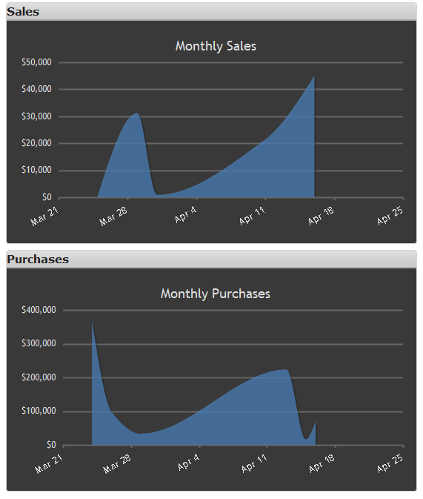

Sale and purchase graph implemented same graphs also can be requested for purchase returns and sale returns these graphs helps user to check total sales by date.

**Dashboard**



**Store**



**Store User**



**Add Vendor**



**Client**



**Products**



**Warehouse**

