**DESIGN AND IMPLEMENTATION OF AN ONLINE STADIUM MANAGAMENT INFORMATION SYSTEM**

**(A CASE STUDY OF GODSWILL AKPABIO INTERNATIONAL STADIUM UYO)**

**ABSTRACT**

An online stadium management information system for the Godswill Akpabio International stadium Uyo, was be developed in this project. The current process of management at the Godswill Akpabio International Stadium is being operated manually and due to this procedure numerous problems are being encountered. The system is developed in order to tackle these problems encountered by the use of the conventional manual registration and ticket procurement.

This system is capable of performing crowd management, ticketing management, fraud checks, and customer care/ advertisement. The incremental software development process was employed in the development of the system. The development of the system passed through three increments and in each increment communication, planning, modelling, construction and deployment activities were carried out. The system iterated between development and testing stages until the set objectives were met. The application was developed using XHTML (Extended Hypertext Markup Language) for the interface, MySQL (Structured Query Language) for the database, PHP (Hypertext Preprocessor) for connecting between the database and GUI, and Apache (Webserver).

The result of the developed system are positive, as the system could be used to create a database of customers in the stadium, better the administrative process of the stadium management, therefore making the general running of the stadium easier and efficient.

**Keywords:** Information Management, Ticketing Management, Fraud Management, Crowd Control and Mechanism.

**TABLE OF CONTENTS**

**CHAPTER ONE**

* **INTRODUCTION**

1.1 Background of Study - - - - - - - - 12

1.2 Statement of the Problem - - - - - - 14

1.3 Objectives of Study - - - - - - - - 15

1.4 Significance of the Study - - - - - - - 16

1.5 Scope and Limitations - - - - - - - - 16

1.6 Project Layout - - - - - - - - - 17

**CHAPTER TWO**

* **LITERATURE REVIEW**

2.1 Brief History of the Godswill Akpabio International Stadium - - 18

2.2 Online Booking and Ticketing - - - - - - 19

2.3 Concept of Information Management - - - - - 21

2.4 Review of Related Works - - - - - - - 22

2.4.1 Design and Implementation of a Computerized Stadium Management Information System (A Case Study of Nnamdi Azikiwe Stadium Enugu) - - 22

**CHAPTER THREE**

* **RESEARCH METHODOLOGY**

3.1 Introduction - - - - - - - - - 24

3.2 System Description - - - - - - - - 25

3.2.1 Functional Decomposition - - - - - - 25

3.3 System Architecture - - - - - - - - 28

3.4 Incremental Software Development Process Model - - - - 29

3.4.1 Increment 1 - - - - - - - - 30

3.4.2 Increment 2 - - - - - - - - 46

3.4.3 Increment 3 - - - - - - - - 49

**CHAPTER FOUR**

* **RESULTS AND DISCUSSION**

4.1 Introduction - - - - - - - - - 53

4.2 The Home Module - - - - - - - - 53

4.3 Ticket Reservation Module - - - - - - - 55

4.4 Regulation Module - - - - - - - - 59

4.5 Administrator Module - - - - - - - 60

4.6 Testing - - - - - - - - - 66

4.7 Test Results - - - - - - - - - 66

4.8 Discussion of Results - - - - - - - - 67

**CHAPTER FIVE**

* **CONCLUSION AND RECOMMENDATIONS**

5.1 Conclusion - - - - - - - - - 68

5.2 Recommendation - - - - - - - - 68

**REFERENCES** - - - - - - - - - 69

**APPENDICES**

Appendix A - - - - - - - - - - 71

Appendix B - - - - - - - - - - 71

Appendix C - - - - - - - - - - 72

Appendix D - - - - - - - - - - 73

Appendix E - - - - - - - - - - 73

Appendix F - - - - - - - - - - 74

Appendix G - - - - - - - - - - 75

Appendix H - - - - - - - - - - 76

Appendix I - - - - - - - - - - 77

Appendix J - - - - - - - - - - 78

**LIST OF TABLES**

* Table 3.1: Customer Registration Table - - - - - 40
* Table 4.1: Average of Testing - - - - - - 67

**LIST OF FIGURES**

* Fig. 2.1: Use Case Diagram of the Computerized Stadium Management System 23
* Fig. 3.1: Flow Chart and Components of the Proposed System - - 25
* Fig. 3.2: Use Case Diagram Showing Customer and System Module Interaction 26
* Fig. 3.3: Use Case Diagram Showing Regulator Interaction with Modules - 27
* Fig. 3.4: Use Case Diagram Showing Administrator Interaction With Modules 27
* Fig. 3.5: Architecture of the System - - - - - - 28
* Fig. 3.6: Incremental Process Model - - - - - - 30
* Fig. 3.7: Home Page for Customers - - - - - - 44
* Fig. 3.8: Signup Page for New Customers - - - - - 45
* Fig. 3.9: Login Page for Existing Customers - - - - - 45
* Fig. 3.10: Regulator Login Page - - - - - - 48
* Fig. 3.11: Administrator Login Page - - - - - - 51
* Fig. 3.12: Administrator Welcome Page - - - - - 52
* Fig. 4.1: Customer Home Page - - - - - - - 54
* Fig. 4.2: Regulator Home Page - - - - - - - 54
* Fig. 4.3: Administrator Home Page - - - - - - 55
* Fig. 4.4: Ticket and Match Display Page - - - - - 56
* Fig. 4.5: Ticket Booking Page - - - - - - - 56
* Fig. 4.6: Payment Component - - - - - - - 57
* Fig. 4.7: Ticket Generation Component - - - - - 57
* Fig. 4.8: Ticket Viewing Component - - - - - - 58
* Fig. 4.9: Ticket Printing Component - - - - - - 58
* Fig. 4.10: Regulator Login Page - - - - - - 59
* Fig. 4.11: Regulator Check-in Component - - - - - 60
* Fig. 4.12: Administrator Login Page - - - - - - 61
* Fig. 4.13: Administrator Welcome Page - - - - - 61
* Fig. 4.14: Ticket Category Creation - - - - - - 62
* Fig. 4.15: Creation of Admin Staff - - - - - - 62
* Fig. 4.16: Creation of Regulators - - - - - - 63
* Fig. 4.17: Creation of Match/Event - - - - - - 64
* Fig. 4.18: Update of Regulator’s Account Information - - - 65
* Fig. 4.19: Customer Information Database Component - - - 65

**CHAPTER ONE**

**INTRODUCTION**

* 1. **BACKGROUND OF STUDY**

The role of information and communication technology (ICT) in stadium management is that systems are designed to make it easy for spectators to connect with the stadium administrators through the internet with their devices (J. R. Mehmet). It provides a mechanism that connects people, goods and services and delivers content and services that spectators can enjoy at the stadium. Furthermore, updates that generate interest in teams, players and games are made possible, which further contributes to the growth of the sports industry, which has close links to local communities, by attracting new fans and encouraging them to watch their teams live, thereby generating greater income for the stadium managers.

The current system of operation at the Godswill Akpabio International stadium is that where when matches are set to be played at the stadium, a promotional team is often set up who go around into town with flyers in a float form and some dancers alongside music trucks to promote the match at some strategic areas around town some days to the match, as well as radio and TV station advertisements. Tickets are then designed and printed which are sent out to distributors like DSTV offices, fast food joints, restaurants, etc, who sell these tickets to the customers when they come to their offices. The tickets which are not sold are returned and then disposed off, constituting a waste of money.

**Information management** (IM) concerns a cycle of organizational activity: the acquisition of **information** from one or more sources, the custodianship and the distribution of that **information** to those who need it, and its ultimate disposition through archiving or deletion (Wikipedia).

Strategic information management is the key to the success of any business in this digital world. All organizations understand the importance of information management and is taking initiatives towards that implementation. There are many operational benefits for an organization if a proper strategic information management is implemented. Information pertaining to the concerned department is available easily through the information systems. There is no delay in getting the information and hence the productivity of the department is increased. Information is easily shared between the department within an organization and with their clients externally. With proper security and protection to the information in the systems, there is no fear that unwanted information is disclosed with the external entities. The information used in the process is consistent .

The most important is the improvement in the decision making. The top management would find it very useful to make decisions faster than earlier when there were no information systems. It helps the organization to move forward faster.

Upon educating the staff on the use of the information systems, all the processes are improved and are on fast track. Redundant information and processes are easily identified with the proper implementation of strategic information management and they are removed from the process. Cost is also reduced with the removal of redundant information and process. Lots of paper work is eliminated since all the data are available in the systems. The users know what information they have and what their clients need clearly (Dr. Dennis Wood).

Earlier, before the use of information system data would have been lost. After the implementation of the strategic information system, the data is protected and available anytime. This saves a lot of time and cost involved in replacing lost data earlier. With the strategic information management unnecessary work is eliminated thus saving time and cost. An online information-management system is a tool that can help stadium managers get the best outcome from the use of the stadium.

**1.2 STATEMENT OF THE PROBLEM**

The problem with today’s stadium ticketing method is that you have to show up early so you can find a parking spot and choose a good seat. In addition, it is not guaranteed to get them. However, with this online ticketing system you will book the seat you like and a seat will be saved for you. Therefore, you can attend the game just a few minutes before the referee's whistle.

The current ticket purchase system makes room for different parties involved in the production and distribution of event tickets of the stadium to be fraudulent thereby making it difficult to attain optimum profit from events held at the stadium. This leaves the government with lesser revenue compared to profits projected when these events are being planned. This in the long run leads to the poor management of stadium facilities, dilapidation of the general structure and eventually the closedown of the stadium except funds are pumped into the system to give it a facelift and keep it running.

After the occurrence of events at the Uyo international stadium, there exists no system to aid the stadium management in keeping record of customers, reach out to these customers and accommodate complaints or suggestions from the customers. The stadium is stadium is just left off in wait of another event, and then the same old routine of sourcing for customers is repeated over and over again. This usual culture of not mapping out a strategy of retaining a customer base greatly hampers the revenue generation and maintenance of the stadium. There is a need to curb this menace which has eaten deep into the stadium management system before it causes a major havoc on the system.

**1.3 OBJECTIVES OF STUDY**

The primary goal of this project is to implement a stadium management information system with an online interface between the supposed customer and the administrative body for the Godswill Akpabio international stadium, Uyo. The specific objectives include:

1. To design an online system for the stadium for ticket sales/ booking, and payment.
2. To design a system that manages customer information and details of previous transactions.
3. To design an administrative system that handles crowd control and prevents defrauding of the stadium management body.

**1.4 SIGNIFICANCE OF THE STUDY**

The benefits of the proposed online stadium information management system in the Godswill Akpabio international stadium, Uyo, are as follows;

To create a website system for managing ticket reservations and making it easier for the user to book tickets and pay electronically.

To immensely reduce the costs of organizing an event in the stadium at any point in time which will give the management more time to create awareness about events through other means.

It reduces the wastage of overall promotion materials and pre-printed tickets which will in many cases will not make it to the target customers.

It ensures effective monitoring and checking by the administration at the comfort of their internet devices.

It makes for orderliness in the entire stadium environment.

**1.5 SCOPE AND LIMITATIONS**

This research work will concentrate on designing and developing an online stadium booking website, as well as an administrative site with information management mechanism using the Godswill Akpabio international stadium, Uyo as a case study. Only booking features, payment features, customer database, and ticket confirmation features will be available in the design. This limitation is posed by majorly financial and time constraints since it is only a proof of an idea.

**1.6 PROJECT LAYOUT**

Chapter two contains the concept of ticket reservation system especially as it pertains to most stadium managements in Nigeria. It offers a review of works related to this project and the limitations of the work.

Chapter three presents in an encompassing manner the design and research methodology. It also explains the current and proposed booking and information management systems. Furthermore the chapter explains in details the system architecture, requirements and specifications.

Chapter four deals with the implementation of the proposed Online Stadium Information Management System and the results are also discussed here.

Chapter five provides the summary of the entire project report. It also gives a few recommendations on how to improve the system.

**CHAPTER TWO**

**LITERATURE REVIEW**

**2.1 BRIEF HISTORY OF THE GODWILL AKPABIO INTERNATIONAL STADIUM**

The **Godswill Akpabio International Stadium** (formerly **Akwa Ibom International Stadium**) is an all-seater national sports stadium located in Uyo, the state capital of Akwa Ibom. The stadium serves as a home to the Nigerian Super Eagles as well as a center for various social, cultural, and religious events. The contract for the construction of the Akwa Ibom International Stadium complex and Games Village was awarded in 2012 to Julius Berger and was completed in 2014. The 30,000 seater ultra modern multipurpose sports complex was modeled after Allianz Arena.

Governor Udom Gabriel Emmanuel renamed Akwa Ibom Stadium as *Godswill Obot Akpabio International Stadium*, immediately following his inauguration ceremony on May 29, 2015 in the stadium. Godswill Akpabio was the immediate past governor of the state.

The contract for the design of the stadium was awarded to Julius Berger, a structural engineering firm based in Nigeria. They were responsible for the architectural design, execution planning, as well as constructional supervision of the stadium, as well as structural maintenance. The stadium which seats on 48 hectares of land has some unique features such as bullet proof VIP/VVIP sections, collapsible seats, two digital score boards, digital playback screens, digital flood lights, and 30 emergency exits.

The stadium structure is in two phases which includes a 400m-running track for athletic events, and is the pilot part of Uyo Sports Park development, and is enclosed by a white triangular-shaped outer covering that encircles the whole spectator stand. The East Stand and Curves can seat approximately 22,500 people. The Governors’ Lounge has sitting capacity for between 30 and 40 VVIPs and is located in the Grand Stand on Level Two. It is constructed to carry little more than 30,000 spectators whether for soccer or track and field events, while the Grand Stand can comfortably accommodate about 7,500 spectators, including the VIP/VVIPs. There is also a six-lane track built specifically for athletes to train (Wikipedia).

**2.2 ONLINE BOOKING AND TICKETING**

The ticket booking system used in the Godswill Akpabio international stadium is one which tickets are disbursed by the stadium management to booking venues around uyo metropolis and customers have to go to these centers to purchase these tickets before the supposed event begins. There are no reserved seats, so the stadium operates on a first come first served basis.

In an online booking system, only private individuals can buy tickets at the website. To buy tickets, first set up your account at the website. You can use your email address to do so.

After logging into your account, you must submit a ticket application. This process consists of several stages: you must confirm your country of residence, agree with the terms of purchase and use of the tickets, as well as the rules of conduct at the stadium, then select a ticket or set of tickets. Enter your information, enter your guest’s information (if you buy more than one ticket), and confirm the purchase.

To submit a ticket application, you will need to fill out the following information about yourself and your guests:

* Name and last name
* Date of birth
* Citizenship
* Passport number or other picture ID number, including for the children
* Country of residence

The ordering customer also has to specify how he will pay for tickets and provide additional information:

* Mailing address for ticket delivery
* Contact information (email, mobile ad home phone numbers)

The application must be completed in full. Information must be verified and submitted on time; otherwise the application may be denied or cancelled.

Ticket purchase has to be confirmed by the admin at any stage of the ticket sale; the association will send you a notification that’s the tickets were reserved for you.

**2.3 CONCEPT OF INFORMATION MANAGEMENT**

**2.3.1 Information management** (**IM**) concerns a cycle of organizational activity: the acquisition of information from one or more sources, the custodianship and the distribution of that information to those who need it, and its ultimate disposition through archiving or deletion.

This cycle of organizational involvement with information involves a variety of stakeholders, including those who are responsible for assuring the quality, accessibility and utility of acquired information; those who are responsible for its safe storage and disposal; and those who need it for decision making. Stakeholders might have rights to originate, change, distribute or delete information according to organizational information management policies.

Information management embraces all the generic concepts of management, including the planning, organizing, structuring, processing, controlling, evaluation and reporting of information activities, all of which is needed in order to meet the needs of those with organizational roles or functions that depend on information. These generic concepts allow the information to be presented to the audience or the correct group of people. After individuals are able to put that information to use, it then gains more value.

Information management is closely related to, and overlaps with, the management of *data*, *systems*, *technology*, *processes* and – where the availability of information is critical to organizational success – *strategy*. This broad view of the realm of information management contrasts with the earlier, more traditional view, that the life cycle of managing information is an operational matter that requires specific procedures, organizational capabilities and standards that deal with information as a product or a service (Wikipedia.org).

**2.4 REVIEW OF RELATED WORKS**

A review of projects similar to this research work will be done in this section; Design and implementation of a computerized stadium management information system (a case study of Nnamdi Azikiwe stadium Enugu) 2012.

**2.4.1 Design and implementation of a computerized stadium management information system (a case study of Nnamdi Azikiwe stadium Enugu).**

This research described the use of a data collection and retrieval system. The developer wanted to design a program that could enable the stadium’s clerical staff to input customer data into the system and their desired purchases thereby generating tickets over the counter. This was designed to serve as an alternative to the conventional pre-printing of tickets for distribution and sale at designated outlets. The developed system was to enable the stadium management reduce the wastage incurred by pre-printing game tickets therefore reducing the cost of ticket printing, and also to give the management an easy alternative of keeping record of their customer database which in this case was a computer programme. The study concluded that with the use of the suggested system, the work of the stadium staff will be made much easier and the storage of data will be more efficient than the existing system. The limitation of this system is that it still requires over the counter reservations therefore customers have to go to the stadium to buy tickets, and it operates a first come first served queue system of booking.

* **Use Case Diagram:** Figure 2.1 shows the use case diagram of the computerized stadium management information system. It represents the users and how interaction in the system works.

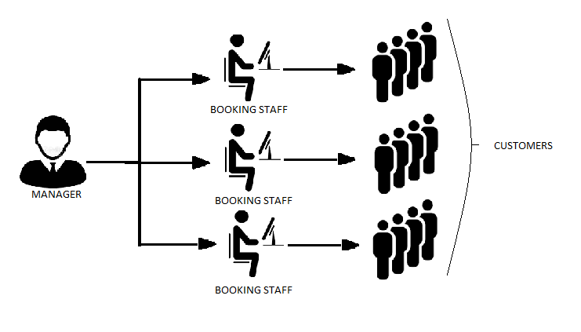

**Fig. 2.1: Use Case Diagram of the Computerized Stadium Management System.**

**CHAPTER THREE**

**RESEARCH METHODOLOGY**

* 1. **INTRODUCTION**

The current ticket booking and reservation system in the Godswill Akpabio International Stadium does not allow the existence of a data based information management system as every booking and reservations are done manually at any location. This system promotes the defrauding of customers and benefits people who fake tickets and sell them to unsuspecting buyers. The stadium management can hardly know the actual profit they are supposed to make as there are many middle men between them and the end customers. These problems contribute a greater percentage of the gradual dilapidation of the stadium and the down sliding of the quality of service rendered at the stadium.

The present scenario in the Godswill Obot Akpabio International Stadium will be presented and then an improved online stadium information management and booking system will be developed using the incremental software development process model to address the needs identified in the previous paragraph.

In the development of this system, the design process I implemented was the incremental software development process model. The system will allow customers to make bookings by themselves on their internet devices, make payments as well, give the admin feedback on reservations, and a database of their customers.

* 1. **SYSTEM DESCRIPTION**

The platform designed is to provide customers with round the clock easy access to ticket booking and reservations, check upcoming events, make complaints or contact a customer care agent. It will also grant the admin agents to monitor booking progress, check attendance, prevent defrauding and maintain a customer database.

* + 1. **Functional Decomposition**

The modules into which the system components are decomposed are developed incrementally and evaluated till it meets the desired system requirements and objectives. Their interaction with other system modules and components are given in figure 3.1.

1. **Module 1: Sign up/ Login**
2. **Module 2: Ticket Booking/ Reservation**
3. **Module 3: Regulation**
4. **Module 4: Information Management**
5. **Module 5: Event Management/ Supervision**

**USERS:**

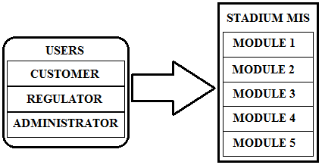

**Fig. 3.1: Flow Chart and Components of the Proposed System**

The users as evidenced in figure 3.1 are sub classed into the customer, the regulator, and the administrator. The users have the most valued interaction with the system as they are the focus of the development of the system.

1. **Customer:** The customer has interaction with a section of the module which is not password protected, but is the transaction module which is the primary focus of the development and design of this system. The customer has access to this module for optimum use of the transaction functionality of this system. Below is a use case diagram depicting the customer interaction with the system module.

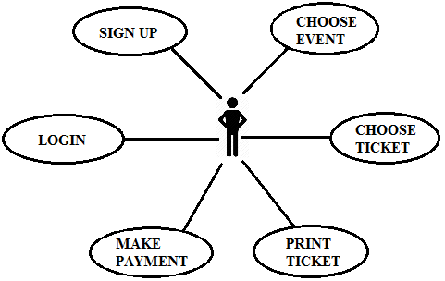

**Fig. 3.2 Use case diagram showing customer and system module interaction.**

1. **Regulator:** The regulator is in charge of fraud regulation at the entrance of the stadium. The job of the regulator is to confirm purchased tickets to avoid customers who make fake tickets from getting into the fan area or having seats in the stadium. They are stationed at the stadium’s entrance to monitor influx of customers, and they are only functional on events or match days.

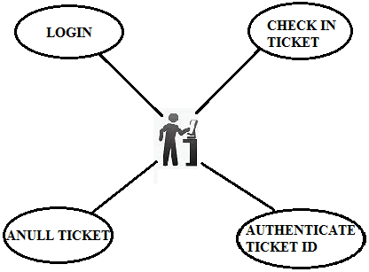

**Fig. 3.3: Use case diagram showing regulator interaction with modules**

1. **Administrator:** The administrator is in charge of the backend of the system, managing customers’ info, registering regulators, uploading events, modifying all accounts, fixing ticket types and prices and generally handling the technical aspects of the system.

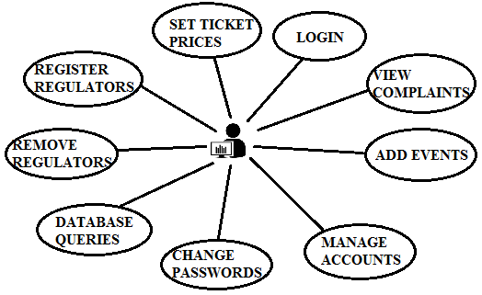

**Fig 3.4: Use case diagram showing Administrator Interaction with Modules.**

* 1. **SYSTEM ARCHITECTURE**

The architecture of the system as sown in Fig3.5 is showing the relationships between system components.

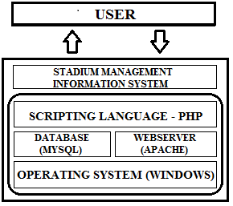

**Fig. 3.5: Architecture of the System.**

The user (via web browser) makes a request (e.g. check current events) which is submitted to the web server which locates the files requested for in its files written in PHP. Since the Web server cannot return a PHP file, the requested files are sent to the PHP software which pulls more information from the database and processes into its specification in the PHP code, then sends the page and associated files (i.e images, CSS) back to the user in the form of an HTML page. The main advantage of this structure is that there is reduced complexity brought on by the installation of software on the client-side, users only need to have a browser installed on their machines in order to logon to the platform which requires no technical skill.

**3.4 Incremental Software Development Process Model**

The incremental model combines elements of linear and parallel process flows. Each linear sequence produces deliverable increments of the software. Based on the general system description, the chosen process model for the project is the incremental development model. The software was designed, implemented and tested incrementally (a little more is added each time) until it came to completion. This iterative model made for the development of increasingly complete versions of the application. As system requirements evolved during the course of the project, more features were added using incremental development process iteration. This means that rather than deliver the system as a single delivery, the development and delivery was broken down into increments with each increment delivering part of the required functionality. This project was developed in three increments, with the first increment addressing the core feature required for the functioning of the system and subsequent increments addressing supplementary features. The advantage of using the incremental model in the development of the course registration system includes;

1. The working software was generated quickly and early during the software life cycle.
2. It is flexible. Requirements and scope can be changed with ease.
3. Testing and debugging was easier and faster.
4. Risk management was easy because risky pieces were identified and handled during the iterations.

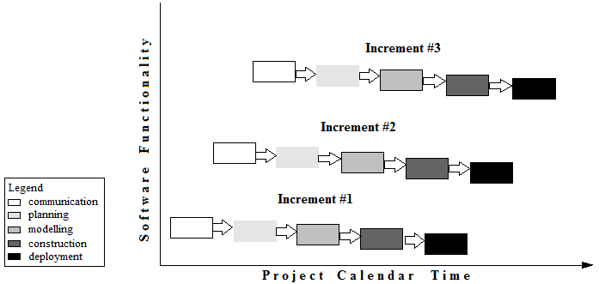

**Fig. 3.6 Incremental Process Model.**

**3.4.1 Increment #1**

The deliverable for the first increment is always a core product upon which all other increments are based off or other components are built off. The core product in this project being ticket reservation module with the sign up and login modules delivered as bonuses of this increment. Below are the processes involved in the process model and the description of activities as regards the first increment.

1. **Communication**

The communication phase involved project initiation, requirements gathering for the proposed system as well as proposed system specifications.

**System Specifications**

The proposed online stadium management information system improves upon existing stadium management system and brings in the regulatory mechanism as an additional functionality in the third increment. It works by storing data on the database and retrieving it when necessary.

This online stadium management information system to be implemented is required to enable the customers buy the tickets of their choice at the convenience of their homes and also allow the admin of the stadium monitor and manage sales effectively.

1. **Planning**

The planning phase covers the cost estimates, scheduling and tracking of project progress and requirements. The estimated cost of the module was put at next to nil excluding cost of report printing. The schedule from start to delivery of the deliverable i.e. the customer registration and ticket procurement module was put at 2 weeks including Saturdays and Sundays.

1. **Modeling**

In the modeling phase, an analysis of the existing sales system was carried out, flaws where identified, an online ticketing and management system was drawn up, an analysis of hardware and software requirements as well as technical know-how to sustain the proposed system was drawn up and its design was started.

1. **Current Management System in Godswill Akpabio International Stadium**

Similar to other stadiums in this part of the world, the Godswill Akpabio International Stadium has its own ticket procurement and registration system bordered by customer transaction processes. This section captures that picture.

1. **Ticket Purchase and Advertising to Customers**

On the occasion of new events (e.g. football matches) at the stadium under study, the stadium management handles publicity and ticket sales through the following sequence of activities;

1. The management first advertises upcoming events on the conventional media means (radio stations, TV stations, and parades).
2. A decided amount of tickets are being printed and disbursed to the designated sale locations within the uyo metropolis.
3. Intending customers troop to these sale points to purchase the tickets as well as middle men who buy tickets in bulk in order to sell them at exorbitant rates when tickets are no longer in stock.
4. The authorized ticket vendors then collate the revenue generated from ticket sales, after removing their cut, and then return the rest of the income to the stadium management.
5. **Match-day Regulation at the Stadium**

For the day of the event, the regulatory process for receiving spectators is usually that which the customers arrive at the stadium entrance and an official confirms their tickets by looking at it and marking it. After this process, the customer moves into the stadium and searches for any available seat to sit on during the event. This process of checking and entering goes on for some time and then everybody is later allowed to flood in at will and take up any available seats, and where there is an overflow of spectators, some of the customers who arrived late have to stand through the event after they had paid to secure seating spaces. A better and more reliable stadium management information system is proposed in the next section.

1. **Proposed Online Stadium Management Information System**

A better online Management Information System with a direct customer-user-interface is necessary to properly manage the affairs of management in the stadium which have so far been mismanaged resulting in low revenue generation by the management team.

1. **Proposed Online Registration and Ticket Purchase System for New Customers**

The proposed online stadium management information system for new customers will follow this sequence;

1. After the customer has become aware of an upcoming event and knows of the online registration portal, the customer visits the stadium’s website and selects the event of his choice.
2. The customer then signs up to open an account with the stadium online portal.
3. The customer is required to fill in necessary information such as names, contact address, e-mail address, phone number, etc.
4. After filling the necessary details, an account is then opened in the name of the customer.
5. The customer then selects the ticket type, and then makes the necessary payments on the site.
6. A ticket with a unique I.D. and seat number is then generated for the customer, which the customer in turn prints and keeps to use at the entrance of the stadium.
7. **Proposed Online Registration and Ticket Purchase System for Old Customers**

The proposed online registration and ticket purchase system for old customers will follow this sequence;

1. Customer visits site and selects event of choice.
2. The customer signs into his already opened account with his personal username and password.
3. The customer then chooses a ticket type and is referred to the payment site to make necessary payments.
4. The customer is given a ticket I.D. and a reserved seat number which he can then print to use on the day of the chosen event at the stadium.
5. **System Requirements**

The proposed online management information system, being a computer-based information system, requires the use of computer which entails hardware and software components.

* **Software Requirements:** The software Architecture of the proposed online course registration system has a database supplying data to a web-based application. MySQL is used for the database. Web-based applications need a webserver and a scripting language. Apache was used as webserver and PHP is used as scripting language.
* **Hardware Requirements:** The hardware setup to suit the Online Registration system requires a personal computer equipped with the applications listed in the software requirements section.

1. **Facilities Required for Implementing the Online Stadium Management Information System.**

For the purpose of this project, the online registration system will be implemented as a proof of concept. However, for this online stadium management information system to be implemented in the Godswill Akpabio International Stadium, the following has to be in place:

1. A Local Area Network linking the administrator and the regulator in the stadium.
2. A data centre for the database: This unit will be responsible for database administration, report generation and archiving. Staff from this unit will also perform periodic audits of the processes and software. The following is a short list of facilities required in the data centre:

* Servers**:** This will serve as the repository of collected data.
* Switches: This will serve as the link between the servers and within and outside the data centre.
* Personal Computers: This would include desktops and laptops.
* Inverters: This will serve as stand-by power source for PHCN and generator power sources. This should also be of the right capacity, enough to sustain the equipment for long enough to cover periods of power outage during work hours.
* Printing facilities: Printers for printing of course forms would be housed here.
* Air conditioning: Air conditioners are also needed to cool the devices provided in the data centre.
* Restricted Access: Only authorized entry should be allowed into the data centre especially room housing sensitive equipment.

1. Personnel training: Provision must also be made for training of staff on the management of the system, both in aspects of use of the software and hardware.

* **The Database**

This will be an SQL (Structured Query Language) server or Relational Database Management System (RDBMS) with MySQL as the database tool. Some of the options to MySQL server as a database management system include: Microsoft Access, Oracle Enterprise, PostgreSQL, Sybase, Microsoft SQL Enterprise, Microsoft SQL Server Express and SQLite.

Basically the SQL server performs two important functions: efficient and fast storage and retrieval of data. It houses data. This data can inserted, deleted and altered. The server can also be queried i.e. information pulled out of the server.

SQL server does not interact directly with the Internet or web browsers as shown in the architectural diagram in figure 3.5, there is a scripting language used for interactions between the SQL server and the browsers. In the web-based application, the Web server and the scripting language complements the SQL server.

* **Preference for MySQL for Stadium Management Information Database**
* **Scalability and Flexibility:** The MySQL database server provides the ultimate in scalability, sporting the capacity to handle deeply embedded applications with a footprint of only 1MB to running massive data warehouses holding terabytes of information. Platform flexibility is a stalwart feature of MySQL with all flavors of Linux, UNIX, and Windows being supported. And, of course, the open source nature of MySQL allows complete customization for those wanting to add unique requirements to the database server.
* **Broad platform support:** Unlike Microsoft SQL Server, MySQL supports over 20 operating systems and platform combinations including Linux, Windows, Mac OS, Solaris, HP-UX and many more. MySQL users are not locked-in to a single operating system or platform and have the flexibility to deploy MySQL in a heterogeneous computing environment.
* **High Performance:** A unique storage-engine architecture allows database professionals to configure the MySQL database server specifically for particular applications, with the end result being amazing performance results. Whether the intended application is a high-speed transactional processing system or a high-volume web site that services a billion queries a day, MySQL can meet the most demanding performance expectations of any system. With high-speed load utilities, distinctive memory caches, full text indexes, and other performance-enhancing mechanisms, MySQL offers all the right ammunition for today's critical business systems.
* **Web and Data Warehouse Strengths:** MySQL is the de-facto standard for high-traffic web sites because of its high-performance query engine, tremendously fast data inserts capability, and strong support for specialized web functions like fast full text searches. These same strengths also apply to data warehousing environments where MySQL scales up into the terabyte range for either single servers or scale-out architectures. Other features like main memory tables, B-tree and hash indexes, and compressed archive tables that reduce storage requirements by up to eighty-percent make MySQL a strong standout for both web and business intelligence applications.
* **Strong Data Protection:** Because guarding the data assets of corporations is the number one job of database professionals, MySQL offers exceptional security features that ensure absolute data protection. In terms of database authentication, MySQL provides powerful mechanisms for ensuring only authorized users have entry to the database server, with the ability to block users down to the client machine level being possible. SSH and SSL support are also provided to ensure safe and secure connections. A granular object privilege framework is present so that users only see the data they should, and powerful data encryption and decryption functions ensure that sensitive data is protected from unauthorized viewing. Finally, backup and recovery utilities provided through MySQL and third party software vendors allow for complete logical and physical backup as well as full and point-in-time recovery.
* **Management Ease:** MySQL offers exceptional quick-start capability with the average time from software download to installation completion being less than fifteen minutes. This rule holds true whether the platform is Microsoft Windows, Linux, Macintosh, or UNIX. Once installed, self-management features like automatic space expansion, auto-restart, and dynamic configuration changes take much of the burden off already overworked database administrators. MySQL also provides a complete suite of graphical management and migration tools that allow a DBA to manage, troubleshoot, and control the operation of many MySQL servers from a single workstation. Many third party software vendor tools are also available for MySQL that handle tasks ranging from data design and ETL, to complete database administration, job management, and performance monitoring.
* **Building of Database**

The design of Stadium Management Information System’s Database came in steps:

**Step 1: Requirement Analysis:** This is where the requirements were gathered and the objectives of the system defined. This was done broadly under two headings:

* **Input requirements specification:** The input of the system follows a simple conventional input of the customer’s personal information for necessary identification, for ease of use and account creation, usernames were specified as customer’s e-mail address and a number of other input data is required from users. Screenshots of the login and signup sections are attached in figure 3.8 and 3.9.
* **Output requirement specification:** Output of the required system is subject to the input form. For customers, the purchase of tickets will produce an output of a print copy of the ticket information.

**Step 2: Data Gathering, Organization of tables and Primary Key Specification**

* **Data Gathering:** After the purpose of the database was decided, the type of data to be stored in the database was identified next. Tables were created for storage of data. Personal data needed were identified to include name, date of birth, passport, phone number, sex, home address, email address.
* **Organization of Tables:** Data identified were divided into subject-based tables and primary keys specified. For instance, name, date of birth, photo, phone number, sex and address were grouped into Customer Registration table as seen in Table 3.1. Each data represents a column.

**Table 3.1: Customer Registration Table.**

|  |  |
| --- | --- |
| **Customer Registration Table** | |
| **P** | E-mail |
|  | Name |
|  | Date of birth |
|  | Phone number |
|  | Sex |
|  | Address |
|  | Photo |

In all tables in the database, primary keys were columns sure to have values (never containing NULL), simple and familiar, unique and never changing.

**Step 3: Creation of Relationships among Tables**

After creating the tables, the next step was establishing relationships between the tables. The CUSTOMER table has a one-to-many relationship with TICKET RESERVATION table as a customer can complete more than one ticket reservations. The ADMINISTRATOR can have more than one REGULATOR hence the one-to-many relationship between ADMINISTRATOR table and REGULATOR table.

**Step 4: Refinement and Normalization of Design**

This is where the rules of normalization were applied to ascertain that the database is structurally correct and optimal. Data normalization reduces and even eliminates data redundancy. The database was normalized up to third normal form (3NF) beginning from first normal form (1NF) through second normal form (2NF).

At the 1NF level, all tables in the database were rid of repeating columns. The next level of normalization (2NF) was achieved by making sure that every non-key column depends on the primary key. It reached the third normal form when all the non-key columns were made to be independent of each other in all the tables.

* **Construction**

In the construction phase, code allowing the display of the module in development on the user end (browser) as well as scripting allowing for interaction between the SQL server and the internet was developed for the course registration, sign up and sign in modules.

Web-applications development demands at least three distinct pieces of software: the database server, the programming/scripting language, and the web server. The scripting language used was PHP and Apache web server was chosen ahead of other web servers for this work. PHP and Apache web server both come in XAMPP, an open source web server stack package. The web-based end of the stadium management information system is divided into three systems:

* Ticket Management System
* Regulation Management System
* Stadium/ Event Management System.
* **Preference of PHP as scripting language**

There are several scripting languages to choose from in building applications such as ASP, JPS, Perl, CGI and PHP. The main debate recently has been between PHP and ASPX, but it is hard to argue against the popularity of PHP. It is used for WordPress development and even Facebook utilizes PHP for their site. There are supporting reasons, though, namely:

* **Scalability:** In the IT world, scalability is like gold. Due to the way PHP is built, cluster size can be easily increased by adding more servers as the projects grow.
* **Simplicity and ease of learning:** PHP scripting is one of the easiest scripting languages to learn and grasp for developers. It is the biggest advantage of PHP over Perl as PHP was designed for scripting for the web, while Perl was designed to do a lot more. Because of this, Perl can get very complicated. The complexity of Perl can make it difficult for developers of varying skill levels to collaborate. PHP has a less-confusing and stricter format without losing flexibility. PHP is also easier to integrate into existing HTML than Perl. It is also easy to prototype new applications and concepts.
* **Support:** With PHP being open source, it has huge following and very helpful community. PHP is so popular and widely used, therefore finding help or documentation for PHP online is free and extremely easy. The wide community of PHP also brings in wide availability of PHP frameworks.
* **Freedom:** First, PHP runs on nearly every modern platform in existence. While, for instance, ColdFusion is only available on Windows, Solaris, Linux (for various CPU architectures), Mac OS, and AIX. Most PHP applications can, therefore, be used on every computer or internet capable device. Secondly, any text editor can be used to code PHP. Again, PHP has a database abstraction layer called PDO which makes it much easier to use with databases from different vendors.
* **Speed:** PHP is commonly said to be faster and more efficient for complex programming tasks and trying out new ideas, and is considered by many to be more stable and less resource-intensive as well Since PHP does not use a lot of a system’s resources in order to run, it operates much faster than other scripting languages. Hosting PHP is also very easy and lots of hosts provide support for PHP. Even when used with other software, PHP still retains speed without slowing down other processes.
* **Frontend of the Online Stadium Management Information system**

**Customer Registration/ Signup and Login:** The sign up process begins by typing the website address and navigating to the sign up button as evidenced in figure 3.7. After successful signup or login, the customer is redirected to the landing page.

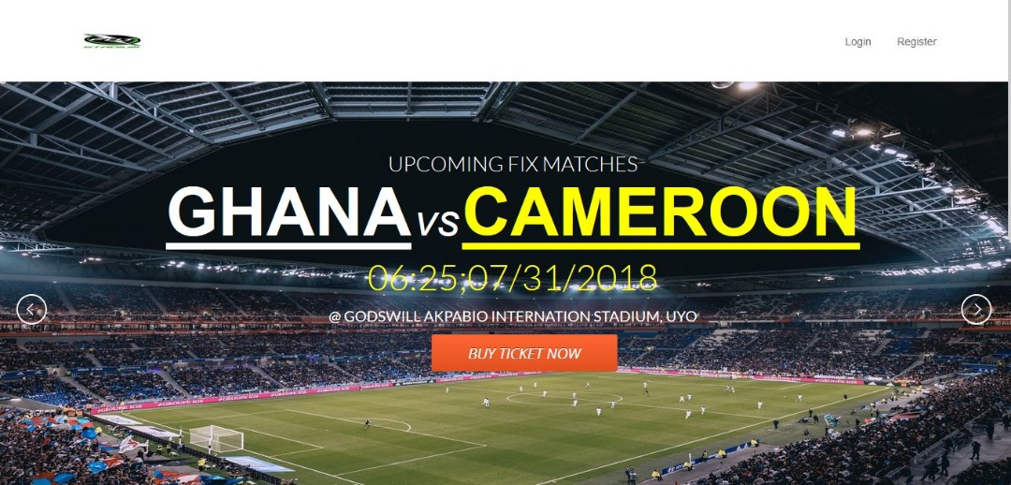

**Fig. 3.7: Home Page for Customers**

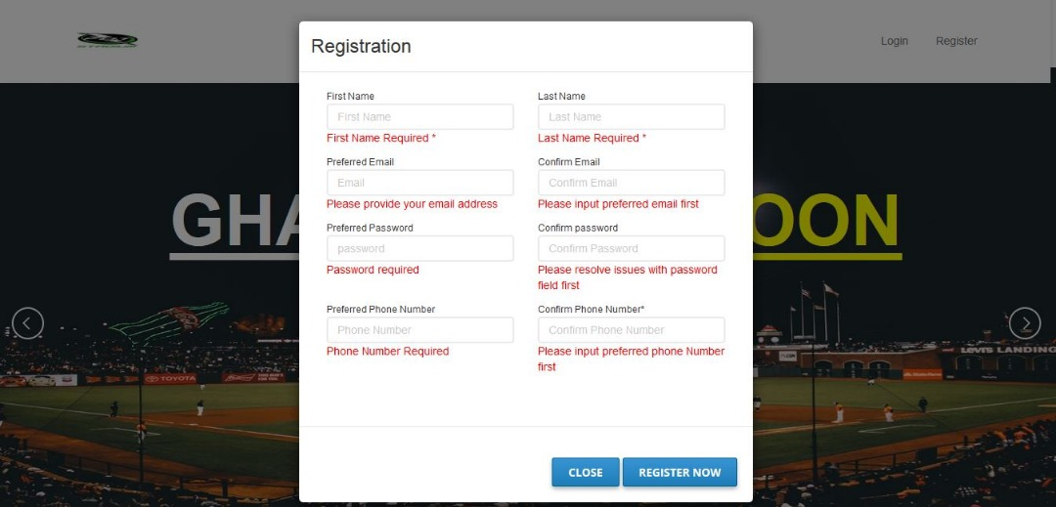

**Fig. 3.8: Signup Page for New Customers**

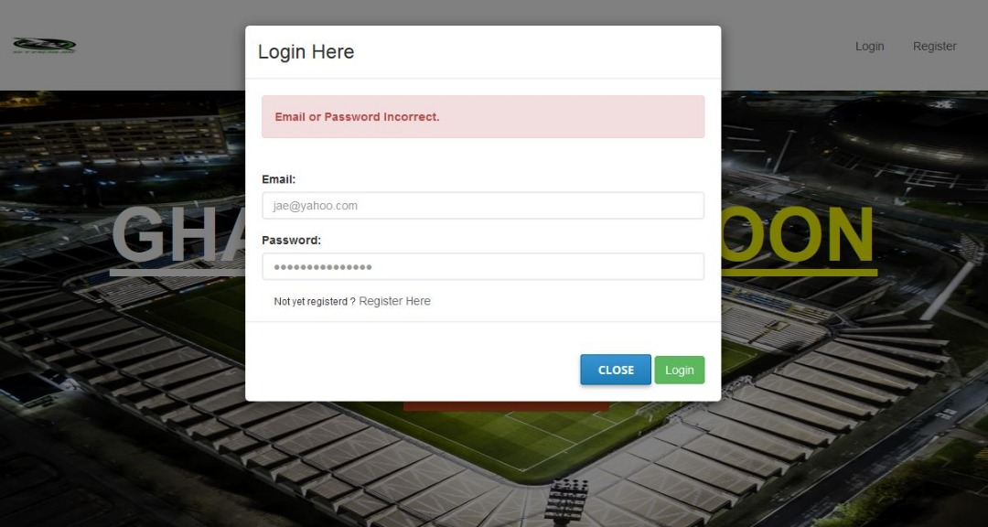

**Fig. 3.9: Login Page for Existing Customers**

**Ticket Reservation:** Upon successful signup, the user is redirected to the landing page containing the system tools shown in figure 3.7 and is then allowed to view, select and pay for match tickets as long as there is still availability of empty seats to be reserved as evidenced in figure 3.8.

* **Deployment**

The deployment phase was carried out by compiling and running all code written, debugging necessary errors and attaching proper documentation. Delivery of this increment was not released to the public as this is only proof of concept of an idea and is restricted to the developers.

**3.4.2 Increment #2**

The deliverable for the second increment is the regulation management module, dependent on the functioning of the ticket reservation module. Below are the processes involved in the process model and the description of activities as regards the second increment.

* **Planning**

The planning phase covers the cost estimates, scheduling and tracking of project progress and requirements. The estimated cost of the module was not accounted for as the engagement of the project was at intervals. The schedule from start to delivery of the deliverable i.e. the regulation management module was put at a two weeks including Saturdays and Sundays.

* **Modeling**

In the modeling phase, an analysis of the existing manual regulation management module was carried out, flaws where identified, an improved online version of the regulation module was drawn up, an analysis of hardware and software requirements as well as technical know-how to sustain the proposed system was drawn up and its design was started.

* **Current Regulation Management Setup**

The present regulation management system is basically comprised of a handful of staffs at the stadium who are assigned with the task of checking in printed slips at the entrance of the stadium. There is usually no reliable means of confirming faked tickets, therefore these regulator find it difficult to confirm tickets. The regulators themselves may sometimes engage in fraudulent activities of checking in the people they wish to favour and sometimes get tips from these individuals, hence making it difficult for the stadium administrator to reach optimum revenue target.

* **Proposed Regulation Management Setup**

The proposed online regulation system will enable the regulators to properly check in the right customers and render concrete evidence for counterfeit tickets. If individuals enter with stolen ticket I.Ds, the management can trace the ticket to the seat number. Regulator activities in turn can be monitored by the stadium administrator and can also be accounted for.

* **Construction**

In the construction phase, the code allowing customer information display fetched from the database, inputted on the back end by the administrator in this situation the regulator is written. Interaction between the SQL server and the internet was based on the already existing interaction developed for the customer ticket reservation, sign up and sign in modules.

* **Frontend of the Regulation management module**

The regulation management module using database components and input requirements from the ticket reservation system displays a form that requests the ticket details of the customer to be confirmed, but this comes up after the regulator has opened the regulatory page and has been signed into his own personal account.

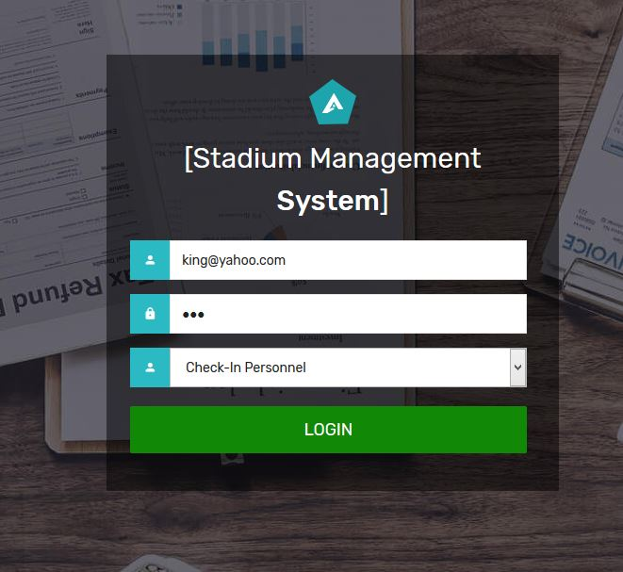

**Fig. 3.10: Regulator Login Page.**

* **Deployment**

The deployment phase was carried out by compiling and running all code written, debugging necessary errors and attaching proper documentation.

**3.4.3 Increment #3**

The deliverable for the third increment is the Administrator Management System, dependent on the functioning of the ticket reservation and regulation management modules. Below are the processes involved in the process model and the description of activities as regards the third increment.

* **Communication**

The communication phase involved project module initiation, requirements gathering for the proposed module as well as proposed module specifications.

The proposed administrator management system is an entirely new feature unavailable in the Godswill Akpabio International Stadium management system, it improves upon the traditional methods of information and fixture management via middle men at the instance of any new event at the stadium. Its working is based on its ability to retrieve registered information from the stadium’s database.

This administrator management system to be implemented is required to:

* Retrieve information on registered customers as well as the information on their transactions.
* Retrieve information on regulator activities in the stadium.
* Allow for registration of regulators and other admin staff.
* Enable event creation and pricing.
* **Planning**

The planning phase covers the cost estimates, scheduling and tracking of project progress and requirements. The estimated cost of the module was put at next to nil excluding cost of report printing. The schedule from start to delivery of the deliverable i.e. the administrator management module was put at three weeks including Saturdays and Sundays.

* **Modeling**

In the modeling phase, an analysis of the existing manual regulation management module was carried out, flaws where identified, a new online version of the administrator module was drawn up including additional features. An analysis of hardware and software requirements as well as technical know-how to sustain the proposed system was drawn up and its design was started.

* **Construction**

In the construction phase, code allowing for user entries, match placement, price modification, and other information and event management features were created. Interaction between the SQL server and the internet was based on the already existing interaction developed for the customer registration, regulation management, signup and sign in modules.

* **Frontend of the Administrator Management Module**

The Administrator Management module uses database components in terms of the retrieval of customers information registered as well as their payment information and regulator activity. The administrator module comprehensively handles management of the whole activities of the stadium with ease.

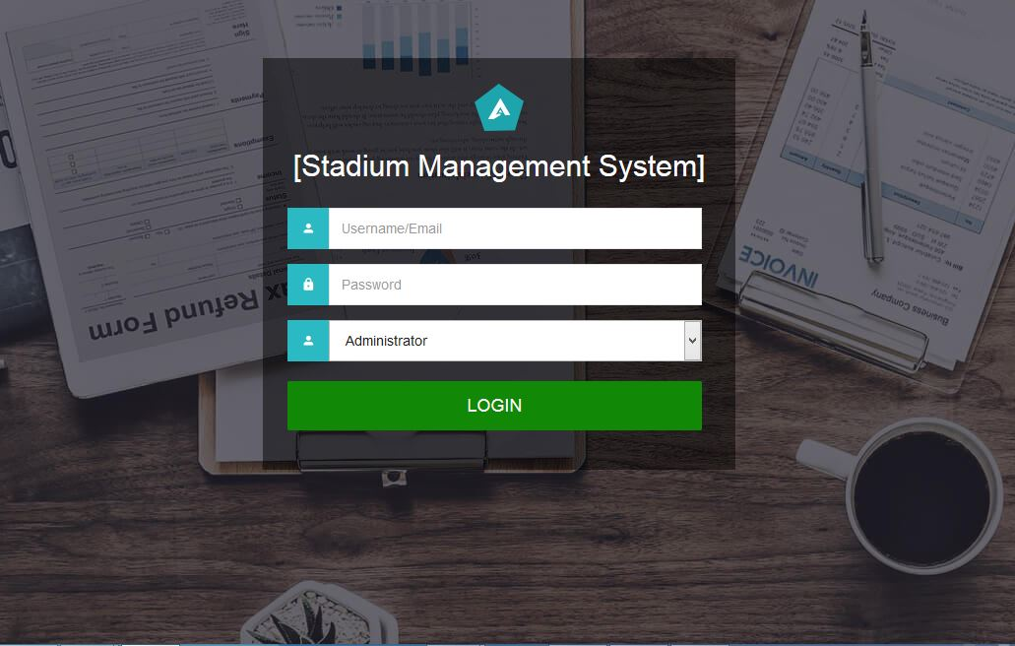

**Fig. 3.11: Administrator Login page.**

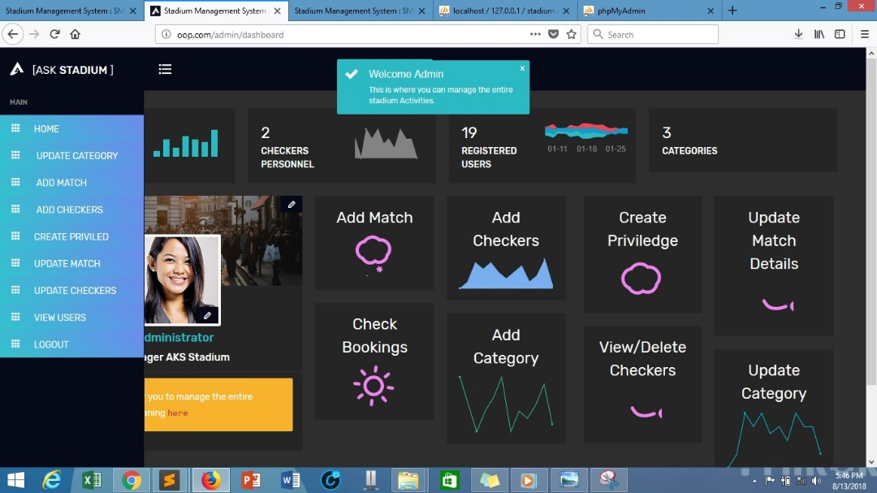

**Fig. 3.12: Administrator Welcome Page.**

* **Deployment**

The deployment phase was carried out by compiling and running all code written, debugging necessary errors and attaching proper documentation.

**CHAPTER FOUR**

**RESULTS AND DISCUSSION**

* 1. **INTRODUCTION**

The Stadium Management Information System has four main modules, the home, ticket reservation, regulation, and administrator management Modules. The modules were tested individually and as a system and it addressed the problems and met the objectives stated in sections 1.2 and 1.3 respectively. The modules are explained in details in the next section.

* 1. **THE HOME MODULE**

This module consists of the sign in page and login page for the users. The system resources are accessed only when the user is signed into the system. In case of a new user, he needs to register his details correctly on the sign up form. After successful registration, he can now sign into the system and thus have access to the system resources. The pages in this module are as shown below;



**Fig. 4.1: Customer Home Page.**

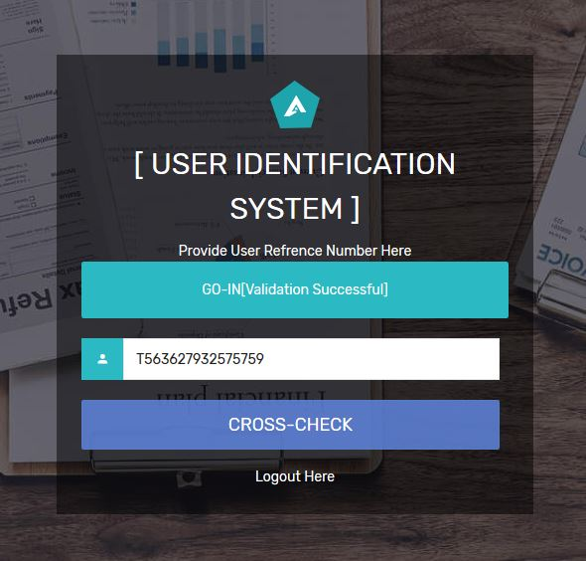

**Fig. 4.2: Regulator Home Page.**



**Fig. 4.3: Administrator Home Page.**

* 1. **TICKET RESERVATION MODULE**

The ticket reservation module enables the users to select matches, select ticket types, make payments and print tickets. The prices of the tickets depend on the ticket type. When customers select new events and ticket types, they are referred to the Paystack page to update their payment requirements. When payments are made, the browser returns to the website and a new ticket is generated, reserving a seat for the customer. If a customer’s bank account is debited without generating a ticket, then the transaction I.D. is to be taken to the bank by the customer for reimbursement. The pages in this module are as shown below;

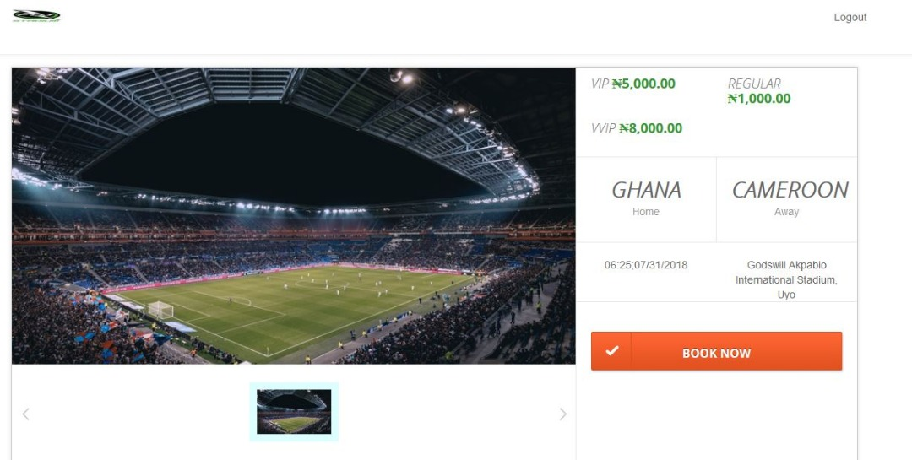

**Fig. 4.4 Ticket and Match Display Page.**

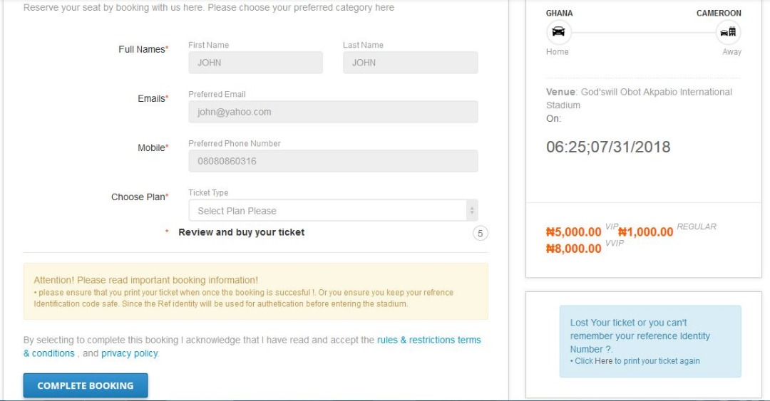

**Fig. 4.5: Ticket Booking Page.**

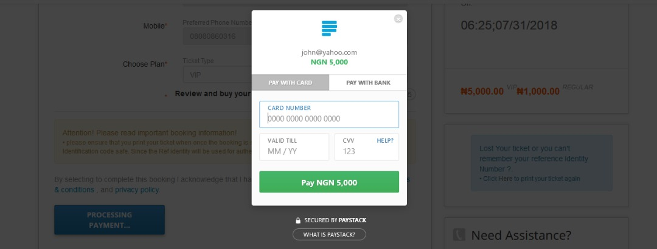

**Fig. 4.6: Payment Component.**

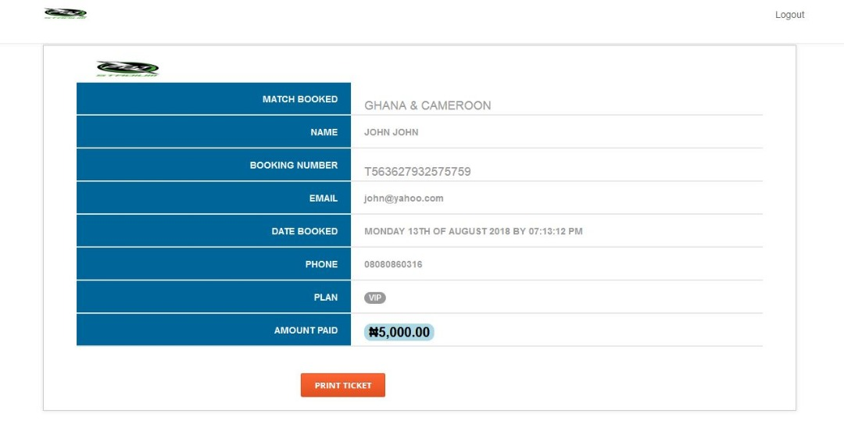

**Fig. 4.7: Ticket Generation Component.**

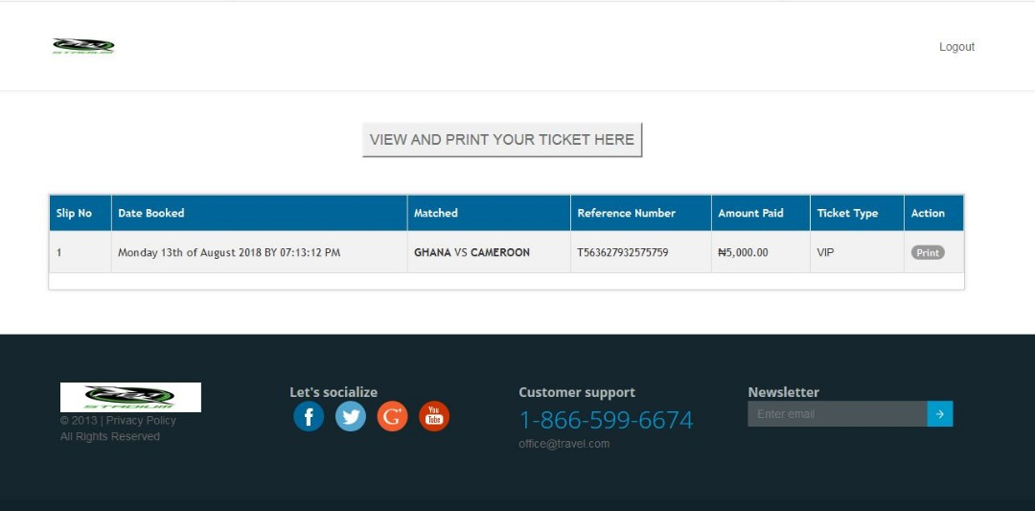

**Fig. 4.8: Ticket Viewing Component.**

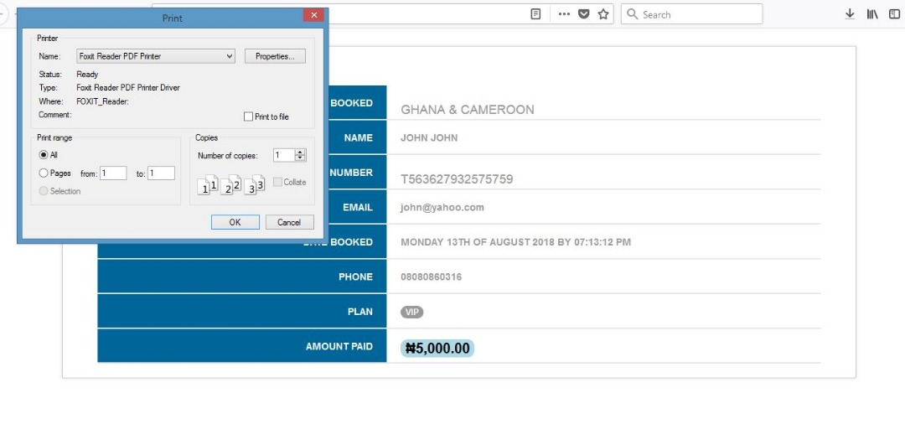

**Fig. 4.9: Ticket Printing Component.**

**4.4 REGULATION MODULE**

The regulation module is a more straight forward system. The regulators are registered by the administrator to function on match days. The regulatory system checks and confirms the validity of ticket I.Ds inputted into the system and shows if a ticket is invalid. It will render a ticket void when a customer has been checked into the stadium. The pages in this module are shown below;



**Fig. 4.10: Regulator Login Page.**



**Fig. 4.11: Regulator Check-in Component.**

**4.5 ADMINISTRATOR MODULE**

This module is the final module which gives the administrator control of the system’s functionalities. The administrator, once signed in, can handle tasks like match creation, ticket-price and ticket-type adjustments, retrieval of customer information, addition and deletion of regulators, creation of administrators, closing of the portal etc. The administrator module is only meant for the use of the person(s) in charge of running the stadium’s affairs. The pages in this module are shown below;



**Fig. 4.12: Administrator Login Page.**



**Fig. 4.13: Administrator Welcome Page.**

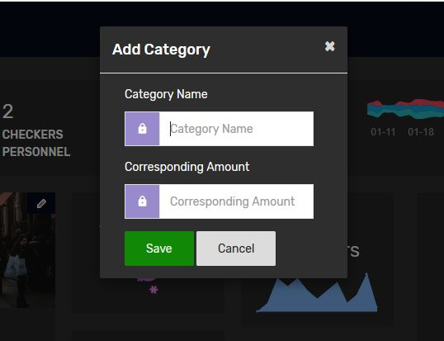

**Fig. 4.14: Ticket Category Creation.**

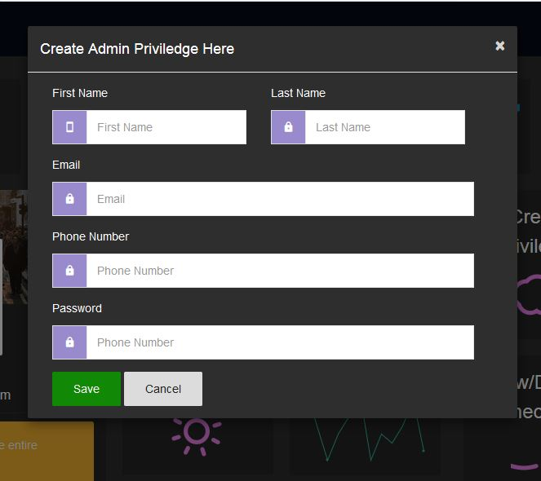

**Fig. 4.15: Creation of Admin Staff.**

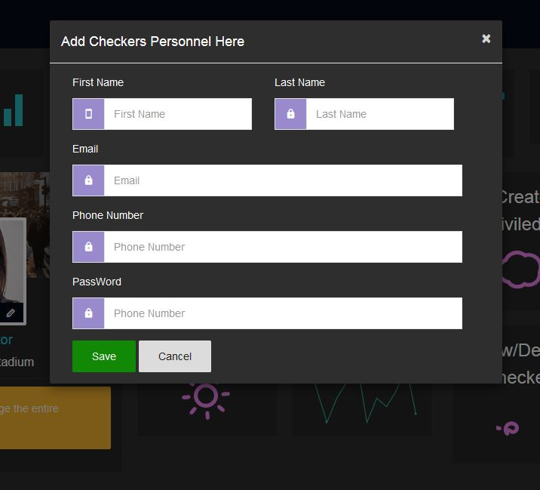

**Fig. 4.16: Creation of Regulators.**

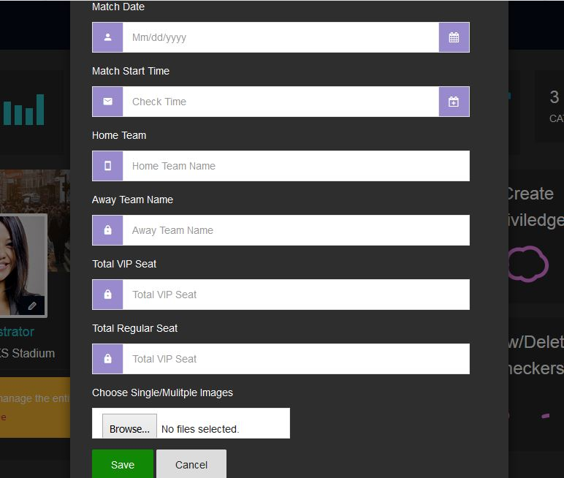

**Fig. 4.17: Creation of Match/ Event.**

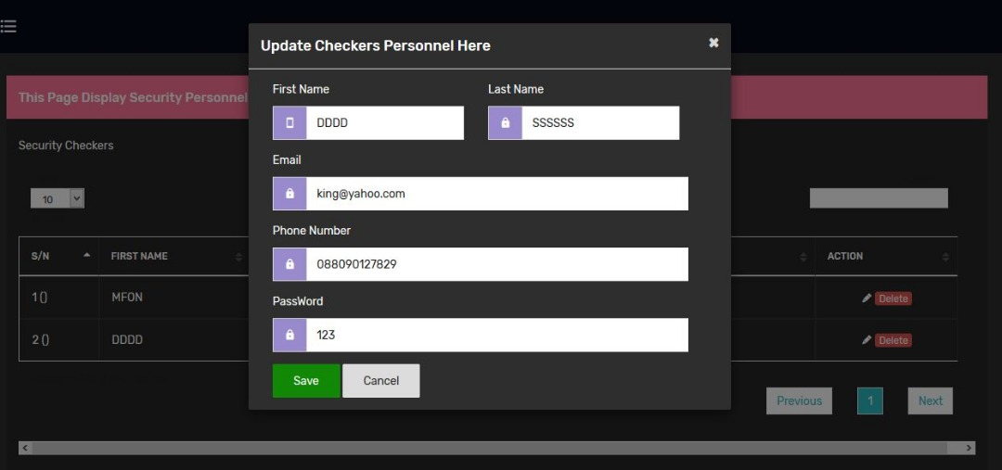

**Fig. 4.18: Update of Regulator’s Account Information.**

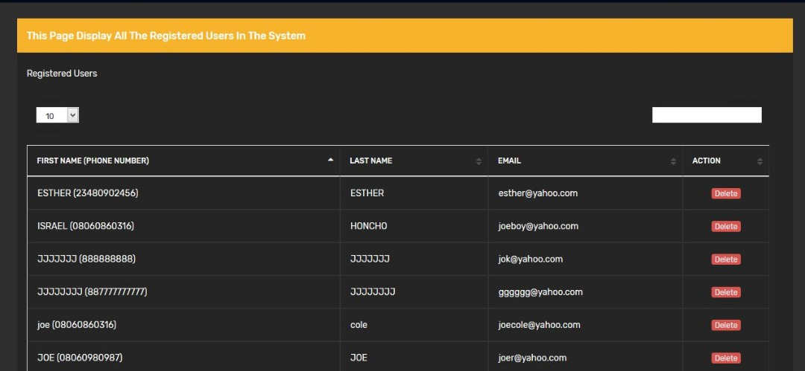

**Fig. 4.19: Customer Information Database Component.**

**4.6 TESTING**

The modules were subjected to extensive testing by five (5) individuals. The testing involved testing involved testing how the system addresses the problems and meets the objectives earlier stated in sections 1.2 and 1.3 respectively. These objectives from the test cases which include an online ticket purchase system, an accessible customer information database, and a system to check defrauding and crowd control, formed a questionnaire handed out for the testing. These test cases were duly explained in the test sheets and there was provision for assessor’s comments on each test case.

A 5-point scale was used for the testing:

5 – Excellent

4 – Very Good

3 – Good

2 – Fair

1 – Poor

**4.7 TEST RESULTS**

The test result sheets are contained in Appendices A to E, but for the purpose of discussing the results, the average assessment of the various test cases are computed in Table 4.1.

Performance averaging 3.0 or more can be termed good as the testing was done on a 5-point scale.

**Table 4.1: Average of Testing.**

|  |  |  |
| --- | --- | --- |
| **S/N** | **TEST CASES** | **AVERAGE ASSESSMENT** |
| 1. | Online Ticket Reservation System | 4.6 |
| 2. | Crowd Control/ Fraud Checking system | 4.6 |
| 3. | Accessible Customer Information Database | 4.8 |

**4.8 DISCUSSION OF RESULTS**

* **Online Ticket Reservation System:** The average assessment of 4.6 in table 4.1 proves that the system is capable of enabling users to make ticket reservations online and printing their unique tickets which will give them access to the stadium on match days.
* **Crowd Control and Fraud Checking System:** The average assessment of 4.6 proves that the system is capable of efficient management of crowd control and is also capable of pin-pointing fake reservations through the use of the regulator and administrator modules of the system.
* **Accessible Customer Information Database:** The average assessment of 4.8 proves that the system s capable of accessing and retrieving customer registration and reservation information thereby giving the administrator control over the use of the customer’s information details.

**CHAPTER FIVE**

**CONCLUSION AND RECOMMENDATIONS**

**5.1 CONCLUSION**

In this research work, a Stadium Management Information System was designed to give customers easy access to ticket reservation and the stadium management team control over affairs of the stadium with ease. As demonstrated by the results, this project has shown that the system can enable customers – who find it tasking to acquire ticket reservations – to make reservations at the comfort of their homes, the system can also enable the stadium management team run the affairs of the stadium without running losses at their own detriment.

This system has proven to be useful in assisting the stadium management and customers to conduct activities without stress and with precision.

**5.2 RECOMMENDATIONS**

This project, as resourceful as it has proven to be, can be improved upon. Recommendations for further work include:

* An additional module that will enable customers order for snacks and other purchasable items available within the stadium premises and get served on their seats.
* The mobile version of the system is recommended to enable stakeholders access the system at their conveniences.
* A chat messaging module could be added to enable customers communicate with the stadium’s help/support team.

**REFERENCES**

Katz, R. N. (2002). About Web Portals: A home page doth not make a portal. Jossey-Bass, A Wiley Company.

Kramer, W. J., Jenkins, B. and Katz, R. S. (2007). The Role of the Information and Communications Technology Sector in Expanding Economic Opportunity, Corporate Social Responsibility Initiative Report No. 22, Cambridge, MA: Kennedy School of Government, Harvard University.

Pena-Lopez, I. (2007). The Personal Research Portal: Web 2.0 Driven Individual commitment with open access development, *Knowledge Management for Development Journal*, Amsterdam. 3 (1), pp 35-48.

Strauss, H. (2000). Tech Talk Event CNI Spring Task Force Meeting, March 27-28.72 Retrieved from [www.cren.net/know/techtalk/events/portals.html](http://www.cren.net/know/techtalk/events/portals.html). Accessed on 20th June, 2018.

Top Reasons to Use MySQL. Retrieved from <http://www.mysql.com/why-mysql/topreasons.html>. Accessed on 10th June, 2018.

Abdullah, J.I (2004). Introduction to the computer, A management tool: Victory publisher Nigeria, No. 2 odor street Owerri.

Abraham S., Henry F.K, & Surdarshan S. (2006). Database System Concepts: (5th ed.). McGraw Hill Companies Inc, New York.

Feingold C. (2007). Introduction to data processing, (2nd ed.). USA, W.M.C. Brown Company publishers.

Loudon, K.C. & Loudon, J.P (2001). Business Information Systems: A Problem Solving Approach USA, The Dryden Press.

Lucas, C.H.(2008). Information Technology for Management (6th ed.). New York University, McGraw-Hill companies, New York.

Orilla, L.S (2009). Introduction to Business Data processing: New York, McGraw- HiLL companies, New York.

Cyril McGregor 2010. Business Information Management [www.management-hub.com](http://www.management-hub.com). Accessed on 15th July, 2018.

Wikipedia- the Godswill Akpabio International Stadium [www.wikipedia.org](http://www.wikipedia.org). Accessed on 8th June, 2018.

J. R. Mehmet(2012) Stadium Management for the 21st century: [www.management-hub.com](http://www.management-hub.com). Accessed on 21st June, 2018.

Dr. Dennis Wood(2008) Staff Management for Efficiency: [www.management-hub.com](http://www.management-hub.com). Accessed on 16th July, 2018.

**APPENDIX A**

**FIRST INDIVIDUAL’S TEST SHEET**

|  |  |  |  |
| --- | --- | --- | --- |
| **S/N** | **TEST CASES** | **ASSESSMENT** | **COMMENTS** |
| 1. | Online Ticket Reservation System | 5 | Excellent |
| 2. | Crowd Control/ Fraud Checking system | 4 | Very Good |
| 3. | Accessible Customer Information Database | 5 | Excellent |

**Assessment Scale**

5– Excellent

4– Very Good

3– Good

2– Fair

1– Poor

**APPENDIX B**

**SECOND INDIVIDUAL’S TEST SHEET**

|  |  |  |  |
| --- | --- | --- | --- |
| **S/N** | **TEST CASES** | **ASSESSMENT** | **COMMENTS** |
| 1. | Online Ticket Reservation System | 5 | Very Good |
| 2. | Crowd Control/ Fraud Checking system | 5 | Very Good |
| 3. | Accessible Customer Information Database | 5 | Very Good |

**Assessment Scale**

5– Excellent

4– Very Good

3– Good

2– Fair

1– Poor

**APPENDIX C**

**THIRD INDIVIDUAL’S TEST SHEET**

|  |  |  |  |
| --- | --- | --- | --- |
| **S/N** | **TEST CASES** | **ASSESSMENT** | **COMMENTS** |
| 1. | Online Ticket Reservation System | 4 | Very Good |
| 2. | Crowd Control/ Fraud Checking system | 5 | Very Good |
| 3. | Accessible Customer Information Database | 5 | Great |

**Assessment Scale**

5– Excellent

4– Very Good

3– Good

2– Fair

1– Poor

**APPENDIX D**

**FOURTH INDIVIDUAL’S TEST SHEET**

|  |  |  |  |
| --- | --- | --- | --- |
| **S/N** | **TEST CASES** | **ASSESSMENT** | **COMMENTS** |
| 1. | Online Ticket Reservation System | 5 | Very Satisfactory |
| 2. | Crowd Control/ Fraud Checking system | 4 | Very Good |
| 3. | Accessible Customer Information Database | 4 | Nice |

**Assessment Scale**

5– Excellent

4– Very Good

3– Good

2– Fair

1– Poor

**APPENDIX E**

**FIFTH INDIVIDUAL’S TEST SHEET**

|  |  |  |  |
| --- | --- | --- | --- |
| **S/N** | **TEST CASES** | **ASSESSMENT** | **COMMENTS** |
| 1. | Online Ticket Reservation System | 4 | Very Good |
| 2. | Crowd Control/ Fraud Checking system | 5 | Excellent |
| 3. | Accessible Customer Information Database | 5 | Excellent |

**Assessment Scale**

5– Excellent

4– Very Good

3– Good

2– Fair

1– Poor

**APPENDIX F**

**COMPONENT SHOWING LIST OF TRANSACTIONS FOR A SELECTED EVENT**

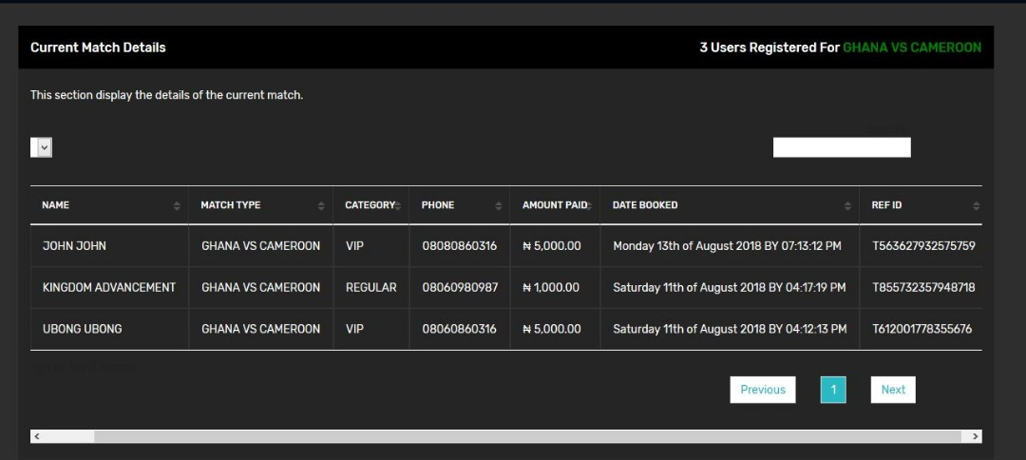

**APPENDIX G**

**ACTION TAKEN BY SYSTEM FOR MULTIPLE BOOKING BY SINGLE CUSTOMER**

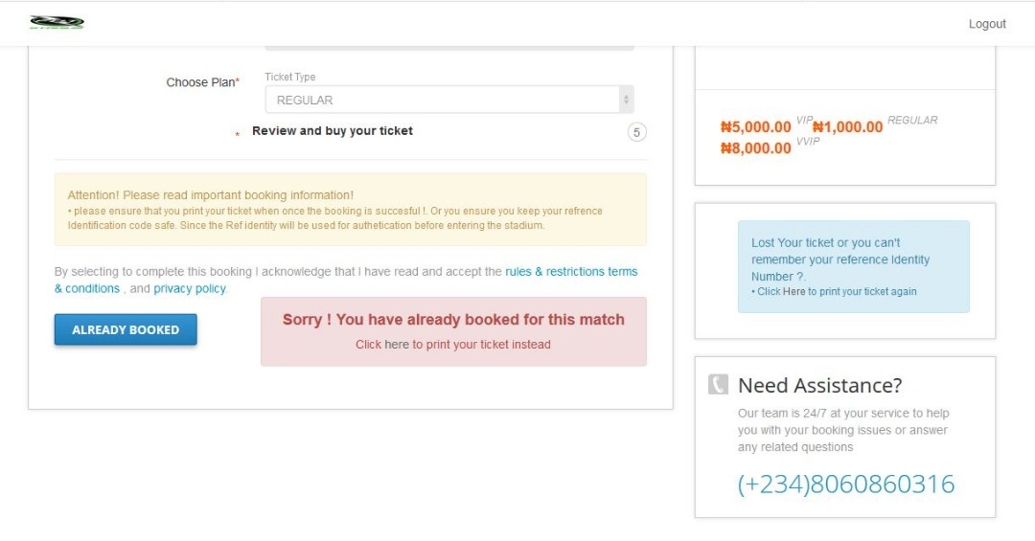

**APPENDIX H**

**MODIFICATION OF TICKET TYPES**

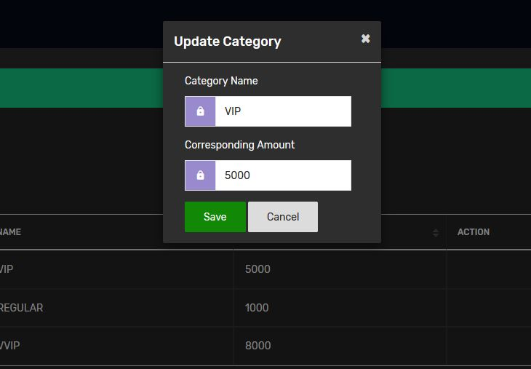

**APPENDIX I**

**ADMINISTRATOR’S END OF THE REGULATION SYSTEM**

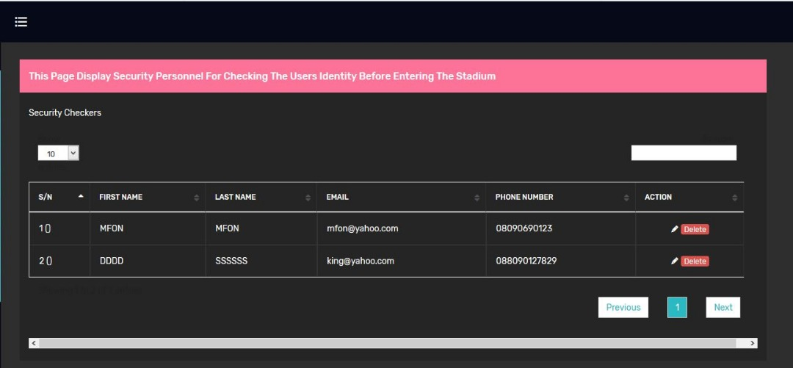

**APPANDIX J**

**GET REGULATOR CODE SNIPPET**

