DESIGN AND IMPLEMENTATION OF AN ONLINE MARKETING INFORMATION MANAGEMENT SYSTEM

ABSTRACT

Online marketing, which is also referred to as internet marketing, involves the utilization of intelligent, interactive, and virtual components for the advancement and promotion of business goods and business ventures on the internet. Recently, web-based communication companies have contributed to the advancement and restructuration of major economic divisions including marketing. Being financially-effective, flexible, adaptable and fast and enjoying an extraordinary global reach, internet marketing has achieved various unimaginable incredible gains for businesses. However, this effective, new technique additionally involves building an online marketing system.
In order to develop an online marketing system, a number of programming technologies must be studied and understood. These include multi-tiered architecture, server and client side scripting techniques, implementation technologies such as HTML, CSS and a Server side programming language (such as PHP) and relational databases. This is a project with the objective to develop a basic online marketing system where business goods and ventures can advertise their goods and business ventures and sell seamlessly.

CHAPTER ONE
INTRODUCTION
1.1 Background of the Study
The Internet has its origins in cold war and technological rivalry between USSR and US. In fact "while the World Wide Web was created in 1991, its origin dates back to 1957 when the Soviet Union launched the Sputnik I satellite" (Dickey and Lewis, 2011: 2). US reacted with establishment a department of Defense Advanced Research Project Agency (DARPA) which launched in 1960s ARPANET, an experimental project of computer networks from which what we now know as internet developed. Since then internet contributed to science incredibly and "by the late 1980s the internet was being used by many government and business institutions" (Ferguson, 2008: 69).
So internet was considered an inclusive communicative tool of scientific and research centers for several years and its academic function was its dominant prior to discovering its commercial capabilities which led to its commercialization. As Oksana (2007) puts it: "until the mid-nineties, the research and academic communities accounted for most of the internet population but the commercialization of internet soon gained enormous momentum and the business community quickly became aware of the potential it has to offer". With increasing the number of internet users during the 1990s, entrepreneurs started to appreciate commercial prospects of this new medium. Although there is no complete consensus on when did internet marketing exactly start, but the majority of commentators refer to 1994. So it is widely held that "significant commercial use of the Internet began with the first ‗banner ads‘ on web pages in 1994, and the appearance of Internet-based ‗malls‘ (the electronic equivalent of a storefront) such as Amazon.com in 1995".
Statistics make it clear that this young marketplace, online marketing, has had an astonishing rate of growth. So amazing is the growth rate of this new paradigm of marketing that it is hard to believe how young it is. In fact "in 1994, spending for internet marketing totaled nearly nothing, but increased to over $300 million in 1995. After a decade later, marketing spending and internet marketing business has exploded to nearly $500 billion (according to Forrester Research). Today, it‘s hard to believe in having an organization which doesn‘t have some kind of online presence." (Shirvastav and Alam, 2014: 25) This brief historic background is concluded by pointing to the fact that step by step online marketing has become a much more sophisticated practice. So early methods of internet marketing such as online advertising and email marketing has been followed by more younger, developed methods such as search engine optimization or social media marketing.
What is online marketing?
Chaffey et al. (2000) simply define internet marketing as "the application of the internet and related digital technologies to achieve marketing objectives"(12). This definition is a simple definition which, unlike the following ones, does not touch the important aspect of customer relationship. According to (Kotler & Armstrong, 2012: 508; Kotler et al., 2010: 493) Online marketing consists of measures and activities to promote products and services and build relationships with customers over the Internet. Burrett (2008) understands online marketing as ―carefully targeting users and getting them to interact with you while they‘re engaged with the most personal, intimate medium ever invented. The most comprehensive definition has been articulated by Chaffey (2007), he defines online marketing as ―Applying Digital technologies which form online channels (Web, e-mail, databases, plus mobile/wireless & digital TV) to contribute to marketing activities aimed at achieving profitable acquisition and retention of customers (within a multi-channel buying process and customer lifecycle) through improving our customer knowledge (of their profiles, behavior, value and loyalty drivers), then delivering integrated targeted communications and online services that match their individual needs". As this relationship concept definitions show online marketing revolve around interaction and building relationship with customers, a point which discriminates it from traditional, offline marketing.

1.2 Statement of the Problem
One of the major problems Business Marketing face in their campaigns is still the use of primitive promotions channels such as press, brochure, catalogue, TV, cell phone, etc, and several offline channels which lacks a comprehensive, harmonizing marketing framework. In this project work, we present a new solution for businesses to promote their business online to reach a wider audience.

1.3 AIM AND OBJECTIVE OF THE STUDY
The principle aim of this project is to develop and implement an online marketing system that will be useful to business owners, with the following objectives:
- To create a platform for businesses to reach a wider audience and increase sales and profits.
- To develop a general purpose store where consumers can find products and services from the comfort of home through the Internet.
- To implement an online virtual store on the Internet where customers can browse the catalog and select products of interest.

1.4 Scope of the Project
This research work presents an online marketing information system that will be implemented within the company to help the inventory manager record the details of the inventory,sales and the details of the stock including the product, supplier and order. The information is stored in a MySQL database. The system will provide all of the information needed for online marketing. It is made up of different modules: manager, product information display, supplier info which will enable the inventory manager to create /delete inventory or add new inventory or send alerts when the inventory levels are low in stock and will enable to track order history of vendor.
The research covers the planning, analyzing and designing phases of the system. A prototype is also created to describe how to use the system. Implementation and testing is also included in this research
1.5 Significance of the Project
Computerized stock management, maintenance and control which are presented by the developed system are a vital tool in any business. To our case study company, this project work will go a long way is simplifying trade especially during peak sale period. It curbs the problems identified from the current system of operation where sales are documented on paper by implementing a fast database which can be queried within seconds. The system notifies the users of stock status,, thereby showing them when to place order for a new item This paper help provides such tools and helpful in management, control and effectiveness.

This research work will also be of importance to scholars researching the field of trade automation as it will serve as a reference point to them or a beginning point for better researches.
1.6 Limitation of the Project
The limitation encountered during the course of project were:
High cost of Internet data, to get relevant materials and journals for the research. Learning various programming languages for the development of the project in a short time.

1.7 Definition of Terms
Internet: The Internet is a global wide area network that connects computer systems across the world.
Business: A business is defined as an organization or enterprising entity engaged in commercial, industrial, or professional activities.
Virtual Store: The virtual store is an online store that displays merchandise and an order form.
Marketing: Marketing is the process of teaching consumers why they should choose your product or service over those of your competitors, and is a form of persuasive communication.
Promotion Channels: In marketing, promotion refers to any type of marketing communication used to inform or persuade target audiences of the relative merits of a product, service, brand or issue.
Customer Relation: Customer relations describes the ways that a company will engage with its customers to improve the customer experience.

CHAPTER TWO
LITERATURE REVIEW

2.1 Definition—Marketing Information System (MkIS)
Simply put, a MkIS is a computerized system that is designed to provide an organized flow of information to enable and support the marketing activities of an organization. The MkIS serves collaborative, analytical and operational needs. In the collaborative mode, the MkIS enables managers to share information and work together virtually. In addition, the MkIS can enable marketers to collaborate with customers on product designs and customer requirements. The analytical function is addressed by decision support applications that enable marketers to analyze market data on customers, competitors, technology and general market conditions. These insights are becoming the foundation for the development of marketing strategies and plans.
The MkIS addresses operational needs through customer management systems that focus on the day-to-day processing of customer transactions from the initial sale through customer service.
MkIS systems are designed to be comprehensive and flexible in nature and to integrate with each other functionally. They are formal, forward looking and essential to the organization’s ability to create competitive advantage. The MkIS is the firm’s “window on the world” and, increasingly, it is the primary customer interface. Figure 1 presents the basic architecture of the MkIS.

2.2 The Strategic Role of the Marketing Information Systems
Historically, the role of the marketing function has been to support “make and sell” business strategies that emphasized increases in market share over the creation of long-term customer value. This view started to change after World War II with the recognition that satisfying the customer’s needs and wants should be the focus of a firm’s business activities.
The emphasis on the customer elevated the importance of marketing as a core business function on a par with research and development and production. The marketing function has become the firm’s window to the world in the sense that it must monitor the marketing environment for changes in buyer behavior, competition, technology, economic conditions, and government policies. Marketing is a “strategic” function in that marketing activities enable organizations to identify and adapt to changes in the market environment.
The strategic function of marketing is further emphasized as Internet-based technologies have enabled radically new approaches to selling where information technology for the first time touches customers and provides new means for collecting marketing information. In a knowledge-intensive economy, the ability to collect, analyze and act upon marketing information more rapidly than the competition is the core competency from which competitive advantage flows. Marketing information systems provide the information technology backbone for the marketing organization’s strategic operations.
In a broader sense, the MkIS creates an organized and timely flow of information required by marketing decision makers. It involves the equipment, software, databases, and also the procedures, methodologies and people necessary for the system to meet its organizational objectives. MkIS encompasses a broad spectrum of activities from simple transaction processing complex marketing strategy decision making.
2.3 The Role of the Internet
Information technology has transformed how firms conduct business. For example, financial service providers such as banks, stockbrokers and insurance companies could not do business today without their client-server-based information technology. This technology has long supported marketing activities. However, it is the recent advent of the Internet, and especially the browserbased World Wide Web, which has ignited a revolution in MkISs.
The term “cybermarketing” is often used to describe the Internet’s convergence of computers, information systems, telecommunications and the customer with the marketing process. Internet marketing is characterized by interactivity, graphical user interfaces, multimedia content, and one-to-one connectivity. Internet technologies are not only providing new ways to reach the customer, but also to enable the reengineering of the entire marketing process and, indeed, the entire enterprise. It is no longer acceptable to view marketing as a standalone activity with lengthy time lapses between product concept, marketing strategy and commercialization.
Marketing has become interactive and real time. The rapidly growing field of marketing automation encompasses customer management functions to support e-commerce. As depicted in Figure 2, customer management applications include marketing decision support systems, customer relationship management, sales force automation, customer service and e-commerce activities. These activities are often described as “front office” customer-oriented activities. “Back office” enterprise resource planning (ERP) activities include manufacturing, finance and human resources. “Supply chain management” (SCM) activities encompass electronic procurement, inventory management, quality management and logistics systems to link an organization with its suppliers. These three elements comprise the enterprise information system.

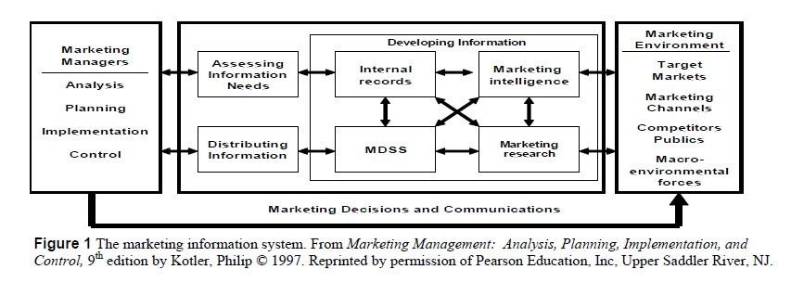

Large integrated enterprise software companies such as Oracle, SAP, PeopleSoft, and IBM address all three major applications and they are beginning to use Web-based technologies to redesign business processes throughout the organization. The result is leaner organizations, faster response times, and lower costs. Decision makers are able to integrate information from customers, suppliers, and the internal organization to obtain an enterprise-wide view of their ability to develop and execute marketing strategy. Until truly integrated browser-based systems are widely in use, the principal challenge for marketers is to tie e-commerce generated data with legacy information systems in order to create a unified view of each customer. Marketers will need to understand all the various ways that customers are touching the business through existing interfaces and e-commerce. Many of the older interfaces, such as telemarketing centers, point of sale (POS) systems, and the sales force are likely to be supported by legacy client-server technology.
Marketers need to consolidate data from those systems with that from the Web-based ecommerce sources into a holistic view of the customer and make it available to decision makers.
2.4 Benefits of the Marketing Information System
The MkIS increases the number of options available to decision-makers and supports every element of marketing strategy. MkIS affects marketing’s interfaces with customers, suppliers and other partners. The primary benefits of the MkIS impact in the areas of functional integration, market monitoring, strategy development, and strategy implementation.
2.4.1. Market Monitoring.
Through the use of market research and marketing intelligence activities the MkIS can enable the identification of emerging market segments, and the monitoring of the market environment for changes in consumer behavior, competitor activities, new technologies, economic conditions and governmental policies. Market research is situational in nature and focuses on specific strategic or tactical marketing initiatives. Marketing intelligence is continuous in nature and involves monitoring and analyzing a broad range of market-based activities and information sources. There are three major sources of market information.
The first is syndicated data published by market research companies and industry associations. Company-sponsored primary research is another option. It is much more focused since you ask specific questions of respondents within your markets. But, it is considerably more expensive and time consuming. Perhaps the best data available are your own customer’s behavior captured from web site viewing, point of sale (POS) transactions, and systematic feed back from the sales force.
2.4.2. Strategy Development.
The MkIS provides the information necessary to develop marketing strategy. It supports strategy development for new products, product positioning, marketing communications (advertising, public relations, and sales promotion), pricing, personal selling, distribution, customer service and partnerships and alliances. The MkIS provides the foundation for the development information system-dependent e-commerce strategies.
2.4.3. Strategy Implementation.
The MkIS provides support for product launches, enables the coordination of marketing strategies, and is an integral part of sales force automation (SFA), customer relationship management (CRM), and customer service systems.

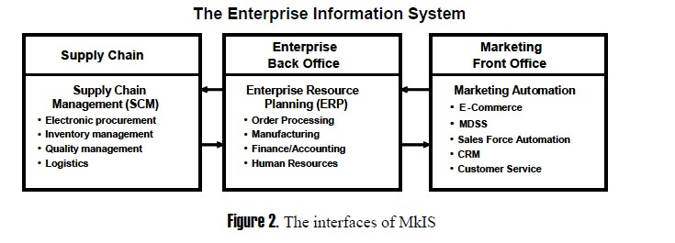

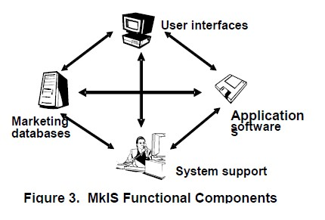

The MkIS enables decision makers to more effectively manage the sales force as well as customer relationships. Some customer management software companies are extending their CRM applications to include partner relationship management (PRM) capabilities. This has become increasingly important as many marketers are choosing to outsource important marketing functions and form strategic alliances to address new markets.
2.4.4. Functional integration.
The MkIS enables the coordination of activities within the marketing department and between marketing and other organizational functions such as engineering, production, product management, finance, manufacturing, logistics, and customer service.

2.5 Marketing Information System Functional Components
As shown in Figure 3, a MkIS consists of four major components: (1) user interfaces, (2) applications software, (3) databases, and (4) systems support.
1. User Interfaces. The essential element of the MkIS is the managers who will use the system and the interfaces they need to effectively analyze and use marketing information. The design of the system will depend on what type of decisions managers need to make. The interface includes the type of hardware that will be used, the way information is analyzed, formatted and displayed, and how reports are to be compiled and distributed. Issues to resolve are ease of use, security, cost, and access.
2. Applications Software. These are the programs that marketing decision makers use to collect, analyze, and manage data for the purpose of developing the information necessary for marketing decisions. Examples include the marketing decisions support software (MDSS) and customer management software for on-line sales and customer service.
3. Marketing Databases. A marketing database is a system in which marketing data files are organized d stored. Data may be collected from internal and external sources. Internal sources largely result from transactions. They provide data from e-commerce sites, sales results, shipping data, inventories, and product profitability. External sources include market research, competitor intelligence, credit bureaus, and financial institutions. Data can be organized in a flat file (Text file with one data record per line) or a relational database (Data is stored in tabular form where each row represents one entity and each column represents one characteristic of that entity). For instance, each row could represent a customer with the columns providing name, identification number, and purchase information.
4. System Support. This component consists of system managers who manage and maintain the systems assets including software and hardware network, monitor its activities andensure compliance with organizational policies. This function may also include a help desk for system users.
2.6 MARKETING DECISION SUPPORT SYSTEM
Marketing decision support systems (MDSS) constitute a set of core applications of the MkIS.
The MDSS provides computer-based tools, models, and techniques to support the marketing manager’s decision process. In the general case, MDSS is optimized for queries of historical data.
MDSS data typically are derived from both internal and external market sources. The MDSS features inquiry and report generation functions where the manager can access marketing data, analyze it statistically, and use the results to determine an optimal course of action.
A. Marketing Decisions Support System Functions
The MDSS can provide analytical models for forecasting, simulation, and optimization. MDSS tools include simple spreadsheets such as Excel, statistical analysis packages such as SPSS and SAS, on-line analytical processing (OLAP) tools, data mining applications, and neural networks.
The MDSS provides the user with the ability to explore multiple options. Typical MDSS functions include models and tools for:
1. Sensitivity analysis. Decision-makers can explore changes in a strategic variable such as price and model its impact on demand or competitive behavior.
2. What-if analysis. Can be easily accomplished with a spreadsheet. Revenues and costs can be manipulated to show the impact of each variable on profits and cash flows.
3. Goal setting. Analysis focuses on the desired result and builds the resource base necessary to accomplish the goal.
4. Exception reporting. Analysis looks for results that exceed or fall short of stated goals or benchmarks. Which products or segments exceeded sales forecasts? Sometimes called gap analysis.
5. Pareto analysis. Analysis looks for activities that generate disproportionate results. For instance, the top 20 percent of customers may account for 80 percent of sales revenues.
6. Forecasting models. Econometric models are used to analyze time series data for the purpose of predicting future sales and market share levels.
7. Simulation models. Monte Carlo simulations address marketing decision making under conditions of uncertainty. Variables such as the market price, unit variable cost, and quantity sold are not known ahead of the product investment decision. Simulation models allow the marketer to analyze risk and assess the probabilities of likely outcomes of their decisions.
8. Scorecards and dashboards. Scorecard systems can present a consistent framework for tracking the effectiveness of marketing activities. They often have different modules for senior executives, marketing managers, product managers, and customer service managers. Scorecard systems allow the user to “drill down” on an analytic and workflow basis to determine the status of any strategic initiative. Dashboards allow frontline managers to monitor their critical performance indicators. These systems are often used in conjunction with “best practice” standards for call-center-based customer support.
B. MDSS Analyses
Marketers typically use MDSS models and tools to analyze markets, customers, competitors, and internal operations. The following list presents some of the most common types of issues targeted by MDSS analyses.
1. Market segment analysis. Use ofmodeling techniques to identify segments and analyze economic trends, demographics and behavior.
2. Market share analysis. Analyze trends and determinants of market share.
3. Competitor analysis. Analysis of competitors’ market positions, economics customer base, and marketing strategies.
4. Pricing analysis. Identifies and analyzes the factors that influence a firm’s ability to set prices including price elasticity and demand analysis. Includes internal economics and market related factors.
5. Cost analysis. Studies a firm’s overall cost structure and its impact on product cost. Margin analysis combines cost analysis with pricing analysis. Variance analysis looks for explanations of costs overages and underages.
6. Sales analysis. Studies the distribution of a firm’s sales by region, product, brand, sales territory, etc.
7. Sales forecasting. Develops estimates of sales potential by product, region, sales territory, brand, etc.
8. Sales force productivity. Studies sales force effectiveness and efficiency and contributing factors.
9. Advertising analysis. Analyzes advertising effectiveness, media choices and brand awareness.
10. Distribution. Analyzes channel decisions from economic and strategic perspectives.
11. Simulation. Simulates decision making under various strategic scenarios.
12. Customer satisfaction. Analyzes issues concerning the customer’s expectations and outcomes with the product.

CHAPTER THREE
SYSTEM ANALYSIS AND DESIGN
3.1 INTRODUCTION
This chapter gives details explanation of system analysis, the structure of the organization used as the case study, designs steps and procedures as well as constraints and limitation of the old system with a new improvement upon the proposed new system.
In this section we briefly describe the existing system and point out the problem caused by the old system. To develop or design OSS the researcher spent time studying the existing system, interviewed the staff and find out how the existing system works and what is required of it by identifying and collecting necessary documentation relating to the system.
3.2 SYSTEM ANALYSIS
System analysis simply refers to what is required of the system as well as the procedures and components required to make the system work on specification. It consists of an in depth analysis of how the existing system worked, its strengths, weakness, benefits and above all its problem which give side to this research work. In carry out system analysis, an analyst must first define the scope within which he intends to work.
System design it therefore the building o0f more efficient system, capable of fulfilling the requirement of the user and the database.
3.3 ORGANIZATIONAL CHART
An organizational chart is a diagram that shows the structure if an organization and the relationship and relative ranks of its part and position/ jobs. Or is visual representation of how a firm intends authority respectability and information to flow within its formal organizational structure.

FUNCTIONAL ORGANIZATIONAL STRUCTURE
General Manager

Finance Human Resources

Operations

Research & Product
Development Marketing

3.5 REVIEW OF THE EXISTING SYSTEM
During the feasibility study, we realized that Most Marketing Companies was operating on manual (offline) method of shopping which involve going to the shops and be on a long queue in order to purchase goods which will consume a lot of time and strength before the customer will search for the goods needed. These results in some problems like;
Slow in processing customer’s information
Data inconsistency/ Redundancy
Inaccurate during customers transaction

STRUCTURE OF THE EXISTING SYSTEM
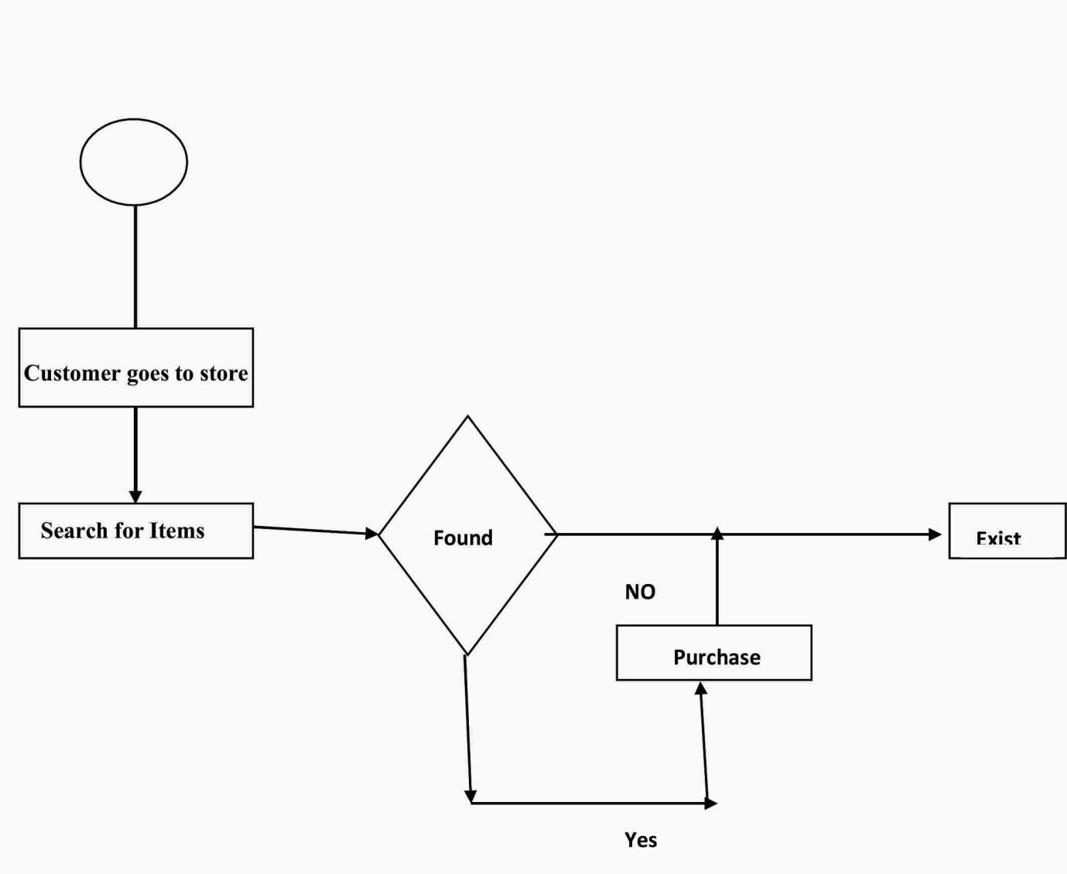

3.6 CONSTRAINTS OF THE EXISTING SYSTEM
The constraints discovered in the existing system during the course of carrying out this research work are as follows:
It involve a lot of paper work during transaction
Inadequate of accuracy in customer’s records
It is inefficient, tedious and time consuming
Customers must carry what they brought

ANALYSIS OF THE PROPOSED NEW SYSTEM
Analysis is an integral part of the development cycle of any system. The proposed new system will make use of files and records in table’s prepared using database to store information about everyday transaction. Having analysed the existing system, there is need for an alternative system; the proposed system (electronic shopping system) will eliminate the problems experienced in the existing system.
The proposed new system is design to enhance the following:
Convenience
Consistency of Data
Reliability
Increases Productivity
Easy update and Maintenance Operations
Variety
Speed Optimization and reduce paper work

STRUCTURE OF THE PROPOSED NEW SYSTEM
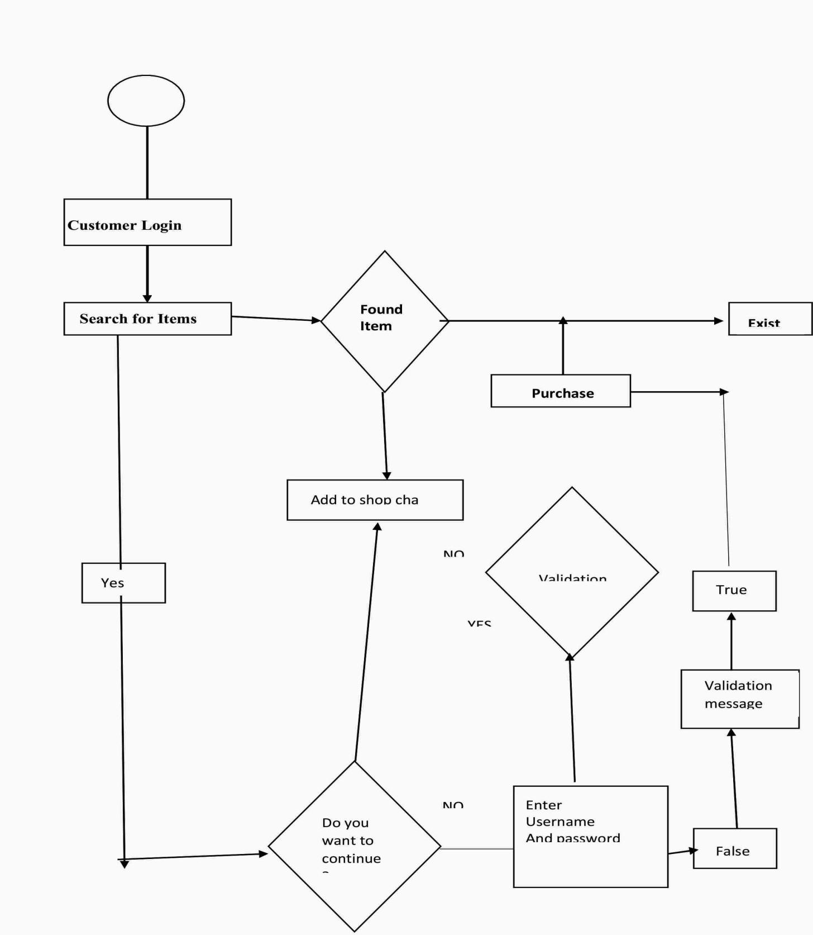

3.8 JUSTIFICATION OF THE NEW SYSTEM

The main reason the new system is being designed is to switch over from offline shopping system (manual) to the online shopping system (Computerizes) so as to enhance easy, fast and convenience shopping rather than being on a queue during shopping . this new system will be designed using PHP such that it will enhance link to database and other advantages like;

It gives access for creating a database file structure for storing and retrieval of information.
It has enough tools and approaches for data management
3.9 OBJECTIVES OF THE NEW SYSTEM
The under listed are the objectives of the new system
It will under listed are the objectives of the new system
It will guarantee data integrity and redundancy
It will also reduce cost related to the old system
It will help in elimination of data redundancy
It will reduce error and maintain accurate data entity with process of operating on the computerized system
It will eliminate the difficulties faced by the customers through the existing system.
CHOICE OF PROGRAMMING LANGUAGE
There are many programming languages that have facilities for database management, such as PHP, MYSQL, Dream Weaver, html etc
PHP is the choice for this system;
It has powerful tools for managing data in the database files it has variable names that will make meaning even to the users of the system. It has tools and controls used for creating forms on the interface in the user’s friendly manner. For database, Microsoft Access is the choice for this system since it is a database application in which each field constraints a discrete item of information in a standardize format. The database management system store in multiple locations, ease data redundancy and inconsistency. The justification for the choice of application packages are:
It is simply to understand and manipulate
It is especially good for handing lots of data that are commercially and industrially oriented
Base of retrieval and update of files.

3.11 SYSTEM CONTROL

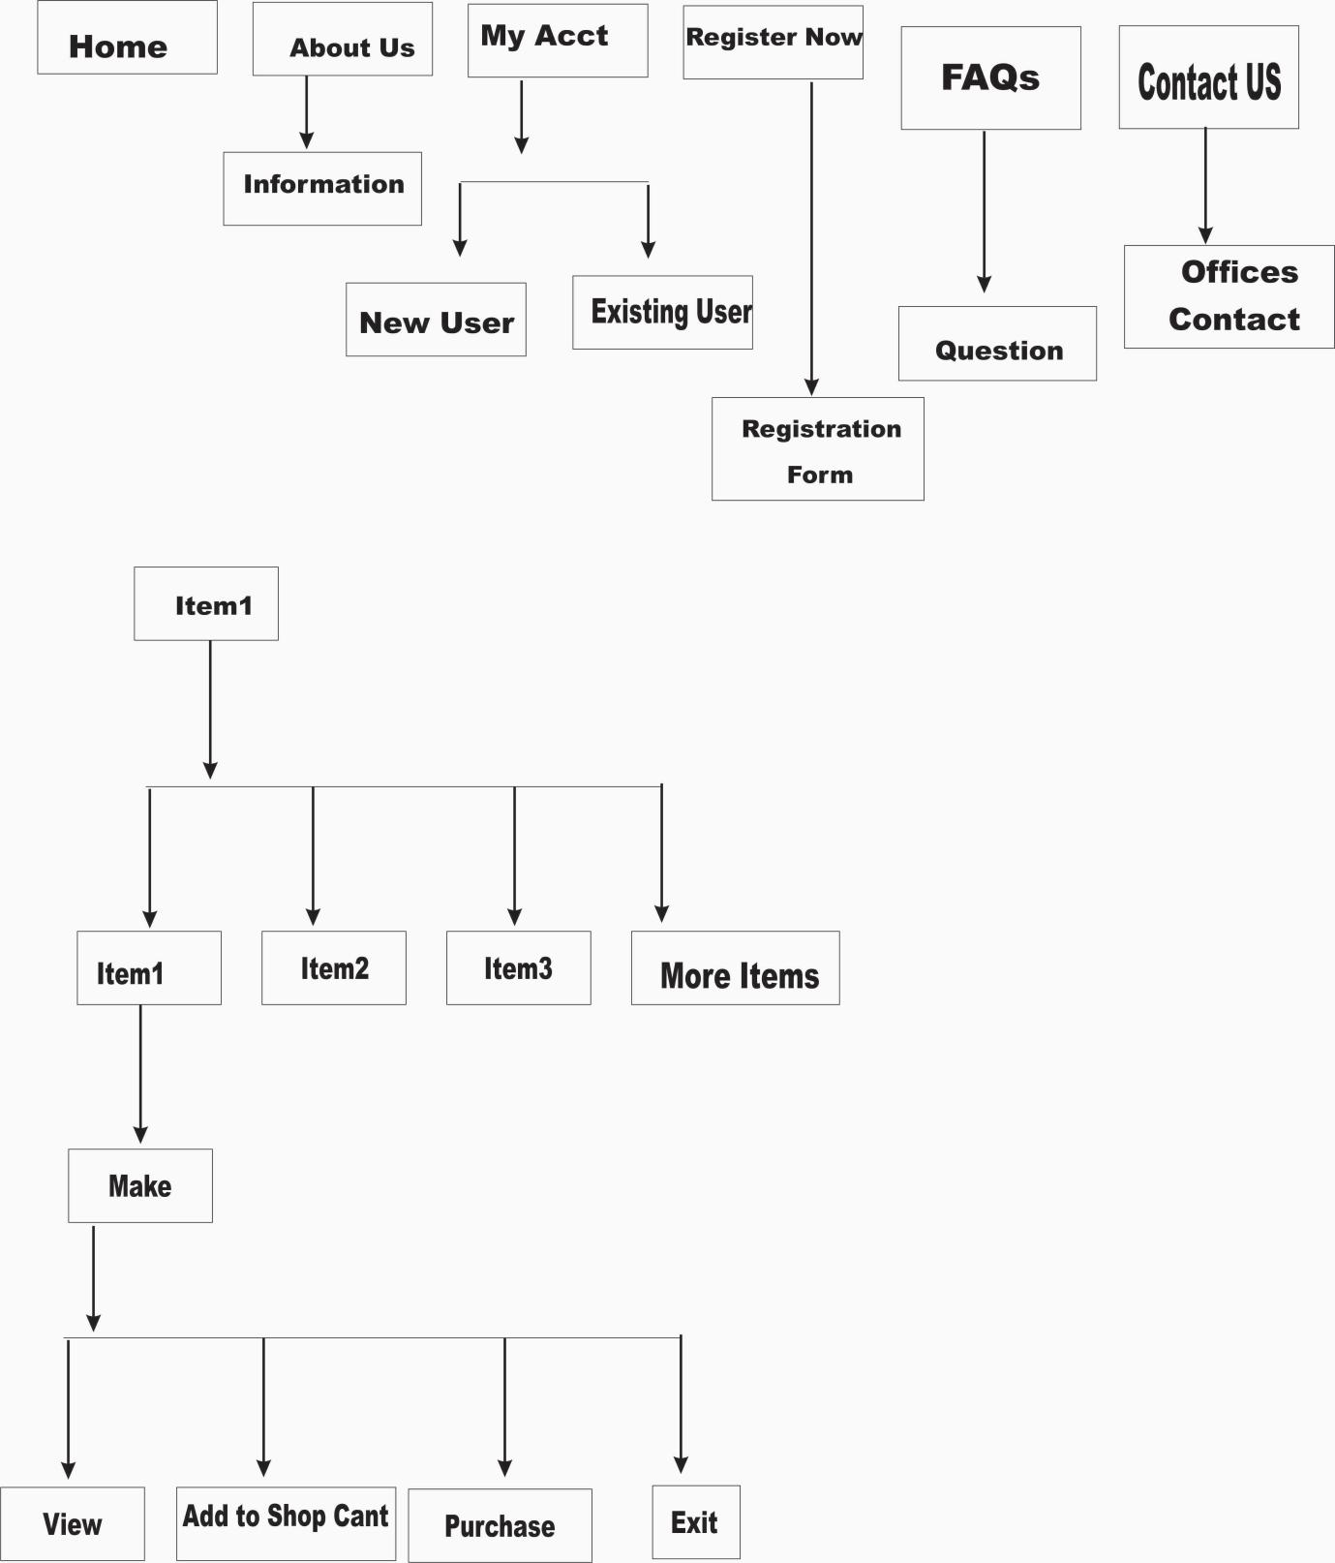

SYSTEM CONTROL: In communications system, is the control and implementation of a set of function that;
Prevent of eliminate degradation of any part of the system
Initiate immediate response to demands that are placed on the system.
Response to changes in the system to long range requirements.
INPUT AND OUTPUT DESIGN
INPUT: an input design refers to the designing of the screen used to enter the information, as well as any form on which users write or types information. It facilitate the entry of data into the computer system.
INPUT DESIGN
FILED NAME | DATA TYPES | SIZE | DESCRIPTION
F_ Name | Text | 30 | First Name
L_ Name | Text | 40 | Last Name
Sex | Character | 30 | Sex
Add | Alphanumeric | 50 | Address
City | Text | 30 | City
State | Text | 40 | State
Country | Text | 40 | Country
Phone _ Num | Number | 20 | Phone Number

OUTPUT DESIGN: Output design refers to the report that the system produces, weather or the screen, on paper or in other media such as the web, it is perhaps the most visible part of any system because the primary reason for using an information system is to access the information it produces.
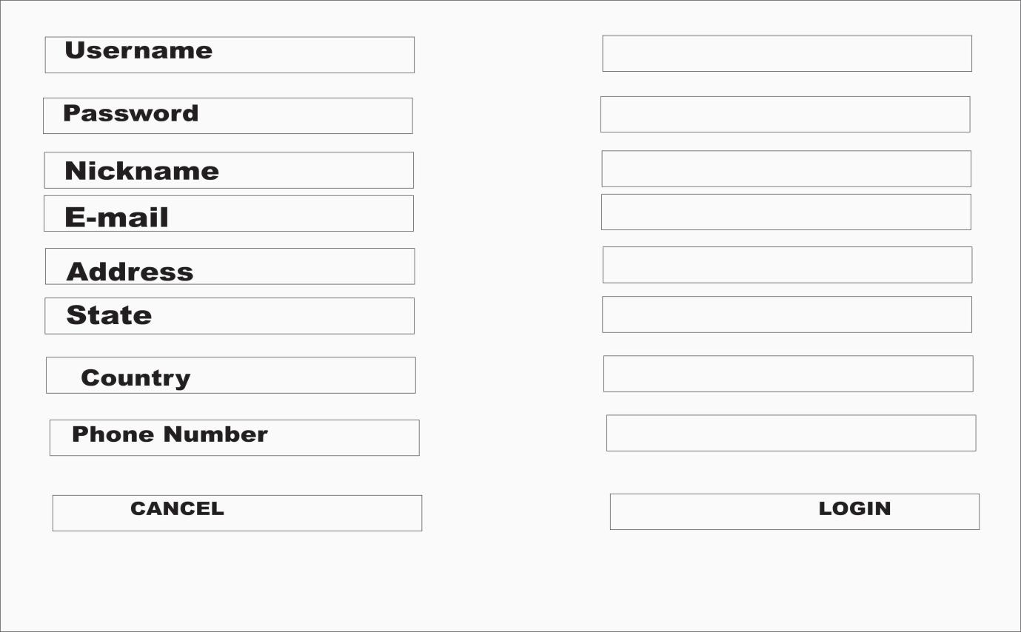
INTERFACE DESIGN: It deals with the process of developing a method of two (or more) modules in a system to connect and communicate. These modules can apply to hardware, software or the interface between a user and a machine.

INTERFACE DESIGN
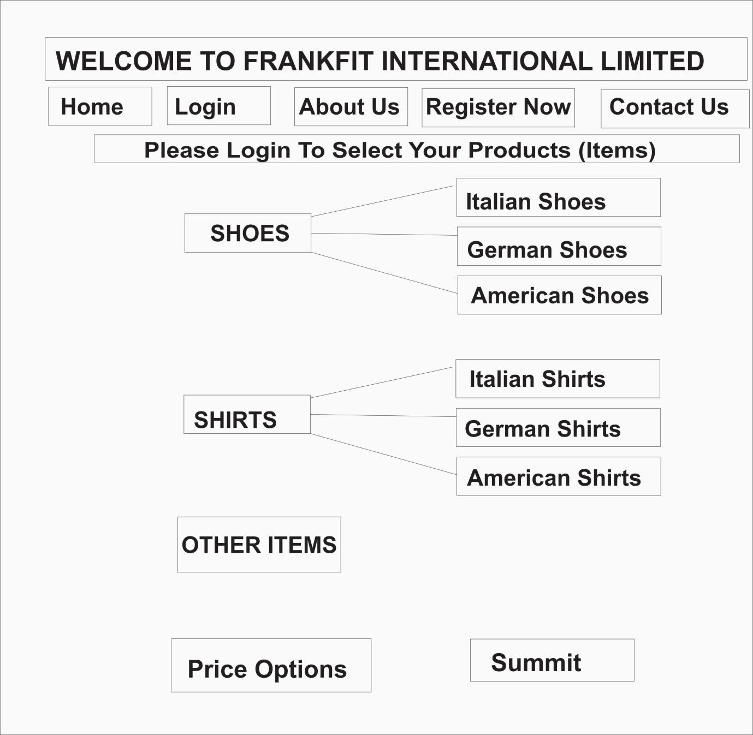

CHAPTER FOUR
SYSTEM IMPLEMENTATION AND DOCUMENTATION
4.1 INTRODUCTION
This chapter deals with the documentation and implementation phase of the new system constituting the main part of the system, the present chapter discusses deeply the implementation of the system, highlighting the testing exercise and describing some of the main component of the system’s Graphical User interface (GUI). It will give an output from the programming language and other tool used to develop the system.
Documentation in the new system provides adequate information and instructions that enable the user to used the system effectively by reviewing and updating the new system while the implementation has to do with the testing of the new system for it functionality.
4.2 SYSTEM IMPLEMENTATION
The implementation of the system simply show how the new system should be applied in order to ensure good performance which can be achieved via system conversion or changing over from the old system to the new system.
The different approaches to system conversion are:
DIRECT APPROACH: This is otherwise known as the scratch approach which involves the total replacement of the old system with the new one. This approach allow the new system to be tested properly in order to determine it efficiency, reliability and durability before the old system is finally phased out.
PARALLER APPROACH: This is a simultaneous data processing on both old and new system for a period of time.
PHASE APPRAOCH: This is the graphical replacement of element in the old system to a small part of the new system until the new system is left at the end.
PILOT APPRAOCH: In this approach, the new system is being tested before it is brought into the operation environment. This approach can only work well when the new system is small in scope but not practicable in large system.
Therefore, in this system, the “DIRECT APPRAOCH” is used since the old system was manual in nature, then the direct replacement of the manual with the new system is recommended.
4.3 SYSTEM REQUIREMENT
In order to use it effectively and efficiently, every system software need certain hardware component or the software requirement to be made available on the computer.
To ensure proper installation and usability of the new system, the following must be taken into consideration:
HARDWARE REQUIREMENT
A minimum of Pentium (M) processor
A minimum of 512 MG RAM
A minimum of 40 GB Hard Disk
14 NGA Monitor of flat Screen
CD ROM Drive, Print, UPS and a Voltage Regulator
Flash Drive
External Hard Disk for Backup
SCREEN SORT OF THE SYSTEM
WELCOME SCREEN

SOFTWARE REQUIREMENT
PHP Framework
MYSQL
Window operation system
Html, Css, Javascript
INETERFACE REQUIREMENT: This system will be professional in its appearance and it has a user-friendly interface for the user to input the relevant data and obtain corresponding results.
USABILITY REQUIREMENT
Ease of Use: This system will be able to be used quality and easily. It will be ask for confirmation before entering into a timely process.
PERFORMANCE REQUIREMENT
Speed and Latency Requirement: This system will produce a viable order within a reasonable amount of time and produce feedback on the progress.
Reliability and Availability Requirement: This program will be available either through the web or on a machine.
Robustness Requirement: The program will have sufficient error handing abilities that it will not crash any other part of the system.
Scalability or Extensibility Requirement: The program will be able to handle a scales shop with up to 150 users and customers.
MAINTAINABILITY AND SUPPORT REQUIREMENT
Maintainabili1ty of the system: New product. Category and vouchers must be able to be added by the administrator. This system must be easily maintainable.
Supportability Requirement: There will be online help and /or a printed manual.
Portability Requirement: The product is expected to run under any operating system that run explorer IE or other web browser and its successors or through a web browser.
SECURITY REQUIREMENT
Accessibility Requirement: Anyone have ability to enter the system (Admin or Customer) each one have its own password and username. The customer can retrieve and create a new orders and the administrator can enter new product and can see the customer orders. Each one has its own page.
Integrity Requirement: Whenever possible, system will prevent incorrect data from being introduced and shall protect itself from accidental misuse. In the event of lost integrity, complete system (and settings), data and most recent current orders will be reloaded from back-up source. This may be a manual process analogues to opening a previous copy of a data after system has crashed.
Privacy Requirement: The customer and order information will be entered into the program and stored. This program will need to be kept on a PC that has adequate security. The program is not providing security.
4.4 USERS OF THE ONLINE SHOPPING SYSTEM
The potential users of the system are administrators and customers of OSS. The customer will enter the require information in the order form. Also, the administrator must fill the form with required information. However, the software and build order. The administrator will have familiarity with the way the order should be filled. The customer programs to an expert.
USER FUNCTION
Registered User: (Customer. Administrator)
Login system (Username and Password)
Customer
Fill the form (with the required Customer information
Display old orders and select one of the them to display it items
Start new orders and select required product and quantity
Fill payment detail and sent order
Administrator
Display product details and add new products
Display category list and can add/modify them
Create, modify and display payment type
Register new administrator employees (create user ID’s for the admin and employees in-order to login)
Change current user password and after login
Display customer orders
Create, modify and display country information
USE CASE DIAGRAM
The login system used by customer or administrator
Form filling, display customer order information
Form filling by customer
Administrator use cases
Use case points (UCP) is a software estimation technique used to forecast the software size for software development projects. UCP is used when the Unified Modelling Language (UML) and rational Unified process (RUP) methodogies are being used for the software design and development.

ONLINE SHOPPING SYSTEM USE-CASE MODEL
ONLINE SHOPPING SYSTEM

View
Product
Product Purchase

Manager
Customer
Information
Create product
Review
Manager
Products
Report
Product
Sales

FulfilOrder

Report
Inventors

Manage
Inventory

TABLE 1
The users will use the table as follows:
S/N | ACTOR | USE CASE
1 | Registered user (Customer/Administrator) | Login system (Username & Password)
2 | Customer | Fill the form (with the required customer information)
3 | Customer | Display old orders & select one of them to display its items
4 | Customer | Start new order & select require product and quantity
5 | Customer | Fill payment details & sent order
6 | Administrator | Display product detail and add new products
7 | Administrator | Display category list & can add/modify them
8 | Administrator | Create, modify & display main category
9 | Administrator | Create, modify & display payment type
10 | Administrator | Register new administrator employees (Create user ID’s for the admin and employee in order to login).
11 | Administrator | Change current user password after login
12 | Administrator | Display customer orders
13 | Administrator | Create, modify and display country information

THE PROPOSED SYSTEM DESIGN
In the proposed system design the customer will select category of product and after that the system will show with all product under this category. Customer will select the product and also select the wanted quantity and add thus products to the cart shopping. The system automatically will show all cart products with their prices and quantity and the total for each product also the net total for all orders. The proposed system consists of the following pages:
Order page
Registered page
Product page
Administration page
Category page
THE PROPOSED SYSTEM IMPLEMENTATION
Cart shopping system is an online system that enables any customer to order his product s form internet without going to any place. The system is very easy to use. The user can select his product in easy way. And the administrator can manipulate the product and customer order by easy way. Most of the work is doing by mouse Administrator can change the price at any time and this will not affect the previous order. System has one page for orders and many pages for administration. The system categorized all products under main category and each category is divided into another category to facilitate the dealing with the system. This system can be used for any shopping.
CART SHOPPING
Table 1 Serial Number 3 – 4: This shows the product list of the selected category and customer can select the required quantity and add the product to shopping cart by clicking on the button ‘ Add to Cart’.
PRODUCT DETAIL: Table 1 serial Number 3-5 will show the product information to the administration and enable user to add modify and delete any product from the system and enable user to add, modify and delete any product from the system and enable user to update product price.
Add New Product: Table 1 serial number 3-6 will used to new product to the system and upload the product photo.
Payment Type: Table 1 serial number 3.7 will used to enter or delete or modify the payment.
Main Category: Table 1 serial number 3-8 will used to create new category or update old main category name.
Category: Table 1 serial number 3-10 will used to create new category or update old category name.
Brand Name: Table 1 serial number 3-11 will used to create new brand name or update old brand name.
SYSTEM TESTING
This is the process of confirming whether the new system is working according to the specification. Testing and tails are pertinent in this system, because it will minimize or eliminate the errors in an online shopping system. This test will show exactly the type of problems develop in the system in the processing of data and would also indicate any problem in the respond time of the system.
The process of testing the system is to defect errors and debug them before it is delivered, installed and made operational errors including bugs that cause system not to work according to specifications.
4.6 STAFF TRAINING/ TRAINING OF PERSONNEL Staff training plays a unique role in the new system. It helps to inform the user about the complicities of the new system and how to offer solutions to them. This is usually passed on by way of organizing seminars, lectures and production of related materials to support the skills of the staff.
4.7 PROCEDURE AND DOCUMENTATION
Documentation is a written record that describes the entire instruction development and operation program about the new system. When a system is well documented, the user finds it easier to use and understand when problem arises and provide solutions to problems.
During the design stage of this system, the followings documentation was considered;
Program Documentation: Stock control system (SCS) and inventory management is a program controlled by various program noodles which are written using visual basic programming language 6.0
System Documentation: This is done at design time with the purpose of aiding controls by providing a record of what has been developed and what has been changed.
User-Reference Documentation: This is the step-by step information guide design to system were in carrying out task with new system. To use the new system, the user has to follow the under listed instructions:
Boot the computer to desktop environment
Slot in the software into your CD drive, wait and follow the instruction for installation.
A welcome screen will appear showing author’s information like (name and password) as well as the file of the software from which the user will check “Login”.
A login screen will appears, then the user is required to type or Keyin the “user ID” and password”.
From here, the program will open the main menn where other sub menu are attached.
4.8 MAINTENANCE AND REVIEW This is an ongoing process after the system has been implemented to ensure that system continue to provide the desire services as planned. Maintenance includes program update with time as need, debugging of the program, repairs, hardware/software changes as need be for safety and management purposes, anti-virus software should be installed before using the new system to avoid system failure. This following are recommended: Air conditioner or fans should be provided to help in cooling the system, Ups, voltage regulator (stabilizer), lightening arrestors, automatic fine alarm and smoke detector is also recommended to maintain the system.
4.9 REPORT GENERATION
At the design stage of this system, some reports were generated using information system with the use of MYSQL Database.

CHAPTER FIVE
SUMMARY, RECOMMENDATION AND CONCLUSION
5.1 SUMMARY
The main essence if this research study was to design and also implement a convenient online shopping system for Frankfit International Limited. The feasibility study revealed that many online shopping malls have over the years improve and made some advance progress in many areas line response to customer’s complaints and also helping them to locate the right shopping malls for their shopping, but there are some outstanding problems which has to do with proper information management of customers personal data. When the new shopping system is full implemented in Frankfit International Limited, it will help in improving the standard of the Boutique and also solve some of the problems encountered the existing method of shopping
5.2 RECOMMENDATION
It is petinent at point to recommend the designed software to be made available to the entire management of Franfit International Limited. Frankfit boutique shold implement this application at least in the ordering department to lest the benefit of it.
Employment of a system analyst who will take care of all programs and system for proper functioning, staff should undergo training for effective handing of the computer system.
5.3 CONCLUSION
In accessing the outcome of this research work, we have come to the final conclusion that online shopping system is more convenient than manual shopping.
The administrator of Most Marketing Companieswill have the full control of the online shopping system in which a module for recording products, ordering and payment will done online.

REFERENCES
Adjei, M. T., Noble, C. H. (2010). The influence of C2C
Communication in online brand communities on customer
Purchase behaviour. Journal of the Academy of Marketing science, 38, 634-653.
Anderws, L, & Bienchi, C. (2013). Consumers internet purchasing
Behaviour in Chile. Journal of business Research, 66, 1791 – 1799.
Amichia, Hamburger, Y. Fine, A., & Holdstain, H. (2004). The
Impact of internet interacting and need for closure on consumer
Preference. Computers in Human Behavi our, 20, 103 – 117.
Janet Valade. PHP & MYSQL for Dummies. Wiley publishing inc.
Second editing, 2004.
M. Kumar and S. I. Feldman, Business Negotitaton on the internet
Proc. Inet 98, Geneva Switzerland, July 21 -23 1998.
Tim Converse and Joyce Park with Clarack Morgan. PHPS and MYSQL
Bible. Wiley publishing Inc. Canada 2004.

REFERENCES
Berry, M. J. A. and Linoff, G. (1997). Data Mining Techniques for Marketing, Sales and Customer Support, New York: Wiley.

Bidgoli, H. (1997). Modern Information Systems for Managers, San Diego: Academic Press.

Hansen, W, (2000). Internet Marketing, Cincinnati, Ohio: South-Western Publishing.

Kachur, R. (2000). Data Warehouse Management Handbook. Paramus, N.J.: Prentice Hall.

Khandpur, N. and Wevers, J. (1998). Sales Force Automation Using Web Technologies. New York:Wiley.

Kotler, P.(1997). Marketing Management: Analysis, Planning, Implementation, and Control, 9th Edition. Upper Saddle River, N.J.: Prentice Hall.

Mougayar, W. (1998). Opening Digital Markets. New York: McGraw-Hill.

Shepard, D. (1998). The New Direct Marketing, New York: McGraw Hill.

Shim, J. et al. (1999). Information Systems Management Handbook. Paramus, N.J.: Prentice Hall.

Web Resources
Business Geographics Magazine. Portal site for GIS systems information and suppliers.
www.bg.geoplace.com
CIO Magazine, Enterprise Resource Planning Center,
On-line ERP information resources.
www.cio.com/forums/erp/
CRM Magazine, Leading CRM industry publication.
www.CRMMagazine.com,.
CRM Community. Web community portal for customer
relationship management.
www.CRMCommunity.com.
Privacy Alliance. An alliance of over 100 leading
businesses and trade associations dedicated to
protecting privacy on-line.
www.privacyalliance.org,
Supply Chain Council. Portal site for supply chain
management information, conferences, and
solutions.
www.supply-chain.org

