DESIGN AND IMPLEMENTATION OF AN ONLINE INVENTORY MONITORING SYSTEM

BY

IBRAHIM-IMAM, SULIHAT BU/18C/IT/3257

DEPARTMENT OF COMPUTER SCIENCE BAZE UNIVERSITY

ABUJA

December, 2020

# DESIGN AND IMPLEMENTATION OF AN ONLINE INVENTORY MONITORING SYSTEM

Thesis Submitted in Partial Fulfilment of the Requirement for the Degree of

B.Sc.

In

Computer Science [Software Engineering]

By

**IBRAHIM-IMAM**, Sulihat To

The Department of Computer Science Baze University, Abuja

December, 2020.

## ACKNOWLEDGEMENT

All praise is due to Allah the most beneficent, the most merciful. There is no power and mighty except by him. May Allah’s peace, mercy and blessings be upon us. We give glory to Allah (SWT) for keeping us alive to fulfil his will, and who made it possible for me to complete my final year project

My deepest thanks to my Supervisors, Dr Chollete Olisah and Mr Samuel Ubaru for their unrelenting effort, encouragement, suggestions, guidance, and support that helped me to complete this project.

My sincere gratitude goes to my Father Alhaji Ibrahim Imam and my Mother Hajiya Maimuna Ibrahim-Imam who has been there for me in good/difficult moments. Thank you for always been there for me and for believing in me for all your efforts may Allah continue to bless you all.

To my siblings; Mubarak, my twin sister Khairat and Imam, I love you all and thank you for your sincere love and kindness to me and for being part of my life

I would also like to extend my love to my friends for supporting and for helping me through difficult times, I will forever be grateful.

## DECLARATION

This is to certify that this Thesis entitled **DESIGN IMPLEMENTATION OF AN ONLINE INVENTORY MANAGEMENT**, which is submitted by **SULIHAT IBRAHIM-IMAM** in partial fulfilment of the requirement for the award of degree for B.Sc. in Software Engineering to the Department of Computer Science, Baze University Abuja, Nigeria, comprises of only my original work and due acknowledgement has been made in the text to all other materials used.

Date: 11th December, 2020 Name of Student: SULIHAT IBRAHIM-IMAM

**APPROVED BY** …………………

**Head**

Department of Computer Science

## CERTIFICATION

This is to certify that this Thesis entitled **DESIGN IMPLEMENTATION OF AN ONLINE INVENTORY MANAGEMENT**, which is submitted by **SULIHAT IBRAHIM-IMAM** in partial fulfilment of the requirement for the award of degree for B.Sc. in Software Engineering to the Department of Computer Science, Baze University Abuja, Nigeria is a record of the candidate’s own work carried out by the candidate under our supervision. The matter embodied in this thesis is original and has not been submitted for the award of any other degree.

Date: 1st Supervisor: Dr Chollete Olisah

Date: 2nd Supervisor: Mr Samuel Ubaru

## APPROVAL

This is to certify that the research work, **DESIGN IMPLEMENTATION OF AN ONLINE INVENTORY MANAGEMENT** by **SULIHAT IBRAHIM-IMAM** with

**BU/18C/IT/3257** has been approved by the Department of Computer Science, Faculty of Computing and Applied Science, Baze University, Abuja, Nigeria.

By

Dr Chollete Olisah Date/Sign

1st Supervisor

Mr Samuel Ubaru Date/Sign

2nd Supervisor

Dr. C. V Uppin Date/Sign

Head of Department

Prof. Mohammed Hammawa Baba Date/Sign Dean, Faculty of Computing and Applied Science

Prof. Ahmed Baita Garko Date/Sign

External Examiner

## DEDICATION

This project is dedicated to the almighty God for His wisdom, guidance, knowledge and understanding

I also dedicate this project to my parents Alhaji Ibrahim Imam and Hajiya Maimuna Ibrahim-Imam and my siblings for the support, care and encouragement.

## ABSTRACT

A significant part of Inventory Management is inventory monitoring. In recent years, many inventory management systems have been created. These frameworks allow stocks of products and items put away in amasses be taken up. It is important to track the inventory and that is where control systems for inventory come in. The inventory information management systems and inventory monitoring systems are coordinated and sent together at a fixed point at store locations in some of the current inventory management systems. This kind of strategy does not facilitate efficient monitoring of stock levels and sales records because a store manager can possibly monitor the stock when he is on-site, despite the fact that he manages more than one store most of the time.

The research was conducted to establish an online inventory monitoring system for shops. In other systems, this scheme would use different subsystems to accomplish its goal. These subsystems incorporate a web portal for recording inventory, vendor records, carrying out supply and sales activities, and storing these records in a database and an android inventory level monitoring application, displaying sales forecasts and sales analytics, and viewing vendor records from the database. To encourage data exchange between the subsystems and the database, a RESTful API would be created. This makes it possible to easily exchange data between different systems implemented on various platforms.

To comprehend inventory activities, for example, the manner in which inventories are recorded, refreshed and bought, interviews were conducted with the end goal of this study. In order to appropriately and fully meet the recent inventory requirement of the said entity, past studies corresponding to the point were collected from books, previous proposals and net.

## TABLE OF CONTENTS

**ABSTRACT** ERROR! BOOKMARK NOT DEFINED.

LIST OF TABLES IX

LIST OF FIGURES… X

LIST OF

ABBREVIATIONS… XI

CHAPTER 1: INTRODUCTION ERROR! BOOKMARK NOT DEFINED.

* 1. OVERVIEW ERROR! BOOKMARK NOT DEFINED.
  2. Background and Motivation 2
  3. Statement of the Problem 4
  4. Aim and Objectives 4
  5. Significance of the Project 5
  6. Project Risks Assessment 5
  7. Scope Organization 6
  8. Project Organization 6

CHAPTER 2: LITERATURE REVIEW 8

* 1. Introduction 8
  2. Historical Overview 9
  3. Related Work 18
  4. Summary 25

CHAPTER 3: REQUIREMENTS, ANALYSIS, AND DESIGN 26

* 1. Overview 26
  2. Proposed Methodology 26
  3. Approach to chosen methodology/methods 30
  4. Tools and Techniques 32
  5. Ethical Consideration 33
  6. Requirement Analysis 33
  7. Requirements Specifications 33
     1. Functional Requirement Specifications 33
     2. Non-Functional Requirement Specifications 34
  8. System Design 35
     1. Application Architecture 36
     2. Use Case 36
     3. Data Design 38
     4. Activity Diagrams 40
     5. Dataflow Diagram 41
     6. Control Flow Diagram 42
     7. Entity-Relationship Diagram (ERD) 43
     8. User Interface Design 44
  9. Summary 52

CHAPTER 4: IMPLEMENTATION AND TESTING 53

* 1. Overview 53
  2. Main Features 53
  3. Implementation Problems 54
  4. Overcoming Implementation Problems 54
  5. Testing 54
     1. Tests Plans (for Unit Testing, Integration Testing, and System Testing) 55
     2. Test Suite (for Unit Testing, Integration Testing, and System Testing) 57
     3. Test Traceability Matrix (for Unit Testing, Integration Testing, and System Testing) 62
     4. Test Report Summary (for Unit Testing, Integration Testing, and System Testing) 63
     5. Error Reports and Corrections 63
  6. Use Guide 63
  7. Summary 77

CHAPTER 5: DISCUSSION, CONCLUSION, AND RECOMMENDATIONS 78

* 1. Overview 78
  2. Objective Assessment 78
  3. Limitations and Challenges 79
  4. Future Enhancements 79
  5. Recommendations 80
  6. Summary 80

REFERENCES 81

APPENDICES 88

## LIST OF TABLES

TABLE 1.1 PROJECT RISK ASSESSMENT 9

TABLE 3.1 FUNCTIONAL REQUIREMENT SPECIFICATIONS 33

TABLE 3.2 NON-FUNCTIONAL REQUIREMENT SPECIFICATIONS 34

TABLE 4.1 TEST SUITE PERFORMED FOR LOGIN 57

TABLE 4.2 TEST SUITE PERFORMED FOR INVENTORY 58

TABLE 4.3 TEST SUITE PERFORMED FOR SALES 59

TABLE 4.4 TEST SUITE PERFORMED FOR ANALYTICS 60

TABLE 4.5 TEST TRACEABILITY MATRIX 62

TABLE 4.6 TEST REPORT SUMMARY 63

## LIST OF FIGURES

FIGURE 2.1 TYPES OF DEMAND CLASSIFICATION 14

FIGURE 3.1 AGILE METHODOLOGY 28

FIGURE 3.2 ITERATIVE WATERFALL MODEL 29

FIGURE 3.3 RAPID APPLICATION DEVELOPMENT METHODOLOGY 29

FIGURE 3.4 PROTOTYPE METHODOLOGY 30

FIGURE 3.5 APPLICATION ARCHITECTURE 36

FIGURE 3.6 USE CASE DIAGRAM 38

FIGURE 3.7 ACTIVITY DIAGRAM 40

FIGURE 3.8 DATAFLOW DIAGRAM 41

FIGURE 3.9 CONTROL FLOW DIAGRAM 42

FIGURE 3.10 ENTITY-RELATIONSHIP DIAGRAM 43

FIGURE 3.11 ANDROID -SIGN INSCREEN 44

FIGURE 3.12 ANDROID -SIGN UP SCREEN 44

FIGURE 3.13 ANDROID-NAVIGATION COMPONENT 45

FIGURE 3.14 ANDROID -STOCK DETAILS SCREEN 45

FIGURE 3.15 ANDROID -VENDOR DETAILS SCREEN 46

FIGURE 3.16 ANDROID -VENDORS SCREEN 46

FIGURE 3.17 ANDROID -ANALYTICS SCREEN 47

FIGURE 3.18 ANDROID -INVENTORY SCREEN 47

FIGURE 3.19 DASHBOARD-SIGN IN PAGE 48

FIGURE 3.20 DASHBOARD-INVENTORY PAGE 48

FIGURE 3.21 DASHBOARD-ADD STOCK MODAL 49

FIGURE 3.22 DASHBOARD-SELL STOCK MODAL 49

FIGURE 3.23 DASHBOARD-REMOVE STOCK MODAL 50

FIGURE 3.24 DASHBOARD-VENDOR PAGE 50

FIGURE 3.25 DASHBOARD-UPDATE VENDOR MODAL 51

FIGURE 3.26 DASHBOARD-REMOVE VENDOR MODAL 51

FIGURE 4.1 ANDROID APPLICATION SIGNUP SCREEN 64

FIGURE 4.2 ANDROID APPLICATION SIGN IN SCREEN 65

FIGURE 4.3 WEB PORTAL SIGN IN PAGE 66

FIGURE 4.4 WEB PORTAL SIGN IN DETAILS PAGE 66

FIGURE 4.5 WEB PORTAL INVENTORY PAGE 67

FIGURE 4.6 WEB PORTAL INVENTORY PAGE'S EDIT MODAL 67

FIGURE 4.7 WEB PORTAL INVENTORY PAGE'S SELL MODAL 68

FIGURE 4.8 WEB PORTAL INVENTORY PAGE'S REMOVE MODAL 68

FIGURE 4.9 WEB PORTAL VENDORS PAGE 69

FIGURE 4.10 WEB PORTAL VENDORS PAGE'S EDIT MODAL 69

FIGURE 4.11 WEB PORTAL VENDORS PAGE'S REMOVE MODAL 70

FIGURE 4.12 ANDROID APPLICATION DRAWER NAVIGATION SCREEN 71

FIGURE 4.13 ANDROID APPLICATION INVENTORY SCREEN 72

FIGURE 4.14 ANDROID APPLICATION STOCK DETAIL SCREEN 73

FIGURE 4.15 ANDROID APPLICATION VENDORS SCREEN 74

FIGURE 4.16 ANDROID APPLICATION VENDOR DETAIL SCREEN 75

FIGURE 4.17 ANDROID APPLICATION ANALYTICS SCREEN 76

**LIST OF ABBREVIATIONS**

|  |  |
| --- | --- |
| WWW | World Wide Web |
| ERD | Electronic Data Exchange |
| PC | Personal Computer |
| EOQ | Economic Order Quantity |
| EPQ | Economic Order Quantity |
| JELS | Joint Economic Lot Sizing |
| RESTAPI  Interface | Representative State Transition Application Programming |
| HTML | Hypertext Markup Language |
| CSS | Cascading Style Sheets |
| HTTP | Hypertext Transfer Protocol |
| API | Application Programming Interface |
| DBMS | Database Management System |
| ERD | Electronic Data Exchange |
| RFID | Radio Frequency Identification |
| AI | Artificial Intelligence |

### 1.1 OVERVIEW

**CHAPTER 1: INTRODUCTION**

The 21st century has seen enormous technological advancements, and this has led to a dramatic shift in how all facets of our everyday lives are done. The Internet has turned the planet into a global village. Communication and cooperation’s across the globe would now be achieved in very quickly. Online-based inventory management is the monitoring and maintenance of a business’s inventory levels utilizing online software. Empowering organizations to avoid many of the errors and issues that emerge with traditional methods of measuring stock levels, Online-based inventory management consistently monitors inventory coming in and leaving your business.

Software is used to perform many functions, in contrast to the use of physical components. Some of these Software also replaced old technology, such as telephones, newspapers and cable television, including messengers, social networking, streaming services. The commercial area is one area that has been improved to a great extent by technology. Electronic commerce, commonly referred to as e-commerce, involves purchase and sale via electronic systems such as the Internet and other computer networks, of goods or services. With widespread Internet use, the amount of exchange directed electronically has developed exceptionally. In this way, the use of commerce is carried out, stimulating and drawing on developments in electronic exchange of funds, supply chain management, Internet marketing, web-based processing of transactions, electronic data interchange (EDI), inventory management systems and automated data collection systems.

The World Wide Web (WWW) is typically used by modern electronic commerce in any event eventually in the existence pattern exchange, in spite of the fact that it can also incorporate a existence scope of technologies such as e-mail, mobile devices and telephones (Turban and King, 2011). The electronic information exchange and inventory management systems technologies used by electronic commerce will be adopted in this project.

### BACKGROUND AND MOTIVATION

An outlet, which can apply to a retail store, is a location where products are sold, typically on a retail basis, and where products are also stored. A department store is a shopping center that sells a wide variety of consumer items. A stockroom is a location where items are stored and is also a form of store.

Inventory is the good and material owned by a corporation to have a resale (or repair) function for the ultimate objective. There are five fundamental explanations why inventory, time, seasonal demand, volatility, economies of scale and value appreciation are preserved, these are:

* + 1. **Time** – The time lags present in the supply chain, at any point, from supplier to customer, enable you to retain certain quantities of inventory to be used in this lead time. In practice, however, inventory during 'variations in lead time' should be retained for use. By ordering so many days in advance, lead time itself can be tackled.
    2. **Seasonal Demand** – Demands vary regularly, but the capacity of producers is constant. This can lead to stock accumulation, considering, for example, how goods consumed only on holidays can lead to large stocks accumulating in anticipation of future consumption.
    3. **Volatility/Uncertainty** – To meet uncertainties in demand, availability and movements of items, inventories are kept as buffers.
    4. **Economics of Scale** – The theory of the ideal situation of "one device at a time at a position where a customer needs it when he needs it" appears to incur loads of logistical costs. So, the procurement, movement and storage of bulk brings in economies of scale, thus inventory.
    5. **Appreciation in Value** – In certain cases, when it is maintained for some time to allow it to meet the desired level for consumption or output, some inventory gains the necessary value. In the brewing business, for instance, beer.

There are few sorts of inventory, Buffer / Safety stock, Reorder stage, Cycle Stock (Used in batch processes, it is the inventory accessible, except buffer stock), De-coupling (Buffer stock assistance between the machines in a solitary cycle that fills in as a buffer

for the following one permitting easy workflow instead of sitting tight for the past or next machine in the similar process).

Inventory management is essentially an order that determines the form and location of stocked products. In order to continue the normal and scheduled course of creation and stock of items, it is needed at various areas within a facility or within several areas of a supply network. Inventory management requires a retailer trying to obtain and retain a sufficient range of products while holding in check buying, shipping, handling and related costs (Haniefuddin, Shamshuddin and Khadar, 2013). It also includes systems and processes that define inventory requirements, set priorities, include techniques for replenishment, report actual and expected inventory status, and handle all functions related to material monitoring and management. This will require the tracking and reconciliation of inventory balances for material moved into and out of warehouse areas.

Stock administration is basically a request that decides the structure and area of supplied items. To go before the ordinary and booked course of creation and load of materials, it is required at different territories inside an office or inside a few regions of an inventory organization. Stock administration requires a retailer attempting to get and hold an adequate scope of items while keeping under control purchasing, transportation, taking care of and related costs (Haniefuddin, Shamshuddin and Khadar, 2013). It additionally incorporates frameworks and cycles that characterize stock necessities, set needs, incorporate procedures for recharging, report genuine and expected stock status, and handle all capacities identified with material checking and the executives. This will require the following and compromise of stock adjusts for material moved into and out of stockroom regions.

Inventory management consists of many main elements working together to create a coherent inventory for the structure of several organizations. These highlights include, Reorder point, Asset monitoring, Service management, Identification of items, enhancement of inventories.

A software system for monitoring inventory levels, orders, purchases and conveyances is inventory management software (Lesonsky, 1998). It can also be used to produce a work request, a bill of materials and other creation related documents in the manufacturing industry. To prevent product overstock and outages, businesses use inventory management tools. It is a method to coordinate inventory information that was normally put away in printed copy structure or in spreadsheets before.

Inventory management systems have two main components: information management systems for inventory and systems for inventory monitoring (Wambua et al., 2015). The primary focus of this project will be the inventory monitoring systems.

### STATEMENT OF THE PROBLEM

The inventory management systems in most stores are currently confronted with numerous obstacles, such as:

* Some of the current systems are ungainly as for inventory monitoring systems as it just implements the inventory data management systems completely.
* In order to urge imperative details such as inventory levels, stock records and sales records, store managers must be on-site or get in contact with store attendants in other store areas.
* Many of the existing inventory management systems suffer mistakes or records that are commonly due to developers' carelessness.

### AIM AND OBJECTIVES

The aim of this project is to develop an Online Inventory Monitoring System.

The following objective steps were taken during the project's implementation in order to accomplish the goal of this project:

* To develop a web portal to take stock records, vendor records, conduct supply and sales activities, and store these records in a database.
* To develop an android application for showing sales forecast, sales analytics and displaying vendor records taken from the database for tracking inventory level.

### SIGNIFICANCE OF THE PROJECT

The significant of this system is to provide an application for store managers to help them keep track of inventory levels and control them, show sales forecasts and sales analytics, and view vendor records. This will allow stress-free management at many locations with multiple stores. Because all important store-related information will be made accessible and gotten to on a solitary application, this would enable simple creation of better store inventory management decisions.

### PROJECT RISK ASSESSMENT

These are some of the areas where the researcher cannot fully control and the steps to be taken to curb these risks:

**Table 1.1: Risk Assessment**

|  |  |
| --- | --- |
| Limited access to store hardware. | A mock store would be setup on available local system. |
| Bugs or errors from 3rd party APIs. | Limit the use of 3rd party to only stable APIs like Google. |
| Loss of work due to power or equipment failure or loss. | Regular backup of work to external storage or Google drive and code  repository. |
| Inadequate hardware device to test mobile app. | Use recommended hardware device for development or emulator. |

### SCOPE OF THE PROJECT

The research was expected to cover the inventory management system and the data system had two (2) modules built with functionalities grouped under every one by analyzing the data collected. To help the business logic to achieve its goals, the built modules must inter-relate and these include:

### INVENTORY/STOCK MANAGEMENT

Under inventory management, the following functionalities were created and implemented;

* + - * Assigning them login information, register product categories, products within the categories, and device users.
      * Record sales per system-registered salesperson.
      * Calculate profits after goods are sold and also include the estimated profits for the entire stock available.
      * Monitor inventory by reducing items automatically at the time of sale and displaying the remaining stock.
      * Enable the selling to consumers of goods within the briefest conceivable period.
      * Generate reports, for example sales per salesperson, inventory available, loyal customers, stock estimated profits, and so on.

### SYSTEM ACCOUNT MANAGEMENT

The following functionalities were developed and implemented under this module;

* + - * Registration and issuance of usernames and passwords to device users.
      * Assigning user rights according to the various functions within the scheme that they will perform.

### PROJECT ORGANIZATION

This project is presented in five chapters:

* + - Chapter One: This chapter provides the whole project with an introduction and history. An explanation of the current and winning circumstances, the issues and an outline of the proposed arrangement have been recorded in this section.
    - Chapter Two: A summary of previous past abstract works, papers and documentation on Inventory Management Systems is provided in this chapter.
    - Chapter Three: The third chapter records the study process of systems, specifications of requirements and the design phase of systems for this project.
    - Chapter Four: This chapter documents the final results of this project. These findings include: the full and implemented framework, screenshots of the interface, different test cases and test results, and other required system-related documents, such as hardware and software specifications.
    - Chapter Five: This chapter outlines the overview of this project, with pertinent and critical suggestions.

**CHAPTER 2: LITERATURE REVIEW**

### INTRODUCTION

An inventory is the supply of products that an organization has close by; it is the load of gadgets and electrical materials that the organization has in a hardware and electrical deals firm. In the stock of the organization, each type, size, shading, structure, of material supplied by the organization is called a thing. An inventory tracking scheme according to (Nickerson, 2001), keeps track of information about items stored by the company. an example of the details it records is the quantity of each commodity that the organization has on hand. Nickerson goes on to demonstrate the data for the daily activities of the organization is provided by the inventory monitoring system. For instance, the system covers the amount on the hand of each style of thing. This information encourages business administrators to decide if to raise stock by buying more items/products (if inventory is cut-price) or decreasing inventory, possibly by selling (if stock is inflated). Accordingly, in both the operations and observing of the company, the inventory management monitoring system assists.

Inventory management systems, as indicated by (O'Brien,2003), measure information representing adjustments with things in the inventory. A PC based inventory management system tracks adjustment to inventory levels and plans necessary conveyance documentation until data regarding a customer order is collected for an order processing system. it will then inform managers of items that require re-ordering and furnish them with a range of reports of stock status.

Inventory monitoring systems subsequently assist a company to give customers great assistance while limiting inventory investments and cost-conveying inventory. It is clear from the two writers above that monitoring of inventory of a company is significant so that customer request is met and when it is low, inventory can be reordered. Inventory monitoring systems also give and facilitate data needs and handling in industries. In business operations, these systems control the progression of data. In order to aid in decision making, they make knowledge readily accessible, helping managers to make informed decisions. Inventory monitoring systems, however, increase the efficacy and

reliability of information processing operations and are utilized in all elements of all forms and sizes of industries and associations.

Therefore, to flourish in this serious market climate, businesses need to put resources into solid stock systems to meet the increasing requirements of systems to meet consumer’s increasing needs and to provide a fair basis for competition as well. This includes the automation of key functions such as product registration and therefore inventory management in the business.

This chapter therefore seeks to provide a comprehensive of the importance of business inventory monitoring systems, the function of inventory monitory system, a survey of a portion of the accessible monitory tools for inventory monitory systems, and to propose conceivable usage components for the arranged framework. finally, the methodology used in the report, such as the analysis methods and techniques used, will be discussed or checked in thus chapter.

### HISTORICAL OVERVIEW

* + 1. **HISTORY OF INVENTORY MONITORING SYSTEMS**

An exchange handling framework is a PC based framework, according to (Kroeber, 1987), which collects, orders, stores, manages, refreshes, and recovers exchange information for record keeping and contribution to other data frameworks. The monitoring information system whose primary purpose is to give data to managers to help activities and dynamic inside an organization is included in these other systems being addressed. With the above description, synthesized from Kroeber 's works, both the exchange preparing frameworks and the tracking information systems are the product of, or a combination of, inventory monitoring systems.

While managers have had and utilized stock/business observing frameworks for quite a long time, interest in inventory monitory systems has increased markedly lately. The integration of computer technology into data frameworks is the essential purpose behind this expanded interest; the intricacy of current companies, the requests of the lawful and social environment, different developments in innovation, and the developing function of observing (Kroeber, 1987).

### MODERN INVENTORY MONITORING SYSTEMS

PC based inventory managements systems are profoundly utilized in companies to offer great assistance, according to (O'Brien, 2003). Other promising innovations have emerged for inventory monitory in recent years. For instance, Radio Frequency Identification (RFID), which utilizes a microchip to send item data to a scanner or other information collection system, such as the manufacturer, type, and serial number. In some respects, this modern system is superior to bar codes. A scanner, for instance, peruses the data from a RFID from a few yards away, making it suitable for monitoring items assembled in warehouses on high rack.

It is in this manner basic that the existence and use of inventory monitory systems in a company is one of the essential resources required for its smooth operation. This is on the grounds that they are urgent for giving data that is necessary to keeping adequate stock, dynamic, consumer loyalty, and for any company’s definitive objective; boosting deals and benefits.

### PURPOSE OF INVENTORY MONITORING SYSTEMS

The aim of an Inventory Management System is, according to (Nickerson 2001), to monitor the inventory of the company, to demonstrate when inventory should be reordered, and to measure the inventory worth. Sales request information and the getting notice information are the inputs to the system giving the sum of products purchased from

suppliers. System outputs are the stock reorder report, which records the things to be reordered, and the stock worth report, which provides the value of the items in.

The stored information used in this framework is the stock master data, which is likewise utilized in order entry and billing frameworks, Nickerson proceeds to state. For the inventory monitoring system, the item number, item number, item portrayal, amount available, reorder point, and reorder amount are the fields required in each record of this data. These fields are used in the reports to generate the production, the unit cost, which is the cost per item, and increase the amount available to quantify the stock value for the stock worth report. The purpose of reorder is the level beneath which the company doesn’t need to stock to fall. The item should be reordered if the amount available is not exactly or equivalent to the reorder point and this reality is imprinted in the stock reorder report. The amount reordered for an item is additionally imprinted in the content, demonstrating the amount of the item to be arranged Processing in the inventory monitoring system from the above topic first includes changing the amount available in the inventory master data from data in the sales orders and gathering note. The sum conveyed from each purchase order for an item is deducted from the amount of the item available, and the amount obtained from each receiving note for the item is applied to calculate the current amount available. A few times per month, or even more frequently, depending on the company's policies, the stock reorder report is set up from the inventory master subtleties, posting all items that should be reordered. The inventory value report is prepared once a month, too.

### INVENTORY MANAGEMENT

Stocks (saves) are made in order to carry out the company's regular operations the right and timely determination of the optimum strategy for inventory management enables the release of a lot of assets, solidified as stocks, which in the end expands the proficiency of the usage of resources. Although there are large numbers of various kinds of goods produced in our country, while managing inventory, there are only two fundamental decisions that one has to make:

1. How enormous should an order for inventory renewal be?
2. When should a renewal order for inventory be put?

On the off chance that it is more productive ready to do rapidly yet more exorbitant or slower yet less expensive, the aims of inventory management also reduce the issue. Optimum inventory management would be such a technique, reducing the number of milestone costs related with production, stockpiling and inventory deficiencies per unit of time or for a specific (counting endless) period of time. The executive’s models change in the pith of the information accessible on the virtual framework's properties.

The embodiment of the comparing numerical model is deterministic when the estimation of the parameters of the model is well characterized. If random values with a known probability are the parameters of the system, the distribution models are probabilistic. It is considered static, if any of the model parameters don’t change over the long run. When receiving a one-time choice on the amount of reserves for a specific duration, static models are utilized, and dynamic, on account of sequential decision- making on stock levels or for changing choices decisions, taking into account the changes taking place. When it is not possible to add static examples of progress in device parameters, it is important to comprehend the inventory management issue in notwithstanding vulnerability.

The following features are taken into account in models of inventory management: single versus numerous objects. This dimension thinks about whether a solitary object should be utilized in isolation for calculations, or whether, because of aggregate spending plan or space imperatives, coordinated control or substitutability between items, multiple interdependent products should be taken into consideration. Period of Time. The sale season for goods is short in some inventory management cases, and surplus stock toward the finish of the period can’t be utilized to fulfill the need for the following season. In such instances, a solitary model of a time is needed. A popular approach is to Decisions here take only a very modest number of future periods into account and are taken at the beginning of each era. In the current period, the choices are then applied, and the issue is

resolved at the beginning of the following period. Use a rolling horizon implementation approach where several phases need to be considered.

**Number of stocking points**. Often, treating a solitary stocking point in segregation is reasonable. In some true instances, inventories are held at more than one location for the same object. The orders created by one area (e.g., a branch stockroom) become part or the entirety of the interest at another area (e.g., a central stockroom) in multi-echelon circumstances. Furthermore, one may have even assortment, that is, multiple areas with the probability of transshipment and redistribution at the similar echelon level (e.g., multiple branch stockroom**).**

**The nature of the product**. Certain product characteristics are defined and considered by the product form dimension. A commodity might be decayable, consumable, repairable or recoverable, for instance. Weakening of an object is a natural phase in the storage era. It can also not be overlooked in the policy on inventory. Because of the variation in the climate, it can be different in different storage places.

**Nature of demand**. In modeling the demand process, there are a variety of potential decisions. Demand types can be classified, as shown in Figure 1. The deterministic demand, in contrast the probabilistic demand, is precisely understood. It can come in two kinds. Static is one of them and does not have any difference. The quantity of demand is known or can be calculated with certainty. The second form, which may vary, is dynamic. This form of demand differs over time, but it is understood over certainty how the demand varies.



Demand

Deterministic

Probabilistic

Dynamic

Static

Stationary

Non-Stationary

**Figure 2.1: Types of demand classification*.***

Stationary distribution with boundaries that are known. This type of demand follows a distribution of probability that is known or inferred from historical evidence. Distributions widely utilized include regular, gamma, Poisson.

**Non-stationary probabilistic market**. This form of demand acts like an arbitrary walk that develops over the long run, with its path and pace of development or decline changing periodically. Demands are split into independent and de-pendent, on the basis of the sources of production. Independent demand is the demand consisting of the requirements of each consumer, each feeling the urge independently of the other. Dependent demand arises when producer utilizes a variety of parts to produce finished products, and the demand for each component is related to other components and depends on the manufacturing production schedule.

**Nature of supply process**. The nature of the supply process applies to any limitations or limitations that have been forced on the supply chain 's inbound processes. Examples of typical factors considered in this dimension are least or most order size or renewal lead times. Three potential forms of lead-time are identified by Silver (2008). The first part is where the lead-time of each renewal is known; the second is the place where renewal shows up after a arbitrary time; and the final part is the place where seasonal factors will affect the time it takes to fulfill an order. Usually, a supplier has restricted capacity; order size limitations are also taken into account in this dissertation. Usually, a supplier has restricted capacity; order size limitations are additionally

considered in this exposition. Furthermore, a constant and proven value is believed to be lead-time.

Penalty and deficit. To dodge a shortage of a particular type of goods dealt with by the framework, every warehouse is set up. Lack of inventory in the correct time contributes to losses associated with downtime, output, lopsidedness, etc. These misfortunes will be referred to as a deficit penalty. Any prototype/model is an approximation of the real world. The further measurements that need to be considered in the model, the more prominent the specifications of the actual world would be met by the model.

Obtaining practical input values for the parameters of the mathematical inventory model is a demanding task. Often, the decision-making entity conducting this role works in an environment of uncertain parameters. In inventory management, the volatility of consumer demand rates, output and delivery lead times is correlated with it. In current inventory management theory, models and decision-making approaches are generally based on deterministic criteria, and modules do not fulfill the full prerequisites of the present reality. Fuzzy models of inventory management occupy an important place in such cases. The Fuzzy set theory proposes ways of coping in a quantitative way with imprecision and ambiguity. Fuzzy logic is commonly used to solve risk-taking problems, artificial intelligence problems such as expert systems building, and in conjunction with artificial neural networks. Fuzzy logic is commonly used to solve risk-taking problems, artificial intelligence problems such as expert systems building, and in conjunction with artificial neural networks.

### ECONOMIC ORDER QUANTITY MODELS

The most well-known economic order quantity (EOQ) model is for the fixed order size inventory models. To evaluate the optimal order size, the simple EOQ model is a formula that limits the amount of requesting costs and ordering costs. Under a set of prohibitive presumptions, the model is derived as follows:

* + - * + Demand is recognized with certainty, and over time it is consistent. No shortages are allowed.
        + Lead time is constant for orders.
        + The order volume is received all at once.

Ford W. Harris, in a paper published in 1913 in Factory, The Journal of Management (Harris, 1913), originally introduced the EOQ model. Many studies have been performed on the basis of this model. The model's coefficients, however, can be fuzzy. K.S was one of the first to use fuzzy theory. Park, who, on the basis of the Harrison model, suggested a solitary product inventory model with fuzzy parameters (Park, 1987). The well-known EOQ inventory model has been expanded to fuzzy versions by Chen and Wang (1996), Roy and Maiti (1997), Yao et al. (2000), and Chang (2004).

### ECONOMIC PRODUCTION QUANTITY MODELS

The Economic Production Quantity (EPQ) model decides the amount that a company or retailer should order by adjusting inventory holding expenses and normal fixed ordering expenses to minimize total inventory costs. The EPQ model was established by E.W. Taft in 1918 (Taft,1918) An extension of the EOQ model is this technique. There has been a widespread use of the classical economic output quantity model (EPQ). In order to expand the basic EPQ model, multiple research efforts have been undertaken by delivering different suppositions or introducing new ones so that the model more closely adjusts to true circumstances. Recently, due to the decline in natural resources and the increase in raw material prices, re-work activities have attracted considerable attention. Lee and Yao (1998) have suggested modified economic output quantity models with various fuzzy input parameter schemes. Features, such as demand quantity and output quantity per day, are fuzzified by the authors. In the actual case, they both have little disruption every day. Chang (1999) considers the inventory model of production in which a fuzzy number is the quantity of the commodity. Based on the numerical example, he also contrasted fuzzy and crisp methods to solve this question. For the fuzzy case of economic output for output inventory model, Lin and Yao (2000) treat the optimal solution. Two fuzzy production inventory models with fuzzy parameters for crisp production quantity, or for fuzzy production quantity, were introduced by Hsieh

(2002). Under the fuzzy arithmetical operations of the Feature Theory, the fuzzy total output inventory costs of these models have been proposed. By using the Graded Mean Integration Representation method for deuzzifying fuzzy total output inventory cost and using the Lagrangean Extension method to solve the problem of inequality constraint, the authors found optimal solutions to these models. In their model, Lee and Yao fuzzified the quantity of demand and volume of output per day (Lee, 1998).

### JOINT ECONOMIC LOT SIZING MODELS

The literature has thoroughly explored inventory models that discuss issues of inventory alignment between a buyer and a seller. Joint economic lot sizing (JELS) models are commonly referred to as this class of inventory models. The goal of these models is to establish a jointly coordinated buyer-seller inventory strategy that is more favorable to the individual non-coordinated inventory strategy of each participant. Lam and Wong (1996), expanding Dolan's current model, made one of the first attempts. To address the joint economic lot size issue of several price breaks, they applied fuzzy mathematical programming. Fuzzy numbers are modelled as single and multiple incremental price discounts. For a deteriorating item, where deterioration is subject to discounts, Das, Roy and Maiti proposed a buyer-seller fuzzy inventory model (Das, 2004). In this paper, in both crisp and fuzzy environments, multi-objective joint economic lot size models are created. Here, the targets are to decrease the overall average expense of the buyer and to increase the average revenue of the seller. To address the model, a fuzzy target programming approach is used. Defective objects were introduced into the JELS model by Ouyang et al. (2006). In an integrated vendor-buyer inventory model, the study applies different modeling methods to control the faulty rate. Three cases are explored: crisp faulty rate, triangular fuzzy faulty rate, and defective rate of statistical fuzzy. In these two fuzzy cases, to measure the joint cumulative expected cost in a fuzzy context, the signed distance technique is applied. Yang introduced a stylized model to find the optimum strategy with fuzzy annual demand and fuzzy flexible output rate for the integrated vendor-buyer inventory model (Yang, 2007). For the model, the fuzzy number ranking method of Signed Distance is used to estimate the joint cumulative estimated yearly expenses in the fuzzy sense and the corresponding order quantity of the quantity. For the model, signed distance’s ranking method for fuzzy number is employed

to discover the assessment of the joint complete expected yearly expenses in the fuzzy sense and the corresponding order quantity of the buyer derived accordingly.

### RELATED WORK

* + 1. **SURVEY OF INVENTORY MODEL**

In this section, a summary of the literature concerned, and a survey of the inventory models developed so far are provided for reference. Despite there is a lot of writing available on general inventory systems, an endeavor has been made to cover significant number of them related to our research work. In comparison to the research work under consideration, the purpose of this section is to present a full and updated image of inventory theory. A significant part of the research work is the analysis of the relevant literature, especially in the case of inventory modelling because it consist of so many factors at the same time, such as storage, handling of seasonal items and variance in lead time in relation to expiration date and implementation of preservation technology if it is cost-effective for the method.

Inventory modelling is also very relevant since the total organization is influenced by decision-making, i.e. product input and production, cash handling and cost minimization and profit maximization.at the national and international level, inventory modelling hits the company on the market. Right decision will make a way to business extension while a wrong decision will cause harm. The correct decision at the right time is therefore the secret to success in inventory modelling in the competitive business environment. With regards to the relevance of the above points for inventory modelling, the following researchers assumed a significant function in considering and solving inventory issues with influencing factors.

Inventory management which usually constitutes a large part of all company exp enditure is needed to ensure that the enterprise has the right amount and the right goods available to prevent shortages and additional storage conditions. The inventory can be outdated or incorrect in size or color. This kind of imbalance between various products

diminishes the demand of customers. Inventory figures are normally quoted at a cheaper price between the initial cost and the market esteem. This practice will reduce the risk of overstating properties. As a reference for comparison, the average industrial figures support. Too big an inventory can’t be justified since the gross income is not on investment certificate. Effective inventory strategies will minimize all of the costs incurred in inventory management.

### SURVEY OF INVENTORY MODELS WITH VARIABLE LEAD TIME

Lead time is portrayed as the time from the second the customer places an order to the second the customer receives it. Lead time can be commonly found in the development process and the supply chain process and the supply chain process. It has usually been noted that after obtaining it, the supplier needs some time to fulfill an order. This time is referred to as lead-time. Every business wants a decrease in the time it takes to produce a product to the consumer. Lead time reduction is typically favored in industry. In situations where the demand of the consumer is not definite and varies from time to time, it becomes very necessary to minimize the lead time, because a long lead time can put businesses at risk of shortages before stock arrives. Among those researchers who initially worked on variable lead in the development of an inventory model, Liao and Shyu were the first. The model for fixed order quantity and normally distributed demand was developed by them. The authors developed the model to reduce lead time by assuming that the lead time function can be disintegrated into various segments, which can be decreased with the assistance of piece-wise straight crash cost functions to a predefined and minimum duration.

Hariga and Ben-Daya developed an inventory model with complete and partial information of lead time. This was a continuous analysis inventory model in which the decision variables were all regarded as lead time, lot size and reorder point. They also suggested. “A model of inventory management with variable lead time for periodic analysis and inventory policies for base stock.” They also consider full and partial awareness of the distribution of lead time demand in the later models. Pan and Yang implemented an inventory model for crash cost considerations with fixed and variable

lead time. They claimed in this paper that “At the expense of extra cost, inventory lead time can be shortened.

The variable lead time can also be treated as a decision variable as it can be broken down into various segments, each with a crash cost function of the respective reduced lead time. The crash cost functions used in the research associated with this topic were only related to lead time were also related to the crash cost function in the Pan and Yang paper.

### SURVEY OF INVENTORY MODELS WITH SEASONAL DEMAND RATE

Time-varying demand functions are commonly used in the industry to describe the sales trend of goods at different points of their life cycle. Typically, when a seasonal product comes on the market, it is only for a certain period of time that demand for these products exists. The demand decreases steadily as the season goes on until finally it becomes negligible. Demand is highest at the beginning of the season in this particular timeframe, which is known as a season, and after that the demand declines as the time increments. At the conclusion of the season, it becomes zero. It is supposed that this type of seasonal demand is practical and rational.

Subrahmanyam and Shoemaker proposed an ideal inventory model in which they claimed that “the demand may be modified over the life of the product, assuming that the value of the product with uncertain demand, a short sales season, and inventory left at the end of the sales season is significantly reduced (e.g. fashion goods, toys)”.

### SURVEY OF INVENTORY MODELS WITH DETERIORATION

In most inventory models, it is typically expected that the items have an infinite life span during storage in the available literature related to inventory management. This

ensures that an item will still stay in perfect condition once stocked and will be suitable to fulfill the potential needs of the consumer. But for all types of products, this assumption is not true. In our everyday lives, there are so many usable items that deteriorate over time, such as fruits, vegetables, bread, etc. In any inventory and production system, the degradation of physical products is one of the important factors. The degradation of goods in inventory models has always been a subject of comprehensive study. Ghare and Schrader were among the first writers who researched inventory issues with perishable goods. For exponentially decaying items, they established an inventory model.

### SURVEY OF INVENTORY MODELS WITH PARTIAL BACKLOGGING

Most of the inventory models presume either all demand is backlogged or totally missing during the stock out. But it's not practically true in a real-life scenario. In reality, some of the customers await the next replenishment during stock out, while some impatient customers go elsewhere. In view of this, researchers studied various models and came up with some interesting details. For declining products with shortages and stock- dependent demand, Datta and Pal proposed a deterministic inventory model. In which the sale price was taken as a feature of available inventory, Padmanabhan and Vrat introduced an order level inventory model. D(t) = [α + βI(t)] was assigned the selling price function at any time t, where D(t) is the selling price, a, β are positive constants and I(t) is the inventory amount at any time t. With full backlogging, partial backlogging and without backlogging, the rate of deterioration was considered to be constant.

Abad developed an ideal commodity inventory model of lot-sizing, deteriorating with a variable pace, and in his model, he additionally included shortages and partial backlogging. Throughout this research, the sale rate was believed to be consistent.

### SURVEY OF INVENTORY MODELS WITH PERMISSIBLE DELAY IN PAYMENTS

It was normally secretly assumed in EOQ models that the retailer had to pay the supplier for all the sales at the moment he obtained the stock, but this assumption isn’t generally valid in the real world in general. It has been practically found that the supplier requires the manufacturer to make all the payments for the credit period during which no interest on the balance sum is paid. Various of researchers have already focused on the inventory model under the scenario over the years. Goyal was the first to suggest an EOQ model with a credit duration for trade.

He believed in this model that an item 's purchase cost and sale price will be the same, which is a downside of this model. The sale price for an object will often be more than its purchase cost, in reality. After this, by thinking about the selling cost per unit must be more prominent than its purchase cost, Dave corrected Goyal 's model. For the trade credit period, Jamal et al. established an inventory model in which the author derived an ideal installment time, which is permitted by the wholesaler to the retailer. With a consistent rate of deterioration, a single retailer model was considered. A legal credit period was given by the wholesaler to pay the dues without paying the retailer any interest. In an EOQ model under the permitted delay in payments environment, Huang developed an optimal ordering strategy for the retailer.

### SURVEY OF INVENTORY MODELS WITH INFLATION

Most studies have overlooked the impact of inflation in conventional inventory models. In designing the models, they believed that various costs related with the inventory models would always be same. But this is, technically, not valid. As time expands, expansion plays a major role and the model's related costs change. A wrong calculation would also lead to the creation of inventory models without taking into account the impact of inflation. The formulation of an inventory method should include inflation as a permanent parameter. The first author to include the concept of inflation in

inventory modelling was Buzacott. He showed that a cost increase results from the impact of inflation.

### SURVEY OF INVENTORY MODELS WITH MULTI ITEMS

Beyer et al. [86] introduced a stochastic multi-product inventory models with minimal storage and a warehousing limitation. Finite horizon as well as stationary and non-stationary limited cost infinite horizon issues are addressed.

### SURVEY OF INVENTORY MODELS WITH INTEGRATED INVENTORY

In recent years, a multiple-product variant of the inventory concerns with capacity limitations has been discussed. For its success, inventory decisions in the supply chain are critical. For high-edge products with spiky irregular demand vacillations, these decisions become more significant. When the executives are required to deal with variety, the issue gets compounded. A multi item inventory model was presented by Ben-Daya and Raouf. The authors developed a procedure that has budgetary and space constraints to solve the single period multi-item inventory problem. Multi item inventory control: Lenard and Roy present a multi-criteria view. In it, the authors built a multi-item inventory management by characterizing the family and total item definitions. Utilizing various attributes, they create families of objects. An aggregate object is constructed in every family in order for the inventory practitioner to decide.

There is great competition in the industry in this age of globalization. Therefore, every supply chain subsystem has a need to optimize customer experience and efficiency and limit the overall cost. This rivalry is not confined to the basic levels of the supply chain. The necessity of robust and efficient company has raised a typical competition. The treatment of supply chains as a coordinated function is, therefore, a matter of considerable interest. A two-echelon inventory model was first studied by Clark and Scarf. For the pure serial inventory system, they demonstrated the optimality of a base stock policy and developed an effective decomposing method to calculate the optimal base stock ordering policy. They claimed that, "This model is a complex programming

method for a framework consisting of many facilities in a series to find the optimal inventory policy." Demand has been stochastic and at any of the phases can be experienced. At each stage, holding and lack costs were assumed to be evaluated at the echelon stock level. "To optimize the ordering policy of the retailer, Sherbrooke introduced a two-echelon inventory model." It has been assumed that there are shortages and the total demands are completely backlogged during stock outs.

### SURVEY OF INVENTORY MODELS WITH PRESERVATION FACTOR.

Generally, businesses invest into gear to lessen the pace of degradation and extend the termination period of the commodity. Preservation innovation is known to diminish the pace of disintegration in order to preserve products. To prevent it from rotting and to enhance its consistency, some additives are added to the substance. The rate of deterioration of fruits, flowers and seafood is reduced by refrigeration. Murr and Morris have shown that a lower temperature built the life of storage and diminishes rot. As a preservation method, they showed the lower temperature. A method for color preservation of litchi fruit with fumigation of Sulphur oxide was developed by Zauberman et al. A model for investment in preservation technology for deteriorating products was presented by Hsu et al. This model is created for products with an expiry date for seasonal products. Dye and Hsieh take into account the amount invested as decision variables in preservation innovation and the renewal plan and formulate an inventory model with a time-varying pace of crumbling and partial backlogging and find ideal investment strategies for recharging and preservation technology while expanding the total profit per unit time. In view of the preservation innovation under two levels of trade credit financing, Singh and Sharma presented an optimization policy for decayed items with a ramp-type demand rate According to this report, the supplier provides the retailer with a reasonable delay time for the settlement of the account, and the retailer collects revenue and receives revenue of that income during that credit period. Shortages are tolerated and backlogged partly. A two-stage supply chain model for crumbling products with successful investment in preservation technology was implemented by Tayal et al In this, an expense for conservation technologies is about to diminish the degradation rate of the commodity.

### SUMMARY

Different aspects have been examined in this chapter, incorporating inventory monitoring systems, history, current inventory systems, and their roles. Consequently, primer proof proposes that companies need to invest in inventory monitoring systems and implement them.

**CHAPTER THREE: REQUIREMENTS, ANALYSIS AND DESIGN**

### OVERVIEW

The methodology and concepts underlying Systems Analysis and Design are explored specifically in this chapter. System analysis deals with the compilation and evaluation process of realities, the identification of problems and the decomposition of a system into its components.

In order to distinguish its targets, system analysis is carried out for the purpose of studying a system or its parts. It is a technique of problem solving that strengthens the system and guarantees that all the system segments work productively to achieve their purpose.

System design is a phase in which a new business system is designed, or a current system is replaced by specifying its parts or components to meet particular specifications. System Analysis and Design centers specifically on the following: structures, processes and technologies.

### PROPOSED METHODOLOGY

Before designing the proposed system, it is essential to have awareness of the current system. This will permit us to acknowledge the requirement for the system proposed.

Currently, majority of the tasks that are done in the business are performed manually. But there will be a RESTAPI (Representative State Transition Application Programming Interface), A Web Portal and an Android Application with the proposed framework.

In the Android application, the Store Manager will sign up and a Store ID will be created for the Store and shipped off his e-mail. This store ID is the gateway to both the Web Portal and Android sign-in.

A Store Attendant of the company will maintain and update the Web Portal; all required details will be uploaded by the Store Attendant.

With their contact information via the Web Server, the Store Attendant introduces a new Vendor. For every user, a vendor can only be added once. The vendor is now in the database and can be picked by any store for future purchases.

When the Store Attendant introduces a new stock, the information including the name and category of the stock are uploaded, the amount, selling price and cost price are set to their default values.

The vendor name, quantity and cost price are entered when an inventory for any stock is to be gotten, and if a vendor does not already exist in the database, they are included.

The product to be sold is selected and the quantity and cost price are entered when a stock sale is to be made.

The Android Program, meanwhile, is built to communicate with the RESTAPI and will be utilized by the Store Manager to monitor sales and levels of Inventory. He can likewise get Vendor Details and view the Sales Analytics and Inventory.

Finally, REST API serves as an intermediary between the database and the Software (Web Portal and Android Applications).

### WEB DEVELOPMENT

In software development, projects can also be carried out utilizing different methodologies such as Iterative Waterfall methodology, Agile Methodology, Rapid Application Development, Incremental Methodology, etc. Below are the different types of software development methodologies.

### AGILE METHODOLOGY

This was developed as a response to the growing frustrations with exceptionally structured and rigid software development methodologies such as the waterfall model. This design approach is designed to oblige changes during the development life cycle. Its only focuses on working with software and lacks documentation efficiency

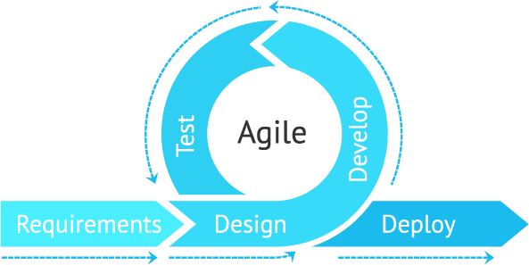

**Figure 3.1: Agile Methodology**

### ITERATIVE WATERFALL METHODOLOGY

The iterative waterfall model gives criticism ways from each phase to its former phases, which is the primary contrast from the classical waterfall model. At the point when errors are identified at some later phase, these criticism ways permit amending errors submitted by developers during some phase.

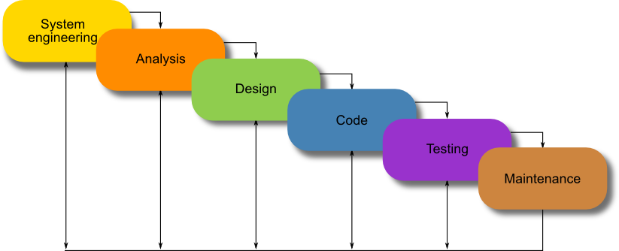

**Figure 3.2: Iterative Waterfall Model.**

### RAPID APPLICATION DEVELOPMENT METHODOLOGY

Rapid Application Development Methodology is a software development methodology that makes release of product solutions at a quick speed a priority. Unlike some different methodologies that attempt to be inflexible and work exclusively on the plan from the earliest starting. it does not work with projects that have a little financial plan and also furthermore requires a skilled team to deal with complexities in the project

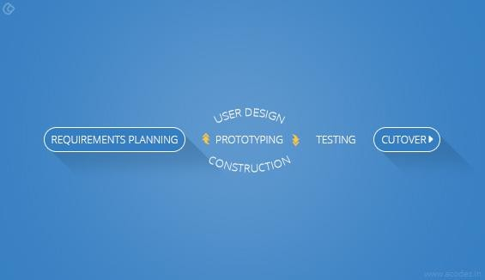

**Figure 3.3: Rapid Application Development Methodology.**

.

### PROTOTYPE METHODOLOGY

It is a specialized software development strategy that initiates developers towards making just the sample of the resolution to approve its practical essence to the customers and roll out essential improvements prior to creating the authentic final solution. An excess of changes influences the workflow of the project and excessive involvement of client can affect processing

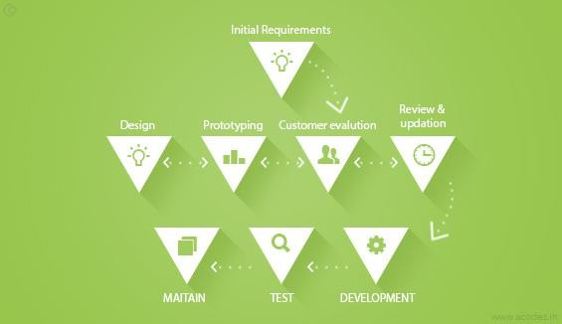

**Figure 3.4: Prototype Methodology***.*

### APPROACH TO CHOSEN METHODOLOGY/METHOD

My project will be designed using this model, as it is progressive and can accommodate changes.

### ADVANTAGES OF THE PROPOSED MODEL

* + - * The system can make sales easy to register.
      * It is easy to retrieve sales records
      * No geographical impediment on getting the sales record in light of the fact that a web-based application is the proposed scheme.
      * Easy forecasting of potential future sales.

### ITERATIVE WATERFALL MODEL

The Waterfall model is an illustration of a plan-driven process. In general, before beginning work on them, you must plan and schedule all process activities.

The principal phases of the waterfall model directly represent the basic activities of development:

* + - 1. **Analysis and specification of requirements** - The facilities, limitations, and priorities

of the system are defined by consultation with system users. Then they are specified in detail and fill in as a specification of the method.

* + - 1. **System and software design** - By defining an overall system configuration, the system design process allocates the specifications to either hardware or software systems. Software design requires the identification and definition of the abstractions of the fundamental software system and its connections.
      2. **Implementation and unit testing** - The software design is acknowledged as a series of projects or program units during this process. Testing of the unit requires ensuring that every unit meets the requirements.
      3. **Integration and system testing** - To ensure that the software specifications have been met, the individual program units or systems are incorporated and evaluated as a complete system. The software system is conveyed to the customer after testing.
      4. **Operation and maintenance** - This is the longest life cycle step, usually (although not necessarily). It is mounted and put into practical use by the machine. Maintenance requires fixing mistakes not found in previous phases of the life cycle, enhancing the implementation of system units and improving the services of the system as new requirements are discovered.

These phases overlap and feed data to one another in practice. The method of software is not a simple linear model but requires input starting with one point then onto the next. It is accordingly common to freeze portions of the development, such as the specification, after a limited number of iterations and to proceed with the later development phases. Problems are left, dismissed, or programmed around for later resolution (Sommerville, 2011).

The iterative waterfall model was developed to address the major limitations of the classical waterfall model. Provision for error rectification feedback paths as and when found later in a stage was made. While mistakes are unavoidable, in the same stage in which they occur, it is beneficial to detect them.

The value of this model is that, at a very early stage of development, there is a working model of the system that makes it simpler to identify functional or design

blemishes. Discovering concerns at a beginning phase of growth allows for remedial action within a small budget.

### METHOD 1 (INTERVIEW)

The interviews were carried out where I did my SIWES program, I interviewed the Store manager there and also the NYSC candidates who are sent to get somethings from the store. The questions which were asked are detailed in appendix B, with this interview I was able to know the way in which inventories are recorded, updated and bought.

### METHOD 2 (BRAINSTORMING)

Brainstorming involves giving a clear definition of what the problem is and coming up with ideas to solve the problem. Using brainstorming, I was able to know the inventory tasks for example, the way in which inventories are recorded, refreshed and bought.

### TOOLS AND TECHNIQUES

The application uses the following tools and techniques:

1. **Web Portal** – HTML, CSS, and JavaScript (Angular).
2. **Android Application** – React Native combines the best parts of native development with React, a best-in-class JavaScript library for building user interfaces.
3. **RESTful API Backend Service** – A RESTful API is an architectural style for an application program interface (API) that utilizes HTTP solicitations to access and utilize information. That information can be utilized to GET, PUT, POST and DELETE data types, which alludes to the perusing, updating, creating and erasing of operations concerning resources. The application system would be making use of NodeJS and Postgres Database. It would also use 3rd Party APIs from Google for sending emails.

### ETHICAL CONSIDERATION

This research is not subject to be harmful in any manners at all and fully respects the dignity of research participants including Store Attendants. Full assent was gotten from the members preceding to the study and the protection of the privacy of research participant were ensured.

### REQUIREMENTS ANALYSIS

What the ideal system needs to perform is defined in this step. It does not, however, decide how the program will be built or constructed. A report called the specifications of the client is typically created. Normally, the client specifications document would define the functional and non-functional requirements of the system. In this step, the user acceptance tests are also developed.

The specifications of software systems are also defined as functional and non- functional specifications:

* Functional requirements- These are proclamations of the system 's services, how the system ought to respond to specific inputs, and how the system should act in specific circumstances. The functional specifications can also specifically state, in certain instances, what the system doesn’t do.
* Non-functional requirements-These are restrictions on the system's provided resources or functions. They include timing constraints, production process constraints, and standards-imposed constraints. Non-functional specifications, rather than specific system features or facilities, often refer to the system as a whole.

### REQUIREMENT SPECIFICATIONS

* + 1. **FUNCTIONAL REQUIREMENTS SPECIFICATIONS**

The system was designed to give its users with and to execute the following functions:

**Table. 3.1: Functional Requirement Specifications.**

|  |  |  |
| --- | --- | --- |
| **Req. No.** | **Description** | **Type** |
| R-101 | The system should be capable of registering all goods  within the company. | Functional |

|  |  |  |
| --- | --- | --- |
| R-102 | The scheme should be able to list products / items that  a consumer purchases and measure their overall costs. | Functional |
| R-103 | The device should have login capabilities that allow  users to have allowed access. | Functional |
| R-104 | The system ought to have the option to permit approved clients to update, browse, insert, delete, and manipulate database records. | Functional |
| R-105 | Sales and transactions made every day should be  registered by the system and such details should also be used at controlled time intervals. | Functional |
| R-106 | The device should be able to automatically measure the  revenues from the selling of goods. | Functional |
| R-107 | When such data is required from it, the device ought to  display the current / available stock. | Functional |

### NON-FUNCTIONAL REQUIREMENTS SPECIFICATIONS

While large numbers of these specifications were not among the center features to be stressed, these specifications were still incorporated in the system design. Regarding adaptability, dependability, security, versatility, manageability, and convenience, non- functional specifications have a major impact on the system's capacity.

**Table. 3.2: Non-Functional Requirement Specifications.**

|  |  |  |
| --- | --- | --- |
| **Req. No.** | **Description** | **Type** |
| R-108 | When launched, the application shall stay running unless  there is an intentional shutdown of the application or the platform. | Performance |
| R-109 | The application should be made to have optimum user experience. Users should be able to operate the system  with ease. | Performance |

### ADVANTAGES OF THE PROPOSED MODEL

* + - * The system can make sales easy to register.
      * It is easy to retrieve sales records
      * No geographical impediment on getting the sales record in light of the fact that a web-based application is the proposed scheme.
      * Easy forecasting of potential future sales.

### SYSTEM DESIGN

Software modeling helps you comprehend and explain the ideas regarding codes and the client necessities that the software system must uphold. For instance, to portray and convey client requirement utilizing use case activity, class or sequence diagram. That depicts and conveys the functionality of the framework.

### APPLICATION ARCHITECTURE

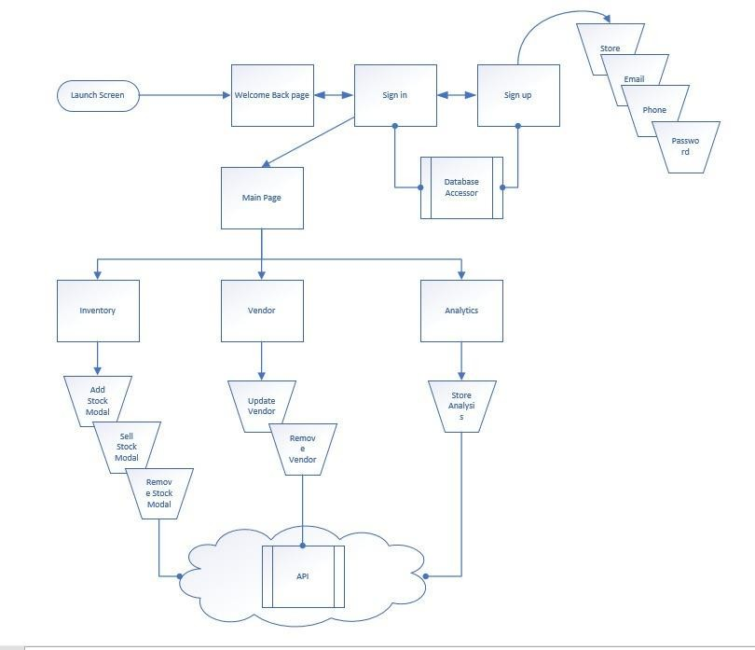

**Figure 3.5: Application Architecture of the Online Inventory Monitoring System.**

### USE CASE

Use-case modeling is used for the analysis of a system's functional requirements. In the beginning stages of system development, use-case modeling is performed to help developers understand the system's functional requirements without thinking considering how those requirements will be implemented.

A use-case model is made up of actors and cases of use. An actor is an outer entity (like an external entity in the Data-Flow Diagram) that interacts with the system. It's someone or someone that the machine shares data with. A use case is a set of similar acts

that an agent initiates; it is a particular way to use the method. An actor represents a role that can be played by device users. The name of the actor ought to indicate that position. Actors assist us to classify the cases of usage they conduct.

The analyst plunks down with the expected users of the system during the requirement review process and conducts a detailed analysis of what capacities they expect from the system. Such features are described as use cases

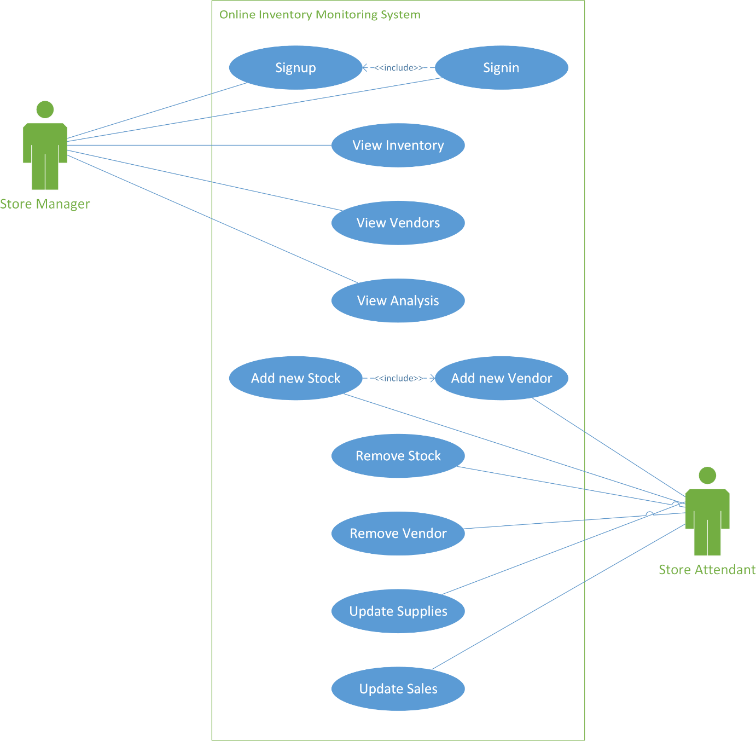

**Figure 3.6: Use Case model of the Online Inventory Monitoring System.**

### DATA DESIGN

These section highlights the data design and relationships between the entities and users in the proposed system.

**Store**

* + - * Store should have an id, name, password and contact properties.
      * There should be a many-to-many relationship between Store and Vendor through the Store Vendor entity relationship, many Stores can be serviced by different Venders and Vendors can also supply different Stores.
      * There should be a one-to-many relationship with Sales, Stores can receive many Orders.
      * Store managers and Store Attendants should be able to login to the system with the Store id and password.

**Inventory**

* + - * Inventory/Stock Item should have id, name. category, quantity, cost price and selling price.
      * There should be a one-to-many relationship between Store and Inventory, Stores can have many items in Stock.
      * There should be a one-to-many relationship between Inventory and Sales, A Stock Item can receive many Orders.
      * There should be a many-to-many relationship between Inventory and Vendor through the Vendor Inventory entity relationship.
      * Vendors can supply Stock to the Inventory and Store Attendants can make Orders from the Stock available in the Inventory.

**Vendor**

* + - * Vendor should have id, name and contact.
      * There should be a many-to-many relationship between Vendor and Store.
      * There should be a many-to-many relationship between Vendor and Inventory.

**Sales**

* + - * Sales/Orders should have id and quantity.
      * There should be a one-to-many relationship between Inventory and Sales.
      * There should be a one-to-many relationship between Store and Sales.
      * Store Attendants should be able to create Sales/Order Items.

### ACTIVITY DIAGRAM

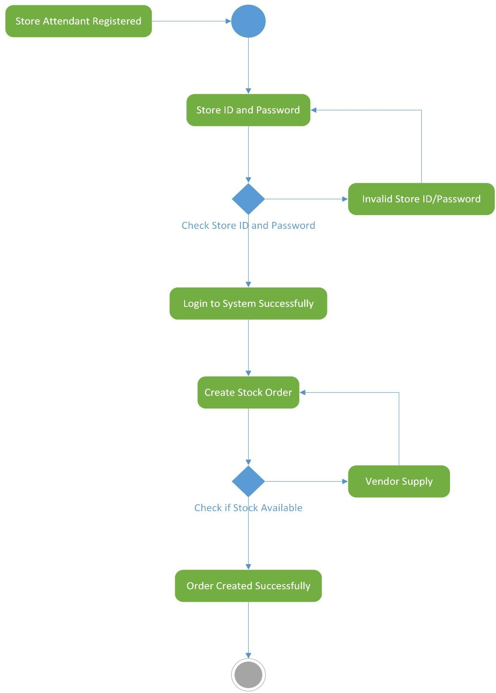

**Figure 3.7: Activity Diagram of the Online Inventory Monitoring System.**

### DATAFLOW DIAGRAM

A data flow diagram is a coherent model of data flow through a system that demonstrates how the constraints, processes and data entities of the system are consistently connected. By drawing a background diagram, documenting the system's boundaries lets the client of the application and the developer imagine elective high-level logical system architecture. With measures recommending programs and procedures, data flows proposing composites and data stores proposing data entities, files and databases, the portion of a data flow diagram leads directly into physical architecture. The data flow diagram of the system is below.

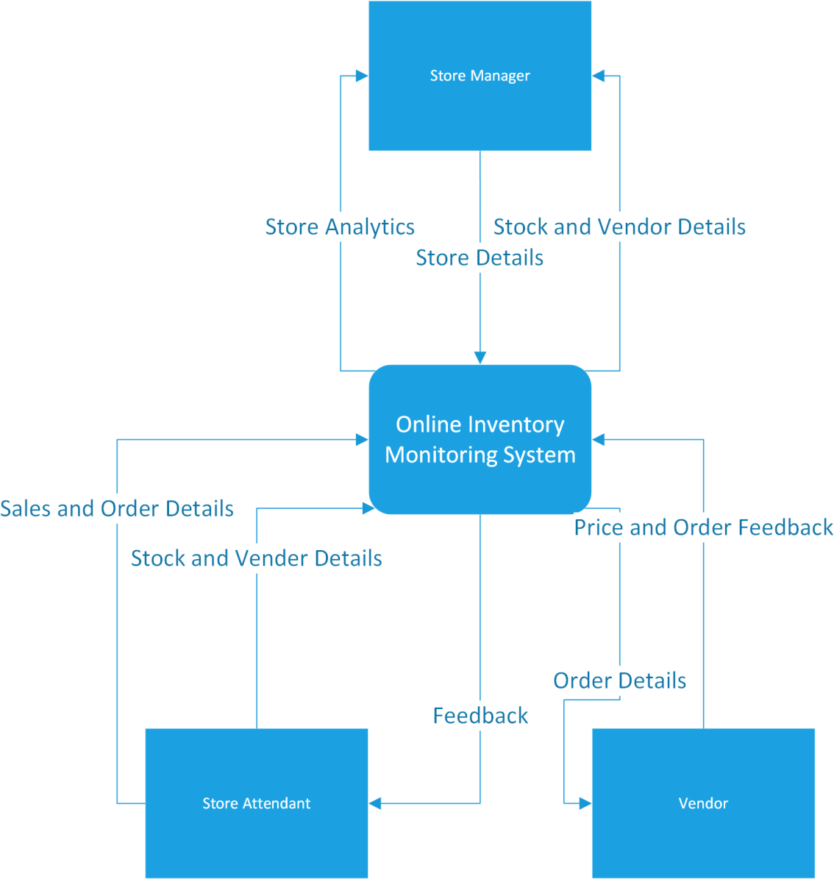

**Figure 3.8: Context Diagram of the Online Inventory Monitoring System.**

### CONTROL FLOW DIAGRAM

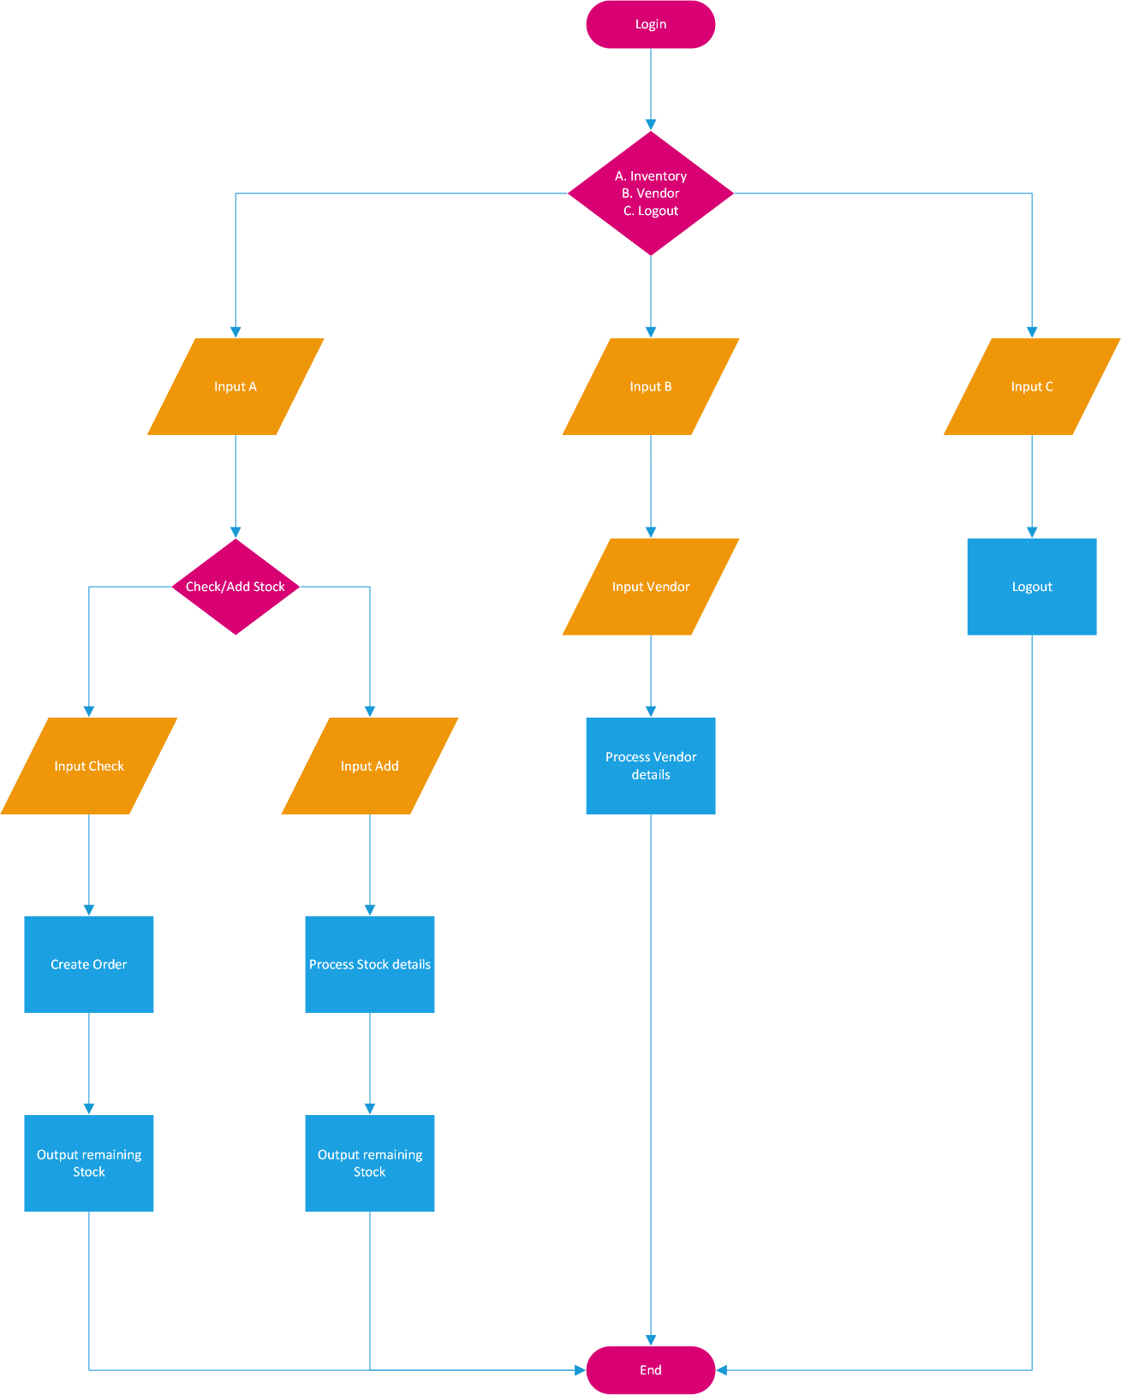

**Figure 3.9: Control Flow Diagram of the Online Inventory Monitoring System.**

### ENTITY-RELATIONSHIP DIAGRAM

The database system schema is the structure of a database system defined in a formal language upheld by the Database Management System (DBMS) and alludes to the arrangement of data in order to build a blueprint for the creation of a database (divided into tables of databases).

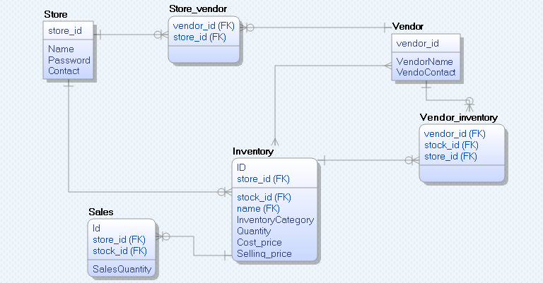A set of formulas (sentences) called integrity constraints imposed on a database is the proper meaning of the database schema. Below is the database structure used by the framework software.

**Figure 3.10: Entity-Relationship diagram of the Online Inventory Monitoring System.**

### 3.8 USER INTERFACE DESIGN

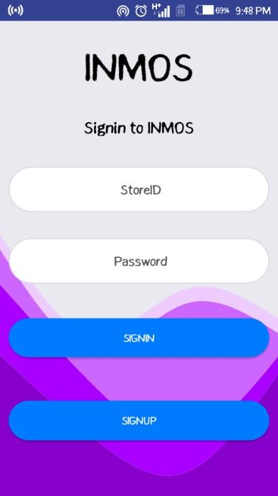

**Figure 3.11: Android – Sign-in Screen.**

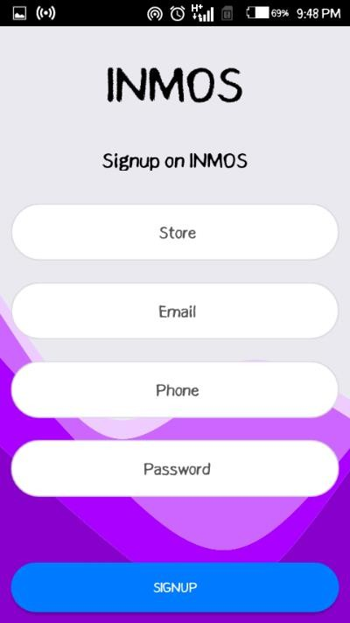

**Figure 3.12: Android – Sign-up Screen.**

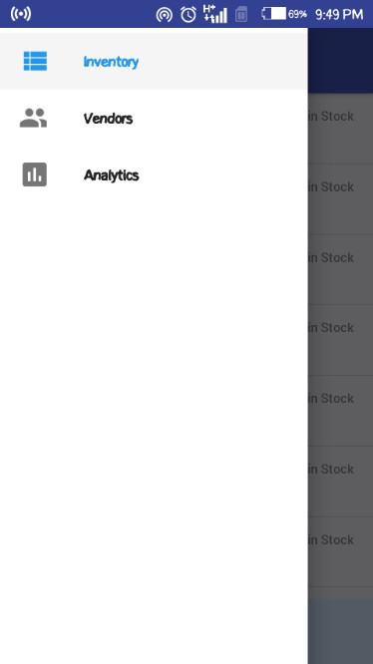

**Figure 3.13: Android - Navigation Component.**

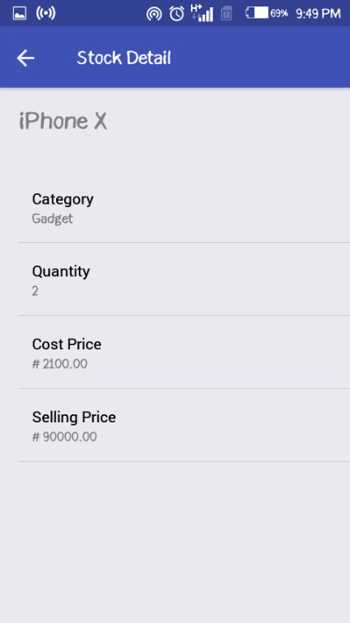

**Figure 3.14: Android - Stock Details Screen.**

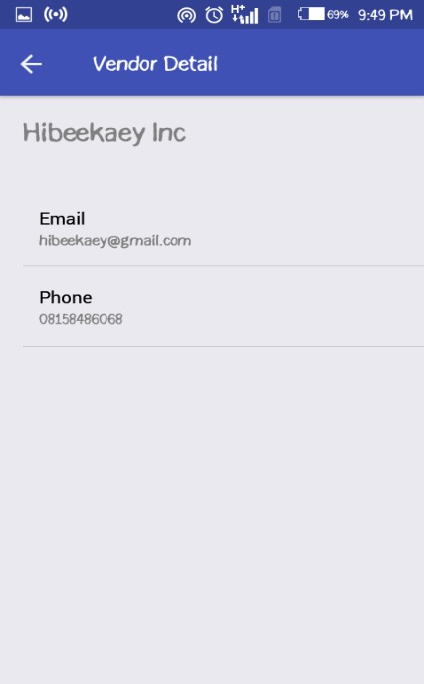

**Figure 3.15: Android - Vendor Details Screen.**

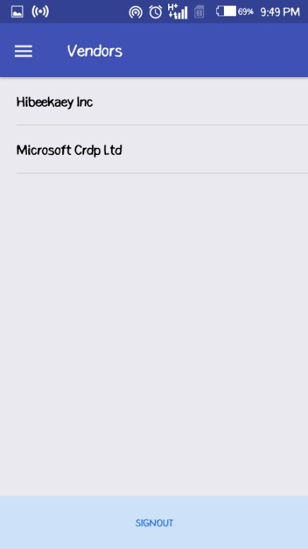

**Figure 3.16: Android - Vendors Screen.**

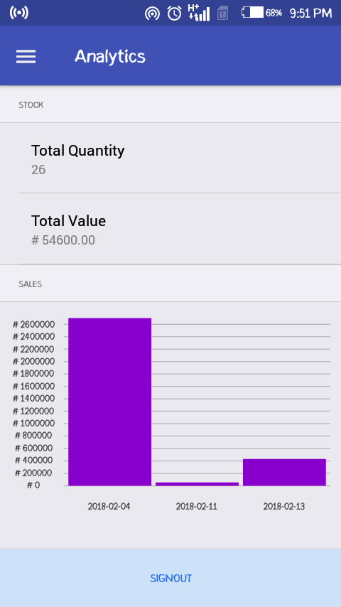

**Figure 3.17: Android - Analytics Screen.**

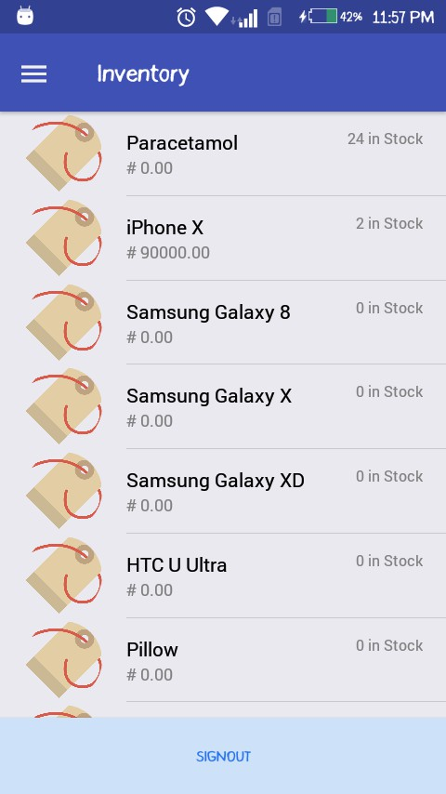

**Figure 3.18: Android - Inventory Screen.**

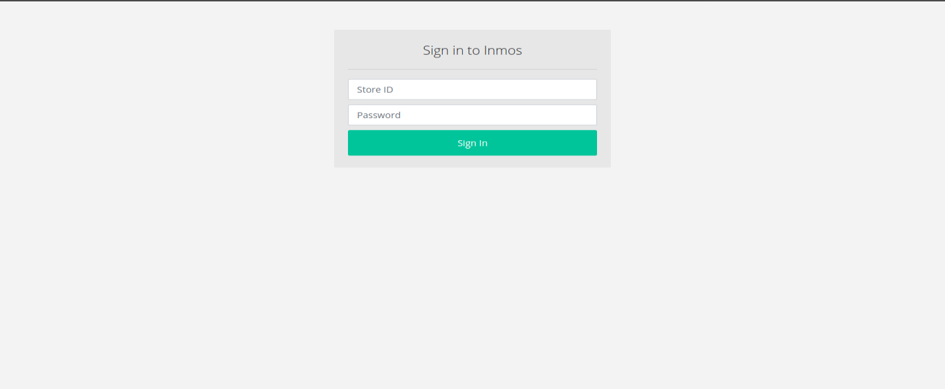

**Figure 3.19: Dashboard – Sign-in Page.**

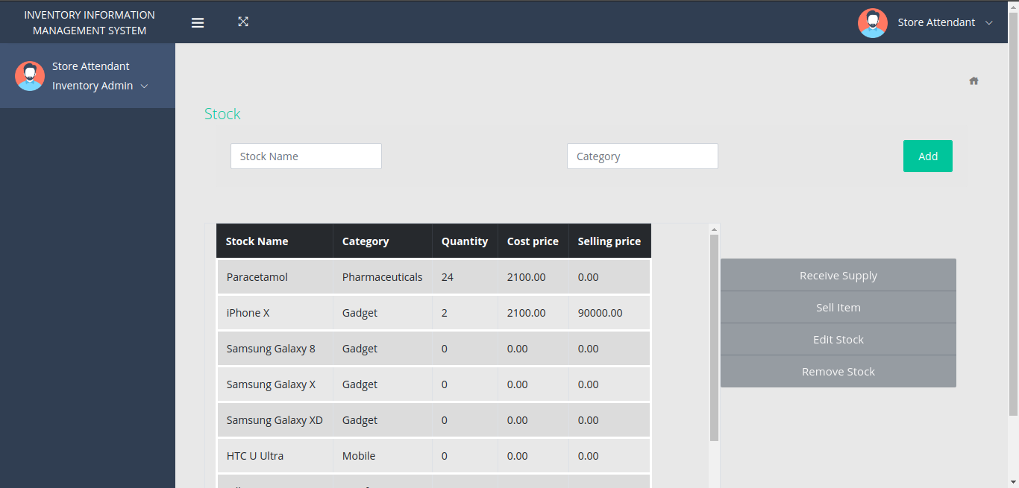

**Figure 3.20: Dashboard - Inventory Page.**

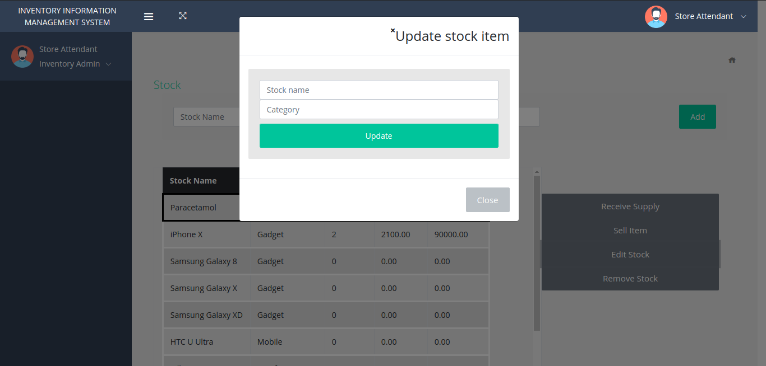

**Figure 3.21: Dashboard – Add Stock Modal.**

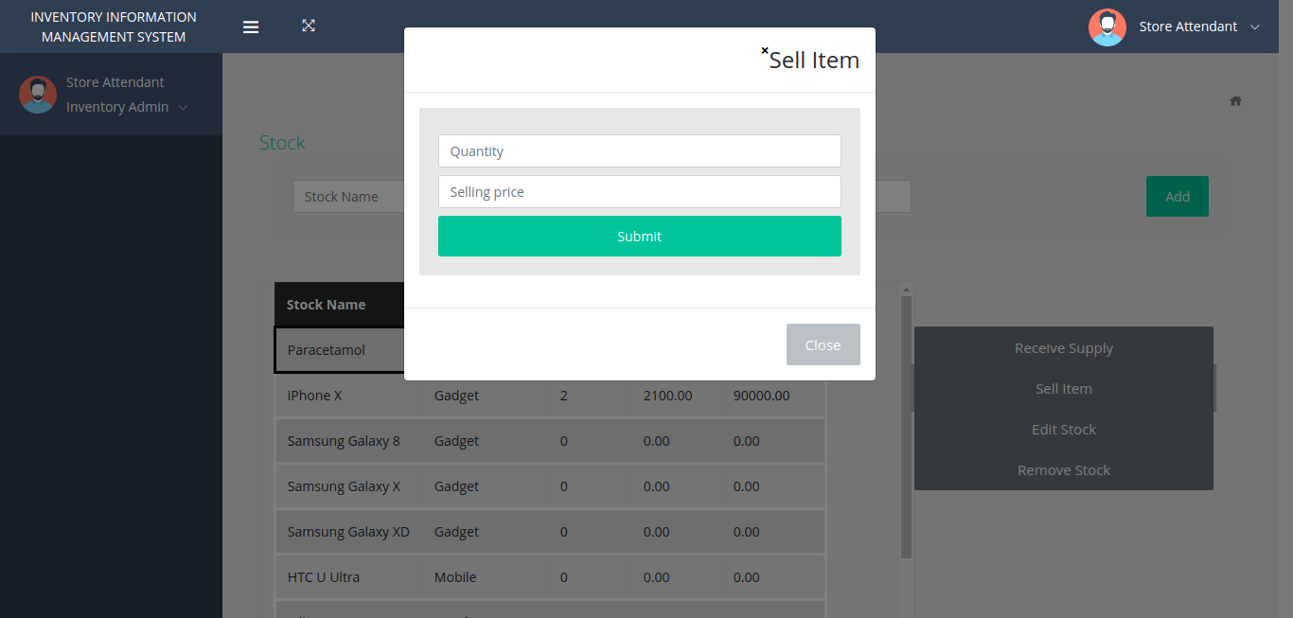

**Figure 3.22: Dashboard – Sell Stock Modal.**

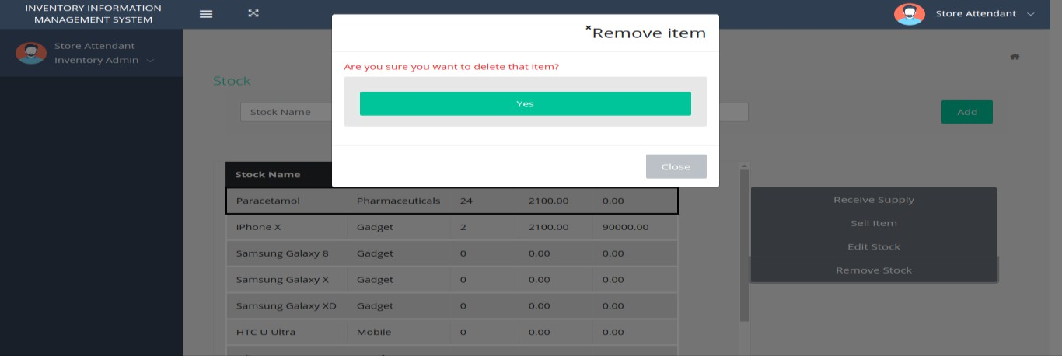

***Fig 3.23: Dashboard – Remove Stock Modal.***

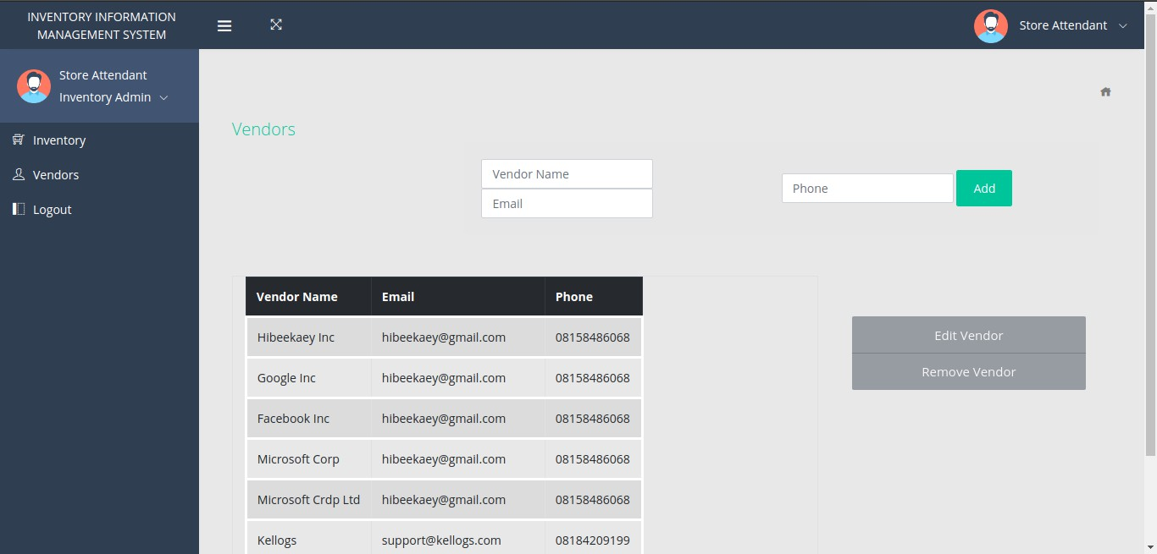

***Fig 3.24: Dashboard – Vendor Page.***

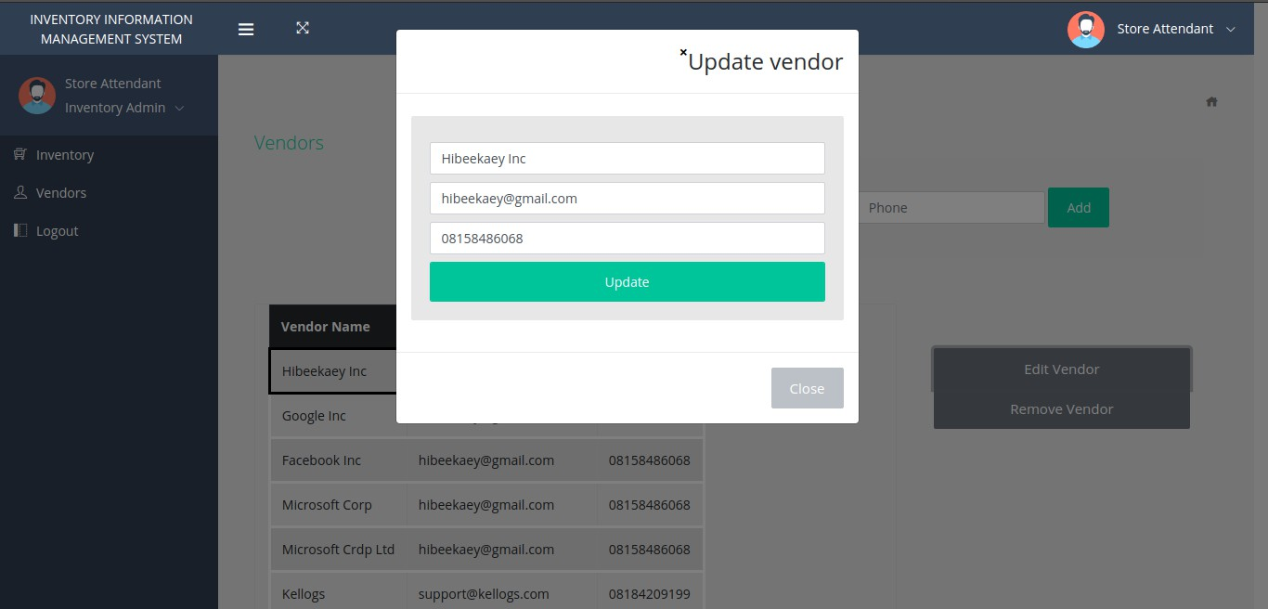

***Fig 3.25: Dashboard – Update Vendor Modal.***

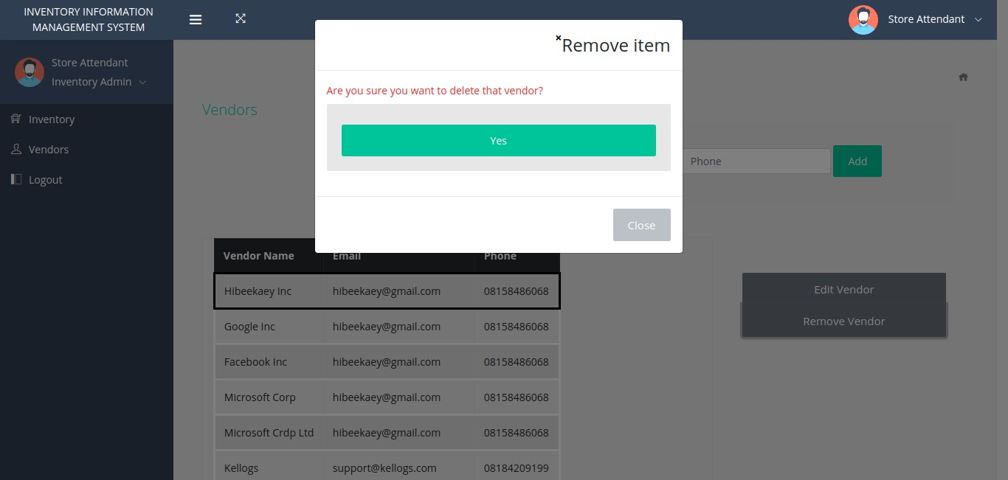

***Fig 3.26: Dashboard – Remove Vendor Modal.***

### SUMMARY

In this chapter, a brief overview of the system was illustrated and described; the methodology was also briefly discussed. It outlined and defined in depth the tools and techniques adopted for the implementation of the Online Inventory Management System. The researcher was able to outline the functional and non-functional specifications of the proposed system in this section. Using diagrams such as the use case diagram, activity diagram, data flow diagram, control flow diagram, a detailed system analysis and design was carried out. The data design was carried out and a diagram of the entity relationship was used to display both the entities in the system and the relationships between the various entities.

Also correctly reported and illustrated were the wireframing of the interface design. A guideline to effectively implement the system was well documented in this chapter.

**CHAPTER FOUR: IMPLEMENTATION AND TESTING**

### OVERVIEW

This chapter depicts how the system is used to deploy, test, install and guarantee its change to an operating system utilizing the models described in the previous chapters. Assistance has been given to current and future clients of the system by converting the specifications of the actual system into a working and solid system and reporting the work carried out.

The designs of the system were converted into code and actual acknowledgement of the database and application designs were completed to interface the user with the system. By identifying all important components and reporting on their behavior, the chapter will also go through the testing plan. Also, we will go through the summary of the test and error report and look at corrections for those errors. Finally, it will provide a user guide and then summarize the contents of this chapter.

### MAIN FEATURES

The project is divided into three subsystems: The Web Portal, the Android application, and the RESTful API.

Firstly, the web portal is specially designed for the store attendant to perform the storing process, to add and remove vendors and to perform sales operations. Each source of information has its dedicated area on the dashboard.

Second, the Android app is designed to allow the store manager to sign in and monitor inventory levels as well as view the sales analytics screen, and to discover how much the store generates.

Finally, the RESTful API is designed to interface all the various components of the system to the central database.

### IMPLEMENTATION PROBLEMS

Several bugs were encountered during the process of development. Although this was expected because, during the development process, there is never any application that is free of bugs and errors. During the implementation of the SendGrid’s mail API, a problem was found. Due to additional verification, several attempts to contact support failed.

### OVERCOMING IMPLEMENTATION PROBLEMS

All issues have been isolated and examined in order to overcome these issues and restrict the development of this application. By searching online for individuals who have experienced the same or similar problems and checking for the solution, most of the bugs were fixed. If a specific one is unique and can't be found, the best thing to do was to post the issue online on a website such as Stack-overflow and Git-hub, then developers respond with a possible solution within a few hours.

Finally, a verified friend's details have been used to resolve the issue of the SendGrid API key.

### TESTING

Software testing is an investigation which is performed to give stakeholders with information on the nature of the software good or service under test. Software testing includes the execution of a software segment or device segment to analyze at least one properties of interest. In all, these characteristics demonstrate the degree to which the testing segment or device meets the design and development criteria, effectively reply’s to all types of inputs, plays out its capacities within a reasonable time frame, is adequately functional, can be installed and operated in its proposed environments, and accomplishes the overall result required by its stakeholders.

Considering this, the developed frameworks has been put to the test utilizing different types of testing. The RESTful API was checked by POSTMAN, an application to check APIs and post their documentation. The entire system was also beta tested and gotten that all the past specified functional requirements were implemented, along with the required non-functional specifications.

The following sub-chapters examine the features to be tested and record the quality of each element. Towards the end, a test report will also be provided.

### TESTING PLANS (FOR UNIT TESTING, INTEGRATION TESTING AND SYSTEM TESTING)

Below is a test plan for the Online Inventory Monitor System.

### TEST IDENTIFIER

TEST LEVEL: Master Test Plan AUTHOR’S NAME: Sulihat Ibrahim Imam AUTHOR’S CONTACT:

### REFERENCE

* + - * + INMOS APP
        + Work Plane
        + Detailed Project Documentation
        + Test Summary

### INTRODUCTION

The master plan for the INMOS app is provided here to verify and validate the functional requirement. Various test methods, such as white and black box testing, will be performed.

### FEATURES TO BE TESTED

The following is a list of areas to be addressed during the testing of the application.

* + - * + The system ought to have login capabilities that permits users to have access.
        + The system ought to be able to list products / items that a consumer purchases and measure their overall costs.
        + Sales and transactions made every day should be registered by the system and such details should also be used at controlled time intervals.
        + The system ought to be able to automatically measure the revenues from the selling of goods.

### FEATURES NOT TO BE TESTED

* + - * + The system ought to be capable of registering all goods within the company.
        + The system ought to be able to permit authorized users to update, browse, insert, delete, and manipulate database records.
        + When such data is required from it, the device ought to be able to display the available.

### APPROACH

By using the built-in debugger for visual studio code, we're going to be able to stop the app at every breakpoint to check the data flow of the app. By using the "console.log" function at the end of each method, we will be able to see exactly what each method returns.

### TEST DELIVERABLES

The deliverables of this test plan are as follows:

* + - * + Test Cases
        + Test Report
        + Traceability Matrix
        + Test Results
        + Error Report

### APPROVALS

Sulihat Ibrahim Imam Baze INMOS

### TEST SUITE (FOR UNIT TESTING, INTEGRATION TESTING AND SYSTEM TESTING)

**Table. 4.1 Test Suite Performed for Login**

|  |  |
| --- | --- |
| Test Suit ID | R-100 |
| Test Case ID | TC-001 |
| Test Case Summary | The system ought to have login capabilities that pernit users to have access. |
| Related Requirement | R-103 |
| Prerequisite | Must be registered |
|  |  |
| Test Procedure | Enter store ID and password. |
| Test Data | Store ID and Password. |
| Expected Result | The system ought to have login capabilities that permit users to have allowed access. |

|  |  |
| --- | --- |
| Actual Result | The system has login capabilities that allow users to have access. |
| Status | Test case passes |
| Remarks | The test was successful |
| Created By | Sulihat Ibrahim Imam |
| Date Created | 10/5/2020 |
| Executed By | Sulihat Ibrahim Imam |
| Date of Execution | 10/5/2020 |
| Test Environment | Hardware: HP Laptop  Software: Browser – google chrome |

**Table. 4.2 Test Suite Performed for Inventory**

|  |  |
| --- | --- |
| Test Suit ID | R-101 |
| Test Case ID | TC-002 |
| Test Case Summary | The system ought to be able to list goods / items that a consumer purchases and measure their overall price. |
| Related Requirement | R-102 |
| Prerequisite | Must be logged in. |
|  |  |
| Test Procedure | Log in and click on inventory. |
| Test Data | Login detail. |

|  |  |
| --- | --- |
| Expected Result | The system ought to be able to list goods / items that a consumer purchases and measure their overall costs. |
| Actual Result | The system is able to list products / items that a consumer purchases and measure their overall price. |
| Status | Test case passes |
| Remarks | The test was successful |
| Created By | Sulihat Ibrahim Imam |
| Date Created | 9/7/2020 |
| Executed By | Sulihat Ibrahim Imam |
| Date of Execution | 9/7/2020 |
| Test Environment | Hardware: HP Laptop  Software: Browser – google chrome |

**Table. 4.3 Test Suite Performed for Sales**

|  |  |
| --- | --- |
| Test Suit ID | R-102 |
| Test Case ID | TC-003 |
| Test Case Summary | Sales and transactions made every day should be registered by the system and such details should also be used at controlled time intervals. |
| Related Requirement | R-105 |
| Prerequisite | Must be logged in. |

|  |  |
| --- | --- |
|  |  |
| Test Procedure | Login to app  Click on analytics screen. |
| Test Data | Login detail. |
| Expected Result | Sales and transactions made every day should be registered by the system and such details should also be used at controlled time intervals. |
| Actual Result | Sales and transactions made every day is registered by the system and such details should also be used at controlled time intervals. |
| Status | Test case passes. |
| Remarks | The test was successful. |
| Created By | Sulihat Ibrahim Imam |
| Date Created | 11/8/2020 |
| Executed By | Sulihat Ibrahim Imam |
| Date of Execution | 11/8/2020 |
| Test Environment | Hardware: HP Laptop  Software: Browser – google chrome |

**Table. 4.4 Test Suite Performed for Analytics**

|  |  |
| --- | --- |
| Test Suit ID | R-103 |
| Test Case ID | TC-004 |

|  |  |
| --- | --- |
| Test Case Summary | The system should be able to automatically measure the revenues from the selling of goods. |
| Related Requirement | R-106 |
| Prerequisite | Must be logged in. |
|  |  |
| Test Procedure | Login to app  Click on analytics screen. |
| Test Data | Login detail. |
| Expected Result | The system should be able to automatically measure the revenues from the selling of goods. |
| Actual Result | The system is able to automatically measure the revenues from the selling of goods. |
| Status | Test case passes. |
| Remarks | The test was successful. |
| Created By | Sulihat Ibrahim Imam |
| Date Created | 12/9/2020 |
| Executed By | Sulihat Ibrahim Imam |
| Date of Execution | 12/9/2020 |
| Test Environment | Hardware: HP Laptop  Software: Browser – google chrome |

### TEST TRACEABILITY (FOR UNIT TESTING, INTEGRATION TESTING AND SYSTEM TESTING)

**Table. 4.5 Test Traceability Matrix**

|  |  |  |  |  |  |
| --- | --- | --- | --- | --- | --- |
| Req# | Description | Priority | Test Case | Test Date | Test Result |
| R-103 | The system ought to have login capabilities that permit users to have access. | 1 | 1 | 10/5/2020 | Pass |
| R-102 | The system ought to be able to list goods / items that a consumer purchases and measure their overall price. | 3 | 2 | 9/7/2020 | Pass |
| R-105 | Sales and transactions made every day should be registered by the system and such details should also be used at controlled time intervals. | 2 | 3 | 11/8/2020 | Pass |
| R-106 | The system should be able to automatically measure the revenues from the selling of goods. | 4 | 4 | 12/9/2020 | Pass |

### TEST REPORT SUMMARY (FOR UNIT TESTING, INTEGRATION TESTING AND SYSTEM TESTING)

**Table. 4.6 Test Report Summary**

|  |  |
| --- | --- |
| SUMMARY OF TEST CARRIED OUT | RESULTS |
| Number of functions tested: | 4 |
| The number of functions not tested: | 3 |
| The number of tests passed: | 4 |
| The number of tests failed: | 0 |
| Percentage of tests passed: | 100% |
| Percentage of tests failed: | 0% |

### ERROR REPORTS AND CORRECTIONS

* Errors due to coding, logical errors and bugs. This was corrected to fit each function by revising the coded logic and changing it.
* Insufficient permissions. This was because users could not read or write from unauthorized routes. This is good because it shows that unauthorized users have not been permitted by the back end.
* Runtime Error. This was caused by plugins that were installed on apps. By disabling the plugins, it was corrected.

### USE GUIDE

The screenshots and operation of the implemented system are introduced and depicted underneath.

### SIGN-UP SCREEN (ANDRIOD APPLICATION)

The Store Manager signs up with the name of the store, email address, phone number and password as shown in Figure 4.1. Upon pressing the signup button, the Store is enlisted, and a Store ID is shipped off to his/her email address.

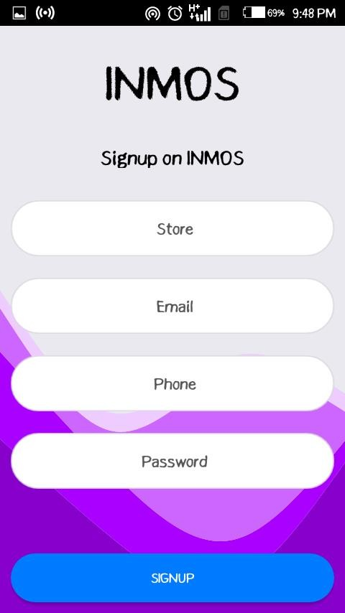

***Fig. 4.1 Android Application Signup Screen*.**

### SIGN-IN SCREEN (ANDROID APPLICATION)

The Store Manager Signs in with the Store ID he got in his email and Password as appeared in Figure 4.2. The Store ID is utilized during resulting Sign in.

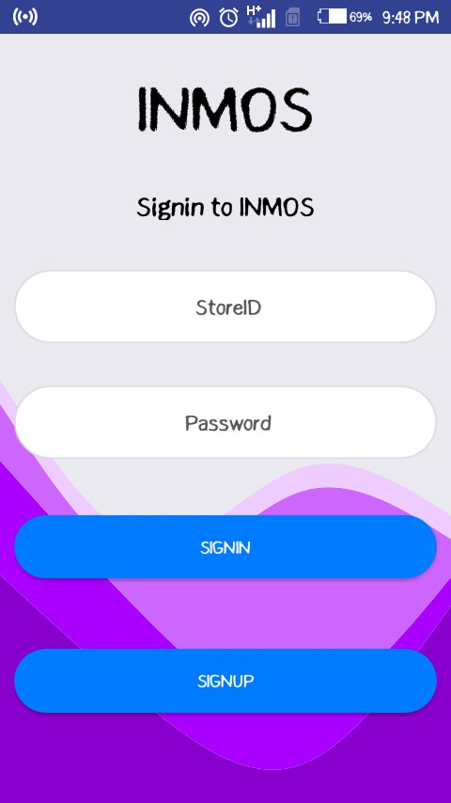

***Fig. 4.2 Android Application Sign in Screen.***

### SIGN-IN PAGE (WEB PORTAL)

The Store Attendant Signs in with the Store ID gotten from the Store Manager and Password as appeared in Figure 4.3. Figure 4.4 shows the inputted Store ID and password, the Store Attendant then taps on the Sign in button to sign in.

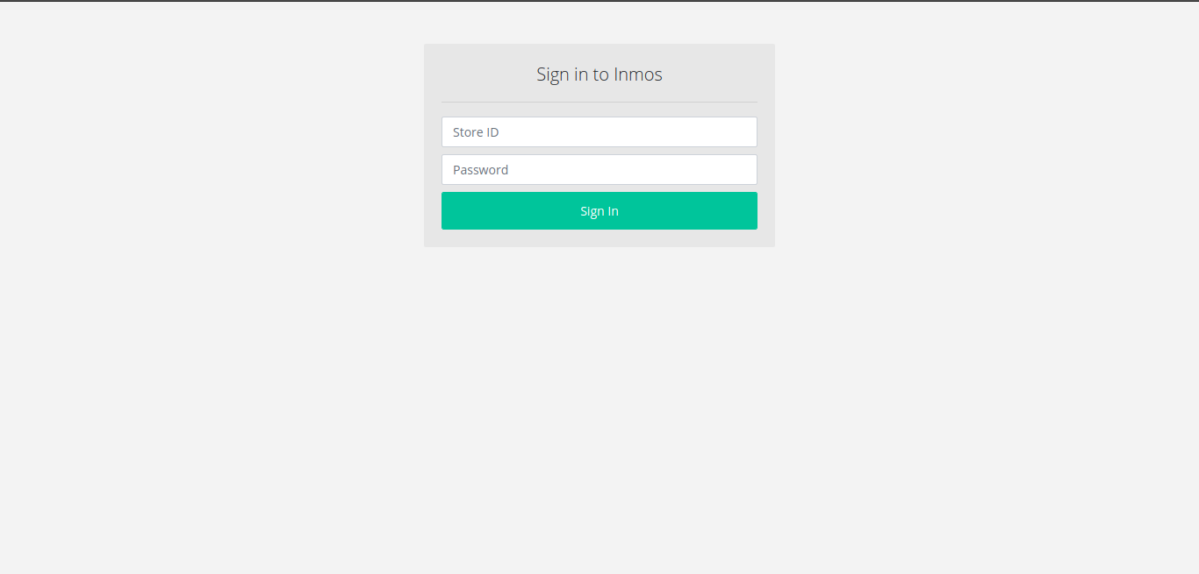

***Fig. 4.3 Web Portal Sign in Page.***

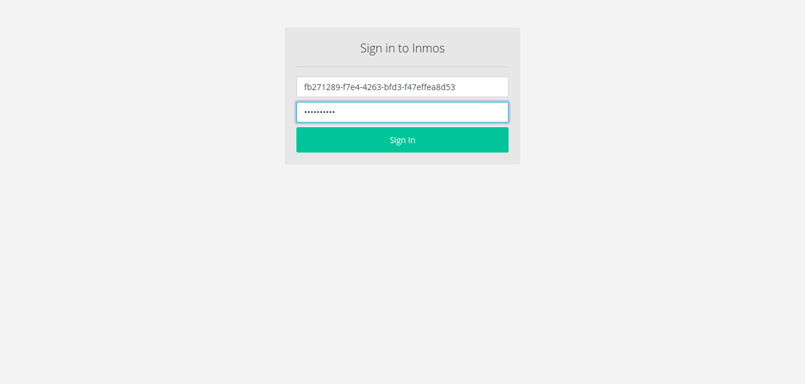

***Fig. 4.4 Web Portal Sign in Details Page.***

### INVENTORY PAGE (WEB PORTAL)

Inventory details, such as the stock name, category, quantity, cost price, and selling price are shown and stock can be added, provided, sold, altered or eliminated by the Store Attendant when endorsed in as appeared in Figure 4.5. Figure 4.6 shows when a chosen item is to be updated. The new stock name and category are inputted, and the Update button is clicked to update the stock details.



***Fig. 4.5 Web Portal Inventory Page*.**



***Fig. 4.6 Web Portal Inventory Page’s Edit Modal.***

Figure 4.7 shows when a stock is to be sold. A stock is chosen, and the Sell Item button is clicked, a modal is shown requesting for the quantity and the selling price. After inputting these values, the Store Attendant clicks on the Submit button to sell the chose item. Figure 4.8 shows the remove item modal.



***Fig. 4.7 Web Portal Inventory Page’s Sell Modal.***

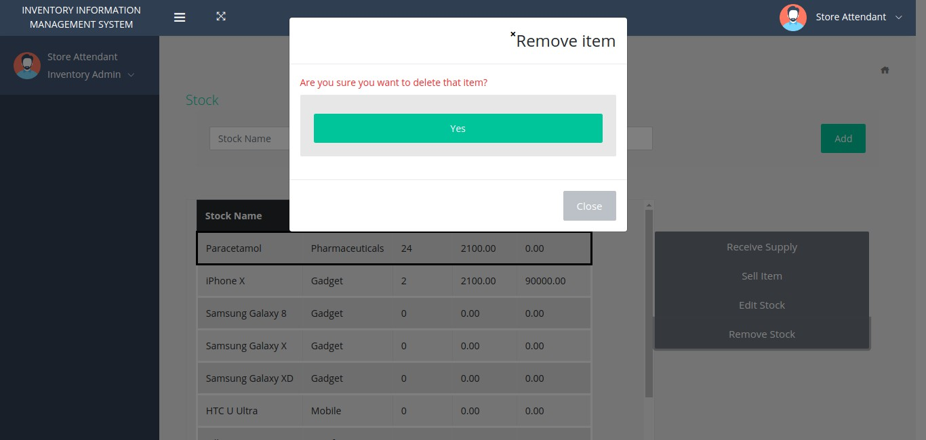

***Fig. 4.8 Web Portal Inventory Page’s Remove Modal***

### VENDOR PAGE (WEB PORTAL)

Vendor details such as the vendor name, email address and phone number are shown and a vendor can be added, altered or removed by the Store Attendant as appeared in the figure beneath. The sidebar is utilized for navigating between the Inventory page and Vendors page. The Logout button is also on the sidebar. Figure 4.10 shows the edit vendor modal.



***Fig. 4.9 Web Portal Vendors Page.***



***Fig. 4.10 Web Portal Vendors Page’s Edit Modal.***

The eliminate vendor modal is appeared in the figure beneath. An affirmation message is presented to the Store Attendant and the required action is selected.



***Fig. 4.11 Web Portal Vendors Page’s Remove Modal.***

### INVENTORY SCREEN (ANDROID APPLICATION)

Inventory and stock subtleties can be viewed by the Store Manager on the Android Application. A Navigation Drawer is appeared in Figure 4.12. The Drawer comprises of the Inventory, Vendors, and Analytics Navigation.

***.***

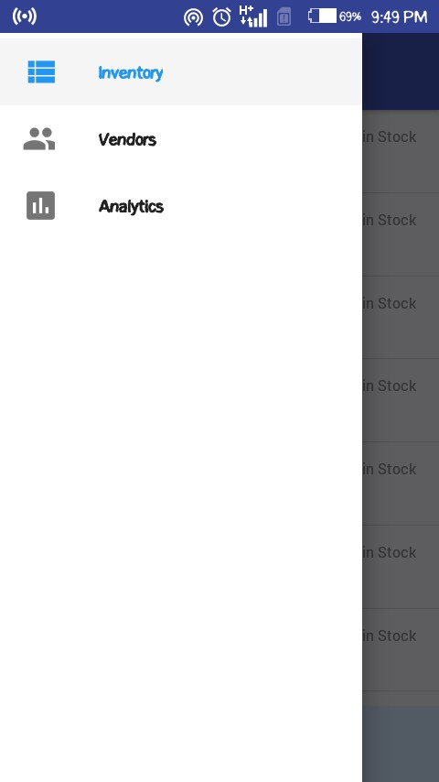

***Fig. 4.12 Android Application Drawer Navigation Screen.***

In Figure 4.13, a rundown of all the stock in the store inventory with their quantities and selling prices are shown. The Store Manager can tap on any of the items to view the details. The Sign out button is located at the button of the screen.



***Fig. 4.13 Android Application Inventory Screen.***

Figure 4.14 shows the subtleties of a specific item. The name of the item, category, quantity, cost price and selling price can be seen on this screen.

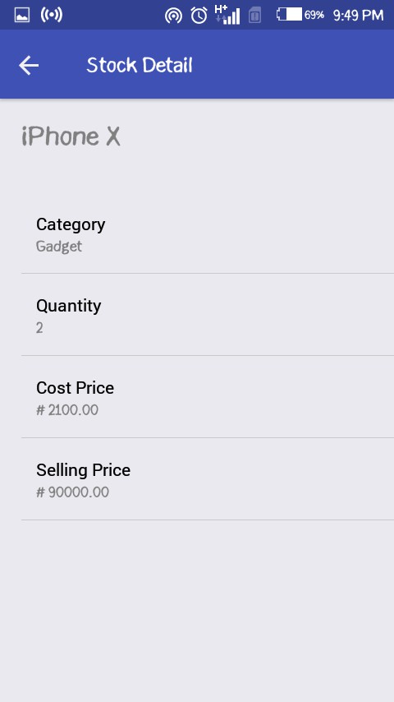

***Fig. 4.14 Android Application Stock Detail Screen.***

### VENDOR SCREEN (ANDROID APPLICATION)

Vendors and vendor subtleties can be seen by the Store Manager. Figure 4.15 shows the list of vendors and can be chosen to show more insights concerning a vendor. The vendor subtleties such as the vendor name, email and phone number are appeared on the screen in Figure 4.16.

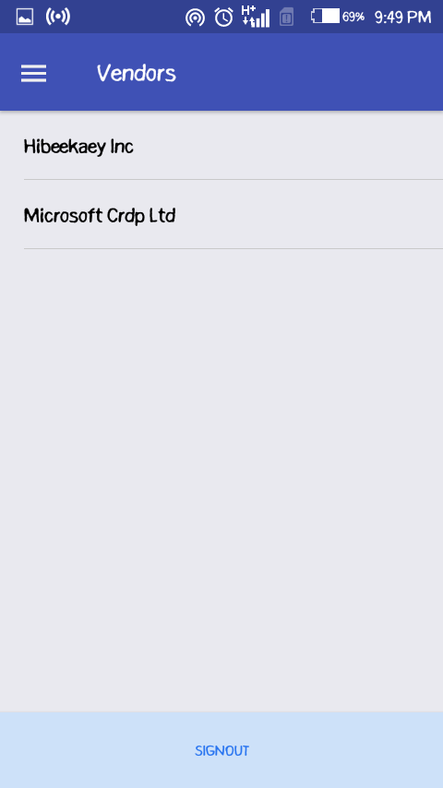

***Fig. 4.15 Android Application Vendors Screen.***

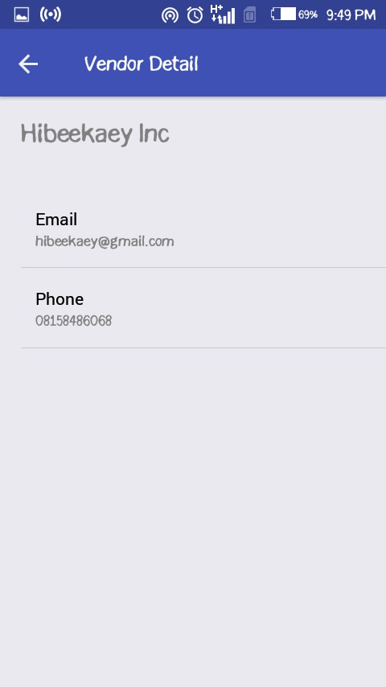

***Fig. 4.16 Android Application Vendor Detail Screen.***

### ANALYTICS SCREEN (ANDROID APPLICATION)

Stock and sales analytics can be seen by the Store Manager on the screen in Figure

4.17. The total quantity of stock in the inventory is displayed and the total value of all the stock in the inventory is shown too. A graph of all daily sales is plotted, and the aggregate sum made in a day can be observed. A sign out button is located at the button of the screen.



***Fig. 4.17 Android Application Analytics Screen.***

### SUMMARY

This chapter shows the main features of the applications in clear detail and describes the techniques used to implement those features. The issues that occurred during the execution were also identified and the chapter also covered all the methods used to solve those problems. Then the chapter goes through the test plan and procedures and documents the outcomes of those tests. Errors detected during the test procedure were also documented, and corrections and a user guide were also provided for those errors. The conclusions, reconditions, and future improvements will be discussed in the next section.

**CHAPTER FIVE: DISCUSSION, CONCLUSION AND RECOMMENDATIONS**

### OVERVIEW

Inventory monitoring is a significant part of Inventory Management. In recent years, a few inventory management systems have been created. The inventory information management systems and inventory monitoring systems are incorporated and sent together at a fixed point at store locations in some of the current inventory management systems.

The project was conducted to establish an online inventory monitoring system for shops. This system uses different subsystems in other to accomplish its aim. These subsystems include a web portal for taking stock records, vendor records, conducting supply and sales operations and storing these records in a database and an android application for tracking inventory level, showing sales forecast and sales analytics and viewing vendor records taken from the database.

Stock checking is a huge piece of Inventory Management. As of late, a few stock administration frameworks have been made. The stock data the executive’s frameworks and stock checking frameworks are consolidated and sent together at a fixed point at store areas in a portion of the current stock administration frameworks.

The examination was led to set up an online stock checking framework for shops. This framework utilizes various subsystems in other to achieve its point. These subsystems incorporate a web-based interface for taking stock records, seller records, leading stockpile and deals activities and putting away these records in an information base and an android application for following stock level, demonstrating deals estimate and deals investigation and survey merchant records taken from the data set.

### OBJECTIVE ASSESSMENT

The objective of this project is to develop an Online Monitoring System for Inventories. In order to attain the goal of this project, several objective steps were taken during the implementation of the project.

The first objective was to develop a web portal to take stock records, vendor records, perform supply and sales activities, and store these records in a database. Legitimate inventory management encourages you sort out precisely how much inventory you need to have available. This will help forestall product deficiencies and permit you to keep barely enough inventory without having a lot in the store.

The second objective sort to develop an android application to display sales forecast, sales analytics, and vendor records taken from the inventory level tracking database. Inventory management can have constant and monetary benefits. By monitoring which products, you have available or requested, you save yourself the exertion of doing an inventory recount to guarantee your records are precise.

### LIMITATIONS AND CHALLENGES

Perhaps the most concerning issue with any automated system is the potential for a system crash. A degenerate hard drive, power blackouts and other technical issues can bring about loss of required information. At the least, businesses are hindered when they are unable to access information they need. Business owners ought to back up information routinely to protect against information loss.

When everything is automated, it is easy to forego tedious physical inventory audits. They may at this point don’t appear to be important when the computers are doing their work. However, it is important to keep on doing regular audits to identify loss such as spoilage or breakage. Audits also help business owners identify potential internal theft and manipulation of the computerized inventory system.

### FUTURE ENHANCEMENTS

There is always room for improvement in any software package, however good and efficient it may be, but the improvement should be such that the system is flexible enough for further modifications. Considering this important factor, the system is designed in such a way that provisions can be given for further enhancement without affecting the system presently developed.

For example, integration of AI into the analysis system can help businesses in deciding, particularly routine ones, with more prominent accuracy and with higher levels

of sophistication. Computers will learn from experience and will react to changes with more prominent levels of quality and certainty. Humans will depend increasingly on AI to make beneficial business decisions that balance cost with customer service.

### RECOMMENDATIONS

All stakeholders should be focused on ensuring that this system works as intended and originally defined by the management of the organization in order to guarantee a smooth activity of the system in the organization. It ought to anyway be noticed that there is need for training of the staff particularly those that need to utilize it consistently for instance the sales attendants. This is because elements of modern technologies that might not be familiar to all are involved in the system.

### SUMMARY

The project was able to develop a working prototype of an Online Inventory Monitoring System that would perform business capacities such as registration of products, and system users; creating different reports; and expanding sales through ensuring product accessibility.

The implementation of this system would generally enhance overall business processes at the organization, provide customer loyalty by investing less energy servicing the customer and guaranteeing that all items are accessible, it would also enhance stock management, monitoring systems, tracking of transactions made every day, and the various activities performed by individual system users, so as to stay competitive in the business world and the steadily changing information technologies.

In conclusion, business processes without information technology uphold are turning out to be an ever-increasing number of disliked and the goods and services are gradually getting more affected by the involvement of information technology and its foundation. Consequently, it is becoming a commitment for all companies to acquire online inventory management systems.

# REFERENCES

Abad, R. L. (1990). *Management Science*, 47, 8, pp. 1093-1104.

Babbie, E. R. (2007). Conducting Qualitative Field Research. In the Practice of Social Research,

Eleventh Edition. USA: Thomson Wadsworth.

Bell, J. (2005). Doing your Research Project: A Guide for First-Time Researchers in Education

Health and Social Science, South Edition. New York: Open University Press.

Ben-Daya, M. and Raouf, A. (1995). Total Maintenance Management: A Systematic Approach.

*Journal of Quality in Maintenance Engineering*. Vol. 1, Issue: 1, pp. 6-14.

Beyer, D., Selti, S. and Ramaswamy (2001). Stochastic Multiproduct Inventory Models with

Limited Storage. *Journal of Optimization Theory and Applications* 111 (3), pp.

553-588.

Buzacott, J. A. (1975). Economic Order Quantities with Inflation*. Oper. Res. Q*., 26, pp. 553-558.

Chang, H. C. (2004). An Application of Fuzzy Sets Theory to the EOQ Model with Imperfect

Quality Items. *Comput. Oper. Res.*, 31(12): 2079–2092.

Chang, S. C. (1999). Fuzzy Production Inventory for Fuzzy Product Quantity with Triangular

Fuzzy Number. Fuzzy Sets and Systems, 107(1): 37–57.

Chase, R. B., Acquiline, N. J. and Jacobs, F. R. (1998). Production and Operations Management:

Manufacturing and Services, Eighth Edition, pp. 582 – 583.

Chen, S. H., and Wang, C. C. (1996). Backorder Fuzzy Inventory Model under Functional Principle. Inf. Sci., 95: 71-79.

Clark, F. and Scarf, H. (1960). Optimal Policies for a Multi-Echelon Inventory Problem.

*Management Science*, 6, pp. 475-490.

Crosby, T. (2007). How Inventory Management Systems Work. *HowStuffWorks.com*.

Das, K., Roy, T. K., and Maiti, M. (2004). Buyer-Seller Fuzzy Inventory Model for a Deteriorating

Item with Discount. *Int J Syst Sci*, 35(8): 457–466.

Datta, I. K. and Pal, A. K. (1991). Effect of Inflation and Time Value of Money on an Inventory

Model with Linear Time Dependent Demand Rate and Shortages. *European Journal*

*Of Operational Research,* 52, pp. 326-333.

Dennis, A. (2002). Systems Analysis and design: an object-oriented approach with UML, New

York: John Wiley & Sons, Inc.

Dutta, P., Chakraborty, D., and Roy, A. R. (2005). A Single-Period Inventory Model with Fuzzy

Random Variable Demand. Math Comput Model, 41(8/9): 915–922.

Dye, C. Y., Ouyang, L. Y. and Hsieh T. P (2007). Deterministic Inventory Model for Deteriorating

Items with Capacity Constraint and Time-Proportional Backlogging Rate.

*European Journal of Operational Research*. 178, 3, pp. 789-807.

Ghare, R. M. and Schrader, G. F. (1963). A Model for an Exponential Decaying Inventory. *Journal*

*of Industrial Engineering* Vol. 14, 1963, pp. 238-243.

Goyal, S. K. (1985). Economic Order Quantity under Conditions of Permissible Delay in Payments. *The Journal of the Operation Research Society*. Vol. 36, 4, pp. 335-

338.

Hariga, M. and Ben-Daya, M. (1999). *European Journal of Operational Research*. 113 (1),

pp.42-51.

Harris, F. W. (1913). How Many Parts to Make at Once, Factory. *The Magazine of Management*,

10(2):135-136, 152.

Hsieh, C. H. (2002). Optimization of Fuzzy Production Inventory Models. *Information Sciences*,

146(1/4): 29–40.

Huang, K. N. (2003). An Inventory Model for Deteriorating Items with Two Levels of Trade Credit

Taking Account of Time Discounting. *Journal of Operational Research Society*

54, pp.

1011-1015.

Jacobs, F. R. and Chase, R. B. Operations and Supply Chain Management: The Core. Third

Edition, pp 346.

Jamal, A. M. M., Barker, B. R. and Wang S. Optimal Payment Time for a Retailer Permitted Delay

of payment by the Wholesaler. *International Journal of Production Economics*.

Kao, C., and Hsu, W. K. (2002). A Single-Period Inventory Model with Fuzzy Demand.

Computer

and Mathematic with Application, 43: 841-848.

Kaye, Morris. (2010). How to Implement Inventory Management Systems: a journal article in the

eHow Contributor, Bellevue Washington D.C.: eHow Inc.

Kroeber, D. W. and Watson, H. J. (1987). Computer-based Information Systems: A management

Approach.

Kvale, S. (2009). Interviews: Learning the Great of Qualitative Research Interviewing, 2nd

Edition. Los Angeles: Sage.

Lee, H. M., and Yao, J. S. (1998). Economic Production Quantity for Fuzzy Demand and Fuzzy

Production Quantity. *European Journal of Operational Research*, 109: 203-211.

34.

Lee, H. M., and Yao, J. S. (1999). Economic Order Quantity in Fuzz Sense for Inventory without

Backorder Model. Fuzzy Sets and Systems, 105: 13-31.

Lenard, J. D. and Roy, B. (1995). Multi-Item Inventory Control: A Multicriteria View. European

*Journal of Operational Research*, 87, pp. 685-692.

Lesonsky, R. (1998). “Tracking Inventory.” Entrepreneur Magazine.

Liao, C. J. and Shyi C. H. (1991). “An Analytical Determination of Lead Time with Normal

Demand,” *International Journal of Operations and Production Management*, Vol. 11 Issue: 9, pp. 72-78.

Lin, D. C., and Yao, J. S. (2000). Fuzzy Economic Production for Production Inventory. Fuzzy

Sets and Systems, 111(3): 465–495.

Liu, B. (1999). Fuzzy Criterion Models for Inventory Systems with Partial Backorders. Ann Oper

Res, 87: 117–126.

Lun, K. (2003). Software Development with UML, New York: Palgrave Macmillan.

Mimbe Derrick. (2010). Laboratory Information Management System for the Accessing, Tracking,

and Storage of Specimens in an Influenza Research Laboratory: case study: Makerere

University Walter Reed Project, Influenza Research Laboratory, Nkozi: Uganda Martyrs

University.

Mula, J., Poler, R., Garcia-Sabater, J. P., and Lario, F. C. (2006). Models for Production Planning

under Uncertainty: A Review. *Int. J. Production Economics*, 103(1): 271-285.

Murr, D. P. and Morris, L. L. (1974). Influence of O2 and C02 on O-Diphenol Oxidase Activity

in Mushroom. *Journal of Horticultural Science*, 99, 00-155-158.

Nickerson, J. A. (2001). Market position, resource, and governance: linking Porter and Williamson

in the context of international courier and small package services in Japan.

*Strategic Management Journal*, 22, pp. 251-273.

O’Brien, J. A. (2003). Introduction to Information Systems: Essentials for the E-Business Enterprise, Eleventh Edition. Boston, McGraw-Hill.

Oldfield, P. (2002). Domain Modelling. Appropriate Process Movement. Mentors of Cally Ltd.

Ouyang, L. Y., Wu, K. S., and Ho, C. H. (2006). Analysis of Optimal Vendor–Buyer Integrated

Inventory Policy Involving Defective Items. *Int J Adv Manuf Tech*, 29(11/12): 1232–1245.

Padmanabhan, G. and Vrat P. (1999). EOQ Models for Perishable Items under Stock Dependent

Selling Rate. *European Journal of Operational Research*, 86, pp. 281-297.

Pan, J. C. H. and Yang J. S. (2002). A Study of an Integrated Inventory with Controllable Lead

Time. *International Journal of Production Research*, 40, pp. 1263-1273.

Park, K. S. (1987). Fuzzy-Set Theoretic Interpretation of Economic Order Quantity. IEEE Trans.

System, Man, Cybernetics, SMC-17: 1082-1084.

Piggot, D. J. and Hobbs, V. J. (2011). VINE: The Journal of Information Knowledge Management

Systems Vol. 41, No. 2, pp. 193-195.

Roy, T. K., and Maiti, M. (1997). A Fuzzy EOQ Model with Demand Dependent Unit Cost under

Limited Storage Capacity. European Journal of Operational Research, 99: 425-

432.

Silver, E. A. (2008). Inventory Management: An Overview, Canadian Publications. Practical

Applications and Suggestions for Future Research. *Information Systems and Operational Research* 46, 1.

Singh, S. R. and Sharma, S. (2013). A Global Optimizing Policy for Decaying Items with Ramp-

type Demand Rate under Two-Level Trade Credit Financing Tracking Account of Preservation Technology.

Sommerville, I. (2011). Software Engineering, Ninth Edition.

Steven, W. J. (1986). Production Operations Management, 2nd Edition. Rochester: Rochester

Institute of Technology.

Subrahmayam, M. G. (2017). Optimal Timing of Inventory Decisions with Price Uncertainty.

(Gavr et. al., 2017).

Taft, E. W. (1918). The Most Economical Production Lot. Iron Age, 101: 1410-1412.

Tayal. S., Singh, S. R., Sharma, R., and Chauhan, A. (2014). Two Echelon Supply Chain Model

for deteriorating items with Effective Investment in Preservation Technology.

*International Journal of Mathematics in Operational Research.*

Turban, E. and King, D. (2011). Introduction to Electronic Commerce, 3rd Edition.

Wagner, H. M. (1980). Research Portfolio for Inventory Management and Production Planning

Systems*. Operation Research*, 28(3): 445–475.

Wambua, B. J., Okibo, W. B., Au, A. N. and Ondieki, S. M. (2015). Effects of Inventory Warehousing Systems on the Financial Performance of Seventh Day Adventist Institutions: A Case of Adventist Book Centers (ABC), Kenya.

Welling L. and Thompson L. (2003). JavaScript and MYSQL Web Development, 2nd ed. Sams

Publishing.

Yang, M. F. (2007). Optimal Strategy for the Integrated Buyer-Vendor Model Fuzzy Annual

Demand and Fuzzy Adjustable Production Rate. *Journal of Applied Science*, 7(7): 1025–1029.

Yao, J. S., Chang, S. C., and Su, J. S. (2000). Fuzzy Inventory without Backorder for Fuzzy Order

Quantity and Fuzzy Total Demand Quantity. *Comput. Oper. Res.,* 27: 935-962.

Zadeh, L. A. (1905). Fuzzy Sets. Information and Control, 8, 338-353.

Zauberman, R., Ronan M., Akerman, A., Wekster, I., Rot, I., and Fuschs, Y (1991). Postharvest

Retention of the Red Colour of Litchi Provit Preicarp. Sci-Hortic, 47, pp. 89-97. Zipkin, Paul H. (2000). Foundations of Inventory Management, Boston: McGraw-Hill.

# APPENDICES

### APPENDIX A – PROJECT DOCUMENT

Documentation of the project for the design and implementation of INMOS App:

### DETAILED PROJECT DOCUMENTATION

**Candidate Name:** SULIHAT IBRAHIM IMAM

**Student ID No:** BU/18C/IT/3257

### INMOS APP

The Design and Implementation of INMOS app.

**Course of Study: Software Engineering**

### BACKGROUND OF STUDY AND OBJECTIVES

The 21st century has seen enormous technological advancements, and this has led to a dramatic shift in how all facets of our everyday lives are done. The Internet has turned the planet into a global village. Communication and interactions across the globe can now be achieved very quickly. Online-based inventory management is the monitoring and upkeep of a business’s inventory levels utilizing online software. Enabling businesses maintain a strategic distance from a significant number of the mistakes and issues that emerge with traditional techniques for estimating stock levels, Online-based inventory management consistently monitors stock coming in and leaving your business.

An outlet, which can apply to a retail store, is a location where products are sold, typically on a retail basis, and where products are also stored. A department store is a shopping center that sells a wide variety of consumer items. A stockroom is a location where items are stored and is also a form of store.

Inventories or stocks are the goods and materials owned by a corporation to have a resale (or repair) function for the ultimate objective. There are five fundamental explanations why inventory, time, occasional interest, volatility, economies of scale and value appreciation are preserved, these are: Time, Seasonal Demand, Volatility/Uncertainty, Economics of Scale, and Appreciation in Value.

The aim of this project is to build up an Online Inventory Monitoring System. The following target steps were taken during the project's implementation in order to achieve the objective of this project: to develop a web portal to take stock records, vendor records, conduct supply and sales activities, and store these records in a database and to develop an android application for displaying sales forecast, sales analytics and displaying vendor records taken from the database for tracking inventory level.

### STATEMENT OF THE PROBLEM

The inventory management systems in most stores are currently confronted with numerous obstacles, such as: Some of the current systems are cumbersome as for inventory monitoring systems as it just implements the inventory information management systems fully, In order to urge imperative details such as inventory levels, stock records and sales records, store managers must be nearby or get in contact with store attendants in other store areas and many of the existing inventory management systems suffer mistakes or records that are commonly due to developers' carelessness.

### APPENDIX B – PROCEEDINGS OF INTERVIEW

**Store Manager:**

* + 1. Can you describe your role as a Store Manager in detail?
    2. What are the issues that are making your job harder?
    3. How was the registration process?
    4. What are your expectations for this system?
    5. How can the system make your job easier?

**Store Attendant:**

1. Can you describe your role as a Store Attendant in detail?
2. What are the issues that are making your job harder?
3. How do you think the system can help improve it?
4. What are your desirables for this system?

### APPENDIX C – SOURCE CODES

**server.js**

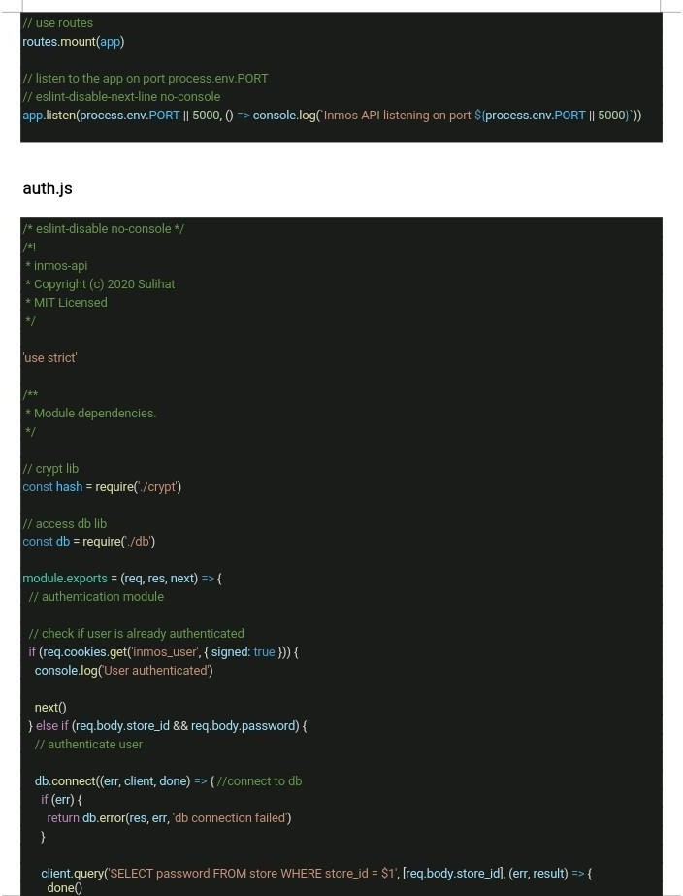

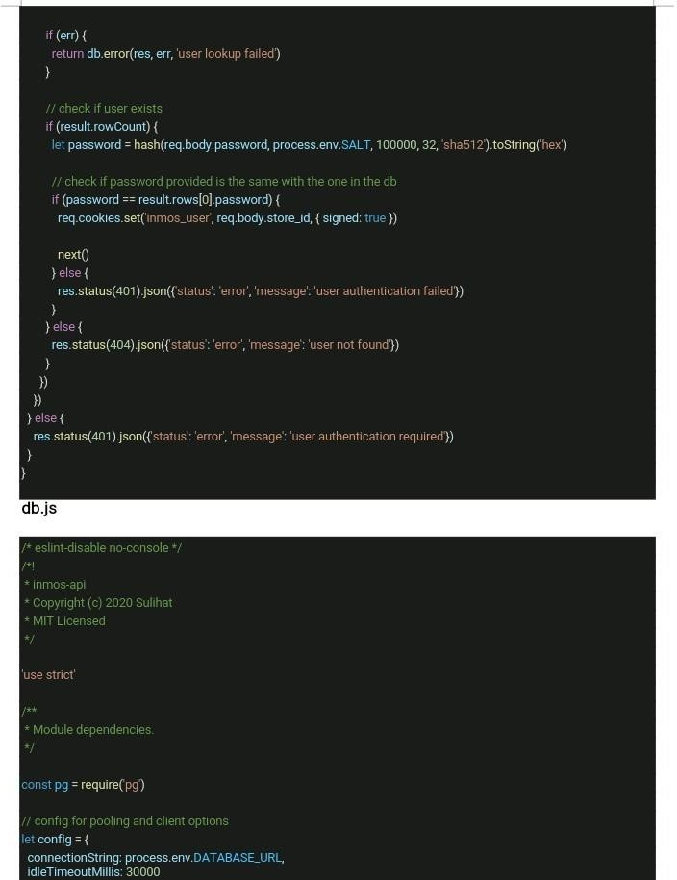

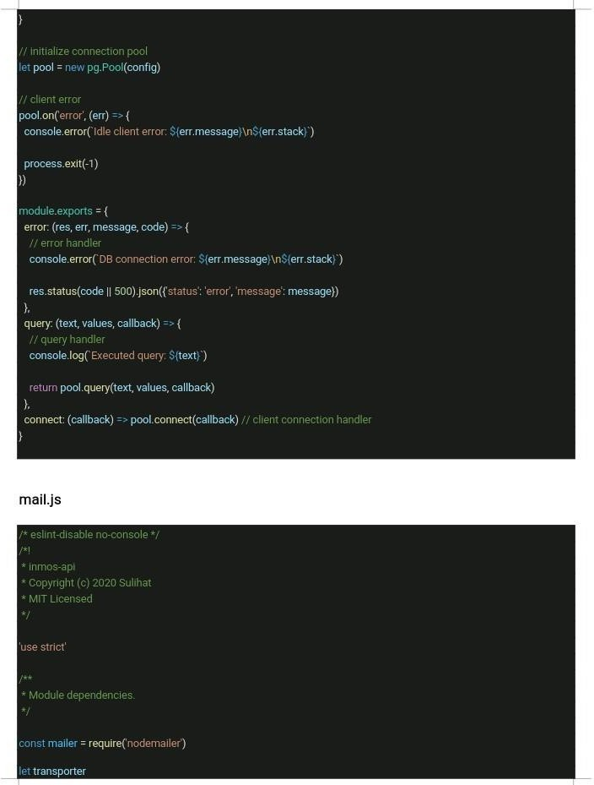

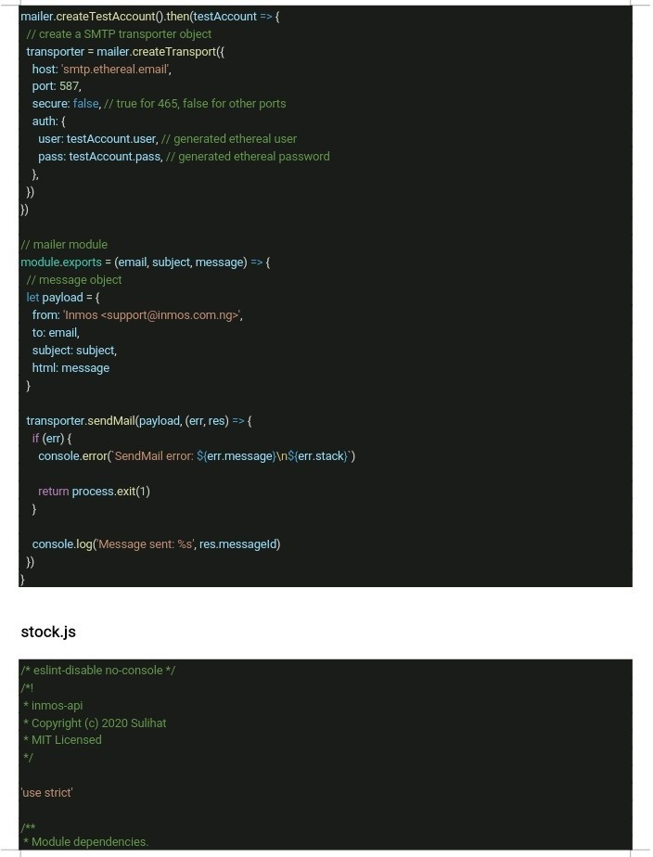

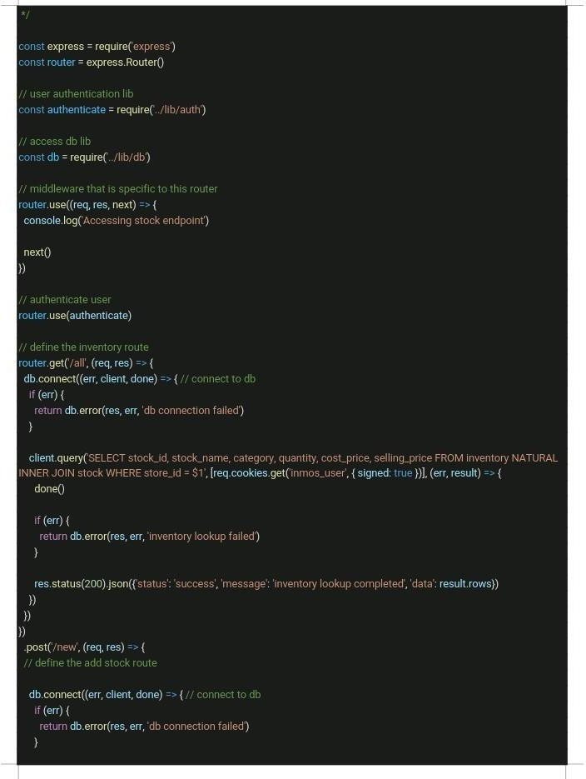

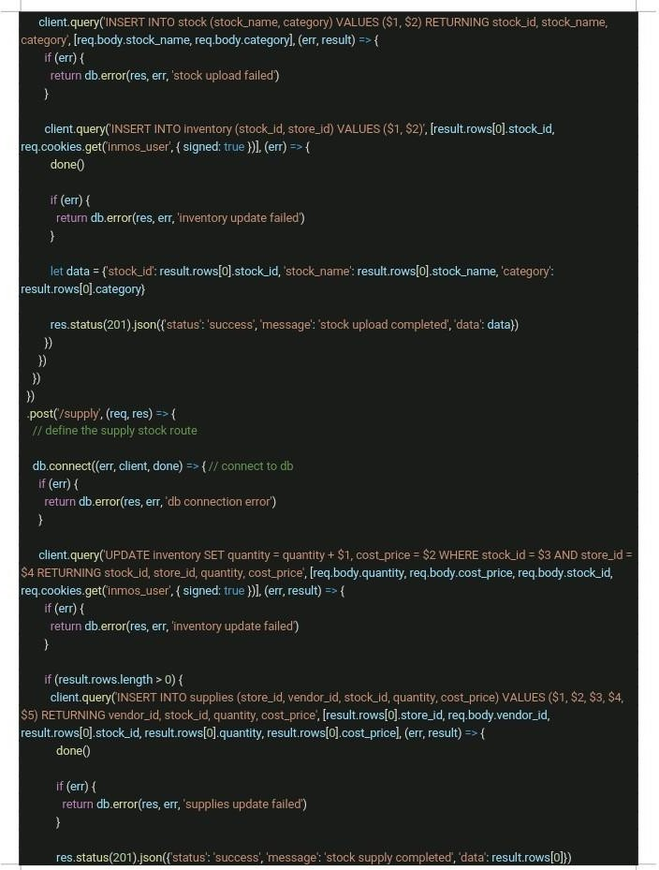

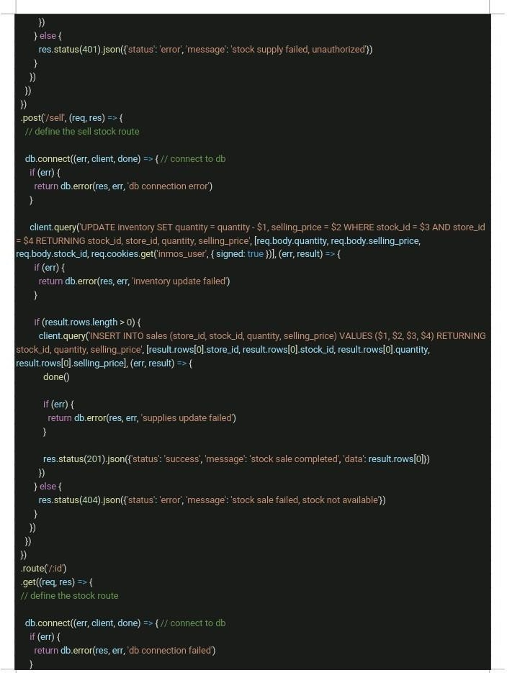

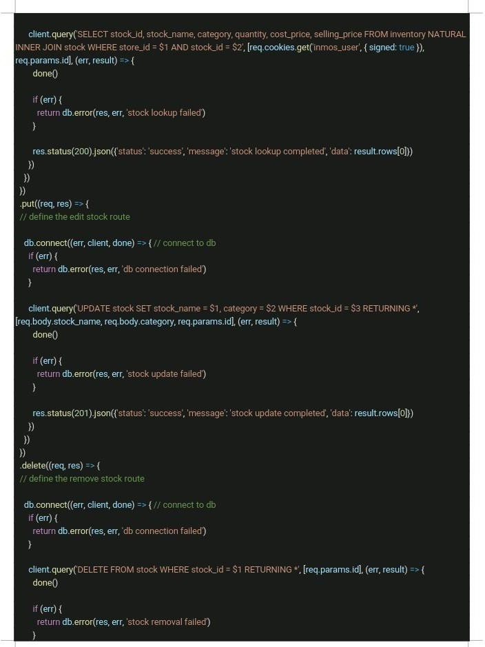

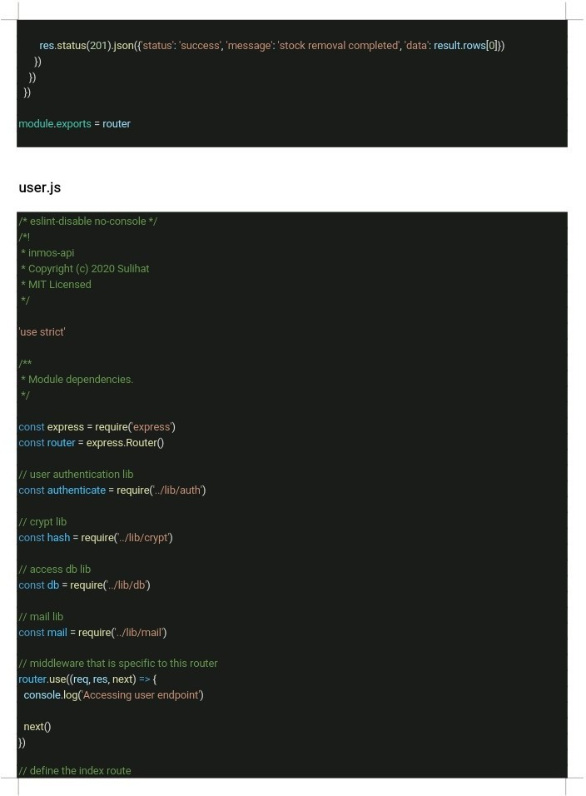

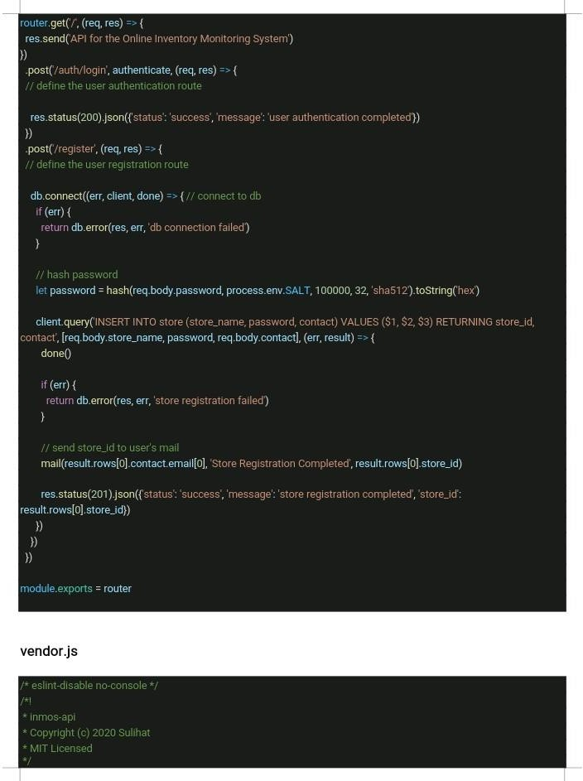

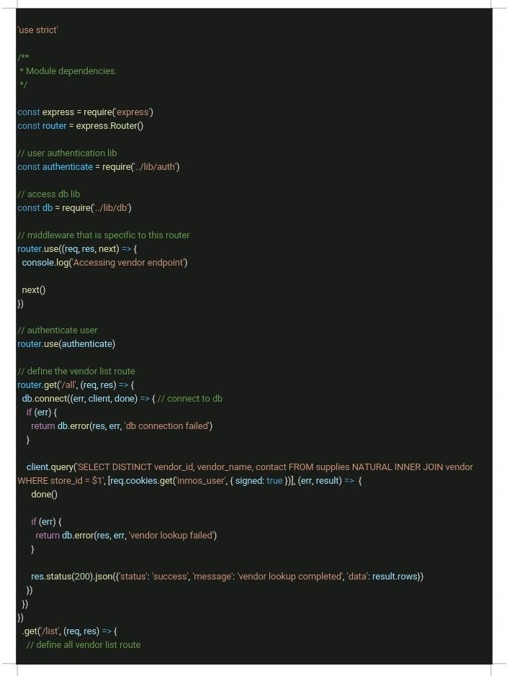

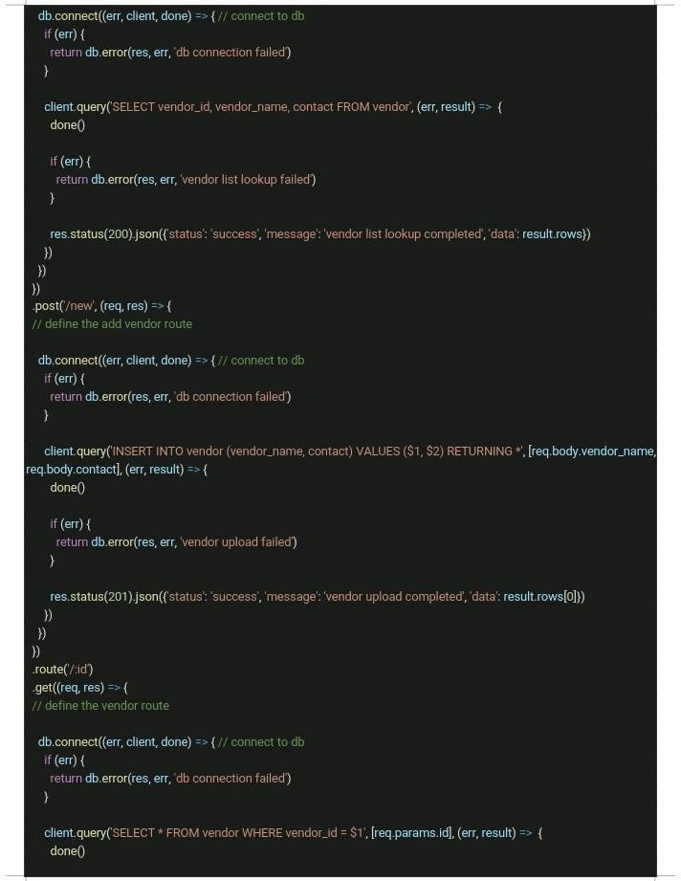

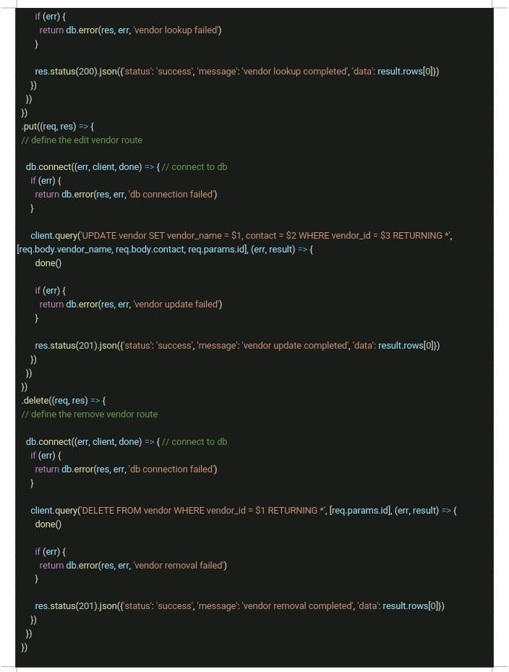

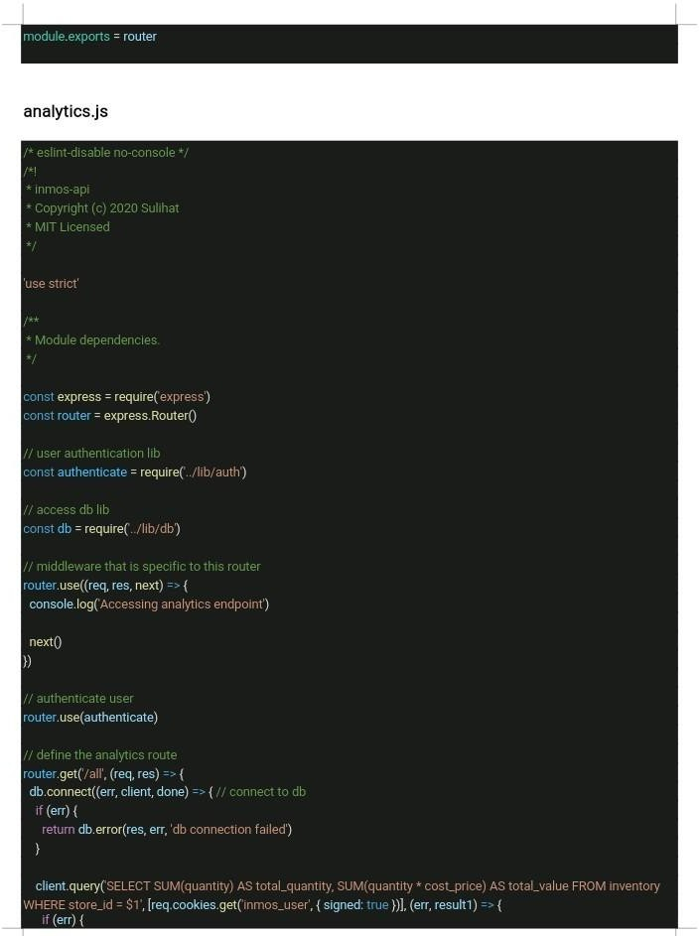

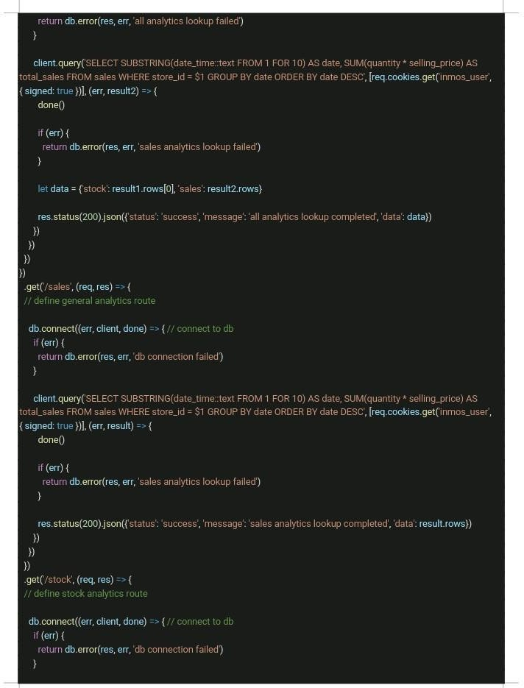

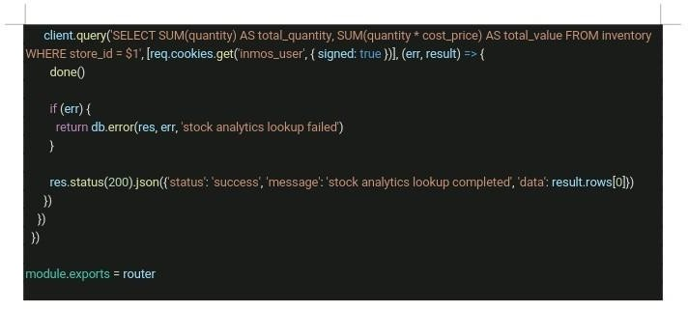

### APPENDIX D – TEST CASES

**Table. 4.1 Test Suite Performed for Login**

|  |  |
| --- | --- |
| Test Suit ID | R-100 |
| Test Case ID | TC-001 |
| Test Case Summary | The system ought to have login capabilities that permit users to have access. |
| Related Requirement | R-103 |
| Prerequisite | Must be registered |
|  |  |
| Test Procedure | Enter store ID and password. |
| Test Data | Store ID and Password. |
| Expected Result | The system ought to have login capabilities that permit users to have allowed access. |

|  |  |
| --- | --- |
| Actual Result | The system has login capabilities that permit users to have access. |
| Status | Test case passes |
| Remarks | The test was successful |
| Created By | Sulihat Ibrahim Imam |
| Date Created | 10/5/2020 |
| Executed By | Sulihat Ibrahim Imam |
| Date of Execution | 10/5/2020 |
| Test Environment | Hardware: HP Laptop  Software: Browser – google chrome |

**Table. 4.2 Test Suite Performed for Inventory**

|  |  |
| --- | --- |
| Test Suit ID | R-101 |
| Test Case ID | TC-002 |
| Test Case Summary | The system ought to be able to list products / items that a consumer purchases and measure their overall costs. |
| Related Requirement | R-102 |
| Prerequisite | Must be logged in. |
|  |  |
| Test Procedure | Log in and click on inventory. |
| Test Data | Login detail. |

|  |  |
| --- | --- |
| Expected Result | The system ought to be able to list products / items that a consumer purchases and measure their overall costs. |
| Actual Result | The system is able to list products / items that a consumer purchases and measure their overall costs. |
| Status | Test case passes |
| Remarks | The test was successful |
| Created By | Sulihat Ibrahim Imam |
| Date Created | 9/7/2020 |
| Executed By | Sulihat Ibrahim Imam |
| Date of Execution | 9/7/2020 |
| Test Environment | Hardware: HP Laptop  Software: Browser – google chrome |

### APPENDIX E – USER GUIDE/MANUAL

**Store Manager’s Guide**

* Access the Android App on your smart phone.
* Login with the Store ID and password.
* Click on the drawer navigation to see all the inventory sections.
* Click on analytics to see your sales chart.
* Click on logout to exit the application.

**Store Attendant’s Guide**

* Access Web Portal by navigating to the URL.
* Login with the Store ID and password.
* On the dashboard, you can see a side menu with all the inventory sections.
* Click on a Stock item and select action e.g., sell item.
* Click on the Vendor menu to perform actions like add, edit and remove vendor.
* Click on logout to exit the application.