DESIGN AND IMPLEMENTATION OF AN ONLINE DRIVING SCHOOL MANAGEMENT SYSTEM
(A CASE STUDY OF AA DRIVING SCHOOL, UYO)

ABSTRACT

With the rapid development in technology, there is a need to develop a management system for drive-training enterprise. Driving-training school’s efficiency will be managed and the will be a reduced waste of human power and information resources. The Management System will grow for the most part of the driving school to deal with the activity increasingly productive, effectively to discover information, record keeping more productive and recover information quicker. This framework will be overseen by the staff of driving school. This staff is dependable to the educator and understudies records. The Driving School Information System will keep all the information of the daily driving school center operation which is from the instructor’s records, schedule, and many more. Besides than that, Driving School Management System will keep track all of the operation information securely and orderly and even with backup option. It is also can make the management easy for searching and retrieving data, and making changes to all stored data. The software will be implemented using HTML, CSS and PHP development technology. Phases that are included are requirement, system analysis, design, implementation and system testing and maintenance. At the end of this project, it is hope that Driving School management System can contribute to driving school operation to make it better and to cater best service.

CHAPTER ONE
INTRODUCTION
BACKGROUND OF THE STUDY
With the rapid development in information technology, higher request is needed by the management of drive-training schools enterprise. Driving-training school’s effective management can reduce the waste of human power and wealth very much, and driving-training school’s information resource can be utilized effectively. As the share of human power and information becomes deeper and weeper, the management and share of driving-training school’s manager, vehicle and student become more and more important. Present management method’ key issues exist as follows. Enrollment, health examination and graduation information of drive-training school students are operated artificially, which is not only with low efficiency but also make mistakes often with many students, vehicle and coaches, in distributing vehicles to student and coach to vehicle is made automatically. In this way, resource can’t be assigned reasonably and used effectively, which are clumsy human usage, unclear of administration responsibility and so on. This application will be managed by the staff of the driving school. The staff are responsible to the instructor and students records. The major problems of driving schools are that as students’ records increases and it is not systematic anymore to keep all the data in the file systems anymore. As example there are data on previous students with over 5 years operation of the driving school, kept in files that fill half of the room and maybe there are several years of data to come and all the files have to be keep. It is very impossible for the driving school center to start thinking of enlarging it building just to add room to store all this files generated over the years. This method of storing sensitive information is not safe, keeping all of the data in order and securely where only the authorize staff can easily have access to it can give more problems. Moreover, in case there’s a fire outbreak or any unexpected incident or disaster happens, for sure all of the saved data will be no more. Although new driving schools are implementing the use of online driving system to manage all of these records, it is still not efficient enough. Normally the staff of the driving school, who is the instructor will contact their students to pass information about class, examination or other related activities to driving lessons. This manual method of informing students about driving lessons is not practical anymore today because it is will involve a lot of time. The management system will not only saves a great deal of manpower and financial resources of driving school, but also to improve and prettify driving school information management more easily and effectively.

1.2 STATEMENT OF THE PROBLEM
The research work, we present a new solution method for driving schools, consisting of three phase:
- Communicating with numbers of students at one time. Driving schools with large amount of students at a particular time face problems communicating with student for their driving class schedule or exam. Looking at this problems faced by driving school, many have a lot of challenges in communicating with their student especially if the number of students are more than the available instructors.
- Tracking student progress. Tracking students’ progress manually might be challenging to the staff handling many student at a time. Beside, staff can’t easily remember each student progress. Especially when there is no proper system to handle the progress. Everything will be manual.
- Managing daily data. Checking and managing data on a daily base is the main priority of the system. Day to day data of a driving school involving government procedures, policies and laws.

1.3 AIM AND OBJECTIVE OF THE STUDY
The principle aim of this project is to develop and implement an online driving school management school system that will be useful to our driving schools institutions, using the web.
The following are the set objective:
- To develop a driving school management system that is implemented on the web technology to display related information and store driving school students’ information.
- To Keep track of Driving school students’ information, payment schedules and many more data which can easily be retrieved by staff of the driving school.

1.4 LIMITATION OF THE PROJECT
The project is developed to cover the fixing of an online driving school management system for all students in AA Driving School but it can be implemented in any other driving school institution, this can be achieved by merely adjusting the input design of the program.

1.5 SCOPE OF THE STUDY
In this project, attention is focused on implementing an online driving school management system for AA driving school, Uyo.

1.6 DEFINITION OF TERMS
- Technology - Technology is the collection of techniques, skills, methods, and processes used in the production of goods or services or in the accomplishment of objectives, such as scientific investigation.
- Driving- Driving is the controlled operation and movement of a motor vehicle, including cars, motorcycles, trucks, and buses.
- Information - what is conveyed or represented by a particular arrangement or sequence of things.
- Implement - a tool, utensil, or other piece of equipment that is used for a particular purpose.
- Institution: organization founded for a religious, educational, professional, or social purpose.

CHAPTER 2
LITERATURE REVIEW

INTRODUCTION
This chapter will discusses about article review of the project. Literature review is the summary of article that sourced from reliable article. This article review important because it is used to help the developer to build the system, so the developer get some knowledge of the strengths and limitation of the system. All of this helps the developer to choose the best way to develop the system. Researches and analysis an existing system or current system have to be done in order to build a good system. Good system always comes after enhancement of existing system. For this project, literature review serves the purpose of gathering information related to the development of driving school management system. This review will focus on the current existing system. The result of the review will serve to better equip the developer with knowledge relevant or essential in the design and planning of the system. It will also discuss the approach that will be used for this project and related research and information about the approach, methodology and tools that will be used to develop this project. Besides that, literature review serves the purpose of gathering information related to the development of an Online Driving School Information System. This review will focus on the method how the system will operate by implementing some technologies.

2.1 FACTS AND FINDING
The main purpose of this study is to identify the problems and drawbacks of current system. Apart from that this study is carried out to analyze the problems that occurred from the current system to come out with the solutions to overcome the regarding drawbacks. Then, it is purposely to study and analyze the management process and activities in order to identify the requirements of the future system. Next is to conclude the future system and to classify the main modules for the system.

2.2 EXISTING OF DRIVING SCHOOL ONLINE SYSTEM
This chapter will discuss about existing online system of driving school in Nigeria.
Refer to figure 1, it show one of example of the current simple online system that is used by one of the driving school in Nigeria. This SKEM Driving Academy, using their online system just to give information about their driving school to potential students. They are using seven main menus in their online system. The first one is front page. This front page will show all of recent promotion, package and announcement of 7 their driving school. In this front page also, there is login box for the instructor to access their email and memo. Then information menu where they will list all information that related to their driving school. Third is service where they list out all of service that they can provide like license application, campaign about road safety and consultation. The next is branch menu. In this menu they listed their entire branch that located around Nigeria. Then customer feedback form where their customer can post any feedback about this driving school whether it is good, neutral or bad. The last one is their contact details.

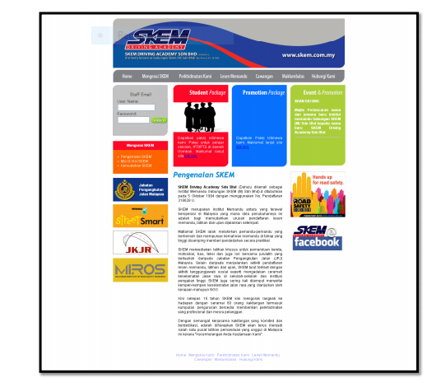

Fig 1. SKEM driving school

This website only provide normal typical function like others online system. Although the system have function for instructor to access their email and memo, but student cannot fully utilize the online system. So this is can consider the online system main purpose only for the staff or instructor of this driving school.

2.3 DISCUSSION
This online system used to give information about their driving school. It is can considered as informative online system to public. They provide information on driving practical, policies and laws, process to gain driving license and also current issues on driving. This website is very informative but there is no communication between driving school staff, instructor and student. Although all of the online system look similar, but some of the online system have unique function integrated. For SKEM Driving Academy, they have function for instructor or staff to access email and memo. This is only for registered staff or customer, not accessible to anyone that not registered. For the Metro Driving academy, they are having online form for the potential students to register if they interested to be a student. But for the Api-Api Driving Center, there is nothing unique. Nowadays, an online system should be complete with functions. So it is convenient for the user of the system. Online system also should allow user to access to the system anywhere without having to install software to a specific desktop computers. In my opinion, it is a good solution for Driving School Information System (DriSIS) to be build as an online system.

2.4 TECHNOLOGY
On this part, I will review about the technology that I used to develop my system. Which are web application, GSM modem, and database server, programming language and web server.

2.4.1 PHP
PHP is a widely-used general-purpose scripting language that is especially suited for Web development and can be embedded into HTML. It is a powerful server-side scripting language for creating dynamic and interactive websites [1]. PHP is the widelyused and free. PHP is perfectly suited for Web development and can be embedded directly into the HTML code. The PHP syntax is very similar to Perl and C [2]. PHP is often used together with Apache web server on various operating systems. It also supports ISAPI and can be used with Microsoft's IIS on Windows. The most important thing is PHP is an open source application and 100% free. Here are some of advantage PHP that needed for my Driving School Information System (DriSIS) project: I. PHP is free, and open source II. PHP is much easier to learn, partly because it requires no adherence to a particular programming style like Java and others language programming language III. PHP runs on virtually any operating system (Windows, Linux and FreeBSD) and HTTP server while others language like Java requires an application server like Tomcat, WebSphere, WebLogic which are OS-dependent. Additionally, others language not always be portable between different application servers like PHP. IV. PHP natively integrates with a large array of database engines.

2.2.3 Online System
Generally, something is said to be online if it is connected to some larger network or system. In other words, the larger network usually refers the Internet. Therefore, 'online' describes the information that is accessible through the Internet. By using online system, it is easy for students or instructors to check any information they need to know, as long as there are internet connection available.

2.4.4 MySQL
MySQL is a relational database management system (RDBMS) based on SQL (Structured Query Language). It was first released in January 1998 and is now one component of parent company MySQL AB’s product line of database servers and development tools. Many internet startups became interested in the original open source version of MySQL as an alternative to the proprietary database systems from Oracle, IBM and Informix. MySQL is currently available under two different licensing agreements which is the free of charge, under the GNU General Public License (GPL) open source system or through subscription to MySQL Network for business applications. There are many advantage of MySQL in term of speed, ease of use, capability, connectivity and security, query language support and cost

2.5 1 Web Server
Function of a web server is to deliver web pages on the request to clients. This means delivery of PHP documents and any additional content that may be included by a document, such as images, style sheets and scripts. In the proposed system, server needed to host webpage of the system. Besides that, it is needed to save all of related media like documents and database.

CHAPTER THREE

SYSTEM ANALYSIS AND DESIGN

3.1 INTRODUCTION

This chapter discuss the concept of methodology used for developing Smart Driving School System. This chapter also informs and describe about the System Development Life Cycle, software and hardware specification that are needed for implementation and develop the system.

3.2 SYSTEM ANALYSIS OF THE SYSTEM

A system is an harmonious arrangement of components hardware and software; that interact to achieve a common goal. ( Stella C.C and France A.E., 2006).

Analysis is the focus of system development and is the stage when system designers’ works at two levels - what to do and how to do. Analysis of driving school management system involves a detailed study of various operation performed by it.

Every system is created against at least a particular problem; that is systems are created to solve problems. This driving school management system solves the problem of capturing student information, allow tutors to enter student grades, student can verify online if their programs has been completed or not, both in studentship and certificate and documents obtained from AA Driving School, Uyo.

The existing management system is a manual one, this is, and it uses manual method where a request usually via letter or memo is sent to the concerned institution to verify the studentship of a student, the tutors’ performance and the grades of student. Everything is done on paper.

In comparison with the manual system, driving school information system is an automated system that simplifies the activities of the manual system with better integration and updates of the manual systems activities. This automated system is designed and developed with Hypertext Preprocessor (PHP) as it language, MYSQL, HTML, AJAX, and JAVASCRIPT Technologies. System analysis squarely deals with the software development activities. Three basic stages are involved in designing and delivering a good driving school information system (and any other system), namely;

A thorough analysis of the system. A problem understood is half solved.

Development of an effective automated system driving school management system; to meet requirement in an effective and efficient way.

Developing, installation, testing of system components, training, management, programming, monitoring and delivery the system; into production yields to successful construction and implementation of the system in the user’s environment.

3.3 CONSTRAINTS OF THE EXISTING SYSTEM

The existing system which is a manual system of driving school system is associated with the following constraints or problems;

- Unreliability: this system (the existing system) can be manipulated since human beings are directly involved in the process of verification.
Human can be bribed, deceived and show favouritism but in the proposed automated system (A case study of AA Driving School, Uyo) these are not possible.

- Speed: this has to do with time,. It takes longer time to send an application letter for verification and the reply thereof when compared to the window based driving school information system. The speed of the manual system is a snail’s speed.

- It increases paper work since it is not an electronic system. The paper work of the manual system is far greater than the paper work of the automated system.

- During the process of application for verification and reply to application, some important document might be lost.

- Un-confidentiality: privacy is not considered in the manual system, important and private information may be made open during the process of verification, as many people (more than two persons) are involved.

32
3.4 PROPOSED SYSTEM DESIGN

Driving school management system is the proposal system and it is designed for institution of learning and is specifically restricted to AA Driving School, Uyo, Nigeria. The system is designed to achieve the establishment objectives of the proposal system.

3.4.1 SYSTEM ALGORITHM DESIGN

Note that the proceeding algorithm is not in pseudo code neither is it written in any programming language but it is written in a natural language. Start

If Admin starter then do

If the file then do

If new then do

Read data

If update then do

Read data

End if

Else if exist then do

Close application

End if

If admin then do If add then do Read admin data start Add new admin
Else

If edit then do

Admin start

Read data

Update admin else

If delete then do

Read admin data

Delete admin

Else

If system operation then do

If add then do

If (item = programme or dept or course or status) then do

Read data

Else

If edit the do

If (item = programme or dept or course or status) then do

36
Read data

Update data

Else

If item = delete then do

If (item = programme or dept or course or status) then do

Read data

Delete data

End if

End if

If organization menu then do

If add then do

Read data

Else

If modify the do

Read data

Update data

Else

If delete then do

Read data

Delete data

End if

End if

If (organization or student) then do

If file then do

If exit then do

Close application

End if

End if

If search then do 10 // does the algorithm with line number 10 end if

If verification then do 20 // does the algorithm with line number 20

End if

End if

38
End

3.4.2 INPUT DESIGN

For there to be an output, there must be an input which must be processed to yield the required output. The input document used to record information of driving School Management System and to verify student information thereafter makes up the input forms.

The supplied data on the input forms servers as the input to the system. These inputs are linked to the systems database and comparison is made with the pre-stored data in the database.

The verification form is shown on the clicking of any of the sub-menus. The required fields used as inputs in this form include student information.

Firstname:

Lastname:

Email Address:

Phone number:

Gender:

Course:
Amount Paid:

Create Account

Fig. 3.1 input form to add Student

3.4.3 INTERFACE DESIGN

This is the physical structure of the visible side of the system, mainly to the users. That is the front and of the system, which the users of the system interacts with, it comprises of both inputs and out put forms.

The interface of the system is a graphical user interface and not a command type; it is also an interactive, clear and not clumsy.

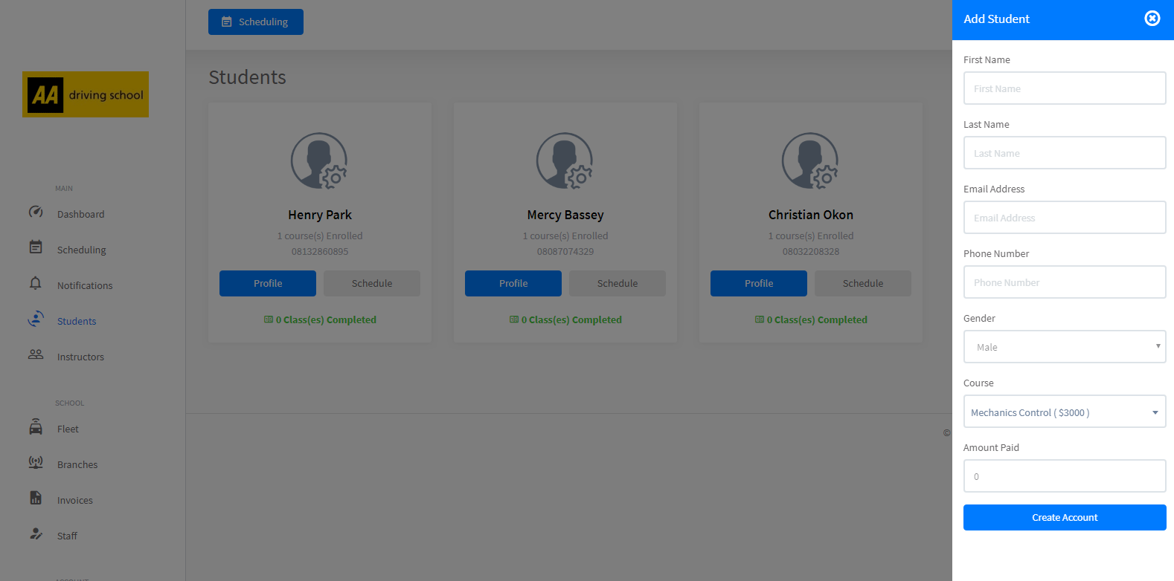

Fig. 3.2 The main interface form

3.4.4 OUTPUT DESIGN

After students grades have been inputted into the system, student can view their result. This form that shows the output (result) is the output form.

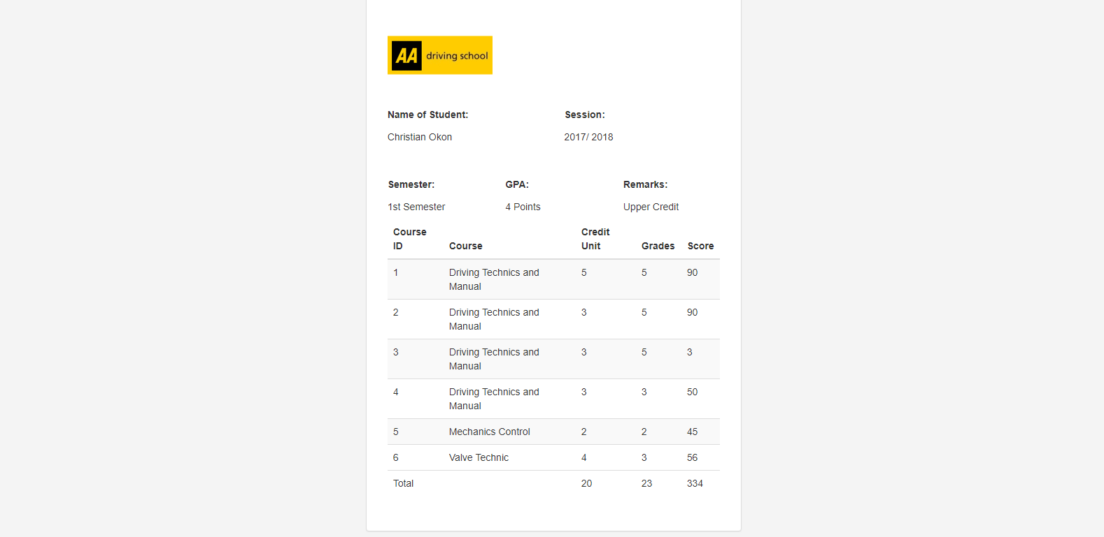

Fig. 3.3a The Result

3.4.5 SYSTEM DATABASE DESIGN

Database is a repository for data and information in an organized way to prevent redundancy and to preserve data integrity amongst others.

The design and implementation of the database is done on MYSQL server engine. This database consists of table of which some are.

The name of the database is ‘simcypla_landa’ and it has 22 tables in which 2 tables will be displayed here as an analysis.
Table: grades

Fields | Data type
id | int
name | varchar
course | varchar
grade | Varchar
semester | Varchar
session | Varchar
Credit_unit | varchar
score | Varchar
instructor | varchar
Grades_date | varchar
Table 3.1 grades table

Fields | Data type
id | int
fname | varchar
lname | varchar
email | Varchar
gender | Enum(‘Male’,’Female’)
Date_of_birth | date
phone | varchar
address | Varchar
password | varchar
avatar | varchar
token | varchar
school | Int
branch | int
course | varchar
role | Enum(‘admin’,’staff’,’instructor’)
position | varchar
Permission | varchar
Status | Enum(‘active’,’suspended’,’inactive’)
Lastnotification | datetime
Lang | varchar
Created_at | Timestamp
Table 3.2 users table

3.5 TECHNOLOGY, TOOLS AND PROGRAMMING LANGUAGE USED

Web based application are developed systems or applications that are objects oriented and run on a web environment. Thus, it needs or no internet connection.

Hypertext Preprocessor (PHP) is an integrated Development Environment (IDE) developed for web programming. it can be used for development of different things such as, console programs, GUI (Graphical User Interface) application, web sites, web pages, web application and services (native code and managed codes and included).

PHP is an object oriental programming language used for developing a variety of applications that runs on web framework. PHP and Javascript is simple, powerful, type-safe objective oriented and encourages Rapid Application Development (RAD).
MYSQL server is a relational database management system (RDMBS) developed for database entry. it runs as a server giving access to a number of databases. The SQL is an acronym for structured Query Language, pronounced officially as “S.Q.L” but one often pronounced as “S-equ-el”.

47
CHAPTER FOUR

DESIGN AND IMPLEMENTATION

4.0 INTRODUCTION

This chapter focuses, on the requirements for this automated system’s implementation. Information about the installation is also discussed, moreover, the automated system is described in UML (Unified Modeling Language) and the use case diagram is given.

An automated system that is not implemental or is not successful implemented can not be used to perform well as the case may be. “Even after the development phase is over, the system project isn’t complete. The new system must be implemented or installed” (said Stella C.C. and Franca A.E, (2006)).

4.1 SYSTEM DESIGN

This automated system is designed using the SSADM (Structured System Analysis and Design Methodology and RAD (Rapid Application Development) Model which are object oriented. The UML which was formulated by Booch, Rumbaugh and Jacobson in 1997 is used to describe the system and the use Case diagram shows the system design (Detail Design or design Overview). UML is a language for specifying, visualizing and constructing the artifacts of software system. A Use case diagram is one of the UMl diagrams. Others are sequence diagram, state diagram, collaboration diagram and so on.

A use case diagram shows typical interactions between a user (actor) and the computer system. As defined by Stella C. C. and Franca A.E. (2006) in their book principle of system analysis and design, use case are included in UML and it is a narrative document that describes the sequence of event of an actor using a system to complete a process.

4.2 SYSTEM DESCRIPTION

To describe this automated system, we apply a use case diagram which is graphical representation of the systems functionality by the different users. The use case diagram consist of actors use cases and arrows (for evens of flow.
49

The actors as concerned in this driving school management system are Admin (Administrator), Staff, instructor, and student. The use cases are registration, update, search, check result, add admin, and modify Admin, Delete Admin, System Operations and organizations menu.

The system operation consists of Add, Edit and Delete of Student, Staff, status, session and so on. The organization menu is meant for the registration of organization, editing and deleting likewise. The registration gives license to the organization to own and use the driving school information system.

The use case diagram of this automated system – driving school management system; is given below.

Student

Organisation

Registration
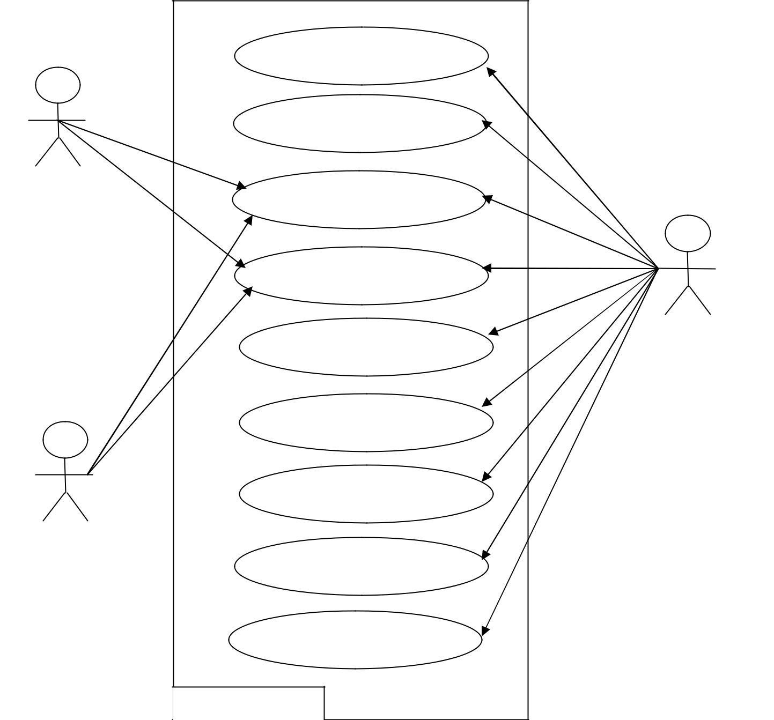

Update

Search

Verification

Add Admin | Admin

Modify Admin

Delete Admin

System Operations

Organisation Menu

System Boundary

Fig 4.1 Use Case Diagram - Shows the description of the driving school management

system.

From the above use case diagram, after the log in process has been met, the system provides an abstraction based on the selection. Thus, if a student or an organization log-in, he/she can only see and perform two function - search and verification, apart from closing the application. When an administrator logs in, he/she can use all the system components.

4.3 SYSTEM IMPLEMENTATION

Designing or developing a system is one thing, another is implementing, not just implementing it, but the successful implementation.

Implementation of any information system or automated system depends on the hardware, software and people. Hence, the hardware being mainly a personal computer (PC) with printers, scanners and any peripheral that is needed. The software for the implementation of this automated system is MySQL server which serves as the database but there is no need for this software if a student or an organization desires to make use of it. The web browser must be a eligible to view the web system.
The people consist of the users of the system which encompasses of Administrators, organization and students. All the users must be trained and computer literates else the system’s aim and objective will be defeated.

4.4 HARDWARE REQUIREMENT

The following hardware components are needed

- Personal computer (PC) – a desktop or laptop

- Printer – a desk jet or inkjet

- Scanner – Preferably colour scanner pictures. The personal computer should have a minimum of

- Pentium 4 Processor

- 512 kb RAM

- GB Hard disk

4.5 SOFTWARE REQUIREMENT

The needed software is as follows:

- Web browser

- MySQL Server.

- Notepad++.

4.6 SYSTEM TESTING

Before a system is put into operation, its components programs must be tested to make sure. They work both individually and as a unit. Testing whether unit testing (individual testing) or individual testing, removes bugs from individual programs and system application. The testing of this system is done with life data and test data.

An automated system may have a hundred programs and a comprehensive database, all must be tested together to ensure harmony of operation. The purpose of system testing is to validate all software, input/output, databases and procedures and so on as the case may be.

4.7 SYSTEM REVIEW AND MAINTENANCE

After successful testing and implementation, system review and maintenance is necessary to do check and balances and for the following.

- Comparison of the system’s actual performance versus the anticipated performance objectives

- Assessment of each facet of the system with respect to present criteria.

- Correction of any error that may occur after its use for say one months;

- Updating of new features;

- Unexpected problems

4.8 INSTALLATION PROCEDURE

After the purchase of the software, insert the CD into a CD/DVD RW/ROM of the computer system you intend to have this software installed on. Then Run the inserted disk and follow the setup procedure, there after, the software will open if it has been successfully installed. This installed software does no open on its own but open on the users demand by double click on its icon or right click on the icon and click on open.

4.9 USERS GUIDE

Users of the software should take the following as a guide:
- Avoid the use of this software by a computer illiterate

- Ensure that you hardware and software meets the hardware requirements and software requirement as stipulated in 4.4 and 4.5 respectively.

- Regular maintenance should be done on the software to avoid unexpected problems.

4.10 SYSTEM FLOWCHART
Input Data – Master Entry

Processor

Disk
Storage
Output (Report)
Result to Screen
Input From the
Keyboard

Control Unit

4.11 PROGRAM FLOW CHART
Start
Main Form
Registration details as new user
A
A
If details exist?
User already exist?
Stop
B
Start
Login username and Password
exist?
B
B
Main Form
Enter student details, staff details, instructor details, branches details, courses, etc
Stop

Submit
Yes
Admin Login
Admin Login
No
No
Yes
Submit and generate password
CHAPTER FIVE

SUMMARY AND CONCLUSION

5.1 SUMMARY

Driving school management system is a major and important activity to any institution. The system that has been in existence is the manual system which has many defects as mentioned earlier in section 3.3 of this material. The merits of this automated system over the existing one are as follows

- Accuracy

- Reliability

- Reduced paper work

- Speed in processing time

- It cannot be manipulated

- Simple process

- Users friendliness with GUI

5.2 RECOMMENDATION

This work should not put a stop to research on driving school technology as biometrics technology, facial recognition and Iris recognition technologies can be integrated to the technology used in this system.

Despite the fact that the system is a window based system (application software), it should be re developed to a web based system but with stronger security measures to avert web hackers and theft.

Also, we strongly recommend this software for AA driving school, Uyo and other driving institution.

5.3 CONCLUSION

Automated system has proved to be more successful when compared to manual systems.

Driving school management system redefines the manual system, hence averts academic fraud and illegal completion of courses. Since the value of every degree is the reputation of the institution and the student produced, driving school management system will in no distance time ‘pocket’ the manual system.

REFERENCE

Byron, S.G. (2001). Theory and Problems of Programming with visual basic Schaum’s Outline. McGraw – Hill USA.

Sikiru, O.A. (2009). Implementation of an Online Job recruitment system. An unpublished M.IT Thesis, University of Lagos, Nigeria.

Stella, C.C. and Franca, A.E (2006). Principles of System Analysis and Design.

Rootprint and publisher, Benin city – Nigeria.

Suhansa, R., George, Y. and Ronald, W. (2011). Students verification system for Online Assessments: Botstering Quality and interigty of Distrance Learning. Journal of Industrial Technology. Volume 27 Number 3. P1-8.

Uzoka. (1998). Human Resources Management an unpublished M. Tech Thesis, federal University of Technology, Akure, Ondo State.
Professional PHP6, By Ed Lecky-Thompson, Steven D. Nowak, and Thomas Myer
Learning PHP, MYSQL, and JavaScript: A Step-by-Step Guide to Creating Dynamic Websites, By Robin Nixon
PHP Solutions: Dynamic Web Design Made Easy, By David Powers
Beginning PHP and MYSQL: From Novice To Professional, By W. Jason Gilmore
Head First PHP & MYSQL, By Lynn Burghley and Michael Morrison
Core PHP programming By Leon Atkinson, Zeev Suraski.
PHP Object-Oriented Solutions By David Powers

WEBSTIES

www.atmae.org/jil/Article/rodchua-student-verification-system-07122011.Pdf (Accessed on: 23rd August 2011).
http://propakistani.pk/2009/01/25/hec-onlinedegree-verification-system-for-

students/ (visited on: 23rd August 2011)

www.zimbio.com/Nigeria+today/articles/qpgfit02wiR/Biometric+fingerprint+2011

+jamb+utme (Accessed on 10th October 2011) http://en.wikipedia.org/wiki/address-verification-system (Accessed on: 10th

October 2011).

http://en.wikipedia.orgwikie/adult-verifiation-system (Accessed on: 10th October

2011)

www.isbestate.il.USnews/2004/july16.htm/ (Accessed on: 1st November 2011).

http://en.wikipedia.org/wiki/microsoft-visual-studio (Accessed on: 10th November 2011).

www.aplusid.com/Education-C00718.html (Accessed on: 1st November, 2011).

APPENDIX (SOURCE CODES)
- login.php

<!DOCTYPE html>
<html>

<head>
<meta charset="utf-8">
<meta http-equiv="X-UA-Compatible" content="IE=edge">
<meta name="viewport" content="width=device-width, initial-scale=1">
<meta name="description" content="Driving School Management System">
<meta name="author" content="Simcy Creative">
<link rel="icon" type="image/png" sizes="16x16" href="{{ url('') }}uploads/{{ env('APP_ICON'); }}">
<title>Login | Driving School Management System</title>

<!-- Material design icons -->
<link href="{{ url('') }}assets/fonts/mdi/css/materialdesignicons.min.css" rel="stylesheet">

<!-- Bootstrap CSS -->
<link href="{{ url('') }}assets/libs/bootstrap/css/bootstrap.min.css" rel="stylesheet">
<link href="{{ url('') }}assets/libs/dropify/css/dropify.css" rel="stylesheet">

<!-- Simcify CSS -->
<link href="{{ url('') }}assets/css/simcify.min.css" rel="stylesheet">

<!-- Landa CSS -->
<link href="{{ url('') }}assets/css/style.css" rel="stylesheet">
</head>
<body>

<div class="auth-page">
<div class="auth-card card">
<div class="auth-logo">
<img src="{{ url('') }}uploads/{{ env('APP_LOGO'); }}" class="img-responsive">
</div>
<div class="login">
<div class="auth-heading mt-15">
<h2>Welcome Back</h2>
<p>A beatiful and powerful system crafted specifically for driving schools.</p>
</div>
<div class="auth-form">
<form class="simcy-form" action="{{ url('Auth@signin') }}" data-parsley-validate="" method="POST" loader="true">
<div class="form-group">
<div class="row">
<div class="col-md-12">
<label>Email Address</label>
<input type="email" class="form-control" name="email" value="demo@simcycreative.com" placeholder="Email Address" required="">
<input type="hidden" name="csrf-token" value="{{csrf_token()}}">
</div>
</div>
</div>
<div class="form-group">
<div class="row">
<div class="col-md-12">
<label>Password</label>
<input type="password" class="form-control" name="password" value="passqw" placeholder="Password" required="">
</div>
</div>
</div>
<div class="form-group">
<div class="row">
<div class="col-md-12">
<button type="submit" class="btn btn-primary btn-block">Login Now</button>
</div>
</div>
</div>
</form>
</div>
<div class="">
<!--<p class="pull-right"><a href="" class="auth-switch" show=".forgot">Forgot Password?</a></p>-->
@if(env('ALLOW_SIGNUP') == 'Enabled')
<p class="text-center"><a href="" class="auth-switch" show=".register">Create an account</a></p>
@endif
</div>
<div class="">
<p class="text-center"><a href="../teacher.php">Login as Instructor</a></p>
</div>
<div class="">
<p class="text-center"><a href="../studentlogin.php">Check Result as a student</a></p>
</div>
</div>
<div class="forgot">
<div class="auth-heading mt-15">
<h2>Forgot password</h2>
<p>Don't worry if you forgot your password, enter your email and you can reset it.</p>
</div>
<div class="auth-form">
<form class="simcy-form" action="{{ url('Auth@forgot') }}" method="POST" loader="true">
<div class="form-group">
<div class="row">
<div class="col-md-12">
<label>Email Address</label>
<input type="email" class="form-control" name="email" placeholder="Email Address" required="">
<input type="hidden" name="csrf-token" value="{{csrf_token()}}">
</div>
</div>
</div>
<div class="form-group">
<div class="row">
<div class="col-md-12">
<button class="btn btn-primary btn-block">Reset Password</button>
</div>
</div>
</div>
</form>
</div>
<div class="">
<p>Remembered your password? <a href="" class="auth-switch" show=".login">Login Now</a></p>
</div>
</div>
@if(env('ALLOW_SIGNUP') == 'Enabled')
<div class="register">
<div class="auth-heading mt-15">
<h2>Create an account</h2>
<p>A beatiful and powerful system crafted specifically for driving schools.</p>
</div>
<div class="auth-form">
<form class="simcy-form" action="{{ url('Auth@signup') }}" data-parsley-validate="" method="POST" loader="true">
<div class="form-group">
<div class="row">
<div class="col-md-12">
<label>First Name</label>
<input type="text" class="form-control" name="fname" placeholder="First Name" required="">
<input type="hidden" name="csrf-token" value="{{csrf_token()}}">
</div>
</div>
</div>
<div class="form-group">
<div class="row">
<div class="col-md-12">
<label>Last Name</label>
<input type="text" class="form-control" name="lname" placeholder="Last Name" required="">
</div>
</div>
</div>
<div class="form-group">
<div class="row">
<div class="col-md-12">
<label>Driving School Name</label>
<input type="text" class="form-control" name="school" placeholder="Driving School Name" required="">
</div>
</div>
</div>
<div class="form-group">
<div class="row">
<div class="col-md-12">
<label>Email Address</label>
<input type="email" class="form-control" name="email" placeholder="Email Address" required="">
</div>
</div>
</div>
<div class="form-group">
<div class="row">
<div class="col-md-12">
<label>Password</label>
<input type="password" class="form-control" name="password" placeholder="Password" required="">
</div>
</div>
</div>
<div class="form-group">
<div class="row">
<div class="col-md-12">
<button class="btn btn-primary btn-block">Create Account</button>
</div>
</div>
</div>
</form>
</div>
<div class="">
<p>Already have an account? <a href="" class="auth-switch" show=".login">Login Now</a></p>
</div>
</div>
@endif
</div>
<p class="copyright"> &copy; {{ date("Y") }} {{ env("APP_NAME") }}. All Rights Reserved.</p>
</div>

<script src="{{ url('') }}assets/js/jquery-3.3.1.min.js"></script>
<script src="{{ url('') }}assets/js/popper.min.js"></script>
<script src="{{ url('') }}assets/libs/bootstrap/js/bootstrap.min.js"></script>
<script src="{{ url('') }}assets/libs/jquery-slimscroll/jquery.slimscroll.min.js"></script>
<script src="{{ url('') }}assets/libs/dropify/js/dropify.min.js"></script>
<script src="{{ url('') }}assets/js/simcify.min.js"></script>
<script src="{{ url('') }}assets/js/app.js"></script>
</body>
</html>
- result.php
- <?php
- include('structure/header.php');
- ?><br><br>
- <div class="row">
- <div class="panel panel-default col-md-4 col-md-offset-4">
- <div class="panel-body">
- <img src="uploads/AA-Driving-School.jpg" class="img-responsive" width="150">
- <?php
- if(isset($_GET['name'])&isset($_GET['semester'])&isset($_GET['session'])){
- $name=$_GET['name'];$semester=$_GET['semester'];$session=$_GET['session'];
- ?>
- <div class="row">
- <div class="col-sm-6">
- <label class="control-label">Name of Student:</label>
- <h5><?php echo $name ?></h5>
- </div>
- <div class="col-sm-6">
- <label class="control-label">Session:</label>
- <h5><?php echo $session ?></h5>
- </div>
- </div><br><br>
- <div class="row">
- <div class="col-sm-4">
- <label class="control-label">Semester:</label>
- <h5><?php echo $semester ?></h5>
- </div>
- <div class="col-sm-4">
- <label class="control-label">GPA:</label>
- <h5>
- <?php
- $sqla = "SELECT * FROM grades WHERE session='$session' and semester='$semester' and name='$name'";
- $resulta = $conn->query($sqla);
- $kA=0;$kB=0;$markA="";$markB="";
- if ($resulta->num_rows > 0) {
- // output data of each row
- while ($rowa = $resulta->fetch_assoc()) {
- $gradeA = $rowa["grade"];
- $creditUnitA = $rowa["credit_unit"];
- $totalUnitA = $gradeA*$creditUnitA;
- $markA = explode(",", $totalUnitA);
- $markB = explode(",", $creditUnitA);
- foreach($markA as $outSA) {
- $kA+=$outSA;
- }
- foreach($markB as $outSB) {
- $kB+=$outSB;
- }
- }
- $totalGrade=$kA/$kB;
- echo round($totalGrade,3)." Points";

- ?>
- </h5>
- </div>
- <div class="col-sm-4">
- <label class="control-label">Remarks:</label>
- <h5><?php
- if($totalGrade >=4.5){
- echo "Distinction";
- }elseif ($totalGrade >=3.5){
- echo "Upper Credit";
- }
- elseif ($totalGrade >=2.5){
- echo "Lower Credit";
- } elseif ($totalGrade >=2.0){
- echo "Pass";
- }elseif ($totalGrade <=2.0){
- echo "Fail";
- }
- }else{

- header('location: /');
- }?></h5>

- </div>
- </div>
- <div class="form-group table-responsive">
- <table class="table table-hover table-striped">
- <thead>
- <tr>
- <th>Course ID</th>
- <th>Course</th>
- <th>Credit Unit</th>
- <th>Grades</th>
- <th>Score</th>
- </tr>
- </thead>
- <tbody>
- <?php
- $count=1;
- $sql = "select * from grades where name='$name' and semester='$semester' and session='$session'";
- $result = $conn->query($sql);
- if ($result->num_rows > 0) {
- // output data of each row
- while ($row = $result->fetch_assoc()) {
- ?>
- <tr>
- <td><?php echo $count++ ?></td>
- <td><?php echo $row["course"] ?></td>
- <td><?php echo $row["credit_unit"] ?></td>
- <td><?php echo $row["grade"] ?></td>
- <td><?php echo $row["score"] ?></td>
- </tr>
- <?php
- }
- }
- ?>
- </tbody>
- <tfoot>
- <tr>
- <td colspan="2">Total</td>
- <td>
- <?php
- $sql = "SELECT sum(credit_unit) AS value_sum FROM grades WHERE name='$name' and semester='$semester' and session='$session'";
- $result = $conn->query($sql);

- if ($result->num_rows > 0) {
- // output data of each row
- while($row = $result->fetch_assoc()) {
- echo $row["value_sum"];
- }
- } else {
- echo "0";
- }
- ?>
- </td>
- <td>
- <?php
- $sql = "SELECT sum(grade) AS value_sum FROM grades WHERE name='$name' and semester='$semester' and session='$session'";
- $result = $conn->query($sql);

- if ($result->num_rows > 0) {
- // output data of each row
- while($row = $result->fetch_assoc()) {
- echo $row["value_sum"];
- }
- } else {
- echo "0";
- }
- ?>
- </td>
- <td>
- <?php
- $sql = "SELECT sum(score) AS value_sum FROM grades WHERE name='$name' and semester='$semester' and session='$session'";
- $result = $conn->query($sql);

- if ($result->num_rows > 0) {
- // output data of each row
- while($row = $result->fetch_assoc()) {
- echo $row["value_sum"];
- }
- } else {
- echo "0";
- }
- ?>
- </td>
- </tr>
- </tfoot>
- </table>
- </div>

- <?php

- }
- ?>
- </div>
- </div></div>
- <?php
- include('structure/footer.php');
?>
- studentlogin.php
- <?php require_once ("database/database.php") ?>
- <?php ob_start() ?>
- <!DOCTYPE html>
- <html lang="en">
- <head>
- <meta charset="utf-8">
- <meta http-equiv="X-UA-Compatible" content="IE=edge">
- <meta name="viewport" content="width=device-width, initial-scale=1">
- <title>Student | Account Login</title>
- <!-- Bootstrap core CSS -->
- <link href="teacher/css/bootstrap.min.css" rel="stylesheet">
- <link href="teacher/css/style.css" rel="stylesheet">
- <link href="uploads/cropped-logoo-180x180.png" rel="icon">
- </head>
- <body>

- <section id="main">
- <div class="container"><br><br>
- <div class="row">
- <div class="col-md-4 col-md-offset-4" style="background-color: #ffffff"><br>
- <img src="uploads/AA-Driving-School.jpg" class="img-responsive" width="150">
- <h4 class="text-center">Student Login</h4>
- <?php
- if($_SERVER['REQUEST_METHOD']=="POST"){
- if(isset($_POST['btnLogin'])) {
- student_login($_POST['txtEmail'],$_POST['txtPassword'],$_POST['txtSemester'],$_POST['txtSession']);
- }
- if($flagp==false){
- echo " <div class=\"alert alert-warning\">
- <a href=\"#\" class=\"close\" data-dismiss=\"alert\" aria-label=\"close\">&times;</a>
- No Username or Password found in this system!!!
- </div>";}
- }
- ?>
- <form id="login" action="studentlogin.php" method="post" style="background-color: #ffffff">
- <div class="form-group">
- <label>Email Address</label>
- <input type="email" class="form-control" name="txtEmail" placeholder="Enter Email">
- </div>
- <div class="form-group">
- <label class="control-label">Semester</label>
- <input type="text" class="form-control" name="txtSemester" placeholder="Enter Semester">
- </div>
- <div class="form-group">
- <label class="control-label">Session</label>
- <input type="text" class="form-control" name="txtSession" placeholder="Enter Session">
- </div>
- <div class="form-group">
- <label>Password</label>
- <input type="password" class="form-control" name="txtPassword" placeholder="Enter Password">
- </div>
- <button type="submit" name="btnLogin" class="btn btn-primary btn-block">Login</button><br>
- </form>
- </div>
- </div>
- </div>
- </section>

- <footer id="footer" style="background-color:transparent;color:#000">
- <p>Copyright SpringLight Technology, &copy; 2019</p>
- </footer>

- <!-- Bootstrap core JavaScript
- ================================================== -->
- <!-- Placed at the end of the document so the pages load faster -->
- <script src="https://ajax.googleapis.com/ajax/libs/jquery/1.12.4/jquery.min.js"></script>
- <script src="teacher/js/bootstrap.min.js"></script>
- </body>
</html>
teacher.php
<?php require_once ("database/database.php") ?>
<?php ob_start() ?>
<!DOCTYPE html>
<html lang="en">
<head>
<meta charset="utf-8">
<meta http-equiv="X-UA-Compatible" content="IE=edge">
<meta name="viewport" content="width=device-width, initial-scale=1">
<title>Teacher | Account Login</title>
<!-- Bootstrap core CSS -->
<link href="teacher/css/bootstrap.min.css" rel="stylesheet">
<link href="teacher/css/style.css" rel="stylesheet">
<link href="uploads/aaIcon.png" rel="icon">
</head>
<body>

<section id="main">
<div class="container"><br><br>
<div class="row">
<div class="col-md-4 col-md-offset-4" style="background-color: #ffffff"><br>
<img src="uploads/AA-Driving-School.jpg" class="img-responsive" width="150">
<h4 class="text-center">Instructor Login</h4>
<?php
if($_SERVER['REQUEST_METHOD']=="POST"){
if(isset($_POST['btnLogin'])) {
insert_login($_POST['txtEmail'],$_POST['txtPassword']);
}
if($flagp==false){
echo " <div class=\"alert alert-warning\">
<a href=\"#\" class=\"close\" data-dismiss=\"alert\" aria-label=\"close\">&times;</a>
No Username or Password found in this system!!!
</div>";}
}
?>
<form id="login" action="teacher.php" method="post" style="background-color: #ffffff;">
<div class="form-group">
<label>Email Address</label>
<input type="email" class="form-control" name="txtEmail" placeholder="Enter Email">
</div>
<div class="form-group">
<label>Password</label>
<input type="password" class="form-control" name="txtPassword" placeholder="Enter Password">
</div>
<button type="submit" name="btnLogin" class="btn btn-primary btn-block">Login</button><br>
</form>
</div>
</div>
</div>
</section>

<footer id="footer" style="background-color:transparent;color:#000">
<p>Copyright SpringLight Technology, &copy; 2019</p>
</footer>

<!-- Bootstrap core JavaScript
================================================== -->
<!-- Placed at the end of the document so the pages load faster -->
<script src="https://ajax.googleapis.com/ajax/libs/jquery/1.12.4/jquery.min.js"></script>
<script src="teacher/js/bootstrap.min.js"></script>
</body>
</html>
- auth.php
<?php
namespace Simcify;

use Simcify\Str;

class Auth {

/**
* Authenicate a user
*
* @param \Std $user
* @param boolean $remember
* @return void
*/
public static function authenticate($user, $remember = false) {
session(config('auth.session'), $user->id);
if( $remember && isset($user->{config('auth.remember')}) ) {
cookie('cmVtZW1iZXI', $user->{config('auth.remember')}, 30);
}
}

/**
* Check if the user is authenticated
*
* @return void
*/
public static function check() {
return session()->has(config('auth.session'));
}

/**
* Log out the authenticated user
*
* @return void
*/
public static function deauthenticate() {
if(isset($_COOKIE['cmVtZW1iZXI'])) {
cookie('cmVtZW1iZXI', '', -7);
}
session()->flush();
}

/**
* Create a valid password
*
* @param string $string
* @return string
*/
public static function password($str) {
return hash_hmac('sha256', $str, config('auth.secret'));
}

/**
* Remember a user
*
* @return void
*/
public static function remember() {
if ( !static::check() && !is_null(cookie('cmVtZW1iZXI')) ) {
$remember_token = cookie('cmVtZW1iZXI');
$user = Database::table(config('auth.table'))->where(config('auth.remember'), $remember_token)->first();
if ( is_object($users) ) {
static::authenticate($user);
} else {
static::deauthenticate();
}
}
}

/**
* Get the authenticated user
*
* @return \Std
*/
public static function user() {
return Database::table(config('auth.table'))->find(session(config('auth.session')) + 0);
}

/**
* Login a user
*
* @param string $username
* @param password $password
* @param string $options
* @return mixed
*/
public static function login($username, $password, $options = array()) {
$givenPassword = self::password($password);
$user = Database::table(config('auth.table'))->where(config('auth.emailColumn'),$username)->first();

if (!empty($user)) {
if (isset($options["status"])) {
$statusColumnName = config('auth.statusColumn');
if ($options["status"] != $user->$statusColumnName) {
return array(
"status" => "error",
"title" => "Account inactive",
"message" => "Your account is not active."
);
}
}

$passwordColumn = config('auth.passwordColumn');
if(hash_compare($user->$passwordColumn, self::password($password))){
if (isset($options["rememberme"]) && $options["rememberme"]) {
self::authenticate($user, true);
}else{
self::authenticate($user);
}

if (isset($options['redirect'])) {
$response = array(
"status" => "success",
"notify" => false,
"callback" => "redirect('".$options['redirect']."', true);"
);
}else{
$response = array(
"status" => "success",
"title" => "Login Successful",
"message" => "You have been logged in successfully"
);
}

}else{
$response = array(
"status" => "error",
"title" => "Incorrect Credentials",
"message" => "Incorrect username or password"
);
}
}else{
$response = array(
"status" => "error",
"title" => "User not found",
"message" => "Incorrect username or password"
);
}

return $response;
}

/**
* Sign up new user
*
* @param array $data
* @param array $options
* @return mixed
*/
public static function signup($data, $options = array()) {
if (isset($options['uniqueEmail'])) {
$user = Database::table(config('auth.table'))->where(config('auth.emailColumn'),$options["uniqueEmail"])->first();
if (!empty($user)) {
return array(
"status" => "error",
"title" => "Email Already exists.",
"message" => "Email Already exists."
);
}
}

$insert = Database::table(config('auth.table'))->insert($data);
$newUserId = Database::table(config('auth.table'))->insertId();

if (isset($options["authenticate"]) AND $options["authenticate"]) {
$user = Database::table(config('auth.table'))->where("id",$newUserId)->first();
self::authenticate($user);
}

if (isset($options['redirect'])) {
$response = array(
"status" => "success",
"notify" => false,
"callback" => "redirect('".$options['redirect']."', true);"
);
}else{
$response = array(
"status" => "success",
"title" => "Sign up Successful",
"message" => "Your account was created successfully",
"id" => $newUserId
);
}

return $response;
}

/**
* forgot password
*
* @param string $email
* @param string $resetlink
* @return mixed
*/
public static function forgot($email, $resetlink) {
$user = Database::table(config('auth.table'))->where(config('auth.emailColumn'),$email)->first();
if (!empty($user)) {

$token = Str::random(32);
$data = array(config('auth.passwordTokenColumn') => $token);
$update = Database::table(config('auth.table'))->where(config('auth.emailColumn') ,$email)->update($data);
$resetLink = str_replace("[token]", $token, $resetlink);

$send = "data";

if ($send) {
$response = array(
"status" => "success",
"title" => "Email sent!",
"message" => "Email with reset instructions successfully sent!",
"callback" => "redirect('".url("Auth@get")."')"
);
}else{
$response = array(
"status" => "error",
"title" => "Failed to reset",
"message" => $send->ErrorInfo
);
}
}else{
$response = array(
"status" => "error",
"title" => "Account not found",
"message" => "Account with this email was not found"
);
}

return $response;

}

/**
* reset password
*
* @param string $token
* @param string $password
* @return mixed
*/
public static function reset($token, $password) {
$user = Database::table(config('auth.table'))->where(config('auth.passwordTokenColumn'),$token)->first();
if (!empty($user)) {
$data = array(config('auth.passwordTokenColumn') => "" , config('auth.passwordColumn') => self::password($password));
$update = Database::table(config('auth.table'))->where("id",$user->id)->update($data);

if ($update) {
$response = array(
"status" => "success",
"title" => "Password reset!",
"message" => "Password successfully reset!",
"callback" => "redirect('".url("Auth@get")."', true);"
);
}else{
$response = array(
"status" => "error",
"title" => "Failed to reset",
"message" => "Failed to reset password, please try again"
);
}
}else{
$response = array(
"status" => "error",
"title" => "Token Mismatch",
"message" => "Token not found or expired."
);
}

return $response;

}
}
- helpers.php
<?php

use Simcify\Auth;
use Simcify\Config;
use Simcify\Container;
use Simcify\Database;
use Simcify\FS;
use Simcify\Router;
use Simcify\Session;
use Simcify\Str;
use Simcify\Middleware\School;

if(! function_exists('asset')) {
/**
* Generate a valid asset url
*
* @param string $url
* @return mixed
*/
function asset($url) {
return substr(url($url), 0, -1);
}
}
if (! function_exists('back')) {
/**
* Return the default value of the given value.
*
* @param mixed $value
* @return mixed
*/
function back()
{
return redirect(request()->getReferer());
}
}
if (! function_exists('money')) {
/**
* Return formated money with currency.
*
* @param int|decimal $number
* @return string
*/
function money($number)
{
$school = School::setup();
return moneyFormat($number, $school->currency);
}
}
if (! function_exists('currency')) {
/**
* Return school currency symbol.
*
* @param int|decimal $number
* @return string
*/
function currency()
{
$school = School::setup();
$currency = new Gerardojbaez\Money\Currency($school->currency);
return $currency->getSymbol();
}
}
if(! function_exists('config')) {
/**
* Get a config value
*
* @param string $str
* @param mixed $value
* @return mixed
*/
function config($str, $value = null) {
if (is_null($value)) {
return Config::get($str);
}else {
return Config::set($str, $value);
}
}
}

if(! function_exists('container')) {
/**
* Get/Set a config value
*
* @param string $key
* @param mixed $value
* @return mixed
*/
function container($key, $value = null) {
$container = Container::getInstance();
if ( is_null($value) ) {
return $container->get($key);
} else {
return $container->set($key, $value);
}
}
}

if (! function_exists('cookie')) {
/**
* Get/Set a cookie
*
* @param string $key
* @param mixed $value
* @param float $days
* @return mixed
*/
function cookie($key, $value = null, $days = 1) {
if ( is_null($value) ) {
return isset($_COOKIE[$key]) ? $_COOKIE[$key] : null;
} else {
return setcookie($key, $value, time() + (86400 * $days), '/');
}
}
}

if (! function_exists('env')) {
/**
* Gets the value of an environment variable. Supports boolean, empty and null.
*
* @param string $key
* @param mixed $default
* @return mixed
*/
function env($key, $default = null) {
$value = getenv($key);

if ($value === false) {
return value($default);
}

switch ( strtolower($value) ) {
case 'true':
case '(true)':
return true;
case 'false':
case '(false)':
return false;
case 'empty':
case '(empty)':
return '';
case 'null':
case '(null)':
return;
}

if ( strlen($value) > 1 && Str::startsWith($value, '"') && Str::endsWith($value, '"') ) {
return substr($value, 1, -1);
}

return $value;
}
}

if (! function_exists('hash_compare')) {
/**
* Compare two string hashes
*
* @param string $a
* @param string $a
* @return boolean
*/
function hash_compare($a, $b) {
if ( !is_string($a) || !is_string($b) ) {
return false;
}

$len = strlen($a);
if ($len !== strlen($b)) {
return false;
}

$status = 0;
for ($i = 0; $i < $len; $i++) {
$status |= ord($a[$i]) ^ ord($b[$i]);
}
return $status === 0;
}
}
if(! function_exists('generatePassword')){
/**
* Generate a random password
*
* @return string
*/
function generatePassword() {
$alphabet = 'abcdefghijklmnopqrstuvwxyzABCDEFGHIJKLMNOPQRSTUVWXYZ1234567890';
$pass = array(); //remember to declare $pass as an array
$alphaLength = strlen($alphabet) - 1; //put the length -1 in cache
for ($i = 0; $i < 8; $i++) {
$n = rand(0, $alphaLength);
$pass[] = $alphabet[$n];
}
return implode($pass); //turn the array into a string
}
}
if (! function_exists('session')) {
/**
* Get the current session
*
* @param mixed $key
* @param mixed $value
* @return mixed
*/
function session($key = null, $value = null) {
$session = container(Session::class);
if ( is_null($key) ) {
return $session;
} else if ( is_null($value) ) {
return $session->get($key);
} else {
$session->put($key, $value);
}
}
}

if (! function_exists('responder')) {
/**
* Return Json response
*
* @param mixed $key
* @param mixed $value
* @return mixed
*/
function responder($status, $title, $message, $callback = null, $notify = true, $notifyType = null, $callbackTime = "onconfirm") {
$response = array(
"status" => $status,
"title" => $title,
"message" => $message
);
if (!empty($callback)) {
$response["callback"] = $callback;
}
if (!$notify) {
$response["notify"] = false;
}
if (isset($notifyType)) {
$response["notifyType"] = $notifyType;
}
if ($callbackTime == "instant") {
$response["callbackTime"] = $callbackTime;
}
return $response;
}
}
if (! function_exists('escape')) {
/**
* Return an escaped string
*
* @param string $string
* @return string
*/
function escape($string) {
$string = mb_convert_encoding($string, 'UTF-8', 'UTF-8');
$string = htmlentities($string, ENT_QUOTES);
return $string;
}
}
if (! function_exists('value')) {
/**
* Return the default value of the given value.
*
* @param mixed $value
* @return mixed
*/
function value($value)
{
return $value instanceof Closure ? $value() : $value;
}
}

if (! function_exists('view')) {
/**
* Return a html page view
*
* @param string $name
* @param array $data
* @return string
*/
function view($name = 'errors.404', array $data = []) {
$general_path = FS::disk('views')->path(str_replace('.', '/', $name));
$HTML_path = "{$general_path}.html";
$PHP_path = "{$general_path}.php";
$text_path = "{$general_path}.txt";

ob_start();
if (file_exists($PHP_path)) {
$general_path = $PHP_path;
} else if (file_exists($HTML_path)) {
$general_path = $HTML_path;
} else if (file_exists($text_path)) {
$general_path = $text_path;
} else {
$general_path = FS::path('errors/404.php');
}
include $general_path;

$search_n_replace = [
'/{{/' => '<?= ',
'/}}/' => '; ?>',
'/\@include\s*\((.*)\)/' => '<?= view( $1, $s_v_data ); ?>',
'/\@for(\w*)\s*(\(.*\))/' => '<?php for$1 $2 { ?>',
'/\@if\s*(\(.*\))/' => '<?php if $1 { ?>',
'/\@elseif\s*(\(.*\))/' => '<?php } else if $1 { ?>',
'/\@else/' => '<?php } else { ?>',
'/\@end\w+/' => '<?php } ?>',
];
$globals = ['<?php global $s_v_data'];
global $s_v_data;
$s_v_data = $data;
foreach($data as $var => $val) {
global ${$var};
${$var} = $val;
array_push($globals, ", \${$var}");
}
array_push($globals, "; ?>\n");
$view = preg_replace(
array_keys($search_n_replace),
array_values($search_n_replace),
implode('', $globals) . ob_get_contents() . "\n<?php return;\n"
);
ob_clean();
$cache_filename = 'framework/views/' . md5($name) . '.php';
FS::disk('storage')->save($cache_filename, $view);
include FS::path($cache_filename);

return ob_get_clean();
}
}

if (! function_exists('__')) {
/**
* Get the translated value of the set language
*
* @param string $name
* @return string
*/
function __($name) {
$dot_keys = explode('.', $name);
$locale = config('app.locale.default');
$dir = config('filesystem.disks.language');
$PHP_path = "{$dir}/{$locale}/{$dot_keys[0]}.php";
if (file_exists($PHP_path)) {
$value = include $PHP_path;
if(count($dot_keys) > 1) {
for($x = 1; $x < count($dot_keys); $x++) {
$value = $value[$dot_keys[$x]];
}
}
return $value;
} else {
return $name;
}
}
}

