**DESIGN AND IMPLEMENTATION OF AN ONLINE AUCTION SYSTEM**

**TABLE OF CONTENTS**

**CERTIFCATION** **ii**

**DEDICATION** **iv**

**ACKNOWLEDGEMENTS** **v**

**ABSTRACT** **vi**

**TABLE OF CONTENTS** **vii**

**TABLE OF FIGURES** **ix**

**CHAPTER ONE** **1**

**INTRODUCTION** **1**

**1.1 Background of Study** **1**

**1.2 Statement of Problem** **2**

**1.3 Aim and Objective of Study** **3**

**1.4 Overview of Methodology** **3**

**1.5 Research Scope** **4**

**1.6 Significance of Study** **4**

**1.7 Definition of Terms** **4**

**1.8 Organization of Project** **5**

**CHAPTER TWO** **6**

**LITERATURE REVIEW** **6**

**2.1 Overview of Auction Systems** **6**

**2.1.1 Origin of Auction Systems** **7**

**2.1.2 Internet Auctions** **8**

**2.1.3 Types of Auction Systems** **8**

**2.1.4 Context of Auctions** **10**

**2.2 Consumer-to-Consumer (C2C) Market** **13**

**2.2.1 Business Model** **14**

**2.2.2 Examples of C2C Businesses** **14**

**2.3 Product Uncertainty in Online Auction Marketplaces** **16**

**2.4 Mitigating Product Uncertainty** **17**

**vii**

**2.4.1 Online Product Description** **17**

**2.4.2 Third Party Product Certifications** **19**

**2.4.3 Auction Posted Price** **19**

**2.4.4 Intrinsic Product Characteristics** **20**

**2.5 Related Works** **21**

**CHAPTER THREE** **23**

**METHODOLOGY** **23**

**3.0 Introduction** **23**

**3.1 Identification of System Requirements** **23**

**3.1.1 Functional Requirements** **23**

**3.1.2 Non Functional Requirements** **23**

**3.2 Software Development Life Cycle** **24**

**3.3 Software Development Model** **25**

**3.4 Object-Oriented Analysis and Design Methodologies** **27**

**3.5 System Implementation** **34**

**CHAPTER FOUR** **35**

**IMPLEMENTATION AND SYSTEM DESIGN** **35**

**4.1 Result of the front-end implementation of the online auction system** **35**

**4.2 Database Implementation** **41**

**CHAPTER FIVE** **42**

**DISCUSSION, CONCLUSION AND RECOMMENDATION** **42**

**5.1 Introduction** **42**

**5.2 Summary** **42**

**5.3 Future Enhancement** **42**

**5.3 Limitations** **43**

**5.4 Conclusions** **43**

**References** **44**

**viii**

**TABLE OF FIGURES**

**Figure 3.1: Software Development Life Cycle** **25**

**Figure 3.2: Big Bang Model** **26**

**Figure 3.3: Buyer Use Case Diagram** **29**

**Figure 3.4: Seller Use Case Diagram** **30**

**Figure 3.5: Admin Use Case Diagram** **31**

**Figure 3.6: Class Diagram** **32**

**Figure 3.7: Entity Relationship Diagram** **34**

**Figure 4.1: Registration Page** **36**

**Figure 4.2: Login Page** **37**

**Figure 4.3: Home Page** **37**

**Figure 4.4: View Listings Page** **38**

**Figure 4.5: Create Listing Page** **39**

**Figure 4.6: View Bids** **40**

**Figure 4.7: Post Reviews** **40**

**Figure 4.8: SQLite Database Implementation** **41**

**ix**

**CHAPTER ONE**

**INTRODUCTION**

**1.1 Background of Study**

**Electronic commerce, also known as e-commerce, has developed rapidly in recent years. More and more and more consumers prefer to shop online for convenience and other benefits. E-commerce and auctions are also attracting attention. Many internet companies like eBay and Yahoo have launched their own auction platforms (Lin, Chang, Chang, & Zheng, 2020).Consumer to consumer (C2C) is a business model whereby customers can trade with each other. The consumer to consumer auction is usually an online environment where one customer purchases good from another customer using a third-party platform to facilitate the auction process. The global reach of online auction market allows for the buyers and sellers to overcome geographical constraints and purchase products anytime from anywhere over the internet (Ghose, Smith, & and Telang, 2006). Online auction systems provide a more convenient platform for purchasing products than a traditional market (Shil, Mouhoub, & Sadaoui, 2013). It provides the consumers with great advantages of low prices, greater product selection and greater efficiency compared to the usual traditional offline markets. The reputation of C2C auctions may be attributed to the simplicity in price negotiations - certainly considered the most frustrating part of the interaction between buyers and sellers (Jin & Andrew, 2006).It provides a flexible price point for products unlike the traditional online stores or physical stores. The functional and operational characteristics of the C2C online auctions are different from those of other e-commerce companies. Unlike other e-commerce sites, C2C auction houses like eBay and Amazon operate as designated third parties**

**1**

**(Rauniar, Rawski, Crumbly, & Simms, 2009).They serve as the middleman creating a virtual platform to connect auction users (sellers and buyers).**

**1.2 Statement of Problem**

**The problem which usually arises in the traditional method of auctioning is that the participants would have to leave their various homes to auctions, this cannot be easy at times and also there are risks involves, for example, a participant may be a victim of a targeted armed robbery attack after bidding . Another issue is the amount of preparation needed before each auction, combined with the high cost of setting up the auction, which made the traditional method efficient for only for the auction of expensive items (Theodoropoulos, 2000). With internet, most of these issues have been resolved but there are still a few issues with the existing online auction systems. The major problem with online auctions is inability of buyers to properly and physically evaluate the product quality as the whole process happens over the internet, this greatly affects a buyer’s choice when it comes to partaking in online auctions (Melnik, 2005). These problems discourages users from participating in online auctions and hurts the online auction industry. Angelika Dimoka and Paul Pavlou (2008) proposed that these product uncertainty problems can be mitigated by a set of product information signals, mechanisms used by sellers to disclose product information. In their study, they proposed that buyers can tackle product uncertainty with a set of product information signals: (1) online product descriptions (text, pictures, multimedia); (2) third-party product certifications (inspection, history report, warranty); (3) posted prices (reserve, starting, buy-it-now); and (4) intrinsic product characteristics (book value and usage).**

**2**

**1.3 Aim and Objective of Study**

**This research is aimed at implementing a secure C2C auction platform using web technologies to tackle product uncertainty in online auctions. The objectives are:**

1. **Develop a user-friendly secure web application.**
2. **Create a database where user and product information is stored**
3. **Compute the seller rating using feedback scores from buyers (bid winners)**
4. **Implement the product information signal in the system**

**1.4 Overview of Methodology**

**Any new system that needs to be developed is required to follow a planned development methodology. Software Development Life Cycle (SDLC) provides a systematic methodology comprising of technologies and methods with the aim to develop high quality software systems (Roebuck, 2011). The system requirement gathering of the auction system was carried out by studying Kumar Mishra’s (2010) research on eBay. After conducting the research, the following are the key requirements identified:**

1. **A welcome/landing page**
2. **Registration/Authentication**
3. **Search/Browse functionality**
4. **Posting/Deleting/Editing of listings by users**
5. **Placing bids on listings**

**Based on the requirements above, this study proposes an online auction system in which usage comprises of four key activities - registration, browse, post listings and place bids. All users must be registered to be eligible for participation in any auction. Another added functionality of the**

**3**

**online auction system is the seller rating score. Using eBay as a case study, the seller rating is a metric determined through feedback from buyers and it will be used to evaluate the seller trustworthiness.**

**1.5 Research Scope**

**This online auction system is being developed specifically for the auctions of used computers by individuals and also by organizations.**

**1.6 Significance of Study**

**There are online auction systems in which the full product description (using the product information signals) are not available to buyers and this increases the product and seller uncertainty (Dimoka & Pavlou, 2008). This new system is trying to improve the buyer’s certainty on the product and the seller they choose to bid on, with the aid of the four important product information signals (text, visual, necessary certifications, book value and usage). The successful implementation of this project results in an auction site which allows for far more effective product evaluations that are comparable to or equal to physical product evaluations.**

**1.7 Definition of Terms**

**Consumer-to-Consumer: This is a business strategy in which two individuals or consumers engage or do business directly with each other.**

**Online Auction: An online auction is a service in which users or participants sell or bid for products over the internet.**

**4**

**1.8 Organization of Project**

**Chapter 1: Introduction**

**This chapter provides an overview of what the project is all about. In this chapter, the problem, the aim and objectives and the scope of the project are specified.**

**Chapter 2: Literature Review**

**This chapter examines the previous works that have been done and discusses their contribution in the area of study.**

**Chapter 3: Methodology**

**This chapter provides an overview of the different techniques for the development of the system. The techniques for development of the system are discussed in this chapter, including justification for the chosen methodology, its advantages and its disadvantages.**

**Chapter 4: System Analysis, Design and Implementation**

**This chapter involves exploring of analysis techniques to provide the system’s general and specific design. It also shows how the objectives of the system are to be implemented making use of the details from the analysis and design stage. It documents the testing and limitations discovered during development.**

**Chapter 5: Conclusion**

**It provides details on what has been achieved, and examines the set objectives to see if they have been met.**

**5**

**CHAPTER TWO**

**LITERATURE REVIEW**

**2.1 Overview of Auction Systems**

**Electronic markets, particularly those based on the internet, have grown in popularity by offering platforms for conducting business transactions. Auction systems are a key component of the electronic marketplace, allowing users to sell and buy things from any location. The vendors hold auctions for their various products, and the consumer who bids the greatest price wins the chance to purchase the product. In general, auction systems employ a variety of agents, the most frequent of which being Purchaser Agents, Seller Agents, and Facilitator Agents. The Seller Agent, on the other hand, serves the job of registering items for bidding to the sellers. This design increases the likelihood that the auctioned product will sell. The second agent is the Purchaser Agent, who demands bidding to buy and recommends a reasonable bidding price based on the bidding competitor's bidding history. The third agent is the Facilitator Agent, who acts as an auctioneer and allows bidders to view the other person's auction history while bidding on and purchasing a goods.**

**6**

**2.1.1 Origin of Auction Systems**

**Auctions have a long history, with records dating back to 500 BC (Krishna, 2002). According to Herodotus, annual auctions of women for marriage were held in Babylon. The auctions began with the most gorgeous woman, then moved to the least beautiful. Allowing a daughter to be sold outside of an auction was considered illegal (Shubik, March 2004). After a military victory, Roman soldiers would frequently drive a spear into the ground, around which the spoils of war were left to be auctioned off. Slaves, frequently captured as "spoils of war," were auctioned off in the Forum under the sign of the spear, with the proceeds going to the war effort. (Shubik, March 2004). Auctions were also used by the Romans to liquidate the assets of borrowers whose property had been confiscated (Shubik, March 2004).**

**According to the Oxford English Dictionary, the term "auction" first occurred in 1595 (Cassady, 1967). During the seventeenth and eighteenth centuries, auctions by candle began to be used in various regions of England for the sale of commodities and leaseholds (Patten, 1970). The conclusion of a candle auction was marked by the expiry of a candle flame, which was meant to ensure that no one knew when the auction would finish and could place a last-second offer. Stockholm Auction House, Sweden (Stockholms Auktionsverk), established in 1674 by Baron Claes Rlamb, was the world's first known auction house. Sotheby's, the world's second-largest auction house, was established in London on March 11, 1744, when Samuel Baker presided over the sale of "several hundred precious and expensive" volumes from an acquaintance's library. Christie's, the world's largest auction house, was founded in 1766 in London by James Christie and released its first auction catalog that year, while newspaper ads of Christie's auctions dating back to 1759 have been discovered. Others which are still in operation include Göteborgs Auktionsverk (1681), Dorotheum (1707), Uppsala auktionskammare (1731), Mallams (1788),**

**7**

**Bonhams (1793), Phillips de Pury & Company (1796), Freeman's (1805), and Lyon & Turnbull (1826).**

**2.1.2 Internet Auctions**

**The Internet has driven the scope and reach of these auctions to levels beyond what the early purveyors had envisaged (Bapna, Goes, & Gupta, 2001). Because auctioneers can solicit bids via the internet from a much wider range of buyers in a much wider range of commodities than was previously practical, the use of auctions has increased significantly (The Heyday of the Auction, 1999). Online auctions have grown in popularity since the internet's inception. The most common example is eBay. If someone owns a rare item, for example, he can put it up for sale through an online auction on a specific platform, and then let people that want it buy it through bidding, with the highest bidder getting it. Online auctions enable more people to participate while also complicating traditional auction theory (Vragov, 2004).**

**2.1.3 Types of Auction Systems**

**English Auctions**

**English auctions are where bids are stated by either an auctioneer or the bidders, and the winner pays the amount they bid to get the object. English auctions are said to be the most popular third-party on-line auction format, and they appear to be the most straightforward of all the formats. The format's most popular operational mechanism is an ascending bid auction in which all bids are visible to everyone. The highest bidder is the winner, and the price is the highest offer. The English auction is popular because it employs a mechanism that customers find familiar and intuitive, lowering transaction costs. It also goes beyond the constraints of a typical English auction, where**

**8**

**bidders must be physically present, making it increasingly popular, despite the fact that it is vulnerable to numerous sorts of fraud (Pinker, Seidmann, & Vakrat, 2003).**

**Dutch Auctions**

**In a Dutch auction, the item is auctioned for the highest price. This price is steadily reduced over time until the buyer bids, reserving the auctioned item for the bidder at the current price. Bidders must balance certainty with the item's price. Bidding early can secure the item, but it is possible to overpay for it; bidding later at a cheaper price may result in a loss to another bidder (Bennett, et al., 2020).**

**First-price sealed-bids**

**First-price sealed-bid auctions occur when all bidding parties place a single bid, and the highest bidder wins and pays the amount bid. The key difference between it and English auctions is that bids are not publicly visible or declared, whereas public bids generate a competitive environment. From a game-theoretic standpoint, the first-price sealed-bid auction is strategic equivalent to the Dutch auction; that is, the players will use the same bidding strategies in both auctions (Milgrom & Weber, 1982).**

**Reverse Auction**

**In a reverse auction, the roles of sellers and buyers are reversed. Multiple sellers compete for the buyer's business, and prices tend to fall over time as new bids are made. They do not use the traditional auction structure in which the buyer may see all of the offers and choose which one they like. Reverse auctions are most commonly used in business for procurement (Jap, 2003).**

**9**

**Vickrey Auction**

**A Vickrey auction (also known as a sealed-bid second-price auction) is a form of sealed-bid auction. Bidders make written bids without knowing what the other bidders in the auction have bid. Although the highest bidder wins, the price paid is that of the second-highest bidder. The auction was first documented academically in 1961 by Columbia University professor William Vickrey, although stamp collectors had been using it since 1893 (Lucking-Reiley, 2000). Johann Wolfgang von Goethe used a sealed-bid, second-price auction to sell a manuscript in 1797 (Moldovanu & Tietzel, 1998).**

**2.1.4 Context of Auctions**

**Real Estate Auctions**

**Auction are a typical technique of selling property in several countries, such as Australia. Auctions were previously used to sell property that was difficult to set a price for due to its unique characteristics, as an option to the private sale/treaty process, in which a price is announced and offers to purchase the property at that price can be made. The advantages of purchasing at auction include broadening your options and potentially purchasing at a lower price. When buying an auction house, you may face less competition than when buying traditionally, but you will also be dealing with a distinct pool of potential buyers—often, experienced investors (Chow, Hafalir, & Yavas, 2015)**

**Government Auctions**

**10**

**A government auction, also known as a public auction, is an auction performed on behalf of a government in which the asset to be auctioned is either government property or property auctioned under the authority of a court of law or a government body with comparable jurisdiction (Ooi, Sirmans, & Turnbull, 2011). When the phrase "government auction" is used, it usually signifies that a general auctioneer has been hired to handle inventory that needs to be liquidated by several government bodies:**

**The right to send signals across electromagnetic spectrum bands Smuggled articles seized by Customs**

**Military surplus in defense**

**Police auction: criminal proceeds**

**Postal service, transportation: missing property Debtors' assets are being sold under a warrant. Tax sale: confiscated property**

**Court auction: things sold to fulfill a court judgment, such as the contents of a non-paying tenant's storage unit.**

**Insolvent firms whose liquidator is the government (e.g. official receiver) Unclaimed property**

**Unreserved commodities are frequently auctioned in government auctions, which means they would be sold to the highest bidder at the auction.**

**Commodity Auctions**

**Auctions are also used to sell commodities, such as wholesale fish auctions. Wool is traded on the international market during wool auctions. Serious collectors can acquire access to rare bottles or**

**11**

**mature vintages not generally available via retail channels through the wine auction sector. Sheep, cattle, pigs, and many other livestock are auctioned in livestock auctions. Large-scale generators and distributors of power compete for producing contracts in electricity auctions. Produce auctions connect growers to local wholesale purchasers (buyers who are interested in acquiring large quantities of locally grown produce) (Gray, 2005).**

**Unique Items Auctions**

**Motor vehicle and automobile auctions — here, one can purchase everything from an accident-damaged car to a brand new top-of-the-line model; from a standard family saloon to a rare collector's item.**

**Antiques and antiques auctions provide an opportunity to view a diverse range of things. Stamps, coins, old toys and railways, classic autos, and fine art are examples of collectibles for sale.**

**On-site auctions – When a firm's stock or assets are just too large or cumbersome for an auction house to transfer or store, they may hold an auction within the limits of the bankrupt company site. Bidders may find themselves bidding on items that are still plugged in, and the big advantage of these on-site auctions is that they can observe the items as they were being used or may be able to try them out. Bidders can also reduce the danger of products being destroyed during removal because they can do it themselves or at least observe the action (Br, 2010).**

**Second-hand products — for the sale of consumer’s second-hand items of all types, including farm (equipment) and house clearances, as well as online auctions.**

**Industrial machinery sales, both surplus and insolvency.**

**12**

**Holidays – A wide range of holidays are available to purchase, especially through eBay. The most popular option appears to be vacation rentals. Many holiday auction websites have attempted but failed to gain traction (d'Arcy, 2010)**

**A mystery auction is a type of auction in which buyers compete for packages or envelopes containing unidentified or under identified things, with the intention that the contents may be amusing, fascinating, or profitable (Ralph & Marcie, 1988).**

**Some unique CryptoKitties, which are tokens depicting virtual cats, have sold for more than $200.000 in automated blockchain auctions (CryptoKitties explained: Why players have bred over a million blockchain felines, 2018)**

**Nonprofits, higher education, and religious institutions use charity auctions to collect revenue for a specific purpose or cause, both through the act of bidding and by encouraging participants to support a cause and make personal donations. These auctions are frequently coupled with another charitable event, such as a benefit concert.**

**Private treaty sales – When looking through an auction catalog, some items may have been withdrawn. Typically, these items were sold by 'private treaty.' This signifies that the products have previously been sold, typically to a dealer or trader on a private, behind-the-scenes basis, before being offered at the auction sale. These items are rarely sold in single lots; photocopiers and fax machines are typically sold in bulk packages.**

**2.2 Consumer-to-Consumer (C2C) Market**

**Marketing can be classified in a variety of ways. Government-to-Business (G2B), Business-to-Business (B2B), Business-to-Consumer (B2C), and Customer-to-Customer (C2C) (C2C). While many companies operate in one or more of these areas, Customer to Customer businesses only**

**13**

**operate in one. With the advent of the internet, customer to customer marketing has grown in popularity. Craigslist, eBay, Facebook Marketplace, Mercari, OfferUp, as well as other classified and auction-based sites and apps have enabled greater consumer interaction, facilitating the Customer to Customer model. Furthermore, as it becomes more affordable for people to network on the internet through social media and personal content generation, this marketing model has been highly leveraged by individuals and businesses alike.**

**The origins of customer to customer markets are attributed to two implementations. These are classified advertisements and auctions (Yutaka, Kurihara, Yamori, & Takaya, 2005).**

**2.2.1 Business Model**

**With their web interface, most C2C websites, such as eBay, have both simplified and globalized traditional person-to-person trading, which was carried out previously via such forms as garage sales, collectibles shows, flea markets, and more. This allows buyers to easily explore the site and allows sellers to list an item for sale within minutes of registering. When a seller lists an item on a C2C website, a nonrefundable insertion fee is charged depending on the seller's initial bid. A final value fee is applied once the bidding is completed. This fee often ranges between 1.25 and 5% of the total sale price.**

**2.2.2 Examples of C2C Businesses**

**Etsy**

**Etsy is a marketplace where you can trade original, handcrafted home products, toys, apparel, vintage things (must be Twenty years or older), and antiques, as well as original artwork and crafting materials. Sellers can sell their items for 20 cents each listing and pay a transaction charge of 5% of the purchase and shipping fees for using Etsy.com platform. Customers can use the e-**

**14**

**commerce platform's simple search choices and check-out capabilities, such as Etsy's Editors' Picks. There are also specific categories such as Black-owned Etsy businesses, Gifts Under $30, and Etsy Weddings, and the platform is used by millions of entrepreneurs and buyers around the world. Etsy enables business owners to construct their own bespoke website to advertise their products to customers. The C2C website provides information and tools for growing the business at varying prices depending on the level of growth of the organization. There's a "Sell on Etsy" app that makes it easier to handle orders, listings, and customer inquiries.**

**Craigslist**

**Craigslist is an online marketplace that links people who are advertising items, services, or circumstances. Craigslist not only offers a forum for selling, buying, and trading things, but it also posts monthly classified advertisements such as job openings and real estate listings. This service requires the seller to deliver the products in person to the buyer.**

**eBay**

**eBay Inc. (EBAY) emerged in the mid-1990s as a way for otherwise unconnected sellers and buyers to meet by entering in a URL, a previously unknown approach. There are two sorts of product listings on eBay: fixed-price products and auction items. By clicking the Buy It Now option, fixed-price products can be purchased instantly. Auction items include a Place Bid option for placing bids and display the current bid price. These products are available to bids for a set period of time before being declared "sold" to the winning bidder.**

**Facebook Marketplace**

**15**

**While not strictly a classified site, Facebook has enabled many of its users to make transactions more quickly, conveniently, and securely than Craigslist. It has two options: Facebook Marketplace and Facebook Buy and Sell Groups. To sell something on Facebook, a user can post a status update with a picture of the product, a brief description, and the price. The user can ask his friends to share the post with their friend lists. Even if only a few people do this, the post's exposure can quickly grow. Many people prefer selling on Facebook to other classified sites since they are interacting with friends or, at the worst, friends of friends rather than strangers.**

**2.3 Product Uncertainty in Online Auction Marketplaces**

**Buyers confront challenges when evaluating products online, especially physical experience and durable commodities such as secondhand vehicles, due to the Internet interface. This increases buyers' product uncertainty, which is defined as the buyer's perceived assessment of product quality variance based on subjective probability regarding the product's features or whether the product will perform adequately (Pavlou & Dimoka, 2008). Product uncertainty is the greatest challenge for online marketplaces, which have been moderately successful in trading real experiential products. Buyers, in addition to having trouble comprehending product information signals, may mistakenly reward low-quality products with higher prices while penalize high-quality products with lower costs. Uncertainty arises from the sellers and the products in the context of online marketplaces .from the buyer's perspective. This is due to the fact that buyers cannot control the behavior of sellers and do not have complete product information.**

**Product descriptions play a key part in alleviating product uncertainty and generating confidence for the buyer to purchase the product, according to research by Pavlou and Dimoka. Product uncertainty comprised of two interconnected components: description uncertainty and performance uncertainty, both of which make it difficult for purchasers to predict the outcome of**

**16**

**a transaction. First, description uncertainty arises from the seller's inability (despite his willingness) to fully describe a product via the Internet interface, making it difficult for the buyer to analyze product information and form reasonable subjective probabilities about the product's quality. Second, performance uncertainty refers to the buyer's inability to predict how well a product will perform in the future (Liebeskind & Rumelt, 1989).**

**According to (Spence, 1973), product descriptions, among other information about a product, are cues or mechanisms used to reduce information asymmetry.**

**2.4 Mitigating Product Uncertainty**

**Product uncertainty is a problem of information asymmetry that makes it difficult for sellers to provide product information reliably and for buyers to receive relevant information for evaluating product quality. Effective signals, according to information signaling theory, must be visible, precise, differentially costly, and reliable (Rao & Monroe, 1989). (1) Online product descriptions,**

1. **third-party product certifications, (3) auction posted prices, and (4) intrinsic product characteristics are four categories of product information signals that are theorized to mitigate product uncertainty by possessing the attributes of effective signals (visibility, preciseness, differential cost, and reliability). The following justifies why these product information signals are effective at mitigating product uncertainty.**

**2.4.1 Online Product Description**

**Text, photos, and graphics can be found in online product descriptions. As a result, (Pavlou & Dimoka, 2008) proposed three components for online product descriptions: textual, visual, and multimedia. According to product diagnosticity theory by (Jiang & Benbasat, 2007), the diagnosticity of online product descriptions is described as the extent to which the online**

**17**

**representation is useful in evaluating a product. Diagnostic online product descriptions are easily visible to purchasers, but they are more costly because they are difficult for sellers to create. They can lessen product uncertainty if its content is obvious to buyers.**

**Textual Product Description**

**Diagnostic textual descriptions for used cars provide details that cannot be visually conveyed. For example, if a person wants to buy a used motorcycle, textual descriptions can be used to provide details such as the bike's type and level of use, maintenance and storage history, and they can ultimately reduce uncertainty.**

**Visual Product Description**

**Studies by (Mitchell & Olson, 1981) has shown that images influence product views positively and (Kauffman & Wood, 2006) study shows that images boost a buyer's utility in online auctions. Diagnostic visual descriptions can show product features that are difficult to explain with text, such as a thorough series of photographs from various distances and perspectives that focus on dents and scratches, the cleanliness of the machine, and so on. As a result, they can help to reduce product uncertainty.**

**Multimedia Product Description**

**Multimedia tools are particularly useful for complex experience products because they allow buyers to simulate physical inspection of a product (Suh & Lee, 2005), reducing physical separation from the product and providing buyers with the virtual sense of viewing the product in person. Multimedia technologies that enable purchasers to rotate products in 3D views, mimic**

**18**

**product functions, edit product photos, and zoom into specific areas have been shown to improve product diagnostics.**

**2.4.2 Third Party Product Certifications**

**Product inspections undertaken by a qualified third-party inspector can provide buyers with expert information about a used motorbike (assuming the inspectors are impartial and qualified), acting as a credible signal. Because sellers of low-quality used motorcycles are less likely to have their products inspected, third-party certifications can also function as a quality indicator This observation is supported by (Emons & Sheldon) study on the sales of used cars by sellers who were not required to submit inspection reports have higher chances of having defects than cars sold by dealers who were required to submit inspection reports. Products inspection can be used to increase the price of used items because it not only ensures the genuineness of the products, but the buyer will also feel safer purchasing that item at a moderately higher price due to the reduction of product uncertainty.**

**2.4.3 Auction Posted Price**

**Buyers evaluate product quality using extrinsic information signals like price. Consumers that are more quality-conscious about durable goods tend to have a higher price-quality correlation (Tellis**

* **Wernerfelt, 1987). As a result, prices can be effective product information signals for purchasers of durable goods. Sellers indicate three posted prices in online auctions: (1) reserve, (2) starting, and (3) buy-it-now.**

**Reserve Price**

**19**

**A reserve price, also known as a reservation price, is the lowest amount a seller will accept as the winning bid. The purpose of reserve prices is to protect the owner of an auctioned product from an unfavorable outcome. In most auctions, the seller is not required to reveal the reserve price to prospective buyers.**

**Starting Price**

**The starting bid, also known as the "opening bid," is the amount recommended by the auctioneer to begin the bidding. If no one bids at that amount, the auctioneer will lower the opening bid till a bid is received.**

**Buy-It-Now Price**

**Unlike most auctions, where competitive bidding drives the sale price above the agreed-upon reserve price, Buy It Now price is a fixed price that any bidder can click to buy at that price, with a reservation agreement or contract exchange taking place immediately, indicating that the sale is secure.**

**2.4.4 Intrinsic Product Characteristics**

**Product Book Value**

**Product book value is an estimate of a used product's intrinsic worth (in this case, motorcycles) based on similar motorcycles. According to consumer utility theory (Kalman, 1968), premium products have a higher variance in quality (due to the size of their value), and thus a higher potential for loss. Because the buyer assumes a potential monetary loss for pricey products whose worth**

**20**

**may be lower than projected, a higher book value is believed to be related with greater performance uncertainty.**

**Product Usage**

**Prior usage of used products provides valuable information regarding their quality. For instance, age and mileage are important indicators for the usage of used motorbikes. Buyers decrease the price of older cars with greater mileage because they are prone to quality issues. Newer bikes with few miles travelled are more likely to be sold due to the product performance uncertainty associated with older used bikes.**

**2.5 Related Works**

**(Majadi, Trevathan, & Bergmann, 2016) developed an online auction system to detect and manage fraudulent activities in online auctions. They wanted to study and detect shill bidding in online auctions and so had to develop their own online auction system as it is illegal to use other sites like eBay.**

**(Theodoropoulos, 2000) designed and implemented a distributed application that hosts online auctions using Java and CORBA. Several experiments were carried out, and various combinations were tested. It was discovered that such an application provides reasonable performance and is an appealing alternative to the more traditional web-based method that is currently prevalent.**

**(Pavlou & Dimoka, 2008) carried out a research on product uncertainty in online auction. Their study adds to and has implications for gaining a better understanding of the nature and significance of product uncertainty, discovering ways for managing product uncertainty, and exhibiting complementarities between product and seller information signal.**

**21**

**(Lin, Chang, Chang, & Zheng, 2020) designed a novel, online and multi-attribute reverse-auction using the semi-honest model. In their system, the sellers’ identities are not revealed to the buyers, and the buyers cannot conduct illegal operations that may compromise the fairness of the auction. (Bolu, Adefowoke, & Gabriel, 2020) developed an intelligent English auction system that uses fuzzy logic technique to intelligently rate the bidder in an auction process and determine the winner. In their research, they used the Fuzzy Triangular Membership Function for membership grading using four input variables with associated degrees of membership to the linguistic terms of the fuzzy input-output relationship. Their system was implemented using HTML and CSS for the front end interface; jQuery, AJAX and PHP for server side interface and MySQL for managing the database.**

**22**

**CHAPTER THREE**

**METHODOLOGY**

**3.0 Introduction**

**The systematic approach of conducting research is referred to as research methodology. In many different sorts of research, methods are used, and the word is typically thought to comprise study design, data collection, and data analysis. Methodology can be represented as a spectrum ranging from a primarily quantitative to a primarily qualitative approach (Newman, 1998). In general, a methodology is similar to a method in that it proposes to provide solutions (Campbell, 2016).**

**3.1 Identification of System Requirements**

**System requirement is the definition of the expected functions of the software system. The functional requirement specifies what exactly should be implemented in the system.**

**3.1.1 Functional Requirements**

**Users should be able to register their details and login using those registered details Users should be able to browse the site and also search for products on the site**

**Users should be able to create and edit listings on the site**

**Users should be able to place bids on listing and also view the items they had bid on in the past.**

**3.1.2 Non Functional Requirements**

**User’s password will be hidden**

**23**

**The system should work on any device The system will be user friendly**

**3.2 Software Development Life Cycle**

**The systems development life cycle (SDLC), also known as the application development life cycle in systems engineering, information systems, and software engineering, is a method for planning, designing, testing, and implementing the system (Pendharkara, Rodgerb, & Subramanian, 2008). The software development lifecycle framework outlines the activities that system designers and developers must complete. It consists of a series of steps or phases, with each SDLC phase building on the preceding one's outcomes (Everatt & McLeod, 2007). This cycle typically includes six stages: requirements analysis, design, development and testing, implementation, maintenance, and assessment.**

* **Requirements Analysis: Define project objectives in terms of the functions and operation of the desired application. This includes obtaining and evaluating facts, identifying problems, and recommending system changes. Project goals will be supported further by an examination of end-user information demands and the elimination of any inconsistencies or gaps in these requirements.**
* **Design: This step describes in detail the desired features and operations, including screen layouts, business logic, flow charts, pseudocode, and some other documentation.**
* **Development and Testing: The real code is written in the development phase then all modules are combined in a special testing environment and inspected for errors, bugs, and interoperability.**

**24**

* **Implementation: This is the final phase of initial development, in which the software is brought to market and used to conduct actual business.**
* **Maintenance: The system is assessed/evaluated throughout the maintenance stage of the SDLC to ensure it does not become redundant. It's also where basic software is modified.**

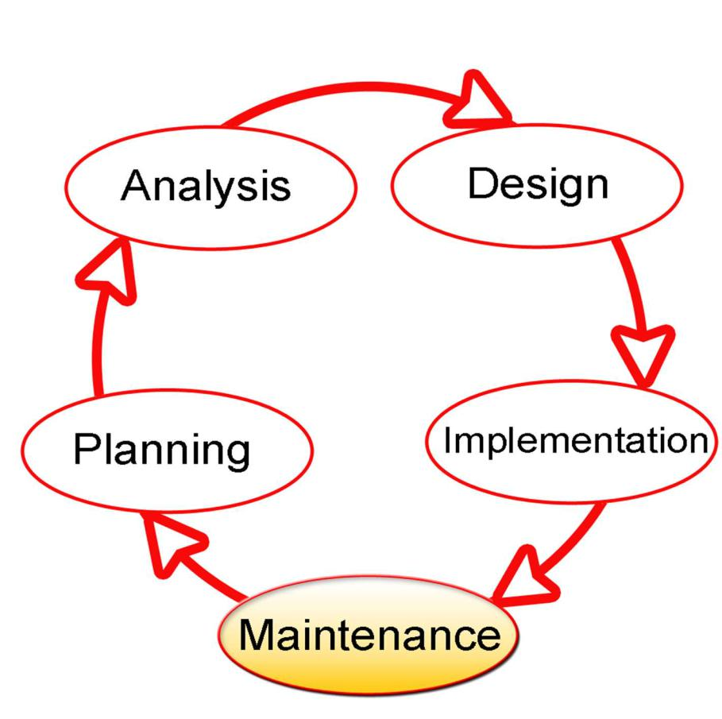

**Figure 3.1: Software Development Life Cycle**

**3.3 Software Development Model**

**The software development model to be used in this project is the big bang model. Software developers in this model don't adhere to any set procedures. With the necessary resources—in the form of inputs—development can begin. Additionally, since even the customer's**

**25**

**requirements are not specified in this model, the outcome may or may not meet their expectations. Projects like academic or practical ones are best suited for this model. On this model, one or two developers can collaborate. This model is the software development model to be employed in this project due to the nature of the project and the limited time to execute it.**

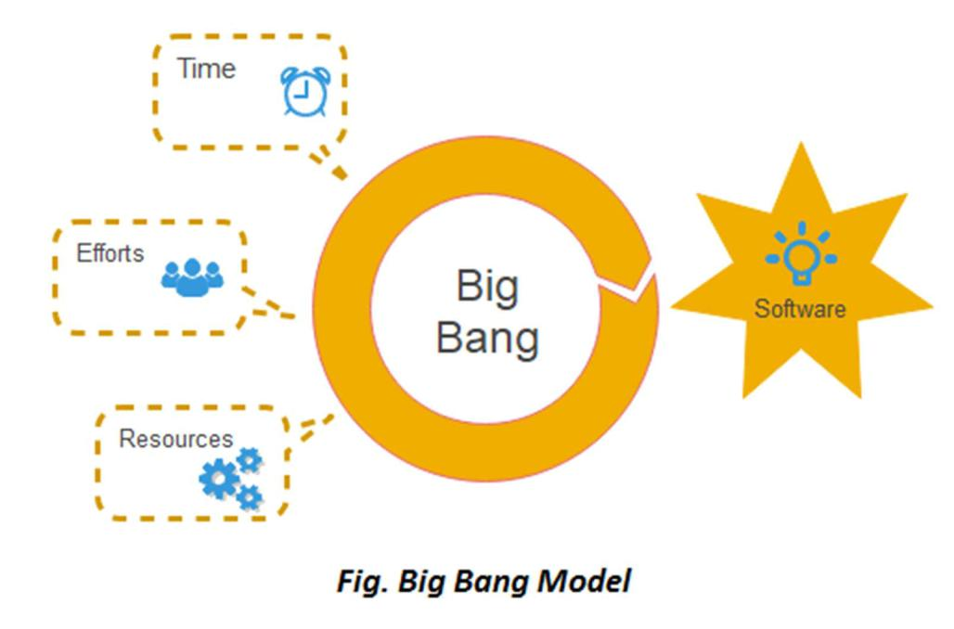

**Figure 3.2: Big Bang Model**

**Advantages of Big Bang Model**

* **There is no need to plan.**
* **Few resources are necessary.**
* **Simple to control**
* **For developers, it is adaptable**

**Disadvantages of Big Bang Model**

**●** **High risk and uncertainty exist.**

**26**

* **Not good enough for a big project.**
* **Uncertain requirements can result in very expensive issues.**

**3.4 Object-Oriented Analysis and Design Methodologies**

**Object-oriented analysis and design (OOAD) is a technical approach to analyzing and designing an application or system using the object-oriented paradigm and concepts such as visual modeling. Some popular object-oriented methodology include:**

1. **Unified Modelling Language (UML)**
2. **Object Modelling Technique (OMT)**
3. **Object Process Methodology (OPM)**

**Unified Modeling Language (UML)**

**The Unified Modeling Language (UML) is a general-purpose, developmental modeling language used in software engineering that is designed to give a common way to visualize a system's design (Addison-Wesley, 2005). UML employs simple graphical notations that allow non-programmers to comprehend its model. Sequence diagrams, use case diagrams, and state chart diagrams are all used in UML. UML diagrams are used to display system requirements as well as the overall system design. The analytical tools used in this project include the use case diagram, entity relationship diagram, class diagram.**

**Use Case Diagram**

**The figure below shows the use case of different user of the online auction system. The use case diagram explains the system's users and the various operations they can carry out on it. It also**

**27**

**discusses their various roles, the requirements for each actor to carry out different tasks and for those tasks to be termed successful. The online auction system has three actors: the seller, the buyer and the system administrator. The activities that can be performed by the seller are creating account, logging in and out, creating listings, viewing listings, viewing bids, viewing reviews and closing listings, for the buyer: creating account, logging in and out, viewing listings, search listings, viewing bids, placing bids, posting reviews, viewing reviews, wadding items to watch list and deleting items from their watch list. The use case of the admin is deleting listings, deleting bids, deleting user, deleting reviews and closing listing.**

**28**

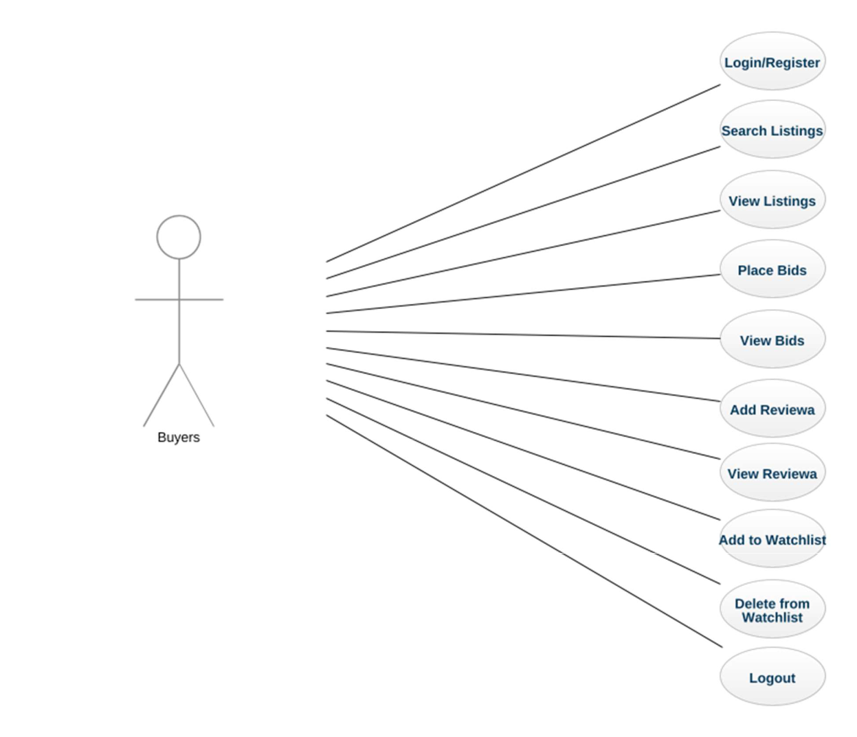

**Figure 3.3: Buyer Use Case Diagram**

**29**

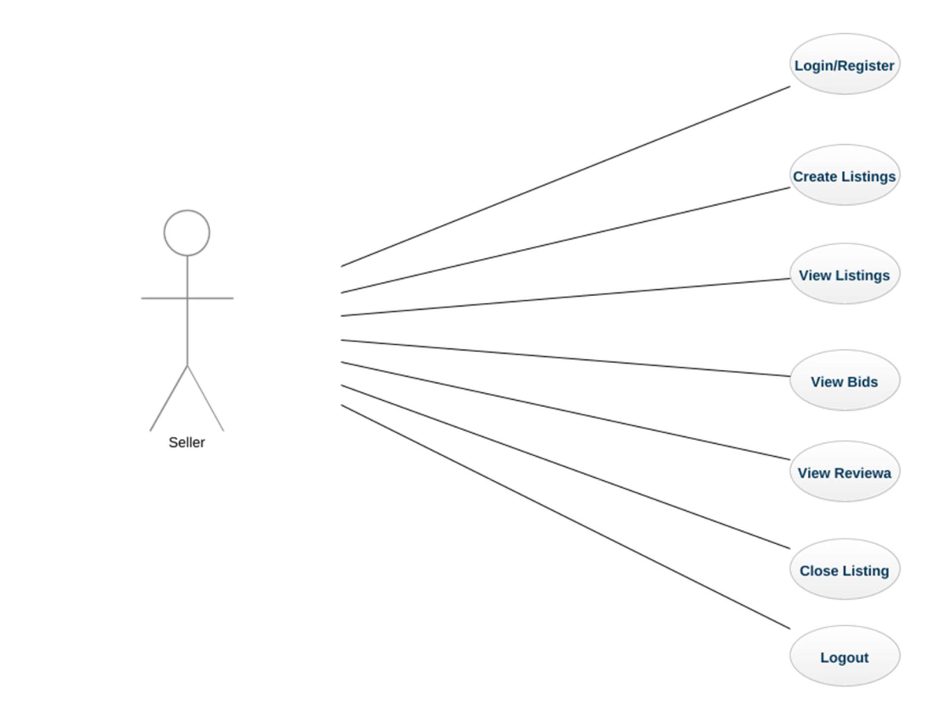

**Figure 3.4: Seller Use Case Diagram**

**30**

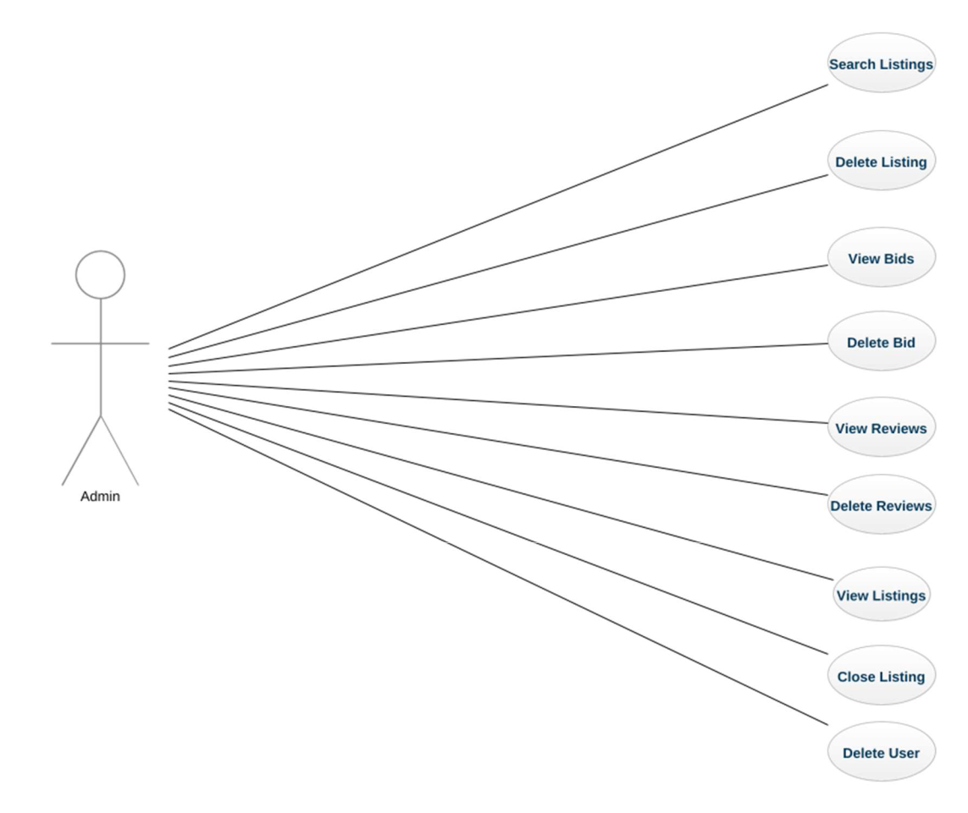

**Figure 3.5: Admin Use Case Diagram**

**Class Diagram**

**The system's class diagram is shown in Figure 3. 3. The relationship between the system entities is depicted in the class diagram. Each of these entities' attributes corresponds to a column in the database tables that they model. The class of users which includes characteristics of the system's users (i.e. buyer and seller), also includes techniques for carrying out various activities and items of this class.**

**31**

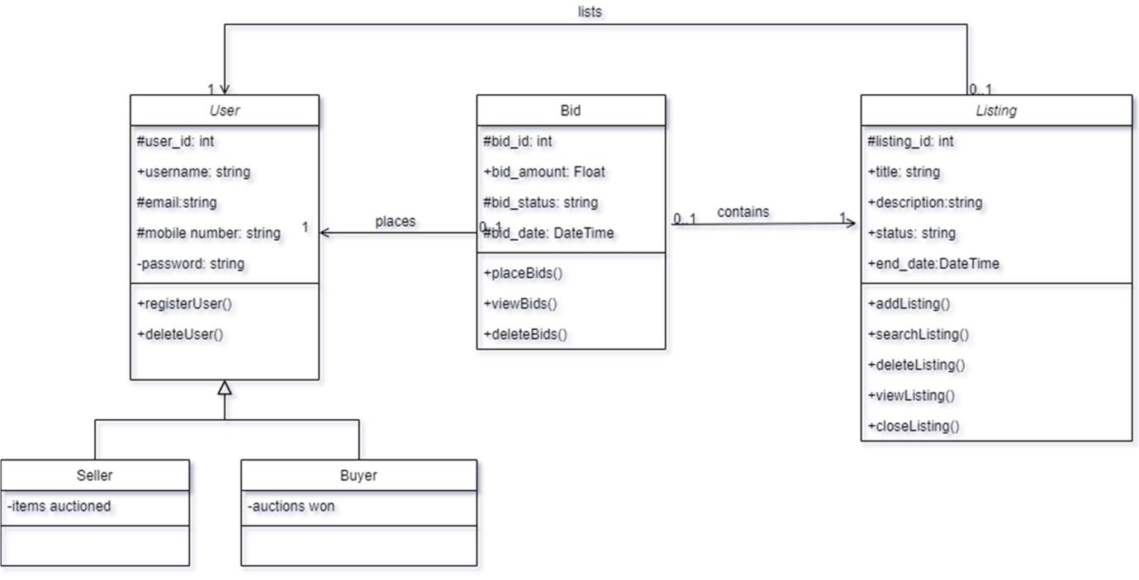

**Figure 3.6: Class Diagram**

**Entity Relationship Diagram**

**The figure 3.4 shows the entity relationship diagram for the system. Each registered user has his/her user information (user table). The users can create, search, view and close listings (listings table), can place bids (bids table) and add reviews (reviews table).**

**32**

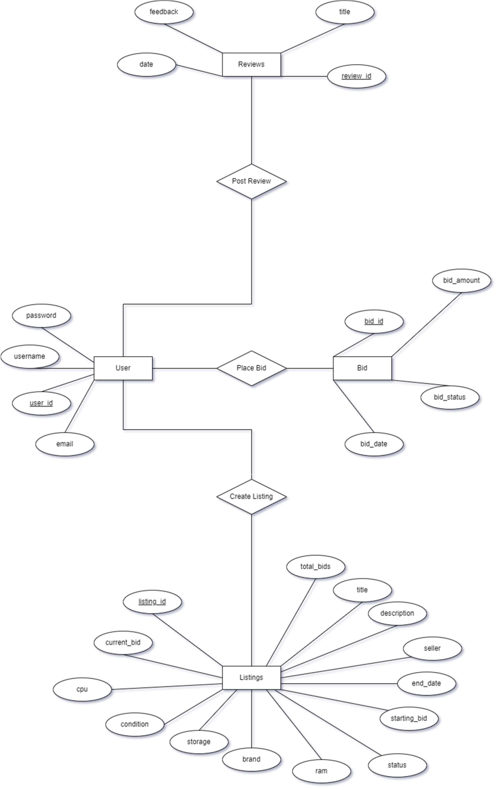

**33**

**Figure 3.7: Entity Relationship Diagram**

**3.5 System Implementation**

**The implementation is divided into three parts i.e. the frontend, the backend and the database. The backend was implemented using the Flask micro-framework. The front end was designed using HTML, CSS and JavaScript. The database was implemented using SQLite.**

**34**

**CHAPTER FOUR**

**IMPLEMENTATION AND SYSTEM DESIGN**

**This chapter presents the implementation of the online auction system and the results. It covers the results of the back-end implementation with the Flask framework in Python, the database implementation with SQLite and the front-end implementation with HTML, CSS and JavaScript. Also the end product will also be highlighted in this chapter.**

**4.1 Result of the front-end implementation of the online auction system**

**Fig 4.1 shows the result of the web interface where the users can register their details on the system. Fig 4.2 shows the webpage where users can log in with their details. Fig 4.3 shows the homepage of the website, it contains a navigation bar that links to the other pages on the website. Fig 4.4 shows the page where the seller can view the listings he has posted. Fig 4.5 shows the page for create listing. Fig 4.6 shows the page to view bids. Fig 4.7 shows the page where users can post reviews to a product they won in an auction.**

**35**

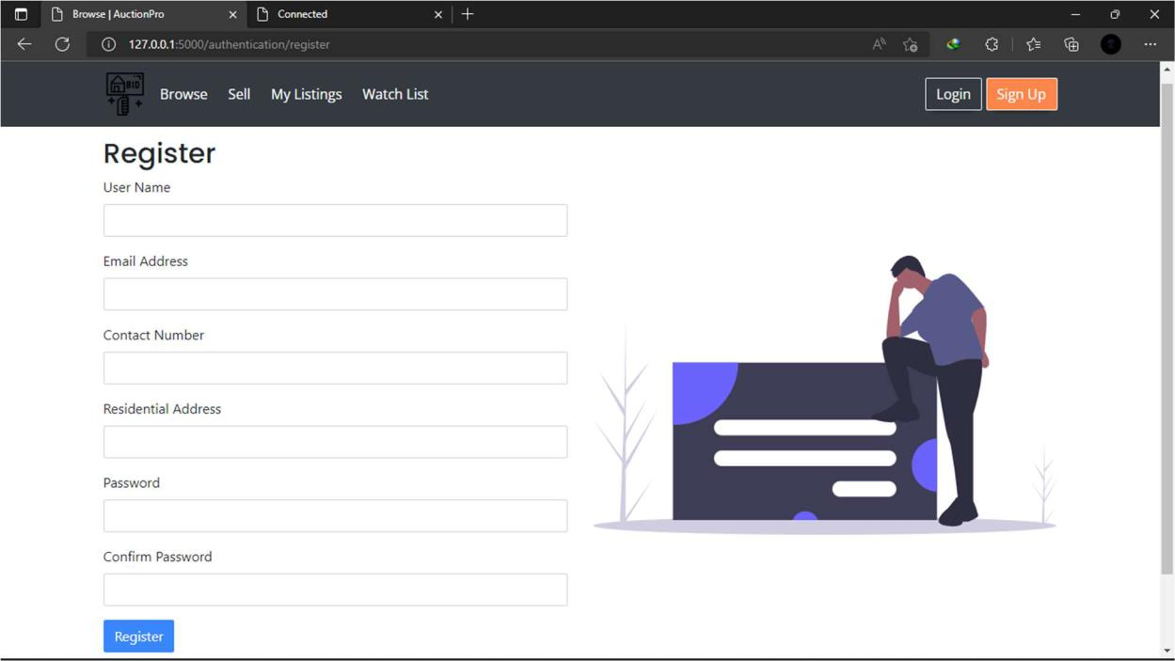

**Figure 4.1: Registration Page**

**36**

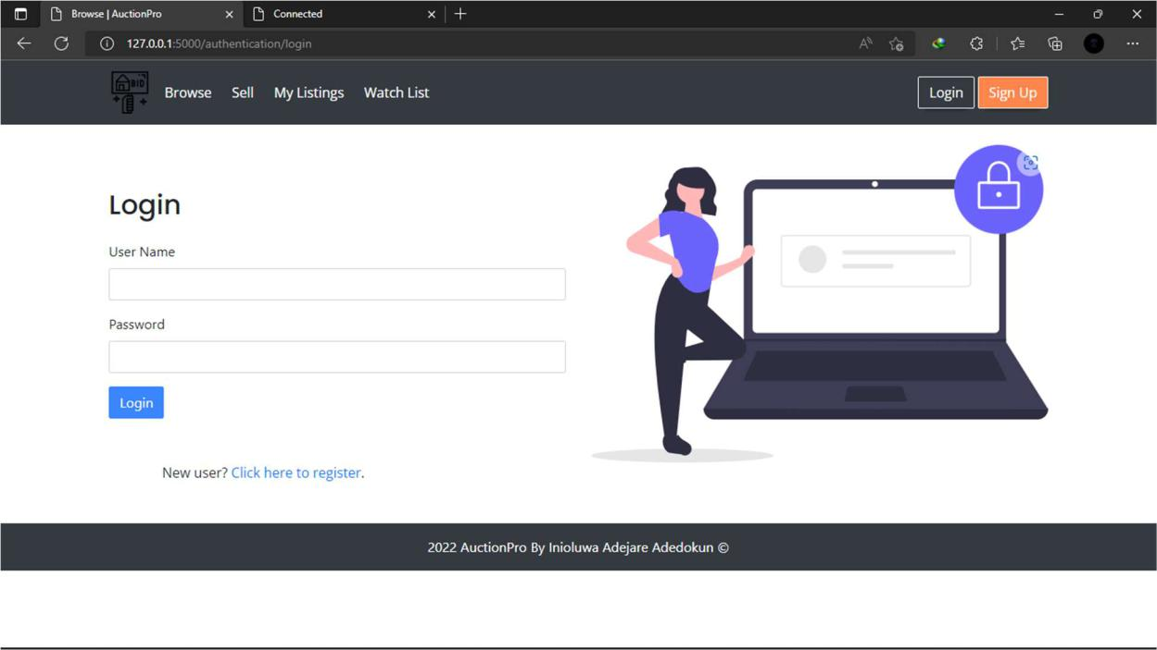

**Figure 4.2: Login Page**

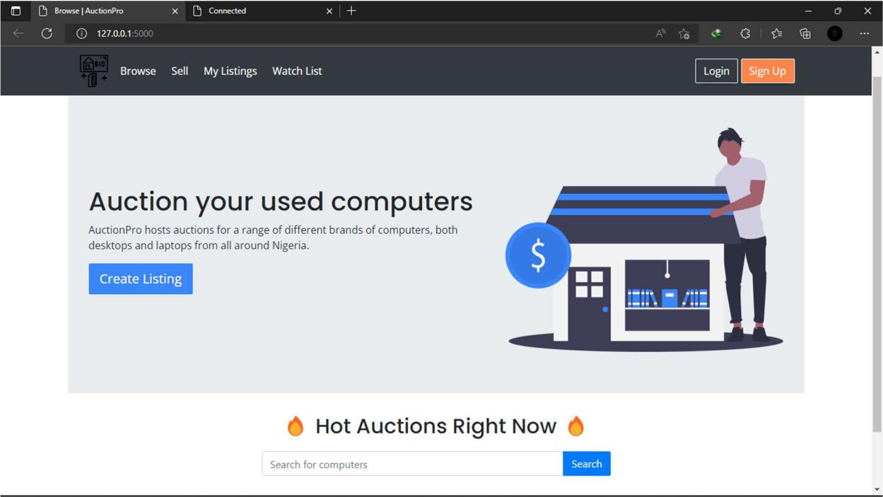

**Figure 4.3: Home Page**

**37**

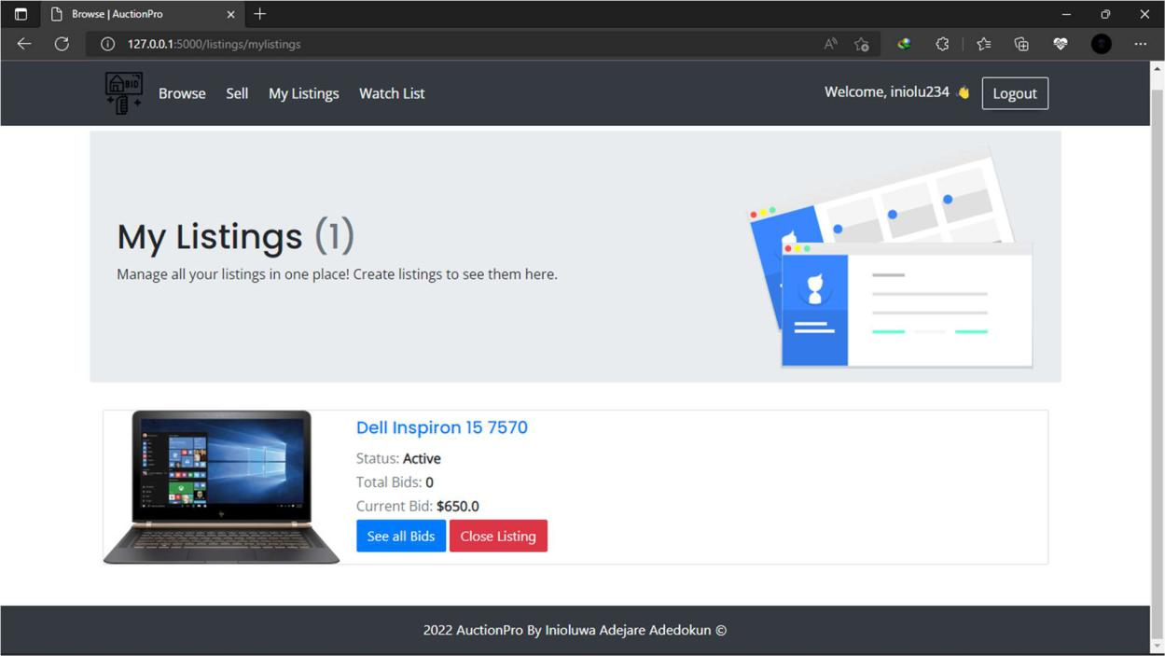

**Figure 4.4: View Listings Page**

**38**

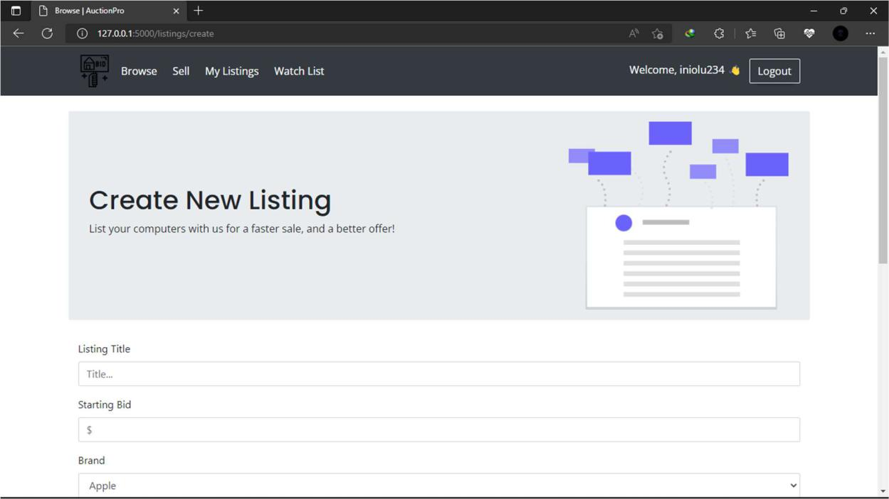

**Figure 4.5: Create Listing Page**

**39**

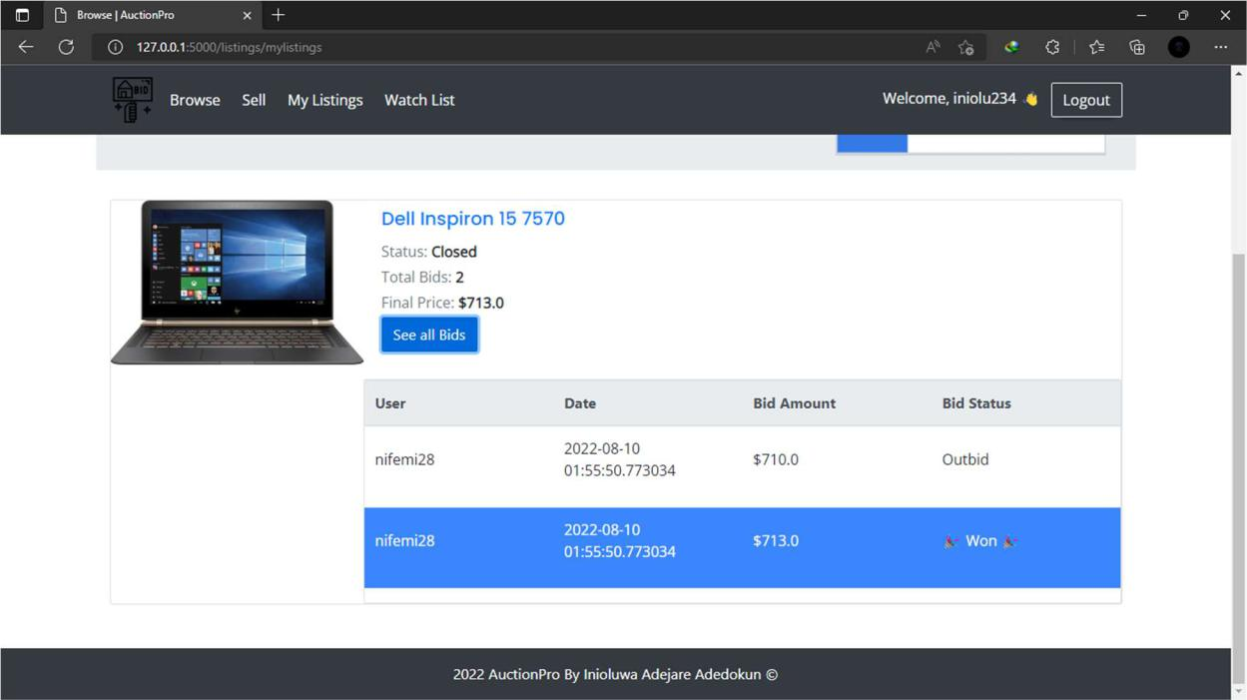

**Figure 4.6: View Bids**

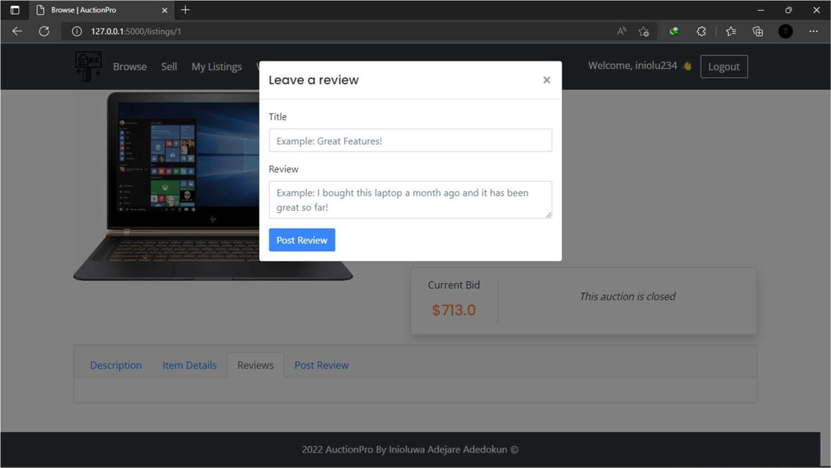

**Figure 4.7: Post Reviews**

**40**

**4.2 Database Implementation**

**The online auction system would need a database to store all the user details, product details and reviews, bids and watch list details to be able to work effectively. SQLite would be used to implement the database. SQLite was used because installation and setup is a simple task, it is open source and also inexpensive to maintain. The diagram below shows the database implementation of the online auction system**

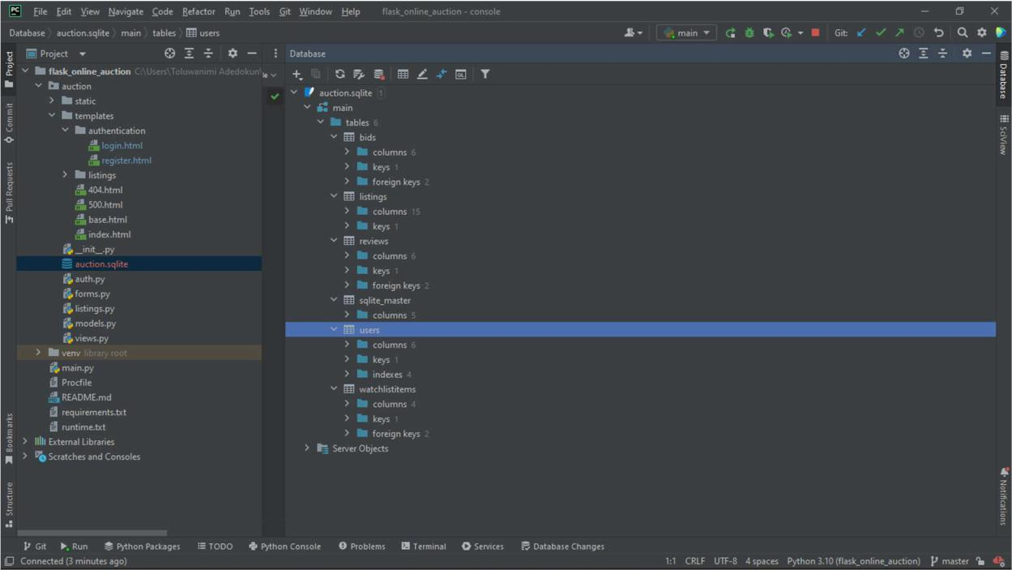

**Figure 4.8: SQLite Database Implementation**

**41**

**CHAPTER FIVE**

**DISCUSSION, CONCLUSION AND RECOMMENDATION**

**5.1 Introduction**

**The goal of this chapter is to discuss the project's objective evaluation, the limitations and problems encountered during development, possible future plans to improve the system, and recommendations for future online auction system projects.**

**5.2 Summary**

**This study developed an online auction system that allows the users to create and participate in auctions for used computers. The user and system requirements that were necessary to be met by the system were identified alongside the software and hardware requirements of the system during this study. The requirements were also specified using UML diagrams such as use case diagram, class diagram for user requirement and system modeling respectively and also the entity relationship diagram. The system was developed using HTML, CSS, and JavaScript for the frontend as well as Flask for the backend and SQLite for the database management of the system.**

**5.3 Future Enhancement**

**The following are possible improvements to the online auction system:**

**Payment Gateways for example paystack, flutterwave e.t.c. Ability to participate in auctions as guest.**

**42**

**SMS or email notification to alert users when they win a bid or when someone outbids them.**

**5.3 Limitations**

**Insufficient time**

**Unreliable internet connection**

**5.4 Conclusions**

**In conclusion, this project designed and implemented an online auction system that addresses the issues product uncertainty among buyers. The study was successful in identifying the numerous restrictions that characterize this process and define the system requirements. The system designs were also well defined with appropriate UML diagrams that conform to the anticipated functionalities of the proposed system.**

**43**

**References**

**Addison-Wesley. (2005). Unified Modelling Language User Guide.**

**Bapna, R., Goes, P., & Gupta, A. (2001). Insights and analyses of online auctions .**

**Communications of the ACM. 44 (11), 42.**

**Bennett, M., Mullard, R., Adam, M. T., Steyvers, M., Brown, S., & Eidels, A. (2020). Going, Going, Gone: Competitive Decision-Making in Dutch Auctions. Cognitive Research: Principles and Implications. 5 (1), 62.**

**Bolu, F., Adefowoke, O., & Gabriel, O. (2020). DEVELOPMENT OF AN INTELLIGENT ENGLISH AUCTION SYSTEM.**

**Br, M. (2010, June 2). From Mike Brandly Auctioneer Blog: https://mikebrandlyauctioneer.wordpress.com/2010/06/02/on-site-versus-off-site-auctions/**

**Campbell, S. (2016). Perspectives: Method and methodology in nursing research. Journal of Research in Nursing. 21 (8), 656–659.**

**Cassady, R. (1967). Auctions and Auctioneering. University of California Press.**

**Chow, Y. L., Hafalir, I. E., & Yavas, A. (2015). Auction versus negotiated sale: evidence from real estate sales. Real Estate Economics Vol. 43, No.2, 432-470.**

**CryptoKitties explained: Why players have bred over a million blockchain felines. (2018, October 6). From VentureBeat: https://venturebeat.com/2018/10/06/cryptokitties-explained-why-players-have-bred-over-a-million-blockchain-felines/**

**d'Arcy, S. (2010, 01 24). Bag a holiday bargain in an online auction. From The Times. London:**

**http://www.timesonline.co.uk/tol/travel/news/article6998942.ece**

**44**

**Dimoka, A., & Pavlou, P. (2008). Understanding and Mitigating Product Uncertainty in Online Auction Marketplaces. Industry Studies Conference Paper.**

**Emons, W., & Sheldon, G. (n.d.). The Market for Used Cars: A New Test of the Lemons Model.**

**2002: University of Bern.**

**Everatt, G., & McLeod, R. J. (2007). Chapter 2: The Software Development Life Cycle. In Software Testing: Testing Across the Entire Software Development Life Cycle (pp. 29– 58). John Wiley & Sons.**

**Ghose, A., Smith, M., & and Telang, R. (2006). Internet Exchanges for Used Books: An Empirical Analysis of Product Cannibalization and Welfare Implications. Information Systems Research (17:1), 3-19.**

**Gray, T. W. (2005). Local-based, alternative-marketing strategy could help save more small farms . Rural Cooperatives. 72, 20–3.**

**Jap, S. (2003). An Exploratory Study of the Introduction of Online Reverse Auctions. Journal of Marketing. 67 (3): , 96–107.**

**Jiang, Z., & Benbasat, I. (2007). The Effects of Presentation Formats and Task Complexity on Online Consumers’ Product Understanding. MIS Quarterly, 31 , 3.**

**Jin, G. Z., & Andrew, K. (2006). Price, Quality, and Reputation: Evidence from an Online Field Experiment. The RAND Journal of Economics Vol. 37, No. 4 , 983-1004.**

**Kalman, P. (1968). Theory of Consumer Behaviors when Prices Enter the Utility Function.**

**Econometrica, 36, 3,, 497-510. .**

**Kauffman, R., & Wood, C. (2006). Doing Their Bidding: An Empirical Examination of Factors that Affect a Buyer's Utility in Internet Auctions. Information Technology and Management (Special Issue on Online Auctions). 7, 2, 171-190.**

**45**

**Krishna, V. (2002). Auction Theory. San Diego, USA: Academic Press.**

**Liebeskind, J., & Rumelt, R. P. (1989). Markets for Experience Goods with Performance Uncertainty. RAND Journal of Economics, 601-621.**

**Lin, C.-C., Chang, Y.-F., Chang, C.-C., & Zheng, Y.-Z. (2020). A Fair and Secure Reverse Auction for Government Procurement. Sustainability 2020, 12, 8567.**

**Lucking-Reiley, D. (2000). Vickrey Auctions in Practice: From Nineteenth-Century Philately to Twenty-First-Century E-Commerce. Journal of Economic Perspectives 14 (3), 183–192.**

**Majadi, N., Trevathan, J., & Bergmann, N. (2016). uAuction: Analysis, Design, and Implementation of a Secure Online Auction System. 14th IEEE International Conference on Dependable, Autonomic and Secure Computing.**

**Milgrom, P., & Weber, R. (1982). A theory of auctions and competitive bidding . Econometrica.**

1. **(5), 1089–1122.**

**Mitchell, A. A., & Olson, J. (1981). Are Product Attribute Beliefs the only mediator of Advertising Effects on Brand Attitudes. Journal of Marketing Research, 18, 318-332.**

**Moldovanu, B., & Tietzel, M. (1998). Goethe's Second-Price Auction. The Journal of Political Economy. 106 (4), 854–859.**

**Newman, I. (1998). Qualitative-quantitative research methodology: exploring the interactive continuum. Southern Illinois University Press.**

**Ooi, J. T., Sirmans, C. F., & Turnbull, G. K. (2011). Government Supply of Land in a Dual Market. Real Estate Economics. 39 (1), 167–184.**

**Patten, R. (1970). Tatworth Candle Auction. Folklore 81, No. 2 , 132-135.**

**Pavlou, P., & Dimoka, A. (2008). Understanding and Mitigating Product Uncertainty in Online Auction Marketplaces. SSRN Electronic Journal.**

**46**

**Pendharkara, P. C., Rodgerb, J. A., & Subramanian, G. H. (2008). An empirical study of the Cobb–Douglas production function properties of software development effort. Information and Software Technology. 50 (12), 1181–1188.**

**Pinker, E. J., Seidmann, A., & Vakrat, Y. (2003). Managing Online Auctions: Current Business and Research Issues. Management Science. 49 (11), 1457.**

**Ralph, B., & Marcie, G. (1988). Fund-raising events: strategies and programs for success.**

**Human Sciences Press.**

**Rao, A., & Monroe, K. (1989). The Effect of Price, Brand Name, and Store Name on Buyers’ Perceptions of Product Quality:An Integrative Review. Journal of Marketing Research, 26, 3, 351-7.**

**Rauniar, R., Rawski, G., Crumbly, J., & Simms, J. (2009). C2C ONLINE AUCTION WEBSITE PERFORMANCE: BUYER'S PERSPECTIVE. Journal of Electronic Commerce Research, 10(2), 56-75.**

**Roebuck, K. (2011). Systems Development Life Cycle (SDLC): High-impact Strategies - What You Need to Know: Definitions, Adoptions, Impact, Benefits, Maturity, Vendors. Lightning Source Incorporated.**

**Shil, S. K., Mouhoub, M., & Sadaoui, S. (2013). Approach to solve winner determination in combinatorial reverse auctions using genetic algorithms. Proceedings of the 15 Annual Conference Companion on Genetic and Evolutionary Computation Conference Companion.**

**Shubik, M. (March 2004). The Theory of Money and Financial Institutions: Volume 1, 214.**

**Spence, M. (1973). Job market signaling . Quarterly Journal of Economics vol(87), 355-74.**

**47**

**Suh, K.-S., & Lee, Y. E. (2005). “Effects of Virtual Reality on Consumer Learning: An Empirical Investigation in web-based Electronic Commerce. MIS Quarterly, 29, 4, 673-697.**

**Tellis, G. J., & Wernerfelt, B. (1987). Competitive Price and Quality under Asymmetric Information. Marketing Science, 6, 2,, 240-53.**

**The Heyday of the Auction. (1999). The Economist, vol. 352, no. 8129, 67–68.**

**Theodoropoulos, T. (2000). Design and Implementation of an Online Auction.**

**Vragov, R. (2004). Why is eBay the King of Internet Auctions? An Institutional Analysis Perspective. e-Service Journal 3, 5–28.**

**Yutaka, Kurihara, Yamori, N., & Takaya, S. (2005). Global information technology and competitive financial alliances. Idea Group Inc.**

**48**