**DESIGN AND IMPLEMENTATION OF AN INVENTORY MANAGEMENT SYSTEM**

**ABSTRACT**

This project will develop an inventory system that will be used to keep a record of the day-to-day activities of an industry or institution. This plan would employ other subsystems in other systems to achieve its objective. These subsystems include a web gateway for managing supply and sales activities, documenting inventories, and storing the results in a database. An inventory management system's primary purpose is to retain stock at a level that is neither overstocked nor understocked. Inventory management has operational as well as financial objectives. Materials and stock should be available in sufficient quantities for operational purposes, while functional purposes should have a minimum working capital lock-in.

**Table of Contents**

DECLARATION ii

CERTIFICATION iii

DEDICATION iv

ACKNOWLEDGEMENTS v

ABSTRACT vi

LIST OF FIGURES ix

CHAPTER ONE 1

INTRODUCTION 1

1.1 Background to the Study 1

1.2 Statement of Problem 2

1.3 Aims and Objective 2

1.4 Scope and Limitations of Study 3

1.5 Research Methodology 4

1.6 Significance of Study 4

1.7 Definition of Terms and Abbreviation 5

CHAPTER TWO 7

LITERATURE REVIEW 7

2.1 INTRODUCTION 7

2.2 INVENTORY SYSTEM 7

2.3 INVENTORY 9

2.4 EXISTING INVENTORY MANAGEMENT SYSTEM 9

2.5 RELATED WORKS 9

CHAPTER 3 12

METHODOLOGY 12

3.1 INTRODUCTION 12

3.2 METHODOLOGY 12

3.3 TOOLS AND TECHNIQUES 14

3.3.1 Programming Language 14

3.3.2 Software 15

3.3.3 Hardware 15

vii

3.4 REQUIREMENT SPECIFICATION 15

3.4.1 Functional Requirement Specification 15

3.4.2 Non-Functional Requirement Specification 16

3.5 SYSTEM DESIGN 16

3.5.1 Application Architecture 16

3.5.2 Use Case Diagram 18

3.5.3 Activity Diagram 19

3.5.6 Control Flow Diagram 20

3.5.7 Entity Relationship Diagram 21

CHAPTER 4 22

IMPLEMENTATION; RESULTS AND DISCUSS 22

4.1 INTRODUCTION 22

4.2 DEVELOPMENT PLATFORM CONFIGURATION 22

4.2.1 Hardware Requirement 22

4.3 SOFTWARE COMPONENTS 23

4.3.1 The Front End: 23

4.3.2 The Back End 24

4.4 DATABASE IMPLEMENTATION 25

4.5 RESULT OF THE FRONTEND IMPLEMENTATION 27

4.5.1 The User Interface Design 27

CHAPTER 5 38

CONCLUSION AND RECOMMENDATIONS 38

5.1 INTRODUCTION 38

5.2 Why Use This System 38

5.3 FUTURE ENHANCEMENT 38

5.4 LIMITATIONS 39

5.5 CONCLUSION 39

References 40

APPENDIX 41

viii

|  |  |
| --- | --- |
| **LIST OF FIGURES** |  |
| Figures | Pages |
| Figure 3.1: Agile Model | 13 |
| Figure 3.2: The architecture for inventory management system | 17 |
| Figure 3.3: UML Use Case Diagram of the system | 18 |
| Figure 3.4: Activity diagram | 19 |
| Figure 3.6: Control diagram of inventory management system | 20 |
| Figure 3.7: Entity Relationship Diagram | 21 |
| Figure 4.1: MySQL database implementation | 26 |
| Figure 4.2: Login Page | 27 |
| Figure 4.3: Register page | 28 |
| Figure 4.4 Dashboard | 29 |
| Figure 4.5: Product View / Edit page | 30 |
| Figure 4.6: Product Set View / Edit page | 31 |
| Figure 4.7: Unit View / Edit page | 32 |
| Figure 4.8: Invoice View / Edit page | 33 |
| Figure 4.9: sales view / Edit page | 34 |
| Figure 4.1.1: User view page | 35 |
| Figure 4.1.2: User Log view page | 36 |
| ix |  |

Figure 4.1.3: Audit Log view page 37

x

**CHAPTER ONE**

**INTRODUCTION**

1.1. Background to the Study

For the production process, the market, and the distribution network to function, inventories are crucial. They act as lubricants and spring for an organization's production and distribution processes. By separating different parts of the overall operation, inventories allow manufacturing firms to operate smoothly and efficiently. portion purchases Inventory enables staff in the purchasing and supply departments to plan, manage, and wrap up activities in certain ways independently of shop-product operations. Inventory is crucial to an organization for production activities, maintenance of equipment and machinery as well as other operational requirements. These inventories enable suppliers more flexibility in planning, producing, and fulfilling an order for a certain product's portion. This causes money or capital that could have been used more productively to be held in reserve. When inventory stockpiles are high, the management of a company becomes quite anxious. Inventory is part of the company's assets and is always reflected in the company's balance sheet. This, therefore, calls for its scrutiny by management, any inventory item shortages that affect the production process are highly scrutinized by management. Any increase in machinery or operational redundancy brought on by inventory shortages may result in production loss and the costs that go along with it. For these two factors, ongoing inventory control is necessary. In addition to considering the physical balance of the items, inventory control and management also considers ways to reduce the cost of the inventory. The

1

seamless running of other processes, including manufacturing, purchasing, sales, marketing, and financial management, is greatly aided by effective inventory management. The fundamental problem, however, is figuring out the inventory level that works best with the operating system or systems already in the business.

**1.2.** Statement of Problem

Many small businesses rely on manually counting stock to track what’s in store. But stock counts are disruptive and time-consuming it also takes time away from making and selling products.

Some other problems include

1. Your records and documents are not always secure.
2. There could be a loss of inventory due to damage, theft, natural disaster, etc.

**1.3.** Aims and Objective

This project aims to design a web-based inventory management system that solves the problem inherent in the manual system by creating an online inventory system with the use of MYSQL, HTML, CSS, and JavaScript.

The following are the objective of the said system

The system is a web-based platform designed for online inventory systems, which is going to have a page where users can log in to the system, the user dashboard, and an input page for uploading new items.

2

The specific objectives are to;

Identify the requirements of the proposed system

1. The required tools needed to build up the system Specify the design of the system
2. How the system is going to be built
3. Building up the system Test the system
4. Check and fix bugs and errors

**1.4.** Scope and Limitations of Study

This study looks at sales control, and how to deal with business abnormalities.

It examines the capacity to add new sales, update products and sales details, and see existing ones.

It allows for faster operation by recording and automating manual processes.

The following are the system limitations;

1. Users would need an internet connection to be able to use the system.

3

1. The system will only be convenient to people with a small geographical region, basically just around the school, i.e.
2. Due to the time and financial constraints, the software that is developed covers only the aspect of adding, updating, and viewing.

**1.5.** Research Methodology

To meet up with the aforementioned objectives of the study, the following methods were adopted

1. A review of the literature will be conducted to identify and comprehend the existing system.
2. System users will be interviewed informally to determine the system's user and system needs.
3. A unified modelling language (UML) diagram will be used to specify the system design: use case, sequence diagram, and class diagram.

**1.6.** Significance of Study

1. This research work is beneficial in checking if arriving materials and goods are consistent with order request forms.
2. To make it easier for users to inputs all the current stock and can be able to update if there should be any changes.
3. Monitoring all the sales activities can be done by simply printing the report sales.
4. Tracking the number of goods available in the store, or if need be for a restock.
5. The user can be able to generate a report on all the activities of the store.

4

**1.7.** Definition of Terms and Abbreviation

the writer of this paper intends to define the terms for a better understanding

**INVENTORY SYSTEM**: a method for monitoring inventory levels, orders, sales, and deliveries is known as inventory management.

**SYSTEM**: a collection of components that act as a unit to form a mechanism or a network; an intricate whole

**MANAGEMENT**: engaging with or exercising control over objects or persons

**WEB-BASED**: connected to or involving the use of the Internet.

**CUSTOMER**: a person who purchases goods or services from a store or business

**TECHNOLOGY**: the application of scientific knowledge to real-world problems, particularly in industry.

**HTML**: Hyper-Text Markup Language

**SQL**: Structured Query Language

**MYSQL**: MYSQL is software that delivers SQL.

**DATABASE:** A computerized record-keeping system for easy access and retrieval of

information.

**DBMS:** Database management system is a suite of programs that manages all access to a

database.

5

**MANAGEMENT:** This can be defined as the process of strategically putting resources together in other to achieve desired/set objectives/goals.

**SALES:** This is an act or process of selling something.

**SME:** Small and medium scale enterprise.

**STOCK:** They are goods bought and stored in the warehouse as well as the product being sold in a superstore.

**PURCHASE:** This is the act of buying or the process of making sale.

6

**CHAPTER TWO**

**LITERATURE REVIEW**

**2.1** **INTRODUCTION**

The studies and issues that were looked into for this project are briefly explained in this chapter. Inventory systems, inventory management systems, and related works are some of the themes that are covered. Besides that, this chapter also makes the study on existing inventory management system.

**2.2** **INVENTORY SYSTEM**

A firm may utilize an inventory management system, which is a collection of methodologies, techniques, and technology, in many simple to complicated ways to manage and control inventories. It focuses on the company's needs and scale, as well as the business software's capabilities and utility. For all businesses that deal with inventory, inventory management system software is a necessary and valuable tool. It controls the flow of inventory in and out, keeps track of inventory levels for all items and stock, gives businesses access to sales data and analytics, and assists businesses in defining specific safety stock requirements. In a sense, inventory management is what propels sales and profits for a company. A comprehensive and effective

7

inventory control system can bring about a huge number of advantages. How a company manages its inventory has a significant impact on its overall success.

Ordering costs, carrying costs, and shortage costs are all included in inventory costs. Inventory control is one of the material management techniques that can help a company increase capital productivity by lowering material costs, preventing large amounts of capital from being locked up for long periods, and increasing the capital turnover ratio. The cost of placing an order with a supplier for any material that an organization needs to create is referred to as ordering cost, also known as replenishment cost, in buy models. Insufficient carrying cost causes shortage costs on the performance of adequate inventory in the organization. When an item is temporarily stored until it is sold, a carrying cost is incurred. This involves moving requested materials from the seller to the warehouse (TARDI, 2021). Technology-based inventory control systems integrate all parts of an organization's inventory tasks, such as shipping, buying, receiving, and warehouse storing. an inventory control management system is a combination of hardware and software that is technology, processes, and procedures that help to monitor and maintain stocked products like company assets, raw materials, and finished productively to final consumers. One of the key elements in the success of both large and small businesses is the management of inventory movement effectively and efficiently along the value chain. Making the most efficient use of money to generate the greatest returns is one of management's fundamental duties.

A company must maintain a suitable level of inventory because its excess or shortage could be detrimental to the company. The organizational framework and operating rules for preserving and regulating the products that will be stocked are provided by an inventory system, which implies that the profitability of any organization is directly and indirectly affected by the inventory management system operated (B.V, 2019).

8

**2.3** **INVENTORY**

A comprehensive list of items, such as real estate, stock goods, or a building's contents, is referred to as inventory. the total number of items and materials that a business has at any given time, including parts, products that are being manufactured, and finished products

**2.4** **EXISTING INVENTORY MANAGEMENT SYSTEM**

Walid Halal has a long and distinguished history in the sector and is amongst the leading spice retailers in the state of Gombe. It has a store that is of a respectable size. Its extensive spice business interests span a large market area, with one shop and a store in Gombe. The shop provides wholesale, retail, and distribution services to customers all over the country. Wholesale services are only available from the shop and store, whereas retail services are only available at the shop, with distribution services available in both locations.

A file-based system that was prone to an excessive number of errors and manual field registration the difficulty of updating stock item information and data redundancy were just two issues the business had with its prior system for wholesale services. (IBRAHIM-IMAM, 2020)

**2.5** **RELATED WORKS**

**Silver Inventory System**

Everywhere in the globe, small to medium sized businesses that need a mid-range, reasonably priced independent stock application with a good selection of features choose Silver Inventory System. You can use this application to create records for deals, purchases, receiving payments, instalment receipts, item names with standardized tags, and any kind of reports for tracking your

9

business. The control of the client and merchant adjustments is possible with the inventory application. (IBRAHIM-IMAM, 2020)

**Features**

* It offers an intuitive user interface that is simple to grasp and can be used without any training.
* Real-time purchases and sales can be made using the system's point-of-sale panel.
* Users can access functions that can be regulated based on their access level or role thanks to the security. Unauthorized users cannot gain access without using secured access.
* Reports may be exported as Excel files at the user's discretion.
* While reserving inventory for sales orders, it also wires costs for requested products and purchase orders.

**Zoho Inventory Management System**

One of the most well-known suppliers of tools and services for small businesses is Zoho. It can be used by e-commerce companies, online vendors, merchants, wholesalers, and other companies.

SMBs (small and medium-sized enterprises). You may fully manage your business using 45 Software as a Service (SaaS) solutions from Zoho. The business has made an imprint with products like Zoho Office Suite, Zoho Cost, Zoho Receipt, and Zoho Social, to name a few. (IBRAHIM-IMAM, 2020)

10

**PROS**

* The system connects inventory tracking information from many warehouses and offers a wide range of distribution features.
* It supports tags and bar-coding and has a large number of e-commerce possibilities.
* The email marketing tool offered by Zoho is quite effective.

**CONS**

* Does not also use forecasts
* No pick list, bill of materials, or bin ID support
* A number of the e-commerce and distribution connectors are particular to a nation or area.
* Backs up the FIFO approach to costing.

Inventory costing based on first in, first out (FIFO) permits the system to make products that were added first available before the addition of subsequent items.

11

**CHAPTER 3**

**METHODOLOGY**

**3.1** **INTRODUCTION**

This chapter talks about the methodology used in making the system, the tools and techniques, requirement analysis, the proposed model of the system, the architecture diagram, and data design. This chapter also talks about the system design, the use case diagram, activity diagrams, data flow diagram, entity-relationship diagram and also the control diagram of the system.

**3.2** **METHODOLOGY**

Agile methodology has been chosen as the software process model. The agile approach is a hybrid of incremental and iterative process models that emphasize process adaptability and customer satisfaction through the delivery of actionable software solutions promptly. The Agile technique

divides the product into smaller incremental builds. Iterative builds are used in this case.

12

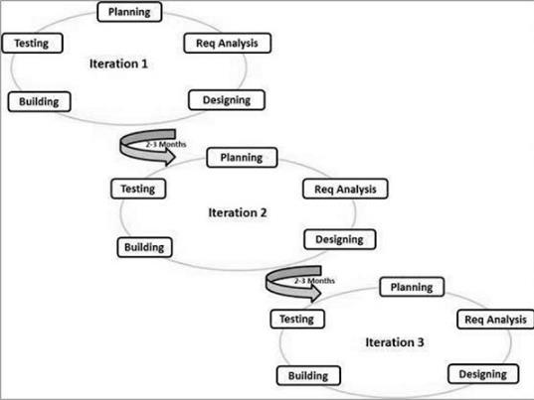

Figure 3.1: Agile Model (taken from (Tutorialspoint, n.d.) )

1. **Incremental software development**: In incremental development, you design the complete product first. You only omit details that may be safely decided later. Then you cut it into parts and create each one independently. When you complete a piece, also known as a module, you integrate it with previously finished sections so that they function as a whole.
2. **Iterative software development:** Iterative development is a lot like inventing: discovering what and how you need as you go. You begin with a rough concept of what

13

you want the product to achieve and design and develop it through a process of successive approximation.

1. You start by designing, constructing, and testing the tiniest version of what you're after. When you're satisfied with a product, you show it around and get comments from everyone who has an interest in it. That's one approximation. And one iteration.
2. If your work is well accepted, you maintain it and improve on it in the following version. If your creation is rejected, you discard it and return it to the drawing board.

The following are the benefits of Agile methodology:

1. Focus on the users
2. Customer satisfaction
3. Better control
4. Reduce risks
5. Allows changes
6. Early and predictable delivery
7. Focus on business value

**3.3** **TOOLS AND TECHNIQUES**

In this project, the following tools are going to be made used to build the inventory management system:

3.3.1 Programming Language

1. PHP
2. SQL
3. HTML

14

1. CSS
2. JAVASCRIPT

3.3.2 Software

1. XAMMP
2. Visual Studio Code

3.3.3 Hardware

1. HP Laptop

**3.4** **REQUIREMENT SPECIFICATION**

3.4.1 Functional Requirement Specification

The following are the functional requirement for the User:

1. The user must have the ability to register for an account
2. The user must have the ability to Log in
3. The user must have the ability to view the dashboard
4. The user must have the ability to view the company setup
5. The user must have the ability to update the company setup
6. The user must have the ability to add products to the inventory
7. The user must have the ability to update products added to the inventory
8. The user must have the ability to view units
9. The user must have the ability to edit the units
10. The user must have the ability to view the categories
11. The user must have the ability to update the categories

15

3.4.2 Non-Functional Requirement Specification

1. The password of the users will not be displayed in text but special characters
2. The system will work on any device
3. The system will be user-friendly**.**

**3.5** **SYSTEM DESIGN**

The creative process of changing a problem into a solution and describing the answer is referred to as design (Pfleeger, 2001). It is also the most critical function during the software development process. Without system design, firms will struggle to create acceptable software that meets user needs.

3.5.1 Application Architecture

Application architecture is a diagrammatic structure of an application which gives developers a visualization of what the application will look like. The figure below shows the application architecture of the inventory management system.

16

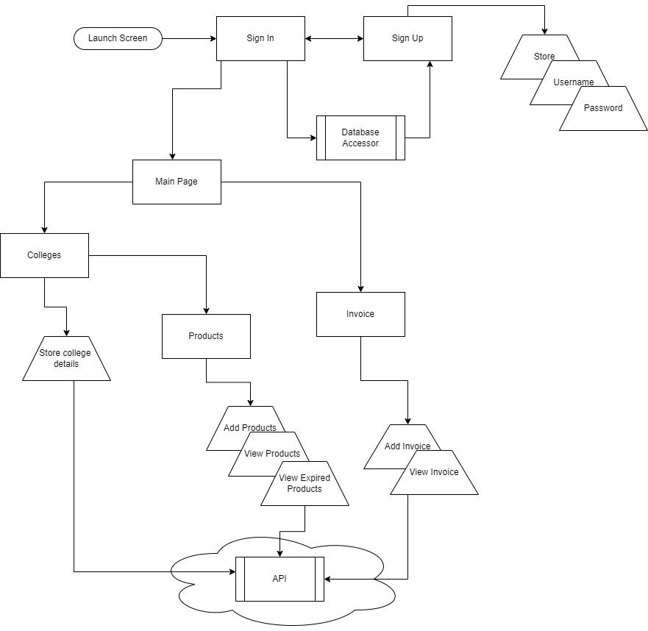

Figure 3.2: The architecture for the inventory management system

17

3.5.2 Use Case Diagram

A use case diagram is used to describe the actions that occur between the users and the system.

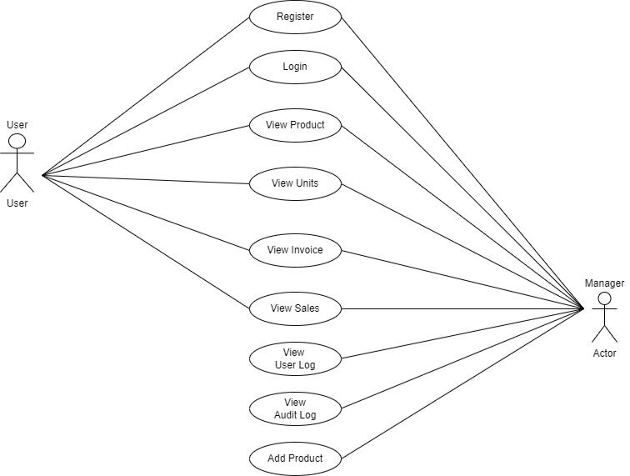

Figure 3.3: UML Use Case Diagram of the system

18

3.5.3 Activity Diagram

According to (Tanwir, adman, Dragos & Ivan 2019), An activity diagram is used to elaborate and give a more in-depth visualization of the use cases. The diagram below shows the process of signing up and logging in.

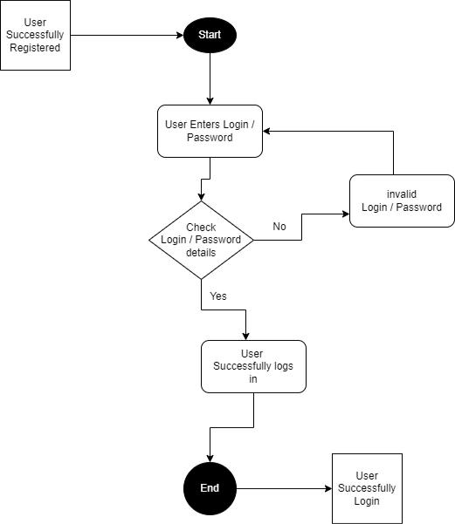

Figure 3.4: Activity diagram

19

3.5.6 Control Flow Diagram

A control flow diagram enables us to clearly depict the intricate procedure. It demonstrates where authority begins and stops as well as possible tangent points in specific circumstances.

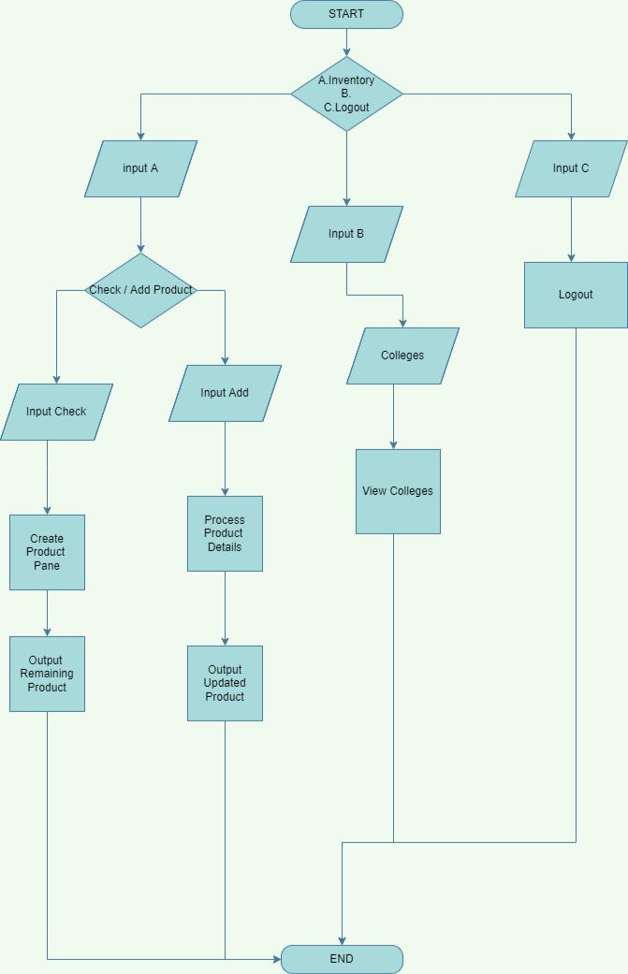

Figure 3.6: Control diagram of an inventory management system

20

3.5.7 Entity Relationship Diagram

An entity relationship diagram is used to depict the structural design of a database. The tables that will be implemented in the database for system functionality are depicted in the image below.

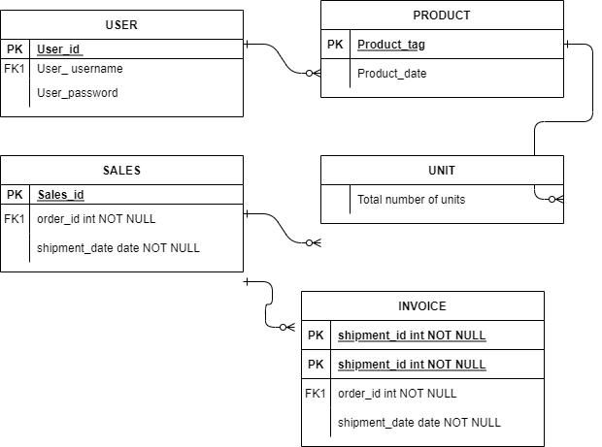

Figure 3.7: Entity Relationship Diagram

21

**CHAPTER 4**

**IMPLEMENTATION; RESULTS AND DISCUSS**

**4.1** **INTRODUCTION**

**T**his chapter introduces the actual user interface, and the process of development of the main features of the website.

**4.2** **DEVELOPMENT PLATFORM CONFIGURATION**

The configuration of a development platform affects the development of a system. The development environment must be properly configured in order to build a high-quality, error-prone system. The platform is made up of both software and hardware. Platform configuration entails configuring the necessary software and hardware.

4.2.1 Hardware Requirement

The hardware used to develop the system is listed below;

1. Intel Celeron processor
2. 4 GB Ram
3. 160Gb Hard drive
4. Intel(R) HD Graphics 400
5. 1.60 GHz CPU Speed

22

**4.3** **SOFTWARE COMPONENTS**

4.3.1 The Front End: This is the user interface part of the web which can be viewed on web browsers. The technique of generating CSS, HTML, and JavaScript for a website such that a user can view and interact with them directly is known as front-end development. The front-end technologies used for this application include:

1. HTML: Html which means Hyper Text Markup Language, is the standard markup language for documents designed to display in the web browser. HTML is usually used alongside other technologies such as Cascading Style Sheet (CSS) and scripting Languages such as JavaScript. HTML is a semantic markup language that specifies the way the web page looks like. HTML consists of elements which are called HTML tags which are the building blocks of HTML pages.
2. Tags such as <body/> and <th/> directly introduce one-page contents into the page. HTML is a markup language that creates structured documents by denoting structural semantics for text such as paragraphs, headings, links, and other items.
3. CSS: Cascading Style Sheets (CSS) is a style sheet language used to describe the appearance and formatting of a markup-language-written document. Although the language is most commonly used to update the style of HTML and XHTML web pages and user interfaces, although it may be applied to any type of XML document, including SVG, and XUL. CSS, in addition to HTML and JavaScript, is a foundational technology used by the majority of websites to build aesthetically appealing webpages, user interfaces for online apps, and user interfaces for many mobile applications. This separation can improve content accessibility, provide greater flexibility and control in the definition of presentation characters, allow many web pages to share formatting by

23

providing the appropriate CSS in a separate.CSS file, and reduce structural content complexity and repetition.

1. JavaScript: JavaScript is a high-level programming language that is dynamic, untyped, and interpreted. It has been standardized by the ECMAScript language specification. It is one of the three main technologies of World Wide Web content generation, alongside HTML and CSS; more than half of the websites online uses it, and it is supported by all current web browsers without the need for plug-ins. JavaScript is a multi-paradigm language that supports object-oriented, imperative, and functional programming approaches. It is prototype-based and has first-class functions. It has an API for working with text, arrays, dates, and regular expressions, but no I/O capabilities, such as networking, storage, or graphics, relying on the host environment.

4.3.2 The Back End**:** The back end is the server code that handles client requests and contains the logic to provide the relevant data back to the client. The database, which will persistently store all of the data for the application, is also part of the back end. This application's back-end code includes the following:

1. PHP: PHP also known as Hypertext Preprocessor is a server-side scripting language that is embedded in HTML. It is used to handle dynamic content, session tracking, databases, and even to create full e-commerce sites. PHP scripts can only be run on servers that have PHP installed. The computer accessing the PHP script requires a web browser only. The difference between PHP and client language like HTML is, that PHP codes run on a server while HTML codes are rendered on a web browser.
2. MYSQL: MySQL is a free and open source relational database management system (RDBMS) based on structured query language (SQL). It is a component of the widely

24

used LAMP platform, which consists of Linux, Apache, My SQL, and PHP. My SQL database is currently accessible on the most popular operating systems. It is compatible with BSD Unix, Linux, Windows, and Mac OS. My SQL is used by Wikipedia and YouTube. Every day, these sites handle millions of searches. My SQL comes in two varieties: My SQL server system and My SQL embedded system.

1. XAMPP: XAMPP is a cross-platform, free as well as an open-source web server solution stack bundle created by Apache Friends that primarily consists of the Apache HTTP Server, MariaDB database, and interpreters for PHP and Perl scripts.

4.4 DATABASE IMPLEMENTATION

The inventory system would need a database to store all the details that are needed for it to be able to work effectively. MySQL would be used to implement the database. MySQL was used because installation and setup is a simple task, it is open source and also inexpensive to maintain. MySQL Workbench would be used as the graphical user interface to make developing the database simple. The diagram below shows the database implementation for an inventory system.

25

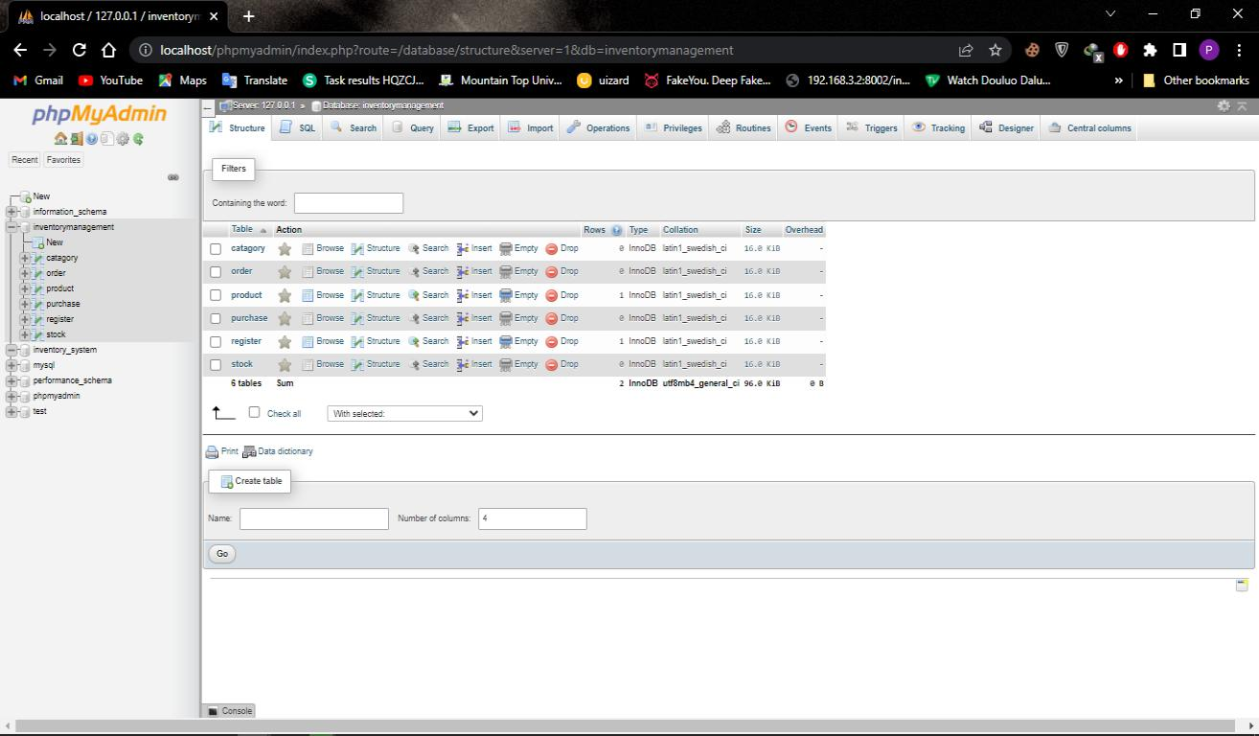

Figure 4.1: MySQL database implementation

26

**4.5** **RESULT OF THE FRONTEND IMPLEMENTATION**

4.5.1 The User Interface Design

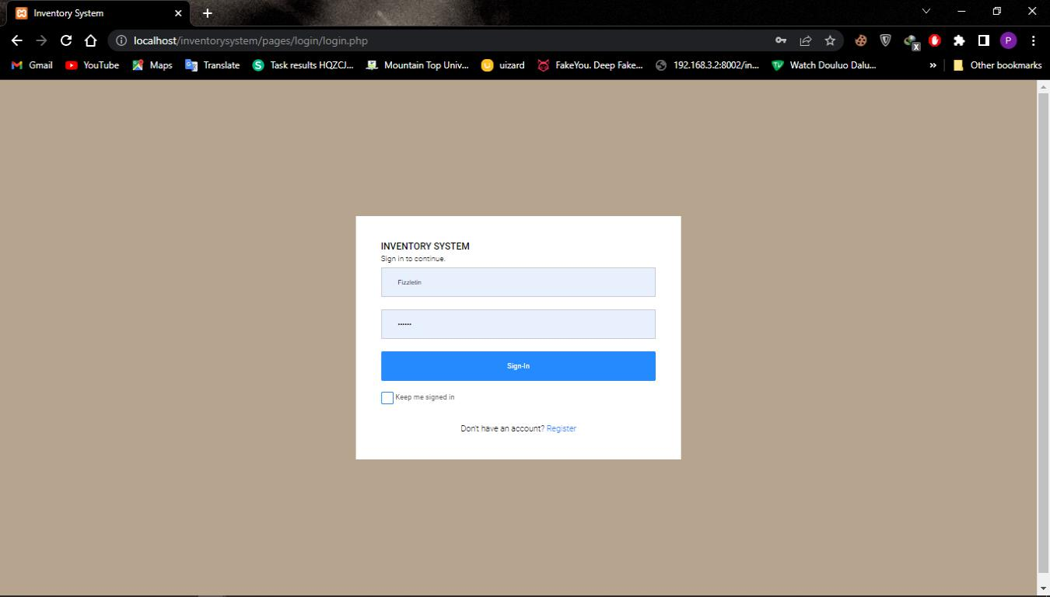

Figure 4.2: Login Page

27

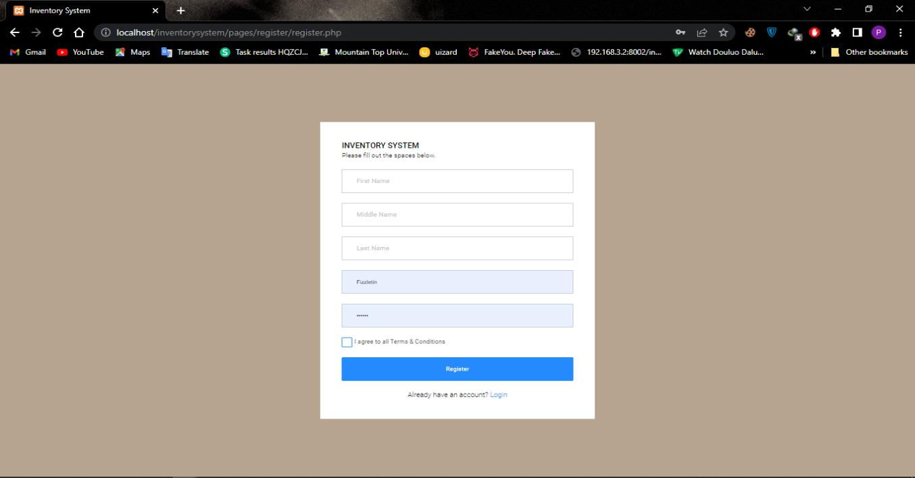

Figure 4.3: Register page

28

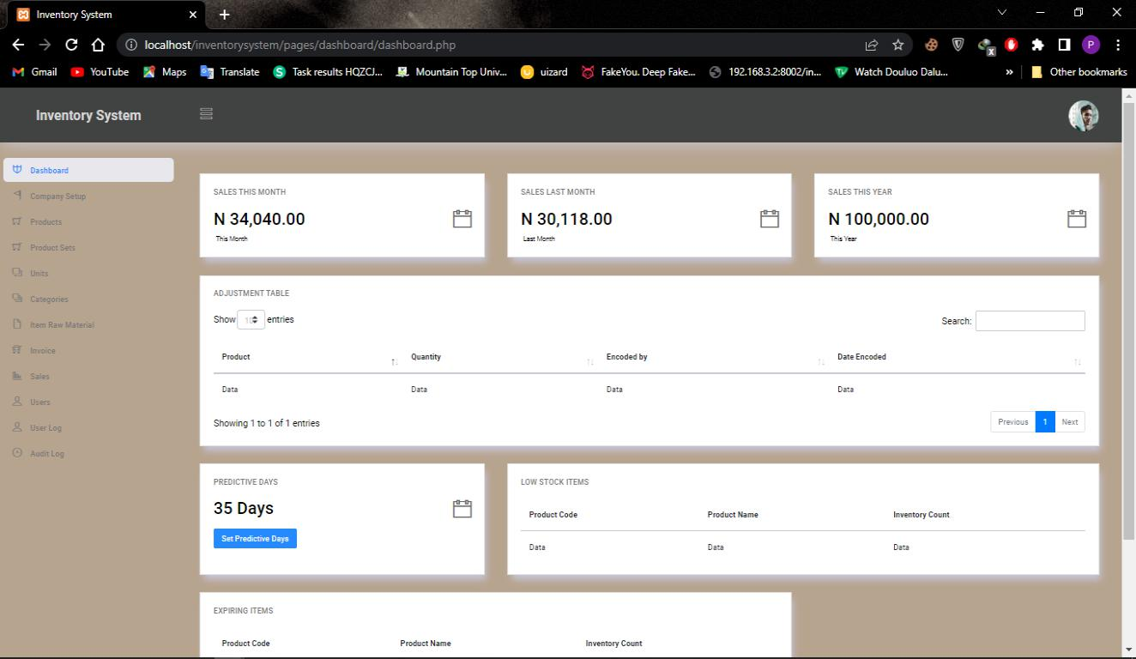

Figure 4.4 Dashboard

29

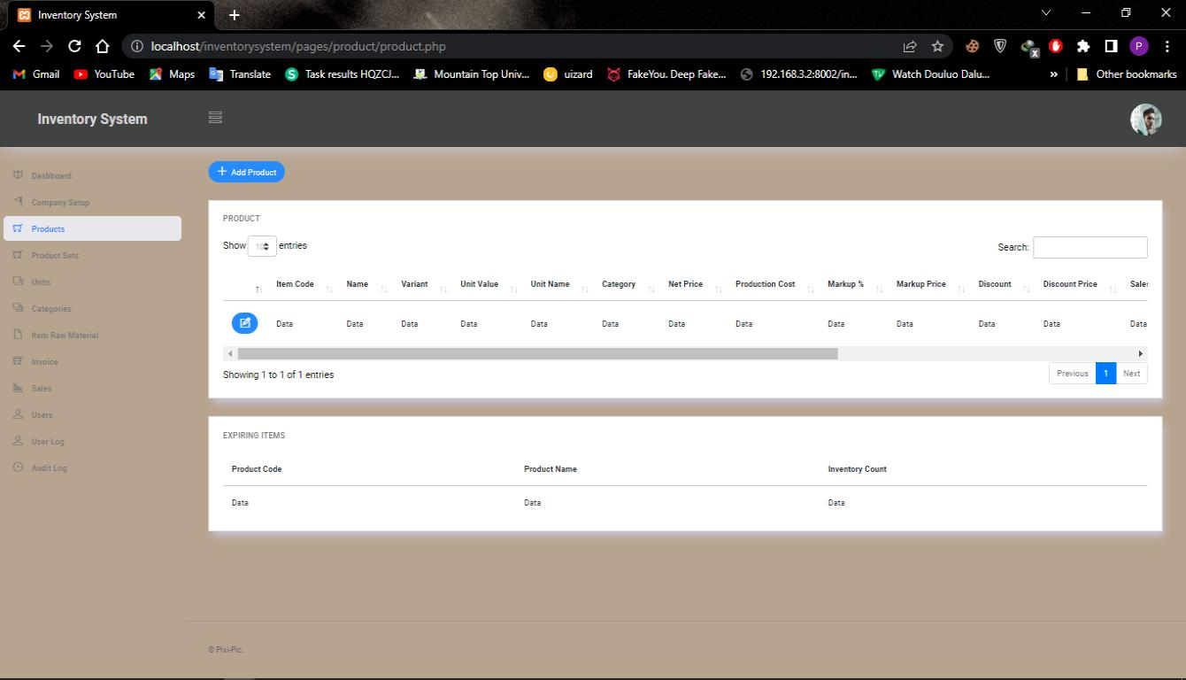

Figure 4.5: Product View / Edit page

30

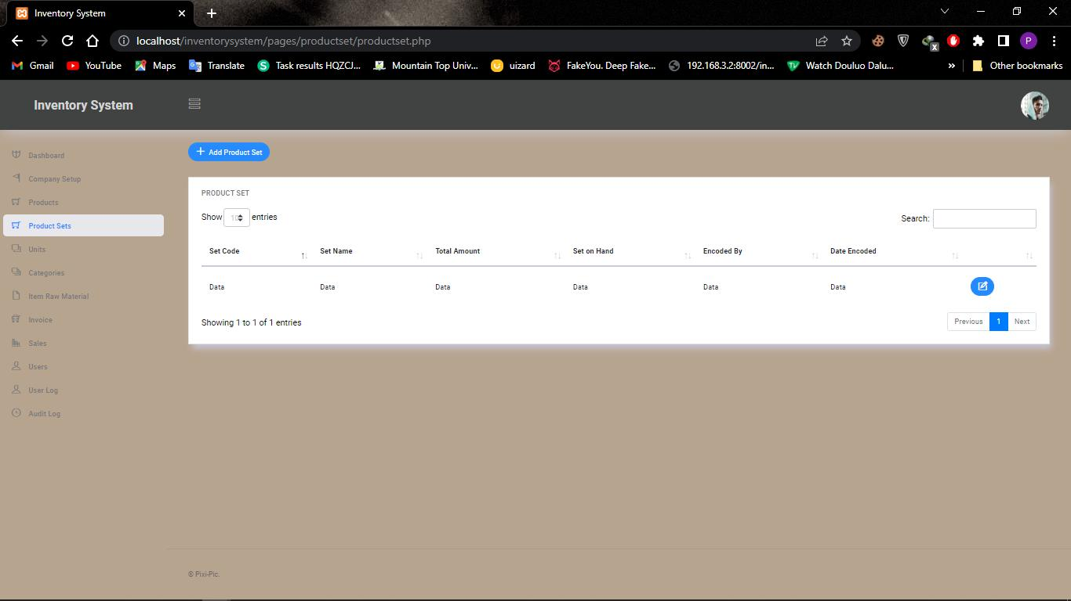

Figure 4.6: Product Set View / Edit page

31

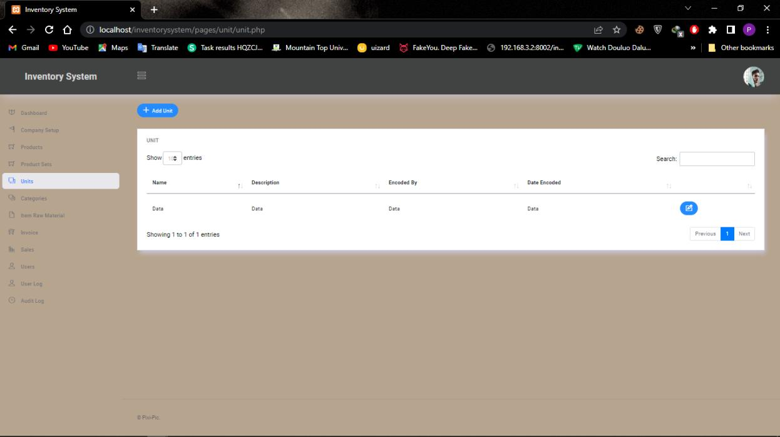

Figure 4.7: Unit View / Edit page

32

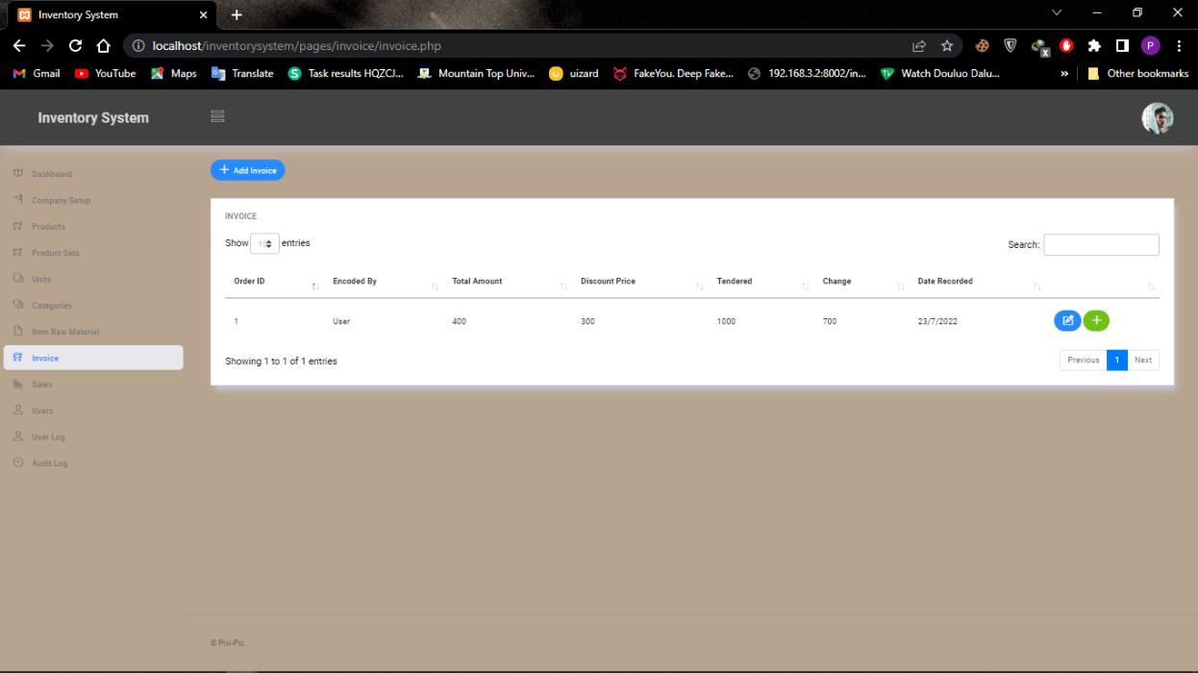

Figure 4.8: Invoice View / Edit page

33

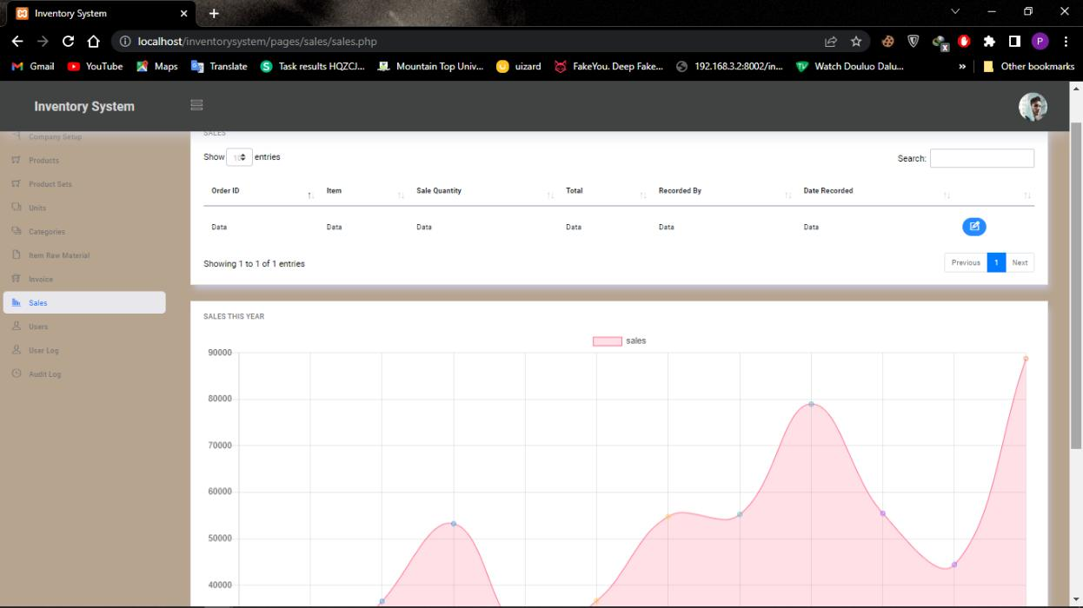

Figure 4.9: sales view / Edit page

34

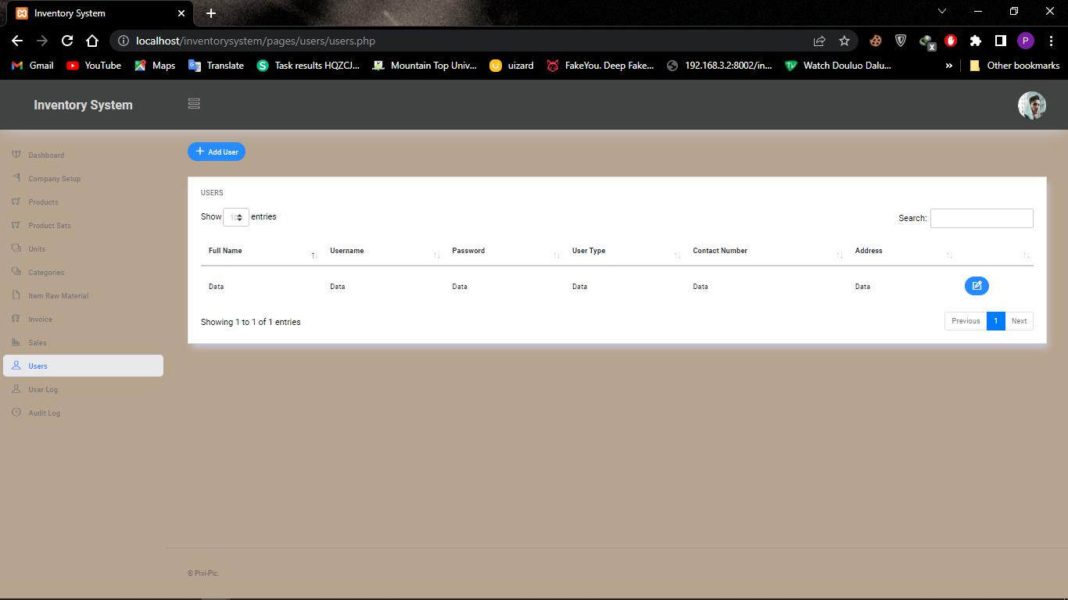

Figure 4.1.1: User view page

35

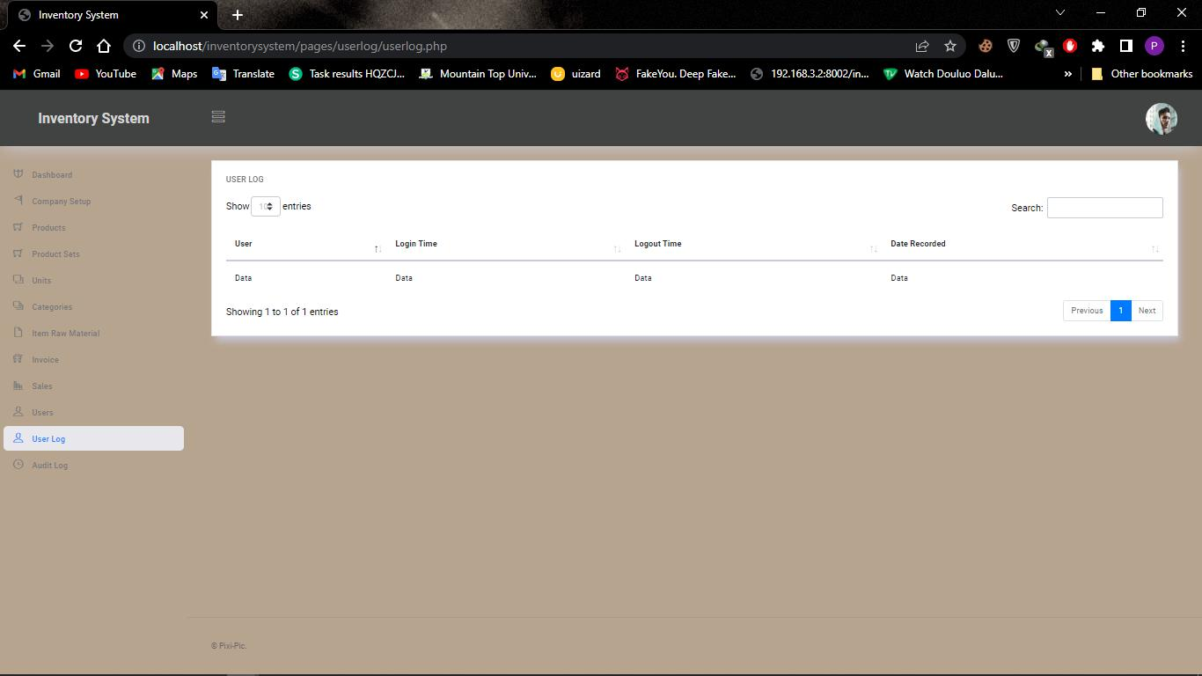

Figure 4.1.2: User Log view page

36

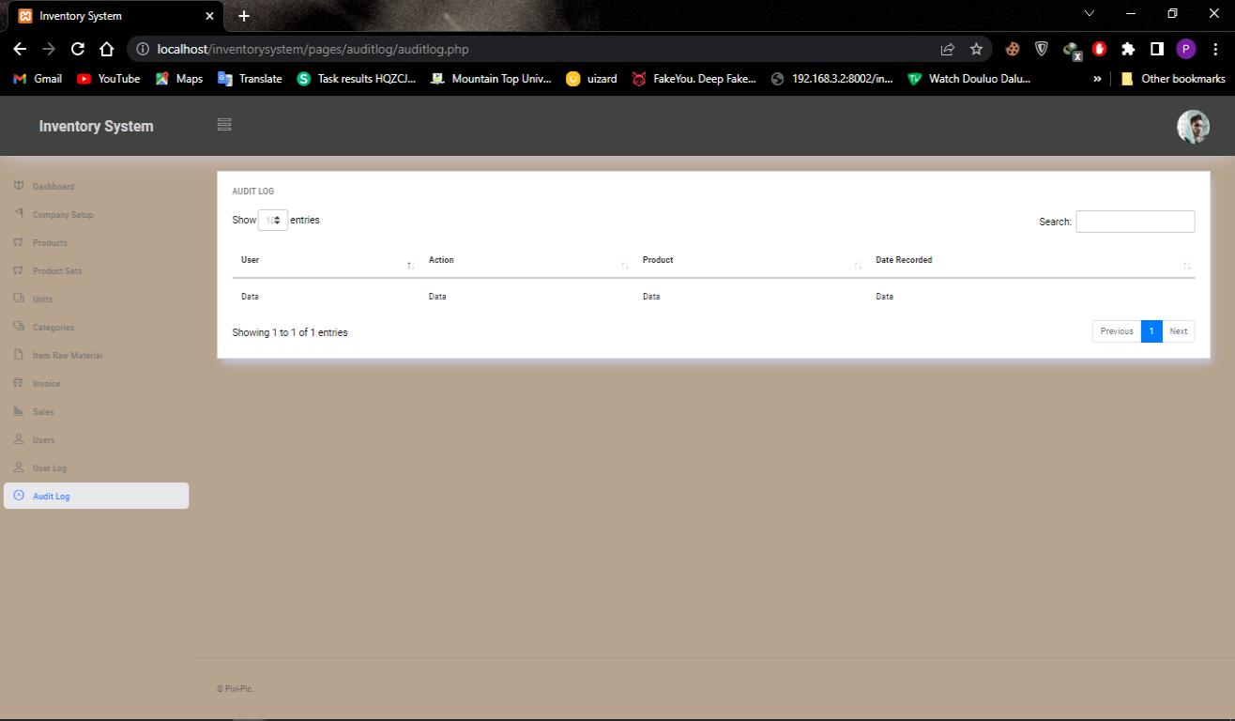

Figure 4.1.3: Audit Log view page

37

**CHAPTER 5**

**CONCLUSION AND RECOMMENDATIONS**

**5.1** **INTRODUCTION**

The main objective of this chapter is to describe the objective evaluation of the project, the limitations and obstacles faced during its development, potential future plans to improve the project, and recommendations for future inventory system initiatives.

**5.2** **Why Use This System**

The goal of stock control is to have as much inventory on hand as you need without having too much to manage or sell. Inventory management collects and analyzes data on demand, turnover rates, and inventory levels, providing you with the information you need to place orders as needed and sell down existing stock as quickly as possible.

**5.3** **FUTURE ENHANCEMENT**

The inventory system could be improved in the ways listed below.

No matter how effective and good a software program is, there is always room for improvement. However, any improvements made should leave the system open to future changes. Considering this important factor, the system is designed in such a way that provisions can be given for further enhancement without affecting the system presently developed.

38

**5.4** **LIMITATIONS**

1. Insufficiency of time.
2. No stable internet connection.
3. Insufficient resources.

**5.5** **CONCLUSION**

To conclude, an inventory management system is a necessary alternative to a manual system. an online inventory management system can make it easier to keep documents. The major goal of automating the inventory system is to keep track of goods' movement and storage. The inventory management system's capabilities were improved thanks to the newly developed software. Currently, the saved data may be sorted by serial number, quickly triggered to ensure the FIFO concept, and precisely provided to dealers with the fewest possible faults. Overall, following automation, the warehouse system has become more reliable and efficient, simplifying the process for the operators, suppliers, and dealers.

39

**References**

A Review of Inventory Management System. (2021). *International Journal of Advanced Research in Computer and Communication Engineering, 10*(6), 421-423.

Anas M. Atieh*, H. K.-a. (2015). *Performance improvement of inventory management system processes by an automated warehouse management system.* German Jordanian University: Elsevier B.V.

B.V, E. (2019). Inventory Management and performance. *Inventory Management and Performance of SMEs in the Manufacturing sector of harare, i*(33), 454-461.

Brent D. Williams, T. T. (2008). *A review of inventory management research in major logistics journals.*

The ohio state university, usa: Emerald Group Publishing Limited.

IBRAHIM-IMAM, S. (2020). *DESIGN AND IMPLEMENTATION OF AN ONLINE INVENTORY MONITORING SYSTEM.* Abuja.

TARDI, C. (2021, April 25). *https://www.investopedia.com/articles/02/060502.asp*. Retrieved from https://www.investopedia.com/: https://www.investopedia.com/articles/02/060502.asp

The impact of inventory management practice on firms’ competitiveness and organizational performance: Empirical evidence from micro and small enterprises in Ethiopia. (2018). *impact of inventory on firms, 5*(1).

Tutorialspoint. (n.d.). *tutorials point*. Retrieved from www.tutorialspoint.com:

https://www.tutorialspoint.com/sdlc/sdlc_agile_model.htm

*unleashed software*. (2022, 01 02). (Inventory Management guide) Retrieved 02 01, 2022, from https://www.unleashedsoftware.com

All Answers Ltd. (November 2018). Inventory Management Literature Review. Retrieved from

https://ukdiss.com/litreview/literature-review-on-inventory-management-with-practical-

examples.php?vref=1

40

**APPENDIX**

**SOURCE CODE**

LOGIN-PAGE

<?php

session_start();

include("../head.php");

include("../config.php");

include("../functions.php");

if($_SERVER['REQUEST_METHOD'] == "POST")

{

//something was posted

$username = $_POST['username'];

$password = $_POST['password'];

if(!empty($username) && !empty($password) && !is_numeric($username))

{

//read from database

$query = "select * from users where username = '$username' limit 1"; $result = mysqli_query($con, $query); if($result)

{

if($result && mysqli_num_rows($result) > 0)

{

$user_data = mysqli_fetch_assoc($result);

if($user_data['password'] === $password)

{

$_SESSION['user_id'] = $user_data['user_id']; header("Location: ../dashboard/dashboard.php"); die;

}

}

41

}

echo "wrong username or password!";

}else

{

echo "wrong username or password!";

}

}

?>

<!DOCTYPE html>

<html>

<head>

<title>Login</title>

</head>

<body>

<div class="container-scroller" >

<div class="container-fluid page-body-wrapper full-page-wrapper" >

<div class="content-wrapper d-flex align-items-center auth px-0" style="background-color:#b7a48f;">

<div class="row w-100 mx-0">

<div class="col-lg-4 mx-auto">

<div class="auth-form-light text-left py-5 px-4 px-sm-5"> <h4>INVENTORY SYSTEM</h4>

<form method="post">

<div class="form-group">

<label for="Username"></label>

<input id="text" type="text" name="username" class="form-control" placeholder="Username">

</div>

<div class="form-group">

<label for="Password">Password</label>

42

<input id="text" type="password" name="password" class="form-control" placeholder="Password">

</div>

<input id="button" type="submit" class="btn btn-block btn-primary btn-lg font-weight-medium auth-form-btn" value="Login">

<div class="my-2 d-flex justify-content-between align-items-center"> <div class="form-check">

<label class="form-check-label text-muted">

<input type="checkbox" class="form-check-input">

Keep me signed in

</label>

</div>

</div>

<div class="text-center mt-4 font-weight-light">

Don't have an account? <a href="../register/register.php" class="text-primary">Register</a>

</div>

</form>

</div> </div> </div> </div> </div> </div> </div> <!-- container-scroller -->

<!-- plugins:js -->

<script src="../../vendors/base/vendor.bundle.base.js"></script>

<!-- endinject -->

<!-- inject:js -->

<script src="../../js/off-canvas.js"></script>

<script src="../../js/hoverable-collapse.js"></script> <script src="../../js/template.js"></script> <script src="../../js/todolist.js"></script>

<!-- endinject -->

</body>

</html>

43