DESIGN AND IMPLEMENTATION OF AN INVENTORY MANAGEMENT SYSTEM FOR WALID HALAL SPICES

BY

DAHIRU, Tahir BU/16C/IT/2184

DEPARTMENT OF COMPUTER SCIENCE FACULTY OF COMPUTING & APPLIED SCIENCES BAZE UNIVERSITY

ABUJA

DECEMBER, 2020

DESIGN AND IMPLEMENTATION OF AN INVENTORY MANAGEMENT SYSTEM FOR WALID HALAL SPICES

Thesis submitted in partial fulfilment of the requirement For the degree of

B.Sc.

In

Computer Science [Information System Management]

By Dahiru, Tahir

To

The Department of Computer Science Baze University, Abuja

DECEMBER, 2020

## DECLARATION

This is to certify that this Thesis/Report entitled Inventory Management System for Walid Halal Spices, submitted by Tahir Dahiru in partial fulfillment of the requirement for the award of degree for B.Sc. in Information System Management to the Department of Computer Science, Baze University Abuja, Nigeria, comprises of only my original work and due acknowledgement has been made in the text to all other materials used.

Date: DECEMBER 2020 Name of Student: Tahir Dahiru

**APPROVED BY** Dr C.V. Uppin

Faculty of Computing and Applied Sciences

## CERTIFICATION

This is to certify that this Thesis/Report entitled Inventory Management System for Walid Halal Spices, submitted by Tahir Dahiru in partial fulfillment of the requirement for the award of degree for B.Sc. in Information System Management to the Department of Computer Science, Baze University Abuja, Nigeria is a record of the candidate’s own work carried out by the candidate under my/our supervision. The matter embodied in this thesis is original and has not been submitted for the award of any other degree.

Date/Sign: Supervisor 1 : Dr Fatima Maikore

Date/Sign: Supervisor 2 : Mr Nasiru Aboki

## APPROVAL

This is to certify that the research work, Inventory Management System for Walid Halal Spices and the subsequent preparation by Tahir Dahiru with BU/16C/IT/2184 has been approved by the Department of Computer Science, Faculty of Computing and Applied Science, Baze University, Abuja, Nigeria.

By

Dr. Fatima Maikore Date

1st Supervisor

Mr Nasiru Aboki Date

2nd Supervisor

Dr Chandra Uppin Date

Head of Department

Prof Mohammed Hammawa Date

Dean, Faculty of Computing and Applied Science

Prof. Ahmed Baita Garko Date

External Examiner

## DEDICATION

This report is dedicated to Almighty Allah (SWA), the creator, source of my knowledge, wisdom and inspiration. Also, my parents, my lecturers and mentors as well as my friends and family alongside every other person that has helped me achieve one of my goals. With the love, help and support, things became easier. I will forever be in gratitude to them and to the All Mighty for giving me this opportunity.

## ACKNOWLEDGEMENT

I express gratitude toward God Almighty for giving me the opportunity to carry out my B.Sc. Also, to my parents, I really appreciate the love and support given and ensuring I go to a good school, my siblings, colleagues and friends; I appreciate all the efforts and support holding me through. In addition, to BAZE UNIVERSITY for giving me the prospect to experience this B.Sc. program. My appreciation goes to all my lecturers, supervisors and mentors for impacting knowledge to be able to achieve all this. My Pleasure goes to you everyone; I convey my gratitude towards all of you for your support, study, recommendation, advice and corrections. I would also like to thank every other person that added to the accomplishment of my B.Sc. program. Thank you

## ABSTRACT

This thesis portrays the Inventory Management System adequately to decide the possibility and convenience of a completed system. The main idea is to trace the trading from the sales registers with extra highlights for deciphering the information. It utilizes a server model with an associated database to permit numerous stores and other locations to be associated. This takes into account later extension while as yet supporting the focus on independent small ventures.

This thesis depicts the IMS adequately to decide the practicality and convenience of a completed framework. The center idea is to follow the offer of things from the sales registers with extra highlights for deciphering the information. It utilizes a customer worker model with an associated information base to permit various stores and distribution centers to be associated. This takes into account later development while as yet supporting the focus on private companies. Inventory Management (IMS) are generally utilized in industry these days to build the effectiveness of thin streams. The conventional technique for IMS included a great deal of administrative work, for example, a bookkeeping page and request list which will be harder to oversee as the capacity becomes greater. In this manner, IMS can be modernized to further expand the effectiveness. This undertaking intended to create IMS programming can store a huge sum of information. Additionally, it has check in/out capacity and search work that runs utilizing examine QR Code. Other than that, the product additionally has the element of low stock notice capacity to caution the client if the thing has low amounts. To build up the product, first the measures of the product are resolved by picking the product advancement devices to build up the product that can accomplish the models of the product. Next the product will be created and fixed. This paper centers on creating IMS programming for SMEs and biomedical field organization use.

**Contents**

ABSTRACT VII

CHAPTER 1: INTRODUCTION 1

* 1. Overview 1
  2. Background and Motivation 1
  3. Statement of the Problem 1
  4. Aim and Objectives 2
  5. Significance of the Project 2
  6. Project Risks Assessment 3
  7. Scope/Project Organization 4

CHAPTER 2: LITERATURE REVIEW 5

* 1. Introduction 5
  2. Historical Overview 5
  3. REVIEW OF THE EXISTING SYSTEM 7
  4. JUSTIFICATION OF THE NEW SYSTEM 7
  5. BENEFITS OF THE NEW SYSTEM 7
  6. Related Work 8

Summary 11

CHAPTER 3: REQUIREMENTS ANALYSIS AND DESIGN 13

* 1. Overview 13
  2. Proposed Methodology 13
     1. Waterfall Development Methodology 13
     2. Agile Development Methodology 14
  3. Approach to Chosen Methodology/Methods 15
     1. WATERFALL METHODOLOGY APPROACH 16
     2. AGILE METHODOLOGY APPROACH 17
  4. Tools and Techniques 18
  5. Ethical Consideration 19
  6. Requirement Analysis 20
     1. Responsibility Matrix 21
     2. Fact-Finding Techniques 21
  7. Requirements Specifications 22
     1. Functional Requirement Specifications 22
     2. Non-Functional Requirement Specifications 23
  8. System Design 23
     1. Application Architecture 24
     2. Use Case 24
     3. Sequence Diagram 25
     4. Data Flow Diagram 26

3.8.6 Entity-Relationship Diagram (ERD) 27

* 1. Summary 27

CHAPTER 4: IMPLEMENTATION AND TESTING 28

* 1. Overview 28
  2. Main Features 28
  3. Implementation Problems 32
  4. Overcoming Implementation Problems 32
  5. Testing 32
     1. Tests Plans (for Unit Testing, Integration Testing, and System Testing) 33
     2. Test Suite (for Unit Testing, Integration Testing, and System Testing) 34
     3. Test Traceability Matrix (for Unit Testing, Integration Testing, and System Testing) 34
     4. Test Report Summary (for Unit Testing, Integration Testing, and System Testing) 39

Table 4. 4 Test Summary Report 39

* + 1. Error Reports and Corrections 40
  1. Use Guide 40
  2. Summary 43

CHAPTER 5: DISCUSSION, CONCLUSION, AND RECOMMENDATIONS 44

* 1. Overview 44
  2. Objective Assessment 44
  3. Limitations and Challenges 44
  4. Future Enhancements 44
  5. Recommendations 45
  6. Summary 45

REFERENCES 46

APPENDICES 47

## LIST OF TABLES

**Table 1.1: Risk and Assessment of Project Table 3.1: Developers Specification Hardware Table 3.2: Developers Specification Software Table 3.3: Developers Specification Hardware Table 3:4: Responsibility Matrix**

**Table 3.5 Functional Requirement Specifications Table 3.6 Non-Functional Requirement Specifications Table 4.1: Test Plan**

**Table 4.2Test Suite Performed Table 4.3: Test Traceability Matrix Table 4. 4 Test Summary Reports**

## LIST OF FIGURES

Figure 2 1 Silver Inventory System 8

Figure 2 2 Zoho Inventory Management System 9

Figure 2 3 Sortly IMS 10

Figure 3 1 Waterfall Model (TechTarget 14

Figure 3 2 Agile Model (TechTarget, 2011) 15

Figure 3 3 Application Architecture diagram 24

Figure 3 4 Use Case diagram 25

Figure 3 5 Sequence Diagram 26

Figure 3 6 Dataflow Diagram Level Zero 26

Figure 3 7 Dataflow Diagram Level one 27

Figure 3 8 Entity Relationship Diagram 28

Figure 4 1 Login Page 29

Figure 4 2 Dashboard 30

Figure 4 3 Product Profile 30

Figure 4 4 Stock Inventory 31

Figure 4 5 Customer Profile 31

Figure 4 6 Daily Sales 32

Figure 4 7 Expired Item 32

Figure 4 8 Add Item 33

Figure 4 9 Admin Login 36

Figure 4 10 New Item Added 37

Figure 4 11 Item Added to Cart 37

Figure 4 12 Items in Stock 38

Figure 4 13 New Stock Added 39

Figure 4 14 New Customer Added 39

Figure 4 15 Netbeans IDE 41

Figure 4 16 Open IAS using App 42

Figure 4 17: Run the code using browser 42

Figure 4 18 Server Directory (Database 43

Figure 4 19 Navigate Pages 44

#### LIST OF ABBREVIATIONS

CPU Central Processing Unit

ERD Entity Relationship Diagram

IT Information Technology

IMS Inventory Management System

ERD Entity Relationship Diagram

# CHAPTER 1: INTRODUCTION

### Overview

Walid Halal Spices is a medium scale business whose Chief Executive Officer is Mr Walid. The research is served to develop an Inventory Management System that covers the product information storage needs for Walid Halal Spice Inventory Management System. With the implementation of this prototype, the company information will be far safer and much better accessible. Companies usually keep their record manually which in this generation can be of inconvenience. In respect to this system, it will help the business run their operation smoothly with accurate and accessible data. This chapter is dedicated to fully understanding the nature of the problem and developing a solution to it. It also explains the significance of the system to the Company.

### Background and Motivation

Walid Halal is one of the largest retail shops for spices in Gombe State and has gained such a wealth of reputation in the Spice industry. It has a quite reasonably sized store. Its vast interest in Spice Business spans across a wide Market Area with one Shop and a Store in Gombe. The shop offers wholesale, retail and distribution services of their products to its customers across the country. For the matter of wholesale services, it is only carried out from the shop and store while the retail services are offered at the shop where distribution services are offered in both places.

The current system for the medium scaled business was described by manual field enrollment and record based system which was vulnerable to an inordinate couple of mistakes, information repetition and the trouble of data about the items in stock are nevertheless only a couple of the difficulties the organization faces.

### Statement of the Problem

Walid Halal uses a manual ledger system which brings about a lot of inconveniences and undesired drawbacks. There is a lot of time wasting since the information is first documented on hard copies then entered into a spreadsheet application. It takes a very long time to search for a particular record with the current system and lots of paper and ink are wasted which makes the system very inefficient. With flat files, data duplication is a common problem that results in all

sorts of problems such as update and delete errors just to mention but a few. Since the manual ledger system can easily be manipulated, ledger books can get lost and it also undergoes wear and tear thus leading to loss of data which is vital to the company ergo making the system insecure.

This therefore brought about a need for an Automated Inventory Management System to be put in place which would help in improving the system. The advent of an Automated Inventory Management System would thus rid of the problems nurtured by the manual ledger system used by Walid Halal Spices.

### Aim and Objectives

The general objective is to implement and develop an Automated Inventory Management System (IMS) that will effectively and efficiently manage the inventory of Walid Halal Spices in their Store. To design an Automated Inventory Management System that acts as the blueprint for the new system.

To collect and analyze user requirements that was to provide the researchers with enough information of what the system users want the system to accomplish.

To test and validate the designed system that ensures all systems requirements are met.

To implement a prototype of the designed system that realizes the system designs and provides the real first taste of the actual system.

### Significance of the Project

The execution of this has a great advantage to the business people dealing with goods in a way that due to the problems the companies are facing, the designed system can be more important to the company in the following ways.

The company is able to save a bit more money on expenses as it wouldn’t need to buy much paper and ink. Whereas the customers are better served as information access with the new system would be far much faster by managing your inventory. Also, the suppliers for the company also benefit as the new system makes it easier to know which items need to be restocked.

With the old system, it is quite easy to maneuver around the books and change numbers but rather, the system also goes a long way in reducing fraud as it would neatly keep track of all the assets in the company. Such that all stock, items and sales are always up to date.

### Project Risks Assessment

These are a few risks that can come up in the advancement of this project and recommended ways the risk may possibly be avoided.

**Table 1.1: Risk and Assessment of Project**

|  |  |
| --- | --- |
| RISK | RESPONSE |
| Software availability (Unavailability of API’s) | Alternative API’s will be checked for. Software necessities will be recognized in a good instance for potential litigious software. |
| Loss of effort due to equipment breakdown /loss | Weekly data backup to H drive |
| Inability to carry out research due to loss of hardware/software resources | Be aware of and observe school IT security procedures.  Secure development device during and after usage. |
| Late delivery of Software | Software necessary requirements will be  acknowledged in good time to be able to convey the product in good time |

### Scope/Project Organization

This describes how the chapters of the project are organized. The report consists of five chapters as outlined below: Chapter 1: provides a general overview of what the whole project is all about such as background and motivation, statement of the problem, aims and objectives, significance of the project, and project risk assessment. Chapter 2: provides Literature Review introduction historical overview, related work and summary. Chapter 3: This chapter depicts the Requirement Analysis and Design. Chapter 4: This includes the implementation and testing of the project’s components Chapter 5: Discussion, conclusion, and recommendation are in this chapter. Finally the reference and appendices is in the last part of the report.

# CHAPTER 2: LITERATURE REVIEW

### Introduction

This chapter is based on the literature review of the techniques and technology used in this thesis. Section 2.2 is the Historical Overview of Inventory Management System. The studies were carried mainly to establish the software application design tool used and technology used to create the IMS software in the previous projects and also the features of the IMS software.

Section 2.3 gives descriptions of some of the literature available with regards to the application of PHP/Database in solving the research question. Finally, section 2.4 is a summary of the entire chapter. At that point the information acquired from this part will be utilized as references to decide the course of this project to make extraordinary Inventory Management System software

### Historical Overview

Each day, people all over the world partake in numerous sales transactions across the world, creating a stable flow of significance which forms the strength of character of our economies. Trade of buying and selling things has been going for centuries, so naturally that way the inventory management system has always been in existence in some manner, at least. In most cases, sales signify a transaction that takes place among two parties where the consumer receives goods (tangible or intangible), service or assets in exchange for money from the merchant.

According to Chase, Jacobs and Aquilano (2004), inventory is the stock of any item or resource used in an organization. A stock system is the set of policies and controls that monitor levels of stock and determine what levels should be maintained, when stock should be replenished, and how large orders should be.

Pycraft et al (2000) defined inventory or stock as “the stored accumulation of material resources in a transformation system. So a manufacturing company will hold stocks of materials, a tax office will hold stocks of information and a theme park will hold stocks of customers ( when it is customers which are being processed we normally refer to the stocks of them as queues).

During the early ages, there was no technology 300 years ago, and surely no tag or bar code readers, but people have always tried to make things easier in the trading process, adopting innovative technologies within the line. In accordance to the study of Navarro (2012), Sales and Inventory System, computer is general purpose device which can be programmed to carry out the finite set arithmetic or local operation, the computer has a big role in our nation today because of technology. Wherever you go, a computer exists, especially in business it makes the procedure

easy and sourced by programming the manual system into a computerized system. The role of technology in our life today has a big impact. Meanwhile, inventory means the resources, unmanufactured goods and finished products that are considered to be a part of a business’s resources that are ready for sales. Back then, merchants had to note down purchases and look out for how many items were sold that day, and how many of them were left.

In the study from Averion, Gaela, and Libo (2009) entitled “Monitoring and Inventory for discovery Mall.com”, it stated that: It will minimize the difficulty of the manager in processing inventory because physical counting products, stocks and computing inventory summary will be the system job. It will monitor the availability of products, items to prevent under stocking, over stocking and running out of stock. The system will also simplify the transaction between trader and supplier relationship because the updated supplier information and price list of items will correspond to collaboration with other suppliers.

Certainly there were no sales forecasting apps, merchants had to estimate future needs themselves, which sometimes not very accurate, and possibly will easily slow down the business. One of the occasions that had the most significant effect on individuals since the beginning is positively the Industrial Revolution, which expanded productivity and large-scale manufacturing. The organizations developed thus improved stock administration. Inventory management likewise entails the significant associations between recharging lead time, resource management, conveying expenses of stock, future stock value determining, actual stock, accessible stock space, request estimating and substantially more. By adjusting these contending prerequisites, an organization will find their ideal stock levels. This is an endless cycle, as the organization should move and respond to its current circumstance as it changes and develops.

Inventory Management system is administered by the clients, who haul products to the point it gets unavailable, and second by the organization that pushes the products to be unavailable dependent on requests and requests. According to Lambert (2001), stock can be categorized into six distinct forms which are: Cycle stock is inventory that results from the replenishment process and is required in order to meet demand under conditions of certainty, that is, when the firm can predict demand and replenishment times (lead times) almost perfectly: In-transit inventories. In- transit are items that are en route from one location to another.

This is the brief history of Inventory Management System, its inception and up to date usage, a brief history of the PHP programming language which will be used to implement. PHP is defined as PHP Hypertext Preprocessor and is an open source general-purpose server-side scripting language originally designed for web development to produce dynamic web pages. Moreover, it

was the first server-side scripting language that was specifically designed to be embedded into HTML elements for server-side processing and execution ~~.~~ (Angela Bradley, 2013).

## REVIEW OF THE EXISTING SYSTEM

Walid Halal is one of the largest retail shops for spices in Gombe State and has gained such a wealth of reputation in the Spice industry. It has a quite reasonably sized store. Its vast interest in Spice Business spans across a wide Market Area with one Shop and a Store in Gombe. The shop offers wholesale, retail and distribution services of their products to its customers across the country. For the matter of wholesale services, it is only carried out from the shop and store while the retail services are offered at the shop where distribution services are offered in both places.

The existing system for the wholesale services was characterized by manual field registration and file based system which was susceptible to an excessive number of mistakes, data redundancy and the difficulty of updating information about the goods in stock are but just a few of the challenges the company faces.

## JUSTIFICATION OF THE NEW SYSTEM

The new proposed system will make it very easy for the staff to keep track of new and old stock, it also has a page for expired products in stock, it is very effective and efficient in terms of retrieving data, it does not give room for data manipulation.

## BENEFITS OF THE NEW SYSTEM

Inventory Management System has several functions which enable the admin to do so many jobs efficiently

The admin inputs all the current stock and can be able to update if there should be any changes. Monitoring all the sales activities can be done by simply printing the report sales.

Tracking the quantity of goods available in the store, or if need be for a restock. Also The admin can be able to generate report on all the activities of the store

### Related Work

##### Silver Inventory System

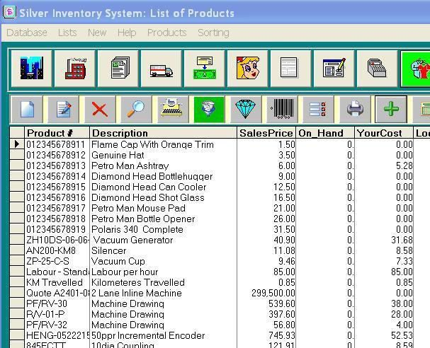

**Figure 2 1 Silver Inventory System**

Silver Inventory System is an application used all through the world, especially with little to medium scale organizations requiring a mid-range, economical independent stock application with a decent scope of highlights. Silver Inventory System is a finished economical application for the executives of deals, buys and purchases. This application will help you in creating records, deal orders, buy orders, accepting records, installment receipts, item names with standardized tags and any sorts of the reports for observing your business. The inventory application permits the control of client adjusts and merchant adjusts.

Features

It has a User friendly interface that is easy to understand, the interface can be used without need for training.

The System utilizes a point of sale panel where purchases and sales can be performed in real time.

The security possesses a User access functions that can be controlled depending on access level or role. Secured access prevents unauthorized access from unauthorized users.

The user can decide to export reports in Excel files.

It also wires costs for ordered products and purchase orders at the same time reserving inventory for sales orders.

##### Zoho Inventory Management System

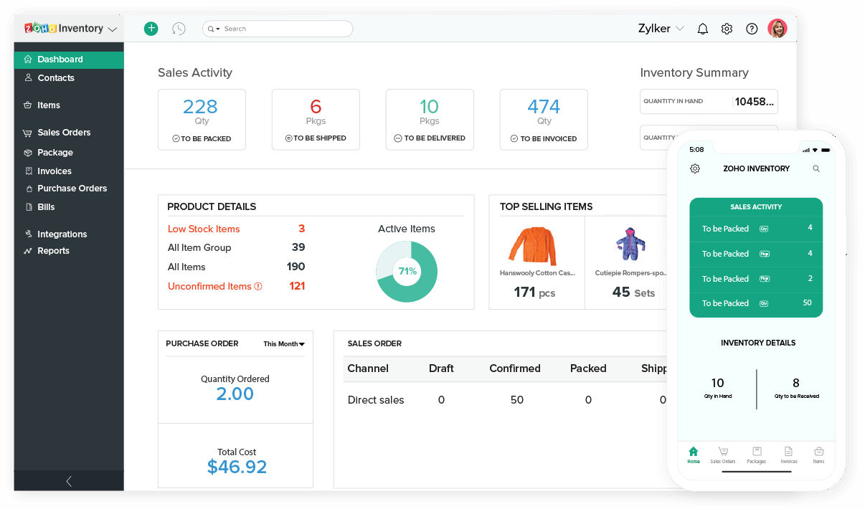

**Figure 2 2Zoho Inventory Management System**

Zoho is one of the most familiar distributors of applications and solutions to small scale businesses. It can be used by e-Commerce Businesses, Online sellers, Retailers, Wholesalers, Small and Medium sized businesses. Zoho possesses 45 Software as-a-service (SaaS) items intended to manage business from start to finish. The organization has made a remarkable imprint with Zoho Office Suite, Zoho Cost, Zoho Receipt, and Zoho Social to give some examples.

PROS

The system has widespread distribution functions.

It integrates tracking reports of inventory across several warehouses.

The system also incorporates the trading and purchasing sort functionality. It has vast ecommerce potentiality and support for tags and bar coding.

Zoho have a potent email promotional marketing tool.

CONS

Also does not do forecasting

No bill of materials, pick list, or bin ID support

Several of the distribution and ecommerce integrations are for a particular set of countries. Supports FIFO costing

First in First out inventory costing enables the system to make available of items first placed in the system before the subsequent ones

##### Sortly Inventory Management System

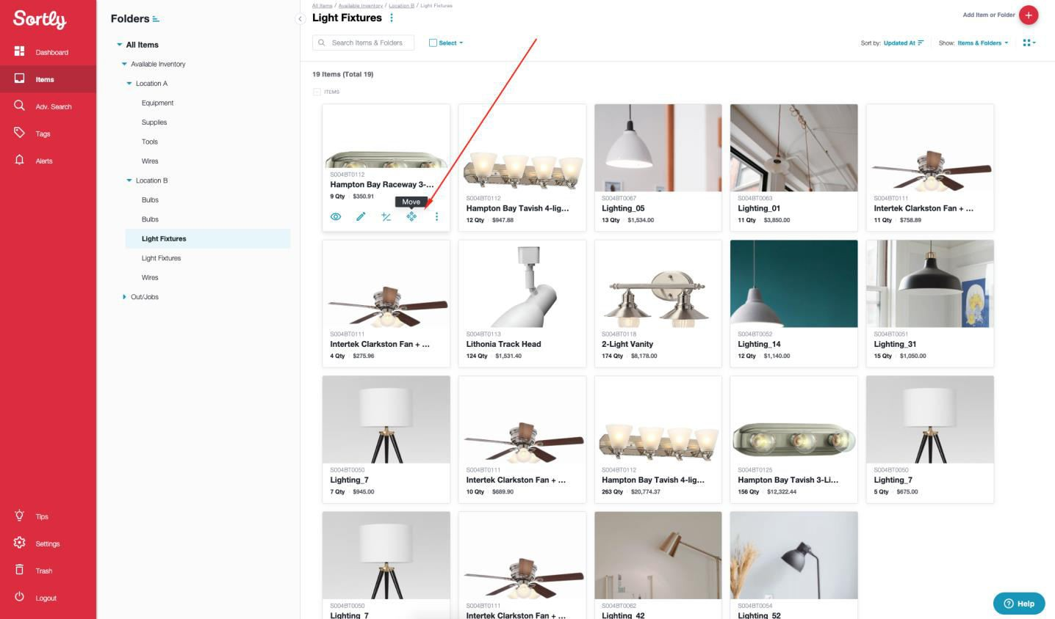

**Figure 2 3Sortly IMS**

Sortly is an easy inventory application and item tracking system that allows you to visualize track items and any of their details including quantity, price, condition, notes, etc. Unlike other inventory applications, it's very easy to understand how to go around the application. It's designed in such a way that you can start the system running in time, all by yourself.

##### Features

Some of the features for Sortly are:

Users can be able to visualize your inventory where you can be able to view your inventory with the aid of photographs instead of words in an accounting page. Incorporate up to 8 pictures for each thing.

Access By means of a Desktop, Tab OR Smartphone. From your work area or from your leisure space, your inventory is consistently available. All data from all devices is synced with the cloud so it's also accessible everywhere you go.

Check in/out Items when utilizing the in application scanner to easily check/out items. Additionally use the scanner to increment and decrement amounts, add labels and alter things.

Set up Auto Alarms and Updates

Set up programmed notifications to assist you with overseeing items levels, returns and so on. Incorporate custom labels and notes

You can include extraordinary and accessible labels and notes to pages and items.

Index - Add the entirety of your inventory to a visual, natural application and track subtleties by altering Sortly to your necessities. You can make envelopes for sold or used items, areas, individuals, and so on

Oversee - Update inventory by moving items between types physically or by checking QR codes/tags with the Sortly application.

Track - Comprehend where things are going and what is being utilized by getting warnings on low stocks and significant dates.

Report - Fare straightforward reports demonstrating current inventory status or past movement by means of PDF or CSV.

#### CONS

One of the greatest absences this application has is that of not pushing instant notifications. It doesn't notify the admin when explicit items are pulled from stock. Also, the upkeep of the application system shouldn't be excessively escalated. Maintenance shouldn't be too labor intensive. Frequently and it is hard to track down help.

### Summary

The literature reviewed in this chapter shows the historical overview of Inventory Management System using PHP and MySQL in a plain design contrast to similar designs. There are numerous Inventory Management Systems with exclusive functionalities but still not reaching its full potential. Even though the end users want to utilize systems that are built to suit their needs, as a result it is significant to survey different resources that are equally willingly accessible to know what to improve or fix and what thoughts to make use of from these related work. Other PHP based inventory management systems exist, but there are numerous application systems that try their absolute best in terms of theft avoidance and supplementary cause inconveniences. Thus this research will be based on client and seller fulfillment. Therefore, developing the system as a web application will be the best approach for now in stipulations of simple access and additional functionalities.

Chapter 3 presents the requirement analysis and the methodology adopted in developing the Inventory Management System.

# CHAPTER 3: REQUIREMENTS ANALYSIS AND DESIGN

### Overview

This chapter is positioned on the requirement analysis and design that will be assumed over the course of the development of this project. Section 3.2 will talk about the proposed development methodology that is going to be utilized in the cause of carrying out this project. Section 3.3 is about the type of approach that suits chosen methodology/methods; section 3.4 entails the tool and techniques that will be utilized. Section 5.5 is about the ethical consideration; section 3.6 will carry a list of requirement analysis while 3.7 is the functional and non-functional requirements section 3.8 is about the system design and other analyst resources and in conclusion section 3.9 will be the summary of the chapter.

### Proposed Methodology

Two development methodologies will be used during the design of this project. They are

* Waterfall Development Methodology
* Agile Development Methodology

##### Waterfall Development Methodology

The waterfall model is a linear, sequential approach to the software development life cycle (SDLC) that is popular in software engineering and product development. The waterfall model emphasizes progression of steps. Similar to the direction water flows over the edge of a cliff, distinct endpoints or goals are set for each phase of development and cannot be revisited after completion. The term was first introduced in a paper published in 1970 by Dr. Winston W. Royce and continues to be used in applications of industrial design. (TechTarget 2009)

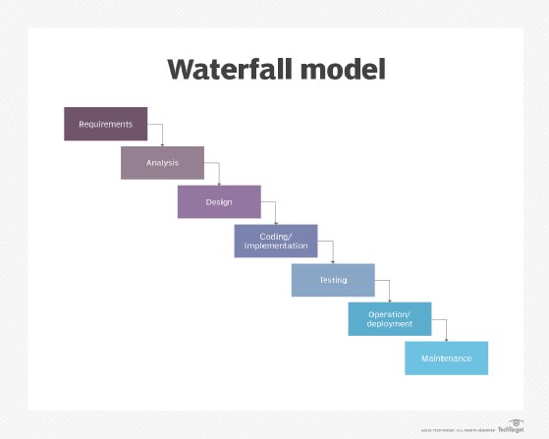

**Figure 3 1Waterfall Model (TechTarget**

The waterfall methodology will be utilized because from the start of the project, everything goes with a flow.

Every component is arranged in an order and will be gotten one after the other but not all the way through the project, then it gets to a point where there will be many unknown circumstances hence the use of Agile Methodology will be suited.

##### Agile Development Methodology

Agile software development -- also referred to simply as agile- is a type of development methodology that anticipates the need for flexibility and applies a level of pragmatism to the delivery of the finished product. Agile software development requires a cultural shift in many companies because it focuses on the clean delivery of individual pieces or parts of the software and not on the entire application.

Agile has replaced Waterfall as the development methodology of choice in most companies, but is itself at risk of being eclipsed or consumed by the growing popularity. (TechTarget 2019)

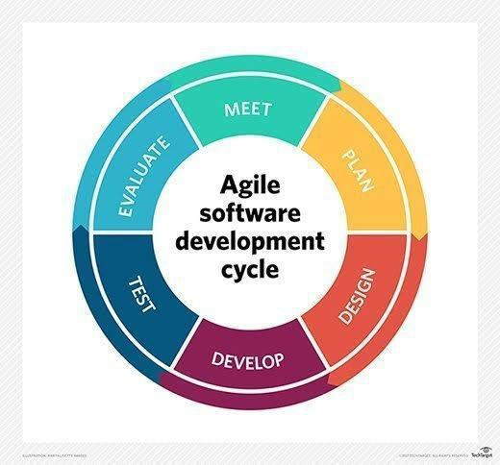

**Figure 3 2Agile Model (TechTarget, 2011)**

Agile Methodology is utilized here because there are some components that might require a test and run kind of approach. The project will be tested for a multiple number of times until the desired outcome is received. This is why the utilization of Agile methodology is important here.

### Approach to Chosen Methodology/Methods

##### Waterfall Model Management

If the waterfall model is to be executed properly, each of the phases we outlined earlier must be executed in a linear fashion. Meaning, each phase has to be completed before the next phase can begin, and phases are never repeated—unless there is a massive failure that comes to light in the verification or maintenance phase.

Furthermore, each phase is discrete, and pretty much exists in isolation from stakeholders outside of your team. This is especially true in the requirements phase. Once the customer’s requirements are collected, the customers cease to play any role in the actual development of the software.

##### Agile Project Management

Agile differs greatly from waterfall in two major ways; namely in regards to linear action and customer involvement. Agile is a nimble and iterative process, where the product is delivered in stages to the customer for them to review and provide feedback.

Instead of having everything planned out by milestones, like in waterfall, Agile operates in “sprints” where prioritized tasks are completed within a short window, typically around two weeks.

These prioritized tasks are fluid, and appear based on the success of previous sprints and customer feedback, rather than having all tasks prioritized at the onset in the requirements phase. (projectmanager 2021)

#### WATERFALL METHODOLOGY APPROACH

Requirement and analysis: Amongst all the requirements of the system to be designed are gotten in this stage and written in a requirement specification document. In this stage, inquisition on how the current system is running and the limitations therein was conducted, in order to know where to start the proposed system. Based on the analysis, the basic requirements of the proposed system will then be determined, i.e. the input and output, and elimination of redundancies.

System Design: The necessity determinations from the first phase are concentrated in this phase and the system configuration is prepared. This system configuration helps in determining hardware and system necessities and helps in characterizing the general system engineering.

Integration and Testing: in this stage, as referenced prior, unit testing will be directed. All the units created in the execution stage are coordinated into a system subsequent to testing of every unit. Post integration the whole framework is tried for any issues and faults.

Deployment of system: This will happen after all the previously mentioned stages. When the functional and non-functional testing is done, the item is sent in the customer environment or delivered into the market.

Maintenance: After the deployment, there will be a few issues which will come up in the customer environment. To fix those issues, patches are delivered. Likewise, to upgrade the software product some better forms are delivered. Maintenance is done to convey these modifications to the client environment.

##### Advantages of the waterfall model:

* It is uncomplicated and undemanding to use.
* Easy to oversee because of the unbending nature of the model – each stage has explicit expectations and a survey cycle.
* It has clearly characterized stages.
* Procedure and results are all in the order in the archived.
* Well gotten achievements.

##### Drawbacks of the waterfall model:

* It is not appropriate for the tasks where necessities are at a moderate to high chance of evolving. Along these lines, danger and vulnerability are high with this cycle model.
* Integration is done as a huge explosion at the end, which doesn't permit recognizing any innovative or business bottleneck or difficulties early.
* It is not a decent model for complex and item arranged tasks.
* High measures of danger and vulnerability.

#### AGILE METHODOLOGY APPROACH

Notion: Projects are imagined and organized.

Inception: Team individuals are distinguished, financing is set up, and starting conditions and necessities are talked about. Iteration/Construction: The advancement group attempts to convey working programming software dependent on cycle necessities and feedback.

Delivery: QA (Quality Assurance) testing, inside and outside preparing, documentation advancement, and last arrival of the cycle into creation.

Creation: Ongoing help of the software product.

Retirement: End-of-life exercises, including client notice and relocation

##### Advantages of the Agile Methodology

* Development is regularly more client-focused in, likely an aftereffect of more and continuous demands from the client.
* There is overall less risk since the project's output is reviewed along the way equally. It saves money and time from unnecessary expenditures, because providing value for users will be prioritized.
* Dividing into segments offers the group the chance to zero in on the individual stages and work quicker.

##### Drawbacks of the Agile Methodology

* The methodology may appear to be basic however be difficult to execute. It requires responsibility and for everybody to be on the same wavelength, in a perfect flow, in a similar actual space.
* Agile works best when individuals from the advancement group are totally committed to the project.
* A significant level of communication between the customer and the designers is required, which can require significant investment and make the cycle troublesome.

### Tools and Techniques

These are the assets and strategies that will be received throughout the span of the task's advancement life cycle. In this system, the client's necessity is a PC with standard arrangement and other computing devices.

**Table 3.1: Developers Specification Hardware**

|  |  |  |
| --- | --- | --- |
|  |  |  |
| S/No | Items | Specifications |
| 1 | Memory (RAM) | 2.9GHz |
| 2 | Hard Disk | Minimum of  200GB |
| 3 | I/O | Mouse, 14-15”  CRT Monitor, |
| 4 | Network |  |

**Table 3.2: Developers Specification Software**

|  |  |
| --- | --- |
| S/No | Items |
| 1 | Netbeans IDE |
| 2 | Xampp |
| 3 | MySQL Workbench |
| 4 | Erwin Data Modeller |
| 5 | Microsoft Word/Visio |
| 6 | StarUML |

**Table 3.3: Developers Specification Hardware**

|  |  |  |
| --- | --- | --- |
| S/No | Items | Specifications |
|  | Memory (RAM) | DDR2 |
|  | Hard Disk | Minimum of  200GB |
|  | I/O | Mouse, 14-15”  CRT Monitor, |
|  | Network | Network  connection |

### Ethical Consideration

All sources will be recognized and referenced during the advancement of the product; credit will be given to all sources. Other thoughts won't be taken; rather the undertaking will be created and afterward dealt with until an ideal arrangement is gotten. No false action will be directed throughout the span of this task advancement and all words will be kept. Everybody engaged with the improvement of the project will hold up his/her finish of the deal. The product will be created and conveyed on time utilizing legitimate advances and systems. Discourteousness and untrustworthy practices will not go on without serious consequences.

### Requirement Analysis

The process of requirements analysis was mainly through:

Interviews (Focus gatherings): where conversation was held with retailers and got bits of knowledge and insights on what the system ought to visualize and how it should function. Observation: Other inventory Management system applications were looked at and analyzed to have a better understanding of the project.

Requirement Analysis additionally called Requirement Engineering is the way toward deciding user expectations for another or changed software product. It includes successive communication with system users. It is a cycle that includes all the exercises needed to develop and optimize system prerequisite requirement documentation.

The essential principles for requirement engineering activities are:

Understand the issue: the issues that clients may confront are to be discovered and should be addressed. This should be possible by playing out the information gathering procedures like poll, interviews, perception, and so forth

Modeling and examining the issue: Structured investigation is utilized as the demonstrating strategy which helps in dissecting the issues found.

Requirement validation: Requirement struggle, exchanges and so forth can be tackled on the grounds that clients might be of various backgrounds.

Requirement management: in the beginning stages of prerequisite examination, necessities keep on advancing in the programming advancement stage, so there is a need to deal with the progressions as issues advance.

Communication issue: the project managers are needed to set up data between the client and the designer which is accomplished through task detailed project specification, documentation and audit gatherings of the developer's group

##### Responsibility Matrix

This identifies the individuals or departmental roles that will be assigned certain categories of activities and also defines the extent of responsibility and relationships among groups. The following table illustrates the main responsibilities of the project and responsibility of each responsibility holder

**Table 3:4: Responsibility Matrix**

|  |  |  |
| --- | --- | --- |
| Member | Position | Responsibility |
| Mr Tahir Dahiru | Project Management | Manages the project |
| Mr Tahir Dahiru | System Analyst | Determine the actual  requirement of the system |
| Mr Tahir Dahiru | Database Administrator | Designs and implement the  data design |
| Mr Tahir Dahiru | Programmer | Develops the codes for the  app |
| Mr Tahir Dahiru | Graphic Designer | Design graphical |
| Mr Tahir Dahiru | Tester | Test the system to ensure its  free from bugs |

##### Fact-Finding Techniques

Interview (Focus groups) where a dialogue takes place with a group of retailers and shop owners got ideas on what the system should visualize and how it should be operated. Interview is a familiar technique that is used in putting together information. To attain a thriving interview, both parties must conduct questions related to the topic and be clear to the interviewees so the questions can be understood easily by them. Choosing the correct people to be interviewed goes a long way in helping to provide important and accurate information about the system.

Reasons for Interview (Focus groups):

After conducting an interview, sensitive issues that or privilege information that the participant may not be willing to write.

Responses that cannot be observed through predefined questionnaire responses are gotten. Detailed information is received.

Having a better understanding of the problems is what retailers and shop owners face, not all retailers are literate; therefore conversing with them was the most effective way of obtaining information regarding this project.

Observation: During this phase, other Inventory Management System applications were analyzed in order to understand the project better. During the development of this project, similar inventory applications were observed to get a better understanding of the project and to be familiar with the system in its entirety.

### Requirements Specifications

##### Functional Requirement Specifications

**Table 3.5 Functional Requirement Specifications**

|  |  |  |
| --- | --- | --- |
| Req. No. | Description | Type |
| R-101 | The server shall run on Windows 7 or later version. | Configuration |
| R-102 | The application shall include a user interface. | Functional |
| R-104 | The Admin shall be able to upload, delete view and  edit available products. | Functional |
| R-105 | The system should have Login Box and which will  allow the user to login | Functional |
| R-106 | The Admin shall be able to Login with admin details. | Functional |
| R-107 | The admin shall be able to log out. | Functional |
| R-108 | The system will display items that have expired in the  expired list | Functional |
| R-109 | The system should only display items in stock in  Stock Inventory and Dashboard | Functional |
| R-110 |  | Functional |

##### Non-Functional Requirement Specifications

**Table 3.6 Non-Functional Requirement Specifications**

|  |  |  |
| --- | --- | --- |
| Req. No. | Description | Type |
| R-101 | When launched, the application shall stay running  unless there is an intentional shutdown of the application or the platform. | Performance |
| R-102 | The system should be accessible at all times unless if  there is a malfunction that can be resolved in a short period of time | Performance |
| R-103 | The system should have a session that ends to prevent  breach | Security |
| R-104 | The system should execute as expected without  returning any issues | System  Dependability |
| R-105 |  |  |

### System Design

This chapter depicts the systems design and unified modelling language (UML). Several UML diagrams were adopted over the course of the development process such as Data Flow

Diagram, Use case Diagram, Application Architecture, Entity Relation Diagram and Sequence Diagram.

### Application Architecture

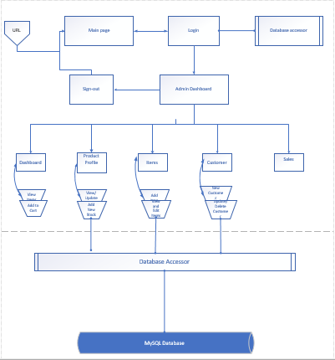

**Figure 3 3Application Architecture diagram**

### Use Case

A Use Case diagram depicts the interaction between the users and the system. It shows the functions of the system from the user’s point of view and the various actions the user as the actor carries out.

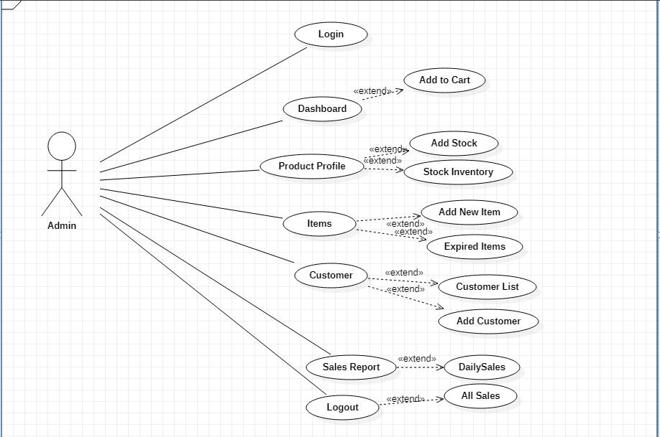

**Figure 3 4Use Case diagram**

### Sequence Diagram

A sequence diagram is a model that shows the process of a task or action from a use case.

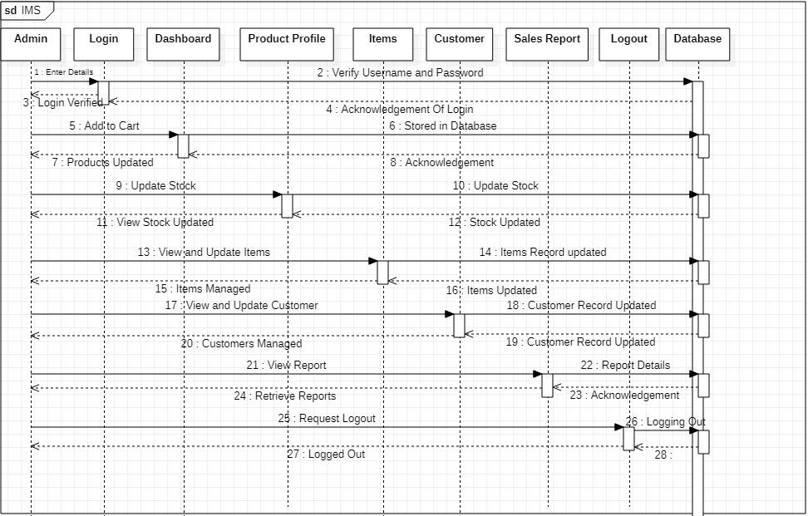

**Figure 3 5Sequence Diagram**

### Dataflow Diagram

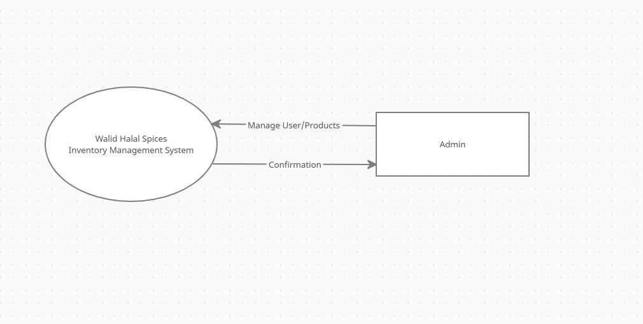

**Figure 3 6Dataflow Diagram Level Zero**

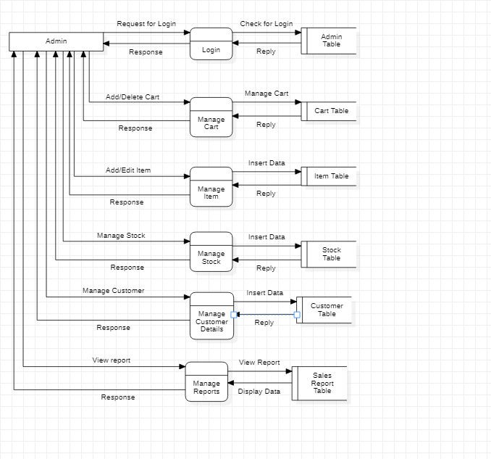

**Figure 3 7Dataflow Diagram Level one**

### 3.8.6 Entity-Relationship Diagram (ERD)

[Entity-relationship diagrams show the entities and attributes of tables in a database. Linked ERDs show the relationship between tables or tables. Entities can only have a many-to-one or one-to-many relationship.

**Entity Relationship Diagram**

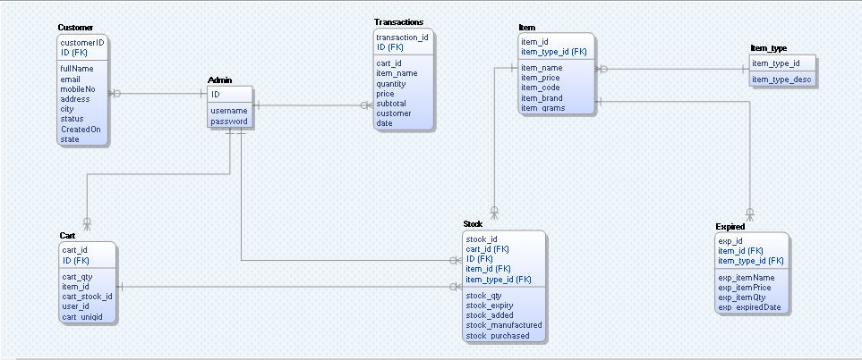

**Figure 3 8Entity Relationship Diagram**

### Summary

This chapter contains the system design, the diagrammatic representation of the analyst tools. It is based on the requirement analysis and design that will be adopted over the course of the development of this project. It also has the proposed development methodology that will be used in carrying out this project, approach to chosen methodology/methods; it also consists of the tool and techniques that will be used. It talks about the ethical consideration and the list of requirement analysis, functional and non-functional requirements system design and other analyst tools such as Entity Relationship Diagram use case, sequence diagram, application architecture and data flow diagram and finally section 3.9 will be the summary of the chapter.

# CHAPTER 4: IMPLEMENTATION AND TESTING

### Overview

This section portrays how the project was actualized and implemented (Walid Halal Spices). It shows the fundamental highlights of the system, their execution and purposes. Additionally, it shows the means needed to utilize or work around the system, and comprehend the framework cycle completely. It likewise discusses the project testing utilizing diverse test scenarios and the outcomes (anticipate result and brought result back). It additionally presents the GUI that was executed to make the interface more agreeable and easy to use when clients are utilizing the application.

### Main Features

When you start the application, the user makes use of the application through the following interfaces to carry out their activities.

#### USER INTERFACE

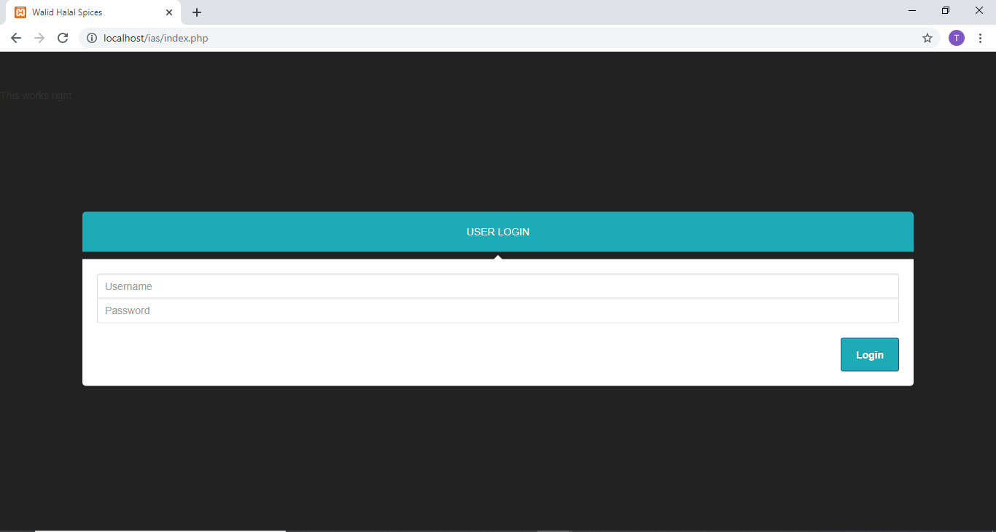

**Figure 4 1Login Page**

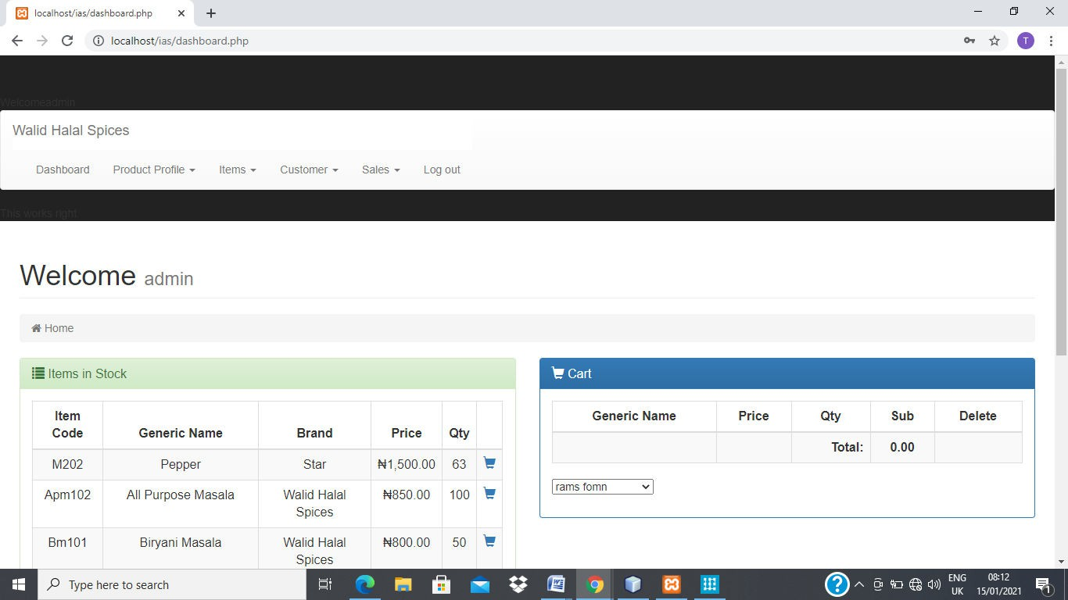

**Figure 4 2Dashboard**

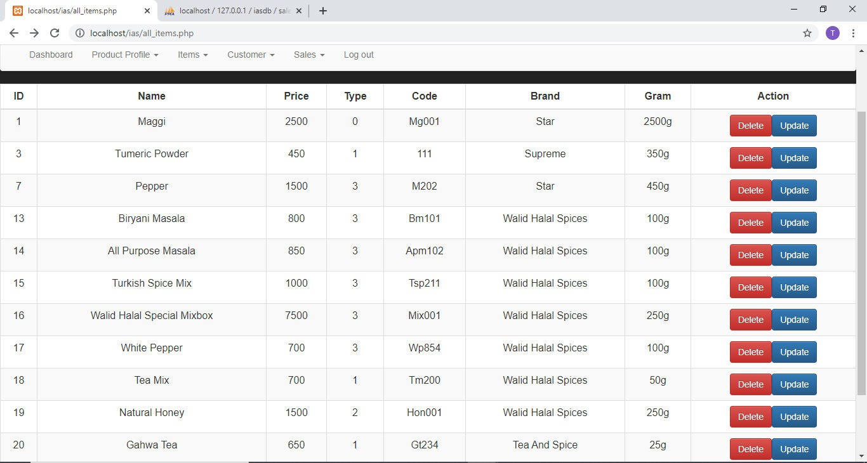

**Figure 4 3Product Profile**

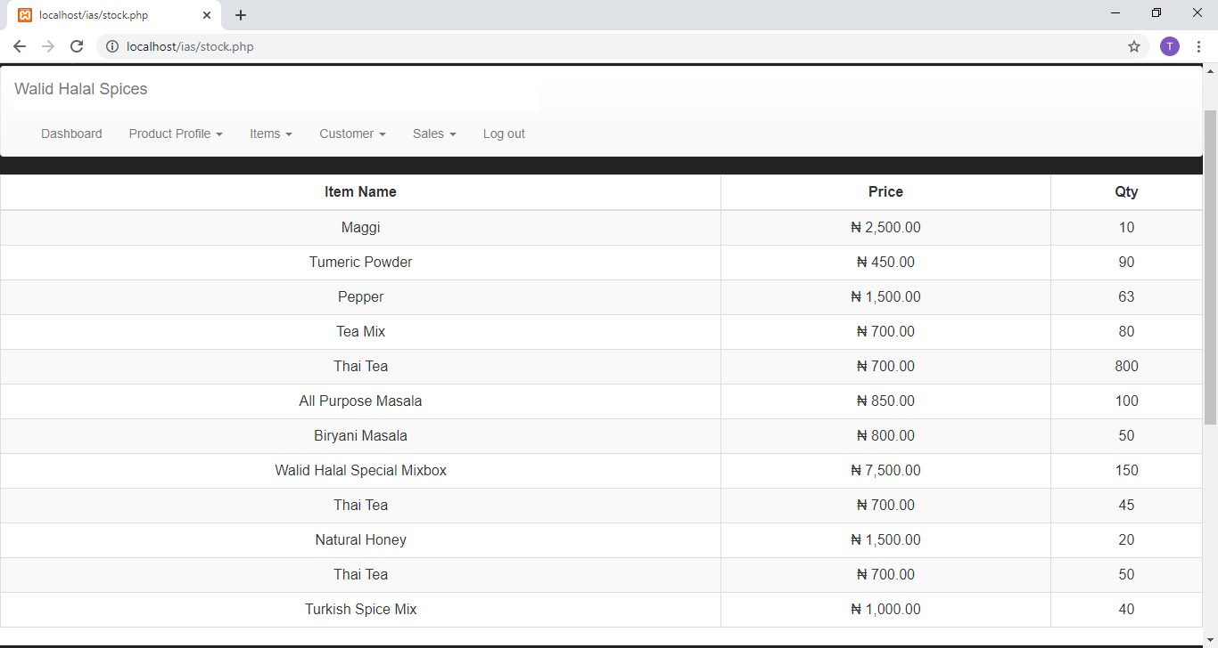

**Figure 4 4Stock Inventory**

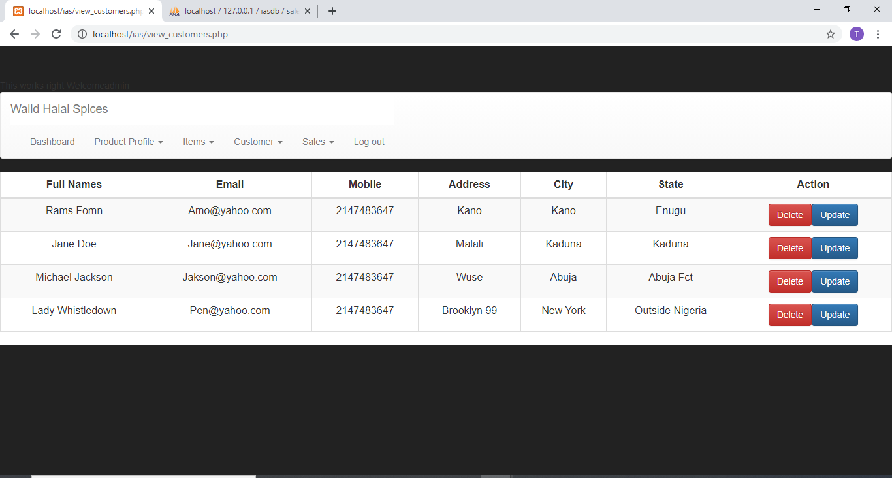

**Figure 4 5Customer Profile**

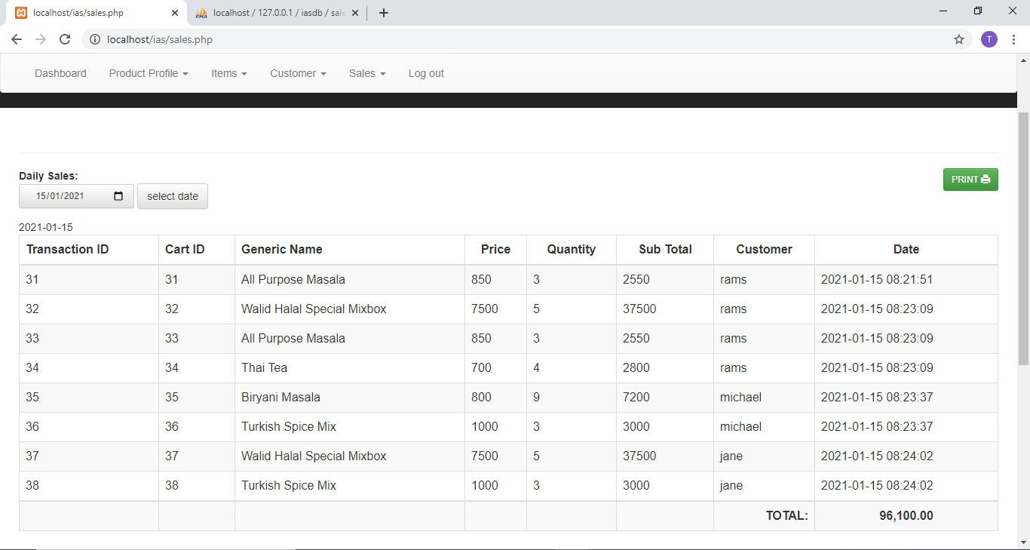

**Figure 4 6Daily Sales**

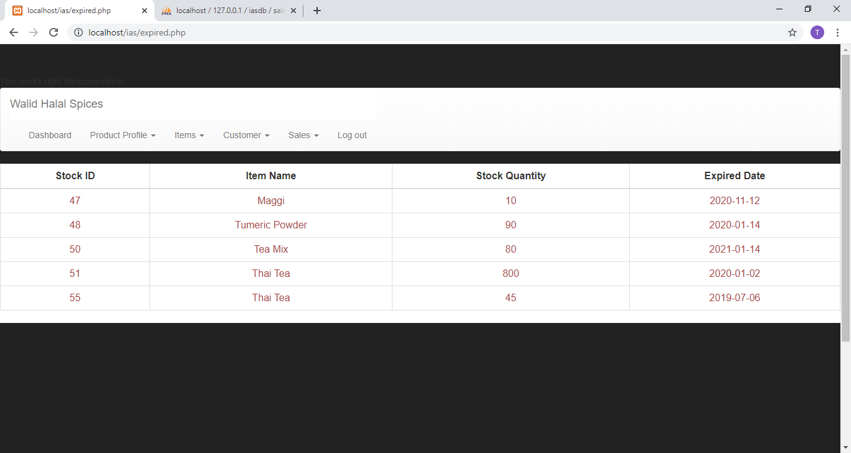

**Figure 4 7Expired Item**

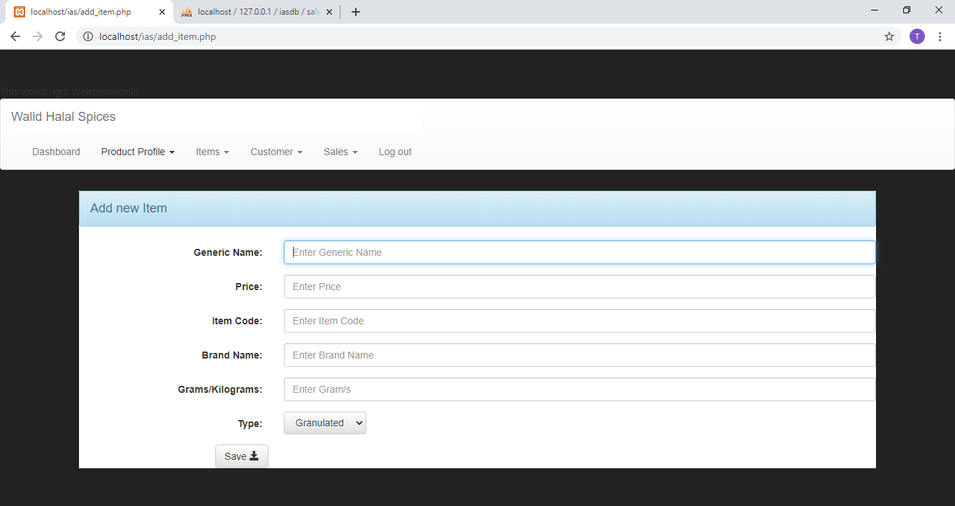

**Figure 4 8Add Item**

### Implementation Problems

The major problems encountered was mainly time and due to this pandemic, being able to get assistance was a little issue alongside getting materials. During the project development and execution, the person responsible (I) is required to also have to focus on other courses which include assignments, tests and examinations. Furthermore, several functionality with the intention of might not have been met, however it can be implemented afterwards in later versions.

### Overcoming Implementation Problems

Managing time to be able to utilize all the accessible assets to guarantee the system has been a success with all the necessary tasks that was applied. Additionally, at every phase there were tests and debugging to ensure everything is running smoothly.

### Testing

In this testing approach, data to run tests were obtained from the determinations of the system and afterward used to test every conceivable section or entries as input. Where subsequently the real outcome was then contrasted with the normal outcome after each test trial was carried out.

On the off chance that the two outcomes relate at a point, the testing can be supposed to be a success. Which means the developer that led the testing was more worried about the genuine outcome delivered by the program than with the web build of the program. This online framework is huge and very much controlled that is the reason testing framework technique was picked as the testing method to streamline the testing cycle and make all around reported outcomes. The system has many website pages and each page has numerous connections and verifications that make the system successful and productive consequently the utilization of System Testing was basic. Different kinds of testing where likewise completed such Unit Testing and Combination Testing and so on

### Tests Plans (for Unit Testing, Integration Testing, and System Testing)

* + - * During execution, bugs and errors of various calls happened. A portion of these bugs were trivial while some made the movement of the application a little slow. Testing was performed while execution was in advancement.
      * Unit testing was performed for example after each combination of a component of line of code,

the system was developed to check for blunder errors and made to check for exemptions.

* + - * Combination Testing was likewise performed for example the whole application was continually checked after a colossal coordination (for example expansion of update part of the application).
      * System testing to test the framework completely.

**Table 4.1: Test Plan**

|  |  |
| --- | --- |
| S/N | Admin |
| 1 | Admin can add stock |
| 2 | Admin can view customer data |
| 3 | Admin can perform CRUD functions on all products |
| 4 | Admin can view available stock |
| 5 | Admin can view and see items that are currently in stock |

### Test Suite (for Unit Testing, Integration Testing, and System Testing)

**Table 4.2Test Suite Performed**

|  |  |  |
| --- | --- | --- |
| **Req.**  **No.** | **Description** | **Type** |
| R-101 | When launched, the application shall stay running unless there is an intentional shutdown of the  application or the platform. | Performance |
| R-102 |  |  |
|  |  |  |
|  |  |  |
|  |  |  |

### Test Traceability Matrix (for Unit Testing, Integration Testing, and System Testing)

**Table 4.3: Test Traceability Matrix**

|  |  |
| --- | --- |
| CASE | 1 |
| OBJECTIVES | Test Validation on Login Page |
| TEST DATA | Try to login without Access |
| EXPECTED RESULT | Unrestricted Access |
| ACTUAL RESULT | Unrestricted Access |
| CONCLUSION | Successful |

|  |  |
| --- | --- |
| CASE | 2 |
| OBJECTIVES | Admin Login |
| TEST DATA | Approve |
| EXPECTED RESULT | Dashboard |

|  |  |
| --- | --- |
| ACTUAL RESULT | As below |
| CONCLUSION | Successful |

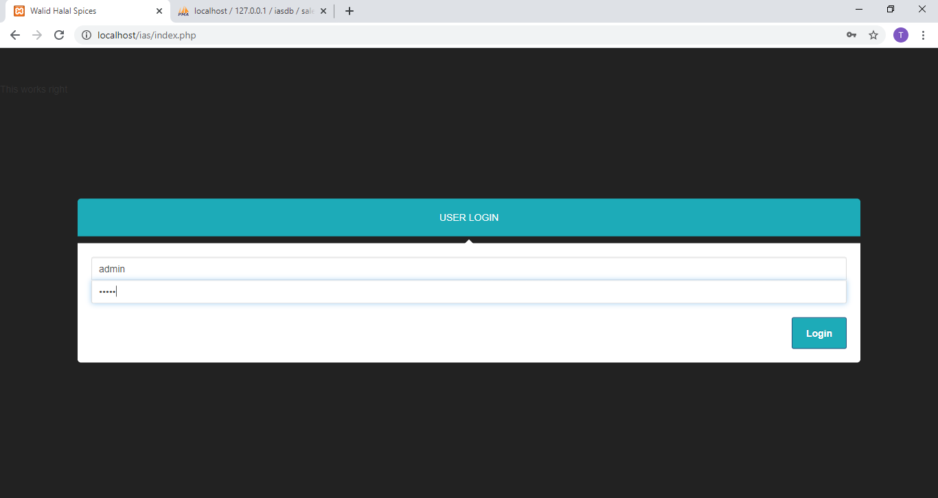

**Figure 4 9Admin Login**

|  |  |
| --- | --- |
| CASE | 3 |
| OBJECTIVES | Add Item |
| TEST DATA | Add Item in Item list |
| EXPECTED RESULT | As below |
| ACTUAL RESULT | Success |
| CONCLUSION |  |

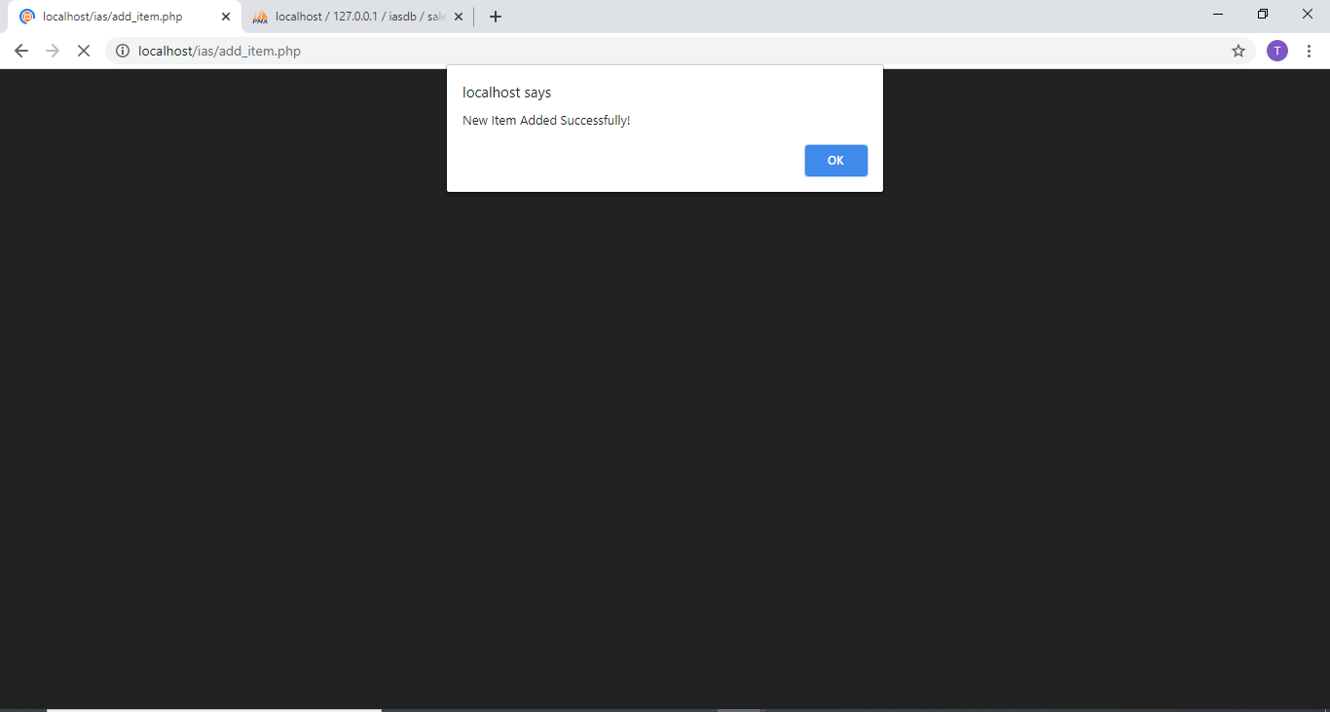

**Figure 4 10New Item Added**

|  |  |
| --- | --- |
| CASE | 4 |
| OBJECTIVES | Add to Cart |
| TEST DATA | Adding Item to Cart |
| EXPECTED RESULT | As below |
| ACTUAL RESULT | Success |

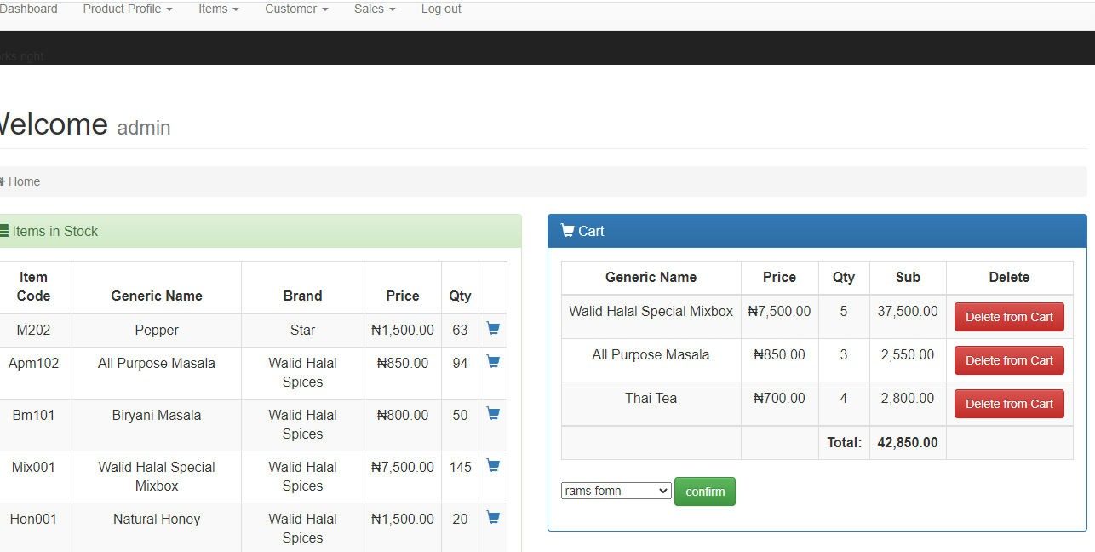**Figure 4 11Item Added to Cart**

|  |  |
| --- | --- |
| CASE | 5 |
| OBJECTIVES | Show only items available in Stock |
| TEST DATA | Stock Inventory |
| EXPECTED RESULT | Item List |
| ACTUAL RESULT | As below |
| CONCLUSION | Success |

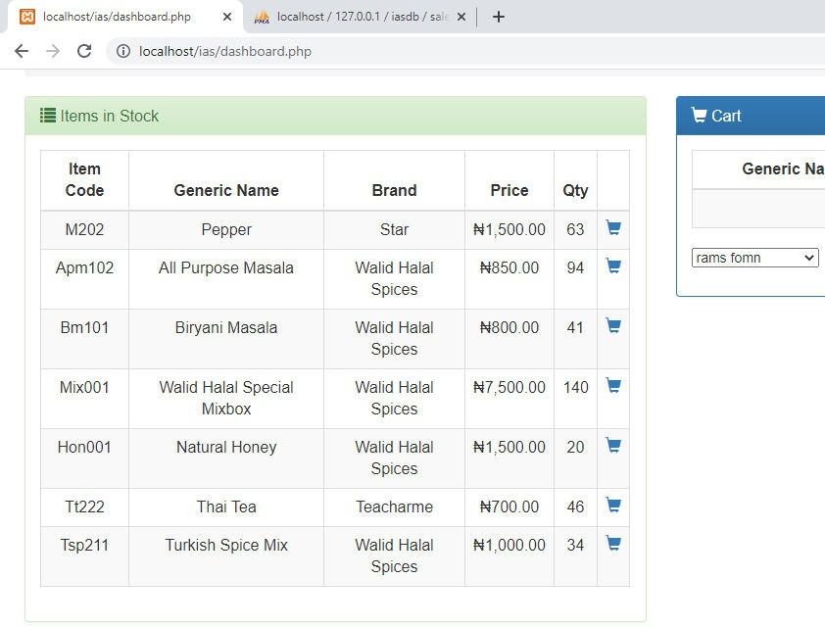

**Figure 4 12Items in Stock**

|  |  |
| --- | --- |
| CASE | 6 |
| OBJECTIVES | Add Stock |
| TEST DATA | Adding Stock |
| EXPECTED RESULT | Success Message |
| ACTUAL RESULT | As below |
| CONCLUSION | Success |

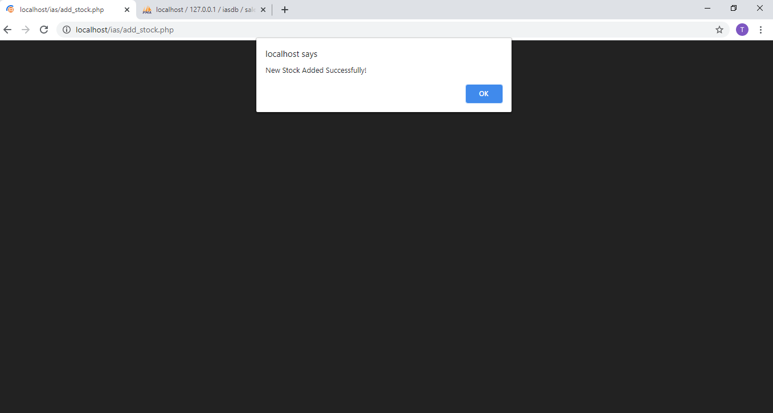

**Figure 4 13New Stock Added**

|  |  |
| --- | --- |
| CASE | 7 |
| OBJECTIVES | Add Customer |
| TEST DATA | Adding customer |
| EXPECTED RESULT | Success message |
| ACTUAL RESULT | As below |
| CONCLUSION | Success |

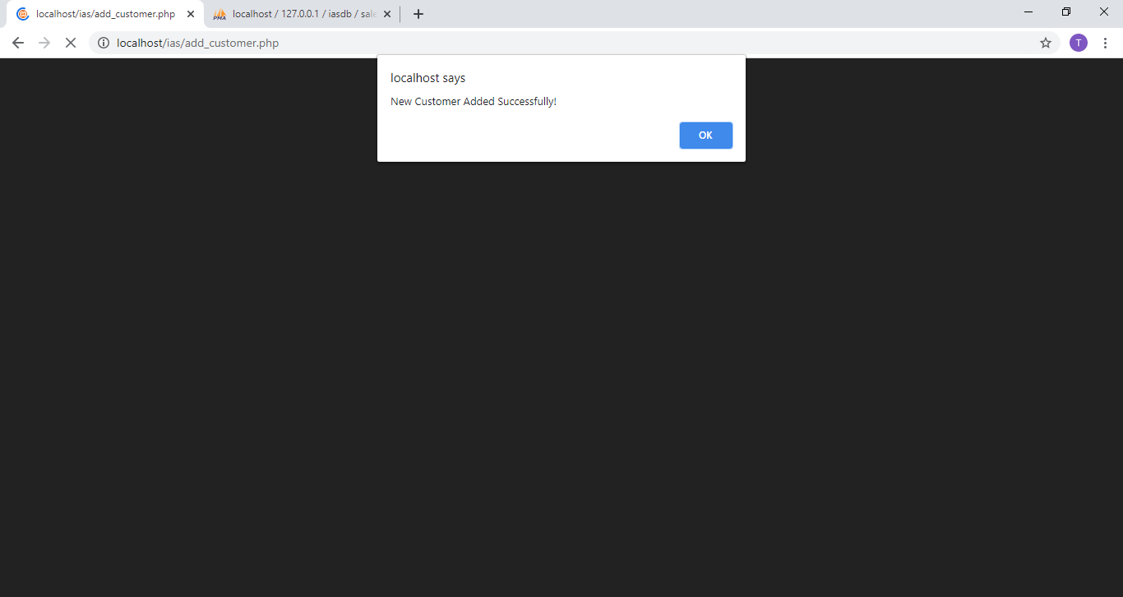

**Figure 4 14New Customer Added**

|  |  |
| --- | --- |
| CASE | 8 |
| OBJECTIVES | Logout |
| TEST DATA | Logout |
| EXPECTED RESULT | Successful Logout |
| ACTUAL RESULT |  |
| CONCLUSION | Success |

|  |  |
| --- | --- |
| CASE | 9 |
| OBJECTIVES | Delete Customer |
| TEST DATA | Deleting Customer |
| EXPECTED RESULT | Deleted from Table |
| ACTUAL RESULT | Deleted |
| CONCLUSION | Success |

|  |  |
| --- | --- |
| CASE | 10 |

|  |  |
| --- | --- |
| OBJECTIVES | Delete Item |
| TEST DATA | Deleting Item |
| EXPECTED RESULT | Delete from Table |
| ACTUAL RESULT | Deleted |
| CONCLUSION | Success |

### Test Report Summary (for Unit Testing, Integration Testing, and System Testing)

##### Table 4. 4 Test Summary Report

|  |  |  |
| --- | --- | --- |
| No | Test Performed | Action |
| 1 | Test Validation on Login Page | Pass |
| 2 | Admin Login | Pass |
| 3 | Add Item | Pass |
| 4 | Add to Cart | Pass |
| 5 | Show only items available in Stock | Pass |
| 6 | Add Stock | Pass |
| 7 | Add Customer | Pass |
| 8 | Delete Customer | Pass |
| 9 | Delete Item | Pass |
| 10 | Logout | Pass |

### Error Reports and Corrections

No error report was detected in the testing stage. All the tests were successful.

### Use Guide

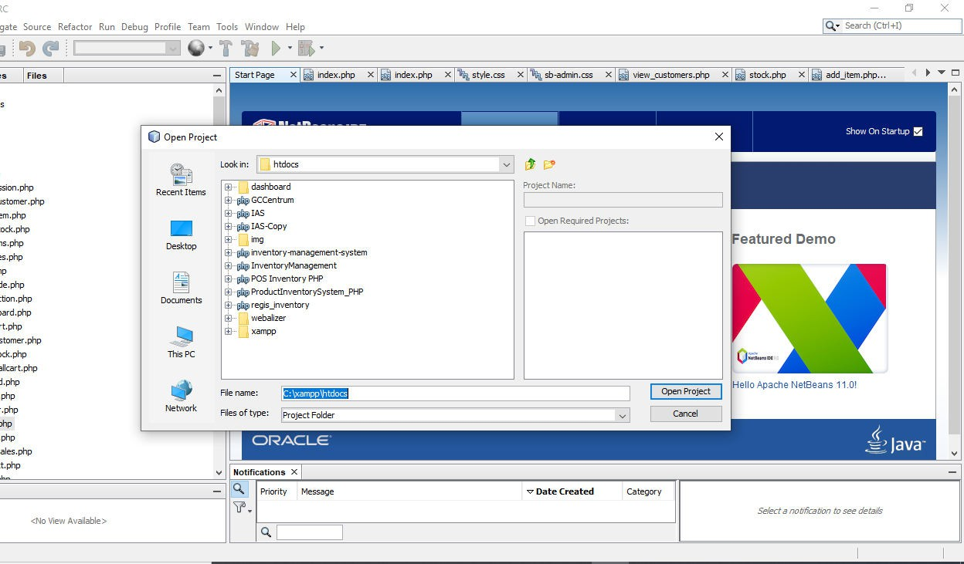

**Figure 4 15Netbeans IDE**



**Figure 4 16Open IAS using App**

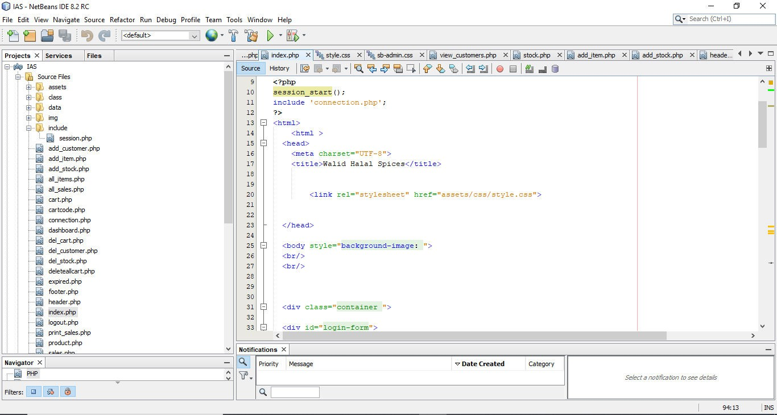

**Figure 4 17: Run the code using browser**

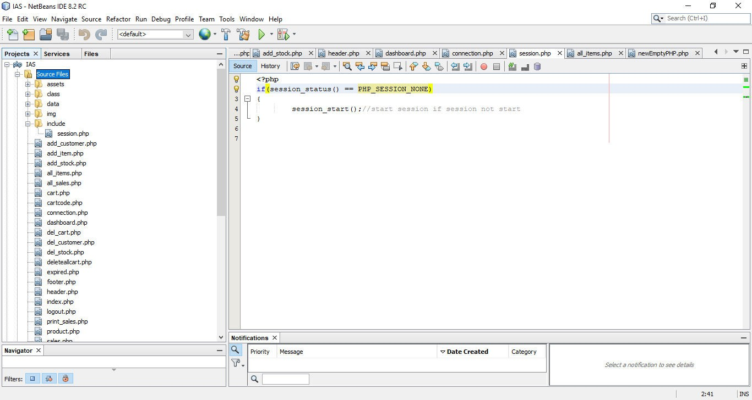

**Figure 4 18Server Directory (Database**

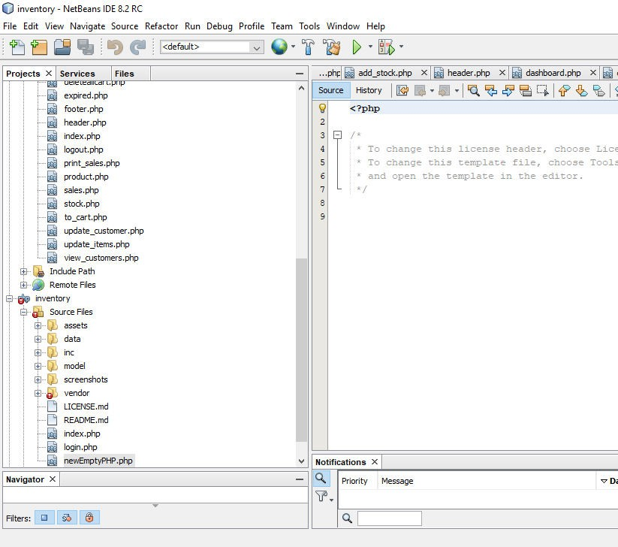

**Figure 4 19Navigate Pages**

### Summary

In this chapter, it shows all the execution and tests conducted in the project. It was successfully accomplished and some problems were encountered along the testing stage but managed to overcome it by debugging and fixing the errors. The functionalities and mechanism are running as expected.

# CHAPTER 5: DISCUSSION, CONCLUSION, AND RECOMMENDATIONS

### Overview

In this chapter, the accomplishments and the goals of the project are defined. The restrictions and difficulties looked throughout the period in this project, proposals and future upgrades that will be actualized in due course.

### Objective Assessment

Great business and relationship building abilities while meeting necessities is acquired along the line, also the ability on how programming advancement is in actuality.

Knowledge gained with the capacity to comprehend and execute tasks to customary also to create a project to this kind of complexity

Also having the capacity to create and see how web applications function, the project had undergone testing in which about 85% doing well.

### Limitations and Challenges

Security Issues: Making the application secure, for example, safe installment long secret key and so on were completely executed to make the application secure.

Finance: Facilitating the application and enlisting an area name and going to meet with various auto merchants all cost additional cash.

Execution: In this time, speed is everything. Also, I tried to make the codes easily executable to consolidate in the project to make it significantly quicker.

### Future Enhancements

A Search bar modal will be integrated to assist in the search for more items, customers and transactions to make it easier.

The system will predict the type of items a user usually purchases using recent transactions. Barcode and tagging will be implemented so as to search for items and add items easier for the user.

As the company market increases, more staff will be employed, so the need of role assignment will be needed where every role registered has its own purpose.

### Recommendations

The application will sooner or later require the utilization of MasterCard to permit transactions, meaning SSL ought to be utilized to permit free from any and all harm exchanges and information move. Also the use of bar code and tagging would be essential in making it easier to keep track of items. At long last, all actual exchanges ought to be done out in the open spots to keep away from any type of illegal movement.

### Summary

Walid Halal Spices is a web application that allows the business to store data of items, stock and transactions making it efficient. The application also makes keeping records and calculating sales easily without errors and mistakes. There could be room for enhancements but the essential necessities needed in this project have been delivered. Also supplementary necessary functionalities will be integrated. With more points in time and funds qualities such and the search bar would be enhanced, types of payment method.

# REFERENCES

According to chase Jacobs and Aquilano 2004 inventory is the stock of any item. (2018, February 21).

Course Hero

Averion, Gaela, and Libo (2009) Monitoring and Inventory for discovery Mall.com

Bradley,A (2013)ThoughtCAvailable:<http://php.about.com/od/phpbasics/qt/what_is_php_used_for.htm>

(Accessed 31 December 2020)

Chase R B, Jacobs F R and Aquilano N J. (2004), *Operations Management for Competitive Advantage.*

*10th Edition. International Edition*. MC GRAW HILL. NY.

[Margaret Rouse](https://www.techtarget.com/contributor/Margaret-Rouse) Waterfall software development February 2019 <https://searchsoftwarequality.techtarget.com/definition/waterfall-model>

[Margaret Rouse](https://www.techtarget.com/contributor/Margaret-Rouse) Agile Software Development November 2019 https://searchsoftwarequality.techtarget.com/definition/agile-software-development

PYCRAFT et al. 2000*. Operations management. Southern Africa edition. Pearson education. South Africa.*

Stock R. & Lambert M. (2001*), Strategic Logistics Management, pp. 232-235, Marketing / Advertising*

*Series, Mc Graw Hill, International Edition, New York.*

## APPENDICES

**Appendix A – Source Code**

##### Admin (Login Form)

<!DOCTYPE html>

<!--

To change this license header, choose License Headers in Project Properties.

To change this template file, choose Tools | Templates and open the template in the editor.

-->

<?php session_start();

include 'connection.php';

?>

<html>

<html >

<head>

<meta charset="UTF-8">

<title>Walid Halal Spices</title>

<link rel="stylesheet" href="assets/css/style.css">

</head>

<body style="background-image: ">

<br/>

<br/>

<div class="container ">

<div id="login-form">

<!-- Bootstrap Core CSS -->

<link href="assets/css/bootstrap.min.css" rel="stylesheet">

<link rel="stylesheet" type="text/css" href="assets/css/bootstrap-theme.min.css">

<!-- Custom CSS -->

<link href="assets/css/sb-admin.css" rel="stylesheet">

<!-- Morris Charts CSS -->

<link href="assets/css/plugins/morris.css" rel="stylesheet">

<!-- Custom Fonts -->

<link href="assets/font-awesome/css/font-awesome.min.css" rel="stylesheet" type="text/css">

<link href="assets/css/dataTables.bootstrap.min.css" rel="stylesheet">

<body>

<div class="container">

<h3>User Login</h3>

<fieldset>

<form method="POST">

<input class="form-control" type="text" autofocus id="un" name="un" placeholder="Username" required autocomplete="off">

<input type="password" class="form-control" id="up" name ="pw" placeholder="Password" required autocomplete="off">

<input class="btnbtn-primary form-controlss" type="submit" name="log" value="Login">

</form>

</fieldset>

</div><!-- end login-form -->

<?php

// put your code here if(isset($_POST['log'])){

$un= $_POST['un'];

$pw =$_POST['pw'];

echo $un; echo $pw;

$sqlq= "select * from user Where username = '$un' AND password = '$pw'";

$result = mysqli_query($con, $sqlq);

$num =mysqli_num_rows($result); echo $num;

if($num >0){

$_SESSION['$un']=$un; header("Location:dashboard.php");

}

else{

echo mysqli_error($con)." "." There was and error ";

?>

<script>

alert("Password or username is incorrect please verify ");</script>

<?php

}

}

?>

</body>

</html>

<script type="text/javascript" src="assets/js/jquery-3.1.1.min.js"></script>

<script type="text/javascript" src="assets/js/jquery-1.12.3.js"></script>

<script type="text/javascript" src="assets/js/bootstrap.min.js"></script>

<script type="text/javascript" src="assets/js/jquery.dataTables.min.js"></script>

<script type="text/javascript" src="assets/js/dataTables.bootstrap.min.js"></script>

##### Dashboard (Home)

<?php

include 'header.php';

$un =$_SESSION['$un']; include 'connection.php';

?>

<!DOCTYPE html>

<div id="page-wrapper">

<div class="container-fluid">

<!-- Page Heading -->

<div class="row">

<div class="col-lg-12">

<h1 class="page-header">

Welcome <small><?php echo $_SESSION['$un']; ?></small>

</h1>

<ol class="breadcrumb">

<li class="active">

<i class="fa fa-home"></i> Home

</li>

</ol>

</div>

</div>

<!-- /.row -->

<div id="order"></div>

<?php

// echo '<pre>';

// print_r($cartDatas);

// echo '</pre>';

?>

<div class="row">

<div class="col-md-6">

<div class="panel panel-success">

<div class="panel-heading">

<h3 class="panel-title">

<span class="glyphiconglyphicon-list" aria-hidden="true"></span> Items in Stock</h3>

</div>

<div class="panel-body">

<!-- start item -->

<div class="table-responsive">

<table id="myTable-item-order" class="table table-bordered table-hover table-striped">

<thead>

<tr>

<th><center>Item Code</center></th>

<th><center>Generic Name</center></th>

<th><center>Brand</center></th>

<th><center>Price</center></th>

<th><center>Qty</center></th>

<th><center></center></th>

</tr>

</thead>

<tbody>

<?php

$sql = "SELECT *

FROM stock s INNER JOIN item i

ON s.item_id = i.item_id

WHERE .s.stock_qty> 0 AND `stock_expiry` >

CURRENT_DATE";

$result = mysqli_query($con, $sql); while($s = mysqli_fetch_assoc($result)){ ?>

<tr align="center">

<td><?= ucwords($s['item_code']); ?></td>

<td><?= ucwords($s['item_name']); ?></td>

<td><?= ucwords($s['item_brand']); ?></td>

<td><?= "₦".number_format($s['item_price'], 2); ?></td>

<td><?= $s['stock_qty']; ?></td>

<td>

<a href="to_cart.php?id=<?php echo $s['stock_id']; ?>" class="glyphiconglyphicon-shopping- cart" value="Add to Cart"/>

</td>

</tr>

<?php }; ?>

</tbody>

</table>

</div>

<script type="text/javascript">

$(document).ready(function() {

$('#myTable-item-order').DataTable();

});

</script>

<!-- end item -->

</div>

</div>

</div>

<div class="col-md-6">

<div class="panel panel-primary">

<div class="panel-heading">

<h3 class="panel-title">

<span class="glyphiconglyphicon-shopping-cart" aria-hidden="true"></span> Cart

</h3>

</div>

<div class="panel-body">

<?php include 'cartcode.php'; ?>

</div>

</div>

</div>

</div>

<br /><br /><br /><br /><br /><br /><br /><br />

</div>

<!-- /.container-fluid -->

</div>

<!-- /#page-wrapper -->

</div>

<!-- /#wrapper -->

</body>

</html>

<?php include 'footer.php'; ?>

##### Cart Code (Add to Cart)

<!-- cart -->

<div class="table-responsive">

<table id="myTable-cart" class="table table-bordered table-hover table-striped">

<thead>

<tr>

<th><center>Generic Name</center></th>

<th><center>Price</center></th>

<th><center>Qty</center></th>

<th><center>Sub</center></th>

<th><center>Delete</center></th>

</tr>

</thead>

<tbody>

<?php

$total = 0;

$sql = "SELECT *

FROM cart c INNER JOIN item i

ON c.item_id = i.item_id ORDER BY cart_id ASC";

$res = mysqli_query($con, $sql); while($c = mysqli_fetch_assoc($res)){

$item_name = $c['item_name'];

$cart_id = $c['cart_id'];

$price = $c['item_price'];

$qty = $c['cart_qty'];

$subTotal = $price * $qty;

$total += $subTotal;

if(isset($_POST['btn_submit'])){

$custName = $_POST['custName'];

$mysqlinsert="insert into transactions (cart_id,item_name,price,quantity,subtotal,customer) Values($cart_id,'$item_name',$price,$qty,$subTotal,'$custName'); ";

$result= mysqli_query($con, $mysqlinsert); if($result =! null){

echo 'added transaction successfully';

?>

<script>

window.location.href="deleteallcart.php";

</script>

<?php } else{

echo mysqli_error($con);

}

}//end ?>

<tr align="center">

<td><?php echo $item_name ?></td>

<td><?= "₦".number_format($c['item_price'], 2); ?></td>

<td><?= $c['cart_qty']; ?></td>

<td><?= number_format($subTotal,2); ?></td>

<td>

<a href="del_cart.php?id=<?php echo $cart_id; ?>" class=" btnbtn-danger " value="Delete from Cart"> Delete from Cart

</td>

</tr>

<?php ;} ?>

</tbody>

<tr>

<td></td>

<td></td>

<td align="right"><strong>Total:</strong></td>

<td align="center">

<strong><?= number_format($total, 2); ?></strong>

</td>

<td>

</td>

</tr>

</table>

</div>

<script type="text/javascript">

$(document).ready(function() {

$('#myTable-cart').DataTable();

});

</script>

<form method="POST">

<select name="custName">

<?php

$sql = "SELECT *

FROM customer";

$result = mysqli_query($con, $sql); while($a = mysqli_fetch_assoc($result)){

?>

<option value=<?php echo $a['fullName']; ?>><?php echo $a['fullName'];}?></option>

</select>

<?php if($total > 0): ?>

<input name='btn_submit' type="submit" value="confirm" class="btnbtn-success" />

<?php endif; ?>

</form>

<!-- cart -->

Expired Items

<?php

include 'connection.php';

include 'header.php';

?>

<div class="table-responsive" style="background-color:white;" >

<table class="table table-bordered table-hover" >

<thead>

<tr>

<th><center>Stock ID</center></th>

<th><center>Item Name</center></th>

<th><center>Stock Quantity</center></th>

<th><center>Expired Date</center></th>

</tr>

</thead>

<tbody>

<?php

$sql = "SELECT * FROM stock s INNER JOIN item i on s.item_id = i.item_id WHERE `stock_expiry` < CURRENT_DATE";

$result = mysqli_query($con, $sql); while($ex = mysqli_fetch_assoc($result)){ ?>

<tr align="center" class="text-danger">

<td><?= ucwords($ex['stock_id']); ?></td>

<td><?= ucwords($ex['item_name']); ?></td>

<td><?= $ex['stock_qty']; ?></td>

<td><?= $ex['stock_expiry']; ?></td>

</tr>

<?php }; ?>

</tbody>

</table>

</div>

<br /><br /><br /><br /><br /><br /><br /><br /><br /><br /><br />

<br /><br /><br /><br /><br /><br /><br /><br /><br /><br /><br />

<!-- for the datatable of employee -->

<script type="text/javascript">

$(document).ready(function() {

$('#myTable-expired').DataTable();

});

</script>

<?php include 'footer.php'; ?>

##### Customer (Add Customer)

=<?php

include 'connection.php';

include 'header.php';

/*

* To change this license header, choose License Headers in Project Properties.
* To change this template file, choose Tools | Templates
* and open the template in the editor.

*/ if(isset($_POST['btn_submit']) ){

$fullname = $_POST['full_name'];

$email = $_POST['email'];

$mobile = $_POST['mobile'];

$address = $_POST['address'];

$city = $_POST['city'];

$state = $_POST['state'];

$fullname = strtolower($fullname);

$email = strtolower($email);

$mobile = ucwords(strtolower($mobile));

$address = ucwords(strtolower($address));

$city = ucwords(strtolower($city));

$state = ucwords(strtolower($state));

$sql = "INSERT INTO customer(fullName, email, mobileNo, address, city, state) VALUES('$fullname','$email','$mobile', '$address',

'$city','$state')";

$result1= mysqli_query($con, $sql);

if($result1!= null){

$return['valid'] = true;

$return['msg'] = "New Customer Added Successfully!";}}

?>

<script>

alert("New Customer Added Successfully!");

</script>

?>

<div class="container"><div style="background-color:white;" >

<div class="">

<div class="">

<div class="">

<h4 class=" alert alert-info">Add new Customer</h4>

</div>

<div class="">

FullName:</label>

<form class="form-horizontal" role="form" method="POST">

<input type="hidden" id="item-id">

<div class="form-group">

<label class="control-label col-sm-3" for="">Customer

<div class="col-sm-9">

<input name="full_name" type="text" maxlength="50"

class="form-control" id="customer-name" placeholder="Enter Customer Name" required="" autofocus="">

</div>

</div>

<div class="form-group">

<label class="control-label col-sm-3" for="">E-Mail:</label>

<div class="col-sm-9">

<input type="email" name="email" min="0.1" step="any" class="form-control" id="email" placeholder="Enter Email" required="">

</div>

</div>

<div class="form-group">

<label class="control-label col-sm-3" for="">Mobile:</label>

<div class="col-sm-9">

<input type="tel" name="mobile" maxlength="50" class="form- control" id="mobile" placeholder="Enter Mobile No" required="" autofocus="">

</div>

</div>

<div class="form-group">

<label class="control-label col-sm-3" for="">Address:</label>

<div class="col-sm-9">

<input type="text" name="address" maxlength="50" class="form-control" id="address" placeholder="Enter Address" required="" autofocus="">

</div>

</div>

<div class="form-group">

<label class="control-label col-sm-3" for="">City:</label>

<div class="col-sm-9">

<input type="text" name="city" maxlength="50" class="form- control" id="city" placeholder="Enter City" required="" autofocus="">

</div>

</div>

<div class="form-group">

<label class="control-label col-sm-3" for="">State:</label>

<div class="col-sm-9">

<select name="state" id="select">

<option>Outside Nigeria</option>

<option>ABUJA FCT</option>

<option>ABIA</option>

<option>ADAMAWA</option>

<option>AKWA IBOM</option>

<option>ANAMBRA</option>

<option>BAUCHI</option>

<option>BAYELSA</option>

<option>BENUE</option>

<option>BORNO</option>

<option>CROSS RIVER</option>

<option>DELTA</option>

<option>EBONYI</option>

<option>EDO</option>

<option>EKITI</option>

<option>ENUGU</option>

<option>GOMBE</option>

<option>IMO</option>

<option>JIGAWA</option>

<option>KADUNA</option>

<option>KANO</option>

<option>KATSINA</option>

<option>KEBBI</option>

<option>KOGI</option>

<option>KWARA</option>

<option>LAGOS</option>

<option>NASSARAWA</option>

<option>NIGER</option>

<option>OGUN</option>

<option>ONDO</option>

<option>OSUN</option>

<option>OYO</option>

<option>PLATEAU</option>

<option>RIVERS</option>

<option>SOKOTO</option>

<option>TARABA</option>

<option>YOBE</option>

<option>ZAMFARA</option>

</select>

</div>

</div>

<div class="form-group">

<div class="col-sm-offset-2 col-sm-10">

<button type="submit" id="submit-item" name="btn_submit" value="add" class="btnbtn-default">Save

<span class="glyphiconglyphicon-save" aria-

hidden="true"></span>

</button>

</div>

</div>

</form>

</div>

</div>

</div>

</div>

Connction (Server)

<?php

$localhost="localhost";

$user="root";

$password ="";

$db="iasdb";

$con = mysqli_connect($localhost, $user, $password, $db); if ($con!= NULL){

echo " This works right ";

}

else{ echo mysqli_error($con);

}

Sales (All Sales)

<?php require_once('connection.php'); include 'header.php';?>

<html lang="en">

<div id="page-wrapper">

<div class="container-fluid">

<!-- Page Heading -->

<div class="row">

<div class="col-lg-12">

<h1 class="page-header">

</h1>

</div>

</div>

<!-- /.row -->

<div id="printBut" class="pull-right">

<button type="button" class="btnbtn-success btn-sm"> PRINT

<span class="glyphiconglyphicon-print" aria-hidden="true"></span>

</button>

</div>

<div id="">

<?php

$sql = "SELECT *FROM transactions ";

$result= mysqli_query($con, $sql);

?>

<br />

<div class="table-responsive">

<table id="myTable-sales" class="table table-bordered table-hover table-striped">

<thead>

<tr>

<th>Transaction ID</th>

<th>Cart ID</th>

<th>Generic Name</th>

<th><center>Price</center></th>

<th><center>Quantity</center></th>

<th><center>Sub Total</center></th>

<th><center>Customer</center></th>

<th><center>Date</center></th>

</tr>

</thead>

<tbody>

<?php

<tr>

$total = 0;

while ( $ds= mysqli_fetch_assoc($result)){

$subTotal = ($ds['price'] * $ds['quantity']);

$total += $subTotal;

?>

<td><?= $ds['transaction_id']; ?></td>

<td><?= $ds['cart_id']; ?></td>

<td><?= $ds['item_name']; ?></td>

<td><?= $ds['price']; ?></td>

<td><?= $ds['quantity']; ?></td>

<td><?= $ds['subtotal']; ?></td>

<td><?= $ds['customer']; ?></td>

<td><?= $ds['date']; ?></td>

</tr>

<?php }; ?>

</tbody>

<tr>

<td></td>

<td></td>

<td></td>

<td></td>

<td></td>

<td></td>

<td align="right"><strong>TOTAL:</strong></td>

<td align="center">

<strong><?= number_format($total,2); ?></strong>

</td>

</tr>

</table>

</div>

<br /><br /><br /><br /><br /><br /><br /><br /><br /><br /><br />

<br /><br /><br /><br /><br /><br /><br /><br /><br /><br /><br />

<!-- for the datatable of employee -->

<script type="text/javascript">

$(document).ready(function() {

$('#myTable-sales').DataTable();

});

</script>

<?php

include 'footer.php';

?>