**[DESIGN AND IMPLEMENTATION OF AN INDUSTRIAL MONITORING AND CONTROL SYSTEM](https://www.researchgate.net/publication/374274831_DESIGN_AND_IMPLEMENTATION_OF_AN_INDUSTRIAL_MONITORING_AND_CONTROL_SYSTEM_USING_AN_ANDROID_MOBILE_APPLICATION?enrichId=rgreq-f03cb51751f2cc6de181eb184a9fe8d3-XXX&enrichSource=Y292ZXJQYWdlOzM3NDI3NDgzMTtBUzoxMTQzMTI4MTE5NDI0NTU3MUAxNjk1OTkwNzU2NjI2&el=1_x_3&_esc=publicationCoverPdf) [USING AN ANDROID MOBILE APPLICATION](https://www.researchgate.net/publication/374274831_DESIGN_AND_IMPLEMENTATION_OF_AN_INDUSTRIAL_MONITORING_AND_CONTROL_SYSTEM_USING_AN_ANDROID_MOBILE_APPLICATION?enrichId=rgreq-f03cb51751f2cc6de181eb184a9fe8d3-XXX&enrichSource=Y292ZXJQYWdlOzM3NDI3NDgzMTtBUzoxMTQzMTI4MTE5NDI0NTU3MUAxNjk1OTkwNzU2NjI2&el=1_x_3&_esc=publicationCoverPdf)**

**ABSTRACT**

This paper presents the design and implementation of an industrial monitoring and control system using an Android mobile application. The system aims to monitor and control critical parameters such as temperature, pressure, and water level in industrial environments. The system utilizes various sensors, microcontrollers, and a mobile application to provide real-time monitoring and remote control capabilities. The paper discusses the design methodology, and implementation details, and presents the results of testing the system. The results show the effectiveness of the system in improving efficiency, reducing manual overhead, and enhancing safety in industrial environments. Additionally, the successful implementation of the system is demonstrated, and its potential for further development.

**Keywords:** Industrial Monitoring, Control System, Android Mobile Application, Real-Time Monitoring, Remote Control.

**CHAPTER ONE**

**INTRODUCTION**

The manual monitoring and control of vital industrial parameters in industries has led to mistakes and accidents, such as boiler explosions in Thermal Power plants. Human operators using data logging systems to monitor these parameters can lead to false results and negligence, which can have major consequences. Incompetence and negligence by human operators have been frequent causes of boiler explosions. Safety is crucial, as insufficient water or excess pressure can lead to severe damage and the risk of explosion. Maintaining control of steam temperature is also important. A recent example of a boiler explosion in India resulted in numerous fatalities and injuries due to negligence by the operators. To overcome these challenges, the use of automated systems that provide real-time monitoring and remote-control functionalities has become crucial. This paper presents an industrial monitoring and control system that utilizes an Android mobile application to facilitate efficient monitoring and control of critical parameters. The system aims to enhance the safety, efficiency, and reliability of industrial operations.

**BACKGROUND**

Various technologies have been employed to collect and analyze data from different industrial parameters for industrial monitoring and control systems. These technologies include LCD displays, CAN bus communication, SCADA systems, web-based systems, GSM wireless technology, and Bluetooth technology [1, 2, 3]. Each technology has its own benefits and drawbacks. To keep track of parameters at specific locations, LCD monitors are frequently utilized. This strategy is prone to manual errors and needs constant supervision by human operators. On the other hand, CAN bus communication enables parameter monitoring and control from a single personal computer. The usage of this technology, however, is restricted to particular locations and necessitates high-end computers, raising installation costs.

SCADA systems provide comprehensive monitoring and control capabilities for multiple field sites. However, they require skilled operators and are not user-friendly. Web-based systems enable remote monitoring using a standard web browser, but they can be slower and less secure. GSM wireless technology allows for remote monitoring and control using mobile phones, but it requires network coverage and has limited range [1, 2, 3]. Bluetooth technology allows for the monitoring of industrial devices but is restricted to short distances. Previous research in this field has mainly focused on switching and controlling industrial devices, rather than remote monitoring and control of the industrial environment. There is a need for a more efficient and user-friendly system that overcomes the limitations of existing technologies.

**CHAPTER TWO**

**SYSTEM ARCHITECTURE**

The industrial monitoring and control system consists of various hardware and software components that work together to achieve its functionalities. This system utilizes an Android application for monitoring and controlling industrial parameters via a mobile phone. It offers automatic control based on fixed set points. Sensors like the DS18b20 temperature sensor, SKU2375445 pressure sensor, and HC-SR04 ultrasonic sensor are used for parameter sensing. The user can input desired set points through the Android app, which are then transmitted to the Wemos D1 R1 microcontroller via a cloud server. The microcontroller compares the parameters with the set points and adjusts them using control elements like pumps, solenoid valves, and water heaters through a four-channel relay. The relay acts as a switch, activating the control devices based on the high pin. The user can monitor the entire process through the mobile application.

The system consists of three separate parts: the sensing unit, the control unit, and the user interface devices. These parts were individually tested before being integrated into the full system. The sensing unit receives input from sensors such as the DS18b20 temperature sensor, SKU2375445 pressure sensor, and HC-SR04 ultrasonic sensor. The control unit provides the output through a four-channel relay, which controls the pump, water heater, and solenoid valve. The user interface devices, including the cloud and the mobile phone, display and represent the system data to the user. These devices also enable remote and automatic control of industrial devices via the Internet.

The ultimate goal of the system is to accurately measure, monitor, and control temperature, pressure, and water levels in an industrial setting. All hardware circuits are designed to send their output signals to the Wemos D1 R1 WiFi Uno Microcontroller for computation. The block diagram of the system architecture shown in Figure 1 provides a visual representation of the components and their interactions, ensuring a clear understanding of the system's functionalities and structure.

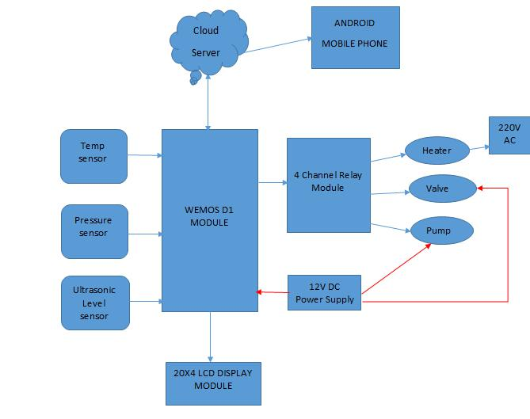

**Figure 1:** The Block Diagram of the System

The microcontroller used in the project is the ESP-12F Wemos D1 R1 WiFi UNO board, which is based on the ESP8266 chip. It runs on the ESP8266 Wi-Fi System-On-Chip (SoC) from Espressif Systems and can be programmed using the Arduino Integrated Development Environment (IDE).

For temperature measurement, a DS18B20 digital waterproof temperature sensor was used. This sensor operates in a range of 3.0V to 5.5V and can measure temperatures from -55 degrees to +125 degrees Celsius. It provides temperature readings in 750ms or less with a resolution of up to 12 bits. A simulation of temperature was done using Proteus Professional software and the setup was as shown below in Figure 2 below.

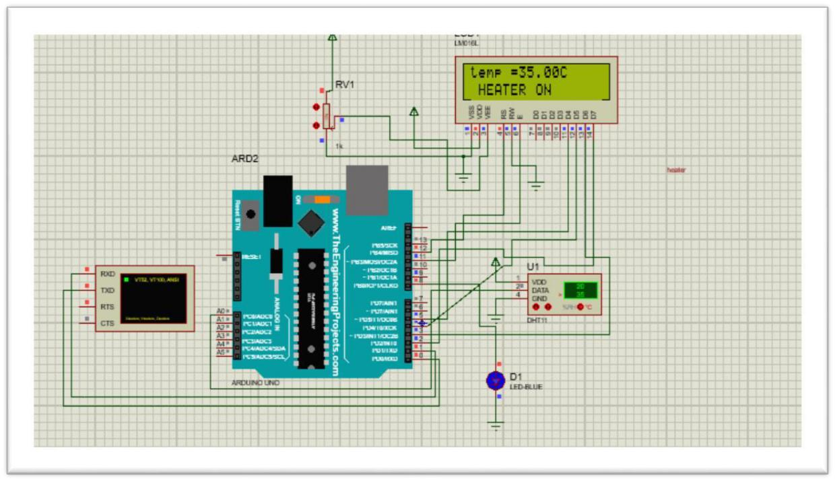

**Figure 2:** Simulation of Temperature Measurement Circuit Using Proteus Software

The water level was measured using an HC-SR04 ultrasonic sensor. This sensor can provide non-contact measurement within a range of 2cm to 400cm with an accuracy of up to 3mm. It works based on the principle of echolocation, where it sends out ultrasonic waves and measures the time it takes for the waves to bounce back. The pin connections to the Wemos D1 board are as shown in Figure 3 below.

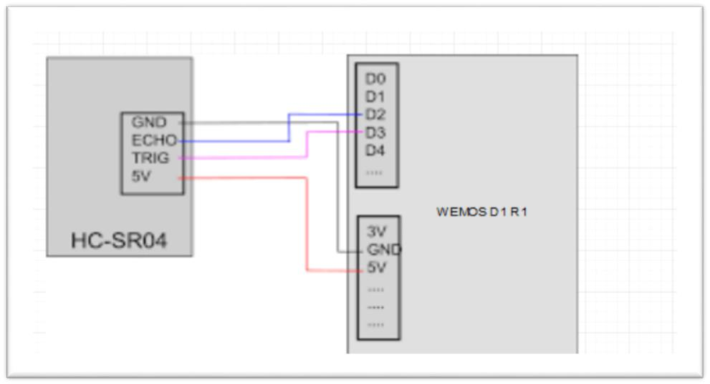

**Figure 3:** The pin connection of Ultrasonic Sensor to Micro-controller

A simulation was done using Proteus Professional software and the setup is like that shown in Figure 3. For pressure measurement, a SKU237545 pressure sensor was used. This sensor is designed for measuring fuel, gas, oil, liquid, water, and air pressure. It operates on a 5V power supply and has a pressure range of 0-1.2 MPa, with a maximum pressure of 2.4 MPa. The pin connections and circuit diagram were as shown in Figure 4 below.

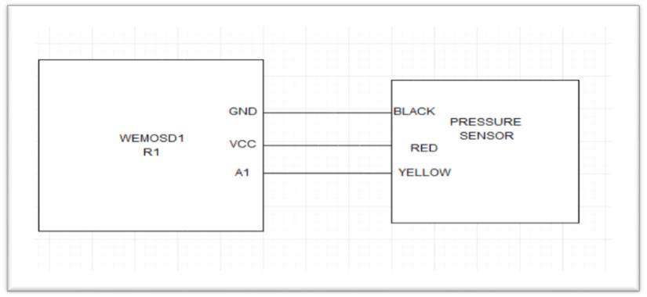

**Figure 4:** The pin connection of Pressure Sensor to Micro-controller

The control unit of the system consists of a 4-channel relay module. The system provided an output with an Actuator, in this case, a 4-channel relay for pump control, water heater control, and solenoid valve control. The relay has three terminals on the low current side- VCC, GND, and IN. The IN pin is how the Wemos board controls the relay. The relay also has three terminals on the high current side – NO, C, and NC – which stand for normally Open, Common, and Normally Closed, respectively. The module used a 5V power supply and could control up to three different devices. The devices were connected in a Normally Open state.

A 12-volt direct current water pump is used for water level control. It has an inlet and outlet port to enable water to flow in and out of the ports. It operates on a 12-volt power supply. The negative cable on the pump is red and the positive cable is black.

Inflow and outflow of liquid content within a storage tank was dependent on the operation of the sensor which triggered on or off the pump switch using a relay. The pump circuit was connected between NO and C, then the pump was initially off. Giving a low signal to the IN pin caused the relay to close the circuit. The pin connections of the pump to the relay and microcontroller were as shown in Figure 5 below.

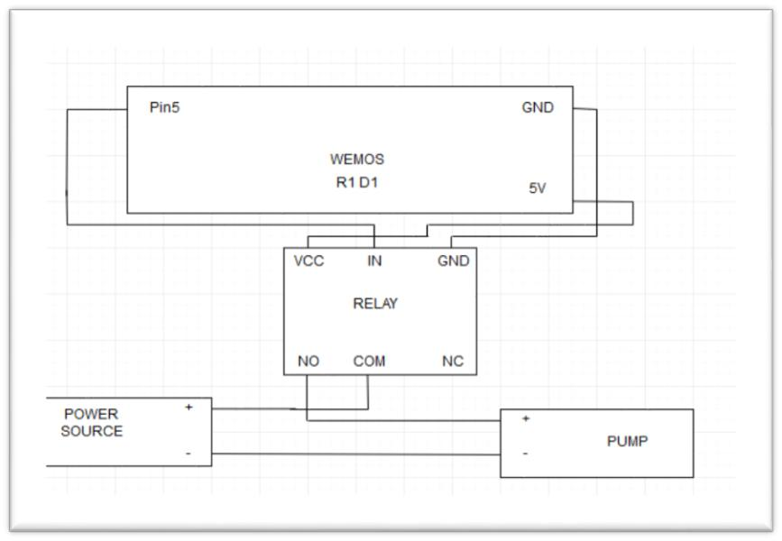

**Figure 5:** The Pin Connections of Pump to Relay and Micro-controller.

A 220- 240 AC heating element was used for temperature control. The heating element has a 1500 watts power rating. The pin connections of the heating element to the relay and microcontroller are shown in Figure 6 below.

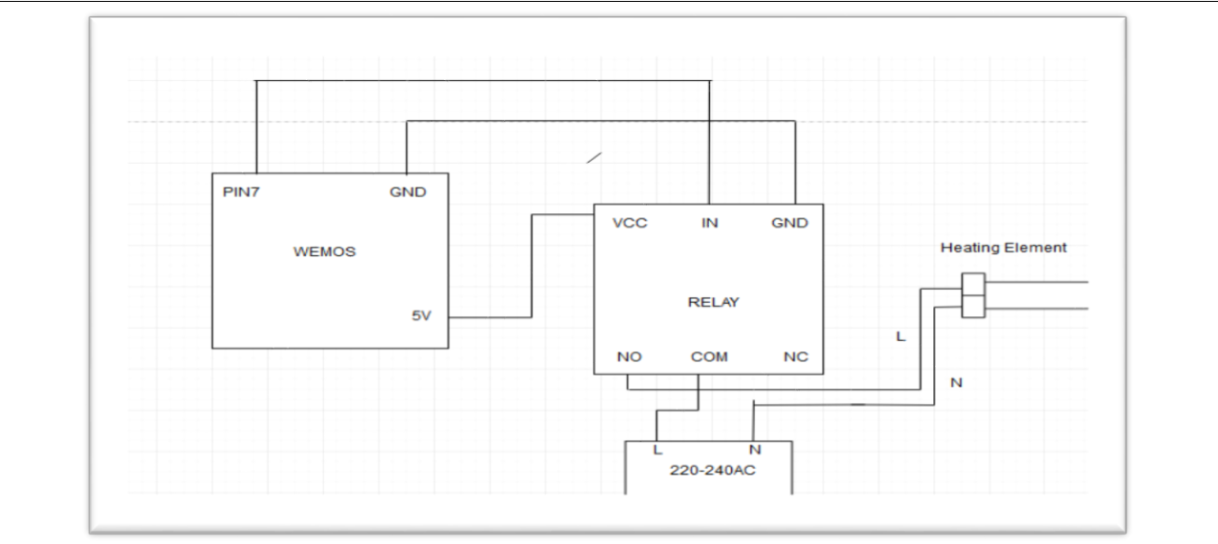

**Figure 6:** The Pin Connections of Heating Element to Relay and Micro-controller

The last part of the design stage was the development of the user interface, in this case a mobile application and set up a communication strategy for the transmission of the system values from the m The project has three distinct parts that were tested separately before the full system integration. These are sensing units shown in Figure 7 below.

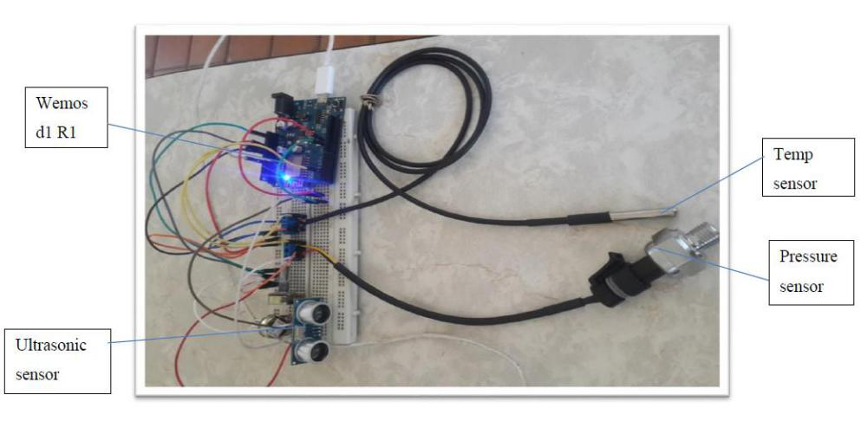

**Figure 7:** Sensing Unit Circuit

The circuit that was used for the control unit is shown in Figure 8 below.

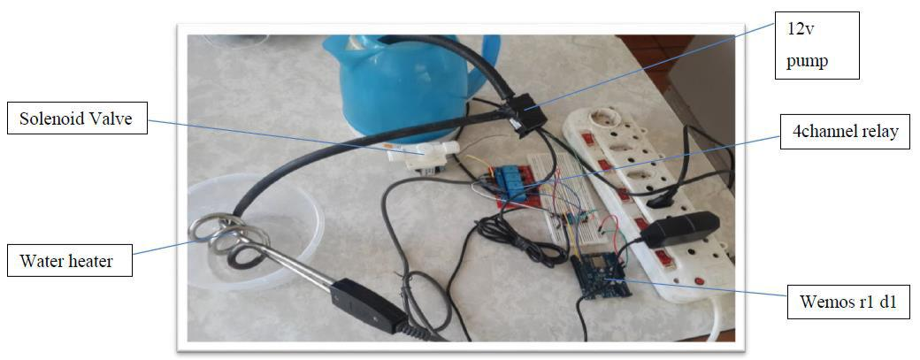

**Figure 8:** The Control Unit Circuit

Control unit shows the 4-channel relay, water heater, water pump and wemos d1 r1 (microcontroller). After integrating the sensing unit consisting of ds18b20 temperature sensor, ultrasonic sensor, and pressure sensor. The control unit consisting of the 12 volts dc pump, solenoid valve and water heater and the microcontroller of the system, the integrated hardware prototype of the system was developed as shown in Figure 9 below.

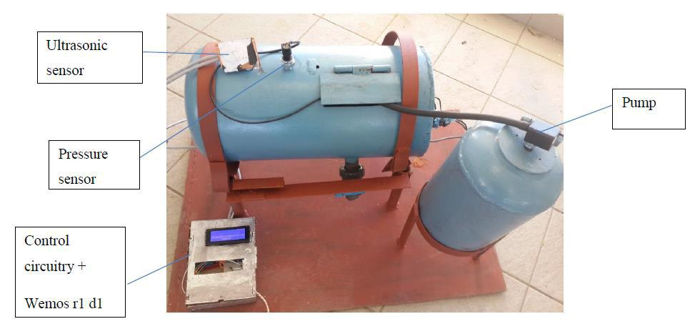

**Figure 9:** Prototype of the system

The design of the user interface had two key elements: designing the Android Application and designing the linking of the Android application to the Wemos D1R1 through a communication protocol which was a Wi-Fi connection. The Wemos board posted values to a page hosted by a Cloud Server. The mobile application could then extract values from the cloud server and display them for the user. The communication strategy that was implemented is shown in Figure 10 below.

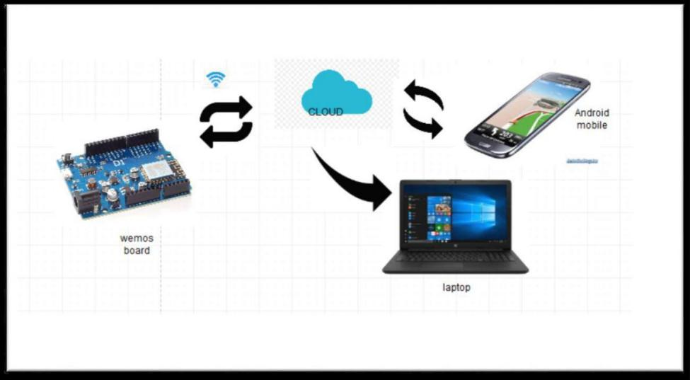

**Figure 10:** Data Flow Diagram for the System

**CHAPTER THREE**

**METHODOLOGY AND DESIGN**

The design process for the industrial monitoring and control system involved several key steps. Firstly, an overview of the system requirements and objectives was defined. This included determining the parameters to be monitored, such as temperature, pressure, and water level, and the necessary control devices, such as pumps and solenoid valves. Next, the selection of sensors was made based on the specific requirements of the system. For temperature monitoring, a DS18B20 temperature sensor was chosen, which provides accurate and digital temperature readings. For pressure measurement, a pressure sensor (SKU237545) was selected, and for water level monitoring, an ultrasonic sensor was used. These sensors were connected to the microcontroller, specifically a Wemos D1 R1, using appropriate circuit connections. The microcontroller acted as the central processing unit, receiving sensor readings and controlling the respective control devices. Design considerations were taken into account for remote monitoring and control. The system was designed to be accessed and controlled through an Android mobile application. This required the establishment of a cloud server to handle data transmission between the microcontroller and the mobile application. The user interface of the mobile application was carefully designed to provide a user-friendly experience, allowing users to monitor the parameters, set desired values, and remotely control the control devices.

The software development process involved writing the necessary code for the microcontroller, the cloud server, and the mobile application. The microcontroller code included reading sensor data, comparing it to the set values, and controlling the relay modules accordingly. The cloud server facilitated the communication between the microcontroller and the mobile application, while the mobile application was responsible for displaying the parameter readings, allowing user interaction, and sending commands to the system.

Implementation details included integrating the hardware components, testing the functionality of individual circuits, and conducting system testing to ensure the proper operation of the overall system. Quality assurance measures were taken to ensure reliability and stability of the system, and any identified issues were addressed and resolved through iterative development. Overall, the methodology and design of the industrial monitoring and control system involved careful consideration of sensor selection, connection to the microcontroller, design considerations for remote monitoring and control, and implementation of the software components. The result was a robust system that effectively monitored and controlled industrial parameters using an Android mobile application.

**CHAPTER FOUR**

**RESULTS AND DISCUSSION**

The results achieved by the different parts of the system were analysed to determine the extent to which they met the objectives of the project. The system algorithms were developed to govern the operation of the system, ensuring that the temperature, water level, and pressure were accurately measured and controlled.

Testing of the sensing units was conducted to ensure that they were working as expected and the serial monitors showing temperature, water level and pressure are shown in Figure 12. The temperature sensing unit, water level sensing unit, and pressure sensing unit were tested individually. The results were recorded and displayed on the serial monitor. The temperature sensing unit accurately measured the temperature, displaying the results on the serial monitor. The water level sensing unit used an ultrasonic sensor to measure the water level, which was displayed on the serial monitor as distance in centimetres. The pressure sensing unit measured the pressure in a closed vessel and displayed the results on the serial monitor as shown in the Figure 11 below.

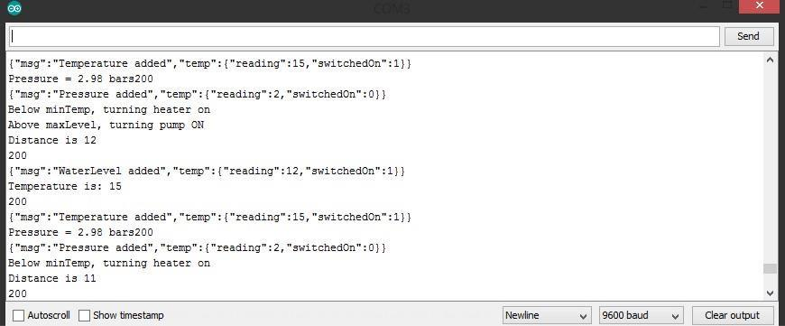

**Figure 11:** The serial monitors showing temperature (a), water level (b) and pressure (c).

The microcontroller's ability to connect to Wi-Fi was also tested, and it successfully connected to the local network as shown in Figure 12 below. This allowed for communication between the microcontroller and the server.

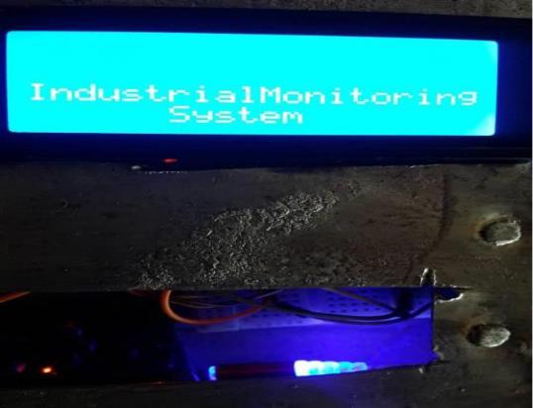

**Figure 12:** Wemos D1 R1 successful connection to WIFI

After successfully testing the sensing units individually and the microcontroller's ability to connect to the network, the sensing units, microcontroller, and control unit circuit were integrated to test the system. The water level and pressure measurements were displayed on the serial monitor and an LCD as shown in Figure 13.

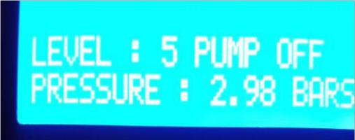

**Figure 13:** Display of level and Pressure measurement on LCD

The control unit effectively controlled the devices based on the set points, turning the heater on or off based on the temperature and the pump on or off based on the water level.

The system was also monitored and controlled using an Android mobile application. The data from the sensing devices was sent to the server, and the mobile application extracted the data and displayed it in real time. The mobile application allowed users to control the system remotely, turning devices on or off based on their preferences. Figure 14 below showed the user authentication and the login page on the mobile application.

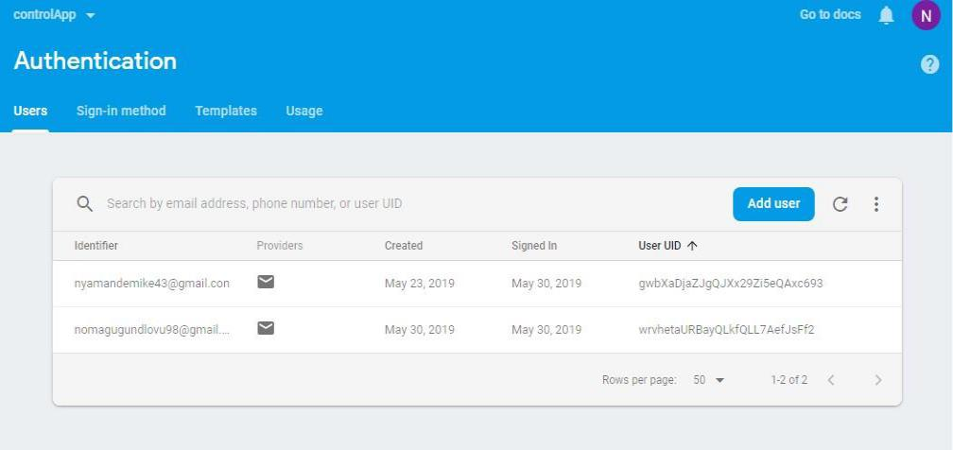

**Figure 14:** User Authentication

To login into the system the user has to login. The authorized user`s email address and high security password were required to successfully login into the android application. Figure 15 below shows how the system authenticates the user and provides user access to the system.

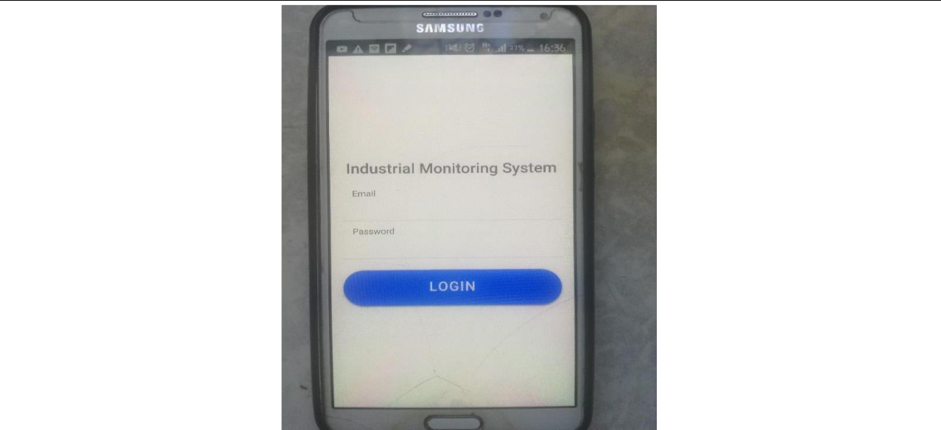

**Figure 15:** Login page of the android mobile application

Overall, the system performed well, with the sensing units accurately measuring temperature, water level, and pressure. The control unit effectively controlled the devices based on the set points, ensuring that the system operated within the desired parameters. The microcontroller successfully connected to the network, allowing for communication with the server. The mobile application provided real-time monitoring and control of the system parameters, allowing users to conveniently monitor and control the system from anywhere with an internet connection. The manual and automatic remote-control system is shown in Figure 16 below. When the manual on button is on, it means the system is on manual remote control. When the manual on button is off, it means the system is on automatic-remote control.

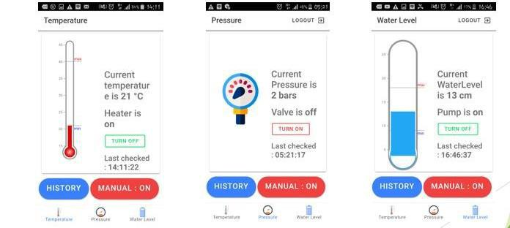

**Figure 16:** Control system using Mobile Application For remote control, the user had two options:

1. Manual Remote Control- which was done by toggling the Device On/Off buttons in the mobile application.
2. Automatic Remote Control - which was done by enabling the Auto Device-Control button which was the manual mode off button. This feature used pre-set limits to determine when to switch devices off as well as the devices to be switched off.

**Features on the Mobile Application:** The mobile application had a vital feature which was the history tab. When the history button was toggled the user was able to view stored parameter values according to the date and time. Furthermore, the user was able to see if a control device was on or off on a particular date and time. This is shown in Figure 17 below.

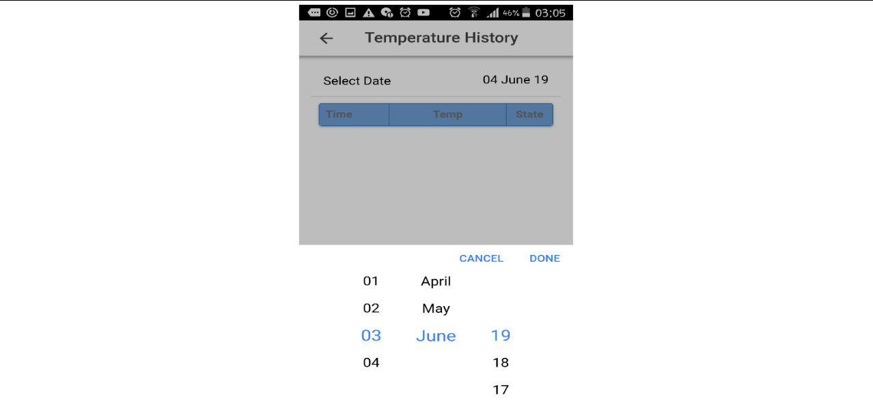

**Figure 17:** Selecting date on History Tab

After the selecting date the user was able to view stored and recorded data as shown in Figure 18 below.

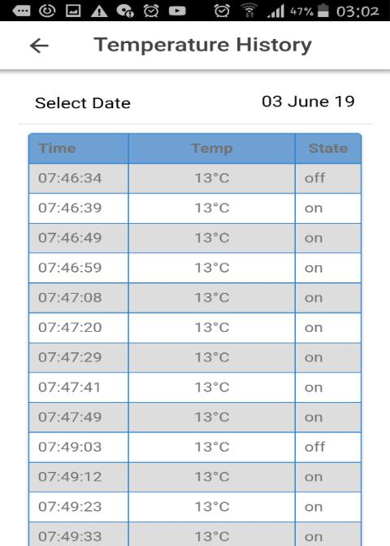

**Figure 18:** Temperature History

Temperature history showing the date and time the temperature was recorded. The state of the heater is also shown. Overall, the system demonstrated the successful integration of sensing units, a microcontroller, and a control unit, along with the use of a mobile application for real-time monitoring and control. The results achieved met the objectives of the project and showed the potential for further development and improvement in the future.

**LIMITATIONS**

In the evaluation of the system's limitations, a few challenges were identified. Firstly, there was a delay in data transmission between the sensors and the mobile application, resulting in occasional delays in real-time monitoring. Secondly, the system had a limited range due to the use of Wi-Fi technology, which restricted its mobility. Lastly, the security of the system was a concern, as unauthorized access to the mobile application. To address these limitations, possible improvements could include exploring alternative wireless communication technologies with faster transmission speeds and longer ranges. Enhanced security measures, such as encryption and authentication, could be implemented to ensure the system's integrity and prevent unauthorized access. Additionally, research and development efforts could focus on optimizing the system's performance for larger-scale industrial applications.

**CONCLUSION**

In conclusion, the research findings have demonstrated the successful implementation of an industrial monitoring and control system using an Android mobile application. The system effectively monitors and controls critical parameters such as temperature, pressure, and water level, reducing the reliance on manual monitoring and minimizing the risk of accidents. The achievements of the system include the design and integration of sensors, microcontrollers, and control units to enable remote monitoring and control via the mobile application. The system provides real-time data, enhances efficiency, and improves user experience. Furthermore, the system's contributions lie in its cost-effectiveness, mobility, and user-friendly interface. It reduces manual overhead, increases reliability, and allows for prompt maintenance and troubleshooting when necessary. In terms of future work and potential enhancements, further research can focus on expanding the system's capabilities to include additional parameters and control devices. Integration with advanced data analytics and machine learning algorithms can enable predictive maintenance and fault detection. Additionally, improvements in data security and robustness can be explored to enhance the system's overall performance and reliability. With continuous development and innovation, the industrial monitoring and control system can contribute significantly to industrial automation and safety.

**REFERENCES**

1. kumar, G. N., & Narain, B. R. (2012). Portable Embedded Data Display and Control Unit using CAN Bus. In Procedia Engineering (Vol. 38, pp. 791–798). Elsevier BV. <https://doi.org/10.1016/j.proeng.2012.06.099>
2. Abbas, H.A. (2014) Future SCADA Challenges and the Promising Solution: The Agent—Based SCADA. International Journal of Critical Infrastructures, 10, 307-333. <http://dx.doi.org/10.1504/IJCIS.2014.066354>
3. Purnima, Purnima & Reddy, S.. (2012). Design of Remote Monitoring and Control System with Automatic Irrigation System using GSM-Bluetooth. International Journal of Computer Applications. 47. 6-13. 10.5120/7238-9355. <http://dx.doi.org/10.5120/7238-9355>
4. Dutta, Atrayee and Dubey, Aditya and Barman, Snehakshi and Borah, Rupsikha, IoT Based Industrial Equipment Controlling and Parameter Monitoring System (2018). International Journal of Computational Intelligence & IoT, Vol. 1, No. 1, 2018, Available at SSRN: <https://ssrn.com/abstract=3354417>
5. Zhao, Y. B., Wang, J., & Chen, H. (2014). Design and implementation of vehicle monitoring system based on the compatible interface of web map. Applied Mechanics and Materials, 556, 2619-2622. <https://doi.org/10.4028/www.scientific.net/AMM.556-562.2619>
6. Sheng, X., Chen, H., Wan, M., Gu, G., Liu, Z., & Wang, X. (2021, February). Design and Implementation of An Intelligent Vehicle Monitoring System. In Journal of Physics: Conference Series (Vol. 1828, No. 1, p. 012099). IOP Publishing. <https://dx.doi.org/10.1088/1742-6596/1828/1/012099>
7. Sui, N., Zhang, C., Liu, H., Sheng, Y., Wang, X., & Wei, Z. (2013, October). Design and Implementation of Vehicles Monitoring System Based on Android Mobile Terminals. In 2013 International Conference on Information Science and Computer Applications (ISCA 2013) (pp. 294-298). Atlantis Press.

<https://doi.org/10.2991/isca-13.2013.50>

1. Ha, D. T., Pham, T. H., & Khanh, N. D. (2013, December). Design and implementation of mobile vehicle monitoring system based on android smartphone. In 2013 Third World Congress on Information and Communication Technologies (WICT 2013) (pp. 51-56). IEEE. <https://doi.org/10.1109/WICT.2013.7113108>
2. Heming, P., Linying, J., Liu, Y., & Kun, Y. (2010, July). Design and implementation of Android phone surveillance system. In 2010 International Forum on Information Technology and Applications (Vol. 2, pp. 222-225). IEEE. <http://dx.doi.org/10.1109/IFITA.2010.198>
3. Zhao, J., & Feng, C. (2015, September). Design and implementation of mobile operation maintenance management system based on Java EE and Android. In 2015 6th IEEE International Conference on Software Engineering and Service Science (ICSESS) (pp. 349-352). IEEE. <http://dx.doi.org/10.21817/ijet/2019/v11i2/191102010>
4. Esp8266Learning. (2018, October 28). Wemos D1 - ESP8266 based board. Retrieved from <http://www.esp8266learning.com/wemos-d1-esp8266-based-board.php>
5. Pandey, R., & Bhatt, N. (2015). Industrial Burner Automation based on PLC HMI & SCADA. <https://www.ijsrd.com/articles/IJSRDV3I90092.pdf>
6. Muusha, P., Stanford, B., Kolbe, M. et al (2023). Relating Cooling Rates in Superheated Liquid During Solidification for Powder Characterization. Metall Mater Trans A <https://doi.org/10.1007/s11661-023-07135-4>
7. Academia.edu. (2019). Industrial Automation and Monitoring System Project. Retrieved from <https://www.academia.edu/5593330/Industrial_Automation_and_Monitoring_System_PROJECT>
8. Freetronics. (2019). Relay4 - 4 Channel Relay Driver Module Quickstart Guide. Retrieved from <https://www.freetronics.com.au/pages/relay4-4-channel-relay-driver-module-quickstart-guide#.XPagdHpR3IU>
9. Keyence. (2019). Ultrasonic Sensor Basics. Retrieved from <https://www.keyence.com/ss/products/sensor/sensorbasics/ultrasonic/info/index.jsp>