**DESIGN AND IMPLEMENTATION OF AN AUTOMATED INVENTORY CONTROL SYSTEM FOR A MANUFACTURING ORGANISATION**

**ABSTRACT**

*This research addresses the inefficiency and inconsistency associated with asset tracking and inventory management. This research focuses on the algorithm and framework of an automated system for large quantities of inventory control.This research work is concise and generally summarizes the activities duly carried out in the design and implementation of an automated inventory control system for a manufacturing organization. The system is designed to efficiently handle the movement and tracking of goods through the replacement of human workers by technology. The manual method or intervention is labour intensive, costly, and error prone and cannot ensure the inventory remains up-to-date due to oversight and internal shrinkage. With the proposed new system, inventory can be updated in real time without product movement, scanning, or human involvement. The automated system allows inventory status to be determined and shipping and receiving documents to be generated automatically triggering automatic orders for products that are low in inventory. The study outlines the main concepts of the analysis and design methodology of the proposed system, compares it to the existing and goes further to explain the design and implementation of the system using Visual Basic 6.0 for the database. The fact finding techniques employed is interview, observation, online and library research.*

TABLE OF CONTENTS

Title page

Approval Page

Certification Page

Dedication

Acknowledgement

Abstract

Table of Contents

List of Figures

List of Tables

CHAPTER ONE

1.0 Introduction

1.1 Background of the Study

1.2 Statement of the Problem

1.3 Purpose of the Study

1.4 Significance of the Study

1.5 Objectives of the Study

1.6 Scope of the Study

1.7 Limitations of the Study

1.8 Definition of Basic Concepts

CHAPTER TWO

2.0 Literature Review

2.1 Comprehensive Overview

2.1.1 Purpose

2.2 Types of Inventory Control Systems

2.2.1 Four types of inventory control systems

2.2.1.1 Manual Inventory Management System

2.2.1.2 Barcode Technology

2.2.1.3 Radio Frequency Identification (RFID)

2.2.1.4 Warehouse Management System

2.3 How Inventory Control Systems Really Work

2.4 What Industries Use Inventory Control Systems

2.4.1 Application of Inventory Control Systems

2.4.2 Importance of Inventory Control Systems

2.5 Warehouse Management Systems

2.5.1 Warehouse Management Rules Engine

2.5.1.1 Rules Workbench

2.5.1.2 Warehouse Management System Strategy

2.5.2 Importance of Warehouse Management Systems

2.5.3 Inventory Control Systems vs. Warehouse Mgt Systems

2.6 Automated Inventory Control System Software

**CHAPTER ONE**

**1.0 INTRODUCTION**

Inventory management and asset tracking need to record all the durable assets of an institute. Many organizations, i.e. construction companies, are still using manual-tracking systems to manage their inventories, which is very time-consuming. Implementing an automated system would cut down the time of checking and tracking of assets, which will make services more efficient. This paper studies the algorithm and framework of an automated system for large quantities of inventory control, particularly those facilities whose assets and inventories have the features of geographically-widely located facility and heterogeneous assets. The automated inventory system used by large warehouse or stores could not satisfy the users’ needs of those large facilities. The authors deliberated two major asset-tracking practices: manual or barcode inventory management system versus automated inventory management system. The objectives of the research are to investigate the current situations and problems in inventory management, examine the algorithms and structures of an automated inventory management system for those facilities, and suggest a design for such a system to track assets.

It is quite inefficient and labor-intensive for operation managers or project managers to track missing items or check inventories manually or using the barcode technology. The Radio Frequency Identification (RFID) network system seems to be a practical solution for this problem. RFID technology helps to make sure that the right assets are located at the right place with no discrepancies and errors. The outcome of this research will help to increase the efficiency of inventory management, improve the accuracy and quality of the asset tracking process, and reduce human errors.

An inventory control system contains a list of orders to be filled and then prompts workers to pick the necessary items, and provides them with packaging and shipping information. Inventory control may be used to automate sales order fulfilment process and also manage in and outward material of hardware. Automation is the replacement of human workers by technology. For optimal sales and inventory management process, robust functionality is needed for managing logistics facilities. Warehouse management functions for inventory control cover internal warehouse movements and storage and its support helps in the recording and tracking of materials on basis of both quantity and value.

This application takes care of all supply orders reducing cost for warehousing, transportation while improving customer service. It significantly improves inventory turns, optimizes flow of goods. It also improves cash flow, visibility and decision making providing efficient execution of tasks using this fast and reliable computerised method

**1.1 BACKGROUND OF THE STUDY**

The Nigerian Breweries PLC was established in the year 1946. It aims at providing satisfaction and nourishment to the Nigerian population through the distribution of drinks like beer, coca-cola, fanta, sprite etc. It is second to none and for this reason, the demand is high and the company responds to the increasing demand by stabilizing supply to strike a balance.

Justifiably, the company has the problem of keeping adequate record of goods transfer and since it is done manually, associated problems of insecurity, high cost of operation and delay in supply arise. Data processing in Nigerian Breweries PLC is presently carried out using people, pens, and paper to control stock and inventory.

The design and development of an automated inventory control system for the Nigerian Breweries PLC will no doubt bring immeasurable relief from the problems associated with the manual system.

**1.2 STATEMENT OF THE PROBLEM**

The Nigerian Breweries PLC is to an extent manually operated and reveals a number of problems.

The recording of sales and cash received are done manually on a book that appears rough. Thus, the books are exposed to physical damage, information can be lost and dust particles are accumulated.

The long list of supply orders waiting to be attended to on daily basis.

The control system is time consuming, less accurate and less efficient, and the environment is not user friendly.

Inaccuracies often ensue from human error.

The manual system is quite tedious and can be reduced or eliminated with the introduction of the proposed system.

**1.3 PURPOSE OF THE STUDY**

The purpose of this study is to improve current operational process in the Nigerian Breweries PLC to its full capacity by developing efficient computer software that can handle inventory in a computerised fashion.

**1.4 SIGNIFICANCE OF THE STUDY**

This study is primarily aimed at increasing efficiency in operations, reducing maintenance and running cost, monitoring the supply of goods and its distribution and increase profit in the Nigerian Breweries PLC by introducing an automated inventory control system.

**1.5 OBJECTIVES OF THE STUDY**

The main objective of this study is to develop a computerised inventory control management system. Others include;

i. It provides total asset visibility.

ii. It allows reduced inventory stocking levels giving full inventory history.

iii. It reduces lead time, shelf space, and errors due to damage, fatigue of staff and overall cost of operations.

iv. It facilitates “just in time” deliveries.

v. It provides full process control for products.

vi. It provides higher level security as the system would be passworded to prevent unauthorised access.

vii. It shortens cross docking time and speeds up sort/pick up rate.

viii. It helps the management plan, monitor, optimize resources and ascertain their financial position at any time.

**1.6 SCOPE OF THE STUDY**

The scope of this study covers the Nigerian Breweries PLC as a whole, and its customers which include retailers, distributors and the general public.

**1.7 LIMITATIONS OF THE STUDY**

This project was constrained by the following factors:

(a) Financial Constraints

Bearing in mind the economic state of the nation, it was found difficult in making both ends meet, because of the exorbitant nature of things nowadays in travelling for the collection of data needed for the project.

(b) Time Constraints

Looking at the interval between the resumption and vacation of the final semester for the project to be completed, the time given seemed to be short for the collection of required information for better work to be done.

(c) Non-Availability of Material

During this project, it was noticed that the required materials needed for the project are not documented. Those that were documented lacked storage facilities where they can be reached.

**1.8 DEFINITION OF BASIC CONCEPTS**

Automation: This is the use of technology or computers to control and process data reducing the need for human intervention.

Database: This refers to a large store of related data on a computer that a user can access and modify.

Password: This is a secret code that must be entered into a computer to enable access to its applications. It is made up of numbers, letters, special characters or a combination of any of the above categories.

Inventory Control System: A list of orders to be filled, and prompts workers to pick the necessary items and provides them with packaging and shipping information.

Computerization: This is the conversion of a manually operated system to a controlled, organized and automated system.

Research: A careful study of a subject to discover facts, establish a theory or develop a plan of action based on the facts discovered.

System: A set of computer components functioning together.

Technology: The study of techniques of mobilizing resources such as information for accomplishing objectives that benefit man and his environment.

Software: A computer program or set of instructions that direct a computer to perform processing functions.

Information System: A collection of procedures, people, instructions and equipment to produce information in a useful form.

Processing: This is dealing with something according to an established procedure.

**CHAPTER TWO: LITERATURE REVIEW**

**INTRODUCTION**

An inventory control system and sales contains a list of orders to be filled and then prompts workers to pick the necessary items, and provides them with packaging and shipping information. Inventory control may be used to automate sales order fulfilment process and also manage in and outward material of hardware. Automation is the replacement of human workers by technology. For optimal sales and inventory management process, robust functionality is needed for managing logistics facilities. Warehouse management functions for inventory control cover internal warehouse movements and storage and its support helps in the recording and tracking of materials on basis of both quantity and value.

2.1 COMPREHENSIVE OVERVIEW

According to Microsoft Encarta (2009), Inventory is the quantity of goods and materials on hand that a manufacturer uses to represent those items that are ready and available for sale. An inventory control system is a set of hardware and software based tools that automate the process of tracking inventory. The kinds of inventory tracked with an inventory control system can include almost any kind of quantifiable goods including food, clothing, books, equipment and other items that consumers, retailers, or wholesalers may purchase. Modern inventory control systems are exclusively based on using technology to track and control inventory. (Kotler, 2003)

Inventory control systems work in real time using technology to transmit information to a central computer system as inventory is monitored and as transactions occur to ensure an organised management system and generate detail-oriented records and reports that cover all aspects of the business. (Harry, 2005)

2.1.1 Purpose Companies often use inventory control systems to reduce their carrying costs. The system is used to track products and parts as they are transported from a vendor to a warehouse, between warehouses, finally to a retailer or directly to a customer. The purpose of a good inventory control system is to maintain a balance between too much and too little inventory. It provides the foundation for monitoring product sales and measuring inventor levels. Inventory control systems acts as a blueprint for picking, packing and shipping items from a warehouse and receiving items into a warehouse or other storage locations to cut down product obsolescence and spoilage. (Monzerka, 2002)

**2.2 TYPES OF INVENTORY CONTROL SYSTEMS**

Properly managing inventory requires a system of some sort. It does not matter if the system consists of writing inventory levels on the back of an envelope or using the most sophisticated radio frequency identification system. As the old saying goes, “there are many ways to skin a cat”, the different types of inventory control systems all have pros and cons. choosing the right one boils down to which system holds the most value for the company. (Rubin, 2007) 2.2.1 Basically, there are four types of inventory control systems:

* Manual inventory management system
* Barcode technology
* Radio Frequency Identification (RFID)
* Warehouse Management System

**2.2.1.1 MANUAL INVENTORY MANAGEMENT SYSTEM**

Many small business owners, especially if the business has very few products, keep track of inventory manually using a spreadsheet. Spreadsheets are set up to calculate when products need to be reordered. At the start of each week, the owner manually counts products and materials that are on hand and enters the values in the spreadsheet and also enters expected usage based on existing orders. Using the appropriate spreadsheet formulas, the owner can determine if he has enough materials for the week or if purchases should be made. Manual systems allow the small business owner to manage inventory with very little investment in systems or training. Maintaining data integrity is a major downside to manual inventory management as a single data entry or formula error can cause major inaccuracies in the data output. (Lysons, 2001)

2.2.1.2 Barcode Technology Barcodes consist of series of parallel vertical lines, or bars, used to assign a unique identification code to an item. The major use of barcode identification system is to track inventory automatically. A barcode combines several sequences to create a unique set of numbers or characters that identifies the item. (Encarta, 2009)

All major retailers use barcode technology as part of an overall inventory control system because it increases the accuracy and efficiency of managing inventory. When a barcode is read at the point of sale, inventory sales data is immediately read and sent to a broader system that maintains usage statistics. Barcodes manage inventory at the warehouse level as it facilitates movement of inventory within the confines of the warehouse. (Kenneth, 2002)

**2.2.1.3 RADIO FREQUENCY IDENTIFICATION (RFID)**

This technology is relatively new and it works by having a tag that emits information that can be collected by a reader from a distance. RFID uses two types of technology to manage inventory movement; active and passive technology. Active RFID technology uses fixed tag readers assigned throughout a warehouse such that anytime an item with an RFID tag passes the reader, the movement of the item is recorded in the inventory management software. Active systems work best in environments that require real time inventory tracking or where inventory security problems exist. Passive RFID technology requires the use of handheld readers to monitor inventory movement. Because RFID technology has a reading range of up to 40 feet using passive technology and 300 feet using active technology, it greatly increases the accuracy of moving inventory around a warehouse. (Hamlett, 2006)

**2.2.1.4 Warehouse Management System**

This is the management of storage of products and services rendered on the product within the four walls of a warehouse. (Sande, 2003) It is a key part of the supply chain and primarily aims to control the movement and storage of materials within a warehouse and process the associated transactions including shipping, receiving, putaway and picking. It can be described as the legs at the end of the line that automates the store, traffic and shipping management. Warehouse management systems help to efficiently monitor the flow of products. Once data has been collected, there is either batch synchronization with, or a real time wireless transmission to a central database. The database can then provide useful reports about the status of goods in the warehouse. The Warehouse management system would be discussed further to reflect its mode of operation.

The types of inventory control systems are used generally to track and control inventory. Many companies are now using sophisticated Warehouse Management Systems integrated with Supply Chain Systems, Enterprise Systems and Electronic Data Interchange (EDI). The movement and tracking of goods through the manufacturing and supply chain process is still a complex procedure which is difficult to manage. In many instances, the goods being distributed to the retailer must go through one or more third party distribution processes before they reach their final destination.

Currently, most material tracking systems employ two dimensional barcodes that must be close to and within the “line of sight” of the barcode reader. This requires manual scanning or a conveyor like process to position the barcode and scanner. Barcodes can run the risk of getting wet or scratched due to mishandling or a harsh environment, which often prevents accurate reading by the scanner. Manual intervention is labour intensive, costly and error prone. In addition, scheduled scanning or manual method cannot ensure the inventory remains up to date, due to oversights, errors and internal shrinkage. With RFID, inventory can be updated in real time without product movement, scanning or human involvement. The fully automated system allows inventory status to be determined and shipping and receiving documents to be generated automatically. The system also triggers automatic orders for products that are low in inventory.

**2.3 HOW INVENTORY CONTROL SYSTEMS REALLY WORK**

The systems work like this, first, barcodes or RFIDs tell scanners which items consumers are buying. The scanners transmit the information to computers by reading the barcodes and sending that information to the software. The software then interprets the numbers from the barcodes and matches those numbers to the type of merchandise they represent. This allows the merchant to track sales and inventory either at the checkout counter or with a handheld scanner keeping the store abreast of which items are selling. (Zenz, 2004)

Specialized software keeps track of how much stock is going out the door via purchases and how much remains on shelves and in the warehouse, giving managers a real time picture of what is happening. The software analyzes the data and makes recommendations for reordering strategies.

Sometimes they are programmed to automatically order at a certain point. It is important to note, however, that good systems leave room for human decision making. The systems provide good information to support decisions but leave the final call up to managers. Once mangers make a reorder decision, the system uses Electronic Data Interchange (EDI) to communicate its needs for additional merchandise to a vendor. Electronic Data Interchange is the process of sending and receiving data between two parties, a retailer and a vendor, for example using data transmission lines, such as the internet. The data is stored in a computer’s memory bank and read by managers at both ends of the line.

While inventory management systems offer retailers and vendors many advantages, there are some pitfalls. Because the system aims to keep a bare minimum of stock in store, retailers can be caught short if an item unexpectedly becomes a big seller. Retailers traditionally have additional stock on hand known as safety stock or buffer to prevent that occurrence but many have discontinued the practise. And as with all technology, these types of systems are subject to the effects of a wide spread computer crash or software failure. Some computer groups have objected to RFID technology too, claiming it invades their privacy by providing additional information about their buying habits and personal data. They argue that the information could be used to push other products on individual customers, or be sold to other businesses for similar purchases. The RFID signals can also “step on” or “collide” with each other, making accurate readings difficult.

Most retailers, however, have bought into the vast advantages offered by such systems. They include the high efficiency, the need for less warehouse space, less cash tied up in inventories and better sales. The systems also promote better information sharing between the retailer and the vendor, which helps drive down cost for both, as well as for the consumer. Inventory control systems can help a worker locate the items on the order list in the warehouse, it can encode shipping information like tracking numbers and delivery addresses, and it can remove these purchased items from the inventory tally to keep an accurate count of in-stock items. The benefits of modern inventory control systems are not just for the retail and manufacturing sectors. They also offer great advantages for any organization that manages a supply chain for consumable items. (Michael, 2002) Everywhere you look, inventory control systems are making sure the products are there when we need them by providing businesses with real time inventory tracking information which makes it simple to locate and analyze inventory information in real time with a simple database search.

**2.4 WHAT INDUSTRIES USE INVENTORY CONTROL SYSTEMS**

Inventory control systems are employed in a wide variety of applications, but they all revolve around tracking delivery of goods to customers. Inventory control is crucial in retail stores especially to those with a large number or variety of merchandise items for sale. Inventory control also used in warehouses to track orders and shipments, and for automated order processing. Other important applications of inventory control systems are in manufacturing, shipping and receiving.

2.4.1 Application of Inventory Control Systems in the Manufacturing Industry Manufacturers mainly use inventory control systems to create work orders and bills of materials. This facilitates the manufacturing process by helping manufacturers efficiently assemble the tools and parts they need to perform certain tasks. For more complex manufacturing jobs, manufacturers can create multilevel work orders and bills of materials which have a timeline of processes that need to happen in the proper order to build a final product. Other work orders that can be created using inventory control systems include reverse work orders and automatic work orders. (Bolton, 2001) Its advantages include;

a) Cost Savings: It helps companies cut expenses by minimizing the amount of unnecessary parts and products in storage and helps keep lost sales to a minimum by having enough stock on hand to meet demand.

b) Warehouse organisation: It helps distributors, wholesalers, retailers, manufacturers optimize the warehouses. If certain products are often sold together or are more popular than others, those products can be grouped together or placed near the delivery area to speed up the process of picking, packing and shipping to customers.

c) Time Savings: It gives employees enough information access to receive products, make orders, transfer products and do other tasks without compromising company security by issuing administrator passwords to prevent unauthorised access.

The disadvantages of its application are mostly cost and complexity. Many large companies use inventory control systems but small businesses may not afford it and if an IT technician leaves, the system might be too complex for the users except another technician is employed.

**2.4.2 IMPORTANCE OF INVENTORY CONTROL SYSTEMS:**

Inventory control is important to ensure quality control in businesses that handle transactions revolving around consumer goods. (Benson, 1999) Without proper inventory control, a large retail store may run out of stock on an important item. Agood inventory control system will alert the retailer when it is time to reorder. Inventory control systems are important means of automatically tracking large shipments. For example, if a business orders ten pairs of socks for retail resale but only receives nine pairs, this will be obvious on inspecting the contents of the package, and error is not likely. On the other hand, say a wholesaler orders 100,000 crates of malt and 10,000 crates are missing, manually counting each crate of malt is likely to result in error. An automated inventory control system helps to minimize the risk of error. In retail stores, an inventory control system also helps track theft of retail merchandise, providing valuable information about store profits and the need for theft-prevention systems.

**2.5 WAREHOUSE MANAGEMENT SYSTEMS**

A warehouse consists of area, equipment, items, devices and people. According to Microsoft Encarta 2009, it is a large building or store in which goods, commodities, or raw materials are stored. Within this warehouse, the processes of purchasing, receiving, putaway, storage, value added services, picking, packing and shipping are constantly taking place. To aid in this endeavour, the use of Warehouse Management Systems have been introduced. It spans the areas of warehouse resource management, warehouse configuration, task management, advanced pick methodologies and value added services. Warehouse Management Systems optimize the material handling business processes for warehouses, manufacturing facilities and distribution centres, as well as, providing integrated barcode scanning and label generation to improve material transactions and advanced shipping process. (Gramaccioni, 2009) A crucial part of a manufacturing organisation’s supply chain inventory management involves proper storage and transportation of products to a chain of retailers and wholesalers. Poor supply chain inventory management could spell disaster for any company. The higher the inventory investment as a percentage of total assets of a company, the higher the damage caused by poor inventory control. To ensure that this does not happen, Warehouse Management System uses a user defined rules engine coupled with its Advanced Task Framework to ensure inventory accuracy.

2.5.1 Warehouse Management Rules Engine Warehouse Management System can provide rules driven processes meaning that flexibility meets needs without customizations. The rules driven processes eliminates customization, can easily be changed or evolved, increases long-term flexibility, and accelerates implementation. They are also supported for directed picking, directed putaway, task assignment, costing and labelling. Through the rules engine, companies can enforce proper work processes and employees interact with the system with instructions that are fed and tasks that follow a predefined work process based on conditions found in the warehouse. (Finchley, 2001) The Rules Engine can be used to create six different types of rules including picking, putaway, task type assignment, cost group assignment, label format assignment, and operation plan assignment in a Warehouse Management System enable environment. It is seeded with several default rules which allows for material organisation. Rules must be defined in a strategy and enabled using the rules workbench.

**2.5.1.1 Rules Workbench**

The Rules Workbench is used to create rules to effectively dispatch tasks and manage inventory. It can be used to streamline picking and putaway of goods, assign newly received products to a cost group, ensure customer complaint labelling, assign tasks to a resource with the appropriate training and equipment, and select the correct operation plan for tasks.

2.5.1.2 Warehouse Management System Strategy

A strategy is a sequence of rules that the rules engine runs to try to allocate products, space, or fulfil a request. Picking, putaway, cost group assignment rules use strategies. Strategies are constructed from one or more rules and rules can be reused for multiple strategies. If a strategy cannot find enough products to fulfil an order or find enough space for a putaway, the product is backordered or the putaway fails.

2.5.2 Importance of Warehouse Management Systems

Warehouse Management Systems provides for daily businesses with access to real time and complete business information. With this information, employees receive real time feedback on activities they perform and their impact on operations. The system has an in-built performance management tool that enable mangers to proactively manage warehouse performance. The Board Management can view the company’s current financial status, perform transactions, and calculate product availability. It is also used to monitor and refine facility activity thereby providing real time status with active alerts and notifications to handle last minute changes and keep key personnel informed with multiple reporting options.

The warehouse management systems enable warehouses to maintain accurate, real time inventory information through physical inventory management and cycle counts. The warehouse would manage inventory levels using automated replenishment and transfers between facilities. It enables companies to maximize their utilization of labour, space and equipment by coordinating and optimizing resource usage. The systems also direct and optimize stock putaway based on real time information about the status of bin utilization. It provides a set of computerised procedure to handle the receipt of stock and returns into a warehouse facility, model and manage the logical representation of the physical storage facilities, manage the stock within the facility and enable a seamless link to order processing and logistics management in order to pick, pack and ship product out of the facility. Warehouse management system is not just managing within the boundaries of a warehouse; it is much wider and goes beyond the physical boundaries. It acts as an interpreter and message buffer between existing systems. It does not just start with receipt of products but with actual initial planning. It monitors the progress of products through the warehouse. It uses the physical warehouse infrastructure, tracking systems and communication between product stations to monitor and deal with receipt, storage and movement of normally finished goods to intermediate storage locations or to a final customer. It helps in optimal cost of timely order fulfilment by managing the resources economically. (Haywood, 1985) 2.5.3 Inventory Control Systems vs. Warehouse Management Systems

An inventory control system can be extended by the warehouse management system which manages to store bins in complex warehouse structures.

While inventory control systems manage stock by quantity and value, the warehouse management system reflects the special structure of a warehouse, and monitors the allocation of storage and transfer transactions in the warehouse.

2.6 AUTOMATED INVENTORY CONTROL SYSTEM SOFTWARE

The automated inventory control system software is a computer based system for tracking product levels, orders, sales and deliveries. It can also be used in the manufacturing industry to create a work order, bill of materials and other production related documents. Companies use inventory management software to avoid product overstock and outages and also, as a tool for organizing inventory data that was generally stored in hardcopy form. The software is made up of components working together to create a cohesive inventory control system which include;

i. Asset tracking: This involves tracking products via its barcodes and other tracking criteria such as serial number when they are in a warehouse or store.

ii. Order management: Once products reach a certain low level, a company’s inventory control system can be programmed to tell managers to reorder that product. This helps companies to avoid running out of products or tying up too much capital in inventory.

iii. Service management: Companies that are primarily service oriented rather than product oriented can use this software to track the cost of the materials they use to provide services. This way, they can attach prices to their services that reflect the total cost of performing them.

Automated inventory control systems are efficient, effective and have helped to improve the manufacturing industry thereby providing more security to warehouses while improving customer service.

**CHAPTER THREE**

**3.0 SYSTEM ANALYSIS AND DESIGN**

**3.1 METHODOLOGY**

This involves the specification of procedures for collecting and analyzing data necessary to define or solve the problem for which the research is embarked upon. The scope of this research covers the Nigerian Breweries PLC, 9th mile corner, Enugu in particular.

3.2 DATA COLLECTION

The major source in data collections and facts findings used is primary source. Primary Source

This involves oral interviews conducted with various personnel in the Nigerian Breweries PLC, Enugu, reviewing and sharing their experience about the difficulties they undergo in using the manual inventory control system.

**3.3 ANALYSIS OF THE EXISTING SYSTEM**

The existing system is one that has been manually operated over the years. It is a system in which all the methods of controlling inventory is of a manual approach. Critical analysis of this system reveals that it is prone to errors. Careful analysis also shows that due to the complexities of the manual system, records of inventory kept are inaccurate and manually operated in such a way that requires the clerk to register sales on a book, thereby making a staff handle two or three jobs at a time. An example is a staff trying to register sales and at the same time rushing back to face a queue of impatient retailers waiting to be attended to. This makes the place so crowded with customers with just one person attending to them. Sometimes, due to unavailability of staff, customers who have other things to do, end up missing their various appointments. As a result of this, the attendant finds it very difficult to have an accurate record as pressure is being mounted on him. The attendant might end up writing an order meant for another customer and have it delivered to the wrong person.

The Nigerian Breweries PLC operates manually and has not adopted a computerised mode of operation. This generates inadequate records or exercise improper management of the company and in extreme cases, the company may lose her customers.

**3.4 LIMITATION OF THE EXISTING SYSTEM**

As we know, manual inventory control systems are quite tedious, time consuming and less efficient and accurate in comparison to the computerised system. The Nigerian Breweries PLC has the following problems/weaknesses.

1. The system cannot inventory stocks by its self or without human help.
2. Compilation of inventory records consumes a lot of time and manpower.
3. Some records get lost over time while some are not easily found.
4. It involves lot of paperwork and data processing is very slow.
5. The environment is not user friendly.
6. The system does not calculate and give financial reports at a glance and as such, the degree of decision making in urgent matters is not applicable.
7. The system is unable to detect faults within the system in case of rectifying fraud.
8. It takes a long time for mistakes to be rectified and sometimes throws the system into confusion.

**3.5 SYSTEM DESIGN TRANSACTION/MOVEMENT FILES:**

These are files used to update a master file which contains new records to be added into the master file or to be deleted from a master file. This file contains all order received at a particular time.

MASTER FILES:

These are files of the company’s permanent nature. It involves the regulars updating of these files to show a current position. It has been seen therefore that master record will contain both data of a static nature e.g. a customer name and data which changes each time transaction occurs.

METHOD OF FILE OPERATION AND ACCESS:

I explained some ways a file can be organized depending on the storage medium and the way the file can be processed. The objective of the designer is to organize the file in such a way as to give a user the facilities he requires while using minimum computer resources access time.

RANDOM ACCESS:

Here files are not accessed serially or sequentially. Records are accessed and likewise stored in direct access device like magnetic diskettes, the arrangement; records are stored without regard to the sequence of their control field.

SEQUENTIAL ACCESS:

This is simply the assessment of file using the sort key on the record are after the other either on a magnetic tape or tapes. It provides fast access of records stored sequentially relative to it position.

INDEXED SEQUENTIAL:

This combines the time feature of both the random and sequential process records that can be accessed both sequentially and randomly as the need arises. Records are indexed at the same time taking note of their locations thus allowing them to run one after the other. Reference to record and direct of its position.

SERIAL ACCESS:

Here, assessment can be on any storage medium without referencing any particle sequence. To access first the records in the serial file are arranged in manner to help for easy sorting.

**3.6 DATA BASE DESIGN**

The operational data base is designed below using the format of the INS.DBD. The design is made to accommodate, database design, representation, character type, field size and decimal where necessary.

TABLE 3.6: LOGIN TABLE

|  |  |  |
| --- | --- | --- |
| FIELDDESCRIPTION | FIELD TYPE | FIELD SIZE |
| USERNAME | TEXT | 15 |
| PASSWORD | TEXT | 15 |

3.6.1 TRANSACTION TABLE; SUPPLY FORM

|  |  |  |
| --- | --- | --- |
| **FIELD DESCRIPTION** | **FIELD TYPE** | **FIELD SIZE** |
| CATEGORIES(BRANDS) | TEXT | 15 |
| PRICE PER CRATE | CURRENCY | 10 |
| QUANTITY SUPPLIED  (IN CARTONS) | NUMBER | 10 |
| PRICE OUTCOME | CURRENCY | 10 |
| QUANTITIY IN STOCK | NUMBER | 20 |
| TOTAL PRICE | CURRENCY | 20 |

3.6.2 SALES TABLE

|  |  |  |
| --- | --- | --- |
| **FIELD DESCRIPTION** | **FIELD TYPE** | **FIELD SIZE** |
| CATEGORIES IN BRAND | TEXT | 15 |
| PRICE PER CRATE | CURRENCY | 10 |
| QUANTITY NEEDED (IN CARTONS) | NUMBER | 10 |
| PRICE OUTCOME | CURRENCY | 10 |
| QUANTITIY AVAILABLE (IN STOCK) | NUMBER | 15 |
| TOTAL PRICE | CURRENCY | 20 |
| DISCOUNT | TEXT | 7 |
| TOTAL BALANCE | CURRENCY | 20 |

3.6.3 CUSTOMERS TABLE

|  |  |  |
| --- | --- | --- |
| **FIELD DESCRIPTION** | **FIELD TYPE** | **FIELD SIZE** |
| CUSTOMER CODE | TEXT | 15 |
| CUSTOMER NAME | TEXT | 15 |
| CUSTOMER ADDRESS | TEXT | 15 |
| PHONE NUMBER | NUMBER | 10 |
| TOTAL | CURRENCY | 15 |
| DISCOUNT | TEXT | 9 |
| TOTAL BALANCE | CURRENCY | 20 |

**3.7.1 ACTIVITY DIAGRAM**

Login

Welcome

Sales/record

Stock manage

Reports/inventory

Backup/exit

Saves Activity and/Backup & Exits

View sales reports and inventory control

Manage Stock –edit, delete, update, add (full control)

View sales and records

Exit system on wrong verification

Authorization (login)

Welcome User

Saves Activity and Exits

View sales reports and inventory (timely)

Can View Stock only (no full control)

Make sales and record each services

Exit system on wrong verification

Authorization (login)

Welcome User

User

Admin

Fig 3.2 Activity Diagram

**3.7.2 CLASS CASE DIAGRAM**

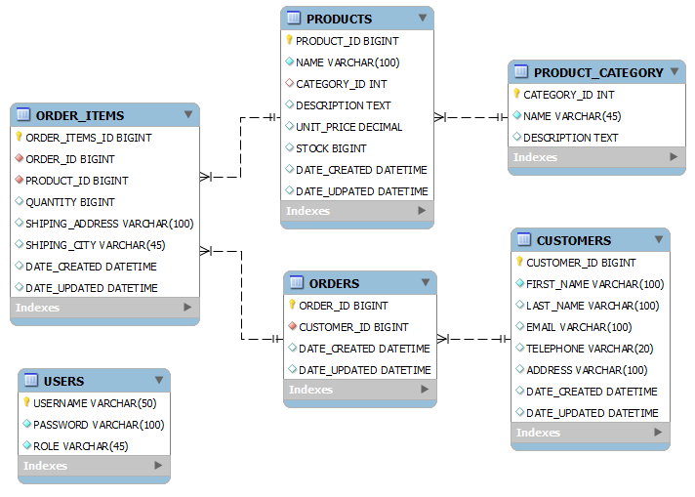

Fig 3.3 Class diagram for the new system

**3.7.3 USE CASE DIAGRAM**

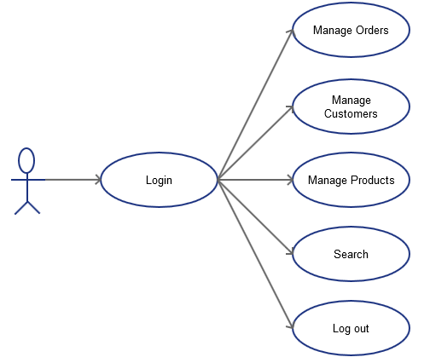

Login

Customers

Record/add

Sales

Record

Report

Print receipts

Logout

User use case

Admin use case

Fig 3.4 Use case diagram

**3.8 SYSTEM FLOWCHART**

###### Output data

Input from keyboard

###### Input data

# CPU

Disk

Storage

Output

Report

Fig 3.5 system flow diagram

**3.10 JUSTIFICATION OF THE NEW SYSTEM**

The new system is an automatic a computer aided system. In this new system records are done directly in the system and reports and sales confirmation code are printed (receipts). In the new system it is easy to track and monitor products, sales, orders, by the use of the inventory, also the new system make the necessary reduction from the product been sold in other to keep accurate and proper record of the stocks. In the new system sales calculation are computerized, therefore brought downs at the day are timely and accurate

**REFERENCE**

Kotler, I.C. (2003). *Inventory Control Management in the 21st Century.* Charlotte (USA): Mac-Williams and Capital Publishers Inc.

Harry, E.G. (2005). *Tracking Inventory.* London: Underwood Pitman.

Monzerka, J.G. (2002). *Sales Management: Theory and Practice.* London: Paul Chapman Publication.

Rubin, K. (2007). *Computer Applications for Inventory Control Systems.* Boston: McGraw Hill.

Lysons, M.C. (2001). *Systematic Planning for Change.* Palo Alto, California: Mayfield Publishing Company.

Kenneth. D.C. (2002). *Contemporary Inventory Management Systems.* New York: McGraw Go Spot.

Hamlet, J. (2006). *Cultivating Alliances with Customers.* International Journal of Organizational Management, New York. Vol. 7. Issue 3, pp. 255-287.

Sande, O.F. (2003). *Automated Warehouse Management Systems.* Journal of Information Technology, Massachusetts. Vol. 2, pp. 35-43.

**CHAPTER**

**4.0 IMPLEMENTATION, TESTING AND PACKAGING**

**4.1 CHOICE OF DEVELOPMENT TOOLS**

To ensure as standardized object oriented in this entire ramification, Visual Basic (VB) 6.0, Microsoft Access and Font page was used.

**4.2 SYSTEM REQUIREMENTS**

The requirements for the implementation of this system are as follows;

❖ Software requirement.

❖ Hardware requirement.

**4.2.1 Software Requirements**

The following specification is needed:

a) Operating system- Certified distribution of Windows.

b) Front end- Visual Basic 6.0 Professional edition.

c) Back end- Microsoft Access 2007

Some additional features of VB like Datagrind, DataReport.

**4.2.2 Hardware Requirements** For effective operation of the newly designed system, the following minimum hardware specifications are recommended:

a) The computer system to use should be 100% IBM compatible since they are considered done systems.

b) The computer system processor to be used should be Intel Pentium technology.

c) The minimum Random Access Memory (RAM) should be 128MB.

d) The system should have a hard disk of at least 20GB, 3.5 floppy drive and CD-ROM drive.

e) The system to use should be equipped with 14” VGA or SVGA monitor (colored).

f) The mouse, keyboard and printer are also required.

The listed configurations are the minimum requirements, but if the configurations are of higher versions, the processing derived will definitely be better and the program will run faster.

**4.3 TOP DOWN DESIGN DIAGRAM**

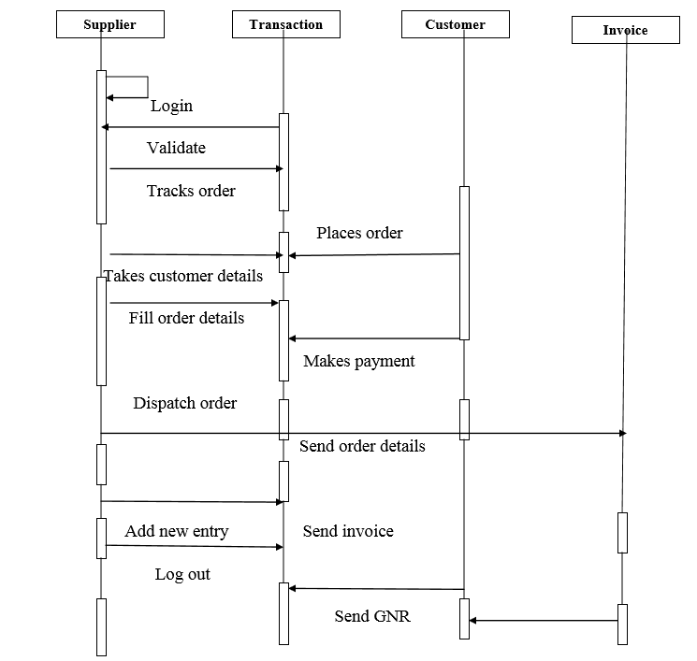

Fig 4.2 Top down Design Diagram

The figure above is a Top down design diagram which orderly represents the step by step activities of the automated inventory control software system and the sequence at which it operates. This diagram enables the operator to efficiently understand, capture and record the flow and functionality of the software. Now, from the above diagram, it is noticed that each system (supplier, transaction, customer and invoice) is broken down to gain insights into compositional subsystems thereby enabling an operator to easily access the software with ease.

**4.4 IMPLEMENTATION**

The new system is designed to be put into efficient use. Here, we will look into the various technical aspects that influenced the successful implementation of this system and determine the effective operation of the system. System implementation follows the approval of the system proposals and its objectives, thus it is to arrive at a satisfactory, implemented, completed, and function evaluated automated system. It also embodies the preparation of resources including equipment and personnel.

The supplier login password and identification is entered, he checks, tracks order, dispatch order on customer and sends invoice after which he updates records. The customer studies and makes a list of requirement, places the order, makes payment and receives his invoice. However, this also includes the steps taken after the final coding of the program.

**PROGRAM DESIGN**

The program for this study was designed using the top down approach. The entire problem associated with the existing system were broken down in smaller unit and processed differently. The units were developed into modules and there are total of three modules in all. However, the implementation of this process follows a certain procedure to enable user access the program software with efficiency as shown in the diagram below:

WELCOME FORM

CUSTOMER DATA

TRANSACTION FORM

EXIT

TRANSACTION FORM

RECIEVER SUPPLY

SALE FORM

SUPPLY RECORD

CUSTOMER RECORD

EDIT

EXIT

Fig: 4.3.1 IMPLEMENTATION OF THE PROGRAM DESIGN

**ENTRY MODULE**

The entire module is responsible for all input data requirements. It receives input data from the computer users and stores them adequately into file. The entire provisions are made very flexible and precise as shown below:

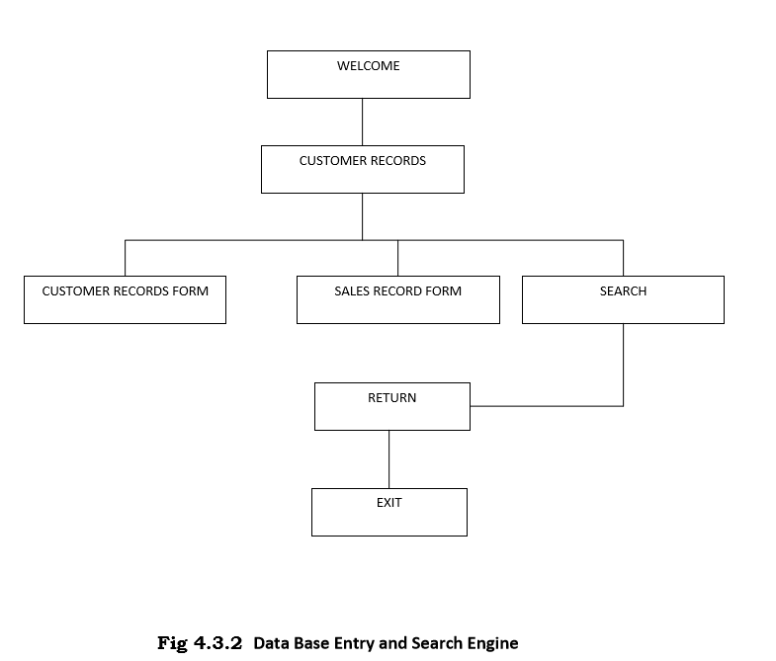

**REPORT MODULE**

The report module, tables all forms of report generation. It displays conditional and unconditional reports. The reports are made comprehensive and timely as shown below:

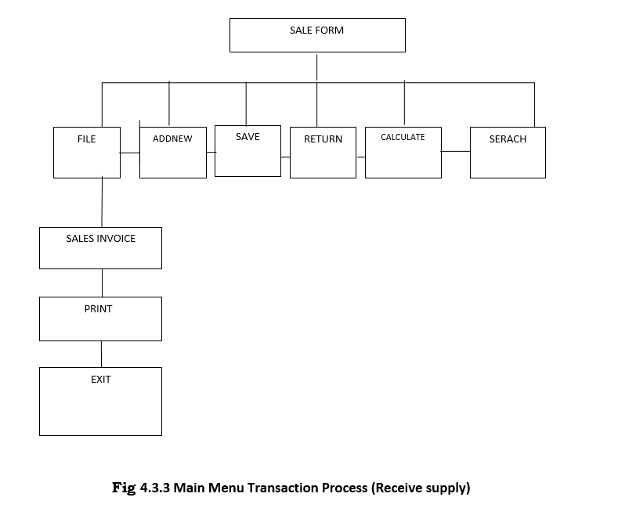

**UPDATE MODULE**

The update module is responsible for modifying stored data or record in the files. The records are searched for in the file and retrieved adequately and then, the update data are retrieved and necessary corrections are made automatically by the computer as adequate. However, it is responsible in keeping track of all the transactions that takes place. It is also known as main menu transaction process as shown below:

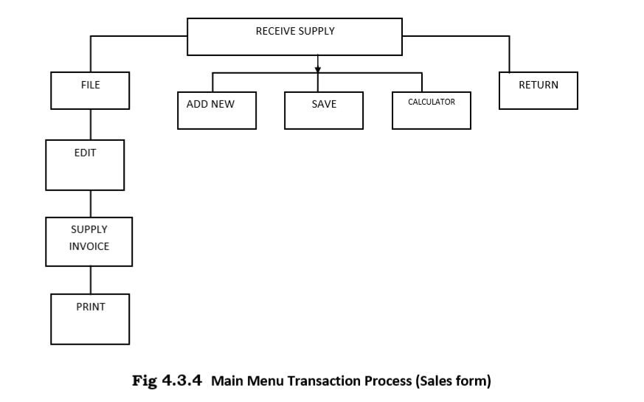

**EXIT MODULE**

This is the module responsible for packing up or quitting the program entirely as shown below:

MAIN MENU

Transaction

Exit

**4.3.6 IMPLEMENTATION OF THE LOGIN FORM**

This form allows a user to input his or her username and password. After the username and password are implemented and the okay button pressed, the form automatically takes the user to the main menu. However, when a wrong user name and password is keyed in, a warning alert displays on the screen.

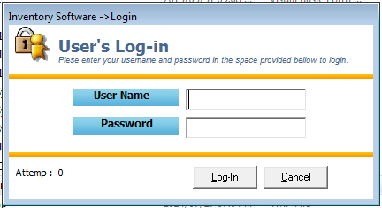

Fig 4.3.6 Splash Screen: Login Screen

**4.3.7 IMPLEMENTATION OF THE MAIN MENU FORM**

This form contains buttons which are Customer Data, Transaction form, and Exit button. The customer button when pressed, takes the user to the customers code, customer name, address and phone number. The Transaction form, simply takes the user to a form of listed options which are the receive supply, sales, supply records, customer record and the edit. Which a user can choose to perform any action from any of the listed options. The Exit button simply ends all the running process.

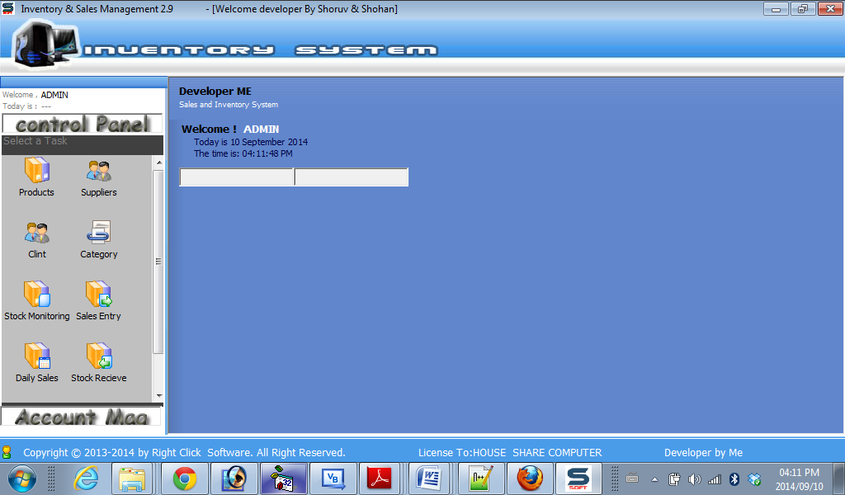

**Fig 4.3.7 Main menu form**

**4.3.8 IMPLEMENTATION OF THE RECEIVE SUPPLY FORM**

This form is found in the transaction form. It is listed as one among the transaction options. Here all the inventories & supplies made are taken down. It contains list of drinks in stock, price for each drink, the quantity supplied & quantity in stock.

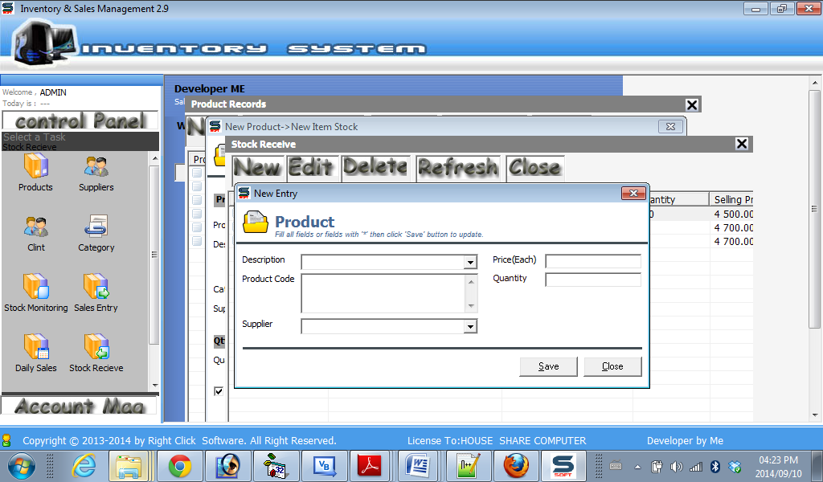

Fig 4.3.8 : Supplier form

**4.3.9 IMPLEMENTATION OF SALES FORM**

Sales Form is found in the transaction form. It is one among the listed options on the option list. This form contains all the sales information carried out during the sales of drinks to the retailers for record purpose.

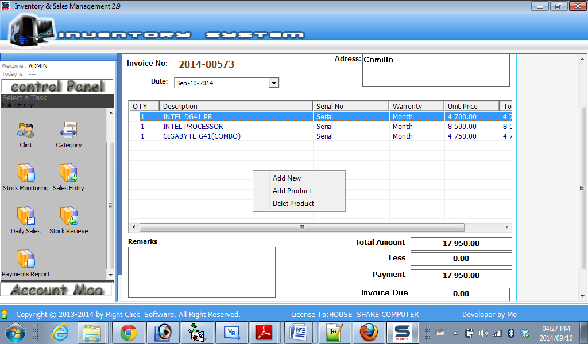

Fig 4.3.9: Sales Form

**4.5 IMPLEMENTATION OF SUPPLIER RECORD FORM**

The supplier form is a form found in the transaction form button. All transactions are made here by the supplier and are been stored for future references.

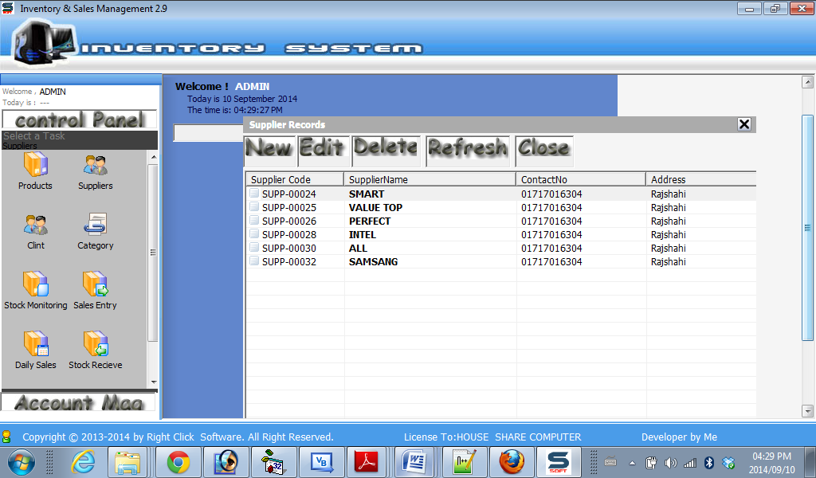

Fig 4.4: Supplier record form

**4.6 TESTING**

Testing is the last stage in the software development and it presents an interesting anomaly for the software engineer where he attempts to build software from an abstract concept to a tangible product. During testing, the engineer creates series of test cases to discard preconceived notions of the “correctness” of software just developed and overcome a conflict of interest :

Testing the software follows a certain process as shown belowthat occurs when errors are uncovered. As a secondary benefit, testing demonstrates that the software functions appear to be working according to specification, that behavioural and performance requirements appear to have been met. In addition, data collected as testing is conducted provide a good indication of software reliability and quality as a whole.

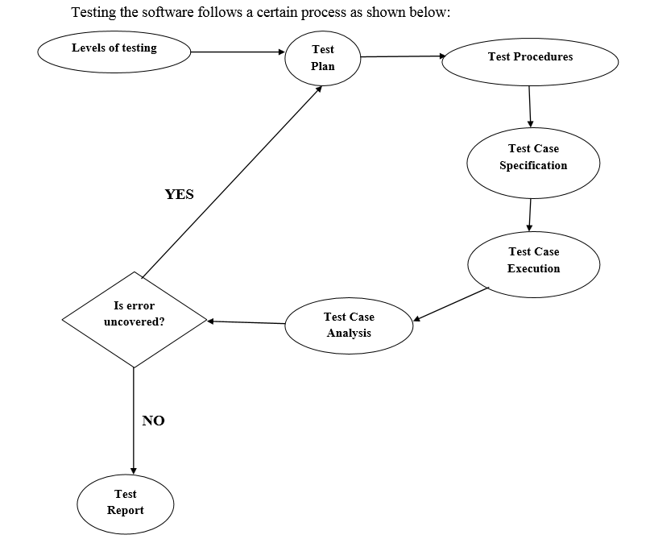

Fig 4.5 System Testing Process

**4.6.1 Unit Test**

Each unit of the new system was tested (test run) individually along side with the old system in other to identify areas of further enhancement and development.

**4.6.2 System Test**

The entire system was as well tested (test run) in general along side with the old system in other to identify areas of further enhancement and development.

**4.7 PACKAGING (INTEGRATION)**

The software will be designed using visual basic. After which will be complied and packed for easy installation in any computer system and further use. The complied software will be transferred in to a CD.

**CHAPTER FIVE**

**5.0 SUMMARY, LIMITATIONS, RECOMMENDATIONS, BEME AND CONCLUSION**

**5.1 SUMMARY**

Inventory proportionality is the goal of demand-driven inventory management. The primary optimal outcome is to have the same number of days' (or hours', etc.) worth of inventory on hand across all products so that the time of runout of all products would be simultaneous. In such a case, there is no "excess inventory," that is, inventory that would be left over of another product when the first product runs out. Excess inventory is sub-optimal because the money spent to obtain it could have been utilized better elsewhere, i.e. to the product that just ran out.

The secondary goal of inventory proportionality is inventory minimization. By integrating accurate demand forecasting with inventory management, replenishment inventories can be scheduled to arrive just in time to replenish the product destined to run out first, while at the same time balancing out the

inventory supply of all products to make their inventories more proportional, and thereby closer to achieving the primary goal. Accurate demand forecasting also allows the desired inventory proportions to be dynamic by determining expected sales out into the future; this allows for inventory to be in proportion to expected short-term sales or consumption rather than to past averages, a much more accurate and optimal outcome. With this new system, the difficulties encountered with the manual inventory control system are overcome. The automated inventory control system reduces the workload of the staff, saves time and increases efficiency. The records of the company are safe and secure, distribution process is well managed, errors are minimized, and reports generated for management are accurate thereby increasing the profit margin.

**5.2 LIMITATION**

In this project, it is only restricted to the stock department of Nigeria bottling company Enugu depot. There are some limitations they encountered in the updating of some finished product supply into store house and are delivered to the customer who depends on demand and supply as a method of stock control the recorder stock level and economics order quantity. Also, the administrative department orders materials for the production of the required product these materials could be gotten through local purchasing order. In addition, the project cannot run on its own without human involvement.

**5.3 RECOMMENDATION**

Having carefully examined the usefulness of computer in eliminating most of the errors and hindrances that ensue from paper work, I recommend this automated inventory control system to Nigerian Breweries PLC, 9th mile corner, Enugu in order to enable them produce an efficient inventory management and likewise reduce the complexity of manual work.

Research and development being continuous processes; is the same in computer and software development. This system will be useful since it is computerized and will promote effective, efficient and improve service delivery thereby promoting profit oriented manufacturing. The employment of computer personnel for an effective maintenance of the system will enhance a maximum output of this package and the use of computer in inventory system.

dopting this system, the following should be taken into consideration, training of staff, security measures, and the provision of dependable real time processing system for speedy responses. Finally, the project work is likewise recommended to different sections in an organization and every other manufacturing organization that still carry out their operation manually because automated inventory control system handles the problem of time constraints and errors that arises when jobs are carried out manually.

**5.4 BILL OF ENGINEERING MEASUREMENT AND EVALUATION (BEME)**

The total expenses made at the cause of the design and implementation of this new software is analysed as follows:

TABLE 5.1: BEME TABLE

|  |  |  |  |
| --- | --- | --- | --- |
| Item | Quantity | Unit price | Total amount  (Naira) |
| VB software | 1 | N5,500 | N5,500 |
| Avast antivirus | 1 | N5000 | N5000 |
| Designing of the  new software | 1 | N15,000 | N15,000 |
| Internet browsing | 12 | N12,000 | N12,000 |
| Phone calls | - | N4500 | N4500 |
| Transportation | - | N5000 | N5000 |
| Printing | - | N10,000 | N10,000 |
| Total | - | N61,500 | N61,500 |

5.5 CONCLUSION

Having carried out the required study of the design and implementation of an automated inventory control system for Nigerian Breweries, the organisation can now comfortably eliminate the manual method which have been proved inefficient, tedious, time consuming and prone to errors

The new automated system is the major target of this project. So the computerization activity depends on the maturity and honesty of the staff. Implementing the new system enables the worker to be well trained and creates new jobs for them.

**REFERENCES**

Kotler, I.C. (2003). Inventory Control Management in the 21st Century. Charlotte (USA): Mac-Williams and Capital Publishers Inc.

Harry, E.G. (2005). Tracking Inventory. London: Underwood Pitman.

Monzerka, J.G. (2002). Sales Management: Theory and Practice. London: Paul Chapman Publication.

Rubin, K. (2007). Computer Applications for Inventory Control Systems. Boston: McGraw Hill.

Lysons, M.C. (2001). Systematic Planning for Change. Palo Alto, California: Mayfield Publishing Company.

Kenneth. D.C. (2002). Contemporary Inventory Management Systems. New York: McGraw Go Spot.

Hamlet, J. (2006). Cultivating Alliances with Customers. International Journal of Organizational Management, New York. Vol. 7. Issue 3, pp. 255-287.

Sande, O.F. (2003). Automated Warehouse Management Systems. Journal of Information Technology, Massachusetts. Vol. 2, pp. 35-43.

Zenz, A.Z. (2004). How Inventory Control Systems Really Work. New Jersey USA: Peterson Educational Inc.

Michael, G.T. (2002). RFID Concept: Principles and Practice. New York: John Wiley and Sons Ltd.

Bolton, D.J. (2001). Applying Automated Inventory Control Systems in Manufacturing Industries. London: D.P Publications Ltd.

Benson, F.T. (1999). Inventory Management: An Instruction Manual. London: Ashore Color Press Go Spot.

Gramaccioni, S .J. (2009). Improving Warehouse Organisation. California: Good Year Publishing Company.

Finchley, O.S. (2001). Developing Strategic Rules Engine for Warehouse Management Systems. Hollywood Illinois: Richard D Irion Inc.

Haywood, R.J. (1984). Warehouse Management Systems. California: Academic Publishers Limited.

Rosenberg, I.J. (2000). A Simple Approach to Service Delivery. Journal of Customer Retention, Toronto. Vol. 1, pp. 45-51.

Rechheld, F.F. and Bills C. (2004). Loyalty-based Management. Harvard Business Review, Harvard University, March-April, pp. 64-73.

Microsoft Encarta Dictionary, (2009). Inventory. Retrieved May 24, 2011. “About VB” http://VB./ABOUT VB.html. Retrieved April 30, 2011.

Barnes, J.G. and Cumby, J.A. (2005). The Cost of Quality in Service

orien ted Manufacturing Companies: Better Customer Service

Delivery through Improved Inventory Control Systems. Beverly Hills,

CA: Bolts Publisher.

Gonroos, C. (2001). Warehouse Management and Inventory: Managing the Moments of Truth in Competitive Manufacturing Organ isations. Massachusetts, Toronto: Lexington Books.

CA: Bolts Publisher.

Gonroos, C. (2001). Warehouse Management and Inventory: Managing the Moments of Truth in Competitive Manufacturing Organ isations. Massachusetts, Toronto: Lexington Books.

SOURCE CODE

Option Explicit

Dim srcRecord As String

Dim srcRecCD As Variant

Public rsData As ADODB.Recordset

Public tempx As Integer

Dim LVX As LabelEdit

Dim blnAuto As Boolean

Sub LoadEntries()

tempx = 0

ListView1.ListItems.Clear

Set rsData = New ADODB.Recordset

rsData.Open "Select * from tblProduct ORDER by productCode ASC", CN, adOpenStatic, adLockPessimistic

With rsData

While Not .EOF

If rsData("QtyRemain") > 0 Then

Dim LS As ListItem

Set LS = ListView1.ListItems.Add(, , rsData!ProductCode, 1, 1)

LS.SubItems(1) = rsData!Description

LS.SubItems(2) = rsData!Qty

LS.SubItems(3) = Format(rsData!UnitPrice, "###,#0.00")

LS.SubItems(4) = Format(rsData!SellingPrice, "###,#0.00")

tempx = tempx + 1

If !QtyRemain = 0 Then

ListView1.ListItems(tempx).ForeColor = vbRed

ListView1.ListItems(tempx).ListSubItems(1).ForeColor = vbRed

ListView1.ListItems(tempx).ListSubItems(4).ForeColor = vbRed

ElseIf !QtyRemain<= 5 Then

ListView1.ListItems(tempx).ForeColor = &H4080&

ListView1.ListItems(tempx).ListSubItems(1).ForeColor = &H4080&

ListView1.ListItems(tempx).ListSubItems(4).ForeColor = &H4080&

End If

End If

.MoveNext

Wend

End With

End Sub

Private Sub Add_Click()

ListView2.ListItems.Add , , 1

ListView2.ListItems(ListView2.ListItems.Count).SubItems(1) = "Description"

ListView2.ListItems(ListView2.ListItems.Count).SubItems(2) = "Serial"

ListView2.ListItems(ListView2.ListItems.Count).SubItems(3) = "Month"

ListView2.ListItems(ListView2.ListItems.Count).SubItems(4) = "Unite Price"

ListView2.ListItems(ListView2.ListItems.Count).SubItems(5) = "Total Price"

ListView2.ListItems(ListView2.ListItems.Count).SubItems(6) = "PRODUCT-CODE"

End Sub

Private Sub AddProduct_Click()

Call LoadEntries

If Picture234.Visible = True Then

Picture234.Visible = False

Else

Picture234.Visible = False

With Picture234

.Top = 2700

.Left = 120

.Visible = True

End With

End If

End Sub

Private Sub cmdCancel_Click()

Unload Me

End Sub

Private Sub cmdExit_Click()

Picture234.Visible = False

End Sub

Private Sub CmdPrint_Click()

Dim i As Integer

CN.Execute "DELETE FROM Invoice"

If Text8.Text = "" Or Text10 = "" Or Text11 = "" Then

MsgBox "Fill all information box and continue"

Exit Sub

End If

Set rsData = New ADODB.Recordset

rsData.Open "Invoice", CN, adOpenStatic, adLockPessimistic

For i = 1 To ListView2.ListItems.Count

With ListView2

rsData.AddNew

rsData("Qty") = .ListItems.Item(i).Text

rsData("Description") = .ListItems(i).SubItems(1)

rsData("Serial No") = .ListItems(i).SubItems(2)

rsData("Price") = .ListItems(i).SubItems(5)

rsData("Warranty") = .ListItems(i).SubItems(3)

End With

Next

' rsData.Update

Set rsData = New ADODB.Recordset

rsData.Open "Invoice", CN, adOpenStatic, adLockPessimistic

InvoicePrint.Sections("Section2").Controls("Label1").Caption = CurrBusinessInfo.BusinessName

InvoicePrint.Sections("Section2").Controls("Label3").Caption = CurrBusinessInfo.BusinessAddress

InvoicePrint.Sections("Section2").Controls("Label4").Caption = CurrBusinessInfo.BusinessContact

InvoicePrint.Sections("Section2").Controls("Label8").Caption = Text1.Caption

InvoicePrint.Sections("Section2").Controls("Label6").Caption = Text8.Text

InvoicePrint.Sections("Section2").Controls("Label32").Caption = Text10.Text

InvoicePrint.Sections("Section2").Controls("Label33").Caption = Text11.Text

InvoicePrint.Sections("Section5").Controls("Label18").Caption = Text5.Text

InvoicePrint.Sections("Section5").Controls("Label23").Caption = Text2.Text

InvoicePrint.Sections("Section5").Controls("Label26").Caption = Text7.Text

InvoicePrint.Sections("Section5").Controls("Label24").Caption = Text9.Text

InvoicePrint.Sections("Section5").Controls("Label34").Caption = txtRemarks.Text

Set InvoicePrint.DataSource = rsData

InvoicePrint.ShowvbModal

End Sub

Private Sub cmdSave_Click()

Dim tAmt As Double

Dim i, Qr, Qr2, Qr3 As Integer

Dim D1, D2, D3, D4, D5, D6, D7 As String

If ListView2.ListItems.Count < 1 Then

MsgBox "There is no record..", vbInformation

Exit Sub

End If

Set rsData = New ADODB.Recordset

rsData.Open "Select * From TblClint Where ClintID= '" & Text8 & "'", CN, adOpenStatic, adLockOptimistic

If rsData.EOF = True Then

Dim Ans As VbMsgBoxResult

Ans = MsgBox(Text8 & " Is Not Registered in Clint list. register now??", vbQuestion + vbYesNo)

If Ans = vbYes Then

FrmClint.Text1(0).Text = Text8

FrmClint.Text1(1).Text = Text10

FrmClint.Text1(6).Text = Text11

FrmClint.Text1(7).Text = Text5

FrmClint.Text1(8).Text = Text9

FrmClint.EditFlag = True

FrmClint.ShowvbModal

End If

Else

rsData("Payment") = Format(Val(rsData("Payment")) + Val(Text5.Text), "###,#0.00")

rsData("Due") = Format(Val(rsData("Due")) + Val(Text9.Text), "###,#0.00")

rsData.Update

End If

For i = 1 To ListView2.ListItems.Count

D1 = ListView2.ListItems.Item(i).Text

D2 = ListView2.ListItems(i).ListSubItems(1).Text

D3 = ListView2.ListItems(i).ListSubItems(2).Text

D4 = ListView2.ListItems(i).ListSubItems(3).Text

D5 = ListView2.ListItems(i).ListSubItems(4).Text

D6 = ListView2.ListItems(i).ListSubItems(5).Text

D7 = ListView2.ListItems(i).ListSubItems(6).Text

'-----------Minus Liters---------------

Set rsData = New ADODB.Recordset

rsData.Open "Select * From tblProduct Where ProductCode= '" & D7 & "'", CN, adOpenStatic, adLockOptimistic

Qr3 = rsData.Fields("QtySold")

Qr = rsData![QtyRemain]

Qr2 = D1

rsData![QtySold] = Qr3 + 1

rsData![QtyRemain] = Qr - Qr2

rsData.Update

Set rsData = Nothing

'-----------End----------------------

Set rsData = New ADODB.Recordset

rsData.Open "INSERT INTO tblSalesInvoice(InvoiceNO,ProductCode,Description,Qty,Price,TotalAmount,DateCreated,Remarks,CreatedBy)" & _

"values ('" & Text1.Caption & "','" & D7 & "','" & D2 & "','" & D1 & "','" & D5 & _

"','" & D6 & "','" & Date & "','" &txtRemarks.Text& "','" &CurrUser.UserNAME& "')", CN, adOpenStatic, adLockOptimistic

Set rsData = Nothing

Next i

Set rsData = New ADODB.Recordset

rsData.Open "INSERT INTO PaymentLog(DateCreated,Invoice,ClintName,ClintId,Due,Payed)" & _

"values ('" & Date & "','" & Text1.Caption & "','" & Text10.Text & "','" & Text8.Text & "','" & Text9 & "','" & Text7 & "')", CN, adOpenStatic, adLockOptimistic

Set rsData = Nothing

MsgBox "New record has been successfully saved.", vbInformation

If MsgBox("Do you want to add another new record?", vbQuestion + vbYesNo) = vbYes Then

Resetfields

Text7.Text = "0.00"

Else

Unload Me

End If

End Sub

Sub Resetfields()

ListView2.ListItems.Clear

Text4.Text = "0.00"

Text2.Text = "0.00"

Text5.Text = "0.00"

Text4.Text = ""

Text6.Text = ""

GeneratePK

End Sub

Private Sub DeletAdded_Click()

If ListView2.ListItems.Count < 1 Then Exit Sub

ListView2.ListItems.Remove (ListView2.SelectedItem.Index)

End Sub

Private Sub Form_Load()

GeneratePK

DTPicker1.Value = Date

InitSubClass

Set LVX = New LabelEdit

LVX.Init Me, ListView2

End Sub

Sub GeneratePK()

Dim iCode As Long

iCode = getIndex("tblSalesInvoice")

Text1 = GenerateID(iCode, Format(Now, "yyyy-"), "00000")

End Sub

Private Sub Form_QueryUnload(Cancel As Integer, UnloadMode As Integer)

' frmWelcome.LOAD_MY_URL

End Sub

Private Sub Form_Unload(Cancel As Integer)

Set rsData = Nothing

End Sub

Private Sub ListView1_ColumnClick(ByValColumnHeader As MSComctlLib.ColumnHeader)

If ListView1.ListItems.Count < 1 Then Exit Sub

SortLV ListView1

End Sub

Private Sub ListView1_ItemClick(ByVal Item As MSComctlLib.ListItem)

If ListView1.ListItems.Count < 1 Then Exit Sub

On Error Resume Next

srcRecCD = ListView1.SelectedItem.Index

srcRecord = ListView1.ListItems.Item(srcRecCD).Text

End Sub

Private Sub ListView2_Click()

Dim i, j As Integer

On Error Resume Next

If ListView2.ListItems.Count < 1 Then Exit Sub

For i = 1 To ListView2.ListItems.Count

ListView2.ListItems(i).SubItems(4) = Format(ListView2.ListItems(i).SubItems(4), "###,#0.00")

ListView2.ListItems(i).SubItems(5) = Format(ListView2.ListItems(i).SubItems(4) * CInt(ListView2.ListItems(i).Text), "###,#0.00")

j = j + ListView2.ListItems(i).SubItems(5)

Next

Text5.Text = Format(j, "###,#0.00")

End Sub

Private Sub ListView2_ColumnClick(ByValColumnHeader As MSComctlLib.ColumnHeader)

SortLV ListView2

End Sub

Private Sub ListView1_DblClick()

If Trim(srcRecord) = vbNullString Then

On Error Resume Next

Dim LVL As ListItems

MsgBox "Please select a record from the list .Can't proceed to the operation!", vbExclamation

Else

Set LVL = ListView2.ListItems

LVL.Add , , 1

LVL(LVL.Count).SubItems(1) = ListView1.SelectedItem.ListSubItems(1).Text

LVL(LVL.Count).SubItems(2) = "Serial"

LVL(LVL.Count).SubItems(3) = "Month"

LVL(LVL.Count).SubItems(4) = ListView1.SelectedItem.ListSubItems(4).Text

LVL(LVL.Count).SubItems(5) = LVL(LVL.Count).SubItems(4) * Val(LVL(LVL.Count).Text)

LVL(LVL.Count).SubItems(6) = ListView1.SelectedItem.Text

Picture234.Visible = False

Set LVL = Nothing

Dim i, j As Long

For i = 1 To ListView2.ListItems.Count

ListView2.ListItems(i).SubItems(4) = Format(ListView2.ListItems(i).SubItems(4), "###,#0.00")

ListView2.ListItems(i).SubItems(5) = Format(ListView2.ListItems(i).SubItems(5), "###,#0.00")

j = j + ListView2.ListItems(i).SubItems(5)

Next

Text5.Text = Format(j, "###,#0.00")

End If

End Sub

Private Sub ListView2_MouseDown(Button As Integer, Shift As Integer, x As Single, y As Single)

If Button = 2 Then PopupMenu Entry

End Sub

Private Sub lvButtons_H2_Click()

ListView1_DblClick

End Sub

Private Sub lvButtons_H4_Click()

LoadEntries

Text3.Text = ""

End Sub

Private Sub Text2_GotFocus()

HighL Text2

End Sub

Private Sub Text2_LostFocus()

On Error Resume Next

HighL Text2

Text2.Text = Format(Text2.Text, "###,#0.00")

Text7.Text = Format(Format(Text5, "###,#0.00") - Format(Text2, "###,#0.00"), "###,#0.00")

End Sub

Private Sub Text3_Change()

tempx = 0

ListView1.ListItems.Clear

Set rsData = New ADODB.Recordset

Set rsData = CN.Execute("Select * from tblProduct where Description like '" & Text3.Text & "%'")

With rsData

While Not .EOF

Dim x As ListItem

Set x = ListView1.ListItems.Add(, , rsData!ProductCode, 1, 1)

x.SubItems(1) = rsData!Description

x.SubItems(2) = rsData!Qty

x.SubItems(3) = Format(rsData!UnitPrice, "###,#0.00")

x.SubItems(4) = Format(rsData!SellingPrice, "###,#0.00")

tempx = tempx + 1

If !QtyRemain = 0 Then

ListView1.ListItems(tempx).ForeColor = vbRed

ListView1.ListItems(tempx).ListSubItems(1).ForeColor = vbRed

ListView1.ListItems(tempx).ListSubItems(4).ForeColor = vbRed

ElseIf !QtyRemain<= 5 Then

ListView1.ListItems(tempx).ForeColor = &H4080&

ListView1.ListItems(tempx).ListSubItems(1).ForeColor = &H4080&

ListView1.ListItems(tempx).ListSubItems(4).ForeColor = &H4080&

End If

.MoveNext

Wend

End With

End Sub

Private Sub TxtDesc_Click()

Call LoadEntries

If Picture234.Visible = True Then

Picture234.Visible = False

Else

Picture234.Visible = False

With Picture234

.Top = 2700

.Left = 2160

.Visible = True

End With

End If

End Sub

Private Sub txtQty_KeyPress(KeyAscii As Integer)

KeyAscii = isNumber(KeyAscii)

End Sub

Private Sub Text5_Change()

On Error Resume Next

HighL Text2

Text7.Text = Format(Format(Text5, "###,#0.00") - Format(Text2, "###,#0.00"), "###,#0.00")

End Sub

Private Sub Text5_LostFocus()

On Error Resume Next

Text7.Text = Format(Format(Text5, "###,#0.00") - Format(Text2, "###,#0.00"), "###,#0.00")

End Sub

Private Sub Text8_Change()

Dim strPart As String, iLoop As Integer, iStart As Integer, strItem As String

If Not blnAuto And Text8.Text <> "" Then

iStart = Text8.SelStart

strPart = Left$(Text8.Text, iStart)

For iLoop = 0 To Text8.ListCount - 1

strItem = UCase$(Text8.List(iLoop))

If strItem Like UCase$(strPart& "*") And _

strItem<>UCase$(Text8.Text) Then

blnAuto = True

Text8.SelText = Mid$(Text8.List(iLoop), iStart + 1)

Text8.SelStart = iStart

Text8.SelLength = Len(Text8.Text) - iStart

blnAuto = False

Exit For

End If

Next iLoop

End If

End Sub

Private Sub Text8_GotFocus()

Dim rsData1 As ADODB.Recordset

Set rsData1 = New ADODB.Recordset

rsData1.Open "Select * from TblClint", CN, adOpenStatic, adLockPessimistic

Text8.Clear

While Not rsData1.EOF

Text8.AddItem rsData1(1)

rsData1.MoveNext

Wend

rsData1.Close

Set rsData1 = Nothing

End Sub

Private Sub Text8_Validate(Cancel As Boolean)

Dim rsData1 As ADODB.Recordset

Set rsData1 = New ADODB.Recordset

rsData1.Open "Select * from TblClint where ClintID='" & Text8.Text & "'", CN, adOpenStatic, adLockPessimistic

Text10 = "": Text11 = ""

If rsData1.EOF = False Then

Text10.Text = rsData1("Customer Name")

Text11.Text = rsData1("Present Adress")

End If

rsData1.Close

End Sub

Private Sub Text9_LostFocus()

On Error Resume Next

Text9.Text = Format(Text9.Text, "###,#0.00")

Text9.Text = Format(Format(Text5, "###,#0.00") - Format(Text7, "###,#0.00"), "###,#0.00")

End Sub

**APPENDIX 1**

**STOCK MONITORY FORM**

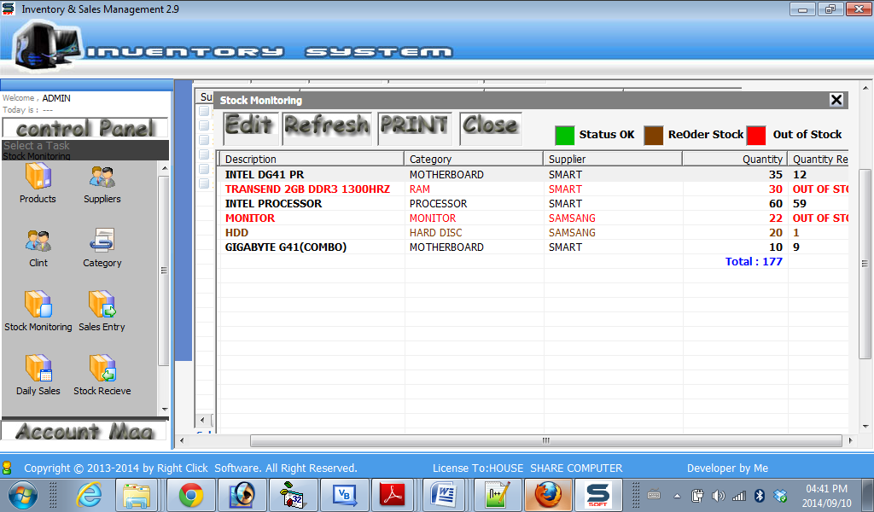

SALES FORM

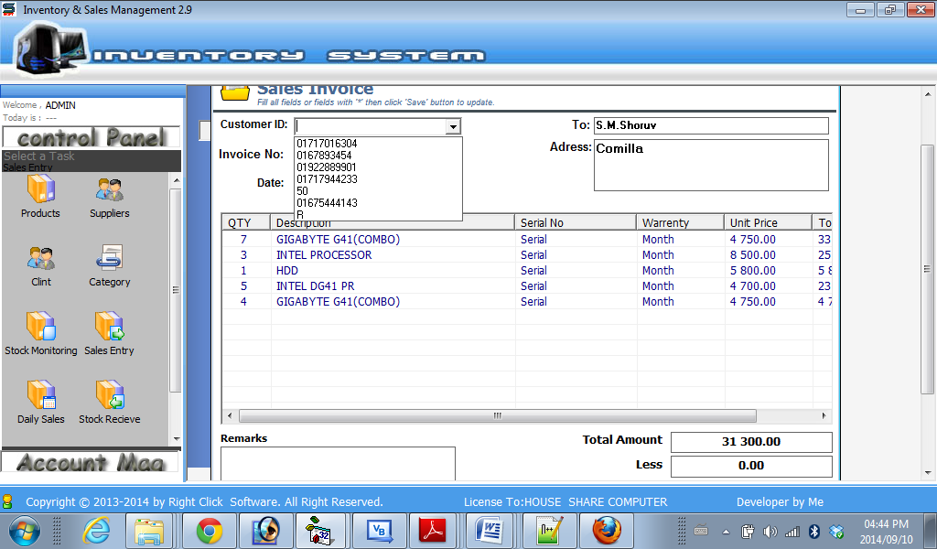

**NEW CUSTOMER REGISTRATION FORM**

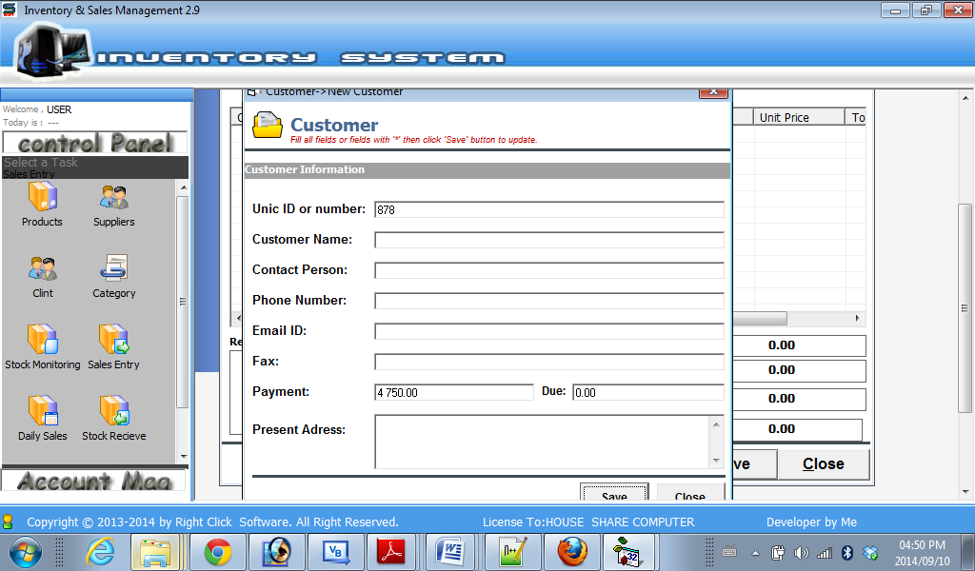

**RECEIPT FORM**

