**DESIGN AND IMPLEMENTATION OF A WEB-BASED SYSTEM FOR DISTANCE LEARNING (CASE STUDY OF NOUN UNIVERSITY)**

**ABSTRACT**

*This project is to design a Web-based distance learning system, where instructors and students can participate fully in distance learning activities while geographically separated from each other. This project is aimed to design and implement a distance learning system and use internet as the delivery mode. This report discusses in detail background research on distance education and different modes of delivery technologies used. It also discusses advantages and disadvantages of distance learning. It also gives tips for successful distance learning and who should opt distance learning, as it is not suited for everyone. This project presents the design and implementation of this new and inexpensive distance learning system. It was developed using HTML, CSS and PHP. It handles three different kinds of users: student, instructor and admin*.

**CHAPTER ONE**

**INTRODUCTION**

**BACKGROUND OF THE STUDY**

Education is the way toward achieving a generally lasting change in human conduct. It is the primary instrument used to safeguard, keep up and overhaul people’s culture, standards and qualities. In any developing country, education is a veritable device for deciding innovative headway and passing on to the new ages, the current learning of the physical condition. Training likewise fills in as stage for presenting people to any association, giving aptitudes for performing day by day employments, recreation just as teaching sound ethics in the individuals for their own advantage and that of the general public. In synopsis, training is the stage on which more youthful age comprehend the past legacy just as take an interest and contribute seriously to the development and advancement of the general public. Conventionally, education has been practiced across the world in segregated buildings by carefully regimented and standardized classes of students and teachers. This has a consequential effect on both the teacher and the learner. For instance, education is verifiably limited distinctly to the individuals who could be in the classroom and pursue the instructor unbendingly with the pace by which he introduces his lectures, the ever increasing population explosion all over the continent and different educational system in every region of the world brought greater challenges to this method of education. For instance, there is an issue of lacking number of human and material assets to cater for the training of the enormous populace. The number of inhabitants in school age resident in many spots has developed immensely to the degree that solitary a little rate can be offered admission. The student – lecturer and student-classroom ratios have grown to the extent that teaching and learning in the classroom have been less effective. The field of education therefore provides the most fascinating application of computing system, which has consequently attracted considerable attention from educationists and policy makers since the late 1960s when computers were introduced into classrooms. Various information technologies have been applied in learning and teaching, such as Computer Aided Instruction, (CAI), Computer Aided Learning (CAL), Research Packages, Project Monitoring, and Computerized Libraries and so on. As a result of technological advancement in multimedia technology, computer networks and the Internet, computers are now being applied in distance learning premised on on-line and real time teaching and instruction.

A distance learning framework carries education nearer to the individuals and evacuates the pressure and imperatives, which characterize the conventional classroom learning system. The hallmarks of distance learning are the separation of teacher and learner in space and/or time, the control of learning by the student rather than the distant instructor, and non-adjacent communication between student and teacher, mediated by print or other forms of technology. At its most essential level, distance education is a procedure where number of teachings is conducted by remotely located lecturers. Two categories of distance learning systems exist; namely On-line and Off-line distance learning. On-line distance learning, also known as virtual classroom is a type of learning system in which students work on their own at home or at the office and communicate with personnel and different studies by means of email, electronic discussions, videoconferencing and different types of PC based correspondence. Off-line distance learning on its own is a multi-campus system where a University or Polytechnic establishes many campuses and each of these campuses may be centrally controlled or decentralized.

* 1. **STATEMENT OF THE PROBLEM**

The role of education for the development of a country is indispensable and countries like Nigeria, countries with very large number of population, with backward technology and few numbers of instructors, are required to contribute more on this division in order to get taught residents with quality and quantity. One methods for doing this is through expanding the quantity of colleges with sufficient human and material assets. Even this may not meet the demand as there are always learners with different constraints which are beyond the capability of universities, moreover the establishment of a university is costly and time taking tasks. So providing education in distance with the existing institutes and academicians can be taken as a best alternative. However the provision of distance education in Nigeria, which mainly uses paper and classrooms as means of delivery, is so passive that there is no interactivity among the students themselves and with tutors. This lack of interactivity is considered as one of factors that affects the quality of distance education. The application of computer assisted distance education can bring the missed interactivity using different tools. In addition to the interactivity, such technique can provide progressive follow ups of the students and avoid the distance barriers in providing the materials. Therefore, this project aims to come up with a web based distance education so as to alleviate or minimize the stated limitations of distance education.

* 1. **AIM AND OBJECTIVE OF THE STUDY**

The main aim of the study is to Design and Implement a web based system for distance learning for NOUN University, with the following objectives:

1. Provide course material on time and with different media types (audio, text and video).
2. Provide online exams.
3. Provide upcoming events
4. Generate grade report.
5. Provide a chat room.
   1. **SCOPE OF THE STUDY**

The scope of the research is focused on designing and implementing a web based system for Distance Learning using innovative technology as a significance tool to drive quality of education using National Open University of Nigeria (NOUN), Nigeria.

**1.5 LIMITATION OF THE STUDY**

During the cause of the study, I encountered they major challenges:

1. Data collection
2. Lack of time
3. Poor Internet Network and many more.

**1.6 DEFINITION OF TERMS**

**NOUN** – National Open University of Nigeria.

**e- Learning** - Distance learning refers to a learning system that we can obtain through the internet using an electronic device.

**Education** - Education is the process of facilitating learning, or the acquisition of knowledge, skills, values, beliefs, and habits.

**CAI** - Computer Aided Instruction

**CAL** - Computer Aided Learning.

**Technology** - the application of scientific knowledge for practical purposes, especially in industry.

**University**- an institution of higher (or tertiary) education and research which awards academic degrees in various academic disciplines.

**Distance Learning** - Distance learning is a way of learning remotely without being in regular face-to-face contact with a teacher in the classroom.

References –

1. Akinyokun O.C., (2003), Prototype of Multimedia System for Nigerian University Collaborative Teaching and Learning. Proceedings of All African University Day Seminar, Federal University of Technology, Akure. Akintola K. G, (2004), Development of Computer Network for Teaching and Learning in Nigerian Universities.M. Tech. Thesis, Federal University of Technology, Akure.
2. Akintola K. G. and Akinyokun O. C., (2011), Design and Development of Multimedia Network System for Distance learning in Nigeria Universities.International Journal of Multimedia and Ubiquitous Engineering, Vol. 6, No. 3, pages 49-60.
3. Akinyokun O.C., Ubaru M.O. and Ezekwesili E., (2008), Information and Communications Technology for Development in Education Sector of Nigerian Economy.Proceedings of the International Conference on ICT Applications; Sponsored and Organized by Carnegie Corporation of New York and Obafemi Awolowo University, Ile-Ife, Nigeria.
4. Perraton H. (1998), A Theory of Distance Education. International perspectives Routledge. Pacific Mountain Network (producer), Far view I-IV [Videotape series]. Available from PMN, 1550 park avenue, Denver, CO 80218-1661, pp 34-45 [6]. Jonassen D. H. (1992), Applications and Limitations of hypertext technology for distance Learning. Paper presented at the distance learning workshop, Armstrong Laboratory, San Antonio, TX.

**CHAPTER TWO**

**2.0 LITERATURE REVIEW**

**2.1 INTRODUCTION**

By 2006, 3.5 million students were participating in on-line learning at institutions of higher education in the United States. According to the Sloan Foundation reports, there has been an increase of around 12–14 per cent per year on average in enrollments for fully online learning over the five years 2004–2009 in the US post-secondary system, compared with an average of approximately 2 per cent increase per year in enrollments overall. Allen and Seamen (2009) claims that almost a quarter of all students in post-secondary education were taking fully online courses in 2008, and a report by Ambient Insight Research suggests that in 2009, 44 per cent of post-secondary students in the USA were taking some or all of their courses online, and projected that this figure would rise to 81 per cent by 2014. Thus it can be seen that Distance learning is moving rapidly from the margins to being a predominant form of post-secondary education, at least in the USA.

Many higher educations, for-profit institutions, now offer on-line classes. By contrast, only about half of private, non-profit schools offer them. The Sloan report, based on a poll of academic leaders, says that students generally appear to be at least as satisfied with their on-line classes as they are with traditional ones. Private institutions may become more involved with on-line presentations as the cost of instituting such a system decreases. Properly trained staff must also be hired to work with students on-line. These staff members need to understand the content area, and also be highly trained in the use of the computer and Internet. Online education is rapidly increasing, and online doctoral programs have even developed at leading research universities.

**2.2 APPROCHES TO DISTANCE LEARNING SERVICES**

Distance learning services have evolved since computers were first used in education. There is a trend to move towards blended learning services, where computer-based activities are integrated with practical or classroom-based situations.

Bates and Poole (2003) and the OECD (2005) suggest that different types or forms of Distance learning can be considered as a continuum, from no Distance learning, i.e. no use of computers and/or the Internet for teaching and learning, through classroom aids, such as making classroom lecture PowerPoint slides available to students through a course web site or learning management system, to laptop programs, where students are required to bring laptops to class and use them as part of a face-to-face class, to hybrid learning, where classroom time is reduced but not eliminated, with more time devoted to online learning, through to fully online learning, which is a form of distance education. This classification is somewhat similar to that of the Sloan Commission reports on the status of Distance learning, which refer to web enhanced, web supplemented and web dependent to reflect increasing intensity of technology use. In the Bates and Poole continuum, 'blended learning' can cover classroom aids, laptops and hybrid learning, while 'distributed learning' can incorporate either hybrid or fully online learning.

It can be seen then that Distance learning can describe a wide range of applications, and it is often by no means clear even in peer reviewed research publications which form of Distance learning is being discussed. However, Bates and Poole argue that when instructors say they are using Distance learning, this most often refers to the use of technology as classroom aids, although over time, there has been a gradual increase in fully online learning.

**2.3** **COMPUTER BASED LEARNING**

Computer-based learning, sometimes abbreviated to CBL, refers to the use of computers as a key component of the educational environment. While this can refer to the use of computers in a classroom, the term more broadly refers to a structured environment in which computers are used for teaching purposes. The concept is generally seen as being distinct from the use of computers in ways where learning is at least a peripheral element of the experience (e.g. computer games and web browsing).

**2.4 COMPUTER BASED TRAINING**

Computer-Based Trainings (CBTs) are self-paced learning activities accessible via a computer or handheld device. CBTs typically present content in a linear fashion, much like reading an online book or manual. For this reason they are often used to teach static processes, such as using software or completing mathematical equations. The term Computer-Based Training is often used interchangeably with Web-based training (WBT) with the primary difference being the delivery method. Where CBTs are typically delivered via CD-ROM, WBTs are delivered via the Internet using a web browser. Assessing learning in a CBT usually comes in the form of multiple choice questions, or other assessments that can be easily scored by a computer such as drag-and-drop, radial button, simulation or other interactive means. Assessments are easily scored and recorded via online software, providing immediate end-user feedback and completion status. Users are often able to print completion records in the form of certificates.

CBTs provide learning stimulus beyond traditional learning methodology from textbook, manual, or classroom-based instruction. For example, CBTs offer user-friendly solutions for satisfying continuing education requirements. Instead of limiting students to attending courses or reading printing manuals, students are able to acquire knowledge and skills through methods that are much more conducive to individual learning preferences. For example, CBTs offer visual learning benefits through animation or video, not typically offered by any other means.

CBTs can be a good alternative to printed learning materials since rich media, including videos or animations, can easily be embedded to enhance the learning. Another advantage to CBTs is that they can be easily distributed to a wide audience at a relatively low cost once the initial development is completed.

However, CBTs pose some learning challenges as well. Typically the creation of effective CBTs requires enormous resources. The software for developing CBTs (such as Flash or Adobe Director) is often more complex than a subject matter expert or teacher is able to use. In addition, the lack of human interaction can limit both the type of content that can be presented as well as the type of assessment that can be performed. Many learning organizations are beginning to use smaller CBT/WBT activities as part of a broader online learning program which may include online discussion or other interactive elements.

**2.5 COMPUTER SUPPORTED COLLABORATIVE LEARNING (CSCL)**

Computer supported collaborative learning (CSCL) is one of the most promising innovations to improve teaching and learning with the help of modern information and communication technology. Most recent developments in CSCL have been called Distance learning 2.0, but the concept of collaborative or group learning whereby instructional methods are designed to encourage or require students to work together on learning tasks has existed much longer. It is widely agreed to distinguish collaborative learning from the traditional 'direct transfer' model in which the instructor is assumed to be the distributor of knowledge and skills, which is often given the neologism Distance learning 1.0, even though this direct transfer method most accurately reflects Computer-Based Learning systems(CBL).  
In *Datacloud: Toward a New Theory of Online Work*, Johndan Johnson-Eilola describes a specific computer-supported collaboration space: The Smart Board. According to Johnson-Eilola, a “Smart Board system provides a 72-inch, rear projection, touchscreen, intelligent whiteboard surface for work”. In *Datacloud*, Johnson-Eilola asserts that “we are attempting to understand how users move within information spaces, how users can exist within information spaces rather than merely gaze at them, and how information spaces must be shared with others rather than being private, lived within rather than simply visited”. He explains how the Smart Board system offers an information space that allows his students to engage in active collaboration. He makes three distinct claims regarding the functionality of the technology:

1) The Smart Board allows users to work with large amounts of information,

2) It offers an information space that invites active collaboration,

3) The work produced is often “dynamic and contingent”. Johnson-Eilola further explains that with the Smart Board “…information work becomes a bodied experience”. Users have the opportunity to engage with inhabit the technology by direct manipulation. Moreover, this space allows for more than one user; essentially, it invites multiple users.

**2.6** **TECHNOLOGY ENHANCED LEARNING (TEL)**

Technology enhanced learning (TEL) has the goal to provide socio-technical innovations (also improving efficiency and cost effectiveness) for Distance learning practices, regarding individuals and organizations, independent of time, place and pace. The field of TEL therefore applies to the support of any learning activity through technology.

Along with the terms *learning technology*, *instructional technology*, and *Educational Technology*, the term is generally used to refer to the use of technology in learning in a much broader sense than the *computer-based training* or *Computer Aided Instruction* of the 1980s. It is also broader than the terms *Online Learning* or *Online Education* which generally refer to purely web-based learning. In cases where mobile technologies are used, the term M-learning (MobilDistance learning) has become more common. Distance learning, however, also has implications beyond just the technology and refers to the actual learning that takes place using these systems.

Distance learning is naturally suited to distance learning and flexible learning, but can also be used in conjunction with face-to-face teaching, in which case the term Blended learning is commonly used. Distance learning pioneer Bernard Luskin argues that the "E" must be understood to have broad meaning if Distance learning is to be effective. Luskin says that the "e" should be interpreted to mean exciting, energetic, enthusiastic, emotional, extended, excellent, and educational in addition to "electronic" which is a traditional national interpretation. This broader interpretation allows for 21st century applications and brings learning and media psychology into the equation.

In higher education especially, the increasing tendency is to create a Virtual Learning Environment (VLE) (which is sometimes combined with a Management Information System (MIS) to create a Managed Learning Environment) in which all aspects of a course are handled through a consistent user interface standard throughout the institution. A growing number of physical universities, as well as newer online-only colleges, have begun to offer a select set of academic degree and certificate programs via the Internet at a wide range of levels and in a wide range of disciplines. While some programs require students to attend some campus classes or orientations, many are delivered completely online. In addition, several universities offer online student support services, such as online advising and registration, e-counseling, online textbook purchase, student governments and student newspapers.

Distance learning can also refer to educational websites such as those offering learning scenarios, worksheets and interactive exercises for children. The term is also used extensively in the business sector where it generally refers to cost-effective online training.

The recent trend in the Distance learning sector is screencasting. There are many screencasting tools available but the latest buzz is all about the web based screencasting tools which allow the users to create screencasts directly from their browser and make the video available online so that the viewers can stream the video directly. The advantage of such tools is that it gives the presenter the ability to show his ideas and flow of thoughts rather than simply explain them, which may be more confusing when delivered via simple text instructions. With the combination of video and audio, the expert can mimic the one on one experience of the classroom and deliver clear, complete instructions. From the learner's point of view this provides the ability to pause and rewind and gives the learner the advantage of moving at their own pace, something a classroom cannot always offer.

**2.7 COMMUNICATION TECHNOLOGIES USED IN DISTANCE LEARNING**

Communication technologies are generally categorized as asynchronous or synchronous. *Asynchronous* activities use technologies such as blogs, wikis, and discussion boards. The idea here is that participants may engage in the exchange of ideas or information without the dependency of other participants’ involvement at the same time. Electronic mail (Email) is also asynchronous in that mail can be sent or received without having both the participants’ involvement at the same time.

*Synchronous* activities involve the exchange of ideas and information with one or more participants during the same period of time. A face to face discussion is an example of synchronous communications. *Synchronous* activities occur with all participants joining in at once, as with an online chat session or a virtual classroom or meeting.

Virtual classrooms and meetings can often use a mix of communication technologies.

In many models, the writing community and the communication channels relate with the Distance learning and the M-learning communities. Both the communities provide a general overview of the basic learning models and the activities required for the participants to join the learning sessions across the virtual classroom or even across standard classrooms enabled by technology. Many activities, essential for the learners in these environments, require frequent chat sessions in the form of virtual classrooms and/or blog meetings. Lately context-aware ubiquitous technology has been providing an innovative way for written and oral communications by using a mobile device with sensors and RFID readers and tags (Liu & Hwang 2009).

A learning management system (LMS) is software for delivering, tracking and managing training/education. LMSs range from systems for managing training/educational records to software for distributing courses over the Internet and offering features for online collaboration.

A learning content management system (LCMS) is software for authoring, editing and indexing Distance learning content (courses, reusable content objects). An LCMS may be solely dedicated to producing and publishing content that is hosted on an LMS, or it can host the content itself (remote AICC content hosting model).

Computer-aided Assessment (also but less commonly referred to as E-assessment), ranging from automated multiple-choice tests to more sophisticated systems is becoming increasingly common. With some systems, feedback can be geared towards a student's specific mistakes or the computer can navigate the student through a series of questions adapting to what the student appears to have learned or not learned.

The best examples follow a Formative Assessment structure and are called "Online Formative Assessment". This involves making an initial formative assessment by sifting out the incorrect answers. The author/teacher will then explain what the pupil should have done with each question. It will then give the pupil at least one practice at each slight variation of sifted out questions. This is the formative learning stage. The next stage is to make a Summative Assessment by a new set of questions only covering the topics previously taught. Some will take this even further and repeat the cycle such as BOFA which is aimed at the Eleven plus exam set in the UK.

The term *learning design* has sometimes come to refer to the type of activity enabled by software such as the open-source system LAMS which supports sequences of activities that can be both adaptive and collaborative. The IMS Learning Design specification is intended as a standard format for learning designs and IMS LD Level A is supported in LAMS V2.elearning has been replacing the traditional settings due to its cost effectiveness.

Electronic performance support systems (EPSS) is a "computer-based system that improves worker productivity by providing on-the-job access to integrated information, advice, and learning experiences". 1991, Barry Raybould

**CHAPTER THREE**

**METHODOLOGY AND ANALYSIS OF THE EXISTING SYSTEM**

**3.1 Introduction**

This chapter describes the methods that were used in the study. It explains the research design, the study population, sampling method and procedures, data collection procedures and instruments, data analysis, reporting and ethical issues.

**3.2 Research Design**

The research design was an analytical survey. Analytical surveys also referred to as diagnostic studies attempt to describe and explain *why* certain situations exist. In this approach two or more variables are usually examined to test research hypotheses. The results allow researchers to examine the interrelationships among variables and to draw explanatory inferences. In this study, the researcher sought to establish the relationship between prior computer skills; socio-demographic characteristics; and level of student engagement effect on academic attainment.

**3.3 Unit of Analysis**

According to Mugenda and Mugenda (2003) units of analysis are units that are designed for purposes of aggregating their characteristics in order to describe some larger group or abstract phenomenon. Nachmias and Nachmias (1996) describe the units of analysis as the most elementary part of the phenomenon to be studied. To Singleton et.al (1988; 69) they are “what or whom to be analyzed”. In this study, the unit of analysis was the different categories discussed in this paper as the ‘study modes’ (Distance learning and conventional).

**3.4 Unit of Observation**

The unit of observation in this study was the individual students whose performance was aggregated to inform category performance.

**3.5 Study Population**

In this study, the population of interest is beneficiaries of the 1500 computers that were provided by ComputerAid international. Each computer was to be used by five Distance learning students. The total population of the beneficiaries is (1500 * 5) 7500 students. An equivalent population was targeted for students under the conventional learning mode so as to avoid overrepresentation of one category. The total population in this study was thus fifteen thousand, (7500 * 2 = 15000) being seven thousand five hundred on the Distance learning program and seven thousand five hundred on the conventional study mode. From the total population, a sample of one hundred and fifty students’ constituting seventy five on Distance learning mode and seventy five on the conventional study mode was targeted. This is a total sample population of 150 which is 1 percent of the total population. The sample 75 for each category was guided by Dr. John Curry Professor of Educational Research, North Texas State University (now retired), who provided his research students (fall, 1984) with the "rule of thumb" on sampling (Gay, 1987) presented in the table 3.1 below. The sample size was also deemed appropriate when it was noted that the beneficiaries of the group learning sets are spread across the country, time and finances did not allow for inclusion of a bigger number. On the same note, in the bid to have equal representation, the number seventy five was settled for students under traditional learning mode.

Table: 3.1 Population sample size

|  |  |
| --- | --- |
| **Size of population** | **Sampling percent** |
| 0-100 | 100% |
| 101-1,000 | 10% |
| 1,001-5,000 | 5% |
| 5,001-10,000 | 3% |
| 10,000+ | 1% |

**Source Gay (1987)**

**3.6 Sampling Method and Procedures**

Through a systematic random sampling procedure where a neutral start point was identified by the researcher where the first student was identified randomly, within the study location. It was key to consider gender parity in the study, as such for those under conventional study mode, if a male student was picked the next was to be a female respondent. Identification of the starting point was done at the gate of Kenyatta University, the data collection was done on one side of the road towards the administration block, upon reaching the administration block, and the other side of the road was taken towards the gate. After identification of the first respondent, five students were past then the sixth was included in the study, if the sixth student was not of the opposite gender, five more students were past till the opposite gender was found. The process was repeated until seventy five respondents were interviewed.

To identify Distance learning respondents, a list of students was obtained from the institution, systematic random sampling was then used to select seventy five students. A starting point was first randomly picked then every fifth name in the list was included in the sample.

**3.7 Data Collection Procedures and Instruments**

This project presents the design and implementation of this new and inexpensive distance learning system. It was developed using HTML, CSS and PHP. It handles three different kinds of users: student, instructor and admin.

**3.7.1 Reliability and Validity**

According to Devellis (1991), as cited by Mugenda, (2004) reliability is the proportion of variance attributable to the time measurement of a variable and estimates the consistency of such measurement over time from a research instrument. It is a measure of the degree to which a research instrument would yield the same results or data after repeated trials.

Validity establishes the relationship between the data and the variable or construct of interest. Its estimates how accurately the data obtained in a study represents a given variable or construct in the study Mugenda, (2004).

**3.8 Data Analysis and Reporting**

According to Miles and Huberman (1994) data analysis is an iterative process. Data analysis consists of three activities: Data reduction, Data display, and Conclusion drawing/verification”.

Data reduction, this process is applied to qualitative data and focus remains on selection, simplification and transformation of data. In this continuous process the data is organized throughout the research to draw and finalize a conclusion (Miles and Huberman, 1994). In this research, the data was reduced from critical elements in implementation of Distance learning to students’ academic performance.

In data display the data is displayed in an organized form or the data has to be put into an order to easily draw the conclusion. Tables and graphs are used to indicate distinct frequencies of various factors of Distance learning implementation and academic performance.

**3.9 Ethical Issues**

**Confidentiality:** The participants were guaranteed that the identifying information will not be made available to anyone who is not involved in the study and it will remain confidential for the purposes it is intended for.

**Permission:** The researcher sought permission to carry out the research from the University

**Informed consent**: The prospective research participants were fully informed about the procedures involved in the research and were asked to give their consent to participate.

**Anonymity:** The participant remained anonymous throughout the study and even to the researchers themselves to guarantee privacy.

**CHAPTER FOUR**

**DESIGN AND IMPLEMENTATION OF THE NEW SYSTEM**

**4.1 DESIGN STANDARD**

1. Design a web-based distance learning system.
2. Design a login button.
3. Design a user and admin dashboard.
4. Design an input format that will enable the user to insert their registration details.
5. Design an Output format that will enable the user to view their details.
6. Structure a database system that will store all the information using Wamp Server.
   1. **OUTPUT SPECIFICATION AND DESIGN**

The output design was based on the inputs. The report generated gives a meaningful report. These outputs can be generated as softcopy or printed in hard copy.

**4.3 INPUT DESIGN AND SPECIFICATION**

Computer is designed in such a way that sometimes it is called GIGO, denoting that what goes in is what comes out. The input forms are designs generally based on the necessary data that needs to be entered into the system. The data are captured through the keyboard and stored on a magnetic disk in an access database.

**4.4 FILE DESIGN**

Mysql Server database was used. The name of the database created is “dbcaiwl”. Below shows the table created with columns and their data types:

4.4.1 Structure for table “tblstudent”

|  |  |  |
| --- | --- | --- |
| FIELD NAME | **DATA TYPE** | **SIZE** |
| StudentID | int | 11 |
| Fname | varchar | 90 |
| Lname | varchar | 90 |
| Address | varchar | 90 |
| MobileNo | varchar | 90 |
| STUDUSERNAME | varchar | 90 |
| STUDPASS | varchar | 90 |

4.4.2 Structure for table “tblstudentquestion”

|  |  |  |
| --- | --- | --- |
| FIELD NAME | **DATA TYPE** | **SIZE** |
| SQID | int | 11 |
| ExerciseID | int | 11 |
| LessonID | int | 11 |
| StudentID | int | 11 |
| Question | varchar | 90 |
| CA | varchar | 90 |
| CB | varchar | 90 |
| CC | varchar | 90 |
| CD | varchar | 90 |
| QA | varchar | 90 |

4.4.3 Structure for table “tblusers”

|  |  |  |
| --- | --- | --- |
| FIELD NAME | **DATA TYPE** | **SIZE** |
| USERID | int | 11 |
| NAME | varchar | 90 |
| UEMAIL | varchar | 90 |
| PASS | varchar | 90 |
| TYPE | varchar | 90 |

4.4.1 Structure for table “tblscore”

|  |  |  |
| --- | --- | --- |
| FIELD NAME | **DATA TYPE** | **SIZE** |
| ScoreID | int | 11 |
| LessonID | int | 11 |
| ExerciseID | int | 11 |
| StudentID | int | 11 |
| NoItems | int | 11 |
| Score | int | 11 |
| Submitted | tinyint | 1 |

**4.6 SYSTEM FLOWCHART**

E – Learning System

Processor

Disk

Storage

Output (Report)

Result to Screen

Input From the

Keyboard

Control Unit

4.7 SYSTEM REQUIREMENTS

The requirements needed to implement this system are as follows:

4.7.1 Hardware Requirements

The software designed needed the following hardware for an effective operation of the newly designed system.

1. A system running on AMD, Pentium 2 or higher processor
2. The random access memory (ram) should be at least 512mb.
3. Enhanced keyboard.
4. At least 20 GB hard disk.
5. V.G.A or a colored monitor.

**4.7.2 Software Requirements**

The software requirements includes:-

1. A window 98 or higher version for faster processing.
2. Wamp Server.
3. PHP
4. MYSQL Server.

4.8 PROGRAM FLOWCHART

Start

LOGIN FORM

Input User and Password

Yes

No

Stop

Dashboard

**CHAPTER FIVE**

**SUMMARY, CONCLUSION AND RECOMMENDATIONS**

**5.1 SUMMARY**

This study focused on the impact of Distance learning on academic performance. The study relates to a level one undergraduate module delivered using traditional lectures and Distance learning based methods. Distance learning has been revealed in this study not to have a positive impact on academic achievement contrary to the expectations of this study.

The paper also examines the data for the presence of interaction effects between Distance learning study hours and socio-demographic characteristics. This is undertaken to identify whether or not personal-characteristic-related learning style differences influence the extent to which students benefit from Distance learning. It is found that, after controlling for other factors, female students benefited less from e-leaning material than their male counterparts.

The methodology that was employed in this study was systematic random sampling for students under traditional study mode and purposive sampling in identification of students under the Distance learning study mode.

It is concluded that in order to improve teaching effectiveness and academic achievement, higher education should consider aiming to develop Distance learning teaching strategies that encourage greater engagement and also take into consideration the different learning styles found within the student body.

The study recommends that critical factors such as institutional issue, management issue, pedagogical factors, technological issue, interface design issue, evaluation issue, and resource support issue and the factors within each issue have not yet been investigated with detail coverage. It further suggests that there is need to carry out detail research involving case studies based on survey questionnaires involving various learning institutions which will ultimately give a better understanding of impact of Distance learning aspects within implementation process.

**5.2 CONCLUSION**

This short study highlights the impact of electronic learning on academic performance of students. Many students are not well prepared to take the challenge of studying through Distance learning, because of the unexpected complexities of the application of IT as a learning tool that requires commitment as there is no strict rules on the learning times.

The perception is that the world has become smaller as a result of the immense progress made in the field of information and communication technologies. IT is accessible to all across the continents and the oceans through the satellites, cables, and other such devices that have made man more independent and have increased his mobility by making distances shorter and communication faster.

As the analysis of data gathered on a small sample of a hundred people, has shown that, there are still many issues that need to be closely considered before we can safely state that Distance learning and other related learning methods have contributed to the enhancement of the performance of students at the higher levels of our education system, irrespective of individual differences due to heredity and/or environment. It can be confidently said that there is still a long way to go before we can make the whole world harvest the benefits from the progress of science and technology.

**5.3 RECOMMENDATIONS FOR FURTHER READING**

This research elicited and examined a number of extreme points of views about the impact of Distance learning on academic achievement. Although it was discovered that certain issues have not yet been properly addressed to Distance learning implementation processes, as the prime focus of the research was on prior computer skills, number of hours individual spend studying and socio-demographic characteristics. The following are the recommendations of this study:

* + 1. Critical factors such as institutional issue, management issue, pedagogical factors, technological issue, interface design issue, evaluation issue, and resource support issue and the factors within each issue have not yet been investigated with detail coverage.
    2. The need to carry out detail research involving case studies based on survey questionnaires involving various learning institutions which will ultimately give a better understanding of impact of Distance learning aspects within implementation process.

APPENDICES

APPENDIX A: FRONT END

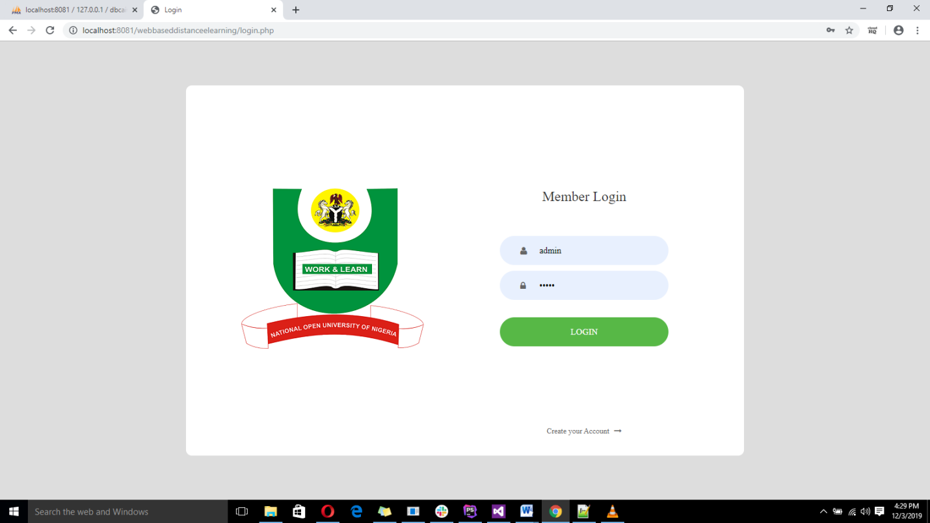

Login Screen

APPENDIX B: REGISTER PAGE

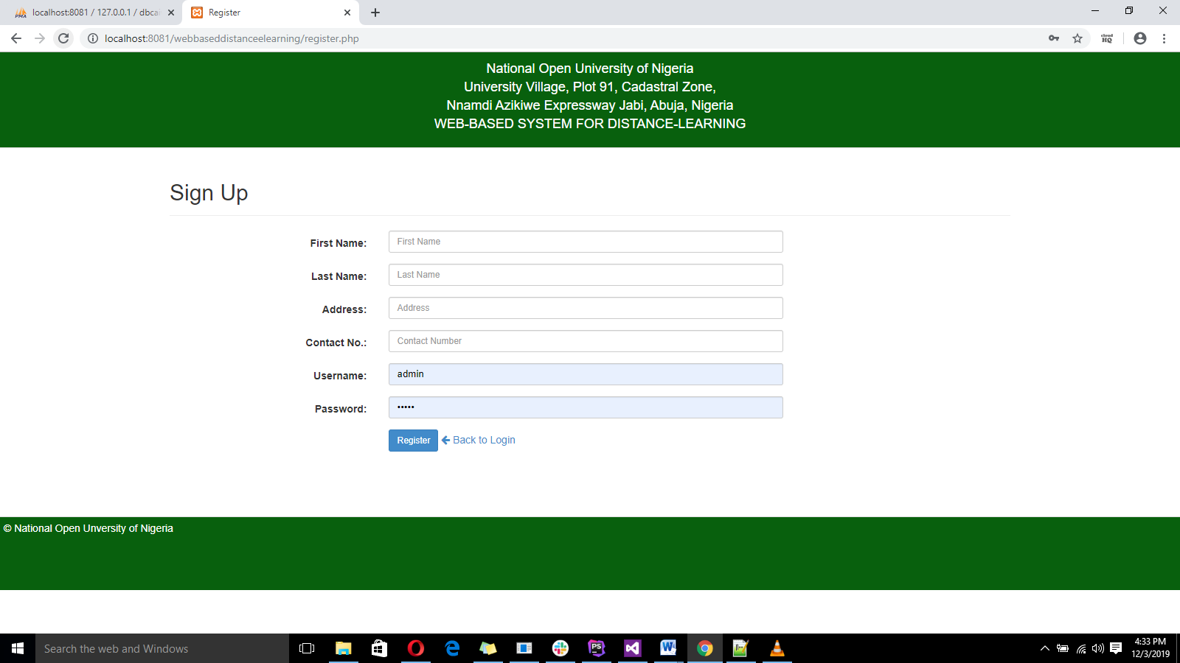

Register page

APPENDIX C: USER DASHBOARD



APPENDIX D: ADMIN DASHBOARD

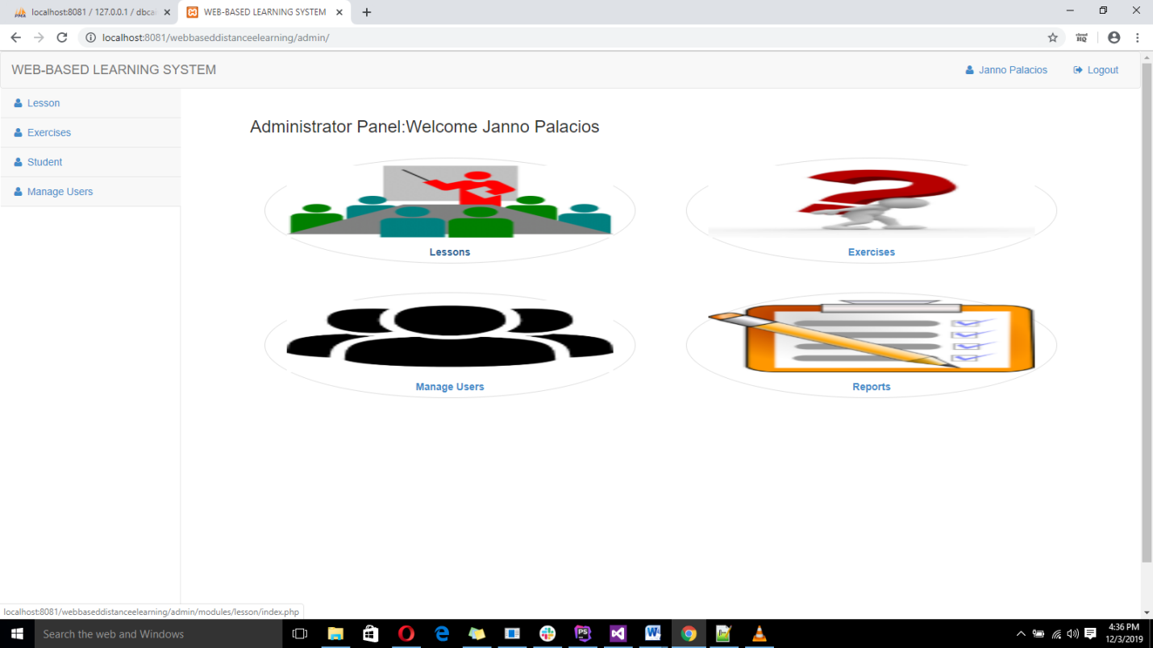

**BILIOGRAPHY**

Allen, I. and Seaman, J. (2009). *Online Education in the United States.*

New Jersey: Wiley publishing.

Allen, I. and Seaman, J. (2003). *The Quality and Extent of Online*

*Education in the United States.* New Jersey:Wiley publishing.

Bates, A. (2005). *Distance learning and Distance Education.*

London: Oxford university press.

Edward, C. (2000). *Distance learning Designing*. Brussels: Sams publishing.

Graziadei, W. (1993). *Virtual Instructional Classroom Environment in*

*Science (VICES).* Atlanta: Hila press

Harasim, L. Hiltz, S. et al (1995). A Field Guide to Teaching and

Learning Online.Cambridge: MIT Press.

Hebert, D. (2007). *[Five Challenges and Solutions in Online Music Teacher](http://www.stthomas.edu/rimeonline/vol5/hebert.htm)*

*[Education](http://www.stthomas.edu/rimeonline/vol5/hebert.htm).* London: Oxford university press

Hiltz, S. (1990). *Evaluating the Virtual Classroom.* New York: St. Martin’s

press

Karrer, T (2008). *Corporate Long Tail Learning and Attention Crisis.*

California: Sun Microsystems, Inc.

Kerkman, L. (2004). *Convenience of Online Education Attracts Midcareer*

*Students.* Cambridge: MIT Press.

Leypoldt, M. Tavangarian, D. et al (2004). *Is Distance learning the Solution for*

*Individual Learning?* Denmark: Aalborg University press.

Mason. R, and Kaye, A. (1989). *Computers and Distance Education.*

London: Oxford university press

Means, B. Toyama, Y. et al (2009). *[Evaluation of Evidence-Based](http://www.ed.gov/rschstat/eval/tech/evidence-based-practices/finalreport.pdf)*

*[Practices in Online Learning.](http://www.ed.gov/rschstat/eval/tech/evidence-based-practices/finalreport.pdf)* [USA:](http://www.ed.gov/rschstat/eval/tech/evidence-based-practices/finalreport.pdf)[McGraw Hill companies](http://www.ed.gov/rschstat/eval/tech/evidence-based-practices/finalreport.pdf)

Nagy, A. (2005). *The Impact of Distance learning.* Berlin: Bath press avon

Redecker, C. (2009). *[Review of Learning 2.0 Practices.](http://ipts.jrc.ec.europa.eu/publications/pub.cfm?id=2059)* [Cambridge: MIT](http://ipts.jrc.ec.europa.eu/publications/pub.cfm?id=2059)

[Press.](http://ipts.jrc.ec.europa.eu/publications/pub.cfm?id=2059)

Seely B, John A, et al (2008). *[Open Education, the Long Tail, and](http://net.educause.edu/ir/library/pdf/ERM0811.pdf)*

*[Learning 2.0](http://net.educause.edu/ir/library/pdf/ERM0811.pdf).* Washington: Grandmasters Inc.

**Journals**

Ambient Insight Research (2009) US Self-paced Distance learning Market

Solan commission reports

**URL (Universal Resources Locator)**

[Www.wikipedia.com](http://Www.wikipedia.com)

APPENDIX E: SOURCE CODE

**Register.php**

<?php

require_once ("include/initialize.php");

if (isset($_SESSION['StudentID'])) {

# code...

redirect('index.php');

}

?>

<!DOCTYPE html>

<html lang="en">

<head>

<meta charset="utf-8">

<meta name="viewport" content="width=device-width, initial-scale=1.0">

<meta name="description" content="">

<meta name="author" content="">

<title>Register</title>

<!-- Bootstrap core CSS -->

<link href="<?php echo web_root; ?>css/bootstrap.min.css" rel="stylesheet">

<link href="<?php echo web_root; ?>fonts/font-awesome.min.css" rel="stylesheet" media="screen">

<style type="text/css">

#title-header {

background-color: #08600d;

border-bottom: 1px solid #ddd;

height: 130px;

padding: 10px 0px;

text-align: center;

color: #fff;

font-size: 18px;

}

</style>

<section id="title-header">

<div class="title">

National Open University of Nigeria <br>University Village, Plot 91, Cadastral Zone,

<br>Nnamdi Azikiwe Expressway

Jabi, Abuja,

Nigeria

<p class="subtitle"> WEB-BASED SYSTEM FOR DISTANCDISTANCE LEARNING</p>

</div>

</section>

<div class="container" style="min-height: 500px;">

<p class="page-header" style="font-size: 30px;">Sign Up</p>

<?php check_message(); ?>

<div id="login-dp">

<form class="form-horizontal span6" action="" method="POST" enctype="multipart/form-data" id="login-nav">

<div class="form-group">

<div class="col-md-9">

<label class="col-md-4 control-label" for=

"FNAME">First Name:</label>

<div class="col-md-8">

<input class="form-control input-sm" id="FNAME" name="FNAME" placeholder=

"First Name" type="text" value="" required>

</div>

</div>

</div>

<div class="form-group">

<div class="col-md-9">

<label class="col-md-4 control-label" for=

"LNAME">Last Name:</label>

<div class="col-md-8">

<input class="form-control input-sm" id="LNAME" name="LNAME" placeholder=

"Last Name" type="text" value="" required>

</div>

</div>

</div>

<div class="form-group">

<div class="col-md-9">

<label class="col-md-4 control-label" for=

"ADDRESS">Address:</label>

<div class="col-md-8">

<input class="form-control input-sm" id="ADDRESS" name="ADDRESS" placeholder=

"Address" type="text" value="" required>

</div>

</div>

</div>

<div class="form-group">

<div class="col-md-9">

<label class="col-md-4 control-label" for=

"PHONE">Contact No.:</label>

<div class="col-md-8">

<input class="form-control input-sm" id="PHONE" name="PHONE" placeholder=

"Contact Number" type="text" value="" required>

</div>

</div>

</div>

<div class="form-group">

<div class="col-md-9">

<label class="col-md-4 control-label" for=

"USERNAME">Username:</label>

<div class="col-md-8">

<input class="form-control input-sm" id="USERNAME" name="USERNAME" placeholder=

"Username" type="text" value="">

</div>

</div>

</div>

<div class="form-group">

<div class="col-md-9">

<label class="col-md-4 control-label" for=

"PASS">Password:</label>

<div class="col-md-8">

<input class="form-control input-sm" id="PASS" name="PASS" placeholder=

"Password" type="password" value="">

</div>

</div>

</div>

<div class="form-group">

<div class="col-md-9">

<label class="col-md-4 control-label" for=

"idno"></label>

<div class="col-md-8">

<button type="submit" name="btnRegister" class="btn btn-primary btn-sm">Register</button>

<a href="login.php"><i class="fa fa-arrow-left"></i> Back to Login</a>

</div>

</div>

</div>

</form>

</div>

</div>

<?php

if (isset($_POST['btnRegister'])) {

# code...

$student = New Student();

$student->Fname = $_POST['FNAME'];

$student->Lname = $_POST['LNAME'];

$student->Address = $_POST['ADDRESS'];

$student->MobileNo = $_POST['PHONE'];

$student->STUDUSERNAME = $_POST['USERNAME'];

$student->STUDPASS = sha1($_POST['PASS']);

$student->create();

message("Your now succefully registered. You can login now!","success");

redirect("register.php");

}

?>

<footer style="height: 100px;border-top:1px solid #ddd;padding: 5px;background-color: #08600d; color:#fff;">

<p align="left">&copy; National Open Unversity of Nigeria</p>

</footer>

</section>

**Navigation.php**

<!DOCTYPE html>

<html lang="en">

<head>

<meta charset="utf-8">

<meta name="viewport" content="width=device-width, initial-scale=1.0">

<meta name="description" content="">

<meta name="author" content="">

<title>National Open Unversity of Nigeria</title>

<!-- Bootstrap core CSS -->

<link href="<?php echo web_root; ?>css/bootstrap.min.css" rel="stylesheet">

<link href="<?php echo web_root; ?>css/bootstrap-datetimepicker.min.css" rel="stylesheet" media="screen">

<link href="<?php echo web_root; ?>css/dataTables.bootstrap.css" rel="stylesheet" media="screen">

<!-- <link href="<?php echo web_root; ?>css/kcctc.css" rel="stylesheet" media="screen"> -->

<link href="<?php echo web_root; ?>fonts/font-awesome.min.css" rel="stylesheet" media="screen">

<link rel="stylesheet" type="text/css" href="<?php echo web_root; ?>loginregister.css">

<link rel="stylesheet" href="<?php echo web_root; ?>assets/iCheck/flat/blue.css">

<!-- bootstrap wysihtml5 - text editor -->

<link rel="stylesheet" href="<?php echo web_root; ?>assets/bootstrap-wysihtml5/bootstrap3-wysihtml5.min.css">

<link rel="stylesheet" href="<?php echo web_root; ?>css/jquery-ui.css">

<style type="text/css">

#content {

min-height: 550px;

margin: 0;

width: 100%;

}

#footer > div {

background-color: #fff;

min-height: 200px;

padding: 10px 50px;

margin-top: 30px;

border-top: 1px solid #ddd;

}

.footer-links {

/*margin-left: 5px;*/

}

#footer > footer {

background-color: #08600d;

min-height: 50px;

padding: 10px;

border-top: 1px solid #ddd;

color:#fff;

}

.navbar-nav {

float: right;

}

@media only screen and (max-width: 768px){

.navbar-nav {

float: none;

}

}

#content {

margin-right: 0px;

margin-left: 90px;

width:90%;

}

#content:before,

#content:after {

display: table;

content: "";

}

#content:after {

clear: both;

}

#content:before,

#content:after {

display: table;

content: "";

}

#content:after {

clear: both;

}

#mySidenav a {

position: absolute;

left: -130px;

transition: 0.3s;

padding: 20px;

width: 190px;

text-decoration: none;

font-size: 25px;

color: white;

border-radius: 0 5px 5px 0;

}

#mySidenav a:hover {

left: 0;

}

#lesson {

top: 180px;

background-color: rgb(0, 67, 200)

}

#exercise {

top:260px;

background-color: rgb(0, 81, 242);

}

#download {

top: 340px;

background-color: rgb(33, 107, 255);

}

#about {

top: 420px;

background-color: rgb(79, 138, 255);

}

#login {

top: 500px;

background-color: rgb(137, 176, 255);

}

#title-header {

background-color: #08600d;

border-bottom: 1px solid #ddd;

height: 130px;

padding: 10px 0px;

text-align: center;

color: #fff;

font-size: 18px;

}

</style>

<body >

<section id="title-header">

<div class="title">

National Open University of Nigeria <br>University Village, Plot 91, Cadastral Zone,

<br>Nnamdi Azikiwe Expressway

Jabi, Abuja,

Nigeria

<p class="subtitle"> WEB-BASED SYSTEM FOR DISTANCDISTANCE LEARNING</p>

</div>

</section>

<section id="navigation">

<div id="mySidenav" class="sidenav">

<a href="<?php echo web_root; ?>index.php?q=lesson" id="lesson">Lesson <i class="fa fa-home"></i></a>

<a href="<?php echo web_root; ?>index.php?q=exercises" id="exercise">Exercises</a>

<a href="<?php echo web_root; ?>index.php?q=download" id="download">Download</a>

<a href="<?php echo web_root; ?>index.php?q=about" id="about">About Us</a>

<a href="logout.php" id="login">Logout</a>

</div>

</section>

<section id="content">

<?php check_message(); ?>

<div class="container">

<?php require_once $content; ?>

</div>

</section>

<section id="footer">

<!-- <div >

</div> -->

<footer >

<p align="left">&copy; National Open Unversity of Nigeria</p>

</footer>

</section>

<script type="text/javascript" language="javascript" src="<?php echo web_root; ?>jquery/jquery.min.js"></script>

<script src="<?php echo web_root; ?>js/bootstrap.min.js"></script>

<script type="text/javascript" src="<?php echo web_root; ?>js/bootstrap-datetimepicker.js" charset="UTF-8"></script>

<script type="text/javascript" src="<?php echo web_root; ?>js/locales/bootstrap-datetimepicker.uk.js" charset="UTF-8"></script>

<script type="text/javascript" language="javascript" src="<?php echo web_root; ?>js/jquery.dataTables.js"></script>

<script src="<?php echo web_root;?>assets/iCheck/icheck.min.js"></script>

<!-- Bootstrap WYSIHTML5 -->

<script type="text/javascript" src="<?php echo web_root; ?>js/jquery-ui.js"></script>

<script type="text/javascript" src="<?php echo web_root; ?>js/autofunc.js"></script>

<script src="<?php echo web_root;?>assets/bootstrap-wysihtml5/bootstrap3-wysihtml5.all.min.js"></script>

<!-- Page Script -->

<script>

$(function () {

//Add text editor

$("#compose-textarea").wysihtml5();

});

</script>

<script type="text/javascript" charset="utf-8">

$(document).ready(function() {

var t = $('#example').DataTable( {

"bSort": false,

"columnDefs": [ {

"searchable": false,

"orderable": false,

"targets": 0

} ],

//vertical scroll

// "scrollY": "300px",

"scrollCollapse": true,

//ordering start at column 1

"order": [[ 1, 'desc' ]]

} );

t.on( 'order.dt search.dt', function () {

t.column(0, {search:'applied', order:'applied'}).nodes().each( function (cell, i) {

cell.innerHTML = i+1;

} );

} ).draw();

} );

$(document).ready(function() {

var t = $('#example2').DataTable( {

"bSort": false,

"columnDefs": [ {

"searchable": false,

"orderable": false,

"targets": 0

} ],

//vertical scroll

// "scrollY": "300px",

"scrollCollapse": true,

//ordering start at column 1

"order": [[ 1, 'desc' ]]

} );

t.on( 'order.dt search.dt', function () {

t.column(0, {search:'applied', order:'applied'}).nodes().each( function (cell, i) {

cell.innerHTML = i+1;

} );

} ).draw();

} );

</script>

<script type="text/javascript">

$('#date_picker').datetimepicker({

format: 'mm/dd/yyyy',

language: 'en',

weekStart: 1,

todayBtn: 1,

autoclose: 1,

todayHighlight: 1,

startView: 2,

minView: 2,

forceParse: 0

});

</script>

<script>

function checkall(selector)

{

if(document.getElementById('chkall').checked==true)

{

var chkelement=document.getElementsByName(selector);

for(var i=0;i<chkelement.length;i++)

{

chkelement.item(i).checked=true;

}

}

else

{

var chkelement=document.getElementsByName(selector);

for(var i=0;i<chkelement.length;i++)

{

chkelement.item(i).checked=false;

}

}

}

function checkNumber(textBox){

while (textBox.value.length > 0 && isNaN(textBox.value)) {

textBox.value = textBox.value.substring(0, textBox.value.length - 1)

}

textBox.value = trim(textBox.value);

}

//

function checkText(textBox)

{

var alphaExp = /^[a-zA-Z]+$/;

while (textBox.value.length > 0 && !textBox.value.match(alphaExp)) {

textBox.value = textBox.value.substring(0, textBox.value.length - 1)

}

textBox.value = trim(textBox.value);

}

$(document).on("change",".radios",function(){

var exerciseid = $(this).data('id');

var value = $(this).val();

// alert(value);

if ($(this).is(':checked'))

{

$.ajax({

type : "POST",

url : "validation.php",

dataType: "text",

data: {ExerciseID:exerciseid,Value:value},

success : function(data){

// alert(data)

}

});

}

});

// $(function(){

// $('input[type="radio"]').change(function(){

// if ($(this).is(':checked'))

// {

// alert($(this).val());

// $(this).disabled=true;

// }

// });

// });

</script>

</body>

</html>

Initialize.php

<?php

//define the core paths

//Define them as absolute peths to make sure that require_once works as expected

//DIRECTORY_SEPARATOR is a PHP Pre-defined constants:

//(\ for windows, / for Unix)

defined('DS') ? null : define('DS', DIRECTORY_SEPARATOR);

defined('SITE_ROOT') ? null : define ('SITE_ROOT', $_SERVER['DOCUMENT_ROOT'].DS.'webbaseddistanceelearning');

defined('LIB_PATH') ? null : define ('LIB_PATH',SITE_ROOT.DS.'include');

//load the database configuration first.

require_once(LIB_PATH.DS."config.php");

require_once(LIB_PATH.DS."function.php");

require_once(LIB_PATH.DS."session.php");

require_once(LIB_PATH.DS."accounts.php");

require_once(LIB_PATH.DS."lessons.php");

require_once(LIB_PATH.DS."exercises.php");

require_once(LIB_PATH.DS."autonumbers.php");

require_once(LIB_PATH.DS."students.php");

//load the database connection

require_once(LIB_PATH.DS."database.php");

?>