1
DESIGN AND IMPLEMENTATION OF A WEB-BASED SOCIAL NETWORKING SITE FOR STAFF AND STUDENTS

TABLE OF CONTENTS
Title page |  | - | - | - | - | - | - | - | - | ii
Certification |  | - | - | - | - | - | - | - | - | iii
Approval page |  | - | - | - | - | - | - | - | - | iv
Dedication |  | - | - | - | - | - | - | - | - | v
Acknowledgment |  | - | - | - | - | - | - | - | - | vi
Table of contents |  | - | - | - | - | - | - | - | - | vii
Abstract |  | - | - | - | - | - | - | - | - | x
Chapter One: Introduction |  |  |  |  |  |  |  |  |  | 1
1.1 | Background of the study |  |  | - | - | - | - | - | - | 1

 |  |  |  |  |  |  |  |  |  | 2
1.2 | Statement of the problem |  | - | - | - | - | - | - |  | 1
1.3 | Objective of the study |  | - | - | - | - | - | - |  | 1
1.4 | Significance of the study |  | - | - | - | - | - | - |  | 2
1.5 | Scope of the study |  | - | - | - | - | - | - |  | 2
1.6 | Definition of terms |  | - | - | - | - | - | - |  | 2
Chapter Two: Literature Review |  |  |  |  |  |  |  |  |  | 4
2.1 | Theoretical background |  |  | - | - | - | - | - |  | 4
2.2 | Connections beyond the classroom |  |  | - | - | - | - | - |  | 5
2.3 | The use of social media in admissions, outreach, or engagement |  |  |  |  |  |  | - |  | 6
2.4 | Uses of social media within IT |  |  | - | - | - | - | - |  | 6
2.5 | Uses of social media in the classroom |  |  |  | - | - | - | - |  | 7
2.6 | Uses of social media by libraries |  |  | - | - | - | - | - |  | 7
2.7 | Uses of social media in establishing relationships and Strengthening the existing ones
 | among youths - | - | - | - | - | - | - | - | - | 8
2.8 | Connection in both schools and working places |  |  |  |  | - | - | - | - | 9
2.9 | Typical features of social networking sites |  |  |  | - | - | - | - | - | 10
2.10 | Additional features of social networking sites |  |  |  |  |  | - | - | - | 11
2.11 | Educational applications of social networking sites |  |  |  |  | - | - | - | - | 11
Chapter Three: System Analysis and Methodology |  |  |  |  |  |  |  |  |  | 13
3.1 | Methodology |  |  | - | - | - | - | - | - | 13
3.2 | Analysis of the present system |  |  |  |  |  | - | - | - | 13
3.3 | Weaknesses and problems identified in the present system. |  |  |  |  |  | - | - | - | 13
3.4 | Data flow diagram of the present system |  |  |  | - | - | - | - | - | 15
3.5 | Analysis of the proposed system |  |  | - | - | - | - | - | - | 16
3.6 | Justification of the proposed system - |  |  |  | - | - | - | - | - | 16
3.7 | High level model of the proposed system |  |  |  |  | - | - | - | - | 17
Chapter Four: System Design and Implementation |  |  |  |  |  |  |  |  |  | 18
4.1 | Concept of the system design |  |  | - | - | - | - | - | - | 18
4.2 | System architecture |  |  | - | - | - | - | - | - | 18
4.3 | Implementation |  |  |  | - | - | - | - | - | 19

3

Chapter Five: Summary and Conclusions
5.1 | Summary | - | - | - | - | - | - | - | 22
5.2 | Conclusion | - | - | - | - | - | - | - | 22
5.3 | Recommendation | - | - | - | - | - | - | - | 22
References |  | - | - | - | - | - | - | - | 24
Appendix A: Program Listing
Appendix B: Sample Outputs

ABSTRACT

In recent times, there has been a significant surge in the popularity of online Social Networking Sites (SNSs). There exist a multitude of online platforms that are specifically designed for the purpose of establishing and managing professional connections, as well as facilitating the discovery and dissemination of various forms of information. Online social networks are a novel sort of information network that exhibits notable distinctions from preexisting networks. The findings of the study indicate that individuals frequently utilise the internet, particularly social networking platforms, as a means to establish and reestablish connections with their acquaintances and relatives. The objectives of this study are to explore the potential of online contexts in enhancing various dimensions of offline connections and to examine how they contribute to the promotion of individuality within the social fabric of the community. In order to facilitate the creation of a social platform, it is imperative to provide a medium that encourages students and staff members to engage in ethical decision-making around self-disclosure and appropriate conduct. The study employed the Structured System Analysis Design and Methodology (SSADM) as the chosen methodology to investigate the impact of website design on the usability of a social networking platform, as well as to develop the necessary tools for content sharing among its members. Social network sites (SNSs) have become a subject of interest for both academic and industry researchers due to their capabilities and extensive user base. The paper provides an overview of the characteristics of social networking sites (SNSs) and presents a detailed description. In the subsequent section, we offer a particular viewpoint on the historical progression of these places by examining relevant scholarly works, elucidating significant shifts and advancements. Following a concise overview of current academic literature on social networking sites, this study culminates with a discussion of potential avenues for future research.

CHAPTER ONE

INTRODUCTION

1.1 Background of the Study

Social networking is a phenomenon which has existed since society began. Human beings have always sought to live in social environments. The proliferation of social networking sites (SNS) and their pervasion in everyday practices is affecting how societies manage their social networks. To a significant extent, SNS have shifted local networking to the internet. In less than five years, these sites have grown from a niche online activity into a phenomenon,
4

through which tens of millions of the internet users are connected both their leisure time, and at work, and also at school. Networking is a system of trying to meet and talk to other people who may be useful to you in your work. Social networking is a theoretical construct useful in the social sciences to study social relationships among students. The theoretical approach is necessary and relational.

1.2 Statement of the Problem

Social network sites are based around profiles, a form of individual (for less frequently, group) homes page, which offers a description of each member. In addition to text, images and video created by the member, the social network site profile also contains comments from other members, and a public list of people that one identifies as friend within the network. Due to this effect and the lack of it in our present communalism; there is a loophole that must be bridged which has caused less relationships among the students resulting to minimal ideas in situations like tweeting famous conversation, attending lectures remotely share inspirations, ideas, reading and thoughts, and also absence in interpersonal understanding, that is getting to know small bits of others overtime, as happens through social media, which provides a greater picture of who those people are and to develop a deeper sense of understanding for openness and sharing in the classroom.

1.3 Objectives of the Study

The objectives of this study are:

- To design and implement a web based social networking system for students and staff.

- Improve on the demands on teacher when redesigning curriculum.

- How students can become valued participants in the teaching and learning process.

- The development of appropriate tool to ensure that active student learning takes place; learning which supports the new literacy needed in our world today.

1.4 Significance of the Study

This project is aimed at returning sanity and restoring hope in the minds of students by putting an end to the clash of lectures and unnecessary shift of lecture by lecturers. The new system will be a reference point for all further research on this subject matter by other departments, faculties and other schools that wish to eliminate the clash of lectures. Potential benefits for students in using social networking are explained in terms below:
5

Social and recreational new media used as a site of learning- It is important to appreciate that people who are interacting socially online are accumulating social and technological skills that are needed to participate in contemporary society.

Diversity in form of media literacy- Online interactions range from purely friendship-driven to interest driven, but each may have benefits in terms of socializing or education that are necessary for participation in future social network environment.

Peer-based learning- Use of new media facilitates learning from peers, which has some advantages over learning from adults, including teachers.

1.5 Scope of the Study

Social networking site is a web-based service that allows individuals to construct a public or semi-public profile, articulates a list of other users with whom they share a connection, new and traverse their list of connections and those made by others within the system. Networking emphasizes relations initiation, often between strangers. While networking is possible on these sites, it is not the primary practices on many of them; nor is it what differentiates them from other forms of computer-mediated communication (CMC). It has to implement in all university in Nigeria. This study shall focus on the development of social networking system for students and staff.

1.6 Definition of Terms

Few terminologies to be defined as it relates to the whole study of chapter one.

Networking to increase greatly in number or to reproduce rapidly.

Phenomenon something experienced; a factor occurrence that can

be observed.

Niche place or an area of the market specializing in one type of product or

service.

Proponent somebody who advocates something or a propose

Semiotics the study of signs and symbols of all kinds; what the

mean, and how they relate to things.

Constructionist somebody putting specified construction on text.

Epidemiology pattern of disease development
6

Scaffold Communalism

platform for execution

communal living or support for a communal society.

CHAPTER TWO

LITERATURE REVIEW

2.1 Theoretical Background

Social networks, as a form of social constructivism, have the potential to foster the interaction through which knowledge and meaning is constructed. Jean Piaget, the Gestalt philosopher and pioneer in the theory of constructivism, saw our brains as active processors. Piaget (1955) posits that children’s understanding of reality develops as the child accumulates errors in his or her understanding. This accumulation eventually causes such a degree of confusion

7

(cognitive disequilibrium) that the brain must restructure its thought structures to create harmony. In other words, children construct knowledge (learn) as their misconceptions are addressed and their thoughts are “restructured.” Piaget’s theory of cognitive development has informed educational theory for decades.

Classroom interaction, according to Piaget, is one of the most important classroom tools by which children learn. Social networks are virtual extension of that essential classroom interaction. Additionally, Berger and Luckman (1966) argue in their well known work The Social Construction of Reality: A Treatise in the Sociology of Knowledge that all knowledge, including the most basic, taken-for-granted common sense knowledge of everyday reality, is derived from and maintained by social interactions. In other words, it is impossible to learn in isolation; collaboration fosters the construction of meaning. And the collaborative power of social networks cannot be denied. The idea of computer-supported collaborative learning (CSCL) arose in the 1990s, in reaction to outdated software that isolated individual learners (Stahl, Koschmann & Suthers, 2006). Rather than using technology to construct meaning, early computer-supported education programs only allowed students access to static, posted materials or methodically drilled students through computer-tutoring software. The pioneers of CSCL sought to create software that would foster learning through collaboration with other students, rather than directly from a teacher. Through shared knowledge, discussion and debate, community becomes the agent of learning. The goal of CSCL software design is to develop activities and environments that enhance the practices of group meaning making. Social networks are the newest generation of such computer-supported collaborative learning environments.

Lastly, social networks help students create narrative versions of their lives and the lives of others. Reading and writing blog entries, podcasts and creative stories on a social network encourages students to effectively express themselves, and to reflect upon the tales of their peers. As Jerome Bruner (1985) states in his article titled Narrative and Paradigmatic Modes of Thought, “Children turn things into stories, and when they try to make sense of their life they use the storied version of their experience as the basis for further reflection. If they don’t catch something in a narrative structure, it doesn’t get remembered very well, and it doesn’t seem to be accessible for further kinds of mulling over.” Educators can help students capture and analyze knowledge through the various narratives that form within an online social network.
8

2.2 Connections Beyond the Classroom

Social networking and online learning communities are keeping teachers and Students connected in and out of the classroom. The University of Wisconsin-Madison documented the enormous potential social networking technologies have to connect students, faculty and staff, and increase the efficiency and flexibility of campus services (Berg, Berquam & Christopher, 2007). These networks create opportunities for students to share, collaborate, showcase and grow together. At the Rhone Island School of Design for example, e-portfolio based online learning communities give teachers and students the ability to personalize and share their content (Yan, 2008). In the United Kingdom, at a school in Haslemere, Surrey, sixth graders are using a social network to post book reviews and critique each others’ writing (McLean, 2006). And in the Saugus Union School District in Santa Clarita, California, 418 teachers and 700 students use the open source social networking software Elgg to share student generated sports articles, historical fiction and math podcasts across classrooms and across the district (Glitten, 2006). Social networks also allow for the exchange of information and ideas not only within the confines of a classroom, but across schools, districts, states and the world. Euroland, a cross-national educational project developed by Ligorio & Van der Meijden (2007) showcased the use of a virtual environment to reshape classroom-based activities.Students ranging from 9 to 14 years old, from seven schools located in two European countries (Italy and The Netherlands), participated in an “online world,” which proved a successful example of mixing a face-to-face community with a larger, online community. Through synchronous chat, text based posts and the manipulation of virtual 3D objects; the project fostered student reflection on cultural issues and sustained a sense of belonging to the European community.

A similar cross-cultural project, documented by Cifuentes & Shih (2001), brought together American pre-service teachers (PST) at Texas A&M University and University level Taiwanese students majoring in English language and literature. The project aimed to prepare the instructors for online teaching, and improve their ability to reach diverse learners. The authenticity of the interaction proved very helpful to Taiwanese students, whose language skills improved through online discussions and private email with instructors. And the teachers had the unique opportunity to learn to teach through observing, conducting and reflecting on these authentic experiences.
9

2.3 The Use of Social Media in Admissions, Outreach, or Engagement

The University of Massachusetts Dartmouth Center for Marketing Research recently conducted one of the first statistically significant, longitudinal studies on the usage of social media by college admissions offices. The new study compares adoption of social media between 2007 and 2008 by the admissions offices of all the four‐year accredited institutions in the United States. The colleges and universities were identified using a directory compiled by the University of Texas. This study revisits the admissions offices at institutions of higher education approximately one year later in the first longitudinal study on college admissions and the use of these new technologies. Given that a detailed wiki and a new longitudinal University of Massachusetts study now show that 13% of the Fortune 500 and 39% of the Inc. 500 currently have a public blog, it is interesting to note that college admissions departments continue to lead the pack with blogs at 41% of US colleges and universities. There is evidence of enthusiasm and eagerness to embrace these new communications tools but there is also evidence that these powerful tools are not being utilized to their potential. Schools using social media must learn the rules of engagement in the online world in order to maximize their effectiveness.

2.4 Uses of Social Media within IT

Social networks of the electronic variety have become thoroughly embedded in contemporary culture. People have woven these networks into their daily routines, using Facebook, Twitter, LinkedIn, online gaming environments, and other tools to build and maintain complex webs of professional and personal relationships. CIOs likewise have recognized the importance of building social networks, using not only these electronic tools but also the old‐fashioned methods of face‐to‐face communication and relationship‐building. Today, establishing these networks is more important than ever in order to manage changes in technology and expectations in the current economy. The communications makeover of IT organizations begins with understanding the higher education landscape and moving inward in concentric circles. IT leaders have long been knowledgeable about higher education, including government policy, finances, and the competitive outlook; now, the importance of broad generalist knowledge is filtering lower in the organization.

2.5 Uses of Social Media in the Classroom
10

Since 2004, the annual ECAR Study of Undergraduate Students and Information Technology has sought to shed light on how information technology affects the college experience. ECAR asks students about the technology they own and how they use it in and out of their academic world. They gather information about how skilled students believe they are with technologies; how they perceive technology is affecting their learning experience; and their preferences for IT in courses. The ECAR Study of Undergraduate Students and Information Technology, 2009 is a longitudinal extension of the 2004, 2005, 2006, 2007, and 2008 studies. It is based on quantitative data from a spring 2009 survey of 30,616 freshmen and seniors at 103 four‐year institutions and students at 12 two‐year institutions; student focus groups that included input from 62 students at 4 institutions; and review of qualitative data from written responses to open‐ended questions. In addition to studying student ownership, experience, behaviours, preferences, and skills with respect to information technologies, the 2009 study also includes a special focus on student ownership and use of Internet‐capable handheld devices.

2.6 Uses of Social Media by Libraries

This article demonstrates how Facebook, a popular social networking Web site, provides libraries with the opportunity to develop an outreach presence and information portal within an online community. While much of the recent literature examines Facebook and defines its customizable Facebook Pages. In December 2007, librarians at the State University of New York at Buffalo began exploring the use of Facebook Pages to virtually reach out to patrons and market library services. Based on user response and Page statistics, librarians found the use of Facebook Pages provided a welcome extension of services and a unique form of outreach that reached beyond the campus community. Through a University at Buffalo Libraries Page on Facebook, librarians can update and inform students, faculty, and staff of new events, workshops, library services, and resources. Librarians at the University at Buffalo maintain an active online community that reaches more than 300 fans. Fans provide discussion and feedback regarding library services, offering a more interactive extension of the Libraries homepage. This article explains the design process, including the use of third‐ party and custom applications. Challenges, ideas, and user response in regards to the use of Facebook Pages in a library setting are also presented. To really connect with students on Facebook, one has to realize that most of them read information that Facebook puts in front of them, not what they seek out on their own. It appears that student response to library
11

outreach on this medium is lackluster at best, with a few students requesting books here and others asking reference questions there. The media often report on the negativity of Facebook, with horror stories of people losing their jobs because of something they posted. There can be useful purposes for Facebook, however, especially after the unthinkable happens on a college campus. Community college libraries can incorporate Facebook into their security planning.

2.7 Uses of Social Media in Establishing Relationships and Strengthening the Existing Ones among Youths
According to Gillian A. (2013) 2go a social network focused on Africans which has more than 10 million active users in South Africa, Kenya and Nigeria allows users to chat and share photos with friends and family; meet new people and play games in chat rooms. However, Chuka Udeze (2013) admits that 2go filters the people you can chat with allowing to meet only people in your defined location rather than mixing up everybody in the platform and this makes it easy for you to easily meet people in your college, university or workplace. 2go also comes with a chat software which enables you to add you friends via phonebook, basically what it does is to scan your computer, it scans your phone contacts to find if your contacts are also on 2go, it sends out a friend request to them, once they accept your request, you will be able to chat and share files with them. Basically, because of its low cost many registered users prefer it to other electronic means of communication and social media. Its easy accessibility and ability to run in any phone that supports java have encouraged many users to join the network. Many people especially youths spend much time on 2go network with both old friends and newly met ones, sharing their ideas and strengthening their ties.

2.8 Connections in both Schools and Work Places

Web-based social networking services make it possible to connect people who share interests and activities across political, economic, and geographic borders. Facebook and other social networking tools are increasingly the object of scholarly research. Scholars in many fields have begun to investigate the impact of social-networking sit investigating how such sites may play into issues of Identity, privacy, social capital, youth culture, and education. Several websites are beginning to tap into the power of the social networking model for philanthropy. Such models provide a means for connecting otherwise fragmented industries and small organizations without the resources to reach a broader audience with interested users. Social networks are providing a different way for individuals to communicate digitally. These
12

communities of hypertexts allow for the sharing of information and ideas, an old concept placed in a digital environment.In 2011, HCL Technologies conducted research that showed that 50% of British employers had banned the use of social networking sites/services during office hours.
In the past, social networking services were viewed as a distraction and offered no educational benefit. Blocking these social networks was a form of protection for students against wasting time, bullying, and invasions of privacy. In an educational setting, Facebook, for example, is seen by many instructors and educators as a frivolous, time-wasting distraction from schoolwork, and it is not uncommon to be banned in junior high or high school computer labs. Cyberbullying has become an issue of concern with social networking services. According to the UK Children Go Online survey of 9-19 year olds, it was found that a third have received bullying comments online. To avoid this problem, many school districts/boards have blocked access to social networking services such as Facebook, MySpace, and Twitter within the school environment.

Social networking services often include a lot of personal information posted publicly, and many believe that sharing personal information is a window into privacy theft. Schools have taken action to protect students from this. It is believed that this outpouring of identifiable information and the easy communication vehicle that social networking services opens the door to sexual predators, cyberbullying, and cyberstalking. In contrast, however, 70% of social media using teens and 85% of adults believe that people are mostly kind to one another on social network sites. Recent research suggests that there has been a shift in blocking the use of social networking services. In many cases, the opposite is occurring as the potential of online networking services is being realized. It has been suggested that if schools block them [social networking services], they’re preventing students from learning the skills they need. Banning social networking is not only inappropriate but also borderline irresponsible when it comes to providing the best educational experiences for students. Schools and school districts have the option of educating safe media usage as well as incorporating digital media into the classroom experience, thus preparing students for the literacy they will encounter in the future.

A social networking service is a platform to build social networks or social relations among people who, for example, share interests, activities, backgrounds, or real-life connections. A social network service consists of a representation of each user (often a profile), his/her social links, and a variety of additional services. Most social network services are web-based and
13

provide means for users to interact over the internet, such as e-mail and instant messaging. Online community services are sometimes considered as a social network service, though in a broader sense, social network service usually means an individual-centered service whereas online community services are group-centered. Social networking sites allow users to share ideas, pictures, posts, activities, events, and interests with people in their network.

The main types of social networking services are those that contain category places (such as former school year or classmates), means to connect with friends (usually with self-description pages), and a recommendation system linked to trust. Popular methods now combine many of these, with American-based services such as facebook, Google+, tumblr and twitter widely used worldwide; there have been attempts to standardize these services to avoid the need to duplicate entries of friends and interests.

2.9 Typical Features of Social Networking Sites

According to Boyd and Ellison's (2007) article, "Why Youth (Heart) Social Network Sites: The Role of Networked Publics in Teenage Social Life", social networking sites (SNSs) share a variety of technical features that allow individuals to: construct a public/semi-public profile, articulate a list of other users that they share a connection with, and view their list of connections within the system (6). The most basic of these are visible profiles with a list of "friends" who are also users of the site. In an article entitled "Social Network Sites: Definition, History, and Scholarship," Boyd and Ellison adopt Sunden's (2003) description of profiles as unique pages where one can "type oneself into being." A profile is generated from answers to questions, such as age, location, interests, etc. Some sites allow users to upload pictures, add multimedia content or modify the look and feel of the profile. Others, e.g., Facebook, allow users to enhance their profile by adding modules or “Applications."

Many sites allow users to post blog entries, search for others with similar interests and compile and share lists of contacts. User profiles often have a section dedicated to comments from friends and other users. To protect user privacy, social networks typically have controls that allow users to choose who can view their profile, contact them, add them to their list of contacts, and so on.

2.10 Additional Features

Some social networks have additional features, such as the ability to create groups that share common interests or affiliations, upload or stream live videos, and hold discussions in
14

forums. Geosocial networking co-opts Internet mapping services to organize user participation around geographic features and their attributes. There is a trend towards more interoperability between social networks led by technologies such as OpenID and OpenSocial. In most mobile communities, mobile phone users can now create their own profiles, make friends, participate in chat rooms, create chat rooms, hold private conversations, share photos and videos, and share blogs by using their mobile phone. Some companies provide wireless services that allow their customers to build their own mobile community and brand it; one of the most popular wireless services for social networking in North America is Facebook Mobile.

2.11 Educational application

The National School Boards Association reports that almost 60 percent of students who use social networking talk about education topics online, and more than 50 percent talk specifically about schoolwork. Yet the vast majority of school districts have stringent rules against nearly all forms of social networking during the school day — even though students and parents report few problem behaviours online. Social networks focused on supporting relationships between teachers and their students are now used for learning, educator professional development, and content sharing. Ning for teachers, TermWiki, Learn Central, TeachStreet and other sites are being built to foster relationships that include educational blogs, eportfolios, formal and ad hoc communities, as well as communication such as chats, discussion threads, and synchronous forums. These sites also have content sharing and rating features.
Social networks are also emerging as online yearbooks, both public and private. One such service is MyYearbook, which allows anyone from the general public to register and connect. A new trend emerging is private label yearbooks accessible only by students, parents, and teachers of a particular school, similar to Facebook's beginning within Harvard.
15

CHAPTER THREE

SYSTEM ANALYSIS AND METHODOLOGY

3.1 Methodology

The methodology adopted in this research is the Structured Systems Analysis and Design Methodology (SSADM) which has Logical Data Modelling, Data Flow Modelling and Entity Behaviour Modelling. This method was chosen due to our project/research nature.

3.2 Analysis of the Present System

The analysis of a system is a procedural study with an attempt to discover the problem area of that system. The existing system must be well studied and understood in other to know the functionalities of such system. In our study, we are able to come out with the analysis of the
16

existing face to face system of interaction and socialization and a plan describing the proposed automated system. In the present system, students only see and interact with each other in school and in their various hostels. Information from lecturers flow from student to student or in most cases from lecturers to course representatives who disseminate the information to the students. Staff also meet and interact/socialize with each other only in the school and in some cases due to much work in the office, time for interaction becomes more of imagination.

3.3 Weaknesses and Problems Identified in the Present System

The present system is associated with many weaknesses and problems which are discussed briefly below.
a. Problem creation: there exist problems and misunderstandings among Staff due to lack of close interaction.
- Poor understanding: there is poor social understanding among students.
- Time constraint: the dissemination and modification of information from staff to students can be time consuming considering the number of students.
- Only official interaction exists between staff and students since their interaction only occur during official duty.
- Error proneness: this system is prone to information error as individuals involved in the process are bound to make one mistake or the other as the information flow from one person to another.
- Weak ties: the present system encourages weak ties between students, especially students from different faculties and hostels.
- Lack of social and academic integration among students who are living off campus most especially in their first year.
- There is also the tendency of weak information flow from staff to students and vice versa.

17

3.4 Data Flow Diagram of the Present System
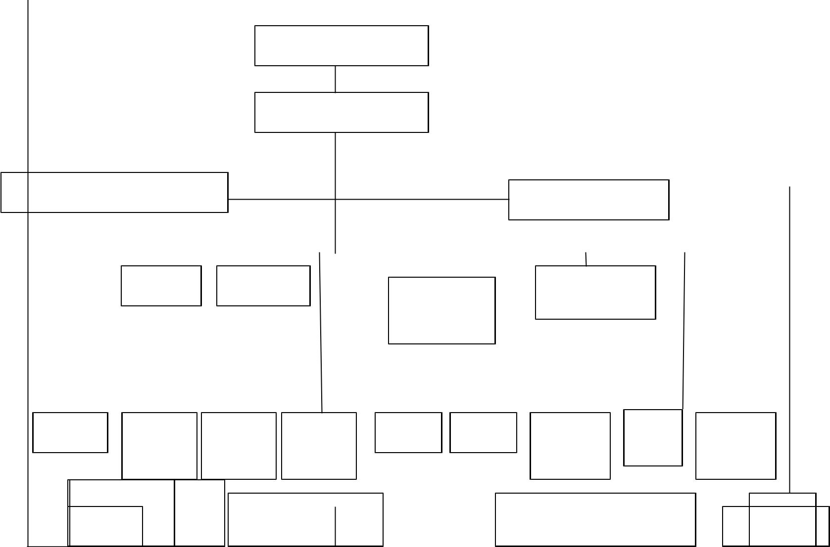

Governing Council

Vice Chancellor

DVC (Administration) | DVC (Academic)

 |  | Bursar |  |  | Registrar |  |  |  |  |  | University
 |  |  |  |  |  |  |  | Provosts of |  |  | University
 |  |  |  |  |  |  |  |  |  |  | Librarian
 |  |  |  |  |  |  |  | Colleges |  |  | Librarian

Internal | Dean of | Director | Director |  |  | Deans of |  |  | Dean PG |  | Directors of | Director | Director
 |  |  |  |  |  |  |  |  |  |  |  | MICT
Audit | Student | of works | of |  |  | Faculties |  |  | School |  | Institutes | MICT | Academic
Audit | Student | of works | Physical |  |  |  |  |  |  |  | Centers/ | Unit
 | Affairs | & Estate |  |  |  |  |  |  |  |  | Programmers |  | Planning
 | Affairs | & Estate | planning |  |  |  |  |  |  |  | Programmers
ChiDirefctor of PUB. |  |  |  |  |  |  |  |  |  |  |  |  |  | SUG
 |  | Heads of Academic |  |  |  |  |  |  |  |  | Co-ordinator of Other |  |  | SUG
SecurRelations,ty |  |  |  |  |  |  |  |  |  |  |  |  |  | SUG
Director |  | Departments |  |  |  |  |  |  |  |  | Academic Units |  | Students
OfficerCommunity Matters |  |  |  |  |  |  |  |  |  |  | Academic Units

18


SUB-

Deans


Lecturers

The Organizational Structure of a University

3.5 Analysis of the Proposed System

Social network analysis (SNA) is the methodical analysis of social networks. Social network analysis views social relationships in terms of network theory, consisting of nodes (representing individual actors within the network) and ties (which represent relationships between the individuals, such as friendship, kinship, organizational position. etc) these networks are often depicted in a social network diagram, where nodes are represented as points and ties are represented as lines. There are four steps through which the data flow which are explained as following:

Step 1: The user requests an application view.

Step 2: The Social Networking Site sends social data to the application server.

Step 3: The third-party server combines social and application data, returning HTML and JavaScript.
Step 4: The Social Networking Site sends the content to the user.

19
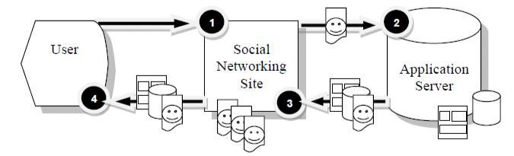

Figure 3.1: Data flow among users, social networking sites and servers

In this present system also, users are required to have the program software and a network connection though this may be charged for by their network operator.

3.6 Justification of the Proposed System

Advantages of the proposed system over the previous system are as follows:

- It will enhance social and academic integration among students.
- It will also enhance information dissemination in the campus.
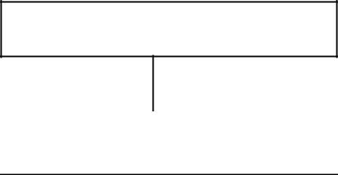

- Increase staff-student ^{General web server}
- Strengthen the ties between students of different faculties and hostels.c.Theproposedunderstandingamongstudents.

 |  |  | f. |  | Reduce the error |  |  |  |  |  |  |  |  |  |  |  |  |  |  | passes from person to person.
 |  | 3.6 |  |  | High Level |  |  |  |  |  |  |  |  |  | Social networkingsitew site
 |  |  |  |  |  |  |  |  |  |  |  | Model of the |  |  |  |  | New System
 |  |  |  |  |  |  |  |  |  |  |  |  |  |  | Welcome screem
 |  |  |  |  |  |  |  |  |  |  |  |  |  |  | Main menu
 |  |  |  |  |  |  |  |  |  |  |  |  |  |  |  |  |  |  |  |  |  |  |  | Students Area
 |  |  |  |  | Staff Area
 |  |  | Staff create account |  |  |  |  |  |  |  |  |  |  |  |  |  |  |  |  |  |  |  |  | Students create accont
 |  |  |  |  |  |  |  |  |  |  |  |  |  |  |  |  |  |  |  |  |  |  |  | account
 |  |  |  |  |  |  |  |  |  |  |  |  |  |  |  |  |  |  |  |  |  |  | Students insert password
 |  |  | Staff insert password
 |  |  |  |  |  |  |  |  |  |  |  |  |  |  |  |  |  |  |  |  |  |  |  | Students’ login
 |  |  |  |  | Staff login
 |  |  |  |  |  |  |  |  |  |  |  |  |  |  |  |  |  |  |  |  |  |  |  | Logout
 |  |  |  |  | Logout




20

Figure 3.2: The High Level Model of the New System

CHAPTER FOUR

SYSTEM DESIGN AND IMPLEMENTATION 4.1 Concept of the System Design
Social network is a set of people (or organizations or other social entities) connected by a set of socially meaningful relationships. Online social network has become very popular in recent years. Some popular social networking websites have hundreds of million users registered. In this kind of sites, users can update their personal profiles, notify friends about themselves, play game and share photos with their friends internationally. Before interacting with friends, a user must add them to form a relationship. In the existing social networking web sites, it is found that, to find a friend, the web sites are commonly based on the text-based information such as email addresses, names of friends, school names of friends, etc.

4.2 System Architecture
21

The system consists of the following three components:

- User Database

- Friendship algorithm

A. User Database

In addition to the basic information of users, the information related to the face recognition feature is needed. The formation includes:
- Face - the user face identity, type and subject.

- Photo - photo information, ID and subject.

- Photo comment - the information of each user’s comment on each photo.

- Friendship - the relationship information between each user.

- Recognition - the relationship information between the faces of photo and each friend.

- Invite - the relationship information of inviting people between user and friendship tables, inviting message and status of invitation.

B. Friendship Algorithm

The friendship algorithm is used to provide the recommendation list for the users. The algorithm makes use the faces recognized in different cases to generate recommendation list. The cases used and the corresponding weighting for each case are shown in Table 1. Note that the exact values the weighting can be revised if necessary. The friendship algorithm considers different case, and in each case there is a weighting associated. From the values of the weighting, it can be seen that priority has been considered in the friendship algorithm. That is, higher priority is given to the owner’s direct relationship and lower priority to the indirect relationship.

4.3 | Implementation
A. |  | Web Client

The information handling process is the core development of the social network service. We
 | HTTP/HTTPS
used the HTML markup Language, JavaScripts, and CSS to develop this part. The functions
are handling |  | . We intended to use
MySQL | Social Network Infrastructure (Information
MySQL | Handling, Image Handling etc.)
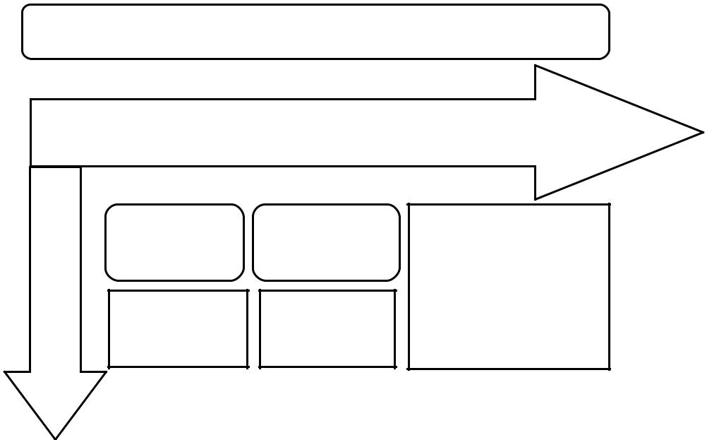

A.

Ac

ces

co s

InterfaceWebEnvironmentSQL

Service Database
ntrol | User
Profile | User
Platform | Database

Friendship

Algorithm

22

Usability of UIE (user interface environment) works in two parts where as a member that is already registered in the database, should login using the ‘Already a member login field set’ beneath the logo, but the non registered member would have to sign up by filling all fields required including upload a photo to complement your profile identity. However the user interface environment is restricted to Nnamdi Azikiwe University, Awka as a case study, knowing that it is the first of its kind in social networking in school.

User Interface Environment
23
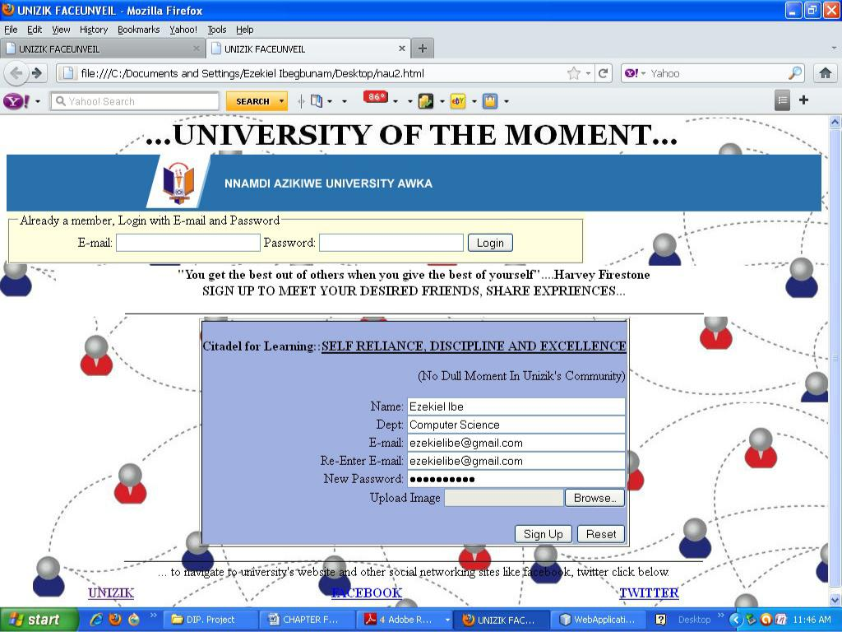

Uploading your photo as a user is done by clicking the browse option from the user interface environment as shown below:
24
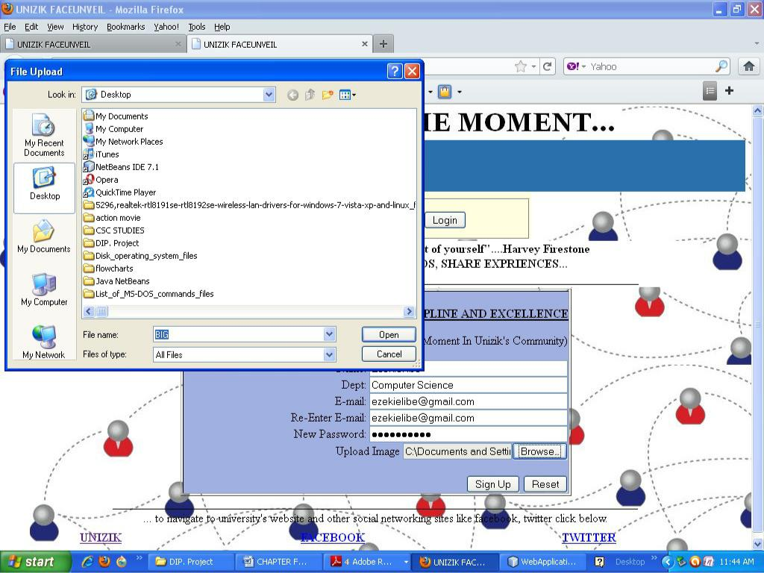

After the whole process of signing up and login in, it should take you to your profile page where all the personal information is given in accordance to your privacy. With regards to limitation we have only succeeded in designing the interface that will bring together the staff and students of Nnamdi Azikiwe University, Awka in a confined community as one family, where you meet with friends from different departments in the school to share experience, twit important conversation among peers, and creating a room for a learning environment within the vicinity of the school.
25

CHAPTER FIVE

SUMMARY AND CONCLUSIONS

5.1 Summary

We implement a prototype to demonstrate the basic function of user registration, and user login, upload photos, edit some text fields, and make friends with/without recommended list. There’s a lot of variety out there in the realm of social network design. Some sites keep a very professional approach (like Linkedln) while others have a more organic, free-form look (like MySpace). Most sites fall somewhere in between, mixing professional with personalization (like Facebook). But what’s the best way to design a social network? What are the elements that make a social network more user-friendly and more attractive to users?

5.2 Conclusion

There are many challenges to bringing social media to the learning environment. Some of them are technical and some of them are conceptual and cultural. In this implementation of a social learning environment several challenges have been discovered. The ability to maintain focus in a socially-aware environment is perhaps the most difficult. There are technical tricks that can mitigate this but the ultimate answer will have to be cultural. The ability to bring game-oriented behaviour to learning has considerable potential that is not being properly addressed. By adapting the existing approach, repackaging it to be more engaging and more detailed, we can tap into that potential. These challenges, although specific to this implementation, are general enough to inform the efforts of others when developing similar systems. Students need to be focused and motivated, and these are the difficulties and solutions found by our learning environment.

5.3 Recommendations

The main types of social networking services are those that contain category places (such as former school year of classmates), means to connect with friends (usually with self-description pages), and a recommendations system linked to trust. Popular methods now combine many of these, with Facebook, Twitter and Google+ widely used worldwide, The Sphere (luxury network), Nexopia (mostly in Canada); Bebo, Vkontakte, Hi5, Hyves (mostly in The Netherlands); Draugiem.Iv (mostly in Latvia), Ask-a-peer (career oriented), StudiVZ (mostly in Germany), iWiW (mostly in Hungary), Tuenti (mostly in Spain), Nasza-Klasa
26

(mostly in Poland), Tagged, XING, Badoo and Skyrock in parts of Europe; Orkut and Hi5 in South America and Central America; and Mixi, Orkut, Wretch, renren and Cyworld in Asia and the Pacific Islands and Faccebook, Google+, Twitter and LinkedIn are very popular in India and Pinterest is also a social networking site which is used in India, and now Zikfacets that is for Nnamdi AZikiwe University, Awka.
27

REFERENCES

Baker, L. and McNulty, J. K. (2010). Shyness and online social networking services. Journal of Social and Personal Relationships, 27(7), 873-889.Retrieved December 10, 2011, from http://levirbaker.com/pubs/shynessandonline.pdf
Bargh, J., McKenna, K., and Fitzsimons, G. (2002). Can you see the real me? Activation and expression of the “true self” on the Internet. Journal of Social Issues, 58(1), 33-48.
Bartlett, M.S., Movellan, J.R. and Sejnowski, T.J. (2002). Face recognition by independent

component analysis, IEEE Transaction on Neural Networks 13, 1450–1464.

Berg, J., Berquam, L. & Christoph, K. (2007). Social Networking Technologies:

A

“Poke”

for Campus Services. Educause Review. March/April 32-44

Berger, P. & Luckmann, T. (1966). The Social Construction of Reality: A

Berry, M. (2008) Personal Interview (Elgg use in Haslemere, Surrey UK)

Bruener, Jerome. (1985) Narrative and Paradigmatic Modes of Thought.

Learning

and

Teaching Ways of Knowing, Eighty-fourth Yearbook of the

National Society for the

Study of Education 97-115

Cifuentes, L. & Shih, Y. (2001) Teaching and Learning Online: A Collaboration Between
U.S. and Taiwanese Students. Journal of Research on Technology in Education,
v33 n4 Sum 456-474
Fleming, Dana L. (2008) Youthful Indiscretions: Should Colleges Protect Social Network
Users from Themselves and Others? New England's Journal of Higher
Education.Winter. 27-29

Glitten, S. (2006) An open source education. Network World. Retrieved on: August 3,

2008:http://www.networkworld.com/allstar/2006/092506- open-source-saugusunion-school-district.html Education.Winter. 27-29

Kirby, M. and Sirovich, L. (1990). Application of the Karhunen-Loeve procedure for the characterization of human faces, IEEE Transactions on Pattern Analysis and Machine Intelligence 12, 103–107.
SED 600: Teaching and Learning 3-2-2008 Prof. Foley
Sirovich L and. Kirby L (1987). A low-dimensional procedure for the characterization of human faces, Journal of the Optical Society of America 4, 519–524.

Treatise in the Sociology of Knowledge. Garden City, New York: Anchor Books.

Visit www.Edustore.ng to get more project materials, jamb past questions and answers

and educational eBooks

28

ACADEMIC RESEARCH
MATERIAL

WE ASSIST OUR CUSTOMERS BY PROVIDING QUALITY MATERIALS FOR ACADEMIC RESEARCH.

TERMS OF USE
TERMS AND CONDITIONS APPLIED. SEE OUR WEBSITE “TERMS AND CONDITIONS” PAGE

