# DESIGN AND IMPLEMENTATION OF A WEB-BASED SOCIAL NETWORK SITE

BY

**Aisha,** Muhammad Kabir BU/18A/IT/3051

DEPARTMENT OF THE COMPUTER SCIENCE FACULTY OF COMPUTER & APPLIED SCIENCES BAZE UNIVERSITY

ABUJA

June, 2021

**Title Page**

# DESIGN AND IMPLEMENTATION OF A WEB BASED SOCIAL NETWORK SITE

Research Submitted in Partial Fulfillment of the Requirement For the Degree of

B.Sc.

In Computer Science [Information System Management]

## By

**Aisha,** Muhammad Kabir BU/18A/IT/3051

To

The Department of Computer Science Baze University, Abuja

## Declaration

This is to certify that this Thesis/Report entitled web-based based social networking site, which is submitted by Aisha Muhammad Kabir (BU/18A/IT/3051) in partial fulfillment of the requirement for the award of degree for B.Sc. in Information System of Management to the Department of Computer Science, Baze University Abuja, Nigeria, comprises of only my original work and due acknowledgement has been made in the text to all other materials used.

Date: 28/06/2021 Name of Student: Aisha Muhammad Kabir ID Number: BU/18A/IT/3051

**APPROVED BY** ………………………………………..……… Head of Department of Computer Science

## Certification

This is to certify that this Thesis/Report entitled Design and Implementation of a Web Based Social Network Site for Baze University Students, which is submitted by Aisha Muhammad Kabir (BU/18A/IT/3051) in partial fulfillment of the requirement for the award of degree for B.Sc. in Information System Management to the Department of Computer Science, Baze University Abuja, Nigeria is a record of the candidate’s own work carried out by the candidate under my/our supervision. The matter embodied in this thesis is original and has not been submitted for the award of any other degree.

Date: 28/06/2021 Supervisor: Dr. Fatima Baba

Date: 28/06/2021 Supervisor: Mrs. Rukayya Muhammad

## Approval

This is to certify that the research work, Design and Implementation of a Web Based Social Network Site for Baze University Students and the subsequent preparation by Aisha Muhammad Kabir with BU/18A/IT/3051 has been approved by the Department of Computer Science, Faculty of Computing and Applied Science, Baze University, Abuja, Nigeria.

By

Dr. Fatima Baba Date/Sign

1st Supervisor

Mrs. Rukayya Muhammad Date/Sign

2nd Supervisor

Prof. Gabreal H. Asenge Date/Sign

Dean, Faculty of Computing and Applied Science

Prof. Ahmed Baita Garko Date/Sign

External Examiner

Dr. C. V. Uppin Date/Sign

Head of Department

## Dedication

I dedicate this project to God Almighty my creator, my strong pillar, my source of inspiration, wisdom, knowledge and understanding for giving me strength throughout this program. I also dedicate this project to my beloved parents; Alhaji Muhammad Kabir, and Hajiya Zarah Muhammad whose efforts towards me can never be comprehend. To my Siblings, Sadiya Muhammad Kabir, Zeenat Muhammad Kabir, and Fatima Muhammad Kabir thank you for always being there when I needed you the most, I also dedicate this project to my friends and families whose names are not mentioned, I said a big thank you. I will never forget my mentor’s Dr Fatima Baba and Mrs Rukayya Muhammad, who had supported, encouraged, and guided me throughout the completion of my project, I really can’t thank you enough.

## Abstract

Individuals are grouped into particular groupings, such as tiny rural communities or a neighborhood subdivision, through social networking. Although social networking can take place in person, particularly at work, in colleges, and in high schools, it is most prevalent online. This is because unlike most high schools, colleges, or workplaces, the internet is filled with millions of individuals who are looking to meet other people. Social network is the mapping and measuring of relationships and flows between people, groups, organizations, computers, URLs, and other connected information/knowledge entities. The nodes in the network are the people and groups while the links show relationships or flows between the nodes. Social network provides both a visual and a mathematical analysis of human relationships. Social Networking Website project itself is a huge project comprising various features like profile updating, friend’s list organization and various other application to enhance the overall look and feel of the website. However, in this project I am basically working on two essential feature or module (PROFILE MANAGEMENT & FRIENDS ORGANIZATION). PROFILE MANAGEMENT module maintains the profile of a user like name, like, comments, gender, status etc. FRIENDS ORGANIZATION module maintains the friend list, handles request and sends request to the other user. Profiles and Friends lists are two key features on social network sites. The third is a public commenting feature ('likes', 'Comments''). This feature allows individuals to like and comments on their Friends' profiles. These comments are displayed prominently and visible for anyone who has access to that profile.

## Table of Contents

Contents

**Title Page - - - - - - - - - - i**

Declaration - - - - - - - - - ii

Certification - - - - - - - - - iii

Approval - - - - - - - - - - iv

Dedication - - - - - - - - - - v

Abstract - - - - - - - - - - vi

Table of Contents - - - - - - - - - vii

List of Tables - - - - - - - - - ix

List of Figures - - - - - - - - - x

CHAPTER ONE: INTRODUCTION

* 1. BACKGROUND OF THE STUDY - - - - - 1
  2. CURRENT SYSTEM - - - - - - - 2
  3. STATEMENT OF THE PROBLEM - - - - - 2
  4. PROPOSED SYSTEM - - - - - - 2
  5. AIMS AND OBJECTIVES OF THE STUDY - - - - 2
  6. SIGNIFICANCE OF THE STUDY - - - - - 2
  7. DEFINATION OF TERMS - - - - - - 4
  8. SCOPE AND LIMITATION OF THE STUDY - - - - 4
  9. PROJECT ORGANIZATION - - - - - - 4

CHAPTER TWO: LITERATURE REVIEW

* 1. INTRODUCTION TO SOCIAL MEDIA CONCEPT - - - 5
  2. HISTORY OF THE SOCIAL MEDIA - - - - - 5
  3. WHAT IS A SOCIAL NETWORK? - - - - - 7
  4. STRUCTURE OF A SOCIAL NETWORK - - - - 8
  5. FEATURES OF A SOCIAL NETWORK - - - - 10

|  |  |  |  |
| --- | --- | --- | --- |
| **2.6 APPLICATIONS OF SOCIAL NETWORK** | **- - - -** | | **11** |
| **2.7 REVIEW OF EXISTING SYSTEMS -** | **- - - -** | | **12** |
| **2.7.1 Facebook - - - -** | **- - - -** | | **13** |
| **2.7.2 Instagram - - - -** | **- - - -** | | **13** |
| **2.7.3 Twitter - - - - -** | **- - - -** | | **14** |
| **2.8 PROJECT SCOPE - - -** | **- - - -** | | **14** |
| **2.9 SUMMARY - - - -** | **- - - -** | | **14** |
| **CHAPTER THREE****:** **REQUIREMENTS ANALYSIS AND DESIGN** | | | |
| **3.1 OVERVIEW - - - - - -** | | **- -** | **16** |
| **3.2 PROPOSED METHODOLOGY: WATERFALL MODEL** | | **- -** | **16** |
| **3.3 APPROACH TO CHOSEN METHODOLOGY -** | | **- -** | **16** |
| **3.4 REQUIREMENT ANALYSIS - - - -** | | **- -** | **17** |
| **3.5 RESPONSIBILITY MATRIX - - - -** | | **- -** | **23** |
| **3.6 TOOLS AND TECHNOLOGIES - - -** | | **- -** | **24** |
| **3.7 ETHICAL CONSIDERATION - - - -** | | **- -** | **25** |
| **3.8 REQUIREMENTS SPECIFICATIONS - -** | | **- -** | **25** |
| **3.8.1 Functional Requirement Specifications - - -** | | **- -** | **25** |
| **3.8.2 Non-Functional Requirement Specifications - -** | | **- -** | **28** |
| **3.9 SYSTEM DESIGN - - - - -** | | **- -** | **28** |
| **3.9.1 Application Architecture - - - -** | | **- -** | **29** |
| **3.9.2 Use Case - - - - - -** | | **- -** | **29** |
| **3.9.3 Context diagram - - - - -** | | **- -** | **34** |
| **3.9.4 Entity-Relationship Diagram (ERD) - - -** | | **- -** | **35** |
| **3.10 SUMMARY - - - - - -** | | **- -** | **36** |

**CHAPTER FOUR****:** **IMPLEMENTATION AND TESTING**

|  |  |  |  |  |  |  |  |  |  |
| --- | --- | --- | --- | --- | --- | --- | --- | --- | --- |
| **4.1** | **OVERVIEW** | **- -** | **-** | **-** | **-** | **-** | **-** | **-** | **37** |
| **4.2** | **MAIN FEATURES -** | | **-** | **-** | **-** | **-** | **-** | **-** | **37** |
| **4.3** | **IMPLEMENTATION PROBLEMS** | | | **- - - - -** | | | | | **41** |

* 1. **OVERCOMING IMPLEMENTATION PROBLEMS - - - 41**
  2. **TESTING - - - - - - - - 41**
     1. **Tests Plans (for Unit Testing, Integration Testing, and System Testing)- 42**
     2. **Test Suite - - - - - - - - 43**
     3. **Test Traceability - - - - - - - 44**
     4. **Test Report Summary - - - - - - - 49**
     5. **Error Reports and Corrections - - - - - - 49**
  3. **USE GUIDE - - - - - - - - 50**
  4. **SUMMARY - - - - - - - - 53**

**CHAPTER FIVE:****DISCUSSION, CONCLUSION AND RECOMMENDATION**

* 1. **OVERVIEW - - - - - - - - 54**
  2. **OBJECTIVE ASSESSMENT - - - - - - 54**
  3. **LIMITATIONS AND CHALLENGES - - - - - 54**
  4. **FUTURE ENHANCEMENTS - - - - - - 54**
  5. **SUMMARY - - - - - - - - 55**

**REFERENCES - - - - - - - - - 56**

## List of Tables

Table 3.1: Responsibility Matrix - - - - - - - 28

Table 3.2: Developer’s Specification Hardware - - - - - 29

Table 3.3: Developer’s Specification Software - - - - - 30

Table 3.4: Client Specification Hardware - - - - - - 30

Table 3.5: Functional Requirement Specifications - - - - - 31

Table 3.6: Non-Functional Requirement Specifications - - - - 33

Table 4.8: Test Plan - - - - - - - - - 49

Table 4.9: Test Suite Performed - - - - - - - 50

Table 4.10 Test Traceability Matrix - - - - - - - 51

Table 4.11: Test Report Summary - - - - - - - 57

## List of Figures

Figure 1: User groups of an Online Forum - - - - - - 12

Figure 3.1: Students view about the system - - - - - - 23

Figure 3.2: Students view about the system - - - - - - 23

Figure 3.3: Students view about the system - - - - - - 24

Figure 3.4: Students view about the system - - - - - - 24

Figure 3.5: Students view about the system - - - - - - 25

Figure 3.6: Students view about the system - - - - - - 25

Figure 3.7: Students view about the system - - - - - - 26

Figure 3.8: Students view about the system - - - - - - 26

Figure 3.9: Students view about the system - - - - - - 27

Figure 3:10: Screen Flow Diagram - - - - - - - 35

Figure 3.11: Login/Registration - - - - - - - 36

Figure: 3.12: Profile Page - - - - - - - - 37

Figure 3.13: Timeline - - - - - - - - - 38

Figure 3.14: Adding friend - - - - - - - - 39

Figure 3.15: context diagram - - - - - - - - 40

Figure: 3.16: Sequence diagram - - - - - - - 41

Figure 3.17: ERD diagram - - - - - - - - 42

Figure 4.1: Home Page (Default Page) - - - - - - 43

Figure 4.2: Signup Page - - - - - - - - 44

Figure 4.3: Profile Page - - - - - - - - 45

Figure 4.4: Timeline - - - - - - - - - 46

Figure 4.5: Photos Page - - - - - - - - 47

Figure 4.6: Notification Page - - - - - - - - 47

Figure 4.7: Editing Post Page - - - - - - - - 48

Figure 4.12: Install Dreamweaver above with Xampp Server. - - - 58

Figure 4.13: Open the Application using BazeGram - - - - - 59

Figure 4.14: Run the application using Google Chrome or Internet Explorer - 60

Figure 4.15: Server Directory (Database). - - - - - - 61

**CHAPTER ONE**

**INTRODUCTION**

# BACKGROUND OF THE STUDY

Our university's social life is dwindling due to a variety of factors. These social constraints have caused some pupils to be unable to relate to others in the outside world. In Baze University socialism is a problem. Creating a social networking website for the university will assist the university in addressing anti-socialist issues. A social network is a social structure made up of "nodes," or persons (or organizations) that are linked (connected) by one or more types of interdependencies, such as friendship, kinship, shared interests, financial transaction, dislike, or relationships of beliefs, knowledge or prestige.

of beliefs, knowledge or prestige.

Communication is a basic human need and for that reason, man has always found a means of meeting this need. The media, which is an umbrella term for various means of communication, has become an integral part of human life around the world. The earliest forms of personal media, speech and gestures, had the benefit of being easy to use and did not necessarily need complex technology (Idakwo, 2011).

Through the social media, the internet community has drastically increased over the years. The social media has become a significant part of today’s modern civilization. It is a defining trait of how integrated social interactions have become. The impact of the social media has been seen in basically five different contexts; news, interactions, political landscapes, learning and marketing (Guha, 2013).

With over 80 percent of teen Internet users frequenting social media sites, it’s no wonder the realworld social lives are seeing some changes. Social media is definitely changing the way people communicate, but in many ways it’s for the better as we expand our social circles and explore new horizons through our online connections (Chopra, 2013).

Every age it has passed through has been based on beliefs and new technologies, responding to the needs of individuals anxious to adjust to new forms of socialization. A time of great change is a period in which society looks for meaning. Information is already a tool, the principal tool, which people use to perceive and understand their environment.

The emergence of online forums has become hugely popular in recent times with interactions based on similar discussions, posts and threads. Online forums have become powerful tools for

sharing information. Online discussion forums have also become one of the most popular places to ask and answer questions.

Online Forums, compared to the other social media sites, have various unique features like threads; where discussions and posts are made, RSS feeds, polls, etc. Online Forums, provide a unique type of social environment that enables people to share and access information freely. Users can either start new topics or leave comments in the threads of existing topics (Xiaolin, et al., 2009).

# CURRENT SYSTEM

Prospective students of Baze University have been making use of the other social networking apps such as Facebook, Instagram, Twitter and others.

# STATEMENT OF THE PROBLEM

Prospective students at Baze University have had difficulty in the past keeping up with school news and events, communicating with new friends or colleagues, and making judgments regarding issues that have bothered them. To remedy these issues, however, a platform must be built where these kids may connect with others who can provide answers to their inquiries. Consequently, relevant requirements have to be taken into consideration in the development of a web based social network to solve these problems stated above.

# PROPOSED SYSTEM

BazeGram is safe and interesting app where students can login to fill up their spare time, share story and ask for opinions, share photos and videos, discuss current events and also find entertaining contents.

# AIMS AND OBJECTIVES OF THE STUDY

To develop a web/online based social network where students can share different story or views on various topics and majorly make information about any institution accessible. This will be achieved through the following objectives:

1. To effectively and efficiently communication of student online.
2. To Reduce anti Socialism.
3. Implementing the system by creating a user-friendly platform that will be easier for student to interact with each other and ask questions using threads and topics.

# SIGNIFICANCE OF THE STUDY

This research has application in resolving real-life issues that students face today, such as

hesitation over student problems, pressure, and anti-social behavior. The application will also be versatile enough to provide different categories from which users can choose. Finally, rather than addressing a larger audience, our application will concentrate on Baze University. . Information is the bane of decision-making for students and present time web based social network cannot live up to providing real time information that can be accessed from anywhere by the end user. It is important to put interest into the development and usage of online forums in solving these problems.

# DEFINATION OF TERMS

**Post:** Content shared through a user's profile. It can be as simple as a blurb of text, but can also include images, videos, and links to other content.

**Timeline:** A list of posts that you created and shared on social media. Generally, your timeline is visible from your home profile page and can be accessed by clicking your profile picture, wherever you see it in.

**Like:** heart symbol Likes are a way for users to acknowledge that they read your post without having to leave a comment.

**Thread:** A series of comments and replies related to an individual post on social media.

**Follow:** button on the profile of another user when they want to receive their posts in their own feed.

**Hash tag (#):** A hash tag is used to add keywords or topics to a post on social media to help you relate your post to a larger discussion. Anyone who searches for a specific hash tag sees a list of all the posts that include the hash tag.

# SCOPE AND LIMITATION OF THE STUDY

The basic limitation of this project is that the right set of university students with the right information and answers to any question may not be available to make this project a success. But this will also be taking into consideration during the implementation of the project.

# PROJECT ORGANISATION

The relevant literatures will be read in Chapter Two in order to elicit requirements for the proposed system. The requirements for the proposed system employing waterfall modeling languages will be designed in Chapter Three. The system development, deployment, and evaluation will be discussed and demonstrated in Chapter Four. The study will be summarized in Chapter 5 and recommendations for future work will be made.

# CHAPTER TWO LITERATURE REVIEW

# INTRODUCTION TO SOCIAL MEDIA CONCEPT

It's the way people interact in the twenty-first century. Individuals are grouped into specific categories, such as small rural communities or a neighborhood subdivision, by social network. While social network can take place in person, particularly at work, in universities, and in high schools, it is most common online. This is due to the fact that, unlike most high schools, universities, or workplaces, the internet is home to millions of people seeking to meet new people. The mapping and measurement of relationships and flows between individuals, groups, organizations, computers, URLs, and other related information/knowledge entities is referred to as social network analysis. People and groups are the network's nodes, while the connections depict relationships or flows between them. Human relationships can be visualized and mathematically analyzed using social networks. The Social Networking Website project is a large project that includes functionality such as profile updating, friend list organization, and other applications to improve the website's overall look and feel.

Social media may be a sort of transmission which facilitates interaction supported certain interests and characteristics. Social media are media for social interaction, using highly accessible and scalable publishing techniques. Social media use web-based technologies to rework and broadcast media monologues into social dialogues (Idakwo, 2011). A social media network platform is one that gives a medium for interaction by groups of individuals making it easy to share information (such as lecture materials, pictures and ideas) across a circle of people or groups. Statistics has shown that the use of social network such as Facebook, Twitter and LinkedIn are on the increase most especially among young individuals, the crop of which are students of tertiary institutions (Ikhu-Omoregbe, et al., 2012).

# HISTORY OF THE SOCIAL MEDIA

Idakwo (2011) claims that social media began as a phenomenon several years ago but has since developed into sophisticated technology. The origins of social media can be traced back to the use of the analog telephone for social communication. The most well-known application of social networking was a web dialogue system developed by Ward Christensen, a former IBM employee, and Randy Suess. Instead of making countless phone calls, distributing memos, and the like, they pictured an environment where they could quickly reach their coworkers for

updates, such as meetings, surveys, and other matters. They were looking into creating a computerized bulletin board, which is why they named the program CBBS (Computerized Bulletin Board System). Soon enough, more and more employees contributed their ideas and comments within the said online community. That event was a momentous episode within the history of computer and internet. It was the birth of online social networking.

The CBBS platform was made known to other companies and has been used for specific purposes. The Bulletin Board System expanded largely and commenced breaking into the mainstream much before it had been planned to. It was during the increase of the web Service Providers within the early 1990s when social networking sites began to flourish. Along with the supply of internet service to people, many of us rummaged to possess themselves familiar with this new technology. With the fast response of individuals to the budding internet community, the bulletin boards which were usually employed by companies have began to expand their roles by offering their service to more people around the globe. More and more people joined the web community with the innate goal of making an identity during this space and at an equivalent time exploring the vast place that is the internet. Because of this, many internet-savvy companies gave what people wanted- going to know more people and sharing common interests and points of view; that's through websites where they can socialize, websites which are now mentioned as social networking sites.

Social media attained an excellent measure of success with the launch of the then very fashionable friendster.com. Creator of Friendster, Jonathan Abrams concocted an ideal mixture of popular features from earlier social networking predecessors. Friendster became a moment success and gathered about three million members who signed up in its early months of launch.

As years passed, Friendster reached an awesome hundred million users from everywhere the world. With much demand from its users, Friendster unfortunately got out of hand and suffered from too many glitches within the server. Today, Friendster has been announced as a newly owned entity of a Malaysian Company, and outshone by present social networking sites but still remains to be patronized above all in Asia.

The conception of myspace.com opened the internet users to vast opportunities of self- expression which include wide control over a user’s profile content. Practically different people from all walks of life have dedicated pages in MySpace. In MySpace, users experienced the simplest of making unique identities to point out to the web world.

MySpace remained because the uncontested favorite among all the social networking sites until 2005 when it met its future competitor within the market. Soon enough, MySpace created additional features like mobile applications so as to stay up with the newest trends within the online community; and at an equivalent time be at par with the growing popularity of up-to-date social networking sites, more specifically subsequent thing in line.

Facebook started as an area social network made for the scholars of Harvard. It was developed by a sophomore, Mark Zuckerberg. Facebook was actually made by hacking Harvard’s database containing identification images of scholars. The initial idea was actually to match the faces of scholars with images of animals, for entertainment purposes. However, thanks to the doubtless damaging contents of the location, the creators decided to place it down before it caught the eye of faculty authorities.

The application was pack up, but the thought of making a web community of scholars came to existence. The platform was then improved and before they expected, Facebook was released in campuses aside from Harvard. Thereafter, high schools were already starting to get attracted to the idea of having online communities, thus opening the website to the younger population. In 2006, facebook.com ultimately offered the opportunity to the rest of

The world. As 2007 approached, the registrants reached an awesome digit roughly 1,000,000 dozen. Facebook has grown to become the most

Important and hottest social networking site today with a population of above 500 million active users.

Other social networking sites continued to seem within the scene. Blogging sites like Bebo, Multiply and lots of others came into view. Micro blogging partnered with social networking became fashionable the launch of Twitter. On Twitter, online users can post their Tweets, basically a 140-character phrase or line about what they have in mind.

With the help of API (Application Programming Interface), micro blogging sites like Twitter and Tumbler and other dedicated sites like Flickr, Photo bucket and many others were able to connect with popular social networking sites, making an unending link of information in the World Wide

Web (Idakwo, 2011).

# WHAT IS A SOCIAL NETWORK?

People can openly share and access information on social networks, which creates a special type

of social atmosphere. Users may either start new topics or leave comments on current topics' threads. A web forum typically has tens or hundreds of different boards or groups. Hundreds to thousands of threads on similar subjects are grouped together on these forums or groups. Because of the large number of users and therefore the high complexities of online forums, they have a high level of difficulty (Vicenç et al., 2008).

A Social network is also a system designed for the discussion of topics, with each topic separated into its own area, called a thread. A thread is begun by a user writing a brief document, called a post, which introduces the subject or asks an issue about the subject (Liu, et al., 2010). Internet users search online forums, generally, for sorts of information. Some of them search the forums for subjective information like different viewpoints, opinions, emotions, evaluations, etc., on specific problems rather than one correct answer (Prakhar, et al., 2012).

# STRUCTURE OF A SOCIAL NETWORK

A social network as a whole has numerous categories (broad subject areas), each of which contains forums (more detailed subject areas), each of which contains topics (threads or conversations) made up of individual postings (where a user contributes something) (Vbulletin, 2014). It is organized in a highly unique way/form, with categories leading to sub forums, and sub forums leading to other sub forums.

1. **User groups and Levels:** User groups are groups of users that divide the community into manageable sections board administrators can work with. Each user are often long to many groups and every group can be assigned individual permissions. This provides a simple way for administrators to vary permissions for several users directly, like changing moderator permissions or granting users access to a personal forum (phpBB, 2007). There are three major user groups in a forum:
   1. a. **Moderators**: they are people (or groups of people) who look after the forums on a daily basis. Within the forum they moderate, they have the authority to edit or remove posts, as well as lock, unlock, move, delete, and split subjects. Moderators are usually present to prevent users from wandering off-topic or publishing abusive or objectionable content (phpBB, 2007). Moderators have the following privileges:: deleting, merging, moving, and splitting of posts and threads, locking, renaming, sticking of threads, banning, suspending, suspending, unbanning, warning the members, or adding, editing, removing the polls of threads (Vbulletin, 2014).
   2. **Administrators:** they're members assigned with the very best level of control over the whole board. These members can control all facets of board operation, including setting permissions, banning users, creating user groups or moderators, etc., dependent upon the board founder and what permissions he or she has given the other administrators. They may even have full moderator capabilities altogether forums, counting on the settings put forth by the board founder (phpBB, 2007). These are individuals who are assigned to manage a forum. They can even be mentioned as forum owners. There also are forums where administrators relate to every other to share their knowledge.
   3. **Users:** are individuals or members who are given access to a forum or who have publicly registered to access the forum. These members don't have any special privileges unless otherwise given by the Forum Owner. Users can become Moderators or Administrators, if designated by the Administrator (IMS Global Learning Consortium, 2014).

## Figure 1: User groups of an Online Forum

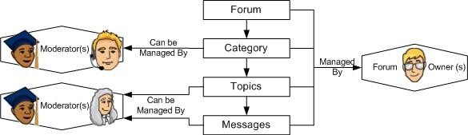

**Source: (IMS Global Learning Consortium, 2021)**

This figure describes the arrangement and flow of communication on an online forum. It consists of the Moderators, Forum Owners, the function they perform and the contents of the online forum (like Category, Topics and Messages).

1. **Post:** A post is a user-provided message that is encased in a block that includes the user's information as well as the date and time the message was posted. Most members have the ability to modify or delete their own posts. Threads contain posts, which are displayed as boxes one after the other. The initial post

in a thread is known as the TS (thread starter) or OP (original post) (original post). Posts that follow in the thread are meant to continue discussion about that post, or respond to other replies; it is not uncommon for discussions to be derailed (Beard, 2011).

1. An initiator starts a thread on a certain subject. People that are interested in the topic of the thread post their thoughts in reply replies. Because reply posts can reply to any previous post, a thread can have numerous branches (sub-threads) of discussion, resulting in a tree-like structure. This is referred to as a thread structure (Jangwon, et al., 2009). A thread starts with the publication of a post, which in turn triggers an amount of activity in the form of comments (Vicenç, et al., 2008). Threads are very important concepts in conversations on online forums.

# FEATURES OF A SOCIAL NETWORK

The ability of social network to be able to submit threads and posts brought the invention of new web technologies/features. In this project, a number of these under-listed features are going to be used like private messages and emoticons. These are some standard features of a web forum:

1. **Tripcodes and Capcodes:** during a trip code system, a secret password is added to the user's name following a separator character (often an octothorpe). This password, or tripcode, is hashed into a special key, or trip, distinguishable from the name by HTML styles. Tripcodes can't be faked but on some sorts of forum software they're insecure and may be guessed (cave76, 2009).
2. **Private Messages:** You are not registered and/or signed in, the board administrator has disabled private messaging for the entire board, or the board administrator has blocked you from sending messages. For more details, contact a board administrator (phpBB, 2007).
3. **Media Uploading:** People would want to be able to upload funny or interesting photos, video, music, and other media to share with their friends while they use their social networking accounts. The media upload section will be found under the media tab, and users will be able to specify a file to upload as well as a brief summary of the file. Just a few file extensions are supported to discourage users from uploading potentially malicious files like executable. Common image extensions like png, jpg, gif, and bitmap are enabled, as are video extensions like wmv and avi, audio extensions like mp3, wma, and wav, and some document files like txt, rtf, doc, and pdf.
4. **BBCode and HTML:** it's impossible to post HTML on this board and have it rendered as HTML. Most formatting which may be administered using HTML are often applied using BBCode instead (phpBB, 2007).
5. **Emoticon:** Emoticons are essentially textual representations of oral discourse markers, generally utilized to convey a writer’s sense of emotion and involvement. It is also a mode of representing a writer’s feelings in communication. (Halvorsen, 2012)
6. **RSS and ATOM feeds:** The RSS (Rich Site Summary and Really Simple Syndication) feed isn't human readable. It is an XML format which is meant to be read by machines instead of humans. There are different versions of RSS in use. RSS 2.0 is the most common. It is used for news/blog feeds also as for Podcasting. A newer format, called Atom, may be a more standardized way of providing XML content updates. However, it's not gotten wide acceptance yet outside of the blog communities (Web Reference, 2007).
7. Other Features include avatars, ignore lists, subscriptions and cookies.

# APPLICATIONS OF SOCIAL NETWORK

The world owes thanks to some significant advancements on the internet, which have resulted in solutions to a variety of problems. In this sense, online forums have acted as both a “Q&A” web application, where anyone with a question about any subject can get an answer, and a social network, where people can create communities and connect.

Social Network have been applied in different spheres of the internet. These are the subsequent applications of online forums today:

1. **Learning in schools through student interactions:** Online forums have served as platforms for college kids to speak with their fellow classmates, lecturers and other e- distance learning students. It has created e-learning opportunities for schools, which are having issues with student interactions within the class (Ikhu-Omoregbe, et al., 2012) (Halvorsen, 2012) (Kadir, et al., 2012).
2. **Discussions:** Online forums have also facilitated different sorts of discussions in schools, organizations and on other larger environments. For example, students given assignments over the vacations can invite assistance and still receive their feedbacks. They also provide a way to interactively participate in discussions or obtain/provide answers to questions; the vast volumes of knowledge contained in forums make them a valuable resource for “support sharing” (Xue, et al., 2007) (Mark, 2002) (Li, et al., 2011).
3. **Decision-Making support:** it's been noticed that the majority online forum users have one decision or more to form at that time in time. This has led to scientists arising with

decision trees to know the behavior of online forums. It can really be of use in schools, businesses, etc. (Xiaolin, et al., 2009) (Ikhu-Omoregbe, et al., 2012).

# REVIEW OF EXISTING SYSTEMS

We define social network sites as web-based services that enable users to create a public or semi- public profile within a bounded structure, articulate a list of other users with whom they share a link, and display and navigate their list of connections as well as those created by others. The essence and terminology of these relations can differ from one site to the next.

Social networking sites (SNSs) like MySpace, Facebook, Cyworld, and Hi5 have attracted millions of users since their launch, with many of them incorporating them into their daily routines. As of this writing, there are hundreds of SNSs promoting a wide variety of interests and activities, each with its own technical affordances. The cultures that emerge around SNSs are diverse, despite the fact that their main technical features are fairly similar. Most platforms help people maintain their current social networks, while others link strangers based on common beliefs, political views, or activities.

Some sites appeal to a wide range of users, while others draw people in based on mutual ethnic, sexual, religious, or nationality identities. Sites also differ in how much new information and networking technologies, such as mobile access, blogging, and photo/video sharing, are incorporated.

Social networking sites are not only a great place to connect and interact with people all over the world, but they are also a great way to promote your company. Many entrepreneurs are now doing business online and using social networking platforms to respond to customer inquiries. It is not only a social media platform where you can socialize with your peers, but it also contains a vast amount of knowledge about everyday life.

A social networking service is an online service, forum, or site that focuses on facilitating the formation of social networks or social relations among people who share common interests, activities, backgrounds, or real-life connections, for example. A social network service includes a representation of each user (often referred to as a profile), his or her social connections, and a number of other features. The majority of social network platforms are web-based and offer users ways to communicate over the Internet, such as e-mail and instant messaging.

Online community services are sometimes considered as a social network service, though in a broader sense, social network service usually means an individual- centered service whereas

online community services are group-centered. Social networking sites allow users to share ideas, activities, events, and interests within their individual networks.

## Facebook

Facebook, Inc. is an American technology conglomerate based in Menlo Park, California. It was founded by Mark Zuckerberg, along with his fellow roommates and students at Harvard College, who were Eduardo Saverin, Andrew McCollum, Dustin Moskovitz and Chris Hughes, originally as TheFacebook.com today's Facebook, a popular global social networking service. Facebook is one of the world's most valuable companies. It is considered one of the Big Five companies in the U.S. information technology industry, along with Google, Apple, Microsoft, and Amazon.

Facebook offers other products and services beyond its social networking platform, including Facebook Messenger, Facebook Watch and Facebook Portal. It also has acquired Instagram, WhatsApp, Oculus VR, Giphy and Mapillary, and has a 9.9% stake in Jio Platforms.

## Instagram

Instagram (commonly abbreviated to IG or Insta) is a Facebook-owned photo and video-sharing social networking site that was created by Kevin Systrom and Mike Krieger in October 2010 and first launched on iOS. The Android version was released in April 2012, with a feature-limited desktop interface following in November 2012, a Fire OS app following in June 2014, and a Windows 10 app following in October 2016. Users can upload photos and videos that can be edited with filters and arranged using hash tags and retagging. Posts may be shared with the general public or with followers who have been pre-approved. Users can browse other users' content by tags and locations and view trending content. Users can like photos and follow other users to add their content to a feed, a function that seems to be discontinued as of September 2020.

Instagram was first characterized by the fact that it only allowed content to be displayed in a square (1:1) aspect ratio of 640 pixels to match the width of the iPhone at the time. These limitations were relaxed in 2015 when the resolution was increased to 1080 pixels. In addition, the service introduced messaging capabilities, the ability to combine multiple images or videos in a single message, and a Stories feature, which is similar to Snapchat's Stories feature, which enables users to post photos and videos to a sequential stream, with each post available to everyone for 24 hours. As of January 2019, 500 million people were using the Stories feature on a regular basis.

## Twitter

Twitter is a micro blogging and social networking site based in the United States that allows users to send and receive messages known as "tweets." Unregistered users can only read tweets, but registered users can write, like, and retweet them. Twitter can be accessed via its website interface or its mobile-device application program ("app"), though the service can also be accessed via SMS.

Prior to April 2020 Twitter, Inc. is headquartered in San Francisco, California, and has over 25 offices worldwide. Tweets were initially limited to 140 characters, but in November 2017, this was increased to 280 characters for non-CJK languages. Most accounts also restrict audio and video tweets to 140 seconds.

In March 2006, Jack Dorsey, Noah Glass, Biz Stone, and Evan Williams founded Twitter, which launched in July of that year. In 2012, the service handled an average of 1.6 billion search requests per day, with more than 100 million users posting 340 million tweets per day. It was one of the top ten most-visited websites in 2013 and has been dubbed "the Internet's SMS." As of the first quarter of 2019, Twitter had more than 330 million monthly active users. Twitter is a some- to-many micro blogging services, given that the vast majority of tweets are written by a small minority of users.

# PROJECT SCOPE

Users may use this framework to create different types of profiles, such as social, family, general, and professional. Users can send a scrap note, photographs, and data files to their friends using this method. The user can keep track of the scraps he has sent to other users in his scrap book. The framework allows users to upload images so that they can keep track of their own albums. This system allows users to enter groups based on their circumstances.

This system allows users to keep track of their friends and refresh their friend lists. This system allows users to invite new friends and add them to their contact list for potential use.

# SUMMARY

In this chapter the relevant literatures and review of existing systems were reviewed so as to elicit requirements for the proposed system.

# OVERVIEW

**CHAPTER THREE REQUIREMENTS ANALYSIS AND DESIGN**

In this chapter, proposed methodology, approach to choosing the methodology, tools and technologies as well as list of requirements that drive the system such as functional and non- functional will be discussed. It contains data gathering and techniques and the Unified Modelling Language (UML) diagrams that aid in the design and implementation of the system.

# PROPOSED METHODOLOGY: WATERFALL MODEL

The waterfall model divides project activities into linear sequential phases, each of which is dependent on the previous phase's deliverables and corresponds to a task specialization. This method is popular in some areas of engineering design. It is one of the least iterative and versatile approaches in software development, as progress are mostly one-way. The waterfall development paradigm emerged from the manufacturing and construction industries, where highly organized physical structures made design adjustments prohibitively costly far earlier in the development phase. There were no recognized alternatives for knowledge-based creative work when it was first implemented for software development. In The following steps are followed in order according to Royce's original waterfall model:

1. System and software specifications are recorded in a product requirements document;
2. Analysis yields models, schema, and business rules.
3. Design yields the software architecture.
4. Coding: software creation, verification, and integration
5. Testing: systematic defect detection and debugging
6. Operations: total system implementation, migration, service, and maintenance.

As a result, the waterfall model maintains that a step can only be entered after the preceding phase has been tested and validated.

However, different updated waterfall models (including Royce's final model) may include minor or major changes to this process. Returning to the previous step after defects were discovered downstream or returning all the way to the design process if downstream phases were considered inadequate, were examples of these combinations.

# APPROACH TO CHOSEN METHODOLOGY

The Waterfall approach, as an internal practice, places little emphasis on the end user or client

involved in a project. Its primary goal has always been to assist internal teams in moving more quickly through project stages, which is ideal for the software industry.

## Advantages of waterfall model;

1. It's easy to understand and use.
2. The model's rigidity makes it simple to handle. There are unique deliverables and a review process for each step.
3. Each step is processed and completed separately.
4. Phases are clearly described.
5. Metrics that is well-understood.
6. Activities are simple to organize.

# REQUIREMENT ANALYSIS

The first activity in requirement analysis phase is to conduct a preliminary investigation and when conducting this investigation data collecting is of utmost important, the following techniques were used for collecting data:

**Questionnaires:** This method of data collection is very common, particularly when dealing with large inquiries. Private people, researchers, private and public organizations, and even governments are using it. This approach involves sending a questionnaire to the people involved (usually by mail) and asking them to answer the questions and return the questionnaire. A questionnaire is a type of survey that consists of a series of questions designed to collect information from respondents. A questionnaire can be thought of as a type of scripted meeting. They can be done eye to eye, by phone, PC or post. The questionnaire is mailed to respondents who are expected to read and understand the questions and write down the reply in the space meant for the purpose in the questionnaire itself. The respondents have to answer the questions on their own which they respondent I gave my questionnaire did, these questions were used to learn feelings, opinions and general experiences on process details or problems. The following are the key advantages of this method:

1. Even though the world is vast and geographically dispersed, there is a low cost.
2. It is clear of the interviewer's bias; responses are given in the respondents' own words.
3. Respondents have enough time to offer thoughtful responses.
4. Respondents that are difficult to meet can also be contacted in a timely manner.
5. Large samples may be used to improve the consistency and reliability of the data.

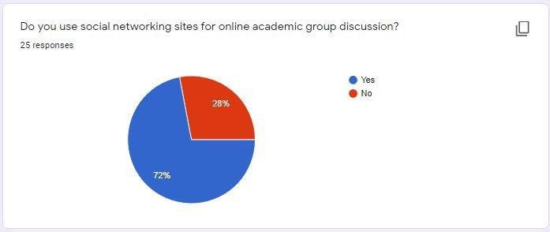

**Figure 3.1: Students view about the system**

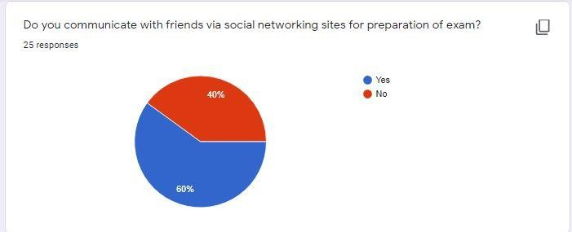

**Figure 3.2: Students view about the system**

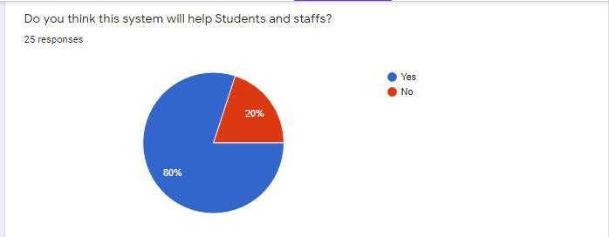

**Figure 3.3: Students view about the system**

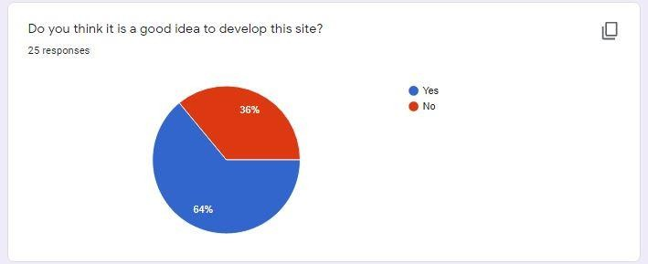

**Figure 3.4: Students view about the system**

From the data obtained clearly, I can say it is a good idea to develop the system 63.3 percent of the students said yes while only 36 said no. Clearly it is good idea to develop this system based on people perspectives.

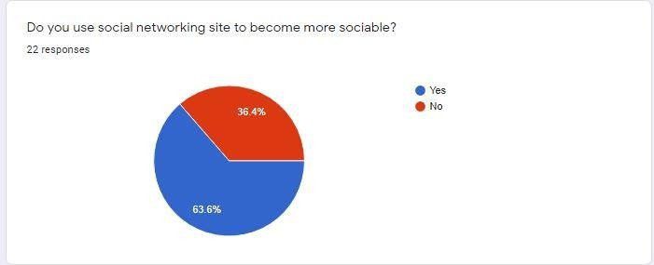

## Figure 3.5: Students view about the system

Some students become more sociable through social network, so it is a good idea to develop this system.

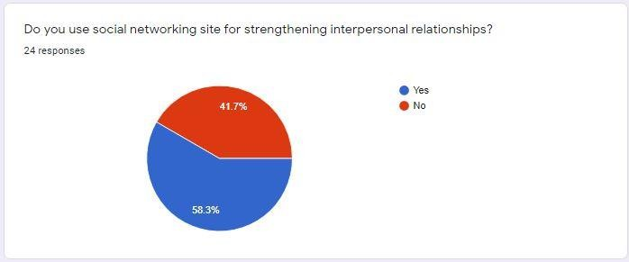

**Figure 3.6: Students view about the system**

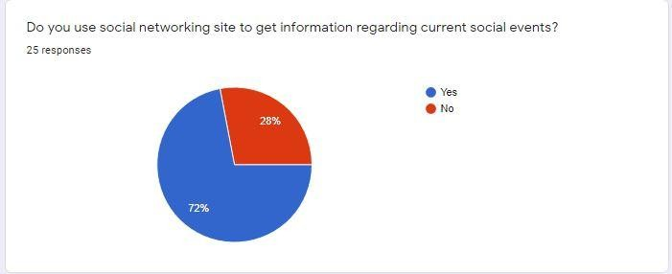

**Figure 3.7: Students view about the system**

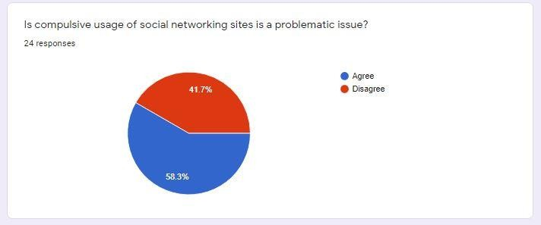

**Figure 3.8: Students view about the system**

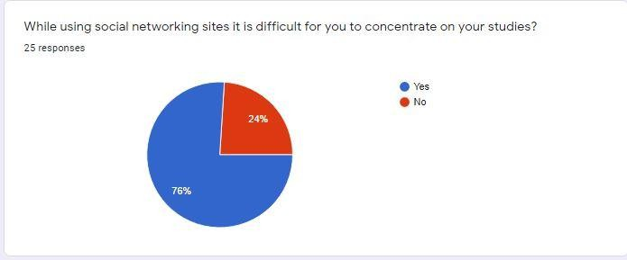

**Figure 3.9: Students view about the system**

**Interview:** interviews are an important source of qualitative data. Interviews are useful for gathering data and as a research tool for a variety of purposes. They are most useful in situations where highly customized data is needed, as well as where there are opportunities for probing to uncover underlying causes. They often become a viable choice when there are a limited number of respondents and a high return rate is needed, as well as when respondents are not fluent in the country's native language or have difficulty with written language (Gray: 2004).

The main advantage of interviews stems from their capability to offer a complete description and analysis of a research subject, without limiting the scope of the research and the nature of participant’s responses and it reaches larger scale of people (illiterates) as often the author can always change to local languages to explain in more details. Interviews are thus useful for gaining insight and context into a topic. During the interview the author will be able to discover the areas of misunderstanding, descriptions of activities and problems along with resistance to the new proposed system. They can provide information to which the interviewee was previously privy to, unlike other data collection methods such as questionnaires may act as blinkers to the responses required.

Observation: "The systematic description of activities, behaviors, and objects in the social setting chosen for analysis," according to the definition of observation. Observations enable the researcher to use the five senses to identify existing circumstances, resulting in a "printed

photograph" of the situation under investigation (ERLANDSON, HARRIS, SKIPPER, & ALLEN, 1993). Participant observation is the main approach used by anthropologists doing fieldwork, according to DeMUNCK and SOBO (1998). Researchers may benefit from observation approaches in a number of ways. They offer researchers a way to look for nonverbal expressions of emotions, figure out who communicates with whom, figure out how participants connect with one another, and see how much time is spent on different activities (SCHMUCK, 1997).

Since we may want to understand the idea of user interaction, or capturing the information of what individuals do, or monitoring users without disrupting their activity, i.e., data collected automatically, the researcher aims to perform observation as a tool to collect data in the study.

# RESPONSIBILITY MATRIX

Responsibility matrix is a matrix that is used to identified the roles that would be played by each department or individuals throughout the completion of certain categories of activities and then explain the extent and the relationship among them,

**Table 3.1: Responsibility Matrix**

|  |  |  |  |  |
| --- | --- | --- | --- | --- |
| S/No | Member | | Position | Responsibility |
| 1 | Miss Muhammad | Aisha Kabir | Project Manager | Manages the project. |
| 2 | Miss Muhammad | Aisha Kabir | Graphic Designer | Designing graphical components. |
| 3 | Miss Muhammad | Aisha Kabir | System Analyst | Designing graphical components and their system integration. |
| 4 | Miss Muhammad | Aisha Kabir | Programmer | Scripting the functions. |
| 5 | Mr. Muhammad | Aisha Kabir | Database Administrator | Designing and database implementations. |

|  |  |  |  |  |
| --- | --- | --- | --- | --- |
| 6 | Mr. Muhammad | Aisha Kabir | Software Tester | Testing the entire system to ensure free bugs. |

# TOOLS AND TECHNOLOGIES

**Developer’s Specification**

**Table 3.2: Developer’s Specification Hardware**

|  |  |  |
| --- | --- | --- |
| Hardware Specification | | |
| S/No | Items | Specification |
| 1 | Processor | 2.9 GHz |
| 2 | Memory (Ram) | 4 GB DDR2 |
| 3 | Display (Graphic Card) | Nvidia Geforce Go7400 @ 2GB |
| 4 | Hard Disk | 500GB |
| 5 | I/O | (Key Board, Mouse, CD Drive) |
| 6 | Network | Intel Pro/1000 PL Network  Connection, wireless 802.11 b/g/n |

**Table 3.3: Developer’s Specification Software**

|  |  |
| --- | --- |
| Software Specification | |
| S/No | Items |
| 1 | MySQL |
| 2 | XamppServer |

|  |  |
| --- | --- |
| 3 | PHP My admin |
| 4 | Operation System : Windows XP or above |
| 5 | Brower: latest |

**Client’s Specification**

**Table 3.4: Client Specification Hardware**

|  |  |  |
| --- | --- | --- |
| Hardware Specification | | |
| S/No | Items | Specifications |
| 1 | Processor | IntelTM CoreTM CPU 54 |
| 2 | Memory (Ram) | 1 GB DDR2 |
| 3 | Display (Graphic Card) | Nvidia Geforce Go7400 @ 1GB |
| 4 | Hard Disk | 120Gb |
| 5 | I/O | (Key Board, Mouse, CD Drive) |
| 6 | Network | IntelPro/1000PL Network Connection, wireless 802.11 b/g/n |

# ETHICAL CONSIDERATION

1. Ensure the app does not share user’s identity
2. Ensure the app does not share’s user’s location without permission
3. Ensure the app does not modify device content without permission etc

# REQUIREMENTS SPECIFICATIONS

We have functional and non-functional requirement specifications;

* + 1. **Functional Requirement Specifications**

**Table 3.5: Functional Requirement Specifications**

|  |  |  |
| --- | --- | --- |
| Req. No. | Description | Type |
| R-101 | The system should provide a user-friendly interface. | Functional |
| R-102 | The moderator can manage accounts. | Functional |
| R-103 | The system should provide two access processes, one for admin and the other for users (i.e. front end for the users and back end for admin). | Functional |

|  |  |  |
| --- | --- | --- |
| R-104 | The system should allow user to change his login details. | Functional |
| R-105 | The system should allow Students to register before posting. | Functional |
| R-106 | The system should allow users both admin and users to logout of the system. | Functional |
| R-107 | The system should allow user to view all available friends. | Functional |
| R-108 | The system should allow administrator to add students. | Functional |
| R-109 | The system should allow moderator to edit posts. | Functional |
| R-10 | The system should allow updating of all posts by the admin | Functional |

|  |  |  |
| --- | --- | --- |
| R-11 | Registration of new students should be allowed by the system. | Functional |
| R-12 | The system should allow students to manage their account. | Functional |
| R-13 | An error message or notification should be provided by the system where necessary. | Functional |
| R-14 | The system should allow students to respond to their posts and other posts. | Functional |
| R-15 | The system should allow students add friends. | Functional |
| R-16 | The system should provide users with a way of recovering password if forgotten. | Functional |
| R-17 | The system should allow administrator Tracking the number of users at each time. | Functional |
| R-18 | Registration of new vehicles should be allowed by the system. | Functional |
| R-19 | The system should allow deleting posts by the admin. | Functional |
| R-20 | The system should provide users with a way of recovering password if forgotten. | Functional |

* + 1. **Non-Functional Requirement Specifications Table 3.6: Non-Functional Requirement Specifications**

|  |  |  |
| --- | --- | --- |
| Req. No. | Description | Type |
| R-101 | The system should be available for use 24/7 except if there is a server issue which should be solved within a small time. | Availability |
| R-102 | Reliable Storage of information | Performance |
| R-103 | Ergonomic and clear usage | Usability |
| R-104 | To prevent unauthorized access into the system, the system will allow a user to register with his/her username and unique password. | Security |
| R-105 | The system should be simple and straight forward to use. | Simplicity |

# SYSTEM DESIGN

This chapter illustrate system design and unified modelling language (UML). Several UML diagrams was adopted as per of the development process such as Data Flow Diagram, Activity Diagram, Use case Diagram, Application Architecture and Entity Relation Diagram.

* + 1. **Application Architecture**

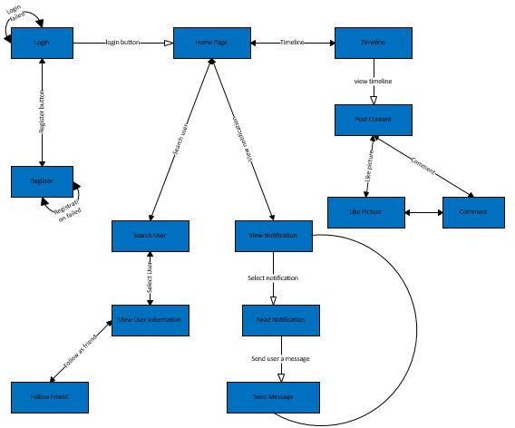

**Figure 3:10: Screen Flow Diagram**

* + 1. **Use Case**

A Use Case diagram depicts the interaction between the users and the system. It shows the functions of the system from the user’s point of view and the various actions the user as the actor carries out.

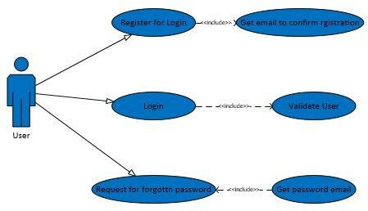

**Figure 3.11: Login/Registration**

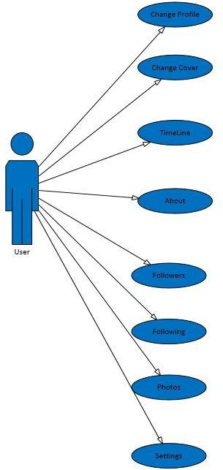

**Figure: 3.12: Profile Page**

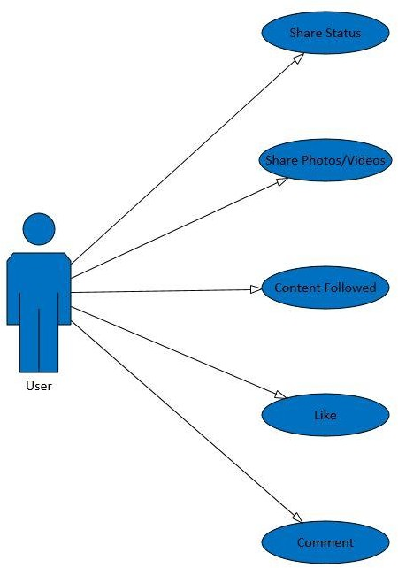

**Figure 3.13: Timeline**

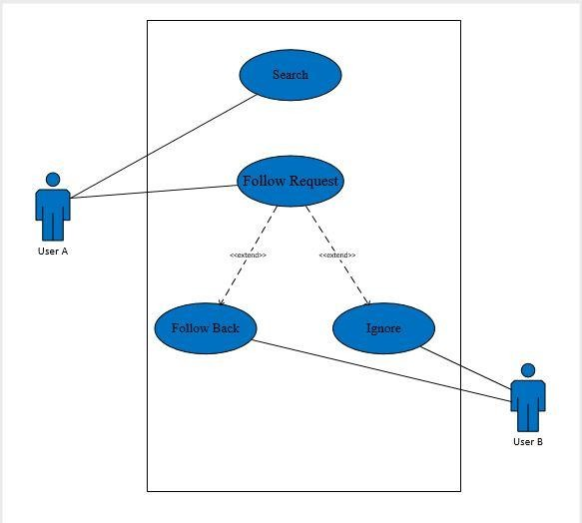

**Figure 3.14: Adding friend**

* + 1. **Context diagram**

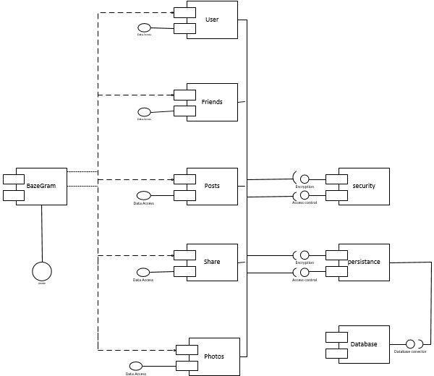

**Figure 3.15: context diagram**

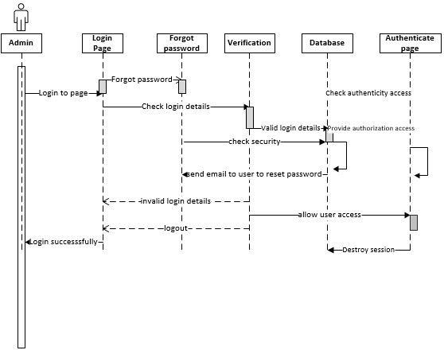

**Figure: 3.16: Sequence diagram**

* + 1. **Entity-Relationship Diagram (ERD)**

Entity-relationship diagrams show the entities and attributes of tables in a database. Linked ERDs show the relationship between tables or tables. Entities can only have a many-to-one or one-to-many relationship.

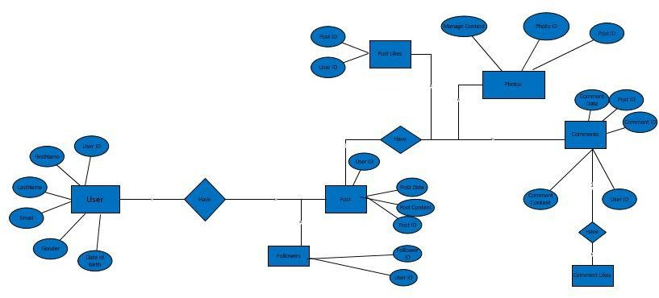

**Figure 3.17: ERD diagram**

# 3.10 SUMMARY

This chapter presents the requirement analysis and the methodology adopted in solving the problem of the site. The above design and diagrams have clearly described how the functionalities of the system is going to be. Most of the diagrams were designed using Microsoft Visio 2016. The language to be used for implementing this system is PHP.

# OVERVIEW

**CHAPTER FOUR IMPLEMENTATION AND TESTING**

This chapter shows how the proper implementation of the application was carried out depicting the necessary tools used for the development and testing of the application. Different type of tests was carried out such as Test suite, test cases, test report, and error reports related to the application are also highlighted in this chapter alongside some vital codes that drives system functionalities. Lastly, the chapter concludes with a simple user guide to help user get better understanding of the system.

# MAIN FEATURES

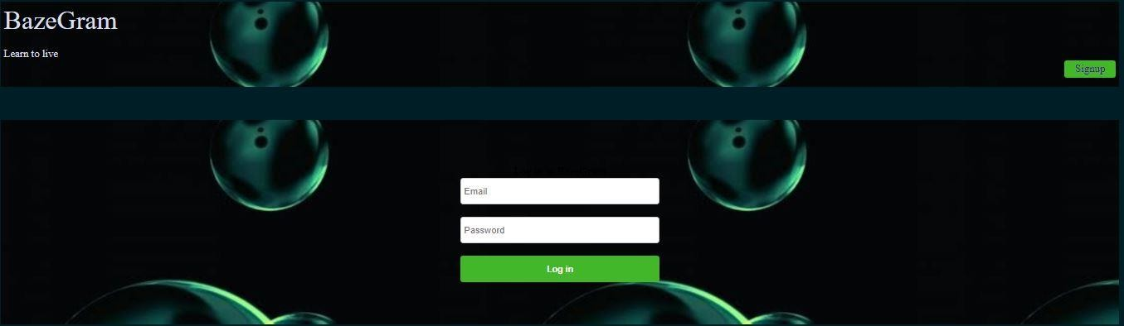

**Figure 4.1: Home Page (Default Page)**

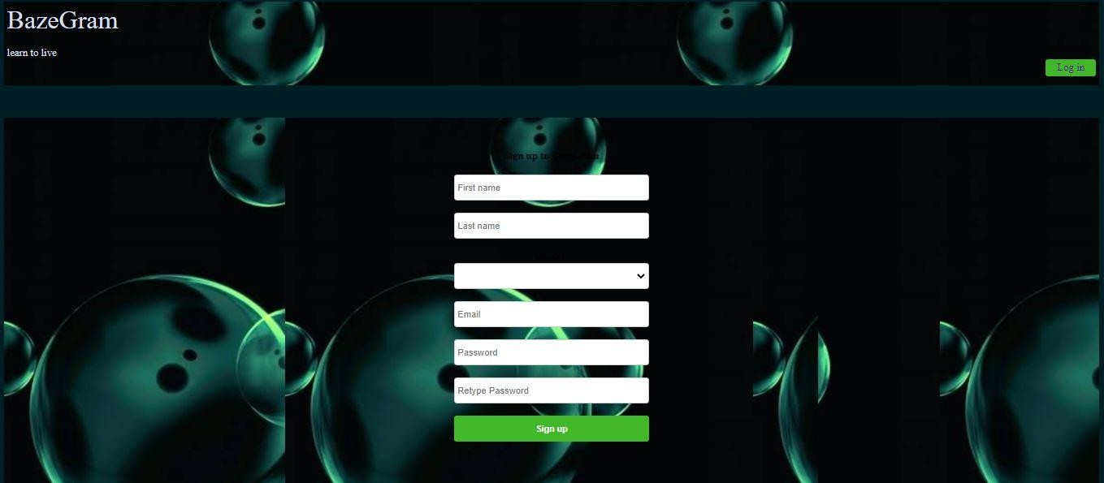

**Figure 4.2: Signup Page**

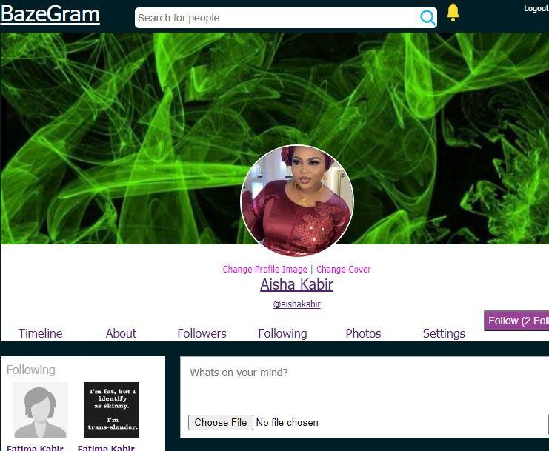

**Figure 4.3: Profile Page**

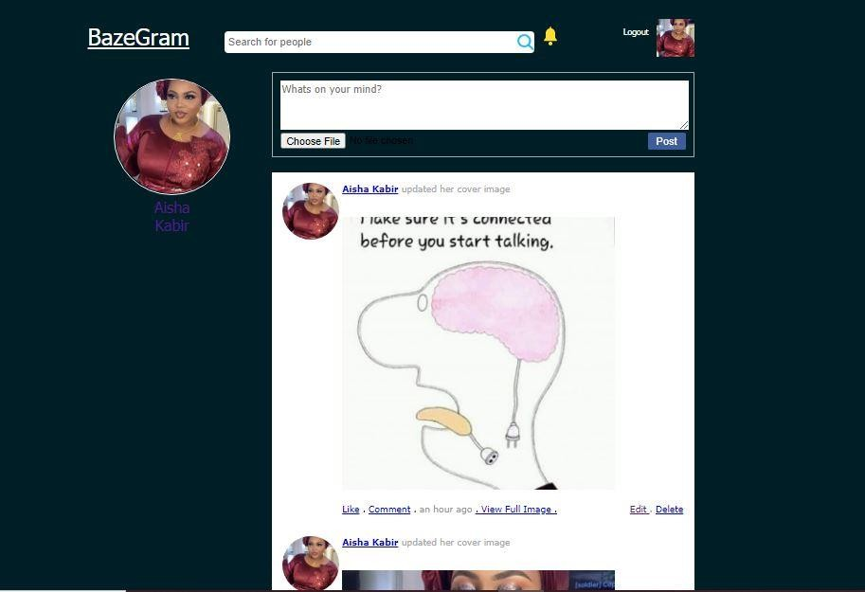

**Figure 4.4: Timeline**

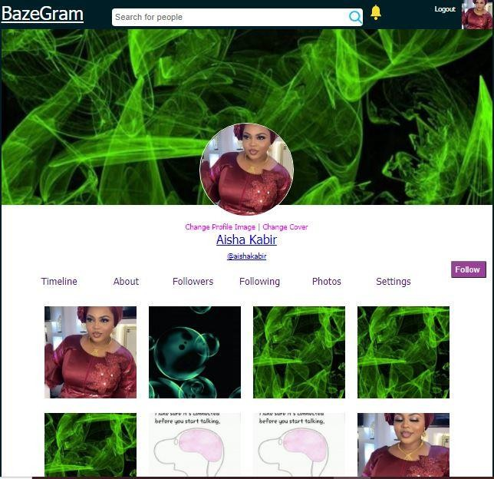

**Figure 4.5: Photos Page**

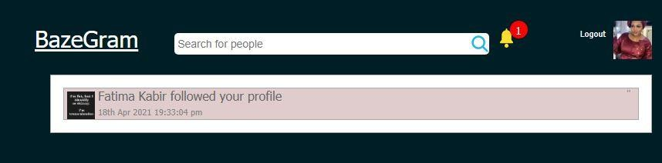

**Figure 4.6: Notification Page**

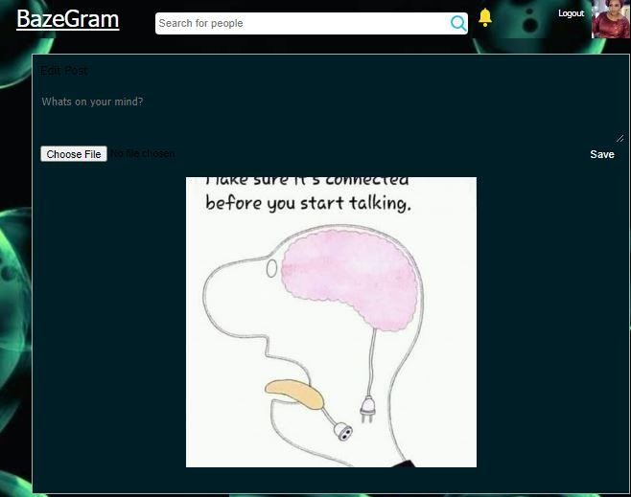

**Figure 4.7: Editing Post Page**

# IMPLEMENTATION PROBLEMS

My intention was to used Django and I have even started my implementation using Django as then, but majority of my colleagues were using PHP and as a result I was influenced and I now change from Django to PHP which I had no much knowledge about because I have not been taught. So, because of this, I found it difficult while implementing some features of my application.

# OVERCOMING IMPLEMENTATION PROBLEMS

I had to squeeze to learn what I can and I have been meeting different people to help me with the implementation in order to make sure all key features of my app are implemented and gladly with the help of those people all the key features were implemented successfully.

# TESTING

In this testing approach, test data is drive from the specifications of the program and carefully selected to test every possible combination of the input. Then the actual result from a given set of test data is compared with the expected result. If the actual results agree with the expected results, it can be concluded that the codes work as they specified. That is, the programmer who carried out the testing is completely unconcerned with the internet construct of the program, but are more interested in the actual result it produced.

## Characteristics of testing:

1. A good test has a high probability of finding an error.
2. A good test is not redundant.
3. A good test should be ―best of breed‖.
4. A good test should be neither too simple nor too complex.
   * 1. **Tests Plans (for Unit Testing, Integration Testing, and System Testing) Table 4.8: Test Plan**

|  |  |
| --- | --- |
| **USER** | |
| **1.** | User can search for friends |
| **2.** | User can see notifications |
| **3.** | User can follow and unfollow friend |
| **4.** | User can change display picture |
| **5.** | User can view another user profile |
| **6.** | User can edit profile |
| **7.** | User can log out |
| **ADMIN** | |
| **8.** | Admin can add user |

|  |  |
| --- | --- |
| **9.** | Admin can Edit Profile |
| **10.** | Admin can delete user |
| **11.** | Admin can edit post |
| **12.** | Admin can update profile |
| **13.** | Admin can change password |

* + 1. **Test Suite**

**Table 4.9: Test Suite Performed**

|  |  |  |
| --- | --- | --- |
| **Req.**  **No.** | **Description** | **Type** |
| R-101 | When launched, the application shall stay running unless there is an intentional shutdown of the application or the platform. | Performance |
| R-102 | Response time, throughout utilization, static volumetric. | Capacity |
| R-103 | The system should be available for use 24/7 except if there is a server issue which should be solved within a small time. | Availability |
| R-104 | The system will be able to accommodate concurrent request at once without throwing any expectations or generating any errors. | System Dependability |

|  |  |  |
| --- | --- | --- |
| R-105 | To prevent unauthorized access into the system, the system will allow a user to register with his/her username and unique password. | Security |

* + 1. **Test Traceability**

**Table 4.10 Test Traceability Matrix**

|  |  |
| --- | --- |
| CASE | 1 |
| OBJECTIVES | To Test Error in signup Page |
| TEST DATA | Click on sign up |
| EXPECTED RESULT | An error message |
| ACTUAL RESULT | Is as below |
| CONCLUSION | Successfully |

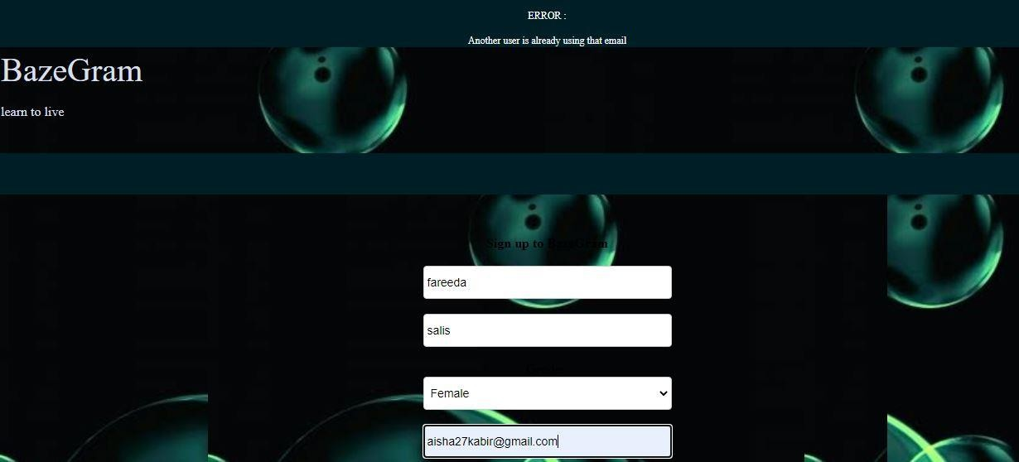

|  |  |
| --- | --- |
| CASE | 2 |
| OBJECTIVES | To Login |
| TEST DATA | Click on login |
| EXPECTED RESULT | An error message |
| ACTUAL RESULT | Is as below |
| CONCLUSION | Successfully |

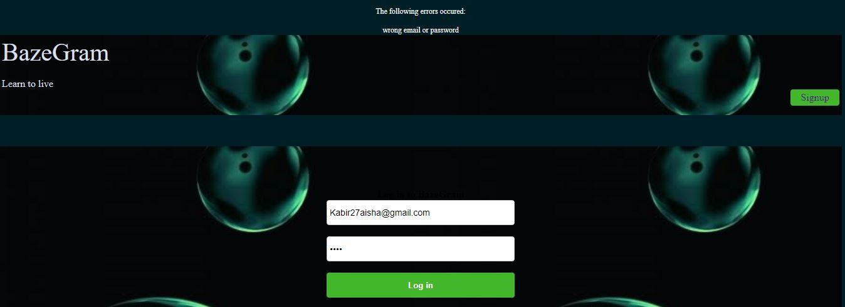

|  |  |
| --- | --- |
| CASE | 3 |
| OBJECTIVES | To Search User |
| TEST DATA | Click on Submit |
| EXPECTED RESULT | An error message |
| ACTUAL RESULT | Is as below |
| CONCLUSION | Successfully |

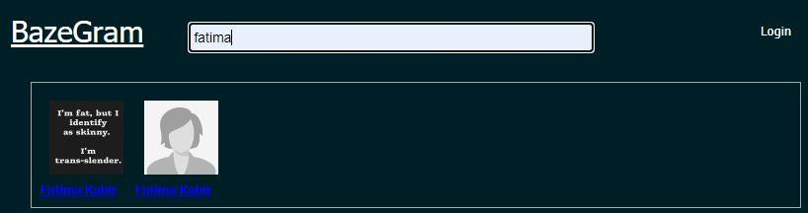

|  |  |
| --- | --- |
| CASE | 4 |
| OBJECTIVES | Update user profile |
| TEST DATA | Click on Update |
| EXPECTED RESULT | An error message |
| ACTUAL RESULT | Is as below |
| CONCLUSION | Successfully |

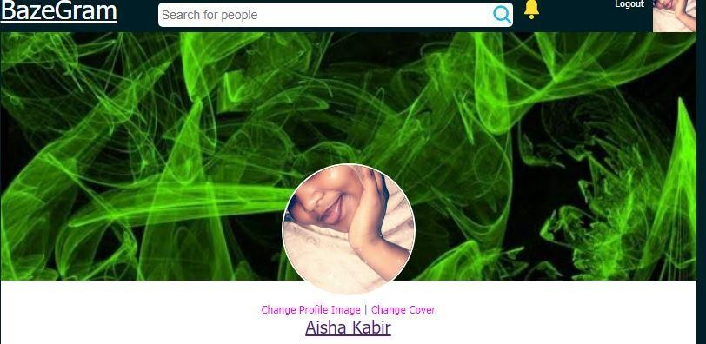

|  |  |
| --- | --- |
| CASE | 6 |
| OBJECTIVES | To Edit profile |
| TEST DATA | Click on Submit |
| EXPECTED RESULT | An error message |
| ACTUAL RESULT | Is as below |
| CONCLUSION | Successfully |

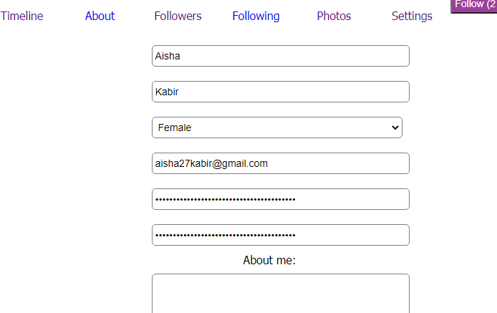

|  |  |
| --- | --- |
| CASE | 8 |
| OBJECTIVES | To like a post |
| TEST DATA | Click on Submit |
| EXPECTED RESULT | An error message |
| ACTUAL RESULT | Is as below |
| CONCLUSION | Successfully |

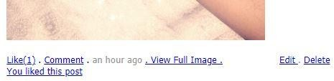

|  |  |
| --- | --- |
| CASE | 9 |
| OBJECTIVES | To comment on post |
| TEST DATA | Click on Submit |
| EXPECTED RESULT | An error message |
| ACTUAL RESULT | Is as below |
| CONCLUSION | Successfully |

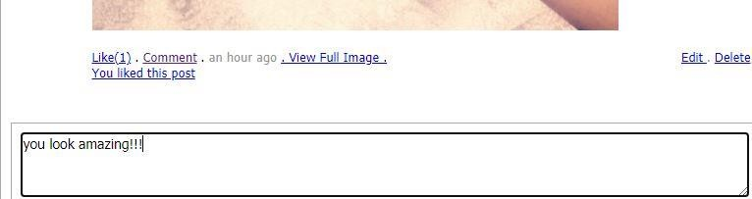

* + 1. **Test Report Summary**

**Table 4.11: Test Report Summary**

|  |  |  |
| --- | --- | --- |
| **No** | **Test Performed** | **Action** |
| **1.** | To Test Error in signup Page | Pass |
| **2.** | To login user | Pass |
| **3.** | To Search user | Pass |
| **4.** | Update user profile | Pass |
| **5.** | To edit profile | Pass |
| **6.** | To follow a user | Pass |
| **7.** | To like a post | Pass |
| **8.** | To Comment on a post | Pass |

* + 1. **Error Reports and Corrections**

No error report was detected in testing stage.

# USE GUIDE



**Figure 4.12: Install Dreamweaver above with Xampp Server.**

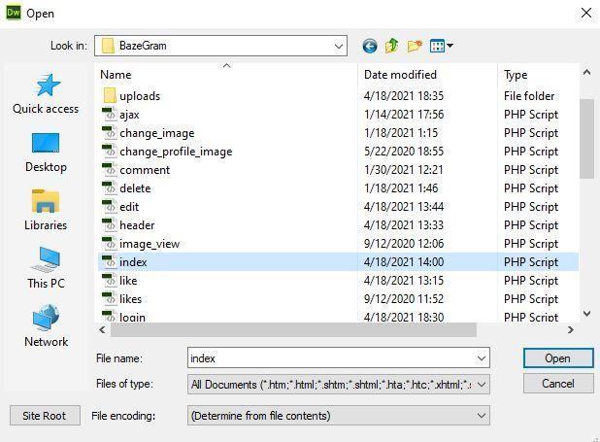

**Figure 4.13: Open the Application using BazeGram**

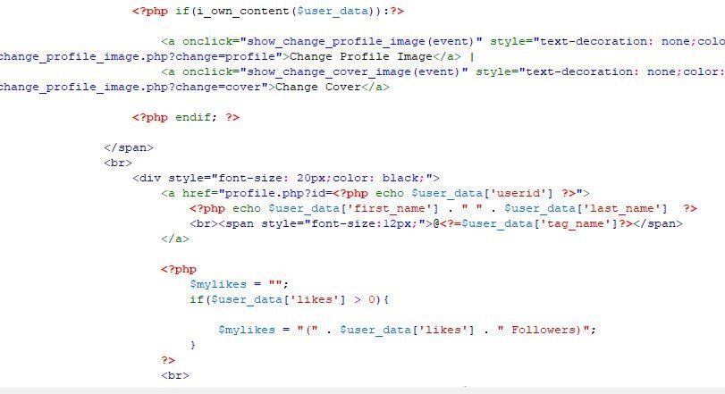

**Figure 4.14: Run the application using Google Chrome or Internet Explorer**

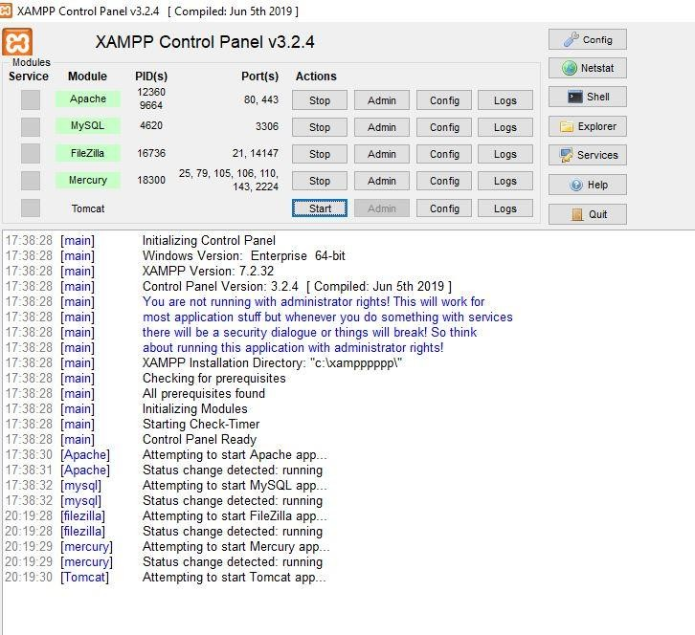

**Figure 4.15: Server Directory (Database).**

# SUMMARY

This chapter shows the overall implementation of this application and this chapter also illustrates on how testing was carried out to make sure that the app meets it is specific requirements. Testing was successful but issues were encounter during the testing and we were able to debug all the identified issues successful.

**CHAPTER FIVE**

**DISCUSSION, CONCLUSION AND RECOMMENDATION**

* 1. **OVERVIEW**

In this chapter, achievements of under taking this project will be outlined. Challenges faced in carrying out the project, and future enhancement will be discussed.

# OBJECTIVE ASSESSMENT

Based on the project goals and objectives that were stated in chapter 1 above, it is very obvious that all the goals and objectives were achieved successfully without very many difficulties.

# LIMITATIONS AND CHALLENGES

1. Using of language that was not my choice and doesn’t know much about which as a result it has been very difficult during implementation.
2. The researcher was using wamp server at first and it started misbehaving which leads to uninstallation of it and use xampp server.
3. My laptop is very slow sometimes when am working on my project.
4. My laptop crashed at some point.
5. There are some of the areas of improvement which couldn’t be implemented due to time constraints. One such feature was online chat where members can chat with his friends through this website.
6. The sickness that the researcher had for almost 3 weeks was a huge challenge because he was even admitted to hospital so a lot of work on project was not done the way the researcher wanted to and he is not able to finish many things on time and it hinder the overall the development of the project.

# FUTURE ENHANCEMENTS

Enhancement is a noteworthy improvement to the product as a part of new version of it. Below are lists of some features which need to be updated and improved:

1. The application shall have audio call and video call between users.
2. The application shall have live video chat.
3. The application will have a direct chat between user and admin.
4. The application will have camera and filters.

# SUMMARY

While making the system, an eye has been kept on making it as user-friendly. As such one may hope that the system will be acceptable to any user and will adequately meet his/her needs. As in case of any system development process where there are a number of short comings, there has been some shortcomings in the development of this system also.

# REFERENCES

Prof Mishra(2014).”Social networking sites effects” [ONLINE].Available at <http://articles.timesofindia.indiatimes.com/2020-06-23/india/40146190_1.html>

Matas Alina(2017) .”SNSs becomes an on-line opportunity for employers and students”, the Washington Post, Nov. 7, 1993, pg. H2

Andreas Mauthe; Peter Thomas (2004). Professional Content Management Systems: Handling Digital Media Assets. John Wiley & Sons. ISBN 978-0-470-85542-3, 3(2), pp. 12-17.

Berners-Lee, et cal; (1992). “World Wide Web; CERN; Invited talk at conference: Computing in High Energy Physics 92, France”. John Walter edition, England: Parker press, 4(7), pp. 89-93

Connolly. T (2007). “A practical approach to design, implement and management”. TShird edition, England: Addison Wesley press, 8(4), pp. 44-49.

Dumas, Marlon, and Arthur H.M. Ter Hofstede, (2001). "UML activity diagrams as a workflow specification language." ≪ UML≫—the Unified Modeling Language. Modeling Languages, Concepts, and Tools. Springer Berlin Heidelberg, 2001., pp. 76-90.

Lamb David (2013)." literature review" in Wikipedia, 2016. [ONLINE]. Available at: http:// en.wikipedia.org/wiki/literature-review. [Accessed on April 02 2021]